

UNIVERSITÀ DEGLI STUDI DI VERONA

DIPARTIMENTO DI MEDICINA

SCUOLA DI DOTTORATO DI SCIENZE DELLA VITA E DELLA SALUTE

DOTTORATO DI RICERCA IN INFIAMMAZIONE, IMMUNITÀ E CANCRO
CICLO/ANNO XXXIV/2018

TESI DI DOTTORATO DI RICERCA

The integrin LFA-1 as a potential target for neutrophil interactions during neuroinflammation
S.S.D. MED/04 PATOLOGIA GENERALE

Coordinatore: Prof.ssa Gabriela Constantin

Tutor: Dott.ssa Barbara Rossi

Dottorando: Dott. Nicola Lopez

Quest’opera è stata rilasciata con licenza Creative Commons Attribuzione – non commerciale
Non opere derivate 3.0 Italia. Per leggere una copia della licenza visita il sito web:

http://creativecommons.org/licenses/by-nc-nd/3.0/it/


Attribuzione Devi riconoscere una menzione di paternità adeguata, fornire un link alla licenza e indicare se sono state effettuate delle modifiche. Puoi fare ciò in qualsiasi maniera ragionevole possibile, ma non con modalità tali da suggerire che il licenziante avalli te o il tuo utilizzo del materiale.
NonCommerciale Non puoi usare il materiale per scopi commerciali.
Non opere derivate —Se remixi, trasformi il materiale o ti basi su di esso, non puoi distribuire il materiale così modificato.

The integrin LFA-1 as a potential target for neutrophil interactions during neuroinflammation
Tesi di Dottorato
Nicola Lopez
Verona, 10 Dicembre 2021
ISBN

ABBREVIATIONS AND ACRONYMS

AD Alzheimer’s Disease
APCs Antigen Presenting Cells
BBB Blood Brain Barrier
BM Bone Marrow
CAMs CNS Associated Macrophages
CCL C-C motif Chemokine Ligand
CCR C-C motif Chemokine Receptor
CXCL C-X-C-motif Chemokine Ligand
CXCR C-X-C-motif chemokine receptor
CNS Central Nervous System
CSF Cerebro-Spinal Fluid
DAMPs Damage-Associated Molecular Patterns
EAE Experimental Autoimmune Encephalomyelitis
ECs Endothelial Cells
ECM Extracellular Matrix
GFAP Glial Fibrillary Acidic Protein
IL Interleukin
LFA-1 Leukocyte Function associated Antigen-1
MOG Myelin Oligodendrocyte Glycoprotein
MPO Myeloperoxidase
NO Nitric Oxyde
MMP Matrix Metalloproteinase
MS Multiple Sclerosis
PAMPs Pathogen-Associated Molecular Patterns
PMNs Polymorphonuclear Neutrophils
ROS Reactive Oxygen Species
SAS Subarachnoid Space
SC Spinal Cord
TGF Tumor Growth Factor
TNF Tumor Necrosis Factor

RIASSUNTO

La neuroinfiammazione è un processo infiammatorio complesso a carico del sistema nervoso centrale (SNC), mediato dalla produzione di citochine, chemochine, specie reattive dell’ossigeno e messaggeri secondari prodotti e secreti dalle cellule residenti nel SNC e dalle cellule immunitarie reclutate nel sito di infiammazione. Recenti studi hanno messo in evidenza il ruolo chiave dei neutrofili nelle malattie infiammatorie croniche, inclusi i disturbi del SNC come la malattia di Alzheimer e la sclerosi multipla (SM). Studi precedenti condotti su un modello animale di SM, l’encefalomielite sperimentale autoimmune (ESA), hanno mostrato che all’interno del SNC i neutrofili si accumulano principalmente in prossimità delle zone di danno, quali le aree di demielinizzazione e i vasi con aumentata permeabilità, suggerendo un potenziale ruolo di queste cellule nella patogenesi e progressione di SM/ESA. L’extravasazione dei neutrofili all’interno del SNC a partire dalla circolazione periferica si pensa essere mediata da cellule sentinella residenti nel SNC tra cui astrociti, macrofagi residenti e microglia, attivati dal rilascio di segnali di danno. Alcuni studi suggeriscono che astrociti e microglia possono regolare le funzioni dei neutrofili e, viceversa, neutrofili infiltranti il SNC possono rilasciare fattori che influenzano lo stato di attivazione delle cellule gliali.
L’obiettivo di questo progetto di tesi è di caratterizzare le interazioni cellulari dei neutrofili infiltranti il midollo spinale in corso di ESA, sfruttando in particolare tecniche di live imaging all’avanguardia. In primo luogo, studi di citofluorimetria fatti su topi con ESA hanno mostrato la presenza di neutrofili infiltranti durante tutte le fasi cliniche di malattia, e in particolar modo al picco di malattia, durante il quale è stata osservata una massiva infiltrazione di queste cellule all’interno del parenchima. Marcature in immunofluorescenza fatte su sezioni di midollo spinale hanno inoltre rivelato la presenza di numerosi neutrofili extravasati in contatto diretto con astrociti e microglia/macrofagi, suggerendo che l’interazione tra neutrofili e cellule gliali possa rappresentare un possibile asse cruciale in corso di ESA finora poco conosciuto. Per corroborare questa ipotesi, abbiamo sviluppato un protocollo di validazione del target su un sistema dinamico in vitro di co-coltura di neutrofili e cellule gliali. È stato osservato che i neutrofili presentano diversi parametri di motilità se messi in co-coltura con astrociti o con microglia/macrofagi, e che il blocco dell’integrina LFA-1 inficia esclusivamente le interazioni con le cellule mieloidi isolate al picco di malattia. In aggiunta, risultati analoghi sono stati ottenuti in vivo mediante microscopia a due fotoni nello spazio subaracnoideo della zona lombare del midollo spinale, eseguita al picco di malattia. Nello specifico, abbiamo osservato che i neutrofili extravasati sono principalmente caratterizzati da una bassa motilità, muovendosi preferenzialmente in prossimità dei vasi. In questo contesto, il blocco dell’integrina LFA-1 determina una progressiva riduzione del numero di neutrofili a bassa motilità in favore di neutrofili che, una volta abbandonata la compartimentalizzazione vascolare, aumentano drasticamente velocità e direzionalità, migrando in profondità nello spazio subaracnoideo del midollo spinale. In topi CX3CR1-eGFP con ESA, la somministrazione a livello locale di un anticorpo anti-LFA-1 è in grado di bloccare nettamente le interazioni tra neutrofili e macrofagi perivascolari, suggerendo che l’integrina LFA-1 rappresenta una molecola chiave nel controllo delle dinamiche dei neutrofili all’interfaccia con il parenchima del midollo spinale durante la fase acuta di ESA. In supporto dei risultati ottenuti in vitro e in vivo, abbiamo somministrato un anticorpo anti-LFA-1 a topi con ESA all’esordio di malattia e 4 giorni dopo mediante iniezione intratecale. Il trattamento ha evidenziato una significativa riduzione dei sintomi clinici della malattia, insieme a un miglioramento delle caratteristiche neuropatologiche in termini di infiltrati leucocitari, demielinizzazione, microgliosi e astrogliosi. Complessivamente, i meccanismi molecolari alla base delle interazioni tra neutrofili e cellule gliali rappresentano un’area di studio innovativa, potendo potenzialmente contribuire nell’identificazione di nuove strategie terapeutiche per il trattamento della SM.

ABSTRACT

Neuroinflammation is a complex inflammatory process occurring within the central nervous system (CNS). It is mediated by the production of cytokines, chemokines, reactive oxygen species and secondary messengers produced and secreted by CNS-resident cells and recruited immune cells. Recent studies highlighted the key role of neutrophils as crucial players in chronic inflammatory diseases including CNS disorders such as Alzheimer’s disease (AD) and multiple sclerosis (MS). Previous studies on experimental autoimmune encephalomyelitis (EAE), the animal model of MS, have shown that neutrophils in the CNS are localized in close proximity to damaged tissues, such as demyelinated areas and leaked vessels, suggesting their potential detrimental role in the pathogenesis and progression of MS/EAE. The extravasation of neutrophils into the CNS from the peripheral circulation is suggested to be induced by CNS-resident sentinel cells (e.g., astrocytes, resident macrophages and microglia), which are activated by tissue danger signals release. Some studies suggested that both astrocytes and microglia might regulate neutrophil functions. Inversely, CNS-invading neutrophils could release factors that affect reactivity of glial cells.
The aim of this project is to shed light on the cellular interplay exerted by infiltrating neutrophils in the spinal cord (SC) during EAE, taking advantage in particular of our cutting-edge live imaging techniques. At first, flow cytometry studies carried on EAE mice showed neutrophil infiltration during all the clinical phases of disease but especially at the peak, during which a massive neutrophil infiltration within the parenchyma was observed. Immunofluorescence staining on SC sections revealed also numerous extravasated neutrophils establishing physical contacts with astrocytes and microglia/macrophages, suggesting that neutrophil-glial cell crosstalk may represent a previously unknown key axis during EAE. To corroborate this hypothesis, we developed a protocol of target validation on a dynamic in vitro neutrophil-glial cell co-culture system. We observed that neutrophils display different motility parameters when co-cultured with astrocytes or microglia/macrophages, and that Leukocyte function associated antigen-1 (LFA-1) blockade affected exclusively interactions with myeloid cells when isolated at the peak of disease. These data were also confirmed using neutrophils isolated from LFA-1 knock-out mice. Interestingly, we obtained similar results in vivo performing two-photon laser microscopy in the subarachnoid space (SAS) of lumbar SC at the peak of disease. Weakly motile extravasated neutrophils were found, moving preferentially located near to the vessels. Interestingly, the blockade of LFA-1 led to a progressive reduction in the portion of neutrophils that were moving slowly near the blood vessels, resulting in an increased portion of cells that, once left vessel compartmentalization, drastically enhanced velocity and directness moving deep in spinal SAS space. In CX3CR1-eGFP EAE mice, the local administration of anti-LFA-1 antibody clearly inhibited perivascular macrophage-neutrophil interactions, suggesting that LFA-1 integrin is a key integrin controlling neutrophil dynamics at the interface with SC parenchyma during acute EAE. To check a therapeutic relevance of our in vitro and in vivo findings, we performed intrathecal injection of anti-LFA-1 antibody at disease onset and 4 days later in EAE-induced mice. We observed that anti-LFA-1 treatment determined a significant inhibition of EAE clinical symptoms, together with amelioration in neuropathological hallmarks, in terms of infiltrated leukocytes, demyelination, microgliosis and astrogliosis. Collectively, the molecular mechanisms controlling neutrophil crosstalk with glial cells could represent an innovative field of study, thus contributing to develop new therapeutic strategies for the treatment of MS.

TABLE OF CONTENTS
RIASSUNTO 4
ABSTRACT 6
INTRODUCTION 10
1. Neuroinflammation 10
1.1 Physiological and pathological responses in neuroinflammation 10
1.2 Glial cell cross-talk during neuroinflammation 11
1.3 Neuroimmune interactions in the CNS 14
2. Multiple Sclerosis 16
2.1 Clinical features of MS 16
2.2 MS as a neuroinflammatory autoimmune disease 20
2.3 An experimental model of MS: the Experimental Autoimmune Encephalomyelitis 21
3. Neutrophils 23
3.1 Neutrophil biology 23
3.2 Neutrophils in EAE and MS 26
3.3 Neutrophils interplay with glial cells 32
4. LFA-1 integrin 34
4.1 The leukocyte adhesion cascade 34
4.2 The molecular features of LFA-1 integrin and its role in immune cells 36
4.3 The clinical targeting of LFA-1: Efalizumab 39
MATERIALS AND METHODS 41
1. Mice 41
2. Isolation of murine neutrophils 41
3. Active EAE induction 42
4. Intracardiac perfusion 42
5. CNS-infiltrating neutrophil evaluation by flow cytometry 43
6. Isolation of glial cells 43
7. In vitro live imaging of neutrophil-glial cell co-cultures 44
8. Tissue immunofluorescence staining 45
9. Intrathecal antibody treatment 46
10. Neuropathological analysis 47
11. Two-photon laser scanning microscopy 47
RESULTS 54
1. Neutrophils differently accumulate in the brain and SC during disease phases 54
2. Neutrophils display different infiltration pattern during EAE, establishing physical interactions with glial cells 56
3. Bone marrow-derived neutrophils express LFA-1 on their surface 58
4. Neutrophils display different motility parameters in co-culture with astrocytes and microglia/macrophages 59
5. LFA-1 integrin selectively mediates neutrophil contacts with microglia/macrophages but not with astrocytes in an in vitro co-culture system 61
6. LFA-1 integrin controls neutrophil compartmentalization and intra-tissue motility during acute EAE 67
7. LFA-1 integrin controls intra-tissue microglia/macrophage-neutrophil interactions at the peak of EAE 72
8. Intrathecal injection of an anti-LFA-1 antibody at EAE onset ameliorates disease severity 76
DISCUSSION 81
BIBLIOGRAPHY 90

INTRODUCTION

Neuroinflammation

1.1 Physiological and pathological responses in neuroinflammation
Neuroinflammation is a complex multifaceted process occurring within the Central Nervous System (CNS) in response to an inflammatory stimulus, such as traumatic brain injury (Ebert et al., 2019), infections, toxic metabolites, aging and neurodegenerative disease (Kwon and Koh, 2020). It is mediated by a plethora of cytokines, chemokines, reactive oxygen species (ROS) and secondary messengers such as prostaglandins and nitric oxide (NO), produced and secreted by CNS-resident cells (microglia and astrocytes), endothelial cells (ECs) and infiltrated peripheral immune cells (DiSabato et al., 2016). Simultaneously, an increase in Blood-Brain Barrier (BBB) permeability occurs. In homeostatic conditions, neural cells trigger cell-contact dependent signals and release neuronal immunoregulatory mediators that dampen microglia activation, antigen presenting cell (APCs) maturation and limit the survival of activated lymphocytes. Upon persistent neuronal damage, the impairment of this axis compromises the protective environment of the CNS leading to the development of a neuroinflammatory condition (Amor et al., 2014). Based on the duration, the diffusion and the intensity of the injury, neuroinflammation assumes different features. Following a mild and localized CNS acute injury or insult, a local immune response consisting in a rapid activation of glial cells contains the spreading of inflammation and enhances the production of neurotrophic factors with consequent stimulation of neuronal repair (Koudriavtseva and Mainero, 2016). Conversely, when stimuli are more intense and spread faster compared with the mechanisms of resolution, an inflammatory condition is triggered and, if prolonged, it evolves in a chronic form. In this scenario, the inflammatory environment promotes a massive production of pro-inflammatory cytokines and damage signals that exacerbate BBB permeability, activation of astrocytes and ECs. Simultaneously, these factors furtherly enhance glial cell activation, that in turn release pro-inflammatory molecules and chemokines, resulting in a peripheral leukocyte recruitment with increased production of neurotoxic and pro-inflammatory cytokines, in a positive feedback mechanism (Figure 1). Myeloid cells and lymphocytes are the main mediators of cytokine release and tissue damage, boosting the inflammatory cascade.

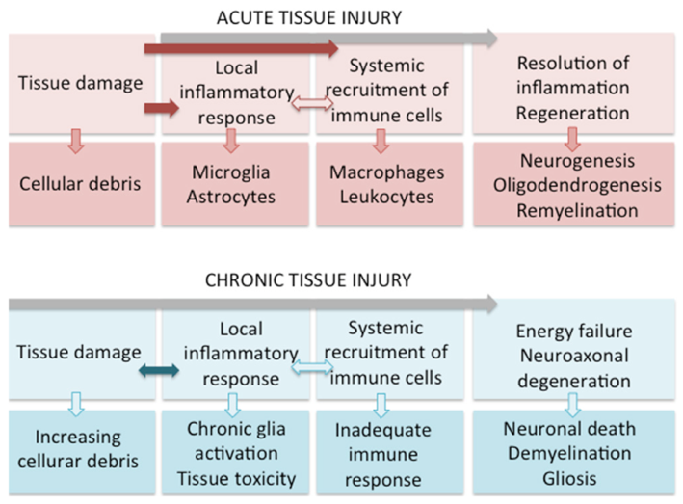
Figure 1. Main features of acute and chronic tissue injury. Following acute injury, local and systemic responses contribute to contain the inflammation and promote tissue repair. During chronic injury, a strong neuroinflammatory environment is established. The unbalance between tissue damage and resolving mechanisms leads to neurodegeneration, demyelination and persistent gliosis. (Adapted from Koudriatseva, T., et al. 2016)

1.2 Glial cell cross-talk during neuroinflammation
Astrocytes and microglia are considered the main innate immune cells in brain and spinal cord (SC), representing the initiators of an immune response within the CNS, producing immunomodulators and expressing immune pattern recognition receptors (PRRs), such as Toll-like receptors (TLRs), NOD-like receptors (NLRs), complement receptors, mannose receptors and scavenger receptor (Tian et al., 2012). Moreover, these cells are key regulators in homeostasis maintenance and inflammation. Microglia are known to be involved in neurogenesis and synaptic pruning during neurodevelopment, whereas in adult brain participate in synaptic plasticity, learning and memory formation, but also in immune surveillance. The development of two-photon microscopy combined with the availability of fluorescent transgenic mice, have allowed to appreciate microglia constantly surveying the microenvironment through their sensosomes (Davalos et al., 2005). On the other way, astrocytes balance homeostasis of ions and neurotransmitters, supply metabolic substrates for neurons and contribute to maintain BBB integrity with ECs. Despite for years classification of glial cells was restricted to a pro-inflammatory and an anti-inflammatory protective status (M1/A1 and M2/A2, respectively), a great heterogeneity and plasticity of their phenotype is now highlighted, based on location, type and stage of disease (Liddelow and Barres, 2017),(Bachiller et al., 2018). Considering their sensing role in the CNS, glial cells need to rapidly adapt to occurring changes, requiring a constant cross-talk with neurons and other glial cells. Through the release of several cytokines, chemokines, growth factors and adenosine triphosphate (ATP), these interactions assume a central role in CNS development, structural organization and homeostasis. Conversely, a miscommunication between cells or a gap in this axis can be involved in neuropathologies. Following an insult, microglia are the first cells to react and get activated, acquiring the capability to migrate toward the site of injury and phagocyting dead cells and debris. Once activated, microglia cells secrete cytokines such as interleukin (IL)-1β, tumor necrosis factor (TNF)-α, IL-6, but also ROS and NO, that induce intracellular signal transduction in astrocytes, with consequent cell activation (Jha et al., 2019). The microglial production of NO induces an increase of glycolytic enzymes in astrocytes, that in turn amplify ROS production and hypoxia inducible factor (HIF)-1α release (Iizumi et al., 2016). As a result, the production of ROS by BBB-forming astrocytes determines vasodilatation and leukocyte recruitment (Prajeeth et al., 2017). Activated astrocytes undergo morphological changes and cytoskeleton rearrangements and overexpress glial fibrillary acidic protein (GFAP). During high grades of activation, reactive astrocytes form a glial scar that surround the injury sites, acting as a barrier against the spreading of damage and limiting the infiltration of peripheral leukocytes (Sofroniew, 2014). Truthfully, the role of astrogliosis during neuroinflammation is complex and characterized by progressive states of activation. Based on the reactive grade and the surrounding microenvironment, astrocytes can be beneficial or harmful (Figure 2). In order to counteract inflammation, in fact, microglia secrete IL-10, inducing astrocytes toward a protective status and the release of transforming growth factor (TGF)-β. In turn, this anti-inflammatory cytokine reinforces microglial M2 profile (Bernaus et al., 2020). On the other side, a previous work from Liddelow, S. et al., demonstrated that activated microglia but also microglia-derived IL-1α, TNF-α and complement component subunit q (C1q) induced a neurotoxic phenotype in astrocytes (namely A1) both in vivo and in vitro. Notably, the A1 phenotype showed production of neurotoxins and impaired capability to promote neuronal survival and growth (Liddelow et al., 2017). Moreover, during MS the chemokines CCL2 (C-C motif chemokine ligand 2) and CXCL10 (C-X-C chemokine ligand 10) produced by astrocytes at the rim of demyelinated areas, recruit and activate astrocytes and microglia in an autocrine and paracrine manner, enhancing axonal injury trough microglia-derived metalloproteinases (MMP)-9 and other toxic molecules (Tanuma et al., 2006). Conversely, it was shown that following axonal damage, the release of TNF-α by activated glial cells induced CXCL12 production by astrocytes, with consequent recruitment of oligodendrocyte precursor cells to demyelinated areas and enhanced remyelination processes (Patel et al., 2012). Until few years ago, immunity in the CNS was prevalently attributed to microglia. However, in CNS borders there are several specialized macrophages whose origins and roles in steady state and disease remains largely not elucidated. These macrophage populations are known as CNS-associated macrophages (CAMs), and include dural, leptomeningeal, perivascular and choroid plexus macrophages (Mrdjen et al., 2018), (Goldmann et al., 2016), (Jordao et al., 2019), (Van Hove et al., 2019), (McMenamin et al., 2003). Their strategic position along the checkpoints of CNS gateways exposed to a continuous flow of CSF, suggests a role in the drainage of antigens and metabolite exchange (Goldmann et al., 2016), (Butovsky et al., 2012) and endorses the idea on their involvement in immune surveillance with the CNS (Nayak et al., 2012). Indeed, it was supposed that CAMs might protect from MS limiting the presence of CNS antigens and thereby controlling the local autoimmune reactions (Boven et al., 2006). On the other hand, a large number of activated macrophages were found within MS lesions and an intense CAMs activation was also observed during EAE (Mrdjen et al., 2018), (Ajami et al., 2011).

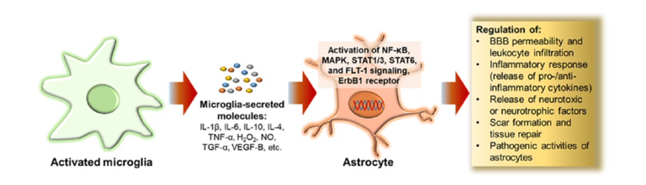
Figure 2. Crosstalk between microglia and astrocytes determines beneficial or detrimental effects. Through the release of a plethora of factors, activated microglia induce in astrocytes the activation of different signaling pathways, that in turn can affect the CNS in a positive or negative manner. This mechanism of interplay among glial cells has been described in several CNS disease, such as Parkinson, Alzheimer’s disease, MS, traumatic brain injury. (Adapted from Jha, M.K. et al. 2019)

1.3 Neuroimmune interactions in the CNS
During neuroinflammation, the environment enriched in pro-inflammatory cytokines and reactive species, determined by gliosis and axonal loss, impacts also on BBB integrity. As a result, ECs undergo activation and upregulate cell surface molecules, accompanied by tight junction weakening and a chemoattractant gradient with a direct effect on leukocyte interaction and transmigration in the CNS (Bernaus et al., 2020). For instance, the upregulated vascular cell adhesion molecule (VCAM)-1 on the activated endothelium has been demonstrated to be involved in direct interactions with α4-integrin on leukocytes in different mouse models of neuroinflammation (Vajkoczy et al., 2001), (Pietronigro et al., 2019). Once reached the CNS, leukocytes can exert their functions interacting both directly and indirectly with resident cells, although the entire set of molecules and mechanisms of interactions is not fully elucidated. In healthy conditions, meningeal, choroidal and perivascular macrophages are the main responsible of antigen presentation within the CNS. Following inflammation, these cells together with microglia and astrocytes upregulated major histocompatibility complex (MHC) class I and II (Yang et al., 2012), but also the co-stimulatory molecules CD40, B7-1, B7-2 and leukocyte-function associated antigen-1 (LFA-1), with consequent effective antigen presentation and lymphocyte activation (Tian et al., 2012). Moreover, it was demonstrated the capability of astrocyte to determine anergy in autoreactive T helper lymphocytes via B7/cytotoxic T-lymphocyte antigen (CTLA)-4 axis (Gimsa et al., 2004), and to limit CD8+ T cell function in an animal model of viral encephalitis, via programmed death-ligand (PD-L)1 (Schachtele et al., 2014). In ischemia, astrocytes-derived CCL1 and CCL20 attract regulatory T cells (Treg) that once proliferating upon IL-2 and T cell receptor (TCR) recognition, secrete factors able to decrease the neurotoxic effect of astrocytes (Ito et al., 2019). Similarly, the intranasal administration of anti-CD3 antibody in an experimental model of MS activate IL-10-producing Treg cells in the periphery. Once in the CNS, these cells influence astrocyte gene expression, with pathophysiological effects in microglia modulation (Csf2), BBB integrity (Mmp3, Mmp9) and monocyte recruitment (Ccl2) (Mayo et al., 2016). Lastly, Barcia C. et al described at a molecular level the physical interactions between T cells and astrocytes. In this work, CD8+ T cells are shown to establish classic immunological synapses with virally infected astrocytes, with the formation of central and peripheral supramolecular adhesion complexes (c-SMAC, rich in TCR, and p-SMAC, rich in LFA-1, respectively), and the activation of tyrosine-kinase phosphorylation cascade (Barcia et al., 2006).

Multiple Sclerosis

2.1 Clinical features of MS
Autoimmunity is a pathological condition in which immune system reacts against autologous antigens, resulting in local or spread tissue damage. The alterations arise for several dysfunctions of immunological tolerance mechanisms against self-antigens. In a not pathological context, a selective process prevents the maturation of specific autoreactive T lymphocytes through mechanisms of peripheral switching-off and clearance. There are several interconnected factors that contribute to the development of autoimmunity, such as immunological alterations of lymphocytes and APCs, genetic factors, microbial infections and injuries. Based on how these factors combine with each other, autoimmune diseases represent a heterogeneous class of disorders with highly complex clinical manifestations and inter-individual differences (Abbas et al., 2000).
MS is one of the main chronic inflammatory neurodegenerative immune-mediated disorders of the CNS, characterized by inflammation, gliosis, demyelination and axonal loss. It affects young adults, arising usually between 20 and 40 years, with a mean of 32 years, and with two-fold incidence in women compared to men (Compston and Coles, 2008). Pediatric MS and late-onset MS over the fifth decade are rare. Although etiopathological causes are still largely unknown, it seems that MS is a complex multifactorial disorder, in which genetic susceptibility interacts with environmental factors (diet, sunlight exposure/vitamin D) and infectious agents. The disease has a heterogeneous geographical distribution, with 2.5 million people affected worldwide. As is in the case of many other autoimmune diseases, the incidence of MS is constantly increasing (Dobson and Giovannoni, 2019). Despite it does not have a direct effect on survival, it leads to the development of chronic progressive disability in the majority of cases, impacting significantly socio-economical aspects. Half of all patients needs assistance with mobility within 20 years of diagnosis and 50% of patients eventually develops substantial cognitive defects (Compston and Coles, 2008). The pathology is characterized by multifocal lesions, known as MS plaques. In the acute phase (active plaques), activated mononuclear cells, including lymphocytes, microglia and macrophages destroy myelin and oligodendrocytes in a variable measure. Myelin debris are phagocyted by macrophages and degraded. During early stages of disease, macrophages contain myelin fragments that later are chemical degraded in myelin-derived proteins and lipids. With time, gliosis develops and plaques reach a burned-out stage consisting of demyelinated axons traversing glial scar tissue (inactive plaques), a classic hallmark of chronic MS. Remaining oligodendrocytes attempt to replace new myelin. If the inflammatory process is arrested at an early phase, plaques are partially remyelinated (shadow plaque). During lesion progression, gliosis creates a barrier between myelin-producing cells and their axonal targets, making remyelination unsuccessful (Frischer et al., 2015).
Based on clinical features and pathophysiological conditions, MS can be classified in different forms (Figure 3). In this context, Magnetic Resonance Imaging (MRI) is proven to be a powerful tool for MS diagnosis and disease monitoring, showing the presence of white matter lesions (some of which can be clinically occult) and their dissemination in space and in time. In 85% of cases, the disease starts as relapsing-remitting MS (RR-MS), with symptoms that last from several days to weeks, generally followed by spontaneous remission. When inflammation and tissue damage continue for many years, disease evolves in secondary progressive MS (SP-MS), with a gradually worsening of pre-existing neurological deficits. The disease results associated with gradual loss of neurological function and ascending paralysis, and it seems to be independent from inflammation. During early stages of SP-MS relapses can occur, while their frequency decreases with the progression of the disease. In almost remaining 15% of cases, starting from the onset clinical manifestations gradually worsen without remission in primary progressive MS (PP-MS). These patients generally are older, less responsive to standard MS therapies and with fewer abnormalities on brain MRI. In a really low percentage of patients, the disease evolves as progressive relapsing MS (PR-MS), in which neurological features gradually worsen since the onset occurs, following with superimposed relapses (Cottrell et al., 1999). Generally, clinical relapses occur every 1 to 2 years during the RR phase of the disease. According to several MRI studies, it seems that inflammatory lesions develop from 10 to 20 times more frequently respect than clinical relapses, despite RR-MS appears to have clinically active and quiescent periods.
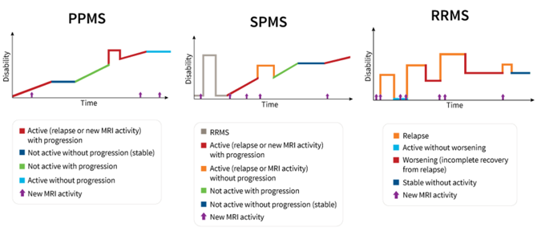

Figure 3. Different clinical courses of MS. During PP-MS, starting from the onset of symptoms, a slow but nearly continuous worsening of the disease occurs, without defined relapse or remission events. However, there are variations in progression over time, occasional plateaus, and temporary minor improvements. During RR-MS, people undergo clearly defined attacks (namely relapses or exacerbations), that are episodes of acute worsening followed by partial or complete recovery periods (remissions). Both these forms of MS can be further characterized as active or not active based on the presence of MRI activity and/or relapses. In most cases, RR-MS can evolve in SP-MS, during which after an initial phase of relapse and remission events the disease constantly worsen, with possible flare-ups, mild remissions and plateaus. (Adapted from Lublin FD et al. 2014)

A current “axonal hypothesis” assumes that evident progression of disability (i.e., SP-MS) occurs when nervous system is no longer able to compensate ongoing tissue injury after overcoming a critical threshold. From this point on, the disease starts to be mainly a neurodegenerative process independent of ongoing superimposed inflammation, although it keeps causing additional injury (Bjartmar et al., 2003). Permanent tissue damage results in brain volume decrease for neuronal loss and increase in disease burden (total volume of lesions). Clinical and MRI findings show how damage occurs in the early disease and gradually progresses over time (Figure 4). MS clinically manifests with multiple neurological dysfunctions and symptoms, being able to affect brain, SC and optic nerve, followed by recovery or by increasing irreversible functional disability. In the case of SC involvement, the disease can cause sensory or motor dysfunctions as hemiparesis and paraparesis, and limb weakness, involving one or both sides of the body. If targeting the brainstem, diplopia, face weakness, ataxia, gait problems, bladder and bowel symptoms can occur (Ortiz et al., 2014). Optic neuritis with blurry vision and painful eye movement is the main manifestation of inflammation of the optic nerve, as well as one of the earliest clinical symptoms of RR-MS. Management of MS requires multiple therapeutic approaches. Although there are several drugs on the market, none of them leads to whole remission from the disease, requiring whole life treatments for mitigating symptoms (Fox and Cohen, 2001).

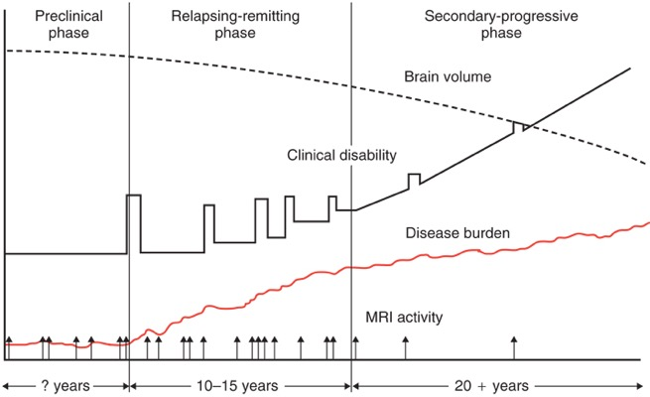
Figure 4. Clinical and MRI features of MS. Axonal degeneration represents the main cause of irreversible neurological disability during MS. The phenomenon remains clinically silent for several years before the onset of disease, despite the presence of MRI activity episodes. First symptoms arise when remyelinating mechanisms are not able to balance axonal loss anymore, overcoming a threshold of damage. Inflammation can cause continuous tissue injury and axonal loss without any clinical symptoms during remission phases. (Adapted from Fox et al. Cleveland Clinic Journal of Medicine, 2001).

2.2 MS as a neuroinflammatory autoimmune disease
The hallmark of MS is the presence of multifocal perivascular inflammatory infiltrates, above all lymphocytes and macrophages, accompanied with BBB breakdown. Despite the pathogenesis of MS is not fully elucidated, the developmental mechanisms of disease can be summarized in three main steps (Figure 5). At first, an autoimmunity reaction is triggered against CNS myelin components through molecular mimicry between a portion of the infectious agents and a part of myelin. Indeed, it is generally thought that some virus/bacteria epitopes share sufficient structural similarity with the immunodominant myelin antigens leading to activation of autoreactive T cells in the secondary lymphoid organs (Wucherpfennig and Strominger, 1995). It is speculated that Epstein-Barr virus, mycoplasma pneumoniae and human herpes virus type 6 can be involved in this mechanism of misrecognition (Fujinami et al., 2006). During the second step, leukocytes are recruited into the CNS through the BBB. The process is facilitated by an increase in the permeability of BBB, as well as in expression of adhesion molecules by ECs and the release of MMPs. As third step, T cells are re-activated through interaction with specific antigens presented by resident APCs. T-helper (Th) cells, so called for their ability to coordinate and fine-tune the immune response, trigger the reaction against self antigens expressed mainly on oligodendrocytes leading to chronic inflammation (Comabella and Khoury, 2012). T cell reactivation also leads to an increase in cytokine production, that in turn further raises BBB permeability leading to a second wave of inflammatory cells in the parenchyma. In particular, final demyelination is rendered either by macrophages recruited from the bloodstream across the BBB, or by TNF-α and NO secreted by T cells, microglia and macrophages, with consequent cytotoxicity exacerbation. It was demonstrated that electrically active axons are more susceptible to NO exposure under inflammatory conditions (Smith et al., 2001). It is still unclear how axonal injury is triggered in early stages of MS. However, some studies suggested that the inflammatory environment generated by immune and glial cells leads to dysfunctional mitochondrial enzymatic activity and DNA damage, with consequent impairment of energy metabolism and ATP synthesis (Lu et al., 2000). Lastly, axonal injury can be aggravated by increased extracellular pressure determined by inflammatory edema (Shi and Blight, 1996).
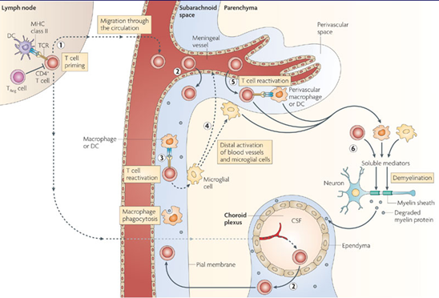
Figure 5. The “outside-in” hypothesis in MS pathogenesis: from peripheral activation to CNS inflammation. According to this model of disease, autoreactive T cells are primed in secondary lymphoid organs. Once polarized in Th1 and Th17, T cells migrate in the CNS, where they undergo reactivation promoting neuronal damage, gliosis and inflammation. The resulting inflammatory environment recruits a second wave of peripheral leukocytes worsening the autoimmune response. (Adapted from Goverman, J. Nat Rev Immunol, 2009)

2.3 An experimental model of MS: the Experimental Autoimmune Encephalomyelitis
At the state of art, different animal models of MS have been developed, such as the Experimental Autoimmune Encephalomyelitis (EAE) and the virus-induced forms, like the Theiler׳s Murine Encephalomyelitis Virus-Induced Demyelinating Disease (TMEV-IDD) (McCarthy et al., 2012). Chronic demyelination and toxin-induced demyelination models, for instance the cuprizone and the lyso-phosphatidylcholine (lysolecithin) models, are also available (Procaccini et al., 2015). Among them, the most widely used is the EAE, a model that mimics the main key features of MS: inflammation, demyelination, axonal loss and gliosis. EAE can be induced by active immunization of susceptible experimental animal strains including primates and rodents with myelin autoantigens emulsified in complete Freund’s adjuvant (CFA). This model was introduced by Rivers in the 1930 (Rivers and Schwentker, 1935) and was substantially improved as an animal model for demyelinating inflammation of the CNS by adding Freund’s adjuvant to emulsify myelin antigens (Kabat et al., 1946). A conceptual breakthrough was achieved in the 1980s by the groups of Wekerle and Cohen, who showed that myelin antigen-specific CD4+ T cell lines propagated in vitro could, upon adoptive transfer, induce demyelinating inflammation in the CNS parenchyma (Ben-Nun et al., 1981). This proved that EAE is induced by an autoimmune response to myelin antigens initiated by CD4+ T cells. In the following years, EAE became an invaluable tool to study the activation of autoreactive T cells in the peripheral immune compartment, their migration and reactivation in the CNS with subsequent inflammation. In murine as previously in primate EAE models, main immunogenic and encephalitogenic CNS autoantigens have been identified by isolation of antigen-specific major histocompatibility complex class II (MHC-II)-associated epitopes recognized by specific T cell clones. Most of these autoantigens are part of the myelin sheet, namely myelin basic protein (MBP), proteolipoprotein (PLP), myelin oligodendrocyte glycoprotein (MOG), and myelin-associated oligodendrocyte basic protein (MOBP) (Gold et al., 2006). Currently, the most common protocol for EAE induction is based on the injection of an encephalitogenic peptide, mostly MOG₃₅₋₅₅ or PLP₁₃₉₋₁₅₁ emulsified in CFA containing mineral oil and Mycobacterium tubercolosis strain H37Ra, followed by injection of pertussis toxin. In general, the elapse of the disease and its clinical phenotype varies mainly depending on the antigen source and the strain used. In C57BL/6J mice the active immunization with MOG₃₅₋₅₅ peptide leads to a chronic-progressive form of EAE, characterized by a peak after the onset, followed by a moderate decrease in the severity that continues in a stable clinical progression (Figure 6A). There are no gender susceptibilities in EAE models after immunization with MOG peptides (Okuda et al., 2002). In Swiss Jim Lambert (SJL) mice, the disease can be actively induced by immunization with CNS homogenate, PLP, MBP or main encephalitogenic protein epitopes in an emulsion with CFA. In this strain, clinical symptoms follow a relapse-remitting course (Figure 6B). Remission can be complete or partial, depending on the severity of the disease. In both models, the disease follows a predictable clinical course: after a pro-dromal period of 10-15 days after immunization ascending paralysis occurs, starting from the tail and hind limbs until involving even forelimbs, concurring with weight loss (Rossi and Constantin, 2016).
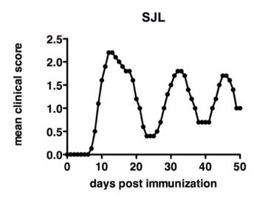
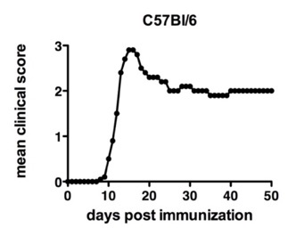
A
B
Figure 6. Difference in EAE progression between C57Bl/6 and SJL strains. In C57BL/6 mice (6A), the disease follows a chronic-progressive course, composed by a pre-clinical phase, an onset, a peak and a chronic phase. In SJL mice (6B), the disease is characterized by relapse and remission events.

Neutrophils

3.1 Neutrophil biology
Besides eosinophils and basophils, neutrophils represent a cell type of granulocytes, alternatively called polymorphonuclear leukocytes (PMNs) for their multilobular nuclear structure. There cells are one of the first lines of defense of innate immunity against invading pathogens, representing mainly the final effectors in the acute inflammatory response. Despite their beneficial antimicrobial functions, a prolonged activation within tissues can contribute to local injury. Lately, their involvement has been extended also in sterile inflammation as additional responsible for tissue damaging in pathological conditions such as autoimmunity, chronic inflammation and cancer (Mantovani et al., 2011), (Kolaczkowska and Kubes, 2013), (Phillipson and Kubes, 2011). Neutrophils are the most abundant white blood cells (WBCs) under physiological conditions, comprising 40 to 70% of circulating WBCs in human and 10 to 25% in mice (Mestas and Hughes, 2004). Their lineage starts in the bone marrow (BM) from hematopoietic stem cells that proliferate and maturate until fully mature neutrophils, able to enter in the peripheral blood circulation, representing respectively the 49% in humans and the 1-2% in mice of the whole neutrophil amount, which basically resides in the BM hematopoietic compartment (Tak et al., 2013). Differentiation is stimulated by granulocyte-macrophage colony-stimulating factor (GM-CSF) and granulocyte colony-stimulating factor (G-CSF) signaling and lasts approximately 14 days. Neutrophil leaving from the BM is mediated by the interaction between the chemokine receptor CXCR2 and its ligands CXCL-1 and CXCL-2, and the receptor CXCR4 with CXCL12 (Silvestre-Roig et al., 2016). The estimated half-life of PMNs in blood circulation is still controversial. Although some old studies suggest that human circulating neutrophil lifespan is about 5 hours (Cartwright et al., 1964), recent experimental evidence raises it up to 5.4 days in vivo, influenced by physiological and pathological environment (Pillay et al., 2010). During inflammation, infiltrating neutrophils are summoned to an inflamed tissue by cytokines, pathogens-associated molecular patterns (PAMPs), damage-associated molecular patterns (DAMPs) and environmental signals, able to shift their phenotype reducing apoptosis and increasing their lifespan in the tissue (Silvestre-Roig et al., 2016).
Mature neutrophil dimension is around 10 to 15 µm. These cells have a multi-lobed polymorphic nucleus and a yellowish granular cytoplasm (Tak et al., 2013). Granules and secretory vesicles play a fundamental role for PMNs, including early activation, migration through endothelial vessels and basement membrane, phagocytosis and killing of pathogens during infection, or cell contact and tissue damage in sterile inflammation. The composition of granule subsets varies depending on neutrophil maturation stages and consequently on their function. Thus, they represent a crucial reservoir for antimicrobial proteins and reactive components of respiratory burst oxidases essential for cytotoxic functions, extracellular matrix (ECM) proteins, adhesion molecules and proteases important in diapedesis, cell interaction and migration through the ECM and soluble mediators of inflammation involved in pro- and anti-inflammatory effects in inflamed tissues. Granule mobilization and exocytosis allows neutrophil switching from passively circulating cell to a potent effector of innate immunity. The regulation of this process is pivotal for targeting cytotoxic proteins in strictly specific sites, thus preventing the spreading of inflammation and tissue damage. According to their content in proteins and capability of mobilization, the original classification of granules in peroxidase-positive and peroxidase-negative have been replaced by the classification in azurophil (containing myeloperoxidase (MPO), neutrophil elastase (NE) and cathepsin G), specific (containing neutrophil gelatinase-associated lipocalin (NGAL), lysozyme and lactoferrin) and gelatinase granules (Pham, 2006), (Hager et al., 2010). In addition, mature neutrophils produce secretory vesicles containing alkaline phosphatase, cytokines and chemokines, rapidly released following activation. Due to their composition, their role is not only limited to microbicidal and cytotoxic activity, but it is enlarged also to basement membrane degradation allowing neutrophil extravasation and migration. Lastly, secretory vesicles represent a reservoir of membrane-associate receptors such as β2-integrin CD11b/CD18 (Mac-1), leukolysin, the complement receptor (CR)-1 (CD35), the formylmethionyl-leucyl-phenylalanine (fMLP) receptor for formylated bacterial peptides involved in the earliest stages of neutrophil-mediated inflammatory response (Faurschou and Borregaard, 2003). The release of secretory vesicle content is limited to the plasma membrane, facilitating PMN interaction with ECs. Upon firm adhesion on ECs, the down-stream signaling of chemokines and β2-integrins induces the release of tertiary granules and secretory vesicles (Othman et al., 2021).

3.2 Neutrophils in EAE and MS
Leukocyte trafficking to the CNS trough the BBB represents a key mechanism of MS and EAE pathogenesis, which results in tissue damage and activation of resident microglia and astrocytes, leading to myelin sheaths disruption and death of underlying axons (Sidoryk-Wegrzynowicz and Struzynska, 2021). Despite the well-established role of myelin-reactive T lymphocytes as key players in the induction of CNS autoimmunity in animal models of EAE, recently it has been demonstrated that myelin-reactive CD4⁺ T cells recruit neutrophils in brain and SC through different mechanisms and chemokines (Simmons et al., 2014). Conversely, infiltrating myeloid cells may escalate the inflammatory response secreting pro-inflammatory molecules and presenting antigens to encephalitogenic T cells within the CNS to promote their in situ reactivation (Kawakami et al., 2004). Among invading myeloid cells, neutrophils play an important role in the pathogenesis of different CNS inflammatory disorders such as ischemic stroke, cancer, epilepsy and Alzheimer's disease, and a role for this cell type is also emerging in the pathogenesis of autoimmune diseases (Chen et al., 2021), (Gunes and Buyukgol, 2020), (Zenaro et al., 2015), (Wang et al., 2018). For their high capability to release ROS, enzymes, neutrophil extracellular traps (NETs) and cytokines in different pathophysiological conditions, neutrophils are involved not only in acute inflammation but also in causing chronic collateral tissue damage, even in absence of conspicuous accumulation within the tissue in chronic contexts (Zarbock and Ley, 2008), (DiStasi and Ley, 2009). Because of the perception as terminally differentiated with short lifespan immune cells combined with the paucity of molecular approaches that could allow their manipulation, neutrophils involvement in autoimmune diseases pathogenesis has been neglected for a long time. Currently, the growing improvement in cutting-edge techniques and the collection of evidence about these cells allowed researchers to investigate their role in specific pathological mechanisms. Several studies proved that neutrophils perform several crucial functions during all the stages of autoimmune progression, including antigen presentation, modulation of several cell types and direct tissue damage (De Bondt et al., 2020), (Takashima and Yao, 2015). In particular, neutrophils are able to expose autoantigens when activated or even to release them with apoptosis or during production of NETs (Gupta and Kaplan, 2016). They are also involved in tissue damage both passively contributing to tissue deposition of autoantibodies and actively by production of pro-inflammatory molecules as effector immune cells (Nemeth and Mocsai, 2012).
In previous studies, to determine the possible involvement of neutrophils in the pathogenesis of EAE (Table 1), infiltration pattern has been examined. During the progression of MOG₃₅₋₅₅-induced EAE in C57Bl/6J mice, immunohistochemistry and flow cytometry showed that the percentage of neutrophils increases significantly during the disease onset, remaining high until the peak stage and then drastically decreases thereafter. In addition, further labeling experiments provided anatomical evidence of a conspicuous accumulation of neutrophils in proximity of demyelinated injured areas and axonal loss sites at early stages of the disease, suggesting that neutrophils are among the main inflammatory cells involved in EAE development, contributing to demyelination and axonal degeneration (Wu et al., 2010). Recently, the group of Whittaker Hawkins demonstrated that the surface expression of ICAM-1 can be considered a marker to discriminate between intravascular crawling neutrophils (ICAM-1⁻) and CNS-infiltrating extravascular neutrophils (ICAM-1⁺) during EAE. Transcriptomic profiling of the two subsets revealed molecular and functional plasticity of neutrophils: once extravasated, ICAM-1⁺ neutrophils acquire macrophage-like properties such as immunomodulation and MHC-II-dependent antigen presentation, establishing physical immune synapses with B and T cells, as highlighted through super-resolution microscopy (Whittaker Hawkins et al., 2017). Moreover, synergic influence with different T helper subsets has been investigated to better understand neutrophil infiltration mechanisms. As evidence, EAE induction by passive myelin-specific Th2 and Th17 cell transfer determines massive recruitment of PMNs in SC lesions (Lafaille et al., 1997), (Herges et al., 2012). In a similar way, mice deficient for interferon-γ (IFN-γ) or IFN-γ receptor (IFN-γR), with a Th2-prone background showed consistent neutrophil infiltration in acute EAE lesions (Tran et al., 2000), (Maatta et al., 1998), (Stoolman et al., 2014) supporting the hypothesis that cytokines and chemokines secreted by Th17 and partially Th2 are able to promote granulocytes infiltration within the parenchyma during EAE (Carlson et al., 2008), (Kroenke et al., 2008), (Soulika et al., 2009), (Rumble et al., 2015). Furthermore, active mice immunization with MOG peptide showed neutrophil increase in the BM and consequently circulating neutrophils in the bloodstream during pre-clinical phase of EAE (Aube et al., 2014).
Immunohistological analysis on SC carried on day 3 and 7 post-immunization both with MOG peptide in CFA and with only CFA as control, revealed occasional Ly6G⁺ neutrophils (Mildner et al., 2008) in adhesion on meninges and on the surfaces of the nerve roots, but intraparenchymal neutrophils infiltrates were not present. By day 12 post-immunization, besides the conspicuous presence of CD3⁺ T lymphocytes in perivascular and subpial infiltration in the SC, there is an enrichment in Ly6G⁺ neutrophils producing neutrophil collagenase MMP-8, a cell-specific protease that facilitates cell penetration in the tissue through ECM degradation. Finally, starting from day 14, Ly6G⁺ neutrophils decrease heavily, becoming a much less prominent component in SC inflammatory infiltration, respect than the increasingly dominating Iba1⁺ microglial and monocyte-derived macrophages (Soulika et al., 2009). Neutrophil adhesion to CNS microvasculature and subpial perivascular infiltration before EAE onset are crucial mechanisms for inducing BBB vascular leakage and promoting consequent leukocyte invasion within the CNS (Carlson et al., 2008), (Aube et al., 2014), (Christy et al., 2013). Notably, neutrophils accumulate exclusively in CNS regions with on-going injury, as vascular leakage, demyelination and axonal damage (Soulika et al., 2009). During active EAE, infiltrating neutrophils produce TNF-α, IFN-α, IL-6 and IL-12, besides inducing activation and maturation of CNS-resident APCs. In agreement with these results, whereas a preclinical transient depletion of neutrophils through single-dose of neutrophil-specific depleting anti-Ly6G monoclonal antibody in MOG-immunized mice delays the onset of disease, prolonged treatment totally abrogates the development of clinical EAE in both RR and chronic type of disease. At the same time, the induction of a myelin-specific T cell response remains unaffected. In according with the early neutrophil recruitment into the CNS during pre-clinical EAE, neutrophil depletion after the onset has no effect on disease incidence and severity (McColl et al., 1998), (Steinbach et al., 2013), (Aube et al., 2014). Similarly, CXCL2- or G-CSF-deficient mice result protected from EAE induction (Carlson et al., 2008), (Rumble et al., 2015). In vitro evidence showed that CNS-infiltrating neutrophils secrete pro-inflammatory molecules and support BM-derived dendritic cells maturation, which in turn enhances their capability to restimulate myelin-specific T cells. These results are confirmed and mirrored in vivo, where neutrophil depletion impaired specifically the maturation of both microglia and macrophages into professional APCs, resulting in a reduced amplification of early CNS inflammation. Thus, CNS infiltrating neutrophils provide local co-factors needed for myeloid cells maturation into professional APCs. This step is crucial for the development of the autoimmune disease through the local re-activation of myelin-specific T cell (Steinbach et al., 2013). However, the involvement of neutrophils both in induction and progression of brain autoimmune disease is still unclear and the molecular mechanisms controlling their pathogenic activity in the CNS parenchyma are not known.
Generally, neutrophils are not detected in CNS biopsies derived from conventional MS patients, where a major mononuclear cell infiltration occurs (Lucchinetti et al., 2002). The phenomenon can happen because of MS tissue samples were obtained from biopsy or autopsy, when lesions use to be sub-acute or chronic. Hence, the idea that neutrophils do not represent a significant leukocyte subpopulation infiltrating the CNS during the disease might reflect exclusively a bias. Regardless of their presence in the CNS, neutrophils could exert anyway their functions from the periphery, where activation in the BM during autoimmune demyelinating disease might increase the pool of myeloid cells recruitable to infiltrate the CNS by promoting monocytes and same neutrophils mobilization in the bloodstream (Singh et al., 2012). Nonetheless, compared with healthy subjects, MS patients present higher percentage of circulating neutrophils, which are characterized by a primed phenotype (Naegele et al., 2012). The shift of peripheral myeloid populations is due to the systemic upregulation of G-CSF and ELR⁺ CXC chemokines. To confirm the association among the expression of these neutrophil-related factors and MS lesions, a panel of chemokines released in the blood was examined. The plasma levels of these factors have been measured in MS patients during relapsing and remitting stages, as confirmed by MRI and clinical progression of the disease. The study revealed that spikes of CXCL5 in plasma were associated with the development of new inflammatory MS lesions in relapsing patients. In addition, the neutrophil attracting chemokine CXCL8 is detected in the cerebrospinal fluid (CSF) of MS patients (Ishizu et al., 2005), (Campbell et al., 2010), whereas higher plasma levels expression of CXCL1, CXCL5, neutrophil elastase and integrin CD11b/CD18 occurs in MS patients during relapses respect than MS remitting phase, healthy controls and subjects affected by different neurological diseases (Aoki et al., 1984), (Guarnieri et al., 1985), (Ziaber et al., 1998). As a further support of their involvement in the disease, neutrophils are detected in the CSF of MS patients both during early phases of the disease and at the beginning of relapses, whereas a great amount of NETs has been identified in the blood of RR-MS patients following a gender-specific trend (Tillack et al., 2013). Another important evidence correlates autoreactive T lymphocytes with neutrophil infiltration. In particular, encephalitogenic Th17 cells can secrete cytokines such as IL-17A and TNF that in turn are able to induce G-CSF and CXCL1 production (Witowski et al., 2000), (Iwakura et al., 2011). Hence, Th17 could drive a key role in local production of neutrophil chemoattractants and activating factors subsequently their reactivation in the CNS. Here, production of G-CSF and CXCL1 might occur by meningeal epithelial cells (as further showed in MOG-immunized mice), astrocytes, neurons or cerebrovascular ECs (Lenhoff and Olofsson, 1996), (Jacob et al., 2012). All these data suggest that MS and its animal model disease activity are dependent on an intricate interplay between the adaptive and innate immune systems, with a potential involvement of neutrophils in MS pathogenesis. However, understand whether neutrophils exert a predominant pro-inflammatory role or if they are involved also in the resolution of chronic inflammatory response in MS remains an unsolved question. Neutrophils in fact are able to release resolving lipidic mediators (for instance, lipoxins, protectins and resolvins) (Serhan et al., 2008), that potentially can affect their infiltration in target tissues and enhance their phagocytosis by macrophages, in a process known as efferocytosis. In turn, this mechanism induces macrophage polarization toward a M2-like phenotype, leading to a resolving outcome on the inflammation (Fox et al., 2010). Immunophenotyping of blood specimens from several MS patients revealed that only during inactive RR-MS, an increase of both CD15⁺ neutrophils and classical and non-classical monocytes resulted inversely correlated with lymphocyte population, suggesting a potential regulatory role for neutrophils during MS (Haschka et al., 2020).

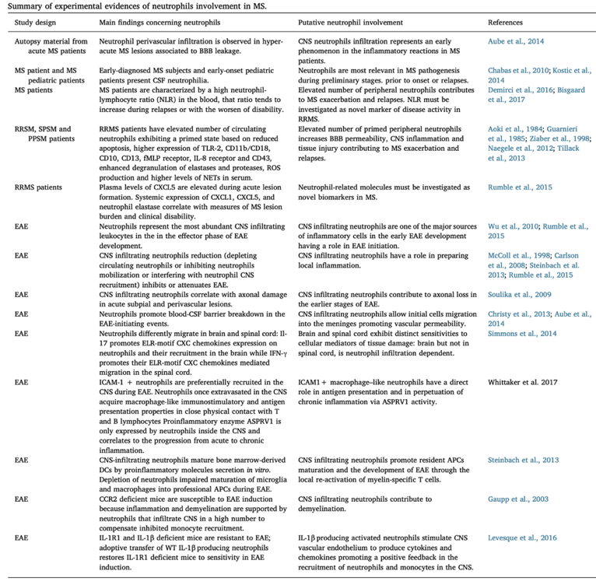
Table 1. Neutrophil involvement in MS and EAE. At the state of art, there are several experimental evidence about the involvement of neutrophils in different forms of MS and in EAE development and progression. (Adapted from Rossi, B. et al. Immunobiology, 2019)

3.3 Neutrophils interplay with glial cells
Despite there are several works available in literature describing interactions among lymphocytes and astrocytes and myeloid cells such as microglia and CAMs, less is known about direct contact of glial cells with neutrophils. In 2010, the group of Xie L. highlighted for the first time the direct contact-mediated immunomodulatory effect exerted by astrocytes on neutrophils through several in vitro approaches. Following co-culture with astrocytes, interacting neutrophils display changed morphology in terms of dimension and granularity, demonstrating activation upon direct contact. Moreover, astrocytes seem to differently affect neutrophil function based on molecular interactions and soluble factors. Following contact engagement, astrocytes mitigate neutrophil apoptosis promoting their survival, reduce ROS production and MPO release, but conversely enhance phagocytic capability, increase transcriptional expression of pro-inflammatory molecules such as CXCL2, IL-1β, TNF-α and IL-6 and activation of neutrophil signaling pathway through phosphorylation of Akt, p38 and Erk1/2 MAPK. Oppositely, non-direct contact induces in neutrophils decreased apoptosis but enhanced necrosis, increased respiratory burst and phagocytosis, and suppressed degranulation. Of note, authors did not provide putative surface molecules involved in the interactions. Considering the bivalent effect of astrocytes on neutrophil depending on the contact, it is possible to assume that this interaction is strongly influenced by the microenvironment. On one hand, direct astrocyte effect on neutrophils can potentiate their inflammatory effect, providing protection against invading microbes upon BBB damage. On the other hand, astrocytes could mitigate excessive activation and tissue damage exerted by infiltrating neutrophils, in a strictly regulated balance (Xie et al., 2010). During ischemic stroke, it was described the presence within the CNS of a neutrophil subset called “N2”, with a comparable phenotype than M2 macrophages, associated with tissue repair functions. It was also demonstrated the possibility to polarized in vitro “naïve” neutrophils (N0) toward a pro-inflammatory (N1), protective (N2) or NETs-producing phenotype, confirming a high plasticity of these cells. In this context, neutrophil incubation with TGF-β increase expression of the mannose receptor CD206, considered a marker for the N2 phenotype together with the chitinase Ym1 and Arginase-1. Notably, astrocytes represent one the main source of TGF-β in the CNS (Diniz et al., 2019). CD206⁺/Ym1⁺ neutrophils not only do not affect viability of ischemic neurons compared with N0, N1 and NETs-producing neutrophils, but display increased tendency to be phagocyted from microglia and perivascular macrophages in the ischemic core. Parallelly, another work showed that inhibiting lectin-like receptors and the α_{V}β₃ integrin, the putative receptors involved in phagocytosis, neuronal viability after oxygen-glucose deprivation results affected (Neumann et al., 2008). Upon neutrophil uptake, microglia/macrophages release TGF-β, probably enhancing the positive loop (Savill et al., 2002). Considering that dying neutrophils strongly release phlogistic molecules that increase tissue damage, promoting the self-clearance of living neutrophils could help inversely the resolution of inflammation in the brain (Cai et al., 2020), (Cuartero et al., 2013). Lastly, an elegant work of intravital two-photon microscopy led in a model of LPS-induced neuroinflammation, clearly showed the establishment of physical interactions between neutrophils and brain-resident CX3CR1-eGFP microglia/macrophages, further inducing morphological changes in interacting glial cells and promoting the mobilization of neighboring microglia toward the site of contact. Intriguingly, after the crosstalk some neutrophils undergo reverse transendothelial migration (rTEM), returning to the bloodstream, probably to deliver pro-inflammatory signals to the periphery (Kim et al., 2020).

LFA-1 integrin

4.1 The leukocyte adhesion cascade
Historically, leukocyte adhesion cascade can be summarized in three main steps: rolling, activation and firm adhesion to the endothelium. Upon inflammation, ECs upregulate adhesion molecules such as E- and P-selectins that bind glycoprotein ligands on leukocytes, mediating the initial weak and transient adhesive interactions on activated endothelium known as tethering and rolling (Somers et al., 2000). Following a chemokine gradient, the binding with respective receptors triggers the activation of integrins, in particular LFA-1 and macrophage-1 antigen (Mac-1). This mechanism is well acknowledged as key event in leukocytes firm arrest on vessel wall, but it also plays a role in the first steps during rolling. Finally, the extravasation of leukocytes, also referred as diapedesis, depends on cytoskeleton rearrangement and represents the final step of the recruitment process. In this step, immune cells scan the endothelium searching for a breaching site, usually cell-cell junctions (paracellular transmigration) (Ley et al., 2007), (Ransohoff et al., 2003), (Park and Hyun, 2016) (Figure 7).
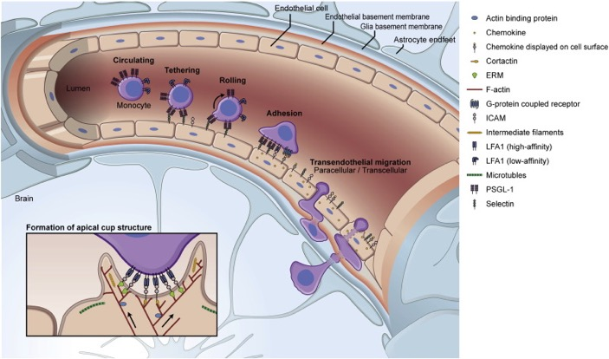
Figure 7. Leukocyte adhesion cascade. Consecutive steps of tethering, rolling and firm adhesion to endothelial wall exerted by leukocytes involving different adhesion molecules and receptors. Leukocytes can cross the endothelium disrupting cell junctions between ECs (paracellular path) or directly through EC body (transcellular path). (Adapted from Lopes Pinheiro MA et al. BBA- Molecular Basis of disease, 2016)

Crossing the BBB is a crucial step in leukocyte trafficking, that typically occurs in proximity of post-capillary venules, where ECs contact each other through tight junctions, delimiting an inner and outer endothelial basement membrane in which pericytes are embedded. Here, astrocytes project cellular end-feet that surround the endothelium composing the glia limitans, associated with a glial basal lamina (Figure 8). BBB represents a physical and metabolic barrier that strictly regulates the passage of cells, ions, proteins, neurotransmitters and nutrients between blood and CNS. During neurodegenerative and autoimmune diseases, the disruption of these basement membranes by MMPs is a key mechanism of BBB breakdown, with consequent leakage and leukocyte migration.

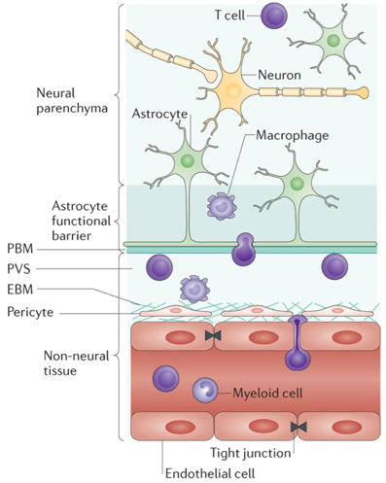
Figure 8. Structural composition of the BBB. This barrier is composed by non-fenestrated capillary ECs, pericytes that lie on the abluminal surface embedded in the inner endothelial basement membrane (EBM). In the outer part, astrocyte end-feet wrap the outer parenchymal basement membrane (PBM). EBM is an ECM composed by EC and pericyte-secreted molecules, whereas PBM contains molecules secreted by astrocytic processes, presenting a different molecular composition (Daneman and Prat, 2015). (Adapted from Sofroniew, M. V. Nat Rev Neurosci, 2015)

4.2 The molecular features of LFA-1 integrin and its role in immune cells
MS and EAE are both characterized by perivascular infiltrations of autoreactive pro-inflammatory immune cells. To reach the parenchyma, these cells need to migrate at first into the subarachnoid space (SAS) by crossing the blood-CSF barrier in choroid plexus vessels or through the pial vessel walls. Specifically, lacking in glia limitans and perivascular space, these routes represent a preferential easier migration path (Zenaro et al., 2013). In this context, integrin family assumes a pivotal role in immune cells interactions with ECs and migration within the CNS. Integrins are a subclass of adhesion molecules expressed on the surface of a wide range of cell types. These molecules belong to a large family of αβ-heterodimeric transmembrane glycoproteins and consist of 18 different large α-subunits and 8 small β-subunits respectively 120-170 kDa and 90-100 kDa heavy, organized in 24 different receptors (Vestweber, 2015). Each subunit is composed by an extracellular domain involved in ligand binding, a single transmembrane domain and an intracellular domain that regulates its function. Integrin ligand-binding activity can be rapidly regulated by conformational changes as well as by transcriptional induction and rearrangement from intracellular pools. In particular, integrin activation requires the engagement of a G-protein-coupled receptor with an appropriate chemoattractant ligand and includes both clustering on cell membrane and modulation of the integrin conformation leading to a state of high affinity for binding to integrin endothelial counter receptor (Carman and Springer, 2003). β2-integrins include four different heterodimers: LFA-1 (alternatively named also CD11a/CD18 or α_{L}β₂), expressed by all leukocytes, Macrophage Antigen-1 (Mac-1, CD11b/CD18, α_{M}β₂) expressed by myeloid cells, CD11c/CD18 (α_{X}β₂), and CD11d/CD18 (α_{D}β₂). Among them, the most studied β2-integrin involved in leukocyte recruitment is LFA-1. Beside its involvement in rolling interactions, LFA-1 mainly mediates firm adhesion/arrest of leukocytes both on the blood vessels of lymphoid organs and inflamed sites by binding the Immunoglobulin (Ig) superfamily ligands ICAM-1 (CD54) and ICAM-2 (CD102), expressed by the vascular endothelium (Luster et al., 2005), (Ley et al., 2007). The two subunits of which LFA-1 is composed are CD18, common to all β2-integrins, and CD11a that is specific for LFA-1. Because of circulating leukocytes are persistently exposed to vasculature-expressed ICAMs, the ligand-binding activity of LFA-1 need to be strictly regulated to avoid improper interactions and subsequent adhesions during flowing in the circulation or migration toward tissues. Hence, two different signaling mechanisms to activate integrins are known. During “inside-out signaling”, an intracellular activator binds β-subunit, inducing a conformational change that leads to an increase in integrin affinity for extracellular ligands. This mechanism is involved in cell migration, adhesion and invasion. On the other hand, according to the “outside-in signaling” a ligand bound to the active integrin can induce a signal cascade that leads to integrin clustering, involved in regulation of cytoskeleton and gene expression, with effects on cell polarity, survival and migration. LFA-1 can organize its structure in three different conformational states (Figure 9). The inactive state shows a bent structure with the ligand-binding headpiece (αI domain) in close proximity to membrane-proximal stalk region, thus resulting in a low affinity for its ligand. In the intermediate affinity state, LFA-1 starts to extend the stalk regions, still presenting a closed headpiece. The conformational switch of the hybrid domain shifts the molecule in an open headpiece with an active high-affinity for the ligand, exhibiting extended extracellular domain with the ligand-binding pocket for ICAM-1 (Vestweber, 2015).

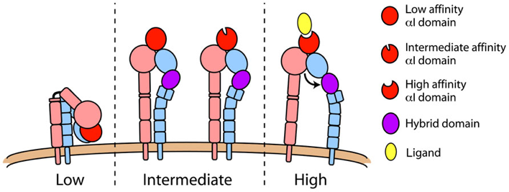
Figure 9. The three different activation states of LFA-1 integrin. Based on its activation status, the LFA-1 integrin exhibits different conformations, ranging from a bent low-affinity status to an open high-affinity, that enables interaction with counter ligands, downstream signaling and cytoskeleton remodeling. (Adapted from Lefort CT and Ley K. Front Immunol, 2012)

Several studies reported that integrin activation leads to matrix interactions and mediates firm arrest on endothelium. In this contest, this mechanism represents the earliest first step of any immune response. The signaling mechanisms that activate integrins are complex. Recently, several structural studies have provided better understanding of how signals may be transmitted from the intracellular integrin domains throughout the cell membrane up to the extracellular ligand-binding domain. LFA-1 is organized into at least three different regions of activity in migrating cells: the projecting lamellae at the leading edge with intermediate affinity state LFA-1, the mid-cell zone containing high-affinity LFA-1 and the elevated uropod at the trailing edge with high levels of LFA-1 of uncertain activity status. In particular, the mid-cell zone provides firm interaction with ICAM-1, allowing cell extensive leading edge to scan the vascular surface. Membrane organization of LFA-1 into intermediate and high-affinity sites gives biological relevance to these different conformations and suggests that they operate together to regulate migration. The ability of leukocytes to adhere and migrate is pivotal for a fully functional immune system. In response to inflammatory signals, immune cells leave the blood stream by migrating along vascular endothelial surfaces, scanning for a suitable exit point into target tissue (Serrador et al., 1999), (Worthylake and Burridge, 2001). Several studies demonstrated that the role of integrins is not exclusively limited to mediate interactions with endothelium, also describing an involvement in cell migration, proliferation, antigen presentation, survival and intratissue motility in several cell types (Verma and Kelleher, 2017), (Barcia et al., 2006). Intriguingly, a recent work described the involvement of LFA-1 in CD4⁺ T cell intraparenchymal motility during EAE. The in situ blockade of LFA-1 affects motility of both Th1 and Th17 T cells, further influencing the biomechanical properties and deformability of Th1 T cells (Dusi et al., 2019). In 2015, Zenaro E. et al. showed that amiloid-β₁₋₄₂ is able to induce both the intermediate and high affinity status of LFA-1 in neutrophils, and that the LFA-1 blockade affects neutrophil trafficking into the brain, both in terms of transmigration and intraparenchymal motility (Zenaro et al., 2015).

4.3 The clinical targeting of LFA-1: Efalizumab
During the recent years, the development of biological drugs gave the opportunity to benefit from long-term therapies in terms of increased safety and efficacy for autoimmune diseases, such as psoriasis and MS (Talamonti et al., 2011). In this context, Efalizumab is a humanized recombinant monoclonal IgG1 antibody against the CD11a subunit of LFA-1 molecule. It acts in the periphery interfering with the initial T cell activation in secondary lymphoid organs, affecting T cell migration and reactivation in target organs. Approved by FDA (Food and Drug Administration) in 2003 and by EMEA (European Medicines Evaluation Agency) in 2004, it demonstrated several side effects, such as infections and progressive multifocal leukoencephalopathy (PML) (Chalkley and Berger, 2013), leading to its withdrawal in 2009.

MATERIALS AND METHODS

1. Mice
C57Bl/6J, CX3CR1-eGFP and LFA-1-deficient mice (Itgal^{-/-}) mice were purchased from Jackson Laboratory. Animals were housed under standardized conditions with a 12-hours photoperiod in climate-controlled facilities and provided with food and water ad libitum. All animal experiments were supervised by the local Institutional Animal Care Committee (OPBA) of the University of Verona and were approved by the Italian Ministry of Health, Department of Veterinary Public Health, Nutrition and Food Safety, Directorate General of Animal Health and Veterinary Medicine, as required by Italian legislation (D. Lgs 26/2014, application of European Directive 2010/63/EU).

2. Isolation of murine neutrophils
Neutrophils were isolated from the BM of healthy adult C57BL/6J mice. After sacrifice, tibias and femurs were surgically removed and the medullary cavity was manually exposed on one extremity. To prevent premature early neutrophil activation, BM cells were rapidly spanned out of the bones in 1X Hank's Balanced Salt Solution (HBSS) supplemented with 0.1% Bovine Serum Albumin (BSA) and lacking Ca²⁺ and Mg²⁺. To lysate red blood cells, samples were treated for few seconds with a 0.2% hypotonic NaCl solution, then a 1.2% isotonic NaCl solution was added for restoring physiological osmolarity. Meanwhile, 81%, 62% and 55% Percoll solutions were carefully stratified into a falcon tube to obtain a Percoll density gradient. Cells were resuspended in 1X HBSS -0.1% BSA solution, stratified over the Percoll gradient and centrifuged at 2700 rpm for 30 minutes (min) without brake. Neutrophils were collected from gradient after discarding the top phase, consisting of cell debris. Cells were washed twice with 1X HBSS -0.1% BSA solution at 1200 rpm for 10 min, and finally resuspended in 1X HBSS -0.1% BSA solution and counted. More than 90% of the isolated cells were Ly6G⁺ pure neutrophils as previously determined by flow cytometry. Freshly isolated neutrophils were rapidly used according to the experimental settings.

3. Active EAE induction
C57BL/6 and CX3CR1-eGFP mice were immunized with 150 µg/mouse of MOG35-55 peptide in 200 µl/mouse of emulsion consisting of equal volumes of Dulbecco’s Phosphate Buffered Saline (PBS) and Complete Freund’s Adjuvant (CFA; Difco Laboratories), supplemented with 1 mg/mouse of Mycobacterium tuberculosis, strain H37Ra (Difco Laboratories)). Immunization was made by sub-cutaneous emulsion injection in the flank (100 µl/flank). Mice further received intravenously 100 ng of pertussis toxin (PTX) at the time of immunization (day 0) and 48 hours later (day +2). Mice were checked daily for clinical symptoms and signs of EAE were translated into clinical score according to the following classification: score 0= no disease; score 1= tail weakness; score 2= paraparesis; score 3= paraplegia; score 4= paraplegia with forelimb weakness or paralysis; score 5= moribund or dead animals.

4. Intracardiac perfusion
Mice were perfused at the onset (11-12 dpi), peak (12-14 dpi) and during the chronic phase of EAE (22-25 dpi), and in absence of disease according to the experimental setting. At first, mice were anaesthetized by intraperitoneal injection of 1X PBS containing ketamine (100 mg/kg body weight) and xylazine (15 mg/kg). Mice were then placed with abdomen facing up and secured on the four paws as wide as possible on a surgical support. Skin was grabbed with forceps at the level of the diaphragm, thus by cutting through the ribs the heart is easily accessible. Then the right atrium was cut and a butterfly needle was placed into the left ventricle. A peristaltic pump (Minipuls3 GILSON®) with an up to 0.5 ml/min flow allowed 25 ml of 1X PBS added with Ca²⁺/Mg²⁺ (1 μM) to flow through mouse systemic circulation to wash away all blood. Here, fresh brain and SC were isolated for neutrophil infiltration assessment by flow cytometry and for of glial cell cultures. For staining on tissue sections, perfusion continued replacing the buffer solution with 25 ml of cold 4% PFA fixative solution. Organs were then carefully excised and maintained in ice-cold 4% PFA solution overnight (O/N) at 4°C. The day after, organs were rinsed with 1X PBS for 1 hour at RT and then transferred in 1X PBS + 30% sucrose solution until they sink. Sucrose was used to cryo-protect and to prevent freeze artefact and loss of tissue architecture. Organs were included in a cryo-embedding matrix such as OCT (CDK Italia) and stored at -80°C.

5. CNS-infiltrating neutrophil evaluation by flow cytometry
Brain and SC were kept separately and accurately homogenized with cold 1X PBS, washed and incubated with a collagenase (1mg/ml)- DNAse (40 U/ml) solution for 45 minutes at 37°, vortexing samples every 15 minutes to resuspend the specimen. Respectively, collagenase is used for extracellular matrix digestion whereas DNAse degrades free DNA released by mechanical cell rupture. Meanwhile, a Percoll gradient was prepared. Cells were washed, filtered and then resuspended in 30% Percoll solution and carefully stratified on 70% Percoll solution. After gradient centrifugation, infiltrating immune cells form a milky ring on the interface, whereas myelin cells accumulate on the top and cell debris on the bottom of the gradient. Infiltrating immune cells were collected, washed and incubated in a blocking solution with Fetal Bovine Serum (FBS) 10% in 1X PBS. Finally, samples were labeled with anti-Ly6G monoclonal antibody (clone HK1.4), washed to remove exceeding antibody and analyzed by flow cytometer (MACSQuant® Analyzer 10 flow cytometer). Analysis of acquired data was performed with FlowJo software (FlowJo LLC). Percentage was then calculated in respect of total CD45⁺ immune cells infiltrated.

6. Isolation of glial cells
SCs were isolated from perfused healthy and EAE mice at different stages of disease and dissociated using the Adult Brain Dissociation kit (Miltenyi Biotec) with a gentleMACS Dissociator (Miltenyi Biotec) following the manufacturer’s instructions. Briefly, organs were weighed and cut into eight slices with a scalpel, then collected in a C Tube (Miltenyi Biotec) with an appropriate volume of enzymatic mix and placed on the gentle MACS Dissociator followed by a homogenization program for 30 min at 37°C. After centrifugation, samples were filtered and resuspended in cold D-PBS and the appropriate volume of debris removal solution (Miltenyi Biotec). The cell suspension was then transferred to a 15-mL tube and carefully overlaid with 4 ml of cold 1X D-PBS. After centrifugation 3000×g, 10 min at 4°C without braking and with a minimum ascending rate, the bottom phase was collected and resuspended in PBS containing Ca²⁺, Mg²⁺ and 0.5% bovine serum albumin (BSA). Cells were counted, incubated with Fc blocker and the ACSA-2 positive fraction containing astrocytes was magnetically isolated according to datasheet. For microglia isolation, the resulting flow-through was collected and stained with CD11b microbeads (Miltenyi Biotec) according to datasheet, then the positive fraction was collected. Cell number was determined for each cell population at the end of the isolation protocol. Astrocytes and microglia were resuspended (1×10⁶ cells/mL) in DMEM-F12 medium supplemented with 10% fetal bovine serum (FBS), 1% glutamine and 1% penicillin/streptomycin, and seeded 10⁵ cells/well in 48 well plate. Astrocytes were seeded in well plates pre-coated for 1 h at 37° C with 0.1 mg/ml poly-d-lysine and 10 μg/mL laminin. The culture medium was renewed every second day by replacing half of the conditioned medium with fresh. Purity of freshly isolated glial cells was assessed by MACSQuant Analyzer (Miltenyi Biotec) flow cytometer, using the following antibodies: Vioblue-conjugated anti-CD45 (Miltenyi Biotec), FITC-conjugated anti-acsa2 (Miltenyi Biotec), PE-conjugated anti-ACSA1 (Miltenyi Biotec), PE-Vio770-cojugated anti-CD11b (Miltenyi Biotec), APC-conjugated anti-O4 (Miltenyi Biotec), and FlowJo v10.7 (BD Biosciences, Franklin Lakes, NJ, USA) was used for the data analysis. Purity of astrocytes and microglia resulted around 90%.

7. In vitro live imaging of neutrophil-glial cell co-cultures
Once glial cells fully spread, medium was fully replaced with 1X phenol red-free HBSS medium supplemented with 10% FBS, 1% glutamine, 1% penicillin/streptomycin, 0,22 mM Na⁺ pyruvate and 10,92 mM HEPES. The absence of phenol red is necessary to avoid photo-oxidative phenomena. The same day neutrophils were freshly isolated from WT or knock-out mice and stained with 10 μM CellTrackerTM Red CMTPX Dye (Thermo Fisher Scientific) or with 25 μM CellTrackerTM Blue CMAC Dye (Thermo Fisher Scientific) for 20 minutes at 37°C, kept in the dark. After washing, WT cells were resuspended in fresh medium and incubated 15 minutes with anti-CD16/32 antibody (Biolegend) in the dark at room temperature. Thereafter, 10 μg/mL anti-LFA-1 (clone TIB213) blocking antibody or 10 μg/mL rat IgG2b isotype control (clone LTF-2, Bioxcell) were added to the cells and incubated for 20 minutes in the dark at room temperature. Neutrophils were washed and resuspended (1×10⁶ cells/mL) in phenol red-free medium. 25x10³ CMTPX-stained and 25x10³ CMAC-stained neutrophils were seeded in the same well with glial cells and left untouched 20 minutes at 7% CO₂ and 37°C for recovery. A well with neutrophils alone was used as control condition to assess their basal activation state. Time-lapse acquisitions were performed using a 40× Plan apochromatic objective (NA 0.6) mounted on the Axio Observer.Z1/7 inverted wide-field microscope (Zeiss), equipped with a thermostatic chamber set at 37°C and 7% CO₂. Images were acquired every minute for 1 hour under controlled conditions. Multi-field acquisition was achieved using the tiles tool with manual focus. Two fields were acquired for each well. Individual image acquisitions were converted to movie format and analyzed using Imaris software (Bitplane). To evaluate neutrophil motility parameters, cells not interacting with glial cells were excluded from the analysis.

8. Tissue immunofluorescence staining
SCs from healthy and EAE mice at different stages of disease were collected and frozen following the aforementioned procedure and used to prepare 15-μm sections. SC sections were incubated 1 hour at RT in blocking solution with 2% BSA and 0.5% TritonX in phosphate buffer, followed by O/N incubation at 4°C with Alexa Fluor 488-conjugated rat anti-Ly6G (1:500 dilution, Biolegend) and polyclonal rabbit anti-GFAP antibody (1:500 dilution, Dako). After three washings with 0.05% Tween-20 in 1X PBS, slices were incubated 1 hour at RT in blocking solution with Alexa Fluor 647 conjugated donkey anti-rabbit secondary antibody (1:700 dilution, Molecular Probes, Invitrogen). After three washings with 0.05% Tween-20 in 1X PBS, nuclei were stained with 1 μg/ml DAPI (Sigma) for 8 min in the dark and slides mounted with Fluoro Gel with DABCO (EMS). Images were acquired with Axio Imager Z2 fluorescence microscope with Apotome system (Zeiss, Germany), and were spatially deconvoluted using linear unmixing algorithm using ZEN software (Carl Zeiss).

9. Intrathecal antibody treatment
To access the CSF space, the most common procedure is an intraventricular injection performed using a stereotactic apparatus. However, this procedure is time-consuming and limits the number of mice that can be treated in a single experiment. In the present study we used an approach adapted by Furlan (Furlan R. et al., Meth. Mol. Biol. 2003) based on the injection of blocking monoclonal antibodies within the CSF space through the cisterna magna. For needle preparation, 3.5 mm marked forceps were used to bend a 27-gauge dental needle with an angle around of 40°, keeping the cutting edge toward the internal part of the loop. The dental needle was then connected to a 10 μl Hamilton syringe needle through a 1 cm long polyethylene tubing. C57BL/6 mice immunized with MOG₃₅₋₅₅ peptide were anaesthetized with an intraperitoneal (i.p.) injection with 1X Dulbecco’s Phosphate Buffered Saline pH 7.4 (PBS) containing ketamine (5 mg/mL) and xylazine (1 mg/mL) and then shaved on the cervical region and bended the head slightly forward to ease the injection. Mice were treated with anti-LFA-1 antibody twice a day after disease onset and then 4 days later. Specifically, 10 μl of blocking anti-LFA-1 monoclonal antibody (clone M17/4) or 10 μl anti-IgG2b isotype control antibody (clone LTF-2, Bioxcell) was loaded into the injection device. The needle scans along the external surface of the occiput and then it is inserted into the split between the occiput and the atlas vertebra in the midline at the back of the neck. The antibody was injected slowly with the support of a second operator. The needle was kept firm in place few seconds before extraction to avoid solution leaks. The entire treatment procedure takes only few minutes and mice showing no evident adverse effects.

10. Neuropathological analysis
EAE mice were euthanized 3 days after the first intrathecal antibody injection. SCs were collected, frozen and used to prepare 15-μm sections for histological staining with hematoxylin/eosin and Luxol Fast Blue to identify inflammatory infiltrates and demyelination, respectively. Microglia were stained using an anti-mouse ionized calcium binding adaptor molecule-1 (Iba-1) antibody (Wako) as previously described (Zenaro et al., 2015). Astrocytes were stained through immunofluorescence using a rabbit anti-GFAP polyclonal antibody (Dako), followed by incubation with a donkey anti-rabbit Alexa Fluo-647 secondary antibody (Biolegend) as previously described. All images were captured using a Zeiss Axio Imager Z2 fluorescence microscope with an Apotome system (Carl Zeiss). Brightness, contrast and color balance were adjusted over the whole image without eliminating any information present in the original. We traced the total cord area, posterior column area, gray matter area and lateral, anterolateral, and anterior column areas (mm²), which were manually outlined and calculated using an automated quantification system in ImageJ v1.49 (NIH). Results from the quantification of neuropathological findings on 4–6 cross-sections of SC per mouse taken at different lumbar and thoracic levels were expressed as a percentage of white matter area or total area.

11. Two-photon laser scanning microscopy
3 × 10⁷ of freshly isolated neutrophils were labeled with 40 mM of fluorescent dye 7-amino-4-chloromethylcoumarin (CMAC) for 45 minutes at 37 °C, filtered and intravenously (i.v.) injected in recipient C57BL/6 or CX3CR1-eGFP EAE mice respectively for neutrophil intra-tissue dynamics and cell-cell contact studies during EAE. 18-24 hours post-injection, mice were anesthetized with an intraperitoneal (i.p.) injection of ketamine (100 mg/kg body weight)/xylazine (15 mg/kg) and prepared for the SC exposure. A midline dorsal incision was made to expose the lumbar column over L1-L4, the main site of inflammation in MOG-induced EAE mice. The region of interest was thinned using a high-speed micro drill and a stainless-steel burr. Drilling was halted every few seconds to prevent heating. Animals showing any signs of damage, such as subdural or epidermal bleeding, were excluded from use.
Muscles are dissected from the sides of the vertebral bone and a small retraction of the paravertebral muscles allowed to lock the vertebral column through a couple of clamps fixed on the spinal column stabilization device. It is used an adapted method developed by Davalos (Davalos et al., 2008) fitted on a customized microscope stage in the mechanical facility at the University of Verona. This method presents excellent stability by combining a customized spinal stabilization device (Narishige STS-A Compact Spinal Cord Clamps and Narishige MA-6N head holding adaptor on a steel base that will be adapted to fit on the microscope's stage) with a method of deep anesthesia minimizing respiratory-induced movements. Few drops of artificial CSF were added on SC without cover-glass to permit the direct immersion of microscope objective. This TPLSM setup allows to visualize cells in the whole dorsal spinal SAS thickness (Figure 10). Blood vessels were stained by i.v. injection of fluorescent Qtracker quantum dots 655 (Qdots-655) immediately before imaging. The mouse was positioned on stabilizing device and maintained at 37°C using a thermostatic blanket system and then placed on a customized upright Leica TCS SP5 AOBS confocal-multiphoton system. Fluorescent neutrophils and vessels were excited with a mode-locked Ti:Sapphire Chameleon Ultra II laser (Coherent Inc) and visualized with an Olympus XLUMPlanFI 20× objective (water immersed, numerical aperture, 0.95). For imaging, simultaneous laser excitation at 750-800 nm have been used. Fluorescence emissions from the different fluorescent dyes were divided passing through panchromatic electronic barrier filters and detected as red (560-650 nm), blue (400-500 nm) and green (490–560 nm) signals.
Stacks of images were acquired using Leica acquisition software. To create time-lapse sequences, we scanned volumes of tissue in which each plane consists of a 100 × 120 μm image (x and y = 2 pixel/μm). Z-stacks were acquired by taking 21 sequential steps at 2.5 μm spacing at 27-35-s intervals for up to 30 min. To increase signal contrast, we averaged 2 video frames for each z-slice. Multidimensional rendering was performed with Imaris (Bitplane).
Sequences of image stacks (Figures 11A, 11B) were transformed into volume-rendered three-dimensional movies and cell movement analysis was performed using Imaris software (Figures 11C, 11E). Three-dimensional spatial position of each cell was detected based on centroid fluorescence intensity. Tracks for each cell consist of serial sets of xyz coordinates of single cell centroid (Figure 11F). Cell tracks were created and then exported to Imaris software to calculate several parameters describing quantitatively cells migration behavior (Figure 11G). Cells were tracked over time manually and tracks longer than 3 min (≥12 time points) were included in the analysis. Intra-tissue tracking of conspicuous number of cells was performed as follows: i) fields with at least 20 fluorescent leukocytes were considered for analysis; ii) a mean of 4 fields/mouse were examined; iii) at least 100 manually tracked cells were considered for each experimental condition. Cell velocity can be calculated either as instantaneous velocity (Figure 12D) or track velocity. In particular, the first one provides a basic parameter based on the cell centroid displacement in adjacent time intervals whereas the latter is obtained from median or mean instantaneous velocity computed from all time intervals throughout a track. The displacement of a cell that moves with a constant velocity from an initial position and then randomly changing direction is on average linearly proportional to the square root of the elapsed time (Figures 12C, 12E). The most accurate current method to detect migration patterns is the mean displacement plot, with which the average displacement of a cell population over specific time intervals is plotted against the square root of time. The slope of the resulting curve can be used to determine the motility coefficient of a cell population (Figure 12E). The arrest coefficient is another useful parameter, representing the proportion of time during tracking in which a cell does not move (threshold <2 μm/min). The arrest coefficient was calculated from cell tracks, so the reported value represents a percentage of cells in the entire population. For example, the arrest coefficient is generally high when neutrophils are in stable contact with other cells or swarm in a chemoattracting microenvironment. Data were expressed in mean ± Standard Error of the Mean (SEM). Statistics were calculated using one way Analysis of Variance (ANOVA) or Mann Whitney test. We used a two-tailed and non-parametric test with a confidence interval of 95%.
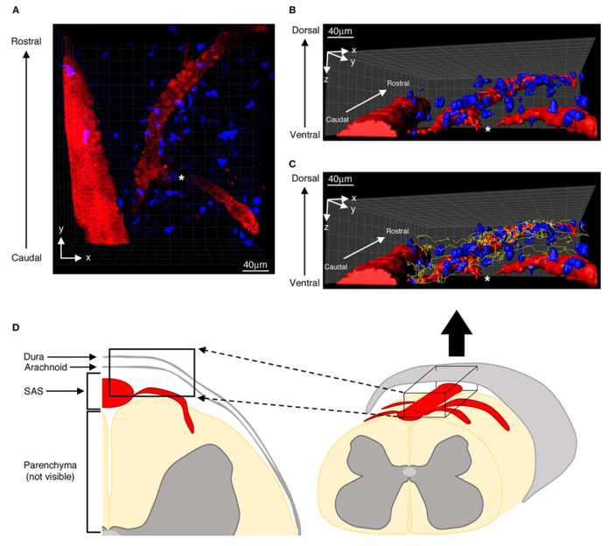
Figure 10. TPLSM on SC allows to visualize spinal SAS. Illustrative representation of TPLSM acquisition on SC. Representative ROI in 2D (A) and after 3D reconstruction (B, C) showing infiltration of fluorescent exogenous T cells (blue) near pial vessels (red). In C, cell tracking paths were highlighted (yellow lines). Asterisks indicates the region in which vessels sank in the white matter parenchyma, not allowing detection by this imaging system. (D) Schematic representation of SC region detectable by TPLSM (black blox). (Adapted from Dusi et al. Front Immunol, 2019).

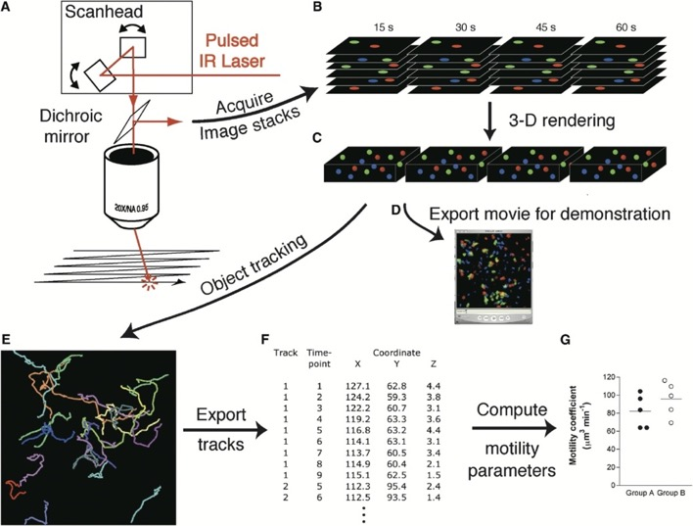
Figure 11. Steps involved in the analysis of the in vivo cell motility by TPLSM.
A) A pulsed beam of infrared (IR) laser light is raster scanned via a microscope objective with high numerical aperture onto a thick specimen by rapid, synchronized movement of a pair of steering mirrors. Fluorescent signals are generated by the multiphoton effect in a ~1µm deep section in the objective’s focal plane. B) Incremental vertical motion of the objective relative to the specimen yields stacks of optical sections, which are serially reacquired at defined time intervals (in this example, 15 s are required to acquire one z stack composed of six optical sections). In C), each z stack is rendered as a three-dimensional volume, and in D) two-dimensional projections of image stacks are exported as movie files for demonstration and further off-line analysis. E) Determination of cell centroids to represent cell position allows automated or manual tracking of migration paths of three or more cell populations recorded in separate color channels. This is achieved by assigning track identities to serial images of individual cells. In F), tracks consisting of serial sets of xyz coordinates of single cell centroids are exported as numerical databases, and in G) are used to compute parameters of cell motility. Specialized software for automated 2D or 3D cell tracking and computing of the acquired tracks is essential for in-depth, large-scale analysis of migratory behavior at single-cell level.
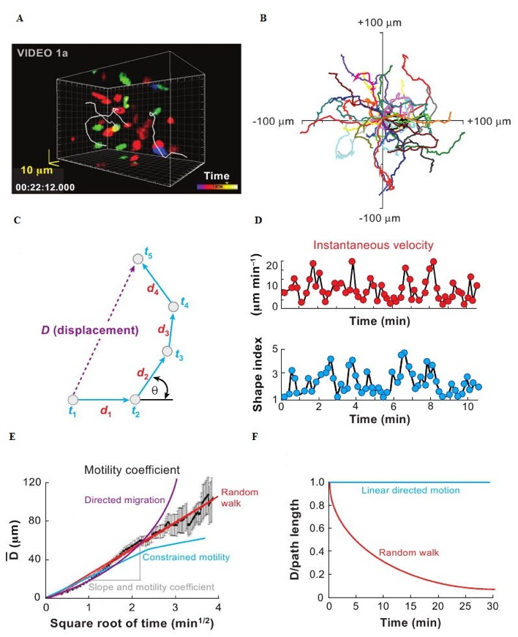

Figure 12. The basic principles of motility analysis. A) Snapshot visualization of the 3-D locations of fluorescently labeled cells throughout the imaging volume at a single time point. Tracks of three cells are superimposed. B) Flower plot representation of 2-D tracks of several cells, superimposed after normalizing their starting coordinates to the origin. C) Schematic showing of cell track at five consecutive time points, t₁, t₂, etc. Instantaneous velocities are calculated from the net distance d traveled during each time interval Δt, and the turn angle θ is the angle through which the cell turns between time steps. The displacement D is the straight-line distance of the cell from its origin at any given time. Path length is given by the sum of d₁, d₂, d₃, etc. Persistence time (or length) is the time for which a cell continues to move without turning appreciably, as is illustrated for time points t₂–t₄. D) The instantaneous velocity of neutrophils fluctuates in a characteristic manner over time, accompanied by changes in shape index (long axis/short axis) as the cell elongates while moving fast. E) The plot of mean displacement from origin of multiple cells is expected to follow a straight line when plotted as a function of square root of time (if cell motility follows a random walk). The slope of this line can be used to derive a motility coefficient M, analogous to the diffusion coefficient for Brownian motion. Deviations from a straight-line relationship may be indicative of directed migration (upward curvature) or migration constrained by physical or biological barriers (plateau). F) Chemotactic index is defined as displacement/path length from origin and remains constant with a value of unity for linear-directed motion but decreases progressively with time for cells following a random walk.

RESULTS

Neutrophils differently accumulate in the brain and SC during disease phases

Previous studies suggest that preferential neutrophil recruitment to brain or SC can impact EAE severity and clinical course (Simmons et al., 2014). Therefore, we evaluated the composition of CD45^{high} leukocytes infiltrating the brain and the SC in typical MOG₃₅₋₅₅–induced EAE mice by multicolor flow cytometry.
In first analysis, neutrophil infiltration was evaluated in brain and SC of C57BL/6 mice during different stages of EAE, both in terms of percentage of Ly6G⁺ cells on total CD45^{high} leukocytes (Figure 13A) and as absolute number of neutrophils in 0.1g of tissue (Figure 13B). The results showed highest percentage of neutrophils during the pre-clinical phase (6-8 dpi) both in the brain and SC, despite their absolute number was low. Notably, neutrophils represent the most abundant leukocyte population in the SC during this stage of disease (81%), suggesting their pivotal role in EAE induction. Moreover, we found a significant raise in neutrophil amount in the brain at the onset (10-12 dpi) and peak stages (12-14 dpi), whereas their number conspicuously increased in the SC exclusively at the peak of disease, before dropping in the chronic stage (22-25 dpi). In parallel, despite Ly6G⁺ cell percentage is reduced by half in the brain after the onset, in SC remained stable throughout the acute phase (43,4% at the onset and 45,2% at the peak, respectively) undergoing a slight decrease in the chronic phase (33,4%). Taken together, our results suggested that neutrophils represent an abundant leukocyte population within the CNS during EAE. Therefore, they could assume different roles and functions during the disease progression, based on the clinical phase and the compartmentalization.
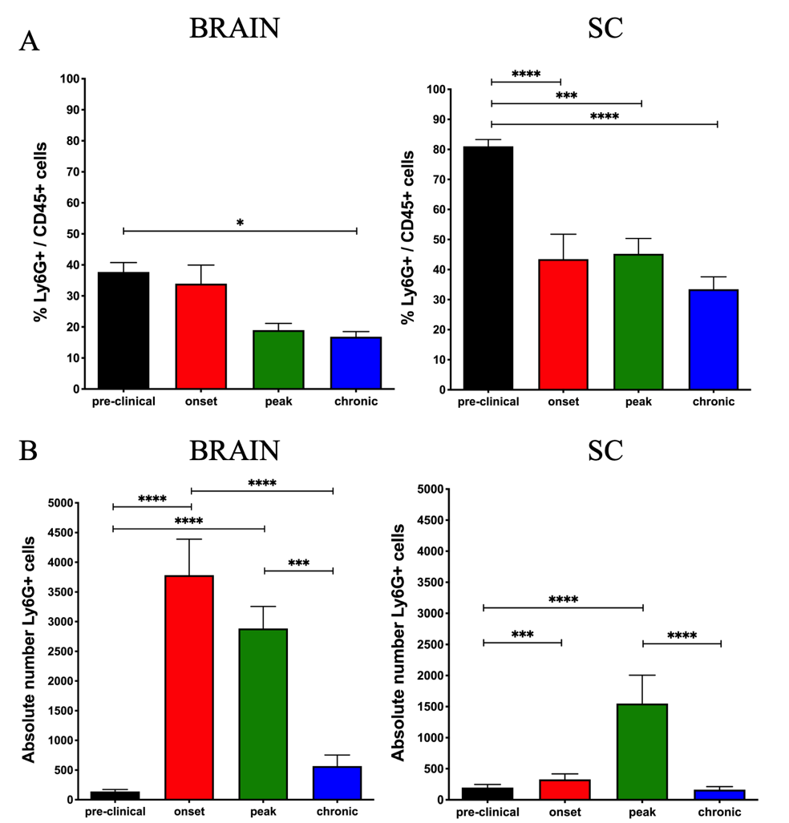
Figure 13. Neutrophils represent one of the most abundant leukocyte subpopulations in the SC during EAE. Flow cytometry analysis representing the percentage of Ly6G⁺ cells on total CD45⁺ cells (A), and the absolute number of cells in 0,1 gr of tissue (B), infiltrated into brain and SC at different stages of disease (pre-clinical, onset, peak, chronic). For each mouse, brain and SC were processed and analyzed separately. In the brain, the amount of infiltrated neutrophils massively increased at the onset, remained high during the peak and then drastically decreased in the chronic phase. However, neutrophil accumulation is significantly raised exclusively at disease peak in the SC, remaining lower during the other stages. Data are expressed as mean ± SEM of 7-11 mice for each condition. Analysis of acquired data was performed with FlowJo software (FlowJo LLC). Statistics were calculated using one-way ANOVA (P>0.05; *P<0.05; ***P=0.0001; ****P<0.0001).

Neutrophils display different infiltration pattern during EAE, establishing physical interactions with glial cells
To better elucidate the spatial infiltration pattern of neutrophils during EAE, considering the limitations in flow cytometry analysis to discriminate among meningeal and intraparenchymal distribution, immunofluorescence staining was performed. We focused our attention on sacral-lumbar sections of SC, the main site of inflammation during EAE, comparing different phases of the disease to healthy conditions. In order to better discriminate leptomeninges from spinal parenchyma, GFAP⁺ astrocytes were labelled together with neutrophils. Previous studies have shown that the function of astrocytes may be affected by neutrophils in an animal model of neuromyelitis optica (NMO) (Piatek et al., 2018), but no data are available on neutrophil-astrocyte contacts during EAE and MS. During pre-clinical phase, Ly6G⁺ neutrophils resulted very few, mainly localized along the wall of the anterior spinal artery (ASA). Rare neutrophils were also detected on the leptomeningeal layer (Figure 14A). At the onset of EAE, neutrophil distribution on the leptomeninges increased, and few Ly6G⁺ cells were observed attached to the parenchymal vessels (Figure 14B), suggesting the ongoing infiltration of these cells. At the peak stage, massive parenchymal infiltration of neutrophils was clearly displayed (Figure 14C), mirroring the clinical severity of disease. Lastly, during chronic phase, a conspicuous decrease in neutrophils was observed, as confirmed by flow cytometry (Figure 14D). As expected, Ly6G⁺ cells were not detected in the SC in healthy conditions (Figure 14E). Intriguingly, we found a great number of infiltrating neutrophils in close contact with GFAP⁺ astrocytes during different EAE stages. In particular, we found some neutrophils wrapped within astrocytes exclusively at the peak of disease, as confirmed by 3D image rendering (Figure 14F). These data suggest that neutrophils interact with reactive astrocytes during EAE progression, and that different types of interactions might occur.
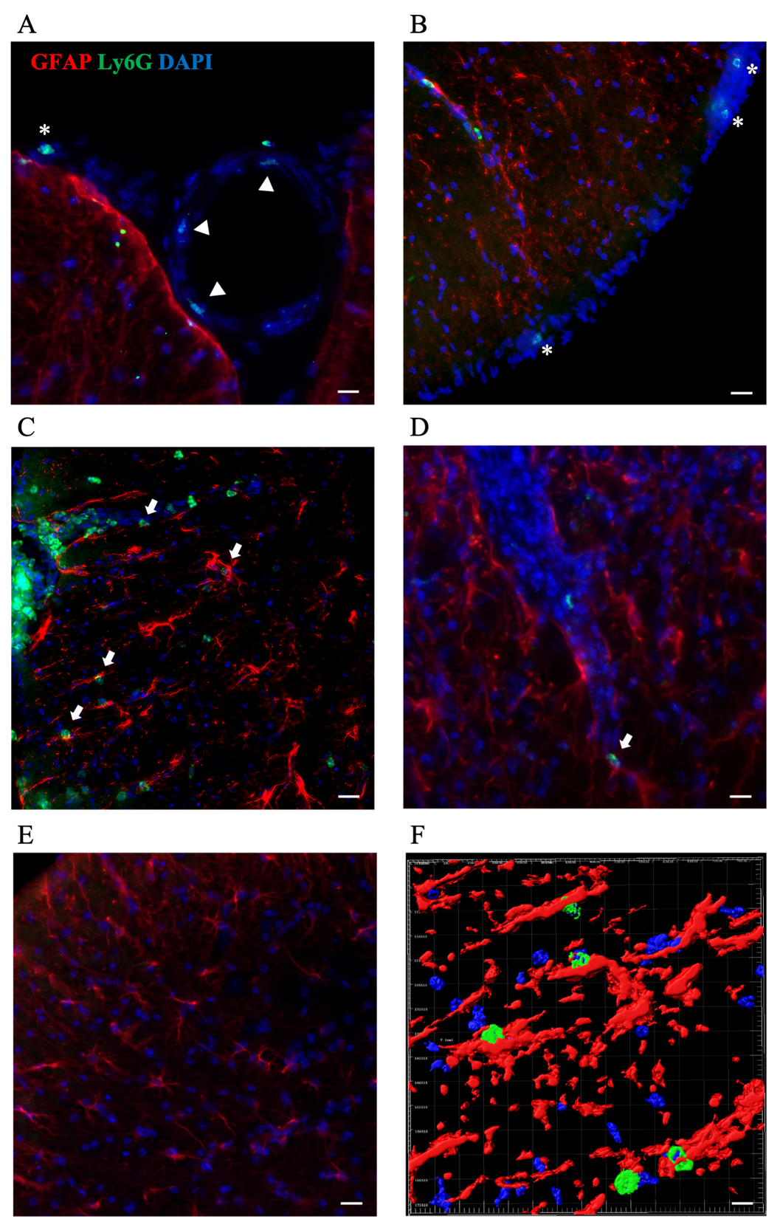
Figure 14. Neutrophils distribution in the SC during EAE. Representative images of immunofluorescence staining on 15 μm-thick SC slices during pre-clinical (A), onset (B), peak (C), chronic (D) EAE and in healthy conditions (E). Ly6G⁺ neutrophils (in green) were absent in the SC parenchyma during pre-clinical phase, reaching the highest infiltration amount during the peak of EAE. No neutrophils were detected in absence of disease. Arrowheads indicate Ly6G⁺ neutrophils along the ASA, whereas stars indicate Ly6G⁺ neutrophils along the leptomeningeal borders. Arrows indicate contacts with GFAP⁺ astrocytes (in red). Nuclei (blue) are stained with DAPI. Scalebars: 20 μm. (F) 3D-image reconstruction of Z-stack acquisition performed with Imaris Software revealed astrocytes in close contact with neutrophils. Scalebars: 10 μm.

Bone marrow-derived neutrophils express LFA-1 on their surface

In order to investigate the role of LFA-1 in neutrophil-glial cell interactions, we firstly evaluated by flow cytometry the expression of the following adhesion molecules on neutrophils isolated from BM of healthy mice: LFA-1 integrin, α4 integrin chain, CD44, L-selectin, PSGL-1 and Gal-3 (data not shown). After the selection of neutrophil cell population based on morphology plot, the analysis showed a high signal in term of mean intensity fluorescence (MIF) for LFA-1 integrin in comparison with the isotypic control, evidencing a high expression of this integrin on freshly isolated neutrophils (Figure 15). Considering the technical issues in terms of amount and activation status of collecting neutrophils from CNS of EAE mice and blood, this data provided a starter point to develop a successful co-culture setting of target engagement.
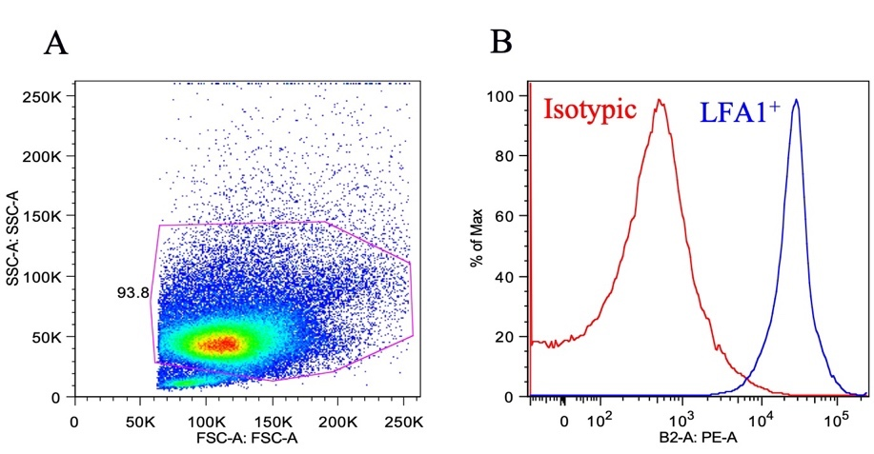
Figure 15. Neutrophils isolated from bone marrow express high levels of LFA-1 integrin on their cell membrane. LFA-1 integrin expression was evaluated by flow cytometry. A gate was tracked on neutrophil cell population in the morphologic plot (A), followed by exclusion of cell doublets and dead cells. LFA-1 integrin expression on neutrophil cell membrane was compared with an isotypic antibody in terms of mean intensity of fluorescence. The histogram shows a high PE-signal specific for LFA-1 (in blue), evidencing a strong expression of this integrin on neutrophils respect than isotypic antibody (in red). Analysis of acquired data was performed with FlowJo software (FlowJo LLC).

Neutrophils display different motility parameters in co-culture with astrocytes and microglia/macrophages

We took advantage of our know-how in live imaging combined with the cutting-edge microscopy facility available in our laboratory to develop an innovative tracking assay on in vitro co-cultures. Astrocytes and microglia/macrophages were separately isolated through magnetic separation from MOG₃₅₋₅₅ immunized mice both at the acute and at the chronic phase of disease, and from healthy mice. After one week, when glial cultures fully spread, neutrophils were isolated from BM of healthy mice, stained with a cell tracker dye and seeded on glial cell cultures for live imaging time-lapses. Neutrophil tracking analysis revealed that they differently behaved when co-cultured with microglia/macrophages and astrocytes under basal condition, displaying shorter swarming paths with the former (Figure 16A), and longer paths with the latter (Figure 16B). This evidence has been confirmed further evaluating motility parameters. Whereas mean velocity of neutrophils co-cultured with microglia/macrophages remained stable around 0.02 µm/s⁻¹, mean velocity of neutrophils co-cultured with astrocytes resulted two-fold increased (Figure 16C). Of note, cells with a mean velocity value of 0.02 µm/s⁻¹ are considered not moving. Conversely, arrest coefficient of neutrophils cultured with microglia/macrophages increased over time and was significantly higher compared with neutrophils cultured with astrocytes (Figure 16D). Collectively, these results suggest that neutrophils interact differently with glial cells, establishing faster and stronger contacts with microglia/macrophages, and milder interactions with astrocytes.
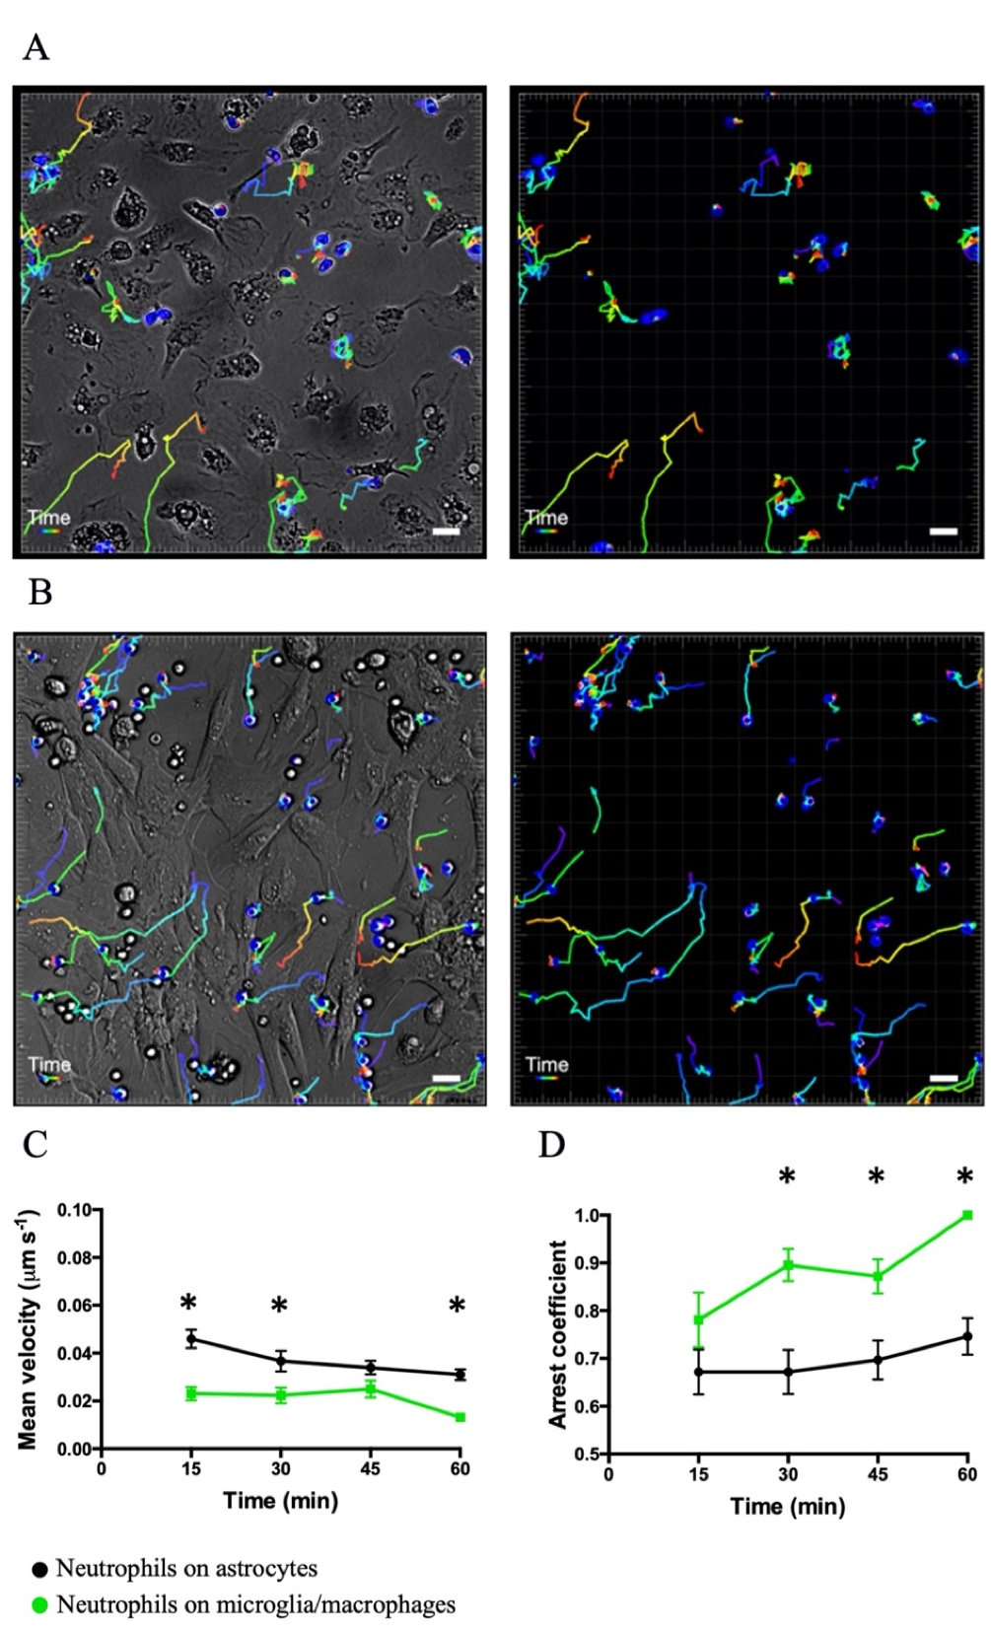
Figure 16. Cell cultures of astrocyte and microglia/macrophages differently influence in vitro neutrophil motility. Freshly isolated neutrophils were seeded on astrocytes or microglia/macrophage cell cultures and time-lapse acquisition was performed for 1 hour. Representative images of neutrophil tracking on microglia/macrophage (A) and astrocyte (B) cultures are shown. Right images represent neutrophil paths alone. Scalebars: 10 µm. Tracks were checked manually each minute of acquisition. Mean velocity (B) and arrest coefficient (C) values of neutrophils were compared between the two groups (black dots for astrocytes and green for microglia/macrophages, respectively). To assess basal interactions, anti-LFA-1 pre-treated neutrophils have not been considered. Analysis of motility parameters was performed by Imaris software. Data are expressed in terms of mean ± SEM. Statistics were calculated using multiple t test (*P<0.05).

LFA-1 integrin selectively mediates neutrophil contacts with microglia/macrophages but not with astrocytes in an in vitro co-culture system

In order to investigate whether LFA-1 integrin mediates neutrophil-glial cell contacts, freshly isolated BM-derived neutrophils were split and stained with two different cell tracker dyes and incubated with anti-LFA-1 blocking antibody or with a control antibody before seeding on glial cell cultures for live imaging time-lapses. We performed experiments with glial cells isolated from mice at the peak of disease, at the chronic phase and in absence of disease, supposing that specific cell phenotypes developed from different inflammatory microenvironments could involve different adhesion molecules. We analyzed neutrophil dynamics in terms of mean velocity (inversely correlated with contact engagement), displacement (to evaluate the surface scanned by neutrophils), arrest coefficient and contact time (direct parameters of interactions). Our data showed that LFA-1 blockade did not affect neutrophil dynamics when co-cultured with astrocytes at any phase of disease (Figure 17 A, B), suggesting that other molecules could be involved in these interactions. On the other hand, we found that LFA-1 activity drastically influenced neutrophil interactions with macrophages/microglia isolated from healthy mice (Figure 17 C) and during acute EAE (Figure 17D). During the first 30 minutes of acquisition, neutrophils pre-treated with anti-LFA-1 blocking antibody moved with higher mean velocity covering more surface compared with the IgG-treated group. At the same time, contact duration resulted shorter and arrest coefficient massively decreased. Unexpectedly, neutrophils co-cultured with microglia/macrophages isolated from chronic phase, slightly slowed down following anti-LFA-1 blockade (Figure 17E), suggesting that LFA-1 integrin could assume a different function within CNS at this stage of EAE. In order to exclude experimental biases, we evaluated the dynamics of neutrophils in co-culture compared with neutrophils seeded in empty wells, as well as the impact of different cell tracker dyes in neutrophil motility. We found that mean velocity and displacement of neutrophil in co-culture with glial cells are two-fold lower compared with neutrophils left alone (Figure 17F). Furthermore, the use of different cell tracker dyes did not influence neutrophil motility in basal conditions when co-cultured with glial cells (Figure 17G). Lastly, to corroborate these results, we repeated the experiments with microglia/macrophages co-cultures using neutrophils isolated from BM of LFA-1-knock-out mice. As expected, our results showed that LFA-1-deficient neutrophils displayed increased mean velocity and displacement mainly during the first 30 minutes of acquisition, with lower arrest coefficient and decreased time of contacts compared with WT-neutrophils, when co-cultured with microglia/macrophages from peak of EAE (Figure 17H). On the contrary, when seeded on microglia/macrophages from chronic phase, LFA-1-deficient neutrophils moved slower with a lower displacement (Figure 17I). Collectively, these data suggest that LFA-1 integrin is a key molecule selectively involved in CNS-resident myeloid cell-neutrophil interactions, with putative different effect during acute and chronic stages of disease.
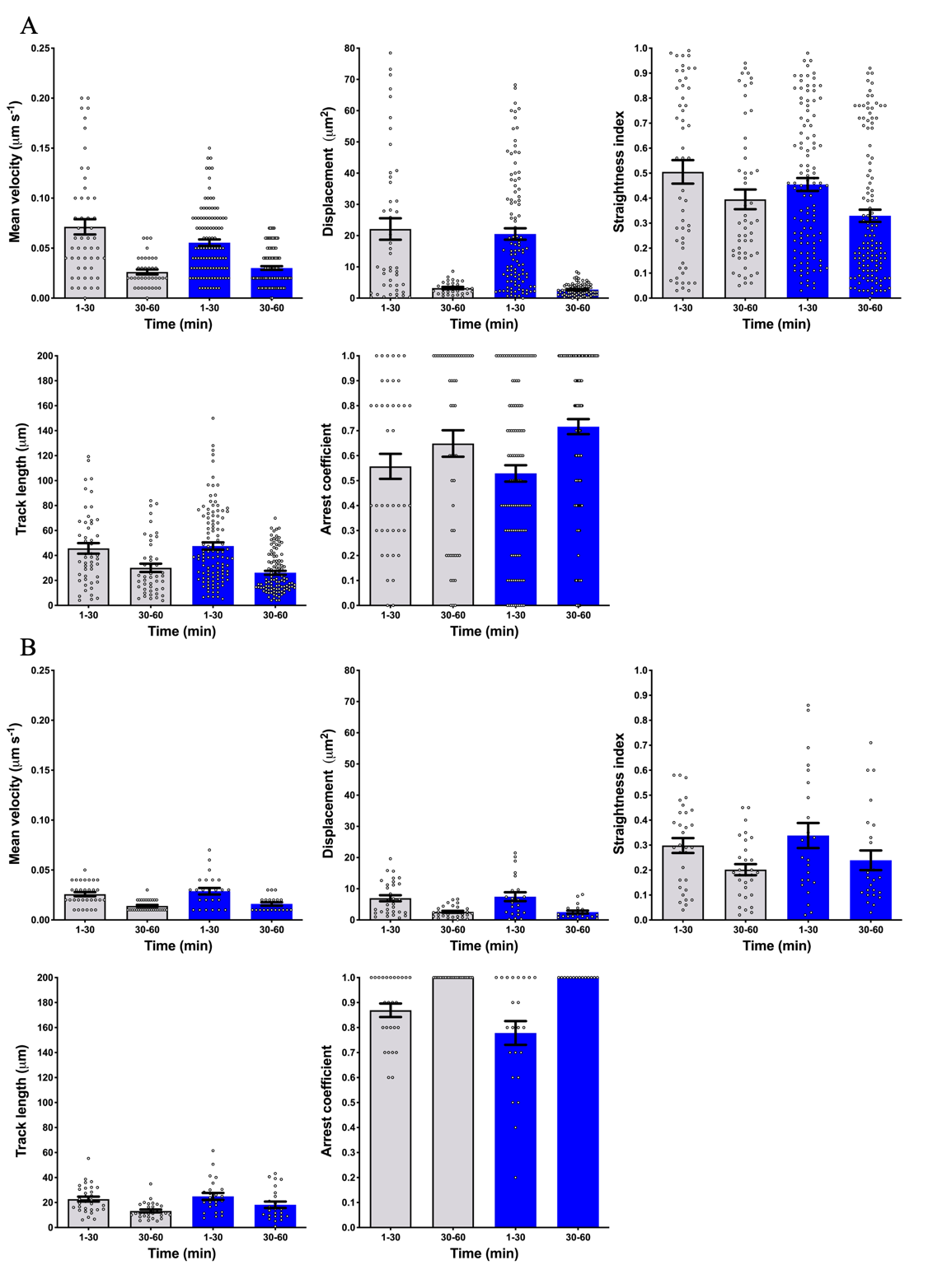

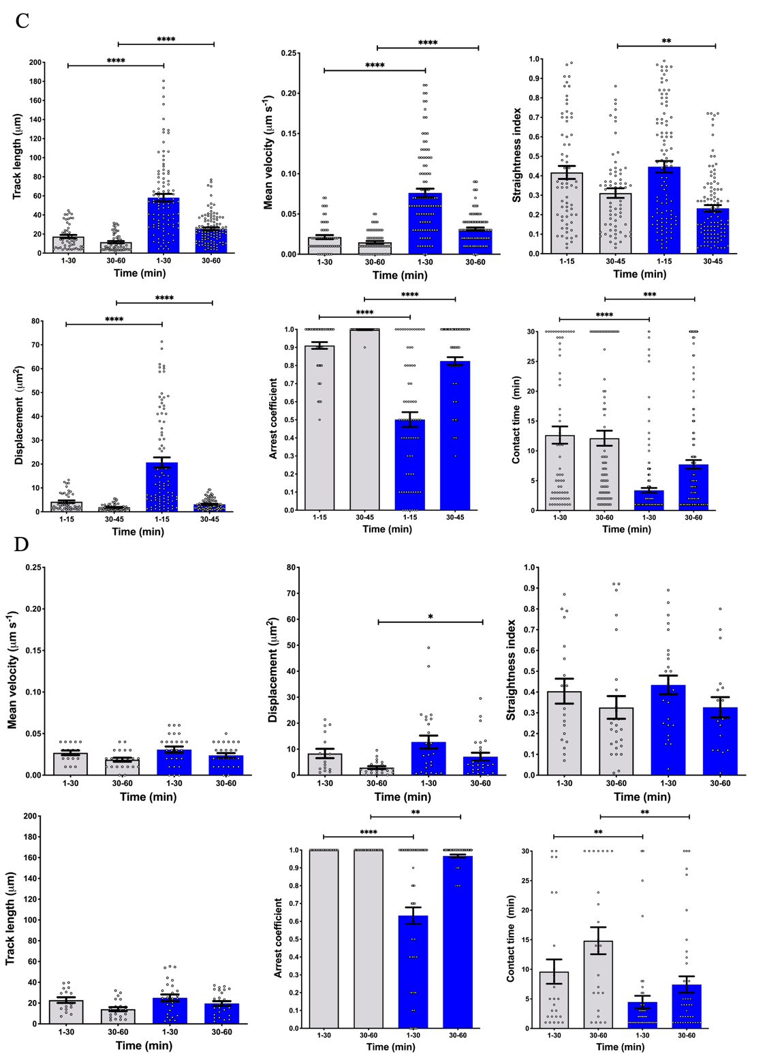
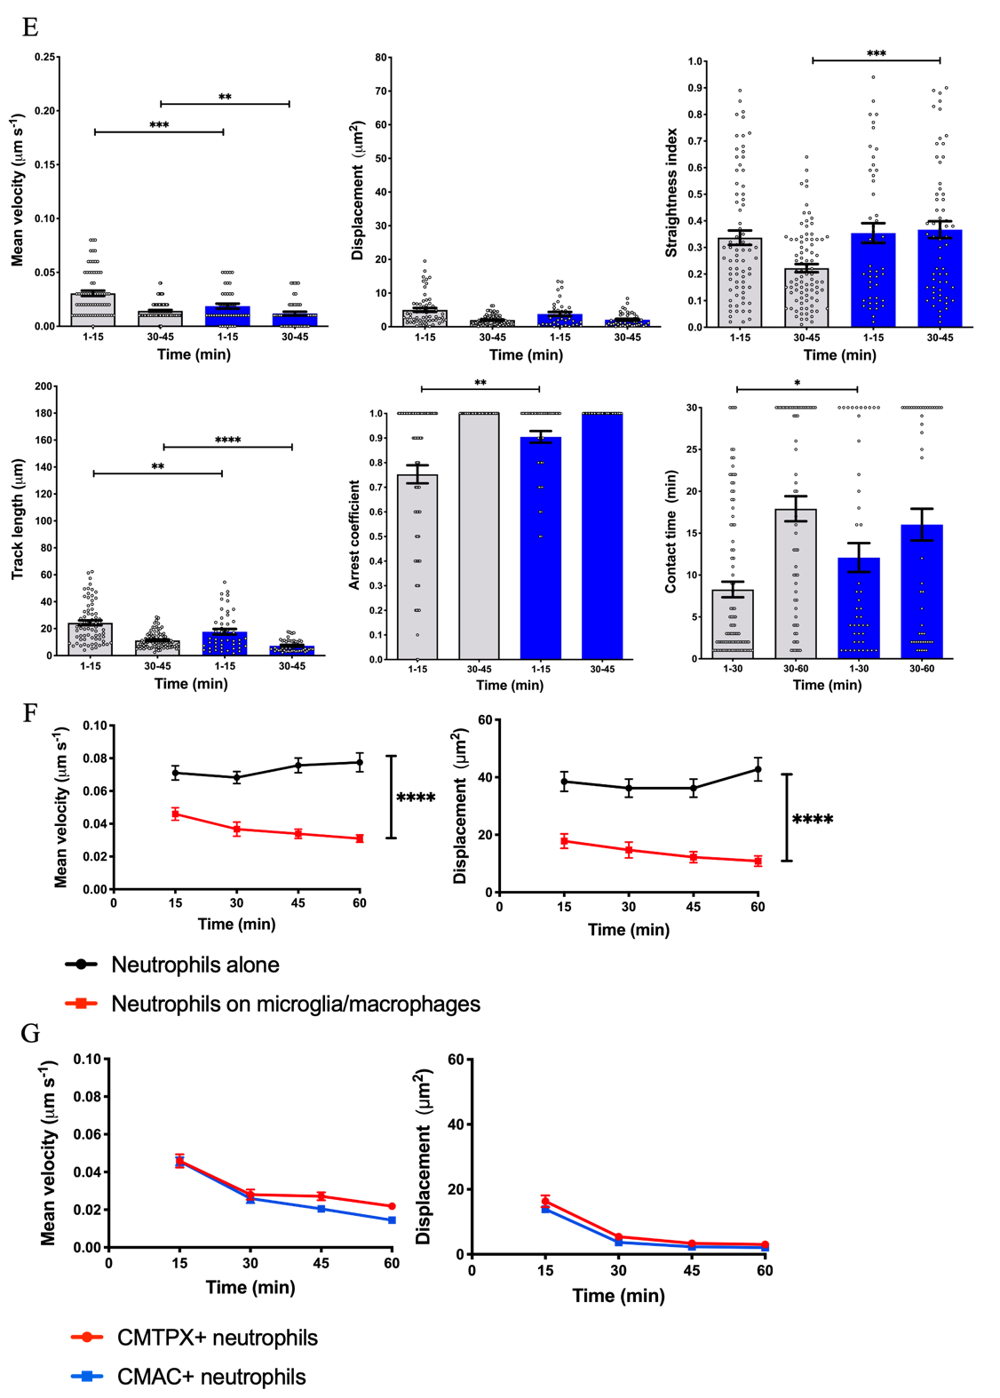

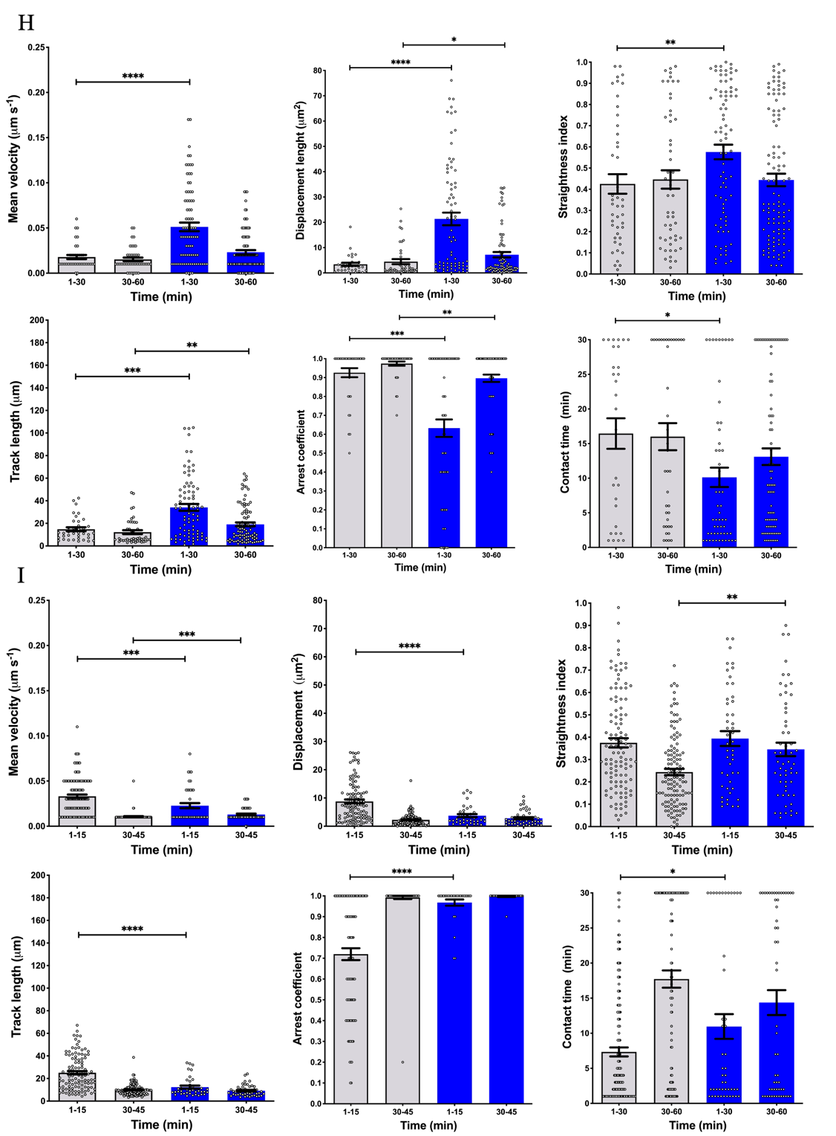
Figure 17. Neutrophils interactions with glial cells display different features in an in vitro co-culture system. Freshly isolated neutrophils were labelled with CMTPX or CMAC cell tracker dyes, pre-incubated with anti-LFA-1 or IgG-isotype control antibody and seeded on astrocytes or microglia/macrophage cell cultures. Time-lapse acquisitions were performed for 1 hour. Cells were tracked manually each minute of acquisition. Mean velocity, displacement, arrest coefficient and time contacts were analyzed for each condition. Neutrophil motility parameters have been assessed for co-culture with astrocytes isolated at the peak of disease (A) and at the chronic phase (B), as well as for macrophage/microglia from healthy mice (C), mice at the EAE peak (D) and in chronic phase (E). As control conditions, motility parameters both of neutrophils seeded alone compared with co-cultured neutrophils (F) and CMTPX-labelled versus CMAC-labelled neutrophils (G) were assessed. Co-cultures with peak-derived (H) and chronic-derived (I) macrophages/microglia and neutrophils from WT-mice and LFA-1-knock-out mice have been performed to confirm previous collected data. Analysis of motility parameters was performed by Imaris software. Data are expressed in terms of mean ± SEM. Statistics were calculated using one tailed Mann-Whitney test (*P<0.05; **P<0.005; ***P=0.0001; ****P<0.0001).

LFA-1 integrin controls neutrophil compartmentalization and intra-tissue motility during acute EAE

In the light of flow cytometry and in vitro results, we next moved in vivo to corroborate our data, focusing at first on the intra-tissue behavior of neutrophils during EAE. Freshly isolated neutrophils from BM of healthy mice were fluorescently labeled and injected in recipient C57Bl/6 MOG₃₅₋₅₅ immunized mice, following cell imaging performed 18-24 hours later. Considering the instrumental limits in white matter penetration by laser, our setting allows us to visualize the subarachnoid-pial meningeal space (Figure 10) (Dusi et al., 2019). To also investigate a potential role of LFA-1 integrin in the migration movement of neutrophils in the spinal SAS parenchyma, we performed TPLSM experiments at the peak of disease, which is characterized by massive neutrophil infiltration within SC, as demonstrated by immunofluorescence staining. Before the acquisition, we intravenously injected fluorescent quantum dots to visualize meningeal vessels, followed by 30 minutes-long acquisitions in the same field before, 30 and 60 minutes after administration of an anti-LFA-1 blocking antibody. We found that neutralizing LFA-1 activity led to a change in all the motility parameters analyzed. Specifically, it was observed a progressive increase in median velocity (from 0.073 to 0.087 μm/s⁻¹) (Figure 18A), but also straightness index (from 0.39 to 0.47) (Figure 18B), displacement (from 13.69 to 20.79 μm²) (Figure 18C) and track length (from 31.1 to 40 μm) (Figure 18D) of total neutrophils tracked 1 hour after treatment. There results suggested that following LFA-1 blockade neutrophils moved faster, covering longer distances within spinal SAS tissues with a more linear path. Intriguingly, we found that almost all infiltrated neutrophils were initially localized close to the vascular area spreading within the tissue after anti-LFA-1 local administration. Thus, we decided to classify neutrophils into two subsets based on a 20 µm-threshold distance from the vessel wall: vessel-related cells, comprising neutrophils moving along the vessel wall close to the vascular environment, and not vessel-related cells, comprising neutrophils moving dispersed in the SAS environment. Before LFA-1 blockade, vessel-related neutrophils represented the most abundant group (66% on total neutrophils) (Figure 19M). Analysis of motility parameters led separately on these two classes showed that vessel-related neutrophil median velocity (Figure 19A), straightness index (Figure 19C), displacement (Figure 19E) and track length (Figure 19G) remained stable after anti-LFA-1 administration. Conversely, not vessel-related neutrophils displayed significantly increased straightness index (from 0.42 to 0.54), (Figure 19D), displacement (from 18.93 to 27.85 μm²) (Figure 19F) and track length (from 38.81 to 48.63 μm) (Figure 19H) 1 hour after LFA-1 blockade, and a slight tendency in median velocity (from 0.09 to 0.10 μm/s⁻¹) (Figure 19B). It is worthy to notice that since basal conditions, median velocity (Figure 19I) and track length (Figure 19L) were significantly lower in vessel-related neutrophils (0.06 μm/s⁻¹ and 28.15 μm, respectively) compared with not vessel-related neutrophils (0.09 μm/s⁻¹ and 38.01 μm, respectively), further supporting the hypothesis that the former group of neutrophils move slower covering shorter distances, presumably engaging contacts with perivascular cells. Interestingly, we observed as neutralizing in situ LFA-1 activity induced a constant raise in the percentage of not vessel-related neutrophils 30 minutes and 1 hours later (48% and 58% on total neutrophils, respectively) (Figure 19E). Collectively, these data suggest a potential involvement of LFA-1 integrin in localized neutrophil interactions with perivascular cells (as instance, leptomeningeal macrophages), and that the interruption of this axis could affect neutrophil intra-tissue dynamics at the peak of disease. Of note, we attempted to repeat the experiments at the chronic phase of disease, though few infiltrating exogenous neutrophils were found at this phase of disease.
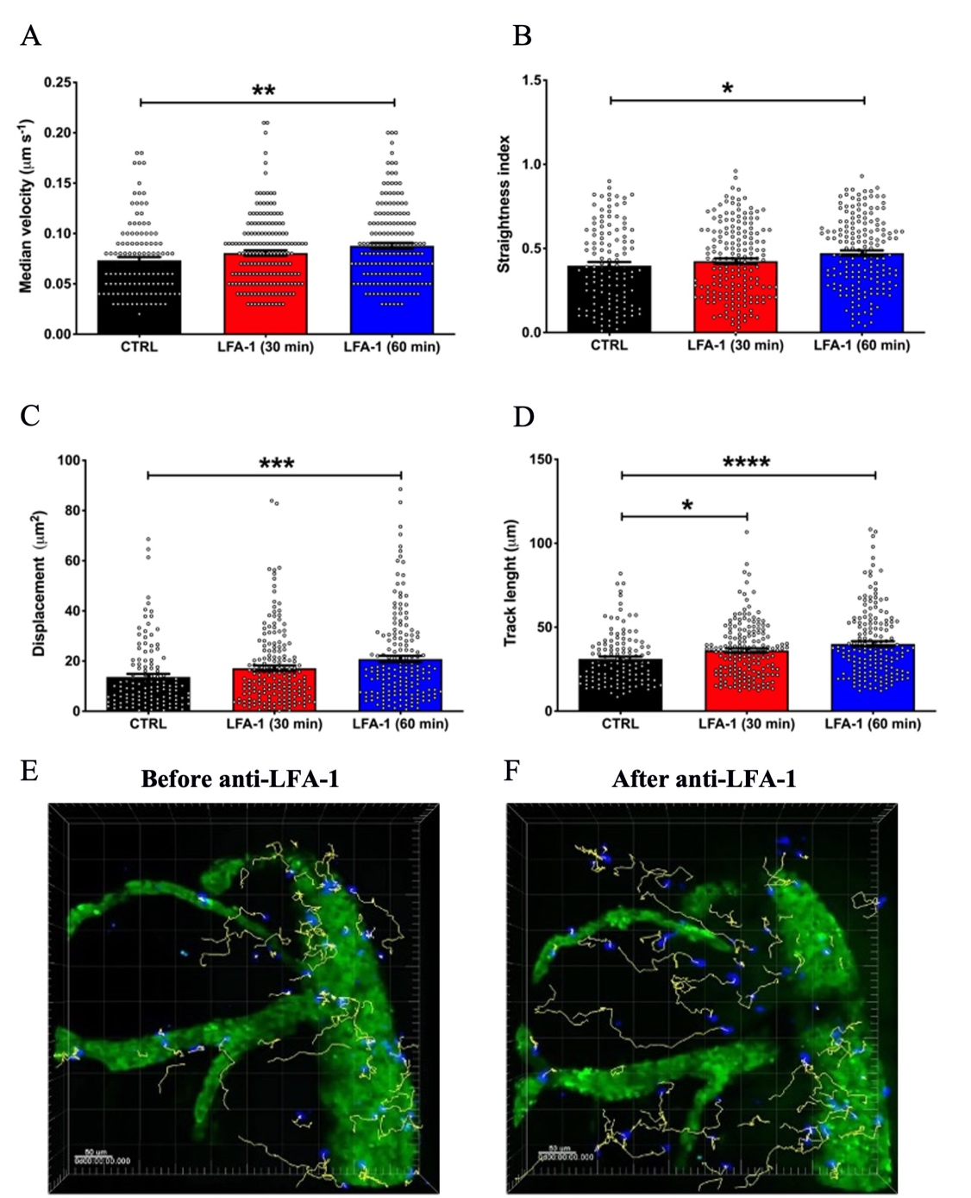
Figure 18. LFA-1 integrin blockade affects intra-tissue neutrophil dynamics at the peak of EAE. Neutrophil dynamics within the SAS environment were analyzed before (CTRL), 30 and 60 minutes after the administration of an anti-LFA-1 antibody (clone M17/4) on the exposed SC of C57Bl/6 mice at the peak of EAE (12-14 dpi) using a TPLSM approach. Median velocity (A), straightness index (B), displacement (C) and track length (D) drastically increased after LFA-1 blockade. Data were analysed using Imaris software and expressed as mean ± SEM of 100 cells from from 3 independent experiments. Statistics were calculated using one-way ANOVA (P>0.05; *P<0.05; **P<0.05; ***P≤0.0005; ****P≤0.0001). (E) Representative cells tracking before anti-LFA-1 administration. (F) Representative cells tracking after 1 hour of anti-LFA-1 local administration. Scalebar: 50 μm.

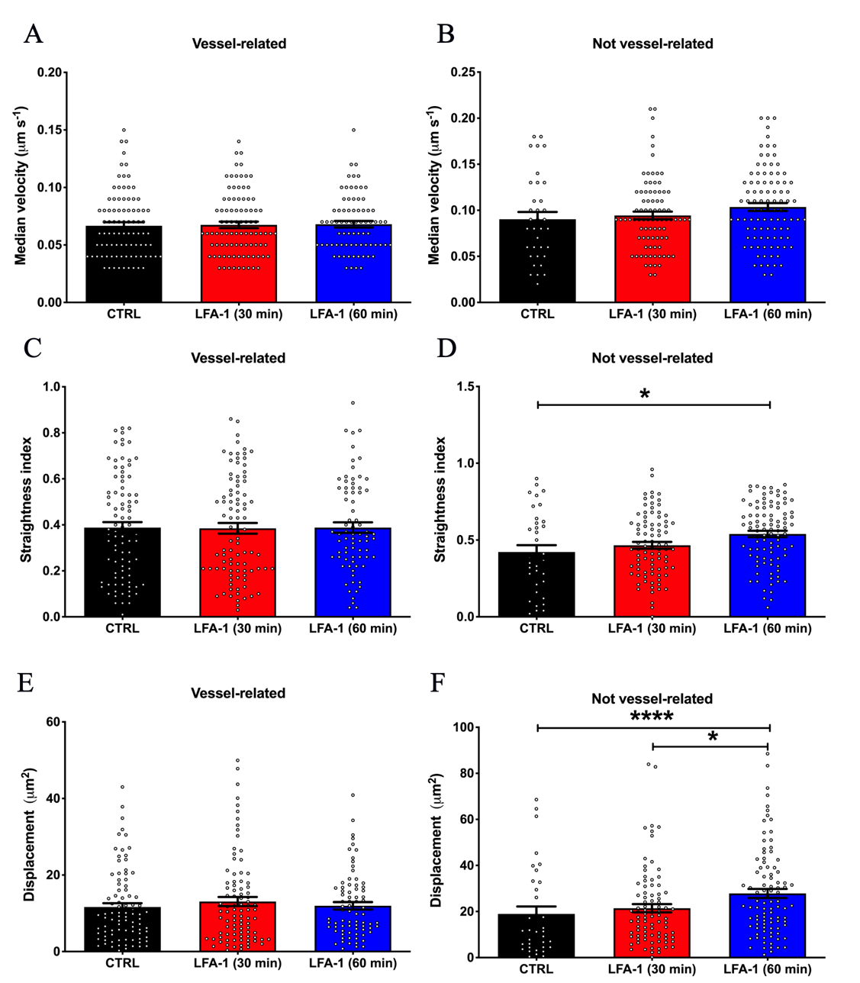

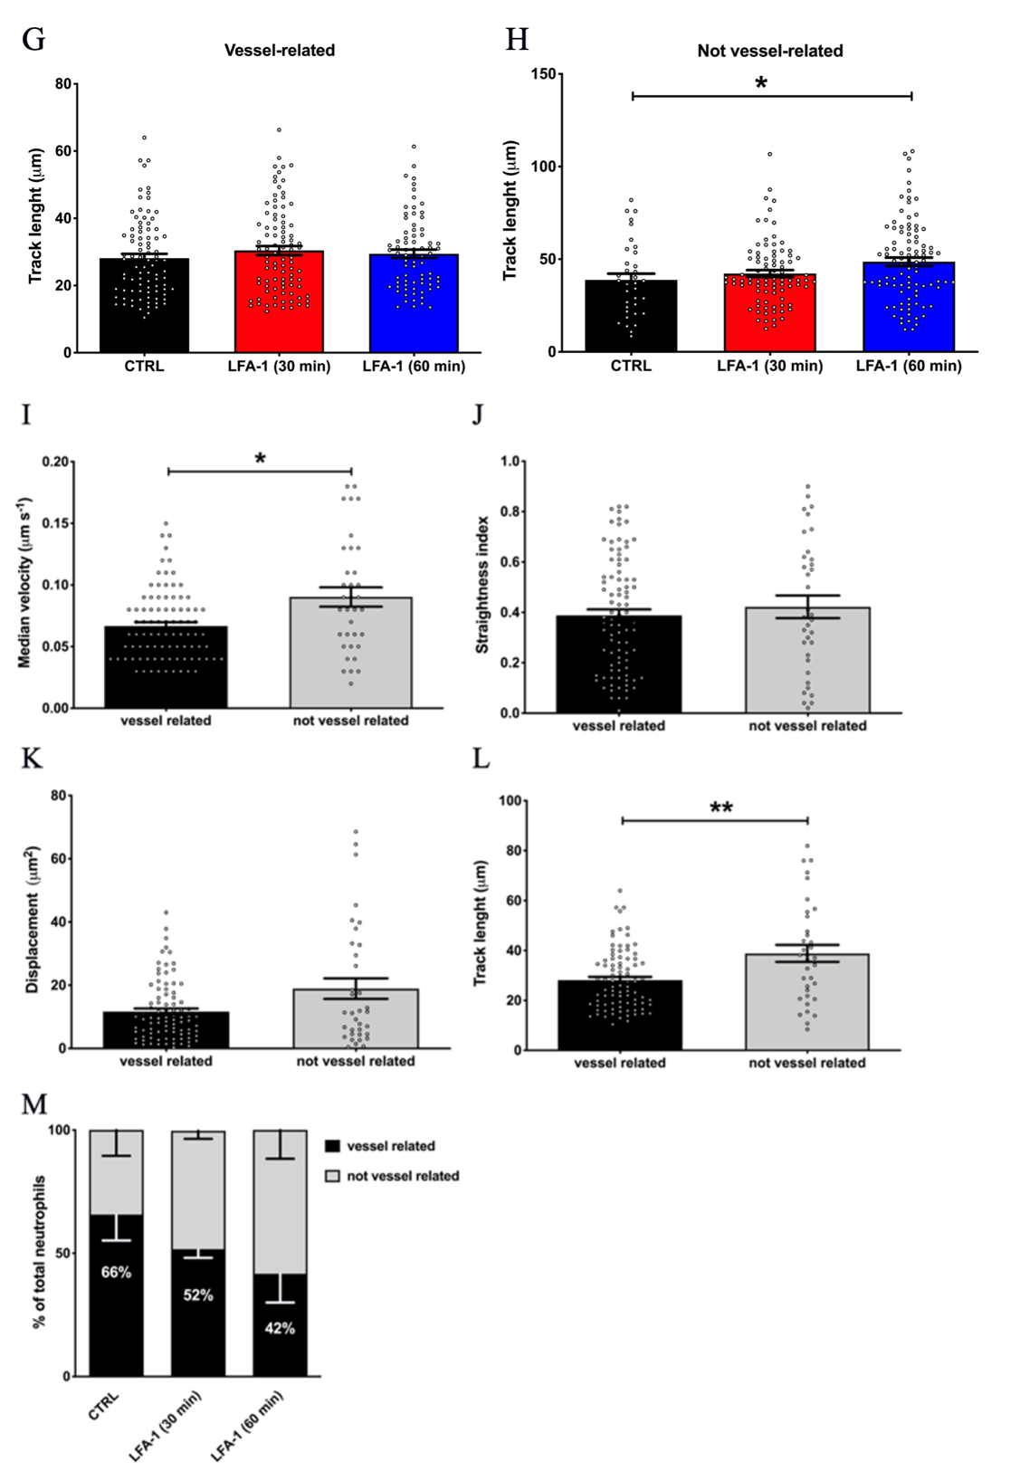
Figure 19. LFA-1 integrin blockade exclusively affects not vessel-related neutrophil dynamics at the peak of EAE. Neutrophil dynamics within the SAS were analyzed before (CTRL), 30 and 60 minutes after administration of an anti-LFA-1 antibody (clone M17/4) on the exposed SC of C57Bl/6 mice at the peak of EAE (12-14 dpi) using a TPLSM approach. According to their distance from the pial vessels (threshold: 20 μm), cells were classified into vessel-related and not vessel-related groups. Motility parameters in terms of median velocity, straightness index, displacement and track length are represented for both clusters (A, C, E, G and B, D, F, H, respectively). LFA-1 blockade exclusively affects not vessel-related neutrophils. (I-L) Comparison of vessel-related and not vessel-related neutrophil dynamics under basal condition. (M) Anti-LFA-1 treatment determined a drastic change in neutrophil distribution among the two groups. Data were analysed using Imaris software and expressed as mean ± SEM from 3 independent experiments. Statistics were calculated using one-way ANOVA (P>0.05; *P<0.05; ***P=0.0001; ****P<0.0001).

LFA-1 integrin controls intra-tissue microglia/macrophage-neutrophil interactions at the peak of EAE

In the light of our data carried on C57Bl/6 mice, we next hypothesized that LFA-1 may mediate neutrophil contacts with macrophage/microglia cells, so we carried out experiments in CX3CR1-eGFP mice (characterized by fluorescent macrophages/microglial cells) at the peak of disease.
As previously described, before antibody administration on the SC surface, infiltrated neutrophils were mainly localized perivascularly, close to the SC pial vessels and related branches. LFA-1 blockade drastically affected the duration of cell contacts between infiltrated neutrophils and meningeal macrophages, exhibiting a 4-fold decrease over time after 1 hour since antibody administration (Figure 20D). Additionally, the percentage of neutrophils engaging both short-lasting contacts (<10 minutes) and long-lasting contacts (considered as arrested cells) dropped off (Figure 21E and 21F, respectively). In support of these data, time-lapse acquisitions showed in fact that neutrophils lacking LFA-1 activity clearly detached from macrophages and distanced from perivascular space covering long-range within SAS at the peak of EAE (Figure 20G). Moreover, immunofluorescence staining on spinal meninges from healthy mice revealed the presence of rare Ly6G⁺ neutrophils in the perivascular space (Figure 20A). Interestingly, such cells resulted in contacts with F4/80⁺ perivascular macrophages (Figure 20B), suggesting that these “immune innate” interactions could be inflammation-independent, further corroborating our in vitro data on CNS-myeloid cells isolated from healthy mice co-cultured with WT neutrophils. In addition, as suggested by confocal images on SC sections, neutrophils were found also in SC parenchyma during EAE, in contact with microglia. Moreover, such cells appeared in an activate state displaying an amoeboid morphology compared to ramified resting microglia typical of healthy CX3CR1-eGFP mice (Figure 20C). Collectively, these results support the hypothesis that LFA-1 integrin is crucial in neutrophil capability to interact with CNS-resident myeloid cells within SC both under physiological and pathological conditions.
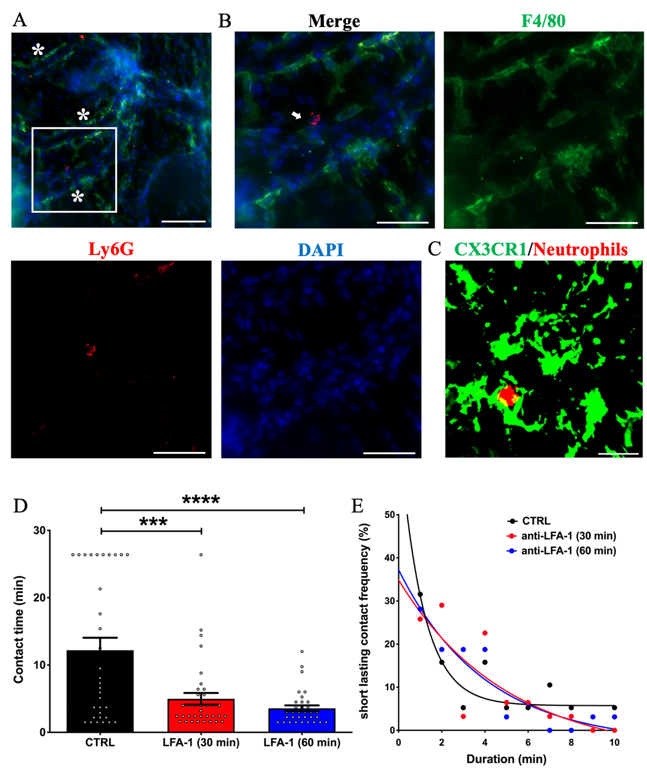

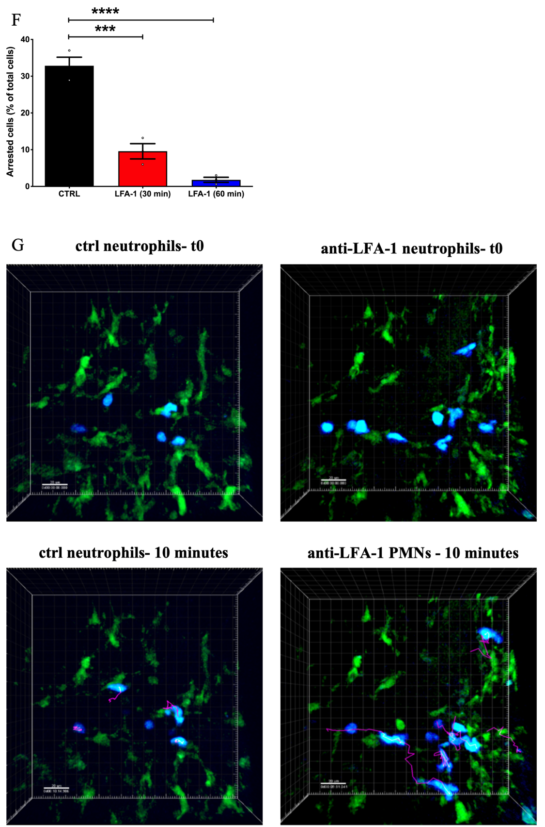

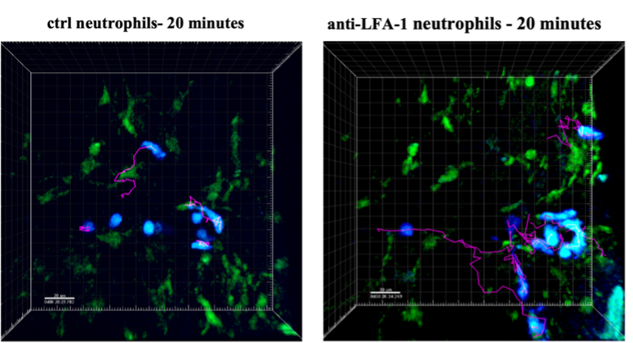
Figure 20. Neutrophils establish cell-cell contacts with resident macrophages and microglia in healthy conditions and during EAE. (A) Representative acquisition of spinal leptomeninges from a healthy mouse. After perfusion, meninges were peeled-off under a stereotactic microscope and stained in free floating for F4/80 macrophages (green) and Ly6G neutrophils (red). Staining with DAPI was used to label nuclei (blue). Stars indicate unstained vessels. Scalebar: 100 μm. (B) ROI of Figure 20A highlighting a Ly6G⁺ neutrophil in contact with a F4/80⁺ perivascular macrophage (white arrow). Scalebar: 50 μm. (C) Representative confocal image showing CMTPX-labeled neutrophil (red) in contact with GFP-macrophages/microglia (green) in the SC parenchyma of CX3CR1-eGFP mice during EAE. Scalebar: 50 μm. LFA-1 blockade strongly decrease neutrophil-macrophage/microglia contact time (D), as well as short-lasting (E) and long-lasting contacts (F). Data were analysed using Imaris software and expressed as mean ± SEM from 3 separate experiments. Statistics were calculated using ordinary one-way ANOVA (***P=0.0001; ****P≤0.0001). (E) Representative neutrophil motility tracks within the SAS before and after local anti-LFA-1 treatment in CX3CR1-eGFP mice at the peak of EAE. CMAC-stained neutrophils (blue) display a swarming behavior closed to GFP-macrophages (green). Neutrophil tracks are also shown (purple lines). Compared with control condition (left panel), after administration of anti-LFA-1 blocking antibody (right panel) neutrophil motility changes drastically: treated neutrophils disengage contacts with macrophages starting to move deeply within the SAS tissue over time. Scale bar: 20 µm. Representative cell tracks at time 0 (top panel), over 10 minutes (middle panel) and 20 minutes (bottom panel) of acquisition are tracked manually. Multidimensional imaging is performed by Imaris software.

Intrathecal injection of an anti-LFA-1 antibody at EAE onset ameliorates disease severity

Considering our results showing that neutrophils have a pivotal role in the pathogenesis of EAE and that LFA-1 blockade influences cell motility and interactions with resident macrophage/microglia cells, we hypothesized that obstructing neutrophil dynamics in the CNS might affect their pathogenicity ameliorating the clinical course of EAE. To confirm this hypothesis, MOG₃₅₋₅₅-immunized mice EAE mice were treated the day after disease onset and 4 days later through intrathecal injection of anti-LFA-1 blocking antibody or an isotype antibody as control. Clinical scores were evaluated daily. The blockade of LFA-1 integrin significantly and massively inhibited the progression of disease in treated mice compared to the control group (Figure 21A). The clinical amelioration of disease was also correlated with a decrease in leukocyte infiltration (Figure 21B) and demyelination (Figure 21C) in anti-LFA-1 treated mice. In addition, whereas the control group showed a massive microgliosis in the lumbar SC, animals treated with anti-LFA-1 presented a strong reduction in Iba1⁺ cell activation, evaluated both in terms of cell number/mm² and as percentage of Iba⁺ area in the acquired fields (Figure 21D), suggesting that the local injection of the blocking antibody profoundly impact the severity of CNS inflammation. Intriguingly, whereas we excluded a direct involvement of LFA-1 integrin in neutrophil-astrocyte interactions, the blockade of LFA-1 induced a decrease in astrogliosis in terms of GFAP⁺ area in the SC of treated mice compared with the control group, suggesting us a profound effect on the whole spinal microenvironment (Figure 21E). A second anti-LFA-1 injection further delayed the development of the clinical peak in EAE mice (Figure 21A). However, after 5–6 days from the last treatment, clinical worsening of EAE occurs, reaching a clinical score comparable to control animals (Figure 21A). These data suggest that during the late phases of disease, LFA-1 blockade might affect other immune cell subsets that dampen inflammation, for instance regulatory T cells. It was recently shown in fact that Treg number remains elevated in lumbar SC during the chronic phase of EAE, suppressing Th17 cell effector functions and Ca²⁺ signaling (Othy et al., 2020). Thereafter, we decided to investigate if the effect of antibody treatment persisted until late stages of disease, as reported in our recently published work (Dusi et al., 2019). At 21 dpi, a less extent in neuropathological differences among the two group have been observed. Except for inflammatory infiltrating cells that still resulted significantly lower in anti-LFA-1-treated mice, the other pathological features did not show significant variations among the two groups. To better explain these results, the comparison among the early and late phases of EAE revealed that the neuropathology (intended as infiltrates and demyelination) following anti-LFA-1 antibody treatment lasts until chronicization of disease, whereas in the control group the amelioration of clinical symptoms was associated with a tendency in the reduction of inflammatory cell infiltration (12.08 ±1.44 at 14 dpi vs. 8.18 ± 1.17 at 21 dpi) and demyelination (11.55 ± 1.45 at 14 dpi vs. 2.58 1025 ± 0.66). The intrathecal injection procedure could potentially determine a rapid efflux of administered antibody from the CSF into the blood and peripheral lymphatic system, partly due to the increased local pressure and to the massive BBB leakage at the peak of the disease. To exclude the possibility that antibody efflux throughout the periphery influences the leukocyte recruitment involved in EAE clinical development, we treated EAE mice intravenously with anti-LFA-1 or control antibodies, mirroring the same protocol of administration dose and timing used for intrathecal treatment (Dusi et al., 2019). No significant differences in EAE progression were observed between the two groups, suggesting that the beneficial effect of anti-LFA-1 treatment is determined specifically by affecting local interactions within the inflamed CNS.

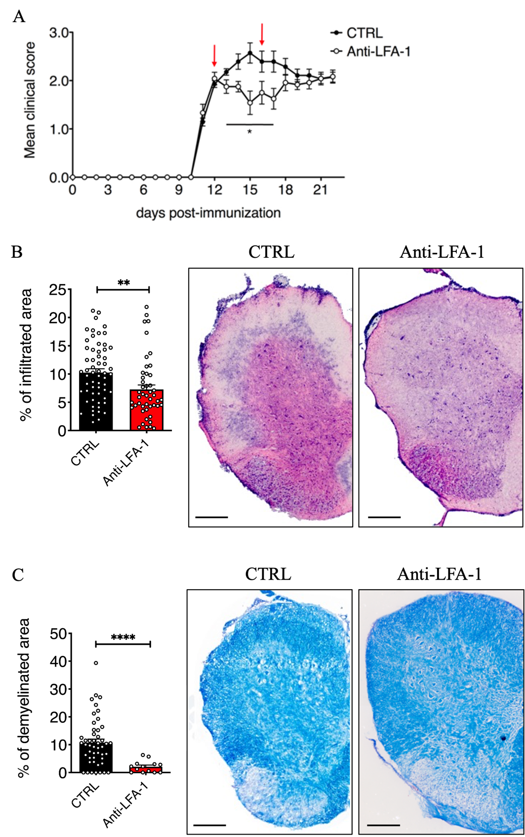

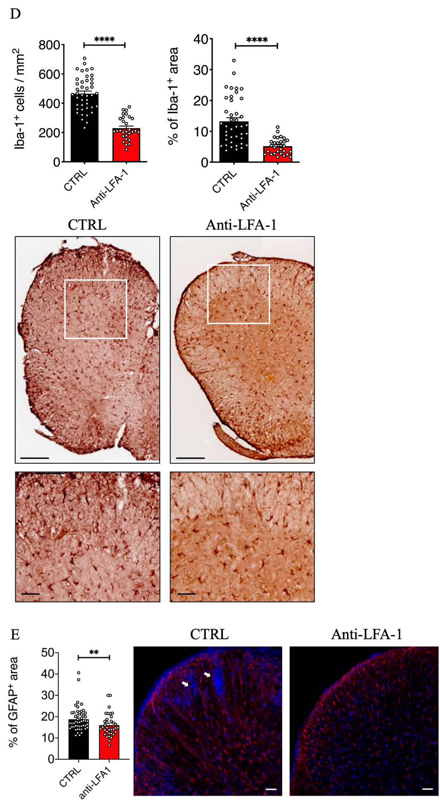
Figure 21. Intrathecal injection of an anti-LFA-1 blocking antibody reduces EAE severity. MOG₃₅₋₅₅-immunized mice were injected in cisterna magna the day after disease onset (11-13 dpi) and 4 days later (red arrows) with 10 μl of PBS containing 50 μg of anti-LFA-1 blocking antibody or with isotype control antibody (CTRL). (A) Mice were scored daily for the severity of clinical disease progression until 22 dpi. Data represent the mean ± SEM of 16 mice per condition from 4 independent experiments (*P < 0.05). (B-E) Neuropathology of EAE mice treated with the anti-LFA-1 blocking antibody. Mice were euthanized 3 days after the first antibody injection (14 dpi), and SC were collected. Quantifications on SC slices were performed to evaluate inflammatory infiltrates (B) and demyelination (C) by hematoxylin/eosin and Luxol Fast Blue staining, respectively. Quantitative analysis for each condition, sided by representative consecutive SC sections from mice treated with control (CTRL) or anti-LFA-1 antibodies are shown (4–6 cross sections of SC per mouse, n = 3 mice). Error bars indicate SEM (**P < 0.005; ****P < 0.0001). Scale bar: 100 μm. (D) Quantitative analysis of Iba-1⁺ cells/mm² of tissue and area occupied by Iba-1⁺ cells was performed on SC sections of mice treated with a control or anti-LFA-1 antibodies (4–6 cross sections of SC per mouse, n = 3 mice per condition). Error bars indicate SEM (****P < 0.0001). Representative images of SC sections stained for Iba-1⁺ cells are represented. Scale bar: 100 μm (top) or 20 μm (bottom). Data are adapted from Dusi et al., 2019. (E) Quantitative analysis led on SC of mice treated with a control or anti-LFA-1 antibodies to determine the ratio between the GFAP⁺ area on the total area of the section, sided by representative images of GFAP⁺ astrocytes (in red) for each condition (4–6 cross sections of SC per mouse, n = 3 mice per condition). Arrows indicate the high-density nuclei area, in which infiltrating leukocytes accumulated, observed in control and in a less extent in anti-LFA-1-treated mice. Staining with DAPI was used to label nuclei (in blue). Error bars indicate SEM (**P < 0.005). Scale bar: 50 μm.

DISCUSSION

Previous studies have shown that neutrophil depletion prevented clinical and histological manifestations of EAE (Carlson et al., 2008), prompting how neutrophils could represent a critical event in MS and EAE pathogenesis. Several studies have reported the presence of infiltrating neutrophils in the SC during EAE. Interestingly, their location and number vary from the pre-clinical phase through disease onset, peak and recovery, suggesting that they may play different roles at different phases of the disease. Moreover, the role of these cells, not only in disease induction, but also in the progression and chronicization remains to be elucidated (Soulika et al., 2009), (Wu et al., 2010), (Steinbach et al., 2013), (Aube et al., 2014). For this reason, we carried on quantitative and qualitative studies on EAE mice during different disease stages (pre-clinical phase, onset, disease peak and chronic phase) to evaluate respectively amount and distribution of infiltrated neutrophils in the CNS. In pre-clinical phases, although the absolute number of infiltrated neutrophils resulted very low, they represented the most abundant leukocyte population in the SC, corroborating their detrimental role in disease development. At disease onset, we found a high number of neutrophils in the CNS, mainly localized at the leptomeningeal level, suggesting a potential involvement of these cells also in the earliest phases of the disease coinciding with the manifestation of clinical symptoms. On the other hand, glial cells represent key players in neuroinflammation. However, despite recent studies described the interactions among astrocytes and neutrophils in vitro, as well as the mutual crosstalk among neutrophils and microglia in vivo, no data are still available on direct neutrophil-glial cell interplay occurring in EAE and MS (Xie et al., 2010), (Kim et al., 2020). Our immunofluorescence staining showed that in the SC of MOG-induced EAE mice, infiltrated neutrophils could establish potential physical contacts with myeloid cells (as instance, microglia and macrophages) and astrocytes. Collectively, these preliminary results intrigued us to investigate the molecular mechanisms underlying neutrophil-glial cell interactions.
During the last decades, the opportunity to use cutting-edge imaging techniques such as in vitro time-lapse microscopy and TPLSM made possible the observation of cells outside and within the tissues of living animal models, shedding light on cellular behavior and molecular signals, providing insights into immunology, tumor biology and neurobiology (Pittet and Weissleder, 2011). Intravital imaging techniques can reveal cellular responses over time and space and can be conducted under close physiological or pathological conditions. This is crucial for the majority of in vivo studies considering the influence in cellular behavior exerted by a plethora of factors including cytokines, interactions with other cellular and extracellular components, anatomical compartmentalization and fluid flow forces. As such, several in vitro platforms have been developed in recent years, ranging from 2D-cell co-culture systems up to complex 3D-cell culture models, organoids and the most innovative organs-on-chip technology. These approaches allow to study selectively the interplay between specific cell types, including adhesion molecules and relevant molecular mechanisms (e.g., intracellular calcium signaling, cytokine production, apoptosis and cytotoxicity) in controlled conditions without the influence of the surrounding environment. Moreover, they successfully represent simplified disease models useful for target engagement and drug testing studies (Slanzi et al., 2020). The in vitro and in vivo techniques represent so far two fundamental consecutive steps in the scientific process to study molecular mechanisms in physio-pathological contexts, potentially involved in the etiology and pathogenesis of complex multifactorial disorders. Based on immunofluorescence results, we decided to better characterize this innovative finding using a multi-step imaging approach.
To confirm a potential interplay between migrated neutrophils and CNS cells, we developed and optimized an in vitro time-lapse protocol in which neutrophils isolated from BM of healthy mice (basally expressing high levels of LFA-1 integrin) were co-cultured with astrocytes or CNS-resident CD11b⁺ myeloid cells (microglia/macrophages). Our results showed that neutrophils basally displayed different motility and interaction paths when cultured with astrocytes or microglia/macrophages. While neutrophils tend to arrest on the microglia/macrophage culture engaging stable contacts, they slow down over time on the astrocyte layer, but probably they continue moving by short frequency contacts. These data underline how neutrophils could exert different interplays depending on the nature of CNS cells they are in contact with.
Our group previously highlighted a key role of LFA-1 integrin in neutrophil recruitment in Alzheimer’s disease mouse model (Zenaro et al., 2015), letting us hypothesize that this molecule could further represent a key mechanism in neutrophil-glial cell interactions. To probe this hypothesis, we pre-treated neutrophils with anti-LFA-1 blocking antibody or an IgG isotype control. LFA-1 blockade led to an increase in the main motility parameters analyzed when co-cultured with microglia/macrophages isolated both at the peak of disease and from healthy mice. Additionally, time and number of contacts resulted drastically reduced. Interestingly, opposite results were observed with microglia/macrophages obtained from SC during the chronic phase, where LFA-1 blockade seemed to induce a braking in neutrophils, supporting the assumption that LFA-1 might be differently involved in the acute phases and during the chronic phase of EAE. Our results were further corroborated repeating the experiments comparing the motility behavior of WT and KO-LFA-1 neutrophils. A previous study showed that whereas adoptive transfer of CD11a^{-/-} encephalitogenic T cells in WT mice induced a milder EAE, the transfer of WT encephalitogenic T cells in CD11a^{-/-} recipient mice developed an exacerbated disease (Dugger et al., 2009). Notably, this outcome resulted different from other studies involving mice lacking in Mac-1, ICAM-1 and CD11c/CD18 integrin (Bullard et al., 2005), (Bullard et al., 2007a), (Bullard et al., 2007b) in which the blockade induced strong amelioration of disease, suggesting that LFA-1 is a critical molecule also for non-effector T cells, assuming a bivalent regulatory role during the course of EAE (Dugger et al., 2009). Recently, a very elegant study characterized myeloid cell subsets through high-throughput scRNA-seq profiling during neuroinflammation. They described such heterogeneous variety of myeloid cells in health and disease, comprising perivascular, meningeal, choroidal macrophages (CAMs) and microglia. A conspicuous number of circulating myeloid cells, mainly comprising monocytes, was transiently found on leptomeninges and perivascularly at the peak of EAE, accompanied by an increased proliferation of microglial cells and resident macrophages. Inversely, whereas circulating myeloid cells and microglia proliferation dropped during the chronic phase, the number of perivascular macrophages remains stable (Jordao et al., 2019). Taken together, these data could be supportive in explaining the differences that we observed in vitro with CNS-derived myeloid cells isolated at different stages of disease. A deeper characterization of the nature and phenotype of these cells, together with a selective isolation of single CNS districts (e.g., leptomeninges, SC parenchyma) could provide a more detailed insight about the pathogenetic cellular interplay exerted by neutrophils in the CNS during EAE. On the other hand, LFA-1 slightly affected motility of neutrophils cultured with spinal astrocytes obtained from different phases of EAE, suggesting that other molecules might be mainly involved in this mechanism. Further studies will be also addressed to evaluate a contribution of LFA-1 on the glial cell counterpart by performing co-cultures in which CNS-derived glial cell will be pretreated with an anti-LFA-1 blocking antibody before neutrophil seeding. This versatile approach could allow us to further investigate the involvement of additional adhesion molecules in cell-cell contacts. Collectively, our findings open the doors wide to exciting new perspectives in the field of neuroimmune interactions. Future additional experiments could additionally provide more information on our data, in terms of functional aspects, signaling pathways and gene expression.
We then performed TPLSM studies to provide direct observations of neutrophil trafficking and cell interactions in a more complex inflammatory environment as the inflamed SC during EAE. We first focused on neutrophil behavior in the SC at the peak of disease in MOG₃₅₋₅₅-immunized mice, where neutrophil infiltration is conspicuous. Notably, the great percentage of exogenous neutrophils were found in proximity of SAS pial vessel wall, with few cells moving deeper, close to the dorsal SC parenchyma. Considering the myelinated nature of the SC, two-photon laser struggled to deeply penetrate the tissue, making difficult to visualize neutrophils within SC white matter (Romanelli et al., 2013). We found that neutrophils close to vessels moved slower covering shorter paths compared with those farther far from vessels, suggesting potential physical contacts between extravasated neutrophils and perivascular meningeal cells. Particularly, local intratissue LFA-1 blockade, interfered with their vessel compartmentalization, selectively increasing motility of not vessel-related neutrophils, while those who remained close to vessels did not show significant dynamic differences. By using a stroke model, previous studies demonstrated that neutrophils could engage interactions with CNS myeloid cells, even if their direct interaction has not been well investigated in depth (Neumann et al., 2015). TPLSM experiments on spinal SAS of CX3CR1-eGFP mice, expressing green fluorescent myeloid cells, showed that neutrophils arrested near to activated perivascular macrophages with amoeboid morphology, displaying high long-lasting contacts. Following anti-LFA-1 blockade, neutrophils clearly detached from CNS myeloid cells moving deeper within spinal SAS tissue and covering longer paths. Overall, the neutralization of LFA-1 activity led to a massive drop in the percentage of arrested cells, together with the amount of both short- and long-lasting contacts. We obtained results at the peak of EAE, whereas our efforts to evaluate steady state and chronic stages failed due to a paucity in infiltrating exogenous neutrophils. Catchup mice expressing fluorescent tdTomato neutrophils may help to improve the experimental setting using endogenous neutrophils (Hasenberg et al., 2015).
Accumulation of immune cells within the meninges precedes the clinical symptoms of the pathology and parenchymal inflammation in EAE/MS and have been associated with grey matter demyelination in MS (Ajami et al., 2011), (Walker-Caulfield et al., 2015), (Brown and Sawchenko, 2007), (Howell et al., 2015). These pathogenic features prompted to investigate the immune dynamics in spinal SAS during EAE by a TPLM approach. These studies accurately described the motility behavior of migrating T cells in the CNS and their in loco reactivation. Importantly, T cells interact with APCs in the SAS during the early stages of EAE, and these contacts seem critical for T cell reactivation and expansion in the CNS resulting in neuroinflammation and disease progression (Bartholomaus et al., 2009),(Kivisakk et al., 2009),(Rossi and Constantin, 2016). Concerning the nature of myelin cells which act more efficiently as APCs, a study identified MHC class II-expressing DCs as the primary APCs in the leptomeninges (Greter et al., 2005), whereas other studies have attributed this function to CAMs (Bartholomaus et al., 2009), (Schlager et al., 2016). More recently, it was established that although microglia and CAMs up-regulate MHC-II molecule during EAE, migrated DCs and monocyte derived cells, represent the key players in antigen presentation (Almolda et al., 2011),(Jordao et al., 2019). Moreover, it was demonstrated that deletion of MHC-II molecules induced in mature microglia and CAMs in the CNS, have no effect on the development of EAE (Jordao et al., 2019),(Wolf et al., 2018),(Mundt et al., 2019), suggesting an innate pathogenic mechanism for these cells during EAE. Literature, together with our data displaying strongest in vitro LFA-1-dependent contacts on microglia/macrophages obtained from healthy animals, strongly suggests resident myeloid cells as major target in the neuroinflammatory interplay exerted by neutrophils. Of course, the complex nature and dynamics of several differing myeloid populations during neuroinflammation makes it more difficult to identify the exact profile of the myeloid cells in contact with neutrophils. As described before, a deeper characterization of these cells is necessary for a better understanding on the role of neutrophils in neuroinflammation triggering. Moreover, considering the aforementioned TPLSM technical limitations, next studies on neutrophil dynamics inside white and grey matter and their interplay with microglia, astrocytes and perivascular macrophages, could be developed on ex vivo fresh acute SC slices isolated at different stages of EAE (Kawakami et al., 2005).
We previously demonstrated that interfering with cellular intra-tissue motility into the CNS could represent a key target of therapeutic intervention during neuroinflammation, reducing T cell movement and reactivation in the CNS (Dusi et al., 2019). An important result of our study was the significant impact of intrathecal injection of anti-LFA-1 blocking antibody on EAE development. Our data clearly indicated that local LFA-1 blockade after disease onset reduced EAE severity compared with the control group, also delaying the appearance of clinical peak in anti-LFA-1-treated mice. This promising result on clinical outcome might depend on the multiple effects that LFA-1 exerts in the CNS: as we previously demonstrated, interfering with the motility patterns of activated T cells (Dusi et al., 2019), but also affecting other type of cells, including neutrophil motility and their interactions with CNS-resident cells. Additionally, neuropathological analysis reflected the positive outcome of the treatment. We found in fact a significant amelioration in terms of demyelinated area, leukocyte infiltration and microgliosis (Dusi et al., 2019). Unexpectedly, despite LFA-1 blockade did not directly affected neutrophil interactions with astrocytes in vitro, local treatment in EAE mice induced a decrease in astrogliosis respect than control mice, suggesting that indirect feedback effects could act on this axis. It was previously shown as the inhibition of microglia activation reduced disease severity in MS (Barnum and Tansey, 2012) that in turn, could be reflected in a reduced GFAP expression and consequent activation on astrocytes. LFA-1 integrin is also involved in the generation of functional immunological synapse during antigen presentation in secondary lymphoid organs and this process may also be important during T cell reactivation by APCs within the CNS (Kawakami et al., 2004), (Springer and Dustin, 2012). In addition, LFA-1 was shown to be also important for neuronal functionality and to mediate direct T cell-neuron contacts through binding to neuronal ICAM-5 (Tian et al., 2008). Through a TPLSM approach it was previously demonstrated that Th17 cells form synapse-like contacts with neurons in an LFA-1/ICAM-1 dependent manner, leading to neuronal dysfunction and axonal damage during EAE (Siffrin et al., 2010). LFA-1 binding is also implicated in the sequestration and accumulation of activated T cells in the leptomeningeal milieu, a crucial process leading to CNS invasion by leukocytes during EAE (Schlager et al., 2016).
Therapeutic approaches in several inflammatory and autoimmune diseases have targeted inhibition of several integrins as a potential treatment. Natalizumab was the first humanized monoclonal antibody targeting the α4-integrin subunit approved by the Food and Drug Administration (FDA) for the treatment of relapsing-remitting forms of MS and Crohn’s disease (Steinman, 2005).
LFA-1 has been also proven to be valuable therapeutic target (Mitroulis et al., 2015). Several anti-LFA-1-inhibitory compounds with various structural motifs have been described in patent literature for the treatment of different inflammatory diseases such as ischemia, stroke, psoriasis and also MS (Wu and Reddy, 2012). Unfortunately, despite the promising therapeutic impact, the occurrence of severe side effects in late clinical phases led to the discontinuation of several drug candidates, including the anti-β₂ antibody Erlizumab (Dove, 2000), Efalizumab, an α_{L}-selective antibody (Woolacott et al., 2006), as well as Natalizumab (Yousry et al., 2006). The progressive multifocal leukoencephalopathy (PML), the most eminent side effect caused by the use of these drugs, is probably blamed to the systemic interference with immune surveillance mechanisms (Dove, 2000). In the light of these considerations, intrathecal therapies may represent an efficient route of administration with lower risk of PML and systemic collateral effects. The intrathecal administration of centrally acting agents (such as drugs, growth factors and cells) has the advantage of bypass the BBB resulting in keeping much higher concentration within the CSF while using reduced amount of treatment to achieve equipotent doses (Hayek et al., 2011). Moreover, preliminary clinical trials for immunosuppressive drug injection directly in the CNS have started, in order to prove its usefulness for treating the symptoms of patients with MS (Keller et al., 2021), (Sadiq et al., 2010). Intranasal drug delivery in the field of drug development, is an interesting alternative route of administration for the treatment of neurological disorders including MS (Hoeflich et al., 2020),(Islam et al., 2020). In this scenario, we hypothesize that since the focus of inflammatory/immune disorders in MS are confined to the CNS, the direct delivery of LFA-1 inhibitors into the brain could be more efficient by avoiding systemic immune impairment and, locally, interfering with leukocyte dynamics in the CNS to improve local control of the neuroinflammatory process.
Together, these results suggest that LFA-1 is a candidate adhesion molecule involved in mediating neutrophil interactions with CNS myeloid cells during EAE, that in turn could affect astrocyte activation and functions. These putative different effects may be also correlated to several CNS pathologies, such as MS and AD. For these reasons, the inhibition of contacts among infiltrating leukocytes, including neutrophils, and CNS-resident or -migrated cells could represent an innovative target in this scenario, with the possibility to determine a beneficial or a detrimental effect on neuroinflammation.

BIBLIOGRAPHY

Ajami, B., Bennett, J.L., Krieger, C., Mcnagny, K.M., and Rossi, F.M. (2011). Infiltrating monocytes trigger EAE progression, but do not contribute to the resident microglia pool. Nat Neurosci 14, 1142-1149.
Almolda, B., Gonzalez, B., and Castellano, B. (2011). Antigen presentation in EAE: role of microglia, macrophages and dendritic cells. Front Biosci (Landmark Ed) 16, 1157-1171.
Amor, S., Peferoen, L.A., Vogel, D.Y., Breur, M., Van Der Valk, P., Baker, D., and Van Noort, J.M. (2014). Inflammation in neurodegenerative diseases--an update. Immunology 142, 151-166.
Aoki, Y., Miyatake, T., Shimizu, N., and Yoshida, M. (1984). Medullasin activity in granulocytes of patients with multiple sclerosis. Ann Neurol 15, 245-249.
Aube, B., Levesque, S.A., Pare, A., Chamma, E., Kebir, H., Gorina, R., et al. (2014). Neutrophils mediate blood-spinal cord barrier disruption in demyelinating neuroinflammatory diseases. J Immunol 193, 2438-2454.
Bachiller, S., Jimenez-Ferrer, I., Paulus, A., Yang, Y., Swanberg, M., Deierborg, T., and Boza-Serrano, A. (2018). Microglia in Neurological Diseases: A Road Map to Brain-Disease Dependent-Inflammatory Response. Front Cell Neurosci 12, 488.
Barcia, C., Thomas, C.E., Curtin, J.F., King, G.D., Wawrowsky, K., Candolfi, M., et al. (2006). In vivo mature immunological synapses forming SMACs mediate clearance of virally infected astrocytes from the brain. J Exp Med 203, 2095-2107.
Barnum, C.J., and Tansey, M.G. (2012). Neuroinflammation and non-motor symptoms: the dark passenger of Parkinson's disease? Curr Neurol Neurosci Rep 12, 350-358.
Bartholomaus, I., Kawakami, N., Odoardi, F., Schlager, C., Miljkovic, D., Ellwart, J.W., et al. (2009). Effector T cell interactions with meningeal vascular structures in nascent autoimmune CNS lesions. Nature 462, 94-98.
Ben-Nun, A., Wekerle, H., and Cohen, I.R. (1981). The rapid isolation of clonable antigen-specific T lymphocyte lines capable of mediating autoimmune encephalomyelitis. Eur J Immunol 11, 195-199.
Bernaus, A., Blanco, S., and Sevilla, A. (2020). Glia Crosstalk in Neuroinflammatory Diseases. Front Cell Neurosci 14, 209.
Bjartmar, C., Wujek, J.R., and Trapp, B.D. (2003). Axonal loss in the pathology of MS: consequences for understanding the progressive phase of the disease. J Neurol Sci 206, 165-171.
Boven, L.A., Van Meurs, M., Van Zwam, M., Wierenga-Wolf, A., Hintzen, R.Q., Boot, R.G., et al. (2006). Myelin-laden macrophages are anti-inflammatory, consistent with foam cells in multiple sclerosis. Brain 129, 517-526.
Brown, D.A., and Sawchenko, P.E. (2007). Time course and distribution of inflammatory and neurodegenerative events suggest structural bases for the pathogenesis of experimental autoimmune encephalomyelitis. J Comp Neurol 502, 236-260.
Bullard, D.C., Hu, X., Adams, J.E., Schoeb, T.R., and Barnum, S.R. (2007a). p150/95 (CD11c/CD18) expression is required for the development of experimental autoimmune encephalomyelitis. Am J Pathol 170, 2001-2008.
Bullard, D.C., Hu, X., Schoeb, T.R., Axtell, R.C., Raman, C., and Barnum, S.R. (2005). Critical requirement of CD11b (Mac-1) on T cells and accessory cells for development of experimental autoimmune encephalomyelitis. J Immunol 175, 6327-6333.
Bullard, D.C., Hu, X., Schoeb, T.R., Collins, R.G., Beaudet, A.L., and Barnum, S.R. (2007b). Intercellular adhesion molecule-1 expression is required on multiple cell types for the development of experimental autoimmune encephalomyelitis. J Immunol 178, 851-857.
Butovsky, O., Siddiqui, S., Gabriely, G., Lanser, A.J., Dake, B., Murugaiyan, G., et al. (2012). Modulating inflammatory monocytes with a unique microRNA gene signature ameliorates murine ALS. J Clin Invest 122, 3063-3087.
Cai, W., Liu, S., Hu, M., Huang, F., Zhu, Q., Qiu, W., et al. (2020). Functional Dynamics of Neutrophils After Ischemic Stroke. Transl Stroke Res 11, 108-121.
Campbell, S.J., Meier, U., Mardiguian, S., Jiang, Y., Littleton, E.T., Bristow, A., et al. (2010). Sickness behaviour is induced by a peripheral CXC-chemokine also expressed in multiple sclerosis and EAE. Brain Behav Immun 24, 738-746.
Carlson, T., Kroenke, M., Rao, P., Lane, T.E., and Segal, B. (2008). The Th17-ELR+ CXC chemokine pathway is essential for the development of central nervous system autoimmune disease. J Exp Med 205, 811-823.
Carman, C.V., and Springer, T.A. (2003). Integrin avidity regulation: are changes in affinity and conformation underemphasized? Curr Opin Cell Biol 15, 547-556.
Cartwright, G.E., Athens, J.W., and Wintrobe, M.M. (1964). The Kinetics of Granulopoiesis in Normal Man. Blood 24, 780-803.
Chalkley, J.J., and Berger, J.R. (2013). Progressive multifocal leukoencephalopathy in multiple sclerosis. Curr Neurol Neurosci Rep 13, 408.
Chen, R., Zhang, X., Gu, L., Zhu, H., Zhong, Y., Ye, Y., et al. (2021). New Insight Into Neutrophils: A Potential Therapeutic Target for Cerebral Ischemia. Front Immunol 12, 692061.
Christy, A.L., Walker, M.E., Hessner, M.J., and Brown, M.A. (2013). Mast cell activation and neutrophil recruitment promotes early and robust inflammation in the meninges in EAE. J Autoimmun 42, 50-61.
Comabella, M., and Khoury, S.J. (2012). Immunopathogenesis of multiple sclerosis. Clin Immunol 142, 2-8.
Compston, A., and Coles, A. (2008). Multiple sclerosis. Lancet 372, 1502-1517.
Cottrell, D.A., Kremenchutzky, M., Rice, G.P., Koopman, W.J., Hader, W., Baskerville, J., and Ebers, G.C. (1999). The natural history of multiple sclerosis: a geographically based study. 5. The clinical features and natural history of primary progressive multiple sclerosis. Brain 122 ( Pt 4), 625-639.
Cuartero, M.I., Ballesteros, I., Moraga, A., Nombela, F., Vivancos, J., Hamilton, J.A., et al. (2013). N2 neutrophils, novel players in brain inflammation after stroke: modulation by the PPARgamma agonist rosiglitazone. Stroke 44, 3498-3508.
Daneman, R., and Prat, A. (2015). The blood-brain barrier. Cold Spring Harb Perspect Biol 7, a020412.
Davalos, D., Grutzendler, J., Yang, G., Kim, J.V., Zuo, Y., Jung, S., et al. (2005). ATP mediates rapid microglial response to local brain injury in vivo. Nat Neurosci 8, 752-758.
Davalos, D., Lee, J.K., Smith, W.B., Brinkman, B., Ellisman, M.H., Zheng, B., and Akassoglou, K. (2008). Stable in vivo imaging of densely populated glia, axons and blood vessels in the mouse spinal cord using two-photon microscopy. J Neurosci Methods 169, 1-7.
De Bondt, M., Hellings, N., Opdenakker, G., and Struyf, S. (2020). Neutrophils: Underestimated Players in the Pathogenesis of Multiple Sclerosis (MS). Int J Mol Sci 21.
Diniz, L.P., Matias, I., Siqueira, M., Stipursky, J., and Gomes, F.C.A. (2019). Astrocytes and the TGF-beta1 Pathway in the Healthy and Diseased Brain: a Double-Edged Sword. Mol Neurobiol 56, 4653-4679.
Disabato, D.J., Quan, N., and Godbout, J.P. (2016). Neuroinflammation: the devil is in the details. J Neurochem 139 Suppl 2, 136-153.
Distasi, M.R., and Ley, K. (2009). Opening the flood-gates: how neutrophil-endothelial interactions regulate permeability. Trends Immunol 30, 547-556.
Dobson, R., and Giovannoni, G. (2019). Multiple sclerosis - a review. Eur J Neurol 26, 27-40.
Dove, A. (2000). CD18 trials disappoint again. Nat Biotechnol 18, 817-818.
Dugger, K.J., Zinn, K.R., Weaver, C., Bullard, D.C., and Barnum, S.R. (2009). Effector and suppressor roles for LFA-1 during the development of experimental autoimmune encephalomyelitis. J Neuroimmunol 206, 22-27.
Dusi, S., Angiari, S., Pietronigro, E.C., Lopez, N., Angelini, G., Zenaro, E., et al. (2019). LFA-1 Controls Th1 and Th17 Motility Behavior in the Inflamed Central Nervous System. Front Immunol 10, 2436.
Ebert, S.E., Jensen, P., Ozenne, B., Armand, S., Svarer, C., Stenbaek, D.S., et al. (2019). Molecular imaging of neuroinflammation in patients after mild traumatic brain injury: a longitudinal (123) I-CLINDE single photon emission computed tomography study. Eur J Neurol 26, 1426-1432.
Faurschou, M., and Borregaard, N. (2003). Neutrophil granules and secretory vesicles in inflammation. Microbes and Infection 5, 1317-1327.
Fox, R.J., and Cohen, J.A. (2001). Multiple sclerosis: the importance of early recognition and treatment. Cleve Clin J Med 68, 157-171.
Fox, S., Leitch, A.E., Duffin, R., Haslett, C., and Rossi, A.G. (2010). Neutrophil apoptosis: relevance to the innate immune response and inflammatory disease. J Innate Immun 2, 216-227.
Frischer, J.M., Weigand, S.D., Guo, Y., Kale, N., Parisi, J.E., Pirko, I., et al. (2015). Clinical and pathological insights into the dynamic nature of the white matter multiple sclerosis plaque. Ann Neurol 78, 710-721.
Fujinami, R.S., Von Herrath, M.G., Christen, U., and Whitton, J.L. (2006). Molecular mimicry, bystander activation, or viral persistence: infections and autoimmune disease. Clin Microbiol Rev 19, 80-94.
Gimsa, U., A, O.R., Pandiyan, P., Teichmann, D., Bechmann, I., Nitsch, R., and Brunner-Weinzierl, M.C. (2004). Astrocytes protect the CNS: antigen-specific T helper cell responses are inhibited by astrocyte-induced upregulation of CTLA-4 (CD152). J Mol Med (Berl) 82, 364-372.
Gold, R., Linington, C., and Lassmann, H. (2006). Understanding pathogenesis and therapy of multiple sclerosis via animal models: 70 years of merits and culprits in experimental autoimmune encephalomyelitis research. Brain 129, 1953-1971.
Goldmann, T., Wieghofer, P., Jordao, M.J., Prutek, F., Hagemeyer, N., Frenzel, K., et al. (2016). Origin, fate and dynamics of macrophages at central nervous system interfaces. Nat Immunol 17, 797-805.
Greter, M., Heppner, F.L., Lemos, M.P., Odermatt, B.M., Goebels, N., Laufer, T., et al. (2005). Dendritic cells permit immune invasion of the CNS in an animal model of multiple sclerosis. Nat Med 11, 328-334.
Guarnieri, B., Lolli, F., and Amaducci, L. (1985). Polymorphonuclear neutral protease activity in multiple sclerosis and other diseases. Ann Neurol 18, 620-622.
Gunes, M., and Buyukgol, H. (2020). Relationship between generalized epileptic seizure and neutrophil/lymphocyte ratio, platelet/lymphocyte ratio, and neutrophil mediated inflammation. Int J Neurosci 130, 1095-1100.
Gupta, S., and Kaplan, M.J. (2016). The role of neutrophils and NETosis in autoimmune and renal diseases. Nat Rev Nephrol 12, 402-413.
Hager, M., Cowland, J.B., and Borregaard, N. (2010). Neutrophil granules in health and disease. J Intern Med 268, 25-34.
Haschka, D., Tymoszuk, P., Bsteh, G., Petzer, V., Berek, K., Theurl, I., et al. (2020). Expansion of Neutrophils and Classical and Nonclassical Monocytes as a Hallmark in Relapsing-Remitting Multiple Sclerosis. Front Immunol 11, 594.
Hasenberg, A., Hasenberg, M., Mann, L., Neumann, F., Borkenstein, L., Stecher, M., et al. (2015). Catchup: a mouse model for imaging-based tracking and modulation of neutrophil granulocytes. Nat Methods 12, 445-452.
Hayek, S.M., Deer, T.R., Pope, J.E., Panchal, S.J., and Patel, V.B. (2011). Intrathecal therapy for cancer and non-cancer pain. Pain Physician 14, 219-248.
Herges, K., De Jong, B.A., Kolkowitz, I., Dunn, C., Mandelbaum, G., Ko, R.M., et al. (2012). Protective effect of an elastase inhibitor in a neuromyelitis optica-like disease driven by a peptide of myelin oligodendroglial glycoprotein. Mult Scler 18, 398-408.
Hoeflich, A., Fitzner, B., Walz, C., Hecker, M., Tuchscherer, A., Bastian, M., et al. (2020). Systemic Effects by Intrathecal Administration of Triamcinolone Acetonide in Patients With Multiple Sclerosis. Front Endocrinol (Lausanne) 11, 574.
Howell, O.W., Schulz-Trieglaff, E.K., Carassiti, D., Gentleman, S.M., Nicholas, R., Roncaroli, F., and Reynolds, R. (2015). Extensive grey matter pathology in the cerebellum in multiple sclerosis is linked to inflammation in the subarachnoid space. Neuropathol Appl Neurobiol 41, 798-813.
Iizumi, T., Takahashi, S., Mashima, K., Minami, K., Izawa, Y., Abe, T., et al. (2016). A possible role of microglia-derived nitric oxide by lipopolysaccharide in activation of astroglial pentose-phosphate pathway via the Keap1/Nrf2 system. J Neuroinflammation 13, 99.
Ishizu, T., Osoegawa, M., Mei, F.J., Kikuchi, H., Tanaka, M., Takakura, Y., et al. (2005). Intrathecal activation of the IL-17/IL-8 axis in opticospinal multiple sclerosis. Brain 128, 988-1002.
Islam, S.U., Shehzad, A., Ahmed, M.B., and Lee, Y.S. (2020). Intranasal Delivery of Nanoformulations: A Potential Way of Treatment for Neurological Disorders. Molecules 25.
Ito, M., Komai, K., Mise-Omata, S., Iizuka-Koga, M., Noguchi, Y., Kondo, T., et al. (2019). Brain regulatory T cells suppress astrogliosis and potentiate neurological recovery. Nature 565, 246-250.
Iwakura, Y., Ishigame, H., Saijo, S., and Nakae, S. (2011). Functional specialization of interleukin-17 family members. Immunity 34, 149-162.
Jacob, A., Saadoun, S., Kitley, J., Leite, M., Palace, J., Schon, F., and Papadopoulos, M.C. (2012). Detrimental role of granulocyte-colony stimulating factor in neuromyelitis optica: clinical case and histological evidence. Mult Scler 18, 1801-1803.
Jha, M.K., Jo, M., Kim, J.H., and Suk, K. (2019). Microglia-Astrocyte Crosstalk: An Intimate Molecular Conversation. Neuroscientist 25, 227-240.
Jordao, M.J.C., Sankowski, R., Brendecke, S.M., Sagar, Locatelli, G., Tai, Y.H., et al. (2019). Single-cell profiling identifies myeloid cell subsets with distinct fates during neuroinflammation. Science 363.
Kabat, E.A., Wolf, A., and Bezer, A.E. (1946). Rapid Production of Acute Disseminated Encephalomyelitis in Rhesus Monkeys by Injection of Brain Tissue With Adjuvants. Science 104, 362-363.
Kawakami, N., Lassmann, S., Li, Z., Odoardi, F., Ritter, T., Ziemssen, T., et al. (2004). The activation status of neuroantigen-specific T cells in the target organ determines the clinical outcome of autoimmune encephalomyelitis. J Exp Med 199, 185-197.
Kawakami, N., Nagerl, U.V., Odoardi, F., Bonhoeffer, T., Wekerle, H., and Flugel, A. (2005). Live imaging of effector cell trafficking and autoantigen recognition within the unfolding autoimmune encephalomyelitis lesion. J Exp Med 201, 1805-1814.
Keller, L.A., Merkel, O., and Popp, A. (2021). Intranasal drug delivery: opportunities and toxicologic challenges during drug development. Drug Deliv Transl Res.
Kim, Y.R., Kim, Y.M., Lee, J., Park, J., Lee, J.E., and Hyun, Y.M. (2020). Neutrophils Return to Bloodstream Through the Brain Blood Vessel After Crosstalk With Microglia During LPS-Induced Neuroinflammation. Front Cell Dev Biol 8, 613733.
Kivisakk, P., Imitola, J., Rasmussen, S., Elyaman, W., Zhu, B., Ransohoff, R.M., and Khoury, S.J. (2009). Localizing central nervous system immune surveillance: meningeal antigen-presenting cells activate T cells during experimental autoimmune encephalomyelitis. Ann Neurol 65, 457-469.
Kolaczkowska, E., and Kubes, P. (2013). Neutrophil recruitment and function in health and inflammation. Nat Rev Immunol 13, 159-175.
Koudriavtseva, T., and Mainero, C. (2016). Neuroinflammation, neurodegeneration and regeneration in multiple sclerosis: intercorrelated manifestations of the immune response. Neural Regen Res 11, 1727-1730.
Kroenke, M.A., Carlson, T.J., Andjelkovic, A.V., and Segal, B.M. (2008). IL-12- and IL-23-modulated T cells induce distinct types of EAE based on histology, CNS chemokine profile, and response to cytokine inhibition. J Exp Med 205, 1535-1541.
Kwon, H.S., and Koh, S.H. (2020). Neuroinflammation in neurodegenerative disorders: the roles of microglia and astrocytes. Transl Neurodegener 9, 42.
Lafaille, J.J., Keere, F.V., Hsu, A.L., Baron, J.L., Haas, W., Raine, C.S., and Tonegawa, S. (1997). Myelin basic protein-specific T helper 2 (Th2) cells cause experimental autoimmune encephalomyelitis in immunodeficient hosts rather than protect them from the disease. J Exp Med 186, 307-312.
Lenhoff, S., and Olofsson, T. (1996). Cytokine regulation of GM-CSF and G-CSF secretion by human umbilical cord vein endothelial cells (HUVEC). Cytokine 8, 702-709.
Ley, K., Laudanna, C., Cybulsky, M.I., and Nourshargh, S. (2007). Getting to the site of inflammation: the leukocyte adhesion cascade updated. Nat Rev Immunol 7, 678-689.
Liddelow, S.A., and Barres, B.A. (2017). Reactive Astrocytes: Production, Function, and Therapeutic Potential. Immunity 46, 957-967.
Liddelow, S.A., Guttenplan, K.A., Clarke, L.E., Bennett, F.C., Bohlen, C.J., Schirmer, L., et al. (2017). Neurotoxic reactive astrocytes are induced by activated microglia. Nature 541, 481-487.
Lu, F., Selak, M., O'connor, J., Croul, S., Lorenzana, C., Butunoi, C., and Kalman, B. (2000). Oxidative damage to mitochondrial DNA and activity of mitochondrial enzymes in chronic active lesions of multiple sclerosis. J Neurol Sci 177, 95-103.
Lucchinetti, C.F., Mandler, R.N., Mcgavern, D., Bruck, W., Gleich, G., Ransohoff, R.M., et al. (2002). A role for humoral mechanisms in the pathogenesis of Devic's neuromyelitis optica. Brain 125, 1450-1461.
Luster, A.D., Alon, R., and Von Andrian, U.H. (2005). Immune cell migration in inflammation: present and future therapeutic targets. Nat Immunol 6, 1182-1190.
Maatta, J.A., Sjoholm, U.R., Nygardas, P.T., Salmi, A.A., and Hinkkanen, A.E. (1998). Neutrophils secreting tumor necrosis factor alpha infiltrate the central nervous system of BALB/c mice with experimental autoimmune encephalomyelitis. J Neuroimmunol 90, 162-175.
Mantovani, A., Cassatella, M.A., Costantini, C., and Jaillon, S. (2011). Neutrophils in the activation and regulation of innate and adaptive immunity. Nat Rev Immunol 11, 519-531.
Mayo, L., Cunha, A.P., Madi, A., Beynon, V., Yang, Z., Alvarez, J.I., et al. (2016). IL-10-dependent Tr1 cells attenuate astrocyte activation and ameliorate chronic central nervous system inflammation. Brain 139, 1939-1957.
Mccarthy, D.P., Richards, M.H., and Miller, S.D. (2012). Mouse models of multiple sclerosis: experimental autoimmune encephalomyelitis and Theiler's virus-induced demyelinating disease. Methods Mol Biol 900, 381-401.
Mccoll, S.R., Staykova, M.A., Wozniak, A., Fordham, S., Bruce, J., and Willenborg, D.O. (1998). Treatment with anti-granulocyte antibodies inhibits the effector phase of experimental autoimmune encephalomyelitis. J Immunol 161, 6421-6426.
Mcmenamin, P.G., Wealthall, R.J., Deverall, M., Cooper, S.J., and Griffin, B. (2003). Macrophages and dendritic cells in the rat meninges and choroid plexus: three-dimensional localisation by environmental scanning electron microscopy and confocal microscopy. Cell Tissue Res 313, 259-269.
Mestas, J., and Hughes, C.C. (2004). Of mice and not men: differences between mouse and human immunology. J Immunol 172, 2731-2738.
Mildner, A., Djukic, M., Garbe, D., Wellmer, A., Kuziel, W.A., Mack, M., et al. (2008). Ly-6G+CCR2- myeloid cells rather than Ly-6ChighCCR2+ monocytes are required for the control of bacterial infection in the central nervous system. J Immunol 181, 2713-2722.
Mitroulis, I., Alexaki, V.I., Kourtzelis, I., Ziogas, A., Hajishengallis, G., and Chavakis, T. (2015). Leukocyte integrins: role in leukocyte recruitment and as therapeutic targets in inflammatory disease. Pharmacol Ther 147, 123-135.
Mrdjen, D., Pavlovic, A., Hartmann, F.J., Schreiner, B., Utz, S.G., Leung, B.P., et al. (2018). High-Dimensional Single-Cell Mapping of Central Nervous System Immune Cells Reveals Distinct Myeloid Subsets in Health, Aging, and Disease. Immunity 48, 599.
Mundt, S., Mrdjen, D., Utz, S.G., Greter, M., Schreiner, B., and Becher, B. (2019). Conventional DCs sample and present myelin antigens in the healthy CNS and allow parenchymal T cell entry to initiate neuroinflammation. Sci Immunol 4.
Naegele, M., Tillack, K., Reinhardt, S., Schippling, S., Martin, R., and Sospedra, M. (2012). Neutrophils in multiple sclerosis are characterized by a primed phenotype. J Neuroimmunol 242, 60-71.
Nayak, D., Zinselmeyer, B.H., Corps, K.N., and Mcgavern, D.B. (2012). In vivo dynamics of innate immune sentinels in the CNS. Intravital 1, 95-106.
Nemeth, T., and Mocsai, A. (2012). The role of neutrophils in autoimmune diseases. Immunol Lett 143, 9-19.
Neumann, J., Riek-Burchardt, M., Herz, J., Doeppner, T.R., Konig, R., Hutten, H., et al. (2015). Very-late-antigen-4 (VLA-4)-mediated brain invasion by neutrophils leads to interactions with microglia, increased ischemic injury and impaired behavior in experimental stroke. Acta Neuropathol 129, 259-277.
Neumann, J., Sauerzweig, S., Ronicke, R., Gunzer, F., Dinkel, K., Ullrich, O., et al. (2008). Microglia cells protect neurons by direct engulfment of invading neutrophil granulocytes: a new mechanism of CNS immune privilege. J Neurosci 28, 5965-5975.
Okuda, Y., Okuda, M., and Bernard, C.C. (2002). Gender does not influence the susceptibility of C57BL/6 mice to develop chronic experimental autoimmune encephalomyelitis induced by myelin oligodendrocyte glycoprotein. Immunol Lett 81, 25-29.
Ortiz, G.G., Pacheco-Moises, F.P., Macias-Islas, M.A., Flores-Alvarado, L.J., Mireles-Ramirez, M.A., Gonzalez-Renovato, E.D., et al. (2014). Role of the blood-brain barrier in multiple sclerosis. Arch Med Res 45, 687-697.
Othman, A., Sekheri, M., and Filep, J.G. (2021). Roles of neutrophil granule proteins in orchestrating inflammation and immunity. FEBS J.
Othy, S., Jairaman, A., Dynes, J.L., Dong, T.X., Tune, C., Yeromin, A.V., et al. (2020). Regulatory T cells suppress Th17 cell Ca(2+) signaling in the spinal cord during murine autoimmune neuroinflammation. Proc Natl Acad Sci U S A 117, 20088-20099.
Park, S.A., and Hyun, Y.M. (2016). Neutrophil Extravasation Cascade: What Can We Learn from Two-photon Intravital Imaging? Immune Netw 16, 317-321.
Patel, J.R., Williams, J.L., Muccigrosso, M.M., Liu, L., Sun, T., Rubin, J.B., and Klein, R.S. (2012). Astrocyte TNFR2 is required for CXCL12-mediated regulation of oligodendrocyte progenitor proliferation and differentiation within the adult CNS. Acta Neuropathol 124, 847-860.
Pham, C.T. (2006). Neutrophil serine proteases: specific regulators of inflammation. Nat Rev Immunol 6, 541-550.
Phillipson, M., and Kubes, P. (2011). The neutrophil in vascular inflammation. Nat Med 17, 1381-1390.
Piatek, P., Domowicz, M., Lewkowicz, N., Przygodzka, P., Matysiak, M., Dzitko, K., and Lewkowicz, P. (2018). C5a-Preactivated Neutrophils Are Critical for Autoimmune-Induced Astrocyte Dysregulation in Neuromyelitis Optica Spectrum Disorder. Front Immunol 9, 1694.
Pietronigro, E., Zenaro, E., Bianca, V.D., Dusi, S., Terrabuio, E., Iannoto, G., et al. (2019). Blockade of alpha4 integrins reduces leukocyte-endothelial interactions in cerebral vessels and improves memory in a mouse model of Alzheimer's disease. Sci Rep 9, 12055.
Pillay, J., Den Braber, I., Vrisekoop, N., Kwast, L.M., De Boer, R.J., Borghans, J.A., et al. (2010). In vivo labeling with 2H2O reveals a human neutrophil lifespan of 5.4 days. Blood 116, 625-627.
Pittet, M.J., and Weissleder, R. (2011). Intravital imaging. Cell 147, 983-991.
Prajeeth, C.K., Kronisch, J., Khorooshi, R., Knier, B., Toft-Hansen, H., Gudi, V., et al. (2017). Effectors of Th1 and Th17 cells act on astrocytes and augment their neuroinflammatory properties. J Neuroinflammation 14, 204.
Procaccini, C., De Rosa, V., Pucino, V., Formisano, L., and Matarese, G. (2015). Animal models of Multiple Sclerosis. Eur J Pharmacol 759, 182-191.
Ransohoff, R.M., Kivisakk, P., and Kidd, G. (2003). Three or more routes for leukocyte migration into the central nervous system. Nat Rev Immunol 3, 569-581.
Rivers, T.M., and Schwentker, F.F. (1935). Encephalomyelitis Accompanied by Myelin Destruction Experimentally Produced in Monkeys. J Exp Med 61, 689-702.
Romanelli, E., Sorbara, C.D., Nikic, I., Dagkalis, A., Misgeld, T., and Kerschensteiner, M. (2013). Cellular, subcellular and functional in vivo labeling of the spinal cord using vital dyes. Nat Protoc 8, 481-490.
Rossi, B., and Constantin, G. (2016). Live Imaging of Immune Responses in Experimental Models of Multiple Sclerosis. Front Immunol 7, 506.
Rumble, J.M., Huber, A.K., Krishnamoorthy, G., Srinivasan, A., Giles, D.A., Zhang, X., et al. (2015). Neutrophil-related factors as biomarkers in EAE and MS. J Exp Med 212, 23-35.
Sadiq, S.A., Simon, E.V., and Puccio, L.M. (2010). Intrathecal methotrexate treatment in multiple sclerosis. J Neurol 257, 1806-1811.
Savill, J., Dransfield, I., Gregory, C., and Haslett, C. (2002). A blast from the past: clearance of apoptotic cells regulates immune responses. Nat Rev Immunol 2, 965-975.
Schachtele, S.J., Hu, S., Sheng, W.S., Mutnal, M.B., and Lokensgard, J.R. (2014). Glial cells suppress postencephalitic CD8+ T lymphocytes through PD-L1. Glia 62, 1582-1594.
Schlager, C., Korner, H., Krueger, M., Vidoli, S., Haberl, M., Mielke, D., et al. (2016). Effector T-cell trafficking between the leptomeninges and the cerebrospinal fluid. Nature 530, 349-353.
Serhan, C.N., Chiang, N., and Van Dyke, T.E. (2008). Resolving inflammation: dual anti-inflammatory and pro-resolution lipid mediators. Nat Rev Immunol 8, 349-361.
Serrador, J.M., Nieto, M., and Sanchez-Madrid, F. (1999). Cytoskeletal rearrangement during migration and activation of T lymphocytes. Trends Cell Biol 9, 228-233.
Shi, R., and Blight, A.R. (1996). Compression injury of mammalian spinal cord in vitro and the dynamics of action potential conduction failure. J Neurophysiol 76, 1572-1580.
Sidoryk-Wegrzynowicz, M., and Struzynska, L. (2021). Astroglial and Microglial Purinergic P2X7 Receptor as a Major Contributor to Neuroinflammation during the Course of Multiple Sclerosis. Int J Mol Sci 22.
Siffrin, V., Radbruch, H., Glumm, R., Niesner, R., Paterka, M., Herz, J., et al. (2010). In vivo imaging of partially reversible th17 cell-induced neuronal dysfunction in the course of encephalomyelitis. Immunity 33, 424-436.
Silvestre-Roig, C., Hidalgo, A., and Soehnlein, O. (2016). Neutrophil heterogeneity: implications for homeostasis and pathogenesis. Blood 127, 2173-2181.
Simmons, S.B., Liggitt, D., and Goverman, J.M. (2014). Cytokine-regulated neutrophil recruitment is required for brain but not spinal cord inflammation during experimental autoimmune encephalomyelitis. J Immunol 193, 555-563.
Singh, P., Hu, P., Hoggatt, J., Moh, A., and Pelus, L.M. (2012). Expansion of bone marrow neutrophils following G-CSF administration in mice results in osteolineage cell apoptosis and mobilization of hematopoietic stem and progenitor cells. Leukemia 26, 2375-2383.
Slanzi, A., Iannoto, G., Rossi, B., Zenaro, E., and Constantin, G. (2020). In vitro Models of Neurodegenerative Diseases. Front Cell Dev Biol 8, 328.
Smith, K.J., Kapoor, R., Hall, S.M., and Davies, M. (2001). Electrically active axons degenerate when exposed to nitric oxide. Ann Neurol 49, 470-476.
Sofroniew, M.V. (2014). Astrogliosis. Cold Spring Harb Perspect Biol 7, a020420.
Somers, W.S., Tang, J., Shaw, G.D., and Camphausen, R.T. (2000). Insights into the molecular basis of leukocyte tethering and rolling revealed by structures of P- and E-selectin bound to SLe(X) and PSGL-1. Cell 103, 467-479.
Soulika, A.M., Lee, E., Mccauley, E., Miers, L., Bannerman, P., and Pleasure, D. (2009). Initiation and progression of axonopathy in experimental autoimmune encephalomyelitis. J Neurosci 29, 14965-14979.
Springer, T.A., and Dustin, M.L. (2012). Integrin inside-out signaling and the immunological synapse. Curr Opin Cell Biol 24, 107-115.
Steinbach, K., Piedavent, M., Bauer, S., Neumann, J.T., and Friese, M.A. (2013). Neutrophils amplify autoimmune central nervous system infiltrates by maturing local APCs. J Immunol 191, 4531-4539.
Steinman, L. (2005). Blocking adhesion molecules as therapy for multiple sclerosis: natalizumab. Nat Rev Drug Discov 4, 510-518.
Stoolman, J.S., Duncker, P.C., Huber, A.K., and Segal, B.M. (2014). Site-specific chemokine expression regulates central nervous system inflammation and determines clinical phenotype in autoimmune encephalomyelitis. J Immunol 193, 564-570.
Tak, T., Tesselaar, K., Pillay, J., Borghans, J.A., and Koenderman, L. (2013). What's your age again? Determination of human neutrophil half-lives revisited. J Leukoc Biol 94, 595-601.
Takashima, A., and Yao, Y. (2015). Neutrophil plasticity: acquisition of phenotype and functionality of antigen-presenting cell. J Leukoc Biol 98, 489-496.
Talamonti, M., Spallone, G., Di Stefani, A., Costanzo, A., and Chimenti, S. (2011). Efalizumab. Expert Opin Drug Saf 10, 239-251.
Tanuma, N., Sakuma, H., Sasaki, A., and Matsumoto, Y. (2006). Chemokine expression by astrocytes plays a role in microglia/macrophage activation and subsequent neurodegeneration in secondary progressive multiple sclerosis. Acta Neuropathol 112, 195-204.
Tian, L., Lappalainen, J., Autero, M., Hanninen, S., Rauvala, H., and Gahmberg, C.G. (2008). Shedded neuronal ICAM-5 suppresses T-cell activation. Blood 111, 3615-3625.
Tian, L., Ma, L., Kaarela, T., and Li, Z. (2012). Neuroimmune crosstalk in the central nervous system and its significance for neurological diseases. J Neuroinflammation 9, 155.
Tillack, K., Naegele, M., Haueis, C., Schippling, S., Wandinger, K.P., Martin, R., and Sospedra, M. (2013). Gender differences in circulating levels of neutrophil extracellular traps in serum of multiple sclerosis patients. J Neuroimmunol 261, 108-119.
Tran, E.H., Prince, E.N., and Owens, T. (2000). IFN-gamma shapes immune invasion of the central nervous system via regulation of chemokines. J Immunol 164, 2759-2768.
Vajkoczy, P., Laschinger, M., and Engelhardt, B. (2001). Alpha4-integrin-VCAM-1 binding mediates G protein-independent capture of encephalitogenic T cell blasts to CNS white matter microvessels. J Clin Invest 108, 557-565.
Van Hove, H., Martens, L., Scheyltjens, I., De Vlaminck, K., Pombo Antunes, A.R., De Prijck, S., et al. (2019). A single-cell atlas of mouse brain macrophages reveals unique transcriptional identities shaped by ontogeny and tissue environment. Nat Neurosci 22, 1021-1035.
Verma, N.K., and Kelleher, D. (2017). Not Just an Adhesion Molecule: LFA-1 Contact Tunes the T Lymphocyte Program. J Immunol 199, 1213-1221.
Vestweber, D. (2015). How leukocytes cross the vascular endothelium. Nat Rev Immunol 15, 692-704.
Walker-Caulfield, M.E., Hatfield, J.K., and Brown, M.A. (2015). Dynamic changes in meningeal inflammation correspond to clinical exacerbations in a murine model of relapsing-remitting multiple sclerosis. J Neuroimmunol 278, 112-122.
Wang, X., Qiu, L., Li, Z., Wang, X.Y., and Yi, H. (2018). Understanding the Multifaceted Role of Neutrophils in Cancer and Autoimmune Diseases. Front Immunol 9, 2456.
Whittaker Hawkins, R.F., Patenaude, A., Dumas, A., Jain, R., Tesfagiorgis, Y., Kerfoot, S., et al. (2017). ICAM1+ neutrophils promote chronic inflammation via ASPRV1 in B cell-dependent autoimmune encephalomyelitis. JCI Insight 2.
Witowski, J., Pawlaczyk, K., Breborowicz, A., Scheuren, A., Kuzlan-Pawlaczyk, M., Wisniewska, J., et al. (2000). IL-17 stimulates intraperitoneal neutrophil infiltration through the release of GRO alpha chemokine from mesothelial cells. J Immunol 165, 5814-5821.
Wolf, Y., Shemer, A., Levy-Efrati, L., Gross, M., Kim, J.S., Engel, A., et al. (2018). Microglial MHC class II is dispensable for experimental autoimmune encephalomyelitis and cuprizone-induced demyelination. Eur J Immunol 48, 1308-1318.
Woolacott, N., Hawkins, N., Mason, A., Kainth, A., Khadjesari, Z., Vergel, Y.B., et al. (2006). Etanercept and efalizumab for the treatment of psoriasis: a systematic review. Health Technol Assess 10, 1-233, i-iv.
Worthylake, R.A., and Burridge, K. (2001). Leukocyte transendothelial migration: orchestrating the underlying molecular machinery. Curr Opin Cell Biol 13, 569-577.
Wu, F., Cao, W., Yang, Y., and Liu, A. (2010). Extensive infiltration of neutrophils in the acute phase of experimental autoimmune encephalomyelitis in C57BL/6 mice. Histochem Cell Biol 133, 313-322.
Wu, X., and Reddy, D.S. (2012). Integrins as receptor targets for neurological disorders. Pharmacol Ther 134, 68-81.
Wucherpfennig, K.W., and Strominger, J.L. (1995). Molecular mimicry in T cell-mediated autoimmunity: viral peptides activate human T cell clones specific for myelin basic protein. Cell 80, 695-705.
Xie, L., Poteet, E.C., Li, W., Scott, A.E., Liu, R., Wen, Y., et al. (2010). Modulation of polymorphonuclear neutrophil functions by astrocytes. J Neuroinflammation 7, 53.
Yang, J.F., Tao, H.Q., Liu, Y.M., Zhan, X.X., Liu, Y., Wang, X.Y., et al. (2012). Characterization of the interaction between astrocytes and encephalitogenic lymphocytes during the development of experimental autoimmune encephalitomyelitis (EAE) in mice. Clin Exp Immunol 170, 254-265.
Yousry, T.A., Major, E.O., Ryschkewitsch, C., Fahle, G., Fischer, S., Hou, J., et al. (2006). Evaluation of patients treated with natalizumab for progressive multifocal leukoencephalopathy. N Engl J Med 354, 924-933.
Zarbock, A., and Ley, K. (2008). Mechanisms and consequences of neutrophil interaction with the endothelium. Am J Pathol 172, 1-7.
Zenaro, E., Pietronigro, E., Della Bianca, V., Piacentino, G., Marongiu, L., Budui, S., et al. (2015). Neutrophils promote Alzheimer's disease-like pathology and cognitive decline via LFA-1 integrin. Nat Med 21, 880-886.
Zenaro, E., Rossi, B., Angiari, S., and Constantin, G. (2013). Use of imaging to study leukocyte trafficking in the central nervous system. Immunol Cell Biol 91, 271-280.
Ziaber, J., Pasnik, J., Baj, Z., Pokoca, L., Chmielewski, H., and Tchorzewski, H. (1998). The immunoregulatory abilities of polymorphonuclear neutrophils in the course of multiple sclerosis. Mediators Inflamm 7, 335-338.

