POLITECNICO DI TORINO – DEPARTMENT OF MECHANICS

DOCTORATE SCHOOL
PhD in Biomedical Engineering – XXIV Cycle


PhD Dissertation
Smart polymeric drug nanocarriers for biomedical applications

SUPERVISOR PhD CANDIDATE
Prof. Gianluca Ciardelli Clara Mattu

January 2012

“ In victory you deserve champagne;
In defeat you need it”
N. Bonaparte

Index
Acknowledgements ………………………………………………………………. | 12
Short Curriculum Vitae ………………………………………………………….. | 14
List of Publications ………………………………………………………………. | 16
Abstract …………………………………………………………………………... | 19
Thesis Outline ……………………………………………………………………. | 23
Section I
Chapter 1
Nanotechnology-based Drug Delivery Systems: State of the Art and Future Trends
1.1 Introduction …………………………………………………………………………. | 28
1.2 Polymeric nanoparticles as drug delivery systems …………………………….. | 28
1.2.1 Advantages of polymeric drug carriers ……………………………………... | 29
1.2.1.1 Localized and targeted drug delivery ………………………………….. | 30
1.2.1.1.1 Passive targeting …………………………………………………… | 30
1.2.1.1.2 Active targeting ……………………………………………………... | 31
1.2.1.2 Sustained and controlled release ……………………………………… | 32
1.2.1.3 Extended blood circulation time and biodistribution …………………. | 32
1.2.1.4 Delivery of poorly water soluble drugs ………………………………… | 32
1.2.1.5 Protection of the encapsulated active principle ………………………. | 32
1.2.1.6 Enhanced cellular uptake and ability to cross biological barriers …... | 33
1.2.1.7 Enhanced surface area …………………………………………………. | 33
1.3 methods for the preparation of nanoparticles …………………………………… | 33
1.3.1 Particles prepared from the polymerization of monomers ……………….. | 33
1.3.1.1 Emulsion polymerization ………………………………………………... | 34
1.3.1.2 Interfacial polymerization ……………………………………………….. | 35
1.3.2 Particles prepared from preformed polymers ……………………………… | 36
1.3.2.1 Emulsification Solvent evaporation form single Oil-in-Water  Emulsion …………………………………………………………………………... | 37
1.3.2.2 Water in Oil in Water (W/O/W) Double emulsion solvent  evaporation method ……………………………………………………………… | 38
1.3.2.3 Solvent Displacement …………………………………………………… | 39
1.3.2.4 Salting out ………………………………………………………………… | 41
1.4 Polymers used in nanoparticle formulations ……………………………………. | 42
1.4.1 Poly(lactic acid) (PLA) ………………………………………………………... | 42
1.4.2 Poly-D,L-lactide-co-glycolide (PLGA) ………………………………………. | 44
1.4.3 Poly(ε)Caprolactone (PCL) ………………………………………………….. | 45
1.4.4 Poly (Ethylene glycol) and the concept of “stealth nanoparticles” ………. | 47
1.5 Thesis goal …………………………………………………………………………. | 49
References ……………………………………………………………………………… | 52
Section II
Chapter 2
Innovative biodegradable Nanoparticles for Passive Targeting of Cancer
Abstract ………………………………………………………………………………….. | 60
2.1 Introduction ...................................................................................................... | 65
2.2 Materials & methods ........................................................................................ | 67
2.2.1 Materials ................................................................................................... | 67
2.2.2 Polymer Synthesis .................................................................................... | 67
2.2.3 Polymer characterization .......................................................................... | 68
2.2.3.1 FTIR Analysis ……………………………………………………………. | 68
2.2.3.2 GPC Analysis …………………………………………………………….. | 68
2.2.3.3 DSC analysis …………………………………………………………….. | 69
2.2.3.4 DMTA Analysis .................................................................................. | 69
2.2.4 Contact Angle measurements ………………………………………………. | 70
2.2.5 Preparation of nanoparticles ..................................................................... | 70
2.2.5.1 Optimization of the protocol ............................................................... | 70
2.2.5.2 Preparation of Paclitaxel-loaded nanoparticles ………………………. | 71
2.2.6 Characterization of nanoparticles …………………………………………… | 71
2.2.6.1 Particle size and size distribution ……………………………………… | 71
2.2.6.2 Surface charge .................................................................................. | 71
2.2.6.3 Particle morphology ........................................................................... | 71
2.2.6.4 Determination of Paclitaxel loading and release profiles ................... | 72
2.2.7 Hydrolytic degradation studies ................................................................. | 72
2.2.8 In vitro cell viability ……………………………………………………………. | 73
2.2.9 In vitro cellular uptake ………………………………………………………... | 73
2.3 Results & Discussion ....................................................................................... | 74
2.3.1 Polymer synthesis and characterization ................................................... | 74
2.3.1.1 ATR-FT-IR Analysis ........................................................................... | 74
2.3.1.2 GPC analysis ..................................................................................... | 75
2.3.1.3 DSC and DMTA Analysis .................................................................. | 75
2.3.2 Contac Angle Analysis .............................................................................. | 76
2.3.3 Preparation & characterization of Nanoparticles ...................................... | 77
2.3.3.1 Optimization of the protocol ............................................................... | 77
2.3.3.2 Preparation & characterization of Paclitaxel-loaded Nanoparticles ... | 80
2.3.4 Hydrolitic degradation studies .................................................................. | 84
2.3.5 Toxicity studies ......................................................................................... | 85
2.3.6 Cellular uptake studies ............................................................................. | 86
2.4 Conclusions ..................................................................................................... | 87
References ............................................................................................................ | 88
Chapter 3
Surface-decorated nanoparticles for Active targeting of breast cancer cells
Abstract ………………………………………………………………………………….. | 91
3.1 Introduction …………………………………………………………………………. | 93
3.2 Materials & Methods ………………………………………………………………. | 94
3.2.1 Materials ................................................................................................... | 94
3.2.2 Polymer Synthesis .................................................................................... | 95
3.2.3 Polymer Characterization …………………………………………………… | 95
3.2.3.1 FTIR Analysis ……………………………………………………………. | 95
3.2.3.2 GPC Analysis …………………………………………………………….. | 96
3.2.4 Preparation of nanoparticles ..................................................................... | 96
3.2.4.1 Optimization of the protocol ............................................................... | 96
3.2.4.2 Preparation of nanoparticles .............................................................. | 98
3.2.4.3 Preparation of Paclitaxel-loaded nanoparticles ………………………. | 99
3.2.5 Surface modification of nanoparticles ....................................................... | 99
3.2.6 Characterization of nanoparticles ………………………………………... | 100
3.2.6.1 Particle size and size distribution ……………………………………… | 100
3.2.6.2 Surface charge .................................................................................. | 100
3.2.6.3 Particle morphology ........................................................................... | 100
3.2.7 Determination of Paclitaxel loading and in vitro release profile ................ | 100
3.2.8 Cell culture ................................................................................................ | 101
3.2.9 In vitro cellular uptake of Coumarin-6 loaded nanoparticles ……………... | 101
3.2.10 In vitro cytotoxicity .................................................................................. | 102
3.3 Results & Discussion ....................................................................................... | 102
3.3.1 Polymer characterization .......................................................................... | 102
3.3.1.1 ATR-FT-IR Analysis ........................................................................... | 102
3.3.1.2 GPC analysis ..................................................................................... | 103
3.3.2 Preparation of nanoparticles ..................................................................... | 104
3.3.2.1 Optimization of the protocol ............................................................... | 104
3.3.2.1.1 Effect of PVA concentration and homogenization speed ........... | 104
3.3.2.1.2 Effect of the washing medium and of the addition of NaCl  during solvent evaporation ........................................................................ | 105
3.3.2.2 Preparation of Paclitaxel-loaded Nanoparticles ................................. | 107
3.3.3 Encapsulation efficiency ........................................................................... | 108
3.3.4 Particles morphology (SEM) ..................................................................... | 109
3.3.5 Surface decoration ................................................................................... | 110
3.3.5.1 Effect of the incubation time .............................................................. | 110
3.3.5.2 Preparation of Herceptin-coated nanoparticles ................................. | 111
3.3.6 Drug release profiles ................................................................................ | 112
3.3.7 Quantitative in vitro cellular uptake …………………………………………. | 114
3.3.8 In vitro cellular uptake: confocal microscopi study ………………………... | 115
3.3.9 In vitro cytotoxicity ……………………………………………………………. | 116
3.4 Conclusions ………………………………………………………………………… | 118
References ……………………………………………………………………………… | 119
Section III
Chapter 4
Innovative bioactive and biodegradable polymeric bone cements for the repair of vertebral injuries
Abstract …………………………………………………………………………………. | 124
4.1 Introduction ...................................................................................................... | 125
4.2 Materials & methods ........................................................................................ | 127
4.2.1 Materials ................................................................................................... | 127
4.2.2 Preparation of Chitosan/βTCP bone cement: optimization of processing  Parameters ........................................................................................................ | 127
4.2.3 Dissolution tests ....................................................................................... | 128
4.2.4 Bioactivity assessment ……………………………………………………….. | 128
4.2.5 Compressive strength ………………………………………………………... | 129
4.2.6 Preparation of Indometacin-loaded PCL nanoparticles ............................ | 129
4.2.7 Characterization of nanoparticles …………………………………………… | 130
4.2.7.1 Process Yield …………………………………………………………….. | 130
4.2.7.2 Particles morphology ......................................................................... | 130
4.2.7.3 Determination of Indometacin loading and release profiles ............... | 130
4.2.7.4 DSC analysis …………………………………………………………….. | 131
4.2.8 Characterization of collagen and nanoparticles-containing  bone cement …………………………………………………………………………. | 131
4.3 Results & Discussion ....................................................................................... | 132
4.3.1 Optimization of the processing parameters .............................................. | 132
4.3.1.1 Determination of the setting time ....................................................... | 132
4.3.1.2 In vitro dissolution tests …………………………………………………. | 133
4.3.1.3 Determination of the compressive strength …………………………... | 136
4.3.1.4 In Vitro bioactivity tests …………………………………………………. | 137
4.3.2 Preparation & Characterization of nanoparticles ………………………….. | 145
4.3.2.1 Morphology ………………………………………………………………. | 145
4.3.2.2 DSC analysis …………………………………………………………….. | 146
4.3.2.3 Process yield and encapsulation efficiency …………………………... | 147
4.3.2.4 Drug release profile ……………………………………………………… | 148
4.3.3 Analysis of the final cement composition …………………………………... | 148
4.3.3.1 Hardening time and injectability of the final composition ……………. | 149
4.3.3.2 Morphology (SEM) ………………………………………………………. | 149
4.3.3.3 Determination of the compressive strength of the  final bone cement ………………………………………………………………… | 150
4.4 Conclusions ..................................................................................................... | 150
References ............................................................................................................ | 151
Section IV
Chapter 5
Final discussion and conclusions
5.1 General discussion ………………………………………………………………… | 158
5.2 Conclusions & future development ………………………………………………. | 161
References ……………………………………………………………………………… | 161
Appendix A
Polyurethanes
A.1 Introduction …………………………………………………………………………. | 165
A.2 Chemistry of Polyurethanes ……………………………………………………… | 165
A.2.1 Synthesis reaction ……………………………………………………………. | 165
A.3 Raw materials in polyurethanes synthesis ……………………………………… | 167
A.3.1 Isocyanate …………………………………………………………………….. | 167
A.3.2 Polyols …………………………………………………………………………. | 169
A.3.3 Chain extenders ………………………………………………………………. | 170
A.4 Tuning PU properties ……………………………………………………………… | 171
A.4.1 Bulk modification ……………………………………………………………… | 171
A.4.2 Surface modification …………………………………………………………. | 171
A.5 Biodegradation of Polyurethanes ………………………………………………… | 171
References ……………………………………………………………………………… | 172

ACKNOWLEDGEMENTS
Non basterebbero cento pagine per ringraziare nel modo giusto tutti quelli che in questi anni di dottorato (e non solo) mi hanno aiutata, sostenuta e incoraggiata.
Innanzitutto voglio ringraziare mio padre, mia mamma e tutta la mia famiglia per essermi sempre stati vicini e non avermi mai fatto mancare niente e, soprattutto, per avere sopportato pazientemente tutti i miei sfoghi in questi anni.
A proposito di pazienza, devo ringraziare Rosario per tutte le volte che ha subìto i miei attacchi isterici.. e non solo!
La mia personal shopper Silvia, per tutti i consigli e per le lunghissime telefonate che mi hanno tenuto compagnia (e aggiornata puntualmente) in questi anni che ho trascorso lontano da casa.
Grazie infinite al mio tutor, prof. Gianluca Ciardelli per il supporto umano e scientifico che in questi tre anni non mi ha mai fatto mancare.
Come potrei non ringraziare tutti i colleghi, ma dovrei dire gli amici, del laboratorio che hanno reso questi anni così belli, tanto che mi sembra di avere iniziato solo ieri?
Perciò grazie alle mie insuperabili compagne di viaggio Antonels, Zia Fa e Jennifer con cui ho condiviso avvincenti avventure alla ricerca della città perduta (Alessandria) e superato innumerevoli ostacoli sulla strada per viale T Michel. Ma tra una risata isterica e qualche pianto, questi viaggi mi rimarranno sempre nella memoria!
Grazie a Santa Monica per tutte le volte che col suo elicottero personale ci ha salvate e ci ha risparmiato il viaggio in notturna e a Susy per il tutto il supporto, l’incoraggiamento e i preziosi consigli.
Ancora grazie a Marins, per aver cercato di convertirmi a uno stile di vita sano e alla filosofia Yoga..ahimè con scarso successo!!
Grazie a tutte le ragazze e ai boys, stabili e di passaggio, del mitico Biolab di Alessandria e non: Cristina, Susy, Marins, Santa, Antonels, PG, Chiara, Valery, Zia, Ruo, il mago Simon, Irene, Michele, Gambetta, Anna, Tony, Rodolfo, Anna (Di Rienzo), Patrizia, Daniela e tutti gli altri per tutti i bellissimi e divertentissimi momenti passati insieme!!
Un grazie particolare a Irene, che ha diviso con me il king size bed a Boston.. dove è stata iniziata al Moment act !
E ancora grazie ai mitici Amici di Franco Maria (che ora hanno un nuovo nome che non ricordo): Penny, Dario, Diana, Diego, Aria, Gianluca, Giulia, Irene, Fabio, Gambetta, Giorgia, Marta, Elena Mancuso & Adelina (fornitrice di torte) e al fantastico PG - mr. Daimond: mi sono divertita tantissimo a giocare con voi, siete persone fantastiche! (Abbasso gli Ambaradan!!!).
A special thanks to Dr Zeibun Ramtoola, for kindly hosting me in her lab and for her support and constant help.
Thanks to Ritesh, who helped so much in doing lots of work in very little time.. and for his kindness and patience. Thanks to Danielle, Ben and Awadh for being such nice friends as well as Gymn/breakfast/tea/coffee buddies.

SHORT CURRICULUM VITAE
Clara Mattu was born in Nuoro (NU) Italy on July 20th 1982. She currently lives in Turin where she works as a PhD student in the Bioengineering Group at Politecnico di Torino.
She received her Bachelor and Master Degree in Biomedical Engineering at Politecnico di Torino in 2005 and 2008 respectively. During the last year of her Marster Degree she worked in the field of Bone tissue engineering. In particular her work dealt with the preparation of antibiotic-loaded bioactive glasses or glass ceramics to be used as bone substitutes.
From 2009 she is a PhD student in the Industrial Bioengineering research group. Her work is focused on the preparation and characterization of biodegradable nanoparticles (prepared with commercial or proprietary materials) for the controlled drug release, especially for what concerns the field of Cancer treatment.
As a PhD Student she collaborated for scientific research within project MANUNET NANOWELL (“Nanostructured functional and active textiles for well-being”).
The work dealt with the functionalization of surgical nets for abdominal wall repair with biodegradable nanoparticles able to release a proper anti-inflammatory agent.
In 2011 she worked for 3 months at The Royal College of Surgeons in Ireland (Dublin) In the Pharmacy Group on the preparation and characterization of biodegradable nanoparticles for the active targeting of breast cancer. The work dealt with the preparation of polymeric (polyurethane) nanoparticles surface-coated with a monoclonal antibody (Herceptin) through the Single Emulsion Solvent Evaporation Technique.
In 2011 she won the research contest Working Capital PNI, founded by Telecom Italia with a research project based on the preparation of injectable thermo-sensitive polymers (polyurethanes) for tissue engineering and regeneration.
During her PhD she attended some of the most important national and international conferences in the field of nanotechnology in drug delivery and is author of 2 Papers, 13 abstracts in national and international congresses proceedings and 1 patent.

LIST OF PUBLICATIONS
- International journal articles
“Cross-linked collagen sponges loaded with plant polyphenols with inhibitory activity towards chronic wound enzymes”
A. Francesko, S. Tourino, C. Mattu, P. Gentile, V. Chiono, G. Ciardelli and T. Tzanov Biotechnol J. (2011) - Accepted
“Crosslinked gelatin nanofibrous matrices for nerve tissue engineering”
C. Tonda-Turo, E. Cipriani, S. Gnavi, V. Chiono, C. Mattu, P. Gentile, I. Perroteau, M. Zanetti and G. Ciardelli.
Journal of Neural Engineering - Submitted
“Antibiotic loading on bioactive glasses and glass-ceramics: an approach to surface modification”
M. Miola, C. Vitale Brovarone, C. Mattu, E. Vernè.
Journal of Biomaterial Applications - Submitted

- Comunications in National/International conferences.

“Biodegradable Micro and Nanoparticles for Controlled Drug Release”

C. Mattu, S. Sartori, E. Ranzato, M. Boffito, R. Li and G. Ciardelli.

Nanotech Conference & Expo, June 13-16 2011 pp Boston MA

C. Mattu, R. Li, G. Ciardelli. “Nanoparticles for targeted Drug Delivery in Cancer treatment”;

R.Li, C. Mattu, G. Ciardelli. “The application of Chitosan in Biomedical Engineering”;

P Gentile, V Chiono, F Baino, F Boccafoschi, I Carmagnola, A M Ferreira-Duarte, I Pashkuleva, C Mattu, L R Reis, C Vitale-Brovarone, G Georgiev, and G Ciardelli. “Engineering of bioactive polymeric or composite scaffolds for bone tissue regeneration”;

A M Ferreira-Duarte, V Chiono, I Carmagnola, P Gentile, C Mattu, and G Ciardelli. “Surface modification of silicone prostheses by plasma treatment for further grafting with Chitosan-Rose Bengal”;

A Gambino, C Tonda-Turo, V Chiono, P Gentile, A Sacco, C Mattu, and G Ciardelli. “Chitosan porous biocompatible membranes for peripheral nerve regeneration”;

I Carmagnola, V Chiono, P Gentile, A M Ferreira-Duarte, C Mattu, I Pashkuleva, L R Reis, G Georgiev, and G Ciardelli. “Nanostructured coating via Layer-by-layer of photoactive polymers for tissue engineering”;

V K Nandagiri, P Gentile, V Chiono, C Mattu, G Ciardelli, F M Montevecchi, and Z Ramtoola. “Porous chitosan-gelatin scaffolds embedded with PLGA nanoparticles for bone repair”;

A.Silvestri, S. Sartori, P.M. Serafini, P. Ferrando, C. Mattu, S. Milione, G. Ciardelli. “Polysiloxane based polyurethane formulations for cardiovascular applications” (2010). In: GNB - Second National Congress of Bioengineering, Turin, Italy
A Gambino, A Sacco, C Tonda-Turo, V Chiono, P Gentile, C Mattu, and G Ciardelli. “Chitosan porous membranesas nerve guides” (2010). In: CIMTEC - 5th Forum New Materials, Montecatini Terme, Italy
A. Silvestri, S. Sartori, P. Serafini, P. Ferrando, C. Mattu, S. Milione, F. Boccafoschi, G. Ciardelli. “Silicone Containing Biomaterials in Cardiovascular Application” (2010). In: 5th International Conference on Times of Polymers (TOP) and Composites, June 20-23 2010 , Ischia (Italy).
P Gentile, V K Nandagiri, C Tonda-Turo, V Chiono, C Mattu, L Ruo, and G Ciardelli. “Bioactive and resorbable glass/gelatin composite scaffolds for bone tissue engineering” (2009). In: 22nd European Conference on Biomaterials, Lausanne, Switzerland
A. Rechichi, A. Silvestri, P. Serafini, C. Mattu, R. Li, V. K. Nandagiri, G. Ciardelli. “Biodegradable polymeric particles for cancer treatment and regenerative medicine” (2009). In COST Action 868 Biotechnical Biopolymers in Textile, Packaging, Cosmetics and Medical Applications, May 18-19 2009, ISOLA D'ELBA (ITALY).

PATENTS

G Ciardelli, P Gentile, C Tonda Turo, V Chiono, C. Mattu, A.M. Ferreira-Duarte. “Biomimetic and biodegradable polymeric bone cements for vertebroplasty” Italian Patent number TO2011A000549, issued Jun. 23, 2011.

Abstract

Biodegradable polymeric nanoparticles (nps) have shown to be promising forms for the delivery of a wide array of drug formulations, because of their ability to: (i) increase the drug half-life in the blood stream, (ii) enhance the solubility of poorly-water soluble drugs, which represents the main obstacle to their efficient administration (iii) improve drug bioavailability and (iv) reduce systemic toxicity. These properties are of particular interest when dealing with deseases like cancer, since they offer the possibility to overcome toxicity and administration problems associated with traditional chemotherapy.

Moreover, polymeric nanoparticles are able to passively target tumour cells through the Enhanced Permeation and Retention (EPR) Effect. Tumours are composed of fastly-growing cells which need an extensive supply of oxygen and other nutrients. Their vessels are therefore highly fenestrated (200-300nm) and allow small-size particles to accumulate inside cancer cells. Moreover tumours lack of an efficient lymphatic system and are not able to eliminate these particles once they entered the cells.

In this thesis work, biodegradable polymeric nanoparticles, prepared with different materials and techniques were proposed for the active and passive targeting of cancer cells and for the functionalization of biomimetic constructs for tissue engineering.
The first section of the present work was mainly focused on the preparation of nanoparticles starting from preformed polyesterurethanes (PU) through two widely used and highly reproducible techniques.
Chapter two describes the preparation of nanoparticles by the Solvent Displacement method with two widely used commercial polyesters, poly(ε-caprolactone) and poly(D,L lactide) and the newly synthesized polyesterurethane C-BC2000, based on poly(ε-caprolactone) blocks. The solvent displacement method was selected, since it leads to the formation of monodisperse, small particles by simple precipitation of the polymer in the non solvent (water) without the use of toxic solvents or the application of shear stresses.
Paclitaxel, one of the most potent antineoplastic drugs, was encapsulated inside the carriers, which were analyzed in terms of:
- Morphology, by means of scanning electron microscopy (SEM) and atomic force microscopy (AFM)
- Size, size distribution, zeta potential
- Encapsulation efficiency and release properties
- Hydrolytic degradation pathways
- Uptake by A431 human epidermal carcinoma cells
Results obtained for PU nanoparticles, regarding morphology, size, size distribution and surface charge are comparable to those observed with commercial polyesters.
All particles possess a small size (<250nm), a low PDI, indicating a narrow size distribution and a regular spherical shape, with little coalescence.
In addition, polyurethane nanoparticles exhibited superior properties, such as longer and more controlled release kinetics of the encapsulated drug and a higher cellular internalization.
In fact, C-BC2000 nanoparticles had the highest encapsulation efficiency (89±2%) compared to only 24±7% and 18±8% for PLA and PCL, respectively. Moreover the release profile for particles prepared with commercial polyesters, showed that almost all the encapsulated drug was released within the first 48 hours and no further release was observed after this time-point. C-BC2000 nanoparticles were able to sustain the release of the drug for longer time (up to 5 days), when 30% of the active principle was released, indicating that the therapeutic effect of these carriers could last even longer.
In chapter 3 two different polyesterurethanes, synthesized with different chain extenders (named C-BC2000 and NS-BC2000) and three commercial polyesters (PCL, PLA and poly(D,L lactide-co-glycolide) PLGA) were used to prepare Paclitaxel-loaded nanoparticles for the active targeting of breast cancer.
A modified Single Emulsion Solvent Evaporation method was used, by selecting ethyl acetate as internal phase, Poly(vinyl alcohol) (PVA) as emulsifier and water as external phase. Particles were characterized in terms of morphology, size distribution and zeta potential.
Carriers with good spherical shape, small size (<200nm) and negative surface charge were obtained, regardless of the polymer used as matrix-forming material.
To augment the targeting ability of nanoparticles towards breast cancer cells, Herceptin, a monoclonal antibody able to selectively recognize a specific receptor (HER2) over-expressed on 25-30% of invasive breast cancer, was attached to the surface of the carriers by hydrophilic/hydrophobic interactions.
Surface coating was successfully achieved, as shown by the changes in zeta potential detected for all carriers.
Moreover the ability of coated particles to selectively recognize their target was tested, by using two different breast cancer cell lines: MCF7, which show a normal expression of the HER2 receptor, and SKBR3 which are known to highly over-express the same receptor.
Quantitative uptake studies showed good cellular internalization, by both cell lines and an augmented uptake by SKBR3 cells, when the surface was coated with the monoclonal antibody, confirming that a targeting effect was achieved.
Encapsulation efficiency and release profiles from both coated and uncoated particles were also analyzed, and the ability of drug-loaded particles (at three different doses) to effectively kill SKBR3 tumor cells was evaluated.
PU showed interesting properties, being superior to commercial polyester in terms of drug release profiles, cellular internalization and cytotoxic activity.
In fact, for C-BC2000 and NS-BC2000 nanoparticles, the amount of Herceptin detected on the surface was higher than for the other polymers, except for PCL. However, PCL nanoparticles showed no release of the encapsulated drug and poor cytotoxicity on SKBR3 cells.
Moreover, both coated and uncoated PU nanoparticles exhibited the highest cellular uptake and good activity in killing cancer cells, as demonstrated by cytotoxicity tests.
The second section of the present work was dedicated to the optimization and characterization of a new, bioactive and biomimetic bone cement containing nanoparticles for the controlled release of an anti-inflammatory agent (Indomethacin). This material is composed of two phases which are naturally present in bones: an organic phase made of chitosan (CH) and collagen as well as of β tricalcium phosphate as inorganic phase, which is expected to increase bioactivity (i.e. the ability to stimulate new bone deposition) of the material. Chitosan and collagen were selected because of their ability to improve injectability and mechanical strength, respectively. Moreover collagen is expected to confer high biomimetic ability to the material. Genipin (GP) was selected as cross-linker for chitosan, due to its natural origin and biocompatibility. The cement composition was optimized to obtain the desired hardening time and dissolution rate and then reinforced with collagen. Moreover, anti-inflammatory properties were given by including Indometacin-loaded biodegradable nanoparticles based on Poly(ε-caprolactone) (PCL) in the cement composition.
Nanoparticles were prepared by the Solvent Displacement Method and their size, encapsulation efficiency as well as release profiles were characterized.
Injectability, compressive strength and bioactivity of the final cement were also investigated.
The material showed good bioactivity, promoting the formation of apatite after 14 days of incubation in simulated body fluids (SBF), especially when high concentrations of inorganic phase were used. The material also possessed a low setting time (around 20min) and good injectability (95%), making it an optimal candidate as injectable bone substitute. Mechanical strength under compression was also analyzed, resulting in poor properties when collagen is not part of the composition. After the addition of collagen, the Young modulus for compression increased from 0,15Mpa to 1Mpa, which meets the requirements for a good vertebral substitute.
Moreover the addition of nanoparticles confers anti-inflammatory properties, as well as additional mechanical strength, since the release rate of the drug is compatible with the infection raising kinetics.
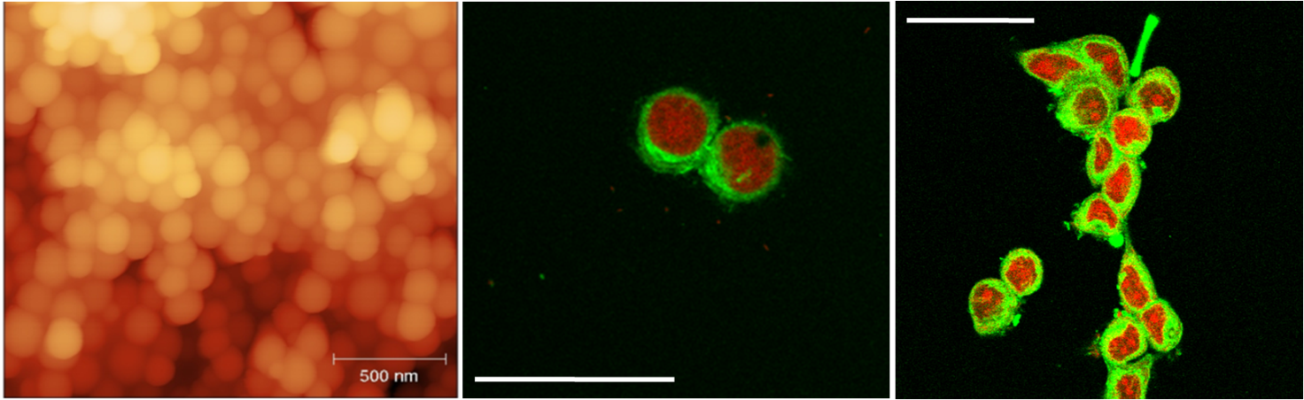
Figure 1 AFM image of PLA nanoparticles (left) and confocal images of coumarin 6-loaded nanoparticles (green fluorescence) internalized by SKBR3 (middle) and MCF7 (right) breast cancer cells.

Thesis outline
The present work is divided in four sections and five chapters. Chapter 1 is a general introduction, drafting a picture on the use of nanoparticles in medicine. The second and third sections are dedicated to the experimental work, aimed at optimizing different parameters and methods for the preparation of nanoparticles to be applied in the field of nanomedicine. Chapter 5 is a short dissertation on the future perspectives regarding the application of nanocarriers as drug delivery devices.
The basic content of each section and chapter is outlined and summarized below.
Section I (Chapter 1) is a brief overview on the use of nanoparticles as drug delivery devices in literature, focused on the description of the principal materials and fabrication protocols adopted. The state of the art and future trends in this field are extensively discussed.
Section II is dedicated to the experimental work dealing with the preparation and characterization of biodegradable nanoparticles. Two different methods were used to prepare nanoparticles for the passive (Chapter 2) and active (Chapter 3) targeting of cancer. In this section, the possibility of introducing novel biodegradable materials with tunable properties (polyurethanes) as matrix-forming materials for nanoparticles was investigated.
Chapter 2 describes the preparation and characterization of biodegradable nanoparticles by using the Solvent Displacement Method, for the controlled release of the anticancer drug Paclitaxel. Three different materials were tested: two widely used biodegradable polyesters (Poly(ε-caprolactone) and Poly(D,L-lactide)) and one proprietary polyester-urethane. The protocol for particles preparation was optimized in order to obtain the appropriate dimensions for the passive targeting of tumor cells. The release kinetics as well as the cellular uptake pathways were also studied and characterized.
Chapter 3 deals with the preparation and characterization of surface-modified nanoparticles for the active targeting of breast cancer cells. Different materials were used as particle-forming matrices: three commercial polyesters and two proprietary polyeter-urethanes, prepared with different chain extenders. The procedure followed for particles preparation was optimized and the surface was coated with a monoclonal antibody able to selectively bind to specific receptors which are over-expressed on breast cancer cells. The ability of coated and non coated particles to enter these cells as well as the cytotoxicity of different drug-nanoparticles formulations was investigated.
Section III (chapter 4) describes the application of nanoparticles to the field of bone tissue engineering. Indomethacin-containing nanoparticles were prepared and loaded on injectable, biodegradable bone cements, containing β-Tricalciumphosphate (TCP) and Collagen.
In section IV (chapter 5), the main achievements of the experimental work are presented and the future trends and general conclusions are discussed.

Section I

Chapter 1

Nanotechnology-based Drug Delivery Systems: State of the Art and Future Trends

1.1 Introduction
Nanotechnology-based drug delivery systems have gained growing attention in the past decades because they offer new opportunities in improving, and often combining, diagnosis and treatment of various diseases.
Corporate investments in the field have increased year by year and founding raised in the United States from $116 million in 2001 to $82 billion in 2007 [1,2].
A successful drug delivery system should enhance therapeutic outcome, improve patient compliance and reduce therapeutic costs.
Moreover they are expected to offer the possibility to: (i) selectively deliver the encapsulated drug by specific recognition of their target tissues/cells; (ii) reduce toxic side effects such as infections, systemic toxicity or undesired immune reactions and (iii) minimize risks associated with drug administration by improving drug pharmacokinetic and bioavailability [3].
Traditional nanotechnology for drug delivery refers to those nanoscale vehicles mainly utilized to improve the release properties of pharmacologically active molecules. Recently new multifunctional platforms have been developed to combine therapeutic purposes with the ability to perform other tasks. These tools combine the traditional function of drug delivery with diagnostics, by encapsulating fluorescent or magnetic resonance imaging agents (such as quantum dots or super-paramagnetic particles) as well as with long-term therapeutic strategies such as photothermal therapy in oncology or combined release of multiple therapies such as drugs in conjugation with biomolecules like nucleic acids or peptides [4,5].
1.2 Polymeric nanoparticles as drug delivery systems
Among the nanotechnology-based drug delivery systems, biodegradable polymeric nanoparticles have attracted immense interest in research because they offer several advantages over traditional medicine with respect to controlled release, therapeutic impact and targeted delivery through easy surface nanoengineering [6]. They can be tailor-made to achieve both controlled drug release and disease specific localization by tuning the polymer characteristics and surface chemistry [7-9].
Figure 1.1 represents the increase in the number of scientific publication from 1996 to 2010 (Scopus) regarding polymer nanoparticles [10] and reflects the growing interest raised in the scientific community in this field.
Figure 1. 1 Representation of the increase in the number of scientific publications on polymer nanoparticles [10].
Nanoparticles are solid, colloidal particles consisting of macromolecular substances that vary in size from 10nm to 1000nm [11.]. The drug of interest could be dissolved, entrapped, adsorbed, attached or encapsulated into the polymer matrix (see figure 1.2) and according to the interactions that take place between the drug and the polymeric carriers, nanocapsules or nanospheres can be obtained [12].
Nanocapsules are core-shell type vesicular systems in which the active principle is confined to a cavity surrounded by a polymeric membrane of variable thickness.
Nanospheres are matrix-type nanoparticles, in which the drug is entrapped or finely dispersed in a polymer matrix.
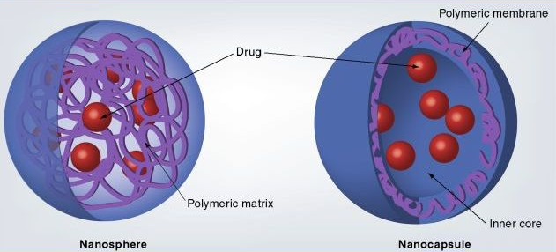
Figure 1. 2 Schematics of exemplary types of drug nanoparticles. In matrix type nanosphere, drug molecules are evenly dispersed in the polymer matrix. In core shell nanocapsule the drug molecule is presented in a core covered by a polymer shell.
1.2.1 Advantages of polymeric drug carriers.
Polymeric nanoparticles have been extensively investigated as carriers for various drug formulations, such as hydrophilic or hydrophobic active principles [13-15], DNA [16], RNA [17] or other biomolecules [18], because of their ability to improve the therapeutic value, the solubility and the bioavailability of the encapsulated active principles [19].
Traditional administration routes, such as transdermal, nasal or oral routes, though simple and comfortable for patients, display several drawbacks like poor bioavailability due to the passage through various biological barriers (like the intestine or the digestive systems) in which extreme conditions (pH, applied stresses) may degrade the active principle and reduce the efficacy of therapies [20-22]. Other challenges involved in conventional drug delivery include reproducibility of the release kinetics, the difficulties of targeting specific regions without affecting healthy tissues and the poor water solubility of many potent active principles.
Nanomedicine formulation depends on the choice of suitable polymeric systems having the higher encapsulation efficiency, bioavailability and retention time.
1.2.1.1 Localized and targeted drug delivery
One of the major goals in drug delivery is the possibility to deliver the drug toward its specific target tissue or organ without affecting normal neighbors [23]. Nanoparticles are capable of targeting at many different levels from organs to tissue and cells. Targeting can be achieved by applying external stimuli, like ultrasounds or magnetic fields, or by simply taking advantage of the size of the carriers (passive targeting) which could be tuned in order to enable nanoparticles to leak through peculiar vasculature fenestrations of different organs and tissues. For example blood vessels in liver have fenestrations of approximately 100-170nm [24], many types of tumors are characterized by highly porous vessels with a pore cut off size between 300 and 700nm [25].
Moreover polymer nanoparticles can be surface-modified with specific ligands such as antibodies, transferring or folate for the active targeting of specific cells over-expressing specific receptors for the immobilized molecules [26,27].
The localized and targeted delivery greatly helps in reducing systemic toxicity and in increasing the efficacy of therapies [28].
1.2.1.1.1 Passive targeting
As mentioned above, the passive targeting ability of nanoparticles relies on their small size, which enables them to preferentially concentrate in the tumor tissues, inflammatory and infectious sites by virtue of the enhanced permeability and retention (EPR) effect of these tissues (see figure 1.3). Tumors are composed of fast-growing cells needing a high supply of nutrients in order to survive and proliferate. To sustain this abnormal growing potential, tumor vessels present specific characteristics like highly fenestrated vessels with a pore
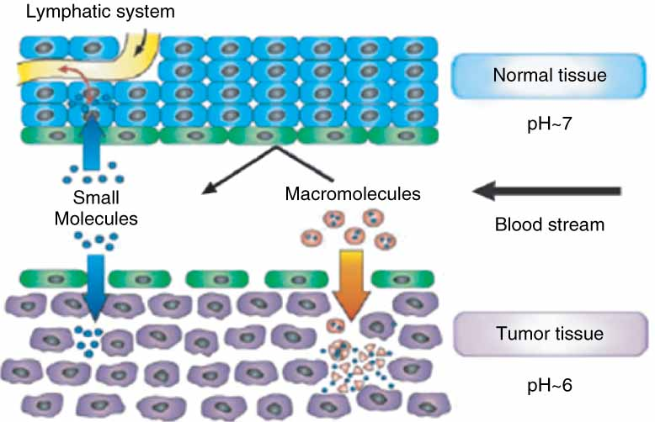
Figure 1. 3 Representation of the passive targeting of small molecules to tumour tissues through the EPR effect. Taken from [29]
cutoff ranging from 300 to 700nm depending on the tumor type. Nanoparticles with average diameters of 100-250nm are able to selectively accumulate into tumors (Enhanced permeation effect) [30].
Moreover these tissues lack of an efficient lymphatic system and are therefore not able to eliminate these particles once they enter the cells (Retention effect).
Once accumulated at the target site, hydrophobic biodegradable polymeric nanoparticles can act as a local drug depot, providing a source for a continuous supply of encapsulated therapeutic compound at the disease site [31,32].
1.2.1.1.2 Active targeting
Targeting molecules may be conjugated to the surface of nanoparticles to actively target them to particular sites in the body. Targeting is mainly achieved by immobilizing small peptides (like transferrins or folate) or monoclonal antibodies which can enhance the receptor-mediated cellular internalization.
Active targeting is particularly helpful in the treatment of cancer, since cancer cells normally over-express peculiar receptors which can be exploited for selective recognition.
For example folate or transferrin receptors are over-expressed on various tumor cells and can enhance cellular endocytosis of decorated drug carriers [33,34].
Monoclonal antibodies can also be used to selectively target specific cancer cells with virtually none or little effect on normal cells [35].
1.2.1.2 Sustained and controlled release
Nanoscale drug delivery systems offer the possibility to deliver various drug formulations at optimum dosages and at controlled intervals of time, thus improving patient compliance and optimizing therapeutic outcomes [36,37].
The release kinetics of encapsulated or matrix-entrapped active principles could be controlled and modulated according to therapeutic needs, by choosing the correct type of material for nanoparticles preparation [10].
1.2.1.3 Extended blood circulation time and biodistribution
Nanocarriers may increase the circulation time of drugs within the body. This property is particularly important for intravenously administered nanoparticles, being a pre-requisite for targeted and sustained delivery.
Particles size is intrinsically related to circulation time. In particular, smaller particles (below 200nm), being able to escape phagocyte clearance, show prolonged blood circulation. Larger particles, on the other hand, are easily taken up by the Reticulo-endothelial system (RES) and eliminated from the body [38,49].
1.2.1.4 Delivery of poorly water soluble drugs
Drugs are conventionally administered in the form of free, unassociated molecules. This strategy has inherent limitations especially for what concerns highly cytotoxic formulations (like most of chemotherapeutics) or environmentally sensitive substances.
Several potent drugs are highly hydrophobic, resulting in poor bioavailability and in the need to increase dosages with a higher risk of severe side effects.
Nanoparticles may increase the solubility of these drugs and thus represent a valid solution to the problem of their effective administration [41].
1.2.1.5 Protection of the encapsulated active principle
Many drugs, especially nucleic acids and peptides, are rapidly cleared and degraded by the body during their passage through biological barriers, this often results in reduced targeting ability. Drug nanoformulations can protect the active principle from premature degradation and interaction with the biological environment thus enhancing intracellular penetration [41].
1.2.1.6 Enhanced cellular uptake and ability to cross biological barriers
Intracellular drug delivery helps in reducing toxicity and improving dosage efficacy.
Hydrophobic nanoscale drug carriers are able to cross biological barriers and are easily internalized by non phagocytic cells [42]. The extent of the uptake and the localization in the specific intracellular compartment is size dependent [43]. The encapsulated principle can therefore be directed to specific sites by tailoring the dimensions of the carrier.
The small size of nanoparticles enables them to cross several biological barriers, like the blood/brain barrier or the intestinal barrier, which represent a major obstacle for the delivery of various drug formulations [44].
1.2.1.7 Enhanced surface area
As compared to conventional drug delivery systems, nanoparticles possess larger surface areas per unit of volume. This feature results in improved loading and release properties [2].
1.3 methods for the preparation of nanoparticles
Several methods have been developed for preparing nanoparticles. Conventionally they can be divided into two main categories, according to weather the formulation requires a polymerization reaction of monomers or is achieved directly from preformed natural or synthetic polymers [45,46].
The choice of the proper preparation method depends on different factors such as the polymeric matrix-forming material, the area of application and the final size.
1.3.1 Particles prepared from the polymerization of monomers
The polymerization methods can be divided into emulsion polymerization (organic or aqueous, depending on the continuous phase) of which two versions have been proposed depending on the addition of surfactants and interfacial polymerization.
In table 1.2 the basic characteristics of nanoparticles prepared by polymerization of monomers are summarized.

1.3.1.1 Emulsion polymerization
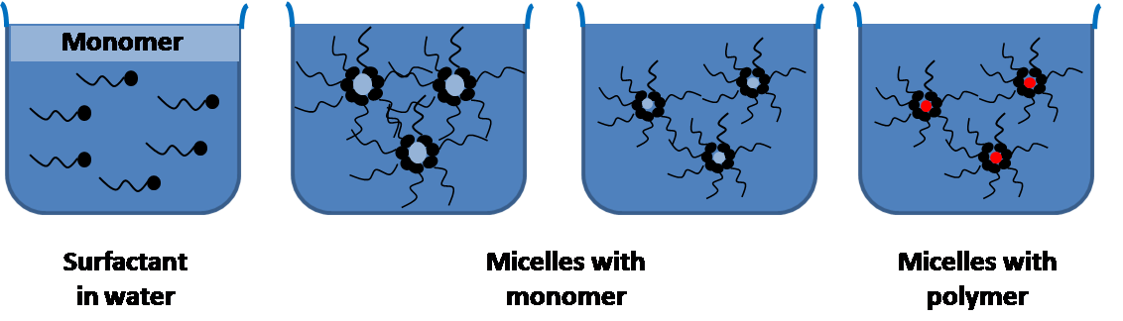
Figure 1. 4 Schematic representation of the basic steps of the Emulsion polymerization technique.
Emulsion polymerization is a simple, common, easily scalable and fast method for the preparation of nanoparticles. Water is used as dispersing medium, since it is environmentally friendly and also allows excellent heat dissipation during the course of the polymerization.
Based on the utilization of surfactants, the method can be classified into conventional and surfactant-free emulsion polymerization [47].
The other ingredients are a monomer of low water solubility and a water-soluble initiator.
Initiation occurs when a monomer molecule dissolved in the continuous phase collides with an initiator molecule that may be an ion or a free radical. Alternatively, the monomer molecule can be transformed into an initiating radical by high-energy radiation, including γ-radiation, ultraviolet or strong visible light. The emulsion polymerization method is comprised of three major steps, as described by Smith and Ewart [48].
At first, the monomer is dispersed or emulsified in a solution of surfactant and water forming relatively large droplets of monomer in water, while excess surfactant will create small micelles in which small amounts of the monomer will slowly migrate (see figure 1.4).
The addition of the water-soluble initiator into the water phase will cause the monomer, present inside the micelles, to react and polymerize. Since the total surface area of the micelles is much greater than the total surface area of the fewer, larger monomer droplets, the initiator typically reacts in the micelles.
During the second step, the monomer in the micelles quickly polymerizes and the monomer-swollen micelle turns into a polymer particle.
Since excess monomer is still present in the initial droplets, it will start to diffuse to the growing particle, where more initiators will eventually react until all remaining monomer is located in the particles.
Phase separation and formation of solid particles can take place before or after the termination of the polymerization reaction [49].
The size of the latex particles thereby produced is usually in the range of 50–300 nm. Under appropriate conditions, these particles, formed either by dispersion or by emulsion polymerization, may have a narrow size distribution [50,51]. Previous studies also demonstrated that various conditions, such as the nature and concentration of the surfactant, monomer and initiator concentration play an important role in determining the size and size distribution of the particles, as well as the efficiency of the polymerization process.
Conventional emulsion polymerization systems utilize varying quantities of surfactants that need to be eliminated from the final product but are hard to remove completely. Removal of surfactants is a time consuming process that increases the cost of production [52,53]. As an alternative, emulsion polymerization has been performed in the absence of emulsifier (surfactant free emulsion polymerization). The reagents used include deionized water, a water soluble initiator and monomers. In such polymerization systems, stabilization of NPs occurs through the use of ionizable initiators or ionic co-monomers.
To further reduce the size of the droplets a slight modification of the tradition emulsion polymerization method has been proposed, called mini-emulsion polymerization. The key difference between these two methods, summarized in table 1.1, is the additional use of low molecular masses co-stabilizers and the use of high shear devices to form the emulsion.
Particles with very low polydispersity and small size, ranging from 10 to 30 nm, can be obtained with this method [54,55].
Characteristics | Emulsion | Mini-emulsion
Thermodynamic stability | Non-stable | Non-stable
Stability period | Seconds to months | Hours to months
Droplet size | 1-10 µm | 20-200 nm
Polydispersity | Low | Very low
Particle size | 50-300 nm | 10-30 nm
Table 1. 1 Basics differences between emulsion and mini-emulsion polymerization. Adapted from [10].
1.3.1.2 Interfacial polymerization
Interfacial polymerization is one of the well established methods used for the preparation of polymer nanoparticles It involves step polymerization of two reactive monomers or agents, which are dissolved respectively in two phases (i.e., continuous and dispersed phase), and the reaction takes place at the interface of the two liquids [56]. Particles obtained by interfacial polymerization have high encapsulation efficiency [57]. Moreover the polymer is formed in situ allowing the polymer membrane to follow the contours of the inner phase of the emulsion. On the other hand the use of organic solvents as external phase and the extensive washing steps required represent the major drawbacks of this method.
Polymer | Encapsulant | Size | Reference
Emulsion polymerization
Poly(methylmethacrylate) | Influenza antigen | 130 | [58]
Poly(methylmethacrylate) copolymer | Doxorubicin | 300 | [59]
Poly(methylcyanoacrylate) | Vinblastine | 200-300 | [60]
Poly(ethylcyanoacrylate) | Insulin | <500 | [61]
Poly(butylcyanoacrylate) | Progesterone | 250 | [62]
Poly(isobutylcyanoacrylate) | Ampicillin  Antibodies  hGFR | 40-80  120  140-170 | [63]  [64]  [65]
Interfacial polymerization
Poly(ethylcyanoacrylate) | Insulin | 150 | [66]
Poly(isobutylcyanoacrylate) | Indomethacin  Insulin  Calcitonin | 220-240  150-300  <1000 | [67]  [68]  [69]
Table 1. 2 Drug-nanoformulations prepared by polymerization of monomers.
1.3.2 Particles prepared from preformed polymers
Most of the monomers suitable for nanoparticles preparation involving in situ polymerization, lead to slowly biodegradable or non biodegradable polymers. In addition, residual molecules in the polymerization medium can be toxic, thus extensive washing and purification steps are needed. To avoid these limitations methods starting from preformed polymers instead of monomers have been proposed.

1.3.2.1 Emulsification Solvent evaporation form single Oil-in-Water emulsion
Solvent evaporation was the first developed method to prepare nanoparticles from preformed polymers [70] and is the most widely employed technique in the literature.
These method utilizes high-speed homogenization or ultrasonication followed by solvent evaporation either by continuous stirring or under reduced pressure.
Nanospheres preparation involves four major steps, as represented in figure 1.5 [71]. During the first step, the polymer is dissolved in an organic solvent, like dichlorometane (DCM), chloroform or ethyl acetate. The drug (generally lypophilic) is dissolved or dispersed into the preformed polymer solution.
Figure 1. 5 Schematic representation of the Single Emulsion Solvent Evaporation method [71]
This mixture is then emulsified using a dispersing agent and high energy homogenization, into an external solution immiscible with the first one (generally water) to make an oil in water (O/W) emulsion.
During the third step the polymer precipitates in the form of nanospheres in which the drug is finely dispersed inside the polymer matrix. The solvent is subsequently evaporated by increasing the temperature, reducing the pressure or by continuous stirring.
The last phase consists in the harvesting and washing of nanospheres, generally by selective centrifugation or dialysis.
The size can be controlled by adjusting the stirring rate, type and amount of dispersing agent, viscosity of organic and aqueous solutions and temperature [72,73].
Generally an increase in the emulsifier concentration results in a decrease in particles size while the homogenization speed and the evaporation rate only slightly influence the nanoparticles size [74].
In the past dichloromethane and chloroform were widely used but are now replaced by ethyl acetate which has a better toxicological profile [10].
Different emulsions can be prepared, though oil in water emulsions are the most common, since the use of water highly simplifies the washing and purification process, reducing the risk of aggregation. This method is suitable only for lypophilic drugs and limitations are imposed by scale up and high energy requirements in homogenization [75].
This method is frequently applied for biodegradable polyesters, like poly(D,L-lactide) PLA [76], poly(ε-caprolactone) (PCL) [77] and poly(lactide-co-glycolide) PLGA [78] and has been successfully proposed for the encapsulation of different active principles like Indomethacin, albumin, loperamide and testosterone [79-80] [75]
1.3.2.2 Water in Oil in Water (W/O/W) Double emulsion solvent evaporation method.
The W/O/W double emulsion methods have been most widely used because of their relatively simple process, convenience in controlling process parameters, and ability to produce small and mono-disperse particles with inexpensive equipment [81,82].
The double emulsion method was first developed by the industrial group of Takeda Chemical Industries [83-85] for the encapsulation of hydrophilic substances, such as peptides or other biomolecules, for which the single emulsion method is not suitable.
During manufacturing, in order to avoid denaturation or aggregation, these molecules must not be subjected to excessive exposure to heat, shear forces or extreme pH variations [86].
The multiple Emulsion Solvent Evaporation method consists in dissolving the drug in distilled water or in a buffer solution containing a surfactant, called the inner phase, while the polymer is dissolved in a proper organic solvent.
The inner water phase is then poured into the second organic phase and emulsified, to form a primary water-in-oil emulsion. This first emulsion is then poured under vigorous mixing into an aqueous solution of the emulsifier (external aqueous phase), to form a secondary water-in-oil-in-water emulsion.
This double emulsion is then kept under constant stirring until solvent evaporation is achieved and solid drug loaded particles are formed [87].
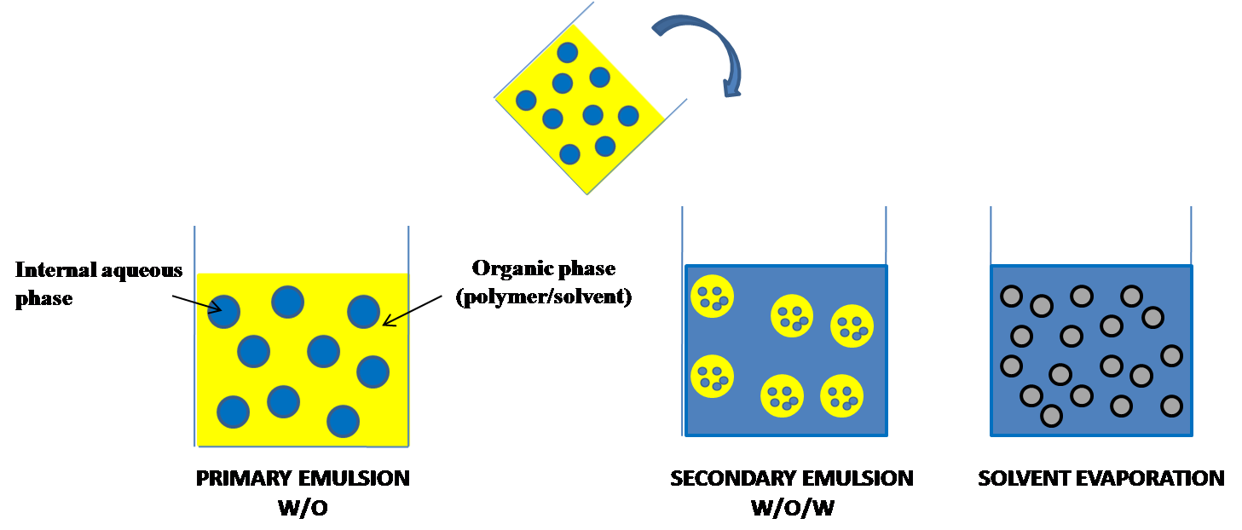
Figure 1. 6 schematic representation of the W/O/W double emulsion method.
Important parameters are the duration and preparation of the emulsification steps, the polymer concentration, the solvent used and the amount and type of emulsifier used [88].
Generally the most used emulsifier is Polyvinylalcohol (PVA) and its concentration in the internal phase is the most important parameter affecting particles size, while PVA concentration in the external aqueous phase and the homogenizer speed only slightly influence the particles size [89].
Polymer | Organic solvent | Stabilizer | Emulsion type | Particles size (nm) | Ref
PLGA | Dichloromethane/acetone | PVA | O/W | 60-200 | [90]
PLGA | Dichloromethane | Span 40 | W/O/W | 200 | [91]
PLA | Dichloromethane | PVA | W/O/W | 200 | [92]
PEG-PLA | Dichloromethane | Sodium Cholate | W/O/W | 200 | [93]
PLGA | Chloroform | SDS | W/O/W | 76 | [94]
Table 1. 3 Different nanoparticles formulations prepared by single or double emulsions using different polymers and processing parameters.
1.3.2.3 Solvent Displacement
The Solvent Displacement method or Nanoprecipitation method was developed by Fessi et al. [95] for the preparation of polymeric nanoparticles.
The method is based on the spontaneous emulsification of the organic internal phase containing the dissolved polymer and the drug into the aqueous external phase.
The method involves the precipitation of a preformed polymer from an organic solution, composed of a completely water miscible solvent such as acetone, in the aqueous medium containing the surfactant.
Rapid diffusion of the solvent into non solvent phase results in the decrease of interfacial tension between the two phases, which increases the surface area and leads to the formation of small droplets of organic solvent [96]. Nanoprecipitation system consists of three basic components: the polymer, the polymer solvent and the nonsolvent of the polymer. Organic solvents (i.e., ethanol, acetone, hexane or dioxane) which are miscible in water and easy to remove by evaporation are chosen as polymer solvents.
The polymers commonly used are biodegradable polyesters, especially poly(ε-caprolactone) [97], poly (D,L-lactide) [92] and poly(lactide-co-glycolide) [64,90] (see table1.4).
Nanoparticles are produced by slow addition of the organic phase to the aqueous phase under moderate stirring. Reversing this order by adding the aqueous phase to the organic phase also leads to the formation of PNP. Nanoparticles with a well defined size are characterized by a narrow distribution formed instantaneously during the rapid diffusion of the polymer solution in the non solvent phase.
Nanoprecipitation is a simple, fast and reproducible method which is widely used for the preparation of both nanospheres and nanocapsules. Even though low polymer surfactant concentrations are employed, challenges pertaining to low polymer concentration in the organic phase have to be addressed.
Polymer | Solvent | Non-Solvent | Stabilizing agent | Size | Reference
PLGA | Acetone | Water | PVA | 90-500 | [98]
PCL | Acetone | Water | PVA | 360 | [99]
PCA | Ethanol/water | Water | - | 150 | [100]
PLA | THF | Water | - | 100-300 | [101]
PCL | Acetone | Water | Span 20 | 741-924 | [97]
PCL | Acetone | Water | Polysorbate 80 | 260 | [102]
PLA | Acetone | Water | Poloxamer 188 | 250 | [103]
PCL | Acetone | Water | Pluronic F68 | 300 | [104]
Table 1. 4 Principal characteristics of different nanoparticles prepared by the Solvent Displacement method.
1.3.2.4 Salting out
Figure 1. 7 Schematic representation of the salting out method [46].
The salting out method is based on the separation of a water miscible solvent from aqueous solution via a salting out effect [46] and avoids the use of surfactant and chlorinated solvents. Generally the polymer and drug are dissolved in a totally water-miscible solvent (i.e. acetone) and added to a solution of water, containing a salting out agent (magnesium chloride, calcium chloride or sucrose). An Oil in Water emulsion is then formed by homogenization and diluted with a sufficient volume of water to decrease salt concentration and enhance the diffusion of the solvent into the aqueous phase, thus inducing the formation of nanospheres.
The most important parameter affecting nanoparticles size is the choice of the salting out agent (table 1.5).
Polymer | Salting-out agent | Organic Solvent | Size | Reference
PDLLA | Mg(CH₃COO)₂4H₂O | Acetone | 295 | [105]
PLGA | MgCl₂6H₂O | THF | >200 | [106]
PLGA | CaCl₂ | Acetonitrile | 480 | [107]
PDLLA | MgCl₂6H₂O | Acetone/Ethyl acetate | 100-400 | [108]
PDLLA | MgCl₂6H₂O | Acetone | 279 | [109]
PDLLA | MgCl₂6H₂O | Acetone | 248 | [110]
PLGA | PVA | Acetone/DCM | 110 | [111]
Table 1. 5 Characteristic of nanoparticles prepared by the Salting out method. Adapted from [10]

1.4 Polymers used in nanoparticle formulations
The most widely used polymers for the preparation of biodegradable nanoparticles belong to the polyester family. Biodegradable polyesters such as poly (D,L-lactic acid), poly (lactide-co-glycolide) and poly (ε-caprolactone) have been used extensively for biomedical applications. In some instances, to improve the circulation time in the blood of nanoparticles, copolymers with poly(ethylene glycol) (PEG) are used since it is known that the presence of PEG chains on the surface of nanoparticles hinders the uptake from the mononuclear phogocytic system (MPS).
1.4.1 Polylactide
PLA belongs to the family of aliphatic polyesters derived from α-hydroxy acids. The building block of PLA, lactic acid (2-hydroxy propionic acid), can exist in optically active D- or L-enantiomers. Depending on the proportion of the enantiomers, PLA of variable material properties can be derived (see figure 1.8). This allows the production of a wide spectrum of PLA polymers to match performance requirements [112].
Commercial PLAs are copolymers of poly(L-lactic acid) (PLLA) and poly(D,L-lactic acid) (PDLLA), which are produced from L-lactides and D,L-lactides, respectively [113]. The l-isomer constitutes the main fraction of PLA derived from renewable sources since the majority of lactic acid in living systems exists in this form. Depending on the composition of the optically active L- and D- enantiomers, PLA can crystallize in three forms (α, β and γ) The α structure is more stable and has a melting temperature T_{m} of 185°C compared to the β structure, with a T_{m} of 175°C [114]. The optical purity of PLA has several profound effects on the structural, thermal, barrier and mechanical properties of the polymer. PLA polymers with L-content greater than 90% tend to be crystalline while those with lower optical purity are amorphous. Moreover, T_{m}, glass transition temperature and crystallinity decrease with decreasing L-isomer content [114][115].

Figure 1. 8 Synthesis of PLA from l and d lactic acids [113].
PLA nanoparticles have been mostly prepared by solvent evaporation, solvent displacement and salting out method, for the encapsulation of various drug formulations (see table 1.6).
Polymer | Encapsulant | EE | Method | Size | Ref
PLA | Oridonin | 91,8% | Single emulsion | 137,3 | [116]
 | Chloricomene | 4% | Solvent displacement | 320 | [117]
 | BSA | 75,6% | Double emulsion | 330 | [118]
 | Savoxepine | 95% | Salting-out | <1000 | [119]
 | Progesterone | 70% | Single emulsion | 260-300 | [120]
 | Doxorubicin | 80% | Solvent displacement | 270 | [121]
 | Taxol | 80% | Solvent displacement | 260 | [122]
 | Diclofenac | 100% | Solvent Displacement | 189-234 | [123]
Table 1. 6 Different drug nanoparticles formulations prepared with PLA as matrix-forming material
The salting out method has been proposed for the preparation of PLA nanoparticles containing Savoxepine [119], a dopamine receptor antagonist, resulting in extended drug delivery over a period of one week and in high encapsulation efficiency (95%).
The solvent evaporation method has been widely applied for the preparation of PLA nanoparticles, reporting fast release profiles. Hormones and other drugs have been encapsulated by this method: Matsumoto et al prepared progesterone loaded nanoparticles with a PEG-PLA-PEG copolymer, reporting high encapsulation efficiency (70%) and small particles size, depending on the amount and molecular weight of the PEG chains [120].
Zhang and coworkers prepared nanoparticles with a PLA-TPGS copolymer for the encapsulation of the anti-cancer drug Paclitaxel, by the solvent extraction evaporation method. They reported small particles size (300nm) and high encapsulation efficiency (80%) [122].
1.4.2 Poly (D,L-lactide-co-glycolide) (PLGA)
PLGA is one of the successfully used biodegradable polymer for the development of nanomedicine, since it undergoes hydrolysis in the body, producing biocompatible degradation monomers (lactic acid and glycolic acid). PLGA is an FDA approved amorphous copolymer of PLA and PGA (Poly glycolic acid), which easily dissolves in common organic solvents such as dichloromethane and ethyl acetate. The degradation rate in water is a function of the molecular weight and of the lactide:glycolide ratio [124] Higher glycolide content and lower molecular weight increase the degradation rate.
Kumari A. et al 2010 Colloids and Surfaces B: Biointerfaces 75:1
PLGA nanoparticles have been prepared for the encapsulation of both hydrophilic and hydrophobic formulations mostly by Single or Double Emulsion Solvent Evaporation technique and by the Solvent Displacement method.
PLGA has been used to encapsulate various anticancer formulations like Paclitaxel, Xanathones, Cisplatin and Doxorubicin (see table 1.7).
Fonseca and co-workers used the solvent displacement method to prepare small (size <200nm) and spherical Paclitaxel-loaded PLGA nanoparticles. Particles showed a high encapsulation efficiency (higher than 90%) and a bi-phasic release profile with an initial burst effect (50%) followed by a slow continuous release [125].
Moreno et al prepared Cisplatin-loaded PLGA nanoparticles (200nm) by the w/o/w double emulsion technique. Encapsulation efficiency was 11% and the release profile followed a linear kinetic, after a 20% burst release [126].
Other drugs, like Insulin, antibiotics, hormones and proteins have also been encapsulated into PLGA nanoparticles.
Polymer | Encapsulant | EE | Method | Size (nm) | Ref
PLGA | Paclitaxel | 90% | Solvent displacement | 200 | [125]
 | Estradiol | 51,3-67,8% | Modified single emulsion | 104-155 | [127]
 | Insulin | 80% | Double emulsion | >1000 | [128]
 | Xanthones | 26-33% | Single emulsion | 164 | [129]
 | Doxorubicin | 95% | Single emulsion | 280 | [130]
 | Doxorubicin | 67% | Double emulsion | 316 | [130]
 | BSA | 95-98% | Double emulsion | 200 | [131]
 | Cisplatin | 11% | Double emulsion | 200 | [126]
Table 1. 7 PLGA nanoparticles for the encapsulation of different drug formulations.
1.4.3 Poly(ε-caprolactone)
Poly(ε-caprolactone) (PCL) obtained by ring opening polymerisation of ε-caprolactone was first reported by Pitt et al. [132] for the controlled release of steroids and narcotic antagonists as well as to deliver opthalmic agents. PCL is a hydrophobic semi-crystalline polymer having a glass transition temperature of -60°C and a melting point ranging from 59 and 64°C [133]. Its crystallinity tends to decrease with increasing molecular weight. The good solubility of PCL, its low melting point and exceptional blend compatibility has stimulated extensive research into its potential application in the biomedical field [134,135]
PCL can be prepared by either ring opening polymerization of ε-caprolactone using a variety of anionic, cationic and coordination catalysts or via free radical ring opening polymerization of 2 methylene 1,3 dioxepane [132].
PCL is known to degrade by hydrolysis according to a bulk degradation mechanism and the rate of degradation is slower than that of other biodegradable polyesters, like PLA and PLGA.
The degradation process proceeds according to two phases (see figure 1.8) [133]: (i) Initial loss of molecular weight due to chain scission and (ii) onset of weight loss. The process is auto catalytic, since the presence of free carboxylic acid end-groups catalyzes further hydrolysis of additional ester groups. A constant decrease in intrinsic viscosity and average molecular weight are observed during the first stage of degradation, while no weight loss can be detected. The second phase of degradation is characterized by a decrease in the rate of chain scission and the onset of weight loss, attributed to an increased probability of diffusion of small polymer chains out of the bulk material. In this stage an increase in crystallinity in also observed, since cleavage takes place preferably in the amorphous regions of the polymer.
Figure 1. 9 The degradation of PCL via hydrolysis intermediates 6hydroxyl caproic acid and acetyl coenzyme A, which are then eliminated from the body via the citric acid cycle (a). Schematic visualization of how crystalline fragmentation could have taken place(b). [136,137]
PCL and its copolymers or blends have been used to prepare nanoparticles by different methods and for the encapsulation of numerous drugs (see table 1.8).

Polymer | Encapsulant | EE | Method | Size | Ref
PCL | Indomethacin | - | Solvent displacement | 200-250 | [138]
 | Tamoxifen | 60% | Solvent displacement | 320 | [139]
 | Taxol | 95% | Solvent displacement | 270 | [140]
 | Diclofenac | 99% | Spray drying | 240-300 | [141]
 | Docetaxel | 65% | Solvent Displacement | 227nm | [142]
Table 1. 8 PCL nanoparticles for the encapsulation of different drug formulations.
Calvo et al. successfully investigated the possibility of using PCL nanoparticles for the relase of Indomethacin in ophthalmic applications. They used the solvent displacement method to prepare nanoparticles with small size (200-250 nm) which showed an in vitro corneal penetration three fold higher than that of commercial eye drops [138].Flurbiprofen and Diclofenac were also successfully encapsulated in PCL nanospheres prepared by solvent displacement method and spray drying, respectively. The encapsulation efficiency of diclofenac-loaded nanoparticles was very high (90-93%) and the average diameter ranged from 240 to 300 nm [140,143]
1.4.4 Poly (ethylene glycol) and the concept of “stealth nanoparticles”
The nature of the surface of the nanoparticles largely influences their biodistribution following in vivo administration. Hydrophobic nanoparticles are rapidly coated by blood proteins (opsonins) and consequently cleared from the systemic circulation by the mononuclear phagocytic system (MPS), ending in the liver or in the spleen.
The macrophages of the MPS have the ability to remove unprotected nanoparticles from the bloodstream within seconds of intravenous administration, rendering them ineffective as site-specific drug delivery devices [144].
These cells cannot directly identify the nanoparticles themselves, but rather recognize the opsonin proteins (like immunoglobulins or other complement proteins) bound to the surface of the particles [145]. The process of opsonization has been shown to be more rapid for hydrophobic polymers. The hydrophobic nature of most biodegradable particles could therefore limit the applicability of these carriers in many drug delivery applications.
Several strategies have been proposed to temporarily bypass the MPS by increasing the surface hydrophilicity of nanoparticles [144,146,147].
Some of these systems make use of surface treatments that interfere with the binding of opsonin proteins to the particle surface. One widely used method to slow opsonization and impart stealth properties to nanoparticles is the use of surface adsorbed or grafted shielding groups which can block the electrostatic and hydrophobic interactions that help opsonins bind to particle surfaces
Several types of surface modified nanoparticles have been described in recent literature.
The most common moiety used for surface modification is poly (ethylene glycol) (PEG). PEG is a hydrophilic, non-ionic polymer that has been shown to exhibit excellent biocompatibility. PEG molecules can be added to the particles via covalent bonding or by surface adsorption.
The presence of a PEG brush on the surface of nanoparticles besides increasing residence time in the systemic circulation can also reduce protein and enzyme adsorption on the surface and thus can retard particle degradation. The degree of protein adsorption depends on the thickness of the PEG layer which, in turn, depends on the density and molecular weight of PEG on the surface [148]. It has been shown that as PEG molecular weight above 2000 leads to longer blood circulation half-life of the PEGylated particles [144,149,150].
Other critical factors are the density and conformation of the PEG chains on the surface.
Figure 1. 10 Schematic representation of PEG distribution on the surface of nanoparticles: A) Mushroom configuration and B) Brush configuration.
At low surface coverage, the PEG chains have a larger range of motion and will typically take on what is termed a “mushroom” configuration (Fig. 1.10 A), and will localize mostly close to the surface of the particle. Very low surface coverage can also lead to gaps in the PEG protective layer where opsonin proteins can freely bind to the nanoparticle surface.
At high PEG density (brush configuration), even though a complete surface coverage is assured, the range of motion of the chains is greatly reduced resulting in decreased steric repulsion of opsonins (Fig 1.10B) [151].
1.5 Thesis Goal
The objective of this thesis is to define new strategies for the preparation of nano-materials for the controlled and targeted drug release for cancer treatment and in tissue engineering, eventually through the application of novel carrier materials and surface decoration with targeting moieties.
At present, lots of work has been carred out on the studying and optimization of nanoparticulate carriers for drug release starting from biodegradable commercial polyesters, such as poly(D,L lactide-co-glycolide), poly(D,L lactide), poly(ε-caprolactone) and their co-polymers [120,125,132]. Even if encouraging results have been so far obtained, the in vivo fate of these carriers still remains to be cleared [38]. It has been demonstrated that nanoparticles are rapidly cleared by the mononuclear phagocytic system (MPS), through a process called opsonization, and are subsequently eliminated from the body or accumulated in organs, such as the liver or the spleen [145]. This phenomenon is particularly evident for highly hydrophobic materials, such as commercial polyesters normally used for particles preparation [145].
To avoid such inconvenience, the most commonly adopted strategy to escape opsonization and increase the residence time of nanoparticles in the blood stream consists in increasing the hydrophilicity of the surface through the introduction of poly(ethylene glycol) (PEG) [147]. Surface PEG chains may also be exploited for further functionalization through chemical coupling of targeting moieties. This may though require additional chemical steps, which in turn result in increased costs and risk of toxicity as well as in poor reproducibility of results.
For this reason, the use of innovative materials such as biodegradable polyesterurethanes (PU) is proposed in this work. PU are an interesting group of block co-polymers that can be synthesized through simple chemical reactions [152].
The synthesis of PU, simply involves three basic components (see appendix A): (i) a macrodiol; (ii) a chain extender and (iii) an isocyanate. Their properties (such as biodegradability, hydrophilicity, mechanical strength) can be tailored by selecting the proper reagents during the synthesis. Biodegradable polyurethanes can be prepared by selecting polyester or polyether diols. Polyethers, such as PEG, can be used as macrodiols, alone or in combination with polyesters during the synthesis, resulting in tuneable hydrophilicity and therefore in longer circulation time and reduced opsonization.
Moreover, specific targeting ligands (like peptides or aminoacids) can be inserted in the polymer backbone or attached as pendant groups or both. This allows for the obtainment of multifunctional carriers with tailored properties, according to the specific therapeutic need, with one simple synthesis process.
Though possessing undeniable interesting properties, biodegradable polyurethanes have been poorly investigated as nanoparticles-forming materials to be applied in the field of drug delivery.
Some authors [153] reported successful preparation of nanoparticles with biodegradable PU by the emulsion polymerization method, which involves in situ polymerization of monomers. As already mentioned, techniques requiring chemical reactions for nanoparticles formation often use toxic solvents and may cause the production of harmful side products.
On the other hand, techniques involving particles preparation from pre-formed polymers have been extensively applied in literature in the past decades and are therefore optimized and standardized.
One of the aims of this work, is therefore the application of preformed biodegradable polyesterurethanes based on poly(ε-caprolactone) diol for the preparation of nanoparticles for the controlled and targeted delivery of Paclitaxel (a potent anti-neoplastic drug), by using two common, fast, non toxic and reproducible methods, described in chapter 1:
1. The Solvent Displacement method, proposed by Fessi and co-workers [105], which requires the use of a solvent (generally acetone) and of water as the non solvent. The polymer and the drug must dissolve in the first system but not in water and particles form for the precipitation of the polymer when added drop-wise into the non solvent.
2. A modified Single Emulsion Solvent Evaporation method, in which ethyl acetate was used as solvent for both the polymer and the drug and water as external system. The formation of nanoparticles requires emulsification of the two solutions, through the application of shear stresses. Commonly-used polyesters are selected as controls.
All nanoparticles need to be analyzed in terms of:
- Morphology (by means of scanning electron microscopy or atomic force microscopy)
- Mean size, size distribution and zeta potential
- Drug encapsulation efficiency and release profiles.
- Extent of cellular internalization by different cell lines (A431 human epidermal carcinoma cell line, for particles prepared by the Solvent Displacement method and MCF7 as well as SKBR3 breast cancer cells for particles prepared by the second method).
Particles prepared by the solvent displacement method are proposed for the passive targeting of cancer cells through the Enhanced Permeation and Retention (EPR) Effect. A431 cells are selected to test the ability of these particles to penetrate tumor cells.
The modified single emulsion solvent evaporation method is used to prepare nanoparticles for the active targeting of breast cancer cells. To achieve targeting ability, Herceptin, a monoclonal antibody able to selectively target tumor cells over-expressing the HER2 receptor, is absorbed on the surface of the carriers.
Within this thesis, the application of nanoparticles encapsulating an anti-inflammatory drug (Indomethacin) for the preparation of biomimetic, multifunctional and injectable bone cement formulations is also investigated.
This material is composed of an organic phase made of chitosan (CH), which is expected to improve injectability, as well as of β tricalcium phosphate as inorganic phase able to increase the bioactivity (i.e. the ability to stimulate new bone deposition) of the material [154]. Genipin (GP) was selected as cross-linker for chitosan, due to its natural origin and biocompatibility [155]. Collagen, which is known to confer biomimetic ability and to increase the mechanical strength [156] of the material, was also added to the cement composition.
The cement composition was optimized to obtain the desired hardening time and dissolution rate and then reinforced with collagen, which is known to confer biomimetic ability and to increase the mechanical strength [156] of the material.
Different compositions were tested, by varying the organic/inorganic phase ratio and the amount of cross linker, in order to obtain the desired hardening time and dissolution rate.
The addition of Indomethacin (IND) loaded nanoparticles to the cement composition, is attempted to face post-operative infections, since the release rate of the drug is compatible with post-operative infections raising kinetics. The proposed formulation is tested as injectable bioactive bone substitute for guided bone regeneration.
References
[1] Sahoo A.K. and V. Labhasetwar 2003 Drug Discov Today 24:112
[2] Xiaojun Y. at al. in Biomedical nanostructures edited by K.E. Gonsalves.
[3] Langer 1998 R. Nature 392:5
[4] Loo C et al. 2005 Nanolett 5:709
[5] Zharov V. et al. 2006 Biophys J 90:619
[6] Liu Y. et al. 2010 Biomaterials 31:9145
[7] Alexis F. et Al. 2008 Mol Pharm 5:505
[8] Shenoy D.B. et Al. 2005 Int J Pharm 293:261
[9] Leroux J. et Al. 1996 J Control Release 39:339
[10] Rao J.P. et al 2011 Progress in Polymer Science 36:887
[11] Kreuter J. in Encyclopaedia of Pharmaceutical Technology, Swarbrick J, Editor. 1994, Marcel Dekker Inc.: New York, USA. p. 165-90.
[12] Brigger I. et al. 2002 Adv. Drug Del. Rev. 54:631
[13] Barichello J.M. et al. 1999 Drug Dev Ind Pharm 25:471
[14] Raghuvanshi R.S. et al. 2002 Int J Pharm 245:109
[15] Kawashima Y. et al. 2000 Pharm Dev Technol 5: 77
[16] Park J.S. et al. 2010 Biomaterials 31:124
[17] Howard K.A. 2006 Advanced Drug Delivery Reviews 61:710
[18] Jung T. et al. 2000 Eur J Pharm Biopharm 50: 147
[19] Soppimath K.S. et al 2001 J Control Release 70:1
[20] Carino G. et al. 1999 Adv Drug Deliv Rev 35:249
[21] McAllister D.et al 2000 Annu Rev Biomed Eng 2:289
[22] Tahara K. et al. 2010 Int. J. Pharm. 392:311
[23] Khademhosseini A. 2006 Chemical Engineering Program 102:38
[24] Ballet F. 1990 Pharmacol Ther 47:281
[25] Jigjiao G et al in Biomedical Nanostructures edited by K.E. Gonsalves.
[26] Visser C.C. at al. 2005 Int J Pharm 25:299
[27] Leamon CP et al. 2004 Adv Drug Deliv Rev 80:1127
[28] Safra T. et al. 2000 Ann Oncol 11:1029
[29] Savita B. et al 2009 WIREs Nanomed Nanobiotechnol 1: 415
[30] Maeda H. et al. 2009 Eur J Pharm Biopharm 71:409
[31] Panyam, J. et al 2003 Int. J. Pharm. 262: 1
[32] Panyam, J. et al. 2003 Adv. Drug Delivery Rev. 55:329
[33] Leamon CP. et al 2004 Adv Drug Deliv Rev 80:1127
[34] Li Y. et al 2003 Int J Pharm 229:93
[35] Malavasi F. et al 2000 Biotechnol Adv 18:385
[36] Shenoy D.B. et Al. 2005 Int J Pharm 293:261
[37] Leroux J. et Al. 1996 J Control Release 39:339
[38] Li Y.P. et al. 2001 J Control Release 71:203]
[39] Moghimi S.M. et al. 2001 Pharmacol Rev 53:289
[40] M. Teixeira et al. 2005 Eur J Pharm Biopharm 59:491
[41] Alexis F. et Al. 2008 Mol. Pharm. 5:505
[42] Hoffman A et al 2002 Polym Adv Technol 13:992
[43] Rejman J et al 2004 Biochem J 377:159
[44] Gao K. et al 2006 Int J Pharm 310:213
[45] Couvreur P. et al. 1995 Eur J Pharm Biopharm 41:2
[46] Pinto Reis C. et al. 2006 Nanomedicine 2:8
[47] Thickett S.C. et al. 2007 Polymer 48:6965
[48] Smith W. V. 1948 J Chem Phys 16, 592.
[49] Kreuter J. et al. 1982 J Polym Sci Polym Lett 20:543
[50] Vauthier C. et al. 2003 Adv Drug Deliv Rev 55:519
[51] Kreuter J. 1983 J Polym Sci 58:196
[52] Liu G. et al. 2010 Colloid Surf A 354:377
[53] Song Z. et al. 1990 J Polym Sci Part A Polym Chem 28:2359
[54] Wang S. et al. 2007 Eur Polym J 43:178
[55] Bardajee GR et al. 2007 Polymer 48:5839
[56] Karode SK et al. 1998 Chem Eng Sci 53:264.
[57] Couvreur P et al 2002 Crit Rev Ther Drug Carrier Syst 19:99
[58] Kreuter J. et al 1976 Exp Cell Biol 44:12
[59]Rolland A. et al 1986 J Pharm Belg 41:94
[60] Couvreur P et al 1980 J Pharm Sci 69:199
[61] Radwan MA et al 2002 J Microencapsul 19:225
[62] Li VHK et al. 1986 J Microencapsul 3:213
[63] Seijo B et al 1990 Int J Pharm 138:237
[64] Kubiak C et al 1988 Int J Pharm 41:181
[65] Grangier JL et al 1991 J Control Release 15:3
[66] Watnasirichaikul S et al 2000 Pharm Res 17:684
[67] Gursoy A et al 1989 Int J Pharm 52:101
[68] Damgé C et al 1988 Diabetes 37:246
[69] Lowe PJ et al 1994 J Pharm Pharmacol 46:547
[70] Vanderhoff JV 1979 US patent 4 177 177
[71] Freitas S. et al. 2005 J Control Release 102:313
[72] Pinto Reis C. et al. 2006 Nanomedicine 2:8
[73] Tice TR et al 1985 J Control Release 2:365
[74] Aftabrouchard D et al 1992 STP Pharma Sci 2:343
[75] Gurny R et al 1981 Drug Dev Ind pharm 7:1
[76] Kumar MVR 2000 J Pharm Sci 3:234
[77] Tabata J et al 1989 Pharm Res 6:296
[78] Bodmeier R et al 1990 J Control Rel 12: 223
[79] Landry FB et al 1996 STP Pharma Sci 6:195
[80] Koosha F et al 1989 J Control release 9:149
[81] Katare Y.K. et al 2006 Eur J Pharm Sci 28 (3):179
[82] Ruan G. et al 2002 J Control Release 84 (3):151
[83] Yamamoto M. et al 1986 European patent 0 190 833
[84] Okada H. et al US patent 1987 4 652 411
[85] Okada H. et al 1989 European patent 0 145 240
[86] Liu WR et al 1991 Biotech Bioeng 37:177
[87] P. Couvreur at Al. 1997 Adv Drug Deliv Rev 28:85
[88] M. Ye et al. 2010 J Control Release 146:241
[89] Mainardes RM et al 2005 J Microencapsul 22:13
[90] Song CX et al 1997 J Control Release 43:197
[91] Lemoine D. 1998 J Control Release54:15
[92] Zambaux MF et al 1998 J Control Release 50:31
[93] Quellec P et al 1999 J Biomed Mater Res A 47:388
[94] Musyanovyc A et al 2008 Macromol Biosci 8:127
[95] Fessi H. et al 1989 Int J Pharm 55:1
[96] Mishra B. et al 2010Nanomedicine 6:9
[97] Limayem I et al 2006 Int J Pharm 325:124
[98] Yallapu MM et al 2010 J Colloid Interface Sci 351:19
[99] Moinard-Checot D et al 2008 J Colloid Interface Sci 317:458
[100] Stella B et al 2007 Int J Pharm 344:71
[101] Legrand P et al 2007 Int J Pharm 344:33
[102] Zili Z et al 2005 Int J Pharm 294:261
[103] Seyler I et al 1999 J Nanopart Res 1:91
[104] Ferranti V et al 1999 int J Pharm 193:107
[105] Alleman E et al 1992 Int J Pharm 87:247
[106] Konan YN et al 2002 Int J Pharm 52:233
[107] Perugini P et al 2002 Int J Pharm 246:37
[108] Zweers MLT et al 2003 J Biomed Mater Res B 66:559
[109] Nguyen CA et al 2003 Eur J Pharm Sci 20:217
[110] Zweers MLT et al 2004 J Control Release 100:347
[111] Zhang Z. et al 2006 J Control Release 111:263
[112] Tim L.T. et al 2008 Progress in Polymer Science 33:820
[113] Auras R et al 2004 Macromol Biosci 4:835
[114] Urayama H. et al 2003 Macromol Mater Eng 288:137
[115] Tsuji H. et al 1996 Macromol Chem Phys 197:3483
[116] Xing J. et al. 2007 Int J BioMacromol 40:153
[117] Leo E. et Al. 2004 Int. J. Pharm. 278: 133
[118] Lee SH et al 2007 Biomaterials 28:2041
[119] Jean-Christophe L. et al 1996 J Control Release 36:339
[120] Matsumoto J et al 1999 Int J Pharm 185:9
[121] Nemati F. 1996 Int J Pharm 138:237
[122] Z. Zhang at al 2006 Biomaterials 27:262
[123] .S. Guterres et al. 1995 International Journal of Pharmaceutics 113:57
[124] Witschi C et al 1998 J. Controlled Release 51:327
[125] Fonseca C. et al 2002 J Control Release 83: 273
[126] Moreno D et al. 2010 Eur J Pharm Biopharm 74:265
[127] Mittal G et al 2007 J Control Release 119: 77
[128] K. Andreas et al. 2011 Acta Biomaterialia 7:1485
[129] M. Teixeira et al. 2005 Eur J Pharm Biopharm 59:491
[130] Tewes F et al. 2007 Eur J Pharm Biopharm 66:488
[131] Feczkó T et al. 2011 Chemical Engineering and Processing 50:757
[132] Pitt CG. In: Chasin M, Langer R editors. Biodegradable polymers as drug delivery systems. New York: Marcel Dekker; 1990. p. 71–120
[133] Sinha VR et al 2004 Int J Pharm 278:1
[134] Chandra R, Rustgi R 1998 Progr Polym Sci 23:1273
[135] Nair LS, Laurencin CT. 2007 Progr Polym Sci 32:762
[136] Lam CXF at al 2008 Biomed Mater 3:1
[137] M.A. Woodruff et al 2010 Progress in Polymer Science 35:1217
[138] Calvo P et al 1996 J Pharm Sci 85:530
[139] Chawla JS et al 2002 International Journal of Pharmaceutics 249:127
[140] Deshpande D 2008 pharm research 25:1936
[141] Muller CR Pharmazie 56:846.
[142] Mei L 2009 Nanoscale Res Lett 4:1530
[143] Lacoulonche F. et al 1999 Drug Dev Ind Pharm 25:983
[144] Gref R. et al 1994 Science 263:1600
[145] Frank M. et al 1991 Immunol Today 12:322
[146] Illum L. et al 1984 FEBS Lett 167:79
[147] Kaul G. et al 2002 Pharm Res 19:1061
[148] D.E. Owens III et al 2006 Int J Pharm 307:93
[149] Peracchia MT 2003 S.T.P. Pharma Sci 13:155
[150] Peracchia M.T. et al 1997 Life Sci 61:749
[151] Storm G et al 1995 Adv Drug Deliv Rev 17:31
[152] Saunders JH et al. 1962 in Polyurethanes: Chemistry and technology. Interscience,
New York
[153] Zanetti-Ramos B. et al 2006 polymer 47:8080
[154] Illum L. 1998 Pharm. Res. 15: 1326
[155] Muzzarelli R A A. 2009 Carbohydrate Polymers 77:1
[156] Wang et al. 2010 biomaterials 31(14):3976

Section II

Chapter 2

Innovative biodegradable Nanoparticles
for Passive Targeting of Cancer

Abstract
Biodegradable polymeric nanoparticles have shown to be promising forms for the delivery of a wide array of drug formulations, such as hydrophobic or hydrophilic active principles, proteins or other bio molecules. Their ability to sustain a controlled release for a prolonged period of time at a specific site of action makes them suitable candidates for the selective delivery of chemotherapy, overcoming common problems associated with high systemic toxicity and poor bioavailability of traditional therapies.
In addition to the above mentioned properties, nanoparticles offer high carrier capacity, stability and the ability to passively target tumour cells through the Enhanced Permeation and Retention (EPR) Effect.
The aim of the present chapter is to investigate the possibility of introducing a novel biodegradable polyesterurethane (PU) for the preparation of nanoparticles via the Solvent Displacement Method. Polyurethanes have been successfully employed as biomaterials for several decades in a variety of applications, because of their tuneable mechanical properties and good biocompatibility; nevertheless their use as particles for controlled drug release has been poorely investigated.

In this work a novel biodegradable material belonging to the polyesterurethane family (C-BC2000), containing poly(ε-caprolactone) as macrodiol, was successfully applied for the preparation of nanospheres with uniform size distribution, for the controlled delivery of Paclitaxel.

If compared to nanoparticles prepared with commercial polyesters, such as Poly (ε-caprolactone) (PCL) and poly(D,L–Lactide) (PLA), C-BC2000 nanoparticles exhibit enhanced cellular internalization and optimal release properties, with the highest encapsulation efficiency, the lowest burst effect and a prolonged release over time.
2.1 Introduction
As extensively discussed in chapter 1, biodegradable polymers have been widely applied in literature as matrix forming materials for drug carriers because of their ability to be reabsorbed by the body without causing toxic reactions [1]. The most used and studied biodegradable polymers belong to the polyester family, mainly Poly(D,L-lactide) (PLA), Poly(ε-caprolactone) (PCL), Poly(D,L-Lactide-co-Glycolide) (PLGA) and their copolymers [2,3,4,5].
Several manufacturing techniques, including Single or Double Emulsion Solvent-Evaporation, Emulsification Diffusion, and Solvent Displacement have been proposed to produce biodegradable nanoparticles for the controlled release of various drugs [6,7,8,9]. Among these, the Solvent Displacement Method (SD), first developed and patented by Fessi and co-workers [10] is a fast, highly reproducible one-step manufacturing process for the preparation of mono-disperse polymeric nanoparticles with a size range of approximately 50–300 nm [11].
The method applies two miscible solvents, generally acetone and water. Both the polymer and the drug must dissolve in the first solvent but not in the second system (the non-solvent). The addition of the first solution to the second one leads to immediate precipitation of the polymer and to rapid drug entrapment. The fast nanoparticle formation is governed by the so-called Marangoni effect, which is due to interfacial turbulences that take place at the interface between the solvent and the non-solvent.
Other interesting features of this technique include the use of non-toxic, completely water-miscible organic solvents and the absence of applied shear stresses or high temperatures during the process, which may cause drug leakage and particles breakdown.
The Solvent Displacement Method has been extensively applied for the preparation of nanoparticles with different biodegradable polyesters for the release of various drug formulations. In most cases rapid release profiles were reported. Chawla et Al [12] proposed PCL nanoparticles for the controlled release of Tamoxifen, an estrogen receptor modulator applied in the treatment of breast cancer. They reported a loading efficiency of 60% and a rapid release profile, with nearly all the encapsulated drug released within the first 20 hours of incubation in deionized water. Leo and co-workers [13] reported similar profiles for the anti-ischemic drug Cloricromene Acid (AD6-Acid) from PLA nanoparticles.
The aim of the present work was to investigate the possibility of introducing novel materials, i.e. biodegradable Polyesterurethanes (PUs) based on Poly(ε-caprolactone), for the preparation of nanoparticles with improved degradation properties and release profiles by the Solvent Displacement Method.
For this reason a novel biodegradable material (in the following referred to as C-BC2000) was synthesised according to a two-step synthesis procedure, using PCL as macrodiol.
The proposed polymer belongs to the Polyester-urethane family, and showed good biocompatibility as well as biodegradability. Polyurethanes are an interesting group of polymers with versatile characteristics, such as tuneable mechanical properties and good biocompatibility, depending on the molecular composition. Changes in the molecular weight or chemical structure of their soft and hard segments allow for optimization of mechanical and chemical properties of these materials based on the desired application. Polyurethanes have been successfully employed as biomaterials for several decades [14]; nevertheless little is reported in literature concerning their use as particles for controlled drug release. Zanetti-Ramos and co-workers [15,16] successfully prepared PU nanoparticles by the emulsion polymerization method, which involves in situ polymerization.
In the present section, the preparation of nanoparticles by the Solvent displacement method with a proprietary biodegradable polyester-urethane (C-BC2000) is proposed for the first time. Two commercial polyesters (PCL and PLA) were used to prepare control nanoparticles. Paclitaxel one of the most potent anti-neoplastic drugs, which is known to show excellent therapeutic efficacy against a wide spectrum of cancers [17,18] was encapsulated inside the carriers.
Particles prepared with the three polymers were analyzed in terms of morphology, size distribution and zeta potential; their degradation properties as well as their cellular uptake behaviour were also investigated and compared.
The protocol for particles’ preparation was optimized by selecting the appropriate polymer and surfactant concentrations in order to obtain nanoparticles with a mean size below 250 nm to be used for the passive targeting of cancer through the Enhanced Permeation and Retention (EPR) Effect [19].
The EPR effect is characteristic of fast-growing tissues, like tumours, which need an extensive supply of oxygen to proliferate and therefore possess more permeable and fenestrated vessels compared to normal tissues [20]. The pore cut-off size of several tumour models has been reported ranging between 380 and 780nm [21]. Nanoparticles or macromolecules larger than 40KDa selectively leak out from tumour vessels and accumulate in tumour tissues, a feature that is not observed for healthy tissues and can therefore be exploited for selective targeting of cancer cells. Moreover, tumours lack of an efficient lymphatic systems and are not able to efficiently eliminate the particles, once they penetrate inside the tissue.
2.2 Materials & methods
2.2.1 Materials
The two commercial polymers used in this study i.e. PCL (M_{W} = 50000 g/mol) and PLA (M_{w} = 20000-30000 g/mol) were purchased from Polysciences Inc.

Tween 80, Trehalose, Rhodamine, Phosphate Buffer Saline (PBS) and Dulbecco's Modified Eagle Medium (DMEM) were purchased from Sigma Aldrich-Italy.

Paclitaxel was donated by Sorin Biomedica.
Milli-Q and deionised water were produced by a Millipore water purification system (Millipore Corporation). All solvents were of analytical grade.
For the synthesis of the polyurethane C-BC2000, Poly(ε-caprolactone) diol (M_{n}=2000 g/mol), 1,4 butanediisocyanate (BDI) and 1,4-cyclohexane dimethanol (CDM, mixture cis and trans) were purchased from Sigma Aldrich-Italy and used as macrodiol, diisocyanate and chain extender respectively. 1,4 butanediisocyanate was distilled before use. Dibutyltin dilaurate (DBTDL, Sigma Aldrich-Italy) was used as catalyst during the pre-polymerization reaction.
2.2.2 Polymer Synthesis
The Polyester-urethane used in this study (C-BC2000) was synthesised following a two steps synthesis procedure in inert atmosphere [22,23]. Briefly, the macrodiol, Poly(ε-caprolactone) diol was dissolved in 1,2-dichloroethane (DCE) and the obtained solution dried azeotropically for at least 8 hours. The diisocyanate, BDI, was then added to the solution (2:1 molar ratio with respect to the macrodiol, DBTDL as catalyst) and reacted with the macrodiol at 85°C in anhydrous DCE for 150 minutes in order to form a pre-polymer. At the end of the pre-polymerization reaction the solution was concentrated and the chain extender CDM, previously dried azeotropically in DCE, was added at 1:1 molar ratio with respect to the macrodiol at room temperature. The chain extension reaction was stopped after 18 hours by addition of methanol. The polymer solution was precipitated in petroleum ether. The polymer was then re-dissolved in dimethylformamide (DMF) and precipitated in methanol in order to remove low molecular weight impurities and residual catalyst. The polymer was finally collected by decantation and centrifugation (Hettich MIRKO 220R, 5500 rpm, 20°C) and dried at 40°C under vacuum for 24 hours.
The polyurethane acronym C-BC2000 is based on the nature of the constituent segments, as follows: the first letter C indicates the chain extender CDM, the letter B corresponds to the diisocyanate BDI, while C2000 corresponds to Poly(ε-caprolactone) diol with average number molecular weight M_{n} = 2000g/mol.
2.2.3 Polymer characterization
2.2.3.1 FTIR Analysis
Attenuated Total Reflectance Fourier Transform Infrared Spectrum (ATR-FT-IR) of the synthesised polyurethane was obtained at room temperature in the spectral range from 4000 to 450 cm⁻¹ using a Perkin Elmer Spectrum 100 equipped with an ATR accessory (UATR KRS5) with diamond crystal. The spectrum, obtained as a result of 16 scans with a resolution of 4 cm⁻¹, was analyzed with the Perkin Elmer Spectrum software. For ATR-FT-IR analysis the sample was prepared as a film, by using conventional solvent-casting techniques with chloroform as a solvent at a concentration of 3 %w/v.
2.2.3.2 GPC Analysis
The number average molecular weight ($\overline{M}$_{n}) and molecular weight distribution of the new polyester-urethane C-BC2000 were characterized by Size Exclusion Chromatography (SEC, Agilent 1200 series), using a Waters Styragel HT2 and HT4 series of columns with Tetrahydrofuran (THF) as eluent at 50°C. A flow rate of 0.5 ml/min and an injection volume of 20μl were selected. The weight-average molecular weight ($\overline{M}$_{w}), average number molecular weight ($\overline{M}$_{n}) and polydispersity ($M$_{w}/$\overline{M}$_{n}) were determined from the retention time data using the Agilent ChemStation software, after calibration with polystyrene standard.

2.2.3.3 DSC analysis
Thermal properties were studied using Differential Scanning Calorimetry (DSC) (TA Instruments DSC Q20). Approximately 5 mg of the sample were encapsulated in hermetic aluminium pans and cooled from room temperature to -20°C. The pan was then heated from -20°C to 200°C at 10 °C/min, isothermally maintained at 200°C for 3 minutes, quenched to -20°C at 10°C/min and reheated from -20°C to 200°C at 10°C/min under nitrogen atmosphere. All Thermograms were analyzed using the TA Universal Analysis software. Melting temperature (T_{m}) was taken at the summit of the melting peak and the melting enthalpy (ΔH_{m}) was calculated through linear integration of the endothermic peak.

C-BC2000 crystallinity was calculated with respect to the content of poly(ε-caprolactone) diol, the reagent responsible for the crystalline domains in the polyurethane structure [24]. Crystallinity was therefore calculated according to the following equation [25]

$$X_{c}\%=\frac{\left({ΔH}_{m}∙100\right)}{\left[\left(ω/{100}\right)∙{ΔH}_{m}^{0}\right]} \left(Eq.2.1\right)$$

where ΔH_{m} (J/g) is the heat of fusion of the sample calculated using the TA Universal Analysis software through linear integration of the endothermic peak of fusion, ω (%) is the weight percent of poly(ε-caprolactone) diol within the polymer, ΔH_{m}⁰ (J/g) is the heat of fusion of a completely crystalline poly(ε-caprolactone) diol (135.44 J/g) [26].
2.2.3.4 DMTA Analysis
Since the glass transition temperature (T_{g}) of the sample was out of the temperature range for DSC analysis, Dynamic Mechanical Thermal Analysis (DMTA TA Instruments DMA Q800) was used. Glass transition temperature (T_{g}) was defined as a change in the heat capacity as the polymer goes from the glass state to the rubber state.
Rectangular samples measuring 25 mm in length, approximately 0.5 mm in thickness and 7 mm in width were obtained by means of hot pressing at 115°C. Films were cooled at -70 °C and then uniaxially deformed in the linear viscoelastic region in tension mode at 1 Hz oscillating frequency in a nitrogen atmosphere. The samples were heated from -70°C to 50°C at a rate of 3°C/min. Glass transition temperature was defined as the location of the peak in tan(δ) curve.

2.2.4 Contact Angle measurements
The water contact angle was measured by means of a Contact Angle Measure instrument (KSV Instrument CAM 200) using a sessile drop method. Samples were prepared by spin coating a 2 %w/v polymer solution in chloroform over a rectangular glass slide. A 5μl drop of distilled water was gently deposited onto the surface of the sample, images were recorded within a time-frame of 5s (1 image/s) and analyzed by using the Attension Theta software that allows an automatic curve fitting of the drop profile based on the Young & Laplace equation. Four different runs were recorded for each sample, and results were expressed as mean ± standard deviation.
2.2.5 Preparation of nanoparticles
2.2.5.1 Optimization of the protocol
Nanoparticles were prepared by the Solvent Displacement Technique using PCL, PLA or the newly synthesised low molecular weight Polyesterurethane C-BC2000 as matrix-forming materials and TWEEN 80 as emulsifier [10]. Two parameters were independently modified in order to obtain particles with the appropriate size distribution:
- The ratio between the polymer and the surfactant (w/w).
- The polymer concentration in acetone (w/v).
Two different ratios (R) between the polymer and the emulsifier were tested (R=1 and R=0.5), as well as four different polymer concentrations (0.4%; 0.6%; 0.9% and 1.2% w/v) at a fixed polymer/surfactant ratio (R=1).
For particles preparation, the polymer was dissolved in 10 ml acetone and then slowly added drop wise into 20 ml of water containing the emulsifier under moderate magnetic stirring. Particles formed instantaneously for the fast diffusion of the solvent from the core of the droplets towards the water phase. Acetone was removed from the colloidal suspension under reduced pressure, by using a rotary evaporator (Buchi). After dialysis (24h) against distilled water, particles were collected by centrifugation, frozen at -80°C and freeze-dried in the presence of Trehalose as cryo-preserving agent [27].

2.2.5.2 Preparation of Paclitaxel-loaded nanoparticles
PX-loaded nanoparticles (3% w/w with respect to the polymer weight) were prepared as described above, at an optimized polymer concentration of 0.6% w/v and at a polymer/surfactant ratio R=1.
2.2.6 Characterization of nanoparticles
2.2.6.1 Particle size and size distribution.
The particle size, size distribution and Polydispersity index (PDI), which is an indicator of the width of the size distribution, were determined using a Dynamic Laser Light Scattering Technology (Malvern Instruments, Zetasizer Nano S90). The dispersion of NPs was diluted with ultrapure water and completely sonicated before analysis. The measured values were averaged by five runs.
2.2.6.2 Surface charge
The zeta potential value, which is a measure of the surface charge of nanoparticles, is an indicator of their stability in suspension.
Surface charge was determined by Zetasizer Nano ZS Zeta Potential Analyzer (Malvern Instruments) at room temperature in ultrapure water.
The measurements were taken as an average of five runs.
2.2.6.3 Particle morphology
NPs Morphology was examined by Scanning Electron Microscopy (SEM Leo Instruments) and by Atomic Force microscopy (AFM NanoWizard II, JPK Instruments,
Berlin, Germany). For SEM analysis, particles were mounted on aluminium stabs and coated with gold, by using an Agar Auto Sputter Coater. The analysis was performed at a working distance of 10mm and a voltage of 20kV.
For AFM, Intermittent-contact mode was used to obtain height and phase data.
Microfabricated Silicon cantilevers with force constants around 40N/m
and fundamental frequencies of 300±10KHz were used. The frequency
of vibration of the cantilever was fixed near the resonance on the
low-side.
2.2.6.4 Determination of Paclitaxel loading and release profiles
The amount of encapsulated PX was quantified by using UV spectrophotometer (Perkin Elmer Lamba25) at an absorbance wavelength of 221nm. For drug loading measurements, 10mg of freeze dried nanoparticles were accurately weighted and dissolved in acetone. After solvent evaporation the encapsulated drug was extracted with ethanol and distilled water (3:1) and its concentration analyzed. Encapsulation efficiency (EE) was determined as follows:
$$EE\%=\left(\frac{W_{PXd}}{W_{PXt}}\right)×100 (Eq. 2.2)$$
where, W_{PXd} is the weight (mg) of drug detected by UV spectroscopy and W_{PXt} is the theoretical amount of drug expected in 10mg of nanoparticles.
For the determination of PX release profiles, 10mg of nanoparticles were accurately weighted, dispersed in 1.5 ml distilled water and incubated at 37°C under constant shaking in a IKA KS-4000 incubator for up to five days. The amount of drug released was measured daily. In order to characterize the initial burst effect, the measurement was taken after 1 and 6 hours soaking during the first day of incubation. At the predetermined time points, the release medium was replaced with fresh water, the old solution was diluted with proper volumes of ethanol and analyzed by UV spectroscopy to determine the amount of drug released over time.
2.2.7 Hydrolytic degradation studies
Hydrolytic degradation studies were performed on the three materials in the form of nanoparticles and films.
PCL, PLA and C-BC2000 films were prepared by solvent casting, using chloroform as a solvent. Polymer films were prepared by solvent casting and then cut into slices (10mm x 10mm) which were used for further analysis.
Degradation was studied by detecting changes in the average molecular weight of samples by Size Exclusion Chromatography (SEC).
Molecular weight loss was expressed according to the following equation [28]:
$$Δ{\overline{M}}_{n}=\left(\frac{{\overline{M}}_{n0}-{\overline{M}}_{nt}}{{\overline{M}}_{n0}}\right)×100 (Eq.2.3)$$
Where $\overline{M}$_{n0} is the initial molecular weight and $\overline{M}$_{nt} is the molecular weight after each degradation step.
To assess the biodegradation behaviour in contact with physiological fluids, nanoparticles (10mg) and films were immersed in PBS pH 7.5 (0.1ml/mg of polymer) at 37°C in a shaking incubator, for up to four weeks. The buffer medium was changed every 3 days. After predetermined periods of time, three samples for each polymer were removed from the solution, washed with distilled water, dried under vacuum at room temperature for 24 hours and their average number molecular weight was determined.
2.2.8 In vitro cell viability.
To assess the toxicity of nanoparticles, the calcein-am assay was used. This viability test uses the lypophilic, non-fluorescent calcein-acetoxymethylester (Cal-AM) which can be transported through the cellular membrane of living cells and then cleaved by intracellular esterases by acetomethoxy group removal [29].
The molecule gets trapped inside living cells and gives out a strong green fluorescence. As dead cells lack active esterases, only live cells can be labelled.
A431 human epithelial carcinoma cells were selected and cultured in DMEM supplemented with 10% foetal bovine serum and 1% antibiotic mixture.
Cells were then incubated for 24 hours in the presence of nanoparticles at three different concentrations ( 2, 1 and 0.5 mg/ml).
For cell viability assessment, cells were washed with sterile PBS and then incubated for 30 min at 37°C with a solution of 2.5 µM Calcein-am in PBS. Plates were read with a fluorescence reader (Infinite Pro200, Tecan, Wien, Austria) by using 485-nm excitation and 535-nm emission filters.
All experiments were run in triplicate and non treated cells were used as positive controls.
2.2.9 In vitro cellular uptake.
To assess the ability of nanoparticles to penetrate cells membrane, Rhodamine-loaded nanoparticles were prepared according to the protocol described in section 2.2.5.1, by adding the dye (0.5% w/w with respect to the polymer weight) to the polymer-acetone solution.
Cells were cultured in 24-well plates until they reached 80% confluence. The medium was then removed and replaced with Rhodamine-loaded particles solution (1mg/ml) and cells were incubated for 2 hours. After incubation, the NPs suspension was removed and cells were washed three times with sterile PBS to remove nanoparticles that were not internalized by the cells.
Microplate reader was used to measure the fluorescence intensity from dye-loaded nanoparticles with an excitation wavelength of 485 nm and emission wavelength at 535 nm.
The cellular uptake efficiency was expressed as the fluorescence of the test well divided by that of the positive control wells.
For fluorescent microscopy, cells were cultured in 24-well plates at a cell density of 50000 cells/well and incubated for 2 hours with Rhodamin-loaded particles solution (1mg/ml).
After incubation, the medium was removed, cells were washed thrice with sterile PBS and fixed with 3.7% paraformaldehyde, permeabilized with 0.1% Triton X-100. The nuclei were stained with Hoechst blue. Cells were observed with a Zeiss LSM 510 confocal system interfaced with a Zeiss Axiovert 100 M microscope (Zeiss, Oberkochen, Germany).
2.3 Results & Discussion
2.3.1 Polymer synthesis and characterization
2.3.1.1 ATR-FT-IR Analysis
A Polyurethane with the desired structure was successfully synthesized as confirmed by Attenuated Total Reflectance Fourier Transform Infrared Spectroscopy (ATR-FT-IR -Perkin Elmer Spectrum 100 UATR KRS5), reported in figure 2.1. ATR-FT-IR shows the presence of the characteristic peaks at 1720 cm⁻¹, 3330 cm⁻¹, 1680 cm⁻¹ and 1530 cm⁻¹, associated with the absorption of the carbonyl of the ester groups, the urethane group and amide I and II respectively. The absorbance at 1160 cm⁻¹ was attributed to C-O stretching in PCL. The conversion of the isocyanate groups was quantitative as no peaks were detected at 2200 cm⁻¹.
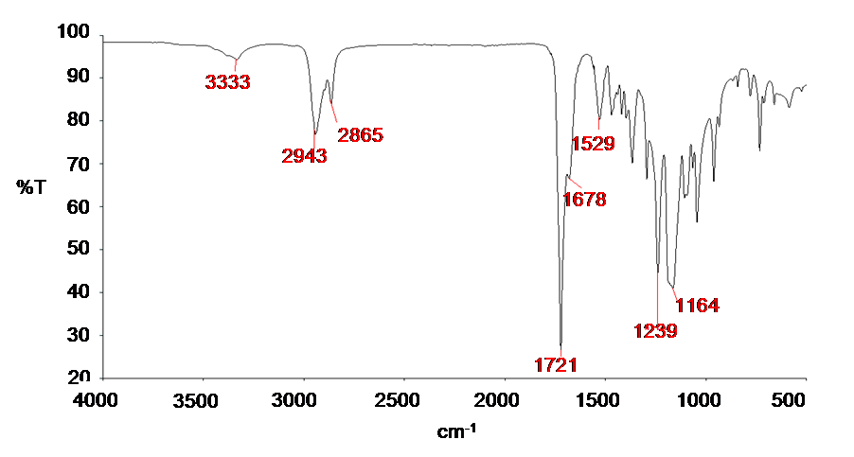
Figure 2. 1 ATR-FT-IR Analysis of the polyurethane C-BC2000. The characteristic peaks identified are labelled in red.
2.3.1.2 GPC analysis
Polyurethane average number molecular weight ($\overline{M}n$), assessed by SEC, is 10500 g/mol with a polidispersity ($\overline{M}w/\overline{M}n$) of 1.6. The weight average molecular weight ($\overline{M}w)$ is 17000 g/mol.
Figure 2.2 shows the molecular weight distribution obtained for C-BC2000
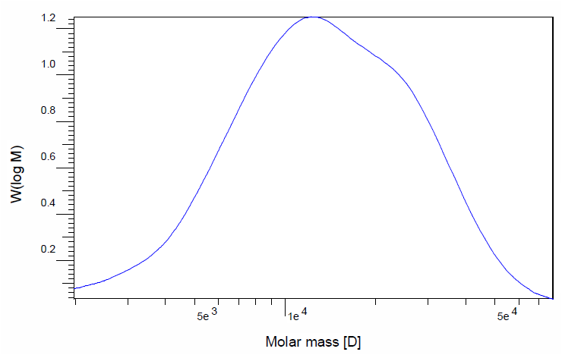
Figure 2. 2 Molar mass distribution of C-BC2000.
2.3.1.3 DSC and DMTA Analysis

Polymer thermal properties were studied by DSC and DMTA. Figure 2.3 shows the three cycles of the DSC thermograms for C-BC2000.

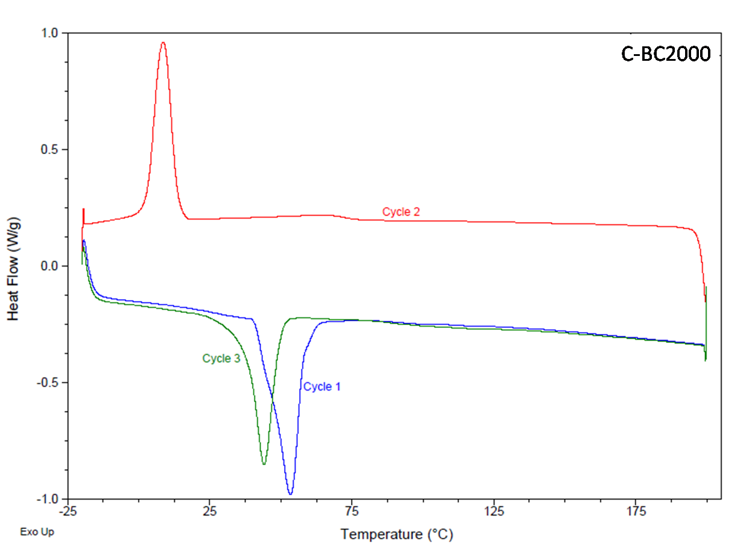
Figure 2. 3 DSC Thermogram of C-BC2000, showing 3 heating cycles.

A reduction of the enthalpy of fusion and consequently of the crystallinity can be observed by comparing the first and the second heating cycle. This behavior can be ascribed to the slow crystallization process typical of polyurethanes, which partially crystallize during the cooling cycle at 10°C/min.

All DSC and DMTA data, i.e. glass transition temperature (T_{g}), melting temperature (T_{m}), melting enthalpy (ΔH_{m}) and cristallinity (X_{c}%) are reported in table 2.1.
DSC analysis of C-BC2000
T_{g} [°C | -34.2
T_{m} [°C] | 44.1
ΔH_{m} [J/g] | 34.8
X_{c}% [%] | 31.1
Table 2. 1 Thermal properties of C-BC 20000

C-BC2000 shows a melting point above the physiological temperature (T_{m} 44°C) which makes it suitable for biological applications.

2.3.2 Contact Angle Analysis
Results from contact angle measurements are reported in table 2.2 and figure 2.4.
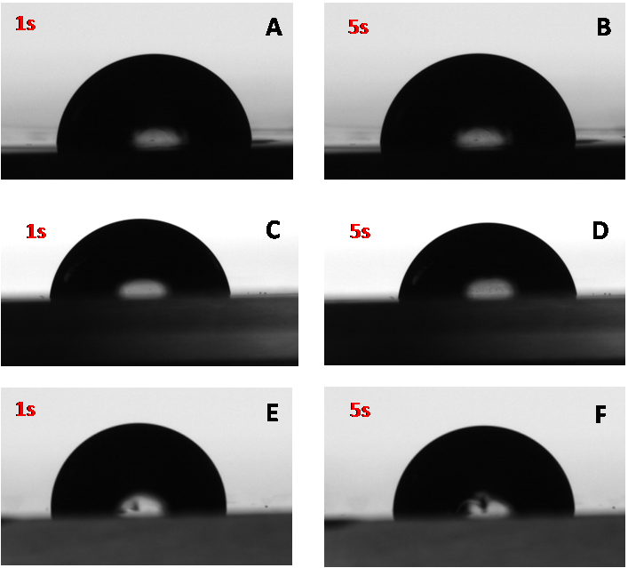
Figure 2. 4 Contact angle measurements after 1s (left) and 5s (right) for PCL (A and B), PLA (C and D) and C-BC2000 (E and F) films.
MATERIAL | Contact Angle(°)
PLA | 82.0 ± 0.7
PCL | 86.0 ± 0.3
C-BC2000 | 90.5 ± 0.9
Table 2. 2 Contact Angle measurements of the three materials. Results are expressed as mean ± SD
As expected all the three polymers are hydrophobic, and are therefore suitable for the encapsulation of poorly water soluble drugs such as Paclitaxel.
PLA shows the lowest contact angle, indicating a slightly higher affinity for water if compared to the other two polymers, PCL and C-BC2000, which show a contact angle of 86° and 90° respectively.
2.3.3 Preparation & characterization of Nanoparticles
2.3.3.1 Optimization of the protocol
In order to optimize the protocol for the preparation of nanoparticles with an appropriate size range for passive targeting, the influence of polymer concentration and of the polymer/surfactant ratio on the mean particle’s size was analyzed.
The concentration of the polymer in acetone is one important parameter affecting nanoparticles size [30]. For this reason this parameter was firstly optimized for the three polymers at a fixed polymer/surfactant ratio R=1.
Results are reported in figure 2.5 and in table 2.3, which show that an increase in the concentration of the polymer solution leads to a linear increase in nanoparticles size, in agreement with results reported by other authors [31] [32].
This result could be explained by the higher viscosity of the polymer solution which reduces the rate of solvent diffusion, thus leading to a slower precipitation and to larger diameters.
At similar conditions, PLA nanoparticles exhibit smaller size when compared to nanoparticles prepared with the other two polymers. This behaviour could probably be ascribed to the lower molecular weight of this polymer [33].
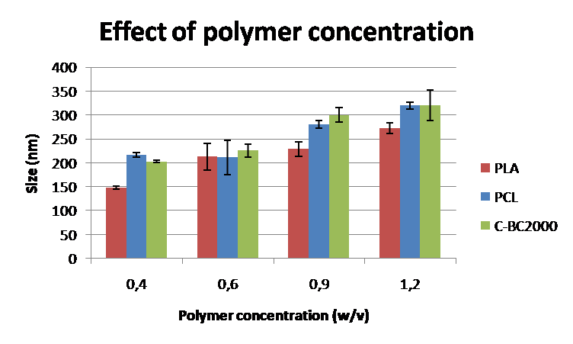
Figure 2. 5 Effect of polymer concentration on Particles’ mean size.
Polymer concentration (w/V) | PLA |  | PCL |  | C-BC2000
Polymer concentration (w/V) | Size [nm] | PDI | Size [nm] | PDI | Size [nm] | PDI
0,4 | 148 ± 3 | 0.11 ± 0.03 | 217 ± 4 | 0.15 ± 0.02 | 203 ± 2 | 0.19 ± 0.04
0,6 | 213 ± 28 | 0.09 ± 0.02 | 211 ± 36 | 0.12 ± 0.06 | 226 ± 13 | 0.1 ± 0.01
0,9 | 229 ± 15 | 0.14 ± 0.03 | 281 ± 8 | 0.21 ± 0.01 | 300 ± 15 | 0.13 ± 0.01
1,2 | 272 ± 11 | 0.12 ± 0.01 | 320 ± 7 | 0.11 ± 0.04 | 320 ± 32 | 0.21 ± 0.03
Table 2. 3 Size and PDI of nanoparticles prepared with different polymer concentrations. Results are reported as mean ± standard deviation (n=5).
Based on these results, a polymer concentration of 0.6% w/v was selected as optimal concentration since it leads to similar nanoparticles size for all the three polymers, ranging from 213nm for PLA nanoparticles to 226nm for C-BC2000 ones. The size range obtained is in all cases lower than 250nm, leading to possible cellular internalization through the EPR effect.
At the optimal polymer concentration of 0.6%w/v, the effect of the polymer/surfactant ratio (R) was assessed. In particular the ratio R was reduced to 0.5.
Results, reported in figure 2.6 and in table 2.4, clearly show that a decrease in the amount of surfactant with respect to the amount of polymer leads to an evident increase in particles’ size for both PCL and C-BC2000 nanoparticles, while a decrease in diameter is observed for PLA nanoparticles. This different behaviour is due to the different molecular weight and cristallinity of the polymers [34]: PLA is easily soluble in acetone and is therefore more likely to form less viscous solutions in which the tendency of the particles to form aggregates is reduced even at low surfactant concentrations. A similar behaviour is not observed for PCL and C-BC2000 which form more viscous solutions thus needing a higher amount of surfactant to avoid aggregation.
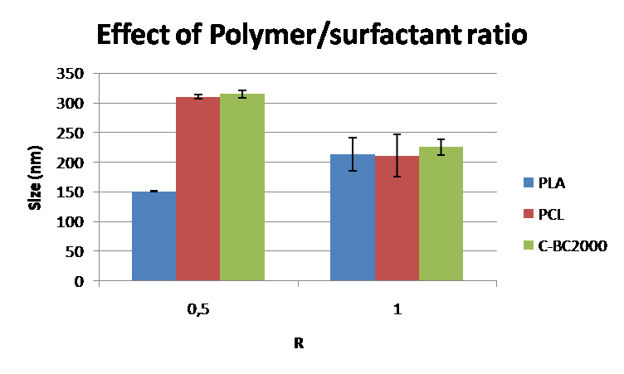
Figure 2. 6 Effect of Polymer/surfactant ratio (R) on the mean particles’ size.

R | PLA |  | PCL |  | C-BC2000
R | Size [nm] | PDI | Size [nm] | PDI | Size [nm] | PDI
0,5 | 151 ± 1 | 0.15 ± 0.03 | 310 ± 3 | 0.05 ± 0.03 | 315 ± 6 | 0.23 ± 0.03
1 | 213 ± 28 | 0.09 ± 0.02 | 211 ± 36 | 0.12 ± 0.06 | 226 ± 13 | 0.10 ± 0.01

Table 2. 4 Size and PDI of nanoparticles prepared at different polymer/surfactant ratio. Results are reported as mean ± standard deviation (n=5).
A polymer/surfactant ratio of 1 was selected for Paclitaxel encapsulation and for cellular tests, since it leads to a similar size distribution for all the three polymers.

2.3.3.2 Preparation & characterization of Paclitaxel-loaded Nanoparticles.
As stated in the previous section, the optimal conditions for all the three polymers are achieved when a polymer/surfactant ratio R=1 and a polymer concentration of 0.6% w/v are selected.
In these conditions, Paclitaxel loaded nanoparticles were prepared at a theoretical drug/polymer ratio of 3% w/w.
The mean particles size, Polydispersity index (PDI) and Zeta potential of nanoparticles were measured on plain as well as on drug loaded particles. These results are summarized in table 2.5 as mean ± standard deviation, calculated as the average of five runs.
Material | PLAIN PARTICLES |  |  | PX-LOADED PARTICLES
Material | Size (nm) | Zeta Potential | PDI | Size (nm) | Zeta Potential | PDI
PCL | 211 ± 36 | -28.6 ± 0.50 | 0.12 ± 0.06 | 233 ± 2 | -21.2 ± 1.1 | 0.25 ± 0.01
PLA | 213 ± 28 | -28.7 ± 0.88 | 0.09 ± 0.02 | 218 ± 12 | -19.8 ± 3.2 | 0.12 ± 0.04
C-BC2000 | 226 ± 13 | -28.9 ± 0.33 | 0.10 ± 0.01 | 162 ± 4 | -21.3 ± 1.5 | 0.15 ± 0.01
Table 2. 5 Mean size, zeta potential and PDI of nanoparticles prepared with different polymers, before and after drug loading.
The encapsulation of the drug did not affect the mean size or the size distribution of nanoparticles.
All particles exhibit a low polydispersity index and a highly negative surface charge, which provides extra stability in water by preventing aggregation.
Results from SEM analysis on plain and Paclitaxel-loaded nanoparticles are reported in figure 2.7.2.
Nanoparticles with regular spherical morphology were successfully obtained with the Solvent Displacement Method with both commercial polyesters and the new Polyestherurethane C-BC2000.
SEM micrographs confirm the results from particles size analysis, in fact all particles exhibit nanosized dimensions with a distinct and well-defined spherical shape. Little or none coalescence is observed in any case.
AFM analysis, performed on plain nanoparticles, further confirms these results, as reported in figure 2.7.1
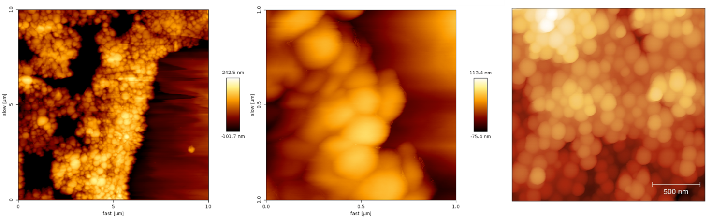
figure 3.7. 1 AFM images of PCL (left), C-BC2000 (middle) and PLA (right) nanoparticles.
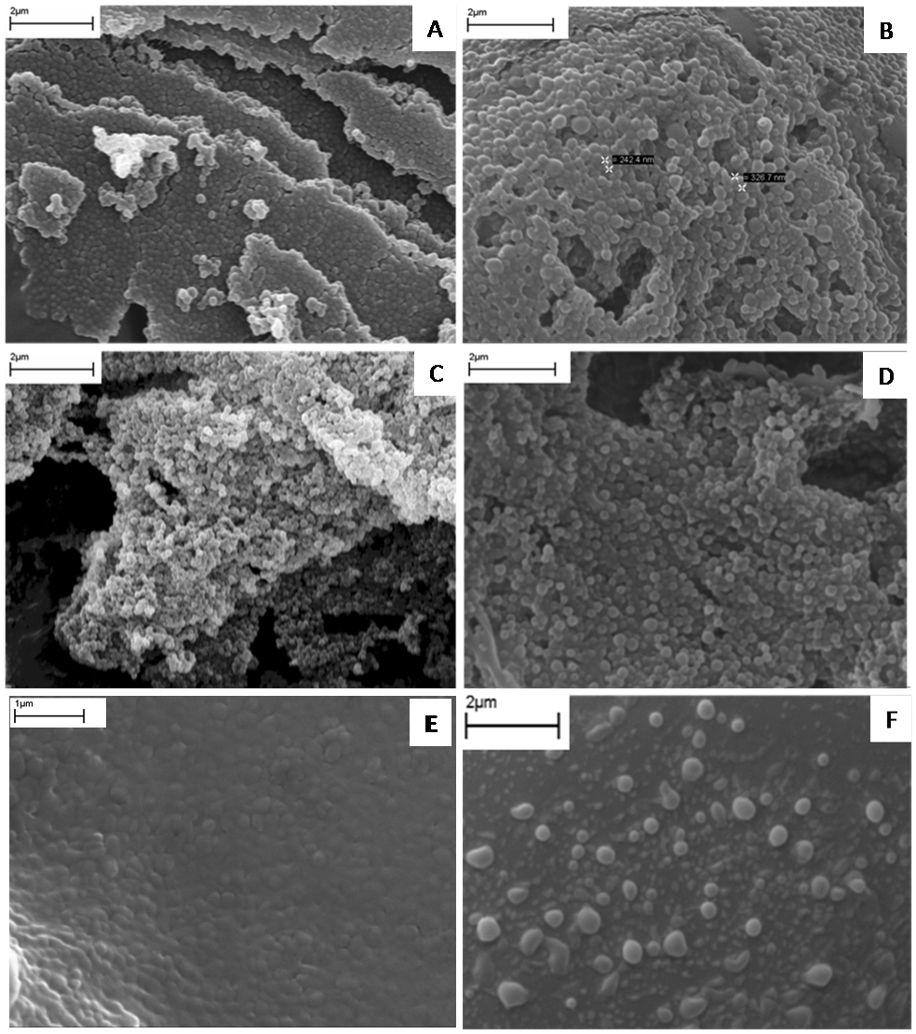
Figure 2. 7.2 SEM micrographs of plain (left) and Paclitaxel-loaded (right) nanoparticles prepared with different polymers: PCL (A and B), PLA (C and D) and C-BC2000 (E and F).
Drug encapsulation efficiency was calculated in triplicate according to equation 2.1 for all particles. Results are reported in table 2.6 expressed as mean ± standard deviation.
The polyurethane C-BC2000 shows a significantly higher drug loading efficiency (89%) when compared to the two commercial polyesters (18% and 24% for PCL and PLA respectively).
Material | EE (%) | Encapsulated drug (µg)
PCL | 18 ± 8 | 53.3 ± 25.2
PLA | 24 ± 7 | 73.3 ± 20.8
C-BC2000 | 89 ± 2 | 266.7 ± 5.8
Table 2. 6 Drug loading efficiency and amount of encapsulated drug
Figure 2.8 represents the release profile of the encapsulated drug over a period of five days expressed as percent of the encapsulated drug and as the quantity of Paclitaxel released at each time-point. The quantity of drug release, expressed as mean ± standard deviation, is also indicated in table 2.7.
C-BC2000 nanoparticles are able to sustain drug release for a prolonged period of time, since only 30% of the encapsulated Paclitaxel is released after 5 days. On the other hand, release from PCL and PLA nanoparticles is completed within the first 2-3 days, according to the results presented by other authors [35][36].
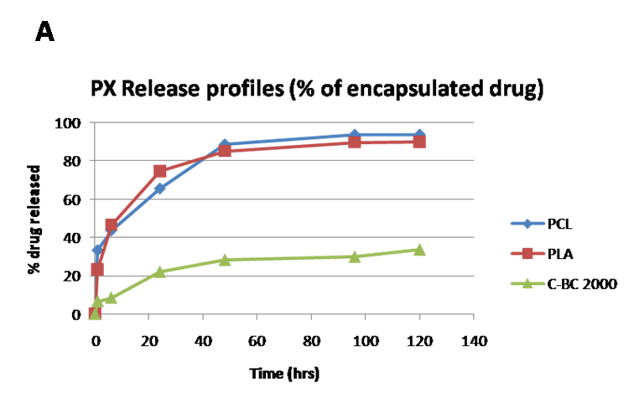

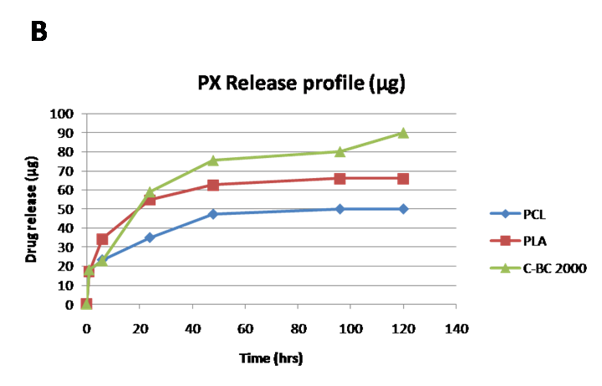
Figure 2. 8 Release profiles of Paclitaxel from different nanoparticles, expressed as percent of the encapsulated drug (A) and as the quantity (µg) of drug released (B).

Released drug (µg) |  |  |  | Released drug (%)
Time (hours) | PCL | PLA | C-BC2000 | PCL | PLA | C-BC2000
1 | 17.8 ± 1.0 | 17.0 ± 1.4 | 18.0 ± 1.5 | 33.3 ± 1.9 | 23.2 ± 1.9 | 6.8 ± 0.6
3 | 23.3 ± 1.8 | 34.2 ± 10.3 | 22.8 ± 5.1 | 43.7 ± 3.4 | 46.6 ± 14.0 | 8.6 ± 1.9
24 | 35.0 ± 4.3 | 54.8 ± 20.2 | 58.9 ± 10.5 | 65.6 ± 8.1 | 74.7 ± 24.2 | 22.1 ± 3.9
48 | 47.3 ± 11.2 | 62.5 ± 21.3 | 75.5 ± 19.7 | 88.7 ± 21.0 | 85.2 ± 30.2 | 28.3 ± 7.4
96 | 50.0 ± 12.6 | 65.8 ± 22.7 | 80.0 ± 21.8 | 93.7 ± 23.6 | 89.8 ± 32.3 | 30.0 ± 8.2
120 | 50.0 ± 12.6 | 65.8 ± 22.7 | 90.0 ± 22.3 | 93.7 ± 23.6 | 90.0 ± 32.3 | 33.7 ± 8.3
Table 2. 7 Amount of drug released (µg and %) expressed as mean ± SD (n=3)
Particles prepared with the two commercial polyesters have a similar release pattern with an initial burst effect in the first hour, followed by a liner tract for the first two days, when all the encapsulated drug is released.
Moreover, C-BC2000 nanoparticles exhibit the lowest burst effect during the first 6 hours of incubation.
Interestingly after this time point the amount of drug released from polyesterurethane nanoparticles is always higher compared to the other polymers.
The release pattern is similar for all particles within the first 4 days. After this time point, no further release can be observed from both PLA and PCL nanoparticles, while C-BC2000 nanoparticles are able to sustain a more prolonged release of Paclitaxel.
C-BC2000 nanoparticles, show the highest drug loading capacity and the lowest burst effect, indicating that nanoparticles with optimal release properties, such as high drug loading capacity, low initial burst and prolonged release over extended periods of time can be obtained with this new polymer.
2.3.4 Hydrolytic degradation studies
Degradation of polyesters occurs by hydrolysis of the ester bonds, preferentially in the polymers amorphous regions, where lose structural packaging makes these groups more exposed to attack from water molecules.
The cleavage of the ester bonds results in the production of carboxylic acids which are known to auto-catalyze further hydrolysis [37].
Changes in the average number molecular weight of the polymers in the form of nanoparticles and films are summarized in table 2.8 and in figure 2.9.
Hydrolytic degradation (-ΔMn %)
Degradation time (weeks) | FILM |  |  | NANOPARTICLES
Degradation time (weeks) | PCL | PLA | C-BC2000 | PCL | PLA | C-BC2000
1 | -10.8 ± 0.2 | -27.4 ± 0.3 | +2.7 ± 0.6 | -15.1 ± 0.2 | -12.5 ± 0.1 | -17.5 ± 0.5
2 | -11.5 ± 0.2 | -31.2 ± 1.3 | +11.2 ± 0.6 | -17.5 ± 0.1 | -16.2 ± 0.6 | -22.9 ± 0.2
3 | -13.3 ± 0.1 | -31.2 ± 0.5 | +6.6 ± 0.9 | -19.4 ± 0.9 | -25.3 ± 0.5 | -29.1 ± 0.1
4 | -19.4 ± 1.2 | -31.3 ± 1.2 | +13.9 ± 1.1 | -20.9 ± 0.1 | -28.7 ± 0.1 | -30.4 ± 0.2
Table 2. 8 Comparison of changes in the molecular weight of different samples after hydrolytic degradation in PBS
The two commercial polyesters showed a similar degradation pattern, in which the molecular weight decreases linearly with increasing soaking time in PBS.
No significant difference can be noticed by comparing the degradation rate of PCL nanoparticles and films, in agreement with the results reported by other authors [38].
PLA seems to degrade much faster, compared to PCL, due to its lower molecular weight and poor cristallinity. Several reports showed that the crystalline part of the PLA is more resistant to degradation than the amorphous part, and that the rate of degradation decreases with an increase in cristallinity [39,40].
Moreover, PLA nanoparticles appear to be less sensitive to hydrolytic degradation compared to films, confirming that this polymer undergoes a size-dependent degradation, as reported by many authors [41].
In particular large size devices degrade faster, with the inner part undergoing rapid degradation, due to a larger contribution to autocatalysis given by the higher amount of free carboxylic groups in the bulk compared to the surface [42]. Briefly, degradation causes an increase in the number of carboxylic acid chain ends which are known to autocatalyse ester hydrolysis. As degradation goes on, soluble oligomers which are located in the core of the matrix remain entrapped, enhancing bulk degradation and leading to the formation of a skin composed of less degraded polymer [43].
For what concerns the polyesterurethane C-BC2000, a completely different behavior between samples in the form of nanoparticles and films was highlighted. While the film displays a slight increase in the average number molecular weight with increasing soaking time, as observed by other authors [44][45], C-BC2000 nanoparticles undergo hydrolytic degradation accompanied by an evident loss in molecular weight similarly to what observed for the two commercial polyesters.
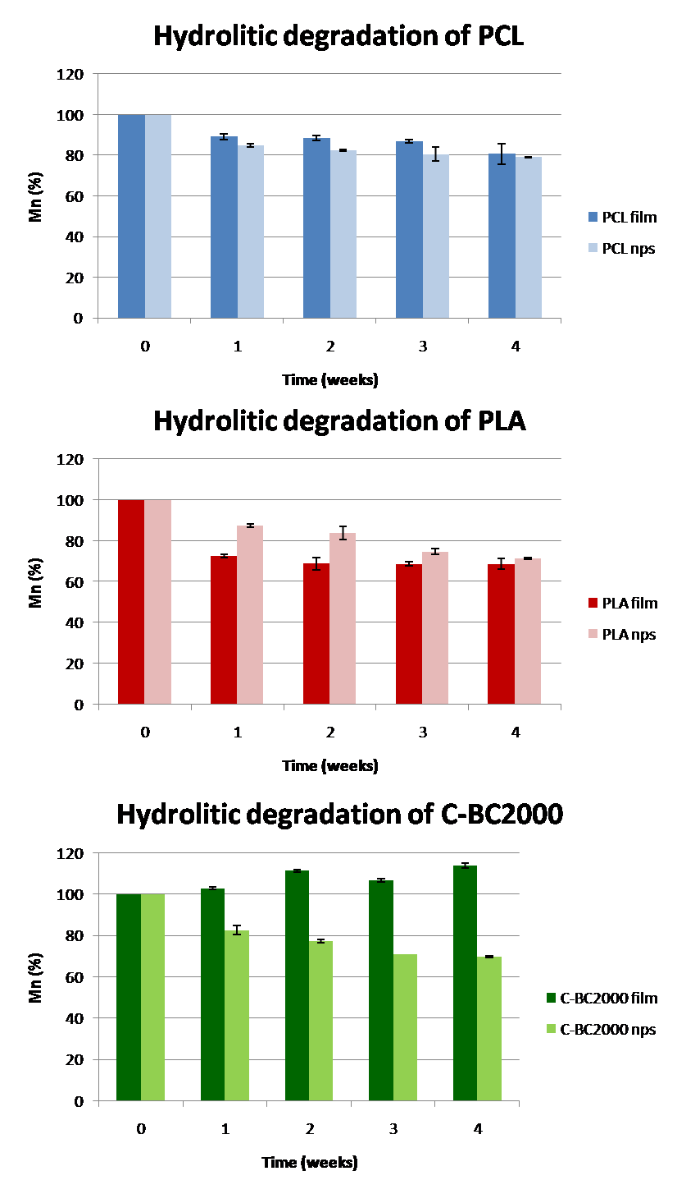
Figure 2. 9 Hydrolytic degradation of PCL, PLA and C-BC2000 films and nanoparticle samples.
2.3.5 Toxicity studies
Figure 2.10 shows cell viability results after incubation in the presence of different concentrations of nanoparticles. The Calcein-am assay showed similar patterns for nanoparticles prepared with different materials regardless of their concentrations.
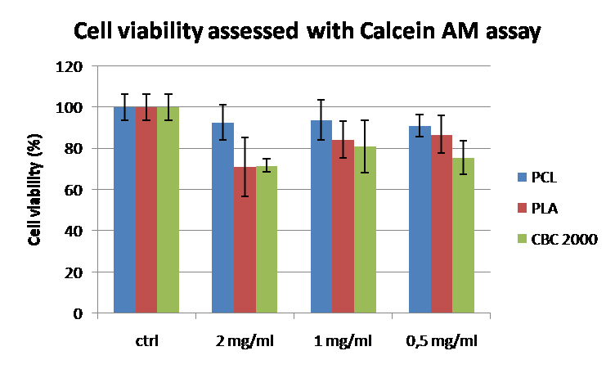
Figure 2. 10 Cell viability after incubation with nanoparticles at different concentrations.
No evident signs of toxicity were detected in any case, cells are almost completely vital after 24hours of incubation in the presence of nanoparticles at different concentrations. A slightly higher cellular death can be observed after exposure to 2mg/ml solution of both PLA and C-BC2000 nanoparticles. 1mg/ml was therefore considered a suitable concentration for further quantitative and qualitative uptake studies.
2.3.6 Cellular uptake studies
Results from cellular uptake studies are summarised in figure 2.11 and 2.12.
Figure 2.11 shows quantitave uptake of rhodamine-loaded nanoparticles after 2hours of incubation by A431 cells. All materials show a similar behaviour, with a slightly higher internalization observed for C-BC2000 nanoparticles.

Figure 2. 11 Quantitative cellular uptake of nanoparticles prepared with different polymers.
Qualitative uptake results were performed by confocal analysis on both living and fixed cells.

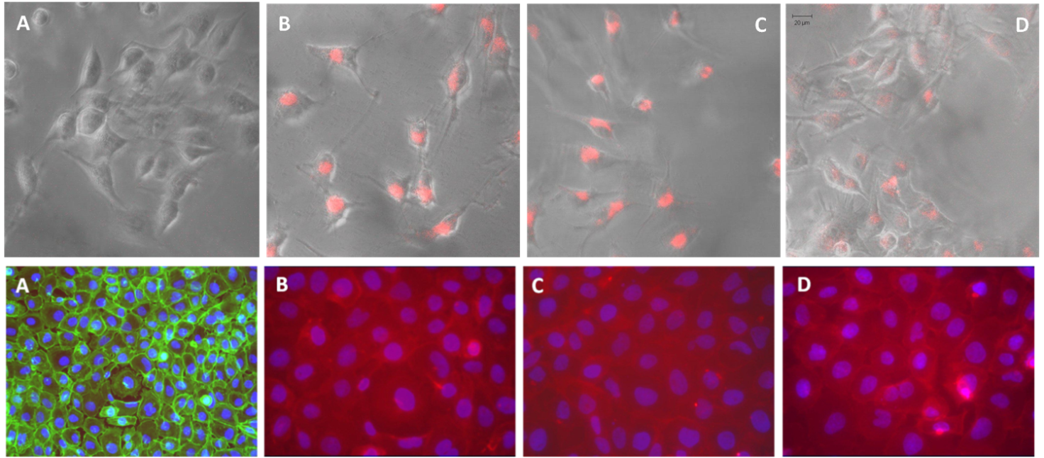
Figure 2. 12 Confocal images of living (first row) and fixed (second row) cells after incubation with rhodamine-containing nanoparticles.: A) Controls, B) PCL nanoparticles, C) PLA nanoparticles and D) C-BC2000 nanoparticles.
Confocal images, reported in figure 2.11, reveal that nanoparticles were internalized by cells and localized almost totally in the cytoplasm, as evidenced by the fluorescence of Rhodamine-loaded nanoparticles.
2.4 Conclusions
In this work biodegradable nanoparticles prepared with commercial polyesters or a novel poly(ε-caprolactone)-based polyesterurethane (C-BC2000) were proposed for the controlled and targeted release of Paclitaxel.
Polyurethanes have been successfully employed as biomaterials for several decades in a variety of applications, because of their tuneable mechanical properties and good biocompatibility [14]; nevertheless their use as nanoparticles for controlled drug release has received little attention in literature [15].
The solvent Displacement method was adopted for nanoparticles preparation, because it is known to produce small and uniformly distributed particles without employing toxic solvents.
The polymers commonly used with this method belong to the biodegradable polyesters family, especially poly(ε-caprolactone) (PCL), poly(lactide) (PLA) and poly(lactide-co-glicolide) (PLGA). Poly(alkylcyanoacrylate) (PACA) or PEG copolymers have also been used to prepare nanoparticles with this method [6,10-12].
The possibility of introducing a novel biodegradable material, belonging to the polyesterurethanes family, for nanoparticles preparation by the Solvent Displacement Method was successfully demonstrated.
Compared to the results obtained for Poly(ε-caprolactone) and Poly (D,L-Lactide), C-BC2000 nanoparticles exhibit similar spherical morphology, size distribution and zeta potential.
The size, assessed by Dynamic Light Scattering, makes the particles optimal candidates for passive targeting of tumours through the EPR effect, as shown by cellular tests. All nanoparticles are easily internalized by tumour cells after 2h of incubation, with C-BC2000 showing the highest cellular uptake.
Release profiles of PX were similar for nanoparticles prepared with the two commercial polyesters with an initial burst release followed by a linear tract. Almost all the encapsulated drug was released after 48 hours. On the other hand, C-BC2000 nanoparticles exhibited optimal release properties, with the highest drug loading capacity, the lowest burst effect and a prolonged release over time.
This study highlighted the possibility to successfully employ novel biomaterials as particles for controlled drug release and to modulate their release profiles and encapsulation properties by selecting the suitable soft segments of the polyurethanes.
References
[1] Kumari A. et Al. 2010 Colloids and Surfaces B: Biointerfaces 75: 1
[2] Mu L. et Al. 2003 J. Control. Release 86 (1): 33
[3] Cheng Q. 2008 et al. Biopharm. Drug Disposition 29: 431
[4] Singh J. et Al. 2006 Methods 38: 96
[5] Ge H. et Al. 2000 J. Appl. Polym. Sci. 75: 874
[6] Ribeiro H. S. et Al. 2008 Food Hydrocolloids 22: 12
[7] Zhang Z. et Al. 2006 Biomaterials 27: 262
[8] Zili Z. et Al. 2005 International Journal of Pharmaceutics 294: 261
[9] Kim D. et Al. 2006 Biomaterials 27: 3031
[10] Fessi H. et Al. 1989 Int. J. Pharm. 55: 25
[11] Deshpande D. et Al. 2008 Pharmaceutical Research 25: 1936
[12] Chawla J.S. et Al. 2002 Int. J. Pharm. 249: 127
[13] Leo E. et Al. 2004 Int. J. Pharm. 278: 133
[14] Vozzi G. et Al. 2008 Macromol. Biosci. 8:60
[15] Zanetti-Ramos B. et al 2006 polymer 47:8080
[16] Zanetti-Ramos B. et al 2008 Mat Sci Eng 28:526
[17] Panchagnula R. 1998 Int. J. Pharm. 172: 1
[18] Wenk M.R. et Al. 1996 Journal of Pharmaceutical Sciences 85: 228
[19] Fang J. et Al. 2011 Advanced Drug Delivery Reviews 63:136
[20] Y. Fukumori et Al. 2006 Advanced Powder Technol. 17:1
[21] I. Brigger et Al. 2002 Advanced Drug Delivery Reviews 54:631
[22] Cerrai P. et Al. 1994 J. Mat. Sci. Mat. Med. 5: 33.
[23] Rechichi A. et Al. 2008 J. Biomedical Mat. Res. Part A 84: 847
[24] Bogdanov B. et Al. 1993 Polymer 40: 3171
[25] Penco M. et Al. 2000 European Polymer Journal 36: 901
[26] Kweon H. 2003 Biomaterials 24: 801
[27] Marion G. et Al. 2008 International Journal of Pharmaceutics 363: 162
[28] Chen D.R. et Al. 2000 Polymer Degradation and Stability 67: 455
[29] Martinotti at Al. Toxicology In Vitro in press
[30] Chorny M. et Al. 2002 J. Control. Rel. 83:389
[31] Thioune O. et Al. 1997 Int. J. Pharm. 146:233
[32] Galindo-Rodriguez S. et Al. 2004 Pharm. Res. 21:1428
[33] Legrand P. et Al. 2007 Int. J. Pharm. 344:33
[34] Limayem Blouza I. et Al. 2006 Int. J. Pharm. 325:124
[35] Zavisova V. et Al. 2007 Journal of Magnetism and Magnetic Materials 311:379
[36] Lince F. et Al. 2011 Chemical Engineering Research and Design 8 9:2410
[37] Bosworth L. et Al. 2010 Polymer Degradation and Stability 95:2269
[38] Woodruff M. et Al. 2010 Polymer Degradation and Stability 95:2269
[39] McDonald et al. 1996 Macromolecules 29:7356
[40] Tsuji and Miyauchi 2001 Polym. Degrad. Stab. 71:415
[41] Grizzi I. et Al. 1995 Biomaterials 16: 305
[42]Li S.M. et Al. 1990 J. Mater. Sci. Mater. Med. 1:198
[43] C.S. Proikakis 2006 Polymer Degradation and Stability 91:614
[44] Zhang Z. 1994 Biomaterials 15:1129
[45] Gorna K. et Al 2002 Polymer Degradation and Stability 75:113

Chapter 3

Novel biodegradable nanoparticles
for the active targeting of breast cancer

Abtract
Nanomedicine formulations offer several advantaged over traditional routes of administration, such as higher drug bioavailability and reduced side effects, since they are able to selectively accumulate into specific organs or tissues [1]. To augment the targeting ability of nanoparticles towards tumor cells, specific ligands or antibodies that selectively recognize biomarkers over-expressed on cancer cells, can be attached to the surface, either by chemical bond or by hydrophilic/hydrophobic interactions [7]. In this chapter, Herceptin, a monoclonal antibody (mAb) able to selectively recognize HER-2 over-expressing tumor cells (like breast and ovarian cancer cells) was absorbed on the surface of nanoparticles through hydrophilic/hydrophobic interactions. Nanoparticles (Nps) were prepared by a modified single emulsion solvent evaporation method, with five different polymers: three commercial polyesters: poly(ε-caprolactone) (PCL), poly (D,L-lactide) (PLA) and poly (D,L-lactide-co-.glycolide) (PLGA) and two novel polyesterurethanes, based on Poly (ε-caprolactone) blocks synthesized with different chain extenders. Nps exhibited a regular spherical morphology, a size below 200nm, which makes them suitable candidates for passive targeting of cancer [3], and a negative zeta potential ideal for surface functionalization with mAb. Surface coating was successfully achieved for all particles, as demonstrated by the increase in zeta potential. The extent of cellular internalization was tested on two different cell lines: MCF7 and SKBR3 breast cancer cells, showing a normal and a high expression of the HER 2 receptor, respectively. Polyesterurethanes nanoparticles exhibited higher cellular internalization and the presence of the antibody increased cellular uptake for all formulations. Moreover the release profile and cytoxicity were also assessed, after encapsulation of the anti-neoplastic drug Paclitaxel.

3.1 Introduction
Nano-sized drug delivery systems, including nanoparticles, liposomes and micelles, have been widely investigated as carriers for various formulations, due to their ability to overcome biological barriers and to deliver their content in a controlled manner at the desired place [3,4].
Moreover, nanomedicine formulations offer several advantaged over traditional routes of administration, such as higher drug bioavailability and reduced side effects, since they are able to selectively accumulate into specific organs or tissues [1]. Due to their small size, nanoparticles can extravasate into the leaky vascular endothelium of cancer tissues, through the Enhanced permeation and retention effect (EPR), and are therefore able to passively target tumor cells [5].
In fact, tumors are composed of fast-growing cells which need a high supply of oxygen and other nutrients to proliferate. Their vessels are therefore highly fenestrated and more permeable compared to normal vessels and particles with a size matching the dimensions of these fenestrations (200-500nm, depending on the tumor type) can easily enter tumor tissues [5]. Moreover lymphatic ducts are absent in most tumors, hampering the elimination of these particles from the tissue.
Several studies have been carried out on the preparation of polymeric nano-sized drug carriers for the selective delivery of chemotherapy, in an attempt to overcome inherent limitations due to the high hydrophobicity of the formulations which results in poor bioavailabilty, high systemic toxicity and scarce patient outcome [3,6].
To augment the targeting ability of nanoparticles towards tumor cells, specific ligands or antibodies that selectively recognize biomarkers over-expressed on cancer cells, can be attached to the surface, either by chemical bond or by hydrophilic/hydrophobic interactions [7,8].
Among targeting moieties, monoclonal antibodies have been extensively applied for their ability to initiate specific signaling cascades resulting in potentiated therapeutic effect of drugs [9,10].
In this chapter, nanoparticles for the controlled delivery of the anti-neoplastic drug Paclitaxel were prepared by a modified single emulsion method, using five different polymers: three commercial polyesters: poly(ε-caprolactone) (PCL), poly (D,L-lactide) (PLA) and poly (D,L-lactide-co-.glycolide) (PLGA) and two novel polyesterurethanes, based on Poly (ε-caprolactone) blocks (in the following referred to as C-BC2000 and NS-BC2000), synthesized with different chain extenders: 1,4-cyclohexane dimethanol (CDM) and N-Boc-serinol BC2000 (which possesses a protected functional amino group NH₂) for the synthesis of C-BC2000 and NS- respectively.
The method for particles preparation was optimized to obtain carriers of small size, in order to favor cellular uptake through the EPR effect, and with negative surface charge, which could be exploited for further modification [11].
Trastuzumab (Herceptin ®), a recombinant humanized IgG1 monoclonal antibody (mAb) used in the treatment of HER2 over-expressing cancer cells, such as breast, ovarian and pancreatic cancer cells, was adsorbed on the surface of nanoparticles, to create functionalized carriers for the active targeting of breast cancer cells [11,12].
It is known that HER2 over-expresses in 25-30% invasive breast cancers. Herceptin is able to bind to the extracellular domain of the HER2 receptor and inhibits cell proliferation and survival, representing an optimal strategy for targeting tumor cells [13,14].
Functionalized as well as non-functionalized nanoparticles, prepared with the five above-mentioned polymers, were incubated in the presence of two different breast cancer cell lines, MCF7 and SKBR3, the first showing a normal expression and the second a high over-expression (3+) of the HER2 receptor [15].
The extent of cellular internalization for nanoparticles prepared with different materials, and the effect of targeting obtained for mAb-coated carriers on SKBR 3 cells was investigated quantitavely, by flow cytometry, and qualitatively, by confocal microscopy.
Release profiles of the encapsulated drug from both functionalized and non-functionalized particles were also studied and the in vitro viability of SKBR3 cells, treated with nanoparticles-Paclitaxel formulations at three different drug concentrations was determined by MTS assay.
3.2 Materials & methods
3.2.1 Materials
Poly(ε-caprolactone) (PCL, M_{W} 50000) and Poly(D,L-lactide) (PLA, M_{w} 20000-30000) were purchased from Polysciences Inc., Poly (D,L-lactide-co-glycolide) (PLGA 403-H) was purchased from Boeringer Ingelheim-Germany, PCL diol (MW 2000), 1,4-Diisocyanatobutane (BDI), 1,4-cyclohexane dimethanol (CDM, mixture cis and trans), N-Boc-serinol, Dibutyltin dilaurate (DBTDL, Sigma Aldrich-Italy) was used as catalyst during the pre-polymerization reaction.
Phosphate Buffer Saline (PBS), DMEM, Coumarin dye, Polyvinylalcohol (PVA) were all from Sigma Aldrich. All solvents were of Analitical grade. Paclitaxel was a kind gift from Sorin Biomedica. Trastuzumab (Herceptin) was provided by Fannin Compounding Ireland Ltd.
Milli-Q and deionised water were produced by a Millipore water purification system (Millipore Corporation).
3.2.2. Polymer Synthesis
The two Polyurethanes used in this study (NS-BC2000 and C-BC2000) were synthesised following a two step synthesis procedure in inert atmosphere [16,17] with Poly(ε-caprolactone) diol (M_{n}=2000g/mol, Aldrich) and 1,4 butanediisocyanate (BDI, Aldrich) as macrodiol and diisocyanate respectively.
Two different chain extenders were selected: 1,4-cyclohexane dimethanol CDM (Aldrich, mixture cis and trans) or N-Boc-serinol (Aldrich) for the synthesis of C-BC2000 and NS-BC2000 respectively.
Briefly, the macrodiol was dissolved in 1,2-dichloroethane (DCE) and the solution was dried azeotropically for 8 hours. The diisocyanate was then added to the solution (2:1 molar ratio with respect to the macrodiol), in the presence of the catalyst (DBTDL) and reacted with the macrodiol at 85°C in anhydrous DCE for 150 minutes in order to form a pre-polymer. At the end of the pre-polymerization reaction the solution was concentrated and the chain extender (CDM or N-BOC-serinol for C-BC2000 and NS-BC2000 respectively) was added at 1:1 molar ratio with respect to the macrodiol at room temperature. The chain extension reaction was stopped after 18 hours by adding methanol. The polymer solution was precipitated in petroleum ether. After drying at 40°C under vacuum, the polymer was re-dissolved in Dimethylformamide (DMF) and precipitated with methanol in order to remove the low molecular weight impurities and residual catalyst. The polymer was finally dried at 40°C under vacuum for 24 hours.
3.2.3 Polymer Characterization
3.2.3.1 FTIR Analysis
Attenuated Total Reflectance Fourier Transform Infrared Spectrum (ATR-FT-IR) of the synthesised polyurethanes was obtained at room temperature in the spectral range from 4000 to 450 cm⁻¹ using a Perkin Elmer Spectrum 100 equipped with an ATR accessory (UATR KRS5) with diamond crystal. The spectrum, obtained as a result of 16 scans with a resolution of 4 cm⁻¹, was analyzed with the Perkin Elmer Spectrum software. For ATR-FT-IR analysis the sample was prepared as a film, by using conventional solvent-casting techniques with chloroform as a solvent at a concentration of 3 %w/v.
3.2.3.2 GPC Analysis
The average molecular weight ($\overline{M}n$) of the polyester-urethanes C-BC2000 and NS-BC2000 was characterized by Size Exclusion Chromatography (SEC, Agilent 1500 series), by dissolving the polymers at a flow rate of 1.0 ml/min through a Waters Styragel HT2 and HT4 THF series of columns with Tetrahydrofuran (THF) as eluent at 35°C. The weight-average molecular weight ($\overline{M}w$) and number-average molecular weight ($\overline{M}n$) and polydispersity ($\overline{M}w$ /$\overline{M}n$) were determined from the retention time data using the Agilent ChemStation software, after calibration with polystyrene standards.
3.2.4 Preparation of nanoparticles
3.2.4.1 Optimization of the protocol
Nanoparticles were prepared by a modified Single Emulsion Solvent Extraction Evaporation Technique, using Ethyl Acetate as the solvent, deionized distilled water as the non solvent and Polyvinylalcohol (PVA) as emulsifier.
The protocol for particles preparation was optimized in order to obtain nanoparticles with a mean diameter below 250nm for easy cellular internalization and a negative surface charge in the range from -10 to -30 mV to favour surface adsorption of the monoclonal antibody Herceptin [11].
Herceptin has an isoeletric point of 8.45 and it is therefore positively charged at acidic pH. In these conditions, the antibody is expected to react with the negatively charged surface of nanoparticles, through hydrophilic/hydrophobic interaction thus forming a coating, which can enhance particles uptake by target tumour cells, by receptor-mediated endocytosis [18].
PLGA, the most investigated and studied matrix-forming material for nanoparticles, was used as a model to optimize the protocol for particles preparation.
Nanoparticles were prepared according to the following general procedure, to which slight modifications were applied in order to reach the desired size and surface charge: 100mg of the polymer were dissolved in 4ml Ethyl Acetate, added dropwise to 4ml of water (internal phase) containing PVA as emulsifier and sonicated (Bransonic 2510 Sonicator) for 2 minutes to form a primary emulsion. This first emulsion was then poured into 50ml of water (external phase) containing PVA and re-emulsified by homogenization for 3 minutes.
The final emulsion was gently stirred overnight to allow solvent evaporation, particles were then collected by centrifugation at 11000rpm, washed 3 times to remove residual emulsifier and freeze dried.
The concentration of the emulsifier in the internal and external aqueous phase, the speed of the homogenizer as well as the washing medium were modified in order to obtain the optimal diameter and zeta potential for PLGA nanoparticles, according to the schematic representation, reported in figure 3.1.
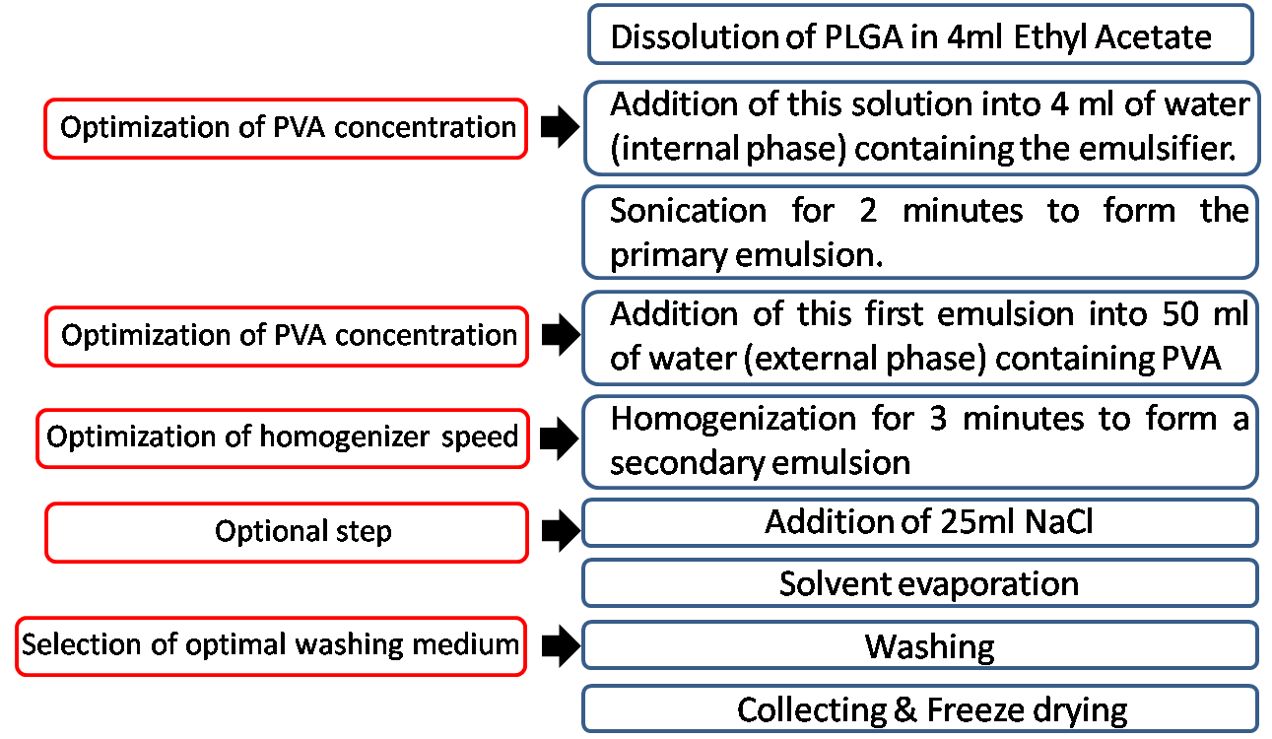
Figure 3. 1 Schematic representation of the optimization of the protocol for PLGA nanoparticles preparation. Modifications of the protocol are highlighted in red.
In some instances 25ml of Sodium Chloride solution were added during solvent evaporation in an attempt to decrease the zeta potential of nanoparticles, since it was expected that charged salts would leave some residual charge on their surface, thus improving Herceptin adsorption [18].
Three different concentrations of PVA (w/v) in the internal and external phase were tested (1% and 2.5% in both phases or 1% in the external phase and 2.5% in the internal one). In all three cases, two different homogenization velocities were tested (13500 rpm and 25000 rpm), as listed in table 3.1.

Sample name | PVA in the  internal phase (w/v) | PVA in the  external phase (w/v) | Homogenization speed
PLGA 1 | 1% | 1% | 13500 rpm
PLGA 2 | 1% | 1% | 25000 rpm
PLGA 3 | 2.5% | 2.5% | 13500 rpm
PLGA 4 | 2.5% | 2.5% | 25000 rpm
PLGA 5 | 2.5% | 1% | 13500 rpm
PLGA 6 | 2.5% | 1% | 25000 rpm

Table 3. 1 List of samples prepared for the optimization of the protocol for nanoparticles preparation.
The concentration of PVA and the homogenization speed are expected to affect the dimensions of nanoparticles [19], while the washing medium and the optional addition of NaCl during the solvent evaporation step are believed to mainly affect the surface charge [20].
To assess the effect of the washing medium on particles surface charge, three different media were used: Sodium Chloride, distilled water and a solution of a second surfactant (Poloxamer F168) in water, at two different concentrations (1% and 2% w/v).
Poloxamer F168 is a non ionic surfactant, composed of a central hydrophobic chain of poly(propylene oxide) flanked by two hydrophilic chains of poly(ethylene oxide), which has been reported to decrease the surface charge of PLGA nanoparticles [21-23].
3.2.4.2 Preparation of nanoparticles
Nanoparticles for in vitro drug release and cellular tests were prepared according to the optimized protocol represented in figure 3.2.
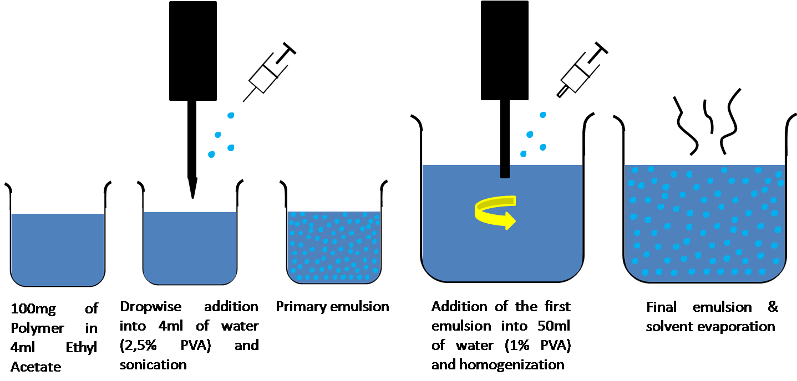
Figure 3. 2 Schematic representation of the protocol adopted.
Briefly 100 mg of the polymer were dissolved in Ethyl Acetate (4ml) and added dropwise into 4ml of water containing 2.5% w/v PVA and sonicated for 2 minutes. The primary emulsion was added into 50 ml of water containing 1% w/v PVA and homogenized at 13500 rpm. The solution was gently stirred overnight to allow solvent evaporation, particles were collected by centrifugation and washed 3 times with distilled water before freeze drying.
3.2.4.3 Preparation of Paclitaxel-loaded nanoparticles
PX-loaded nanoparticles (5% w/w with respect to the polymer weight) for in vitro drug release and cytotoxicity studies were prepared according to the above-described procedure, by adding the drug to the polymer solution in ethyl acetate.
    - Surface modification of nanoparticles
In order to prepare nanoparticles for the active targeting of HER-positive breast cancer cells, the monoclonal antibody Herceptin which is able to selectively bind to specific receptors over-expressed on the surface of these cells, was introduced on the surface of nanoparticles [11].
As already mentioned, Herceptin is positively charged below pH 8.45 and could therefore interact with the negative surface of nanoparticles through hydrophilic/hydrophobic interactions, forming a coating.

For Herceptin decoration, 500µl of nanoparticles solution in PBS pH 5.6 (1mg/ml) were added to the same volume of antibody solution (1mg/ml) and incubated at 4°C for 6 hours.
In order to optimize the decoration process, PLGA nanoparticles were incubated in the presence of the antibody for three different time points (1, 6 and 24 hours) at 4°C. The amount of adsorbed protein and the changes in the zeta potential and mean diameter of nanoparticles were detected after each time point [20].
The amount of the antibody on the surface of nanoparticles was evaluated as the difference between the initial and the residual amount of Herceptin in the supernatant, by using a standard Bradford assay.

3.2.6 Characterization of nanoparticles
3.2.6.1 Particle size and size distribution.
The particle size and size distribution analysis were performed using a dynamic laser light scattering technology (Malvern Instruments, Zetasizer Nano S90). The dispersion of NPs was diluted with ultrapure water and completely sonicated before measurement. The measured values were averaged by five runs.
3.2.6.2 Surface charge
Surface charge was determined by Zetasizer Nano ZS zeta-potential analyzer (Malvern Instruments) at room temperature in ultrapure water. Measures were averaged five times.
3.2.6.3 Particle morphology
NPs Morphology was examined by scanning electron microscopy (SEM Leo Instruments). Particles were mounted on aluminium stabs and coated with gold, by using a sputter coater. The analysis was performed at a working distance of 10mm and a voltage of 20kV.
3.2.7 Determination of Paclitaxel loading and in vitro release profile
The amount of encapsulated PX was quantified by using high performance liquid chromatography (HPLC, Agilent), equipped with a reversed phase Intertsil C18 column (150x4.6 mm, particles size 5µm).
5mg of nanoparticles were dissolved in 1ml DCM to extract the encapsulated drug. After DCM evaporation, the mobile phase (a mixture of acetonitrile and water in 50% volume ratio) was added. The solution was then filtered through a 0.45µm PVDF membrane before HPLC analysis.
The encapsulated drug was detected at an absorbance wavelength of 227nm by means of an UV/VIS detector.
Drug encapsulation efficiency (EE) was determined as follows:
$$EE\%=\left(\frac{W_{PXd}}{W_{PXt}}\right)×100 Eq.3.1$$
Where, W_{PXd} is the weight (mg) of drug detected by HPLC and W_{PXt} is the theoretical amount of drug expected in 5mg of nanoparticles.
For the determination of PX release profiles, 1mg of nanoparticles were accurately weighted, dispersed in 1ml distilled water and incubated at 37°C under constant shaking. The amount of drug released was measured daily for up to 4 days. At the predetermined time points, the solution was centrifuged at 10000 rpm for 15 minutes and the release medium was replaced with fresh water.
The drug released in the supernatant was extracted by DCM and transferred in the mobile phase. The amount of released Paclitaxel was measured by HPLC, after evaporation of DCM. Samples were analyzed in triplicate.
3.2.8 Cell culture
SK-BR-3 breast cancer cells, which show high over-expression of Her2 receptor (3+), were cultured in RPMI-1640 media supplemented with 10% HI Foetal Bovine Serum (HI-FBS).
MCF7 breast cancer cells, which show normal expression of HER2 were cultured in Minimum Essential Eagle Medium with Earle’s salts, l-glutamine and sodium bicarbonate containing 10% HI-FBS. Cells were propagated in 75cm² tissue culture flasks, in humidified environment at 37°C with 5% CO₂. Medium was changed every two days and cells were split at a ratio of 1:2 every 4 days when 90% confluence was reached.
3.2.9 In vitro cellular uptake of Coumarin-6 loaded nanoparticles.
For quantitative cellular uptake analysis, coumarin-6 (Sigma Aldrich) loaded nanoparticles were prepared, according to the protocol described in figure 3.2 by adding the dye (0,5% w/w with respect to the amount of polymer) in ethyl acetate.
Cells were seeded into 24-well plates at 5x10³ cells/well and incubated for 2 days, after which 0.5 ml of coumarin-6 loaded nanoparticles suspension (1mg/ml) in sterile PBS were added to each well.
After 2 hours of incubation the nanoparticles suspension in the testing wells was removed and cells were washed three times with sterile PBS to remove nanoparticles that were not internalized by cells.
The extent of cellular internalization was determined by flow cytometry. The experiment was carried out in triplicate.
For confocal study, cells were seeded in the coverglass chamber and cultivated for 2 days. 0.5ml of coumarin-6 loaded nanoparticles suspension (1mg/ml) in sterile PBS were added to the cells and incubated for 2 hours. After incubation, cells were washed three times with sterile PBS and fixed with 70% ethanol for 20 minutes. The nuclei were then stained with Propidium Iodide (PI) for 20 minutes.
Cells were again washed thrice with PBS and observed at confocal laser scanning microscopy.
3.2.10 In vitro cytotoxicity
For cytotoxicity measurement, SKBR 3 cells were incubated in 96-well plates at 5x10³ cells/well. After 12 hours the medium was removed and replaced with a suspension of Herceptin-coated or non-coated nanoparticles in sterile PBS. All nanoparticles were sterilized by UV irradiation for 2 hours before use. The effect of three different doses (0.25 µg/ml, 1µg/ml and 2.5µg/ml) of Paclitaxel was investigated. After 24 hours of exposure, the particles suspension was removed and cell viability was assessed by MTS assay. The absorbance of the wells was read by the microplate reader at a wavelength of 490 nm. Cell viability is defined as the percentage of the absorbance of each well containing the nanoparticles suspension over that of the cells only.
3.3 Results & Discussion
3.3.1 Polymer characterization
3.3.1.1 ATR-FT-IR Analysis
A polyesterurethane was successfully synthesized as confirmed by Attenuated Total Reflectance Fourier Transform Infrared Spectroscopy (ATR-FT-IR -Perkin Elmer Spectrum 100 UATR KRS5), reported in figure 3.1. ATR-FT-IR shows the presence of the characteristic peaks at 1720 cm⁻¹, 3330 cm⁻¹, 1680 cm⁻¹ and 1530 cm⁻¹, associated with the absorption of the carbonyl of the ester groups, the urethane group and amide I and II respectively. The absorbance at 1160 cm⁻¹ was attributed to C-O stretching in PCL. The conversion of isocyanates was quantitative as no diagnostic peaks of these groups were detected at 2200 cm⁻¹.
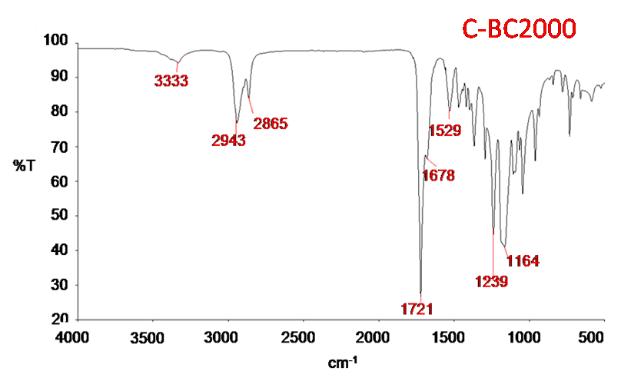
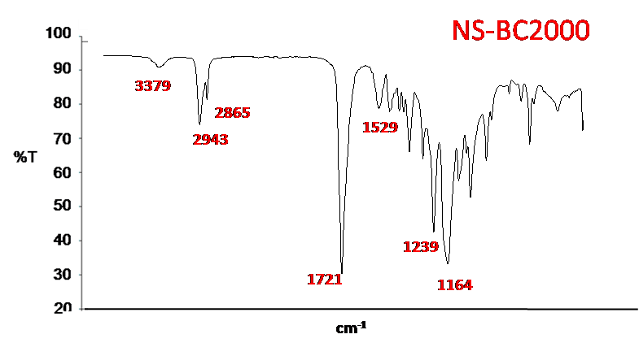
Figure 3.1 ATR-FT-IR Analysis of the polyurethanes C-BC2000 and NS-.BC2000. The characteristic peaks identified are labelled in red.
3.3.1.2 GPC analysis
The average number molecular weight (g/mol), the weight average molecular weight (g/mol) and the polydispersity $\overline{M}w/\overline{M}n$ of the polymers, assessed by Size Exclusion Chromatography, are summarized in table 3.2.
 | C-BC2000 | NS-BC2000
$\overline{M}$_{n} | 10500 | 38000
$${\overline{M}}_{w}$$ | 170000 | 61600
$\overline{M}$_{w}/$\overline{M}$_{n} | 1.6 | 1.6
Table 3. 2 Results from SEC analysis of C-BC2000 and NS-BC2000
3.3.2 Preparation of nanoparticles
3.3.2.1 Optimization of the protocol
3.3.2.1.1 Effect of PVA concentration and homogenization speed.
According to the protocol described in section 3.2.4, PLGA nanoparticles were prepared by selecting different concentrations of the emulsifier in the internal and external phase and by changing the homogenization speed. NaCl was used as washing medium to remove residual PVA.
The size, PDI and zeta potential of all PLGA nanoparticles are reported in table 3.3.
Sample | PVA in  internal phase (w/v) | PVA in external phase (w/v) | Homogenizer speed (rpm) | Size (nm) | PDI | Zeta Potential  (mV)
PLGA 1 | 1% | 1% | 13500 | 246 ± 1 | 0.03 ± 0.01 | -2.1 ± 0.7
PLGA 2 | 1% | 1% | 25000 | 254 ± 19 | 0.2 ± 0.04 | -1.2 ± 0.2
PLGA 3 | 2.5% | 2.5% | 13500 | 146 ± 1 | 0.08 ± 0.02 | -2.2 ± 0.3
PLGA 4 | 2.5% | 2.5% | 25000 | 184 ± 3 | 0.05 ± 0.01 | -1.7 ± 0.4
PLGA 5 | 2.5% | 1% | 13500 | 156 ± 2 | 0.08 ± 0.02 | -1.9 ± 0.2
PLGA 6 | 2.5% | 1% | 25000 | 155 ± 2 | 0.08 ± 0.01 | -1.7 ± 0.3
Table 3. 3 Mean size, PDI and zeta potential of PLGA nanoparticles, prepared at different PVA concentrations and homogenization speeds.
Results from particles size analysis of all PLGA samples are represented and compared in figure 3.3.
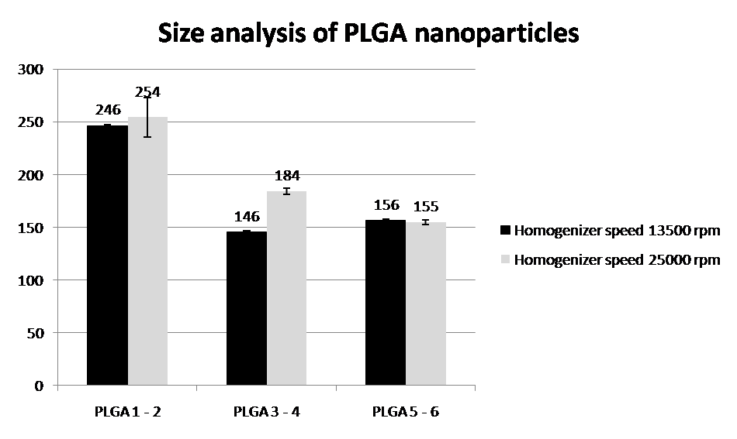

Figure 3. 3 Size analysis of PLGA nanoparticles
As can be noticed from figure 3.3, the concentration of the emulsifier PVA in the internal aqueous phase is a crucial parameter to control the mean diameter of nanoparticles, as observed by other authors [22,24].
Samples PLGA1 and PLGA2, for which low concentrations of PVA were adopted (1% in both phases), displayed the largest size (around 250nm).
An increase in the emulsifier concentration leads to a drastic reduction in size, as observed for the other four samples, indicating that a higher amount of PVA can help in stabilizing the emulsion and in preventing aggregation phenomena [22].
By analyzing the size results obtained for the other four samples (form PLGA3 to PLGA6) it is evident that the amount of emulsifier in the external aqueous phase does not have a significant effect on the size of nanoparticles, while increasing PVA concentration in the internal phase leads to smaller particles diameters. Vandervoort at al. [22] reported an increase in particles size after increasing PVA concentration in the external phase, due to a higher viscosity of the solution which resulted in the formation of larger droplets and, consequently, of larger particles.
Moreover, increasing the speed of the homogenizer does not seem to have an effect on particles’ size and size distribution [25].
Therefore, the optimal size for PLGA nanoparticles can be obtained at low PVA concentration (1% w/v) for the external phase, at high (2.5% w/v) PVA in the internal phase and at a low homogenization speed (13500 rpm).
3.3.2.1.2 Effect of the washing medium and of the addition of NaCl during solvent evaporation
Figure 3.4 and table 3.4 show the effect of the washing medium and of the addition of 25ml of sodium chloride (NaCl) during solvent evaporation on the mean size, size distribution and zeta potential of nanoparticles.
Particles washed with NaCl exhibit a slightly negative zeta potential, not sufficient to ensure their stability in suspension and the adsorption of the antibody.
The use of distilled water or of a water solution of Poloxamer F168 at two different concentrations (1% and 2% w/v) led to a more negative surface charge of PLGA nanoparticles, ranging from -19,4 mV to -24,4 mV.
The addition of NaCl during the solvent evaporation step showed no effect on the zeta potential, regardless of the selected washing medium.
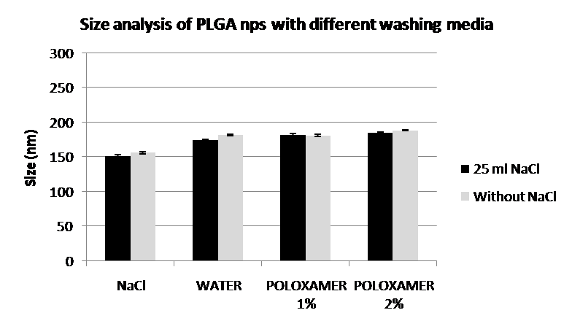
Figure 3. 4 Size Analysis of PLGA nanoparticles with different washing media, with or without the addition of NaCl during solvent evaporation.
Washing medium | Addition of 25 ml NaCl |  |  | Without addition of NaCl
Washing medium | Size [nm] | PDI | Zeta Potential  [mV] | Size [nm] | PDI | Zeta Potential  [mV]
NaCl | 151 ± 2 | 0.06 ± 0.01 | -2.3 ± 0.4 | 156 ± 1 | 0.08 ± 0.02 | -1.9 ± 0.2
Water | 174 ± 1 | 0.06 ± 0.01 | -22.0 ± 1.2 | 182 ± 1 | 0.07 ± 0.03 | -24.4 ± 0.4
Poloxamer 1% | 182 ± 2 | 0.08 ± 0.03 | -15.3 ± 0.8 | 181 ± 1 | 0.06 ± 0.02 | -24.4 ± 0.2
Poloxamer 2% | 1845 ± 1 | 0.05 ± 0.02 | -16.6 ± 1.4 | 188 ± 1 | 0.07 ± 0.02 | -19.4 ± 1.0
Table 3. 4 Mean size, PDI and zeta potential of PLGA nanoparticles prepared with different washing media, with or without the addition of NaCl during solvent evaporation.
Particles were therefore prepared with all the five polymers without the addition of 25ml NaCl during solvent evaporation and the effect of the three different washing media on particles size and surface charge was evaluated. Results are reported in figure 3.5 and in table 3.5, which show that the addition of a second surfactant did not lead to the expected decrease in the surface charge of nanoparticles.
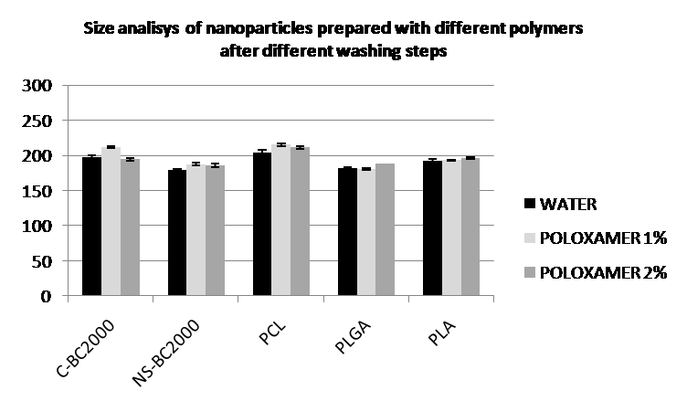
Figure 3. 5 Size analysis of nanoparticles prepared with five different polymers and three different washing media.
 | MATERIAL
 | C-BC2000 | NS-BC2000 | PCL | PLGA | PLA |  | Washing
Size [nm] | 197 ± 2 | 178 ± 1 | 204 ± 3 | 181,9 ± 1 | 193 ± 2 |  | Water
PDI | 0.11 ± 0.02 | 0.11 ± 0.02 | 0.06 ± 0.01 | 0.07 ± 0.03 | 0.14 ± 0.02
Zeta Pot. [mV] | -12.2 ± 0.6 | -9.4 ± 0.5 | -9.6 ± 0.4 | -24.4 ± 0.4 | -22.0 ± 0.9
Size [nm] | 212 ± 1 | 188 ± 2 | 215 ± 2 | 181 ± 2 | 193 ± 1 |  | Poloxamer 1%
PDI | 0.13 ± 0.01 | 0.11 ± 0.01 | 0.10 ± 0.02 | 0.06 ± 0.02 | 0.08 ± 0.02
Zeta Pot. [mV] | -15.8 ± 0.2 | -14.3 ± 0.5 | -17.1 ± 1.7 | -24.4 ± 0.2 | -22.5 ± 1.4
Size [nm] | 194 ± 2 | 186 ± 2 | 211 ± 3 | 188 ± 1 | 196 ± 2 |  | Poloxamer 2%
PDI | 0.11 ±0.01 | 0.07 ± 0.03 | 0.09 ± 0.01 | 0.07 ± 0.02 | 0.12 ± 0.08
Zeta Pot. [mV] | -18.8 ± 0.7 | -15.8 ± 0.1 | -14.7 ± 0.8 | -16.6 ± 1.4 | -17.1 ± 0.5
Table 3. 5 Mean size, size distribution and zeta potential of nanoparticles prepared with different polymers, after washing with water or a water solution of Poloxamer F168 at two different concentrations.
For this reason distilled water was selected as the optimal washing medium, since it brings to a sufficiently negative surface charge for all polymers.
The choice of the polymer did not significantly alter the size distribution of nanoparticles: the mean particles size ranges from 180nm for NS-BC2000 to 204nm for PCL nanoparticles. The two polyesterurethanes used in this study appear to be suitable materials for nanoparticles preparation with the Double Emulsion Technique.
3.3.2.2 Preparation of Paclitaxel-loaded Nanoparticles.
Paclitaxel loaded nanoparticles (5% w/v) were successfully prepared with all five polymers and size, PDI and zeta potential were measured before and after drug loading.
Results are summarized in table 3.6 and in figure 3. 6.

Material | Plain particles |  |  | PX-loaded particles
Material | Size [nm] | PDI | Zeta Pot.  [mV] | Size [nm] | PDI | Zeta Pot.  [mV]
C-BC2000 | 197 ± 2 | 0.11 ± 0.02 | -12.2 ± 0.6 | 208 ± 3 | 0.06 ± 0.03 | -17.5 ± 0.4
NS-BC2000 | 178 ± 1 | 0.11 ± 0.03 | -9.4 ± 0.4 | 193 ± 1 | 0.02 ± 0.01 | -12.8 ± 0.5
PCL | 204 ± 3 | 0.06 ± 0.01 | -9.6 ± 0.4 | 164 ± 1 | 0.03 ± 0.02 | -6.3 ± 1.1
PLGA | 182 ± 1 | 0.07 ± 0.03 | -24.4 ± 0.4 | 177 ± 2 | 0.14 ± 0.01 | -13.2 ± 0.9
PLA | 193 ± 2 | 0.14 ± 0.02 | -22.0 ± 0.9 | 223 ± 9 | 0.29 ± 0.02 | -18.0 ± 2.9
Table 3. 6 Mean size, size distribution and zeta potential of plain and Paclitaxel loaded nanoparticles prepared with different polymers.
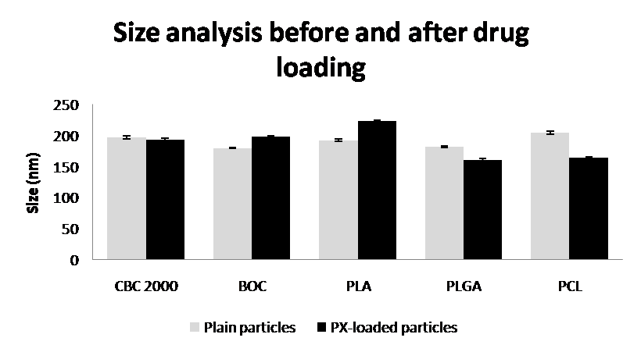
Figure 3. 6 Effect of drug loading on mean particles size.
No evident changes in size or surface charge of nanoparticles can be detected after Paclitaxel loading.
3.3.3 Encapsulation efficiency
Drug loading efficiency was calculated according to eq. 3.1 for all samples in triplicate and are presented in table 3.7.
MATERIAL | EE %
PCL | 30.0 ± 3.7
PLA | 45.0 ± 4.5
C-BC2000 | 33.8 ± 4.2
NS-BC2000 | 38.9 ± 9.3
PLGA | 55.7 ± 6.4
Table 3. 7 Encapsulation efficiency calculated according to eq. 3.1. Results are expressed as mean ± SD (n=3).
PLGA showed the highest encapsulation efficiency (55.7 ± 6.4 %), while all other samples displayed similar values, ranging from 33.8 ± 4.2 for C-BC2000 to 45.0 ± 4.5 for PLA nanoparticles.
This result again shows that our polyesterurethanes are good candidates as matrix-forming materials for nanoparticles.
3.3.4 Particles morphology (SEM)
Morphology of nanoparticles prepared with the five different materials has been investigated by means of scanning electron microscopy. Figure 3.7 reports SEM micrographs for plain nanoparticles, which show good spherical morphology and negligible coalescence, regardless of the carrier material.
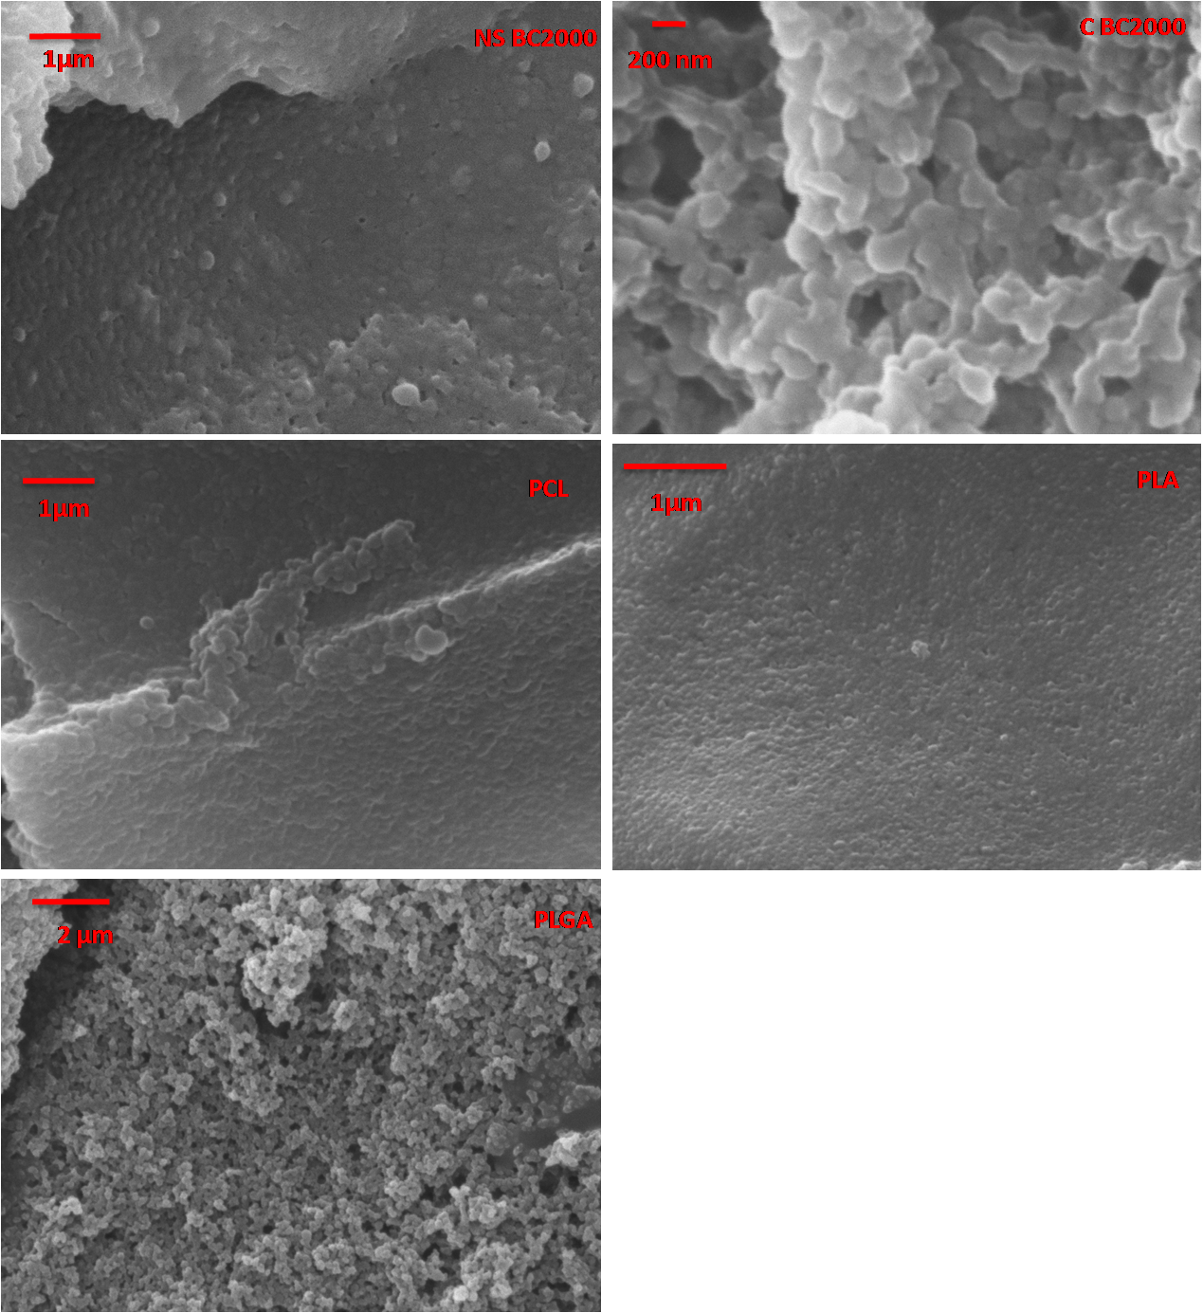
Figure 3. 7 SEM micrographs of nanoparticles prepared with different materials: A) PLGA; B) PCL; C) PLA; D) C-BC2000 and E) NS-BC2000.

3.3.5 Surface decoration
3.3.5.1 Effect of the incubation time
The optimal incubation time for surface decoration was determined for PLGA nanoparticles, by detecting the changes in particles size and zeta potential as well as the amount of antibody present on the surface of the carrier, at three different time points (1h, 6h and 24h).
These results are summarized in table 3.8 before and after incubation with mAb (n=3).
Figures 3.3 and 3.9 represent the changes in zeta potential and particles size, respectively.
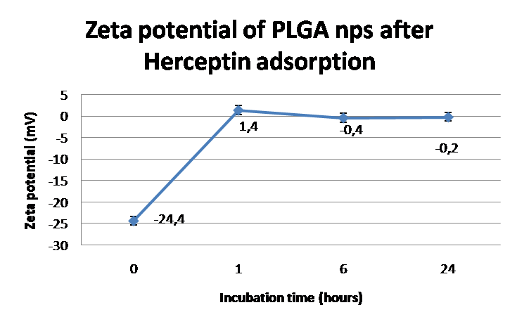
Figure 3. 8 Changes in the zeta potential of PLGA nanoparticles after different incubation time-points in the presence of Herceptin
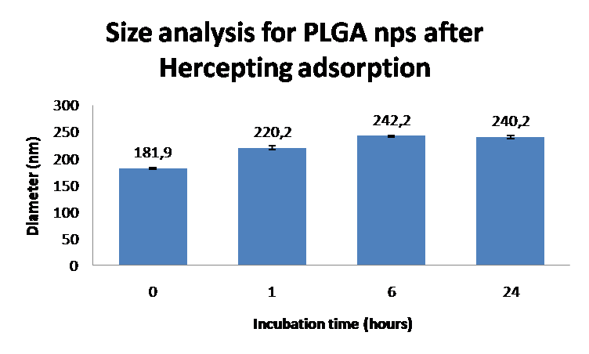
Figure 3. 9 Size measurements for PLGA nanoparticles after different incubation time-points in the presence of Herceptin
The increase in mean particles diameter and surface charge of nanoparticles after incubation in the presence of the protein suggest that the surface has been successfully decorated with the antibody, as reported by other authors [20,26].
The mean diameter increases with increasing incubation time for PLGA nanoparticles.
After one hour of incubation a sudden increase of the surface charge of nanoparticles is observed, which goes from –24.4mV to a slightly positive value of 1.4 mV. No further increase can be detected after increasing the incubation time.
The amount of adsorbed Herceptin on the surface of nanoparticles, determined by standard Bradford assay, increases with increasing incubation time, as shown in figure 3.10.
All this considered, an incubation time of 6 hours was selected to prepare surface-decorated nanoparticles with the other four polymers.
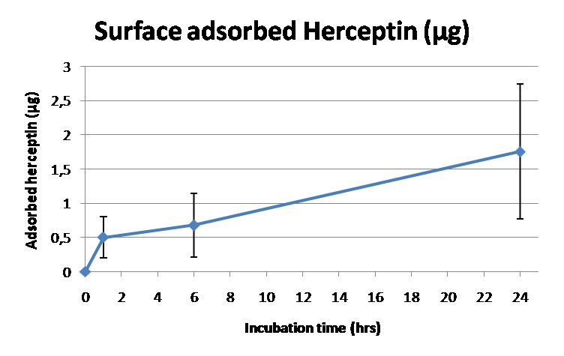
Figure 3. 10 Amount of Herceptin absorbed on the surface of PLGA nanoparticles at different incubation times.
Incubation time (h) | Adsorbed HER (µg) | Size [nm] | PDI | Zeta Pot. [mV]
1 | 0.5 ± 0.3 | 220 ± 4 | 0.14 ± 0.01 | 1.4 ± 0.2
6 | 0.7 ± 0.5 | 242 ± 2 | 0.17 ± 0.03 | -0.4 ± 0.1
24 | 1.8 ± 0.9 | 240 ± 3 | 0.15 ± 0.02 | -0.2 ±0.1

Table 3. 8 Size, PDI, zeta potential after and amount of herceptin on the surface of nps after different incubation times in the presence of monoclonal antibody.
3.3.5.2 Preparation of Her-coated nanoparticles
Size and zeta potential analysis was performed on particles prepared with all five polymers before and after 6 hours of incubation in the presence of Herceptin. Results are summarized in table 3.9 and show that in every case the surface charge of nanoparticles changed towards less negative values.
This indicates that the surface decoration was achieved successfully, as confirmed by the increase of the mean diameter.

MATERIAL | Plain particles |  |  |  | HER coated particles
MATERIAL | Size [nm] | PDI | Zeta Pot.  [mV] | Size [nm] |  | PDI | Zeta Pot.  [mV] |  |  | Her on  surface (µg)
C-BC2000 | 197 ± 2 | 0.11 ± 0.02 | -12.2 ± 0.6 | 201 ± 2 |  | 0.12 ±0.05 |  | -5.3 ± 0.4 | 1.3 ± 0.8
NS-BC2000 | 178 ± 1 | 0.11 ± 0.03 | -9.4 ± 0.4 | 223 ± 12 |  | 0.15 ± 0.01 |  | -3.5 ± 1.1 | 3.9 ± 0.6
PCL | 204 ± 3 | 0.06 ± 0.01 | -9.6 ± 0.4 | 240 ± 4 |  | 0.07±0.01 |  | -1.1 ±0.1 | 4.2 ± 0.6
PLGA | 182 ± 1 | 0.07 ± 0.03 | -24.4 ± 0.4 | 242 ± 2 |  | 0.17 ± 0.03 |  | -0.4 ± 0.1 | 0.7 ± 0.5
PLA | 193 ± 2 | 0.14 ± 0.02 | -22.0 ± 0.9 | 231 ± 2 |  | 0.13 ± 0.03 |  | -0.7 ± 0.1 | 2.5 ± 0.2
Table 3. 9 Changes in size, PDI and zeta potential of nanoparticles prepared with different polymers, and amount of Herceptin oresent on the surface of the carriers after 6 hours of incubation in the presence of mAb.
The amount of Herceptin on the surface of nanoparticles after 6 hours of incubation was also measured for all polymers, showing that PCL and the polyesterurethane NS-BC2000 exhibit the higher amount of antibody on their surface. Accordingly these two polymers exhibit the higher increment in their mean diameter after surface decoration.
3.3.6 Drug release profiles
Figure 3.11 and table 3.10 and 3.11 show the release kinetics and the amount of released drug at each time point, expressed in µg and as percent of encapsulated drug from HER-coated and uncoated nanoparticles prepared with different polymers. Results for PCL nanoparticles are not reported, since a small release from these carriers was observed only after the first day of incubation for non coated particles.
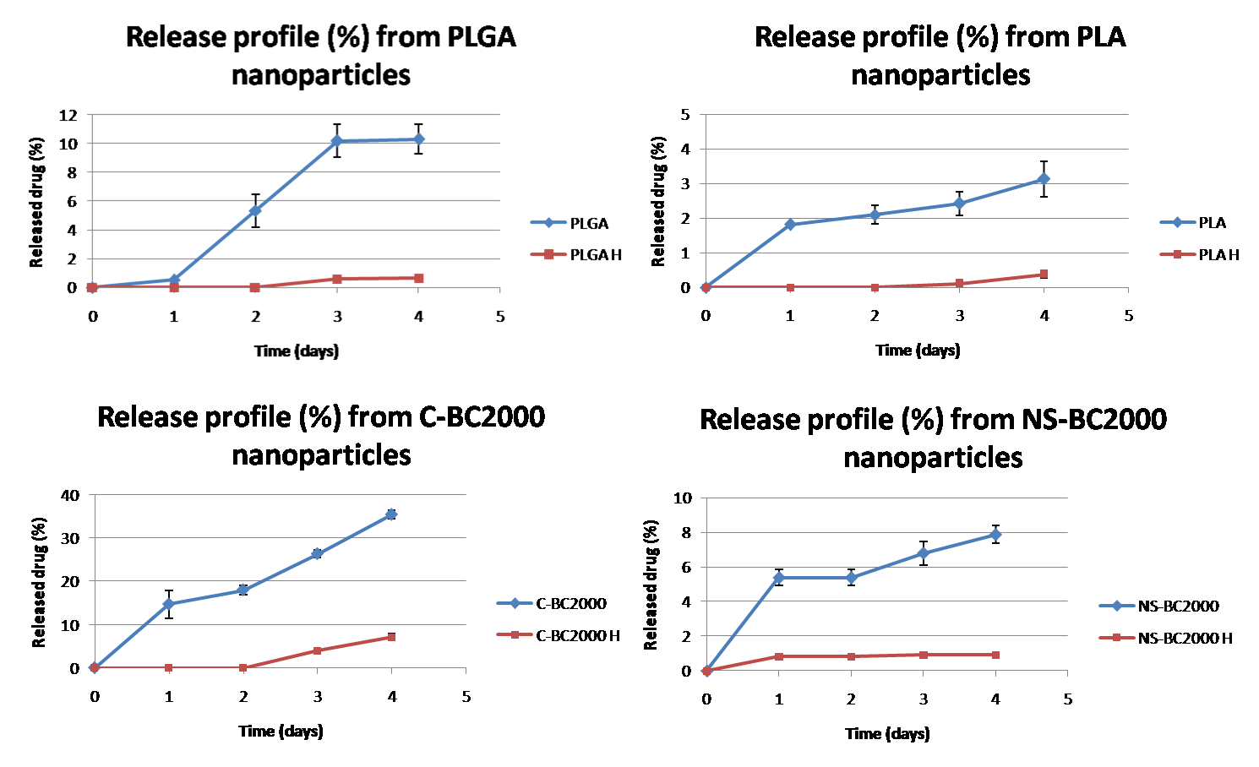
Figure 3. 11 Release profiles from HER-coated and non-coated nanoparticles prepared with different polymers
Paclitaxel release rate is slower for Herceptin-coated nanoparticles, since the presence of the antibody may result in a barrier to water permeation into the polymeric core thus lowering the diffusion rate of the drug [14].
Appreciable drug release can be noticed after the second day from HER-coated PLGA, PLA and C-BC2000 nanoparticles while HER-coated NS-BC2000 nanoparticles start releasing their content from the first day of incubation.
Release(days) | 1 | 2 | 3 | 4
 | Uncoated nanoparticles
PLGA | 0.50 ± 0.09 | 5.30 ± 1.20 | 10.20 ± 1.12 | 10.3 ± 1.0
PLA | 1.81 ± 0.02 | 2.09 ± 0.28 | 2.42 ± 0.34 | 3.13 ± 0.51
PCL | 3.28 ± 0.72 | / | / | /
C-BC 2000 | 14.73 ± 3.24 | 18.01 ± 1.08 | 26.38 ± 0.80 | 35.46 ± 1.01
NS-BC2000 | 5.39 ± 0.47 | 5.39 ± 0.51 | 6.80 ± 0.61 | 7.87 ± 0.52
 | Herceptin-coated nanoparticles
PLGA H | / | / | 0.59 ± 0.01 | 0.63 ± 0.00
PLA H | / | / | 0.10 ± 0.05 | 0.37 ± 0.09
PCL H | / | / | / | /
C-BC 2000 H | / | 0.02 ± 0.00 | 4.02 ± 0.25 | 7.09 ± 0.76
NS-BC2000 H | 0.81 ± 0.06 | 0.81 ± 0.06 | 0.90 ± 0.01 | 0.90 ± 0.01
Table 3. 10 Cumulative drug release from nanoparticles prepared with different polymers, expressed as % of the encapsulated drug.
Release(days) | 1 | 2 | 3 | 4
 | Uncoated nanoparticles
PLGA | 0.52 ± 0.09 | 1.49 ± 0.32 | 2.85 ± 0.31 | 2.88 ± 0.29
PLA | 0.40 ± 0.01 | 0.46 ± 0.06 | 0.53 ± 0.07 | 0.69 ± 0.11
PCL | 0.98 ±0.21 | / | / | /
C-BC 2000 | 2.50 ± 0.55 | 3.06 ± 0.18 | 4.48 ± 0.14 | 6.03 ± 0.17
NS-BC2000 | 1.02 ± 0.09 | 1.02 ± 0.09 | 1.29 ± 0.13 | 1.50 ± 0.09
 | Herceptin-coated nanoparticles
PLGA H | / | / | 0.17 ± 0.00 | 0.18 ± 0.00
PLA H | / | / | 0.02 ± 0.01 | 0.08 ± 0.02
PCL H | / | / | / | /
C-BC 2000 H | / | 0.003 ± 0.001 | 0.68 ± 0.04 | 1,21 ± 0,13
NS-BC2000 H | 0.15 ± 0.01 | 0.15 ± 0.01 | 0.17 ± 0.02 | 0,17 ± 0.02
Table 3. 11 Cumulative drug release from nanoparticles prepared with different polymers (µg)
A small burst release can be noticed for non coated nanoparticles followed by different profiles, depending on the material used. The moderate initial burst is needed to suppress the growth of cancer cells at the beginning of the treatment [14]. C-BC2000 nanoparticles are able to release a higher amount of drug at each time point, compared to particles prepared with other polymers.

3.3.7 Quantitative in vitro cellular uptake
A quantitative investigation has been conducted by measuring the percentage of dye-loaded nanoparticles internalized by SKBR3 and MCF7 cells.
The cells were exposed to the same concentration of Herceptin-coated and uncoated particles (1mg/ml) for 2 hours.
Results from cellular uptake studies are summarized in figure 3.12 A and B, showing the uptake from MCF7 and SKBR3 cells respectively, for plain and Herceptin-coated nanoparticles.
For MCF7 cells, which show a moderate expression of the HER-2 receptors, the presence of the antibody on the surface of nanoparticles does not cause a detectable increase of cellular internalization for PCL and PLA particles. Only a slight increase in cellular uptake can be observed for Herceptin-coated carriers made of PLGA and the two polyesterurethanes, C-BC2000 and NS-BC2000 (fig. 3.12A).
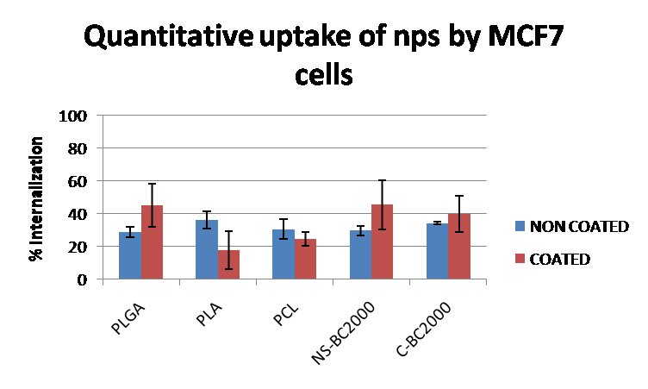
A
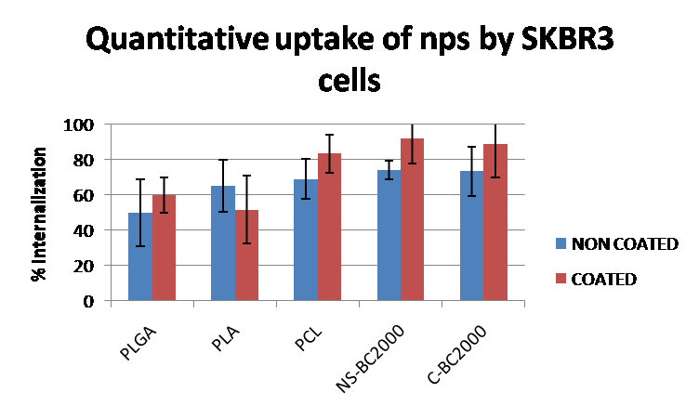
B
Figure 3. 12 Celluar uptake efficiency of dye-loaded, Herceptin-coated or uncoated particles prepared with different polymers, for MCF 7 cells (A) and SKBR3 cells (B) .
Moreover, MCF7 cells show less particles uptake when compared to SKBR3 cells for both Herceptin coated and uncoated particles, regardless of constituent material of the matrix.
On the other hand surface-coated particles show increased internalization, when compared to uncoated ones, for SKBR3 cells which are of high HER-2 receptors over-expression. This behavior is observed for all polymers, excepted PLA, for which the presence of the antibody on the surface did not increase endocytosis.
For both cell lines, higher cellular internalization can be observed for nanoparticles prepared with the two novel polyesterurethanes, confirming that these materials can be optimal candidates as matrix-forming materials for nanoparticles.
3.3.8 In vitro cellular uptake: confocal microscopy study
The cellular uptake efficiency of Herceptin- coated and non coated particles was further investigated by confocal microscopy, on both SKBR3 and MCF7 cell lines to visualize the penetration of nanoparticles into the cells and to verify the targeting effect.
The results are shown in figure 3.13 for MCF7 and in figure 3.14 for SKBR3.
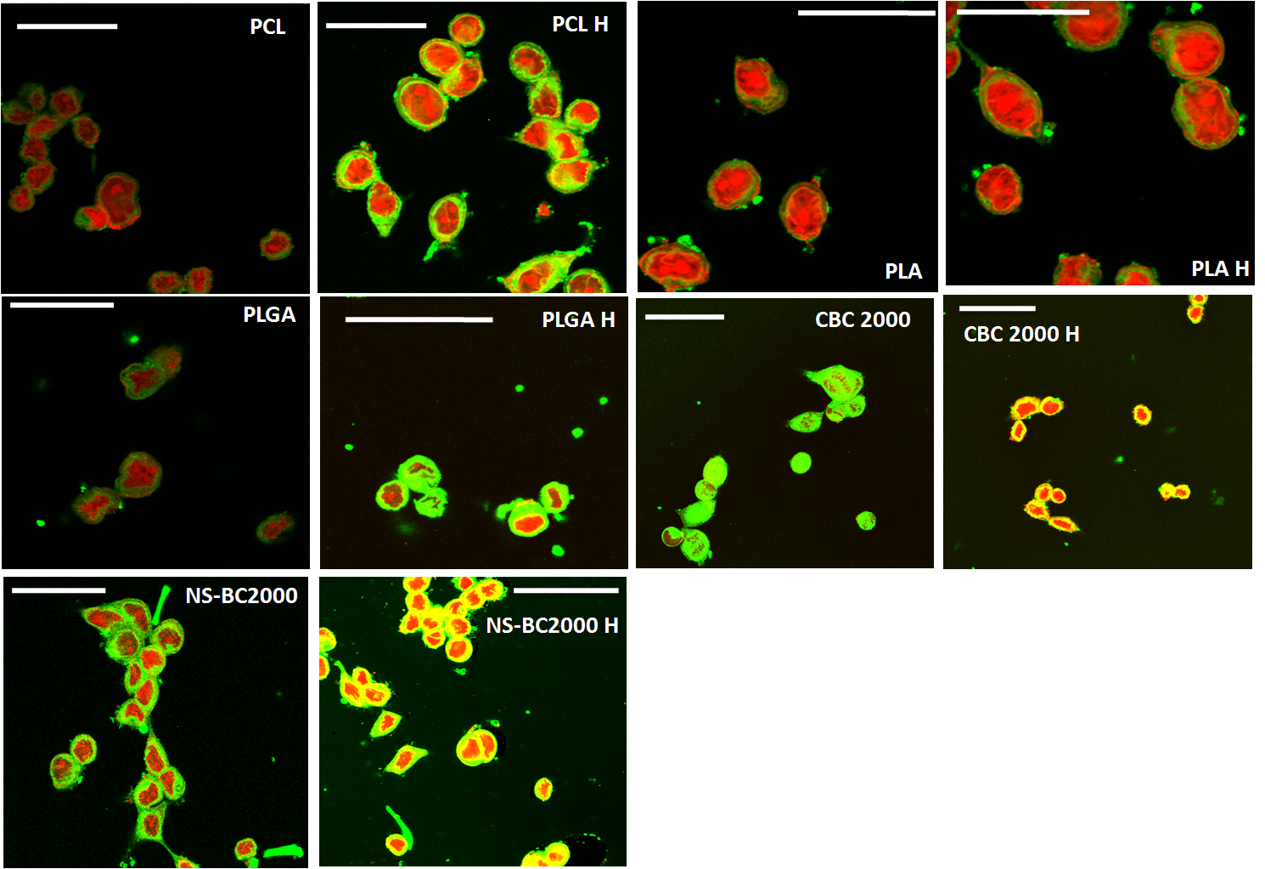
Figure 3. 13 Confocal microscopy on MCF7 cells: images are obtained from the merged channels for red (nuclei) and green (Coumarin dye inside nanoparticles).
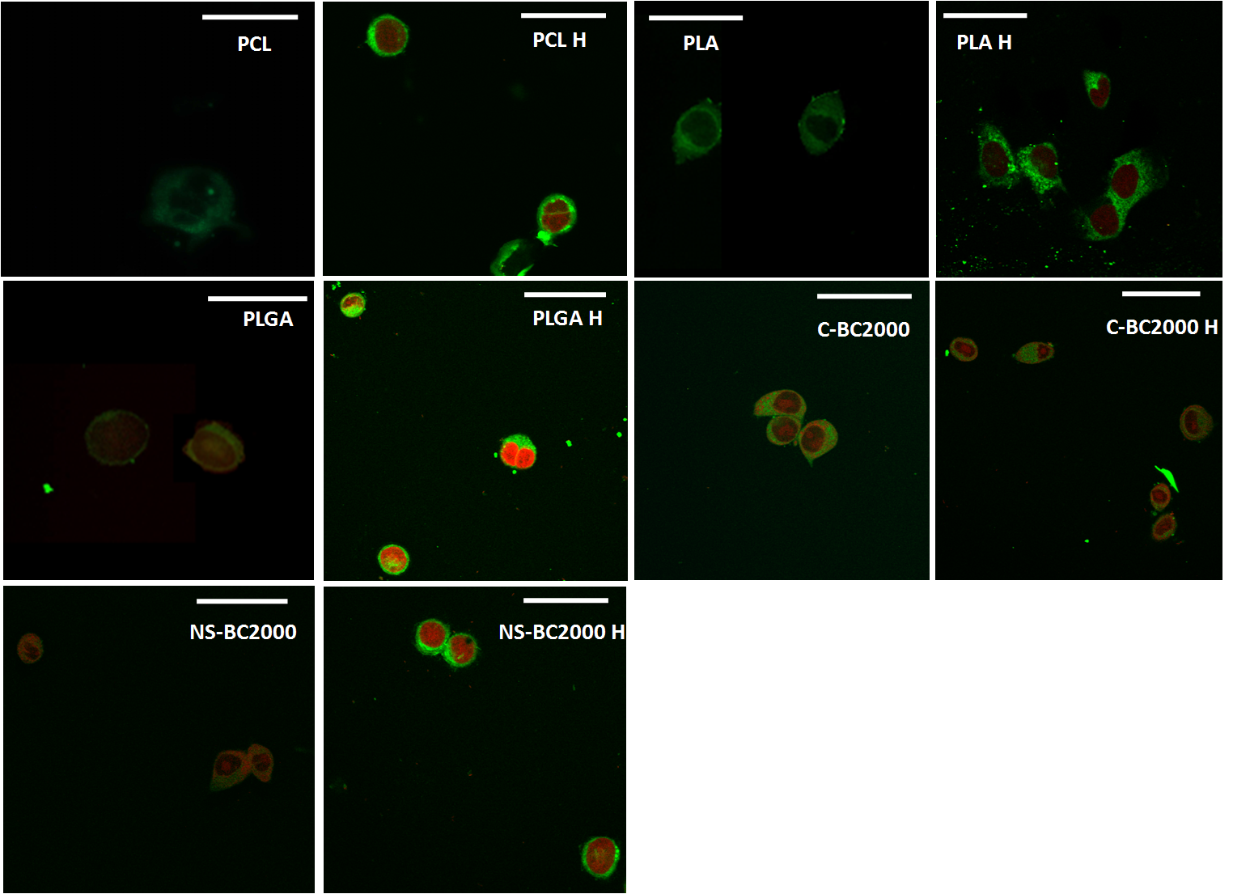
Figure 3. 14 Confocal microscopy on SKBR3 cells: images are obtained from the merged channels for red (nuclei) and green (Coumarin dye inside nanoparticles).
Confocal analysis shows that nanoparticles localize in the cell’s cytoplasm, since the nucleus (red) appears circumvented by the green fluorescence of the coumarin6 dye present inside the particles.
A more intense green fluorescence can be observed for Herceptin-coated nanoparticles for SKBR-3 and MCF-7 cells, indicating that a targeting effect can be achieved on both cell lines.
3.3.9 In vitro cytotoxicity
Quantitative analysis of the cytotoxicity of different Paclitaxel-containing nanoparticles formulations with or without mAb coating, was performed on SKBR3 cells.
A comparison between coated and uncoated samples for each polymer, is presented in figure 3.15.
Uncoated particles show a similar behavior for all polymers, with a dose-dependent cytotoxic effect. In fact the percent of living cells linearly decreases with increasing drug dose. This is particularly evident for C-BC2000 non coated nanoparticles, which show the highest cytotoxic activity against SKBR3 tumor cells especially at high drug doses. A Paclitaxel dose of 2.5µg/ml encapsulated into C-BC2000 uncoated particles possessed the ability to kill more than 50% of cancer cells during the first day of treatment.
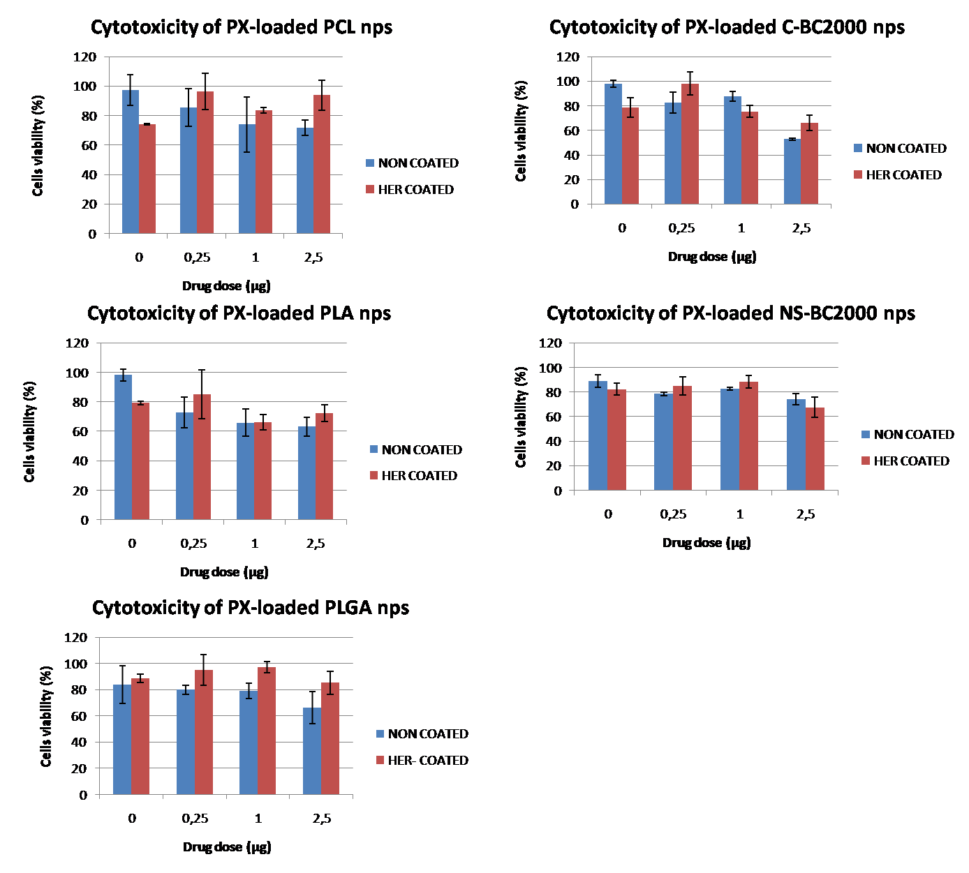
Figure 3. 15 Cytotoxicity of different PX-nanoformulations.
At a fixed Paclitaxel dose, Herceptin-coated particles did not show increased cytotoxicity when compared to their uncoated counterparts. This indicates that the presence of the antibody on the surface of nanoparticles does not increase its activity in killing tumor cells, though increasing the extent of cellular internalization. These results are in accordance with what observed from the drug release tests, which showed that the presence of the mAb coating on the surface of nanoparticles resulted in a delayed release profile of the encapsulated drug, especially during the first day. For coated particles, cytotoxicity is also dependent on the matrix-forming material, since the amount of Herceptin on the surface is correlated with the polymer used to prepare nanoparticles.
3.4 Conclusions
In this chapter, nanoparticles with different polymers were successfully prepared by a modified single emulsion solvent extraction evaporation method for the active targeting of HER2 over-expressing breast cancer cells.
Regardless of the polymer used, all particles exhibited a spherical morphology and a small size, which could be exploited for the passive targeting of cancer cells through the EPR effect [4].
To further increase targeting ability of these carriers, Herceptin, a monoclonal antibody known to selective bind to HER-2 over-expressing cells like pancreatic and breast cancer cells, was introduced on the surface of nanoparticles as a coating, through hydrophilic/hydrophobic interactions between the negatively charged polymer surface and the positively charged protein.
Surface modification was successfully achieved, as demonstrated by changes in size and zeta potential of the particles [20,26]. The amount of Herceptin on the surface of the carriers was measured by standard Bradford assay, confirming the presence of the antibody on nanoparticles.
The targeting ability of the carriers was measured by quantifying cellular uptake on two different breast cancer cell lines: MCF7 which have moderate expression of the HER2 receptor and SKBR3, which exhibit high over-expression of the same receptor. Results showed that the presence of the mAb on the particles surface led to increased cellular internalization, regardless of the polymer used to prepare nanoparticles, for both cell lines. Moreover, Paclitaxel, one of the most potent anti-neoplastic drugs, was encapsulated inside nanoparticles, and the cytotoxicity of these drug nanoformulations was evaluated at three different drug concentrations (0.25; 1and 2.5 µg/ml) for both plain and HER-coated particles. In vitro cytoxicity results showed that antibody-coated nanoparticles, which exhibited a delayed release profile, also had lower cytotoxicity against SKBR-3 cells. On the other hand, uncoated carriers showed a dose-dependent cytotoxic activity regardless of the polymer used.
Two novel biodegradable polyesterurethanes prepared with different chain extenders were proposed as matrix-forming materials for nanoparticles, obtaining satisfactory results. In fact PU nanoparticles, exhibited higher cellular internalization, targeting ability and cytoxic activity on SKBR-3 cells.
Results indicate that these new materials show superior properties, when compared to standard, traditionally used matrix-forming materials. In this work, polyurethanes were synthesised with two different chain extenders: 1,4-cyclohexane dimethanol CDM and N-Boc-serinol for C-BC2000 and NS-BC2000 respectively. The latter posses protected functional amino groups (NH₂) which, after de-protection, could be exploited for future chemical coupling of antibodies or other targeting moieties.
All this considered, PUs may be considered as optimal candidate for the preparation of nanoparticles, since they offer the possibility to modulate the final properties, by controlling their chemical composition [27]. Their potential as matrix-forming materials for novel nanomedicine formulations is therefore demonstrated.
References
[1] Haley B. et al 2008 Urologic Oncology: Seminars and Original Investigations 26:57
[3] Hans ML. et al. 2002 Current Opinion in Solid State and Materials Science 6:319
[4] Parveen S. et al 2011 Nanomedicine: Nanotechnology, Biology, and Medicine in press
[5] McGuire WP. 2003 Br. J. Cancer 89(3):S3
[6] [Parveen S. et al. 2008 J. Drug Target. 16:108].
[7] Garnett MC et al. 2001 Adv. Drug del. Rev. 53:171
[8] Lambert JM 2005 Curr. Opin. Pharmacol. 5:543
[9] Kohler G. et al. 1975 Nature 256:495
[10]Funaro A. et al. 2000 Biotechnol. Adv.18:385
[11] Kocbek P. et al. 2007 J. Control. Rel. 120:18
[12] [Cirstoiu-Hapca A. et al. 2010 J. Control. Rel. 144:324
[13] Pabari RM. Et al. 2011 Pharmaceutics 3:510
[14] Y. Liu et al. 2010 Biomaterials 31:9145
[15] Arya G. et al. 2011 Nanomed. Nanotech. biol. med. 7:859
[16] Cerrai P. et al. 1994 J. Mat. Sci. Mat. Med., 5:33
[17] Rechichi A. et Al. 2008 J. Biomedical Mat. Res. Part A 84: 847
[18] Illum L. et al. 1983 Int. J. Pharm. 17:65
[19] M. Gaumet et al. 2008 Eur. J. Pharm. Biopharm. 69:1
[20] C. Cai et al. 2008 Eur. J. Pharm. Biopharm. 69: 31
[21] Goppert TM. 2005 Eur. J. Pharm. Biopharm. 60:361
[22] Vanderoort J. 2002 Int. J. Pharm. 238:77
[23] Scholes, P.D 1999 Int. J. Pharm. 59:261
[24] Coombes A. et al. 1998 J. Control. Release 52:311
[25] Ye M. et al. 2010 J. Control. Release 146:241
[26] Calvo P et al. 1997 Biomaterials 18:1305
[27] Lamba NMK et al. 1998 in Polyurethanes in biomedical applications CRC press

Section III

Chapter 4

Innovative bioactive and biodegradable polymeric bone cements for the repair of vertebral injuries.

Abstract
Vertebral fractures, weather caused by age-related diseases or by trauma, often result in pain, significant physiological and functional impairment and deformity of the spine, which in turn leads to a decreased ventilatory capacity and shortened life expectancy [1]. Kyphoplasty and vertebroplasty are the most diffused percutaneous methods for the repair of vertebral injuries [2]. Both methods involve the use of bone cements (typically polymethyl methacrylate PMMA) to restore the load-bearing capacity and stiffness of the bone [3]. To overcome limitations associated with use of PMMA (such as poor Osseo-integration, absence of biologic potential to stimulate remodeling and potential monomer toxicity) a new biomimetic and biocompatible bone cement is proposed. This material is based on an organic phase, composed of chitosan (CH) and collagen, cross linked with genipin (GP), and on an inorganic bioactive β tricalcium phosphate-based phase. Different compositions were tested, by varying the organic/inorganic phase ratio and the amount of cross linker. The proposed material showed good bioactivity after 14 days of soaking in simulated body fluids (SBF), good mechanical properties and dissolution behavior, as well as a low setting and hardening point. Moreover, the addition of Indomethacin (IND) loaded nanoparticles to the cement composition, added the ability to face post-operative infections, since the release rate of the drug is compatible with post-operative infections raising kinetics. The proposed material appears to be a promising candidate as injectable bioactive bone substitute for guided bone regeneration.
4.1 Introduction
The increased life expectancy in the developed countries has led to a serious rise in the number of musculoskeletal disorders, such as osteoporosis and osteoarthritis [1].
Osteoporosis is a systemic skeletal disease characterized by low bone mass and micro-architectural deterioration, with a consequent increase in bone fragility and susceptibility to fracture. These fractures include the vertebral body, distal forearm and proximal femur and may cause considerable morbidity and mortality [4].
More than 700000 osteoporotic vertebral compression fractures (VCFs) are estimated each year in the United States which are associated with significant physiologic and functional impairment [5-7].
A vertebral fracture, whether originating from osteoporosis or trauma, can be the cause of pain, disability and neurological deficit. Multiple vertebral compression fractures can,
beside pain, lead to a considerable shortening and deformity of the spine, which in turn results in postural instability and decreased ventilatory capacity [8].
Different treatments have been proposed for vertebral injuries, such as open surgery and non-operative management, including medications and bracing. Unfortunately, large numbers of patients report intractable pain and inability to return to activities. The limitations of non-operative management have fostered increasing interest in new, percutaneous methods of fracture stabilization that allow early return to activity and do not require fixation in weak bone [2].
The most common percutaneous methods are vertebroplasty and kyphoplasty. Both of them involve the use of injectable bone cements (in particular polymethylmethacrylate - PMMA) to restore the load-bearing capacity and stiffness of the treated vertebral body [9-11].
Vertebroplasty involves the injection of PMMA into the compressed vertebral body [12]. Kyphoplasty employs a balloon tamp to create a void in the vertebral body and restore physiological height [13]. Viscous PMMA is then applied into the created defect These procedures are well tolerated and associated with high rates of pain relief [14].
Polymethylmethacrylate bone cements have been used for many years for the fixation of the metal and plastic components of joint replacement. PMMA has been reported to be bioinert and to show good biocompatibility over long-term follow-up. Several inherent advantages of PMMA include familiarity for orthopedic surgeons, ease of handling, good biomechanical strength and stiffness, and cost-effectiveness [15].
On the other hand, several problems associated with the use of PMMA have been reported, including: (i) absence of biologic potential to remodel or integrate into the surrounding bone, resulting in the formation of a fibrous layer between the bone surface and the cement [3], (ii) no direct bone apposition, (iii) excessive inherent stiffness, (iv) high polymerization temperature, and (v) potential monomer toxicity. Although good clinical results have been reported for both vertebroplasty and kyphoplasty procedures, it is still unclear whether some component of the pain relief is secondary to the mechanical stabilization, chemical toxicity, or thermal necrosis of surrounding tissues and nerve ends [3].
To overcome limitations associated with the use of PMMA, bioactive and biodegradable bone cements have been proposed. These bone cements are generally based on bioactive calcium phosphate compounds, like Hydroxyapatite (HA), β tricalcium phosphate (βTCP) or bioactive glasses [17].
These materials possess numerous advantages, such as self-setting ability in vivo, injectability (which allows cement implantation by means of minimally invasive surgical techniques) and the ability of perfectly fit the implant site, which assures good bone–material contact, even in geometrically complex defects.
Moreover the low-temperature setting allows incorporation of different drugs: from antibiotics and anti-inflammatory drugs to growth factors which are able to stimulate certain biological responses. This aspect gives a great potential to this type of materials for the controlled drug delivery in target sites of the skeletal system [17].
In this chapter the preparation and characterization of a new biodegradable and bioactive bone cement is described.
This material is composed of an organic phase made of chitosan (CH), which is expected to improve the injectability, as well as of β tricalcium phosphate as inorganic phase able to increase the bioactivity (i.e. the ability to stimulate new bone deposition) of the material [18].
Genipin (GP) was selected as cross-linker for chitosan, due to its natural origin and biocompatibility [19].
The cement composition was optimized to obtain the desired hardening time and dissolution rate and then reinforced with collagen, which is known to confer biomimetic ability and to increase the mechanical strength [20] of the material.
Moreover, anti-inflammatory properties were given by including Indometacin-loaded biodegradable nanoparticles based on Poly(ε-caprolactone) (PCL) in the cement composition.
Nanoparticles were prepared by the Solvent Displacement Method [21] and their size, encapsulation efficiency as well as release profiles were characterized.
Injectability, compressive strength and bioactivity of the final cement composition were also investigated.
4.2 Materials & methods
4.2.1 Materials

Chitosan (Mn 1000, 75%-85% deacetilation), collagen (from calf skin), β tricalcium phosphate (310.2 g/mol), tween80, vitamin E TPGS and Indomethacin were all purchased from Sigma Aldrich Italy. Simulated Body Fluids (SBF) were prepared according to the protocol proposed by Kokubo et al [22].
Poly(ε-caprolactone) (Mn 30000) was from Polysciences Inc, Genipin was supplied by Challange Bioproducts Co, Taichung – Taiwan.
All other reagents and solvents were from Sigma Aldrich Italy. Solvents were of analytical grade. Deionized water was produced by a Millipore purification system.
4.2.2 Preparation of Chitosan/βTCP bone cement: optimization of processing parameters.
Crosslinking and hardening properties of different CH/βTCP blends were analyzed in order to optimise the ratio between the two components, as well as the amount of crosslinking agent (GP) with respect to the initial amount of chitosan.
Five different CH/βTCP ratios (90/10, 70/30, 50/50, 30/70, 10/90 w/w) and four Genipin concentrations (2.5%, 3.5%, 5%, 7.5% w/w) were tested (see table 4.1).

CH-TCP ratio (w/w) | GP concentration (w/w)
CH-TCP ratio (w/w) | 2.5% | 3.5% | 5% | 7.5%
90/10 | 90/10_ GP2.5 | 90/10_ GP3.5 | 90/10_ GP5 | 90/10_ GP7.5
70/30 | 70/30_ GP2.5 | 70/30_ GP3.5 | 70/30_ GP5 | 70/30_ GP7.5
50/50 | 50/50_ GP2.5 | 50/50_ GP3.5 | 50/50_ GP5 | 50/50_ GP7.5
30/70 | 30/70_ GP2.5 | 30/70_ GP3.5 | 30/70_ GP5 | 30/70_ GP7.5
10/90 | 10/90_ GP2.5 | 10/90_ GP3.5 | 10/90_ GP5 | 10/90_ GP7.5
Table 4. 1 Sample nomenclature according to the concentration of cross linking agent and to the ratio of organic/inolrganic phase
Chitosan (2%w/v) was dissolved in 0.5M acetic acid under magnetic stirring for 12 hours. The pH of the solution was adjusted to 6 by addition of 1M NaOH.
Blends were prepared by adding the inorganic phase (βTCP) and the cross-linker (GP) to known amount of the chitosan solution, under magnetic stirring at 40°C.
The obtained solutions were kept under stirring until complete setting was achieved, then poured into 24 well plates and incubated at 37°C for 24 hours to complete the cross linking reaction. Samples were stored at 4°C and used for further analysis.
4.2.3 Dissolution tests
Dried samples were accurately weighted immersed in 5ml of 0,1M Phosphate buffer (PBS, pH 7.4) and incubated at 37°C for 3, 7 and 14 days.
After each time period, samples were washed several times with de-ionized distilled water, dried for 48/72 hours and then weighed.
Weight loss was measured as follows:
$$\%D=\frac{W_{i}-W_{f}}{W_{i}}*100 Eq 4.1$$
Where W_{i} and W_{f} are the initial and final weight of each sample, respectively.
Experiments were carried out in triplicate and results are expressed as mean ± standard deviation.
4.2.4 Bioactivity assessment
To assess the bioactivity, all samples were immersed in simulated body fluids (SBF pH 7,4) and incubated at 37°C for 14 and 30 days.
SBF was prepared according to the protocol proposed by Kokubo et al. [22] at 37°C, by adding the following reagents (Sigma Aldrich) in de-ionized distilled water:
1. NaCl (8.035 g)
2. NaHCO₃ (0.355 g)
3. KCl (0.225 g)
4. K₂HPO₄ 3H₂O (0.231g)
5. MgCl₂ 6H₂O (0.311g)
6. CaCl₂ (0.292 g)
7. Na₂SO₄ (0.072 g)
The pH of the solution was adjusted to 7.4 by adding 6.118 g TRIS and 39ml HCl.
After incubation, samples were washed with distilled water, dried for 72hours and prepared for scanning electron microscopy (SEM-EDS) analysis, to assess the amount of apatite (Calcium Phosphate) present on the surface which is an indicator of the ability of a material to stimulate new bone formation.
For SEM analysis samples were mounted on aluminium stabs and coated with gold, by using an Agar Auto Sputter Coater. The analysis was performed at a working distance of 15mm and a voltage of 20kV.
4.2.5 Compressive strength
MTS testing machine was used to determine the compressive Young Modulus (E) of samples prepared with different organic/inorganic ratio an cross linker concentrations.
A 10N load was applied at 1mm/min, after selecting an initial preload of 0.05N and a maximum compression of 80% of the initial height of the sample.
Young Modulus for compression was determined from the slope of the stress-strain curve in the elastic/linear region for low deformations.
4.2.6 Preparation of Indometacin-loaded PCL nanoparticles
Nanoparticles were prepared by the Solvent Displacement Technique using PCL as matrix-forming material and TWEEN 80 or Vitamin E TPGS as emulsifiers.
For particles preparation, the polymer and the drug (3% w/w) were dissolved in 10 ml acetone and then slowly added dropwise into 20 ml of water containing the emulsifier under moderate magnetic stirring. Particles formed instantaneously for the fast diffusion of the solvent from the core of the droplets towards the water phase. Acetone was removed from the colloidal suspension under reduced pressure, by using a rotary evaporator (Buchi). After dialysis (24h) against distilled water, particles were collected by centrifugation, frozen at -80°C and freeze-dried in the presence of Trehalose as cryo-preserving agent.
4.2.7 Characterization of nanoparticles
4.2.7.1 Process Yield
Process Yield (R%) was calculated according to equation 4.2, where W_{pcl} and W_{Ind} are the initial weight of polymer and drug and W_{NPS} is the final weight of nanoparticles after freeze drying.
$$\frac{W_{pcl}+W_{ind}}{W_{nps}}*100 Eq 4.2$$
4.2.7.2 Particle morphology
NPs Morphology was examined by Scanning Electron Microscopy (SEM Leo Instruments). Particles were mounted on aluminium stabs and coated with gold, by using an Agar Auto Sputter Coater. The analysis was performed at a working distance of 10mm and a voltage of 20kV.
4.2.7.3 Determination of Indometacin loading and release profiles
The amount of encapsulated Indometacin was quantified by using UV spectrophotometer (Perkin Elmer Lamba25) at an absorbance wavelength of 319nm. For drug loading measurements, 10mg of freeze dried nanoparticles were accurately weighed and dissolved in acetone. After solvent evaporation the encapsulated dru g was extracted with ethanol and distilled water (3:1) and its concentration analyzed. Encapsulation efficiency (EE) was determined as follows:
$$EE\%=\left(\frac{W_{Ind}}{W_{Ind-t}}\right)×100 (Eq. 2.2)$$
where, W_{ind} is the weight (mg) of drug detected by UV spectroscopy and W_{ind-t} is the theoretical amount of drug expected in 10mg of nanoparticles.
For the determination of Indometacin release profiles, 10mg of nanoparticles were accurately weighted, dispersed in 1.5 ml distilled water and incubated at 37°C under constant shaking in a IKA KS 4000 incubator. The amount of drug released was measured daily for up to four days. At predetermined time points, the release medium was replaced with fresh water, the old solution was diluted with proper volumes of ethanol and analyzed by UV spectroscopy to determine the amount of drug released over time.
4.2.7.4 DSC analysis
Physical state of the encapsulated drug was studied by Differential Scanning Calorimetry (DSC) (TA Instruments DSC Q20). Approximately 5 mg of the sample were encapsulated in hermetic aluminium pans and cooled from room temperature to -20 °C. The pan was then heated from -20 °C to 200 °C at 10 °C/min, isothermally maintained at 200 °C for 3 minutes, quenched to -20°C at 10°C/min and reheated from -20 °C to 200 °C at 10 °C/min under nitrogen atmosphere. All Thermograms were analyzed using the TA Universal Analysis software.
DSC analysis was performed on plain and drug loaded particles, emulsifiers (Tween 80 e Vitamin E-TPGS) as well as on the polymer (PCL) and the drug (IND).
4.2.8 Characterization of collagen and nanoparticles-containing bone cement
Based on the results of the above-described characterization, the best cement composition was determined and used to prepare a reinforced material, containing nanoparticles loaded with the anti-inflammatory drug Indometacin and collagen as an additional organic phase.
Collagen was added to better mimic the characteristics of bone tissue and to impart higher mechanical strength to the material.
The composition of the tested material was:
1. Percent of organic phase, composed of a blend of chitosan and collagen (3% w/v), of 30%
2. Percent of inorganic phase (βTCP) of 70%
3. 10% w/v of PCL nanoparticles, containing the anti-inflammatory agent Indomethacin
4. Amount of cross-linker (Genipin) 7.5% (w/v).
This material was characterized in terms of morphology, hardening time and injectability as well as mechanical strength under compression.
Injectability was determined according the equation proposed by Xiaopeng Qi et al [23]:
$$Injectability \left(\%\right)= \frac{Injected volume}{Initial volume}*100 Eq 4.3$$
Briefly, 5ml of bone cement solution were sucked up by using a syringe and then injected in a graduated cylinder, to measure the injected volume.
4.3 Results & Discussion
4.3.1 Optimization of the processing parameters
4.3.1.1 Determination of the setting time
To evaluate the effect of the organic/inorganic ratio and of the concentration of cross linker on the final properties of the material, setting time was recorded for all the bone cement formulations described in the previous section.
Results are reported in figure 4.1 and show that setting time increases with increasing cross/linker concentration, as well as with increasing inorganic phase content.
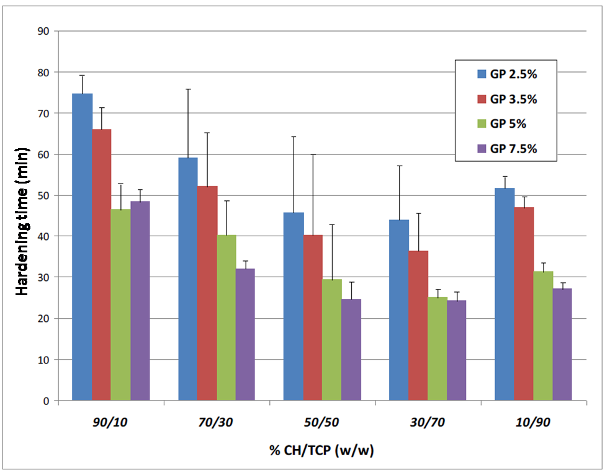
Figure 4. 1 Hardening time of samples prepared with different organic/inorganic ratio and different cross-linker concentrations.
In particular, at a constant GP concentration, increasing the βTCP ratio up to 70% w/w leads to a drastic reduction in the hardening time. Interestingly, a higher βTCP content (90%) results in longer hardening time, probably because the complete cross linking of the organic phase could be hampered by the massive presence of the inorganic component.
As an example, the series of samples obtained at a 2.5% GP concentration, show how an increased βTCP content led to shorter hardening time, ranging from 75min, for sample 90/10_GP2.5, to 44min for sample 70/30_GP2.5. Sample 10/90_GP2.5 displayed a higher hardening time (52min).
Similar profiles can be detected for all other formulations, obtained at higher GP concentrations, as summarized in table 4.2.

Sample 30/70_GP7.5 shows the best behavior with a setting time of 24 minutes, which meets the requirements indicated in literature [24].
% CH/βTCP (w/w) | GP 2.5% (w/w) | GP 3.5% (w/w) | GP 5%  (w/w) | GP 7.5% (w/w)
90/10 | 75±5 | 66±5 | 46±6 | 48±2
70/30 | 59±17 | 52±13 | 40±8 | 32±3
50/50 | 46±19 | 40±20 | 29±14 | 25±4
30/70 | 44±13 | 36±9 | 25±2 | 24±2
10/90 | 52±3 | 47±3 | 31±2 | 27±2
Table 4. 2 Setting times recorded for all samples.
4.3.1.2 In vitro dissolution tests
In order to assess the optimal GP concentration, dissolution tests were performed on all samples, by measuring their weight loss after 3, 7 and 14 days of soaking in phosphate buffer saline (PBS) at 37°C.
Results are reported in figures 4.2–4.5 and show that no evident weight loss was recorded, regardless of the sample composition.
The highest dissolution rate (17%) was observed for sample 50/50_GP5 after 14 day of incubation.
As expected, the dissolution rate slightly increased with increasing soaking time and decreased at higher GP concentration. In fact the best behavior was observed for samples with the highest GP content (7.5%).
In these conditions, samples prepared with an organic/inorganic ratio of 30/70 were the most stable, with a dissolution rate ranging from 0.8 ± 0.1% to 2.6 ± 0.5% after 3 and 14 days in PBS respectively (see table 4.3).

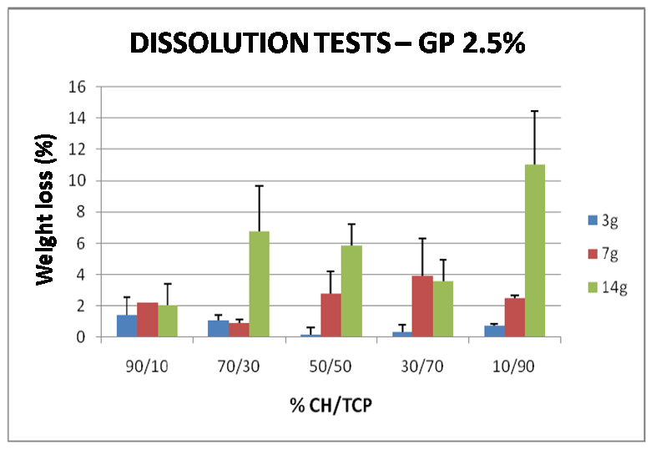
Figure 4. 2 Dissolution tests performed on bone cements prepared with different organic/inorganic phase ratios and with a cross linker concentration of 2.5% w/v
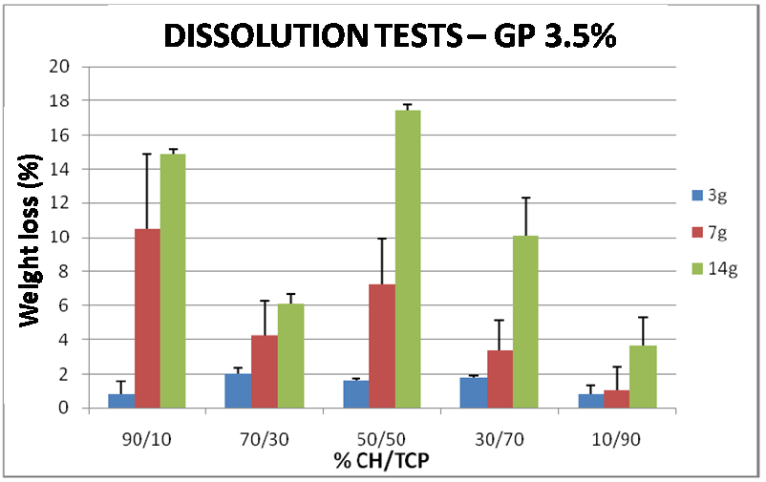
Figure 4. 3 Dissolution tests performed on bone cements prepared with different organic/inorganic phase ratios and with a cross linker concentration of 3.5% w/v

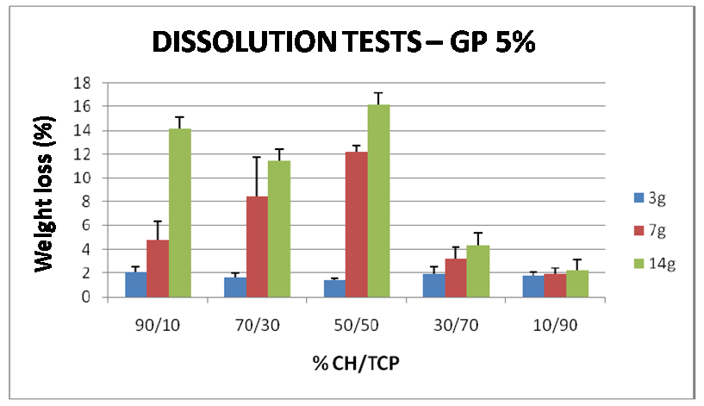
Figure 4. 4 Dissolution tests performed on bone cements prepared with different organic/inorganic phase ratios and with a cross linker concentration of 5% w/v
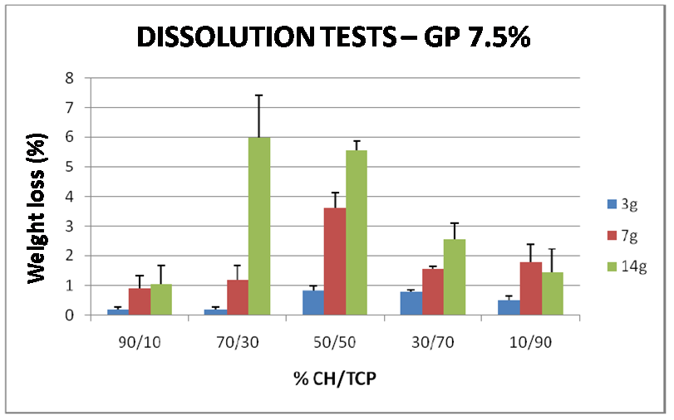
Figure 4. 5 Dissolution tests performed on bone cements prepared with different organic/inorganic phase ratios and with a cross linker concentration of 7.5% w/v
Soaking time in PBS (days) | Dissolution rate (%)
3 | 0.8 ± 0.1
7 | 1.5 ± 0.1
14 | 2.6 ± 0.5
Table 4. 3 Dissolution rates of sample 30/70 GP 7.5 which showed the best behaviour in this test.

4.3.1.3 Determination of the compressive strength

The samples behavior under compression has been assessed by determining the Young Modulus for compression (E). Results are summarized in figure 4.6, and show a Young Modulus for all samples ranging between 7.7 ± 1.2 kPa, for sample 90/10_GP2.5, and 188.6 ± 36.3 kPa, for sample 10/90_GP7.5.
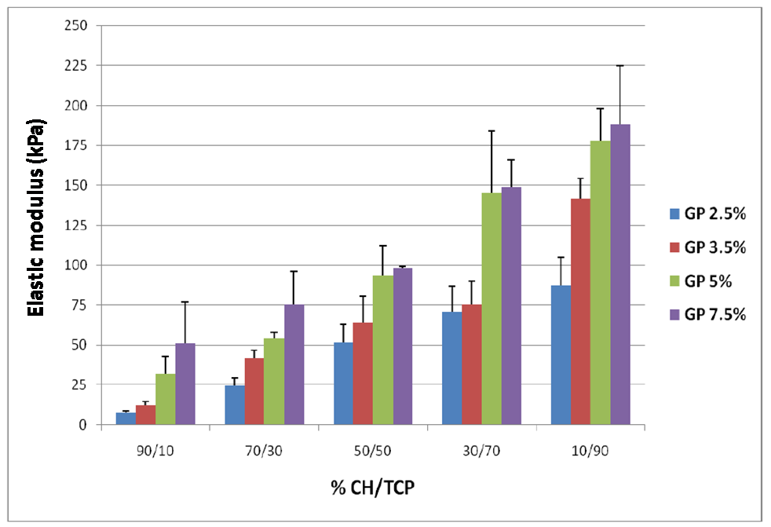
Figure 4. 6 Elastic modulus of samples prepared with different organic/inorganic phase ration and concentration of cross linker.
An increase in the amount of inorganic (βTCP) phase results in a considerable increase in the Young modulus for compression. This effect is particularly evident for samples cross-linked with the higher amount of Genipin (7.5%) which also showed the best hardening and dissolution behavior in the previous tests. In fact, Young Modulus values for these samples range from 51.1 ± 25.8 kPa for samples containing 10% inorganic phase, to 188.6 ± 36.3 for samples prepared with higher amount of βTCP (90%).
The amount of cross-linker also showed an effect on the Young modulus for compression. In particular, increasing GP content results in increased mechanical strength especially for those samples prepared with higher inorganic/organic phase ratio.
The obtained values are, in every case, superior to those reported in the literature for different polymeric bone cements of similar compositions [25]. The addition of natural collagen to the organic phase of the cement is expected to lead to a further increase in the cement mechanical properties.
4.3.1.4 In Vitro bioactivity tests
In order to be classified as biocompatible, a material must create an environment able to stimulate new tissue in-growth (osteogenesis) leading to the formation a natural mineralized junction between the surrounding tissue and the host material [26].
Materials for bone regeneration may be classified into two main categories: (i) osteoconductive materials, which are able to actively stimulate new tissue in-growth, by promoting precipitation of apatite (Calcium phosphate) crystals and (ii) osteoinductive materials, which simply offer a favorable environment for tissue growth without any active stimulation [27].
β-TCP, used as inorganic phase during the preparation of the bone cement, is a calcium phosphate ceramic material, known to show bioactive and osteoconductive properties [28].
The ability of the GP-cross-linked βTCP-based bone cements to actively stimulate the deposition of new apatite crystals after immersion in SBF was therefore tested.
Apatite deposition after two different immersion time-points (14 and 30 days) was qualitatively and semi-quantitatively investigated, by means of Scanning Electron Microscopy and EDS respectively.
Since no difference has been observed in the bioactivity of samples cross-linked with different amounts of Genipin, results of bioactivity tests are reported only for samples containing 5% and 7.5% w/w cross-linker.
SEM micrographs are summarized in figures 4.7-4.26, while the atomic content of the elements detected by EDS analysis are reported in tables 4.4 and 4.5.
After 14 days of immersion in SBF, the formation of Hydroxyapatite crystals has been detected on the surface of all samples regardless of their composition. Samples prepared with higher inorganic/organic phase ratio showed higher bioactivity, as confirmed by EDS results which detected higher Ca and P content, indicating that the composition is a key parameter for a successful osteointegration.
As already observed, the amount of cross-linker added to the cement composition, does not affect the sample bioactivity. No difference in the percent of Ca and P between samples prepared with 5% and 7.5% GP was detected by EDS analysis, confirming this observation.
After 30 days of incubation the density of apatite crystals as well as the atomic percent of Ca and P ions increased for all samples, as shown by SEM micrographs and EDS analysis.
Moreover, the molar ratio between Ca and P after 39 days of incubation ranges from 1.64 to 1.92, and is therefore very close to the theoretical ratio for hydroxyapatite (1.67) [26].
Figure 4. 7 SEM micrographs of sample 90/10_GP 7.5 after 14 days of incubation
Figure 4. 8 SEM micrographs of sample 70/30_GP 7.5 after 14 days of incubation

Figure 4. 9 SEM micrographs of sample 50/50_GP 7.5 after 14 days of incubation
Figure 4. 10 SEM micrographs of sample 30/70_GP 7.5 after 14 days of incubation
Figure 4. 11 SEM micrographs of sample 10/90_GP 7,5 after 14 days of incubation

Figure 4. 12 SEM micrographs of sample 10/90_GP 5 after 14 days of incubation
Figure 4. 13 SEM micrographs of sample 30/70_GP 5 after 14 days of incubation
Figure 4. 14 SEM micrographs of sample 50/50_GP 5 after 14 days of incubation
Figure 4. 15 SEM micrographs of sample 30/70_GP 5 after 14 days of incubation
Figure 4. 16 SEM micrographs of sample 10/90_GP 5 after 14 days of incubation
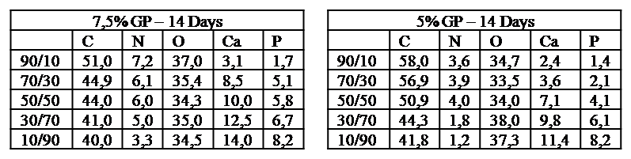
Table 4. 4 Atomic composition of the surface of all samples after 14 day of incubation in SBF, detected by EDS analysis.
Figure 4. 17 SEM micrographs of sample 90/10_GP 7.5 after 30 days of incubation
Figure 4. 18 SEM micrographs of sample 70/30_GP 7.5 after 30 days of incubation
Figure 4. 19 SEM micrographs of sample 50/50_GP 7.5 after 30 days of incubation
Figure 4. 20 SEM micrographs of sample 30/70_GP 7.5 after 30 days of incubation
Figure 4. 21 SEM micrographs of sample 10/90_GP 7.5 after 30 days of incubation
Figure 4. 22 SEM micrographs of sample 90/10_GP 5 after 30 days of incubation
Figure 4. 23 SEM micrographs of sample 70/30_GP 5 after 30 days of incubation
Figure 4. 24 SEM micrographs of sample 50/50_GP 5 after 30 days of incubation
Figure 4. 25 SEM micrographs of sample 30/70_GP 5 after 30 days of incubation
Figure 4. 26 SEM micrographs of sample 10/90_GP 5 after 30 days of incubation
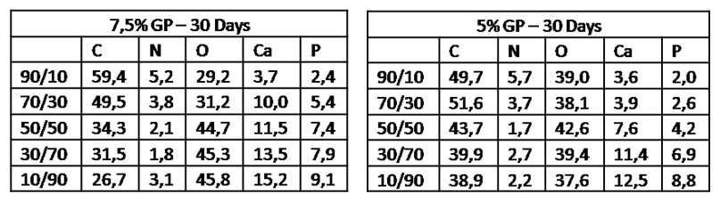
Table 4. 5 Atomic composition of the surface of all samples after 30 day of incubation in SBF, detected by EDS analysis.
It is possible to conclude that the proposed material shows high bioactivity, as confirmed by the deposition of apatite crystals after immersion in SBF [29] and is therefore a suitable material for bone-substitution.
4.3.2 Preparation & Characterization of nanoparticles
4.3.2.1 Morphology
Nanoparticles were successfully prepared by the Solvent Displacement method, as confirmed by SEM images (reported in figure 4.27) with both emulsifiers (Tween 80 and Vitamin E TPGS).
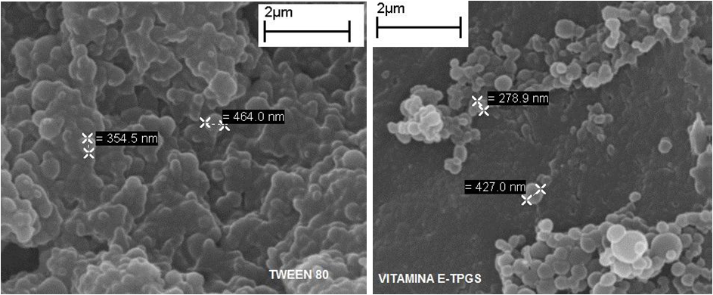
Figure 4. 27 SEM micrographs of PCL nanoparticles prepared with the two different emulsifiers.
4.3.2.2 DSC analysis
DSC analysis was used to determine the physical state (amorphous or crystalline) of the encapsulated drug, Results are reported in figures 4.28 and 4.29 for nanoparticles prepared with vitamin E TPGS and Tween 80 as emulsifiers, respectively.
Figure 4. 28 DSC thermograms of plain drug (black), PCL (blue), Vitamin E TPGS (green) and empty (red) and drug-loaded (purple) particles prepared with vitamin E TPGS as emulsifier.
Figure 4. 29 DSC thermograms of plain drug (black), PCL (blue) and empty (red) and drug-loaded (purple) particles prepared with Tween 80 as emulsifier.
PCL thermogram shows a melting temperature at 58°C, according to the results reported by Fukushima and co-workers [30]. This peak is clearly visible in the thermograms of empty and drug loaded nanoparticles, prepared with both emulsifiers.
Indometacin has a melting temperature at 163°C which cannot be detected in the thermograms of drug-loaded nanoparticles indicating that the encapsulated drug is in an amorphous state, according to what observed by Mokarram et al [31].
4.3.2.3 Process yield and encapsulation efficiency
The process yield was high in every case (68.4% and 64.2% for Tween 80 and Vitamin E TPGS, respectively) and is not correlated with choice of the emulsifier, as shown in table 4.6. Particles prepared with vitamin E TPGS as emulsifier have a slightly smaller size and better spherical morphology, but exhibit a very low encapsulation efficiency (lower than 3%). On the other hand, when tween 80 was used as emulsifying agent, particles showed a much higher encapsulation efficiency (33%). For this reason, only nanoparticles prepared with Tween 80 were inserted in the bone cement composition and were characterized in terms of release kinetics.

Emulsifier | Yield (%) | Size (nm) | EE (%)
Tween 80 | 68.4 ± 5.0% | 350 ± 9 | 33.3 ± 6.7
Vitamin E TPGS | 68.2 ± 4.1% | 300 ± 20 | <3.0 ± 0.8
Table 4. 6 Mean size, yield and encapsulation efficiency of nanoparticles prepared with different emulsifiers.
4.3.2.4 Drug release profile
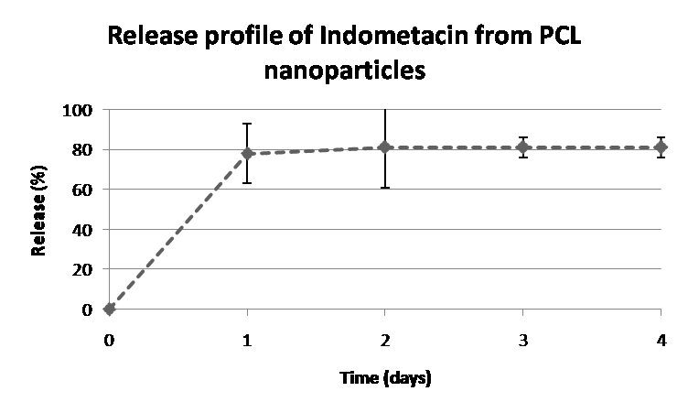
Figure 4. 30 Release profile of Indomethacin from PCL nanoparticles.
Figure 4.30 shows the release profile of Indometacin from PCL nanoparticles, after 4 days of immersion in water.
The release of the encapsulated drug is very fast with almost 80% of the content released during the first 24 hours. A slight increase in the amount of delivered drug can be detected between day 1 and 2 of incubation, while no further increase was measured after this time point, according to the results reported by other authors [32].
4.3.3 Analysis of the final cement composition
According to the results reported in the previous sections, the cement composition (i.e. the organic/inorganic phase ratio) showing the best hardening and setting behavior, as well as the most suitable mechanical properties, was selected to prepare a new material containing drug-loaded nanoparticles and an additional organic phase, composed of collagen.
The selected cement composition contains an organic/inorganic phase ratio of 30/70, and the organic phase, composed of a blend of chitosan and collagen (3% w/v), is cross linked with the highest amount of Genipin (7.5% w/w).
Moreover, 10% w/v of PCL nanoparticles, containing the anti-inflammatory agent Indomethacin, were added to the final cement composition.
This material was then characterized in terms of morphology, hardening time and injectability as well as mechanical strength under compression.
4.3.3.1 Hardening time and injectability of the final composition
Hardening time and injectability were calculated for the cement prepared according to the optimized composition.
The material showed a hardening time of 22 ± 2 min, which is slightly lower compared to that of the cement prepared with only chitosan and TCP (24 ± 2min). This hardening time is compatible with the characteristic required for a suitable bone cement material, i.e. an initial preparation time of 6-10 minutes and a setting time of about 15 minutes [33].
Injectability, calculated according to equation 4.3, was 95%, greater than the values reported by other authors for calcium phosphate-based bone cements [33].
This parameter makes the proposed material an optimal candidate for bone tissue repair.
4.3.3.2 Morphology (SEM)
SEM images on the material prepared according to the optimized final composition are reported in figure 4.31.
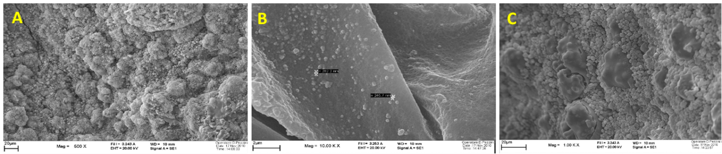
Figure 4. 31 SEM micrographs of the bone cement prepared according to the optimized composition, after the addition of collagen and nanoparticles.
Figure 4.31 A shows an overview of the surface of the material, in which the typical granular structure of TCP is visible. Calcium phosphate powders, in fact, are generally organized as agglomerates of 10-50µm dimensions [17].
Both the organic and inorganic phases are present on the surface of the cement and appear to be well integrated with each other, as shown by figure 4.31 C.
Polymeric nanoparticles with a size of 240-280nm can also be detected on the surface and inside the porosities of the material (see figure 4.31 B).
4.3.3.3 Determination of the compressive strength of the final bone cement
The effect of the addition of collagen and polymeric nanoparticles on the material mechanical strength was assessed. Results are reported in table 4.7 and show that the addition of a second organic phase led to a significant increase in the material strength under compression.
Material | Young modulus (MPa)
30/70 GP 7.5 | 0,15 ± 0,02
30/70 GP 7.5 col - nps | 1,0 ± 0,2
Table 4. 7 Mechanical properties of the bone cement prepared with 30/70 organic inorganic phase ratio, with and without addition of collagen and polymeric nanoparticles.
According to Hu and co-workers [34] the elastic modulus of the osteoporotic vertebral body should be in the range 10–500 MPa and the mechanical strength under compression should be 1/100 of this value, therefore around 0.5–5 MPa.
The proposed formulation presents therefore interesting features, which make it a suitable candidate as biodegradable bone substitute.
4.4 Conclusions
The objective of this work was the preparation and characterization of a novel, biocompatible and biomimetic injectable material, to be used as bone cement in mini-invasive surgery for the repair of vertebral injuries.
The proposed material was composed of two principle phases which are naturally present in bones: an organic phase (composed of chitosan or a blend of chitosan and collagen) and an inorganic one (β tricalcium phosphate) which was expected to induce new bone formation (i.e. bioactivity), overcoming current problems with traditional PMMA-based bone cements.
The organic phase was cross-linked to improve mechanical properties and to favor the material solidification (setting), by using a natural cross-linker (Genipin).
In the first part of the work the composition of the material was optimized, in order to determine the organic/inorganic ratio and amount of cross-linker which would lead to higher bioactivity and mechanical strength as well as to a faster setting and hardening time. The material’s bioactivity and mechanical properties were strongly dependent on the amount of inorganic phase, while the amount of cross linker did not affect the bioactivity. A higher content of cross-linker led to better mechanical properties and to faster hardening times.
Among the different compositions analyzed, an organic/inorganic phase ratio of 30/70 and an amount of cross-linker of 7.5% w/v (sample 30/70 GP7.5) were selected as optimal parameters, since this sample showed a setting time of 24 minutes and an elastic modulus under compression of 149.1± 16.9 kPa, similarly to what reported for other injectable and biodegradable gels [25]. Mechanical and biomimetic properties of this composition were further improved by adding a second organic phase composed of natural collagen [35]. Moreover, an anti-inflammatory agent (Indometacin) was included in the cement composition, after encapsulation into polymeric PCL nanoparticles. Nanoparticles were successfully prepared by the solvent displacement method and were characterized in terms of size, morphology as well as encapsulation and release properties. Spherical particles, with a size of approximately 240- 300 nm and an encapsulation efficiency of 33% were obtained.

The release profile showed that almost 80% of the encapsulate drug was released during the first 24 hours. This kinetics are compatible with post-operative infection raising time [17].
Nanoparticles (10% w/w) and collagen (3% w/v) were added to the previously selected optimal cement composition and the material was analyzed in terms of morphology, hardening time and injectability. Mechanical properties were also tested to assess the effect of the addition of collagen on the material strength.
This new composition led to a fast hardening and setting time (22 min) and to a high injectability (95%), making the material an optimal candidate as injectable bone substitute [33,35-37]. As expected, the addition of collagen (and to a smaller extent of polymeric nanoparticles) strongly affected the mechanical properties of the material, resulting in increased Young Modulus under compression (from 0.1 MPa for sample 30/70 GP7.5, to 1 GPa for the new material) [35,38].
The new bone cement developed in this study appears to be a promising candidate as injectable bioactive material for the substitution and guided regeneration of bone tissue.
References
[1] R. Eastell 2009 Medicine 37:475
[2] E. Truumees et al. 2004 The Spine Journal 4:218
[3] Mousa W.F. et al. 2000 Biomaterials 21: 2137
[4] L.K.H. koh JMHG 1:204
[5] Wasnich U. 1996 Bone 18:1791
[6] Melton LJ. 1989 Am J Epidemiol 129:1000
[7] Delmas PD. 2002 Lancet 359:2018.
[8] J.J. Verlaan et al. 2006 Biomaterials 27:290
[9] Belkoff SM et al. 2000 Spine 25:1061
[10] Dean JR et al 2000 Clin Radiol 55:471
[11] Bostrom MP et al 1997 Spine 22(24 suppl): 38S
[12] Deramond H et al. 1998 Radiol Clin North Am 36:533
[13] Garfin SR et al. 2001 Spine 26:1511
[14] Martin JB et al. 1999 Bone 25:11S
[15] I.H. Lieberman et al. 2005 The Spine Journal 5:305S
[16] G.X. Ni et al. 2006 Biomaterials 27:1963
[17] M.P. Ginebra et al. 2006 J Control Release 113:102
[18] Illum L. 1998 Pharm. Res. 15: 1326
[19] Muzzarelli R A A. 2009 Carbohydrate Polymers 77:1
[20] Wang et al. 2010 biomaterials 31(14):3976
[21] Fessi H. et al. 1989 Int. J. Pharm. 55: 25
[22] Kokubo T. et al. 1990 J. Non-Cryst. Solids 120:138.
[23] Xiaopeng Qi et al. 2008 Acta Biomaterialia 4:1837
[24] Hu YC et al in Complications of vertebroplasty and kyphoplasty; Techniques in Regional Anesthesia and Pain Management. 2007
[25] D.S. Couto et al. 2009 Acta Biomaterialia 5:115
[26] Royer J.C. et al 1993 J Mater Sci: Mater Med, 4 :76
[27] Sabir et al. 2009 J Mater Sci 44: 5713
[28] Tanimoto et al. 2005 Wiley Periodicals
[29] Kokubo T. 1998 Acta Mater 7:2519
[30] Fukushima et al. 2010 Materials Science and Engineering C 30:566
[31] Mokarram et al. 2010 DARU 18:3
[32] V. Zavisova et al. 2007 Journal of Magnetism and Magnetic Materials 311:379
[33] G. Lewis 2005 Wiley Periodicals
[34] Hu X.et al 2009 Macromol. Biosci. 9:195
[35] Wang et al 2010 Biomaterials 31:3976
[36] Charnley J. 1964 J Bone Joint Surg
[37] Kühn K. 2003, in: The well-cemented total hip arthroplasty: theory and practice; Chapter 3.1
[38] Ioos P. et al 2001 Biomaterials 22.

Section IV

Chapter 5

Final discussion & conclusions

5.1 General discussion
The first section of the present work was mainly focused on the preparation of nanoparticles starting from preformed polyesterurethanes through two widely used and highly reproducible techniques: the Solvent Displacement method and the Single Emulsion Solvent Evaporation method.
These two methods have been widely used for the preparation of nanoparticles for the encapsulation of various drugs, mainly by using commercial polyesters such as poly(ε-caprolactone) (PCL), Poly(D,L lactide) (PLA) and poly (D,L lactide-co-glycolide) (PLGA) [1-3], since they offer the possibility to control the size distribution of the carriers, by simply optimizing the process parameters, such as type and amount of emulsifier, ratio between the solvent and the non solvent and the molecular weight of the polymer [4-6].
Chapter 2 describes the preparation of Paclitaxel-loaded nanoparticles for the passive targeting of cancer by the Solvent Displacement method with two widely used commercial polyesters (PCL and PLA) and the newly synthesized polyesterurethane C-BC2000, based on poly(ε-caprolactone) blocks. The solvent displacement method was selected, since it leads to the formation of monodisperse, small particles by simple precipitation of the polymer in the non solvent (water) without the use of toxic solvents or the application of shear stresses [7].
Different authors reported that nanoparticles with average diameters of 100-250nm are able to passively accumulate into tumors, through the the Enhanced Permeation and Retention (EPR) effect [8-11]. Accumulation of nanoparticles inside tumors is made possible by the highly permeable blood vessels of these tissues, which is a result of their rapid and defective angiogenesis [12]. In addition tumors are characterized by dysfunctional lymphatic drainage, that favors retention of nanoparticles inside the tissue [13-16]. Particles prepared in this part of the thesis, regardless of the polymer used, respond to this size requisite, and are therefore good candidates for passive targeting of tumors, as also demonstrated by the high extent of cellular internalization (tested on A 431 human epidermal carcinoma cells).
The Solvent Displacement Method has been extensively applied for the preparation of nanoparticles with different biodegradable polyesters for the release of various drug formulations. In most cases rapid release profiles were observed: Chawla et Al [17] proposed PCL nanoparticles for the controlled release of Tamoxifen, an estrogen receptor modulator applied in the treatment of breast cancer. They reported a loading efficiency of 60% and a rapid release profile, with nearly all the encapsulated drug released within the first 20 hours of incubation in deionized water. Leo and co-workers [18] reported similar profiles for the anti-ischemic drug Cloricromene Acid (AD6-Acid) from PLA nanoparticles.
According to these findings, a rapid release was observed in this work from particles prepared with commercial polyesters while polyurethane nanoparticles exhibited longer and more controlled release kinetics of the encapsulated drug. In fact, C-BC2000 nanoparticles had the highest encapsulation efficiency (89±2%) compared to only 24±7% and 18±8% for PLA and PCL, respectively. Moreover the release profile for particles prepared with commercial polyesters, showed that almost all the encapsulated drug was released within the first 48 hours and no further release was observed after this time-point. C-BC2000 nanoparticles were able to sustain the release of the drug for longer time (up to 5 days), when only 30% of the active principle was released, indicating that the therapeutic effect of these carriers could last even longer.
To augment the targeting ability of nanoparticles towards tumor cells, specific ligands or antibodies that selectively recognize biomarkers over-expressed on cancer cells, can be attached to the surface, either by chemical bond or by hydrophilic/hydrophobic interactions [19,20]. Among targeting moieties, monoclonal antibodies have been extensively applied for their ability to initiate specific signaling cascades resulting in potentiated therapeutic effect of drugs [21,22].
For this reason, in chapter 3 two different polyesterurethanes, synthesized with different chain extenders (named C-BC2000 and NS-BC2000) and three commercial polyesters (PCL, PLA and poly(D,L lactide-co-glycolide) PLGA) were used to prepare Paclitaxel-loaded nanoparticles for the active targeting of breast cancer.
A modified Single Emulsion Solvent Evaporation method was used to prepare nanoparticles, by selecting ethyl acetate as internal phase, Poly(vinyl alcohol) (PVA) as emulsifier and water as external phase.
To augment the targeting ability of nanoparticles towards breast cancer cells, Herceptin, a monoclonal antibody able to selectively recognize a specific receptor (HER2) over-expressed on 25-30% of invasive breast cancer, was attached to the surface of the carriers by hydrophilic/hydrophobic interactions [23,24].
Surface modification was successfully achieved, as demonstrated by changes in size and zeta potential of the particles [25,26]. The amount of Herceptin on the surface of the carriers was measured by standard Bradford assay, confirming the presence of the antibody on nanoparticles. Moreover the active targeting ability of these carriers was demonstrated by their superior uptake by HER2-overexpressing breast cancer cells (SKBR3) compared to that of MCF7 cells, which show normal expression of the same receptor.
The above-stated results indicate that PU may be used for the preparation of nanoparticles starting from pre-formed polymers and that they show superior properties when compared to traditionally used polyesters.
This encouraging outcomes suggest further and extensive investigation on the introduction of different PU formulations as nanosystems for drug release.
In the section section of the present work a new, bioactive and biomimetic bone cement was optimized and characterized. Polymeric (PCL) nanoparticles containing an anti-inflammatory agent (Indomethacin) were added to the cement composition to realize a multifunctional construct, able to stimulate the deposition of new bone tissue, while decreasing the risk of post-operative infections.
The material is composed of two phases which are naturally present in bones: an organic phase made of chitosan (CH) and collagen and an inorganic phase made of β tricalcium phosphate, which is expected to increase bioactivity (i.e. the ability to stimulate new bone deposition) of the material [27,28].
According to different authors, bone cements should: (i) have good mechanical strength, in particular under compression; (ii) support new bone formation (i.e. be bioactive); (iii) have a low setting time (iv) be easily injectable and (v) do not cause local temperature increase during setting [29,30].
The material showed good bioactivity, promoting the formation of apatite after 14 days of incubation in simulated body fluids (SBF), a low setting time (around 20min) and a good injectability (95%), making it an optimal candidate as injectable bone substitute. Mechanical strength under compression was also analyzed, resulting in poor properties when collagen is not part of the composition. After the addition of collagen, the Young modulus for compression increased from 0,15Mpa to 1Mpa, which meets the requirements for a good vertebral substitute [31].
Moreover the addition of nanoparticles confers anti-inflammatory properties, since the release rate of the drug is compatible with the infection raising kinetics.
The proposed material is an optimal candidate for bone substitution, meeting all the requirements concerning mechanical properties and bioactivity and is also able to decrease the risk of post-operative infections and therefore of implant failure.

5.2 Conclusions & future developments
In this thesis work, biodegradable nanoparticles were successfully prepared with different proprietary or commercial materials and by different methods for the passive and active targeting of cancer (chapter 2 and 3) and for the preparation of biomimetic constructs for tissue engineering (chapter 4).
The application of biodegradable polyesterurethanes (PU) as matrix-forming materials for nanoparticles prepared staring from preformed polymers, was proposed for the first time with encouraging results. In fact, compared to particles prepared with commercial polyesters (such as PCL, PLA and PLGA), PU nanoparticles showed superior cellular internalization by cancer cells, enhanced and sustained release rate of the encapsulated drug and lower initial burst effect.
Though possessing undeniable interesting properties, biodegradable polyurethanes have been poorly investigated [32,33] as nanoparticles-forming materials to be applied in the field of drug delivery.
The results obtained in the present work suggest further investigation on the use of polyurethanes for the preparation of nanoparticles for controlled drug delivery, perhaps by selecting different starting reagents.
In fact, the simple chemistry of polyurethanes allows tailoring of the material properties (such as biodegradability, hydrophilicity and mechanical strength) by selecting the proper reagents during the synthesis. Polyethers, such as PEG, can be used as macrodiols, alone or in combination with polyesters, such as poly(ε-caprolactone) during the synthesis, resulting in tuneable hydrophilicity and reduced opsonization. The effect of different hydrophilicity on the size, zeta potential, extent of cellular internalization as well as on the drug loading and release properties should be investigated.
Moreover, specific targeting ligands (like peptides or aminoacids) can be inserted in the polymer backbone or attached as pendant groups or both. This allows for the obtainment of multifunctional carriers with tailored properties, according to the specific therapeutic need, with one simple synthesis process.
References
[1] Thickett S.C. et al. 2007 Polymer 48:6965
[2] Karode SK et al. 1998 Chem Eng Sci 53:264.
[3] Vanderhoff JV 1979 US patent 4 177 177
[4] Pinto Reis C. et al. 2006 Nanomedicine 2:8
[5] P. Couvreur et al. 2002 Adv Drug Deliv. Rev. 54: 631
[6] Rao J.P. et al 2011 Progress in Polymer Science 36:887
[7] Fessi H. et Al. 1989 Int. J. Pharm. 55: 25
[8] Mora Huertas C.E. et al. 2010 Int. J. Pharm. 385: 113
[9] Maeda H. et al. 2009 Eur J Pharm Biopharm 71:409
[10] Panyam, J. et al 2003 Int. J. Pharm. 262: 1
[11] Panyam, J. et al. 2003 Adv. Drug Delivery Rev. 55:329
[12] Matsumura Y. et al. 1986 Cancer Res. 46:6387
[13] Leroux J. et Al. 1996 J Control Release 39:339
[14] Thanou M. et al. 2003 Curr. Opin. Investig. Drugs 4:701
[15] Maeda H et al. 1994 Jpn J Cancer Res 85:331
[16] Maeda H. et al. 2001 J. Control. Rel. 74: 47
[17] Chawla J.S. et Al. 2002 Int. J. Pharm. 249: 127
[18] Leo E. et Al. 2004 Int. J. Pharm. 278: 133
[19] Garnett MC et al. 2001 Adv. Drug del. Rev. 53:171
[20] Lambert JM 2005 Curr. Opin. Pharmacol. 5:543
[21] Kohler G. et al. 1975 Nature 256:495
[22]Funaro A. et al. 2000 Biotechnol. Adv.18:385
[23] Kocbek P. et al. 2007 J. Control. Rel. 120:18
[24] Liu Y. et al. 2010 Biomaterials 31:9145
[25] C. Cai et al. 2008 Eur. J. Pharm. Biopharm. 69: 31
[26] Calvo P et al. 1997 Biomaterials 18:1305
[27] Illum L. 1998 Pharm. Res. 15: 1326
[28] Muzzarelli R A A. 2009 Carbohydrate Polymers 77:1
[29] Mousa W.F. et al. 2000 Biomaterials 21: 2137
[30] M.P. Ginebra et al. 2006 J Control Release 113:102
[31] Hu X.et al 2009 Macromol. Biosci. 9:195
[32] Zanetti-Ramos B. et al 2006 polymer 47:8080
[33] Zanetti-Ramos B. et al 2008 Mat Sci Eng 28:526]

Appendix A

Polyurethanes

A.1 Introduction
Polyurethanes (PU) are a family of heterogeneous polymers, first produced and investigated by Dr. Otto Bayer in 1937 [1] , at I.G. Farbenindustrie (Germany), in which the repeating unit contains a urethane moiety (figure A.1).
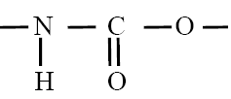
Figure A. 1 Urethane bond
Polyurethanes are employed in a wide range of uses and applications, from the medical field to automotive and industry. They can be found in products such as furniture, coatings, adhesives, building materials, paints, elastomers and as constituents of different biomedical devices [2].
Advantages of PUs over traditional plastics consist in: (i) increased tensile strength and melting points, which result in high durability [1], (ii) high resistance to degradation by water, oils, and solvents [3], (ii) excellent adhesion to many substances, abrasion and weather resistance which makes them excellent candidates for the preparation of coatings and for industrial purposes [4].
A.2 Chemistry of Polyurethanes
A.2.1 Synthesis reaction
PUs belong to the class of thermoplastic elastomers and are composed of alternating blocks of soft and hard segments, as shown in figure A.2 [5].
For application in the biomedical field, the soft segment is generally a polyether, a polyester or a polyalkyldiol of low-glass transition temperature, while the hard segment is composed of a high glass transition temperature, semicrystalline diisocyanate, linked with a low molecular weight chain extender, such as a diol or a diamine.
PUs exhibit a broad range of physical properties, due to the wide array of different building blocks that can be selected for their synthesis and the possibility of varying the ratio in which these components are reacted [2].
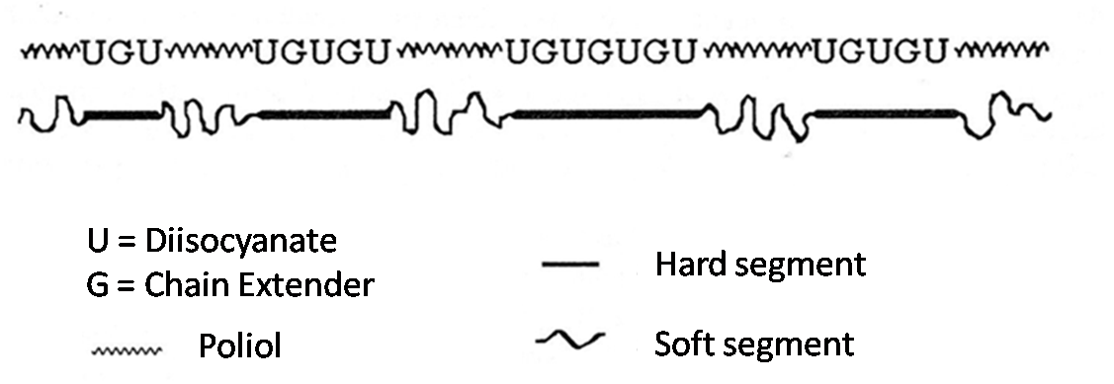
Figure A. 2 Schematic representation of the PU structure.
The superior mechanical, physical and biological properties of PUs strongly depends on their molecular structure. In fact due to the mild miscibility of the soft and hard segment PUs may be considered as isotropic materials, at a macroscopic level. Nevertheless, phase separation of the two segments occurs, producing a structure composed of hard segments domains embedded in a soft segment matrix. The resultant two-phase microstructure is responsible for the superior mechanical properties and biocompatibility of these materials (see figure A.3) [5].
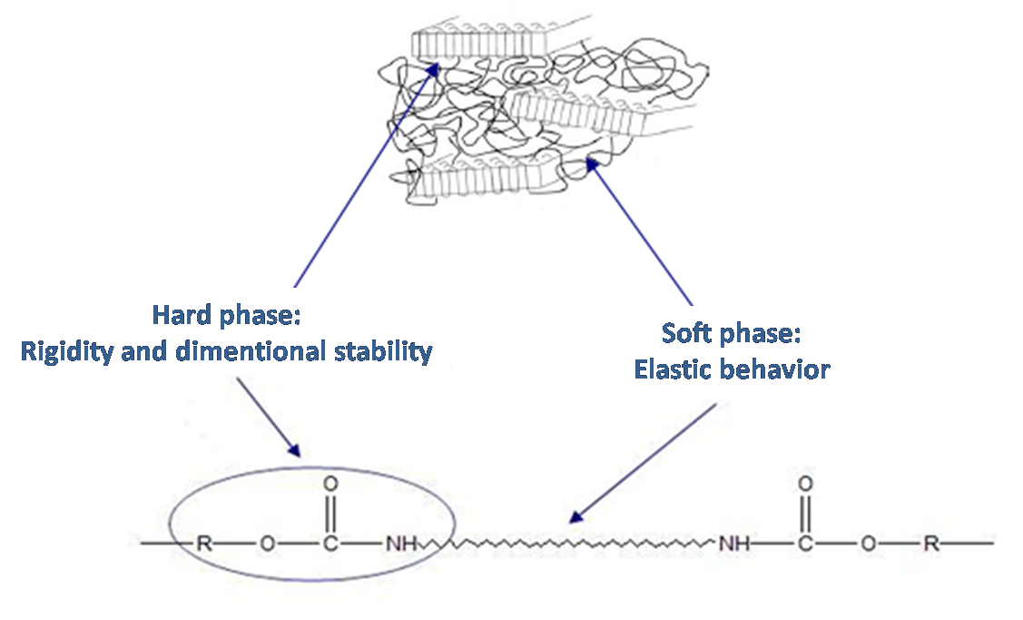
Figure A. 3 Two-phase microstructure of PUs.
As the weight fraction of the hard and soft segment increases, the properties of the polyurethane changes from that of a hard plastic to that of flexible elastomers.
Commercially, PUs can be synthesized via a “one step” or a “multistep” synthesis process.
The one step process is easier and faster and requires the reaction between a multifunctional liquid isocyanate and a diol [5].
Multi step synthesis allows for a better control over the chemistry of the reaction, leading to more predictable structural, physical, mechanical and manufacturing properties, and is therefore the favored procedure for the synthesis of PUs.
The most common multi-step synthesis procedure, extensively applied for materials for biomedical applications, involves two steps. During the first step, called pre-polymerization reaction, a diol is reacted with excess diisocyanate, to produce an isocyanate-terminated molecule. This low molecular weight pre-polymer is subsequently reacted with a chain extender, which could be a diol or a diamine, to produce a block copolymer, as shown in figure A.4.
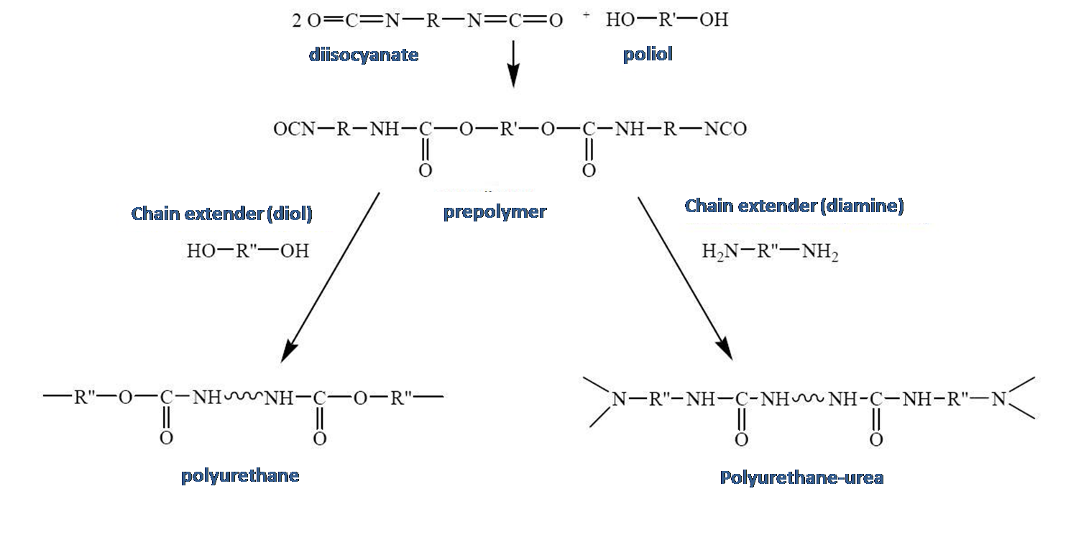
Figure A. 4 Schematic representation of the two-step synthesis procedure.
A.3 Raw materials in polyurethanes synthesis
As already mentioned, the synthesis of PUs requires the reaction between a polyol and an isocyanate to form a prepolymer, which is again reacted in the presence of a chain extender to form a high molecular weight polymer.
A.3.1 Isocyanate
Isocyanate (R-NCO) or diisocyanate (OCN-R-NCO) are compounds characterized by the presence of one or two isocyanate groups (N=C=O).
For PU synthesis, both aliphatic and aromatic isocyanates can be used (see table A.1), depending on the nature of the group R.
Isocyanates are part of the hard domains composing PU microstructure and the choice of these molecules significantly affects the properties of the material.
Isocyanate |  | Chemical structure
lysine diisocyanate | LDI
1,4-diisocyanatebuthane | BDI
Examethylene diisocyanate | HDI
Cycloexyl diisocyanate | CHDI
Toluene diisocyanate | TDI
Metihylene  Bis(p-phenyl isocyanate) | MDI
Table A. 1 List of the most commonly used isocyanates for PU synthesis. Adapted from [5].
In particular, the use of aromatic isocyanates leads to the production of stiffer polymer chains with higher melting point, while the selection of aliphatic isocyanates results in greater resistance to oxidation and higher stability but also in decreased mechanical properties.
The symmetry of the isocyanate is another important parameter since it favors the crystallization of the hard segment, thus increasing the degree of phase separation, hardness, modulus and abrasion resistance.
In biomedical applications, the use of aliphatic diisocyanates such as lysine diisocyanate (LDI), 1,4-diisocyanatebuthane (BDI) and examethylene diisocyanate (HDI) [6.], is preferred since aromatic isocyanates lead to the formation of toxic, carcinogenic side products.

A.3.2 Polyols
Polyols for PU synthesis include polyesters, polyethers, polycarbonates and polydimethylsiloxanes (PDMS), as listed in table A.2.
Polyol | Chemical structure
Poly(ethylene oxyde)
Poly(propylene oxyde)
Poly(ε-caprolactone) diol
Hydroxy-terminated polyisobutylene
Hydroxybutyl terminated poly(dimethylsiloxane)
Poly(ethylene adipate)
Table A. 2 List of different polyols used for PU synthesis. Adapted from [5]
Polyols, due to their flexibility, form the soft segment matrix of the PU microstructure, in which the hard segments (composed of isocyanate and chain extender) are dispersed. They are responsible for the flexibility and the elongation at break of the material. An increase in the molecular weight of the soft segment leads to higher glass transition temperature (T_{g}) of the polymer, while low molecular weight polyols lead to a higher degree of microphase separation which results in lower T_{g} and higher flexibility.
The use of polyesters and polyethers for the synthesis of polyurethanes for biomedical applications has been extensively reported. Generally polyester-based PUs show good physical properties, but are susceptible to hydrolysis of their ester linkages. When polyethers are used as dyols, better stability and resistance to hydrolytic degradation is achieved.
A.3.3 Chain extenders
Chain extenders are used to extend the length of the hard segment and to increase the hydrogen bond density and molecular weight of the polyurethanes.
The chemistry of the chain extender plays an important role in determining the final physical properties of the material.
Most commonly used chain extenders are listed in table 5.3 and can be classified into aromatic or aliphatic diols and diamines. The selection of diamines or diols determines whether urea groups or urethane groups are formed in the chain extension reaction.
Chain extender | Chemical structure
1,4-butanediol
1,4-butane diamine
Ethylene glycol
Ethylene diamine
Exanediol
1,4 Cyclohexane dimethanol
Table A. 3 List of chain extenders used during PU synthesis. Adapted from [5].
In general, aliphatic chain extenders bring to softer materials while cyclic ones or a mixture of the two can be adopted to increase the rigidity of the polymer.
Diamine-based chain extenders react rapidly and vigorously to produce urea groups, for the production of polyurethane-urea polymer.
Glycol extended PUs are more flexible but less strong than amine-extended analogs.

A.4 Tuning PU properties
A.4.1 Bulk modification
Polyurethanes are versatile polymers and therefore provides a great variety of synthesis options. By selecting the chemistry of each reagent (diisocyanate, soft or hard segment, chain extender) it is possible to incorporate specific functional groups inside the polymer structure, according to the selected application.
These groups can modify the biological performance or can provide sites for further modification, to improve biocompatibility. Ionic groups, such as sulfonate, carboxyl or amino groups can be incorporated to change the physico-chemical properties of the material [7]. Other additives, such as anti-oxidants, proteins or surfactants, can be added during the synthesis [8]. These molecules are then able to migrate towards the surface, once implanted in vivo providing excellent biomimetic properties and increasing biocompatibility.
A.4.2 Surface modification
Modification of the bulk material, often results in surface modification as well. Since this approach may cause excessive alteration of the physico-chemical properties, treatments for surface modification have been developed, including: (i) surface treatment after bulk modification and (ii) surface treatment alone. The insertion of carboxyl groups in the bulk material can be exploited for further attachments of peptides to the surface, as proposed by Lin et al. [9]. Heparinized surfaces to improve the hemocompatibility of the material have been obtained by incorporating ammonium groups which are able to bind Heparin through the formation of ionic bonds [10]. Molecules, such as pharmaceutical agents, peptides etc., can be covalently attached to the surface through the use of diisocyanate bridges. A large number of molecules can be attached to the surface, including poly(ethylene oxide) (PEO), albumin and heparin [11,12]. Other techniques for surface modification include graft photo-polymerization [13] and plasma glow discharge technology [14].
A.5 Biodegradation of Polyurethanes
It is known that many PU degrade in vivo as a result of a number of processes, including hydrolysis and oxidation, leading to significant changes in the mechanical properties and surface chemistry of the material [5].
In general, when polyesters are used as macrodiols, the material is more sensitive to hydrolytic degradation; while if the PU is based on polyether diols oxidation will be the main mechanism of degradation.
Hydrolysis is one of main mechanisms of degradation of PU in aqueous environment. Urethane bonds are little susceptible to hydrolysis and the process is facilitated by the presence of ester bonds or polar groups in the polymer.
The hydrolysis rate depends upon the reactivity of the chemical bonds and on the concentration of water inside the polymer, which is also dependent on the diffusion properties of the material.
Hydrolysis results in the cleavage of polymer chains, which causes a reduction of the molecular weight and therefore an alteration of the mechanical and physical properties of the material.
Different components, like cells, enzymes, vitamins, water, salts and peroxides are responsible for the degradation of these materials. Generally, for hydrophobic PUs degradation involves only the surface, while more hydrophilic materials undergo bulk hydrolysis.
In chemically active media, like plasma, degradation occurs through different stages:
1. Adsorption of the medium on the polymer surface
2. Diffusion into the bulk material
3. Chemical reaction with the chemically unstable bonds of the material
4. Desorption and diffusion of the degradation products out of the material.

Different enzymes and Fungi are also known to cause PU degradation [2]. Porcine pancreatic elastase rapidly degrades polyester-based PU, at 10-times higher rate than polyether PUs [15]. Phua et al. [16] tested the activity of two proteolitic enzymes, papain and urease, on polyether PUs, demonstrating that papain is able to degrade both cross-linked and not cross-linked polymers, by hydrolyzing the urethane and urea linkages producing free amine and hydroxyl groups. Urease activity, because of its high molecular weight (473 kDa), was limited to the PU surface and therefore was not significant.
References
[1] Bayer O. 1947 Modern plastics 24: 149
[2] Howard G.T. 2002 Int. Biodeterioration Biodegradation 49:245
[3] Saunders JH et al. 1964 in: Polyurethanes: chemistry and technology part II: technology. Interscience publishers, New York.
[4] Urbanski J. et al. 1977 in: Handbook of analysis of synthetic polymers and plastics. Hellis Horwood Limited, Chichester, UK.
[5] Lamba N.M.K. et al. 1998 in: Polyurethanes in biomedical applications, CRC press
[6] Skarja G.A., Woodhouse K.A. 2000 Journal of Applied Polymer Science 75: 1522
[7] Harvey R.A. et al. 1989 Thromb. Haemostat. 61:131
[8] Santerre J.P. et al. 1991 Macromolecules 24:5497
[9] Lin H.B. et al. 1994 J. Biomed. Mater. Res. 28:329
[10] Ito Y. et al. 1986 J. Biomed. Mater. Res. 20:1017
[11] Bamford C.H. et al. 1984 Polymer Prepr. 25:27
[12] Joseph G. et al. 1987 J. Biomed. Mater. Res 21:937
[13] Jansen B. et al 1985. J. Biomed. Mater. Res 19: 1085
[14] Gombotz W.R. et al. 1987 in Critical Reviews in Biocompatibility, CRC press.
[15] Labrow R.S. et al. 1996 Biomaterials 17: 2381
[16] Phua S.K. et al. 1987 J. Biomed. Mat. Research 21:231

