Table of Contents

Abstract

General introduction. 4

Experiments. 8

Subitizing, estimation and texture density. 8

2.1.1. Subitizing but not estimation of numerosity requires attentional resources. 8

2.1.2. The effects of cross-sensory attentional demand on subitizing and estimation. 21

2.1.3. Adaptation affects both high and low (subitized) numbers under

conditions of high attentional load. 29

2.1.4. Separate mechanisms for perception of numerosity and density. 36

Mapping numbers onto space: a ‘mental number line’. 45

2.2.1. Linear mapping of numbers onto space requires attention. 45

2.2.2. The effects of cross-sensory attentional demand on mapping number

onto space. 54

2.2.3. Mapping number to space engages adaptive encoding mechanisms. 60

Number and attention during development. 75

2.3.1. Visual sustained attention and numerosity sensitivity correlate with math

achievement in children. 75

General conclusions. 88

References. 93

Aknowledgements

I really would like to thank my supervisor Burr David Charles for giving me the great opportunity to work in his high quality science laboratory and for following me with dedication, professionality and patience during all this three years experience. I also want to thank all the members of the laboratory for teaching me how to work in a team with generosity and sense of collaboration.

A special thanks goes to my family for supporting me along all my school career.

Abstract

Although humans are the only species with a linguistically mediated code for numbers, we share a nonverbal representation of numerical quantities with many animals species. We posses a “visual sense of numbers” that allow us to roughly estimate the numerosity of objects present in the visual scene. The efficency of this capacity, has been demonstrated to be a strong predictor of school acquired formal math skills. Numerosity perception can been interpreted has a “start-up” tool for the development of formal math achievements. In this thesis, we studied the capacity to visually estimate numerosity by using psychophysical paradigms and we were able to uncover new and unexpected features of this ability.
In the first part of the thesis we have shown that numerosity estimation is not a monolithic entity but is composed by several different and separable, although closely overlapped, sub-systems. In particular, our results clearly show that three different systems are engaged, governed by different psychophysical laws. In the second part of the thesis we dealt with the spatial nature of numbers. The ability to map numbers onto space evolves during development: preschool children as well as illetterate adults show a performance characterized by a compressed, simil-logarithmic shape, which is then linearized by increasing chronological age and formal math skills. The current literature interprets the logarithmic shape as a reflection of the 'innate shape’ (not yet culturally modified) of the numerical representation. Our studies show that instead, the logarithmic shape results from a different process based on a dynamic mechanisms, that interprets and combines the to be mapped stumuli. This phenomenon, by itself, produces a pattern of results well describable by a logarithmic function but logarithmic in its nature. In the final part of the thesis, in a sample of school-age children, we have dealt with the relationship between numerosity perception, visual attention and the development of formal mathematical skills. Through a correlational approach, we have shown that these functions are closely related. Importantly, we demonstrated that the proper functioning of the attentional system, plays a key role in the development of mathematical skills. These results have an important impact on the recent researches regarding children suffering from difficulty in learning arithmetic (developmental dyscalculia).

1. General introduction

In everyday life we are constantly surrounded and forced to 'deal' with numbers. It is easy to understand how the efficiency of the development of this capacity can impact on the quality of our life. Indeed, starting from the early years of schooling, we are subjected to learning math, as series of formal rules useful to the manipulation of numerical quantities and math concepts. As just described happens at school age, that is, when our language skills have developed enough in order to support these formal computations. However, numbers, before becoming linguistic labels and concepts, exist as abstact quantity. For example, for an animal, be it predator or prey is evolutionarily crucial to be able to quickly estimate the number of members of the herd that is attacking him or that is going to be attacked. Indeed, has been demostrated that although we are the only species with a linguistically mediated code for numbers we share a nonverbal representation of numerical quantities with many animals species (Nieder, Diester et al. 2006, for a review; Pepperberg 2006; Dacke and Srinivasan 2008). What it means representating numerical quantities and what is its relevance? It means that we possess the ability to quickly and roughly estimate the numerosity of a group of elements even when the serial count is prevented (for example by a limited time exposure): an Approximate Number System (ANS). In humans, the signature of the ANS is reported surprisingly early, from the ﬁrst hours of life: newborn babies habituated for some minutes to auditory sequences of a given number (e.g. six syllables), look longer at numerically matching visual sets (e.g. six dots) subsequently presented to them than to non-numerically matching sets (e.g. 18 dots) (Izard, Sann et al. 2009). Importantly, the babies fail to match numerosities that are more similar in their numerosity (with a ratio approximating a value of one). This highlight the main feaure of the Approximate Number System: it follow Weber’s Law. Weber's law states that the just-noticeable difference (the threshold of discrimination) between two stimuli is proportional to the magnitude of the stimuli.
Indeed, while the representation of integers is exact, estimation of numerical quantities is approximate, with a certain degree of error associated with. Weber fraction here reflects the precision, with which two numerical quantities can been perceived as numerically different: an index of “number acuity”. This index of precision strongly improve during development (Piazza 2010): one-years old children can discriminate numerical quantities that differ between them of 100%, adults can discriminate differences of about and sometimes less than 20%.
Which is the relationship between the system that perceive abstract quantities (ANS) and that supporting the acquisitin of the formal math skills? A growing amount of evidence links ANS acuity with the proficiency in the culturally invented and linguistically mediated number code (Feigenson, Libertus et al. 2013). Halberda (2008) in a seminal paper, shows that ANS acuity measured at 14-year-old is able to retrospectively predict the subjects formal math achievements measured each year starting from kindergarten. Inportantly, that correlation remains statistically significant even after possible counfonding variables (e.g. general intelligence) were controlled for. Other strong evidence linking these two mathematical skills (formal and non-symbolic) come from studies that have dealt with clinical populations. ANS acuity of 10-year-old dyscalculic children is much higher than age matched controls and not different than 5-year-old control children (Piazza, Facoetti et al. 2010). Even if the causal direction of influence has not been demonstrated, is clear that numerosity representation plays a key role in the acquisition of formal mathematical ability.

A particular aspect of numerical perception is the so-called subitizing: we never made estimation errors for numbers of items up to four. There has been a long-standing debate as to whether enumerating numbers in the subitizing range invokes different processes than for larger ranges of objects (estimation range). Although the nature of this phenomenon is still debated, one influential hypothesis propose that subitizing refer to a pre-attentive system (Trick and Pylyshyn 1994). Contrary to that, many recent studies has been demostrate that subitizing capacity is strongly dependent by the avaibility of attentional resources (Olivers and Watson 2008; Railo, Koivisto et al. 2008; Vetter, Butterworth et al. 2008; Vetter, Butterworth et al. 2010).

Another topic that has long aroused the attention of many researchers is the intrinsic connection between numbers and space. Indeed, we have a direct intuition that the numbers are spatially distributed, mainly from left to right in order of magnitude. Mapping of numbers onto space plays a fundamental role for many aspects of mathematics, including geometry, Cartesian coordinates and mapping real and complex numbers onto lines or planes. The exercise of mapping numbers onto lines demarcating a given numerical range – Number line - is often used by math teachers and has been recently demonstrated that specific training based on numerical board games are able to improve certain math skills (Wilson, Revkin et al. 2006). As described above for the ANS acuity, the performance in the Number line task improve during development (Siegler and Opfer 2003; Siegler and Booth 2004; Booth and Siegler 2006): kindergarten children represent numbers in space in a compressed, seemingly logarithmic, scale (placing, for example, the number 10 near the midpoint of a 1-100 scale). The scale becomes progressively more linear over the first three or four years of schooling. Interestingly, dyscalculic children show a poor “number-acuity” (Piazza, Facoetti et al. 2010), and a more logarithmic representation of the numberline than controls (Geary, Hoard et al. 2007; Geary, Hoard et al. 2008; Ashkenazi and Henik 2010).

Like space representation, attention is strongly linked with many aspects of numerosity and number processing. Attention acts as a filter to select and maintain relevant information while suppressing irrelevant distractors, improving the efficiency with which information arriving from the environment is acquired and processed, then memorized and learned (Posner and Rothbart 2005). Recent studies demonstrate a causal link between visual attention and reading acquisition: serial search and spatial cueing facilitation predict future reading acquisition in children (Franceschini, Gori et al. 2012). Furthermore, they showed that playing action video games improved both attentional skills of children, and their reading speed (Franceschini, Gori et al. 2013). Reading and math skills, at least during development, are highly related. Developmental dyslexia and dyscalculia have an high probability of occur together but there are surprisingly few studies examining the connection between attention and math abilities, especially during development.

However, some evidence come from studies on adult subjects, for example attention-training (through video-game playing) increases subitizing range (Green and Bavelier 2003); merely looking at numbers causes a shift in covert attention to the left or right side, depending upon number magnitude (Fischer, Castel et al. 2003). The recent literature that deals with people who have difficulty in learning math and/or reading is reporting that these subjects as well as having specific deficits in those capacities, also have deficit in attention (Ashkenazi and Henik 2010; Askenazi and Henik 2010). In line with this, dyscalculics children show impaired subitizing (Koontz 1996; Ashkenazi, Mark-Zigdon et al. 2012) and as mentioned above this is an attentional dependent enumeration capacity (Olivers and Watson 2008; Railo, Koivisto et al. 2008; Vetter, Butterworth et al. 2010). The connection between attention and number processing also ﬁnds support from fMRI studies of neural correlates of visual enumeration under attentional load. Ansari, Lyons, van Eimeren, and Xu (2007) have shown that the temporal-parietal junction (rTPJ), an area thought to be involved in stimulus-driven attention (Corbetta and Shulman 2002), is activated during a comparison task of quantities. The general picture that come from the literature reveals a strong connection between the representations of numbers and attention.

As previously mentioned, numerosity perception as almost all the visual proprieties follow Weber’s law (Ross 2003). This has led to advance the idea that numerosity could reflect a primary visual properties of a scene. Indeed, as all the primary visual properties like color, orientation or motion, also numerosity has been demonstrate to be higlhy prone to adaptation: the prolonged exposure to a more numerous visual stimulus makes the current stimulus appear less numerous, and vice versa (Burr and Ross 2008; Thompson and Burr 2009). This result strongly suggest that we possess “a visual sense of number”. Even if much physiological and psychophysical research suggests that we possiede a genuine “sense of number” several researchers have questioned whether number is sensed directly, suggesting instead that it can only be derived indirectly from other visual feautures as texture density (Durgin 2008; Dakin, Tibber et al. 2011). Indeed, numerosity and density are naturally linked: when one varies the number of elements within a ﬁxed region, one also varies the density of elements.

Using several psychophysical paradigms and attentional manipulations, we address the issues outlined above. More specifically: we addressed the issue of the two possible separate mechanisms for the perception of low (<4, subitizing) and high numbers; we dealt with the strategies used in mapping numbers onto space; in a sample of school-age children we measured attention, number acuity and number-to-space mapping abilities and asked wheter and how these perceptual capacities constrain the acquisition of the formal mathematical ability, finally, we dealt with the issue asking whether numerosity is perceived as primary visual feature or, as some authors suggest, it is just a surrogate of other visual features like density.

2. Experiments

2.1. Subitizing, estimation and texture density.

2.1.1. Subitizing but not estimation of numerosity requires attentional resources.

Jevons (1871) was the first to note that when making rapid estimates of the number of black beans tossed into a dish, he never made errors for bean numbers up to four, but did for larger numbers, with the standard deviation of the estimates increasing in direct proportion to the physical number of beans (Weber's law). The ability to enumerate quickly and effortlessly numbers up to four has been coined “subitizing” (Kaufman and Lord 1949) , from the Latin subitus meaning sudden (the root of the common Italian adverb subito). There has been a long-standing debate as to whether enumerating numbers in the subitizing range invokes different processes than for larger ranges of objects. For accurate denomination, or “counting,” there is good evidence for the dichotomy: for items up to four, reaction times are quite constant, increasing by at most 40–100 ms per item; for larger numbers the cost of additional items is 250–350, leading to clear changes in curve slope (Atkinson, Campbell et al. 1976; Mandler and Shebo 1982). Evidence for the dichotomy has also been provided by a PET study (Sathian, Simon et al. 1999), but this was not replicated by a more recent, better controlled, functional magnetic resonance imaging study (Piazza, Mechelli et al. 2002). Some behavioral studies have also questioned the existence of two distinct processes. For example, Balakrishnan and Ashby (1992) found no evidence of a sharp discontinuity in reaction times between the subitizing and counting ranges: the “mental effort” for enumeration increases with each additional element in the display, both within and beyond the putative subitizing range, with no suggestion of two distinct processes. Even when subjects do not have the time or opportunity to count the number of objects in the field of view, they can estimate numerosity rapidly. Approximate estimation of number has been demonstrated in humans (Whalen, Gallistel et al. 1999), in infants (Xu and Spelke 2000; Xu, Spelke et al. 2005), in cultural groups with no word for numbers much above two (Gordon 2004; Dehaene, Izard et al. 2008), in monkeys using a habituation–discrimination paradigm with auditory stimuli (Sawamura, Shima et al. 2002; Hauser, Tsao et al. 2003), in birds (Pepperberg 2006), and even in bees (Dacke and Srinivasan 2008). After appropriate training, parrots can make a visual number estimation up to six items, and bees up to four. Both are able to generalize this to novel objects. Most recently, number discrimination has been demonstrated in newborns, with a cross-modal matching technique (Izard, Sann et al. 2009). The ability to estimate number correlates strongly with mathematics achievement (Halberda, Mazzocco et al. 2008; Piazza, Facoetti et al. 2010), suggesting it is strongly linked to other number-based capacities. Recently, it has been shown that the estimation process is strongly subject to adaptation (Burr and Ross 2008) leading the authors to suggest that it is a primary visual sense. Furthermore, there is clear evidence that numerosity estimation is distinct from perception of texture density (Franconeri, Bemis et al. 2009; He, Zhang et al. 2009; Ross and Burr 2010). Estimation of numerosity is rapid and effortless but not errorless. As Jevons (1871) first showed, error increases in direct proportion to the number of items to be estimated, a property known as Weber's law. The Weber fraction, defined as the just noticeable difference or precision threshold divided by the mean, is usually found to be quite constant over a large range of base numerosities. For example, in a recent study, using rigorous two-alternative forced choice techniques, Ross (2003) reported Weber fractions for adult subjects to be about 0.25 over a wide range of base values (8–60). The value of 0.25—1 in 4—lead Ross to suggest that the precision for estimation may explain the subitizing limit: the quantal leap from the limit 4 to the nearest neighbor is 1, corresponding to the Weber fraction precision limit. Thus, subitizing may be nothing special, merely a consequence of the resolution of estimation mechanisms and the quantal separation at low numbers. Similar ideas have been advanced by Dehaene and Changeux (1993) and Gallistel and Gelman (1992). Although this idea is appealing, it has not received experimental support. Revkin, Piazza, Izard, Cohen, and Dehaene (2008) explicitly tested the idea by measuring estimation precision for numbers ranging from 1 to 8 (grain of 1) and 10 to 80 (grain of 10). If the same mechanism determined precision over the entire range, Weber fractions for the 1–8 range should be like those of the 10–80 range: but they were not, they were three times lower. Subitizing tends to be resistant to attempts to disrupt it, and this has lead many to assume that subitizing is pre-attentive, or at least makes use of pre-attentive information (Trick and Pylyshyn 1994). However, a few recent studies suggest that subitizing is in fact vulnerable to manipulations of attentive load. About 200 ms after performing an attentive task, attentive mechanisms are at a low ebb, a phenomenon referred to as the “attentional blink” (Raymond, Shapiro et al. 1992). During this period, subitizing is highly compromised (Juan, Walsh et al. 2000; Egeth, Leonard et al. 2008; Railo, Koivisto et al. 2008). Other studies have shown that during dual tasks, when spatial attention is diverted from the estimation task, subitizing suffers (Railo, Koivisto et al. 2008; Vetter, Butterworth et al. 2008). In this study, we take advantage of the fact that manipulations of attention in both space and time can affect subitizing and examine whether it has the same effect on estimation at larger number ranges. The results show that both spatial and temporal attention affects number estimation for low but not high numbers. Furthermore, under conditions of high attentional load, the precision in the subitizing range is reduced to be similar to the estimation range. This suggests that pre-attentive estimation mechanisms can operate over both high and low number ranges: but small numbers, within the subitizing range, can call on an additional attentive mechanism that operates—when attentional resources permit—over a range of up to four items.

Methods

The stimuli were presented in a dimly lit room on a 15-inch Macintosh monitor with 1440 × 900 resolution at a refresh rate of 60 Hz and mean luminance of 60 cd/m². Subjects viewed the stimuli binocularly at a distance of 57 cm from the screen. Stimuli were generated and presented under Matlab 7.6 using PsychToolbox routines (Brainard 1997).

Attentional blink

Three subjects (2 males, 1 female: mean age 25) with normal or corrected-to-normal vision participated in this study. The technique was to present a stream of 12 white letters in rapid serial visual presentation (RSVP), followed by a cloud of dots, then a random-noise mask. The letters were chosen randomly from the set “A B C D E F G H M N O P”, presented on a gray background (see Figure 1). Each letter was presented within a (5° × 5°) matrix for 83 ms (5 frames) with a 33-ms (2-frame) blank gap between consecutive letters. The first target was one of these letters, chosen randomly in each trial and presented in a yellow instead of white, in a position selected to create a specific lag between it and the next target, the dot pattern to be estimated. At the end of the stream, a cloud of dots (T2), varying in number from one to eight, was presented for 130 ms (8 frames) followed immediately by a binary pixel noise mask of 600 × 600 pixels, randomly black or white, presented for 150 ms. Dots in the target were half-white and half-black so luminance was not a cue to number. Each dot was 0.4° in diameter, with position chosen at random within a matrix of 14° diameter (Figure 1A). The task of the subjects was to report first the target letter, then estimate the number of dots that appeared, by mouse-clicking two virtual keyboards that appeared after each trial, the first contained all possible letters, the second the range of numbers from 1 to 8. The important variable was the time lag between the yellow letter and dot stimulus, set at random to be 110, 220, 330, or 880 ms. In separate sessions, subjects were either instructed to ignore the letters and respond only to the number (single-task control); or to respond to both, as mentioned above (experimental attentional blink condition). The response to the number task was considered only if that to the first task was correct (about 90% of trials, constant across lag). In total, we measured 8 levels of numerosity, 4 lags and two response conditions (8 × 4 × 2 = 64 conditions in all). A total of 2764 trials were run for the control condition (number only) and 3496 for the experimental condition (number plus letter). When plotting the results, the extremes of the range (1 and 8) were discarded, as the subjects were aware of the range, and therefore tended to make fewer errors in the extremes.

Spatial attention

Four subjects (mean age: 24, 1 female, 3 males, different from those of Experiment I) with normal or corrected-to-normal vision participated. The experiment employed a dual-task paradigm (Figure 1B). The stimulus for the primary task was made up of 4 centrally positioned colored squares, each subtending 3° of visual angle. The squares could take up eight color combinations, which determined whether the stimulus was a target or not. In the low attentional load condition, the stimulus was a target if it contained red squares, irrespective of the spatial arrangement of colors. Under high attentional load conditions, the stimulus was a target if a specific conjunction of color and spatial arrangement was satisfied: two green squares along the right diagonal or two yellow squares along the left diagonal. In the no-load condition, the primary stimuli appeared, but subjects could ignore it. The stimulus for the secondary task was a cloud of dots (like those of the other experiment), displayed in random position within an eccentric annulus of 6° inner diameter and 18° of diameter, displayed simultaneously with the primary stimulus. Subjects were required to estimate number of dots in the cloud (which could vary from 1 to 8). On each trial, the fixation point was presented for 1 s, then the primary and secondary stimuli for 200 ms, followed by the binary pixel noise mask (600 × 600 pixels). Subjects responded with mouse press on a virtual keypad, first to the primary then to the secondary task. Responses to the secondary task were recorded only if those to the primary task were correct. In total, there were three attentional load conditions and 8 numerosities, resulting in 24 conditions per subject. Forty trials were run for each condition, yielding a total of 4000 trials for 4 subjects (Figure 1B).

Figure 1
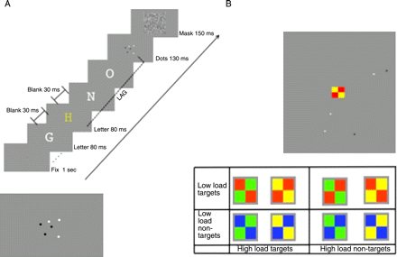

(A) Attentional blink paradigm. The letter stimuli were presented in RSVP. Each trial began with a fixation point presented for 1 s, followed by an RSVP stream (12 letters), each letter displayed for 80 ms with a 30-ms blank gap. The dot array was displayed for 130 ms and from 110 ms to 880 ms after the target letter (yellow) and was followed by a binary pixel noise mask (150 ms). (B) Spatial attention paradigm. The presentation began with a fixation point for 1 s. Stimuli (dots and colored square) were presented simultaneously for 200 ms, followed by a binary pixel mask (200 ms).

Data analysis

Data were analyzed separately for each subject. For each subject, the responses were pooled for each condition and numerosity, from which two parameters were estimated: the mean and standard deviation. The standard deviation is the main parameter, providing an estimate of response precision, which, normalized by the number of items in that condition, provides an estimate of the Weber fraction, the standard parameter of precision performance that is often independent of magnitude. The mean estimates systematic biases in judgments, or accuracy, plotted in Figure 6.

Results

Attentional blink

As detailed above, the “attentional blink” is a double-task paradigm where subjects first identify the odd-colored letter in an RSVP stream, then estimate the number of dots in a cloud. Examples of number estimation are shown in Figure 2A, for numerosities 3 and 6, under control conditions (when the letter was presented but ignored: red symbols), and during the peak of the attentional blink (lag 220 ms: black symbols). The distributions of the estimates were well described by a Gaussian, from which the Weber fraction is readily calculated from the standard deviation of the fit. When subjects were not required to perform the dual task, the curves for 3 and 6 were quite different: for numerosity 3 there were no errors (hence a delta function), while for numerosity 6 there were many errors resulting in a distribution with standard deviation of 0.66 (Weber fraction of 0.11).

Spatial dual task

Here subjects performed a double-task paradigm, but for stimuli simultaneously presented. While estimating numerosity of the dot cloud, subjects also performed a central task, reporting either the presence of a red square (low load), or a conjunction of color and orientation (high load). Figure 2B shows sample distributions of number estimation for target numbers 3 and 6 in high-load and single-task (no-load) conditions. The distributions are very similar to those of Figure 2A. Estimation of three dots was error-free with the single task, while at 6 the estimates formed a clear Gaussian distribution, whose standard deviation yielded a Weber fraction of 0.9. Under high attentional load, this distribution changed little, while that for 3 elements became as broad as that for 6.

Figure 2

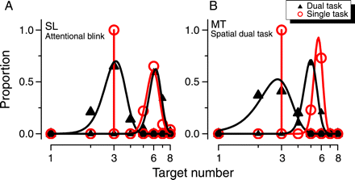
Example of mean probability distribution in the two ranges of numerosity for the two experimental conditions (single task and dual task) in the (A) attentional blink and (B) spatial attention paradigms; N = 3 (subitizing) and N = 6 (estimation). The increase of the attentional load lead to a considerable increase in the response variability in the subitizing range, while that in the estimation range remained virtually unchanged.

Effect of attention on subitizing and estimation

Figure 3 brings the effect of attention out more clearly, plotting Weber fractions (obtained from the standard deviation of the Gaussian fits) against numerosity, for various levels of attentional loads. The results are similar for both paradigms: in the high number range all conditions lead to a similar estimate of Weber fraction around 15%; in the subitizing range, however, the results clearly depend on attentional load, with perfect (or near-perfect) performance at 2 and 3 in the no-load conditions of both experiments.

Figure 3
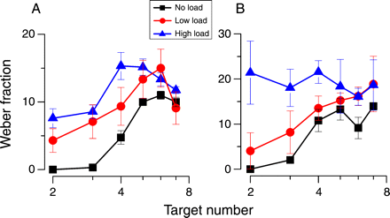

Plot of mean Weber fraction against target number for various attentional loads (see legend) against target number for the (A) attentional blink paradigm and (B) spatially divided attention. For attentional blink paradigm, “No Load” refers to the average of 880-ms lag and all conditions without the double-task; “Low Load” is 110-ms lag; and “High Load” is the average of 330- and 220-ms lags. For both spatial and temporal paradigms, the curves become much flatter at high attentional load.

Figure 4 plots the results another way, separately for the six different numerosities: for the attentional blink experiment, they are plotted as a function of the lag between the two stimuli, for the spatial attention experiment as a function of task complexity. The effect of attentional load is clearly different for different numerosities. At the higher numerosities (5–7), the curves were fairly flat, sitting around 15%, independent of load. However, performance at low numerosities (2–3) clearly depended on task load, reaching near-perfect performance at low and no-load conditions. Performance at 4 was somewhat in between, sitting with the higher number range in the spatial task and lower range in the temporal task. Note that in the subitizing range (<4) the curves in Figure 3° follow the classical attentional blink result, peaking around 200–300 ms, returning to baseline for separations of 900 ms.

Figure 4

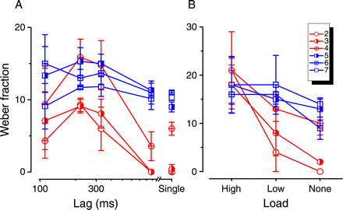

Weber fraction against attentional load, separately for all numbers, in the (A) attentional blink and (B) spatial attention conditions. Large number (5–7) are largely unaffected while small numbers (2–4) show a large effect of attention.

Figure 5 shows individual results for the three subjects in the attentional blink experiment (Figure 5A) and four in the spatial dual task Figure 5B, plotting Weber fractions in the high-load conditions against those in the low-load conditions, separately for the subitizing (2–4) and estimation (5–7) ranges. For the attentional blink, the high load is the average of 220- and 330-ms lag and no load is the average of single task at all lags. The results were very similar for all subjects and both tasks: performance in the higher estimation range was largely independent of load, while in the subitizing range it was strongly dependent on load. The ordinates of all points were very similar for high load, but at low load form two non-overlapping clusters, with near perfect for the subitizing range.

Figure 5

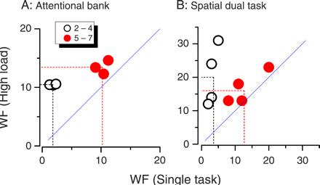
Scatter plot of Weber fractions in high-load against low-load conditions for all subjects in both (A) attentional blink and (B) spatial dual-task conditions, separately for low numbers (2–4) and high numbers (5–7). For the attentional blink, high load was the average of 220 and 330 ms, single task was the average of all delays with no primary task. For all subjects, attentional load affected Weber fraction much more in the subitizing than estimation range.

As mentioned in the Methods section, the numerosity estimation trend is well described by a Gaussian probability distribution, defined by two numbers: the standard deviation, the estimate of response precision, that leads to the Weber fraction when normalized by the target number; and the mean, which estimates the response accuracy (a bias away from veridical behavior). Figures 6A and 6C plot the perceived numerosity obtained from the means of the Gaussian fit, averaged over subjects for the two attentional conditions. In general, the perceived numerosity was quite accurate (little bias), tending to follow the actual target number (dashed diagonal). The only systematic deviation from veridicality was in the high-load spatial dual-task condition, where there tended to be an underestimation at the higher numbers. Finally, Figures 6B and 6D plot “error rate” as a function of target number, to help relate the present results to previous reports, that often express results as error rate. There are two problems with this approach; one is that it confuses bias and precision, as both lead to errors, but are quite different attributes; the other is that the magnitude of the error is lost. When expressed in this way, the effect of attentional load appears to be larger for higher numerosities, but this is in fact quite misleading.

Figure 6

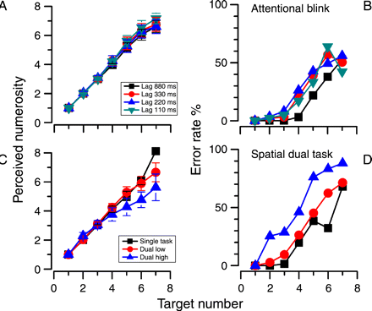

Plot of (A, C) perceived numerosity and (B, D) error rate in the (A, B) attentional blink paradigm and (C, D) dual-task spatial attention. Attentional load had little effect on perceived numerosity. Error rate, as always, is difficult to interpret because it contains errors both in accuracy and precision and does not weight for the amplitude of the error.

Discussion

Using two complementary techniques, this study shows that subitizing depends strongly on attentional resources, while estimation of larger quantities depends far less on attentional load. Under conditions of high attentional demand, both during the attentional blink (200–300 ms after recognition of a target letter) or during an attentionally demanding simultaneous task (detection of a color-orientation conjunction), performance in estimating the number of dots in a cloud remained remarkably constant, around 15% for target numbers ranging from 2 to 8. It would be difficult to account for these results within the framework of a single mechanism covering the whole range. If this mechanism were attention-dependent at low numbers, it should also be attention-dependent at high numbers. It appears far more plausible that two mechanisms are at work. One possibility is that “density estimation” comes into play in the higher number range. Although we did not control specifically for this possibility, as our previous study (Ross and Burr 2010) showed that for adult humans density and numerosity activate different processes, it seems likely that the two mechanisms revealed by this study are both involved in number judgment, not density. However, these mechanisms need not be completely separate. A parsimonious explanation could be that estimation mechanisms operate over the entire range, with similar normalized resolution capacity (Weber fraction), but at low numerosities these mechanisms are supplemented by attentional mechanisms, mechanisms that identify and enumerate very precisely, but have a very low capacity, around four items. A capacity of four items would be consistent, for example, with the capacity to track moving stimuli (Pylyshyn and Storm 1988), which is heavily dependent on visual attentive mechanisms (Arrighi, Lunardi et al. 2011). This explanation also finds support from recent fMRI studies of neural correlates of visual enumeration under different attentional loads. Ansari, Lyons, van Eimeren, and Xu (2007) have shown that the temporal-parietal junction (rTPJ), an area thought to be involved in stimulus-driven attention (Corbetta and Shulman 2002), is activated during a comparison task of quantities, but only for small numbers of items, up to 3 or 4. More recently Vetter, Butterworth, and Bahrami (2010) showed that this area responds to small numbers only in conditions of low attentional load. All these studies suggest that this area could be the neural substrate for the attention-assisted boost in performance of estimation in the subitizing range. Our current results suggest that when this attention-based system is unavailable because of competing demands, the estimation system still functions, providing numerosity estimates for small numbers, but with greatly reduced precision. That the estimation range also spans small numbers is consistent with the single unit physiology (Nieder, Freedman et al. 2002) and behavioral data (Nieder and Miller 2004) of macaque monkeys, and also fMRI studies that suggest that the same mechanisms are active for small and large numerosities (Piazza, Mechelli et al. 2002). Subitizing is often considered to be a pre-attentive process or at least to have access to pre-attentive processes (Trick and Pylyshyn 1994), while enumeration of larger numbers is considered to require attention. This study shows, at least as far as estimation (rather than counting) is concerned, that this distinction is not true. Subitizing was heavily dependent on attentive resources, as previous studies have shown (Juan, Walsh et al. 2000; Egeth, Leonard et al. 2008; Olivers and Watson 2008; Railo, Koivisto et al. 2008; Vetter, Butterworth et al. 2008; Xu and Liu 2008; Vetter, Butterworth et al. 2010), while thresholds for numbers outside the subitizing range were completely unaffected by attentional manipulations. Interestingly, the limit of the subitizing range is very similar to that of other attention-related phenomena, such as transfer of information across saccades (Melcher 2009). It is interesting that both spatial and temporal manipulations of attention produced similar results, suggesting that the dependence of subitizing on attention is general, not specific to a particular type. It would be interesting to examine the effect of dual attentional tasks in other modalities, such as sound, on visual subitizing (and vice versa), as previous studies have shown that vision and audition tap separate attentional resources (Alais, Morrone et al. 2006). Broadly speaking, our results fit well with other studies of the effects of attention on enumeration. For example, Vetter et al. (Vetter, Butterworth et al. 2008) showed, with a paradigm very similar to our spatial dual task, that attentional load affected enumeration. They claimed that attention affected equally the subitizing and estimation ranges. However, inspection of their data (their Figure 3D) suggests that although statistically significant, the effects of attentional load were far less in the estimation than the subitizing range. In our hands, the effect of attention in the estimation range (5–7) was very small, and not statistically significant (for both paradigms p > 0.05), while the effect of attentional load is strong in subitizing range and is statistically significant (for both paradigms p < 0.0002). They also agree in principle with studies showing that the attentional blink and attentional spatial task affects subitizing (Juan, Walsh et al. 2000; Egeth, Leonard et al. 2008; Olivers and Watson 2008; Xu and Liu 2008). However, it is difficult to see in those studies whether the effect also occurs in the estimation range, as they report error rate rather than precision, that does not estimate performance well. In our experiments, attentional load caused very little bias in perceived numerosity: precision was impaired in dual-task conditions in the subitizing range, but there was very little effect on average perceived numerosity (accuracy). Only in the high-load spatial dual task was there a systematic under estimation of numerosity, and there only in the estimation range (where Weber fractions were unaffected by attentional load). Most studies on numerosity tend to concentrate on two measures, reaction times and percent errors. As the dual task makes reaction times difficult in our paradigm, we concentrated on error rate. However, it is important to distinguish the two forms of error, accuracy and precision. The precision tells us how reliably subjects can make enumeration judgments. Systematic biases or inaccuracies are not related to precision but could reflect other processes. For example, after adapting to fields with large numbers of items, subjects underestimate numerosity, but do so reliably. Therefore looking only at error rate is very uninformative about underlying processes. Another problem with error rate is that the magnitude of the error is lost. For example, confusing 2 with 3 is a 50% error, whereas 10 with 11 is only 10%: yet when scoring error rate, both are scored equally, which leads to an overestimation of the imprecision in the larger range, which can be quite misleading. So while our results agree qualitatively with many previous studies looking at the effect of attention on enumeration, the important difference between the subitizing and estimation ranges is lost in many of those studies. Two main conclusions can be drawn from the present study: that subitizing and estimation are not identical processes, as they are differently affected by attentional load; and that subitizing, described by many as a pre-attentional process, relies heavily on attentional mechanisms (while estimation mechanisms do not). A parsimonious explanation of the current data would be that estimation processes work over all numerosity ranges, and this is broadly consistent with the animal neurophysiology (Nieder, Freedman et al. 2002) and human imagining studies (Piazza, Mechelli et al. 2002). However, in the low number range, additional attention-based processes exist, and these have a very limited capacity, around four items. Our results are also in agreement with the recent evidence that the capacity of trans-saccadic perception, measured as the transfer of adaptation aftereffects across gaze shift, is around four items in single-task condition, instead with the addition of visual working memory or counting task this capacity decrease to only one item (Melcher 2009). When attention is diverted on a demanding task, estimation mechanisms still operate, with lower precision.

2.1.2. The effects of cross-sensory attentional demand on subitizing and estimation

In the previous experiment we demonstrate that subitizing strongly depend on visual attention. However, it is not clear whether the attentional effects are modality specific, or whether they transfer across modalities. This question is particularly relevant to recent work showing that subitizing is not strictly visual, but also seems to operate in audition (Repp 2007; Camos and Tillmann 2008) and touch (Riggs, Ferrand et al. 2006; Plaisier, Bergmann Tiest et al. 2009). Concurrent perceptual tasks of the same sensory modality interfere with each other to degrade performance (Pashler 1992; Pashler 1994). However, evidence for cross-modal interference is conflicting. Bonnel and Hafter (1998) found evidence for audio-visual cross-modal interference for detecting the sign of a magnitude change (luminance in vision and intensity in audition). Spence, Ranson and Driver (2000) found that selecting an auditory stream of words presented concurrently with a second (distractor) stream is more difficult if a video of moving lips mimicking the distracting sounds it is also displayed. These psychophysical findings are not only consistent with some of the cognitive literature of the 1970s and 1980s (Taylor, Lindsay et al. 1967; Tulving and Lindsay 1967), but also with recent neurophysiological and imaging results. For example, Joassin, Maurage, Bruyer, Crommerlink and Campanella (2004) examined the electrophysiological correlates of auditory interference on vision in an identification task of non-ambiguous complex stimuli, such as faces and voices, and showed that cross-modal interactions occur at various different stages, involving brain areas such as the fusiform gyrus, associative auditory areas (BA 22), and the superior frontal gyri. Hein, Alink, Kleinschmidt and Muller (2007) showed with a functional magnetic resonance (fMRI) study, that even without competing motor responses, a simple auditory decision interferes with visual processing at neural levels including prefrontal cortex, middle temporal cortex, and other visual regions. Taken together these results imply that limitations on resources for vision and audition operate at a central level of processing, rather than in the auditory and visual peripheral senses. However, much evidence also suggests independence of attentional resources for vision and audition. For example, Larsen, Mclhagga, Baert and Bundesen (2003) compared subject accuracy for identifying two concurrent stimuli (such as a visual and spoken letter) relative to performance in a single-task. They found that the proportion of correct responses was almost the same for all experimental conditions, either single-task or divided-attention. Similarly, Bonnel and Hafter (1998) used an audio-visual dual-task paradigm to show that when identification of the direction of a stimulus change is capacity-limited, simple detection of visual and auditory patterns is governed by “capacity-free” processes, as in the detection task there was no performance drop compared with single-task controls. Alais, Morrone and Burr (2006) measured discrimination thresholds for visual contrast and auditory pitch, and showed that visual thresholds were unaffected by concurrent pitch discrimination of chords and vice versa, while when two tasks were performed within the same modality, thresholds increased by a factor of around two for visual discrimination and four for auditory discrimination. Also for sustained attentional tasks (such as 4 seconds of the Moving-Objects-Tracking task of Pylyshyn and Storm (1988) separate attentional resources seem to be allocated to vision and audition (Arrighi, Lunardi et al. 2011). Many of these results are in line with imaging studies suggesting that attention can act at early levels, including primary cortices A1 and V1 (Jancke, Mirzazade et al. 1999; Posner and Gilbert 1999; Somers, Dale et al. 1999).
The current study was designed to examine the role of crossmodal attentional competition in visual numerosity estimation using dual-tasks with visual, auditory and haptic distractors.

Methods

Stimuli were presented in a dimly lit room on a 23-in. liquid crystal monitor (ACER) with 1280 X 1024 resolution, mean luminance 60 cd/m2, refresh rate 60 Hz. Subjects viewed the screen binocularly at a distance of 57 cm. Stimuli were generated and presented with Matlab 7.6, using PsychToolbox routines (Brainard,1997) running on a Macintosh laptop. Sounds were played by two loudspeakers (Trust SP-2420) flanking the computer screen. Speaker separation was around 80 cm and intensity 75 dB at the sound source. Haptic stimuli were delivered by a modified speaker resting on the index finger of the non-dominant hand (the left, for all the participants).

Participants

Ten naive subjects (mean age: 26 ± 3) with normal or corrected to-normal vision participated. Four subjects were tested in the visual attentional load and in one (of the two) auditory distractor paradigms (frequency discrimination). Four subjects (including three new) were tested on a different auditory attentional load task (time bisection). Finally, three new subjects performed the haptic load task (time bisection). All subjects performed the single task condition.

Stimuli and procedure

Each trial started with a fixation point (randomly displayed for a random interval from 200 to 2000 ms), followed by the simultaneous presentation of both distractors and numerosity task, both lasting 230 ms, followed immediately by a mask (600X600 pixels, randomly black or white) for 250 ms (Figure 1). The numerosity stimulus was a cloud of non-overlapping dots varying in number from 1 to 10, which subjects were required to enumerate. Dots were half-white and half-black so luminance was not a cue to number. Each dot was 0.4° in diameter, with position chosen at random within a matrix of 18° diameter. The visual distractor comprised four centrally positioned coloured squares, each subtending 3° of visual angle. The stimulus was classed as a target if a specific conjunction of colour and spatial arrangement was satisfied: two green squares along the right diagonal or two yellow squares along the left diagonal. Two separate auditory distractors were used: pitch discrimination and interval discrimination. For the pitch discrimination, three tones (each 30 ms) were played equi-spaced within 250 ms. Two reference stimuli had the same frequency, while the target to be detected (chosen at random) differed by ±40% Hz. Both the sign of the increase (increase or decrease) and the reference frequency (400–1000 Hz) were chosen randomly on each trial. For the auditory interval discrimination task, we performed interval bisection of three 1300 Hz, 10 ms tones. The first and the third were always played at 0 and 250 ms, the second at a variable interval (60, 80, 90, 110, 120 or 140 ms): subjects reported whether it was closer to the first or third tone. The haptic distractor task was like the auditory time bisection, with taps to the hand instead of tones. Taps were delivered by the coil of a small speaker resting on the hand, through which a 10 ms tone of 80 Hz was played. Like the auditory time bisection task, subjects determined whether the second tap was nearer in time to the first or third (same conditions as for audition). To prevent the use of auditory cues, subjects wore noise-reduction headphones that played white noise. In the single task condition, distractor stimuli were presented on all trials, but subjects were instructed to ignore them. These conditions were re-run separately for all distractor conditions (visual, auditory and tactile). Numerosity responses were recorded only if the distractor task was correct. We measured 10 levels of numerosity (from 1 to 10) and five attentional conditions (visual, haptic, two different auditory dual-task and single-task), yielding a total of 5500 trials (equally divided between subjects and conditions). In separate sessions we measured enumerations where subjects were not requie to do the distractor task (although the stimuli were always displayed). In this experiment we also asked subjects to perform the auditory frequency-discrimination and visual conjunction task together, to verify that they did not interfere with each other (as others have previously reported).

Figure 1
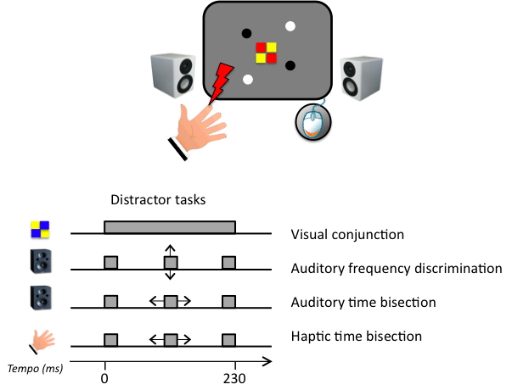

Illustration of stimulus sequences. Each trial starts with a ﬁxation point (randomly displayed for 200–2000), followed by the numerosity stimulus (dot cloud), together with the distractor. Both last for 230 ms, immediately followed by a binary pixel mask (200 ms). Subjects responded ﬁrst to the distractor task then enumerated the numerosity.

Results

As detailed above, we asked subjects to estimate the numerosity of dot-clouds, both when presented alone and with the various distractor tasks: visual conjunction detection, auditory frequency discrimination, auditory interval bisection task and tactile interval bisection task. Figure 2 shows response distributions averaged over all subjects for two sample stimuli (3-dot and 6-dot), which we approximate by Gaussian distributions (on logarithmic abscissa). In the single task conditions the response distributions are narrow, particularly for the 3-dot stimulus (within the subitizing range). In the dual task conditions, the response distributions are broader. The effect of attention is clearly greater on the 3-dot than the 6-dot distribution, as they are so narrow without attentional load. With attentional load subjects begin to make errors in estimating the number of presented dots, deviating from veridicality by one or even more units. However, the mean remains virtually unchanged, around three.

Figure 2
Sample response distribution for enumerating 3 or 6 dot stimuli numbers in single task (black) and dual task conditions. Filled symbols show responses to 3-dot stimuli, hollow symbols to 6-dot stimuli. Several dual task conditions are shown: (A) Auditory frequency discrimination (blue). (B) Auditory time bisection (cyan). (C) Visual conjunction (red). (D) Haptic time bisection (orange). Best ﬁtting log-gaussian curves are shown as continuous lines.

We calculated separately for each subject the mean and standard deviation, to yield respectively estimates of accuracy and precision, which were then averaged and shown in Figure 3. Fig. 3 A plots precision as average Weber fraction (standard deviation divided by dot number) of the subjects for each attentional condition, as a function of dot number (excluding the extremes 1 and 10), for the various conditions. For the single-task condition, Weber fractions are near zero in the subitizing range, but rise to about 0.1 for numbers 5 and higher. This pattern changes completely under attentional load. When subjects were required to perform a concomitant dual-task – visual, auditory or tactile – precision was severely impaired in the subitizing range, with Weber fractions rising to 0.2 or higher. Precision was also impaired for the higher numbers, but by a lesser extent. This confirms the results of Burr et al (2010), and further shows that a distractor task in any modality, not just vision, impacts heavily on subitizing. In fact the worst performance was obtained with the tactile distractors. It is not clear why this is so, but perhaps the tactile task was, for some reason, more demanding.
Figure 3 B plots the average perceived numerosity, the mean responses for each numerosity, averaged over subjects. In general, these estimates were quite accurate (bias-free) in all conditions, following reasonably closely the actual target number (dashed diagonal). The only small deviation from veridicality was for the higher numbers (7-8-9), which tended to be slightly underestimated. This shows that the errors in the subitizing range were not simply due to some elements not being seen, as this would have lead to a systematic under-estimation of numerosity.

Figure 3
Number enumeration. (A) Mean Weber fraction (standard deviation divided by physical number) as a function of target number, for the various distractor conditions. Attentional load strongly impairs precision in the subitizing range (4 and below), irrespective of the modality or type of distractor task. The effect at high numerosities was much less. (B) Attention had a little effect on average accuracy, with mean perceived numerosity nearly veridical over the range.

To be certain that the distractors tasks were performed appropriately during the dual-task conditions, we also measured in separate sessions the baseline performance of on the different distractor tasks. Performance on average does not change when these tasks were performed alone or within dual-task paradigm. Mean performances were 98, 77, 83 and 83% respectively for the visual colour-orientation conjunction, auditory frequency discrimination, auditory time bisection and haptic time bisection task when performed alone, compared with 97, 75, 80 and 81% when performed in the dual-task paradigm. The similar performance suggests that they made similar attentional demands on the subjects. As a final test of the independence of auditory and visual attention, we measured performance on the two distractor-stimuli – visual conjunction and auditory frequency discrimination – in the presence of the other. The methodology was exactly as before, except that subjects had to report on the conjunction task and the auditory-frequency task (and ignore the numerosity. Figure 4 shows the results, for the auditory (A) and visual (B) tasks, measured alone and together with the task in the other modality. Clearly, doing two tasks in different modalities incurs little cost: performance, shown as percent correct responses, is little affected by the concomitant task.

Figure 4
(A) Average performance (shown as percent correct) for four subjects on the auditory distractor task (frequency discrimination), measured either alone (black) or in dual-task with the visual conjunction task (right-slanting red). The cross-modal distractor clearly did not affect performance. (B) The converse of (A): percent correct on the visual conjunction task measured either alone (black) and or in dual-task condition (right-slanting blue). Again, auditory attention had little effect on visual performance.

Discussion

One of the main results of this study is to show that subitizing is affected by cross-attentional demands. While we conﬁrmed previous work showing independent attentional resources for visual and auditory tasks for estimation of moderately high numerosities, subitizing of small quantities of visual items was strongly affected by concurrent attentionally demanding tasks in vision, audition
(frequency discrimination or interval discrimination) or touch. For the distractor stimuli we used, all had similar effects, raising Weber fractions from virtually 0% to more than 30%. This suggests that subitizing may be an amodal phenomenon, rather than strictly visual, an idea that ﬁnds support in some recent research showing that subitizing processes also operate in audition (Repp 2007; Camos and Tillmann 2008) and touch (Riggs, Ferrand et al. 2006; Plaisier, Bergmann Tiest et al. 2009). Estimating the numerosity of either visual or auditory stimuli causes increased activity of a right-lateralized fronto-parietal cortical network, independently of the modality of the stimuli (Piazza, Mechelli et al. 2006). All this suggests that subitizing may rely on supra-modal attentional resources. Estimation, however, was little affected by cross-modal attention, further evidence that it is an independent process. It is not clear why subitizing is more affected by attention than estimation. One possibility is that it is a qualitatively different process, requiring more attentional resources than estimation. Indeed, it has been suggested that subitizing is directly linked to the capacity to individuate objects (Melcher and Piazza 2011). The cross-modal interference reported here tends to support this view, as all modalities may be contributing to object individuation. However, we cannot exclude other possibilities, such as there being some form of pre-normalization noise, highly dependent on attention, that would affect the low range of numbers more than the higher range. Further experimentation may be able to tease out these two possibilities.

2.1.3. Adaptation Affects Both High and Low (Subitized) Numbers Under Conditions of High Attentional Load

Numerosity perception like all primary sensory properties, is susceptible to adaptation: the prolonged exposure to a more numerous visual stimulus makes the current stimulus appear less numerous, and vice versa (Burr and Ross 2008). Interestigly, low numbers (<4) were not susceptible to adaptation. In the previous experiments we shown that dual-task paradigms affect precision performance (Weber Fraction) in the subitizing range far more than in a higher range. Under attentional load, precision in the subitizing range deteriorated considerably to approach that of the higher estimation range. The results imply that two systems are involved with numerosity. However, we do not believe that the two number ranges are processed by completely independent mechanisms. We suggested that there may exist a preattentive estimation mechanism operating over the entire range of numbers, both large and small, and that this system is supplemented by an additional attentive mechanism with very limited capacity, capable of attending to up to about four items: the attentive mechanism makes performance virtually perfect over this low range. In this study we test directly this hypothesis by measuring adaptation to numerosity under demanding attentional load conditions.

Methods

The stimuli were presented in a dimly lit room on a 15-inch Macintosh monitor with 1440 × 900 resolution at refresh rate of 60 Hz and mean luminance of 60 cd/m², and viewed binocularly by subjects from 57 cm. Stimuli were generated and presented under Matlab 7.6 using PsychToolbox routines (Brainard 1997). Three subjects with normal or corrected-to-normal vision participated in this study, two authors and one naïve to the goals of the study (all male, mean age 26). The experiment used a dual-task paradigm: subjects ﬁrst performed a difﬁcult conjunction task, then a numerosity judgment (see Figure. 1). The stimuli for the primary task comprised 4 centrally positioned colored squares, each subtending 1◦ of visual angle, presented concurrently with the numerosity matching task (lasting the entire duration of both test and probe). The squares could be arranged in eight different color combinations. If two green squares fell along the right-sloping diagonal or two yellow squares fell along the left diagonal, the stimulus was a target. In the single-task condition, the conjunction stimulus was presented as before, but subjects were instructed to ignore them. The test stimulus for the secondary task (numerosity comparison) was a cloud of non-overlapping dots (diameter 10 arcmin), half white and half black at 90% contrast. The dots were constrained to fall within a virtual circle of 4◦ visual angle, and were always separated from each other by at least 12 arcmin. The adaptation and probe stimuli were similar to the test, with the probe comprising 3, 6, 12 or 24 dots (depending on adaptation condition), and the adaptor 200 dots. Each session started with 40 s of the adaptor presented 6◦ left of ﬁxation; in subsequent trials it appeared for only 6 s (top-up adaptation). 150 ms after the adaptor disappeared, the test appeared for 200 ms in the same position as the adaptor, and the primary task (colored-squares) in the centre of the screen for 550 ms. 150 ms after the test was extinguished, a probe stimulus was presented for 200 ms, 6◦ right of ﬁxation. The probe was also a dot pattern, similar to the test, with numerosity 3, 6, 12, 24 dots depending on condition. In the dual-task condition, subjects were required ﬁrst to report whether the central stimulus was a target (by appropriate mouse-click), then respond whether the test or probe appeared to be more numerous. All subjects were about 90% correct on the conjunction task, with no differences between conditions: responses were recorded to the number task only if the response to the conjunction task was correct. In the no-load condition, subjects performed only the numerosity task. The number of dots in the test was initially equal to the probe, then varied from trial to trial depending on subject response, with numerosity determined by the QUEST algorithm (Watson and Pelli, 1983), and with parameters initial numerosity = probe numerosity, standard deviation = 0.5 log-units; beta = 3.5; epsilon = 0.01; gamma = 0. To determine the numerosity of the next trial, the algorithm estimated the point of subjective equality (PSE) after each trial, then perturbed that with a random number drawn from a Gaussian distribution of standard deviation 0.15 log-units. At the end of each session, data were analyzed separately for each subject and condition. The proportions of trials where the test appeared more numerous than the probe was plotted against test numerosity and ﬁtted with cumulative Gaussian functions like those of Figure. 2, yielding estimates of PSEs (median of psychometric function) and precision (standard deviation). Statistical testing was performed by bootstrapped sign test of the whole procedure that led to the particular measure. For example, to test whether adaptation had a signiﬁcant effect in the single task condition at N = 6, we calculated for each subject the PSE in that condition with a sample of data (with replacement, equal to the number of trials), and computed the average across subjects. The same was done for the no-adaptation single-task condition. The process was reiterated 10 000 times, counting which was the higher average on each reiteration. The proportion of times when the non-adapted condition had a higher mean than the adapted condition is the signiﬁcance value. For each subject there were two adaptation conditions, two attention conditions and 4 numerosities, yielding 16 conditions for each subject (with about sixty trials for each condition). The conditions were blocked into separate sessions, two sessions per condition, with order of conditions randomized between subjects. There was always a considerable pause (hours) between the adapted and non-adapted conditions to ensure that the effects did not carry over.

Figure 1
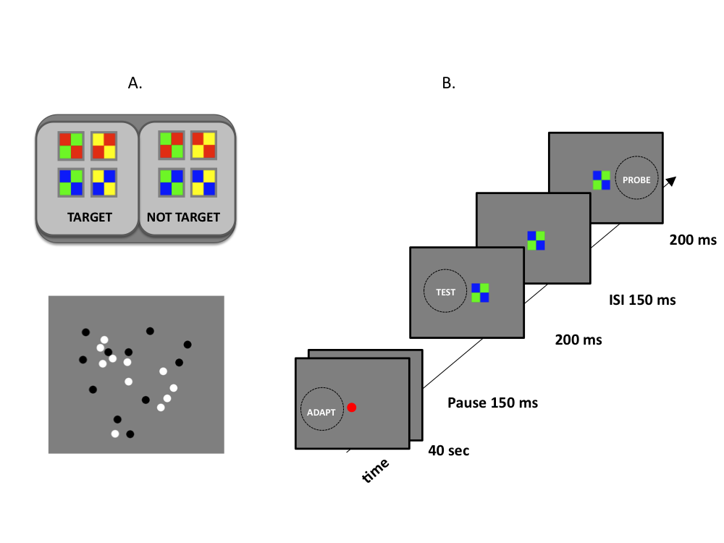
(A) Illustrations of primary (upper) and secondary (lower) stimuli. Primary stimuli were classed as targets if there were two green squares along the right-to-left diagonal or two yellow squares along the left-to-right diagonal. (B) Trial sequence: after adaptation (40 s on ﬁrst trial, 6 s thereafter) to 200 dots, the test-stimulus was presented in the adapt region (200 ms); after 150 ms inter stimulus interval, the probe was displayed in the opposite ﬁeld (200 ms). The colored squares remained on for 550 ms.

Results

Figure 2 shows sample psychometric functions for 1 subject, for three relevant conditions at two numerosities. At the highest numerosity measured (24 dots), the PSE in the no-adapt, single-task condition was 32, close to the veridical value of 24. After adaptation to 200 dots, 50 dots were required to match to 24, implying that the apparent numerosity of stimuli in the adapted region was greatly reduced. The result in the dual-task condition was also similar (54 dots). However, the pattern of results in for probe numerosity of three (subitizing range) was quite different. In the single-task condition, adaptation had only a weak effect (PSE = 3.8, compared with no-adapted PSE = 3.4), while in the dual-task condition the adaptation was as strong as for larger numerosities (PSE = 6.3). The results of all subjects are summarized in Fig. 3, both for the three individual subjects (symbols) and averages across subjects (bars). The ordinate reports the ratio of the PSE of the particular condition to that of the baseline for that numerosity (single-task, no adaptation). A value of one means that the adaptation and/or dual-task had no effect, greater than one means that the apparent numerosity of the test was reduced by that factor (so the test numerosity was increased to obtain the match). As the example psychometric functions of Fig. 2 show, attentional load affected adaptation in the subitizing range. In the single-task condition, adaptation affected perceived numerosity for large numerosities (Bootstrap t -test with: N (6) p = 0.03; N (12 and 24) p < 0.01), but very little effect where N = 3 (p = 0.38). However, under attentional load the effect of the adaptation increased considerably for low numbers to 40%, nearly as much as for the large numbers (50%). The effects of attentional-load by itself are shown by the black right-slanting bars. For low number (n = 3), the double-task by itself had very little effect, but at higher numerosities it caused a slight underestimation, by about 25% at N = 24. Figure 4 reports the geometric means of Weber Fraction against numerosity for all four conditions. Note that there are four rather than three conditions here, as the Weber fraction for the baseline is also shown. As previously reported, the strongest effects of attentional-load were in the subitizing range: there the Weber Fraction increases from 7% in the no-load condition to 16% in the double-task, while for the larger ranges it remains about in the order of 22–24% irrespective of attentional demand. The only signiﬁcant effect of attentional load was in the subitizing range (see t -tests in ﬁgure caption), agreeing with our previous study (Burr, Turi et al. 2010).

Figure 2
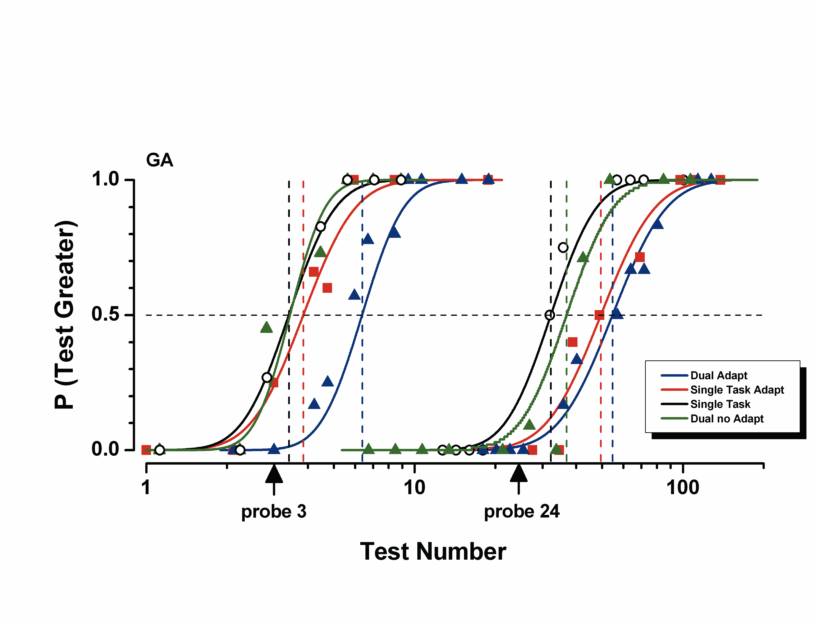
Example psychometric functions for subject GA for two numerosities (3 and 24) and four conditions. In all cases the proportion of times the subject reported the test to be more numerous than the probe (ﬁxed at 3 or 24 dots) is plotted as a function of test number. The various conditions are indicated by the colors described in the legend. The effect of adaptation was far greater in the dual-task than in the single-task condition at low, but not high numerosities.

Figure 3
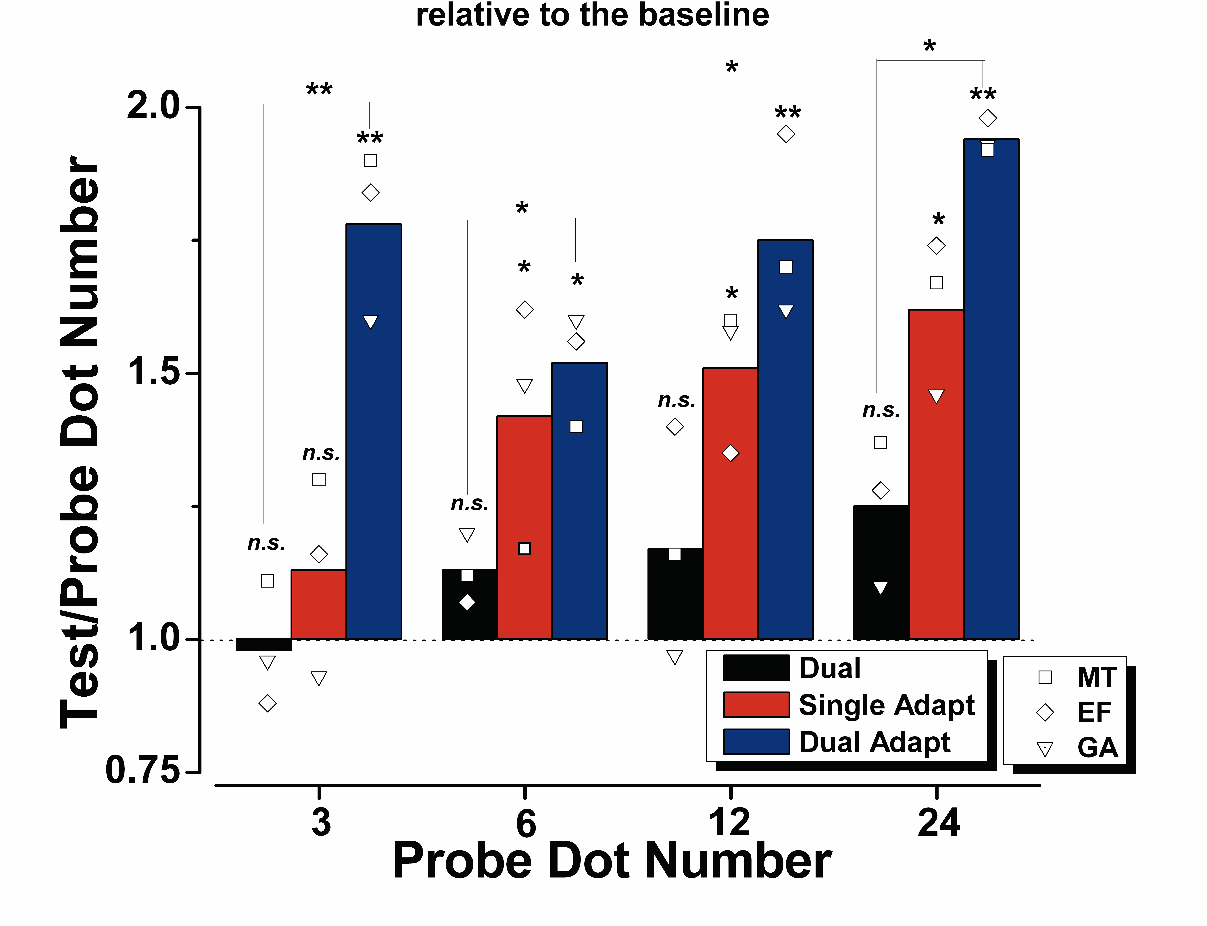
Effect of attention and adaptation on number estimation. Symbols report individual results (EF is the naïve subject); bars indicate averages of the three subjects. All data show the PSE for that particular condition divided by the PSE for the single-task, no adaptation condition at that numerosity. Values greater than unity mean that the perceived numerosity of the test is proportionally less than of the probe. (Color coding: right-slanting black — dual task, no adaptation; red left-slanting — adaptation, single-task; blue cross-hatched — adaptation, dual-task.) The values of all conditions were tested for statistical difference from 1 by bootstrap sign-test (see methods), and the result reported by the symbols above each bar: n.s. p > 0.05; ∗ p < 0.05; ∗∗ p < 0.01).

Figure 4
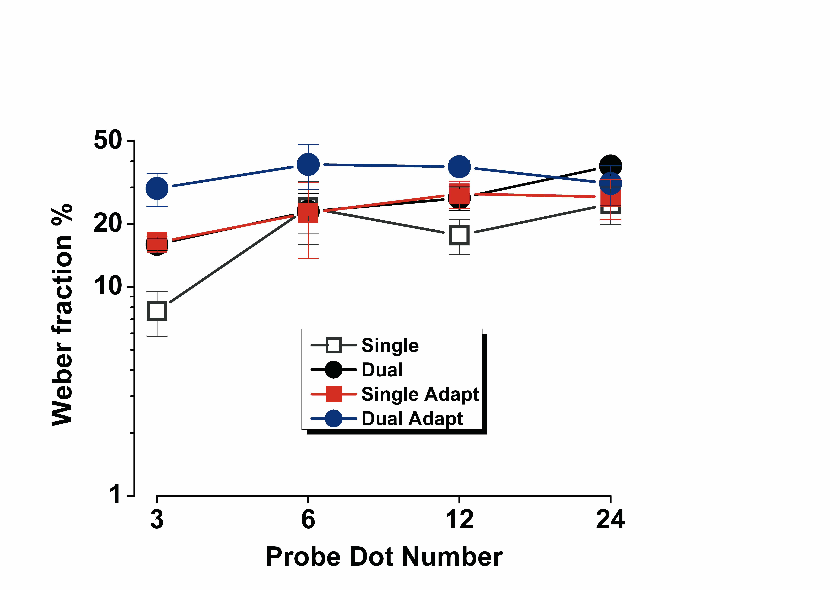
Mean Weber Fraction (std/tested number): color-coding as Fig. 3, with the single-task no adaptation condition shown by open symbols. The strongest effects of attentional load were for the low numbers. T-tests between single and dual (non-adapted conditions) revealed signiﬁcant effects only for the smallest numerosity: N (3): t= 3.93, p= 0.017; N (6): t= 0.10, p= 0.92; N (12): t = 1.84, p = 0.14; N (24): t = 2.33, p = 0.09.

Discussion

In our previous study we presented evidence that subitizing depends strongly on attentional resources, whereas estimation of larger numbers was much less affected. We suggested that an estimation mechanism senses number directly over all ranges of numbers, but the low subitizing range beneﬁt from an additional attention based mechanism. A direct prediction of this idea was that under conditions of high attentional load, the low subitizing range should also be strongly susceptible to visual adaptation. Our results verify this prediction, showing very strong effects of adaptation in the subitizing range in high-load, dual-task conditions, but very little in the single-task condition. Attention also affected adaptation of larger numbers, but the effects were much weaker. We also showed that precision was affected by attention more in the subitizing than estimation range, supporting our previous study (Burr, Turi et al. 2010) and those of others (Juan, Walsh et al. 2000; Egeth, Leonard et al. 2008; Olivers and Watson 2008; Railo, Koivisto et al. 2008; Vetter, Butterworth et al. 2008; Xu and Liu 2008). There is a long-standing debate regarding the possible existence of two neural systems for number processing — one precise and dedicated to numbers of items less than three/four and another one approximate system, dedicated to large sets (Feigenson, Dehaene et al. 2004). On the other hand, that the estimation mechanism operates over both large and small number ranges is consistent with fMRI studies suggesting that the two ranges share common mechanisms (Piazza, Mechelli et al. 2002). It is also con- sistent with more recent studies of neural correlates of visual enumeration under different attentional load (Vetter, Butterworth et al. 2010), showing that the temporal-parietal junction (rTPJ), an area implicated in stimulus-driven attention (Corbetta and Shulman 2002), responds to small numbers only in conditions of low attentional load, suggesting that this area could be the neural substrate for the attention-assisted boost in number-naming performance in the subitizing range. Evoked potential studies in humans have also provided evidence for separate neural mechanisms for the subitizing and estimation ranges. For example, Hyde and Spelke (2009) all have demonstrated that an early (N1) component is modulated by absolute number with small, but not large, number arrays, while a later component (P2p) is modulated by the ratio between arrays for small but not large numbers. Most interestingly, under dual-task conditions, the late component P2p is also modulated by small, as well as large numbers (Hyde and Wood 2011), suggesting that under these conditions, where the subitizing system is rendered ineffective, the estimation system continues to function, and dominates the evoked response. Single-unit physiology (Nieder, Freedman et al. 2002) and behavioral data (Nieder and Miller 2004) of macaque monkeys also suggest that estimation mechanisms work over both large and small number ranges. Two classes of number neurons have been described in monkeys: neurons in areas IPS with overlapping log-normal tuning curves each tuned to a speciﬁc number (Nieder 2005); and a different type of neuron in area LIP, which responds in a graded manner to number, some maximally to large numbers some to small (Roitman, Brannon et al. 2007). These neurons have clearly deﬁned receptive ﬁelds, and have been suggested as being the site of adaptation to numerosity. We (Burr, Turi et al. 2010) have previously shown that attentional load affects the capacity to estimate number most in the subitizing range, causing resolution thresholds to increase to the levels of estimation of larger numbers. We suggested that this implicated the existence of two separate mechanisms: one working over the entire range of numerosity (including subitizing), assisted by an attentional-based sys-tem of subitizing that operated for small numbers, no more than about four. One system, subitizing, is an exact and robust system, highly resistant to change by processes such as adaptation. However, during very demanding dual-task conditions, the attentional-based subitizing system cannot operate, and even this range is subject to adaptation.

2.1.4. Separate mechanisms for perception of numerosity and density

In the previous experiment we shown that even very small numbers — as low as 3 — are subject to adaptation. This is a very clear evidence that numerosity is adaptable directly, as these low numbers of items do not create patterns that can be considered ‘texture’ (usually considered to comprise an uncountable number of elements). However, several researchers have questioned whether number is in fact sensed directly, suggesting instead that it can be derived only indirectly from texture density (Durgin 2008; Dakin, Tibber et al. 2011). In this study, we addressed this issue by measuring thresholds for numerosity and density discrimination as a function of dot density.

Method

We measured thresholds for discriminating numerosity and density of two clouds of nonoverlapping dots confined to circular regions on either side of a central fixation point (Figure 1a). The numerosity of the patch to the right of the fixation point (the reference) was constant within a session, whereas that of the patch to the left of the fixation point (the probe) varied from trial to trial. The number of dots in the probe patch was varied according to the QUEST adaptive algorithm (Watson and Pelli 1983), perturbed by a Gaussian jitter (σ = 0.15 log units).
Stimuli were generated with the Psychophysics Toolbox (Brainard 1997) and presented at a viewing distance of 57 cm on a 24-in. LCD monitor (resolution = 1,600 × 1000 pixels; refresh rate = 60 Hz; mean luminance = 60 cd/m²; Hewlett Packard, Palo Alto, CA). In each stimulus, half of the dots were white, and the other half were black. Each dot had a diameter of 0.3, and the dots were always separated from each other by at least 0.3. Dots were randomly displayed within virtual circular patches with a diameter of either 8 or 14 The patches were centered 13 left or right of fixation. The patch with the 8 diameter covered 50 deg², and the patch with the 14 diameter covered 154 deg². Six subjects with normal or corrected-to-normal vision participated in this study: 2 of the authors and 4 subjects naive to the goals of the study (5 men, 1 woman; mean age = 27 years). At the beginning of each trial, subjects fixated the point in the center of the screen. After a random interval of between 300 and 1,300 ms, the two dot clouds were presented for 240 ms, and subjects were asked to indicate, by pressing a button on a computer keyboard, which cloud was more numerous or more dense. In the equal-area conditions, the reference and probe patches were the same size, either small (8 or large (14 efore formal data collection, subjects were familiarized with these conditions via two 30-trial practice sessions in which they were given no feedback regarding correct or incorrect responses. We also measured thresholds for patches with different areas (unequal-area condition, in which a small reference patch appeared with a large probe patch. Before data for this condition were collected, all subjects received two training sessions of 50 trials; if the subjects made an error during the training, they heard a feedback tone. The feedback was provided to eliminate the systematic biases in discrimination judgments that have been reported in the literature (Dakin, Tibber et al. 2011). Because we report Weber fractions rather than coefficients of variation, this seemed to be a sensible precaution. Two 50-trial sessions (one for numerosity judgments and one for density judgments) were run for each condition. The order of conditions was randomized differently for different subjects. During the experimental trials, in which no feedback was given, no significant biases were recorded in any of the three conditions. The proportion of trials in which the probe appeared more numerous or more dense than the reference was plotted against the number of reference dots and fitted with a Gaussian error function. The median of such a function estimates the point of subjective equality, and the standard deviation estimates the precision threshold (i.e., a just-noticeable difference), which was divided by point of subjective equality (a measure of perceived numerosity) to estimate the Weber fraction. We also calculated the coefficient of variation (threshold divided by physical numerosity). However, because this calculation gave results similar to those obtained when we used the median and standard deviation, we decided to stay with the formally correct definition of the Weber fraction.

Figure 1
Experimental stimuli and results. The stimuli (a) were confined to circles with a diameter of either 14 or 8, centered 13 to either side of a fixation point. In all cases, the reference patch, which contained a constant number of dots, was on the right, whereas the probe patch, which contained a variable number of dots, was on the left. The illustrations show (from left to right) examples of stimuli in the large-equal-area, small-equal-area, and unequal-area conditions. The filled symbols in (b) show Weber fractions (thresholds normalized by perceived number of dots) as a function of dot number in the large-equal-area and small-equal-area conditions. The blue hexagons show thresholds for discriminating numerosity in the unequal-area condition. The red diamonds show thresholds for discriminating density in the same condition. The red horizontal brackets span the range of numerosity of the two patches in the unequal-area conditions (more in the larger patch); the diamonds are positioned on the geometric mean of these extremes. All thresholds are the geometric means of 6 subjects. Error bars refer to 1 SEM. The curves are two-segment, piecewise linear fits of the data, the first of slope zero and the second free to vary. The graph in (c) shows individual subjects’ Weber fractions for discriminating density as a function of their Weber fractions for discriminating numerosity in the unequal-area condition (subjects coded by symbol shape), separately for reference patches of 6 dots (purple) and reference patches of 64 dots (green). The striped areas show 95% confidence intervals. The dotted diagonal line is the equithreshold line.

Results

The filled symbols in Figure 1b plot average Weber fractions (thresholds normalized by perceived numerosity) for numerosity discrimination as a function of number of dots in the reference patch in the equal-area conditions. For both small (8) and large (14) patch sizes, thresholds follow Weber’s law at low numerosities (constant Weber fraction around 0.18) and then decrease steadily with numerosity, with log-log slopes near 0.5 (square-root relationship). The curves passing through the data points are two-segment, piecewise linear fits of the data, the first of slope zero and the second free to vary. For both large and small reference patches, the best fit of the slope of the second limb was near −0.5 (−0.45 and −0.47, respectively). The point of slope change for the large reference patch was 29 dots (0.2 dots/deg²), and that for the small reference patch was 14 dots (0.3 dots/deg²).This behavior points to the action of two separate mechanisms, one with thresholds that increase proportionally with numerosity (Weber’s law) and another with thresholds that increase with the square root of numerosity. We suggest that the first Weber function reflects the action of number mechanisms, whereas the square-root relationship — which begins to take effect at densities around 0.25 dots/deg² — reflects another system for discriminating density. Because the areas of the two patches were always the same (either both large or both small) in the equal-area conditions, density (numerosity per unit area) necessarily covaried with numerosity, so numerosity and density provided equally valid cues for veridical discrimination (irrespective of the instructions). The strategy of using density as a proxy for number (and vice versa) is easily thwarted by varying the size of the two comparison patches and then asking subjects to compare the numerosity and, separately, the density of an 8 with that of a 14 patch. Figure 1b shows the results for discrimination of numerosity for reference numerosities of 6 and 64. Again, Weber’s law is observed, and the Weber fraction for the unequal-area condition is similar to that for the equal-area conditions. For the larger numerosity, the Weber fraction was higher for the unequal-area condition than for either of the equal-area conditions, which is consistent with the suggestion that the equal-area conditions can tap different mechanisms, numerosity or density, depending which is more sensitive. However, at the lower numerosity, thresholds were comparable in the equal- and unequal-area conditions, which shows that unequal area does not necessarily incur a cost for numerosity discrimination (in accordance with the findings of (Ross and Burr 2010)). The results for density discrimination in Figure 1b show a different pattern for the unequal-area condition. At low densities, the Weber fraction is very high (0.3), far higher than in either of the equal-area conditions; at high densities, however, it drops to 0.08, comparable with the Weber fraction for the equal-area condition over this density range. The line connecting these two points has a log-log slope value of 0.51. We predicted that density thresholds would be higher than numerosity thresholds at low numerosities (which would show that the change in slope is not due simply to a saturation effect) and lower than numerosity thresholds at high numerosities, and the results confirmed our predictions. Figure 1c shows the consistency of the data across subjects. For each subject, the Weber fraction for density discrimination is plotted against the Weber fraction for numerosity discrimination, for both a low and a high numerosity. The Weber fractions for numerosity are clustered around 0.15 for both the 6-dot and the 64-dot conditions; the Weber fractions for density, however, fall into two very distinct clusters that differ by a factor of 3.4. The 95% confidence bands show that the difference between the 6- and 64-dot conditions is highly significant for density discrimination. Figure 2 shows the predictions of two distinct models of numerosity discrimination. The graph on the left shows the predictions of a model in which estimated number ($\hat{N}$) is derived from the product of the estimates of density (D) and area (A), as in many theories (e.g., (Dakin, Tibber et al. 2011)).
If we assume that these estimates are corrupted by independent additive noise (η_{D} and η_{A}, respectively), a value for overall noise can be calculated as follows:

(1)

(2)

If we further assume that area estimation scales with area and is independent of number (but see later in this section), η_{A} will be constant for constant patch size:

(3)

where k_{A} is an arbitrary constant. D and the associated noise, η_{D}, both depend on number. We assume that density noise increases with the square root of numerosity:

(4)

Substituting Equations 3 and 4 into Equation 2, we obtain the noise for the estimated number:

(5)

After the negligible term $k_{A}k_{D}A\sqrt{N}$ is removed, dividing by N gives the Weber fraction for the product:

(6)

Figure 2
Two models’ predictions of how Weber fractions vary with numerosity in the large-equal-area condition (14) and the small-equal-area condition (8) If numerosity is derived from the product of the noisy estimates of area and density (see Equations 1–6 in the text; a), the free parameters k_{D} and k_{A} of Equation 6 govern the horizontal and vertical positions, respectively, of the curves. However, our findings predict separate mechanisms (b) for number and density. Numerosity discrimination is assumed to follow Weber’s law (Equation 7), and density discrimination to follow Equation 9. The more sensitive mechanism will determine thresholds for any given numerosity.

The trend of this model is clear in Figure 2: For low numerosity (where density noise dominates), Weber fractions decrease with numerosity; the curves then reach asymptotes as area noise begins to dominate at larger numerosities. The height of the function and the position of the asymptote are determined by free parameters k_{A} and k_{D}, but the general shape of the function is an initial decline followed by a plateau. Clearly, this model does not describe the data shown in Figure 1b. Furthermore, it fails to predict the data for the unequal-area condition, in which density cannot be used as a proxy for number, and vice versa. If the computation were always made via density, it would be hard to explain how estimating number or density could lead to such different results. For simplicity, in constructing the model estimating number from the product of area and density, we assumed that area noise does not depend on numerosity. However, this may not be true because of the greater physical variability in area when the perimeter is constrained by few dots. We simulated a more realistic estimate of area by measuring the convex hull (the smallest convex set containing all dots); the variability of these measurements was incorporated into the area noise. The pattern of results was similar; an initial decline in the Weber fraction, followed by a plateau. However, the convex-hull estimates led to even higher Weber fractions at lower numerosities, further still from the actual data trend. The graph on the right in Figure 2 shows the predictions of a model based on two independent mechanisms, one for numerosity and the other for density.
We assume that the noise in estimating number is proportional to number:

(7)

where w_{N} is the Weber fraction. We again assume that the density noise increases with the square root of numerosity:

(8)

where k_{D} is a constant. Dividing by N gives the Weber fraction for density w_{D}:

(9)

We assume these mechanisms to be independent, so the most sensitive will determine the threshold for any particular numerosity. This simulation clearly captures the trend of the data in Figure 1b for both the large- and the small-equal-area conditions. It also predicts the data for the unequal-area condition, in which density cannot be used as a proxy for number, and vice versa. In the unequal-area condition, the Weber fractions for numerosity follow the numerosity curve in the right-hand graph in Figure 2, and the Weber fractions for density follow the density curve.

Discussion
In the past, the presence of two distinct psychophysical laws governing thresholds has often been taken to imply two distinct neural mechanisms. Perhaps the most famous example is the time course of recovery from dark adaptation, in which the initial rapid recovery is taken to reflect the action of cones, whereas the later slower recovery is taken to reflect the action of rod cells in the retina (Hecht 1921). Likewise, we suggest, the two distinct limbs governing numerosity thresholds reflect two distinct mechanisms. Numerosity can be defined as the product of density and area, which implies that the nervous system calculates it in that way. For example, although velocity equals displacement divided by time, the system need not compute displacement and time separately and perform the division. It is well known that the speed and direction of objects in motion are detected by dedicated mechanisms, and sensitivity to motion is far greater than that which could be obtained from independent estimates of space and time (Burr and Ross 1986). Likewise, it seems that the visual system senses numerosity directly (for relatively low densities, at least) without requiring estimates of density or area. Weber’s law for numerosity is consistent with many previous observations in both humans and other animals (Whalen, Gallistel et al. 1999; Ross 2003; Nieder 2005) and is well predicted by the logarithmic bandwidth of neurons selective for number (Nieder 2005). The mechanisms that come into play for density discriminations are unclear, but it is not unreasonable to assume that density is based on average dot separation. However, the exact manner by which average nearest-neighbor distance is decoded to yield estimates of density goes beyond the scope of this study. Whatever the exact mechanisms behind coding of number and density, the distinct psychophysical curves describing thresholds for high and low densities in the equal-area conditions (in which density and numerosity provide equivalent information) point to two separate mechanisms. This suggestion was supported by the data from the unequal-area-condition (variable patch size), which thwarted the strategy of switching mechanisms to optimize performance: Weber fractions for numerosity were the same for large and small numbers, whereas those for density varied by a factor of 3.4 for a 10-fold change in number, which is again consistent with the square-root law. This result finds support in many studies, including those showing that apparent numerosity depends strongly on luminance, whereas texture density does not (Ross and Burr 2010), and that many manipulations that affect discrimination of numerosity do not affect discrimination of density. Linking neighboring points of a random-dot display greatly reduces apparent number without increasing density judgments (Franconeri, Bemis et al. 2009; He, Zhang et al. 2009). However, such findings are inconsistent with suggestions that a common mechanism underlies both density and numerosity discrimination or that perceived numerosity is derived only from density (Dakin, Tibber et al. 2011).

2.2. Mapping numbers onto space: a ‘mental number line’

2.2.1. Linear mapping of numbers onto space requires attention

Number and space are intrinsically interconnected. Mapping of numbers onto space plays a fundamental role for many aspects of mathematics, including geometry, Cartesian coordinates and mapping real and complex numbers onto lines or planes (Butterworth 1999; Dehaene 1999). Recent work has shown that children’s conceptions of how numbers map onto space shifts radically during the early school years (Siegler and Opfer 2003; Siegler and Booth 2004; Booth and Siegler 2006). Kindergarten children can represent numbers in space in a non-random manner, but their representation tends to be logarithmic (placing, for example, the number 10 near the midpoint of a 1-100 scale). The logarithmic representation becomes progressively more linear over the first three or four years of schooling (Siegler and Opfer 2003; Siegler and Booth 2004; Booth and Siegler 2006) , suggesting that the logarithmic representation of numbers may be the “native” system, which becomes modified by schooling (Berteletti, Lucangeli et al. 2010). Very strong support for this idea comes from a recent study of the Mundurucu, an Amazonian indigenous group with a limited number lexicon and little or no formal training: both adults and children of this tribe map numbers and numerical quantities onto space in a logarithmic fashion (Dehaene, Izard et al. 2008). This points to both genetic and cultural roots to numerical mapping: the ability to represent numbers in space appears to be innate, but formal mathematical training is required to refine the representation from logarithmic to linear. Interestingly, dyscalculic children from developed societies also show a more logarithmic representation of the numberline than controls (Geary, Hoard et al. 2007; Geary, Hoard et al. 2008; Ashkenazi and Henik 2010).
Attention has been shown to play an important role in number perception. Attentional-training (through video-game playing) increases the subitizing range (Green and Bavelier 2003). Although subitizing has often been considered to be “pre-attentive”, several studies have shown that it in fact highly attentional-dependent, suffering considerably when attention is diverted with dual-task or attentional-blink paradigms (Railo, Koivisto et al. 2008; Vetter, Butterworth et al. 2008; Xu and Liu 2008; Burr, Turi et al. 2010). Under dual-task attentional conditions, number discrimination (measured by Weber fraction) in the subitizing range falls to the same level as the estimation range, where precision is relatively immune to attentional load (Burr, Turi et al. 2010). And under these conditions of split attention, numerosity perception is subject to adaptation even in the subitizing range (Burr, Turi et al. 2010), consistent with the notion of two number systems, one system covering the whole range (which is adaptable), supplemented by an attentional system for small numbers.
In this study we ask whether spatial mapping of numbers depends on attention. Adult observers positioned dot-stimuli on a numberline, with and without a concurrent demanding color-conjunction task. With the attention-demanding task, the spatial representation of number shifts from linear to logarithmic. The results suggest that the native system of number representation is logarithmic, in typical adults with normal mathematical ability, and that the linearization of this representation requires attention.

Methods

Participants

Four subjects with normal or corrected-to-normal vision participated in this study, one author and three naïve to the goals of the study. All subjects were graduate students, two with previous experience in numerosity judgment tasks (three female, one male; mean age 26).

Stimuli and procedure

The stimuli were generated and presented under Matlab 7.6 using PsychToolbox routines (Brainard 1997). They were displayed in a dimly lit room on a 13-inch Macintosh monitor with 1440 X 900 resolution at 60 Hz refresh rate, mean luminance 60 cd/m², viewed binocularly from 57 cm. The stimulus sequence is illustrated in Figure. 1. Each trial started with subjects viewing a 20 cm “number-line” with sample dot-clouds representing the extremes: one dot on the left of the numberline, and either 10, 30 or 100 dots on the right. The numberline and samples remained on throughout the trial. On subject initiation, the stimuli were presented for 240 ms, followed by a random-noise mask that remained on until the subject responded. Two stimuli were presented simultaneously: a cloud of non-overlapping dots (the stimulus to be positioned on the numberline and four colored squares (the distractor stimulus). The dots were half-white, half-black at 90% contrast on a gray background, falling within inside a circle of 8° diameter, and sparing the central 1°. The 4 distractor squares were positioned centrally (covering 1° of visual angle), and arranged in color combinations that either do or do not constitute a target (defined as both the top-right and bottom-left squares green, OR both top-left and bottom-right squares yellow). In all trials, subjects were required to position and click a mouse pointer on the position of the number line corresponding to the estimated numerosity. In the dual-task paradigm, subjects performed a color-orientation conjunction task on the central squares before making the number-line judgment, with a left mouse-click for a target, right-click for not. In the single-task condition subjects ignored the central task (that was always presented). Numberline data were recorded both for correct and incorrect responses for the distractor task, with errors running around 10% for all subjects. Each block measured one of the 6 conditions (3 ranges, single and dual-task), presenting eight to ten test stimuli of different numerosity were presented in random order once. Three blocks were run for each condition, order randomized between observers. Following Siegler and Opfer (2003), the numerosities used for the three ranges were: 1-10: 2, 3, 4, 5, 6, 7, 8, 9; 1-30: 2, 3, 4, 6, 10, 14, 18, 20, 22; 1-100: 2, 3, 4, 5, 6, 18, 25, 42, 67, 71, 86. To discourage observers using strategies other than numerosity (such as density), on each block we kept constant either the total covered area (varying individual dot size) or individual dot size (varying total area covered), alternatively trial-by-trial. Thus on average, neither dot size nor total covered area correlated with numerosity.

Figure 1
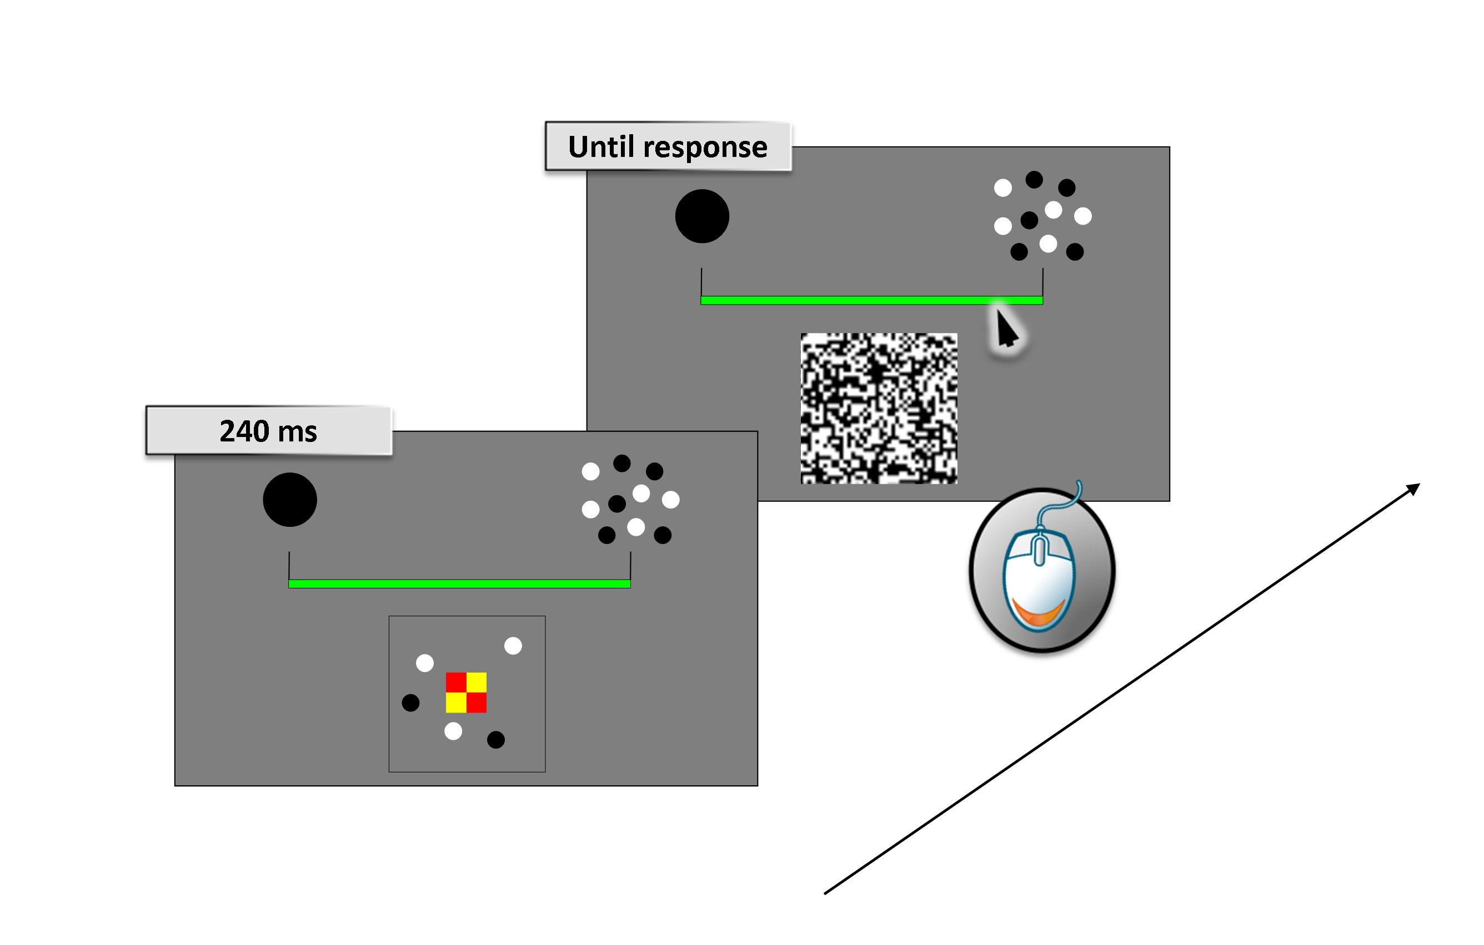
Illustration of stimuli sequence. At onset of each trial observers view the number line, marked at each end with a single dot to the left and 10, 30 or 100 dots to the right. On key press, the dot stimulus appears, together with four colored squares in the center of the dot cloud. After 240 ms a binary pixel random-noise mask was displayed until subjects respond. Subjects respond first to the color conjunction task (in the dual-task condition, otherwise they ignore it), then mouse-click the numberline at the position they think the dot cloud should occupy.

Data analysis
We performed two types of analysis, a linear-logarithmic fit, and a Bayesian model of central tendency.
Linear-logarithmic fits
In this model we assume that the data can be described as the sum of a linear and a logarithmic component, given by the following equation:

$R=a\left(\left(1-λ\right)N+λ\frac{N_{max}}{\ln\left(N_{max}\right)}\ln\left(N\right)\right)$

where N is the number of stimulus dots, R the average response location for that stimulus, N_{max} the set size (10, 30 or 100), and a a scaling factor. The main free parameter of the equation is λ, which determines the logarithmic component of the fit (λ=0 defines a linear function, λ=1 logarithmic). Both individual data and pooled data were well fit by this equation, with 0.84≤R²≤0.99, and no tendency for the goodness of fit to vary with the degree of linearity.

Bayesian model

We also model the data with a Bayesian model, illustrated in Fig. 3. Bayes rule, in this context, is

$p\left(R\backslash N\right)∝p(R)p(N\backslash R)$ (1)
where R represents the mapped location and N the actual number of dots. p(R) is the prior, which in our model represents the central tendency, the apriori likelihood that the response is at a given point near line center. We model the prior with a Gaussian function, with center , and standard deviation determined by best fit of the data. The term p(N|R) represents the sensory likelihood, which is set by the observer’s precision. We assume that Weber’s law applies over the range tested (Ross 2003), so precision thresholds will be given by wN, where w is the Weber fraction (arbitrarily set to be 0.3). Again we model the sensory likelihood by a Gaussian probability density function, centered at the physical numerosity N with standard deviation wN. The posterior – p(R|N) – will also be a Gaussian pdf, whose mean will be between the sensory estimate and the central prior. The extent to which the prior draws the results towards the mean depends on the relative widths of the prior and sensory likelihood functions. As the width of the sensory pdf is proportional to N, the effect will be stronger for large than for small numerosities, resulting in a compressive function.
There were only two free parameters to optimize, and , the mean and standard deviation of the prior. The choice of the weber fraction was somewhat arbitrary (but reasonable), but as it is the ratio of the weber fraction to prior width that determines the effect, it makes no difference to the fit what value is chosen. The parameters that best fit the data were and .

Results

Figure 2A-C show the number line judgments for the two attentional conditions, for the three different numerosities, averaged over all subjects. In all cases the numberlines for the single-task conditions (black symbols) are virtually linear, while those of the dual-task conditions (blue symbols) show a clear compressive non-linearity. The lines passing through the symbols are best fits of the log-linear equation 1. Figure 2D shows how the logarithmic index (λ) of these fits depends on attention for all three number ranges (bars the fits of the group data of Figs 2A-C, linked symbols individual data). For every subject, the logarithmic component was far larger in the dual-task than the single-task condition. A two-way repeated measures ANOVA on the λ values revealed a significant main effect for attentional condition (F=47.8, p=0.006), but no effect for range (F=1.17, p=0.387) and no interaction (F=0.85, p=0.47). Post-hoc t-tests revealed that in none of the range conditions for the single-task λ was significantly different from 0 (0.77<t<1.55; 0.22<p<0.49), showing that the linear model was adequate for the single-task conditions.

Figure 2

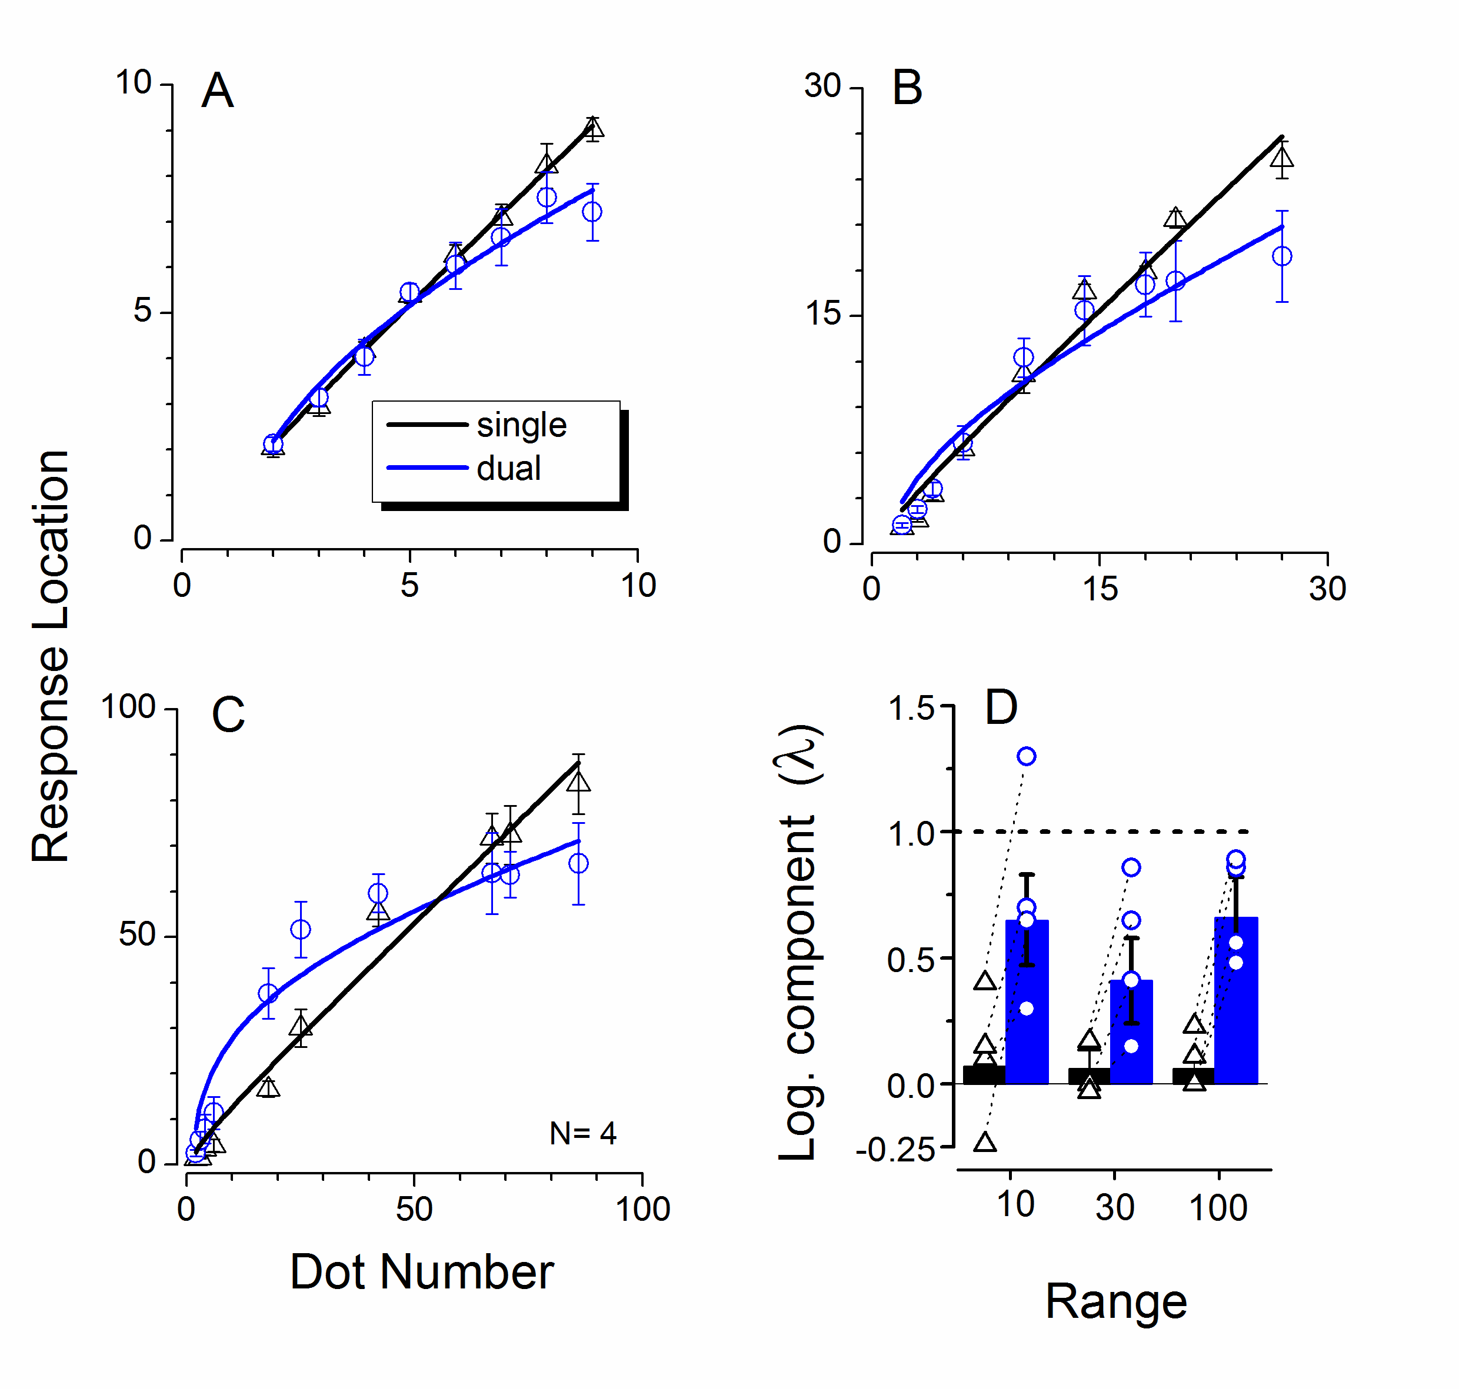
A-C) Average response location (pooling over all four subjects), plotted against actual dot number, for the three different ranges tested. Single-task judgments in black, dual-task in blue (error bars (±1 s.e.m.). The curves are best fits of eqn. 1. D) Values of the logarithmic component (λ of eqn. 1) of the best fits, for the averaged data of Figs. 2A-C as bars, and also for the individual subjects (connected symbols). The error bars indicate the standard errors of the fit to the averaged data.

We also fit our data with an alternative model, the Bayesian model of central tendency (eqn. 2), where the posterior probability of a particular localization response is given by the normalized product of the sensory data (the likelihood distribution resulting from a given number of dots) and the “central tendency” prior, which draws the sensory estimates towards the center. The blue curves at right show the Bayesian predictions for the three numberlines, clearly capturing the pattern of results (0.95<R²<0.98).

Figure 3

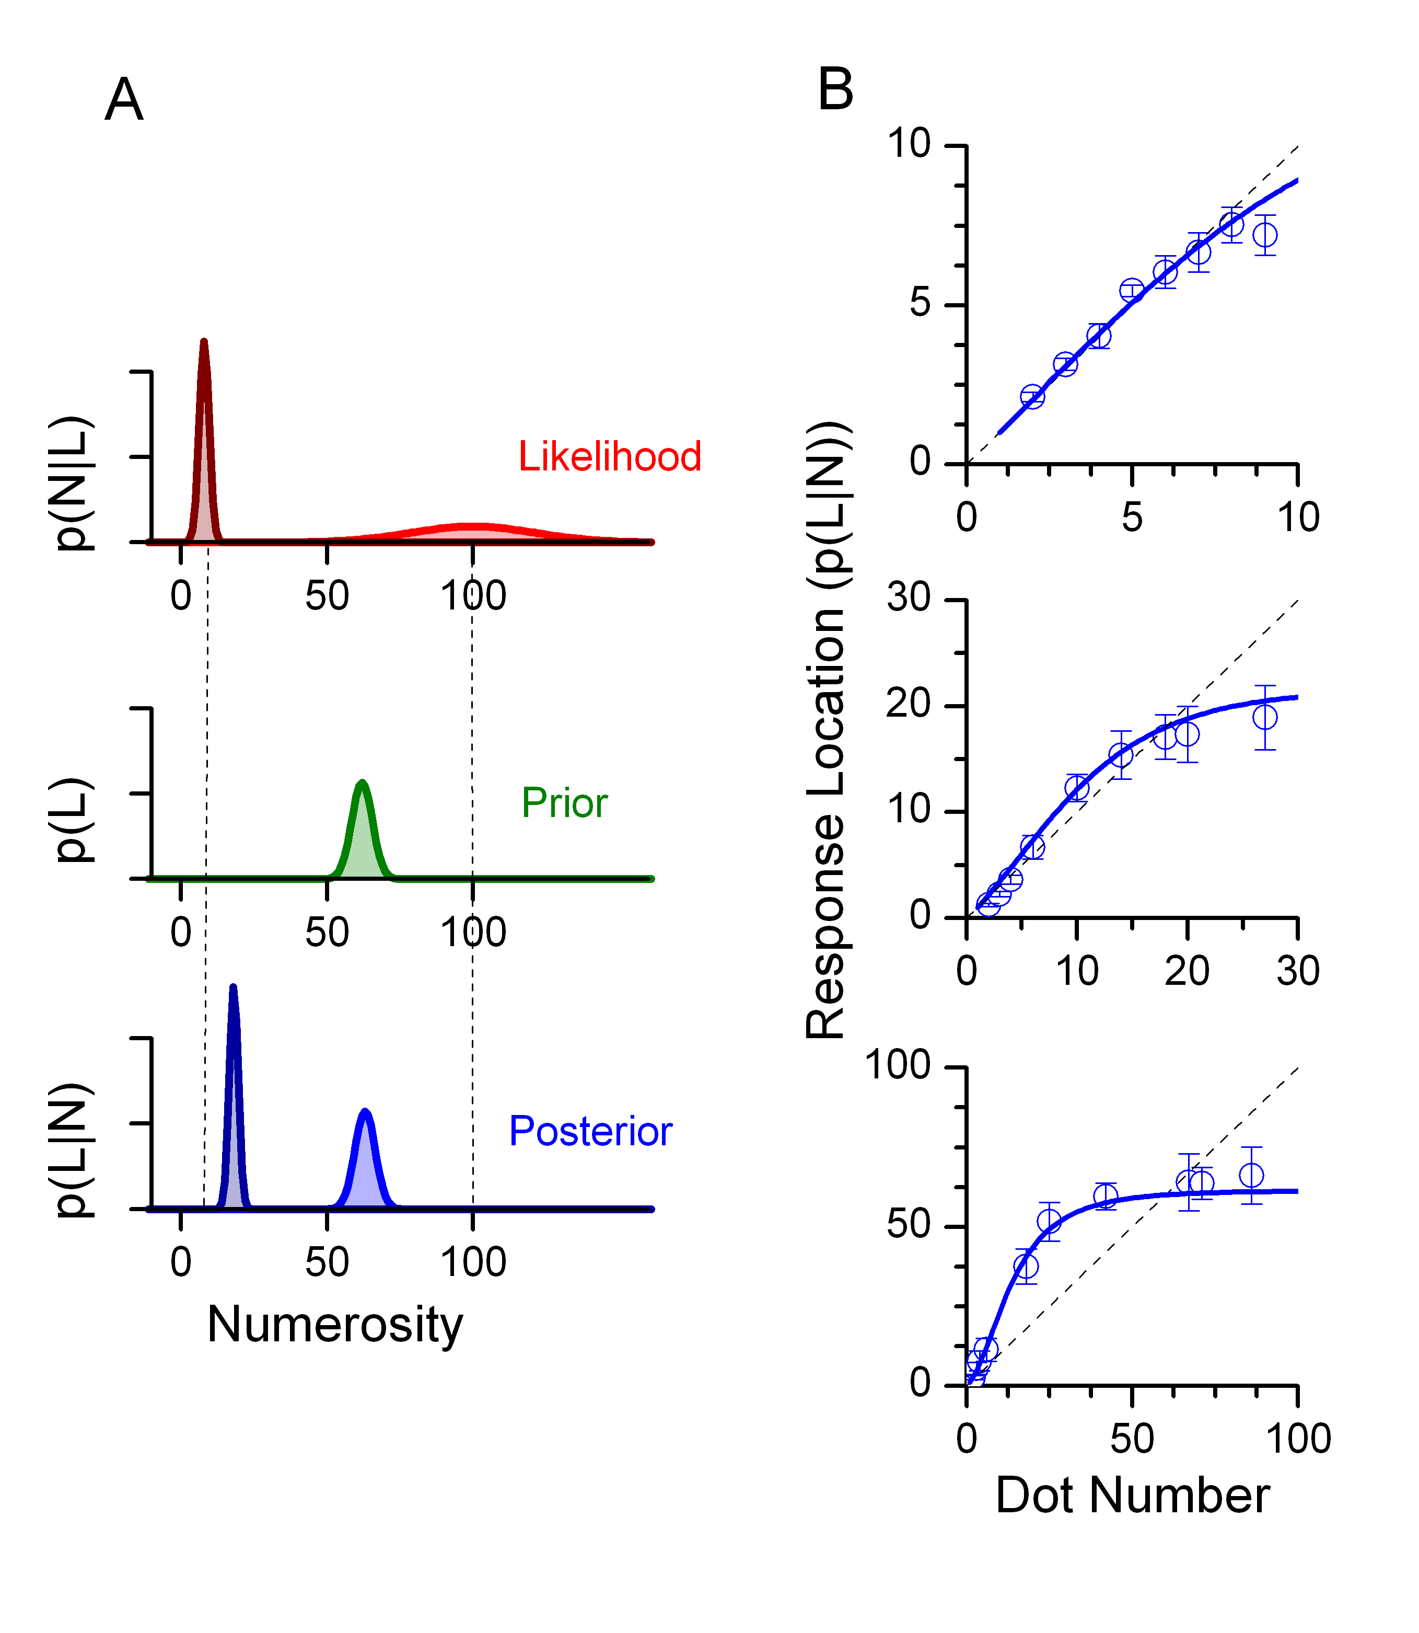
Illustration of the central-tendency model of non-linear mapping. A) Probability density functions for likelihood, prior and posterior (eqn. 2), for two physical displays of 10 or 100 dots to be mapped onto a 1-100 numberline. For all three numberlines, the prior is a Gaussian pdf centered at 60% on the number line with standard deviation of 5 (determined by best fit to data). The likelihood was also Gaussian, centered at the physical number L, with standard deviation equal to wL, where w is the Weber fraction (set at 0.3). The posterior is the product of the sensory likelihood and the prior. B) Data from figure 2, with the simulations shown by continuous curves. Again the fit to the data was good, with 0.95≤R²≤0.98 (pooled data).

Discussion

This study shows that when adult humans are asked to position a cloud of dots on a number line, they normally do so accurately: that is, linearly. However, when attentional resources are diverted by a concurrent demanding conjunction task, the judgments become distinctly non-linear, well described by a logarithmic relationship. One potential confound of our results is that they may reflect memory, as well as attentive, processes, as the average time of response in the dual-task condition was nearly twice that of the single-task condition (5.8 compared with 3.4 secs). It would be interesting to pursue which of these two factors is more important. Furthermore, our data do not allow us to distinguish whether the attentional (and memory) manipulation disrupts the encoding of non-symbolic quantity, or the mapping process itself – or both. However, our results make clear that when both encoding and mapping are required – as they are in this and previous studies – the non-linearity emerges very clearly. This is interesting, as it suggests that withdrawing attention may reveal a more native representation of numbers, one which prevails in young children (Siegler and Opfer 2003; Siegler and Booth 2004; Berteletti, Lucangeli et al. 2010) and unschooled adults (Dehaene, Izard et al. 2008). Attention is necessary to map numbers linearly onto the number line. We believe that it is the attentional manipulation that affects the results, as previous work has demonstrated that linear responses occur even under conditions of speeded response (Pinhas and Fischer 2008). However, other work has shown that humans adults, normally linear on a numberline task, show logarithmic-like non-linearities when asked to gauge the randomness of random a series that oversampled small numbers (Viarouge, Hubbard et al. 2010). This suggests that both linear and compressed maps can coexist, and the use of one or the other may be due to a variety of task-driven strategic factors. What is the neural substrate underlying the logarithmic encoding and/or mapping? One possibility, assumed by many, is that it reflects the bandwidth of neurons selective to number. In both non-human and human primates, neural responses in the intraparietal sulcus show a logarithmic-like tuning, with bandwidth proportional to preferred number (Piazza, Izard et al. 2004; Nieder 2005; Nieder and Merten 2007), consistent with a pre-attentive logarithmic mapping onto the numberline. A native logarithmic representation is also consistent with the fact that numerosity discrimination in both monkeys and humans shows Weber-Law behavior, with the root-variance of the discrimination increasing directly with numerosity. However, another possibility that we have explicitly modeled is that the non-linearity does not reflect logarithmic encoding of numerosities, but a more general perceptual principle, central tendency, observed in almost all sensory systems. That numerosity may be subject to the central tendency is further support for the notion of number being a visual sensory attribute (Dehaene 1997; Burr and Ross 2008). The intuitive explanation for how the model introduces the compressive non-linearity is that for constant Weber fraction, the sensory likelihood function at high numbers is broad, so the prior will be effective, while at low numerosities, the likelihood function is narrow, so the prior impacts less on it. This may also explain why numerosities over a larger scale tend to show more compression than over a smaller scale (Berteletti, Lucangeli et al. 2010). The model has only two parameters, the mean of the distribution, which error minimization sets near the center of the numberline (excluding the small, easily recognizable numbers), and the width of the prior (relative to the Weber fraction). It has no more free parameters than the logarithmic model of equation 1, and the parameters remain fixed for all three numberlines: yet it accounts for 97% of the variance of all number lines. What exactly is the prior, and how does it depend on attention? The prior could be computed from the sensory input, a “running average” calculated over trials, much in the same way as the system does in the “method of constant stimuli”, where subjects compare quantities on individual trials against an estimate of the mean. Alternatively it may depend on the output numberline, which has finite length. For example, if a physical numerosity of 100 were perceived as 130 (through noise fluctuations), it could not be placed higher than 100 – and this effect could propagate down. We suspect that both these factors contribute to the prior. What purpose does the prior – and central tendency in general – serve? As others have argued, a prior based on the statistics of the sensory events can improve performance – measured as the sum of total error – at the expense of reducing veridicality (see Jazayeri and Shadlen 2010, for detailed account ). Effectively, under conditions of great uncertainty, performance can be improved by considering the past history of events. But why does the regression to the mean occur only under conditions of divided attention? The most straight-forward possibility is that the sensory Weber fraction is higher under conditions of divided attention (Burr, Turi et al. 2010), so the prior becomes more effective (as it is the relative widths of prior and sensory likelihood that determines the extent of central tendency). Another possibility is that attention induces a more qualitative change in the processing, acting on the prior itself by reducing its width, and hence the mode of encoding and/or mapping numbers. We are currently investing these possibilities quantitatively. To conclude, the current results show that attention can change the pattern of mapping numerosity estimates onto a numberline. The study provides support for the idea that mapping numbers onto space is a universal intuition, but that the native mapping principle is non-linear. The non-linearity could arise either from an intrinsic logarithmic representation of numbers, as many have assumed, or from a more general principle of central tendency of perceptual judgments. Either way it would seem that the linear numberline is a cultural invention, depending on formal education. But even after it has been instilled by years of schooling, it remains strongly dependent on the availability of attentional resources.

2.2.2. The effects of cross-sensory attentional demand on mapping number onto space

In the previous experiment we demonstrate that mapping numbers onto space strongly depend on visual attention. Here we tested the effects crossmodal attention on mapping of numbers onto space. We also modeled the mapping effects within a Bayesian framework.

Methods

The general conditions (apparatus, etc.) were like the experiment reported in previous method section (2.2.1), unless otherwise stated. Three new naive subjects were recruited (mean age: 26 ± 2), with normal or corrected-to-normal vision, and who had not participated in the previous study participated in this one. Throughout each trial a ‘‘numberline’’ was displayed, a 25 cm line without markings, with sample dot-clouds representing the extremes: one dot on the left and 100 dots on the right. On subject initiation, both distractor and dot-cloud stimuli were presented for 230 ms, followed by a random-noise mask that remain on until the subject responded. In separate sessions we measured three different attentional conditions: single-task, visual distractor (as described in method section of 2.2.1) and auditory distractor (the frequency-discrimination task as described in method section of 2.1.2). Subjects responded first to the distractor task (when appropriate). The numerosity stimulus was a cloud of nonoverlapping dots, half-white, half-black at 90% contrast, falling inside a circle of 8° diameter (sparing the central 1°). The numerosities were randomly selected from the set: 2, 3, 4, 5, 6, 18, 25, 42, 67, 71, 86 following Siegler and Opfer (Siegler and Opfer 2003). To discourage observers using strategies other than numerosity (such as texture density), on each trial we kept constant either the total covered area at 8° by varying individual dot size, or constant individual dot size of 0.4°, varying total area covered. Thus on average, neither dot size nor total covered area correlated with numerosity. Subjects clicked a mouse pointer on the position of the number line corresponding to the estimated numerosity. Data were recorded only if the distractor task was correct. Each block measured one of the three conditions (single and two dual-task), presenting 10 test stimuli of different numerosity presented in random order once. About five blocks were run for each condition, order randomized between observers.

Bayesian modelling

We modelled numberline mapping with the Bayesian modeldeveloped by Anobile, Cicchini & Burr (2012) , which assumes that subjects base their performance on a distribution that combines both their sensory estimates and an apriori hypothesis about the stimulus.
Bayes’ rule states that:

(1)
Where r is the response and n is the numerosity of the stimulus. P(n|r) is typically termed the likelihood, p(r) the prior and p(r|n) the posterior. We model likelihood with a gaussian distribution centred on the stimulus, with width given by Weber's law (Weber fraction times number). The prior is also modelled as a gaussian distribution centred on the mean of the stimulus range, with variable width (standard deviation). Bayes' Law states that the optimal combination of information is obtained point-wise multiplication of the two gaussian distributions:

(2)

where N indicates the gaussian function. The resulting distribution is itself gaussian whose centre is given by a weighted average of the centres of the likelihood and that of the prior:
(3)

(4)

where w is the Weber fraction, assumed constant. σ_{r} increases linearly with n, so the prior will have a weight proportional to n². For low numbers, the posterior distribution should be centred on the physical sensory number, while for higher numbers, the posterior estimates are attracted towards the prior (see Figure 3 A of 2.2.1).
The final equation for the curves of figure 1 is obtained by substituting eqn. 4 into eqn. 3 and simplifying:

(5)

The shape of the function depends only on the position and width of the prior. By inspection it is obvious that as , (total regression to the mean), and as , (veridical response). For intermediate values, the equation follows a Naka-Rushton-like rule, compressing towards the mean of the prior (μ_{P}).

Results

Mapping onto the numberline is a standard task in number research. Subjects view a cloud of dots, estimate its numerosity and map that onto a line. Here we asked subjects to perform the task under dual-task conditions, with a visual or an auditory distractor. Figures 1A-C show numberline judgements for all three conditions (single-task, and visual and auditory frequency-discrimination distractors), averaged over all subjects. Without attentional load (A), the numberline is quite linear. With a concomitant visual conjunction task (B), the mapping shows a clear compressive non-linearity, as previous observed (Anobile, Cicchini et al. 2012). However, the auditory distractor (C) had very little effect, leaving the mapping almost linear. The curves are fits of the Bayesian model described in Anobile et al. (2012) and methods section (eqn. 5). Best fits of the data were obtained with priors centred at 52 for single and auditory, and 40 for visual distractors: both near the mid-point of the stimulus range (2-86). If we assume a Weber fraction of 0.25 (agreeing with Ross (2003), and many other estimates), prior widths giving best fits are of 130, 34 and 10 for the single, auditory distractor and visual distractor respectively (the more narrow the prior, the greater the deviation from linearity). Assuming a higher or lower Weber would require the priors to be scaled commensurably. Figures 1D-F plot the precision of the mapping, expressed as Weber Fraction (standard deviation normalized by dot number), with dot-number on a logarithmic abscissa (to bring out better the effects at low numbers). These results confirm those of experiment I. Without attentional load (D), Weber fraction is low everywhere, including the subitizing range (slightly higher here than in experiment I, presumably reflecting noise in positioning the pointer). However, with both visual and auditory distractors (E&F respectively), the Weber fraction increased considerably in the low number range, as in the previous experiment.

Figure 1

Number line. (A–C) Mapped response (averaged across subjects), as a function of physical dot-number for different attentional load conditions: single task (A), visual conjunction (B) and auditory dual-task (C). The continuous curves are the ﬁts of the Bayesian central tendency model, described in Section 2. (D–F) Mean Weber fraction as a function of numerosity (on logarithmic scale to display more clearly low numbers), again for single-task (D), visual (E) and auditory (F) distractors. Attentional load affects Weber fraction more for low (2–4) than high (6–98) numbers. Error bars represent ±1 s.e.m.

Following Jazayeri and Shadlen (2010), we partitioned error into two components: bias (inaccuracy) – the distance of the average mapping from the true value – and root-variance (imprecision) – the standard deviation of the individual trials. Figure 2 shows the results of the numberline, partitioned in this way, separately for low (2–6) and for high numbers (18–86). This representation is revealing. For low numbers, the attentional demand increases both the bias and root-variance slightly more for vision modality compared with the single task condition. However, for high numbers only the visual attentional load increases the bias, the auditory distractors affecting only the root-variance (slightly). This is reﬂected in the non-linear mapping so clear in Figure 1C, but not E.

Figure 2

Partitioning of the error of the numberline task into root-variance (average standard deviation of trials at a particular numerosity) and bias (average distance of the mean response from the physical numerosity), plotted separately for low numbers (2–4: panel A) and high numbers (6–86: panel B). Open symbols represent data of individual subjects, ﬁlled the average over subjects for each condition. Colour-coding as before: single – task black squares; visual – red diamonds; auditory – blue triangles. Total error is given by the distance of each symbol from the origin.

Discussion

The goal of the study was to examine the effects of intra and cross-modal attentional demand on mapping number onto space. Here we found that visual, but not auditory attentional load caused the mapping process to become strongly non-linear, with a logarithmic-like compression. Both auditory and visual distractors impaired the precision (Weber fraction) in the low numerosity range, agreeing with the previous result showing that cross-modal attentional load affects subitizing. The compressive non-linearity we observed with visual attentional load is similar to the non-linearities observed with young children (Siegler and Opfer 2003; Siegler and Booth 2004; Booth and Siegler 2006) children with dyscalculia (Geary, Hoard et al. 2007; Geary, Hoard et al. 2008; Askenazi and Henik 2010) and adults without mathematical schooling (Dehaene, Izard et al. 2008). In all these cases, the mapping process has been described as ‘‘logarithmic’’. However, the fact that a logarithm describes the function does not necessarily imply that it reﬂects underlying logarithmic transformation. Anobile, Cicchini, and Burr (Anobile, Cicchini et al. 2012) have suggested that the compression may reﬂect a ‘‘central tendency of judgements’’, which has been studied for at least 100 years (Hollingworth 1910) and recently revived in Bayesian terms (Jazayeri and Shadlen 2010). In their version, the central tendency is a Bayesian prior, which combines with the sensory likelihood to produce a posterior biased towards the mean. Given that the likelihood is essentially the product of the Weber constant and dot number, and Weber fraction is fairly constant, the likelihood is much broader at the higher number range, and therefore more inﬂuenced by the prior. We modelled our numberline data with a simple Bayesian model that predicted both the compressive shape, and ﬁtted the data well, accounting for about 95% of the variance. What function does the prior serve? Jazayeri and Shadlen (2010) suggest that it serves to optimize performance, deﬁned as the total error. Error can be partitioned into accuracy and precision, or bias and root-variance, as shown in Figure 2 Total error is the Pythagorean sum of the two, the distance of the points from the origin. At low numerosities, both visual and auditory attentional loads affect performance, and they affect root-variance and bias in very similar amounts. As has been shown elsewhere (Jazayeri and Shadlen 2010; Cicchini, Arrighi et al. 2012), increasing bias towards the mean optimizes performance, measured by total error. For high numerosities, however, the results were quite different. Visual attentional load caused a small increase in variance, but a large increase in bias, reﬂected in the compressive, non-linear mapping. Auditory attention had little effect on either bias or variance, agreeing with previous studies showing visual tasks to have separate attentional resources from audition. In summary, this study examined how attentional tasks, either in the same and different sensory modalities, can affect number to space mapping. Attention affects the numerical mapping however, the attention-dependence seems to be speciﬁc for vision.

2.2.3. Mapping number to space engages adaptive encoding mechanisms

In the previous experiments we demostrated that a logarithmic response pattern, on a number line task, could not necessarily imply that it reﬂects underlying logarithmic transformation. Instead, we have suggested that the compression may reﬂect a ‘‘central tendency of judgements’’.
Is it possible to distinguish between these two plausible classes of explanations of the numberline non-linearities? Here we develop a model of Bayesian integration that combines sensory information about the current stimulus with information about past stimuli. We show that this class of model predicts strong dependencies between the response to the current trial and the magnitude of the previous one. We test this hypothesis, and report that numberline responses depend strongly on the magnitude of the previous trial, both in adults and in primary school children.

Methods

Numberline mapping

Five adults naïve to the purpose of the study (mean age = 26 years), all with normal or corrected-to-normal vision, participated in the study.
Stimuli and procedure were similar to those in typical numberline experiments, described in detail elsewhere (Eg [8]). Briefly, participants were presented with a cloud of dots, and asked to indicate the quantity on a line demarcated by two sample numerosities. Each trial started with participants viewing a 22 cm “numberline” which remained visible throughout the trial with sample dot-clouds representing the extremes: one dot on the left of the numberline, and 100 on the right. Dot stimuli (half black, half white), were presented for 240 ms (in a circular region of 8° diameter and were followed by a random-noise mask. The numerosities were 2, 3, 6, 18, 25, 42, 67, 71, 86, and subjects responded by mouse click. As described in reference (2012), in the dual-task condition adults performed the task together with color-orientation conjunction task on the central squares, before making the number-line judgment. In the single-task condition, everything was identical except they ignored the color-orientation stimuli and responded only to the number task. The stimulus sequence was random and counterbalanced across sessions. All subjects performed 8 blocks of 18 trials each.

Goodness of fit

We assessed goodness of fit of the two models employed by calculating the coefficient of determination $R^{2}$of the biases predicted by the different models. If a model has $R^{2}=0$ it predicts the data as well as the veridical line: if $R^{2}<0$, the prediction is worse than veridicality.

Montecarlo Simulations

Predictions of the Bayesian model were obtained simulating the behavior of 1,000 virtual subjects carrying out an experimental session as that of control subjects. For each trial the response was calculated as a weighted average of a noisy representation of the current stimulus and the previous response. Weights are assigned online to the two sources of information following Eq. 6. We assume that motor noise is negligible for our task. Responses due to noise that would have gone beyond the number line are clipped at the boundary of the line. The current response is stored and retrieved without further noise corruption. Noise levels k employed for the simulations were 3.3 and 6.6 for adults in single and dual task, and 3.6 for children. The same noise levels were employed to simulate serial dependencies of the lin-log model (red curves of Figure 3).

Results

We measured numberline mapping under high and low attentional demand. Subjects were asked to indicate the numerosity of clouds of dots by on a line demarcated by a single dot on the left, and a 100-dot cloud on the right. In the single-task condition they simply responded to the numerosity, in the dual-task condition they first responded to a difficult visual conjunction task, then to the numerosity (see methods and reference (Anobile, Cicchini et al. 2012)). The symbols of Fig. 1 show the results for single-task (a) and dual-task (b) conditions. Agreeing with previous studies, under dual-task the data show a less linear pattern. The thin black curves show the best linear and log fits to the data. Neither is particularly good, but the log model provides a better fit to the dual-task data and the linear model to the single-task data (see table 1 for goodness of fits). However, as has been shown before (Dehaene, Izard et al. 2008; Anobile, Cicchini et al. 2012), a mixed model combining linear and logarithmic transforms provides a better fit in both cases:

$R=a\left(\left(1-λ\right)N+λ\frac{N_{max}}{\ln\left(N_{max}\right)}\ln\left(N\right)\right)$ (1)

Where R is the response to numerosity N, a is a scaling factor, N_{max} the end of the numberline (equal to 100) and λ a factor describing the logarithmic non-linearity (0 for pure linear, 1 for pure logarithmic). This two-parameter model produced very good fits, with R² > 0.8. The logarithmic component λ was 0.11 for the single-task condition, and 0.38 for the double task (see table 1), reflecting the increased non-linear component of number mapping under attentional load.

Figure 1
The black square symbols show the average response location of subjects in the single-task (a) and dual-task conditions (b). The red lines show the best-fitting prediction for the log-linear model (eqn. 1), and the blue lines for the Bayesian model (eqn. 2) that considers the stimulus history. The parameters of the models are given in table 1.

The Bayesian Integration Model

As an alternative to the static logarithmic transformation model, we propose a Bayesian integration model, whose output is shown by the blue lines in Figure 1. With this model, the expected response to any given trial i is given by the weighted average of the numerosity of the current stimulus and the estimate of that of the past:

$R_{i}=\left(1-w_{i-1}\right)N_{i}+w_{i-1}{\hat{N}}_{i-1}$ (2)

Where $w_{i-1}$ the weight assigned to the estimate of the numerosity of previous trial. In Bayesian terms this can be considered as a prior from previous stimulus history. As subjects do not have direct access to the physical magnitude of the previous trial $N_{i-1}$, we assume that the best estimate of it is given by the response to it: ${{\hat{N}}_{i-1}≅R}_{i-1}$. As $R_{i-1}$ in turn depends on $N_{i-2}$, the formula is clearly recursive.
How do we define the weight $w_{i-1}$? For two redundant cues, the weight of each cue should be proportional to its reliability $ρ$, the inverse of variance.

$w_{i-1}=\frac{ρ_{i-1}}{ρ_{i}+ρ_{i-1}}=\frac{1/{σ_{i-1}^{2}}}{1/{σ_{i}^{2}}+1/{σ_{i-1}^{2}}}=\frac{σ_{i}^{2}}{σ_{i}^{2}+σ_{i-1}^{2}}$ (3)
This formula expresses ideal weighting when trials i and i−1 sample the same physical stimulus. In this case they do not, and the probability that they are different can be shown to vary with the square of their separation ${\left(N_{i}-{\hat{N}}_{i-1}\right)}^{2}$ (Roach, Heron et al. 2006; Ernst 2007). The Bayesian integration formula now becomes:

$w_{i-1}=\frac{σ_{i}^{2}}{σ_{i}^{2}+σ_{i-1}^{2}+{\left(N_{i}-{\hat{N}}_{i-1}\right)}^{2}}$ (4)
Assuming shot-noise (variance proportional to mean), variance will scale with stimulus magnitude:

$σ^{2}=kN$ (5)
where k is a free constant (the only degree of freedom in the model), giving the overall level of noise. Substituting 5 in 4 the weight given to the previous trial is:

$w_{i-1}=\frac{kN_{i}}{kN_{i}+k{\hat{N}}_{i-1}+{\left(N_{i}-{\hat{N}}_{i-1}\right)}^{2}}$ (6)

Predictions of the Bayesian Model
Model predictions were obtained by Monte Carlo simulations, adjusting k to give best fits to both sets of data. With only this one degree of freedom, the fits capture the nature of the numberline data, with a better fit than either the logarithmic or linear model, and comparable to that of the two-parameter log-linear model (see table 1).

Table 1. Summary of Goodness of fit and weights

 | Adults Single | Adults Dual | Children
Goodness of Fit | $$R^{2}$$ | $$R^{2}$$ | $$R^{2}$$
Linlog (Eq. 1) | 0.811 | 0.993 | 0.978
Bayesian(Eq. 2) | 0.671 | 0.951 | 0.925
Linear $y=mx$ | 0.476 | 0.784 | 0.774
Log $y=a\ln{(x)}$ | <0 | 0.802 | 0.411
1-back weight | $$w$$ | $$w$$ | $$w$$
Measured ${(w}_{M})$ | 0.083 ± 0.015 | 0.113 ± 0.026 | 0.060 ± 0.020
Bayesian ${(w}_{B})$ | 0.118 | 0.156 | 0.101
$$p(w_{M}>0)$$ | <10⁻⁵ | <10⁻⁵ | 0.002
2-back weight | $$w$$ | $$w$$ | $$w$$
Measured ${(w}_{M})$ | 0.012 ± 0.015 | 0.054± 0.031 | -0.014 ± 0.018
Bayesian ${(w}_{B})$ | 0.005 | 0.028 | 0.010
$$p(w_{M}>0)$$ | 0.22 | 0.04 | ns
Parameters
Linlog $\left[λ,α\right]$ | 0.112  0.89 | 0.381  0.62 | 0.266  0.74
Bayesian$\left[k\right]$ | 3.3 | 6.6 | 3.6
Linear $\left[m\right]$ | 0.932 | 0.722 | 0.818
Log $\left[a\right]$ | 0.601 | 0.484 | 0.572

Eqn. 6 shows that the weighting to the previous trial depends on four factors: for $N_{i}≠{\hat{N}}_{i-1}$, it increases with the general noise level k (which makes all judgments less reliable), and with the numerosity of the current trial (making that judgment less reliable); it decreases with the numerosity of the previous trial (as that becomes less reliable), and with the difference between the current trial and the estimates of the previous one. This last term is effectively a “confusability” index: if the numerosities of successive trials are similar, they are more likely to be considered to be samples of the same stimulus, and therefore averaged together. Fig. 2a shows graphically how these terms influence weight $w_{i-1}$, for four sample numerosities and two values of k of 3.3 and 6.6. For all numerosities, the weights are 0.5 when $N_{i}={\hat{N}}_{i-1}$, and peak at slightly lower numerosities. The functions are far broader for the higher numerosities, and it is this that should lead to compression of the high end, producing a logarithmic-like function. The functions are also broader for the higher values of k.
Figure 2b shows Monte Carlo simulations of how average weights vary with current numerosity, for four values of k. The simulations use eqn. 2, with ${{\hat{N}}_{i-1}=R}_{i-1}$, under the actual conditions of the experiment, running simulations of 45-trial sessions 1,000 times (as if 1,000 subjects were measured: see methods). As the actual weight depends not only on the past trial, but also on earlier trials (given the recursive nature of the model), there is considerable variability in the estimates, so the curves are not as smooth as the theoretical curves of Fig. 2a. However, the trend is clear. The value of the weights increases with k, particular for the higher numerosities. Figure 2c shows the predicted numberlines for these 4 levels of noise: they become increasing curved as k increases. The main reason for this is that weight of the higher numbers increases, so the effect there becomes greater. Interestingly, at a moderate level of noise, say k=3.3 (from the single-task data), the model predicts little deviation from linearity, even though the weights rise to over 15%. This is because the weights are high only at middle numerosities, and there they have little average effect, as the effect of the previous stimuli can be both positive and negative.

Figure 2

a) The weight (w_{i-1} of eqn 6) given to the previous trial as a function of estimated numerosities, for four representative numerosities (3, 18, 42 and 71). The thick lines show simulations for the single-task condition, where k=3.3, think lines for the dual-task condition, k=6.6. b) Monte Carlo Simulation showing how weights (averaged over all previous numerosities) vary as a function of current numerosity, for four levels of noise (k=1.5: yellow; 3.3: olive; 6.6: brown, 13: purple). The average weights are calculated from the average slope of the regression of predicted response against previous numerosity (see Fig. 3a). The weights are highest at mid-range numbers. Weights increase with k, particularly for high numerosities. c) Numberlines predicted from the model, with the four values of k of Fig. 2b. The non-linearities at high k result mainly from the higher weighting at high values of current numerosity.

Testing the Bayesian Integration Model

While it is difficult to distinguish the Bayesian integration model from the log-linear model on the basis of the goodness of fit (they both perform well), we can test a clear prediction of eqn 2, illustrated in Fig. 2: as the response to the current trial R_{i} depends not only on the numerosity of the current trial but also on the estimated numerosity of the previous trial, we expect to find systematic dependencies between the current response and the magnitude previous trials, especially N_{i−1} which dominates the estimate ${\hat{N}}_{i-1}$.
Figure 3a shows the predicted and measured dependency on the numerosity of the previous trial for the single- (left) and dual-task (right) conditions, using the noise level k that best fitted the two sets of numberline data. As before, the simulations were made under the same conditions as the actual experiment. At low subitizing numerosities, the simulations show that previous trials should have very little effect; but at higher numerosities their effectiveness should increase, with responses varying almost monotonically with the strength of previous stimulus. Obviously, neither linear nor logarithmic models, or any combination of them, predict dependencies on previous stimuli. The color-coded square symbols show the experimental data, averaged over subjects separately for the two conditions. The data clearly follow the trend of the predictions, generally increasing with the numerosity of the previous trial. The thin straight color-coded lines show the linear regressions of the data, all of which have positive slope.
We take the slope of these regressions as an index of the response dependency on previous stimuli and plot them in Fig. 3b, as a function of the numerosity of the current trial (black squares). We also replot the slope of the linear regression of the predicted responses (blue solid lines, taken from Fig. 2b). In general, the data tend to follow the predictions well, showing stronger weighting to previous stimuli at mid-high numerosities. The red curves show simulations of the log-linear model (eqn. 1), assuming the same levels of shot-noise as the Bayesian model. As to be expected, the predicted effects are near zero, quite different from the observed effects. To describe the dependency of current response of past and future stimuli, we averaged the weights of Fig. 3b for the range of numerosities greater than 5, where the model predicted clear and measurable dependence. These average weights are plotted below in Fig. 3c, as a function of past and future trials. The solid blue and red lines show the predicted dependencies for the Bayesian and log-linear models, obtained by Monte Carlo simulations, using the same procedure (and program) as that for the experimental data. In both conditions, the measured theoretical weights followed closely the Bayesian predictions, and violated the predictions of the static non-linearity. In both cases the weights of trial i−1 was strong (0.08 for single-task, 0.12 for dual-task), and highly significant (p < 10⁻⁵ bootstrap sign-test). They were similar to the predictions (0.12 and 0.16 for single and dual). The Bayesian model also predicted non-zero weights for trial i−2, of about 0.03. The estimate from the data was 0.04, significantly greater than zero (p=0.04, bootstrap sign test). The weight for trial i−2 in the single-task condition was also positive (0.01), but not significantly greater than zero. Importantly, there were no significant correlations with future trials, a strong control against statistical artifacts. Another sanity check is that the noisy log-linear simulations showed no systematic serial dependencies for any trials, past or future. The data clearly confirm the predictions of the Bayesian model, and reject the predictions of a purely static logarithmic transformation.

Figure 3
A) Response as a function of numerosity of the previous trial for single-task (left) and dual-task (right) conditions, for both the experiment data (open squares) and the predictions from the Bayesian integration model of eqn 2 (heavy color-coded lines), for the four representative numerosities. Values of k are 3.3 and 6.6. The thin straight lines show best-fitting linear regressions to the data. The arrows show the veridical responses. B) Average dependency (weight) on previous stimuli, as a function of current numerosity, given by the slope of regression lines such as those above. The thick lines show the predicted weights for the two models, log-linear (eq 1, red) and the Bayesian model (blue, taken from Fig. 2b). The black symbols show the correlations in the data for the three datasets. The error bars mark ± 1 S.E.M. C) Average weights as a function past and future trial number, for the data (open squares) and the two model predictions (Bayesian integration blue, log-linear red). Stars indicate significance from zero: *** p<10⁻⁵, * p<0.05, one-tailed bootstrap sign test.

Potential advantages of Bayesian Integration

Bayesian strategies are usually thought to be statistically advantageous, reducing the variability of sensory estimates. Figure 4 shows how this may apply in this case. We simulated RMS error as a function of noise constant (k of eqn. 5) for a simple memory-less linear system, and the Bayesian model performing the weighted sum of eqn. 2 (Figure 4a). The Bayesian model predicts less error than the memory-less model, and the difference increases with noise level. The symbols studded into the lines show the noise level that best-fitted the dual-task adult condition.
Figure 4b gives an intuition of how the weighted average can lead to an advantage. We take the example of adult responses under attentional load (which showed the greatest non-linearities). Following Jazayeri and Shalden (Jazayeri and Shadlen 2010), we partition the error into two orthogonal components, the bias (average accuracy) given by the distance of the average response from veridicality (the distance of the points of Fig. 1 from the equality line), and the precision, given by the standard deviation of the scatter of responses around that mean. The Pythagorean sum of these two components gives the total error, on this graph represented by the distance from the origin. While a memory-less linear system is essentially bias-free (near vertical red curve), both the Bayesian model and the data show increasing bias for larger numbers. The result of this is that the total error (distance from the origin) is about 33% less than that predicted by a memory-less system with the same amount of shot noise.

Figure 4
a) Predictions of how error increases with noise for a memory-less system (red) and the Bayesian integration model (blue). The Bayesian model predicts less error, with the difference increasing as the noisiness of the system increases. The symbols indicate k=6.6, the level that best-fitted the dual-task data. b) The abscissa shows the bias (average deviation from veridicality) and the ordinate the precision (standard deviation of the scatter of responses around their mean), for the dual-task adult data. The red curve shows the prediction of a memory-less linear model and the blue curve that of the Bayesian model (eqn 2). The black symbols show the data. The Bayesian model captures the pattern of the data: both the model and the data show less total error (distance from origin) than the memory-less model.

Non-linear number-mapping in children

Finally, we asked whether the current model may be useful in explaining previously reported numberline data for school-aged children (Anobile, Stievano et al. 2013). These data were collected on 68 primary school children (age 8-11), for purposes that goes beyond the actual study and they will be re-described in the next session (2.4.1).

Figure 5a shows the data (for a shorter numberline, 1-30), together with the fits of the log-linear model and Bayesian integration model (blue: k=3.6). Again both models show reasonable fits. Figure 5b shows the dependency on past and future trials, calculated in the same way as for adults. Again, there is no dependency on future trials, or on trials two-back or further, but the dependency on trial i−1 is clearly significant (p=0.002).

Figure 5
a) Average numberline reproduction in 68 primary school children, taken from reference(Anobile, Stievano et al. 2013). Same conventions as Fig. 1, except the line extended only to 30. b) Average weights as a function past and future trial number, for the data (open squares) and the two model predictions (Bayesian integration blue, log-linear red).

Discussion

Two general conclusions can be drawn from this study. The first is that the characteristic non-linearities in numberline mapping of young or unschooled subjects, or under attentional load, need not result from logarithm encoding of number. We are able to account completely for the non-linearities observed in three sets of data with a simple Bayesian model that performs a linear weighted sum between present and past stimuli. Obviously we cannot exclude that static non-linearities also occur, but the non-linear numberline cannot be taken as evidence for them. Secondly – and perhaps more importantly – we suggest that taking stimulus history into account may reflect a very general strategy of optimizing behavior to take into account environmental statistics.

Logarithmic transformation of stimulus magnitude

Much evidence has been thought to reflect logarithmic encoding of number, including the approximation to Weber’s law (thresholds proportional to numerosity) of range for both humans (Jevons 1871) and monkeys, and the logarithmic bandwidth of neurons selective to number (Dehaene 2003; Nieder 2005; Nieder and Merten 2007 ). However, compressive non-linearities do not necessarily implicate intrinsic logarithmic encoding (Gallistel and Gelman 1992; Brannon, Wusthoff et al. 2001; Gallistel and Gelman 2005). This is a very old controversy in psychophysics, dating back to Weber and Fechner, who interpreted the proportionality of sensory thresholds to stimulus intensity (now called the Weber-Fechner Law) to reflect logarithmic processing (as the derivative of the logarithm is 1/x) (Weber 1834; Fechner 1860). However, this was famously challenged by S. S. Stevens (1957), who showed that the logarithmic-like behavior holds only at threshold. Weber-Fechner behavior for sensory attributes is now rarely interpreted to imply logarithmic encoding, usually adaptation or gain control, mechanisms that have been linked to optimal behavior (Barlow 1990; Chopin and Mamassian 2012; Gepshtein, Lesmes et al. 2013). So the strongest evidence for logarithmic coding was the logarithmic numberline: as that now has a more plausible explanation, there exists no evidence at all for logarithmic encoding of number in primate brains. Just as the dependency of increment thresholds on magnitude led to erroneous assumptions of logarithmic transformation of sensations, rather than dynamic gain-control, so too has the logarithmic-like shape of the number line led to assumptions of logarithmic encoding of number, rather than dynamic adaptive coding.

Alternative modeling parameters

We assumed that the variance of the sensory noise is Poisson-like, and increases directly with numerosity (“shot noise”). This assumption agrees well with our measurements (Anobile, Cicchini et al. 2013), over a fairly wide range of numerosities. However, we have also modeled our data assuming that Weber’s law holds (variance increasing with squared numerosity), and find similar results. What is important to produce the logarithmic-like decelerating non-linearity is that variance for higher numbers is less than lower numbers, so the reliability (ρ in eqn. 3) will be lower. Thus the curve will tend to be anchored at low numbers, and bend towards the mean (downwards) at high numbers.
As eqn. 2 predicts a dependency on the estimate of the previous numerosity, and this is approximated by R_{i−1}, it may seem sensible to search for dependencies between current and previous responses, rather than previous stimuli. However, this is impractical, as any systematic response biases could lead to spurious correlations with previous (and future) responses. Imagine, for example, that at the beginning of a session a subject tends to respond always a little too low, then shifts the bias to a little too high: this will lead to a spurious correlation between neighboring trials. However, no such behavior can lead to spurious correlations between previous stimuli and current responses, as each stimulus was independently drawn. As the main component of ${\hat{N}}_{i-1}$ is given by N_{i−1}, showing a dependency of R_{i} on N_{i−1} is the strongest support possible for the model. That there is no dependency on N_{i+1} is very strong proof against artifacts that could have led to spurious correlations.
In our study we chose to use clouds of dot stimuli, as their sensory characteristics are more easily defined. However, many numberline tasks use symbolic stimuli, like Arabic digits. Indeed, the logarithmic form of the numberline has been shown to be predictive of math performance in school-age children. We have yet to show that coding of symbolic numbers may be influenced by past history, but there is no reason to suppose that they will not. The modeling suggests that incorporating past information can be beneficial for any noisy judgment, possibly also for encoding symbolic number information. If this does turn out to be so, it may provide insights into why non-linear numberline performance is associated with poor math performance. In any event, whatever the reason for the non-linearity does not affect their usefulness in predicting math performance (Halberda, Mazzocco et al. 2008).
The modeled could be refined in many ways. For example, there is no active memory, estimating the mean of previous stimuli. Stimuli older than 1-back do affect the predictions, but only because of the innate recursiveness of the model: the best estimate of the magnitude of trial i−1 is considered to be the response to it, and that includes a weighting from trial i−2, etc. Indeed, in the condition with the highest noise (dual-task), we do find a significant dependency on trial i−2. However, it is conceivable that the system may us an estimate of the mean as the prior, as has been suggested in previous works (Jazayeri and Shadlen 2010; Anobile, Turi et al. 2012). It would be relatively simple to extend the model to incorporate a running average of the mean, and this may lead to slightly improved fits.

Functional advantage of Bayesian Integration?

Why should the current responses depend on the magnitude of previous stimuli? Typically, within the Bayesian framework the use of priors is considered optimal. Indeed, in this case, the prior does lead to a reduction of error, particularly in precision. However, the reduction in total error is not great, only about 33%. Is this a large enough advantage to be driving this effect? Possibly, but it is also possible that other factors are at work. For example, the dependencies may reflect an inherent hysteresis of the system. Indeed, priming (positive dependency on past events) is a ubiquitous phenomenon in psychology (Maljkovic and Nakayama 1994; Maljkovic and Nakayama), which may well reflect a general strategy to cope adaptively with environmental statistics (Chopin and Mamassian 2012).
To summarize, we have shown that when mapping number to space, subjects dynamically adjust responses to take into account recent history, fitting well with suggestions that the spatial representation of numbers is not an inert map but is an highly dynamic process (Chesney and Matthews 2013). If this notion is correct, we are in a position to make predictions for future research. For example, Dotan & Dehaene (2013) have developed a clever strategy to measure not only the final decision in numberline mapping, but the dynamical process of reaching it: responses are initially “logarithmic”, then become progressively more linear. Our strong prediction is that in that experiment the early responses should be highly correlated with prior stimuli, reflecting the intrinsic tendency to incorporate the prior, which is steadily reduced as evidence accumulates. Indeed, as the technique seems to be extremely sensitive in revealing non-linearities, we expect the effects to be very strong, possibly revealing dependencies of trials earlier than 2-back. We also expect to find strong trial-wise correlations in many other experimental conditions, including time reproduction (Jazayeri and Shadlen 2010) and even causality (Rolfs, Dambacher et al. 2013).

2.3. Number and attention during development.

2.3.1. Visual sustained attention and numerosity sensitivity correlate with math achievement in children

Educational problems are often related to the inability to sustain attention, even when there are no apparent cognitive impairments (Zentall 1993). Attention acts as a filter to select and maintain relevant information while suppressing irrelevant distractors, improving the efficiency with which information arriving from the environment is acquired and processed, then memorized and learned (Posner and Rothbart 2005). Recent studies demonstrate a causal link between visual attention and reading acquisition: serial search and spatial cueing facilitation predict future reading acquisition in children (Franceschini, Gori et al. 2012). Furthermore, they showed that playing action video games improved both attentional skills of children, and their reading speed (Franceschini, Gori et al. 2013). The current research raises a simple and relevant question: what is the relationship between visual attention, and perceptual capacities in general, and the acquisition of math skills? Using a correlational approach we tested whether visual sustained attentional capacity of children, as well as perceptual tasks related to the perception of number, correlate with formal school-acquired and non-symbolic numerical skills carefully controlling for potential confounding variables as age, non-verbal IQ, gender, and reading accuracy.

Methods

Participants

Sixty-eight typically developing children, aged 8–11 years (mean age 9.7 years) participated in the study. Partecipants were recruited from local schools and only those who returned a signed consent from parents were included. None had diagnoses of learning or attention disorders, and all had non-verbal intelligence in the normal range – as measured by Raven’s Matrices (Belacchi, Scalisi et al. 2008) – and normal visual acuity (measured by Snellen chart).

Materials and Procedure

All visual stimuli were presented in a dimly lit room on a 17-inch LG touch screen monitor with 1280 × 1024 resolution at refresh rate of 60 Hz, viewed binocularly from 57 cm. Stimuli were generated and presented under Matlab 7.6 using PsychToolbox routines (Brainard 1997).

Numerosity acuity

Two patches of dots were briefly (500 ms) and simultaneously presented either side of central fixation. Children performed a comparison task touching the side of the screen with more dots (figure 1 A). Standard numerosity was fixed at 24 dots while the probe (of varying number) adaptively changed, according to subject responses, with numerosity determined by the QUEST algorithm (Watson and Pelli 1983). The side of the standard and probe were counterbalanced. Patches consisted in non-overlapping dots (0.27° area) half white and half black, constrained to fall within a virtual circle of 6° visual angle. The procedure consisted of two blocks of 45 trials (90 trials in total). Each trial was initiated by the experimenter to ensure that children maintained fixation throughout. To ensure that neither density nor area were a consistent and reliable cue to numerosity, three different conditions were simultaneously interleaved: equal area (density and numerosity correlated), equal density (area and numerosity correlated) or a minimal increase in both. In the equal-area condition, area was kept constant at 6 degrees with density varying accordingly with numerical changes, while in the equal-density condition, density was fixed at 7.3% and area increased with numerosity accordingly. In the minimal-increase condition an increase in number was associated with half the equal-density condition increase in area and half the equal-area increase in density. The proportion of “more” trials were plotted against probe numerosity and fit with a cumulative Gaussian function where the 50% point provided an estimate of the point of subjective equality (PSE) and the normalised difference between this and the 75% point gave an estimate of Weber fraction.

Mapping numerosity onto space

We measured the ability to map numbers using a ‘‘non-symbolic numberline’’ task (Figure 1 B): partecipants view a cloud of dots and position their quantity on a line demarcated by two sample numerosities. As anticipated, these data are the same that we re-analyzed and shown in the previous section (section 2.2.3). Each trial started with partecipants viewing a 22 cm “number-line” with sample dot-clouds representing the extremes: one dot on the left of the numberline, and 30 on the right, which remained throughout the trial. Dot stimuli were presented for 500 ms, followed by a random-noise mask that remained until the subject responded. The dots were half-white, half-black and positioned in pseudo-random positions on a gray background without overlap, within a virtual circle of 8° diameter. Partecipants touched the touchscreen at the position on the numberline they thought corresponded to the dot cloud. Each block measured one of the 9 different numerosities that were each presented once in random order. Partecipants performed three blocks, with numerosities of 2, 3, 4, 6, 10, 14, 18, 20 & 27. To discourage observers using strategies other than numerosity (such as texture density), on each block we kept constant either the total covered area (varying individual dot size) or individual dot size (varying total area covered), alternatively trial-by-trial. Thus on average, neither dot size nor total covered area correlated with numerosity. In the sample dot-clouds of the number line, we kept constant total covered area. It follows that the left extreme (numerosity of one) was represented by a dot with a diameter greater than the dots that represented the right extreme. We quantified performance by computing the root mean square error (RMS), an index that takes into account both variance (average standard deviation of trials at a particular numerosity) and bias (average distance of the mean response from the physical numerosity).

(1)

where X_{i} is the tested numerosity on the i’th trial, R_{i} is the response location to that numerosity and N is the number of trials.

Visual sustained attention

Visual sustained attention was measured by a multiple object tracking task (Pylyshyn and Storm 1988). Eleven disks of 0.9° diameter – four green targets and seven red distracters – moved randomly on the full screen at 4°/s for a period of 3 secs (figure 1 C). The green targets then turned red (like the distracters), which partecipants track with their attention for 3 seconds. They then identified (by touching the screen) which of four possible items (highlighted in yellow) was the target (4ACF). Each experimental session comprised ten trials, and partecipants perform three sessions for a total of 30 trials. No feedback was provided. Performance was measured as proportion correct, and converted to d’ as a measure of sensitivity.

Math achievement

Mathematical achievement was measured by an age-standardized Italian battery (Biancardi and Nicoletti 2004 ) that explores several aspects of math with several different tasks in which accuracy and/or total time are recorded. There were ten separate tasks. 1. Arabic numeral reading: the child reads aloud 36 or 48 Arabic numbers – depending on chronological age – arranged in four different lists, each comprised of 12 integer numbers of three, four, five or six digits (e.g. 193, 1832, 31020, 142634). Both accuracy (total of numeral stated correctly) and speed were measured. 2. Arabic numeral writing: the child writes in Arabic format 36 or 48 spoken number words (3–6 digits, the same used for the numeral reading subtest) named by the experimenter, accuracy is measured. 3. Arabic numeral repetition: the child repeats 36 or 48 spoken number words of 3–6 digits (the same used for the numeral reading and writing subtests), and accuracy was measured. 4. Triplets: for 14 or 22 trials the child chooses the largest number among a set of three Arabic numbers (1–6 digits): both accuracy and speed were measured. 5. Insertions: for 12 trials the child positions a number (1–5 digits) in one of four possible positions among three other numbers: both accuracy and speed were measured. Triplets and insertions are collapsed together in a combined index called ‘semantic coding’. 6. Simple calculation: the child performs 16 multiplications (operands between 1 and 9), 6 additions and 6 subtractions with results smaller than 10. A response is scored correct only if it was given within a 2 s deadline. 7. Complex calculation: the child performs 10 additions and 10 subtractions with results above 10. A response is scored as correct only if it was given within a 15 s deadline. 8. Counting: the child counts aloud between 1 and 100 in ascending and then descending order: both accuracy and speed are measured. 9. Math tables: the child recites aloud the 4 and 7 times multiplication table: response is scored correct only if there are no hesitations longer than 2 s. 10. Complex written calculation: the child performs 12 written calculations (4 additions, 4 subtractions, 4 multiplications within 10 minutes). The child is given a sheet of paper with the mathematical operations to be performed. The numbers on which to operate comprises integer Arabic numerals. Accuracy was scored. The scores are then age-standardized, to yield total math score (the sum of the individual scores).

Reading ability

As an index of reading ability we measured text reading accuracy, where children were asked to read standardized Italian texts quickly and accurately (Cornoldi and Colpo 1995).

Data analysis

In order to quantify the relationships between variables we used bivariate correlations (Pearson) and hierarchical regressions. All statistical assumptions were checked before reporting the results of the regressions. Only Weber fractions violated the assumption of normality of the residual, requiring logarithmic transform, which resolved the violation. Indeed it is typical to represent Weber fractions on a logarithmic scale.
As data reduction analysis, we performed a principal component analysis with oblique rotation on the math scores extracted from the individual subtests. Principal component analysis revealed two factors with eigenvalues over 1, explaining together 56% of the variance (Table 2). We termed the first component ‘conceptual’ as it collapses tasks mostly related to memory retrieval (e.g. math tables, number repetition) and automatized competences (e.g. simple calculation). The second component was termed ‘magnitude-oriented’ as it reflects competences related to number magnitude processing (e.g. complex calculation and digit magnitude comparison).

Figure 1

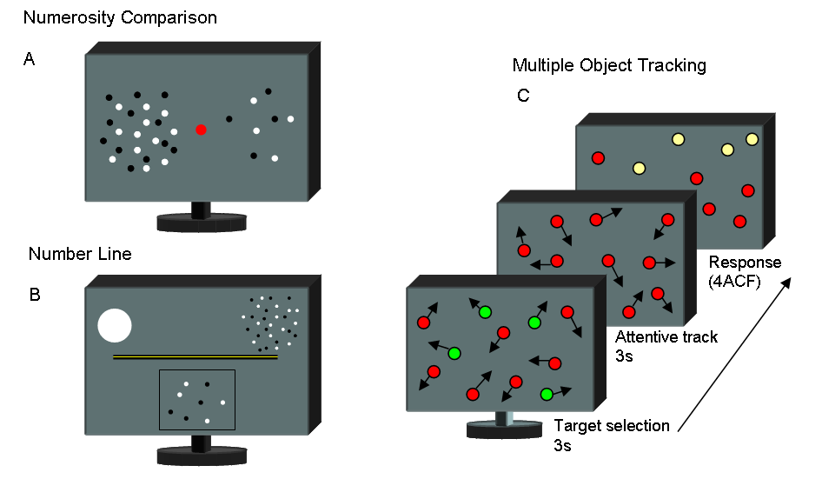
Illustration of tasks and stimuli. A. Numerosity Comparison: two patches of dots were briefly (500 ms) presented either side of central fixation point. Partecipants are asked to touch the side of the screen with more dots. B. Number Line: at the onset of each trial observers view a number line, marked at each end with a single dot to the left and 30 dots to the right. On key press, the dot stimulus appears, after 500 ms a binary pixel random-noise mask was displayed until partecipants respond. Partecipants touched the screen at the position on the numberline they thought corresponded to the dot cloud. C. Multiple Object Tracking: Eleven disks, four green targets and seven red distracters, moved randomly on the screen (4°/s) for a period of 3 secs. The green targets then turned red (like the distracters), which partecipants track with their attention for 3 seconds. They then identified (by touching the screen) which of four possible items (highlighted in yellow) was the target (4ACF).

Results

Correlation between math and perceptual variables

Figure 2 shows Pearson correlations between total math score and reading accuracy against the three perceptual tasks: numberline, numerosity discrimination and attention. Total score on math test is predicted by all three perceptual tasks. High scores on formal math test are associated with fewer errors on the numberline task (r = -0.238, p=0.05), higher precision in numerosity comparison (low Weber Fraction: r = -0.307, p=0.01) and higher attentional performance (r = 0.403, p = 0.001). On the other hand, none of the perceptual tasks are significantly correlated with reading ability. This shows that there is not simply some generic component driving the correlations (Table 1).

Table 1
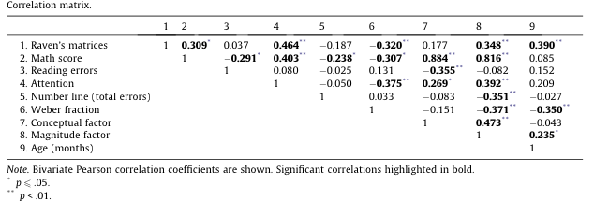

Figure 2
Bivariate Pearson correlations among variables. Psychophysical measures predict math (a, b, c) but not reading (d, e, f) abilities. Total math score is the sum of the individual scores on math subtests while reading reflect the number of errors during text reading.

Correlation between math and perceptual variables controlling for age, non-verbal IQ gender and reading accuracy.

Using hierarchical regressions we tested how much variance is explained by perceptual variables after partitioning out the effects of chronological age, general non-verbal intelligence, gender and reading accuracy – which are important but non-specific variables. The F change statistic indicates the partial effect of the perceptual variables on the total math score, controlling for the influence of the mentioned control variables.
Figure 3 shows that controlling for chronological age does not eliminate any of the correlations. After partitioning out age, the proportion of variance R² explained by numberline performance is 5.6 %, (F change _{(1,65)} = 3.84, p = 0.054), Weber fraction 7.7% (F change _{(1,65)} = 6.29, p = 0.015) and attentional performances 15% (F change _{(1,65)} = 12, p = 0.001). All remain highly significant.
Partitioning out both chronological age and general non-verbal intelligence together (figure 3), eliminated the correlation between number-line and math (R² change = 3.5 %, F change _{(1,64)} = 2.41, p = 0.125), but numerosity comparison precision (R² change = 5.3 %, F change _{(1,64)} = 4.28, p = 0.043) and attentional performance (R² change = 7.5 %, F change _{(1,64)} = 6.78, p = 0.011) remained statistically significant.
Partitioning out age, non-verbal intelligence and gender, the pattern of results does not change: the correlation between number-line and math remains not statistically significant (R² change = 2.7 %, F change _{(1,64)} = 1.88, p = 0.17), while numerosity comparison precision (R² change = 5.1 %, F change _{(1,64)} = 4.11, p = 0.04) as well as attention still explained a statistically significant portion of the math score variance (R² change = 7.8%, F change _{(1,64)} = 6.9 , p = 0.01 ).
Finally, we simultaneously controlled for age, non-verbal intelligence, gender and reading accuracy. After controlling for all these variables, attentional performance remain correlated with math score (R² change = 9.7%, F change _{(1,64)} = 8.8, p = 0.004), while the correlations with numerosity comparison precision (R² change = 3.3%, F change _{(1,64)} = 2.61, p = 0.11) and number line (R² change = 3.5%, F change _{(1,64)} = 2.48, p = 0.12) dropped below significance.
Considering the three perceptual variables together as math predictors, they explain a significant portion of variance of math scores (R² change = 14.5%, F _{(3,60)} = 4.37, p = 0.008) even after simultaneously controlling for the influence of age, non-verbal intelligence, gender and reading accuracy.

Figure 3
Partitioning out the influence of chronological age (black arrows), all the psychophysical measures still explains a significant proportion of variance of the math abilities. Controlling for both chronological age and non-verbal intelligence (blu arrows) only eliminated the correlation between number-line and math.

Correlation between math components and perceptual variables

Hierarchical regression analysis on factor scores (figure 4) reveal that after partitioning out the influence of chronological age, attention still explains a significant proportion of variance of the first “conceptual’” (R² change = 7.8 %, F change _{(1,65)} = 5.74, p = 0.019) as well as of the second, “magnitude-oriented’”, (R² change = 12.4 %, F change _{(1,65)} = 9.69, p = 0.003) component. Numberline, as well as numerosity-comparison performances, are related to the ‘magnitude-oriented’ component (R² change = 12.5 %, F change _{(1,65)} = 9.33, p = 0.003 ; R² change = 8.8%, F change _{(1,65)} = , p = 0.009, for numberline and numerosity respectively), but not with the “conceptual” (R² change = 0.7%, F change _{(1,65)} = 0.47, p = 0.495 ; R² change = 2.8%, F change _{(1,65)} = 2.11, p = 0.151, for number line and numerosity respectively).
More interestingly, after partitioning out the influence of both age and general non-verbal intelligence, all three perceptual tasks correlate with the ‘magnitude oriented’ factor (R² change = 6.3%, F change _{(1,64)} = 5.20 , p = 0.026 ; R² change = 9.8%, F change _{(1,64)} = 7.21, p = 0.009 ; R² change = 5.9%, F change _{(1,64)} = 5.24 , p = 0.025, for numerosity, number line and attention respectively) but not with the ‘conceptual’ component (R² change = 1.6%, F change _{(1,64)} = 1.26 , p = 0.265 ; R² change = 0.2%, F change _{(1,64)} = 0.137, p = 0.713 ; R² change = 3.8%, F change _{(1,)} = 3.28 , p = 0.075 , for numerosity, number line and attention respectively).

Table 2
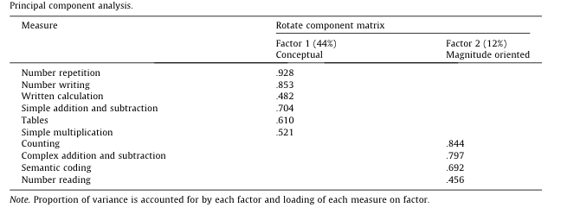

Figure 4
Partitioning out the influence of chronological age (black-arrows) or chronological age plus non-verbal intelligence (blu-arrows), all the three psychophysical measures still explains a significant proportion of variance of the first component (“magnitude-oriented’”). Controlling for chronological age, the “conceptual” component, remain related only with attention. Importantly, partitioning out the influence of age plus non-verbal intelligence, none of the psychophysical measures correlate with the “conceptual” component (dotted blu arrows).

Correlation between perceptual variables.

We also performed preliminary bivariate correlations between perceptual variables. Total error on number line, does not correlate with with Weber fraction (r = 0.033, p = 0.788) or d’ (r = -0.050, p = 0.684). However, numerosity comparison precision (Weber fraction) strongly correlate with attentional performance (r = -0.375, p = 0.002) even when chronological age (R² change = 9.6 %, F change _{(1,64)} = 7.94, p = 0.006) or chronological age and non verbal intelligence were controlled for (R² change = 6.2%, F change _{(1,64)} = 5.07 , p = 0.028: figure 5 a and b.

Figure 5
a) Numerosity comparison precision (weber fraction) strongly correlated with attentional performance. b) Controlling for the influence of cronological age alone (black-arrow) or together with non-verbal intelligence (blu-arrow) does not eliminate the correlation.

Discussion

We investigated the relationship between formal math skills and three psychophysical measures of numerosity and visual attention, in a sample of typically developing children between 8 to 11 years of age. Our results replicate those showing a correlation between number-acuity, number-to-space mapping and math skills (Piazza, Facoetti et al. 2010; Mazzocco, Feigenson et al. 2011; Steele, Karmiloff-Smith et al. 2012). Interestingly, individual differences in formal math skills are also highly correlated with visual sustained attention. This correlation remains highly significant even after controlling for chronological age, non-verbal intelligence, gender and text reading accuracy. As reported in other studies, we found that number-acuity and number-to-space are not two “generic performance” predictors, as they do not correlate with children’s reading ability. This is also the case with visual sustained attention. These results are closely in line with those very recently reported by Steele (2012) and colleagues. They measured attentional performance in preschool children with several tasks involving the capacity to sustain attention for a prolonged period of time (Go/No-Go task) to visually search targets among distracters and to benefit from a target presented in a position spatially congruent with the response. Correlating attentional performance with math and reading skills measured 1 year later, they found that sustained attention and visual search predict numeracy, but not literacy. Our results show that the correlation between attention and formal mathematics also extends to ages later than preschool, from eight to eleven years. During this age period, both formal numerical cognition as well as the ability to estimate and manipulate numerical quantities are evolving and are characterized by a large inter-individual variability. Formal math aggregates many different skills. We asked which math components are most closely correlated with visual attention, number-acuity and with the ability to map number onto space. Some evidence (Piazza, Facoetti et al. 2010) shows that number acuity of dyscalculic children correlates with errors in semantic tasks – in tests involving number magnitude processing – but not with other number-related competences, like simple calculation and transcoding. We performed a simple principal component analysis on the different math sub-tests, revealing two factors, one more related to semantic-processing and the other to conceptual and memory-based math competence. Interestingly, the three psychophysical tasks – after controlling for chronological age and non-verbal intelligence – correlate with the ‘magnitude oriented’ but not with the ‘conceptual’ factor, again pointing to a specific role of numerosity, number-line and attention in the apprehension of magnitude-related number processing. Finally, we show that sustained visual attention strongly correlates with number acuity. As others have suggested, understanding the interplay between attention and learning could be important both theoretically and operationally (see Scerif 2010 , for a review). Recent studies have shown that, along with deficits in numerical processing, people suffering from dyscalculia also have deficits in attention (Ashkenazi and Henik 2010; Askenazi and Henik 2010). However, the same research group found that attentional training, through the use of video games, does not improve arithmetic processing in a group of dyscalculic university students (Ashkenazi and Henik 2012). Other evidence comes from studies showing a dysfunctional subitizing in dyscalculics (Koontz 1996; Ashkenazi, Mark-Zigdon et al. 2012). Importantly, our (Burr, Turi et al. 2010; Anobile, Turi et al. 2012) as others recent works (Olivers and Watson 2008; Railo, Koivisto et al. 2008; Vetter, Butterworth et al. 2010) demonstrate that subitizing is strongly attentional dependent. Several questions remain open, including why sustained visual attention correlated with math but not with reading accuracy. Previous studies (Franceschini, Gori et al. 2012; Franceschini, Gori et al. 2013) have reported a correlation between reading skills and attention. However, those studies did not measured sustained attention, but transient attention, using visual search and Posner-like paradigms. On the other hand, Steele et al. (2012) measured sustained attention with a continuous performance test, and reported similar results to ours. They advanced the intuitive hypothesis that reading could be more related to sustained auditory attention than it is to visual attention. Given the evidence that attentional resources for visual tracking are independent of auditory resources (Arrighi, Lunardi et al. 2011), this suggestion seems quite plausible. It would be interesting to test auditory attention to see if it correlates with reading ability. Few studies have measured attentional performance in people with dyscalculia, but the little information available agrees with the idea that difficulties in acquisition of math skills may be related to attentional deficits (Ashkenazi and Henik 2010; Askenazi and Henik 2010). This evidence is beginning to call into question the domain-specific nature of this disorder. Although our research did not involve subjects with dyscalculia, it adds weight to this idea and highlights how, at least during typical development, math and attention are strongly linked. Given the correlational nature of our study, we cannot assert a causal role of attention on acquisition of arithmetic skills. However, the fact that visual sustained attention continues to be correlated with math skills even after the influence of IQ, age, gender and reading accuracy has been eliminated, strongly supports the hypothesis that effective learning of mathematical skills could depend on proper functioning of the visual sustained attentional system.

3. General conclusions

In this thesis we investigated several characteristics governing visual perception of numerical quantities. Using psychophysical paradigms we have shown that attention is strictly related to many aspects of numerical-cognition and that attentional manipulations can be used as a strong tool to reveal unexpected features of this ability.
We started this work studying the nature and the possible dicotomy between the systems dedicated to the numerical estimation of low (<4, subitizing) and relatively high numbers (>4, estimation). We clearly found that subitizing strongly depends on attentional resources, while estimation of larger quantities does not. Exactly the same results were found when the attentional resources dedicated to the visual numerical estimation task were limited on other sensory modalities: indeed visual, auditory and also haptic attentional load strongly and similarly impair visual subitizing but much less high numbers. Crucially, we found that under attentional load (visual, auditory or haptic), the sensory precision (Weber Fraction) with which we estimate quantities inside the subitizing range declines rapidly to approach that measured for number that exceed this range. We suggested that this implicated the existence of two separate mechanisms: one working over the entire range of numerosity (including subitizing), assisted by an attentional-based system of subitizing that operated for small numbers, no more than about four.
In line with that we also demonstrated that visual adaptation to numerosity, absent in the subitizing range under normal condition, emerges under attentional load with a magnitude of the effect highly comparable to that measured for high numbers (>4).
On the basis of these results, we advanced two ideas: 1) Adaptable numerosity estimation mechanisms operate over the entire range (both less then and more than 4), with similar sensory precision, but at low numerosities these mechanisms are supplemented by attentional mechanisms, mechanisms that identify and enumerate very precisely, but have a very low capacity, around four items; 2) Subitizing may reflect an amodal phenomenon, rather than being strictly visual.
Up to this point of the thesis we demostrated the dicotomy between the perception of low (<4, subitizing) and relatively high (>4, estimation) numbers, but what happens when we have to estimate even higher quantities? In other words, the numerical estimation system, saw at work for numbers beyond the subitizing range (estimation-range), also has an upper limit of operation?
This question arises from the fact that changing the numerosity of the elements to estimate other visual characteristics of the stimulus may lead to usable cues congruent with numerosity, but not numerosity per se. Indeed, when the number of elements encrease in a defined area increases, they inevitably became more packaged in the space, so texture density will also increase (as defined by the between elements distances). At a certain point, the distances between the elements will become so short that prevent the selection of the single elements, so they become uncountable. The strong interrelationship between numerosity and density has led several researchers to believe that numerosity is in fact not a primary visual feature, suggesting instead that it can be simply derived indirectly from texture density. In our work, we asked subjects to judge wich of two sets of item was more noumerous and we measured discrimination thresholds for a large range of numerosities (from 6 to 150 elements). We found that thresholds remain stable (follow Weber’s law) at low numerosities (constant Weber fraction around 0.18) and then decrease steadily with numerosity following square-root relationship. We demonstrate that the first Weber function reflects the action of number mechanisms, whereas the decrease (square-root relationship) — which begins to take effect at densities around 0.25 dots/deg² — reflects another system for discriminating texture density. This study clearly demonstrates that numerosity and texture density are perceived by two different systems, governed by two different psychophysical laws, and that numerosity can be sensed directly, without passing through other visual features such as density. However, when the density of the elements becomes a useful cue (as it is for heavily packaged items), is it automatically used for the numerical estimation.
Taking toghether this evidence, we advance the idea that visual numerosity can be sensed by three different but overlapped systems (figure 1): a supramodal, errorless and attentional dependent system dedicated to the perception of numbers up to four (subitizing); then a more error-prone system (obeying Weber’s law) that perceives sets of elements larger then four but still segregable in space (with a density less than 0.25 elements/deg²); and a third system, dedicated to the perception of density, comes into play when the element density becomes larger than 0.25 elements/deg² and governed by square-root law.

Figure 1
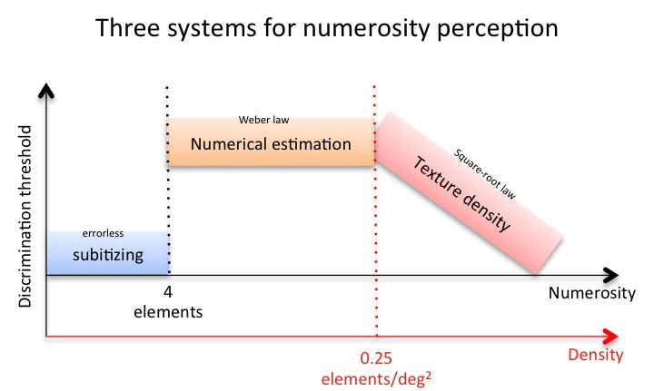
Three systems for the perception of numerosity: Subitizing accurately estimates number of items less than four (blue bar); numerical estimation, a more error-prone system, comes into play for numerosities more than four and it is governed by Weber’s law (yellow bar); texture density perception comes into play when the elements became too packaged in space (density higher than 0.25 elements/deg²) to be individually selected and perceived.

As we described before, numerical quantities can be estimated (how many?) or compared (which set is more numerous?), but they can also be mapped onto space. Indeed numbers are naturally thought spatially: in our culture they generally follow a left to right convention, with smaller numbers occupying more leftward positions. What is the form of the internal numerical map? This is an issue that has attracted much attention in the last years. The internal numerical map hes been classically measured with the so-called “number line task”. This is a really simple task, often used with very young children where subjects are asked to place a number on a line demarcating a numerical range. Literate adults perform well and accurately on this task with their responses quite linear. Conversely, young children, children with developmental dyscalculia as well as illiterate adults perform less accurately showing a non-linear, (compressed) logarithmic response function. The form of the response function obtained in this task, has been interpreted as the direct reflection of the internal numerical map form with the logarithmic shape reflecting the native - still not culturally linearized - representation of numbers.
In the second part of this thesis we first demonstrate that the ability to accurately map numbers onto space also depends on attentional resources, showing that the assumption that performance on the ‘number line task’ is the direct reflection of the internal numeric representation form could be misleading. We demonstrate that the non-linearity arises from a general perceptual principle: central tendency, observed in almost all sensory systems. This effect could be seen as a sort of running average between the stimuli, which leads to an overestimation of lower magnitude stimuli, and an underestimation of the higer, mirroring a compressed logarithmic response function. We tested this new hypothesis and developed a model of Bayesian integration that combines sensory information about the current stimulus with information about past stimuli. Unlike the ‘static internal logarithmic number map’, this model predicts strong dependencies between the response to the current trial and the magnitude of the previous one. We tested this hypothesis, and reported that numberline responses depend strongly on the magnitude of the previous trial, both in adults and in primary school children. Crucially, these measured dependencies are not predictable by an internal static logarithmic map of numbers.
In the last session of this work we asked how visual attention and numerosity perception are linked to the development of formal math skills in shoolage children. We used a correlational approach, and we found that visual sustained attention and numerosity perception strongly predict children’s formal math scores (measured by a standardized neuropsychological battery). Moreover, we expanded that finding showing that even after statistically controlling for several general variables, including age, gender, nonverbal IQ, and reading accuracy, visual attention remained strongly correlated with formal math skills and visual numerosity discrimination. These results suggest that both numerosity perception and visual attention play a key role in the acquisition of formal math skills. We also advanced the idea that attentional deﬁcits may be implicated in disturbances such as developmental dyscalculia.

In brief, in this thesis we demonstrate that the estimation of small (subitizing) and large quantities are subserved by two different but overlapped systems and that subitizing reflect an amodal process. We demonstrated that humans can sense numerosity directly, without passing through other perceptual features such as elements density. We showed that the ability to transform numbers onto spatial coordinates is a highly dynamic and attention-dependent system. Moreover, performance on the number line task obeys the general perceptual principle of central tendency (observed in almost all sensory systems), and this effect explains completely the pattern of results previously differently interpreded. Finally, we highlighted the key role played by visual attention and numerosity perception in the acquisition of the formal math skills during development.

4) References

Alais, D., C. Morrone and D. Burr (2006). "Separate attentional resources for vision and audition." Proc Biol Sci 273(1592): 1339-1345.

Anobile, G., G. M. Cicchini and D. C. Burr (2012). "Linear mapping of numbers onto space requires attention." Cognition 122(3): 454-459.

Anobile, G., G. M. Cicchini and D. C. Burr (2013). "Separate mechanisms for perception of numerosity and density." Psychol Sci.

Anobile, G., P. Stievano and D. C. Burr (2013). "Visual sustained attention and numerosity sensitivity correlate with math achievement in children." Journal of Experimental Child Psychology 116(2): 11.

Anobile, G., M. Turi, G. M. Cicchini and D. C. Burr (2012). "The effects of cross-sensory attentional demand on subitizing and on mapping number onto space." Vision Res 74: 102-109.

Ansari, D., I. M. Lyons, L. van Eimeren and F. Xu (2007). "Linking visual attention and number processing in the brain: the role of the temporo-parietal junction in small and large symbolic and nonsymbolic number comparison." J Cogn Neurosci 19(11): 1845-1853.

Arrighi, R., R. Lunardi and D. Burr (2011). "Vision and audition do not share attentional resources in sustained tasks." Front Psychol 2: 56.

Ashkenazi, S. and A. Henik (2010). "A disassociation between physical and mental number bisection in developmental dyscalculia." Neuropsychologia 48(10): 2861-2868.

Ashkenazi, S. and A. Henik (2012). "Does attentional training improve numerical processing in developmental dyscalculia?" Neuropsychology 26(1): 45-56.

Ashkenazi, S., N. Mark-Zigdon and A. Henik (2012). "Do subitizing deficits in developmental dyscalculia involve pattern recognition weakness?" Dev Sci 16(1): 35-46.

Askenazi, S. and A. Henik (2010). "Attentional networks in developmental dyscalculia." Behav Brain Funct 6: 2.

Atkinson, J., F. W. Campbell and M. R. Francis (1976). "The magic number 4 +/- 0: a new look at visual numerosity judgements." Perception 5(3): 327-334.

Balakrishnan, J. D. and F. G. Ashby (1992). "Subitizing: magical numbers or mere superstition?" Psychol Res 54(2): 80-90.

Barlow, H. (1990). "The mechanical mind." Annu Rev Neurosci 13: 15-24.

Belacchi, T. G. Scalisi, E. Cannoni and C. C. Cornoldi (2008). "Matrici Progressive di Raven Forma Colore (CPM-47). Manuale d’uso e standardizzazione italiana. Firenze.".

Berteletti, I., D. Lucangeli, M. Piazza, S. Dehaene and M. Zorzi (2010). "Numerical estimation in preschoolers." Dev Psychol 46(2): 545-551.

Biancardi, A. and C. Nicoletti (2004 ). "Batteria per la discalculia evolutiva (BDE): Omega."

Bonnel, A. M. and E. R. Hafter (1998). "Divided attention between simultaneous auditory and visual signals." Percept Psychophys 60(2): 179-190.

Bonnel, A. M. and W. Prinzmetal (1998). "Dividing attention between the color and the shape of objects." Percept Psychophys 60(1): 113-124.

Booth, J. L. and R. S. Siegler (2006). "Developmental and individual differences in pure numerical estimation." Dev Psychol 42(1): 189-201.

Brainard, D. H. (1997). "The Psychophysics Toolbox." Spat Vis 10(4): 433-436.

Brannon, E. M., C. J. Wusthoff, C. R. Gallistel and J. Gibbon (2001). "Numerical subtraction in the pigeon: evidence for a linear subjective number scale." Psychol Sci 12(3): 238-243.

Burr, D. C. and J. Ross (1986). "Visual processing of motion." Trends in Neurosciences 9: 3.

Burr, D. C. and J. Ross (2008). "A visual sense of number." Curr Biol 18(6): 425-428.

Burr, D. C., M. Turi and G. Anobile (2010). "Subitizing but not estimation of numerosity requires attentional resources." J Vis 10(6): 20.

Butterworth, B. (1999). The mathematical brain. London, Macmillan.

Camos, V. and B. Tillmann (2008). "Discontinuity in the enumeration of sequentially presented auditory and visual stimuli." Cognition 107(3): 1135-1143.

Chesney, D. L. and P. G. Matthews (2013). "Knowledge on the line: Manipulating beliefs about the magnitudes of symbolic numbers affects the linearity of line estimation tasks." Psychon Bull Rev.

Chopin, A. and P. Mamassian (2012). "Predictive properties of visual adaptation." Curr Biol 22(7): 622-626.

Cicchini, G. M., R. Arrighi, L. Cecchetti, M. Giusti and D. C. Burr (2012). "Optimal encoding of interval timing in expert percussionists." J Neurosci 32(3): 1056-1060.

Corbetta, M. and G. L. Shulman (2002). "Control of goal-directed and stimulus-driven attention in the brain." Nat Rev Neurosci 3(3): 201-215.

Cornoldi, C. and G. Colpo (1995). "Nuove Prove di lettura MT per la Scuola. Media Inferiore. Manuale. Firenze: Organizzazioni Speciali."

Dacke, M. and M. V. Srinivasan (2008). "Evidence for counting in insects." Anim Cogn 11(4): 683-689.

Dakin, S. C., M. S. Tibber, J. A. Greenwood, F. A. A. Kingdom and M. J. Morgan (2011). "A common visual metric for approximate number and density." Proceedings of the National Academy of Sciences of the United States of America 108(49): 19552-19557.

Dehaene, S. (1997). The Number Sense: How the Mind Creates Mathematics, Oxford University Press).

Dehaene, S. (1999). The Number Sense: How the Mind Creates Mathematics, Oxford University Press).

Dehaene, S. (2003). "The neural basis of the Weber-Fechner law: a logarithmic mental number line." Trends Cogn Sci 7(4): 145-147.

Dehaene, S. and J. P. Changeux (1993). "Development of elementary numerical abilities: a neuronal model." J Cogn Neurosci 5(4): 390-407.

Dehaene, S., V. Izard, E. Spelke and P. Pica (2008). "Log or linear? Distinct intuitions of the number scale in Western and Amazonian indigene cultures." Science 320(5880): 1217-1220.

Dotan, D. and S. Dehaene (2013). "How do we convert a number into a finger trajectory?" Cognition 129(3): 512-529.

Durgin, F. H. (2008). "Texture density adaptation and visual number revisited." Current Biology 18(18): R855-R856.

Egeth, H. E., C. J. Leonard and M. Palomares (2008). "The role of attention in subitizing: Is the magical number 1?" Visual Cognition 16(4): 463-473.

Ernst, M. O. (2007). "Learning to integrate arbitrary signals from vision and touch." J Vis 7(5): 7 1-14.

Fechner, G. T. (1860). Elemente der Psychophysik (2 vols.). Leipzig, Breitkopf und Härtel.

Feigenson, L., S. Dehaene and E. Spelke (2004). "Core systems of number." Trends Cogn Sci 8(7): 307-314.

Feigenson, L., M. E. Libertus and H. Justin (2013). "Links Between the Intuitive Sense of Number and Formal Mathematics Ability." Child Development Perspectives 0(0): 1-6.

Fischer, M. H., A. D. Castel, M. D. Dodd and J. Pratt (2003). "Perceiving numbers causes spatial shifts of attention." Nat Neurosci 6(6): 555-556.

Franceschini, S., S. Gori, M. Ruffino, K. Pedrolli and A. Facoetti (2012). "A causal link between visual spatial attention and reading acquisition." Curr Biol 22(9): 814-819.

Franceschini, S., S. Gori, M. Ruffino, S. Viola, M. Molteni and A. Facoetti (2013). "Action video games make dyslexic children read better." Curr Biol 23(6): 462-466.

Franconeri, S. L., D. K. Bemis and G. A. Alvarez (2009). "Number estimation relies on a set of segmented objects." Cognition 113(1): 1-13.

Gallistel, C. R. and R. Gelman (1992). "Preverbal and verbal counting and computation." Cognition 44(1-2): 43-74.

Gallistel, C. R. and R. Gelman (2005). Mathematical Cognition. Cambridge Handbook of Thinking and Reasoning. K. J. Kolyoak and R. Morrison, Cambridge University Press: 559-588.

Geary, D. C., M. K. Hoard, J. Byrd-Craven, L. Nugent and C. Numtee (2007). "Cognitive mechanisms underlying achievement deficits in children with mathematical learning disability." Child Dev 78(4): 1343-1359.

Geary, D. C., M. K. Hoard, L. Nugent and J. Byrd-Craven (2008). "Development of number line representations in children with mathematical learning disability." Dev Neuropsychol 33(3): 277-299.

Gepshtein, S., L. A. Lesmes and T. D. Albright (2013). "Sensory adaptation as optimal resource allocation." Proc Natl Acad Sci U S A 110(11): 4368-4373.

Gordon, P. (2004). "Numerical cognition without words: evidence from Amazonia." Science 306(5695): 496-499.

Green, C. S. and D. Bavelier (2003). "Action video game modifies visual selective attention." Nature 423(6939): 534-537.

Halberda, J., M. M. Mazzocco and L. Feigenson (2008). "Individual differences in non-verbal number acuity correlate with maths achievement." Nature 455(7213): 665-668.

Hauser, M. D., F. Tsao, P. Garcia and E. S. Spelke (2003). "Evolutionary foundations of number: spontaneous representation of numerical magnitudes by cotton-top tamarins." Proc Biol Sci 270(1523): 1441-1446.

He, L., J. Zhang, T. Zhou and L. Chen (2009). "Connectedness affects dot numerosity judgment: implications for configural processing." Psychon Bull Rev 16(3): 509-517.

Hecht, S. (1921). "The Nature of Foveal Dark Adaptation." J Gen Physiol 4(2): 113-139.

Hein, G., A. Alink, A. Kleinschmidt and N. G. Muller (2007). "Competing neural responses for auditory and visual decisions." PLoS One 2(3): e320.

Hollingworth, H. L. (1910). "The central tendency of judgements." Journalof Philosophy, Psychology and Scientiﬁc Methods 7: 461–469.

Hyde, D. C. and E. S. Spelke (2009). "All numbers are not equal: an electrophysiological investigation of small and large number representations." J Cogn Neurosci 21(6): 1039-1053.

Hyde, D. C. and J. N. Wood (2011). "Spatial Attention Determines the Nature of Nonverbal Number Representation." J Cogn Neurosci.

Izard, V., C. Sann, E. S. Spelke and A. Streri (2009). "Newborn infants perceive abstract numbers." Proc Natl Acad Sci U S A 106(25): 10382-10385.

Jancke, L., S. Mirzazade and N. J. Shah (1999). "Attention modulates the blood oxygen level dependent response in the primary visual cortex measured with functional magnetic resonance imaging." Naturwissenschaften 86(2): 79-81.

Jazayeri, M. and M. N. Shadlen (2010). "Temporal context calibrates interval timing." Nat Neurosci 13(8): 1020-1026.

Jevons, W. S. (1871). "The power of numerical discrimination." Nature 3: 363–372.

Joassin, F., P. Maurage, R. Bruyer, M. Crommelinck and S. Campanella (2004). "When audition alters vision: an event-related potential study of the cross-modal interactions between faces and voices." Neurosci Lett 369(2): 132-137.

Juan, C. H., V. Walsh and P. McLeod (2000). "Preattentive vision and enumeration." Investigative Ophthalmology & Visual Science 41(4): S39-S39.

Kaufman, E. L. and M. W. Lord (1949). "The discrimination of visual number." Am J Psychol 62(4): 498-525.

Koontz, L. K., Berch, D.B. (1996). "Identifying Simple Numerical Stimuli: Processing Inefficiencies Exhibited by Arithmetic Learning Disabled Children." Mathematical Cognition 2(1): 1-23.

Larsen, A., W. McIlhagga, J. Baert and C. Bundesen (2003). "Seeing or hearing? Perceptual independence, modality confusions, and crossmodal congruity effects with focused and divided attention." Percept Psychophys 65(4): 568-574.

Maljkovic, V. and K. Nakayama (1994). "Priming of pop-out: I. Role of features." Mem Cognit 22(6): 657-672.

Maljkovic, V. and K. Nakayama (1996). "Priming of pop-out: II. The role of position." Percept Psychophys 58(7): 977-991.

Mandler, G. and B. J. Shebo (1982). "Subitizing: an analysis of its component processes." J Exp Psychol Gen 111(1): 1-22.

Mazzocco, M. M., L. Feigenson and J. Halberda (2011). "Impaired acuity of the approximate number system underlies mathematical learning disability (dyscalculia)." Child Dev 82(4): 1224-1237.

Melcher, D. (2009). "Selective attention and the active remapping of object features in trans-saccadic perception." Vision Res 49(10): 1249-1255.

Melcher, D. and M. Piazza (2011). "The role of attentional priority and saliency in determining capacity limits in enumeration and visual working memory." PLoS One 6(12): e29296.

Nieder, A. (2005). "Counting on neurons: the neurobiology of numerical competence." Nat Rev Neurosci 6(3): 177-190.

Nieder, A., I. Diester and O. Tudusciuc (2006). "Temporal and spatial enumeration processes in the primate parietal cortex." Science 313(5792): 1431-1435.

Nieder, A., D. J. Freedman and E. K. Miller (2002). "Representation of the quantity of visual items in the primate prefrontal cortex." Science 297(5587): 1708-1711.

Nieder, A. and K. Merten (2007). "A labeled-line code for small and large numerosities in the monkey prefrontal cortex." J Neurosci 27(22): 5986-5993.

Nieder, A. and E. K. Miller (2004). "Analog numerical representations in rhesus monkeys: evidence for parallel processing." J Cogn Neurosci 16(5): 889-901.

Olivers, C. N. L. and D. G. Watson (2008). "Subitizing requires attention." Visual Cognition 16(4): 439-462.

Pashler, H. (1992). "Attentional limitations in doing two tasks at the same time." Curr. Dir. Psychol. Sci. 1, 44–48.

Pashler, H. (1994). "Dual-task interference in simple tasks: data and theory." Psychol Bull 116(2): 220-244.

Pepperberg, I. M. (2006). "Grey parrot numerical competence: a review." Anim Cogn 9(4): 377-391.

Piazza, M. (2010). "Neurocognitive start-up tools for symbolic number representations." Trends Cogn Sci 14(12): 542-551.

Piazza, M., A. Facoetti, A. N. Trussardi, I. Berteletti, S. Conte, D. Lucangeli, S. Dehaene and M. Zorzi (2010). "Developmental trajectory of number acuity reveals a severe impairment in developmental dyscalculia." Cognition 116(1): 33-41.

Piazza, M., V. Izard, P. Pinel, D. Le Bihan and S. Dehaene (2004). "Tuning curves for approximate numerosity in the human intraparietal sulcus." Neuron 44(3): 547-555.

Piazza, M., A. Mechelli, B. Butterworth and C. J. Price (2002). "Are subitizing and counting implemented as separate or functionally overlapping processes?" Neuroimage 15(2): 435-446.

Piazza, M., A. Mechelli, C. J. Price and B. Butterworth (2006). "Exact and approximate judgements of visual and auditory numerosity: an fMRI study." Brain Res 1106(1): 177-188.

Pinhas, M. and M. H. Fischer (2008). "Mental movements without magnitude? A study of spatial biases in symbolic arithmetic." Cognition 109(3): 408-415.

Plaisier, M. A., W. M. Bergmann Tiest and A. M. Kappers (2009). "One, two, three, many - subitizing in active touch." Acta Psychol (Amst) 131(2): 163-170.

Posner, M. I. and C. D. Gilbert (1999). "Attention and primary visual cortex." Proc Natl Acad Sci U S A 96(6): 2585-2587.

Posner, M. I. and M. K. Rothbart (2005). "Influencing brain networks: implications for education." Trends Cogn Sci 9(3): 99-103.

Pylyshyn, Z. W. and R. W. Storm (1988). "Tracking multiple independent targets: evidence for a parallel tracking mechanism." Spat Vis 3(3): 179-197.

Railo, H., M. Koivisto, A. Revonsuo and M. M. Hannula (2008). "The role of attention in subitizing." Cognition 107(1): 82-104.

Raymond, J. E., K. L. Shapiro and K. M. Arnell (1992). "Temporary suppression of visual processing in an RSVP task: an attentional blink?" J Exp Psychol Hum Percept Perform 18(3): 849-860.

Repp, B. H. (2007). "Perceiving the numerosity of rapidly occurring auditory events in metrical and nonmetrical contexts." Percept Psychophys 69(4): 529-543.

Revkin, S. K., M. Piazza, V. Izard, L. Cohen and S. Dehaene (2008). "Does subitizing reflect numerical estimation?" Psychol Sci 19(6): 607-614.

Riggs, K. J., L. Ferrand, D. Lancelin, L. Fryziel, G. Dumur and A. Simpson (2006). "Subitizing in tactile perception." Psychol Sci 17(4): 271-272.

Roach, N. W., J. Heron and P. V. McGraw (2006). "Resolving multisensory conflict: a strategy for balancing the costs and benefits of audio-visual integration." Proc Biol Sci 273(1598): 2159-2168.

Roitman, J. D., E. M. Brannon and M. L. Platt (2007). "Monotonic coding of numerosity in macaque lateral intraparietal area." PLoS Biol 5(8): e208.

Rolfs, M., M. Dambacher and P. Cavanagh (2013). "Visual adaptation of the perception of causality." Curr Biol 23(3): 250-254.

Ross, J. (2003). "Visual discrimination of number without counting." Perception 32(7): 867-870.

Ross, J. and D. C. Burr (2010). "Vision senses number directly." J Vis 10(2): 10 11-18.

Sathian, K., T. J. Simon, S. Peterson, G. A. Patel, J. M. Hoffman and S. T. Grafton (1999). "Neural evidence linking visual object enumeration and attention." J Cogn Neurosci 11(1): 36-51.

Sawamura, H., K. Shima and J. Tanji (2002). "Numerical representation for action in the parietal cortex of the monkey." Nature 415(6874): 918-922.

Scerif, G. (2010). "Attention trajectories, mechanisms and outcomes: at the interface between developing cognition and environment." Dev Sci 13(6): 805-812.

Siegler, R. S. and J. L. Booth (2004). "Development of numerical estimation in young children." Child Dev 75(2): 428-444.

Siegler, R. S. and J. E. Opfer (2003). "The development of numerical estimation: evidence for multiple representations of numerical quantity." Psychol Sci 14(3): 237-243.

Somers, D. C., A. M. Dale, A. E. Seiffert and R. B. Tootell (1999). "Functional MRI reveals spatially specific attentional modulation in human primary visual cortex." Proc Natl Acad Sci U S A 96(4): 1663-1668.

Spence, C., J. Ranson and J. Driver (2000). "Cross-modal selective attention: on the difficulty of ignoring sounds at the locus of visual attention." Percept Psychophys 62(2): 410-424.

Steele, A., A. Karmiloff-Smith, K. Cornish and G. Scerif (2012). "The multiple subfunctions of attention: differential developmental gateways to literacy and numeracy." Child Dev 83(6): 2028-2041.

Stevens, S. S. (1957). "On the psychophysical law." Psychological Review 64 (3): 153–181. PMID 13441853. 64(3): 153–181.

Taylor, M. M., P. H. Lindsay and S. M. Forbes (1967). "Quantification of shared capacity processing in auditory and visual discrimination." Acta Psychol (Amst) 27: 223-229.

Thompson, P. and D. Burr (2009). "Visual aftereffects." Curr Biol 19(1): R11-14.

Trick, L. M. and Z. W. Pylyshyn (1994). "Why Are Small and Large Numbers Enumerated Differently - a Limited-Capacity Preattentive Stage in Vision." Psychological Review 101(1): 80-102.

Tulving, E. and P. H. Lindsay (1967). "Identification of simultaneously presented simple visual and auditory stimuli." Acta Psychol (Amst) 27: 101-109.

Vetter, P., B. Butterworth and B. Bahrami (2008). "Modulating attentional load affects numerosity estimation: evidence against a pre-attentive subitizing mechanism." PLoS One 3(9): e3269.

Vetter, P., B. Butterworth and B. Bahrami (2010). "A candidate for the attentional bottleneck: set-size specific modulation of the right TPJ during attentive enumeration." J Cogn Neurosci 23(3): 728-736.

Viarouge, A., E. M. Hubbard, S. Dehaene and J. Sackur (2010). "Number line compression and the illusory perception of random numbers." Exp Psychol 57(6): 446-454.

Watson, A. B. and D. G. Pelli (1983). "QUEST: a Bayesian adaptive psychometric method." Percept Psychophys 33(2): 113-120.

Weber, E. H. (1834). De pulsu, resorptione, auditu et tactu. Annotationes anatomicae et physiologicae. Leipzig, Koehler.

Whalen, J., C. R. Gallistel and R. Gelman (1999). "Nonverbal counting in humans: the psychophysics of number representation." Psychological Science 10: 130 - 137.

Wilson, A. J., S. K. Revkin, D. Cohen, L. Cohen and S. Dehaene (2006). "An open trial assessment of "The Number Race", an adaptive computer game for remediation of dyscalculia." Behav Brain Funct 2: 20.

Xu, F. and E. S. Spelke (2000). "Large number discrimination in 6-month-old infants." Cognition 74(1): B1-B11.

Xu, F., E. S. Spelke and S. Goddard (2005). "Number sense in human infants." Dev Sci 8(1): 88-101.

Xu, X. and C. Liu (2008). "Can subitizing survive the attentional blink? An ERP study." Neurosci Lett 440(2): 140-144.

Zentall, S. (1993). "Research on the educational implications of attention deficit hyperactivity disorder " Exceptional Children 60(2): 143-153.

