DIPARTIMENTO DI

NEUROSCIENZE, BIOMEDICINA E MOVIMENTO

SCUOLA DI DOTTORATO DI

SCIENZE DELLA VITA E DELLA SALUTE

DOTTORATO DI RICERCA IN

SCIENZE APPLICATE DELLA VITA E DELLA SALUTE

XXXIII ciclo/2017

SAVE ‘STEWARDSHIP ANTIBIOTICA VERONA’:
A QUALITY IMPROVEMENT PROJECT TO REDUCE IN-HOSPITAL ANTIBIOTIC CONSUMPTION IN A SETTING WITH A HIGH LEVEL OF ANTIMICROBIAL RESISTANCE

S.S.D. MED/17

Coordinatore: Prof. Giovanni Malerba

Tutor: Prof.ssa Evelina Tacconelli
Dott.ssa Michela Conti

Dottorando: Dott. ssa Elena Carrara

Quest’opera è stata rilasciata con licenza Creative Commons Attribuzione – non commerciale
Non opere derivate 3.0 Italia. Per leggere una copia della licenza visita il sito web:

http://creativecommons.org/licenses/by-nc-nd/3.0/it/


Attribuzione Devi riconoscere una menzione di paternità adeguata, fornire un link alla licenza e indicare se sono state effettuate delle modifiche. Puoi fare ciò in qualsiasi maniera ragionevole possibile, ma non con modalità tali da suggerire che il licenziante avalli te o il tuo utilizzo del materiale.
Non Commerciale Non puoi usare il materiale per scopi commerciali.
Non opere derivate —Se remixi, trasformi il materiale o ti basi su di esso, non puoi distribuire il materiale così modificato.

SAVE ‘Stewardship Antibiotica Verona’:
a quality improvement project to reduce in-hospital antibiotic consumption
in a setting with a high level of antimicrobial resistance
Elena Carrara
Tesi di Dottorato
Verona, 13 luglio 2021
ISBN XXXX
SOMMARIO

Introduzione: secondo le recenti stime del Centro Europeo per la Prevenzione e il Controllo delle Malattie, l'Italia è il paese europeo con il più alto burden di malattia causato della resistenza antimicrobica. In linea con le raccomandazioni del Piano Nazionale di Contrasto dell’Antibiotico Resistenza (PNCAR), nel giugno 2018 è stato avviato presso l'Azienda Ospedaliera Universitaria Integrata di Verona un intervento di Stewardship Antibiotica volto a ridurre il consumo di antibiotici e le infezioni sostenute da batteri antibiotico-resistenti.
Metodi: Gli elementi principali del progetto SAVE (Stewardship Antibiotica VErona) erano: I. valutazione qualitativa dei determinanti della prescrizione di antibiotici tramite un questionario; II. presenza di uno specialista in malattie infettive a tempo pieno presso il reparto di intervento per 12 settimane; III. formazione accreditata-ECM di almeno due medici per ciascun reparto di intervento; IV. sviluppo di linee guida personalizzate di terapia antibiotica empirica e V. nove mesi di audit periodici e feedback mirati a prescrizioni inappropriate. L'outcome primario dell'intervento era di mostrare una riduzione del consumo complessivo di antibiotici per uso sistemico (ATC-J01) per 1000 giorni-paziente (PD) misurati sia come ‘giorni di terapia’ (DOT) e secondo lo standard stabilito dall’Organizzazione Mondiale della Sanità ‘defined-daily doses’ (DDD). Gli outcomes secondari erano il consumo di carbapenemici e fluorochinolonici, la mortalità ospedaliera, la durata media della degenza, l’incidenza di infezioni da Clostridium difficile e le batteriemie da Enterobacteriaceae resistenti ai carbapenemici. L'effetto dell'intervento di Stewardship Antibiotica sul consumo mensile di antibiotici, sugli outcomes clinici e microbiologici è stato valutato con un’analisi sul modello delle interrupted-time-series confrontando i 12 mesi pre-intervento con i 21 mesi successivi.
Risultati: da giugno 2018 a marzo 2020, quattro reparti di area medica hanno completato il follow-up, 57 medici hanno partecipato al questionario di valutazione iniziale, otto medici sono stati formati sulla prescrizione di antibiotici e 1116 prescrizioni sono state sottoposte a revisione durante la fase di audit e feedback.
L'intervento di Stewardship Antibiotica si è associato ad una riduzione immediata del livello di consumo complessivo di antibiotici, misurata sia in termini di DOT * 1000 PD (-162,2; P = 0,005) che di DDD * 1000 PD (-183,6; P = <0,001). Durante l'intera fase post-intervento, il consumo ha continuato a diminuire con un tasso mensile di 3,6 DDD * 100PDs (P = 0,04) e 3,36 DOTs * 1000PDs (P = 0,03). La riduzione del consumo è stata consistente anche nelle due classi di antibiotici target (-35,5 DOT * 1000PD per i fluorochinolonici e - 23,1 DOT * 1000PD per i carbapenemici, P = 0,03 e 0,003 rispettivamente). Tuttavia, mentre la classe dei fluorochinolonici ha mantenuto una riduzione significativa anche sul lungo termine (-2,1 DOT * 1000PDs, P = 0,016), il consumo di carbapenemici è rimasto approssimativamente stabile durante l'intero periodo post-intervento (-0,04 DOT * 1000PDs, P> 0,05).
L'intervento di Stewardship Antibiotica si è associato anche ad una riduzione precoce della durata media della degenza ospedaliera (-1,72 giorni P <0,001) e della mortalità ospedaliera (-3,71 morti * 100 ricoveri) con una significativa riduzione della tendenza nel periodo post-intervento rispetto al periodo pre-intervento (- 0,17 giorni al mese e -0,26 morte * 100 ricoveri al mese; P = 0,012 e 0,001). I tassi di infezioni da Clostridium difficile e di batteriemie da Enterobacteriaceae resistenti ai carbapenemici hanno mostrato una tendenza, seppur non significativa, alla riduzione sia nella fase precoce che a lungo termine dopo l'intervento.
Conclusioni: l'intervento SAVE si è dimostrato efficace e sicuro nel ridurre il consumo di antibiotici e la durata della degenza ospedaliera in quattro reparti di area medica. Sebbene i risultati mostrati siano promettenti, potrebbe essere necessaria l’inclusione di più osservazioni e di un periodo di follow-up più lungo per dimostrare un effetto decisivo di questo programma di Stewardship Antibiotica nel ridurre le infezioni correlate all’antibiotico-resistenza.
ABSTRACT

Background: According to recent estimates from the European Centre for Disease Prevention and Control, Italy is the European country with the highest disease burden due to antimicrobial resistance (AMR). In line with the recommendations from the National Plan for Combating Antibiotic Resistance in Italy, in June 2018, the Verona University hospital started a quality improvement Antibiotic Stewardship (AS) intervention aimed at reducing antibiotic consumption and infections sustained by targeted AMR pathogens.
Methods: The core elements of the SAVE (Stewardship Antibiotica VErona) intervention were: I. Qualitative assessment of determinants of antibiotic prescribing via a 21-item questionnaire; II. provision of a full-time Infectious Disease specialist to the intervention ward for 12 weeks; III. mandatory CME-accredited training for at least two physicians per intervention ward; IV. development of customized guidance on empirical antibiotic therapy, and V. nine months of periodic audits and feedbacks targeting inappropriate prescriptions. The primary outcome of the intervention was to show a reduction in the overall consumption of systemic antibiotics (ATC-J01) measured as Days of Therapy (DOTs) and Daily Defined Doses (DDDs) per 1000 patient-days (PDs). Secondary outcomes were carbapenems and fluoroquinolones consumption, all-cause in-hospital mortality, mean length of hospital stay, the incidence of Clostridium difficile infections, and carbapenem-resistant Enterobacteriaceae bloodstream infections. The AS intervention's effect on monthly antibiotic consumption, clinical and microbiological outcomes was assessed with an interrupted-time-series analysis comparing the 12-month pre-intervention phase with the 21-month following the intervention’s start.
Results: from June 2018 to March 2020, four medical wards completed the follow-up, 57 medical doctors participated in the initial assessment questionnaire, eight non-Infectious Disease physicians were trained in antibiotic prescribing, and 1116 prescriptions were revised during the audit and feedback phase.
The AS intervention was associated with a significant immediate reduction in the level of overall antibiotic consumption, measured both in terms of DOTs*1000 PDs (-162.2; P=0.005) and DDDs*1000 PDs (-183.6; P=<0.001). During the whole post-intervention phase, consumption kept decreasing with a monthly rate of 3.6 DDD*100PDs (P= 0.04) and 3.36 DOTs*1000PDs (P=0.03). Reduction in consumption was consistent also in the two target antibiotic classes (-35.5 DOTs*1000PDs for fluoroquinolones and - 23.1 DOTs*1000PDs for carbapenems, P=0.03 and 0.003 respectively). However, while the fluoroquinolones class maintained a long-term significant reduction (-2.1 DOTs*1000PDs, P=0.016), carbapenem consumption remained approximately stable during the whole post-intervention period (-0.04 DOTs*1000PDs, P>0.05).
The AS intervention was also associated with a significant early reduction in the mean length of hospital stay (-1.72 days P<0.001) and all-cause mortality rates (-3.71 deaths*100 admissions) with a significant decrease of the trend in the post-intervention period compared to the pre-intervention period (- 0.17 days per month and -0,26 death*100 admissions per month; P= 0.012 and 0.001). Rates of Clostridium difficile and carbapenem-resistant Enterobacteriaceae bloodstream infections tended to reduce, although non-significantly, in both the early and the long-term phase after the intervention.
Conclusions: The SAVE intervention was effective and safe in reducing antibiotic consumption and length of hospital-stay in four medical wards. Although results are promising, more observations and a more extended follow-up period might be needed to demonstrate the AS program's decisive effect in reducing AMR's clinical burden.

INDEX

INTRODUCTION 9
The burden of antimicrobial resistance and the role of antibiotic stewardship 9
Antibiotic Stewardship: planning and organizational structure 11
Antibiotic Stewardship: outcomes and process indicators 14
Structure and epidemiology of the Verona University Hospital 17
Preliminary steps of the SAVE program 22
METHODS 26
Study setting 26
The SAVE intervention 27
1. Initial assessment 27
2. Intensive phase (1st-3rd month) 28
3. Maintenance phase (4th-12th month) 29
4. Educational event 30
Process indicators 31
Survey data 32
Audit data 32
Consumption data 32
Clinical and microbiological outcomes 33
Statistical analysis 33
Data confidentiality and ethical aspects 35
RESULTS 37
Survey 37
Check-lists 39
Audit and feedback 42
Antimicrobial consumption 49
Defined-Daily-Doses of systemic antibiotics (ATC J01) 51
Days of antibiotic Therapy (all classes, ATC J01) 52
Antibiotic Free Days 53
Defined Daily Doses of Carbapenems 54
Days of carbapenem therapy 55
Defined Daily Doses of Fluoroquinolones 56
Days of fluoroquinolone therapy 57
Clinical and microbiological outcomes 58
Incidence of Clostridium difficile infections 59
Incidence of Carbapenem-resistant Enterobacteriaceae bloodstream infections 60
Mortality rates 61
Length of hospital stay 62
DISCUSSION 63
CONCLUSIONS 69
ACKNOWLEDGMENTS 70
REFERENCES 71
APPENDIX 78
Figure A1: the SAVE survey 78
Figure A2: Audit record form 82

INTRODUCTION

The burden of antimicrobial resistance and the role of antibiotic stewardship
The World Health Organization (WHO) defined antimicrobial resistance (AMR) as one of the most critical public health challenges in the coming decades. Infections caused by antibiotic-resistant bacteria are strongly associated with an excess of mortality and morbidity. They have a significant impact in terms of economic costs related to hospitalization (prolonged hospital stay, greater use of diagnostic procedures and high-cost drugs) and loss of productivity (1). If not appropriately contrasted, the continuous rise in resistance rates will progressively compromise the effectiveness of available antibiotics and hamper the success of complex medical procedures such as major surgeries, implantation of prosthetic materials, organ transplants, and immunosuppressive therapies (2).
The European Center for Disease Control and Prevention (ECDC) has recently published a landmark study on AMR infections' clinical burden, concluding that approximately 670,000 infections and 33,000 deaths are attributed to AMR every year in Europe. Italy alone contributes to almost one-third of those figures, and it is considered the European country with the highest burden of disease related to AMR (3).
The AMR pathogens categorized as of critical priority by the WHO have all reached hyperendemic levels in Italy. The resistance mechanisms present in these pathogens (e.g., carbapenemase productions in Klebsiella pneumoniae) are often determining cross-resistance to other antibiotic classes, leaving old molecules with reduced efficacy and high risk of toxicity as the only therapeutic options. Moreover, the most recent data show a progressive increase in resistance rates also towards these molecules. As for KPC-producing Klebsiella pneumoniae, for example, colistin resistance has reached 13% in isolates from Italy (4, 5). An upward trend is also seen in 3rd generation cephalosporin-resistant Escherichia coli and vancomycin-resistant Enterococcus faecium (VRE). Albeit with a slightly decreasing trend, methicillin-resistance rates in Staphylococcus aureus isolates are above the European average. (5)
There is well-established evidence supporting that antibiotic exposure is one of the most critical antimicrobial resistance drivers (6). Therefore, it is not surprising that countries with high AMR rates, such as Italy or Greece, report the highest prevalence of antibiotic use among hospitalized patients and the lowest adherence to international guidelines (i.e., duration of surgical prophylaxis) (7).
When confronted with this rapidly growing phenomenon, several international public health authorities have underlined the need to prioritize responsible use of antibiotics to guarantee the best treatment for today's patients without affecting the availability of adequate resources for next generations (8, 9). Therefore, the balance between current and future patients must be regarded as the grounding principle of any ‘Antibiotic Stewardship’ (AS) activity. More in detail, according to the Infectious Disease Society of America (IDSA), AS should encompass ‘a set of coordinated interventions designed to improve and measure the appropriate use of antibiotics by promoting the selection of the optimal therapeutic regimen in terms of dosage, duration, and route of administration’. According to the same document, a therapy is regarded as ‘optimal’ when clinically effective and with a minimum risk of toxicity and selection of resistances (10, 11).
Nowadays, the need to optimize antibiotic prescriptions at every healthcare setting level has been largely recognized; and the mandatory implementation of AS programs is required in several countries with different socio-economic status (12).
In November 2017, Italy approved the first national policy document to contrast the AMR phenomenon (Piano Nazionale di Contrasto all’Antibiotico Resistenza). The plan dedicates a section to the correct use of antibiotics in humans, outlining local initiatives' national and regional reference frameworks. The leading process indicators identified by the plan are the reduction in consumption of systemic antibiotics for human use (> 10% in 2020 compared to 2016), the decrease in the consumption of fluoroquinolones (> 10% in the territory and > 5% in the hospital), the reduction in the prevalence of MRSA and carbapenemase-producing Enterobacteriaceae (CPE) isolated from blood (> 10%). Furthermore, by 2020 all Italian regions are required to start microbiological surveillance of AMR and consumption of alcohol-hand-rub solution. (13)

Antibiotic Stewardship: planning and organizational structure
Antimicrobial Stewardship cuts across all the disciplines related to antimicrobial prescription, and several experts from different disciplines are required to form an AS team. Core members usually belong to the infectious diseases and clinical microbiology area and should be supported by a pharmacist with knowledge of antimicrobials. Additional members could include an infection control practitioner, nurses, and contributors from the information technology department or program managers.
The inclusion of medical doctors from more specialized departments is essential for AS programs targeting specific areas such as intensive-care units or haemato-oncology. The involvement of a ‘program champion’, a figure that is trusted by colleagues and has a full understanding of antibiotic prescribing processes, has proven successful in emergency and pediatric departments. Additionally, ensuring the full endorsement and support from the hospital administration is a key-requirement before starting any intervention. (14)
In their initial steps, AS programs should carefully assess the context where the intervention is going to take place. This phase usually targets clinical and epidemiological aspects, such as the prevalence of antimicrobial consumptions and hospital-acquired infections, and is a key to selecting adequate intervention targets. Besides those practical aspects, individual and social determinants of antimicrobial prescribing (such as awareness, motivation, belief, interpersonal dynamics, and culture) are relevant in designing an adequate intervention. Research on psycho-social drivers of antimicrobial prescribing is growing in many healthcare settings. Several tools are currently available to cover those areas (questionnaires, face-to-face interviews, direct observations, or focus groups). (15-18)
In the following phase, the AS intervention is practically designed based on the initial assessment phase results. Potential behavior-change aspects and recommendations for an effective and sustainable intervention need to be considered at this level, underlining the importance of using a theory- and context-driven approach. (19) The ‘behavior change wheel’ approach, suggested by Michie et al. in 2011, is considered by several scientists an acceptable framework for the implementation of effective AS interventions. An accurate evaluation of ‘behavior change’ techniques can target specific psycho-social determinants of inappropriate prescribing. (20)
Consistently with this same ‘behavior change framework’, the last update of the Cochrane systematic review on AS interventions used the terms ‘persuasive’ or ‘restrictive’ to categorize various intervention types. Although the authors deemed suboptimal the quality of reporting of the included studies, the adoption of persuasive approaches (mainly including periodic audits and feedback) seemed associated with improved efficacy. (21, 22) Based on the available evidence, the authors concluded that research on AS should include more structured behavior change interventions, ideally with the contribution of experts in social science. (23)
The Dutch Unique Method for Antimicrobial Stewardship (DUMAS) in acute healthcare facilities is a practical example of combining AS and social sciences, where the AS team promotes the active contribution of every stakeholder involved in antibiotic prescribing. Periodic and structured discussions involving prescribers can have a significant role in planning-acting-reflecting on present and future actions. (24) For example, the use of a structured debate over the initial assessment results can set the intervention’s priorities and bring to light the complexity of human decision making regarding antibiotic prescribing. The DUMAS experience resulted in a sustained improvement of prescribing over 12 months, allowing prescribers to maintain their autonomy, encouraging their collaboration and empowerment while reducing their resistance to behavior change. (25)
In this phase, communication strategies are necessary to favor a collaborative climate between the multidisciplinary AS team members and the prescribers. Experts in communication abilities could have a role in training team members to effectively communicate, educate and use persuasive strategies with wards´ leaders and AS champions. During educational interventions, change might be more effectively promoted through discussion on practice and small group learning. (26) During the audit and feedback actions, practical communication competencies can reinforce prescribers’ achievements, underlining effort and strengths, and acknowledging the complexity of behavior change. A motivational communication approach with prescribers helps increase acceptance of AS recommendations and develop good-quality relationships between AS team and ward staff in a rehabilitative service. (27, 28)
Better communication strategies can also improve prescribers’ competencies in other areas, such as decision-making (e.g., metacognition and reflective reasoning, shared-decision-making) and communication skills (e.g., doctor-to-patient communication skills and teamwork relationship dynamics). Training can be offered via several solutions, such as face to face discussion or internet-based session. Training General Practitioners in communication skills using internet-based solutions was cost-effective in reducing antibiotic prescribing at a community level. (29)
Follow up after the intervention is the final and crucial phase of the AS intervention. Usually, the AS team is responsible for running periodic audits and ensuring quality controls on pre-selected patients´ outcomes. Monitoring and benchmarking prescribing practices through audit and feedback can motivate clinicians to reflect on their prescribing practices. When the practice is changed, positive feedback can increase sustained engagement in the new behavior. (26) Additionally, the re-assessment of the prescribing drivers allows to explore possible risk factors of relapse and optimize the intervention's sustainability. (19) Follow up needs a structured setting for allowing analysis and discussion of the results achieved, establishing new goals, and facilitating peer support and team engagement. Potential barriers to the consolidation of the desired behaviors and factors that lead to the eventual relapse can also be discussed and targeted during feedback sessions. (30)

Antibiotic Stewardship: outcomes and process indicators
The ability to measure AS intervention's efficacy remains a big challenge for research in the AS field. The main objective of AS is, by definition, to promote the optimal use and improve the ‘appropriateness of prescription’. Therefore, considerable research efforts have been made in identifying sets of relevant quality indicators that might help define the concept of ‘appropriate use’. (31) Some of the most commonly reported quality indicators are ‘concordance with guidelines’, ‘optimized dosing or route of administration’, ‘de-escalation according to in vitro susceptibility’. Thanks to their association with the quality of antibiotic use, diagnostic aspects could also be included while evaluating treatment’s appropriateness (e.g., timing of culture collection).
Although quality indicators can include several aspects of prescriptions, they require a thorough revision of single prescriptions, and they remain subjective and hard to standardize. Thus, several studies tend to adopt easier to measure process indicators as surrogate outcomes to demonstrate the intervention’s effectiveness. Antibiotic consumption is the most typical process indicator that is widely used for this purpose.
Measuring antibiotic consumption for AS purposes usually targets the total consumption for systemic antibiotics (ATC J01 class) and, when possible, additional stratification by antibiotic classes or single targeted agents. (32) Broad-spectrum antibiotics, high-volume or top-ranking agents are often monitored during AS intervention to capture their variation and a possible shift in use. The AWARE index, introduced by the World Health Organization, is a practical tool for data stratification and performance evaluation. The index divides antibiotics into three classes: Access (antibiotic of choice for the most common infections, should be available at all times, affordable and quality assured); Watch (highest-priority critically important antibiotics to be recommended only for limited indications); Reserve (to be used as a last resort, when all other antibiotics have failed). (33, 34)
Monitoring of antibiotic use in the hospital setting can be done via several metrics such as DDDs (Defined Daily Doses, i.e., the assumed average maintenance dose per day used for its main indication in adults) and DOTs (Days of Therapy, i.e., the administration of a single agent on a given day regardless of the number of doses administered or dosage strength). When single prescriptions are available, the Length of Therapy (LOT) could also provide useful information for directing AS efforts. LOTs are inversely correlated with Antibiotic Free Days and are not influenced by combination treatment. Antibiotic costs (COT) should be documented in addition to antibiotic consumption, but they do not provide a suitable basis for evaluation of AS intervention efficacy.
The WHO recommends using at least two metrics since each measurement has some drawbacks. DDDs, for example, are easily obtained from the pharmacy databases but scarcely reliable in populations with significant dosing issues (renal impairment or pediatrics). DOTs offer a more reliable measure of consumption in special populations, but they require the collection of single prescriptions (ideally via a computerized system). (35)
Normalization of absolute antibiotic consumption for at-risk days is necessary to allow for comparison and process monitoring. Patients Days, Days Present, or Occupied Bed Days are usually employed according to how the hospital handles administrative data. The number of admissions could also be appropriate in settings where hospitalizations are known to be short. Since different denominators can produce relevant variations in measurements, it is always relevant to state how denominators are computed (e.g., state whether PDs are calculated on calendar days, passages of midnight).
When resources are limited, especially when electronic records are unavailable, Point Prevalence Surveys (PPSs) on antibiotic use can provide a general idea on antibiotic consumption. PPSs offer a cross-sectional analysis of every antibiotic prescription with specific indications, administration routes, and standardized patient risk factors. The PPS usually follows standardized protocols, allowing benchmarking between healthcare facilities. Also, regularly repeated PPSs could be of help in directing AS interventions. (14)
The main hypothesis grounding ASPs’ rationale is that AMR mainly derives from the selective pressure exerted by antibiotic usage. Therefore, a decrease in antibiotic overuse should reduce the selective pressure exerted by antibiotics on bacterial flora and contribute to reversing the AMR phenomenon. However, despite this strong rationale, the effect of ASPs in practically reducing infections with AMR infections remains difficult to demonstrate, especially when focusing on specific multi-drug-resistant phenotypes (21). Few systematic reviews have been published on this subject. Some evidence of ASPs efficacy in reducing AMR rates has been suggested regarding methicillin-resistant Staphylococcus aureus, imipenem-resistant Pseudomonas aeruginosa, and Extended-spectrum-beta-lactamase (ESBL) producing Enterobacteriaceae. (36-38) Evidence is also quite consistent in pointing at a reduced incidence of Clostridium difficile infections following AS interventions. Conversely, more conflicting results have been described for other AMR phenotypes, such as carbapenem-resistant Gram-negative bacteria (CRGNB). (36, 39, 40) Uncertainty around this subject can be partially explained by our incomplete understanding of the complex relationship between antibiotic exposure and resistance development. Additionally, studies exploring ASPs' effect on microbiological outcomes often suffer from relevant methodological limitations that can significantly impair the results' strength. (21)
Changes in relevant microbiological outcomes, for example, might happen over a period that is longer than the usual time-periods allocated to AS interventions. Also, different statistical models not assuming a linear relationship between those two variables could better clarify the association between reduced antibiotic consumption and variation in resistance rates. (41)

As for clinical outcomes, there is well-established evidence that ASPs do not expose patients to an increased risk of mortality and might have a positive impact in reducing the length of hospitalization. (21, 40)
Other outcomes related to patients’ safety need to be further explored when examining AS interventions' impact. According to the Cochrane review, some ‘unintended consequences of AS’ such as ‘treatment delay’ or ‘negative professional culture’ could be potentially associated with restrictive interventions. However, not enough evidence was available to conclude those specific topics in the last review update. (21)

Structure and epidemiology of the Verona University Hospital
The ‘Azienda Ospedaliera Universitaria Integrata di Verona’ hospital (AOVR) is a 1350-bed tertiary care hospital located in two different sites in Verona. The two hospitals operate under the same administration. Different medical and surgical departments are located in each site, with 70% of the bed capacity located in the “Ospedale Civile Maggiore, Borgo Trento” and 30% in the “Policlinico G. B. Rossi, Borgo Roma”.
AOVR average daily census is approximately 1100 patients, with 49500 admissions per year and 170 surgical procedures per day. Around 5000 healthcare workers are employed by the hospital, with about 700 senior physicians and 1000 junior doctors (specialist trainees, medical fellows, or university researchers). The hospital is considered an excellent center for clinical and surgical specialties and works as a regional hub for several procedures (oncological surgery, neonatal emergency, burn-unit, solid organ transplantation). Infectious Diseases consultation service is available in both facilities 24/7 through dedicated specialists during working days and on-call consult during non-working hours (remote consult for one site and in-person consult for the other site).
Estimated figures regarding hospital-acquired infections are collected every year through a Point of Prevalence Survey (PPS) performed following the ECDC protocol. (42)
According to the most recent PPS data (2018), hospital case-mix shows that 52.5% of the admitted patient is aged 65 or above, 71.6% of the patients suffer from a non-fatal condition according to McCabe score, 10.9% from a rapidly fatal one. 78.3% of the included patients carry at least one invasive device, with 21.4% patients having a central-line catheter inserted and 34.3% a urinary catheter (39.7% in the surgical area, more than 55% in the geriatric area). On average, 34.7% of the admitted patient undergo a surgical procedure during their hospitalization. Patients admitted in the medical, surgical, intensive areas account for 43% (8% in the geriatric ward), 35%, and 5% of the total admitted patients. The median length of hospital stay is 6 days (IQR 2-13 days).

Before March 2018, no formal AS program was active in the hospital. Local guidelines on antibiotic treatment existed concerning surgical prophylaxis and empirical treatment but were not homogeneously implemented throughout the wards. Prescription of few antibiotics (carbapenems, anti-MRSA drugs other than glycopeptides, new beta-lactams/beta-lactamase inhibitors) was monitored by the hospital pharmacy using a post-authorization strategy, requiring an Infectious Diseases written consult within 48 hours from the treatment start.
Estimates regarding antibiotic consumption and antibiotic-resistance rate before starting the SAVE program can be retrieved from the PPS conducted immediately before beginning the AS program (Table 1).

In November 2017 the 45.7% of all the included patients were receiving at least one systemic antibiotic agent. Prevalence was higher in the geriatric (63%) and the intensive care (77.8%) areas. The reason for prescribing antibiotics was to treat an infection in 66.9% of patients and as prophylaxis in 27.8% (55.3% medical, 44.7% surgical prophylaxis).
One out of five prescriptions for surgical prophylaxis had a duration longer than 24 hours. On average, 45% of antibiotic targeted hospital-acquired infections. Pneumonia, abdominal sepsis, and bacteremia were the three most common treatment indications, accounting for more than 45% of the total prescriptions.
Beta-lactam/beta-lactamase inhibitors (BL/BLIs) alone represented one-third of the agents prescribed as treatment (32.6%), followed by carbapenems and third or fourth-generation cephalosporin, both accounting for 10% of prescriptions. A considerable reduction in fluoroquinolone prescriptions was recorded compared to 2015 data, with a drop from 11.2% to 7.9% of the total. As for surgical prophylaxis, first-generation cephalosporins were the most prescribed agent, followed by BL/BLIs (39.3% and 27%, respectively).

Table 1: Benchmarking AOVR data with national and EU PPS

 | AOVR 2018 | AOVR 2017 | ITA PPS  2016-17 | EU PPS 2016-17
Patients receiving systemic antimicrobials | 45.8% | 45.7% | 44.5% | 30.5%
Systemic antimicrobial consumption (ATC J01) DDDs/100PDs | 77.84 | 73.36 | 64.6 | 46
HAI prevalence | 11.4% | 10.5% | 9.3%  hospitals  > 500 beds | 6%  (2012 PPS)
Alcohol hand rub consumption | 15 l/1000PDS | 12 l/1000PDs | 22.5 l/1000PDs  hospitals  > 500 beds | 23.9 l/1000PDs

The percentage of patients receiving at least one antibiotic agent is similar to the national average (45.7% versus 44.5%), but it is considerably higher than the European one (30.5%). In the most recent European PPS (2016-2017), Italy was the fifth EU country with the highest rate of hospitalized patients receiving antibiotics during the survey period. Among AOVR wards, a very high prevalence of patients receiving antibiotics was recorded in the medical and geriatric areas, whose rates were almost comparable to the national prevalence of ICU wards (63% and 64%, respectively).
In 2017, local consumption of systemic antimicrobials (J01 ATC class) resulted higher than the national average from 2016-2017 PPS (73.36 versus 64.6 DDDs*100PDs).

According to the report published by the local Committee for Infection Prevention and Control (IPC), blood cultures collected in the medical area in 2014-2017 grew coagulase-negative staphylococci in more than 40% of positive samples. S. aureus was isolated in about 10% of cases, and E. coli in slightly less than 15%. In 2016, 41% of all S. aureus isolates from all samples were oxacillin resistant, and the trend was stable when compared to the previous five years. E. coli's susceptibility to third-generation cephalosporins was maintained in more than 80% of isolates, while fluoroquinolone-resistance was observed in more than 40% of isolates. More than 50% of K. pneumoniae isolates showed resistance to carbapenems and more than 60% to third-generation cephalosporins, resistance to colistin was observed in less than 5% of the isolates.
Among all clinical isolates from the surgical areas, coagulase-negative Staphylococci grew from 40% of the positive blood-cultures, while S. aureus was isolated in 5% of cases. Enterobacteriaceae were isolated in about 30% of samples, with E. coli accounting for half of them. In 2016 less than 30% of all the S. aureus isolates from the surgical area were resistant to oxacillin. E. coli strains were susceptible to third-generation cephalosporin in more than 75% of cases, while fluoroquinolone-resistance was observed in more than 60%. Less than 30% of K. pneumoniae isolates were resistant to carbapenems and about 40% to third-generation cephalosporins; colistin resistance was observed in less than 5% of the cases.
Benchmarking local AMR rates to national and European prevalence data is limited by the lack of sample-specific stratification. To ensure data reliability and generalizability across countries, the ECDC network (EARS-Net) includes only data from blood-cultures. (5)
Some additional analyses were conducted before the SAVE project, and resistance rates on blood isolates were found to reflect the national average. Carbapenem-resistance in K. pneumoniae isolates and third-generation cephalosporins resistance (particularly ESBL production) in Enterobacteriaceae represent a relevant threat in AOVR, in line with the situation of the majority of the Italian hospitals. Additionally, even if with stable or slightly decreasing trends, the prevalence of methicillin-resistant S. aureus (MRSA), MDR P. aeruginosa, and vancomycin-resistant Enterococcus faecium (VRE) need to be carefully monitored.

The yearly PPS survey also provides data on hospital-acquired infections (HAI). In 2017 10.5% of included patients presented at least one HAI (ranging from 3.7% in the pediatric area to 37.8% in ICU), 94% of the identified infections were acquired in AOVR, and 82.1% of the total was acquired during the current hospital admission. An average of 20.4 days (±23.8 DS) occurred from the admission to the onset of symptoms. Surgical site infections (SSIs) were the most common HAI (26%), followed by respiratory tract infections and bloodstream infections (24% and 12.2% of the total, respectively).
According to the 2016-2’17 PPS, HAI prevalence in AOVR is higher than the national average for hospitals with more than 500 beds (10.5% versus 9.3%). Unadjusted European mean in 2011-2012 was 6%. (7) Surgical Site Infections in AOVR represent the most common HAI recorded (26%), while in the national survey, they are responsible only for 16% of the total HAIs. (43)
Alcohol Hand Rub (AHR) consumption in AOVR is 12.1 liters per 1000 PDs, considerably below the national average for large hospitals (22.5 l*1000PDs) when only considering hospitals with more than 500 beds. (43)

Preliminary steps of the SAVE program
In March 2018, following the hospital administration's approval, a multidisciplinary AS committee was formed to design and implement an AS program within the AOVR. ‘SAVE (Stewardship Antibiotica Verona)’ was chosen as the program's name to be developed under the Infectious Diseases Department's coordination. Members of the multidisciplinary group were selected as representatives of key disciplines involved in antibiotic prescribing (Infectious Diseases, Microbiology, Pharmacy, Infection Prevention and Control, Hospital Epidemiology, and Psychology). Contribution to the AS program from the several disciplines was planned as follow:
- Microbiology: providing essential expertise to assist the Infectious Disease consultant during the implementation of the intervention; monitoring the appropriateness of microbiological diagnostic procedures; contributing to microbiological surveillance of AMR; ensuring an accurate data-flow to measure AS microbiological outcomes.
- Pharmacy: monitoring antibiotic consumption and tracking prescriptions requiring ‘post-authorization’ from the Infectious Disease specialist.
- Infection Prevention and Control Department: ensuring integration with the IPC Committee, favoring the implementation of existing IPC policies and Standard Operative Procedures.
- Clinical Psychology: contributing to the intervention design in line with the ‘Behavior Change framework theory’.
- Infectious Diseases: providing direct contact and coordination with the hospital wards before and after the intervention; coordination of AS activities in the selected wards.
- Hospital Epidemiology: collecting data on selected process and outcome indicators.
The team activities consisted of periodic plenary meetings to design and schedule the AS intervention and coordinate all the participants involved.
The SAVE intervention was planned as a quality improvement project. While not as highly structured as research processes are, those interventions need to be carefully planned with established aims, pre-defined measures, and appropriate efficacy tests. The main difference with a research project is that quality improvement projects are applied in a real work setting, and the learning process itself continuously influences their conduction. A typical model reflecting the concept of quality improvement interventions is the Plan-Do-Study-Act cycle. (44) This approach is used for action-oriented learning and requires first planning the change, second results observations, third acting on what is learned during the process so that the initial transition can be continuously refined for the purpose of improvement. The output from those projects can be applied to future quality improvement initiatives and help determine the most successful changes leading to measurable progress.
Appropriate indicators and a statistical analysis plan were selected to ensure the intervention's measurability in terms of safety and efficacy. The analysis plan followed the most recent recommendations from the literature. (45)
The AS Team agreed on prioritizing wards based on available data on antibiotic consumption (from the pharmacy database) and prevalence of antibiotic prescription (from the hospital PPS). Wards with more than 60% of patients receiving antibiotic treatment were granted a ‘high priority’, wards with a prevalence ranging between 30 and 60% were prioritized as ‘medium’, and wards with less than 30% of prevalence of antibiotic prescription were prioritized as ‘low’ (Table 2 summarizes the prioritization of the AS intervention in the hospital wards).
The initial intervention plan did not include Intensive Care Units, Hematology, Obstetrics-Gynecology, and Pediatrics. The peculiar aspects of the patients admitted in those wards, usually considered more fragile and subjected to infections, made those wards eligible for a dedicated intervention to be carried out later and over a more extended time period.
A periodic analysis of antibiotic consumption and PPS data could prompt variation to the intervention calendar, highlighting particular areas of need that should be prioritized for the AS intervention.
The SAVE intervention was planned as a stepped-wedge implementation encompassing two phases: a three-month intensive phase followed by a nine-month follow-up. This scheme was designed to include blocks of new wards every three months and to cover the medical and surgical areas over three years.
This work aims to describe the long-term results of the SAVE intervention in the first block of medical wards that so far have completed a one-year follow-up after the intervention.

Table 2: Prioritization of wards for the SAVE intervention

Ward name | DDD*100 PD 2017 | Prevalence of antibiotic prescription (2017 PPS) | Priority
Internal Medicine B | 86 | 63 | High priority
Internal Medicine C | 62 | 62 | High priority
Geriatrics A | 70 | 61 | High priority
Geriatrics B | 80 | 61 | High priority
Maxillo-facial surgery | 129 | 82 | High priority
Endocrinology and Gastroenterology | 74 | 69 | High priority
Pneumology | 45 | 61 | High priority
Urology | 99 | 68 | High priority
General Surgery BT | 78 | 71 | High priority
Internal Medicine D | 76 | 45 | Medium priority
General Surgery A | 65 | 48 | Medium priority
Internal Medicine BT | 59 | 42 | Medium priority
Orthopedics | 35 | 52 | Medium priority
ENT | 43 | 40 | Medium priority
General Surgery B | 76 | 37 | Medium priority
Heart Surgery | 51 | 19 | Low priority
Neurosurgery | 29 | 16 | Low priority
Nephrology | 67 | 27 | Low priority
Neurology B | 32 | 20 | Low priority
Neurology A | 31 | 5 | Low priority
Cardiology | 45 | 22 | Low priority
Gastroenterology B and Rheumatology | 42 | 14 | Low priority
Psychiatry | 14 | 0 | Low priority
Oftalmology | 13 | 0 | Low priority

METHODS

Study setting
The first cluster of wards undergoing the SAVE intervention was composed of four internal medicine departments. All the wards were ranked in the high priority group due to a prevalence of patients receiving antibiotics higher than 60% in the 2017 PPS. A short description of each ward follows:
Internal Medicine B. A 32-bed general medicine ward with a focus on immunological and hematological disorders. The ward is located in the university hospital building, and the medical staff is composed of seven senior doctors and 24 residents.
Internal Medicine C. A 26-bed general medicine ward located in the university hospital building. This ward has a specific focus on hypertension and coagulation disorders and includes a separate unit for patients with advanced liver disease. The medical staff is composed of six senior doctors and 22 residents.
Geriatric Medicine A. Located in a separate building in the non-university hospital site, it is a 45-bed ward with a staff of 11 senior doctors admitting elderly patients with medical conditions or transfers from the orthopedic department after surgery.
Geriatric Medicine B. Located in the same building as Geriatrics A, it is a 44-bed ward with a staff of eight senior doctors and 26 residents. The ward is composed of an acute care unit admitting elderly patients with medical conditions and two other smaller units, one delivering high-intensity care to patients needing non-invasive ventilation and continuous vital monitoring and one serving as a step-down unit for patients with less severe conditions requiring long term care and unable to be discharged.

The SAVE intervention
The AS implementation was conducted simultaneously in the four medical wards and started in June 2018. The intervention lasted one-year, divided into two phases: an initial three-month ‘intensive phase’ followed by a nine-month ‘maintenance phase’. An additional one-year follow-up with no intervention was planned for the analysis to assess the long-term effect of the AS intervention. A scheme of the SAVE intervention and its timeline is represented in Figure 1.




Figure 1: The SAVE intervention’s timeline
3 mo.
2nd Meeting
1-2 mo.
7-12 mo.
4-6 mo.
3rd Meeting
Guidelines Implementation
6 mo. Results
Audit & feedback
Observation
+ Education
4th Meeting
1st Meeting
Presentation
+ Survey
Audit & feedback
12 mo Results
STOP
START
Observation’s
Results + Guidelines

1. Initial assessment
Before the implementation phase, the Department Directors granted their formal endorsement, and an official meeting was held with the whole medical staff. During the plenary meeting, the project’s rationale, structure, and objectives were presented to the staff. The members of the AS team presented themselves and explained their role during the AS intervention.
Two senior physicians were appointed by the Department Director as the local representatives for the AS program to coordinate and support the project throughout its duration.
After the project’s presentation, the medical staff was offered to anonymously and voluntarily participate in a short survey to identify specific ward-needs and target behaviors for the following implementation phases.
The survey tool was based on 21 relevant items exploring different aspects of three relevant domains linked with antibiotic prescribing: individual and contextual determinants of prescriptions and AMR awareness. Each item was
evaluated on a Likert scale from 0 (totally disagree) to 10 (totally agree) points (full text of the survey is available in the Appendix, Figure A1).

2. Intensive phase (1st-3rd month)
2.1 Observation and education


In this phase, a dedicated Infectious Disease specialist with expertise in AS was involved in the following ward-activities:
3 mo.
2nd Meeting
1-2 mo.
7-12 mo.
4-6 mo.
3rd Meeting
Guidelines Implementation
6 mo. Results
Audit & feedback
Observation
+ Education
4th Meeting
1st Meeting
Presentation
+ Survey
Audit & feedback
12 mo Results
STOP
START
Observation
Results + Guidelines
- daily rounds and department meetings to favor multidisciplinary discussion of clinical cases with proven or suspected infections;
- revision of every antibiotic prescription with the clinician in charge in terms of indication, molecule, dosage, and duration of treatment;
- provision of written consultations upon request of the ward physicians;
- identification of the most commonly encountered infectious syndromes, diagnostic and therapeutic issues to be addressed by the local guidance document;
- auditing infection control practices in collaboration with the IPC department;
While conducting those activities, the Infectious Disease physician performed a careful evaluation of the main factors influencing antibiotic prescribing within the ward context. The observations were recorded via three qualitative checklists: 1) quality indicators of antibiotic prescription; 2) individual and contextual determinants of antibiotic prescribing; 3) adherence to infection prevention and control practices. The observer could rate each item in the checklist as having a minor, medium, or high priority intervention.

2.2 Implementation
The second part of the intensive phase was opened by a second plenary meeting with the medical staff where the results of the observation phase were presented and discussed. The AS team proposed target strategies and behaviors to improve performance in the elements rated as "highly critical" during the observation. At the end of the meeting, the draft documents of the guidelines for empiric antibiotic prescription was presented in detail.
In the following 4-6 weeks, the guideline document was verified and validated by the medical staff and tested during the clinical activity with the Infectious Diseases specialist's support. At the end of this period, formal approval was obtained from the AS team, the ward representatives, the Department Director and the Hospital Committee for Quality Improvement.

3. Maintenance phase (4th-12th month)
After the guideline document's final approval, the maintenance phase started officially via periodic audit and feedback activities. During the first two months, one audit every 7 to 14 days was conducted, then one audit every month until the end of the intervention was scheduled.
The audit activity was conducted by the Infectious Disease specialist through periodic revision of every prescription of systemic antibiotics (class J01) on a random day of the week from Monday to Saturday. Appropriateness of prescription was systematically evaluated using a pre-defined ‘Audit record form’ where prescriptions were first categorized into empirical treatment, targeted treatment, and surgical/perioperative prophylaxis. Secondly, each prescription was evaluated in terms of several parameters: written indication, antibiotic molecule, posology, duration, combination, other reasons for inappropriateness (i.e., not compiling with the Infectious Disease specialist’s recommendations). The inappropriateness of antibiotic molecules was evaluated based on adherence to local guidelines for empirical treatment, in vitro activity, and de-escalation for targeted treatment. Allergies and any recommendations provided by the Infectious Disease consultant were also collected (the complete ‘Audit record form’ is available in the Appendix, Fig A2).
According to the protocol, periodic feedback was to be e-mailed to the Department Director and the AS reference physicians during the 48 hours following the auditing day. The written report contained a list of non-compliant prescriptions and some suggestions for revision. An Infectious Disease specialist was available during the whole audit and feedback period to discuss clinical cases and provide written consult upon request.
During the maintenance phase, two meetings with the medical staff were held to present the audit and feedback activity results and provide further improvement recommendations. A final meeting at month 12th officially closed the AS intervention, reporting final results on available projects’ outcomes.

4. Educational event
An official training event was offered to the medical staff through a CME accredited 2-days course. The course aimed at providing the basis for the correct management of the most frequent infectious diseases encountered in the ward daily practice. At the end of the training, learning objectives were verified via a multiple-choice test. Participants earning at least 75% of the score were accredited by the CME and obtained a one-year certificate for an antibiotic prescription. The course was open for all senior specialists and residents but mandatory for the two physicians serving as a reference for the AS program.
Periodic editions of the course were repeated every year for the renewal of the certificate.
Periodic meetings with the nursing staff to enforce adherence to IPC protocols were also organized in collaboration with the AS team members representing the IPC department.

Process indicators
Every AS intervention aims to improve the appropriateness of antibiotic prescribing and reduce antibiotic overuse with the final objective of curbing the occurrence of infections sustained by antibiotic-resistant bacteria. However, those endpoints can be challenging to measure and usually require long-term follow up. Therefore, some intermediate indicators, able to guarantee a continuous process assessment, are generally selected as primary outcomes for AS programs. Antimicrobial consumption is the most frequently encountered indirect process indicator that can serve this purpose.
Several indicators were selected to capture the efficacy and ensure the safety of the SAVE intervention. All indicators were measured in an aggregate manner at the level of the single department or per area of care (e.g., general medicine, surgery). Data collection was carried out retrospectively for the 12 months before the intervention. Prospective data collection started after the intervention start and encompassed the whole intervention duration and an additional one-year follow-up after the AS stop. The following table details the selected indicators and the corresponding units of measurement.

Table 3: SAVE indicators

Indicators | Unit of measure
Defined Daily Doses of antibiotics for systemic use (ATC J01)  (overall consumption, carbapenems, and fluoroquinolones) | DDD*1000 PDs  (per ward or area of care)
Day of Therapy of antibiotics for systemic use (ATC J01)  (overall consumption, carbapenems, and fluoroquinolones) | DOT*1000 PDs  (per ward or area of care)
Antibiotic Free Days  (Inverse of Length-of-treatment) | AFD*1000 PDs
Incidence of carbapenem-resistant Entobactariaceae bacteremia (CRE) | No. of CRE positive blood cultures *1000 PDs
Incidence of Clostridium difficile infections | No. of C. difficile positive samples (GDH + / EIA toxin +) *1000 PDs
Monthly in-hospital mortality | Patients who died during the hospital stay/total admitted patients
Average monthly length-of-stay (LOS) | PDs monthly/total patients admitted in the same month

Survey data
Single responses were recorded into a pre-defined database, and overall
responses were summarized as median with interquartile range (IQR). Specific differences across respondents’ categories were tested and compared using Mann –Whitney U test

Audit data
Percentages of appropriate treatment assessed through cross-sectional audits were graphically displayed over time (nine months maintenance period). Visual inspection of the graphs was carried out monthly, and comprehensive feedback to the ward regarding the trend of appropriateness was provided every six months.

Consumption data
Data on monthly antibiotic consumption were collected retrospectively through electronic pharmacy records using single wards as the unit of analysis.
DDDs were computed through the pharmacy records of antibiotic procurements by single wards. The total amount of procurements was converted in DDDs according to the 2019 ATC/DDD index issued by the World Health Organization. (46) DOTs and LOTs were computed from single doses of administered antibiotics recorded via the pharmacy electronic prescription software. AFDs were calculated as the inverse of LOTs. Patient-days were provided by the hospital administrative data management service and were computed by dividing each patient's length of stay per 24 hours.

Clinical and microbiological outcomes
Cases of C. difficile infections were provided by the Microbiology Laboratory and defined as positivity of Glutamate Dehydrogenase (GDH) and toxin A or B detected via an enzyme immunoassay technique.
Cases of carbapenem-resistant Enterobacteriaceae bacteremia were provided by the Microbiology Laboratory and defined as any blood culture growing Enterobacteriaceae with phenotypic resistance to at least one carbapenem. Following current recommendations on the topic, only the first isolates/positive tests per patient in a 28-days-period were counted. (47)

Statistical analysis
The hypothesis of any intervention effect on the selected outcomes was tested across the included medical wards, comparing the pre-intervention and the post-intervention phases through a single-group interrupted time series (ITS) analysis.
The following parameters defining the ITS analysis were used to interpret the hypothetical effect of the AS intervention in reducing antibiotic consumption:
- Baseline (Fig. 2; A): intercept of the regression line with the y axis. It represents the starting level of the outcome in the pre-intervention phase;
- Pre-intervention trend (Fig. 2; B): the slope of the regression line in the pre-intervention phase;
- Change in level (Fig. 2; C): graphically represented by the distance between the two regression lines (pre-intervention and post-intervention) intersecting the y axis at the intervention point. It represents the immediate impact of the target intervention;
- Post-intervention trend (Fig. 2; D): the slope of the regression line in the post-intervention phase;
- Trend difference (Fig 2; E): graphically represented as the width of the angle formed between the slope of the pre-intervention and post-intervention lines. It is a parameter that describes changes in the two trends.

Figure 2: Main parameters defining the Interrupted Time Series (ITS) analysis

The model was fit using an ordinary least squares regression analysis (Newey-west), and autocorrelation in the error distribution was tested using the Cumby and Huizinga general test for autocorrelation. All the analyses were carried out using STATA Software (© 2015 StataCorp LLC, Texas). (48)

Data confidentiality and ethical aspects
Quantitative data on antibiotic consumption, the incidence of MDR infections, and other clinical indicators (i.e., ward-mortality and average length of stay) were collected in an aggregate manner via the hospital administrative database, the pharmacy, the microbiology databases. Thus, no direct access to electronic patients’ records was needed for those outcomes. The audit and feedback process required direct access to patient files, but records were anonymized before entering the database. Specific reference to a single patient case was made only during the discussion between the Infectious Disease physician and the department physicians as part of the routine patient care.
The survey was compiled voluntarily by medical personnel, upon the signature of informed consent. The questionnaire was anonymous, and only the following socio-demographic data of each prescriber were requested: gender, professional role, years of activity in the department. Disclosure of such data was carried out in an aggregate manner (per area rather than per ward) to ensure participants’ anonymity and enhance participants’ freedom of expression.
The efficacy and safety of AS programs in improving the appropriateness of antibiotic prescriptions are well-documented. The 2017 national plan for contrasting AMR dedicated an entire section to the correct use of antibiotics in the human context, tracing the reference framework at a national and regional level to implement dedicated projects. Several of the SAVE indicators on antibiotic consumption and resistance were adopted in line with those national requirements.
To promote the active participation and adherence of individual departments to the program, the hospital CEO included the SAVE project among each department budget objectives for the period 2018-2021. However, the final decision to participate in the program was left to the Department Director. During the entire program, the medical staff maintained a complete decision-making autonomy regarding both the diagnostic and therapeutic process. Each medical staff component was free to decide whether or not to be actively involved in the AS program.
The SAVE intervention aimed to stimulate reflection and discussion over the antibiotic decision-making process, prompting the revision of the most recent scientific evidence on frequently encountered clinical issues.
For its purpose and design, the SAVE project was considered a Quality Improvement initiative rather than a research initiative. In agreement with the Verona University Hospital's ethical regulation, Institutional Review Board approval was obtained for data collection and results’ publications (Prog. 2024CESC Verona e Rovigo, 29/01/2019). Informed consent was deemed as necessary only from physicians participating in the initial survey, but not from individual patients admitted in the participating departments.

RESULTS

Survey
Fifty-seven out of 104 medical doctors (54.5%) working in the four departments returned the questionnaire. Among those, 32 (56%) were female, 37 (65%) were residents, 28 (49%) prescribed antibiotics under supervision-only, and 41 (72%) prescribed antibiotics at least once a week.
Respondents expressed considerable agreement regarding the high level of AMR prevalence in the country (Q1; median 9, IQR 8-10), but were more uncertain regarding local data on the prevalence of AMR (Q5; median 5, IQR 4-8) and antibiotic consumption (Q3; median 5, IQR 3-7). The determinant with the most significant impact on antibiotic prescription was uncertainty due to “unavailability of rapid diagnostic” (Q9; median 8, IQR 5-8). “Negative organizational and relational climate” (Q21), although reported with very low median scores, presented high variability, suggesting some disagreement between single respondents. When compared to attending physicians, residents were less prone to consider their antibiotic-knowledge as sufficient for clinical practice (Q6 p<0.01), tended to neglect the risk of resistance development when prescribing (Q13 p<0.01), and were more influenced by ward habitual prescribing patterns (Q16 p<0.01). A summary of the survey results is displayed in Table 4.

Table 4: Survey results: respondents were asked to rate their level of agreement with 21 sentences regarding possible determinants of antibiotic prescriptions. The agreement was expressed on a scale from 1 (totally disagree) to 10 (totally agree). Results are presented as median with IQR and stratified according to training level.

Survey items |  | Residents | Seniors | P-value
Q1 | Antimicrobial resistance has reached critical levels in Italy | 9 (8-10) | 10 (8-10) | 0.02
Q2 | Antimicrobial resistance has a negative impact on the clinical course of my patients | 10 (9-10) | 10 (9-10) | NS
Q3 | Antimicrobial consumption in my hospital is in line with the average consumption in Europe | 5 (3-6,25) | 5 (2,75-8) | NS
Q4 | Antimicrobial misuse is one of the leading causes of antibiotic resistance | 10 (9-10) | 10 (9-10) | NS
Q5 | The prevalence of fluoroquinolone-resistant and third-generation cephalosporin-resistant E.coli in my hospital overlaps the average consumption in Europe | 5 (4-7) | 6 (3-8) | NS
Q6 | I have sufficient knowledge about antimicrobials for appropriate prescribing in my daily clinical practice | 5 (3-6) | 7 (6-8) | < 0.001
Q7 | I often disregard guidelines in my clinical practice because they do not consider specific characteristics of the patient I usually care for (frailty, comorbidities) | 5 (3-6) | 4 (1-7) | NS
Q8 | I prefer the risk of prescribing an unnecessary antibiotic therapy rather than delaying the starting of an essential one | 5 (2-8) | 4 (0,75-6) | 0.01
Q9 | The unavailability of microbiological results or imaging diagnostic investigation influences my prescribing habits | 8 (6-8,75) | 7 (4,75-8) | NS
Q10 | Sometimes I prescribe antibiotics to meet the expectations of my patients and their next-of-kin | 2 (0-3) | 0 (0-2) | NS
Q11 | Due to the fear of sub-optimal clinical monitoring of my patients, weekends influence my prescribing habits | 5 (2-7) | 0,5 (0-5) | < 0.001
Q12 | The fear of serious complications when delaying the antibiotic administration influences my prescribing habits | 5 (2-7) | 4,5 (0-6) | NS
Q13 | When prescribing, I carefully choose the antibiotic to minimize the risk of selecting resistant strains | 5 (3-6) | 7 (5-8,5) | < 0.001
Q14 | When prescribing, I also consider the economic cost of the antibiotic agent | 2 (1-5) | 3 (1-5) | NS
Q15 | Extensive knowledge of antimicrobials is fundamental in my clinical practice | 10 (9-10) | 10 (9-10) | NS
Q16 | I don’t feel confident prescribing antibiotics that are different from the commonly used ones | 7 (7-8) | 5 (1,75-7) | < 0.001
Q17 | I feel uncomfortable when another physician modifies an antibiotic therapy I had prescribed | 3 (2-5) | 3 (1-6,25) | NS
Q18 | I feel confident when modifying antibiotic treatment that other physicians had prescribed if they are not appropriate, in my opinion | 6 (5-8) | 9 (7-10) | < 0.001
Q19 | In my clinical division, most of the antibiotic therapies are collegially discussed and reviewed during the ward round | 7 (3-8) | 7,5 (2-9) | NS
Q20 | I can freely share my opinions, suggestions, and disagreements with my colleagues/supervisors | 7 (4-8) | 9 (8-10) | < 0.001
Q21 | In my clinical division, when a patient suffers from a complicated clinical course caused by an infectious event, the physician considered responsible for withholding or delaying antibiotic therapy is blamed for it | 3 (2-6) | 0 (0-2) | < 0.001

Check-lists
The AS team elaborated three check-lists during the initial observation period. The check-lists aimed to highlight major areas of improvement regarding antibiotic prescription and infection control practices. Results were returned to the medical staff during the second plenary meeting and were used to build future educational initiatives for both medical and nursing staff.

Table 5: Quality indicators of antibiotic prescription (Check-list 1)

 | Geriatric Medicine A | Geriatric Medicine B | Internal Medicine  C | Internal Medicine B
Antibiotics are prescribed according to local guidelines
Microbiological samples are collected before the antibiotic start
Microbiological samples are collected when appropriate
Combination therapy is prescribed when appropriate
Biomarkers are used appropriately
Antibiotic start and modification are appropriately documented
Antibiotic treatment is re-evaluated after 48-72h
Antibiotic treatment is re-evaluated based on microbiological results
Duration of antibiotic treatment is appropriate
Surgical/endoscopic prophylaxis is appropriate in terms of molecule and duration
low priority medium priority high priority for improvement

Table 6: Individual and socio-contextual determinants of antibiotic prescription (Check-list 2)

 | Geriatric Medicine A | Geriatric Medicine B | Internal Medicine C | Internal Medicine B
Self-evaluation of knowledge regarding antibiotics
Attitude and trust towards guidelines and protocols
Fear of unfavorable outcomes/defensive medicine
Handling of diagnostic uncertainties
Doctor-patient relationship
Influence of the end-of-the-week regarding antibiotic prescription
Influence of previous unfavorable experiences
Ethical values of antibiotic use
Personal motivation/interest
Team relationship: autonomy/conformity
Team relationship: group engagement, freedom of expression
No blame culture
low priority medium priority high priority for improvement

The first two checklists focused specifically on antibiotic prescriptions and were filled by the Infectious Disease specialist attending the wards during the observation phase.
The third check-list was filled by the infection control nurse to highlight major areas of improvement in the field. An educational initiative targeting both the medical and the nursing staff were organized in the following months to enhance antibiotic prescription and adherence to specific IPC practice.

Table 7: Adherence to infection prevention and control practice (Check-list 3)

 | Geriatric Medicine A | Geriatric Medicine B | Internal Medicine C | Internal Medicine B
Alcohol-Hand-rub available at point-of-care
Correct use of Soap/Alcohol-Hand-rub for hand hygiene
Correct procedures for hand hygiene (5 moments)
The isolation room is correctly equipped
Gloves are used correctly
Reconditioning of multi-use medical equipment
Environmental disinfection follows hospital standard operating procedures
Contact precaution follows hospital standard operating procedures
Droplet precaution follows hospital standard operating procedures
Blood-cultures are sampled appropriately
low priority medium priority high priority for improvement

Audit and feedback
During the maintenance phase, each ward underwent a periodic cross-sectional assessment of the appropriateness of antibiotic prescriptions. The auditing activity was conducted by the senior Infectious Disease performing the AS intervention. Written feedback was sent to the head of the department and the AS representatives within 48 hours so that ‘inappropriate treatments’ could be timely reviewed and discussed. An average of 17 audits per ward were performed during 36 weeks. The audits were performed weekly during the first 12 weeks and every four weeks in the remaining period. A total of 1116 prescriptions were revised over the whole auditing phase.
The cross-sectional evaluation of antibiotic prescriptions allowed the AS team to analyze antibiotic prescriptions both quantitatively (point prevalence of patients receiving any antibiotic prescriptions) and qualitatively (prevalence of patients receiving inappropriate antibiotic treatment).

Figure 3A: Prevalence of patients receiving antibiotic therapy in the Internal Medicine C ward. The y-axis represents the percentage of patients; the x-axis represents the weeks during which the auditing activity took place.

Figure 3B: Prevalence of patients receiving antibiotic therapy in the Internal Medicine B ward. The y-axis represents the percentage of patients; the x-axis represents the weeks during which the auditing activity took place.

Figure 3C: Prevalence of patients receiving antibiotic therapy in the Geriatric Medicine A ward. The y-axis represents the percentage of patients; the x-axis represents the weeks during which the auditing activity took place.

Figure 3D: Prevalence of patients receiving antibiotic therapy in the Geriatric Medicine B ward. The y-axis represents the percentage of patients; the x-axis represents the weeks during which the auditing activity took place.

The average prevalence of patients on antibiotic therapy was the lowest in Internal Medicine C (33.5%, 151 prescriptions evaluated) with a progressive trend towards further reduction at the end of the auditing period (Fig. 3A). On the opposite, an increasing trend towards a higher prevalence of patients under antibiotic treatment was registered in Internal Medicine B, with a mean prevalence of 44.8% over 243 prescriptions evaluated during the auditing phase (Fig. 3B). Both Geriatric Medicine departments showed a decreasing trend towards a lower prevalence of antibiotic prescription and a mean prevalence of 48.1% (Geriatric Medicine B, 369 prescriptions evaluated) and 44.8% (Geriatric Medicine A, 353 prescriptions evaluated) (Fig. 3C-3D) Point prevalence of antibiotic use recorded during the auditing activity showed a decreasing trend over time in all the wards except one.
Appropriateness of prescription was the other relevant parameter measured during the auditing activity. The qualitative evaluation was based on the written indication, the molecule, the duration, the posology, the use of the combination, and the spectrum of activity (for targeted treatment only). Treatment was deemed as appropriate if all those requirements were fulfilled.
The best results regarding appropriate treatment were obtained in the Geriatric Medicine A department with an average rate of inappropriate prescriptions of 52% when considering empirical therapy and 28% when considering targeted therapy alone (overall mean inappropriate prescriptions were 48%; Fig. 4A). During the maintenance phase, this ward showed a significant trend towards reducing inappropriate therapies, shifting from peaks of 65-70% during the first audits performed to 20-30% in the last phase of the auditing phase.

Figure 4A: Prevalence of patients receiving inappropriate antibiotic therapy in the Internal Medicine C ward. Y-axis represents the percentage of patients; the x-axis represents the weeks during which the auditing activity took place.

Figure 4B: Prevalence of patients receiving inappropriate antibiotic therapy in the Internal Medicine B ward. The y-axis represents the percentage of patients; the x-axis represents the weeks during which the auditing activity took place.

Figure 4C: Prevalence of patients receiving inappropriate antibiotic therapy in the Geriatric Medicine A ward. The y-axis represents the percentage of patients; the x-axis represents the weeks during which the auditing activity took place.

Figure 4D: Prevalence of patients receiving inappropriate antibiotic therapy in the Geriatric Medicine B ward. The y-axis represents the percentage of patients; the x-axis represents the weeks during which the auditing activity took place.

An average rate of inappropriate prescriptions of 44% was registered for the Geriatric Medicine B department (53% for the empirical therapy subgroup and 17% in the targeted therapy subgroup) (Fig. 4C). Internal Medicine B showed an average rate of 54% inappropriate prescriptions (Fig. 4A), with empirical therapy reaching 59% and 20% for targeted therapy. Internal Medicine C showed a very low rate of inappropriate prescriptions (overall mean 30%, Fig. 4B) with 35% for empirical therapy and 17% for targeted therapy. Overall all the wards showed a trend towards a reduction of inappropriate prescriptions over time.
Specific reasons for which treatments were deemed as inappropriate are detailed in Fig. 5A-D. In general, the lack of a written/specific indication for starting/modifying a treatment was the most frequent cause of error observed (30% in Geriatric Medicine A and 34% in Geriatric Medicine B respectively). As for the Internal Medicine departments, the choice of an antibiotic molecule not complying with the indications was the leading cause of inappropriateness (42% in Internal Medicine B and 40% in Internal Medicine C respectively).

Figure 5A: Reasons for inappropriateness assessed during the auditing activity in the Internal Medicine C department

Figure 5B: Reasons for inappropriateness assessed during the auditing activity in the Internal Medicine B department

Figure 5D: Reasons for inappropriateness assessed during the auditing activity in the Geriatric Medicine B department

Figure 5C: Reasons for inappropriateness assessed during the auditing activity in the Geriatric Medicine A department

The excessive duration of antibiotic therapy was another reason for frequent errors in all the departments, accounting for 25% of inappropriate therapies in Geriatric Medicine A, 19% in Geriatric Medicine B, and 11% in Internal Medicine B and C.

Antimicrobial consumption
Antimicrobial consumption data were analyzed across the included wards through an ITS analysis comparing the pre-intervention to the post-intervention phase. The pre-intervention phase included the 12 months before the intervention start (June 2017-May 2018), the post-intervention phase started at month 13th (June 2018) and included the one-year intervention phase with three months of intensive observation and education (June 2018-August 2018) plus nine months of follow up (September 2018-May 2019) and nine additional follow-up months when the AS intervention was completely relieved (June 2019-February 2020). Additional follow-up was truncated at nine months instead of 12, as initially planned, due to the SARS-CoV2 pandemic.
Results of the ITS analysis relative to antibiotic consumption are summarized in Table 8.

Table 8: Defining parameters of the interrupted time series analysis of antibiotic consumption data

 | Starting level | Pre-intervention slope | Change in level | Change in slope | Post-intervention slope
DDDs*1000PDs | 628.72 | 11.89 | -183.62 | -15.52 | -3.64
95% CI | 536.12, 721.32 | -2.70, 26.48 | -307.75, -59.49 | -30.24, -0.80 | -7.20, -0.07
P-value | NA | 0.107 | 0.005 | 0.039 | 0.0459
DOTs*1000PDs | 798.03 | -0.31 | -162.23 | -3.04 | -3.36
95% CI | 737.96, 858.10 | -7.77, 7.14 | -236.22, -88.23 | -10.38, 4.29 | -6.53, -0.19
P-value | NA | 0.932 | 0.000 | 0.403 | 0.0387
AFDs*1000PDs | 401.96 | 5.62 | 30.77 | -1.74 | 3.87
95% CI | 352.14, 451.78 | -.37, 11.61 | -32.44, 93.97 | -8.37, 4.88 | 0.7281 7.0174
P-value | NA | 0.065 | 0.328 | 0.595 | 0.0175
Carbapenems DDDs*1000PDs | 64.68 | -1.36 | -16.75 | 1.36 | 0.0011
95% CI | 53.47, 75.90 | -3.38, 0.66 | -36.48, 2.96 | -0.78, 3.50 | -0.66, 0.66
P-value | NA | 0.179 | 0.093 | 0.203 | 0.9974
Carbapenems DOTs*1000PDs | 87.82 | -1.87 | -23.10 | 1.83 | -0.04
95% CI | 75.27, 100.37 | -4.15, 0.41 | -44.67, -1.53 | -0.57, 4.23 | -0.79, 0.71
P-value | NA | 0.104 | 0.037 | 0.130 | 0.9198
Fluoroquinolones  DDDs*1000PDs | 115.00 | -2.41 | -29.96 | -0.23 | -2.64
95% CI | 97.52, 132.48 | -4.90, 0.07 | -55.05 -4.87 | -2.82, 2.36 | -3.83, -1.46
P-value | NA | 0.057 | 0.021 | 0.857 | 0.0001
Fluoroquinolones  DOTs*1000PDs | 99.30 | -0.61 | -35.48 | -2.09 | -2.70
95% CI | 90.92, 107.68 | -2.07, 0.85 | -57.61, -13.35 | -3.75, -0.43 | -3.88, -1.52
P-value | NA | 0.398 | 0.003 | 0.016 | 0.0001

Defined-Daily-Doses of systemic antibiotics (ATC J01)
As shown in Table 8, the starting level of monthly overall antibiotic consumption was estimated at 628 DDDs*1000PDs, and consumption before the intervention appeared to be increasing every month by 11.89 DDDs*1000 PDs (P > 0.05). In the first month of the intervention (June 2018), there appeared to be a significant decrease in monthly DDDs*1000 PDs of 183.62 (P 0.005), followed by a significant decrease in the monthly consumption (relative to the preintervention trend) of 15.52 monthly DDDs*1000PDs (P = 0.039). The estimate produced by the post-trend analysis showed a post-intervention monthly decreased of 3.64 DDDs*1000PDs (P= 0.04). Figure 6 provides a visual display of these results.

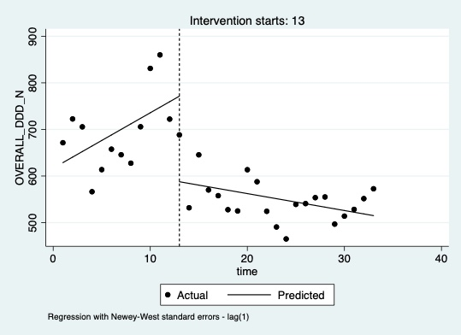

Figure 6: Interrupted-time series analysis of overall antibiotic consumption measured in DDD*1000 PDs

Days of antibiotic Therapy (all classes, ATC J01)
As shown in the results’ table (Table 8), the starting level of monthly overall antibiotic consumption measured in DOTs was estimated at 798 DOTs*1000PDs. Overall monthly DOTs*1000 PDs was slightly and non-significantly decreasing prior to the intervention (-0.31 DOTs*1000PDs; P > 0.05). In the first month of the intervention (June 2018), there appeared to be a significant decrease in monthly DOTs*1000 PDs of 162.23 (P < 0.001), followed by a non-significant decrease in the monthly consumption (relative to the preintervention trend) of 3.04 monthly DOTs*1000PDs. Data also showed, from the estimate produced by the post-trend analysis, that after the intervention, DOTs*1000PDs continued decreasing monthly at a rate of 3.36 DOTs*1000PDs (P= 0.03). Figure 7 provides a visual display of these results.

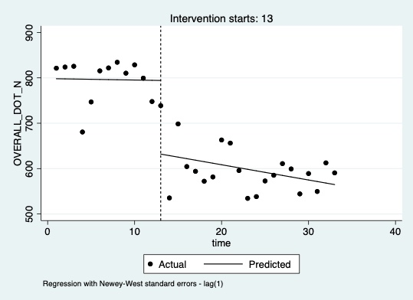

Figure 7: Interrupted-time series analysis of overall antibiotic consumption measured in DOTs*1000 PDs

Antibiotic Free Days
As shown in the results’ table (Table 8), the starting level of monthly AFD before the intervention phase was estimated at 401 AFDs*1000PDs. Overall monthly AFDs were slightly, but non-significantly, increasing before the intervention phase (5.62 AFDs*1000PDs per month). In the first month of the intervention (June 2018), there appeared to be a non-significant increase in monthly AFDs*1000 PDs of 30.77, followed by a non-significant decrease (relative to the preintervention trend) of 1.74 monthly AFDs*1000PDs. However, from the estimate produced by the post-trend analysis, data showed that monthly AFDs*1000PDs started increasing significantly at a rate of 3.87 AFDs*1000PDs (P= 0.01). Figure 8 provides a visual display of these results.

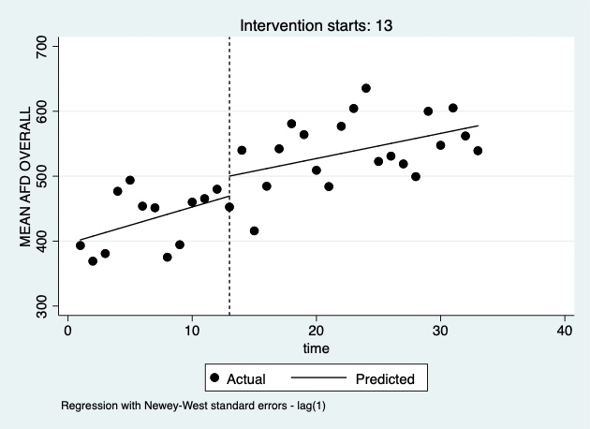

Figure 8: Interrupted-time series analysis of overall antibiotic-free days

Defined Daily Doses of Carbapenems
As shown in the results’ table (Table 8), the starting level of monthly carbapenem consumption measured in DDDs*1000PDs before the intervention phase was estimated at 64.68. Before the intervention, monthly consumption was slightly, but non-significantly, decreasing (-1.36 DDDs*1000PDs). In the first month of the intervention (June 2018), there appeared to be a decisive, although non-statistically significant, change in the level of consumption (-16.75 DDDs*1000 PDs), followed by a non-significant increase (relative to the preintervention trend) of 1.36 monthly DDDs*1000PDs. The estimate produced by the post-trend analysis showed that monthly DDDs*1000PDs remained practically stable (0.001 DDDs*1000PDs; P>0.05). Figure 9 provides a visual display of these results.

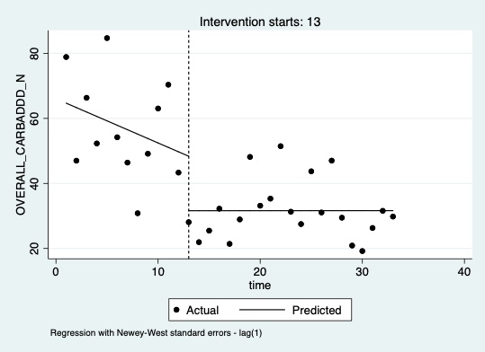

Figure 9: Interrupted-time series analysis of carbapenem consumption measured in DDD*1000 PDs

Days of carbapenem therapy
As shown in the results’ table (Table 8), the starting level of monthly days of treatment with carbapenems before the intervention phase was estimated at 87.82 DOTs*1000PDs. Before the intervention, monthly consumption was slightly, but non-significantly, decreasing (-1.87 DOTs*1000PDs). In the first month of the intervention (June 2018), there appeared to be a significant decrease in the level of monthly usage (-23.1 DOTs*1000 PDs; P=0.03), followed by a non-significant increase (relative to the preintervention trend) of 1.83 monthly DOTs*1000PDs. The estimate produced by the post-trend analysis showed that monthly DOTs*1000PDs for carbapenems remained practically stable (-0.04 DOTs*1000PDs; P>0.05). Figure 10 provides a visual display of these results.

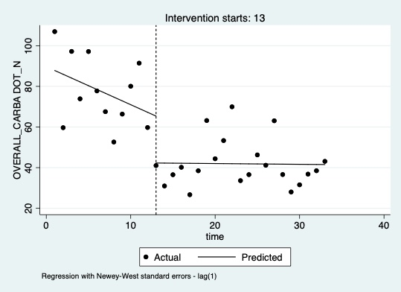

Figure 10: Interrupted-time series analysis of carbapenem consumption measured in DOTs*1000 PDs

Defined Daily Doses of Fluoroquinolones
As summarised in the results’ table (Table 8), the starting level of monthly fluoroquinolones consumption measured in DDDs*1000PDs was estimated at 115. Before the intervention, monthly consumption was slightly, but non-significantly, decreasing (-2.41 DDDs*1000PDs). In the first month of the intervention (June 2018), there appeared to be a significant decrease in monthly consumption (-29.96 DDDs*1000 PDs; P=0.02), followed by a non-significant slight decrease (relative to the preintervention trend) of 0.23 monthly DDDs*1000PDs. The estimate produced by the post-trend analysis showed that monthly consumption of fluoroquinolones kept significantly decreasing at a rate of 2.64 DDDs*1000 PDs P < 0.001). Figure 11 provides a visual display of these results.

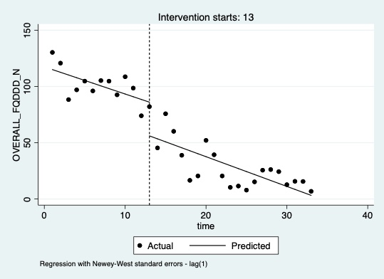

Figure 11: Interrupted-time series analysis of fluoroquinolone consumption measured in DDDs*1000 PDs

Days of fluoroquinolone therapy
As summarised in the results’ table (Table 8), the starting level of monthly days of treatment with fluoroquinolones before the intervention phase was estimated at 99.3 DOTs*1000PDs. Before the intervention, monthly consumption was slightly, but non-significantly, decreasing (-0.61 DOTs*1000PDs). In the first month of the intervention (June 2018), there appeared to be a significant decrease in monthly usage (-35.48 DOTs*1000 PDs; P=0.003), followed by a significant decrease (relative to the preintervention trend) of 2.09 monthly DOTs*1000PDs. (P= 0.016) The estimate produced by the post-trend analysis showed that monthly DOTs*1000PDs for fluoroquinolones kept decreasing significantly at a rate of 2.7 DOTs*1000PDs; P=0.0001). Figure 12 provides a visual display of these results.

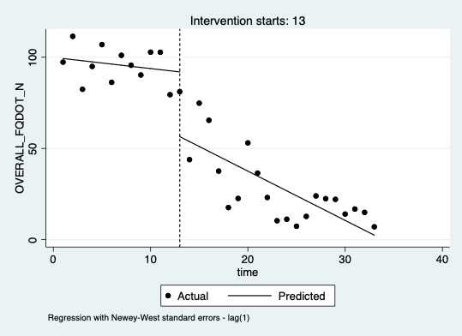

Figure 12: Interrupted-time series analysis of fluoroquinolone consumption measured in DOTs*1000 PDs

Clinical and microbiological outcomes
Clinical and microbiological outcomes were analyzed across the included wards through an ITS analysis comparing the pre-intervention to the post-intervention phase. The Follow-up phase for those outcomes was also truncated at nine months due to the SARS-CoV2 pandemic.
Results of the ITS analysis relative to the clinical and microbiological data are summarized in Table 9.

Table 9: Defining parameters of the interrupted time series analysis of clinical and microbiological outcomes

 | Starting level | Pre-intervention slope | Change in level | Change in slope | Post-intervention slope
C. difficile  *1000PDs | 0.44 | 0.06 | -0.70 | -0.06 | -0.001
95% CI | -0.20,1.07 | -.08, 0.19 | -1.95, 0.55 | -0.19, 0.08 | -0.02, 0.02
P value | NA | 0.400 | 0.263 | 0.402 | 0.9240
CRE BSI  *1000PDs | 0.27 | 0.02 | -0.10 | -0.02 | -0.002
95% CI | 0.03, 0.51 | -0.01, 0.06 | -0.45, 0.24 | -0.07,0.02 | -0.02, 0.02
P value | NA | 0.225 | 0.552 | 0.248 | 0.7764
Deaths*100 admissions | 11.07 | 0.33 | -3.71 | -0.26 | 0.06
95% CI | 10.45, 11.69 | 0.19, 0.46 | -5.96, -1.47 | -0.46, -0.06 | -0.09, 0.22
P value | NA | 0.000 | 0.002 | 0.012 | 0.4108
Mean LOS | 9.46 | 0.19 | -1.72 | -0.17 | 0.01
95% CI | 8.81, 10.09 | 0.10, 0.27 | -2.37 -1.08 | -0.27, -0.08 | -0.0273 0.0538
P value | NA | 0.000 | 0.000 | 0.001 | 0.5093

Incidence of Clostridium difficile infections
As summarised in Table 9, the starting level of C. difficile incidence before the intervention phase was estimated at 0.44*1000PDs. Before the intervention, the monthly incidence was non-significantly increasing (0.06*1000PDs). In the first month of the intervention (June 2018), there appeared to be a non-significant decrease in monthly incidence (-0.70*1000 PDs), followed by a non-significant decrease (relative to the preintervention trend) of 0.06 monthly cases*1000PDs. The estimate produced by the post-trend analysis showed that monthly C. difficile cases *1000PDs remained approximately stable during the whole post-intervention phase (-0.001 cases*1000PDs; P>0.05). Figure 13 provides a visual display of these results.

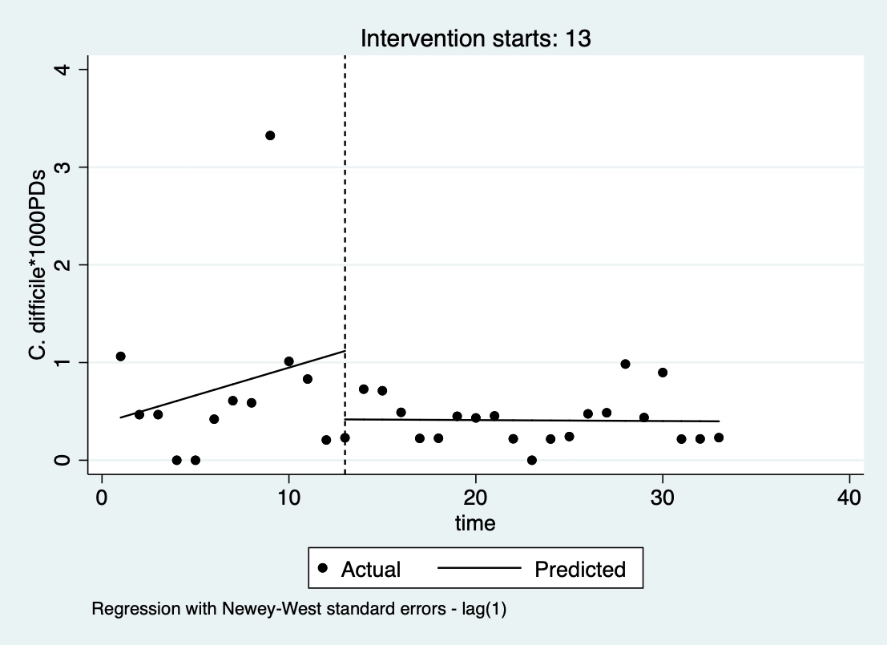

Figure 13: Interrupted-time series analysis of the monthly incidence of Clostridium difficile infections

Incidence of Carbapenem-resistant Enterobacteriaceae bloodstream infections
As summarised in Table 9, the starting level of CRE-BSIs before the intervention phase was estimated at 0.27 cases*1000PDs. Before the intervention, the monthly incidence was non-significantly increasing (0.02*1000PDs). In the first month of the intervention (June 2018), there appeared to be a non-significant decrease in monthly incidence (-0.10*1000 PDs), followed by a non-significant decrease (relative to the preintervention trend) of 0.02 monthly cases*1000PDs. The estimate produced by the post-trend analysis showed that monthly CRE-BSIs cases *1000PDs remained approximately stable during the whole post-intervention phase (-0.002 cases*1000PDs; P>0.05). Figure 14 provides a visual display of these results.

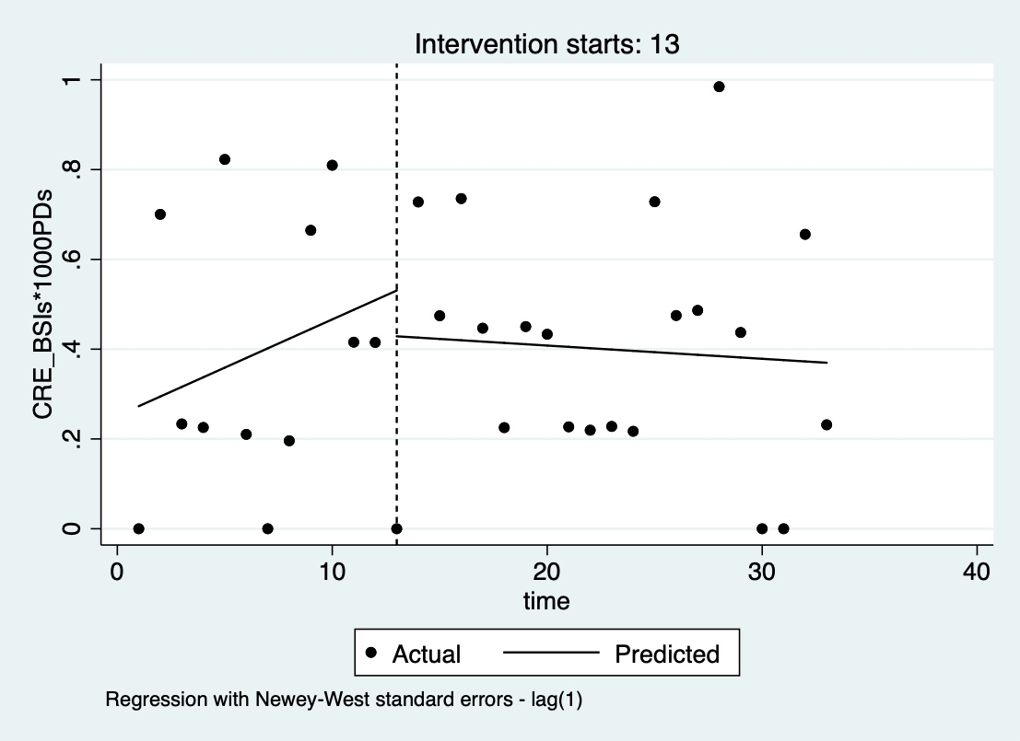

Figure 14: Interrupted-time series analysis of the monthly incidence of carbapenem-resistant Klebsiella pneumoniae bloodstream infections

Mortality rates
As summarised in the results’ table 9, the starting level of the mortality rate before the intervention phase was estimated at 11 deaths*100 admissions. Before the intervention, the mortality rate was significantly increasing (0.33*100admissions). In the first month of the intervention (June 2018), there appeared to be a significant decrease in the monthly mortality rate (-3.71*100 admissions; P=0.002), followed by a significant decrease (relative to the preintervention trend) of 0.26 deaths per 100 admissions. The estimate produced by the post-trend analysis showed that mortality kept increasing at a slower, non-significant rate of 0.06 deaths*100 admissions. Figure 15 provides a visual display of these results.

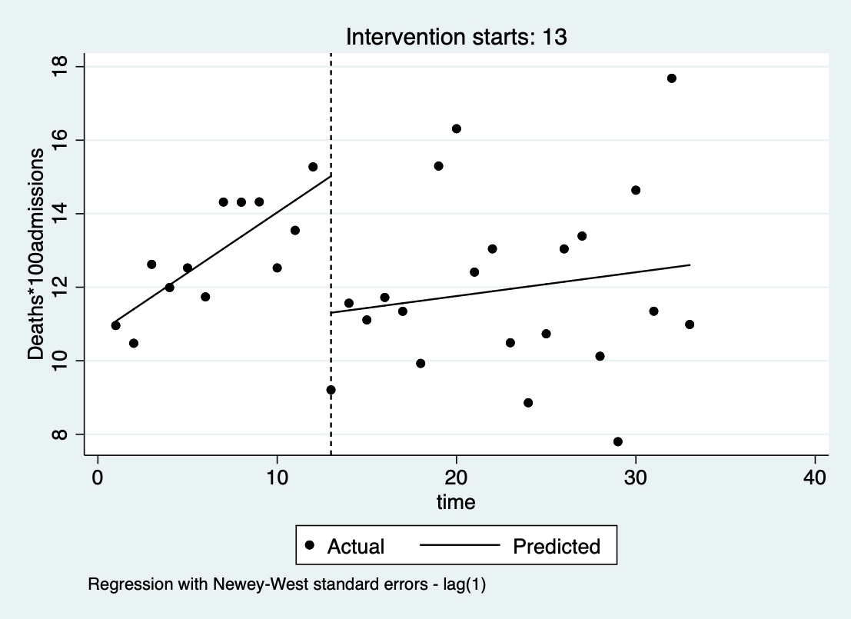

Figure 15: Interrupted-time series analysis of monthly deaths*100 admissions

Length of hospital stay
As summarised in the results’ table 9, the starting level of mean monthly LOS before the intervention phase was estimated at 9.46 days. Before the intervention, the mean monthly LOS was slightly but significantly increasing (0.19 days). In the first month of the intervention (June 2018), there appeared to be a significant decrease in monthly mean LOS (-1.72 days; P<0.001), followed by a significant monthly decrease (relative to the preintervention trend) of 0.17 days. The estimate produced by the post-trend analysis showed that monthly mean LOS remained approximately stable during the whole post-intervention period (+0.01 days; P=0.5). Figure 16 provides a visual display of these results.

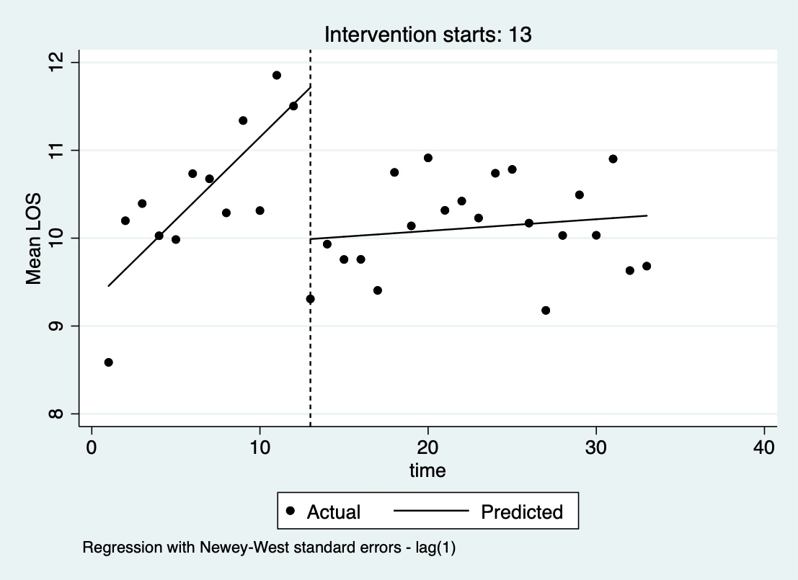

Figure 16: Interrupted-time series analysis of monthly mean length of hospital stay

DISCUSSION

The SAVE project is an educational, quality improvement intervention aimed at reducing antibiotic overuse in a large tertiary care hospital in Northern Italy. The intervention started in April 2018 with the objective of involving the whole medical and surgical areas over a three-year period. So far, four internal medicine departments have completed the long-term follow-up, and the AS intervention has proven to be associated with a sustained reduction in antibiotic consumption, mortality, and length of hospital stay in those wards.
The SAVE intervention was designed as a quality improvement project, to optimize prescribing behaviors of medical doctors practicing in the intervention wards. The program was modeled with the initial involvement of experts in behavioral sciences. It encompassed an assessment phase (questionnaire and real-world observation) and an intervention phase where customized educational initiatives were carried out to enable more appropriate antibiotic prescribing within an active participatory framework. Although educational activities were the core of the intervention, other elements were necessary to enhance the program’s chances for success: the program’s endorsement by the hospital leadership, the release of CME-accredited certifications, the official recognition of the guidance documents by the Quality Improvement Department, the assignation of hospital-budget-points to participating wards.
One of the project's main strengths is the flexibility of the intervention itself, which allowed to organize many activities (consultations, audit and feedback) respecting each wards’ needs and promoting a broad adherence and motivation among the staff. The assessment phase allowed the AS team to better understand each ward's reality and focus on intervention targets. The initial questionnaire highlighted how both residents and senior physicians were scarcely aware of how critical was the local situation in respect of AMR rates and the level of antibiotic consumption. The following observation period also revealed how often prescribers were unaware of the significant influence that weekends or the fear of unexpected complications had in prolonging treatment duration unnecessarily. The Infectious Disease specialist's prolonged presence in the ward prompted more frequent discussion over antibiotic treatment and raised awareness of hospital-acquired infections among the whole healthcare personnel. In this context, antibiotic re-evaluation, culture collection before starting antibiotics, and adherence to IPC procedures became gradually part of the clinical routine.
Management of uncertainties, especially in frail patients, the fear of complications due to antibiotic withholding, difficulties in changing personal or local prescribing trends were all aspects of prescribing that were addressed during clinical cases discussion and plenary educational activities. Additionally, ward doctors were free to ask for written consultations if they wanted to share decision-making responsibilities with the Infectious Disease specialist. A restrictive policy, requiring post-authorization approval for some molecules, was already in place before the intervention started. Thus, the AS team activities were never perceived as a limitation to the prescribers’ autonomy. Ward doctors were always free to decide whether or not to discuss antibiotic prescriptions with the AS team.
Among the IPC observations, poor hand hygiene adherence and appropriate blood culture collection techniques were common traits to all four departments. Educational activities aimed at improving those aspects were organized, targeting both medical and nursing staff.
The audit and feedback phase aimed to maintain the intervention in place without the AS team's daily presence in the ward. Results from this phase showed a general improvement of prescriptions’ appropriateness. The significant number of revised prescriptions allowed the AS team to capture the most relevant causes of error (i.e., lack of written indication, excessive duration, and choice of an inappropriate molecule) and provide the wards with feedback for improvement.
Although improving the appropriateness of antibiotic prescription is the main target of every AS intervention, other outcomes, such as antibiotic consumption, are generally selected because they are easier to measure and more objectifiable.
Following the main guidance on the topic (14), antibiotic consumption before and after the intervention was recorded using at least two units of measures (DDD and DOTs). Antibiotic-free days were also employed to capture the number of days during which patients were not receiving any antibiotics. Being computed as the inverse of LOTs (length-of-treatment), AFDs have the added value of not being influenced by combination therapy (i.e., a patient receiving two antibiotics in one day counts as 2 DOTs, but only 1 LOT).
All the consumption measures showed a convincing and significant reduction from the pre to the post-intervention phase.
By only looking at the data trend, the mean monthly consumption of antibiotics started from approximately 700 DDDs*1000 PDs and decreased to mean monthly consumption of approximately 500 DDDs*1000PDs. The ECDC Network (ESAC-Net), the American NHSN, or other federal databases (49) collect systematic antibiotic consumption data, but are difficult to benchmark with our data because they use different data sources, unit of measures, and lack of stratification per ward type (i.e., DDD*1000 inhabitants vs. PDs, electronic prescriptions vs. sales data). The most comprehensive data available for benchmarking is from a 2016 systematic review on antibiotic consumption where a mean value of 677 DDDs*1000 PDs (95%CI 634-720) was recorded across the internal medicine wards, with a very high between-study variance (I2 99%) (50). This value was computed mainly from studies conducted in the first decade of 2000 and is in line with the pre-intervention values of the Verona University hospital. No databases or other literature data were found to define the ‘ideal consumption’ of a general medicine ward that could be set as a goal for AS in this setting. (14).
Another attractive measure reflecting overall antibiotic consumption is the mean average of patients on antibiotic treatment. This measure was derived from the AFDs and decreased from 60% of patients receiving antibiotics to approximately 45%, in line with the data collected during the audit and feedback period. Like other consumption measures, the prevalence of patients receiving antibiotic treatment can be hard to benchmark when referring to a specific ward type. Patients’ case mix, seasonality, and ward size are all factors that can contribute to substantial fluctuation regarding this measure.
When considering specific classes, the above mentioned systematic review reported a mean consumption of 16 DDD*1000 PDs (95% CI 13, 19) for carbapenems with a 99.5% between-study variance (50). Although no more recent data were found to appropriately benchmark carbapenem consumption, it is undeniable that a pre-intervention average monthly consumption well-above 50 DDDs*1000 PDs was remarkably high for this ward type. The SAVE intervention was significantly associated with a decisive change in the level of consumption measured either in DDDs or DOTs. The mean average of monthly carbapenem consumption in the post-intervention phase fell at approximately 35 DDDs*1000 PDs. The post-intervention phase showed a stable/slightly increasing trend in carbapenem consumption, probably reflective of the clinical burden of ESBLs’ infection in patients hospitalized in those wards. Conversely, fluoroquinolones consumption showed a decisive and sustained decrease over the whole period.
Subgroup analysis was potentially available for all antibiotic classes, and additional stratifications were made for internal purposes. According to the WHO AWARE classification, post-stratification analysis by antibiotic classes showed a promising shift towards increased use of the ‘access’ compared to the ‘watch’ category. Those additional analyses are not discussed in this work since they were not initially planned. The choice of target antibiotic classes and microbiological outcomes reflected what is required by the national plan for contrasting antimicrobial resistance. (13)
The effect of AS intervention in reducing the length of hospital stay and mortality is in line with the most recent evidence from the literature (21, 40), although the positive effect on mortality has been demonstrated less frequently by available studies on the topic. (21)
Consistently with literature data, the effect on microbiological outcomes remains more challenging to demonstrate. Several reviews on the topic have shown how often inadequate outcome measures or inappropriate study design are biased towards detecting unrealistic positive effects on microbiological outcomes. (6, 51)
The ITS analysis was adopted to analyze the intervention effect following several expert recommendations, mainly thanks to its ability to control for seasonality and pre-existing temporal trends. According to those recommendations, at least 10 points over one year for each intervention phase are needed to control for seasonality (a relevant parameter when considering antibiotic consumption). Additionally, at least 100 observations per data point should be available to ensure the model stability (45, 52). According to the data recorded during the SAVE intervention, ITS models were adequately fit to capture changes in antibiotic consumption, but probably not always adequate when analyzing rare events, such as mortality or MDR infections.
With the limit of those observations, the SAVE intervention was associated with a non-significant reduction in C. difficile and CRE bacteremias. In some recently published studies, the inclusion of a greater number of observations, clustered over wider areas (i.e., the whole hospital) or more extended periods (i.e., quarters), has allowed to build adequately fit time-series models and to capture positive effects of AS also with rare microbiological outcomes such as CRE bacteremias. (53, 54)
Although the SAVE intervention is strongly and plausibly associated with a reduction in antibiotic consumption, the inclusion of a control group could have strengthened the validity of this assumption. A non-intervention arm could have ruled out other confounders potentially influencing antibiotic consumption (other educational initiatives, historical trends, change of patient-mix, or national policies). However, the SAVE project was implemented as a quality improvement intervention, where similar wards with high antibiotic consumptions were prioritized together for receiving the intervention earlier. This organizational structure was chosen to increase the intervention efficacy in the first phase and maximize team efforts while preparing guidance documents and educational activities. In this context, selecting a similar ward to be ‘spared’ from the intervention to work as a control group was considered unfeasible.
The SAVE intervention was conceived as a multifaceted intervention. Since the beginning of the project, the infection control team's active participation was foreseen to maximize its educational impact. Thus, several activities targeted both AS and IPC aspects at the same time. As it often happens during AS interventions, the potential contribution of improved IPC adherence to reducing C. difficile infection and CRE bacteremias cannot be disentangled by the potential impact of improved antibiotic use.
The original analysis plan included an additional 12 months of follow-up after the intervention stopped. Still, the Departments’ reorganization and the significant variation in patients’ case-mix due to the SARS-CoV2 pandemic made results relative to antibiotic consumption and other clinical and microbiological outcomes scarcely comparable with the previous months. Thus, the final analysis was truncated at 21 months follow-up after the intervention.

CONCLUSIONS

In conclusion, the SAVE intervention was associated with a sustained and positive long-term effect on antibiotic consumption, all-cause mortality, and length of hospital stay in four medical departments from 2017 to 2020. Results from additional wards that still did not complete the follow-up phase might extend the intervention's generalisability to other areas and allow detection of a more substantial effect on microbiological outcomes.

ACKNOWLEDGMENTS

In a context of growing uncertainties and complex clinical decision-making, I wish that this work would be regarded as a small but clear example of how much can be achieved through active participation and multidisciplinary collaboration.
For this reason, I am indebted to the whole SAVE team for their essential contribution to this project. This work would not have been possible without the efforts of every single component of the team.
My biggest thanks go to Professor Evelina Tacconelli for her constant presence, her scientific advice and her passionate engagement in every step of the project.
I am particularly grateful also to Doctor Marcella Sibani for having shared the daily efforts over the last three years. Thank you for being a knowledgeable listener, and for continuously contributing to our list of ‘unanswered questions’.
I thank Doctor Lorenzo Barbato for his kind and professional support to the project, for his unreplaceable help in extracting, elaborating, and interpreting the data on antimicrobial consumption.
I thank the Directors of the first group of intervention wards, Professor Oliviero Olivieri, Professor Pietro Minuz, Professor Mauro Zamboni, and Doctor Vincenzo di Francesco for having supported our work thoroughly. I also thank the whole medical and nursing staff for the active and enthusiastic contribution.
Special thanks should go to Doctor Andrea Dalbeni, Doctor Giorgia Fontana, and Doctor Luca Pelizzari for having been the best example of active participation and commitment. The SAVE project has walked a long way since our first encounter, but those initial steps have been essential to set the right pace.

Finally, heartfelt thanks go to my family in my hometown and in Verona, to all my friends and colleagues in Italy, Europe and Israel. Thank you for always walking beside me, regardless of how far we have gone and the directions we have taken.

REFERENCES

1. Antimicrobial resistance: Global report on surveillance. Geneva: World Health Organization; 2014.
2. Teillant A, Gandra S, Barter D, Morgan DJ, Laxminarayan R. Potential burden of antibiotic resistance on surgery and cancer chemotherapy antibiotic prophylaxis in the USA: a literature review and modelling study. The Lancet Infectious diseases. 2015;15(12):1429-37.
3. Cassini A, Högberg LD, Plachouras D, Quattrocchi A, Hoxha A, Simonsen GS, et al. Attributable deaths and disability-adjusted life-years caused by infections with antibiotic-resistant bacteria in the EU and the European Economic Area in 2015: a population-level modelling analysis. The Lancet Infectious diseases. 2019;19(1):56-66.
4. ECDC. Antimicrobial resistance surveillance in Europe 2014. Annual Report of the European Antimicrobial Resistance Surveillance Network (EARS-Net). Stockholm: European Centre for Disease Prevention and Control; 2015.
5. ECDC. Antimicrobial resistance surveillance in Europe 2016. Annual Report of the European Antimicrobial Resistance Surveillance Network (EARS-Net). 2017.
6. Carrara EC, M.; Meschiari, M.; Mussini, C.;. The role of antimicrobial stewardship in preventing KPC-producing Klebsiella pneumoniae. . J Antimicrob Chemother. 2021;76.
7. Plachouras D, Kärki T, Hansen S, Hopkins S, Lyytikäinen O, Moro ML, et al. Antimicrobial use in European acute care hospitals: results from the second point prevalence survey (PPS) of healthcare-associated infections and antimicrobial use, 2016 to 2017. Euro Surveill. 2018;23(46):1800393.
8. WHO. Global action plan on antimicrobial resistance. . Geneva: World Health Organization; 2015 May 2015. Contract No.: (document WHA68/2015/REC/1, Annex 3.)
9. A European One Health action plan against antimicrobial resistance (AMR). European Commission; 2017.
10. Dellit TH, Owens RC, McGowan JE, Jr., Gerding DN, Weinstein RA, Burke JP, et al. Infectious Diseases Society of America and the Society for Healthcare Epidemiology of America guidelines for developing an institutional program to enhance antimicrobial stewardship. Clin Infect Dis. 2007;44(2):159-77.
11. Barlam TF, Cosgrove SE, Abbo LM, MacDougall C, Schuetz AN, Septimus EJ, et al. Implementing an Antibiotic Stewardship Program: Guidelines by the Infectious Diseases Society of America and the Society for Healthcare Epidemiology of America. Clin Infect Dis. 2016;62(10):e51-e77.
12. Antimicrobial stewardship programmes in health-care facilities in low-and middle-income countries: a WHO practical toolkit. World Health Organization; 2019. Report No.: 9241515481.
13. Piano Nazionale di Contrasto dell’Antimicrobico-Resistenza (PNCAR) 2017-2020. Ministero della Salute; 2017.
14. Pezzani MD, Carrara E, Sibani M, Presterl E, Gastmeier P, Renk H, et al. White Paper: Bridging the gap between human and animal surveillance data, antibiotic policy and stewardship in the hospital sector-practical guidance from the JPIAMR ARCH and COMBACTE-MAGNET EPI-Net networks. J Antimicrob Chemother. 2020;75(Supplement_2):ii20-ii32.
15. van Esch TE, Brabers AE, Hek K, van Dijk L, Verheij RA, de Jong JD. Does shared decision-making reduce antibiotic prescribing in primary care? Journal of Antimicrobial Chemotherapy. 2018;73(11):3199-205.
16. Charani E, Tarrant C, Moorthy K, Sevdalis N, Brennan L, Holmes A. Understanding antibiotic decision making in surgery—a qualitative analysis. Clinical Microbiology and Infection. 2017;23(10):752-60.
17. Parker HM, Mattick K. The determinants of antimicrobial prescribing among hospital doctors in England: a framework to inform tailored stewardship interventions. British journal of clinical pharmacology. 2016;82(2):431-40.
18. Chambers A, MacFarlane S, Zvonar R, Evans G, Moore JE, Langford BJ, et al. A recipe for antimicrobial stewardship success: Using intervention mapping to develop a program to reduce antibiotic overuse in long-term care. Infection Control & Hospital Epidemiology. 2019;40(1):24-31.
19. Lorencatto F, Charani E, Sevdalis N, Tarrant C, Davey P. Driving sustainable change in antimicrobial prescribing practice: how can social and behavioural sciences help? Journal of Antimicrobial Chemotherapy. 2018;73(10):2613-24.
20. Michie S, Atkins L, West R. The behaviour change wheel. A guide to designing interventions 1st ed Great Britain: Silverback Publishing. 2014:1003-10.
21. Davey P, Marwick CA, Scott CL, Charani E, McNeil K, Brown E, et al. Interventions to improve antibiotic prescribing practices for hospital inpatients. Cochrane Database Syst Rev. 2017;2(2):Cd003543.
22. Davey P, Sneddon J, Nathwani D. Overview of strategies for overcoming the challenge of antimicrobial resistance. Expert Rev Clin Pharmacol. 2010;3(5):667-86.
23. Rosenstock IM. Historical origins of the health belief model. Health education monographs. 1974;2(4):328-35.
24. van Buul LW, Sikkens JJ, van Agtmael MA, Kramer MH, van der Steen JT, Hertogh CM. Participatory action research in antimicrobial stewardship: a novel approach to improving antimicrobial prescribing in hospitals and long-term care facilities. Journal of Antimicrobial Chemotherapy. 2014;69(7):1734-41.
25. Sikkens JJ, Van Agtmael MA, Peters EJ, Lettinga KD, Van Der Kuip M, Vandenbroucke-Grauls CM, et al. Behavioral approach to appropriate antimicrobial prescribing in hospitals: the Dutch Unique Method for Antimicrobial Stewardship (DUMAS) participatory intervention study. JAMA internal medicine. 2017;177(8):1130-8.
26. Stålsby Lundborg C, Tamhankar AJ. Understanding and changing human behaviour—antibiotic mainstreaming as an approach to facilitate modification of provider and consumer behaviour. Upsala journal of medical sciences. 2014;119(2):125-33.
27. Foral PA, Anthone JM, Destache CJ, Vivekanandan R, Preheim LC, Gorby GL, et al. Education and communication in an interprofessional antimicrobial stewardship program. J Am Osteopath Assoc. 2016;116(9):588-93.
28. Rawlins MD, Sanfilippo FM, Ingram PR, McLellan DG, Crawford C, D’Orsogna L, et al. Optimizing adherence to advice from antimicrobial stewardship audit and feedback rounds. Journal of Chemotherapy. 2018;30(1):59-62.
29. Oppong R, Smith RD, Little P, Verheij T, Butler CC, Goossens H, et al. Cost-effectiveness of internet-based training for primary care clinicians on antibiotic prescribing for acute respiratory tract infections in Europe. Journal of Antimicrobial Chemotherapy. 2018;73(11):3189-98.
30. Donisi V, Sibani M, Carrara E, Del Piccolo L, Rimondini M, Mazzaferri F, et al. Emotional, cognitive and social factors of antimicrobial prescribing: can antimicrobial stewardship intervention be effective without addressing psycho-social factors? J Antimicrob Chemother. 2019;74(10):2844-7.
31. Monnier AA, Schouten J, Le Maréchal M, Tebano G, Pulcini C, Stanic Benic M, et al. Quality indicators for responsible antibiotic use in the inpatient setting: a systematic review followed by an international multidisciplinary consensus procedure. J Antimicrob Chemother. 2018;73(suppl_6):vi30-vi9.
32. Methodology WCCfMS. ATC classification index with DDDs and Guidelines for ATC classification and DDD assignment. . Oslo, Norway: Norwegian Institute of Public Health.: World Health Organization: ; 2006.
33. The 2019 WHO AWaRe classification of antibiotics for evaluation and monitoring of use. . Geneva: World Health Organization; 2019, (WHO/EMP/IAU/2019.11). World Health Organization: ; 2019.
34. Budd E, Cramp E, Sharland M, Hand K, Howard P, Wilson P, et al. Adaptation of the WHO Essential Medicines List for national antibiotic stewardship policy in England: being AWaRe. J Antimicrob Chemother. 2019;74(11):3384-9.
35. Stanic Benic M, Milanic R, Monnier AA, Gyssens IC, Adriaenssens N, Versporten A, et al. Metrics for quantifying antibiotic use in the hospital setting: results from a systematic review and international multidisciplinary consensus procedure. J Antimicrob Chemother. 2018;73(suppl_6):vi50-vi8.
36. Baur D, Gladstone BP, Burkert F, Carrara E, Foschi F, Dobele S, et al. Effect of antibiotic stewardship on the incidence of infection and colonisation with antibiotic-resistant bacteria and Clostridium difficile infection: a systematic review and meta-analysis. The Lancet Infectious diseases. 2017;17(9):990-1001.
37. Karanika S, Paudel S, Grigoras C, Kalbasi A, Mylonakis E. Systematic Review and Meta-analysis of Clinical and Economic Outcomes from the Implementation of Hospital-Based Antimicrobial Stewardship Programs. Antimicrob Agents Chemother. 2016;60(8):4840-52.
38. Teerawattanapong N, Kengkla K, Dilokthornsakul P, Saokaew S, Apisarnthanarak A, Chaiyakunapruk N. Prevention and Control of Multidrug-Resistant Gram-Negative Bacteria in Adult Intensive Care Units: A Systematic Review and Network Meta-analysis. Clin Infect Dis. 2017;64(suppl_2):S51-s60.
39. Feazel LM, Malhotra A, Perencevich EN, Kaboli P, Diekema DJ, Schweizer ML. Effect of antibiotic stewardship programmes on Clostridium difficile incidence: a systematic review and meta-analysis. J Antimicrob Chemother. 2014;69(7):1748-54.
40. Schuts EC, Hulscher ME, Mouton JW, Verduin CM, Stuart JWC, Overdiek HW, et al. Current evidence on hospital antimicrobial stewardship objectives: a systematic review and meta-analysis. The Lancet infectious diseases. 2016;16(7):847-56.
41. Lopez-Lozano JM, Lawes T, Nebot C, Beyaert A, Bertrand X, Hocquet D, et al. A nonlinear time-series analysis approach to identify thresholds in associations between population antibiotic use and rates of resistance. Nature microbiology. 2019;4(7):1160-72.
42. ECDC. Point prevalence survey of healthcare- associated infections and antimicrobial use in European acute care hospitals. 2016.
43. Vicentini C, Quattrocolo F, D'Ambrosio A, Corcione S, Ricchizzi E, Moro ML, et al. Point prevalence data on antimicrobial usage in Italian acute-care hospitals: Evaluation and comparison of results from two national surveys (2011-2016). Infect Control Hosp Epidemiol. 2020;41(5):579-84.
44. Institute for Healthcare Improvement. Science of Improvement: How to Improve 2014 [Available from: http://www.ihi.org/resources/Pages/HowtoImprove/ScienceofImprovementHowtoImprove.aspx.
45. de Kraker MEA, Harbarth S. Chapter 20 - Methodological Challenges in Evaluating Antimicrobial Stewardship Programs: “Through Measuring to Knowledge”. In: Pulcini C, Ergönül Ö, Can F, Beović B, editors. Antimicrobial Stewardship: Academic Press; 2017. p. 341-60.
46. ATC/DDD system database [Internet]. 2019 [cited 31 Jan 2019]. Available from: https://www.whocc.no/atc_ddd_methodology/who_collaborating_centre/.
47. Pezzani MD, Mazzaferri F, Compri M, Galia L, Mutters NT, Kahlmeter G, et al. Linking antimicrobial resistance surveillance to antibiotic policy in healthcare settings: the COMBACTE-Magnet EPI-Net COACH project. J Antimicrob Chemother. 2020;75(Supplement_2):ii2-ii19.
48. Linden A. Conducting interrupted time-series analysis for single-and multiple-group comparisons. The Stata Journal. 2015;15(2):480-500.
49. Baggs J, Fridkin SK, Pollack LA, Srinivasan A, Jernigan JA. Estimating national trends in inpatient antibiotic use among US hospitals from 2006 to 2012. JAMA internal medicine. 2016;176(11):1639-48.
50. Bitterman R, Hussein K, Leibovici L, Carmeli Y, Paul M. Systematic review of antibiotic consumption in acute care hospitals. Clinical Microbiology and Infection. 2016;22(6):561. e7-. e19.
51. Stone SP, Cooper BS, Kibbler CC, Cookson BD, Roberts JA, Medley GF, et al. The ORION statement: guidelines for transparent reporting of outbreak reports and intervention studies of nosocomial infection. The Lancet Infectious diseases. 2007;7(4):282-8.
52. Schweitzer VA, van Werkhoven CH, Rodríguez Baño J, Bielicki J, Harbarth S, Hulscher M, et al. Optimizing design of research to evaluate antibiotic stewardship interventions: consensus recommendations of a multinational working group. Clin Microbiol Infect. 2020;26(1):41-50.
53. Rodriguez-Bano J, Perez-Moreno MA, Penalva G, Garnacho-Montero J, Pinto C, Salcedo I, et al. Outcomes of the PIRASOA programme, an antimicrobial stewardship programme implemented in hospitals of the Public Health System of Andalusia, Spain: an ecologic study of time-trend analysis. Clin Microbiol Infect. 2019.
54. Viale P, Tumietto F, Giannella M, Bartoletti M, Tedeschi S, Ambretti S, et al. Impact of a hospital-wide multifaceted programme for reducing carbapenem-resistant Enterobacteriaceae infections in a large teaching hospital in northern Italy. Clin Microbiol Infect. 2015;21(3):242-7.

APPENDIX

Figure A1: the SAVE survey

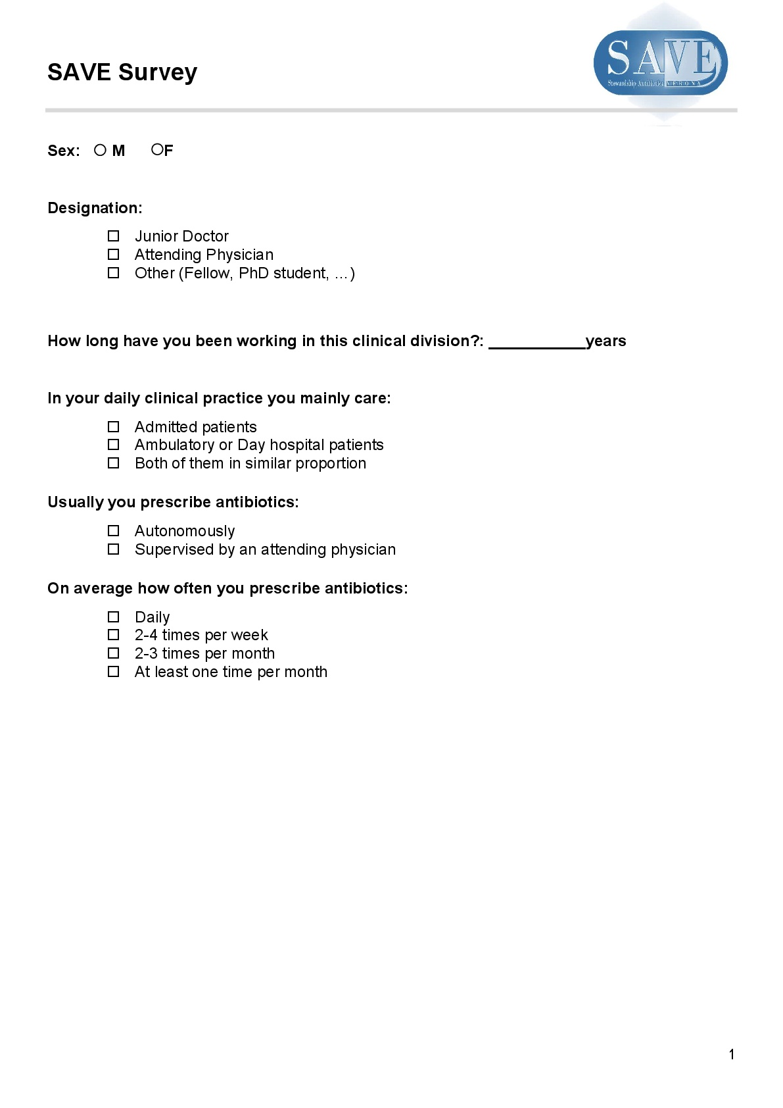

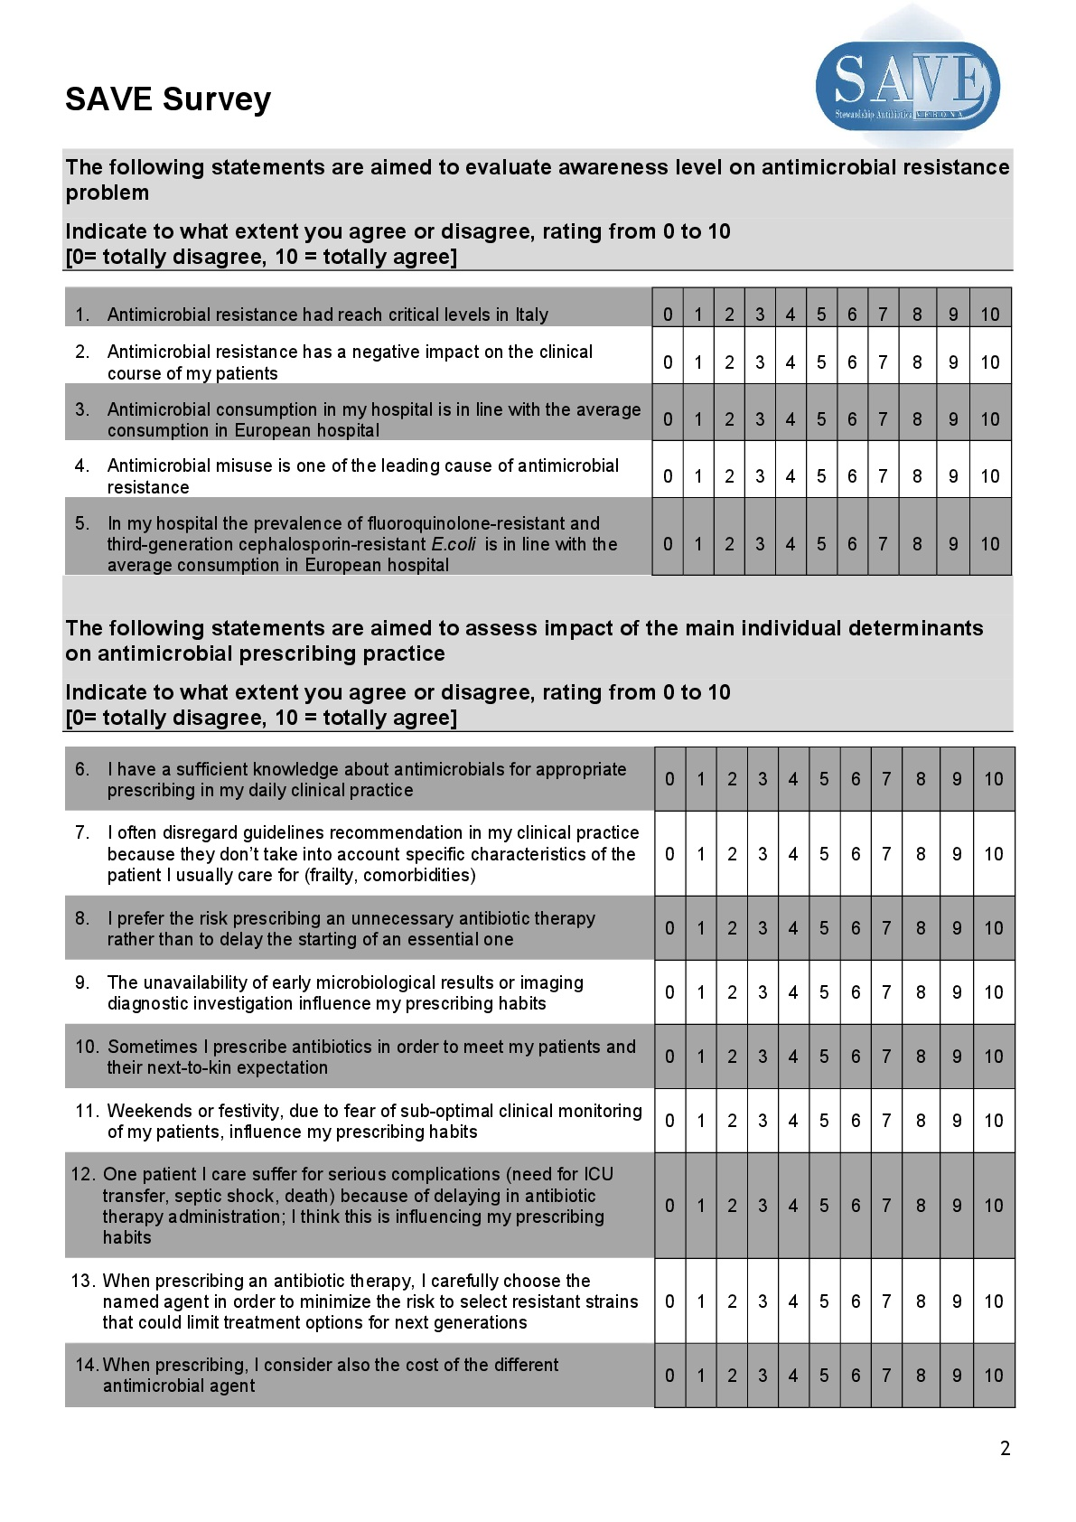

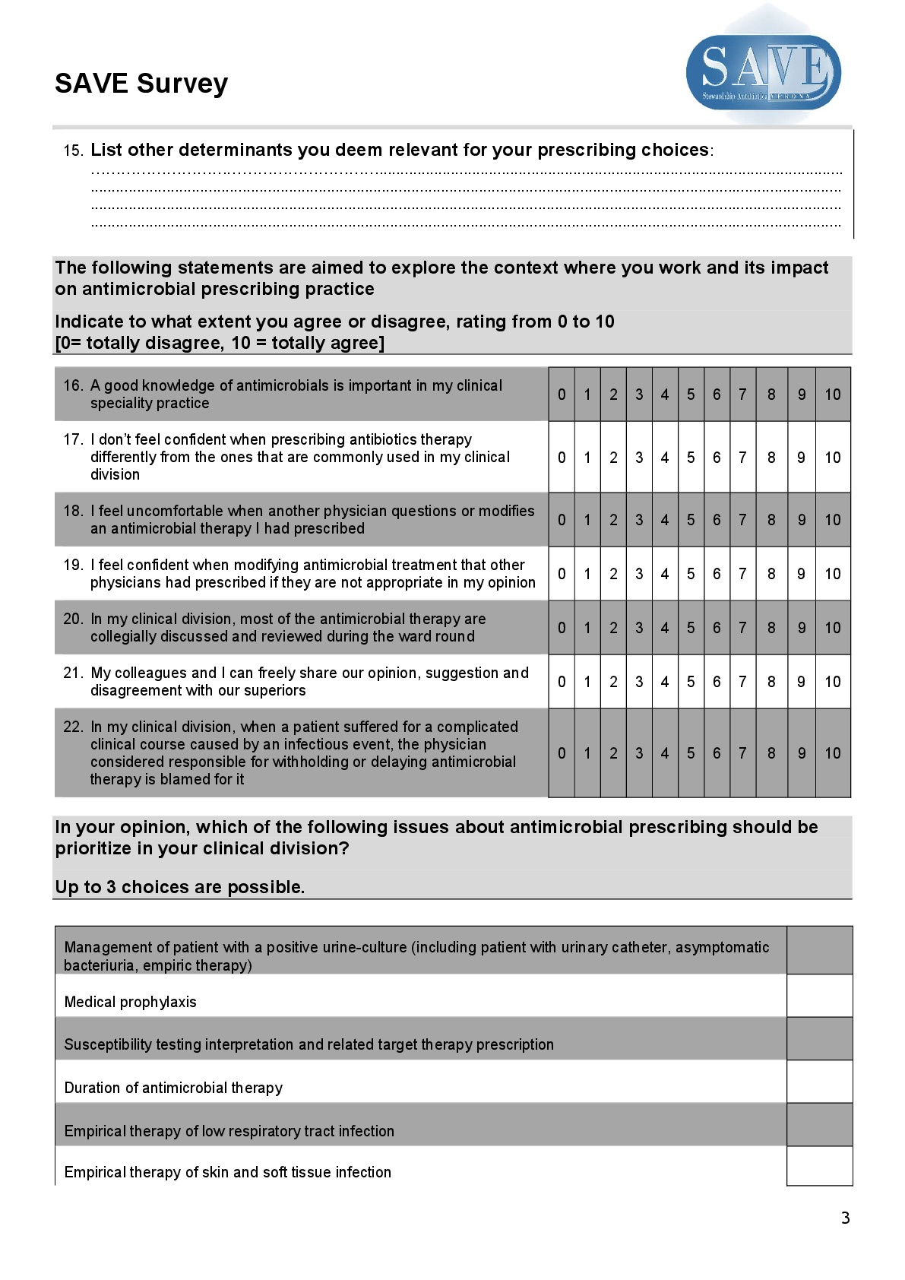

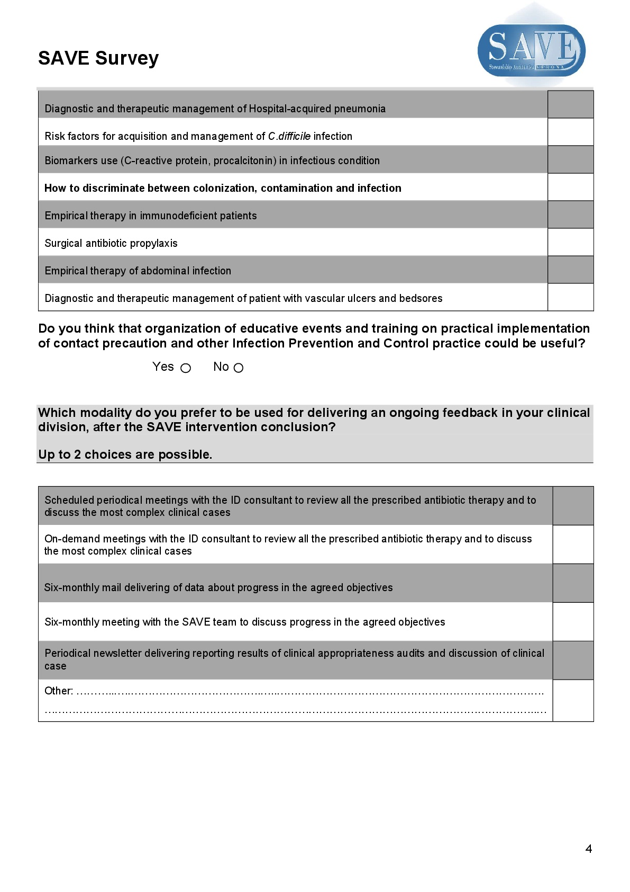

Figure A2: Audit record form
