
Politecnico di Milano
Dipartimento di Meccanica
Doctoral Program in Mechanical Engineering

NUMERICAL METHODOLOGIES FOR NOISE AND VIBRATION SOURCES ASSESSMENT IN POWERTRAIN APPLICATIONS

Doctoral Dissertation of:
Antonio Acri
Supervisor:
Prof. Roberto Corradi
Industrial Supervisors:
Ph.D. Eugene Nijman
Prof. Günter Offner
Tutor:
Prof. Stefano Manzoni
The Chair of the Doctoral Program:
Prof. Maria Bianca Colosimo

Year 2017 – XXXth Cycle

Acknowledgements

The author gratefully acknowledges the European Commission for their support with the ITN Marie Curie project No. 605867 “BATWOMAN” (Basic Acoustics Training - & Workprogram on Methodologies for Acoustics – Network).

The author acknowledges the financial support of the COMET K2 - Competence Centres for Excellent Technologies Programme of the Austrian Federal Ministry for Transport, Innovation and Technology (BMVIT), the Austrian Federal Ministry of Science, Research and Economy (BMWFW), the Austrian Research Promotion Agency (FFG), the Province of Styria and the Styrian Business Promotion Agency (SFG).

The author also gratefully acknowledges the support of Prof. Roberto Corradi and Prof. Carlo Gorla from Politecnico di Milano for the cooperation in this project.

I am grateful to have met all Indalians: away from my family they were able to let me feel home.

Un sentito ringraziamento a tutte le persone, amici e parenti che mi hanno aiutato durante il mio periodo di formazione.

Ringrazio la mia famiglia, della quale ho sentito la lontananza in questo periodo all’estero.

Dedico questa opera a mia moglie, il cui supporto mi ha concesso di affrontare le difficoltà che mi si sono presentate e di raggiungere questo traguardo.

Antonio.

List of publications

Conference papers
  - A. Acri, G. Offner, E. Nijman, “Numerical Transfer path analysis for structure-borne and air-borne problems in internal combustion engines”, in Proceedings of International Conference on Structural Engineering Dynamics ICEDyn2015, Lagos, Algarve, Portugal, 22-24 June 2015.
  - A. Acri, G. Offner, E. Nijman, J. Rejlek, “Application of numerical transfer path analysis method for noise source identification in internal combustion engines”, in Proceedings of International Conference on Structural Engineering Dynamics ICEDyn2015, Lagos, Algarve, Portugal, 22-24 June 2015.
  - A. Acri, G. Offner, E. Nijman, R. Corradi, Numerical transfer path analysis for the assessment of air-borne noise in internal combustion engines, in Proceedings of ICoEV 2015 International Conference on Engineering Vibration, 2015, p. 383-392.
  - A. Acri, P. Zsifkovits, E. Nijman, G. Offner, R. Corradi, Surface Noise Contribution Analysis in Wave Based Method framework for exterior radiation noise problems, in Proceedings of ISMA, Leuven, Belgium, Sept. 2016.
  - J. J. Tan, A. Chaigne, A. Acri, Contribution of the vibration of various piano components in the resulting piano sound, in Proceedings of the 22nd International Congress on Acoustics, 5-9 Sept 2016.

Journal papers
    - A. Acri, G. Offner, E. Nijman, J. Rejlek, Substructuring of multibody systems for numerical transfer path analysis in internal combustion engines, Mech. Syst. Signal Process. Vol. 79, 2016, pp. 254–270.
http://dx.doi.org/10.1016/j.ymssp.2016.02.034
    - A. Acri, G. Offner, T. Resch, E. Nijman, R. Corradi, Dynamic Substructuring for Sources Contributions analysis in Internal Combustion Engines, No. 2016-01-1761, SAE Technical papers, 2016.
doi:10.4271/2016-01-1761
    - Acri A., Nijman E., Acri A., Offner G., Influences of system uncertainties on the numerical transfer path analysis of engine systems, Mech. Syst. Signal Process. Vol. 95, 2017, pp. 106-121.
http://dx.doi.org/10.1016/j.ymssp.2017.03.037
    - Acri, A., Nijman, E., Klanner, M., Offner, G., & Corradi, R. (2018). On the influence of cyclic variability on surface noise contribution analysis of internal combustion engines. Applied Acoustics, 132, 97-108
https://doi.org/10.1016/j.apacoust.2017.11.012

Abstract

The Aim of this project is to define numerical methodologies for noise sources assessment, validate them and analyse their limits of validity. In this project, dynamic substructuring for Numerical Transfer Path Analysis (NTPA) and Surface Contribution Analysis (SCA) within Wave Based Method (WBM) were developed. A validation on a particular case was also performed for the NTPA method. In addition, the robustness of these methodologies was investigated. Moreover, an newly energy based method was developed: Energy Flow Contribution Analysis (EFCA). EFCA is a methodology which can be also investigated in an experimental setup. Therefore, in the last part of the project a series of experimental measurements will be held in Milano.

NTPA is based on dynamic substructuring of multi-body dynamic systems. The body under investigation is isolated and the body joint contacts replaced with contact forces. Each excitation is then treated as a separate source and its response is computed.

SCA is a methodology thought to operate within a wave based method framework. It is based on the decomposition of the boundary conditions of the acoustic radiation problem, under the assumption of the validity of the superposition principle on the boundary conditions (structural vibrations can be treated with linear models). Different surfaces of the radiating object consider different boundary conditions and with this procedure the noise radiated from each different surface is separately investigated.

EFCA is similar to NTPA analysis but it directly operates with power quantities. At the interfaces of the investigated body, the transmitted power is evaluated giving direct information of the interaction of the different noise sources. Concerning the problem of sources assessment and ranking, no experimental methodologies work with power quantities. Hence, similar analysis can be done also on real systems via direct measurements of interface transmitted power.

Finally, this projects deals also with the estimation of the robustness of the proposed methodologies. Therefore, the influence of system uncertainties is investigated. In particular the effect of cyclic cylinder variability (uncertainties on excitation input) and the uncertainties on model parameters (applying random matrix theory) are considered. In these investigations it was shown the frequency range of validity and how to correctly perform multibody dynamic analysis or acoustic radiation analysis in order to derive useful information on the source assessment and ranking.

Nomenclature

Symbols

A, B Subsystems names
$A$ WBM system matrix
$A$ Surface area
$\text{B}$ Matrix of shape function derivatives
$C$ Matrix containing information about the geometry and wave functions
$\text{D}$ Elasticity matrix
$D$ Damping matrix
$E$ Young’s modulus
$G\left(\right)$ Green’s function
$H_{0,2}\left(\right)$ Zero-order Hankel function of the second kind
$I$ Identity matrix
$I$ Moment of inertia
$\text{J}$ Jacobian matrix of transformation
$J\left(β,j\right)$ Cost function of the cross-validation method
$K$ Stiffness matrix
$L_{x}$, $L_{y}$, $L_{z}$ Smallest dimensions of the bounding box in WBM
$M$ Mass matrix
$\text{N}$ Matrix of shape functions
$P$ Active power
$T$ Transformation matrix
$V_{0}\left(β\right)$ Cross-validation function
$Y$ Complex mobility matrix
$Y_{lm}(ϑ,φ)$ Spherical harmonics
$Z$ Complex impedance matrix
${\overline{Z}}_{n}$ Normal impedance

$b$ WBM vector of known terms
$c$ Speed of sound
$d$ Damping coefficient
$f$ Excitation vector, vector of known terms
$g$ Interface forces vector
$h$ Height, gap, clearance
${\overline{h}}_{T}$ Average clearance
$h_{l}(kr)$ Spherical Hankel functions
$i$ Imaginary unit
$k$ Stiffness coefficient, wave number
$k$ Element stiffness matrix
$m$ Element mass matrix
$n$ Normal vector
$n$ Total number of degrees of freedom/modes
$p_{Bj}$ Vector of weighting factors in WBM
$p_{ow}$ Vector of active power contributions
$p_{w}$ Vector of weighting functions in WBM
$p$ Pressure
$p_{l}^{m}$ Legendre polynomials
${\hat{p}}_{q}^{ }$ Particular solution of Helmholtz equation
$q, \dot{q}, \ddot{q}$ Generalized local displacement, velocities and accelerations vectors respectively
$r$ Position vector
$r$ Radius
$s$ Generic surface
$u$ Complex displacement vector
$v$ Complex velocity vector
$v$ Velocity
$w$ Velocity
$z$ Modal DoFs vector
$z, \dot{z}, \ddot{z}$ Modal displacement, velocity and acceleration

Greek letters

$Γ_{∞}$ Far field boundary of an exterior acoustic problem
$Σ$ Matrix of singular values
$Ω$ Fluid domain

$α$, $β$ Parameters for Rayleigh damping matrix estimation
$β$ Regularization parameter (used for matrix regularization)
$δ$ Dirac delta function
$ζ$ Damping ratio
$η$ Oil film viscosity
$θ$ Oil fill ratio
$λ$ Eigenvalue
$ρ$ Density
$σ_{i}$ Singular values
$Φ_{B,j}$ Vector of acoustic wave functions
$Φ_{B}$ Wave function
$φ$ Flow factor in Reynolds equation
$ω$ Angular frequency

Operators

$\det\left(\right)$ Determinant of a matrix
${\left[\right]}^{T}$ Transpose of a matrix
${\left[\right]}^{H}$ Hermitian transpose of a matrix
${\left[\right]}^{*}$ Complex conjugate
${\left[\right]}^{+}$ Moore-Penrose pseudo inversion
$∂$ Partial derivative, domain boundary
$∆$ Laplace operator
$∙$ Matrix component wise multiplication

Acronyms

BalExh, BalInt Supports of balancer shafts
BEM Boundary Element Method
CAE Computer Aided Engineering
Comb Excitation contributions of the combustion chambers
Diff Differential supports
DMF Dual mass flywheel
DoFs Degree of Freedom
DS Dynamic Substructuring
FEM Finite Element Method
FMBD Flexible Multibody Dynamics
FRF Frequency Response Function
GP Gauss Point
HTPA Hybrid Transfer Path Analysis
MBD Multibody Dynamics
MLV Multi-Local-Velocity mapping algorithm
NVH Noise Vibration and Harshness
NTPA Numerical Transfer Path Analysis
OTPA Operational Transfer Path Analysis
PCA Panel Contribution Analysis
PSRB1,2 Primary Shaft Roller Bearing 1 and 2
RMT Random Matrix Theory
SCA Surface Contribution Analysis
SPL Sound Pressure Level
SSRB1,2,3 Secondary Shaft Roller Bearing 1, 2 and 3
TPA Transfer Path Analysis
WBM Wave Based Method

Summary

1 | Introduction on NVH problems in automotive industry
1.1 | Introduction and motivation | 1
1.2 | Internal combustion engine and vehicle noise phenomena | 3
 | - Engine noise  - Gear noise  - Driveline influences on NVH  - Intake and exhaust system noise  - Tyre noise | 3  7  8  8  9
2 | Brief overview of numerical methods in automotive NVH analysis
2.1 | Introduction on numerical modeling | 10
2.2 | Finite element method for structural analysis  - Finite element mass and stiffness  - General formulation of a dynamic system  - Rayleigh damping | 12  13  14  15
2.3 | Multi body dynamics  - Bodies definition  - Condensed degrees of freedom  - Contact forces and moments | 16  17  18  21
2.4 | Modeling of vibroacoustic problems  - Finite element method for acoustic analysis  - Boundary element method | 23  25  26
3 | Dynamic substructuring for numerical transfer path analysis
3.1 | State of the art on transfer path analysis methodology | 28
3.2 | Basics of TPA | 30
3.3 | Application of dynamic substructuring on multi body systems for numerical TPA | 31
3.4 | Comparison between classical TPA and the proposed methodology  - The model investigated  - Results  - Considerations | 34  34  35  37
3.5 | Vibration contribution assessment for powertrain application  - The model investigated  - Analysis of vibration path  - Error estimation | 37  37  39  44
3.6 | Comparison with experimental investigation  - Analysis setup  - Results  - Comparison with measurement data | 45  45  46  47
3.7 | Structure-borne noise contribution assessment | 49
3.8 | Combination with HTPA and investigation of interior acoustics using measured FRFs  - Numerical model of the engine investigated  - Noise contributions to driver hear position | 53  53  56
4 | Surface contribution analysis in wave based method framework
4.1 | State of the art on acoustic source identification problems | 58
4.2 | Wave based method applications in exterior radiation problems  - Problem definition  - Bounded region  - Unbounded region  - Boundary conditions application | 59  59  60  62  62
4.3 | Surface contribution analysis formulation | 63
4.4 | Assessment of radiating surfaces in powertrain applications  - The model investigated  - SCA results  - Comparison with NTPA results  - Analysis of radiated power and comparison with surface normal velocity | 64  65  67  69  69
5 | Energy Flow Contribution Analysis
5.1 | Motivations and introduction on energy flow analysis | 71
5.2 | Theoretical Basics of EFCA | 73
5.3 | Bearing energy flow estimation  - Bearing representation  - Forces and moments estimation  - Velocities estimation  - Investigated structure  - EFCA results | 74  74  76  81  83  85
6 | Influences of uncertainties on sources assessment
6.1 | Introduction on uncertainties estimation | 91
6.2 | Influences of model parameter variability on source assessment  - Introduction on random matrix theory  - The Wishart distribution  - The Monte Carlo methodology adopted  - The model investigated  - System uncertainties  - Influences of system uncertainties on the assessment of vibration sources | 92  92  93  95  95  97  101
6.3 | Influences of excitation variability on source assessment  - Cyclic cylinder pressure variability  - The model investigated  - Influences of cylinder cyclic variability on NTPA results  - Influences of cylinder cyclic variability on SCA results | 105  106  108  110  118
7 | Bibliography
 | Bibliography | 125

CHAPTER1

Introduction on NVH problems in automotive industry

- Introduction and motivation

The constantly increasing fossil fuel prices, the need to reduce transport-generated CO₂ emissions, the increasing legislation restrictions in terms of traffic noise pollution and the attempt to improve urban air quality have promoted the automotive industry to focus efforts on development of fuel efficient vehicle technologies. In order to fulfill this goal, the main two strategies adopted in these years are introduction of electrical engines in vehicles and the reduction of vehicle weight introducing lightweight materials. Both these two options require an improvement of the actual Noise, Vibration and Harshness (NVH) behavior of the vehicles. In the case of electric vehicle, most of the NVH design and problem-solving knowledge gathered since many years has concentrated on internal combustion vehicle and so there is a need to develop novel analysis techniques for such new kind of vehicles. On the other hand, the introduction of lightweight materials in vehicle design intrinsically deteriorates NVH performances. This is because mass is reduced and critical resonances phenomena starts to appear at lower frequencies: this is a struggling problem especially for classical internal combustion vehicles.
Improvement of vehicle NVH means not only the reduction of unpleasant noise or vibrations, but also the enhancement of passengers comfort (or “quality”). Three principal means of improving NVH performances can be identified: reducing source strength, manipulate the noise (or vibration) path or absorb the energy at the receiver. Therefore, a proper assessment of vibration and acoustic sources, together with the identification of the most critical energy paths is a prior task in engineering analysis.
Nowadays, the state of the art is primarily based on measurement analysis and test methodologies, which can be applied only on prototypes, almost at the end of the design phase. In experimental investigations, the aim is to get the necessary system information through trials approach using appropriate equipment and measuring instruments. This methodology may face the following problems:
- Measurements on real objects are often difficult or even impossible, e.g. because the dimension is too small or too large, the processes too slow or too fast, the objects of the investigation are not directly accessible or the data are affected by error during the measurement process.
- The conclusions made on prototypes often are not directly applicable (e.g. because of different boundary conditions).
- Experiments can be prohibitive for environmental or safety reason.
- Experiments are often very expensive and time-consuming (e.g. crash tests, wind tunnel costs, model making, parameter variations, not all interesting quantities can be measured simultaneously).
In addition to these techniques, in recent years Computer Aided Engineering (CAE) established as an independent science. The advantages of numerical simulation compared to purely experimental investigations are obvious:
- Numerical results can be obtained more quickly and often at lower cost.
- Parameter variations are usually very easy to carry out on the computer.
- A simulation usually provides comprehensive information through global and simultaneous calculation of various problem-relevant variables (e.g. Temperature, pressure, humidity and wind on weather forecast).
- Weaknesses can be identified and eliminated at an earlier stage of the design process.
- There is a significant reduction of expenses for Trouble-shooting before SOP (Start of Production).
It is for these reasons that, in this scenario, NVH engineering starts to play an important role not only in vehicle prototype analysis, but also in early vehicle design. This means that good representative models of both vehicle and powertrain are needed for NVH evaluation before of the definition of prototypes. In fact, an important condition to take advantage of the benefits of numerical analysis is the reliability of the calculations. In NVH applications, the most reliable and commonly used numerical methodologies in automotive industry are Finite Element Analysis (FEM), Multi Body Dynamics (MBD) and Boundary Element Method (BEM).
The aim of this work is to extend the use of common numerical methods focusing on the definition of methodologies to assess noise and vibration sources and identify critical noise paths in numerical models. Particular attention is here paid on engine and powertrain applications. This aim is motivated by the change of perspective in NVH analysis: from “after-prototype” troubleshooting to early stage design.
In this thesis, the following numerical methodologies for source assessment and ranking are discussed:
- Dynamic Substructuring of multi-body systems for a Numerical Transfer Path Analysis (NTPA)
- Surface Contribution Analysis (SCA) for acoustic radiation problems in a Wave Based Method (WBM) framework
- Energy Flow Contribution Analysis, which is a methodology that also have new insights on the experimental side
Furthermore, robustness and effects of uncertainties are also investigated with respect to both excitation and model parameter variability.

- Internal combustion engine and vehicle noise phenomena

As an introduction, a short description of engine and vehicle noise phenomena will be provided in this section.
Automotive noise phenomena are usually investigated and studied in time domain, frequency domain or engine orders. Engine orders are multiples of the frequency at which engine crankshaft is rotating. Considering an engine running at 3000 rpm, 50Hz correspond to the first order, 100 Hz to the second order and so on. This classification is useful to compare results for varying engine speeds because very basic engine and transmission mechanisms are directly related to engine speed.
The noise of a vehicle is mainly due to the engine, then also transmission systems, accessories, exhaust system, road excitations and air buffeting. Air buffeting is not of great importance at low speeds and also at high speeds it rarely represents the predominant noise. Hence, most of the effort is done to improve the NVH performances of the other mechanisms. The following sub-sections will summarize the main noise generation mechanisms.
1.2.1 Engine noise
The acoustic optimization of the power unit (engine and transmission system) is of central importance, since it represents the main acoustic/vibrational excitation source in a vehicle. The power unit system has effects on interior and exterior noise, although in many driving conditions it is no longer dominant (e.g. above 60 km/h the contribution of tire noise become significantly larger).
Engine noise excitations are both gas forces (e.g. combustion, gas injection) and mechanical forces (forces and moments effects of moving parts). These parts lead to a series of impulsive processes that produce mechanical noise. Depending on the natural oscillation behavior of these parts and the engine structure, this mechanical noise can also reinforce resonance phenomena. A good review of engine and vehicle noise and vibration phenomena can be found in [1-3].
The main sources of noise in the engine are:
- Combustion
- Injection
- Mechanical friction
- Piston slap noise
- Valve train noise (chains, cams, valves, etc.)
Combustion noise originates during gas compression and especially combustion in the cylinder, when intense fluctuations are generated [4,5]. Typically the low frequency content (below 500Hz) is mainly due to the sudden compression pressure increase, while the high frequency component is due to combustion phenomena or chamber resonances. In Diesel engines, combustion noise is mainly determined by the amount of fuel injected during the ignition delay and pre-mixed fuel ready for combustion [6,7]. The greater the amount of pre-mixed fuel the higher is the combustion noise. In connection with this, there are two important factors in the combustion noise: the ignition delay and the duration of injection. Other effects, which are less effective, are temperature of combustion chamber and compression ratio. Typically, the combustion noise of Otto engines is significantly lower than that of diesel engines, because of the lower pressure gradient upon combustion. Compared with Diesel engines, Otto engines have a higher firing speed that shifts noise towards higher frequencies. To be mentioned is also the knocking phenomenon that appears for unusual combustion conditions: high pressure in combination with a low octane number of the fuel-mixture [8,9].
Mechanical noise in engines can be classified as friction or impact noise. Friction noise appears in rolling or sliding systems, like bearings or traction mechanism guides. Impact noise is mainly due to backlashes in joints or contacts between different components. Impulsive forces induce broadband noise contributions. Due to the natural frequencies oscillations of the excited engine structure, specific frequency ranges may be amplified. E.g. the typical frequency range of crankshaft noise is around 500-1000 Hz [10,11], while piston slap noise (generated by impulsive impacts between piston and liner) can be especially dominant in the 2 kHz octave band [4,5,12-14].The spectral properties of vibration caused by highly transient dynamics of valve train system are characterized by high frequency ranges contributions over 3 kHz. It is revealed that there are two major sources of vibration from the valve train during its operation. The dynamic interaction force between the rotating cam and tappet movement is one of the source mechanisms and the valve seating impact is another [15-18].
The contributions of these sound sources to overall noise are usually very different and can vary depending on powertrain model and operating conditions. Fig. 1.1 gives the reader a rough idea on the influence of operating conditions to noise contributions. Results of Fig. 1.1 are derived with the separation method and are not general, but characteristics of a particular engine model [19,20].

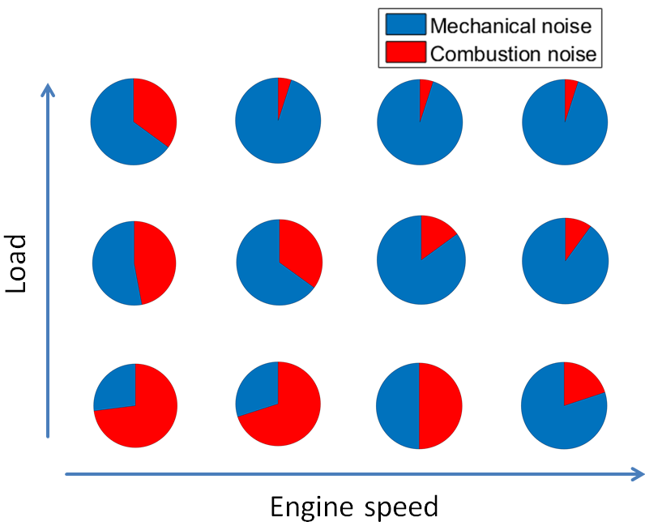
Figure 1.1 – Example of comparison between combustion and mechanical engine noise in a Diesel Engine.

Exact knowledge of the radiations and transmission patterns of an engine is also a critical issue. Vibrations are mainly transmitted throw engine mounts and drive line to the rest of the vehicle, while structure-borne sound is directly radiated from powertrain surface. There are different techniques to investigate acoustic radiation patters of an engine. Methodologies like lead covering (also called shielding technique), surface vibrations technique, acoustic intensity technique, acoustic holography and beam forming are experimental methodologies commonly applied in automotive industrial applications [21-23]. Also in this case, contribution patterns of the different radiating engine surfaces can vary depending on engine configuration, design, operating condition and frequency range investigated.
Fig. 1.2 gives a general idea of the typical contributions of the different engine components to overall radiated noise [24]. Results shown in Fig. 1.2 are determined using the near field sound intensity analysis, which rank the engine surfaces parts in terms of emitted power. Like Fig. 1.1, also Fig. 1.2 depends on the particular engine investigated and it is used here only to give the reader an overview of the possible contributions.

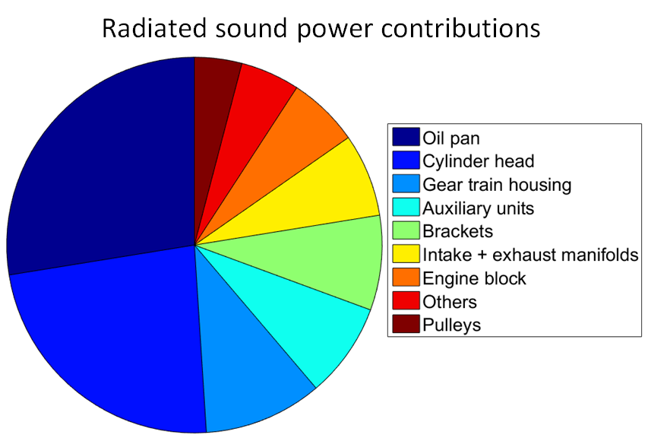
Figure 1.2 – Example of noise source ranking in terms of radiated sound power evaluated with the intensity technique.

Fig. 1.3 shows the typical sound pressure level (SPL) up to 1 kHz of an internal combustion engine running from 1000 to 6000 rpm. This graph is called Campbell diagram and illustrate how the frequency spectra varies with engine running conditions. The noise emitted from combustion engines is strongly affected by harmonic orders.
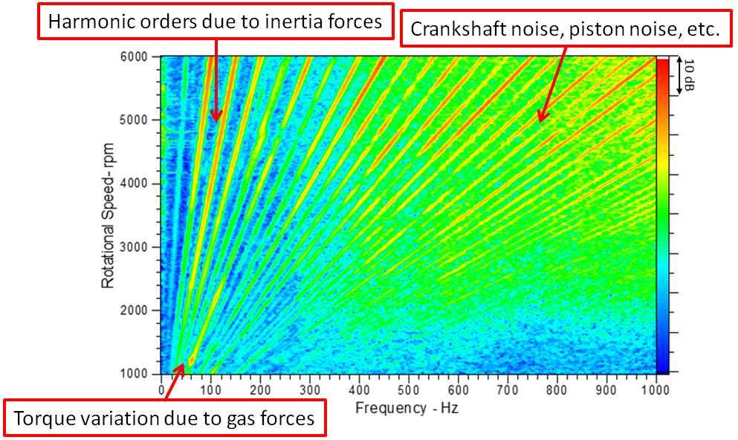
Figure 1.3 – Example of engine noise measured with a microphone.

1.2.2 Gear noise
To generate noise from gears, the primary cause is a force variation which generates a vibration transmitted in the surrounding structure. The following different gear noise phenomena can be identified [25]:
- The impact of the teeth produces a tonal noise which dominant frequency (often addressed as gear meshing frequency) is proportional to shaft speed and number of teeth. Also higher tonal harmonics are associated to this noise generation mechanism.
- Tonal modulation can also be encountered. In spectral analysis, this phenomenon is seen as sidebands of the main gear meshing frequency and harmonics. This modulation effect can be due to variable torques, eccentricities, moving source position or errors and defects.
- Vibro-impacts induced by backlash between meshing gears leads to excessive vibration in many geared rotating system. This phenomenon is named rattle noise, is more pronounced in unloaded meshes (e.g. in not engaged gears in a vehicle manual transmission system) and has more broadband frequency spectra [26,27]. The rattle noise is related mainly to transmission errors and variations in gear rotation. Gear rattle noise increases if the powertrain oscillates at its resonance frequency.
Fig. 1.4 shows typical measured vibrations on a gearbox unit. Gear meshing frequency, its harmonics and sidebands can be clearly seen. The primary shaft is rotating at 3000 rpm. Considering that the driving gear has 17 teeth, the gear meshing frequency is 850 Hz. The sidebands indicate a modulation with a period of one revolution, 50 Hz.
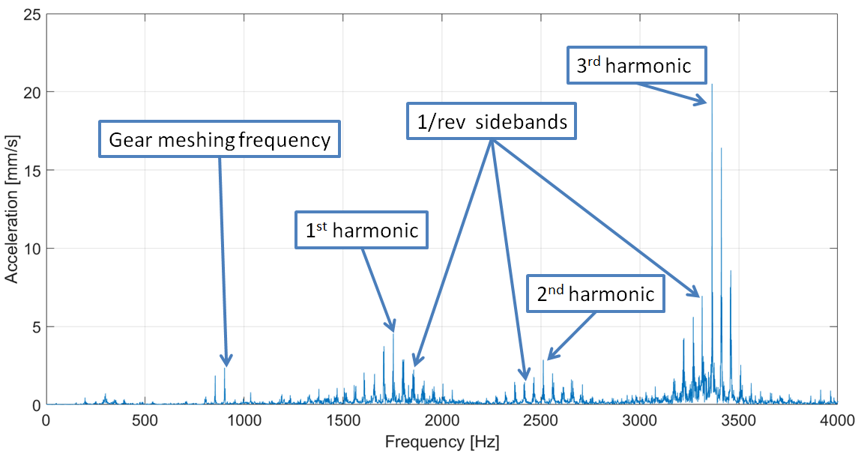
Figure 1.4 – Typical measured accelerations on a gearbox structure.

1.2.3 Driveline influences on NVH
Several driveline-related noise and vibration problems, within different frequency ranges have been investigated and controlled to ensure good NVH vehicle performances [28]. Fig. 1.5 shows the list of the most commonly encountered driveline NVH phenomena and their usual frequency range (To be noted is that also gear noise is often associated with driveline system).
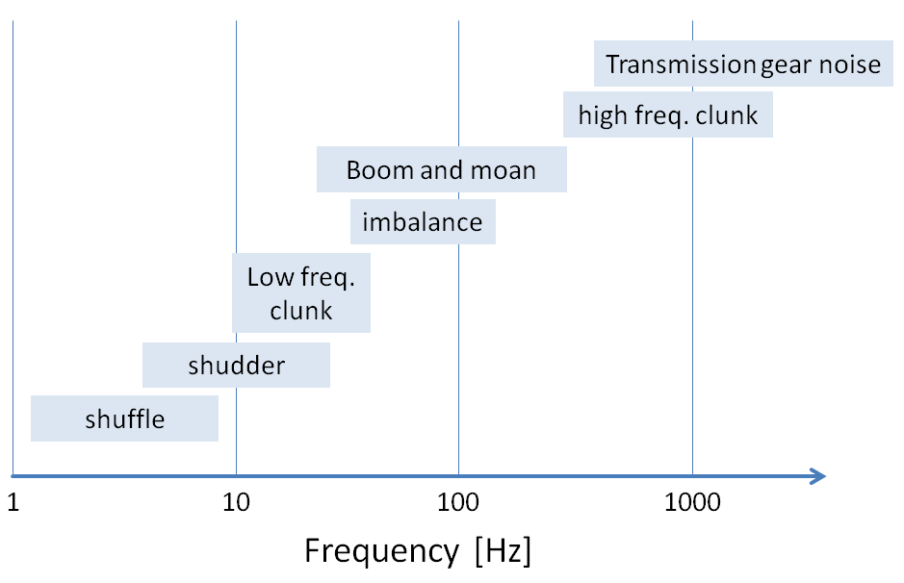
Figure 1.5 – Typical frequency ranges of various driveline NVH issues

The driveline architecture can generate various NVH issues in a broad frequency ranges. Sudden load changes (e.g. pedal tip-in/out) can cause the so-called vehicle shuffle, typically connected to the first natural frequency of the driveline (below 10 Hz).Driveline launch shudder noise is experienced typically when the vehicle starts accelerating from a stopped position. Typically, the shudder results from low frequency driveline instability and can be generated from friction torque transmission via the clutch [29]. Boom is an objectionable low frequency noise in the vehicle compartment, which can dominate the overall noise level. Often, a boom noise is caused by driveline resonances, which get excited by the main engine orders. This can be the firing order and its harmonics as well as engine mass forces and moments. More details in all different driveline-related noise phenomena can be found in [28].
1.2.4 Intake and exhaust system noise
Intake and exhaust noise from internal combustion engines is one of the major noise contributions. In many applications like trucks, farm and construction machinery, motorcycles or recreational vehicles as snow-mobiles, exhaust noise level can reach (or even exceed) 90 dBA. Sound associated with engine gas flow is normally radiated from the open orifices of intake and exhaust systems and is then known as orifice or tailpipe noise. It may also be radiated by their external surfaces when these are excited by the internal fluctuating pressure field (shell noise). The cyclic pulsating flow through the valves is primary cause of the tonal noise component, which frequency is therefore related to engine firing frequency. Flow turbulence also induces aeroacoustic sources that generate broadband spectral noise components and are associated with shear layers, vortices and acoustic resonances [30-32].
Concerning orifice noise issues, mufflers may be readily designed to achieve almost any level of control [33,34]. Increasing level of attenuation can be reached with increasing muffler volume, weight and backpressure at engine manifold. However, these parameters affect engine cost and performances (e.g. higher back pressure may reduce engine performances).
Also turbocharger is often associated with intake and exhaust system noise. Due to the presence of the muffler in the exhaust system, noise problems are usually associated with the compressor in the intake side, especially in connection with the high frequency noise generated by the turbocharger, due to clearance between rotor and casing and blades rotating speed. A complete description of turbochargers noise issues can be found in [35,36].
1.2.4 Tyre noise
Tyre-road noise represents one of the main noise sources for light vehicles with driving speed above 60 km/h. Radial vibrations produced by contact interactions with the road surface radiate noise in the low- and medium-frequency range. One may consider different excitation mechanisms in the contact zone: compression forces due to the roughness of the road surface, the tread patterns, imperfections of the tyre geometry, and shearing forces due to contact friction [37,38]. Radial and tangential vibrations have to be considered because normal and shear excitation forces exist in the contact patch. Moreover, the tyre rotation makes the radial and tangential responses coupled. Therefore, for a detailed study of the excitation and generation, vibration measurements on a rotating and loaded tyre are necessary. Generally, the radial vibrations of a loaded tyre rolling on a rough surface are divided into two types. First, the radial tyre vibrations which result from the moving load excitation of the tyre footprint. Second, radial force ﬂuctuations in the contact patch generate travelling waves around the tyre capable of generating sound.
Tyre noise can dominates the interior noise of vehicles, especially at high speeds. Therefore, many studies investigates how vibrations propagates from tires to internal acoustic cavity [39,40].

CHAPTER2

Brief overview of numerical methods in automotive NVH analysis

- Introduction on numerical modeling

Due to competitive nature of the market and the progressively increasing customer demands, engineers are facing the challenging and complex issue of meeting the ever expanding but often conflicting design criteria. To accomplish this difficult task, the industry has become aware and convinced that a major imperative for any advance beyond the very time-consuming and expensive prototype testing approach is to apply appropriate predictive engineering methods in all stages of the design process. Noise legislations and the increasing customer demands determine the NVH development of modern commercial vehicles. Consequently, both dynamic and acoustic behavior of vehicles became an important criterion in many design problems. In order to incorporate vibro-acoustic criteria in the design process, there is a strong need for numerical prediction tools that provide the necessary insight in the physical phenomena which govern the NVH behavior of complex systems and that allow a reliable evaluation of different design alternatives.
To illustrate the different aspects that play a role in the application of numerical simulation methods, Fig. 2.1 schematically shows the general procedure adopted for engineering problem troubleshooting. The first step consists in the appropriate mathematical modeling of the processes to be investigated. This aspect is of crucial importance, since usually the calculation will not bring beneficial results if it is not used and adequate model. The modeling procedure usually brings to a set of mathematical expressions, which consists of a system of differential or integral equations in mechanics and acoustic problems. Quite often the mathematical expressions adopted have general interpretation, cannot represent the real physics behind the problem and thus discretization is required. The discretization process can include both domain discretization (computational mesh generation) and equation discretization (e.g. time discretization procedure for equation resolution). The discretization of the problem area approximates the continuous investigated area by a finite number of sub-areas where then numeric values of the unknown variables are determined. The relationships to calculate these values are obtained by the discretization of the equations, which approximates the continuous systems by algebraic equations. Unlike an analytical solution, a numerical solution represents a set of the discretized values from which the variables history can be approximated. Once the problem is discretized, a set of algebraic system equations, which is usually dealing with millions of unknowns, can be solved to obtain the numerical solution of the problem. In all previously performed steps, some errors are introduced and it is necessary to understand their order of magnitude (e.g. with reference experiments for systematic model error or calculations for numerical errors). To validate the model, it is often necessary to adapt the model accuracy or to perform again the calculation with an improved discretization. Finally, when the model is validated, results are considered for analysis interpretation and troubleshooting.
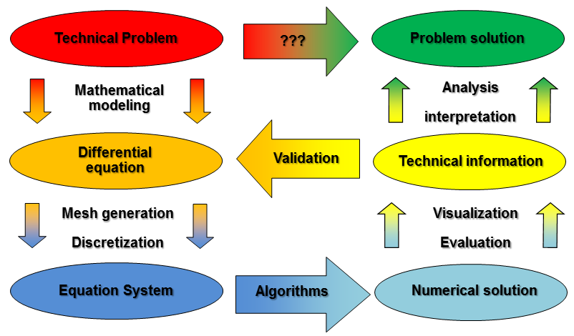
Figure 2.1 – Procedure for the application of numerical simulation to solve engineering problems.

During the engine and vehicle developing process, calculations are usually performed for individual components. This is mainly done for two reasons: the total cost for the whole vehicle simulation is too large and often the simulation of the connections between different components is a challenging task. Therefore, it is important to design and optimize the individual different components during design phase. This is particularly challenging in structural dynamics and NVH analysis, because the subdivision of the system always have a repercussion on the overall behavior. Single component structural analysis is usually done via Finite Element Analysis (FEM). Nowadays, FEM has become established as the generally accepted analysis method for structural and mechanical design. A methodology of practice relevance, that combines the modeling of different components to study their interaction, is Multi Body Dynamics (MBD) analysis. The analysis of the acoustic radiation problems can also be investigated with finite element (FE) methodologies, although some other techniques like Boundary Element Method (BEM) and Wave Based Method (WBM) found also some applications in industry.
The aim of this work is to discuss numerical methodologies for sources assessment. These methodologies are based on the methods here introduced and therefore in this chapter only a brief description of the most common numerical methods adopted in automotive industry for NVH analysis will be given. This section does not aim at giving an exhaustive list of different numerical methods that can provide a solution for vibration and acoustic problems. The descriptions provided in this chapter gives an overview of the most common techniques and mainly focus on the basic aspects required to understand the methodologies introduced in this thesis.

- Finite element method for structural analysis

Nowadays FEM has become established as the universally accepted analysis method in mechanics and structural design. The method is characterized by the construction of a discrete system of matrix equations that represent the mass and stiffness properties of a continuous structure. The matrices are usually banded and symmetric. There is no restriction on the geometrical complexity of the structure because the mass and stiffness matrices are assembled from the contributions of the individual finite elements having simple shapes. Thus, the computational domain is divided into discrete areas or volumes known as elements. The whole computational domain is a grid (or mesh) of different elements. The boundaries of the elements are defined by nodal points, which are connected by a unique polynomial curve or surface. The most common definition considers the same polynomial description to relate the internal, element displacements to the displacements of the nodes. This process is generally known as shape function interpolation. Since the boundary nodes are shared between neighboring elements, the displacement field is generally continuous through the element boundaries. The mathematical formulation of FEM can be a variational problem with an element-wise Rayleigh-Ritz treatment and shape function discretization. Another common opportunity is to define element equations directly from the characteristic differential equations using a Galerkin approach weighted by the element shape functions.
More details on FEM formulation, properties, typical element characteristics and applications can be found in the well-known books of Zienkiewicz and Taylor [41] and Friswell and Mottershead [42]. In this Section, only a brief description is provided and most of the discussions are derived from these books.
2.2.1 Finite element mass and stiffness
Consider a single element of a FEM computational domain. Every finite element is characterized by mass and stiffness properties which depend both on the material and the geometry of the element. The general form of the element mass and stiffness matrices is commonly represented as the integrals
$$m= \iiint{{\text{N}}^{T}ρ \text{N}\det\left(\text{J}\right)dξ_{1}dξ_{2}dξ_{3}}$$ | (1)
$$k= \iiint{{\text{B}}^{T}\text{DB}\det\left(\text{J}\right)dξ_{1}dξ_{2}dξ_{3}}$$ | (2)
where $ρ$ represents mass density, $m$ and $k$ are respectively mass and stiffness of the element,$\text{ N}$ is the matrix of shape functions, $\text{B}$ is the matrix of shape function derivatives, $\text{D}$ is the elasticity matrix and $\text{J}$ is the Jacobian matrix that defines the relationship between global reference system ($x,y,z$) and the local frame ($ξ_{1},ξ_{2},ξ_{3}$). Hence,
$$dx dy dz= \det\left(\text{J}\right)dξ_{1}dξ_{2}dξ_{3},$$ | (3)
and
$$\text{J}=\left[\begin{matrix}\frac{∂x}{∂ξ_{1}} & \frac{∂y}{∂ξ_{1}} & \frac{∂z}{∂ξ_{1}} \\ \frac{∂x}{∂ξ_{2}} & \frac{∂y}{∂ξ_{2}} & \frac{∂z}{∂ξ_{2}} \\ \frac{∂x}{∂ξ_{3}} & \frac{∂y}{∂ξ_{3}} & \frac{∂z}{∂ξ_{3}}\end{matrix}\right].$$ | (4)
The easy case of a mono-dimensional Euler beam shows that Eqs. (1) and (2) simplify to
$$m= ρA\iiint{{\text{N}}^{T}\text{N}\frac{∂x}{∂ξ_{1}}dξ_{1}}$$ | (5)
$$k= EI\iiint{{\text{B}}^{T}\text{B}\frac{∂x}{∂ξ_{1}}dξ_{1}},$$ | (6)
which indicates that system matrices directly depend on well understood physical quantities like Young’s modulus, density, area and second moment of inertia (respectively $E$, $ρ$, $A$ and $I$).
In more complex structures, mass and stiffness matrices, respectively $M$ and $K$, can be also obtained directly from energy considerations such that the shape functions and their derivatives represent the distribution of displacements (or rotations) and strains respectively. The global FE model is assembled from the individual element’s contributions. The overall mass and stiffness matrices are generally sparsely populated and the degree to which the matrices are banded is significantly affected by the arrangement and ordering of the degrees of freedom in the assembled system of equations.
2.2.2 General formulation of a dynamic system
The FEM representation of a continuous structure leads to a system of $n$ second order differential equations both statically and dynamically coupled. The equation describing the system dynamics due to external harmonic excitations is
$M\ddot{q}\left(t\right)+D\dot{q}\left(t\right)+Kq\left(t\right)=fe^{iωt}$, | (7)
Where $M, D_{ }$and $K_{ }$are respectively mass, damping and stiffness matrices of the system, $q_{ }$ is the vector of local translational and rotational displacements of all points of the considered body and ${\dot{q}}_{ }$ and ${\ddot{q}}_{ }$ are respectively its first (velocities) and second time derivative (accelerations). $f$ is the vector of external forces or moments directly applied on the considered system. Moreover, $i$ is the imaginary unit and $ω$ is the angular frequency of the harmonic signal considered. For harmonic motion, assume a harmonic solution of the form
$q(t)=u\left(ω\right)e^{iωt}$, | (8)
where$u$ is a complex displacement vector. Taking the first and second derivative of Eq. (8) and introducing into Eq. (7), it is obtained
${{(-ω^{2}M}_{ }}^{ }+{iωD}_{ }+K_{ }) u_{ }e^{iωt}=f_{ }e^{iωt}$, | (9)
and after, dividing by $e^{iωt}$ simplifies to
$(-ω^{2}M+{iωD}_{ }+K) u=f$. | (10)
For the sake of readability, from Eq. (9) and further the dependency from $ω$ is omitted. Eq. (10) is the general formulation of a dynamic system expressed in frequency domain and can be solved for every forcing frequency$ω$. Introducing into Eq. (10) the complex velocity vector $v=iωu$, it is obtained
$\left(iωM+D+\frac{K}{iω}\right)v=f$. | (11)
Eq. (11) can be also expressed in a more compact form:
$Zv=f$, | (12)
or
$v=Yf$, | (13)
where$Z$ is the complex impedance matrix, which is expressed as
$$Z= \left(iωM+D+\frac{K}{iω}\right)$$ | (14)
and $Y$, the complex mobility matrix of the system, is defined by
$Y=Z^{-1}$. | (15)
2.2.3 Rayleigh damping
Mechanical systems are not only characterized by mass and stiffness, but also by damping properties. Damping is a property that is related to the amount of energy dissipated into the structure. It indicates the velocity decrease in proportion to the acting excitation force on the structure. The precise mechanisms of damping are not well understood in structural dynamics problems and therefore in common FEM applications there are no clear formulations similar to those of mass and stiffness, clearly based on well-defined physical parameters. Consequently, in common FEM applications the amount of damping associated to a structure is often chosen with empirical methods. A methodology often employed is the proportional damping, introduced by Rayleigh and therefore also known as Rayleigh damping [43,44]. In its idealization, Rayleigh assume the damping matrix to be a linear combination of the mass and stiffness matrices
$$D= αM+ βK,$$ | (16)
being$α$ and $β$ pre-defined constants. According to [43], the value of these constants can be estimated solving the following system
$$\left\{\begin{matrix}2ζ_{1}ω_{1}= α+βω_{1}^{2} \\ 2ζ_{2}ω_{2}= α+βω_{2}^{2}\end{matrix}\right.$$ | (17)
for prescribed values of damping ratio, $ζ$, at two given angular frequencies$ω_{1}$ and $ω_{2}$. Fig. 2.2 shows the typical trend of structural damping ration with a Rayleigh definition. In Fig 2.2, both mass and stiffness proportional regions can be seen. More detailed information on Rayleigh damping model and other alternative methods can be found in [44].
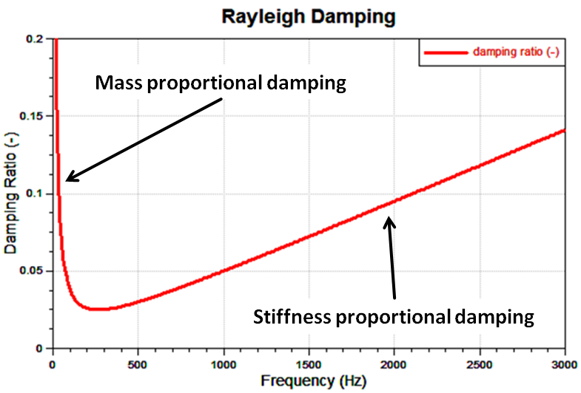
Figure 2.2 – Typical damping ratio estimation using Rayleigh damping definition.

- Multi body dynamics

The understanding of dynamics and motion of mechanical systems is a challenging task during automotive development and design process. In automotive industry there is lots of effort in the development of numerical methodologies that simulate engine and transmission system dynamics. Also the simulation of contacting elements, e.g. contacting engine parts, considering appropriate impact, friction and tribological properties is a crucial issue in automotive engineering design. Multibody dynamics (MBD) is a numerical methodology that aims to undertake dynamic problems considering also the interaction and the contact between different elements of the mechanical system. These elements are called bodies and in the original formulation are treated as rigid. MBD has been initially applied to the analysis of the dynamics of systems of rigid bodies connected by kinematic constraints. The motion of each body is restricted by its contacts to other bodies. The mathematical representation of the contacts is done via joints.
The rigid body approximation is only valid if the motion related to body deformation is limited compared to the motion of the mechanism, and only slightly excited by the external loads and the overall mechanism motion. However, as soon as the focus moved from dynamic analysis to the investigation of the structures subjected to high load conditions (which is the case in powertrain) the small deformations are non-negligible. For example, the main engine bearings are subjected to small deformations induced by crankshaft rotation, although the crankshaft is very stiff and can be approximated as a rigid body. In these systems the ﬂexibility of the structure is essential because it is at the roots of the stiffening response of the contact. Therefore, the flexibility of the bodies cannot be neglected and it is included into the classical MBD formulation, bringing to a flexible multi body dynamic (FMBD) formulation. FMBD combines deterministic FEM models (to replace the rigid formulation of the bodies) with equations of classical MBD in order to refine the modeling of the reality. The equations describing the motion of the flexible multi-body system are derived from linear elasticity theory using a floating frame of reference formulation. The resulting equation system is an implicit differential equation system including pure algebraic equations. Joints contact can introduce non-linear functional relations. Hence, it is not possible to solve the equation system in frequency domain and it is also not possible to derive an analytical solution in time domain. Thus, an efficient time integration scheme has to be implemented.
A good overview of multi body dynamics can be found in the books from Shabana [45] and Amirouche [46]. To be noticed also the review papers from Shabana [47], Rahnejat [48] and Schiehlen [49]. Some applications in automotive industry can be found in [50-56].
2.3.1 Bodies definition
The motion of a body having a flexible definition can be separated into gross global motion and local vibration motion. From a mathematical point of view, these components have to be considered as specific degrees of freedom. For any element, motion components and their time derivatives can be collected in a vector, reading[52]
$$\left(q,\dot{q},\ddot{q},q_{G},{\dot{q}}_{G},{\ddot{q}}_{G}\right),$$ | (18)
where$q$ is the generalized local displacement vector (considering local displacements and rotations of all nodes of the body), $\dot{q}$ and $\ddot{q}$ are respectively its first and second time derivative, $q_{G}$ is the generalized vector of global position and orientation coordinates and ${\dot{q}}_{G}$ and ${\ddot{q}}_{G}$ are respectively its first and second time derivative.
The mathematical model of each body is derived from Newton’s law and Euler’s equation of angular momentum [57]. These fundamental equations can be considered for each body in a fixed coordinate system and introducing linear elastic structural properties, results in the classical equation of motion for linear systems:
$$M\ddot{q}+D\dot{q}+Kq=f^{ext}+f^{gyros}-f^{rbAcc}.$$ | (19)
In Eq. (19), $M$, $K$ and $D$ respectively indicate body mass, stiffness and damping matrices. The body is excited with the following loads:$f^{ext}$, which is the vector of external loads; $f^{gyros}$, which is the vector that represents the gyroscopic terms considered for the total elastic body; $f^{rbAcc}$, which is the vector that contains the rigid body accelerations.
External loads can be prescribed functions expressed in time domain that are determined via simulations or measurements and are directly applied on the nodes of the body. Also joint contacts can be expressed as external loads and are applied only in the nodes connecting one body to another. Joint contacts can both be linear or highly non-linear excitation terms. Both $f^{gyros}$ and $f^{rbAcc}$ are non-linear terms that consider the inertia components resulting from global motion of the body. These vectors result from the coordinate transformation of the equations of momentum and angular momentum into the body relative coordinate system. More details can be found in [52,55].
For NVH purpose, the understanding of the small system vibrations is of crucial importance. Thus, global and local motion quantities, which are calculated at the same time, need to be separated. In order to distinguish of the overall results into gross motion and elastic quantities additional conditions need to be defined. A set of reference conditions minimizing the square average of the relative displacements is used. These reference conditions are based on the idea of minimizing the discrete weighted square-norm of the displacements to minimize the distance from the linearization point [52].
2.3.2 Condensed degrees of freedom
To make better use of simulations in the automotive driveline design process there is a need for both improved predictive capabilities of typical system models and increased number of variant evaluations carried out during system concept design phase. Unfortunately, numerous evaluations are extremely time-consuming in systems considering high number of degrees of freedom (DoFs). In common industrial applications, FEM models can have also several millions of DoFs. For this reason, FMBD models as well as FEM models often consider a significant reduction of the computational degrees of freedom. This reduction is often referred in literature as model order reduction or condensation. Condensation techniques consider a transformation of the system matrices which aim is to reduce the computational effort required for simulation, but preserving system characteristics. The accuracy of these condensation methodologies is clearly limited up to a certain frequency limit and depends on the method adopted and number of DoFs preserved in the condensation procedure. A good overview of current condensation methodologies can be found in the book of Qu [58].
The first example of condensation methodology is the static condensation, introduced by Guyan in 1965 [59]. Consider the static equation system that neglects both mass and damping properties
$$Kq=f.$$ | (20)
Assuming that the DoFs vector can be decomposed into two subsets
$$q=\left(\begin{matrix}q_{t} \\ q_{0}\end{matrix}\right)$$ | (21)
the equation system in Eq. (20) is transformed into
$$\left[\begin{matrix}K_{tt} & K_{t0} \\ K_{0t} & K_{00}\end{matrix}\right]\left(\begin{matrix}q_{t} \\ q_{0}\end{matrix}\right)=\left(\begin{matrix}f_{t} \\ f_{0}\end{matrix}\right),$$ | (22)
where $f_{0}$ is a null vector and it is the sub-vector corresponding to nodes of the bodies where no excitation is applied, $f_{t}$ is the excitation vector associated to nodes where non-zero loads are applied, $q_{0}$ and $q_{t}$ are respectively the displacement sub-vectors of non-loaded and loaded nodes. Considering that $f_{0}$ is a null vector, it is possible to derive
$$q_{0}=-K_{00}^{-1} K_{0t} q_{t}=T_{0t} q_{t},$$ | (23)
Being $T$ a transformation matrix. From Eq. (23), it follows that all DoFs can be expressed only using the sub set $q_{t}$
$$q=\left(\begin{matrix}q_{t} \\ q_{0}\end{matrix}\right)=\left(\begin{matrix}I \\ T_{0t}\end{matrix}\right)q_{t}=T_{ft}{ q}_{t}.$$ | (24)
Introducing Eq. (24) into Eq. (19) and grouping all excitations in a single vector, the vibration equation of a flexible body will give
$$\left(T_{ft}^{T} M T_{ft}\right){\ddot{q}}_{t}+\left(T_{ft}^{T} D T_{ft}\right){\dot{q}}_{t}+\left(T_{ft}^{T} K T_{ft}\right)q_{t}=T_{ft}^{T} f.$$ | (25)
Fig. 2.3 shows an example of static reduction.

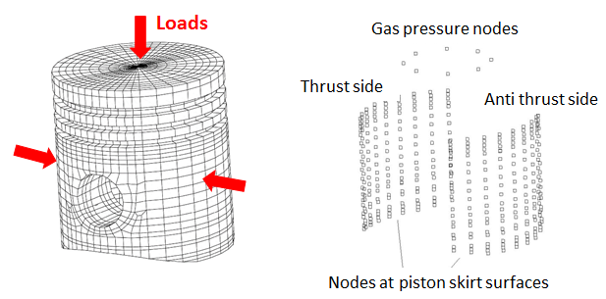
Figure 2.3 – Typical example of static reduction. Left: uncondensed FEM model of a piston. Right: condensed nodes of the original model.

An alternative and convenient reduction method is the modal reduction. Natural modes of a body are used to create a space of the reduces system as a linear combination of the physical system. If the interest is to study the body up to a certain frequency, it is possible to use a limited number of modes, resulting in an efficient model reduction. The evaluation of the eigenfrequencies is based on the undamped equation system
$$M\ddot{q}+Kq=\text{0},$$ | (26)
where $\text{0}$ is the null vector. The eigenvalue problem associated to Eq. (26) is
$$det\left(K-λ M\right)=\text{0}.$$ | (27)
Solving for each eigenvalue $λ_{i}$, the corresponding eigenfrequency $ω_{i}$ and eigenvector $a_{i}$ are computed respectively from
$$ω_{i}^{2}= λ_{i},$$ | (28)
$$\left(K-λ_{i} M\right) a_{i}=\text{0}.$$ | (29)
Due to orthogonality with respect to mass and stiffness, it is possible to derive modal mass and modal stiffness, respectively $m_{jj}$ and $k_{jj}$, for each eigenfrequency
$$a_{i}^{T}Ma_{j}=\left\{\begin{aligned}m_{jj} i=j \\ 0 i≠j\end{aligned} \right.,$$ | (30)
$$a_{i}^{T}Ka_{j}=\left\{\begin{aligned}k_{jj} i=j \\ 0 i≠j\end{aligned}\right. .$$ | (31)
Moreover, if appropriate damping model are used, e.g. proportional Rayleigh damping (see section 2.2.3), also modal damping can be derived.
$$a_{i}^{T}Da_{j}=\left\{\begin{aligned}d_{jj} i=j \\ 0 i≠j\end{aligned} \right..$$ | (32)
Defining a reduced set of $n$ eigenfrequencies to investigate, due to orthogonality, a simple system can be solved to identify the modal DoFs $z$ for $j=1,…,n$
$$m_{jj} {\ddot{z}}_{j}+d_{jj}{\dot{z}}_{j}+k_{jj}z_{j}=a_{j}^{T}f.$$ | (33)
The system Eq. (33) is a reduced easy model that perfectly represent the original model up to the frequency limit $ω_{n}.$ This reduction technique is very performing in FEM for linear problems, but in FMBD has the disadvantage resulting from nonlinear joint contacts between different bodies. The nonlinear excitation loads depend on the physical DoFs and therefore a modal condensation leads to additional computational costs for transforming these forces and moments. To overcome these problems, modal reduction is often coupled with a static reduction. In this combination, here called dynamic reduction, the reduced set of DoFs, $q_{a}$, consist of a sub-vector of physical DoFs, $q_{t}$, and a sub-set of modal DoFs, $z$
$q_{a}=\left(\begin{matrix}q_{t} \\ z\end{matrix}\right)$. | (34)
The reduced set of DoFs, $q_{a}$, is connected to the original set of DoFs via the transformation
$q=\left(\begin{matrix}q_{t} \\ q_{0}\end{matrix}\right)=\left[\begin{matrix}I & \text{0} \\ T_{0t} & T_{0q}\end{matrix}\right]\left(\begin{matrix}q_{t} \\ z\end{matrix}\right)=T_{fa}q_{a}$ . | (35)
The final vibration equation for a dynamic reduced system is finally
$$\left(T_{fa}^{T} M T_{fa}\right){\ddot{q}}_{t}+\left(T_{fa}^{T} D T_{fa}\right){\dot{q}}_{t}+\left(T_{fa}^{T} K T_{fa}\right)q_{t}=T_{fa}^{T} f,$$ | (36)
where, the excitation vector is
$$T_{fa}^{T} f=\left[\begin{matrix}I & T_{0t}^{T} \\ \text{0} & T_{0q}^{T}\end{matrix}\right] \left(\begin{matrix}f_{t} \\ f_{0}\end{matrix}\right),$$ | (37)
and considering that $f_{0}$ is a null vector, it is clear that it is not needed to evaluate the transformation of Eq. (37). This is only valid in a global reference system, where all external forces are applied on the set of DoFs $q_{t}.$ In the case of a body fixed reference system, also rigid body accelerations and gyroscopic effects has to be appropriately reduced [55].
2.3.3 Contact forces and moments
Multibody dynamics is particularly suited to model nonlinear contact forces and moments between bodies. E.g., in powertrain applications nonlinear models has to be provided for piston-liner contacts, radial and axial bearings, engine mounts or coupling between shafts [52,56]. These body contacts are basically represented with a wide range of joints. The simplest joint is obtained with a spring-damper model in a node-to-node connection between two bodies, which reads
$$f= k_{joint} ∆x+d_{joint} ∆\dot{x},$$ | (38)
where $∆x$ and $∆\dot{x}$ denote respectively the distance between connected nodes and its time derivative. The joint stiffness and damping coefficients, respectively $k_{joint}$ and $d_{joint}$, are constant in linear models. Nonlinear models can consider different expressions for $k_{joint}$ and $d_{joint}$, such as the following exponential definition
$$k_{joint}=k_{0}{\left(\frac{k_{b}}{k_{0}}\right)}^{\left|\frac{∆x}{x_{b}}\right|}$$ | (39)
$$d_{joint}=d_{0}{\left(\frac{d_{b}}{d_{0}}\right)}^{\left|\frac{∆x}{x_{b}}\right|}.$$ | (40)
The parameters $k_{0}$, $k_{b}$, $d_{0}$ and $d_{b}$ define the behavior relative to a reference length $x_{b}$. This model can be used to represent different joint connections, although it has some limitations: local effects and highly non-linear phenomena cannot be well captured. For this purpose, higher sophisticated joint models have been proposed for specific applications, especially in the case of oil film lubricated contacts [54,56]. In particular, these lubricate contacts can be represented by an averaged Reynolds equation or dry contact models. Depending on geometric shape of the contact, different types of averaged Reynolds equation can be distinguished. In the case of radial slider bearings, Reynolds equation apply in the form
$$-\frac{∂}{∂x}\left(θ φ_{x}\frac{h^{3}}{12η}\frac{∂p}{∂x}\right)-\frac{∂}{∂z}\left(θ φ_{z}\frac{h^{3}}{12η}\frac{∂p}{∂z}\right)+\frac{v_{journal}-v_{shell}}{2}\frac{∂}{∂x}\left(θ \left({\overline{h}}_{T}+σ{ φ}_{s}\right)\right)+\frac{∂}{∂t}\left(θ {\overline{h}}_{T}\right)=0.$$ | (41)
Analogously, the hydrodynamic contacts between piston and cylinder liner is
$$-\frac{∂}{∂x}\left(θ φ_{x}\frac{h^{3}}{12η}\frac{∂p}{∂x}\right)-\frac{∂}{∂z}\left(θ φ_{z}\frac{h^{3}}{12η}\frac{∂p}{∂z}\right)+\frac{w_{liner}-w_{piston}}{2}\frac{∂}{∂z}\left(θ \left({\overline{h}}_{T}+σ{ φ}_{s}\right)\right)+\frac{∂}{∂t}\left(θ {\overline{h}}_{T}\right)=0.$$ | (42)
The equation for the axial slider bearing contacts is given by
$$-\frac{∂}{∂x}\left(θ φ_{x}\frac{h^{3}}{12η}\frac{∂p}{∂x}\right)-\frac{∂}{∂z}\left(θ φ_{z}\frac{h^{3}}{12η}\frac{∂p}{∂z}\right)+r \frac{v_{flange}-v_{thrust}}{2}\frac{∂}{∂x}\left(θ \left({\overline{h}}_{T}+σrφ_{s}\right)\right)+r^{2}\frac{∂}{∂t}\left(θ {\overline{h}}_{T}\right)=0.$$ | (43)
Eqs. (41), (42) and (43) are solved with respect to the hydrodynamic pressure $p$ in regions where the clearance gap, $h$, is completely filled with oil, i.e. a fill ratio $θ=1$, while them are solved with respect of the fill ration $θ$ in cavitation regions. The average clearance is here expressed as ${\overline{h}}_{T}$. The oil film viscosity is $η$ [60,61]. The formulation consider also $r$ as radius,$φ$ denotes a flow factor (in direction $x$, $z$ or due to shear $s$) and $σ$ is a composite roughness value [62]. The terms $v$ and $w$ are respectively circumferential and axial velocity components of the considered bodies.
In addition to the hydrodynamic pressure, also a local asperity pressure can be considered in dry or mixed lubrication contacts. Assuming Gaussian distribution of surface roughness and constant radius of curvature for the asperity summits, the nominal contact pressure can be determined according to Greenwood and Tripp formulation [63].

- Modeling of vibroacoustic problems

A first basic distinction of acoustic problems is between aeroacoustic and vibroacoustic. The former considers noise generation and propagation in a fluid medium, while the latter also considers the interaction with a solid structure. In automotive application it is often the case that vibroacoustic phenomena are predominant, although there are also some aeroacoustic contributions (e.g. exhaust or fan noise). For this reason the discussion here will mainly focus on the description of vibroacoustic modeling and numerical methodologies that implement these models.
For modeling purposes, vibroacoustic problems are divided into interior and exterior acoustic problems, depending on whether the acoustic domain is bounded or not. In an interior vibroacoustic system, the fluid is inside a bounded acoustic domain $Ω$, fully surrounded by a boundary surface $∂Ω$ consisting in an elastic structure. Conversely, in an exterior vibroacoustic problem the fluid is in an unbounded domain, which is the space between a structural boundary surface ${∂Ω}_{s}$ and a boundary surface ${∂Ω}_{∞}$ located at infinity. For practical reasons, numerical models cannot consider an infinite domain. Therefore, in exterior radiation problems a truncation surface $Γ_{∞}$ is considered as boundary of the acoustic domain. $Γ_{∞}$ represents the limit of the fluid domain in a numerical model and it is placed in the far field. The far field is the region of the domain where local effects due to proximity with the structure can be neglected. A rule of the dumb is that the far field is the region distant from the structure at least 5 times the propagating wavelength of the acoustic wave. By contrast, the near filed is the region in proximity of the structural boundaries where local effects cannot be neglected. A further distinction is made between coupled and uncoupled vibroacoustic problems. The goal of a coupled vibroacoustic model is the prediction of the dynamic quantities of the system, i.e. fluid pressure field in the acoustic medium and the displacement field of the elastic structure. Conversely, if it is only the structure influencing the fluid or vice versa, the problem is uncoupled.
In automotive, many problems, such as engine noise radiation or interior vehicle acoustic design, can be represented with an uncoupled vibroacoustic model. In these models, the structural vibrations influence the fluid pressure without being influenced from the pressure field of the acoustic medium. Assuming that the system is linear, the fluid inviscid and isotropic and that the process is adiabatic, the steady-state pressure $p$ at any point of the fluid having generalized coordinate $r$ is governed by the linear Helmholtz wave equation [64-66]
$$∆p\left(r\right)+k^{2}p\left(r\right)=0,$$ | (44)
where $∆ = \frac{∂^{2}}{∂x^{2}}+\frac{∂^{2}}{∂y^{2}}+\frac{∂^{2}}{∂z^{2}}$ is the Laplace operator and $k= \frac{ω}{c}$ is the wave number (the ratio between frequency $ω$ and speed of sound $c$). In Eq. (44) the source term is set to zero. There are three possible boundary conditions associated to this problem, assuming that the solid and the fluid structures are not coupled:
- Imposed normal velocity (Neumann boundary condition)
$$v_{n}\left(r\right)=\frac{i}{ρω}\frac{∂p(r)}{∂n}={\overline{v}}_{n}(r), ∀ r∈ ∂Ω_{v},$$ | (45)
- Imposed pressure (Dirichlet boundary condition)
$$p\left(r\right)=\overline{p}(r), ∀ r∈ ∂Ω_{p},$$ | (46)
- Normal impedance boundary condition (Mixed boundary conditions)
$$p\left(r\right)={\overline{Z}}_{n}\left(r\right){ v}_{n}\left(r\right)={\overline{Z}}_{n}\left(r\right)\frac{i}{ρω}\frac{∂p(r)}{∂n}, ∀ r∈ ∂Ω_{z},$$ | (47)
where $i$ is the imaginary unit, $n$ is the normal vector, $ρ$ is the fluid density and ${\overline{Z}}_{n}$ denotes the normal impedance. Furthermore, $∂{Ω }_{p}∪∂{Ω }_{v}∪∂{Ω }_{z}=∂Ω.$ Boundary conditions from Eq. (45) to (47) can be applied on surfaces representing solid elastic structures.
In exterior radiation problems, the boundary $Γ_{∞}$ does not represent a structure interacting with the fluid, but it is placed at infinity. In the far field the acoustic waves can freely propagate radiating towards infinity and $Γ_{∞}$ is the surface where these acoustic waves are absorbed. Therefore, Sommerfeld radiation condition is applied to ensure that no acoustic energy is reflected at infinity [67]:
$$\lim_{|r|→∞}\left(\left|r\right|\left(\frac{∂p\left(r\right)}{∂\left|r\right|}+ikp\left(r\right)\right)\right)=0.$$ | (48)
Due to geometrical complexity and boundary conditions, for most vibroacoustic problems, the solution of Helmholtz equation (Eq. (44)) cannot be found in a closed analytical form. Hence, transforming the mathematical model into a set of algebraic equations, an approximated solution can be calculated via numerical implementation. The two most commonly used numerical methods in acoustic industrial automotive applications are FEM and Boundary Element Methods (BEM).
2.4.1 Finite Element Method for acoustic analysis
FEM is the most commonly used numerical simulation technique, consisting of finding the distribution of the field variables in a continuum domain governed by appropriate partial differential equations and boundary conditions. FEM is based on the transformation of the original problem into an equivalent weighted residual or variational integral formulation. Computational domain is divided into finite elements in which field variable distributions and domain geometry are approximated using shape functions. The original concept of FEM was derived for structural analysis and therefore a brief introduction is provided in Sec. 2.2. In this section, the analogy adopted to represent an acoustic problem using Eq. (10) is [68]
$(-ω^{2}M+{iωD}_{ }+K) a=f$. | (49)
In Eq. (49), $a$ is the solution vector and $f$ is the excitation vector containing the contributions from the a priori assigned boundary conditions. $M$ is the acoustic “mass” matrix, relating the pressure to a displacement
$$M= \int_{Ω}^{ }{\frac{1}{c^{2}} {\text{N}}^{T}\text{N}}dΩ,$$ | (50)
where $\text{N}$ is the shape function matrix. $D$ is a acoustic damping matrix resulting from the impedance boundary conditions
$$D= \int_{∂Ω}^{ }{\frac{ρ}{{\overline{Z}}_{n}} {\text{N}}^{T}\text{N}}ds.$$ | (51)
$K$ is an inverse mobility matrix relating the pressure to an acceleration
$$K= \int_{Ω}^{ }{ {\text{B}}^{T}\text{B}}dΩ,$$ | (52)
being $\text{B}$ defined as
$$\text{B} \text{= }\text{∇} \text{N}\text{,}$$ | (53)
where $\text{∇}$ is the nabla operator.
2.4.2 Boundary element method
The Boundary Element Method (BEM) has become a valuable modeling alternative for several types of engineering problems, especially for problems involving unbounded domains. In BEM, the distribution of the field variables in the continuum domain is related to the distribution of boundary variables via a direct or indirect integral formulation of the problem. Therefore, a two-step procedure is required. Firstly, boundary variables distribution is determined. In a following step, the boundary integral formulation is used to determine field variables in any point of the domain. Similar to FEM, also BEM is based on the transformation of the problem into a collocational or variational formulation. Another analogy with FEM is that also in BEM boundary surface geometry is discretized using simple elements on which boundary variables are approximated in terms of sets of shape functions. BEM found many applications in acoustics, both in interior and exterior acoustic problems [64,69].
The direct boundary integral formulation relates pressure and normal velocity distribution on the boundary surface of the acoustic domain to the pressure in any point of the acoustic field [70]. Direct boundary formulation requires a closed boundary. Therefore, it can only represent either an interior or an exterior problem and the formulation is the same. Pressure field has to satisfy the homogeneous Helmholtz equation, Eq. (44), and also Sommerfeld radiation conditions, Eq. (48), in the case of exterior problems. For exterior problems, the pressure $p$ in any point of the domain $Ω$ is expressed as
$$p\left(r\right)= \int_{∂Ω}^{ }{p\left(r_{b}\right)\frac{∂G(r,r_{b})}{∂n}+iρωv_{n}(r_{b})G(r,r_{b})}ds_{b},$$ | (54)
where $r$ is the position vector and $n$ is the unitary vector normal to boundary surface and having positive orientation into the acoustic domain. $p\left(r_{b}\right)$ and $v\left(r_{b}\right)$ are respectively the pressure and normal velocity on position $r_{b}$ on the boundary $∂Ω$ of the domain $Ω$. The function $G(r,r_{b})$ is the Green’s kernel function, which satisfies the inhomogeneous Helmholtz equation
$$∆G\left(r,r_{b}\right)+k^{2}G\left(r,r_{b}\right)=-δ(r-r_{b}),$$ | (55)
and the Sommerfeld radiation conditions. Green’s function is the free field pressure in the position $r$ due to an acoustic point source in $r_{b}$ and in planar space it reads
$$G\left(r,r_{b}\right)=-\frac{i}{4}H_{0,2}\left(k\left|r-r_{b}\right|\right),$$ | (56)
or, in three-dimensional space
$$G\left(r,r_{b}\right)=\frac{e^{ik\left|r-r_{b}\right|}}{4π\left|r-r_{b}\right|}.$$ | (57)
In Eq. (56) $H_{0,2}$ denotes the zero-order Hankel function of the second kind.
Due to limitations of a direct formulation, problems that requires open boundary surfaces or combines interior and exterior radiation problems can be formulated in terms of the indirect boundary integral formulation [71]. The indirect formulation relates pressure field satisfying Helmholtz equation (and Sommerfeld conditions in exterior radiation problems) to the distribution of $σ(r_{b})$ and $μ(r_{b})$
$$p\left(r\right)= \int_{∂Ω}^{ }{μ\left(r_{b}\right)\frac{∂G(r,r_{b})}{∂n}-σ(r_{b})G(r,r_{b})}ds_{b}.$$ | (58)
The quantities $σ(r_{b})$ and $μ(r_{b})$ are respectively
$$σ\left(r_{b}\right)= \frac{∂p(r_{b}^{+})}{∂n}-\frac{∂p(r_{b}^{-})}{∂n},$$ | (59)
and
$$μ\left(r_{b}\right)= p\left(r_{b}^{+}\right)-p\left(r_{b}^{-}\right).$$ | (60)
being $r_{b}^{+}$ and $r_{b}^{-}$ respectively the position on the boundary at positive and negative side of the normal direction $n$.

CHAPTER3

Dynamic substructuring for numerical transfer path analysis

- State of the art on transfer path analysis methodology

Noise legislations and the increasing customer demands determine the NVH (Noise Vibration and Harshness) development of modern commercial vehicles. In order to meet the stringent legislative requirements for the vehicle noise emission, exact knowledge of all vehicle noise sources and their acoustic behavior is required. Transfer path analysis (TPA) is a fairly well established technique for estimating and ranking individual low-frequency noise or vibration contributions via the different transmission paths. TPA is a test-based method, which allows to trace the flow of vibro-acoustic energy from a source, through a set of known structure- and air borne pathways, to a given receiver location. It is commonly implemented for the analysis of vibrating active systems and the transmission of these vibrations to connected passive structures.
In recent years TPA tends to be particularly associated with noise, vibration and harshness (NVH) engineering, with particular interest in the automotive industry driven by the increasing customer expectations on acoustic comfort [72-76]. TPA technique is adopted in automotive industry since 1970’s and so far it is still a useful tool for the NVH assessment of vehicles and mechanical structures. It is commonly applied for the analysis of interior and radiated noise and the identification of different noise paths in vehicles.
TPA has been developed mostly during the second half of the XX century. Bendat and Piersol between 1971 and 1981 presented solutions for the derivation of general multiple input/output problems involving any number of stationary random processes having any arbitrary spectral density matrix [77-80]. These publications have empowered multiple-input/multiple-output (MIMO) measurement techniques, giving the chance to analyze vibration problems in their full complexity instead of simplified or analytical descriptions.
The first examples of techniques nowadays denoted as classical TPA are often attributed to the work of Verheij around 1980s who studied the transmission of ship machinery vibrations through resilient mounts [81,82]. In 1981 Magran studied the transmissibility between terminals in a network [83]. The so called Global Transfer Direct Transfer (GTDT) method, further investigated by Guasch [84-86], was put into practice as the advanced TPA [87]. Independently, Liu and Ewins [88] and Varoto and Mc Connel [89] explored properties of transmissibility matrices for structural vibration problems, followed by Ribeiro, Maia, Silva and Fontul [90-93]. The transmissibility based method known as Operational TPA, developed to overcome the disadvantage of having individual measure of each single path from a source to a receiver, was developed by Nomura and Yoshida [94]; further reviews and benchmark studies can be found in [95-98].
A different approach is the one proposed by Mondot and Petersson in 1987, in which the vibration transfer problem is investigated using the characteristic power of the source and a coupling function accounting for the dynamics of the receiving structure [99]. This methodology led to the characterization of the source by means of blocked forces or free velocities [100-102], to the in situ method [103,104] and the pseudo-forces method [105,106].
Recent applications combine TPA methodology with the novelty of numerical simulations. Kim and Lee in 2008 proposed a Hybrid TPA formulation (HTPA) that uses simulated excitation forces as input for TPA analysis, where the vibro-acoustic transfer functions are measured [107].
In practical applications, TPA often requires the decomposition of the investigated system by means of DS, in order to investigate a system considering its substructures [108]. The first DS were developed as reduction techniques by Hurty in 1960 [109] and further extended in [110]. Together with the method proposed by Gladwell [111], these methodologies are known as component-mode synthesis (CMS) and represent the first application of DS. More recent and detailed reviews of TPA and DS can be found respectively in [108] and [112].

- Basics of TPA

The theoretical basics presented here follow the notation and terminology of the general framework for Transfer Path Analysis presented in [108]. There are different families of TPA methods, respectively denoted classical TPA, component-based TPA and transmissibility based TPA. All of them apply on linear systems and are based on the superposition principle for the combination of the response contributions due to different excitations.
In this section, only the classical TPA formulation for vibration paths is described. Discussion of the other two is beyond the scope of this work and for further reviews the reader is invited to refer to [108]. In section 3.3 the dynamical substructuring of a numerical flexible multibody dynamic (FMBD) model is considered as the basis for the proposed numerical transfer path analysis.
Let us consider a dynamic system AB in which it is possible to distinguish an active subsystem A and a passive subsystem B. A classical TPA performs operational test on the system AB to obtain interface forces between the active and the passive side with the aim of assessing their contribution to specific receiver positions, assuming it is practical impossible to measure the excitation directly acting on the active subsystem A.
The subsystem A contains the excitation node 1 and B the response node of interest 3. Let 2 be the nodal rigid interface between subsystems A and B. For the sake of simplicity, the Degrees of Freedom (DoFs) are restricted to these nodes. The system AB is illustrative for a wide range of practical problems containing appropriate sets of DoFs representing sources, interfaces and receivers. Under the assumption that the system AB is linear, the response spectra at the receiving location $u_{3}\left(ω\right)$ in node 3 is related with the force excitation $f_{1}(ω)$ in node 1 via its linear transfer functions contained in the columns of admittance frequency response functions (FRFs) matrix $Y_{31}^{AB}(ω)$
$$u_{3}\left(ω\right)=Y_{31}^{AB}\left(ω\right) f_{1}\left(ω\right)$$ | (61)
For the sake of simplicity, in the following equations the frequency dependency ($ω$) will be omitted. Note that the response set $u$ may contain accelerations, velocities, displacements or any other quantity of interest, provided the consistency of the terms in $Y$matrix. In eq. (1) the discussion is restricted to the case of a single excitation source applied on node 1 but, assuming linear property of the system, the superposition principle is valid and the motion in the response node can be considered as the sum all different sources occurring in different excitation nodes of the system.
Considering the subsystem’s FRF matrices $Y^{A}$ and$Y^{B}$, eq. (1) can be written considering the decomposition of AB into A and B. The obtained system equations is similar to the admittance variant of dual assembly in standard DS applications [46]
$$\left[\begin{matrix}u_{1} \\ u_{2}^{A} \\ \begin{matrix}u_{2}^{B} \\ u_{3}\end{matrix}\end{matrix}\right]={\left[\begin{matrix}Y_{11}^{A} \\ Y_{21}^{A} \\ \begin{matrix}0 \\ 0\end{matrix}\end{matrix} \begin{matrix}Y_{12}^{A} \\ Y_{22}^{A} \\ \begin{matrix}0 \\ 0\end{matrix}\end{matrix} \begin{matrix}0 \\ 0 \\ \begin{matrix}Y_{22}^{B} \\ Y_{32}^{B}\end{matrix}\end{matrix} \begin{matrix}0 \\ 0 \\ \begin{matrix}Y_{23}^{B} \\ Y_{33}^{B}\end{matrix}\end{matrix}\right]}^{ }\left(\left[\begin{matrix}f_{1} \\ 0 \\ \begin{matrix}0 \\ 0\end{matrix}\end{matrix}\right]+\left[\begin{matrix}0 \\ g_{2}^{A} \\ \begin{matrix}g_{2}^{B} \\ 0\end{matrix}\end{matrix}\right]\right)$$ | (62)
In eq. (2) the excitation force $f_{1}$ in node 1 produces a motion $u_{2}^{A}$ in node 2 on the subsystem A, while the motion at the interface on subsystem B is$u_{2}^{B}$. The forces $g_{2}^{A}$ and $g_{2}^{B}$ are respectively the interface forces in node 2 on subsystems A and B. For the complete solution of eq. (2) it is assumed that the force acting in node 1 is measurable. In reality this is not often the case.
In automotive applications, passive and active subsystems are often dismounted and only the passive subsystem is investigated, typically evaluating its FRFs from impact or shaker tests. Hence, it is preferable to describe the motion in node 3 considering the interface forces. The derivation of the interface forces is a challenging task and different methodologies, e.g. mount-stiffness or matrix inverse method, was derived with the intent of determine them [8, 9, 51-54]. Assuming satisfied the equilibrium condition $g_{2}^{A}={-g}_{2}^{B}$ and the compatibility condition${ u}_{2}^{A}=u_{2}^{B}$, the motion in response node 3 can be expressed as
$$u_{3}=Y_{32}^{B} g_{2}^{B}$$ | (63)
In eq. (3) it is assumed that the dynamics at the interface node 2 are measurable and can well represent the source excitation acting in node 1.

- Application of dynamic substructuring on multi body systems for numerical TPA

In this chapter a numerical methodology based on TPA is implemented on a multibody dynamic system. The aim of this methodology is to assess the different NVH sources of a numerical multibody model. A multibody system consists of discrete components named bodies, having known inertia and elastic properties, and connected each other via force elements, called joints. The multibody system has to be described mathematically by equations of motions for the dynamical analysis; an introduction can be found in section 2.3. A growing area in industry is multibody dynamics (MBD) of powertrain systems: crankshaft and engine dynamics, radial slider bearing dynamics, bearing setting, preloading, interface fitting, out-of-balance assembly errors, elastodynamics of the shaft and analysis of lubricated contacts under a mixed regime of lubrication are some examples [48]. In recent years, much attention has been paid to the analysis of noise and vibration performances of powertrain systems. These analyses require simultaneous solutions of large displacement dynamics (such as piston and connecting rods motions) and the infinitesimal elastic response of the system bodies.
In NVH powertrain analysis it can be useful to divide the powertrain multibody model into several substructures. Each substructure can be a collection of bodies and linear joints or can be represented by a single body. For example, in acoustic analysis engine block, gearbox, oil pan and cover head are bodies that are in direct contact with the acoustic medium (surrounding air) and can represent a unique substructure, while all other bodies (i.e. crankshaft connected with conrods and pistons) can be seen as another substructure. In order to analyze the dynamics of a substructure considering nonlinear connections at interfaces, a numerical transfer path analysis (NTPA), based on the substructuring of a multibody system, was proposed [113]. The original system is decomposed in order to define a target substructure which consists of linear bodies connected via linear joints. Vibro-acoustic sources and noise paths of the considered vibrating subsystem are analyzed and assessed. This NTPA method applied on a substructuring framework does not require to evaluate the FRFs because the partial contributions are evaluated applying external and interface forces directly on the investigated subsystem. The equation describing the local vibrational motion due to external excitations or interaction with other bodies, i.e. Eq. (19), can be formulated for every single substructure. Consider a system with a single target substructure $s$ (e.g. engine block connected with linear engine mounts to the chassis) on which are applied a total of $n$ different excitations. The total number of excitations $n$ can be divided into $m$ different external forces directly applied on subsystem $s$ and $n-m$ different contact forces at interfaces with the other substructures of the global system. The motion contributions at the receiving locations of interest are obtained from the following equations system written in the physical domain
$$\left\{\begin{aligned}{{M_{s}}^{ } {{\ddot{q}}_{s,1}}^{ }+D_{s} {\dot{q}}_{s,1}+K_{s} q_{s,1}=f_{s,1} \atop ⋮} \\ {{M_{s}}^{ } {{\ddot{q}}_{s,m}}^{ }+D_{s} {\dot{q}}_{s,m}+K_{s} q_{s,m}=f_{s,m} \atop {M_{s}}^{ } {{\ddot{q}}_{s,m+1}}^{ }+D_{s} {\dot{q}}_{s,m+1}+K_{s} q_{s,m+1}=g_{s,m+1}} \\ {⋮ \atop {M_{s}}^{ } {{\ddot{q}}_{s,n}}^{ }+D_{s} {\dot{q}}_{s,n}+K_{s} q_{s,n}=g_{s,n} }\end{aligned}\right.$$ | (64)
The components of the motion vectors,$q_{s,i}$, ${\dot{q}}_{s,i}$ and${\ddot{ q}}_{s,i}$ with$i=1,…,n$, are the partial contributions obtained applying on the substructure $s$ the $n$ different external and interface sets of forces. Eq. (64) is nothing but the application of the superposition principle on Eq. (19) for the target subsystem$s$.
In order to solve Eq. (64), a prior knowledge of the contact forces $g_{s,i}$ between substructures is needed. Therefore, the full MBD model is solved in time domain (the resolution of nonlinear contacts require a time domain formulation) and the contact forces are collected and applied on the target substructure$s$. Once all forces are known, the dynamics of the target substructure $s$ is solved separately for each set of forces according to Eq. (64).
Since only the contact forces are nonlinear, but the substructure is assumed to have linear properties, the combination of the different components of the motion vectors give
$$\sum_{i=1}^{n}{q_{s,i}}= q_{s}$$ | (65a)
$$\sum_{i=1}^{n}{{\dot{q}}_{s,i}}= {\dot{q}}_{s}$$ | (65b)
$$\sum_{i=1}^{n}{{\ddot{ q}}_{s,i}}= {{\ddot{q}}_{s}}^{ }$$ | (65c)
For NVH applications, it is often required to analyze motion quantities in frequency domain. Hence, a Fourier transform can be applied on motion quantities results. The diagram in Fig. 3.1 describes the workflow of the NTPA methodology.

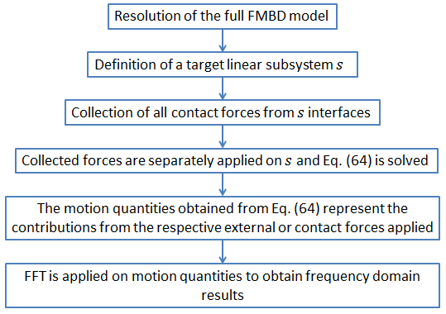
Figure 3.1 – Schematic algorithm of NTPA methodology.

- Comparison between classical TPA and the proposed methodology

3.4.1 The model investigated
In order to compare the two methodologies, a four cylinder engine block is investigated. The geometry investigated consists of 32906 TETRA and HEXA elements, with 149124 DoFs. The material selected is steel with an elastic modulus of 210000 N/mm², a Poisson ration of 0.3 and a density of 8076 kg/m³. In this case, the TPA methodology is based on numerical simulation and not on test measurements like in common applications. The simulation is carried out in time domain using the software AVL EXCITE [114]. The simulation procedure consists of three main steps: pre-processing, simulation and post-processing.
In the first step the geometry and the structural data of all components as well as all joint data are prepared and entered in the model. Since the total amount of time needed for the computation is significantly influenced by the number of DoFs of the system, a condensed model with a reduced number of DoFs, equivalent to the full model, is considered for the simulation. More details on the condensation procedure are given in section 2.3.2. The condensed number of DoFs for the investigated model is 1546. In the second step, the dynamic system of equations is solved in time domain. In the last step, result data can be extracted in time and can be transformed into frequency domain. The results are analyzed in frequency domain up to 3 kHz.
The system is excited with a moving force which represents the piston-cylinder contacts. Let us assume that we are interested in the distinction between thrust side and anti-thrust side contributions. This force is decomposed in ten different nodal forces, which are then applied in ten nodes that represent the investigated cylinder of the engine. The only excited nodes are the ones in red in Fig 3.2.
All forces are applied in time domain in thrust and anti-thrust directions. These forces are derived from a different dynamic analysis at 3000rpm of a 4-cylinder internal combustion engine which has the same engine block. They correspond to thrust components of the interaction forces between piston and cylinder liner and derive from a multi body analysis. More info about the simulation from which this force come from can be found in [113]. In order to evaluate the FRFs for the TPA, an extra simulation for each excitation point is needed. In these simulations, an impulsive force is applied in the same nodal position of the excitations. For the sake of simplicity, in Fig. 3.3 are shown only the transfer functions from the impulsive excitations to the vertical velocity component in the “response node”, with a discretization of 1.67 Hz. The forces which are used for TPA analysis has the same discretization.
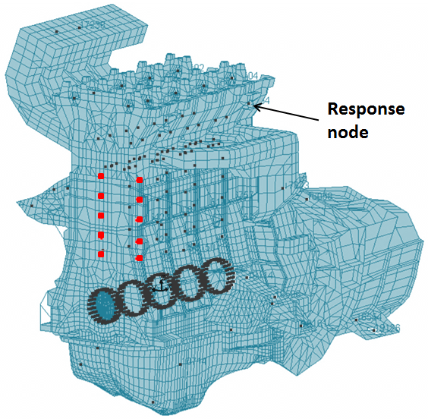
Figure 3.2 – Investigated engine block. In dark grey the nodes of the condensed mesh and in red the 10 nodes of the investigated cylinder. The engine body is transparent and some red nodes are inside the structure.

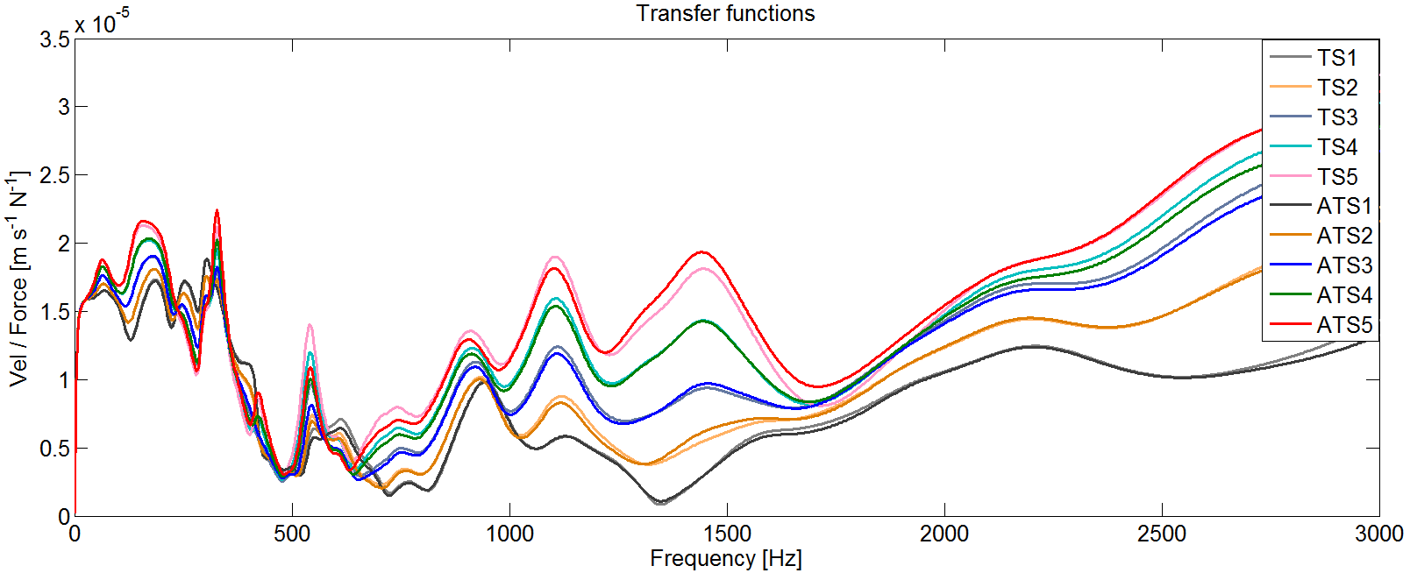
Figure 3.3 –FRFs evaluated with an impulsive force, from excitation nodes to response node. TS and ATS stand for thrust and anti-thrust sides respectively. The nodes are numbered from top to bottom of cylinder.

3.4.2 Results
Once the FRFs are computed, it is possible to apply the TPA methodology described in section 3.2 to obtain the vibration contributions of each excitation. The same contributions can be computed when it is applied the methodology described in section 3.3, by performing a simulation for each excitation set: in each simulation all the forces corresponding to one side of the cylinder are applied.
From Fig. 3.3 it is clear that FRFs can differ from point to point. Moreover it is not possible to summarize the information of the excitations (e.g. integrating all forces and concentrate them in one single node) without introducing some error. Therefore, in TPA ten simulations are needed, one for each FRF that needs to be calculated.
On the other hand, assuming that we are interested in the distinction between thrust side and anti-thrust side contributions, with the proposed methodology it is possible to get them with just two simulations, one for each set of excitations. The proposed methodology considers the possibility of multiple inputs on the investigated substructure and therefore it requires fewer simulations. For both methodologies, it was chosen the same constant time step of 0.0003 s and a simulated time of 1.08 s. Under these conditions, the CPU time of the simulation is of the same order of magnitude in both methodologies: nearly 121 s for the proposed methodology and 103 s for the evaluation of one FRF. In Fig. 3.4 the contributions evaluated with both methodologies are compared: all dominant phenomena are recognized with both methodologies and no significant error is made.
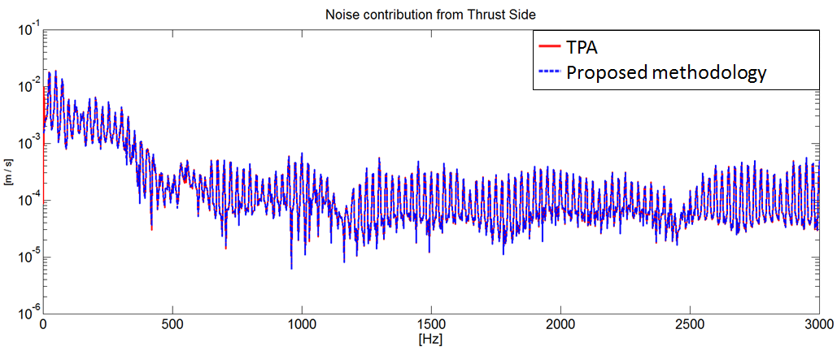
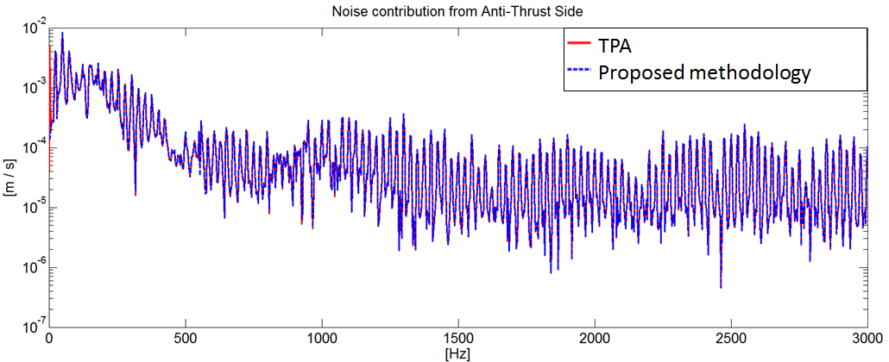
Figure 3.4 – Comparison between contributions evaluated with the proposed methodology (dotted blue line) and TPA contributions (red line) to global surface velocity in vertical direction in response node: contribution of thrust side (up) and anti-thrust side (down)

3.4.3 Considerations
In From this analysis it is clear that if a force is distributed on a surface, it is necessary to evaluate the FRF for each excited node of the structure in TPA, in order to take into account all excitations and all phenomena occurring in the vibration transmission. Conversely, in the proposed TPA methodology it is possible to apply all forces, which belong to the same excitation phenomenon, at the same time: this significantly reduces the number of required extra simulations.
The advantage of the methodology here introduced is that FRFs are intrinsically represented by the subsystem adopted to evaluate the contributions. Therefore, it reduces the number of simulations required to determine the response contributions of a set of forces without making any simplification of the FRFs and without losing information.
This represent ad advantage if engineers are interested in the contribution of a moving source, a source spread on a wide surface or the combination of more forces in different areas of the system. The drawback of proposed methodology is that the structure property information contained in the FRFs is missing because they are not evaluated.

- Vibration contribution assessment for powertrain application

3.5.1 The model investigated
In this section the numerical algorithm described in section 3.3 is performed on a dynamic system for the evaluation of the vibration contributions up to 3 kHz. The geometry investigated consists of 32906 TETRA and HEXA elements, with 149124 DoFs. The material selected is steel with an elastic modulus of 210000 N/mm², a Poisson ration of 0.3 and a density of 8076 kg/m³. The condensed number of DoFs for the investigated model is 1546. The system investigated is a four-cylinder internal combustion engine running at a full load conditions with constant engine cycle averaged speed of 3000 rpm, even though the methodology can be applied for any engine running condition. The simulation is carried out in time domain using the software AVL EXCITE [114]. The simulation procedure is the same described in section 3.4. In Fig. 3.5, joints, cylinders and connecting rods are numbered from front to rear engine. The x, y and z directions of the Cartesian coordinate reference system are associated with rotation axis, thrust and vertical directions respectively. The dynamic system of equations is solved in time domain and then results data are extracted in time and transformed into frequency domain.
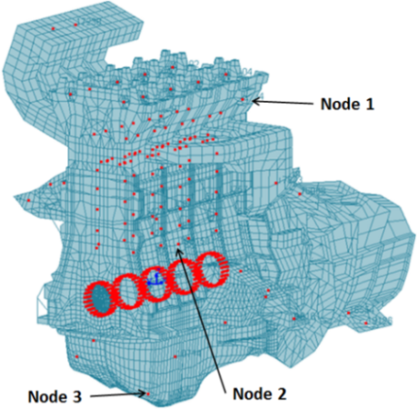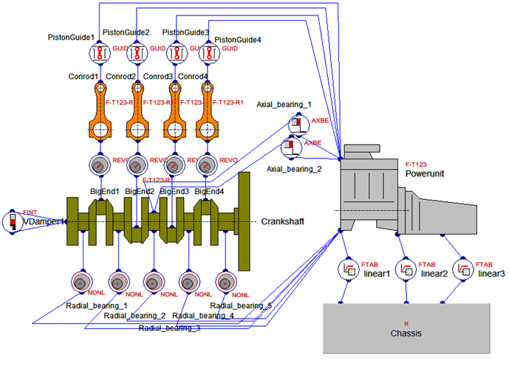
Figure 3.5 – Left: nodal positions of response points on investigated engine body. Right: 2D schematic representation of the investigated multi-body system (the engine body is transparent and some red nodes are inside the structure).

In order to perform the proposed analysis, all forces acting on the engine block are collected and grouped in sets. The forces collected are the ones transmitted from joints, from the auxiliary components on engine top head (valves and cams) and the combustion acting in the combustion chambers. Each set of forces contains the forces applied on the structure from the same joint, i.e. from the same excitation. All forces transmitted from cams and valves are considered in two different sets respectively. The subsystem contains only the engine block, a set on linear mountings that connect the block to the chassis and it is excited with only one set of forces at the time.
Sixteen different load cases, i.e. sixteen different paths, are analyzed. The following cases are identified:
- 4 combustion chambers (corresponding to the vibrations transmitted directly from the walls of the combustion chambers; from “Comb1” to 4 in figures)
- 5 radial bearings (corresponding to the main bearings of the crankshaft; from “Bearing1” to 5 in figures)
- 4 guidance for connecting rod small ends (which represent the piston-liner interaction; from “Guide1” to 4 in figures)
- Axial bearings
- Valve contacts
- Cam contacts
Once all cases are computed, the vibration contributions are evaluated in three nodes of the condensed mesh: “Node1” is placed on the engine top-head, “Node2” is on the outer surface of thrust side of “Cylinder2” and “Node3” is at the bottom of the oil pan (see Fig. 3.5). The positions of the investigated nodes are chosen in order to show the differences in vibration contribution of the same source, depending on the receiver position.
3.5.2 Analysis of vibration path
The vibrations transmitted through all considered paths to “Node1” are displayed in Figs. 3.6 and 3.7. The three different directions are considered separately.
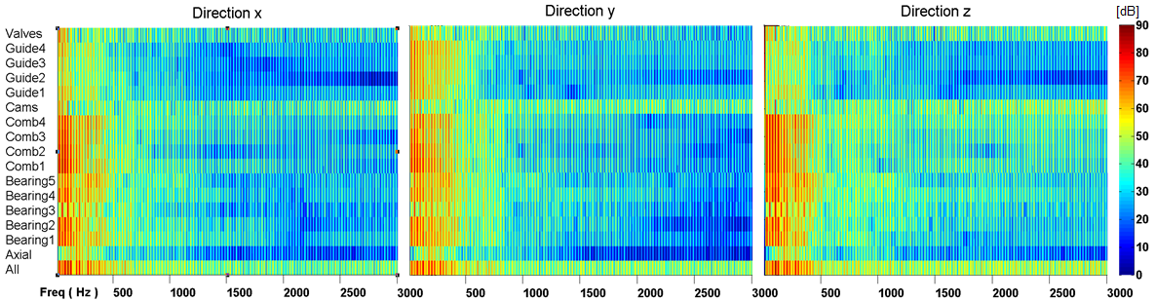
Figure 3.6 – Velocity amplitude in “Node1”: comparison between different vibration paths and global response (All).

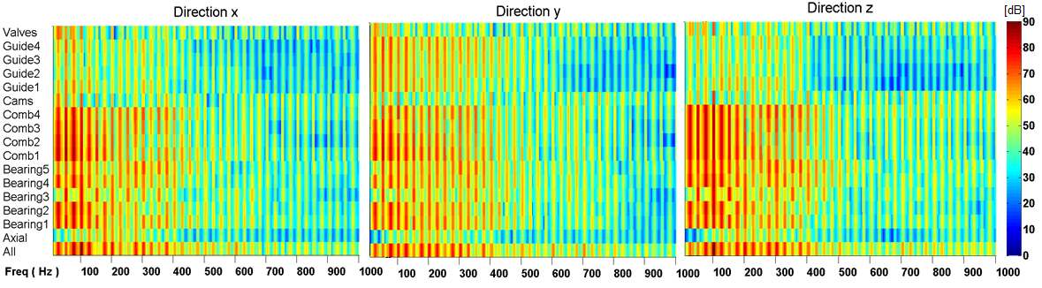
Figure 3.7 – Velocity amplitude in “Node1”: comparison between different vibration paths and global response (All). Focus on low frequency range up to 1 kHz.

Local phenomena occurring in each vibration path are recognized comparing the vibration level of each contribution. Some examples of the phenomena which occur in this model are the differences in vibration contributions depending on the node position. In order to show these differences, the normal velocity amplitude of all contributions is displayed in Fig. 3.8 for each investigated node.
The overall vibration level in Node3, which is placed in the oil pan, is higher than the other two investigated nodes. This result agrees with the findings from [115,116]: in both cases it is discussed how the oil pan represents one of the most vibrating surfaces of the whole engine.
It can be stated that in this model the vibrations are mainly generated at low frequencies and transmitted through the walls of the combustion chambers and radial bearing contacts, while the high frequency vibrations transmitted through cams, valves and piston-liner contacts are more effective. This is confirmed also from Fig 3.9, where the velocity contributions are plotted considering the contributions from all bearing as a unique set, as well for vibrations transmitted from combustion chambers and piston-liner interaction. Similar results were obtained in [115,117], where experimental analyses were conducted on two different 4-stroke Diesel engines running at constant speed of 2500 rpm. These analyses show that, at low-mid frequency, the most relevant noise contributions are combustion noise (transmitted through radial bearings and combustion chamber walls) under full load conditions. In [77] was also performed a TPA analysis that shows how vibrations transmitted from other sources, like valve contacts or oil pump, are less effective, especially at low frequency.
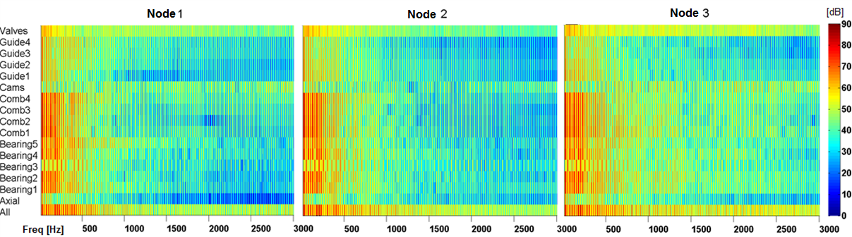
Figure 3.8 – Normal velocity amplitude magnitude in every investigated node: comparison between different vibration paths and global response (All).

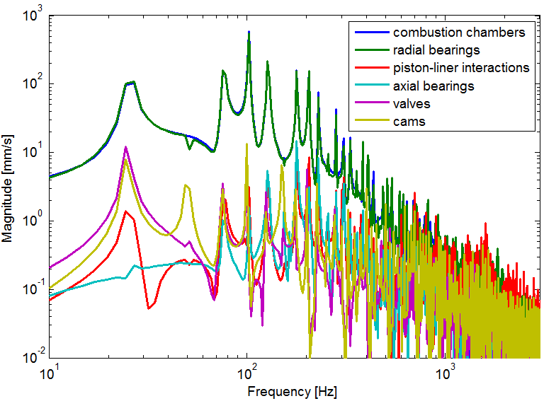
Figure 3.9 – Normal velocity amplitude magnitude in “Node 2”: comparison between different z.

The vibration contributions of each investigated path are displayed in terms of velocity magnitude in Figs. from 3.6 to 3.8. In addition, also phase information is considered in order to get a clear understanding of the combination of all contributions. For the sake of simplicity, only results in “Node1” in vertical direction are investigated. The results displayed in Figs. 3.10 and 3.11 refer to the first four orders of the particular running condition investigated, because the engine orders represent the frequencies related to the main noise and vibration phenomena at low frequency. However similar considerations can be done at every frequency in every node.

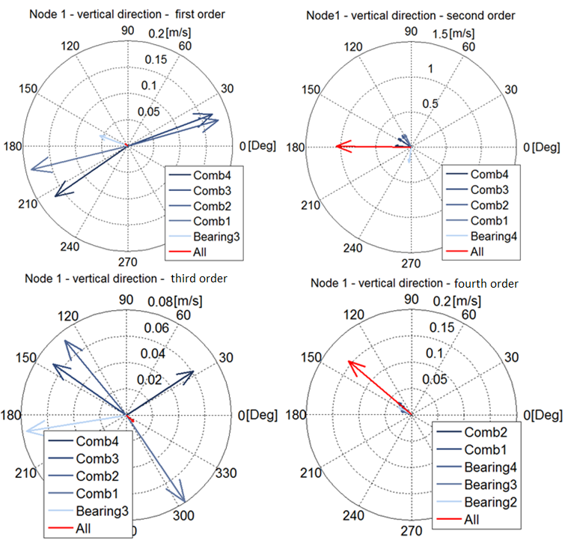
Figure 3.10 – Vertical Velocity components in “Node1”: investigation of five biggest velocity contributions at firsts four orders.

The polar graphs in Fig. 3.10 show the vibration contributions in terms of velocity magnitude and phase. Their phase reference is the phase of overall vibrations at 0 Hz. Only the biggest five vibration contributions in terms of magnitude are considered.
At first and third orders the single contributions are orders of magnitude bigger than the overall combination (red arrow in Fig. 3.10). Hence, it is clear that these effects cancel each other. In fact, at first order, contributions from combustion chambers 1 and 4 are, more or less, opposite in phase to the contributions from “Comb2” and “Comb3”. Conversely, at second and fourth orders all contributions concur to increase the total response, even though there are some differences in phase.
To understand how these differences in phase influence the combined response, all contributions are projected with respect of the phase of the combined response. The projection of a single contribution, at a specific frequency, can be expressed as
$$v_{p}=v_{m} cos⁡( φ_{v}- φ_{u})$$ | (66)
where $v_{p}$ is the projected velocity component, $v_{m}$ is the velocity magnitude of the considered vibration contribution, $φ_{v}$ is the phase of the considered vibration contribution and $φ_{u}$ is the phase of the combined response. The projected components give information about the effective contribution of each vibration path to the overall response. In Fig. 3.11, the projected vibration contributions are displayed. According to results displayed in Fig. 3.11, in order to reduce the vibrations at first order, it is necessary to reduce vibrations coming from “Comb1”, “Comb4” and third radial bearing, “Bearing3”. Conversely, the vibrations coming from all other radial bearings contacts and from walls of “Comb2” and 3 help to reduce the total vibrations.
The considerations, which arise from the projection of all contributions at second order, are more interesting: even though the vibrations coming from the fourth radial bearing are higher in magnitude than all other contributions from radial bearings (see Fig. 3.10), its projection, i.e. its effective influence to the overall vibration, is less effective than the projection of the vibrations coming from “Bearing2”. In fact, the vectors of overall and “Bearing4” vibrations are nearly orthogonal (see Fig. 3.10, second order).
Similar conclusions arise from the analysis of the projected components at third order: even though the magnitude of vibrations coming from the first combustion chamber is high, its vector, in Fig. 3.10, has a phase delay of nearly 60 deg to the overall vibrations. Hence, at third order the projected component of “Comb1” is less effective than the vibrations coming from “Bearing1”.
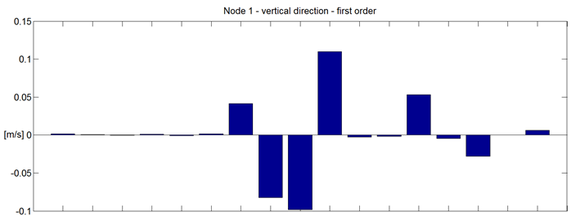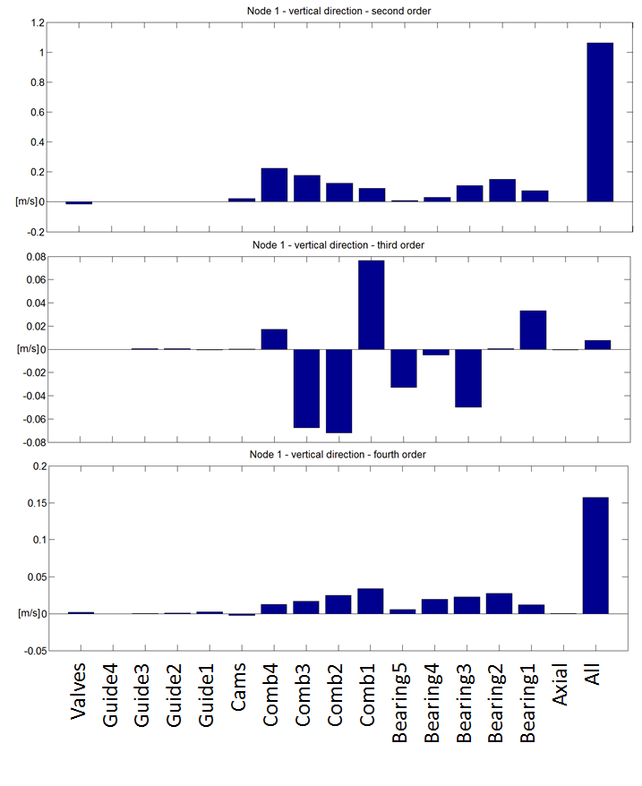
Figure 3.11 – Vertical Velocity components in “Node1”: investigation of projected velocity contributions at firsts four orders

3.5.3 Error estimation
In order to verify the accuracy of the proposed methodology, all sixteen contributions, displayed in Fig. 3.6, are summed and compared with the signal evaluated when all excitations are applied together to the structure. For the sake of simplicity only results in vertical direction in “Node1” are considered, but similar accuracy is reached in every node for every direction. The comparison and the relative error made are displayed in Fig. 3.12.
The relative error, displayed in Fig. 3.12, is defined as
$$error= 100 \left|\frac{full_simulation_results - contributions_sum}{full_simulation_results}\right|$$ | (67)
The time discretization of the numerical methodology adopted to perform the simulation is enough accurate to have a good resolution up to 3 kHz and above. Therefore, the error should mainly be numerical round-off, equally distributed over frequency.

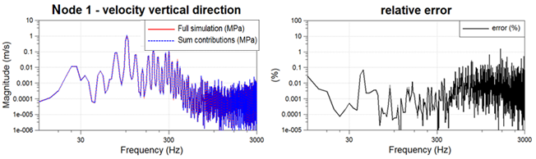
Figure 3.12 – Up: comparison between the reconstruction of contributions with the numerical TPA methodology (dotted blue line) and signal obtained when all excitation are applied concurrently on the engine body (Full Simulation – red line). Red line can hardly be seen below the blue line. Down: relative error between the two curves.

- Comparison with experimental investigation

This section shows the investigation of a V6 engine with the aim to illustrate the accuracy of proposed methodology [118]. The vibrations generated by the contacts between pistons and cylinder liners are analyzed at low frequencies for a wide range of engine speeds.
The piston slap noise generation mechanism, which occurs in cylinder-liner contacts, concerns lateral reaction forces due to piston primary motion and impact forces due to piston tilting (secondary) motion [12,119]. Even though the typical frequency range of interest of this noise phenomenon is between 1 and 3 kHz, in this application the numerical model is investigated up to 1 kHz, focusing on the analysis at main orders in low frequencies.
The simulated contribution from all six cylinders is compared with measurement data from two different variants of the engine investigated and, finally, the accuracy of proposed methodology is discussed.
3.6.1 Analysis setup
The investigated engine is a V6 gasoline engine for passenger cars. Two variants of the engine are tested. The differences between these two variants concern:
- Coating of the internal cylinder surface to improve the stiffness of the contact between piston and cylinder liner in the second engine;
- The presence of actuators for camshafts and accessory belt in the front end of second engine;
- Minor design modifications in engine block structure (mainly concentrated around inlet and outlet cam covers) between the two engine variants;
- Minor modifications in measurements instrumentation settings (instruments typology and position) between the two engine variants.
The surface accelerations are measured for both variants in order to understand the influence of these modifications on the NVH response. The difference between surface acceleration, measured on both variants and used as a representation of the applied modifications, will be compared with the results obtained from contribution analysis, performed on a numerical model of the first engine. By that, it is expected to see correlations of main affected speed and frequency ranges for the modifications of both engines to the contribution of piston impact forces from the numerical contribution analysis.
In order to make this comparison, the following assumptions are made:
- The differences in measured data at main orders in low frequency range are mainly due to the effect of the piston side forces: only the coating of the cylinders surface can modify the surface accelerations;
- The contribution of the piston side forces, evaluated in the numerical model of the first engine, is effective at the same frequencies and engine speeds at which the measured data exhibit differences between the two engines tested.
The first assumption can be considered as valid, because the investigated evaluation node is chosen on the external lateral surface of the engine (see Fig. 3.13), far enough from the regions where the actuators are placed and the structure modifications occur. As concern the latter, we assume that the modifications in the cylinder coating can only cause a modification in the amplitude of the force applied there. Even though, it is necessary to take into account that a modification of the structure properties (increasing cylinders surface stiffness in the second engine) may lead also to a modification of the phase of the response.
Under these assumptions, the results of proposed methodology will predict in which region of the Campbell diagram the piston lateral forces are more effective. Therefore, the contribution analysis performed will predict at which frequency and engine speed the differences in NVH response between the two engine variants occur.
3.6.2 Results
The contributions of piston lateral forces are evaluated in the numerical model of the engine. This vibrational contribution consists of all piston lateral forces from all six cylinders applied simultaneously: both thrust and anti-thrust sides. The surface accelerations are evaluated on a node located on the lateral external surface of the engine, as shown in Fig. 3.13.
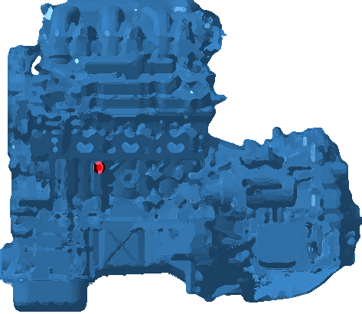
Figure 3.13 – 3D mesh of the V6 engine model. In red the position of the investigated node.
Fig. 3.14 shows the absolute value of the projected contribution of piston lateral forces on a Campbell diagram from 1000 to 6000 rpm with steps of 250 rpm, up to 1 kHz. The results presented refers to the acceleration magnitude on the investigated node in the normal direction. The results show a particular influence of this contribution at 3rd order, 6th order and around 8.5th and 9th orders at high speeds.
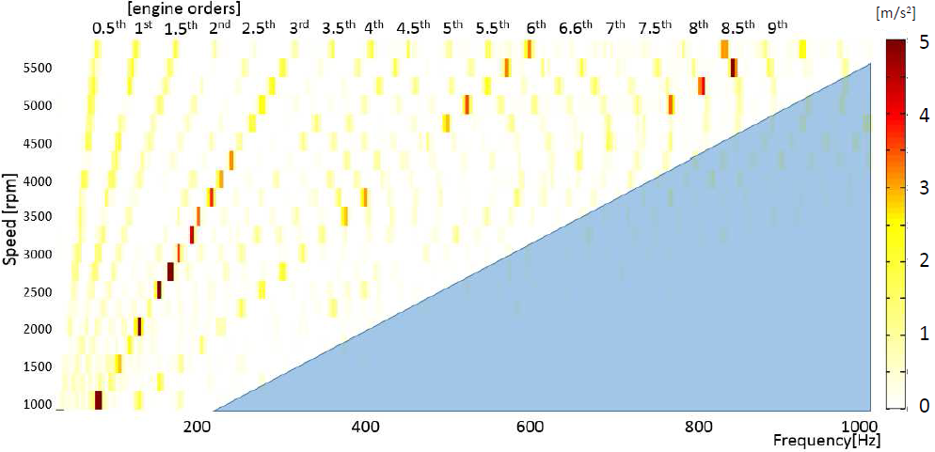
Figure 3.14 – Projected contribution magnitude of piston lateral forces evaluated with contribution analysis on the numerical model of a V6. Acceleration magnitude on the investigated node in the normal direction.

3.6.3 Comparison with measurement data
In this section, the numerical results presented in Fig. 3.14 are compared with the measurement results obtained from the two engine variants. The surface accelerations in normal direction are measured in the same investigated node in both engine variants: the quantities compared are the projected contributions and the difference between the two engine variants, in terms of measured acceleration level percentage, between the two engine variants. Under the assumptions described in section 3.6.1, both numerical results of contribution analysis and measured differences should be relevant at the same frequencies and engine speeds.
Fig. 3.15 shows the acceleration level measured on the first engine variant in normal direction in the investigated node. From these results it is clear that the background noise is orders of magnitude lower than the noise occurring at main engine orders. Consequently, in order to neglect the scattering noise in background level, it was chosen to compare numerical and measurement results at main engine orders only.
Fig. 3.16 shows the percentage difference, between the two engine variants, of acceleration magnitude on the investigated node in the normal direction. Results are presented as Campbell diagram from 1000 to 6000 rpm with steps of 25 rpm, up to a frequency of 1 kHz.

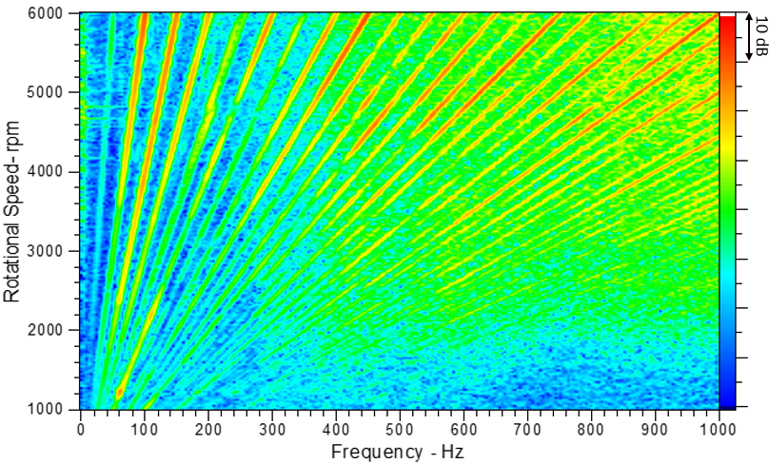
Figure 3.15 – Measured acceleration magnitude on the investigated node of the first engine variant in the normal direction.

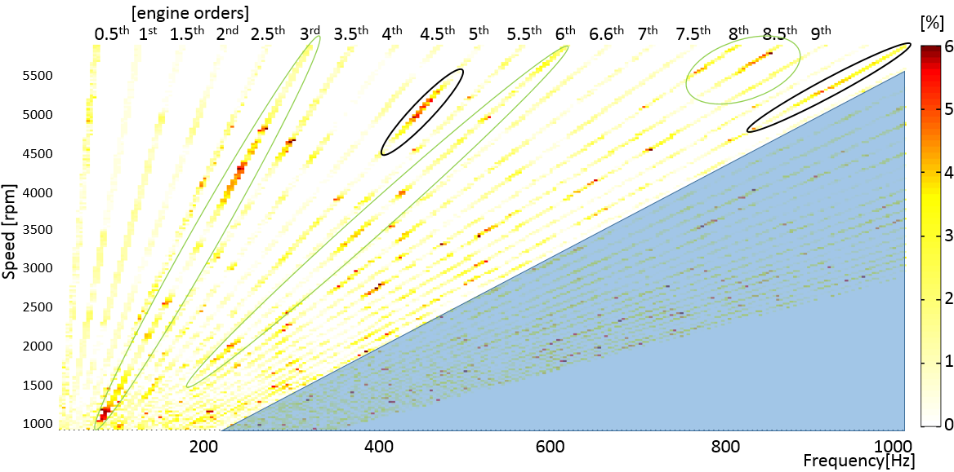
Figure 3.16 – Percentage difference between the two engine variants in measured acceleration magnitude on the investigated node in the normal direction. Highlighted in green the results that fit with contribution analysis and in black the noise addressed to accessory belt in second engine variant.

In green are highlighted the areas of the Campbell diagram that correlate with the outcome of the analysis proposed in this section (Fig. 3.14): the differences between the two engine variants occur at 3rd order, 6th order and around 8.5th and 9th orders at high speeds. At many other orders and in particular at low engine speeds it is possible to have some differences between first and second engine variants, but most of them can be neglected, considering that these differences are percentages referring to acceleration levels that are orders of magnitude lower than values encountered at 3rd, 6th and 9th orders (see Fig. 3.15). The only exception is represented by the noise occurring at 5th and 10th orders at high engine speeds (highlighted in black in Fig. 3.16): this noise can be addressed to the effect of the additional accessory belt in the front end of second engine and, therefore, this noise contribution is not considered in the numerical investigation. In this investigation, it must be considered that the projected contributions cannot be directly compared with the measured differences, because they have a different physical meaning. The formers are vibrations generated by the piston side forces in the numerical model, while the latter are the consequence of a modification occurring in correspondence of the region where the piston side forces are applied.
The aim of this analysis was to prove that the contribution analysis here proposed is accurate enough to give correct information, in terms of engine speed and frequency, about the influence of a considered set of excitation forces. It is clear that the accuracy of proposed methodology rely on the accuracy of the numerical model adopted for the analysis.

- Structure-borne noise contribution assessment

In this section the algorithm proposed in section 3.3 is performed on a dynamic system and then extended for the evaluation of the structure-borne noise paths up to 3 kHz. The model investigated is similar to the one investigated in section 3.5, but some mesh modifications (head cover and gearbox) and the gear components are introduced (see Fig. 3.17). Prior to investigate the structure-borne noise contributions, it is necessary to perform a simulation of the dynamic system. Then it is possible to apply a numerical TPA analysis for the evaluation of the structural vibration contribution to the whole exterior surface of the engine. Finally, the structural normal velocities on the engine surface are adopted as boundary conditions for the evaluation of the acoustic radiation and the structure-borne noise paths are analyzed.
In this analysis, twenty-two different load cases, i.e. twenty-two different paths, are analyzed. The following cases are identified:
- 4 combustion chambers (corresponding to the noise transmitted directly from the walls of the combustion chambers; from “Comb1 to 4” in figures)
- 5 radial bearings (corresponding to the main bearings of the crankshaft; from “Bearing1 to 5” in figures)
- 4 guidance for connecting rod small ends (which represent the piston-liner interaction; from “Guide1 to 4” in figures)
- 5 roller bearings (corresponding to the roller bearings of primary and secondary gear shafts, respectively “PSRB1 and 2” and “SSRB1 to 3” in figures)
- Supports of differential (“Diff” in figures from)
- Axial bearings
- Valve contacts
- Cam contacts
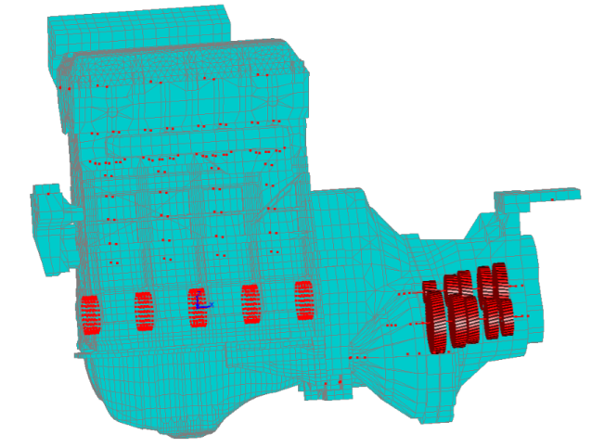
Figure 3.17 – Mesh of the engine investigated for the acoustic analysis. In red the nodes of the condensed mesh and gears (the engine body is transparent and some nodes are inside the structure).

Once the structural normal velocities on the engine surface are computed for each load case, it is possible to analyze the air-borne noise paths. The acoustic radiation is computed with the wave based method [64,68], implemented in AVL EXCITE [114], adopting the surface normal velocities as boundary conditions for the evaluation of the acoustic radiation. A more detailed description of the wave based method will be provided in Chapter 4. The acoustic pressure is evaluated in a field point node located 1 m distant from the rear of the engine, in accordance with standards in engine noise measurements tests [120,121] and shown in Fig. 3.18. The position of the investigated node is chosen in order to emphasize some of the well-known acoustic phenomena occurring in engine noise radiation problems.
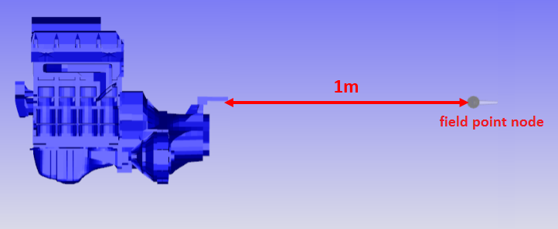
Figure 3.18 – Position of the field point node where the sound pressure is computed.

The noise generated from combustion and mechanical forces is transmitted into the structure and radiated from its surface into the air. The different contributions to the global Sound Pressure Level (SPL) computed in the field point node (see Fig. 3.18) are displayed in Fig. 3.19.
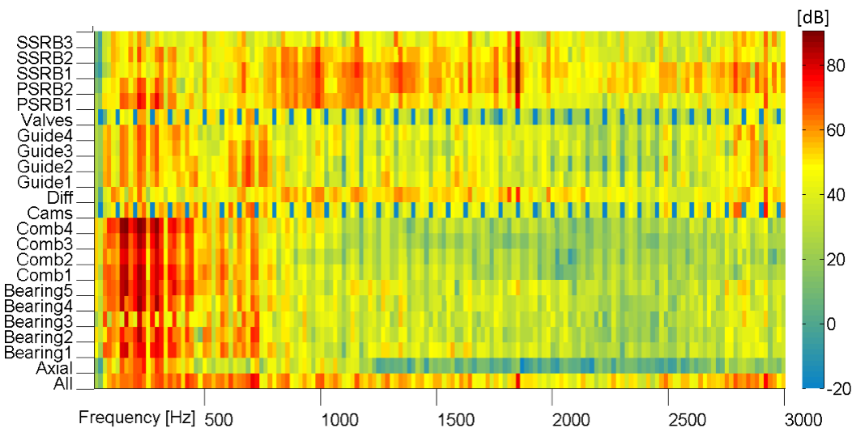
Figure 3.19 – SPL contributions in field point node.

It can be stated that in this model the noise reaching the field point node is mainly generated at low frequencies from forces applied on the walls of the combustion chambers and radial bearing contacts, even though, some relevant middle and high frequency phenomena transmitted from roller bearings supporting the gears can be detected. In particular it is possible to clearly distinguish the gear whine noise occurring at 36th order. This is a well-known phenomenon which generation mechanism is due to gear teeth impact [25,122,123]. With this analysis it is possible to understand how impact forces acting on gears produce noise that propagates mainly through gear shafts and differential. This noise reaches the external surface of the engine, and then the acoustic media, taking six different main paths: two roller bearings, which support the primary shaft (“PSRB1” and “PSRB2”), three roller bearings, which support the secondary shaft (“SSRB1”, “SSRB2” and “SSRB3”) and the supports of the differential (considered as a single path named “Diff”).
In Fig. 3.19 the noise contributions of each investigated path are displayed in terms of SPL. In this section also phase information is considered in order to get a clear understanding of the combination of all contributions. The polar graph in Fig. 3.20 shows the noise contributions in terms of sound pressure and phase. Only the biggest five noise contributions in terms of magnitude are considered. For the sake of simplicity, only results at 36th order are displayed, because of the high noise level computed at this order due to gear whine noise. However, similar considerations can be done at every frequency.
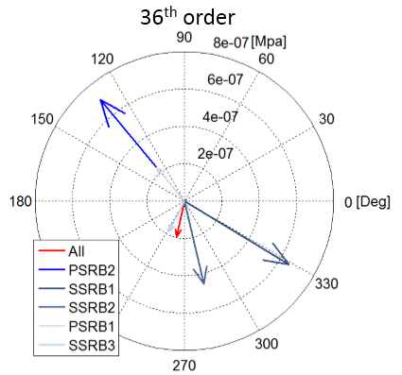
Figure 3.20 – Sound Pressure components in field point node: five biggest pressure contributions at 36th order.

The results shown in Fig. 3.20 can be also expressed in terms of projected contributions, defined by Eq. (7). The projected components are represented in Fig. 3.21. In this case, noise is mainly generated by the contact forces occurring at the gear shafts supports. Also some noise is transmitted from the differential supports. The interesting conclusion of this analysis is that, for this particular example and for this particular investigated field point node, only secondary shafts supports (“SSRB1” to 3) produce a sound pressure which is in phase with the overall sound. Conversely, all other relevant noise paths (primary shaft and differential supports) produce a sound pressure which is opposite in phase.
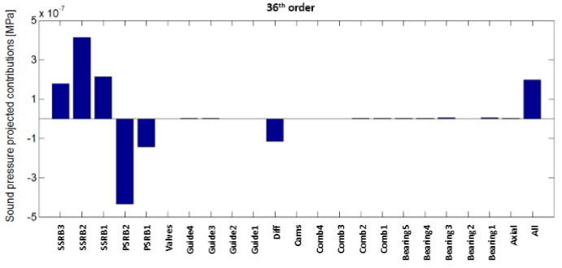
Figure 3.21 – Investigation of projected pressure contributions at 36th order in field point node.

- Combination with HTPA and investigation of interior acoustics using measured FRFs

In this section, the HTPA methodology proposed by Kim and Lee in 2008 [107] is combined with the methodology introduced section 3.3 for the analysis of the vibration contributions of the different internal engine sources to the interior noise.
The substructure investigated in this section is the engine block connected with the car chassis via linear mountings. In the MBD simulation the chassis is considered having infinite stiffness. Once the motion contributions are determined, the forces at mounts are evaluated. The joint contacts between engine and chassis, i.e. the mount contacts, are internal contact into the substructure $s$ where the NTPA is applied. Therefore, the force applied to the mounts is here derived from motion quantities considering a simple linear approximation
$$d {\dot{q}}_{mount,i}+k q_{mount,i}=f_{mount,i}$$ | (68)
In Eq. (68), $d$ and $k$ are respectively the linear damping and stiffness of the engine mount, while the contributions ${\dot{q}}_{mount,i}$ and $q_{mount,i}$ are defined at the nodal positions of engine mounts connections and are used to derive the force component $f_{mount,i}$ of the $i$-th source. Finally, the HTPA methodology is applied using the $f_{mount,i}$ components and the interior noise is derived.
3.8.1 Numerical model of the engine investigated
In this section, a MBD system of an internal combustion engine is investigated. It is an in-line four-cylinder internal combustion engine running at a full load conditions with constant engine cycle averaged speed of 3000 rpm. It is a four-stroke engine, with a stroke of 92.8mm and cylinder bore of 82.5mm. The numerical system consists of one engine block mounted on 3 different mount positions, a crankshaft, four con-rods, two balancer shafts in correspondence of intake and exhaust systems and a dual-mass-flywheel (DMF). The joints connecting gearbox and engine block are linear, while all others are nonlinear joints with exponential increasing stiffness as function of the displacement. No gear transmissions are included into the model. The pistons are excited with moving forces representing the combustion pressure.
The torque applied on the crankshaft from the pistons is balanced with an external torque applied in correspondence of the DMF. The simulation is carried out in time domain using the software AVL EXCITE [114].

The reliability of the NTPA presented in section 3.3 depends on the accuracy of the numerical simulation. Therefore, Fig. 3.22 shows the accuracy of the MBD model, comparing measured and simulated surface acceleration evaluated in one mount position. The mount placed on the right side of the engine is “mount 1”, the one on the left side of the engine is “mount 2” and the last, placed on the rear of the gearbox is “mount 3”. Although Fig. 3.22 shows an enough adequate matching between measurements and simulations for a wide range of engine speeds, for the sake of simplicity, the HTPA is performed only at 3000 rpm. Anyway, the same analysis can be performed at any engine speed.
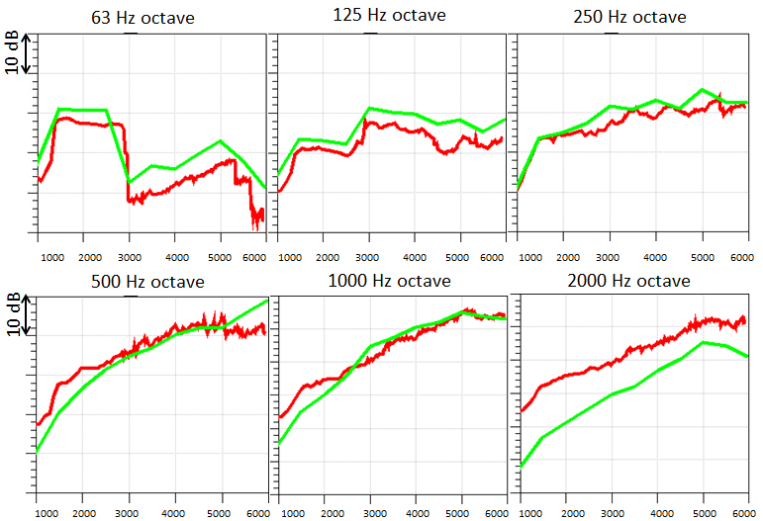
Figure 3.22 – Surface acceleration at “mount 1” as function of engine speed, from 1000 to 6000 rpm. Results expressed in octave bands. Green, numerical model; Red, measurements.

Once the full MBD simulation is performed, the methodology described in section 2 can be applied. The substructure investigated is the engine block. All forces acting on the engine block are collected and grouped in sets. The forces collected are the ones transmitted from joints and the combustion pressure acting in the combustion chambers. Each set of forces contains the forces applied on the structure from the same joint, i.e. from the same excitation. 21 different load cases, i.e. 21 different paths, are analyzed. The following cases are identified:
- 4 combustion chambers (corresponding to the vibrations transmitted directly from the walls of the combustion chambers; from “Comb1” to 4 in figures)
- 5 radial main bearings (corresponding to the main bearings of the crankshaft; from “Bearing1” to 5 in figures)
- 4 guidance for connecting rod small ends (which represent the piston-liner interaction; from “Liner1” to 4 in figures)
- 6 bearings for balancer shafts (respectively from “BalInt1” to 3 for the supports in correspondence of intake system and from “BalExh1” to 3 for supports in correspondence of exhaust system in figures)
- Axial bearings
- DMF supports
When all cases are computed, the force contributions are evaluated in the nodes of interest. Fig. 3.23 shows the force contributions evaluated at Mount1. For the sake of readability, only force in vertical direction at Mount1 is here shown, although, all force components exhibit similar behavior.
The force contributions are finally used as input of the HTPA. These forces are multiplied with the measured transfer functions shown in Fig. 3.24 to derive the influence of internal engine sources on interior noise.
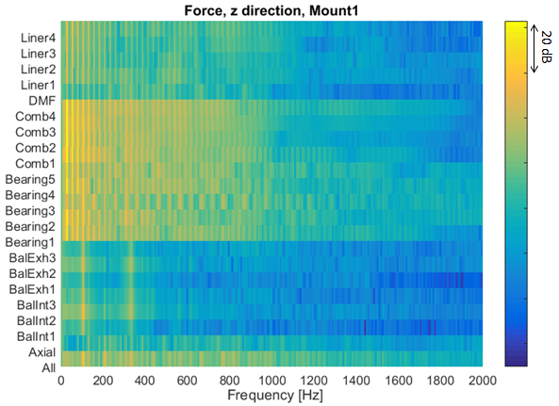
Figure 3.23 – Force contributions at Mount1 in vertical direction. The bottom line is the overall force transmitted in vertical direction. Other lines are the absolute values of the force contributions.

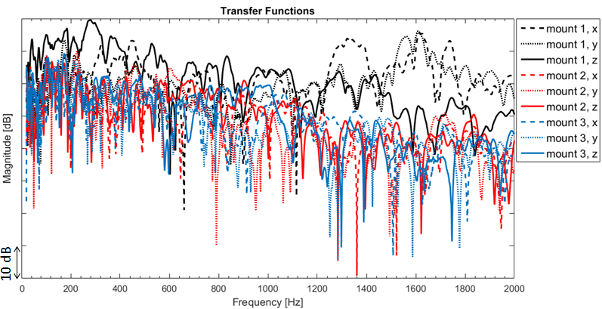
Figure 3.24 – Measured FRFs from mount positions to driver position. Data are expressed in Pa/N.

3.8.2 Noise contributions to driver hear position
The transfer functions, from mount position to interior drives position, are shown in Fig. 3.24. A frequency response function (FRF) is measured for each direction. “Z” correspond to the vertical direction, “X” to the direction of the axis of the crankshaft and “Y” is the thrust direction. The FRFs shown in Fig. 3.24 refers to the SPL measured at driver position and are expressed in Pa/N. These measured transfer functions are used to weight the force contributions shown in Fig. 3.23 and obtain the SPL contributions at driver position. Fig. 3.25 shows the SPL contributions in dB (A weighted). The results shown in Fig. 3.25 are useful to understand how the different noise contributions interact when transmitted via 3 different paths (the 3 mounts). The results presented in Fig. 3.25 consider only absolute values of the SPL contributions. At low frequency, and especially at main engine orders, also the phase information can be taken into account to better analyze the interaction of the different sources. E.g., the Plots in Fig. 3.26 show the phase interaction of the contributions at 200 and 330 Hz, where the SPL is relatively high. Form this graphs it is clear that, depending on the frequency, some contributions are opposite and some others are in phase with the overall noise. This info can be useful during the design phase to understand where it is more convenient to act in order to improve sound quality.
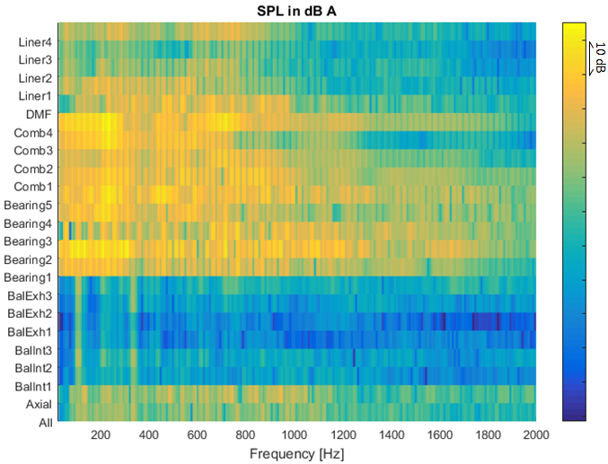
Figure 3.25 – SPL contributions at driver position. The bottom line is the overall noise measured, while all other lines are the absolute values of the contributions.

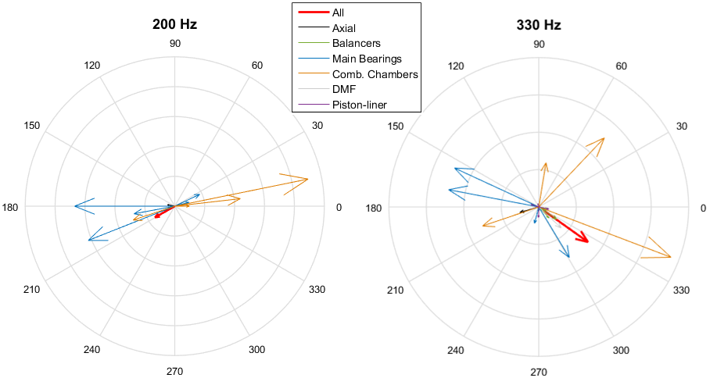
Figure 3.26 – Sound pressure contributions at 200 and 330 Hz. In red, the overall noise.

CHAPTER4

Surface contribution analysis in wave based method framework

- State of the art on acoustic source identification problems

Together with the reduction of fuel consumption and exhaust pollution, noise reduction is one of the main topics of interest in internal combustion engine development, because of the more and more strict noise legislation and the increasing customer demands. Engine noise can be separated into structure-borne noise and air borne noise. Structure-borne noise is generated from combustion and mechanical phenomena that occur inside the engine, it is transmitted through the engine structure and it is radiated from the external surface of the engine. Conversely, air borne noise is directly generated into the air in correspondence of intake and exhaust systems. The air borne noise can be significantly reduced adopting air intake and exhaust mufflers, therefore, surface radiated noise becomes the predominant acoustic issue. Covers, such as oil pans, valve covers and front gear covers, are important engine components used to contain liquids (oil and/or water) and, in many applications, also to reduce the noise emission of the internal components. It has been shown that most of the noise is radiated from covers and an optimal cover design can considerably improve the noise emission [124,125]. In order to understand where and how to improve the external covers and engine surfaces design, it is necessary to analyze and rank the different engine surfaces in terms of emitted noise. Experimentally, several methods can be used to rank the different radiating surfaces: Lead covering (also called shielding technique), surface vibrations technique, acoustic intensity technique, beam forming and acoustic holography [21-24]. To reduce design and development timing and costs, computer-aided-engineering (CAE) methods are extensively used. In industrial applications the finite elements method (FEM) and the boundary element method (BEM) are the most widely used methods to predict the acoustic field in interior and exterior radiation problems. Specific methods within FEM and BEM framework were developed with the aim to analyze and rank different radiating surfaces of a body, such as panel contribution analysis (PCA) [126-128]. In addition to FEM and BEM, the wave based method (WBM) has been developed as an alternative method for solving steady-state acoustic problems in the mid-frequency range [64]. This chapter focus on the definition of a numerical methodology to assess and rank different radiating surfaces within a WBM framework.

- Wave based method applications in exterior radiation problems

The WBM is based on an indirect Trefftz approach [129-131] and the field variables are expressed in terms of globally defined shape functions, which are the exact solutions of the homogeneous governing differential equation (Helmholtz Eq.(44)), but which do not necessarily satisfy the boundary conditions [64,68]. The wave models are substantially smaller than equivalent FEM and BEM counterparts and exhibit an increased computational efficiency [132,133]. The WBM is nowadays applied to model many different problems, for example interior acoustic problems [68,134-136], exterior acoustic problems [137-140,113], plate and membrane problems [141-145], coupled vibro-acoustic problems [64,130,134] or poroelastic material modeling [146,147]. A wide overview on the WBM can be found in [148]. Within the WBM framework, a surface contribution analysis (SCA) was proposed to assess and rank the different radiating surfaces of the investigated system [149]. In the following sections, the basics of WBM are given and the SCA formulation is introduced.
4.2.1 Problem definition
Let us consider an exterior acoustic problem with a vibrating structure which boundary $∂Ω$ is surrounded by an unbounded 3-dimensional fluid domain$Ω$. The fluid is characterized by its speed of sound $c$ and density$ρ$. Assuming that the system is linear, the fluid inviscid and isotropic and that the process is adiabatic, the steady state pressure field is governed by the homogeneous Helmholtz equation, Eq. (44), as described in section 2.4. There are three possible boundary conditions associated to this problem, assuming that the solid and the fluid structures are not coupled: imposed normal velocity, imposed pressure and normal impedance boundary conditions, respectively described in Eq. (45), (46) and (47). Considering an exterior radiation problem, where the acoustic waves are radiating towards infinity, the Sommerfeld radiation condition is applied on the boundary $Γ_{∞}$, in order to ensure that no acoustic energy is reflected at infinity, see Eq (48). $Γ_{∞}$ is the boundary placed in the far field and represents the limit of the fluid domain in a numerical model (see Fig. 4.1). As described in [139] and [150], the WBM includes an additional treatment to tackle exterior radiation problems with the introduction of an artificial truncation boundary that defines two subdomains: a bounded part and an unbounded part. In the bounded region of the domain, the WBM formulation for interior problems is applied, whereas in the unbounded region, radiating functions, which satisfy the Sommerfeld radiation condition, are employed. The modeling strategy is shown in Fig. 4.1, where an internal combustion engine is investigated.

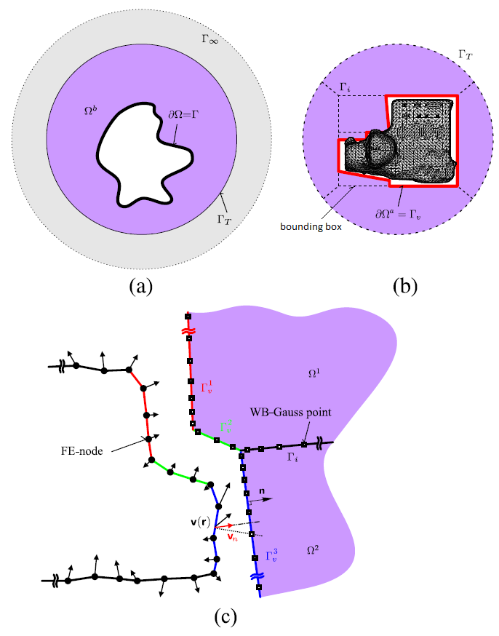
Figure 4.1 – Application of WBM for one-way coupled structural-acoustic unbounded problems: (a) the concept of a truncation boundary $Γ_{T}$ and (b) the modelling strategy [150].

4.2.2 Bounded region
In the bounded sub-domain, the exact pressure solution is approximated with a linear combination of $n_{B}$ acoustic wave functions $Φ_{B}$
$p\left(r\right) ≈ \sum_{j=1}^{n_{B}}{{p_{Bj} Φ}_{B,j}\left(r\right)+{\hat{p}}_{q}^{ } }$, (69)
where the unknown $p_{Bj}$ weighting factors are the degrees of freedom of the problem and ${\hat{p}}_{q}^{ }$ is the source term (the particular solution of the Helmholtz equation). As discussed in [68], the acoustic wave functions are
$Φ_{B,j}\left(r\right)= \left\{\begin{aligned}Φ_{B,r}\left(x,y,z\right)=\cos\left(k_{xB,r} x\right)\cos\left(k_{yB,r} y\right)e^{{-ik}_{zB,r} z} \\ Φ_{B,s}\left(x,y,z\right)=\cos\left(k_{xB,s} x\right)e^{-ik_{yB,s} y}\cos\left(k_{zB,s} z\right) \\ Φ_{B,t}\left(x,y,z\right)= e^{-ik_{xB,t} x}\cos\left(k_{yB,t} y\right)\cos\left(k_{zB,t} z\right)\end{aligned}\right.$. (70)
The only condition needed to satisfy the Helmholtz equation is that the wave numbers in the different directions are related by the expression: ${k_{xB}}^{2}+{k_{yB}}^{2}+{k_{zB}}^{2}={k_{ }}^{2}.$
In [64], it is suggested to consider the following wave number components
$\begin{matrix}\left(k_{xB,r},k_{yB,r},k_{zB,r}\right)=\left[\frac{b_{1}π}{L_{x}},\frac{b_{2}π}{L_{y}},±\sqrt{k^{2}-{\left(\frac{b_{1}π}{L_{x}}\right)}^{2}-{\left(\frac{b_{2}π}{L_{y}}\right)}^{2}}\right] \\ \left(k_{xB,s},k_{yB,s},k_{zB,s}\right)=\left[\frac{b_{3}π}{L_{x}},±\sqrt{k^{2}-{\left(\frac{b_{3}π}{L_{x}}\right)}^{2}-{\left(\frac{b_{4}π}{L_{z}}\right)}^{2}} , \frac{b_{4}π}{L_{z}}\right] \\ \left(k_{xB,t},k_{yB,t},k_{zB,t}\right)=\left[±\sqrt{k^{2}-{\left(\frac{b_{5}π}{L_{y}}\right)}^{2}-{\left(\frac{b_{6}π}{L_{z}}\right)}^{2}},\frac{b_{5}π}{L_{y}},\frac{b_{6}π}{L_{z}}\right]\end{matrix}$, (71)
${ b}_{1}$,$b_{2}$,$b_{3}$,$b_{4}$, $b_{5}$ and $b_{6 }$ being integer numbers and $L_{x}$, $L_{y}$ and $L_{z}$ are the smallest dimensions of the rectangular bounding box enclosing the considered sub-domain.
The bounded domain can also be decomposed in smaller convex subdomains. At the interfaces between subdomains, appropriate coupling conditions (imposed pressure, imposed velocity or impedance coupling) have to be fulfilled. WBM requires convex numerical domains and therefore, this decomposition can be required if the geometry has a non-convex shape [64,68].
For the WBM problem resolution in bounded domains of Eq. (69), a weighted residual formulation can be applied for the evaluation of the boundary and continuity conditions [64,68]. Applying a Galerkin weighted residual formulation for each subdomain $Ω_{α}$, yields
$p_{w}^{α,T}\sum_{β=1}^{N_{v}}{[C^{α,β}p_{B}^{α}-f^{α}-f^{α,β}]}=0$, (72)
where, ${\left[\right]}^{T}$ denotes the transpose, $α$ and $β$ denote indices associated to the subdomains that constitute the bounded region, $N_{v}$ is the total number of subdomains, $p_{B}$ is the vector of WBM weighting factors $p_{Bi}$ (see Eq. (69)), $p_{w}$ denotes the vector of weighting functions, $C$ is a matrix containing information about the geometry and wave functions, $f$ is the vector of known terms which depends on boundary conditions. The weighted residual formulation in Eq. (72) should hold for any weighting function $p_{w}$. Therefore, the sum in Eq. (72) must be equal to zero. This yields a set of linear equations where the unknown terms are the wave function contribution factors $p_{Bi}$. In matrix form, it reads:
$\left[\begin{matrix}C^{\left(1\right)} & \begin{matrix}C^{\left(1,2\right)} & C^{\left(1,3\right)} & …\end{matrix} & C^{({1,N}_{v})} \\ \begin{matrix}C^{\left(2,1\right)} \\ ⋮\end{matrix} & \begin{matrix}\begin{matrix}C^{\left(2\right)} \\ ⋮\end{matrix} & \begin{matrix}{ C}^{\left(2,3\right)} \\ ⋮\end{matrix} & \begin{matrix} … \\ ⋱\end{matrix}\end{matrix} & \begin{matrix}C^{({2,N}_{v})} \\ ⋮\end{matrix} \\ C^{(N_{v},1)} & \begin{matrix}C^{(N_{v},2)} & C^{(N_{v},3)} & …\end{matrix} & C^{(N_{v})}\end{matrix}\right]\left[\begin{matrix}p_{B}^{1} \\ \begin{matrix}p_{B}^{2} \\ p_{B}^{3} \\ ⋮\end{matrix} \\ p_{B}^{N_{v}}\end{matrix}\right]=\left[\begin{matrix}b^{1} \\ \begin{matrix}b^{2} \\ b^{3} \\ ⋮\end{matrix} \\ b^{N_{v}}\end{matrix}\right]$ , (73)
with
$b^{α}= f^{α}+\sum_{β=1,β≠α}^{N_{v}}{f^{α,β}}$ . (74)
The WBM matrix equation can also be expressed in a condensed form as
$A p_{B}=b$ . (75)
4.2.3 Unbounded region
In the unbounded domain, the solution has to fulfill both Sommerfeld radiation condition and Helmholtz equation. A valid basis set for the wave function expansions is given in [139,151] and in a spherical coordinates reference system it reads
$p\left(r,ϑ,φ\right)=\sum_{l=0}^{N_{U}}{\sum_{m=-l}^{l}{p_{l}^{m}h_{l}\left(kr\right)Y_{lm}(θ,φ)}}+{\hat{p}}_{q}^{α}$ (76)
where $p_{l}^{m}$are the Legendre polynomials, $Y_{lm}(ϑ,φ)$ denote the spherical harmonics and $h_{l}(kr)$ are the spherical Hankel functions.
The modeling of exterior acoustic problems in WBM is done using an artificial spherical truncation boundary surface, as described in [139,114]. A bounding box, whose characteristic dimensions are the ones of the investigated radiating object, is introduced together with 6 elements between the truncation boundary $Γ_{T}$ and the bounding box, as shown in Fig. 4.1.
4.2.4 Boundary conditions application
In Eq. (74), the terms $b^{α}$ that constitute the known terms of the WBM system equation are a sum of different $f^{α,β}$ terms. Their expression is related to the boundary conditions described in Eqs. (45) to (47) and the coupling conditions between subdomains.
In the case that$α=β$, it is possible to write
$f^{α}=f_{v}^{α}+f_{p}^{α}{+ f}_{Z}^{α}+f_{Iv}^{α}+f_{Ip}^{α}$. (77)
The term associated to velocity boundary conditions is
$f_{v}^{α}= \int_{{∂Ω}_{v}^{α}}^{ }{Φ^{α,T}} \left({\overline{v}}_{n}-\frac{i}{ρ_{0}ω}n^{α,T} ∇{\hat{p}}_{q}^{α}\right) dΓ$. (78.1)
The term associated to pressure boundary condition is
$f_{p}^{α}= \int_{{∂Ω}_{p}^{α}}^{ }{\frac{i}{ρ_{0}ω} {\left(∇ Φ^{α}\right)}^{T}} n \left({\hat{p}}_{q}^{α}-\overline{p}\right) dΓ$. (78.2)
The term associated to impedance boundary condition is
$f_{Z}^{α}= \int_{{∂Ω}_{Z}^{α}}^{ }{Φ^{α,T}} \left(\frac{{\hat{p}}_{q}^{α}}{{\overline{Z}}_{n}}-\frac{i}{ρ_{0}ω}n^{α,T} ∇{\hat{p}}_{q}^{α}\right) dΓ$. (78.3)
The term associated to velocity continuity at interfaces with other subdomains is
$f_{Iv}^{α}= \int_{{∂Ω}_{Iv}^{α}}^{ }{Φ^{α,T}} \left(\frac{i}{ρ_{0}ω}n^{α,T} ∇{\hat{p}}_{q}^{α}\right) dΓ$. (78.4)
The term associated to pressure continuity at interfaces with other subdomains is
$f_{Ip}^{α}= \int_{{∂Ω}_{Ip}^{α}}^{ }{\frac{i}{ρ_{0}ω} {\left(∇ Φ^{α}\right)}^{T} n \left({\hat{p}}_{q}^{α}\right)} dΓ$. (78.5)
In the case that$α≠β$, it is possible to write
$f^{α,β}=-\int_{{∂Ω}_{Iv}^{α,β}}^{ }{Φ^{α,T}} \left(\frac{i}{ρ_{0}ω}n^{β,T} ∇{\hat{p}}_{q}^{β}\right) dΓ-\int_{{∂Ω}_{Ip}^{α,β}}^{ }{\frac{i}{ρ_{0}ω} {\left(∇ Φ^{α}\right)}^{T} n \left({\hat{p}}_{q}^{β}\right)} dΓ$ (79)
where ${\overline{v}}_{n}$ and$\overline{p}$ are respectively the imposed velocity and pressure at the boundary,${\overline{Z}}_{n}$ is the imposed impedance at the boundary, ${\hat{p}}_{q}^{α}$ is the particular solution of the Helmholtz equation (source term) in subdomain $α$ while ${\hat{p}}_{q}^{β}$ is the solution of subdomain $β$, $∂Ω_{I}^{α}$ is the coupling boundary with other subdomains and $∂Ω_{I}^{α,β}$ is the surface boundary that subdomain $α$ and $β$ share. Note that
$∂Ω_{I}^{α}= \bigcup_{β=1,β≠α}^{N_{v}}{∂Ω_{I}^{α,β}}$ (80)
and also
$∂Ω_{ }^{α}= ∂Ω_{v}^{α}∪∂Ω_{p}^{α}∪∂Ω_{Z}^{α} ∪∂Ω_{I}^{α}$. (81)
In exterior radiation problems, the boundary conditions of the bounded region are the ones in Eq. (77) and are introduced to solve the system in Eq. (75).

- Surface contribution analysis formulation

The purpose of a surface contribution analysis (SCA) is to separately calculate the solution of Eq. (75) decomposing the area on which the boundary conditions are calculated. For the sake of simplicity, in the following expressions the source terms${\hat{p}}_{q}^{α}$ are set equal to zero, although, for a more general source contribution analysis formulation, it is possible to consider also these terms. Neglecting the source terms, it is straight forward to analyze separately the noise radiated from the different surfaces. The terms $b^{α}$ in Eq. (73) are defined as sum of different boundary conditions, which are expressed in Eqs. (78) and (79) and are applied on different surfaces, $∂Ω_{v}^{α}$, $∂Ω_{p}^{α}$, $∂Ω_{Z}^{α}$ and$∂Ω_{I}^{α}$.
Consider a boundary surface selection $∂Ω_{j}$ such that$∂Ω_{ }^{ }=\bigcup_{j=1}^{Ns}{∂Ω_{j}^{ }}$, being$Ns$ the total number of surface selections. Introducing Eq. (80) and Eq. (81) in Eq. (74), the boundary conditions associated to $∂Ω_{j}$ can be expressed as
$b_{j}= \left[\begin{matrix}b_{j}^{1} \\ \begin{matrix}b_{j}^{2} \\ b_{j}^{3} \\ ⋮\end{matrix} \\ b_{j}^{N_{v}}\end{matrix}\right]=\left[\begin{matrix}f_{j}^{1}+\sum_{β=1,β≠1}^{N_{v}}{f_{j}^{1,β}} \\ \begin{matrix}f_{j}^{2}+\sum_{β=1,β≠2}^{N_{v}}{f_{j}^{2,β}} \\ f_{j}^{3}+\sum_{β=1,β≠3}^{N_{v}}{f_{j}^{3,β}} \\ ⋮\end{matrix} \\ f_{j}^{N_{v}}+\sum_{β=1,β≠N_{v}}^{N_{v}}{f_{j}^{N_{v},β}}\end{matrix}\right]$ . (82)
where $f_{j}^{α}$ and $f_{j}^{α,β}$ differ from Eqs. (78) and (79) only because of the different integration regions ${∂Ω}_{v,j}^{α}$,${∂Ω}_{p,j}^{α}$,${∂Ω}_{Z,j}^{α}$,${∂Ω}_{Iv,j}^{α}$,${∂Ω}_{Ip,j}^{α}$,${∂Ω}_{Iv,j}^{α,β}$ and${∂Ω}_{Ip,j}^{α,β}$. Moreover, the relation$∂{Ω_{x}^{α }}_{ }^{ }=\bigcup_{j=1}^{Ns}{∂Ω_{x,j}^{α}}$ holds for every integration surface. Given that, the WBM system of Eq. (12) can be solved considering the known terms${ b}_{i}$, it follows
$A p_{Bj}=b_{j}$ . (83)
The terms$p_{Bj}$, correspond to the contribution of surface$∂Ω_{j}$ to the global solution of the associated radiation problem. Since the WBM formulation solves the Helmholtz equation, for which solution the superposition principle is valid, and considering the validity of Eqs. (80) and (81), also the solutions $p_{Bj }$, obtained considering the known terms $b_{j}^{α}$, can be linearly summed
$p_{B}= \sum_{j=1}^{N_{s}}{p_{Bj}}$ . (84)

- Assessment of radiating surfaces in powertrain applications

In industrial applications, engine noise radiation is a typical example of one-way coupled (from structure to fluid) exterior radiation problem, where the velocity boundary conditions of the acoustic problem are derived from the structural vibrations of the engine surface. In this case, the aim is to divide the noise contributions from different engine surfaces in order to assess them in terms of emitted noise. Therefore, the only boundary condition of interest for a SCA is the imposed velocity as expressed in Eq. (78.1).
The structural and acoustic problems are based on different computational techniques and thus use incompatible numerical models. To define the velocity boundary condition for the acoustic problem, a generic multi-local-velocity (MLV) algorithm is implemented [114]. As described in [132,150] and shown in Fig. 4.2, to each WB boundary, $∂{Ω_{v,j}}_{ }^{ }=Γ_{v}^{j}$, a FE mesh is assigned and the imposed velocity ${\overline{v}}_{n}$ is defined on specific Gauss Point (GP), mapping the structural velocities components, which are normal to the acoustic boundary.

Figure 4.2 – Generic MLV algorithm [150].

The WBM formulation and the MLV mapping scheme used to solve the acoustic problem that will be presented in next section, as well as the SCA algorithm, are implemented in the software AVL EXCITE Acoustics [114].
4.4.1 The model investigated
The model investigated is an in-line four cylinder internal combustion engine (see Fig. 4.3), running at full load conditions with constant engine cycle averaged speed of 3000 rpm. The dynamic simulation of the engine is carried out in time domain using the software AVL EXCITE Power Unit [114]. The dynamic simulation procedure and the model description can be found in section 3.
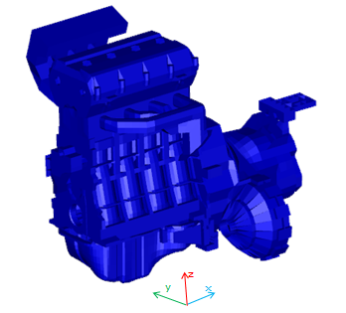
Figure 4.3 – Surface structural mesh of the numerical model investigated.

Once the structural surface velocities are computed in frequency domain, applying the Fourier Transform of the time domain results obtained from dynamic analysis, it is possible to map the velocities on the acoustic mesh using an MLV scheme. Both structural and acoustic wave based surface meshes are displayed in Fig. 4.4. In order to apply a SCA, the surface of the acoustic mesh of the investigated engine is divided into different selections of interest al illustrated in Fig. 4.5. The different surfaces selections of interest are:
- Head cover
- Front block
- Rear block
- Right side block
- Left side block
- Oil pan
- Gear box
- Differential cover

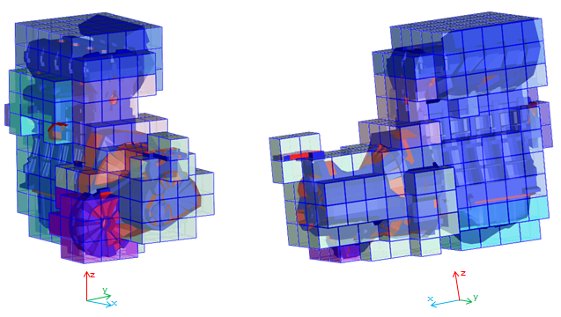
Figure 4.4 – Acoustic surface mesh enveloping the structural surface mesh of the engine. Two different points of view are displayed.
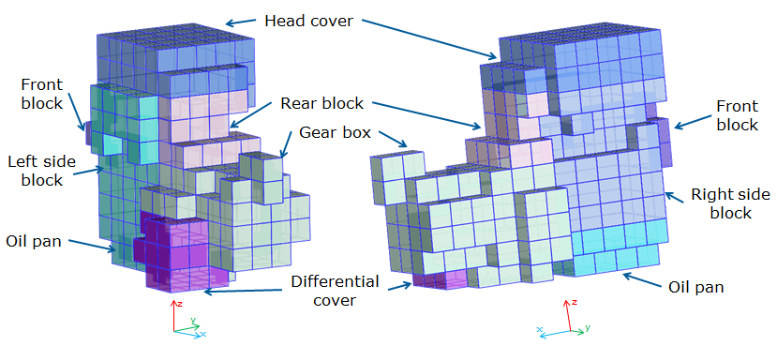
Figure 4.5 – Surface selections for SCA. Two different points of view are displayed.

4.4.2 SCA results
Results are collected up to a frequency of 2500 Hz in two different field point nodes, which are placed in the transverse plane 1 m distance from the bounding box surface (acoustic WBM surface mesh). The first field point node is placed on the rear of the engine, while the second is placed on the right side of the engine. The results obtained with a SCA are influenced by the measuring position and the position of the two field point nodes (see Fig. 4.6) is chosen to emphasize these differences.
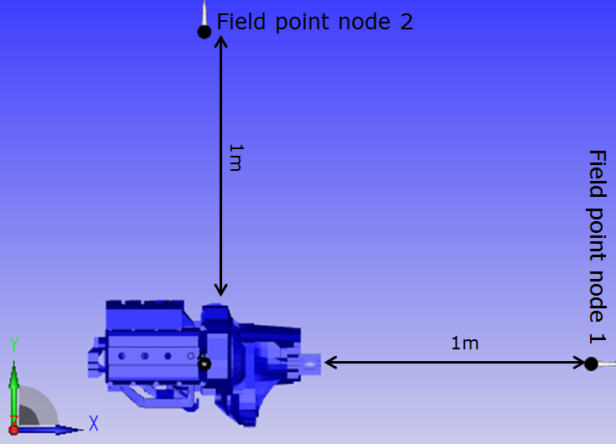
Figure 4.6 – Position of the investigate field point nodes

The results obtained in field point node 1 and 2 are respectively displayed in Figs. 4.7 and 4.8. From these results it is clear that the noise measured at the rear of the engine, in field point node 1, is mostly influenced by the one radiated from the gearbox, in particular at 36th order (1800 Hz at 3000rpm), which correspond the gear whine noise. Conversely, the noise emitted from the front engine block is extremely less effective. As concern the noise emitted on the second field point node, in Fig. 4.8 it is shown how the noise sources are equally distributed along the surfaces which are partly oriented to the direction of the investigated node: right block, head cover, oil pan and gear box. On the other hand, the left side is less effective in this node position.
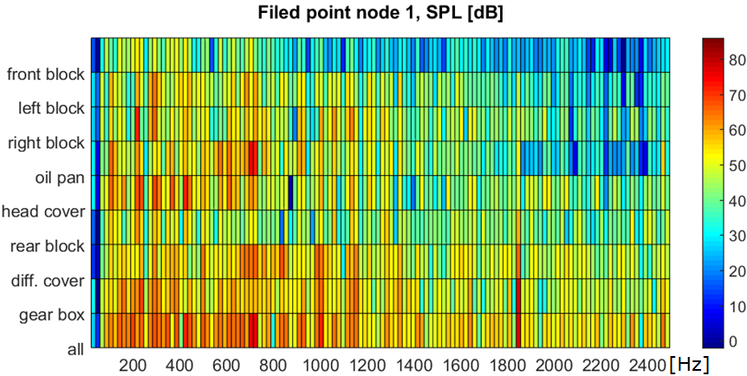
Figure 4.7 – Surface contributions in field point node 1.

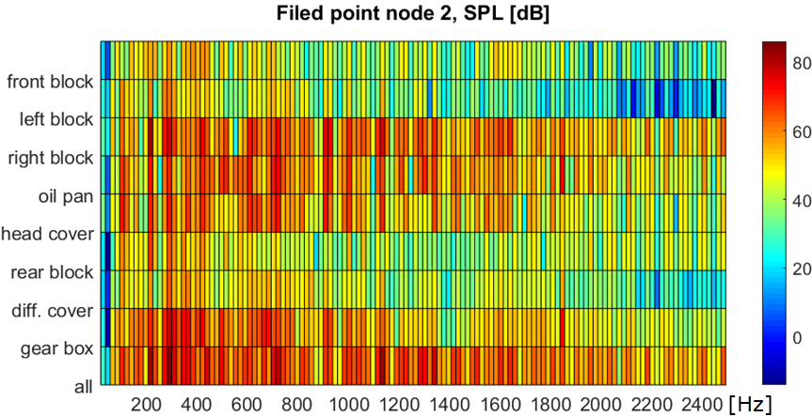
Figure 4.8 – Surface contributions in field point node 2.

4.4.3 Comparison with NTPA results
The results obtained in this analysis can be compared with the one obtained on the same model in section 3.7 where the internal noise sources where ranked with reference to the sound pressure level (SPL) using a numerical TPA methodology based on dynamic substructuring.
Comparing Figs. 4.7 and 3.19, it is possible to study particular tonal noise. E.g., at 36th order the gear whine noise is transmitted through the roller bearings supporting the gear shafts and then it is radiated via the gear box external surface. At this frequency the contributions from the supports of the differential are less effective compared with the contributions of the gear shafts supports, in accordance with the outcome of the SCA that shows how the cover of the differential emits nearly 67 dB. Although it is obvious that once the vibrations are transmitted from the supports to the structure, there are several paths they can take before reaching the external surface (which means that it is also possible that the noise transmitted through the gear shafts supports can reach the differential cover), it is interesting to see how the two effects (less noise from differential supports and less noise from differential cover) are correlated.
Another interesting consideration which arises considering the comparison of Figs. 4.7 and 3.19 is that at some frequencies vibrations are generated by different sources and transmitted via many paths into the structure, but the radiation is localized only in few surface selections. E.g., at 700 Hz both combustion chambers and main bearings generate high intensity vibrations that generate noise and the results of SCA show that this noise measured in node 1 is mainly radiated from the oil pan.
4.4.4 Analysis of radiated power and comparison with surface normal velocity
The graphs in Figs. 4.7 and 4.8 show how the solution is influenced from the chosen investigated field point node. For this reason it can be useful to refer to the active acoustic radiated power, since it is a value that does not depend on a single observation point. Fig. 4.9 shows the acoustic radiated active power from all the different surface selections. The surface selections in Fig. 4.9 is different from the one in Fig. 4.5: a more detailed surface selection is chosen. The reason is that in this section the surface normal velocities are compared with the noise radiation from the different surfaces and a more detailed subdivision is required.
Results from SCA shown in Fig. 4.9 helps to rank the different surfaces in terms of emitted noise. E.g., at 1800 Hz, where gear whine noise appears, surfaces 20 and 23 (shown in Fig. 4.10) are the most relevant, with more than 10dB of difference from all other surfaces. Fig. 4.10 also shows the normal surface velocities on the engine, highlighting how SCA helps to properly assess the radiating surfaces. In fact, although the oil pan and the bottom of the gearbox have similar velocity levels to the ones of surfaces 20 and 23, their emitted acoustic power is negligible (10 dB difference or more).
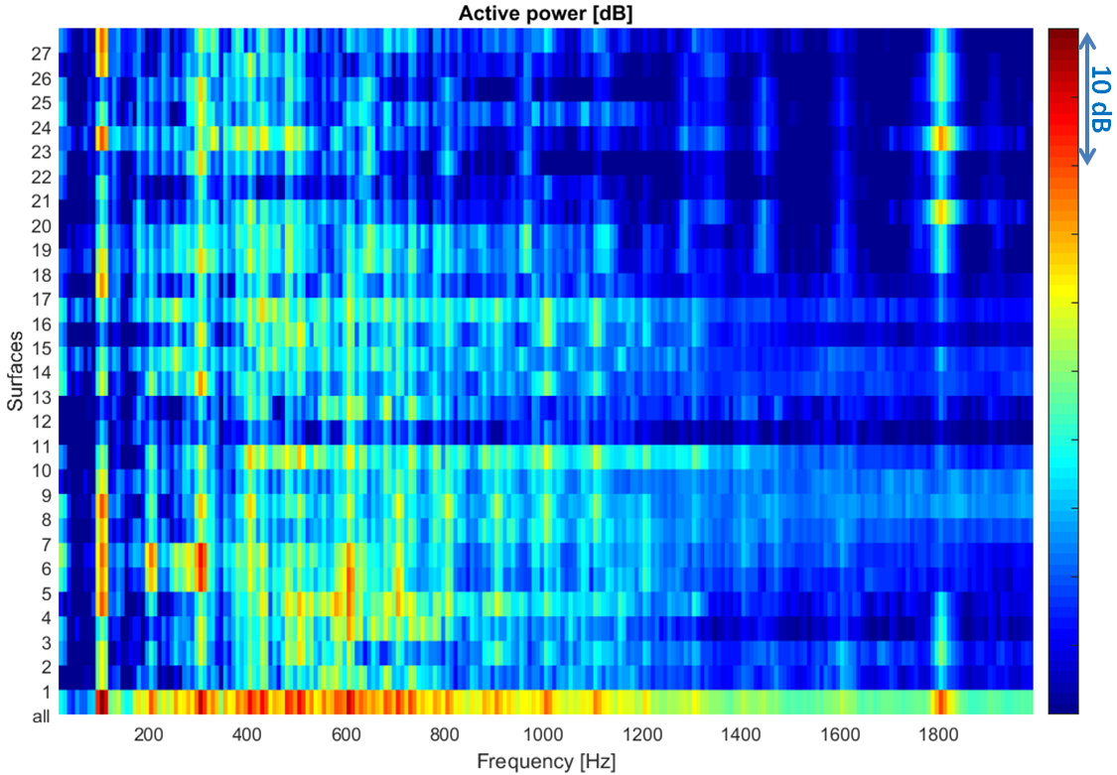
Figure 4.9 – Active acoustic power from the different surfaces. Mean values of the Monte Carlo method.

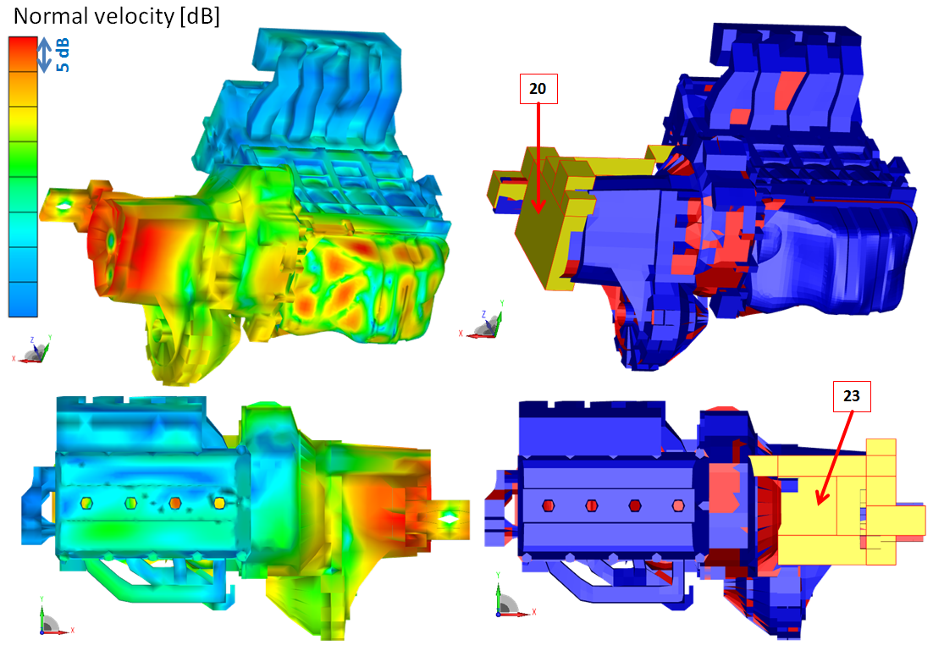
Figure 4.10 – Comparison between surface normal velocity and the position of the most radiating surfaces (in yellow) at 1800 Hz.

CHAPTER5

Energy Flow Contribution Analysis

- Motivations and introduction on energy flow analysis

The characterization of vibration and noise sources is a challenging task required for the purpose of effective NVH optimization. The development of new analysis tools to investigate the vibroacoustic behavior within the vehicle development process is of essential importance to achieve better products in combination with development time and cost reduction. This section discusses a methodology that applies energy flow analysis (EFA) for the NVH assessment and ranking of different system sources. An energy flow contribution analysis (EFCA) considers the different sources in terms of exchanged power with the system.
The earliest study associated to EFA has been published by Lyon and Maidanik in 1961 [152]. They worked on vibration propagation in simple systems. This study later formed the basis for the SEA (Statistical Energy Analysis) technique. A good review of SEA method can be found in [153]. In 1980 Goyder and White proposed a broad theoretical study of structural energy flow transmission in flexible structures [154-156]. Their definition of energy flow (in their paper addressed as power flow) corresponds to the effective power that can be derived in harmonic state from the real part of the complex power. In their work, Goyder and White mainly investigated power transmission of waves in beams, plates and interaction between rigid substructures connected to flexible receiver by spring elements. They demonstrated that vibrational power is a parameter allowing to quantify and to compare, in an efficient way, the main effects associated to structural vibrations. In literature, energy and power problems were also further investigated and extended. Petersson and Plunt in 1982 defined a matrix formulation for the problem of structure-borne sound power transmission between multi-point coupled structures and investigated the importance of the estimation of the effective mobility [157,158]. To be cited is also the work of Mondot and Peterson, [159], that introduced two new quantities to fully characterize a source substructure and the transmitted energy flow: the source descriptor (representing the source ability to deliver power) and the coupling function (representing the portion of energy flow transmitted to the receiver). Miller et al. (1989; 1990) applied EFA on structural networks identifying the components which contain the largest amount of vibrational energy, studying the energy flow at the junctions and its control modifying junction reflection and transmission properties [160,161]. Fulford and Gibbs studied the relationship between point and transfer mobilities for the analysis of structure-borne sound power and source characterization in multi-point connected structures [162-164]. In 2001, Moorhouse introduced three new concepts to characterize sources of structure-born sound [165]. He introduced the concept of mirror power, which is the power delivered by a vibration source when connected to a passive receiver structure that is a mirror image of itself. A second quantity, the characteristic power was defined as the dot product of the blocked force and free velocity vectors and this was shown to be four times the mirror power. In addition, Moorhouse also provided expressions for the maximum available power from a source. Bonhoff and Petersson investigated the importance and signiﬁcance of Fourier coefficients for the characterization of vibrational sources [166]. On average their cross-order terms are found to be insigniﬁcant and can be neglected with good approximation. Therefore, few years later a method that does not consider cross-order terms was proposed by Mathiowetz and Bonhoff [167]. A broader review of EFA and its applications can be found in [168,169].
The methodology discussed here is innovative both in numerical analysis and in experimental analysis. Therefore, it is decided to only focus on the experimental application of the methodology, although the discussion can also be applied on numerical analysis. The difference between a numerical and an experimental application of EFCA is the determination of velocities and excitations for power estimation: in a numerical model velocities and excitations has to be calculated using FEM or MBD methods, while in experimental analysis a newly defined procedure is here presented.
The procedure to experimentally determine velocities and excitations is applied on a gearbox-like structure. The power transmitted through the different shaft bearings into the gearbox structure is experimentally investigated. In literature, similar problems were already examined. Typically, bearings have been modeled as ideal boundary conditions or scalar spring dampers. More complex models consider a stiffness matrix of dimension 6 to describe motion or force transmissibility across rolling elements [170]. This matrix formulation was also incorporated into an overall numerical calculation procedure to describe the related energy flow problem [171]. This numerical methodology requires a prior knowledge of system matrices (shafts and gearbox mass, stiffness and damping matrices) and bearings are modeled as massless joints characterized by stiffness and damping properties. Here, a methodology to experimentally measure the power transmitted through the bearings is proposed. The main issue is related with bearing moment estimation and moment frequency response function (FRF) determination. For moment excitation a number of options exist, for example, twin shaker arrangements [172], blocks [173-175], magnetostrictive exciters [176,177] and synchronized hammers [178]. Other methods instead aim to avoid direct moment excitation altogether [179-181]. The moment acting on bearing is here estimated using a finite difference technique [182].
Once excitation and velocities are determined, EFCA is applied to the target structure and the power contributions of the different bearings (here considered as the energy sources of the gearbox structure) are assessed and ranked. The aim of this study is to characterize and rank the different sources of the system using power quantities, giving more insight on the vibration generation and transmission mechanisms.

- Theoretical basics of EFCA

Energy flow analysis (EFA) is defined as the analysis of power transmission between different components of a mechanical system. The formulation introduced by Goyder and White in 1980 [154-156], is mostly suited for the analysis of energy flow at system interfaces. These interfaces are points where forces or moments are directly applied or where the investigated system is connected with other systems. Consider a structure excited by the force $f$ in a single point and single degree of freedom (DoF). The basic concept of EFA is that, for a fixed frequency, the active vibrational power, $P$, feed by the force into the structure is defined as
$P=\frac{1}{2}Re\left\{f^{*}v\right\}$, | (85)
where, $v$ is the velocity, ${\left[\right]}^{*}$ denotes the conjugate of the considered quantity and $Re\left\{\right\}$ is the real part of the complex quantity considered. Introducing the mobility concept,$Y=v/F$, it is possible to define the active power as
$P=\frac{1}{2}{\left|f\right|}^{2}Re\left\{Y\right\}=\frac{1}{2}{\left|v\right|}^{2}\frac{Re\left\{Y\right\}}{{\left|Y\right|}^{2}}$. | (86)
Eq. (85) can also be written in matrix form considering the whole system and not only a single interface point:
$p_{ow}=\frac{1}{2}Re\left\{f^{*}∙v\right\}$, | (87)
where $∙$ denotes component-wise multiplication. Each term of vector $p_{ow}$ corresponds to a different source contribution and its power intensity directly corresponds to its rank. The information obtained can be directly used to identify the most dominant phenomena in the system.
The terms of vector $p_{ow}$ can also be derived extending the formulation of Eq. (86). Consider $P_{i}$ being the $i$-th element of vector $p_{ow}$ (the $i$-th contribution), i.e. the power associated to the excitation $f_{i}$ applied on the DoF $i$ having velocity $v_{i}$. If the velocity is expressed as
$$v_{i}= \sum_{j=1}^{n}{f_{j}Y_{i,j}}$$ | (88)
with $n$ being the number of different excitation acting on the system (i.e. the size of vector $p$), then $p_{i}$ becomes
$$P_{i}=\frac{1}{2}{\left|f_{i}\right|}^{2}Re\left\{Y_{i,i}\right\}+\frac{1}{2} Re\left\{f_{i}\sum_{j=1,j≠i}^{n}{f_{j}Y_{i,j}}\right\}.$$ | (89)
Eq. (89) can be applied either using numerical input data or experimental input data. Numerical results obtained from FEM or FMBD analysis can be used to assess the energy contributions of the numerical model. In Section 5.3, an experimental methodology is introduced to apply EFCA and assess the energy contributions of an existing gearbox.

- Bearing energy flow estimation

5.3.1 Bearing representation
This section describes the methodology proposed to evaluate energy flow through bearing supports using direct measurements. The bearings investigated in this paper are cylindrical roller bearings. In reality, the dynamic interaction between the rotating shaft and the gearbox housing is realized via the rotating contacts between cylinders and the inner and outer rings of the bearing. Due to the considerable thickness of the housing and the outer bearing ring, long structural wavelengths are established. The rotating contacts are therefore always closely spaced in terms of the governing wavelength. The resultant dynamic loads on the housing may consequently be treated as point quantities concentrated in the center point of the bearing.
In order to estimate the power transmitted through the bearings, it is needed to derive, for each DoF associated with a bearing, excitation and velocity (translational or angular including their phase). The choice of the DoFs to associate to each bearing is of essential importance to properly represent the bearing dynamics and therefore for the estimation of the power quantities. In this application, the X direction (see Fig. 5.1) was neglected, because the gears inside the investigated gearbox structure are cylindrical (see Fig. 5.2) and the excitation in this direction was considered negligible.
Hence, it was decided to simplify the model and consider only 4 DoFs for each bearing. Fig. 5.1.a shows the four DoFs chosen to represent each bearing in the multi-point-multi-dof application described in this paper. Directions Z and Y are respectively vertical and horizontal direction, both are perpendicular to the rotation axis of the shaft (direction X), while $θ$ and $ϕ$ are the rotational dofs respectively associated to Z and Y axis. In this particular test case, the total system consist of four bearing supports, as shown in Fig. 5.1.b, and therefore a total number of 16 dofs is considered to model the connections between gearbox structure and gear shafts.
As shown in Fig. 5.1.a, all dofs are considered in the center of the bearing and not in the points of the structure where the excitations are actually applied (i.e. contact points between shaft and structure). Hence, the excitations estimated in this method are equivalent excitations that represent the global forces and moments applied to the bearing. The modulation of the transmitted loads, due to the rotation of the contacts, can be well described in terms of these concentrated equivalent excitations. The same applies to the dynamic loads generated inside the bearings.
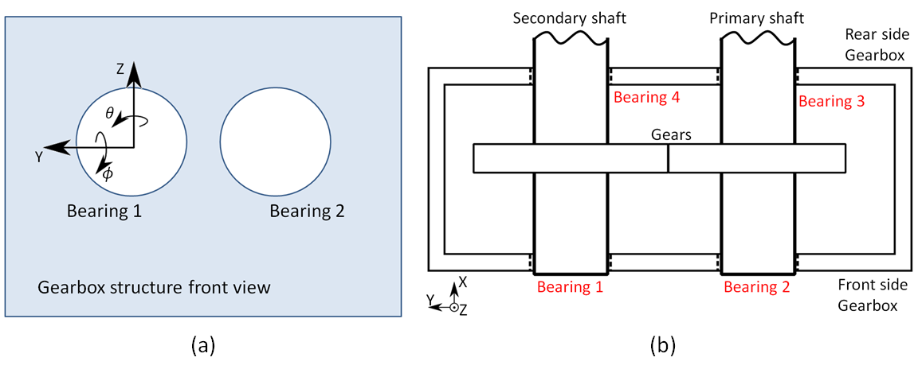
Figure 5.1 – a) Schematic modeling of each bearing with 2 translational and 2 rotational degrees of freedom. b) Schematic 2D representation of the gearbox structure investigated; In red, the 4 bearing supporting the gear shafts and transmitting power to the structure.
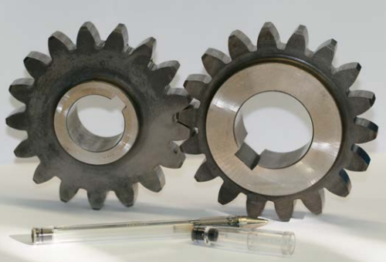
Figure 5.2 – Tested gears.

5.3.2 Forces and moments estimation
To estimate bearings excitations, i.e. forces and moments transmitted to the gearbox structure, the inverse problem shown in Eq. (12) is solved. The velocities are derived from operational measurements, while the impedance matrix is derived inverting the mobility matrix (Eq. (15)). The terms of mobility matrix are derived via hammer testing. The methodology used to derive mobilities needed to estimate these virtual excitations is here described.
The identification of the force mobilities is done using a finite difference technique, testing in opposite direction of the bearing. Consider the structure in Fig. 5.3. Exciting in point $A$ with a force $f_{A}$ produces a velocity $v_{C,A}$ in point$C$, being point$C$ the investigated point on which the velocity is measured. In the same way, hammering in point $B$ with a force $f_{B}$ produces a velocity $v_{C,B}$ in point $C$. The force transfer mobility associated with excitation at the center point ‘O’ of the bearing and response in C, is
$$Y_{O,C}^{f}= \frac{1}{2}\left(\frac{v_{C,A}}{f_{A}}-\frac{v_{C,B}}{f_{B}}\right)=\frac{1}{2}\left(Y_{A,C}^{f}- Y_{B,C}^{f}\right) .$$ | (90)
In Eq. (90), the negative sign is due to the different direction of the hammering as shown in Fig. 5.3.

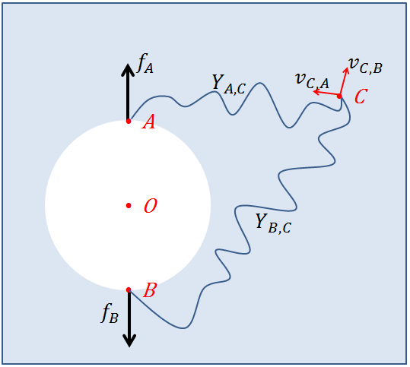
Figure 5.3 – Identification of vertical force mobility using dual hammer testing.

Also the identification of moment mobilities is done via the finite difference technique. More details about FRF estimation from moment excitation using the finite difference technique can be found in [182]. Fig. 5.4 shows the cross section of a bearing. As shown for force mobility estimation, hammering in point $A$ with a force $f_{A}$ produces a velocity $v_{C,A}$ in point$C$ and hammering in point $B$ with a force $f_{B}$ produces a velocity $v_{C,B}$ in point$C$. This time, the excitations are applied in the direction of the rotation axis of the shaft (direction X). Being $b$ the radius of the bearing hole, i.e. the distance between the central point and the hammering positions, the moment transfer mobility associated with moment excitation in the center point ‘O’ of the bearing and response in C, can be approximated with [182]:
$$Y_{O,C}^{M}=\frac{1}{2b}\left(\frac{v_{C,A}}{f_{A}}+\frac{v_{C,B}}{f_{B}}\right)=\frac{1}{2b}\left(Y_{A,C}^{M}+Y_{B,C}^{M}\right),$$ | (91)
where the superscript $M$ indicates a momentum excitation.
From Fig. 5.4, it is clear that it is not practical to hammer inside the bearings, especially in the same direction of the axis of the shaft. Hence, exploiting reciprocity principle, in this application an accelerometer is placed inside the bearing and the hammering position is located on the external surface of the structure (see Fig. 5.5).
Force and Moment mobilities are calculated for $k$ points on the external surface, being $k$ greater than the total number of excited dofs, $m$, in order to get an over-determined system of equations. In this application example, $m$ is equal to 16 and$k$ is 26. Once all mobilities are evaluated, it is possible to measure the velocities in operating conditions and solve the inverse problem associated to derive the excitations [183]:
$$f=Y^{+}v_{s}.$$ | (92)
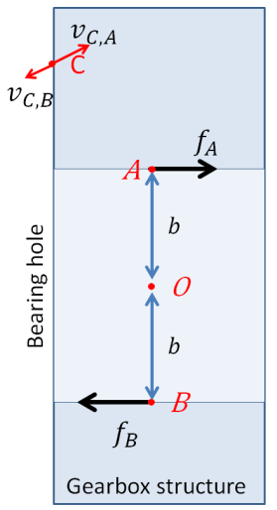
Figure 5.4 – Identification of momentum mobility using dual hammer testing. View of a section of the bearing.

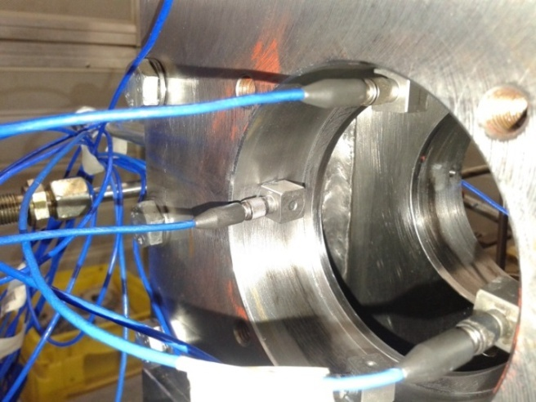
Figure 5.5 – Example of measuring position for mobility estimation. Exploiting reciprocity, the hammer position is on the external surface of the structure.

For the sake of readability, the system in Eq. (92) considers only force excitations, but it is clear that also moment excitations have to be included when considered in the analysis. Since $k>m$, the mobility matrix is not square. Therefore, the symbol ${\left[\right]}^{+}$ denotes the Moore-Penrose pseudo inverse matrix [184]. Moreover, the subscript $s$ in Eq. (92) indicates that these velocities are measured in operational conditions on the external surface of the investigated gearbox including their relative phase.

The accuracy of excitation strength reconstruction (in the presence of noise that contaminates the measurements) is crucially dependent on the conditioning number of the mobility matrix to be inverted. For this reason, before estimating the vector $f$ it is suggested to perform a regularization of matrix $Y$. In this application, a Tikhonov regularization is employed [183,185].
Considering the following singular value decomposition of impedance matrix [186-188]
$$Y=UΣV^{H},$$ | (93)
where $U$ and $V$ are unitary matrices, the superscript ${\left[\right]}^{H}$ denotes the Hermitian transpose and the diagonal matrix of singular values, $Σ$, can be written as
$$Σ=\left[\begin{matrix}\begin{matrix}σ_{1} & 0 \\ 0 & σ_{2}\end{matrix} & \begin{matrix}. \\ .\end{matrix} & \begin{matrix}0 \\ 0\end{matrix} \\ \begin{matrix}. & . \\ 0 & 0 \\ 0 & 0\end{matrix} & \begin{matrix}⋱ \\ . \\ .\end{matrix} & \begin{matrix}. \\ σ_{m} \\ 0\end{matrix} \\ \begin{matrix}. & . \\ 0 & 0\end{matrix} & \begin{matrix} \\ .\end{matrix} & \begin{matrix}. \\ 0\end{matrix}\end{matrix}\right],$$ | (94)
being $σ_{i}$ the singular values of matrix $Y$.
Substituting Eq. (93) into Eq. (92), the inverse problem for the determination of the excitation strength is solved as
$$f=VΣ^{+}U^{H}{ v}_{s} ,$$ | (95)
where the matrix $Σ^{+}$ is the pseudo-inverse of matrix $Σ$ and can be written as
$$Σ^{+}=\left[\right].$$ | (96)
Low singular values due to measurement errors may generate high errors during inversion process. To avoid issues associated with matrix inversion, Tikhonov regularization tries to reduce the matrix condition number manipulating the singular values of matrix $Σ$. Hence, the problem to be solved is not anymore Eq. (95) but

$$f=VΣ_{R}^{+}U^{H}{ v}_{s} ,$$ | (97)
where $Σ_{R}^{+}$ is given by
$$Σ_{R}^{+}={\left[Σ^{H}Σ+βI\right]}^{-1}Σ^{H}=\left[\right].$$ | (98)
Therefore, any particularly small singular value will be effectively increased by the addition of the regularization parameter $β$ and the inversion of the matrix is thus stabilized.
The optimum choice of the regularization parameter can be achieved via an ordinary cross-validation methodology, as illustrated in [185]. In synthesis, the ordinary cross validation method is a “leave-one-out” process that allows to identify the optimal value of $β$ solving the problem considering $k-1$ measurements and predicting the response in the “left-out” measured velocity.
The essence of cross validation method is to first find the vector of complex excitation strengths that minimizes the cost function
$$J\left(β,j\right)= \sum_{i=1;i≠j}^{k}{{\left(v_{i}-{\hat{v}}_{i}\right)}^{2}}+ βf^{H}f,$$ | (99)
which is the usual cost function for minimization as described in [183,185], but with the $j$-th value of the measured and modelled velocities (respectively $v_{i}$ and ${\hat{v}}_{i}$) omitted from the calculation. Once the source strength vector $f$ is determined minimizing Eq. (99), its effectiveness is tested comparing the measured value of the left out measurement, $v_{j}$, with its modeled value ${\hat{v}}_{j}$ (the modeled value is obtained solving the inverse problem). This procedure is repeated leaving out all measured velocities one by one. The optimal value of $β$ is obtained minimizing the cross-validation function
$$V_{0}\left(β\right)=\frac{1}{k}\sum_{j=1}^{k}{{\left(v_{j}-{\hat{v}}_{j}\right)}^{2}},$$ | (100)
for which the error between measured velocities and modeled ones is minimal. At each investigated frequency, Fig. 5.6 shows the typical improvement in the condition number of the system matrix after Tikhonov regularization. Finally, bearing forces and moments are estimated solving Eq. (97) for each frequency and adopting an optimal value of regularization parameter estimated with an ordinary cross-validation method.

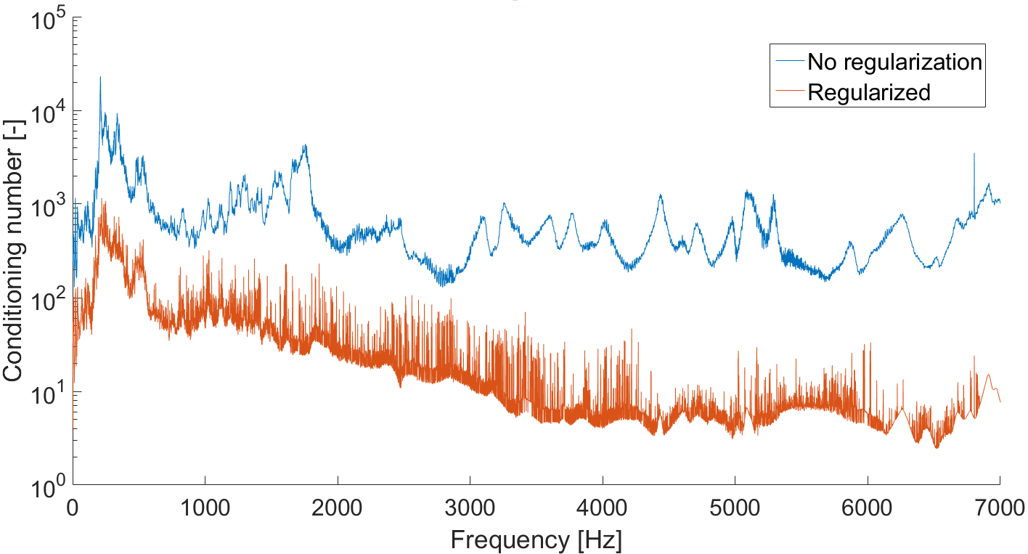
Figure 5.6 – Improvement of system matrix conditioning number after Tikhonov regularization.

5.3.3 Velocities estimation
Power estimation using Eq. (87) requires both complex load vector estimation (see section 5.3.3) and velocity estimation. Translational and angular velocities have to be estimated referred to the bearing center. For obvious reasons, no methodologies allow direct measurement in these points under operating conditions. In this section a methodology to estimate the required velocities is described. The methodology here considered consists in direct measurements of translational velocity of surface points near the bearing location under the hypotheses that the distance between measurement location and DoFs where the velocity has to be estimated is small compared with the governing structural wavelength.
Considering Fig. 5.7, two different approaches are considered to estimate translational and rotational speeds of the bearing central point, respectively $v_{O}$ and ${\dot{α}}_{O}$. Fig. 5.7.a shows the case in which both sides of the structure can be investigated in operating conditions. Conversely, if only the external surface of the gearbox can be investigated, it is possible to refer to Fig. 5.7.b.
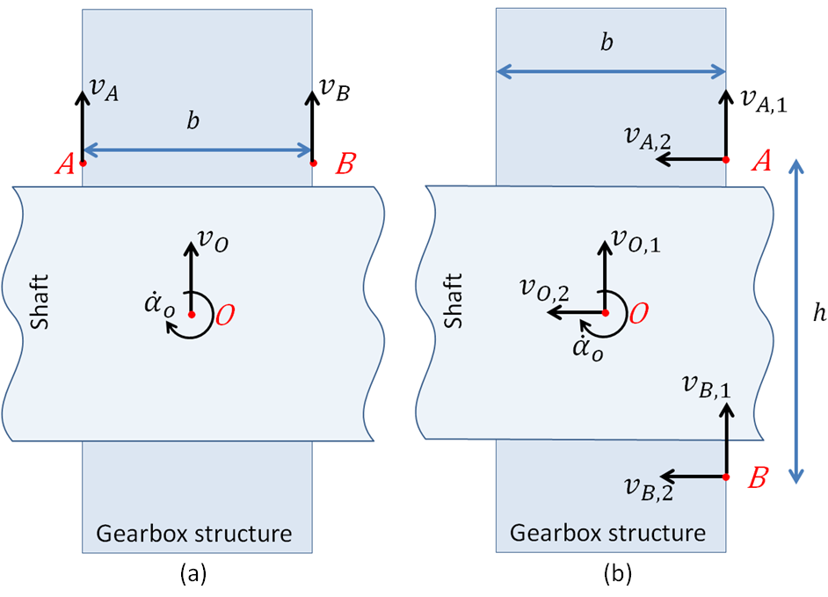
Figure 5.7 – Measurement positions ($A$ and $B$) for velocities estimation in the bearing central point ($O$). a) Measurement positions on opposite sides of the bearing; b) Measurement positions on the same side of the bearing.

If measurement instruments are displaced as shown in Fig. 5.7.a, the velocities $v_{A}$ and $v_{B}$ can be measured in operating conditions. It is possible to express $v_{A}$ and $v_{B}$ as a function of $v_{O}$ and ${\dot{α}}_{O}$
$$v_{A}=v_{O}+\frac{b}{2}{\dot{α}}_{O},$$ | (101)
$$v_{B}=v_{O}-\frac{b}{2}{\dot{α}}_{O}.$$ | (102)
The signs in Eqs. (101) and (102) are chosen according with the directions shown in Fig 5.7.a and $b$ denotes the distance between measurement positions $A$ and $B$ along the direction of the shaft axis. Summing Eq. (102) and Eq. (102) it is obtained
$$v_{O}=\frac{1}{2}\left(v_{A}+v_{B}\right),$$ | (103)
while subtracting Eq. (101) and Eq. (102) gives
$${\dot{α}}_{O}=\frac{1}{b}\left(v_{A}-v_{B}\right).$$ | (104)
Consider that measurement transducers are displaced as shown in Fig. 5.7.b and the velocities $v_{A,1}$,$v_{A,2}$,$v_{B,1}$ and $v_{B,2}$ can be measured. It is possible to express velocities in $A$ and $B$ as a function of $v_{O,1}$, $v_{O,2}$ and ${\dot{α}}_{O}$
$$v_{A,1}=v_{O,1}-\frac{b}{2}{\dot{α}}_{O},$$ | (105)
$$v_{A,2}=v_{O,2}-\frac{h}{2}{\dot{α}}_{O},$$ | (106)
$$v_{B,1}=v_{O,1}-\frac{b}{2}{\dot{α}}_{O},$$ | (107)
$$v_{B,2}=v_{O,2}+\frac{h}{2}{\dot{α}}_{O}.$$ | (108)
The signs in Eqs. from (105) to (108) are chosen according with the directions shown in Fig 5.7.b and $h$ denotes the distance between measurement positions $A$ and $B$ in the direction perpendicular to shaft axis. Summing $v_{A,1}$ with $v_{B,1}$, $v_{A,2}$ with $v_{B,2}$ and subtracting $v_{A,2}$ and $v_{B,2}$, it is obtained:
$$v_{A,1}+v_{B,1}=2v_{O,1}-b{\dot{α}}_{O},$$ | (109)
$$v_{A,2}+v_{B,2}=2v_{O,2},$$ | (110)
$$v_{A,2}- v_{B,2}=h {\dot{α}}_{O}.$$ | (111)
Eqs. (109) to (111) can be combined into a more compact matrix form
$$\left[\begin{matrix}2 & 0 & -b \\ 0 & 2 & 0 \\ 0 & 0 & h\end{matrix}\right]\left[\begin{matrix}v_{O,1} \\ v_{O,2} \\ {\dot{α}}_{O}\end{matrix}\right]=\left[\begin{matrix}v_{A,1}+v_{B,1} \\ v_{A,2}+v_{B,2} \\ v_{A,2}- v_{B,2}\end{matrix}\right],$$ | (112.1)
from which $v_{O,1}$, $v_{O,2}$ and ${\dot{α}}_{O}$ are determined.
The application shown in this paper investigates a gearbox-like structure which cannot be investigated from the interior side (where gears are located). Therefore, measurements can only be carried out on the external surface under operating conditions. Bearing velocities are estimated with dual measurement on the same side of the bearing (see Fig. 5.7.b) and Eq. (112.1) is solved. Moreover, neglecting the effect of forces in axial direction (direction X in Fig. 1.b), the DoF corresponding to $v_{O,2}$ is not considered and a simpler system can be solved
$$\left[\begin{matrix}2 & -b \\ 0 & h\end{matrix}\right]\left[\begin{matrix}v_{O,1} \\ {\dot{α}}_{O}\end{matrix}\right]=\left[\begin{matrix}v_{A,1}+v_{B,1} \\ v_{A,2}- v_{B,2}\end{matrix}\right].$$ | (112.2)
5.3.4 Investigated structure
The investigated gearbox-like structure is mounted on a gear test bench. Inside the gearbox, a test gear drive is mounted, as shown in Figs. 5.8 and 5.9. The gears under test are shown in Fig. 5.9. The gear test bench is a back-to-back spur gear rig with 91,5 mm centre distance. The rig re-circulates power in a closed-loop torque regenerative arrangement, also known as four- square configuration: the variable-speed AC electric motor provides only the power necessary to overcome the frictional losses in the system. The test spur gear pair at one end is connected to a slave gear drive at the other end by two parallel shafts. One shaft is divided into two parts with an hydraulic loading system that permits to continuously vary the applied torque during tests. The other shaft is equipped with a strain gage system for torque measuring and a telemetric system for data transmission. The whole test bench was originally thought for gear damage test [189]. The test gear drive mounts the gears shown in Fig. 5.2. On the primary shaft a gear with 17 teeth has been mounted, while the secondary has 18 teeth.

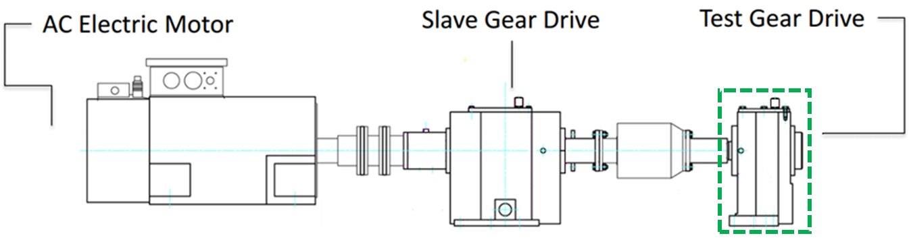
Figure 5.8 – Schematic representation of the test bench. Highlighted in green, the investigated gearbox-like structure containing the test gear drive.

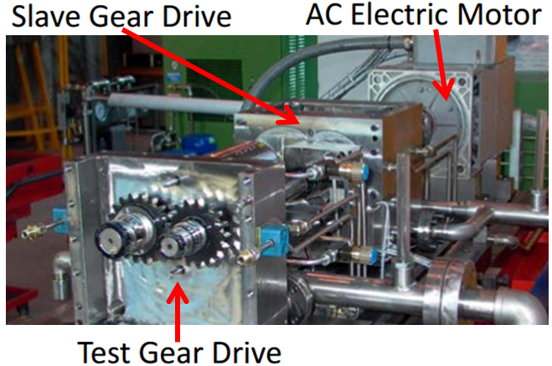
Figure 5.9 – The test bench. The investigated structure is the gearbox containing the test gear drive.

In this work, only the gearbox structure containing the test gear drive (green highlighted area in Fig. 5.8) is investigated and the power transmitted from the shafts to the gearbox structure through the bearings is measured. The influence of electric motor and slave gear drive on surface velocity measurements of test gear drive is investigated. Above 500 Hz, transfer mobilities from electric motor and from slave gear drive mount positions to test gear drive surface points is at least one order of magnitude lower than mobilities from investigated bearing positions. Hence, contributions from other sources are neglected and the test gear drive gear box is considered as an isolated structure in the frequency range of interest. Fig. 5.1.b shows an easy schematic representation of the investigated gearbox of the test gear drive, which includes 4 bearings, each of them modeled with 4 DoF. In the bearings holes, cylindrical roller bearings are mounted. These roller bearings support gear shafts and are the components that directly excite the gearbox structure.
5.3.5 EFCA results
The operating conditions tested are a rotational speed of the primary shaft of 3000±1rpm and a recirculating applied torque of 200±2 Nm. Under these running conditions, the velocity is measured on 27 external surface points for which the mobility matrix (containing transfer mobilities between velocities normal to the housing surface and DoFs of the bearings) was previously obtained via hammer testing. The measured surface velocities are shown in Fig 5.10. Using these velocities, bearing forces and moments are estimated up to 7 kHz. Due to low coherence of hammer testing measurements, results above 7 kHz were removed from this analysis.

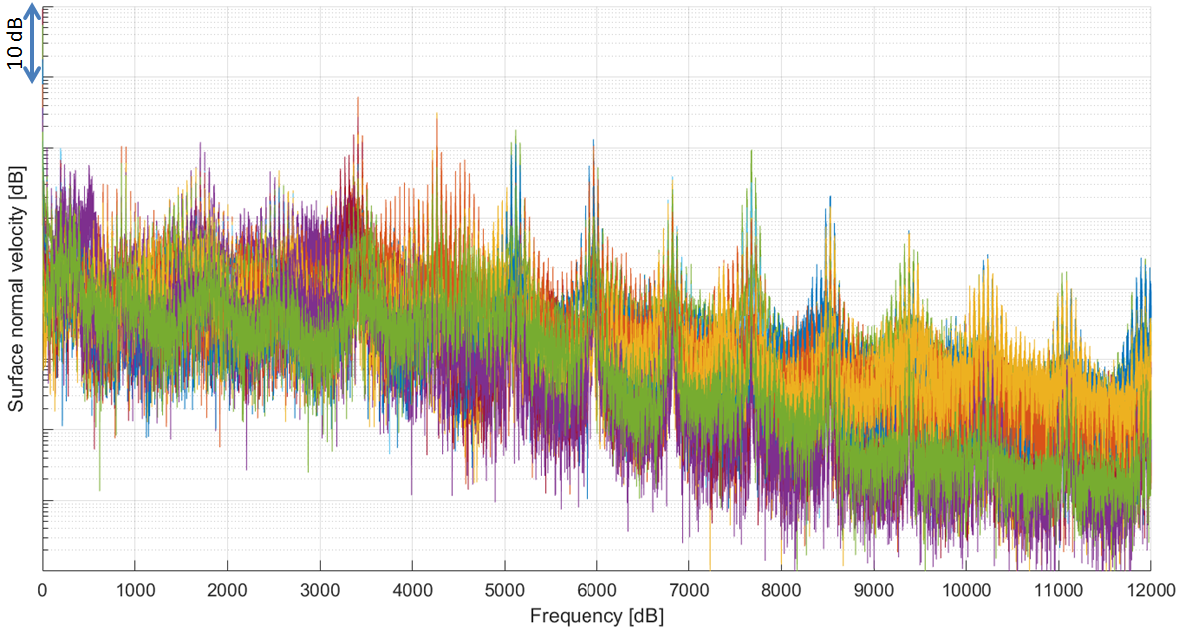
Figure 5.10 – Frequency spectra of surface velocities used to estimate bearing forces.

The gear meshing frequency is 850 Hz and Fig. 5.10 it is possible to clearly distinguish this frequency component including sidebands and harmonics. From Fig. 5.10 it can be concluded that the meshing frequency harmonics constitute the most relevant noise phenomenon.
The estimated power quantities for each point and each DoF were collected and results are presented in Fig. 5.11. Fig. 5.11 shows the power transmitted between the four bearings and the gearbox structure. For the sake of visibility, Fig. 5.11 shows results in bands of 25 Hz. Each bearing power contribution considers the sum of the power transmitted by the two associated translational and rotational dofs. The information obtained from an EFCA shows the most relevant sources in terms of energy contribution. In this particular test case, the most relevant energy content is at 4th gear meshing frequency order (3400 Hz). Between 1st and 5th gear order, the vibrational energy of the gearbox housing (casing) is mainly originating from the bearings supporting the primary shaft (bearings 2 and 3).
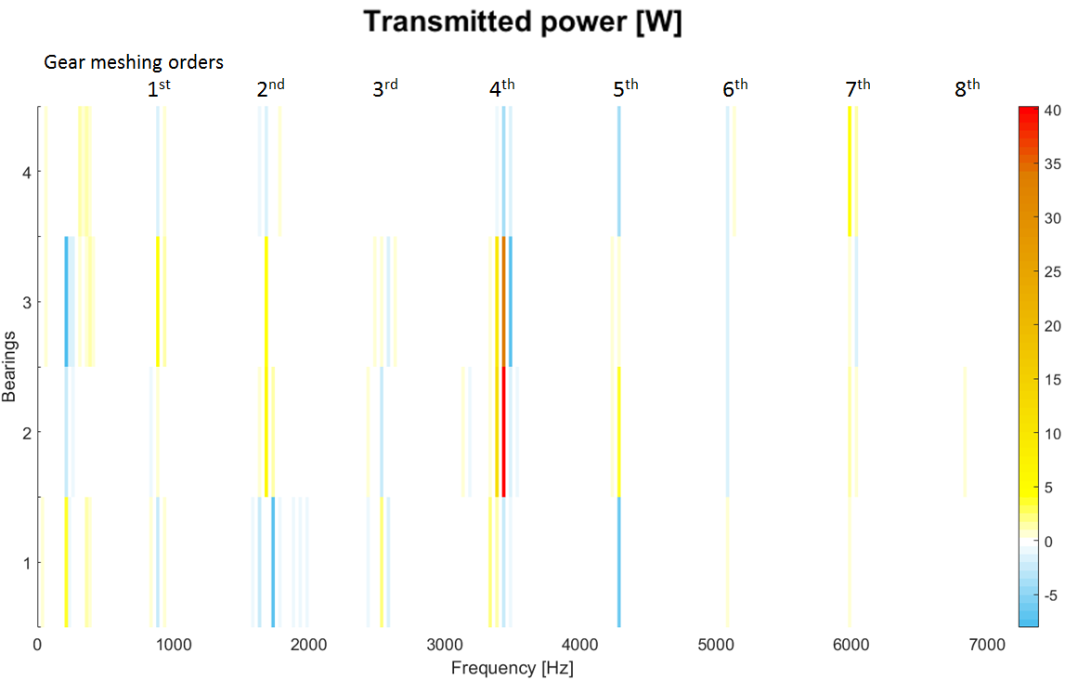
Figure 5.11 – Power contributions of the four bearings. Frequency bands of 25 Hz.

Fig. 5.12 shows the energy flow of the highest contributions in detail, at 3400 Hz and 3350 Hz. At these two frequencies, the power transmitted to the structure has its maximum levels. Fig. 5.12 shows that the bearings supporting the primary shaft are the ones that excite the gearbox structure most. This is in accordance with the investigation of the system excitations shown in Fig. 5.13: moments from Bearings 2 and 3 are few dB higher than others. Another important consideration is that moment excitations (dofs $θ$ and $ϕ$) transmit more power than force excitations. This can be understood considering the shape of the gearbox housing: the faces of the gearbox, on which the bearings are located, are thick plates and can be more effectively excited by moments than in-plane excitations (i.e. forces in direction Z and Y).
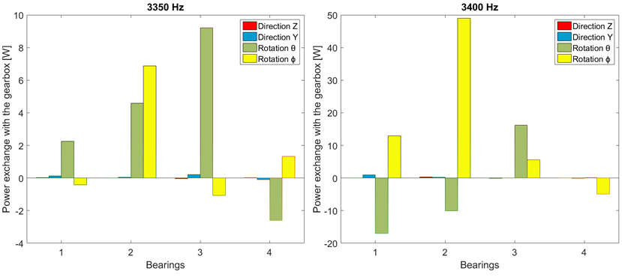
Figure 5.12 – Details of power contributions at 3350 Hz and 3400 Hz. The different dofs are shown for each bearing.
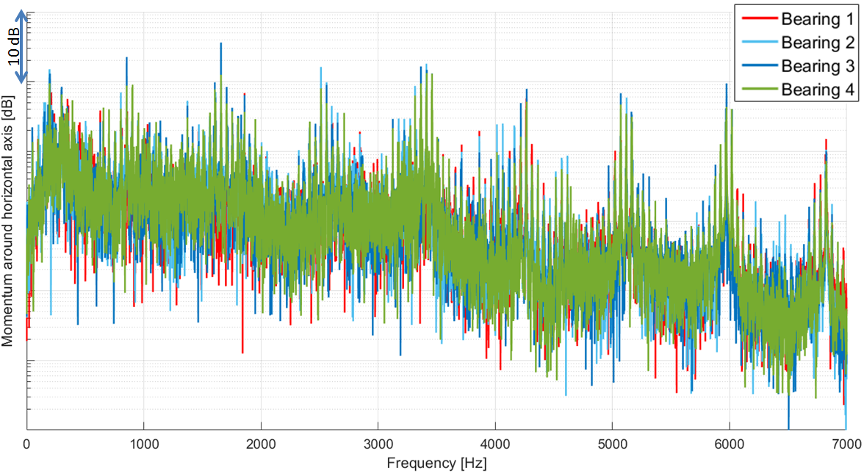
Figure 5.13 – Frequency spectra of moment around horizontal axis in the four bearings.

Positive values in Fig. 5.11 and Fig. 5.12 indicate that energy flows from the shafts, through the bearings into the gearbox structure. Conversely, negative values indicate that excitations and velocities are opposite in phase in the considered DoF. Therefore, energy flows through the structure into the shaft. According with Eq. (89), negative energy flow contributions can appear only when cross order terms cannot be neglected and their values is negative. Cross order terms can be influenced by the phase of the contact forces and velocities. From the physical point of view, these negative cross order terms indicate a recirculation of energy in the system.

A discussion of the results and measurement accuracy will be given in this section. Results from Fig. 5.10 and especially Fig. 5.11 show that vibrations and power are lower at first gear meshing order (850 Hz) than the higher orders (especially 2nd order at 1700 Hz and 4th order at 3400 Hz). This phenomenon can be explained as follows. The gears used in the Slave Gear Drive have a double number of teeth compared with the gears in the Test Gear Drive. Therefore, the fundamental gear meshing frequency is not anymore 850 Hz but 1700 Hz. As a consequence, vibrations from the Slave Gear Drive are transmitted through the shafts and combine with the vibrations generated by the gears under test at even orders. Fig. 5.14 shows the transfer mobilities between all 16 Dofs representing the bearings and one node on the external surface of the investigated gearbox. The mentioned frequencies, 1700 and 3400 Hz, are close to important peaks indicating that at these frequencies the power flow may be amplified due to the presence of structural modes of the gearbox housing (casing).

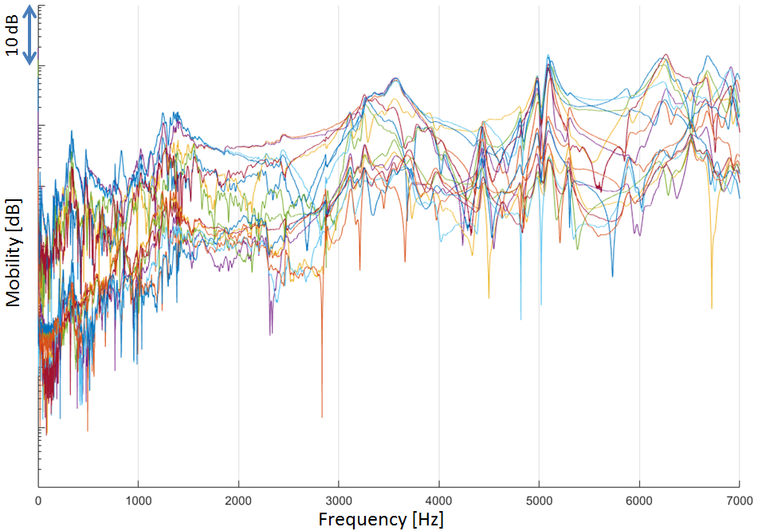
Figure 5.14 – Mobility between bearing’s dofs and point surface.

Particular attention has to be paid also to the results obtained from EFCA, which suggest that most of the power that flows into the gearbox comes from the bearings supporting the primary shaft. The structure of the gearbox can be considered symmetric with good approximation; therefore no big differences are encountered in the transfer functions between primary shaft bearings and secondary shaft bearings. Conversely, the structure of the two shafts is intrinsically different because one shaft is divided into two parts with a hydraulic loading system that permits to continuously vary the applied torque during tests. This difference is reflected into the excitations transmitted (and therefore power) from the shafts to the bearings.
An important aspect to discuss is also the interface geometry. In this application, interfaces at bearing location are modeled as single points. However, the real contact between gearbox and shaft considers the presence of a roller bearing. Therefore, the real application point of the excitation is moving and, due to possible bending of the shaft supported, also not symmetric. This simplification can generate some modeling errors leading to inaccuracies in mobility and force estimation.
Being this an experimental methodology, influences from measurement errors can also be expected. In particular, small errors in the phase of the quantities measured can generate big misunderstanding in the physics of the problem investigated. In order to understand the influence of these errors, Fig. 5.15 shows the total power fed to the system, which is the sum of the power of all the 16 DoFs. Being the gearbox a passive structure, it is expected that at every frequency the sum of all power contributions is entering the system, the total sum should consequently be positive. Nevertheless, Fig. 5.15 shows some negative values, indicating that the system (i.e. the housing) is virtually generating energy and it is transferring this energy into the shafts. The presence of these errors is an index of the errors made during the measurement procedure. The causes of these errors can be mainly identified in:
- inaccuracies in the measurement of the mobilities used for the estimation of the forces;
- the regularization procedure itself, because it manipulates the mobility matrix;
- inaccuracies in the application of the finite difference technique as described in section 3.3;
- inaccuracies in neglecting the axial component of the force acting on the bearings;
- the approximation of considering a multi-point-multi-dof system, while in reality the application region of the excitation is moving.

Despite the measurement inaccuracies encountered (negative power sum at some frequencies in Fig. 5.15), Fig. 5.15 clearly shows how the most relevant phenomena can still be identified with this analysis. Moreover, the contribution patterns shown in Figs. 5.11 and 5.12 (energy mainly transmitted from primary shaft bearings) give an evident hint on which sources have the higher contribution.

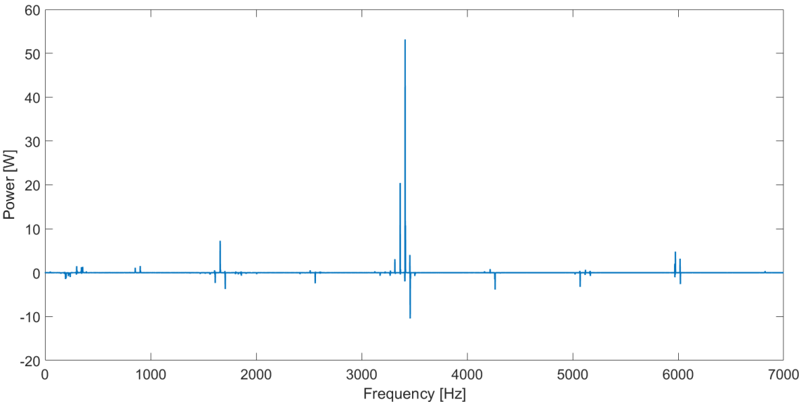
Figure 15 – Total power feed into the gearbox structure. Negative values indicated measurement inaccuracies.

In this section it was shown that notwithstanding the inherent measurement inaccuracies, the approximations introduced by the finite difference technique and by the regularization of the structural mobility matrix, the power flow through the bearings into the gearbox casing could be successfully carried out. The contributions of the different degrees of freedom of the separate bearings to the vibration of the casing could be ranked. Relatively small amounts of negative power occurred in the side bands of the gear meshing harmonics and could most probably be ascribed to the fact that the power transmission from the shafts into the casing takes place via rotating contacts in the bearing.

CHAPTER6

Influences of uncertainties on sources assessment

- Introduction on uncertainties estimation

Practical mechanical systems operate with some degree of uncertainty. In numerical models uncertainties can result from poorly known or variable parameters, from geometrical approximation, from discretization or numerical errors, from uncertain inputs or from rapidly changing forcing that can be best described in a stochastic framework. The focus of this investigation is the vibro-acoustic response of the investigated mechanical system. Particular attention is paid to the influence of these uncertainties on the analysis and the assessment of the different engine vibration sources. This chapter discusses how these uncertainties affects source assessment methodologies, giving hints on the robustness of these methods. Two different kinds of uncertainties are studied: model parameter estimation and excitation definition. Regarding these two different aspects, two new methodologies are also introduced to deal with source assessment numerical engine problems considering uncertainties.
Mechanical models of engine systems may exhibit modeling errors or uncertainties that arise naturally due to incomplete knowledge of the system (e.g. Ref. [190-193]). Joint clearances, friction, lubrication, load estimation, material non-uniformities, manufacturing and assembly errors are examples of factors influencing the model uncertainties of internal combustion engines. As any model contains such uncertainties, the question of their effect on the quality of results, obtained when using such a model becomes relevant.
In literature, several methods can be found that can be used to formally assess the effects of uncertainties in mechanical systems. A very general approach is to solve the Fokker-Plank equation that governs the evolution of uncertainty distribution under system dynamics, but this method requires high-dimensional probability space and cannot be easily implemented in systems of practical interest [194,195]. The Monte Carlo (MC) approach is maybe the most extensively used method in dynamic models. It consists of repeated random sampling of a set of system parameters to obtain the uncertainty distribution via numerical simulation results [196-198]. Being computationally demanding, Latin Hypercube Sampling [199] and Bayesian methods [200,201] were introduced to overcome classical MC limitations. The perturbation approach, useful when the perturbations are small, uses ﬁrst and higher order sensitivity coefficients to derive low order moments of the simulation uncertainty [202,203]. Other methodologies such as the Neumann series expansion, statistical linearization, stochastic averaging and generalized polynomial chaos methods, together also with some applications on numerical modeling, are described in [204-214]. In this paper, a Monte Carlo methodology is implemented to determine the influence of the variability due to:
- Model parameter variability
- Statistically independent excitations

- Influences of model parameter variability on source assessment

Recently, random matrix theory was introduced to take parameter uncertainties into account in numerical modeling problems. In particular in this section, Wishart random matrix theory is applied on a multi-body dynamic system to generate random variations of the properties of system components. Multi-body dynamics is a powerful numerical tool largely implemented during the design of new engines. In this section, the influence of model parameters variability on the results obtained from the multi-body simulation of engine dynamics is investigated.
6.2.1 Introduction on random matrix theory
Uncertainties on mechanical automotive systems where firstly observed by Kompella and Bernhard [215]. In their experiment, they used 98 vehicles of the same make, evaluating the frequency response function (FRF) from wheel to driver’s ear position. Although the FRF for each vehicle shows the same characteristics, the plot of all the resulting 98 FRFs shows a spread of approximately 20dB from 50 to 500 Hz. Similar findings have been reported also by Fahy, that demonstrated that FRFs measured in the same way on very simple and presumably identical elements, beer cans, could vary considerably [216]. Due to these findings, it became clear that it is important to quantify the order of variability of simulated mechanical models, considering system uncertainties.
On numerical multi-body models there are several uncertainties, which consist of geometry or discretization errors, approximation of the physical parameters, or uncertain excitations. Concerning multi-body analysis, recently Batou and Soize studied the random response of multi-body dynamic systems considering random rigid bodies [217,218]. In their probabilistic model, the mass, the center of mass and the tensor of inertia are modeled by random variables for which the prior probability density functions are constructed using the maximum entropy principle under the constraints deﬁned by all the available mathematical, mechanical and design properties. Uncertainties related to physical or geometrical properties can be observed from the variation in sparsity structure of the mass, stiffness and damping matrices of the total system. To introduce these variations, different models with different system matrices can be derived from the original one. In order to consider the effects of these parameter uncertainties on small vibrations of flexible bodies, perturbation models using random matrix theory, pioneered by Soize et al. [219-228] and subsequently extended by others [229-234], are used in this paper to generate the different samples of the Monte Carlo method. In particular, the Wishart model [232-234] is implemented here. Although random matrix theory is commonly associated with finite element analysis (FEM), the Wishart model is here used to study the variability of the response of a flexible multi-body system under the assumption that the uncertainties of mass, stiffness and damping matrices are not affecting the gross motion of the bodies. Therefore, the contact forces between bodies are assumed to be uncorrelated from system variations. This hypothesis is valid for internal combustion engines where the forces resulting from body motions act mainly at low frequency, where the system is less sensitive to parameter variation. Nevertheless, it is obvious that strong modification in system matrix have an effect on the accuracy of local joint forces estimations. For these reasons, low system variability is considered and in NTPA is directly applied on the investigated body considering constant excitations. In this chapter, the effects of uncertainties of engine block modeling are investigated introducing Wishart random matrices in the NTPA method.
6.2.2 The Wishart distribution
Suppose that $\overline{M}$, $\overline{D}$ and $\overline{K}$ are, respectively, the condensed mass, damping and stiffness matrices of the engine block (see Section 2.3.2 for the definition of the matrices with reduced DoFs). This information is likely to be available, e.g., using deterministic FEM in conjunction with modal updating [235]. However, there are uncertainties associated with the numerical modeling. Hence, $M$, $D$ and $K$ are indeed random matrices whenever a probabilistic approach is adopted. The matrices $\overline{M}$, $\overline{D}$ and $\overline{K}$ are the best known information regarding the system matrices and may be close to the mean of the fundamental matrix ensemble of $M$, $D$ and $K$. According with [219-222,229-233] the matrix variate distributions of the random matrices should be such that:
- $M$, $D$ and $K$ are symmetric;
- $M$ is positive-definite, $D$ and $K$ are non-negative-definite matrices and their null space removed from the analysis;
- Give$H={\left[-ω^{2}M+iωD+K\right]}^{-1}$ and excluding its null space, the moments of the complex dynamic stiffness matrix $H$ should exist, i.e.$E\left[{\left\|H\left(ω\right)\right\|}_{F}\right]<∞$,$∀ ω$ (where $E$ denotes the mathematical expectation).
Considering that$M$, $D$ and $K$ have similar probabilistic characteristics, for the sake of readability the notation $G$, which stands for any one of the three system matrices, is introduced. In [219,220,222] Soize proved that system matrices should follow the Gamma distribution, which in turn is related to the Wishart distribution $W_{n}(p,Σ)$. Indeed, the maximum entropy probability density function of $G$ follows the Wishart distribution with parameters $p=(2ν+n+1)$ and $Σ=(\overline{G}/p)$, where $n$ is the number of DoFs and $ν$ is an integer number defined as$ν= E[ln⁡(det⁡[G])]$. Subsequently, Adhikari proposed an optimal distribution of $G$, suggesting the following values for Wishart parameters [230]:
$$p=n+1+θ_{G}$$ | (213)
and
$$Σ=\overline{G}/α_{G}.$$ | (214)
The constants $θ_{G}$ and $α_{G}$ are defined as
$$θ_{G}=\frac{1}{σ_{G}^{2}}\left\{1+\frac{{\left\{Trace\left(\overline{G}\right)\right\}}^{2}}{Trace\left({\overline{G}}^{2}\right)}\right\}-n-1$$ | (215)
and
$$α_{G}= \sqrt{θ_{G}(n+1+ θ_{G})} ,$$ | (216)
Where $σ_{G}^{ }$ is the dispersion parameter characterizing the variability of the random matrix $G$. This parameter is the only one controlling the variability and it is the only information regarding the system uncertainty that is required in this approach. This can be obtained from physical or computer experiments as shown in [219-222,229-233]. Although in literature several valid approaches can be found to define the parameters of Wishart distributions, it was found that using Eqs. (213) and (214) to define them gives the best agreement between calculated response statistics and direct numerical simulation results [232]. Therefore, parameters corresponding to Eqs. (213) and (214) will be used in this paper.
6.2.3 The Monte Carlo methodology adopted
The implemented Monte Carlo methodology is discussed here. A full multi-body dynamic simulation is performed. Under the hypothesis that the variability of the contact forces can be neglected, the NTPA methodology can be iteratively applied in a Monte Carlo scheme considering unchanging excitations. Each iteration considers a different sample for the engine block’s $M$, $D$ and $K$ matrices. The matrices considered are directly the condensed matrices with a reduced number of DoFs. A total of 40 simulations are performed, according with [236]. The simulation algorithm considers a Wishart distribution for the system matrices with parameters expressed by Eqs. (213) and (214). According to [233], the method was implemented following these steps:
- The parameter $n$ is defined as the dimension of the system matrices;
- Different values for the parameter $σ_{G}^{ }$ are chosen for the considered model;
- Calculate $θ_{G}$ and $α_{G}$ from Eqs. (215) and (216);
- Generate the different samples of Wishart matrices using the parameters previously evaluated and apply NTPA methodology for each sample to obtain the response statistics of interest (the algorithm used for this purpose is available in [230]).
6.2.4 The model investigated
The system investigated is a four-cylinder internal combustion engine running at full load condition with constant engine cycle averaged speed of 3000 rpm, even though the methodology can be applied for any engine running condition. The excitations applied in the model are the cylinder forces (including imbalance inertial contributions), simulated cam contacts on engine block and resistant torque applied on differential. In order to address all uncertainties to model parameters, combustion forces used in this model are simulated and identical for each engine cycle.
The FMBD model considers 4 con-rods, the crankshaft, the engine block, primary and secondary gear shaft with their gears, the differential case and the chassis. All bearings in the model (both radial and axial) are simple non-linear stiffening contacts. Also the ball bearings are modeled with simple non-linear contacts without considering balls contacts. The motion of the piston is purely translational in this model. Gear contacts are modeled with varying meshing stiffness/damping joints. In this model the 3rd gear, having 36 teeth is engaged; therefore, gear meshing frequency is supposed to appear at 36th engine order. Fig. 6.1 shows a 2D schematic representation of the multi-body model studied: highlighted in dotted-green, the target substructure; in red, the joints connected to the target substructure.

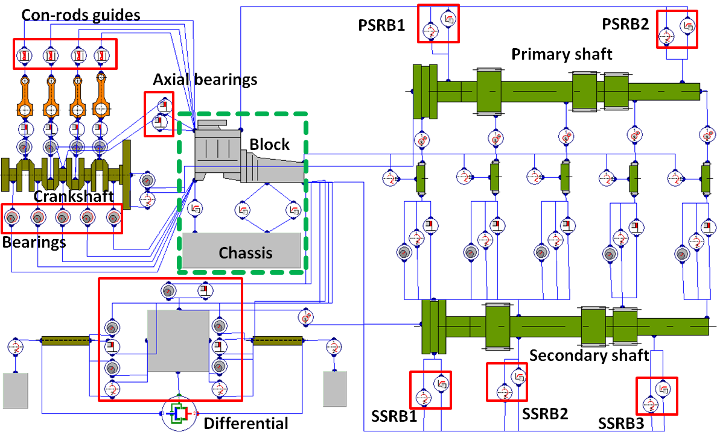
Figure 6.1 – Schematic 2D representation of the multi-body dynamic system of the engine investigated. : highlighted in dotted-green, the target substructure; in red the joints connected to the target substructure.

The geometry investigated in the NTPA is the engine block of the powerunit system connected with linear mountings to the chassis. The block consists of 153728 degrees of freedom (DoFs). It is made of steel with an elastic modulus of 210000 N/mm², a Poisson ration of 0.3 and a density of 8076 kg/m³. The whole system (both simulated cylinder pressure and system dynamics) is simulated using the software AVL EXCITE [114].
Since the total amount of time needed for the computation is significantly influenced by the number of DoFs of the system, a condensed model with a reduced number of DoFs, equivalent to the full model, is considered for the simulation. The condensed number of DoFs of the engine block is 1666. The dynamic system of equations is solved in time domain and result data are transformed into frequency domain. Once the full simulation is performed, the substructuring method and the consequent NTPA can be applied. In this analysis, 21 different load cases, i.e. 21 different paths, are analyzed. The following cases are identified:
- 4 combustion chambers (corresponding to the noise transmitted directly from the walls of the combustion chambers; from “Comb1 to 4” in the figures)
- 5 radial bearings (corresponding to the main bearings of the crankshaft; from “Bearing1 to 5” in the figures)
- 4 guidance for connecting rod small ends (which represent the piston-liner interaction; from “Guide1 to 4” in the figures)
- 5 roller bearings (corresponding to the roller bearings of primary and secondary gear shafts, respectively “PSRB1 and 2” and “SSRB1 to 3” in the figures)
- Supports of differential (“Diff” in the figures)
- Axial bearings
- Cam contacts
Among these cases, 16 of them refer to contact forces with other bodies and are highlighted in red in Fig. 6.1.
6.2.5 System uncertainties
Having no information on system uncertainties and possible variations, in this paper different values of the dispersion parameter were chosen, in accordance with the values used in other applications that can be found in literature [230,232,233,237]. The values of 0.01, 0.05 and 0.1 are selected for $σ_{G}^{ }$, in order to show the order of variability of the system while changing${ σ}_{G}^{ }$. The same values are chosen for $M$, $D$ and $K$ matrices. Figs. 6.2, 6.3 and 6.4 show the point mobility evaluated in the nodal rear mount position. The coefficient of variation $cv$, defined as the ratio between the standard deviation and the mean value of a statistical group of samples, is evaluated for the eigenfrequencies below 1kHz. The average value of this coefficient of variation is: for${ σ}_{G}^{ }=0.01$, the mean value of $cv$is 0.0008; for${ σ}_{G}^{ }=0.05$, the mean value of $cv$is 0.0041; for${ σ}_{G}^{ }=0.1$, the mean value of $cv$is 0.0088.
Figs. 6.5, 6.6 and 6.7 show the vertical acceleration results obtained in the front mount position in vertical direction. These results are obtained considering the different samples of the engine block system matrices. The excitations do not change from sample to sample and correspond to the contact forces evaluated in the multi-body dynamic simulation. Figs. 6.5, 6.6 and 6.7, also the coefficient of variation is shown. As expected, the coefficient of variation of results increases with increasing $σ_{G}^{ }$ and also with increasing frequency. However, in correspondence of half engine orders (running at 3000 rpm the 1stengine order is at 50Hz) the variability is lower.

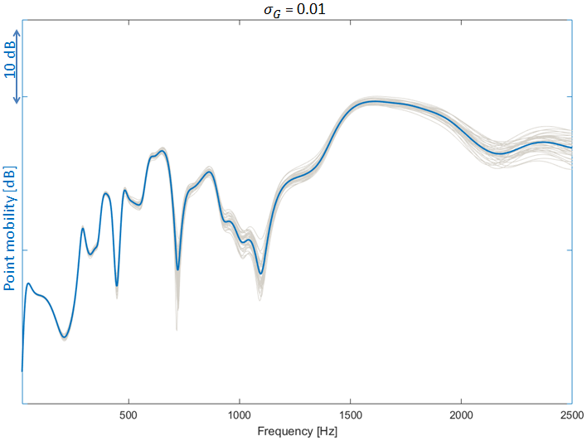
Figure 6.2 – Point mobility evaluated in rear mount for${ σ}_{G}^{ }$ equal to 0.01. In grey, the different samples of Monte Carlo set; in blue, the mean value.
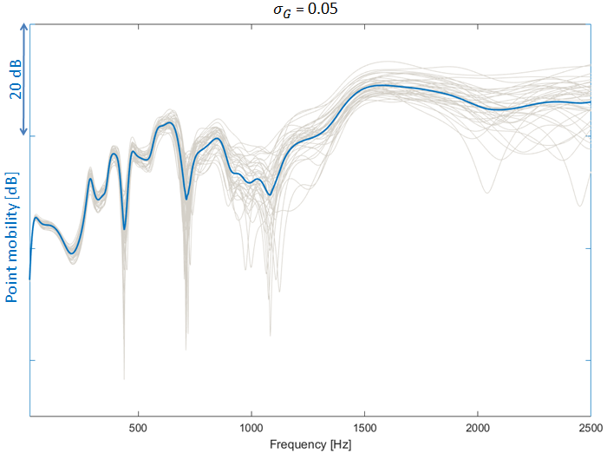
Figure 6.3 – Point mobility evaluated in rear mount for${ σ}_{G}^{ }$ equal to 0.05. In grey, the different samples of Monte Carlo set; in blue, the mean value.
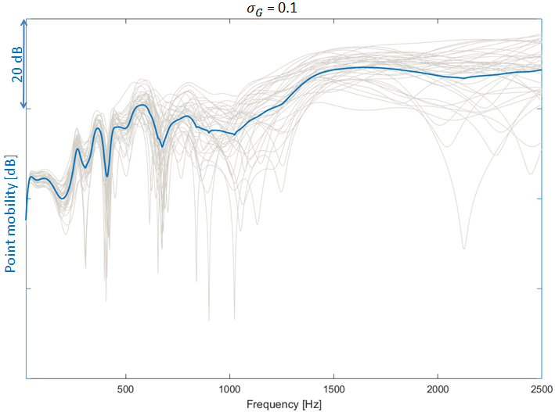
Figure 6.4 – Point mobility evaluated in rear mount for${ σ}_{G}^{ }$ equal to 0.1. In grey, the different samples of Monte Carlo set; in blue, the mean value.
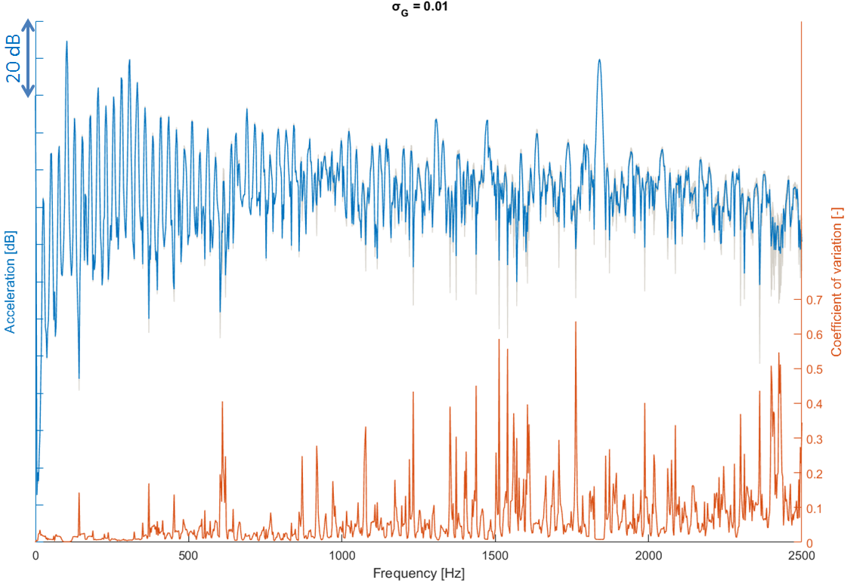
Figure 6.5 – Vertical acceleration at front mount position for${ σ}_{G}^{ }$ equal to 0.01.

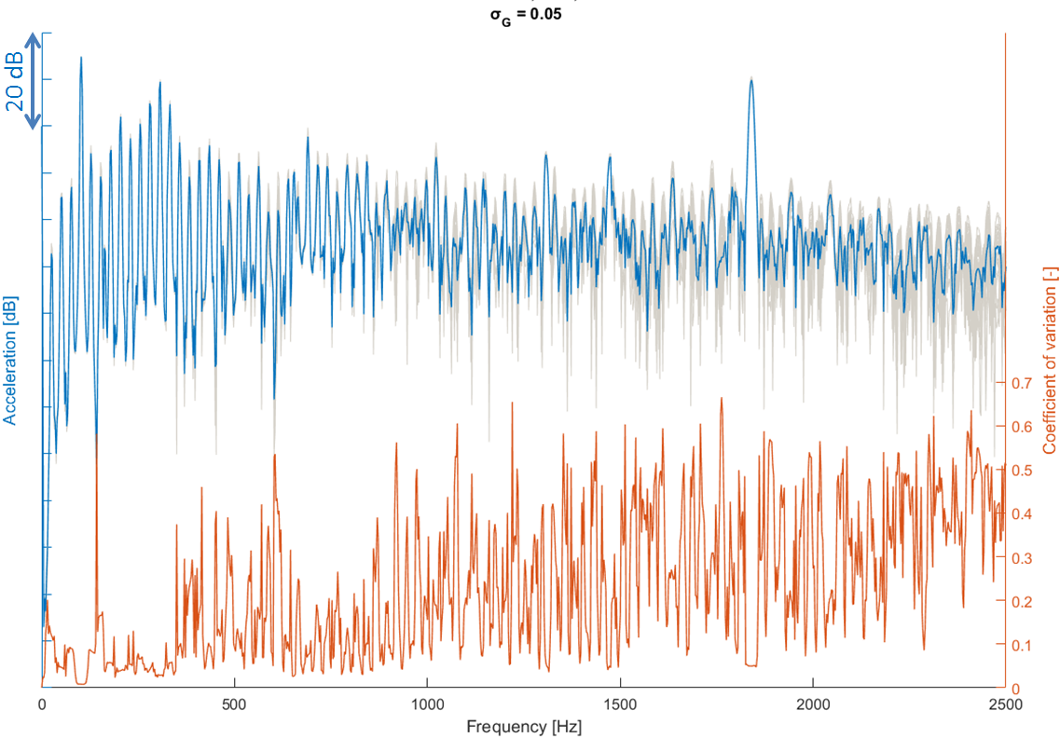
Figure 6.6 – Vertical acceleration at front mount position for${ σ}_{G}^{ }$ equal to 0.05.
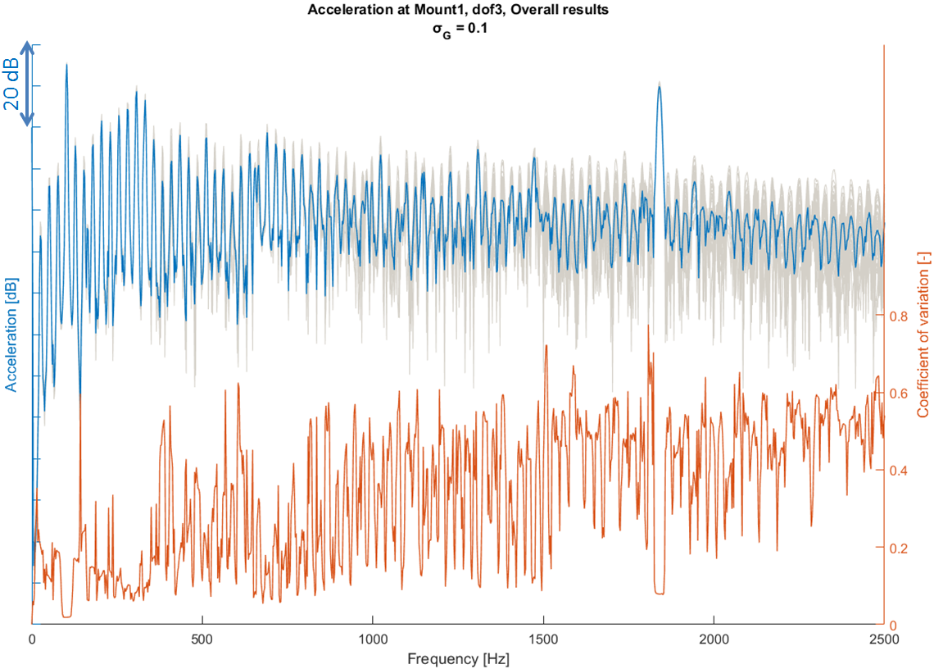
Figure 6.7 – Vertical acceleration at front mount position for${ σ}_{G}^{ }$ equal to 0.1.

Considering that the energy of the frequency spectra is almost totally included into these frequencies (25 Hz and multiples), it can be said that for low level of${ σ}_{G}^{ }$ (e.g. the case of $σ_{G}^{ }$ = 0.01) the uncertainties are not relevant. This is also confirmed in Fig. 6.8 where the coefficient of variation of the vertical acceleration is shown in octave bands. In fact, for $σ_{G}^{ }$ = 0.01 the coefficient of variation is always lower than 0.02, while for higher values of the parameter${ σ}_{G}^{ }$, the coefficient of variation of results increases but never exceeds 0.2.
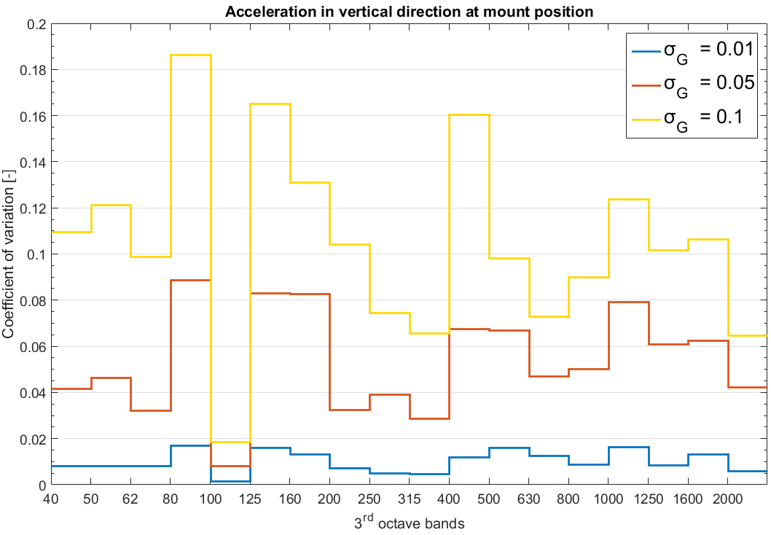
Figure 6.8 – Coefficient of variation of vertical acceleration at front mount position. Results in third octave bands.

6.2.6 Influences of system uncertainties on the assessment of vibration sources
In this section, the influence of model parameter variability on the ranking of the different source contributions is discussed. In Fig. 6.9, the mean values of the contributions to acceleration in vertical direction at nodal position of Mount1 are shown. The quantities shown consider the mean values obtained from all the different samples of the Monte Carlo method.
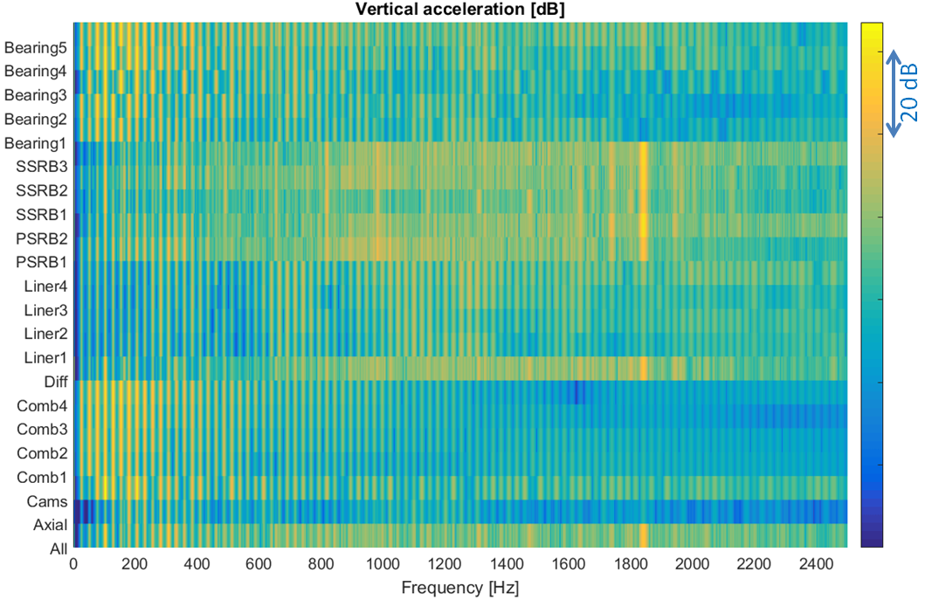
Figure 6.9 – Acceleration contributions in vertical direction in front mount position. Mean values.

The graph in Fig. 6.9 shows only magnitude information of the different source vibration contributions. The bottom line of Fig. 6.9 is the overall acceleration measured in the investigated node. It is possible to clearly distinguish the tonal components of the main engine orders at low frequencies, mainly due to combustion chamber and radial bearing supports. Also the gear whine noise at 36th order transmitted from roller bearings supporting gear shafts and differential can be distinguished. Due to variability of source contribution results, in this section the influences of model parameters uncertainties on the source ranking are also investigated. For this reason, the phase information is also included. The projected contributions (see Eq. (66)) are considered to rank the different sources. The sources contributions are here used to study the interaction between sources and their variability.
For the sake of simplicity, Figs. 6.10 and 6.11 show results only at 300 and 1800 Hz, although this rating can be done at every frequency. The bars in Figs. 6.10 and 6.11 represent the 95% interval of results dispersion (two times standard deviation). In Figs. 6.10 and 6.11, the projected contributions are shown for all 3 values of${ σ}_{G}^{ }$ investigated. The projected contribution gives an idea of the investigated configuration: the higher its value, the higher is the component of the contribution on the direction of the overall vibration. E.g., at 1800 Hz, which correspond to the gear whine noise frequency, the supports of the differential and the second roller bearing supporting the secondary gear shaft are the most contributing sources. From the analysis of the projected contributions in Figs. 6.10 and 6.11, it is also possible to have an idea of the influence of system variabilities on source ranking. The comparison between 300 and 1800 Hz shows how, with increasing frequency, the variability is increased. In Figs. 6.10 and 6.11, results obtained at different values of $σ_{G}$ are compared. These graphs show how results uncertainties obtained at low variability can be practically neglected.
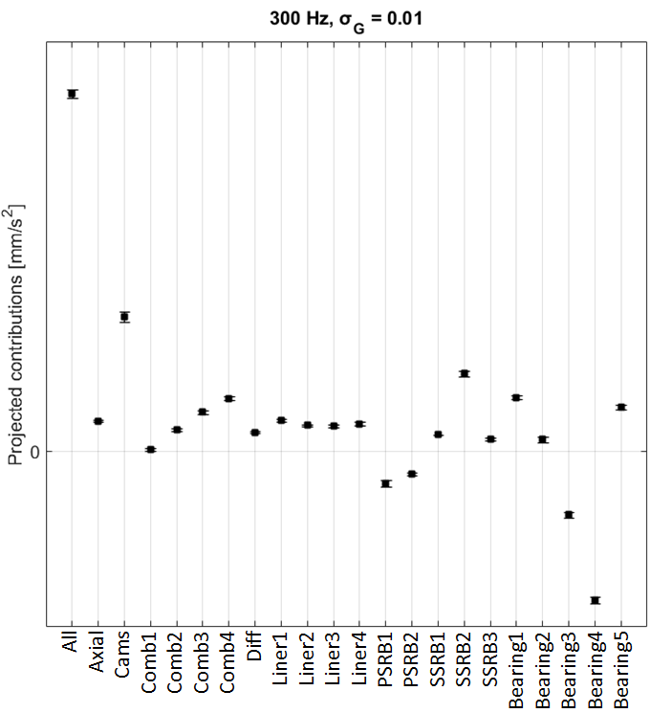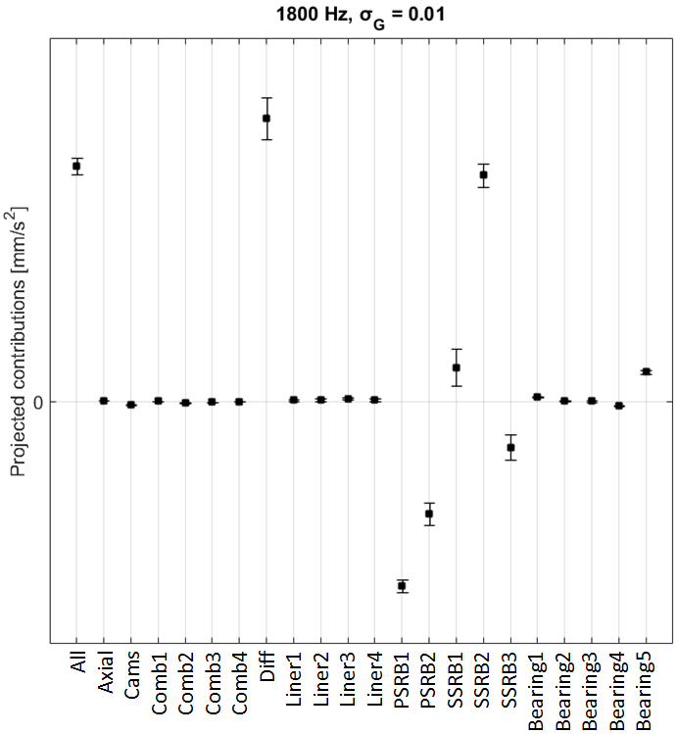
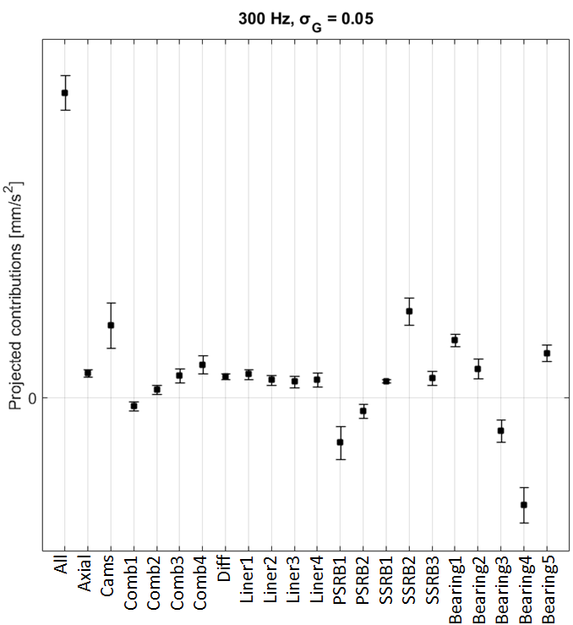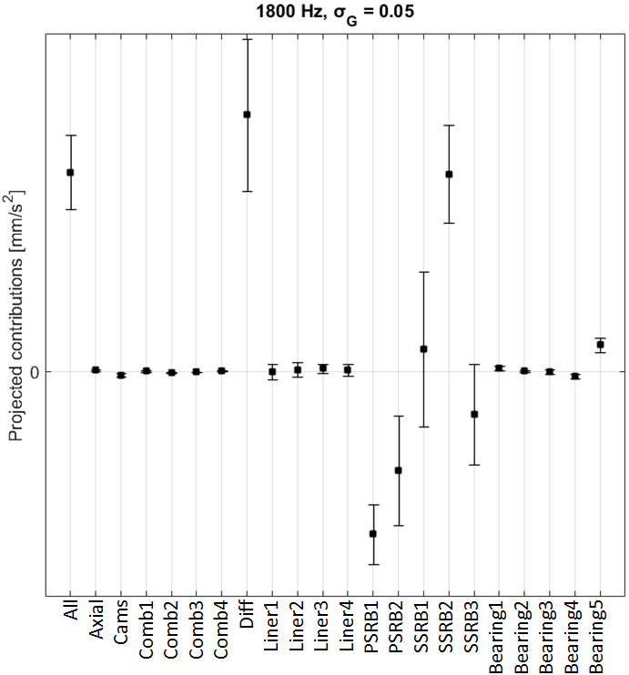

Figure 6.10 – Projected contributions at 300 and 1800 Hz with $σ_{G}$ = 0.01 and 0.05. Bars refer to 95% confidence interval.
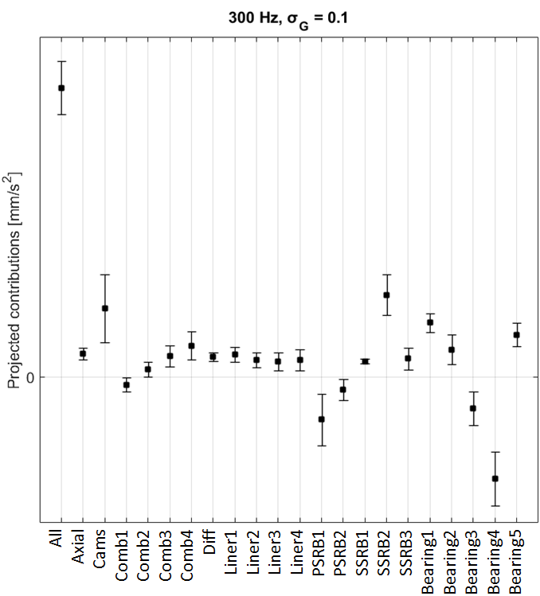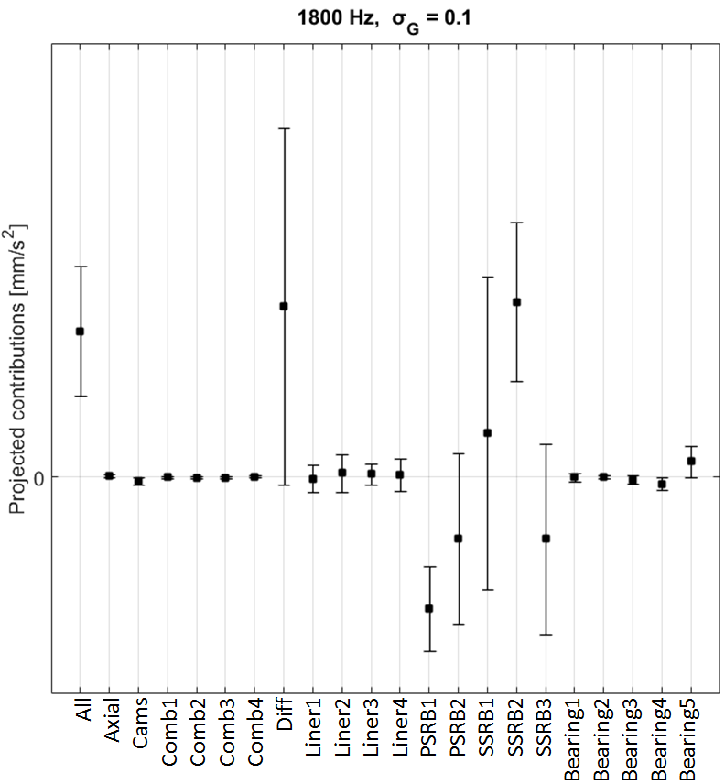

Figure 6.11 – Projected contributions at 300 and 1800 Hz with $σ_{G}$= 0.1. Bars refer to 95% confidence interval.

Conversely, increasing variability makes the assessment of the vibration sources less straightforward. If the variability is increased, it is harder to uniquely rank the sources. E.g., at 1800 Hz and$σ_{G}$ = 0.05, the 95% intervals of sources “Diff” and “SSRB2” overlap, indicating that it is not possible to identify which is the most relevant one. The same happen at the same frequency for $σ_{G}$ = 0.1. Moreover, it may happen that some projected contributions change their sign: this suggests a change in the phase. Similar conclusions arise also from the study of any other frequencies.
Due to these reasons it is important to understand if and how the sources are correlated. Fig. 6.12 shows the Pearson correlation coefficients between the different projected contributions for a given frequency. The Pearson correlation coefficient is defined as the ratio between the covariance of two random variables,$A$ and$B$, and the product of their standard deviations, respectively $σ_{A}$and $σ_{B}$, [238]
$$cc=\frac{cov\left(A,B\right)}{σ_{A}σ_{B}}.$$ | (217)
Studying the cross correlation coefficients in Fig. 6.12, the direct correlation between the different sources can be observed. For the sake of simplicity, results in Fig. 6.12 are shown only for $σ_{G}$ = 0.1, where the variability is sufficiently high to let some projected contributions change sign. These correlations are useful to see how, for example, vibrations in the combustion chambers are inversely correlated with the vibrations of the main bearings at 300 Hz, or how at 1800 Hz all roller bearing supports on the gear shafts are highly correlated. More significant are the considerations made on the contributions derived from differential supports at 1800 Hz. In fact, this contribution is inversely correlated with the contributions of secondary gear shaft roller bearing 1 and 2 (respectively SSRB1 and 2 in figures), suggesting that in some cases, these contributions from roller bearing contacts can became more relevant than differential support. Indeed, at 1800 Hz for $σ_{G}$ = 0.1, the contributions Diff and SSRB2 have similar probability to be the highest contribution: in the 53% of the cases Diff is the highest one, while the 47% of the cases SSRB2 is the highest. Considering that at 1800 Hz there is a strong correlation also between SSRB1 and SSRB2 (see Fig. 6.12) it is not surprising that from this analysis SSRB1 never results as the highest contribution, although the 95% intervals of confidence of Diff, SSRB1 and SSRB2 overlap. These considerations can be applied at any frequencies and can help to analyze system sources ranking.
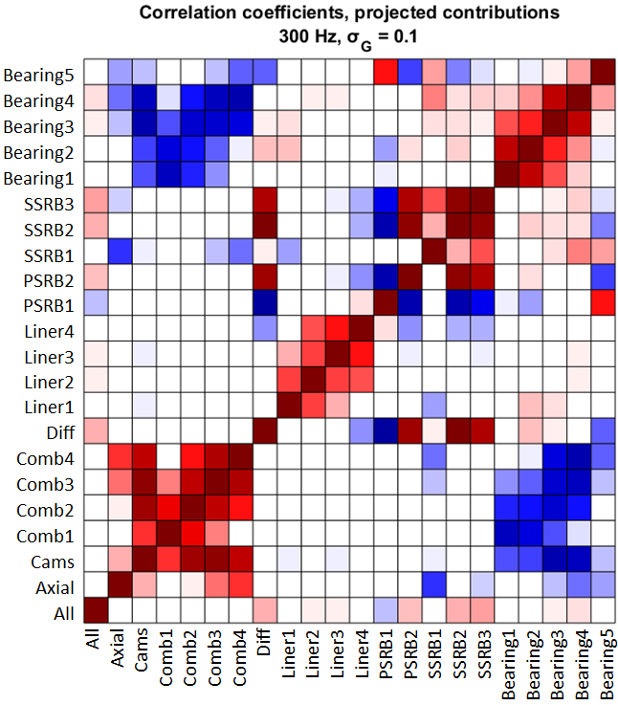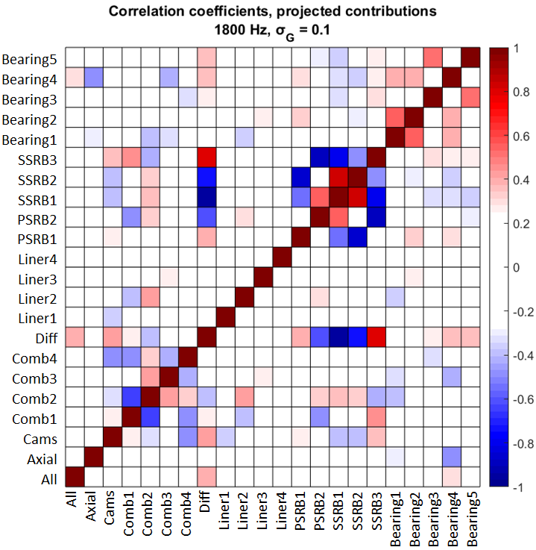
Figure 6.12 – Pearson Correlation coefficient between projected contributions at 300 and 1800 Hz for $σ_{G}^{ }$ = 0.1.

- Influences of excitation variability on source assessment

In automotive applications, cylinder pressure variability is one of the uncertain parameters that engineers have to deal with when designing and analyzing internal combustion engines. Multi-body dynamics is a powerful numerical tool largely implemented during the design of new engines. In this section the influence of cylinder pressure cyclic variability on the results obtained from the multi-body simulation of engine dynamics is investigated. Particular attention is paid to the influence of these uncertainties on the analysis and the assessment of the different engine vibration sources and radiating surfaces. NTPA is used to derive and assess the internal engine vibration sources, while SCA is used to study the different radiating surfaces. In order to investigate the cyclic variability of cylinder pressure, a Monte Carlo approach is adopted. Starting from measured cylinder pressure that exhibits cyclic variability, random Gaussian distribution of the equivalent force applied on the piston is generated. The aim of this paper is to outline a methodology which can be used to derive correlations between cyclic variability and statistical distribution of results. The statistical information derived can be used to advance the knowledge of the multi-body analysis and the assessment of system sources when uncertain inputs are considered.
6.3.1 Cyclic cylinder pressure variability
Cyclic variability has been observed since the earliest scientific studies of internal combustion engines [239,240]. Although in the beginning the predominant understanding of cyclic variability was that cycle-to-cycle variations were of stochastic nature [241,242], there have been many attempts to analyze the cycle-to-cycle variations by applying deterministic methods from nonlinear dynamical systems and chaos theory [243-247]. In general, it can be said that the physiochemical processes in an internal combustion engines are influenced by many factors like composition of fuel air mixtures, amount of recycled gases in the combustion chamber, engine aereodynamics or engine operating conditions. In this section the cylinder pressure is measured in experimental data and the cylinder variability is statistically treated to define the input for the multi-body dynamic simulations.
Cylinder pressure was measured on a GDI engine running under full load operating conditions with constant engine cycle averaged speed of 3000 rpm and firing crank angle of 0 deg. The measured data consist of 16 different periods (one cycle correspond to two complete crankshaft rotations being a 4-stroke engine). In Fig. 6.13, the blue line shows the mean value of the cylinder pressure measured, while the orange line correspond to the standard deviation,$σ$, of the measured data.
The maximum pressure measured exhibits a Gaussian distribution with a standard deviation of 8.6 bar. From these pressure data, an equivalent force is derived, which is applied in vertical direction both on piston head and on the walls of the combustion chambers. Each time history is obtained by mixing the 16 measured cycles in random sequence. Each excitation in a cylinder has a time history which is independent from the excitations in the other cylinders and the statistical dispersion of the excitations correspond to the one shown in Figs. 6.13 and 6.14. Fig. 6.14 shows the statistical distribution of the force applied in the combustion chamber in vertical direction. This distribution is obtained from a MC approach consisting of 31 simulations.
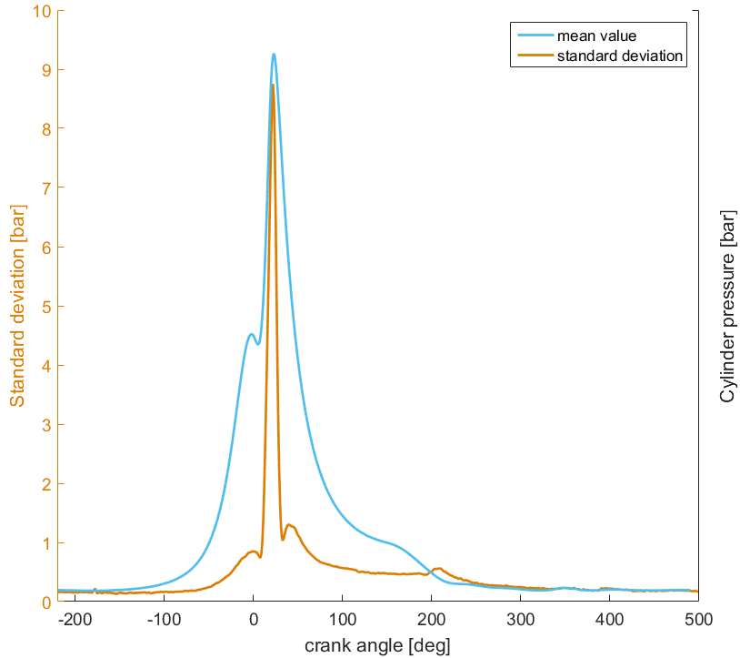
Figure 6.13 –Cyclic variability of measured cylinder pressure. In blue, the mean value. In orange, the standard deviation of measured data.
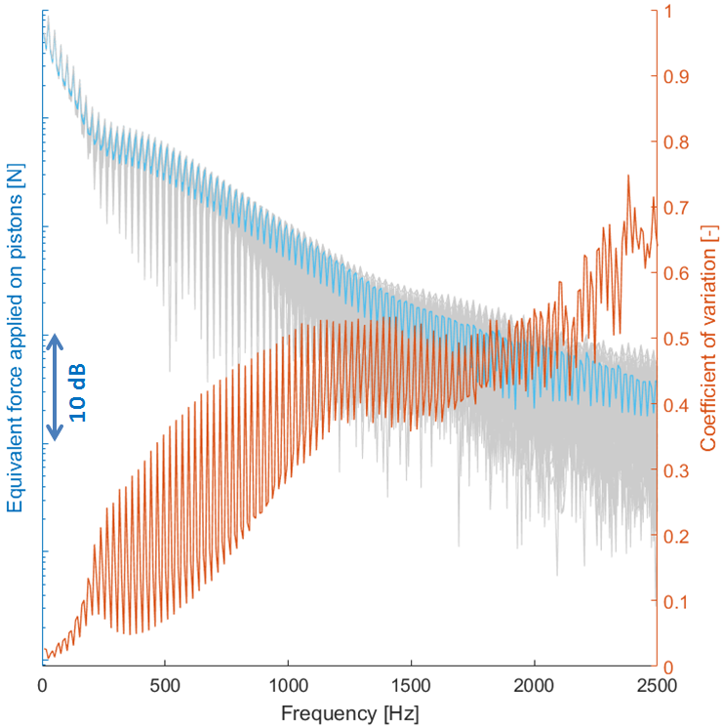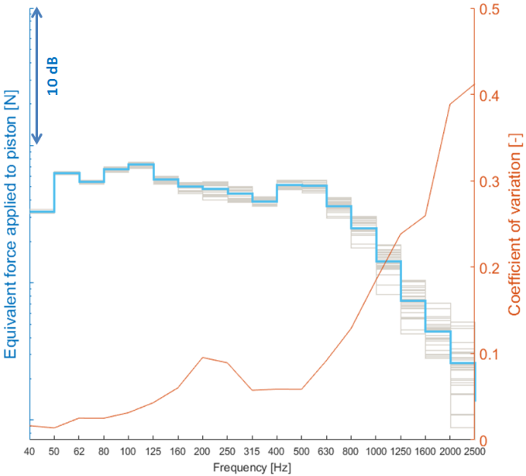
Figure 6.14 – Cyclic variability of piston force frequency spectra. Left, narrowband. Right, third octave band. In blue, the mean value. In orange, the coefficient of variation of measured data. In grey, all the different samples of the MC approach.

The frequency spectra, together with the coefficient of variation, here indicated with $σ_{n}$, defined as the ratio of the standard deviation and the mean value of the measured data, are plotted in Fig. 6.14. This frequency spectrum is obtained from the FMBD simulation considering a period of 3 engine periods, i.e. 0.12 s, resulting in a frequency step of 8.3 Hz. From Fig. 6.14, it can be seen that the frequency spectra of the applied force is characterized by a series of tones. These tones depend on the engine speeds. The first peak in the frequency spectra occur at the 0.5th engine order, 25 Hz, and the other harmonics at its multiples. Most of the energy is contained below 250 Hz. Concerning the statistical distribution of the data, it can be said that the coefficient of variation $σ_{n}$ is relatively low in correspondence of the cylinder orders, when the frequency spectra exhibits tonal peaks. Comparing narrowband data and third octave bands data, it can be noticed that the${ σ}_{n}$ is drastically reduced when the data are investigated in bands. In detail, $σ_{n}$ is lower than 0.1 up to nearly 1 kHz third octave band. Conversely, in narrowband $σ_{n}$ stays below 0.1 only up to 250-300 Hz.
The dispersion in the frequency spectra is higher compared with the one in time domain. The main reason is that higher frequency content is influenced by the shape and the smoothness of the excitation time history [1]. In fact, the variability of the cylinder pressure spectrum is not only influenced by the maximum pressure but also (and especially) by the shape of the cylinder pressure time history, as confirmed in Fig. 6.15 where first and second time derivative of the pressure are plotted.

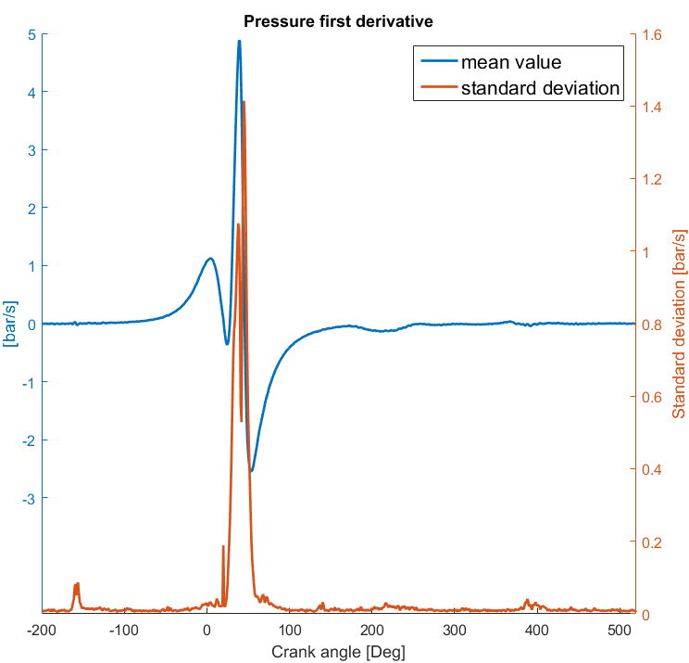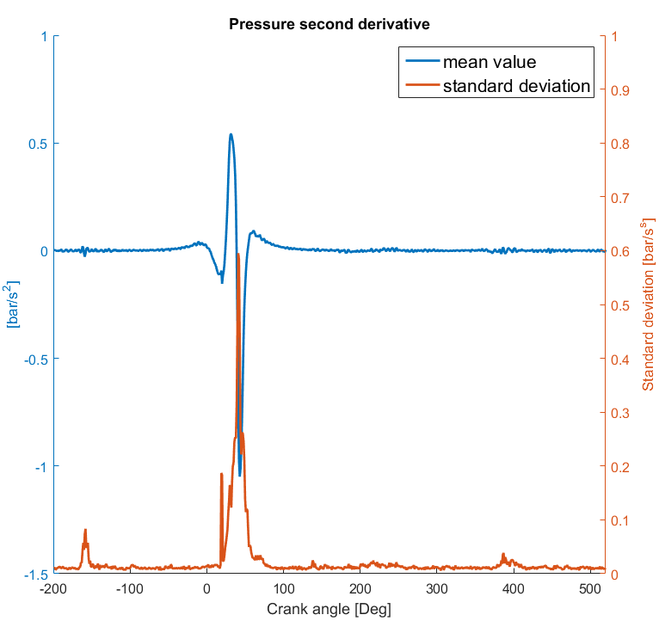
Figure 6.15 – First and second time derivative of cylinder pressure.

6.3.2 The model investigated
The model here investigated is the same described in section 3.8.1. The system consists of one engine block mounted on 3 different mount positions, a crankshaft, four con-rods, two balancer shafts in correspondence of intake and exhaust systems and a dual-mass-flywheel (DMF). The joints connecting gearbox and engine block are linear, while all others are nonlinear joints with exponential increasing stiffness as function of the displacement. No gear transmissions are included into the model. The pistons are excited with moving forces representing the combustion pressure analyzed in section 6.3.1. The torque applied on the crankshaft from the pistons is balanced with an external torque applied in correspondence of the DMF. In Fig. 6.16, a schematic 2D representation of the system investigated is shown. Pistons, cylinders, bearings and other joints are numbered from front to rear. The simulation is carried out in time domain using the software AVL EXCITE [114].
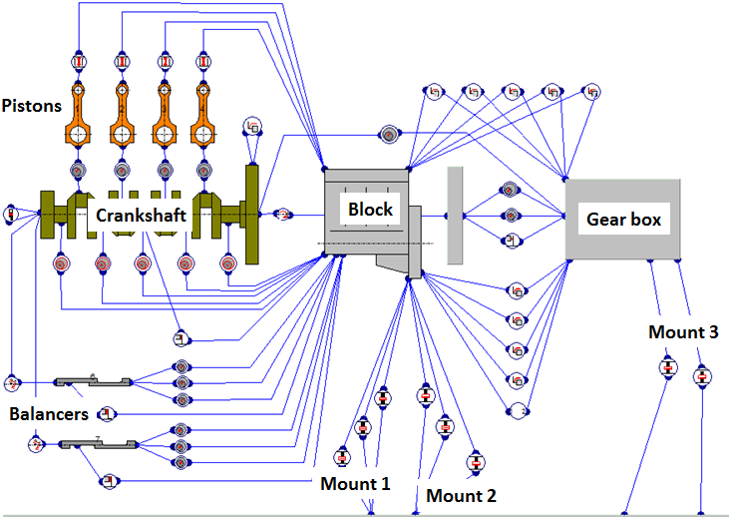
Figure 6.16 – Schematic 2D representation of the multi-body dynamic system of the engine investigated.

The substructure investigated is the engine block. All forces acting on the engine block are collected and grouped in sets. The forces collected are the ones transmitted from joints and the combustion pressure acting in the combustion chambers. Each set of forces contains the forces applied on the structure from the same joint, i.e. from the same excitation. 21 different load cases, i.e. 21 different paths, are analyzed. The following cases are identified:
- 4 combustion chambers (corresponding to the vibrations transmitted directly from the walls of the combustion chambers; from “Comb1” to 4 in the figures)
- 5 radial main bearings (corresponding to the main bearings of the crankshaft; from “Bearing1” to 5 in the figures)
- 4 guidance for connecting rod small ends (which represent the piston-liner interaction; from “Liner1” to 4 in the figures)
- 6bearings for balancer shafts(respectively from “BalInt1” to 3 for the supports in correspondence of intake system and from “BalExh1” to 3 for supports in correspondence of exhaust system in the figures)
- Axial bearings
- DMF supports
Finally, when all cases are computed, the vibration contributions are evaluated in the nodes of interest.
In order to investigate the cyclic variability of cylinder pressure, a Monte Carlo approach is adopted. Starting from measured cylinder pressure that exhibits cyclic variability, random Gaussian distribution of the equivalent force applied on the piston is generated. According with [236], 31 different multi-body simulations are investigated to get relevant statistical results. The aim of this paper is to describe a methodology to derive correlations between cyclic variability and statistical distribution of results; therefore the number of simulations here performed was chosen to optimize the statistical relevance of results and calculation time required. In real industrial applications it is strongly suggested to perform a convergence analysis related to the statistics of the quantities of interest.
6.3.3 Influences of cylinder cyclic variability on NTPA results
In this section, the influence of cyclic variability on the ranking of the different source contributions is discussed. The assessment of the vibration contributions is done using the numerical transfer path analysis described in chapter 3.
In Fig. 6.17, the mean values of the contributions to acceleration in vertical direction at nodal position of Mount1 are plotted. In fig. 6.18, the acceleration spectrum of Mount1 in the vertical direction is shown. Both in fig. 6.17 and 6.18, the quantities shown consider the mean values obtained from all the different samples of the Monte Carlo method.
In order to account for their phase relationship, the sources are ranked in terms of projected contributions (see Eq. (66)) and their variability is studied. The projected contribution gives an idea of the investigated configuration: the higher its value, the higher is the component of the contribution on the direction of the overall vibration.
Fig. 6.19 shows the variability of the projected contributions at the frequencies shown in Fig. 6.18. These frequencies were chosen to show how to use the results obtained from the NTPA method.
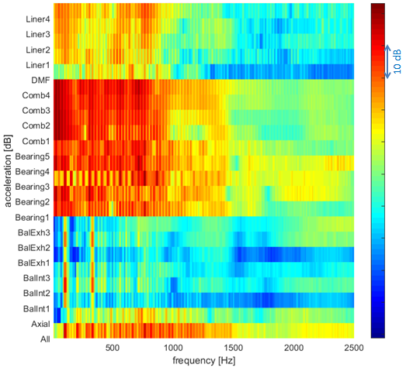
Figure 6.17 – Acceleration contributions in vertical direction at Mount1. Mean values.

Fig. 6.19 can help to understand how the different sources interact, e.g. at 100 Hz the vibrations derived from the excitations applied in combustion chambers are opposite in phase with the main bearings contributions. Moreover, it can be seen that the assessment of the sources is not straightforward. For instance, at 1140 and 1625 Hz, some relevant contributions may change direction. Unfortunately, with increasing frequency, the variability also increases and may happen that some projected contributions change sign.

This suggests that the variability of the phase is not negligible. To show how the variability of the phase affects the projected contributions, in Fig. 6.20 the projected contribution of Bearing3 is investigated in frequency domain. The coefficient of variation of the cosine of the phase of the complex vector of this contribution is also considered. For the sake of simplicity only Bearing3 is investigated.

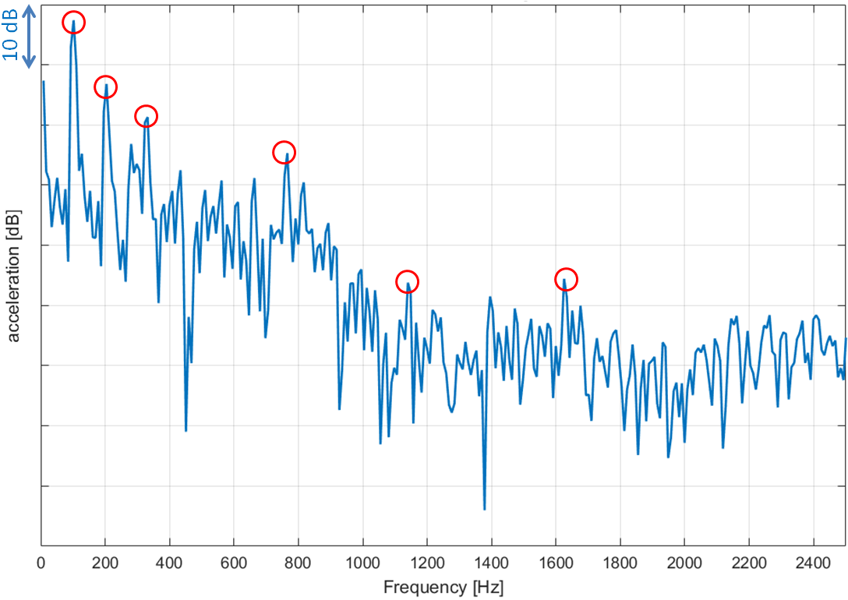
Figure 6.18 –Mean value of acceleration in vertical direction at Mount1. In red, the frequencies investigated considering phase information and plotted in Fig. 7.

From Fig. 6.20, it is possible to conclude that if the coefficient of variation of the phase cosine is lower than 0.2, the projected contribution do not change its sign (i.e. the complex vector of the contribution and the complex vector of the overall acceleration preserve their directions). This condition is fulfilled at low frequencies and in correspondence of the main engine orders. Between engine orders and with increasing frequency, the variability is high and it is difficult to properly rank the different contributions considering the phase information.

Given the high variability of the results with increasing frequency, the cross correlation between the sources is investigated. Fig. 6.21 shows the Pearson correlation coefficients between the different projected contributions for a given frequency. The Pearson correlation coefficient is defined as the ratio between the covariance of two random variables and the product of their standard deviations (see Eq. (217)).

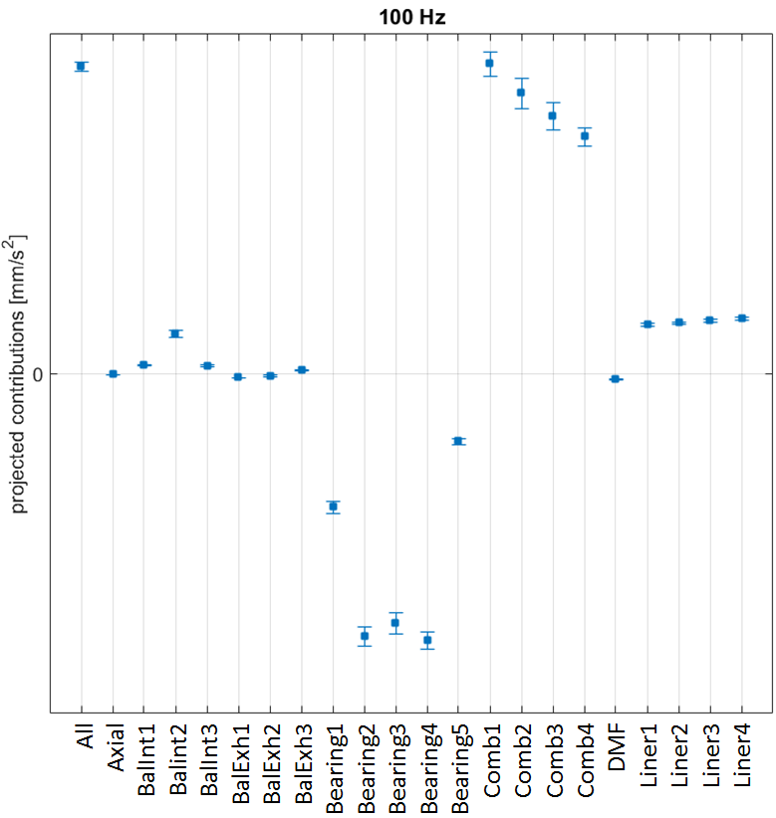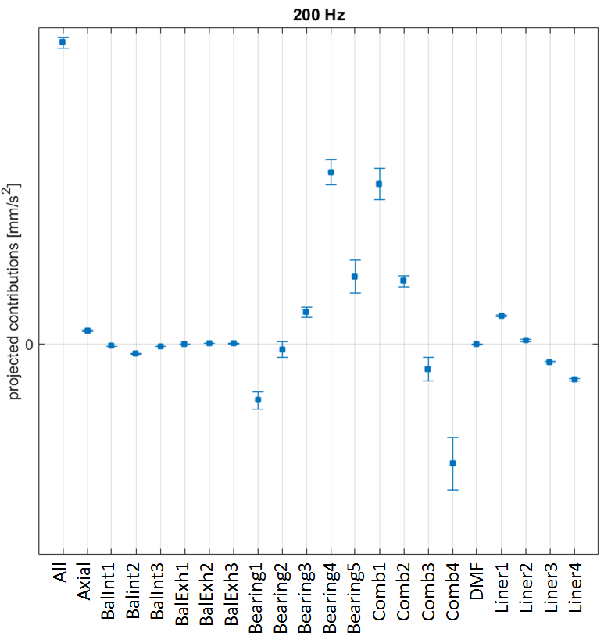
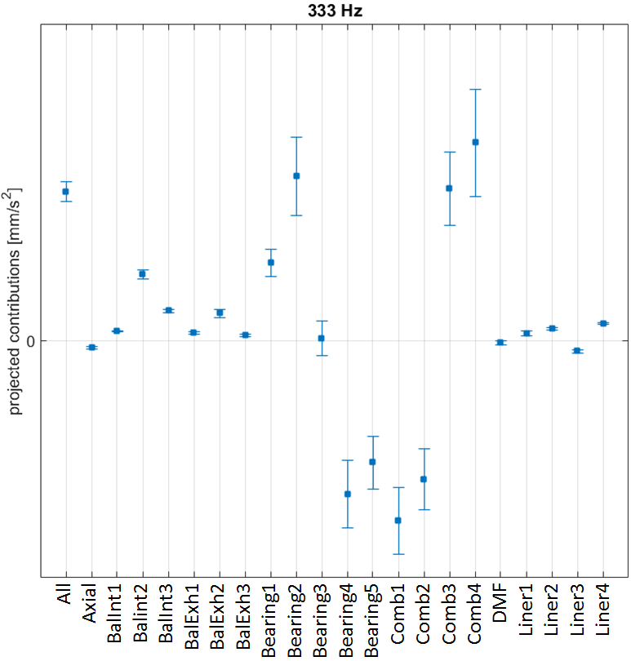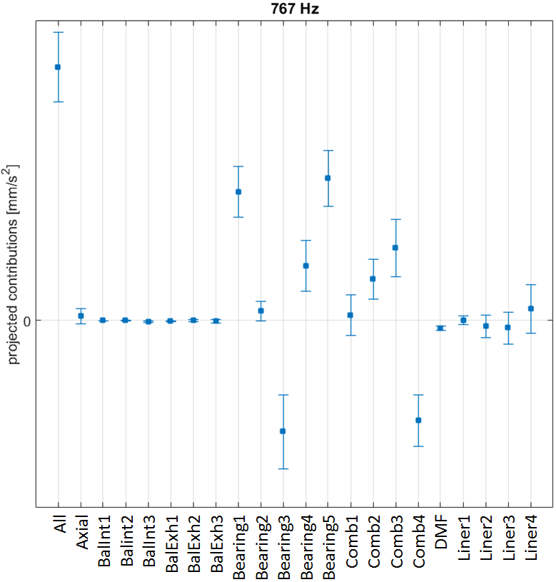
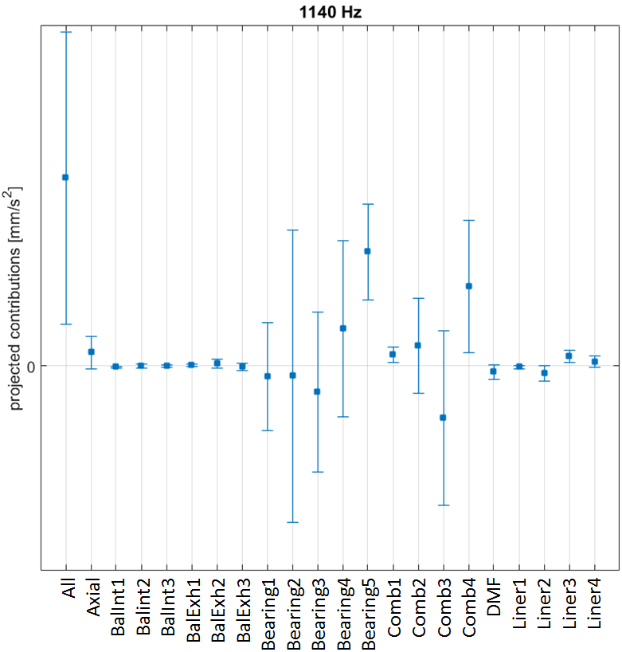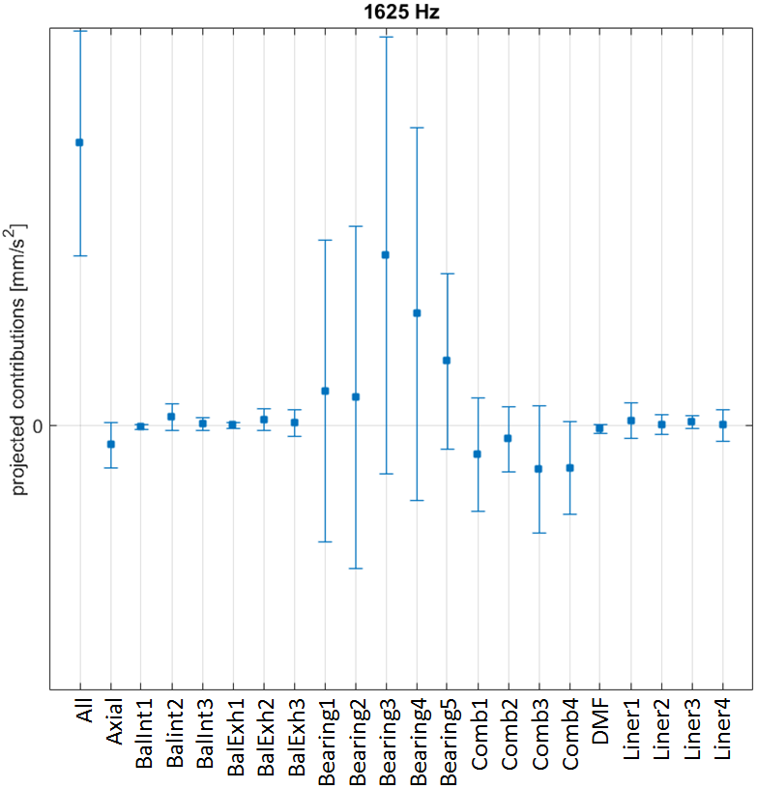
Figure 6.19 – Variability of projected contributions at 100Hz, 200Hz, 333Hz, 767Hz, 1140 Hz and 1625 Hz. The bars around the mean value indicate to the 95% confidence interval of data.

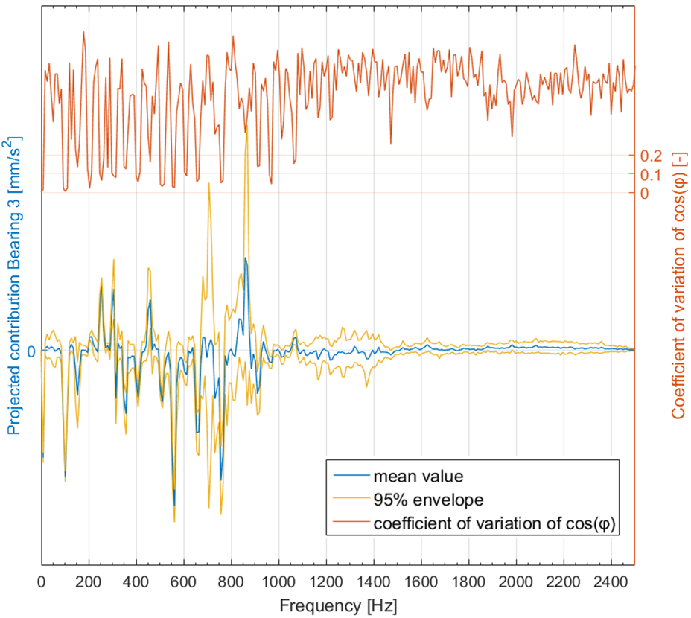
Figure 6.20 – Cyclic variability projected contributions of Bearing3 with 95% confidence interval of data. In orange, the coefficient of variation of the phase of the contribution of Bearing3.

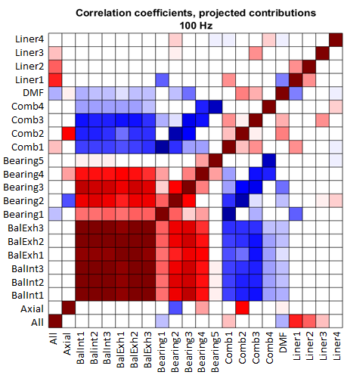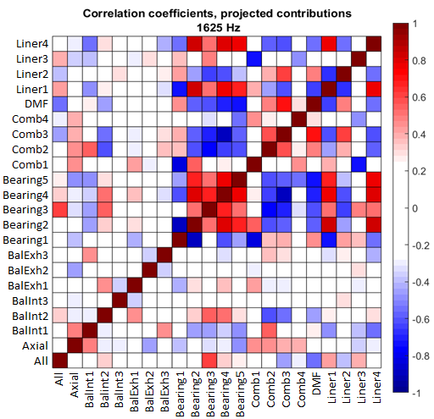
Figure 6.21 – Pearson Correlation coefficient between projected contributions at 100 and 1625 Hz.

Analyzing Fig. 6.21, three things can be observed:
- Although the high variability of some sources, their projected contributions are correlated. E.g., at 1625 Hz, bearing contributions are strongly correlated. Therefore, it rarely happens that the contribution from bearing 3 is less relevant than the others.
- Despite of the high variability, comparing the correlation coefficients between the overall acceleration and all other projected contributions, it is still possible to rank the sources. For example, again at 1625 Hz, the contribution from Bearing3 is the most relevant. The conclusion is that at this frequency, the variability mainly influences the magnitude of all contributions and that Bearing 3 remains the most relevant source in most of the cases.
- Studying the correlation between contributions also when the variability is low, gives more insights on the source assessment. This is the case for the second order, 100 Hz, where bearings and balancers contributions are inversely correlated with combustion chambers contributions and cancel each other. In fact, only liners contributions and combustion chamber 1 are correlated with the overall noise. This suggests that it is more convenient to act on piston-liner contacts to influence the acceleration measured in the investigated mount position.

Given two or more correlated sources, one may intuitively think that they can be ranked using only mean values despite of high variability. To quantify how much the ranking based on mean values of projected contributions is affected from system variability, the difference between projections is investigated. Considering two projected contributions $A$ and$B$, their difference ($A-B$) has mean value $μ_{AB}$ and standard deviation $σ_{AB}$. The probability that $A$ is grater that $B$ is proportional to the integral between zero and $+∞$ of the Gaussian probability function generated using $μ_{AB}$ and $σ_{AB}$. The elements in Fig. 6.22 indicate the probability that the projected contribution $i$ on the row is greater or equal to the projected contribution $j$ on the column. For the sake of simplicity, Fig. 6.22 refers to the same frequencies of Fig. 6.21.
If the variability is low, the comparison is quite obvious: Fig. 6.22 shows how projected contributions almost never change their ranking at 100 Hz. At 100 Hz, Comb1 is always the highest projected contribution, Comb2 the second, Comb3 the third and so on, in accordance with the results shown in Fig. 6.19. At 1625 Hz, the discussion arising are more interesting and less intuitive. As shown in Fig. 6.22, at 1625 Hz, Bearing 3 is often bigger than all other projected contributions, but it is not always the highest. In the 86% of the cases, Bearing 3 is higher than Bearing 5 and only in the 76% of the cases it is higher than Bearing 4. In conclusion, the ranking based on mean values of projected contributions is valid, although correlations between sources and data dispersion has to be investigated if the variability increase.

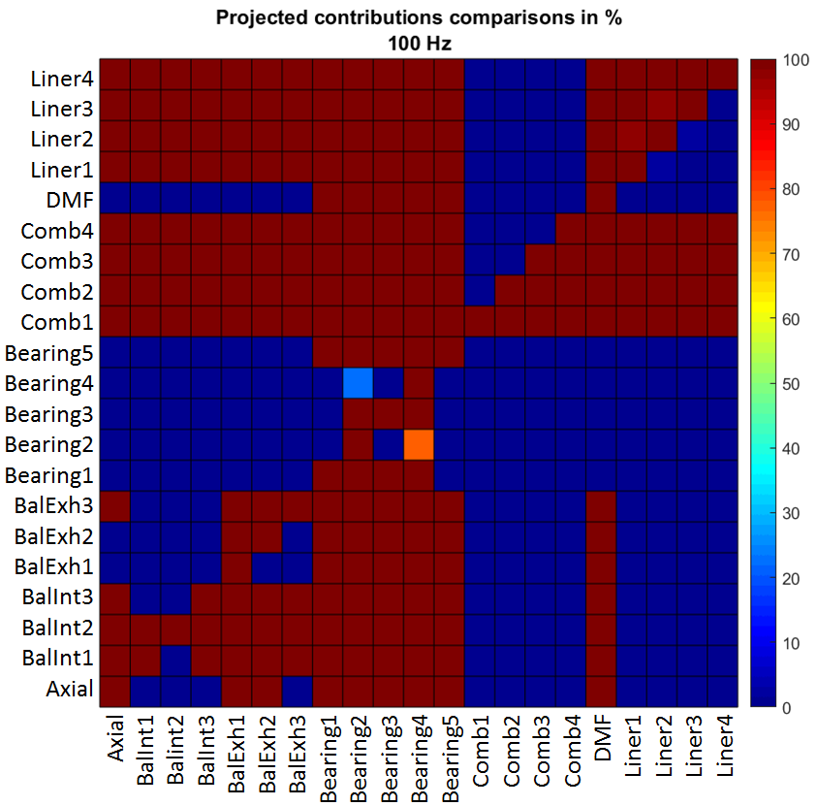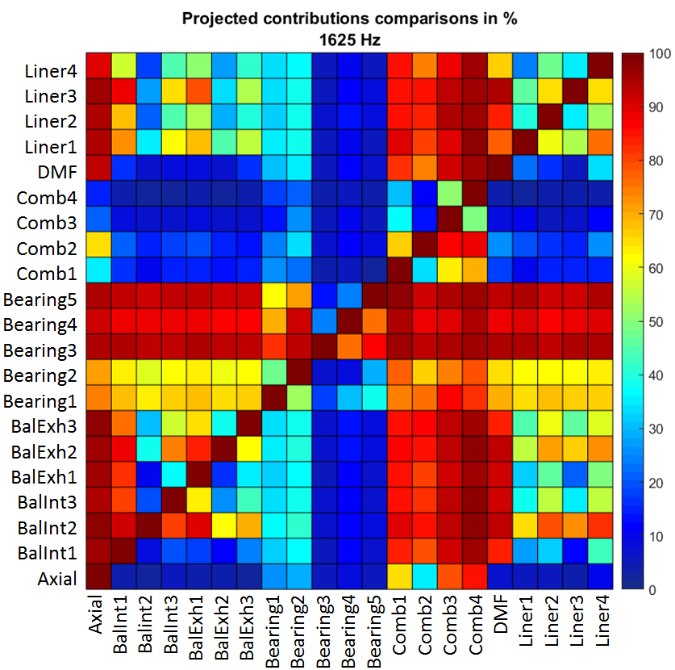
Figure 6.22 – Comparisons between projected contributions at 100 and 1625 Hz. The data indicate the probability that the contribution on the row is greater or equal compared with the contribution on the column.

An alternative to rank the system sources at high frequencies is to investigate only the acceleration magnitude, in particular, can be useful to study results in broad bands. Fig. 6.23 shows the variability of the ranking of the contributions in third octave bands. For the sake of simplicity, results are shown only in bands from 800 to1600 Hz, where the variability is higher. Lower frequencies bands are mainly driven from the tones appearing at engine orders (see Fig. 6.18) and, therefore, it is more convenient to study directly the tones with the projected contributions. Studying Fig. 6.23, it is clear that, despite of the variability that the model exhibits, it is possible to focus on the sources which have the highest absolute amplitude and neglect the ones which are orders of magnitude lower than the overall acceleration level. The results presented in this section refer only to the vertical acceleration at the nodal position of Mount1, because the vertical direction is the one that exhibits the highest magnitude acceleration and joint contact forces. The conclusions reached in this section can also be derived from the analysis of the other directions of the mount acceleration.

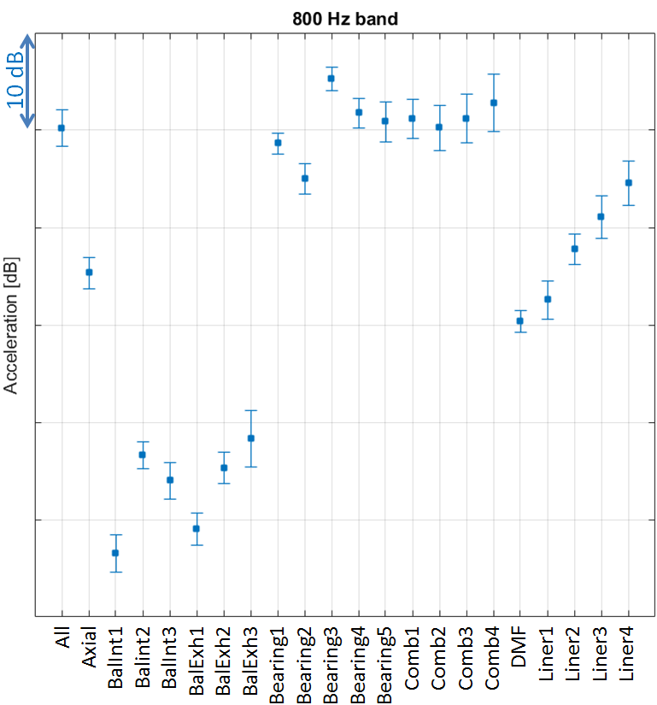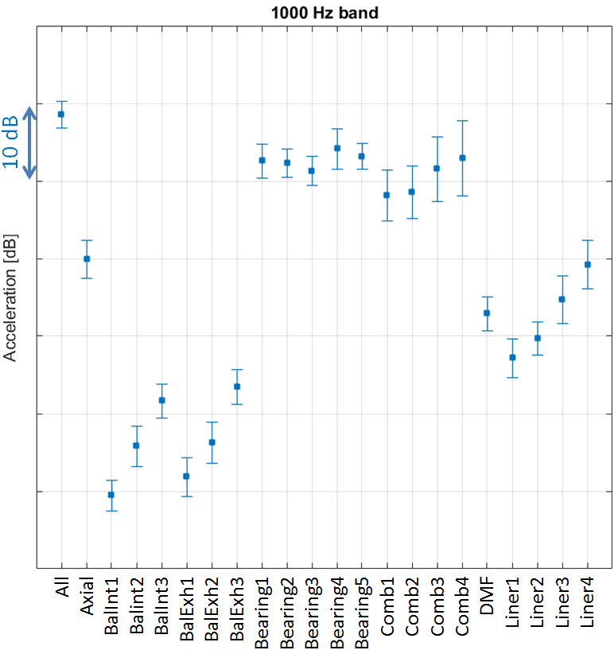
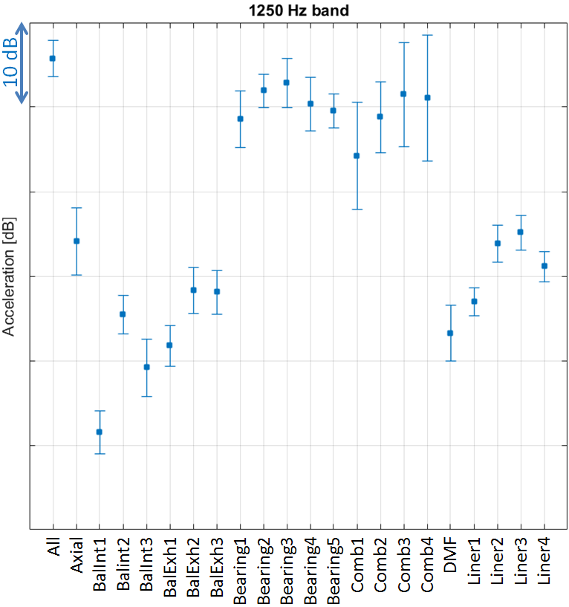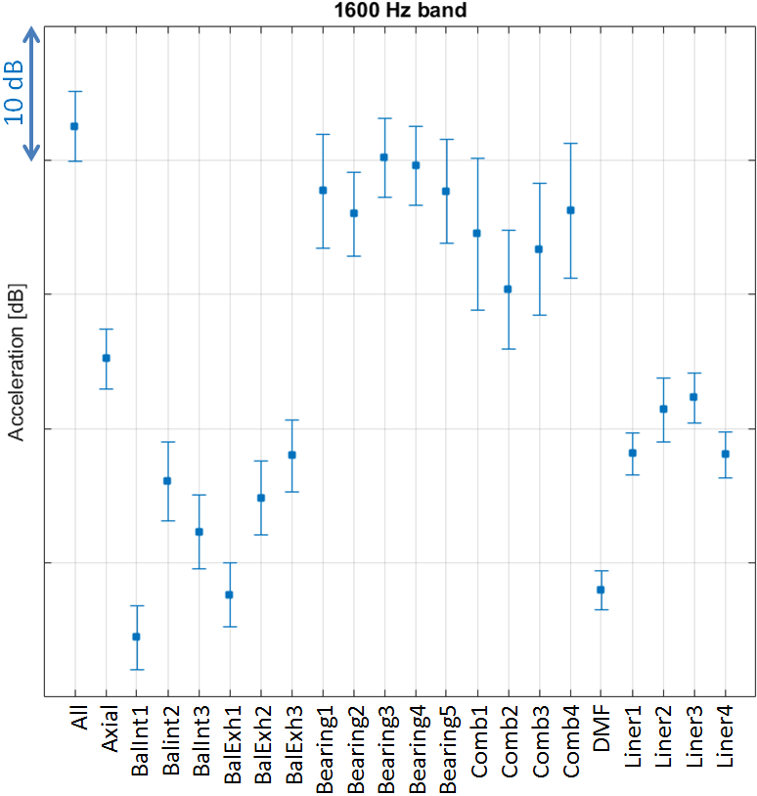
Figure 6.23 – Influence of cylinder pressure variability on sources ranking at mid-high frequency. The bars around the mean value indicate to the 95% confidence interval of data.
The statistical information here derived can be used to advance the knowledge of the multi-body analysis and the assessment of system sources when uncertain inputs are considered. From this study, the following considerations can be made:
- The variability of cylinder pressure can affect the results of multi-body analysis simulation at high frequency range;
- In the low frequency range and at main engine orders the variability is limited;
- The variability of the different sources contributions is connected to the variability of the corresponding exciting forces;
- In order to rank the different source contributions at low frequencies and at main engine orders it is convenient to use both magnitude and phase information. Conversely, at higher frequencies, where the variability of both magnitude and phase is higher, the assessment made using the phase is not straightforward. It is still possible to consider the phase at high frequency, although it can be required to also include information regarding the correlation terms between the different sources. As an alternative, it can be possible to rank the sources in terms of band results (octave or third octave bands).
- The investigation of the cross correlation between source terms can be used to analyze the correlation between sources. Also sources relationship with the overall vibrations can be investigated with correlation coefficients, giving more insight on the effective contributions to the global response.

6.3.4 Influences of cylinder cyclic variability on SCA results
The same model described in section 6.3.2 is here investigated using a surface contribution analysis. The aim is to describe a methodology to deal with excitation uncertainties when assessing and ranking different radiating surfaces using a SCA. The SCA methodology is described in chapter 4. The external surface of the investigated engine is shown in Fig. 6.24. Fig. 6.25 shows all the different surfaces investigated in the SCA. There are in total 27 different surfaces. Each surface is associated with an identification number as shown in Fig. 6.25: surfaces 1 to 4 are associated to the oil pan; 5 and 6 correspond to the air intake system; the cover head is from 7 to 9; the exhaust manifold in surface 10; 11 and 12 are placed in the front of the engine; the right hand side of the engine block consist of surfaces 13 and 14 while 15 and 16 belong the left hand side; the rear of the engine block is surface 17; 18 and 19 are the surfaces of the gearbox directly enclosing the differential; all the surfaces from 20 to 27 are associated with the gearbox.
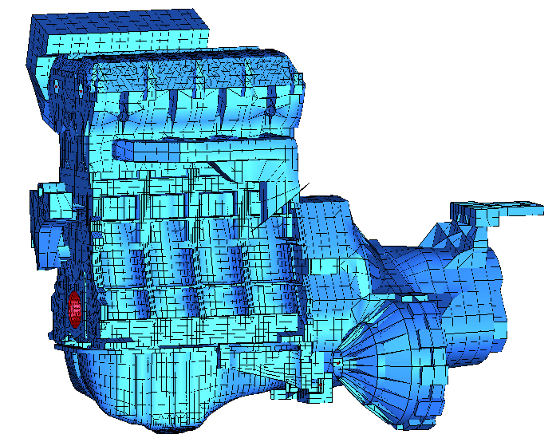
Figure 6.24 –The engine investigated.
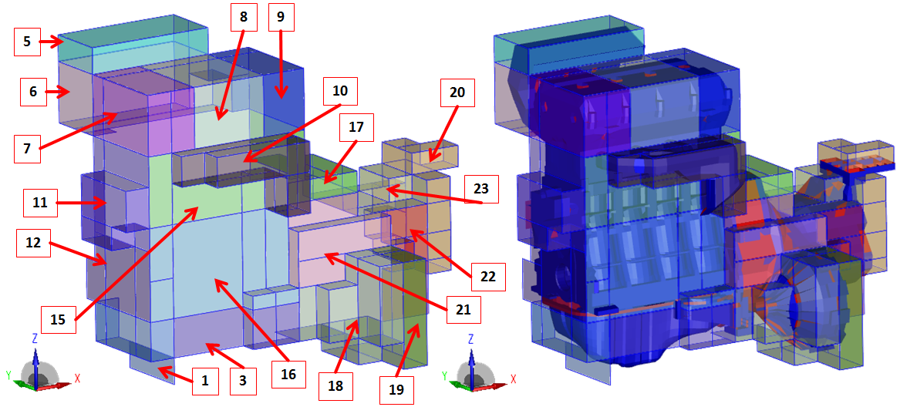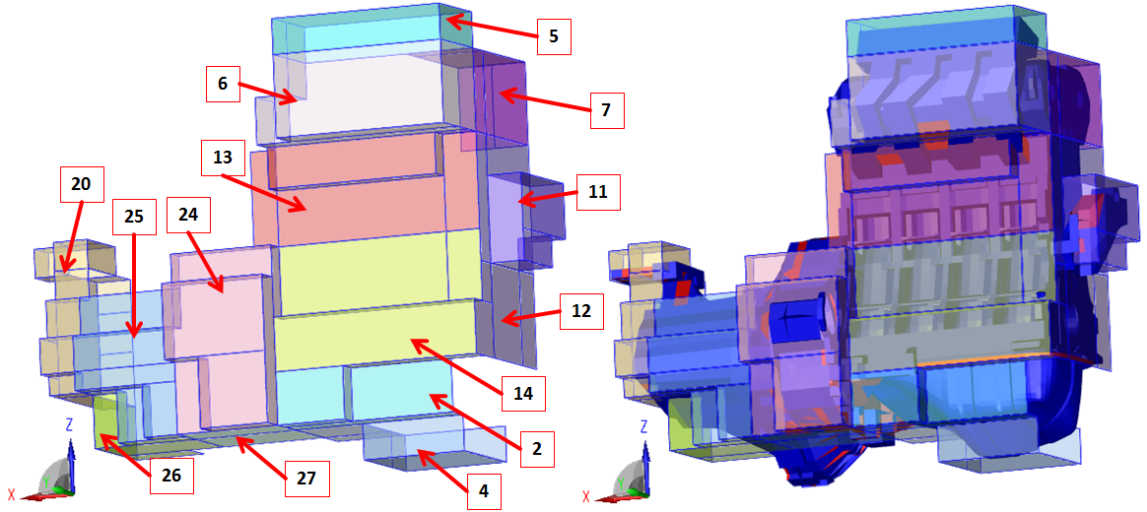
Figure 6.25 –The different surface selections investigated in the SCA.

The cyclic variability of the cylinder pressure influences the results of the multi-body dynamic simulation. Therefore, the structural normal velocities on the engine surface, which are the boundary conditions of the acoustic radiation model, may differ from one sample of the Monte Carlo methodology to another. In Fig. 6.26, the structural velocities on engine surface and the sound pressure level (SPL) on a spherical field point mesh of radius 2.2 m are shown for a frequency of 1450 Hz. Fig. 6.26 compares results of 2 samples of the Monte Carlo algorithm, showing how relatively small changes on the structural side (on average 10 dB) can lead to more than 30 dB of difference on the acoustic side, depending on the investigated field point node. Similar results were also obtained from experimental investigations [248]. These differences can also be caused by sound directivity variability.

Due to high variability of results and directivity oscillations, it was preferred to focus the attention on power quantities, which are associated to system surfaces.
Fig. 6.27 shows the acoustic active output power evaluated on the spherical field point mesh placed in the far field having radius of 2.2 m. The orange lines indicate the 95% confidence interval. The conclusion arising from Fig. 6.27 is that variability of results increases with increasing frequency, in agreement with the trend shown in Fig. 6.14.
Fig. 6.28 shows the average of acoustic radiated active power from all the different surfaces. Data are also compared with the overall power radiated from the whole engine (bottom line in Fig 6.28).

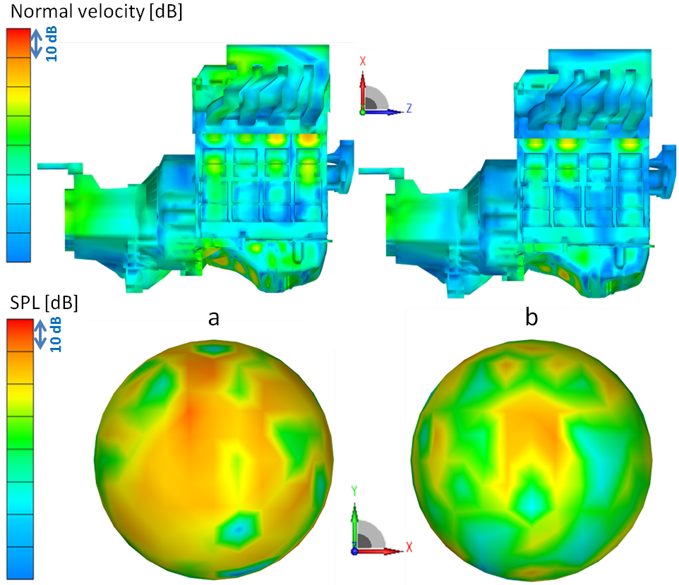
Figure 6.26 – Variability of results due to cyclic cylinder pressure variations at 1450 Hz. Two different samples of the Monte Carlo calculations are shown (respectively a and b). Above, normal surface velocity. Below, SPL on a 2.2 m radius sphere.

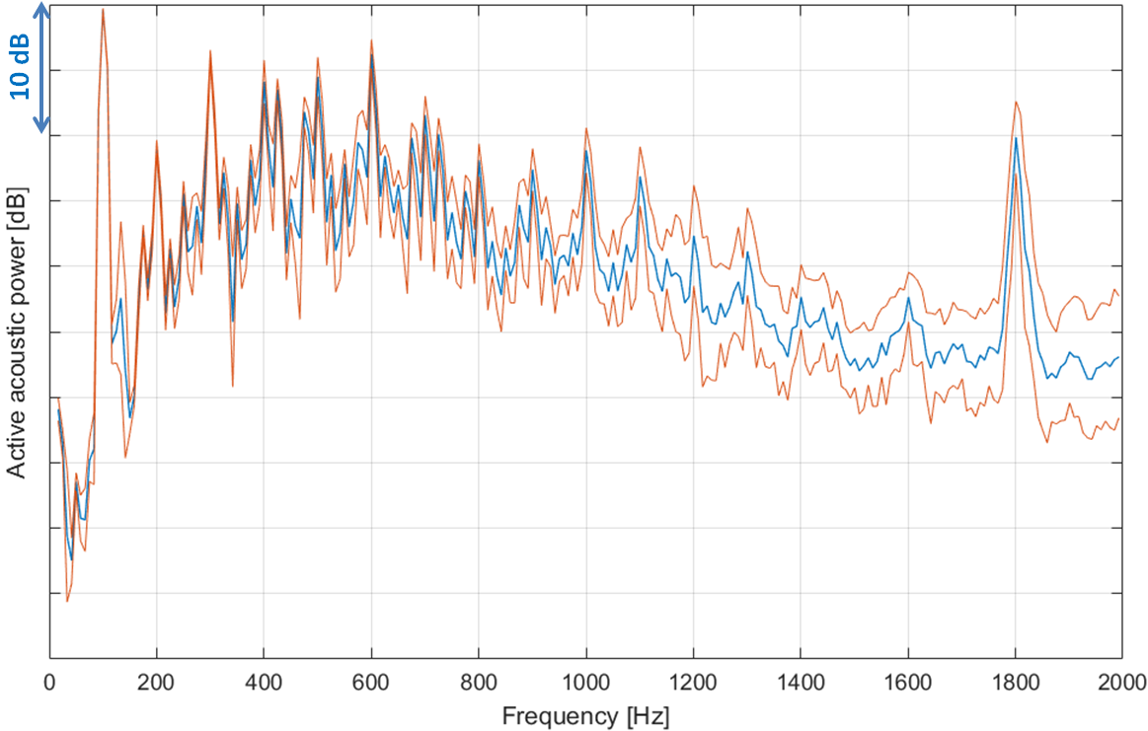
Figure 6.27 – Active acoustic power evaluated on the spherical field point mesh placed in the far field having radius of 2.2m. In blue, the mean value. In red, the 95% confidence interval.

Figure 6.28 – Active acoustic power from the different surfaces. Mean values of the Monte Carlo method.
The influence of cylinder cyclic variability on the assessment of the different radiating surfaces is shown in Figs. 6.29 and 6.30, where the acoustic radiated power at 600 and 1800 Hz is shown including the 95% confidence interval bars (two times the standard deviation). According to Fig. 6.27, also the results of the different surface selections are affected by variability which increases with frequency. Similar considerations may also arise from the analysis of other frequencies.
As shown in Figs. 6.29 and 6.30, with increasing variability of results, the 95% confidence interval bars of different surfaces may overlap. Therefore, it may happen that it is not possible to univocally rank the different panels. As for example in Fig. 6.29 at 1800 Hz, it is not completely clear if the noise produced from surface 23 always has higher intensity than the one produced from surface 20.
To deal with this, the cross correlation between the sources is investigated. As an example, Fig. 6.31 shows the Pearson correlation coefficients $cc$ between the different power results at 1800 Hz (See Eq. (217)).
From Fig. 6.31, it is clear that all the contributions to the overall noise from oil pan and gear box surfaces are strongly correlated to each other. Hence, it is possible to state that acoustic power radiated from surfaces 20 and 23 are correlated. Being correlated, the contribution of surface 23 is the most relevant at 1800 Hz, because increasing contribution of surface 20 are correlated with increasing contribution of surface 23.
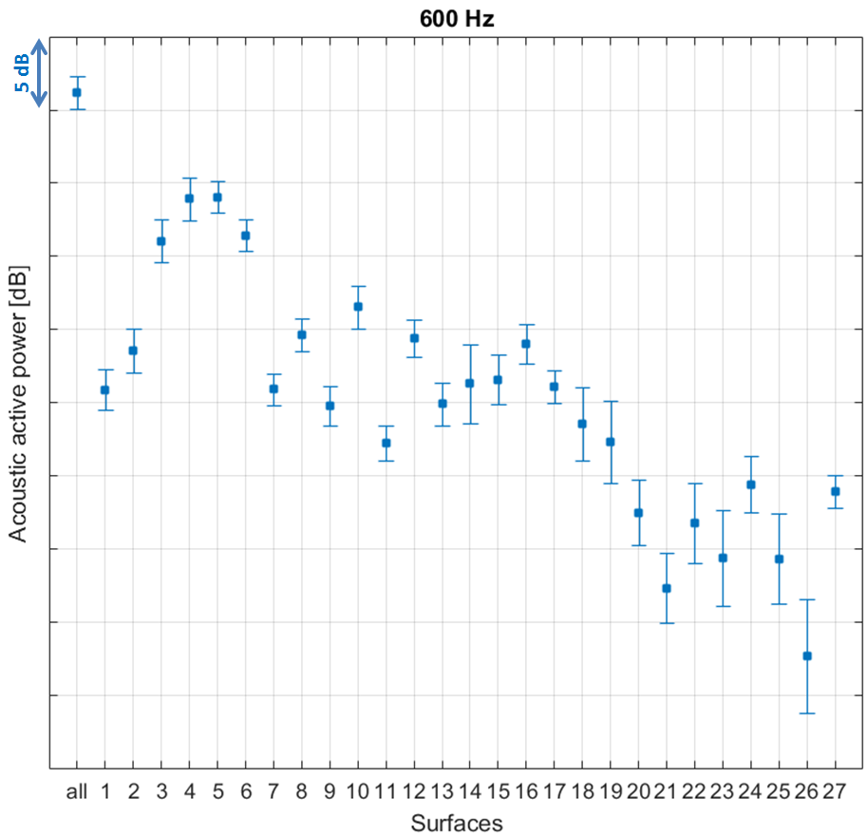
Figure 6.29 – Acoustic active power of all different surfaces at 600 Hz. The bars consider the 95% envelop of results.
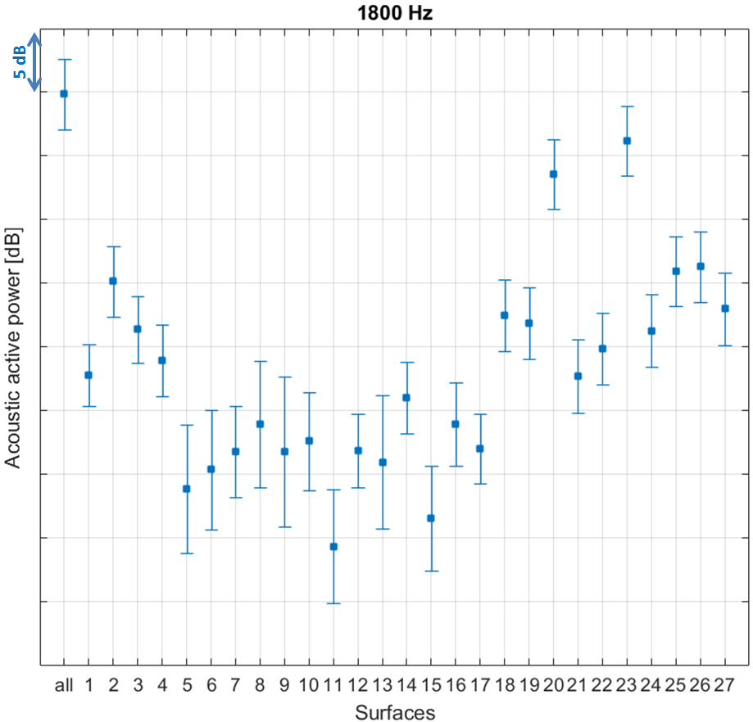
Figure 6.30 – Acoustic active power of all different surfaces at 1800 Hz. The bars consider the 95% envelop of results.
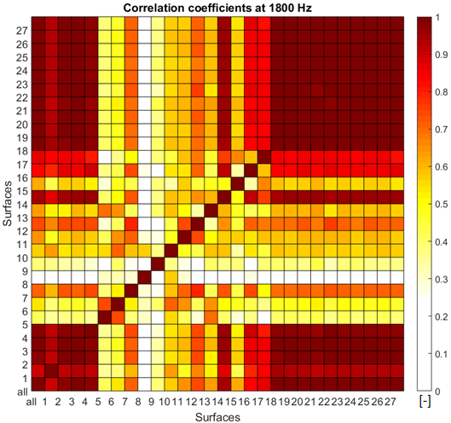
Figure 6.31– Pearson Correlation coefficient between acoustic radiated power of different engine surfaces at 1800 Hz.
Given two or more correlated contributions, one may intuitively think that they can be ranked using only mean values despite of high variability. To quantify how much the ranking based on mean values of radiated power is affected from system variability, the difference between projections is investigated. Considering the power radiated from two surfaces$A$ and$B$, respectively $P_{A}$ and$P_{B}$, their difference ($P_{A}-P_{B}$) has a mean value $μ_{AB}$ and a standard deviation $σ_{AB}$. The probability that $P_{A}$ is grater that $P_{B}$ is proportional to the integral between zero and $+∞$ of the Gaussian probability function generated using $μ_{AB}$ and $σ_{AB}$. This information tell us that at 1800Hz, although the 95% confidence intervals of surfaces 20 and 23 overlap, surface 23 is always radiating more power (in accordance with their Pearson correlation coefficient shown in Fig. 6.31). This is not the case for surfaces 4 and 5 at 600 Hz. Their Pearson correlation coefficient is 0.53 and only in the 58% of the cases surface 5 radiates more power than surface 4, as shown in Fig. 6.32. The elements in Fig. 6.32 indicate the probability that the contribution $i$ on the row is greater or equal to the contribution $j$ on the column. For the sake of simplicity, only the 4 most relevant radiating surfaces are considered.
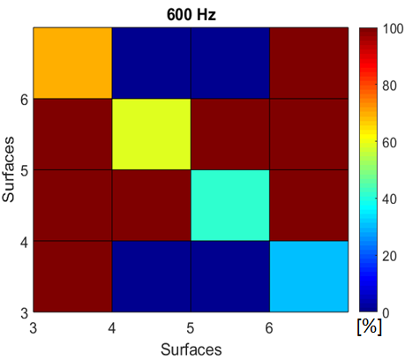
Figure 14 – Comparisons between power levels radiated by different surfaces at 600 Hz. Data indicate the probability that the contribution on the row is greater or equal compared with the contribution on the column.

CHAPTER7

Bibliography

- Priede, T. (1968). Noise and engineering design. Philosophical Transactions of the Royal Society of London. Series A, Mathematical and Physical Sciences, 263(1142), 461-480.
- Priede, T. (1971). Origins of automotive vehicle noise. Journal of sound and vibration, 15(1), 61-73.
- Qatu, M. S., Abdelhamid, M. K., Pang, J., & Sheng, G. (2009). Overview of automotive noise and vibration. International Journal of Vehicle Noise and Vibration, 5(1-2), 1-35.
- Badaoui, M. E., Daniere, J., Guillet, F., & Servière, C. (2005). Separation of combustion noise and piston-slap in diesel engine—Part I: Separation of combustion noise and piston-slap in diesel engine by cyclic Wiener filtering. Mechanical Systems and Signal Processing, 19(6), 1209-1217.
- Servière, C., Lacoume, J. L., & El Badaoui, M. (2005). Separation of combustion noise and piston-slap in diesel engine—Part II: Separation of combustion noise and piston-slap using blind source separation methods. Mechanical Systems and Signal Processing, 19(6), 1218-1229.
- Carlucci, P., Ficarella, A., Chiara, F., Giuffrida, A., & Lanzafame, R. (2004). Preliminary studies on the effects of injection rate modulation on the combustion noise of a common rail diesel engine (No. 2004-01-1848). SAE Technical Paper.
- Machado, G. B., & De Melo, T. C. C. (2005). Diesel Cetane Number Versus Noise Emission (No. 2005-01-2150). SAE Technical Paper.
- Naber, J., Blough, J. R., Frankowski, D., Goble, M., & Szpytman, J. E. (2006). Analysis of combustion knock metrics in spark-ignition engines (No. 2006-01-0400). SAE Technical Paper.
- Szwaja, S., Bhandary, K. R., & Naber, J. D. (2007). Comparisons of hydrogen and gasoline combustion knock in a spark ignition engine. International Journal of Hydrogen Energy, 32(18), 5076-5087.
- Maetani, Y., Niikura, T., Suzuki, S., Arai, S., & Okamura, H. (1993). Analysis and reduction of engine front noise induced by the vibration of the crankshaft system (No. 931336). SAE Technical Paper.
- Offner et al. (2004). Quality and validation of cranktrain vibration predictions-effect of hydrodynamic journal bearing models. Multi-body Dynamics: Monitoring and Simulation Techniques III, 255.
- de Luca, J. C., & Gerges, S. N. (1996). Piston slap excitation: literature review (No. 962395). SAE Technical Paper.
- Patel, P., Mourelatos, Z. P., & Shah, P. (2006, January). A comprehensive method for piston secondary dynamics and piston-bore contact. In STLE/ASME 2006 International Joint Tribology Conference (pp. 555-556). American Society of Mechanical Engineers.
- Cuschieri, J. M., & Richards, E. J. (1985). On the prediction of impact noise, Part VIII: Diesel engine noise. Journal of Sound and Vibration, 102(1), 21-56.
- Hanaoka, M., & Fukumura, S. (1973). A study of valve train noises and a method of cam design to reduce the noises (No. 730247). SAE Technical Paper.
- Kalser, H. J., Deges, R., Schwarz, D., & Meyer, J. (1991). Investigations on valve train noise in multi-valve engines (No. 911062). SAE Technical Paper.
- Stout, J. L. (1997). Valvetrain Unbalance and Its Effects on Powertrain NVH (No. 971993). SAE Technical Paper.
- Suh, I. S., & Lyon, R. H. (1999). An investigation of valve train noise for the sound quality of IC engines (No. 1999-01-1711). SAE Technical Paper.
- Beidl, C. V., & Rust, A. (1997). Meeting Future Demands for Quieter Commercial Powertrain Systems (No. 972042). SAE Technical Paper.
- Rust, A., & Brandl, F. (1994, May). Indicating Technology as a Part of the Noise Analysis of Combustion Engines. In 1st Darmstädter Indicating Symposium, Darmstadt.
- L. Yuehui, H. Zhiyong, B. Fengrong, F. Lu-hua, H. Song-tao, Engine noise source identification with different methods, Transactions of Tianjin University, 8(3), 2002, pp. 174-177.
- J.D. Maynard, E.G. Williams, Y. Lee, Nearfiled acoustic holography: I. Theory of generalized holography and the development of NAH, The Journal of the Acoustic Society of America, 78(4), 1985, pp. 1395-1413.
- J.D. Maynard, E.G. Williams, Y. Lee, Nearfiled acoustic holography: II. Holographic reconstruction algorithms and computer implementation, The Journal of the Acoustic Society of America, 81(5), 1987, pp. 1307-1322.
- Crewe, A., Perrin, F., Benoit, V., & Haddad, K. (2003). Real-time pass-by noise source identification using a beam-forming approach (No. 2003-01-1537). SAE Technical Paper.
- Smith, J. D. (2003). Gear noise and vibration. CRC Press.
- Singh, R., Xie, H., & Comparin, R. J. (1989). Analysis of automotive neutral grear rattle. Journal of sound and vibration, 131(2), 177-196.
- Padmanabhan, C., Rook, T. E., & Singh, R. (1995). Modeling of automotive gear rattle phenomenon: state of the art (No. 951316). SAE Technical Paper.
- Wellmann, T., Govindswamy, K., Braun, E., & Wolff, K. (2007). Aspects of driveline integration for optimized vehicle NVH characteristics (No. 2007-01-2246). SAE Technical Paper.
- Tohyama, M., Ohmori, T., & Ueda, F. (1999). Anti-shudder mechanism of ATF additives at slip-controlled lock-up clutch (No. 1999-01-3616). SAE Technical Paper.
- Davies, P. O. A. L., & Holland, K. R. (1999). IC engine intake and exhaust noise assessment. Journal of Sound and Vibration, 223(3), 425-444.
- Torregrosa, A. J., Broatch, A., Bermudez, V., & Andres, I. (2005). Experimental assessment of emission models used for IC engine exhaust noise prediction. Experimental thermal and fluid science, 30(2), 97-107.
- Bender, E. K., & Brammer, A. J. (1975). Internal‐combustion engine intake and exhaust system noise. The Journal of the Acoustical Society of America, 58(1), 22-30.
- Tao, Z., & Seybert, A. F. (2003). A review of current techniques for measuring muffler transmission loss (No. 2003-01-1653). SAE Technical Paper.
- Kumar, S. (2007). Linear Acoustic Modelling and Testing of Exhaust Mufflers. Marcus Wallenberg laboratory, PhD Dissertation KTH (Royal Institute of Technology).
- El Nemr, Y. A., Veloso, R., & Girstmair, J. (2016). Literature review on automotive turbocharger acoustic characteristics. ASRO Journal of applied Mechanics, 1(1), 16-19.
- Rämmal, H., & Abom, M. (2007). Acoustics of turbochargers (No. 2007-01-2205). SAE Technical Paper.
- Heckl, M. (1986). Tyre noise generation. Wear, 113(1), 157-170.
- Perisse, J. (2002). A study of radial vibrations of a rolling tyre for tyre–road noise characterisation. Mechanical Systems and Signal Processing, 16(6), 1043-1058.
- De Klerk, D., & Ossipov, A. (2010). Operational transfer path analysis: Theory, guidelines and tire noise application. Mechanical Systems and Signal Processing, 24(7), 1950-1962.
- Koners, G., & Lehmann, R. (2014). Investigation of Tire-Road Noise with Respect to Road Induced Wheel Forces and Radiated Airborne Noise. SAE International Journal of Passenger Cars-Mechanical Systems, 7(2014-01-2075), 1194-1197.
- Zienkiewicz, O. C., Taylor, R. L., & Taylor, R. L. (1977). The finite element method (Vol. 3). London: McGraw-hill.
- Friswell, M., & Mottershead, J. E. (2013). Finite element model updating in structural dynamics (Vol. 38). Springer Science & Business Media.
- Chowdhury, I., & Dasgupta, S. P. (2003). Computation of Rayleigh damping coefficients for large systems. The Electronic Journal of Geotechnical Engineering, 8(0), 1-11.
- Adhikari, S. (2001). Damping models for structural vibration (Doctoral dissertation, University of Cambridge).
- Shabana, A. A. (2013). Dynamics of multibody systems. Cambridge university press.
- Amirouche, F. (2007). Fundamentals of multibody dynamics: theory and applications. Springer Science & Business Media.
- Shabana, A. A. (1997). Flexible multibody dynamics: review of past and recent developments. Multibody system dynamics, 1(2), 189-222.
- Rahnejat, H. (2000). Multi-body dynamics: historical evolution and application. Proceedings of the Institution of Mechanical Engineers, Part C: Journal of Mechanical Engineering Science, 214(1), 149-173.
- Schiehlen, W. (1997). Multibody system dynamics: Roots and perspectives. Multibody system dynamics, 1(2), 149-188.
- Boysal, A., & Rahnejat, H. (1997). Torsional vibration analysis of a multi-body single cylinder internal combustion engine model. Applied Mathematical Modelling, 21(8), 481-493.
- Hegazy, S., Rahnejat, H., & Hussain, K. (1999). Multi-body dynamics in full-vehicle handling analysis. Proceedings of the Institution of Mechanical Engineers, Part K: Journal of Multi-body Dynamics, 213(1), 19-31.
- Offner, G., & Priebsch, H. H. (2006, September). Flexible multi-body dynamics simulation-a powerful method for prediction of structure borne noise of internal combustion engines. In Proceedings of the International Conference on Noise and Vibration Engineering (ISMA2006) (pp. 2663-2677).
- Drab, C. B., Engl, H. W., Haslinger, J. R., Offner, G., Pfau, R. U., & Zulehner, W. (2009). Dynamic simulation of crankshaft multibody systems. Multibody system dynamics, 22(2), 133-144.
- Offner G., Priebsch H. H., Krasser J., Laback O., (2001). Simulation of multi-body dynamics and elastohydrodynamic excitation in engines especially considering piston-liner contact. Proceedings of the Institution of Mechanical Engineers, Part K: Journal of Multi-body Dynamics, 215(2), 93-102.
- Offner, G. (2011). Modelling of condensed flexible bodies considering non-linear inertia effects resulting from gross motions. Proceedings of the Institution of Mechanical Engineers, Part K: Journal of Multi-body Dynamics, 225(3), 204-219.
- Offner, G. (2013). Friction power loss simulation of internal combustion engines considering mixed lubricated radial slider, axial slider and piston to liner contacts. Tribology Transactions, 56(3), 503-515.
- Bestle, D. (2013). Analyse und Optimierung von Mehrkörpersystemen: Grundlagen und rechnergestützteMethoden. Springer-Verlag.
- Qu, Z. Q. (2013). Model order reduction techniques with applications in finite element analysis. Springer Science & Business Media.
- Guyan, R. J. (1965). Reduction of stiffness and mass matrices. AIAA journal, 3(2), 380-380.
- Bukovnik, S., Offner, G., Čaika, V., Priebsch, H. H., & Bartz, W. J. (2007). Thermo‐elasto‐hydrodynamic lubrication model for journal bearing including shear rate‐dependent viscosity. Lubrication Science, 19(4), 231-245.
- Offner, G., Lorenz, N., & Knaus, O. (2012). Piston Clearance Optimization using Thermo-elasto Hydrodynamic Simulation to Reduce Piston Slap Excitation and Friction Loss (No. 2012-01-1530). SAE Technical Paper.
- Patir, N. and Cheng, H. S. (1976), “An Average Flow Model for Determining Effects of Three-Dimensional Roughness on Partial Hydrodynamic Lubrication,” Journal of Lubrication Technology, 100(1), pp 12–17.
- Greenwood, J. A., & Tripp, J. H. (1970). The contact of two nominally flat rough surfaces. Proceedings of the institution of mechanical engineers, 185(1), 625-633.
- Desmet, W. (1998). A wave based prediction technique for coupled vibro-acoustic analysis. These, Katholieke Universiteit Leuven, Belgique.
- Kinsler, L. E., Frey, A. R., Coppens, A. B., & Sanders, J. V. (1999). Fundamentals of acoustics. Fundamentals of Acoustics, 4th Edition, by Lawrence E. Kinsler, Austin R. Frey, Alan B. Coppens, James V. Sanders, pp. 560. ISBN 0-471-84789-5. Wiley-VCH, December 1999., 560.
- Nilsson, A., & Liu, B. (2015). Vibro-acoustics (Vol. 2). Springer.
- A. Sommerfeld, Partial Differential Equations in Physics, Academic Press, New York, 1949.
- Pluymers, B. (2006). Wave based modelling methods for steady-state vibro-acoustics. These, Katholieke Universiteit Leuven, Belgique.
- Kirkup, S. M. (2007). The boundary element method in acoustics. Integrated sound software.
- Schenck, H. A. (1968). Improved integral formulation for acoustic radiation problems. The journal of the acoustical society of America, 44(1), 41-58.
- Filippi, P. J. T. (1977). Layer potentials and acoustic diffraction. Journal of Sound and Vibration, 54(4), 473-500.
- F. Penne, Shaping the sound of the next-generation BMW, ISMA 2004 International Conference on Noise and Vibration Engineering, Katholieke Universiteit Leuven, September. 2004. Pp. 25-39.
- J. Plunt, "Finding and fixing vehicle NVH problems with transfer path analysis." Sound and vibration 39, November 2005, 12-17.
- H. Van der Auweraer, P. Mas, S. Dom, A. Vecchio, K. Janssens, P. Van de Ponseele, Transfer path analysis in the critical path of vehicle refinement: the role of fast, hybrid and operational path analysis. No. 2007-01-2352. SAE Technical Paper, 2007.
- P. Zeller, Handbuch Fahrzeugakustik. Springer Fachmedien, 2009.
- G. Cerrato, Automotive sound quality-powertrain, road and wind noise, Sound Vib. 43 (4) (2009) 16–24.
- J.S. Bendat, A.G. Piersol, Random Data: Analysis and Measurement Procedures, John Wiley and Sons, Inc., New York, 1971.
- J.S. Bendat, A.G. Piersol, Engineering Applications of Correlation and Spectral Analysis, John Wiley & Sons, Inc., New York, London, Sydney, 1980.
- J.S. Bendat, Solutions for the multiple input/output problems, J. Sound Vib. 44 (3) (1976) 311–325.
- J.S. Bendat, System identification from multiple input/output data, J. Sound Vib. 49 (3) (1976) 293–308.
- J.W. Verheij, Measuring sound transfer through resilient mountings for separate excitation with orthogonal translations and rotations, In: InterNoise80, Miami, FL, Number 2 in INTER-NOISE and NOISE-CON Congress and Conference Proceedings, Institute of Noise Control Engineering, Washington, 1980, pp. 723–726.
- J.W. Verheij, Multi-path sound transfer from resiliently mounted shipboard machinery: experimental methods for analyzing and improving noise control (Ph.D. thesis), Delft University of Technology, The Netherlands, 1982.
- F.X. Magrans, Method of measuring transmission paths, J. Sound Vib. 74 (3) (1981) 321–330.
- O. Guasch, F.X. Magrans, The global transfer direct transfer method applied to a finite simply supported elastic beam, J. Sound Vib. 276 (1) (2004) 335–359.
- O. Guasch, Direct transfer functions and path blocking in a discrete mechanical system, J. Sound Vib. 321 (3) (2009) 854–874.
- O. Guasch, C. García, J. Jové, P. Artís, Experimental validation of the direct transmissibility approach to classical transfer path analysis on a mechanical setup, Mech. Syst. Signal Process. 37 (1) (2013) 353–369.
- F.X. Magrans, P.V. Rodriguez, G.C. Cousin, Low and mid-high frequency advanced transmission path analysis, In: Proceedings of the XII International Congress on Sound and Vibration (ICSV), Lisbon, Portugal, 2005.
- W. Liu, D.J. Ewins, Transmissibility properties of mdof systems, In: Proceedings of the XVI International Modal Analysis Conference (IMAC), Santa Barbara, CA, Society for Experimental Mechanics, Bethel, CT, 1998, pp. 847–854.
- P.S. Varoto, K.G. McConnell, Single point vs. multi point acceleration transmissibility concepts in vibration testing, In: Proceedings of the XVI International Modal Analysis Conference (IMAC), Santa Barbara, CA, vol. 1, Society for Experimental Mechanics, Bethel, CT, 1998, pp. 83–90.
- A.M.R. Ribeiro, N.M.M. Maia, J.M.M. Silva, Experimental evaluation of the transmissibility matrix, In: Proceedings of the XVII International Modal Analysis Conference (IMAC), Kissimmee, FL, 1999.
- A.M.R. Ribeiro, J.M.M. Silva, N.M.M. Maia, On the generalisation of the transmissibility concept, Mech. Syst. Signal Process. 14 (1) (2000) 29–35.
- N.M.M. Maia, J.M.M. Silva, A.M.R. Ribeiro, The transmissibility concept in multi-degree systems, Mech. Syst. Signal Process. 15 (1) (2001) 129–137.
- M. Fontul, A.M.R. Ribeiro, J.M.M. Silva, N.M.M. Maia, Transmissibility matrix in harmonic and random processes, Shock Vib. 11 (5–6) (2004) 563–571.
- K. Noumura, J. Yoshida, A method of transfer path analysis for vehicle interior sound with no excitation experiment, In: Proceedings of FISITA 2006 World Automotive Congress, F2006D183, JSAE, 2006.
- M. Lohrmann, Operational transfer path analysis: comparison with conventional methods, J. Acoust. Soc. Am. 123 (2008) 3534.
- D. de Klerk, A. Ossipov, Operational transfer path analysis: theory, guidelines and tire noise application, Mech. Syst. Signal Process. 24(7) (2010) 1950–1962, Special Issue: ISMA 2010.
- P. Gajdatsy, K. Janssens, W. Desmet, H. van der Auweraer, Application of the transmissibility concept in transfer path analysis, Mech. Syst. Signal Process. 24 (7) (2010) 1963–1976.
- J. Scheuren, M. Lohrmann, Transfer path analysis—experiences, expectations and perspectives, In: International Noise and Vibration Colloquium, SAE Brazil, 2014.
- J.M. Mondot, B.A.T. Petersson, Characterization of structure-borne sound sources: the source descriptor and the coupling function, J. Sound Vib. 114 (3) (1987) 507–518.
- B.A.T. Petersson, B.M. Gibbs, Use of the source descriptor concept in studies of multi-point and multi-directional vibrational sources, J. Sound Vib. 168 (1) (1993) 157–176.
- B.A.T. Petersson, B.M. Gibbs, Towards a structure-borne sound source characterization, Appl. Acoust. 61 (3) (2000) 325–343.
- A.T. Moorhouse, On the characteristic power of structure-borne sound sources, J. Sound Vib. 248 (3) (2001) 441–459.
- A.S. Elliott, A.T. Moorhouse, Characterisation of structure borne sound sources from measurement in-situ, J. Acoust. Soc. Am. 123 (5) (2008) 3176.
- A.T. Moorhouse, A.S. Elliott, T.A. Evans, in situ measurement of the blocked force of structure-borne sound sources, J. Sound Vib. 325 (4-5) (2009) 679–685.
- M.H.A. Janssens, J.W. Verheij, D.J. Thompson, The use of an equivalent forces method for the experimental quantification of structural sound transmission in ships, J. Sound Vib. 226 (2) (1999) 305–328.
- M.H.A. Janssens, J.W. Verheij, A pseudo-forces methodology to be used in characterization of structure-borne sound sources, Appl. Acoust. 61 (3) (2000) 285–308.
- S.J. Kim, S.K. Lee, “Prediction of interior noise by excitation force of the powertrain based on hybrid transfer path analysis” International Journal of Automotive Technology, Vol. 9, No. 5, 2008, pp. 577-583.
- M.V. van der Seijs, D. de Klerk, D.J. Rixen, General framework for transfer path analysis: History, theory and classification of techniques. Mechanical Systems and Signal Processing 68-69 (2016) 217-244.
- W.C. Hurty, Vibrations of structural systems by component mode synthesis, J. Eng. Mech. Div. 86 (4) (1960) 51–70.
- W.C. Hurty, "Dynamic analysis of structural systems using component modes." AIAA journal 3.4 (1965): 678-685.
- G.M.L. Gladwell, "Branch mode analysis of vibrating systems." Journal of sound and vibration 1.1 (1964): 41-59.
- D. de Klerk, D. J. Rixen, S. N. Voormeeren. "General framework for dynamic substructuring: history, review and classification of techniques." AIAA journal 46.5 (2008): 1169-1181.
- A. Acri, G. Offner, E. Nijman, J. Rejlek, Substructuring of multibody systems for numerical transfer path analysis in internal combustion engines, Mech. Syst. Signal Process. Vol. 79, 2016, pp. 254–270.
- AVL LIST GmbH: AVL-Excite Reference Manual, Version 2016.
- H. Kanda, M. Okubo, T. Yonezawa, “Analysis of noise sources and their transfer paths in diesel engines”, No. 900014. SAE Technical Paper, 1990.
- C.V. Bedil, A. Rust, M. Rasser, “Key Steps and Methods in the Development of Low Noise Engines”, SV Sound and vibration 35.4, 2001, 48-54.
- Y. Yawata, M.J. Crocker, “Identification of internal noise sources in diesel engines”. No. 831330. SAE Technical Paper, 1983.
- A. Acri, G. Offner, T. Resch, E. Nijman, R. Corradi, Dynamic Substructuring for Sources Contributions analysis in Internal Combustion Engines, No. 2016-01-1761, SAE Technical papers, 2016.
- Dolatabadi, N., Theodossiades, S., Rothberg, S. J., "On the identification of piston slap events in internal combustion engines using tribodynamic analysis." Mechanical Systems and Signal Processing 58 (2015) pp 308-324.
- G. C. Jr Maling. "International Standards for Specifying Noise Emissions.” Sound and vibration 47.12 (2013): 13-16.
- ISO 6798:1995 – Reciprocating internal combustion engines; Measurement of emitted airborne noise; Engineering method and survey method.
- J. L. Dion, S. Le Moyne, G. Chevallier, H. Sebbah, “Gear impacts and idle gear noise: Experimental study and non-linear dynamic model”, Mechanical Systems and Signal processing, 23.8 (2009): 2608-2628.
- M. Ognjanović, S.C. Kostić, “Gear Unit Housing Effect on the Noise Generation Caused by Gear Teeth Impacts” Strojniški vestnik-Journal of Mechanical Engineering 58.5, pp. 327-337, 2012.
- F. K. Brandl, J. Affenzeller, G.E. Thin, Some strategies to meet future noise regulations for truck engines, No. 870950, SAE Technical Paper, 1987.
- N.J.W. Boesch, The developement of low/noise DI diesel engines, No. 870951, SAE Technical Paper, 1987.
- Y.K. Zhang, et al., Vehicle noise and weight reduction using panel acoustic contribution analysis, No. 951338, SAE Technical Paper, 1995.
- K. Jahani, S. Beigmoradi, A. Ramezani, H. Hajabdollahi, Panel Contribution Analysis for a Sedan Car Using Numerical Simulations, In Proceedings of 20th Int. Congress on Sound and Vibration (ICSV20), Bangkok, Thailand, 2013.
- A.R. Mohanty, B.D.S. Pierre, P. Suruli-Narayanasami, Structure-borne noise reduction in a truck cab interior using numerical techniques, Applied Acoustics, 59(1), 2000, pp. 1-17.
- E. Trefftz, Ein Gegenstück zum Ritzschen Verfahren, in Proceedings of the 2nd International Congress on Applied Mechanics, Zürich, Switzerland, 1926, pp. 131-137.
- B. Pluymers, B. Van Hal, D. Vandepitte, W. Desmet, Trefftz-based methods for time-harmonic acoustics, Arch. Comput. Methods Eng. 14 (2007) 343–381.
- B. Van Genechten, Trefftz-based mid-frequency analysis of geometrically complex vibro-acoustic problems - hybrid methodologies and multi-level modelling. KULeuven, division PMA, Ph.D. Thesis 2010D08, 2010.
- A. Hepberger, F. Diwoky, K. Jalics, H.H. Priebsch, Application of Wave Based Technique for a cavity considering forced excitation at boundaries and effects of absorption materials, in Proceedings of ISMA, Leuven, Belgium, 2004.
- B. Bergen, B. Van Genechten, D. Vandepitte, W. Desmet, An efficient wave based method for threedimensional Helmholtz problems in unbounded domains, in Proceedings of the 16th international congress on sound and vibration (ICSV16), Kraków, Poland, 2009.
- B. van Hal, Automation and performance optimization of the wave based method for interior structural-acoustic problems. Ph.D. Thesis, Faculty of Engineering, Katholieke Universiteit Leuven, 2004.
- B. Van Genechten, O. Atak, B. Bergen, E. Deckers, S. Jonckheere, J.S. Lee, A. Maressa, K. Vergote, B. Pluymers, D. Vandepitte, W. Desmet, An efficient Wave Based Method for solving Helmholtz problems in three-dimensional bounded domains, Eng. Anal. Bound. Elem. 36 (2012) 63–75.
- E. Deckers, B. Bergen, B. Van Genechten, D. Vandepitte, W. Desmet, An efficient wave based method for 2D acoustic problems containing corner singularities, Comput. Methods Appl. Mech. Eng. 241-244 (2012) 286–30.
- B. Pluymers, W. Desmet, D. Vandepitte, P. Sas, On the use of a wave based prediction technique for steady-state structural-acoustic radiation analysis, Computer Model. Eng. Sci. 7 (2) (2005) 173–184.
- B. Bergen, B. Van Genechten, D. Vandepitte, W. Desmet, An efficient Trefftz-based method for three-dimensional Helmholtz problems in unbounded domains, Computer Model. Eng. Sci. 61 (2) (2010) 155–175.
- A. Hepberger, H.H. Priebsch, F. Diwoky, H. Pramberger, Application of the Wave Based Technique to predict the engine noise radiation under anechoic conditions, SAE International Journal of Passenger Cars-Mechanical Systems, 2(2009-01-2211), 2009, pp. 1477-1486.
- A. Acri, G. Offner, E. Nijman, R. Corradi, Numerical transfer path analysis for the assessment of air-borne noise in internal combustion engines, in Proceedings of ICoEV 2015 International Conference on Engineering Vibration, 2015, p. 383-392.
- C. Vanmaele, D. Vandepitte, W. Desmet, An efficient wave based prediction technique for plate bending vibrations, Comput. Methods Appl. Mech. Eng. 196 (2007) 3178–3189.
- C. Vanmaele, D. Vandepitte, W. Desmet, An efficient wave based prediction technique for dynamic plate bending problems with corner stress singularities, Comput. Methods Appl. Mech. Eng. 198 (2009) 2227–2245.
- K. Vergote, C. Vanmaele, D. Vandepitte, W. Desmet, An efficient wave based approach for the time-harmonic vibration analysis of 3D plate assemblies, J. Sound Vib. 332 (2013) 1930–1946.
- M. Klanner, K. Ellermann, Wave Based Method for the steady-state vibrations of thick plates, Journal of Sound and Vibration, 345, 2015, pp. 146-161.
- M. Klanner, K. Ellermann, Improvement of the Wave Based Method for Thick Plate Vibrations, International Journal of Acoustics and Vibration, 2016.
- R. Lanoye, G. Vermeir, W. Lauriks, F. Sgard, W. Desmet, Prediction of the sound field above a patchwork of absorbing materials, J. Acoust. Soc. Am. 123 (2008) 793–802.
- E. Deckers, N.-E. Hörlin, D. Vandepitte, W. Desmet, A wave based method for the efficient solution of the 2D poroelastic Biot equations, Comput. Methods Appl. Mech. Eng. 201–204 (2012) 245–262.
- E. Deckers, et al., The wave based method: An overview of 15 years of research. Wave Motion, 51(4), 2014, pp. 550-565.
- A. Acri, P. Zsifkovits, E. Nijman, G. Offner, R. Corradi, Surface Noise Contribution Analysis in Wave Based Method framework for exterior radiation noise problems, in Proceedings of ISMA, Leuven, Belgium, Sept. 2016.
- J. Rejlek, T. Mocsai, P. Silar, A. Hepberger, H.H. Priebsch, Wave Based Prediction Technique for Sound Radiation Analysis, in Proceedings of International Conference on Acoustics, NAG/DAGA, 2009, pp. 23-26.
- B. Pluymers, W. Desmet, D. Vandepitte, P. Sas, Application of an efficient wave-based prediction technique for the analysis of vibro-acoustic radiation problems, Journal of computational and applied mathematics, 168(1), 2004, pp. 353-364.
- Lyon, R. H., & Maidanik, G. (1962). Power flow between linearly coupled oscillators. The Journal of the Acoustical Society of America, 34(5), 623-639.
- Lyon R.H., De Jong R.G. (1995). Theory and Application of Statistical Energy Analysis. Butterworth-Heinemann, Boston, USA.
- Goyder, H. G. D., & White, R. G. (1980). Vibrational power flow from machines into built-up structures, part I: introduction and approximate analyses of beam and plate-like foundations. Journal of sound and vibration, 68(1), 59-75.
- Goyder, H. G. D., & White, R. G. (1980). Vibrational power flow from machines into built-up structures, Part II: Wave propagation and power flow in beam-stiffened plates. Journal of sound and vibration, 68(1), 77-96.
- Goyder, H. G. D., & White, R. G. (1980). Vibrational power flow from machines into built-up structures, Part III: power flow through isolation systems. Journal of Sound and Vibration, 68(1), 97-117.
- Petersson, B., & Plunt, J. (1982). On effective mobilities in the prediction of structure-borne sound transmission between a source structure and a receiving structure, part I: theoretical background and basic experimental studies. Journal of Sound and Vibration, 82(4), 517-529.
- Petersson, B., & Plunt, J. (1982). On effective mobilities in the prediction of structure-borne sound transmission between a source structure and a receiving structure, part II: procedures for the estimation of mobilities. Journal of Sound and Vibration, 82(4), 531-540.
- Mondot, J. M., & Petersson, B. (1987). Characterization of structure-borne sound sources: the source descriptor and the coupling function. Journal of sound and vibration, 114(3), 507-518.
- Miller, D. W., & Von Flotow, A. (1989). A travelling wave approach to power flow in structural networks. Journal of Sound and Vibration, 128(1), 145-162.
- Miller, D. W., R.S Hall & Von Flotow, A. (1990). Optimal control of power flow at structural junctions. Journal of Sound and Vibration, 140(3), 475-497.
- Fulford, R. A., & Gibbs, B. M. (1997). Structure-borne sound power and source characterisation in multi-point-connected systems, part 1: Case studies for assumed force distributions. Journal of Sound and Vibration, 204(4), 659-677.
- Fulford, R. A., & Gibbs, B. M. (1999). Structure-borne sound power and source characterization in multi-point-connected systems, part 2: About mobility functions and free velocities. Journal of Sound and Vibration, 220(2), 203-224.
- Fulford, R. A., & Gibbs, B. M. (1999). Structure-borne sound power and source characterization in multi-point-connected systems. Part 3: force ratio estimates. Journal of Sound and Vibration, 225(2), 239-282.
- Moorhouse, A. T. (2001). On the characteristic power of structure-borne sound sources. Journal of sound and vibration, 248(3), 441-459.
- Bonhoff, H. A., & Petersson, B. A. T. (2010). The influence of cross-order terms in interface mobilities for structure-borne sound source characterization. Journal of Sound and Vibration, 329(16), 3280-3303.
- Mathiowetz, S., & Bonhoff, H. A. (2013). Interface mobilities for characterization of structure-borne sound sources resiliently mounted via multiple contact points. Journal of Sound and Vibration, 332(22), 5789-5803.
- Acri, A. (2016). A literature review on energy flow analysis of vibrating structures. Part I: Interface Energy Flow. ASRO Journal of applied Mechanics, 1(1), 12-15.
- Acri, A. (2017). A literature review on energy flow analysis of vibrating structures. Part II: Volume Energy Flow and Energy Finite Element Method. ASRO Journal of Applied Mechanics, 2(1), 6-9.
- Lim, T. C., & Singh, R. (1990). Vibration transmission through rolling element bearings, part I: bearing stiffness formulation. Journal of sound and vibration, 139(2), 179-199.
- Rook, T. E., & Singh, R. (1996). Mobility analysis of structure-borne noise power flow through bearings in gearbox-like structures. Noise Control Engineering Journal, 44(2), 69-78.
- M. Sanderson, Direct measurement of moment mobility: Part II: An experimental study, Journal of Sound and Vibration, 179 (1995) 685–696.
- D.J. Ewins, P.T. Gleeson, Experimental determination of multidirectional mobility data for beams, Shock and Vibration Bulletin 45 (1975) 153–173.
- J. Smith, Measurement of the total structural mobility matrix, Shock and Vibration Bulletin 40 (7) (1966) 51–84.
- J. Mottershead, Structural modification of a helicopter tailcone, Journal of Sound and Vibration 298 (1–2) (2006) 191–194.
- B. Petersson, On the use of giant magnetostrictive devices for moment excitation, Journal of Sound and Vibration, 116 (1) (1987) 191–194.
- S. Jianxin, C. Mak, Direct measurement of moment mobility and a moment excitation system, Applied Acoustics63 (2002) 139–151.
- Y. Champoux, V. Cotoni, Moment excitation of structures using two synchronized impact hammers, Journal of Sound and Vibration, 263 (2003) 515–533.
- S. Sattinger, Method for experimentally determining rotational mobilities of structures, Shock and Vibration Bulletin 50 (1980) 17–27.
- A.T. Moorhouse, T. Evans, A. Elliott, Some relationships for coupled structures and their application to measurement of structural dynamic properties in situ, Mechanical Systems and Signal Processing 25 (5) (2011) 1574–1584.
- A. Moorhouse, A. Elliott, T. Evans, Indirect Measurement of Structural Frequency Response Function (FRF) Matrices and Free Velocity, Forum Acusticum, Aalborg, 2011.
- Elliott, A. S., Moorhouse, A. T., & Pavić, G. (2012). Moment excitation and the measurement of moment mobilities. Journal of sound and vibration, 331(11), 2499-2519.
- Nelson, P. A., & Yoon, S. H. (2000). Estimation of acoustic source strength by inverse methods: Part I, conditioning of the inverse problem. Journal of sound and vibration, 233(4), 639-664.
- Penrose, R. (1955, July). A generalized inverse for matrices. In Mathematical proceedings of the Cambridge philosophical society (Vol. 51, No. 03, pp. 406-413). Cambridge University Press.
- Yoon, S. H., & Nelson, P. A. (2000). Estimation of acoustic source strength by inverse methods: Part II, experimental investigation of methods for choosing regularization parameters. Journal of sound and vibration, 233(4), 665-701.
- GolubG. H., Van LoanC. F.(1989). Matrix Computations. Baithimore: The John Hopkins University Press, second edition.
- Elliott S. J., Boucher C. C., Nelson P. A.(1992). The behaviour of a multiple channel active control-system. IEEE transactions on Signal Processing 40, 1041-1052.
- F. Deprettere(1988). SVD and signal processing. Amsterdam: North-Holland.
- Conrado, E., Gorla, C. A vibration monitoring system for detecting pitting damage in spur gear tests, inProceedings of 15th International Conference on Experimental Mechanics, Porto/Portugal, 22-27 July 2012.
- C. Soize, A model and numerical-method in the medium frequency-range for vibroacoustic predictions using the theory of structural fuzzy, Journal of the Acoustical Society of America 94 (2), 1993, pp. 849–865 (part 1).
- M. Strasberg, D. Feit, Vibration damping of large structures induced by attached small resonant structures, Journal of the Acoustical Society of America 94 (3), 1995, pp. 1814–1815.
- D.A. Russell, V.W. Sparrow, Backscattering from a bafﬂed ﬁnite plate strip with fuzzy attachments, Journal of the Acoustical Society of America 98 (3), 1995, pp. 1527–1533.
- R.L. Weaver, Mean and mean-square responses of a prototypical master/fuzzy structure, Journal of the Acoustical Society of America 101 (3), 1997, pp. 1441–1449.
- T.K. Caughey, Nonlinear theory of random vibrations, Advances in Applied Mechanics 11, Academic Press, New York, 1971.
- M.F. Dimentberg, An exact solution to a certain non-linear random vibration problem, Int. J. Non-linear Mech. 17(4), 1982, pp.231–234.
- R.Y. Rubinstein, Simulation and the Monte Carlo Method, John Wiley, New York,1981.
- P.D. Spanos, M.D. Mignolet, Arma Monte Carlo Simulation in Probabilistic Structural Analysis, Shock and Vibration Digest 21, 1989, pp.3–10.
- G. Evensen, Sequential data assimilation with a nonlinear quasi-geostrophic model using Monte-Carlo methods to forecast error statistics, J. Geophys. Res. 99(C5), 1994.
- M.D. McKay, R.J. Beckman, W.J. Conover, A comparison of three methods for selecting values of input variables in the analysis of output from a computer code, Technometrics 21(2), 1979, pp. 237–240.
- M.S. Bergin, G.S. Noblet, K. Petrini, J.R. Dhieux, J.B. Milford, R.A. Harley, Formal uncertainty analysis of a lagrangian photochemical air pollution, Model. Environ. Sci. Technol. 32, 1999, pp.1116–1126.
- M.S. Bergin, J.B. Milford, Application of bayesian Monte Carlo analysis to a lagrangian photochemical air quality Model, Atmos. Env. 33(5), 2000, pp.781–792.
- A.H. Nayfeh, Perturbation Methods. Wiely-Interscience, London, 1973.
- A.H. Nayfeh, Introduction to Perturbation Techniques. Wiely-Interscience, London, 1981.
- G. Adomian, Stochastic Systems, Academic Press, New York, 1983.
- J.B. Roberts, P.D. Spanos, Random Vibration and Statistical Linearization, John Wiley and Sons, New York, 1990.
- G. Falsone, Stochastic linearization of MDOF systems under parametric excitations, Int. J. Non-linear Mech. 27(6), 1992, pp. 1025–1035.
- R.L. Stratonovich, Topics in the Theory of Random Noise, Gordon and Breach, New York,1963.
- J.B. Roberts, P.D. Spanos, Stochastic averaging: an approximate method of solving random vibration problems, Int. J. Non-linear Mech. 21(4), 1986, pp.111–133.
- W.Q. Zhu, Stochastic averaging methods in random vibration, Appl. Mech. Rev. 38(5), 1988, pp. 189–199.
- R. Ghanem, P. Spanos, Stochastic Finite Elements: A Spectral Approach, Springer Verlag, 1991.
- N. Wiener, The homogeneous chaos, Amer. J. Math. 60, 1936, pp. 897–936.
- A. Keese, A review of recent developments in the numerical solution of stochastic partial differential equations (stochastic ﬁnite elements),Insitute für Wissenschaftliches Rechnen, Technische Universität Braunschweig, 2003.
- A. Sandu, C. Sandu, M. Ahmadian, Modeling multibody systems with uncertainties. Part I: Theoretical and computational aspects, Multibody System Dynamics 15(4), 2006, pp. 369-391.
- C. Sandu, A. Sandu, M. Ahmadian, Modeling multibody systems with uncertainties. Part II: Numerical applications, Multibody System Dynamics 15(3), 2006, pp. 241-262.
- M.S. Kompella, R.J. Bernhard, Variation of structural-acoustic characteristics of automotive vehicles. Noise Control Engineering Journal, 44(2), 1996.
- F.J. Fahy, Foundations of engineering acoustics. Academic press, 2000.
- A. Batou, C. Soize, Multibody system dynamics with uncertain rigid bodies. Proceedings of 8th International Conference on Structural Dynamics, EURODYN, July 2011, Leuven.
- A. Batou, C. Soize, Rigid multibody system dynamics with uncertain rigid bodies. Multibody System Dynamics, 27(3), 2012, pp. 285-319.
- C. Soize, A nonparametric model of random uncertainties for reduced matrix models in structural dynamics, Probabilistic Engineering Mechanics 15 (3), 2000, pp. 277–294.
- C. Soize, Maximum entropy approach for modeling random uncertainties in transient elastodynamics, Journal of the Acoustical Society of America 109 (5), 2001, pp. 1979–1996 (part 1).
- H. Chebli, C. Soize, Experimental validation of a nonparametric probabilistic model of nonhomogeneous uncertainties for dynamical systems, Journal of the Acoustical Society of America 115 (2), 2004, pp. 697–705.
- C. Soize, Random matrix theory for modeling uncertainties in computational mechanics, Computer Methods in Applied Mechanics and Engineering 194 (12–16), 2005, pp. 1333–1366.
- C. Soize, E. Capiez-Lernout, J.-F. Durand, C. Fernandez, L. Gagliardini, Probabilistic model identiﬁcation of uncertainties in computational models for dynamical systems and experimental validation, Computer Methods in Applied Mechanics and Engineering 198 (1), 2009, pp. 150–163.
- M.P.Mignolet, C. Soize, Nonparametric stochastic modeling of linear systems with prescribed variance of several natural frequencies, Probabilistic Engineering Mechanics 23 (2–3), 2008, pp. 267–278.
- M.P. Mignolet, C. Soize, Stochastic reduced order models for uncertain geometrically nonlinear dynamical systems, Computer Methods in Applied Mechanics and Engineering 197 (45–48), 2008, pp. 3951–3963.
- M.P. Mignolet, C. Soize, Nonparametric stochastic modeling of structures with uncertain boundary conditions and uncertain coupling between substructures, Proceedings of the 49th Structures, Structural Dynamics, and Materials Conference (SDM), American Institute of Aeronautics and Astronautics (AIAA), Schaumburg, Illinois, USA, 2008.
- M.P. Mignolet, P.C. Chen, Aeroelastic analyses with uncertainty in structural properties, Proceeding of the AVT-147 Symposium: Computational Uncertainty in Military Vehicle Design, Athens, Greece, 2007.
- M.P. Mignolet, C. Soize, K. Kim, D.H. Lee, Nonparametric stochastic modeling of structural dynamic and aeroelastic systems: formulation and novel extensions, Proceedings of the 48th Structures, Structural Dynamics, and Materials Conference (SDM), American Institute of Aeronautics and Astronautics (AIAA), Honolulu, Hawaii, 2007.
- M. Arnst, D. Clouteau, H. Chebli, R. Othman, G. Degrande, A non-parametric probabilistic model for ground-borne vibrations in buildings, Probabilistic Engineering Mechanics 21 (1), 2006, pp. 18–34.
- S. Adhikari, Matrix variate distributions for probabilistic structural mechanics, AIAA Journal 45 (7), 2007, pp. 1748–1762.
- S. Adhikari, On the quantiﬁcation of damping model uncertainty, Journal of Sound and Vibration 305 (1–2), 2007, pp. 153–171.
- S. Adhikari, Wishart random matrices in probabilistic structural mechanics, ASCE Journal of Engineering Mechanics 134 (12), 2008,pp. 1029–1044.
- S. Adhikari, A. Sarkar, Uncertainty in structural dynamics: Experimental validation of a Wishart random matrix model, Journal of Sound and Vibration 323, 2009, pp. 802–825.
- A. Gupta, D. Nagar, Matrix Variate Distributions, Monographs & Surveys in Pure & Applied Mathematics, Chapman & Hall, CRC, London, 2000.
- M.I. Friswell, J.E. Mottershead, Finite Element Model Updating in Structural Dynamics, Kluwer Academic Publishers, The Netherlands, 1995.
- S.M. Ross, Introduction to probability and statistics for engineers and scientists, Academic Press, 2014.
- S. Adhikari, R. Chowdhury, A reduced-order random matrix approach for stochastic structural dynamics. Computers & structures, 88(21), 2010, pp. 1230-1238.
- K. Pearson, Notes on regression and inheritance in the case of two parents, Proceedings of the Royal Society of London, 1985, 58: 240–242.
- D. Clerk, The gas engine, 1st ed. London: Longmans, Green & Co, 1886.
- D.J. Patterson, Cylinder pressure variations, a fundamental combustion problem, No. 660129, SAE technical papers, 1966.
- M.B. Young, Cyclic dispersion in the homogeneous-charge spark-ignition engine – a literature survey, No. 810020, SAE Technical papers, 1981.
- N. Ozdor, M. Dulger, E. Sher, Cyclic variability in spark-ignition engines: a literature survey, No. 940987, SAE Technical papers, 1994.
- Z. Hu, Nonlinear instabilities of combustion processes and cycle-to-cycle variations in spark ignition engines, No. 961197, SAE Technical papers,1996.
- L. Chew, R. Hoekstra, J.F. Nayfeh, J. Navedo, Chaos analysis of in-cylinder pressure measurements, No. 942486, SAE Technical papers,1994.
- J.W. Daily, Cycle-to-cycle variations: a chaotic process?, Combustion Science and Technology 57, 1988, pp. 149–162.
- A. K. Sen, R. Longwic, G. Litak, K. Górski, Analysis of cycle-to-cycle pressure oscillations in a diesel engine, Mechanical Systems and Signal Processing, 22(2), 2008, pp. 362-373.
- C. E. Finney, B. C. Kaul, C. S. Daw, R. M. Wagner, K. D. Edwards, J. B. Green, A review of deterministic effects in cyclic variability of internal combustion engines, International Journal of Engine Research, 16(3), 2015, pp. 366-378.
- E. Nijman, Airborne sound of automotive IC engines: A piece of cake or a can of worms?, In proceedings of 33. Deutsche Jahrestagung für Akustik - DAGA 2007, Stuttgart, March 2007.

