PhD in Biodiversity in Agriculture and Forestry
Dipartimento di Scienze Agrarie, Alimentari e Forestali (SAAF)
Settore Scientifico Disciplinare AGRI-04/B

Applications of UAV Multispectral Imaging and Digital Technologies in Precision Viticulture

PhD Candidate PhD Coordinator
Massimo Vincenzo Ferro Prof. Riccardo Lo Bianco

Supervisor Co-supervisor
Prof. Pietro Catania Prof. Antonino Pisciotta

XXXVII PhD Cycle

Year 2024

TABLE OF CONTENTS
Chapter 1. – GENERAL OVERVIEW 4
References 6
CHAPTER 2. 7
7
1. Introduction 8
2. Review Methodology 11
3. Technologies and Sensors for Vineyard Monitoring 12
3.1. Remote Sensing 15
3.1.1. Satellite 16
3.1.2. Aircraft 18
3.1.3. Unmanned Aerial Vehicle 18
3.2. Proximal Sensing 20
4. Image Processing in Precision Viticulture 24
4.1. Image Pre-Processing 24
4.2. Computer Vision Techniques 24
4.3. Computation of Vegetation Indices 31
4.4. Vineyard Canopy Geometry Based on the Point Cloud 34
5. Data Mining in Viticulture 37
5.1. Machine learning in Viticulture 37
5.2. Deep Learning in Viticulture 40
6. Conclusions 43
7. References 45
CHAPTER 3. 61
1. Introduction 62
2. Materials and Methods 63
2.1 Study area 63
2.2 Flight scheduling and multispectral data acquisition 63
2.3 Processing and data analysis 64
3. Results 64
3.1 Flat subplot 67
3.2 Sloped subplot 68
4. Discussion 69
5. Conclusions 70
6. References 71
CHAPTER 4. 73
1. Introduction 74
2. Materials and methods 77
2.1 Study site 77
2.2 UAV image acquisition 78
2.3 UAV image pre-processing 79
2.4.1Object-based image analysis 81
2.4.2 K-means 84
2.4.3 Deep learning image analysis 84
2.5 Evaluation metrics 87
2.6 Vegetation index 88
2.7 Canopy Data Measurements 88
2.8 Statistical analysis 89
3. Experimental results 90
4. Discussion 105
4.1 Quantitative comparison of the different methods 105
4.2 Inter-relationship analysis among methods and agronomic parameters 107
4.3 Limitations and future work directions 110
5. Conclusions 111
6. References 112
CHAPTER 5. 116
1. Introduction 117
2. Materials and methods 120
2.1 Experimental site 120
2.2 Aerial platform and multispectral sensors used 121
2.3 Data acquisition 122
2.4 Data Processing 123
2.5 Plant sampling and measurements 125
2.6 Statistical analysis 126
2.7 Geostatistical analysis 127
3 Results 128
3.1 Vegetation index data 128
3.2 Yield and must composition variability 131
3.3 Correlation analysis between ground measurements and UAV spectral indices 133
3.4 Analysis of prediction model of shoot pruning weight 136
4. Discussion 141
5. Conclusions 145
6. References 146
CHAPTER 6. 152
Abstract 153
1. Introduction 154
2. Materials and Methods 157
2.1 Study area and Experimental Design 157
2.2 Data survey 158
2.3 Agronomic sampling 159
2.3.1 Determination of soil physical and chemical properties 160
2.4 UAV configuration and data acquisition 161
2.4.1 UAV Image processing and analysis 162
2.5 Statistical analysis 164
3. Results 165
3.1 Assessment of cover crop and vineyard variability 165
3.2 Spatial-cluster analyses 171
3.3 Evaluation of soil characteristics 173
3.4 Soil penetration resistance 178
4. Discussion 181
4.1 Evaluation of vegetation indices and variability 181
4.2 Effects of soil variability on crop’s growth 183
5. Conclusions 185
6. References 185
Chapter 7 – Final Remarks 191

Chapter 1. – GENERAL OVERVIEW
This activity is the result of the research scope of the National Operational Programme Research and Innovation (PON R&I 2014-2020), managed by the Ministry of Universities and Research (MUR), which significantly contributes to the improvement of higher education and the strengthening of research, technological development and innovation, in line with the objectives of the European Union's cohesion policy.
The research pathway described in this document has been developed within the framework of Action IV.4, focusing on the objectives of Innovation Topics. In this context, a project has been structured that integrates scientific expertise and technologies for the implementation of advanced agricultural production models. The main objectives of the project include optimising efficiency, improving quality, reducing production losses, saving resources, reducing land use, and decreasing the ecological footprint.
This research programme involved the partnership of Tenute Rapitalà S.p.A (Gruppo Italiano Vini), a private company, and the Department of Agricultural, Food and Forestry Sciences of the University of Palermo, the research organisation and coordinator of the project. The collaboration between these organisations was essential for the outcome of the research activities. The specific focus of the project related to vineyard management through the combination of precision viticulture practices and artificial intelligence (AI) technologies was pursued by monitoring vineyards and collecting large amounts of data using advanced technologies and sensors. This approach has supported the validation and development of digitisation in viticulture and the implementation of agriculture in a European context.
Modern agriculture faces significant challenges posed by climate change, which makes effective crop management increasingly difficult. In this context, precision agriculture (PA), which emerged in the 1980s, poses innovative solutions for optimizing the use of agricultural resources, thereby reducing environmental impact. International Society of Precision Agriculture (ISPA) has promoted and regulated a few key criteria that improve the sustainability, efficiency and productivity of agricultural activities. By leveraging advanced technologies for data collection and analysis, PA enables the adoption of more precise and targeted agronomic practices, improving resource use efficiency, such as water and fertilizers, while lowering operational costs.
Grapevine (Vitis vinifera spp.) is a perennial woody crop belonging to the Vitaceae family and is one of the most widespread and economically significant fruit crops globally. Beyond its historical, cultural, and economic importance, particularly in the Mediterranean region, the grapevine serves a wide array of uses [1]. This crop is characterized by significant heterogeneity within vineyards, influenced by factors such as soil characteristics, cultivation practices, and seasonal weather conditions. Following the pioneering research of Mulla (1993), who introduced the concept of Management Zones (MZ) in precision agriculture, a significant approach was introduced. This concept allows for a more accurate and rational management of agronomic resources, considering spatial variability. This variability directly affects the grapes quality and consequently the wine, emphasising the importance of specific agronomic management that considers the spatial variability within the vineyard [3]. In the context of climate change, with increasing occurrences of extreme heat and drought, the sustainability of viticulture, especially in semi-arid regions like the Mediterranean is under serious threat. Therefore, precise monitoring of vineyard conditions is essential for optimizing resource management and enhancing the grape quality. Remote sensing technologies, particularly the use of Unmanned Aerial Vehicles (UAVs), are gaining increasing attention for their ability to capture high-resolution imagery, revealing fundamental vegetative details. Additionally, proximal sensors, employed for soil and crop mapping, are making viticulture increasingly data-driven [4]. An emerging and highly relevant concept in precision agriculture is the "digital twin." This approach virtually replicates the state and behavior of crops throughout their growth, relying on data collected from sensors, Internet of Things (IoT) devices, and other sources that survey grapevines vegetative status and their environment. Digital twins use this information to create virtual models that simulate crop growth, integrating advanced data analytics techniques such as machine learning and predictive models [5]. This innovative tool enhances the accuracy of simulations, supporting more informed and timely agronomic decision-making.
In this context, the primary objective of this thesis is to design innovative agronomic management protocols based on advanced algorithms that, using spectral data, enable the sustainable management of vineyards in a Mediterranean environment. The research focuses on the use of unmanned aerial vehicles (UAVs) for remote sensing and the processing of multispectral images, utilizing machine learning and deep learning models to enhance the determination of spectral conditions of the vineyard canopy. Through specific case studies, the spatial and temporal variability of agronomic parameters within the vineyard has been evaluated, with the aim of proposing innovative procedures that employ advanced algorithms to improve the assessment of vineyard growth status. These insights could contribute to making viticulture more sustainable and resilient, aligning with the demands of modern and advanced agriculture.

References
- Limier, B., Ivorra, S., Bouby, L., Figueiral, I., Chabal, L., Cabanis, M., Ater, M., Lacombe, T., Ros, J., & Bremond, L. (2018). Documenting the history of the grapevine and viticulture: A quantitative eco-anatomical perspective applied to modern and archaeological charcoal. Journal of Archaeological Science, 100, 45–61.
- Mulla, D. J. (1993). Mapping and managing spatial patterns in soil fertility and crop yield, pp. 15–26. In: P. Robert, W. Larson, and R. Rust (eds.), Soil Specific Crop Management. American Society of Agronomy, Madison, WI.
- Bramley R. (2003). Smarter thinking on soil survey. Australian and New Zealand Wine Industry Journal.;18(3):88–94.
- Fuentes, Sigfredo, and Jorge Gago. (2022). Modern approaches to precision and digital viticulture. In Improving sustainable viticulture and winemaking practices, pp. 125-145. Academic Press.
- Pylianidis, C., Osinga, S. and Athanasiadis, I.N., (2021). Introducing digital twins to agriculture. Computers and Electronics in Agriculture, 184, p.105942.

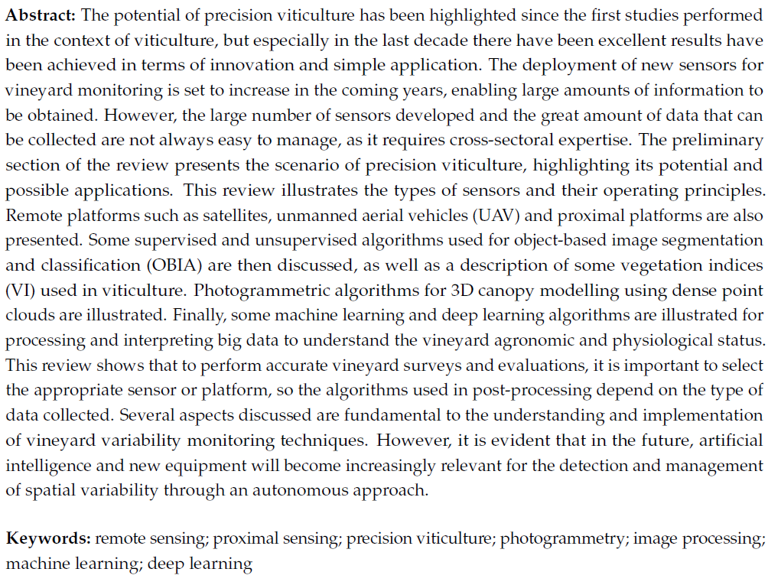
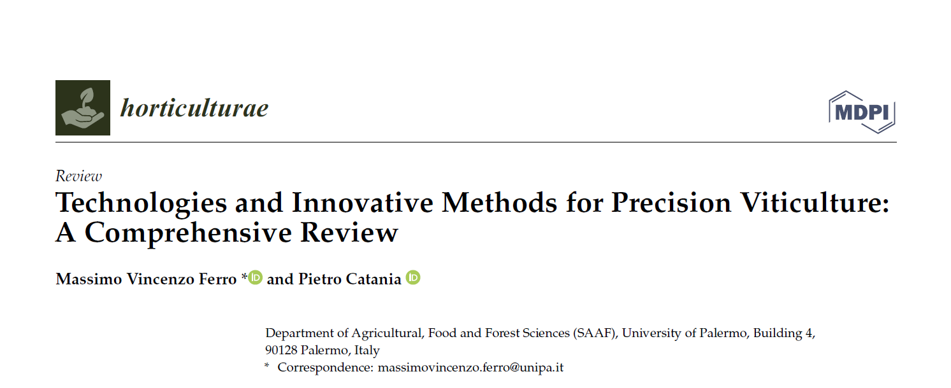
CHAPTER 2.


1. Introduction
In the context of modern agriculture, the focus should be on the application of new digital technologies, which make it possible to satisfy the human demand for food implementing its quality and safeguarding the environment and natural resources. Digital technologies, but especially the emergence of sensors and intelligent machines to support agriculture, can improve the sustainability of a production process that involves the environment and its resources [1,2]. The Organisation for Economic Co-operation and Development (OECD), together with the programmes supported by the Food and Agriculture Organisation of the United Nations (FAO), aim to promote this model of food production based on precision agriculture and digital technology, in order to respond to the rapidly increasing food needs due to population increase and consumer demands [3]. Viticulture is considered an important agricultural and food sector, and this is primarily due to the economic importance it generates [4]. It is one of the most intensively cultivated crops, with a total area under vine amounting to approximately 7.3 million hectares; this area is used for the production of wine grapes, table grapes, and sultanas [5]. In order to achieve these issues, it is necessary to take into account the dynamic nature of agricultural systems arising from the high temporal and spatial variability of responses to production factors [6] and thus to implement site-specific management. The first experiences in precision viticulture application were developed in Australia towards the end of the last century [7] and then applied in countries in which the crop was historically present such as European countries. The deployment of these technologies for vineyard management has found wide availability and interest from the entire production sector, and the excellent results obtained and the great feasibility of application has allowed rapid expansion [8]. Research in viticulture and precision agriculture has been involved in an increasing scientific effort over the years (Figure 1a); however, it should be mentioned that the number of publications relating to precision viticulture corresponds to only 5 % of the publications relating to precision agriculture.
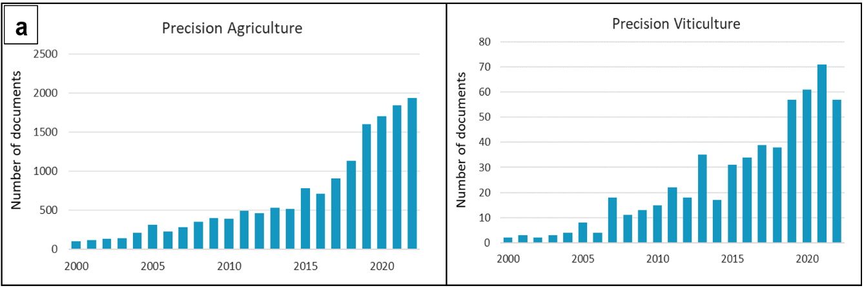
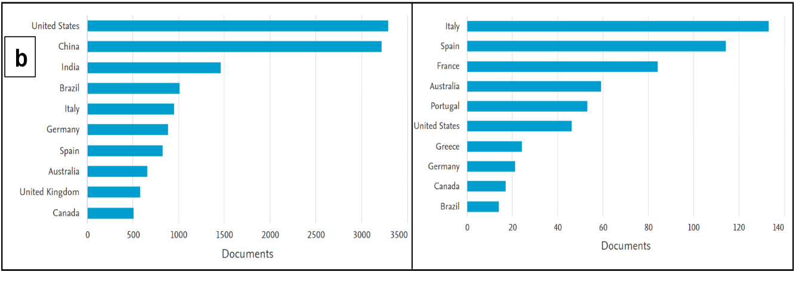
Figure 1. (a)—Evolution of the number of publications on the topics of precision agriculture and viticulture; (b) Evolution of publications per country; The data were derived through the methodology explained in Section 2 and refer to the time interval between 1999 and 2022. Source: SCOPUS 2022.

Observing Figure 1b, we can observe that many countries on the European continent are leaders in the scientific production related to precision viticulture. However, if we focus on the figure for precision agriculture, certain countries on the Asian continent, including China and India, are more interested in this research topic besides the United States. The development of precision viticulture is related to a series of technological advances that have enabled site-specific management, these advances are diversified into three main fields. The innovations relating to global navigation satellite systems (GNSS) that are relatively accurate and accessible, allowing the position of a point on the earth’s surface to be determined using geodetic coordinates, i.e., longitude, latitude and altitude[9,10]. The scientific progress of accurate and easy to use software regarding spatial or geographic data management; and finally, the availability of remote sensing platforms equipped with increasing spatial and temporal resolutions, or proximal sensors that allow crops to be monitored in localised form on a continuous basis. For instance, systems recording temperature, air humidity, leaf wetness and rainfall data are used to collect meteorological data in order to build models for forecasting disease problems [11]. For soil monitoring, data are collected on electrical conductivity [12], soil structure and soil moisture [13]. Equally important are measurements based on the plants themselves, as it is possible to survey canopy vigour and development, LAI [14–18] and grape yield and quality [19,20]. These canopy surveys are carried out using autonomous and semi-autonomous devices such as unmanned aerial vehicles (UAV) or unmanned ground vehicles (UGV). Equally important is the use of satellite images to monitor the vineyard agronomic status. The current agricultural production model is characterised by technologies such as the Internet of Things (IoT) and artificial intelligence (AI)[21]. These innovations ensure the connection between the flow of data measured in vineyard by sensors and the information needed by other mobile devices, agricultural machines to perform the steps of a farming production process autonomously [11,22], in this framework the farmer becomes central in the process of supervision and decision-making control. AI is based on the concept of intelligent computer systems that can simulate the capabilities and behaviour of human cognition, a concept that was first introduced in 1956, since then this discipline has made considerable progress. AI is a discipline that brings several research areas within their framework, the main ones being Machine learning (ML) and Deep learning (DL). The former refers to a process that allows computer systems to improve task performance with experience or to “learn by themselves without being explicitly programmed”. Instead, DL is considered a subset of ML and AI and hence DL can be seen as an implemented function of AI that simulates data processing with similar decision processes to humans [23,24]. Equally important is computer vision (CV) which is defined as the process of analysing images in order to extract data and obtain numerical information [25], CV procedures use both ML and DL algorithms. The application of artificial intelligence is used in many fields of precision viticulture with the aim of changing many agronomic management processes. AI, for example, is applied in agriculture to assess growth conditions and nutritional status to optimise agronomic management [26]. AI can also be used for phenology recognition and provide information that can be used to increase yield quality [27]. Currently, AI has been mainly focused on grape variety recognition techniques [28], grape ripening estimation [29–31], yield estimation [32,33] the evaluation of berry and bunch number and weight [34–40], evaluation of canopy development [41,42], optimisation of pruning techniques and automatic bud detection [43,44]. AI represents an excellent strategy that can be used to improve the current process of sustainable management of the wine sector, its use currently concerns the detection and classification of diseases that affect vines [35,45,46]. The benefits of precision viticulture are multiple and can be resumed in stress identification, monitoring, and reduction of vineyard spatial variability [47]. These procedures reduce the time and operational costs of vineyard management, optimising the use of water resources and the use of fertilisers and pesticides, and consequently reducing environmental impact by increasing yields. These scientific advances related to the application of artificial intelligence, combined with the evolution of geostatistics software [48], have allowed for the expansion of the application fields in precision viticulture, providing the possibility of implementing spatially variable agronomic techniques (VRA) through VRT technologies [49–52]. One of the main novelties of this work is the detailed explanation of the handling of multispectral, hyperspectral, thermal, and dense point cloud data. An effort is therefore made to clarify how to use specific platforms and how to manage this big data with the aim of summarising this information, which is currently brief and fragmentary for the vineyard sector.

2. Review Methodology
The search for documents on the evolution of PA and PV and sensors commonly used in viticulture was conducted on Scopus, however, to produce a holistic evaluation, the Google Scholar and Web of Science platforms were also consulted in addition to the Scopus platform. Accordingly, the adoption of a literature approach and an integrative review strategy allowed us to select the most reliable and representative sources of scientific literature for the topic of investigation [53]. As a first step, we identified several key terms to define the research topic and to identify sources and topics indirectly related to our investigation. After performing this check and ascertaining that the search engines had identified all the documents related to our study, the keywords were defined. A relational database model was created to manage the research papers identified on Scopus, with reference to the evolution of publications from January 1, 1999 to December 31, 2022 concerning the topic of precision agriculture and precision viticulture and the sensors used. On Scopus 16,018 articles were identified using the keywords ‘precision agriculture’ and 561 articles using ‘precision viticulture’ as keywords. Then the 561 research papers were downloaded and, after removal of duplicates and short reviews and surveys, an investigation was conducted concerning the various types of sensors used.

3. Technologies and Sensors for Vineyard Monitoring
The main objective of vineyard monitoring is to collect a large amount of georeferenced information and data, which can be measured using a wide range of sensors. Electroluminescence has become increasingly common with the introduction of silicon sensors [54]. Sensors can be either Charged Coupled Device (CCD) or Complementary-Metal-Oxide-Semiconductor (CMOS) types, both have as their basic element the photodiode, the photosensitive element that generates an electrical charge when it is hit by a flow of transmitted light [55,56]. In addition to this primary classification of sensors, it is possible to divide into other parameters, for example, according to radiometric resolution or the energy source used for measurements. The radiometric resolution of a sensor indicates the intensity of the radiation that the sensor can identify [57]. Sensors are divided into passive and active, according to the energy source used. The former are instruments that detect electromagnetic radiation reflected or naturally emitted by vegetation using natural light sources, such as sunlight. Active sensors, on the other hand, detect electromagnetic radiation reflected from an object irradiated by an energy source artificially generated by the sensor. Sensors with active detection technology are distinguished by their capability to be used in any environmental light conditions and at any time of day. Reflectance measurement of electromagnetic radiation can be performed at different wavelengths within the range from 350 to approximately 25,000 nm. This range includes the most used frequency bands in precision agriculture, such as visible (VIS), near infrared (NIR), short-wave infrared (SWIR) and thermal infrared (TIR). Figure 2 shows the type of sensors most used in PV, this investigation refers to scientific publications released from the year 1999 to 2022 on Scopus search engine, as described in section 2. It is evident that the most used sensors are multispectral sensors.
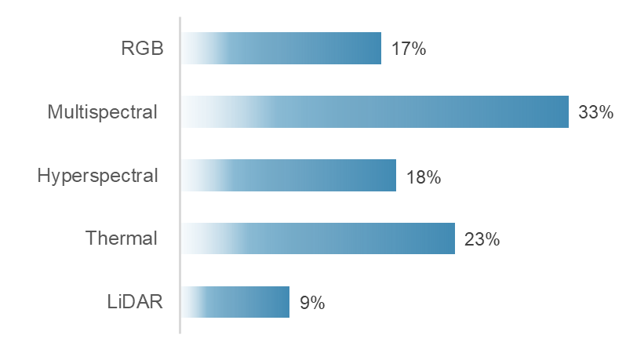
Figure 2. Analysis of percentage distribution of the most used sensors for vineyard monitoring over the past 23 years of research.
Another type of sensor used is the RGB camera, which is increasingly being used to conduct object detection surveys in the vineyard, with the aim of identifying vine canopy, shoot or bunches. Hyperspectral sensors are used in viticulture in many fields of application. Although thermal sensors are used in similar proportions to hyperspectral sensors, their main use is for investigations of vine water stress, particularly in irrigation operations. Finally, the figure shows that the use of altimetric laser sensors for the estimation of biophysical parameters of the vineyard canopy is still not often used compared to the rest of the available sensors.
RGB sensors used include wavelengths of blue (450–490 nm), green (520–560 nm) and red (635–700 nm). In PV, RGB indices are often calculated to enhance the vegetation of the vineyard from the overall image. Indeed, using RGB bands exclusively enhances the segmentation of green vegetation, as these bands reduce environmental and illumination effects to a minimum [58]. Radiometric sensors operating in the field of multispectral imaging typically record the radiation reflected by vine in a small number of broad bands, between 2 and 8, usually for certain wavelengths that enable the detection of stress conditions [59]. Most multispectral cameras include five sensors that, in addition to being equipped with active sensors at the wavelengths of blue, green and red, can also investigate in the Red Edge (700–740 nm) and near-infrared (NIR) (780 nm). The main process of radiometric calibration of a multispectral sensor consists of acquiring images of Lambertian targets with different reflectance levels. Then the DN (digital number) values of these Lambertian targets are calculated to obtain the radiometric calibration parameters for each band [60].The data provided by the hyperspectral image is called a data cube. These hyperspectral cameras combine spectroscopy and imaging techniques, providing spatial and spectral information. The resulting output from the use of this technology are georeferenced image cubes referred to as hypercubes (Figure 3). A 3-D image hypercube consists of a two-dimensions X∗Y (2-D) narrowband image array, organised along the spectral (λ) axis [61]. Hyperspectral sensors can detect numerous closely spaced wavelength ranges. These make it possible to detect reflectance, transmittance, and emissivity information in bands with spectral resolution ranging from 1 to 10 nm and thus very narrow [62]. Even the greater the number of bands, and consequently the smaller their width, greater is the ability to identify specific components or elements of a culture based on its reflectance characteristics. Using hyperspectral technology, images can be collected in a wavelength range of 400–2500 nm with variable spectral resolution, expressed in nm, and high spatial resolution [63]. The calibration of the hyperspectral sensor is made by detecting the reflective curves of a Spectralon® panel through a spectrometer, which is considered a Lambertian reflector. In this way it is possible to determine the wavelength corresponding to each image band [64].
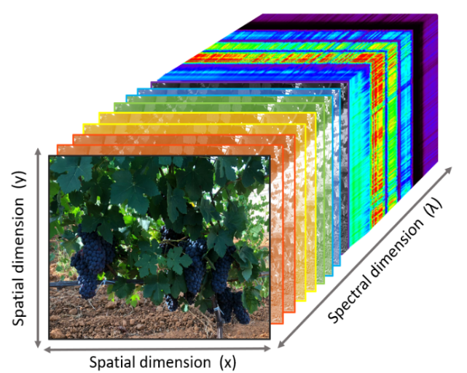
Figure 3. Representation of the three-dimensional hypercubic architecture of hyperspectral images of a vineyard canopy.
In VP, hyperspectral sensors have been used to characterise the water status by calculating appropriate indices [65,66]. Using hyperspectral images (HIS) referred to berries, grape quality can be assessed, through non-destructive detection methods of soluble solids content, or to determine the anthocyanin content of grapes. The wavelengths in the VIS region at 454, 625, 646 and 698 nm are the most relevant for determining the composition of grapes (TSS, titratable acidity, malic acid, and anthocyanins) using the technique (HSI). These wavelengths reported prediction coefficients (R²_{p}) of 0.82 for TSS, 0.81 for titratable acidity, 0.61 for pH, 0.62 for tartaric acid, 0.84 for malic acid, 0.88 for anthocyanins and 0.55 for total polyphenols [67]. The HSI technique enables the early identification of pathogens and diseases at various spatial, spectral and temporal scales [68–71]. Referring to the infrared region of the electromagnetic spectrum, it is usually divided into reflected and emitted infrared. The wavelength of the emitted radiation is inversely proportional to the temperature, but the behavior of the emitted energy is different. The emitted energy is proportional to the temperature of the target, therefore the higher temperature the more radiation is emitted. Thermographic surveys can be carried out in a wavelength range of 7000–20,000 nm, nevertheless, the thermal imaging cameras typically used to detect the water status of vines focus on a narrower range of 7000 nm to 14,000 nm [72]. Generally, thermal imaging cameras are subjected to radiometric calibration processes in the laboratory using blackbody at different target and environmental temperatures by developing special algorithms, as described by [73]. Thus, by measuring the foliar emissivity acquired in the thermal infrared spectra, the water stress related to leaf temperature can be calculated, through the estimation of the Crop Water Stress Index (CWSI) and can have a value between 0 and 1, indicating stressful and well irrigated conditions, respectively [74]. Instruments used in 3D surveying technology use active laser scanning sensors to determine the distance between a laser signal and a target object. This technique, used in airborne laser scanning (ALS) or Terrestrial laser scanning (TLS) [75], are known as Light Detection and Ranging, or LiDAR. These systems typically use a laser signal at ≈1000 nm in the near infrared (NIR). One of the most important outputs of laser scanning surveying is the point cloud, which can be used to extract geometric characteristics of objects, such as volume and height. There are two types of laser measurement systems, the Time-of-Flight (ToF), and the Continuous Wave (CW) system. These instruments are commonly classified according to the features of the information that they can collect, such as spatial, spectral, and temporal information. There are two distinct techniques for recording the return signal in ALS systems. Discrete return ALS systems, most commonly used, record single (first or last) or multiple (first and last, or sometimes up to five) echoes for each transmitted pulse [76]. The other technique is ALS with waveform digitisation, which samples and records the entire return waveform to capture a complete height profile within the footprint of the target, or the area illuminated by the laser beam [77,78]. LiDAR systems can collect spatial information of one-dimensional (1D), two-dimensional (2D), and three-dimensional (3D) types with the use of optical scanning systems [79]. LiDAR systems have revolutionised methods that included manual measurements of primary canopy attributes, such as height, width and distance between rows, to generate integrative canopy indicators such as leaf wall area (LWA), or tree row volume (TRV) [80]. The 2D laser scanner surveys revealed a significant relationship with pruning weight (r = 0.80), yield and vigour indices, demonstrating the potential of using laser scanner measurements to assess the variability of vine vigour within vineyards [81]. The evaluation of canopy attributes (height, width and density), assessed with laser scanning technology provide information to improve agrochemical spray treatments [82,83].

3.1. Remote Sensing
Another important distinction that is made between the sensors used concerns the distance between the sensor making the measurement and the object to be detected, and thus we distinguish remote sensing and proximal sensors. Remote sensing identifies platforms that derive qualitative and quantitative information about crops or objects positioned at a distance from a sensor through measurements of emitted, reflected or transmitted electromagnetic radiation.

3.1.1. Satellite
The use of satellite systems in remote sensing represents an excellent monitoring tool that ensures wide use in multiple surveys in PV. However, due to the spatial resolution that is sometimes not sufficient to realise detailed discretisation of vineyard characteristics, as it is an in-wall cultivation system, it presents the difficulty of easily separating the inter-row from the soil and other elements [84]. To ensure optimal spatial resolution, there is a need to implement proper radiometric correction, furthermore, the processes of separating the rows from the soil can be quite complex and sometimes not feasible with spatial resolutions higher than 0.50 m. In addition, many scenes surveyed by satellite imagery may have the problem of cloud cover that hinders and makes surveying inaccurate; this problem has been solved by international space agencies, minimising this disturbance. Satellites are classified according to their spatial resolution capability [85] (Table 1), high definition ones include RapidEye, which acquires images in 5 multispectral bands, with a resolution of 5 metres, first launched into orbit in 1996 and developed by a European project, since it has been active it has been used in many agriculture and forestry studies [86]. Another satellite with medium to high spatial resolution is Landsat 8 OLI (Operational Land Imager) which has provided excellent results for VP, it consists of nine spectral bands with a spatial resolution of 30 m for the bands operating on visible light, it also consists of bands operating in the shortwave infrared. While a band has been implemented that reduces the disturbance caused by clouds. With the Landsat system, progress was made in terms of image resolution, however, high-resolution satellite systems such as IKONOS and Quickbird were later devised, the former providing panchromatic (PAN) images with a resolution of 0.80 m, the latter launched in October 2001 provided images with a higher resolution than IKONOS [87]. Another satellite is Planet, which provides a high-resolution, continuous, and comprehensive view of agronomic field conditions [88]. GeoEye-1 launched in 2008 and WorldView-3 launched in 2014, are very high-resolution commercial satellites, for example WorldView-3 has 29 spectral bands and an average revisit time of less than 1 day. The MODIS satellite acquires data in 36 spectral bands with wavelengths from 0.4 μm to 14.4 μm and varying spatial resolutions, two bands at 250 m, five bands at 500 m and 29 bands at 1 km. The satellite provides large scale global dynamics measurements of the entire earth’s surface, minimising the effect of cloud disturbance. One of the most widely used satellites in PA and PV is the Sentinel-2 this satellite is capable of sampling 13 spectral bands up to a resolution of 10m. The main advantage of Sentinel-2 over other satellites is that the data are open-source [89]. The use of data derived from satellite platforms is very wide, examples include studies to identify vineyards growing in large regions or areas [90], monitor vineyard variability, predict yield variability [91]. Landsat and MODIS satellites are often used to monitor evapotranspiration processes in the vineyard and in general are useful for detecting water status [92]; [93]; [94]. Another satellite that is being used to conduct vineyard water stress prediction surveys is the Advanced Spaceborne Thermal Emission and Reflection Radiometer (ASTER) satellite [95]. Consisting of 15 bands with 15 m resolution, it is suitable for measuring soil properties, soil temperatures [96]. Another satellite system used to evaluate soil moisture content is TerraSAR-X, which is equipped with a synthetic aperture radar (SAR) antenna that provides high-quality radar images [97]. Finally, the use of satellite systems is also important for monitoring soil erosion phenomena [98]. The use of satellite information is increasingly in demand, to date, petabyte-scale remote sensing data archives can be accessed free of charge through government agencies (NASA; NOAA; Copernicus) [99], which provide geospatial data processing tools [100].
Table 1. Representation of satellites used for viticulture surveys. Subscript ⁽¹⁾ indicates the GSD for PAN bands, while subscript ⁽²⁾ indicates the GSD for Multispectral bands.
Satellite | Temporal  Cover Age | Spectral Bands | Global  Revisit Time | Ground Sample Distance (GSD)
RapidEye AG | 1996–2020 | VIS-NIR | 5.5 days | 6.5 m
IKONOS | 1999–2015 | PAN-VIS-NIR | 3 days MS 12 days PAN | 0.8 m ^{(1)–}3.6 m ⁽²⁾
MODIS | 1999–present | VIS-NIR | 2 days | 250–500 m
ASTER | 1999–present | VIS-NIR | 4–16 days | 15 m
Quickbird | 2001–2015 | PAN-VIS-NIR | 3 days | 0.6 m ⁽¹⁾–2.5 m ⁽²⁾
TerraSAR-X | 2007–present | X-band SAR | 3 days | 3 m
WorldView-2 | 2009–present | PAN-VIS-NIR | 1 day | 0.46 m ⁽¹⁾ –1.84 m ⁽²⁾
Planet | 2009–present | VIS-NIR | 1 day | 3.7 m
WorldView-3 | 2014–present | PAN-VIS-NIR | 1 day | 0.31 m ⁽¹⁾–1.24 m ⁽²⁾
Sentinel-2 | 2015–present | VIS-NIR | 5 days | 10 m

3.1.2. Aircraft
Aircraft have been used in precision viticulture to map large areas, surveys can be carried out in a more flexible manner, and these platforms allow for a long flight range and to carry heavy loads. These platforms have a better resolution of the final image than satellite platforms; indeed, they reach a level of detail on the ground that is less than 10 m, depending on the flight altitude. However, these monitoring systems have not been widely used in VP, one of the main constraints being the presence of intermediary agencies offering this service, which reduces the flexibility of time acquisition. In addition to this issue is the sometimes expensive cost, another constraint is the impossibility of flying in some areas [101]. However, it has been used in studies on the prediction of grape composition by [102] in which they reveal high spatial variability within the plot. Although these technologies are used to a limited extent, they can provide useful results; however, the set of constraints that make their use unfeasible and complicated, and the increasing supply of new instruments with high spatial resolution and ease of use, coupled with the low cost of application, will probably lead to a decline in the use of PVs in PV practices.

3.1.3. Unmanned Aerial Vehicle
In recent years, crop monitoring systems have been interested in technologies that offer very efficient operational performance. Among these tools, unmanned aerial vehicles (UAV) offer great possibilities for acquiring data in the field in a simple, fast and inexpensive way compared to previous methods. These technologies were developed for purposes quite different from agricultural monitoring; indeed, they were initially used for military purposes. These monitoring systems are more efficient than ground-based systems due to their ability to cover flight distances in a short space of time; they are also more efficient than satellite systems and aircraft as they can fly at low altitudes, which allows for very high spatial resolution images. UAV, depending on wing structure, are divided into fixed-wing systems, which require a runway to take off from the ground or one to land. These can travel at a higher flight speed than the other type of rotary-wing UAV, in view of this, it can be assumed that these systems can cover greater monitoring distances. The rotary-wing ones that do not require specific conditions for take-off and landing, this is performed vertically (VTOL) [103]. These monitoring systems are widely used in precision viticulture because their use is not very complex, as they can be controlled remotely from the ground; indeed, these systems are connected to Apps or software that remotely control flight operations and the UAV follows exactly the indications loaded on the flight plan [104]. These aerial vehicles are integrated with global positioning system (GPS) and real time kinematics (RTK) components, which provide very accurate and real-time positioning data of the drone and allow each image to be geo-referenced. Therefore, the part that needs the greatest attention is the flight mission plan, the choice of flight parameters such as flight altitude, flight speed, lateral and frontal overlap of the images to be captured, and the frequency of shots. The choice of these parameters directly influences the ground sampling distance (GSD), which is the resolution on the ground and thus the size of an image pixel. However, it is important to regulate the flight height as well as the lateral and frontal overlap of the images according to the type of survey to perform. A high overlap, usually set at 80%, and a low flight altitude, usually set below 40 m, are required to perform a 3D point cloud survey [105]. The UAV has been widely used for the reconstruction of vineyards into 3D maps using this flight height and overlap parameters results in an average density of the generated 3D point clouds of approximately 1450 points per m² of map surface [106]. A point cloud is a large set of points, indicated in a coordinate system in three spatial dimensions, representing points on the outer surface of objects where light is reflected [107]. These reconstructions can be made from surveys carried out with laser scanner sensors (LiDAR) or through sensors operating in the visible or multispectral, exploiting dedicated algorithms or computer vision techniques [108]. The use of UAV platforms in VP has focused on the capability of acquiring multispectral reflectance images, thermal images and RGB images for photogrammetric processing. Multispectral analyses allow the identification of vineyard vigour variability, some studies compare the performance of some vegetation indices with shoot pruning weight and the results obtained show a good regression (R² = 0.69) [109], similar results were found by [15] where multispectral data showed good correlation with shoot pruning weight (r= 0.55) and bunch weight (r = 0.59). Through the use of UAV it is possible to apply thermography techniques and develop special indices, such as the CWSI to monitor changes in vineyard water status [110]. Generally, thermal cameras installed on UAV can measure a spectral range of 7500 to 14,000 nm and can identify thermal variations in the range of −20 to 550 °C. Indeed many studies confirm that the CWSI detected by UAV is well correlated with leaf water potential (ᴪL) (R² = 0.83) [111,112] and a moderate correlation with stem water potential measurements (ᴪ_{st}) (R² = 0.55) [113]. The assessment of CWSI using UAV can be useful to replace the traditional method of assessing stem water potential using a pressure chamber. The latter is not feasible for large-scale studies, in addition, is an invasive method compared to UAVs which allow, among other things, the spatialization of information on the vineyard water status of large areas.

3.2. Proximal Sensing
Proximal sensing exploits a set of measurement technologies in which the sensor is within direct contact or proximity of the object to be measured. According to this definition, proximal sensors are generally of the optical or contact type. A proximal sensor is usually defined as such when the distance to the target object does not exceed 2 m [114]. Proximal sensors allow data on spatial variability to be obtained in a georeferenced mode and in a very accurate and precise manner. This feature is due to the proximity of the sensor to the crop or soil, which allows for excellent resolution of the images or measured data [115]. Proximal sensing can be of the point type, for example when optical contact sensors are used to detect the nutritional and physiological state of the vine, assessing for example the content of certain leaf pigments and nitrogen status [116,117]. For assessing the physiological and nutritional status of the vineyard, these systems can be either monoparametric sensors, which assess, for example, only the chlorophyll content [118], or multiparametric devices [119]. The physical principle that these instruments exploit is called fluorescence, which is the property of certain substances such as chlorophyll to emit received electromagnetic radiation as dissipation of light energy. The instruments that enable such investigations are called fluorimeters, which measure the absorbance and transmittance of radiation by the leaf [120]. Other types of proximal sensors that are used in precision viticulture include those that do not require direct contact with the crop and can be carried manually or installed on a tractor [121]. On-the-go sensing measurements allow for the fulfilment of in-vineyard monitoring, collecting data over large areas in reduced time [122]. Commercial sensors used to investigate the physiological status of the vineyard include, for example, the GreenSeekerTM (Trimble Navigation Limited), which allows for the calculation of certain vegetation indices that correlate well with grape quality parameters [123]; this is equipped with a multispectral sensor that operates at a wavelength of 660–770 nm and with a minimum operation height of 0.6 m and a field of view of 0.6–1.6 m. Another sensor is the Crop CircleTM (Holland Scientific Inc., Lincoln, NE, USA), this instrument offers six spectral bands investigating in wavelengths from 450 to 880 nm of the electromagnetic spectrum [124], it is mainly used to assess the nitrogen status of the vine canopy through near-infrared reflectance [125]. OptRXTM (AgLeader, South Riverside Drive Ames, IA, USA) is a device equipped with active sensors that emit light and record reflected light in wavelengths from 670 to 780 nm, and has an operation height ranging from 0.25 (m) to 2.5 (m), its field of view (m) depends on the operation height at which it is set multiplied by 0.6 (m) and can support up to 8 sensors on a CANbus system. This optical sensor has been used in PV for monitoring symptoms induced by Flavescence dorée and Esca disease [126]. Other sensor types used in PV are those involved in investigating proximal thermography. These investigations are carried out using infrared cameras. Thermal imaging cameras are equipped with a long-wave infrared sensor with a thermal sensitivity of 0.1 °C and a field of view of 46 mm horizontally and 35 mm vertically. The thermal camera measures in a temperature range of −20 °C to 120 °C with an accuracy of ±0.3 °C (±37.5 °F) or ± 5 % (of the average of the difference between the ambient and scene temperature)[127]. The thermal imaging camera is set with appropriate emissivity values, which for the plant parts of the vineyard corresponds to 0.95, with a focal length of approximately 2 m [128]. Handheld thermal cameras can be used to assess the CWSI (Figure 4), this index is usually determined through empirical. These methods are based on the relationship between the difference leaf temperature (Tc) and air (Ta) coupled with the water vapour pressure deficit of a non-water-stressed baseline [129]. The optimum time to obtain robust and physiologically more meaningful thermal data to assess the vineyard water status is usually between 11 a.m. and 2 p.m [130].
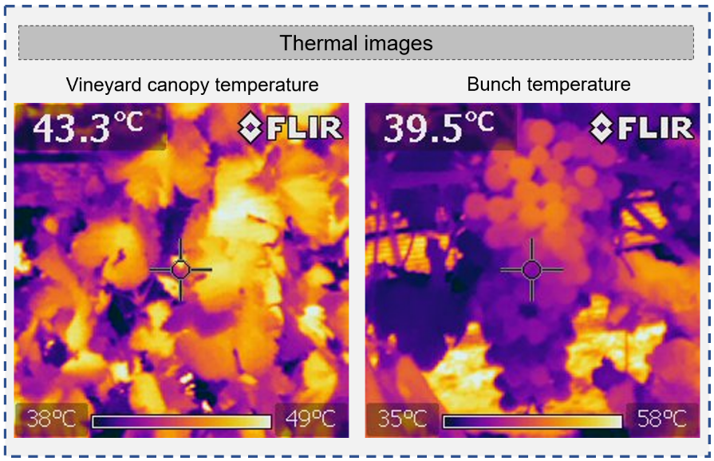
Figure 4. Thermal images of the vineyard canopy and bunches collected with a FLIR handheld thermal imaging camera in a hot arid climate environment.
The CWSI assessed by images obtained from proximal instruments can be influenced by the row orientation and the correlation with the (ΨL) can differ between the shaded side of the canopy versus the sunlit side. However, by combining measurements from both sides of the canopy, an accurate estimate of the water status can be obtained with correlation values between CWSI and (ΨL) of R² of 0.70 [131]. Furthermore, the CWSI index evaluated by the handheld thermal camera correlates well with the index values measured by the UAV (R² = 0.58), however, proximal measurements have the limitation of not allowing spatialisation of the data [113]. Thus, thermography offers many advantages, however, there are currently sensors that including microchips embedded in the vine trunk that allow continuous monitoring of the stem water potential [132]. These instruments present some criticalities such as maintaining intimate contact with the xylem over long periods of time and, finally, its single measurements, which makes it difficult to apply them in large areas. Hyperspectral reflectance data is usually collected using an instrument named spectrometer. Measurements with the spectrometer are carried out at specific times of the day to reduce variations in the solar zenith angle, and a radiometric calibration must also be carried out using a white standard panel (spectralon) (Figure 5a) [133]. Through radiometric calibration, the image values recorded by the sensor and expressed in DN, are converted into reflectance values or radiance (Figure 5b). The conversion to reflectance spectra is done using the equation (1):
$$R \left(λ\right)=\frac{canopyI\left(λ\right)-DI \left(λ\right)}{Spe.I \left(λ\right)-DI \left(λ\right)}$$ | (1)
in which R is the reflectance, λ is the wavelength, canopyI(λ)is the intensity of the signal from the canopy, Spe.I (λ)is the intensity of the signal from a calibration panel, which is the white spectralon, that has the highest diffuse reflectance observed over the operational wavelengths of the spectrometer. DI(λ) represents the dark intensity that is measured with the spectrometer fibre [134]. Radiance is measured in watts per square metre per steradian (W sr⁻¹ m⁻²). For reflectance, since it is a ratio of the energy reflected from the target and the energy incident on the target, it is a dimensionless measure [135,136]. Information derived from hyperspectral analyses has been used to identify grape varieties, considering specific wavelengths ranging from 630 to 730 nm. Grape quality can also be determined by means of spectra analysis, e.g., wavelengths of 446, 489, 504, 561 nm are most effective for determining pH, whereas soluble solids content can be determined with wavelengths of 418, 525, 556, 633, 643 nm [137]. Water strongly absorbs radiation in the 970 nm, 1200 nm, 1450 nm, 1940 nm bands, and these wavelengths can therefore be used to estimate the water content and vine water potential [138].
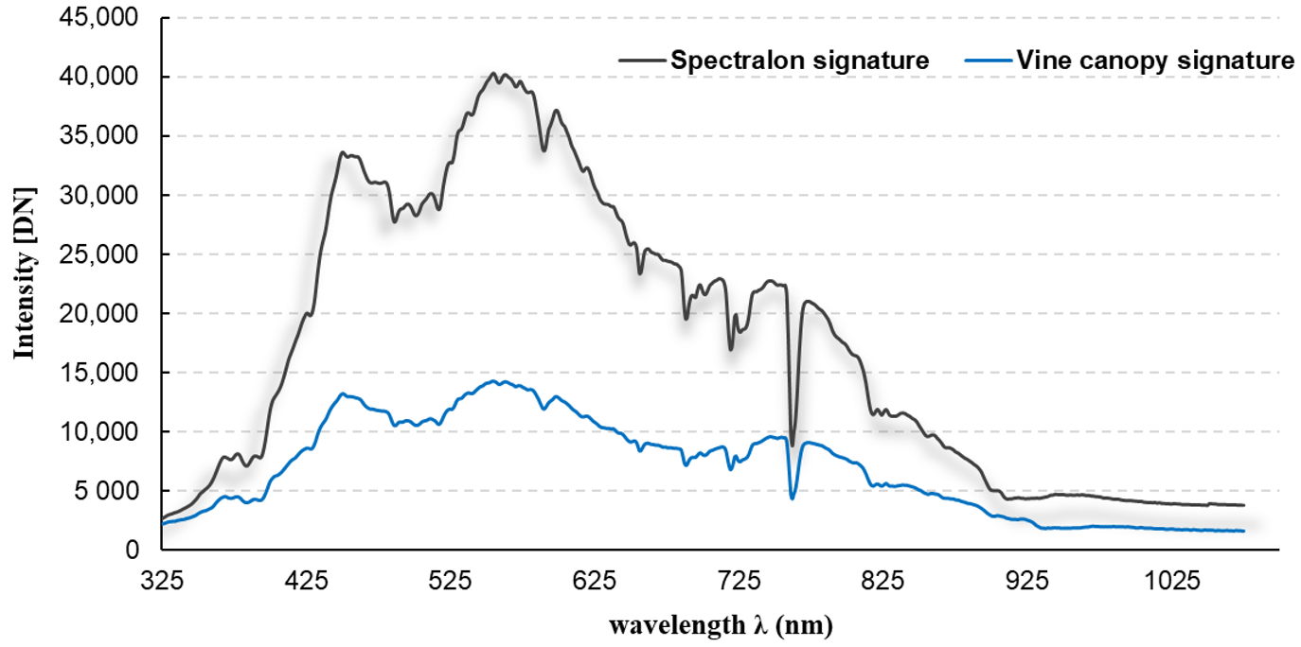
(a)
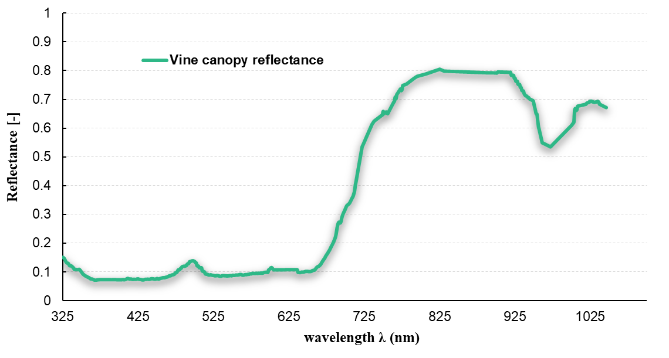
(b)
Figure 5. (a) Hyperspectral reflectance data (digital number) of Spectralon panel and vine; (b) Conversion of raw DN values to vine canopy reflectance with the ASD field spectrometer.
Mobile platforms, capable of moving across the field at a speed of between 2 and 10 km/h, and equipped with RGB, NIR or thermal sensors, have recently been designed. These robotic platforms are powered by batteries that allow them to move autonomously, and their movements are guaranteed by GPS antennas that guide them precisely between the rows. These multisensor units are versatile ground-based platforms able to survey vineyard variability [139]. In addition to these technologies, there are devices that are used daily, these are called mobile communication technologies (MCTs), which include all types of portable devices, such as smartphones or tablets. Currently, research is focused on finding solutions for use in precision viticulture that are low cost and available to everyone. Mobile devices allow images to be recorded, with good definition and resolution, and according to these advantages, some companies are designing specific apps [140]. In the bibliography, there are many works concerning the application of some monitoring techniques performed through mobile devices, especially in reference to the estimation of the vineyard production by counting berries or bunches [141], or the evaluation of the vineyard canopy development [142], or to measure the leaf area index (LAI) through images captured by a smartphone/tablet [143].

4. Image Processing in Precision Viticulture

4.1. Image Pre-Processing
Satellite, aircraft, or UAV data are subject to an initial processing operation aimed at minimising image noise effects and obtaining physical unit data such as radiance or reflectance from corrected raw data. This first phase aims to identify all sources of noise that then influence the quality of the data, the procedures involve radiometric calibration techniques, atmospheric correction for satellite data and georeferencing. Radiometric calibration consists of correcting the DN values recorded by the sensor and converting them into absolute physical units, this can be performed on the ground or on board for example for satellites. Regarding the atmospheric correction of atmospheric gas absorption and scattering effects, this correction is done through numerical models that require atmospheric input data, these are for example MODTRAN [144] which provides a simulation of vine canopy irradiance, or through the application of specific software [145]. Georeferencing consists of returning the image to a known cartographic reference system; this allows orthoimages to be generated that describe the characteristics of the entire scene surface. These operations are usually performed through aerial triangulation techniques, automatically identifying homologous points in the image scenes, or through ground sampling points of known topographic coordinates (GCPs), this practice is often employed in surveys performed with UAV [146].

4.2. Computer Vision Techniques
Photogrammetry is a technique of accurate reconstruction by superimposing images of a given area or section of a vineyard, using methods from many disciplines, including optics and projective geometry. Using photogrammetry techniques, spatial models are developed based on the combination of several images that are superimposed, generating the orthomosaic of images [147]. Photogrammetric processing can be performed using specific tools and software to process the images. This tool makes it possible to carry out photogrammetric triangulation, generate the dense point cloud. It allows georeferenced orthomosaics to be generated and exported in GeoTIFF format compatible with most GIS, which is made possible by the ability to support EPSG register coordinate systems: WGS84 and UTM [148]. The processing of high-resolution images, which are characterised by large intra-class variability of their component pixels, requires the use of geographic information called GIScience, in which image segmentation is based on object detection. This is implemented through Geographic Object-Based Image Analysis (GEOBIA) procedures, which aim to provide methods for high spatial resolution image analysis, which is usually applied to remote sensing images collected by satellites, aircraft and UAV. The general steps involved in GEOBIA procedures are mainly image segmentation and merging; feature extraction and image space reduction; image and object classification; and finally, the evaluation of the accuracy of the algorithms and processes used. Image segmentation is typically performed with unsupervised segmentation algorithms classified as edge-based, region-based and hybrid [149]. Edge-based methods accurately detect segment edges, but sometimes fail to detect closed segments. Region-based or closed segment methods, on the other hand, inaccurately delineate segment boundaries. The classification of objects in images is usually carried out by applying supervised and unsupervised machine learning algorithms [150]. The use of GEOBIA procedures using orthomosaics and digital elevation models as input for map segmentation is increasingly practised, applying classification algorithms one can efficiently characterise vineyard canopies [108], or the classification of vegetation types or weeds [151].
One element used for graphic processing in PV is the Digital Elevation Model (DEM) is a generic term for the earth’s surface and includes all objects on it. The DEM can be divided into two surface representation models, the Digital Terrain Model (DTM) (Figure 6a), which represents the elevation of the earth’s surface and is a topographic terrain model. The Digital Surface Model (DSM) (Figure 6b) represents the elevation of the surface and the objects detected by the remote sensing system. A DSM is suitable for orthorectification of images, because of the information on the elevation of the top of the canopies, in other words, the objects visible in the images [152]. Whereas a DTM is required for terrain surface modelling. Elevation values are generally defined as heights, i.e., measured relative to a horizontal surface modelling the Earth at sea level.
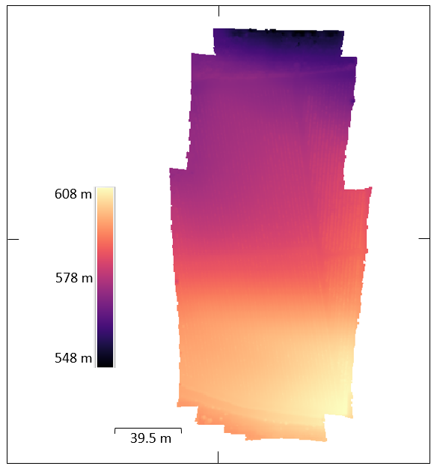 | 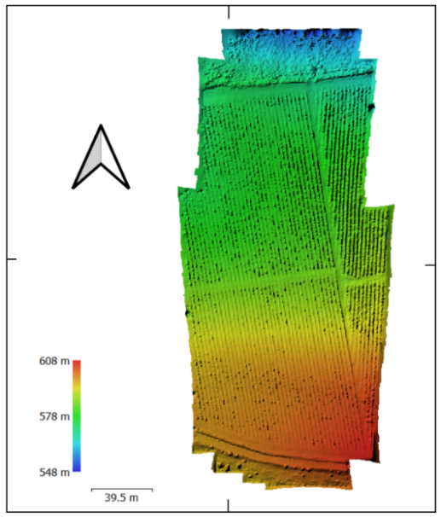
(a) | (b)
Figure 6. Representation of the elevation distribution of a vineyard obtained using UAV images; (a) Representation of a Digital Terrain Model; (b) Digital Surface Model.
The information in the dense cloud allows objects within the scene to be reconstructed and enables the mesh to be generated. This term refers to a mesh that defines an object in space, consisting of vertices, edges and faces [153]. The bit depth is also an important specification for developing a DEM. Indeed, a depth of 32 bits is preferable for high-precision DEM obtained by aerial photogrammetry or via UAV [154]. The accuracy in generating the dense cloud is also affected by the resolution capability of the cameras used; actually, with low resolution cameras, problems can be observed in generating the DSM in detail [155]. One of the main problems found in processing vineyard vigour maps is the identification of vine vegetation. Pixel extraction techniques of the vineyard canopy eliminate disturbance sources such as, for example, soil-induced noise or spontaneous vegetation, improving the final quality of vigour maps. Some studies have proposed semi-automatic methods, using single-band image processing techniques or digital elevation models (DEM). Single-band image processing involves the use of greyscale images by processing specific algorithms according to the DN [156] or through raster images in the red band, which allows for greater contrast between vine vegetation and soil [157]; [158].
Nowadays, due to the capability of very detailed surveys, it is possible to exploit the information from the dense point cloud [107]. Using these maps, it is possible to develop the Crop Surface Model (CSM) (Figure 7), calculating it by subtracting the elevation values of the DTM from the DSM [159–161] as per Equation (2):
$$CSM=DSM-DTM$$ | (2)
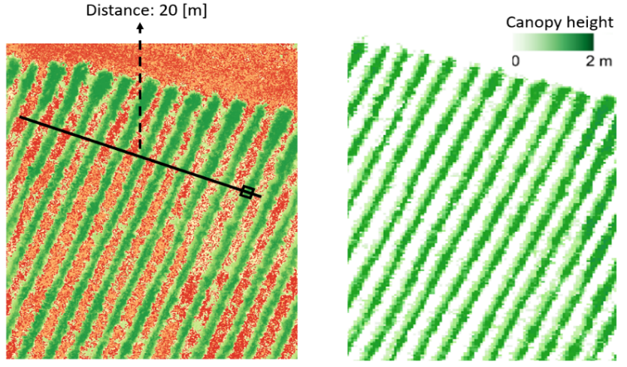
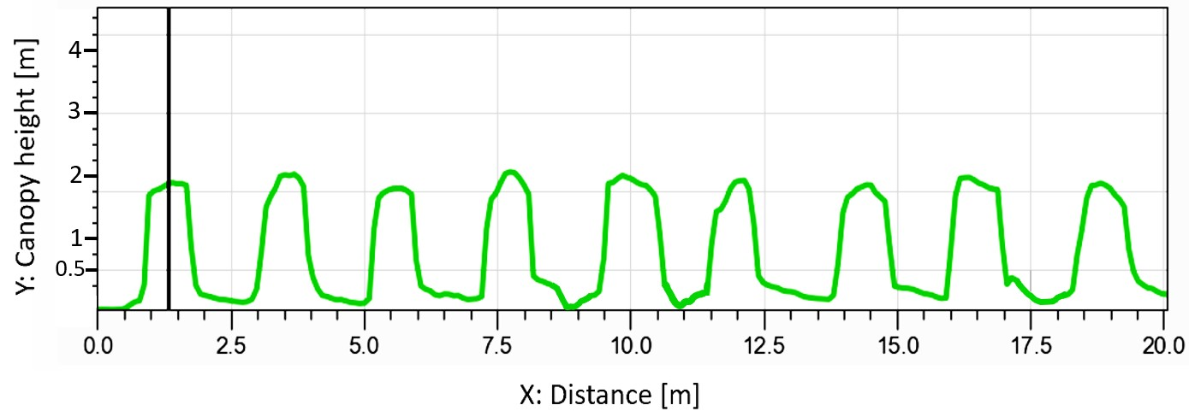
(a)

(b)
Figure 7. (a) Representation of the raster analysis using DEM information to extract the vineyard Crop Surface Model; (b) Diagram of Digital Elevation Model of vineyard canopies, the green line represents the CSM profile from the line traced over the vine rows.
In addition to this method that uses data from the dense point cloud, methods are also applied that consider the DN values of the pixels using them as a threshold value to remove sources of noise from the raster, such as soil or other background elements, focusing on the vineyard vegetation as the main element [160]. The thresholding process that is commonly performed by software is based on a simple Equation (3):
$${B.I}_{i,j}=\left\{\begin{aligned}1, IF a_{i,j}≥T \\ NULL, IF a_{i;j}<T\end{aligned}\right.$$ | (3)
Using the Equation (3), it is possible to transform the image (B.I) into binary format. In fact, the value of a pixel in row i and column j of a given image (a), is evaluated if this value is greater than or equal to the threshold value T. Thus, if the pixel value is greater than or equal to the threshold T, this takes on a value of 1, whereas if the DN of the pixels is less than the threshold T, this is considered Null (Figure 8).
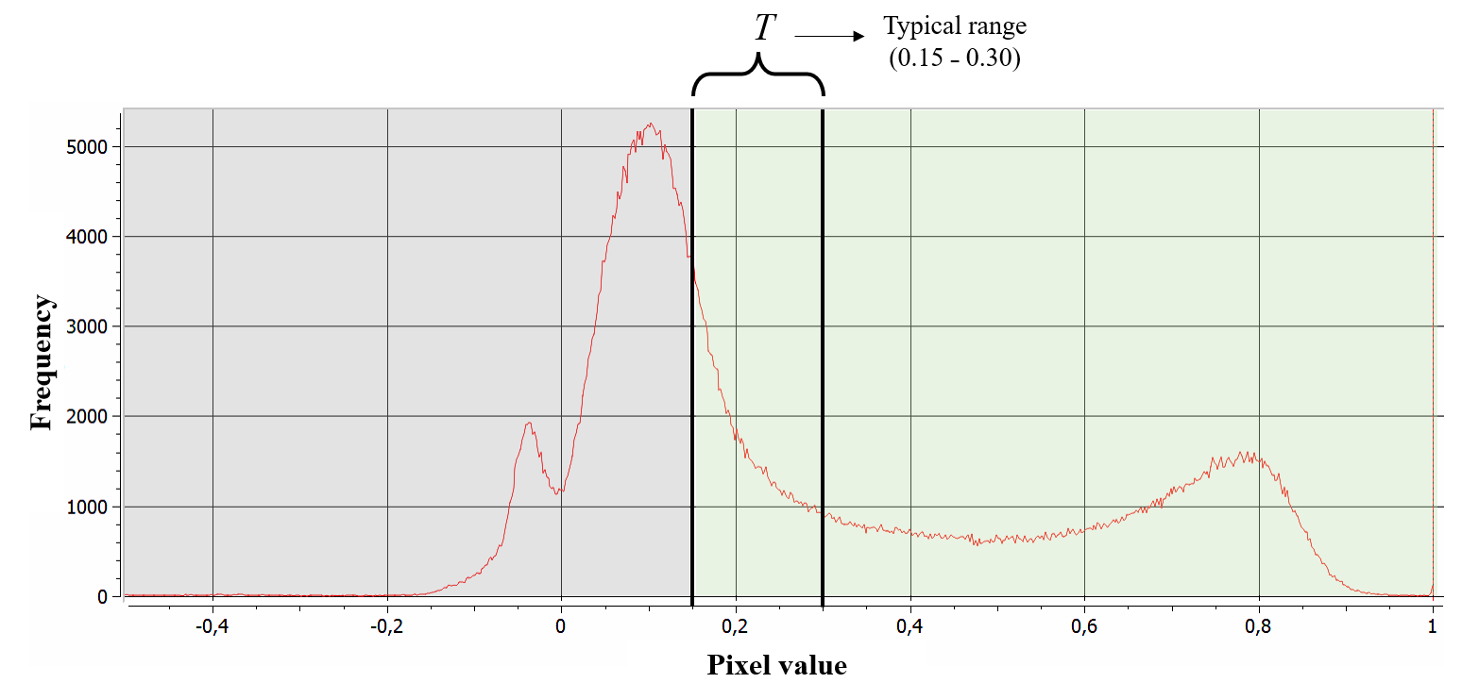
Figure 8. Orthomosaic histogram of the Normalised Differention Vegetation Index (NDVI) of a vineyard showing the soil thresholding method, the red line represents the frequency curve of pixel values.
The estimation of the threshold value [T] for discriminating bare soil and spontaneous weeds from the vineyard canopy cannot be assumed randomly, for this reason a valid alternative has been developed, the Otsu method [162]. It assumes that well-separated classes can be distinguished about the intensity values of their pixels, the method by calculating a certain threshold value succeeds in obtaining the best separation between the classes (bare soil and vegetation) allowing the binarization of the images (Figure 9) [160]. Otsu’s method is based exclusively on the histogram of the raster, which is a one-dimensional matrix that can be easily calculated; the goal of the method is to find the threshold value [T] that maximises the interclass variance [163,164]. This algorithm can be applied for RGB or multispectral image segmentation [165], or to binarize the greyscale point cloud for 3D point classification [166].

Figure 9. Representation of binarized vineyard rows by applying the Otsu method.
Color-space-based methods, better known as Hue-Saturation-Value (HSV) or Hue-Saturation-Intensity (HSI), are often used to segment RGB or multispectral images [167]. Furthermore, these identify and separate the pixels relating to vineyard vegetation from those relating to shadows and soil [168]. To understand the algorithm, it is first necessary to explain the color space, which is usually illustrated by a geometric shape similar to a three-dimensional cone. In which the hue is represented by a three-dimensional conical structure, the saturation is represented by the area of a circular cross-section of the cone, the value or intensity is the distance to the end of the cone [169]. Hue is the dominant wavelength in a mixture of primary colors, and depending on the value it takes, a different color is obtained, this value varies from 0 to 360, hence red (0°–60°), yellow (60°–120°), up to magenta (300°–360°) (Equation 4). Saturation indicates the intensity and pureness of the color and is indicated as the distance from the centre of the cone surface, and therefore the further away from the centre the purest color becomes, if on the other hand this value is 0 and therefore in the centre of this surface the resulting color is white. Finally, the value/intensity indicates the brightness, or the height of the cone, the nearer to the end, the darker the color becomes [170]. Thus, the first step in performing segmentation is to transform the images from RGB to HSV format, whereby the red (r), green ($g$) and blue ($b$) components must first be extracted [164]. The algorithm uses mathematical expressions to convert RGB color space to HSV color space:
$$H=\left\{\begin{matrix}θ, if b≤g \\ 360-θ, if b>g \end{matrix}\right.$$ | (4)
$$θ=\cos^{-1}\left[\frac{0.5\left[\left(r-g\right)+\left(r-b\right)\right]}{\sqrt{{\left(r-g\right)}^{2}+\left(r-b\right)\left(g-b\right)}}\right]$$ | (5)

To calculate the Hue, it is assumed that the theta angle is calculated in HSV space (Equation 5) with respect to the red axis and that the RGB values are normalised between 0 and 1. Subsequently via Equation (6) the saturation channel is determined, via Equation (7) the light intensity value is determined.
$$S=1-\frac{3}{\left(r+g+b\right)}\left[min\left(r;g;b\right)\right]$$ | (6)
$$V=\frac{1}{3}\left(r+g+b\right)$$ | (7)
However, algorithms often make use of the Otsu thresholding method. Indeed, the segmentation between ground, vegetation and shadow is applied by sorting the pixels according to the H;S;V parameters, comparing them with reference threshold values obtained through the Otsu thresholding technique. Another RGB image segmentation method that relies on colour space to separate information based on chrominance is CIE-LAB. This method is based on three basic parameters, with the letter ‘L’ representing the brightness of the image, parameter ‘A’ relating to the chromaticity layer, represented by a range of colours from green to red, and the parameter B representing a chromaticity layer from blue to yellow. All colour information is thus located in the ‘A-B’ subspace, while brightness information remains isolated in the ‘L’ plane [171]. This colour space method has been used for the segmentation of diseased vineyard vegetation from healthy vegetation and soil [172].
Among other techniques and methodologies, the processes used to discretize vineyard vigour maps utilise the extraction of similar digital information within vigour maps containing large amounts of data, following the concept of data mining. Among the techniques most employed in VP is the K-means algorithm, a partitional clustering algorithm [173] that allows a set of objects (in this case pixels) to be divided into ‘K’ groups based on their numerical attributes. A cluster of pixels is a set of data with similar attributes that are simultaneously dissimilar compared to the data of the other image clusters. Clustering is an unsupervised learning technique and allows data or observations to be divided into several clusters. Each cluster is identified by a centroid or midpoint. The principle of operation involves randomly defining several initial K centroids; then, the data are divided into several clusters, after which the algorithm calculates the distance between the data and the reference centroids [174]. The aim of K-means clustering is to minimise the total intra-cluster variance, the quadratic error function, this is achieved by applying the objective function (Equation [8])
$$J\left(C\right)=\sum_{k=1}^{k}{\sum_{X_{i }∈C_{k}}{{\left\|X_{i}-μ_{k}\right\|}^{2} }}$$ | (8)
where k identifies the number of clusters, Xi set of data, in this case pixels that are to be clustered into a set of k clusters (C = Ck, k = 1,...,k), instead µ_{k} represents the reference centroids for k clusters [175]. The number of clusters of parameter k is usually set to identify five clusters, considering the average pixel value of the row vegetation about shade and soil effect [176]. This algorithm and its variants or other clustering methods [177] have been widely implemented in software used in AP, which allows to classify vineyard vigour maps obtaining a reliable result. In PV they are often used to delineate the vineyard canopy and discretise it from the soil [178] or to delineate homogeneous zones within the vineyard characterised by spatio-temporal variability [179–181].

4.3. Computation of Vegetation Indices
After image processing and discretisation of the vineyard canopy, vegetation indices are usually determined. These are usually calculated using spectral information and thus reflectance values, which are derived from wavelengths ranging from the ultraviolet (UV) region to the infrared band [182,183]. Considering the spectral response of vegetation in the red and near-infrared regions of the electromagnetic spectrum, it is possible to identify a group of vegetation indices termed slope-based. This group considers arithmetic combinations of the reflectance of vegetation pixels in the red and near-infrared. The group of distance-based indices, on the other hand, measures the difference between the reflectance of a vegetation pixel and the reflectance of the bare soil. According to the density of vegetation pixels and the distribution of bare soil pixels, represented by a spectral graph, a linear function is derived, called the soil line [184,185]. Through multispectral indices, it is possible to investigate a series of physiological characteristics that allow to diversify the vigour of vines, their productivity, assess the evolution of technological maturity and some specific pigments and aromas [186–188], as well as detect water [189] and nutritional stresses in specific wavelengths [190]. The Table 2 shows the most used vegetation indices in viticulture, these can be applied either for RGB, multispectral or hyperspectral surveys.

Table 2. The most calculated vegetation indices (VI) for viticulture surveys.
Vegetation Index (VI) | Equations | ID |  | Author of Index
Excess Green (ExG) | $$\left(\frac{\left(2*ρ 550\right)-ρ 680- ρ 450}{ρ 680+ρ 550+ρ 450}\right)$$ |  | 1 |  | [191]
Excess Red (ExR) | $$\left(\frac{(1.4*ρ 680)- ρ 550}{ρ 680+ρ 550+ρ 450}\right)$$ |  | 2 |  | [191]
Normalized Difference Vegetation Index (NDVI) | $$\frac{ρ 800-ρ 680}{ρ 800+ρ 680}$$ |  | 3 |  | [192]
Simple Ratio (SR) | $$\frac{ρ 800}{ρ 680}$$ |  | 4 |  | [193]
Green Normalized Difference Vegetation Index (GNDVI) | ($ρ 800-ρ 550)/(ρ 800+ρ 550)$ |  | 5 |  | [194]
Modified simple ratio (MSR) | $$((ρ 800/ρ 680)-1)/\sqrt{\left(\left(\frac{ρ 800}{ρ680}\right)+1\right)}$$ |  | 6 |  | [195]
Renormalized Difference Vegetation Index (RDVI) | ($ρ 800-ρ 680)/\sqrt{\left(ρ 800+ρ 680\right)}$ |  | 7 |  | [193]
Soil Adjusted Vegetation Index (SAVI) | $$\frac{ρ 800-ρ 680}{ρ 800+ρ 680+L}*\left(1+L\right)$$ |  | 8 |  | [196]
Enhanced vegetation index (EVI) | 2.5 $*$ ($ρ 800-ρ 680)/(ρ 800+C1*ρ 680-C2*ρ 450+L)$ |  | 9 |  | [197]
Normalized Difference Red-Edge Index (NDRE) | ($ρ 800- ρ 730)/(ρ 800+ρ 730)$ |  | 10 |  | [198]
Modified Soil Adjusted Vegetation Index (MSAVI) | $$\frac{2*ρ 800-1-\sqrt{{\left(2*ρ 800+1\right)}^{2}-8*\left(ρ 800-ρ 680\right)}}{2}$$ |  | 11 |  | [199]
Optimized Soil-Adjusted Vegetation Index (OSAVI) | (1+ 0.16) *$\frac{ρ 800-ρ 680}{\left(ρ 800+ρ 680+0.16\right)}$ |  | 12 |  | [200]
Modified Chlorophyll Absorption in Reflectance Index (MCARI) | (($ρ 730-ρ 680)-0.2*(ρ 730-ρ 550))*(ρ 730/ρ 680)$ |  | 13 |  | [201]
Transformed Chlorophyll Absorption Ratio Index (TCARI) | 3*((($ρ 800-$ $ρ 680)-0.2*(ρ 800-ρ 550))*(\frac{ρ 800}{ρ 680}))$ |  | 14 |  | [202]
Anthocyanin (Gitelson) | $$\left(1/{⍴550-1/{⍴700}}\right)* ⍴780$$ |  | 15 |  | [203]

Vegetation indices [1,2] based on the visible spectra are usually calculated to enhance vegetation characteristics; indeed, they can effectively assess the variation in biomass cover of green crops based on RGB orthoimages [191]. Different combinations of the R, G and B bands can be developed; from these combinations, environmental and lighting effects are reduced by segmenting the vineyard rows from the main image [46]. Although the normalised difference vegetation index (NDVI) index is one of the most widely used indices in precision viticulture, other indices that are often computed are green normalised difference vegetation index (GNDVI) and the simple ratio [85,192,194]. The GNDVI index is often used as it exhibits a very good sensitivity to chlorophyll content, even higher than NDVI [204], this allows it to be correlated with vineyard yield variables, obtaining correlation results (r = 0.73, p < 0.01) as demonstrated by [205]. This index is often used to investigate vine water status and shows a significant correlation with stem water potential (ᴪ_{stem}) [206]. The multispectral indices we have discussed can be affected by sources of error or disturbance. For this reason, indices such as enhanced vegetation index (EVI) and soil adjusted vegetation index (SAVI) have been developed with the aim of overcoming the effect of saturation, they reduce the effects of soil and atmospheric background [207,208]. These effects are minimised by introducing some known factors into the formula, such as L, which represents the canopy background correction that considers the non-linear transfer of NIR and red wavelengths. In order to solve aerosol influences in the red band, C1, C2 coefficients developed on the basis of the blue band are used [209]. The indices [11,12] were specifically proposed as an evolution of the SAVI index, these indices include a soil correction factor (L), which allows for the reduction of soil effects on the spectral response of vegetation [199,200], however these indices require knowledge of the soil line gradient [210]. The index [7] was developed from the difference vegetation index (DVI) with the aim of improving biomass reflectance values, as the DVI index usually tends to saturate in the presence of high chlorophyll contents [211]. Often when observing the spectral reflectance curve of the vine (Figure 5b), one notices that there is an abrupt change in reflectance at the 700 nm wavelength, the zone of the spectrum known as the red-edge (RE) band. This zone marks the boundary between the absorption of the chlorophyll pigments in the red band and the reflection in the NIR band due to the structure of the leaf mesophyll. Being a transition region, the position of the red edge is very sensitive to physiological and structural changes in the vegetation, so a specific index, the normalised Difference Red-edge index (NDRE), has been developed [198]. This index is often used to determine the health status of the vineyard and detect symptoms of specific diseases [212]. Indices transformed chlorophyll absorption ratio index (TCARI) or optimised soil-adjusted vegetation index (OSAVI) are used to measure the amount of chlorophyll uptake at certain wavelengths, providing precise information on vegetative and reproductive growth [202]. Nevertheless, while these are the most widely calculated, they constitute only a small part of the vegetation indices applied in viticulture; actually, there are about a hundred vegetation indices calculated in PV [85]. This large number of indices also includes the combinations that can be applied with some of them, such as TCARI/OSAVI and MCARI/OSAVI, which have been shown to successfully minimise the variation of the soil background and the vineyard leaf area variation index (LAI) [213]. The use of physiological indices calculated from hyperspectral images are considered excellent indicators for the assessment of wine grape quality in vineyards characterised by nutritional deficiencies [214]. Furthermore, hyperspectral images make it possible to exploit the information of certain bands and extract information of vegetation characteristics by investigating specific pigments [215]. The measurement of reflectance is a method for rapidly and non-destructively assessing the Anth content of leaves. Anthocyanin (Anth) content in leaves provides valuable information on the vineyard’s physiological status, therefore an accurate and non-destructive estimate of Anth can be made using equation [15] proposed by Gitelson [203]. This index calculated from the wavelengths of 550, 700 and 780 nm, is closely related to anthocyanin. The estimation of Anth is essential for stress assessment and appropriate agronomic management.

4.4. Vineyard Canopy Geometry Based on the Point Cloud
The evaluation of biophysical parameters of vineyards and canopy geometries enables detailed monitoring. This possibility is provided by the growing innovations in the field of remote sensing. Through surveys performed with UAVs, very detailed spatial resolutions can be achieved [216,217], unlike satellite images, in which the resolution is often not sufficient to perform these surveys [218]. Data for implementing 2D maps or 3D modelling can be provided by laser scanners such as LiDAR [82], or derived from RGB, multispectral imagery [17,176]. LiDAR, however, is still considered an expensive solution with some operational limitations for winegrowers, a low-cost solution consists of UAVs equipped with consumer RGB cameras [219]. Advances in the field of computer vision/image processing have prompted the development of a photogrammetric approach, suitable for monitoring in precision viticulture. The main photogrammetric method being used in PV is based on Structure-from-Motion (SfM) and image matching algorithms, which allow the automatic reproduction of high-resolution topographic scenes from multiple overlapping photographs [220]. In order to orientate a set of overlapping images, it is necessary to identify a sufficient number of homologous points (called ‘tie points’) (Figure 10) that connect the various survey images.
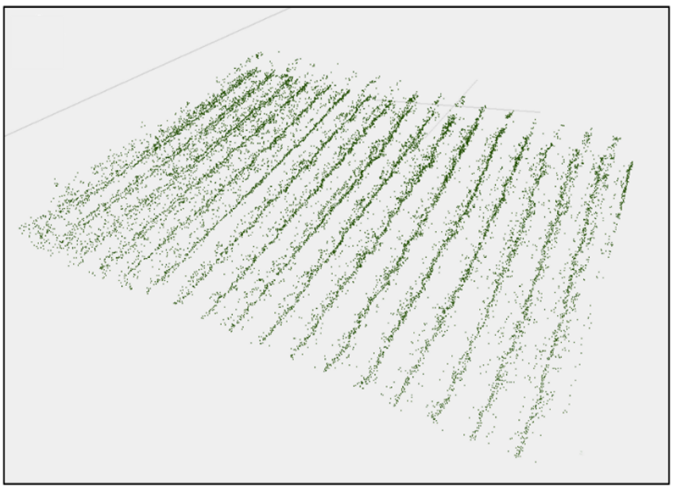
Figure 10. Representation of the tie points from the images detected by the UAV that represent the vineyard rows.
SfM technology is applied using unsupervised algorithms that enable the identification of image tie points in a fully automated form. The identification of tie points begins with the extraction of feature points (‘keypoints’) from each image using feature detection algorithms [221]. Using specific algorithms, point feature descriptor information is obtained for each extracted feature, which are numerical vectors describing the gradient trend in the neighbourhood of the point. The next step is feature matching [222]. Usually software is based on Euclidean distance calculation, which determines the similarity between two descriptors and classifies them, during this process a percentage of outliers can be found that is often not irrelevant, so it is necessary to identify geometrically consistent matching points by removing outliers using specific algorithms such as RANSAC (RANdom Sample Consensus) [223]. After this stage, the process involves performing Triangulation and Bundle Adjustment operations that iteratively add new points to the reconstruction. Subsequently, using specific algorithms, such as Multi-View Stereo (MVS) [224], which considers all the characteristic points of the scene, the dense point cloud is obtained, which allows the 3D geometry of the canopy to be constructed (Figure 11).
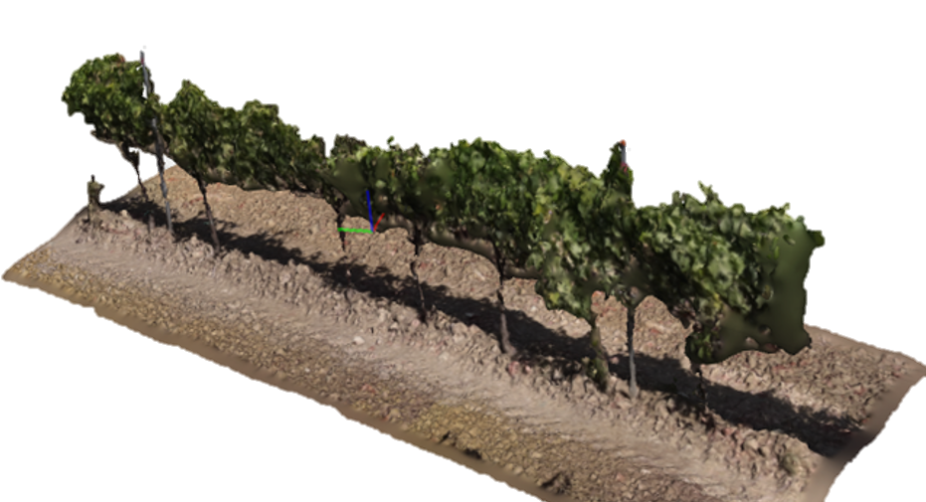
(a)
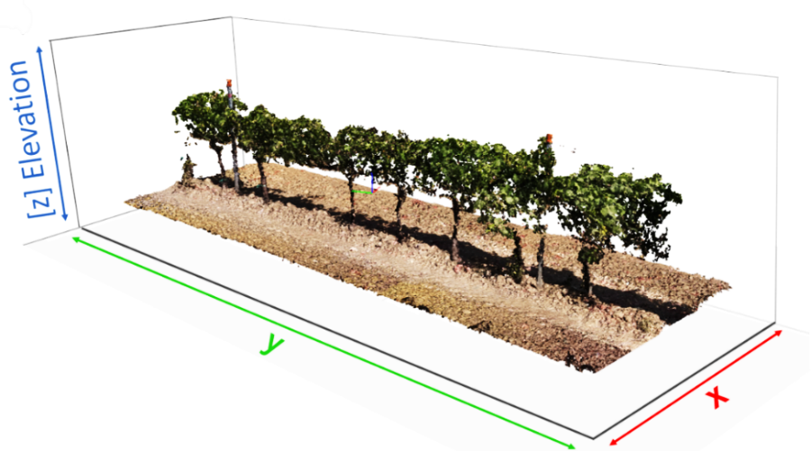
(b)

Figure 11. 3D model representation of a vineyard row processed using Agisoft Metashape Professional version 1.8.4 (Agisoft LLC, St. Petersburg, Russia), (a) depicts a 3D solid model of the row; (b) depicts the result of applying the model reconstruction algorithms.
One of the main issues of research interest in this area concerns the localisation of vine rows. Biglia et al., proposed an innovative 3D point cloud processing algorithm for the identification and automatic locations of rows within vineyard maps, based on the identification of key points and a clustering approach based on the density of these points [106]. This classification algorithm can locate vineyard rows in any layout or orientation, independent of the air sensor adopted to collect the data. The application of vineyard canopy 3D reconstructions is widely used in PV, especially in agronomic management, indeed, the method offers the opportunity to characterise the leaf area index (LAI) of the vine simply and fast, compared to manual methods that are laborious and time-consuming [225]. The use of 3D maps constructed from point clouds allow for very accurate leaf area estimation representative of the real condition, with R² values greater than 0.8 [105,226]. The estimation of leaf area allows modulating the vegetative-productive balance, together with other parameters such as, for example, the weight of pruning wood closely related to the variability of vine vigour. Some studies developed on the basis of the SfM method have provided interesting correlation results between vine canopy volume and pruning weight (R² range 0.56–0.71) [18]. The 3D models provide a detailed view of the vineyard rows and therefore these results can be used as input for autonomous driving of unmanned ground vehicles [227,228], and can provide useful information to carry out operations such as pruning in an automated form by bud detection [43].

5. Data Mining in Viticulture
The use of platforms previously presented makes it possible to collect a large amount of data and information. Various digital processes have been developed that fall under the heading of artificial intelligence, including computer vision, machine learning (ML) and deep learning (DL). The ML algorithms used in precision viticulture fall into two categories. Supervised learning is learning with a supervisor. These algorithms are developed based on a set of labelled data, organised in such a way that each input data is associated with an output data [229,230]. The most common supervised tasks are ‘classification’ which separates data and ‘regression’ which evaluates the relationship between two or more variables. Unsupervised learning differs from supervised learning algorithms, both in complexity and in the type of input data, indeed these allow for the prediction of missing outputs (labels) and allow for the identification of unknown elements by grouping them according to their similarity. Within the discipline of artificial intelligence, there is an area of study concerning DL, a subset of ML techniques allowed to learn from unlabelled or unstructured data [231]. DL networks have shown great advantages for feature extraction of complex, non-linear data [232]. The expression ‘deep’ refers to the many articulated layers in the neural network, this allows an advantage in analysing more complicated inputs including large datasets of images by automatically recognising the complexities of the structures embedded in the data [233].

5.1. Machine learning in Viticulture
The applications of ML in viticulture are many and primarily relate to regression and classification tasks, for example yield prediction, classification of vineyard components, weeds, disease detection, and grape quality. Vineyard yield forecasting has always been a main interest of winegrowers. Usually, yield forecasting is applied with traditional, manually performed, labor-intensive and time-consuming methods [234], resulting in an inaccurate result. In opposition to these estimation methods, crop simulation models have been developed, which allow the development of a vineyard yield forecast. Among ML methods, regression analysis is one of the most common methods. Among the best-known regression techniques are simple and multiple linear regression. These regression models have been applied in viticulture by considering multispectral vegetation indices that show good regression values of R² = 0.76 with good accuracy (RMSE = 1.2 kg vine⁻¹ and RE = 28.7%), similar results are obtained by considering canopy geometries R² = 0.69, evaluated in proximity to harvest. However, the combination of vegetation indices and the geometric approach is the most accurate model for predicting vineyard yield [19]. Among the supervised ML algorithms, non-parametric techniques based on kernel functions are applied, analysing the data for classification and regression analysis. One of the most widely used is an algorithm called support vector machine (SVM), which is one of the most robust prediction methods, based on statistical learning frameworks. The SVM algorithm can be applied to data sets that present a linear type of distribution or non-linear distributions, in the latter case mathematical Kernel functions have been introduced [235]. The most popular ones are Linear, then there are the Polynomial and Sigmoid functions and finally the gaussian radial basis function (RBF). The choice of kernel function usually depends on a-priori knowledge of the data set. Excellent prediction results have been obtained by considering SVM models (Gaussian exp GPR), using multispectral data (NDVI) as a dataset, which allow good yield prediction results with a lower error (RMSE % = 0.29–0.39), compared to the regression model (RMSE % = 0.42–0.44) [33]. Another type of models belonging to the group of supervised learning are Bayesian probabilistic models (BM). These processing models have been applied to the pixel classification of vine images. Bayesian decision-making based on joint modelling of colour and texture using multivariate Gaussian distributions identifying canopy and bunches in the vineyard, with a high level of accuracy [236]. Among the applications of unsupervised machine learning are several algorithms that allow image optimisation, detection, and classification processes in an automated form. These include Artificial Neural Networks (ANN), which are information processing systems whose operating mechanisms are inspired by biological neural circuits. An Artificial Neural Network has processing units that are interconnected in various ways through various architectures [237]. ANNs consist of units that are classified on several levels, in a neural network there is at minimum one level of input units, an intermediate level consisting of hidden units, and a level with output units [238]. Each unit or node in the network becomes active if the total amount of signal it receives is higher than the activation level, which is defined by a function called the activation function (f). If a node is activated, it emits a signal (y) that is transmitted along the transmission channels until it reaches the other units that it is connected to [239]. At each connecting node, it acts as a filter that transforms the message into an inhibitory or excitatory signal by increasing or decreasing its intensity [240]. Thus, the ANN connection points have the fundamental function of weighing the intensity of transmitted signals, multiplying them by specific intensities (w). The weights are real numbers, if the weight is positive, the channel is excitatory, if it is negative is inhibitory. The absolute value of a weight represents the strength of the connection. The output signal, namely the transmission of its activity to the outside world, is calculated by applying the activation function; these functions can be linear or non-linear [241]. The operation of an ANN depends on the network architecture, the activation function, and the weights, the first two parameters being fixed prior to the training phase. Commonly used learning algorithms in ANNs include the radial basis function networks [242], perceptron algorithms [243], back-propagation [244], and resilient back-propagation [245]. The results of the application of ANN for vineyard yield forecasting, considering parameters such as vegetation indices (VI) and vegetated fraction cover (Fc) allow for forecasting in early phenological periods with good results (R² = 0.8 and RMSE kg vine⁻¹ = 0.8), with more accurate results near harvest (R² = 0.9 and RMSE kg vine⁻¹ = 0.5) [19]. Behroozi-Khazaei and Maleki applied an image segmentation technique, separating the grape bunches from the leaves and background, applying ANN algorithms by accurately visualising the bunches, these methods can be used to efficiently predict grape yield [246]. Another research carried out by [20] in which yield prediction models based on regression analysis and artificial neural networks (ANN) were applied, using satellite images of time series, considering NDVI and LAI which had a very high accuracy in estimating yield (r = 0.79). The Random Forest is a classification algorithm consisting of a set of simple decision trees (DT) classifiers, represented as independent random vectors, this algorithm is trained from a random subset of the data in the training set [247]. The Random Forest is a particular method of ensamble learning, this concept is based on the combined use of several learning algorithms to obtain enhanced predictions. RF is used to classify RGB images, it classifies bunches and separates them from background vegetation. However, some authors remark that the algorithm cannot accurately identify overlapping clusters in the image [248]. In viticulture, there is a requirement to assess grape quality characteristics in addition to yield. Using different data acquisition platforms at different vine growth stages, excellent results have been found in predicting grape sugars with regression (ML) models that estimate grape composition with accuracy [30,137]. These grape composition prediction studies generally use ML algorithms that exploit non-linear, decision tree (DT) methods including the Random Forests algorithm [249]. ML applied for vineyard segmentation and classification to optimise vineyard management. Pádua et al., using only data derived from an RGB sensor obtained from UAVs, applying three machine learning techniques, support vector machine (SVM), random forest (RF) and artificial neural network (ANN), were able to classify the components present in the orthomosaics in vine, shade, soil and other vegetation [250]. In this study, the results show that the RF and ANN models performed equally, but the RF classifier was better. A further test performed by Pádua et al., considering RGB and multispectral data for vineyard classification using SVM algorithms; RF and ANN, shows that combining the two data sources can improve the classification result [58].

5.2. Deep Learning in Viticulture
An important problem in data analysis, or more specifically in computer vision, is object detection. Object detection consists of identifying and classifying objects in an image. In precision viticulture, these techniques are often applied to solve different agronomic problems, for instance to determine the vigour [251] or the weight of vine pruning [252], the evaluation of grape production [253]. In PV, such DL procedures are applied for the recognition of specific pathogens and pests, which cause diseases that reduce vineyard performance [254]. Object detection often makes use of deep learning, which is a recent and modern technique for image processing and data analysis [237]. The main architectures applied in deep learning there are recurrent neural networks, also known by the term RNN (Recurrent Neural Network), short and long term neural networks, also known by the term LSTM (Long Short Term Memory) and convolutional neural networks, also called CNN (Convolutional Neural Network) [90,255]. There are several platforms that provide the ability to develop neural networks, among them is GoogLeNet, created by Google [256], which introduced important improvements to convolutional neural networks, however, an optimisation of the latter is available, which is Inception v3 [257]. Other platforms used for image analysis are the convolutional neural networks ResNet-5 and ResNet-101 which are characterised by different levels of interconnection [258].
Another platform is SqueezeNet, which was created to simplify the architecture of traditional neural networks [259]. These platforms are characterised by varying levels of accuracy and complexity in visualising symptoms or effects on specific organs on the vine canopy [260]. Figure 12 shows a typical architecture of a Region-Based Convolutional Neural Network (R-CNN) which, by means of convolutional layers, transforms an image of raw pixels. A convolution is an operation between two functions of a variable that consists of integrating the result between the first and second function by a specific value. In image analysis, one function is the input values, represented by the raw pixels at an image position, while the second function is a filter, these are represented as number matrices [261]. These number matrices of the two functions are multiplied by each other, this calculation is repeated until the entire image is covered, at the end an output is obtained. This output is called a feature map (or activation map), it is a map of the points where the filter is strongly activated and ‘sees’ an obvious feature of the image. In subsequent layers, these features become progressively stronger and more obvious. These feature maps become input for the next level of the CNN architecture [262]. The next layer of the architecture is the rectified linear unit (ReLU), this is an activation function that returns zero if it receives a negative input from a neuron, but for any positive value it returns a value. The pooling layer is embedded between the convolution and ReLU layers to reduce the number of parameters to be calculated and simplify image analysis, in other words it summarises the strongest activations in each image context. The final layer of a CNN is the fully connected layer, every neuron in the previous layer is connected to every neuron in the latter layer of the architecture [263]. In this level, scores or class probabilities are assigned, thus placing the input in the class with the highest probability [264]. To overcome the disadvantages in the process of image analysis using DL techniques, better performing methods have been proposed such as, for example, the R-CNN method [265] which uses a selective search method [266]. This method extracts only specific regions from the images, which are also called Region Proposal Network (RPN). Each region proposal is then transformed into an image of fixed size by scaling and then applied to the pre-trained convolutional neural network model, this first step is responsible for the generation of regions of interest (RoI). Deep learning techniques such as CNNs help to obtain models that classify images with high accuracy, for instance to detect and differentiate symptoms of certain vine diseases. Gutiérrez et al., using RGB images of grapevine leaves achieved an accuracy of 0.94 in simultaneously classifying leaves with downy mildew, spider mite and without symptoms, demonstrating the effectiveness of deep learning techniques [267]. Kerkech et al.,proposed a methodology for the automatic detection of grapevine disease symptoms using images in the visible domain acquired by UAV [46]. In the study, the performance of CNNs is evaluated using combinations of different colour spaces and vegetation indices, with a result accuracy of over 95.8%. The object detection performed by the R-CNN algorithms is very accurate; however, these models suffer from a slow recognition rate and a complex computational system. Recently, a faster model in the recognition process has been developed, this is the “You Only Look Once” network also better known as YOLO introduced in 2016 da Redmon et al., [268]. This network consists of 24 convolutional layers, followed by 2 fully interconnected layers. This high speed of object recognition is due to the use of the Single Shot Detector (SSD) process in the network. YOLO does not divide the recognition into several stages but predicts a bounding box (a square within the image whose centre is the recognised object), the probability and classes of the objects in the input image in a single stage. The training of YOLO is divided into two phases, a first pre-training phase, during which only the deeper layers are trained, and a second training phase involving the entire network. YOLO detection algorithms are diversified according to their accuracy and speed in detecting objects, the ones most used in PV being YOLOv3, YOLOv4 and YOLOv5. For example, many studies referring to bunch detection using the YOLO model, show varying accuracy values, using YOLOv5 values of 0.76 were obtained [36], other authors processing the YOLOv4 algorithm obtain a high prediction value of up to 0.90 [269]. Finally, the YOLOv3 and YOLOv2 algorithms show lower prediction performance than their counterparts, indeed Santos et al., obtain cluster number prediction values (0.60) for YOLOv3 and slightly better for YOLOv2, however, the authors report that the Mask R-CNN model shows that the maximum prediction values are around 0.80, which is a considerable improvement [270]. This convolutional neural network model (Mask R-CNN) provided good object detection performance even in early phenological periods, such as at flowering, where due to the dense distribution of flowers, and the similar colour shade of all plant parts, it can be complicated to obtain acceptable results, however, Rahim et al., apply segmentation and inflorescence detection reporting significant performance of the algorithm (0.94) [271]. Yield prediction using image analysis of grape bunches or other reproductive organs, with DL algorithms, can report variable prediction results as there are several variables that affect the result, for instance image resolution, or the presence or absence of vegetative elements such as leaves or shoots that induce greater or lower bunch occlusion [272]. The accurate recognition of grape bunches using DL techniques is very important as it enables, for instance, robotic harvesting and overall a new solution for precision harvesting in viticulture [39].
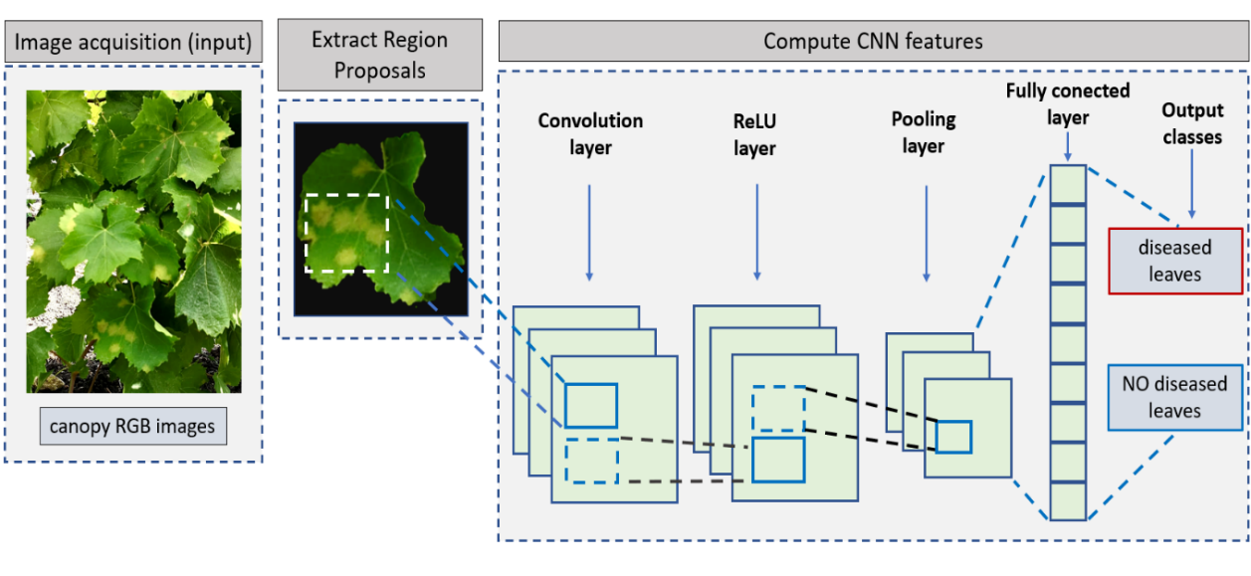
Figure 12. Structure of the segmentation method for diseased vine leaves applied using Mask R-CNN.

6. Conclusions
This review presented the sensors and platforms applied to detect the spatial variability of the vineyard, presenting the main methods of data collection and processing. In this study, the distribution of sensor use in PV is shown, highlighting that multispectral sensors are the most widely used, followed by surveys with sensors operating in hyperspectral, visible, thermal and laser altimetry. The use of proximal and remote sensing platforms depends on the type of survey to be performed, and the information to be obtained. The applications that can be conducted in the vineyard, with proximal sensors, are possible to assess the physiological status of the vine, monitoring the content of chlorophyll pigments by means of sensors that assess fluorescence, or with more high-performance hyperspectral sensors that provide the entire spectral signature of the plant, or multispectral sensors. From these surveys, in addition to assessing the physiological state of the vineyard, we can obtain further information regarding, for example, the water status, either by means of hyperspectral or thermal technology. While proximal sensors provide good results, carrying out surveys with these sensors can be time-consuming and inefficient if done manually, or laborious if done using agricultural tractors. In this context, to increase efficiency and, above all, the speed of surveying operations in the vineyard, there are remote sensing platforms that allow very large survey areas to be sampled in a short time, ensuring a certain level of accuracy. The information obtained through these instruments, which are characterised by varying technological complexity, must be processed according to specific procedures and methods. For example, pre-processing steps such as radiometric correction and georeferencing of images are essential for data obtained via remote sensing platforms. Equally important are methods of extracting image features, in which various image analysis procedures are reported that allow high-resolution images to be segmented and classified. These surveys are conducted using various platforms, employed with different observation points and at varying distances from the target object, which may be the canopy of the vineyard as a whole or specific vegetative elements such as leaves, shoots or bunches or berries. Thus, both proximal survey data and image analysis provide large amounts of data and information that require advanced analysis methods and procedures. In PV, artificial intelligence techniques need to be implemented, so machine learning procedures need to be carried out, both with supervised and unsupervised methods. In addition to these procedures, deep learning methods are often applied lately, which solve complex classification and detection problems with good accuracy. From the articles reviewed, it is evident that research follows these methods and algorithms; however, it must be noted that operational methods are still scarce, and in the future, it is planned to implement these object recognition algorithms on platforms such as unmanned ground vehicles. Currently, the main applications are in the vegetative growth monitoring, yield estimation, disease control, nutrition mapping and water status monitoring. However, the outputs of monitoring represent the basic material for planning the agronomic treatments to be applied to make grape production homogenous both qualitatively and quantitatively. Variable-rate vineyard management, and thus decisions on input application, are directly related to vineyard variability. The adoption of the IsoBus system on tractors has made it possible to develop standardised communication between the operating machine and the equipment that applies differentiated tillage or distribution according to the parameters in the prescription maps. These are georeferenced maps that subdivide the vineyard into management zones (MZs) or areas of uniform conditions, allowing for variable application of fertiliser elements, crop protection products or simply tillage. Prescription maps are usually polygonal maps, in which spatially variable distribution information is included in each map element. These technological advances enable site-specific agronomic management, respecting the agronomic requirements of the vineyard, reducing management costs, and implementing environmental sustainability. Furthermore, the development of UGV platforms such as robots could simplify cultivation operations and make them more efficient, such as weed control, soil tillage, harvesting and plant protection. These aspects are part of the goals promoted by the United Nations through the Agenda 2030 document, which is based on supporting innovation and technological progress to promote sustainable consumption and production patterns. Ultimately, considering the extensive scientific literature reviewed, it is possible to define future scenarios that will influence viticulture. For example, as far as computer vision techniques for monitoring are involved, there are few experiments conducted in real time under field conditions. In the future, therefore, efforts should be made to develop image processing algorithms that perform these processes rapidly, providing detailed results in real time in the field. Specific image processing devices, based on automatic and not overly complicated technologies, will ensure rapid deployment among farmers. Exploiting technologies such as IoT, a rapid interconnection between different technologies, such as UAV, UGV, or weather stations, will relay comprehensive information in real-time, for farmers or robotic platforms capable to perform specific agronomic tasks.
Author Contributions: Conceptualization, M.V.F. and P.C.; methodology, M.V.F. and P.C.; software, M.V.F.; validation, M.V.F., and P.C.; investigation, M.V.F.; resources, M.V.F. and P.C.; data curation, M.V.F.; writing—original draft preparation, M.V.F.; writing—review and editing, M.V.F. and P.C.; visualization, M.V.F. and P.C.; supervision, P.C.; project administration, P.C.; All authors have read and agreed to the published version of the manuscript.
Funding: This research received no external funding.
Data Availability Statement: The data presented in this study are available on request from the corresponding author.
Conflicts of Interest: The authors declare no conflict of interest.

7. References
- Villa-Henriksen, A.; Edwards, G.T.; Pesonen, L.A.; Green, O.; Sørensen, C.A.G. Internet of Things in Arable Farming: Implementation, Applications, Challenges and Potential. Biosyst. Eng. 2020, 191, 60–84.
- Khan, N.; Ray, R.L.; Kassem, H.S.; Hussain, S.; Zhang, S.; Khayyam, M.; Ihtisham, M.; Asongu, S.A. Potential Role of Technology Innovation in Transformation of Sustainable Food Systems: A Review. Agriculture 2021, 11, 984.
- Lajoie-O’Malley, A.; Bronson, K.; van der Burg, S.; Klerkx, L. The Future (s) of Digital Agriculture and Sustainable Food Systems: An Analysis of High-Level Policy Documents. Ecosyst. Serv. 2020, 45, 101183.
- Pisciotta, A.; Barone, E.; Di Lorenzo, R. Table-Grape Cultivation in Soil-Less Systems: A Review. Horticulturae 2022, 8, 553.
- OIV. OIV—International Organisation of Vine and Wine—Intergovernmental Organisation; International Organisation of Vine and Wine: Dijon, France, 2022.
- Lal, R. 16 Challenges and Opportunities in Precision Agriculture. Soil-Specif. Farming: Precis. Agric. 2015, 22, 391.
- Bramley, R.; Proffitt, A. Managing Variability in Viticultural Production. Grapegrow. Winemak. 1999, 427, 11–16.
- Santesteban, L.G. Precision Viticulture and Advanced Analytics. A Short Review. Food Chem. 2019, 279, 58–62.
- Marucci, A.; Colantoni, A.; Zambon, I.; Egidi, G. Precision Farming in Hilly Areas: The Use of Network RTK in GNSS Technology. Agriculture 2017, 7, 60.
- Catania, P.; Comparetti, A.; Febo, P.; Morello, G.; Orlando, S.; Roma, E.; Vallone, M. Positioning Accuracy Comparison of GNSS Receivers Used for Mapping and Guidance of Agricultural Machines. Agronomy 2020, 10, 924.
- Pérez-Expósito, J.P.; Fernández-Caramés, T.M.; Fraga-Lamas, P.; Castedo, L. An IoT Monitoring System for Precision Viticulture. In Proceedings of the 2017 IEEE International Conference on Internet of Things (iThings) and IEEE Green Computing and Communications (GreenCom) and IEEE Cyber, Physical and Social Computing (CPSCom) and IEEE Smart Data (SmartData), Exeter, UK, 21–23 June 2017; pp. 662–669.
- Bañón, S.; Álvarez, S.; Bañón, D.; Ortuño, M.F.; Sánchez-Blanco, M.J. Assessment of Soil Salinity Indexes Using Electrical Conductivity Sensors. Sci. Hortic. 2021, 285, 110171.
- Lei, F.; Crow, W.T.; Kustas, W.P.; Dong, J.; Yang, Y.; Knipper, K.R.; Anderson, M.C.; Gao, F.; Notarnicola, C.; Greifeneder, F. Data Assimilation of High-Resolution Thermal and Radar Remote Sensing Retrievals for Soil Moisture Monitoring in a Drip-Irrigated Vineyard. Remote Sens. Environ. 2020, 239, 111622.
- Dobrowski, S.; Ustin, S.; Wolpert, J. Grapevine Dormant Pruning Weight Prediction Using Remotely Sensed Data. Aust. J. Grape Wine Res. 2003, 9, 177–182.
- Rey-Caramés, C.; Diago, M.P.; Martín, M.P.; Lobo, A.; Tardaguila, J. Using RPAS Multi-Spectral Imagery to Characterise Vigour, Leaf Development, Yield Components and Berry Composition Variability within a Vineyard. Remote Sens. 2015, 7, 14458–14481.
- Caruso, G.; Tozzini, L.; Rallo, G.; Primicerio, J.; Moriondo, M.; Palai, G.; Gucci, R. Estimating Biophysical and Geometrical Parameters of Grapevine Canopies (‘Sangiovese’) by an Unmanned Aerial Vehicle (UAV) and VIS-NIR Cameras. Vitis 2017, 56, 63–70.
- Di Gennaro, S.F.; Matese, A. Evaluation of Novel Precision Viticulture Tool for Canopy Biomass Estimation and Missing Plant Detection Based on 2.5 D and 3D Approaches Using RGB Images Acquired by UAV Platform. Plant Methods 2020, 16, 1–12.
- García-Fernández, M.; Sanz-Ablanedo, E.; Pereira-Obaya, D.; Rodríguez-Pérez, J.R. Vineyard Pruning Weight Prediction Using 3D Point Clouds Generated from UAV Imagery and Structure from Motion Photogrammetry. Agronomy 2021, 11, 2489.
- Ballesteros, R.; Intrigliolo, D.S.; Ortega, J.F.; Ramírez-Cuesta, J.M.; Buesa, I.; Moreno, M.A. Vineyard Yield Estimation by Combining Remote Sensing, Computer Vision and Artificial Neural Network Techniques. Precis. Agric. 2020, 21, 1242–1262.
- Arab, S.T.; Noguchi, R.; Matsushita, S.; Ahamed, T. Prediction of Grape Yields from Time-Series Vegetation Indices Using Satellite Remote Sensing and a Machine-Learning Approach. Remote Sens. Appl. Soc. Environ. 2021, 22, 100485.
- Subeesh, A.; Mehta, C. Automation and Digitization of Agriculture Using Artificial Intelligence and Internet of Things. Artif. Intell. Agric. 2021, 5, 278–291.
- Gubbi, J.; Buyya, R.; Marusic, S.; Palaniswami, M. Internet of Things (IoT): A Vision, Architectural Elements, and Future Directions. Future Gener. Comput. Syst. 2013, 29, 1645–1660.
- Sarker, I.H. Deep Learning: A Comprehensive Overview on Techniques, Taxonomy, Applications and Research Directions. SN Comput. Sci. 2021, 2, 1–20.
- Van Klompenburg, T.; Kassahun, A.; Catal, C. Crop Yield Prediction Using Machine Learning: A Systematic Literature Review. Comput. Electron. Agric. 2020, 177, 105709.
- Grimm, J.; Herzog, K.; Rist, F.; Kicherer, A.; Toepfer, R.; Steinhage, V. An Adaptable Approach to Automated Visual Detection of Plant Organs with Applications in Grapevine Breeding. Biosyst. Eng. 2019, 183, 170–183.
- Guo, Y.; Chen, S.; Li, X.; Cunha, M.; Jayavelu, S.; Cammarano, D.; Fu, Y. Machine Learning-Based Approaches for Predicting SPAD Values of Maize Using Multi-Spectral Images. Remote Sens. 2022, 14, 1337.
- Yalcin, H. Phenology Recognition Using Deep Learning. In Proceedings of the 2018 Electric Electronics, Computer Science, Biomedical Engineerings' Meeting (EBBT), Istanbul, Turkey, 18–19 April 2018; pp. 1–5.
- Franczyk, B.; Hernes, M.; Kozierkiewicz, A.; Kozina, A.; Pietranik, M.; Roemer, I.; Schieck, M. Deep Learning for Grape Variety Recognition. Procedia Comput. Sci. 2020, 176, 1211–1220.
- Kangune, K.; Kulkarni, V.; Kosamkar, P. Grapes Ripeness Estimation Using Convolutional Neural Network and Support Vector Machine. In Proceedings of the 2019 Global Conference for Advancement in Technology (GCAT), Bangalore, India, 18–20 October 2019; pp. 1–5.
- Kasimati, A.; Espejo-García, B.; Darra, N.; Fountas, S. Predicting Grape Sugar Content under Quality Attributes Using Normalized Difference Vegetation Index Data and Automated Machine Learning. Sensors 2022, 22, 3249.
- Ramos, R.P.; Gomes, J.S.; Prates, R.M.; Simas Filho, E.F.; Teruel, B.J.; dos Santos Costa, D. Non‐invasive Setup for Grape Maturation Classification Using Deep Learning. J. Sci. Food Agric. 2021, 101, 2042–2051.
- Carrillo, E.; Matese, A.; Rousseau, J.; Tisseyre, B. Use of Multi-Spectral Airborne Imagery to Improve Yield Sampling in Viticulture. Precis. Agric. 2016, 17, 74–92.
- Matese, A.; Di Gennaro, S.F. Beyond the Traditional NDVI Index as a Key Factor to Mainstream the Use of UAV in Precision Viticulture. Sci. Rep. 2021, 11, 1–13.
- Aquino, A.; Barrio, I.; Diago, M.-P.; Millan, B.; Tardaguila, J. VitisBerry: An Android-Smartphone Application to Early Evaluate the Number of Grapevine Berries by Means of Image Analysis. Comput. Electron. Agric. 2018, 148, 19–28.
- Liu, B.; Ding, Z.; Tian, L.; He, D.; Li, S.; Wang, H. Grape Leaf Disease Identification Using Improved Deep Convolutional Neural Networks. Front. Plant Sci. 2020, 11, 1082.
- Sozzi, M.; Cantalamessa, S.; Cogato, A.; Kayad, A.; Marinello, F. Automatic Bunch Detection in White Grape Varieties Using YOLOv3, YOLOv4, and YOLOv5 Deep Learning Algorithms. Agronomy 2022, 12, 319.
- Tardaguila, J.; Diago, M.; Blasco, J.; Millán, B.; Cubero, S.; García-Navarrete, O.; Aleixos, N. Automatic Estimation of the Size and Weight of Grapevine Berries by Image Analysis. Proc. CIGR AgEng,2012, 35, 230–239.
- Torres-Sánchez, J.; Mesas-Carrascosa, F.J.; Santesteban, L.-G.; Jiménez-Brenes, F.M.; Oneka, O.; Villa-Llop, A.; Loidi, M.; López-Granados, F. Grape Cluster Detection Using UAV Photogrammetric Point Clouds as a Low-Cost Tool for Yield Forecasting in Vineyards. Sensors 2021, 21, 3083.
- Wang, J.; Zhang, Z.; Luo, L.; Zhu, W.; Chen, J.; Wang, W. SwinGD: A Robust Grape Bunch Detection Model Based on Swin Transformer in Complex Vineyard Environment. Horticulturae 2021, 7, 492.
- Zabawa, L.; Kicherer, A.; Klingbeil, L.; Töpfer, R.; Kuhlmann, H.; Roscher, R. Counting of Grapevine Berries in Images via Semantic Segmentation Using Convolutional Neural Networks. ISPRS J. Photogramm. Remote Sens. 2020, 164, 73–83.
- Gao, R.; Torres-Rua, A.F.; Aboutalebi, M.; White, W.A.; Anderson, M.; Kustas, W.P.; Agam, N.; Alsina, M.M.; Alfieri, J.; Hipps, L. LAI Estimation across California Vineyards Using SUAS Multi-Seasonal Multi-Spectral, Thermal, and Elevation Information and Machine Learning. Irrig. Sci. 2022, 40, 1–29.
- Ilniyaz, O.; Kurban, A.; Du, Q. Leaf Area Index Estimation of Pergola-Trained Vineyards in Arid Regions Based on UAV RGB and Multispectral Data Using Machine Learning Methods. Remote Sens. 2022, 14, 415.
- Díaz, C.A.; Pérez, D.S.; Miatello, H.; Bromberg, F. Grapevine Buds Detection and Localization in 3D Space Based on Structure from Motion and 2D Image Classification. Comput. Ind. 2018, 99, 303–312.
- Pérez, D.S.; Bromberg, F.; Diaz, C.A. Image Classification for Detection of Winter Grapevine Buds in Natural Conditions Using Scale-Invariant Features Transform, Bag of Features and Support Vector Machines. Comput. Electron. Agric. 2017, 135, 81–95.
- Waghmare, H.; Kokare, R.; Dandawate, Y. Detection and Classification of Diseases of Grape Plant Using Opposite Colour Local Binary Pattern Feature and Machine Learning for Automated Decision Support System. In Proceedings of the 2016 3rd International Conference on Signal Processing and Integrated Networks (SPIN), Noida, India, 11–12 February 2016; pp. 513–518.
- Kerkech, M.; Hafiane, A.; Canals, R. Deep Leaning Approach with Colorimetric Spaces and Vegetation Indices for Vine Diseases Detection in UAV Images. Comput. Electron. Agric. 2018, 155, 237–243.
- Verdugo-Vásquez, N.; Villalobos-Soublett, E.; Gutiérrez-Gamboa, G.; Araya-Alman, M. Spatial Variability of Production and Quality in Table Grapes ‘Flame Seedless’ Growing on a Flat Terrain and Slope Site. Horticulturae 2021, 7, 254.
- Zakeri, F.; Mariethoz, G. A Review of Geostatistical Simulation Models Applied to Satellite Remote Sensing: Methods and Applications. Remote Sens. Environ. 2021, 259, 112381.
- Bramley, R. Progress in the Development of Precision Viticulture-Variation in Yield, Quality and Soil Proporties in Contrasting Australian Vineyards; Fertilizer and Lime Research Centre: Palmerston North, New Zealand, 2001.
- Campos, J.; Gallart, M.; Llop, J.; Ortega, P.; Salcedo, R.; Gil, E. On-Farm Evaluation of Prescription Map-Based Variable Rate Application of Pesticides in Vineyards. Agronomy 2020, 10, 102.
- Sozzi, M.; Bernardi, E.; Kayad, A.; Marinello, F.; Boscaro, D.; Cogato, A.; Gasparini, F.; Tomasi, D. On-the-Go Variable Rate Fertilizer Application on Vineyard Using a Proximal Spectral Sensor. In Proceedings of the 2020 IEEE International Workshop on Metrology for Agriculture and Forestry (MetroAgriFor), Trento, Italy, 4–6 November 2020; pp. 343–347.
- Wandkar, S.V.; Bhatt, Y.C.; Jain, H.; Nalawade, S.M.; Pawar, S.G. Real-Time Variable Rate Spraying in Orchards and Vineyards: A Review. J. Inst. Eng. Ser. A 2018, 99, 385–390.
- Snyder, H. Literature Review as a Research Methodology: An Overview and Guidelines. J. Bus. Res. 2019, 104, 333–339.
- Nijland, W.; De Jong, R.; De Jong, S.M.; Wulder, M.A.; Bater, C.W.; Coops, N.C. Monitoring Plant Condition and Phenology Using Infrared Sensitive Consumer Grade Digital Cameras. Agric. For. Meteorol. 2014, 184, 98–106.
- Lesser, M. Charge Coupled Device (CCD) Image Sensors. In High Performance Silicon Imaging; Elsevier: Amsterdam, The Netherlands, 2014; pp. 78–97.
- Arya, S.K.; Wong, C.C.; Jeon, Y.J.; Bansal, T.; Park, M.K. Advances in Complementary-Metal–Oxide–Semiconductor-Based Integrated Biosensor Arrays. Chem. Rev. 2015, 115, 5116–5158.
- Verde, N.; Mallinis G, Tsakiri-Strati, M.; Georgiadis, C.; Patias, P. Assessment of radiometric resolution impact on remote sensing data classification accuracy. Remote Sensing. 2018, 10, 1267.
- Pádua, L.; Matese, A.; Di Gennaro, S.F.; Morais, R.; Peres, E.; Sousa, J.J. Vineyard Classification Using OBIA on UAV-Based RGB and Multispectral Data: A Case Study in Different Wine Regions. Comput. Electron. Agric. 2022, 196, 106905.
- Kitić, G.; Tagarakis, A.; Cselyuszka, N.; Panić, M.; Birgermajer, S.; Sakulski, D.; Matović, J. A New Low-Cost Portable Multispectral Optical Device for Precise Plant Status Assessment. Comput. Electron. Agric. 2019, 162, 300–308.
- Guo, Y.; Senthilnath, J.; Wu, W.; Zhang, X.; Zeng, Z.; Huang, H. Radiometric Calibration for Multispectral Camera of Different Imaging Conditions Mounted on a UAV Platform. Sustainability 2019, 11, 978.
- Amigo, J.M.; Martí, I.; Gowen, A. Hyperspectral Imaging and Chemometrics: A Perfect Combination for the Analysis of Food Structure, Composition and Quality. In Data Handling in Science and Technology; Elsevier: Amsterdam, The Netherlands, 2013; Volume 28, pp. 343–370, ISBN 0922-3487.
- Thenkabail, P.S.; Teluguntla, P.; Gumma, M.K.; Dheeravath, V. Hyperspectral Remote Sensing for Terrestrial Applications. In Land Resources Monitoring, Modeling, and Mapping with Remote Sensing; CRC Press: Boca Raton, FL, USA, 2015; pp. 201–233.
- Wieme, J.; Mollazade, K.; Malounas, I.; Zude-Sasse, M.; Zhao, M.; Gowen, A.; Argyropoulos, D.; Fountas, S.; Van Beek, J. Application of Hyperspectral Imaging Systems and Artificial Intelligence for Quality Assessment of Fruit, Vegetables and Mushrooms: A Review. Biosyst. Eng. 2022, 222, 156–176.
- Yang, G.; Li, C.; Wang, Y.; Yuan, H.; Feng, H.; Xu, B.; Yang, X. The DOM Generation and Precise Radiometric Calibration of a UAV-Mounted Miniature Snapshot Hyperspectral Imager. Remote Sens. 2017, 9, 642.
- Loggenberg, K.; Strever, A.; Greyling, B.; Poona, N. Modelling Water Stress in a Shiraz Vineyard Using Hyperspectral Imaging and Machine Learning. Remote Sens. 2018, 10, 202.
- Pôças, I.; Rodrigues, A.; Gonçalves, S.; Costa, P.M.; Gonçalves, I.; Pereira, L.S.; Cunha, M. Predicting Grapevine Water Status Based on Hyperspectral Reflectance Vegetation Indices. Remote Sens. 2015, 7, 16460–16479.
- Fernández-Novales, J.; Barrio, I.; Diago, M.P. Non-Invasive Monitoring of Berry Ripening Using on-the-Go Hyperspectral Imaging in the Vineyard. Agronomy 2021, 11, 2534.
- Gao, Z.; Khot, L.R.; Naidu, R.A.; Zhang, Q. Early Detection of Grapevine Leafroll Disease in a Red-Berried Wine Grape Cultivar Using Hyperspectral Imaging. Comput. Electron. Agric. 2020, 179, 105807.
- Nguyen, C.; Sagan, V.; Maimaitiyiming, M.; Maimaitijiang, M.; Bhadra, S.; Kwasniewski, M.T. Early Detection of Plant Viral Disease Using Hyperspectral Imaging and Deep Learning. Sensors 2021, 21, 742.
- Pérez Roncal, C.; Arazuri Garín, S.; López Molina, C.; Jarén Ceballos, C.; Santesteban García, G.; López Maestresalas, A. Exploring the Potential of Hyperspectral Imaging to Detect Esca Disease Complex in Asymptomatic Grapevine Leaves. Comput. Electron. Agric. 2022, 196, 1–12.
- Bendel, N.; Kicherer, A.; Backhaus, A.; Köckerling, J.; Maixner, M.; Bleser, E.; Klück, H.-C.; Seiffert, U.; Voegele, R.T.; Töpfer, R. Detection of Grapevine Leafroll-Associated Virus 1 and 3 in White and Red Grapevine Cultivars Using Hyperspectral Imaging. Remote Sens. 2020, 12, 1693.
- Santesteban, L.; Di Gennaro, S.; Herrero-Langreo, A.; Miranda, C.; Royo, J.; Matese, A. High-Resolution UAV-Based Thermal Imaging to Estimate the Instantaneous and Seasonal Variability of Plant Water Status within a Vineyard. Agric. Water Manag. 2017, 183, 49–59.
- Berni, J.A.; Zarco-Tejada, P.J.; Suárez, L.; Fereres, E. Thermal and Narrowband Multispectral Remote Sensing for Vegetation Monitoring from an Unmanned Aerial Vehicle. IEEE Trans. Geosci. Remote Sens. 2009, 47, 722–738.
- Jackson, R.D.; Kustas, W.P.; Choudhury, B.J. A Reexamination of the Crop Water Stress Index. Irrig. Sci. 1988, 9, 309–317.
- Lowe, T.; Moghadam, P.; Edwards, E.; Williams, J. Canopy Density Estimation in Perennial Horticulture Crops Using 3D Spinning Lidar SLAM. J. Field Robot. 2021, 38, 598–618.
- Mallet, C.; Bretar, F. Full-Waveform Topographic Lidar: State-of-the-Art. ISPRS J. Photogramm. Remote Sens. 2009, 64, 1–16.
- Flood, M. LiDAR Activities and Research Priorities in the Commercial Sector. Int. Arch. Photogramm. Remote Sens. Spat. Inf. Sci. 2001, 34, 3–8.
- Miltiadou, M.; Grant, M.G.; Campbell, N.D.; Warren, M.; Clewley, D.; Hadjimitsis, D.G. Open Source Software DASOS: Efficient Accumulation, Analysis, and Visualisation of Full-Waveform Lidar; SPIE: Bellingham, WA, USA, 2019; Volume 11174, pp. 524–540.
- Raj, T.; Hanim Hashim, F.; Baseri Huddin, A.; Ibrahim, M.F.; Hussain, A. A Survey on LiDAR Scanning Mechanisms. Electronics 2020, 9, 741.
- Chakraborty, M.; Khot, L.R.; Sankaran, S.; Jacoby, P.W. Evaluation of Mobile 3D Light Detection and Ranging Based Canopy Mapping System for Tree Fruit Crops. Comput. Electron. Agric. 2019, 158, 284–293.
- Tagarakis, A.; Koundouras, S.; Fountas, S.; Gemtos, T. Evaluation of the Use of LIDAR Laser Scanner to Map Pruning Wood in Vineyards and Its Potential for Management Zones Delineation. Precis. Agric. 2018, 19, 334–347.
- Cheraiet, A.; Naud, O.; Carra, M.; Codis, S.; Lebeau, F.; Taylor, J. Predicting the Site-Specific Distribution of Agrochemical Spray Deposition in Vineyards at Multiple Phenological Stages Using 2D LiDAR-Based Primary Canopy Attributes. Comput. Electron. Agric. 2021, 189, 106402.
- Mahmud, M.S.; Zahid, A.; He, L.; Choi, D.; Krawczyk, G.; Zhu, H.; Heinemann, P. Development of a LiDAR-Guided Section-Based Tree Canopy Density Measurement System for Precision Spray Applications. Comput. Electron. Agric. 2021, 182, 106053.
- Khaliq, A.; Comba, L.; Biglia, A.; Ricauda Aimonino, D.; Chiaberge, M.; Gay, P. Comparison of Satellite and UAV-Based Multispectral Imagery for Vineyard Variability Assessment. Remote Sens. 2019, 11, 436.
- Giovos, R.; Tassopoulos, D.; Kalivas, D.; Lougkos, N.; Priovolou, A. Remote Sensing Vegetation Indices in Viticulture: A Critical Review. Agriculture 2021, 11, 457.
- Stoll, E.; Konstanski, H.; Anderson, C.; Douglass, K.; Oxfort, M. The RapidEye Constellation and Its Data Products. In Proceedings of the 2012 IEEE Aerospace Conference, Big Sky, MT, USA, 3–10 March 2012; pp. 1–9.
- Yang, C. High Resolution Satellite Imaging Sensors for Precision Agriculture. Front. Agric. Sci. Eng. 2018, 5, 393–405.
- Cheng, T.; Ji, X.; Yang, G.; Zheng, H.; Ma, J.; Yao, X.; Zhu, Y.; Cao, W. DESTIN: A New Method for Delineating the Boundaries of Crop Fields by Fusing Spatial and Temporal Information from WorldView and Planet Satellite Imagery. Comput. Electron. Agric. 2020, 178, 105787.
- Varghese, D.; Radulović, M.; Stojković, S.; Crnojević, V. Reviewing the Potential of Sentinel-2 in Assessing the Drought. Remote Sens. 2021, 13, 3355.
- Zhao, L.; Li, Q.; Zhang, Y.; Wang, H.; Du, X. Integrating the Continuous Wavelet Transform and a Convolutional Neural Network to Identify Vineyard Using Time Series Satellite Images. Remote Sens. 2019, 11, 2641.
- Sun, L.; Gao, F.; Anderson, M.C.; Kustas, W.P.; Alsina, M.M.; Sanchez, L.; Sams, B.; McKee, L.; Dulaney, W.; White, W.A. Daily Mapping of 30 m LAI and NDVI for Grape Yield Prediction in California Vineyards. Remote Sens. 2017, 9, 317.
- Semmens, K.A.; Anderson, M.C.; Kustas, W.P.; Gao, F.; Alfieri, J.G.; McKee, L.; Prueger, J.H.; Hain, C.R.; Cammalleri, C.; Yang, Y. Monitoring Daily Evapotranspiration over Two California Vineyards Using Landsat 8 in a Multi-Sensor Data Fusion Approach. Remote Sens. Environ. 2016, 185, 155–170.
- Knipper, K.R.; Kustas, W.P.; Anderson, M.C.; Alsina, M.M.; Hain, C.R.; Alfieri, J.G.; Prueger, J.H.; Gao, F.; McKee, L.G.; Sanchez, L.A. Using High-Spatiotemporal Thermal Satellite ET Retrievals for Operational Water Use and Stress Monitoring in a California Vineyard. Remote Sens. 2019, 11, 2124.
- Ohana-Levi, N.; Knipper, K.; Kustas, W.P.; Anderson, M.C.; Netzer, Y.; Gao, F.; Alsina, M.d.M.; Sanchez, L.A.; Karnieli, A. Using Satellite Thermal-Based Evapotranspiration Time Series for Defining Management Zones and Spatial Association to Local Attributes in a Vineyard. Remote Sens. 2020, 12, 2436.
- Alkassem, M.; Buis, S.; Coulouma, G.; Jacob, F.; Lagacherie, P.; Prévot, L. Estimating Soil Available Water Capacity within a Mediterranean Vineyard Watershed Using Satellite Imagery and Crop Model Inversion. Geoderma 2022, 425, 116081.
- Silvero, N.E.Q.; Di Raimo, L.A.D.L.; Pereira, G.S.; De Magalhães, L.P.; da Silva Terra, F.; Dassan, M.A.A.; Salazar, D.F.U.; Demattê, J.A. Effects of Water, Organic Matter, and Iron Forms in Mid-IR Spectra of Soils: Assessments from Laboratory to Satellite-Simulated Data. Geoderma 2020, 375, 114480.
- Tang, T.; Radomski, M.; Stefan, M.; Perrelli, M.; Fan, H. UAV-Based High Spatial and Temporal Resolution Monitoring and Mapping of Surface Moisture Status in a Vineyard. Pap. Appl. Geogr. 2020, 6, 402–415.
- Baiamonte, G.; Minacapilli, M.; Novara, A.; Gristina, L. Time Scale Effects and Interactions of Rainfall Erosivity and Cover Management Factors on Vineyard Soil Loss Erosion in the Semi-Arid Area of Southern Sicily. Water 2019, 11, 978.
- Loveland, T.R.; Dwyer, J.L. Landsat: Building a Strong Future. Remote Sens. Environ. 2012, 122, 22–29.
- Yu, J.; Wu, J.; Sarwat, M. Geospark: A Cluster Computing Framework for Processing Large-Scale Spatial Data. In Proceedings of the 23rd SIGSPATIAL International Conference on Advances in Geographic Information, Seattle Washington, CD, USA, 3–6 November 2015; pp. 1–4.
- Matese, A.; Toscano, P.; Di Gennaro, S.F.; Genesio, L.; Vaccari, F.P.; Primicerio, J.; Belli, C.; Zaldei, A.; Bianconi, R.; Gioli, B. Intercomparison of UAV, Aircraft and Satellite Remote Sensing Platforms for Precision Viticulture. Remote Sens. 2015, 7, 2971–2990.
- Bonilla, I.; Toda, F.; Martínez-Casasnovas, J.A. Grape Quality Assessment by Airborne Remote Sensing over Three Years. In Precision Agriculture’13; Springer: Berlin/Heidelberg, Germany, 2013; pp. 611–615.
- Gupta, S.G.; Ghonge, D.; Jawandhiya, P.M. Review of Unmanned Aircraft System (UAS). Int. J. Adv. Res. Comput. Eng. Technol. (IJARCET) 2013, 2, 1646–1658.
- Rejeb, A.; Abdollahi, A.; Rejeb, K.; Treiblmaier, H. Drones in Agriculture: A Review and Bibliometric Analysis. Comput. Electron. Agric. 2022, 198, 107017.
- Comba, L.; Biglia, A.; Aimonino, D.R.; Gay, P. Unsupervised Detection of Vineyards by 3D Point-Cloud UAV Photogrammetry for Precision Agriculture. Comput. Electron. Agric. 2018, 155, 84–95.
- Biglia, A.; Zaman, S.; Gay, P.; Aimonino, D.R.; Comba, L. 3D Point Cloud Density-Based Segmentation for Vine Rows Detection and Localisation. Comput. Electron. Agric. 2022, 199, 107166.
- Weiss, M.; Baret, F. Using 3D Point Clouds Derived from UAV RGB Imagery to Describe Vineyard 3D Macro-Structure. Remote Sens. 2017, 9, 111.
- De Castro, A.I.; Jiménez-Brenes, F.M.; Torres-Sánchez, J.; Peña, J.M.; Borra-Serrano, I.; López-Granados, F. 3-D Characterization of Vineyards Using a Novel UAV Imagery-Based OBIA Procedure for Precision Viticulture Applications. Remote Sens. 2018, 10, 584.
- Mesas-Carrascosa, F.-J.; de Castro, A.I.; Torres-Sánchez, J.; Triviño-Tarradas, P.; Jiménez-Brenes, F.M.; García-Ferrer, A.; López-Granados, F. Classification of 3D Point Clouds Using Color Vegetation Indices for Precision Viticulture and Digitizing Applications. Remote Sens. 2020, 12, 317.
- Matese, A.; Di Gennaro, S.F. Practical Applications of a Multisensor UAV Platform Based on Multispectral, Thermal and RGB High Resolution Images in Precision Viticulture. Agriculture 2018, 8, 116.
- Baluja, J.; Diago, M.P.; Balda, P.; Zorer, R.; Meggio, F.; Morales, F.; Tardaguila, J. Assessment of Vineyard Water Status Variability by Thermal and Multispectral Imagery Using an Unmanned Aerial Vehicle (UAV). Irrig. Sci. 2012, 30, 511–522.
- Bellvert, J.; Zarco-Tejada, P.J.; Girona, J.; Fereres, E. Mapping Crop Water Stress Index in a ‘Pinot-Noir’Vineyard: Comparing Ground Measurements with Thermal Remote Sensing Imagery from an Unmanned Aerial Vehicle. Precis. Agric. 2014, 15, 361–376.
- Romero, M.; Luo, Y.; Su, B.; Fuentes, S. Vineyard Water Status Estimation Using Multispectral Imagery from an UAV Platform and Machine Learning Algorithms for Irrigation Scheduling Management. Comput. Electron. Agric. 2018, 147, 109–117.
- Araújo-Paredes, C.; Portela, F.; Mendes, S.; Valín, M.I. Using Aerial Thermal Imagery to Evaluate Water Status in Vitis Vinifera Cv. Loureiro. Sensors 2022, 22, 8056.
- Viscarra Rossel, R.; McBratney, A.; Minasny, B. Proximal Soil Sensing; Springer: Berlin/Heidelberg, Germany, 2010.
- Yu, R.; Brillante, L.; Torres, N.; Kurtural, S.K. Proximal Sensing of Vineyard Soil and Canopy Vegetation for Determining Vineyard Spatial Variability in Plant Physiology and Berry Chemistry. OENO One 2021, 55, 315–333.
- Cerovic, Z.G.; Ghozlen, N.B.; Milhade, C.; Obert, M.; Debuisson, S.; Moigne, M.L. Nondestructive Diagnostic Test for Nitrogen Nutrition of Grapevine (Vitis Vinifera, L.) Based on Dualex Leaf-Clip Measurements in the Field. J. Agric. Food Chem. 2015, 63, 3669–3680.
- Friedel, M.; Hendgen, M.; Stoll, M.; Löhnertz, O. Performance of Reflectance Indices and of a Handheld Device for Estimating In‐field the Nitrogen Status of Grapevine Leaves. Aust. J. Grape Wine Res. 2020, 26, 110–120.
- Ates, F.; Kaya, O. The Relationship Between Iron and Nitrogen Concentrations Based On Kjeldahl Method and SPAD-502 Readings in Grapevine (Vitis Vinifera L. Cv.‘Sultana Seedless’). Erwerbs-Obstbau 2021, 63, 53–59.
- Blank, M.; Tittmann, S.; Ben Ghozlen, N.; Stoll, M. Grapevine Rootstocks Result in Differences in Leaf Composition (Vitis Vinifera L. Cv. Pinot Noir) Detected through Non‐invasive Fluorescence Sensor Technology. Aust. J. Grape Wine Res. 2018, 24, 327–334.
- Cerovic, Z.G.; Masdoumier, G.; Ghozlen, N.B.; Latouche, G. A New Optical Leaf‐clip Meter for Simultaneous Non‐destructive Assessment of Leaf Chlorophyll and Epidermal Flavonoids. Physiol. Plant. 2012, 146, 251–260.
- Pallottino, F.; Antonucci, F.; Costa, C.; Bisaglia, C.; Figorilli, S.; Menesatti, P. Optoelectronic Proximal Sensing Vehicle-Mounted Technologies in Precision Agriculture: A Review. Comput. Electron. Agric. 2019, 162, 859–873.
- Mazzetto, F.; Calcante, A.; Mena, A.; Vercesi, A. Integration of Optical and Analogue Sensors for Monitoring Canopy Health and Vigour in Precision Viticulture. Precis. Agric. 2010, 11, 636–649.
- Sozzi, M.; Kayad, A.; Tomasi, D.; Lovat, L.; Marinello, F.; Sartori, L. Assessment of Grapevine Yield and Quality Using a Canopy Spectral Index in White Grape Variety. In Precision Agriculture’19; Wageningen Academic Publishers: Wageningen, The Netherlands, 2019; pp. 111–129.
- Darra, N.; Psomiadis, E.; Kasimati, A.; Anastasiou, A.; Anastasiou, E.; Fountas, S. Remote and Proximal Sensing-Derived Spectral Indices and Biophysical Variables for Spatial Variation Determination in Vineyards. Agronomy 2021, 11, 741.
- Walker, H.V.; Jones, J.E.; Swarts, N.D.; Rodemann, T.; Kerslake, F.; Dambergs, R.G. Predicting Grapevine Canopy Nitrogen Status Using Proximal Sensors and Near‐infrared Reflectance Spectroscopy. J. Plant Nutr. Soil Sci. 2021, 184, 204–304.
- Daglio, G.; Cesaro, P.; Todeschini, V.; Lingua, G.; Lazzari, M.; Berta, G.; Massa, N. Potential Field Detection of Flavescence Dorée and Esca Diseases Using a Ground Sensing Optical System. Biosyst. Eng. 2022, 215, 203–214.
- Messina, G.; Modica, G. Applications of UAV Thermal Imagery in Precision Agriculture: State of the Art and Future Research Outlook. Remote Sens. 2020, 12, 1491.
- Petrie, P.R.; Wang, Y.; Liu, S.; Lam, S.; Whitty, M.A.; Skewes, M.A. The Accuracy and Utility of a Low Cost Thermal Camera and Smartphone-Based System to Assess Grapevine Water Status. Biosyst. Eng. 2019, 179, 126–139.
- Ru, C.; Hu, X.; Wang, W.; Ran, H.; Song, T.; Guo, Y. Evaluation of the Crop Water Stress Index as an Indicator for the Diagnosis of Grapevine Water Deficiency in Greenhouses. Horticulturae 2020, 6, 86.
- Alvino, A.; Marino, S. Remote Sensing for Irrigation of Horticultural Crops. Horticulturae 2017, 3, 40.
- Zhou, Z.; Diverres, G.; Kang, C.; Thapa, S.; Karkee, M.; Zhang, Q.; Keller, M. Ground-Based Thermal Imaging for Assessing Crop Water Status in Grapevines over a Growing Season. Agronomy 2022, 12, 322.
- Lakso, A.N.; Santiago, M.; Stroock, A.D. Monitoring Stem Water Potential with an Embedded Microtensiometer to Inform Irrigation Scheduling in Fruit Crops. Horticulturae 2022, 8, 1207.
- Rallo, G.; Minacapilli, M.; Ciraolo, G.; Provenzano, G. Detecting Crop Water Status in Mature Olive Groves Using Vegetation Spectral Measurements. Biosyst. Eng. 2014, 128, 52–68.
- Fernandes, A.M.; Utkin, A.B.; Eiras-Dias, J.; Cunha, J.; Silvestre, J.; Melo-Pinto, P. Grapevine Variety Identification Using “Big Data” Collected with Miniaturized Spectrometer Combined with Support Vector Machines and Convolutional Neural Networks. Comput. Electron. Agric. 2019, 163, 104855.
- Aasen, H.; Burkart, A.; Bolten, A.; Bareth, G. Generating 3D Hyperspectral Information with Lightweight UAV Snapshot Cameras for Vegetation Monitoring: From Camera Calibration to Quality Assurance. ISPRS J. Photogramm. Remote Sens. 2015, 108, 245–259.
- Deng, L.; Yan, Y.; Gong, H.; Duan, F.; Zhong, R. The Effect of Spatial Resolution on Radiometric and Geometric Performances of a UAV-Mounted Hyperspectral 2D Imager. ISPRS J. Photogramm. Remote Sens. 2018, 144, 298–314.
- Cao, F.; Wu, D.; He, Y. Soluble Solids Content and PH Prediction and Varieties Discrimination of Grapes Based on Visible–near Infrared Spectroscopy. Comput. Electron. Agric. 2010, 71, S15–S18.
- Wei, H.-E.; Grafton, M.; Bretherton, M.; Irwin, M.; Sandoval, E. Evaluation of Point Hyperspectral Reflectance and Multivariate Regression Models for Grapevine Water Status Estimation. Remote Sens. 2021, 13, 3198.
- Tardaguila, J.; Stoll, M.; Gutiérrez, S.; Proffitt, T.; Diago, M.P. Smart Applications and Digital Technologies in Viticulture: A Review. Smart Agric. Technol. 2021, 1, 100005.
- Mendes, J.; Pinho, T.M.; Neves dos Santos, F.; Sousa, J.J.; Peres, E.; Boaventura-Cunha, J.; Cunha, M.; Morais, R. Smartphone Applications Targeting Precision Agriculture Practices—A Systematic Review. Agronomy 2020, 10, 855.
- Grossetete, M.; Berthoumieu, Y.; Da Costa, J.-P.; Germain, C.; Lavialle, O.; Grenier, G. A New Approach on Early Estimation of Vineyard Yield: Site Specific Counting of Berries by Using a Smartphone; European Conference on Precision Agriculture: Bologna, Italy, 2011; p. 8.
- Fuentes, S.; de Bei, R.; Pozo, C.; Tyerman, S. Development of a Smartphone Application to Characterise Temporal and Spatial Canopy Architecture and Leaf Area Index for Grapevines. Wine Vitic. J. 2012, 27, 56–60.
- De Bei, R.; Fuentes, S.; Gilliham, M.; Tyerman, S.; Edwards, E.; Bianchini, N.; Smith, J.; Collins, C. VitiCanopy: A Free Computer App to Estimate Canopy Vigor and Porosity for Grapevine. Sensors 2016, 16, 585.
- Schläpfer, D.; Borel, C.C.; Keller, J.; Itten, K.I. Atmospheric Precorrected Differential Absorption Technique to Retrieve Columnar Water Vapor. Remote Sens. Environ. 1998, 65, 353–366.
- Main-Knorn, M.; Pflug, B.; Louis, J.; Debaecker, V.; Müller-Wilm, U.; Gascon, F. Sen2Cor for Sentinel-2; SPIE: Bellingham, WA, USA, 2017; Volume 10427, pp. 37–48.
- Gomes Pessoa, G.; Caceres Carrilho, A.; Takahashi Miyoshi, G.; Amorim, A.; Galo, M. Assessment of UAV-Based Digital Surface Model and the Effects of Quantity and Distribution of Ground Control Points. Int. J. Remote Sens. 2021, 42, 65–83.
- Bruce, R.W.; Rajcan, I.; Sulik, J. Plot Extraction from Aerial Imagery: A Precision Agriculture Approach. Plant Phenome J. 2020, 3, e20000.
- Aicardi, I.; Angeli, S.; Milazzo, R.; Lingua, A.M.; Musci, M.A. A Python Customization of Metashape for Quasi Real-Time Photogrammetry in Precision Agriculture Application; Springer: Berlin/Heidelberg, Germany, 2019; pp. 229–243.
- Hossain, M.D.; Chen, D. Segmentation for Object-Based Image Analysis (OBIA): A Review of Algorithms and Challenges from Remote Sensing Perspective. ISPRS J. Photogramm. Remote Sens. 2019, 150, 115–134.
- Kucharczyk, M.; Hay, G.J.; Ghaffarian, S.; Hugenholtz, C.H. Geographic Object-Based Image Analysis: A Primer and Future Directions. Remote Sens. 2020, 12, 2012.
- de Castro, A.I.; Peña, J.M.; Torres-Sánchez, J.; Jiménez-Brenes, F.M.; Valencia-Gredilla, F.; Recasens, J.; López-Granados, F. Mapping Cynodon Dactylon Infesting Cover Crops with an Automatic Decision Tree-OBIA Procedure and UAV Imagery for Precision Viticulture. Remote Sens. 2019, 12, 56.
- Catania, P.; Roma, E.; Orlando, S.; Vallone, M. Evaluation of Multispectral Data Acquired from UAV Platform in Olive Orchard. Horticulturae 2023, 9, 133. https://doi.org/10.3390/horticulturae9020133.
- Kölle, M.; Laupheimer, D.; Schmohl, S.; Haala, N.; Rottensteiner, F.; Wegner, J.D.; Ledoux, H. The Hessigheim 3D (H3D) Benchmark on Semantic Segmentation of High-Resolution 3D Point Clouds and Textured Meshes from UAV LiDAR and Multi-View-Stereo. ISPRS Open J. Photogramm. Remote Sens. 2021, 1, 100001.
- Polidori, L.; El Hage, M. Digital Elevation Model Quality Assessment Methods: A Critical Review. Remote Sens. 2020, 12, 3522.
- Matese, A.; Di Gennaro, S.F.; Berton, A. Assessment of a Canopy Height Model (CHM) in a Vineyard Using UAV-Based Multispectral Imaging. Int. J. Remote Sens. 2017, 38, 2150–2160.
- Comba, L.; Gay, P.; Primicerio, J.; Aimonino, D.R. Vineyard Detection from Unmanned Aerial Systems Images. Comput. Electron. Agric. 2015, 114, 78–87.
- Delenne, C.; Durrieu, S.; Rabatel, G.; Deshayes, M. From Pixel to Vine Parcel: A Complete Methodology for Vineyard Delineation and Characterization Using Remote-Sensing Data. Comput. Electron. Agric. 2010, 70, 78–83.
- Puletti, N.; Perria, R.; Storchi, P. Unsupervised Classification of Very High Remotely Sensed Images for Grapevine Rows Detection. Eur. J. Remote Sens. 2014, 47, 45–54.
- Burgos, S.; Mota, M.; Noll, D.; Cannelle, B. Use of Very High-Resolution Airborne Images to Analyse 3D Canopy Architecture of a Vineyard. Int. Arch. Photogramm. Remote Sens. Spat. Inf. Sci. 2015, 40, 399.
- Pádua, L.; Marques, P.; Hruška, J.; Adão, T.; Bessa, J.; Sousa, A.; Peres, E.; Morais, R.; Sousa, J.J. Vineyard Properties Extraction Combining UAS-Based RGB Imagery with Elevation Data. Int. J. Remote Sens. 2018, 39, 5377–5401.
- Duarte, L.; Teodoro, A.C.; Sousa, J.J.; Pádua, L. QVigourMap: A GIS Open Source Application for the Creation of Canopy Vigour Maps. Agronomy 2021, 11, 952.
- Otsu, N. A Threshold Selection Method from Gray-Level Histograms. IEEE Trans. Syst. Man Cybern. 1979, 9, 62–66.
- Guijarro, M.; Pajares, G.; Riomoros, I.; Herrera, P.; Burgos-Artizzu, X.; Ribeiro, A. Automatic Segmentation of Relevant Textures in Agricultural Images. Comput. Electron. Agric. 2011, 75, 75–83.
- Meyer, G.E.; Neto, J.C. Verification of Color Vegetation Indices for Automated Crop Imaging Applications. Comput. Electron. Agric. 2008, 63, 282–293.
- Torres-Sánchez, J.; López-Granados, F.; Pena, J.M. An Automatic Object-Based Method for Optimal Thresholding in UAV Images: Application for Vegetation Detection in Herbaceous Crops. Comput. Electron. Agric. 2015, 114, 43–52.
- Yang, W.; Wang, S.; Zhao, X.; Zhang, J.; Feng, J. Greenness Identification Based on HSV Decision Tree. Inf. Process. Agric. 2015, 2, 149–160.
- Hamuda, E.; Mc Ginley, B.; Glavin, M.; Jones, E. Automatic Crop Detection under Field Conditions Using the HSV Colour Space and Morphological Operations. Comput. Electron. Agric. 2017, 133, 97–107.
- Chernov, V.; Alander, J.; Bochko, V. Integer-Based Accurate Conversion between RGB and HSV Color Spaces. Comput. Electr. Eng. 2015, 46, 328–337.
- Ruiz-Ruiz, G.; Gómez-Gil, J.; Navas-Gracia, L. Testing Different Color Spaces Based on Hue for the Environmentally Adaptive Segmentation Algorithm (EASA). Comput. Electron. Agric. 2009, 68, 88–96.
- Schanda, J. CIE Colorimetry. In Colorimetry: Understanding the CIE System; John Wiley & Sons: Hoboken, NJ, USA, 2007; pp. 25–78.
- del-Campo-Sanchez, A.; Ballesteros, R.; Hernandez-Lopez, D.; Ortega, J.F.; Moreno, M.A.; Agroforestry and Cartography Precision Research Group Quantifying the Effect of Jacobiasca Lybica Pest on Vineyards with UAVs by Combining Geometric and Computer Vision Techniques. PLoS One 2019, 14, 0215521.
- Jain, A.K. Data Clustering: 50 Years beyond K-Means. Pattern Recognit. Lett. 2010, 31, 651–666.
- Hartigan, J.A.; Wong, M.A. Algorithm AS 136: A k-Means Clustering Algorithm. J. R. Stat. Society. Ser. C (Appl. Stat.) 1979, 28, 100–108.
- Hung, M.-C.; Wu, J.; Chang, J.-H.; Yang, D.-L. An Efficient K-Means Clustering Algorithm Using Simple Partitioning. J. Inf. Sci. Eng. 2005, 21, 1157–1177.
- Cinat, P.; Di Gennaro, S.F.; Berton, A.; Matese, A. Comparison of Unsupervised Algorithms for Vineyard Canopy Segmentation from UAV Multispectral Images. Remote Sens. 2019, 11, 1023.
- Pascucci, S.; Carfora, M.F.; Palombo, A.; Pignatti, S.; Casa, R.; Pepe, M.; Castaldi, F. A Comparison between Standard and Functional Clustering Methodologies: Application to Agricultural Fields for Yield Pattern Assessment. Remote Sens. 2018, 10, 585.
- Poblete-Echeverría, C.; Olmedo, G.F.; Ingram, B.; Bardeen, M. Detection and Segmentation of Vine Canopy in Ultra-High Spatial Resolution RGB Imagery Obtained from Unmanned Aerial Vehicle (UAV): A Case Study in a Commercial Vineyard. Remote Sens. 2017, 9, 268.
- González-Fernández, A.B.; Rodríguez-Pérez, J.R.; Sanz-Ablanedo, E.; Valenciano, J.B.; Marcelo, V. Delineating Vineyard Zones by Fuzzy K-Means Algorithm Based on Grape Sampling Variables. Sci. Hortic. 2019, 243, 559–566.
- Pedroso, M.; Taylor, J.; Tisseyre, B.; Charnomordic, B.; Guillaume, S. A Segmentation Algorithm for the Delineation of Agricultural Management Zones. Comput. Electron. Agric. 2010, 70, 199–208.
- Tagarakis, A.; Liakos, V.; Fountas, S.; Koundouras, S.; Gemtos, T. Management Zones Delineation Using Fuzzy Clustering Techniques in Grapevines. Precis. Agric. 2013, 14, 18–39.
- Batten, G. Plant Analysis Using near Infrared Reflectance Spectroscopy: The Potential and the Limitations. Aust. J. Exp. Agric. 1998, 38, 697–706.
- Xue, J.; Su, B. Significant Remote Sensing Vegetation Indices: A Review of Developments and Applications. J. Sens. 2017, 2017, 1353691.
- Basso, B.; Cammarano, D.; De Vita, P. Remotely Sensed Vegetation Indices: Theory and Applications for Crop Management. Riv. Ital. Di Agrometeorol. 2004, 1, 36–53.
- Silleos, N.G.; Alexandridis, T.K.; Gitas, I.Z.; Perakis, K. Vegetation Indices: Advances Made in Biomass Estimation and Vegetation Monitoring in the Last 30 Years. Geocarto Int. 2006, 21, 21–28.
- Anastasiou, E.; Balafoutis, A.; Darra, N.; Psiroukis, V.; Biniari, A.; Xanthopoulos, G.; Fountas, S. Satellite and Proximal Sensing to Estimate the Yield and Quality of Table Grapes. Agriculture 2018, 8, 94.
- Filippetti, I.; Allegro, G.; Valentini, G.; Pastore, C.; Colucci, E.; Intrieri, C. Influence of Vigour on Vine Performance and Berry Composition of Cv. Sangiovese (Vitis Vinifera L.). OENO One 2013, 47, 21–33.
- Fiorillo, E.; Crisci, A.; De Filippis, T.; Di Gennaro, S.; Di Blasi, S.; Matese, A.; Primicerio, J.; Vaccari, F.; Genesio, L. Airborne High‐resolution Images for Grape Classification: Changes in Correlation between Technological and Late Maturity in a Sangiovese Vineyard in Central Italy. Aust. J. Grape Wine Res. 2012, 18, 80–90.
- Cogato, A.; Wu, L.; Jewan, S.Y.Y.; Meggio, F.; Marinello, F.; Sozzi, M.; Pagay, V. Evaluating the Spectral and Physiological Responses of Grapevines (Vitis Vinifera L.) to Heat and Water Stresses under Different Vineyard Cooling and Irrigation Strategies. Agronomy 2021, 11, 1940.
- Taskos, D.; Koundouras, S.; Stamatiadis, S.; Zioziou, E.; Nikolaou, N.; Karakioulakis, K.; Theodorou, N. Using Active Canopy Sensors and Chlorophyll Meters to Estimate Grapevine Nitrogen Status and Productivity. Precis. Agric. 2015, 16, 77–98.
- Woebbecke, D.M.; Meyer, G.E.; Von Bargen, K.; Mortensen, D.A. Color Indices for Weed Identification under Various Soil, Residue, and Lighting Conditions. Trans. ASAE 1995, 38, 259–269.
- Rouse, J. W. "Monitoring the vernal advancement of retrogradation of natural vegetation." NASA/GSFC, type III, final report, greenbelt, 1974, MD 371.
- Jordan, C.F. Derivation of Leaf‐area Index from Quality of Light on the Forest Floor. Ecology 1969, 50, 663–666.
- Gitelson A, Merzlyak MN. Spectral reflectance changes associated with autumn senescence of Aesculus hippocastanum L. and Acer platanoides L. leaves. Spectral features and relation to chlorophyll estimation. Journal of plant physiology. 1994 Mar 1;143(3):286-92.
- Chen, J.M. Evaluation of Vegetation Indices and a Modified Simple Ratio for Boreal Applications. Can. J. Remote Sens. 1996, 22, 229–242.
- Huete, Alfredo R. "A soil-adjusted vegetation index (SAVI)." Remote sensing of environment. 1988, 25(3), 295-309.
- Huete, Alfredo, C. Justice, and H. Liu. "Development of vegetation and soil indices for MODIS-EOS." Remote Sensing of environment 49.3 (1994): 224-234.
- Maccioni, A.; Agati, G.; Mazzinghi, P. New Vegetation Indices for Remote Measurement of Chlorophylls Based on Leaf Directional Reflectance Spectra. J. Photochem. Photobiol. B Biol. 2001, 61, 52–61.
- Qi, J.; Chehbouni, A.; Huete, A.R.; Kerr, Y.H.; Sorooshian, S. A Modified Soil Adjusted Vegetation Index. Remote Sens. Environ. 1994, 48, 119–126.
- Rondeaux, G.; Steven, M.; Baret, F. Optimization of Soil-Adjusted Vegetation Indices. Remote Sens. Environ. 1996, 55, 95–107.
- Daughtry, C. S., Walthall, C. L., Kim, M. S., De Colstoun, E. B., & McMurtrey Iii, J. E. Estimating corn leaf chlorophyll concentration from leaf and canopy reflectance. Remote sensing of Environment. 2000, 74(2), 229-239.
- Haboudane, D.; Miller, J.R.; Tremblay, N.; Zarco-Tejada, P.J.; Dextraze, L. Integrated Narrow-Band Vegetation Indices for Prediction of Crop Chlorophyll Content for Application to Precision Agriculture. Remote Sens. Environ. 2002, 81, 416–426.
- Gitelson, A.A.; Gritz, Y.; Merzlyak, M.N. Relationships between Leaf Chlorophyll Content and Spectral Reflectance and Algorithms for Non-Destructive Chlorophyll Assessment in Higher Plant Leaves. J. Plant Physiol. 2003, 160, 271–282.
- Candiago, S.; Remondino, F.; De Giglio, M.; Dubbini, M.; Gattelli, M. Evaluating Multispectral Images and Vegetation Indices for Precision Farming Applications from UAV Images. Remote Sens. 2015, 7, 4026–4047.
- Zúñiga Espinoza, C.; Khot, L.R.; Sankaran, S.; Jacoby, P.W. High Resolution Multispectral and Thermal Remote Sensing-Based Water Stress Assessment in Subsurface Irrigated Grapevines. Remote Sens. 2017, 9, 961.
- Helman, D.; Bahat, I.; Netzer, Y.; Ben-Gal, A.; Alchanatis, V.; Peeters, A.; Cohen, Y. Using Time Series of High-Resolution Planet Satellite Images to Monitor Grapevine Stem Water Potential in Commercial Vineyards. Remote Sens. 2018, 10, 1615.
- Fraga, H.; Malheiro, A.C.; Moutinho-Pereira, J.; Cardoso, R.M.; Soares, P.M.; Cancela, J.J.; Pinto, J.G.; Santos, J.A. Integrated Analysis of Climate, Soil, Topography and Vegetative Growth in Iberian Viticultural Regions. PLoS One 2014, 9, e108078.
- Huete, A.; Didan, K.; Miura, T.; Rodriguez, E.P.; Gao, X.; Ferreira, L.G. Overview of the Radiometric and Biophysical Performance of the MODIS Vegetation Indices. Remote Sens. Environ. 2002, 83, 195–213.
- Huete, A.; Liu, H.; Batchily, K.; Van Leeuwen, W. A Comparison of Vegetation Indices over a Global Set of TM Images for EOS-MODIS. Remote Sens. Environ. 1997, 59, 440–451.
- Jackson, R.D.; Huete, A.R. Interpreting Vegetation Indices. Prev. Vet. Med. 1991, 11, 185–200.
- Roujean, J.-L.; Breon, F.-M. Estimating PAR Absorbed by Vegetation from Bidirectional Reflectance Measurements. Remote Sens. Environ. 1995, 51, 375–384.
- Albetis, J.; Jacquin, A.; Goulard, M.; Poilvé, H.; Rousseau, J.; Clenet, H.; Dedieu, G.; Duthoit, S. On the Potentiality of UAV Multispectral Imagery to Detect Flavescence Dorée and Grapevine Trunk Diseases. Remote Sens. 2018, 11, 23.
- Meggio, F.; Zarco-Tejada, P.J.; Miller, J.R.; Martín, P.; González, M.; Berjón, A. Row Orientation and Viewing Geometry Effects on Row-Structured Vine Crops for Chlorophyll Content Estimation. Can. J. Remote Sens. 2008, 34, 220–234.
- Meggio, F.; Zarco-Tejada, P.J.; Núñez, L.C.; Sepulcre-Cantó, G.; González, M.; Martín, P. Grape Quality Assessment in Vineyards Affected by Iron Deficiency Chlorosis Using Narrow-Band Physiological Remote Sensing Indices. Remote Sens. Environ. 2010, 114, 1968–1986.
- Gitelson, A.A.; Keydan, G.P.; Merzlyak, M.N. Three‐band Model for Noninvasive Estimation of Chlorophyll, Carotenoids, and Anthocyanin Contents in Higher Plant Leaves. Geophys. Res. Lett. 2006, 33, L11402.
- Barbedo, J.G.A. A Review on the Use of Unmanned Aerial Vehicles and Imaging Sensors for Monitoring and Assessing Plant Stresses. Drones 2019, 3, 40.
- Zhang, C.; Kovacs, J.M. The Application of Small Unmanned Aerial Systems for Precision Agriculture: A Review. Precis. Agric. 2012, 13, 693–712.
- Pastonchi, L.; Di Gennaro, S.F.; Toscano, P.; Matese, A. Comparison between Satellite and Ground Data with UAV-Based Information to Analyse Vineyard Spatio-Temporal Variability: This Article Is Published in Cooperation with the XIIIth International Terroir Congress November 17-18 2020, Adelaide, Australia. Guest Editors: Cassandra Collins and Roberta De Bei. Oeno One 2020, 54, 919–934.
- Madec, S.; Baret, F.; De Solan, B.; Thomas, S.; Dutartre, D.; Jezequel, S.; Hemmerlé, M.; Colombeau, G.; Comar, A. High-Throughput Phenotyping of Plant Height: Comparing Unmanned Aerial Vehicles and Ground LiDAR Estimates. Front. Plant Sci. 2017, 8, 2002.
- Jay, S.; Rabatel, G.; Hadoux, X.; Moura, D.; Gorretta, N. In-Field Crop Row Phenotyping from 3D Modeling Performed Using Structure from Motion. Comput. Electron. Agric. 2015, 110, 70–77.
- Manzo, M. Attributed Relational Sift-Based Regions Graph: Concepts and Applications. Mach. Learn. Knowl. Extr. 2020, 2, 233–255.
- Fareed, N.; Rehman, K. Integration of Remote Sensing and GIS to Extract Plantation Rows from a Drone-Based Image Point Cloud Digital Surface Model. ISPRS Int. J. Geo-Inf. 2020, 9, 151.
- Ghahremani, M.; Williams, K.; Corke, F.; Tiddeman, B.; Liu, Y.; Wang, X.; Doonan, J.H. Direct and Accurate Feature Extraction from 3D Point Clouds of Plants Using RANSAC. Comput. Electron. Agric. 2021, 187, 106240.
- Hui, F.; Zhu, J.; Hu, P.; Meng, L.; Zhu, B.; Guo, Y.; Li, B.; Ma, Y. Image-Based Dynamic Quantification and High-Accuracy 3D Evaluation of Canopy Structure of Plant Populations. Ann. Bot. 2018, 121, 1079–1088.
- Vitali, M.; Tamagnone, M.; La Iacona, T.; Lovisolo, C. Measurement of Grapevine Canopy Leaf Area by Using an Ultrasonic-Based Method. OENO One 2013, 47, 183–189.
- Kalisperakis, I.; Stentoumis, C.; Grammatikopoulos, L.; Karantzalos, K. Leaf Area Index Estimation in Vineyards from UAV Hyperspectral Data, 2D Image Mosaics and 3D Canopy Surface Models. Int. Arch. Photogramm. Remote Sens. Spat. Inf. Sci. 2015, 40, 299.
- Mammarella, M.; Comba, L.; Biglia, A.; Dabbene, F.; Gay, P. Cooperative Agricultural Operations of Aerial and Ground Unmanned Vehicles. In Proceedings of the 2020 IEEE International Workshop on Metrology for Agriculture and Forestry (MetroAgriFor), Trento, Italy, 4–6 November 2020; pp. 224–229.
- Marden, S.; Whitty, M. Gps-Free Localisation and Navigation of an Unmanned Ground Vehicle for Yield Forecasting in a Vineyard; UNSW Sydney: Kensington, Australian, 2014.
- Kubat, M.; Kubat, J.A. An Introduction to Machine Learning; Springer: Berlin/Heidelberg, Germany, 2017; Volume 2;.
- Marsland, S. Machine Learning: An Algorithmic Perspective; Chapman and Hall/CRC: Boca Raton, FL, USA, 2011; ISBN 0-429-14038-X.
- El-Mashharawi, H.Q.; Alshawwa, I.A.; Elkahlout, M. Classification of Grape Type Using Deep Learning. Int. J. Acad. Eng. Res. 2020, 3, 41–45.
- Zheng, Y.-Y.; Kong, J.-L.; Jin, X.-B.; Wang, X.-Y.; Su, T.-L.; Zuo, M. CropDeep: The Crop Vision Dataset for Deep-Learning-Based Classification and Detection in Precision Agriculture. Sensors 2019, 19, 1058.
- LeCun, Y.; Bengio, Y.; Hinton, G. Deep Learning. Nature 2015, 521, 436–444.
- Bramley, R.; Hamilton, R. Understanding Variability in Winegrape Production Systems: 1. Within Vineyard Variation in Yield over Several Vintages. Aust. J. Grape Wine Res. 2004, 10, 32–45.
- Murphy, K.P. Machine Learning: A Probabilistic Perspective; MIT Press: Cambridge, MA, USA, 2012; ISBN 0-262-30432-5.
- Abdelghafour, F.; Rosu, R.; Keresztes, B.; Germain, C.; Da Costa, J.-P. A Bayesian Framework for Joint Structure and Colour Based Pixel-Wise Classification of Grapevine Proximal Images. Comput. Electron. Agric. 2019, 158, 345–357.
- Kamilaris, A.; Prenafeta-Boldú, F.X. Deep Learning in Agriculture: A Survey. Comput. Electron. Agric. 2018, 147, 70–90.
- Khazaei, N.B.; Tavakoli, T.; Ghassemian, H.; Khoshtaghaza, M.H.; Banakar, A. Applied Machine Vision and Artificial Neural Network for Modeling and Controlling of the Grape Drying Process. Comput. Electron. Agric. 2013, 98, 205–213.
- Bishop, C.M.; Nasrabadi, N.M. Pattern Recognition and Machine Learning; Springer: Berlin/Heidelberg, Germany, 2006; Volume 4.
- Abiodun, O.I.; Jantan, A.; Omolara, A.E.; Dada, K.V.; Mohamed, N.A.; Arshad, H. State-of-the-Art in Artificial Neural Network Applications: A Survey. Heliyon 2018, 4, e00938.
- Villarrubia, G.; De Paz, J.F.; Chamoso, P.; De la Prieta, F. Artificial Neural Networks Used in Optimization Problems. Neurocomputing 2018, 272, 10–16.
- Broomhead, D.S.; Lowe, D. Radial Basis Functions, Multi-Variable Functional Interpolation and Adaptive Networks; Royal Signals and Radar Establishment Malvern: Malvern, UK, 1988.
- Rosenblatt, F. The Perceptron: A Probabilistic Model for Information Storage and Organization in the Brain. Psychol. Rev. 1958, 65, 386.
- Cilimkovic, M. Neural Networks and Back Propagation Algorithm; Institute of Technology Blanchardstown: Dublin, Ireland, 2015; p. 15.
- Riedmiller, M.; Braun, H. A Direct Adaptive Method for Faster Backpropagation Learning: The RPROP Algorithm. In Proceedings of the IEEE Int Conf Neural Networks, San Francisco, CA, USA, 28 March–1 April 1993; pp. 586–591.
- Behroozi-Khazaei, N.; Maleki, M.R. A Robust Algorithm Based on Color Features for Grape Cluster Segmentation. Comput. Electron. Agric. 2017, 142, 41–49.
- Breiman, L. Random Forests. Mach. Learn. 2001, 45, 5–32.
- Riggio, G.; Fantuzzi, C.; Secchi, C. A Low-Cost Navigation Strategy for Yield Estimation in Vineyards. In Proceedings of the 2018 IEEE International Conference on Robotics and Automation (ICRA), Brisbane, QLD, Australia, 21–25 May 2018; pp. 2200–2205.
- Kasimati, A.; Espejo-Garcia, B.; Vali, E.; Malounas, I.; Fountas, S. Investigating a Selection of Methods for the Prediction of Total Soluble Solids Among Wine Grape Quality Characteristics Using Normalized Difference Vegetation Index Data From Proximal and Remote Sensing. Front. Plant Sci. 2021, 12, 683078.
- Pádua, L.; Adão, T.; Hruška, J.; Guimarães, N.; Marques, P.; Peres, E.; Sousa, J.J. Vineyard Classification Using Machine Learning Techniques Applied to RGB-UAV Imagery. In Proceedings of the IGARSS 2020–2020 IEEE International Geoscience and Remote Sensing Symposium, Waikoloa, HI, USA, 26 September 2020–2 October 2020; pp. 6309–6312.
- Oliveira, P.C.; Moura, J.P.; Fernandes, L.F.; Amaral, E.M.; Oliveira, A.A. A Non-Destructive Method Based on Digital Image Processing for Calculate the Vigor and the Vegetative Expression of Vines. Comput. Electron. Agric. 2016, 124, 289–294.
- Kicherer, A.; Klodt, M.; Sharifzadeh, S.; Cremers, D.; Töpfer, R.; Herzog, K. Automatic Image‐based Determination of Pruning Mass as a Determinant for Yield Potential in Grapevine Management and Breeding. Aust. J. Grape Wine Res. 2017, 23, 120–124.
- Liu, S.; Cossell, S.; Tang, J.; Dunn, G.; Whitty, M. A Computer Vision System for Early Stage Grape Yield Estimation Based on Shoot Detection. Comput. Electron. Agric. 2017, 137, 88–101.
- Oberti, R.; Marchi, M.; Tirelli, P.; Calcante, A.; Iriti, M.; Borghese, A.N. Automatic Detection of Powdery Mildew on Grapevine Leaves by Image Analysis: Optimal View-Angle Range to Increase the Sensitivity. Comput. Electron. Agric. 2014, 104, 1–8.
- Prakash, A.J.; Prakasam, P. An Intelligent Fruits Classification in Precision Agriculture Using Bilinear Pooling Convolutional Neural Networks. Vis. Comput. 2022, 38,1–17.
- He, K.; Zhang, X.; Ren, S.; Sun, J. Deep Residual Learning for Image Recognition. In Proceedings of the IEEE Conference on Computer Vision and Pattern Recognition (CVPR), Las Vegas, NV, USA, 27–30 June 2016; pp. 770–778.
- Szegedy, C.; Vanhoucke, V.; Ioffe, S.; Shlens, J.; Wojna, Z. Rethinking the Inception Architecture for Computer Vision. In Proceedings of the IEEE Conference on Computer Vision and Pattern Recognition (CVPR), Las Vegas, NV, USA, 27–30 June 2016; pp. 2818–2826.
- Szegedy, C.; Liu, W.; Jia, Y.; Sermanet, P.; Reed, S.; Anguelov, D.; Erhan, D.; Vanhoucke, V.; Rabinovich, A. Going Deeper with Convolutions. In Proceedings of the IEEE Conference on Computer Vision and Pattern Recognition (CVPR), Boston, MA, USA, 7–12 June 2015; pp. 1–9.
- Shin, J.; Chang, Y.K.; Heung, B.; Nguyen-Quang, T.; Price, G.W.; Al-Mallahi, A. A Deep Learning Approach for RGB Image-Based Powdery Mildew Disease Detection on Strawberry Leaves. Comput. Electron. Agric. 2021, 183, 106042.
- Cruz, A.; Ampatzidis, Y.; Pierro, R.; Materazzi, A.; Panattoni, A.; De Bellis, L.; Luvisi, A. Detection of Grapevine Yellows Symptoms in Vitis Vinifera L. with Artificial Intelligence. Comput. Electron. Agric. 2019, 157, 63–76.
- LeCun, Y.; Bengio, Y. Convolutional Networks for Images, Speech, and Time Series. Handb. Brain Theory Neural Netw. 1995, 3361, 1995.
- Alzubaidi, L.; Zhang, J.; Humaidi, A.J.; Al-Dujaili, A.; Duan, Y.; Al-Shamma, O.; Santamaría, J.; Fadhel, M.A.; Al-Amidie, M.; Farhan, L. Review of Deep Learning: Concepts, CNN Architectures, Challenges, Applications, Future Directions. J. Big Data 2021, 8, 1–74.
- Chen, J.; Chen, J.; Zhang, D.; Sun, Y.; Nanehkaran, Y.A. Using Deep Transfer Learning for Image-Based Plant Disease Identification. Comput. Electron. Agric. 2020, 173, 105393.
- Kattenborn, T.; Leitloff, J.; Schiefer, F.; Hinz, S. Review on Convolutional Neural Networks (CNN) in Vegetation Remote Sensing. ISPRS J. Photogramm. Remote Sens. 2021, 173, 24–49.
- He, K.; Gkioxari, G.; Dollár, P.; Girshick, R. Mask R-Cnn. In Proceedings of the IEEE Conference on Computer Vision and Pattern Recognition (CVPR), Honolulu, HI, USA, 21–26 July 2017; pp. 2961–2969.
- Uijlings, J.R.; Van De Sande, K.E.; Gevers, T.; Smeulders, A.W. Selective Search for Object Recognition. Int. J. Comput. Vis. 2013, 104, 154–171.
- Gutiérrez, S.; Hernández, I.; Ceballos, S.; Barrio, I.; Díez-Navajas, A.M.; Tardaguila, J. Deep Learning for the Differentiation of Downy Mildew and Spider Mite in Grapevine under Field Conditions. Comput. Electron. Agric. 2021, 182, 105991.
- Redmon, J.; Divvala, S.; Girshick, R.; Farhadi, A. You Only Look Once: Unified, Real-Time Object Detection. In Proceedings of the IEEE Conference on Computer Vision and Pattern Recognition (CVPR), Las Vegas, NV, USA, 27–30 June 2016; pp. 779–788.
- Li, H.; Li, C.; Li, G.; Chen, L. A Real-Time Table Grape Detection Method Based on Improved YOLOv4-Tiny Network in Complex Background. Biosyst. Eng. 2021, 212, 347–359.
- Santos, T.T.; de Souza, L.L.; dos Santos, A.A.; Avila, S. Grape Detection, Segmentation, and Tracking Using Deep Neural Networks and Three-Dimensional Association. Comput. Electron. Agric. 2020, 170, 105247.
- Rahim, U.F.; Utsumi, T.; Mineno, H. Deep Learning-Based Accurate Grapevine Inflorescence and Flower Quantification in Unstructured Vineyard Images Acquired Using a Mobile Sensing Platform. Comput. Electron. Agric. 2022, 198, 107088.
- Olenskyj, A.G.; Sams, B.S.; Fei, Z.; Singh, V.; Raja, P.V.; Bornhorst, G.M.; Earles, J.M. End-to-End Deep Learning for Directly Estimating Grape Yield from Ground-Based Imagery. Comput. Electron. Agric. 2022, 198, 107081.

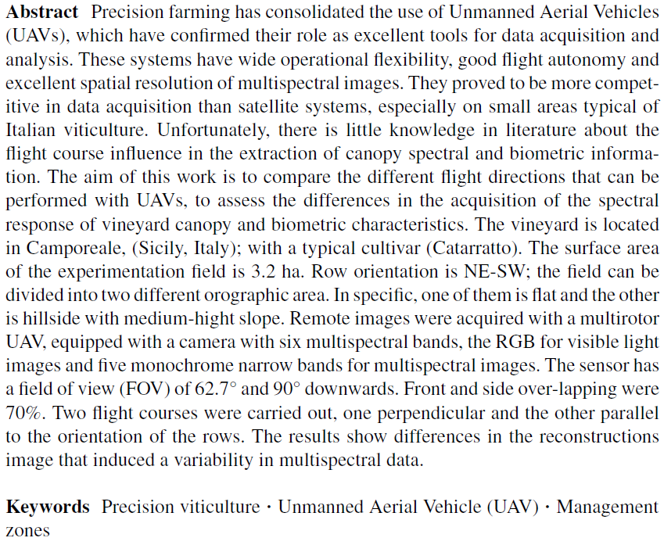
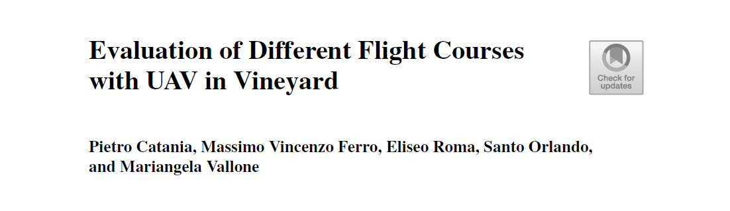
CHAPTER 3.



1. Introduction
The use of unmanned aerial vehicles (UAV) is becoming increasingly important in precision viticulture. Therefore, there is a huge interest in generating orthophotos with high spatial resolution. UAVs are used in various fields and sectors due to their flexibility and ease of survey. The drones can be divided into horizontal take-off and landing (HTOL), vertical take-off and landing (VTOL) and hybrid drones [11]. Among them, VTOL-type multi-rotor drones are the most widely used in precision agriculture [9, 19]. This configuration benefits from vertical take-off and landing, which increases the operational flexibility [8]., The drones used in precision agriculture are semi-autonomous. This means that the UAV flies a specific flight path, following information obtained through waypoints and previously established altitudes. The UAV is equipped with a positioning measurement system, such as a Global Navigation Satellite System or GNSS, to find out its location in real-time from waypoints. It is also equipped with an altimeter to maintain a constant altitude. UAVs are used to produce images generated by various sensors, such as RGB, multispectral, hyperspectral, and thermal cameras, allowing to detect variability in crop growth and productivity [1, 6, 10, 13].
One of the main advantage of UAVs is the flexibility of carrying sensors that are able to capture images at closer or shorter distances from multiple viewing angles [2]. In particular, depending on the adjustment of the camera axis, either vertical or at a variable angle of inclination, the detail of the survey can be changed [20]. The accuracy of image acquisition performed by UAVs can be affected by several parameters and factors, which depend on the embedded characteristics of the sensor used, but especially on the configuration of flight operations. Field characteristics such as soil profile, hydrology, soil conditions can also influence the acquisition accuracy. In particular, soil profile can affect the spectral features due to the change in altitude [16]. The speed and direction of flight influence its duration, while varying other flight attributes such as height, the ground resolution of the images changes [12]. Variation in flight height affects some parameters of the spectral response of crops, influencing, for instance, a variation in NIR reflectance [22]. There are scientific references in the literature that defines how the flight path affects geometric resolution [25]. However, in the context of precision agriculture, no studies investigate the influence of different flight routes. The aim of this study was to evaluate the influence of two flight paths on the spectral response (in terms of Normalized Difference Vegetation Index, NDVI) and vigor area (expressed in m²) in vineyard plot characterized by irregular orography using UAVs platform.

2. Materials and Methods

2.1 Study area
The trial was performed in Camporeale (Palermo, Italy) in Tenute Rapitalà farm with centroid coordinates of Lat 37° 55’ 11.18’’ N, Long 13°04’22.31” E. According to the Koppen–Geiger’s classification, the climate of the area is classified as Mediterranean hot summer climates [14]. Climatic data were recorded by a weather station positioned in the field; the mean air temperature was from 18.3 to 24.6 °C and the mean annual rainfall from 700 to 820 mm in the growing season. The experiment was carried out in 2022 in a vineyard cultivated according to the ordinary management practices of the area with drip irrigation system. The field has a total area of 3.2 hectare with an irregular orography. The experimental plot was divided into two different sub plots according to soil profile, flat and slope condition. The flat area (F) had a surface of 1.7 hectare corresponding to 6,905 vines, the sloped area (S) had a surface of 1.5 hectare corresponding to 6,038 vines. The planting layout was 2.4 x 1 meter for both plots. The rows orientation was NE-SW with an angle of 22° from the North. The trellis system was a double cordon spur pruned. The vineyard was planted in 2007 with cv. Catarratto, a typical cultivar of the area, in full productivity.

2.2 Flight scheduling and multispectral data acquisition
A remote UAV platform equipped with a multispectral camera was used. to investigate the spectral features. The UAV platform used, was a quadcopter model Phantom 4 (DJI, Shenzhen, China). Before the flight, 12 Ground Control Points (GCPs) were located in the external and internal part of each sub area. They were georeferenced using the GNSS receiver S7-G by Stonex (Milan, Italy), equipped with a Stonex geodetic antenna [4, 5]. This instrument is able to use multiband signals from the main GNSS satellites and improve accuracy through the Real Time Kinematic (RTK) differential correction data. The coordinates of the different GCPs were acquired in RTK mode as an average of 60 measurements. The flight was carried out on DOY 195 at 12:00, with the sun rising at the zenith and under clear sky conditions and low wind speed, with the automatic guide following the set route and waypoints (Fig. 1).

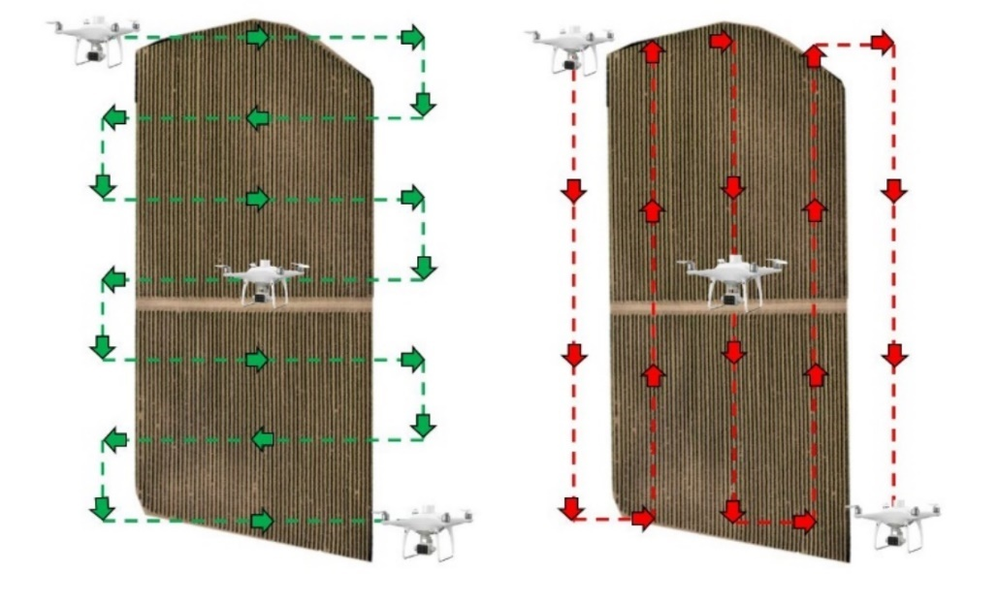
(a) (b)
Fig 1. Schematic representation of the flight paths. (a) perpendicular flight path; (b) parallel flight path (with reference to row orientation).

A flight height of 30 m a.g.l. was set in the two flight configurations, using Real Time Kinematic (RTK) differential corrections, obtaining a ground sample surface (GSD) of 1.7 cm. The image acquisition was performed at an average speed of 10 m*s⁻¹ in stop-and-go mode. The front and side overlap percentage between the image was 70%, while the gimbal pitch was set at 90° (downwards).

2.3 Processing and data analysis
Photogrammetric processing to obtain the orthomosaics was performed using Agisoft Metashape software, version 1.7.3. The orthomosaics were processed on QGis (version 3.2) to obtain NDVI map and perform Kriging interpolation to identify homogeneous vigor areas. The raw NDVI map was calculated using the near infra-red (NIR) and red reflectance map [21]. NDVI was calculated to identify the vigor level through the segmentation process [3]. The K-means algorithm from the SAGA library of QGIS was used; through this tool three classes of vigor were defined, low vigor (LV), medium vigor (MV) and high vigor (HV). Statistical analysis was performed using Minitab and Microsoft Excel software.

3. Results
The study area showed two different soil profile according to their slope values (Fig. 2a). Figure 2b shows the altitude curve for the entire plot. The first part of the curve refers to the flat subplot. It shows values ranging from 362 a.g.l. at the lowest point, to 365 a.g.l. at the highest, with an average slope value of 2.55 %. The second section of the curve, referred to the sloped subplot, has values ranging from 363 a.g.l. at the highest point to 348 a.g.l. at the lowest point, with an average slope value of 10.55 %.
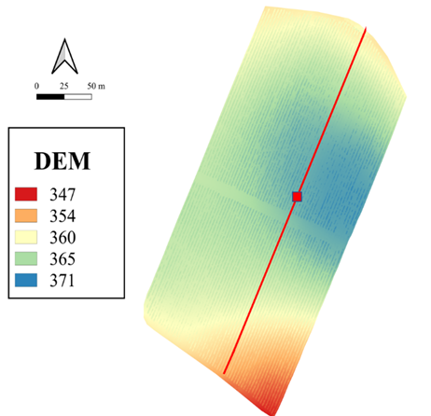
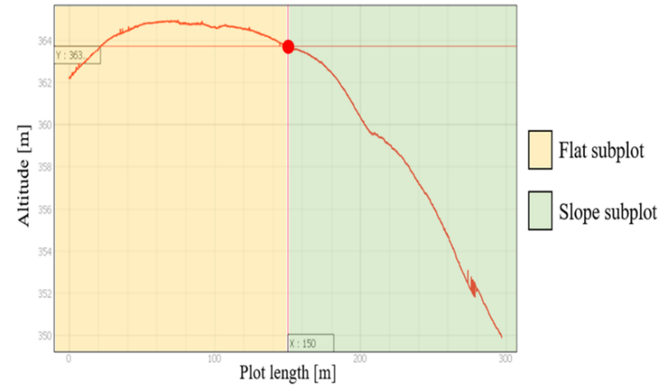
(a)
(b)

Fig 2. (a) Digital Elevation Model (DEM) of the whole study area; (b) Graphical representation of the altitude of the two subplots.
The study area showed a good variability in the multispectral response. The NDVI raw map ranging from -1 to 1 from both flight configuration. The lowest NDVI value characterized the soil zone, while the highest NDVI value corresponded to vegetation. Through the segmentation analysis it was possible to remove the soil pixel value and to extract only the vegetation canopy value. After this processing, the average NDVI was 0.31 ± 0.19 and 0.48 ± 0.19 for parallel and perpendicular flight path respectively. Analyzing the entire study area, it was possible to assess the influence of the different slopes on vineyard vigor.
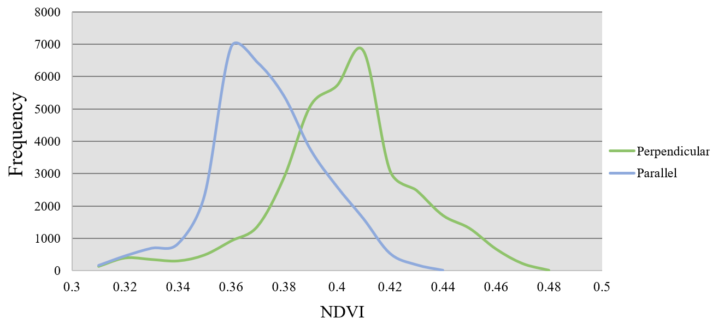
Fig 3. NDVI frequency histogram of parallel and perpendicular flight paths rasters.

Figure 3 shows differences in terms of NDVI pixels frequency over the entire study area according to the flight path. In the flight perpendicular to the vineyard rows, a higher frequency of pixels shifted to higher NDVI values was observed, compared to the parallel flight path. Using an unsupervised clustering algorithm, the pixels of the NDVI rasters were classified into three different vigor classes: low, medium and high. For each of the three clusters obtained, the surface area was calculated. In the parallel flight path, the total low vigor area was 3,567 m², the medium was 18,173 m² and the high vigor area was 9,298 m². Among these areas, in the flat area the percentage of low vigor was 3.6%, the medium vigor was 34.19% and the high vigor was 10.91%. The sloped area showed a low vigor zone of 7.55 %, a medium vigor zone of 21.09 % and a high vigor zone of 18.00%, referred to the whole study area.
In the perpendicular flight path, the total low vigor area was 4,390 m², the medium was 21,000 m² and the high vigor area was 7,580 m². Among these areas, in the flat area the percentage of low vigor was 6.3%, the medium vigor was of 37.61% and the high vigor was 8.71%. The sloped area showed a low vigor zone of 6.95 %, a medium vigor zone of 25.91 % and a high vigor zone of 14.24%. referred to the whole study area. The results concerning the analysis of variance of the multispectral data showed statistical significance for the two flight paths (p value < 0.001) for all the three levels of vigor. A similar result was obtained for the NDVI data in the two topographical conditions (p value < 0.001). However, the analysis of variance showed zero significance in the interaction between the flight configurations and the two topographical conditions for NDVI data of medium and high vigor areas (p value = 0.483 and 0.045 respectively). The interaction was significant for low vigor areas (p value < 0.001).

3.1 Flat subplot
In the flat plot and parallel flight path (Fig. 4a), the low vigor area was of 3,947 m², the medium area was 8,526 m² and the high vigor was 4,087 m² corresponding to 23.83%, 51.49% and 24.68% respectively. In the perpendicular flight configuration (Fig. 4b), the low vigor area was of 5,283 m², the medium area was 8,056 m² and the high vigor was 4,107 m² corresponding to 30.28%, 46.18% and 23.54% respectively.

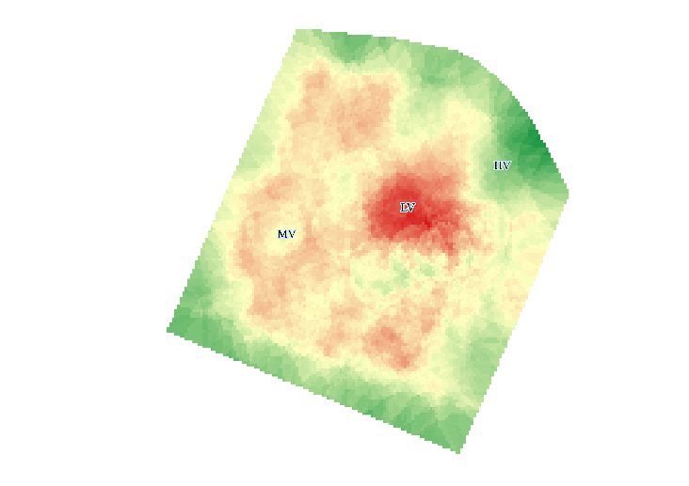 | 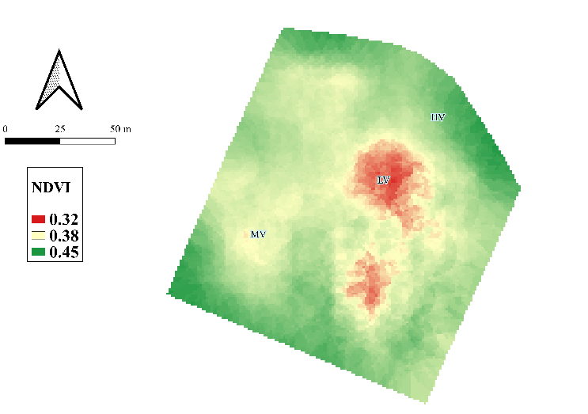
(a) | (b)
Fig. 4. Distribution of vigor classes in the flat plot; (a) parallel flight path; (b) perpendicular flight path; Low Vigor (LV), Medium Vigor (MV), High Vigor (HV).
Regarding multispectral data, there were statistically significant differences among the different flight paths and vigor levels (Fig. 5). The ANOVA test showed that high vigor level in the perpendicular flight and low vigor level in the parallel flight were statistically different with all the data (p value < 0.001). No statistically significant differences were found between the medium vigor level of the perpendicular flight and the high level vigor of the parallel flight according to the ANOVA test (p value < 0.001). No statistically significant differences were found between the low vigor level of perpendicular flight and the medium level vigor of parallel flight according to the ANOVA test (p value < 0.001).

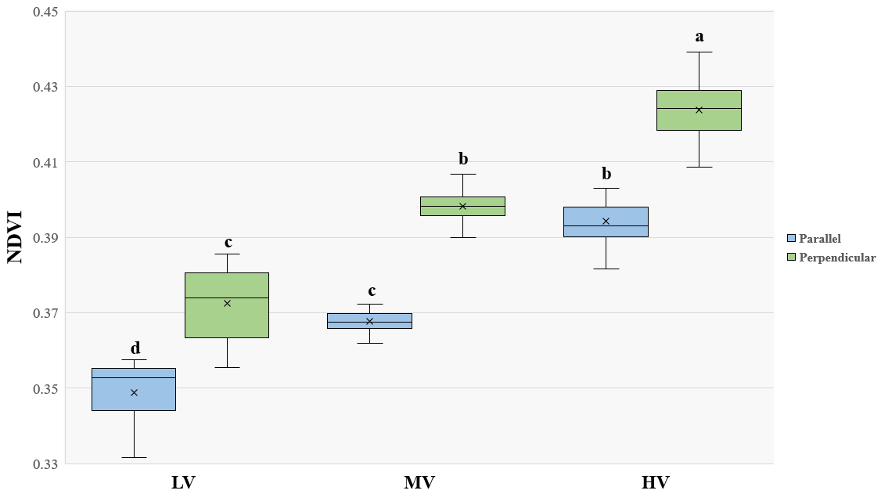

Fig. 5. Box plot and ANOVA test results of different vigor levels in the flat area for the two flight configurations.

3.2 Sloped subplot
In the sloped plot and parallel flight configuration (Fig. 6a), the low vigor area was 3,056 m², the medium area was 7,889 m² and the high vigor was 3,536 m² corresponding to 21.10%, 54.48% and 24.42% respectively. In the perpendicular configuration (Fig. 6b), the low vigor area was 2,112 m², the medium area was 9,667 m² and the high vigor was 3,758 m² corresponding to 13.59%, 62.22% and 24.19% respectively.
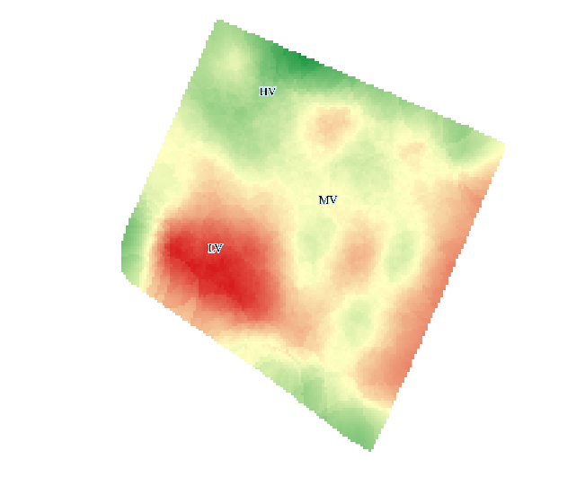 | 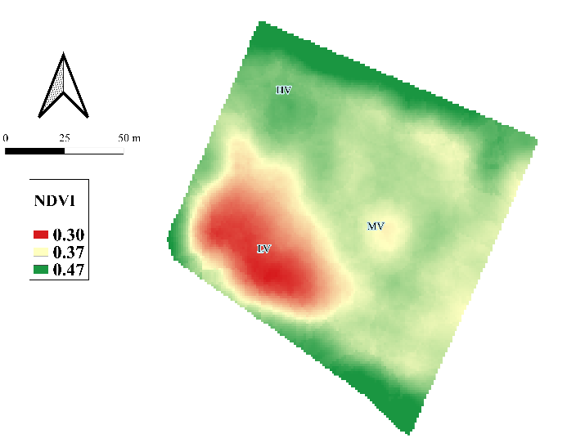
(a) | (b)
Fig. 6. Distribution of vigor classes in the sloped plot; (a) parallel flight path; (b) perpendicular flight path; Low Vigor (LV), Medium Vigor (MV), High Vigor (HV).
Regarding multispectral data, there were statistically significant differences among the different flight paths and vigor levels (Fig 7). The ANOVA test showed that high vigor level in the perpendicular flight and medium vigor level in the parallel flight were statistically different with all the data (p value < 0.001). No statistically significant differences were found between the medium vigor level of the perpendicular flight and the high vigor level of the parallel flight according to the ANOVA test (p value < 0.001). No statistically significant differences were found between the low vigor level of both flight paths according to the ANOVA test (p value < 0.001).
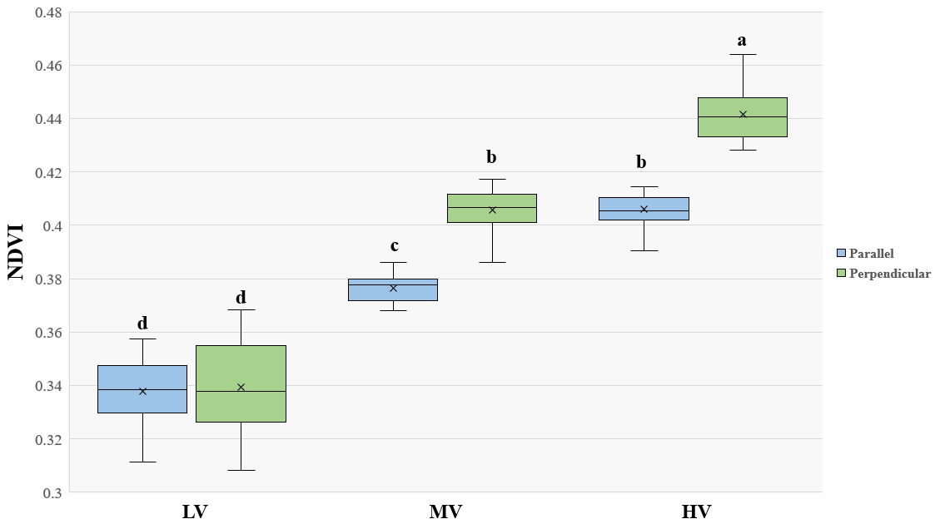
Fig. 7. Box plot and ANOVA test results of different vigor levels in the sloped area for the two flight configurations.

4. Discussion
The orography of the study area influenced the result of the experiments [7]. Indeed, it is commonly observed that sloped vineyards show several types of soil erosion processes bringing soil fertility in downhill [7, 16]. This process leads to the change of soil hydrological dynamics and increased sediment transport [18]. The impact of orography on the extension of the vigor areas and multispectral data was studied by means of the DEM. Previous studies had shown that the vine growth is closely correlated with soil differences [23, 24].The experiment showed that the flat area in both path configurations was characterized by a larger extension of high vigor area than the sloped plot. The largest extension of medium vigor area was always in the sloped plot. The low vigor area was similar in the perpendicular path for both plots and slightly lower for the sloped plot in the parallel path. These results are different from that obtained in another study where soil fertility is higher in the downhill [17]. In this case, the effect can be explained considering that the sloped plot was not in the lowest altitude zone. In addition, the flat plot is not directly joined with the sloped plot because there is the street that prevents the transport process. For this reason, the flat plot had a greater extension of the high vigor area.
The difference in the vigor areas has been detected in multispectral data as observed in previous studies [17, 23]. They found lower value of NDVI in the upper zone of the field than in the bottom zone. Instead, in our study for the same reason of vigor distribution, the higher NDVI values were concentrated in the flat plot. Therefore, the flat plot has not facilitated the elements transport process, while the sloped plot allowed it.
With reference to NDVI data, our study showed statistically significant differences between NDVI data in the two flight configurations. The values reported by the flight path performed perpendicular to the rows overestimate the NDVI for all three vigor levels. About that it is observed that in the flat plot the three vigor levels are all statistically different. Between the two flight paths, in the sloping plot there are statistically significant differences in medium and high vigor area unlike the low vigor data. This effect can be explained by taking into consideration the results obtained from the analysis of variance. The spectral response of the vineyard depends on both the slope effect and the flight configurations, thus their interaction was not significant. In the bibliography it is known that some pixels of the marginal parts of the vineyard canopy are mixed pixels, which in many cases are identified as shadow pixels and can affect the spectral response of the vineyard [15]. Due to this effect, we have noticed that in the low vigor areas it has not been discretized efficiently and probably the spectral response is flawed. On the other hand, in the areas of medium and high vigor, this effect was lower, discretizing the canopy more efficiently.

5. Conclusions
This study investigated the effects of different image acquisition procedures from UAV in two topographic configurations. The results obtained showed that the topography of the plot affects the spectral response data of the vineyard. Within each plot a different vigor distribution trend can be identified. In the flat zone there was a greater extension of the high vigor area, while in the sloped zone there was a greater extension of the low vigor area. In addition, we found that both flight paths influenced the spectral response data. Specifically, performing a flight perpendicular to the vineyard rows, it induces an overestimation of NDVI values. Our findings provide a better understanding of the influences of different flight paths in vineyard multispectral response, and further highlights that terrain orography plays a key role in the distribution of vegetation vigor. These preliminary results define the importance of setting a correct UAV flight path planning and further underline that the use of UAVs in precision viticulture allows to obtain vigor maps with high definition.

6. References
1. Adão T, Hruška J, Pádua L, Bessa J, Peres E, Morais R, Sousa JJ (2017) Hyperspectral imaging: A review on UAV-based sensors, data processing and applications for agriculture and forestry. Remote Sens 9:1110
2. Barba S, Barbarella M, Di Benedetto A, Fiani M, Gujski L, Limongiello M (2019) Accuracy assessment of 3D photogrammetric models from an unmanned aerial vehicle. Drones 3:79
3. Caruso G, Zarco-Tejada PJ, González-Dugo V, Moriondo M, Tozzini L, Palai G, Rallo G, Hornero A, Primicerio J, Gucci R (2019) High-resolution imagery acquired from an unmanned platform to estimate biophysical and geometrical parameters of olive trees under different irrigation regimes. PLoS One 14:e0210804
4. Catania P, Comparetti A, Febo P, Morello G, Orlando S, Roma E, Vallone M (2020) Positioning accuracy comparison of GNSS receivers used for mapping and guidance of agricultural machines. Agronomy 10:924
5. Catania P, Orlando S, Roma E, Vallone M (2019) Vineyard design supported by GPS application. pp 227–234
6. Catania P, Roma E, Orlando S, Vallone M (2023) Evaluation of Multispectral Data Acquired from UAV Platform in Olive Orchard. Horticulturae 9, 133. doi: https://doi.org/10.3390/horticulturae9020133
7. Comino JR, Senciales J, Ramos Mc al, Martínez-Casasnovas JA, Lasanta T, Brevik EC, Ries JB, Sinoga JR (2017) Understanding soil erosion processes in Mediterranean sloping vineyards (Montes de Málaga, Spain). Geoderma 296:47–59
8. Czyba R, Lemanowicz M, Gorol Z, Kudala T (2018) Construction prototyping, flight dynamics modeling, and aerodynamic analysis of hybrid VTOL unmanned aircraft. J Adv Transp 2018
9. Darvishpoor S, Roshanian J, Raissi A, Hassanalian M (2020) Configurations, flight mechanisms, and applications of unmanned aerial systems: A review. Prog Aerosp Sci 121:100694
10. Fernández-Guisuraga JM, Sanz-Ablanedo E, Suárez-Seoane S, Calvo L (2018) Using unmanned aerial vehicles in postfire vegetation survey campaigns through large and heterogeneous areas: Opportunities and challenges. Sensors 18:586
11. Hassanalian M, Abdelkefi A (2017) Classifications, applications, and design challenges of drones: A review. Prog Aerosp Sci 91:99–131
12. Hu P, Guo W, Chapman SC, Guo Y, Zheng B (2019) Pixel size of aerial imagery constrains the applications of unmanned aerial vehicle in crop breeding. ISPRS J Photogramm Remote Sens 154:1–9
13. Hunt Jr ER, Hively WD, Fujikawa SJ, Linden DS, Daughtry CS, McCarty GW (2010) Acquisition of NIR-green-blue digital photographs from unmanned aircraft for crop monitoring. Remote Sens 2:290–305
14. Kottek M, Grieser J, Beck C, Rudolf B, Rubel F (2006) World map of the Köppen-Geiger climate classification updated
15. Lu S, Xuan J, Zhang T, Bai X, Tian F, Ortega-Farias S (2022) Effect of the Shadow Pixels on Evapotranspiration Inversion of Vineyard: A High-Resolution UAV-Based and Ground-Based Remote Sensing Measurements. Remote Sens 14:2259
16. Manandhar R, Odeh IO (2014) Interrelationships of land use/cover change and topography with soil acidity and salinity as indicators of land degradation. Land 3:282–299
17. Martínez-Casasnovas J, Ramos M, Balasch C (2013) Precision analysis of the effect of ephemeral gully erosion on vine vigour using NDVI images. In: Precision agriculture’13. Springer, pp 777–783
18. Novara A, Keesstra S, Cerdà A, Pereira P, Gristina L (2016) Understanding the role of soil erosion on CO2-C loss using 13C isotopic signatures in abandoned Mediterranean agricultural land. Sci Total Environ 550:330–336
19. Roma E, Laudicina VA, Vallone M, Catania P (2023) Application of Precision Agriculture for the Sustainable Management of Fertilization in Olive Groves. Agronomy 13, 324. doi: https://doi.org/10.3390/agronomy13020324
20. Rossi P, Mancini F, Dubbini M, Mazzone F, Capra A (2017) Combining nadir and oblique UAV imagery to reconstruct quarry topography: Methodology and feasibility analysis. Eur J Remote Sens 50:211–221
21. Rouse Jr J, Haas RH, Deering D, Schell J, Harlan JC (1974) Monitoring the vernal advancement and retrogradation (green wave effect) of natural vegetation
22. Stow D, Nichol CJ, Wade T, Assmann JJ, Simpson G, Helfter C (2019) Illumination geometry and flying height influence surface reflectance and NDVI derived from multispectral UAS imagery. Drones 3:55
23. Tagarakis A, Liakos V, Fountas S, Koundouras S, Gemtos T (2013) Management zones delineation using fuzzy clustering techniques in grapevines. Precis Agric 14:18–39
24. Tardáguila J, Baluja J, Arpon L, Balda P, Oliveira M (2011) Variations of soil properties affect the vegetative growth and yield components of “Tempranillo” grapevines. Precis Agric 12:762–773
25. Zheng X, Wang F, Li Z (2018) A multi-UAV cooperative route planning methodology for 3D fine-resolution building model reconstruction. ISPRS J Photogramm Remote Sens 146:483–494

CHAPTER 4.
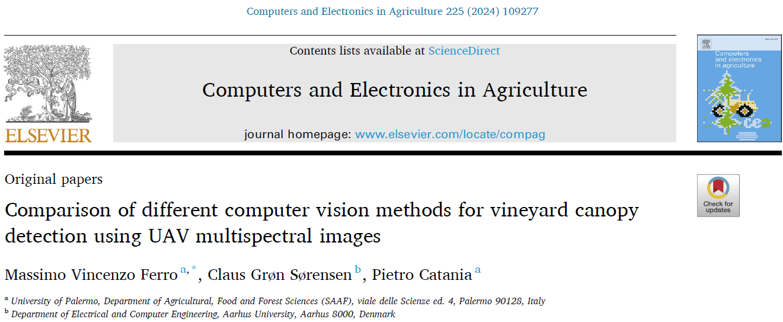
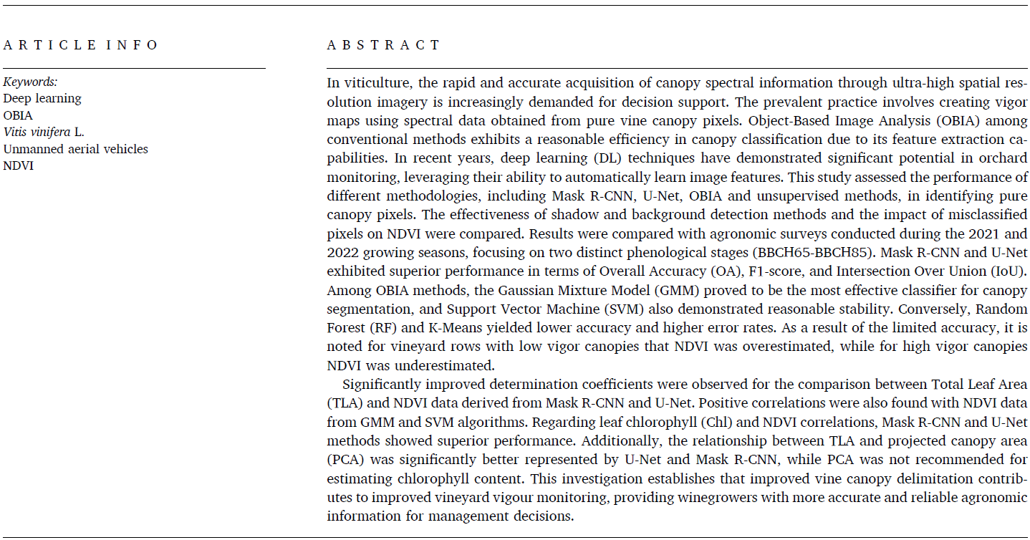


1. Introduction
Viticulture is increasingly focusing on technologies and strategies to enhance vineyard management efficiency, improving yield and grape quality, while also sustaining sustainability and resilience. Digital technologies and Information and Communication Technology (ICT) applications involve sensor data collection on soil, climate, and plant conditions, enabling subsequent data processing and decision support. Among these technologies, unmanned aerial vehicles (UAV) operating at low altitude acquire high-resolution images (HRI), both in RGB format and in multispectral/hyperspectral or thermal infrared format. These capabilities enhance vineyard monitoring and provide detailed information on vegetation phenotypic traits [1]. Recently, the study of image processing techniques are expanding the application of vineyard monitoring using UAV, enabling the creation of detailed vigor maps that assess the spatial variability of agronomic parameters using vegetation indices (VIs) [4,5]. VIs are computed by considering spectral values of solely vineyard canopy pixels. Currently, research is focused on finding new methods of UAV image analysis for vineyards trained with vertical trellis systems (VSP), aiming to isolate vineyard row pixels from the background. The reflectance of the soil is influenced by features such as colour, moisture and roughness [6]. The authors affirm that if the soil is very bright, the reflectance in red band of the spectrum increase; consequently, VIs can be affected, especially those based on the red band (e.g. NDVI). Conversely, an increase in soil moisture leads to a general decrease in reflectance. Shadow depends on the density of the vegetation and the geometric characteristics of the canopy, as well as the rows orientation in relation to the sun. In VSP vineyards, shading has a significant effect on canopy NDVI and is dependent on both solar elevation and the horizontal angle of incidence relative to the row orientation (relative azimuth)[7]. The intensity of shadow is influenced by the intensity of the light source and the amount of blocked light. Several studies have examined how shaded ground pixels and partially shaded canopy pixels can influence pure pixel information due to lower reflectance [8]. This effect is mainly reflected in the digital number (DN) values, where shaded pixels have significantly lower values than sunlit pixels. The image analysis process consists of several steps and can be performed with different methodologies, of which a central process involves canopy segmentation and classification. Vineyard row segmentation methods can be carried out by pixel-based or object-based methods. Within the pixel-based category, threshold-based methods can be used to segment crops by setting a certain threshold value that exploits colour intensity or by considering the reflectance value for pixel [8,9]. This category includes unsupervised clustering algorithms such as K-Means that do not consider the spatial relationships between pixels but provides for assigning them to a cluster based on similarity [10]. In a study conducted in a vineyard, it was observed that clustering methods sometimes exhibit inferior performance compared to other machine learning (ML) methods widely employed for object-based image analysis (OBIA) [11]. These methods have provided satisfactory results in analysing images from vineyard cultivated using VSP. Aboutalebi et al., (2019) demonstrated that supervised classification outperformed unsupervised methods and highlighted how the presence of shadows significantly influences the calculation of NDVI in a vine canopy. These mentioned methods are considered to be effective for canopy segmentation, mainly when the edges between regions are clearly delineated; however, they can be sensitive to noise in images, and moreover, it is difficult to choose an appropriate threshold value [13]. OBIA include several supervised classification algorithms such as Random Forest (RF) and Support vector machines (SVM) that exploit an iterative approach to determine canopies [14]. Pádua et al., (2022) applied a segmentation approach (OBIA) and achieved accurate classification results for soil, canopies, and shadow pixels. Among the supervised type algorithms, the Gaussian Mixture Model (GMM) provided accurate classification of high-dimensional remote sensing images, using low computation time [16]. This algorithm was used for vegetation classification by improving the accuracy of the model, demonstrating that GMM can effectively group together pixels with similar spectral features [17]. OBIA methods are more complicated than pixel-based methods, but they can generate an improved segmentation result by leveraging different ML classifiers for extraction of spectral and textural features [18]. In addition to the methods described above, there are recent applications of classification by deep learning (DL) for UAV images based on semantic and instance segmentation (Osco et al., 2021; Ye et al., 2023). In the first case, object identification and classification are performed by assigning pixels to a predetermined semantic class, conversely, instance segmentation identifies and separates objects in the image based on their identity. Semantic segmentation can identify categories but not individual objects within the same category, constraining canopy image analysis, especially with complex images and specific details. These methods employ the architecture of a convolutional neural network (CNN) trained to perform feature extraction using band combination for canopy segmentation. This process is applied by the Mask R-CNN method, which identifies and delineates the boundary of objects in an image at the pixel level [19]. This method has been widely used in remote sensing by UAV, for example, in the context of horticulture, Lucena et al., (2022) applied it to identify and to delineate the canopies of high-density orange tree rows, exploiting canopy height model and RGB images data as input, with optimal overall accuracy. Hao et al., (2021) used different spectral band combinations of UAV images and detect tree crowns and classify trees according to height, with significant positive Intersection over Union (IoU) results. Safonova et al., (2021) have explored the application of Mask R-CNN for the segmenting of olive tree canopies from shadows, aiming to accurately estimate the volume of individual trees. In the context of semantic segmentation, Osco et al., (2021) applied the U-Net neural network in orchard row segmentation studies using multispectral UAV images, obtaining an F1 score of 0.94. Sahin et al., (2023) trained U-Net to perform multi-class segmentation, reporting IoU values for soil, crop, and weed classes of 0.99, 0.90, and 0.75, respectively. U-Net is recognized for its effectiveness in managing class imbalances within the training dataset. In images acquired via UAV, it is common for the canopy class to be under-represented. This is a consequence of the constrained and limited size of the canopy, particularly in vines trained with the VSP system. However, owing to its downsampling and upsampling architecture, U-Net can overcome this issue and achieve significant accuracy. The model was also tested on orthomosaic images for automatic detection and localization of orchard tree canopy under various growing conditions, different growing seasons, and various weed cover levels, obtaining reasonably good analysis accuracy [25]. Barros et al., (2022) have conducted an interesting study about the application of semantic segmentation methods in vineyard, comparing the variation in performance of DL networks when the input images used change, and define that using RGB+NIR images improve segmentation performance. Similar results were also obtained for OBIA segmentation methods in which higher performance is obtained when using both sensor features [15]. Recent studies have demonstrated that utilizing high-resolution images obtained through UAV enables a more precise evaluation of chlorophyll content (Chl) in vineyards compared to lower-resolution images [27]. The more accurate representation of vine physiological activity is achieved by considering the average VIs of solely canopy pixels. Hence, the occurrence of noise factors due to soil reflectance or shaded pixels could affect the accuracy of physiological parameters estimation. Therefore, identifying detection methods that enhance the exclusive segmentation of canopy pixels reduces interference and optimizes the estimation of biochemical parameters [28]. Zhang et al., (2024) quantitatively evaluated the impact of orchard canopy shading, finding that the removal of canopy shadows significantly improved the accuracy of LAI and leaf chlorophyll content estimation.
Limited research exists on assessing shadows and background components' impact on canopy spectral response, while DL methods' potential in agriculture requires further exploration for vineyard canopy segmentation. Specifically, there has been limited investigation into evaluating the benefits and drawbacks of DL methods compared to traditional OBIA approaches for canopy segmentation and classification process.
In recent years, the use of multispectral cameras by UAVs has been widely applied for vineyard surveys, and in order to provide insight into different methods of high-resolution image segmentation, a comparison of computer vision (CV) methods is proposed. The objective of this study was to compare the efficiency and accuracy of OBIA, K-means and DL segmentation techniques applied to grapevine canopy at different phenological stages. The effects of segmentation methods on canopy NDVI were evaluated by comparing them with Projected Canopy Area (PCA) and leaf chlorophyll (Chl) parameters, aiming to enhance the estimation of vine biometric parameters.

2. Materials and methods

2.1 Study site
This study was conducted in a vineyard in Mediterranean area, in the region of Sicily (Italy). The experiment was carried out between 2021 and 2022, in a vineyard established in 2008 with Vitis vinifera L. cv. Catarratto. The vineyard has a total area of 8.2 ha and a perimeter of 1162 m. Following the methodology of an on-farm experiment (37°55'12"N; 13°04'27"E), the site was selected as situated within the Bianco Alcamo Protected Designation of Origin (PDO) zone, given that this area is very suitable for the cultivation of grapevine. Vineyard planting layout is 2.4 m between rows and 1.0 m within rows (4,170 plants ha⁻¹). The rows are oriented in the NE-SW direction and the vineyard is located at an average altitude of 350 m above sea level and in an area with a hill-type orography. The elevation variability within the vineyard ranges from a maximum elevation of 367 m a.s.l. to a minimum elevation of 335 m a.s.l., with an average slope value of 9.8%. For the shaping of the canopy, the vines are trained through a vertically positioned shoot system (VSP). The pruning system is a double spurred cordon with two buds per spur. The vineyard trellis has an overall height of 1.70 m in which the first supporting wire for the plants is positioned 0.70 m above ground level and the remaining two are positioned with 0.50 m between them. These wires are maintained by galvanized bearing poles placed at 6 m apart from each other.
Vineyard management was conducted through standard agronomic practices applied uniformly across the field. Traditionally, the vineyard was subjected to surface tillage sessions during each year to control weeds and mitigate water evaporation.

2.2 UAV image acquisition
The UAV DJITM Phantom 4 multispectral (P4, SZ DJI Technology Co., Ltd., Shenzhen, Guangdong, China), equipped with one RGB sensor for imaging on visible light and five monochrome sensors for multispectral image acquisition was used. Two field survey campaigns were executed from June until the end of August, for two consecutive years, from bloom to harvest, covering the most important phenological stages (Table 1).
Table 1 UAV surveys and corresponding phenological stages.
Flight | Phenological stages
F1_21 | Full flowering (BBCH65)
F2_21 | Softening of berries (BBCH 85)
F1_22 | Full flowering (BBCH65)
F2_22 | Softening of berries (BBCH 85)

In the year 2021, the first flight was performed on June 18 (F1_21) and this timing corresponds to the flowering phenological stage of vineyard (BBCH65), and the second flight was performed on August 26 (F2_21) and this timing corresponds to the berry softening phenological stage (BBCH 85). At the same phenological stages, flights were performed and replicated for the year 2022, the first flight was performed on June 21 (F1_22) and the second flight was performed on August 28 (F2_22). The specific flight parameters are shown in table 2.

Table 2 Flight parameter settings.
Parameter | Value/Method
Flight altitude | 70 m
Flight speed | 6,5 m/s
Shooting mode | Timed shooting
Pitch gimbal | -90°
Side overlap rate | 60%
Forward overlap rate | 60%
Ground sampling distance | 0.37 m
flight duration | 19 minutes

Camera acquired the photos automatically, at an interval of 1 s, and the images were stored in TIFF format. Images with a resolution of 1600 * 1300 pixels were captured through this camera. The UAV was programmed to traverse the field following a predetermined path using DJI GO Pro software, with the aim of capturing images of the entire on-farm plot. A total of 258 images were captured per spectral band, for a total of 1290 captures. The UAV images were acquired at a specific time of day, i.e., between 12:00 noon and 1:00 p.m., in sunny or non-cloudy weather, considering solar noon for each survey. The flight height was set at 70 m relative to the take-off point to balance the sharpness of the field of view with the total flight duration, which was 19 minutes for each survey session. Ground conditions during data collection were characterized by the absence of weeds. Furthermore, a reflectance calibration panel (LABSPHERE INC., North Sutton, US) was employed. Using this technique, regulation of the sensors was performed to provide accurate measurements of the crops' reflectance and surrounding surface. This is feasible because the reflectance characteristics of the panel are pre-determined. During UAV flights, the use of calibration panels allows balancing environmental variations such as illumination, ensuring accurate data reflecting surface conditions and enabling instrument stability verification over time.

2.3 UAV image pre-processing
Agisoft Metashape Professional Edition software (Agisoft LLC, St. Petersburg, Russia) version 1.7.2 was used for image pre-processing, where the first step was to apply radiometric corrections for the images, removing any problems such as vignetting, dark pixel offsets, and especially to convert the raw images to radiance and then to reflectance space. Through the software, the point cloud was generated and then the vineyard images were converted into a Digital Orthophoto Map (DOM) (Figure 1). To increase the accuracy of the DOM, pre-measured ground control points (GCPs) were imported via a GNSS receiver. As the resolution of the DOM is too large, the images were cropped to satisfy the appropriate size for running DL segmentation methods. Using QGis 3.20 software, it was possible to split the DOM into smaller subimages with a standard size of 240 x 240 pixels such dimensions reduce the computational overhead by contributing to improved performance of the segmentation networks. For each survey, the image dataset was divided by a random assignment process into three specific subsets and then a training set (80 %), a validation set (10 %) and a test set (10 %) were generated. For example, through the DOM splitting process, for the survey conducted in F1_21, 835 sub-images were obtained, which were split into: 668 images used for training, 84 for validation and 83 for testing. The annotation was carried out using an open source software Labelme 3.6 [30], which allows for manual image annotation. Class annotation tools were employed, and polygons encompassing the vine canopy, soil, and shadow were generated. At the end of the process, these annotations were saved in a JSON (JavaScript Object Notation) format file.
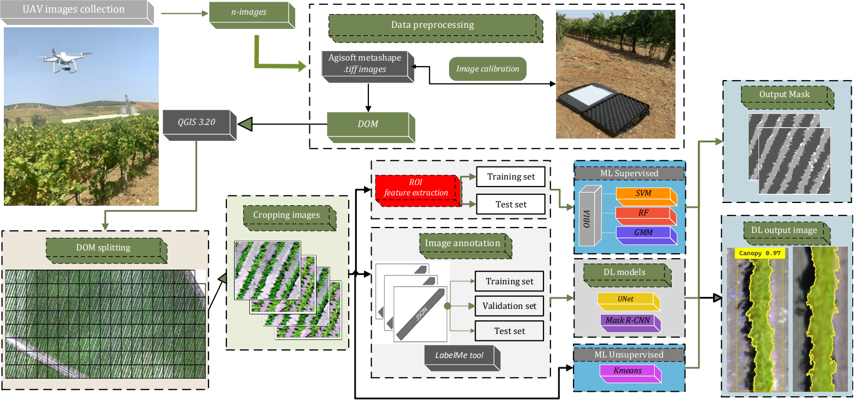
Figure 1. Process flow involved with the proposed methodology for supervised and unsupervised segmentation methods of UAV images.

2.4 Image analysis techniques
This section explains the models employed for canopy image segmentation. In this study, supervised image segmentation techniques such as the OBIA method, unsupervised techniques such as K-means and two DL models were applied.

2.4.1Object-based image analysis
The OBIA methodology segmented the images into several non-overlapping regions, where each region is called an object; these categories are distinguished as being composed of a group of pixels with homogeneous features. For each object, the relevant features (radiometric, contour, and shape) were extracted. This method consists of three distinct steps involving image segmentation, feature extraction, and classification. The trained models were used to classify the entire vineyard into three distinct classes, such as soil, shadow, and vine canopy. In the dataset of this paper, the vineyard canopy despite having an irregular geometry has a definite shape, and this differs mainly in size from that of the soil and shadow. For spectral features, the average value of each spectral band is calculated. The training set is used to train the model, the testing set is used to evaluate the accuracy of the model on new data, and the validation set is used to adjust the model parameters. The next step was to constitute 390 samples to the training model, divided into 130 samples per each class. An additional 90 samples, divided into 30 for soil, 30 for canopy and 30 for shadow, respectively, were applied for the testing image set and likewise for the 90 samples for the validation images. The number and size of polygons were chosen to maintain balance between classes and to cover a greater diversity of cases. To classify the vineyard objects in the images obtained from DOM subdivision, i.e., subimages that have a spatial resolution of at least 0.37 m per pixel, a segmentation process based on the large-scale mean-shift (LSMS) algorithm developed by [31]. This algorithm is applied using the OTB library (orfeo toolbox) that provides a set of tools for image analysis, the first step of operations performed by the LSMS algorithm is to apply the LSMS-Smoothing function, in which in a first operation consists of removing noise and then applying a normalization procedure [32]. Subsequently, a bottom-up approach is adopted, in which objects to be classified are gradually created by aggregating similar pixels, this aggregation is done by exploiting the spatial proximity or spectral similarity of them. The smoothing phase aims to improve the shape and consistency of the objects. The second step (LSMS-segmentation) is done by setting appropriate parameters, including the range, defined as the minimum Euclidean distance between the spectral signature values of pixels and expressed in radiometric units [33]. In this study, the parameter concerning the range radius was set to 25. Conversely, by setting a spatial radius of 15, the distance within which pixels are considered similar was determined. These parameters were selected after conducting multiple tests with different values of range and spatial radius, ultimately yielding the best segmentation (visually assessed). This parameter selection could affect the size of objects and the accuracy of segmentation, potentially resulting in the inclusion of non-targeted objects. The supervised classification models used in this study were chosen according to the reference literature concerning the segmentation of orchards and in general canopies by UAV imaging. In this context, Support Vector Machines (SVM) and Random Forests (RF) machine learning algorithms were selected as having good operational stability and being less affected when applied successively to the operations performed by the OTB library [14]. Another machine learning algorithm applied for image classification is the Gaussian Mixture Model (GMM), which has provided excellent results in the past for analysis of pixel distribution in agricultural scene images. One of the supervised classifiers that was used is Support Vector Machines, and this is a nonparametric method because it does not assume the distribution of the data, as this algorithm uses an optimization function that tries to find the hyperplane that maximizes the distance between data classes. In the specific case was used SVM type using a linear hyperplane in an ultra-dimensional space, where the SVM classifier determines to which class the pixels nearest to the hyperplane belong in a manner consistent with the training samples [34]. In this study, a specific linear type of Kernel function with a C-type model that has a cost parameter set to one and gamma to 0.02 were used for the application of the algorithm. The LIBSVM library was used to perform this algorithm; it allows the selection of several parameters to be specified during training, including the kernel type and the C parameter that controls the penalty for classification errors.
The Random Forest algorithm is a supervised machine learning method; it is called ensemble, implying that it combines the predictions of multiple models to produce a final prediction. Specifically, the RF algorithm combines predictions from a set of decision trees, this via bootstrap aggregation. For each decision tree, the RF algorithm selects a random subset of features from the training data. The predictions from each decision tree are then combined to produce a final prediction. The number of bootstraps was set to 150 so that different decision trees could be developed and thus increase the robustness of the algorithm, but still was not too high as to affect the accuracy of the classification [35]. However, to set some parameters of the algorithm, an estimation was carried out through the out-of-bag (OOB) process to calculate the generalization error, which was set equal to 0.001; these estimates are carried out using the training data that were not used to construct the decision trees. Therefore, the maximum number of decision trees was set as 200, with five maximum tree depths.
The unsupervised Gaussian mixture model (GMM) classification algorithm is a statistical model that assumes the data are generated from a combination of Gaussian distributions. Thus, considering the image in terms of a matrix in which each element represents a pixel, considered a random variable and denoted by the variable x assuming the values of the bands that constitute the image. The classification probability of the elements in the image is represented by the function 1, where represents a weighted sum of Gaussian distributions through:
$f\left(x\right)=\sum_{i=1}^{k}{w_{i} N\left(X | µ_{i},σ_{i}^{2}\right)}$ $\left[1\right]$
where k represents the total number of areas while the set {𝑤₁,𝑤₂,....,𝑤_{𝑘}} defines weights that satisfy the condition $\sum_{i=1}^{k}{w_{i}=1}$.
In this study, the parameter k in equation 1 was tuned to 3, estimated using the Bayesian Information Criterion (BIC). The number of EM iterations was set to a value of 100, which proved to be sufficient for the convergence of the EM algorithm.
The expression $N\left(X | µ_{i},σ_{i}^{2}\right)$ represents the Gaussian distribution of the i-th region with the mean 𝜇𝑖 and the standard deviation 𝜎𝑖 respectively, as indicated by function 2:
$$N\left(X | µ_{i},σ_{i}^{2}\right)= \frac{1}{σ\sqrt{2π}}exp\left(\frac{-{\left(x-μ_{i}\right)}^{2}}{2σ_{i}^{2}}\right) \left[2\right]$$
the GMM algorithm tries to find the parameters μ, σ and α that maximize this condition and exploits the likelihood function (maximum-likelihood), which represents a system of nonlinear equations. To solve the maximum-likelihood equation in the operations performed by the GMM classifier, an expectation maximization (EM) algorithm is computed, which is an iterative algorithm that updates the parameters μ, σ e α. Therefore, the EM algorithm was terminated when the difference between two consecutive log-likelihood scores was less than 10⁻³.This algorithm was applied using scikit-learn library [36], and then after importing the training images, the number of model components was set. This parameter determines the number of classes into which the data will be clustered; several components that is too low can lead to under-approximation, while a number of components that is too high can lead to an over-approximated model; in this specific case, the number of components were 3. In this study, the GMM classifier was applied through the OTB library, in which Lagrange et al., (2017) developed an efficient implementation.

2.4.2 K-means
In this paper, we chose to use one of the most widely used clustering algorithms for automatic classification of remote sensing images namely K-Means. This learning model is not provided with special labels for the training data, as observed for previous methods, so the method has to learn relationships completely on its own. The K-means algorithm iteratively clusters data points based on their distance, with closer points indicating greater similarity [37]. Pixel clustering is performed by calculating the sum of the squared Euclidean distances of the pixel values, compared with the centroids of the clusters. In the case under study, three clustering centers corresponding to the categories of soil, vineyard canopy and shadow were selected. After clustering, the images of the experimental vineyard, are binarized and contain only the three specific categories.

2.4.3 Deep learning image analysis
This paper investigated the neural networks which apply supervised semantic segmentation via U-Net method and a convolutional neural network using the Mask R-CNN method. The architecture of Mask R-CNN performs two separate operations, a first module identifies regions where objects are located, another module performs pixel-level segmentation to delimit object boundaries, this last module is implemented based on the Faster R-CNN structure [38]. The hyperparameters of the Mask R-CNN model used during the training are shown in Table 3. Mask R-CNN consists of a core network layer (Backbone) comprising the ResNet101 architecture, used in this study. Input images pass through this backbone layer, which performs a set of convolutional and pooling operations. ResNet101 produces an attribute map for each object in the image based on the training information. ResNet101 uses Global Average Pooling at the end of the network, this operation reduces the spatial dimension of the feature maps to a single value for each channel, creating a compact feature representation. In the model structure is the Region Proposed Network (RPN) layer, which is responsible for generating proposals of regions that might contain the image objects, this operation creates positive and negative samples. For each identified region in which the objects are present, Regions of Interest (RoI) are developed, these have different sizes and proportions to each other. Next, using the RoI Align layer, which plays a key role in aligning the features extracted from the map to the corresponding (RoI). Another step is the MaskHead, which is responsible for generating the masks associated with the detected objects. These masks indicate which pixels belong to the detected object and are used to perform segmentation. RoIs having the same dimensions are used as input first in the process that indentifies the class and respective probability of each identified object, this process is performed through the Fully Connected Network (FCN). Then the softmax classifier is applied to these RoIs to assign a class label to the object. Generally defined, the output of the model application provides a class label indicating the name of the object class, a bounding box delimiting the object (bounding box), and a mask delimiting the pixels of the object to be detected. This is a binary mask (with the values 0 and 2) in which the value 0 indicates pixels that do not belong to the vine canopy and instead can be traced back to the soil, the value 1 refers to the vine canopy pixels, and finally the value 2 refers to the shadow projected by the canopy. Stochastic Gradient Descent (SGD) optimization algorithm was applied with the purpose of updating the model parameters based on a random subset of data (minibatches), so during each epoch the entire dataset was divided into random mini batches of predetermined dimensions. The experimental process used in this study involved setting a learning rate of 0.001 and a momentum of 0.9, batch size was set to 16 and a weight decay of 0.0005. The neural network was trained with 50 epochs for each spectral band.
Table 3. Values of Mask R-CNN hyperparameters.
Hyperparameters | Mask R-CNN Input
NUM classes | 3
Backbone | ResNet101
Pooling layer | Global Average Pooling
Model Structure | RPN - MaskHead
Optimization Algorithm | SGD
Batch size | 16
Number of Epochs | 50
Learning rate | 0.001
Momentum | 0.9
Weight decay | 0.0005
Image resize mode | Square (240x240)
Image channel count | 4 (RGB + NIR)
Train ROIs per image | 390

U-Net is a model for image segmentation that was first introduced by [39]. The U-Net architecture consists of two main parts, namely an encoder part and a decoder part. The encoder part is responsible for feature extraction from the input image, while the decoder part is responsible for reconstructing the segmented image. The encoder part of U-Net is a deep convolutional neural network that uses a series of pooling and max pooling layers that both enable feature extraction from the input image. The hyperparameters of the U-Net model used during the training are shown in Table 4. A batch size of 16 with an initial learning rate of 0.001 was used during model training. The encoder stage starts with the definition of a feature map of fixed size, in this study having used training subimages of size 240x240x3. These passing through a series of convolution layers (3×3 unpadded) [40], a batch normalization layer (BatchNorm)[41] and pooling layers and to these are added max pooling layers of type 2×2 that are used to reduce the image size and number of parameters creating a feature map of size 120x120x16. Each convolution layer then applies a filter to the feature map and progressively produces smaller feature maps until the size is 15x15x64, at which point the feature map is output to the decoder architecture layer. The decoder part of U-Net is an inverted convolutional neural network that starts by applying a series of convolution layers to the feature map defined as upsampling and concatenation to reconstruct the segmented image. The size of the feature map is doubled with each convolution layer providing as output a segmented image of size 240x240x3. The concatenation layers in the decoder part of U-Net combine the features extracted from the encoder part with the features extracted from the decoder part. All convolutional and deconvolutional layers are followed by an activation function ReLU defined Rectified Linear Unit, except for the 1 × 1 convolutional layer at the last, which predicts class probability. In this study, categorical cross entropy was used as a loss function for training the model. This function measures the difference between the predicted probability distribution and the true labels for each pixel. The Softmax function was used to transform the final feature map into probabilities, which allows obtaining a probability distribution over all classes for each pixel.

Table 4. Values of U-Net hyperparameters.
Hyperparameters | U-Net Input
NUM classes | 3
Encoder filter size | 3x3 (unpadded)
Activation function | ReLU
Decoder upsampling | Deconvolution layers
Loss function | Categorical cross entropy
Final activation function | Softmax
Number of Epochs | 50
Batch Size | 16
Learning rate | 0.001
Weight decay | 0.0001
Image resize mode | Square (240x240)
Image channel count | 4 (RGB + NIR)

The investigation was performed using a workstation running laptop with Windows 11 Pro. The DL models were based on PyTorch 1.9.0, while the computing architecture was CUDA 11.1 is used to accelerate the training process, in addition, pakages such as TensorFlow 1.3, Keras 2.0.8 were considered for the application of convolutional network. The deployment of the Mask R-CNN model was carried out following a procedure allowing for processing the TIFF format images that are characterized by more than three bands per image. Specific environment configuration were used as a central processing unit CPU Intel(R) Core^{(TM)}i7-12700 K (4.9 GHz), 32.0 GB and a graphics processor unit (GPU) NVIDIA GeForce RTX™ 4090 16GB GDDR6 with processor CUDA cores.

2.5 Evaluation metrics
In this study, two main performance measures, i.e. overall accuracy (OA) (4), F1-score (5), were used based on a specific confusion matrix with four main factors, such as false negative (FN), false positive (FP), true negative (TN) and true positive (TP), to evaluate the performance of the model for extracting features of soil, canopy and shadow classes from high-resolution UAV images. The OA is specified as the sum of correctly identified pixels divided by the totality of pixels. F1 score, on the other hand, represents the combination of recall and precision metrics. Recall is specified as the percentage of correctly identified pixels among all pixels that were depicted for that class. Precision is calculated as the percentage of pixels identified exactly among the pixels identified in a specific class. An additional parameter calculated to measuring the accuracy of segmentation algorithms was the intersection over union (IoU), also referred to as the Jaccard Index. In Expression 3, this parameter is defined as the ratio of the intersection area, the area identified by the algorithm and the ground truth manually identified by the operator. These are divided with the intersection area between the area observed by the segmentation method and the ground truth.
$IoU=\frac{area ofoverlap}{area of union}=\frac{S∩S_{i}}{S∪S_{i}} [3]$$IoU=\frac{area ofoverlap}{area of union}=\frac{S∩S_{i}}{S∪S_{i}}*100$
where S represents the area identified by the segmentation algorithm; instead, the term S_{i} represents the actual area computed manually by segmenting the edges of the category of objects to be identified. Thus, the numerator of the equation indicates the area shared by S and S_{i}. The denominator represents the total area of S and S_{i}. A value of IoU greater than 0.70 generally indicates good agreement between the two components S and S_{i}.

2.6 Vegetation index
After obtaining the pure vegetation pixels by the segmentation and classification techniques described above, the normalized difference vegetation index was calculated (NDVI) [42]. This is one of the most widely considered indices for assessing crop growth and is calculated by considering the near-infrared (NIR) and red spectrum bands.

2.7 Canopy Data Measurements
Ground sampling was performed to assess two agronomic parameters of the vineyard such as total leaf area (TLA) and leaf chlorophyll (Chl). The ground sampling performed in the on-farm vineyard was carried out in specific areas that were characterized by different growth vigor. In fact, agronomic surveys designed to classify vigor levels for 2021 and 2022 identified two distinct vigor levels. Using field surveys, fourteen sampling blocks were identified divided into areas with low vigor vines (LV) and areas with high vigor vines (HV). Each individual sampling block has a length of 6 meters and consists of six plants; thus, a total of 84 plants were monitored. Survey activities were preceded by the identification of the 14 ground control points (GCPs), with known coordinates, useful for georeferencing all survey points to a common reference system (WGS84; UTM 32N).
Evaluation of (TLA) was performed by applying the empirical model for non-destructive estimation of leaf area for primary and lateral shoots as formulated by Lopes and Pinto, (2005). This method includes sampling vine shoots collected randomly within the canopy. Each individual shoot generally consists of a primary shoot axis and secondary shoots that originate from it during the growing season. These shoots were collected from plants placed in the rows in front of the row that was selected as the sampling block in total 60 shoots (one shoot per vine) were collected for each survey session. These shoots were labelled according to the vigor level to which the plants belonged. From each shoot the primary and lateral shoot leaves were separated, on these shoots the number of nodes and the overall length measured from the base to the node where the last leaf counted was inserted were also evaluated. Leaf area was determined in the laboratory with a leaf area meter (LI-3100C area meter Li-COR Biosciences, Lincoln, NE, USA). These surveys were conducted for two years, at the phenological stages of vine flowering (BBCH65) and berry softening (BBCH85). For each primary and lateral shoot, the following variables were measured: sum of primary leaf area and sum of lateral leaf area; these two parameters together constitute the average leaf area (LA) of the shoot. Based on these biometric measurements conducted in the field, it was possible to determine (TLA) on each labelled vine by multiplying the average LA by the total number of shoots per plant. Leaf area assessment method adopted in this study has been applied by several authors because it provides an estimate of vine leaf area regardless of cultivar, year and phenological stage, representing a low-cost, simple and accurate method, however, being a manual sampling method, it is time-consuming and labour intensive for operators. The evaluation of chlorophyll content (Chl) (µg cm⁻²), done during the growing season in two phenological stages, was measured by proximal sensor, a portable leaf fluorimeter Dualex® Force-A (Orsay, Cedex, Francia). This instrument performs non-destructive, simple and rapid measurements by taking an absorbance measurement of the leaf epidermis, exploiting the mechanism of fluorescence emitted by the chlorophyll pigment [44]. Measurements were performed on the sampling blocks by selecting three leaves per plant. Leaves sampled during the BBCH65 phenological stage were positioned on the 5/6 node of the primary shoot, for BBCH85 phenological survey the sampled leaves were positioned in the 8/10 node of the shoot, this methodology allows for standardization of measurements and sampling of even-aged leaves.

2.8 Statistical analysis
To evaluate the overall performance of canopy segmentation and classification methods, statistical analyses were carried out on the sampling blocks described. In these sampling blocks, the geometric information of the canopy was extracted by evaluating the Projected Canopy Area (m²) (PCA) parameter, and spectral information derived from NDVI, which represent key parameters needed to properly assess TLA and Chl. This information was obtained using the QGIS plugin (Zonal Statistics), which allows information such as the count, mean, standard deviation, minimum and maximum value of each raster to be extracted. ANOVA test was used after dividing the dataset of sampling blocks into LV and HV to test the equality of the averages of both PCA and NDVI. Comparisons between the averages were performed with Tukey's test (p ≤ 0.05). In addition to calculating the basic statistic, Gini heterogeneity index was evaluated to appreciate the variability of the dataset [45]. This index is a measure of the inequality of a distribution and is a number between 0 and 1. A value of 0 indicates that the frequency distribution is homogeneous, whereas a higher value means that the sample is more heterogeneous. Pearson's correlation coefficient was used to compare the similarity of vineyard rows geometric data (PCA) and NDVI with canopy biometric traits such as TLA, shoot length and chlorophyll content.

3. Experimental results
The on-farm vineyard shows a high degree of vegetative and reproduction variability, and it was observed that one of the factors determining high variability in vine vigour growth was vineyard topography. Field areas show distinct soil profiles based on slope values identified through the Digital Elevation Model (DEM). Figure 2 illustrates the elevation variation within the plot, showing significant elevation heterogeneity, with elevation values ranging from 365 m at the highest areas to 335 m at the lowest areas of the vineyard. A flat area extends to the highest elevation with elevation values ranging from 362 m a.s.l. at the lowest point to 365 m a.s.l. at the highest point, with an average slope value of 3.55%. Another section of the DEM corresponds to the slope area, with elevation values ranging from 361 m a.s.l. at the highest point to 338 m a.s.l. at the lowest point, with an average slope value of 14.77%.

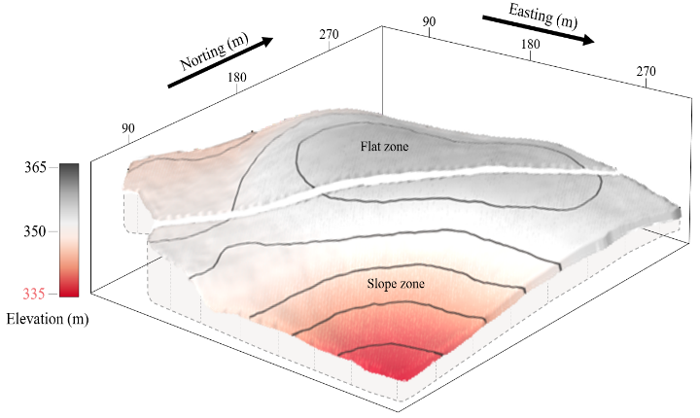
Figure 2. Representation of Digital Elevation Model (DEM) of the studied on-farm vineyard.
As a result, topographical variability of this specific vineyard, sampling points were identified in correspondence with flat areas and sloping areas that showed different vine canopy growth.
The accuracy indices F1 Score, OA and IoU were calculated both for each phenological stages and for segmentation methods: OBIA, DL and K-means, (Tab. 5). Supervised algorithms relying on the Large-scale mean-shift segmentation (LSMS) method used in OBIA, performed lower than DL methods but still significantly better than the K-means clustering method in two survey epochs. The best results in evaluating the accuracy of segmentation and object detection can be observed through the value of OA, it is evident that U-Net and Mask R-CNN were the most efficient in segmenting and detecting object classes, with accuracy values above 0.85 for both BBCH65 and BBCH85. Nonetheless, it is evident that among the supervised ML methods, the GMM showed the best OA values, showing comparable values to the DL methods.
Specifically, these results indicate that among the supervised classifiers used after the segmentation process, the GMM had the best F1 score performance for the identified classes. Indeed, for the surveys conducted in BBCH65, canopy identification was done with an accuracy index of 0.80 and 0.74 for the surveys conducted at BBCH85. The classifiers RF and SVM obtained lower F1-score values, in fact SVM detects the vineyard canopy with an accuracy of 0.72 and 0.68 for BBCH65 and BBCH85, respectively. RF, on the other hand, obtained the lowest accuracy values among the supervised methods; in fact, the F1 score value for canopy detection was 0.67 and 0.57 for the two phenological periods considered, respectively. The K-Means clustering segmentation method, instead, was the least accurate in identifying the canopy, with an F1 score index of 0.63 and 0.58. A different reasoning can be made if the F1 score data traced back to the U-Net and Mask R-CNN methods are observed, where the identification of the vineyard canopy has an accuracy index of 0.92 and 0.87 for Mask R-CNN and 0.89 and 0.85 for U-Net. The other F1 score values for the remaining classes identified in the images show similar performance, in fact, the U-Net method shows an F1 score value for soil of 0.91 and 0.87 indicating a low level of error, as also found for Mask R-CNN. Among the supervised methods, on the other hand, GMM is the most promising, with values of 0.84 for the first survey epoch and 0.75 for the second. K-means clustering, meanwhile, proves to have low OA values, with a high degree of error, easily inferred from the values of 0.68 and 0.63. Evaluation of the F1 score values when it comes to the shadow highlights that among the supervised methods RF is the least accurate, with values of 0.60 and 0.58 for the two survey periods, respectively. Similarly, K-means clustering exhibits similar F1 score values. The other two supervised methods, instead, while reporting OA values that are not specifically high, still prove to be better than the two previous cases, especially the GMM method, which showed a value of 0.74 for BBCH65 stage. DL methods show higher F1 score values than the previous methods and prove to be more accurate in detecting this category.

Table 5 shows the geometric accuracy ratings of the segmentation and classification methods employed. As can be seen between the two survey periods there are general differences in terms of the accuracy of the segmentation algorithms, it is noticeable that for the surveys performed at BBCH65 both the IoU and accuracy values are better, this indicates a better shape overlap of the surveyed objects. This result could be related to the smaller size of the canopies, and consequently less shadow projected on the ground, which is a disturbance factor in the process of delineating canopy edges. Among the results to be considered, it is noticeable that the K-Means clustering method, and the RF supervised classification method show less overlap, especially for IoU results that refer to shadow, both algorithms show values of about 0.50. Instead, among the supervised methods SVM and especially GMM show the best performance, the DL segmentation models show results about 30% higher than the clustering algorithm as well as RF and achieved a 10 % increase in accuracy over GMM on all classes considered. These values agree with the results observed for F1 score and OA and further clarify how the U-Net, Mask R-CNN and models were more proficient in classifying image pixels as belonging to the three classes under investigation.

Table 5 F1 score, IoU and OA indices of the segmentation models applied to the object classes Soil, Canopy and Shadow in the two different phenological stages of the vine (BBCH 65 and BBCH 85)
 | BBCH 65 |  |  |  |  | BBCH 85
Method | Index | Soil | Canopy | Shadow |  | Soil | Canopy | Shadow
OBIA (GMM) | IoU | 0.77 | 0.79 | 0.68 |  | 0.74 | 0.60 | 0.65
OBIA (GMM) | F1 score | 0.84 | 0.80 | 0.74 |  | 0.75 | 0.74 | 0.67
OBIA (GMM) | Tot IoU |  | 0.76 |  |  |  | 0.72
OBIA (GMM) | OA |  | 0.85 |  |  |  | 0.78
OBIA (RF) | IoU | 0.58 | 0.62 | 0.47 |  | 0.62 | 0.55 | 0.51
OBIA (RF) | F1 score | 0.71 | 0.67 | 0.60 |  | 0.64 | 0.57 | 0.58
OBIA (RF) | Tot IoU |  | 0.58 |  |  |  | 0.55
OBIA (RF) | OA |  | 0.72 |  |  |  | 0.68
OBIA (SVM) | IoU | 0.72 | 0.71 | 0.64 |  | 0.69 | 0.65 | 0.55
OBIA (SVM) | F1 score | 0.76 | 0.72 | 0.66 |  | 0.69 | 0.68 | 0.63
OBIA (SVM) | Tot IoU |  | 0.70 |  |  |  | 0.63
OBIA (SVM) | OA |  | 0.77 |  |  |  | 0.71
K-Means | IoU | 0.64 | 0.48 | 0.50 |  | 0.60 | 0.51 | 0.47
K-Means | F1 score | 0.68 | 0.63 | 0.56 |  | 0.63 | 0.58 | 0.54
K-Means | Tot IoU |  | 0.55 |  |  |  | 0.53
K-Means | OA |  | 0.64 |  |  |  | 0.55
DL (Mask R-CNN) | IoU | 0.85 | 0.84 | 0.79 |  | 0.82 | 0.80 | 0.78
DL (Mask R-CNN) | F1 score | 0.94 | 0.92 | 0.90 |  | 0.89 | 0.87 | 0.85
DL (Mask R-CNN) | Tot IoU |  | 0.84 |  |  |  | 0.80
DL (Mask R-CNN) | OA |  | 0.92 |  |  |  | 0.89
DL (U-NET) | IoU | 0.84 | 0.82 | 0.76 |  | 0.80 | 0.79 | 0.75
DL (U-NET) | F1 score | 0.91 | 0.89 | 0.87 |  | 0.87 | 0.85 | 0.83
DL (U-NET) | Tot IoU |  | 0.82 |  |  |  | 0.78
DL (U-NET) | OA |  | 0.91 |  |  |  | 0.88

The results for the accuracy indices can be verified with the graphical representations of the images in Figure 3. This figure shows the masks obtained after applying the segmentation and classification methods. In addition, for each segmentation method, masks referring to two different conditions of canopy growth are represented. It shows a case of areas where vineyards have a larger and more highly developed canopy, attributable to an area of HV, while another case refers to areas of LV, where vineyard canopies are sparser and less developed.
 |  | Vigor level
 |  | HV | LV
DOM | 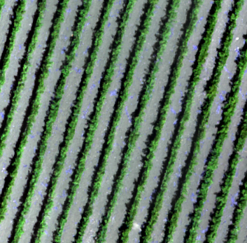 | 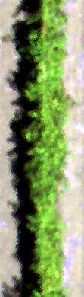 | 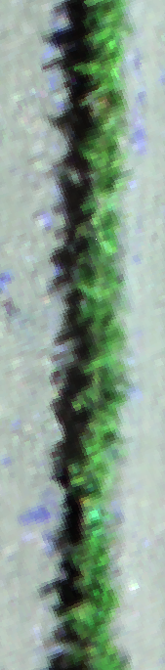
Gaussian Mixture Model |  | 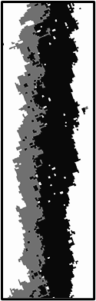 | 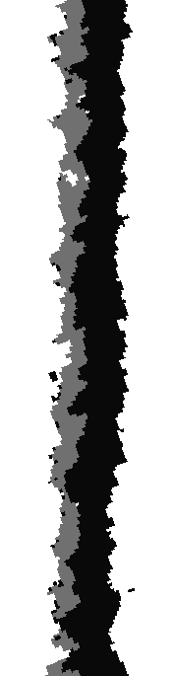
Random Forest | 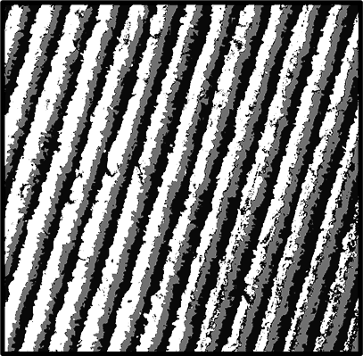 | 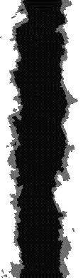 | 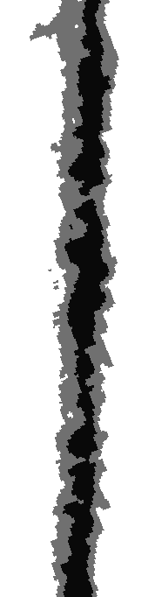
Support Vector Machines |  | 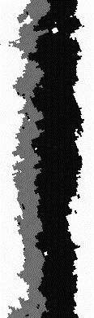 | 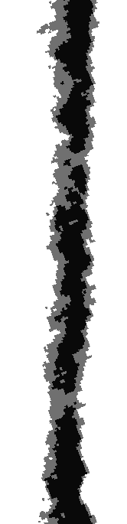
K-Means |  | 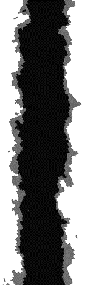 | 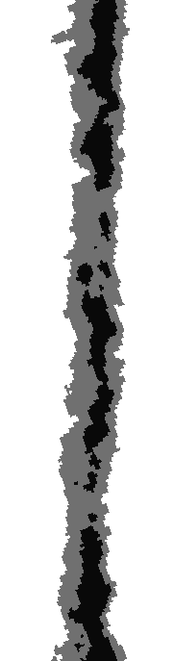
Mask R-CNN |  | 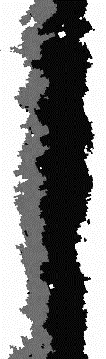
U-Net |  | 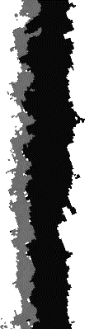 | 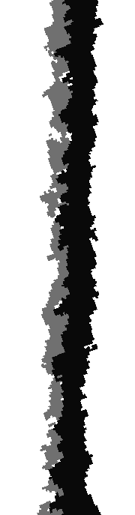
Figura 3. Graphical representations obtained after the application of the methods to the vineyard sub-images derived from the DOM splitting, and the segmentation masks subsequently obtained. Detailed images of two vineyard vigour conditions and their respective masks are also shown.

Figure 4a refers to the phenological period BBCH65 in which the surface area is more covered by soil and the incidence of shadow is lower. In contrast, in the phenological period BBCH85 depicted in figure 4b, both the surface area covered by canopy is greater and the surface area covered by shadow is also larger than in the previous period. Among the methods, K-Means was the one that identified the lowest area covered by canopy. The latter and RF were the methods that overestimated the area occupied by the shadow, with values of 22.5% and 25.8%, respectively, referring to the BBCH85 phenological stage (Figure 4b). This effect of shadow overestimation is mainly attributable to misclassification errors of canopy pixels that are classified as shadow, which is found for canopies of LV growth. DL methods and the GMM methods reported comparable percentage values with reference to the surface area covered by soil, these values differing significantly from the values reported by RF and K-Means, which instead identified an area of approximately 40%.
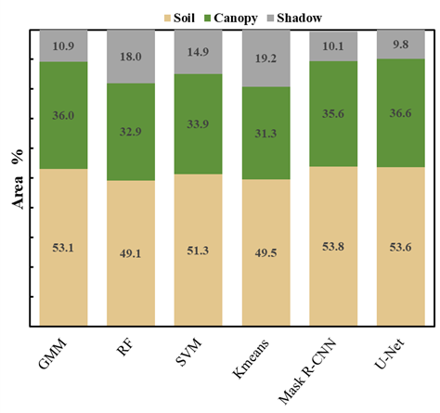  a | 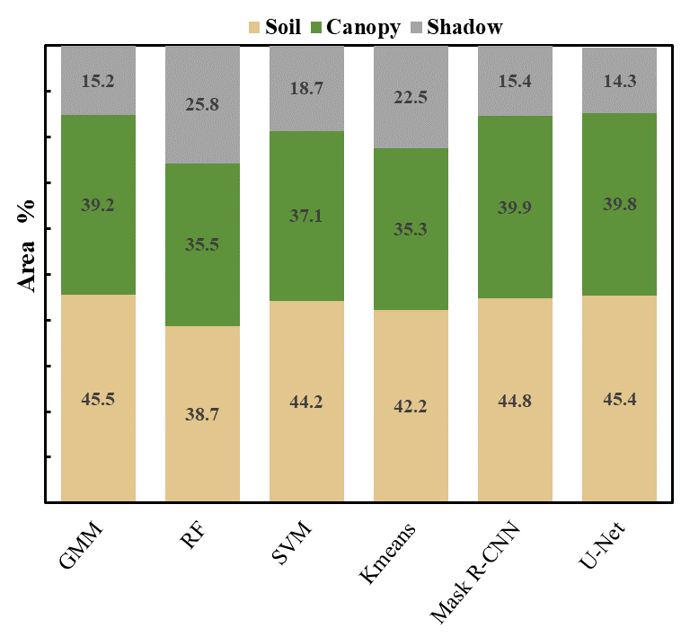  b
Figure 4 Distribution of the surface area covered by the three classes composing the DOM images; Figure a refers to phenological stage BBCH65; Figure b refers to phenological stage BBCH85

3.2 Assessment of vine canopy delimitation
In order to obtain a more detailed assessment of the impact of the vineyard canopy segmentation methods, the sampling blocks were divided by the vigor level with the aim of identifying differences in the blocks lying in LV zones and those lying in the HV zones. It was observed that on average, the PCA among the different models applied is 4 (m²). However, some classifiers have underestimated this area, e.g. RF identifies 3.62 (m²) and even the K-Means reports an average PCA value of 3.51 (m²). The GMM method reports an average PCA value of 4.21 (m²), which is comparable to Mask R-CNN and UNet that are 4.12 and 4.07, respectively (m²).
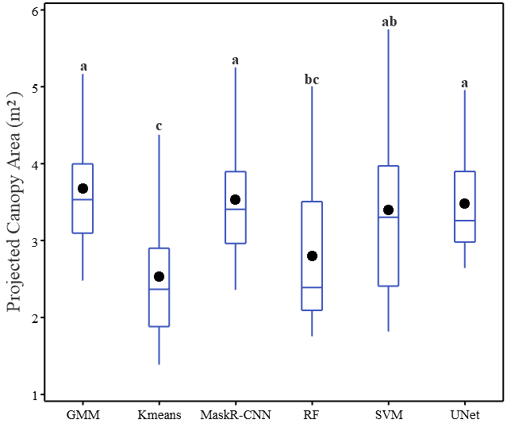  a | 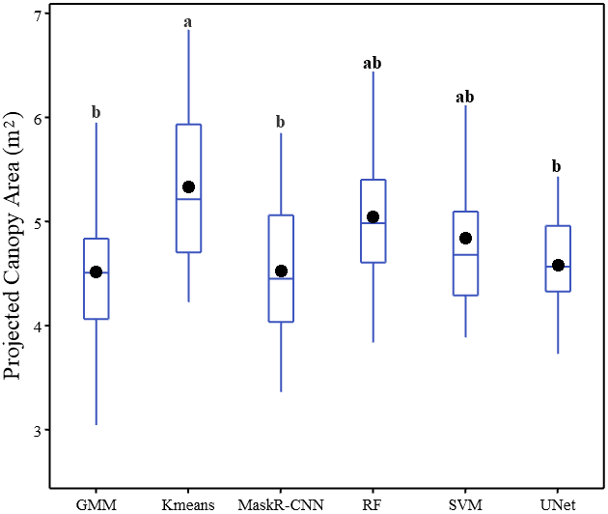  b
Figure 5. Boxplot representation of Projected Canopy Area (m²) values divided among the methods; boxplot a pertains to the sampling blocks of low-vigor (LV) canopies, while boxplot b pertains to the blocks of high-vigor (HV) canopies.
Through analysis of variance, it was observed that both the vigor levels and image analysis methods applied in this study affect the response of PCA values (p-value=0.008). Boxplots showing how the average PCA figure varied between HV and LV are shown in figure 5. Boxplot 5a shows the results of the analysis carried out by Tukey's test related to LV zones, showing how the U-Net and Mask R-CNN methods are statistically different from the K-Means classification model; instead, RF shows a statistically intermediate result between the groups. The graph in Figure 5b, meanwhile, shows the results of PCA for HV zones. Tukey test did not find differences between GMM, Mask R-CNN and
U-Net models. This group reported average PCA for the HV canopies with smaller size than the average PCA derived from the SVM and the RF as well as K-Means. The SVM reported the value of PCA in the HV vineyard areas similar to RF, these methods and also the K-Means overestimated this parameter, the latter exhibiting the highest value of canopy overestimation, being statistically different from all other methods. In the same manner as performed for PCA, the analysis of variance between factors such as vigor levels and segmentation methods has found a significant and positive interaction with the NDVI variable.
The boxplots in figure 6 represent the distribution of NDVI corresponding to the canopy segmentation masks in the two vineyard vigor conditions. The boxplot 6a refers to the sampling blocks located in LV zones, it is observed that the classification methods that underestimated the size of the PCA (Fig.5a), such as RF and K-Means, report higher NDVI than the other methods. In fact, the GMM, Mask R-CNN and U-Net show lower NDVI for LV areas, this is confirmed by the Tukey test. In contrast, Tukey test computed in ANOVA analysis for the RF and SVM indicates that the NDVI are intermediate to the previous groups. Observing the boxplots shows an interesting result about the distribution of NDVI among the models under investigation. Models that tend to overestimate the NDVI of LV canopies are characterised by a narrow boxplot, indicating a narrow dispersion of values within the population and thus less heterogeneity in the data. The boxplot in Figure 6b refers to NDVI of HV zones, in this case the analysis of Tukey test shows statistically significant differences between DL methods and K-Means, the latter underestimates the NDVI of the HV canopies.
The larger boxplot of K-means represents greater dispersion of the data within the sample and thus a higher data heterogeneity.

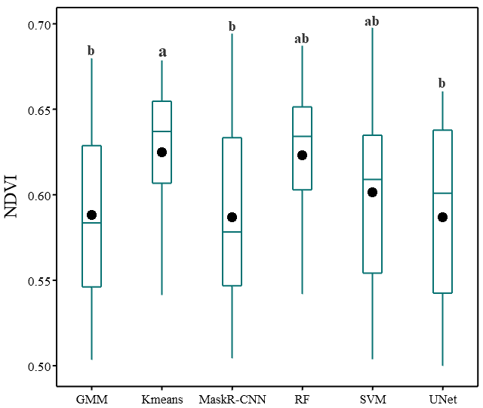 | 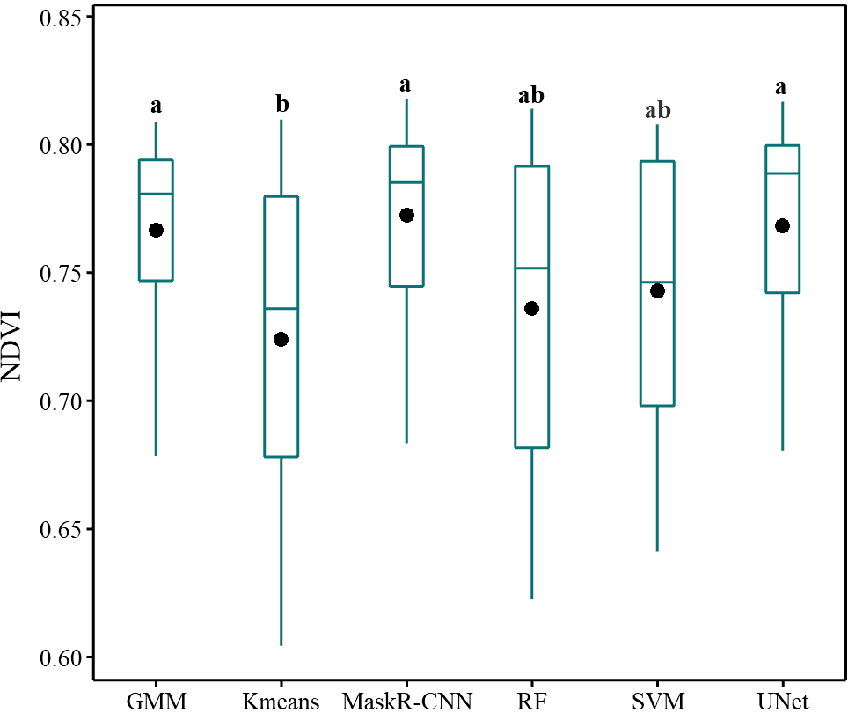
Figure 6. Boxplot representation of NDVI divided among the classification models; boxplot a relates to the sampling blocks of low-vigor zones, while boxplot b relates to the blocks of high-vigor zones.
b
a

Table 6 shows the values for the Gini index, these results allow explaining the observed variability between LV and HV canopies among the image analysis methods. With reference to PCA parameter for vineyard blocks located in LV areas, it is seen that the U-Net and Mask R-CNN methods reported low Gini values. An opposite result was obtained for the RF and K-Means methods, in which the index was 21.44% and 25.85%, respectively, which were significantly higher.

Table 6. Gini heterogeneity index (G%) representing the range of variation for the variables Projected Canopy Area (PCA) and NDVI calculated for the LV and HV sampling blocks and the whole dataset.
Method | Low vigor |  | High vigor |  | All data set
 | G% (NDVI) | G% (PCA) | G% (NDVI) | G% (PCA) | G% (NDVI) | G% (PCA)
(OBIA) GMM | 6.86 | 16.07 | 3.10 | 6.68 | 12.57 | 17.44
K-Means | 2.60 | 25.85 | 7.87 | 8.33 | 9.12 | 26.45
Mask R-CNN | 6.88 | 15.80 | 2.13 | 8.85 | 11.73 | 16.38
(OBIA) RF | 3.01 | 21.44 | 6.73 | 6.87 | 8.59 | 25.70
(OBIA) SVM | 4.34 | 19.72 | 4.15 | 6.34 | 10.04 | 20.20
U-Net | 6.25 | 12.66 | 2.74 | 7.76 | 11.88 | 16.84

On the other hand, observing the distribution of the Gini index for the NDVI, it is noted that this is lower for the K-Means and RF methods and instead is higher for the other methods.
Referring to the NDVI, it is noted that the lowest values of the Gini index are reported by the DL methods. Among OBIA methods, GMM and SVM show low Gini values, unlike those reported by K-Means and RF, which exhibit greater heterogeneity.
This performance is determined by the variability of the pixels of the high vigor canopies as a result and where the segmentation method was unable to separate the canopy pixels with those of the shadow and soil.
Figure 7 shows how segmentation methods that tend to underestimate canopy size exclude edge pixels characterized by lower values than the middle pixels. This phenomenon tends to increase the average NDVI canopies. For HV canopies, segmentation methods that were unable to accurately identify canopy pixels (K-Means; RF), tend to underestimate the NDVI. This underestimation is due to the greater heterogeneity of the pixels that characterise the canopy. In particular, the values of shaded pixels that have been misclassified as a canopy, having a lower NDVI, influence the average value of the resulting canopy.
Figures 7 and 8 show a visual comparison of the results obtained through the different image analysis methods for two vegetative canopy growth conditions. It can be seen clearly through these visual results, which further confirm the analyses of quantitative comparisons performed through the accuracy indices. Figure 7 refers to LV canopies, in which after removing complex background features such as soil and shadows, only the canopy masks are obtained. Through this visualisation, a comparison can be made between the methods for delineating the canopy edges. Figures 7 (a), (b) and (d) show the output results of the supervised ML methods, focusing particularly on Figure 7 (d) it is evident that the RF method is the one that generates the least accurate canopy boundary shape. The K-Means method in Figure 7 (c) is the worst, with many false detections, this is shown by observing the details on the canopy edges that are completely different from the actual edges. In contrast, in Figure 7 (e) and (f) canopy segmentation masks are observed to be completely superimposed on the real conditions of LV canopies; in fact, these have the greatest details on the canopy edges. Thus, the classification and segmentation methods that obtained the worst results in LV areas, detect a lower number of pixels and these are mainly the middle pixels of the canopy, and these methods cannot identify the vegetation pixels located at the edges.
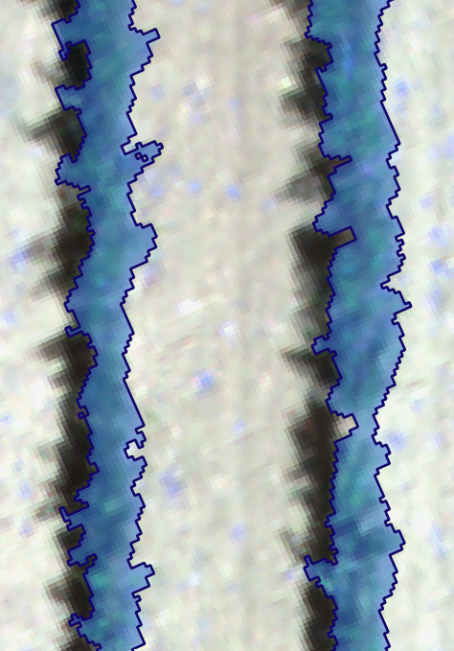 | 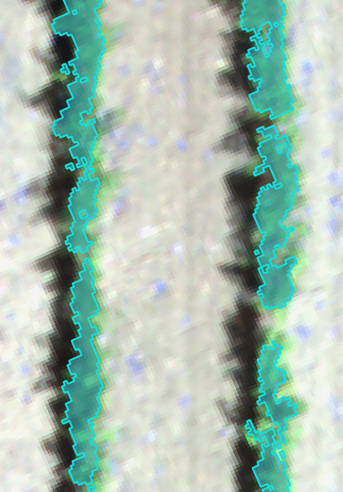 | 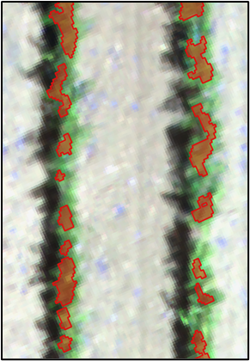
(a) | (b) | (c)
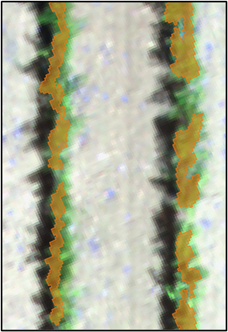 | 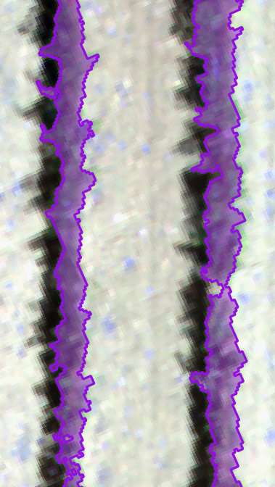 | 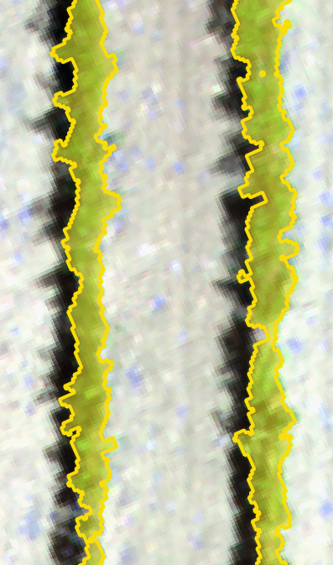
(d) | (e) | (f)
Figure 7 Results of different vineyard canopy detection methods in low vigor growth conditions. (a) GMM; (b) SVM; (c) K-Means; (d) RF; (e) Mask R-CNN; (f) U-Net

Figure 8, on the other hand, shows the results obtained by the methods for HV canopy, areas of the vineyard where the row vegetation has a larger size. It is noticeable that among the OBIA supervised ML models, GMM (figure 8a) was the one that was able to delineate the canopy edges better, compared to the SVM and RF methods, which were instead more affected by shaded pixels. Especially observing Figure 8 (c) for the K-Means method, the canopy mask does not delineate by vegetation pixels, but rather includes shaded pixels. DL networks were comprehensively better than the other methods for detecting vineyard canopies in HV zones and show greater detail on the canopy edges, which explains their higher accuracy values.
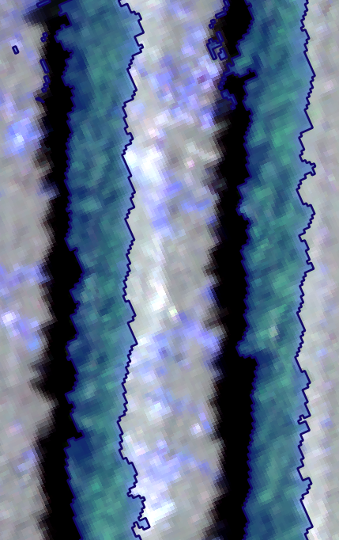 | 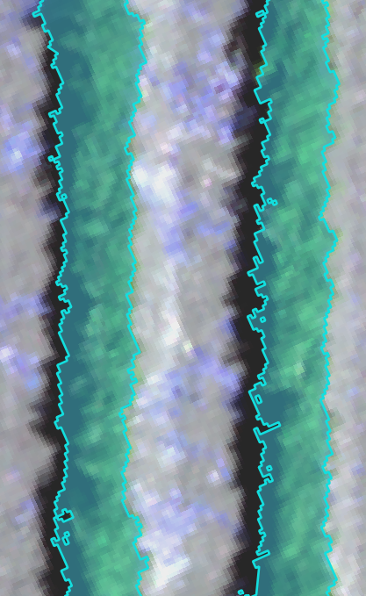 | 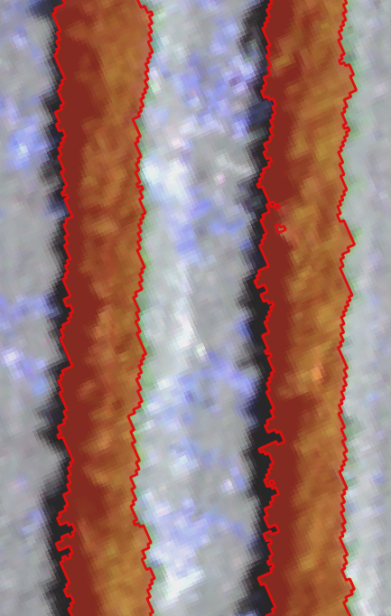
(a) | (b) | (c)
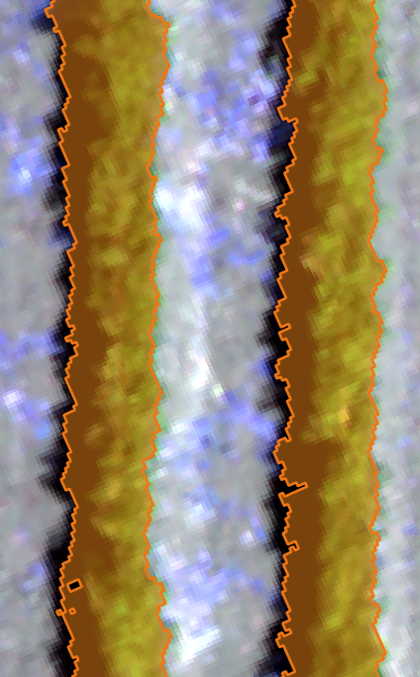 | 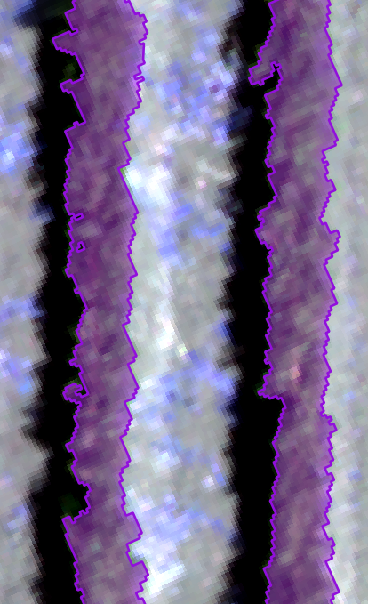 | 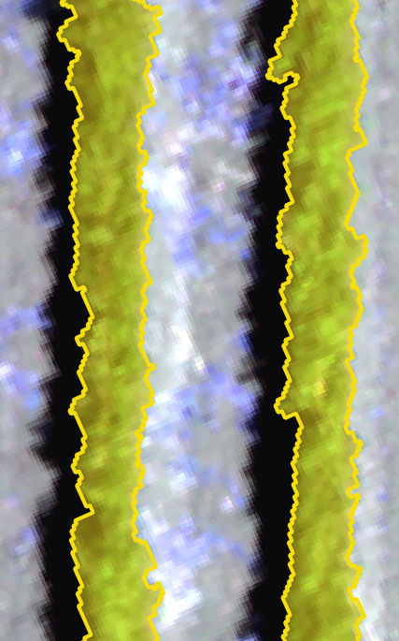
(d) | (e) | (f)
Figure 8 Results of different vineyard canopy detection methods in high vigor growth conditions.
(a) GMM; (b) SVM; (c) K-Means; (d) RF; (e) Mask R-CNN; (f) U-Net

Figure 9 shows an example of overlapping of two classification masks referring to the methods that accurately classified the canopies, and in this example the U-Net method is mentioned. Furthermore, viewing at the edges of the yellow mask, it can be observed that for the LV vines (Figure 9a), the canopy pixels are identified, whereas the K-Means (red line) only identifies a part of the canopy. Figure 9 (c) further clarifies this direct effect on canopy NDVI, as the U-Net also identifies pixels at canopy edges, which usually have a lower value than the middle canopy pixels alone. Consequently, NDVI of the LV canopies identified by DL methods is lower in absolute value and with greater heterogeneity in the dataset. In Figure 9 (b), meanwhile, it is observed that in HV zones, classifiers such as K-Means (red line), which cannot identify canopies clearly from shaded pixels, report lower NDVI than methods that identify canopies accurately and with acceptable overlap. In Figure 9 (d), it is observed that in this case the shaded pixels cause an evident interference with the vegetation pixels, and thus a lower NDVI.
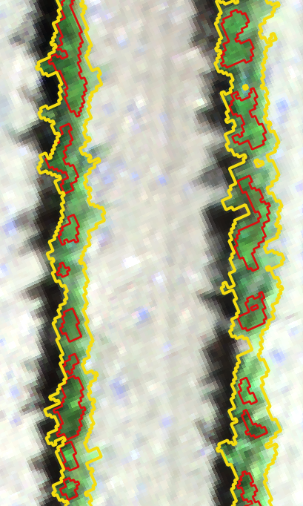 | 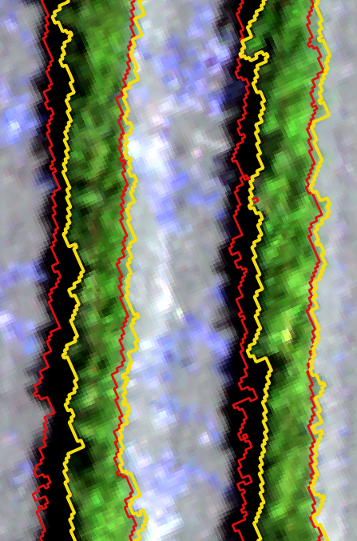
(a) | (b)
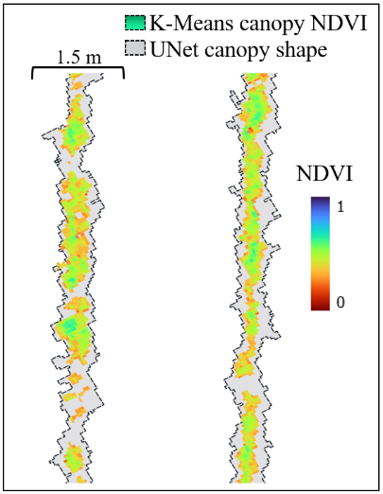 | 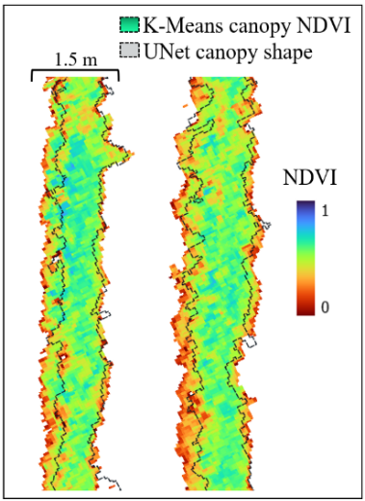
(c) | (d)
Figure 9. Illustration of two canopy boundary masks under two different vigor conditions; (a) Overlapping of U-Net (yellow line) and K-Means (red line) canopy masks in LV vineyard zones; (b) overlapping of U-Net (yellow line) and K-Means (red line) canopy masks in HV vineyard zones. (c) graphical representation of LV vineyard canopy NDVI; (d) graphical representation of canopy NDVI in HV zones.

The histograms shown in Figure 10 illustrate the difference in NDVI distribution depending on which method was used to classify the canopies. Histogram 10 (a) refers to LV canopies and three methods are represented, with reference to the U-Net and GMM classifiers, it is noted that both have a broader distribution range compared to K-Means distribution. With reference to this histogram, the relative frequency percentage of NDVI pixel observations with values below 0.60 is significantly higher for U-Net and GMM. For NDVI class of 0.55, the relative frequency percentage of U-Net and GMM is 10% compared to K-Means, which is 2%. The histogram in Figure 10 (b), however, refers to the canopies of the HV zones, and in this case the distribution range of NDVI for the canopy pixels identified by K-Means is greater, in view of the shadowed pixels. For example, for the NDVI value class of 0.70, the relative percentage frequency is 10% for K-Means and on the other hand is approximately 3% for NDVI detected by U-Net and GMM methods.
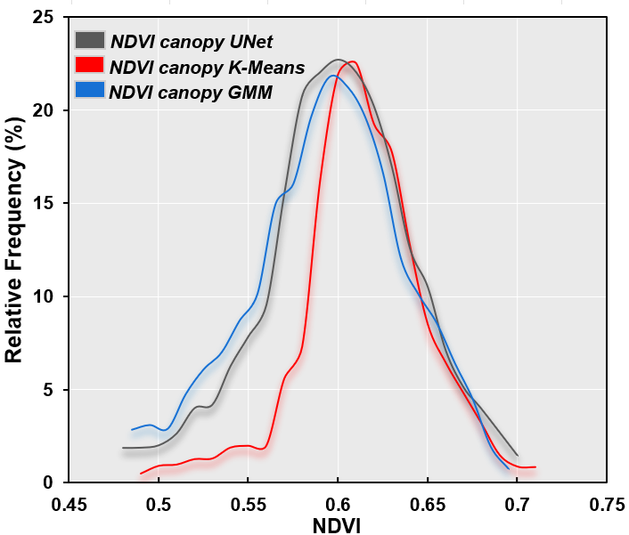 | 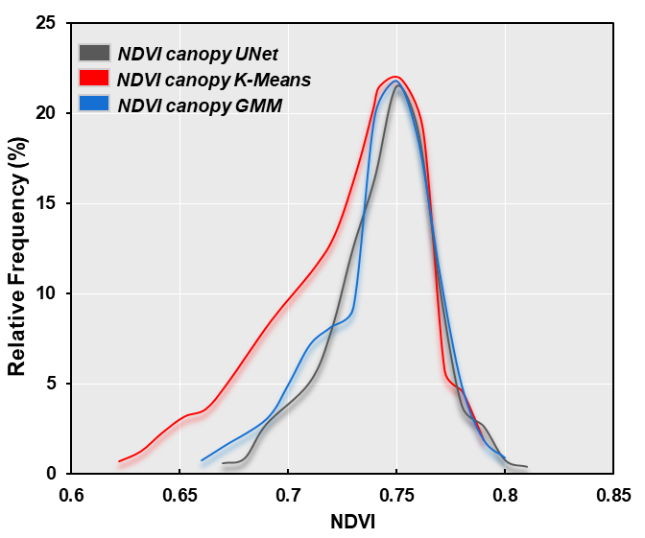
Figure 10. NDVI histograms of three different canopy detection methods respectively for LV canopy (a) and HV canopy (b) zones of the vineyard.
a
b

3.3 Correlation analysis
The results of the spectral and canopy area information obtained through the different segmentation methods were used for correlation analyses combining the vineyard agronomic parameters and evaluated for the two phenological stages (figure 11). Observing both correlation matrices, positive Pearson correlation values are noted between the NDVI and the agronomic variables TLA and Chl. In addition, the coefficient values are better for surveys performed during the phenological stage BBCH65. With reference to this phenological stage, the correlation results are shown in figure 11 a, considering the canopy NDVI, the highest correlations with the TLA parameter were obtained by U-Net and Mask R-CNN and are respectively 0.89 and 0.87. Among the supervised methods, instead, the correlation between TLA and SVM and GMM is slightly lower than DL networks, in contrast, the correlation between TLA and NDVI values identified by RF classifier is 0.77 and thus lower, a similar value is reported by the correlation between TLA and K-Means and is the worst correlation result (r=0.76). In Figure 11 b, similar results to those reported for BBCH85 are observed, however, the correlation for DL methods is still higher (r=0.78), compared to methods such as RF and K-Means, which instead report r values of 0.69 and 0.68, respectively. When considering the agronomic parameter Chl conversely, the NDVI values derived by Mask R-CNN and U-Net have the highest correlation coefficients (r=0.86), during the phenological period BBCH65, this value decreases to BBCH85 (r=0.80), remaining the highest result. Thus, the correlation coefficient with leaf Chl increased by 0.10 compared to the NDVI obtained with the RF and K-Means methods. The agronomic parameter S.L was the one that reported lower correlation values and in generally less than 0.50, however even in this case it is observed that DL networks and supervised ML methods report better correlation values. These correlations were also carried out considering the PCA data, and the results obtained are quite remarkable, as shown by the correlation in figure 11 a, where TLA and PCA are better represented by U-Net and Mask R-CNN with values of r=0.80 and 0.81, respectively, than the values of the K-Means and RF methods, which are lower (r=0.77). As shown by the correlation coefficients between Chl and PCA, it can be stated that PCA is not a recommended variable for the estimation of Chl content. Correlation coefficients between PCA and Chl were better for phenological stage BBCH65. Referring to the correlation coefficients between the NDVI values of U-Net and Mask R-CNN, are the highest for both phenological periods, in fact with values above 0.95, the clear correspondence between the two methods is evident. Furthermore, DL methods also show a correlation with NDVI of the canopies detected by GMM, further demonstrating their correspondence. Among the results observed in the correlation matrix, it is noteworthy that the lowest correlation values were obtained in the comparison between the U-Net and Mask R-CNN methods with the K-Means method, reporting average values of 0.75 for the BBCH65 and 0.81 for the BBCH85 stage. Additionally, K-Means shows good correlation values when compared to the RF method, both for NDVI and PCA data. Finally, DL methods demonstrate the highest correlation values between NDVI and PCA, compared to the K-Means method, where the correlation between NDVI and PCA is lower, with r values for BBCH65 and BBCH85 of 0.75 and 0.85, respectively.

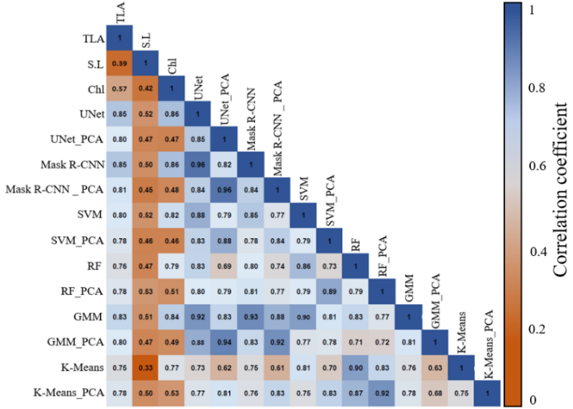  a | 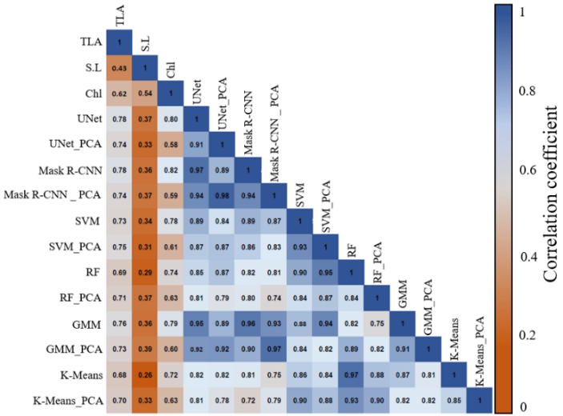  b
Figure 11. Correlation matrices for the 15 variables examined. The matrices show the Pearson correlation coefficient (r) values between the agronomic variables and the NDVI and Projected Canopy Area (PCA) data identified using the six image segmentation methods. The colour intensity is proportional to the correlation coefficients, with values close to 1 coloured in blue, and values close to zero in orange. The correlation matrix in figure a and b refer the phenological period BBCH65 and BBCH85, respectively.

4. Discussion

4.1 Quantitative comparison of the different methods
The studied vineyard shows a high level of vegetative and reproductive variability, which has been studied in previous investigations at experimental vineyards [4]. High variability is found in the heterogeneous canopy growth, which can be attributed to a different canopy thickness due to the variation in shoot number, shoot length and consequently number of leaves. Moreover, this heterogeneity also affects grape yield and quality parameters, which differ significantly between the LV and HV zones. The terrain topography contributes significantly to an uneven change in vineyard vigour. The effects of this phenomenon show that flat areas have higher NDVI values, indicating a higher vegetative density of the canopy. Earlier studies show that in sloping areas there is a decrease in grape yield, together with a lower vegetation density and consequently a low grapevine NDVI is observed [46].
This study has considered a complex context, characterized by a vineyard with a wide variability in vine growth, leading to different canopy densities. This parameter is considered one of the main constraints for canopy delimitation [47]. The results of vineyard segmentation and classification vary for different image components and in terms of the size of the obtained segments. However, this was expected since six different pixel-wise methods with varying structural complexity and architecture were employed. In this comparative study between DL networks and classical supervised machine learning methods (GMM; SVM; RF), as well as unsupervised K-Means, the analysis was conducted using a dataset comprising both NIR and RGB bands. This operational mode was adopted because it is known from the literature that the NIR band provides high segmentation performance [48]. However, combining NIR with the RGB bands, which are widely used for image segmentation studies, enhances the overall performance [10,15]. The image analyses were performed by segmenting each sub-image separately rather than the entire orthomosaic. Accurate detection of vine canopy is crucial for obtaining precise information about vegetation, especially in the presence of elements that can negatively influence canopy spectral response, such as soil, shadows, or weeds. Compared to other traditional machine learning methods, both semantic segmentation and instance segmentation models demonstrated a significant improvement in classification accuracy, with higher (OA) and F1-score. Some other classification methods (e.g., RF; K-Means) misclassified the vine canopy as soil background or erroneously identified shadows as vine canopy. These findings align well with conclusions from other studies that leverage spectral combinations and assess various approaches to canopy segmentation and classification (Huang et al., 2020). Nevertheless, among the supervised ML methods, GMM exhibited the lowest error index and stands out as one of the most stable classifiers. SVM showed some errors in classification, however, it can be considered relatively stable, in contrast to RF, which showed clear errors in determining shadows classified as soil or vegetation. Concerning RF method, lower accuracy in shadow detection in VSP systems has been previously observed as well [15,51]. It is well-known that various factors can influence the accuracy of OBIA methods, including segmentation parameters, feature selection, and detailed algorithm tuning. Therefore, thorough controls are necessary to determine the optimal parameter values [52]. The division of the image dataset into training, validation, and testing sets was performed after a series of trials with different dataset splits. It was observed that all OBIA methods showed better performance with increasing training dataset size. The dataset splitting procedure used in this study was consistent with that of other studies, where a training dataset portion equal to or greater than 70% was selected, and the classification accuracy demonstrated robust stability with no overfitting observed for ML models [53,54]. OBIA methods, tuning the number of elements for the training samples of each image can have a significant impact on the classification accuracy. In this study, the subdivision was made considering the study conducted by [55] in which it is observed that the different ML methods become insensitive to an increase in sample size and thus the accuracy of the models does not increase significantly by exceeding the threshold of 125 samples [56]. Therefore, the greater stability achieved by GMM and SVM methods could be attributed to their lower sensitivity to changes in the number of samples, as demonstrated by [55].
The superior performance of Mask R-CNN observed here can be justified by the use of multi-band images, an approach known to significantly enhance segmentation accuracy compared to models utilizing single-band images [57]. Moreover, image spatial resolution has a direct impact on the accuracy of detection, which is notably high in this study. It is acknowledged that (CNN) are significantly influenced by spatial resolutions, and their efficiency diminishes as resolution decreases [21,22]. In line with the findings of this study, a recent comparison was made between the performance of Mask R-CNN and the OBIA-MDTWS algorithm. The experimental results affirmed the effectiveness of Mask R-CNN in segmenting crops, revealing a higher overall average F1-score of 97.63% compared to the OBIA method [53]. From vineyard investigations using RGB and NIR images, it is evident that semantic segmentation methods, including U-Net, exhibit overall superior performance compared to unsupervised segmentation methods. This aligns with the results presented in this study. However, the authors demonstrate that some of these methods can have competitive performance under specific conditions [26]. In this study, U-Net accurately identifies the three classes, particularly in terms of canopy delineation. U-Net has achieved positive outcomes primarily due to the concatenation and upsampling structures it incorporates. The encoder and decoder layers, indeed, allow for the acquisition of detailed information from the features of the training image set [58]. This result is consistent with the literature, which asserts that the use of semantic segmentation can significantly improve the efficiency of multi-class segmentation [23,24].

4.2 Inter-relationship analysis among methods and agronomic parameters
Recent studies have revealed that semantic segmentation significantly improved the accuracy of LAI estimates compared to traditional methods [59]. This is done by masking multispectral images through U-Net to generate specific canopies segmentations, follows by the computation of VI, together with analyses conducted to understand how specific parts of the canopy influence the spectral characteristics. This study conducted on an on–farm vineyard with VSP system, more accurate canopy delineation results were observed during the vegetative phase BBCH65. During this period, the general conditions of shoot growth did not have a negative impact or make the image analysis process laborious. The canopy exhibited a more distinctive morphological aspect compared to the BBCH85 stage, where the occurrence of shading and other background elements could result in a performance decrease for some methods. The canopy size affects the results of pixel-wise model delineation. Canopies with higher density tend to be oversized, and this effect has been observed for DL networks [60]. However, in this study, DL networks were not significantly disadvantaged by this effect. On the contrary, traditional segmentation methods were significantly influenced, as also noted by [61]. The variation in canopy sizes plays a crucial role in segmentation and classification processes. In this study, it was observed that differences in canopy size were not solely phenological but were also related to variations in vine vigor within the plot. The accuracy and F1-score results indicate that certain classifiers, both in OBIA methods and unsupervised approaches, tend to exclude smaller vine canopies in LV areas. HV zones, conversely, vine rows with high canopy thickness and density tend to be oversized. The error is likely related to the presence of shadows in the images, affecting both the K-Means method [10], and OBIA methods, such as the RF classifier [15]. The multiclass segmentation analysis allows for the identification of soil and particularly shadow influence on the overall area of pure vegetation pixels. Methods that underestimated canopy sizes in LV zones exhibited an overall higher NDVI compared to more accurate methods. In HV vineyard zones, on the other hand, methods with higher classification errors overestimated canopy pixels, resulting in lower NDVI compared to methods that achieved high accuracy and excluded the spectral response from shadows. The literature regarding this specific result, observed for pure pixels, is limited. However, the phenomenon can be explained by considering the findings from Sozzi et al., (2020) where the Gini index is taken into account. The authors conducted a multi-resolution comparison study, comparing two data acquisition platforms in a vineyard and evaluating their respective NDVI. They report that a high NDVI value is associated with a lower Gini index, and conversely, a lower NDVI is paired with a high Gini index. These results align with those identified in this study. A similar result to that identified in this study was observed by Aboutalebi et al., (2019), where the average NDVI in pure canopy pixels were higher than those in shadowed vegetation pixels. The authors applied both unsupervised classification methods and supervised OBIA techniques, with the latter achieving superior accuracy indices in shadow detection. On the other hand, the results shown by RF and K-Means methods in LV vineyard zones are a consequence of the small and constrained canopy sizes, especially in VSP systems. This phenomenon has also been observed in other studies [11,62]. Campos et al., 2021, observed that background elements negatively influence the pixels of the vine canopy area. The edge effect on multispectral images significantly impacts the NDVI of the vine canopy, consequently decreasing its correlation with canopy architecture parameters. Correlation matrices demonstrate positive and significant interactions in comparing NDVI data with agronomic parameters such as TLA and Chl. It has been found that the correlations between canopy NDVI and TLA, evaluated through high-resolution UAV images, can be rather low. This is explained by considering the phenomenon that canopy pixels are more influenced by the physiological activity of the vine than canopy structure [27]. Conversely, NDVI obtained from lower-resolution images, such as satellite imagery, incorporate reflectance information from both the canopy and the soil. Consequently, it is more influenced by changes in vegetation cover than by plant physiology [63]. In this study, it was demonstrated that the correlation between pure canopy pixel NDVI and vineyard leaf area can be increased by exploiting canopy segmentation and classification methods that remove the negative influence of background effects. These observations are in line with other recent studies, which obtained higher accuracy in the estimation of LAI and leaf Chl after removing shaded canopy pixels in an orchard context [29].
The coefficients of determination obtained between NDVI and leaf chlorophyll content indicate a high correlation, supporting the capability of NDVI to precisely assess chlorophyll content in leaves. These results are in line with the findings reported by Caruso et al., (2023), which highlighted a consistent and stable relationship between these two parameters. Furthermore, correlations related to NDVI data obtained from segmentation methods showed a decline in correlation with leaf chlorophyll content at BBCH85, in agreement with observations by Caruso et al., (2017) in which the estimation of vine leaf chlorophyll content was conducted using UAV images.
Results obtained suggest that it is possible to enhance canopy delineation and achieve an accurate estimation of spectral conditions. Improving vine canopy delineation through the application of these technologies opens new perspectives for vineyard phenotyping and the prediction of key agronomic parameters. The scientific contributions of this study primarily concern the development of more precise and reliable phenotyping systems, enabling the identification of variation in canopy growth in relation to plant vigor. A more realistic monitoring of vigor offers the possibility to accurately identify the onset of abiotic stress. Vine canopy segmentation and vigor monitoring have the potential to provide valuable information for improving grapevine growth simulation models.

4.3 Limitations and future work directions
In this study, the dataset used for training exhibited high variation in vegetation growth conditions, in terms of vigor and overall vegetation growth between low and high vigor canopies. This spatial variability primarily concerns the differing canopy thickness, and consequently also the spectral response evaluated through NDVI between LV and HV vineyard zones. For these reasons, a biennial trial was conducted, in two distinct phenological phases, with the aim of evaluating the impact of canopy growth variability on segmentation and classification processes. In the future, to obtain more accurate measurements of Chl and TLA, it is desirable to retrieve more data on canopy structure. Future studies will include sensors capable of capturing canopy biometric data through direct measurement systems rather than point-based approaches. Manual annotation of ground truth masks for model segmentation training poses a challenge due to its laborious nature in terms of time and effort. For instance, accurately delineating canopy shadows generated by sunlight in aerial photography is one of the main challenges in the labelling process. Possible future directions will be exploration of hybrid annotation approaches, combining semi-automatic methodologies, or using machine learning algorithms capable of generating initial masks. These approaches could drastically reduce the annotation workload required while simultaneously improving the flexibility and overall efficiency of the process. This study did not report the time consumed for model calculations. However, it was observed that the computationally most expensive algorithms, ML ones used in OBIA analysis, demanded more time to complete the analysis, heavily utilizing processor capabilities. ML algorithms utilize the CPU to analyze the multi-dimensional features of each object. In this study, analyzing a very large multispectral image dataset requires multiple computation cycles to segment and classify each class, leading to a significant increase in processing time, which represents an intrinsic limitation of the CPU. On the contrary, the two DL methods leverage the parallel computing power of GPU, designed to handle large amounts of data. These distribute computations across multiple cores, significantly accelerating the segmentation and classification process of classes. This research provides the baseline for future studies on the implementation of UAV-mounted multispectral sensors that could be equipped with GPUs for real-time canopy detections, providing accurate information on vineyard phenotyping or vegetation maps in real time.

5. Conclusions
The utilization of multispectral image analysis technologies captured by UAVs represents an additional asset for the comprehensive monitoring and prediction of vineyard vegetation conditions. By combining these technologies with computational models of OBIA or deep learning, it becomes possible to accurately compute VIs using various spectral bands. This study presents a workflow that includes cutting-edge deep learning methods such as Mask R-CNN and U-Net, supervised machine learning methods such as GMM, SVM, RF, and the unsupervised K-Means method. The analyses were executed employing high-resolution multispectral images acquired from UAV. The methods were employed for vine canopy delineation, aiming to investigate the potential influence of segmentation and classification algorithms on crucial parameters such as the projected canopy area and NDVI. These parameters, derived from image analysis, were subsequently correlated with agronomic data, encompassing total leaf area, shoot length, and leaf chlorophyll content. In conclusion, the Mask R-CNN and U-Net achieved higher accuracy indices overall compared to OBIA algorithms. However, among the OBIA methods, the GMM algorithm demonstrated the lowest error rate and can be considered one of the valid OBIA methods for extracting canopy margin features. While SVM yielded acceptable accuracy, it faced challenges in efficiently separating shadows from vegetation in certain contexts. On the other hand, the RF and K-Means algorithms reported misclassifications of image components, significantly affecting the spectral data of the canopy. Specifically, for LV vineyard zones, the NDVI was overestimated, while in HV vineyard zones, the NDVI was underestimated. This result has a direct impact on the correlation with canopy agronomic parameters. The NDVI identified in canopies delineated using Mask R-CNN and U-Net methods showed a strong correlation with total leaf area and chlorophyll content. Supervised OBIA methods employing GMM and SVM algorithms exhibit stable and positive determination coefficients with agronomic variables, although marginally lower than those obtained from DL networks. This study represents an innovative approach that elucidates the practical implications of using neural networks and OBIA methods for the detailed assessment of canopy. By expanding this knowledge, vineyard vigor monitoring systems can be enhanced, providing grape growers with increasingly precise and reliable crop information.

Acknowledgments
This work was supported by the project "SiciliAn MicronanOTecH Research And Innovation CEnter "SAMOTHRACE" (MUR, PNRR-M4C2, ECS_00000022), spoke 3 - Università degli Studi di Palermo "S2-COMMs - Micro and Nanotechnologies for Smart & Sustainable Communities".

6. References
- Sozzi, M.; Kayad, A.; Marinello, F.; Taylor, J.; Tisseyre, B. Comparing Vineyard Imagery Acquired from Sentinel-2 and Unmanned Aerial Vehicle (UAV) Platform. Oeno One 2020, 54, 189–197.
- Andújar, D.; Moreno, H.; Bengochea-Guevara, J.M.; de Castro, A.; Ribeiro, A. Aerial Imagery or On-Ground Detection? An Economic Analysis for Vineyard Crops. Computers and electronics in agriculture 2019, 157, 351–358.
- Feng, Q.; Yang, J.; Liu, Y.; Ou, C.; Zhu, D.; Niu, B.; Liu, J.; Li, B. Multi-Temporal Unmanned Aerial Vehicle Remote Sensing for Vegetable Mapping Using an Attention-Based Recurrent Convolutional Neural Network. Remote Sensing 2020, 12, 1668, doi:10.3390/rs12101668.
- Ferro, M.V.; Catania, P.; Miccichè, D.; Pisciotta, A.; Vallone, M.; Orlando, S. Assessment of Vineyard Vigour and Yield Spatio-Temporal Variability Based on UAV High Resolution Multispectral Images. Biosystems Engineering 2023, 231, 36–56,
- Moghimi, A.; Pourreza, A.; Zuniga-Ramirez, G.; Williams, L.E.; Fidelibus, M.W. A Novel Machine Learning Approach to Estimate Grapevine Leaf Nitrogen Concentration Using Aerial Multispectral Imagery. Remote Sensing 2020, 12, 3515, doi:10.3390/rs12213515.
- Bannari, A.; Morin, D.; Bonn, F.; Huete, A. A Review of Vegetation Indices. Remote sensing reviews 1995, 13, 95–120.
- Towers, P.C.; Poblete-Echeverría, C. Effect of the Illumination Angle on NDVI Data Composed of Mixed Surface Values Obtained over Vertical-Shoot-Positioned Vineyards. Remote Sensing 2021, 13, 855.
- Ferreira, M.P.; Féret, J.-B.; Grau, E.; Gastellu-Etchegorry, J.-P.; Do Amaral, C.H.; Shimabukuro, Y.E.; de Souza Filho, C.R. Retrieving Structural and Chemical Properties of Individual Tree Crowns in a Highly Diverse Tropical Forest with 3D Radiative Transfer Modeling and Imaging Spectroscopy. Remote Sensing of Environment 2018, 211, 276–291.
- Pádua, L.; Marques, P.; Hruška, J.; Adão, T.; Bessa, J.; Sousa, A.; Peres, E.; Morais, R.; Sousa, J.J. Vineyard Properties Extraction Combining UAS-Based RGB Imagery with Elevation Data. International Journal of Remote Sensing 2018, 39, 5377–5401.
- Cinat, P.; Di Gennaro, S.F.; Berton, A.; Matese, A. Comparison of Unsupervised Algorithms for Vineyard Canopy Segmentation from UAV Multispectral Images. Remote Sensing 2019, 11, 1023.
- Poblete-Echeverría, C.; Olmedo, G.F.; Ingram, B.; Bardeen, M. Detection and Segmentation of Vine Canopy in Ultra-High Spatial Resolution RGB Imagery Obtained from Unmanned Aerial Vehicle (UAV): A Case Study in a Commercial Vineyard. Remote Sensing 2017, 9, 268.
- Aboutalebi, M.; Torres-Rua, A.F.; Kustas, W.P.; Nieto, H.; Coopmans, C.; McKee, M. Assessment of Different Methods for Shadow Detection in High-Resolution Optical Imagery and Evaluation of Shadow Impact on Calculation of NDVI, and Evapotranspiration. Irrigation science 2019, 37, 407–429.
- Ferro, M.V.; Catania, P. Technologies and Innovative Methods for Precision Viticulture: A Comprehensive Review. Horticulturae 2023, 9, 399.
- Modica, G.; De Luca, G.; Messina, G.; Praticò, S. Comparison and Assessment of Different Object-Based Classifications Using Machine Learning Algorithms and UAVs Multispectral Imagery: A Case Study in a Citrus Orchard and an Onion Crop. European Journal of Remote Sensing 2021, 54, 431–460, doi:10.1080/22797254.2021.1951623.
- Pádua, L.; Matese, A.; Di Gennaro, S.F.; Morais, R.; Peres, E.; Sousa, J.J. Vineyard Classification Using OBIA on UAV-Based RGB and Multispectral Data: A Case Study in Different Wine Regions. Computers and Electronics in Agriculture 2022, 196, 106905.
- Lagrange, A.; Fauvel, M.; Grizonnet, M. Large-Scale Feature Selection with Gaussian Mixture Models for the Classification of High Dimensional Remote Sensing Images. IEEE Transactions on Computational Imaging 2017, 3, 230–242.
- Zhu, C.; Ding, J.; Zhang, Z.; Wang, J.; Wang, Z.; Chen, X.; Wang, J. SPAD Monitoring of Saline Vegetation Based on Gaussian Mixture Model and UAV Hyperspectral Image Feature Classification. Computers and Electronics in Agriculture 2022, 200, 107236.
- Jiménez-Brenes, F.M.; Lopez-Granados, F.; Torres-Sánchez, J.; Peña, J.M.; Ramírez, P.; Castillejo-González, I.L.; de Castro, A.I. Automatic UAV-Based Detection of Cynodon Dactylon for Site-Specific Vineyard Management. PloS one 2019, 14, e0218132.
- He, K.; Gkioxari, G.; Dollár, P.; Girshick, R. Mask R-Cnn.; 2017; pp. 2961–2969.
- Lucena, F.; Breunig, F.M.; Kux, H. The Combined Use of UAV-Based RGB and DEM Images for the Detection and Delineation of Orange Tree Crowns with Mask R-CNN: An Approach of Labeling and Unified Framework. Future Internet 2022, 14, 275.
- Hao, Z.; Lin, L.; Post, C.J.; Mikhailova, E.A.; Li, M.; Chen, Y.; Yu, K.; Liu, J. Automated Tree-Crown and Height Detection in a Young Forest Plantation Using Mask Region-Based Convolutional Neural Network (Mask R-CNN). ISPRS Journal of Photogrammetry and Remote Sensing 2021, 178, 112–123.
- Safonova, A.; Guirado, E.; Maglinets, Y.; Alcaraz-Segura, D.; Tabik, S. Olive Tree Biovolume from UAV Multi-Resolution Image Segmentation with Mask R-CNN. Sensors 2021, 21, 1617.
- Osco, L.P.; Nogueira, K.; Marques Ramos, A.P.; Faita Pinheiro, M.M.; Furuya, D.E.G.; Gonçalves, W.N.; de Castro Jorge, L.A.; Marcato Junior, J.; dos Santos, J.A. Semantic Segmentation of Citrus-Orchard Using Deep Neural Networks and Multispectral UAV-Based Imagery. Precision Agriculture 2021, 22, 1171–1188.
- Sahin, H.M.; Miftahushudur, T.; Grieve, B.; Yin, H. Segmentation of Weeds and Crops Using Multispectral Imaging and CRF-Enhanced U-Net. Computers and Electronics in Agriculture 2023, 211, 107956.
- Anagnostis, A.; Tagarakis, A.C.; Kateris, D.; Moysiadis, V.; Sørensen, C.G.; Pearson, S.; Bochtis, D. Orchard Mapping with Deep Learning Semantic Segmentation. Sensors 2021, 21, 3813.
- Barros, T.; Conde, P.; Gonçalves, G.; Premebida, C.; Monteiro, M.; Ferreira, C.S.S.; Nunes, U.J. Multispectral Vineyard Segmentation: A Deep Learning Comparison Study. Computers and Electronics in Agriculture 2022, 195, 106782.
- Caruso, G.; Palai, G.; Tozzini, L.; D’Onofrio, C.; Gucci, R. The Role of LAI and Leaf Chlorophyll on NDVI Estimated by UAV in Grapevine Canopies. Scientia Horticulturae 2023, 322, 112398.
- Campos, J.; García-Ruíz, F.; Gil, E. Assessment of Vineyard Canopy Characteristics from Vigour Maps Obtained Using UAV and Satellite Imagery. Sensors 2021, 21, 2363.
- Zhang, C.; Chen, Z.; Yang, G.; Xu, B.; Feng, H.; Chen, R.; Qi, N.; Zhang, W.; Zhao, D.; Cheng, J. Removal of Canopy Shadows Improved Retrieval Accuracy of Individual Apple Tree Crowns LAI and Chlorophyll Content Using UAV Multispectral Imagery and PROSAIL Model. Computers and Electronics in Agriculture 2024, 221, 108959.
- Torralba, A.; Russell, B.C.; Yuen, J. Labelme: Online Image Annotation and Applications. Proceedings of the IEEE 2010, 98, 1467–1484.
- Michel, J.; Youssefi, D.; Grizonnet, M. Stable Mean-Shift Algorithm and Its Application to the Segmentation of Arbitrarily Large Remote Sensing Images. IEEE Transactions on Geoscience and Remote Sensing 2014, 53, 952–964.
- Grizonnet, M.; Michel, J.; Poughon, V.; Inglada, J.; Savinaud, M.; Cresson, R. Orfeo ToolBox: Open Source Processing of Remote Sensing Images. Open Geospatial Data, Software and Standards 2017, 2, 1–8.
- De Luca, G.; N. Silva, J.M.; Cerasoli, S.; Araújo, J.; Campos, J.; Di Fazio, S.; Modica, G. Object-Based Land Cover Classification of Cork Oak Woodlands Using UAV Imagery and Orfeo ToolBox. Remote Sensing 2019, 11, 1238.
- Vapnik, V. Estimation of Dependences Based on Empirical Data; Springer Science & Business Media, 2006; ISBN 0-387-34239-7.
- Belgiu, M.; Drăguţ, L. Random Forest in Remote Sensing: A Review of Applications and Future Directions. ISPRS journal of photogrammetry and remote sensing 2016, 114, 24–31.
- Scikit-Learn 2022.
- Sinaga, K.P.; Yang, M.-S. Unsupervised K-Means Clustering Algorithm. IEEE access 2020, 8, 80716–80727.
- Ren, S.; He, K.; Girshick, R.; Sun, J. Faster R-Cnn: Towards Real-Time Object Detection with Region Proposal Networks. Advances in neural information processing systems 2015, 28.
- Ronneberger, O.; Fischer, P.; Brox, T. U-Net: Convolutional Networks for Biomedical Image Segmentation.; Springer, 2015; pp. 234–241.
- Long, J.; Shelhamer, E.; Darrell, T. Fully Convolutional Networks for Semantic Segmentation.; 2015; pp. 3431–3440.
- Ioffe, S.; Szegedy, C. Batch Normalization: Accelerating Deep Network Training by Reducing Internal Covariate Shift.; pmlr, 2015; pp. 448–456.
- Rouse Jr, J.; Haas, R.H.; Deering, D.; Schell, J.; Harlan, J.C. Monitoring the Vernal Advancement and Retrogradation (Green Wave Effect) of Natural Vegetation; 1974;
- Lopes, C.; Pinto, P. Easy and Accurate Estimation of Grapevine Leaf Area with Simple Mathematical Models. Vitis 2005, 44, 55–61.
- Cerovic, Z.G.; Masdoumier, G.; Ghozlen, N.B.; Latouche, G. A New Optical Leaf‐clip Meter for Simultaneous Non‐destructive Assessment of Leaf Chlorophyll and Epidermal Flavonoids. Physiologia plantarum 2012, 146, 251–260.
- Gini, C. Measurement of Inequality of Incomes. The economic journal 1921, 31, 124–125.
- Novara, A.; Pisciotta, A.; Minacapilli, M.; Maltese, A.; Capodici, F.; Cerdà, A.; Gristina, L. The Impact of Soil Erosion on Soil Fertility and Vine Vigor. A Multidisciplinary Approach Based on Field, Laboratory and Remote Sensing Approaches. Science of the Total Environment 2018, 622, 474–480.
- Sarabia, R.; Aquino, A.; Ponce, J.M.; López, G.; Andújar, J.M. Automated Identification of Crop Tree Crowns from Uav Multispectral Imagery by Means of Morphological Image Analysis. Remote Sensing 2020, 12, 748.
- Zheng, H.; Zhou, X.; He, J.; Yao, X.; Cheng, T.; Zhu, Y.; Cao, W.; Tian, Y. Early Season Detection of Rice Plants Using RGB, NIR-GB and Multispectral Images from Unmanned Aerial Vehicle (UAV). Computers and Electronics in Agriculture 2020, 169, 105223.
- Huang, H.; Lan, Y.; Yang, A.; Zhang, Y.; Wen, S.; Deng, J. Deep Learning versus Object-Based Image Analysis (OBIA) in Weed Mapping of UAV Imagery. International Journal of Remote Sensing 2020, 41, 3446–3479.
- Khan, S.; Tufail, M.; Khan, M.T.; Khan, Z.A.; Anwar, S. Deep Learning-Based Identification System of Weeds and Crops in Strawberry and Pea Fields for a Precision Agriculture Sprayer. Precision Agric 2021, 22, 1711–1727, doi:10.1007/s11119-021-09808-9.
- Kerkech, M.; Hafiane, A.; Canals, R. Deep Leaning Approach with Colorimetric Spaces and Vegetation Indices for Vine Diseases Detection in UAV Images. Computers and electronics in agriculture 2018, 155, 237–243.
- Gonçalves, J.; Pôças, I.; Marcos, B.; Mücher, C.A.; Honrado, J.P. SegOptim—A New R Package for Optimizing Object-Based Image Analyses of High-Spatial Resolution Remotely-Sensed Data. International Journal of Applied Earth Observation and Geoinformation 2019, 76, 218–230.
- Ye, Z.; Yang, K.; Lin, Y.; Guo, S.; Sun, Y.; Chen, X.; Lai, R.; Zhang, H. A Comparison between Pixel-Based Deep Learning and Object-Based Image Analysis (OBIA) for Individual Detection of Cabbage Plants Based on UAV Visible-Light Images. Computers and Electronics in Agriculture 2023, 209, 107822.
- Yuba, N.; Kawamura, K.; Yasuda, T.; Lim, J.; Yoshitoshi, R.; Watanabe, N.; Kurokawa, Y.; Maeda, T. Discriminating Pennisetum Alopecuoides Plants in a Grazed Pasture from Unmanned Aerial Vehicles Using Object‐based Image Analysis and Random Forest Classifier. Grassland science 2021, 67, 73–82.
- Qian, Y.; Zhou, W.; Yan, J.; Li, W.; Han, L. Comparing Machine Learning Classifiers for Object-Based Land Cover Classification Using Very High Resolution Imagery. Remote Sensing 2014, 7, 153–168.
- Zhou, X.; Yang, L.; Wang, W.; Chen, B. Uav Data as an Alternative to Field Sampling to Monitor Vineyards Using Machine Learning Based on Uav/Sentinel-2 Data Fusion. Remote Sensing 2021, 13, 457.
- Yu, K.; Hao, Z.; Post, C.J.; Mikhailova, E.A.; Lin, L.; Zhao, G.; Tian, S.; Liu, J. Comparison of Classical Methods and Mask R-CNN for Automatic Tree Detection and Mapping Using UAV Imagery. Remote Sensing 2022, 14, 295.
- Sun, Q.; Zhang, R.; Chen, L.; Zhang, L.; Zhang, H.; Zhao, C. Semantic Segmentation and Path Planning for Orchards Based on UAV Images. Computers and Electronics in Agriculture 2022, 200, 107222.
- Shao, M.; Nie, C.; Zhang, A.; Shi, L.; Zha, Y.; Xu, H.; Yang, H.; Yu, X.; Bai, Y.; Liu, S. Quantifying Effect of Maize Tassels on LAI Estimation Based on Multispectral Imagery and Machine Learning Methods. Computers and Electronics in Agriculture 2023, 211, 108029.
- Xi, X.; Xia, K.; Yang, Y.; Du, X.; Feng, H. Evaluation of Dimensionality Reduction Methods for Individual Tree Crown Delineation Using Instance Segmentation Network and UAV Multispectral Imagery in Urban Forest. Computers and Electronics in Agriculture 2021, 191, 106506.
- Ouyang, J.; De Bei, R.; Fuentes, S.; Collins, C. UAV and Ground-Based Imagery Analysis Detects Canopy Structure Changes after Canopy Management Applications. Oeno One 2020, 54, 1093–1103.
- Hall, A.; Louis, J.; Lamb, D. Characterising and Mapping Vineyard Canopy Using High-Spatial-Resolution Aerial Multispectral Images. Computers & Geosciences 2003, 29, 813–822.
- Gitelson, A.A.; Kaufman, Y.J.; Stark, R.; Rundquist, D. Novel Algorithms for Remote Estimation of Vegetation Fraction. Remote sensing of Environment 2002, 80, 76–87.
- Caruso, G.; Tozzini, L.; Rallo, G.; Primicerio, J.; Moriondo, M.; Palai, G.; Gucci, R. Estimating Biophysical and Geometrical Parameters of Grapevine Canopies (‘Sangiovese’) by an Unmanned Aerial Vehicle (UAV) and VIS-NIR Cameras. Vitis 2017, 56, 63–70.

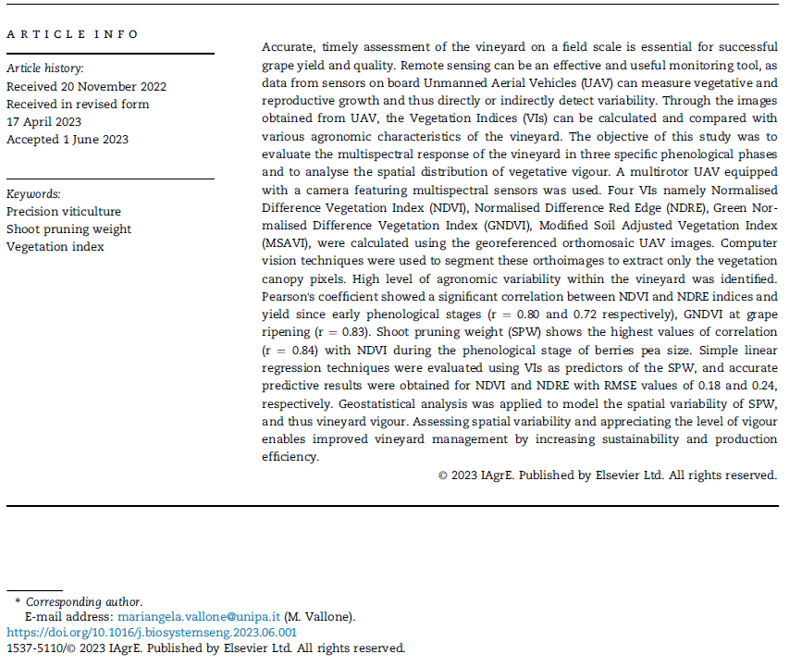
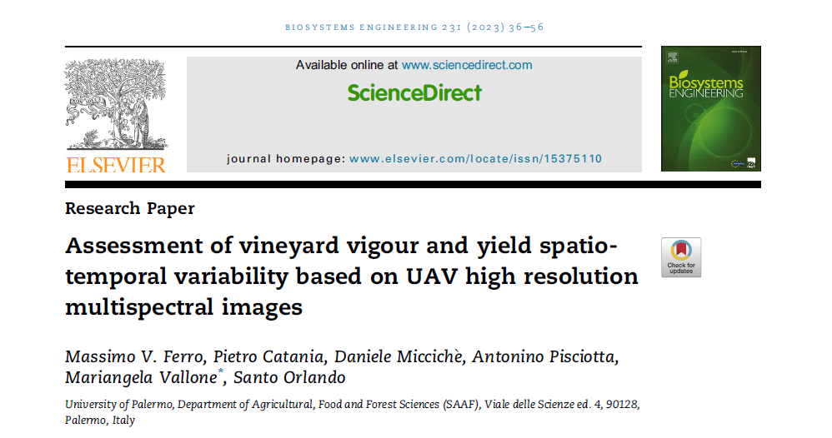
CHAPTER 5.

1. Introduction
Grapevine (Vitis vinifera L.) is a crop of great economic importance, widely cultivated worldwide. Vineyards' reproductive and qualitative variability is very high [1–4], in addition to environmental factors is also influenced by anthropogenic factors regarding agronomic techniques [4]. Nowadays, it’s increasingly important to achieve excellent production standards, focusing on grape quality, which are influenced by several factors, such as genetic factors that distinguish cultivars and clones, or the effects of soil characteristics [5], soil erosion [6], row orientation [7–9], nutrients, light, temperature and water availability [10,11], which occur as single factors or as an interaction [12,13]. In addition there are risks related to climatic conditions, which are expected to worsen and thus strongly impact the whole sector [14]. All these factors contribute to increasing the spatial variability of vineyards, therefore information on spatial and temporal variation is essential to support farmers in decision making to enhance profitability. The estimation of the agronomic variability of each plot should be done from year to year and at different phenological stages of the vineyard [15]. Today, there are new technologies for monitoring and managing the vineyard and controlling vegetative and productive growth. Using high-resolution remote and proximal sensors, spatial variability of vine vigour can be investigated, and chemical parameters determined from grapes [16], at any time; this information can thus be used for the variable application of many agronomic practices according to the principles of Precision Viticulture (PV) [17].
Satellite systems and Unmanned Aerial Vehicles (UAVs) that capture images in the visible and near-infrared bands of the electromagnetic spectrum are widely used to generate vegetation maps [18]. Sensors used for crop monitoring have a specific geometric resolution, which refers to the size of the ground surface area (pixel) whose electromagnetic energy is detected. They have also a certain spectral resolution, which indicates the number of acquisition bands and their range, and a specific radiometric resolution indicating the intensity of the radiation that the sensor can identify. Finally, there is a temporal resolution which indicates the period of time between two consecutive images acquisition [19]. Satellites employed for multispectral surveys are divided according to their spectral resolution [20,21]. These platforms can assess vineyard variability in a relatively detail in terms of resolution. On the contrary, UAVs proved to be more effective tools in representing vineyard variability as they can easily discretise the canopy from the inter-row [22]. If satellite systems are very suitable for extensive cultivation [23], in other areas the use of UAVs is preferred, allowing quick surveys and providing important information for winegrowers. In general, the spectral sensors that UAVs are equipped with, have high spatial resolution and can be classified according to the method by which they achieve spectral discrimination [24]. These sensors have a short ground sampling distance, and the captured images can generate high-quality dense point clouds and high-resolution orthomosaics [25,26]. The combination of the different bands of the electromagnetic spectrum provides important information about the vegetative growth of crops [27]. For instance, the wavelength of RGB (Red, Green, Blue) investigates the pigments present in the vegetative tissues and the status of biomass [28,29]. The combination of RGB with Red Edge studies the efficiency of chlorophyll pigments, whereas the prediction of biophysical parameters is carried out by investigating the Red and Near-Infrared spectrum regions [30]. Vegetation mapping is performed by calculating different Vegetation Indices (VIs) from specific wavelengths [31] and is often used to estimate plant growth parameters. An equally important issue is the relationship between multispectral indices and vegetative vigour; it's known that there is a close relationship between Normalised Difference Vegetation Index (NDVI) and vigour [32]. A distance-based index commonly used in PV is Modified Soil-Adjusted Vegetation Index (MSAVI); it reduces the soil disturbance effect and produces more accurate vineyard vegetation assessment [33]. The Normalised Red Edge Difference Index (NDRE) and the Green Normalised Difference Vegetation Index (GNDVI), are able to provide information on the health status of grapevine's through determining the variability of vegetation physiological parameters [34,35]. The agronomic estimation of vine vigour is often carried out by assessing the Shoot Pruning Weight (SPW) [36]. SPW is related to the vegetative biomass in the growing season and, therefore, to vine vigour. Among the vegetative growth parameters it is distinguished by its high sensitivity to variations in soil fertility and water availability [37]. SPW is used to assess the relationship between vegetative and reproductive growth by calculating the Ravaz index [38], which is an indicator of vine balance and grape quality [39]. The predictive study of SPW is a topic that has always attracted much interest; knowing in advance how the variability of this vigour parameter is distributed, allows to manage vines by balancing vegetative-productive development. It is reported in the literature that pruning weight correlates well with multispectral indices or RGB imagery [40–43]. Positive spatial autocorrelations were found through comparisons made between SPW and NDVI data of the vineyard canopy surveyed by UAV [44]. Many authors separate SPW values into different vigour classes and identify equally differences in NDVI class data, using different monitoring platforms [40,45–47]. Matese & Di Gennaro (2018) demonstrated that using UAVs allows for obtaining both detailed spectral information that correlates well with SPW and also optimal correlations with canopy geometric characters, such as thickness [49].
Leaf Area Index (LAI) is another relevant index applied for assessing vigour spatial variability. The estimation of this canopy parameter using multispectral and hyperspectral images taken by UAV has given positive results [50,51].
The estimation of yield parameters using UAV-derived data is demonstrated to be very efficient; in fact, an assessment of spatial variability indicates common behaviour in high vigour zones where higher yields and higher total acidity values are associated. In turn, low vigour zones exhibit higher pH and higher soluble solids. In opposition, medium vigour zones are associated with greater leaf area, high values of shoot pruning weights and average bunch weights (Gatti et al., 2017; Ferrer et al., 2020). In López-García et al., (2022) RGB imagery provides better yield prediction results at the beginning of the grapevine growing season, in contrast with multispectral data at the phenological stages of fruit set and at ripening. The estimates of yield at the beginning of the growing season allow farmers to perform cultural practices to adjust yield, reducing production quantity but increasing quality. The identification of vineyard areas with different productive and qualitative potentials makes it possible to apply selective harvesting by selecting grapes with different compositions and processing them according to their properties [52,53]. Using Variable Rate Technology (VRT), the effects of uneven plot vigour could be reduced, for instance by setting up fertilisation based on the real needs of the vines [54]. Plant protection dosage based on spatial variability uses Variable Rate Application (VRA) and is adapted to the vines' requirements. By exploiting these innovations, significant pesticide savings can be achieved without compromising treatment efficacy [55–58]. Although spectral reflectance indices have been extensively used to evaluate the characteristics of various crops, the information on the performance of some indices, which differ from the commonly used NDVI, is not very thorough. Furthermore, the evaluation of these indices at different phenological stages can improve knowledge on the prediction of a given agronomic variable.
This study aims at determining vineyard spatio-temporal variability based in UAV high resolution multispectral images, to optimise the vineyard management. In particular, vineyard multispectral orthoimages were used to detect some agronomic parameters, to assess the vegetative growth and to determine grape yield variability. Four vegetation indices and their relationship to vegetative growth and yield were examined, providing more detailed information to winegrowers for the management of crop operations. The spatial variability of SPW was also determined by assessing the most correlated multitemporal VI of the vineyard canopies.

2. Materials and methods

2.1 Experimental site
The study was carried out during the 2021 growing season in a 15 years old vineyard, cultivar Catarratto, grafted onto rootstock 1103 Paulsen. The experimental site was located within the Alcamo Protected Designation of Origin (PDO) area, in the hinterland of western Sicily (Italy) at Tenuta Rapitalà farm (37°55'9.61"N; 13° 4'28.59"E).
The vineyard is located at an altitude of 315 m above sea level and is drip irrigated (600 m³ ha⁻¹). The plot has an extension of 8.2 ha and a perimeter of 1,162 m, with layout of planting 2.40 x 1.00 m (4,170 plants ha⁻¹). The rows orientation is NE-SW (Fig. 1), with an angle to the North of about 22°. The terrain is slightly hilly, with slopes of approximately 12% on the steepest line.

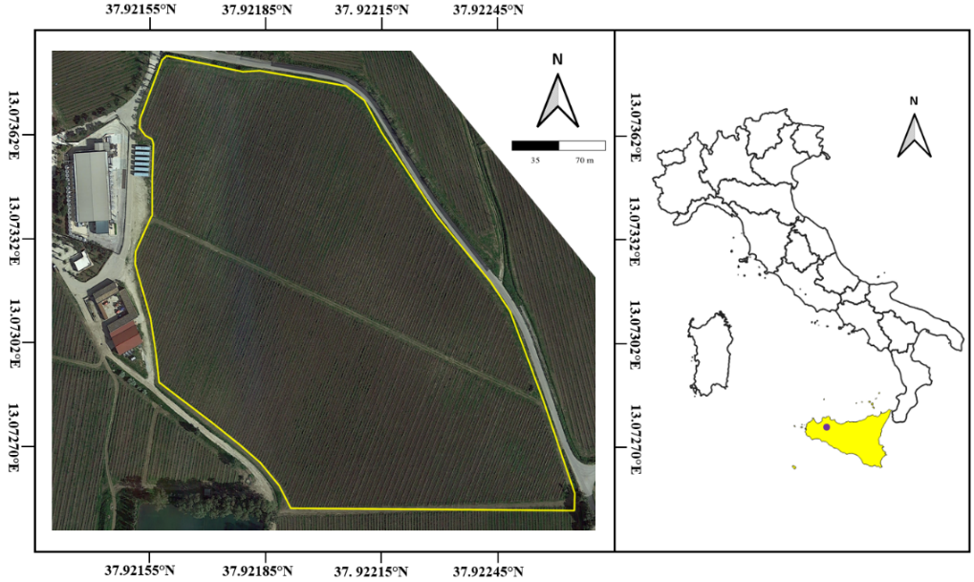
Fig. 1. Location of the experimental vineyard in Sicily, south Italy (WGS84).

Vines were vertically trained (VSP trellis system) and double cordon spur pruned with two buds per spur, spaced at approximately 0.20 m. Catarratto is an ancient white variety of the Italian grapevine assortment. It is a vigorous, medium-late-ripening grapevine cultivar, widely cultivated in western Sicily. The vineyard has been managed following ordinary agronomic practices conducted uniformly on the whole field. The vineyard was traditionally managed with five passes of superficial tillage (0.1 m depth) during the year to control weeds and water evaporation and to prevent soil cracking. A mineral soil fertilisation was carried out at DOY82. Pest management practices to produce healthy grapes were applied. Figure 2 shows the meteorological data in the examined area during the period under consideration. The 2021 season was hot and dry, a typical hot arid climate.
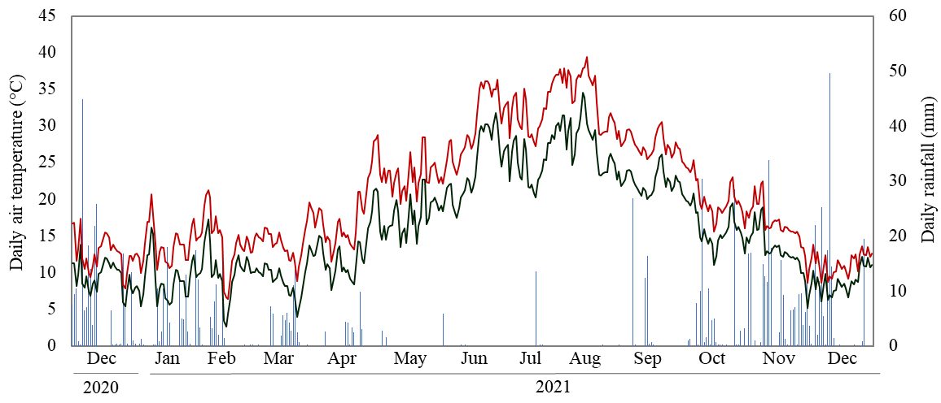
Fig. 2 Daily maximum (―) and mean (―) air temperature and daily rainfall (―) were recorded from the beginning of November 2020 to the end of December 2021, nearby the experimental vineyard. (Sicilian Agrometeorological Information System; SIAS).

Taking the period from 1 April to the end of October, the amount of average daily temperatures that directly influence the vine growth and grape ripening season, the Winkler index, can be computed. In this case, it was 2300 °C, a value often observed in Mediterranean areas and exacerbated by heatwaves, while the total rainfall during the 2021 season was 810 mm.

2.2 Aerial platform and multispectral sensors used
The remote images were acquired with a UAV, a Da-Jiang Innovations (DJI) quadcopter model Phantom 4 (DJI, Shenzhen, China), classified as VTOL (Vertical Take-Off and Landing). The UAV can carry a maximum payload of 477 g for 20–30 minutes with a maximum flight range of 7 km. The flight autonomy of the UAV is approximately 30 minutes, guaranteed by a LiPo 4S battery with a capacity of 5870 mAh and a voltage of 15.2V. Three batteries were used to survey the entire plot. The Phantom 4 was used to acquire RGB and multispectral images; it was equipped with a camera composed of six 1/2.9” CMOS sensors, mounted on the UAV using a two-axis carbon fibre gimbal, one RGB sensor for visible light images, and five monochrome sensors for multispectral image acquisition. The gimbal mitigated airframe vibration (pitch and roll) caused by wind and allowed pointing vertically downwards for image collection. Multispectral sensors operate in the bands of blue (B): 450 nm, green (G): 560 nm, red (R): 650 nm, red-edge (RE): 730 nm, and near-infrared (NIR): 840 nm, with a resolution of 2.08 MP. Each sensor has a spectral sensitivity range of ± 16 nm respect to its nominal wavelength, except the NIR sensor which has a spectral sensitivity range of ± 26 nm [59]. The features of the camera are focal length 5.74 mm, image size 1600 × 1300 pixels, angle of view (FOV) 62.7° and aperture f/2.2. Radiometric calibration is performed based on the irradiance measured in real-time by the sensor located on the top of the UAV. In addition, a radiometric calibration was applied to the image blocks, using reference images from a calibrated reflectance panel (LABSPHERE INC., North Sutton, US).

2.3 Data acquisition
The flight sessions performed with the UAV were conducted with 70% forward overlap and 70% lateral overlap at ≈70 m a.g.l height from the take-off point in a dual-grid configuration, obtaining an image pixel size (GSD) of approximately 3.7 cm for RGB and multispectral images (Fig. 3). The field of view (FOV) was 51.50 × 41.25 m and the flight speed was 20 km h⁻¹. The camera takes photos automatically, at an interval of one second, and the image is stored in TIFF format.
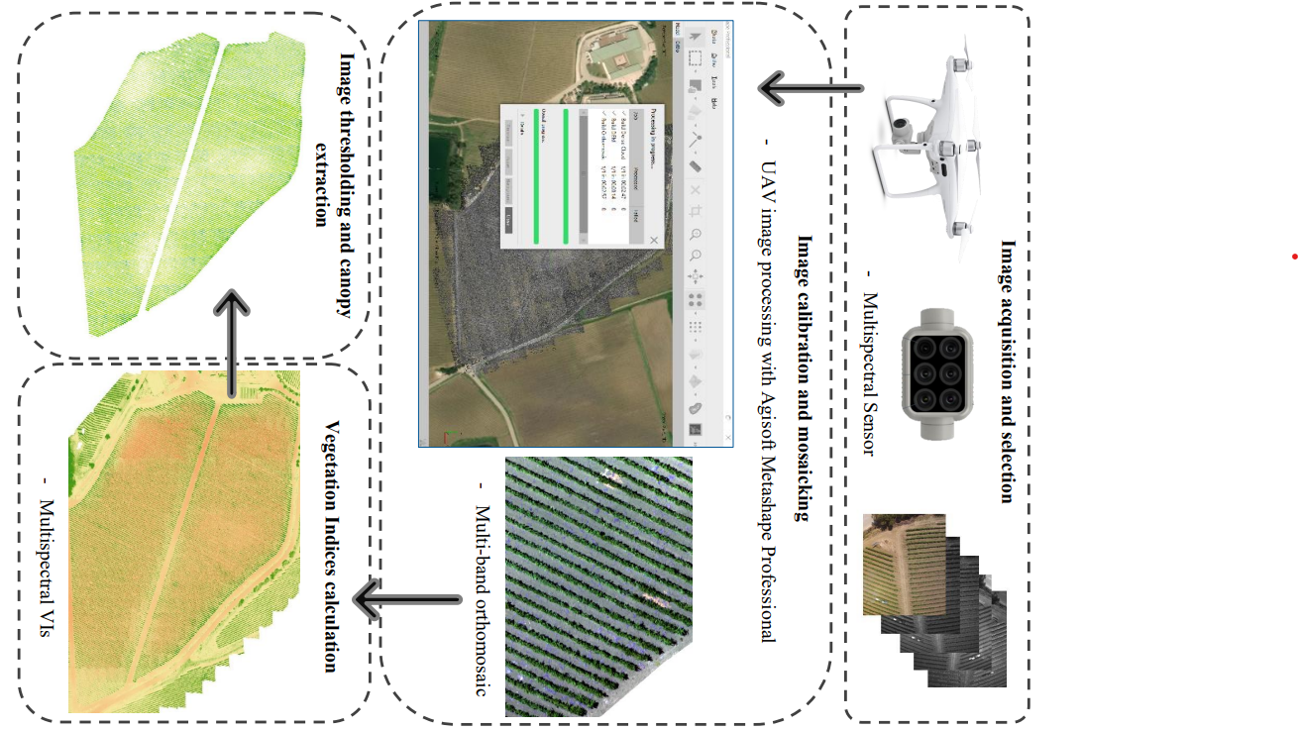
Fig. 3. Procedure for vegetation indices calculation using multispectral images acquired by UAV.
Three flight sessions were carried out during the 2021 vegetative season in different vine phenological stages (scale Biologische Bundesanstalt, Bundessortenamt und CHemische Industrie, BBCH, according to Lorenz et al., 1995) (Table 1). The first flight was performed at berries pea size (BBCH 75), while the second at beginning of ripening (BBCH 81). The last flight was made close to ripening, at full ripening (BBCH 89). Surveys were conducted during these phenological stages based on the physiological vine behaviour corresponding to the ripening process. The flight operations were scheduled from 11:30 AM to 01:00 PM.
Table 1 – Remote sensing data acquisition during the 2021 growing season. Meteorological data logged by the station closest to the surveyed area (Sicilian Agrometeorological Information System; SIAS).
UAV flight missions
Acquisition  time | Growth  stage | DOY | Radiation  (MJ/m²) | Wind Speed  (m/s) | Wind direction
18 June 2021 | BBCH 75 | 169 | 26.40 | 1.62 | N-O
21 July 2021 | BBCH 81 | 202 | 27.80 | 1.57 | S-E
28 August 2021 | BBCH 89 | 239 | 25.84 | 1.68 | S-O

The weather data summarised in Table 1 relate to the three flight dates, giving information about brightness, measured by irradiance, and wind conditions, both in terms of speed and direction, referred to the hours of the day when the flights took place. During the flights, there was excellent light, the wind speed was very low, and the conditions were optimal for carrying out the surveys.

2.4 Data Processing
The georeferenced multispectral images were mosaicked using Agisoft Metashape Professional Edition (Agisoft LLC St. Petersburg, Russia - https://www.agisoft.com/). A high-resolution orthophoto 3.7 cm pixel⁻¹) in GeoTIFF format and a Digital Elevation Model (DEM) of the experimental vineyard were created. The first post-processing operation was to align the orthoimages. Automated procedures (batch processing) were then carried out to generate the dense points cloud and the generation of the multi-band orthomosaic. To assure the accuracy of the image, the ground control point (GCP) method was applied for geometric correction, fixing 14 points using a GPS receiver on the entire plot [60].
Using the software QGIS version 3.22. it was possible to calculate some vegetation indices (Table 2); indeed, based on the generated orthomosaic, the NDVI was calculated using the NIR bands at a wavelength of 840 nm and the red band at a wavelength of 650 nm [61]. The GNDVI, that is directly proportional to leaf chlorophyll concentration at wavelengths of 540 nm and 760 nm was also used [62–64]. The NDRE was also evaluated, providing useful information on the ecophysiological state of the crop [65]. Previous research observed a sudden change between the Red and NIR reflectance of vegetation in what is known as the Red Edge band. This zone marks the boundary between chlorophyll absorption in the red band and scattering due to the internal structure of leaves in the NIR band [66]. The MSAVI was also considered; this is the soil-adjusted vegetation index that attempts to address some of the limitations of NDVI when applied to areas with a high degree of the exposed soil surface, at wavelengths of 640 nm and 760 nm (Candiago et al., 2015; Martínez & Gomez-Miguel, 2017; Qi et al., 1994).
Table 2 Vegetation indices and equations used.
Vegetation Index | Equation | Author
NDVI | $$\frac{\left(NIR-RED\right)}{\left(NIR+RED\right)}$$ | Rouse et al. (1974)
GNDVI | $$\frac{\left(NIR-GREEN\right)}{\left(NIR+GREEN\right)}$$ | Gitelson and Merzlyak (1998)
NDRE | $$\frac{\left(NIR-RED EDGE\right)}{\left(NIR+RED EDGE\right)}$$ | Maccioni et al. (2001)
MSAVI | $$\frac{2*NIR+1-\sqrt{{(2*NIR+1)}^{2}-8*(NIR-RED)}}{2}$$ | Qi et al. (1994)

After computing the vegetation index maps, it was necessary to identify and segment the vineyard canopy from the soil and weeds by applying the unsupervised k-means segmentation algorithm as applied by [69]. The principle is to segregate k groups of similar pixels (clusters) from other groups of dissimilar pixels within the raster (Fig. 4). The k-means segregates clusters based on their mean value [70,71]. The algorithm produced a 1-bit image, with pixels assuming values equal to zero for the soil and 1 for the vegetation as Digital Number (DN). The mask thus obtained was multiplied by the NDVI map using the QGIS raster calculator, in order to assign zero to all the soil pixels (0 = NULL) and leave the DN of the vegetation pixels unchanged. Through a new k-means classification (k=3), the latter made it possible to identify the management areas with low (LV), medium (MV) and high (HV) vigour.
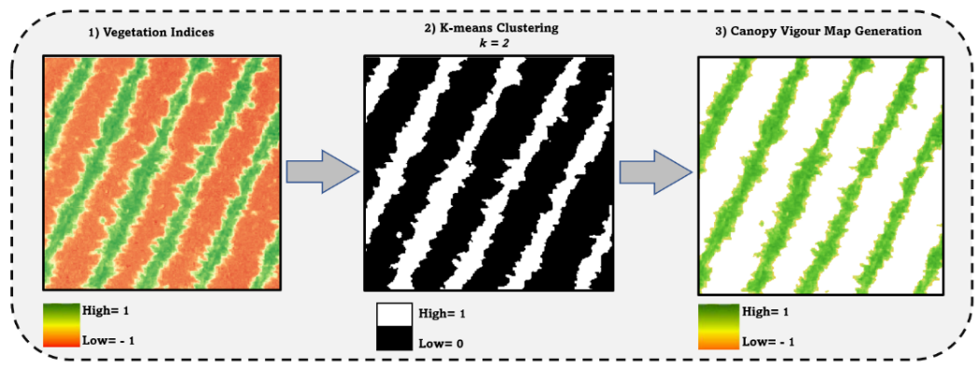
Fig. 4. Workflow of the unsupervised algorithm proposed for multispectral indices maps by applying K-means clustering. From the first step to the second, soil is identified by the black colour and the remaining set of pixels identifies vines (white colour). In third step the canopy of the vegetation is obtained.

2.5 Plant sampling and measurements
At full ripening (BBCH 89), fourteen vineyard blocks belonging to different areas of the vineyard, showing diverse vigour, were identified, forming the Vineyard Plot 1 (VP1). Each block consisted of 6 vines and, consequently a total of 84 vines were monitored in VP1. The Total Leaf Area per vine (TLA) was measured using the LI-3100C area meter (Li-COR Biosciences, Lincoln, NE, USA). At harvest, the yield per vine was measured and the number of bunches was counted on each vine per block. The weight of each bunch per vine was determined with a balance (Wunder, mod.60, Milan, Italy). The grape of each vine was crushed, and 100 ml of must were taken to determine the total soluble solid (TSS) (°babo) using a digital refractometer (HANNA Instruments, mod. HI96811, Italy) and titratable acidity (TA) using a Crison Compact Titrator (Crison Instruments, mod. PH-Matic 23, Barcelona, Spain). During winter, SPW was determined using a dynamometer (Wunder, mod. 60, Milan, Italy) on the 84 vines selected at harvest (VP1). In addition to this group of vines (VP1), another 57 vineyard blocks of 6 vines (342 total vines) were identified forming the Vineyard Plot 2 (VP2), where only SPW was measured to perform an accurate analysis of pruning weight prediction. All the analyses were carried out in triplicates.
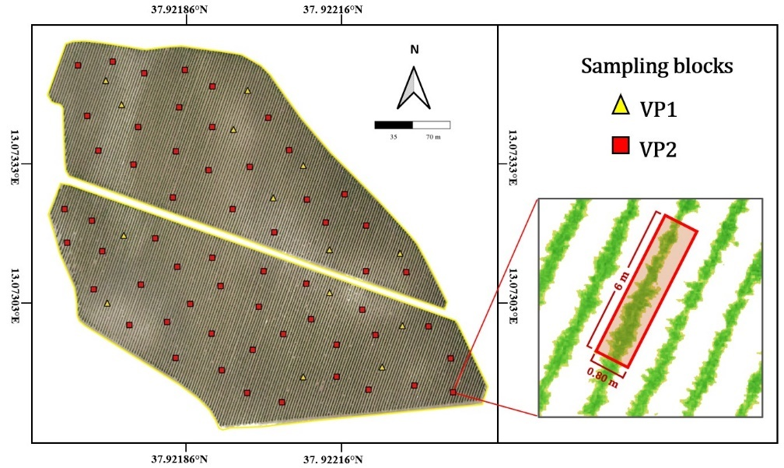
Fig. 5. Scheme of sampling used in the vineyard plot. Overview of the entire process for identifying the sampling blocks in the field, performed using GCP information to obtain the contours of the sampling polygons.

The six plants of each vineyard block were identified using the coordinates by the GPS STONEX S70G (STONEX® Srl, Milan, Italy) with real-time kinematic correction (RTK) and sub-centimetre accuracy. Through these points it was possible to develop buffers in shape file format on QGIS, with defined dimensions, length of 6 m and width of 0.80 m (Fig. 5).

2.6 Statistical analysis
The characteristics of the vegetation indices (count, mean, minimum, maximum, and standard deviation) from the UAV raster images were extracted using the Zonal statistical plugin in QGIS. Statistical data extracted from each vegetation index raster were processed using a shapefile with polygons corresponding to the sampling blocks VP1 and VP2, which included only vegetation pixels. The data obtained from the plant measurements were processed with a variance analysis model (ANOVA). The significance level (α) was set at 99% (p < 0.01). The null hypothesis (H₀) in the comparison of the three groups is that all means are equal, whereas the alternative hypothesis (H₁) is that not all means are equal. Tukey's multiple comparison tests were used to detect the different averages. In addition, the relationships between the vegetation indices and the qualitative parameters of the plants were tested using regression analysis and Pearson's correlation coefficient (r) in the three acquisition times. The difference between slopes was tested using Student's t-test. The SLRM was employed using the multispectral VIs that best correlated with the SPW sampling data. The prediction model was developed based on a SPW training dataset consisting of 3 VP1 sampling blocks and 11 VP2 sampling blocks, equally distributed over the field. Using the SLRM, the SPW prediction of 57 sampling blocks (VP2) was made and then these prediction data were compared with the 57 SPW data observed in the field. Once the model was tested, multispectral VIs data were used for prediction of 1,000 SPW values, which were used as input for Kriging to generate the maps. All the statistical procedures were performed using R software (R Core Team, 2020).

2.7 Geostatistical analysis
The spatial variability of multispectral indices and the vineyard vigour were conducted using QGIS. Based on a semivariogram and a cross-validation analysis, appropriate models were fitted, and the input parameter employed the ordinary kriging interpolate. This method can express the spatial variation of a specific variable by minimising the distribution error of the predicted values. Kriging interpolation assumes that the estimate at an arbitrary point in a specific zone of the field is expressed with a linear weighting of all observations. To provide the best linear estimation, semivariograms are calculated, which consider the spatial structure [72,73]:
$y\left(h\right)=\frac{1}{2N (h)}\sum_{i=1}^{N(h)}{{[ Z\left(xi+h\right)-Z\left(xi\right)]}^{2}}$ [1]

where N(h) represents the number of pairs of observations separated by a value (h), which in turn corresponds to the distance deviation expressed in meters. The parameter Z(xi) is the value of the variable Z at the sampled location xi. The semivariogram, therefore, allows modelling functions to be developed for many infinitely large environmental variables. Therefore, the selection of a semivariogram is critical for geostatistics analysis techniques, as it allows the parameters needed to perform Kriging interpolation to be defined. The selection of the suitable semivariogram was done by calculating the semivariances at different distance intervals (h), fitting specific theoretical models. Isotropic semivariograms were chosen as it was observed that the spatial correlation depends only on the distance module, but not on direction. The experimental semivariogram [1] was adapted through the application of some appropriate theoretical models [74]: the spherical [2] and the exponential ones [3].
$y\left(h\right)=C_{0}+C \left[1.5\frac{h}{a}-0.5 {\left(\frac{h}{a}\right)}^{3}\right]$ [2]
$y\left(h\right)=C_{0}+C \left[1-exp \left(-\frac{h}{a}\right)\right]$ [3]
In these mathematical models, the input parameters are the sill variance (C₀+C), the range indicated by (a), and nugget variance (C₀), these inputs were calibrated to identify the spatial variability of vineyard vigour. The sill variance concerns the amount of spatial structural variance in the data set. The range represents the distance in which the semivariogram lies around a limit value. The nugget defines the variability of a sampling interval or analysis error.
In cross-validation, the values estimated from ordinary kriging were compared with the SPW values observed at the sampling points. To check the accuracy of the calculated predicted values for pruning weight estimation, the coefficient of determination (R²) [4], the root means square error (RMSE) [5] and mean absolute percentage error (MAPE) [6] index were calculated as follows:
$R^{2}=1-\frac{\sum_{i=1}^{n}{{\left\{y\left(xi\right)-y^{*}(xi\left.)\right\}\right.}^{2}}}{\sum_{ì=1}^{n}{{\left\{y\left(xi\right)-\overline{y}(xi\left.)\right\}\right.}^{2}}}$ [4]
$RMSE= \sqrt{\frac{\sum_{i=1}^{n}{{\left\{y\left(xi\right)-y^{*}(xi\left.)\right\}\right.}^{2}}}{N} }$ [5]
$MAPE= \frac{100\%}{N}\sum_{i=1}^{n}{\left|\frac{y\left(xi\right)-y*(xi)}{y(xi)}\right|}$ [6]
where n is the number of points, y(xi) is the measured value, and y *(xi) is the predicted value, $\overline{y}$(xi) is the mean value of the observed data. The best prediction model was obtained when the RMSE and MAPE had the lowest value.

3 Results

3.1 Vegetation index data
Table 3 shows the average values and range of the four vegetation indices, showing the minimum and maximum values among the zones considered. These values are distinct for the three flights performed during the growing season and indicated with the letter F, and thus flight F1 was performed at berries pea size stage, flight F2 at beginning of ripening, and F3 at full ripening. The average values of all the indices were lower during the full ripening phase than in the others, except for MSAVI whose lowest values were observed in the veraison phase (F2). The mean values of NDVI and GNDVI, decreased gradually in the three phenological phases. This result can be explained by considering the spectral response of the vegetation in F2, in which the level of photosynthetic activity and efficiency is high, due to the activity of the chlorophyll pigments. Instead, it is difficult to understand the spectral response of NDRE index, again during the F1 monitoring the values are within the range 0.59-0.66, as the other indices; in the subsequent phenological phase there is a drastic reduction that continues until the last monitoring.
Table 3. Descriptive statistics of the vegetation indices obtained by UAV multispectral images at different growth stages. The mean value of each index is obtained from 71 replicates ± standard deviation (SD).
 | F1 | F2 |  | F3
 | mean ± SD range |  | mean ± SD range |  | mean ± SD range
NDVI | 0.64 ± 0.03 0.60 - 0.68 | 0.57 ± 0.06 0.51 - 0.63 |  | 0.35 ± 0.05 0.31 ± 0.40
GNDVI | 0.46 ± 0.05 0.43 - 0.49 | 0.44 ± 0.03 0.40 - 0.48 |  | 0.42 ± 0.05 0.39 ± 0.46
NDRE | 0.62 ± 0.03 0.59 - 0.66 | 0.33 ± 0.02 0.20 - 0.36 |  | 0.31 ± 0.01 0.18 ± 0.33
MSAVI | 0.75 ± 0.04 0.73 - 0.76 | 0.68 ± 0.06 0.63 - 0.73 |  | 0.70 ± 0.08 0.66 ± 0.75

From the vigour maps generated, different vigour zones were identified by applying the k-means clustering algorithm. For each vegetation index considered, areas of low, medium and high vigour were identified from the first survey F1 (Fig. 6); the determinations made for the subsequent surveys (F2 and F3) confirmed this variability.
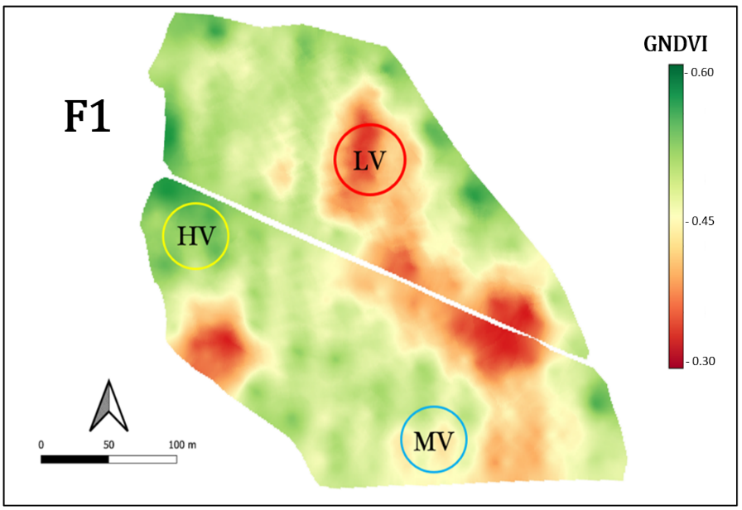
Fig. 6. Green normalised differential vegetation index map showing the high-vigour (HV), medium-vigour (MV) and low-vigour (LV) vegetation classes derived from a multispectral image remotely sensed by UAV during the F1 survey.
Fig. 7 (a) and (b) show row sections with different thickness and thus variability in the number of pixels; the differences identified in the rasters were observed in the vineyard, as illustrated in Fig. 7 (c) and (d).

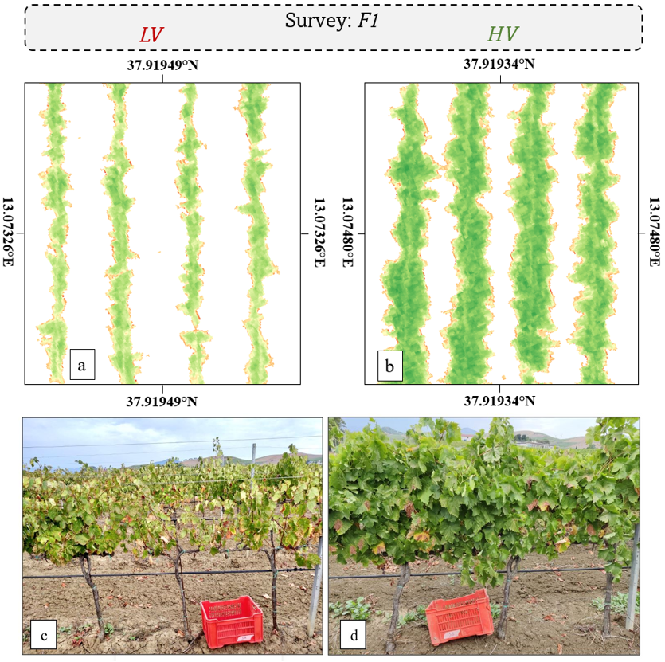
Fig. 7. GNDVI map with zones of different vigour, (a) section of vineyard row with low vigour (LV), (b) section of vineyard row with high vigour HV). Canopy in LV vines (c), and HV vines (d)
With reference to VP1 blocks, they were distributed in the three vigour levels as follows: 5 blocks in LV zone, 5 blocks in MV zone and 4 blocks in HV zone. The results of the vegetative-productive variability are shown in the boxplots in Fig.8. With reference to VP2 blocks sampled at pruning, they were distributed in the three vigour levels as follows: 20 blocks in the LV zone, 21 blocks in the MV zone and 16 blocks in the HV zone.
In agreement with the above, it was revealed that there were different growth trends among the vines (VP1) of the three vigour levels identified. The leaf area per vine was higher in HV and MV (3.24 and 2.90 m² /vine respectively) than in LV vines (2.45 m² /vine), (Fig. 8 a). Fig. 8 b shows how the three vigour levels identified for VP1 vines through the clustering algorithm correspond to three levels of agronomic vigour identified in the field. Indeed, the vines in the LV zones have an SPW average value of 0.29 kg, which is different from high vigour vines (0.47 kg); MV vines, on the other hand, show statistically intermediate values (0.38 kg) between low and HV.
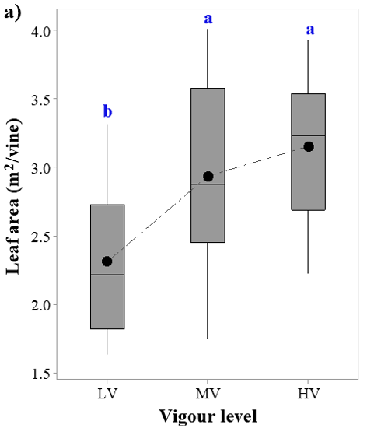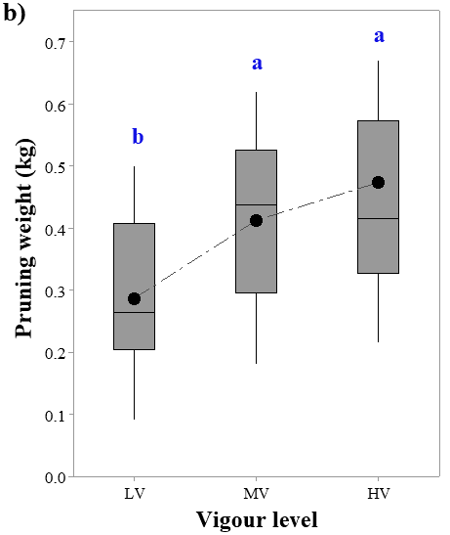
Fig. 8. Box plots showing the vegetative parameters of the VP1 vines group. (a) Leaf area (b) Shoot Pruning Weight. ●Mean values; data were processed according to Tukey's test with 99% confidence level. Box plot marked with different letters are significantly different.

3.2 Yield and must composition variability
The descriptive statistics of yield and must quality data are reported in Fig. 9, which shows a wide variability over the different zones detected through the analysis of the UAV images. The vines monitored at harvest (VP1) reported a different number of bunches between low and medium-high vigour vines, as shown in Fig. 9 a. The group of vines corresponding to the low vigour (LV) zones had an average of 10 bunches per plant, compared to 14 bunches reported by the high vigour plants. The average bunch weight of the medium and high vigour vines was 66% higher than that of the LV vines (Fig. 9 b). Yield per vine was also significantly different among the groups. It was positively correlated with increasing vigour as illustrated in Fig. 9 c, varying from 1.2 kg in LV to 2.8 kg in HV, corresponding to a potential yield of 5 and 11.3 t ha⁻¹ respectively. This higher yield per vine is due both to the higher number and the greater weight of the bunches, as observed in the sampled vines.
The grape quality parameters showed different behaviour between the three vigour levels (Fig. 9 d), the vines from the low vigour zones had a higher soluble solids content (18.3°) than the group of higher vigour vines (17.6°). In view of the above, the vines with a higher yield showed a higher total acidity (5.3 g/L), compared to the vines with a lower yield (4.8 g/L) (Fig. 9 e).
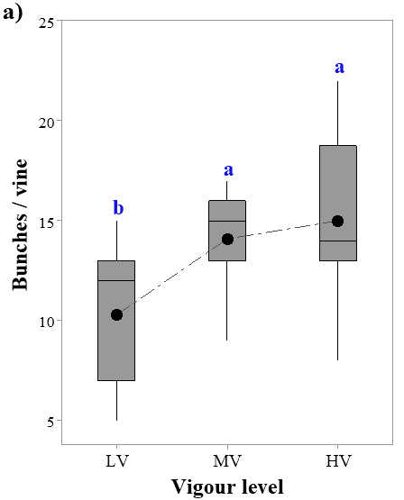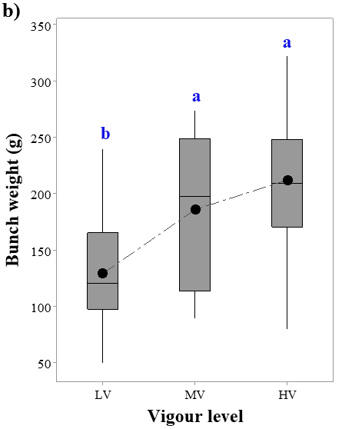
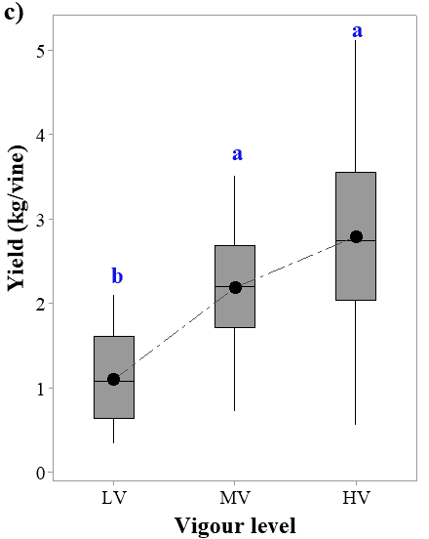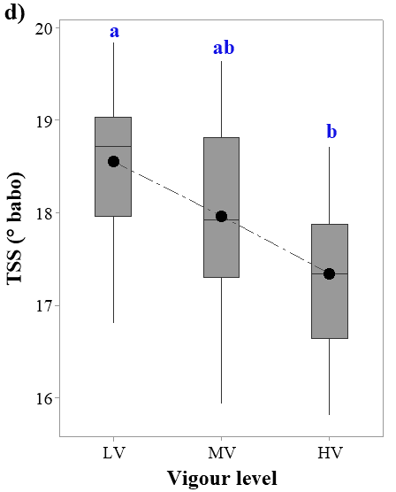
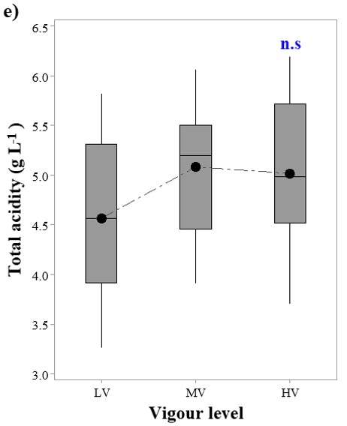
Fig. 9. Box plots showing the reproductive parameters measured at harvest of the VP1 vines group. ●Mean values; data were processed according to Tukey's test with 99% confidence level. Columns marked with different letters are significantly different, n.s= not significant.

3.3 Correlation analysis between ground measurements and UAV spectral indices
Table 4 shows the correlations and relative significance between the vegetation indices and the corresponding values of the quantitative and qualitative parameters of VP1 vines. The first parameter considered was the number of bunches per vine The Pearson index was calculated to find a correlation between the vegetation indices as the number of bunches increased or decreased. However, it was not found a clear trend between the two evaluated variables, as shown by the low values in Table 4. Further considering the variability related to the bunch, the correlation between the indices and the measured weight of bunch was evaluated. Excellent results were found in this case, since the first phenological phase F1 and for the other two surveys carried out. High correlation rates were found, especially for the vegetation indices investigating the spectral response in the red band and red edge. GNDVI also showed a good correlation with bunch weight. However, non-significant correlations between the MSAVI vegetation index and the variable considered were found. For the other two phenological periods examined, excellent significant correlations were found with high values of the Pearson correlation coefficients. Regarding the yield per plant, the results obtained through correlations are in line with those of the average bunch weight. NDVI proved to be a very good predictor of average production per plant. It showed high correlation values of 0.786 in the period in which the first flight was carried out, showing very positive correlations for the two subsequent phenological periods, 0.754 at veraison; the highest correlation of this parameter was found at full berry ripening, equal to 0.806. GNDVI can also be considered a good predictor, but in the phenological periods before ripening it shows a lower correlation than NDVI; when ripening is reached, GNDVI shows a very good correlation with plant yield, equal to 0.839. NDRE was a good predictor in the early phases of crop development with a Pearson correlation index from 0.728 to 0.748 for the phenological phases of berry development and veraison, respectively. After these phases, NDRE showed a lower value and significance than the vegetation indices previously examined. Regarding the only soil-adjusted index, MSAVI, it is not a reliable predictor of production per plant when evaluated at early phenological stages; however, the index proved to be a good predictor of grape yield at veraison with a correlation index of 0.765.

Table 4. Pearson correlation coefficients between agronomic yield variables measured for the VP1 vines group and vegetation indices, with significance *p ≤ 0.05, **p ≤ 0.01, ***p ≤ 0.001, n.s= not significant.
 | F1 | F2 | F3
Bunch/vine
Spectral indices
NDVI | 0.542* | 0.528* | 0.314^{n.s}
GNDVI | 0.307^{n.s} | 0.382^{n.s} | 0.444^{n.s}
NDRE | 0.403^{n.s} | 0.416^{n.s} | 0.265^{n.s}
MSAVI | 0.374^{n.s} | 0.545* | 0.419^{n.s}
Bunch weight [g]
NDVI | 0.805*** | 0.744** | 0.770***
GNDVI | 0.646** | 0.753*** | 0.875***
NDRE | 0.757*** | 0.767*** | 0.701**
MSAVI | 0.466^{n.s} | 0.730** | 0.739**
Yield [kg/vine]
NDVI | 0.786*** | 0.754*** | 0.806***
GNDVI | 0.609* | 0.687** | 0.839***
NDRE | 0.728** | 0.748*** | 0.616*
MSAVI | 0.504^{n.s} | 0.765*** | 0.654**

The vegetation indices considered in this study are well correlated with the agronomic variables of grape production. It is relatively easy to identify a phenological period that proves most suitable for evaluating the yield in the vineyard. The highest correlation values were observed at veraison, both in terms of average bunch weight and yield per vine.
In this study, in addition to the evaluation of yield and quality parameters, an important vegetative parameter closely linked to plant vigour was evaluated for VP1 vines, the shoot pruning weight describing the overall growth of the vine. Table 5 shows the correlation data between vegetation indices and SPW. NDVI proves to be a good index in predicting the weight of the pruning mass when evaluated in the phenological phases before veraison. Similar results can be observed for the indices investigated in the green and red edge band, with the only exception of MSAVI which shows a low correlation at the phenological stage of berry growth. On the contrary, MSAVI showed a very positive correlation with SPW at survey F2, also NDVI correlated highly at this phenological stage corresponding to veraison. These results indicate that sampling flights must be carried out during the first periods of vine development to have a more accurate estimation of the pruning mass weight. As berries approach ripeness and senescence processes of the chlorophyll, tissues are triggered, there is a risk of not making a real estimation of this agronomic parameter.
Table 5. Pearson correlation coefficients between pruning weight measured for the VP1 vines group and the vegetation indices considered. With significance *p ≤ 0.05, **p ≤ 0.01, ***p ≤ 0.001, n.s= not significant.
Shoot Pruning weight [kg/vine]
 | F1 | F2 | F3
NDVI | 0.844*** | 0.771*** | 0.521^{n.s}
GNDVI | 0.663** | 0.696** | 0.584*
NDRE | 0.759*** | 0.597* | 0.564^{n.s}
MSAVI | 0.473^{n.s} | 0.776*** | 0.655*

Grape quality parameters correlations with the vegetation indexes are shown in Table 6. Negative Pearson correlation coefficients were found for total soluble solids, indicating that an increase in one of the two variables leads to a reduction in the other and vice versa. This study showed that TSS is well correlated with NDRE with a high statistical significance in the last two surveys. GNDVI also showed a good correlation with this parameter, while NDVI did not show a satisfactory correlation with TSS during the three surveys; in the two phenological stages after the first survey, the statistical significance of the correlation decreased (p < 0.05). In addition, the adjusted soil index did not show a good correlation with the previously mentioned quality parameter. In F1 survey, there is no correlation; in the F2 survey, the significance is low (p < 0.05); however, the survey in the F3 is an exception, showing a fair correlation (p < 0.01). No clear correlations were found about total acidity. In all the phenological periods considered, the correlation indices are not significant except for NDRE and MSAVI indices, which show statistically significant correlation in correspondence with the last sampling flight F3. Based on the results obtained, it can be stated that total acidity could not be easily predicted using multispectral images.
Table 6. Pearson correlation coefficients between grape quality parameters measured for the VP1 vines group and vegetation indices. With significance *p ≤ 0.05, **p ≤ 0.01, ***p ≤ 0.001, n.s= not significant.
Total soluble solids [°babo]
 | F1 |  |  | F2 |  | F3
NDVI |  | - 0.513 ** | - 0.391 * |  | - 0.341*
GNDVI |  | - 0.760 *** | - 0.722*** |  | - 0.662**
NDRE |  | - 0.411 ** | - 0.651** |  | - 0.714**
MSAVI |  | - 0.186 ^{n.s} | - 0.219* |  | - 0.573**
Total acidity [g L⁻¹]
NDVI |  | 0.428 ^{n.s} | 0.214 ^{n.s} |  | 0.326 ^{n.s}
GNDVI |  | 0.490 * | 0.479 ^{n.s} |  | 0.338 ^{n.s}
NDRE |  | 0.462 ^{n.s} | 0.466 ^{n.s} |  | 0.426 *
MSAVI |  | 0.063 ^{n.s} | 0.306 ^{n.s} |  | 0.539 *

3.4 Analysis of prediction model of shoot pruning weight
After evaluating the correlations among vegetation indices and the key agronomic parameters, it was appropriate to test the validity of the multispectral indices and their possible predictive use. Based on the results of the relationships between SPW and multispectral data, it was decided to continue with the setting up of predictive models with the aim of verifying the validity of these correlations to extend these relationships and information on vegetative growth, to the entire vineyard. Obtaining this information will make it possible to optimise the pruning of the vineyard, adopting a balanced bud load according to the vegetative capacity of the vines. In agreement with the correlation values, NDVI from F1 shows the highest R² value, while the other indices, although showing a valid linear regression, remain at lower values (Table 7). The SLRM were developed, which showed a good fit between VIs and SPW, for flight missions F1 and F2. Model error metrics were computed, which provide information on the prediction error of the agronomic variable. The best model was based on NDVI index referred to the F1 flight survey, which showed a good linear relationship with pruning weight (R²= 0.81; RMSE= 0.18; MAPE= 12.8 %). The SLRM based on MSAVI, although having a very good correlation with pruning weight, was the index with the highest error value (R² = 0.67; RMSE = 0.34; MAPE = 20.51 %), demonstrating poor reliability in developing predictive calculations on pruning weight.
Table 7. Quantitative relationships between spectral VIs (y) and shoot pruning weight (SPW) (x) of 3 VP1 and 11 VP2 sampling blocks of the vineyard for 2021 growing season.
 |  |  |  | Model calibration  (VP1 and VP2) |  | Model validation  (VP2)
Data set | VIs |  | R² Prediction model |  |  |  | RMSE  (kg vine⁻¹) |  |  | MAPE (%)
F1 | NDVI |  | 0.81 |  | y = 2.2314 x - 1.0657 |  |  | 0.18 | 11.21
F1 | NDRE |  | 0.69 |  | y = 2.0928 x - 0.9431 |  |  | 0.24 | 14.77
F2 | NDVI |  | 0.70 |  | y = 1.3475 x – 0.4101 |  |  | 0.30 | 19.11
F2 | MSAVI |  | 0.67 |  | y = 1.6834 x - 0.7890 |  |  | 0.34 | 20.51

The relationships between the forecast pruning weight and the observed value, for the four cases studied, are shown in Fig. 10. In Fig. 10 (a) the SLRM between the observed SPW (VP2) and the predicted data using the NDVI at F1 as a predictor variable is presented, with correlation R²= 0.69. Figure 10 (b) again shows the linear distribution between the data observed SPW in vineyard (VP2) and those calculated by the prediction model using NDRE index as a predictor, with R²= 0.69. The application of the model predicting the parameter SPW as a function of the vegetation indices with reference to the period F2, instead, did not provide acceptable results, which can be observed in Fig. 10 (c), (d). Based on the results, it is evident that the prediction correlation of SPW is better in the phenological stages prior to veraison. The prediction of SPW for the 342 vines (VP2) monitored through flight F1 was the most accurate, showing the most stable performance with the lowest RMSE values.
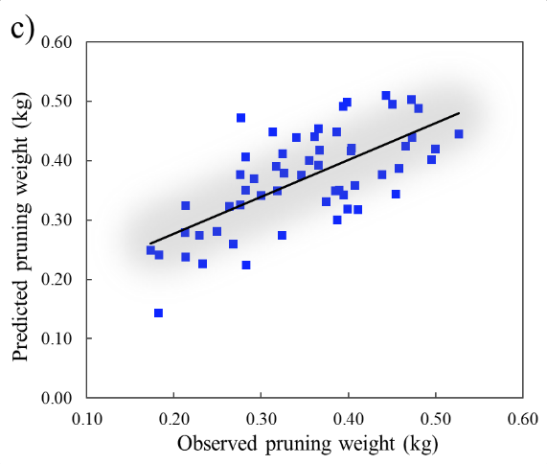
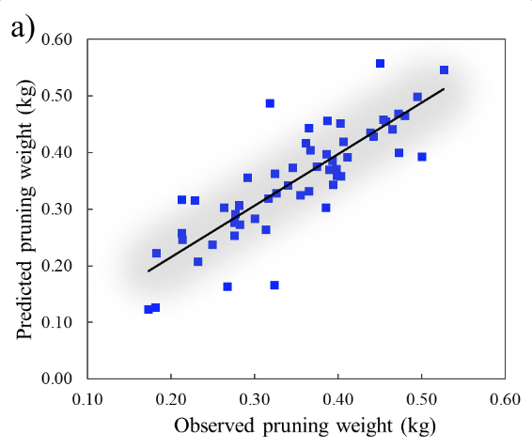
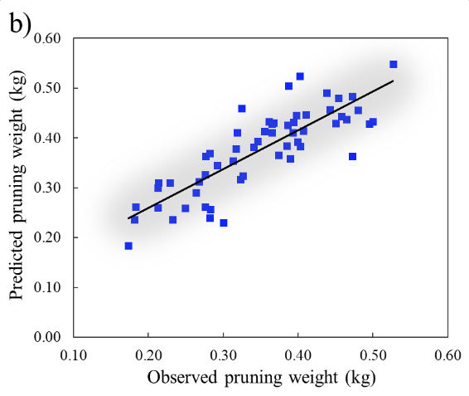
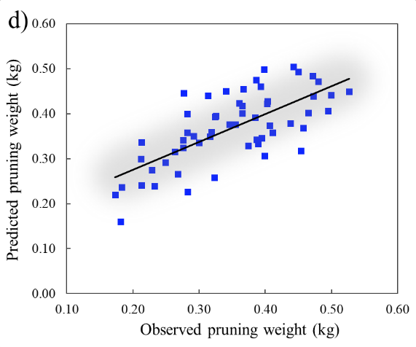
Fig. 10. Correlation between predicted and observed shoot pruning weight for monitored vines (VP2) using SLRM based on a data set for model validation. (a) correlations developed as a function of NDVI values observed in F1 (R²=0.69); (b) NDRE values observed in F1 (R²=0.69); (c) MSAVI values observed in F2 (R²=0.46); (d) NDVI values observed in F2 (R²=0.49).
Histograms of the residuals were plotted for all the regression models; Fig. 11 shows only the best regression results identified between the predicted and observed pruning weights calculated from the multispectral NDVI F1 data. The residuals are predominantly concentrated around zero and have a normal distribution, indicating that there are not many outliers.
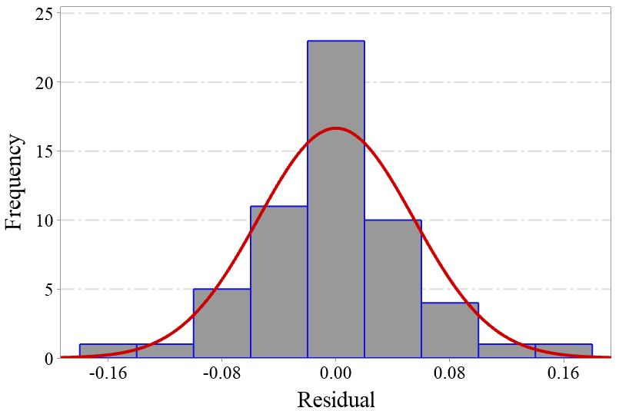
Fig. 11 Histogram of residual values showing the frequency of each range of values referred to the prediction model using NDVI index data at survey F1.
With the aim of spatialising the prediction data of shoot pruning weight over the entire vineyard area, we applied geostatistics techniques. A semivariogram is used to represent the spatial variation of regionalised variables. Cross-validation is an evaluation technique used to assess the accuracy of results obtained from training data on test data. The estimation accuracy was applied to the data set of values calculated as a function of NDVI, NDRE, and MSAVI referred to F1 and F2. For further clarity on the distribution of variability, the results of some parameters of the geostatistical analyses are reported in Table 8. The semivariogram models that displayed the best fit interpolation for the four datasets considered were the exponential and spherical models. The semivariograms of the predicted pruning weight data calculated based on NDRE (F1), MSAVI (F2), and NDVI (F2) indices were described by the exponential model, reporting a spatial dependence distance of 110(m), 228(m), 233(m) respectively. However, the smallest spatial dependence distance was found by a spherical type semivariogram model, concerning the predicted pruning weight data calculated from NDVI (F1). We calculated the percentage ratio between the fraction of variability not related to distance and the fraction of variability associated with distance; it was found that the lowest values were related to the spherical model.
Table 8. Geostatistical parameters of the fitted semivariogram models for shoot pruning weight predict.
SPW predictive indices | Semivariogram model | Range a (m) | Nugget | Sill variance |  | Nugget/  sill ratio %
SPW NDVI (F1) | Spherical | 89 | 0.001 |  | 0.005 | 20
SPW NDRE (F1) | Exp | 110 | 0.001 |  | 0.002 | 50
SPW MSAVI (F2) | Exp | 228 | 0.001 |  | 0.002 | 50
SPW NDVI (F2) | Exp | 233 | 0.002 |  | 0.005 | 40
Nugget/sill ratio (%) = [C₀/(c₀+c)] x 100
These statistical analyses highlight the differences among the four data sets, as shown in Fig. 12. The fit of the semivariogram models of the kriging interpolation was based on the values of the cross-validation determination coefficients near the coefficient of the 1:1 line. The value of RMSE refers to the estimation errors in the interpolation of the data and thus in the spatial distribution of the vigour data, this value should be as low as possible. The kriging technique was validated using R-square and RMSE to evaluate the performance and errors associated with the SPW prediction map. The values of R-square were calculated to measure the goodness of fit. The R-square values for the semivariogram models of NDVI and NDRE (Fig. 12 a - b) calculated based on the F1 surveys, show a good fit, while MSAVI and NDVI indices calculated based on the F2 surveys do not offer an acceptable fit. RMSE values vary from 0.027 to 0.044; these results indicate the accuracy of precision of the prediction models.
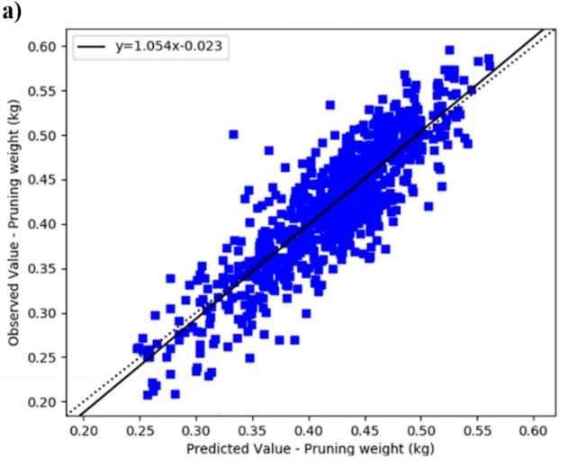 | 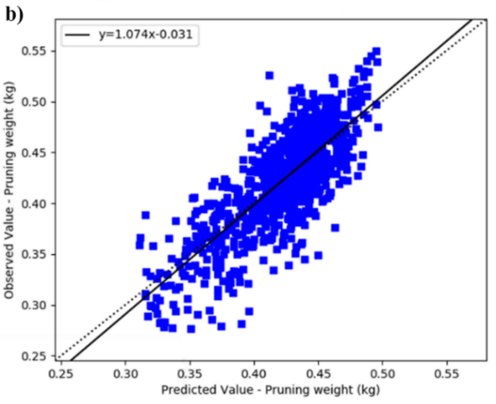
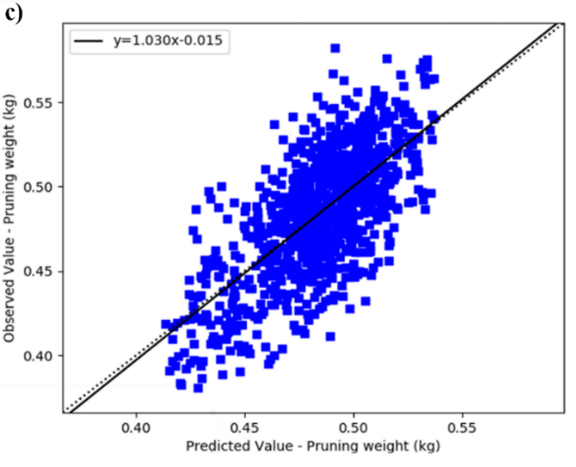 | 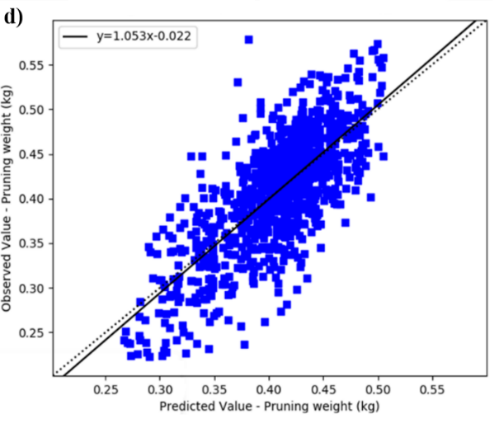
Fig. 12 Output of cross-validation between the observed and predicted pruning weight data for the regression models developed according to the VIs examined, (a) based on NDVI F1 (R²=0.75; RMSE=0.034); (b) NDRE F1 (R²=0.61; RMSE=0.030); (c) MSAVI F2 (R²=0.47; RMSE=0.027); (d) NDVI F2 (R²=0.55; RMSE=0.044).
Based on the semivariogram concept and models, kriging interpolation methods were evaluated for the spatial distribution of the predicted SPW data in the entire vineyard (Fig. 13). The vegetative vigour showed a heterogeneous distribution in all the four vigour maps, revealing the randomness and dependence of the spatial distribution of vegetative vigour in some areas of the vineyard. Figure 13.a shows the spatial distribution of vegetative vigour; this map was developed based on NDVI index data recorded in flight F1. The pruning weight values of the whole vineyard are concentrated around the average values of 0.6 kg. Figures 13.b and 13.d, on the contrary, show SPW values greater than the average weight assessed in the field, and thus the maps tend to provide an overestimation of pruning weight. Figure 13 c, referred to the spatial distribution of pruning weight and developed as a function of MSAVI index, on the other hand, shows an underestimation compared to the true value.
a) | 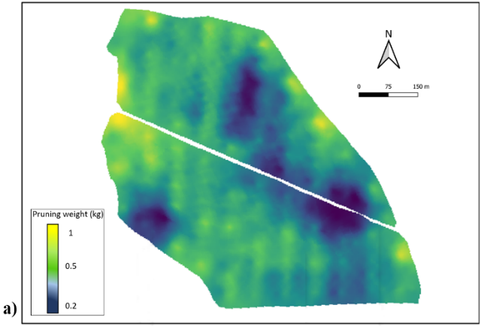 | b) | 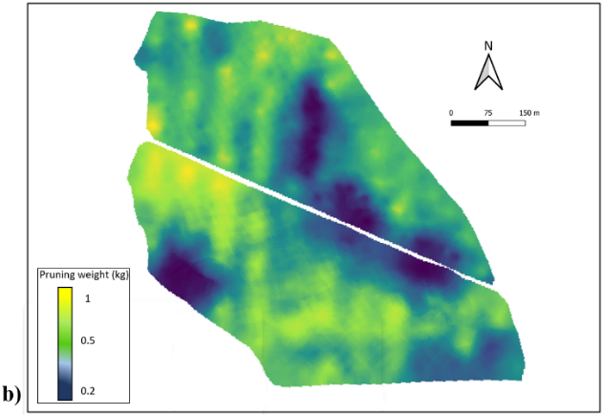
c) | 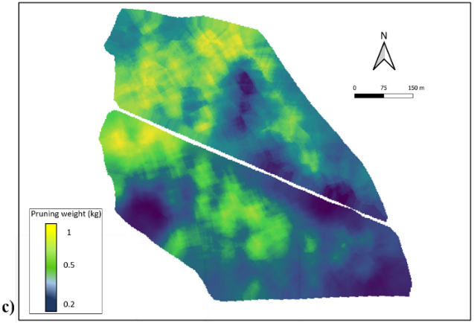 | d) | 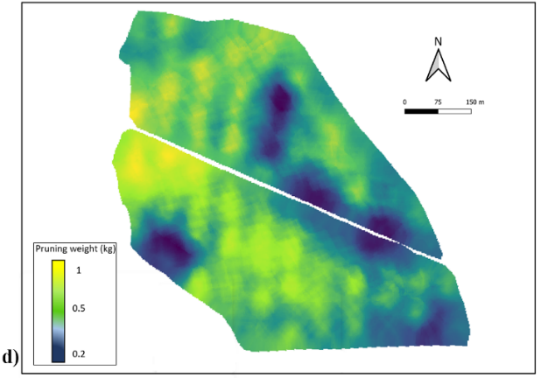
Fig. 13 Maps obtained by interpolation of predicted pruning weight (kg). Set of points (training): 1,000 on all maps. SPW prediction maps calculated as a function of VIs (a) based on NDVI F1; (b) NDRE F1; (c) MSAVI F2; (d) NDVI F2.

4. Discussion
The most significant results obtained in this study are discussed in this section: (i) the analysis of the vineyard spectral response in the three phenological stages; (ii) the correlations between multispectral indices and some vegetative and qualitative characteristics considered; (iii) the analysis of the prediction shoot pruning weight and then the spatial distribution of vigour according to the indices showing the best correlations with this agronomic parameter.
The data shown in Table 3 concerning the variability of the spectral response of the monitored plots allow an estimation of the level of intra-plot variability. Similarly, the agronomic data presented in Fig. 8 and 9 also show some spatial variability. Pruning weight, which is a very good descriptor of vigour, is one of the parameters that best represents this spatial variability. It shows high variability between low, medium and high vigour plots, in line with other studies (Gatti et al., 2017) conducted in a Mediterranean environment in a non-irrigated vineyard of cv. Barbera cultivated using the trellis system. Also, Matese and Di Gennaro (2021), using UAV-derived multispectral images for surveys on cv. Sangiovese, obtained a distribution in three different vigour levels after performing canopy segmentation of the vineyard. However, three levels of vigour were identified for the multispectral indices considered (Fig.6), observing the agronomic data; on the other hand, three distinct levels of vigour were not identified, except for the SPW. The temporal dynamics of the four UAV-based multispectral indices studied at the three different phenological stages show average values with a decreasing trend. The highest values were found during the first survey (F1) and then decreased near the last survey, that coincided with the phenological stage of berry ripening. This result can be related to the canopy development; when the first two surveys were performed, the vines were in a phase of intense vegetative growth and therefore the canopies were denser, as obtained by Katsoulas et al. (2016). The last survey was performed at ripeness, when vegetative growth ceased, as a function of which the canopies were sparser [49]. Also Romboli et al. (2017) identified two vigour levels through UAV surveys in a non-irrigated vineyard in Montalcino (central Italy) of the Sangiovese variety trained on trellis system. NDVI values of the only pixels of the vine canopy of each experimental block were 0.58 ± 0.04 (HV) and 0.36 ± 0.08 (LV). The authors conducted surveys at three phenological periods that coincide with those shown in our study, with NDVI values having a decreasing trend from fruit set phenological stage to ripening for the low vigour level area.
The variability in canopy size development impacts the outcome of the spectral response [76], as vineyards, not being continuous cropping systems, are affected by the vineyard background [43,77,78]; by reducing canopy density, the effect of soil background reflectance increases. Some multispectral indices are very sensitive to the effect of soil reflectance, and low LAI values can affect the spectral response (Liu et al., 2012). Furthermore, with the onset of grape ripening, leaf tissues show senescence and chlorophyll pigment degradation phenomena, marked by the progressive yellowing of leaves [80], which cause a change in canopy reflectance [81]. The vine performance in terms of yield, soluble solid content, acidity reported by the vine groups examined shows a different behaviour only between low and high vigour, while the group of medium vigour plants shows agronomic behaviour comparable to the high vigour areas according to the ANOVA. A corresponding vigour distribution was also observed for the agronomic parameter SPW by Gatti et al., 2017, in which the total pruning mass was different in all vigour classes, varying between 0.485 (LV) and 0.895(HV) g/vine. Similar results were also obtained by Bonilla et al. (2013), using multispectral remote sensing images on the Tempranillo variety, in which vigour-related variables such as leaf area and SPW showed significant differences within the three zones. Matese and Di Gennaro (2018) through multispectral UAV surveys carried out during the veraison stage, identified two vigour levels where NDVI data varied between 0.55 (LV) and 0.60 (HV) with corresponding differences in SPW values. In our study, the results for leaf area while not equally distributed across the three vigour levels are significantly different in LV areas compared to HV areas, as Gatti et al. (2017). In their study, LV vines are characterised by less canopy leaf area than HV vines, this may have affected the leaf-to-fruit ratio, a feature noted to influence carbohydrate accumulation in vines (Kliewer and Dokoozlian, 2005).
In our study, TSS shows significant differences between LV and HV zones, the latter showing less accumulation of soluble solids; these results agree with those obtained by Bonilla et al. (2013), Carrillo et al. (2016), Romboli et al. (2017), Gatti et al. (2017).This phenomenon is related to the greater leaf layers in HV vines compared to LV vines; this affects the exposure of the bunch to sunlight and consequently a change in temperature at the berry level, as observed by Dokoozlian and Kliewer (1996). They found that berries grown under lower sunlight conditions from the fruit set stage to ripening have lower soluble solids contents than those of bunches well exposed to sunlight. No differences in total acidity were found in our study among the three vigour levels; a similar result is reported in Bonilla et al. (2013) and Filippetti et al. (2013). The relationships between multispectral indices and the quantitative and qualitative parameters of the grape, and vegetative parameters of the vineyard canopy were investigated. Positive correlations were found through Pearson's index computation, especially with bunch weight and yield per vine (Table 4), as well as SPW (Table 5). Pearson's index showed negative correlations with total soluble solids (Table 6); in contrast, no correlation was found with total acidity as well as for the number of clusters. This study shows that high-resolution images captured by UAV can improve the relationships between yield or quality parameters and multispectral indices. For example, very strong correlations with yield data, in all the phenological stages considered, were obtained in contrast to Bonilla et al. (2013), instead [85] found positive correlations between yield and VIs in determined phenological phases, especially considering NDVI, in agreement with the results of this study.
The study of the relationships between technological ripeness and multispectral indices did not provide a clear trend. The relationships between soluble solids and NDVI were not satisfactory, at any of the three phenological stages. Only one multispectral index showed excellent correlation performance with TSS; in effect, GNDVI can be considered in studies predicting the variability of sugar accumulation in grapes. Significant Pearson's correlation values were found for all the relevant phases (Table 6), moreover, a negative correlation between GNDVI and TSS was also found by Maimaitiyiming et al. (2019) who obtained r=-0.53. However, it has been shown that the prediction of soluble solids content of grapes, which is usually performed considering the NIR absorption band, can be influenced by some specific substances such as pigments, carbohydrates and especially the presence of water [87]. The variation in their content depends on ripeness and thus this can influence the result of correlations. The results found in this study are in agreement with other studies conducted by [20], in which negative correlations were found through satellite surveys for TSS and NDVI and GNDVI. Among the vegetative variables, pruning weight and its correlations with the spectral indices were mainly considered. The results obtained show that measurements conducted with UAV at pre-veraison phenological stages are more correlated with some multispectral indices than measurements conducted close to grape ripening. The results of the present study confirm the relationship between NDVI and pruning weight found by other authors [1,41,43,88]. Overall, the obtained multispectral indices showed very good significant correlations with the parameters that are most related to vigour, namely grape yield and shoot pruning weight.
As a result of the correlations observed in this study, we deployed forecast models to monitor the variability of pruning weight and thus vigour of the entire vineyard. The prediction models shown in Table 7 were linear, high coefficients of determination were identified, and low values of RMSE and MAPE were obtained, implying that stable prediction models were selected. Consequently, acceptable coefficients of determination between predicted and observed pruning weights were identified (Fig. 10a and Fig. 10b), with some exceptions for multispectral indices based on the flight of the F2 survey, as shown in Fig. 10c and Fig.10d. To extend these vigour prediction models to the entire vineyard extension (8.2 ha), we performed geostatistical analyses. The four semivariograms obtained provided different information regarding the spatial distribution of vigour. Taking into consideration the pruning weight data obtained with the predictive model based on NDVI (F1), vigour shows a distribution that is closely dependent on the spatial variability of the field and thus not random. In the other cases considered by the prediction models, the semivariogram parameters indicate a weak spatial dependence. Indeed, in agreement with the criteria proposed by Cambardella et al. (1994), in the first case the Nugget variance parameter (C₀) corresponds to a small portion of the Sill variance (C₀ + C), and thus the percentage ratio of Nugget/Sill is less than 20% (Table 8). For the second case, the Nugget/Sill ratio is more than 40%, either for the prediction model based on NDRE (F1) or the other two indices MSAVI and NDVI (F2); this typifies the weak spatial dependence. Based on these results, the prediction of SPW and thus vigour that best represents the variability of the vineyard is obtained by taking into consideration NDVI data for the flight performed before veraison. Previous studies confirmed that key vegetative components are a spatially dependent agronomic variable [1,36]; environment predominantly influences the vegetative-productive performance of the vineyard through intrinsic variables such as, for example, the direct effect of soil [90,91].

5. Conclusions
This study investigated the capability of a multi-spectral sensor mounted on a multirotor UAV to monitor vegetative indices derived from the spectral response of the vineyard, at different phenological stages of the crop cycle. According to the results obtained by the four multispectral indices studied, it was possible to identify three different vigour levels in the vineyard. Through Pearson's correlation analysis it was found that a large proportion of the agronomic variables showed a stable correlation with the multispectral indices. The correlation analysis between yield components and multispectral surveys performed in the three periods was highly significant. For F1 survey, the indices most correlated with yield were NDVI and NDRE; at veraison and berry maturity, instead, all indices showed a very positive correlation with yield. However, awareness of these correlations at early stages allows corrective operations to be planned and applied throughout the season to improve yield or grape quality. Grape quality parameters were most correlated with multispectral indices investigated mainly in the green band. In fact, GNDVI proved to be the most suitable for representing the variability of grape TSS accumulation, displaying high correlation values starting from the phenological stage of berries pea size. SPW and vegetative vigour should be estimated before veraison, especially using VIs that include the red and near-infrared band. NDVI and NDRE showed high significance of correlation with SPW especially during the phenological stage of berries pea size. At veraison, on the contrary, only NDVI and MSAVI index showed good correlation. Through geostatistical analyses, it was possible to observe that the ordinary kriging method obtained very good interpolation results when using vigour prediction data processed as a function of NDVI from flights performed at preliminary stages of the vineyard crop cycle. These evaluations indicate that among the indices examined, NDVI provides detailed information for the management of crop operations. It was correlated with most of the agronomic parameters considered during the three phenological periods. However, for certain agronomic parameters and in certain phenological stages, the GNDVI and NDRE indices should also be considered.
The UAV sensing system enables the assessment of variability in a mid-range cultivation area, typical of Mediterranean vineyards, with higher efficiency than manual sensors and more detailed spatial resolution than satellite systems. In addition, we aimed to extend vineyard monitoring techniques with predictive survey methods, thus simplifying the sampling procedure performed in the field and relying on the accuracy of multispectral surveys by obtaining spatial awareness of whole-field variability. Prediction maps can assist farmers in managing subareas of the vineyard with different vigour. SPW prediction maps can guide winegrowers in choosing the appropriate bud load for winter pruning. Finally, these results could be used to develop new pruning management techniques.
Acknowledgments
This work was supported by the project “SiciliAn MicronanOTecH Research And Innovation CEnter “SAMOTHRACE”(MUR, PNRR-M4C2, ECS_00000022), spoke 3 - Universit_a degli Studi di Palermo “S2-COMMs - Micro and Nanotechnologies for Smart & Sustainable Communities”.

6. References
- Baluja, J.; Diago, M.P.; Balda, P.; Zorer, R.; Meggio, F.; Morales, F.; Tardaguila, J. Assessment of Vineyard Water Status Variability by Thermal and Multispectral Imagery Using an Unmanned Aerial Vehicle (UAV). Irrigation Science 2012, 30, 511–522.
- Barbagallo, M.G.; Guidoni, S.; Hunter, J. Berry Size and Qualitative Characteristics of Vitis Vinifera L. Cv. Syrah. South African Journal of Enology and Viticulture 2011, 32, 129–136.
- Pisciotta, A.; Barbagallo, M.G.; Lorenzo, R. di; Hunter, J. Anthocyanin Variation in Individual’Shiraz’berries as Affected by Exposure and Position on the Rachis. Vitis 2013, 52, 111–115.
- Pisciotta, A.; di Lorenzo, R.; Barbagallo, M.G.; Hunter, J. Berry Characterisation of Cv Shiraz According to Position on the Rachis. South African Journal of Enology and Viticulture 2013, 34, 100–107.
- Barbagallo, M.G.; Vesco, G.; Di Lorenzo, R.; Lo Bianco, R.; Pisciotta, A. Soil and Regulated Deficit Irrigation Affect Growth, Yield and Quality of ‘Nero d’Avola’grapes in a Semi-Arid Environment. Plants 2021, 10, 641.
- Novara, A.; Pisciotta, A.; Minacapilli, M.; Maltese, A.; Capodici, F.; Cerdà, A.; Gristina, L. The Impact of Soil Erosion on Soil Fertility and Vine Vigor. A Multidisciplinary Approach Based on Field, Laboratory and Remote Sensing Approaches. Science of the Total Environment 2018, 622, 474–480.
- Catania, P.; Orlando, S.; Roma, E.; Vallone, M. Vineyard Design Supported by GPS Application.; 2019; pp. 227–234.
- Hunter, J.; Volschenk, C.; Mania, E.; Castro, A.V.; Booyse, M.; Guidoni, S.; Pisciotta, A.; Di Lorenzo, R.; Novello, V.; Zorer, R. Grapevine Row Orientation Mediated Temporal and Cumulative Microclimatic Effects on Grape Berry Temperature and Composition. Agricultural and Forest Meteorology 2021, 310, 108660.
- Pisciotta, A.; Catania, P.; Orlando, S.; Vallone, M. Influence of Row Orientation on the Canopy Temperature of Sicilian Vineyards.; 2019; pp. 367–374.
- Hunter, J.; Volschenk, C.; Novello, V.; Pisciotta, A.; Booyse, M.; Fouché, G. Integrative Effects of Vine Water Relations and Grape Ripeness Level of Vitis Vinifera L. Cv. Shiraz/Richter 99. II. Grape Composition and Wine Quality. South African Journal of Enology and Viticulture 2014, 35, 359–374.
- Triolo, R.; Roby, J.P.; Pisciotta, A.; Di Lorenzo, R.; van Leeuwen, C. Impact of Vine Water Status on Berry Mass and Berry Tissue Development of Cabernet Franc (Vitis Vinifera L.), Assessed at Berry Level. Journal of the Science of Food and Agriculture 2019, 99, 5711–5719.
- Mirás-Avalos, J.M.; Fandiño, M.; Rey, B.J.; Dafonte, J.; Cancela, J.J. Zoning of a Newly-Planted Vineyard: Spatial Variability of Physico-Chemical Soil Properties. Soil Systems 2020, 4, 62.
- Poni, S.; Gatti, M.; Palliotti, A.; Dai, Z.; Duchêne, E.; Truong, T.-T.; Ferrara, G.; Matarrese, A.M.S.; Gallotta, A.; Bellincontro, A. Grapevine Quality: A Multiple Choice Issue. Scientia horticulturae 2018, 234, 445–462.
- Droulia, F.; Charalampopoulos, I. Future Climate Change Impacts on European Viticulture: A Review on Recent Scientific Advances. Atmosphere 2021, 12, 495.
- Bramley, R.; Hamilton, R. Understanding Variability in Winegrape Production Systems: 1. Within Vineyard Variation in Yield over Several Vintages. Australian Journal of Grape and Wine Research 2004, 10, 32–45.
- Kemps, B.; Leon, L.; Best, S.; De Baerdemaeker, J.; De Ketelaere, B. Assessment of the Quality Parameters in Grapes Using VIS/NIR Spectroscopy. Biosystems Engineering 2010, 105, 507–513.
- Matese, A.; Toscano, P.; Di Gennaro, S.F.; Genesio, L.; Vaccari, F.P.; Primicerio, J.; Belli, C.; Zaldei, A.; Bianconi, R.; Gioli, B. Intercomparison of UAV, Aircraft and Satellite Remote Sensing Platforms for Precision Viticulture. Remote Sensing 2015, 7, 2971–2990.
- Roma, E.; Catania, P. Precision Oliviculture: Research Topics, Challenges, and Opportunities—A Review. Remote Sensing 2022, 14, 1668.
- Assmann, J.J.; Kerby, J.T.; Cunliffe, A.M.; Myers-Smith, I.H. Vegetation Monitoring Using Multispectral Sensors—Best Practices and Lessons Learned from High Latitudes. Journal of Unmanned Vehicle Systems 2018, 7, 54–75.
- Anastasiou, E.; Balafoutis, A.; Darra, N.; Psiroukis, V.; Biniari, A.; Xanthopoulos, G.; Fountas, S. Satellite and Proximal Sensing to Estimate the Yield and Quality of Table Grapes. Agriculture 2018, 8, 94.
- Sun, L.; Gao, F.; Anderson, M.C.; Kustas, W.P.; Alsina, M.M.; Sanchez, L.; Sams, B.; McKee, L.; Dulaney, W.; White, W.A. Daily Mapping of 30 m LAI and NDVI for Grape Yield Prediction in California Vineyards. Remote Sensing 2017, 9, 317.
- Khaliq, A.; Comba, L.; Biglia, A.; Ricauda Aimonino, D.; Chiaberge, M.; Gay, P. Comparison of Satellite and UAV-Based Multispectral Imagery for Vineyard Variability Assessment. Remote Sensing 2019, 11, 436.
- Sozzi, M.; Kayad, A.; Gobbo, S.; Cogato, A.; Sartori, L.; Marinello, F. Economic Comparison of Satellite, Plane and UAV-Acquired NDVI Images for Site-Specific Nitrogen Application: Observations from Italy. Agronomy 2021, 11, 2098.
- Sellar, R.G.; Boreman, G.D. Classification of Imaging Spectrometers for Remote Sensing Applications. Optical Engineering 2005, 44, 013602.
- Aasen, H.; Honkavaara, E.; Lucieer, A.; Zarco-Tejada, P.J. Quantitative Remote Sensing at Ultra-High Resolution with UAV Spectroscopy: A Review of Sensor Technology, Measurement Procedures, and Data Correction Workflows. Remote Sensing 2018, 10, 1091.
- Toth, C.; Jóźków, G. Remote Sensing Platforms and Sensors: A Survey. ISPRS Journal of Photogrammetry and Remote Sensing 2016, 115, 22–36.
- Pádua, L.; Marques, P.; Hruška, J.; Adão, T.; Bessa, J.; Sousa, A.; Peres, E.; Morais, R.; Sousa, J.J. Vineyard Properties Extraction Combining UAS-Based RGB Imagery with Elevation Data. International Journal of Remote Sensing 2018, 39, 5377–5401.
- Jannoura, R.; Brinkmann, K.; Uteau, D.; Bruns, C.; Joergensen, R.G. Monitoring of Crop Biomass Using True Colour Aerial Photographs Taken from a Remote Controlled Hexacopter. Biosystems Engineering 2015, 129, 341–351.
- Lu, J.; Cheng, D.; Geng, C.; Zhang, Z.; Xiang, Y.; Hu, T. Combining Plant Height, Canopy Coverage and Vegetation Index from UAV-Based RGB Images to Estimate Leaf Nitrogen Concentration of Summer Maize. Biosystems Engineering 2021, 202, 42–54.
- Giovos, R.; Tassopoulos, D.; Kalivas, D.; Lougkos, N.; Priovolou, A. Remote Sensing Vegetation Indices in Viticulture: A Critical Review. Agriculture 2021, 11, 457.
- Xue, J.; Su, B. Significant Remote Sensing Vegetation Indices: A Review of Developments and Applications. Journal of sensors 2017, 2017.
- Costa Ferreira, A.; Germain, C.; Homayouni, S.; Da Costa, J.; Grenier, G.; Marguerit, E.; Roby, J.; Van Leeuwen, C. Transformation of High Resolution Aerial Images in Vine Vigour Maps at Intra-Block Scale by Semi-Automatic Image Processing.; 2007; pp. 1372–1381.
- Tassopoulos, D.; Kalivas, D.; Giovos, R.; Lougkos, N.; Priovolou, A. Sentinel-2 Imagery Monitoring Vine Growth Related to Topography in a Protected Designation of Origin Region. Agriculture 2021, 11, 785.
- Daglio, G.; Cesaro, P.; Todeschini, V.; Lingua, G.; Lazzari, M.; Berta, G.; Massa, N. Potential Field Detection of Flavescence Dorée and Esca Diseases Using a Ground Sensing Optical System. Biosystems Engineering 2022, 215, 203–214.
- Tosin, R.; Martins, R.; Pôças, I.; Cunha, M. Canopy VIS-NIR Spectroscopy and Self-Learning Artificial Intelligence for a Generalised Model of Predawn Leaf Water Potential in Vitis Vinifera. Biosystems Engineering 2022, 219, 235–258.
- Rey-Caramés, C.; Tardaguila, J.; Sanz-Garcia, A.; Chica-Olmo, M.; Diago, M.P. Quantifying Spatio-Temporal Variation of Leaf Chlorophyll and Nitrogen Contents in Vineyards. Biosystems Engineering 2016, 150, 201–213.
- White, R.E. Understanding Vineyard Soils; Oxford University Press, 2015; ISBN 0-19-934207-5.
- Taylor, J.A.; Bates, T.R. Sampling and Estimating Average Pruning Weights in Concord Grapes. American Journal of Enology and Viticulture 2012, 63, 559–563.
- Smart, R.; Robinson, M. Sunlight into Wine: A Handbook for Winegrape Canopy Management.; Winetitles, 1991; ISBN 1-875130-10-1.
- Caruso, G.; Tozzini, L.; Rallo, G.; Primicerio, J.; Moriondo, M.; Palai, G.; Gucci, R. Estimating Biophysical and Geometrical Parameters of Grapevine Canopies (‘Sangiovese’) by an Unmanned Aerial Vehicle (UAV) and VIS-NIR Cameras. Vitis 2017, 56, 63–70.
- Dobrowski, S.; Ustin, S.; Wolpert, J. Grapevine Dormant Pruning Weight Prediction Using Remotely Sensed Data. Australian Journal of Grape and Wine Research 2003, 9, 177–182.
- García-Fernández, M.; Sanz-Ablanedo, E.; Pereira-Obaya, D.; Rodríguez-Pérez, J.R. Vineyard Pruning Weight Prediction Using 3D Point Clouds Generated from UAV Imagery and Structure from Motion Photogrammetry. Agronomy 2021, 11, 2489.
- Rey-Caramés, C.; Diago, M.P.; Martín, M.P.; Lobo, A.; Tardaguila, J. Using RPAS Multi-Spectral Imagery to Characterise Vigour, Leaf Development, Yield Components and Berry Composition Variability within a Vineyard. Remote sensing 2015, 7, 14458–14481.
- Pastonchi, L.; Di Gennaro, S.F.; Toscano, P.; Matese, A. Comparison between Satellite and Ground Data with UAV-Based Information to Analyse Vineyard Spatio-Temporal Variability: This Article Is Published in Cooperation with the XIIIth International Terroir Congress November 17-18 2020, Adelaide, Australia. Guest Editors: Cassandra Collins and Roberta De Bei. Oeno One 2020, 54, 919–934.
- Bonilla, I.; Toda, F.; Martínez-Casasnovas, J.A. Grape Quality Assessment by Airborne Remote Sensing over Three Years. In Precision agriculture’13; Springer, 2013; pp. 611–615.
- Filippetti, I.; Allegro, G.; Valentini, G.; Pastore, C.; Colucci, E.; Intrieri, C. Influence of Vigour on Vine Performance and Berry Composition of Cv. Sangiovese (Vitis Vinifera L.). OENO One 2013, 47, 21–33.
- Gatti, M.; Garavani, A.; Vercesi, A.; Poni, S. Ground‐truthing of Remotely Sensed Within‐field Variability in a Cv. Barbera Plot for Improving Vineyard Management. Australian journal of grape and wine research 2017, 23, 399–408.
- Matese, A.; Di Gennaro, S.F. Practical Applications of a Multisensor UAV Platform Based on Multispectral, Thermal and RGB High Resolution Images in Precision Viticulture. Agriculture 2018, 8, 116.
- Matese, A.; Di Gennaro, S.F. Beyond the Traditional NDVI Index as a Key Factor to Mainstream the Use of UAV in Precision Viticulture. Scientific Reports 2021, 11, 1–13.
- Kalisperakis, I.; Stentoumis, C.; Grammatikopoulos, L.; Karantzalos, K. Leaf Area Index Estimation in Vineyards from UAV Hyperspectral Data, 2D Image Mosaics and 3D Canopy Surface Models. The International Archives of Photogrammetry, Remote Sensing and Spatial Information Sciences 2015, 40, 299.
- Siegfried, W.; Viret, O.; Huber, B.; Wohlhauser, R. Dosage of Plant Protection Products Adapted to Leaf Area Index in Viticulture. Crop Protection 2007, 26, 73–82.
- Bramley, R. Precision Viticulture: Managing Vineyard Variability for Improved Quality Outcomes. In Managing wine quality; Elsevier, 2022; pp. 541–586.
- Gatti, M.; Squeri, C.; Garavani, A.; Frioni, T.; Dosso, P.; Diti, I.; Poni, S. Effects of Variable Rate Nitrogen Application on Cv. Barbera Performance: Yield and Grape Composition. American Journal of Enology and Viticulture 2019, 70, 188–200.
- Sozzi, M.; Bernardi, E.; Kayad, A.; Marinello, F.; Boscaro, D.; Cogato, A.; Gasparini, F.; Tomasi, D. On-the-Go Variable Rate Fertilizer Application on Vineyard Using a Proximal Spectral Sensor.; IEEE, 2020; pp. 343–347.
- Campos, J.; Gallart, M.; Llop, J.; Ortega, P.; Salcedo, R.; Gil, E. On-Farm Evaluation of Prescription Map-Based Variable Rate Application of Pesticides in Vineyards. Agronomy 2020, 10, 102.
- del-Moral-Martínez, I.; Rosell-Polo, J.R.; Uribeetxebarria, A.; Arnó, J. Spatially Variable Pesticide Application in Vineyards: Part I, Developing a Geostatistical Approach. Biosystems Engineering 2020, 195, 17–26.
- Gil, E.; Llorens, J.; Llop, J.; Fàbregas, X.; Escolà, A.; Rosell-Polo, J. Variable Rate Sprayer. Part 2–Vineyard Prototype: Design, Implementation, and Validation. Computers and Electronics in Agriculture 2013, 95, 136–150.
- Román, C.; Llorens, J.; Uribeetxebarria, A.; Sanz, R.; Planas, S.; Arnó, J. Spatially Variable Pesticide Application in Vineyards: Part II, Field Comparison of Uniform and Map-Based Variable Dose Treatments. Biosystems Engineering 2020, 195, 42–53.
- Tominaga, S.; Nishi, S.; Ohtera, R. Measurement and Estimation of Spectral Sensitivity Functions for Mobile Phone Cameras. Sensors 2021, 21, 4985.
- Catania, P.; Comparetti, A.; Febo, P.; Morello, G.; Orlando, S.; Roma, E.; Vallone, M. Positioning Accuracy Comparison of GNSS Receivers Used for Mapping and Guidance of Agricultural Machines. Agronomy 2020, 10, 924.
- Rouse Jr, J.; Haas, R.H.; Deering, D.; Schell, J.; Harlan, J.C. Monitoring the Vernal Advancement and Retrogradation (Green Wave Effect) of Natural Vegetation; 1974;
- Candiago, S.; Remondino, F.; De Giglio, M.; Dubbini, M.; Gattelli, M. Evaluating Multispectral Images and Vegetation Indices for Precision Farming Applications from UAV Images. Remote sensing 2015, 7, 4026–4047.
- Gitelson, A.A.; Merzlyak, M.N. Remote Sensing of Chlorophyll Concentration in Higher Plant Leaves. Advances in Space Research 1998, 22, 689–692.
- Maccioni, A.; Agati, G.; Mazzinghi, P. New Vegetation Indices for Remote Measurement of Chlorophylls Based on Leaf Directional Reflectance Spectra. Journal of Photochemistry and Photobiology B: Biology 2001, 61, 52–61.
- Barnes, E.; Clarke, T.; Richards, S.; Colaizzi, P.; Haberland, J.; Kostrzewski, M.; Waller, P.; Choi, C.; Riley, E.; Thompson, T. Coincident Detection of Crop Water Stress, Nitrogen Status and Canopy Density Using Ground Based Multispectral Data.; 2000; Vol. 1619, p. 6.
- Jorge, J.; Vallbé, M.; Soler, J.A. Detection of Irrigation Inhomogeneities in an Olive Grove Using the NDRE Vegetation Index Obtained from UAV Images. European Journal of Remote Sensing 2019, 52, 169–177.
- Martínez, A.; Gomez-Miguel, V.D. Vegetation Index Cartography as a Methodology Complement to the Terroir Zoning for Its Use in Precision Viticulture. Oeno One 2017, 51, 289–289.
- Qi, J.; Chehbouni, A.; Huete, A.R.; Kerr, Y.H.; Sorooshian, S. A Modified Soil Adjusted Vegetation Index. Remote sensing of environment 1994, 48, 119–126.
- Cinat, P.; Di Gennaro, S.F.; Berton, A.; Matese, A. Comparison of Unsupervised Algorithms for Vineyard Canopy Segmentation from UAV Multispectral Images. Remote Sensing 2019, 11, 1023.
- Galambošová, J.; Rataj, V.; Prokeinová, R.; Prešinská, J. Determining the Management Zones with Hierarchic and Non-Hierarchic Clustering Methods. Research in Agricultural Engineering 2014, 60, S44–S51.
- Javadi, S.H.; Guerrero, A.; Mouazen, A.M. Clustering and Smoothing Pipeline for Management Zone Delineation Using Proximal and Remote Sensing. Sensors 2022, 22, 645.
- Chiles, J.-P.; Delfiner, P. Geostatistics: Modeling Spatial Uncertainty; John Wiley & Sons, 2009; Vol. 497; ISBN 0-470-31783-3.
- Webster, R.; Oliver, M.A. Geostatistics for Environmental Scientists; John Wiley & Sons, 2007; ISBN 0-470-51726-3.
- Cressie, N. Statistics for Spatial Data; John Wiley & Sons, 2015; ISBN 1-119-11518-3.
- Katsoulas, N.; Elvanidi, A.; Ferentinos, K.P.; Kacira, M.; Bartzanas, T.; Kittas, C. Crop Reflectance Monitoring as a Tool for Water Stress Detection in Greenhouses: A Review. Biosystems Engineering 2016, 151, 374–398.
- Hall, A.; Louis, J.; Lamb, D.W. Low‐resolution Remotely Sensed Images of Winegrape Vineyards Map Spatial Variability in Planimetric Canopy Area Instead of Leaf Area Index. Australian journal of grape and wine research 2008, 14, 9–17.
- Comba, L.; Gay, P.; Primicerio, J.; Aimonino, D.R. Vineyard Detection from Unmanned Aerial Systems Images. computers and Electronics in Agriculture 2015, 114, 78–87.
- Turner, D.; Lucieer, A.; Watson, C. Development of an Unmanned Aerial Vehicle (UAV) for Hyper Resolution Vineyard Mapping Based on Visible, Multispectral, and Thermal Imagery.; 2011; p. 4.
- Liu, J.; Pattey, E.; Jégo, G. Assessment of Vegetation Indices for Regional Crop Green LAI Estimation from Landsat Images over Multiple Growing Seasons. Remote Sensing of Environment 2012, 123, 347–358.
- Filimon, R.; Rotaru, L.; Filimon, R. Quantitative Investigation of Leaf Photosynthetic Pigments during Annual Biological Cycle of Vitis Vinifera L. Table Grape Cultivars. South African Journal of Enology and Viticulture 2016, 37, 1–14.
- Pádua, L.; Marques, P.; Hruška, J.; Adão, T.; Peres, E.; Morais, R.; Sousa, J.J. Multi-Temporal Vineyard Monitoring through UAV-Based RGB Imagery. Remote Sensing 2018, 10, 1907.
- Kliewer, W.M.; Dokoozlian, N.K. Leaf Area/Crop Weight Ratios of Grapevines: Influence on Fruit Composition and Wine Quality. American Journal of Enology and Viticulture 2005, 56, 170–181.
- Romboli, Y.; Di Gennaro, S.; Mangani, S.; Buscioni, G.; Matese, A.; Genesio, L.; Vincenzini, M. Vine Vigour Modulates Bunch Microclimate and Affects the Composition of Grape and Wine Flavonoids: An Unmanned Aerial Vehicle Approach in a Sangiovese Vineyard in Tuscany. Australian journal of grape and wine research 2017, 23, 368–377.
- Dokoozlian, N.; Kliewer, W. Influence of Light on Grape Berry Growth and Composition Varies during Fruit Development. Journal of the American Society for Horticultural Science 1996, 121, 869–874.
- López-García, P.; Ortega, J.F.; Pérez-Álvarez, E.P.; Moreno, M.A.; Ramírez, J.M.; Intrigliolo, D.S.; Ballesteros, R. Yield Estimations in a Vineyard Based on High-Resolution Spatial Imagery Acquired by a UAV. Biosystems Engineering 2022, 224, 227–245.
- Maimaitiyiming, M.; Sagan, V.; Sidike, P.; Kwasniewski, M.T. Dual Activation Function-Based Extreme Learning Machine (ELM) for Estimating Grapevine Berry Yield and Quality. Remote Sensing 2019, 11, 740.
- Benelli, A.; Cevoli, C.; Ragni, L.; Fabbri, A. In-Field and Non-Destructive Monitoring of Grapes Maturity by Hyperspectral Imaging. Biosystems Engineering 2021, 207, 59–67.
- Proffitt, T.; Malcolm, A. Implementing Zonal Vineyard Management through Airborne Remote Sensing. The Australian & New Zealand Grapegrower and Winemaker 2005, 22.
- Cambardella, C.A.; Moorman, T.B.; Novak, J.; Parkin, T.; Karlen, D.; Turco, R.; Konopka, A. Field‐scale Variability of Soil Properties in Central Iowa Soils. Soil science society of America journal 1994, 58, 1501–1511.
- Bramley, R.; Ouzman, J.; Boss, P.K. Variation in Vine Vigour, Grape Yield and Vineyard Soils and Topography as Indicators of Variation in the Chemical Composition of Grapes, Wine and Wine Sensory Attributes. Australian Journal of Grape and Wine Research 2011, 17, 217–229.
- Tardaguila, J.; Diago, M.; Blasco, J.; Millán, B.; Cubero, S.; García-Navarrete, O.; Aleixos, N. Automatic Estimation of the Size and Weight of Grapevine Berries by Image Analysis. Proc. CIGR AgEng 2012.

CHAPTER 6.

Grapevine and cover crop spectral response to evaluate vineyard
spatio-temporal variability.

This is the under-revision version of the manuscript in the Scientia Horticulturae (Elsevier) journal: Catania Pietro, Ferro Massimo Vincenzo *, Orlando Santo, Vallone Mariangela. Grapevine and cover crop spectral response to evaluate vineyard spatio-temporal variability. Scientia Horticulturae. Submited on 18 May. 2024.

Abstract
The use of cover crops in vineyards is considered a management strategy that contributes to improving soil structure. Remote sensing techniques of cover crops provide information on spatial variability that can be useful in precision viticulture. This study aims to investigate soil-plant interactions using biometric data, spectral response and soil physico-chemical parameters measured across 2021-2022, with the scope of assessing spatio-temporal variations of cover crop and vineyard. These evaluations were conducted on an on-farm vineyard in a semi-arid Mediterranean environment. During the winter season (T1), the cover crop (Vicia Faba) growth was evaluated. Equally, during the summer season (T2), vineyard monitoring was carried out during the phenological stages of flowering (T2A) and grape ripening (T2B). Multispectral images acquired through unmanned aerial vehicle (UAV) were employed, and subsequently, the normalized difference vegetation index (NDVI) was calculated to obtain crops vigor maps. Through bivariate LISA cluster maps, cover crop vigor maps were compared with those of the vineyard, revealing the presence of significant positive spatial autocorrelation between the two crops. Indeed, in areas where the cover crop exhibited higher dry matter accumulation, grapevine high vigor growth was observed. The spatial association identified in surveys conducted in T1 and T2 was examined considering soil parameters. It emerged that in areas where both the cover crop and the vines exhibited high NDVI values, soil factors such as soil organic carbon (SOC) content and total nitrogen (TN) were higher. Conversely, in areas where both crops showed low NDVI values, they were associated with higher soil bulk density (BD). Moreover, in low vigor zones, higher soil penetration resistance (SPR) values were observed in both T1 and T2, contributing to limiting root elongation and thus reducing overall crop growth. Vegetative growth variability observed through vigor maps and soil physicochemical properties was evaluated through principal component analysis (PCA). Soil parameters considered within these components highlighted their influence on crop growth. This study emphasizes how soil factors directly influence the spatiotemporal variability of crops. Monitoring cover crops allows for early detection of spatial variability, supporting vine growers in choosing sustainable vineyard management techniques.

Keywords: Cover crop; Soil penetration resistance; NDVI; UAV; Grapevine

1. Introduction
The vineyard agroecosystem represents a complex agricultural environment, where interactions between vines, soil, climate, and farming practices play a crucial role in grape quality production. In this context, understanding the dynamics of the vineyard agroecosystem is essential for optimizing farming practices, promoting environmental sustainability, and ensuring high enological standards. The importance of environmental sustainability in the grapevine sector is increasingly recognized, as traditional farming practices can have negative impacts on soil, water, and biodiversity [1]. Intensive management of vineyard lands can lead to soil compaction, depletion of water resources, and erosion, compromising the functionality of the agroecosystem. Agricultural activity and soil management systems can influence the soil physical properties over time, particularly about soil bulk density (BD) and soil penetration resistance (SPR), which are significantly influenced by soil tillage practices [2,3]. When soil penetration resistance exceeds the value of 2.5 MPa, it hinders root growth in the soil, compromising their ability to reach water and essential nutrients for growth. This threshold has commonly been accepted as a critical point beyond which these negative effects occur. However, some studies have proposed a higher threshold for agricultural soils, highlighting the complexity of evaluating SPR and the importance of carefully considering specific soil conditions and the traffic caused by agricultural machinery [4–6]. Among the factors regulating soil physical properties, soil aeration is a dynamic process influenced by various factors, including soil water content and bulk density [7]. Under conditions of inadequate aeration, roots may effort to obtain oxygen, compromising their metabolism and nutrient absorption capacity. The presence of oxygen in the soil is crucial for the decomposition of organic matter by microorganisms [8,9]. High temperatures and arid conditions typical of the Mediterranean area can accelerate the decomposition processes of organic matter in the soil. The practice of conventional tillage such as chisel plough and rotary tillers can promote the fragmentation of soil organic matter [10], resulting in an increase in soil penetration resistance [11]. Other observed phenomena include the association between losses of soil organic carbon and increased sediment erosion. These interdependent phenomena can influence the overall vigor of the vineyard [12]. In this context, the practice of cover cropping in the vineyard inter-rows emerges as a promising strategy to improve the overall sustainability. This practice helps to improve soil structure by promoting the formation of stable aggregates, increasing organic matter, reducing bulk density [13], and mitigating soil erosion. The roots of cover crops create vertical porosity in the soil, promoting infiltration, while the canopy of cover crops limits the dispersive effect of raindrops [14,15]. Additionally, cover crops enhance water infiltration, increase water retention capacity, and promote nutrient balance [16]. Cover crop residues promote an increase in soil organic carbon (SOC) accumulation. Research has confirmed a strong correlation between soil aggregate stability, soil structure, and organic matter content [17–19]. Soil stable aggregates help to balance the ratio between macropores and micropores, consequently reducing bulk density [20,21]. Cover crops, including legumes, are characterized by their ability to contribute to soil nitrogen accumulation. The phenomenon of nitrogen rhizodeposition carried out by the roots of legumes represents a potential pathway that vines could benefit from [22]. However, the main nitrogen source resulting from the practice of legume cover crops is due to the decomposition and mineralization of the organic residues of legumes at the end of the growing season [23]. The amount of nitrogen derived from the cover crop depends on a complex interaction of factors, including the legume species, the duration of the growing season, and soil and climatic conditions [24]. In general, legume cover crops are characterized by a low C:N ratio, which facilitates the mineralization process. Moreover, in the Mediterranean area, high soil temperatures and rainfall occurring after the burial of biomass provide favourable conditions for rapid residue decomposition [25]. It is estimated that through fixation and decomposition of legume residues, soil can receive an amount of nitrogen exceeding 40 kg/ha⁻¹. However, it has been found that only a limited portion of this released nitrogen from legumes is effectively utilized by the vine [26]. The grapevine nitrogen uptake model depends on soil availability and management techniques. This can give rise to noticeable effects on vigor, regulating parameters such as canopy efficiency and shoot growth rate [24]. Certainly, the benefits associated with the practice of cover crops are manifold; however, in many cultivation areas of the Mediterranean basin, grape growers do not always tend to apply this soil management technique [27]. Some research has observed a reduction in vineyard yield, primarily affecting cluster modifications, such as a decrease in weight. However, this reduction in yield could be associated with improved must quality [28]. Nonetheless, vineyard management in semiarid environments is complex, and one of the main risks is competition for water and nutrients between permanent cover crops and the vineyard. Consequently, growers prefer to use cover crops in a temporary mode, especially with legume species positioned in the inter-rows and then buried at the beginning of spring [29]. The variations observed in the soil can directly influence plant development, potentially affecting their spectral response. More vigorous plants tend to have greater biomass, larger leaf area, and a balanced chlorophyll content, which may result in a different spectral response compared to less vigorous plants. Crop growth monitoring can be carried out using vegetation indices (VI), utilizing information collected from sensors measuring radiation reflected by plants across different bands of the electromagnetic spectrum. More vigorous plants generally exhibit higher reflectance across most spectral bands. Among the vegetation indices, the normalized difference vegetation index (NDVI) is commonly used to assess crop development variability, considering reflectance in the red and near-infrared bands [30]. Several studies have investigated the advantages of using multispectral platforms and sensors compared to traditional methods for crop monitoring. Among these technologies, unmanned aerial vehicles (UAV) are increasingly utilized as they enable more frequent and detailed monitoring of crops, thanks to the high spatial resolution of the images [31]. Recent studies have shown that vigor maps derived from UAV, focusing solely on vine vegetation, provide an accurate representation of vineyard variability [32–34]. NDVI has been extensively studied and demonstrated to be closely associated with various vegetative and physiological parameters of the vineyard, often used as a key factor for spatial management decisions in vineyards [35–38]. Understanding vineyard heterogeneity is strategic; in this regard, gaining insight into the dynamics related to soil physical and chemical properties, alongside climatic factors, is essential for determining the causes of spatial variability [39,40]. Yuan et al., (2019) identified strong linear correlations between cover crop biomass and NDVI, demonstrating that UAVs are valid tools for obtaining relatively rapid and non-destructive estimates of biomass. Damian et al., (2017) evaluated the effect of variability caused by organic residues and released nutrients from cover crops on the yield of subsequent main crops, using estimates based on NDVI maps calculated from UAVs. Crop cover remote sensing can be used as a 'reflector' or 'bio-indicator' of soil conditions. Futerman et al., (2023), leveraging this concept, proposed the use of prescription maps for the primary crop's basic fertilization, relying on maps depicting the variability of cover crop vigor. The spatiotemporal assessment in precision agriculture is carried out by considering Local Indicators of Spatial Autocorrelation (LISA). These consist of specific indices to evaluate the presence of spatial clusters or simultaneous spatial dispersions for two variables in a specific area [44]. These statistical methods have recently been applied to images acquired from UAVs, aiming to compare different vegetation index maps of a vineyard with other maps related to parameters derived from in-situ ground characterizations [45,46]. Based on these studies, site-specific variability corresponding to cover crop and vineyard across two different seasons of the crop cycle was investigated. A comparative study was conducted considering the main factors influencing plant growth, including soil physical and chemical properties, and crop biometric data that determine variations in their spectral response. This was carried out through the application of specific geostatistical methods that successfully identify clusters or spatial associations.

2. Materials and Methods

2.1 Study area and Experimental Design
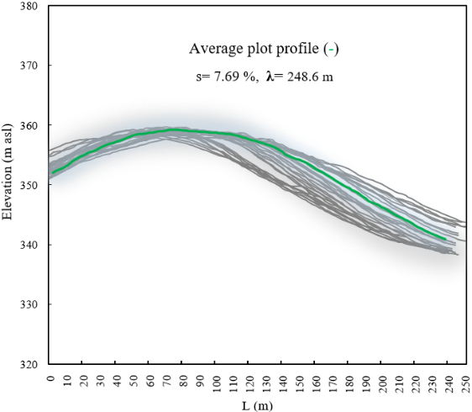
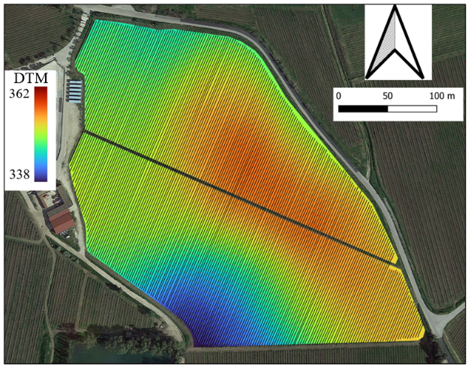
The experimental vineyard studied in this experiment is in southern Italy, specifically in the Bianco Alcamo protected designation of origin (PDO) area (37°55'12 "N and 13°04'27 "E). Based on the methodology of an on-farm experiment, a study was conducted in 2021-2022 in a 16-year-old vineyard located in Camporeale (Palermo, Italy) at Tenuta Rapitalà (Figure 1a). The area is characterized by a Mediterranean climate (summer drought) according to Kottek et al., (2006). The climate of this area is classified as Csa and can alternatively be described as semi-arid according to the Thornthwaite moisture index [48]. Rainfall is distributed throughout autumn, winter, and spring, with the highest rainfall intensities observed during the autumn season. Mean air temperature ranging from 18.3 to 24.6 °C, while mean annual rainfall from 700 to 820 mm. The total experimental area is 8 hectares with irregular orography and elevation ranging from 340 to 369 m above sea level. Due to the irregularity of the terrain orography in terms of elevation and soil properties, the selected vineyard is characterised by heterogeneous vigour variability. The graph in Figure 1 shows the average planar slope of the plot under investigation. Considering plot average length “λ” (m) and digital elevation model (DEM) values (Figure 1b), it was possible to determine the average slope, which is 7.69%.

- b)
Figure 1: a) Experimental site location, coordinates of field centroid: 37°55’11.18’’ N, 13°04’22.31’’E. b) Graphical representation of the average slope of the vineyard rows.

The vineyard was planted in 2007 with a 2.40 m distance between rows and 1 m intra-row distance. The orientation of the rows is NE-SW with a double spurred cordon training system. The field is managing according to the ordinary agronomic practices of the area with drip irrigation system. The soils are vertisols with typical characteristics of clayey soils according to [49]. The main soil properties, determined before setting up the experimentation and referring to 0–20 cm soil layer are reported in Table 1. The soil is characterized by a clay loam texture with pH equal to 7.66 (1:2.5 H₂O, w/v) and 0.19 dS m⁻¹ cation exchange capacity.
Table 1: Basic properties of soil sampled and measured before the experiment in March 2021
Soil properties | Value
Sand (0.02 < Φ < 2 mm, g kg⁻¹) | 388 ± 12
Silt (0.002 < Φ < 0.02 mm, g kg⁻¹) | 226 ± 14
Clay (Φ < 0.002 mm, g kg⁻¹) | 378 ± 15
pH in water | 7.66 ± 0.1
Electrical conductivity (dS m⁻¹) | 0.19 ± 0.03

Before cover crop sowing in October 2021, tillage was carried out with a horizontal spring tiller with 7 chisel-type shares, at a depth of 0.15 m. Subsequently, a legume species (Vicia fava L.) was sown as cover crop. This cover crop was seeded using a combined power harrow with a mechanical seed drill, in the beginning of November 2021. Sowing was carried out in vineyard in the inter-row areas, 0.20 m row spacing, and 0.05 m depth, with the amount of 90 kg ha⁻¹. Cover crops were mechanically buried by plowing in the 0.20 m depth in spring (mid-April). After the cover crop was buried and aerate the topsoil, the vineyard was managed following the traditional agronomic practices applied in semi-arid climate zones, with the soil in the inter-row spaces tilled with a cultivator [29]. Soil tillage operations were superficial and typically performed at a depth of 0.15 m, aiming to control weeds, water evaporation, and prevent soil cracking.

2.2 Data survey
To assess crops spatial and temporal variability, ground and remote surveys were performed (Figure 2). The ground survey was carried out to evaluate the agronomic and vegetative condition of the plants, while the remote surveys were performed using a UAV. Temporal variability was assessed in three different periods. During the winter, while the vineyard was in the dormancy, at DOY 63 cover crops spatial variability was evaluated by measuring agronomic variables and spectral surveys. In this period, the cover crop vegetative stage was full flowering. During the vineyard growing season at DOY 169 and 226, vegetative and spectral measurements were assessed. Specifically, the phonological stages of the vine were fruit set (BBCH 65) and grape ripening (BBCH 85), respectively.
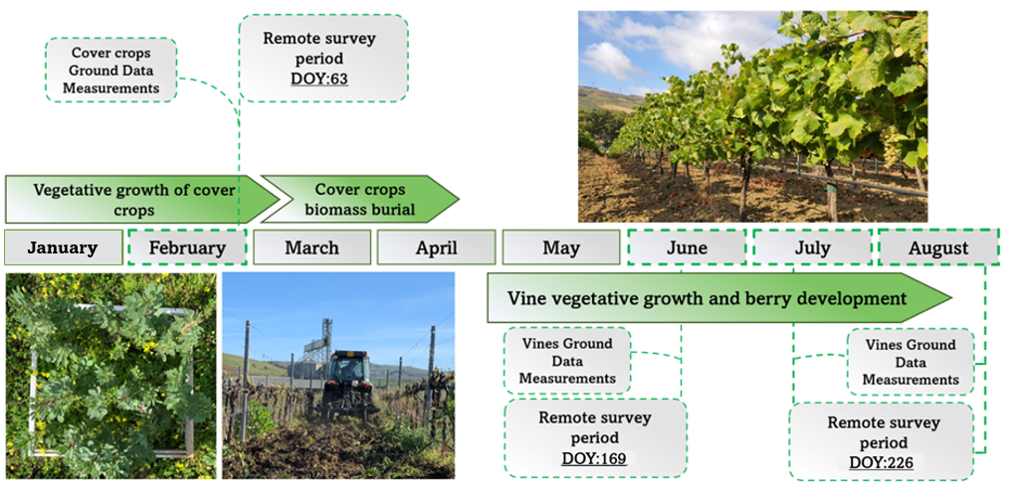Figure 2: Flow chart of the biometric and multispectral surveys carried out on cover crop and vineyard.

2.3 Agronomic sampling
The sampling points were identified in areas with different vigour, excluding the most external part of the field. A total number of 20 experimental units was sampled both in the vineyard and the cover crop in the same position (Figure 3). Each sample was divided into three sub-sampling (n = 3 replicates per block sample).
The cover crop block-sampling was identified using a 1 (m²) square positioned in the central part of the inter-row. In the aboveground cover crop sub-sampling area, three agronomic parameters were evaluated: plant length (PL), fresh weight (FW) dry weight (DW). Fresh weight was measured using a digital balance (Shimadzu ATY324R, Milan, Italy). Plant material was clipped at soil level and weed and cover crop biomass was separated. These samples were dried at 60 ◦C for 48 hours until a constant weight was reached to determine their dry weight.
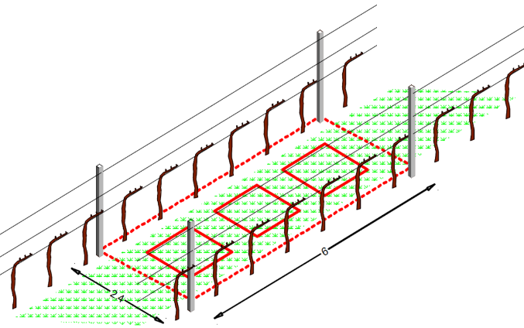
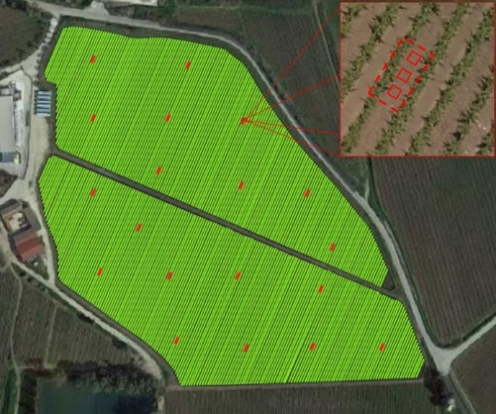
Surveys on the vegetative parameters were carried out in the vineyard selecting the same 20 experimental units used in the cover crop sampling. Each experimental unit consisted of six vines; a total of 120 vines were monitored. In Figure 3b, the sampling blocks are shown for both the cover crops and the vineyard. The dashed red line refers to the vineyard sampling area. Conversely, the squares marked with a solid red line denote the sampling points for the cover crops. The vegetative parameters were shoot length (SL), leaf counts for each shoot (LS), total leaf area (TLA), epidermal chlorophyll (Chl) and nitrogen balance index (NBI). The TLA of primary and lateral shoots was measured using an LI-3100C area meter (Li-COR Environmental, 4647 Superior Street Lincoln, NE, USA). Chl and NBI values were measured with the Dualex 4 leaf-clip version (Dualex Scientific+, Force-A, Orasy, France) on fully expanded leaves at the second phenological stage of sampling. Chlorophyll a + b was estimated from near-infrared (NIR) transmittance measurements at 710 and 850 nm, it was used as data from the device without transformation. The average value of Chl and NBI were calculated at two separate points on the epidermal surface for each leaf.
Figure 3a) Representation of the experimental units in the field and configuration of the three sub-samples. b) Graphic representation of an experimental unit where the vineyard sampling zones are highlighted in red with dashed lines, and for the cover crops with squares.
b
a

2.3.1 Determination of soil physical and chemical properties
Soil samples were collected at two times of the year, in 2021 and 2022, during the autumn season (rainy season in the southern Mediterranean area) and in summer. Soil rings of 98 cm³ for the first 0.20 metre layer were used to determine bulk density. The soil bulk density (BD) was measured following the protocol of Blake & Hartge, (1986), using intact samples collected with a steel rings with 0.05 m diameter and height. Gravimetric soil water content (SWC) was determined by weight difference between fresh and dried (24 h at 105 ◦C) sample. Soil water filled pore space (WFPS) was calculated considering the SWC, BD, and taking into consideration the soil absolute density (AD) equal to (2.65 g cm⁻³). The calculation follows the analytical formula [1] presented:
$$WFPS= \frac{SWC*BD*100}{(1-BD/AD)} [1]$$
At these sampling points, soil penetration resistance (SPR) measurements were conducted. SPR was assessed down to a depth of 0.60 m using a portable digital penetrometer (Eijkelkamp Penetrologger mod. 06.15), equipped with a load cell, an ultrasonic depth sensor, a data logger, and a probing rod. It culminates with a cone having a base area of 200 mm² (compliant with ASAE standard 313.1)[51]. Capable of measuring penetration force from 0 to 1000 N with a resolution of 1 N, it can assess soil resistance up to a depth of 0.80 m with a resolution of 10 mm [4]. Two measurements per second were recorded. Soil chemical analyses were carried out on samples which were air-dried and sieved at 2 mm. Soil organic carbon (SOC) and total nitrogen (TN) were determined on pulverized soil samples by dichromate digestion [52] and for total N by the Kjeldahl method. Cation exchange capacity (CEC) was determined with ammonium acetate solution buffered at pH 7.0 [53].

2.4 UAV configuration and data acquisition
A remote UAV platform equipped with a multispectral and RGB camera was used to investigate the spectral features of cover crop and vine. The DJI model Phantom 4 (DJI, Shenzhen, China) is a quadcopter with four rotating wings and vertical takeoff and landing (VTOL), described in detail in [54]. The multispectral camera consists of five independent sensors 1/2.9" CMOS, operating in the blue band at 450 nm, the green band at 560 nm, the red band at 650 nm, the red edge at 730 nm, and the NIR band at 840 nm. All the sensors have a spectral sensitivity range of ±16 nm around their nominal wavelengths, except for NIR sensor, which has a wider spectral sensitivity range of ±26 nm. The camera is equipped with a sixth sensor capturing images in the visible spectrum.
The UAV flights were conducted in three dates throughout the cover crop and grapevine growth cycle (Table 2). The first flight was conducted during the winter season in February (T1) to assess cover crop spectral response (DOY 63). Subsequently, two surveys were performed in vineyard corresponding to the late flowering stage (T2A) and at the grape ripening stage (T2B). All surveys presented the same setting characteristics.

Table 2 Sampling date and corresponding phenological growth stages.
Survey | Description | BBCH code
T1 | Cover crop flowering (vine bud swell) | 01
T2A | Grapevine flowering stage | 65
T2B | Grape ripening stage | 85

Images were taken between 11:30 and 13:00, with the best weather condition and the automatic guide following the set route and waypoints. The flight height was 70 m a.g.l. using Real Time Kinematic (RTK) differential corrections, obtaining a ground sample surface (GSD) of 3.7 cm. The image acquisition was performed at an average speed of 6.9 m*s⁻¹ in stop-and-go mode. The front and side overlap percentage between the image was 70%, while the gimbal pitch was set at 90° (downwards). Prior to and following each flight, images were acquired using specific reflectance calibration panels. Image acquisitions in TIFF format were performed to carry out radiometric calibration in post-processing. To enhance the accuracy of survey, 20 Ground Control Points (GCPs) were positioned both externally and internally within the field. GCPs were georeferenced using the GNSS receiver S7-G by Stonex (Italy, Milano), equipped with a Stonex geodetic antenna in RTK mode as an average of 60 measurements. The GCPs were imported into the QGIS software, version 3.28 (QGIS Development Team, 2021), and all orthomosaics were geometrically corrected.

2.4.1 UAV Image processing and analysis
Georeferenced multispectral images were mosaicked using Agisoft Metashape Professional Edition version 1.7.3 software. The total number of images obtained for each individual survey and sensor was 215. All multiband images were uploaded into the software, followed by image alignment, GCP (Ground Control Points) loading, and reflectance calibration. Utilizing calibration panel images, reflectance was corrected using Agisoft Metashape software. Subsequently, the images containing the calibration panel were selected. Then, leveraging the reflectance calibration function within software, the correct reflectance values were determined. Finally, the dense cloud and the orthomosaic multiband were constructed for each survey [55]. NDVI map was calculated using the near infra-red (NIR) and Red reflectance band maps, according to Rouse et al., (1974) equation, using QGIS software [57]. This vegetation index (VI) was calculated to investigate the spectral canopy conditions and identify the vigor level (Caruso et al., 2019). For the high-resolution images acquired by UAV, it was necessary to perform a segmentation process of the NDVI images to differentiate the vineyard canopy rows from soil and shaded pixels, which classifies the input pixels into several different classes. Vine canopy segmentation and classification process was performed using the Object-Based Image Analysis (OBIA) method. For image segmentation, the Orfeo Toolbox library was employed, leveraging the large-scale mean-shift (LSMS) algorithm developed by Michel et al., (2014). Subsequently, the object image classification was performed using the supervised classifier namely support vector machines (SVM).
The crops were divided into three different vigor classes based on specific agronomic evaluations. Indeed, by means of field assessments, the vegetative growth of the crops was monitored. Remote sensing was useful for identifying sampling points and providing spatial input for the model, as previously ascertained by other authors [61]. In the vineyard, shoot development, the number of leaves per shoot, and total leaf area were used to characterize three different vigor areas of the vineyard, namely low, medium, and high vigor. These evaluations were conducted at both the T2A and T2B phenological stages. This classification into different vigor categories was also conducted for investigations on vegetative cover. Indeed, during winter, detailed agronomic assessments identified areas with varying vegetative growth, exhibiting low, medium, and high vigor. These agronomic assessments involved evaluating fresh weight and overall vegetative cover development. By combining these agronomic insights with the variability detected through NDVI maps, the crops were classified into three distinct zones: high vigor (HV), medium vigor (MV), and low vigor (LV). The three clusters of each map were identified using the K-means algorithm through the utilization of the SAGA library in QGIS.
The ordinary kriging interpolation method was used to create continuous vigor maps for cover crop and vineyard. Kriging interpolation implies that the estimation of an arbitrary point in a defined zone of the field is expressed with a linear weighting of all the observations. In order to provide the best linear estimate, semivariograms considering the spatial structure were calculated as made in previous studies [62,63].
The spatial structure of each vigour attribute of both crops was characterized and quantified using the experimental semivariogram, which was adapted using linear, linear with sill, spherical, exponential, and Gaussian theoretical models. The graph of the experimental semivariogram was obtained by calculating the semivariances at different distance intervals. For each model, we determined the following parameters: nugget variance (C₀), contribution (C1), sill variance (C₀+ C1) and range (a). The selection of the theoretical semivariogram model that was most suitable to represent the vigor variability in different phenological stages for both crops, was made according to the highest coefficient of determination (R²).

2.5 Statistical analysis
The data obtained from the ground sampling and remote sensing platform were processed and statistically analysed. After determining the descriptive statistics (mean, maximum, minimum, standard deviation), the analysis of variance (ANOVA) and the Tukey’s multiple comparison tests were applied. In this study, the bivariate local indicators of spatial association (BiLISA) was calculated, which is a measure of spatial autocorrelation assessing the association between two different variables, unlike the Moran's I (MI) which evaluates the autocorrelation of a single variable. To evaluate the global spatial autocorrelation of the data in an specific area, the statistical index I developed by [64] was measured according to equation [2] [65]:
$$I= \frac{n}{W}* \left[\frac{\sum_{i=1}^{n}{\sum_{j=1}^{n}{w_{ij}\left(x_{i}-\overline{x}\right)*\left(y_{j}-\overline{y}\right)}}}{\sum_{i=1}^{n}{\sum_{j=1}^{n}{w_{ij}}}}\right] [2]$$
where n represents the number of observations, in our case 817, corresponding to the number of points derived from the regular grid used for each map; x_{i}, y_{j} represent the observed values of the two variables located at points i, j; $\overline{x},\overline{y}$ are the average of the two variables of the n observed points of the NDVI attribute. In this equation, the spatial weights matrix (w_{ij}) with value 0 in the diagonal (w_{ii}=0) is considered; the sum of all spatial weights w_{ij} is represented by the spatial weight matrix W. Using an algorithm from the Python library, a specific kernel function was implemented that calculates neighbor weights based on the separation distance of the observation points [66]. MI index was calculated to evaluate the spatial autocorrelation in adjacent area. The MI index ranges from -1 to +1, where positive spatial autocorrelation implies similar values in neighboring locations, while negative spatial autocorrelation indicates dissimilar values in neighboring locations. A null value (MI = 0) suggests that there is no spatial autocorrelation, and that the spatial arrangement is completely random. The result is a pseudo p-value for each location, which can be used to assess significance. The calculations to assess the local spatial dependence of NDVI related to cover crop and vineyard were performed using the GeoDa software, which provides the capability to manage spatial weights. All computations were performed using R software (R Core Team, 2022) supplemented by R Studio (version 4.3.0, 2023-04-21) (RStudio, 2020) and Microsoft Excel.

3. Results

3.1 Assessment of cover crop and vineyard variability
In this section, the findings of the analysis exploring temporal variability between period T1 and T2 are presented. This investigation proposes a direct comparison of temporal variability evolution, providing an in-depth insight into the growth dynamics over time of both the cover crop and the vineyard. Through a detailed analysis of data collected at different times, the aim is to identify any trends, variations, or distinctive patterns in crop growth.
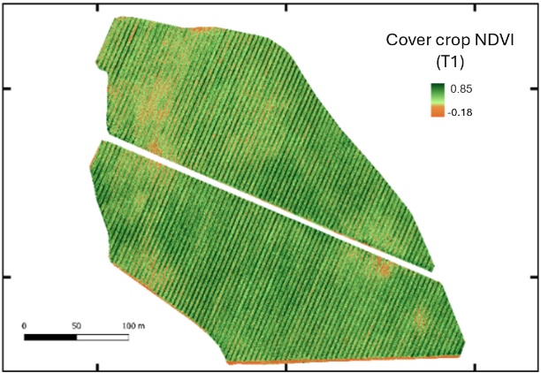 | (a)
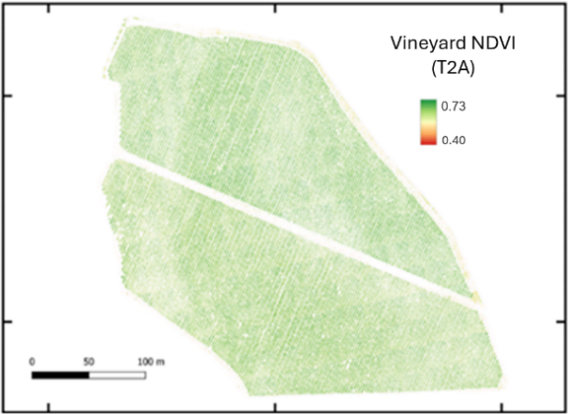 | (b)
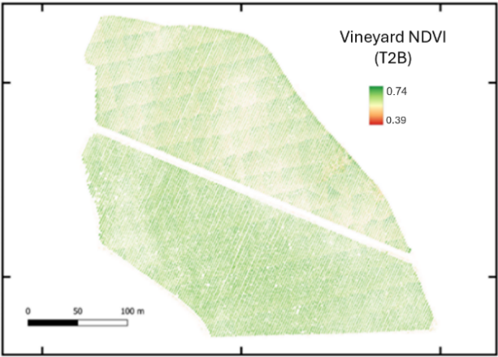 | (c)
Figure 4 Representation of NDVI for cover crop (a) and vineyard canopy variability detected by UAV during T2A (b) and T2B (c).
In Figure 4a, the NDVI map representing the cover crop spectral response is depicted. This survey was conducted during the flowering stage of the leguminous crop. The flowering stage is characterized by the highest biomass accumulation and, consequently, the most significant period of vegetative activity. However, it is evident from the map that there is variability in vegetation; in some areas, there is a lower intensity of spectral response compared to others with green coloring, which according to the scale corresponds to higher crop development values. In Figures 4b and 4c, the NDVI results of the vine canopy are depicted. In the first figure, the flight was conducted during the fruit set stage (T2A), while in the second figure, the survey was carried out during grape ripening (T2B). These vegetation index maps related to the canopy allow for an approximate assessment of vegetation growth variability.
Table 3 presents the results of descriptive statistics for the NDVI index evaluated during the three investigation periods, referring to the conditions of the cover crop during the winter period (T1) and to the vineyard during the summer period (T2A and T2B). These results aid in understanding the vigor maps through an analytical approach. Referring to period T1, it is observed in Table 3 that the most represented area is HV, covering an area of 48,900 m², followed by low vigor areas for the cover crop (18,700 m²). The area with moderate vigor is slightly lower, totalling 14,200 m². The average NDVI value associated with these areas is well differentiated across the three vigor levels. It is noted that high vigor is represented by an average value of 0.74, differing from the one of moderate vigor, which is 0.59. Conversely, the low vigor of the cover crop shows an NDVI value of 0.32, considerably lower than that observed for the other levels. In this latter case, very low NDVI values (-0.18) were observed with a high standard deviation. This result is due to soil moisture conditions that can significantly influence the spectral response, as water can attenuate a greater amount of radiation in the near-infrared (NIR) band. This can lead to a decrease in NDVI values, as the index is based on the difference between reflectance in the red band and that in the near-infrared band. For the other two vigor levels, the observed minimum value is approximately 0.2, with maximum NDVI values reaching around 0.8. Table 3 also shows the results related to the vineyard, indicating that during period T2A, the largest area is characterized by medium-high vigor. A similar trend is observed in period T2B, where HV areas constitute approximately 50% of the plot, while areas with medium and low vigor account for 25%. However, it should be noted that LV areas underwent an increase of 11% between period T2A and T2B. Conversely, the MV area decreased by 11% over the same period. The areas identified as high vigor remained stable between the two phenological periods considered. Concerning NDVI values observed during vineyard growth cycle, it can be stated that they differ from those observed for cover crop. Indeed, both for the periods T2A and T2B, the range of variation among the three vigor levels is smaller compared to cover crop NDVI. Particularly, during T2A survey, average values of 0.72 for HV, 0.65 for MV, and 0.60 for LV were observed. This trend of NDVI values remains relatively stable throughout the vineyard growth season, as also observed for period T2B. In fact, the average NDVI value decreased by 6% from June to August, 5% in the case of MV, and 9% in the case of LV. In general terms, LV reported a higher standard deviation value in both investigation periods.
Table 3: Summary statistics of NDVI and the distribution of extension vigor areas results for cover crop.
 | Vigor levels | Extension area (m²) | Mean | Min | Max | Standard deviation
T1 | HV | 48.900 | 0.745 | 0.233 | 0.814 | 0.083
T1 | MV | 14.200 | 0.590 | 0.211 | 0.734 | 0.074
T1 | LV | 18.700 | 0.323 | -0.183 | 0.654 | 0.097
T2A | HV | 40.300 | 0.725 | 0.505 | 0.763 | 0.046
T2A | MV | 30.700 | 0.663 | 0.465 | 0.735 | 0.043
T2A | LV | 10.800 | 0.602 | 0.419 | 0.722 | 0.056
T2B | HV | 40.500 | 0.682 | 0.662 | 0.738 | 0.014
T2B | MV | 21.200 | 0.630 | 0.618 | 0.664 | 0.012
T2B | LV | 20.100 | 0.549 | 0.381 | 0.619 | 0.047

The maps depicted in Figure 5 refer to the distribution of vigor within the three classes in the cover crop T1 and vineyard T2 monitoring. On the other hand, these maps enable a clearer and simpler evaluation of the distribution of crop growth variability. These vigor maps were obtained through kriging interpolation; the three vigor levels are distinguished by colors. Intense green indicates areas defined as having high vigor, light green areas are associated with moderate crop growth, while white areas represent regions with decreased crop growth and thus low vigor.

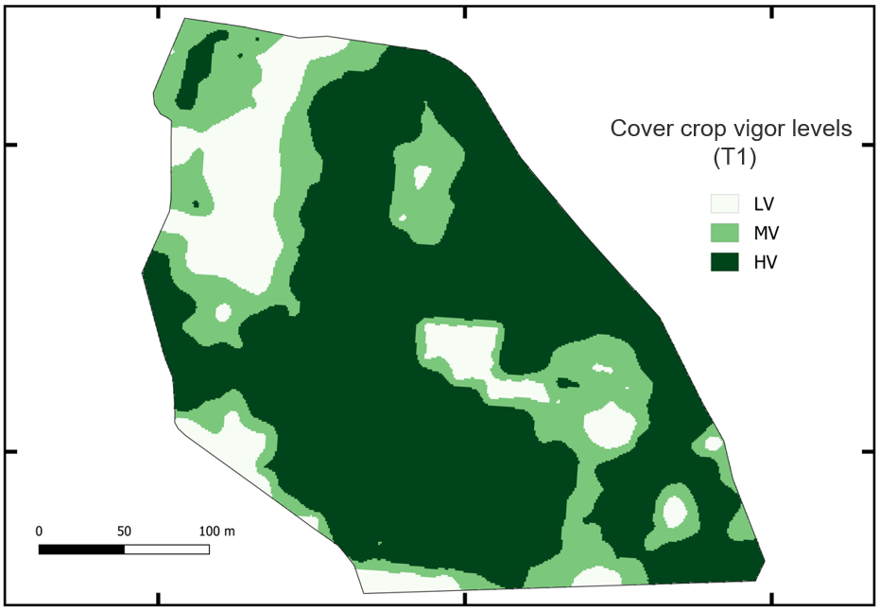 | (a)
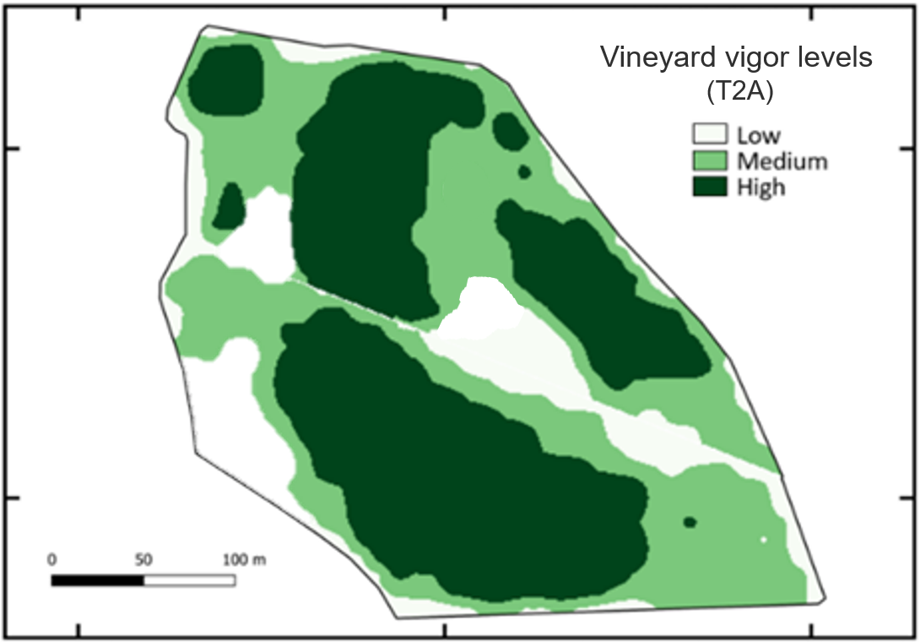 | (b)
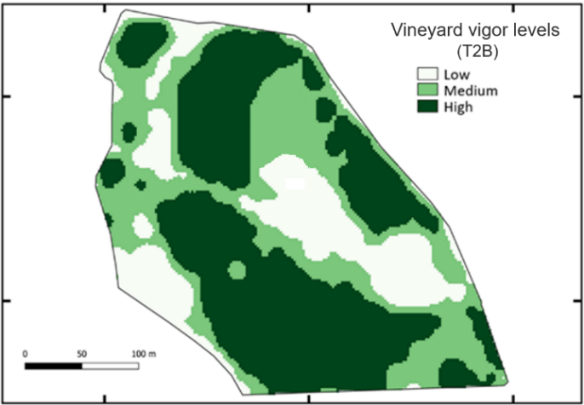 | (c)
Figure 5 Vigor maps obtained by application of kriging interpolation. Figure (a) show cover crop vigor map and vineyard vigor map for two surveys T2A (b) and T2B (c).
The vegetative parameters of the cover crop were investigated. The analysis of variance (p = 0.01) clarified a certain significance of the observed differences in terms of cover crop development between the vigor zones. Table 4 shows that plants grown in an area classified as HV had an overall length by 40% greater than plants grown in LV zone. A similar reasoning applies to the comparison between the length of MV plants and those from LV zones; the latter showed an overall reduction in development of 37%. These differences in cover crop development impact their biomass accumulation. Indeed, plants with a greater overall length accumulate more biomass. In fact, plants from MV zones report a higher fresh weight by 70% compared to LV plants. Tukey’s test confirms that both for plant length and fresh weight, the HV and MV groups are not statistically different; instead, statistically significant differences are reported for both groups when compared to LV plants. Cover crop dry weight was also considered; it allows to evaluate the quantity of organic matter or biomass produced. Dry weight provides a more accurate estimate of the total plant biomass, as it considers only the organic matter present in plant tissues, not including water. In line with these observations, regarding dry weight, plants from MV zones exhibit the highest growth compared to the other two vigor levels. Specifically, the latter display a weight greater by 50% compared to LV plants, a difference confirmed by the Tukey test. The group of plants cultivated in HV areas, on the other hand, is intermediate between the MV and LV vigor groups. Nevertheless, even plants grown in these areas show a 32% dry weight increase compared to LV plants, which record the lowest weight. The results of the biometric analysis and vineyard yield, conducted during the summer growth season, are presented in Table 3, too. Regarding vegetative growth, it was observed that in terms of overall SL, vines developed in areas characterized by HV exhibited approximately 60% higher growth compared to vines grown in LV zones. Consistent with this result, the analysis of leaf area (LA) per plant provided clear findings regarding the overall canopy growth of the vineyard. Indeed, vines from HV and MV zones collectively showed a statistically significant 40% greater LA value compared to LV. The growth trend of vines developed in different vigor zones is also reflected in terms of production, as yield per plant measured at harvest. Higher yield was identified in vines displaying greater vegetative growth; actually, vines from HV and MV zones showed a 60% increase of yield per plant compared to LV vines.
Table 4: Vegetative parameters assessed during period T1 (Cover crop) and period T2 (Vineyard).
Crops parameters | Vigor level
Crops parameters | HV | MV | LV
T1
Plant Length (m) | 0.82 ± 0.10 a | 0.80 ± 0.13 a | 0.58 ± 0.06 b
Fresh weight (kg) | 1.53 ± 0.45 a | 1.64 ± 0.35 a | 0.95 ± 0.01 b
Dry weight (kg) | 0.33 ± 0.06 ab | 0.38 ± 0.01 a | 0.25 ± 0.02 b
T2
SL (m) | 1.09 ± 0.23 a | 0.92 ± 0.30 ab | 0.68 ± 0.21 b
LS (n) | 15 ± 3.0 | 12 ± 1.7 | 10 ± 3.2 n.s
Bunch/vine (n) | 13 ± 2.2 | 10 ± 1.8 | 8 ± 1.9 n.s
LA(m²) | 2.78 ± 0.36 a | 2.48 ± 0.49 a | 1.91 ± 0.18 b
Yield/vine (kg) | 2.31 ± 0.37 a | 2.39 ± 0.10 a | 1.47 ± 0.24 b

During the growth season, data on chlorophyll (Chl) content in leaves were evaluated. The results presented in Figure 6a were obtained during the berry set stage, corresponding to the month of June (T2A). The Chl content per leaf unit (μg cm⁻²) assessed for the three vigor levels further characterizes the vineyard. In HV and MV zones, there is a 15% higher Chl content compared to LV areas. This trend is primarily observed during T2A; however, during T2B, MV and LV vineyard areas show an overall decrease in Chl content, corresponding to 25% and 19%, respectively. These differences between the two periods are confirmed by the Tukey test. Conversely, vines in HV zones did not exhibit a statistically significant decrease. The Chl content during T2B shows statistically significant differences between HV and LV vines, with HV vines showing a 34% higher Chl content compared to LV. In addition to leaf Chl content, nitrogen status was also monitored. The analysis of variance on nitrogen balance index (NBI) revealed differences between low and high NBI values. HV was statistically different from LV (p < 0.01), with an NBI value 24% higher. However, regarding the phenological phase of grape ripening, the highest value was observed for the MV vines. The comparison between the two phenological periods, T2A and T2B, showed an overall 45% reduction in vineyard nitrogen status from the berry set phase to berry ripening.
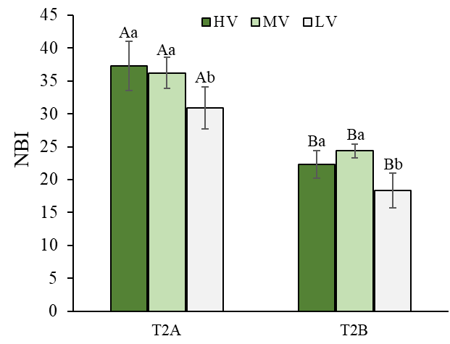
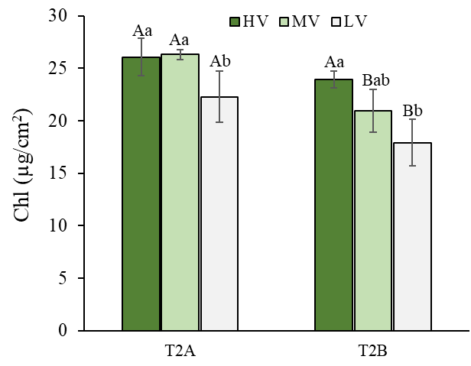
b
a
Figure 6. Evaluation of leaf chlorophyll content (Chl) (a) and NBI (b) for the three-vineyard vigor in two phenological periods. Data were subjected to two-way ANOVA (Tukey’s test, p-value <0.05) capital letters indicate statistically significant difference between the two periods, while the lowercase letters indicate differences between the vigor levels. ± SE is shown with the bars.

3.2 Spatial-cluster analyses
The results of the global Moran statistics and bivariate analysis are illustrated in the scatter plots of Figure 7. Bivariate spatial autocorrelation, as opposed to traditional spatial autocorrelation focusing solely on a single variable, characterizes the spatial relationship between two variables geographically associated with a defined area. The Moran scatter plot provides a clear interpretation of the spatial relationships between the two variables. For instance, the quadrant in the upper-right indicates positive clusters (high-high), while the quadrant in the lower-left indicates a positive relationship (low-low). The upper-left quadrant shows a negative relationship (low-high), while the lower-right indicates a negative relationship (high-low). In the case of positive spatial relationships, high (or low) values are observed for both variables. For negative relationships, high values are observed for the first variable and low values for the second variable, or vice versa. The "non-significant" points indicate a lack of spatial association between the variables.
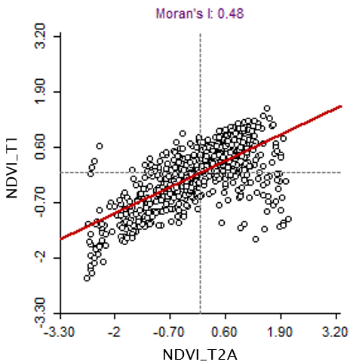  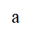 | 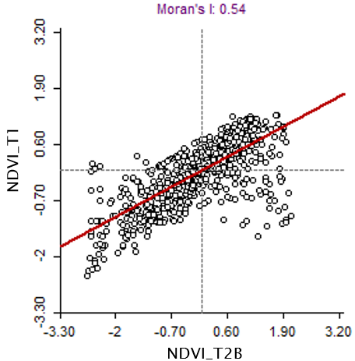  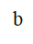 | 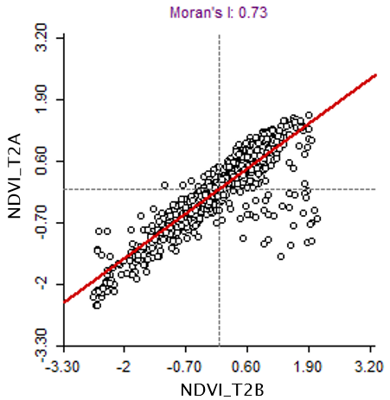  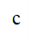
The results presented in the scatter plot in Figure 7a show a significant spatial autocorrelation (p <0.05) between map T1 and map T2A with a Moran I value of 0.48. The positive correlation between the vigor index of period T1 and period T2B is even stronger, with a Moran I value equal to 0.54. This indicates that the spatial variability identified in the winter season, related to the cover crop, corresponds to the variability identified in the vineyard. However, the results indicate that soil and its physicochemical characteristics play a crucial role in both periods of investigation. The analysis of spatial correlation is confirmed by observing the Moran I value referred to the phenological epochs T2A and T2B (figure 7c), obtaining a value of 0.73, indicating a close correspondence of the vineyard vigor macro-areas throughout the growing season.
Figure 7. Moran scatter plots to assess the local spatial autocorrelation of vigor maps for the three periods. a) comparison between T1 and T2A; b) comparison between T1 and T2B; c) comparison between T2A and T2B.
The patterns in Figure 8 indicate the spatial association between cover crop vigor (T1) and vineyard vigor (T2B). This map of spatial association between the two times has been provided to demonstrate the correspondence between homogeneous management zones. Four different colors are used in this map to represent four different types of local spatial autocorrelation. The green color denotes points where a high-high correspondence between the two variables was observed. Conversely, the red color indicates a low-low spatial autocorrelation between the variables. The blue and orange colors indicate points where a negative correlation between the variables was observed. The blue color represents points where the T2B map shows high vigor values, while the T1 map shows opposite values. Conversely, the orange points indicate zones where high vigor values were observed in the T1 survey, while the vineyard showed low vigor values at T2B. It is observed that points identified as high-high correspond to approximately 25%, and points with a positive low-low autocorrelation account for 20% of the total. Points with negative correlation represent a smaller percentage; for instance, low-high points account for 6%, and high-low points for about 8%. Meanwhile, points with gray coloring indicate areas with spatial correlations that do not reach significance (p > 0.05). Therefore, it was not possible to categorize them into any of the four observed cases, and at this level of significance, they exhibit a random spatial pattern. The comparison between seasons allows observing a relatively high stability of two clear large NDVI cluster patterns, showing a low-low association in the north-western part of the field and a high-high association in the central and south-western area of the field (Figure 8). On the other hand, low-high points were mainly located near the low-low cluster area, whereas the high-low cluster distributes centrally and in the southwestern part of the field, adjacent to the High-High clusters. Therefore, cover crop NDVI is indeed associated with vineyard NDVI.
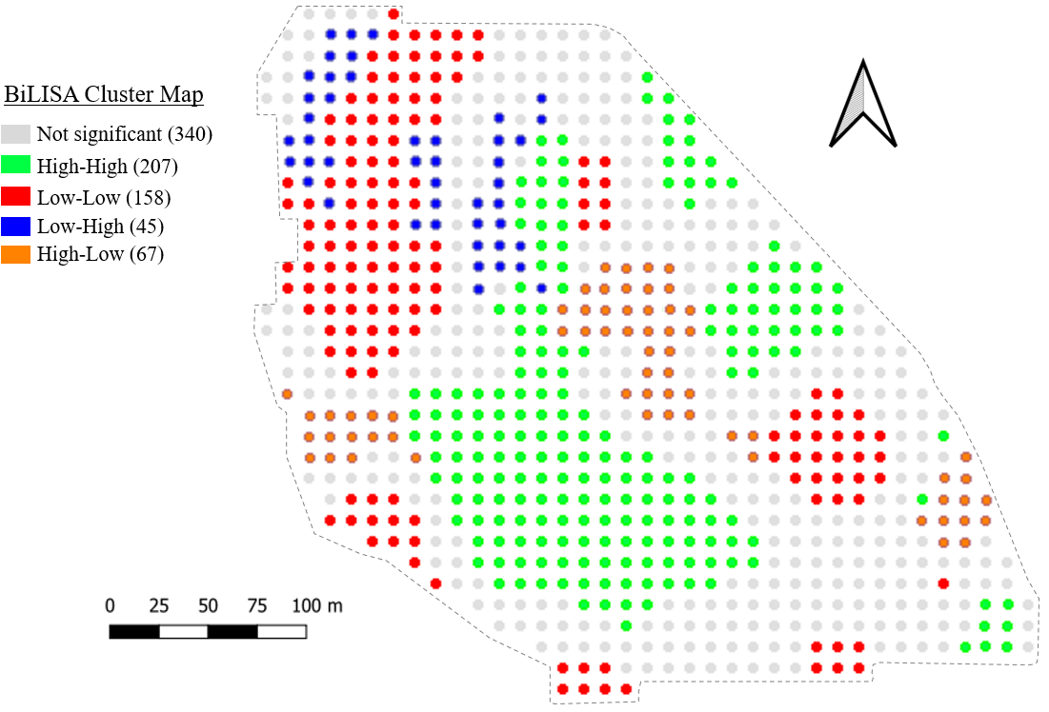
Figure 8. BiLISA cluster maps between cover crop NDVI (T1) and vineyard NDVI (T2B).

3.3 Evaluation of soil characteristics
The analysis of variance performed for the soil chemical-physical parameters (Table 5) displays both the F-test statistic values and the level of statistical significance. From the analysis of variance, F-test values were obtained, allowing the interpretation of which factors contributed most to increasing variability. Typically, a low F-value indicates a case where the group means are close to each other (low variability) compared to the variability within each group. Conversely, a high F-value indicates a case where the variability of group means is large compared to the variability within the group. In relation to the "time" factor, the null hypothesis, which assumes that the group means are equal, was rejected for the variables SWC, SBD, WFPS, and N, based on high F-values and particularly on the value P < 0.05. Regarding the "vigor level" factor, however, the null hypothesis was rejected for the variables SWC, SBD, SOC, and WFPS, except for the soil N content parameter. Regarding the interaction "time*vigor level", it was significant only for the variable SBD and WFPS.
Table 5: Two-way ANOVA was conducted in the specific agroecosystem studied for the parameters soil water content (SWC), soil bulk density (SBD), soil organic carbon (SOC), water content and water-filled pore space (WFPS), and nitrogen content (N) (Fisher test F and p-values).
Source of variation | SWC |  | SBD |  | SOC |  |  | WFPS |  |  | N
 | F-Value | P-Value | F-Value | P-Value |  | F-Value | P-Value |  | F-Value | P-Value | F-Value | P-Value
Time | 846.43 | <0.001 | 32.09 | <0.001 |  | 0.18 | 0.681 |  | 733.91 | <0.001 | 6.86 | 0.017
Vigor level | 8.74 | 0.003 | 7.95 | 0.005 |  | 5.46 | 0.019 |  | 154.79 | <0.001 | 0.99 | 0.396
Time*vigor level | 2.16 | 0.152 | 10.97 | 0.001 |  | 0.04 | 0.961 |  | 201.36 | <0.001 | 0.55 | 0.587

Regarding soil bulk density, it is observed that the values at the time of survey T1 are higher in areas where cover crop growth is limited (LV) (Table 6). The other two vigor conditions show a 12% reduction in SBD. Conversely, in HV vigor zones, a 7% lower water content is recorded compared to MV and a 15% lower compared to LV, with the latter showing a statistically different value from HV. With reference to WFPS, that is considered an indicator of soil water availability and saturation, the highest value was recorded in LV zones. In these areas, WFPS is observed to be more than 30% higher than in the MV and HV vigor zones. During the summer season, there is a 7% increase in SBD value in the soil. In T2, differences between the areas of vigour were observed, confirming the findings of T1. In this case, LV zones had values 11% higher than HV and MV. In terms of water content, a significant 60% decrease in the amount of soil water was observed between seasons T1 and T2.

Table 6: Bulk density, water content and water filled pore space (WFPS) of soil determined in winter seasons (T1) and after grape harvest (T2). Different letters indicate significant differences (P<0.01) among the three vigor levels.
Soil parameter | Vigor level
Soil parameter | HV | MV | LV
T1
Bulk density (g cm⁻³) | 1.08 ± 0.03 b | 1.10 ± 0.03 b | 1.24 ± 0.01 a
Soil water content (%) | 28.29 ± 1.61 b | 30.05 ± 1.20 ab | 34.53 ± 0.97 a
WFPS | 55.66 ± 4.60 b | 63.19 ± 1.93 b | 86.30 ± 2.35 a
T2
Bulk density ( g cm⁻³) | 1.16 ± 0.04 b | 1.18 ± 0.03 b | 1.30 ± 0.02 a
Soil water content (%) | 12.36 ± 1.43 | 12.89 ± 0.22 | 10.63 ± 0.65 n.s
WFPS | 21.12 ± 3.08 | 22.65 ± 0.89 | 24.00 ± 1.83 n.s

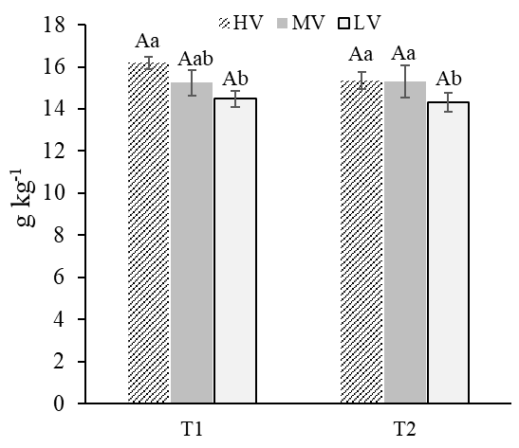
Figure 9 shows the trend of soil organic carbon content; this parameter is stable between the periods T1 and T2; indeed, no difference is observed in terms of time. Nevertheless, statistically significant differences were found between the vigour levels in each epoch. In T1 the HV zones are characterised by a greater content than the LV zones, while an intermediate behaviour was observed for the MV zones. In the case of the T2, no difference was observed between HV and MV; however, in this phase, statistically significant differences can be attributed only to the LV zone compared to the other two.
Figure 9. Concentration of soil organic carbon (SOC) contents determined in T1 and T2 among the three vigor levels.
The results of soil nitrogen monitoring during the two observation periods are presented in Figure 10. Regarding stage T1, no significant differences were observed among the vigor zones, with a mean soil nitrogen content equal to 1.33 (g/kg⁻¹). This trend was also confirmed in T2, where no statistically significant differences were observed among the vineyard vigor levels. However, it is important to note that soil nitrogen content is subject to seasonal fluctuations: an increase in nitrogen content from stage T1 to T2 can be observed. In HV there was a 12% increase over the year, reaching a value of 1.47 (g/kg⁻¹) during grape ripening (T2).
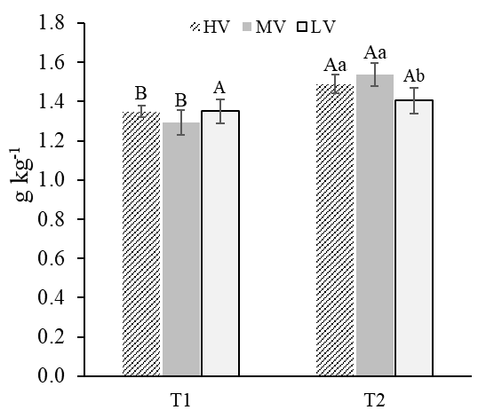
Figure 10. Concentration of soil total nitrogen (TN) content determined in T1 and T2 among the three vigor levels.
The dynamics of soil nitrogen content in MV zones are particularly interesting: although nitrogen content was initially low in phase T1, there was a 20% increase during stage T2, with values reaching 1.51 (g/kg⁻¹). In contrast, no significant variations in soil nitrogen content were observed in LV zones, with only a slight 4% increase. The main differences between the vigour levels can be recognised for the T2 season; actually, the MV vineyard zones show a higher nitrogen content of the soil in those areas than in the other vigour levels.
Principal Component Analysis (PCA) was carried out with the aim of reducing the number of linear combinations of variables that represent most of the data variability. In this study, PCA was performed for the two investigation periods, and it is displayed in table 7, treating the dataset of period T1 separately from the dataset of period T2. In the case of PCA performed for the T1 dataset, eight components were extracted, collectively representing 100% of the variability in the original data. For the T2 dataset twelve components were extracted, collectively representing 100% of the variability. In the case of the T1 dataset, the eigenvalues extracted from the correlation matrix show that the first two components of the PCA are sufficient to explain the total variance of the sample. In the analysis conducted for the T1 dataset, the first eigenvalue is (3.9850), and the second is (2.8712), while the other components have values below 1 and are not considered. The first principal component explains 49.8% of the total variance, and the second component explains 35.9% of the total variance in the data. It can be stated that the first two components are sufficient to explain a significant portion of the variance of the entire dataset, as both collectively explain 85.7%. In the case of the T2 dataset, based on the Kaiser criterion, the first two components can be considered. In fact, the first component of the PCA is characterized by an eigenvalue of (7.9391), and the second has an eigenvalue of (2.3365), while the other ten components have eigenvalues below 1 and are not considered to explain the model. On the other hand, the cumulative variation explained by the first two principal components is 0.85, meaning that the first two principal components explain over 85% of the total variance in the data.
Table 7: Principal component analysis of 8 variables for T1 and 12 for T2 dataset with eigenvalues and proportion of variability explained for the first five principal components (PC) with eigenvalues > 0.5.
 | T1
 | PC 1 | PC 2 | PC 3 | PC 4 | PC 5
Eigenvalue | 3.985 | 2.8712 | 0.8379 | 0.6645 | 0.5083
Proportion | 0.498 | 0.359 | 0.075 | 0.031 | 0.037
 | T2
Eigenvalue | 7.9391 | 2.3365 | 0.9804 | 0.8012 | 0.6567
Proportion | 0.682 | 0.171 | 0.082 | 0.067 | 0.055

Eight factors were considered in the case of T1 dataset, corresponding to soil parameters (SBD, WFPS, SWC, N, SOC), cover crop biometric parameters (PL, CC-DW), and crop spectral response represented by NDVI. PCA was able to separate the different parameters by establishing precise patterns as observed in Figure 11a. WFPS, SWC, N, SBD were positioned on the negative side of PCA. Instead, the soil parameter SOC, NDVI as well as the length of the cover crop (PL) and dry weight of cover crop biomass (CC-DW), opposed the previous group of parameters and were positioned in the positive quadrant of PC1. In Figure 11b, the biplot of PCA referred to the T2 dataset is represented. In this case, the soil condition descriptor parameters, such as SBD, WFPS, SWC, N, are positioned in the negative quadrant of PC1, except for the SOC parameter, which instead is located in the opposite position, in the quadrant of positive values of PC1 and PC2. Regarding the vegetative parameters of the vineyard, represented by S.L, L.S, L.A, NBI, Chl, they are positioned in the quadrant of positive values of PC1 and negative of PC2. The parameter representing the spectral response of the vineyard (NDVI) is located near the vegetative parameters, and indeed it resides in the quadrant of positive values of PC1 and PC2. The vineyard yield parameter is set in an intermediate position relative to the clusters of soil parameters and that of the vegetative parameters of the vineyard; however, it leans towards the latter, and indeed it resides in the quadrants of positive values both of PC1 and PC2.
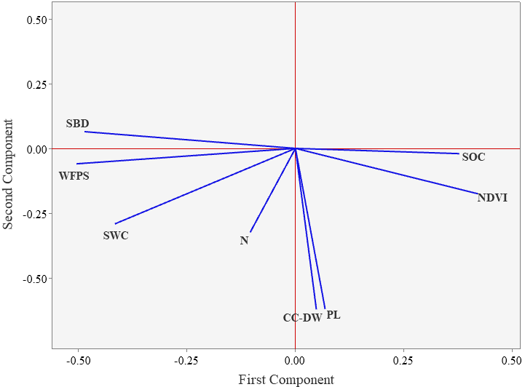  a | 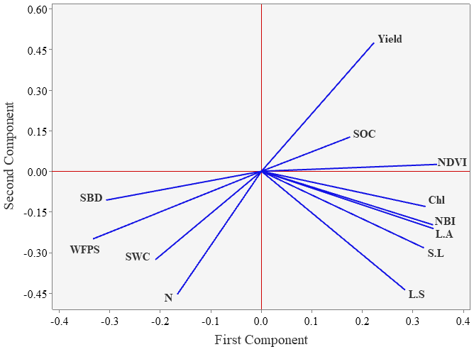  b
Figure 11 Principal Components Analysis 2D plot of Component Weights.

3.4 Soil penetration resistance
Table 8 presents the results of the analysis of variance (ANOVA), highlighting the significant effect of the three factors considered (Time, Depth, and Vigor Level) and their interactions on the observed response for the variable (SPR). The “time” factor shows a highly significant effect (P-Value <0.001), indicating significant differences between the two time periods considered in the study. Similarly, the “depth” factor also demonstrates a highly significant effect (P-Value <0.001), suggesting significant differences between the various soil sampling depths. Both the time factor (F-Value = 309.88), with a significant difference between the means of the periods considered, and the depth factor (F-Value = 233.25), with notable disparities among the means of the different soil sampling depths, exert a strong impact on the observed response. The “vigor level” factor shows a highly significant effect (P-Value <0.001), indicating significant differences between the different vigor levels for each of the two periods (T1 and T2). The interaction between time and vigor level is significant (P-Value = 0.002), indicating the effect of vigor level in both observation stages, T1 and T2. Similarly, the interaction between time and depth is significant (P-Value = 0.003), suggesting variations between the two investigation times based on the depth of SPR measurement. However, the interaction between depth and vigor level is not significant (P-Value = 0.882). Finally, the residual error (0.1146) is relatively low, indicating that the model effectively explains the observed variation for the data.
Table 8: Within-subject ANOVA for soil penetration resistance (SPR) [MPa] (p-values) as a function of the two investigation periods and the vigor levels considered.
Source of variation
 | DF |  | Adj SS | Adj MS | F-Value | P-Value
Time | 1 |  | 3.5528 | 3.55279 | 309.88 | <0.001
Depth | 5 |  | 13.3712 | 2.67424 | 233.25 | <0.001
Vigor level | 2 |  | 1.219 | 0.60948 | 53.16 | <0.001
Time*Depth | 5 |  | 0.4553 | 0.09105 | 8.94 | 0.003
Time*Vigor level | 2 |  | 0.2589 | 0.12943 | 19.29 | 0.002
Depth*Vigor level | 10 |  | 0.0526 | 0.00526 | 0.46 | 0.882
Error | 10 |  | 0.1146 | 0.01146
Total | 35 |  | 19.024

The average SPR values measured in T1 when the soil was cultivated with the cover crop in the inter-row space, and during period T2 when the soil was bare, are shown in figure 12. Soil penetration resistance is represented in soil depth intervals of 10-20cm, 21-30cm, 31-40cm, 41-50cm, 51-60cm. No significant differences are observed in the 10-20cm layer. However, significant differences are evident in the 11-20cm layer, where the SPR value increased by 40% between periods T1 and T2, rising from average values of 2.16 MPa during period T1 to 3.05 MPa during period T2. Soil penetration resistance values increased from T1 to T2 for all considered depth layers.
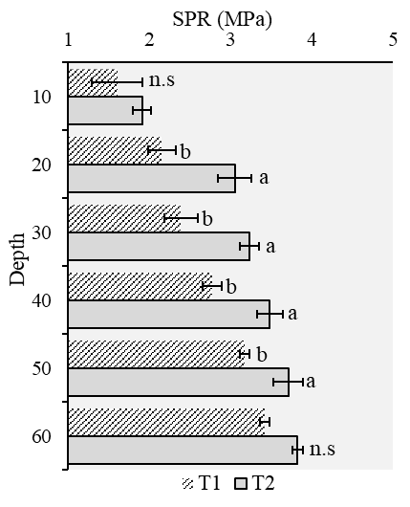
Figure 12: Representation of soil penetration resistance for monitoring stages T1 and T2 divided by soil depth layers.
The penetration resistance curves measured for the two times T1 and T2 in the soil depth 0-60 cm are illustrated in Figure 13. The average penetration resistance values evaluated for the three vigour levels were significantly different (P<0.001) as also observed in Table 6. Soil penetration resistance values increased with depth in all the three vigor levels. Referring to T1, no significant differences were observed between the penetration resistance values at a depth of 10-20cm, with LV (1.77 MPa) being the highest value in this layer. The highest SPR values for the 21-30cm layer were found in LV (2.45 MPa), which is statistically different from MV and HV, which show values of (1.94MPa) and (2.08 MPa) respectively. At layer 31-40cm, the highest value is reported by LV (2.75 MPa), however it is worth mentioning that HV values (2.30 MPa) are statistically intermediate between LV and MV, the latter reporting the lowest value (2.12 MPa). For the levels below the depth of 40cm, SPR is always greater in the LV zones, whereas no differences were found between HV and MV. Surveys performed during the summer season (T2) show that the LV zones are characterised by statistically higher SPR values than the other vigour levels. For example, high values of 2.21 and 3.39 MPa were recorded in the shallowest 10cm and 20cm layers, respectively. Comparing LV with MV values, a reduction of 17% is observed for the first layer. These differences decreased in the 21-30cm layer by 10%. In the latter case, no statistical differences were observed. HV, on the contrary, shows SPR values that are always lower than those observed for LV and MV. In the surface layer a value of (1.68 MPa) is reported, in the 21-30cm layer the value is decreased in respect to LV by about 20%. Furthermore, SPR values follow the trends described for the three vigour levels even for the layers below, and at least up to a depth of 40cm there are statistically significant differences. In these layers, HV showed the lowest SPR, with values of 2.94 MPa and 3.19 MPa respectively for the layers up to a depth of 50cm. In contrast, the measurements carried out in the LV zones are significantly higher, showing 3.50 MPa and 3.75 MPa respectively.
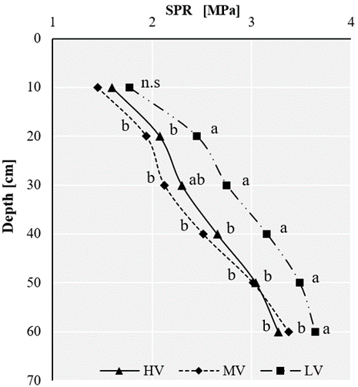  a | 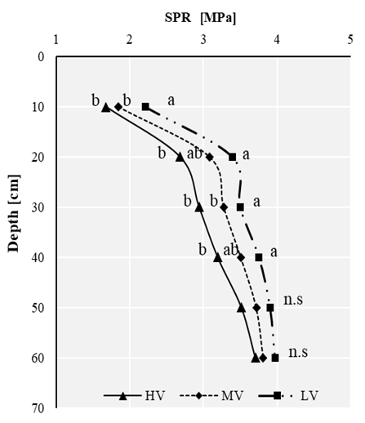  b
Figure 13: Soil penetration resistance (SPR) in three vigor levels. a) T1; b) T2

4. Discussion

4.1 Evaluation of vegetation indices and variability
The aim of this study was to multi-temporally compare cover crop conditions during the winter season, when the vineyard was dormant, and the summer season, using both classical statistical methods and geospatial analysis. The study was carried out using information acquired from a UAV platform; subsequently, the degree of similarity of T1 and T2 datasets was assessed through appropriate analyses. An extensive study area (8 hectares) with a high degree of variability was selected. The different behavior of HV and LV zones observed through NDVI remained consistent and was obtained both during the winter and the summer season. Regarding NDVI data, it is observed that the range of values reported for the three cover crop vigor levels is much wider than that observed for vine canopy. The wider range of values observed in table 3, especially in T1, is due to the low values encountered, especially for LV, whereas in HV zones, NDVI data were much higher. The low values observed during the winter season can be explained by considering first the high soil moisture conditions. Under moist soil conditions, water can significantly influence NIR reflectance [67]. Furthermore, these low values observed for the cover crop are mainly attributable to the LV zones, where cover crop growth was sparse. Bare soil has a high reflectance in the NIR, which can lead to a significant reduction in NDVI values [68]. These findings are consistent with those identified by Yuan et al., (2019), where a significant spatial variability for cover crop NDVI was observed, with the average index value ranging from 0.34 to 0.61 during the growth season. The NDVI values observed for the vineyard, on the other hand, display a more limited range of variation among the three vigor levels. However, it was still possible to discriminate between the three vigor levels across the entire experimental plot. With reference to maps T2A and T2B, the NDVI values for LV zones exceed the threshold of 0.5. This result is consistent with observations made by other authors, where by segmenting only pixels of trellised vine canopy, similar NDVI values were obtained [36,69]. A relatively consistent spatial variability between vineyard and cover crop was observed. Thanks to the spatial autocorrelation maps derived from BILISA, it was possible to conduct a quantitative analysis of spatial variability between T1 and T2, providing a clear understanding of the multitemporal correspondence. Unlike visual analysis, this approach resolves issues associated with qualitative analysis [45]. In reference to the cover crop and vineyard vigor maps, the highest correlation was found for the T1 dataset with T2B (MI = 0.54, Figure 7). The spatial analysis conducted by BILISA revealed a significant presence of spatial dependence between the two maps and some local differences in spatial heterogeneity. It is worth noting that inputs and cultural practices were uniformly applied across the entire plot. Cover crop cultivation in the inter-row was carried out on a temporary basis, exclusively during the winter season, for 8 consecutive years. Consequently, variations in vineyard and cover crop growth are primarily attributable to environmental factors, specifically soil chemical and physical conditions, as confirmed by several studies [70,71]. Recently, it has been discovered that remote sensing of cover crops appears to be a viable option for assessing the spatial variability of soil nutrient status. By leveraging the concept that cover crops serve as excellent indicators of soil physicochemical conditions, it is possible to utilize spatial variability information to enhance the management of cash crop cultivation [43]. Damian et al., (2017) conducted UAV monitoring on a cover crop followed by a cash crop, observing a positive correlation between the vigor maps of the two periods. Additionally, they noted that dry matter and accumulated soil nitrogen levels, assessed after cover crop termination, exhibited a positive correlation with cash crop yield variability.

4.2 Effects of soil variability on crop’s growth
Subsequently, we delved deeper into the analysis to identify the reasons behind the observed variation in soil vigor levels. This allowed for a more thorough examination of the factors that could influence such variability. Overall, the soil physical properties, i.e. SWC, SBD and SPR observed through the measurements conducted for LV, MV and HV vigour zones on the two survey dates, showed significant differences. In this study, a clear temporal variation in SWC was observed. The temporal variation dynamics were characterized by a marked decrease in water content during the summer season, which directly or indirectly influences other soil parameters [72]. This could justify the increase in SBD value between T1 and T2. The decrease in SWC leads to soil compaction, as the voids previously filled with water diminish. This compaction can result in an increase in SBD, as soil particles tend to become closer to each other, thus increasing soil density [73]. Soil water content is the most important factor influencing soil compaction processes [74]. When soil loses water, its cohesion and consistency properties may decrease, making it more susceptible to compaction and structural loss, thereby contributing to an increase in SPR [5,75]. Regarding period T1, the differences observed in the vigor levels are mainly related to the soil's physical properties. In LV, the highest SWC percentage was observed. This phenomenon is primarily due to reduced water infiltration along the soil profile [6], where the excess water in the soil is attributed to higher soil compaction, as demonstrated by the elevated values of SBD observed for LV. Soil compaction reduces total porosity, resulting in decreased soil hydraulic conductivity [76]; thus, WFPS parameter in LV zones was statistically higher. This phenomenon is also supported by the data in table 4, where the cover crop in LV zones exhibited shorter plant length, lower fresh weight, lower dry weight biomass, leading to a reduced NDVI (table 3). Reduced water infiltration may reduce oxygen supply to the roots, triggering a shift in their metabolism, including increased anaerobic respiration and greater utilization of reserve carbohydrates, ultimately reducing overall development [77]. However, the differences in SPR values observed among the vigor levels are primarily attributable to the higher presence of organic matter, as observed in HV and MV zones. Scientific literature has demonstrated that an increase in soil organic carbon (SOC) content results in greater total porosity, contributing to lower soil bulk density and consequently reducing penetration resistance [16,17]. The variability observed in SOC content among the vigor levels (Figure 13) influenced SPR, which exhibited higher values in LV zones where SOC content was low. Comparison of soil penetration resistance curves for the three vigor levels revealed that this parameter increased with soil depth, likely due to overburden pressure generated by agricultural machinery traffic [4]. However, for layers below 20 cm, the SPR value tends to increase, exceeding the critical threshold for root development [78]. This phenomenon is more pronounced in LV zones compared to MV and HV zones and is observed below the 30 cm layer. This occurrence may have led to such differences in root development between the vigor areas; indeed, the root system of Vicia faba, like other legumes, tends to develop deep following the soil profile [79]. SPR values during the summer period are high when compared to the critical threshold for vine root elongation. However, other studies conducted in Mediterranean environments report comparable values to those observed in this vineyard [2,80]. Nevertheless, the observed differences between medium-high vigor zones compared to LV zones are attributed to a higher bulk density. Pereyra et al., (2023) found that grapevines in LV zones were characterized by 70% of roots thinner than 2 mm positioned in the top 0.30m deep layer of soil, and no roots were observed below 0.5 meters. Consistent with previous experiments, it can be supposed that the increased growth of cover crops observed during the winter season for MV and HV released more residues into the soil, which led to reduced soil compaction [81].
In these zones, the increased growth of cover crops may also explain the higher accumulation of total N in the soil (Figure 10). The increase in total N from period T1 to period T2 was significant. This result is justified by the rapid mineralization process of N to which residues of leguminous cover crops are subjected; moreover, through rhizodeposition, roots manage to fix satisfactory amounts of nitrogen [79]. Therefore, the higher presence of easily assimilable N in the soil and lower values of SBD and SPR contributed to improving the vine nitrogen status observed in HV and MV. This result is in line with what was observed by Pereyra et al., (2023), where a higher concentration of N in the soil was measured for HV zones; furthermore, these vines were characterized by a higher leaf N content. Similarly, this study observed that LV zones had a lower leaf N content compared to HV and MV (figure 6b). These results confirm that vine leaf N content is an excellent diagnostic tool for identifying vigor levels [39,82].
The soil physical-chemical variability has shown a significant influence on crop growth and spectral response through NDVI obtained from UAVs. The results obtained in this study corroborate those reported by Yeom et al., (2019), which compared the spectral response of crops under different soil management conditions. It is observed that, generally, as SBD and SPR increase, crops show a variation in spectral response. In this study, the differences observed among the vigor levels are attributed to the variation in red and NIR reflectance. Both for cover crops and for the vineyard in HV and MV zones, low reflectance is recorded for the red band, due to high chlorophyll activity, while the NIR band is strongly reflected [84]. This phenomenon could indirectly explain the high chlorophyll content measured for the leaves of HV and MV vines (Figure 6a), consequently inducing an increase in NDVI. However, in other studies conducted using UAVs with multispectral cameras on herbaceous crop cultivated with different soil management methods, no significant differences were found in the spectral response [85]. In this case, the absence of differences may be attributed to the low values of SBD and SPR, which did not reach the thresholds that could potentially influence root development.

5. Conclusions
The current study found new information regarding soil and vineyard agroecosystem interactions. The study of soil variability parameters uncovered interesting information on the influence of the spectral response of the vineyard and cover crop. Using remote sensing, clusters of plants with the highest vegetative growth capacity were identified. In comparison, significant differences in vegetative growth between the two crops were observed in the same areas. The main differences can be attributed to reduced SOC content and consequently higher SBD and SPR. In addition, SPR for LV vigor remained significantly higher (p < 0.05) for all the depths and for both periods. Both crops show similar behavior under the same soil conditions. In addition, it can be stated that the reduction of cover crop growth influence soil properties. Conversely, in areas where cover crop produces more biomass, it contributes to maintaining or improving the overall soil condition, with a net benefit to the vineyard. Cover crops variability has an influence on vine growth, with this in mind using the information derived from remote sensing of cover crops can enable better planning of precision vineyard management.

6. References
1. Puig-Montserrat, X.; Stefanescu, C.; Torre, I.; Palet, J.; Fabregas, E.; Dantart, J.; Arrizabalaga, A.; Flaquer, C. Effects of Organic and Conventional Crop Management on Vineyard Biodiversity. Agriculture, ecosystems & environment 2017, 243, 19–26.
2. Catania, P.; Vallone, M.; Pipitone, F.; Argento, G.F.; Spartà, G.; Laudicina, V.A. Soil Management Effect on Soil Penetration Resistance in the Vineyard. Journal of Agricultural Engineering 2013, 44.
3. Ozpinar, S.; Ozpinar, A.; Cay, A. Soil Management Effect on Soil Properties in Traditional and Mechanized Vineyards under a Semiarid Mediterranean Environment. Soil and Tillage Research 2018, 178, 198–208.
4. Carrara, M.; Castrignanò, A.; Comparetti, A.; Febo, P.; Orlando, S. Mapping of Penetrometer Resistance in Relation to Tractor Traffic Using Multivariate Geostatistics. Geoderma 2007, 142, 294–307.
5. Håkansson, I.; Lipiec, J. A Review of the Usefulness of Relative Bulk Density Values in Studies of Soil Structure and Compaction. Soil and Tillage Research 2000, 53, 71–85.
6. Hamza, M.; Anderson, W.K. Soil Compaction in Cropping Systems: A Review of the Nature, Causes and Possible Solutions. Soil and tillage research 2005, 82, 121–145.
7. Bhandral, R.; Saggar, S.; Bolan, N.; Hedley, M. Transformation of Nitrogen and Nitrous Oxide Emission from Grassland Soils as Affected by Compaction. Soil and Tillage Research 2007, 94, 482–492.
8. Czyż, E.A. Effects of Traffic on Soil Aeration, Bulk Density and Growth of Spring Barley. Soil and Tillage Research 2004, 79, 153–166.
9. McArtney, S.; Ferree, D. Root and Cane Pruning Affect Vegetative Development, Fruiting, and Dry-Matter Accumulation of Grapevines. HortScience 1999, 34, 617–621.
10. Laudicina, V.; Barbera, V.; Gristina, L.; Badalucco, L. Management Practices to Preserve Soil Organic Matter in Semiarid Mediterranean Environment. In Soil organic matter: ecology, environmental impact and management; Nova Science Publishers, Inc., 2012; pp. 39–61 ISBN 1-62100-399-X.
11. Catania, P.; Badalucco, L.; Laudicina, V.A.; Vallone, M. Effects of Tilling Methods on Soil Penetration Resistance, Organic Carbon and Water Stable Aggregates in a Vineyard of Semiarid Mediterranean Environment. Environmental Earth Sciences 2018, 77, 1–9.
12. Novara, A.; Pisciotta, A.; Minacapilli, M.; Maltese, A.; Capodici, F.; Cerdà, A.; Gristina, L. The Impact of Soil Erosion on Soil Fertility and Vine Vigor. A Multidisciplinary Approach Based on Field, Laboratory and Remote Sensing Approaches. Science of the Total Environment 2018, 622, 474–480.
13. Wheaton, A.; McKenzie, B.; Tisdall, J.M. Management to Increase the Depth of Soft Soil Improves Soil Conditions and Grapevine Performance in an Irrigated Vineyard. Soil and Tillage Research 2008, 98, 68–80.
14. Kaye, J.P.; Quemada, M. Using Cover Crops to Mitigate and Adapt to Climate Change. A Review. Agronomy for sustainable development 2017, 37, 1–17.
15. Novara, A.; Minacapilli, M.; Santoro, A.; Rodrigo-Comino, J.; Carrubba, A.; Sarno, M.; Venezia, G.; Gristina, L. Real Cover Crops Contribution to Soil Organic Carbon Sequestration in Sloping Vineyard. Science of the Total Environment 2019, 652, 300–306.
16. Haruna, S.I.; Anderson, S.H.; Udawatta, R.P.; Gantzer, C.J.; Phillips, N.C.; Cui, S.; Gao, Y. Improving Soil Physical Properties through the Use of Cover Crops: A Review. Agrosystems, Geosciences & Environment 2020, 3, e20105.
17. Celik, I.; Gunal, H.; Budak, M.; Akpinar, C. Effects of Long-Term Organic and Mineral Fertilizers on Bulk Density and Penetration Resistance in Semi-Arid Mediterranean Soil Conditions. Geoderma 2010, 160, 236–243.
18. Hati, K.M.; Swarup, A.; Dwivedi, A.; Misra, A.; Bandyopadhyay, K. Changes in Soil Physical Properties and Organic Carbon Status at the Topsoil Horizon of a Vertisol of Central India after 28 Years of Continuous Cropping, Fertilization and Manuring. Agriculture, ecosystems & environment 2007, 119, 127–134.
19. Haynes, R.J.; Naidu, R. Influence of Lime, Fertilizer and Manure Applications on Soil Organic Matter Content and Soil Physical Conditions: A Review. Nutrient cycling in agroecosystems 1998, 51, 123–137.
20. Dexter, A. Soil Physical Quality: Part I. Theory, Effects of Soil Texture, Density, and Organic Matter, and Effects on Root Growth. Geoderma 2004, 120, 201–214.
21. Guzmán, G.; Cabezas, J.M.; Sánchez-Cuesta, R.; Lora, Á.; Bauer, T.; Strauss, P.; Winter, S.; Zaller, J.; Gómez, J. A Field Evaluation of the Impact of Temporary Cover Crops on Soil Properties and Vegetation Communities in Southern Spain Vineyards. Agriculture, Ecosystems & Environment 2019, 272, 135–145.
22. Wichern, F.; Eberhardt, E.; Mayer, J.; Joergensen, R.G.; Müller, T. Nitrogen Rhizodeposition in Agricultural Crops: Methods, Estimates and Future Prospects. Soil Biology and Biochemistry 2008, 40, 30–48.
23. Fillery, I. The Fate of Biologically Fixed Nitrogen in Legume-Based Dryland Farming Systems: A Review. Australian Journal of Experimental Agriculture 2001, 41, 361–381.
24. Guerra, B.; Steenwerth, K. Influence of Floor Management Technique on Grapevine Growth, Disease Pressure, and Juice and Wine Composition: A Review. American Journal of Enology and Viticulture 2012, 63, 149–164.
25. Shennan, C. Cover Crops, Nitrogen Cycling, and Soil Properties in Semi-Irrigated Vegetable Production Systems. HortScience 1992, 27, 749–754.
26. Ovalle, C.; Del Pozo, A.; Peoples, M.B.; Lavín, A. Estimating the Contribution of Nitrogen from Legume Cover Crops to the Nitrogen Nutrition of Grapevines Using a 15 N Dilution Technique. Plant and Soil 2010, 334, 247–259.
27. Lopes, C.; Monteiro, A.; Machado, J.; Fernandes, N.; Araújo, A. Cover Cropping in a Sloping Non-Irrigated Vineyard: II–Effects on Vegetative Growth, Yield, Berry and Wine Quality of ‘Cabernet Sauvignon’Grapevines. Ciência Téc. Vitiv 2008, 23, 37–43.
28. Muscas, E.; Cocco, A.; Mercenaro, L.; Cabras, M.; Lentini, A.; Porqueddu, C.; Nieddu, G. Effects of Vineyard Floor Cover Crops on Grapevine Vigor, Yield, and Fruit Quality, and the Development of the Vine Mealybug under a Mediterranean Climate. Agriculture, Ecosystems & Environment 2017, 237, 203–212.
29. Novara, A.; Gristina, L.; Saladino, S.; Santoro, A.; Cerdà, A. Soil Erosion Assessment on Tillage and Alternative Soil Managements in a Sicilian Vineyard. Soil and Tillage Research 2011, 117, 140–147.
30. Rouse Jr, J.; Haas, R.H.; Deering, D.; Schell, J.; Harlan, J.C. Monitoring the Vernal Advancement and Retrogradation (Green Wave Effect) of Natural Vegetation; 1974;
31. Sozzi, M.; Kayad, A.; Marinello, F.; Taylor, J.; Tisseyre, B. Comparing Vineyard Imagery Acquired from Sentinel-2 and Unmanned Aerial Vehicle (UAV) Platform. Oeno One 2020, 54, 189–197.
32. Ferro, M.V.; Catania, P.; Miccichè, D.; Pisciotta, A.; Vallone, M.; Orlando, S. Assessment of Vineyard Vigour and Yield Spatio-Temporal Variability Based on UAV High Resolution Multispectral Images. Biosystems Engineering 2023, 231, 36–56, doi:10.1016/j.biosystemseng.2023.06.001.
33. Filippetti, I.; Allegro, G.; Valentini, G.; Pastore, C.; Colucci, E.; Intrieri, C. Influence of Vigour on Vine Performance and Berry Composition of Cv. Sangiovese (Vitis Vinifera L.). OENO One 2013, 47, 21–33.
34. Pádua, L.; Marques, P.; Adão, T.; Guimarães, N.; Sousa, A.; Peres, E.; Sousa, J.J. Vineyard Variability Analysis through UAV-Based Vigour Maps to Assess Climate Change Impacts. Agronomy 2019, 9, 581.
35. Campos, J.; García-Ruíz, F.; Gil, E. Assessment of Vineyard Canopy Characteristics from Vigour Maps Obtained Using UAV and Satellite Imagery. Sensors 2021, 21, 2363.
36. Caruso, G.; Palai, G.; Tozzini, L.; D’Onofrio, C.; Gucci, R. The Role of LAI and Leaf Chlorophyll on NDVI Estimated by UAV in Grapevine Canopies. Scientia Horticulturae 2023, 322, 112398.
37. Caruso, G.; Tozzini, L.; Rallo, G.; Primicerio, J.; Moriondo, M.; Palai, G.; Gucci, R. Estimating Biophysical and Geometrical Parameters of Grapevine Canopies (‘Sangiovese’) by an Unmanned Aerial Vehicle (UAV) and VIS-NIR Cameras. Vitis 2017, 56, 63–70.
38. Matese, A.; Di Gennaro, S.F. Beyond the Traditional NDVI Index as a Key Factor to Mainstream the Use of UAV in Precision Viticulture. Scientific Reports 2021, 11, 1–13.
39. Gatti, M.; Garavani, A.; Squeri, C.; Diti, I.; De Monte, A.; Scotti, C.; Poni, S. Effects of Intra-Vineyard Variability and Soil Heterogeneity on Vine Performance, Dry Matter and Nutrient Partitioning. Precision Agriculture 2022, 23, 150–177.
40. Pereyra, G.; Pellegrino, A.; Ferrer, M.; Gaudin, R. How Soil and Climate Variability within a Vineyard Can Affect the Heterogeneity of Grapevine Vigour and Production. OENO One 2023, 57, 297–313.
41. Yuan, M.; Burjel, J.; Isermann, J.; Goeser, N.; Pittelkow, C. Unmanned Aerial Vehicle–Based Assessment of Cover Crop Biomass and Nitrogen Uptake Variability. Journal of Soil and Water Conservation 2019, 74, 350–359.
42. Damian, J.M.; Santi, A.L.; Fornari, M.; Da Ros, C.O.; Eschner, V.L. Monitoring Variability in Cash-Crop Yield Caused by Previous Cultivation of a Cover Crop under a No-Tillage System. Computers and Electronics in Agriculture 2017, 142, 607–621.
43. Futerman, S.I.; Laor, Y.; Eshel, G.; Cohen, Y. The Potential of Remote Sensing of Cover Crops to Benefit Sustainable and Precision Fertilization. Science of The Total Environment 2023, 891, 164630.
44. Anselin, L.; Rey, S.J. Modern Spatial Econometrics in Practice: A Guide to GeoDa, GeoDaSpace and PySAL. (No Title) 2014.
45. Matese, A.; Di Gennaro, S.F.; Santesteban, L.G. Methods to Compare the Spatial Variability of UAV-Based Spectral and Geometric Information with Ground Autocorrelated Data. A Case of Study for Precision Viticulture. Computers and Electronics in Agriculture 2019, 162, 931–940.
46. Pastonchi, L.; Di Gennaro, S.F.; Toscano, P.; Matese, A. Comparison between Satellite and Ground Data with UAV-Based Information to Analyse Vineyard Spatio-Temporal Variability: This Article Is Published in Cooperation with the XIIIth International Terroir Congress November 17-18 2020, Adelaide, Australia. Guest Editors: Cassandra Collins and Roberta De Bei. Oeno One 2020, 54, 919–934.
47. Kottek, M.; Grieser, J.; Beck, C.; Rudolf, B.; Rubel, F. World Map of the Köppen-Geiger Climate Classification Updated. 2006.
48. Peel, M.C.; Finlayson, B.L.; McMahon, T.A. Updated World Map of the Köppen-Geiger Climate Classification. Hydrology and earth system sciences 2007, 11, 1633–1644.
49. FAO, I. ISRIC: World Reference Base for Soil Resource in World Soil Resource Report No. 103. FAO, Rome, Italy 2006.
50. Blake, G.; Hartge, K. Particle Density. Methods of soil analysis: Part 1 physical and mineralogical methods 1986, 5, 377–382.
51. ASAE Procedures for Using and Reporting Data Obtained with the Soil Cone Penetrometer. Test.; 2009;
52. Nelson, D. a; Sommers, L. Total Carbon, Organic Carbon, and Organic Matter. Methods of soil analysis: Part 2 chemical and microbiological properties 1983, 9, 539–579.
53. Sumner, M.E.; Miller, W.P. Cation Exchange Capacity and Exchange Coefficients. Methods of soil analysis: Part 3 Chemical methods 1996, 5, 1201–1229.
54. Ferro, M.V.; Catania, P. Technologies and Innovative Methods for Precision Viticulture: A Comprehensive Review. Horticulturae 2023, 9, 399.
55. Hirschmuller, H. Accurate and Efficient Stereo Processing by Semi-Global Matching and Mutual Information.; IEEE, 2005; Vol. 2, pp. 807–814.
56. Rouse, J.W.; Haas, R.H.; Schell, J.A.; Deering, D.W.; Harlan, J.C. Monitoring the Vernal Advancement and Retrogradation (Green Wave Effect) of Natural Vegetation. NASA/GSFC Type III Final Report, Greenbelt, Md 1974, 371.
57. Bollas, N.; Kokinou, E.; Polychronos, V. Comparison of Sentinel-2 and UAV Multispectral Data for Use in Precision Agriculture: An Application from Northern Greece. Drones 2021, 5, 35.
58. Caruso, G.; Zarco-Tejada, P.J.; González-Dugo, V.; Moriondo, M.; Tozzini, L.; Palai, G.; Rallo, G.; Hornero, A.; Primicerio, J.; Gucci, R. High-Resolution Imagery Acquired from an Unmanned Platform to Estimate Biophysical and Geometrical Parameters of Olive Trees under Different Irrigation Regimes. PloS one 2019, 14, e0210804.
59. Catania, P.; Roma, E.; Orlando, S.; Vallone, M. Evaluation of Multispectral Data Acquired from UAV Platform in Olive Orchard. Horticulturae 2023, 9, 133.
60. Michel, J.; Youssefi, D.; Grizonnet, M. Stable Mean-Shift Algorithm and Its Application to the Segmentation of Arbitrarily Large Remote Sensing Images. IEEE Transactions on Geoscience and Remote Sensing 2014, 53, 952–964.
61. Basso, B.; Ritchie, J.; Pierce, F.; Braga, R.; Jones, J. Spatial Validation of Crop Models for Precision Agriculture. Agricultural Systems 2001, 68, 97–112.
62. Chiles, J.-P.; Delfiner, P. Geostatistics: Modeling Spatial Uncertainty; John Wiley & Sons, 2009; Vol. 497; ISBN 0-470-31783-3.
63. Webster, R.; Oliver, M.A. Geostatistics for Environmental Scientists; John Wiley & Sons, 2007; ISBN 0-470-51726-3.
64. Moran, P.A. The Interpretation of Statistical Maps. Journal of the Royal Statistical Society. Series B (Methodological) 1948, 10, 243–251.
65. Legendre, P.; Fortin, M.J. Spatial Pattern and Ecological Analysis. Vegetatio 1989, 80, 107–138.
66. Rey, S.J.; Anselin, L. PySAL: A Python Library of Spatial Analytical Methods. In Handbook of applied spatial analysis: Software tools, methods and applications; Springer, 2009; pp. 175–193.
67. Merzlyak, M.N.; Chivkunova, O.B.; Melø, T.; Naqvi, K.R. Does a Leaf Absorb Radiation in the near Infrared (780–900 Nm) Region? A New Approach to Quantifying Optical Reflection, Absorption and Transmission of Leaves. Photosynthesis Research 2002, 72, 263–270.
68. Jensen, J.R. Remote Sensing of the Environment: An Earth Resource Perspective 2/e; Pearson Education India, 2009; ISBN 81-317-1680-5.
69. Romboli, Y.; Di Gennaro, S.; Mangani, S.; Buscioni, G.; Matese, A.; Genesio, L.; Vincenzini, M. Vine Vigour Modulates Bunch Microclimate and Affects the Composition of Grape and Wine Flavonoids: An Unmanned Aerial Vehicle Approach in a Sangiovese Vineyard in Tuscany. Australian journal of grape and wine research 2017, 23, 368–377.
70. Kotsaki, E.; Reynolds, A.G.; Brown, R.; Lee, H.-S.; Jollineau, M. Spatial Variability in Soil and Vine Water Status in Ontario Vineyards: Relationships to Yield and Berry Composition. American Journal of Enology and Viticulture 2020, 71, 132–148.
71. Tardáguila, J.; Baluja, J.; Arpon, L.; Balda, P.; Oliveira, M. Variations of Soil Properties Affect the Vegetative Growth and Yield Components of “Tempranillo” Grapevines. Precision Agriculture 2011, 12, 762–773.
72. Vereecken, H.; Huisman, J.; Pachepsky, Y.; Montzka, C.; Van Der Kruk, J.; Bogena, H.; Weihermüller, L.; Herbst, M.; Martinez, G.; Vanderborght, J. On the Spatio-Temporal Dynamics of Soil Moisture at the Field Scale. Journal of Hydrology 2014, 516, 76–96.
73. Shah, A.N.; Tanveer, M.; Shahzad, B.; Yang, G.; Fahad, S.; Ali, S.; Bukhari, M.A.; Tung, S.A.; Hafeez, A.; Souliyanonh, B. Soil Compaction Effects on Soil Health and Cropproductivity: An Overview. Environmental Science and Pollution Research 2017, 24, 10056–10067.
74. Soane, B.D.; van Ouwerkerk, C. Soil Compaction in Crop Production; Elsevier, 2013; ISBN 0-08-093400-5.
75. Lipiec, J.; Ferrero, A.; Giovanetti, V.; Nosalewicz, A.; Turski, M. Response of Structure to Simulated Trampling of Woodland Soil. Adv. Geoecol 2002, 35, 133–140.
76. Pagliai, M.; Marsili, A.; Servadio, P.; Vignozzi, N.; Pellegrini, S. Changes in Some Physical Properties of a Clay Soil in Central Italy Following the Passage of Rubber Tracked and Wheeled Tractors of Medium Power. Soil and Tillage Research 2003, 73, 119–129.
77. Jackson, M.; Colmer, T. Response and Adaptation by Plants to Flooding Stress. Annals of botany 2005, 96, 501–505.
78. Whalley, W.; To, J.; Kay, B.; Whitmore, A. Prediction of the Penetrometer Resistance of Soils with Models with Few Parameters. Geoderma 2007, 137, 370–377.
79. Kocira, A.; Staniak, M.; Tomaszewska, M.; Kornas, R.; Cymerman, J.; Panasiewicz, K.; Lipińska, H. Legume Cover Crops as One of the Elements of Strategic Weed Management and Soil Quality Improvement. A Review. Agriculture 2020, 10, 394.
80. López-Piñeiro, A.; Muñoz, A.; Zamora, E.; Ramírez, M. Influence of the Management Regime and Phenological State of the Vines on the Physicochemical Properties and the Seasonal Fluctuations of the Microorganisms in a Vineyard Soil under Semi-Arid Conditions. Soil and Tillage Research 2013, 126, 119–126.
81. Muñoz, A.; López-Piñeiro, A.; Ramírez, M. Soil Quality Attributes of Conservation Management Regimes in a Semi-Arid Region of South Western Spain. Soil and Tillage Research 2007, 95, 255–265.
82. Balachandra, L.; Edis, R.; White, R.; Chen, D. The Relationship between Grapevine Vigour and N-Mineralization of Soil from Selected Cool Climate Vineyards in Victoria, Australia. Journal of Wine Research 2009, 20, 183–198.
83. Yeom, J.; Jung, J.; Chang, A.; Ashapure, A.; Maeda, M.; Maeda, A.; Landivar, J. Comparison of Vegetation Indices Derived from UAV Data for Differentiation of Tillage Effects in Agriculture. Remote Sensing 2019, 11, 1548.
84. Haboudane, D.; Tremblay, N.; Miller, J.R.; Vigneault, P. Remote Estimation of Crop Chlorophyll Content Using Spectral Indices Derived from Hyperspectral Data. IEEE Transactions on Geoscience and remote Sensing 2008, 46, 423–437.
85. Martins, R.N.; Portes, M.F.; e Moraes, H.M.F.; Junior, M.R.F.; Rosas, J.T.F.; Junior, W. de A.O. Influence of Tillage Systems on Soil Physical Properties, Spectral Response and Yield of the Bean Crop. Remote Sensing Applications: Society and Environment 2021, 22, 100517.

Chapter 7 – Final Remarks
This thesis investigated the potential and effectiveness of UAV in managing vineyard variability, with a focus on the use of multispectral and proximal sensors to monitor the physiological status of grapevines. The results clearly demonstrate how these innovative technologies can provide effective solutions to address many of the current and future challenges in viticulture, enhancing the ability to monitor and manage vineyards.
This approach can be scaled to larger field areas, allowing for detailed information to be obtained over extensive vineyard plots. However, despite technological advancements, it is evident that the practical application of these tools requires further research to optimize processes and make them more accessible. Currently, the management of these complex datasets demands advanced scientific and computational expertise, which often limits their use by non-specialized agricultural operators. One of the key recommendations emerging from the study is the need to develop more intuitive and user-friendly platforms and software that would allow for broader adoption of these technologies. This would not only facilitate the use of the proposed solutions but could also help reduce overall vineyard management costs, thus increasing the economic efficiency of winegrowing farms. Among the technologies analyzed, UAVs stood out for their flexibility and versatility, overcoming some of the limitations of satellite systems, particularly in the context of Italian viticulture, which often operates on small plots. Their ability to offer high spatial resolution and operate with significant flight autonomy makes them ideal for monitoring vineyards characterized by significant topographic variability. This thesis delves into several interrelated themes in the context of precision viticulture, highlighting the intricate relationships between vineyard topography, flight paths, and vegetation spectral data. A notable finding is that flat areas in vineyards tend to exhibit higher vegetation vigor compared to sloping regions. Additionally, the direction of flight paths has a significant impact on data accuracy; specifically, flights perpendicular to vineyard rows often lead to an overestimation of NDVI values, which can result in misleading interpretations. The vineyard canopy, as a discontinuous system, presents further challenges, as its spectral response can be influenced by external variables such as soil characteristics and noise from neighboring rows. Neglecting these factors may yield inaccurate findings and hinder effective agronomic treatments. To tackle these complexities, the thesis employs innovative deep learning techniques, specifically Mask R-CNN and U-Net models, to enhance the segmentation of grapevine canopies. These models have shown superior accuracy over traditional methods like OBIA, which is crucial for refining vineyard vigour monitoring. This improvement allows for more reliable and targeted agronomic information, which enhances crop management. Another significant contribution of the research is the explanation of the spectral response variation in grapevine canopies at different phenological stages. The findings indicate that vegetation indices calculated during the early growth phases of vineyards are particularly effective in predicting potential grape yields. This suggests that even at the initial stages of grape berry development, winegrowers can access valuable insights to plan timely and targeted agronomic interventions, enhancing both efficiency and quality of yields. Moreover, the application of remote sensing extends beyond grapevines to cover crops, revealing substantial potential for sustainable vineyard management. A practical study within the thesis demonstrates a positive correlation between the vigour of cover crops and grapevines, showing that areas with higher biomass in cover crops correspond to more vigorous grapevine growth. The observed differences in growth dynamics can be attributed to various soil factors, including soil organic carbon content, bulk density, and soil penetration resistance. This research enriches our understanding of the interactions between soil and vineyard systems, contributing valuable insights to integrated crop management practices. The thesis examined the rise of artificial intelligence in agriculture, highlighting how the integration of advanced technologies and agronomic practices is driving a significant transformation in the area. The use of deep learning models and real-time computer vision, applied to tools such as UAVs and robotic platforms, represents a key opportunity to enhance sustainability and yield in agriculture. However, the adoption of these technologies raises ethical and technological challenges, such as optimizing the computational capacity of devices and improving algorithm efficiency to ensure their optimal use in agricultural operations. In the context of precision agriculture, variable rate application allows for the optimization of agricultural inputs such as fertilizers and water, reducing environmental impact while improving both the quality and yield of vineyards. In viticulture, VRA enables targeted fertilization and precise use of crop inputs, responding to the specific needs of different management zones within the vineyard. The identification of MZs through multispectral imaging allows for the calibration of resources based on soil variability and vegetative conditions, reducing waste and improving the sustainability of crop operations. The implementation of variable rate operations has been shown to improve the uniformity of vine nutrition, contributing to the balance of grape ripening across different vigour levels. A balanced mineral nutrition of the vineyard could enhance its resilience to adverse environmental conditions, such as drought or diseases, and may help reduce vine stress. In addition, the management of grape variability within the vineyard allows selective harvesting according to vine vigour. This has a significant impact on yield, sugar concentration and acidity, which are key factors in determining wine quality. By utilizing vegetation indices, winegrowers can identify zones of varying vigour and optimize the harvest to improve grape quality. From an economic perspective, this approach allows for the differentiation of wine based on grape quality, contributing to more precise and profitable viticulture. In the realm of precision viticulture, the use of UAVs for real-time vegetation monitoring offers promising perspectives, though some complexities remain. The ability to operate autonomously and gather useful data for agronomic decision-making depends on the integration of GPU-optimized libraries, which in cloud computing systems ensure high performance and energy efficiency. This is particularly important given the limited energy and payload capacities of UAVs. These drones could evolve to autonomously perform agronomic operations using information derived from vigour maps, but the path toward fully autonomous UAVs remains long. One of the main challenges is the lack of stable internet connectivity in many rural areas, which limits access to AI data centers necessary for real-time data processing. This represents one of the major obstacles to the full implementation of the digital twin concept for agricultural monitoring.
In conclusion, this thesis has demonstrated that the use of advanced technologies such as UAV-based remote sensing offers new opportunities for precise and sustainable vineyard management. The adoption of these innovations can not only improve the quality and yield of grapevines but also contribute to more sustainable and efficient viticulture by enabling more accurate monitoring of spatial variability within vineyards and significant optimization of agronomic practices.

