UNIVERSITA’ VITA-SALUTE SAN RAFFAELE

CORSO DI DOTTORATO DI RICERCA
IN NEUROSCIENZE COGNITIVE

PREDICTIVITY AND EFFECTIVENESS OF COGNITIVE-BEHAVIORAL THERAPY FOR INSOMNIA IN OBJECTIVE AND
SUBJECTIVE INDICES

DoS: Professor Luigi Ferini-Strambi

Tesi di DOTTORATO di RICERCA di Marco Sforza
matr. 015600
Ciclo di dottorato XXXV
SSD M-PSI/08

Anno Accademico 2021/2022
UNIVERSITA’ VITA-SALUTE SAN RAFFAELE

CORSO DI DOTTORATO DI RICERCA
IN NEUROSCIENZE COGNITIVE

PREDICTIVITY AND EFFECTIVENESS OF COGNITIVE-BEHAVIORAL THERAPY FOR INSOMNIA IN OBJECTIVE AND SUBJECTIVE INDICES

DoS: Professor Luigi Ferini-Strambi


Tesi di DOTTORATO di RICERCA di Marco Sforza
matr. 015600
Ciclo di dottorato XXXV
SSD M-PSI/08

Anno Accademico 2021/2022
CONSULTAZIONE TESI DI DOTTORATO DI RICERCA

Il/la sottoscritto/I Marco Sforza
Matricola / registration number 015600
nat_ a/ born at Milano
il/on 13/02/1990
autore della tesi di Dottorato di ricerca dal titolo / author of the PhD Thesis titled

Effectiveness of cognitive-behavioral therapy for insomnia in objective and subjective indices

☑ AUTORIZZA la Consultazione della tesi / AUTHORIZES the public release of the thesis
□ NON AUTORIZZA la Consultazione della tesi per …… mesi /DOES NOT AUTHORIZE the public release of the thesis for …… months
a partire dalla data di conseguimento del titolo e precisamente / from the PhD thesis date, specifically
Dal / from ……/……/…… Al / to ……/……/……
Poiché / because:
□ l’intera ricerca o parti di essa sono potenzialmente soggette a brevettabilità/ The whole project or part of it might be subject to patentability;
□ ci sono parti di tesi che sono già state sottoposte a un editore o sono in attesa di pubblicazione / Parts of the thesis have been or are being submitted to a publisher or are in press;
□ la tesi è finanziata da enti esterni che vantano dei diritti su di esse e sulla loro pubblicazione / the thesis project is financed by external bodies that have rights over it and on its publication.

È fatto divieto di riprodurre, in tutto o in parte, quanto in essa contenuto / Copyright the contents of the thesis in whole or in part is forbidden
Data /Date 01/02/2023 Firma /Signature 

DECLARATION

This thesis has been:
- composed by myself and has not been used in any previous application for a degree. Throughout the text I use both ‘I’ and ‘We’ interchangeably.
- has been written according to the editing guidelines approved by the University.

Permission to use images and other material covered by copyright has been sought and obtained. For the following image, it was not possible to obtain permission and is/are therefore included in thesis under the “fair use” exception (Italian legislative Decree no. 68/2003).
Figure 13: Hyperarousal and 3P Factor model along time. Adapted by IsHak, 2023.

All the results presented here were obtained by myself.
The following list details the publications included in this PhD thesis of the research group of which I am a member.
“THINKING ABOUT THINKING” IN INSOMNIA DISORDER: THE EFFECT OF COGNITIVE-BEHAVIORAL THERAPY FOR INSOMNIA ON SLEEP-RELATED METACOGNITION”. GALBIATI A., SFORZA M., SCARPELLINO A., SALIBBA A., LEITNER C., D’ESTE G., MOMBELLI S., FERINI-STRAMBI L., CASTRONOVO V. FRONTIERS IN PSYCHOLOGY. DOI: 10.3389/fpsyg.2021.705112
“THE RELIABILITY OF OBJECTIVE TOTAL SLEEP TIME IN PREDICTING THE EFFECTIVENESS OF COGNITIVE-BEHAVIORAL THERAPY FOR INSOMNIA”. GALBIATI A., SFORZA M., LEITNER C., CASTELNOVO A., D’ESTE G., FERINI-STRAMBI L., MANCONI M., CASTRONOVO V. SLEEP MEDICINE. DOI: https://doi.org/10.1016/j.sleep.2021.03.021.
“DEPRESSIVE AND STRESS SYMPTOMS IN INSOMNIA PATIENTS PREDICT GROUP COGNITIVE-BEHAVIORAL THERAPY FOR INSOMNIA LONG-TERM EFFECTIVENESS: A DATA-DRIVEN ANALYSIS”. SFORZA M., GALBIATI A., ZUCCONI M., CASONI F., HENSLEY M., FERINI-STRAMBI L., CASTRONOVO V. JOURNAL OF AFFECTIVE DISORDERS. DOI: https://doi.org/10.1016/j.jad.2021.04.021
“IMPACT OF PRE-SLEEP HABITS ON ADOLESCENT SLEEP: AN ITALIAN POPULATION-BASED STUDY”. NOSETTI, L. LONATI, I. MARELLI, S. SALSONE, M. SFORZA, M. CASTELNUOVO, A. MOMBELLI, S. MASSO, G. FERINI-STRAMBI, L. AGOSTI, M. CASTRONOVO, V. SLEEP MEDICINE. DOI: https://doi.org/10.1016/j.sleep.2021.02.054.
“THE ASSOCIATION BETWEEN EMOTIONAL DYSREGULATION AND REM SLEEP FEATURES IN INSOMNIA DISORDER”. GALBIATI, A. SFORZA, M. FASIELLO, E. CASONI, F. MARRELLA, N. LEITNER, C. ZUCCONI, M. FERINI-STRAMBI, L. BRAIN AND COGNITION, DOI: https://doi.org/10.1016/j.bandc.2020.105642.
“IMPACT OF PHENOTYPIC HETEROGENEITY OF INSOMNIA ON THE PATIENTS’ RESPONSE TO COGNITIVE-BEHAVIORAL THERAPY FOR INSOMNIA: CURRENT PERSPECTIVES” A. GALBIATI, M. SFORZA, E. FASIELLO, V. CASTRONOVO, L. FERINI-STRAMBI. NATURE AND SCIENCE OF SLEEP, DOI: https://doi.org/10.2147/NSS.S198812.
“HIGH‑DOSE LORMETAZEPAM DEPENDENCE: STRANGE CASE OF DR. JEKYLL AND MR. HYDE—COMMENT” L. FERINI-STRAMBI, M. SFORZA, A. GALBIATI. INTERNAL AND EMERGENCY MEDICINE, DOI: 10.1007/s11739-019-02142-z.
“SLOW WAVE SLEEP AND RESPONSE TO COGNITIVE BEHAVIORAL THERAPY FOR INSOMNIA” V. CASTRONOVO, M. SFORZA, E. FASIELLO, R. FARINA, A. GALBIATI, L. FERINI STRAMBI. SLEEP, VOL. 42, 0410.
“INSOMNIA PATIENTS WITH SUBJECTIVE SHORT TOTAL SLEEP TIME HAVE A BOOSTED RESPONSE TO COGNITIVE BEHAVIORAL THERAPY FOR INSOMNIA” V. CASTRONOVO, A. GALBIATI, L. VERGA, M. SFORZA, M. POLETTI, M. ZUCCONI, L. FERINI-STRAMBI. BEHAVIORAL SLEEP MEDICINE, DOI: 10.1080/15402002.2018.1545650.
“LONG-TERM CLINICAL EFFECT OF GROUP COGNITIVE BEHAVIORAL THERAPY FOR INSOMNIA: A CASE SERIES STUDY” V. CASTRONOVO, A. GALBIATI, M. SFORZA, M. POLETTI, L. GIAROLLI, T. KUO, M. ZUCCONI, M. MANCONI, M. HENSLEY, C. MORIN, L. FERINI-STRAMBI. SLEEP MEDICINE, DOI: 10.1016/j.sleep.2018.03.017.

All sources of information are acknowledged by means of reference.
ACKNOWLEDGEMENTS
Vorrei ringraziare in primis il Professor Ferini-Strambi, senza il quale, il seguente progetto, ma anche questo mio sviluppo personale (dalla formazione universitaria a quella lavorativa) non sarebbe stato realizzabile. In aggiunta, vorrei ringraziare Andrea Galbiati, il quale ha avuto un ruolo fondamentale nello sviluppo della mia professionalità e del progetto, lavorando fianco a fianco lungo tutto il percorso.
Vorrei ringraziare Vincenza Castronovo, Marco Zucconi e Francesca Casoni, i quali dal punto di vista clinico mi hanno fortemente influenzato ed insegnato moltissimo; bagaglio di conoscenza che spero mi porterò dietro per sempre. Vorrei ringraziare anche tutti i tecnici del Centro del Sonno, i quali sono stati di grande aiuto durante i “montaggi”, e mi hanno supportato accogliendomi nel loro ambiente.
Vorrei ringraziare i Professori Thanh Dang-Vu, Perlis Michael, Chiara Baglioni, Charles M. Morin, Janku Karolina e Alexandros Vgontzas i quali si sono dimostrati interessati al progetto ed hanno collaborato attivamente allo stesso; oltretutto, proponendo delle revisioni illuminanti.
Ringrazio enormemente Chiara, la mia compagna, la quale non solo mi ha supportato e sopportato durante questo percorso, ma ha reso questi anni, seppur impegnativi, alcuni degli anni più belli della mia vita.
Ringrazio tutta la mia famiglia. Mia madre mi ha supportato sempre a proseguire negli studi che amavo ed amo. E con sempre intendo, anche nonostante alcune cadute. In alcuni momenti è stata l’unica a credere in me veramente. Chi l’avrebbe mai detto? (risposta: mia madre). Ringrazio mia nonna che con la sua dolcezza e pietanze ha reso tutto più semplice. Mio padre, il quale mi ha insegnato a non mollare mai nella vita, anche quando sei distrutto da essa. Ringrazio mia sorella. Ringrazio mia sorella perché davvero mi è stata vicino ogni giorno concretamente ed emotivamente, dicendomi sempre “io ci sono”. Ringrazio Ariele, suo marito, in quanto mi ha permesso di vedere in lui non solo un punto di riferimento, ma anche un modello da perseguire, davvero in tutte le sue sfaccettature. Ringrazio zio Franco e zia Rosy i quali mi hanno permesso di essere anche viziato nella vita, mostrandomi il lato caldo e leggero di essa. Ringrazio mia zia Marisa la quale mi è sempre stata accanto, anche con un gran rispetto dei miei spazi e necessità.
Ringrazio tutti i miei migliori amici e l’associazione Sit Hanuman sport e cultura. Insieme a voi ho avuto la fortuna di crescere in un ambiente divertente e stimolante.
In ultimo (come è solito fare nei manoscritti di ricerca, nella sezione “prospettive future”), vorrei ringraziare Ludovico, mio nipote. Ti ringrazio perché anche nei momenti più difficili mi bastava pensarti per disegnare un sorriso sul mio volto, mostrandomi il futuro e distraendomi dal presente. Ti auguro davvero che un giorno avrai anche tu la possibilità di ringraziare qualcuno, in qualsiasi forma, modalità e nel contesto che vorrai.
ABSTRACT
Insomnia disorder (ID) is a condition characterized by both nocturnal and diurnal symptoms. ID is the most prevalent sleep disorder worldwide. 10% of the population meets the diagnostic criteria and a third of the population reports sleep complaints. Despite the European and United States guidelines recommending a subjective assessment to diagnose insomnia disorder, objective evaluation of nocturnal sleep could potentially reveal other pathologic diseases in insomnia disorder patients, identify different subtypes, as well as evaluate treatment effectiveness outcomes. Nevertheless, the effectiveness of Cognitive-Behavioral Therapy for Insomnia (CBT-I), the first-choice treatment for chronic insomnia, is often assessed through subjective variables, in line with the global diagnostic guidelines suggested. Macrostructural standard indices of sleep recorded by polysomnography (PSG) do not seem to change significantly following CBT-I; however, quantitative and micro-structural EEG indices should be more revealing in evaluating treatment objective response, such as high and slow frequencies, delta power, and sleep spindles indices. The aim of this project is twofold. The first purpose is to evaluate the subjective and objective effectiveness of CBT-I in chronic insomnia patients. The second aim is to reveal predictors of treatment effectiveness, specifically identifying neurophysiological phenotypes of ID that may predict treatment outcomes. A total of 90 chronic insomnia patients were enrolled in this multi-center study, composed of 6-8 weeks of group CBT-I, two PSG evaluations pre- and post-treatment, as well as subjective indices assessed by sleep diaries and Insomnia Severity Index. Our results showed significant improvements to both subjective and objective macro-structural indices following CBT-I. Micro-structural sleep quantitative analyses suggested a significant decrease after treatment of Beta band relative power. In addition, data-driven analyses and automated algorithms allowed us to reveal three insomnia phenotypes labeled as “Minor severity, misperceptions with no objective sleep deficits”, ”Subjective severity, misperceptions with micro-structural deficits” and “Objective macro-structural severity, with no micro-structural deficits” insomnia profiles. Furthermore, the three profiles maintained their differences in the objective but not subjective indices by following the treatment. These findings add data to the effectiveness of CBT-I treatment by means of objective and subjective indices, as well as evaluating heterogeneity both in the disorder and in the treatment effectiveness outcomes, with the final aim of tailoring treatment according to insomnia patient characteristics.
TABLE OF CONTENTS
Introduction 7
Insomnia Disorder 7
Epidemiology 7
Costs impact 8
Etiology and Pathophysiology 8
Hyperarousal model 9
The psychobiosocial point of view 17
Diagnosis 20
Polysomnography 23
Actigraphy 24
Heterogeneity 25
Consequences of insomnia 27
Treatments 28
Pharmachotherapy 29
Cognitive-Behavioral Therapy for Insomnia (CBT-I) 31
Behavioral components 33
Stimulus control 33
Sleep Restriction 34
Cognitive techniques 35
Relaxation techniques 36
Psychoeducation 37
CBT-I efficacy 38
CBT-I subjectively reported efficacy 38
Subcomponents CBT-I efficacy 39
CBT-I objectively reported efficacy 41
CBT-I and psychophysiological mechanism of action 42
K-complexes' role in CBT-I effectiveness 43
K-complex neurophysiological function 44
K-complex in insomnia disorder 45
Aim of the work 45
Materials and Methods 46
Study design 46
Treatment 48
Polysomnographic assessment 48
Patients 49
Measures 50
EEG analyses 51
Pre-processing 51
Automatic sleep stage scoring 52
Power spectral analyses and waveforms detections 52
Statistical analyses 54
Results 55
Subjective and objective effectiveness of CBT-I 55
CBT-I treatment subjective effectiveness 56
CBT-I treatment objective effectiveness 57
Macro-structural objective indices 57
Micro-structural objective indices 58
Neurophysiological insomnia phenotypes to predict CBT-I outcomes 59
Agreement between visual and automatic K-complex scoring 59
Predictive role of K-complexes in CBT-I outcomes 61
Latent Profiles in insomnia patients 62
Profile 1 65
Profile 2 65
Profile 3 65
Latent Profiles in CBT-I effectiveness 66
Discussion 70
Limitations 77
Conclusions 77
References 80

ACRONYMS AND ABBREVIATIONS:
DSM – Diagnostic and Statistical Manual of Mental Disorders
ICSD – International Classification of Sleep Disorders
AASM – American Academy of Sleep Medicine
ID – Insomnia Disorder
SOL or SL – Sleep Onset Latency
WASO – Wake After Sleep Onset
NoA – Number of Awakenings
TST – Total Sleep Time
TIB – Time in Bed
SE – Sleep Efficiency (the percentage of time spent asleep while in bed)
CBT-I - Cognitive-Behavioral Therapy for Insomnia
EEG – Electroencephalography
PSG – Polysomnography
SD – Sleep Diary
REM – Rapid Eye Movement
NREM – Non-Rapid Eye Movement
N1 – Non-Rapid Eye Movement Sleep, Stage 1
N2 – Non-Rapid Eye Movement Sleep, Stage 2
N3 – Non-Rapid Eye Movement Sleep, Stage 3
Sstab – Sleep Stability by sleep stages transition matrix
SWS – Slow Wave Sleep
SW – Slow Waves
SS – Sleep Spindles
KC – K-complex
KCSlope – the slope of the linear equation between the density of K-Complexes
PTP – Peak-to-peak
d – density
ISI – Insomnia Severity Index
LPA – Latent Profile Analysis
MI – Misperception index

LIST OF FIGURES
Figure 1: Prolonged periods of alpha rhythm during sleep onset in a patient with insomnia with difficulties initiating and maintaining sleep. 9
Figure 2: Alpha-Delta Sleep. High EEG frequencies during Slow Wave Sleep, i.e. insomnia hyperarousal during sleep. 11
Figure 3: Actigraphy recording of a normal sleeper and an insomnia patient. 11
Figure 4: Polysomnography indices in normal sleep versus insomnia patients. (Adapted by Van Someren, 2021 [32], license ID: 1317539-1). 12
Figure 5: Arousal during REM sleep. A REM epoch with an arousal that can be classified as a “Restless REM Sleep” epoch. 13
Figure 6: Graphical abstract adapted from Wassing et al. 2019 [45], license ID: 1317536-1. 13
Figure 7: Graphical representation of the flip-flop switch model, adapted from Morin et al. 2015 and Saper et al. 2005 [46], [56]. The flip-flop switch avoids the existence of in-between states among sleep and arousal, and instead produces sharp and unstable switches between awake (a) and sleep state (b). This is realized through direct mutual inhibition between neurons in the ventrolateral preoptic nucleus (VLPO) and the monoaminergic cell groups (nuclei). Some stability is added to the system through the action of orexin (ORX) neurons. Wakefulness is encouraged through the action of groups of monoaminergic cells such as the raphe nuclei, locus coeruleus (LC) and tuberomammillary nucleus (TMN). License ID: 5478880059996. 15
Figure 8: Solid and dashed arrows represent pathways that are assumed to be reinforced or attenuated, respectively, in insomnia. ACC, anterior cingulate cortex; ARAS, ascending reticular activating system; PFC prefrontal cortex. Adapted by Morin et al. 2015 [46]. License ID: 5478880059996. 16
Figure 9: Electrophysiological, endocrinal and autonomic nervous systems involved in insomnia hyperarousal. Adapted from Morin et al, 2015 [46]. License ID: 5478880059996. 16
Figure 10: Graphical representation of 3P’s model. Adapted by Morin et al, 2015 [46]. License ID: 5478880059996. 19
Figure 11: Hyperarousal and 3P Factor model along time. Adapted by IsHak, 2023 [69]. 19
Figure 12: Clinical algorithm for the diagnosis and treatment of insomnia disorder. Adapted from Riemann et al., 2017 [77]. License ID: 5478860692793. 32
Figure 13: Graphical representation of sleep hygiene. Adapted by Baglioni et al., 2022 [79]. License ID: 5478930069464. 37
Figure 14: Effect sizes (SMD) of CBT- and single components compared to control group in randomized controlled trials. Adapted by Baglioni et al, 2022 [79]. License ID: 5478870667763. 39
Figure 15: Experimental design structure; composed by an example of 8 weeks of group CBT-I (small rectangles) and two PSG evaluations pre- and post-treatment, within a one-month time slot (large rectangles). 47
Figure 16: Graphical representation of the PSG montage according with American Academy of Sleep Medicine [259]. 49
Figure 17: Demographics of the 90 chronic insomnia patients. 49
Figure 18: Pie chart of percentages of subjects in the 4 centers. 50
Figure 19: K-complex detection alghorithm workflow. (A) The pre-processing step using a DWT; (B) dataset balancing; (C) classification using DL and Gaussian processing. Adapted by Lechat et al., 2020 [276]. License ID: 1317540-1. 54
Figure 20: Means and standard deviations of sleep diaries indices (SD) pre- and post-treatment. Error bars represent standard errors. Abbreviations: ISI, Insomnia Severity Index; SE, Sleep efficiency; TST, Total sleep time; SOL, Sleep onset latency; NoA, Number of awakenings; WASO, Wake after sleep onset; TIB, Time in bed. 57
Figure 21: Means and standard deviations of polysomnographic (PSG) macro-structural indices pre- and post-treatment. Error bars represent standard errors. Abbreviations: SE, Sleep efficiency; SOL, Sleep onset latency; WASO, Wake after sleep onset; TIB, Time in bed; Sstab; sleep stability index by means of the transition matrix. 58
Figure 22: Means and standard deviations of Beta and Delta EEG bands relative power indices pre- and post-treatment. Error bars represent standard errors. 59
Figure 23: K-complex densities both by Lechat algorithm and visual scoring. 60
Figure 24: Scatter plot correlation between K-complex densities scored both by visual scoring and Lechat algorithm. 60
Figure 25: Bland-Altman Plot of the agreement between K-complex densities between visual and Lechat algorithm scoring. 61
Figure 26: Scatter plots of the correlations between KC density slope along the night (KCSlope) at the baseline, and improvements in sleep efficiency (SE) both objectively assessed by polysomnography and subjectively reported by sleep diaries. 62
Figure 27: Profile plot by showing the bars reflecting a confidence interval for the class centroids and boxes reflecting the standard deviations within each class. Abbreviations: BL, Baseline indices; SD, Sleep diaries; PSG, Polysomnography; SE, Sleep efficiency; Slow, relative slow oscillation band power; Delta, relative delta band power; Theta, relative theta band power; Alpha, relative alpha band power; Sigma, relative sigma band power; Beta, relative sigma band power; KC, K-complex; SW, slow wave; SS, sleep spindle; Sstab; sleep stability index by means of the transition matrix; d, density. 64
Figure 28: Density plot with for each variable examined a total density plot for each latent class. The cases were weighted by the posterior probability of being assigned to the profile. Abbreviations: BL, Baseline indices; SD, Sleep diaries; PSG, Polysomnography; SE, Sleep efficiency; Slow, relative slow oscillation band power; Delta, relative delta band power; Theta, relative theta band power; Alpha, relative alpha band power; Sigma, relative sigma band power; Beta, relative sigma band power; KC, K-complex; SW, slow wave; SS, sleep spindle; Sstab; sleep stability index by means of the transition matrix; d, density. 64
Figure 29: Means and standard errors in three latent profiles of Sleep Efficiency (SE), Total Sleep Time (TST), Sleep Latency (SL), Wake After Sleep Onset (WASO) and Time in bed (TIB) in sleep diaries indices, as well as Insomnia Severity Index (ISI) pre- and post-treatment (tx). Error bars represent standard errors. *p<0.05, **p<0.001. Bonferroni’s correction was administered for pairwise comparison in order to reduce the probability of a Type I error. 67
Figure 30: Means and standard errors in three latent profiles of Sleep Efficiency (SE), Total Sleep Time (TST), Sleep Latency (SL), Wake After Sleep Onset (WASO) and Time in bed (TIB) assessed by polysomnography pre- and post-treatment (tx). Error bars represent standard errors. *p<0.05, **p<0.001. Bonferroni’s correction was administered for pairwise comparison in order to reduce the probability of a Type I error. 68
Figure 31: Means and standard errors in three latent profiles of slow oscillation relative band power (SO) and Delta relative band power assessed by polysomnography pre- and post-treatment (tx). Error bars represent standard errors. *p<0.05, **p<0.001. Bonferroni’s correction was administered for pairwise comparison in order to reduce the probability of a Type I error. 69
Figure 32: Means and standard errors in three latent profiles of theta relative band power, Alpha relative band power, Sigma relative band power and Beta relative band power assessed by polysomnography pre- and post-treatment (tx). Error bars represent standard errors. *p<0.05, **p<0.001. Bonferroni’s correction was administered for pairwise comparison in order to reduce the probability of a Type I error. 69
Figure 33: Means and standard errors in three latent profiles of K-complex (KC), Slow waves (SW) and Sleep Spindles (SS) densities (d) pre- and post-treatment (tx). Error bars represent standard errors. *p<0.05, **p<0.001. Bonferroni’s correction was administered for pairwise comparison in order to reduce the probability of a Type I error. 70
Figure 34: Stepped care model. Adapted by Riemann et al., 2022 [299]. Abbreviations: CBT-I, Cognitive-behavioral therapy for insomnia. License ID: 1317541-1. 78

LIST OF TABLES
Table 1: An overview of questions about sleep history. Adapted by Baglioni et al., 2022 [79]. License ID: 5478870463234. 23
Table 2: European recommendations for insomnia treatment. Adapted by Riemann et al., 2017 [77]. License ID: 5478860692793. 31
Table 3: Treatment instruction for stimulus control therapy. Adapted by Baglioni et al., 2022 [79]. License ID: 5478930069464. 34
Table 4: Treatment instructions for sleep restriction therapy. Adapted by Baglioni et al., 2022 [79]. License ID: 5478930069464. 35
Table 5: Treatment instructions for cognitive therapy. Adapted by Baglioni et al., 2022 [79]. License ID: 5478930069464. 36
Table 6: Percentages of subjects in the 4 centers. 50
Table 7: Mean and standard deviations (SD) of sleep diaries (SD), polysomnographic (PSG), relative bands power, k-complex (KC), slow waves (SW) and sleep spindles (SS) indices at the baseline and at the post-CBT-I treatment. Abbreviations: ISI, Insomnia Severity Index; SE, Sleep efficiency; TST, Total sleep time; SOL, Sleep onset latency; NoA, Number of awakenings; WASO, Wake after sleep onset; TIB, Time in bed; NREM, Non-rapid eye movement sleep; REM, Rapid eye movement sleep; %, percentage; Sstab; sleep stability index by means of the transition matrix; KCSlope, the slope of the linear equation of the KC density calculated in each NREM stage 2 epoch. 56
Table 8: Fit indices in the first five profiles by means of Latent Profile Analyses. AIC: Aikake information criterion; based on -2 log-likelihood, and penalized by number of parameters. BIC: Bayesian information criterion; based on -2 log-likelihood, and penalized by number of parameters adjusted by sample size. Entropy: A measure of classification uncertainty, reverse-coded so that 1 reflects complete certainty of classification, and 0 complete uncertainty. Prob. Min.: Minimum of the diagonal of the average latent class probabilities for most likely class membership, by assigned class. The minimum should be as high as possible, reflecting greater classification certainty (cases are assigned to classes they have a high probability of belonging to. Prob. Max.: Maximum of the diagonal of the average latent class probabilities for most likely class membership, by assigned class. The maximum should also be as high as possible, reflecting greater classification certainty (cases are assigned to classes they have a high probability of belonging to). N Min.: Proportion of the sample assigned to the smallest class (based on most likely class membership). N Max.: Proportion of the sample assigned to the largest class (based on most likely class membership). BLRT p-value: p-value for the bootstrapped likelihood ratio test. 63

Introduction

Insomnia Disorder
Insomnia disorder is a common condition characterized by both nocturnal and diurnal symptoms. It comprises a predominant complaint of dissatisfaction with sleep quality or duration, associated with difficulties in initiating sleep at bedtime, frequent or prolonged awakenings, or early-morning awakenings with an inability to go back to sleep [1], [2]. These difficulties occur despite adequate opportunity for sleep and are associated with clinically significant distress or impairment of daytime functioning, including less energy, fatigue and reduced cognitive functions such as impaired attention, concentration and memory, as well as mood disturbances. Diagnosis of insomnia is characterized by sleep-related difficulties for ≥3 nights per week over a duration of at least 3 months [1], [2].

Epidemiology
Insomnia Disorder (ID) is the most common sleep disorder worldwide [2]. ID is a common health problem, about 10% of the population meets the diagnostic criteria and a third of the population reports sleep complaints. ID is the second most prevalent mental disorder in the European Union [3].
Disease definition (sleep dissatisfaction vs symptoms vs clinically significant syndrome), however, is of the utmost importance to evaluate incidence rates. For example, in Canada, it has been reported an incidence rate of 30.7% insomnia symptoms compared to a percentage of 7.4% of patients with insomnia disorder syndrome [4], whereas in the literature the values tend to range between 5% and 50% in the literature [5]. In addition, assessment procedures, assessment intervals and sample characteristics play a key role in establishing prevalence rates [6]. More specifically, between 30% to 36% of the general population report at least one insomnia symptom, but this index decreases (ranging between 10% to 15 %) when symptoms are associated with daytime consequences, reaching up to 25% when evaluating sleep dissatisfaction [6]. Applying stricter diagnostic criteria, such as DSM [1] or ICSD [2], the reported indicators range from 6% to 10% [7]–[11]. The most prevalent reported symptom is difficulty in maintaining sleep, followed by symptoms associations between maintaining and sleep onset difficulties [7]–[11].
Early morning and awakenings in the middle of the night are equally prevalent, even if the latter manifest more frequently in older adults [11], [12]. The non-specificity of the non-restorative sleep complaint, suggested by its reduced frequency as a single symptom, led the major diagnostic manuals to remove these criteria from the insomnia definition [1], [2].

Costs impact
Even when controlling for comorbidities, subjects with untreated insomnia show significantly higher health-care utilization [13]. The overall societal impact is estimated to be up to $100 billion/year in the USA [14]. In Europe the cost estimate ranges from direct costs at $2 billion USD in France [15] to €40-50 billion/year annually in Germany [16] adding up both direct and indirect costs. A less recent study in the United States suggested that, when comparing insomniacs and healthy controls, the average total of direct and indirect costs for younger adults was about $1,253 higher in insomnia patients [17]. When inspecting these numbers further, disease severity resulted fundamental [18], in fact, while annual health care costs for good sleepers are computed around $757, $907 for subthreshold insomnia, on the other hand, patients with moderate to severe insomnia used to spend $1323 per year in the United States. In summary, the literature suggested that insomnia disease caused a significant economic burden on those affected. Nevertheless, to estimate an accurate cost estimate of insomnia taking into account the discrepancy between countries including relative healthcare systems is challenging. The complexity added by separating direct and indirect costs, while also evaluating risk factors and relative comorbidities, leads to an enormous need for research in this field.

Etiology and Pathophysiology
Literature suggested a partial contribution of genetic factors in predicting insomnia development. Some results showed an association between sleep disturbance and circadian clock genes alterations [19], but also neurotransmitter function genes related with sleep-wake regulation [20], [21]. More recently, however, conflicting results were exposed.
A large-scale genome-wide association study and a genome-wide gene-based association study in 113,006 individuals with questionnaire-collected insomnia complaints was implemented [22]; insomnia symptoms were measured as experiencing trouble falling asleep or waking up in the middle of the night. Authors identified five new genes (MEIS1, HHEX, RHCG, IPO7 and TSNARE1) and one locus (encompassing MEIS1) associated with insomnia complaints whose association was corroborated by joint analysis with an independent sample.
A more recent study [23], added fundamental genetic information highlighting key brain areas and cell types involved in insomnia, and possibly providing new treatment targets. Authors revealed gene set enrichments for the axonal part of neurons, cortical and subcortical tissues, and specific cell types, including striatal, hypothalamic, and claustrum neurons. Interestingly, they found considerable genetic correlations with psychiatric traits and sleep duration, and modest correlations with other sleep-related traits. In summary, recent literature showed that insomnia risk genes overlap with depression, anxiety disorders, emotional regulation, and stress risk genes, rather than with other sleep disorders or clock-related genes.

Hyperarousal model
The most widely accepted etiology and pathophysiology model is the hyperarousal model. Indeed, ID pathophysiology suggests hyperarousal during both sleep and wakefulness [24].

Figure 1: Prolonged periods of alpha rhythm during sleep onset in a patient with insomnia with difficulties initiating and maintaining sleep.

Findings in literature suggested increased levels of cortisol, indicating a crucial contribution by stress circuit activity of the hypothalamic-pituitary-adrenal axis [25]. Specifically, insomnia indices are linked to dysfunction of the HPA axis. Increased cortisol awakening response reference to increase (CARi) is associated with insomnia diagnosis, and elevated evening cortisol levels was linked to poor subjective sleep quality. Furthermore, taking into account age characteristics, the association between insomnia and increased CARi occurred at the tail end of puberty, while gender differences developed in adulthood, and not in adolescence.
Additionally, a modified activity of the autonomic nervous system was revealed in insomnia patients when compared with controls. Patients showed variations of heart rate and heart rate variability parameters during Stage-2 non-REM sleep and when awake [26]. In line with sleep findings another research group suggested that resting heart rate was higher in insomnia patients than in controls during NREM and REM sleep [27]. Insomniacs, despite demonstrating increased multiple sleep latency test values, whole body VO2 was well above average across at all measurement points, i.e., intervals throughout the day and one night of sleep, in comparison with healthy controls [28]. In accordance with insomnia subtypes, also body temperature also turned out to be important in order to validate the hypothesis of an autonomic hyper-arousal [29]. Sleep onset insomnia is indeed associated with a delayed circadian core body temperature rhythm; on the other hand, an earlier circadian rhythm body temperature has been linked with early awakening insomnia; and sleep maintenance insomnia is associated with elevated nocturnal core temperature; and more comprehensively elevated core temperature throughout the 24-h period is linked with a combination of sleep onset and maintenance insomnia. In summary, elevated body temperature, metabolic rate, resting heart rate and altered heart rate variability parameters confirmed the hypothesis of an autonomic hyper-arousal [26]–[29].
Macrostructural polysomnographic indicators seem to fail when trying to identify a consistent pattern of insomnia patient hyperarousal [30]. However, recent literature showed relevant differences between insomniacs and healthy controls. Meta-analysis studies showed significant impairments in sleep continuity and sleep architecture. In terms of continuity, it emerges that insomnia patients manifested reduced sleep efficiency (SE), longer falling asleep latency (SL), and shorter total sleep time (TST). Concerning sleep architecture, insomniacs spent less time in slow wave sleep (SWS), showed a higher infra-sleep wakefulness index (WASO), as well as a reduction in REM percentage. Overall, in insomniacs, sleep appears more unstable, with a higher tendency to transition to less deep sleep stages [31], [32].
Alternatively, EEG quantitative analyses seem to be more explanatory. An increase in fast frequencies in nocturnal EEG was reported in Insomnia patients [33], [34], which seems to be linked with the known phenomenon of sleep misperception in insomnia (overestimation of sleep latency and wake after sleep onset, and underestimation of sleep time), interpreted as an increase in sensorimotor and cognitive hyperarousal [35]. A non-recent but comprehensive theoretical review illustrated a three-component hyperarousal model, suggesting that the arousal is not a singular phenomenon but three recognizable components: A CNS hyperarousal, potentially evaluated by EEG fast frequencies activity (beta and gamma); a somatic hyperarousal measured by increased EKG; and a cognitive arousal evaluated by self-report scales (e.g., Pre-Sleep Arousal Scale [36]). Therefore, Authors suggested the use of a multicomponent model for a few reasons. Firstly, the option to evaluate each component individually could greatly benefit all research in this field. On top of that, even if some data indicated that the first two components seem to be two sides of the same coin [37], they list a number of points suggesting that beta/gamma activity is not only derived from, or the same as, EMG activity, but also that beta/gamma activity is reliably associated with cognitive processes [35].

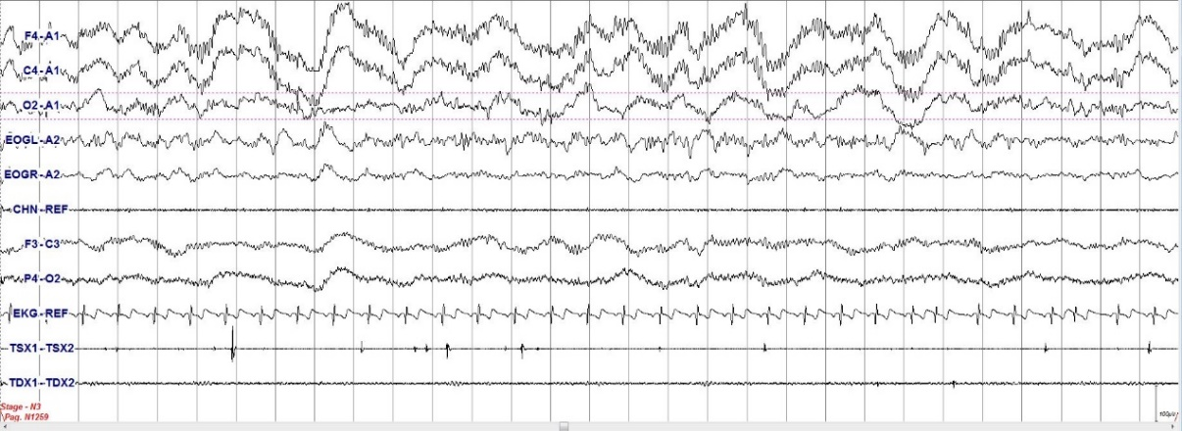
Figure 2: Alpha-Delta Sleep. High EEG frequencies during Slow Wave Sleep, i.e. insomnia hyperarousal during sleep.

Figure 3: Actigraphy recording of a normal sleeper and an insomnia patient.
On the other hand, likely due to an increase in the presence of components of the model described above, insomnia patients present a reduced low frequency activity (slow-wave activity <4 Hz) [38]–[40], specifically in slow-oscillation (0.5-1 Hz) [41]. These results do not contradict the previous ones but support the thesis postulating the existence of a deficit of sleep homeostatic drive in insomnia patients. A research group revealed a relative deficit in initial sleep drive, as manifested in lower initial NREM EEG delta power and slower decline of delta power over the night [42]. In addition, the same research group revealed that treated insomnia led to a more rapid decline (the slope became more negative) in EEG delta power throughout the night. This change was attributed to an increase in homeostatic sleep drive deficient in insomniacs [43].

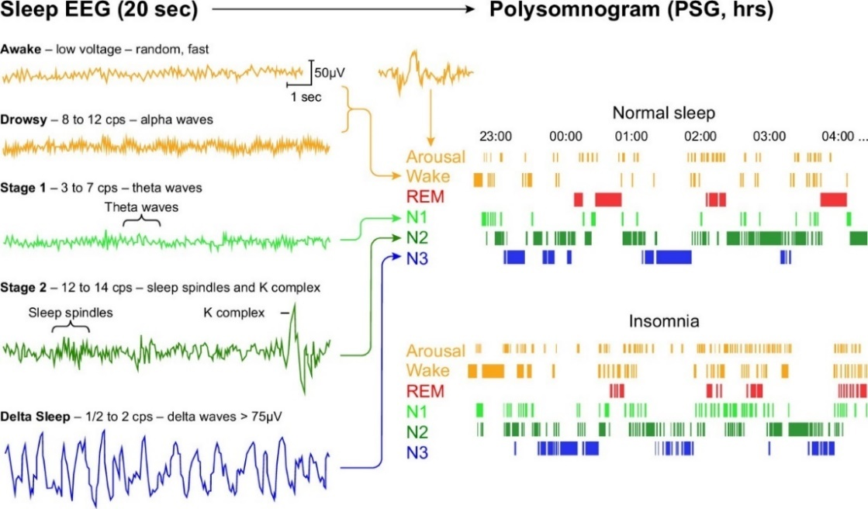
Figure 4: Polysomnography indices in normal sleep versus insomnia patients. (Adapted by Van Someren, 2021 [32], license ID: 1317539-1).

Even though the study of NREM sleep in insomnia patients has been widely explored, the assessment of REM has not received the same amount of scrutiny. Recently, however, a major research thread addressing REM sleep has been developed, consistent for the most part with the hyperarousal model.
Rapid Eye Movement sleep features seem to be a key feature of insomnia objective sleep. Specifically, “Restless REM sleep” indicators, such as REM sleep with high number of phasic events, including arousals and eye movements, seem to interfere with the overnight resolution of emotional distress and may contribute to its accumulation, resulting in a chronically hyperaroused state [44], [45].
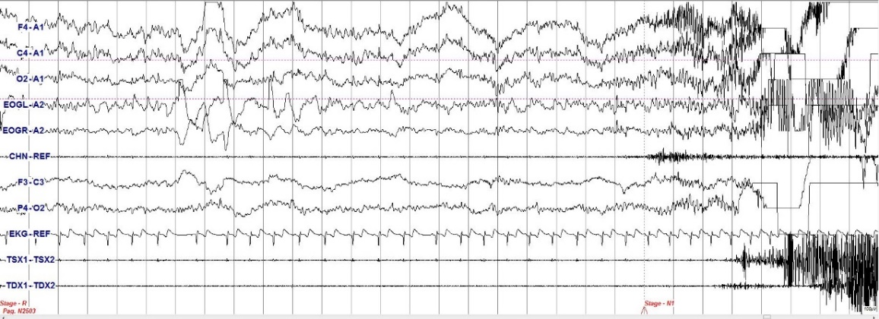
Figure 5: Arousal during REM sleep. A REM epoch with an arousal that can be classified as a “Restless REM Sleep” epoch.

Moving on to more specific findings, this research group identified a maladaptive form of sleep, called “restless REM sleep” which could prevent emotional processing maintaining amygdala reactivity. This phenomenon was interpreted as an insufficient silencing of the locus coeruleus after an induction of shame and embarrassment during a karaoke task recorded by the same subject (singing a Christmas song) [45].

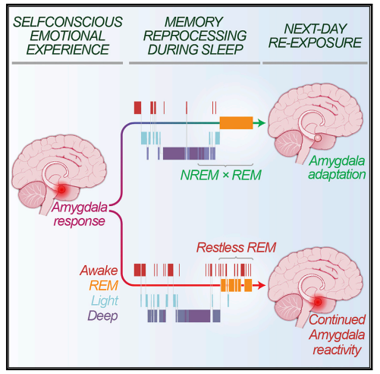
Figure 6: Graphical abstract adapted from Wassing et al. 2019 [45], license ID: 1317536-1.

Further imaging studies corroborated the hyperarousal insomnia theory, suggesting overactivation of the arousal system, the emotion-regulating system and parts of the cognitive system accompanied by reduced activation of the prefrontal cortex and the caudate head [46]. In addition, a brain imaging study using FDG (18F-fluorodeoxyglucose) PET showed ID patients with increased brain metabolism in brain networks, such as the arousal, emotion-regulating and the cognitive system [47]. In spite of that, we do not yet have a clear picture of the pathophysiology of insomnia. Given the heterogeneity of methods and study protocols of neuroimaging studies, it is challenging, but possible, to delineate some linked findings coherently with the hyperarousal model. First of all, a key role in processing and memorizing arousing and fear inducing stimuli has been revealed to be played by the amygdala, which has been subject of detailed evaluations [48]. Also, Insomnia patients showed increased amygdala reactivity towards negative sleep-related stimuli [49], reduced overnight amygdala adaptation following restless REM sleep [45], as well as shape alterations in amygdala [50], [51].
Through another methodological approach, Resting State fMRI showed a positive relation between sleep disturbances and hippocampal connectivity within the DMN, a neural network associated with self-related processing and emotion regulation [52]. In accordance with these findings, insomnia patients’ hippocampus-MFG connectivity suggested an increased pattern associated with rumination and episodic memory retrieval, reporting on a large sample size the association between alterations in the DMN and impaired sleep, showing the central role of the hippocampus in insomnia disease [53]. To sum up these latest results, maladaptive emotion regulation strategies, as well as dysfunctional, processing, detection, appraisal and memorization of negative internal and external (sleep-related) stimuli appeared to be highly important mechanisms revealed in insomnia, connected to impairment of sleep and daytime functioning subjectively reported [48].
Indeed, daytime insomniacs’ performances were defined by a hypoactivation of task-related areas in fronto-striatal networks. Insomnia disorders could be the result of an overactivity in corticolimbic areas interfering with sleep initiation and sleep maintenance. Insomnia seemed to be associated with altered brain morphometry in the frontal cortex, hippocampus, anterior cingulate cortex, and pineal gland [54].
Another interesting hyperarousal model made use of the neuroimaging approach. It is based on the flip-flop switch model [46]. This describes the rapid transitions between wakefulness and sleep, induced by mutually inhibitory neuronal circuits. Insomnia disorder patients had a chance to show a chronic instability in this system, represented by incomplete transitions between the two stages, as well as an increased number of transitions. This deficit might impact the accurate perception and memorization of the consciousness states duration; possibly overestimating the wake and underestimate the sleep durations, which are typical of the misperception insomnia. In addition, the instability of the REM sleep could potentially lead to a further increase in the instability of the flip-flop switch mechanism [55].

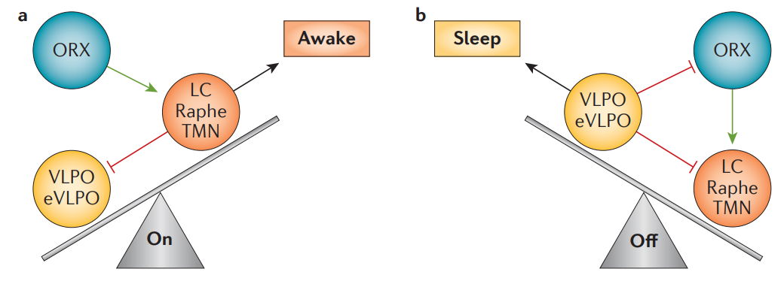
Figure 7: Graphical representation of the flip-flop switch model, adapted from Morin et al. 2015 and Saper et al. 2005 [46], [56]. The flip-flop switch avoids the existence of in-between states among sleep and arousal, and instead produces sharp and unstable switches between awake (a) and sleep state (b). This is realized through direct mutual inhibition between neurons in the ventrolateral preoptic nucleus (VLPO) and the monoaminergic cell groups (nuclei). Some stability is added to the system through the action of orexin (ORX) neurons. Wakefulness is encouraged through the action of groups of monoaminergic cells such as the raphe nuclei, locus coeruleus (LC) and tuberomammillary nucleus (TMN). License ID: 5478880059996.

In order to summarize the central nervous system pathways that may be involved in the hyperarousal etiology and pathophysiology of insomnia, the following Figure could be explanatory.

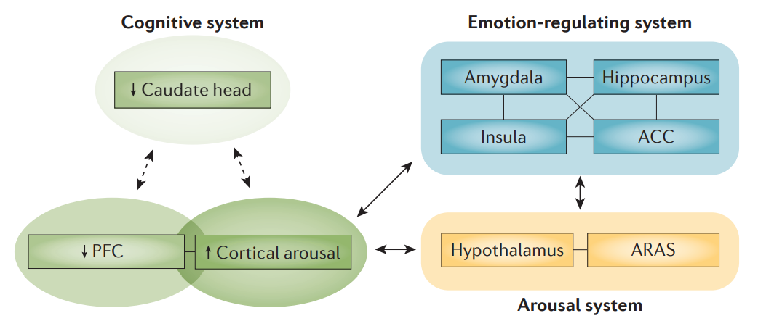
Figure 8: Solid and dashed arrows represent pathways that are assumed to be reinforced or attenuated, respectively, in insomnia. ACC, anterior cingulate cortex; ARAS, ascending reticular activating system; PFC prefrontal cortex. Adapted by Morin et al. 2015 [46]. License ID: 5478880059996.

The previous model showed the overactivation of the hyperarousal system, the emotion-regulating system, parts of the cognitive system as well as the reduced activation of the caudate head and of the prefrontal cortex. Authors assumed that the fatigue during the day is linked with the reduced recruitment of the caudate head and the PFC [46].
To date, the literature shows us that the most valid and accepted etiopathogenetic model for describing insomnia disorder seems to be the hyperarousal model.

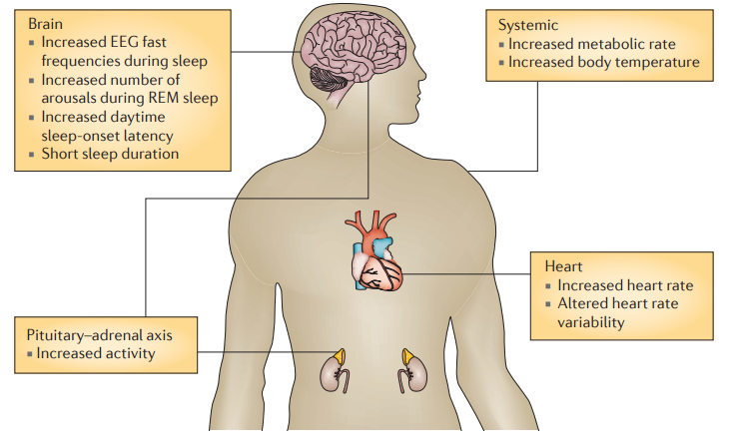
Figure 9: Electrophysiological, endocrinal and autonomic nervous systems involved in insomnia hyperarousal. Adapted from Morin et al, 2015 [46]. License ID: 5478880059996.

On the other hand, could it also be that hyperarousal may apply to the acute phase of insomnia, but not to the chronic phase [57], [58]?
In order to evaluate temporarily the development of insomnia disorder over time, we need to add another approach, transitioning from a medical and biological point of view to a bio-psycho-social point of view. Therefore, describing the 3 Factor model and merging it with the previously described findings. In this context, our research group published a paper entitled: The association between emotional dysregulation and REM sleep features in insomnia disorder [59] (Supplementary A).

The psychobiosocial point of view
Consistently with the previous approach, Spielman and colleagues in 1987 [60] elaborated the 3 Factor Model, defined by Perpetuating, the Precipitating and Predisposing factors. This model, while not recent, but still academically relevant [61], allows us to bridge the gap between acute and chronic insomnia. The genetic and hyperarousal characteristics, described previously, as well as psychological factors (e.g., worry and rumination) and social factors (such as incompatible work or partner schedule) in insomnia patients constitute the predisposing factors. Furthermore, other predisposing factors appear to be personality variables, such as the tendency to internalize problems, neuroticism, sensitivity to anxiety symptoms and perfectionism [62], [63]. Together, these factors constitute predisposing factors, and the premorbid condition of the subjects, which does not yet reach the threshold that determines insomnia symptoms onset.
From this point, if the subject undergoes a stressful event (e.g., related to work, school, family or health), insomnia symptoms have a chance to exceed the threshold and become clinically significant. In most of the cases, reported triggers of acute episodes of insomnia are stressful life events related to a threat of security to family, health and work–school living conditions that are coupled with negative emotional valence.
Moving on, precipitating factors are acute occurrences that interact with the patient’s predisposition for insomnia to produce a transient phenomenon that naturally go into remission. In line with this, assessing the remission rates of insomnia over a 5-year naturalistic follow-up period, a recent study reported that the remission rates were 29.3%, 50.6%, 62.5% respectively at 1-, 3- and 5-years follow-up with no intervention [64]. Nevertheless, chronic insomnia occurs when perpetuating factors are present, interacting with the two previous factors and consequently leading to the chronicization of the disorder. In the previous study [64], persistence rates for all participants with insomnia syndrome or subsyndromal insomnia at baseline were 70.7%, 49.4%, and 37.5% respectively at 1-, 3-, and 5-year follow-up.
These findings suggest that insomnia is often a persistent condition. More specifically, patients with more severe insomnia were at greater risk of persistent sleep disturbances, with almost two-thirds (62.9%) of that subgroup vs approximately one-third (30.3%) of the subsyndromal group reporting insomnia at each annual follow-up assessment.
The maintenance factors refer to cognitive and behavioral strategies aimed at responding to stress; such as conditioned arousal (e.g., negative state of arousal rather than state of relaxation associated at the bedroom), sleep effort (e.g., extended time in bed and avoiding evening or morning activities in order to strain to sleep) and worry about sleep, daytime and health consequences. These can be further divided into behavioral components, i.e., irregular sleep–wake schedules, prolonged time in bed daytime napping and other dysfunctional behaviors (such as alcohol abuse to deal with insomnia). In the majority of cases, these behaviors are compensatory attempts to deal with the lost sleep; in reality, these acts exacerbate symptomatology by decreasing sleep pressure. On the other hand, though closely related, the cognitive perpetuating components of perpetuating factors, such as, unrealistic beliefs about sleep, and the selective attention process have been identified as a major insomnia trigger [65]–[67]. In recent years, the literature has emphasized the role of the latter arguing that the attentional system of patients with insomnia leads to increased worry and rumination, as well as direct efforts and intention towards sleeping [67], [68].

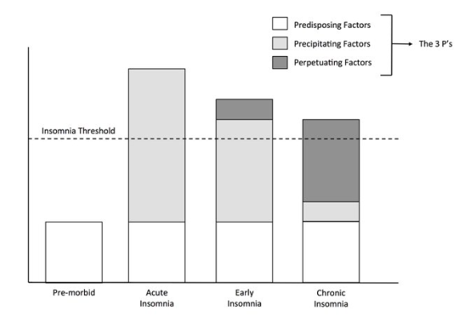
Figure 10: Graphical representation of 3P’s model. Adapted by Morin et al, 2015 [46]. License ID: 5478880059996.

By combining the hyperarousal model and Spielman's 3-P model, we have the ability to represent the possible trajectories of insomniac patients over time. While predisposing factors, of which hyperarousal indices are a part, do not necessarily lead us to symptom onset, precipitating factors lead us to onset, though a small percentage of subjects will end up having symptoms remission. On the other hand, a substantial percentage number of patients will maintain the disorder, due to the implementation of dysfunctional cognitive and behavioral strategies that will perpetuate the symptomatology, eventually making it chronic.

Figure 11: Hyperarousal and 3P Factor model along time. Adapted by IsHak, 2023 [69].

Diagnosis
Insomnia has been defined by the World Health Organization as a pathological condition whose defining feature is non-restorative sleep, in which affected individuals lament of difficulties falling asleep and/or maintaining sleep and/or early awakening. In addition to nocturnal symptomatology, diurnal issues may be present as well: asthenia, anamnestic, attention and concentration deficits, increased irritability and mood alteration, poor work/school performance. In short, generic daytime inefficiency [70].
Over the past five decades, though, several diagnostic systems have been developed, which in turn have updated the diagnostic criteria based on research guidelines. Previous versions of Diagnostic and Statistical Manual of the American Psychiatric Association [71], [72], suggested a distinction between primary and secondary insomnias. At that time, however, literature reported poor diagnostic accuracy, reliability and validity of the insomnia subtypes [73].
Therefore, there no longer is a distinction between primary and secondary insomnia to be found in the new diagnostic manuals’ version, where the secondary form describing a symptom of a primary medical or psychiatric condition has been replaced with a unitary diagnosis [1], [2]. This change in diagnostic classification was also implemented through the lens of bidirectional causal relationship between insomnia and mental disorders. Specifically, Baglioni et colleagues suggested that non-depressed people with insomnia have a twofold risk to develop depression, when compared to people with no sleep difficulties [74]. Furthermore, the role of insomnia as a predictor for the future onset of depression (10 studies, OR 2.83, CI 1.55-5.17), anxiety (six studies, OR 3.23, CI 1.52-6.85), and alcohol abuse (two studies, OR 1.35, CI 1.08-1.67), and a potential predictor of psychotic symptoms (one study, OR 1.28, CI 1.03-1.59), was also revealed [75]. In summary, Sivertsen and colleagues cast a light on the bidirectional relationship between insomnia and depression. In fact, both insomnia and depression significantly predicted the onset of the other disorder, with an odds ratio from 6.2 to 6.7, respectively [76].
To date the diagnostic criteria for Insomnia Disorder in the Diagnostic and Statistical Manual of Mental Disorders fifth-edition [1] are:
A. A predominant dissatisfaction regarding the quantity or quality of sleep is reported, associated with one (or more) of the following symptoms:
- Difficulty initiating sleep (in children, this may manifest as difficulty initiating sleep without the intervention of the caregiver).
- Difficulty maintaining sleep, characterized by frequent awakenings or problems falling back to sleep after waking up (in children, this may manifest as difficulty falling back to sleep without the intervention of the caregiver).
- Early awakening in the morning with inability to fall back asleep.
B. Sleep disruption causes clinically significant distress or impaired functioning in social, work, school, college, behavioral, or other important areas.
C. Sleep difficulty occurs at least 3 times per week.
D. Sleep difficulty persists for at least 3 months.
E. Sleep difficulty occurs despite adequate conditions for sleeping.
F. Insomnia is not best explained by, and does not occur exclusively during the course of, another sleep-wake rhythm disorder (e.g., narcolepsy, a breathing-related sleep disorder, a circadian sleep-wake rhythm disorder, a parasomnia).
G. Insomnia is not attributable to the physiological effects of a substance (i.e., a substance of abuse, a drug).
H. Mental disorders and co-existing medical conditions do not adequately explain the predominant disorder of insomnia.
Specify whether:
- Comorbidity with a mental disorder unrelated to sleep, including substance use disorders.
- Comorbidity with another medical condition.
- Comorbidity with another sleep disorder.
Specify whether:
- Episodic: Symptoms last for at least 1 month but less than 3 months.
- Chronic: Symptoms last for 3 months or more.
- Recurrent: Two (or more) episodes within 1 year.

Coherently with the previous criteria, the diagnostic criteria for Insomnia Disorder in the international classification of sleep disorder third-edition (ICSD-3) [2] are:
A. The patient reports, or the patient’s parent or caregiver observes, one or more of the following:
- Difficulty initiating sleep.
- Difficulty maintaining sleep.
- Waking up earlier than desired.
- Resistance to going to bed following an appropriate schedule.
- Difficulty sleeping without parent or caregiver intervention.
F. The patient reports, or the patient’s parent or caregiver observes, one or more of the following sleep-related difficulties:
- Fatigue/malaise.
- Attention, concentration or memory impairment.
- Impaired social, family, occupational or academic performance.
- Mood disturbance/irritability.
- Day-time sleepiness.
- Behavioral problems (e.g., hyperactivity, impulsivity, aggression).
- Reduced motivation/energy/initiative.
- Proneness for errors/accidents.
- Concerns about or dissatisfaction with sleep.
J. The reported sleep/wake complaints cannot be explained purely by inadequate opportunity (i.e., enough time is allotted for sleep) or inadequate circumstances (i.e., the environment is safe, dark, quiet, and comfortable) for sleep.
K. The sleep disturbance and associated day-time symptoms occur at least three times per week.
L. The sleep disturbance and associated day-time symptoms have been present for at least three months.
M. The sleep/wake difficulty is not better explained by another sleep disorder.

The European and US guidelines suggest a clinical evaluation of ID patients, just through subjective assessment alone [1], [2].
Riemann and colleagues [77] proposed a clinical algorithm for the diagnosis and consequently, the treatment of insomnia. Authors focused on sleep onset/sleep maintenance/early morning awakening disturbances and associated daytime impairment evaluation in the first instance.
Due to insomnia disorder being primarily a sleep disorder, to accomplish this the clinician should evaluate sleep continuity parameters. Sleep onset latency (SL), wake-time after sleep onset (WASO), number of awakenings (Naw), early morning awakening (EMA), total sleep time (TST), time in bed (TIB) and sleep efficiency (SE, the percentage of time spent asleep while in bed) are usually evaluated with a sleep diary.
On the top of that, if the symptoms are clinically significant and persistent (criteria of durability: presence of symptoms at least 3 times a week and for a minimum of 3 months), the clinician can proceed with the evaluation of possible circadian indices, substance use/abuse (e.g., alcohol) and somatic and mental co-morbidities, both through questions about sleep and comorbidities and with valid and standardized questionnaires [78].
Here an overview of questions about sleep history.
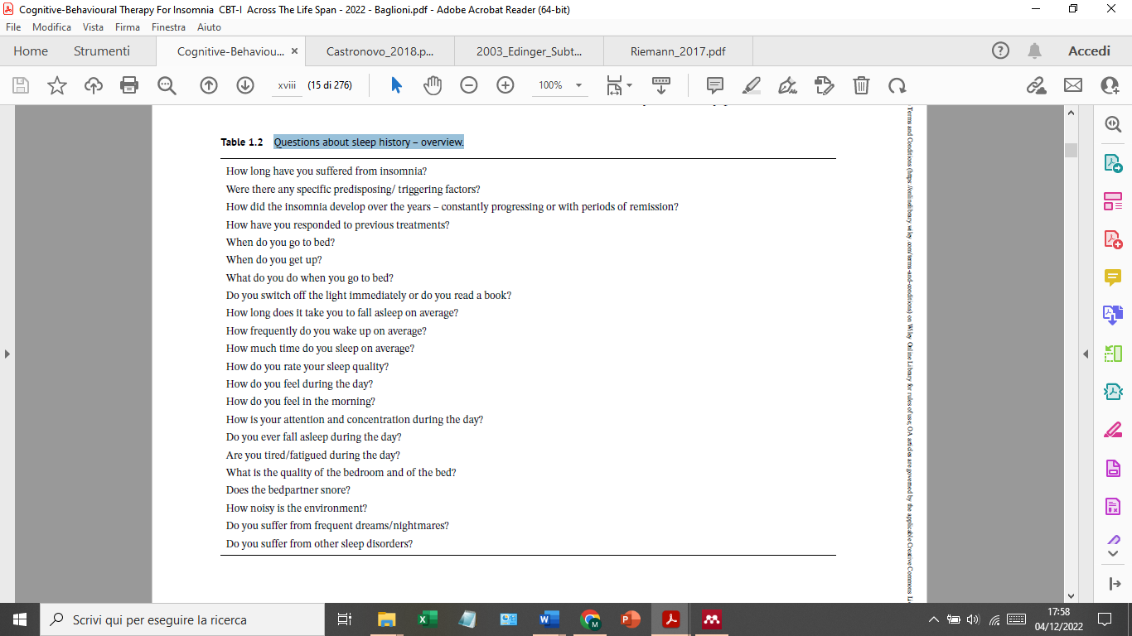
Table 1: An overview of questions about sleep history. Adapted by Baglioni et al., 2022 [79]. License ID: 5478870463234.

These details will be crucial when deciding on the treatment to be administered.
As suggested previously, an objective evaluation of sleep is not mandatory for the diagnosis of insomnia disorders. However, objective evaluation could provide crucial information regarding nocturnal sleep, and for evaluating other pathologic diseases, secondary to the disorder [80]–[82].

Polysomnography
Recently, some guidelines have suggested the use of objective measures such as polysomnography (PSG). The use of such a tool, however, while strongly recommended in case of clinical suspicion of other sleep disorders, treatment-resistant insomnia, insomnia in occupational at-risk groups (professional drivers), and in case of clinical suspicion of discrepancy between subjectively and objectively reported sleep indices, is not necessary for diagnostic purposes [77]. In addition, PSG indices seem to reveal extremely important information regarding treatment outcomes [41]–[45], [83], [84].
The history of this instrument to collect physiologic parameters during sleep goes back to the animals’ brain activity studies from Caton in 1875 [85]. Bergen discovered differences between wakefulness and sleep in brain activity in 1929 [86], and shortly after the first continuous overnight EEG recording during sleep was recorded [87]. In order to find polysomnography as we know it, consisting of the combination of electroencephalogram (EEG), electro-oculogram (EOG), and electromyogram (EMG) to determine various behavioral states in wakefulness and sleep, including rapid eye movement (REM) sleep, we will need to wait another 20 years or so [88]–[90].
PSG is considered to be the gold standard for diagnosing most sleep disorders, such as sleep-related breathing disorders (including obstructive sleep apnea, central sleep apnea, and sleep-related hypoventilation/hypoxia), hypersomnia, periodic limb movement disorder, and rapid eye movement sleep behavior disorder [2], [91].
However this tool, although widely used, is not easy to implement outside of the laboratory or clinic due to a number of factors, such as: high cost, specialized personnel, the large time investment to conduct it and to analyze the results [92]. Moreover, the procedures and equipment used for PSG require controlled environments, in addition to the fact that they are cumbersome and for this reason could disrupt the sleep itself and the patient's normal sleep routine [93]. It is also necessary to consider that a crucial but extremely delicate part of the sleep study (carried out by technicians) is the application of the sensors and electrodes to the patient, because if they are misplaced there is an impairment of data quality [94]. For these reasons, the use of an alternative objective measure of sleep is frequently implemented, the actigraphy.

Actigraphy
The accelerometer to monitor sleep/wake alternation are generally placed on the non-dominant wrist [82]. Its usage is strongly recommended in case of clinical suspicion of irregular sleep–wake schedules or circadian rhythm disorders in insomnia patients. This device may also be used to evaluate quantitative sleep parameters, but in this case it doesn’t appear to be as effective [77].
Comparing PSG and actigraphy, the latter appears to be less invasive and more convenient when evaluating sleep/wake cycles based on magnitude of wrist movement. In addition, collecting multiple nights’ worth of data in the participant’s natural environment can provide more reliable estimates of sleep compared to PSG, which is typically performed for only one or two nights in a sleep laboratory [93].
Despite, actigraphy compared to ambulatory PSG was determined as a valid objective measurement of SL, WASO, TST, and SE in insomnia patients [95], [96], recent literature suggested that the vast majority of ambulatory actigraphy sleep variables did not help to differentiate patients with insomnia from controls [97].

Heterogeneity
Despite the high incidence, the identification of genes that confer an associated risk of insomnia [22], [23] and a substantial heritability of insomnia [98], it remains very difficult to characterize insomnia taking into account many factors into a single phenotype.
Heterogeneity in insomnia patients was revealed by several investigations: evaluating cognition authors tried comparing ID with normal sleepers, and found significant impairments in episodic memory, problem solving, manipulation in working memory, and retention in working memory. Mood indices like depressive symptoms could show differences within insomnia patients’ group [74]. Furthermore, insomniacs with a family history of insomnia reported higher scores on measures of insomnia severity, anxiety symptomatology, and arousal predisposition [99]. Moreover, trauma history of life events seems to be reliable indices to subtype insomnia patients [100]. In terms of personality traits, there are findings indicating that insomniacs display more signs of neuroticism, internalization, anxious concerns and traits associated with perfectionism, even though several conflicting findings are still present [63].
In line with the previous paragraphs, and insomnia being primarily a sleep disorder [1], macro and micro-quantitative sleep indices, subjectively and objectively reported, are of the utmost importance when it comes to revealing the heterogeneity, and subsequent subtyping of ID patients. The first sleep variables to come under scrutiny in the literature were subjective insomnia complaints, such as difficulty initiating sleep, difficulty maintaining sleep, and early morning awakening. But also, despite being removed from the new diagnostic criteria, subtyping patients in idiopathic, psychophysiological, and paradoxical insomnia appeared to be quite poor in terms of diagnostic accuracy, reliability and validity for clustering insomnia patients [73].
On the other hand, a recently growing body of literature suggested that a subtype of insomnia patients seems to be relevant. Specifically, the old definition of paradoxical insomnia, which to date is defined as misperception. Insomniacs usually tend to underestimate their total sleep time and overestimate the wake after sleep onset and sleep latency, suggesting that subjective and objective insomnia subtypes may suffer from distinctive forms of sleep-related pathophysiology [101], [102]. Diagnostic manuals’ esteemed preponderance of this subtype of insomnia ranges from 5 to 9 percentage [103]. Despite this, lack of a consensus on a precise index and cut-off to determine the misperception index, even if the most reliable index seems to be the one emerging from a study by Manconi and colleagues [104]. However, suggesting the need to evaluate specific indices of sleep, insomniacs who underestimated sleep time by at least 10% were correlated with NREM EEG spectral indices and not with traditional polysomnography measures, highlighting the need to evaluate specific indices of sleep [35]. In fact, more recently the guidelines suggested that future research on sleep misperception should focus on sleep microstructure and quantitative EEG studies in both REM and NREM sleep, hopefully developing an unambiguous evidence-based measure of sleep state misperception [105], [106].
Several studies have investigated the value of objective TST for phenotyping ID [107], [108] challenging the current guidelines claiming that PSG assessment is not useful in the evaluation of ID [77]. This research line described an ID phenotype called short sleeper (TST < 6h), characterized by physiological hyperarousal, significant medical consequences and a non-remitting course [107]–[109]. Another phenotype, normal sleeper (TST ≥ 6h), was also identified, featuring no physiological arousal, cortical and cognitive-emotional arousal, anxious-ruminative psychological profile, a possible remission over time and no significant medical sequelae [107]–[109].
Therefore, other sleep indices were also investigated further in order to subtype patients, such as other macro-structure objective sleep indices [31], microstructure of sleep [110], but also imaging causes and consequences linked to sleep complaints [111].
In summary, recent literature suggested that sleep outcomes seem insufficient to define the heterogeneity of insomnia patients, and it is focusing on the investigation of non-sleep related characteristics. In accordance with this, Benjamins and colleagues [112] concluded that inconsistencies in studies describing subtypes of insomnia patients may arise from the limitations of measuring just sleep related variables. Non-sleep related variables could better reveal insomniac patients’ characteristics, including personality traits, history of disease and life events [113]–[117].

Consequences of insomnia
Insomnia disorders are related to relevant both short-term and long-term relevant consequences.
In the short-term, insomnia patients reported fatigue, hypersensitivity to noise and light, tiredness, low motivation during the day, physical discomfort on awakening and unpleasant body sensations such as heavy eyes [118]. In addition, insomnia is associated with emotional reactiveness, dysfunctional relational interaction, reduced optimism and self-esteem, possibly linked to mood disturbances, and consequently with poor quality of life [118]–[122]. Even if subjectively and objectively evaluated symptoms are usually not consistent, literature suggested, albeit minor, objective cognitive deficits in insomnia patients, such as attention and memory [123].
In the long-term, as already mentioned before, chronic insomnia is related with several psychiatric disorders; specifically, patients with insomnia are four times as likely to develop depression across all age groups [74], [124]–[127], and twice as likely to develop anxiety [128]. In line with psychological health consequences, the role of insomnia as a predictor for the future onset of alcohol abuse, and potential predictor of psychotic symptoms was revealed [75], as well as a 2-fold increased risk of suicide in the most severe insomnia phenotype [129].
The literature investigating the role of insomnia as a risk factor toward physical health are not as consistent. For instance, insomnia symptoms seem to show a significantly association with cardiovascular and all-cause mortality up to seventeen years after the onset [130], especially in men with objective short sleep duration [131]. Another study suggested a 45% increased risk factor of cardiovascular morbidity and mortality with insomnia symptoms [132]. However, other Authors covariating sleep duration, depression and implementing shorter follow-up, ended up with different results [133]–[135].
The everyday life impact of insomnia symptoms is especially intense in the occupational environment. In fact, ID patients showed less productivity and more absenteeism (8.1 hours more than good sleepers), as well as arriving late for work [136]. In addition, worst future professional advancements, such as promotion and salary increase were reported by ID patients [137], [138].
In summary, insomnia’s role as a risk factor both in short and in long-term ended up being crucial. For evaluating the insomnia consequences, both psychologically and in terms of physical health as well as in a work environment, it would be worthwhile to increasingly evaluate daytime impairments and distress over daytime functioning [6], [139], [140].

Treatments
In recent years, literature focused a lot on insomnia treatments efficacy, empowering patients to pursue the most effective and efficient treatment based on their own characteristics and goals [141], [142].
Pharmachological treaments displayed weak effectiveness evidence and safety if used beyond a 12-16 weeks period [143].
On the other hand, according to the main treatment guidelines, Cognitive-Behavioral Therapy for Insomnia (CBT-I) is the first-choice treatment for chronic insomnia. Its effectiveness has been proved to be greater in the long-term with fewer side effects in comparison to pharmacotherapy [77], [144]–[146].
Despite this, however, recent guidelines often do not consider the fact that insomnia treatment is provided by general practitioners, and they are often poorly informed on sleep disorders, which remain underdiagnosed and sub-optimally managed [147], [148]. In addition, pharmacotherapy is still by far the predominant treatment for insomnia, provided in routine healthcare worldwide [142]. Furthermore, literature suggested that CBT-I is only provided to a very modest percentage of patients who are suffering from chronic insomnia [149].

Pharmachotherapy
Prior to 2016, psychotherapeutic treatments and especially Cognitive Behavioral Treatment for Insomnia were not considered the treatment of choice for insomnia patients. Pharmacotherapy was the go-to approach in the vast majority of cases [150].
Given the most recent scientific evidence, pharmacological treatment may only occur in the short term, given the high dependence [151], just in case CBT-I is not available or not effective [77] or, if the patient still reports symptoms following the psychotherapeutic therapy [144]. However, this is not always the case: despite the fact that non-pharmacological treatment is considered to be of greater clinical utility and with fewer side effects, many insomnia patients predominantly receive pharmacological treatment from their treating physicians [152].
Categories of drugs that can be administered for insomniacs include benzodiazepines, benzodiazepine receptor agonists, antidepressants, low-dose antipsychotics (such as quetiapine), antihistamines, and finally melatonin [144]. The most commonly used medications are benzodiazepines and benzodiazepine receptor agonists, at least for patients who benefit from them at the acute time of need or in case of any relapse [77]. The reason why the latter are still administered is that, given that they both act on GABA receptors-the most important inhibitory neurotransmitter in the central nervous system that promotes sleep by inhibiting all central arousal systems (which in insomniac patients have reduced levels [46]), they have an anxiolytic, sedative, muscle-relaxing and hypnotic effect, thus promoting drowsiness within a few hours [153].
In addition, benzodiazepines efficacy has also been demonstrated through studies that have found a significant reduction in insomnia symptoms through polysomnography or sleep diaries filled out by the patient [154], especially with regard to benzodiazepine receptor agonists, which have also been found to be relatively safe in regards to the chances of their abuse [155].
However, guidelines do not consider benzodiazepines as the treatment of choice for insomnia due to the fact that they have a high risk of developing dependence, experiencing "rebound insomnia", i.e., the recurrence of psychopathology following discontinuation of treatment, [156] and most importantly contributing to cognitive impairment following pharmacological intake [151].
Specifically, regarding to the drug dependence, the half-life of the drug in the blood (i.e., the amount of time it takes for the concentration of the blood substance to halve from its initial intake) plays a crucial role: in fact, as the rate of release of the substance increases, dependence on it increases as well [157]. The most appropriate benzodiazepines, that also cause less dependence, at the same time are those with a longer half-life, while conversely, benzodiazepines with immediate and stronger release result in greater dependence and are therefore not recommended [158].
The use of antihistamines and especially antipsychotics is not recommended [159], as the potential side effects are significant [77]: for instance, the presence of a sedative effect during the day, dizziness, anticholinergic effects, and increased appetite [46]. Likewise, taking melatonin is also not recommended [142], [160].
It is important to remember how the beneficial effect of the drug is greater in the acute phase than the long-term benefits: once the drug's effect is over, if a remission doesn’t occur, the patient will tend to take the drug continuously and in increasingly larger quantities [161]. In addition, even when taking the medication, the sleep performed is not as restorative as physiologically normal sleep, precisely because these medications tend to decrease the amount of restorative sleep (sleep NREM 2 stage) while also reducing the REM stage, such that the patient will be able to sleep through the medication, but will never be as rested as a good sleeper going through deep stages of sleep, thus performing qualitatively worse sleep [144].
In short, the American Academy of Sleep Medicine claimed that pharmacological treatment of insomnia even for short-term intervention the evidence for all drugs is, at best, “weak” (including Z-drugs, benzodiazepines, melatoninergic agonists, suvorexant and others) [144].

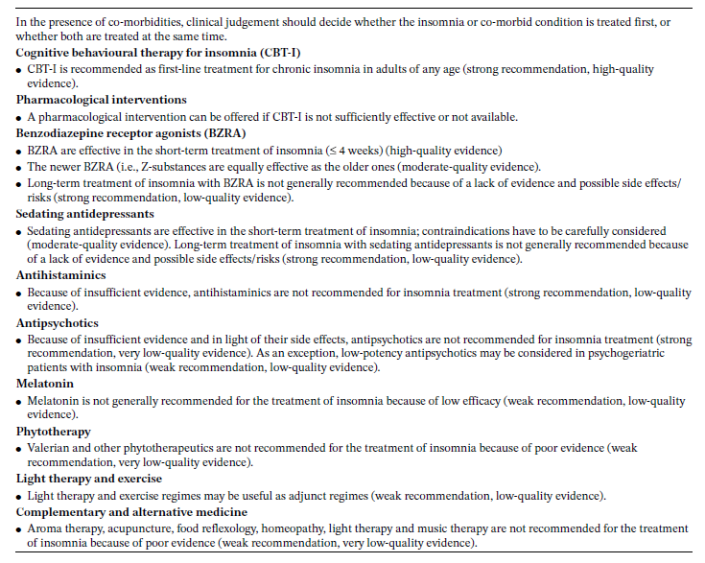
Table 2: European recommendations for insomnia treatment. Adapted by Riemann et al., 2017 [77]. License ID: 5478860692793.

In this context our research group published a paper entitled: High‑dose lormetazepam dependence: strange case of Dr. Jekyll and Mr. Hyde—comment [162] (Supplementary B).

Cognitive-Behavioral Therapy for Insomnia (CBT-I)
The first-choice treatment for ID is represented by Cognitive-Behavioral Therapy for Insomnia. CBT-I is applied face-to-face, or possibly in a group, by an expert clinician in four to eight sessions.
CBT-I [163]–[165] is a multicomponent approach enveloping psycho-education on sleep hygiene [164], behavioral interventions (such as stimulus control [166] and sleep restriction [60]), cognitive technique [165], as well as relaxation [167].
Riemann and colleagues [77] proposed a clinical algorithm in order to implement a tailored diagnosis and treatment for insomnia patients.

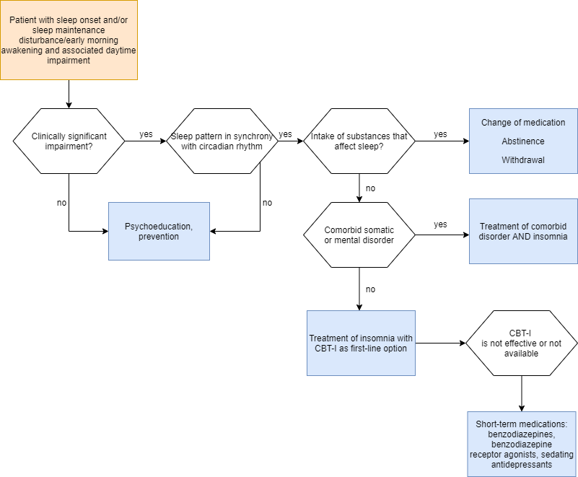
Figure 12: Clinical algorithm for the diagnosis and treatment of insomnia disorder. Adapted from Riemann et al., 2017 [77]. License ID: 5478860692793.

Starting to describe the algorithm from the top left of the figure, the first step is to determine if the patient suffers from the main diagnostic criteria, such as sleep onset/sleep maintenance/early morning awakening disturbances, as well as daytime impairment, in order to continue the evaluation. At this point, the clinician has to evaluate the clinical significance of the symptoms, assessing frequency indices to symptomatology (3 times a week, for at least 3 months), as well as the impact of the disorder on the subject's everyday life functioning. If the revealed symptoms are not severe enough to determine a clinically significant impairment, the clinician should propose psychoeducative/preventive interventions, such as sleep hygiene and psychoeducation. Should the symptoms be clinically significant, however, the clinician should check for possible circadian dysfunctional patterns, and /or substance consumption, such as alcohol and/or drugs, and any somatic and/or mental co-morbidities. In the event that one or more of these comorbidities are detected, the therapist should intervene in that area. The order of intervention, and thus whether to intervene first on comorbidity or insomnia disorder will have to be evaluated by the expert. In a standard scenario, however, CBT-I should always be considered the first-choice treatment. In fact, medications such as benzodiazepines, benzodiazepine receptor agonists or antidepressants are recommended only in the short-term, but only in the case that CBT-I has not been effective or available.
More in details CBT-I is a multicomponent approach, including:

Behavioral components

Stimulus control
Stimulus control focuses on enhancing the link between bed and successful sleep. This technique is appropriate for both sleep onset insomnia and insomnia with maintenance issues, by also intervening on maladaptive day time sleep, such as naps during the day or naps in non-sleep environments.
The Stimulus control technique derives from the academical body of work of the behavioral school, and thus from the studies of animal behavior implemented by Authors such as Pavlov and Thorndike. Research on associative learning includes the early studies of classical conditioning carried out by Pavlov and colleagues. These induced an association between a previously neutral stimulus, such as the ringing of a bell, to a behavior already intrinsic in the animal, such as salivation, induced by the appearance of food. At this point the stimulus, which up until a few moments earlier was neutral to the animal (i.e., the ring of a bell), following classical conditioning induced by the researcher, becomes a conditioned stimulus, inducing salivation even without offering food to the animal [168].
Subsequent Authors studied and described Operant Conditioning (associating a behavior with a reinforcement), studying different, and increasingly effective, protocols and types of reinforcers. In this case, the animal responded with learned behaviors (conditional responses) in order to get a reinforcement [169].
Later, the study of stimulus-response associations in children led to the insight that parents or therapists would also be able to model the behavior of their children or patients in order to create an association between stimulus and response [170].
The earliest uses of the stimulus control technique date back to the mid-1960s in patients with psychosis (such as, for example, the "token economy"), and later around the 1970s in patients with substance use disorder, autistic disorder, anxiety and depressed patients.
Its use in the field of sleep medicine was introduced by Bootzin and Colleagues [166], who took their cue from good sleepers. The Authors revealed that the bedroom environment in insomniac patients was highly dysfunctional, not discriminating between the environment devoted to wakefulness and the environment useful for sleep. These subjects, with their dysfunctional behaviors, create a very strong association between where they sleep, with insomnia, as well as with wakefulness, and somatic, cognitive and behavioral hyperarousal. Thus, the main goal of this technique is to re-establish a functional association between one's bed and bedroom with sleep, through clear stimuli to help subjects differentiate between waking and sleep-related activities.
In order to reinforce a functional association between the bedroom environment and sleep, it is very helpful that sleep itself becomes a natural intrinsic reinforcement, such that the strong desire to fall asleep itself acts as a reinforcement when necessary [79].
Below can be found the main instructions of the stimulus control:

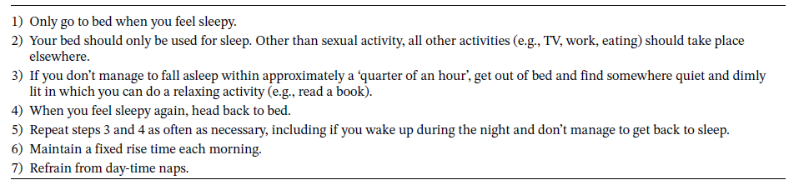
Table 3: Treatment instruction for stimulus control therapy. Adapted by Baglioni et al., 2022 [79]. License ID: 5478930069464.

Sleep Restriction
Sleep restriction therapy (SRT) is a technique designed to limit the time spent in bed compared to the actual amount of sleep subjectively reported by patients. The aim is to improve the consolidation of sleep and retrain its occurrence to a specific time, increasing sleep pressure (such as the homeostatic system of sleep).
The physiological expression of sleep is based on the synchronization between the subject's homeostatic sleep system (Process S) and circadian system (Process C) [171], [172]. If Process S is discharged during sleep and recharged during the day, Process C, a circadian pace-maker, keeps us awake and alert. These two systems are highly dependent on behavioral inputs. For example, by going to bed later, exposing ourselves to a lot of light (Process C); likewise, sleeping during the day or staying awake at night (Process S). The two processes are closely interrelated, influencing each other mutually, not only affecting the total sleep time, but also the specific stages of sleep [173].
Arthur Spielman estimated that by modifying behaviors dysfunctional to the physiological propensity to sleep, which affect both the S-process and the C-process, one could not only study the role of these processes in the etiopathogenesis of chronic insomnia, but also produce appropriate treatments [60].
Therefore, a behavioral treatment was developed that reinforces the homeostatic drive (process S) and thus increases the propensity to sleep by limiting the time spent in bed for a certain number of nights [174]–[176].

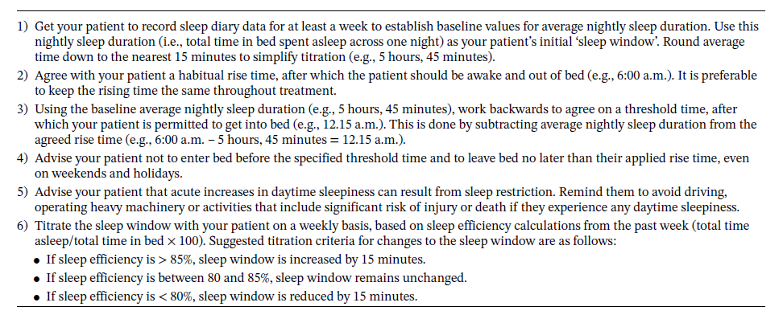
Table 4: Treatment instructions for sleep restriction therapy. Adapted by Baglioni et al., 2022 [79]. License ID: 5478930069464.

Cognitive techniques
Cognitive component of CBT-I [165] aimed to identify, challenge and modify dysfunctional beliefs regarding sleep, insomnia and its consequences, including strategies to reduce or prevent excessive monitoring and worrying.
In the 1970s, therapeutic theories of cognitive approaches began to discredit the behavioral approaches while maintaining a scientific methodology. Edward Tolman, studying animals, disputed the purely behavioral theory that described the mind as a “black-box”, putting forward the possibility that animals have to anticipate the consequences of their actions by developing cognitive maps of their environment [177]. Later, Borkovec elaborated a treatment of worry stimulus control, in which by restricting the possible times and places where worry arises, the frequency of worry itself could be reduced [178]. Similarly, this technique has been implemented standardizing the treatment of anxiety disorders [179].

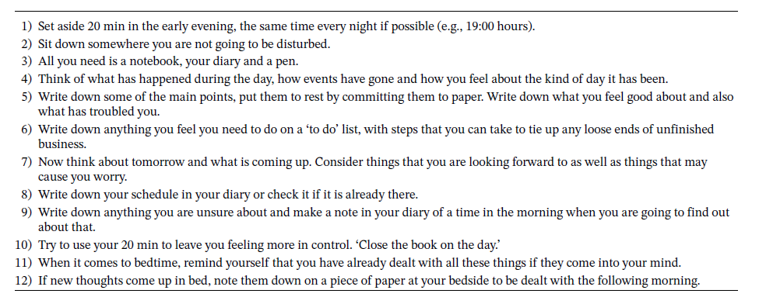
Table 5: Treatment instructions for cognitive therapy. Adapted by Baglioni et al., 2022 [79]. License ID: 5478930069464.

Relaxation techniques
Relaxation therapy includes clinical procedures aimed at reducing somatic tension, such as progressive muscle relaxation and autogenic training, or intrusive thoughts at bedtime, such as imagery training or meditation.
The first publications in this area were proposed by Edmund Jacobsen in 1929 [180]. This approach was immediately found to be consistent with behavioral theories, which used this technique to cope with the counter-conditioning of fear and anxiety [181]. Later, various modifications were made, proposing a shorter protocol [182], or a more passive version [183].
In the 1940s Yates also suggested associating relaxation with a relaxing word like 'calm' in order to increase its effectiveness [184]. Approaches such as Biofeedback also took advantage of these techniques by proposing EEG, MG or GSR protocols in parallel [185].
Many different variants of relaxation techniques have surfaced over the years, either using imaginative processes or basing themselves on philosophical approaches [186].

Psychoeducation
Psycho-education on sleep hygiene, which includes ‘sleep hygiene rules’ about health practices (e.g., clockwatching, physical exercise, substance use) and environmental factors (e.g., light, noise, temperature) is able to promote or disrupt sleep. This component of CBT-I includes several basic information about normal sleep and age-related changes in sleep patterns [164]. A graphic representation of these is as follows:

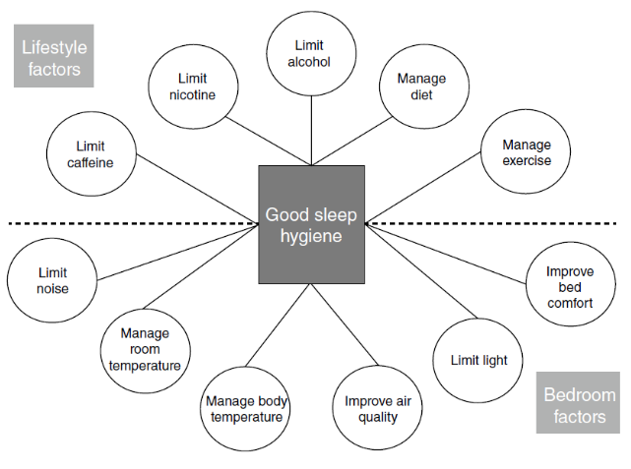
Figure 13: Graphical representation of sleep hygiene. Adapted by Baglioni et al., 2022 [79]. License ID: 5478930069464.

Many factors influence sleep beyond Process S and Process C. These factors may be not endogenous but external, such as diet, lifestyle, and the environment itself. Sleep hygiene aims to share with patients the knowledge that the modern academic literature has provided us, about the sleep-wake system and the factors that influence these systems, while also providing a set of healthy sleep habits that the patient can follow to improve their condition. Following the proposal of these habits and behaviors, it is advisable to keep in mind that in all likelihood many patients have already been confronted with these general rules, and make it as clear as possible that psychoeducation on sleep is only one component of CBT-I. In this context, our research group published a paper entitled: Impact of pre-sleep habits on adolescent sleep: an Italian population-based study [187] (Supplementary C).

CBT-I efficacy

CBT-I subjectively reported efficacy
Several reviews and meta-analyses have focused on CBTI efficacy. Literature claims that CBTI is effective [188]–[193] both in primary [194] and in comorbid [195], [196].
In 2018, Van Straten and colleagues [197], evaluated 87 randomized controlled trials comparing at least one component of CBT-I to a control group, such as no treatment or waiting list in insomnia disorder patients. The effectiveness of CBT-I was undisputable, specifically in Insomnia Severity Index results showed the most amelioration (g = 0.82), followed by SL (g = 0.47) and SE (g = 0.63).

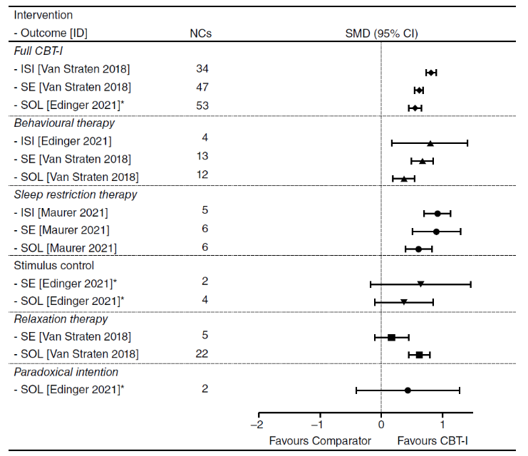
Figure 14: Effect sizes (SMD) of CBT- and single components compared to control group in randomized controlled trials. Adapted by Baglioni et al, 2022 [79]. License ID: 5478870667763.

The same meta-analysis suggested that face-to-face treatments and treatments of at least four sessions seem to be more effective when compared to self-help interventions or face-to-face interventions with fewer sessions [197]. In addition, literature highlighted a medium-to-large effect of CBT-I in insomnia patients with comorbidities with medical or psychiatric disorders such as chronic pain, heart conditions, cancer, PTSD, COPD, alcohol dependence, other sleep disorders, mood and anxiety disorders [195], [196].
In order to assess the cost-to-benefit ratio, a prosperous literature has compared the effect of face-to-face CBT-I and the same protocol administered digitally. On the one hand, longer treatment with greater specialist involvement leads to the patient receiving greater benefits from the therapy [198]. On the other hand, the effects of online treatment seem comparable to standard treatment on specific indices, such as the ISI, SL, SE, and WASO [199].
The long-term CBT-I treatment effect has not only shown a maintenance of the effect beyond 12 months after the end of treatment [200], but has also been shown to be greater than that of a drug therapy one [161].
Thus, the AASM guidelines regarding CBT treatment for insomnia were recently updated [201]. The review and evaluation of the strength of this literature, recommends the use of the set of components found in CBT-I to effectively treat chronic insomnia disorder in adults. In this context, our research group published two papers entitled: Long-term clinical effect of group cognitive behavioral therapy for insomnia: a case series study [202] (Supplementary D); Insomnia patients with subjective short total sleep time have a boosted response to cognitive behavioral therapy for insomnia despite residual symptoms [203] (Supplementary E).

Subcomponents CBT-I efficacy
Sleep hygiene appears to be the least studied component as it is often used itself as a control active arm. Albeit 15 RCTs have shown us that the soft-component of CBT-I leads to small-to-medium effects, its effectiveness appears to be smaller in all outcomes when compared to the full CBT-I protocol [204].
Conversely, evaluating the effect of relaxation techniques increases the effects. Specifically, a recent meta-analysis shows a medium-to-high effect on SL [197]. Recent guidelines [201], show small but significant reductions in SL and WASO following the relaxation component of the CBT-I protocol.
The cognitive component of CBT-I is certainly less standardized than behavioral approaches. Nevertheless, cognitive therapy has been shown to be effective in treating insomnia patients even when used as a component alone [205]. Further studies are needed in order to study and better standardize this approach, however, comparing the effect of cognitive therapy with the full CBT-I protocol, the literature showed us a lower short-term effect, but a comparable percentage of responders to therapy between the cognitive component (62.3%) and CBT-I (67.3%) six months after treatment [206], suggesting a more long-term mechanism of effect. Comparable effects have also been shown through online administration [207].
The behavioral component on the other hand has been examined in greater detail, in order to evaluate the possibility of brief treatment that could also be cost-effective. A medium-to-large effect has emerged for indices such as SL and SE, up to large effects on ISI [197], when evaluating the two main behavioral components together (stimulus control and sleep restriction). Taking only sleep restriction into consideration, Edinger and colleagues [208] reported four RCTs which describe a medium effect on sleep quality but reduced effects on SL and WASO. Furthermore, evaluating the effectiveness of the sole component of stimulus control, the same meta-analysis shows us some admittedly slight effects on variables such as SL (10 minutes) and WASO (19 minutes) [208]. However, the literature in this area is limited, suggesting the need for further study on the effect of individual components of CBT-I in an attempt to better understand their specific mechanism of action. In this context, our research group published a paper entitled: “Thinking About Thinking” in Insomnia Disorder: The Effect of Cognitive-Behavioral Therapy for Insomnia on Sleep-Related Metacognition [209] (Supplementary F). In addition, according with this field, our research group prepared a manuscript under review entitled: The impact of affective states on Cognitive-Behavioral Therapy for Insomnia effectiveness: a mediation analysis study with the validation of the Italian version of Profile of Mood States (POMS) (Supplementary G).

CBT-I objectively reported efficacy
Most studies used subjective indices in order to evaluate CBT-I efficacy. Nevertheless, it seems that also objective CBT-I efficacy has been proven too. To be more specific, while actigraphy or polysomnography-derived sleep macro-structural indices [203], [210] don’t appear to be helpful in this regard; specific microstructural sleep features [84], and quantitative EEG indices [41], [43], [83], turned out to be very informative in evaluating CBT-I efficacy.
Mitchell and colleagues in 2019 [210] evaluated the effect of CBT-I on objective indices, measured by both actigraphy and polysomnography. The results showed no evidence that CBT-I reliably improves PSG sleep parameters relative to control groups at post-treatment. It must be noted, however, that very few studies incorporated PSG measurement (n = 5). For actigraphy, where we had more comparisons, there was a small reduction in effect for SL.
Conversely, quantitative analyses suggested different findings. Cervena and colleagues [83], already in 2004 already suggested that CBT-I may have a favorable eﬀect on CNS hyperarousal by decreasing high EEG frequencies and enhancing sleep pressure improving homeostatic sleep regulation by increasing Slow Waves Activity. More recently Hogan and colleagues [41] suggested that following CBT-I, high-frequency EEG power consistently decreased across NREM periods, and elevated high-frequency activity is reduced for sigma and beta power following the treatment. These findings inform the pathophysiology of insomnia, including the mechanisms underlying CBT-I in older adults, highlighting the increase in the homeostatic sleep system (Process S).
Literature suggested that insomnia patients displayed a slower rate in overnight delta decline compared to healthy controls, which is not explained by differences in total sleep time or wake after sleep onset [42]. And the Authors interpreted these findings as insomnia patients having a relative deficit in initial “sleep drive”, as manifested in lower initial NREM EEG delta power and less rapid decline of delta power over time. In fact, the same research group showed that CBT-I led to a more rapid decline (the slope became more negative) in EEG delta power over the night. This change is interpreted as the therapeutic effect of CBT-I, which appears to occur in conjunction with an increase in homeostatic sleep drive [43].
In addition, there are other elements that could predict and/or indicate the effect of CBT-I, such as the graphoelements of sleep. In this case [84], reduced sleep spindles (transitory rhythmic brain oscillation between 11 and 15 hertz, that constitutes a hallmark of NREM sleep, and represents the interplay between thalamic nuclei and cortical neurons) density at pre-treatment predicted poorer response to the CBT-I at the Pittsburgh Sleep Quality and sleep diaries. Given these results, authors hypothesized that patients with altered spindles activity would constitute an insomnia subtype, characterized by a neurophysiological vulnerability to sleep disruption linked to reduced responsiveness to CBT-I. In this context, our research group published a paper and an abstract entitled: The reliability of objective total sleep time in predicting the effectiveness of cognitive-behavioral therapy for insomnia [211] (Supplementary H); Slow wave sleep and response to cognitive behavioral therapy for insomnia [212] (Supplementary I).

CBT-I and psychophysiological mechanism of action
The effectiveness of the behavioral subcomponent of CBT-I [208], leads us to first address the specifically behavioral effect of the protocol. The effect of CBT-I on sleep homeostatic pressure (process S) is increasingly being investigated and validated. Increased homeostatic drive is detected both subjectively, through improvements in sleep continuity and a reduction of symptom severity [213], [214], and objectively, through the presence of increased slow wave activity (SWA) [41], as well as more rapid declines in EEG delta band power throughout the night [43]. In addition, the other behavioral component, stimulus control, leads to a more positive bed-sleep association by regulating the circadian system (Process C) [215].
From the perspective of the impact of CBT-I on the cognitive system, a variety of research studies have shown that symptomatic improvements appear to be closely correlated with reductions in beliefs and attitudes about sleep [216]–[218]. On the other hand, the mediators with the greatest effect on improvement at SE don’t seem to be dysfunctional beliefs, but the meta-cognitive processes of worry and rumination [219]. On the topic of cognitive impact, CBT-I has also been shown to improve the hypoactivity of prefrontal regions involved in a cognitive flexibility task compared to a control group [220]. Conversely, the hypoactivity of brain regions related to working memory tasks does not show changes following treatment [221]. Other studies have shown a reduction in gray matter volume in insomniac patients [222]–[224], specifically the orbitofrontal cortex, which plays a key role in emotional regulation [225]. These findings could explain the effect of therapy in correlating increased cortical thickness with reduced WASO [226]. A further theorization of cognitive dysfunctionality was described by Espie [68]. In support of this theory, cortical hyperactivation in response to sleep-related sounds was recently found to decrease following treatment [227]. In addition, improvement at the ISI index appears to correlate with changes in activity in the supramarginal gyrus involved in a cognitive task [228].
Unfortunately, the literature on the impact of CBT-I on the hyperarousal system is limited. However, reductions in pre-sleep arousal following treatment have been detected [229]–[231]. In this area, Miller and colleagues demonstrated a decrease in body temperature (arousal index) following CBT-I [232], although cortisol and heart rate indices did not yield the hypothesized results [232], [233]. Despite this, increased blood flow in the basal ganglia during NREM sleep as a result of the behavioral component of CBT-I has been found to be synonymous with cerebral deactivation as well as homeostatic regulation [234]. More recent connectivity studies have shown effects of CBT-I at the thalamic level, in the amygdala, caudate nucleus and orbitofrontal cortex [235]; as well as a correlation between improvement to sleep-related indices and increased connectivity between the premotor/dorsolateral prefrontal cortex and the default-mode network [236]. In this context, our research group published an original paper and a narrative review entitled: Depressive and stress symptoms in insomnia patients predict group cognitive-behavioral therapy for insomnia long-term effectiveness: A data-driven analysis [237] (Supplementary L); Impact of phenotypic heterogeneity of insomnia on the patients’ response to cognitive-behavioral therapy for insomnia: current perspectives [238] (Supplementary M).

K-complexes' role in CBT-I effectiveness
Moreover, there is a graphoelement that could predict and/or indicate the effect of CBT-I called K-complex (KC), proposing a potential mechanism of psychophysiological action of the treatment. To date, there are no studies on the relationship between KC and the CBT-I efficacy outcomes, nevertheless the role of slow-wave forerunner [239]–[244], sleep-promoting function [240], [245], [246] and preventing sleep arousal [247] present in the literature motivates us in exploring the psychophysiological mechanism of action of KC in insomniacs and subsequent treatment.
KC is a high-amplitude graphoelement, whose maximal amplitude is most commonly detectable over the frontal regions. A K-complex is a NREM sleep stage 2 feature well-delineated negative sharp wave (upward deflection) immediately followed by a positive component (downward deflection) [248]. It is a Bi-triphasic EEG complex pattern reflecting a sequence of depolarizing and hyperpolarizing membrane potentials of cortical neurons. A waveform with a minimum duration of 0,5 seconds and a maximum of 3 seconds [249]. This cortical phenomenon is associated with vasoconstriction, an increase in sympathetic activity and a rise in arterial pressure. K-complexes can either be spontaneous or induced by a known sensory stimulus, although both look identical [250].

K-complex neurophysiological function
Literature suggested to us that KC seems to act as a forerunner of slow wave activity (SWA). Indeed, it is characterized by cortical UP state and DOWN state as slow waves [239]. In addition, by showing the relations between the slow oscillation (oscillations lower than 1 Hz characterized by the activity of corticothalamic cats and humans’ networks during quiescent sleep) and K-complexes, Steriade and Amzica suggested that slow oscillations could play a role in triggering, grouping and synchronizing thalamic or thalamic-cortical rhythms, like sleep spindles and delta waves [251]. Again, in line with the role of KC as a forerunner of SWA, KC density decreased across the sleep cycles and inter-KC intervals increased across the sleep cycles [240]. KC frequency increased between transitions from stage 2 to SWS, rather than to REM sleep [240]. Furthermore, the decay of KC density from evening to morning between cycles across the night sleep was revealed [240]–[243]. And the same decrease in KC density has been described within a cycle [244].
KC also revealed a sleep protective phenomenon, by both promoting sleep and preventing arousals. The first function was discovered by detecting a higher KC density before the transition to deep sleep (trigger to delta waves) [240]. In addition, evoked and spontaneous KCs are more frequent following a night of fragmented sleep (increased sleep drive) [245], and are also followed by an increase in delta power relative to baseline [246].
The arousal-preventing function was found in a different study. During SWS, when a K-Complex was not elicited, there was a significant overall increase in theta, alpha, sigma, and beta activity following stimulus [247]. In line with this, Jahnke and Collegues revealed a two-sided nature of evoked KC [252]: an association with subcortical arousal with low-level information processing limited by disengagement of salience network regions and sleep-preserving counteraction promoted by cerebral midline structures.

K-complex in insomnia disorder
There is very little agreement, however, on the specific function of KC when it occurs in insomnia patients. On the one hand, Wauquier and colleagues observed a lower occurrence of KC among insomniacs [253]. On the other hand, Bastien observed no significant difference between ID and good sleepers in both the number and density of KC in NREM sleep stage 2 [254]. While studying the evoked-KC, Hairston et al. observed an increase in KC associated with stimulation for good sleepers but not for ID patients [255]. In contrast, Forget et al. did not find any differences in number and density in evoked-KC between ID and good sleepers [246].
Unfortunately, currently, there are no studies on the relationship between K-complexes and the effectiveness of the first-choice treatment for ID, such as CBT-I efficacy.

Aim of the work
The research question of this Ph.D. project is focused on the evaluation of sleep, assessing indices both subjectively reported and objectively detected, that would ideally reveal the heterogeneity of insomnia disorder, as well as predict and evaluate, CBT-I effectiveness.
Despite the European and United States guidelines recommending a subjective assessment to diagnose insomnia disorder [1], [2], objective evaluation of nocturnal sleep could potentially reveal other pathologic diseases in insomnia disorder patients [80]–[82], identify different subtypes of ID [256], as well as evaluate treatment effectiveness outcomes [238]. Nevertheless, the effectiveness of Cognitive-Behavioral Therapy for Insomnia (CBT-I), the first-choice treatment for chronic insomnia [146], is often assessed through subjective variables, in line with the global diagnostic guidelines suggested. Macrostructural standard indices of sleep recorded by polysomnography (PSG) do not seem to change significantly following CBT-I [210]; however, quantitative and micro-structural EEG indices should be more revealing in evaluating treatment objective response, such as high and slow frequencies [41], [83], delta power [43], and sleep spindles indices [84].
Based on the previous literature, the present multicenter study aims to evaluate both objective and subjective indices of sleep before and after CBT-I treatment.
The primary outcomes evaluate in insomnia patients are the following:
Subjectively reported indices are sleep diary outcomes [257], as well as symptom severity detected through the Insomnia Severity Index (ISI) [258], assessed before and after group CBT-I treatment. In addition, we assessed several objective sleep-related macro- and micro-structural indices detected through a polysomnographic evaluation before and after treatment. Specifically, we first evaluated the classical macro-structural indices (SOL, TST, TIB, WASO, and NREM 1, NREM 2, NREM 3 and REM stage percentages); in addition, we calculated a sleep stability index extracted from each patient's average probability of maintaining NREM 2, NREM 3, and REM stages, given the increased probability of stage shifts present in insomniac patients [32]. Therefore, we implemented quantitative analyses of relative powers in different frequency bands (Slow oscillation, Delta, Theta, Alpha, Sigma and Beta bands) based on the literature suggesting that quantitative sleep-related indices may be useful in detecting the objective effectiveness of CBT-I treatment [41], [43], [83]. In addition, we detected three sleep graphoelements in order to evaluate possible subtypes of insomnia patients, namely slow waves, sleep spindles and K-complexes, based on KC sleep protection function [240], [245], [246] and preventing sleep arousal [247] and in accordance with recent literature evaluating the effectiveness of objective CBT-I both in sleep spindles [84] and in slow wave activity [83].
Secondary outcomes are two indices of misperception. The literature has shown us that there is a tendency for insomnia patients to underestimate their sleep and overestimate their wakefulness compared with the objective assessment [101], [106]. For this reason, we evaluated two indices of misperception related to both TST and SE [104].
In summary, the aim of this project is twofold. The first objective of evaluating the subjective and objective effectiveness of the treatment in the whole sample; i.e., to evaluate CBT-I efficacy through the analysis of both objective (macro and microstructure sleep outcomes), and subjectively reported sleep indices. The second aim is to predict the effectiveness of the treatment, specifically identifying neurophysiological phenotypes of ID that may predict outcomes to CBT-I.

Materials and Methods

Study design
This is a retrospective multi-center study, composed of 6-8 weeks of group CBT-I and two PSG evaluations pre- and post-treatment, within a one-month period.

Figure 15: Experimental design structure; composed by an example of 8 weeks of group CBT-I (small rectangles) and two PSG evaluations pre- and post-treatment, within a one-month time slot (large rectangles).

All patients received ID diagnosis from a neurologist expert in sleep medicine, according to diagnostic criteria at the time of the evaluation [1], [2], [103].
Inclusion Criteria: Adult patients with chronic insomnia diagnosed according to diagnostic criteria at the time of the evaluation: difﬁculties in initiating sleep (deﬁned as a sleep onset latency greater than 30 min), difﬁculties maintaining sleep (deﬁned as wake after sleep onset greater than 30 min), and/or early morning awakenings (deﬁned as ﬁnal awakening time earlier than desired by at least 30 min), combined with signiﬁcant impairment of daytime functioning, for a duration of 3 months or more with sleep disturbances 3 times a week or more [1], [2], [103].
Exclusion Criteria: Untreated medical condition, psychiatric comorbidities, and other sleep disorders: having major psychiatric or medical conditions including sleep disorders other than insomnia (e.g., sleep apnea, restless legs syndrome, and periodic limb movement disorder). Particularly, sleep apnea and periodic limb movement disorder (an apnea e hypopnea index > 5/h and an index of periodic limb movements during sleep > 15/h were exclusion criteria). Recent shift work, or changes in time zones over the past 2 months, and use of recreational drugs or prescription drugs that might affect sleep. If patients used medication, they had to stop medication before the first PSG assessment. In case of benzodiazepine, for at least 1 week before the PSG assessment. In case of antidepressants, for at least 2 weeks before the ﬁrst PSG assessment. The withdrawal management was proposed according to the clinical picture of the patient.
All participants provided written informed consent for the study, which was approved by the local research ethics committee. In addition, in order to share data between Centers, the Data Sharing Agreements were produced in accordance with the local legal and/or University office.
In the following multicenter project, patient data were shared from four international centers. Specifically, obtained from Professor Charles M. Morin from the Department of Psychology, Laval University, Canada; Professor Thanh Dang-Vu from Concordia University, Canada; Professor Alexandros Vgontzas from the Department of Psychiatry and Behavioral Health, Penn State University, United States of America; and finally, Professor Bušková Jitka from Charles University in Prague, Czechia.

Treatment
CBT-I [163]–[165] is a multicomponent approach enveloping psycho-education on sleep hygiene [164], behavioral interventions, such as stimulus control [166] and sleep restriction [60], cognitive technique [165], as well as relaxation [167].
Protocols across centers appear to be comparable, consisting of 6-8 sessions of 90 minutes each. Specifically, the behavioral, cognitive, sleep hygiene, and relaxation components were consistent across centers. For more details, please refer to the introduction section, treatment chapter, Cognitive-Behavioral Therapy for Insomnia (CBT-I) section.

Polysomnographic assessment
The montage required to all centers was in accordance with the American Academy of Sleep Medicine guidelines [259].
12 electrophysiologic derivations were applied: two EOG referenced to both mastoids (LOC/A2 and ROC/A1), six EEG referenced to both mastoids (F3-C3-O1/A2 and F4-C4-O2/A1) and a bipolar mentalis EMG. One channel of nasal air flow (nasal pressure canula), one channel of oral air flow (thermocouple), two channels for thoracic and abdominal respiratory movements (piezo-electric) a channel for SaO2 acquisition were acquired in order to reveal the presence of sleep apneas.
Figure 16: Graphical representation of the PSG montage according with American Academy of Sleep Medicine [259].

Patients
A total of 90 chronic insomnia patients were enrolled (49.57±12.67 years; 71.11% females).
Figure 17: Demographics of the 90 chronic insomnia patients.

Four centers were included in this multicentric study.
Centers | Frequency | Percent | Cumulative Percent
Concordia | 21 | 23.333 | 23.333
Laval | 39 | 43.333 | 66.667
NIMH CZ | 19 | 21.111 | 87.778
Penn State | 11 | 12.222 | 100.000

Table 6: Percentages of subjects in the 4 centers.
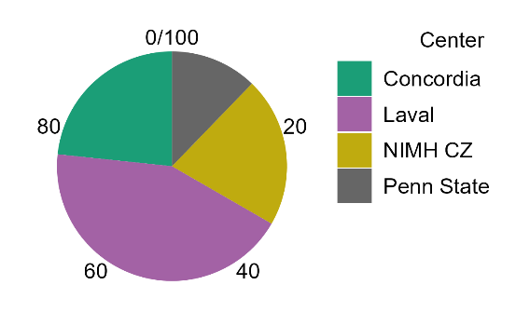
Figure 18: Pie chart of percentages of subjects in the 4 centers.

All patients received ID diagnosis from a neurologist expert in sleep medicine, according to diagnostic criteria at the time of the evaluation [1], [2], [103].

Measures
The subjective outcomes were Insomnia Severity Index (ISI) [258], [260], [261], and Sleep diaries [257] both evaluated at pre- and post- CBT-I treatment. ISI is a 7-item self-report questionnaire to evaluate subjective symptoms and daytime consequences of insomnia as well as the degree of distress caused by these difficulties. A higher score indicates greater insomnia severity. In literature Responders to treatment are defined by a decrease of ≥8 points on the ISI total score, whereas Remitters are determined by a total ISI score <8 at the end of the treatment [262]. Sleep diaries indices evaluated were SOL, TST, TIB, WASO and NoA.
Objective outcomes were:
- PSG macrostructural outcomes, i.e., SOL, TST, TIB, WASO and minutes, percentages and latency of N1, N2, N3, REM, NREM.
- Sleep Stability index, calculated by the average probability to remain in the NREM 2, NREM 3 and REM sleep stages by means of transition matrix, i.e., the probability to transition between stages.
- Relative power bands, i.e., Slow oscillation (0.5-1 Hz), Delta (1–4 Hz), Theta (4–8 Hz), Alpha (8–12 Hz), Sigma (12-16 Hz), Beta (16–30 Hz).
- K-complex number, duration, peak-to-peak, slope and KC density (KC number/ N2minutes)
- KCSlope variable is determined in each ID patient by the slope of the linear equation of the KC density calculated in each NREM stage 2 epoch. Specifically, this is more negative, the greater the sleep pressure present in the subject. This index was evaluated in order to have a slope index of KC density along the night, and thus evaluate the homeostatic function of K-complexes [239]–[244].
- Slow waves number, the peak-to-peak, slope, and density (SW number/ N3minutes).
- Sleep spindles number, amplitude and density (SS number/ N2minutes).
In addition, we calculated the Misperception index [104] both by TST (objective total sleep time (PSG_TST) - subjective total sleep time (SD_TST)] / PSG_TST) and SE (objective sleep efficiency (PSG_SE) - subjective sleep efficiency (SD_SE)] / PSG_SE).

EEG analyses

Pre-processing
The first step for EEG analyses was a visual inspection of traces in order to assess its quality of acquisition, called pre-processing. This step was implemented through the software EDFbrowser (https://www.teuniz.net/edfbrowser/), a free, opensource, multiplatform, universal viewer, annotator and toolbox intended for, but not limited to, time-series storage files like EEG, EMG, ECG, BioImpedance, etc. With the help of this software, we created the montage from the raw data received from the centers according with the guidelines described above, filtering signals (high-pass = 0.3 Hz, low-pass = 35 Hz) [259]. In addition, through the same software we visualized the power spectrum (window=Hamming; Blocksize: 1000 samples; Overlap 50%), and color density spectral array (Segment length: 30 seconds; Block length: 1 second; Overlap: 80%; Window: Hamming) [263] of the whole traces. This was done to check the high presence of band frequencies sleep-related (Theta (4-7 Hz), Delta (1-3 Hz), alpha peak in the first 20 minutes), as well as the low rate of presence of band frequencies related to artifacts along night (Alpha (8-12 Hz), Sigma (12-16 Hz), Beta (16-30 Hz)), and finally rejecting bad channels. According with the pre-processing of data, we implemented a first 30s epochs-visual inspection of all traces, in order to reject the 30s epochs with presence of artifacts, referring to American Academy of Sleep Medicine [259]. Finally, through the Python library “Yasa” implemented by Raphael Vallat [264], we executed a standard-deviation based artifact rejection of 5-seconds epochs, first calculating the standard deviations of each epoch and each channel. Then, the resulting array of standard deviations is log-transformed and z-scored. Any epoch with one or more channels exceeding the threshold would be marked as artifact. The Author of this algorithm suggested to visually inspect and remove artifacted channels prior to using this function, because this approach is sensitive to noise and/or the influence of one bad channel, as we performed and described previously.

Automatic sleep stage scoring
In order to execute the sleep scoring consistently across centers, we re-scored all traces through an automatic algorithm [264]. For each 30-seconds epoch and each channel, the following features are calculated: standard deviation, interquartile range, skewness and kurtosis, number of zero crossings, Hjorth mobility and complexity, absolute total power in the 0.4-30 Hz band, relative power in the main frequency bands (for EEG and EOG only), power ratios (e.g., delta/beta), permutation entropy, Higuchi and Petrosian fractal dimension. In addition, the features are then normalized using a robust z-score. This algorithm comes with a default set of pre-trained classifiers, which were trained and validated on ~3000 nights from the National Sleep Research Resource [265], [266].

Power spectral analyses and waveforms detections
We used Python 3.8 as well as various libraries such as “Yasa” [264], “MNE-python” [267] “PyWavelets” [268], “Pytorch” [269] and “GPytorch” [270] for power spectral analyses and waveforms detections analyses.
More in detail the Python library “Yasa” returned us the sleep statistics, calculated from the hypnogram, and it also calculated the sleep transition matrix, i.e., the probability to transition between stages. Furthermore, we calculated the EEG power in specific frequency bands in each sleep stage, with an acquisition sampling rate of 128 Hz. Specifically, Welch's periodogram was used, which consists in averaging consecutive Fourier transform, with a frequency resolution of 0.25 Hz. Spectral analysis quantifies the relative power, i.e., a proportion of the total power between the lowest frequency (default 0.5 Hz) and the highest frequency (default 40 Hz) of the EEG signal in different frequency bands. The relative bands power evaluated were Slow oscillation (0.5-1 Hz), Delta (1–4 Hz), Theta (4–8 Hz), Alpha (8–12 Hz), Sigma (12-16 Hz), and Beta (16–30 Hz).
Afterward, we evaluated the waveforms in our traces:
Sleep spindles: Lacourse and Colleagues proposed the “A7” sleep spindles detection [271]. To test the performance of the detector, they compared it to a gold standard spindle dataset derived from the consensus of a group of human experts. We ran this automatic sleep spindle detection in stage 2 NREM sleep epochs.
Slow waves: We detected slow waves in stage 3 NREM sleep according to the following criteria (bandpass, 0.1-4 Hz): (1) a negative zero crossing and a subsequent positive zero crossing separated by 0.3-1.0 sec, (2) a negative peak between the two zero crossings with voltage less than -80 μV [272], (3) a negative-to-positive peak-to-peak amplitude >140 μV, (4) negative peak < -40 μV, (5) peak-to-peak amplitude > 75 μV, (6) duration of negative deflection > 125 ms and < 1500 ms, and (7) duration of positive deflection < 1000 ms [273]–[275].
K-complexes (KC): In order to detect KCs in a central derivation in non-artifacted stage 2 NREM sleep epochs, we used an automatic detection implemented by Bastien Lechat [276]. The algorithm was developed in Python, using MNE-python [267] for EEG processing, PyWavelets [268] for DWT, Pytorch [269] and GPytorch [270] for the classification model, and reported at https://github. com/Adelaide-Institute-for-Sleep-Health/K-complex_algorithm.
The algorithm was executed in order to specifically detect in stage 2 NREM sleep, in the C3 channel the KCs following three processing stages, such as data pre-processing, balancing and classification by deep learning. In the first stage, peaks greater than 15 μV are selected in EEG segments as KC potentials and the other peaks as non-KC (nKC). In the preceding and following portion of these spikes, a 3-second portion of the tracing is evaluated. Although the standard criteria for detecting KCs are others, the Author intentionally considered a larger portion. The standard criteria are peak-to-peak amplitude ≥75 μV [277], duration 0.5 seconds [259]. Furthermore, the discrete wavelet transform was used, in order to decompose the KCs and nKCs [278]. In this stage, 128 coefficients are extracted which were then used in the deep learning analysis, such as bands 0-1, 1-2, 2-4, 4-8 and 8-16 Hz. The second stage of balancing is achieved by creating new KCs by adding Gaussian noise (μ=0 and σ=0.4) to the existing KCs. The balanced dataset contained about 500,000 KCs and 500,000 nKCs. In the last stage, the Authors implemented the classification of EEG segments as KCs or nKCs using deep kernel learning [279]. That is, a combination of deep neural network and Gaussian processes [280], consisting of 5 layers.
In order to differentiate slow waves from KCs, the authors calculated a ratio of up-states to down-states (N550) on all KCs obtained during sleep stages 2 and 3. Assuming that down-states and up-states have the same amplitude [281], the ratio of up-states to down-states for slow waves should be about 100%, while the ratio for KCs should be lower. In addition, 500 KCs and 500 nKCs were randomly selected, in the slow-wave sleep periods, and were examined manually, blind to the output of the algorithm, by five experienced sleep assessment researchers, as defined by the AASM manual [259], or as a random EEG segment. In addition, we defined the consensus of the scoring as KCs assessed by at least three out of five evaluators.
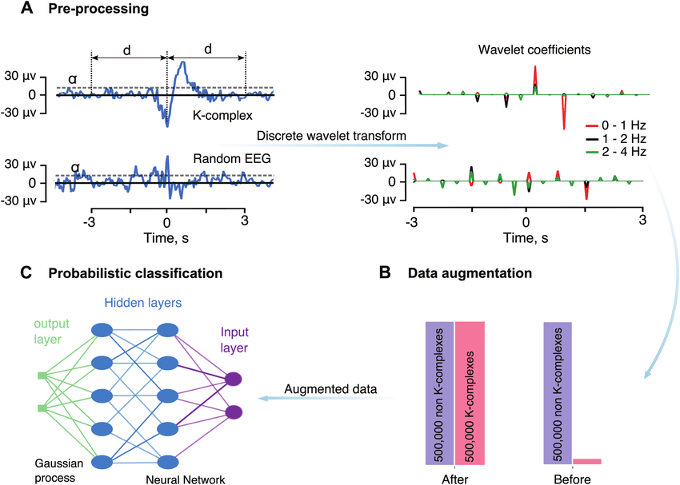
Figure 19: K-complex detection alghorithm workflow. (A) The pre-processing step using a DWT; (B) dataset balancing; (C) classification using DL and Gaussian processing. Adapted by Lechat et al., 2020 [276]. License ID: 1317540-1.

Statistical analyses
Latent Profile Analysis (LPA) is a statistical modeling approach for estimating distinct profiles of variables. LPA assumes that subjects can be typed with varying degrees of probabilities into categories (subpopulations) that have different configural profiles of personal and/or environmental attributes. From this approach, different parameters (means, variances, and covariances) are freely estimated across profiles, fixed to be the same across profiles, or constrained to be zero. We used tidyLPA [282] in RStudio statistical computing environment [283]. TidyLPA provides an interface to the powerful and widely-used Mclust package for Gaussian Mixture Modeling [284]. Different models can be specified and estimated. We chose the first proposed model, such as with equal variances, and covariances fixed to 0. This model is highly constrained but also parsimonious: the profiles are estimated in such a way that the variables’ variances are identical for each of the profiles, and the relationships between the variables are not estimated. In this way, less degrees of freedom are taken to explain the observations that make up the data. The package does not directly return the number of latent profiles, but it does offer several indices of goodness of fit statistics to choose latent classes as the most parsimonious model.
We used IBM SPSS Statistics 20 to implement general linear models [285]. One-way ANOVA was used to test the difference between Profiles implemented by tidyLPA. Repeated measures ANOVA was employed to evaluate the mean trend path of profiles (repeated measures ANOVA with profile membership as a between variable), and the effects of CBT-I across time (baseline and end-of-treatment). We implemented post-hoc analyses to verify differences in individual profiles over time (baseline and end-of-treatment). Bonferroni’s correction was administered for pairwise comparison in order to reduce the probability of a Type I error. To evaluate the agreement between visual and automatic scoring of K-complexes in insomnia patients, we used the Bland-Altman Plot and Inter Class Correlation Coefficient analyses with fixed rates and random subjects. Therefore, in order to predict treatment efficacy through the sleep homeostatic index assessed through the density of K-complexes, we used Pearson correlations. The statistical significance threshold was set at p < 0.05.

Results

Subjective and objective effectiveness of CBT-I
This part of the results concerns the aim according with to evaluate CBT-I efficacy through the analysis of both objective sleep (macro and microstructure), and subjectively reported sleep outcomes in the whole sample composed by 90 chronic insomnia patients enrolled in this multicentric study.
The following table shows the pre- and post-treatment means and standard deviations, as well as the statistical significance of the repeated-measures ANOVA.
 | BASELINE  Mean±SD | END OF TREATMENT  Mean±SD | Sig. p-value
SD SE | 71.281±16.803 | 84.138±11.41 | p<0.001**
SD TST | 351.764±86.164 | 360.971±71.425 | p=0.119
SD SOL | 39.315±39.978 | 19.793±14.255 | p<0.001**
SD NoA | 2.401±1.320 | 1.891±1.070 | p=0.003*
SD WASO | 60.612±43.516 | 32.980±39.192 | p<0.001**
SD TIB | 493.878±48.021 | 426.632±53.294 | p<0.001**
ISI | 16.966±3.413 | 8.978±4.543 | p<0.001**
PSG TIB | 509.356±101.716 | 470.433±96.712 | p<0.001**
PSG WASO | 79.433±57.012 | 55.772±44.609 | p<0.001**
PSG TST | 334.089±76.844 | 329.028±69.061 | p=0.481
PSG SOL | 32.606±40.181 | 24.711±36.330 | p=0.016*
PSG %NREM 1 | 7.531±5.494 | 6.967±6.049 | p=0.330
PSG %NREM 2 | 52.759±7.711 | 51.989±8.493 | p=0.392
PSG %NREM 3 | 17.856±9.775 | 18.369±9.200 | p=0.449
PSG %REM | 21.854±5.936 | 22.675±6.006 | p=0.256
PSG SE | 67.292±17.219 | 72.046±17.121 | p=0.002*
PSG Sstab | 0.820±0.070 | 0.840±0.067 | p=0.022*
Slow oscillation | 0.216±0.057 | 0.212±0.048 | p=0.426
Delta | 0.434±0.047 | 0.441±0.045 | p=0.068
Theta | 0.165±0.032 | 0.164±0.035 | p=0.702
Alpha | 0.092±0.033 | 0.090±0.033 | p=0.345
Sigma | 0.041±0.012 | 0.041±0.012 | p=0.316
Beta | 0.043±0.013 | 0.042±0.014 | p=0.042*
KC number | 295.978±190.796 | 293.133±185.073 | p=0.873
KC duration | 0.429±0.040 | 0.423±0.034 | p=0.029
KC PTP | 121.439±26.601 | 122.765±36.554 | p=0.621
KC slope | 321.083±68.218 | 327.895±87.569 | p=0.360
KCSlope | -4.828e-5±7.830e-5 | -3.767e-5±1.338e-4 | p=0.496
KC density | 1.755±1.076 | 1.742±0.983 | p=0.854
SW number | 319.828±290.863 | 308.609±290.787 | p=0.507
SW PTP | 107.303±10.528 | 106.559±10.863 | p=0.382
SW Slope | 394.401±60.152 | 391.331±50.966 | p=0.500
SW density | 5.365±6.178 | 4.582±3.391 | p=0.178
SS number | 293.289±235.357 | 292.622±252.113 | p=0.969
SS duration | 0.799±0.064 | 0.807±0.067 | 0.086
SS amplitude | 53.525±11.265 | 52.889±12.000 | p=0.401
SS density | 1.578±1.060 | 1.642±1.244 | p=0.393
Table 7: Mean and standard deviations (SD) of sleep diaries (SD), polysomnographic (PSG), relative bands power, k-complex (KC), slow waves (SW) and sleep spindles (SS) indices at the baseline and at the post-CBT-I treatment. Abbreviations: ISI, Insomnia Severity Index; SE, Sleep efficiency; TST, Total sleep time; SOL, Sleep onset latency; NoA, Number of awakenings; WASO, Wake after sleep onset; TIB, Time in bed; NREM, Non-rapid eye movement sleep; REM, Rapid eye movement sleep; %, percentage; Sstab; sleep stability index by means of the transition matrix; KCSlope, the slope of the linear equation of the KC density calculated in each NREM stage 2 epoch.
At this point, we explore specifically the improvement to CBT-I therapy subjectively reported, as well as objectively detected both micro-structurally and macro-structurally assessed.

CBT-I treatment subjective effectiveness
All subjectively reported indices at post-treatment displayed an amelioration except for TST sleep diaries. Insomnia severity index displayed us 58.43% of responder ID patients (ISI decrease ≥ 8) and 41.57% of remitters ID patients (ISI end-of-treatment < 8) [262].
Figure 20: Means and standard deviations of sleep diaries indices (SD) pre- and post-treatment. Error bars represent standard errors. Abbreviations: ISI, Insomnia Severity Index; SE, Sleep efficiency; TST, Total sleep time; SOL, Sleep onset latency; NoA, Number of awakenings; WASO, Wake after sleep onset; TIB, Time in bed.

CBT-I treatment objective effectiveness

Macro-structural objective indices
Moreover, objective CBT-I efficacy indices showed differences between pre- and post-treatment as shown in the figure.

Figure 21: Means and standard deviations of polysomnographic (PSG) macro-structural indices pre- and post-treatment. Error bars represent standard errors. Abbreviations: SE, Sleep efficiency; SOL, Sleep onset latency; WASO, Wake after sleep onset; TIB, Time in bed; Sstab; sleep stability index by means of the transition matrix.

Micro-structural objective indices
In the whole sample sleep graphoelements indices didn’t show ameliorations after treatment. On the other hand, the Beta band relative power showed a statistically significant decrease after treatment (p=0.042), and the Delta band relative power showed a non-significant increase tendency after treatment (p=0.068).
Figure 22: Means and standard deviations of Beta and Delta EEG bands relative power indices pre- and post-treatment. Error bars represent standard errors.

Neurophysiological insomnia phenotypes to predict CBT-I outcomes
The other goal of this Ph.D. project is to predict the effectiveness of the treatment, specifically identifying neurophysiological phenotypes of ID that may predict outcomes to CBT-I.
There is a lack of literature evaluating the predictive role of K-complex indices with respect to the efficacy of CBT-I. For this reason, we first explore the predictive function of the k-complexes and subsequently, due to the large amount of variables assessed, we use a latent profiles analysis in order to explore the insomnia patients' heterogeneity, and subsequently assess their response to treatment.

Agreement between visual and automatic K-complex scoring
Before describing the K-complex results, in order to compare the visual scoring of K-complexes with automatic scoring in insomniac patients, the following analyses show the degree of agreement between the two indices in a subsample of our study. KC is a high-amplitude bi-triphasic EEG graphoelement usually detectable when it reaches its maximal amplitude over the frontal regions during NREM sleep stage 2. It is characterized by a negative sharp wave immediately followed by a positive component [248]. The standard criteria suggested a minimum duration of 0,5 seconds and maximum of 3 seconds [249], and a peak-to-peak amplitude ≥75 μV [277]. The KC detection, however, is time-consuming (about a day's work to score a subject's night), so to limit the mismatch between different scorers a valid algorithm was executed [276]. For this reason, our research group tried to use different tools to detect KCs. Authors have often implemented algorithms to detect different waves, especially slow wave sleep, but rarely to detect KC. Bastien Lechat and colleagues produced a tool [276] differentiating slow waves and KC. Therefore, we tested Lechat’s algorithm by comparing it to a subsample of our insomnia patients visually KC scored by a sleep specialist.
Going into further detail, 18 chronic ID patients were assessed with a PSG. A sleep specialist detected the traces by using EDFbrowser (https://www.teuniz.net/edfbrowser/). The outcome was KC density in the whole night (by the ratio between the number of K-complexes and the duration of stage 2 in minutes). We compared the KC density in all patients between the visual and the automatic scoring.

Figure 23: K-complex densities both by Lechat algorithm and visual scoring.

In addition, we correlated the two measurements (r = 0.875; p < 0.001).
Figure 24: Scatter plot correlation between K-complex densities scored both by visual scoring and Lechat algorithm.

The Bland-Altman Plot visually indicated a good agreement between the two outcomes.
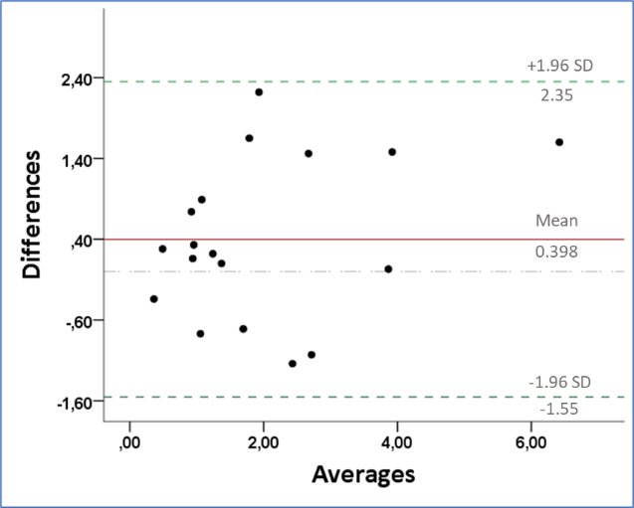
Figure 25: Bland-Altman Plot of the agreement between K-complex densities between visual and Lechat algorithm scoring.

Results showed the non-significance of the Linear Regression with the difference between two outcomes as a dependent variable, and the mean between measurements as a predictor (p = 0.209). Indeed, we could accept the non-hypothesis, with no proportional bias.
The Inter Class Correlation Coefficient analyses, specifically a two-way mixed analysis (fixed raters and random subjects), with an absolute agreement model, showed a great-to-excellent agreement between the visual scoring and Lechat’s algorithm detecting K-complex density in insomnia patients (ICCC single measures = 0.789; ICCC mean measures = 0.882).
In summary, Lechat's algorithm [276] has not only been validated in the literature and effectively differentiates KC from slow waves, but has also proven consistent in detecting KC density in 18 chronic insomnia patients compared to an expert visual scoring.

Predictive role of K-complexes in CBT-I outcomes
No significant correlations were found between baseline Slow oscillation relative power and improvements pre- and post-treatment in ISI, SE both subjectively (SD_SE) and objectively (PSG_SE) reported. Unexpectedly, Delta band relative power at the baseline showed a significant negative correlation with SD_SE, possibly indicating a lack of necessity of sleep pressure (Process S) in insomnia patients with high ratings of Delta power (r=-0.218, p=0.042). Interestingly, KC density is negatively correlated with the variable KCSlope, determined by the slope of the linear equation of the KC density calculated in each NREM stage 2 epoch. Specifically, this index is more negative, the greater the sleep pressure present in the subject. This finding suggests a link between the protective function of KCd and the homeostatic function of KCd over the course of the night. In addition, KCSlope is not correlated with improvements in ISI, however, it revealed a negative significant correlation with improvements in SE both objectively assessed by PSG (r=-0.411, p<0.001) and subjectively reported by sleep diaries (r=-0.355, p<0.001). Specifically, more sleep pressure at the baseline, evaluated with KCSlope, was linked with more improvements in SE, both objectively and subjectively reported.
Figure 26: Scatter plots of the correlations between KC density slope along the night (KCSlope) at the baseline, and improvements in sleep efficiency (SE) both objectively assessed by polysomnography and subjectively reported by sleep diaries.

No results were found correlating the delta value (KCSlope pre – KCSlope post = improvement) of the KCSlope, and the delta value (SE post – SE pre = improvement) of the sleep efficiency subjectively reported by sleep diaries.

Latent Profiles in insomnia patients
Insomnia Disorder is characterized by a high degree of phenotypic heterogeneity, which might influence treatment response [237], [238], in addition, due to the large number of variables assessed, we decided to use an all-inclusive analysis in order to assess the heterogeneity of insomnia patients. For this reason, we computed the Latent Profile analyses (LPA) to evaluate different profiles in ID at pre-treatment and reveal the different possible trajectories of CBT-I effectiveness. We used the sequent representative variables at the baseline: SE by diaries, SE by PSG, ISI total score, all band power evaluated (Slow oscillation, Delta, Theta, Alpha, Sigma, Beta), Sleep Stability index and densities of KC, SW and SS. As a result of Latent Profile Analysis, we chose 3 profiles as the most parsimonious model in terms of the minimum Akaike information criterion (AIC), and minimum Bayesian information criterion (BIC) criteria.
Classes | AIC | BIC | Entropy | Prob min | Prob max | N min | N max | BLRT p
1 | 3617.65 | 3687.64 | 1.00 | 1.00 | 1.00 | 1.00 | 1.00
2 | 3507.08 | 3614.57 | 0.88 | 0.96 | 0.98 | 0.37 | 0.63 | 0.01
3 | 3436.58 | 3581.57 | 0.91 | 0.93 | 0.98 | 0.21 | 0.44 | 0.01
4 | 3444.28 | 3626.77 | 0.87 | 0.81 | 0.99 | 0.18 | 0.33 | 0.68
5 | 3446.89 | 3666.88 | 0.89 | 0.83 | 0.98 | 0.08 | 0.32 | 0.27
Table 8: Fit indices in the first five profiles by means of Latent Profile Analyses. AIC: Aikake information criterion; based on -2 log-likelihood, and penalized by number of parameters. BIC: Bayesian information criterion; based on -2 log-likelihood, and penalized by number of parameters adjusted by sample size. Entropy: A measure of classification uncertainty, reverse-coded so that 1 reflects complete certainty of classification, and 0 complete uncertainty. Prob. Min.: Minimum of the diagonal of the average latent class probabilities for most likely class membership, by assigned class. The minimum should be as high as possible, reflecting greater classification certainty (cases are assigned to classes they have a high probability of belonging to. Prob. Max.: Maximum of the diagonal of the average latent class probabilities for most likely class membership, by assigned class. The maximum should also be as high as possible, reflecting greater classification certainty (cases are assigned to classes they have a high probability of belonging to). N Min.: Proportion of the sample assigned to the smallest class (based on most likely class membership). N Max.: Proportion of the sample assigned to the largest class (based on most likely class membership). BLRT p-value: p-value for the bootstrapped likelihood ratio test.

Statistically significant differences were found in terms of Center membership derivation between profiles (X² p<0.001). X² significance in the contingency table of the three profiles percentages in the four centers suggests differences in LPA membership percentages between derivation centers.
In order to explore the results, we implemented a profile plot by showing the bars reflecting a confidence interval for the class centroids and boxes reflecting the standard deviations within each class; a box encompasses +/- 64% of the observations in a normal distribution. Raw data, whose transparency is weighted by the posterior class probability, such that each datapoint is most clearly visible for the class it is most likely to be a member of.
Figure 27: Profile plot by showing the bars reflecting a confidence interval for the class centroids and boxes reflecting the standard deviations within each class. Abbreviations: BL, Baseline indices; SD, Sleep diaries; PSG, Polysomnography; SE, Sleep efficiency; Slow, relative slow oscillation band power; Delta, relative delta band power; Theta, relative theta band power; Alpha, relative alpha band power; Sigma, relative sigma band power; Beta, relative sigma band power; KC, K-complex; SW, slow wave; SS, sleep spindle; Sstab; sleep stability index by means of the transition matrix; d, density.

In addition, we implemented a density plot that represented, for each variable, a total density plot, along with separate density plots for each latent class, where cases are weighted by the posterior probability of being assigned to that class.

Figure 28: Density plot with for each variable examined a total density plot for each latent class. The cases were weighted by the posterior probability of being assigned to the profile. Abbreviations: BL, Baseline indices; SD, Sleep diaries; PSG, Polysomnography; SE, Sleep efficiency; Slow, relative slow oscillation band power; Delta, relative delta band power; Theta, relative theta band power; Alpha, relative alpha band power; Sigma, relative sigma band power; Beta, relative sigma band power; KC, K-complex; SW, slow wave; SS, sleep spindle; Sstab; sleep stability index by means of the transition matrix; d, density.

The first insomnia Profile composed by 40 patients displayed 48.38 ± 11.24 years and 72.5% female. Profile 2 of 19 ID patients showed 58.84 ± 8.52 years and 78.95% female. The third Profile of 31 ID patients was 45.42 ± 13.95 years old and presented 64.52% females. Profile 2 showed the highest age in comparison with other classes (p<0.001). However, no differences between profiles were found in terms of gender (X²=0.532).

Profile 1
The first insomnia profile revealed showed the highest TST objective evaluated (p=0.014), and the lowest WASO (p=0.016) by PSG at the baseline, in comparison with the other two profiles. On the other hand, similarly to profile 2, the first Profile showed low decrease of KCd along the night, differently from profile 3 (KCSlope p=0.032) at the baseline. On the other hand, Profile 1 showed the highest rating of Delta power (p<0.024). Moreover, again according with profile 2, the first Profile displayed high misperception index both evaluated by TST and SE, in comparison with profile 3 (MITST p<0.001; MISE p<0.001).

Profile 2
The second profile, aside from being the oldest profile (p<0.001), displayed less SE, TST and highest WASO subjectively reported by sleep diaries in comparison with other profiles (SE p=0.010; TST p=0.029; WASO p=0.017). This profile is mainly characterized by microstructural dysfunction revealed by band power analyses. Specifically, Profile 2 showed the lowest amount of Slow oscillation relative power (2vs3 p<0.001, 2vs1 p=0.079), the lowest relative power Delta band (2vs1 p<0.001; 2vs3 p=0.003), the highest amount of Alpha relative band (p<0.001) and Sigma (p<0.001). In accordance with Profile 1, the second profile showed the highest rating of Misperception indices evaluated both by TST and SE in comparison with Profile 3 (p<0.001).

Profile 3
The third profile showed the highest TIB recorded by PSG compared to other profiles (p=0.001), high WASO in comparison with profile 1 (p<0.001), and the highest amount of SOL in comparison with other profiles (p<0.001), objectively assessed by PSG. Accordingly, Profile 3 showed the lowest rating of SE recorded by PSG in comparison with other profiles (p<0.001). On the other hand, this profile showed a high rating of Slow oscillation (p<0.001) and Delta band power (p=0.024), and low Theta (p<0.001). Coherently with the lower bands’ findings Profile 3 showed the highest indices of number of KC (p<0.001), KC PTP (p<0.001), KC mean slope (p=0.005), KCd (p<0.001), SW PTP (p=0.015) and SW d (p=0.002) in comparison with other profiles. Profile 3 showed the lowest mean of KCSlope index along the night in comparison with profile 1 (p<0.032), suggesting high sleep drive (Process S). In addition, this profile showed a lower rate of Misperception index evaluated both by TST and SE (p<0.001) in comparison with other profiles.
Based on the previous results, shown by the statistical differences between the profiles at the baseline, the three profiles were labeled as follows:
Profile 1: “Minor severity, misperceptions with no objective sleep deficits”.
Profile 2: “Subjective severity, misperceptions with micro-structural deficits”.
Profile 3: “Objective macro-structural severity, with no micro-structural deficits”.

Latent Profiles in CBT-I effectiveness
At this point in order to assess the maintenance or modification of these characterizations, we evaluated the treatment effectiveness trajectories of the three profiles.
Repeated measures ANOVA was employed to evaluate treatment outcomes trajectories (pre- post-CBT-I) between latent profiles revealed (with profile membership as a between variable).
Profile membership, revealed by means of LPA, shows that Profile 2 differs from the other two profiles in the overall linear mixed effects model shown by the indices of SE (p=0.007), TST (p=0.018) and WASO (p=0.028), suggesting mean differences between profiles. On the other hand, the means post-treatment in all subjectively reported variables (SE, TST, SL, WASO, TIB and ISI) show no significant differences between the profiles, as shown in the following figure.
Figure 29: Means and standard errors in three latent profiles of Sleep Efficiency (SE), Total Sleep Time (TST), Sleep Latency (SL), Wake After Sleep Onset (WASO) and Time in bed (TIB) in sleep diaries indices, as well as Insomnia Severity Index (ISI) pre- and post-treatment (tx). Error bars represent standard errors. *p<0.05, **p<0.001. Bonferroni’s correction was administered for pairwise comparison in order to reduce the probability of a Type I error.

Macrostructural indices show that the profile LPA membership variable calculated with baseline indices has statistical weight in the linear mixed models at TIB, WASO, TST, SOL and SE (p<0.001). On the other hand, post-hoc comparisons show us that profile 3 maintains its highest indices at TIB both before and post-treatment. The WASO polysomnographic index shows that profile 1 although with lower averages than the other profiles at the beginning of treatment (p=0.032), at the end of CBT-I differs only from profile 3 (p=0.005). The TST index shows statistically significant differences at baseline exclusively between profile 3 and profile 1 showing a lower mean of profile 3 (p=0.001). These differences disappear post-treatment (p=n.s.). The objective index of SOL shows that profile 3 maintains higher mean values than the other profiles both pre-treatment (p<0.001) and post-treatment (p=0.003) at the post-hoc comparisons. Similarly, the SE index also shows that profile 3 maintains more severe mean values at post-hoc comparisons than the other two profiles both at baseline (p<0.001) and post-treatment (p<0.001).
Figure 30: Means and standard errors in three latent profiles of Sleep Efficiency (SE), Total Sleep Time (TST), Sleep Latency (SL), Wake After Sleep Onset (WASO) and Time in bed (TIB) assessed by polysomnography pre- and post-treatment (tx). Error bars represent standard errors. *p<0.05, **p<0.001. Bonferroni’s correction was administered for pairwise comparison in order to reduce the probability of a Type I error.

Also relative power bands show some differences between profiles. The relative power of the slow oscillation band shows profile 3 differing significantly between the profiles both pre-treatment (p<0.001) and at the end (p=0.023), showing higher outcomes. On the other hand, the relative power of the Delta band shows that profile 2 differs at post-hoc comparisons both before (p=0.013) and after CBT-I treatment (p=0.002), displaying the most severe phenotype.
Figure 31: Means and standard errors in three latent profiles of slow oscillation relative band power (SO) and Delta relative band power assessed by polysomnography pre- and post-treatment (tx). Error bars represent standard errors. *p<0.05, **p<0.001. Bonferroni’s correction was administered for pairwise comparison in order to reduce the probability of a Type I error.

Post-hoc comparisons also show that the Theta, Alpha and Sigma bands statistically significantly differentiate the three profiles. Specifically, profile 3 shows lower values at the relative power of Theta band both before (p=0.001) and after treatment (p=0.012) in comparison to the other two profiles. In addition, profile 2 maintains higher indices in comparison with the other profiles both pre-treatment (p<0.001) and at the end (p<0.001) both at the relative power of Alpha band and in Sigma band. On the other hand, the relative power of Beta band, while showing significant improvement following treatment in the total sample (p=0.023), shows no significant difference between the profiles.
Figure 32: Means and standard errors in three latent profiles of theta relative band power, Alpha relative band power, Sigma relative band power and Beta relative band power assessed by polysomnography pre- and post-treatment (tx). Error bars represent standard errors. *p<0.05, **p<0.001. Bonferroni’s correction was administered for pairwise comparison in order to reduce the probability of a Type I error.

Furthermore, the values of graphoelements densities show that the LPA profile membership variable calculated with baseline indices has statistical weight in the linear mixed models for both K-complexes and Slow waves (p<0.001), but not for Sleep Spindles (p=0.462). On the other hand, post-hoc comparisons show that KC density reveals that profile 3 maintains higher values than the other profiles both before (p<0.001) and following CBT-I (p<0.001). SW densities show that profile 3 has higher indices at baseline (p<0.001), and these differences between profiles disappear following treatment (p=0.077).
Figure 33: Means and standard errors in three latent profiles of K-complex (KC), Slow waves (SW) and Sleep Spindles (SS) densities (d) pre- and post-treatment (tx). Error bars represent standard errors. *p<0.05, **p<0.001. Bonferroni’s correction was administered for pairwise comparison in order to reduce the probability of a Type I error.

Discussion
This Ph.D. project aimed to evaluate subjective (ISI and sleep diaries), but also objective indices (macro- and micro-polysomnographic indices) pre- and post-treatment, in an attempt to reveal the heterogeneity of insomnia disorder, as well as predict and evaluate CBT-I effectiveness, assessing 90 chronic insomnia patients (49.57±12.67 years; 71.11% females).
More specifically, we had a first objective of evaluating the subjective and objective effectiveness of the treatment in the whole sample; i.e., to evaluate CBT-I efficacy through the analysis of both objective sleep (macro and microstructure outcomes), and subjectively reported sleep indices. And second aim is to predict the effectiveness of the treatment, specifically identifying neurophysiological phenotypes of ID that may predict outcomes to CBT-I.
According to the first aim, all subjectively reported indices at post-treatment displayed an amelioration (SE, SOL, NoA, WASO, TIB and ISI), except for TST in sleep diaries. Moreover, objective CBT-I efficacy indices showed improvements after treatment (SE, SOL, WASO, TIB and Sleep Stability index). Microstructural sleep quantitative results suggested a statistically significant decrease after treatment of Beta band relative power, and Delta band relative power showed a non-significant tendency to increase after treatment. Graphoelements indices, however, did not display ameliorations after treatment. On the other hand, KCSlope revealed a negative significant correlation with improvements in SE both objectively assessed by PSG and subjectively reported by sleep diaries. Specifically, more sleep pressure at the baseline, evaluated with KCSlope, was linked with more improvements in SE, both objectively and subjectively reported, suggesting the role of the KC homeostatic function as a reliable biomarker of CBT-I efficacy outcomes, potentially identifying neurophysiological phenotypes.
To explore the second objective, i.e., evaluate insomnia heterogeneity and the consequent treatment efficacy differences, we implemented Latent Profile Analysis, and we revealed 3 latent Profiles based on the most representative objective and subjective sleep variables at the baseline.
We labeled profile 1 as “Minor severity, misperceptions with no objective sleep deficits”, profile 2 as ”Subjective severity, misperceptions with micro-structural deficits” insomnia profile, and the third labeled as “Objective macro-structural severity, with no micro-structural deficits” insomnia profile, based on the specific characteristics of the profile at baseline, in contrast to the others.
Evaluating the differences between profiles in treatment trend trajectories, in regards to the effect of CBT-I, the subjectively reported variables, while differing at the start of treatment between the profiles showed no more statistically significant differences post-CBT-I.
On the other hand, macro-structural indices showed us that the third profile maintains its higher severity at macro-structural indices in contrast to the other profiles, given by higher pre- and post-treatment levels of TIB and SOL, and lower SE indices both before and at the end of CBT-I.
In addition, relative powers in different frequency bands also showed differences between the profiles. The third profile maintained less severe levels shown at baseline than the other profiles even post-treatment, shown by higher indices at the Slow Oscillations band and lower values in Theta band even post-CBT-I.
Thus, the second profile maintained low levels of power relative to the Delta band, and high levels of Alpha and Sigma post-treatment, suggesting a more severe profile at both the slower and fast frequency bands.
The unique graphoelement index that maintained significant differentiation even post-treatment among the profiles appears to be K-complex density. Specifically, the third profile maintains high levels of K-complexes densities even post-treatment, in comparison with the other profiles.
In summary, this multi-centric, large sample, Ph.D. study project reported the subjective, as well as the objective effectiveness of the first-choice treatment for chronic insomnia, the CBT-I; while also proposing data-driven approaches in order to explore insomnia heterogeneity and the resultant treatment efficacy differences.
Several reviews and meta-analyses have been focused on CBTI efficacy. Literature suggested that CBT-I is effective [188]–[193] both in primary [194] and in comorbid insomnia [195], [196]. Most studies, however, have focused on the assessment of subjective sleep indices in order to evaluate their effectiveness. Van Straten and colleagues [197], evaluating 87 randomized controlled trials, found the effectiveness of CBT-I to be quite evident, especially in Insomnia Severity Index outcome, which showed the most amelioration, followed by SL and SE. Our findings were consistent with the literature, displaying an amelioration in all subjectively reported indices at post-treatment, except for TST.
The European and United States guidelines suggest a subjective assessment to diagnose insomnia disorder, indicating that sleep objective evaluation is not mandatory [1], [2]. For these reasons, most studies did not evaluate objective sleep indicators in insomnia patients. However, objective evaluation might provide crucial information regarding nocturnal sleep, while also revealing other pathologic diseases in insomnia disorder patients [80]–[82].
A recent meta-analysis showed that sleep macro-structural indices assessed both by polysomnography and actigraphy did not seem to improve after treatment, such as Sleep latency, Wake after sleep Onset, Sleep efficiency and Total Sleep Time. It must be noted, however, that very few studies incorporated PSG measurement [161]. For actigraphy, where we had more comparisons, there was a small reduction in effect for SL.
Our research held very different findings: objective CBT-I efficacy indices revealed improvements after treatment in Sleep Efficiency, Sleep latency, Wake after sleep onset, Time in bed and a Sleep Stability index (the mean probability to remain in 2, 3 NREM and REM sleep stages) objectively assessed.
Regarding micro-structural indices, on the other hand, in the literature there were already promising results of objective evaluation of the effectiveness of CBT-I therapy.
Cervena and colleagues [83] in a 2004 study came to two relevant conclusions regarding the effects of CBT-I: first, that a decrease in high EEG frequencies may have a positive eﬀect on CNS hyperarousal, and second, that an increase in Slow Waves Activity leads to higher sleep pressure and therefore more efficient homeostatic sleep regulation. In accordance with this, Delta band relative power in our sample showed a non-significant tendency to increase after treatment. Hogan and colleagues [41] demonstrated high-frequency EEG power activity (sigma and beta) reduced following the treatment. Coherently, we revealed a statistically significant decrease after the treatment of the Beta band relative power. These findings inform the pathophysiology of insomnia, including the mechanisms underlying CBT-I in older adults, highlighting the increase of the homeostatic sleep system (Process S). However, graphoelements indices across the whole sample did not display ameliorations after treatment.
Literature suggested that insomnia patients displayed a slower rate in overnight delta decline compared to healthy controls, which is not explained by differences in total sleep time or wake after sleep onset [42]. The Authors interpreted these findings as insomnia patients having a relative deficit in initial “sleep drive”, as manifested in lower initial NREM EEG delta power and less rapid decline of delta power over time. The same research group did, in fact, show that CBT-I led to a more rapid decline (the slope became more negative) in EEG delta power over the night. This change is interpreted as the therapeutic effect of CBT-I, which appears to occur in conjunction with an increase in homeostatic sleep drive [43]. Thus, we evaluated the “sleep drive” throughout the homeostatic KCd function along the night (the night slope of KCd, i.e., KCSlope), and our results displayed that the higher sleep pressure at the baseline (evaluated with KCSlope) was linked with more improvements in SE, both objectively and subjectively reported.
CBT-I effectiveness has been proven to be greater in the long term with fewer side effects in comparison to pharmacotherapy [46], [146], [286], [287]. Nevertheless, it has been reported that up to 40 percent of patients do not achieve remission after treatment [202], [288]. Several research groups interpreted this lack of effectiveness as a consequence of neurophysiological and clinical heterogeneity of insomnia disorder patients [113], [238]. To investigate insomnia heterogeneity several research groups implemented data-driven analyses, revealing multiple insomniacs subtypes [113]. Therefore, in trying to evaluate insomnia heterogeneity and the subsequent treatment efficacy differences, we revealed 3 latent profiles by means of Latent Profile Analysis.
Vgontzas and colleagues have investigated the value of objective TST for phenotyping ID [107], [108] challenging the current guidelines, which claim that PSG assessment is not useful in the evaluation of ID [77]. This research group described an ID phenotype called short sleeper (TST < 6h) characterized by physiological hyperarousal, high rates of comorbidity, significant medical consequences and a non-remitting course [107]–[109], [289]. This was put in contrast with the normal sleeper (TST ≥ 6h), characterized by sleep misperception with no physiological arousal, cortical and cognitive-emotional arousal, anxious-ruminative psychological profile, a possible remission over time and no significant medical sequelae [28], [107]–[109], [290]. Although there is a considerable amount of research in this area in the literature, the results are inconsistent: other studies report no significant differences between these two phenotypes in terms of treatment efficacy [203], [291]–[293]. In summary, for these reasons, the TST index alone has proven to be an inconsistent marker, and insufficient in predicting the outcome of CBT-I [238]. However, pushing this research line further, LPA revealed a subtype of insomnia patient characterized by high level of misperception and long TST objectively reported, the “Minor severity, misperceptions with no objective sleep deficits” insomnia profile. At this point the line of research pursued by Vgontzas and colleagues could be confirmed as useful not for describing the totality of the heterogeneity of insomnia patients, but rather a subset of them. Given the less severe condition of this specific phenotype, we propose that the Brief Therapies for Insomnia (an abbreviated version of CBT-I emphasizing the behavioral components, typically 1–4 sessions) might have a cost-benefit advantage [208].
On the other hand, studying the mismatch between objective and subjective TST, Lecci and colleagues evaluated sleep perception in a population-based sample, composed of 2,092 individuals who underwent a full PSG at home and estimated TST the next day [294]. The results indicated that a shift from low to high frequency (power spectral) in center-posterior brain regions, not evident in conventional PSG parameters, is associated with an underestimation of sleep duration (misperception). This challenged the concept of sleep misperception. In fact, insomniac patients may correctly perceive mild shifts to wakefulness, which are not reflected in standard PSG parameters. Our results are consistent with the hypotheses and results of previous research. LPA analysis revealed a profile of insomniac patients characterized by high indices of misperception and severe indices subjectively reported, which were, however, not consistent with macro-structural indices objectively detected by polysomnography. On the other hand, this sub-sample of insomniacs showed us that while the macro-structural indices did not report a significant deficit, the quantitative indices (frequency bands in relative power) detected an objective deficit. In addition, this profile showed more severe indices also post-treatment, in microstructural band power indices, maintaining lower rates of Delta band relative power pre-post-treatment, as well as higher Alpha and Sigma bands in comparison with other Profiles. In line with neurocognitive models, which suggest that subtle EEG changes such as elevated beta activity could precede subjective sleep complaints [40], and coherently with Hogan and colleagues [41], we revealed an effect of CBT-I on high EEG band power, quantitative analyses of objective sleep could prove informative in order to evaluate insomnia treatment. In addition, given that beta/gamma activity is consistently associated with cognitive processes [35], an increased number of sessions of the cognitive subcomponent of CBT-I, or adding specific psychotherapy treatment implemented for worry and rumination (Meta-Cognitive Therapy) [295], coherently with the attention-intention-effort pathway [68], may prove very effective in the ”Subjective severity, misperceptions with micro-structural deficits” insomnia profile.
Micro-structural sleep indices, i.e., graphoelements and quantitative analyses ended up being crucial in describing the etiopathogenesis of insomnia disorder. ID patients with altered spindle activity might constitute an insomnia subtype, defined by a neurophysiological vulnerability to sleep disruption linked to reduced responsiveness to CBT-I [84]. In addition, CBT-I may have a favorable eﬀect on CNS hyperarousal by decreasing high EEG frequencies and enhancing sleep pressure improving homeostatic sleep regulation by increasing Slow Waves Activity [41], [83]. However, there is considerably less agreement on the specific function of KC in insomnia patients. Wauquier and colleagues observed a less frequent occurrence of KC among insomniacs [253], while Bastien observed no significant difference between ID and good sleepers on both number and density of KC in NREM sleep stage 2 [254]. Nevertheless, Literature showed us that KC seems to act as a forerunner of slow wave activity [239]–[244], [251], and a sleep-protecting phenomenon, by promoting sleep [240], [245], [246] and preventing arousals [247], [252] in the general population. Following these findings, we interpreted the high rating of Slow oscillation and Delta band power, the highest indices of KCd, SWd and the lowest KCSlope index, in the third profile labeled as “Objective macro-structural severity, with no micro-structural deficits” insomnia profile, as a protective sleep micro-structural features in this insomnia phenotype. On the other hand, the worst macro-structural sleep indices shown recorded by PSG could lead the clinician to administer drug therapy to the subject, still widely used [142], which could induce abuse and, in the long-term a marked depression of slow-wave activity and physiological instability [296]. Profile 3 showed more severe macro-structural indices also post-treatment (TIB, SL and SE), nevertheless less severe microstructural power indices (Slow oscillation and Theta) and microstructural graphoelements index (K-complex density) maintained higher pre-post-treatment in comparison with other insomnia profiles. If these results are replicated in other studies, the use of promising new drugs may be useful in order to reduce macro-structural indices as well, although it is too early to have a clear picture of their objective effects [297], [298].
In evaluating the differences between profiles in treatment efficacy trajectories, subjectively reported variables do not maintain the differentiation between profiles. On the other hand, some objective indices maintain post-treatment differentiation. These results would suggest the usefulness of objective assessment not only pre-treatment but also at the end, in order to add additional individualized treatments based on patients' characteristics. The literature has introduced a more severe phenotype of insomnia patient characterized by reduced total sleep time [107]. However, the outcome of CBT-I treatment in these patients appears to be much more debated [238]. Our results showed that indices such as SL, TIB and SE, objectively assessed by PSG, seem to be more effective in detecting a more severe phenotype not only pre-treatment but also in terms of treatment outcome. This may be meant to suggest that the subject's behavior (TIB and thus SE), rather than solely the subject's sleep (TST), may be more effective in detecting macro-structurally physiological hyper-arousal patients, and thus a more adverse course of the treatment. Intervention in these patients on the one hand it might be useful to propose a more strict CBT-I behavioral treatment, or with a greater focus on adherence; on the other hand, silencing the excessive activity of the arousal system through orexin receptor agonist pharmacotherapies could intervene on the remaining macro-structural objective indices not in remission in these patients [298].

Limitations
Despite the interesting results, there are some limitations to highlight. The following multicenter study included patients treated with standard CBT-I protocol [163]–[165], as well as PSG montages strictly according to the most up-to-date guidelines [259]. Significant differences, however, were found in terms of derivation center membership among the profiles revealed by LPA analysis. This finding could mean that the extracted classes, as well as the resulting differences, should derive from inconsistencies between centers (e.g., cultural, social and economic) rather than characterizations of the heterogeneity intrinsic in chronic insomnia disorder.
A further limitation originates from the fact that the misperception indices, which were useful in describing the 3 classes as well as revealing the differences in efficacy among them, were calculated through objective and subjective indices discrepant with each other in terms of date: the polysomnography was administered within a month from the start of therapy, while the sleep diaries were started within a week, thus the discrepancy. In this case assessing the fluctuation of these indices over time in our sample could have been useful in weighting the indices of misperception.
In order to speculate on the results obtained, we hypothesized different intervention types, or intervention components, in the discussions, in order to treat the different profiles. An additional limitation of this study was not assessing the specific effectiveness of the subcomponents of the CBT-I protocol. It needs to be said, however, that this would have complicated the experimental design by adding more arms to the protocol, likely reducing the sample size.
In addition, despite promising data regarding REM sleep indices [44], [45] in literature, specific REM sleep analyses were not implemented, which might have proven useful not only to differentiate the insomnia sample at baseline, but also to evaluate the effectiveness of CBT-I therapy.

Conclusions
Taking these limitations into account, the following research project has demonstrated that although to date objective sleep index measurements have not been mandatory for diagnostic and treatment purposes in insomnia patients, the use of both objectively reported and subjective assessments can not only highlight the effectiveness of treatment, but also reveal the heterogeneity intrinsic in insomnia patients. Results showed us that the treatment of choice for chronic insomnia has an effect on both subjective and objective macrostructural indices. In addition, quantitative analyses as well as automated algorithms can help us detect micro-structural indices useful in adding information for diagnostic purposes as well as treatment efficacy evaluation.
Future studies could contribute to the omni-comprehensive analyses of this dissertation in a few ways, such as assessing specific indices in the micro-structural assessment of REM sleep (i.e., eye movements and arousals), or evaluating the sub-components of CBT-I treatment (and/or evaluating new, such as Meta-Cognitive Treatment), revealing the specific efficacy of each technique. The ultimate goal would be to use a cost-effective protocol, tailoring the therapy to the patient's characteristics, taking into account the heterogeneity of the insomnia disorder.
A stepwise care model for the administration of CBT-I has been proposed in the literature [299]. Digital CBT offers a treatment that is accessible to all patients with an excellent cost-benefit ratio. However, if needed, this could be supplemented by in-person and/or group therapy. This model also integrates a step dedicated to more complex and/or treatment-resistant patients. In this case, the intervention of a more specialized and experienced clinician will be necessary.
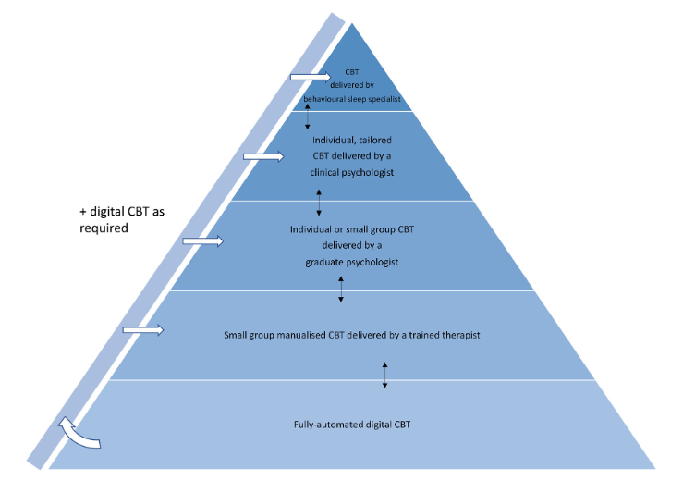
Figure 34: Stepped care model. Adapted by Riemann et al., 2022 [299]. Abbreviations: CBT-I, Cognitive-behavioral therapy for insomnia. License ID: 1317541-1.

In order to assess the level of preparation and, therefore, training that the clinician must have (based on the patient's characteristics) we could refer to the model proposed by Baglioni et al. [142].
Taking into account our results and the aim of tailoring treatment on patients’ heterogeneity, we proposed that for insomnia patients characterized by “Minor severity, misperceptions with no objective sleep deficits”, the Brief Therapies for Insomnia (an abbreviated versions of CBT-I emphasizing the behavioral components) might have a cost-benefit advantage [208]. On the other hand, proposing to the ”Subjective severity, misperceptions with micro-structural deficits” insomnia profile an increased number of sessions of the cognitive subcomponent of CBT-I, or adding specific psychotherapy treatment implemented for worry and rumination (Meta-Cognitive Therapy) [295], coherently with the attention-intention-effort pathway [68], could result very effective. In addition, patients that could be labeled as “Objective macro-structural severity, with no micro-structural deficits” could benefit from a more strict CBT-I behavioral treatment, a greater focus on patient adherence, as well as from promising new pharmacological treatments [297], [298].
In summary, this Ph.D. project displayed the effect of the treatment of choice for chronic insomnia, by both evaluating subjectively reported indices and detecting objective effects. In addition, data-driven analyses and automated algorithms allowed us to assess the heterogeneity of insomnia patients as well as discover different efficacy trends following the CBT-I group protocol.
These findings add data to the effectiveness of CBT-I treatment through objective and subjective indices, measuring heterogeneity both in the disorder and in the treatment effectiveness outcomes. Future research should use these new findings to tailor the therapy based on the patient’s characteristics, hopefully further increasing the cost-benefits and treatment effectiveness of the proposed protocol in insomnia patients.

References
[1] American Psychiatric Association, American Psychiatric Association: Diagnostic and Statistical Manual of Mental Disorders Fifth Edition. 2013. doi: 10.1176/appi.books.9780890425596.744053.
[2] American Academy of Sleep Medicine, The international classification of sleep disorders (ICSD-3). 2014.
[3] H. U. U. Wittchen et al., “The size and burden of mental disorders and other disorders of the brain in Europe 2010,” European Neuropsychopharmacology, vol. 21, no. 9, pp. 655–679, Sep. 2011, doi: 10.1016/j.euroneuro.2011.07.018.
[4] M. LeBlanc, C. Mérette, J. Savard, H. Ivers, L. Baillargeon, and C. M. Morin, “Incidence and Risk Factors of Insomnia in a Population-Based Sample,” Sleep, vol. 32, no. 8, pp. 1027–1037, Aug. 2009, doi: 10.1093/sleep/32.8.1027.
[5] M. M. Ohayon, “Epidemiology of insomnia: What we know and what we still need to learn,” Sleep Medicine Reviews, vol. 6, no. 2. 2002. doi: 10.1053/smrv.2002.0186.
[6] C. M. Morin and D. C. Jarrin, “Epidemiology of Insomnia,” Sleep Med Clin, vol. 17, no. 2, pp. 173–191, Jun. 2022, doi: 10.1016/j.jsmc.2022.03.003.
[7] T. Roth, S. Jaeger, R. Jin, A. Kalsekar, P. E. Stang, and R. C. Kessler, “Sleep Problems, Comorbid Mental Disorders, and Role Functioning in the National Comorbidity Survey Replication,” Biol Psychiatry, 2006, doi: 10.1016/j.biopsych.2006.05.039.
[8] C. MORIN, M. LEBLANC, M. DALEY, J. GREGOIRE, and C. MERETTE, “Epidemiology of insomnia: Prevalence, self-help treatments, consultations, and determinants of help-seeking behaviors,” Sleep Med, vol. 7, no. 2, pp. 123–130, Mar. 2006, doi: 10.1016/j.sleep.2005.08.008.
[9] C. M. Morin, M. LeBlanc, L. Bélanger, H. Ivers, C. Mérette, and J. Savard, “Prevalence of Insomnia and its Treatment in Canada,” The Canadian Journal of Psychiatry, vol. 56, no. 9, pp. 540–548, Sep. 2011, doi: 10.1177/070674371105600905.
[10] M. Jansson-Fröjmark and S. J. Linton, “The Course of Insomnia over One Year: a Longitudinal Study in the General Population in Sweden,” Sleep, vol. 31, no. 6, pp. 881–886, Jun. 2008, doi: 10.1093/sleep/31.6.881.
[11] M. M. Ohayon and C. F. Reynolds, “Epidemiological and clinical relevance of insomnia diagnosis algorithms according to the DSM-IV and the International Classification of Sleep Disorders (ICSD),” Sleep Med, vol. 10, no. 9, pp. 952–960, Oct. 2009, doi: 10.1016/j.sleep.2009.07.008.
[12] I. Jaussent et al., “Insomnia Symptoms in Older Adults: Associated Factors and Gender Differences,” The American Journal of Geriatric Psychiatry, vol. 19, no. 1, pp. 88–97, Jan. 2011, doi: 10.1097/JGP.0b013e3181e049b6.
[13] E. M. Wickwire, S. E. Tom, S. M. Scharf, A. Vadlamani, I. G. Bulatao, and J. S. Albrecht, “Untreated insomnia increases all-cause health care utilization and costs among Medicare beneficiaries,” Sleep, vol. 42, no. 4, 2019, doi: 10.1093/sleep/zsz007.
[14] E. M. Wickwire, F. T. Shaya, and S. M. Scharf, “Health economics of insomnia treatments: The return on investment for a good night’s sleep,” Sleep Medicine Reviews, vol. 30. 2016. doi: 10.1016/j.smrv.2015.11.004.
[15] D. Leger, E. Levy, and M. Paillard, “The direct costs of insomnia in France,” Sleep, vol. 22, no. SUPPL. 2, 1999.
[16] H. Thiart et al., “Internet-based cognitive behavioral therapy for insomnia: A health economic evaluation,” Sleep, vol. 39, no. 10, 2016, doi: 10.5665/sleep.6152.
[17] R. J. Ozminkowski, S. Wang, and J. K. Walsh, “The direct and indirect costs of untreated insomnia in adults in the United States,” Sleep, vol. 30, no. 3, 2007, doi: 10.1093/sleep/30.3.263.
[18] K. Sarsour, A. Kalsekar, R. Swindle, K. Foley, and J. K. Walsh, “The association between insomnia severity and healthcare and productivity costs in a health plan sample,” Sleep, vol. 34, no. 4, 2011, doi: 10.1093/sleep/34.4.443.
[19] A. U. Viola et al., “PER3 Polymorphism Predicts Sleep Structure and Waking Performance,” Current Biology, 2007, doi: 10.1016/j.cub.2007.01.073.
[20] M. Deuschle et al., “Association between a serotonin transporter length polymorphism and primary insomnia,” Sleep, 2010, doi: 10.1093/sleep/33.3.343.
[21] A. Buhr et al., “Functional characterization of the new GABAA receptor mutation β(R192H),” Hum Genet, 2002, doi: 10.1007/s00439-002-0766-7.
[22] A. R. Hammerschlag et al., “Genome-wide association analysis of insomnia complaints identifies risk genes and genetic overlap with psychiatric and metabolic traits,” Nat Genet, vol. 49, no. 11, pp. 1584–1592, Nov. 2017, doi: 10.1038/ng.3888.
[23] P. R. Jansen et al., “Genome-wide analysis of insomnia in 1,331,010 individuals identifies new risk loci and functional pathways,” Nat Genet, vol. 51, no. 3, pp. 394–403, Mar. 2019, doi: 10.1038/s41588-018-0333-3.
[24] D. Riemann et al., “The hyperarousal model of insomnia: A review of the concept and its evidence,” Sleep Medicine Reviews. 2010. doi: 10.1016/j.smrv.2009.04.002.
[25] J. Zhang et al., “A community-based study on the association between insomnia and hypothalamic-pituitary-adrenal axis: Sex and pubertal influences,” Journal of Clinical Endocrinology and Metabolism, 2014, doi: 10.1210/jc.2013-3728.
[26] B. Farina et al., “Heart Rate and Heart Rate Variability Modification in Chronic Insomnia Patients,” Behavioral Sleep Medicine, 2014, doi: 10.1080/15402002.2013.801346.
[27] K. Spiegelhalder et al., “Heart rate and heart rate variability in subjectively reported insomnia,” J Sleep Res, 2011, doi: 10.1111/j.1365-2869.2010.00863.x.
[28] M. H. Bonnet and D. L. Arand, “24-Hour metabolic rate in insomniacs and matched normal sleepers,” Sleep, 1995, doi: 10.1093/sleep/18.7.581.
[29] L. C. Lack, M. Gradisar, E. J. W. Van Someren, H. R. Wright, and K. Lushington, “The relationship between insomnia and body temperatures,” Sleep Medicine Reviews. 2008. doi: 10.1016/j.smrv.2008.02.003.
[30] D. A. Kalmbach et al., “Hyperarousal and sleep reactivity in insomnia: Current insights,” Nature and Science of Sleep. 2018. doi: 10.2147/NSS.S138823.
[31] C. Baglioni et al., “Sleep changes in the disorder of insomnia: a meta-analysis of polysomnographic studies,” Sleep Med Rev, 2014, doi: 10.1016/j.smrv.2013.04.001.
[32] E. J. W. Van Someren, “BRAIN MECHANISMS OF INSOMNIA: NEW PERSPECTIVES ON CAUSES AND CONSEQUENCES,” Physiological Reviews, vol. 101, no. 3. 2021. doi: 10.1152/physrev.00046.2019.
[33] K. Spiegelhalder et al., “Increased EEG sigma and beta power during NREM sleep in primary insomnia,” Biol Psychol, 2012, doi: 10.1016/j.biopsycho.2012.08.009.
[34] B. Israel, D. J. Buysse, R. T. Krafty, A. Begley, J. Miewald, and M. Hall, “Short-term stability of sleep and heart rate variability in good sleepers and patients with insomnia: For some measures, one night is enough,” Sleep, 2012, doi: 10.5665/sleep.2088.
[35] M. L. Perlis, H. Merica, M. T. Smith, and D. E. Giles, “Beta EEG activity and insomnia,” Sleep Medicine Reviews. 2001. doi: 10.1053/smrv.2001.0151.
[36] P. M. Nicassio, D. R. Mendlowitz, J. J. Fussell, and L. Petras, “The phenomenology of the pre-sleep state: The development of the pre-sleep arousal scale,” Behaviour Research and Therapy, vol. 23, no. 3, 1985, doi: 10.1016/0005-7967(85)90004-X.
[37] M. H. Bonnet and D. L. Arand, “Impact of activity and arousal upon spectral EEG parameters,” Physiol Behav, vol. 74, no. 3, 2001, doi: 10.1016/S0031-9384(01)00581-9.
[38] C. H. Lamarche and R. D. Ogilvie, “Electrophysiological changes during the sleep onset period of psychophysiological insomniacs, psychiatric insomniacs, and normal sleepers,” Sleep, 1997, doi: 10.1093/sleep/20.9.726.
[39] H. Merica, “Spectral characteristics of sleep EEG in chronic insomnia,” European Journal of Neuroscience, 1998, doi: 10.1046/j.1460-9568.1998.00189.x.
[40] C. H. Bastien, M. LeBlanc, J. Carrier, and C. M. Morin, “Sleep EEG power spectra, insomnia, and chronic use of benzodiazepines,” Sleep, 2003, doi: 10.1093/sleep/26.3.313.
[41] S. E. Hogan et al., “Slow-oscillation activity is reduced and high frequency activity is elevated in older adults with insomnia,” Journal of Clinical Sleep Medicine, 2020, doi: 10.5664/jcsm.8568.
[42] J. R. Lunsford-Avery, J. D. Edinger, and A. D. Krystal, “Optimizing computation of overnight decline in delta power: Evidence for slower rate of decline in delta power in insomnia patients,” Clinical Neurophysiology, vol. 132, no. 2, 2021, doi: 10.1016/j.clinph.2020.12.004.
[43] A. D. Krystal and J. D. Edinger, “Sleep EEG predictors and correlates of the response to cognitive behavioral therapy for insomnia,” Sleep, 2010, doi: 10.1093/sleep/33.5.669.
[44] R. Wassing et al., “Slow dissolving of emotional distress contributes to hyperarousal,” Proc Natl Acad Sci U S A, 2016, doi: 10.1073/pnas.1522520113.
[45] R. Wassing, O. Lakbila-Kamal, J. R. Ramautar, D. Stoffers, F. Schalkwijk, and E. J. W. Van Someren, “Restless REM Sleep Impedes Overnight Amygdala Adaptation,” Current Biology, 2019, doi: 10.1016/j.cub.2019.06.034.
[46] C. M. Morin et al., “Insomnia disorder,” Nat Rev Dis Primers, 2015, doi: 10.1038/nrdp.2015.26.
[47] E. A. Nofzinger, D. J. Boysse, A. Germain, J. C. Price, J. M. Miewald, and D. J. Kopfer, “Functional neuroimaging evidence for hyperarousal in insomnia,” American Journal of Psychiatry, 2004, doi: 10.1176/appi.ajp.161.11.2126.
[48] J. E. Schiel et al., “Affect and Arousal in Insomnia: Through a Lens of Neuroimaging Studies,” Current Psychiatry Reports, vol. 22, no. 9. 2020. doi: 10.1007/s11920-020-01173-0.
[49] C. Baglioni et al., “Insomnia disorder is associated with increased amygdala reactivity to insomnia-related stimuli,” Sleep, vol. 37, no. 12, 2014, doi: 10.5665/sleep.4240.
[50] D. L. Koo, J. H. Shin, J. S. Lim, J. K. Seong, and E. Y. Joo, “Changes in subcortical shape and cognitive function in patients with chronic insomnia,” Sleep Med, vol. 35, 2017, doi: 10.1016/j.sleep.2017.04.002.
[51] L. Gong et al., “Amygdala Changes in Chronic Insomnia and Their Association with Sleep and Anxiety Symptoms: Insight from Shape Analysis,” Neural Plast, vol. 2019, 2019, doi: 10.1155/2019/8549237.
[52] W. Regen et al., “Objective sleep disturbances are associated with greater waking resting-state connectivity between the retrosplenial cortex/ hippocampus and various nodes of the default mode network,” Journal of Psychiatry and Neuroscience, vol. 41, no. 5, 2016, doi: 10.1503/jpn.140290.
[53] J. Leerssen et al., “Increased hippocampal-prefrontal functional connectivity in insomnia,” Neurobiol Learn Mem, vol. 160, 2019, doi: 10.1016/j.nlm.2018.02.006.
[54] K. Spiegelhalder, W. Regen, C. Baglioni, C. Nissen, D. Riemann, and S. D. Kyle, “Neuroimaging Insights into Insomnia,” Current Neurology and Neuroscience Reports, vol. 15, no. 3. 2015. doi: 10.1007/s11910-015-0527-3.
[55] D. Riemann, K. Spiegelhalder, C. Nissen, V. Hirscher, C. Baglioni, and B. Feige, “REM Sleep Instability – A New Pathway for Insomnia?,” Pharmacopsychiatry, Jan. 2012, doi: 10.1055/s-0031-1299721.
[56] C. B. Saper, T. E. Scammell, and J. Lu, “Hypothalamic regulation of sleep and circadian rhythms,” Nature, vol. 437, no. 7063. 2005. doi: 10.1038/nature04284.
[57] I. Vargas, A. M. Nguyen, A. Muench, C. H. Bastien, J. G. Ellis, and M. L. Perlis, “Acute and Chronic Insomnia: What Has Time and/or Hyperarousal Got to Do with It?,” Brain Sci, vol. 10, no. 2, p. 71, Jan. 2020, doi: 10.3390/brainsci10020071.
[58] C. Bastien, “Does insomnia exist without hyperarousal? What else can there be?,” Brain Sciences, vol. 10, no. 4. 2020. doi: 10.3390/brainsci10040225.
[59] A. Galbiati et al., “The association between emotional dysregulation and REM sleep features in insomnia disorder,” Brain Cogn, vol. 146, p. 105642, Dec. 2020, doi: 10.1016/j.bandc.2020.105642.
[60] A. J. Spielman, P. Saskin, and M. J. Thorpy, “Treatment of chronic insomnia by restriction of time in bed.,” Sleep, vol. 10, no. 1, pp. 45–56, Feb. 1987.
[61] J. G. Ellis et al., “The natural history of insomnia: Predisposing, precipitating, coping, and perpetuating factors over the early developmental course of insomnia,” Sleep, vol. 44, no. 9, 2021, doi: 10.1093/sleep/zsab095.
[62] K. Dekker, T. F. Blanken, and E. J. W. van Someren, “Insomnia and personality—a network approach,” Brain Sci, vol. 7, no. 3, 2017, doi: 10.3390/brainsci7030028.
[63] M. van de Laar, I. Verbeek, D. Pevernagie, A. Aldenkamp, and S. Overeem, “The role of personality traits in insomnia,” Sleep Med Rev, vol. 14, no. 1, pp. 61–68, Feb. 2010, doi: 10.1016/j.smrv.2009.07.007.
[64] C. M. Morin, D. C. Jarrin, H. Ivers, C. Mérette, M. Leblanc, and J. Savard, “Incidence, Persistence, and Remission Rates of Insomnia over 5 Years,” JAMA Netw Open, vol. 3, no. 11, 2020, doi: 10.1001/jamanetworkopen.2020.18782.
[65] C. A. Espie, “Understanding insomnia through cognitive modelling,” Sleep Med, vol. 8, no. SUPPL. 4, 2007, doi: 10.1016/S1389-9457(08)70002-9.
[66] C. A. Espie, “Insomnia: Conceptual issues in the development, persistence, and treatment of sleep disorder in adults,” Annu Rev Psychol, vol. 53, 2002, doi: 10.1146/annurev.psych.53.100901.135243.
[67] A. G. Harvey, “A cognitive model of insomnia,” Behaviour Research and Therapy, vol. 40, no. 8, 2002, doi: 10.1016/S0005-7967(01)00061-4.
[68] C. A. Espie, N. M. Broomfield, K. M. A. MacMahon, L. M. Macphee, and L. M. Taylor, “The attention-intention-effort pathway in the development of psychophysiologic insomnia: A theoretical review,” Sleep Medicine Reviews, vol. 10, no. 4. 2006. doi: 10.1016/j.smrv.2006.03.002.
[69] Waguih William IsHak, Atlas of Psychiatry. Springer International Publishing AG, 2023.
[70] WHO, “International Statistical Classification of Diseases and Related Health Problems, 10th Revision ICD-10 : Tabular List,” World Health Organization, vol. 1, 2016.
[71] S. B. GUZE, “Diagnostic and Statistical Manual of Mental Disorders, 4th ed. (DSM-IV),” American Journal of Psychiatry, vol. 152, no. 8, pp. 1228–1228, Aug. 1995, doi: 10.1176/ajp.152.8.1228.
[72] R. E. KENDELL, “Diagnostic and Statistical Manual of Mental Disorders, 3rd ed., revised (DSM-III-R),” American Journal of Psychiatry, vol. 145, no. 10, pp. 1301–1302, Oct. 1988, doi: 10.1176/ajp.145.10.1301.
[73] J. D. Edinger, “Testing the Reliability and Validity of DSM-IV-TR and ICSD-2 Insomnia Diagnoses,” Arch Gen Psychiatry, vol. 68, no. 10, p. 992, Oct. 2011, doi: 10.1001/archgenpsychiatry.2011.64.
[74] C. Baglioni et al., “Insomnia as a predictor of depression: A meta-analytic evaluation of longitudinal epidemiological studies,” J Affect Disord, vol. 135, no. 1–3, pp. 10–19, Dec. 2011, doi: 10.1016/j.jad.2011.01.011.
[75] E. Hertenstein et al., “Insomnia as a predictor of mental disorders: A systematic review and meta-analysis,” Sleep Med Rev, vol. 43, pp. 96–105, Feb. 2019, doi: 10.1016/j.smrv.2018.10.006.
[76] B. Sivertsen et al., “The bidirectional association between depression and insomnia: The HUNT study,” Psychosom Med, 2012, doi: 10.1097/PSY.0b013e3182648619.
[77] D. Riemann et al., “European guideline for the diagnosis and treatment of insomnia,” J Sleep Res, vol. 26, no. 6, pp. 675–700, Dec. 2017, doi: 10.1111/jsr.12594.
[78] C. Baglioni, C. A. Espie, and D. Riemann, Eds., Cognitive‐Behavioural Therapy For Insomnia (CBT‐I) Across The Life Span. Wiley, 2022. doi: 10.1002/9781119891192.
[79] C. A. E. D. R. E. S. R. S. E. I. N. E. A. for C. B. T. for I. Chiara Baglioni, Cognitive‐Behavioural Therapy For Insomnia (CBT‐I) Across The Life Span. Wiley, 2022. doi: 10.1002/9781119891192.
[80] T. Crönlein et al., “Polysomnography reveals unexpectedly high rates of organic sleep disorders in patients with prediagnosed primary insomnia,” Sleep and Breathing, vol. 16, no. 4, 2012, doi: 10.1007/s11325-011-0608-8.
[81] R. Ferri, V. Gschliesser, B. Frauscher, W. Poewe, and B. Högl, “Periodic leg movements during sleep and periodic limb movement disorder in patients presenting with unexplained insomnia,” Clinical Neurophysiology, vol. 120, no. 2, 2009, doi: 10.1016/j.clinph.2008.11.006.
[82] S. Ancoli-Israel, R. Cole, C. Alessi, M. Chambers, W. Moorcroft, and C. P. Pollak, “The Role of Actigraphy in the Study of Sleep and Circadian Rhythms,” Sleep, vol. 26, no. 3, pp. 342–392, May 2003, doi: 10.1093/sleep/26.3.342.
[83] K. Cervena et al., “Effect of cognitive behavioural therapy for insomnia on sleep architecture and sleep EEG power spectra in psychophysiological insomnia,” J Sleep Res, 2004, doi: 10.1111/j.1365-2869.2004.00431.x.
[84] T. T. Dang-Vu et al., “Sleep spindles may predict response to cognitive-behavioral therapy for chronic insomnia,” Sleep Med, 2017, doi: 10.1016/j.sleep.2017.08.012.
[85] R. Caton, “The Electric Currents of the Brain,” American Journal of EEG Technology, vol. 10, no. 1, 1970, doi: 10.1080/00029238.1970.11080764.
[86] H. Berger, “Über das Elektrenkephalogramm des Menschen,” Arch Psychiatr Nervenkr, vol. 87, no. 1, pp. 527–570, Dec. 1929, doi: 10.1007/BF01797193.
[87] A. L. Loomis, E. N. Harvey, and G. A. Hobart, “Cerebral states during sleep, as studied by human brain potentials.,” J Exp Psychol, vol. 21, no. 2, pp. 127–144, Aug. 1937, doi: 10.1037/h0057431.
[88] M. JOUVET, F. MICHEL, and J. COURJON, “[On a stage of rapid cerebral electrical activity in the course of physiological sleep].,” C R Seances Soc Biol Fil, vol. 153, pp. 1024–8, 1959.
[89] W. Dement and N. Kleitman, “Cyclic variations in EEG during sleep and their relation to eye movements, body motility, and dreaming,” Electroencephalogr Clin Neurophysiol, vol. 9, no. 4, pp. 673–690, Nov. 1957, doi: 10.1016/0013-4694(57)90088-3.
[90] E. Aserinsky and N. Kleitman, “Regularly Occurring Periods of Eye Motility, and Concomitant Phenomena, During Sleep,” Science (1979), vol. 118, no. 3062, pp. 273–274, Sep. 1953, doi: 10.1126/science.118.3062.273.
[91] J. V. Rundo and R. Downey, “Polysomnography,” 2019, pp. 381–392. doi: 10.1016/B978-0-444-64032-1.00025-4.
[92] E. D. Chinoy et al., “Performance of seven consumer sleep-tracking devices compared with polysomnography,” Sleep, vol. 44, no. 5, May 2021, doi: 10.1093/sleep/zsaa291.
[93] D. Fekedulegn, M. E. Andrew, M. Shi, J. M. Violanti, S. Knox, and K. E. Innes, “Actigraphy-Based Assessment of Sleep Parameters,” Ann Work Expo Health, vol. 64, no. 4, pp. 350–367, Apr. 2020, doi: 10.1093/annweh/wxaa007.
[94] B. Jafari and V. Mohsenin, “Polysomnography,” Clin Chest Med, vol. 31, no. 2, pp. 287–297, Jun. 2010, doi: 10.1016/j.ccm.2010.02.005.
[95] J. M. Williams et al., “Validity of Actigraphy in Young Adults With Insomnia,” Behavioral Sleep Medicine, vol. 18, no. 1, pp. 91–106, Jan. 2020, doi: 10.1080/15402002.2018.1545653.
[96] M. Marino et al., “Measuring Sleep: Accuracy, Sensitivity, and Specificity of Wrist Actigraphy Compared to Polysomnography,” Sleep, vol. 36, no. 11, pp. 1747–1755, Nov. 2013, doi: 10.5665/sleep.3142.
[97] L. Rösler, G. van der Lande, J. Leerssen, R. Cox, J. R. Ramautar, and E. J. W. van Someren, “Actigraphy in studies on insomnia: Worth the effort?,” J Sleep Res, vol. 32, no. 1, Feb. 2023, doi: 10.1111/jsr.13750.
[98] M. J. Lind, S. H. Aggen, R. M. Kirkpatrick, K. S. Kendler, and A. B. Amstadter, “A Longitudinal Twin Study of Insomnia Symptoms in Adults,” Sleep, vol. 38, no. 9, pp. 1423–1430, Sep. 2015, doi: 10.5665/sleep.4982.
[99] S. Beaulieu-Bonneau, M. LeBlanc, C. Mérette, Y. Dauvilliers, and C. M. Morin, “Family History of Insomnia in a Population-Based Sample,” Sleep, vol. 30, no. 12, pp. 1739–1745, Dec. 2007, doi: 10.1093/sleep/30.12.1739.
[100] S. S. Sinha, “Trauma-induced insomnia: A novel model for trauma and sleep research,” Sleep Med Rev, vol. 25, pp. 74–83, Feb. 2016, doi: 10.1016/j.smrv.2015.01.008.
[101] J. D. Edinger and A. D. Krystal, “Subtyping primary insomnia: is sleep state misperception a distinct clinical entity?,” Sleep Med Rev, vol. 7, no. 3, pp. 203–214, Jun. 2003, doi: 10.1053/smrv.2002.0253.
[102] P. A. Vanable, J. E. Aikens, L. Tadimeti, B. Caruana-Montaldo, and W. B. Mendelson, “Sleep latency and duration estimates among sleep disorder patients: variability as a function of sleep disorder diagnosis, sleep history, and psychological characteristics.,” Sleep, vol. 23, no. 1, pp. 71–9, Feb. 2000.
[103] American Academy of Sleep Medicine, International Classification of Sleep Disorders: Diagnostic and Coding Manual. (ICSD-2). 2005.
[104] M. Manconi et al., “Measuring the error in sleep estimation in normal subjects and in patients with insomnia: Insomnia,” J Sleep Res, vol. 19, no. 3, 2010, doi: 10.1111/j.1365-2869.2009.00801.x.
[105] A. Castelnovo et al., “The paradox of paradoxical insomnia: A theoretical review towards a unifying evidence-based definition,” Sleep Med Rev, vol. 44, pp. 70–82, Apr. 2019, doi: 10.1016/j.smrv.2018.12.007.
[106] A. Castelnovo et al., “Extreme sleep state misperception: From psychopathology to objective-subjective sleep measures,” International Journal of Psychophysiology, vol. 167, pp. 77–85, Sep. 2021, doi: 10.1016/j.ijpsycho.2021.06.011.
[107] A. N. Vgontzas, J. Fernandez-Mendoza, D. Liao, and E. O. Bixler, “Insomnia with objective short sleep duration: The most biologically severe phenotype of the disorder,” Sleep Medicine Reviews. 2013. doi: 10.1016/j.smrv.2012.09.005.
[108] A. N. Vgontzas and J. Fernandez-Mendoza, “Insomnia With Short Sleep Duration,” Sleep Med Clin, vol. 8, no. 3, pp. 309–322, Sep. 2013, doi: 10.1016/j.jsmc.2013.04.009.
[109] J. Fernandez-Mendoza et al., “Insomnia with Objective Short Sleep Duration is Associated with Deficits in Neuropsychological Performance: A General Population Study,” Sleep, vol. 33, no. 4, pp. 459–465, Apr. 2010, doi: 10.1093/sleep/33.4.459.
[110] B. Feige, C. Baglioni, K. Spiegelhalder, V. Hirscher, C. Nissen, and D. Riemann, “The microstructure of sleep in primary insomnia: An overview and extension,” International Journal of Psychophysiology, vol. 89, no. 2, pp. 171–180, Aug. 2013, doi: 10.1016/j.ijpsycho.2013.04.002.
[111] E. J. W. van Someren et al., “Imaging causes and consequences of insomnia and sleep complaints,” in Neuroimaging of Sleep and Sleep Disorders, 2010. doi: 10.1017/CBO9781139088268.
[112] J. S. Benjamins et al., “Insomnia heterogeneity: Characteristics to consider for data-driven multivariate subtyping,” Sleep Med Rev, vol. 36, pp. 71–81, Dec. 2017, doi: 10.1016/j.smrv.2016.10.005.
[113] T. F. Blanken et al., “Insomnia disorder subtypes derived from life history and traits of affect and personality,” Lancet Psychiatry, vol. 6, no. 2, pp. 151–163, Feb. 2019, doi: 10.1016/S2215-0366(18)30464-4.
[114] O. Bruni et al., “Clinically Oriented Subtyping of Chronic Insomnia of Childhood,” J Pediatr, vol. 196, pp. 194-200.e1, May 2018, doi: 10.1016/j.jpeds.2018.01.036.
[115] K. A. Foley, K. Sarsour, A. Kalsekar, and J. K. Walsh, “Subtypes of Sleep Disturbance: Associations Among Symptoms, Comorbidities, Treatment, and Medical Costs,” Behavioral Sleep Medicine, vol. 8, no. 2, pp. 90–104, Mar. 2010, doi: 10.1080/15402001003622842.
[116] M. J. Green, C. A. Espie, and M. Benzeval, “Social class and gender patterning of insomnia symptoms and psychiatric distress: a 20-year prospective cohort study,” BMC Psychiatry, vol. 14, no. 1, p. 152, Dec. 2014, doi: 10.1186/1471-244X-14-152.
[117] J. Yu, R. Mahendran, F. N. M. Abdullah, E.-H. Kua, and L. Feng, “Self-reported sleep problems among the elderly: A latent class analysis,” Psychiatry Res, vol. 258, pp. 415–420, Dec. 2017, doi: 10.1016/j.psychres.2017.08.078.
[118] S. D. Kyle, C. A. Espie, and K. Morgan, “‘… Not Just a Minor Thing, It Is Something Major, Which Stops You From Functioning Daily’: Quality of Life and Daytime Functioning in Insomnia,” Behavioral Sleep Medicine, vol. 8, no. 3, pp. 123–140, Jun. 2010, doi: 10.1080/15402002.2010.487450.
[119] S. Lemola, K. Räikkönen, V. Gomez, and M. Allemand, “Optimism and Self-Esteem Are Related to Sleep. Results from a Large Community-Based Sample,” Int J Behav Med, vol. 20, no. 4, pp. 567–571, Dec. 2013, doi: 10.1007/s12529-012-9272-z.
[120] B. P. Hasler and W. M. Troxel, “Couples’ Nighttime Sleep Efficiency and Concordance: Evidence for Bidirectional Associations With Daytime Relationship Functioning,” Psychosom Med, vol. 72, no. 8, pp. 794–801, Oct. 2010, doi: 10.1097/PSY.0b013e3181ecd08a.
[121] M. Novak, I. Mucsi, C. M. Shapiro, J. Rethelyi, and M. S. Kopp, “Increased utilization of health services by insomniacs—an epidemiological perspective,” J Psychosom Res, vol. 56, no. 5, pp. 527–536, May 2004, doi: 10.1016/j.jpsychores.2004.02.007.
[122] M. LeBlanc, S. Beaulieu-Bonneau, C. Mérette, J. Savard, H. Ivers, and C. M. Morin, “Psychological and health-related quality of life factors associated with insomnia in a population-based sample,” J Psychosom Res, vol. 63, no. 2, pp. 157–166, Aug. 2007, doi: 10.1016/j.jpsychores.2007.03.004.
[123] É. Fortier-Brochu, S. Beaulieu-Bonneau, H. Ivers, and C. M. Morin, “Insomnia and daytime cognitive performance: A meta-analysis,” Sleep Med Rev, vol. 16, no. 1, pp. 83–94, Feb. 2012, doi: 10.1016/j.smrv.2011.03.008.
[124] A. M. Gregory, F. v Rijsdijk, J. Y. F. Lau, R. E. Dahl, and T. C. Eley, “The direction of longitudinal associations between sleep problems and depression symptoms: a study of twins aged 8 and 10 years.,” Sleep, vol. 32, no. 2, pp. 189–99, Feb. 2009, doi: 10.1093/sleep/32.2.189.
[125] R. E. Roberts and H. T. Duong, “Depression and insomnia among adolescents: A prospective perspective,” J Affect Disord, vol. 148, no. 1, pp. 66–71, May 2013, doi: 10.1016/j.jad.2012.11.049.
[126] D. J. Buysse, J. Angst, A. Gamma, V. Ajdacic, D. Eich, and W. Rössler, “Prevalence, Course, and Comorbidity of Insomnia and Depression in Young Adults,” Sleep, vol. 31, no. 4, pp. 473–480, Apr. 2008, doi: 10.1093/sleep/31.4.473.
[127] N. Breslau, T. Roth, L. Rosenthal, and P. Andreski, “Sleep disturbance and psychiatric disorders: A longitudinal epidemiological study of young Adults,” Biol Psychiatry, vol. 39, no. 6, pp. 411–418, Mar. 1996, doi: 10.1016/0006-3223(95)00188-3.
[128] H. Morphy, K. M. Dunn, M. Lewis, H. F. Boardman, and P. R. Croft, “Epidemiology of insomnia: a longitudinal study in a UK population.,” Sleep, vol. 30, no. 3, pp. 274–80, Mar. 2007.
[129] J. H. Bjørngaard, O. Bjerkeset, P. Romundstad, and D. Gunnell, “Sleeping Problems and Suicide in 75,000 Norwegian Adults: A 20 Year Follow-up of the HUNT I Study,” Sleep, vol. 34, no. 9, pp. 1155–1159, Sep. 2011, doi: 10.5665/SLEEP.1228.
[130] P. M. Nilsson, M. Rööst, G. Engström, B. Hedblad, and G. Berglund, “Incidence of Diabetes in Middle-Aged Men Is Related to Sleep Disturbances,” Diabetes Care, vol. 27, no. 10, pp. 2464–2469, Oct. 2004, doi: 10.2337/diacare.27.10.2464.
[131] A. N. Vgontzas et al., “Insomnia with Short Sleep Duration and Mortality: The Penn State Cohort,” Sleep, vol. 33, no. 9, pp. 1159–1164, Sep. 2010, doi: 10.1093/sleep/33.9.1159.
[132] F. Sofi, F. Cesari, A. Casini, C. Macchi, R. Abbate, and G. F. Gensini, “Insomnia and risk of cardiovascular disease: a meta-analysis,” Eur J Prev Cardiol, vol. 21, no. 1, pp. 57–64, Jan. 2014, doi: 10.1177/2047487312460020.
[133] S. W. Schwartz, J. Cornoni-Huntley, S. R. Cole, J. C. Hays, D. G. Blazer, and D. D. Schocken, “Are Sleep Complaints an Independent Risk Factor for Myocardial Infarction?,” Ann Epidemiol, vol. 8, no. 6, pp. 384–392, Aug. 1998, doi: 10.1016/S1047-2797(97)00238-X.
[134] B. Phillips, P. Bůzková, P. Enright, and Cardiovascular Health Study Research Group, “Insomnia did not predict incident hypertension in older adults in the cardiovascular health study.,” Sleep, vol. 32, no. 1, pp. 65–72, Jan. 2009.
[135] D. F. Kripke, L. Garfinkel, D. L. Wingard, M. R. Klauber, and M. R. Marler, “Mortality Associated With Sleep Duration and Insomnia,” Arch Gen Psychiatry, vol. 59, no. 2, p. 131, Feb. 2002, doi: 10.1001/archpsyc.59.2.131.
[136] M. Daley, C. M. Morin, M. LeBlanc, J.-P. Grégoire, and J. Savard, “The economic burden of insomnia: direct and indirect costs for individuals with insomnia syndrome, insomnia symptoms, and good sleepers.,” Sleep, vol. 32, no. 1, pp. 55–64, Jan. 2009.
[137] B. Sivertsen et al., “The Long-term Effect of Insomnia on Work Disability,” Am J Epidemiol, vol. 163, no. 11, pp. 1018–1024, Jun. 2006, doi: 10.1093/aje/kwj145.
[138] B. SIVERTSEN et al., “Insomnia and long sleep duration are risk factors for later work disability. The Hordaland Health Study,” J Sleep Res, vol. 18, no. 1, pp. 122–128, Mar. 2009, doi: 10.1111/j.1365-2869.2008.00697.x.
[139] “National Institutes of Health State of the Science Conference Statement,” Sleep, vol. 28, no. 9, pp. 1049–1057, Sep. 2005, doi: 10.1093/sleep/28.9.1049.
[140] D. J. Buysse, S. Ancoli-Israel, J. D. Edinger, K. L. Lichstein, and C. M. Morin, “Recommendations for a Standard Research Assessment of Insomnia,” Sleep, vol. 29, no. 9, pp. 1155–1173, Sep. 2006, doi: 10.1093/sleep/29.9.1155.
[141] A. D. Krystal, A. A. Prather, and L. H. Ashbrook, “The assessment and management of insomnia: an update,” World Psychiatry, vol. 18, no. 3, pp. 337–352, Oct. 2019, doi: 10.1002/wps.20674.
[142] C. Baglioni et al., “The European Academy for Cognitive Behavioural Therapy for Insomnia: An initiative of the European Insomnia Network to promote implementation and dissemination of treatment,” J Sleep Res, vol. 29, no. 2, Apr. 2020, doi: 10.1111/jsr.12967.
[143] P. Rios et al., “Comparative effectiveness and safety of pharmacological and non-pharmacological interventions for insomnia: an overview of reviews.,” Syst Rev, vol. 8, no. 1, p. 281, Nov. 2019, doi: 10.1186/s13643-019-1163-9.
[144] M. J. Sateia, D. J. Buysse, A. D. Krystal, D. N. Neubauer, and J. L. Heald, “Clinical Practice Guideline for the Pharmacologic Treatment of Chronic Insomnia in Adults: An American Academy of Sleep Medicine Clinical Practice Guideline,” Journal of Clinical Sleep Medicine, vol. 13, no. 02, pp. 307–349, Feb. 2017, doi: 10.5664/jcsm.6470.
[145] V. Castronovo et al., “Long-term clinical effect of group cognitive behavioral therapy for insomnia: a case series study,” Sleep Med, vol. 47, pp. 54–59, Jul. 2018, doi: 10.1016/j.sleep.2018.03.017.
[146] A. Qaseem et al., “Management of Chronic Insomnia Disorder in Adults: A Clinical Practice Guideline From the American College of Physicians,” Ann Intern Med, vol. 165, no. 2, p. 125, Jul. 2016, doi: 10.7326/M15-2175.
[147] M. A. Grandner and A. Malhotra, “Sleep as a vital sign: why medical practitioners need to routinely ask their patients about sleep,” Sleep Health, vol. 1, no. 1, pp. 11–12, Mar. 2015, doi: 10.1016/j.sleh.2014.12.011.
[148] M. A. Grandner and S. Chakravorty, “Insomnia in Primary Care: Misreported, Mishandled, and Just Plain Missed,” Journal of Clinical Sleep Medicine, vol. 13, no. 08, pp. 937–939, Aug. 2017, doi: 10.5664/jcsm.6688.
[149] E. Koffel, A. D. Bramoweth, and C. S. Ulmer, “Increasing access to and utilization of cognitive behavioral therapy for insomnia (CBT-I): a narrative review,” J Gen Intern Med, vol. 33, no. 6, pp. 955–962, Jun. 2018, doi: 10.1007/s11606-018-4390-1.
[150] A. Cicolin and A. Giordano, “Cognitive-Behavioral and Pharmacological Treatments for Insomnia: A Combined Approach,” Clinical Management Issues, vol. 14, no. 1, Jul. 2020, doi: 10.7175/cmi.v14i1.1474.
[151] P. C. Bollu and H. Kaur, “Sleep Medicine: Insomnia and Sleep.,” Mo Med, vol. 116, no. 1, pp. 68–75, 2019.
[152] B. Sivertsen and I. H. Nordhus, “Management of insomnia in older adults,” British Journal of Psychiatry, vol. 190, no. 4, pp. 285–286, Apr. 2007, doi: 10.1192/bjp.bp.106.031278.
[153] S. Madari, R. Golebiowski, M. P. Mansukhani, and B. P. Kolla, “Pharmacological Management of Insomnia,” Neurotherapeutics, vol. 18, no. 1, pp. 44–52, Jan. 2021, doi: 10.1007/s13311-021-01010-z.
[154] N. Buscemi et al., “The Efficacy and Safety of Drug Treatments for Chronic Insomnia in Adults: A Meta-analysis of RCTs,” J Gen Intern Med, vol. 22, no. 9, pp. 1335–1350, Aug. 2007, doi: 10.1007/s11606-007-0251-z.
[155] L. Liang, Y. Huang, R. Xu, Y. Wei, L. Xiao, and G. Wang, “Eszopiclone for the treatment of primary insomnia: a systematic review and meta-analysis of double-blind, randomized, placebo-controlled trials,” Sleep Med, vol. 62, pp. 6–13, Oct. 2019, doi: 10.1016/j.sleep.2019.03.016.
[156] D. J. Buysse, “Insomnia,” JAMA, vol. 309, no. 7, p. 706, Feb. 2013, doi: 10.1001/jama.2013.193.
[157] J. D. Lie, K. N. Tu, D. D. Shen, and B. M. Wong, “Pharmacological Treatment of Insomnia.,” P T, vol. 40, no. 11, pp. 759–71, Nov. 2015.
[158] C. S. McCrae and K. L. Lichstein, “Secondary insomnia: diagnostic challenges and intervention opportunities,” Sleep Med Rev, vol. 5, no. 1, pp. 47–61, Feb. 2001, doi: 10.1053/smrv.2000.0146.
[159] S. Cohrs et al., “Sleep-promoting properties of quetiapine in healthy subjects,” Psychopharmacology (Berl), vol. 174, no. 3, Jul. 2004, doi: 10.1007/s00213-003-1759-5.
[160] N. G. Cuellar, A. E. Rogers, V. Hisghman, and S. L. Volpe, “Assessment and Treatment of Sleep Disorders in the Older Adult,” Geriatr Nurs (Minneap), vol. 28, no. 4, pp. 254–264, Jul. 2007, doi: 10.1016/j.gerinurse.2007.01.017.
[161] M. D. Mitchell, P. Gehrman, M. Perlis, and C. A. Umscheid, “Comparative effectiveness of cognitive behavioral therapy for insomnia: a systematic review,” BMC Fam Pract, vol. 13, no. 1, p. 40, Dec. 2012, doi: 10.1186/1471-2296-13-40.
[162] L. Ferini-Strambi, M. Sforza, and A. Galbiati, “High-dose lormetazepam dependence: strange case of Dr. Jekyll and Mr. Hyde—comment,” Intern Emerg Med, vol. 15, no. 2, pp. 341–342, Mar. 2020, doi: 10.1007/s11739-019-02142-z.
[163] C. A. Espie, The psychological treatment of insomnia. Chichester: Wiley, 1991.
[164] P. J. Hauri, “Sleep Hygiene, Relaxation Therapy, and Cognitive Interventions,” in Case Studies in Insomnia, Boston, MA: Springer US, 1991, pp. 65–84. doi: 10.1007/978-1-4757-9586-8_5.
[165] C. M. Morin, Insomnia: Psychological assessment and management. Guilford Press, 1993.
[166] R. R. Bootzin, D. Epstein, and J. M. Wood, “Stimulus Control Instructions,” in Case Studies in Insomnia, Boston, MA: Springer US, 1991, pp. 19–28. doi: 10.1007/978-1-4757-9586-8_2.
[167] Lichstein, Clinical relaxation strategies. New York: Wiley, 1988.
[168] I. P. Pavlov, “Conditioned reflexes: An investigation of the physiological activity of the cerebral cortex,” Ann Neurosci, vol. 17, no. 3, Jun. 2010, doi: 10.5214/ans.0972-7531.1017309.
[169] B. F. Skinner, “Are theories of learning necessary?,” Psychol Rev, vol. 57, no. 4, pp. 193–216, 1950, doi: 10.1037/h0054367.
[170] J. B. Watson, “Psychology as the behaviorist views it.,” Psychol Rev, vol. 20, no. 2, pp. 158–177, Mar. 1913, doi: 10.1037/h0074428.
[171] A. A. Borbély, S. Daan, A. Wirz-Justice, and T. Deboer, “The two-process model of sleep regulation: a reappraisal.,” J Sleep Res, vol. 25, no. 2, pp. 131–43, Apr. 2016, doi: 10.1111/jsr.12371.
[172] A. A. Borbély, “A two process model of sleep regulation.,” Hum Neurobiol, vol. 1, no. 3, pp. 195–204, 1982.
[173] D. Dijk and C. Czeisler, “Contribution of the circadian pacemaker and the sleep homeostat to sleep propensity, sleep structure, electroencephalographic slow waves, and sleep spindle activity in humans,” The Journal of Neuroscience, vol. 15, no. 5, pp. 3526–3538, May 1995, doi: 10.1523/JNEUROSCI.15-05-03526.1995.
[174] A. J. Spielman, C.-M. Yang, and P. B. Glovinsky, “Sleep Restriction Therapy,” in Behavioral Treatments for Sleep Disorders, Elsevier, 2011, pp. 9–19. doi: 10.1016/B978-0-12-381522-4.00001-8.
[175] W. B. Webb and A. H. W. Agnew, “The Effects of a Chronic Limitation of Sleep Length,” Psychophysiology, vol. 11, no. 3, pp. 265–274, May 1974, doi: 10.1111/j.1469-8986.1974.tb00543.x.
[176] W. B. Webb and H. W. Agnew, “Sleep: Effects of a Restricted Regime,” Science (1979), vol. 150, no. 3704, pp. 1745–1747, Dec. 1965, doi: 10.1126/science.150.3704.1745.
[177] E. C. Tolman, “Maps in your mind,” Psychol Rev, vol. 55, 1948.
[178] T. D. Borkovec, L. Wilkinson, R. Folensbee, and C. Lerman, “Stimulus control applications to the treatment of worry,” Behaviour Research and Therapy, vol. 21, no. 3, pp. 247–251, 1983, doi: 10.1016/0005-7967(83)90206-1.
[179] H. Mairs, “The Complete CBT Guide for AnxietyThe Complete CBT Guide for Anxiety,” Mental Health Practice, vol. 16, no. 9, 2013, doi: 10.7748/mhp2013.06.16.9.8.s9.
[180] Jacobsen, “Progressive Relaxation.,” Arch Intern Med, vol. 44, no. 4, p. 622, Oct. 1929, doi: 10.1001/archinte.1929.00140040160015.
[181] J. Wolpe, “Psychotherapy by reciprocal inhibition,” Conditional reflex : a Pavlovian journal of research & therapy, vol. 3, no. 4, 1968, doi: 10.1007/BF03000093.
[182] D. A. ; B. T. D. Bernstein, Progressive Relaxation Training: A Manual for the Helping Professions. 1973.
[183] J. H. L. W. Schultz, “Autogenic Training: A Psychophysiologic Approach in Psychotherapy,” Medical Journal of Australia, vol. 1, no. 13, 1960, doi: 10.5694/j.1326-5377.1960.tb73123.x.
[184] D. H. Yates, “Relaxation in Psychotherapy,” J Gen Psychol, vol. 34, no. 2, pp. 213–238, Apr. 1946, doi: 10.1080/00221309.1946.10544536.
[185] D. Moss, “Book Review: Biofeedback: A Practitioner’s Guide (3rd ed.). Edited by M. S. Schwartz and F. Andrasik. New York: Guilford Press, 2003. 930 pp. ISBN 1-57230-845-1,” Appl Psychophysiol Biofeedback, vol. 29, no. 1, 2004, doi: 10.1023/b:apbi.0000017971.86310.26.
[186] J. Kabat-Zinn, “Orthogonal Rotation in Consciousness: Mindfulness,” Mindfulness (N Y), vol. 6, no. 6, 2015.
[187] L. Nosetti et al., “Impact of pre-sleep habits on adolescent sleep: an Italian population-based study,” Sleep Med, vol. 81, pp. 300–306, May 2021, doi: 10.1016/j.sleep.2021.02.054.
[188] A. G. Harvey and N. K. Y. Tang, “Cognitive behaviour therapy for primary insomnia: Can we rest yet?,” Sleep Medicine Reviews, vol. 7, no. 3. 2003. doi: 10.1053/smrv.2002.0266.
[189] S. M. McCurry, R. G. Logsdon, L. Teri, and M. v. Vitiello, “Evidence-based psychological treatments for insomnia in older adults,” Psychol Aging, vol. 22, no. 1, 2007, doi: 10.1037/0882-7974.22.1.18.
[190] P. Montgomery and J. Dennis, “A systematic review of non-pharmacological therapies for sleep problems in later life,” Sleep Medicine Reviews, vol. 8, no. 1. 2004. doi: 10.1016/S1087-0792(03)00026-1.
[191] C. M. Morin, R. R. Bootzin, D. J. Buysse, J. D. Edinger, C. A. Espie, and K. L. Lichstein, “Psychological and behavioral treatment of insomnia: Update of the recent evidence (1998-2004),” Sleep, vol. 29, no. 11. 2006. doi: 10.1093/sleep/29.11.1398.
[192] D. R. R. Murtagh and K. M. Greenwood, “Identifying Effective Psychological Treatments for Insomnia: A Meta-Analysis,” J Consult Clin Psychol, vol. 63, no. 1, 1995, doi: 10.1037//0022-006x.63.1.79.
[193] A. Siebern and Manber, “New developments in cognitive behavioral therapy as the first-line treatment of insomnia,” Psychol Res Behav Manag, 2011, doi: 10.2147/prbm.s10041.
[194] J. M. Trauer, M. Y. Qian, J. S. Doyle, S. M. W. Rajaratnam, and D. Cunnington, “Cognitive behavioral therapy for chronic insomnia: A systematic review and meta-analysis,” Annals of Internal Medicine, vol. 163, no. 3. 2015. doi: 10.7326/M14-2841.
[195] J. M. Geiger-Brown, V. E. Rogers, W. Liu, E. M. Ludeman, K. D. Downton, and M. Diaz-Abad, “Cognitive behavioral therapy in persons with comorbid insomnia: A meta-analysis,” Sleep Medicine Reviews, vol. 23. 2015. doi: 10.1016/j.smrv.2014.11.007.
[196] J. Q. Wu, E. R. Appleman, R. D. Salazar, and J. C. Ong, “Cognitive behavioral therapy for insomnia comorbid with psychiatric and medical conditions a meta-analysis,” JAMA Intern Med, vol. 175, no. 9, 2015, doi: 10.1001/jamainternmed.2015.3006.
[197] A. van Straten, T. van der Zweerde, A. Kleiboer, P. Cuijpers, C. M. Morin, and J. Lancee, “Cognitive and behavioral therapies in the treatment of insomnia: A meta-analysis,” Sleep Medicine Reviews, vol. 38. 2018. doi: 10.1016/j.smrv.2017.02.001.
[198] R. Zachariae, M. S. Lyby, L. M. Ritterband, and M. S. O’Toole, “Efficacy of internet-delivered cognitive-behavioral therapy for insomnia – A systematic review and meta-analysis of randomized controlled trials,” Sleep Med Rev, vol. 30, pp. 1–10, Dec. 2016, doi: 10.1016/j.smrv.2015.10.004.
[199] H. L. Soh, R. C. Ho, C. S. Ho, and W. W. Tam, “Efficacy of digital cognitive behavioural therapy for insomnia: a meta-analysis of randomised controlled trials,” Sleep Med, vol. 75, pp. 315–325, Nov. 2020, doi: 10.1016/j.sleep.2020.08.020.
[200] T. van der Zweerde, L. Bisdounis, S. D. Kyle, J. Lancee, and A. van Straten, “Cognitive behavioral therapy for insomnia: A meta-analysis of long-term effects in controlled studies,” Sleep Med Rev, vol. 48, p. 101208, Dec. 2019, doi: 10.1016/j.smrv.2019.08.002.
[201] J. D. Edinger et al., “Behavioral and psychological treatments for chronic insomnia disorder in adults: an American Academy of Sleep Medicine clinical practice guideline,” Journal of Clinical Sleep Medicine, vol. 17, no. 2, pp. 255–262, Feb. 2021, doi: 10.5664/jcsm.8986.
[202] V. Castronovo et al., “Long-term clinical effect of group cognitive behavioral therapy for insomnia: a case series study,” Sleep Med, vol. 47, pp. 54–59, Jul. 2018, doi: 10.1016/j.sleep.2018.03.017.
[203] A. Galbiati et al., “Insomnia Patients With Subjective Short Total Sleep Time Have a Boosted Response to Cognitive Behavioral Therapy for Insomnia Despite Residual Symptoms,” Behavioral Sleep Medicine, vol. 18, no. 1, pp. 58–67, Jan. 2020, doi: 10.1080/15402002.2018.1545650.
[204] K.-F. Chung, C.-T. Lee, W.-F. Yeung, M.-S. Chan, E. W.-Y. Chung, and W.-L. Lin, “Sleep hygiene education as a treatment of insomnia: a systematic review and meta-analysis,” Fam Pract, vol. 35, no. 4, pp. 365–375, Jul. 2018, doi: 10.1093/fampra/cmx122.
[205] M. Jansson-Fröjmark and A. Norell-Clarke, “The cognitive treatment components and therapies of cognitive behavioral therapy for insomnia: A systematic review,” Sleep Med Rev, vol. 42, pp. 19–36, Dec. 2018, doi: 10.1016/j.smrv.2018.05.001.
[206] A. G. Harvey et al., “Comparative efficacy of behavior therapy, cognitive therapy, and cognitive behavior therapy for chronic insomnia: A randomized controlled trial.,” J Consult Clin Psychol, vol. 82, no. 4, pp. 670–683, Aug. 2014, doi: 10.1037/a0036606.
[207] R. Sunnhed et al., “Comparing internet-delivered cognitive therapy and behavior therapy with telephone support for insomnia disorder: a randomized controlled trial,” Sleep, vol. 43, no. 2, Feb. 2020, doi: 10.1093/sleep/zsz245.
[208] J. D. Edinger et al., “Behavioral and psychological treatments for chronic insomnia disorder in adults: an American Academy of Sleep Medicine systematic review, meta-analysis, and GRADE assessment,” Journal of Clinical Sleep Medicine, vol. 17, no. 2, pp. 263–298, Feb. 2021, doi: 10.5664/jcsm.8988.
[209] A. Galbiati et al., “‘Thinking About Thinking’ in Insomnia Disorder: The Effect of Cognitive-Behavioral Therapy for Insomnia on Sleep-Related Metacognition,” Front Psychol, vol. 12, Sep. 2021, doi: 10.3389/fpsyg.2021.705112.
[210] L. J. Mitchell, L. Bisdounis, A. Ballesio, X. Omlin, and S. D. Kyle, “The impact of cognitive behavioural therapy for insomnia on objective sleep parameters: A meta-analysis and systematic review,” Sleep Medicine Reviews. 2019. doi: 10.1016/j.smrv.2019.06.002.
[211] A. Galbiati et al., “The reliability of objective total sleep time in predicting the effectiveness of cognitive-behavioral therapy for insomnia,” Sleep Med, vol. 82, pp. 43–46, Jun. 2021, doi: 10.1016/j.sleep.2021.03.021.
[212] V. Castronovo, M. Sforza, E. Fasiello, R. Farina, A. Galbiati, and L. F. Strambi, “0410 Slow Wave Sleep And Response To Cognitive Behavioral Therapy For Insomnia,” Sleep, vol. 42, no. Supplement_1, 2019, doi: 10.1093/sleep/zsz067.409.
[213] L. F. Maurer et al., “Isolating the role of time in bed restriction in the treatment of insomnia: a randomized, controlled, dismantling trial comparing sleep restriction therapy with time in bed regularization,” Sleep, vol. 43, no. 11, Nov. 2020, doi: 10.1093/sleep/zsaa096.
[214] L. F. Maurer, S. Ftouni, C. A. Espie, L. Bisdounis, and S. D. Kyle, “The acute effects of sleep restriction therapy for insomnia on circadian timing and vigilance,” J Sleep Res, vol. 30, no. 4, Aug. 2021, doi: 10.1111/jsr.13260.
[215] L. F. Maurer, C. A. Espie, and S. D. Kyle, “How does sleep restriction therapy for insomnia work? A systematic review of mechanistic evidence and the introduction of the Triple-R model,” Sleep Med Rev, vol. 42, pp. 127–138, Dec. 2018, doi: 10.1016/j.smrv.2018.07.005.
[216] M. Thakral, M. von Korff, S. M. McCurry, C. M. Morin, and M. v. Vitiello, “Changes in dysfunctional beliefs about sleep after cognitive behavioral therapy for insomnia: A systematic literature review and meta-analysis,” Sleep Med Rev, vol. 49, p. 101230, Feb. 2020, doi: 10.1016/j.smrv.2019.101230.
[217] P. I. Chow et al., “Cognitive mechanisms of sleep outcomes in a randomized clinical trial of internet-based cognitive behavioral therapy for insomnia,” Sleep Med, vol. 47, pp. 77–85, Jul. 2018, doi: 10.1016/j.sleep.2017.11.1140.
[218] J. D. Edinger, W. K. Wohlgemuth, R. A. Radtke, G. R. Marsh, and R. E. Quillian, “Does Cognitive-Behavioral Insomnia Therapy Alter Dysfunctional Beliefs About Sleep?,” Sleep, vol. 24, no. 5, pp. 591–599, Aug. 2001, doi: 10.1093/sleep/24.5.591.
[219] J. Lancee, M. Effting, T. van der Zweerde, L. van Daal, A. van Straten, and J. H. Kamphuis, “Cognitive processes mediate the effects of insomnia treatment: evidence from a randomized wait-list controlled trial,” Sleep Med, vol. 54, pp. 86–93, Feb. 2019, doi: 10.1016/j.sleep.2018.09.029.
[220] E. Altena et al., “Prefrontal hypoactivation and recovery in insomnia.,” Sleep, vol. 31, no. 9, pp. 1271–6, Sep. 2008.
[221] D. Stoffers et al., “The caudate: a key node in the neuronal network imbalance of insomnia?,” Brain, vol. 137, no. 2, pp. 610–620, Feb. 2014, doi: 10.1093/brain/awt329.
[222] S. Yu et al., “The Orbitofrontal Cortex Gray Matter Is Associated With the Interaction Between Insomnia and Depression,” Front Psychiatry, vol. 9, Dec. 2018, doi: 10.3389/fpsyt.2018.00651.
[223] D. Stoffers et al., “Orbitofrontal Gray Matter Relates to Early Morning Awakening: A Neural Correlate of Insomnia Complaints?,” Front Neurol, vol. 3, 2012, doi: 10.3389/fneur.2012.00105.
[224] E. Altena, H. Vrenken, Y. D. van der Werf, O. A. van den Heuvel, and E. J. W. van Someren, “Reduced Orbitofrontal and Parietal Gray Matter in Chronic Insomnia: A Voxel-Based Morphometric Study,” Biol Psychiatry, vol. 67, no. 2, pp. 182–185, Jan. 2010, doi: 10.1016/j.biopsych.2009.08.003.
[225] P. H. Rudebeck and E. L. Rich, “Orbitofrontal cortex,” Current Biology, vol. 28, no. 18, pp. R1083–R1088, Sep. 2018, doi: 10.1016/j.cub.2018.07.018.
[226] C. S. McCrae et al., “Gray Matter Changes Following Cognitive Behavioral Therapy for Patients With Comorbid Fibromyalgia and Insomnia: A Pilot Study,” Journal of Clinical Sleep Medicine, vol. 14, no. 09, pp. 1595–1603, Sep. 2018, doi: 10.5664/jcsm.7344.
[227] N. Kim et al., “Decreased regional brain activity in response to sleep‐related sounds after cognitive behavioral therapy for psychophysiological insomnia,” Psychiatry Clin Neurosci, vol. 73, no. 5, pp. 254–261, May 2019, doi: 10.1111/pcn.12822.
[228] J. Y. Hwang et al., “Stroop Task-Related Brain Activity in Patients With Insomnia: Changes After Cognitive-Behavioral Therapy for Insomnia,” Behavioral Sleep Medicine, vol. 17, no. 5, pp. 621–633, Sep. 2019, doi: 10.1080/15402002.2018.1435546.
[229] R. Wu, J. Bao, C. Zhang, J. Deng, and C. Long, “Comparison of Sleep Condition and Sleep-Related Psychological Activity after Cognitive-Behavior and Pharmacological Therapy for Chronic Insomnia,” Psychother Psychosom, vol. 75, no. 4, pp. 220–228, 2006, doi: 10.1159/000092892.
[230] N. Vincent and S. Lewycky, “Logging on for Better Sleep: RCT of the Effectiveness of Online Treatment for Insomnia,” Sleep, vol. 32, no. 6, pp. 807–815, Jun. 2009, doi: 10.1093/sleep/32.6.807.
[231] R. C. Rosen, D. S. Lewin, L. Goldberg, and R. L. Woolfolk, “Psychophysiological insomnia: combined effects of pharmacotherapy and relaxation-based treatments,” Sleep Med, vol. 1, no. 4, pp. 279–288, Oct. 2000, doi: 10.1016/S1389-9457(00)00042-3.
[232] C. B. Miller et al., “Physiological Markers of Arousal Change with Psychological Treatment for Insomnia: A Preliminary Investigation,” PLoS One, vol. 10, no. 12, p. e0145317, Dec. 2015, doi: 10.1371/journal.pone.0145317.
[233] D. C. Jarrin, I. Y. Chen, H. Ivers, M. Lamy, A. Vallières, and C. M. Morin, “Nocturnal heart rate variability in patients treated with cognitive–behavioral therapy for insomnia.,” Health Psychology, vol. 35, no. 6, pp. 638–641, Jun. 2016, doi: 10.1037/hea0000347.
[234] M. T. Smith, M. L. Perlis, V. U. Chengazi, J. Soeffing, and U. McCann, “NREM sleep cerebral blood flow before and after behavior therapy for chronic primary insomnia: preliminary single photon emission computed tomography (SPECT) data,” Sleep Med, vol. 6, no. 1, pp. 93–94, Jan. 2005, doi: 10.1016/j.sleep.2004.10.003.
[235] Y.-J. G. Lee et al., “Changes in subcortical resting-state functional connectivity in patients with psychophysiological insomnia after cognitive–behavioral therapy,” Neuroimage Clin, vol. 17, pp. 115–123, 2018, doi: 10.1016/j.nicl.2017.10.013.
[236] H. Y. Park et al., “Changes in resting-state brain connectivity following computerized cognitive behavioral therapy for insomnia in dialysis patients: A pilot study,” Gen Hosp Psychiatry, vol. 66, pp. 24–29, Sep. 2020, doi: 10.1016/j.genhosppsych.2020.05.013.
[237] M. Sforza et al., “Depressive and stress symptoms in insomnia patients predict group cognitive-behavioral therapy for insomnia long-term effectiveness: A data-driven analysis.,” J Affect Disord, vol. 289, pp. 117–124, Jun. 2021, doi: 10.1016/j.jad.2021.04.021.
[238] A. Galbiati, M. Sforza, E. Fasiello, V. Castronovo, and L. Ferini-Strambi, “Impact Of Phenotypic Heterogeneity Of Insomnia On The Patients’ Response To Cognitive-Behavioral Therapy For Insomnia: Current Perspectives</p>,” Nat Sci Sleep, vol. Volume 11, pp. 367–376, Nov. 2019, doi: 10.2147/NSS.S198812.
[239] F. Amzica and M. Steriade, “The K-complex: Its slow (<1-Hz) rhythmicity and relation to delta waves,” Neurology, vol. 49, no. 4, 1997, doi: 10.1212/WNL.49.4.952.
[240] L. De Gennaro, M. Ferrara, and M. Bertini, “The spontaneous K-complex during stage 2 sleep: Is it the ‘forerunner’ of delta waves?,” Neurosci Lett, vol. 291, no. 1, 2000, doi: 10.1016/S0304-3940(00)01366-5.
[241] B. , H. A. , G. M. , & D. U. Kurella, “The probability of eliciting K-complexes during sleep.,” Journal of Sleep Reaserch, vol. Supplementary 1, no. 124, 1992.
[242] G. Curcio, M. Ferrara, M. C. Pellicciari, R. Cristiani, and L. De Gennaro, “Effect of total sleep deprivation on the landmarks of stage 2 sleep,” Clinical Neurophysiology, vol. 114, no. 12, pp. 2279–2285, Dec. 2003, doi: 10.1016/S1388-2457(03)00276-1.
[243] E. Sforza, F. Chapotot, R. Pigeau, P. Naitoh, and A. Buguet, “Effects of Sleep Deprivation on Spontaneous Arousals in Humans,” Sleep, vol. 27, no. 6, pp. 1068–1075, Sep. 2004, doi: 10.1093/sleep/27.6.1068.
[244] P. Rajna, P. Halász, O. Kundra, and I. Pál, “Event-related non-specific responses (K-complexes) during sleep.,” Acta Med Hung, vol. 40, no. 1, pp. 33–40, 1983.
[245] C. L. Nicholas, J. Trinder, and I. M. Colrain, “Increased production of evoked and spontaneous K-complexes following a night of fragmented sleep.,” Sleep, vol. 25, no. 8, pp. 882–7, Dec. 2002.
[246] C. M. M. C. H. B. Daniel Forget, “The Role of the Spontaneous and Evoked K-Complex in Good-Sleeper Controls and in Individuals with Insomnia,” Sleep, Sep. 2011, doi: 10.5665/SLEEP.1250.
[247] C. H. Bastien, C. Ladouceur, and K. B. Campbell, “EEG characteristics prior to and following the evoked K-Complex,” Canadian Journal of Experimental Psychology, vol. 54, no. 4, 2000, doi: 10.1037/h0087345.
[248] H. P. Attarian and N. S. Undevia, “Normal Electroencephalography Variants in Sleep,” in Atlas of Electroencephalography in Sleep Medicine, Boston, MA: Springer US, 2012, pp. 25–38. doi: 10.1007/978-1-4614-2293-8_2.
[249] S. Chokroverty, R. J. Thomas, and M. Bhatt, Atlas of Sleep Medicine. 2005. doi: 10.1016/B978-0-7506-7398-3.X5001-3.
[250] M. H. Silber et al., “The visual scoring of sleep in adults,” Journal of Clinical Sleep Medicine, vol. 3, no. 2. 2007. doi: 10.5664/jcsm.26814.
[251] M. Steriade and F. Amzica, “Slow sleep oscillation, rhythmic K-complexes, and their paroxysmal developments,” J Sleep Res, vol. 7, no. S1, pp. 30–35, Jun. 1998, doi: 10.1046/j.1365-2869.7.s1.4.x.
[252] K. Jahnke et al., “To wake or not to wake? The two-sided nature of the human K-complex,” Neuroimage, vol. 59, no. 2, 2012, doi: 10.1016/j.neuroimage.2011.09.013.
[253] A. WAUQUIER, L. ALOE, and A. DECLERCK, “K-complexes: are they signs of arousal or sleep protective?,” J Sleep Res, vol. 4, no. 3, pp. 138–143, Sep. 1995, doi: 10.1111/j.1365-2869.1995.tb00162.x.
[254] C. H. Bastien, G. St-Jean, I. Turcotte, C. M. Morin, M. Lavallée, and J. Carrier, “Sleep spindles in chronic psychophysiological insomnia,” J Psychosom Res, vol. 66, no. 1, pp. 59–65, Jan. 2009, doi: 10.1016/j.jpsychores.2008.05.013.
[255] I. S. Hairston, L. S. Talbot, P. Eidelman, J. Gruber, and A. G. Harvey, “Sensory gating in primary insomnia,” European Journal of Neuroscience, vol. 31, no. 11, pp. 2112–2121, Jun. 2010, doi: 10.1111/j.1460-9568.2010.07237.x.
[256] L. Ferini-Strambi, A. Fossati, M. Sforza, and A. Galbiati, “Subtyping insomnia disorder,” The Lancet Psychiatry, vol. 6, no. 4. 2019. doi: 10.1016/S2215-0366(19)30098-7.
[257] V. Natale et al., “The consensus sleep diary: Quantitative criteria for primary insomnia diagnosis,” Psychosom Med, vol. 77, no. 4, 2015, doi: 10.1097/PSY.0000000000000177.
[258] V. Castronovo et al., “Validation study of the Italian version of the Insomnia Severity Index (ISI),” Neurological Sciences, vol. 37, no. 9, pp. 1517–1524, Sep. 2016, doi: 10.1007/s10072-016-2620-z.
[259] R. B. Berry et al., “Rules for Scoring Respiratory Events in Sleep: Update of the 2007 AASM Manual for the Scoring of Sleep and Associated Events,” Journal of Clinical Sleep Medicine, vol. 08, no. 05, pp. 597–619, Oct. 2012, doi: 10.5664/jcsm.2172.
[260] C. M. Morin, G. Belleville, L. Bélanger, and H. Ivers, “The insomnia severity index: Psychometric indicators to detect insomnia cases and evaluate treatment response,” Sleep, vol. 34, no. 5, 2011, doi: 10.1093/sleep/34.5.601.
[261] C. Bastien, “Validation of the Insomnia Severity Index as an outcome measure for insomnia research,” Sleep Med, vol. 2, no. 4, pp. 297–307, Jul. 2001, doi: 10.1016/S1389-9457(00)00065-4.
[262] L. Bélanger et al., “Impact of comorbid anxiety and depressive disorders on treatment response to cognitive behavior therapy for insomnia.,” J Consult Clin Psychol, vol. 84, no. 8, pp. 659–667, Aug. 2016, doi: 10.1037/ccp0000084.
[263] G. , R. A. , & S. R. Heinzel, “Spectrum and spectral density estimation by the Discrete Fourier transform (DFT), including a comprehensive list of window functions and some new at-top windows.,” 2002.
[264] R. Vallat and M. P. Walker, “An open-source, high-performance tool for automated sleep staging,” Elife, vol. 10, Oct. 2021, doi: 10.7554/eLife.70092.
[265] G.-Q. Zhang et al., “The National Sleep Research Resource: towards a sleep data commons,” Journal of the American Medical Informatics Association, vol. 25, no. 10, pp. 1351–1358, Oct. 2018, doi: 10.1093/jamia/ocy064.
[266] D. A. Dean et al., “Scaling Up Scientific Discovery in Sleep Medicine: The National Sleep Research Resource,” Sleep, vol. 39, no. 5, pp. 1151–1164, May 2016, doi: 10.5665/sleep.5774.
[267] A. Gramfort, “MEG and EEG data analysis with MNE-Python,” Front Neurosci, vol. 7, 2013, doi: 10.3389/fnins.2013.00267.
[268] G. Lee, R. Gommers, F. Waselewski, K. Wohlfahrt, and A. O’Leary, “PyWavelets: A Python package for wavelet analysis,” J Open Source Softw, vol. 4, no. 36, p. 1237, Apr. 2019, doi: 10.21105/joss.01237.
[269] S. G. F. M. S. C. Adam Paszke, “PyTorch: an imperative style, highperformance deep learning library,” Vancouver, 2019.
[270] G. P. K. Q. W. D. B. A. G. W. Jacob Gardner, “GPyTorch: Blackbox Matrix-Matrix Gaussian Process Inference with GPU Acceleration,” Montreal, 1995.
[271] K. Lacourse, J. Delfrate, J. Beaudry, P. Peppard, and S. C. Warby, “A sleep spindle detection algorithm that emulates human expert spindle scoring,” J Neurosci Methods, vol. 316, pp. 3–11, Mar. 2019, doi: 10.1016/j.jneumeth.2018.08.014.
[272] M. Mölle, L. Marshall, S. Gais, and J. Born, “Grouping of Spindle Activity during Slow Oscillations in Human Non-Rapid Eye Movement Sleep,” The Journal of Neuroscience, vol. 22, no. 24, pp. 10941–10947, Dec. 2002, doi: 10.1523/JNEUROSCI.22-24-10941.2002.
[273] J. Carrier et al., “Sleep slow wave changes during the middle years of life,” European Journal of Neuroscience, vol. 33, no. 4, pp. 758–766, Feb. 2011, doi: 10.1111/j.1460-9568.2010.07543.x.
[274] T. T. Dang-Vu et al., “Spontaneous neural activity during human slow wave sleep,” Proceedings of the National Academy of Sciences, vol. 105, no. 39, pp. 15160–15165, Sep. 2008, doi: 10.1073/pnas.0801819105.
[275] M. Massimini, “The Sleep Slow Oscillation as a Traveling Wave,” Journal of Neuroscience, vol. 24, no. 31, pp. 6862–6870, Aug. 2004, doi: 10.1523/JNEUROSCI.1318-04.2004.
[276] B. Lechat, K. Hansen, P. Catcheside, and B. Zajamsek, “Beyond K-complex binary scoring during sleep: probabilistic classification using deep learning,” Sleep, vol. 43, no. 10, Oct. 2020, doi: 10.1093/sleep/zsaa077.
[277] C. Bastien and K. Campbell, “The Evoked K-Complex: All-or-None Phenomenon?,” Sleep, vol. 15, no. 3, pp. 236–245, May 1992, doi: 10.1093/sleep/15.3.236.
[278] S. G. Mallat, “A theory for multiresolution signal decomposition: the wavelet representation,” IEEE Trans Pattern Anal Mach Intell, vol. 11, no. 7, pp. 674–693, Jul. 1989, doi: 10.1109/34.192463.
[279] A. G. Wilson, Z. Hu, R. Salakhutdinov, and E. P. Xing, “Stochastic Variational Deep Kernel Learning,” Nov. 2016.
[280] W. C. K. I. R. CE, Adaptive Computation and Machine Learning series. 2005.
[281] R. A. Mak-McCully et al., “Distribution, Amplitude, Incidence, Co-Occurrence, and Propagation of Human K-Complexes in Focal Transcortical Recordings,” eNeuro, vol. 2, no. 4, p. ENEURO.0028-15.2015, Jul. 2015, doi: 10.1523/ENEURO.0028-15.2015.
[282] J. Rosenberg, P. Beymer, D. Anderson, C. j. van Lissa, and J. Schmidt, “tidyLPA: An R Package to Easily Carry Out Latent Profile Analysis (LPA) Using Open-Source or Commercial Software,” J Open Source Softw, vol. 3, no. 30, 2018, doi: 10.21105/joss.00978.
[283] R. C. Team, “R: A Language and Environment for Statistical Computing,” R Foundation for Statistical Computing. 2021.
[284] C. Fraley and A. E. Raftery, “Model-based methods of classification: Using the mclust software in chemometrics,” J Stat Softw, vol. 18, no. 6, 2007, doi: 10.18637/jss.v018.i06.
[285] IBM Corp. Released, “IBM SPSS Statistics for Windows, Version 20.0,” 2011, 2011.
[286] S. Beaulieu-Bonneau, H. Ivers, B. Guay, and C. M. Morin, “Long-term maintenance of therapeutic gains associated with cognitive-behavioral therapy for insomnia delivered alone or combined with zolpidem,” Sleep, vol. 40, no. 3, 2017, doi: 10.1093/sleep/zsx002.
[287] M. J. Sateia, “International classification of sleep disorders-third edition Sateia, M. J. (2014). International classification of sleep disorders-third edition highlights and modifications. Chest, 146(5), 1387–1394. https://doi.org/10.1378/chest.14-0970highlights and m,” Chest, 2014.
[288] D. Riemann, C. Nissen, L. Palagini, A. Otte, M. L. Perlis, and K. Spiegelhalder, “The neurobiology, investigation, and treatment of chronic insomnia,” Lancet Neurol, vol. 14, no. 5, pp. 547–558, May 2015, doi: 10.1016/S1474-4422(15)00021-6.
[289] S. M. Bertisch et al., “Insomnia with objective short sleep duration and risk of incident cardiovascular disease and all-cause mortality: Sleep Heart Health Study,” Sleep, vol. 41, no. 6, 2018, doi: 10.1093/sleep/zsy047.
[290] A. N. Vgontzas et al., “Chronic insomnia and activity of the stress system: A preliminary study,” J Psychosom Res, vol. 45, no. 1, 1998, doi: 10.1016/S0022-3999(97)00302-4.
[291] N. Lovato, L. Lack, and D. J. Kennaway, “Comparing and contrasting therapeutic effects of cognitive-behavior therapy for older adults suffering from insomnia with short and long objective sleep duration,” Sleep Med, vol. 22, no. 2016, pp. 4–12, 2016, doi: 10.1016/j.sleep.2016.04.001.
[292] T. Crönlein, T. C. Wetter, R. Rupprecht, and K. Spiegelhalder, “Cognitive behavioral treatment for insomnia is equally effective in insomnia patients with objective short and normal sleep duration,” Sleep Med, 2020, doi: 10.1016/j.sleep.2018.10.038.
[293] A. Rochefort, D. C. Jarrin, L. Bélanger, H. Ivers, and C. M. Morin, “Insomnia treatment response as a function of objectively measured sleep duration,” Sleep Med, vol. 56, no. xxxx, pp. 135–144, 2019, doi: 10.1016/j.sleep.2019.01.016.
[294] S. Lecci, J. Cataldi, M. Betta, G. Bernardi, R. Heinzer, and F. Siclari, “Electroencephalographic changes associated with subjective under- And overestimation of sleep duration,” Sleep, vol. 43, no. 11, 2020, doi: 10.1093/sleep/zsaa094.
[295] A. Wells, Metacognitive therapy for anxiety and depression. Guilford press., 2009.
[296] M. Manconi et al., “Sleep architecture in insomniacs with severe benzodiazepine abuse,” Clinical Neurophysiology, vol. 128, no. 6, 2017, doi: 10.1016/j.clinph.2017.03.009.
[297] K. Spiegelhalder, B. Feige, D. Riemann, and S. D. Kyle, “Daridorexant for insomnia disorder,” The Lancet Neurology, vol. 21, no. 2. 2022. doi: 10.1016/S1474-4422(22)00007-2.
[298] E. Mignot et al., “Safety and efficacy of daridorexant in patients with insomnia disorder: results from two multicentre, randomised, double-blind, placebo-controlled, phase 3 trials,” Lancet Neurol, vol. 21, no. 2, 2022, doi: 10.1016/S1474-4422(21)00436-1.
[299] D. Riemann et al., “Insomnia disorder: State of the science and challenges for the future,” J Sleep Res, vol. 31, no. 4, Aug. 2022, doi: 10.1111/jsr.13604.

Supplementary materials

Supplementary A
The association between emotional dysregulation and REM sleep features in insomnia disorder [1].
The purpose of this study was to assess the presence of emotional dysregulation in insomnia patients, as well as to test the relationship of this feature with objective microstructural indices of REM sleep. More specifically, to evaluate the levels of emotional dysregulation in insomnia patients when compared to a group of healthy controls through a validated questionnaire (Difficulties in emotion regulation scale, DERS) [2]. Another goal of the study was to evaluate the relationship between emotional dysregulation and REM sleep characteristics, such as REM density, eye movements, arousals in REM, and the percentage of REM epochs containing phasic events in patients with insomnia. In accordance with the literature on "Restless REM sleep" [3], [4], we hypothesized that increased levels of emotion dysregulation would be associated with an increased occurrence of phasic events during REM sleep.
Twenty-three insomnia patients (11 males, mean age 41.87 ± 13.99, range 22-66) and twenty-three healthy controls matched for sex and age (11 males, mean age 41.83 ± 12.77, range 25-61) were evaluated. The entire sample was extensively assessed on emotion dysregulation, sleep quality, severity of insomnia, excessive daytime sleepiness, depressive and anxiety symptoms, as well as worry and rumination.
Consistent with the previously described hypotheses, patients with insomnia reported higher values on the DERS scale than healthy controls. In addition, positive correlations were found between REM arousal index and emotion dysregulation, while REM density correlated negatively with DERS subscales.
In conclusion, our results reveal the presence of a relationship between REM sleep and emotional regulation in a clinical sample of insomnia patients, as well as specifying the role of REM microstructural indices. Since REM sleep fragmentation could be involved in the breakdown of the neural network leading to diurnal cognitive and emotional alterations, these findings could add solidity to the bridge between insomnia and depression [5]. In addition, given the presence of emotional dysregulation in patients, it might be important to implement a specific treatment for emotional dysregulation. Future studies should also assess whether this excess of emotional dysregulation in insomnia patients is exclusively a sub-sample of insomnia patients, and then evaluate its effect in terms of treatment as well.
Figure S1: Mean ± standard deviation of DERS total score and subscales in insomnia patients (ID) and healthy controls (HC). Adapted by Galbiati et al.2020 [1].

Figure S2: Correlation between REM density and REM arousal index with DERS subscales. Adapted by Galbiati et al.2020 [1].

Supplementary B
High‑dose lormetazepam dependence: strange case of Dr. Jekyll and Mr. Hyde—comment [6].
In this study, we analyzed data from the Italian National Pharmacovigilance Network on abuse cases reported over 4 years (from January 2014 to December 2017). We evaluated the use of Triazolam and Zolpidem, in order to assess whether the type of pharmaceutical formulation could influence the frequency of abuse of these drugs. There were 112 cases of abuse found with Triazolam (drops N=7, tablets N=74) and 207 with Zolpidem (drops N=14, tablets N=190). A very interesting finding was that an increased risk of abuse was shown for the tablet formulation compared to the liquid formulation of Zolpidem (OR 2.27, 95% CI 1.32-3.91). Conversely, this result was not shown for Triazolam (OR 2.27, 95% CI 1.32-3.91). To summarize, this research showed that there was a greater risk of dependence with the use of tablets compared to the liquid formulation for Zolpidem, but that the same result was not found for Triazolam.
The literature had shown greater addictive power of Lormetazepam in solution than Lormetazepam in tablets [7]. This may be explained by the presence of 95% alcohol in the drop formulation, which seems to be irrelevant for therapeutic doses but could become a significant factor by increasing dosages. In our study, abuse of Zolpidem and Triazolam does not appear to relate to the liquid formulation. These data and those in the previous literature [7] could be taken into consideration when physicians prescribe hypnotic therapy with Benzodiazepine or Benzodiazepine receptor agonists, especially in the case of patients at risk of abuse.

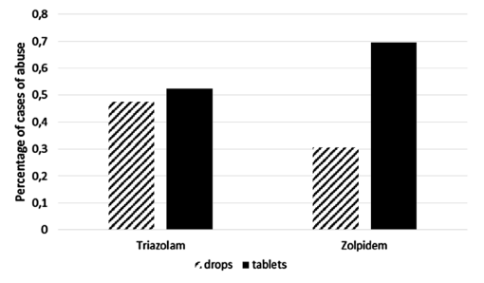
Figure S3: Abuse cases’ percentage both for triazolam and zolpidem, according with formulation and weighted for the total number of sold posological units. Adapted by Ferini-Strambi et al., 2020 [6]. License ID: 5479241357343.

Supplementary C
Impact of pre-sleep habits on adolescent sleep: an Italian population-based study [8].
This study aimed to investigate the association between pre-sleep habits, technology use and sleep quality among in the general population, specifically in adolescents, stratified by age. To this end, we analyzed all stages of adolescent development from preadolescence, adolescence and adulthood, and the effect of different electronic devices both at bedtime and during the day.
Given the previous literature [9], the experimental hypotheses were that pre-sleeping habits in adolescents would be different according to age. In addition, we hypothesized the presence of a positive correlation between the use of technological devices and complaints about sleep.
A total of 972 adolescents born between 2000 and 2007 who were attending high school were recruited. The experimental design included three evaluation sections at a time, which investigated: sleep habits; use of electronic devices/activities during the last hour before bedtime; and use of electronic devices/activities during the day.
The results showed an age group (16 years old) most at risk, vulnerable to sleep problems, including poor sleep and frequent awakenings at night, also aggravated by the use of multiple technologies at bedtime and intense digital activity during daytime hours.
In addition, our sample showed that the use of electronic devices pre-sleep appears to have a negative impact on sleep in adolescents. Specifically, smartphone/internet and homework use correlated with shorter sleep duration as well as increased sleep latency. In addition, pre-sleep e-reader activity correlated negatively with anticipation of bedtime and wake-up time.
In conclusion, the results showed a phenotype more vulnerable to dysfunctional behaviors pre-sleep, during the day and sleep problems. This study could allow the clinical, supportive, and school settings to be attentive to this most vulnerable age range in order to limit the propagation of dysfunctional behaviors pre-sleep, during the day, as well as sleep disorders. This may lead to an overall improvement in the quality of life of the general population, as well as facilitating the work of professionals in this field. However, further investigations in this area will be needed both longitudinally and nationally in order to replicate these results.
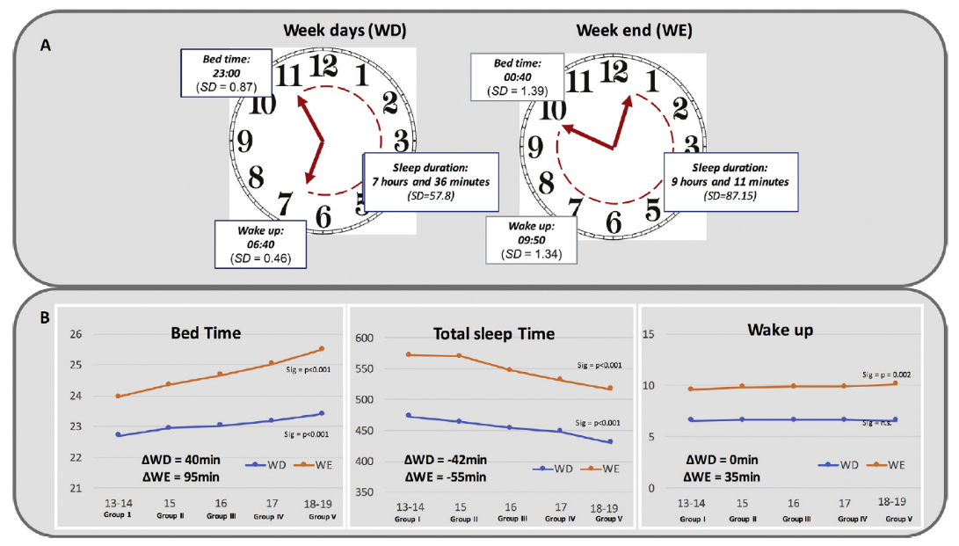
Figure S4: Sleep habits during week school days and weekends. A) sleep preferences in the whole sample. B) correlations between sleep parameters and age-stratified groups. Adapted by Nosetti et al., 2021 [8]. License ID: 1317810-1.

Supplementary D
Long-term clinical effect of group cognitive behavioral therapy for insomnia: a case series study [10].
The goal of this study was to evaluate the long-term effects of group CBT-I therapy at 7.8 ± 1.6 years after the end of treatment (ranging from 4 to 10 years). In this retrospective study, we evaluated before, after treatment, and at follow-up. 292 insomnia patients were included, and among them, 258 had completed the CBT-I intervention. In addition, 123 patients completed the follow-up assessment at an interval of 4-10 years. The insomnia severity index (ISI) was the primary outcome measure and sleep diaries detected the secondary outcome measures. In our sample, patients initially reported a mean total ISI score of 17.15 ± 4.51, which decreased after the intervention (9.68 ± 4.57) and was maintained at follow-up (9.88 ± 6.29). At follow-up, we also assessed relapse, evaluated as worsening of insomnia symptoms (difficulty in getting and maintaining sleep or waking up too early) at least four times a week. Seventy-nine percent of patients presented at least one relapse. In addition, we analyzed how each individual coped with relapse by assessing whether patients reused medications (mainly hypnotics), or techniques learned during the CBT-I protocol, or CBT-I techniques plus medications. The results showed that the patients who reported the lowest ISI score were those who used only CBT-I techniques with a significantly lower ISI score than those who used only medication. In conclusion, our study shows that the beneficial effects of group CBT-I are maintained at long-term follow-up, up to 10 years. Furthermore, we showed that patients who used only CBT-I techniques to cope with relapse had better outcomes, particularly compared with patients who used medication.

Figure S5: Mean ± standard error of Insomnia Severity Index (ISI) total score at the baseline, end of treatment and at the follow-up. Adapted by Castronovo et al., 2018 [10]. License ID: 1317811-1.

Figure S6: Mean ± standard error of Insomnia Severity Index (ISI) total score in the subgroup of patients that reported relapses at the follow-up. Adapted by Castronovo et al., 2018 [10]. License ID: 1317811-1.

Supplementary E
Insomnia patients with subjective short total sleep time have a boosted response to cognitive behavioral therapy for insomnia despite residual symptoms [11].
The main purpose of this study was to evaluate the effect of CBT-I in patients with chronic insomnia, divided into two subgroups based on subjectively reported TST from sleep diaries. We identified patients with TST < 6 hours as Short Sleeper (SS) and patients with TST ≥ 6 hours as Normal Sleeper (NS), based on previous literature [12]. Our retrospective study assessed ID patients before and after treatment. The main measures were insomnia severity index (ISI) and sleep efficiency (SE).
After CBT-I, SS insomnia patients showed an enhanced response to treatment compared to NS patients, both in terms of improvement at ISI and improvement at SE. In addition, the percentage of remitters (final ISI < 8) between the two groups was not significantly different, but more responders (decrease in ISI >= 8) were found in the SS group compared with NS. However, after treatment the SS group did not achieve a mean value of total sleep time ≥ 6 hours, and the two groups still had a significant statistical difference for this variable, as well as for ISI, SE and WASO.
In conclusion, our results demonstrate that patients with ID characterized by subjectively short total sleep time not only have a beneficial response to CBT-I, but also showed a greater response compared to patients with normal subjective total sleep time. Further literature investigating the heterogeneity of insomnia patients and treatment response based on the Total Sleep Time index will be needed.

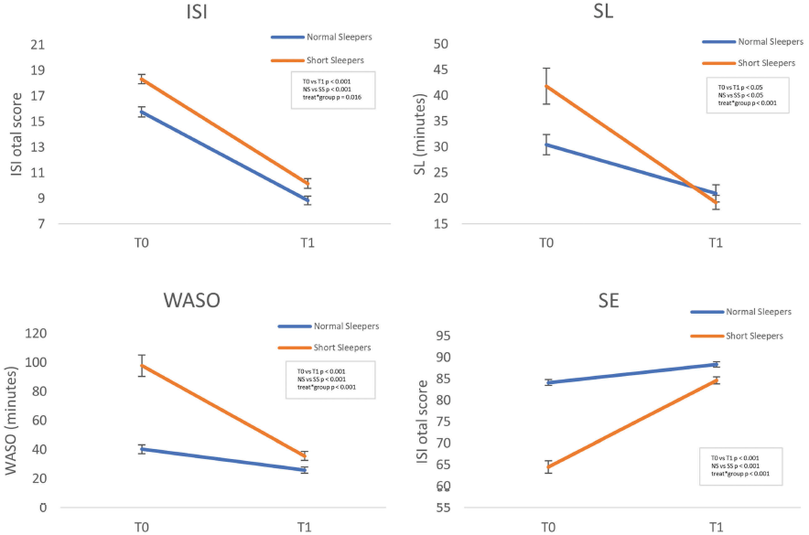
Figure S7: Insomnia Severity Index (ISI), Sleep Latency (SL), Wake After Sleep Onset (WASO) and Sleep Efficiency (SE), pre- and post-CBT-I treatment. Adapted by Galbiati et al., 2020 [11].

Supplementary F
“Thinking About Thinking” in Insomnia Disorder: The Effect of Cognitive-Behavioral Therapy for Insomnia on Sleep-Related Metacognition [13].
This study aimed to, first, test the presence of metacognitive impairment in chronic insomnia patients. Secondly, to evaluate the effect of CBT-I on dysfunctional cognitive and metacognitive functions. The scales used were the Dysfunctional Beliefs and Attitudes about Sleep (DBAS) [14], which assesses the presence of dysfunctional beliefs about sleep, at the cognitive content level. In addition, we used the Metacognition Questionnaire - Insomnia (MCQ-I) [15], in order to assess the presence of dysfunctional metacognitive strategies in insomniac patients, at the process level. The ultimate goal was to evaluate the effect of CBT-I on dysfunctional cognitive and metacognitive content and processes in insomniac patients. Our experimental hypothesis was that despite an improvement in sleep-related indices following treatment, metacognitive indices might reveal different trends. In fact, CBT-I does not present a protocol aimed at metacognitive dysfunctional processes, but specifically a cognitive component that intervenes solely on dysfunctional sleep-related cognitive content.
Twenty-seven patients with insomnia (52% female, mean age 46.37 ± 13.67 years), and 23 healthy controls (63% female, mean age 33.00 ± 13.77 years) were enrolled. The patients participated in a unique CBT-I protocol consisting of 7 sessions of 90 minutes. The results confirmed a greater presence of dysfunctional metacognition in patients with insomnia than in healthy controls. Regarding the effect of CBT-I, the study showed improvement in metacognitive dysfunctional strategies as measured by the MCQ-I. In addition, these improvements were associated with a significant reduction in insomnia symptoms (sleep diary and ISI). When evaluating subgroups of patients, the results were not as consistent. A significant percentage of patients (63%) did not have MCQ-I scores below the cut-off after CBT-I, despite significant improvement in insomnia symptoms. Thus, for some patients, CBT-I does not seem to have been sufficient for the purpose of treating dysfunctional metacognitive functioning at the process level, despite its relative efficacy on insomnia-related symptoms. On the other hand, with regard to the content-level presence of dysfunctional sleep-related thoughts (DBAS), CBT-I was effective in reducing them, even in patients who showed impaired metacognitive levels at the end of treatment.
In conclusion, our study showed that insomniac patients, despite exhibiting a benefit from CBT-I on insomnia symptomatology and sleep-related dysfunctional beliefs, showed metacognitive impairment, which could be a risk factor, e.g., with long-term relapse.

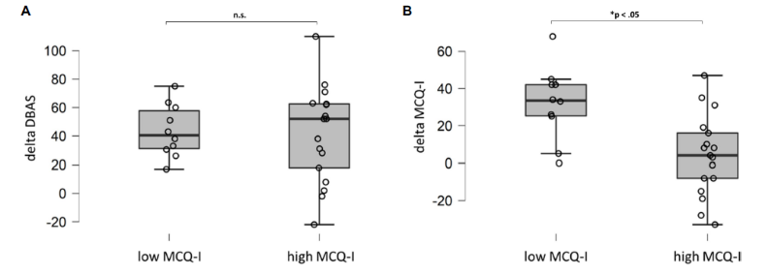
Figure S8: Comparisons (Mann-Whitney U test) of DBAS (dysfunctional beliefs and attitude about sleep) delta scores (A) and MCQ-I (metacognition insomnia questionnaire) (B) in insomnia patients with MCQ-I score above and below the cut-off after treatment. Adapted by Galbiati et al., 2021 [13].

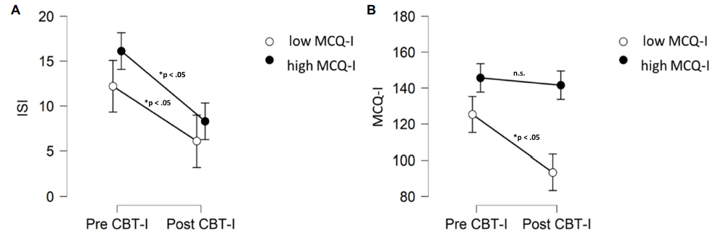
Figure S9: Comparisons (Wilcoxon signed rank test) in Insomnia Severity Index (ISI) (A) and MCQ-I (metacognition insomnia questionnaire) (B) scores pre- and post-treatment CBT-I in insomnia patients with MCQ-I score above and below the cut-off after treatment. Adapted by Galbiati et al., 2021 [13].

Supplementary G
The impact of affective states on Cognitive-Behavioral Therapy for Insomnia effectiveness: a mediation analysis study with the validation of the Italian version of Profile of Mood States (POMS).
The primary aim of this study was to validate and examine the psychometric properties of the Italian version of the POMS scale, translated from the 37-item self-report 5-point scale [16]. Furthermore, we investigated the impact of affective states on chronic insomnia patients’ symptoms, as well as evaluated the predictive role of the POMS Italian version on the effectiveness of CBT-I. Finally, we aimed to discriminate between the impact of depressive symptoms and transient affective state changes on CBT-I effectiveness.
Our non-published study, confirmatory factor analysis seems to support the six-factor structure proposed by Baker et al. [16]. Additionally, our results show that the Italian version of POMS seems to be a reliable tool for the evaluation of the subjective complaints of affective states in an Italian-speaking population, indicating good internal consistency reliability (Cronbach’s alpha above 0.80 [17]). Our findings also suggested a good construct validity by means of convergent and partially supported divergent validity.
In addition, concerning the evaluation of the impact of affective states on chronic insomnia patients’ symptoms, as well as the assessment of the predictive role of the POMS Italian version on the effectiveness of CBT-I, our results seem to suggest that CBT-I, the first-choice treatment for insomnia, improved both insomnia and mood states in line with the literature [18]. Furthermore, in our sample affective states appear to predict insomnia severity improvements, both by baseline and changes outcomes. On the other hand, the mediation model enabled us to specify the influence of transient affective states on insomnia severity mediated by depressive symptoms. The preponderance of the latter in influencing CBT-I outcomes notwithstanding, whether these results will be confirmed, future longitudinal studies should thoroughly investigate the effects of transient mood states in the early stage of insomnia disease when overt depressive symptoms are not yet clearly detectable.
In summary, the introduction of the Italian version of the POMS scale for the evaluation of mood states in sleep disorders, specifically chronic insomnia patients, appeared to be a reliable and a useful tool both in diagnostic and treatment settings. Since some insomnia patients presented transient affective states, if these results will be confirmed, the Italian version of POMS scale seemed to be relevant both in revealing diagnosis heterogeneity and to clusterize treatment trajectories.

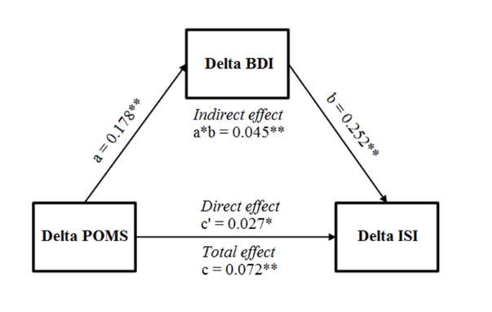
Figure S10: The mediation model tested: the Delta POMS effect on Delta ISI mediated by Delta BDI.

Supplementary H
The reliability of objective total sleep time in predicting the effectiveness of cognitive-behavioral therapy for insomnia [19].
A growing literature suggests the usefulness of the objective sleep duration (TST) index in distinguishing between two clinical phenotypes of insomnia [12]: insomnia with short sleep duration (SS < 6 h), and insomnia with normal sleep duration (NS > 6 h). Though it has been suggested that the SS phenotype in particular seems to respond better to pharmacotherapy than CBT-I, the literature has been inconsistent in this area [20]. The main objective of the study was to evaluate the predictive value of TST in each insomnia subgroup on the effect of CBT-I, dividing patients into SS and NS based on TST measured by both actigraphy and PSG. In addition, we wanted to assess the agreement between the TST measured by PSG and actigraphy in identifying the two phenotypes in the context of CBT-I. Our hypothesis was that the distinction between SS and NS represents an unreliable index in predicting CBT-I outcomes because of a rigid cut-off value of 6 hours, which is unlikely to account for the nocturnal variability of patients with insomnia and the enormous heterogeneity of this disorder [21]. Our sample was composed of fifty-three patients with insomnia (50.9% female; mean age 56,53 ± 11,43). Before receiving a seven-session group CBT-I, all patients underwent a baseline PSG assessment in the sleep laboratory and a one-week actigraphic assessment. The results showed that using both TST detected through actigraphy and TST detected through PSG in order to identify SS and NS, the two subtypes did not differ in their response to CBT-I treatment. Moreover, these TST indices showed little agreement in classifying the two subgroups, with concordance levels of 51%. This study put into question the reliability and usefulness of the TST, both based on PSG and actigraphic assessment, in predicting the effectiveness of CBT-I. Future research could study the night-to-night variability experienced by patients with insomnia in order to predict CBT-I effectiveness [22].
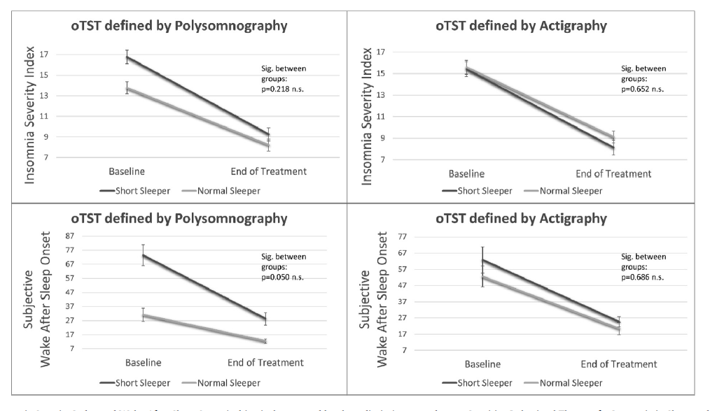
Figure S11: Insomnia Severity Index (ISI) and subjective Wake After Sleep Onset (WASO) pre- and post-treatment in Short and Normal Sleeper both by actigraphy and polysomnography. Error bars refer to standard errors. Adapted by Galbiati et al., 2021 [19]. License ID: 1317815-1.

Supplementary I
Slow wave sleep and response to cognitive behavioral therapy for insomnia [23].
The aim of the study was to evaluate whether PSG variables at the beginning of treatment could predict the subjectively reported effects of CBT-I.
Twenty-nine patients with chronic insomnia (15 females and 14 males, mean age 40.8±12.0) had been enrolled. The whole sample was assessed by an outpatient PSG registration prior to CBT-I treatment. Patients filled in sleep diaries during the PSG evaluation and throughout the 9-week group PSG treatment. Objective PSG indices were used as primary outcomes in order to detect different degrees of treatment efficacy. Specifically, we used a general linear model to assess whether PSG sleep measures could predict patients' response to CBT-I in terms of insomnia severity (Insomnia Severity Index, ISI) or subjective sleep diary variables. The study showed that the percentual slow wave sleep (%SWS) before treatment predicted better response to CBT-I (greater improvement in WASO after CBT-I (98.6±79.9 vs. 51.7±52.2; p= .032). This result apparently supports the hypothesis of a possible insomnia phenotype characterized by %SWS which could act as a natural mediator of the "process S" of sleep pressure. Such a thing would lead to greater improvement in WASO and thus better outcome after CBT-I.

Figure S12: Scatter plot of correlation between Slow Wave Sleep percentage (SWS%) and delta Wake After Sleep Onset (WASO) subjectively reported by sleep diaries.

Supplementary L
Depressive and stress symptoms in insomnia patients predict group cognitive-behavioral therapy for insomnia long-term effectiveness: A data-driven analysis [24].
The literature showed us that sleep-related indices are not sufficient to describe the heterogeneity of insomniacs, especially when it comes to predicting the effect of CBT-I therapy [20], [21].
This research ventured into previously unexplored areas, investigating the predictive role of heterogeneity of insomnia patients toward the efficacy of CBT-I in the short- and long-term. The main purpose of the present study was to reveal latent subgroups of insomnia patients, as well as to assess any differences in treatment efficacy between classes, both at the end and at long-term follow-up (7.8 ± 1.6 years after the end of treatment).
A total of 294 patients were enrolled, 258 of whom completed the CBT-I intervention and 123 completed the follow-up assessment, between 4 and 10 years after the end of treatment.
The assessment at the beginning and end of treatment included a validated test battery that investigated the severity and characteristics of insomnia, anxiety and depressive symptomatology, stress, sleepiness, and circadian rhythm. The follow-up assessment included only the severity of insomnia index (ISI).
Thus, the first objective was to identify different classes of patients with insomnia disorder through the data-driven approach of Latent Class Analysis, based on the indices at treatment onset described above, as well as an index of treatment effectiveness (ISI).
The results showed 3 classes of insomnia patients: class 1 "PURE INSOMNIA", class 2 "INSOMNIA + ANXIETY + DEPRESSION + STRESS," and Class 3 "INSOMNIA + ANXIETY."
Subtyping patients with insomnia on the basis of stress and depression symptoms at baseline could be very informative in order to predict not only reduced CBT-I efficacy in the long term, but also possible symptom worsening several years after therapy.
The treatment efficacy in the whole sample on insomnia symptomatology on the top of the other clinical indices (anxiety, stress, and depression) showed that an individualized CBT-I intervention could increase the efficacy of CBT-I in the long term, while maintaining improvements.
The literature also showed us that the presence of depression could not only lead to having a higher risk of developing insomnia [25], but also predict insomnia symptom recurrences in patients following CBT-I treatment. A specific phenotype/class of more severe insomnia, in comorbidity with clinically significant stress and depression, could predict symptom patterns not only right at the end of treatment, but also several years after CBT-I, in our case 7.8 ± 1.6 years after the end of treatment (range 4-10 years).
Future research should further investigate the heterogeneity of insomnia patients, and how this may predict the effect of treatments; perhaps with the use of data-driven statistics, useful in order to reveal latent classes, otherwise not manifest.

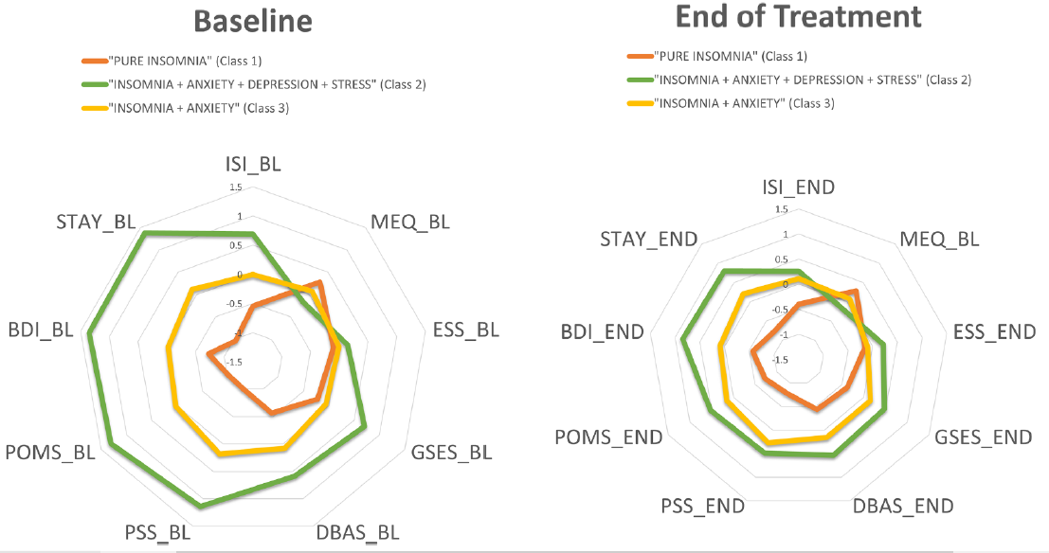
Figure S13: Zscore means of questionnaires outcomes in three classes at the baseline and at the end of treatment. Abbraviations: Baseline (BL); End of the treatment (END); Insomnia Severity Index (ISI); Morningness-Eveningness Questionnaire Self-Assessment (MEQ); Epworth Sleepiness Scale (ESS); Glasgow Sleep Effort Scale (GSES); Dysfunctional Beliefs and Attitudes about Sleep - 16 (DBAS); Perceived Stress Scale (PSS); Profile of Mood State (POMS); Beck Depression Inventory - II (BDI); Stay-Trait Anxiety Inventory: Y form (STAY). Adapted by Sforza et al., 2021 [24]. License ID: 1317817-1.
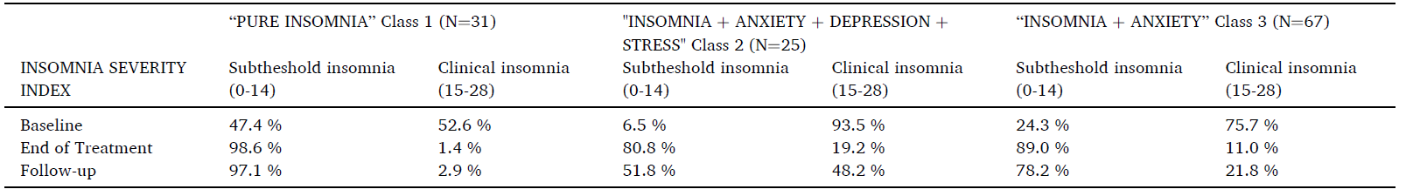
Table S1: percentages in the three classes at the baseline, end of treatment and at the follow-up in Insomnia Severity Index ranges. Adapted by Sforza et al., 2021 [24]. License ID: 1317817-1.

Supplementary M
Impact of phenotypic heterogeneity of insomnia on the patients’ response to cognitive-behavioral therapy for insomnia: current perspectives [20].
The aim of this review was to summarize the scientific literature concerning the impact of heterogeneity within chronic insomnia disorder in response to CBT-I. The review was divided in two parts: one on the subtyping of insomnia, and the second on related and unrelated sleep indices that predict responses to CBT-I treatment.
Despite the high efficacy of CBT-I therapy, the literature shows us that 40% of insomnia patients do not achieve symptomatic remission. Therefore, assessing the heterogeneity of insomnia patients could help predict the effectiveness of treatment, and individualizing it according to patient characteristics. The first aspect considered in this review in order to achieve the previous goal is to assess the heterogeneity of the treatment itself (i.e., duration, administration, individual/group modality, therapist preparation, possible alternatives, etc.). It needs to be specified, however, that the lack of both a defined index to assess symptomatic remission following treatment, as well as an index of adherence limited this investigation.
Predictors of treatment efficacy can be both objective (PSG and actigraphy) or subjective (sleep diaries and questionnaires), and methods differ considerably: ranging from simple ones, such as classic sleep indices (total sleep time, etc.), to very complex statistical analyses engineered to reveal latent subclasses.
The use of very strict and rigorous indices such as total sleep time (both objectively and subjectively reported) leads to contradictory results for the purpose of predicting the effectiveness of CBT-I. In fact, the presence of night-to-night variability in the sleep quantity and quality in patients with insomnia dispute the validity of TST as a valid marker. On the other hand, the existence of homeostatic dysfunction in insomnia patients appears to be very robust [26].
Clinical indices, especially those not related to sleep, seem to have good validity in detecting the effectiveness of CBT-I, including the presence of comorbidities, life events, dysfunctional beliefs, and emotional regulation abilities.
In conclusion, future studies should consider a combination of objective and subjective variables, sleep-related and non-sleep-related, in order to make the CBT-I elective treatment individualized. In summary, although there is clear phenotypic heterogeneity between ID patients, the limited number of studies and methodological variability does not allow for solid conclusions on how to subtype insomnia patients and thus predict effective treatment specification.

References
[1] A. Galbiati et al., “The association between emotional dysregulation and REM sleep features in insomnia disorder,” Brain Cogn, vol. 146, p. 105642, Dec. 2020, doi: 10.1016/j.bandc.2020.105642.
[2] C. Sighinolfi, A. N. Pala, L. R. Chiri, I. Marchetti, and C. Sica, “Difficulties in Emotion Regulation Scale (DERS): The Italian translation and adaptation,” Psicoterapia Cognitiva e Comportamentale, vol. 16, no. 2, 2010.
[3] R. Wassing, O. Lakbila-Kamal, J. R. Ramautar, D. Stoffers, F. Schalkwijk, and E. J. W. Van Someren, “Restless REM Sleep Impedes Overnight Amygdala Adaptation,” Current Biology, 2019, doi: 10.1016/j.cub.2019.06.034.
[4] R. Wassing et al., “Slow dissolving of emotional distress contributes to hyperarousal,” Proc Natl Acad Sci U S A, 2016, doi: 10.1073/pnas.1522520113.
[5] D. Riemann, K. Spiegelhalder, C. Nissen, V. Hirscher, C. Baglioni, and B. Feige, “REM Sleep Instability – A New Pathway for Insomnia?,” Pharmacopsychiatry, Jan. 2012, doi: 10.1055/s-0031-1299721.
[6] L. Ferini-Strambi, M. Sforza, and A. Galbiati, “High-dose lormetazepam dependence: strange case of Dr. Jekyll and Mr. Hyde—comment,” Intern Emerg Med, vol. 15, no. 2, pp. 341–342, Mar. 2020, doi: 10.1007/s11739-019-02142-z.
[7] M. Faccini, S. Tamburin, R. Casari, L. Morbioli, and F. Lugoboni, “High-dose lormetazepam dependence: strange case of Dr. Jekyll and Mr. Hyde,” Intern Emerg Med, vol. 14, no. 8, pp. 1271–1278, Nov. 2019, doi: 10.1007/s11739-019-02101-8.
[8] L. Nosetti et al., “Impact of pre-sleep habits on adolescent sleep: an Italian population-based study,” Sleep Med, vol. 81, pp. 300–306, May 2021, doi: 10.1016/j.sleep.2021.02.054.
[9] P. M. RUSSO, O. BRUNI, F. LUCIDI, R. FERRI, and C. VIOLANI, “Sleep habits and circadian preference in Italian children and adolescents,” J Sleep Res, vol. 16, no. 2, pp. 163–169, Jun. 2007, doi: 10.1111/j.1365-2869.2007.00584.x.
[10] V. Castronovo et al., “Long-term clinical effect of group cognitive behavioral therapy for insomnia: a case series study,” Sleep Med, vol. 47, pp. 54–59, Jul. 2018, doi: 10.1016/j.sleep.2018.03.017.
[11] A. Galbiati et al., “Insomnia Patients With Subjective Short Total Sleep Time Have a Boosted Response to Cognitive Behavioral Therapy for Insomnia Despite Residual Symptoms,” Behavioral Sleep Medicine, vol. 18, no. 1, pp. 58–67, Jan. 2020, doi: 10.1080/15402002.2018.1545650.
[12] A. N. Vgontzas and J. Fernandez-Mendoza, “Insomnia With Short Sleep Duration,” Sleep Med Clin, vol. 8, no. 3, pp. 309–322, Sep. 2013, doi: 10.1016/j.jsmc.2013.04.009.
[13] A. Galbiati et al., “‘Thinking About Thinking’ in Insomnia Disorder: The Effect of Cognitive-Behavioral Therapy for Insomnia on Sleep-Related Metacognition,” Front Psychol, vol. 12, Sep. 2021, doi: 10.3389/fpsyg.2021.705112.
[14] C. M. Morin, A. Vallières, and H. Ivers, “Dysfunctional beliefs and attitudes about sleep (DBAS): validation of a brief version (DBAS-16).,” Sleep, vol. 30, no. 11, pp. 1547–54, Nov. 2007, doi: 10.1093/sleep/30.11.1547.
[15] J. Waine, N. M. Broomfield, S. Banham, and C. A. Espie, “Metacognitive beliefs in primary insomnia: Developing and validating the Metacognitions Questionnaire – Insomnia (MCQ-I),” J Behav Ther Exp Psychiatry, vol. 40, no. 1, pp. 15–23, Mar. 2009, doi: 10.1016/j.jbtep.2008.03.002.
[16] F. Baker, M. Denniston, J. Zabora, A. Polland, and W. N. Dudley, “A POMS short form for cancer patients: psychometric and structural evaluation,” Psychooncology, vol. 11, no. 4, pp. 273–281, Jul. 2002, doi: 10.1002/pon.564.
[17] L. J. Cronbach, “Coefficient alpha and the internal structure of tests,” Psychometrika, vol. 16, no. 3, 1951, doi: 10.1007/BF02310555.
[18] E. Hertenstein et al., “Cognitive behavioral therapy for insomnia in patients with mental disorders and comorbid insomnia: A systematic review and meta-analysis,” Sleep Med Rev, vol. 62, p. 101597, Apr. 2022, doi: 10.1016/j.smrv.2022.101597.
[19] A. Galbiati et al., “The reliability of objective total sleep time in predicting the effectiveness of cognitive-behavioral therapy for insomnia,” Sleep Med, vol. 82, pp. 43–46, Jun. 2021, doi: 10.1016/j.sleep.2021.03.021.
[20] A. Galbiati, M. Sforza, E. Fasiello, V. Castronovo, and L. Ferini-Strambi, “Impact Of Phenotypic Heterogeneity Of Insomnia On The Patients’ Response To Cognitive-Behavioral Therapy For Insomnia: Current Perspectives</p>,” Nat Sci Sleep, vol. Volume 11, pp. 367–376, Nov. 2019, doi: 10.2147/NSS.S198812.
[21] T. F. Blanken et al., “Insomnia disorder subtypes derived from life history and traits of affect and personality,” Lancet Psychiatry, vol. 6, no. 2, pp. 151–163, Feb. 2019, doi: 10.1016/S2215-0366(18)30464-4.
[22] A. Vallières, H. Ivers, S. Beaulieu-Bonneau, and C. M. Morin, “Predictability of Sleep in Patients with Insomnia,” Sleep, vol. 34, no. 5, pp. 609–617, May 2011, doi: 10.1093/sleep/34.5.609.
[23] V. Castronovo, M. Sforza, E. Fasiello, R. Farina, A. Galbiati, and L. F. Strambi, “0410 Slow Wave Sleep And Response To Cognitive Behavioral Therapy For Insomnia,” Sleep, vol. 42, no. Supplement_1, 2019, doi: 10.1093/sleep/zsz067.409.
[24] M. Sforza et al., “Depressive and stress symptoms in insomnia patients predict group cognitive-behavioral therapy for insomnia long-term effectiveness: A data-driven analysis.,” J Affect Disord, vol. 289, pp. 117–124, Jun. 2021, doi: 10.1016/j.jad.2021.04.021.
[25] C. Baglioni et al., “Insomnia as a predictor of depression: A meta-analytic evaluation of longitudinal epidemiological studies,” J Affect Disord, vol. 135, no. 1–3, pp. 10–19, Dec. 2011, doi: 10.1016/j.jad.2011.01.011.
[26] D. Neu, O. Mairesse, and O. le Bon, “What about sleep homeostasis in insomnia? Comment on the European guideline for the diagnosis and treatment of insomnia,” J Sleep Res, vol. 26, no. 6, 2017, doi: 10.1111/jsr.12625.

