

UNIVERSITA’ DEGLI STUDI DI VERONA

DEPARTMENT OF MEDICINE

GRADUATE SCHOOL FOR HEALTH AND LIFE SCIENCE

DOCTORAL PROGRAM IN

INFLAMMATION, IMMUNITY AND CANCER

WITH THE FINANCIAL CONTRIBUTION OF PON

Cycle XXXVII / 2022

TITLE OF THE DOCTORAL THESIS

Integrated psychological intervention to support the emotional well being of oncological patients under standard and exceptional circumstances

S.S.D. PSIC-01/A

Coordinator: Prof. Vincenzo Corbo

Signature __________________________

Tutor: Prof. Michele Milella

Signature __________________________

Doctoral Student: Dott./ssa Daniela Tregnago

Signature _____________________



La borsa di dottorato è stata cofinanziata con risorse del
Programma Operativo Nazionale Ricerca e Innovazione 2014-2020, risorse FSE REACT-EU
Azione IV.4 “Dottorati e contratti di ricerca su tematiche dell’innovazione”
e Azione IV.5 “Dottorati su tematiche Green”

Contents

Summary | 5
PART 1
- Willingness, preferences, barriers, and facilitators of a multimodal supportive care intervention including exercise, nutritional and psychological approach in patients with cancer: a cross-sectional study
1.1 Abstract | 7
1.2 Introduction | 8
1.3 Materials and methods | 9
1.3.1 Study design and participants | 9
1.3.2 Questionnaire description | 10
1.3.3 General characteristics | 11
1.3.4 Distress, exercise level, and risk of malnutrition | 11
1.3.5 Multimodal intervention preferences | 12
1.3.6 Barriers and facilitators associated with a multimodal intervention | 12
1.3.7 Cancer diagnosis and treatment | 12
1.3.8 Statistical analysis | 13
1.4 Results | 13
1.4.1 General characteristics | 13
1.4.2 Willingness and preferences for a multimodal supportive care intervention | 20
1.4.3 Barriers and facilitators to a multimodal intervention | 22
1.5 Discussion | 23
1.6 Conclusions | 27
PART 2
- A randomized clinical trial with crossover testing to different tuning frequences to optimize music therapy in oncological patients
2.1 Abstract | 28
2.2 Introduction | 29
2.3 Materials and methods | 31
2.3.1 Participants and procedure | 31
2.3.2 Questionnaires description | 34
2.3.2.1 Psychological survey tools | 34
2.3.2.2 Nursing survey tools | 34
2.3.2.3 Flowchart | 35
2.3.3 Statistical analysis | 35
2.4 Results | 36
2.4.1 General characteristics | 36
2.4.2 Differences between 432 Hz vs 440 Hz frequencies | 38
2.5 Discussion | 42
2.6 Conclusions | 43
PART 3
- Psychological impact of COVID-19 vaccination in patients with cancer: The VACCINATE Study
3.1 Abstract | 44
3.2 Introduction | 45
3.3 Materials and methods | 46
3.3.1 Participants and procedure | 46
3.3.2 Questionnaires | 46
3.3.3 Data analysis | 47
3.4 Results | 48
3.4.1 Patients charactheristics | 48
3.4.2 Baseline levels of anxiety, depression, and distress | 50
3.4.3 Attitude towards vaccination | 53
3.4.4 Associations between patients' characteristics, psychological variables, and attitude towards vaccination | 54
3.4.5 Comparison with patients vaccinated at an independent spoke Centre | 56
3.5 Discussion | 58
3.6 Conclusions | 60
References | 62

Summary

A cancer diagnosis is stressful and often accompanied by negative emotions, such as fear, uncertainty, sadness, and anxiety. The disease progression and treatment-related side effects may have negative physical impacts, adversely affecting patients’ daily activities. Additionally, anticancer treatment can last months or even years, leading to a great deal of mental and physical stress involving patients and their social and familiar contexts. All of these situations may compromise the patient’s QoL, with potential negative effects. Indeed, QoL has been found to be a significant prognostic factor in patients with cancer. For instance, exercise may regulate systemic metabolic and immune function, as well as modulate the tumor physiologic microenvironment, regularizing the tumor vasculature, reducing hypoxia, diminishing the utilization of glucose metabolism in favor of the oxidative one, and normalizing the immunosuppressive acidic tumor microenvironment. Nutritional status, through a balancing in body composition, may affect immune response. Behavioral strategies and psycho-oncological interventions, reducing chronic stress and depression, may control the activation of the hypothalamic-pituitary-adrenal axis and sympathetic-adrenal-medullary axis, enhancing antitumor immunity.
Understanding patients’ willingness, preferences, barriers, and needs may permit to develop an optimal and tailored multimodal intervention. Although the factors influencing the single lifestyle intervention in a population with cancer are investigated, studies exploring the feasibility and the willingness of patients to join a multimodal intervention are lacking.
This is the main objective of the first chapter with a specific focus on care of the emotional well-being of patient with cancer. The published study that investigated the preferences and obstacles in starting and continuing the integrated intervention.
The comprehensive definition of integrative oncology is a patient-centered, evidence-informed field of cancer care that utilizes mind and body practices and lifestyle modifications alongside conventional cancer treatments. Integrative oncology aims to optimize health, quality of life, and clinical outcomes across the cancer care continuum, and to empower people to prevent cancer and become active participants before, during, and beyond cancer treatment. An integrative approach to the treatment of illness like cancer is one in which combines conventional medicine with evidence-based complementary medicines/therapies, lifestyle interventions for the treatment and prevention of disease and the optimisation of health. In the second chapter the attention focuses on the impact of music therapy on the physical and emotional state.
Finally, the third work concludes by considering an exceptional and highly impactful state, the Covid pandemic. Even among subjects who felt accepting vaccination was somehow inevitable, reluctance and erroneous perceptions could develop, concurring to increase the psychological burden, particularly in cancer patients in whom the already high level of emotional vulnerability was further impacted by the pandemic. The aim of our study was indeed to investigate the levels of anxiety, depression, and distress, on the one hand, and the subjective perception of the protective effects of the vaccination and its potential interference with anticancer treatment and overall health status, on the other, in cancer patients undergoing COVID-19 vaccination in the context of the campaign.

- Chapter

Willingness, preferences, barriers, and facilitators of a multimodal supportive care intervention including exercise, nutritional and psychological approach in patients with cancer: a cross-sectional study

1.1 Abstract

Supportive care, including exercise, nutritional and psycho-oncological interventions, is becoming increasingly important in cancer given their impact on ‘patients’ quality and quantity of life. The purpose of this study was to explore willingness, preferences barriers and facilitators for a multimodal intervention in patients with cancer.

An anonymous questionnaire was proposed on randomly selected days to the patients visiting the cancer outpatients’ facilities at the Oncology Unit of the University Hospital of Verona. The questionnaire investigated willingness, preferences, barriers, and facilitators associated with participation in a multimodal program designed for patients with cancer. Exercise level was estimated using two open questions, nutritional risk was identified using the Nutritional Risk Screening 2002, while distress was evaluated with the Distress Thermometer.

Based on 324 participants, 65% were interested in starting a multimodal intervention. Patients declared to prefer to receive instructions from dedicated experts, with a face-to-face approach, and during the anticancer treatment. Treatment-related side effects were the major obstacles for a multimodal program, while the availability of a specialized staff as exercise kinesiologists, dietitians, and psycho-oncologists was found to be an important facilitator for increasing ‘patients’ participation.

Patients patients with cancer are interested in participating in a multimodal supportive care program specifically designed for them. Information from this study may help to design a tailored multimodal intervention for patients with cancer.

  - Introduction

All the contents of this Chapter refer to the same-titled article, Journal of Cancer Research and Clinical Oncology and reproduced with permission from Springer Nature [1].
Whereas cancer incidence increased over the years (one out of three men and one out of four women are expected to develop cancer in their lifetime), cancer mortality decreased in many countries, leading to a high prevalence of people living with cancer [2]. Nevertheless, malignancy and its treatments are often related to several side effects, potentially impairing patients’ quality of life for years even after the therapy conclusion [3]. In this sense, patients with cancer may experience a range of different symptoms and adverse events affecting their physical and psychological well-being, such as functional deconditioning, nausea, vomiting, loss of muscle mass, anxiety, and depression [3]. This scenario emphasizes the need for supportive care programs aimed to help patients in recovering from the cancer pathway. Indeed, supportive care, defined as “the prevention and management of the adverse effects of cancer and its treatment” [4], is an essential tool able to manage physical and psychological symptoms and enhance the rehabilitation and survivorship of patients. Among them, exercise, nutrition, and psycho-oncological interventions are important for patients with cancer. Individually, these interventions have been shown to bring a series of benefits. Exercise can increase patients' physical fitness, such as cardiorespiratory fitness, muscle mass, and strength, which are prognostic factors in patients with cancer [5]. Moreover, exercise may ameliorate adverse events of cancer and its treatments, manage cancer-related fatigue, anemia, and psychological impairments, improving peripheral neuropathy and quality of life [5]. Similarly, a nutritional screening may help to individuate, and consequently manage, malnourished patients or those at risk of malnutrition [6]. Nutritional intervention may facilitate maintaining an adequate nutritional intake, controlling body composition, and nutritional impact symptoms, such as nausea, vomiting, and appetite loss, to prevent loss of muscle mass and nutrient inadequacies [6, 7, 8, 9, 10]. Nutritional support has been shown to reduce mortality and improve the QOL of patients with cancer [11]. Preliminary research shows that 77.5% of outpatients receiving chemotherapy need nutrition counselling, the need for which is associated with their QOL [11]. The European Society for Clinical Nutrition and Metabolism recommends nutritional intervention to increase oral intake in cancer patients who can eat but are malnourished or at risk of malnutrition [12]. Therefore, it is imperative to understand the psychosocial factors of patients who require nutritional intervention, in addition to their physical factors. While some studies have explored the views of cancer patients in relation to nutrition support using a mixed-method approach and others have examined specific circumstances in which patients require counselling [13, 14], to the best of our knowledge, no study has investigated psychosocial factors related to nutrition counselling.
A cancer diagnosis carries an important psychological burden for patients and their caregivers. Symptoms of anxiety, depression, fear of death, and/or recurrence frequently occur in patients with cancer. Psychological interventions, e.g., cognitive–behavioral therapy, address various psychological and social aspects that may alleviate the emotional outcomes, improving patients' quality of life [15, 16].
Exercise, nutrition, and psychological aspects are strictly related, and it is reasonable to speculate that a supportive care multimodal approach could grow the benefits, as supported by previous research [17]. An 18 week exercise program including cognitive–behavioral principles of social cognitive theory found positive effects on fatigue and physical fitness levels in patients with breast cancer receiving chemotherapy [16]. Similarly, a two-week prehabilitation program incorporating exercise, nutritional counseling, and psychological guidance has been shown to be effective in increasing perioperative functional capacity in patients with lung cancer undergoing thoracoscopic lobectomy [15]. Nevertheless, investigations combining exercise, nutritional and psychological approaches are still few, and more research on the benefit of multimodal interventions is necessary. However, participating in a supportive care multimodal program requires a time effort from patients, making high the risk of non-compliance.
Understanding patients’ willingness, preferences, barriers, and needs may permit to develop an optimal and tailored multimodal intervention. Although the factors influencing the single lifestyle intervention in a population with cancer are investigated, studies exploring the feasibility and the willingness of patients to join a multimodal intervention are lacking. To fill this gap, this research aims to: (i) establish the willingness of patients with cancer to participate in a multimodal supportive care intervention, including exercise, nutritional and psychological approaches, (ii) analyze the patients' characteristics associated with their willingness to participate in a multimodal supportive care intervention, (iii) describe patients’ preferences about exercise, nutritional and psychological interventions, (iv) examine the perceived barriers and facilitators affecting patients adherence to the multimodal intervention.

1.3 Materials and methods

1.3.1 Study design and participants

A cross-sectional survey was utilized. Between February 2020 and May 2021, an anonymous questionnaire was delivered to the patients visiting the cancer outpatients' facilities at the Oncology Unit of the University Hospital of Verona. Patients' eligibility criteria were: 18 years or older, a cancer diagnosis, and ability to understand Italian. The study staff distributed the questionnaires on randomly selected days. Patients were approached face-to-face, informed about the study, and asked whether they would be willing to complete the questionnaire. If interested, patients signed the informed consent and received a copy of the questionnaire to return directly. A duplicate check was done, looking for duplicates by date of birth, sex, education, and marital status. Approval of the Ethics Committee for Clinical Trials (Prot. No. 48647) was obtained. The study protocol adhered to Good Clinical Practice principles and the procedures were conducted following the last revision of the declaration of Helsinki as well as the declaration of Oviedo. The current report is compliant with the Strengthening the Reporting of Observational Studies in Epidemiology (STROBE) guidelines (Cuschieri 2019).

    - Questionnaire description

A self-administered survey questionnaire was developed to collect preferences, barriers, and facilitators associated with a multimodal intervention. A pilot version of the questionnaire was created using questions derived from previous studies (Arthur et al. 2016; Avancini et al. 2020a; Weller et al. 2019), and made available to experts, including kinesiologists, oncologists, and psycho-oncologists, to make an informal peer review and develop the current version.
The questionnaire comprised 30 items and took approximately 30 min to complete. The survey included five parts: (i) General characteristics; (ii) Distress, exercise level, and risk of malnutrition; (iii) Multimodal intervention preferences; (iv) Barriers and facilitators associated with a multimodal intervention; (v) Cancer diagnosis and treatment.

    - General characteristics

The following demographic, and socio-economic factors were self-reported: birth date (day, month, year), sex (male/female), educational level (elementary—up to age 10–11 years/secondary—up to 14 years/secondary—up to 18–19 years/college–university/postgraduate), marital status (single/married/divorced/widowed), occupational status (retired/ homemaker/part-time employed/ full-time employed), perceived economic adequacy (inadequate/ barely adequate/adequate/ more than adequate). Weight in kilograms and height in meters were collected to obtain body mass index (BMI). BMI was calculated dividing the weight by the squared height, and categorizing as: underweight (BMI < 18.5 kg/m2), normal weight (BMI 18.5–24.9 kg/m2), overweight (BMI 25.0–29.9 kg/m2) and obese (BMI > 29.9 kg/m2) (“Physical status: the use and interpretation of anthropometry. Report of a WHO Expert Committee” 1995).

    - Distress, exercise level, and risk of malnutrition

Distress was assessed using the National Comprehensive Cancer Network (NCCN) Distress screening tool (Riba et al. 2019). Through a single item, representing an 11 points visual/Likert scale, from 0 (no distress) to 10 (extreme distress), the patient was asked to rate her/his level of distress experienced over the past week. Distress is classified as mild with a cutoff point < 4, whereas a score > 3 requires further screening (Riba et al. 2019). Exercise level was assessed with the two open-ended questions, adapted by Schmitz et al. (Schmitz et al. 2019): “How many days per week and times per session do you perform an aerobic activity at moderate intensity (where the heart beats faster and the breathing harder than normal, e.g., walking, cycling, running, swimming)? and “How many days per week do you perform exercise to increase muscle strength (e.g., lifting weights, bodyweight exercise, climbing)? According to the American College of Sports Medicine guidelines for patients with cancer, patients were defined as meeting the guidelines if they engaged in at least 90 min/week of aerobic exercise and performed strength activities at least two times/week (Campbell et al. 2019). The Nutritional Risk Screening 2002 (NRS-2002) was used to identify the nutritional risk. Malnutrition risk identification was not directly captured, but the questionnaire included nutrition-related questions, including severity of the disease, weight loss in the past one, two, and three months, perceived impairments in general condition, and the reduction of food intake in the preceding week, that allowed us to estimate its prevalence. NRS-2002 is evaluated through three components: nutritional status (0–3 points), the severity of disease (0–3 points), and age (0–1 points). The total NRS-2002 score ranges from 0 to 7, and patients with a score of < 3 and ≥ 3 are classified as “no nutritional risk” and “at nutritional risk”, respectively (Kondrup et al. 2003).

1.3.5 Multimodal intervention preferences

Preferences were explored using closed-item questions adapted from prior investigations. The first question concerned the patients’ willingness to participate in a multimodal supportive care intervention including exercise, nutritional counseling and psycho-oncological interventions specifically designed for patients with cancer (yes/no/maybe).
For each intervention, i.e., exercise, nutrition and psycho-oncological interventions, were asked patient ‘preferences concerning: who would give them instructions (oncologist/nurse/dietitian/kinesiologist/psycho-oncologist/another patient with cancer/other); how to receive instructions (face to face/over the internet/television/radio/brochure-pamphlet/other); where (at hospital/a community center outside the hospital/other); when (before treatment/during treatment/after treatment/other).

1.3.6 Barriers and facilitators associated with a multimodal intervention

A list of potential barriers and facilitators associated with participation in a multimodal intervention was provided. Patients may select up to three barriers and up to three facilitators.

1.3.7 Cancer diagnosis and treatment

Self-reported medical variables included: cancer site (breast/lung/colorectal/upper gastrointestinal/head-neck/gynecological/urogenital/melanoma/other), disease status (early/advanced/metastatic/in remission-cured/unknown), date of diagnosis (month/year), type of treatment (surgery/chemotherapy/radiotherapy/hormone therapy/other), and current treatment status (about to start/ongoing/completed/not known).

1.3.8 Statistical analysis

Descriptive analyses were utilized to summarize the response to survey questions. Categorical data were presented as frequencies and percentages. Logistic regression models were applied to identify patients’ characteristics (sex, age, education, body mass index, exercise level, psychological distress, risk of malnutrition, marital status, occupational status, perceived income adequacy, tumor site, disease status, cancer treatment, treatment status, and time from diagnosis) associated with their willingness to participate in a multimodal supportive care program. Additionally, logistic regression models were applied to explore patients’ characteristics associated with exercise level, risk of malnutrition and distress. SPSS version 28.0 software was utilized to analyze data. The significance level was set at 0.05, whereas all statistical tests were two-sided.

1.4 Results

Between February 2020 and May 2021, a total of 623 were approached, and among them, 324 agreed to participate in the survey (52% response rate).

1.4.1 General characteristics
The demographic and medical characteristics of the survey respondents are listed in Table 1. Overall, 57% had less than 65 years, 53% were female, 61% had a higher education (at least up to age 18–19 years), and 70% were married. Upper gastro-intestine (44%) and breast (17%) were the most frequent cancer site, and about 77% were on active anticancer treatment.

Table 1.
General characteristics of the survey’s participants¹
 | No | %
Age (years) (n = 324)
< 65 | 184 | 57
≥ 65 | 140 | 43
Sex (n = 324)
Female | 171 | 53
Male | 183 | 47
Education (n = 324)
Elementary (up to 10–11 years) | 27 | 8
Secondary (up to 14 years) | 101 | 31
Secondary (up to 18–19 years) | 120 | 37
College/University | 67 | 21
Postgraduate | 9 | 3
Body Mass Index² (n = 324)
Underweight | 12 | 4
Normal weight | 134 | 41
Overweight | 133 | 41
Obese | 45 | 14
Marital status (n = 324)
Single | 35 | 11
Married | 228 | 70
Divorced | 33 | 10
Widowed | 28 | 9
Occupational status (n = 324)
Retired | 154 | 48
Homemaker | 47 | 16
Part-time employed | 24 | 7
Full-time employed | 93 | 29
Other | 0 | 0
Perceived income adequacy³ (n = 324)
Inadequate | 14 | 4
Barely adequate | 59 | 18
Adequate | 159 | 49
More than adequate | 92 | 28
Exercise level (n = 314)
Meeting aerobic guidelines
Yes | 94 | 30
No | 220 | 70
Meeting strength guidelines
Yes | 31 | 10
No | 283 | 90
Meeting exercise guidelines
Yes | 11 | 4
No | 303 | 96
Distress level (n = 306)
Mild | 129 | 42
Clinically elevate | 177 | 58
Risk of malnutrition (n = 320)
Yes | 97 | 30
No | 223 | 70
Tumor site (n = 324)
Breast | 55 | 17
Lung | 18 | 6
Colorectum | 20 | 6
Head/neck | 19 | 6
Upper gastro-intestine | 143 | 44
Gynecological | 4 | 1
Urogenital | 24 | 7
Melanoma | 22 | 7
Other | 19 | 6
Disease status (n = 324)
Unknown | 59 | 18
In remission/cured | 67 | 21
Early | 44 | 14
Advanced | 72 | 22
Metastatic | 82 | 25
Treatments⁴ (n = 324)
Surgery | 157 | 48
Chemotherapy | 221 | 68
Radiation therapy | 73 | 23
Hormone therapy | 22 | 7
Other | 56 | 17
Treatment status (n = 324)
About to start | 16 | 5
Ongoing | 234 | 77
Completed | 43 | 14
Unknown | 12 | 4
Time from diagnosis (n = 324)
≤ 30 months | 186 | 57
≥ 30 months | 138 | 43
¹Participants of survey study conducted in Verona, Italy, from February 2020 to May 2021
²Body mass index categories are those of the World Health Organization]
³Perceived income adequacy assessed by the question: does your monthly income cover your monthly expenditure?
⁴Treatments, which may be completed or in course, and are not mutually exclusive

Overall, 30% and 10% of patients reported following the amount of exercise suggested for aerobic and strength activities, respectively. When the two types of exercise were merged, only 4% of survey participants resulted to follow the ACSM guidelines. Whereas the aerobic exercise levels were similar in males and females and through the age, strength training was higher in male patients with < 65 years (Table 2-3). The Distress Thermometer found clinically relevant levels of distress in 58% of survey participants, with percentages slightly higher in female patients (Table 4-5). A total of 30% of patients were at risk of malnutrition. Older patients, both male and female were more frequently at high risk of malnutrition compared to < 65 years. Logistic regression models found several patients’ characteristics associated with exercise level, risk of malnutrition and distress (Table 6).

1.4.2 Willingness and preferences for a multimodal supportive care intervention

The willingness to participate to a multimodal supportive care program is shown in Fig. 1. A total of 65% of the survey participants were interested (i.e., yes, or maybe) in participating in a multimodal program, including exercise, nutrition, and psycho-oncological interventions, specifically designed for patients with cancer. Compared to patients having < 65 years, older subjects were less willing to participate in a multimodal intervention (OR = 0.42, 95% CI = 0.26–0.69). Patients who were single were more likely to join the multimodal intervention (OR = 2.24, 95% CI = 1.08–4.63) than those married. Patients who self-defined their cancer stage as “early were less interested in participating in an intervention, including exercise, nutrition, and psycho-oncological interventions (OR = 0.34, 95% CI = 0.14–0.86).

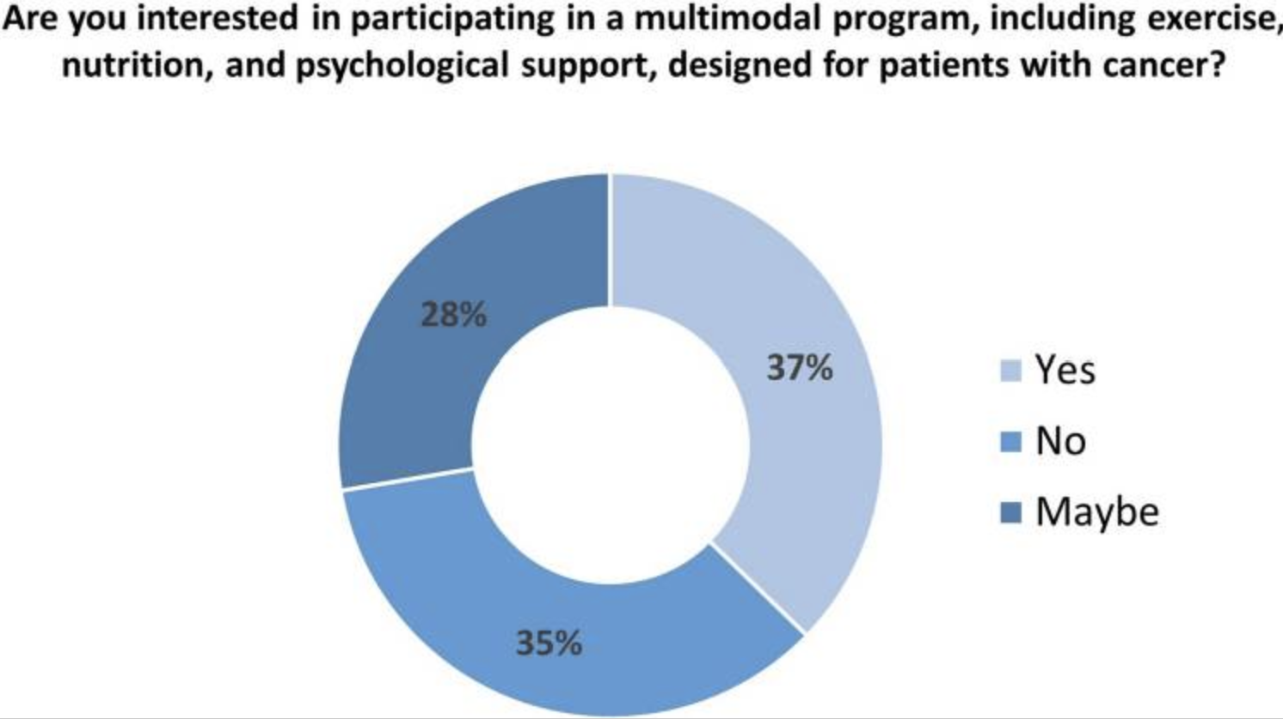
Fig.1 Willingness to start a multimodal intervention including exercise, nutritional counseling, and psycho-oncological interventions

Survey ‘respondents’ preferences are listed in Table 7. Patients preferred to receive instructions from the reference experts for each area: a kinesiologist (48%) for exercise, a dietitian (61%) for nutrition, and a psycho-oncologist (61%) for psycho-oncological interventions. For each intervention, the preferred way to receive information was through a face-to-face approach (66% for exercise, 69% for nutrition, and 72% for psycho-oncological interventions), at the hospital (78% for exercise, 87% for nutrition, and 88% for psycho-oncological interventions), and during anticancer treatment (44% for exercise, 47% for nutrition, and 51% for psycho-oncological interventions).

Table 2.
Preferences in patient with cancer for exercise, nutrition, and psychological aspect¹
Preference as expressed by answers to questions | Exercise |  | Nutrition |  | Psychology
 | N | % | N | % | N | %
Who would you prefer to receive instructions from? | (n = 304) |  | (n = 312) |  | (n = 305)
Oncologist | 125 | 41 | 112 | 36 | 102 | 33
Nurse | 2 | 1 | 1 | 0 | 2 | 1
Kinesiologist | 145 | 48 | 4 | 1 | 6 | 2
Nutritionist | 14 | 5 | 191 | 61 | 2 | 1
Psychologist | 2 | 1 | 3 | 1 | 186 | 61
Another patient cancer | 0 | 0 | 0 | 0 | 0 | 0
No preference | 0 | 0 | 0 | 0 | 0 | 0
Other | 16 | 5 | 1 | 0 | 7 | 2
How would you prefer to receive instructions? | (n = 300) |  | (n = 305) |  | (n = 301)
Face to face | 197 | 66 | 209 | 69 | 218 | 72
Television | 8 | 3 | 7 | 2 | 6 | 2
Radio | 1 | 0 | 1 | 0 | 1 | 0
Leaflet/pamphlet | 23 | 8 | 18 | 6 | 13 | 4
Over the internet | 60 | 20 | 61 | 20 | 51 | 17
No preference | 0 | 0 | 0 | 0 | 0 | 0
Other | 11 | 4 | 9 | 3 | 12 | 4
Where would you prefer to receive instructions? | (n = 310) |  | (n = 306) |  | (n = 306)
At the hospital | 240 | 78 | 271 | 87 | 264 | 88
At a center outside the hospital | 57 | 19 | 33 | 11 | 35 | 11
Other | 9 | 3 | 6 | 2 | 7 | 2
When would you prefer to receive instructions? | (n = 300) |  | (n = 294) |  | (n = 292)
Before treatment | 85 | 29 | 89 | 30 | 74 | 25
During treatment | 130 | 44 | 142 | 47 | 148 | 51
After treatment | 34 | 12 | 26 | 9 | 27 | 9
Other | 45 | 15 | 43 | 14 | 43 | 15
¹Participants of survey study conducted in Verona, Italy, from February 2020 to May 2021

    - Barriers and facilitators to a multimodal intervention

Figure 2 reported the barriers and facilitators of a multimodal program individuated by patients. The most commonly reported barriers potentially hindering participation in a multimodal supportive care intervention were: treatment-related side effects, distance from the structures, and lack of motivation. On the contrary, most commonly reported features facilitating the involvement in a program, including exercise, nutrition, and psycho-oncological interventions, were: availability of specialized experts, encouragement from caregivers, and having the exercise, nutritional and psychological clinics in the same place.

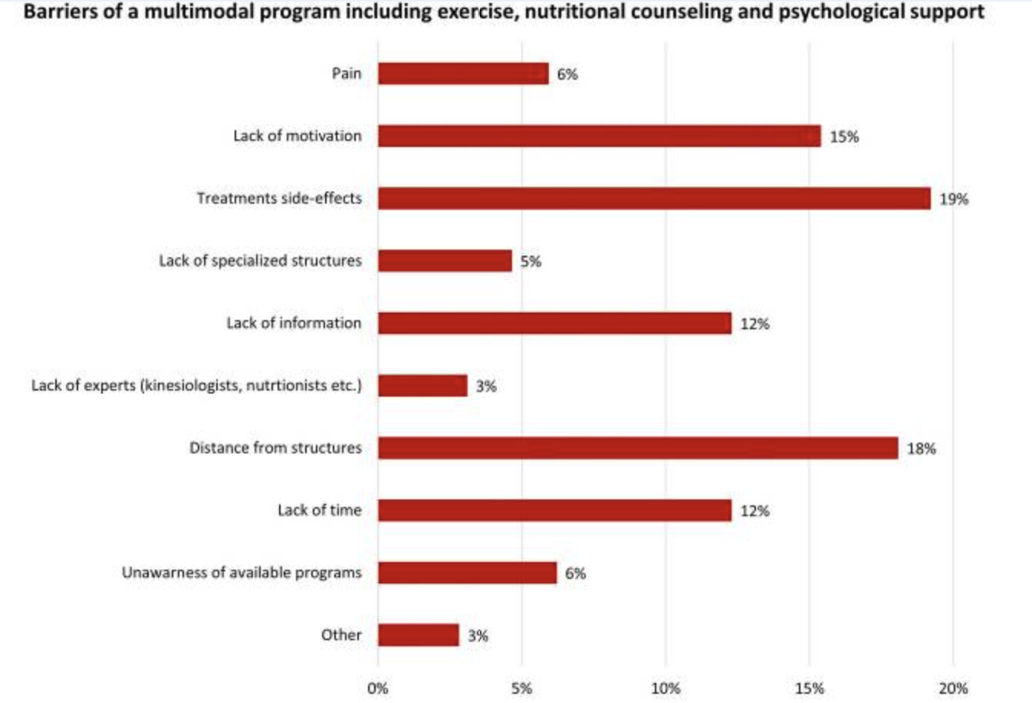

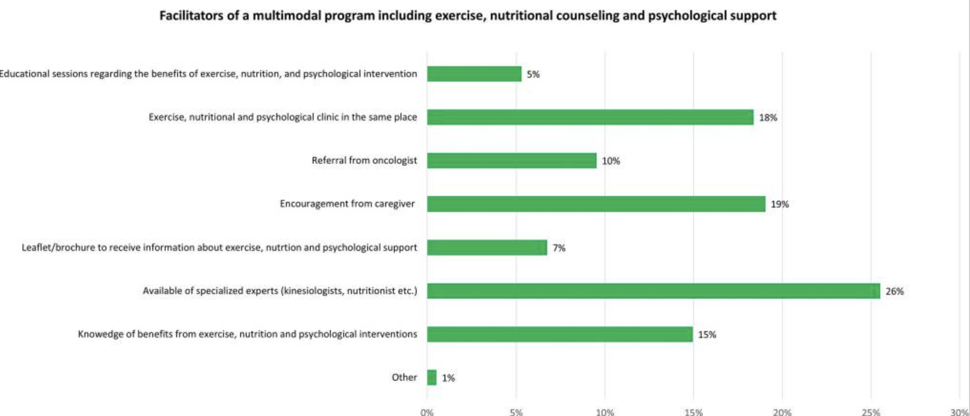
Fig.2 Barriers and facilitators associated with a multimodal intervention

  - Discussion

The present study is the first to explore willingness, preferences, barriers, and facilitators among patients with cancer to participate in a multimodal supportive care program including exercise, nutritional counseling, and psycho-oncological interventions.
We found that roughly 65% of the survey participants were willing to start a multimodal program, including exercise, nutrition, and psycho-oncological interventions, designed for patients with cancer. This finding is particularly crucial especially if considered that 30% of patients were at nutritional risk, 58% reported clinically relevant levels of distress, and 96% did not meet the current exercise guidelines for cancer patients, and the possible consequences in terms of quality and quantity of life of such impaired levels [18, 19, 20, 21]. Prior investigations reported that patients with cancer usually express interest in health-related behaviors intervention, such as exercise [24], nutritional counseling [25, 26, 27, 28], and psycho-oncological interventions [19, 29, 30]. Similarly, a study exploring the preferences related to physical activity and diet interventions in pancreatic cancer survivors found that 69% of study participants were interested in participating a combined lifestyle intervention [23]. Our results support the desire of the patients with cancer to be proactive in their disease journey and their wish for a multimodal supportive care service. Moreover, this finding is crucial, especially in view of the multidisciplinary approach delivery and from a clinical point of view [28]. In this sense, different societies support the integration of supportive care alongside the cancer continuum. For instance, prehabilitation, i.e., interventions, such as exercise, smoking cessation, nutrition, and psycho-oncological interventions, performed between the time of cancer diagnosis and the beginning of the acute treatment, is becoming more and more relevant and a standard of care so much that different guidelines insert it in their recommendations [29, 30, 31, 32]. On the other hand, the multimodal intervention has been suggested as a possible treatment for a complex syndrome like cancer-related cachexia. This multifactorial syndrome, characterized predominantly by loss of skeletal muscle mass, not fully reversed by nutritional support, and leading to a progressive functional impairment, is still orphan of effective treatments [27]. Whereas single interventions failed to gain benefits, multimodal management may be the best strategy, given its multifactorial nature [33].
Logistic regression revealed that younger patients and those who were single were more interested in participating in a multimodal supportive care intervention. These results may be explained by the fact that aging is associated with comorbidities and growing difficulties. Prior researches on exercise found mixed results. On one side, some studies reported that more than half of older patients with cancer were interested in participating in a physical activity program [34,40]. On the contrary, a cross-sectional study on ovarian cancer survivors found that the interest in physical activity diminished in among participants who were aged ≥ 60 years [35], and Morielli and colleagues reported that age was associated with a low exercise adherence in patients with rectal cancer [36]. Regarding medical variables, patients who defined their cancer at “early” stage were less willing to participate in a multimodal supportive care program. Despite, to our knowledge, no prior studies reported a similar finding; this could intuitively explain by the fact that patients with an early stage of disease might feel less in danger, while individuals with an advanced/metastatic cancer, being aware of the severity of their disease, would try everything to feel better [34, 37].
Regarding the preferred source for receiving instructions about each intervention, patients preferred to receive information from a dedicated expert (i.e., kinesiologist, dietitian, psycho-oncologist). These results are in line with previous studies [38, 39], and with recommendations of international societies [22, 5]. Nevertheless, a relevant percentage of patients, ranging from 33 to 41%, have indicated the oncologist as the preferred person to deliver instructions. Similarly, our previous work focusing on exercise identified the oncologist as the preferred person to deliver information [24]. These results may be explained by the fact that the patients recognize the specificity of each approach and thus the need for specialized staff. Nevertheless, patients put their trust in their oncologists during the cancer journey, and therefore some of them may feel more reassured to receive instruction from their voice.
Most patients reported that they preferred to receive exercise and nutritional and psychological instructions face-to-face. Whereas face-to-face counseling is the most preferred counseling modality in several previous investigations [26, 37], we found that a quarter of patients have indicated the internet as the preferred source of information. Information over the internet may have the great advantages of reaching a large number of individuals, increasing patients’ knowledge and engagement in health decision-making strategies. On the other hand, web-based informations are difficult to regulate, and often the quality control is a challenge, in which the risk of incurring misleading information becomes high, hitting more individuals in a vulnerable position, such as patients with cancer. In this sense, providing reliable websites developed by reputable institutions, such as universities or hospitals, may overcome this problem and offer evidence-based information.
The hospital was identified as the preferred place to receive information. Moreover, patients wished to receive instruction about the multimodal intervention before the beginning of therapies or during anticancer treatment. Although the time variance in the preference of lifestyle program start has been reported in the literature [40], our results are encouraging because such interventions (or the monitoring through appropriate screening tools), should be early and regularly administered [41] to prevent or manage possible impairments.
Treatment side effects, distance from facilities, and lack of motivation were reported as the major barriers. These results of mixed disease specific and general obstacles to multimodal intervention mirror the current literature [42, 43, 44]. Although treatment-related adverse events, such as fatigue, and lymphoedema, are frequently reported as potential barriers in lifestyle interventions [45], it is interesting to highlight that many of these side effects can effectively be managed through supportive care intervention. In this sense, increasing patients’ knowledge and awareness about the benefits of supportive care intervention may be a useful strategy to increase patients’ compliance. Distance from facilities and lack of motivation may be easily overcome, including tailored programs with different modality options (e.g., face-to-face approach or using telehealth), and incorporating motivational approach (e.g., goal setting, self-monitoring, action planning) to behavior change.
On the other, the availability of specialized experts, having exercise, nutrition, and psychological clinic in the same facilities, and social support were identified as facilitators for the participation in a multimodal supportive care program. Prior investigations support the experts’ supervision as facilitators to participate in a lifestyle program [46, 47, 48], and may suggest that patients desire tailored intervention based on their needs. Social support may play a role in the intervention compliance, supporting patients ‘motivation and enhancing emotional well-being [49, 50].
The present work has some limitations that should be noted. Information was self-reported and therefore open to different sources of bias. Recall bias may be a possible source of error. To minimize this issue, we have adopted the short version of the questionnaire investigating exercise, nutritional risk, and distress, asking for recent information (e.g., in the previous week). Moreover, the questionnaire did not collect information regarding participants’ diet, and that limit its ability to explore associations with other possible determinants of willingness to participate in a multimodal lifestyle program. The social desirability bias may be less likely because the questionnaire was filled and returned anonymously.
However, it cannot be excluded that patients who decided to participate in this study may be individuals more interested in the supportive care. To reduce this potential bias, the questionnaire was proposed to all patients on randomly selected days. The study participants were sampled to be representative of those attending the Verona oncology clinic, and not the full total of the patients, making our results little generalizable.
The existing literature has shown that nutrition support has the potential to reduce nutritional risk during cancer treatment and address eating problems, and optimal management could improve treatment tolerance and decrease treatment interruptions. Ultimately, the desire for nutrition counselling emerged more because of the influence of ‘anxiety caused by the symptoms’ and ‘confusion about information on eating’. Since this study highlighted patients’ state of confusion caused by being overwhelmed with unclear information about food, the impact of dietary information spread through social networks should be further investigated. Furthermore, healthcare professionals should consider their issues related to family relationships and help nurture sustained feelings of hope and well-being. It is important to empathize with patients’ anxiety about lack of appetite and weight loss and help manage their feelings of remorse for not being able to meet family expectations. This attitude seems to change during the patients’ illness trajectory. Previous findings indicated that patients’ eating deficiencies caused hesitancy about attending social gatherings and led to complete avoidance of such situations. This made them feel lonely and separated from the life they had lived as healthy people [51].
The results of this study show that the need for nutrition counselling is related to psychosocial factors such as living situation, employment status, and psychosocial outcomes, including anxiety and confusion regarding diet.
Therefore, a multidimensional approach is recommended to support patient with cancer [52]. Many patients with advanced cancer undergoing chemotherapy are anxious about their future. Therefore, as part of a holistic treatment approach, dieticians should collaborate with specialists in relevant fields to develop multidisciplinary interventions. Furthermore, rather than merely insisting that patients follow their instructions, medical professionals should consider both the symptoms and emotions of patients.
Furthermore, to assess the real situation in clinical practice, it is useful to employ a mixed-methods design that combines qualitative assessments of the patients’ subjective data and a quantitative analysis to objectively evaluate their conditions.

  - Conclusions
In conclusion, this study highlights that patients desire to participate in a multimodal supportive care intervention, including exercise, nutritional and psycho-oncological interventions, specifically designed for individuals with cancer. Patients prefer to receive instruction in the hospital, from dedicated experts, and with a face-to-face approach. Although different barriers to multimodal supportive care intervention have been identified, several facilitators may promote patient compliance.
Overall, these results support that a multimodal supportive care intervention is feasible and desired by patients with cancer, and represent the first step toward the development of a tailored program.

Chapter 2
A randomized clinical trial with crossover testing to different tuning frequences to optimize music therapy in oncological patients

  - Abstract
All contents of this chapter refer to the randomized clinical trial conducted in our medical oncology unit and the manuscript is in preparation.
Among complementary treatments, music therapy can be beneficial for soothing the side effects of antiblastic therapy, such as pain and anxiety, and inducing relaxation and serenity. In this regard, there are some currents of music therapy thought that adopt mathematical and physical theories relating to the tuning of A at 432 Hertz: it would ensure that the notes of the musical scale are tuned according to the Fibonacci sequence and the golden ratio, both mathematical aspects found in the order of Nature and the known Universe.
This study attempted to verify these hypotheses by conducting two music therapy meetings per participant, in which the same song recorded with different frequencies (one at 440 Hertz, one at 432 Hertz) was listened to by a sample of 42 cancer patients., blood pressure, heart rate, respiratory rate, anxiety, stress, and quality of life were assessed using special devices for measuring vital and psychological parameters: electronic sphygmomanometer, STAI-Y questionnaire, distress thermometer, EORTC QLQ-C30. Whenever possible, singing was used during the meetings.
There is a tendency towards significance for blood pressure: with the tuning of the A at 440 Hz, it tends to increase; with the A at 432 Hz, it tends to decrease or remain stable. The remaining data (other vital parameters considered and values ​​obtained from the administration of the anxiety and stress questionnaires) were found not to be statistically significant. These results highlighted a role of music therapy in determining a state of relaxation, making us lean more towards a set of factors (the patient’s musicality, his tastes and harmony of the piece, patient-therapist relationship, and environmental factors) that go beyond simple frequencies.

  - Introduction

Cancer is a chronic, systemic illness with a variety of aetiological factors including genetic susceptibility, environmental, and epigenetic factors. Other associated factors include those that are largely modifiable by the individual, including emotive distress, poor nutrition/diet, lack of physical activity and poor sleep. Cancer and its treatment are associated with many symptoms and signs, many of which decrease the ability of patients to complete treatment, such as cancer-related pain, chemotherapy-induced peripheral neuropathy, oral mucositis, anxiety, depression, and poor sleep [53; 104-106]. Many of these are not well managed with orthodox medicine approaches.
An integrative approach to the treatment of illness like cancer is one in which combines conventional medicine with evidence-based complementary medicines/therapies, nutritional medicine and lifestyle interventions for the treatment and prevention of disease and the optimisation of health. Its basis is a holistic one; to treat the whole person, not just the disease. It makes use of adjunct technologies which may assist the clinician in diagnosis of early carcinogenesis and monitoring of treatment effectiveness, such as circulating tumour cell tests [54-57].
Our understanding of the potential mechanisms of action of various complementary therapies has grown over the past two decades, and the number of studies that probed into the clinical effectiveness of these therapies has increased. An international multidisciplinary professional organization, the Society for Integrative Oncology (SIO), was formed to advance evidence-based, comprehensive, integrative healthcare in order to improve the lives of people affected by cancer [55-59]. The comprehensive definition of integrative oncology is a patient-centered, evidence-informed field of cancer care that utilizes mind and body practices and lifestyle modifications alongside conventional cancer treatments. Integrative oncology aims to optimize health, quality of life, and clinical outcomes across the cancer care continuum, and to empower people to prevent cancer and become active participants before, during, and beyond cancer treatment [59,107].
Music therapy was recommended to improve mood disturbance and reduce anxiety.
The effects of music on human psycho-neuro-endocrine-immunology is a growing area of research at both the cellular and clinical levels [104,109,110]. While not a stand-alone treatment modality, there is tremendous evidence-base for the role of music therapy as an adjunct in mitigating cancer-associated symptoms [61]. Music modifies heart rate, respiratory rate, and blood pressure, and soothing music may reduce serum cortisol, a stress hormone, explaining its calming effect [60], [62], [63]. A meta-analysis shows the beneficial effect of music in patients with depression [64]. A randomized controlled trial conducted among 207 patients undergoing surgery for potential or known breast cancer reported that music was a safe and effective intervention for lowering (P < 0.001) preoperative anxiety [66]. In addition, music therapy has been shown to reduce mood disturbance and help pain management among patients undergoing high-dose chemotherapy with autologous stem cell transplantation [65], [68]. Music therapy has notably lowered patient anxiety and distress during the simulation of radiation therapy [67]. Systematic reviews suggest that music therapy is a promising non-pharmacological approach for coping with pain perception and mood disorders in patients undergoing radiation treatment [69-70]. Music therapy may help to alleviate cancer-related fatigue in patients during and after treatment [71].
Additionally, music therapy may be offered to cancer patients at various treatment phases, as the intervention can improve relevant health outcomes [72-74].
Patients with cancer may undergo extensive and long-term emotional, physical and social suffering, and listening to music that a patient finds comfort in, will be a great tool to alleviate this psychosocial distress and improve their quality of life [75-78]. Thus, we need to tailor music therapy for patients with cancer. In order to achieve this, we need more clinical evidence from randomized controlled trials.
To increase the longevity and quality of life of cancer patients, integrative oncology must undertake new evidence-based initiatives that focus on building the awareness of individualized music therapy among patients and care providers. Therefore, our prime focus is to get clinical data to understand how patient preference in music affects music therapy experience. Randomized controlled trials evaluating personalized music choices or playlists would be the appropriate way to start building this understanding. Therefore, clinicians and board-certified music therapists must be encouraged to provide an open conversation with patients about their ideas of creative expression through music, choices in music, and listening preferences [79,80,112]. Every small step taken towards embracing personalization will have a remarkable positive effect on the physical and emotional suffering of patients with cancer.
In addition to its scientific basis, supported and already reported by Pietro Blaserna in his report of the Vienna Conference [81], the 432 Hz tuning fork also seems to conform to human biology: according to what was supported by the molecular biologist and musician Emiliano Toso, "the the music I compose has a tone of 432 Hz because, compared to the standard one used now in the world which is tuned to 440 Hz, it is more similar to the biological sounds of nature, to our cells" [82]. In fact, according to recent discoveries in Physics, especially in the quantum field, vibration is one of the fundamental components of the known Universe, both at a microscopic and macroscopic level; matter, energy and their interactions have an oscillatory nature, as do sound and light [83]. In fact, it seems that cells can communicate with each other through mechanical vibrations, oscillating even at the level of their smallest components (for example in mRNA molecules), through precise pauses, rhythms and periods; it would thus be possible to use certain frequencies to resonate with these vibrations, and cure some pathologies resulting from incorrect cellular communication [84].
The primary objective of the study is to compare tuning at 440 Hz and 432 Hz in two separate sessions, approximately 15 days apart, to identify any differences between them in inducing relaxation in cancer patients. The secondary objectives were consequently the following: evaluate changes in vital parameters (blood pressure, heart rate, and respiratory rate), state of anxiety and distress, and quality of life; the levels of anxiety and distress were measured at the beginning and end of each meeting, the quality of life at the first meeting and one month after the same. Returning to the purely frequency aspect, it seems that a frequency of 8 Hz (of which 432 is a multiple), found in DNA replication and in alpha and theta type brain waves (from 4 to 11 Hz) associated with states of sleep, relaxation and deep meditation, is able to stimulate the release of certain hormones by the pineal gland, which thus regulates our circadian well-being [85,109]. Given this knowledge, combined with the studies he conducted for twenty years on DNA and its replication processes in the laboratory, Emiliano Toso recorded, as a pianist and composer, some records using 432 Hz intonation, today reproduced with remarkable outcomes in numerous care settings [86,87].
The primary objective of the study is to compare tuning at 440 Hz and 432 Hz in two separate sessions, approximately 15 days apart, to identify any differences between them in inducing relaxation in cancer patients. The secondary objectives were consequently the following: evaluate changes in vital parameters (blood pressure, heart rate, and respiratory rate), state of anxiety and distress, and quality of life; the levels of anxiety and distress were measured at the beginning and end of each meeting, the quality of life at the first meeting and one month after the same.

  - Materials and methods
    - Study design and participants
A randomized controlled pilot study was carried out to compare two music therapy treatments. The enrolled patients were randomized to receive the music therapy intervention with the two frequencies under study (440 and 432 Hz) in two possible sequences: Group A, sequence 440 > 432 Hz, or Group B, sequence 432 > 440 Hz.
The sample is represented by 40 adult patients, affected by solid tumors, undergoing active treatment under a Day Hospital regime at the Complex Oncology Operating Unit of the Integrated University Hospital of Verona, within the “Giovanni Battista Rossi” Polyclinic in Borgo Roma, who agreed to participate in the study.
- Inclusion criteria
• Age >18 years; there are no upper age limits for inclusion in the study.
• Diagnosis of solid neoplasm in active treatment (chemotherapy, hormone therapy, molecular targeted therapy, immunotherapy).
• Good general condition (ECOG PS: 0-1; reference table in Appendix 5).
• Written informed consent to participate in the study.
- Exclusion criteria
• Patients being treated with psychotropic drugs.
• Patients with ongoing psychopathologies.
• Patients in poor general condition (ECOG PS: 2 or higher).
• Inability or inability of the subject to undergo the procedures required by the study.

Potentially eligible patients, identified by the Music Therapy student and/or reported by the reference psychologist. Patients who agreed to participate in the study were then randomized to one of the two treatment sequences provided by the study (group A: 440 > 432 Hz or group B: 432 > 440 Hz) (Fig.1). Randomization was carried out by the Study Coordinator responsible for the study, who followed these procedures:
• Assign the patient a unique identification number (ID).
• Complete the eligibility verification checklist, based on the data provided by the investigators.
• Randomize the patient (using the ID), through a randomization list in paper format, to one of the two study sequences:
Group A: 440>432 Hz sequence;
Group B: 432>440 Hz sequence.
• Prepare the specific treatment plan for the patient with the relevant data collection forms pre-filled with the patient’s ID and differentiated by Visit 1 (first frequency) and Visit 2 (second frequency) depending on the assigned group.
The music therapy intervention, which always took place in a clinic of the oncology day hospital of the “Giovanni Battista Rossi” hospital in Verona, was structured according to the provisions of the randomization sequence and based on the attached flowchart. After the necessary information and the signing of the consent, which was followed by the administration of the questionnaires and the measurement of the vital signs, the student and the individual patient, sitting facing each other, listened to a pre-recorded 440 Hertz and/or 432 Hertz, depending on the meeting, performing when possible short vocal improvisations on the base itself. The base consisted of a guitar piece composed by the student himself, recorded first at 440 Hertz and subsequently at 432 Hertz; the two pieces are therefore identical in structure and duration (10 minutes and 20 seconds), differing only in the tuning. The duration of each meeting, including all the steps foreseen by the flowchart and any interruptions mainly due to medical treatments, ranged from a minimum of 25 to a maximum of 50 minutes.

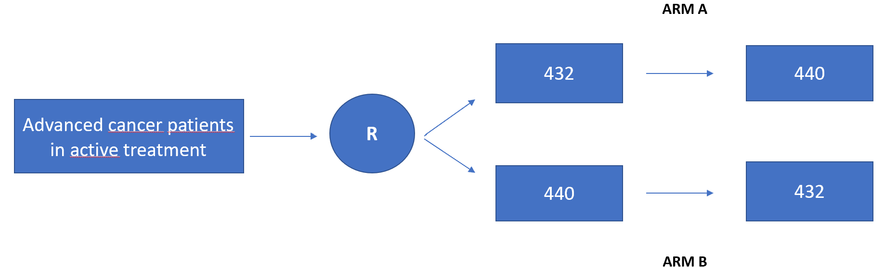
Fig.1 Study design

In the study 42 patients were eligible to participate, aged between 32 and 78 years (median age: 53.5 years), 13 males and 29 females; at the time of the first meeting, the ECOG-PS was rated 0 for 39 patients, the remaining 3 had an ECOG-PS equal to 1. Thirty-one patients completed the entire music therapy process, including the 2 meetings and the administration of the questionnaire EORTC on quality of life at the first meeting and one month after it. Unfortunely, 4 patients did not complete this questionnaire at the end of the interviews, as their subsequent visits, therapies and checks went beyond the time frame foreseen by the study. Finally, 7 patients were lost to follow up, due to worsening of their clinical conditions or excessive level of anxiety at the time of the second meeting, which did not allow them to complete the process. Of these, 1 was randomized to arm A (440->432) and 6 to arm B (432->440); overall, the frequency 440 was evaluated in 36 cases while the 432 in 41 cases. Therefore, 35 couples were eligible for statistical calculation. As regards the pathologies from which they were affected, the most represented in the sample was breast cancer, from which 13 patients were affected (equal to 31% of the entire sample), all female; followed by pancreatic cancer with 11 patients (26.2%, 6 females and 5 males), colorectal cancer with 7 patients (16.7%, 5 females and 2 males) and melanoma with 3 patients (7.1 %, 2 females and 1 male also affected by renal carcinoma). In addition to participants with these diagnoses, the remaining 19.2% of the sample consisted of patients affected individually by cardiac angiosarcoma, lung cancer, colloid adenocarcinoma, and prostate cancer (males), fallopian tube cancer, endometrial sarcoma, and Ewing’s sarcoma (females).

    - Questionnaire description

      - Psychological survey tools
At each visit, were administered the STAI-Y (Stait-Trait Anxiety Inventory- form Y) questionnaire to assess the level of state and trait anxiety, the distress thermometer (TD) to assess stress and, when required, the EORTC-QLQ (European Organization for Research and Treatment of Cancer-Quality of Life Questionnaire) questionnaire to investigate quality of life, following the flowchart below.

2.3.2.2 Nursing survey tools
The measurement of vital parameters used the following tools, chosen with a reference nurse and used for all patients:
• Blood pressure: appropriately calibrated automatic electronic sphygmomanometer; alternatively, appropriately calibrated aneroid sphygmomanometer and stethoscope.
• Heart rate: appropriately calibrated automatic electronic sphygmomanometer; alternatively, measurement of the radial pulse or other body pulses (e.g. carotid) for 60 seconds.
• Respiratory rate: observation of the number of breaths in 1 minute.
The parameters under study will be measured following current nursing guidelines (Saiani and Brugnolli, 2013) and reported on each patient’s data collection sheet, including the measurement time.

2.3.2.3 Flowchart

Activity | Baseline | Visit 1 | Visit 2 | Visit 3
Activity | Days -15/0 | Day 0 | Day +15/+21 | Day +30/+45
Informed consent | x | x
Inclusion/ Exclusion Criteria | x | x
Demographics and baseline characteristics | x | x
EORTC-QLQ | x |  |  | x
PA | x | x | x
FC | x | x | x
FR | x | x | x
STAI-Y | x | x | x
TD | x | x | x
Music Therapy Treatment (440 Hz) |  | x (Group A) | (Group A)
Music Therapy Treatment (440 Hz) |  | (Group B) | x (Group B)
Music Therapy Treatment (432 Hz) |  | (Group A) | x (Group A)
Music Therapy Treatment (432 Hz) |  | x (Group B) | (Group B)
PA post treatment |  | x | x
FC post treatment |  | x | x
FR post treatment |  | x | x
STAI-Y post treatment |  | x | x
TD post treatment |  | x | x

    - Statistical analysis
Patient characteristics will be reported for the entire sample and for the sample split between the two sequences. The quantitative variables will be summarized with means and standard deviations, while for the qualitative items absolute frequencies and percentages will be used. The primary endpoint, i.e. the assessment of anxiety, will be evaluated with the Student’s t test for paired data; this test will also be applied with exploratory intent to secondary endpoints (vital parameters, stress and quality of life).
The primary endpoint is the pre-post music therapy session change in STAY-I questionnaire values. A sample of 40 patients randomly subjected to alternating sequences of music therapy will allow us to detect an effect size equal to or greater than 0.75, with a power of 90% at a significance level of 5%. The comparison test will be the Student’s t test for paired data.
The data are expressed as mean and standard deviation (mean ± SD); the comparison between the raw data, between the differential data (post – pre) and between the data consisting of relative differences (i.e. relative data, (post – pre)/pre) were performed using Student’s t test for paired samples. The alpha level was set at 5% (p<0.05).
As previously reported, 35 pairs were evaluable for statistical calculation, created based on the primary and secondary objectives and endpoints established by the study; after calculating the mean and standard deviation for each objective, the absolute differences before and after the meeting were calculated (therefore the value after the therapy minus the value before the therapy) and the corresponding relative differences (the absolute difference compared to the pre-therapy value encounter). For both differences there is a tendency towards significance for blood pressure: with the tuning of the A at 440 Hz it tends to increase (e.g. mean absolute difference maximum PA = 2.4000, standard deviation = 8.72185, p = 0.05), with the A at 432 Hz decreasing or remaining stable (e.g. mean absolute difference maximum PA= -1.6857, standard deviation= 8.15934, p= 0.05). All the other pairs, made up of the other vital parameters considered and the values ​​obtained from the administration of the questionnaires on anxiety and stress, were found not to be statistically significant (e.g. mean absolute difference HR at 432 Hz = 0.1429, standard deviation = 5.15149, p = 0.64).

  - Results
    - General characteristics

In the study 42 patients were eligible to participate, aged between 32 and 78 years (average age: 53.5 years), 13 male and 29 female; at the time of the first meeting, the ECOG was calculated as 0 for 39 patients, the remaining 3 were given a value of 1. 31 patients completed the entire music therapy process, including the 2 meetings and the administration of the EORTC quality of life questionnaire at the first meeting and one month after the same; 4 patients did not complete this questionnaire at the end of the interviews, as their subsequent visits, therapies and checks went beyond the time frame foreseen by the study. Finally, 7 patients were lost to follow up, due to worsening of their clinical conditions or due to an excessive level of anxiety at the time of the second meeting, which did not allow them to complete the process; the reasons for this anxiety were multiple: first scheduled chemotherapy, fear of missing one’s turn for a check-up and/or therapy visit, family commitments outside the hospital, distance from home and therefore lack of time to dedicate to studying, in addition to the absence of interest or negative perceptions regarding the proposed music (Figure 2). Of this group of patients, one was randomized to arm A (440->432) and 6 to arm B (432->440); overall, the frequency 440 was evaluated in 36 cases while the 432 in 41 cases. Therefore, 35 couples were eligible for statistical calculation.
As regards the pathologies from which they were affected, the most represented in the sample was breast cancer, from which 13 patients were affected (equal to 31% of the entire sample), all female; followed by pancreatic cancer with 11 patients (26.2%, 6 females and 5 males), colorectal cancer with 7 patients (16.7%, 5 females and 2 males) and melanoma with 3 patients (7, 1%, 2 females and 1 male also affected by renal carcinoma). In addition to participants with these diagnoses, the remaining 19.2% of the sample was composed of patients affected individually by cardiac angiosarcoma, lung cancer, adenocarcinoma colloid and prostate cancer (males), fallopian tube cancer, endometrial sarcoma and Ewing’s sarcoma (females). Moving on to comorbidities, 7 patients (6 females and 1 male) suffered from arterial hypertension, one patient was suffering from deep venous thrombosis with associated episodes of phlebitis, one patient had a mild mitral valve defect and another suffered from tachycardia; in any case, none of these cardiovascular pathologies compromised the patients’ participation in the study.

Table 1- Patients characteristics
 | Arm A | Arm B | Total
Sex  Male No (%)  Female No (%) | 6 (28.6)  15 (71.4) | 7 (33.3)  14 (66.7) | 13 (31.0)  29 (69.0)
Age (years)  mean (range) | 54 (32-78) | 53 (32-78) | 53.5 (32-78)
ECOG PS No (%)  0  1 | 20 (65.2)  1 (4.8) | 19 (90.5)  2 (9.5) | 39 (92.9)  3 (7.1)
Tumor site No (%)  Adenocarcinoma colloid  Cardiac angiosarcoma  Colerectum  Breast  Pancreatic carcinoma  Lung  Urogenital  Gynecological  Melanoma  Melanoma renal cell-carcinoma  Sarcoma  Ewing’s sarcoma | 1 (4.8)  1 (4.8)  4 (19.0)  8 (38.1)  2 (14.3)  0  0  1 (4.8)  1 (4.8)  1 (4.8)  0  1 (4.8) | 0  0  3 (14.3)  5 (23.8)  8 (38.1)  1 (4.8)  1 (4.8)  0  2 (9.5)  0  1 (4.8)  0 | 1 (2.4)  1 (2.4)  7 (16.7)  13 (31.0)  11 (26.2)  1 (2.4)  1 (2.4)  1 (2.4)  3 (7.1)  1 (2.4)  1 (2.4)  1 (2.4)

The study was not completed by 7 patients, of these, 1 was randomized to arm A (440->432) and 6 to arm B (432->440). Therefore, the frequency 440 was evaluated on 36 cases while the 432 on 41 cases. Overall, 35 couples can be evaluated (Figure 2).

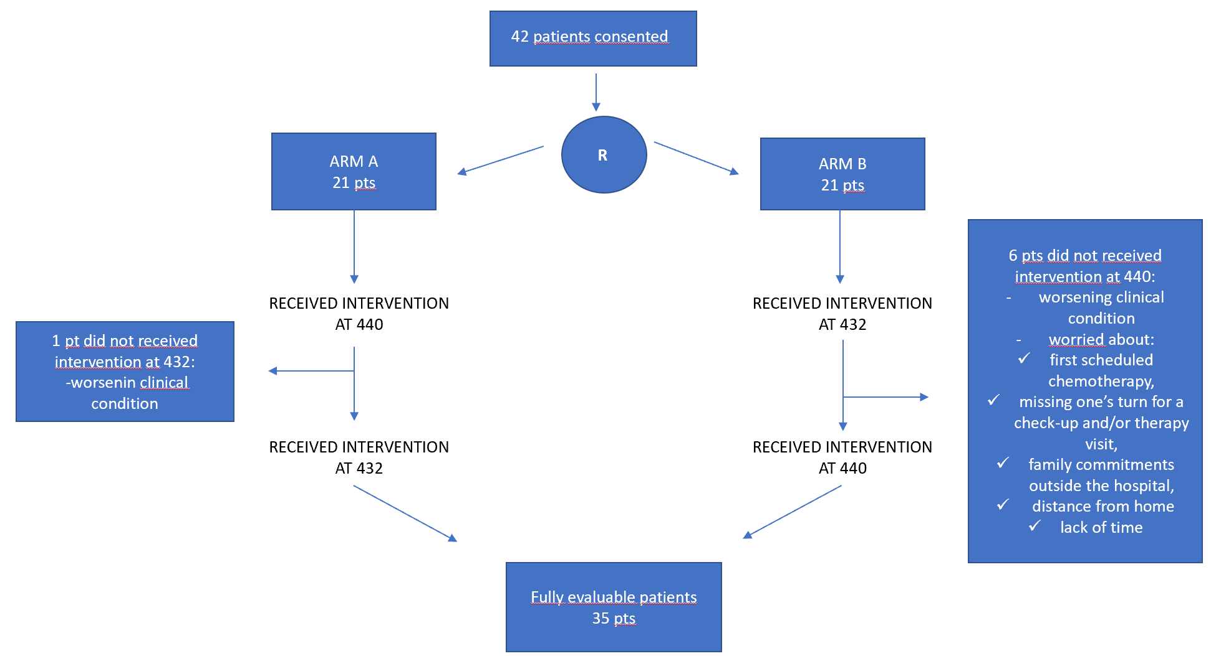
Fig.2 Consort diagram

    - Differences between 432 Hz vs 440 Hz frequencies

Table 2 Differences Post-Pre 432Hz_440Hz
 |  | Mean | Std. Deviation | P value
Pair 1 | diff_Bpmax* 440 | 2,4000 | 8,72185 | 0.061
Pair 1 | diff_Bpmax* 432 | -1,6857 | 8,15934
Pair 2 | diff_Bpmin** 440 | 2,3714 | 5,66769 | 0.054
Pair 2 | diff_Bpmin** 432 | ,0571 | 4,45198
Pair 3 | diff_Hr*** 440 | -,2000 | 3,74794 | 0.64
Pair 3 | diff_Hr*** 432 | ,1429 | 5,15149
Pair 4 | diff_Rr**** 440 | -,5714 | 2,99299 | 0.31
Pair 4 | diff_Rr**** 432 | -1,1143 | 2,15258
Pair 5 | diff_Dt***** 440 | -1,8857 | 2,48254 | 0.63
Pair 5 | diff_Dt***** 432 | -2,1429 | 2,43918
Pair 6 | diff_ STAI-Y1****** 440 | -8,2857 | 8,20535 | 0.26
Pair 6 | diff_STAI-Y1****** 432 | -6,9143 | 6,58595
Pair 7 | diff_ STAI-Y2****** 440 | -1,9714 | 4,17616 | 0.62
Pair 7 | diff_ STAI-Y2****** 432 | -1,4857 | 4,03930
*Maximum blood pressure;**Minimum blood pressure;***Heart rate;****Respiratory rate;*****DistressThermomether;****** State-Trait Anxiety Inventory******

These are the post music therapy – pre music therapy differences for the two frequencies. The table 2 is made on 35 patients. The data shows that there are no statistically significant differences in patients having received the intervention in arm A (440>432) compared to arm B (432>440). There are no statistically significant differences even between pre and post 440 vs 432.

Table 3 EORTC Differences Pre-Post 432Hz_440Hz-Analysis of Variance

 | ARM A (440>432) |  | ARM B (432>440) |  | p value
 | I | II | I | II | A vs B | I vs II
EORTC | 55.1 +/- 10.0 | 54.6 +/- 10.4 | 57.8 +/- 10.0 | 55.5 +/-10.7 | 0.79 | 0.083
Felt tense | 1.8 +/- 0.75 | 1.8 +/- 0.83 | 1.9 +/- 0.83 | 1.4 +/-0.63 | 0.30 | 0.19
Worried | 1.9 +/- 0.83 | 1.8 +/- 0.91 | 2.0 +/- 0.77 | 1.5 +/-0.64 | 0.43 | 0.11
Felt irritable | 1.9 +/- 0.89 | 1.7 +/- 0.86 | 2.1 +/- 0.97 | 1.5 +/-0.74 | 0.63 | 0.06
Felt depressed | 1.6 +/- 0.74 | 1.5 +/- 0.82 | 1.5 +/- 0.81 | 1.3 +/-0.62 | 0.54 | 0.50

The Analysis for repeated measures does not highlight any differences between the first and second evaluations or between the two arms with the values ​​of eortc, the item of feeling tense, worried, irritable and depressed (Table 3).

Table 4
432 Hz
 | First Intervention |  |  | Second Intervention
 | N | Mean | Std. Deviation | N | Mean | Std. Deviation | P value
Bpmax* | 21 | 124,62 | 17,724 | 20 | 117,20 | 16,606 | 0.17
Bpmin** | 21 | 84,00 | 8,456 | 20 | 78,35 | 9,063 | 0.046
Hr*** | 21 | 67,00 | 11,389 | 20 | 76,00 | 11,899 | 0.018
Rr**** | 21 | 14,90 | 5,856 | 20 | 15,50 | 3,301 | 0.69
DT***** | 21 | 4,19 | 2,542 | 20 | 3,95 | 2,929 | 0.78
STAI-Y1****** | 21 | 40,62 | 11,834 | 20 | 35,75 | 10,622 | 0.17
STAI-Y2****** | 21 | 42,10 | 11,966 | 20 | 39,10 | 11,960 | 0.43
*Maximum blood pressure;**Minimum blood pressure;***Heart rate;****Respiratory rate;*****DistressThermomether;****** State-Trait Anxiety Inventory******

Table 4bis
440 Hz
 | First Intervention |  |  | Second Intervention
 | N | Mean | Std. Deviation | N | Mean | Std. Deviation | P value
Bpmax* | 21 | 119,24 | 13,652 | 15 | 119,07 | 20,222 | 0.98
Bpmin** | 21 | 79,24 | 8,318 | 15 | 78,00 | 12,541 | 0.72
Hr*** | 21 | 74,05 | 12,347 | 15 | 66,20 | 11,169 | 0.059
Rr**** | 21 | 15,00 | 3,271 | 15 | 12,47 | 5,055 | 0.08
DT***** | 21 | 4,24 | 3,032 | 15 | 2,80 | 2,242 | 0.13
STAI-Y1****** | 21 | 38,00 | 11,095 | 15 | 38,20 | 9,734 | 0.95
STAI-Y2****** | 21 | 40,24 | 12,641 | 15 | 38,27 | 9,331 | 0.61
*Maximum blood pressure;**Minimum blood pressure;***Heart rate;****Respiratory rate;*****DistressThermomether;****** State-Trait Anxiety Inventory******

There is no difference except for the minimum blood pressure for frequency 432, this frequency was higher in patients who received it as the first intervention. As well as the baseline heart rate was lower for the 432 frequence as the first intervention. No statistically significant differences were found in the other parameters with respect to the order of intervention and type of frequency (Table 4-4bis). For this reason, given the lack of difference between first and second interventions, they were considered together.

Instead, working separately for the two frequencies (table 5-6) pre e post intervention the level of distress was lower in the post-intervention of arm A and arm B, the levels of state anxiety were also decreased after the intervention of both arm A and arm B.

Table 5 Differences pre/post intervent Arm A 440 > 432 Hz
 |  | Mean | N | Std. Deviation | P VALUE
 | Bp max pre | 118,24 | 41 | 15,008 | 0.96
 | Bp max post | 118,17 | 41 | 16,539
 | Bp min pre | 78,80 | 41 | 8,591 | 0.007
 | Bp min post | 81,10 | 41 | 9,148
 | Hr pre | 75,00 | 41 | 12,019 | 0.62
 | Hr post | 75,41 | 41 | 11,688
 | Rr pre | 15,24 | 41 | 3,254 | 0.043
 | Rr post | 14,61 | 41 | 3,598
 | Dt pre | 4,10 | 41 | 2,948 | <0.001
 | Dt post | 2,32 | 41 | 2,285
 | STAI-Y1 pre | 36,90 | 41 | 10,791 | <0.001
 | STAI-Y1 post | 29,93 | 41 | 7,637
 | STAI-Y2 pre | 39,68 | 41 | 12,173 | 0.010
 | STAI-Y2 post | 37,90 | 41 | 12,486

Table 6 Differences pre/post intervent Arm B 432 > 440 Hz
 |  | Mean | N | Std. Deviation | P value
 | Bp max pre | 122,31 | 36 | 18,729 | 0.49
 | Bp max post | 123,11 | 36 | 19,748
 | Bp min pre | 81,50 | 36 | 10,619 | 0.91
 | Bp min post | 81,42 | 36 | 10,691
 | Hr pre | 66,67 | 36 | 11,143 | 0.058
 | Hr post | 65,58 | 36 | 10,311
 | Rr pre | 13,89 | 36 | 5,595 | 0.081
 | Rr post | 12,83 | 36 | 4,808
 | Dt pre | 3,61 | 36 | 2,487 | <0.001
 | Dt post | ,94 | 36 | 1,308
 | STAI-Y1 pre | 39,61 | 36 | 10,926 | <0.001
 | STAI-Y1 post | 30,33 | 36 | 5,870
 | STAI-Y2 pre | 40,50 | 36 | 10,969 | 0.002
 | STAI-Y2 post | 38,44 | 36 | 9,685

Table 7 Generalized linear model
 | Bp max | Bp min | Hr | Rr | Dt | STAI-Y1 | STAI-Y2
Arm  A  B | p=0.57  Ref.  1.06 (1.88) | p=0.05  Ref.  -2.11 (1.09) | P=0.01  Ref.  -2.52 (1.03) | P=0.19  Ref.  -0.77 (0.58) | P=0.001  Ref.  -1.21 (0.37) | P=0.47  Ref.  -0.80 (1.11) | P=0.82  Ref.  -0.20 (0.87)
Baseline values | P<0.001  0.96 (0.06) | P<0.001  0.90 (0.06) | P<0.001  0.88 (0.04) | P<0.001  0.74 (0.06) | P<0.001  0.35 (0.07) | P<0.001  0.44 (0.05) | P<0.001  0.91 (0.04)

In this model the post values ​​were related to the pre and to the arm they belong to. All post values ​​are strongly correlated with pre values ​​(all significant at the p<0.001 level).
Furthermore, some endpoints (BP min, HR, D) were also significantly decreased in arm B compared to arm A

- 2.5 Discussion

The results obtained seem to demonstrate that intonation and tuning are just two of the countless factors that can make conventional music therapy effective in relaxing cancer patients [95-98]. Therefore, the performance of an improvisation or a simple listening at 440 Hertz or 432 Hertz seems induce the same effects, when other elements are at play. Among these elements, the patients' interest and passion for the proposed activity seems to have a fundamental role: the more they participate by getting involved without any type of prejudice or reservation, the more the distraction from their pathological condition and the relaxation, even if only perceived, they will be effective. The influence that the clinical conditions in which the patient finds himself can play at this level is equally obvious: fatigue, pain and the psychological, physical and social difficulties due to diagnoses and oncological treatments constitute a obstacle to even simply listening to a short song, thus limiting the participation of possible users and the range of action of the music therapist [99].
The limitations of the study are represented by the small sample size, as well as the absence of single/double-blind administration, which could reduce the generalizability of the results; this limitation was taken into account when designing a study which aims to provide a proof-of-concept and working hypothesis for subsequent studies, rather than definitive results. In particular, knowing the frequency on which one improvised could have influenced, even unconsciously, the performance of the improvisation, due to the personal suggestion of the student and regarding the possible beneficial effect of tuning at 432 Hertz. To overcome this event, the student avoided as much as possible providing further information regarding the properties of the tunings used, explaining to the patient that it was a simple comparison. Moreover, the difference between the two frequencies is almost imperceptible, except for a trained ear, and the choice to carry out only 2 meetings per patient approximately 15 days apart has allowed us to avoid the habit of recognizing of the frequency used.
The results of the quality of life questionnaire could reach some significance, but the sample appears to be excessively small: only 31 patients completed the entire path foreseen by the study, compared to an initially foreseen sample of 40 patients, which would have allowed us to detect an effect size equal to or greater than 0.75, with a power of 90% at a significance level of 5%.
Other factors that can influence relaxation are undoubtedly the executive and human skills of the therapist, which can favor or not favor the creation of an empathic relationship with the patient [100,101]. The acoustics of the room in which the meeting takes place, the presence and the intensity of the light sources, the devices used for sound reproduction, the choice of using pre-recorded music or performing one's own songs live, the harmonic structure of the song and the personal tastes of the performer and/or audience. All elements, these, which reduce the impact that the simple frequency of intonation and/or tuning can have on health, in particular when performing very free melodic improvisations.
In this study, an attempt to overcome these problems was implemented through the creation of standardized, very long and repetitive pre-recorded backing tracks, which however did not totally exclude active and improvised performance through the use of the voice and, obviously, tastes personal information of each participant.
Perhaps, in the future it would be more appropriate to verify the effects of individual frequencies on human biology through study designs that involve the use of minimal, pure sounds and/or beats [102,103]. Therefore, free from rhythmic, harmonic, melodic and aesthetic influences that reduce inevitably the relevance of the Hertz disputes: trying to give answers to such questions would, at that point, be up to Sound Therapy or, at the limit, to Vibrational Music Therapy. Finally, the 2 meetings are most likely insufficient to determine not only the impact of one tuning compared to another: a longer and more constant Music Therapy program could provide more significant results and conclusions, as well as more in-depth studies on the issue raised.

- 2.6 Conclusion

In conclusion, the results of this randomized trial of music tehrapy as evidence for the benefit of a music intervention for patients with cancer in active oncological treatment. Listening to music has clinical benefit for improving positive mood and reducing negative
mood and distress. This study highlights that music therapy have a positively impact to reduce distress symptomps and levels of anxiety. Furthermore, the data show that music therapy has a significant effect on physiological parameters (blood pressure, heart rate).
Overall, these results support that a music therapy intervention is feasible and desired by patients with cancer, and represent the first step toward the development of a tailored program.

Charpter 3

Psychological impact of COVID-19 vaccination in patients with cancer: The VACCINATE Study

3.1 Abstract

The COVID-19 pandemic has profoundly impacted on cancer patients' psychological well-being and clinical status. We assessed the levels of anxiety, depression, and distress and the attitude towards COVID-19 vaccination in cancer patients, accepting vaccination at the Verona University Hospital and Camposampiero Hospital in the Veneto region. Self-reported questionnaires were administered to patients undergoing COVID-19 vaccination between March and May 2021 (first and second dose). Twenty-seven items were investigated: i) demographics/clinical characteristics; ii) anxiety, depression, and distress (Hospital Anxiety and Depression Scale - HADS - and Distress Thermometer - DT); iii) four specific items regarding awareness about infection risks, interference with anticancer treatments, and vaccine side effects. Sixty-two and 57% of the patients who accepted to be vaccinated responded to the survey in the two participating Hospitals, respectively. Mean age was 63 years (SD: 12 years; range 19-94 years), women were slightly more prevalent (57.6%), most participants were married (70%), and either worker or retired (60%). Borderline and clinical levels of anxiety were recorded in 14% and 10% of respondents; borderline and clinical levels of depression in 14% and 8%; and moderate and severe distress levels in 33% and 9%. Overall, there was high confidence that vaccination would reduce the risk of contracting COVID-19 (70%), which would make patients feel less worried about contracting the infection (60%). Fear that vaccine-related side effects would interfere with anticancer treatment and/or global health status was low (10% and 9% for items 3 and 4, respectively) and significantly associated with baseline levels of anxiety, depression, and distress at multivariate analysis. Results did not differ between the Verona and Camposampiero cohorts. During the COVID-19 vaccination campaign, adult cancer patients demonstrated high levels of confidence towards vaccination; baseline levels of anxiety, depression, and distress were the only significant predictors of reduced confidence.

3.2 Introduction

All the contents of this Chapter refer to the same-titled article, PLoS One journal [114].
Availability of vaccines against severe acute respiratory syndrome coronavirus-2 (SARS-CoV-2) represents a turning point in the war against the COVID-19 pandemic. This has been even more crucial for vulnerable populations, particularly for patients with cancer, where the infection has hit stronger, in terms of both severity and mortality [115]. COVID-19 vaccination recommendations were initially released from national and international Oncology scientific societies on theoretical grounds and based on consensus among peers [116]. Subsequent studies have shown that vaccination is safe and effective in protecting cancer patients from hospitalization and death deriving from COVID-19 infection [117-119]. In Italy, population studies conducted in the Friuli-Venezia Giulia region and Reggio Emilia province show that the risk of death of cancer patients who did not undergo anti-SARS-CoV-2 vaccination is 2-3 fold higher than that of their vaccinated counterpart [120], in line with European data from the OnCovid registry study [121].
While the highly favorable risk/benefit profile is nowadays taken for granted, at the time of vaccination campaigns initiation mistrust in efficacy data, concerns about side effects, and lack of sufficient information led to substantial vaccine hesitancy among cancer patients and the general population alike [121-129]. Even among subjects who felt accepting vaccination was somehow inevitable, reluctance and erroneous perceptions could develop, concurring to increase the psychological burden, particularly in cancer patients in whom the already high level of emotional vulnerability was further impacted by the pandemic [130]. In this context, it is crucial that organizational and protective measures adopted to contain the infection do not worsen patients' mental well-being and that related information is conveyed in a way that reassures patients and elicits their convinced and spontaneous adherence [131]. While the reasons for vaccination refusal have been extensively investigated [132-134], the psychological impact of COVID-19 vaccination in cancer patients who, more or less reluctantly, accepted vaccination has been explored to a much lesser extent [135]. The aim of our study was indeed to investigate the levels of anxiety, depression, and distress, on the one hand, and the subjective perception of the protective effects of the vaccination and its potential interference with anticancer treatment and overall health status, on the other, in cancer patients undergoing COVID-19 vaccination in the context of the campaign promoted by the Veneto Oncology Network (Rete Oncologica Veneta - ROV) between March and May 2021 (the VACCINATE study); here we report the results obtained in two independent cohorts of patients with active cancer vaccinated at a larger academic hub (Verona University and Hospital Trust) and at a smaller local spoke (Camposampiero Hospital).

  - Materials and methods

3.3.1 Study design and participants

A cross-sectional study design was utilized. Data were collected during the COVID-19 vaccination campaign promoted by ROV between March and May 2021, which was directed to adult (>18 years) patients with active cancer, defined as: i) patients with a new cancer diagnosis, scheduled to receive any systemic anticancer treatment; ii) patients on ongoing systemic cancer treatment or who had completed systemic treatment within 6 months from the vaccination proposal. The only mandatory inclusion criteria to participate in the VACCINATE study were: 1) accepting the vaccination proposal, and 2) signing the study-specific informed consent form. Immediately after the Pfizer-BioNTech COVID-19 mRNA vaccine BNT162b2 administration (dose 1 and dose 2), patients were asked whether they would be willing to participate in an anonymous survey investigating their level of anxiety, depression, distress, and perceptions about COVID-19 vaccination and received a copy of the questionnaire to be returned after its completion.
Ethics committee approval was obtained (Prot. No. 80222). Declaration of Helsinki, declaration of Oviedo, as well as the Good Clinical Practice, were followed to conduct the study and design the protocol. STrengthening the Reporting of OBservational studies in Epidemiology (STROBE) statement was followed to report findings [136].

3.3.2 Questionnaires

An anonymous questionnaire containing 27 items, was drawn after a literature review. The questionnaire was divided into three sections. The first investigated patients’ demographics and clinical characteristics, in particular: birth date (open-ended question), sex (male/ female), education level (elementary/up to age 10-11 years; secondary/up to 14 years; secondary/up to 18-19 years; college/university), marital status (single, married, widowed, other), occupational status (worker, retired, student, unemployed, other) tumor site (gastro-intestinal, breast, genito-urinary, lung, melanoma, head/neck, haematological, rare tumor, other) and date of diagnosis (open-ended question). The second section was dedicated to the evaluation of the patient’s level of anxiety, depression and distress, using the Hospital Anxiety and Depression Scale (HADS) and the Distress Thermometer (DT). HADS is composed of a total of 14 items (7 items regarding anxiety and 7 items regarding depression) with a 4-point ordinal response format and reports how patients felt in the previous week. Scores for each subscale range from 0 to 10, with scores of 8-10 indicating borderline symptoms, while scoring ≥ 10 denotes the presence of clinically relevant levels of anxiety and depression [137]. DT is an 11-point numerical analogue scale in which the subject quantified her/his distress [138]; as cutoff scores for specific patient populations may vary [139-141], we elected to analyze DT categorically (null: score 0; mild: scores 1-5; moderate: scores 6-7; or severe: scores ≥8), based on the work of Mitchell and coll. [138]. In the third section, four specific items assessing: i) the rational perception of vaccination efficacy (item 1: “Do you think vaccine can reduce risk of COVID-19 infection and/or complications?”), ii) subjective feelings towards vaccination protective effects (item 2: “Do you think the vaccine would make you feel less worried about contracting COVID-19?”), iii) the subjective perception of the possible interference of vaccine side effects with anticancer treatment and global health status, respectively (items 3: “Are you worried that side effects of COVID-19 vaccine could interfere with your anticancer treatment?” and 4: “Are you worried that side effects of COVID-19 vaccine could compromise your health?”), were developed, using a 4-points Likert scale.

3.3.3 Data analysis

In descriptive statistics, general characteristics were summarized as mean and standard deviation (or median and interquartile range, if the distribution was skewed) for quantitative variables and absolute and percent frequencies for categorical variables. The number of patients that refused the vaccination was calculated. Statistical analysis then considered:
- Primary endpoints: assessment of cancer patients' perception of possible interference of vaccination's side effects with their anti-cancer treatment and global health status (represented by items 3 and 4, respectively);
- Secondary endpoint: assessment of patients' rational perception of vaccination efficacy in reducing infection risks and subjective feelings towards vaccination protective effects (represented by items 1 and 2, respectively).
Significance of the associations between primary or secondary endpoints and the levels of anxiety, depression, and distress, was assessed by chi-squared test or Fisher’s exact test. Multivariable analysis was accomplished by ordered logistic regression, where the response to the questions about vaccination was the response variable, while the level of anxiety, depression, and distress were the main variables, and gender, age class, education level, type of cancer, and treatment duration were the potential confounders.
Since VACCINATE was designed as a repeated cross-sectional study, first and second-dose patients were different individuals; therefore, socio-demographic and clinical characteristics, as well as basal levels of anxiety, depression, and distress levels, were assessed separately and compared between the two populations (Tables 1 and 2). Since anxiety, depression, and distress levels, as well as answers to the 4 specific items assessing attitudes towards vaccination were homogeneously distributed between the first- and second-dose cohorts, they were considered globally as a single sample for multivariable analysis (Figure 3A-B).

3.4 Results
3.4.1 Patients charactheristics

A total of 1,794 patients with cancer were invited to receive COVID-19 vaccination at the Oncology Unit of Verona University and Hospital Trust, 31 of whom (1.7%) declined the vaccination proposal. One thousand and eighty-nine patients (62%) participated in the anonymous survey investigating their level of anxiety, depression, and distress, as well as perceptions about COVID-19 vaccination, and returned a completed questionnaire after vaccine administration (764 and 325 patients at the first and second dose, respectively). Patients' characteristics are shown in Table 1; no significant differences in socio-demographic and clinical characteristics were observed between patients enrolled at the first and second dose, respectively, with the exception of a higher prevalence of retired patients at the second dose and a different distribution of cancer diagnoses between the first and second dose administrations. Overall, gastrointestinal (GI, 34.7%), breast (24.6%), and genitourinary (GU, 17.3%) cancers accounted for the majority (77%) of cancer diagnoses among responding patients (Table 1).

Table 1. Sociodemographic and clinical characteristics of the study’ participants in Verona
Variable | Total (n=1,089)  N (%) | First administration (n=764)  N (%) | Second Administration (n=325)  N (%) | p-value
Age (years)
<65 years | 527 (47.3) | 367 (46.8) | 160 (48.5) | .597
≥65 years | 588 (52.7) | 418 (53.2) | 170 (51.5) | .597
Gender
Male | 462 (42.4) | 332 (43.5) | 130 (40.0) | .291
Female | 627 (57.6) | 432 (56.5) | 195 (60.0) | .291
Education
University or higher | 162 (15.2) | 114 (15.3) | 48 (15.1) | .520
High school | 482 (45.3) | 329 (44.2) | 153 (48.0) | .520
Junior high | 318 (29.9) | 225 (30.2) | 93 (29.2) | .520
Primary school or lower | 102 (9.6) | 77 (10.3) | 25 (7.8) | .520
Marital status
Single | 104 (9.7) | 74 (9.8) | 30 (9.5) | .849
Married | 752 (70.0) | 529 (69.7) | 223 (70.5) | .849
Widowed | 128 (11.9) | 94 (12.4) | 34 (10.8) | .849
Other | 91 (8.5) | 62 (8.2) | 29 (9.2) | .849
Occupational status
Worker | 329 (31.4) | 230 (31.3) | 99 (31.7) | <.001
Retired | 298 (28.4) | 165 (22.4) | 133 (42.6) | <.001
Student | 6 (0.6) | 3 (0.4) | 3 (1) | <.001
Unemployed | 26 (2.5) | 23 (3.1) | 3 (1) | <.001
Other | 389 (37.1) | 315 (42.8) | 74 (23.7) | <.001
Tumor site
Gastro-intestinal | 371 (34.7) | 292 (38.5) | 79 (25.5) | <.001
Breast | 263 (24.6) | 177 (23.4) | 86 (27.7) | <.001
Genito-urinary | 185 (17.3) | 117 (15.4) | 68 (21.9) | <.001
Lung | 93 (8.7) | 60 (7.9) | 33 (10.7) | <.001
Melanoma | 66 (6.2) | 43 (5.7) | 23 (7.4) | <.001
Head/Neck | 43 (4.0) | 30 (4.0) | 13 (4.2) | <.001
Haematological | 6 (0.6) | 3 (0.4) | 3 (1.0) | <.001
Rare tumor | 29 (2.7) | 26 (3.4) | 3 (1.0) | <.001
Other | 12 (1.1) | 10 (1.3) | 2 (0.7) | <.001
Time from diagnosis
≤18 months | 519 (51.1) | 342 (65.9) | 177 (34.1) | .372
>18 months | 499 (48.9) | 331 (66.3) | 168 (33.7) | .372

3.4.2 Baseline levels of anxiety, depression, and distress
Baseline psychological patients' status was measured using the HADS and DT tools. Borderline and clinical levels of anxiety were detected in 14% and 10% of patients, respectively; the corresponding figures for depression were 14% and 8%; moderate and severe distress levels were observed in 33% and 9%, respectively (Table 2). No significant differences in the distribution of anxiety, depression, and distress were observed according to the dose of vaccination (first or second) at which questionnaires were administered.
Table 2. Levels of anxiety, depression and distress according to COVID-19 vaccine administration.
Variable | Total (n=1089) N (%) | First administration (n=764) N (%) | Second administration (n=325) N (%) | p-value
HADS-Anxiety
Normal | 804 (75.1) | 554 (73.9) | 250 (78.1) | .358
Borderline | 155 (14.5) | 114 (15.2) | 41 (12.8) | .358
Clinical | 111 (10.4) | 82 (10.9) | 29 (9.1) | .358
HADS-Depression
Normal | 825 (78.2) | 570 (77.0) | 255 (81.0) | .393
Borderline | 148 (14.0) | 109 (14.7) | 39 (12.4) | .393
Clinical | 82 (7.8) | 61 (8.2) | 21 (6.7) | .393
Distress Thermometer
Absent | 223 (21.2) | 158 (21.3) | 65 (20.8) | .655
Mild | 383 (36.4) | 277 (37.4) | 106 (34.0) | .655
Moderate | 351 (33.3) | 239 (32.3) | 112 (35.9) | .655
Severe | 96 (9.1) | 67 (9.0) | 29 (9.3) | .655
Note: a HADS classified as follows: score 0-7 points, mild; score 8-10 points, borderline; score ≥10 points, clinically relevant; b Distress thermometer classified as follows: score 0 point, absent; score 1-4 points, mild; score 5-7 points, moderate; score ≥8 points, severe.

The distribution of anxiety, depression, and distress levels according to the underlying cancer diagnosis is shown in Fig 1. Interestingly, clinical anxiety was significantly more frequent in breast cancer and rare tumor patients (17.5% and 21.4%, respectively; p=0.005); although clinical depression also tended to be more frequent among patients with rare tumors (14.8%) and head and neck (9.3%) or breast (8.4%) cancers, these differences did not reach statistical significance (S1 table). Anxiety and depression levels were highly correlated with each other (rho=0.5142, p<0.0001) and with distress levels (rho=0.4800, p<0.0001 for anxiety and distress, and rho=0.3962, p<0.0001 for depression and distress; S2 and S3 Tables).
S1 table Anxiety and depression according to cancer site.
HADS- Anxiety
Tumor site | N (%) | N (%) | N (%)
Tumor site | Normal | Borderline | Clinical | p-value
Gastro-intestinal | 271 (75.3) | 56 (15.6) | 33 (9.2) | .005
Breast | 164 (65.3) | 43 (17.1) | 44 (17.5) | .005
Lung | 76 (83.5) | 9 (9.9) | 6 (6.6) | .005
Melanoma | 48 (78.7) | 7 (11.5) | 6 (9.8) | .005
Head-neck | 35 (81.4) | 5 (11.6) | 3 (7.0) | .005
Genito-urinary | 145 (81.5) | 23 (12.9) | 10 (5.6) | .005
Rare | 18 (64.3) | 4 (14.3) | 6 (21.4) | .005
Hematological | 5 (83.3) | 1 (16.7) | 0 (0) | .005
Other | 8 (72.7) | 3 (27.3) | 0 (0) | .005
HADS- Depression
Tumor site | N (%) | N (%) | N (%)
Tumor site | Normal | Borderline | Clinical | p-value
Gastro-intestinal | 265 (74.7) | 61 (17.2) | 29 (8.2) | .107
Breast | 188 (75.2) | 41 (16.4) | 21 (8.4) | .107
Lung | 77 (88.5) | 6 (6.9) | 4 (4.6) | .107
Melanoma | 53 (88.3) | 4 (6.7) | 3 (5) | .107
Head-neck | 34 (79.1) | 5 (11.6) | 4 (9.3) | .107
Genito-urinary | 143 (82.7) | 17 (9.8) | 13 (7.5) | .107
Rare | 18 (66.7) | 5 (18.5) | 4 (14.8) | .107
Hematological | 5 (83.3) | 1 (16.7) | 0 (0) | .107
Other | 6 (54.6) | 3 (27.3) | 2 (18.2) | .107

S2 Table. Correlation between HADS-anxiety HADS-depression/DT Distress Thermometer.
HADS-A | DT DISTRESS THERMOMETER
HADS-A | N (%) | N (%) | N (%) | N (%) | Correlation*
HADS-A | Absent | Mild | Moderate | Severe | rho = 0.4800  p <.000
Normal | 200 (26) | 337 (44) | 201 (26) | 29 (4) | rho = 0.4800  p <.000
Borderline | 10 (7) | 34 (22) | 90 (60) | 17 (11) | rho = 0.4800  p <.000
Clinical | 1 (0) | 6 (6) | 49 (47) | 47 (46) | rho = 0.4800  p <.000
 | DT DISTRESS THERMOMETER
HADS-D | N (%) | N (%) | N (%) | N (%) | Correlation*
HADS-D | Absent | Mild | Moderate | Severe | rho = 0.3962  p <.000
Normal | 200 (25) | 333 (42) | 215 (27) | 41 (5) | rho = 0.3962  p <.000
Borderline | 8 (6) | 28 (20) | 82 (58) | 22 (16) | rho = 0.3962  p <.000
Clinical | 3 (4) | 11 (14) | 35 (46) | 28 (36) | rho = 0.3962  p <.000
* Spearman correlation
S3 Table. Correlation between HADS-anxiety/HADS-depression.
HADS-Depression | HADS-Anxiety
HADS-Depression | N (%) | N (%) | N (%) | Correlation*
HADS-Depression | Normal | Borderline | Clinical | rho = 0.5142  p <.0001
Normal | 703 (86) | 90 (11) | 25 (3) | rho = 0.5142  p <.0001
Borderline | 69 (47) | 43 (29) | 35 (24) | rho = 0.5142  p <.0001
Clinical | 14 (17) | 19 (24) | 47 (59) | rho = 0.5142  p <.0001
* Spearman correlation

Fig 1. Distribution of anxiety (A), depression (B), and distress levels (C) according to the underlying cancer sites.
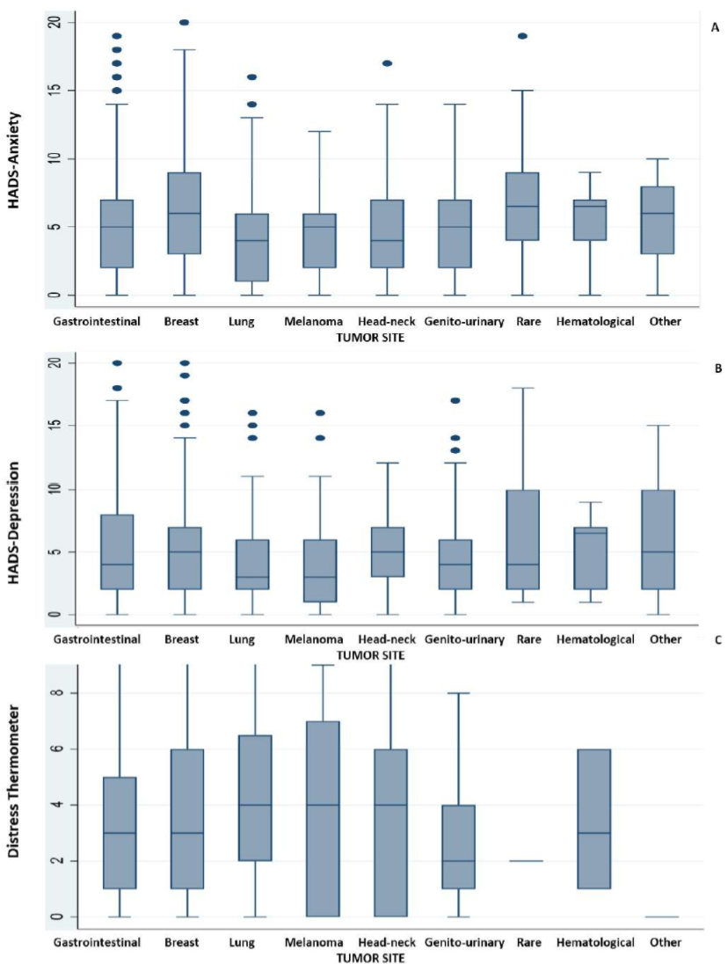

3.4.3 Attitude towards vaccination

Answers to the 4-item questionnaire exploring attitudes and beliefs towards the risk of contracting COVID-19 and the possibility that vaccination could interfere with oncological treatment and/or global health status were distributed as shown in Fig 2. Overall, there was high confidence that vaccination would reduce the risk of contracting COVID-19 (70%), which would make patients feel less worried about contracting the infection (60%); fear that vaccine-related side effects would interfere with anticancer treatment and/or global health status was low (2% and 2%, respectively).
Fig 2. Answers to the 4-item questionnaire in the first and the second administration.
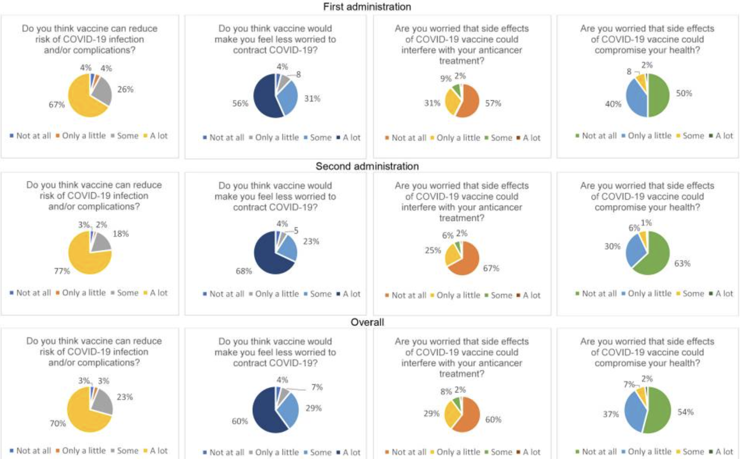

3.4.4 Associations between patients' characteristics, psychological variables, and attitude towards vaccination
Ordered logistic regression revealed statistically significant associations between the levels of anxiety, depression, and distress and responses to items 3 and 4, assessing the fear that vaccine-related side effects would interfere with anticancer treatment and/or global health status (primary endpoints), respectively, which remained independent at multivariate analysis (Fig 3A-B). In particular, cancer patients with borderline and clinical levels of anxiety, borderline levels of depression, and mild to severe levels of distress were significantly more likely to be worried (some or a lot afraid) that COVID-19 vaccination could interfere with their anticancer treatment (item 3, Fig 3A) or with their global health status (item 4, Fig 3B); similarly, female patients were significantly more likely to be worried that COVID-19 vaccination could interfere with their global health status (item 4, Fig 3B) and significantly less confident that vaccination would make them feel less worried about contracting COVID-19 (item 2). Conversely, elderly patients were significantly less likely to be worried about interference between vaccination and global health status (item 4, Fig 3B) and more confident about vaccination protective effects. No significant differences in the distribution of answers to items assessing confidence in vaccination efficacy (items 1 and 2) or fear that vaccine-related side effects would interfere with anticancer treatment and/or global health status (items 3 and 4) were observed according to other socio-demographic or clinical characteristics at multivariate analysis (S1 Fig).
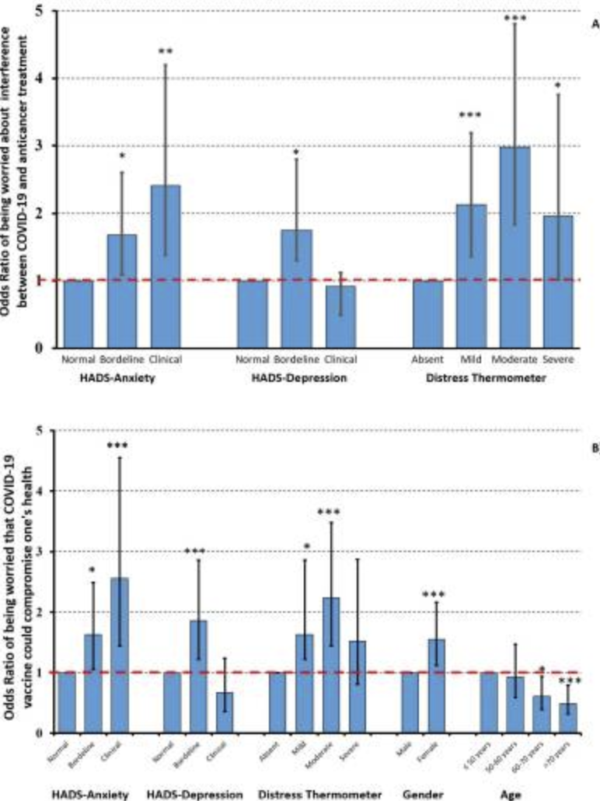
Fig 3. Influence of potential determinants on being worried that COVID-19 side effects could interfere with anticancer treatments (item3; panel A) or compromise one’s health (item 4; panel B).
Odds Ratios (ORs) and 95% confidence intervals were derived by a multivariable logistic regression model. In the graph columns are ORs, bars are 95% confidence intervals. * p=0.01 ** p=0.001 *** p<0.001

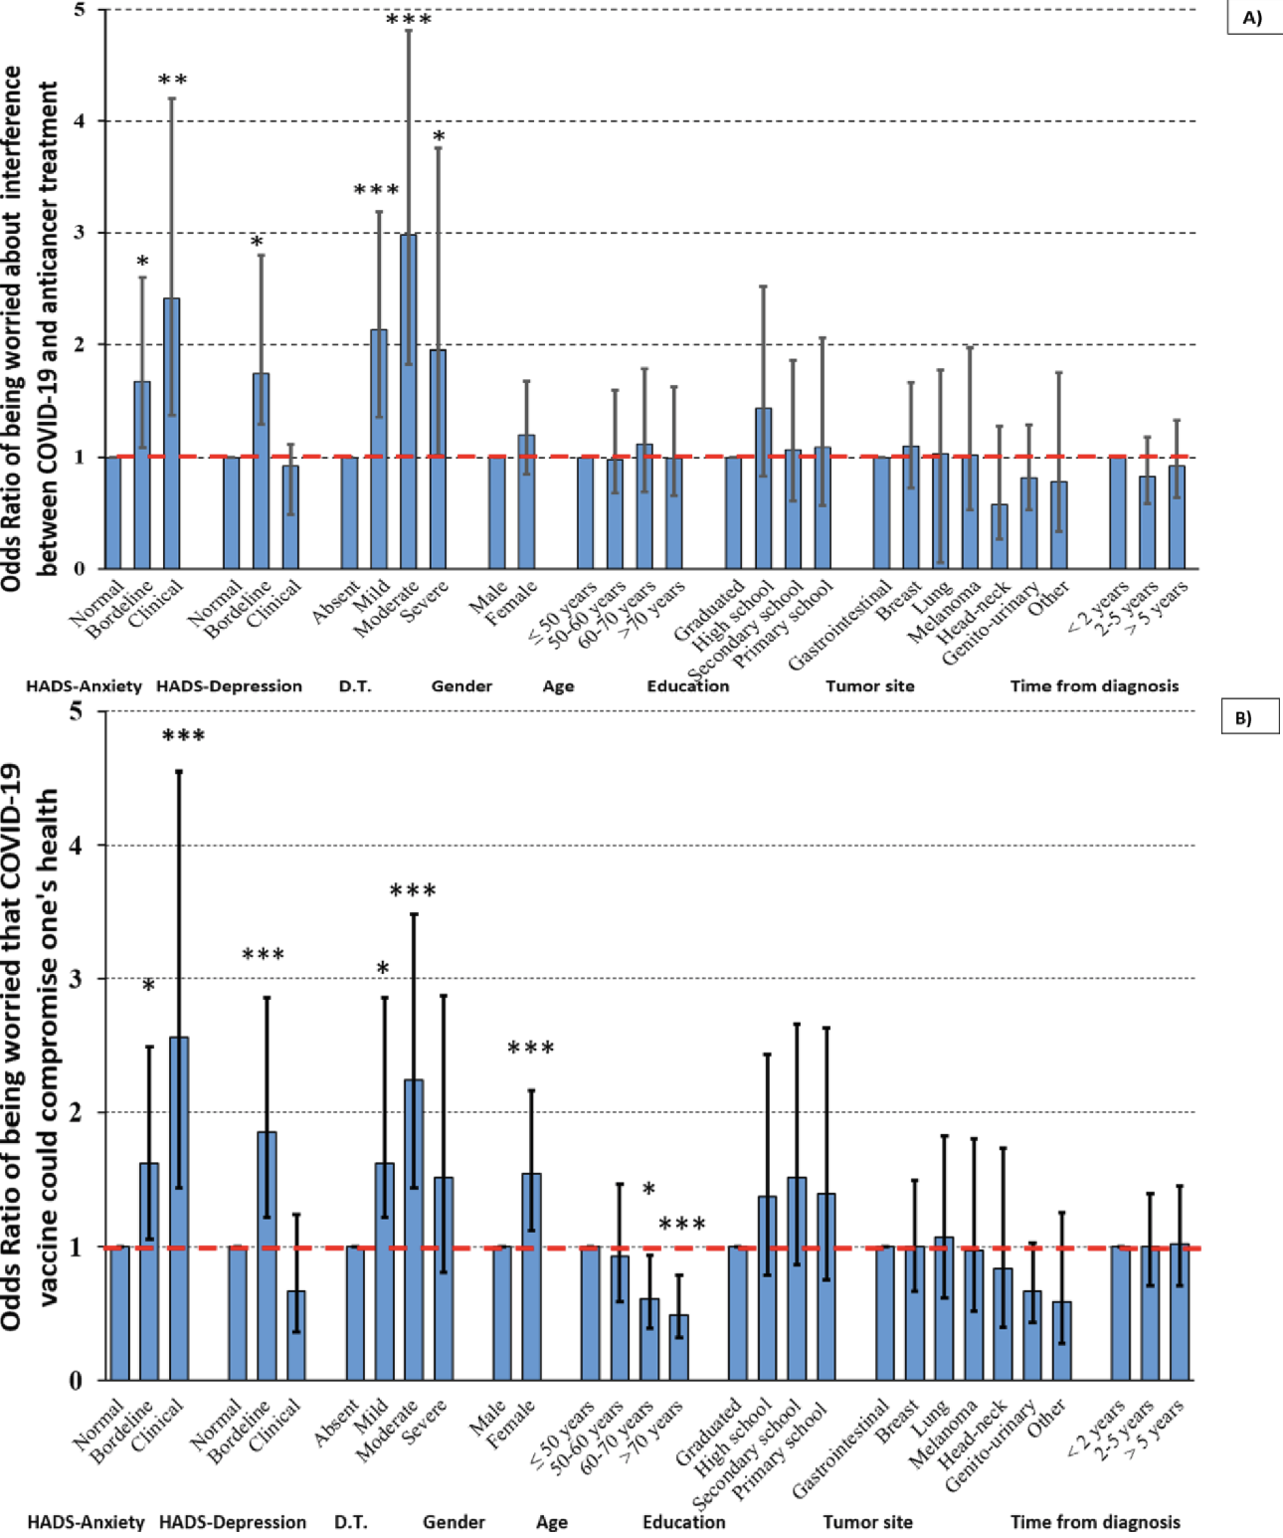
S1 Fig. Influence of potential determinants on being worried that COVID-19 side effects could interfere with anticancer treatments (A) or compromise one’s health (B).

3.4.5 Comparison with patients vaccinated at an independent spoke Centre
Five hundred and twenty-nine cancer patients were offered vaccination in the context of the VACCINATE program at the Camposampiero Hospital, 28 (5.3%) of whom declined the vaccination proposal (p-value for the comparison with the Verona population <0.001). Of these, 286 patients (57%) participated in the anonymous survey investigating their levels of anxiety, depression, and distress, as well as perceptions about COVID-19 vaccination, and returned a completed questionnaire (196 and 90 patients after the first and second dose administrations, respectively).
Similar to the population of patients assessed in Verona, 14.3% and 5.9% of patients had borderline and clinical levels of anxiety, respectively, and 19.5% and 8.6% had borderline and clinical levels of depression, respectively. Moderate and severe levels of distress were recorded in 30.2% and 9.4% of the Camposampiero population overall, but, at a difference with the Verona population, such distribution significantly shifted towards lower levels of distress among patients who were interviewed at the time of the second dose (p for the comparison between first and second dose in the Camposampiero population=0.002).
Answers to the 4-item questionnaire were distributed as shown in S2 Fig. Overall, there was high confidence that vaccination would reduce the risk of contracting COVID-19 (52%), which would make patients feel less worried about contracting the infection (48%); fear that vaccine-related side effects would interfere with anticancer treatment and/or global health status was low (5% and 3%, respectively).
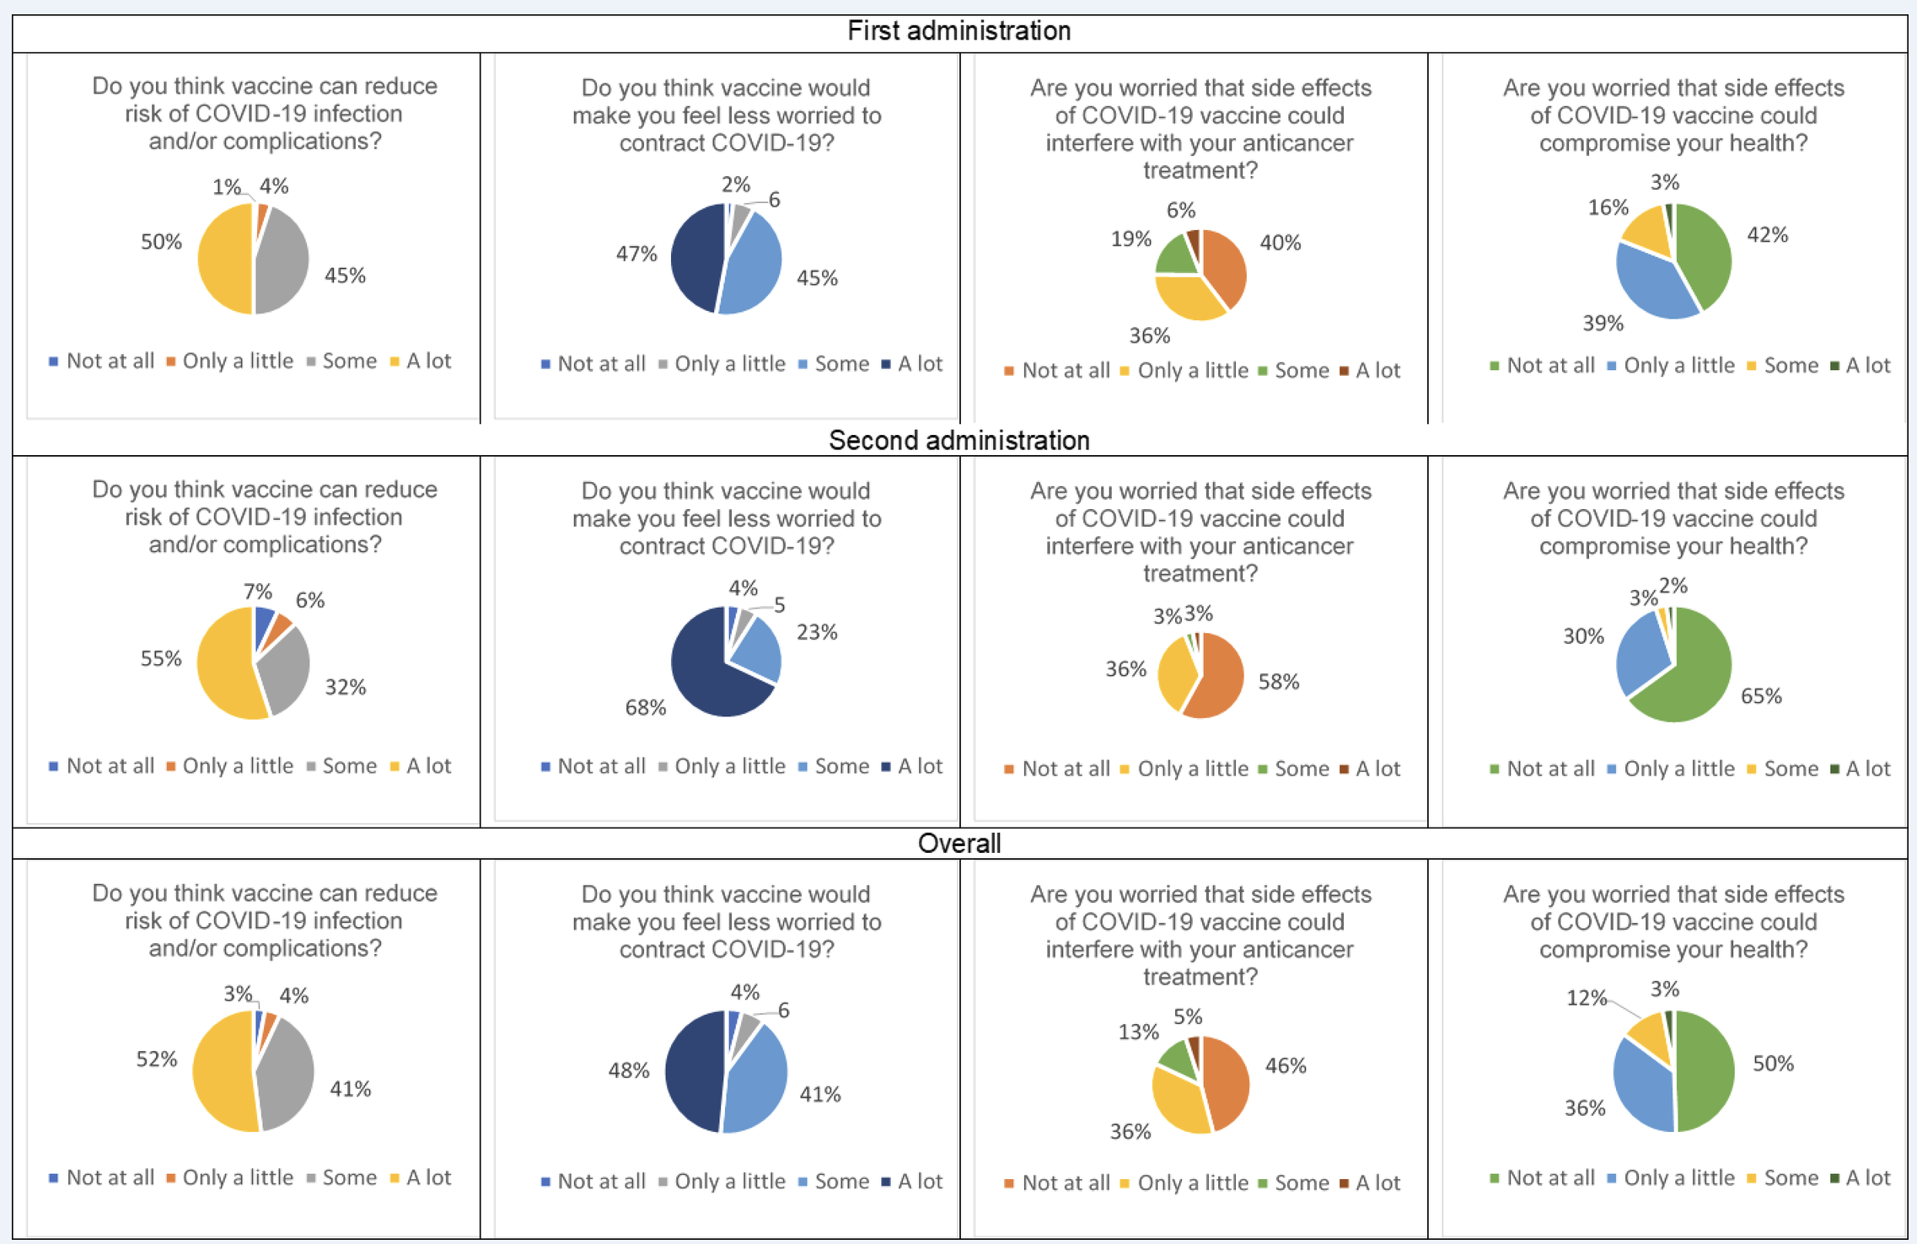
S2 Fig. Answers to the 4-item questionnaire in the first and the second COVID-19 vaccine administration at the Spoke center (Camposampiero)
In this population of patients, the distribution of responses to item 3 was significantly associated with anxiety levels, with only 13.9% of patients with normal anxiety levels stating that they were some or a lot afraid that "side effects of COVID-19 vaccine could interfere with [their] anticancer treatment", as opposed to 30.6% and 31.5% among patients with borderline and clinical levels of anxiety, respectively (item 3, p=0.005). Responses to item 4, on the other hand, were significantly influenced by depression levels, with only 8.3% of patients with normal depression levels stating they were some or a lot afraid that "side effects of COVID-19 vaccine could compromise [their] health", as opposed to 26.1% and 27.3% among patients with borderline and clinical levels of depression, respectively (p<0.001). Patients with borderline and clinical depression levels were also significantly less confident that the "vaccine [could] reduce risk of COVID-19 infection and/or complications" (item 1, p<0.001).

3.5 Discussion

In the VACCINATE study, we attempted at correlating the levels of anxiety, depression, and distress with the subjective perception of the protective effects of COVID-19 vaccination and its potential interference with anticancer treatment and overall health status in patients with active cancer undergoing the first and second vaccine dose. Overall, confidence that vaccination would reduce the risk of contracting COVID-19 was high (70%), resulting in patients feeling less worried about contracting the infection (60%); fear that vaccine-related side effects would interfere with anticancer treatment and/or global health status was low (10% and 9% for items 3 and 4, respectively) and significantly associated with baseline levels of anxiety, depression, and distress at multivariate analysis. Results did not differ in two independent cohorts of patients vaccinated at a larger academic hub (Verona University and Hospital Trust) and at a smaller local spoke (Camposampiero Hospital).
While many studies have investigated the reasons for vaccine refusal and hesitancy in cancer patients [141-147], much less is known about the reciprocal relationships between levels of anxiety, depression, and distress and the attitude towards vaccination in cancer patients who, more or less reluctantly, accept being vaccinated. In our study patients who underwent COVID-19 vaccination, the prevalence of borderline/clinically relevant levels of anxiety (20-24%), depression (22-28%), and moderate/severe distress (39-42%) was consistent with that reported in cancer patients outside a pandemic/vaccination campaign context. A meta-analysis, including 24 studies for a total of 4,007 patients, found that depression affected approximately 15%-16% of patients with oncological diseases, whereas anxiety was present in 10.4% of them [148]; another cross-sectional study shows a slightly higher prevalence (23.4% for depression and 19.9% for anxiety) in a sample of 1,001 patients with mixed cancer types [149]; regarding distress, one patient out of two reported high levels, with fatigue and sleep problems being among the most prevalent associated symptoms [150]. The association of higher clinical anxiety levels with a breast cancer diagnosis observed in our population is also widely confirmed in the literature [150]. With regard to rare neoplasms, on the other hand, there is little supporting data in the literature; however, it is reasonable to speculate that the rarity of the disease itself, which makes prognosis more difficult to evaluate, treatment choices more complicated, and outcome less predictable, would contribute to the state of uncertainty experienced by the patient, thereby triggering clinical anxiety levels.
As reported in recent similar studies [145, 151], the overall confidence in COVID-19 vaccination efficacy in the vaccinated population was high and made patients feeling less worried about contracting the infection. As it might be expected, the main concern in patients with active cancer was the fear that vaccination side effects might interfere with cancer treatment and with their general health status [only 46-60% of respondents were "not (worried) at all", items 3-4]. In the cohort from the spoke Centre (Camposampiero Hospital), patients were significantly less distressed and worried at the time of the second administration, perhaps based on not having experienced side effects or delays in their cancer treatment with the first vaccine dose. Although such aspect was not formally investigated in this study, we speculate that the choice of having cancer patients carefully counselled and vaccinated at their treating Oncology services, by physicians and nurses who routinely cared for their cancer, may have substantially contributed to the low hesitancy rate and the favorable psychological profile observed in the VACCINATE study. Other studies have indeed shown that medical recommendations can increase the willingness of patients with cancer to be vaccinated [128-131]. Considering that major concerns about COVID-19 vaccination in oncological populations are related to its safety, side effects, limited efficacy, and interference with cancer and treatments [128, 152], dispelling these doubts may not only push patients towards vaccination, but also help them accept it with a positive attitude and a balanced psychological and emotional status. Interestingly, patients' socio-demographic characteristics only marginally affected their attitude towards vaccination in our study. The most important factors influencing patients' fears about possible detrimental effects of vaccination on their cancer trajectory and general health status were indeed their underlying levels of anxiety, depression, and distress. Studies conducted in non-cancer patients have evaluated the interference of clinical conditions of anxiety and depression on the attitude towards COVID-19 vaccination. A study in Japan reported that impaired mental health conditions such as depression and generalized anxiety are associated with reluctance or indecision towards vaccination against COVID-19 in the general population [153].
The VACCINATE study has some limitations: indeed, exclusion of patients who refused the vaccination, the inability to collect data on patients who accepted vaccination, but did not agree to participate in the study, may have influenced the results; although the cross-sectional design did not allow longitudinal monitoring of the population, the repeated assessment at the time of both the first and second vaccine administration was able to detect changes in attitude towards vaccination over time, particularly at the spoke Centre.

3.6 Conclusions

Despite its limitations, our study provides a thorough assessment of cancer patients' psychological status and attitude towards vaccination under exceptional circumstances (such as the COVID-19 pandemic). In our interpretation, the most important finding is that baseline levels of anxiety, depression, and distress are the major determinant of confidence towards COVID-19 vaccination; together with the observation that anxiety, depression, and distress levels are mostly related to the underlying cancer diagnosis, rather than to the pandemic situation, these data confirm a pressing need to timely and effectively manage cancer patients' emotional and psychological distress, in normal and pandemic circumstances alike. A meta-analysis including seven randomized controlled trials involving 888 patients found that psychological interventions such as mindfulness-based approaches are effective to manage and relieve anxiety and depression [154]. Additionally, psychological interventions proved to ameliorate treatment-side effects, including fatigue and improve overall patients’ quality of life and fear of recurrence 156]. Patients with a well-balanced psychological status, in turn, will be more willing to embrace preventive measures and healthcare recommendations, even under exceptional conditions such as those described here, thereby setting in motion a virtuous circle, protecting them from irrational fears (e.g. the so-called “coronaphobia” [135]) that may lead to avoiding hospital visits and delaying potentially lifesaving treatments [157]. While further highlighting the irreplaceable role of physician-patient communication in favoring a healthy therapeutic relationship, these data may help improving the penetration and acceptance of vaccination and/or other public health campaigns, not just in cancer patients but also in the general population. Further longitudinal research is needed to monitor the longer-term effects of COVID-19 on psychological health in patients with cancer.

References

- Avancini A, Trestini I, Tregnago D, Belluomini L, Sposito M, Insolda J, Schena F, Milella M, Pilotto S. Willingness, preferences, barriers, and facilitators of a multimodal supportive care intervention including exercise, nutritional and psychological approach in patients with cancer: a cross-sectional study. J Cancer Res Clin Oncol. 2023 Jul;149(7):3435-3445. doi: 10.1007/s00432-022-04232-6. Epub 2022 Aug 9. PMID: 35943598; PMCID: PMC10314831.
- Fitzmaurice C, Allen C, Barber RM, Barregard L, Bhutta ZA, Brenner H, Collaboration, G.B. o. D. C. Global, regional, and National Cancer incidence, mortality, years of life lost, years lived with disability, and disability-adjusted life-years for 32 cancer groups, 1990 to 2015: a systematic analysis for the global burden of disease study. JAMA Oncol. 2017;3(4):524–548. doi: 10.1001/jamaoncol.2016.5688
- Devlin EJ, Denson LA, Whitford HS. Cancer treatment side effects: a meta-analysis of the relationship between response expectancies and experience. J Pain Symptom Manage. 2017;54(2):245–258.e242. doi: 10.1016/j.jpainsymman.2017.03.017.
- Berman R, Davies A, Cooksley T, Gralla R, Carter L, Darlington E, Higham C. Supportive care: an indispensable component of modern oncology. Clin Oncol (R Coll Radiol) 2020;32(11):781–788. doi: 10.1016/j.clon.2020.07.020.
- Campbell KL, Winters-Stone KM, Wiskemann J, May AM, Schwartz AL, Courneya KS, Schmitz KH. Exercise guidelines for cancer survivors: consensus statement from international multidisciplinary roundtable. Med Sci Sports Exerc. 2019;51(11):2375–2390. doi: 10.1249/MSS.0000000000002116.
- Rock CL, Thomson CA, Sullivan KR, Howe CL, Kushi LH, Caan BJ, McCullough ML. American Cancer Society nutrition and physical activity guideline for cancer survivors. CA Cancer J Clin. 2022 doi: 10.3322/caac.21719.
- Caccialanza R, Cotogni P, Cereda E, Bossi P, Aprile G, Delrio P, Pedrazzoli P. Nutritional support in cancer patients: update of the Italian Intersociety Working Group practical recommendations [Research Paper] J Cancer. 2022;13(9):2705–2716. doi: 10.7150/jca.73130.
- Trestini I, Sperduti I, Sposito M, Kadrija D, Drudi A, Avancini A, Pilotto S. Evaluation of nutritional status in non-small-cell lung cancer: screening, assessment and correlation with treatment outcome. ESMO Open. 2020 doi: 10.1136/esmoopen-2020-000689.
- Trestini I, Caldart A, Dodi A, Avancini A, Tregnago D, Sartori G, Pilotto S. Body composition as a modulator of response to immunotherapy in lung cancer: time to deal with it. ESMO Open. 2021;6(2):100095. doi: 10.1016/j.esmoop.2021.100095.
- Trestini I, Sperduti I, Caldart A, Bonaiuto C, Fiorio E, Parolin V, Carbognin L. Evidence-based tailored nutrition educational intervention improves adherence to dietary guidelines, anthropometric measures and serum metabolic biomarkers in early-stage breast cancer patients: a prospective interventional study. Breast. 2021;60:6–14. doi: 10.1016/j.breast.2021.08.008.
- Arch JJ, Vanderkruik R, Kirk A, Carr AL. A closer lens: cancer survivors’ supportive intervention preferences and interventions received. Psychooncology. 2018;27(5):1434–1441. doi: 10.1002/pon.4526. [DOI] [PubMed] [Google Scholar]
- Muscaritoli, M.; Arends, J.; Bachmann, P.; Baracos, V.; Barthelemy, N.; Bertz, H.; Bozzetti, F.; Hütterer, E.; Isenring, E.; Kaasa, S.; et al. ESPEN practical guideline: Clinical Nutrition in cancer. Clin. Nutr. 2021, 40, 2898–2913.
- Ganzer, H.; Rothpletz-Puglia, P.; Byham-Gray, L.; Murphy, B.A.; Touger-Decker, R. The eating experience in long-term survivors of head and neck cancer: A mixed-methods study. Support. Care Cancer 2015, 23, 3257–3268.
- Loeliger, J.; Dewar, S.; Kiss, N.; Drosdowsky, A.; Stewart, J. Patient and carer experiences of nutrition in cancer care: A mixed-methods study. Support. Care Cancer 2021, 29, 5475–5485.
- Liu Z, Qiu T, Pei L, Zhang Y, Xu L, Cui Y, Huang Y. Two-week multimodal prehabilitation program improves perioperative functional capability in patients undergoing thoracoscopic lobectomy for lung cancer: A randomized controlled trial. Anesth Analg. 2019 doi: 10.1213/ANE.0000000000004342.
- Travier N, Velthuis MJ, Steins Bisschop CN, van den Buijs B, Monninkhof EM, Backx F, May AM. Effects of an 18-week exercise programme started early during breast cancer treatment: a randomised controlled trial. BMC Med. 2015;13:121. doi: 10.1186/s12916-015-0362-z.
- Avancini A, Trestini I, Tregnago D, Lanza M, Menis J, Belluomini L, Pilotto S. A multimodal approach to cancer-related cachexia: from theory to practice. Expert Rev Anticancer Ther. 2021;21(8):819–826. doi: 10.1080/14737140.2021.1927720.
- Gerritsen JK, Vincent AJ. Exercise improves quality of life in patients with cancer: a systematic review and meta-analysis of randomised controlled trials. Br J Sports Med. 2016;50(13):796–803. doi: 10.1136/bjsports-2015-094787.
- Hamer M, Chida Y, Molloy GJ. Psychological distress and cancer mortality. J Psychosom Res. 2009;66(3):255–258. doi: 10.1016/j.jpsychores.2008.11.002.
- Patel AV, Friedenreich CM, Moore SC, Hayes SC, Silver JK, Campbell KL, Matthews CE. American College of Sports Medicine Roundtable Report on Physical Activity, Sedentary Behavior, and Cancer Prevention and Control. Med Sci Sports Exerc. 2019;51(11):2391–2402. doi: 10.1249/MSS.0000000000002117.
- Zhang X, Tang T, Pang L, Sharma SV, Li R, Nyitray AG, Edwards BJ. Malnutrition and overall survival in older adults with cancer: a systematic review and meta-analysis. J Geriatr Oncol. 2019;10(6):874–883. doi: 10.1016/j.jgo.2019.03.002.
- Arends J, Baracos V, Bertz H, Bozzetti F, Calder PC, Deutz NEP, Weimann A. ESPEN expert group recommendations for action against cancer-related malnutrition. Clin Nutr. 2017;36(5):1187–1196. doi: 10.1016/j.clnu.2017.06.017. [DOI] [PubMed] [Google Scholar]
- Arthur AE, Delk A, Demark-Wahnefried W, Christein JD, Contreras C, Posey JA, Rogers LQ. Pancreatic cancer survivors’ preferences, barriers, and facilitators related to physical activity and diet interventions. J Cancer Surviv. 2016;10(6):981–989. doi: 10.1007/s11764-016-0544-5. [DOI] [PMC free article] [PubMed] [Google Scholar]
- Avancini A, Pala V, Trestini I, Tregnago D, Mariani L, Sieri S, Lanza M. Exercise levels and preferences in cancer patients: a cross-sectional study. Int J Environ Res Public Health. 2020 doi: 10.3390/ijerph17155351. [DOI] [PMC free article] [PubMed] [Google Scholar]
- Avancini A, Tregnago D, Rigatti L, Sartori G, Yang L, Bonaiuto C, Lanza M. Factors influencing physical activity in cancer patients during oncological treatments: a qualitative study. Integrative Cancer Treatments. 2020 doi: 10.1177/1534735420971365. [DOI] [PMC free article]
- Avancini A, Tregnago D, Rigatti L, Sartori G, Yang L, Trestini I, Lanza M. Factors influencing physical activity in cancer patients during oncological treatments: a qualitative study. Integr Cancer Ther. 2020;19:153473542097136. doi: 10.1177/1534735420971365. [DOI]
- Avancini A, Trestini I, Tregnago D, Lanza M, Menis J, Belluomini L, Pilotto S. A multimodal approach to cancer-related cachexia: from theory to practice. Expert Rev Anticancer Ther. 2021;21(8):819–826. doi: 10.1080/14737140.2021.1927720. [DOI]
- Avancini A, Belluomini L, Borsati A, Riva ST, Trestini I, Tregnago D, Pilotto S. Integrating supportive care into the multidisciplinary management of lung cancer: we can't wait any longer. Expert Rev Anticancer Ther. 2022 doi: 10.1080/14737140.2022.2082410. [DOI]
- Low DE, Allum W, De Manzoni G, Ferri L, Immanuel A, Kuppusamy M, Ljungqvist O. Guidelines for perioperative care in esophagectomy: enhanced recovery after surgery (ERAS. World J Surg. 2019;43(2):299–330. doi: 10.1007/s00268-018-4786-4.
- Arch JJ, Vanderkruik R, Kirk A, Carr AL. A closer lens: cancer survivors’ supportive intervention preferences and interventions received. Psychooncology. 2018;27(5):1434–1441. doi: 10.1002/pon.4526
- Berman R, Davies A, Cooksley T, Gralla R, Carter L, Darlington E, Higham C. Supportive care: an indispensable component of modern oncology. Clin Oncol (R Coll Radiol) 2020;32(11):781–788. doi: 10.1016/j.clon.2020.07.020. [DOI] [PMC free article]
- Caccialanza R, Cotogni P, Cereda E, Bossi P, Aprile G, Delrio P, Pedrazzoli P. Nutritional support in cancer patients: update of the Italian Intersociety Working Group practical recommendations [Research Paper] J Cancer. 2022;13(9):2705–2716. doi: 10.7150/jca.73130. [DOI] [PMC free article] [PubMed] [Google Scholar]
- Campbell KL, Winters-Stone KM, Wiskemann J, May AM, Schwartz AL, Courneya KS, Schmitz KH. Exercise guidelines for cancer survivors: consensus statement from international multidisciplinary roundtable. Med Sci Sports Exerc. 2019;51(11):2375–2390. doi: 10.1249/MSS.0000000000002116. [DOI] [PMC free article] [PubMed] [Google Scholar]
- Cheung DST, Takemura N, Chau PH, Ng AYM, Xu X, Lin CC. Exercise levels and preferences on exercise counselling and programming among older cancer survivors: a mixed-methods study. J Geriatr Oncol. 2021;12(8):1173–1180. doi: 10.1016/j.jgo.2021.05.002. [DOI] [PubMed] [Google Scholar]
- Clifford BK, Mizrahi D, Sandler CX, Barry BK, Simar D, Wakefield CE, Goldstein D. Barriers and facilitators of exercise experienced by cancer survivors: a mixed methods systematic review. Support Care Cancer. 2018;26(3):685–700. doi: 10.1007/s00520-017-3964-5. [DOI] [PubMed] [Google Scholar]
- Morielli AR, Boulé NG, Usmani N, Joseph K, Tankel K, Severin D, Courneya KS. Predictors of adherence to aerobic exercise in rectal cancer patients during and after neoadjuvant chemoradiotherapy. Psychol Health Med. 2018;23(2):224–231. doi: 10.1080/13548506.2017.1344356.
- Wong JN, McAuley E, Trinh L. Physical activity programming and counseling preferences among cancer survivors: a systematic review. Int J Behav Nutr Phys Act. 2018;15(1):48. doi: 10.1186/s12966-018-0680-6. [DOI] [PMC free article] [PubMed] [Google Scholar]
- Gjerset GM, Fosså SD, Courneya KS, Skovlund E, Jacobsen AB, Thorsen L. Interest and preferences for exercise counselling and programming among Norwegian cancer survivors. Eur J Cancer Care (Engl) 2011;20(1):96–105. doi: 10.1111/j.1365-2354.2009.01161.x. [DOI] [PubMed] [Google Scholar]
- Nicole Culos-Reed S, Leach HJ, Capozzi LC, Easaw J, Eves N, Millet GY. Exercise preferences and associations between fitness parameters, physical activity, and quality of life in high-grade glioma patients. Support Care Cancer. 2017;25(4):1237–1246. doi: 10.1007/s00520-016-3516-4. [DOI] [PubMed] [Google Scholar]
- Cuschieri S. The STROBE guidelines. Saudi J Anaesth. 2019;13(Suppl 1):S31–S34. doi: 10.4103/sja.SJA_543_18. [DOI] [PMC free article] [PubMed] [Google Scholar]
- Ravasco P. Nutrition in cancer patients. J Clin Med. 2019 doi: 10.3390/jcm8081211. [DOI] [PMC free article] [PubMed] [Google Scholar]
- Cuschieri S. The STROBE guidelines. Saudi J Anaesth. 2019;13(Suppl 1):S31–S34. doi: 10.4103/sja.SJA_543_18. [DOI] [PMC free article] [PubMed] [Google Scholar]
- Devlin EJ, Denson LA, Whitford HS. Cancer treatment side effects: a meta-analysis of the relationship between response expectancies and experience. J Pain Symptom Manage. 2017;54(2):245–258.e242. doi: 10.1016/j.jpainsymman.2017.03.017. [DOI] [PubMed] [Google Scholar]
- Fong AJ, Scarapicchia TMF, McDonough MH, Wrosch C, Sabiston CM. Changes in social support predict emotional wellbeing in breast cancer survivors. Psychooncology. 2017;26(5):664–671. doi: 10.1002/pon.4064. [DOI] [PubMed] [Google Scholar]
- Fournier B, Delrieu L, Russo C, Terret C, Fervers B, Pérol O. Interest and preferences for physical activity programming and counselling among cancer patients aged over 70 years receiving oncological treatments. Eur J Cancer Care (Engl) 2022;31(1):e13527. doi: 10.1111/ecc.13527. [DOI] [PubMed] [Google Scholar]
- Green HJ, Steinnagel G, Morris C, Laakso EL. Health behaviour models and patient preferences regarding nutrition and physical activity after breast or prostate cancer diagnosis. Eur J Cancer Care (Engl) 2014;23(5):640–652. doi: 10.1111/ecc.12190. [DOI] [PubMed] [Google Scholar]
- Hamer M, Chida Y, Molloy GJ. Psychological distress and cancer mortality. J Psychosom Res. 2009;66(3):255–258. doi: 10.1016/j.jpsychores.2008.11.002. [DOI] [PubMed] [Google Scholar]
- Keaver L, O’Callaghan N, Douglas P. Nutrition support and intervention preferences of cancer survivors. J Hum Nutr Diet. 2022 doi: 10.1111/jhn.13058. [DOI] [PubMed] [Google Scholar]
- Kondrup J, Rasmussen HH, Hamberg O, Stanga Z, Group, A. H. E. W. Nutritional risk screening (NRS 2002): a new method based on an analysis of controlled clinical trials. Clin Nutr. 2003;22(3):321–336. doi: 10.1016/s0261-5614(02)00214-5. [DOI] [PubMed] [Google Scholar]
- Liu Z, Qiu T, Pei L, Zhang Y, Xu L, Cui Y, Huang Y. Two-week multimodal prehabilitation program improves perioperative functional capability in patients undergoing thoracoscopic lobectomy for lung cancer: A randomized controlled trial. Anesth Analg. 2019 doi: 10.1213/ANE.0000000000004342. [DOI] [PubMed] [Google Scholar]
- Wallin, V.; Carlander, I.; Sandman, P.-O.; Håkanson, C. Meanings of eating deficiencies for people admitted to palliative home care. Palliat. Support. Care 2015, 13, 1231–1239. [Google Scholar] [CrossRef]
- Arends, J. Struggling with nutrition in patients with advanced cancer: Nutrition and nourishment—Focusing on metabolism and supportive care. Ann. Oncol. 2018, 29, ii27–ii34.
- O’Brien K, Ried K, Binjemain T, Sali A. Integrative Approaches to the Treatment of Cancer. Cancers (Basel). 2022 Nov 30;14(23):5933. Doi: 10.3390/cancers14235933. PMID: 36497414; PMCID: PMC9740147.
- Koshimoto, S., Yamazaki, T., Amano, K., Kako, J., Arimoto, M., Saitou, K., Hashizume, A., Takeuchi, T., & Matsushima, E. (2023). Psychosocial Factors and the Need for Multidisciplinary Support in Nutrition Counselling for Cancer Chemotherapy Patients. Nutrients, 15(12), 2712. https://doi.org/10.3390/nu15122712
- Muscaritoli, M.; Arends, J.; Bachmann, P.; Baracos, V.; Barthelemy, N.; Bertz, H.; Bozzetti, F.; Hütterer, E.; Isenring, E.; Kaasa, S.; et al. ESPEN practical guideline: Clinical Nutrition in cancer. Clin. Nutr. 2021, 40, 2898–2913. [Google Scholar] [CrossRef] [PubMed]
- Omlin, A.; Blum, D.; Wierecky, J.; Haile, S.R.; Ottery, F.D.; Strasser, F. Nutrition impact symptoms in advanced cancer patients: Frequency and specific interventions, a case-control study. J. Cachexia Sarcopenia Muscle 2013, 4, 55–61. [Google Scholar] [CrossRef] [PubMed]
- Amano, K.; Satomi, E.; Oyamada, S.; Ishiki, H.; Sakashita, A.; Miura, T.; Maeda, I.; Hatano, Y.; Yamauchi, T.; Oya, K.; et al. The prevalence of artificially administered nutrition and hydration in different age groups among patients with advanced cancer admitted to palliative care units. Clin. Nutr. Open. Sci. 2021, 40, 69–78. [Google Scholar] [CrossRef]
- Bressan, V.; Bagnasco, A.; Aleo, G.; Catania, G.; Zanini, M.P.; Timmins, F.; Sasso, L. The life experience of nutrition impact symptoms during treatment for head and neck cancer patients: A systematic review and meta-synthesis. Support. Care Cancer 2017, 25, 1699–1712. [Google Scholar] [CrossRef]
- Kasvis, P.; Vigano, M.; Vigano, A. Health-related quality of life across cancer cachexia stages. Ann. Palliat. Med. 2018, 8, 33–42. [Google Scholar] [CrossRef]
- Baracos, V.E. Cancer-associated malnutrition. Eur. J. Clin. Nutr. 2018, 72, 1255–1259. [Google Scholar] [CrossRef]
- Amano, K.; Morita, T.; Koshimoto, S.; Uno, T.; Katayama, H.; Tatara, R. Eating-related distress in advanced cancer patients with cachexia and family members: A survey in palliative and supportive care settings. Support. Care Cancer 2019, 27, 2869–2876. [Google Scholar] [CrossRef]
- Bargetzi, L.; Brack, C.; Herrmann, J.; Bargetzi, A.; Hersberger, L.; Bargetzi, M.; Kaegi-Braun, N.; Tribolet, P.; Gomes, F.; Hoess, C.; et al. Nutritional support during the hospital stay reduces mortality in patients with different types of cancers: Secondary analysis of a prospective randomized trial. Ann. Oncol. 2021, 32, 1025–1033. [Google Scholar] [CrossRef]
- Koshimoto, S.; Arimoto, M.; Saitou, K.; Uchibori, M.; Hashizume, A.; Honda, A.; Amano, K.; Nakajima, Y.; Uetake, H.; Matsushima, E. Need and demand for nutritional counselling and their association with quality of life, nutritional status and eating-related distress among patients with cancer receiving outpatient chemotherapy: A cross-sectional study. Support. Care Cancer 2019, 27, 3385–3394. [Google Scholar] [CrossRef]
- Alderman, B.; Allan, L.; Amano, K.; Bouleuc, C.; Davis, M.; Lister-Flynn, S.; Mukhopadhyay, S.; Davies, A. Multinational Association of Supportive Care in Cancer (MASCC) expert opinion/guidance on the use of clinically assisted nutrition in patients with advanced cancer. Support. Care Cancer 2022, 30, 2983–2992. [Google Scholar] [CrossRef]
- Kok, A.; van der Lugt, C.; Leermakers-Vermeer, M.J.; de Roos, N.M.; Speksnijder, C.M.; de Bree, R. Nutritional interventions in patients with head and neck cancer undergoing chemoradiotherapy: Current practice at the Dutch Head and Neck Oncology centres. Eur. J. Cancer Care 2022, 31, e13518. [Google Scholar] [CrossRef]
- van Beek, F.E.; Jansen, F.; Mak, L.; Lissenberg-Witte, B.I.; Buter, J.; Vergeer, M.R.; Voortman, J.; Cuijpers, P.; Leemans, C.R.; Verdonck-de Leeuw, I.M. The course of symptoms of anxiety and depression from time of diagnosis up to 2 years follow-up in head and neck cancer patients treated with primary (chemo)radiation. Oral Oncol. 2020, 102, 104576. [Google Scholar] [CrossRef]
- Morse, L.; Kober, K.M.; Viele, C.; Cooper, B.A.; Paul, S.M.; Conley, Y.P.; Hammer, M.; Levine, J.D.; Miaskowski, C. Subgroups of patients undergoing chemotherapy with distinct cognitive fatigue and evening physical fatigue profiles. Support. Care Cancer 2021, 29, 7985–7998. [Google Scholar] [CrossRef] [PubMed]
- de Kruif, A.J.; Westerman, M.J.; Winkels, R.M.; Koster, M.S.; van der Staaij, I.M.; van den Berg, M.M.G.A.; de Vries, J.H.M.; de Boer, M.R.; Kampman, E.; Visser, M. Exploring changes in dietary intake, physical activity and body weight during chemotherapy in women with breast cancer: A Mixed-Methods Study. J. Hum. Nutr. Diet. 2021, 34, 550–561. [Google Scholar] [CrossRef] [PubMed]
- Ganzer, H.; Rothpletz-Puglia, P.; Byham-Gray, L.; Murphy, B.A.; Touger-Decker, R. The eating experience in long-term survivors of head and neck cancer: A mixed-methods study. Support. Care Cancer 2015, 23, 3257–3268. [Google Scholar] [CrossRef]
- Loeliger, J.; Dewar, S.; Kiss, N.; Drosdowsky, A.; Stewart, J. Patient and carer experiences of nutrition in cancer care: A mixed-methods study. Support. Care Cancer 2021, 29, 5475–5485. [Google Scholar] [CrossRef]
- Abbott, J.; Teleni, L.; McKavanagh, D.; Watson, J.; McCarthy, A.L.; Isenring, E. Patient-Generated Subjective Global Assessment Short Form (PG-SGA SF) is a valid screening tool in chemotherapy outpatients. Support. Care Cancer 2016, 24, 3883–3887. [Google Scholar] [CrossRef]
- Gramaglia C, Gambaro E, Vecchi C, Licandro D, Raina G, Pisani C, et al. Outcomes of music therapy interventions in cancer patients—a review of the literature. Crit Rev Oncol Hematol 2019;138:241–54.
- He Y, Guo X, May BH, Zhang AL, Liu Y, Lu C, et al. Clinical evidence for association of acupuncture and acupressure with improved cancer pain: a systematic review and meta-analysis. JAMA Oncol 2020;6(2):271.
- Alcântara-Silva TR, de Freitas-Junior R, Freitas NMA, de Paula Junior W, da Silva DJ, Machado GDP, et al. Music therapy reduces radiotherapy-induced fatigue in patients with breast or gynecological cancer: a randomized trial. Integr Cancer Ther 2018;17(3):628–35.
- Rosenthal DS, Dean-Clower E. Integrative medicine in hematology/oncology: benefits, ethical considerations, and controversies. Hematology Am Soc Hematol Educ Program 2005;2005(1):491–7.
- National Center for Complementary and Integrative Health. ‘‘What research will NCCIH fund?” (2021-12-08) [2021-12-08]. https://www.nccih. nih.gov/grants/whatnccihfunds.
- Witt CM, Balneaves LG, Cardoso MJ, Cohen L, Greenlee H, Johnstone P, et al. A comprehensive definition for integrative oncology. J Natl Cancer Inst Monogr 2017;2017(52). https://doi.org/10.1093/jncimonographs/lgx012.
- Lyman GH, Bohlke K, Cohen L. Integrative therapies during and after breast cancer treatment: ASCO endorsement of the SIO clinical practice guideline summary. J Oncol Pract 2018;14(8):495–9.
- Bradt J, Dileo C, Myers-Coffman K, Biondo J. Biondo Music interventions for improving psychological and physical outcomes in people with cancer. Cochrane Database Syst Rev 2021;10(10):CD006911.
- Greenlee H, DuPont-Reyes MJ, Balneaves LG, Carlson LE, Cohen MR, Deng G, et al. Clinical practice guidelines on the evidence-based use of integrative therapies during and after breast cancer treatment. CA Cancer J Clin 2017;67 (3):194–232.
- Blaserna, P. (1885). The International Conference in Vienna and the adoption of a uniform chorister. “New Anthology”, issue 1, volume LV, pp. 10-11.
- Jannone, A. Emiliano Toso, il biologo molecolare che scopre il potere della sua musica.<http://www.italiachecambia.org/2018/12/emiliano-toso-biologo-molecolare-che-scopre-potere-musica/#>, 2018
- Pizzuti, M. (2016). “Il potere del suono.” Scienza e Conoscenza, 57, pp. 55- 59.
- Pignatta, V. (2016). “La musica delle cellule. Intervista a Carlo Ventura.” Scienza e Conoscenza, 57, pp. 4- 9.
- TUIS, R. T. (2014). 432 Hertz: la rivoluzione musicale. L’Accordatura Aurea per intonare la musica alla biologia. Battaglia Terme (PD), Nexus Edizioni.
- Chanda ML, Levitin DJ. The neurochemistry of music. Trends Cogn Sci 2013;17 (4):179–93.
- Toso, E. (2016). “La musica come nutrimento.” Scienza e Conoscenza, 57, pp. 10- 13.
- Blood AJ, Zatorre RJ, Bermudez P, Evans AC. Emotional responses to pleasant and unpleasant music correlate with activity in paralimbic brain regions. Nat Neurosci 1999;2(4):382–7.
- Finn S, Fancourt D. The biological impact of listening to music in clinical and nonclinical settings: a systematic review. Prog Brain Res 2018;237: 173–200.
- Koelsch S. Investigating the neural encoding of emotion with music. Neuron 2018;98(6):1075–9.
- Schaefer HE. Music-evoked emotions—current studies. Front Neurosci 2017;11:600.
- Aalbers S, Fusar-Poli L, Freeman RE, Spreen M, Ket JC, Vink AC, et al. Music therapy for depression. Cochrane Database Syst Rev 2017;11(11):CD004517.
- Palmer JB, Lane D, Mayo D, Schluchter M, Leeming R. Effects of music therapy on anesthesia requirements and anxiety in women undergoing ambulatory breast surgery for cancer diagnosis and treatment: a randomised controlled trial. J Clin Oncol 2015;33(28):3162–8.
- Cassileth BR, Vickers AJ, Magill LA. Music therapy for mood disturbance during hospitalisation for autologous stem cell transplantation: a randomised controlled trial. Cancer 2003;98(12):2723–9.
- Bates D, Bolwell B, Majhail NS, Rybicki L, Yurch M, Abounader D, et al. Music therapy for symptom management after autologous stem cell transplantation: results from a randomised study. Biol Blood Marrow Transplant 2017;23 (9):1567–72.
- Rossetti A, Chadha M, Torres BN, Lee JK, Hylton D, Loewy JV, et al. The impact of music therapy on anxiety in cancer patients undergoing simulation for radiation therapy. Int J Radiat Oncol Biol Phys 2017;99 (1):103–10.
- Nardone V, Vinciguerra C, Correale P, Guida C, Tini P, Reginelli A, et al. Music therapy and radiation oncology: state of art and future directions. Complement Ther Clin Pract 2020;39:101124.
- Bradt J, Dileo C, Magill L, Teague A. Music interventions for improving psychological and physical outcomes in cancer patients. Cochrane Database of Syst Rev 2016;(8):CD006911.
- Qi Y, Lin L, Dong B, Xu E, Bao Z, Qi J, et al. Music interventions can alleviate cancerrelated fatigue: a meta-analysis. Support Care Cancer 2021;29(7):3461–70.
- Tang H, Chen L, Wang Y, Zhang Y, Yang N, Yang N. The efficacy of music therapy to relieve pain, anxiety, and promote sleep quality, in patients with small cell lung cancer receiving platinum-based chemotherapy. Support Care Cancer 2021;29(12):7299–306.
- Köhler F, Martin ZS, Hertrampf RS, Gäbel C, Kessler J, Ditzen B, et al. Music therapy in the psychosocial treatment of adult cancer patients: a systematic review and meta-analysis. Front Psychol 2020;11:651.
- Rentfrow PJ, Goldberg LR, Levitin DJ. The structure of musical preferences: a five-factor model. J Pers Soc Psychol 2011;100(6):1139–57.
- Bailey LM. The use of songs in music therapy with cancer patients and their families. Music Ther 1984;4(1):5–17.
- Trehub SE. The developmental origins of musicality. Nat Neurosci 2003;6 (7):669–73.
- Soley G, Hannon EE. Infants prefer the musical meter of their own culture: a cross-cultural comparison. Dev Psychol 2010;46(1):286–92.
- Garza-Villarreal EA, Pando V, Vuust P, Parsons C. Music-induced analgesia in chronic pain conditions: a systematic review and meta-analysis. Pain Physician 2017;20(7):597–610.
- Morrison SJ, Demorest SM. Cultural constraints on music perception and cognition. Prog Brain Res 2009;178:67–77.
- Janata P, Tomic ST, Rakowski SK. Characterisation of music-evoked autobiographical memories. Memory 2007;15(8):845–60.
- Juslin PN, Västfjäll D. Emotional responses to music: the need to consider underlying mechanisms. Behav Brain Sci 2008;31(5):559–75.
- Blood AJ, Zatorre RJ. Intensely pleasurable responses to music correlate with activity in brain regions implicated in reward and emotion. Proc Natl Acad Sci U S A 2001;98(20):11818–23.
- Toppozada MR. Multi-cultural training for music therapists: an examination of current issues based on a national survey of professional music therapists. J Music Ther 1995;32(2):65–90.
- Witt CM. Training oncology physicians to advise their patients on complementary and integrative medicine. J Altern Complement Med 2018;24(9–10):1016–7.
- Wahner-Roedler DL, Lee MC, Chon TY, Cha SS, Loehrer LL, Bauer BA. Physicians’ attitudes toward complementary and alternative medicine and their knowledge of specific therapies: 8-year follow-up at an academic medical center. Complement Ther Clin Pract 2014;20(1):54–60.
- Tregnago D, Avancini A, Belluomini L, Trestini I, Sposito M, Insolda J, Bianchi F, Sava T, Gaiani C, Del Piccolo L, Guarnieri V, Verlato G, Tfaily A, Vesentini R, Zuliani S, Pilotto S, Milella M. Cross-sectional survey evaluating the psychological impact of the COVID-19 vaccination campaign in patients with cancer: The VACCINATE study. PLoS One. 2024 Jan 25;19(1):e0290792. doi: 10.1371/journal.pone.0290792. Erratum in: PLoS One. 2024 Jul 24;19(7):e0307924. doi: 10.1371/journal.pone.0307924. PMID: 38271378; PMCID: PMC10810487
- Giannakoulis VG, Papoutsi E, Siempos II. Effect of Cancer on Clinical Outcomes of Patients With COVID-19: A Meta-Analysis of Patient Data. JCO Glob Oncol. 2020;6:799-808. doi: 10.1200/GO.20.00225. PubMed PMID: 32511066; PubMed Central PMCID: PMCPMC7328119.
- ESMO. ESMO STATEMENTS ON VACCINATION AGAINST COVID-19 IN PEOPLE WITH CANCER 2022. Available from: https://www.esmo.org/covid-19-and-cancer/covid-19-vaccination.
- Yang Y, Xu G. SARS-CoV-2 infection and COVID-19 vaccination in cancer patients undergoing immune checkpoint inhibitors. Cell Death Dis. 2023 Jun 30;14(6):390. doi: 10.1038/s41419-023-05922-w. PMID: 37391394; PMCID: PMC10313683
- Di Noia V, Pimpinelli F, Renna D, Campo F, Cosimati A, Torchia A, Marcozzi B, Massacci A, Pallocca M, Pellini R, Morrone A, Cognetti F. Duration of humoral response to the third dose of BNT162b2 vaccine in patients with solid cancer: Is fourth dose urgently needed? Eur J Cancer. 2022 Nov;176:164-167. doi: 10.1016/j.ejca.2022.09.006. Epub 2022 Oct 9. PMID: 36223679; PMCID: PMC9548024.
- Nuzzo A, Manacorda S, Sammarco E, Sbrana A, Bazzurri S, Paolieri F, Manfredi F, Mercinelli C, Ferrari M, Massaro G, Bonato A, Salfi A, Galli L, Morganti R, Antonuzzo A, Cremolini C, Masi G. Safety and Tolerability of COVID-19 Vaccines in Patients with Cancer: A Single Center Retrospective Analysis. Vaccines (Basel). 2022 Jun 2;10(6):892. doi: 10.3390/vaccines10060892. PMID: 35746500; PMCID: PMC9227366.
- I Numeri del Cancro in Italia 2022: https://www.aiom.it/wpcontent/uploads/2022/12/2022_AIOM_NDC-web.pdf.
- Pinato DJ, Aguilar-Company J, Ferrante D, Hanbury G, Bower M, Salazar R, et al. Outcomes of the SARS-CoV-2 omicron (B.1.1.529) variant outbreak among vaccinated and unvaccinated patients with cancer in Europe: results from the retrospective, multicentre, OnCovid registry study. Lancet Oncol. 2022;23(7):865-75. Epub 2022/06/07. doi: 10.1016/s1470-2045(22)00273-x.
- Mejri N, Berrazega Y, Ouertani E, Rachdi H, Bohli M, Kochbati L, et al. Understanding COVID-19 vaccine hesitancy and resistance: another challenge in cancer patients. Support Care Cancer. 2022;30(1):289-93. Epub 20210719. doi: 10.1007/s00520-021-06419-y. PubMed PMID: 34279721; PubMed Central PMCID: PMCPMC8286987.
- Marijanović I, Kraljević M, Buhovac T, Sokolović E. Acceptance of COVID-19 Vaccination and Its Associated Factors Among Cancer Patients Attending the Oncology Clinic of University Clinical Hospital Mostar, Bosnia and Herzegovina: A Cross-Sectional Study. Med Sci Monit. 2021;27:e932788. Epub 20211113. doi: 10.12659/MSM.932788. PubMed PMID: 34772907; PubMed Central PMCID: PMCPMC8596742.
- Moujaess E, Zeid NB, Samaha R, Sawan J, Kourie H, Labaki C, et al. Perceptions of the COVID-19 vaccine among patients with cancer: a single-institution survey. Future Oncol. 2021;17(31):4071-9. Epub 20210802. doi: 10.2217/fon-2021-0265. PubMed PMID: 34337969; PubMed Central PMCID: PMCPMC8328088.
- Di Noia V, Renna D, Barberi V, Di Civita M, Riva F, Costantini G, et al. The first report on coronavirus disease 2019 (COVID-19) vaccine refusal by patients with solid cancer in Italy: Early data from a single-institute survey. Eur J Cancer. 2021;153:260-4. Epub 20210526. doi: 10.1016/j.ejca.2021.05.006. PubMed PMID: 34183225; PubMed Central PMCID: PMCPMC8149194.
- Stoeklé HC, Sekkate S, Angellier E, Hervé C, Beuzeboc P. Refusal of anti-coronavirus disease 2019 vaccination in cancer patients: Is there a difference between the sexes? Eur J Cancer. 2021;155:54-5. Epub 20210721. doi: 10.1016/j.ejca.2021.06.048. PubMed PMID: 34352570; PubMed Central PMCID: PMCPMC8292033.
- Barrière J, Gal J, Hoch B, Cassuto O, Leysalle A, Chamorey E, et al. Acceptance of SARS-CoV-2 vaccination among French patients with cancer: a cross-sectional survey. Ann Oncol. 2021;32(5):673-4. Epub 2021/02/03. doi: 10.1016/j.annonc.2021.01.066. PubMed PMID: 33529740; PubMed Central PMCID: PMCPMC7846886.
- Chun JY, Kim SI, Park EY, Park SY, Koh SJ, Cha Y, et al. Cancer Patients' Willingness to Take COVID-19 Vaccination: A Nationwide Multicenter Survey in Korea. Cancers (Basel). 2021;13(15). Epub 2021/08/08. doi: 10.3390/cancers13153883. PubMed PMID: 34359783; PubMed Central PMCID: PMCPMC8345425.
- Freeman D, Waite F, Rosebrock L, Petit A, Causier C, East A, et al. Coronavirus conspiracy beliefs, mistrust, and compliance with government guidelines in England. Psychol Med. 2020:1-13. Epub 2020/05/22. doi: 10.1017/s0033291720001890. PubMed PMID: 32436485; PubMed Central PMCID: PMCPMC7264452.
- Pigozzi E, Tregnago D, Costa L, Insolda J, Turati E, Rimondini M, et al. Psychological impact of Covid-19 pandemic on oncological patients: A survey in Northern Italy. PLoS One. 2021;16(3):e0248714. Epub 2021/03/17. doi: 10.1371/journal.pone.0248714. PubMed PMID: 33724999; PubMed Central PMCID: PMCPMC7963060.
- Zuliani S, Zampiva I, Tregnago D, Casali M, Cavaliere A, Fumagalli A, et al. Organisational challenges, volumes of oncological activity and patients' perception during the severe acute respiratory syndrome coronavirus 2 epidemic. Eur J Cancer. 2020;135:159-69. Epub 2020/06/11. doi: 10.1016/j.ejca.2020.05.029. PubMed PMID: 32580131; PubMed Central PMCID: PMCPMC7287451.
- Stoeklé HC, Sekkate S, Vallée A, Beuzeboc P, Hervé C. Refusal of vaccination against influenza and COVID-19 in patients with solid cancers: from bio-ethical issues to solutions. Eur J Cancer. 2023 Apr;183:139-141. doi: 10.1016/j.ejca.2023.01.028. Epub 2023 Feb 9. PMID: 36857818; PMCID: PMC9908742.
- Di Noia V, Renna D, Barberi V, Di Civita M, Riva F, Costantini G, Aquila ED, Russillo M, Bracco D, La Malfa AM, Giannarelli D, Cognetti F. The first report on coronavirus disease 2019 (COVID-19) vaccine refusal by patients with solid cancer in Italy: Early data from a single-institute survey. Eur J Cancer. 2021 Aug;153:260-264. doi: 10.1016/j.ejca.2021.05.006. Epub 2021 May 26. PMID: 34183225; PMCID: PMC8149194.
- Prabani KIP, Weerasekara I, Damayanthi HDWT. COVID-19 vaccine acceptance and hesitancy among patients with cancer: a systematic review and meta-analysis. Public Health. 2022 Nov;212:66-75. doi: 10.1016/j.puhe.2022.09.001. Epub 2022 Sep 8. PMID: 36244261; PMCID: PMC9452406.
- Erdem D, Karaman I. Impact of corona-phobia on attitudes and acceptance towards COVID-19 vaccine among cancer patients: a single-center study. Future Oncol. 2022;18(4):457-69. Epub 20211201. doi: 10.2217/fon-2021-1015. PubMed PMID: 34851155; PubMed Central PMCID: PMCPMC8650765.
- Cuschieri S. The STROBE guidelines. Saudi J Anaesth. 2019;13(Suppl 1):S31-S4. doi: 10.4103/sja.SJA_543_18. PubMed PMID: 30930717; PubMed Central PMCID: PMCPMC6398292.
- Bjelland I, Dahl AA, Haug TT, Neckelmann D. The validity of the Hospital Anxiety and Depression Scale. An updated literature review. J Psychosom Res. 2002;52(2):69-77. doi: 10.1016/s0022-3999(01)00296-3. PubMed PMID: 11832252.
- Mitchell, A. J. (2010). Short screening tools for cancer-related distress: a review and diagnostic validity meta-analysis. Journal of the National Comprehensive Cancer Network, 8(4), 487-494.
- Ploos van Amstel F, Tol J, Sessink K, van der Graaf W T, Prins J, Ottevanger P. A specific distress cutoff score shortly after breast cancer diagnosis. Cancer Nursing. 2017;40(3):E35–E40.
- Ohnhäuser Stefanie, Wüller Johannes, Foldenauer Ann Christina, Pastrana Tania. Changes in Distress Measured by the Distress Thermometer as Reported by Patients in Home Palliative Care in Germany. Journal of palliative care. 2018;33:39–46.
- Ownby KK. Use of the Distress Thermometer in Clinical Practice. J Adv Pract Oncol. 2019 Mar;10(2):175-179. Epub 2019 Mar 1. PMID: 31538028; PMCID: PMC6750919.22.
- Reno C, Maietti E, Fantini MP, Savoia E, Manzoli L, Montalti M, et al. Enhancing COVID-19 Vaccines Acceptance: Results from a Survey on Vaccine Hesitancy in Northern Italy. Vaccines (Basel). 2021;9(4). Epub 20210413. doi: 10.3390/vaccines9040378. PubMed PMID: 33924534; PubMed Central PMCID: PMCPMC8070202.
- Rodriguez M, López-Cepero A, Ortiz-Martínez AP, Fernández-Repollet E, Pérez CM. Influence of Health Beliefs on COVID-19 Vaccination among Individuals with Cancer and Other Comorbidities in Puerto Rico. Vaccines (Basel). 2021;9(9). Epub 20210906. doi: 10.3390/vaccines9090994. PubMed PMID: 34579231; PubMed Central PMCID: PMCPMC8473277.
- Lou E, Teoh D, Brown K, Blaes A, Holtan SG, Jewett P, et al. Perspectives of Cancer Patients and Their Health during the COVID-19 Pandemic. medRxiv. 2020. Epub 20200505. doi: 10.1101/2020.04.30.20086652. PubMed PMID: 32511661; PubMed Central PMCID: PMCPMC7277017.
- Martinez-Cannon BA, Garcia-Ronquillo K, Leon-Rodriguez E. Vaccination status and attitudes towards COVID-19 vaccination in patients undergoing active cancer treatment in a referral center in Mexico: a survey study. Support Care Cancer. 2023 Mar 13;31(4):209. doi: 10.1007/s00520-023-07667-w. PMID: 36913048; PMCID: PMC10009352.
- Hong J, Xu XW, Yang J, Zheng J, Dai SM, Zhou J, Zhang QM, Ruan Y, Ling CQ. Knowledge about, attitude and acceptance towards, and predictors of intention to receive the COVID-19 vaccine among cancer patients in Eastern China: A cross-sectional survey. J Integr Med. 2022 Jan;20(1):34-44. doi: 10.1016/j.joim.2021.10.004. Epub 2021 Oct 26. PMID: 34774463; PMCID: PMC8559872.
- Heyne S, Esser P, Werner A, Lehmann-Laue A, Mehnert-Theuerkauf A. Attitudes toward a COVID-19 vaccine and vaccination status in cancer patients: a cross-sectional survey. J Cancer Res Clin Oncol. 2022 Jun;148(6):1363-1374. doi: 10.1007/s00432-022-03961-y. Epub 2022 Feb 26. PMID: 35218401; PMCID: PMC8881553.
- Mitchell AJ, Chan M, Bhatti H, Halton M, Grassi L, Johansen C, et al. Prevalence of depression, anxiety, and adjustment disorder in oncological, haematological, and palliative-care settings: a meta-analysis of 94 interview-based studies. Lancet Oncol. 2011;12(2):160-74. Epub 20110119. doi: 10.1016/S1470-2045(11)70002-X. PubMed PMID: 21251875.
- Naser AY, Hameed AN, Mustafa N, Alwafi H, Dahmash EZ, Alyami HS, et al. Depression and Anxiety in Patients With Cancer: A Cross-Sectional Study. Front Psychol. 2021;12:585534. Epub 20210415. doi: 10.3389/fpsyg.2021.585534. PubMed PMID: 33935849; PubMed Central PMCID: PMCPMC8081978.
- Mehnert A, Hartung TJ, Friedrich M, Vehling S, Brähler E, Härter M, et al. One in two cancer patients is significantly distressed: Prevalence and indicators of distress. Psychooncology. 2018;27(1):75-82. Epub 20170616. doi: 10.1002/pon.4464. PubMed PMID: 28568377.
- Szilagyi PG, Thomas K, Shah MD, Vizueta N, Cui Y, Vangala S, et al. The role of trust in the likelihood of receiving a COVID-19 vaccine: Results from a national survey. Prev Med. 2021;153:106727. Epub 20210716. doi: 10.1016/j.ypmed.2021.106727. PubMed PMID: 34280405; PubMed Central PMCID: PMCPMC8284053
- Tadele Admasu F. Knowledge and Proportion of COVID-19 Vaccination and Associated Factors Among Cancer Patients Attending Public Hospitals of Addis Ababa, Ethiopia, 2021: A Multicenter Study. Infect Drug Resist. 2021;14:4865-76. Epub 20211123. doi: 10.2147/IDR.S340324. PubMed PMID: 34848979; PubMed Central PMCID: PMCPMC8627267.
- Sekizawa Y, Hashimoto S, Denda K, Ochi S, So M. Association between COVID-19 vaccine hesitancy and generalized trust, depression, generalized anxiety, and fear of COVID-19. BMC Public Health. 2022;22(1):126. Epub 20220118. doi: 10.1186/s12889-021-12479-w. PubMed PMID: 35042506; PubMed Central PMCID: PMCPMC8764499.
- Zhang MF, Wen YS, Liu WY, Peng LF, Wu XD, Liu QW. Effectiveness of Mindfulness-based Therapy for Reducing Anxiety and Depression in Patients With Cancer: A Meta-analysis. Medicine (Baltimore). 2015;94(45):e0897-0. doi: 10.1097/MD.0000000000000897. PubMed PMID: 26559246; PubMed Central PMCID: PMCPMC4912240.
- Corbett TK, Groarke A, Devane D, Carr E, Walsh JC, McGuire BE. The effectiveness of psychological interventions for fatigue in cancer survivors: systematic review of randomised controlled trials. Syst Rev. 2019;8(1):324. Epub 20191213. doi: 10.1186/s13643-019-1230-2. PubMed PMID: 31836007; PubMed Central PMCID: PMCPMC6911282.
- Tauber NM, O'Toole MS, Dinkel A, Galica J, Humphris G, Lebel S, et al. Effect of Psychological Intervention on Fear of Cancer Recurrence: A Systematic Review and Meta-Analysis. J Clin Oncol. 2019;37(31):2899-915. Epub 20190918. doi: 10.1200/JCO.19.00572. PubMed PMID: 31532725; PubMed Central PMCID: PMCPMC6823887.
- Karacin C, Bilgetekin I, B Basal F, Oksuzoglu OB. How does COVID-19 fear and anxiety affect chemotherapy adherence in patients with cancer. Future Oncol. 2020;16(29):2283-93. Epub 2020/07/17. doi: 10.2217/fon-2020-0592. PubMed PMID: 32677462; PubMed Central PMCID: PMCPMC7367513.

