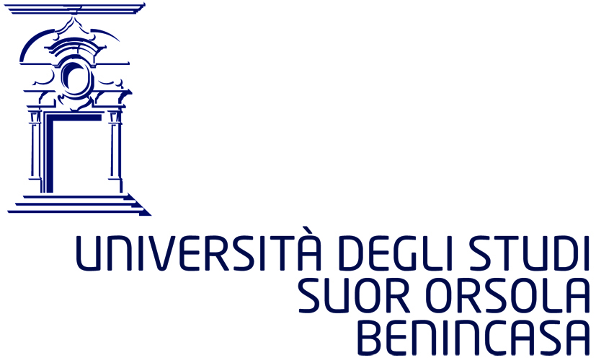

DOTTORATO DI RICERCA
Sugli ambiti di interazione e integrazione tra le scienze umane e le tecnologie avanzate.
Humanities and Technologies: an integrated research path

Ciclo XXXVI

Abstract della tesi di dottorato
L’abstract deve essere redatto sia in lingua italiana che in lingua inglese e nella lingua straniera eventualmente indicata dal Collegio dei docenti.

Dottorando: Veronica Torre matricola: D14000006

Dottorato: Sugli ambiti di interazione e integrazione tra le scienze umane e le tecnologie avanzate. Humanities and Technologies: an integrated research path

Ciclo: XXXVI

Titolo della tesi: La Cittadella Monastica di Suor Orsola Benincasa. Esempio di tutela del patrimonio e di trasmissione della conoscenza

Abstract:
The idea for the project was born from the lack of public knowledge about some spaces - of notable historical, artistic and architectural importance - of the monastic complex of the citadel of Suor Orsola Benincasa. The PhD was carried out at the same time as my role as Teaching Coordinator at the high schools of the Suor Orsola Benincasa Institute. Therefore, it was considered interesting to combine the research work with the educational and pedagogical aspects of my teaching, involving students in the creation of work that allows them to get to know these places through their point of view. The Citadel was represented by the students according to the disciplinary techniques learned during the school cycle. The plan of the monastic complex of Suor Orsola Benincasa from 1635, the representations of Suor Orsola Benincasa and the images recovered from the Historical Archive of the Institute were the starting documents of the project. The final objective was also the creation of a website that can be updated and increased progressively. Finally, for tourism purposes, the students of the Linguistic High School will be involved who will provide a guide service in the foreign languages included in their studies.

Firma del dottorando
