
2012
Author: Macarena Cataldo Hernández Supervisor: Debora Fino, Paolo Spinelli
Politecnico di Torino.
16/01/2012

Ph.D. in Chemical Engineering
Cycle XXIV

Electrocatalytic treatment of wastewaters

Dedicada a mi esposo Ignacio, por creer en mi y enseñarme a luchar por un mundo mejor, más justo y equitativo, exento de discriminaciones de cualquier tipo.

Acknowledgements – Ringraziamenti.
Alla fine di questo percorso, vorrei ringraziare prima di tutto Dio per avermi dato il coraggio e l’energia necessaria per dare il massimo possibile tutti i giorni, e avermi aiutata a non perdere la fiducia nel mio lavoro di ricerca.
Vorrei inoltre ringraziare tante persone, che mi hanno aiutato in questo cammino. Il mio compagno di vita, Ignacio (amorcito) che condivide i mie stessi ideali, complice perfetto e sostegno. Ti ringrazio, Ignacio, per tutto l’appoggio: grazie per avermi ricreato un pezzo di paradiso sulla terra.
Vorrei ringraziare la mia famiglia (Mamá, Papá, Marce, Gaby) per essermi stata vicina, anche se ci sono più di 15.000 km di distanza!
Ringrazio tutti quelli che mi hanno fatto sentire a casa, in Italia così lontana dal Cile. Ringrazio tutti quelli dell’ufficio “granata” (Benny, Luca ed Andrea). Ma che bei momenti abbiamo trascorso insieme! … grazie ragazzi per aver reso la mia giornata più piacevole ed essermi stati amici più che colleghi … Vi voglio tantissimo bene. Ringrazio inoltre Samir per aver gioito con me dei miei successi.
Ringrazio i miei relatori, Prof. Paolo Spinelli e Prof.ssa Debora Fino, per avermi dato questa importante opportunità di crescita, ed il Prof. Nunzio Russo per la sua costante disponibilità.
Infine, uno speciale ringraziamento a tutti quelli che operano nel gruppo di elettrochimica dell’ Università di Genova, soprattutto all’ Dr. Marco Panizza, che oltre ad avermi arricchito con la sua professionalità, mi è stato vicino umanamente.

ABSTRACT

The electrocoagulation tests were carried out considering both relatively high metal contents (in the range of ppm) and very low metal concentrations (in the range of ppb). The experiments with very low metal concentrations were carried out in the framework of a collaboration project with the metropolitan water agency of Turin (SMAT). The scope of the work was to investigate the performance of the electrocoagulation process, in order to produce drinking water, using aluminum electrodes to remove nickel and chromium from two different water-well samples. Different experimental parameters, such as stirring, distance between the electrodes and current density, were examined. The test campaign carried out on these two water samples has shown that the removal process of nickel is faster than that of chromium. In the case of water poisoned by nickel, a final concentration of 5 ppb was achieved, starting from 41 ppb, while the chromium case showed a final concentration of 10 ppb compared to the initial one of 20 ppb.
As far as the second part of the thesis is concerned, several experiments were carried out in order to obtain a complete understanding of the organic electroxidation process. To this end, a preliminary approach, based on a voltammetric analysis in a solution containing phenol in laboratory cells with Pt electrodes, was carried out. In this preliminary investigation, phenol was used as a model organic contaminant, since this compound has been widely investigated and reported on in the literature. As a result of the study on the model compound, general knowledge of the voltammetric technique was obtained and the best conditions for cleaning and reactivating the Pt electrodes in the presence of phenol were assessed. The investigation was then devoted to the abatement of urea by means of electroxidation. Cyclic voltammetry tests with laboratory cells were carried out, and these were followed by a series of tests in a pilot plant cell. In this investigation, it was possible to determine the conditions for urea oxidation by using different kinds of electrodes which, according to what has been reported in the literature, can be classified as active or non-active. The best conditions for the abatement of urea were through the use of boron diamond doped (BDD) electrodes and Pt electrodes.
Finally, purposely fabricated SnO₂-Sb₂O₅/ Ti electrodes were tested, due to their highly promising behaviour with respect to the increase in the oxygen evolution overpotential and service life. Different thicknesses of the Sn-Sb oxide layers were considered and a complete physico-chemical and electrochemical characterization of the electrodes was obtained.

INDEX
1. Introduction 4
1.1. Waterscarcity 4
1.2. Electrochemicaltechnologies in water treatment. 4
2. Fundamental concepts of electrochemistry 4
2.1. Kinetics of electrode reaction. 4
2.2. Cell parameters 4
2.3. Type of electrochemical reactor 4
3. Electrocoagulation in water treatment. 4
3.1. Introduction 4
3.2. Electrocoagulation and chemical coagulation. 4
3.3. Theoretical aspect. 4
3.4. Factors affecting electrocoagulation. 4
3.5. Application of electrocoagulation. 4
4. Removal of zinc by electrocoagulation 4
4.1. Introduction 4
4.2. Experimental procedure 4
4.3. Results and discussion. 4
4.4. Conclusion 4
5. Electrocoagulation for drinking water production. 4
5.1. Introduction 4
5.2. Experimental. 4
5.3. Results and discussion. 4
5.4. Conclusion. 4
6. Electrooxidation. 4
6.1. Introduction 4
6.2. Oxidation reactions & mechanisms. 4
6.3. Importance of nature electrode material. 4
6.4. Electrode materials. 4
7. Reactivation of pt anodes used in solution containing phenol. 4
7.1. Introduction. 4
7.2. Experimental 4
7.3. Results and discussion. 4
7.4. Conclusions 4
8. Electrochemical oxidation of urea in aqueous solutions. Part 1 4
8.1 Introduction 105
8.2. Experimental 4
8.3. Results and discussion. 4
8.4. Conclusions 117
9. Electrochemical oxidation of urea in aqueous solutions. Part 2 122
9.1. Introduction 4
9.2. Experimental 4
9.3. Results and discussion. 4
9.2. Conclusions 4
10. SNO₂-SB₂O₅ electrode preparation. 4
10.1. Introduction. 4
10.2. Experimental 4
10.3. Results anddiscussion 4
10.4. Conclusions. 4

CHAPTER 1:
Introduction



Introduction.
  - Water scarcity.
Water is essential for all socio-economic development and for maintaining healthy ecosystems. As population increases and development calls for increased allocations of groundwater and surface water for the domestic, agriculture and industrial sectors, the pressure on water resources intensifies, leading to tensions, conflicts among users, and excessive pressure on the environment. The increasing stress on drinking water resources brought about by ever-rising demand and profligate use, as well as by growing pollution worldwide, is of serious concern.
There are many ways of defining water scarcity. In general, water scarcity is defined as the point at which the aggregate impact of all users impinges on the supply or quality of water under prevailing institutional arrangements to the extent that the demand by all sectors, including the environment, cannot be satisfied fully. Water scarcity is a relative concept and can occur at any level of supply or demand. Scarcity may be a social construct or the consequence of altered supply patterns – stemming from climate change for example. Scarcity has various causes, most capable of being remedied or alleviated. A society facing water scarcity usually has options. However, scarcity often has its roots in water shortage, and it is in the arid and semi-arid regions affected by droughts and wide climate variability, combined with high population growth and economic development, that the problems of water scarcity are most acute.
Symptoms of water scarcity include severe environmental degradation (including river desiccation and pollution), declining groundwater levels, and increasing problems of water allocation where some groups win at the expense of others [1]
According with the studies of the Comprehensive Assessment of Water Management in Agriculture, one in three people today face water shortages [2]. Around 1.2 billion people live in areas of physical scarcity, and 500 million people are approaching this situation. Another 1.6 billion people face economic water shortage.
Scarcity often has its roots in water shortage, and it is in the arid and semiarid regions affected by droughts and wide climate variability, combined with population growth and economic development, that the problems of water scarcity are most acute.
Figure 1.1: areas of water scarcity.

Water use has been growing at more than twice the rate of population increase in the last century, and, although there is no global water scarcity as such, an increasing number of regions are chronically short of water. By 2025, 1 800 million people will be living in countries or regions with absolute water scarcity, and two-thirds of the world population could be under stress conditions. The situation will be exacerbated as rapidly growing urban areas place heavy pressure on neighbouring water resources.
Addressing water scarcity requires actions at local, national and river basin levels. It also calls for actions at global and international levels, leading to increased collaboration between nations on shared management of water resources, it requires an intersectoral and multidisciplinary approach to managing water resources in order to maximize economic and social welfare in an equitable manner without compromising the sustainability of vital ecosystems.
First and foremost, water scarcity is an issue of poverty. Unclean water and lack of sanitation are the destiny of poor people across the world. Lack of hygiene affects poor children and families first, while the rest of the world's population benefits from direct access to the water they need for domestic use. One in five people in the developing world lacks access to sufficient clean water (a suggested minimum of 20 litres/day), while average water use in Europe and the United States of America ranges between 200 and 600 litres/day. In addition, the poor pay more. A recent report by the United Nations Development Programme shows that people in the slums of developing countries typically pay 5-10 times more per unit of water than do people with access to piped water [3].
For poor people, water scarcity is not only about droughts or rivers running dry. Above all, it is about guaranteeing the fair and safe access they need to sustain their lives and secure their livelihoods. For the poor, scarcity is about how institutions function and how transparency and equity are guaranteed in decisions affecting their lives. It is about choices on infrastructure development and the way they are managed. In many places throughout the world, organizations struggle to distribute resources equitably.
Water for life, water for livelihood. While access to safe water and sanitation have been recognized as priority targets through the Millennium Development Goals (MDGs) and the Johannesburg plan of action of the World Summit on Sustainable Development (WSSD), there is increasing recognition that this is not enough. Millions of people rely in one way or another on water for their daily income or food production. Farmers, small rural enterprises, herders and fishing people - all need water to secure their livelihood. However, as the resources become scarce, an increasing number of them see their sources of income disappear. Silently, progressively, the number of water losers increases - at the tail end of the irrigation canal, downstream of a new dam, or as a result of excessive groundwater drawdown [1].
Due to this important problem generated by water scarcity it is important to develop new and convenient technologies. Different solutions can be devised, to improve the freshwater treatment to obtain drinking water on one hand and to reuse waste water after appropriate treatments on the other hand.
Water treatments are the processes used to enhance water quality for a specific end or use, including the use as drinking water and industrial wastewater processes. The purpose of the water treatment process is to remove the contaminants in the water, or to reduce their concentration, so the water becomes fit for its desired end-use. A important aim is returning water that has been used back into the natural environment without adverse ecological impact in surface waters and without damaging their biodiversity. Another important aim is to produce potable water. The most important contaminants in both cases, drinking water and wastewater, are hard metals and organic compounds. In the case of wastewater it is quite common to find relatively high quantities (>>ppm) of contaminants. Instead, in the case of purification of water for drinking, the quantities of contaminant metals are typically in the range of ppb.
This work has been developed by taking into consideration the removal of specific hard metals by means of electrocoagulation for the first case, and the abatement of urea from waste water, by means of electrooxidation, for the second case.
  - Electrochemical technologies in water treatment.
With the ever increasing quantity of drinking water supply and the stringent environmental regulations regarding the wastewater discharge, electrochemical technologies have regained their importance worldwide during the past two decades. There are companies supplying facilities for metal recoveries, for treating drinking water or process water, treating various wastewaters resulting from tannery, electroplating, diary, textile.
Electrochemical technology has an important role to play as part of an integrated approach to the avoidance of pollution, monitoring of pollution and process efficiency, cleaner processing. Electrochemistry can play many roles in clean technology and pollution control [4-5]:
a) the avoidance of polluting reagents in materials synthesis, such as zinc powder for organic reductions, by the use of direct electron transfer,
b) the monitoring of pollutant and reagent levels in process streams, rinse sections, effluents, and gaseous emissions,
c) the treatment of water by electrochemically generated species, such as chlorination of swimming pools and sterilization of medical instruments using a powerful cocktail of oxidizing reagents in “super oxidized” water,
d) the removal of environmental contaminants, such as metal ions and organics from industrial process streams,
e) the clean conversion of chemical to electrochemical energy using fuel cell and photovoltaic devices.
Continued developments in our understanding and documentation of the electrodes and membranes and electrochemical reactor design together with increasing industrial experience of their use are resulting in a more widespread acceptability of electrochemical technology and its features.
The many advantages of electrochemical technologies .
- Electrons are clean reagents.
- Effective control of the electron transfer rate.
- Measurement of reaction conditions.
- The process can be turned on and off via the current.
- Can often use benign conditions of temperature and pressure.
Possible limitations are:
- Many research workers have little industrial/large –scale experience of electrochemical technology.
- Some industrial sectors have limited knowledge or experience of electrochemical technology
- There are relatively few “showcases” for the technology.
- There is a shortage of experienced electrochemical engineers.
Chemical reactions, corrosion, adsorption can cause problems restrict performance and longevity [6].

Particular focus was given to electrodeposition, electrocoagulation (EC), electroflotation (EF) and electrooxidation. Electrodeposition is effective in recover heavy metals from wastewater streams. It is considered as an established technology with possible further development in the improvement ofs pace-time yield. Electrocoagulation (EC) has been in use for water production or wastewater treatment. It is finding more applications using either aluminum, iron or the hybrid Al/Fe electrodes. The separation of the flocculated sludge from the treated water can be accomplished by using electroflotation (EF). The EF technology is effective in removing colloidal particles, oil and grease, as well as organic pollutants. It is proven to perform better than either dissolved air flotation, sedimentation, impeller flotation (IF). The newly developed stable and active electrodes for oxygen evolution would definitely boost the adoption of this technology. Electrooxidation is finding its application In wastewater treatment in combination with other technologies. It is effective in degrading the refractory pollutants on the surface of a few electrodes. Titanium-based boron-doped diamond film electrodes (Ti/BDD) show high activity and give reasonable stability. Its industrial application calls for the production of Ti/BDD anode in large size at reasonable cost and durability [7].
    - Electrochemical reactor for metal recovery.
The electrochemical recovery of metals has been practiced in the form of electrometallurgy since long time ago. The first recorded example of electrometallurgy was in mid-17th century in Europe. The electrochemical mechanism for metal recovery is very simple. It basically is the cathodic deposition as :
M^{n+} + ne → M (1)
    - Electrocoagulation.
This process involves the generation of coagulants in situ by dissolving electrically either aluminum or iron ions from respectively aluminum or iron electrodes. The metal ions generation takes place at the anode, hydrogen gas is released from the cathode. The hydrogen gas would also help to float the flocculated particles out of the water. The Al³⁺ or Fe²⁺ ions are very efficient coagulants for particulates flocculating. Aluminum is usually used for water treatment and iron for wastewater treatment. The advantages of electrocoagulation include high particulate removal efficiency, compact treatment facility, relatively low cost and possibility of complete automation[5-7].
    - Electroflotation.
Electroflotation is a simple process that floats pollutants to the surface of a water body by tiny bubbles of hydrogen and oxygen gases generated from water electrolysis. Therefore, the electrochemical reactions at the cathode and anode are hydrogen evolution and oxygen evolution reactions, respectively. EF was first proposed by Elmore in 1904 for flotation of valuable minerals from ores [7].
    - Electrooxidation.
Indirect process.
Electrooxidation of pollutants can be fulfilledthrough different ways. Use of the chlorine and hypochlorite generated anodically to destroy pollutants is well known. This technique can effectively oxidize many inorganic and organic pollutants at high chloride concentration. The possible formation of chlorinated organic compounds intermediates or final products hinders the wide application of this technique [109]. Moreover, if the chloride content in the raw wastewater is low, a large amount of salt must be added to increase the process efficiency. Pollutants can also be degraded by the electrochemically generated hydrogen peroxide. In this system, the cathode is made of porous carbonpolytetrefluorethylene (PTFE) with oxygen feeding and the anode is either Pb/PbO₂, Ti/Pt/PbO₂, or Pt. Fe²⁺ salts can be added into the wastewater or formed in-situ from a dissolving iron anode to make an electro-Fenton reaction.
Direct process.
Electrooxidation of pollutants can also occur directly on anodes by generating physically adsorbed “active oxygen” or chemisorbed “active oxygen” This process is usually called anodic oxidation or direct oxidation. The physically adsorbed “active oxygen” causes the complete combustion of organic compounds (R), and the chemisorbed “active oxygen”(MOx+1) participates in the formation of selective oxidation products. In general, •OH is more effective for pollutant oxidation than O in MOx+1. Because oxygen evolution, can also take place at the anode, high overpotentials for O2 evolution is required in order to proceed with high current efficiency. Otherwise, most of the current supplied will be wasted to split water. The anodic oxidation does not need to add a large amount of chemicals to wastewater or to feed O2 to cathodes, with no tendency of producing secondary pollution and fewer accessories required. These advantages make anodic oxidation more attractive than other electrooxidation processes. The important part of an anodic oxidation process is obviously the anode material [7].

References.
[1] Coping with water scarcity challenge of twenty-first century, 2007 world water day, march 22.
[2] CA (Comprehensive Assessment of Water Management in Agriculture). 2007. Water for food, water for life: A comprehensive assessment of water management in agriculture.
[3] Report - 2. UNESCO and Berghahn Books, Paris and London. UNDP. 2006. Human Development Report 2006. Beyond scarcity: Power, poverty and the global water crisis. United Nations Development Programme, New York.
[4] D. Pletcher and F. C. Walsh. Industrial Electrochemistry, 2nd ed., Chapman & Hall, London (1990).
[5] F. C. Walsh. A First Course in Electrochemical Engineering, The Electrochemical Consultancy, Romsey (1993).
[6] F. C.Walsh , , Pure Appl. Chem., Vol. 73, No. 12, (2001),1819.
[7] G. Chen, , Sep. and Purif. Technol. 38 (2004),11.

CHAPTER 2:
Fundamental Concepts
of
Electrochemistry

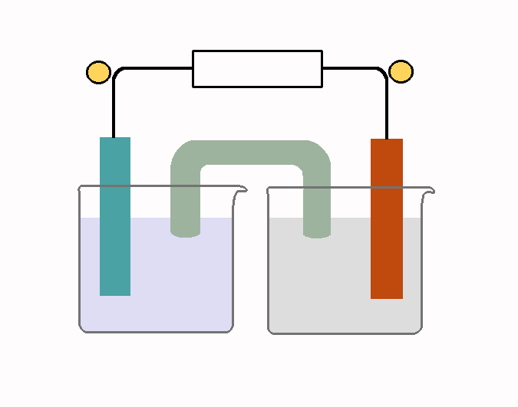

Fundamental concepts of electrochemistry.
An electrochemical system is characterized by the presence of two electrodes (electronic conductors) in contact with an ionic conductor (electrolyte). The passage of a current causes chemical changes at the electrodes due to the fact that at the electrode-electrolyte interface a charge transfer process occurs, which is influenced to a great extent by the applied electrical potential. The charge transfer may be a cathodic process, in which an otherwise stable species is reduced by the transfer of electrons from the cathode,
2H₂O + 2e⁻ → H₂ + 2OH⁻ (2.1)
Cu²⁺ + 2e ⁻ → Cu (2.2)
Conversely, the charge transfer may be related to an anodic process in which an otherwise stable species is oxidized by the removal of electrons through the anode,
2H₂O - 4e⁻ → O₂ + 4H⁺ (2.3)
2Cl⁻ - 2e ⁻ → Cl (2.4)
In an electrochemical process the amount of charges involved in the reduction process at the cathode must be equal to the amount of charges involved in the oxidation process at the anode, in order to avoid the accumulation of positive and negative net charges within the system. The motion of ions through the electrolyte solution is responsible for maintaining the electrical neutrality in the solution itself; the anions move towards the anode and / or the cations more towards the cathode in a sufficient quantity to maintain, a charge balance. The overall chemical change that occurs in an electrochemical cell is determined by both anodic and cathodic reactions.
The current through the circuit (I) is also a convenient measure of the speed with which the electrode reacts, it can be related to the amount of chemical change through Faraday’s law:
(2.5)
where m is the mass of the species reacting at the electrode, I is the current intensity [A] operating for the time t [s], M is the molecular weight of the reacting species, z is the number of electrons transferred and F is Faraday’s constant (96486 C mol⁻¹).
  - Electrode reaction kinetic.
In order to understand the functioning of a cell, it is necessary to have some basic knowledge of thermodynamics and kinetics of the electrode reactions. A simple redox process that takes place on an inert surface can be described by the following reaction:
O + ne ⇔ R (2.6)
where the O and R species, are a completely stable and soluble electrolyte medium. A simple electrode reaction, such as (2.6) is actually described by a sequence of steps. In order for a reaction to take place, the O species has to be supplied to the electrode and the R species has to be removed from the surface during the electron transfer reaction:
(2.7)
(2.8)
(2.9)
Since the reduction rate, and hence the cathodic current density, is determined by the rate of the overall sequence, the reduction rate depend on the speed of the slowest step. This case does not always correspond to the real situation, because it often occur in a multi-stage process involving not only the electrochemical processes, but also chemical reactions, adsorption and phase transitions.
    - Electron transfer.
The equilibrium of a redox reaction such as (2.6) is characterized by the Nernst equation (2.10) which binds the electrode potential and the concentration of chemical species that participates in the same reaction:
(2.10)
Where c_{O}∞ and c_{R}∞ are the concentrations, with respect to O and R in the solution and E_{e}^{φ} is the potential standard of the redox couple O/R.
Although no net current is observed, at the equilibrium potential, the surface of the electrode is under a dynamic equilibrium, in which the reduction in O and the oxidation of R occur at the same speed, and the composition of the solution therefore does not change. This condition can be written in terms of current density:
-i_{C} = i_{A} = i₀ (2.11)
where i_{A} and i_{C} are the current density of the reduction and oxidation, respectively. Their sign is different because the two reactions occur the external circuit, electrons flow in opposite directions and, by convention, the anodic current density is positive and the cathode is negative. A measured potential current density is given by:
i = -i_{C} + i_{A} (2.12)
The partial currents depend on the constant rate speed, and concentration of the electroactive species on the electrode surface:
-i_{C} = nFk_{c} c₀∞ and i_{A} = nFk_{A} c_{R}∞ (2.13)
The kinetic constant, can be explained as a function of the applied electric potential:
(2.14)
where α_{C}, α_{A} are the cathodic and anodic transfer coefficients (with α_{C} + α_{A}=1) and k_{C}°, k_{A}° are the constant kinetic rates (to E = 0 V vs. RE).
Substituting in (2.12) we can obtain the density of current that flows at a given potential:
(2.15)
Introducing overpotential η, which measures the change in the experimental equilibrium potential:
η = E - E_{e} (2.16)
and where E_{e} is the equilibrium potential (2.11) and η = 0, we can simplify (2.15) to obtain the Butler-Volmer equation (Figure 2.1):
(2.17)
which shows that the current density i is a function of the overpotential η, the exchange current density i₀ and the transfer coefficients α_{A} and α_{C}.
An important limiting case of Butler-Volmer equation occurs at high values of overpotential, in case in which one of the two exponentials of (2.17) becomes negligible. For very negative values of η we obtain:

(2.18)

so can be simplified and written as:
(2.19)

This is known as the cathodic Tafel equation. On the other hand, for very positive η values, we obtain the following anodic Tafel equation:
(2.20)

The transfer coefficients and exchange current density i₀ can be derived from the Tafel equations as illustrated in Figure 2.2.
 | 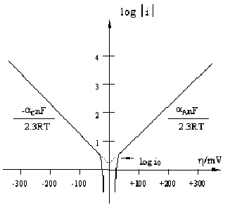
Figure 2.1: Butler Volmer equation 17. | Figure 2.2: Tafel equation 19 and 20.

    - Mass transport.
When there are electric current flows in the system are always present mass transfer or diffusion phenomena. Initially, species O spreads on the electrode surface, and this is followed by a surface reaction and then by diffusion of the reagents from the surface. In general, the mass transfer can occur by means of:
- Migration: this is the movement of electrical charge due to a potential gradient and this phenomenon is responsible for the passage of an ionic current through the electrolyte. In many cases, forced convection is the predominant factor, due to the need to achieve high production rates, especially when treating dilute reactants. In the typical case of industrial synthesis processes, in which the electrolyte solutions have an excess of inert electrolytes, the contribution of migration to the spread is small and can be considered negligible.
- Convection: natural convection results if the forces are caused by localised temperature fluctuations and changes in density, whereas forced convection ensues if the solution is moved by external forces, such as electrolyte pumping or electrode movement.
- Diffusion: is the movement of species due to a concentration gradient in the solution. Such phenomenon occurs. In electrolytic processes between the surface of the electrode and the solution. The mass transport due to diffusion is described by Fick's law:
flux N = -D_{i} (dc_{i} / dx) (21)
where D_{i} is its diffusion coefficient.
In the absence of chemical reactions in the electrolyte near the electrode to changes in concentration of the reactive species are practically linear. This defines a diffusion layer (δ_{N}) that part of the solution immediately in front of the electrode where, as a result of electrode reaction, the composition is different from that of the homogeneous mass. Equation (2.22) can then be written in terms of the coefficient of mass transport, with c_{O}^{S} indicating the concentration of O at the surface of electrode:
N = k_{m} [c_{O}∞ - c_{O}^{S}] (2.22)

where k_{m} is the mass transfer coefficient which is related to the diffusion layer (δ_{N}) by the relation:
k_{m} = D_{i} / δ_{N} (2.23)

When there are mass transport phenomena, the current steady state is given by: (2.24)

dove sono le concentrazioni, di O sulla superficie elettrodica e R nella soluzione rispettivamente.
Where c_{O}^{S} and c_{O}∞and are the concentrations of O on the electrode surface and R in the solution, respectively.
Increases the potential of electrode current density, in the absence of secondary reactions, approaches a limit value and the concentration of surface O species decreases. Sometimes it becomes so small that the current density reaches a value almost constant. The situation is such that the reagent O just come to the surface it reacts so quickly that c_{O}^{S} is equal to zero and the mass transport limits the speed of the process. Under these conditions the value of the current density is called the current density limit (i_{lim}) and is given by [1]:
i_{lim} = -n F k_{m} c_{O}∞ (2.25)
    - Electron transfer and mass transport control.
If the current through an electrode is recorded as a function of the electrode potential (with respect to a reference electrode), current vs. electrode potential curves, such as those presented in Fig. 2.3 can be obtained. In the general case, three zones can be observed.
The first zone is characterized because the use of a larger overpotential leads to an increase in the current; this region is known as the charge transfer controlled zone because the rate of the process depends on the electron transfer rate. The current density is less than a few percent of the limit current density [2]. As long as the current is low, the concentration of O and R on the surface of the electrode will not be significantly different from the solution and therefore the mass transport will have a negligible effect under these conditions and the current is only determined by electron transfer; this potential Tafel range curve is linear. The second zone represents an intermediate situation where there is mixed control: increasing the rate of decline so rapidly. The current is given by the mass transport and electron and the Tafel curve will not be linear. In the third region, an additional, side reactions occurs, typically hydrogen evolution due to the reduction of the solvent [1-2].
Figure 2.3: A typical current versus overpotential curve for the single electrode process. Three zones of reaction rate control. Zone I: charge transfer control; Zone II: mass transport control; Zone III: a secondary reaction [2].

  - Cell parameters.
It is important to design an electrochemical reactor for a specific process, and it is clear that energy conversion and electrochemical synthesis reactors will have different drivers to those used for the destruction of electrolyte-based contaminants. Adequate attention must be paid to the form of the electrode and its geometry and motion, together with the need for cell division or a thin electrolyte gap. The form of the reactants and products as well as the mode of operation (batch or continuous) are also important design factors. Desirable factors in reactor design include [18]:
a) moderate costs (low-cost components, a low cell voltage, and a small pressure drop over the reactor)
b) convenience and operation reliability (designed for easy installation, maintenance, and monitoring)
c) appropriate reaction engineering (uniform and appropriate of current density, electrode potential, mass transport, and flow values)
d) simplicity and versatility (in an elegant design, which is attractive to end users) [1,3].

    - Electrode materials.
The starting point for the development of an electrochemical process is the choice, through the use of adequate experimental methods, the suitable electrode material for to carry out the desired reaction. Some criteria concerning the choice of an electrode material for use in an electrochemical process are:
- High catalytic activity towards the oxidation of organic substances.
- Low catalytic activity towards the side reactions (oxygen evolution).
- Good chemical stability and electrochemistry.
- Satisfactory electrical conductivity.
- Simple and inexpensive production.
In fact, it is very difficult to find all these requirements at the same time. Although it is still not possible to establish with certainty the factors that determine the electrocatalytic activity of a material, several general principles may be taken into consideration. Although it has been shown that metals, alloys and semiconductors have satisfactory electrocatalytic properties, many electrodes are based on transition metals, and it seems that their design requires the placement of atoms and ions of heavy metals in a matrix that allows their electronic conFiguretion to be optimized. The success of transition metals as electrocatalysts can be explained by their adsorption capacity, because they have unpaired and incomplete electrons of the orbital that can form bonds with the substance what has to be adsorbed. The free energy of adsorption, however, depends to a great extent on the number of unpaired electrons per atom and their energy levels. Consequently, the activities will vary on the basis of the transition metal and may be modified by combining these metal alloy or by placing them in a non-metallic mesh. Another important factor, in addition to the electronic ones, concerns the geometrical arrangement of the active centres of the catalyst. All electrocatalytic reactions involve the formation or breaking of bonds, and it is possible that the speed of these processes increases if they occur simultaneously. These mechanisms require a suitable distance between the adsorption sites, this distance is central in the case of larger molecules, which may involve more than one site.
However, it should be noted that, in some processes, such as when there is oxygen reduction, the evolution of hydrogen and chlorine, and the oxidation of ethylene, methanol and carbon monoxide, a few catalysts can lead to lower voltage values than those obtained with platinum electrodes. Consequently, research is being aimed at funding electrocatalytic materials with similar properties to those of noble metals, but which are cheaper and / or prevent the formation of "poisons" on the surface [4].
The materials most commonly used for anodes and cathodes are shown in Table 2.1. The best ones are often expensive, and it is therefore preferred to use them in the form of coatings which are applied to cheaper inert substrates cheaper, such as titanium or carbon, for the anodes, cathodes and steel.

Table 2.1: Common electrode materials [1].
CATHODES | ANODES
Hg, Pb, Ni | Pt, Pt/Ti, Ir/Ti, Pt-Ir/Ti
Graphite and others forms of C sometimes treated thermally with organics or polymers to modify porosity, density, corrosion resistance, wettability | Graphite or other forms of C  Pb in acid sulphate media  PbO₂ on Ti, Nb, C
Steel and stainless steel | Nichel in alkaline media
Coating of low H₂ overpotential materials on steel ( Ni, Ni/Al, Ni/Zn) | DSA®(Ru-Ti su Ti for Cl₂ e IrO₂ on Ti for O₂)
Hastelloys ( Ni-Mo-Fe o Ni-Mo-Cr) | Magnetite: Fe_{3-x}O₄
TiO_{x} | Conducting ceramics, eg. Ti₄O₇

    - Electroactive area per unit volume.
Since the rate of an electrochemical reaction, for a given current density, is directly proportional to the electroactive surface A, it is very important to obtain a cell with a high electroactive area per unit volume of the electrolyte. In heterogeneous catalysis, which only requires a large surface area of the catalyst, the problem is simple, but there are restrictions in concerning the electrolytic cells connected to the electrode potential which must suitable for the reaction to occur. In fact, in order to have a uniform reaction rate over the entire electrode area, the current distribution must be uniform across the electrode surface. Figure 2.4 shows four electrode geometries: in cells (a) and (b), respectively, parallel plate and concentric cylinder rotating, the current distribution is uniform, while in cells (c) and (d) plates respectively in a reactor shaft and plates are not parallel, it can not be one. In fact, in cell (c) the rear electrode is isolated from the solution and there are additional losses due to the fact that iR a small current also flows at the back of the electrode, while in cell (d) an electrode surface has protrusions and indentations, therefore the distance between the electrodes is not constant.
Electroactive area A_{S} per unit volume (V_{R}), which is frequently called “the specific” electrode area, and should be stated whenever possible;
A_{S} = A / V_{R} (26)
It is obviously attractive to maximize A_{S} in order to produce a compact high performance reactor and this has been a major driving force for many of the “ high –surface –area” cells developed over the last two decades. It is remarkably difficult , in practice, to obtain a high A_{S} value whilst maintaining a uniform reaction rate over the entire electrode surface.
Figure 2.4 : Elementary reactor geometries (a) Parallel-plate cell. (b) Concentric rotating cylinder cell. (c) Plate in tank cell. (d) Plate cell with non- parallel electrodes.

    - Mass transport coefficient.
For a process under mass transport control, the limiting current I_{lim} expresses the duty of the reactor :
I_{lim} = k_{m}AnFC∞ (2.27)
In the general case, for a mass transport controlled reaction, the values of both k_{m} and the electrode area contribute to the performance. Therefore, it is often useful to calculate their product:
k_{m}A = I_{lim}/( nF C∞ ) (2.28)
This is a particularly useful approach in circumstances in which these parameter are closely related, and perhaps time-dependent, such as for the cathodic deposition of metals. It is important to be able to maximize the k_{m}A product for high speed production. However sometimes there are practical limitations and costs related to increased electrode / electrolyte speed (and therefore of k_{m}) and of the electrode.

    - Current Efficiency.
Current efficiency is the yield obtained from the electrical charge passed during electrolysis, compared to a produced substance, that is the ratio between the amount of electricity needed to theoretically obtain the product in question and the amount actually used:
φ (2.29)
On the basis of Faraday’s laws:
φ (2.30)
where m is the number of produced moles (mol), n is the number of exchanged electrons, F is the Faraday constant, V is the reactor volume (m³), an ΔC, is the change in concentration of the products (mol m⁻³) using the electric charge q (C).
A value of φ less than 100% indicates that a certain proportion is the reverse reaction, or that form of by-products. However, a value of less than 100% φ is not necessarily associated with a yield of material of less than 100%.

    - Cell voltage.
Cell voltage is a complex quantity that is made up of a number of terms:
- Equilibrium Potential for the anode and cathode, Ee = E_{e}^{C} - E_{e}^{A} ;
- anodic and cathodic overpotentials (η_{A}+η_{C}), due to polarization phenomena, which increase for an increasing reaction rate or current density, and which can be minimized using stable electrocatalytic materials;
- potential drop in the electrodes in the electrolyte, iR_{Cell};
- potential in the circuit, iR_{Circuit};
Consequently the ΔECell can be expressed through :
ΔE_{Cell} = ΔE_{e}-η_{A}+η_{C}- iR_{Cell}- iR_{Circuit} (2.31)

In general, some terms, we can rewrite (31) as follows:

ΔE_{Cella} = E_{e}^{C} - E_{e}^{A} - η_{A} + η_{C}- iR_{Catholyte} - iR_{Separator} - iR_{Anolyte} - iR^{C}_{Circuit} - iR^{A}_{Circuit} (2.32)

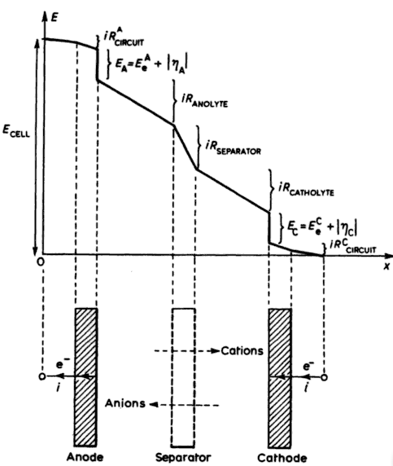
Figure 2. 5: Schematic voltage components in a divided cell, illustrated by a plot of potential versus distance x in the interelectrode direction.

Figure 2.5 illustrates Equation (32) in a schematic form, and shows certain sloping, straight lines which indicates ohmic behavior, i.e. the current is linearly dependent on the potential. In the case of an electrode and its Busbar, electronic conduction occurs, while ions transport the current in a solution. The nearly vertical lines , which represent the anode and cathode potentials, reflect the fact that these potential drops occurs over very small distances, corresponding to the electrode interface and the hydrodynamic boundary. The horizontal lines represent ( idealistic) zero voltage components.
    - Costing an electrolyte process.
Generally the most important strategy for a electrochemical system is to minimize the product costs by optimizing the current density. Productivity increases at high current densities, but this usually increases the cell voltage, and thus decreases the energy efficiency per product unit. The cost of the components of the cell is also important, therefore when selecting materials, it is necessary to remember that the concentrated electrolyte solutions used in electrolysis processes are corrosive. Therefore, the various components should be prepared with high resistance to corrosion. Considering a simplified approach, it can be assumed that the total costs of production (C_{TOTAL}) for a single cell, can be divided into:
C_{TOTAL} = C_{E} + C_{I} +C_{S} (2.33)
where C_{E} is the electrolytic power cost , C_{I} is the reactor investment cost, C_{S} is the electrolytic stirring cost .
The electrolytic power cost :
C_{E} ≅ bqiR_{TOTAL} (2.34)
where b is the cost of a unit of electrical energy, ( e.g. $ per kWh) and is the electrical charge requirement, and cell voltage.
The reactor investment cost is given by :
C_{I} = aA (2.35)
where a is the cost per electrode area (e.g. $ per m²) and A is the electrode area. The cost of electrolyte stirring Cs dependents to a great extent on upon the considered process, and in some cases:
C_{S} = bWt (2.36)

where b is the unit cost of energy , W is the power required for the electrolyte – electrode movement, t is the elapsed time per electrode area (e.g. $ per m²) and A is the electrode area.

The total cost is given by:
C_{TOTAL} = bqiR_{TOTAL} + aA + bWt (2.37)

Under constant current conditions, q = it , equation (37) can be rewritten as :

C_{TOTAL} = bqiR_{TOTAL} + aAq/it + bWq/i (2.38)

This equation is shown schematically in figure 6. The total cost has a minimum at the optimum current i_{OPT,} which can be calculated by annulations the derivative of the total cost with respect to the current:
dC_{TOTAL} / di = 0 (2.39)

from which one obtains:
(2.40)
In general, the optimal current depends on the unit cost of the electrode a, on the electric energy cost b and the total resistance of the cell.

Figure 2.6: Componenti dei costi di un reattore elettrochimico in funzione della densità di corrente applicata [1].
  - Type of electrochemical reactor.
There are different types of electrochemical reactors, which can be classified according to the electrode geometry ( bidimensional or tridimensional) and to the electrode motion ( static or dynamic)[4,5].
The plate and frame cell which is sometimes called filter press, Figure 2.7, is one of the most popular electrochemical reactor designs. It conveniently houses units with an anode, a cathode, and a membrane (if necessary) in one module. This module system makes the design, operation and maintenance of the reactor relatively simple. It is possible to use both bidimensional and tridimensional electrodes, in a filter press reactor, with this type of reactor, in order to improve the mass transport, it is common to use flux promoter (e.g. with plastic red). In general, these reactors are used, to increase electroactive area, but they suffer from some problems due to:
- High pressure drops in the electrolytic solution
- Insulation of the electrode.
- Problems between the electric contact and the electrode.

Figure 2.7: Filter press reactor [6].

The rotating cathode cell was designed in order to enhance the mass transfer from the bulk to the electrode surface and also to remove the metal powders deposited on the cathode. Figure2.8. The pump cell is a variant of the rotating cathode cell. With a static anode and a rotating disk cathode, the narrow spacing between the electrodes allows the effluent to enter. The metals are electrically scraped as powders. Another design employs rotating rod cathodes between the inner and outer anodes [6].
Figure 2.8: rotating cylinder electrode.

Since metal deposition occur on the surface of the cathode, it is necessary to increase the specific surface area in order to improve the space–time yield. The fluidized bed electrode was therefore designed, Figure 2.9. The cathode is made of conductive particles, which are put in contact with a porous feeder electrode. Electrical contact is not always maintained thus the current distribution is not always uniform and the ohmic drop within the cell is high. A large number of additional rod feeders was used, in order to improve the contact between the electrode feeder and cathode particles.
Figure 2.9: Fluidized bed reactor.

From a chemical engineering, point of view there are three types of reactors:
Plug flow: in this case it is assumed that the fluid flow is continuous through the reactor with no mixing of the electrolyte in the direction of the flow between the inlet and the outlet. The reactant and product concentrations are both functions of the distance, but they are independent of time. As a result, the residence time must be equal for all the species in the reactor. A reactor with such properties is called a plug flow (or piston flow) reactor (PFR). The most used commonly PFR conFiguretion are parallel plate and three-dimensional electrode cells ( fig 2.10).
Figure 2.10: Continuous reactor.

The simple batch reactor: this reactor is an example of a perfectly mixed reactor is this reactor( fig 2.11) , which the reactant is continuously stirred during batch time in which a reaction occurs. The batch reactor is used due to its simplicity and versatility. Batch reactors are used for small-scale operations as they are more economic than continuous reactors. During the batch processing time, the concentration of the reactants and products progressively changes. However, the electrolyte composition is uniform throughout the reactor at any instant.
Figure 2.11: Batch reactor Figure 2.12: CSTR reactor

Continuously stirred tank reactor, or back mix reactor. This consists of a perfectly stirred tank with a continuous flow through the reactor (CSTR). In this case, the concentration of the reactants and products are uniform throughout the reactor but reactants can be add continuously and the product stream removed at the same rate (fig 2.12)
Table 2.2- summary of the design equations of a batch reactor, plug flow reactor and continuously stirred tank reactor in single pass mode [1,4].
Table 2.2: Summary of design equations .

References.
[1] D. Pletcher e F. C. Walsh, “Industrial Electrochemistry” 2nd Edn., Chapman and Hall, London and New York (1990).
[2] P. Trinidad and F. Walsh Int. J. Engng Ed. Vol. 14, No. 6, (1998), 431
[3] F.C. Walsh. A First Course in Electrochemical Engineering, The Electrochemical Consultancy, Romsey (1993).
[4] Walsh e G. Reade, Analyst, 119, (1994),791
[5] K. Rajeshwar, J. G. Ibanez e G. M. Swain, J. Appl. Electrochem., 24, (1994),1077.
[6] G. Chen, Sep. and Purif. Technol. 38 (2004) 11.

CHAPTER 3:
Electrocoagulation
in
a water treatment.

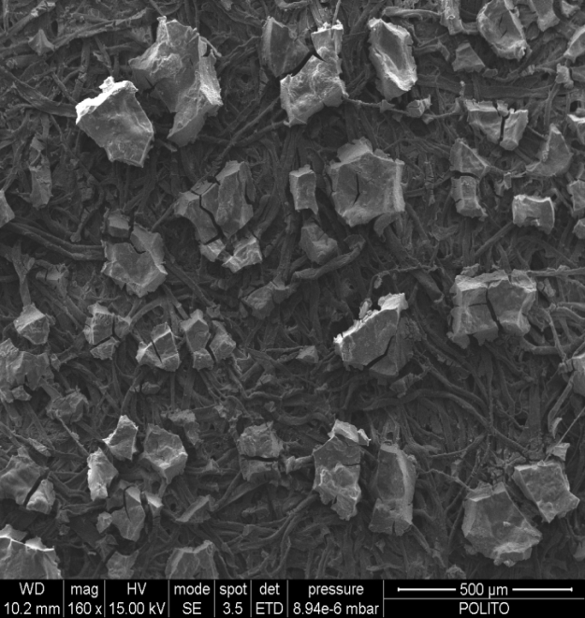

Electrocoagulation in a water treatment.
  - Introduction.
EC is a complicated process involving many chemical and physical phenomena that use consumable electrodes (Fe/Al) to supply ions to the water stream. At the turn of the nineteenth century, EC was applied in several large-scale water treatment plants in London (Matteson et al. 1995). Over the following decades, plants were also commissioned in the United States to treat municipal wastewater. However, in 1930s, there plants were abandoned due to higher operating costs [2]. Recent years, smaller scale ec have been used in the water treatment industry, due to their reliable and effective technologies [3-5]. In the EC process, Fe/Al are dissolved from the anode and generate the corresponding metal ions, which immediately hydrolyze to polymeric iron or aluminum hydroxide. These polymeric hydroxides are excellent coagulating agents. The sacrificial anodes are used to continuously produce polymeric hydroxides in the vicinity of the anode. Coagulation occurs when these metal cations combine with the negative particles carried towards the anode by electrophoretic motion. The contaminants present in the water stream are treated either by chemical reactions and precipitation or by physical and chemical attachment to the colloidal materials that are generated by erosion of the electrode. They can be removed by electroflotation, sedimentation, or filtration.
  - Electrocoagulation and chemical coagulation.
Coagulation is a phenomenon in which the charged particles in colloidal suspension are neutralized by mutual collision with counter ions and are then agglomerated; this is followed by sedimentation or flotation. The difference between electrocoagulation and chemical coagulation is mainly in the way by which the aluminum or iron ions are delivered. In chemical coagulation, hydrolyzing metal salts, based on aluminum or iron, e.g., aluminum, ferric sulfates and chlorides, are used widely as coagulants in water treatments. Instead, ec is a process that involves of creating metallic hydroxide flocks within the water by means of electrodissolution of the soluble anodes [6]. EC offers some advantages compared to chemical coagulation:
- In the chemical coagulation process, the hydrolysis of the metal salts leads to a decrease in pH. Chemical coagulation is highly sensitive to change in pH and effective coagulation is achieved a pH of 6–7. While in the electrocoagulation, the pH neutralization effect is effective in a much wide pH range (4–9).
- Flocs formed by means of EC are similar to chemical floc. However, EC flocs tend to be much larger, contain less bound water, are acid resistant, and are more stable. In the chemical coagulation process, it is always followed by sedimentation or filtration. The electrocoagulation process can instead be followed by sedimentation or flotation. The gas bubbles produced during electrolysis can carry the pollutant to the top of the solution where it can be concentrated, collected, and removed more easily.
- Sludge formed from EC tends to be readily settable and easy to de-water, because it is mainly composed of metallic oxides/hydroxides. EC is a low-sludge producing technique.
- Chemicals are not used in the EC process. Thus, there is no need to excess chemicals, and secondary pollution caused by addition of chemical substances can be avoided.
- The EC process offers the advantage of treating being able to treat low temperature and low turbidity water. In this case, it is difficult to obtain satisfactory result with the chemical coagulation.
- EC requires simple equipment and is easy to operate

The disadvantages of EC are.
- The “sacrificial electrodes” dissolve into wastewater as a result of oxidation, and need to be regularly replaced.
- The passivation of the electrodes in time has limited its implementation.
- The use of electricity may be expensive in many places.
- High conductivity of the wastewater suspension is required [7].

  - Theoretical aspect.
    - Possible mechanism.

Electrocoagulation (EC) involves chemical and physical phenomena that use consumable electrodes to generate ions in the water solution. In an Ec process, the coagulant is generated in situ in three stages (i) formation of the coagulants by means of oxidation of anode, (ii) destabilization of the contaminants, particulate suspension, and breaking of the emulsions and (iii) aggregation of the destabilized phases to form flocs [6].
In the EC process, the destabilization mechanism of the contaminants and breaking of the emulsions may be summarized as follows :(1) Compression of the diffuse double layer around the charged species by the interaction of the ions generated by means of oxidation of the sacrificial anode. (2) Charge neutralization of the ionic species present in wastewater by means of counter ions produced by the electrochemical dissolution of the sacrificial anode. These counter ions reduce the electrostatic interparticle repulsion to the extent that the van der Waals attraction predominates, thus causing coagulation. A zero net charge results in the process. (3) Floc formation: the floc formed as a result of coagulation creates a sludge blanket that entraps and bridges the colloidal particles that still remains in the aqueous medium[8].
According to Paul (1996), the following physiochemical reactions may also take place in the EC cell :
(1) cathodic reduction of the impurities;
(2) discharge and coagulation of the colloidal particles;
(3) electrophoretic migration of the ions in solution;
(4) electroflotation of the coagulated particles through the O₂ and H₂ bubbles produced at the electrodes;
(5) reduction in the metal ions at the cathode; and
(6) other electrochemical and chemical processes [9].
Figure 3.1 shows the complex, interdependent nature of the electrocoagulation process.

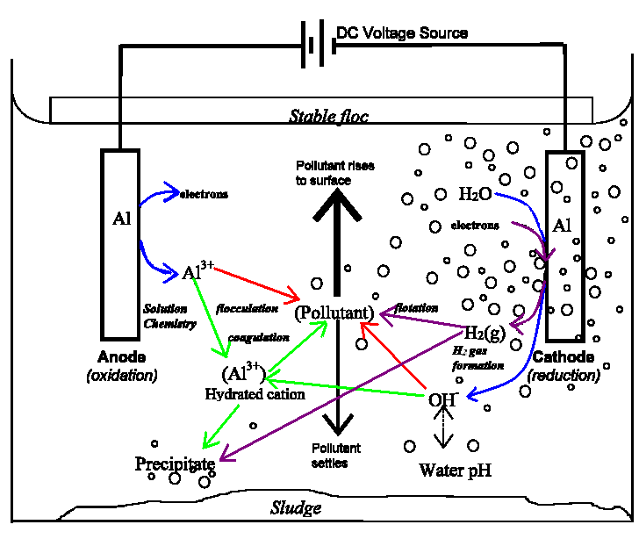
Figure 3.1: Schematic diagram of a two-electrode electrocoagulation cell.

    - Reaction at the electrodes.

A current is passed through a metal electrode, and the metal (M) is oxidized to its cation (M^{n+}) (eq. 3.1) , while water is reduced to hydrogen gas and the hydroxyl ion (OH⁻) (eq. 3.2). Ec thus, electrochemically introduces metal cations in situ, usually aluminum or iron sacrificial anodes [10- 13]:
(3.1)
(3.2)

if the anode potential is sufficiently high, a second reaction may also occur at the anode:
(3.3)
Finally, the ions produced by electrolytic dissolution of the anode promote the generation of metal hydroxide in the bulk wastewater, Equations 3.4 –3.10 illustrate, the case of aluminum.

(3.4)

The generation of the Al species can be explained through two mechanisms: neutralization of the negative charge colloids by means of the cation, and incorporation of the impurities in the hydroxide precipitate (flocculation). The electrical current determines the coagulant dosage rate, which in tern influences the efficiency of the coagulation process. Hydroxides are also generated in relation to the total metal concentration and to the pH of the solution, according to the following sequence [14]:

(3.5)
(3.6)
pH
(3.7)
(3.8)

Therefore, aluminum hydroxide flocs act as a trap for the metal ions, which are then removed from the solution. The overall reaction is:
(3.9)

Finally, the generation of the surface complex between the pollutants and hydrous aluminum occur in the following manner [7]:
(3.10)
The electrical current determines the bubble production rate and size as well as the growth of the flocs, and also influences the efficiency of the electrocoagulation process.

    - Electrode passivation and activation.
One of the greatest operational problems with electrocoagulation is electrode passivation. The passivation of electrodes is of concern because of the longevity of the process and it has widely been observed and recognized as detrimental to reactor performance. This formation of an inhibiting layer, usually an oxide on the electrode surface, prevents metal dissolution and electron transfer, and it limits the addition of the coagulant to the solution. Over time, the thickness of this layer increases, and the efficacy of the electrocoagulation process decreases. It has also been observed that, deposits of calcium carbonate and magnesium hydroxide are formed at the cathode during electrocoagulation with iron electrodes. In this case, it is recommended to use stainless steel as the cathode material. It was observed that in the presence of anions electrode passivation also slow down. The positive effect is as follows: Cl⁻> Br⁻ > I⁻> F_ > ClO₄⁻ > OH_ and SO₄²⁻ [3].
Nikolaev et al. (1982) investigated different methods of to prevent and / or control electrode passivation :
• Changing the polarity.
• Hydromechanical cleaning;
• Introducting inhibiting agents;
• Mechanical cleaning of the electrodes.

According to these studies, the most efficient method was to periodically clean the electrodes mechanically.
  - Factors that affect electrocoagulation.
    - Effect of current density or charge Loading.
The density of the current is very important in ec as it is the only operational parameter that can be controlled directly. Current density directly determines both the coagulant dosage and bubble generation rate and strongly influences both solution mixing and mass transfer at the electrodes to a great extent . The amount of coagulant delivered to the solution may be calculated using the simple relationship [16-18]:
(3.11)
where m is the mass of aluminum and hydroxide ions generated in the solution [g], I is the operating current [A] for time t [sec], M is the molecular weight of aluminum [g mol⁻¹], z is the number of electrons transferred in the anodic dissolution (z = 3) and F is Faraday’s constant (96486 C mol⁻¹). A lower uncertainty occurs between theoretical and experimental data when more attention is paid to the geometry of the electrode assembly and to the setting of the optimal operating conditions. In addition the potential required to obtain the desired current density depends on three components: kinetic overpotential, concentration overpotential, IR-drop over potential (caused by solution resistance).
$η_{AP}=η_{k}+η_{Mt}+η_{IR}$ (3.12)
where η_{AP} is the applied overpotential , η_{k} is the kinetic overpotential , η_{Mt}, is the concentration overpotential and IR is the overpotential caused by the solution resistance or IR drop (V).
The IR-drop is related to the distance between the electrodes, the surface area of the electrodes and the specific conductivity of the solution. The IR-drop can be minimized by decreasing the distance between the electrodes and increasing the cross-section area of the electrodes and specific conductivity of the solution. Concentration overpotential, which is also called mass transfer or diffusion overpotential is caused by the change in the analytic concentration that occurs in the proximity of the electrode surface, due to electrode reactions. Kinetic overpotential originates from the activation energy barrier to electron transfer reactions . The activation overpotential is particularly high due to the evolution of gases on certain electrodes. Both the kinetic and concentration overpotentials increase as the current increase. [2,16 ,19-23].
    - Effect of conductivity.
Current efficiency decreases when the electrolytic conductivity is low, therefore a high-applied inclination potential is needed, but this leads to increased costs and to the passivation of the electrode.
It was found that chloride ions could significantly reduce the adverse effect of other anions, such as HCO₃⁻, SO₄²⁻. The existence of t carbonate or sulfate ions leads to the precipitation of Ca²⁺ or Mg²⁺ ions that form an insulating layer on the surface of the electrodes. This insulating layer sharply increases the potential between the electrodes and result in a significant decrease in the current efficiency. It is therefore recommended that among the anions that are present, there should be 20% Cl− to ensure a normal operation of electrocoagulation in the water treatment. The addition of NaCl would also lead to a decrease in power consumption because of the increase in conductivity. Moreover, electrochemically generated chlorine has been found to be effective in water disinfections.
Table 3.1. salt is commonly employed to increase the conductivity of the solution [23].
Table 3.1: The aluminum and power consumption necessary to remove pollunts from water
    - Effect of pH.
The effects of the pH of a solution on ec can be observed in the current efficiency as well as in the solubility of the metal hydroxides. It has been found that the aluminum current efficiencies are higher at either acidic or alkaline conditions that at neutral conditions. However, the treatment behaviour depends on the nature of the pollutants,. If the solution is highly conductive, the effect of pH is not important. The pH after ec would increase because of influence of the acid and decrease because of influence of the acid alkaline. Acid condition the increase of pH was attributed to hydrogen evolution at cathodes reaction [2]. In fact, besides the evolution of hydrogen, the formation of Al(OH)₃ near the anode would release H⁺ and this would lead a in pH. In addition, there is also an oxygen evolution reaction that leads to a pH decrease. The increase in pH, due to the hydrogen evolution, can be compensated by the previously mentioned H⁺ release reactions [23].
  - Application of electrocoagulation.
Electrocoagulation is able to remove more than 99 percent of some heavy metal cations and also appears to be able to electrocute microorganisms in water. It is also able to precipitate charged colloids and remove significant amounts of other ions, colloids, and emulsions. The following lab and field test results are routinely attained through electrocoagulation( table 3.2)[24].
Table 3.2: Removal using electrocoagulation

References.
[1] M. Matteson, L. Regina, R. Glenn, N. Kukunoor, W. Waits, E. Clayfield, Colloids and Surfaces A: Physicochemical and Engineering Aspects, 104 (1),(1995),101.
[2] E.A. Vik, D.A. Carlson, A.S. Eikum, E.T. Gjessing, Water Research, 18,(11),(1984) 1355.
[3] P. Holt, G. Barton, C. Mitchell, The Third Annual Australian Environmental Engineering Research Event, M:41,(1999).
[4] P. Holt, G.W. Barton, C.A. Mitchell, A step forward to understanding electrocoagulation, characterisation of pollutant’s fate, Sixth World Congress of Chemical Engineering, Melbourne, 2001.
[5] Holt, G. Barton, C. Mitchell , W.Geoffrey, M. Wark, Colloids and Surfaces A: Physicochem. Eng. Aspects, (2002),211.
[6] M. Yousuf A. Mollah, R. Schennach, J.R. Parga, D.L. Cocke, J. Hazard. Mater. B84 (2001),29.
[7] Yildiz, Y.S., Koparal, A.S., Irdemez, S., Keskinler, J. Hazard. Mater. B139, (2007), 373.
[9] M. Mollah, P.Morkovsky, A.G.Gomes. M Kemez, J. parga, D. Cocke, J. Hazard. Mater.B114,(2004),199.
[9 ] A.B. Paul, Proceedings of the 22nd WEDC Conference on Water Quality and Supply, New Delhi, India, (1996), 286.
[10] Rocha, C.A. Martínez-Huitle, Exploration and Production: Oil and Gas Review, in press. 2010
[11] M.G. Arroyo, V. Pérez-Herranz, M.T. Montañés, J. García-Antón, J.L. Guiñón, J. Hazard. Mater. 169,(2009),1127.
[12] E. Bazrafshan, A.H. Mahvi, S. Naseri, A.R. Mesdaghinia, Turkish J. Eng. Env. Sci. 32,(2008),59.
[13] G. Mouedhen, M. Feki, M. De Petris Wery, H.F. Ayedi, J. Hazard. Mater. 150, (2008),124.
[14] N. Adhoum, L. Monser, N. Bellakhal, J. Belgaied, J. Hazard. Mater. B112,(2004),207.
[15] S.P. Novikova, Shkorbatova, T.L.Soviet, Journal of Water Chemistry and Technology, 4,(1982),353.
[16] P.K. Holt, G.W. Barton, and C.A. Mitchell, The future for electrocoagulation as a localized water treatment technology, Chemosphere 59 ( 2005) 355-367
[17] I. Heidmann, W. Calmano, J. Hazard. Mater. 152,(2008), 934.
[18] T. Picard, G. Cathalifaud-Feuillade, M.Mazed, C. Vandensteendam, J. Environ. Monit. 2,(2000),77.
[19] M. Mollah, P.Morkovsky, A.G.Gomes. M Kemez, J. parga, D. Cocke, J. Hazard. Mater. B114,(2004),199.
[20] P.K. Holt, G.W. Barton, M. Wark, C.A. Mitchell, Colloids and Surface A: Physicochem. Eng. Aspects 211, (2002),233.
[21] N.K. Shammas, M.F. Pouet, A. Grasmick, Flotation Technology, Humana Press, New York,(2010),199.
[22] E. A. Vik, D. A. Carlson, A. S. Eikum, E. T. Gjessing, Water Res. 18,(1984),1355 [23] G. Chen, Electrochemical technologies in wastewater treatment, Sep. and Purif. Technol. 38,(2004),11.
[24] Powell Water Systems Inc., Powell electrocoagulation, Sustainable technology for the future, New times demand more effective technology, Technical Manual 02-26-02, Centennial, CO, 2002.

CHAPTER 4:
Removal of zinc by
electrocoagulation
with aluminum electrodes.



Removal of zinc by electrocoagulation.
  - Introduction.
Over last few decades, the amount of zinc in the surface water has increased dramatically due to the considerable use of this element in industrial processes. Zinc is used principally to galvanize iron and steel, but it is also important in the preparation of a few alloys. Zinc is also used as a white pigment in watercolors paints, and as an activator in the rubber industry. The same method is used to make plastics, cosmetics, photocopy paper, wallpaper and printing ink, with a resulting world production of about 7 million metric tons.
The main problem of the production process is that the discharges of these are often not cleaned properly before being released into the water. The consequence zinc-polluted sludge is being deposited on the banks of rivers and lakes and in their water on their banks and waters. Water pollution affects plants and organisms and, in almost all cases, the effect is not only a dramatic reduction of individual species and populations, but also permanent damage of natural the biological communities.
Zinc increases the acidity of the water and it can accumulate in the bodies of fish, and when zinc enters the body of fish, it is able to bio-magnify up the food chain. It is the most common mineral in thw human body after iron, but high concentrations can cause problems such as stomach cramps, atherosclerosis, pancreas damage and protein metabolism disorders. Moreover, zinc can pose a serious threat to plants, as they are unnable to absorb this metal when too high concentrations are available [1]. Because of reasons the Italian law (D.P.R. 236 and L.D. 152/2006) has enforced a restriction of 0.5ppm of Zinc for surface waters.
The treatments currently used by industry to reduce the amount of heavy metals such as zinc, are precipitation, adsorption, ion-exchange and reverse osmosis techniques. Precipitation is the most commonly used of these techniques. This technique is based on chemical coagulation through the addition of coagulating agents, and the removal of formed the colloids as gelatinous hydroxides which can be physically separated. This process requires a continual supply of chemical agents. However, the addition of chemicals to the process can produce secondary pollution. The electrocoagulation technique, an effective low cost treatment, could be adopted to solve this problem [2].
Electrocoagulation involves the in situ generation of a coagulant through electro-oxidation of a sacrificial anode. It is characterized by simple and easy equipment, short operation times, negligible amounts of chemicals and a low sludge production [3].
The electrocoagulation process involves many chemical and physical phenomena and can be considered an alternative technique for removing pollutants, such as heavy metals, suspended and colloidal solids, oils emulsions and organic substances from water and wastewater and it is also used to obtain clean, potable, colourless and odourless water. It is a simple method in which the flocculating agent is generating by electro-oxidation of a sacrificial anode by means og an applied electric current, while the formation of hydrogen for pollutant removal by flotation is witnessed at the cathode. This method is particularly useful as can remove pollutants from water without the addition of chemicals, as happens in chemical coagulation.
The capital and operating costs are usually lower than those the clotting chemical, offering and the initial investment can usually be recovered in less than a year (table 4.1). For example, Zn with chemical coagulation vs the electrocoagulation treatment, for the same Zn reduction from 25 to 2.38 (mg/l) shows the following value [4]:
Table 4.1: capital and operating costs for chemical coagulation and electrocoagulation for a flow rate of 30 million GPY
Operating costs | Chemical coagulation | Electrocoagulation
1000 gal | $ 14.18 | $ 1.69
For 1 year | $ 425400.0 | $ 50700.0

Among the advantages of electrocoagulation the following can be cited:
- not requirement of additional chemicals,
- the removal of different kinds and sizes of pollutants,
- pH control is not necessary.
- Only a simple piece of fully automated and easy to use is equipment required.
- The flocs generated by EC are similar to chemical flocs, except that the EC flocs tend to be much larger, contain less bound water, are acid-resistant and more stable, and they can therefore be quickly separated by filtration,
- low sludge production. The gas bubbles produced during electrolysis can carry the pollutant to the top of the solution where it can be more easily concentrated, collected and removed.
However, the disadvantages are:
- the “sacrificial electrodes” dissolve as a result of oxidation and need to be regularly replaced,
- the need of electricity may be expensive in many cases,
- high concentrations of aluminum ions in the effluent have to be removed,
- an impermeable oxide film that prevents metal dissolution and electron transfer, and which can reduce the process efficiency may form. Nevertheless changing the polarity of the electrodes, hydro-mechanical cleanings with inhibiting agents or mechanical cleaning of the electrodes can solve this problem [5-7].
The electrocoagulation process involves three successive stages:
- formation of coagulants through electrolytic oxidation of the “sacrificial electrode”
- destabilization of the contaminants, particulate suspension, and breaking of the emulsions
- aggregation of the destabilized phases to form flocs
The main reactions that occur at the aluminum electrodes are oxidation of the sacrificial electrode (eq. 4.1) and water reduction to hydrogen gas and the hydroxyl ion OH⁻ [8- 11]:

(4.1)
(4.2)

If the anode potential is sufficiently high, a secondary reaction at the anode may also occur:

(4.3)

Finally, aluminum ions produced by electrolytic dissolution of the anode promote the generation of aluminum hydroxide in the bulk wastewater:
(4.4)

In particular, the generation of the Al species can be explained through two mechanisms: neutralization of the negative charge colloids by means of the cation, and incorporation of the impurities in the hydroxide precipitate (flocculation). The electrical current determines the coagulant dosage rate, which intern influences the efficiency of the coagulation process. Hydroxides are also generated in relation to the total metal concentration and to the pH of the solution according to the following sequence [12]:
(4.5)
(4.6)
pH
(4.7)
(4.8)

Therefore, the aluminum hydroxide flocs act as a trap for the metal ions which are then removed from the solution. The overall reaction is:

(4.9)
Finally the generation of the surface complex between the pollutants and hydrous aluminum is in the following manner [7]:

(4.10)

The electrical current determines the bubble production rate and size as well as the growth of the flocs, which also influences the efficiency of the electrocoagulation process.
The amount of dissolved metal depends on the quantity of electricity that passes through the electrolytic solution. The amount of coagulant delivered to the solution may be calculated by using means of simple relationship [13-15]:

(4.11)
where m is the mass of aluminum and hydroxide ions generated into the solution [g], I is the operating current [A] for time t [sec], M is the molecular weight of aluminum [g mol-1], z is the number of electrons transferred in the anodic dissolution (z = 3) and F is Faraday’s constant (96486 C mol-¹).
  - Experimental procedure.
The removal of zinc by electrocoagulation with aluminum electrodes was investigated via electrolysis in a 90mm diameter, 100mm high cylindrical batch glass reactor. 1mm thinck 50x50mm aluminum electrodes (purity 99.999%), were used as the anode and cathode, with a submerged surface area of 5 cm² and a distance between them of 10 mm.
Before each test, the electrode surface was mechanically polished with WS-FLEX 18-C sandpaper, scrubbed with 15% HNO₃, rinsed with distilled water and then treated in an ultrasonic bath at 40°C for 1 hour. The electrodes were connected to a DC power supply for 120 minutes ; in these tests, the voltage was kept constant for each run in a 10-60V range, and the 400ml solution was composed of zinc sulphate heptahydrate (ZnSO₄∙7H₂O) in different concentrations.
The solution in batch reactor were periodically sampled, and analysed by means of an Atomic absorption spectrophotometer Perkin-Elmer 5000 and a Perkin-Elmer 1100B to determine the amount of zinc and aluminum ions in the solution. Important parameters such as pH, and conductivity (ION450 Ion Analyser, Radiometer Analytical), which are fundamental to investigate the electrochemical process, were also measured.
The initial tests were carried out using a 1 ppm of Zn solution at 40V with and without a 600 rpm stirring . Subsequently, different tests were performed at 10V, 20V, 40V and 60V at 600 rpm in order to find the best condition for the electric potential. When these values were found, different concentrations of zinc (2ppm-10ppm) were tested. Finally, in order to improve the efficiency of the process, NaCl was added to enhance the conductivity of the solution.
After 50 hours of electrolysis, the electrodes were examinated by means of SEM observation (FESEM/EDS Leo 50/50VP with Gelmini column) in order to provide additional information on the corrosion of electrodes.
  - Results and discussion.
    - Effect of agitation.
In order to confirm whether stirring has any influence on the performance of the EC treatment, experiments were performed for a period of 120 min, with or without stirring at 600 rpm. The other tests were run at 40V with and 1ppm initial concentration of Zn.
The Zn reduction reached the limit fixed by law, in both cases, after the first 10 minutes; an amount of 0,33ppm was obtained in the test without stirring, while 0.35 ppm was obtained in the stirring test (Figure 4.1 left).
As few as the Al released in the solution, is concerned the test with stirring increased the concentration faster at the beginning, but the final concentration was lower than the case without stirring. This could be due to the release of aluminum in the proximity of the electrode, slowly reaching the bulk of the solution. The influence of stirring on the pH and on the current was only slight (Figure 4.1 right).
As a consequence, it can be concluded that the implementation of a stirring device is clearly positive for the performance of the EC treatment. The electrochemical reaction at the surface of the anode was in fact fast enough to decrease the active species concentration near the anode surface, but not fast enough to diffuse the species in the bulk. This process is controlled by the mass transfer and it can be enhanced by increasing the turbulence. Given the impact of stirring in the species removal, all the subsequent experiments were performed considering an agitated solution.

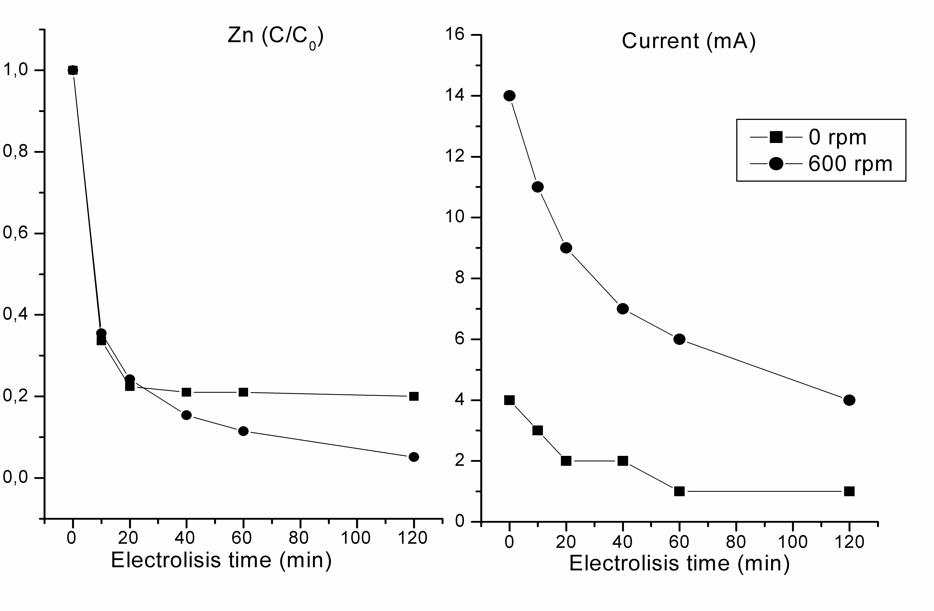
Figure 4.1: Effect of agitation on zinc removal and current density.

    - Effect of electric potential
The effect of the electrical potential on the removal of Zn was investigated in a solution with 1ppm of Zn, stirred at 600 rpm and applying 10V, 20V, 40V and 60V DC for 120 min The removal efficiency increased proportionally according to with the electrical potential applied, as is shown in Figure 4.2 on the left. In all cases, the law constraint was satisfied after only 20 minutes. The highest electrical potential (60 V) allowed 97% of Zn to be removed, while the percentage was 95% for the 40V case. However, aluminum consumption also followed this tendency.
A progressive increase in pH was observed in the experiments. This reached a steady state after 40 min. The final pH increase is also proportional to the electrical potential, 7.2 at 10 V and 7.6 at 60V, due to the larger amount of OH⁻ produced at the higher potential.
Because the cost of the process is determined by the energy expense and the consumption of the sacrifice anode, the value of 40V could be a good compromise, since it couples a high Zn removal with a low consumption of the electrode.

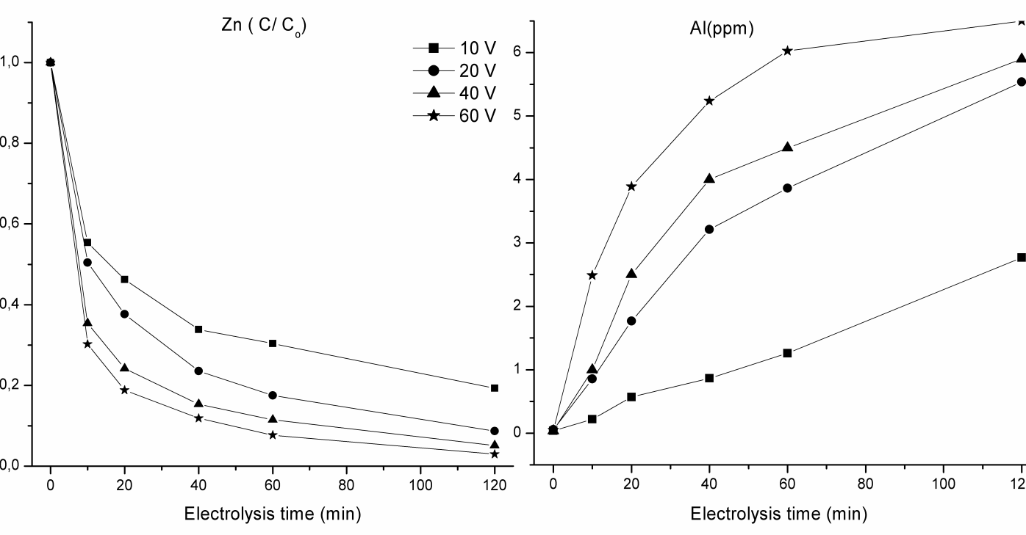Figure 4.2: Effect of different electrical potential on the removal of zinc and the release of aluminum.

    - Effect of initial concentration of Zinc and NaCl.
Given that an almost complete removal of Zinc was obtained in the previous tests at 1ppm, other experiments were performed at higher concentrations. A range from to 2 to 10 ppm was chosen as a target for the EC runs. The test conditions were 40V and 600 rpm. Samples of the solution were taken at different intervals and analysed.
All the experiments showed a fast decrease of Zn in the first 10 minutes, and lower concentrations than those fixed by law (0.5ppm for surface waters) were obtained except for the 10ppm run. Hence, NaCl was added, at concentrations of 5ppm and 10ppm, to enhance the removal efficiency by improving the conductivity.
The addition of sodium chloride was positive for the removal of zinc, and it lowered the times necessary to reach the 0.5ppm concentration. For example, in the presence of 2ppm of Zinc, the 0.5ppm limit was reached after 20 and 10 minutes, respectively in the presence of 5 and 10ppm of NaCl, respectively 40 minutes were needed in the absence of the salt.
However, sodium chloride also affected the aluminum dissolved concentration, with an increase (in the 2ppm case) from 0.3 to values that were ten times higher in the presence of NaCl.
Figure 4.3 shows the behaviour of pH and the current during the electrolysis process. In the presence of salt, the increase in pH is faster, and almost exponential, in the first 60 minutes. Moreover, the final value is higher, probably due to the partial exchange of Cl⁻ with OH⁻ in Al(OH)_{3.} As for the current evolution during the treatment, it can be observed that it decreases sharply after 10 and 20 minutes, in the absence and in the presence of salt, respectively Furthermore the decrease is proportional to the NaCl concentration.

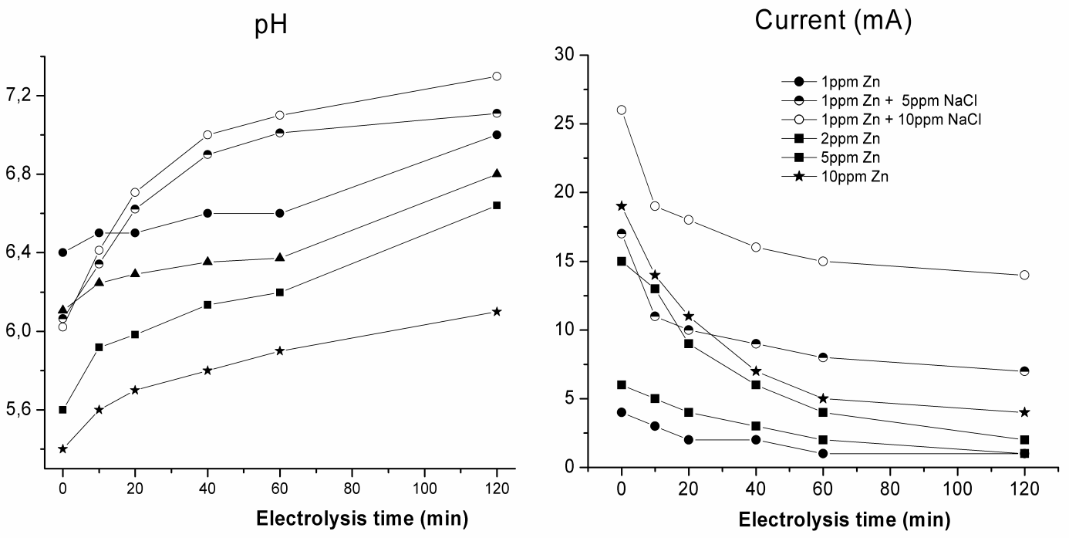
Figure 4.3 : Effect of initial concentration of zinc and NaCl on the pH and current.

The average energy consumption per volume can be calculated and expressed in kWhm⁻³. The current and time needed to reach the levels fixed by law were used for the purposes of this study.
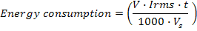
(4.34)
where V is the electrical potential, Irms is the root mean squared value of current(A), t is the time of the electrolysis treatment, and V_{s} is the sample volume (m³).
Table 4.2 summarizes the overall results of the EC experiments, and indicates the time required for each case to reach the limits set by law, the amount of Al released by the anode, and the energy consumption. The energy consumption is not directly correlated to the sodium chloride concentration, while it clearly increases with the Zinc concentration has to be removed.
Table 4.2: the time required for the treatment, the amount of Al released and the energy consumed.
Zn Initial (ppm) | 0 ppm NaCl | 5 ppm NaCl | 10 ppm NaCl
1 | 10 min,  1.5 ppm Al  0.058 kWhm⁻³ | 10 min,  2.1 ppm Al  0.23 kWhm⁻³ | 10 min,  3.92 ppm  0.375 kWhm⁻³
2 | 40 min  0.3 ppm Al  0.3 kWhm⁻³ | 20 min,  3.1 ppm Al  0.66 kWhm⁻³ | After 10 min  >3.5 ppm Al  0.416 kWhm⁻³
5 | 40 min,  0.5 ppm Al  0.66 kWhm⁻³ | 20 min,  1.2 ppm Al  0.53 kWhm⁻³ | 20 min,  6.2 ppm Al  1.1 kWhm⁻³
10 | ---------- | 90 min,  4.7 ppm Al  2.7 kWhm⁻³ | 60 min,  6.7 ppm Al  2.7 kWhm⁻³

    - Corrosion.
After 50 hours of the experiment, the used electrodes showed evidence of corrosion. Moreover, a great difference in the kind of pitting was observed according to whether the experiment was performed with or without salt.
Figure 4.4 depicts a new electrode, an electrode used without salt, and two used with different salt concentrations (5ppm and 10ppm). It is possible to observe, at the electrode surface how the corrosion has formed a superficial layer that covers the electrode surface in the presence of salt. The superficial layer, instead cannot be observed in the NaCl free solution, although pitting corrosion can be observed in all cases.
The aluminum surface is covered by a protective oxide layer, and its rupture is believed to cause the corrosion of the aluminum or its electro-dissolution when it anodically polarizes. The causes of the pitting corrosion of aluminum causes are listed as follows: dissolution or thinning of the layer, direct attack of the exposed metal and the start of an intense localized dissolution, adsorption of the aggressive anions on the oxide layer due to the ion–ion force of interaction and chemical reaction of the adsorbed Cl⁻ with the ion in the oxide layer [16].
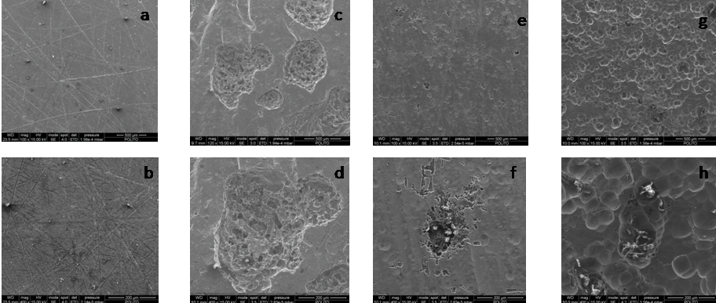
Figure 4.4 : Sem morphology of an aluminum anode after 50 hrs of electrolysis in different solutions containing NaCl containing solution, (a and b) new electrode, (c and d) without NaCl, (e and f) 5ppm of NaCl, (g and h) 10ppm of NaCl

From the Figure 4.4 (e,f,g,h), it can be observed that the presence of Cl⁻ has produced a superficial film on the electrode. According morphology of the film, it can be assumed that it has been attacked by exfoliation corrosion. This corrosion is commonly known as layer or stratified corrosion. In these cases the attack proceeds along selective strata parallel to the metal surface and the attack progresses along grain boundaries, exfoliation is sometimes considered as a form of intergranular attack.
Exfoliation is characterized by layers of non corroded metal between the selective paths, which are separate and begin to rise above the original surface.
This phenomena is promoted by the corrosion products that formed along the paths of attack and a marked grain-shaped structure can be observed, similar to platelets, which is thin in relation to length and width [17].
  - Conclusions.
In this work, the feasibility of the electrocoagulation process to remove zinc from solution has been demonstrated.
It has been shown that agitation positively influences the removal of the metal. In fact, considering the test set at 600 rpm, 40V and an initial concentration of 1ppm (120 minutes), it is possible to see that the residual zinc concentration is has 0.05ppm, which is 0.15ppm lower than the unstirred test concentration.
In the tests carried out at different electrical potential (10V-60V), 600rpm and 1 ppm of zinc, it was observed that the removal efficiency increased proportionally to the electrical potential. It could be observed that the law constraint was satisfied for all the cases after 20 minutes. Even though the removed amount was 97% of Zn at 60V, the consumption of the aluminum electrode was much higher than the test at 40V which reached 95% of metal removal. Therefore, cconsidering that the total cost of the process is determined by the energy cost and the consumption of the sacrifice anode, the subsequest tests were carried out at 40V.
Increasing the initial Zn concentration (2 -10ppm), it was not possible to reach the allowed concentration of Zn in the test at 10ppm. For this reason, it was necessary to add NaCl, to increase the conductivity; the process was improved, and the for surface water was reached in all cases
The energy consumed to reach the limit set by law varied between 0.058 kWhm-3 for the initial concentration of 1ppm, and for 10 ppm of zinc is of 2,7 kWhm^{-3.}
After 50 hours of electrolysis, the examined electrodes presented traces of corrosion. However a great differences was observed in the kind of pitting, depending on whether the experiment was performed with or without NaCl. Pitting corrosion was identified in all case, however in the presence of salt it was possible to observe a superficial layer that covered the electrode surface. On the basis the film morphology, it was deduced that the electrodes were attacked by exfoliation corrosion. Different voltammetries analysis will be carried out in the future to clarify the corrosion behavior.

References.
[1] Eisler, Ronald, Contaminant Hazard Reviews ,26 (1993).
[2] N. Adhoum , M. Monsera, N.Bellajkhala , J. Belgaieda, J. of Hazardous Materials,112, ( 2004), 207.
[3] G. Mouedhen, M. Feki, M. De Petris Wery, H.F. Ayedi, J. of Hazardous Materials, 150,(2008), 124.
[4] A.K. Golder, A.N. Samanta, S. Ray, Separation and Purification Technology 53, (2007), 33.
[5] M. Yousuf A. Mollah, R. Schennach, J.R. Parga, D.L. Cocke, Journal of Hazardous Materials B84, (2001), 29 .
[6] N.K. Shammas, M.F. Pouet, A. Grasmick, Wastewater treatment by electrocoagulation-flotation, Vol.12: Flotation Technology, L.K. Wang et al., 2010
[7] Rocha, C.A. Martínez-Huitle, Exploration and Production: Oil and Gas Review, in press. 2010
[8] M.G. Arroyo, V. Pérez-Herranz, M.T. Montañés, J. García-Antón, J.L. Guiñón, Journal of Hazardous Materials,169, (2009), 1127.
[9] E. Bazrafshan, A.H. Mahvi, S. Naseri, A.R. Mesdaghinia, Turkish J. Eng. Env. Sci. 32, (2008), 59.
[10] G. Mouedhen, M. Feki, M. De Petris Wery, H.F. Ayedi, Journal of Hazardous Materials, 150 ,(2008), 124.
[11] N. Adhoum, L. Monser, N. Bellakhal, J.E. Belgaied, Journal of Hazardous Materials, B112, (2004), 207.
[12] P.K. Holt, G.W. Barton, M. Wark, C.A. Mitchell, Colloids and Surface A: Physicochem. Eng. Aspects, 211, (2002), 233.
[13] P.K. Holt, G.W. Barton, C.A. Mitchell, Chemosphere, 59, (2005), 355.
[14] Heidmann, W. Calmano, Journal of Hazardous Materials, 152, (2008), 934
[15] T. Picard, G. Cathalifaud-Feuillade, M.Mazed, C. Vandensteendam, J. Environ. Monit. 2, (2000), 77.
[16] A.K. Golder, A.N. Samanta, S. Ray∗ Journal of Hazardous Materials 141, (2007), 123.
[17] J.R. Davis Corrosion of aluminum and aluminum alloys, ed. J.R. Davis, SM International,1999.

CHAPTER 5:
Removal of nickel and chromium by electrocoagulation using Aluminum electrodes for drinking water production.



Electrocoagulation for drinking water production.
  - Introduction.
The presence of Nickel and Chromium in drinking water is a worldwide problem. The assimilation of high amounts of nickel can cause a wide number of cancers (lungs, nose, larynx, prostate) as well as other diseases such as asthma and allergic skin reactions [1-3]. Chromium (VI) is toxic and in non-lethal levels is carcinogenic. Moreover it can irritate eyes, skin and mucous membranes [4,5].
Water for human consumption must not contain more than 20 ppb of nickel and 50 ppb of chromium, in accordance with the requirements of the drinking water current Italian legislation (Dgls 02/02/2001 n. 31). The drinking water company of Turin SMAT (Società Metropolitana Acque Torino), that is in charge of providing a high quality standard water to the Turin municipality, has fixed even lower values in terms of amount of chromium and nickel: less than 10 ppb for chromium and 5 ppb for the nickel. For this reason, a very efficient technology to achieve such low-removal targets is required.
The most used methods for the removal of metals from water are: coagulation/filtration, ionic exchange and reverse osmosis [6]. All these techniques require multi-step passages and a post-treatment. The electrocoagulation (EC), in particular, is an effective low cost treatment and could be adopted to solve these problems. This technique was compared with chemical coagulation, showing high removal efficiencies [7-9]. The EC process involves the in situ generation of a coagulant through the electro-oxidation of a sacrificial anode and it has a lot of advantages. The most important ones are following cited:
- requirement of no additional chemicals,
- removal of different kinds and sizes of pollutants,
- no need to have the pH control,
- EC requires simple equipment and is easy to be operated,
- the flocs generated by EC are similar to chemical flocs, except that the EC flocs tend to be much larger, contain less bound water, are acid-resistant and more stable, and they can therefore be quickly separated by filtration, low sludge production.
The gas bubbles produced during the electrolysis can carry the contaminant to the top of the solution, where it can be more easily concentrated, collected and removed [10-12].
The EC process involves three successive stages:
- formation of coagulants through electrolytic oxidation of the “sacrificial electrode,
- destabilization of the contaminants, particulate suspension, and breaking of the emulsions,
- aggregation of the destabilized phases to form flocs [13-15] .
In the EC process, the Faraday's law describes the relationship between the current density and the amount of aluminum which goes into the solution. A lower uncertainty occurs between theoretical and experimental data, when more attention is paid to the geometry of the electrode assembly and to the setting of optimal operating conditions. In addition the required potential to get the desired current density depends from three components: kinetic overpotential, concentration overpotential, IR-drop over potential (caused by solution resistance).
Concentration overpotential also called mass transfer or diffusion overpotential is caused by the change in the analyte concentration occurring on the proximity of the electrode surface, due to electrode reactions. Kinetic overpotential has its origin in the activation energy barrier to electron transfer reactions . The activation overpotential is particularly high for evolution of gases on certain electrodes. Both kinetic and concentration overpotential increase as the current increase. The IR-drop is related to the distance between electrodes, the surface area of electrodes and the specific conductivity of the solution. The IR-drop can be minimized by decreasing the distance between electrodes and increasing the area of cross-section of the electrodes and specific conductivity of the solution [7,11].
The EC is a popular method for the abatement of chromium hexavalent from waste water, reducing the chromium from Cr⁶⁺ to Cr³⁺ and generating a lime precipitation that can be removed [16-18]. Different ranges had been considered, in some cases from 500 to 2000 ppm of chromium and others from 50 to 800 ppm, always with residual concentrations below 0.5 ppm [19-22].
In the case of nickel, the Al electrodes have shown good performances[13,23], with a removal efficiency of 98%from an initial pollutant concentration of 60 ppm [13,23].
Ratna Kumar et al. demonstrated that the EC can be utilized also to remove As³⁺ and As⁺⁵ from water for drinking water production. They conduct experiments comparing 3 electrodes (Fe, Al and Ti) and obtained an As residual concentration lower than 1 ppb [24].
At the best of our knowledge, this is the first work using the EC, in the range of ppb, to promote the abatement of nickel and chromium in water-treatments. The objective of the present work is to evaluate the efficacy of the electrocoagulation using aluminum electrodes, as option for the bilge water treatment to remove a initial concentration of nickel near to 41 ppb, and chromium around 23 ppb. Operation conditions like agitation, distance between electrodes, current density as well electrical potential to minimize the power consumption were considered.
Furthermore, after 50 hours of electrolysis, the electrodes were examined by means of SEM (Scanning Electron Microscope) analysis, in order to provide additional information about the corrosion of electrodes.

  - Experimental.
Electrocoagulation with aluminum electrodes was investigated on two water samples, provided by SMAT, coming from Water well A (Ni = 41 ppb ) and Water well B, (Cr = 23 ppb), two municipalities in the province of Turin. The conductivity, the Ph and the most important ion species of these samples are reported in Table 5.1.
Table 5.1: Characteristics of water to process from water well A and water well B.
Sample | Ca²⁺ (ppm) | Mg²⁺ (ppm) | Cl⁻ (ppm) | pH | Conductivity(µS cm⁻¹)
Nickel | 10.675 | 12.65 | 4.25 | 7.633 | 191.3
Chromium | 102.4 | 20.75 | 9.5 | 7.379 | 505.6

Electrolysis was carried out using a batch glass reactor of 400 ml and two 1 mm-thickness aluminum electrodes (purity 99.999%, specific area 25 cm²) as anode and cathode.
Before each test, the electrode surface was mechanically polished with WS-FLEX 18-C sandpaper, scrubbed with 15% HNO₃, rinsed with distilled water and then treated in an ultrasonic bath at 40°C for 1 hour in order to ensure surface reproducibility. The electrodes were connected to a DC power-supplier for 120 minutes, maintaining the current density constant during the tests. The current density in each run was in the range of 0.2- 1.6 (mA/cm²).
The first EC experiments were conducted for 120 min. with and without agitation at 600 rpm using a Teflon coated magnetic stirrer. The distance between electrodes was 1cm and the current density 0.2 mA cm⁻². Subsequently, the distance between electrodes was decreased at 0.5 cm in order to reduce the electric potential and the energy consumption. Finally tests were carried out at different current density at 0.2; 0.4; 0.8 and 1.6 mA cm⁻² at 600 rpm with the purpose to find the best removal conditions . All Experiments were conducted with temperatures around 25 ºC.
The treated water was sampled at the times of 0, 10, 20, 40, 60, 120 minutes, filtered in pure cotton pulp pore size 5-6 µm and analyzed by means of an ion chromatography (ICS 1100 Dionex) to determine the amount of nickel, chromium and aluminum ions in the solution. Other parameters such as pH, and conductivity (ION450 Ion Analyzer, Radiometer Analytical), fundamental to investigate the electrochemical process, were also measured.
After 50 hours of electrolysis with both the selected waters, the electrodes were examined by means of SEM observation (FESEM/EDS Leo 50/50VP with Gelmini column) in order to provide additional information about the electrodes corrosion.
  - Results and discussion.
In this work, electrocoagulation process has been evaluated as a technological treatment for drinking water production. The electrocoagulation may be affected by several operating parameters such as type of pollutant, distance between electrodes, current density and agitation. To enhance the process performance, the effects of those parameters have been explored.
    - Effect of stirring.
In order to evaluate the influence of the stirring on the EC treatment, experiments have been carried out with two different well waters, running the same test with or without stirring at 600 rpm for 120 min. Table 5.2 depicts results conducted when fixing the current density to 0.2 mA cm⁻² at 1 cm of gap between electrodes, for both nickel and chromium samples.
As in the nickel and chromium experiments, it has been observed lower metal removal for those without stirring. For nickel case, the amount of metal has decreased from 41 ppb to 22 ppb, while for chrome has decreased from 23 ppb to 20 ppb. On the other hand when the solution is stirred the removal rate is higher, reaching for nickel a final metal concentration of 16 ppb, and a 19 ppb for chromium case. Denote, both cases didn’t reach the removal target set by SMAT. However, in the experiments carried out, the abatement of chromium has been lower, probably due to the fact that the most of chromium in solution was Cr⁶⁺, which has been reduced to Cr³⁺ on the cathode before it forms flocs. This characteristic has not been observed for nickel, since it doesn't need to be reduced on the cathode as chromium [14].
Table 5.2: Pollutant removal, Al release, Potential, pH and conductivity in not stirred and stirred (600 rpm) conditions.
 |  | Time (min) | 0 | 10 | 20 | 40 | 60 | 120
NIckel | Ni  (ppb) | 0 rpm | 41 | 38 | 36 | 32 | 28 | 22
NIckel | Ni  (ppb) | 600 rpm | 41 | 34 | 33 | 26 | 22 | 16
NIckel | Al  (ppb) | 0 rpm | 0 | 111 | 65 | 89 | 123 | 69
NIckel | Al  (ppb) | 600 rpm | 0 | 132 | 136 | 184 | 190 | 200
NIckel | Potential  ( V) | 0 rpm | 3.10 | 3.30 | 3.70 | 4.15 | 4.37 | 5.01
NIckel | Potential  ( V) | 600 rpm | 3.10 | 3.21 | 3.32 | 3.36 | 3.45 | 3.50
NIckel | pH | 0 rpm | 7.413 | 7.513 | 7.589 | 7.614 | 7.724 | 7.784
NIckel | pH | 600 rpm | 7.413 | 7.534 | 7.728 | 7.872 | 8.023 | 8.06
NIckel | Cond.  ( μS cm⁻¹) | 0 rpm | 191.3 | 171.9 | 162.1 | 162.5 | 163.9 | 153.6
NIckel | Cond.  ( μS cm⁻¹) | 600 rpm | 191.3 | 172.6 | 162.8 | 163.2 | 161.3 | 161.8
Chromium | Cr  (ppb) | 0 rpm | 23 | 23 | 23 | 22 | 21 | 20
Chromium | Cr  (ppb) | 600 rpm | 23 | 23 | 22 | 21 | 20 | 19
Chromium | Al  (ppb) | 0 rpm | 0 | 8 | 55 | 75 | 71 | 62
Chromium | Al  (ppb) | 600 rpm | 0 | 60 | 156 | 100 | 121 | 208
Chromium | Potential  ( V) | 0 rpm | 2.60 | 3.02 | 3.22 | 3.72 | 3.84 | 4.34
Chromium | Potential  ( V) | 600 rpm | 2.60 | 3.26 | 3.30 | 3.29 | 3.30 | 3.20
Chromium | pH | 0 rpm | 7.326 | 7.402 | 7.571 | 7.663 | 7.703 | 7.780
Chromium | pH | 600 rpm | 7.326 | 7.426 | 7.626 | 7.902 | 7.950 | 8.970
Chromium | Cond.  ( μS cm⁻¹) | 0 rpm | 505.6 | 468 | 462 | 461.0 | 459.0 | 439.0
Chromium | Cond.  ( μS cm⁻¹) | 600 rpm | 505.6 | 482.0 | 477.0 | 457.0 | 447.0 | 444.0

From Table 5.2, it is observed that the aluminum concentration never exceeds the limit fixed by law (200 ppb). When agitation is applied, higher amounts of aluminum are found. Indeed, since the increase of aluminum in solution is caused by a release of aluminum in anodes proximity, stirring helps aluminum to reach faster the bulk solution [9, 11].
According to electric potential, when solution is stirred the voltage applied is ever lower than the case without stirring (table 5.2). The difference of the electric potentials in the experiments with and without stirring, is due to the fact that the turbulence helps metal ions reach the bulk solution from the anode surfaces, reducing the concentration (mass transport) over potential [14]. This can be verified by comparing the final conductivity: Water well A water, 161.8 μS cm⁻¹ at 600 rpm against 153.6 8 μS cm⁻¹ for experiments without agitation. There is reported a similar behaviour for Water well B water also (440 μS cm⁻¹ and 431 μS cm⁻¹, respectively).
The pH, in all experiments remains between 7.2 and 7.8, the range that facilitates the formation of Al (OH)^{2+,} Al (OH) ₂ ⁺ and Al (OH)₃⁰ [26].
Results already reported suggest that stirring definitively enhances the performance of the whole EC treatment. The electrochemical reaction on the anode is fast enough to decrease concentration of active species near the anode surface, but not fast enough to diffuse species in the bulk. Thus the process is controlled by the mass transfer and it can be enhanced by increasing the turbulence. Therefore given the impact of stirring in the species removal, all the subsequent experiments has been carried out considering an agitated solution.
    - Effect of distance between electrodes.
In order to enhance the process efficiency in terms of energy consumption, the IR-drop can be minimized by decreasing the distance between the electrodes and/or increasing the conductivity [7,11]. The samples taken are from well waters, in which the addition of chemical agents was not the matter of investigation and thus the conductivity is not modifiable. For this reason, some experiments have been carried out by changing the gap between electrodes, for the two different well waters (nickel, chromium), at fixed current electricity of 0.2 mA cm⁻² and at 600 rpm.
Figure 5.1 reports the electrical potential during the experiments (nickel and chromium) when the space between electrodes are 1 cm or 0.5 cm. It is observed that the electric potential decreases when the gap between electrodes is 0.5 cm for all the experiments. This decrease has an important influence for energy consumption, verified as a lower final energy consumption of 0.082 kWh m⁻³ and 0.057 kWh m⁻³ ( from 23 ppb to 17 ppb) at 1cm and 0.5 for chromium; and energy consumption 0.084 kWh m⁻³ per ppb and 0.080 kWh m⁻³ (from 41 ppb to 16 ppb) at 1cm and 0.5 cm for nickel case.
Regarding to costs determined by consumption of sacrifice node, no increment neither decrement have been observed when varying the gap between electrodes. Hence all cost reductions are reached by decreasing energy consumption by means of putting closer the electrodes. Therefore all subsequent experiments are performed considering a gap of 0.5 cm.
Figure 5.1: Variation of electric potential during electrocoagulation time with a distance between the electrodes of 1 cm and then of 0.5 cm, for Water well A and Water well B samples, at 0.2 mA cm-2 and 1.6 mA cm-2 fixed current density and 600 rpm.

    - Effect of current density.
The current density not only determines the amount of coagulant generated, but also the bubbles speed and size [9]. In particular, the following figures (4-6) compares the experiments conducted at fixed current of 0.2, 0.4, 0.8 and 1.6 mA cm⁻². All experiments are conducted maintaining the distance between the electrodes of 0.5 cm and the solution stirred at 600 rpm.
Figure 2 and Fig. 3 report nickel and chromium removal during the experiments. It is observed that current density bends removal rate, notwithstanding the removal evolution is different. For nickel sample (fig.2) there is an almost exponential decrease of metal during the electrolyisis. After 60 minutes of treatment is observed a metal removal range of (50-78%), but removal rate starts to decrease, reaching after 120 minutes a range between 60-93% of removed material. Only at 0.8 and 1.6 mA cm⁻² with a energy consumption of 0.819 kWh m⁻³ (from 41 to 5 ppb) and 2.489 kWh m⁻³ (from 41 to 3 ppb) respectively, target nickel concentration has been achieved.
Figure 5. 2: Nickel removal present in Water well A sample, for different current density, 0.2 ,0.4, 0.8 and 1.6 mA cm-2, distance between the electrodes of 0.5 cm and the solution stirred at 600 rpm.

Figure 5.3 shows the removal evolution of chromium. It is observed that chromium removal is slower than nickel removal, indeed after 60 minutes a range of 17-25% is reached, that at same conditions (0.2 mA cm⁻²) nickel removal is 3 times more than chromium removal. At varying current density the target fixed by SMAT has been achieved after 60 minutes at 1.6 mA cm⁻² and after 120 minutes at 0.8 mA cm⁻². Recalling energy consumption it is 0.596 Kwh m⁻³ and 0.479 Kwh m⁻³ for 1.6 mA cm⁻² and 0.8 mA cm⁻². Interestingly, the higher the current density lesser is the time necessary to remove the same amount of chromium, moreover the time needed is inverse proportional to the current density (I=alpha*t), however even the energy efficiency for the second case is higher because it consumes less energy to remove the same amount of metal.
Figure 3: Chromium removal present in Water well B sample, distance between the electrodes of 0.5 cm and the solution stirred at 600 rpm .

Comparing the experiments carried out with nickel and chromium samples, they differ greatly in removal rate, due to the fact two different mechanisms had been evaluated. Nickel does not need previous reduction and it can flocculate immediately. Instead, often chromium in well water is found as Cr⁶⁺, that is reduced at the surface of the cathode by a direct electrochemical reduction to Cr³⁺. Simultaneously, the hydroxyl ions, which are produced at the cathode, increase the pH in the electrolyte and may induce co-precipitation of reduced chromium in the form of their corresponding hydroxides [14,16,17]. Therefore nickel removal is higher. However, it's impossible that a considerably amount of chromium could be released in solution as Cr³⁺, that is well known not to be as toxic as Cr⁶⁺.
Metal removal is strongly affected by pH of solution that changes during the process. Variations of pH are caused by anode materials as well the initial pH value of solution. Thus figure 4 shows the trend of pH for nickel (Water well A) and chromium (Water well B) samples, when current density is fixed in the range of (0.2 - 1.6 mA cm⁻²). For nickel sample, the initial pH was 7.6, while for chromium sample it was 7.4. These initial pH values are good, since when aluminum electrodes were used, better pollutant removal efficiencies were found near the neutral pH. Indeed the bestefficiency found was near pH 7 [19].
Recalling the pH trends, both cases shown a proportional to current density slight increase in time. Final pH values for nickel samples obtained are 8.3, 8.2, 7.7 and 7.5, instead for chromium are 8.0, 7.8, 7.6 and 7.5, at 0.2, 0.4, 0.8 and 1.6 mA cm⁻² respectively. Vik et al. (1984) reported that removal of nickel and chromium from water by electrocoagulation means increases pH at initial pH about 7, ascribed to hydrogen evolution and generation of OH ions on cathodes. Highlights that salt presence, due to the exchange of Cl⁻ with OH⁻ in Al(OH)₃ molecule can interfere causing an increase of pH [22,26]. A basic solution (pH>8) pH does not change considerably during time, due to generated OH ions on cathodes are consumed by generated Al³⁺ ions on anode, thus forming the result Al(OH)₃ flocs. Moreover, OH ions can partially combine with Ni²⁺, as well Cr³⁺ ions, forming insoluble hydroxide precipitates Ni(OH)₂, and Cr(OH)₃ respectively [11].
Figure 5.4: Variation of pH during electrolysis time for different current density, 0.2 ,0.4, 0.8 and 1.6 mA cm⁻² for nickel and chromium samples, distance between the electrodes of 0.5 cm and 600 rpm.

Figure 5.5 depicts behavior of conductivity at different current densities. In both cases, nickel and chromium samples, has been observed a decrease of this parameter in the time, that decreases more at higher currents. This phenomenon is caused by the decrease of ions in solution and formation o hydroxide precipitates during the treatment.
The electric potentials in the experiments were increased due to removal of ions in solution and it was possible to see higher values at higher current densities, due to both kinetic and concentration over potential increase, as the current increases [9,14].
Figure 5.5 : Variation of conductivity during electrolysis time for different current density for nickel and chromium samples. Distance between the electrodes of 0.5 cm and 600 rpm

In addition, during the experiments carried out with chromium sample, a simultaneous removal of selenium, strontium and barium was observed. Table 3 shows values of concentrations at the beginning and at the end of the processes presented. An increase of applied current, has improved the removal rate of Se, Sr and Ba, as well for the main pollutant. Recall, the legal limit set for Selenium in drinking water is 10 ppb l-1 (D. Lgs. No. 31/2001); also, is possible to verify (table 3) that in the tests conducted the residual concentration is under this value. Regarding other metals such as strontium and barium, the current legislation does not set any concentration limit; anyhow the results at high current applied show an abatement greater than 50% for Strontium to even 100% in the case of Barium.
Table 5.3: Co- removal values of concentrations at the beginning and at the end of the process of electrolysis in Chromium sample.
: | Time [min] | 0.2 mA cm⁻² | 0.4 mA cm⁻² | 0.8 mA cm⁻² | 1.6 mA cm⁻²
Selenium [ppb] | 0 | 6 | 5 | 4 | 4
Selenium [ppb] | 120 | 4 | 4 | 3 | 2
Strontium [ppb] | 0 | 224 | 226 | 253 | 250
Strontium [ppb] | 120 | 189 | 146 | 153 | 99
Barium [ppb] | 0 | 12 | 12.2 | 15.9 | 15.6
Barium [ppb] | 120 | 11.5 | 0 | 0 | 0

    - Electrodes.
To evaluate the corrosion on aluminum electrodes, experiments at 0.8 mA cm⁻², in solutions with nickel and chromium, during 50 hours have been performed; after that time, anodes and cathodes have been analyzed by means of SEM (FESEM/EDS Leo 50/50VP with Gelmini column) Fig. 6. As expected, both nickel and chromium anodes (figure 6: A,B and E,F) present an evident pitting corrosion. This is a localized corrosion that occurs on the surface with small holes (cracks or craters), in some cases, visible to human eye, surrounded by a series of depth cavities [7]. This kind of corrosion helps the current to generate from 20 to 40% Al³⁺ more, improving its efficiency specially when there are chlorine ions in solution [19]. Additionally to pitting corrosion is observed exfoliation corrosion in anodes used for nickel water as shown in figure 6a.b. This phenomenon has been reported as an attack of selective parallel layers to the metal surface, that continues along the grain boundaries and propagated though the crystal grains resulting in the intergranular corrosion [27].
On the cathode used in Water well B's treatment (Figure 5.6, G and H), a film deposited on the electrode surface, as electroplating of inorganic salts was observed. According to EDS analysis, the deposited film is composed by calcium carbonate and magnesium hydroxide. The insulating layer formed around the electrodes would sharply increase the potential between them and result in a significant decrease in the current efficiency, causing electrode passivation [19]. This is the main operational issue for the process which affects the longevity of it [9]. This process could be advantageous when the goal is to reduce the concentration of Mg²⁺ and Ca²⁺ in solution, but a film removal from cathode is requeried first, to avoid resistance problems that could interfere in the process of generation of Al³⁺.
Figure 5.6: Sem morphology of an aluminum electrodes after 50 hrs of electrolysis in samples from Water well A and Water well B at 200 and 50 µm respectable, (A and B) nickel anode and cathode (C and D) . Chromium anode(E and F) and (G and H) cathode.

Nikolaev et al. (1982) studied various methods of controlling electrode passivation including: changing polarity of the electrode, hydromechanical cleaning, introducting inhibiting agents, mechanical cleaning of the electrodes [28].
The most efficient and reliable method of electrode maintenance in this case can be periodically mechanically clean the electrodes.
In the other hand, on the cathode used in Water well A there is no-film deposited, (Figure 5.6, C and D).
  - Conclusions.
This study shown the high potentiality by use the electrocoagulation process, in the treatment of drinking water contaminated by chromium and nickel. The most efficient operative condition found for the well water considered is stirred, and operating with a gap between electrodes of 0.5 cm and with a current density between 0.8 and 1.6 mA cm⁻². The removal of chromium was slower compared with the nickel one. This was attributed to a more complex removal mechanism: chromium (VI) is firstly reduced at the surface of the cathode, and then is removed through the process of co-precipitation.
The electrocoagulation promoted also the removal of selenium, strontium and barium.
After 50 hours of electrolysis, both the anodes shown evident pitting corrosion. Additionally, an exfoliation corrosion on the nickel electrode was also observed. On the other hand chromium's cathode presented a film deposited on the electrode surface after 50 hour of electrolysis , this phenomenon could be advantageous when the goal is to reduce the concentration of Mg²⁺ and Ca²⁺ in solution, but caused resistance problems. However this can be handled by removing periodically by means of electrode mechanical cleaning. On the cathode used to treat nickel water there was no-film deposite.

References.
[1] Kasprzak, Sunderman, K. Salnikow, Nickel carcinogenesis, Mutation Res. 533, (2003), 67.
[2] J.K. Dunnick, M. R. Elwell, A. E. Radovsky, J. M. Benson, F. F. Hahn, K. J. Nikula, E. B. Barr, C. H. Hobbs, Cancer Res. 55, (1995), 5251
[3] J. P Thyssen., A. Linneberg, T. Menné, J. D. Johansen, Contact Derm. 57, (2007), 287.
[4] A. Katz, H. Sidney, Salem, J. Appl. Tox. 13, (1992), 217.
[5] A. D. Dayan, A. J.,Paine, Mechanisms of chromium toxicity, carcinogenicity and allergenicity: Review of the literature from 1985 to 2000, Human & Experimental Toxicology, 20 (2001) 439–451
[6] D. Galan, I.O. Castaneda, Water Res. 39, (2005), 4317.
[7] M. Mollah, P.Morkovsky, A.G.Gomes. M Kemez, J. parga, D. Cocke, Fundamentals, present and future perpectives of electrocoagulation. J. Hazard. Mater. B114 (2004) 199-210
[8] P.K. Holt, G.W. Barton, M. Wark, C.A. Mitchell, Colloids and Surface A: Physicochem. Eng. Aspects, 211, (2002), 233.
[9] P.K. Holt, G.W. Barton, and C.A. Mitchell, Chemosphere 59, ( 2005), 355.
[10] N.K. Shammas, M.F. Pouet, A. Grasmick, Flotation Technology, Humana Press, New York, (2010), 199.
[11] E. A. Vik, D. A. Carlson, A. S. Eikum, E. T. Gjessing, Water Res. 18, (1984), 1355. [12] G. Mouedhen, M. Feki, M. De Petris Wery, H.F. Ayedi, J. Hazard. Mater. 150, (2008), 124.
[13] M.G. Arroyo, V. Pérez-Herranz, M.T. Montañés, J. García-Antón, J.L. Guiñón, J. Hazard. Mater.,169, (2009) ,1127.
[14] E. Bazrafshan, A.H. Mahvi, S. Naseri, A.R. Mesdaghinia, Turkish J. Eng. Env. Sci. 32, (2008), 59.
[15] G. Mouedhen, M. Feki, M. De Petris Wery, H.F. Ayedi, J. Hazard. Mater. 150, (2008), 124.
[16] M. Yousuf A. Mollah, R. Schennach, J.R. Parga, D.L. Cocke, Electrocoagulation (EC)- Science and applications, J. Hazard. Mater. B84, (2001), 29.
[17] T. Wang, Z. Li , J. Hazard. Mater. B112, (2004), 63.
[18] P. Gao, X. Chen, F. Shen, G. Chen, Separation and Purification Technology 43, (2005), 117.
[19] G. Chen, Sep. and Purif. Technol. 38, (2004), 11.
[20] N. Kongsricharoern, C. Polprasert, Water Sci. Technol. 9, (1996), 109.
[21] A. K. Golder, A. N. Samanta, S. Ray, J. Hazard. Mater. 141, (2007), 653.
[22] N. Adhoum, L. Monser, N. Bellakhal, J. Belgaied, , J. Hazard. Mater. B112, (2004), 207.
[23] I. Heidmann, W. Calmano, J. Hazard. Mater. 152, (2008), 934.
[24] P. Ratna Kumar, S. Chaudhari, K. Khilar, S.P. Mahajan, Chemosphere, 55, (2004), 1245.
[25] X. Chen, G. Chen, P. L. Yue, Chem. Eng. Sci. 57, (2002), 2449.
[26] X. Chen, G. Chen, P. L. Yue, Sep. Purif. Technol.19, (2000), 65.
[27] J.R. Davis, Corrosion of aluminum and aluminum alloys, ed. J.R. Davis, SM International, 1999.
[28] Novikova, S.P., Shkorbatova, T.L., et al., Soviet Journal of Water Chemistry and Technology, 4, (1982), 353.

CHAPTER 6:
Electrooxidation
of Organic compounds.

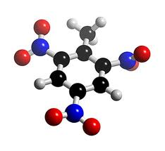

Electrooxidation.
  - Introduction.
In recent decades, oxidative electrochemical technologies, providing versatility, energy efficiency, amenability to automation, environmental compatibility, and cost effectiveness have reached a promising stage of development and can now be effectively used for the destruction of toxic or biorefractory organics. The overall performance of the electrochemical processes is determined by the complex interplay of parameters that may be optimized to obtain an effective and economical incineration of pollutants [1].
During the last two decades, research been focused on the efficiency in oxidizing various pollutants on different electrodes, improvement of the electro-catalytic activity and electrochemical stability of the electrode materials, investigation of factors affecting the process performance and the exploration of the mechanisms and kinetics of the pollutant degradation.
Experimental investigations, focused mostly on the behaviour of anodic materials, have been realized by different research groups. In particular, the discovery of a new material like boron-doped diamond (BDD) has allowed to achieve high efficiency of electric energy in function of the contaminant abatement [2].
Electrochemical oxidation processes often show additional economic advantages when the full process is taken into account. For example, in the case of treating the waste off-site, one has to consider the energy to concentrate the waste water, the cost to haul it to a treatment facility, the cost of treatment and the long term potential liability with the process and final disposal of any residuals.
Electrochemical oxidation can offer an economical alternative to hauling waste, activated carbon or the use of chemical oxidants. Table 6.1 illustrates that using only electricity can offer savings versus the use of common chemical oxidants [3].
Electrochemical conversion/incineration trials of organic pollutants can be subdivided in two different typologies:
- Direct oxidation at the anode
- Indirect oxidation using appropriate, anodic-generation of oxidants.
Table 6.1: Price of some chemical oxidants and electrons (U.S.A.)
Oxidant | Equivalent / mole | $ /lb | $/equivalent
Electrons ($0.05/kWh) | 1 | NA | 0.005
Chlorine | 1 | 0.128 | 0.020
Hydrogen peroxide | 2 | 0.245 | 0.038
Potassium Permanganate | 5 | 1.29 | 0.090
Potassium Dichromate | 6 | 1.18 | 0.127

  - Oxidation reactions & mechanisms.
Electrooxidation of organic pollutants can be performed in several different ways, including direct and indirect oxidation, which are schematized in Fig. 1 It has been generally observed that the nature of the electrode material, the experimental conditions, and the electrolyte composition strongly influence the oxidation mechanism.
Figure 6.1: Scheme of the electrochemical processes for the removal of organic compounds (R): (a) direct electrolysis; (b) via hydroxyl radicals produced by the discharge of the water; and (c) via inorganic mediators.

Making reference at the distinction between oxidation on the anodic surface and oxidation in the bulk solution using mediators formed on the anode, it is clear how the a) and b) paths schematized in upper figure belong to direct oxidation; while that indicated with c) is considered an indirect oxidation. Nevertheless in the b) case exists a mediator between anode-contaminant that is the OH∙ radicals obtained by means of the discharge of water molecules.
Connway in the 1981 summarized different kinds of electrode reactions [4]:
- Reaction of the organic substance with bulk type of film produced anodically at the electrode or (b) Reaction of the organic substance with a solution-soluble product of an anodic reaction.
- Formation of carbonium ions or organic free radicals at the anode surface, followed by reaction or rearrangement in solution.
- Dissociative chemisorption coupled with oxidation from the chemisorbed state.
- Reaction of dissociatively chemisorbed fragments of a molecule with reactive surface oxide species at noble metal anodes (bifunctional electrocatalytic mechanism).
- Direct reaction with a thin-film or monolayer oxide at noble metals.
- Reactions that occur on an anodic oxide film but not necessarily involving reaction with it

Direct Electrooxidation
The more interesting reactions, in term of electrochemistry-catalysis, are those reactions where the organic substance diffuses to the electrode (or the electrode moves amongst the reactant as in a fluidized bed system or a rotating gauze electrode) and directly undergoes a primary reaction on the electrode surface. This type of reaction can occur in several ways:
- An initial dissociative adsorption with oxidative removal of H;
- A coupled or subsequent oxidation of the dissociated C-containing adsorbed fragments, usually with electrodeposited OH or O species at the metal surface;
- A direct oxidation with an oxide-film covered electrode;
- Formation of carbonium ions by electron transfer at the electrode interface followed by homogeneous reaction and rearrangement in solution;
- Formation of radicals (adsorbed or in solution very near the electrode) by electron transfer from organics anions, usually RCOO⁻ or RO⁻.
As was pointed out, the oxidation of the organic compounds, occurs on the anode surface by an electrochemical mechanism.
This involves either interaction of the pollutant with surface OH group generated at high potential, or direct electron transfer from the organic molecule to the electrode. A theoretical scheme of the oxidative path of a generic organic molecule was postulated by Comninellis [5] in figure 6.2
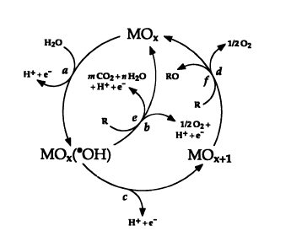
Figure 6.2: Scheme of Electroxidation path of a generic organic pollutant.

From this scheme, it is possible to recognize two mechanism, related to two different oxidizing agent, both electrogenerated from dissociative absorption of water. The nature of this two different electron acceptor species (physically adsorbed OH* or higher oxides), depend (working at high potential) in the electrode nature.
The reaction with higher oxides (path d and f in the scheme rewritten in equation 6.1 and 6.2 correspondingly) pointed out the importance of the oxide films, which can be generated at noble metals, on which the oxidation reaction proceeds, in distinction to the underlying metal. It is evident also the influence of the kinetics of oxygen evolution, the side reaction equation 6.1.
(6.1)
(6.2)
The reaction 6.1 is considered a true electrocatalytic one, since it is present the absorption step of the organic matter and the desorption step of the oxidized product. Consequently, the generation is rather selective, where anion adsorption play an important role. As a consequence of the parallelism of equation 6.1 and 6.2, a generic organic molecule (R) is oxidized with increasing difficulty at electrode materials having higher oxygen affinity.
The electrocatalytic oxidation currents that arise at these metals are intimately connected with the states of oxidation of their surfaces and the hysteresis which arises between the currents for formation and reduction of the surface oxide films with respect to changes in electrode potential.
An unselective attack of organic molecules happens in path e in figure 6.1. In this typology of reaction, rewritten in equation 6.3, the organics are likely to no absorb over the anode surface, and the degradation of the molecule include a in series of hydroxylation reactions, in a determinate cites of the chemical structure of the organic matter by OH* species, that are transferred to the organic matter from the anode surface.
(6.3)

Hydroxyl radicals can also be past in solution and participate in hydroxylation reaction of molecules in homogeneous (in solution) reactions with, generally, mass control rate.
The anodes in which an oxides layer can be formed are characterized by a high metal OH adsorption enthalpy (chemisorption of OH* radicals that come from the splitting of water molecule), this result in an high electrochemical reactivity of the OH* that favours their homogeneous recombination to allow oxygen evolution (equation 6.2), this can be called as low oxidation power anodes. On the contrary, electrodes having low metal OH adsorption enthalphy (physisorption of OH* radicals) results in an increase of the chemical reactivity of this radicals, and favour the organics reaction (equation 6.3) instead oxygen evolution, this canbe called as high power anodes.

Indirect Electrooxidation.
In this case, the electrode can simply generate an oxidizing agent which reacts in solution with a suitable organics substance.
The most important, and studied electrogenerate species are: hypochlorite, ozone and hydrogen peroxide.
- hypochlorite:
In the literature, the term `hypochlorite' is often used to denote the sum of hypochlorous acid and the hypochlorite anion. In technical literature, the term “active chlorine” is used for the sum of chlorine, hypochlorous acid and hypochlorite.
On-site production of the hypochlorite could use a small membrane chlorine/caustic cell and an external reactor. The reaction is exothermic and cooling is required to minimize the formation of sodium chlorate.
In electrolytic hypochlorite production there are two steps. First, the primary oxidation of chloride to chlorine at the anode surface:
2Cl⁻ Cl₂ + 2e⁻ E°: 1,23V ^{v}/_{s} SHE (6.4)
this is followed by the secondary solution phase reaction:
Cl_{2 (aq.)} + H₂O HClO + Cl⁻ + H⁺ (6.5)
Hypochlorous acid can dissociate to form hypochlorite and hydronium, the relative proportions of which depend on the pH of the water:
HOCl ClO⁻ + H⁺ (6.6)
The amount of active chlorine obtainable depend mainly on the current density directly, chloride concentration and temperature [6] for the last two factors in possible to determine a optimum value, since chloride salt addition, for environmental application, must be keep on the minimum value. On the other hand the possible enhancement on the kinetics by increment on the temperature is limited by the decrease on the solubility of chlorine with predictable consequence in the reaction 14 and, the before mentioned, formation of sodium chlorate.
- Ozone
The ozone evolution reaction has a standard potential of 1.51 V (^{v}/_{s} SHE), thus 0,28V more than oxygen evolution reaction.
The most studied electrodes for this purpose were Pt, PbO₂, glassy carbon and Ti suboxides [7]. Requisites of the anode material are high overpotential for O₂ evolution and high stability. The competition between ozone and oxygen formation can be shifted in favour of ozone by suppressing oxygen evolution by operating on a number of variables, in the case of ex-cell generation (with ozone injection to wastewater containing cell) it is possible operate on the electrolyte composition, where the presence of certain ions (F or BF₄⁻) increase the overpotential of oxygen evolution [8]. In the case of in-solution generation, modify the natural (incoming) electrolyte composition is not convenient, in term of environmental compatibility, and thus, the principal parameters to modulate were the electrode material and fludynamic regime.
- Hydrogen peroxide:
Traditionally, the electrochemical production of H₂O₂ was an indirect process where sulfate was anodically oxidized to persulfates (equation 6.7) and the latter hydrolyzed in solution to sulfate and hydrogen peroxide (equation 6.8)
2SO₄²⁻ → S₂O₈²⁻ + 2e⁻ E°: 2,87 ^{v}/_{s} SHE (6.7)
S₂O₈²⁻ + 2H₂O → 2HSO₄⁻ + H₂O (6.8)
The concentration of this bulk oxidant in the treated solution should be limited not only by reaction with the organic molecules to be abated, but also by anodic destruction:
H₂O₂ → HO₂ + H⁺ + e⁻ (6.9)
However, cathodic electro generation was more studied than the persulfate route (Ilea et al., 2000), since theoretically it is kinetically favored. In addition it would allow to carry out a coupled generation (anode-cathode) of oxidizing agent, thus with high current efficiency.
Cathodic Oxygen reduction to hydrogen peroxide generation is a two-electron reaction followed by a in-solution reaction . The oxygen reduction reaction (ORR) is also a very common, and crucial, in fuel cell studies, in this later case the reaction is headed to obtain water as a final product in a four-electron reaction, then the materials and operation of the process will be different.
O₂ + H₂O + 2e⁻ HO₂⁻ + OH⁻ E°: -0,065V ^{v}/_{s} SHE (6.10)
2HO₂⁻ H₂O₂ (6.11)
Other possible route, not well studied yet, can be the generation by an homogeneous reaction of two electrogenerated OH* radicals (2,8V ^{v}/_{s} SHE) on the anode surface or in solution.
By in-solution electrogeneration of hydrogen peroxide, its maximum concentration may be limited, by a scavenger reaction. In the case of cathodically generation the formed H₂O₂ tend to dissociate to HO₂ in basic solution (normally encountered in a cathodic process), and the formation of H₂O₂ by combination of two OH* anodically generated is limited by parallel rapid reaction between the generated hydrogen peroxide and other hydroxyl radicals. Then in an electrochemical reactor for wastewater application, the electrogenerated hydrogen peroxide should be transport away from the anode or cathode with an appropriate rate to avoid the consumption of electrogenerated oxidizing agent by scavenger reactions.
  - Importance of nature electrode material.
The electrode material is very important for this process, since it has a direct impact on the mechanism, products of the anodic reactions, selectivity and efficiency. According to the mechanism proposed by Comninellis et al. (Comninellis 1994; Comninellis and De Battisti 1996; Simond et al. 1997) two extreme classes of electrodes can be defined: ‘active’ and ‘non-active’ electrodes.
The first step in both cases involves the reaction of water molecules to form adsorbed hydroxyl radicals:
M + H₂O → M(•OH)+ H⁺ + e⁻ (6.2)
With “active” electrodes, where higher oxidation states are available on the electrode surface, the adsorbed hydroxyl radicals interact with the anode with possible transition of the oxygen from the hydroxyl radical to the anode surface, forming the so-called higher oxide:
M (•OH) → MO + H⁺ + e⁻ (6.13)
The surface redox couple MO / M can act as mediator in the conversion or selective oxidation of organics :
MO + R→ M + RO (6.14)
The “active” electrode are characterized by low overpotential for oxygen evolution.
The most extensively used active electrodes are Platinum and DSA electrodes based on Iridium or Ruthenium oxide. Platinum has been studied for the oxidation of many organic compounds solutions and it was verified like a good catalyst in acid medium [12-15]. On other hand, in the last years different study about oxidation of organics were carried out with DSA electrodes and they show low current efficiencies and long times for complete TOC removal [16-19] mainly due to the competing reaction of oxygen evolution.
On the contrary, at non-active electrodes there is a weak interaction between the surface and the •OH radicals. In this way the hydroxyl radicals are physisorbed on the surface and they assist a non-selective oxidation of organic compounds which may results in the complete mineralization of the organics:
R + M(•OH) → M + CO₂ + H₂O + H⁺ + e⁻ (6.15)
Non-active electrodes are usually characterized by high oxygen evolution overpotential [9-11]. The most extensively used non-active electrode are antimony –doped tin oxide, lead dioxide, and boron-doped diamond (BDD). Different studies have demonstrated that the SnO₂-Sb electrodes can oxidize a wide range of organic pollutants with efficiency about five times higher than with platinum anode [20-24]. BDD possess several technologically important characteristics including an inert surface with low adsorption properties, remarkable corrosion stability and extremely high oxygen evolution overpotential. BDD is therefore a promising material for water treatment [25]. So far, many papers have demonstrated that BDD anodes allow complete mineralization, with high current efficiency, several types of organic compound [26-30]
  - Electrode materials.
According to the model proposed by Comninellis (1994), anode materials are divided for simplicity into two classes as follows:
Class 1 anodes, or active anodes, have low oxygen evolution overpotential and consequently are good electrocatalysts for the oxygen evolution reaction:
- Carbon and graphite.
- Platinum-based anodes.
- Iridium-based oxides.
- Ruthenium-based oxides.
Class 2 anodes, or nonactive anodes, have high oxygen evolution overpotential
and consequently are poor electrocatalysts for the oxygen evolution reaction:
- Antimony-doped tin oxide.
- Lead dioxide.
- Boron-doped diamond.
The oxygen evolution potentials in H₂SO₄ of the most extensively investigated anode materials was reported by Panizza and Cerisola 2006 (table 6.2)

Table 6.2: Potential for oxygen evolution of different anodes in H₂SO₄
Anode | Value vs. SHE | Conditions
RuO₂ | 1.47 | 0.5M H₂SO₄
IrO₂ | 1.52 | 0.5M H₂SO₄
Pt | 1.6 | 0.5M H₂SO₄
Oriented pyrolytic graph. | 1.7 | 0.5M H₂SO₄
SnO₂ | 1.9 | 0.05M H₂SO₄
PBO₂ | 1.9 | 1 M H₂SO₄
BDD | 2.3 | 0.5M H₂SO₄

    - Carbon and Graphite electrodes.
Carbon and graphite electrodes are so cheap and have a large surface area and so they have been widely used for the removal of organics in electrochemical reactors with three-dimensional electrodes.However, with these materials the electrooxidation is generally accompanied by surface corrosion, especially at high current densities.
Carbon-based materials have also been widely used as cathodes in indirect electrolyses of organics generating in situ hydrogen peroxide, by two-electron reduction of oxygen on the cathode surface. In fact, carbon and graphite exhibit good electrochemical activities for oxygen reduction, high overpotential for hydrogen evolution, and low catalytic activity for hydrogen peroxide decomposition (32-33). It is well known that in acidic solutions, the addition of a small concentration of Fe(II) to the electrogenerated H₂O₂ enhances the rate and the efficiency of the oxidation of organics, due to the formation of highly oxidizing OH* radicals, according to Fenton’s classical mechanism [33]. In this field, several authors have reported the complete removal of organic pollutants, such as formaldehyde , aniline, phenol , pesticides, herbicides, and industrial effluent containing naphthalene- and anthraquinone-sulfonic acids by in situ electrogenerated hydrogen peroxide catalyzed by iron ions [34-40].
    - Platinum electrodes.
The platinum is one of the most commonly used anodes in both preparative electrolysis and synthesis because of its good chemical resistance to corrosion even in strongly aggressive media. The behavior of platinum electrodes in the electrochemical oxidation of organic pollutants has been widely reported in literature, showing a significant electrocatalytic activity [41-46]. In 1984 Lammy, studied the oxidation of organic compounds (e.g., methanol, ethanol, butanol, ethylene-glycol, C2 oxygenated compounds, etc.) on noble metal electrodes (e.g., platinum, gold, rhodium, and palladium) in aqueous solutions and verified that platinum appears to be the best electrocatalyst, particularly in an acidic medium. Gattrell and Kirk investigated the oxidation of phenol at platinum and peroxidized platinum anodes using cyclic voltammetry and chronoamperometry. Their studies demonstrated that the phenol can be irreversibly adsorbed on metallic platinum, quickly passivating the electrode. However, the presence of a platinum oxide layer on the electrode surface slightly inhibited the formation of the passivating film due to the decreased adsorption strength of the reaction products at the oxide surface. In long-term electrolyses, the activity of metallic platinum and platinum oxide had the same behavior. More recently, Bonfatti et al. (1999) have verified that the reactivity of glucose at Ti/Pt electrodes was acceptable in all current densities, slightly higher at 600Am⁻²; however, the electrochemical mineralization was low, particularly over a long electrolysis time, due to the accumulation of intermediates, mainly glucaric acid, which resisted further attack at the platinum electrode. The situation improved by increasing the temperature to 56º C.

    - Dimensional stable electrode.
The dimensionally stable anodes (DSA) consist of a titanium base metal covered by a thin conducting layer of metal oxide or mixed metal-oxide oxides. Since their discovery by Beer (1966) in the late 1960s, a lot of work has been done on DSAr and on finding and preparing new coating layers for many electrochemical applications. The development of anodes coated with a layer of RuO₂ and TiO₂ brought about significant improvements in the chloralkali industry .DSA- Cl₂, while the anodes coated with IrO2 have been commercially used for oxygen evolution reactions .DSA - O₂/ in acidic media in several electrochemical processes, such as water electrolysis and metal electrowinning. Recently, DSA anodes with a different coating composition have been also studied for applications in the oxidation of organics [14,47-50]
Several studies of the oxidation of organic compounds with Ti-IrO₂ electrodes have been carried out by Comninellis’ group [11,21,28,47]. In the region before oxygen evolution, Ti-IrO2 did not show any electrocatalytic activity for the oxidation of alcohols (methanol, propanol, and butanol) and carboxylic acids (maleic, oxalic, and formic acid). Instead, in the presence of phenol, Ti-IrO₂ had high electrocatalytic activity, but this was quickly diminished because of the formation of a polymer film on the surface of the electrode. Comninellis and Nerini (1995) studied the oxidation of phenol with Ti-SnO₂ and Ti-IrO₂ anodes in the presence of sodium chloride. They showed that the addition of 85mM of NaCl to the solution catalyzed the oxidation of phenol at Ti-IrO₂ anodes due to the participation of electrogenerated ClO⁻, increasing the EOI from about 0.06 to 0.56. Surprisingly, the COD elimination was independent of the NaCl concentration and the applied current density. Unfortunately, in their experimental conditions, organo chlorinated intermediates, which were further oxidized to volatile organics .CHCl₃, were formed. A systematic study of the kinetics Chlorine-mediated electrolysis has also been used efficiently for the treatment of real wastewater such as landfill leachate , textile effluents, olive oil wastewater, industrial effluent containing aromatic sulfonated acids, and tannery wastewaters [1]

    - Tin dioxide
During the last 10 years, many papers have demonstrated that conductive Sb-doped SnO₂ anodes, which have an onset potential for O₂ evolution of about 1.9V vs.SHE, are highly effective for the electrooxidation of organics in wastewater treatment [18,21,22,24]
Different studies reported that anodic oxidation of a wide range of organic compounds at SnO2 was very much unselective, which means that the electrode can be applied to a multitude of different wastewater compositions, and proceeded with an average efficiency that was five times higher than with Pt anodes [25].
Despite the high removal ability of organic pollutants, the SnO2 anodes have the major drawback of a short service life that limits their practical applications . Correa-Lozano et al. (1997) investigated the stability of the Ti/Sb₂O₅ - SnO₂ and found that the service life of those produced by spray pyrolysis can be improved by using a high electrode loading (about 100 g/m_2) and a preparation temperature of 550º C, but even under these conditions their life remained less than 12 h at 100mA cm⁻² in 1MH₂SO₄ at 25ºC. Ways of improving these anodes are now being investigated in many laboratories and it has been demonstrated that the service life of Sb-doped SnO₂ electrodes can be increased by the incorporation of new dopants such as platinum[1].

    - Lead dioxide
Lead dioxide anodes have a long history of use as electrode materials for the oxidation of organics because of their good conductivity and large overpotential for oxygen evolution in acidic media, enabling the production of hydroxyl radicals during water discharge[21,29,53]. The possible release of toxic ions, especially in basic solutions, is the main drawback of these electrodes.
Early papers studied the oxidation of phenol and aniline using a packed-bed reactor of PbO₂ pellets with a reticulating anolyte. The phenol and aniline in the solution were oxidized readily, but further oxidation of intermediates to carbon dioxide was more difficult. The extent of organic and TOC removal increased with the applied current density [1].

    - Boron doped diamond.
BDD electrodes has several technologically important characteristics like an inert surface with low adsorption properties, remarkable corrosion stability even in strong acidic media, and extremely high oxygen evolution overpotential. During electrolysis in the region of water discharge, a BDD anode produces a large quantity of the OH⁻ that is weakly adsorbed on its surface, and consequently it has high reactivity for organic oxidation, providing the possibility of efficient application to water treatment. Several papers had demonstrated that BDD anodes allow complete mineralization of different types of organic compounds, such as carboxylic acids , polyacrilates, herbicides, cyanides, wastewater from automotive industry, surfactants, benzoic acid, industrial wastewaters , naphthol, phenol, chlorophenols, nitrophenols , synthetic dyes, and other pollutants, with high current efficiency.
It was showed that the oxidation is controlled by the diffusion of the pollutants toward the electrode surface, where the hydroxyl radicals are produced, and the current efficiency is favored by high mass-transport coefficient, high organic concentration, and low current density. Performing electrolysis under optimum conditions, without diffusion limitation, the current efficiency approaches 100%. BDD have also been studied with the aim of developing highly efficient electrochemical processes for water disinfection for domestic water treatment purposes or industrial water cooling systems. The good electrochemical stability and high overpotential for water electrolysis allows the production of a mixture of very strong oxidants under several disinfection mechanisms, without using any chemicals.
However, despite the numerous advantages of diamond electrodes, their high costand the difficulties in finding an appropriate substrate on which to deposit the thin diamond layer are their major drawbacks. In fact, stable diamond films can really only be deposited on Silicon, Tantalum, Niobium, and Tungsten, but these materials are not suitable for large-scale use. In fact, a silicon substrate is very brittle and its conductivity is poor and Tantalum, Niobium, and Tungsten are too expensive. Titanium possesses good electrical conductivity, sufficient mechanical strength, electrochemical inertness, and is inexpensive. However, the stability of the diamond layer deposited on the Titanium substrate is still not satisfactory, because cracks may appear and may cause the detachment of the diamond film during long-term electrolysis [1]

References.
[1] C. Comninellis, G. Chen, Electrochemistry for the environment, Springer 2010.
[2] C. Camilleri, Industrie Mineral, Les Techniques 67 (1) (1985) 25.
[3] P. Canizares, M. Diaz, J.A. Dominguez, J. Garcia Gomez, M.A. Rodrigo, Ind.Eng.Chem. Res. 41, (2002), 4187.
[4] B.E. Conway in S. Trasatti (Editor) Electrodes of conductive metallic oxides Part B Chapter 9, p.433, Elsevier, New York, (1981)
[5] C. Comninellis, Electrochimica Acta 39 (1994) 1857.
[6] A. Kraft, M. Stadelmann, M. Blaschke, D. Kreysig, B. Sandt, F. Schröder, J. Rennau, J. of Applied Electrochemistry 29 (1999) 861.
[7] J.E. Graves, D. Pletcher, R.L. Clarke, F.C. Walsh, J. of applied Electrochemistry 22 (1992) 200.
[8] S. Trasatti, J. of Hydrogen Energy 20 (1995) 835.
[9] C. Comninellis, Electrochim. Acta 39 (1994) 1857-1862.
[10] Comninellis, C. and De Battisti, A. J. Chim. Phys. 93, (1996), 673.
[11] O. Simond, V. Schaller, C. Comninellis, Electrochim. Acta 42 (1997) 2009-2012.
[13] C. Lamy, Electrochim. Acta 29 (1984) 1581-1588.
[14] Bonfatti, F., Ferro, S., Lavezzo, F., Malacarne, M., Lodi, G. and De Battisti, A. J. Electrochem. Soc. 146, (1999), 2175.
[15] C. Comninellis, C. Pulgarin, J. Appl. Electrochem. 21, (1991), 703.
[16] M. Gattrell, D. Kirk, J. Electrochem. Soc. (1993), 1534.
[17] S. K. Johnson, L. L. Houk, J. Feng, D. C. Johnson, Environ. Sci. Technol. 33, (1999), 2638.
[18] C. Bock, B. MacDougall, J. Electroanal. Chem. 491 ,(2000), 48.
[19] M. R. V. Lanza, R. Bertazzoli, Ind. Eng. Chem. Res. 41 (2002) 22.
[20] G. R. P. Malpass, R. S. Neves, A. J. Motheo, Electrochim. Acta 52 (2006) 936.
[21] C. Pulgarin, N. Adler, P. Peringer, C. Comninellis, Wat. Res. 28 (1994) 887.
[22] R. Cossu, A. M. Polcaro, M. C. Lavagnolo, M. Mascia, S. Palmas, F. Renoldi, Ind. Eng. Chem. Res. 32, (1998), 3570.
[23] C. Bock, B. MacDougall, J. Electrochem. Soc. 146, (1999), 2925.
[24] J. H. Grimm, D. G. Bessarabov, U. Simon, R. D. Sanderson, J. Appl. Electrochem. 30, (2000), 293.
[25] S. Stucki, R. Kotz, B. Carcer, W. Suter, J. Appl. Electrochem. 21, (1991), 99.
[26] M. Panizza, G. Cerisola, Chem. Rev. 109 ,(2009) ,6541.
[27] M. Gandini, Michaud, Haenni, Perret, Comninellis, J. Appl. Electrochem. 30, (2000), 1345.
[28] G. Foti, D. Gandini, C. Comninellis, A. Perret, W. Haenni, Electrochem. Solid St. 2 (1999), 228.
[29] L. Gherardini, P. A. Michaud, M. Panizza, C. Comninellis, N. Vatistas, J. Electrochem. Soc. 148, (2001), D78.
[30] A. Perret, W. Haenni, N. Skinner, X.-M. Tang, D. Gandini, C. Comninellis, B. Correa, G. Foti, Diam. Relat. Mater. 8, (1999), 820.
[31] Panizza, M. and Cerisola, G. (2006b) Advances in Chemistry Research, Vol. 2. Nova Science, New York, NY, pp. 1–38.
[32] Do, J. S. and Chen, C. P. J. Appl. Electrochem. 24, (1994a), 936.
[33] Ponce-de-Leon, C. and Pletcher, D. J. Appl. Electrochem. 25, 307.
[34] Brillas, E., Bastida, R. M., Llosa, E. and Casado, J. Electrochem. Soc. 142, (1995), 1733.
[35] Brillas, E., Mur, E. and Casado, J. J. Electrochem. Soc. 143, (1996), L49.
[36] Alvarez-Gallegos, A. and Pletcher, D. Electrochim. Acta, 44, (1998), 853.
[37] Guivarch, E., Oturan, N. and Oturan, M. A., Environ. Chem. Lett. 1, (2003), 165.
[38] Boye, B., Dieng, M. M. and Brillas, E., Environ. Sci. Technol. 36, (2002), 3030.
[39] Panizza, M. and Cerisola, G., Water Res. 35, (2001), 3987.
[40] Do, J. S. and Chen, C. P. J. Electrochem. Soc. 140, (1993), 1632.
[41] Soriaga, M. P. and Hubbard, A. T. J. Am. Chem. Soc. 104, (1982), 2735.
[42] Lamy, C., Leger, J. M., Clavilier, J. and Parsons, R. J. Electroanal. Chem. 150, (1983), 71.
[43] Foti, G., Gandini, D. and Comninellis, C. Electrochem. 5, (1997), 71.
[44] Rodgers, J. D., Jedral, W. and Bunce, N. J.. Environ. Sci. Technol. 33, (1999), 1453.
[45] Lamy, C. Electrochim. Acta 29, (1984), 1581.
[46] Gattrell, M. and Kirk, D. J. Electrochem. Soc. 140, (1993), 1534.
[47] Beer, H. B. (1966) US Patent Appl. 549 194.
[48] Bock, C. and MacDougall, B. J. Electroanal. Chem. 491, (2000), 48.
[49] Lanza, M. R. V. and Bertazzoli, R. Ind. Eng. Chem. Res. 41, (2002), 22.
[50] Malpass, G. R. P., Neves, R. S. and Motheo, A. J. Electrochim. Acta 52, (2006), 936.
[51] Comninellis, C. and Nerini, A. J. Appl. Electrochem. 25, (1995), 23.
[52] Correa-Lozano, B., Comninellis, C. and De Battisti, A. J. Appl. Electrochem. 27, (1997), 970.
[53] Saracco, G., Solarino, L., Aigotti, R., Specchia, V. and Maja, M. Electrochim. Acta 46, (2000),.373.

CHAPTER 7:
Reactivation of
Pt anodes
in solution containing phenol.

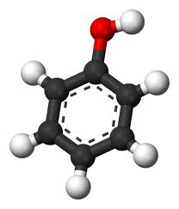

Reactivation of Pt anodes used in solution containing phenol.
  - Introduction.
The process of direct anodic oxidation of phenol involves various steps: after adsorption on the anode, phenol is oxidized to form a radical [1], that can be further oxidized to hydroquinone and then to benzoquinone or can react to form a polymeric structure less reactive than the phenol and characterized by strong adhesion to the electrode surface. This last occurrence entails electrode deactivation and hinders further oxidation of phenol. Some SEM observations of the fouling layers [2] suggest that, after oxygen evolution, small blisters form in the layers causing the generation of uncovered areas of the electrode surface.
Anodic oxidation of phenol has been the subject of fundamental and applied studies [2-7]. Various anode materials have been studied including Pt, Ti covered with oxides, lead dioxide and boron-doped diamond. In the absence of chlorides the main oxidation products are benzoquinone and hydroquinone with some traces of cathecol and carboxylic acids.
This chapter is focus on the electrode deactivation phenomena which are known to progressively reduce the treatment efficiency. In order to resolve this problem different test were carried out to find the best conditions of reactivation insitu and subsequently cleaning.
  - Experimental.
The Pt electrode (radiometer) was polished 30% HNO₃ (galvanostatic polarization at -360 mA and 360 mA). Subsequently, 10 voltammetric cycles (100 mV s⁻¹) in 1M sulphuric acid between - 700mV and 1200 mV vs. Hg/Hg₂SO₄ were performed. Such a procedure allowed to obtained the voltammogram reported by Conway et al. [8] as a reference for clean Pt electrodes in sulphuric acid solutions (figure 7.1).
Electrochemical measurements were carried out in a conventional three-electrode cell using a computer controlled potentiostat model Voltalab 301. Pt was used as working electrodes, Hg/Hg₂SO₄ as a reference and Pt plate as a counter electrode. The exposed apparent area of the working electrodes was 1 cm². Cyclic voltammetry and linear sweep voltammetries were performed at room temperature (T=25°C) in a solution prepared dissolving 5mM phenol (Sigma Aldrich) in 0.5M H₂SO₄.

Figure 7.1: Cycle voltammetries according with Conway.
  - Results and discussion.
In the figure 7.2 is possible to see a typical voltammograms for phenol (Ph) oxidation on Pt in sulphuric acid. The anodic scan of the two different cycles indicates the electrode deactivation. M. Gattrell et al. attributed this phenomenon to an adherent film generated by polymerization of phenoxy radicals produced in the oxidation.
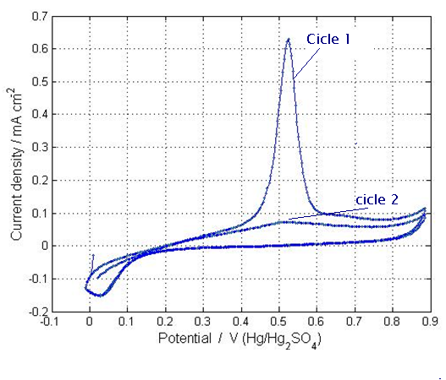
Figure 7.2 : Voltammetric curves for 5nM phenol in 0.5 M H₂SO₄ on a Pt-anode (sweep rate = 10 mV s⁻¹).

After the first voltammetric cycle, it may be inmediatly produced the adsorption of intermediates leads to immediate deactivation whereas the formation of a polymer film covering the electrode. This was confirmed by mean of fig 3. FESEM micrographs of a clean and a heavily-deactivated (24 h operation at +0.7 V under 5 mM Ph) Pt-electrode surface. The growth of an irregular and blistered polymer layer over the electrode surface can be noticed. Analysis of chemical elements, at a blistered location showed that even where the direct presence of the polymer layer is not evident, a significant amount of carbon and oxygen is present over the electrode surface, as opposed to the clean electrodes (see Figure 3 caption). The listed elemental weight percentages correspond to an average C:O atomic ratio of about 4, higher than the ratio of such elements in the hydroquinone or benzoquinone structures (C:O=3) but lower than that of phenol or of polymer molecules obtained by poly-condensation (C:O=6). This suggests the coexistence of all these molecules on the deactivated electrode surface [9].
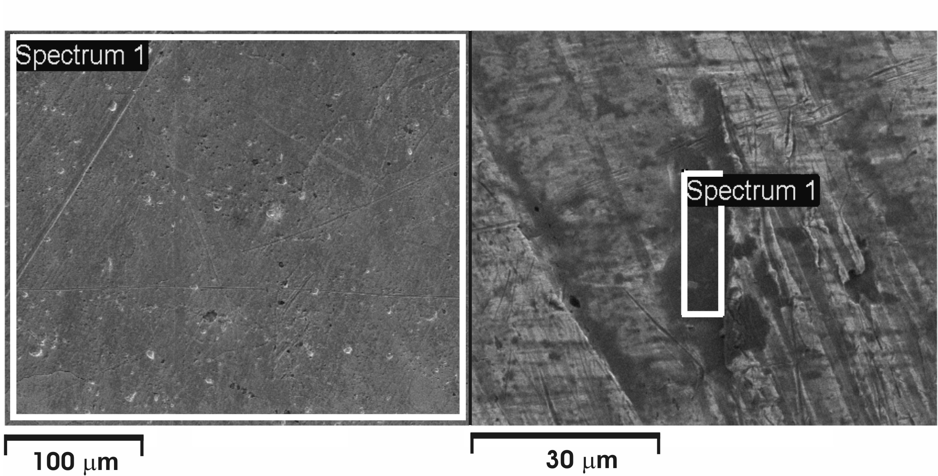
Figure 4 : FESEM pictures of a clean (left) and heavily fouled (right) Pt electrode [9].

Reactivation
Considering the result obtained by Carlesi et al., in order to find a solution for the polymeric film, several experiments were carried out with Pt electrode. These tests were performed with both cathodic and anodic polarization at different time, in 0,5M sulfuric acid solution containing 0,5mM phenol after 2 cycles voltammetries in the rage of 0-0.9 V vs Hg/Hg₂SO₄ at 10 mV/s.
In the Figures 7.4, 7.5, 7.6 were reported the first cycles of the CV on the Pt anodes before to be reactivated and the voltammograms obtained after reactivation at negative potential (inducing hydrogen formation) or/and high positive potential (inducing oxygen evolution).
In figure 7.4, the reactivation experiment was effectuated at maintained high positive potential (1500 mV) for 15 min. It was possible to see in the cv after treatment a shifted pick to higher potential respect to clean electrode, it can be due to modification of the anode superficial layer in higher oxide
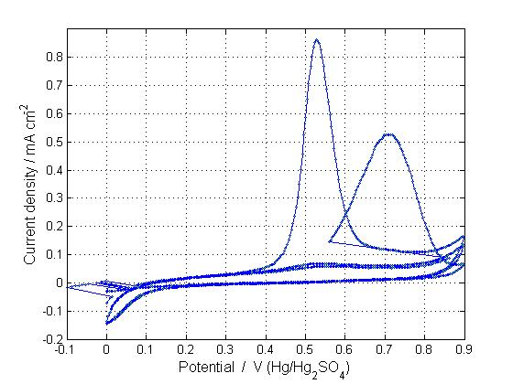
Figure 7.4 : Reactivation at 1.5 V for 15 minutes
In this case the reactivation at – 700 mV for 15 min to generate uncovering region on the anode surface able to oxidize again the dissolved phenol in solution. The current density obtained by oxidation is lower than that given by clean electrode, justifying a partial removal of polymeric layer or intermediate reaction adsorbed on the electrode (fig. 7.5)

Figure 7.5 : Reactivation at -0.7 V for 15 minutes

Finally was presented the voltagram obtained at – 700 mV and at 1500 mV both for 15 min. The results depicts in the fig. 7.6 had shown improvement of the performance of phenol removal efficiency.
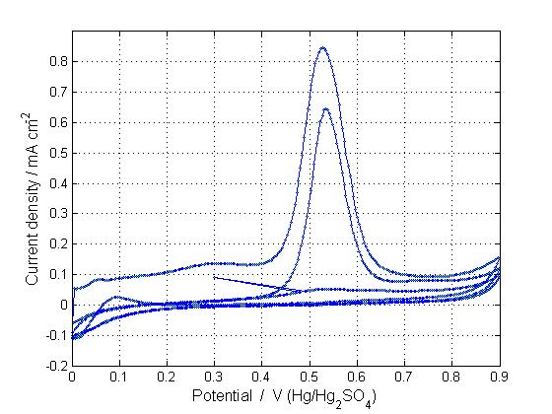
Figure 7.6: Reactivation at -0.7 V and 1.5V for 15 minutes
In the last reactivation experiment, the passivation can be partially destroyed by of polarized at elevated potential. This effect can be generated:
- generation of OH∙ radicals produced on the anode at high positive potential; which could oxidise partially the polymeric layers uncovering thereby producing some active zones for phenol adsorption and reaction on the electrode surface;
- mechanical effect of gas bubbles generate at both electrodes with wrecking of the polymeric film.
- modification of the anode superficial layer in higher oxide like PtO_{n}; which being more reactive supply a very active surface for direct electro-oxidation.

  - Conclusions.
The experiments developed in this section allowed to understand the cv by mean of study of model molecule like phenol. In addition was observed the effect of phenol on Pt anode and investigated reactivation treatments, which showed that the Pt electrode was reactivated to potential -700 and 1500 mV vs. Hg/Hg₂SO₄ for 15 minutes.

References.
[1] M. Gattrell and D.W. Kirk, J. of Electrochem. Soc. 140 (1993) 1534.
[2] J.L. Boudenne, O. Cerclier and P. Bianco, J. Electrochem. Soc. 145, (1998), 2763.
[3] P. Canizares, F. Martinez, M. Diaz, J. Garcia-Gomez and M-A. Rodrigo, J. Electrochem. Soc. 149, (2002), D118.
[4] Ch. Comninellis and C. Pulgarin, J. App. Electrochem. 21, (1991), 703.
[5] B. Fleszar and J. Ptoszynska, Electrochimica Acta ,30 (1985), 31.
[6] J. Iniesta, E. Exposito, J. Gonzales-Garcia, V. Montiel and A. Aldaz., J. Electrochem. Soc. 149, (2002), D57.
[7] R.C. Koile and D.C. Johnson, Anal. Chem. 51, (1979), 741.
[8] B.E. Conway, in S. Trasatti (Ed.), Electrodes of conductive metallic oxides, Part B, chapter 9 p.433 Elsevier, New York, (1981).
[9] D. Fino, C. Jara, G. Saracco, V. Specchia, P. Spinelli Journal of Applied Electrochemistry,35, No.4, (2005), 405.

CHAPTER 8:
Electrochemical oxidation of urea.
Part 1.
Cycle voltammetries.

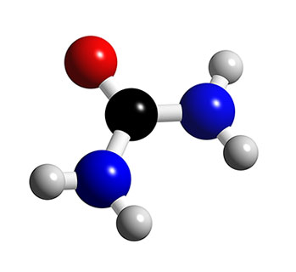

Electrochemical oxidation of urea in aqueous solutions.

Introduction.
Urine is derived from the human metabolic process and its composition is mainly constituted of urea. Different methods for urea removal have been studied, such as adsorption, oxidation, biological decomposition, chemical oxidation and enzymatic decomposition [1-3]. Some of these processes require high energy input, or rather complicated equipment, thus limiting their implementation at industrial level. An attractive alternative for the removal of urea is the electrochemical oxidation process [4-7]. The electro-oxidative treatment of waste water can serve either as a process of disinfection, or as a part of a more complex waste treatment process.
The electrode material is very important for this process, since it has a direct impact on the mechanism, products of the anodic reactions, selectivity and efficiency. According to the mechanism proposed by Comninellis et al. [8,9] two extreme classes of electrodes can be defined: ‘active’ and ‘non-active’ electrodes.
The first step in both cases involves the reaction of water molecules to form adsorbed hydroxyl radicals:
M + H₂O → M(•OH)+ H⁺ + e⁻ (8.1)
With “active” electrodes, where higher oxidation states are available on the electrode surface, the adsorbed hydroxyl radicals interact with the anode with possible transition of the oxygen from the hydroxyl radical to the anode surface, forming the so-called higher oxide:
M (•OH) → MO + H⁺ + e⁻ (8.2)
The surface redox couple MO / M can act as mediator in the conversion or selective oxidation of organics :
MO + R→ M + RO (8.3)
The “active” electrode are characterized by low overpotential for oxygen evolution.
The most extensively used active electrodes are Platinum and DSA electrodes based on Iridium or Ruthenium oxide. Platinum has been studied for the oxidation of many organic compounds solutions and it was verified like a good catalyst in acid medium [10-13]. On other hand, in the last years different study about oxidation of organics were carried out with DSA electrodes and they show low current efficiencies and long times for complete TOC removal [14-17] mainly due to the competing reaction of oxygen evolution.
On the contrary, at non-active electrodes there is a weak interaction between the surface and the •OH radicals. In this way the hydroxyl radicals are physisorbed on the surface and they assist a non-selective oxidation of organic compounds which may results in the complete mineralization of the organics:
R + M(•OH) → M + CO₂ + H₂O + H⁺ + e⁻ (8.4)
Non-active electrodes are usually characterized by high oxygen evolution overpotential [8,9]. The most extensively used non-active electrode are antimony –doped tin oxide, lead dioxide, and boron-doped diamond (BDD). Different studies have demonstrated that the SnO₂-Sb electrodes can oxidize a wide range of organic pollutants with efficiency about five times higher than with platinum anode [18-22]. BDD possess several technologically important characteristics including an inert surface with low adsorption properties, remarkable corrosion stability and extremely high oxygen evolution overpotential. BDD is therefore a promising material for water treatment [23]. So far, many papers have demonstrated that BDD anodes allow complete mineralization, with high current efficiency, several types of organic compound [24-28].
There has been different researches about the anodic degradation of urea, however its oxidation mechanism is still not well understood. For example, using Pt electrodes, many papers discussed the adsorption of urea [29-33], some authors asserted that the adsorption of urea is reversible [29-33] while other papers suggested that it is not reversible [31,33]. Many other works [3,34-36] deal with urea electro-oxidation using different anodic materials such as Ti/Pt, Ti/Pt-Ir, Ti-RuO₂ Ti/IrO₂. However these works performed electrolysis in the presence of chloride ions that act as inorganic mediators.
This study was carried out to increase the knowledge of the direct electrochemical oxidation of urea in order to evaluate the electrochemical oxidation as a treatment technology. The specific objectives were to clarify the adsorption phenomena and to explore the mechanism of anodic electrooxidation with different electrodes such as Pt, Ti-Ru oxide, BDD and antimony-doped tin oxide anode.

Experimental.
Chemicals.
The solutions were prepared dissolving different amounts of Urea (CO(NH₂)₂, (Sigma Aldrich) in 1M NaClO₄, which was chosen as the supporting electrolyte, because it does not generate oxidizing species which can react with the organics, as occurs when using a Cl⁻ medium (i.e. generation of Cl₂) or a SO₄²⁻ medium (i.e. production of S₂O₈ ⁻² ).
Electrode materials.
The antimony-doped tin oxide anodes, hereafter referred as SnO₂-Sb₂O₅, were prepared by coating titanium substrates (2 mm thick) by thermal decomposition of a mixture of 10 g/l SnCl_{4*}5H₂O and 0,1 g dm⁻³ SbCl₃ dissolved in isopropanol. The titanium sheets were subjected to surface pre-treatment consisting in mechanical polishing with WS-FLEX 18- C sandpaper, followed by degreasing with 40% NaOH at 80 ºC for 120 minutes, etching in hydrochloric acid 11,5 M for 1 minute, washing in distilled water and treatment by an ultrasonic bath 60 ºC for 60 minutes. The precursor solution was painted on the titanium plates and the solvent was evaporated at 100°C. for 15 minutes, then the sample was calcined at 550 ºC in a 2 dm³ min⁻¹ oxygen (pure) flow, for 15 minutes; this procedure is repeated 16 times. Finally the electrodes were calcined at 550 ºC for 3 h in 0.5 l/min oxygen [37-40]. An average thickness value of about 4µm was obtained. The nominal composition of the mixed oxide was Sn_{0,918} Sb_{0,109} O₂.
The boron-doped diamond thin-film electrode was supplied by CSEM Centre Swiss d’Electronique et de Microtechnique of Neuchâtel. It was synthesised by the hot filament chemical vapour deposition technique (HF CVD) on single crystal p-type Si wafers. The doping level of boron in the diamond layer expressed as B/C ratio was about 3500 ppm. The obtained diamond film thickness was about 1 µm with a resistivity of 10–30 mΩ cm. In order to stabilise the electrode surface and to obtain reproducible results, the diamond electrode was pre-treated at 25°C by anodic polarization in 1 M HClO₄ at 10 mA cm⁻² during 30 min using stainless steel as the counter electrode. This treatment made the surface hydrophilic.
Before each cyclic voltammetry test, the Pt electrode (Radiometer) was treated in a 30% nitric acid solution under anodic and cathodic polarization at 50 mA cm⁻² for about 20 min. Subsequently, 10 voltammetric cycles (100 mV s⁻¹) in 1M sulphuric acid between –300mV and 1600 mV vs. SCE were performed. Such a procedure allowed to obtained the voltammogram reported by Conway et al. [41] as a reference for clean Pt electrodes in sulphuric acid solutions.
Ti-Ru oxide anodes, hereafter referred to as TiRuO_{2,} was a commercial DSA® anode consisting in a titanium substrate covered with TiO₂/RuO₂ layer and it was purchased from De Nora (Italy).

Electrochemical system.
Electrochemical measurements were carried out in a conventional three-electrode cell using a computer controlled potentiostat model Voltalab 301. Pt, Ti-RuO₂, BDD and SnO₂-Sb₂O₅ were used as working electrodes, saturated calomel (SCE) as a reference and Pt plate as a counter electrode. The exposed apparent area of the working electrodes was 1 cm². Cyclic voltammetry and linear sweep voltammetries were performed at room temperature (T=25°C).

Results and discussion.
Since the value of the overpotential for oxygen evolution is an important parameter to understand the behavior of an electrode, a series of linear sweep voltammetries (LSV) in the anodic range up to oxygen evolution, have been carried out with Pt, Ti-RuO₂, BDD and SnO₂-Sb₂O₅ electrodes. These LSV tests were performed with a potential scan rate of 15 mV s⁻¹, in 1M NaClO₄ solution and the results are presented in Figure 8.1.
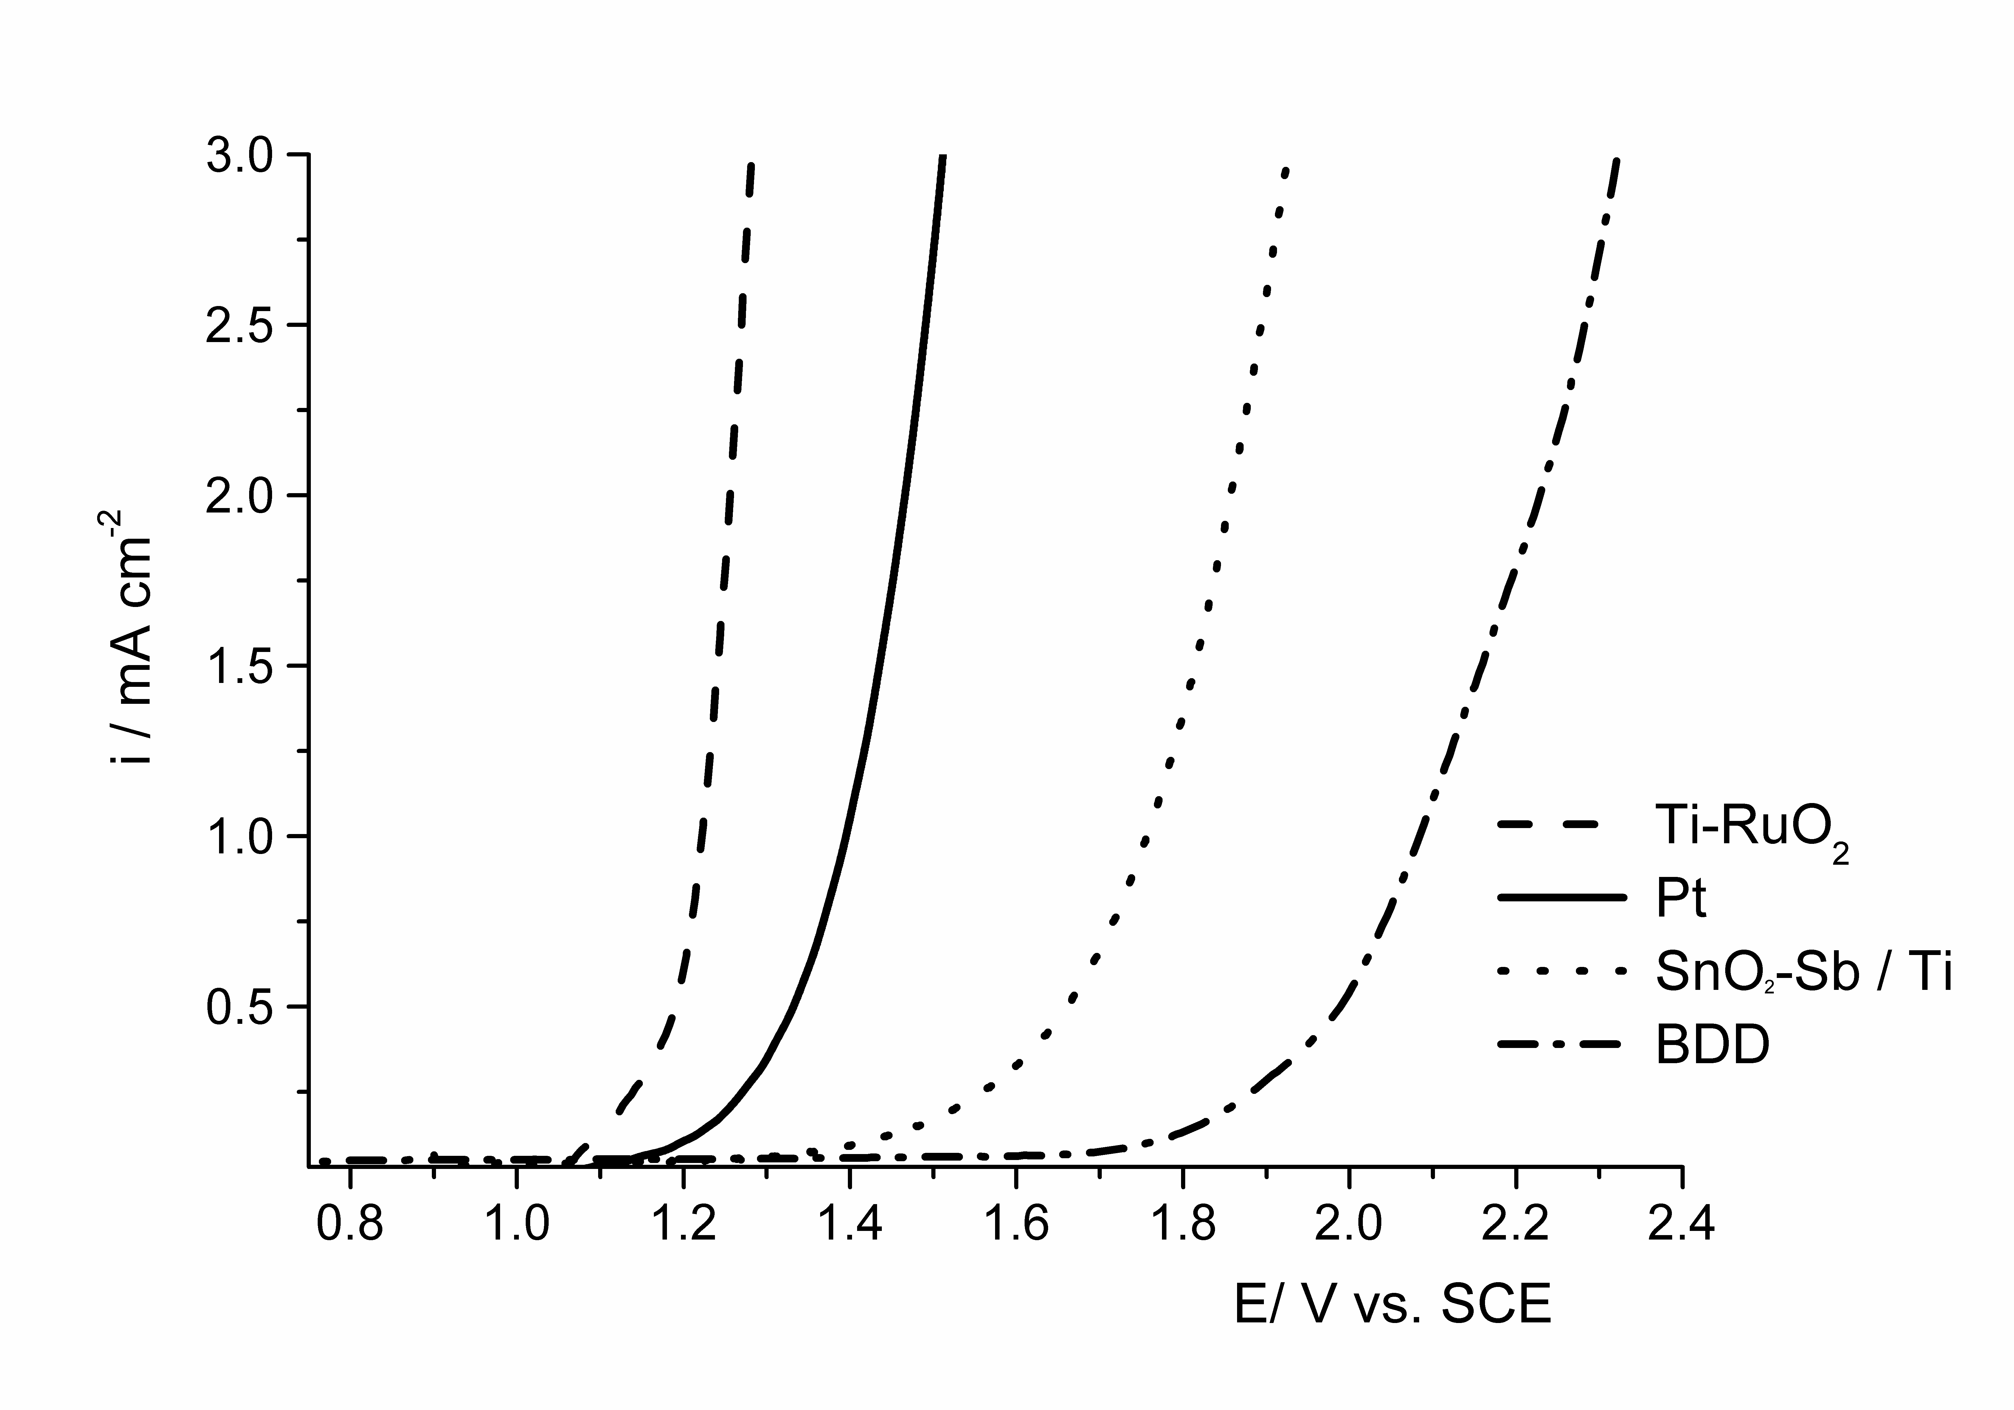Figure 8.1: Linear polarisation curves recorded on Pt, Ti-RuO₂, BDD and SnO₂-Sb₂O₅ in 1M NaClO₄ at scan rate = 15 mV s⁻¹.

The four curves are very different and show that oxygen evolution potential (at 0.25 mA cm⁻²) was 1.125 V, 1.25 V, 1.55 V and 1.9 V vs. SCE for Ti-RuO₂, Pt, SnO₂-Sb₂O₅ and BDD respectively. These values indicate that Ti-RuO₂ and Pt are “active” anodes, while SnO₂-Sb₂O₅ and BDD are “non active” anodes. In particular, for the SnO₂-Sb₂O₅ electrode a value of the anodic potential at 3 mAcm⁻² of about 1.9 vs. SCE was found, which provides, a value for the oxygen overpotential higher than 1.1 V, which is somewhat higher than similar data found in the literature, at the same current density, for this type of electrode [42].
Pt electrode.
Figure 8.2 shows cyclic voltammograms of Pt electrodes obtained in 1M NaClO₄ with a scan rate of 30 mV sec⁻¹ with different concentrations of urea. The presence of urea resulted in an increase in the current in the potential regions between -0.1V and 0.2V vs. SCE and between 0.6 and 1.1 V vs. SCE. These increases, as observed by other authors [37-40], are not influenced by urea concentration and they seem due to urea adsorption, the former, and to urea direct oxidation, the latter.
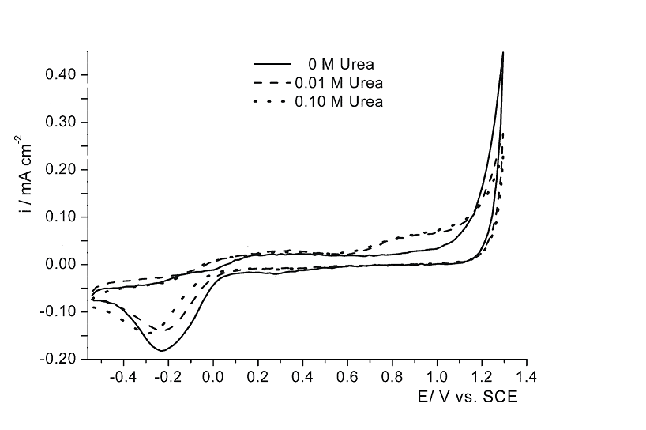
Figure 8.2: Cyclic voltammetry using Pt electrode in 1M NaClO₄ electrolyte with different urea concentration. Scan rate: 30 mV s⁻¹.

The starting potential for oxygen evolution does not seem to be influenced by the presence of urea, however, the current in the region of oxygen evolution at 1.2 V decreases significantly in the presence of urea. Moreover, on the cathodic branch of the voltammogram, in the region corresponding to the Pt-oxide reduction, between 0 and -0.6 V vs. SCE, the current density decreases in the presence of urea and the reduction peak is shifted towards negative potentials.
Figure 8.3 shows consecutive cyclic voltammograms on Pt carried out with 0.01M of urea. The curve does not change when the number of cycles increases (up to 10 cycles) and this suggests that the adsorption- desorption processes are reversible.
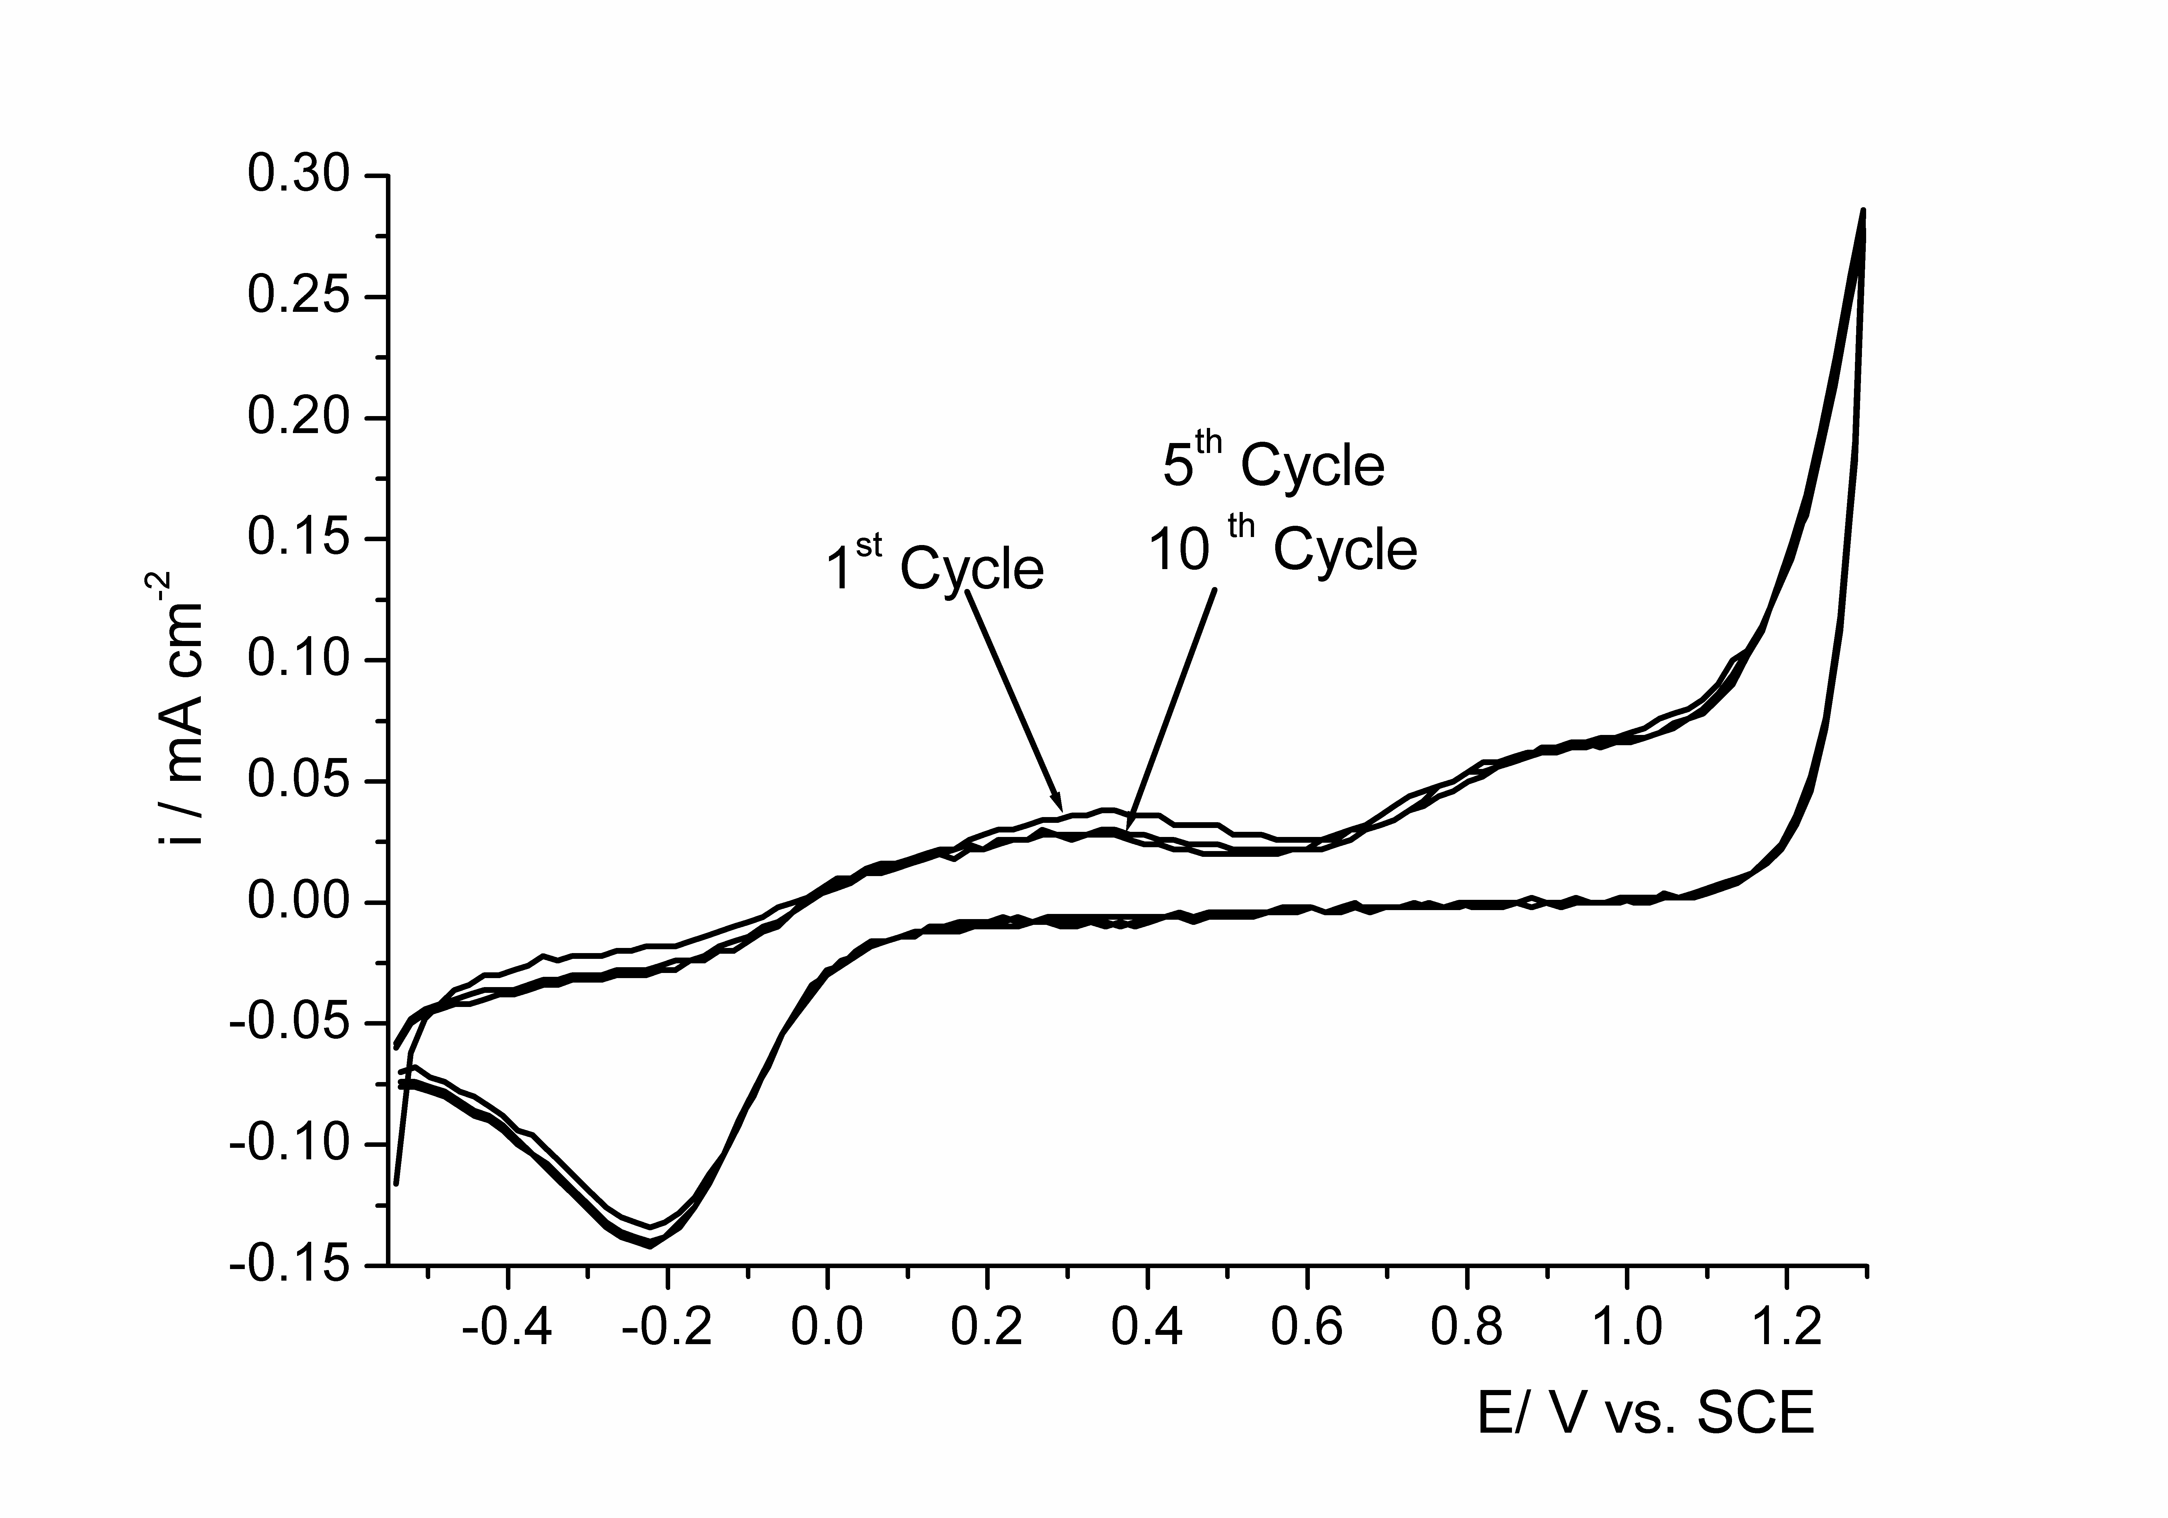Figure 8.3: Consecutive cyclic voltammetries using Pt electrode in urea 0.01 mM + 1M NaClO₄. Scan rate 30 mV s⁻¹.

In order to validate this assumption, voltammetries were carried out in 1M NaClO₄ solution using a new Pt anode or an electrode preconditioned with 10 cycles in presence of 0.01M urea solution. Figure 8.4 shows that the voltammetries are identical, confirming that the urea overall adsorption-desorption processes are reversible.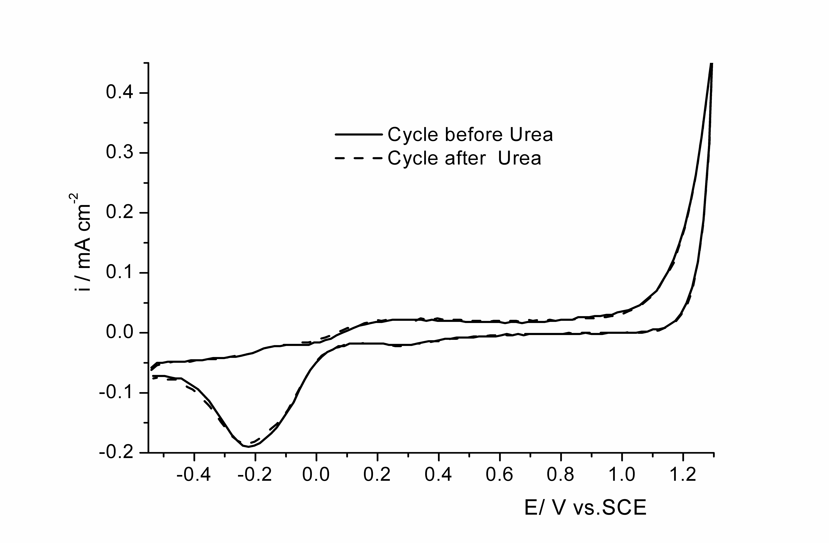Figure 8.4 : Cyclic voltammograms in 1M NaClO₄ solution with new Pt electrode and with Pt electrode after 10 cycles in 0.01 mM + 1M NaClO₄. Scan rate 30 mV s⁻¹.

Ti-RuO₂ electrode.
Figures 8.5 shows cyclic voltammograms of Ti-RuO₂ electrodes obtained in 1M NaClO₄ with a scan rate of 30 mV sec⁻¹ with different concentration of urea.
In 1M NaClO₄, the voltammogram presents two broad and not well defined peaks at 0.6 and -0.2 V vs. SCE that are related to the redox processes for the lower metal oxide / higher metal oxide transition.
In the potential region of water stability between -0.4 and 1.0V vs. SCE, no significant change was observed in presence of urea, just a little shift toward lower currents density in presence of urea. Also the starting potential for oxygen evolution does not seem to be affected by the presence of urea. On the contrary in the region of oxygen evolution, at 1.25 V an increase in urea concentration caused a decrease in current density. This is due to urea adsorption which causes a blockage of the electrode actives sites for oxygen evolution, these results are consistent with the results of Simka et al. [34] and are similar to those obtained with the Pt electrode.
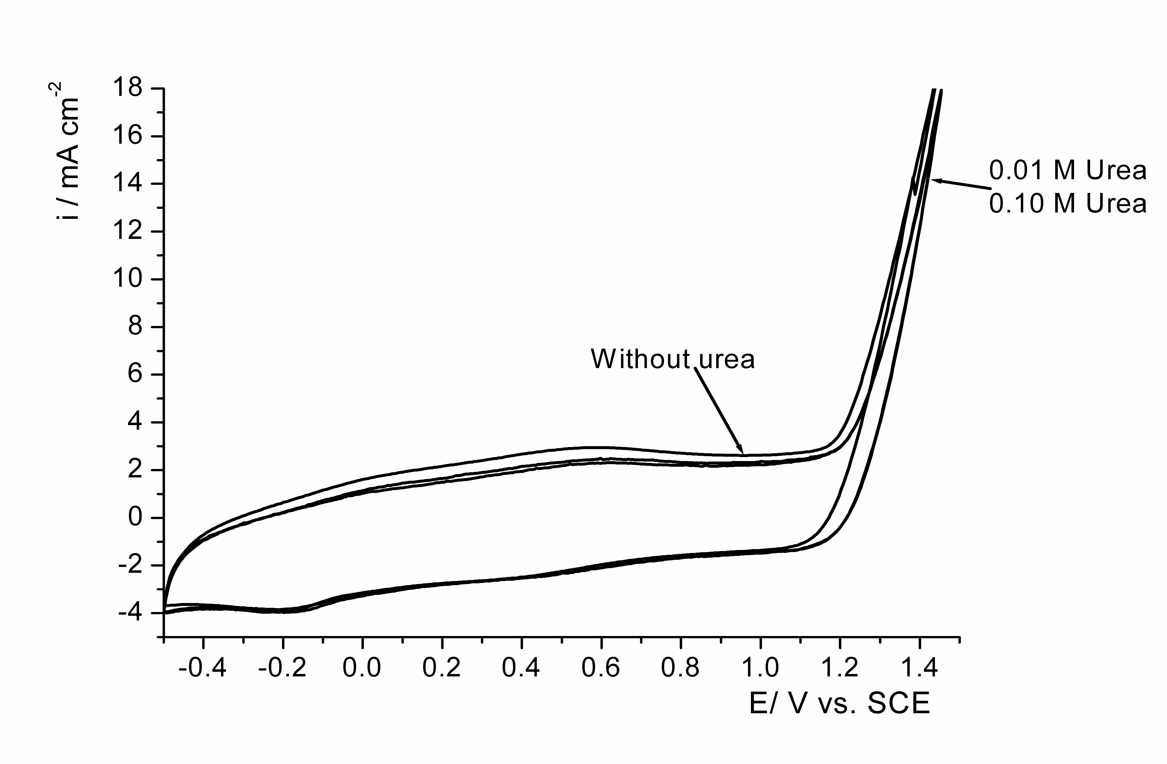Figure 8.5 : Cyclic voltammetry using Ti-RuO₂ electrode in 1M NaClO₄ electrolyte with different urea concentration. Scan rate: 30 mV s⁻¹.

SnO₂-Sb₂O₅/ Ti electrode.
Figures 8.6 shows cyclic voltammograms of SnO₂-Sb₂O₅ electrode in 1M NaClO₄ with a scan rate of 30 mV sec⁻¹ with different concentration of urea. In the presence of supporting electrolyte the voltammogram (continuous line) is nearly featureless in the studied potential region. In the presence of urea the oxygen evolution (at 2 mA cm⁻²) is shifted to more negative potentials and there is a considerable increase in the current density, which is proportional to the concentration of urea.
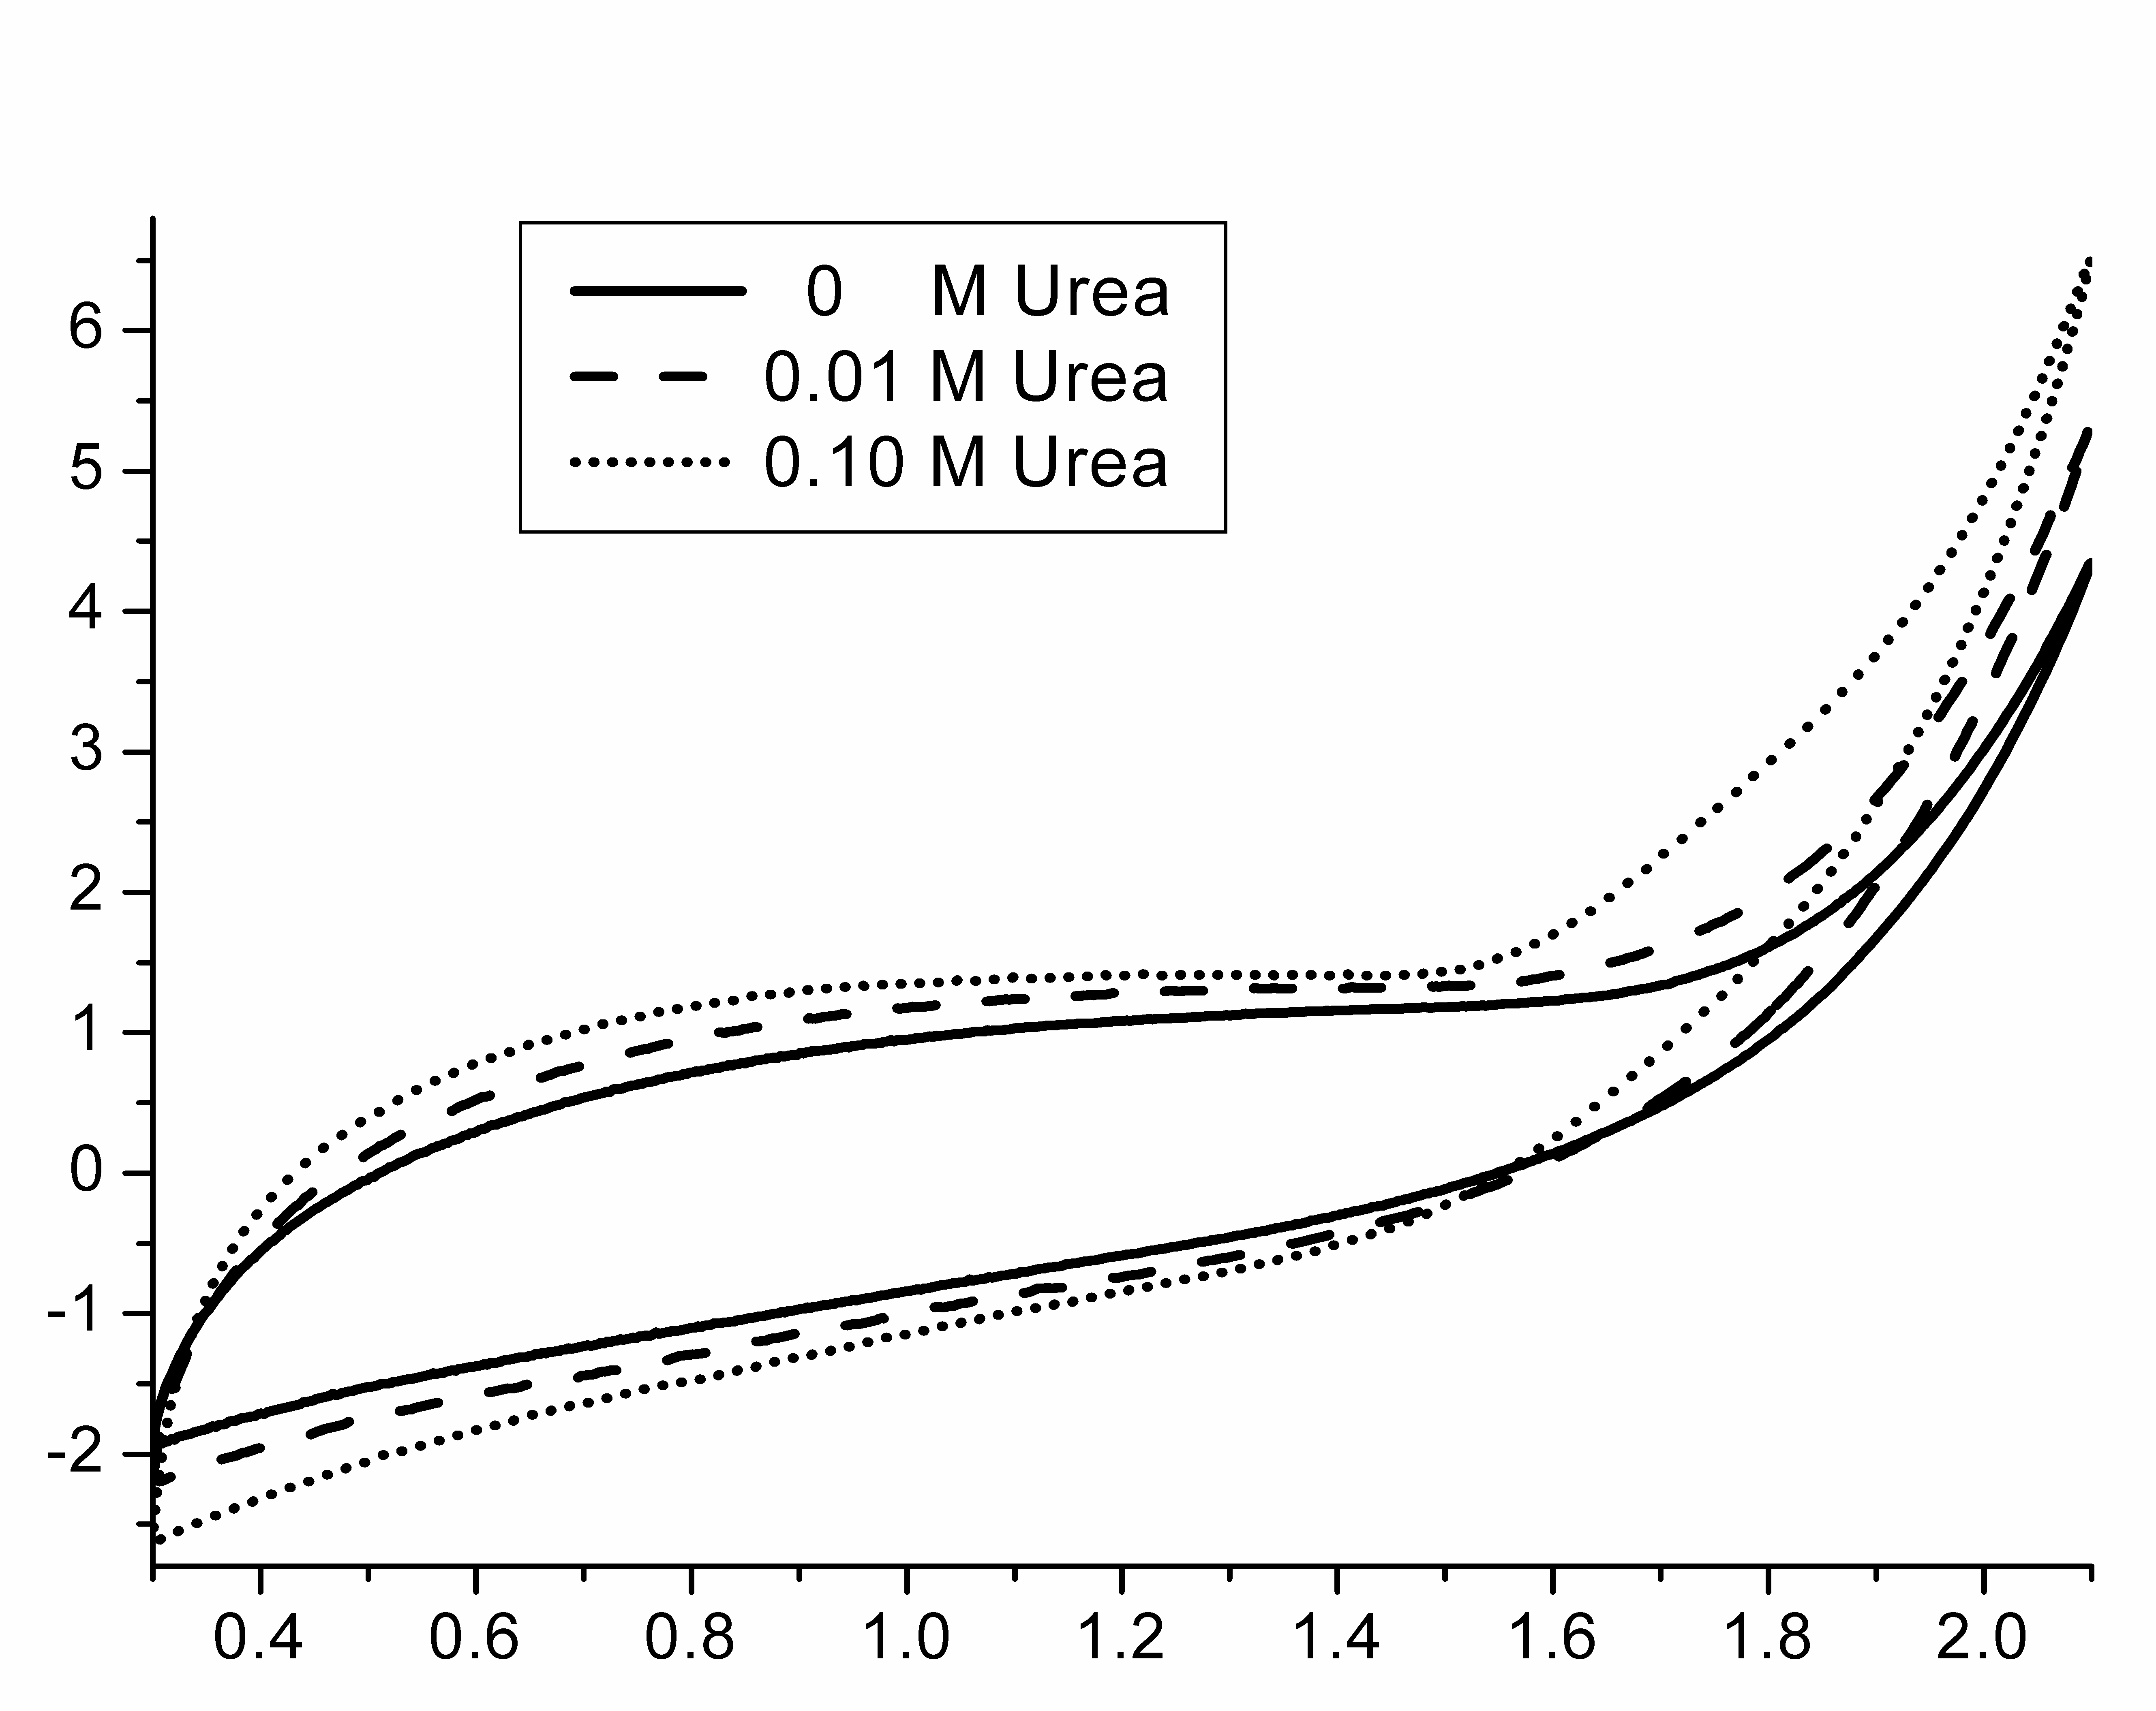
Figure 8.6: Cyclic voltammetry using SnO₂-Sb₂O₅ electrode in 1M NaClO₄ electrolyte with different urea concentration. Scan rate: 30 mV s⁻¹.

This shift can be explained taking into account that oxygen evolution physisorbed •OH are produced on the SnO₂-Sb₂O₅ surface. In the presence of urea, there is a decrease in •OH concentration that affects the current–potential curves causing a shift of the potential [43-45].
In fig. 8.7 consecutive cyclic voltammograms on SnO₂-Sb₂O₅ in 0.01M urea are reported. The 5th and 10th cycles are perfectly overlapped, this and the fact that not find changes and peaks in the curve like in the case of platinum, it is possible to infer that urea is not adsorbed on the electrode.

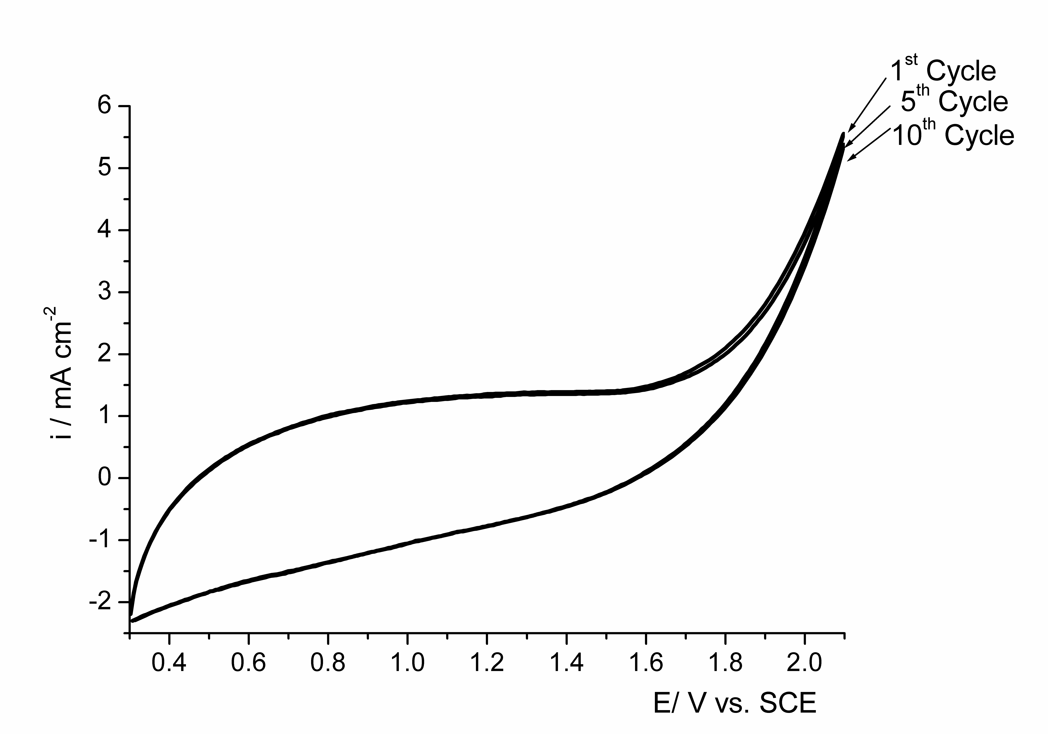Figure 5.7 : Consecutive cyclic voltammetries using SnO₂-Sb₂O₅ electrode in urea 0.01 mM + 1M NaClO₄. Scan rate 30 mV s⁻¹.

BDD Ti electrode.
Fig. 8.8 shows the cyclic voltammograms recorded on BDD electrodes in absence and presence of urea in 1M NaClO₄ supporting electrolyte, with a scan rate of 30 mV sec⁻¹.
The voltammograms before oxygen evolution display no significant change in presence of urea with respect to the voltammogram of the supporting electrolyte. The only difference is a slight decrease in the starting potential of oxygen evolution, indicating an effect of the organic compound on the overpotential of oxygen evolution. However, the current density at 1.5 V in the region of oxygen evolution increases with urea concentration. In fact, the current density in the case of 0.1M urea at 1.75 V vs. SCE is three times the value of the current density in the absence of urea. This behavior, which is similar to that obtained with SnO₂-Sb₂O₅, indicates that the oxidation of urea involves hydroxyl radicals, which are available under oxygen evolution conditions.
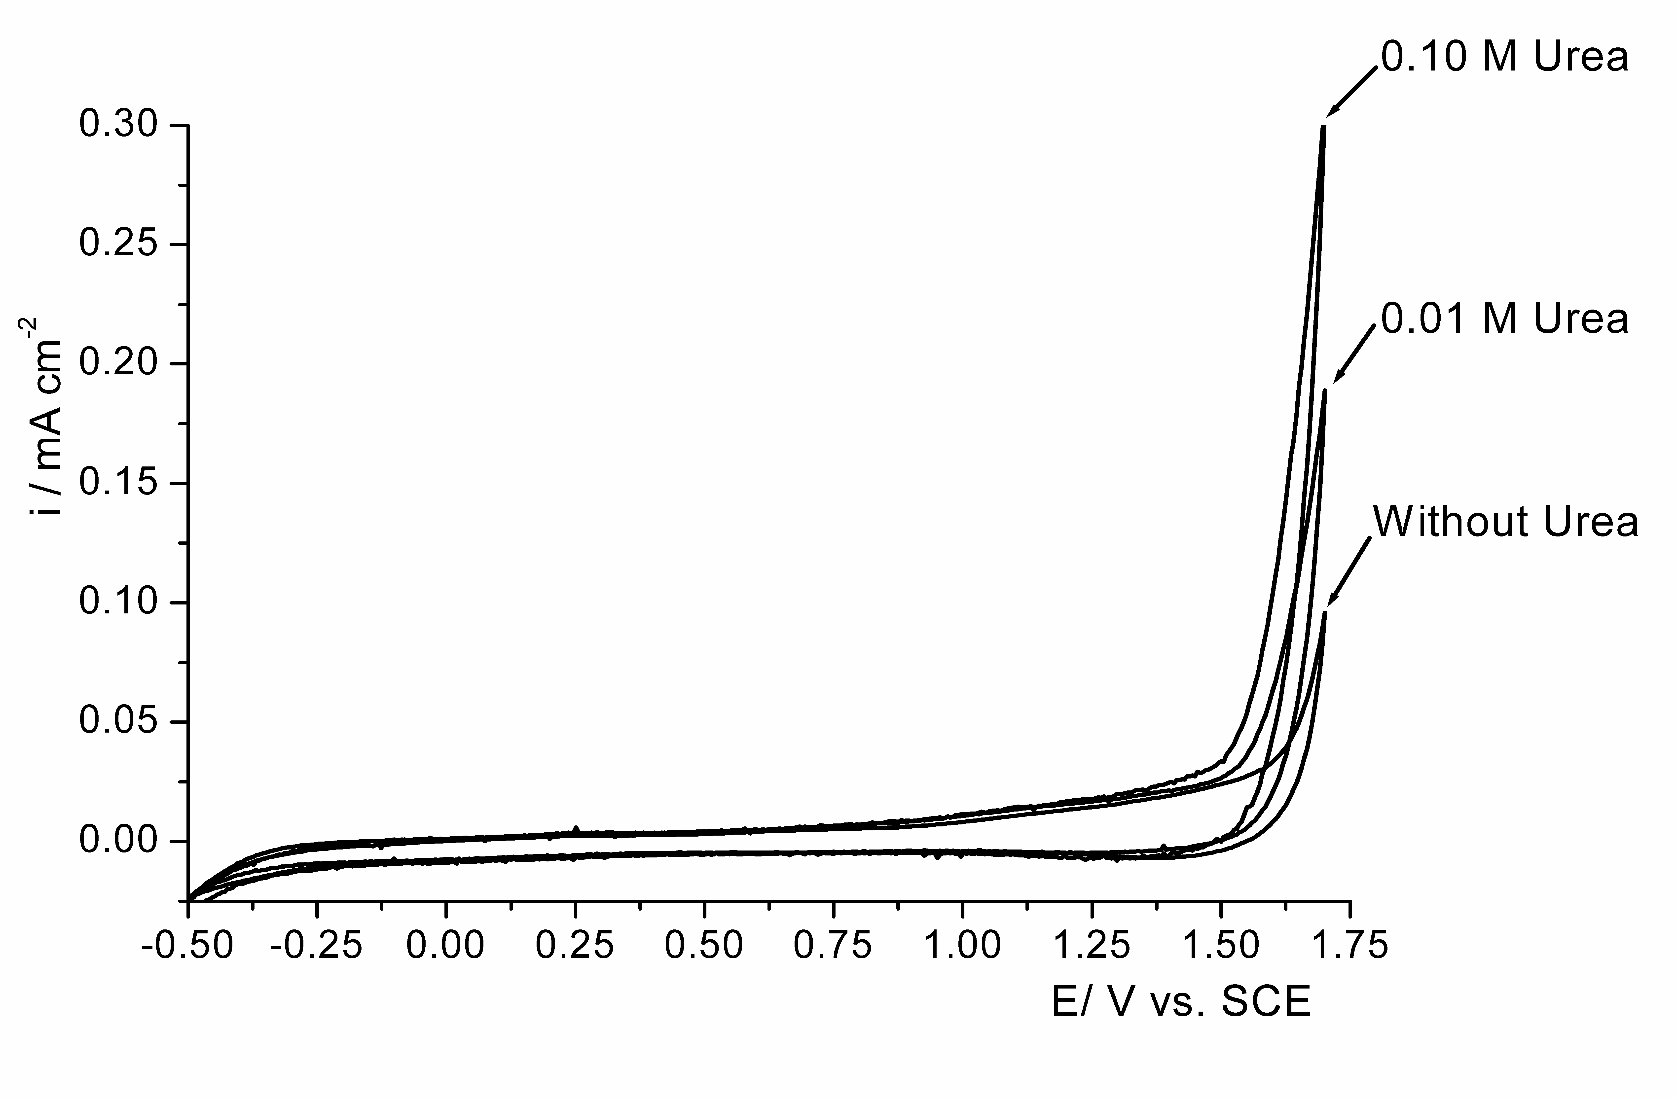Figure 8.8 : Cyclic voltammetry using BDD electrode in 1M NaClO₄ electrolyte with different urea concentration. Scan rate: 30 mV s⁻¹.
Since it is known that BDD electrode exhibits an inert surface with low adsorption properties, in order to investigate the effects of urea adsorption consecutive cyclic voltammograms with 0.01M of urea in 1M NaClO₄ supporting electrolyte were performed like with the others electrodes. Figure 8.9, shows 1st cycle, 5th cycle and 10th cycle, and it is possible to observe that the curves do not change on subsequent cycling and are completely overlapped. Considering the previous information and that there were no changes in current or peaks attributable to the adsorption of urea like in the case the Pt electrodes , indicating that urea is not adsorbed.

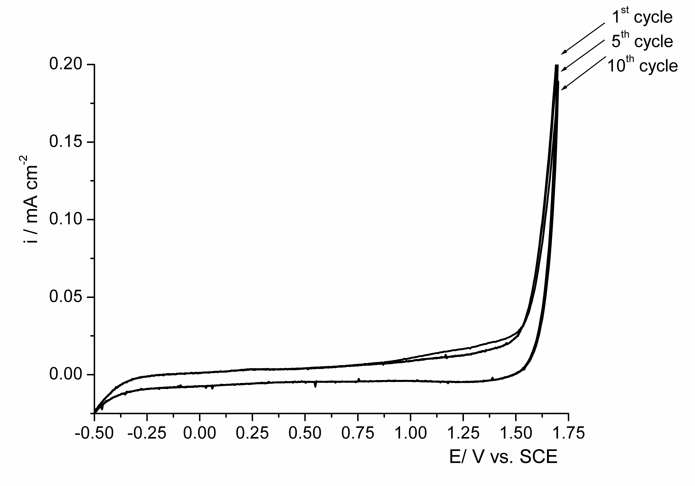Figure 8.9: Consecutive c.v. using BDD in urea 0.01 mM + 1M NaClO₄. Scan rate 30 mV s⁻¹.

Conclusions.
In this work, the electrochemical oxidation of urea in sodium perchlorate has been studied on different anode materials: Pt, Ti-Ru oxide, BDD and antimony-doped tin oxide. Linear polarization indicated that Pt and Ti-Ru oxide have a low overpotential for oxygen evolution and thus they can be considered “active” anodes, while BDD and antimony-doped tin oxide have a high overpotential for oxygen evolution and behave as “non-active” anodes. Cyclic voltammetry measurements have shown that using Pt and Ti-Ru oxide, the presence of urea caused a decrease in the current density in the region of oxygen evolution. This behavior can be attributed to the blockage of the electrode’s active sites for oxygen evolution by urea adsorption. It was also shown that on Pt anode the adsorption- desorption of urea are reversible processes.
On BDD and antimony-doped tin oxide, in the presence of urea, there was an increase in the current density at a given potential in the region of oxygen evolution, and this indicated that urea was oxidised by •OH electrogenerated during oxygen evolution. On BDD and antimony-doped tin oxide electrodes, no evidence of adsorption phenomena was found.

References.
[1] W. Zaborska, B. Krajewska, M. Leszko, Z. Olech, J. Mol. Catal. B: Enzymatic 13 (2001) 103.
[2] R. Hüttl, K. Bohmhammel, G. Wolf, R. Oehmgen, Thermochim. Acta 250 (1995) 1.
[3] W. Simka, J. Piotrowski, Przemysl Chemiczny 86 (2007) 841.
[4] M. Panizza, G. Cerisola, Electrochim. Acta 51 (2005) 191.
[5] M. Panizza, P. A. Michaud, G. Cerisola, C. Comninellis, Electrochem. Commun. 3 (2001) 336.
[6] P. Canizares, M. Hernandez-Ortega, M. A. Rodrigo, C. E. Barrera-Diaz, G. Roa-Morales, C. Saez, J. Hazard. Mater. 164 (2009) 120.
[7] C. A. Martinez-Huitle, M. A. Quiroz, C. Comninellis, S. Ferro, A. De Battisti, Electrochim. Acta 50 (2004) 949.
[8] O. Simond, V. Schaller, C. Comninellis, Electrochim. Acta 42 (1997) 2009.
[9] C. Comninellis, Electrochim. Acta 39 (1994) 1857.
[10] C. Lamy, Electrochim. Acta 29 (1984) 1581.
[11] F. Bonfatti, S. Ferro, F. Lavezzo, M. Malacarne, G. Lodi, A. DeBattisti, J. Electrochem. Soc. 146 (1999) 2175.
[12] C. Comninellis, C. Pulgarin, J. Appl. Electrochem. 21 (1991) 703.
[13] M. Gattrell, D. Kirk, J. Electrochem. Soc. (1993) 1534.
[14] S. K. Johnson, L. L. Houk, J. Feng, D. C. Johnson, Environ. Sci. Technol. 33 (1999) 2638.
[15] C. Bock, B. MacDougall, J. Electroanal. Chem. 491 (2000) 48.
[16] M. R. V. Lanza, R. Bertazzoli, Ind. Eng. Chem. Res. 41 (2002) 22.
[17] G. R. P. Malpass, R. S. Neves, A. J. Motheo, Electrochim. Acta 52 (2006) 936.
[18] C. Pulgarin, N. Adler, P. Peringer, C. Comninellis, Wat. Res. 28 (1994) 887.
[19] R. Cossu, A. M. Polcaro, M. C. Lavagnolo, M. Mascia, S. Palmas, F. Renoldi, Ind. Eng. Chem. Res. 32 (1998) 3570.
[20] C. Bock, B. MacDougall, J. Electrochem. Soc. 146 (1999) 2925.
[21] J. H. Grimm, D. G. Bessarabov, U. Simon, R. D. Sanderson, J. Appl. Electrochem. 30 (2000) 293.
[22] S. Stucki, R. Kotz, B. Carcer, W. Suter, J. Appl. Electrochem. 21 (1991) 99.
[23] M. Panizza, G. Cerisola, Chem. Rev. 109 (2009) 6541.
[24] M. Gandini, Michaud, Haenni, Perret, Comninellis, J. Appl. Electrochem. 30 (2000) 1345.
[25] G. Foti, D. Gandini, C. Comninellis, A. Perret, W. Haenni, Electrochem. Solid St. 2 (1999) 228.
[26] L. Gherardini, P. A. Michaud, M. Panizza, C. Comninellis, N. Vatistas, J. Electrochem. Soc. 148 (2001) D78.
[27] A. Perret, W. Haenni, N. Skinner, X.-M. Tang, D. Gandini, C. Comninellis, B. Correa, G. Foti, Diam. Relat. Mater. 8 (1999) 820.
[28] M. A. Rodrigo, P. A. Michaud, I. Duo, M. Panizza, G. Cerisola, C. Comninellis, J. Electrochem. Soc. 148 (2001) D60.
[29] V. Climent, A. Rodes, J. M. Orts, A. Aldaz, J. M. Feliu, J. Electroanal. Chem. 461 (1999) 65.
[30] O. A. Petrii, S. Y. Vassina, J. Electroanal. Chem. 349 (1993) 197.
[31] e. a. O. J. Murphy, Final Report for NASA Grant NAG 9-350, 1990.
[32] C. Carlesi Jara, S. Di Giulio, D. Fino, P. Spinelli, J. Appl. Electrochem. 38 (2008) 915.
[33] R. W. Keller Jr., S. J. Yao, J. M. Brown, S. K. Wolfson Jr., M. V. Zeller, J. Electroanal. Chem. 116 (1980) 469.
[34] W. Simka, J. Piotrowski, G. Nawrat, Electrochim. Acta 52 (2007) 5696.
[35] W. Simka, J. Piotrowski, A. Robak, G. Nawrat, J. Appl. Electrochem. 39 (2009) 1137.
[36] B. J. Hernlem, Wat. Res. 39 (2005) 2245.
[37] H.-y. Ding, Y.-j. Feng, J.-f. Liu, Mater. Lett. 61 (2007) 4920.
[38] C. P. De Pauli, S. Trasatti, J. Electroanal. Chem. 396 (1995) 161.
[39] V. A. Alves, L. A. da Silva, J. F. C. Boodts, S. Trasatti, Electrochim. Acta 39 (1994) 1585.
[40] A. I. Onuchukwu, S. Trasatti, J. Appl. Electrochem. 21 (1991) 858.
[41] H. Angerstein-Kozlowska, B. E. Conway, W. B. A. Sharp, J. Electroanal. Chem. Interfacial Electrochem. 43 (1973) 9.
[42] X. Chen, F. Gao, G. Chen, J. Appl. Electrochem. 35 (2005) 185.
[43] A. Kapaka, G. Foti, C. Comninellis, Electrochim. Acta 54 (2009) 2018.
[44] A. Kapaka, G. Foti, C. Comninellis, Electrochim. Acta 53 (2007) 1954.
[45] A. Kapaka, G. Foti, C. Comninellis, J. Electrochem. Soc. 155 (2008) E27.

CHAPTER 9:
Electrochemical oxidation of urea.
Part 2.
Pilot cell tests.

Electrochemical oxidation of urea in aqueous solutions.
  - Introduction.
The major component of human and animal liquid residues is urea. Urine is derived from the human metabolic process and its composition is mainly constituted of urea (36.2 % w) and sodium chloride (21.6 % w). Different methods for urea removal have been studied; adsorption, oxidation, biological decomposition, chemical oxidation and enzymatic decomposition [1-4]. Some of these processes require high energy input, or rather complicated equipment, thus limiting their implementation at industrial level. As in other cases of organic pollutants abatement, an attractive alternative is the electrochemical oxidation process [5-8].
In the last decades, electrochemical reactors have been used for a wide range of applications to environmental treatments of polluted waters, due to their versatility, energy efficiency, amenability to automation, environmental compatibility, and cost effectiveness [9].
The electro-oxidative treatment of waste water can serve either as a process of disinfection, or as a part of a more complex waste treatment process. Basically, the electrochemical oxidation is similar to a chemical incineration, but with an in-situ generated strong oxidant.
Direct electrochemical oxidation is conceivable at rather low electrode potentials, before oxygen evolution. The reaction rate depends on the electro-catalytic activity of the anode. The pollutants are oxidized on the anode surface after chemisorption of hydroxyl radicals, without substances other than the electron, which is a clean reagent. On the other hand, in the indirect electro-oxidation, also referred to as mediated electrochemical oxidation, the presence of additional electro-active species is required, which act as intermediates in the exchange of electrons [10, 11].
The electrode material is very important for this process, since it has a direct impact on the mechanism, products of the anodic reactions, selectivity and efficiency. According to the mechanism proposed by Comninellis et al. [12 ,13] two extreme classes of electrodes can be defined: ‘active’ and ‘non-active’ electrodes.
The first step in both cases involves the reaction of water molecules to form adsorbed hydroxyl radicals:
M + H₂O → M(•OH)+ H⁺ + e (9.1)
With “active” electrodes, where higher oxidation states are available on the electrode surface, the adsorbed hydroxyl radicals interact with the anode with possible transition of the oxygen from the hydroxyl radical to the anode surface, forming the so-called higher oxide:
M (•OH) → MO + H⁺ + e (9.2)
The surface redox couple MO / M can act as mediator in the conversion or selective oxidation of organics :
MO + R→ M + RO (9.3)
The “active” electrode are characterized by low overpotential for oxygen evolution.
The most extensively used active electrodes are Platinum and DSA electrodes based on Iridium or Ruthenium oxide. Platinum has been studied for the oxidation of many organic compounds solutions and it was verified like a good catalyst in acid medium [14-17]. On other hand, in the last years different study about oxidation of organics were carried out with DSA electrodes and they show low current efficiencies and long times for complete TOC removal [18-21] mainly due to the competing reaction of oxygen evolution.
On the contrary, at non-active electrodes there is a weak interaction between the surface and the •OH radicals. In this way the hydroxyl radicals are physisorbed on the surface and they assist a non-selective oxidation of organic compounds which may results in the complete mineralization of the organics:
R + M(•OH) → M + CO₂ + H₂O + H⁺ + e⁻ (9.4)
Non-active electrodes are usually characterized by high oxygen evolution overpotential [12,13]. The most extensively used non-active electrode are antimony –doped tin oxide, lead dioxide, and boron-doped diamond (BDD). Different studies have demonstrated that the SnO₂-Sb electrodes can oxidize a wide range of organic pollutants with efficiency about five times higher than with platinum anode [22-26]. BDD possess several technologically important characteristics including an inert surface with low adsorption properties, remarkable corrosion stability and extremely high oxygen evolution overpotential. BDD is therefore a promising material for water treatment [27]. So far, many papers have demonstrated that BDD anodes allow complete mineralization, with high current efficiency, several types of organic compound [28-32].
There has been different researches about the anodic degradation of urea, however its oxidation mechanism is still not well understood. For example, using Pt electrodes, many papers discussed the adsorption of urea [29-33], some authors asserted that the adsorption of urea is reversible [29-33] while other papers suggested that it is not reversible [34,37]. Many other works [38-40] deal with urea electro-oxidation using different anodic materials such as Ti/Pt, Ti/Pt-Ir, Ti-RuO₂ Ti/IrO₂. However these works performed electrolysis in the presence of chloride ions that act as inorganic mediators.
This study was carried out to increase the knowledge of electrochemical oxidation of urea in order to evaluate the electrochemical oxidation as a treatment technology.
The present work describes the anodic decomposition of urea using of anodic electrooxidation in different electrodes ; Pt, commercial DSA, BDD and SnO₂-Sb₂O₅/ Ti . for regenerative treatments of waste water containig urea.
Electrochemical tests were analyzed to determine the optimal operating conditions that allow higher reaction kinetics as a function of current density, urea concentration and electrolyte composition. Preliminary tests in a pilot electrochemical reactor proved the feasibility of the process.
  - Experimental
Electrode materials.
The antimony-doped tin oxide anodes, hereafter referred as SnO₂-Sb₂O₅, were prepared by coating titanium substrates (2 mm thick) by thermal decomposition of a mixture of 10 g/l SnCl_{4*}5H₂O and 0,1 g dm⁻³ SbCl₃ dissolved in isopropanol. The titanium sheets were subjected to surface pre-treatment consisting in mechanical polishing with WS-FLEX 18- C sandpaper, followed by degreasing with 40% NaOH at 80 ºC for 120 minutes, etching in hydrochloric acid 11,5 M for 1 minute, washing in distilled water and treatment by an ultrasonic bath 60 ºC for 60 minutes. The precursor solution was painted on the titanium plates and the solvent was evaporated at 100°C. for 15 minutes, then the sample was calcined at 550 ºC in a 2 dm³ min⁻¹ oxygen (pure) flow, for 15 minutes; this procedure is repeated 16 times. Finally the electrodes were calcined at 550 ºC for 3 h in 0.5 l/min oxygen [41-44]. An average thickness value of about 4µm was obtained. The nominal composition of the mixed oxide was Sn_{0,918} Sb_{0,109} O₂.
The boron-doped diamond thin-film electrode was supplied by CSEM Centre Swiss d’Electronique et de Microtechnique of Neuchâtel. It was synthesised by the hot filament chemical vapour deposition technique (HF CVD) on single crystal p-type Si wafers. The doping level of boron in the diamond layer expressed as B/C ratio was about 3500 ppm. The obtained diamond film thickness was about 1 µm with a resistivity of 10–30 mΩ cm. In order to stabilise the electrode surface and to obtain reproducible results, the diamond electrode was pre-treated at 25°C by anodic polarization in 1 M HClO₄ at 10 mA cm⁻² during 30 min using stainless steel as the counter electrode. This treatment made the surface hydrophilic.
Before each experiment, the Pt electrode (Radiometer) was treated in a 30% nitric acid solution under anodic and cathodic polarization at 50 mA cm⁻² for about 20 min. Subsequently, 10 voltammetric cycles (100 mV s⁻¹) in 1M sulphuric acid between –300mV and 1600 mV vs. SCE were performed. Such a procedure allowed to obtained the voltammogram reported by Conway et al. [45] as a reference for clean Pt electrodes in sulphuric acid solutions.
Ti-Ru oxide anodes, hereafter referred to as TiRuO_{2,} was a commercial DSA® anode consisting in a titanium substrate covered with TiO₂/RuO₂ layer and it was purchased from De Nora (Italy).

Pilot electrochemical reactor
The experiments have been carried out in a batch recirculation reactor. Figure 9.1 shows a sketch of the reactor set-up, whose important features are a great flexibility and an easy operation mode.
This reactor includes anodic and cathodic compartments, separated by a cationic membrane (CMX Neosepta-Tokuyama Soda Co., Japan) that allows the transfer of NH₄⁺ produced as a consequence of the urea oxidation reaction( only the test with Pt and SnO₂-Sb₂O₅ used the cationic membrane).
Figure 9.1 : Cell scheme. DC power supplies, 2. Cathode 3. Anode, , 4.Cationic exchange Membrane , 5. Anodic compartment 6. Cooling water, 7. Cathodic compartment

Pt, commercial DSA, BDD and SnO₂-Sb₂O₅/ Ti had been used as anode, and stainless steel as the cathode both of 150x110 mm in size. Close to the anode surface a turbulence promoter has been inserted in order to favor the mass transfer.
The electrolyte solution consisting of 2 g l⁻¹ sodium sulphate and the solution of 2 g l⁻¹ of urea were introduced into cathodic and into anodic compartments respectively. The solutions were stored in different reservoirs and circulated through the electrochemical cell by means of centrifugal pumps. The electro oxidation test were carried out under galvanostatatic conditions, with a current density between 5- 20 mA cm⁻², while the operating temperature was controlled at 20 ºC ± 3 by means of a water cooling system.
In the experiments with cationic membrane, the solutions in the anodic and cathodic compartments were periodically sampled by means of a spectrophotometer (Cary 5000 Varian) and a colorimeter (model 975-MP Orbeco-Hellige) to determine, during the treatment, all the dissolved chemical species. The urea concentration was analyzed by means of a spectrophotometric (Varian Caray 5000) method, based on the addition of p-dimethylaminobenzaldehyde and hydrochloric acid solution to the urea sample, in order to obtain yellow–green color due to the complexation reaction [18]. In addition, important parameters such as, pH, and conductivity, which are useful to investigate the electrochemical process, have been continuously measured (ION 450 Hach-Lange).
  - Results and discussion.
The anodic oxidation of urea was performed in the pilot reactor with and without cationic membrane, described in the experimental section. These tests were carried out under galvanostatic conditions at different values of the current density between 5 and 20 mAcm⁻².

    - Pt electrode.
Direct electro-oxidation.
These tests have been carried out using 2 g l⁻¹ of urea added to the electrolyte consisting of 2 g l⁻¹ sodium sulphate at three different current densities of 5, 10 and 20 mA cm⁻² .
In these test, the pH value in the anodic compartment decreases due to oxygen evolution,
2H₂O → 4H⁺ +O₂+4e⁻ (9.5)
While in the cathodic compartment an increase of the pH value occurs according to the reaction:
2H₂O+2e⁻ → H₂ +OH⁻ (9.6)
Figure 9.2 shows that, as expected, the anodic decomposition rate of urea strongly depends on the current density. For a better comparison of the influence of the current density, the concentration change of urea is plotted against the amount of charge passed through the cell. From the data reported in figure 9.2, at the end of the test, the decomposition of urea was close to 50% at 5 and 10 mA cm⁻², while at 20 mA cm⁻² the decomposition was 94%.
On the same figure 9.2, the change of NH₄⁺ versus the passed anodic charge is reported in the middle graph. The formation of NH₄⁺ may be due to the heterogeneous reaction with higher oxides on the anode surface,
NH₂CONH₂ + 4O*→ 2NH₄⁺ + NO₃⁻ + CO₂ (9.7)
and hydrolysis:
NH₂CONH₂ + H₂O→ 2NH₃ + CO (9.8)
The low pH values in the anodic compartment facilitate the reaction from ammonia NH₃ to ammonium ion NH₄⁺.
NH₄⁺ + H⁺ → NH₄⁺ (9.9)
The ammonium ion profile presents a maximum value which can be explained by taking into account the transport of NH₄⁺ to the cathodic compartment through the cationic membrane, thus creating a limited concentration of NH₄⁺ in the anodic compartment. In the cathodic compartment the presence of OH⁻ is responsible for ammonia formation, which will be removed from the cathodic side by volatilization.
NH₄⁺ + OH⁻ → NH₃ + H₂O (9.10)
The lower graph in figure 9.2 shows the formation of nitrate, whose concentration increases with the passed anodic charge. On the other hand the curve slope is proportional to the current density. At 20 mA cm⁻², there is an important increase of NO₃- concentration. This behavior may be caused by the direct oxidation of ammonia species on the anode surface at high anodic potential. It must be noted that generated nitrates remain in the anodic compartment.
Figure 6: Analysis of pilot reactor testing, using anode of 194.25 cm²,to different current densities Legend : 20 mA cm⁻²( filled square), 10 mA cm⁻²( filled circle) and 5 mA cm⁻²( filled triangle) without sodium chloride, a) Urea concentration, b) NH₄⁺ concentration, c) NO₃⁻ Concentration.

In general, direct electro-oxidation of nitrogen-containing molecules enables to decrease the total organic carbon, but at the same time, this generates high amounts of inorganic pollutants like ammonia and nitrate ions. For industrial applications a high concentration of these pollutants can be a drawback, so that further specific abatement processes are required [46].

Combination of direct and indirect electro-oxidation.
The direct electro-oxidation has proven to be successful with the urea molecule, but it has the counterpart that it produces high amount of inorganic pollutants like ammonia and nitrate ions. The presence of high concentrations of nitrates and ammonia in water has a negative effect to the environment [47].
A possible approach to this problem is the addition of chloride ions to the electrolyte solution, because chlorine and nitrate generation are competing processes. This is obtained by a process combining direct and the indirect electro-oxidation.
In order to understand the influence of combined processes, different tests were performed adding 1.5 and 3 g l⁻¹ sodium chloride in the anodic compartment.
The chloride ion in the anodic compartment can react in the following ways:
2Cl⁻→ Cl₂ + 2e⁻ (aq) (9.11)
considering slightly acidic conditions, this reaction is favored:
Cl₂ + H₂O → HClO + Cl⁻ + H⁺ (9.12)
The hypochlorous acid formed is a strong oxidant: it can quickly react with organic species, thus it regenerates chloride ions and allows to continue the cycle. [48]
At this point the oxidation of urea is due to direct electro-oxidation on the active surface of the electrodes , as well as the reaction with hypochlorous anion :
NH₂CONH₂ + 3OCl⁻ → N₂ + CO₂ + 3Cl⁻ + 2H₂O (9.13)
This homogeneous multi-step process produces N₂ and CO₂, as showed in the reaction. As a result an abatement of urea of about 96 % at 10 mAcm⁻² can be obtained, which it is quite high (figure 9.3) compared to the values without chloride addition. The intermediate steps of this process involve the formation of chloramines and other forms of combined chlorine
Figure 9.3: Analysis of pilot reactor testing using anode of Pt to 10 and 20 mA cm⁻² with NaCl in different concentration Legend : without NaCl ( filled square), 1.5 g l⁻¹ NaCl ( filled circle) and 3.0 g l⁻¹ NaCl ( filled triangle) a) Urea concentration, b) NH₄⁺ concentration, c) NO₃⁻ Concentration.

The middle graph of figure 3 shows the NH₄⁺ concentration change for the tests carried out in the presence and in the absence of NaCl. Initially the amount of NH₄⁺ is higher in presence of salt, until around 1,5x10⁴ [C/l], then a sharp decrease occurs reaching a value close to zero, which cannot be attained in the absence of NaCl. This may be due to reactions between the ammonium ion and hypochlorous acid:
NH₄⁺ + 3HClO → N₂ + 3H₂O + 5H⁺ + 3Cl⁻ (9.14)
On the other hand, adding the salt, the process of chloramines formation competes with nitrate generation, reducing the maximum amount of nitrate and increasing the amount of recovered ammonia, as a consequence of enhanced homogeneous urea degradation. The urea electro-oxidation process, in presence of sodium chloride (figure 9.3) at the same current density, produces a lower concentration of NO₃⁻ than that observed when sodium chloride is not present.
Bar graph (fig. 9.4) shows the final concentration of total carbon for every cases, and is observed a important decrease from 420 to 60 ppm in worse case ( 50 mA/cm²). These results can be mean a total mineralization of urea molecule, which is higher in presence of salt.
When the combined electro-oxidation process is carried out, a strong abatement of pollutant is obtained at high rates of anodic urea decomposition. With this process the formation of nitrates and other intermediates is reduced, while the formation of molecular nitrogen N₂ is promoted.

Figure 9.4 : Final total carbon

    - DSA electrode.
This commercial DSA® anode consisting in a titanium substrate covered with TiO₂/RuO₂.
Considering that DSA electrode is active electrode like Platino, but without good catalytic qualities and the good results obtained with Pt electrode in presence of NaCl,different tests were performed adding 1.5; 3.0 and 6 g l⁻¹ sodium chloride. These tests have been carried out using 2 g l⁻¹ of urea added to the electrolyte consisting of 2 g l⁻¹ sodium sulphate at 5, 10 and 20 mA cm⁻². These experiments were carried out without cationic membrane.
The figure 9.5 shows urea electroxdation , which was poorly degraded at the TiO₂/RuO₂ anode. The final values reached around 1000ppm in the best case ( with 6 g/l NaCl). However this value is lower than 40% of depuration.
Figure 9.5: Urea concentration during electrooxidation, using pilot reactor with DSA anode, at 20 mA cm⁻² with NaCl in different concentration .

Observing the values achieved of total carbon ( fig 9.6). It can see that this parameter decrease slowly specially in the case without salt. The phenomena showed that the primary oxidation is more effective that subsequently oxidations resulting in an accumulation of carboxylic acids. Similar results were found by Pulgarin et al. ( 1994). The results obtained in presence of salt were considerable better than the other without. However, despite the higher destruction, the indirect electrooxidation resulted in the production of several chloroorganic compounds, which was a major disadvantage of this method.
Figure 9.6: Total carbon during electrooxidation, using pilot reactor with DSA anode, at 20 mA cm-2 with NaCl in different concentration .
-

    - BDD
These tests have been carried out using 2 g l⁻¹ of urea added to the electrolyte consisting of 2 g l⁻¹ sodium sulphate at three different current densities of 5, 10 and 20 mA cm⁻² .
Fig. 9.7 shows the concentration of urea during the electrooxidation. It was observed that near to 10000 C/l a strong decrease in urea concentration, if found values about 300 ppm of urea from 2200, after the abetment continues slowly until reached the total depuration. This is due to a large quantity of the OH⁻ that is weakly adsorbed on its surface, and consequently it has high reactivity for organic oxidation, providing the efficient depuration of water.
Figure 9.7: Urea concentration during electrooxidation, using pilot reactor with BDD anode.

In order to understand if urea’s depuration was completes, also was measured total organic carbon (fig. 9.8). These results demonstrated that BDD anode allows complete mineralization of urea molecule. The oxidation is controlled by the diffusion of the pollutants toward the electrode surface, where the hydroxyl radicals are produced, and the current efficiency is favored by high mass-transport coefficient, high organic concentration, and low current density. Performing electrolysis under optimum conditions, without diffusion limitation, the current efficiency approaches 100%.
Figure 9.8 : Total organic carbon during electrooxidation, using pilot reactor with BDD anode.
However, despite the numerous advantages of diamond electrodes, their high cost and the difficulties in finding an appropriate substrate on which to deposit the thin diamond layer are their major drawbacks.

    - SnO₂-Sb₂O₅/ Ti .
These tests have been carried out using 2 g l⁻¹ of urea added to the electrolyte consisting of 2 g l⁻¹ sodium sulphate at three different current densities of 5, 10 and 20 mA cm⁻² .
The fig. 9.9 shows the urea abatement, and if observed that a 20 ma/cm² was reached a total abatement.
Figure 9.9 : Urea during electrooxidation, using pilot reactor with SnO2-Sb2O5/ Ti anode.
Considering that in the case of BDD anode was obtained a total mineralization. Total carbon was measured during the experiments. The results not were positive because the quantity of TC was higher, this is a clued that urea molecule only was depurated a other molecule, and it was not produced a total mineralization.
Some investigations have compared the behavior of SnO2 with other BDD for the oxidation of organic pollutants. However, this case reported that the current efficiency obtained with Ti/BDD was higher than that obtained with the SnO₂-Sb₂O₅/ Ti electrode.
Figure 9.10: Total carbon during electrooxidation, using pilot reactor with BDD anode.
  - Conclusions
In this paper, the electrochemical oxidation of urea in pilot cell has been studied on different anode materials: Pt, Ti-Ru oxide, BDD and antimony-doped tin oxide. Urea and TC concentration abatement was monitored via electro-oxidation tests.
The highest efficient removal of urea was obtained using a BDD electrode, because total mineralization of urea was reached. Higher removal efficiencies were obtained with the SnO₂/Sb₂O₅ electrode due to its better catalytic activity. However the urea molecule doesn’t reach the total mineralization, according with TC values.
When non active anodes was used , the removal efficiency in the electro-oxidation test doesn’t rise at higher current density. This due to the removal efficiency depends on the capacity to generate OH radicals.
Instead for active anodes, the current density influenced more than in non active electrodes, due to the removal efficiency mainly depends on the degree of adsorption of the organic substances, which in turn can be limited by the rate of oxygen evolution that inhibits the adsorption sites for organic compounds. Confirmation of this interpretation was provided from the tests carried out in the presence of urea at a high current density, which showed the formation of lower nitrate species than expected. Subsequently, experiments with salt were performed in order to improve the electro oxidation process. The test showed the important difference in nitrogen formation by comparing the tests in the presence and in the absence of sodium chloride.
The urea abatement is proportional to the current density, however the presence of sodium chloride in the electrolyte has a positive impact on the abatement, by increasing its value up to 40%. This behaviour it is due to direct electro-oxidation on the active surface of the electrodes, as well as to the indirect oxidation reactions occurring in the presence of chloride ions, which are also effective in the decrease of the concentration of ammonium and nitrate at the end of the process, this is a remarkable result since these species are highly pollutant for the environment.

References
[1] Zaborska, W.; Leszko, M.J. Polish J. of Chemistry 68, (1994), 2733.
[2] Hüttl, R.; Bohmhammel, K.; Wolf, G.; Oehmgen, R. Term Acta , 250,(1995) 1.
[3] Simka,W.; Piotrowski, J.. Przemysl Chemiczny 86, (2007), 841.
[4] Simka,W.; Piotrowski, J.; Robak, A.; Nawrat, G. J. Appl. Electrochem. 39, (2009), 39,1137.
[5] Hernlem, B., Water Res. 39, (2005), 245.
[6] Vidotti, M.; Silva, M.; Salvador, R.; Cordova de Torresi, S.; Dall’ Antonia H. Electrochim. Acta, 53, (2008), 4030.
[7] Carlesi, C.; Di Giulio, S.; Fino, D.; Spinelli, P. J. App. Electrochemis. Doi 10.1007/s10800-008-9496-4
[8] Simka,W.; Piotrowski, J.; Nawrat, G. Electrochim. Acta, 52,(2007), 5696.
[9] Trinidad, P.; Walsh, F.; Int. J. Engng., 14, (1998), 431.
[10] Chang, H.; Johnson, D. J. electrochem. Soc. 137 ,(1990), 2457.
[11] Panizza, M.; Cerisola, G. Chem. Rev. 109, (2009), 6541.
[12] O. Simond, V. Schaller, C. Comninellis, Electrochim. Acta 42 (1997) 2009.
[13] C. Comninellis, Electrochim. Acta 39 (1994) 1857.
[14] C. Lamy, Electrochim. Acta 29 (1984) 1581.
[15] F. Bonfatti, S. Ferro, F. Lavezzo, M. Malacarne, G. Lodi, A. DeBattisti, J. Electrochem. Soc. 146 (1999) 2175.
[16] C. Comninellis, C. Pulgarin, J. Appl. Electrochem. 21 (1991) 703-708.
[17] M. Gattrell, D. Kirk, J. Electrochem. Soc. (1993) 1534.
[18] S. K. Johnson, L. L. Houk, J. Feng, D. C. Johnson, Environ. Sci. Technol. 33 (1999) 2638.
[19] C. Bock, B. MacDougall, J. Electroanal. Chem. 491 (2000) 48.
[20] M. R. V. Lanza, R. Bertazzoli, Ind. Eng. Chem. Res. 41 (2002) 22.
[21] G. R. P. Malpass, R. S. Neves, A. J. Motheo, Electrochim. Acta 52 (2006) 936-.
[22] C. Pulgarin, N. Adler, P. Peringer, C. Comninellis, Wat. Res. 28 (1994) 887
[23] R. Cossu, A. M. Polcaro, M. C. Lavagnolo, M. Mascia, S. Palmas, F. Renoldi, Ind. Eng. Chem. Res. 32 (1998) 3570.
[24] C. Bock, B. MacDougall, J. Electrochem. Soc. 146 (1999) 2925
[25] J. H. Grimm, D. G. Bessarabov, U. Simon, R. D. Sanderson, J. Appl. Electrochem. 30 (2000) 293.
[26] S. Stucki, R. Kotz, B. Carcer, W. Suter, J. Appl. Electrochem. 21 (1991) 99.
[27] M. Panizza, G. Cerisola, Chem. Rev. 109 (2009) 6541.
[28] M. Gandini, Michaud, Haenni, Perret, Comninellis, J. Appl. Electrochem. 30 (2000) 1345.
[29] G. Foti, D. Gandini, C. Comninellis, A. Perret, W. Haenni, Electrochem. Solid St. 2 (1999) 228.
[30] L. Gherardini, P. A. Michaud, M. Panizza, C. Comninellis, N. Vatistas, J. Electrochem. Soc. 148 (2001) D78.
[31] A. Perret, W. Haenni, N. Skinner, X.-M. Tang, D. Gandini, C. Comninellis, B. Correa, G. Foti, Diam. Relat. Mater. 8 (1999) 820.
[32] M. A. Rodrigo, P. A. Michaud, I. Duo, M. Panizza, G. Cerisola, C. Comninellis, J. Electrochem. Soc. 148 (2001) D60.
[33] V. Climent, A. Rodes, J. M. Orts, A. Aldaz, J. M. Feliu, J. Electroanal. Chem. 461 (1999) 65.
[34] O. A. Petrii, S. Y. Vassina, J. Electroanal. Chem. 349 (1993) 197.
[35] e. a. O. J. Murphy, Final Report for NASA Grant NAG 9-350, 1990.
[36] C. Carlesi Jara, S. Di Giulio, D. Fino, P. Spinelli, J. Appl. Electrochem. 38 (2008) 915.
[37] R. W. Keller Jr., S. J. Yao, J. M. Brown, S. K. Wolfson Jr., M. V. Zeller, J. Electroanal. Chem. 116 (1980) 469.
[38] W. Simka, J. Piotrowski, G. Nawrat, Electrochim. Acta 52 (2007) 5696.
[39] W. Simka, J. Piotrowski, A. Robak, G. Nawrat, J. Appl. Electrochem. 39 (2009) 1137.
[40] B. J. Hernlem, Wat. Res. 39 (2005) 2245.
[41] H.-y. Ding, Y.-j. Feng, J.-f. Liu, Mater. Lett. 61 (2007) 4920.
[42] C. P. De Pauli, S. Trasatti, J. Electroanal. Chem. 396 (1995) 161.
[43] V. A. Alves, L. A. da Silva, J. F. C. Boodts, S. Trasatti, Electrochim. Acta 39 (1994) 1585.
[44] A. I. Onuchukwu, S. Trasatti, J. Appl. Electrochem. 21 (1991) 858.
[45] H. Angerstein-Kozlowska, B. E. Conway, W. B. A. Sharp, J. Electroanal. Chem. Interfacial Electrochem. 43 (1973) 9.
46] Carlesi, C.; Di Giulio, S.; Fino, D.; Spinelli, P.; Saracco, G. F Ind. Eng. Chem. Res. 46, (2007), 6783.
[47] Carlesi, C.; Martinez-Huitle, C.; Torres-Palma, R. Electrochim. Acta, 27,(2009), 203.
[48] Rutigliano,L.; Fino, D.; Saracco, G.; Specchia,V.; Spinelli, P.; Grizzaffi, L. J. Appl Electrochem, DOI 10.1007/s 10800-009-9831-4

CHAPTER 10:
SnO₂-Sb₂O₅ / Ti
Electrode preparation

SnO₂-Sb₂O₅ electrode preparation.
  - Introduction.
The electrode material is an important parameter in the electrooxidation process, since the mechanism and the products of several anodic reactions depend the anode material and its surface characteristic.
Tin dioxide crystallizes is quite inert toward chemical, with high-oxygen evolution overpotential, the main application of supported SnO2-film electrodes is the electrochemical incineration of organic compounds in aqueous solutions. SnO2 is added to TiO2 to enhance the electrochemical oxidation of organic. This non active anode has high efficiency in the complete oxidation of organic compounds to CO2, due to the formation of hydroxyl radicals [1-7]
Since SnCl4 volatilization happens at temperatures above 114ºC, the greatest difficulty in preparing electrodes containing Sn by this thermal decomposition process is the proper control of the amount of SnO2 in the coating [8]. Careful control of the preparation parameters is essential to maintain the desired SnO2 content and enhance the deposition yield.
The conductivity can be enhanced by the addition dopant into the SnO2 film [9]. The most common dopant for the electrochemical oxidation application is Sb [10-13].
However , SnO₂/Ti electrodes have a short life service, this aspect has conduced to research other precursor solutions [12, 14-16]. The aim of this work is compare two different synthesis in terms, by mean of use of different precursor. It was compare the traditional brush coating, wish is based in the dissolution of chlorate salts of tin and antimony in alcohols, commonly propanol [17], and a new technique based in the use of ionic liquid as precursor. Ionic liquid has different proprieties respect to water an traditional organic solvents, for instance the suppression of solphtation phenomena and the capacity of dissolve high quantities of inorganic salts. Other important characteristic is the low equilibrium vapor pressure, which allowed to perfume high temperature process [18].
In this charter , It was research the SnO2-Sb2O5 coatings of different thinness , directly deposited on titanium substrate by mean of brush coating technique using two different precursors solutions isopropanol and methyl imidazol.
  - Experimental.
The SnO₂-Sb₂O₅/Ti anodes were prepared using the technique defined at our laboratories. Titanium foils (99,7 % purity, Aldrich) of two different sizes of 110 x 140 x 2 mm and 30 x 60 x 2 mm have been used as the anode substrate. A pretreatment was applied to the substrate, consisting in polishing it with WS-FLEX 18- C sandpaper until to remove between 20g/m² and 40g/m² (to increase the adhesion between the substrate and the oxide film with the purpose to increase the material roughness). Subsequently, the electrodes were degreasing in hydrochloric acid 11,5 M for 15 minutes, washed in distilled water and treated by an ultrasonic bath 60 ºC for 60 minutes [19-22]
The SnO₂-Sb₂O₅/Ti electrodes were prepared by thermical decomposition using two different methods. In the first one, the procedure is defined as follows: a solution of 95% SnCl_{4*}5H₂O and 5% SbCl₃ in isopropanol is deposited on the titanium surface using a paintbrush, the solvent is evaporated at 100 ºC for 15 minutes, then the sample is calcined at 550 ºC in a 2 l/min oxygen flow, for 15 minutes; this procedure is repeated until the desired weight is reached ( 10, 20, 40, 60, 80, 100 g/m²). Finally the electrodes are calcined at 550 ºC for 3 h in 0.5 l/min oxygen, for final sealing of the film.
In the second one the same proportion of salts SnCl_{4*}5H₂O and 5% SbCl₃ dissolved in the ionic liquid was used. The ionic liquid was prepared by mean stoichiometric mix of 1- methyl- imidazol and sulfuric acid (98% V) controlling the temperature by cryostat. In this way was obtained methyl imidazol sulfate acid. The titanium supports was showed with the precursor solution forming very thin films. Subsequently calcined at 750 ºC with a rate of 20ºC/min. At this temperature, the solvent and chlorite were decomposed promoting the stick of metals and the generation of oxide (using air or oxygen) (fig.10.1).
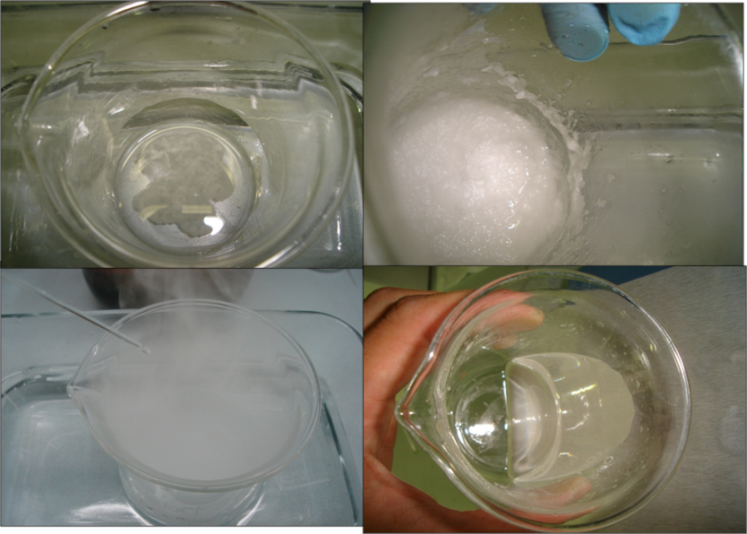
Figure 10.1: preparation of ionic liquid.

After preparation, the electrodes were examined by means of X-ray diffraction (PW 1710 Philips Diffractomer), and the surface composition was analyzed by an energy dispersion spectrometer (SEM/Eds Leo 50/50VP with a Gelmini column). Particularly, this analysis provides important information about the coating quality and presumable electrode service life.
The electrochemical measurements were carried out using a Voltalab (PGZ 301, Radiometer) potensiostato, with Pt as the counter-electrode, SCE as the reference electrode, and SnO₂-Sb₂O₅/Ti as the working electrode, in a 400 ml cell with NaClO₄ as the electrolyte solution (fig. 10.2). LSV scans were performed at 15 mVs⁻¹ .
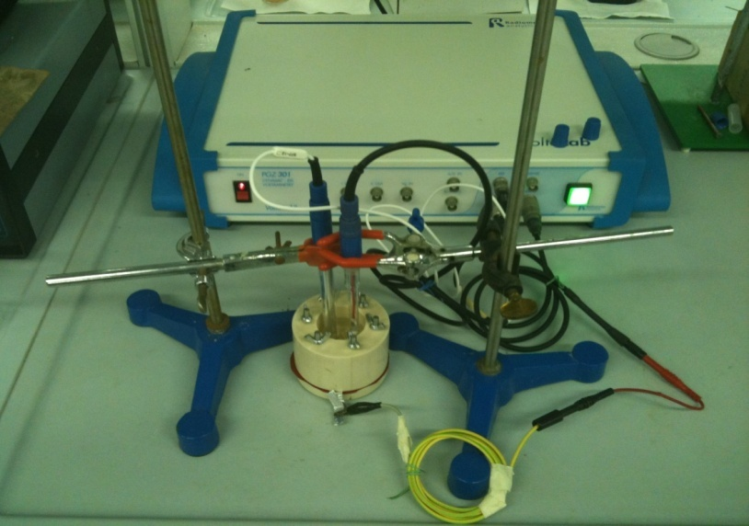
Figure 10.2: System for voltammetric tests.
  - Results and discussion.

The electrodes have been periodically weighed throughout the preparation and examined by different surface characterization techniques (SEM/EDS, XRD) and by voltammetric testing in order to evaluate the quality of the coating.

Electrode morphology.
From the SEM observations, an example of which is illustrated in figures 10.3 and 10.4, it is possible to see that the coating is homogeneous and compact, when the rate g/m² was higher. In fact, the films adhered well to the substrate, with few cracks located only in the most superficial SnO₂-Sb₂O₅ layers. These cracks were despaired with the increase rate g/m². This is a remarkable fact because the presence of cracks interesting the inner Ti-base may cause the oxidation to TiO₂, with a consequent increase of the electrode resistance, and a detrimental activity loss [19].

Table 10.2: w/w EDS traditional brush coating.
g/cm² | Sn [%] | Sb [%] | Ti [%]
10 | 27,93 | 2,47 | 69.61
20 | 76.24 | 4.86 | 18,9
40 | 76.24 | 6.12 | 16.58
60 | 89,35 | 8,31 | 2,34
80 | 91,21 | 7,32 | 1,47
100 | 93.51 | 6.01 | 0,48

Figure 10.3: sem tradiotional brush coating

In the case of electrodes made with ionic liquid solution, the first electrodes were more homogeneous than the other ones, It is product that in the last electrodes de calcinations process were carried out with less oxygen, interfering the oxidation process.
Table 10.3: EDS ionic liquid preparation
g/cm² | Sn [%] | Sb [%] | Ti [%]
10 | 42,7 | 1,78 | 28,35
20 | 47,21 | 2,07 | 23,64
40 | 77,16 | 1,33 | 0,94
60 | 73,55 | 2,59 | 2,95
80 | 63,01 | 1,58 | 11,15
100 | 76,86 | 2,21 | 0,67

Figure 10.4: Sem ionic liquid coating.
After, the electrodes fabricated by mean of typical brush coating, were exposed at 100 ma/cm² in 1M sulfuric acid solution during 4 hours and subsequently analyzed by SEM.
It observed that only the electrodes with 60 and 100 g/m² maintained the coating in good conditions. However, in the other ones were found almost pure Ti.

X–ray diffraction.
The coatings composition of the SnO₂-Sb₂O₅/Ti were analyzed by XRD: the graph in figure 10.5 y 10.6 show the diffraction spectrum of the final film obtained to different weights with the two different methods . In both cases, pure Ti and different weight coating were compared. It was possible find, other picks different to Ti. The nominal composition of the mix oxide was Sn_{0,918} Sb_{0,109} O₂ according to PDF (882348) and this mix oxide presented more defined picks to higher rate g/m². That is important because, Sb in the SnO₂ crystal increases the electrical conductivity and the catalytic efficiency of the electrode. However in the diffraction spectrum of the final film obtained by ionic liquid method were found other not identified picks, possibly associate at sulfuric compounds from liquid ionic.
It must be observed that the presence of Ti peaks in the spectrum depends on the penetration depth of XRD and is not in contrast with SEM observation indicating a quite homogeneous and compact coverage of the electrode surface.
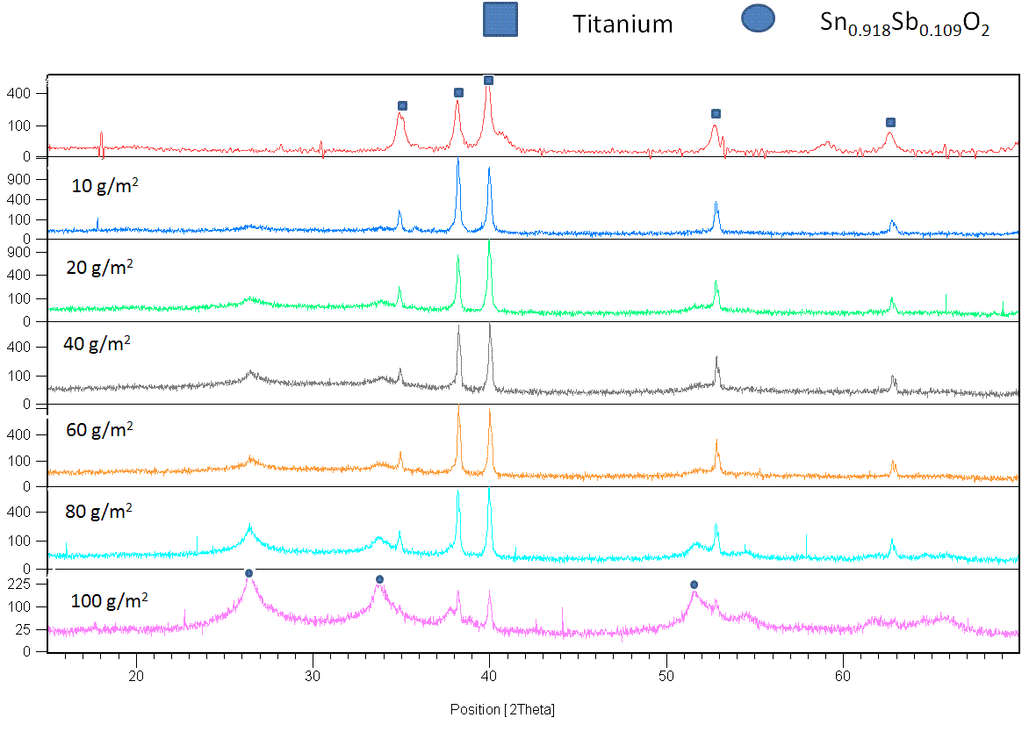
Figure 10.5: Traditional brush coating
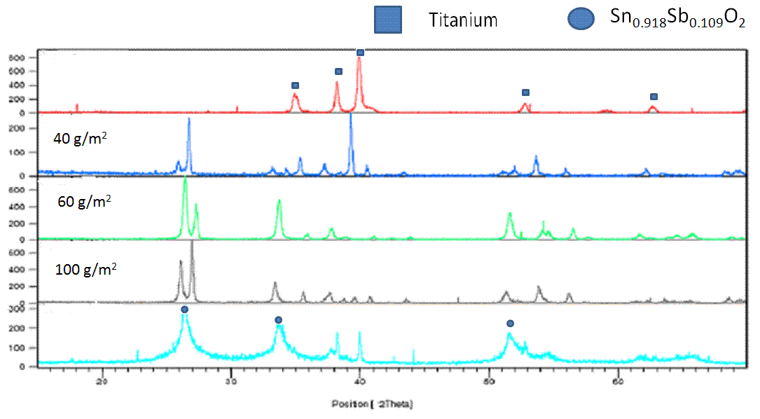
Figure 10.6: Liquid ionic coating.

Oxygen evolution overpotential.
Since the value of the oxygen evolution overpotential is a direct parameter of the oxidating power of the electrode, a series of linear sweep voltammetries in the anodic range, up to oxygen evolution, have been carried out with SnO₂-Sb₂O₅/Ti electrodes. For the purpose of this investigation LSV tests were performed with potential scan rate of 15 mVs⁻¹, in 1M Na₂SO₄ solution, at room temperature.
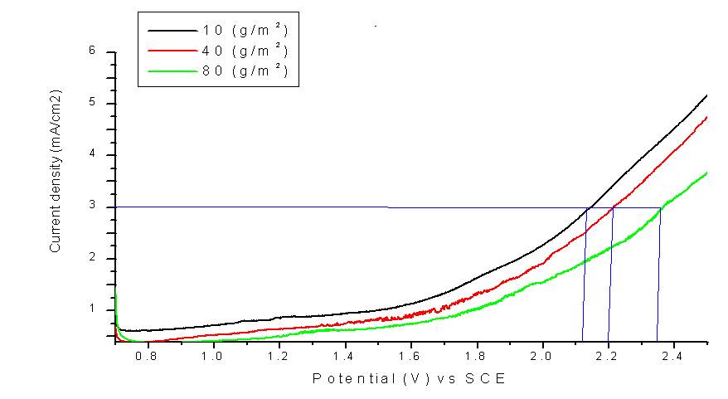
Figure 10.7: 15 mVs⁻¹, in 1M Na₂SO₄ solution, at room temperature.

Figure 10.7 shows the comparison of the behavior of different coating weights SnO₂-Sb₂O₅/Ti electrodes. For the Sb-doped SnO₂ electrode a value of the anodic potential at 3 mAcm⁻² of about 2.35 vs. SCE (i.e. 1.9 V vs. NHE) is found at 100 g/m², which provides, taking into account the solution pH, a value for the oxygen overpotential higher than 1.79 V and more than 1.5 in all other cases were found . This overpotential value is somewhat higher than similar data found in the literature, at the same current density, for this type of electrode, see e.g. [20] and is almost like BDD. (fig. 10. 8). This indicates that the procedure for the preparation of the Sb-doped SnO₂ electrode here presented, appears to be effective for the anodic oxidation of urea, due to high anodic potential that can be reached, generating large amounts of hydroxyl radicals.
Figure 10.8: BDD vs Sb doped SnO₂
  - Conclusions.
The electrode preparation by a brush coating and ionic liquid technique show that an optimal electrode characteristic were obtained over 60 g/m². SEM analysis indicated that the coating is homogeneous, compact, constituted of thin films well adhering to the substrate and with a very limited amount of superficial cracks which never involve the Ti substrate. The electrode conductivity and catalytic efficiency are improved due to the presence of Sb in the crystal of SnO₂. Furthermore, the voltammetric analysis indicated a rather high oxygen overpotential about 1.5 V, providing an optimal condition for urea treatment. Future work can be devoted to the implemention of liquid ionic technique for the electrode preparation in order to further increase the electrode life service

References.
[1] C. Comninellis, Electrochimica Acta 39 (1994) 1857.
[2] S. Stucki, R. KoÈ tz, B. Carter and W. Suter, ibid. 21 (1991) 99.
[3] Ch. Comninellis and C. Pulgarin, ibid. 23 (1993) 108.
[4] Ch. Comninellis, Electrochim. Acta 39 (1994) 1857.
[5] Ch. Comninellis and A. Nerini, J. Appl. Electrochem. 25 (1995) 23.
[6] Ch. Comninellis and A. De Battisti, J.Chim.Phys. 93 (1996) 673.
[7] B. Correa-Lozano, Ch. Comninellis and A. De Battisti, J. Appl. Electrochem. 26 (1996) 83.
[8] Comninellis, C. and Vercesi, G. P. J. Appl. Electrochem., 21, (1991), 136
[9] Chopra, K. L., Major, S. and Pandya, D. K. Thin Solid Films, 102(1), (1983), 1.
[10] Correa-Lozano, B., Comninellis, C. and De Battisri, A.. J. Electrochem. Soc., 143(1), (1996), 203.
[11] Correa-Lozano, B., Comninellis, C. and De Battisti, A. J. Appl. Electrochem., 27(8), (1997), 970.
[12] Lipp, L. and Pletcher, D. Electrochim. Acta, 42(7),(1997), 1091.
[13] Vicent, F., Morallon, E., Quijada, C., Vazquez, J. L., Aldaz, A. and Cases, F. J. Appl. Electrochem., 28(6), (1998), 607.
[14] R. Watts, M. Wyeth, D. Finn, A. Teel, J appl Electrochem 38,(2008), 31.
[15] K. L. Meaney, S. Omanovic, Mater Chem Phys 105 (2007) 143.
[16] X.Cui, G. Zhao, Y.Lei, H. Li, P. Li, M. Liu, Mater Chem Phys 113 (2009) 31
[17] J. Ribeiro, M. Moats, A. De Andrade, J appl Electrochem 38 (2008) 767.
[18] K.R. Seddon, J Chem Tech Biotechnol 68 (1997) 351-356.
[19] De Pauli, CP.; Trasatti, S. J. Electranal Chem. 396, (1995), 161.
[20] Alves, VA.; Da Silva, LA.; Boodts, JFC.; Trasatti, S. Electrochem acta 39, (1994), 1585.
[21] Onuchukwa, AI.; Trasarri, S., J. Appl. Electrochem. 21, (1991), 858.
[22] Vercesi, GP.; Rolewicz, J.; Comninellis, Ch. Thermochim Acta, 176, (1991),31.

