DOTTORATO DI RICERCA IN
SCIENZE CLINICHE

CICLO XXXVII

COORDINATORE Prof. Gian Maria Rossolini

Evidence Based evaluation of anatomical barrier quality in soft tissue sarcoma resections.

Settore Scientifico Disciplinare MED/33

Dottorando Tutore
Dott. Federico Sacchetti Prof. Domenico Andrea Campanacci



Coordinatore
Prof. Gian Maria Rossolini

_______________________________
(firma)

Summary
Soft tissue sarcomas. 3
Epidemiology 3
Risk, familial, hereditary factors 4
Histological classification 4
1. Neoplasms with adipocyte differentiation. 6
2. Neoplasms with fibroblastic/myofibroblastic differentiation 8
3. Neoplasms with "fibrohistiocyte" differentiation16 10
4. Smooth muscle differentiation neoplasms 10
5. Neoplasms with striated muscle differentiation 11
6. Neoplasms with vascular differentiation 12
7. Perivascular neoplasms 12
8. Chondro-osseous differentiation neoplasms 12
9. Neoplasms of uncertain differentiation 12
Diagnosis 14
Ultrasound 14
Computed Tomography 15
Magnetic Resonance Imaging 16
The biopsy. 18
Staging.
AJCC and UICC
The staging of Enneking 20
Treatment of soft tissue sarcomas
Limited local disease. 23
The chemotherapy approach in locally advanced disease 28
Metastatic disease 29
Follow Up in sarcomas of any site 30
Margins Quality and Quantity 39
Project 40
Methods 41
Results 44
Discussion 88
Conclusions 103

Soft tissue sarcomas.
Soft tissue sarcomas are a heterogeneous group of malignant neoplasms of mesenchymal origin. They can originate from muscle, tendon, synovial, fat or connective cells, more than 50 different subtypes are recognized, albeit with different incidence.

Epidemiology
Soft tissue sarcomas (STS) are very rare tumors representing about 1% of adult neoplasms with a global incidence of around 3-5 cases/100,000 inhabitants/year. In the USA there are about 8700 cases/year.
In Italy, in 2018, about 2100 new cases of malignant neoplasms of the soft tissues were observed, 1200 among men and 900 among women. STS usually affects more men (1 in 265) than women (1 in 452). In both sexes, the risk increases with increasing age. It also seems to be slightly more frequent in Northern Italy than in the Centre-South.
The incidence in relation to age shows a first peak in pediatric age, then a plateau and finally a rather constant upward trend with age starting from 20 years-old patients with a maximum peak after 60 years of age.
The different histological entities tend to occur with different incidence in relation to age. In children, infantile forms prevail (infantile fibrosarcoma and rhabdomyosarcoma), in adults the majority of diagnosed STS are non-small cell forms, which have significant variety in histological structure and are defined as adult-type soft tissue sarcomas.
Due to the uncertainties in diagnosis, however, the real prevalence of Soft tissue Sarcomas is frequently underestimated, however with all the difficulties to correctly categorize them, there’s a certain similarity in their prevalence and incidence across countries. ¹
Furthermore, despite accounting for 1% of malignant tumors in adulthood, these neoplasm are responsible for 2% of all cancer deaths, thus they are correctly considered in general to be very aggressive-entities.
Soft tissue tumors can occur anywhere; about 40% develop in the lower limbs, especially the thigh, 20% in the upper limbs, 10% in the head and neck and 30% in the trunk and retroperitoneum. ²

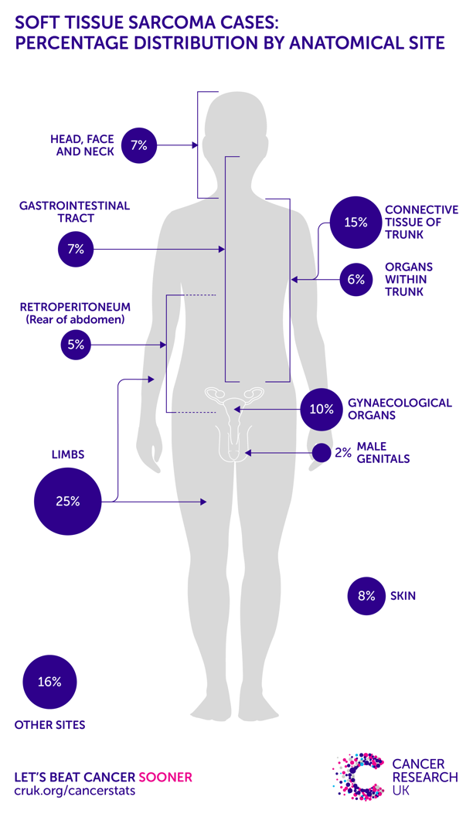
At 5 years, overall survival is only around 65% considering all subtypes and anatomical site affected, nevertheless from the 1980s there has been registered a decrease in mortality in STS of the extremities. This could be linked to a better understanding of limbs compartments and their role to perform more oncological safe excisions although the role of surgical margin in determining overall survival has been recently challenged ³
Figure 1. The percentage of presentation of soft tissue sarcomas based on anatomical site.

Risk, familial, hereditary factors
The etiology in most soft tissue tumors is idiopathic. However, there are documented associations with radiation therapy and rare cases where chemical burns, thermal burns, or trauma have been linked to the subsequent development of a sarcoma.
Environmental risk factors have also identified: exposure to Thorotrast, pesticides, arsenic, phenoxyherbicides, chlorophenols, dioxin, vinyl chloride, immunosuppressive drugs, alkylating agents, anabolic androgenic steroids. Moreover, Kaposi's sarcoma is considered to be caused by the human immunodeficiency virus HHV 8, however viruses are probably not a relevant cause in the genesis of sarcomas. ⁴
Most tumors have sporadic etiology, a small proportion are associated with genetic syndromes, among which the most important are: neurofibromatosis type 1 (for neurofibroma, malignant tumor of the peripheral nerve sheaths), familial adenomatous polypatosis (FAP), especially in the variant of Gardner's syndrome is correlated with the expression of desmoids, Li-Fraumeni syndrome (determined by a mutation in the suppressor gene p53) is associated with an increased risk for bone and soft tissue sarcomas.
In view of the rarity of STMs and the ubiquity of their manifestation, it is not possible to plan any screening of the population. On the other hand, it is possible to sensitize both the population and general practitioners to take into consideration large suspicious masses (generally over 5 cm), deep, rapidly growing or painful. In suspicion, it is important to refer patients to reference, tertiary centers for these diseases. ⁵

Histological classification
As already mentioned, the STMs being very diversified, a classification, complex and constantly updated, is more important than ever.
In general, however, the histological type does not provide sufficient information in prognostic terms, which is why it is important to also define the grade and stage of the tumor. ⁶
There is agreement on the recommendation that the pathological diagnosis of STM should contain the following information:
- Macroscopic description
- State of the margins, so as to allow the attribution of the surgery to the categories "radical", "wide", "marginal", "intralesional";
- Histotype according to WHO 2020
- Degree of malignancy when possible according to FNCLCC system ⁷

Currently, the most widely used malignancy classification system for soft tissue sarcomas in adults is the one referred to by the French Federation of Centers for the Fight Against Cancer (FNCLCC). This system provides for a classification of tumors into three grades, which is one of the most important prognostic factors of the tumor:
- Grade 1: Low grade
- Grade 2: Intermediate Grade
- Grade 3: High Grade
In 2002, the WHO recommended the FNCLCC scheme; this indication was maintained in the 2020 version. ⁸⁹
The WHO in 2020 suggested to define Soft Tissue Tumours in four categories according to their biological potential: benign, intermediate (locally aggressive), intermediate (rarely metastatizing) and malignant.
- Benign: they don’t easily recur and if recur they do in non-destructive fashion and can be easily re-excised. A benign tumour could give metastasis in exceedingly rare rates (<1/50000)
- Intermediate (locally aggressive): in this category there are many tumours that could easily recur locally even in destructive manner they metastasize very rarely and can be cured by wide surgical excision; an example may be desmoid fibromatosis.
- Intermediate (rarely metastasizing) Tumors with a metastasis rate of less than 2% that are also generally locally aggressive, such as plexiform fibrohistiocytic tumour.
- Malignant: tumours which carry a risk of distant metastasis (20-100%).

1. Neoplasms with adipocyte differentiation.
Liposarcomas are among the most frequent sarcomas of adulthood and occur on average between the ages of 40 and 70, while they are rather rare in children. They are mainly located in the deep soft tissues in the proximal portions of the limbs, in addition they can reach considerable size.
Liposarcoma is frequently associated with local recurrences (10%), however, in the absence of dedifferentiation it has no metastatic potential.
Mediastinum, retro-peritoeneal and para-testicular tumors are associated with high rates of local recurrence and histological de-differentiation; extremities deep seated liposarcoma are associated with mild risk of recurrence and low risk of de-differentiation while superficial seated tumours rarely recur or become dangerous. Generally, the tumor presents as a deep, indolent, slow-growing mass; however, it can reach a large size, especially in the retroperitoneum. Retroperitoneal lesions are often indolent until they reach 20 cm in diameter. Due to the anatomical location of these lesions, it is often difficult to obtain microscopically negative surgical margins; this explains the high percentage of local recurrences observed in well-differentiated liposarcomas ¹⁰
Among the liposarcomas we can distinguish:
- Atypical lipomatous tumor/well-differentiated liposarcoma which in turn can be divided into three subtypes, namely:
- Adipocytic (lipoma-like)
- Sclerosing
- Inflammatory
The adipocytic variant is characterized by well-differentiated and mature fat cells that present a considerable variability in cell size and shape, unlike what is found in lipomas. This subtype is also distinguished by the presence of lipoblasts with mono-vacuolar or multi-vacuolar cytoplasm and by the nuclear atypia of adipocytes and stromal cells.
The sclerosant has a peculiar characteristic, namely that it is given by the presence of bizarre stromal cells characterized by nuclear hyperchromasia and the presence of fibrous septa that often divide the tumor into irregular lobules.
The inflammatory variant is the rarest one of almost exclusively retroperitoneal relevance where it presents inflammatory infiltrates that simulate a reactive/inflammatory process and which, in some cases, can mask the adipocytic nature of the neoplasm. It is often difficult to distinguish a liposarcoma from a lipoma and from here we resume the discussion regarding the absolute importance of a correct diagnosis as well-differentiated liposarcoma shows local aggressive behavior and requires long-term follow-up. In addition, both cancers are treated surgically, but the type of surgery differs radically. Generally this variant is the most indolent, adipocytes are well recognizable microscopically and generally derive from an amplification of the MDM2 and CDK4 genes. ¹¹ 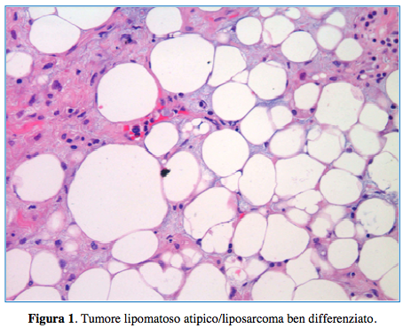
Prognosis
The main prognostic factor of liposarcoma is anatomical location. Lesions located in surgically treatable sites with adequate margins do not show local recurrence after complete resection,
Large, Well-differentiated liposarcomas are tumors that do not metastasize and for which the rate of local recurrence depends mainly on the site of the tumor.
For what has been said, we can therefore understand how a deep localization that is difficult to diagnose is closely correlated with a poorer prognosis. In tumors located deep in the soft parts such as the retroperitoneum, spermatic cord or mediastinum, they tend to recur repeatedly. In this position, the tumor tends to include vital structures, making complete surgical resection difficult or impossible.
The local recurrence rate for retroperitoneal tumors can reach 80%, distant metastases are observed in 30% of cases.
About a quarter of retroperitoneal lesions undergo dedifferentiation. This process took place manifests itself with the appearance of tumor areas without lipomatous features and which morphologically have the appearance of high-grade sarcomas, typically with spindle or pleomorphic cells This phenomenon is usually indicative of a worse prognosis due to the acquisition of a more aggressive local behavior and the ability to metastasize ¹²
The overall mortality for these tumors is between 0% for the well-differentiated liposarcoma of the extremities and 80% for the retroperitoneal sites in patients followed-up for 10-20 years. On average, in the second case, patients die after 6-11 years ¹⁰
- Dedifferentiated liposarcoma. The term dedifferentiated liposarcoma was coined by Evans in 1979 to describe a liposarcoma consisting of the coexistence of areas of well-differentiated liposarcoma and non-lipogenic sarcomatous areas consisting of spindle or pleomorphic cells with high mitotic activity. The peculiar morphological feature of this form of sarcoma is the transition from a well-differentiated liposarcoma to a non-lipogenic sarcoma which in most cases is high-grade.
This transition is usually sudden, but in some cases it is more gradual so that the two areas respectively at low grade and at high degree can coexist. Almost all retroperitoneal dedifferentiated liposarcoma recur locally, while all anatomical sites considered, the overall recurrence rate hits 40%. Furthermore 15-20% of the patients develop a distant metastasis while death rate is above 30% at 5 years. ¹³
- Myxoid liposarcoma they account for 20-30% of all liposarcoma, they are coupled with a 12-25% rate of local recurrences and a 30-60% rate of distant metastasis that usually progress slowly. Surprisingly, this histology metastasize more frequently on other soft tissue sites or to bone rather than to lungs.
- Pleomorphic liposarcoma , it is very aggressive and metastasizes frequently, even if they are adequately removed they are coupled by a high rate of local recurrences. ¹⁴
2. Neoplasms with fibroblastic/myofibroblastic differentiation
Fibrosarcomas can occur anywhere on the body, but they are most commonly found in deep soft tissues in extremities. These are aggressive tumors that recur in more than 50% of cases and metastasize in more than 25%. Some variants are: ¹⁴
- Desmoid fibromatosis
- Giant cell fibroblastoma
- Dermatofibrosarcoma protuberans: it is a slowly growing mesenchymal tumor with a very low metastatic potential and high long-term survival. The peculiarity of this tumor is however the subclinical ability of the tumor to extend and invade the surrounding structures with possible destruction of the peri-lesional anatomical structures and to cause functional impairment. Locally, therefore, it behaves like a very aggressive tumor with a high incidence of recurrences, and it often requires multiple surgeries.
This malignant neoplasm presents in most cases as a superficial mass located in the trunk with alteration of the overlying skin, although it can originate anywhere in the body.
The data in the literature also report that an MMS (Mohs Micrographic Surgery) surgical approach is preferable to a wide-margin excision as it is correlated with a lower rate of local recurrences. ¹⁵
- Dermatofibrosarcoma protuberans fibrosarcomatous
- Atypical fibroxanthoma
- Solitary fibrous tumor
- Inflammatory myofibroblastic tumor
- Low-grade myofibroblastic sarcoma
- Juvenile Fibrosarcoma
- Myxofibrosarcoma: Myxofibrosarcoma is a rare tumor with a very marked local aggressiveness and a 30%of recurrence rate, especially when excised without wide margins, the treatment involves a surgical excision of at least 2-3 cm wide with or without adjuvant therapy. It generally develops in the extremities and in patients over 50 years of age. Its metastatic potential is highly correlated with the histological grade, with high grade tumours metastasizing in 20-30% of patients.
- Inflammatory fibroblastic sarcoma
- Low-grade fibromyxoid sarcoma is a slow-growing tumor that frequently develops in a deep area, often presents as a circumscribed, soft mass, without bleeding, nodularity or infiltrated margins and for this reason it is often mistaken for a benign tumor. The incidence is estimated at 0.18 per million, thus representing 0.6% of all soft tissue sarcomas with a peak incidence in young adults, the average age is 34 years. Obviously, it is very difficult to distinguish it from other mesenchymal tumors for which it requires accurate pre-operative planning. The radiographic study plays a crucial role in both diagnosis and treatment, both CT and MRI can visualize the morphological characteristics of the lesion and the relationship with the lesions. MRI seems to be a more adequate technique than CT according to the few data in the literature, the fibrous component shows a low signal intensity in both the T1 and T2 sequences. The myxoid area, on the other hand, has a low T1 signal but intense T2. ¹⁶
- Sclerosing epithelioid sarcoma
3. Neoplasms with "fibrohistiocyte" differentiation
- Plexiform fibrohistiocyte tumor
- Giant cell tumor of the soft tissues
4. Smooth muscle differentiation neoplasms
Leiomyosarcoma accounts for about 10% of soft tissue sarcomas, arise in adults and affect women more frequently than men. They can occur in the skin, deep soft tissues, and retroperitoneum.
The prognosis depends strictly on the size, superficial or deep seated position, and histological grade. Generally leiomyosarcomas presents as small and superficial lesions, characterized by a good prognosis, conservative surgical treatment is thus sufficient. Histologically, they are characterized by atypical spindle cells with "cigar-like" nuclei and arranged in intertwined bundles ¹⁴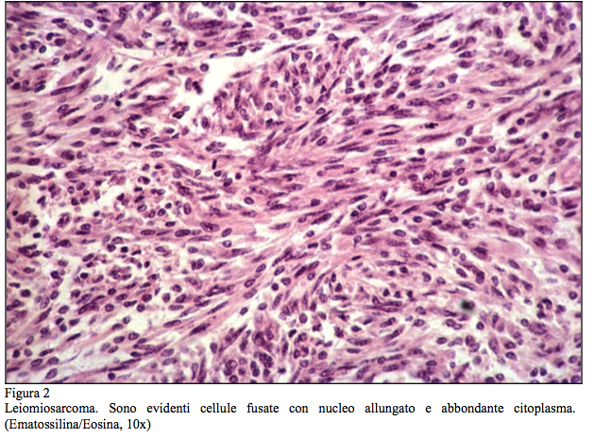
Metastases are infrequent and almost always pulmonary as they are hematogenic, few cases in the literature also report liver metastases, these are more frequently identifiable with CT with contrast medium. Periodic investigations of the chest and abdomen are necessary in the follow-up of patients who have undergone a resection of a leiomyosarcoma of the extremities. ¹⁷
5. Neoplasms with striated muscle differentiation
Rhabdomyosarcoma is the most common soft tissue sarcoma in childhood and adolescence and typically appears before the age of 20. It can arise in any anatomical district, but more frequently it can be located at the head and neck level or even in the genitourinary tract. They are often aggressive tumors that require surgery frequently associated with chemotherapy and/or radiotherapy. They can be divided into:
- Embryonic rhabdomyosarcoma: this is the most frequent type and accounts for 60% of all striated muscle forms. The peak incidence is at 10 years and is frequently caused by a mutation in the IGFII gene subject to imprinting. ¹⁸
- Alveolar rhabdomyosarcoma: it is more frequent in early and middle adolescence and mainly affects the deep portions of the limbs, accounting for 20% of all rhabdosarcomas. The cells are small and with poor cytoplasm, often have nuclear atypia.
- Pleomorphic Rabdomiosarcoma
- Spindle cell rhabdomyosarcoma/sclerosing rhabdomyosarcoma
6. Neoplasms with vascular differentiation
- Emangioendotelioma kaposiforme
- Emangioendotelioma retiforme
- Intralymphatic papillary angioendothelioma
- Composite hemangioendothelioma
- Kaposi's sarcoma
- Epithelioid emangioendothelioma
- Pseudomyogenic hemangioendothelioma
- Cutaneous Angiosarcoma
- Soft tissue angiosarcoma
7. Perivascular neoplasms
- Malignant glomic tumor
8. Chondro-osseous differentiation neoplasms
- Malignant tumor of peripheral nerve sheaths and variants
- Malignant granular cell tumor
- Sarcoma di Ewing/PNET
9. Neoplasms of uncertain differentiation
- Synovial sarcoma: among these, the most important and deserving of additional investigation is synovial sarcoma, which is the fourth most common among all soft tissue sarcomas, accounting for about 10% of all STS. It occurs mainly in the young population with a peak incidence between 20 and 50 years of age, 30% of them however arise in the population under 20 years of age. It is called synovial because it was once thought to derive from synovial tissue, but its cell of origin is still uncertain. It often develops in deep tissues and in 70% of cases it is localized at the level of the lower limbs, especially knee and thigh.
These tumors are aggressively treated with limb-preserving surgeries and often with radiation or chemotherapy. 5-year survival ranges from 25 to 62% and only 11-30% survive 10 years or more. The most frequent metastases are to the lung, skeleton and regional lymph nodes occasionally.
Most synovial sarcomas have a particular chromosomal translocation with the production of SS18-SSX1, SSX2, or SSX4 fusion genes, which encode chimeric transcription factors. ^{19(p46)}
Furthermore, for this tumor a delayed diagnosis is common, so it is often treated with unplanned surgery, the most common presentation is a mass that grows gradually associated or not with pain, survival in the pediatric population is estimated to be between 75-84% which is better than that of the adult population which stands between 25 and 71%.
Based on morphology, it can be divided into two subgroups: biphasic and monophasic. Prognostic factors are still being studied; however, it has been identified that tumor stage, male gender, trunk location, size and grade are correlated with a worse outcome.
Therapy is strictly surgical with adequate margins followed by adequate polychemotherapy with or without radiation therapy: while the role of radiotherapy has been confirmed to be correlated with a lower risk of local recurrence, the role of chemotherapy is still controversial. Adjuvant therapy is strongly indicated if initial surgery has not been adequate.
The trend towards local recurrence and late metastasis of synovial sarcoma is well known and reflects the marked difference between medium and long-term survival. However, being a very rare disease, studies are still few and not randomized, the largest study that has been reported to date is that of Guadagnolo et al. which analyzes an average of 13.2 years of follow-up in a cohort of patients between 2 and 37 years of age of which 90% are pediatric, According to this study, a follow-up over time for at least 10 years is an essential safeguard for the early diagnosis of recurrence and improvement in the life expectancy of these patients. ²⁰
- Hyalinizing angiectatic tumor of the soft parts
- Angiomatoid fibrous histiocytoma
- Fibromyxoid tumor ossificating
- Mioepithelioma
- Phosphaturic mesenchymal tumor
- Sarcoma epitelioide
- Alveolar sarcoma of the soft parts
- Clear cell sarcoma ¹⁴ ²¹²²¹⁰

Diagnosis
STMs most often present as asymptomatic masses in extremities, however they can be located anywhere, including the trunk and retroperitoneum.
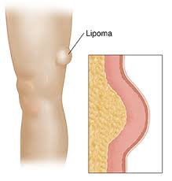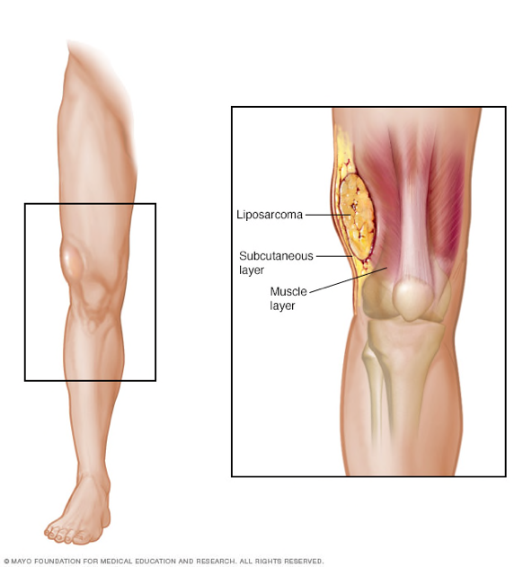
Figure 1. On the left a benign lesion, on the right a malignant lesion. Clinically they are completely indistinguishable from each other.
These findings are very frequent in clinical practice and completely non-specific. In most cases, these are benign lesions that do not threaten the survival of patients. In a minority of cases, however, they can be an expression of a malignant neoplasm, which is usually coupled with a poor prognosis, since these lesions can locally attack the anatomical site from which they originate or even metastasize at a distance. Precisely for this reason, a correct diagnostic procedure is more necessary than ever.
A precise radiological diagnostic workflow and a pathological diagnostic obtained generally with an needle biopsy are recommended when there is evidence of a superficial mass with a diameter greater than 5 cm, a deep mass of any size, a rapidly growing lesion or associated with pain as they are strongly suspected of malignancy. ²³
The definitive diagnosis is made with the anatomopathological study of the lesion; however, a correct characterization of the tumor is necessary; a staging of the cancer must be completed before taking a decision about how to manage it.

Echography
Ultrasound as a first-level instrumental technique allows to measure the size of the mass, evaluate the relationships with the surrounding structures, the morphology, the margins (regular, irregular, presence or absence of capsule) and the solid and liquid component and vascularization by power-doppler. The ultrasound investigation can be completed with a study with contrast medium. to distinguish areas of neo-vascularization from necrotic, mucoid or fibro-scarring areas and to select the tissue areas on which to carry out biopsy sampling. ²⁴
Ultrasound, however, has a very low specificity, it can be useful for example in identifying a benign lesion such as a Baker's cyst, a ganglioma, an angioma, lipoma or ossifying myositis, it is a "real time" technique that can be performed easily without movement artifacts, and this is very important especially in children. Furthermore, being dynamic, it can be used in the differential diagnosis of some pathologies such as an STM compared to a muscle hernia. Elastosonography is the new frontier of ultrasonography and can assess the degree of elasticity of a mass with respect to the surrounding tissue or evaluate, for example, the compression of its structures. Finally, ultrasound also plays a very important role in guiding the subsequent biopsy, which we remember is a fundamental step in diagnosis. ²⁵

Computed tomography
As a second level, CT without contrast medium, is a very fast and accurate method, allowing to evaluate with good definition the anatomical compartment involved and the relationship that the mass has with the surrounding structures. The study on the axial plane integrated with multiplanar reconstructions allows to establish exactly the dimensions, the location with respect to the surgical landmarks and the relationships with the vascular-nervous bundle. In addition to this, it can give very useful information on the presence of components such as fat or calcifications, the extent of vascularization and is excellent in evaluating the relationships with the adjacent bone for deep masses. ²⁶
Both ultrasound and CT are very important for diagnosis, but today they are overshadowed by MRI ²⁷. CT Scan are useful when there’s a doubt about osseous involvement or invasion by the tumour.

Magnetic Resonance Imaging

The growing role of Magnetic Resonance Imaging
Magnetic Resonance Imaging is a technique that in recent years has been taking on an increasingly important role in the diagnosis of soft tissue sarcomas, both in pre-operative planning and in follow-up. MRI by virtue of the greater contrast resolution, is preferable in the study of structures such as nerves and vessels. It also has extreme accuracy in assessing size, relationships with surrounding structures, contours, the presence of pseudocapsule and peritumoral edema. With contrast medium, in both static and dynamic mode, it can give very useful information on the benign or malignant nature of the lesion.
The increasing use of magnetic resonance imaging in recent years has led the latter to be the method of choice in the loco-regional study of the disease.

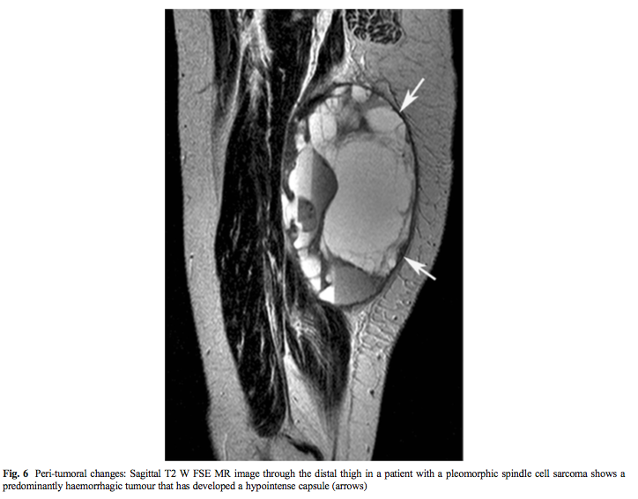
Figure 2. T2-weighted sagittal MRI of a pleomorphic sarcoma of the distal thigh, the presence of hemorrhage and the hypointense perilesional capsule can be identified.
For staging purposes, it is also essential to integrate with a chest CT study, with or without contrast medium, as the lungs are the most frequent site of metastasis. ²⁸²⁹
The technique involves positioning the patient as comfortably as possible to minimize the movements and artifacts that could result, with the isocenter of the magnet centered on the lesion.
It is possible for smaller lesions to reduce the field of view to obtain sharper images of the tumor.
The MRI must necessarily precede the biopsy, not only because the latter could alter the characteristics of the lesion but also to assess whether the biopsy itself and the technique with which to perform it will be necessary. In fact, in some cases it is possible to have an accurate diagnosis of a wide variety of benign neoplasms or non-neoplastic soft tissue lesions, including lipomas, vascular malformations, nerve tumors, ganglia, hematomas, ossifying myositis, necrosis of adipose tissue, etc. That said, obviously most pathologies do not have characteristics such as to diagnose them exclusively with resonance, some more important parameters that can increase the suspicion of malignancy are for example the size (>3.3 cm), inhomogeneity, irregular margins, areas of intra-tumor necrosis, but in any case a histological characterization will be essential.³⁰

The role of MRI in radicalizations.
Following Unplanned Surgery, it would be optimal to identify the presence of residual tumor tissue with appropriate imaging techniques to predict the recurrence of the disease. In the postoperative period this is practically impossible as the presence of residual tissue would be masked by reactive inflammatory tissue completely indistinguishable from the first, for this reason the MRI technique could only be useful as a pre-operative investigation of a radicalization.
Also, in this case there are conflicting opinions: the studies conducted by Kaste et al. They report how an MRI is unreliable for identifying the need for radicalization intervention. Siebenrock et al. report that there are no significant differences in terms of prediction of residual tumor mass. James et al affirm the usefulness of magnetic resonance imaging in identifying the presence of portions of residual sarcoma adjacent to neuro-vascular structures without however demonstrating the presence of microscopic residues.
The largest study on this topic was carried out by Denver et al. Analyzing a cohort of 111 patients, they report a PPV of 93% in the use of MRI and an NPV of 63%. In conclusion, according to this study, the usefulness of MRI before an operation could allow an adequate identification of the location of the tumor residue and the extent of the recission to be performed. ³¹
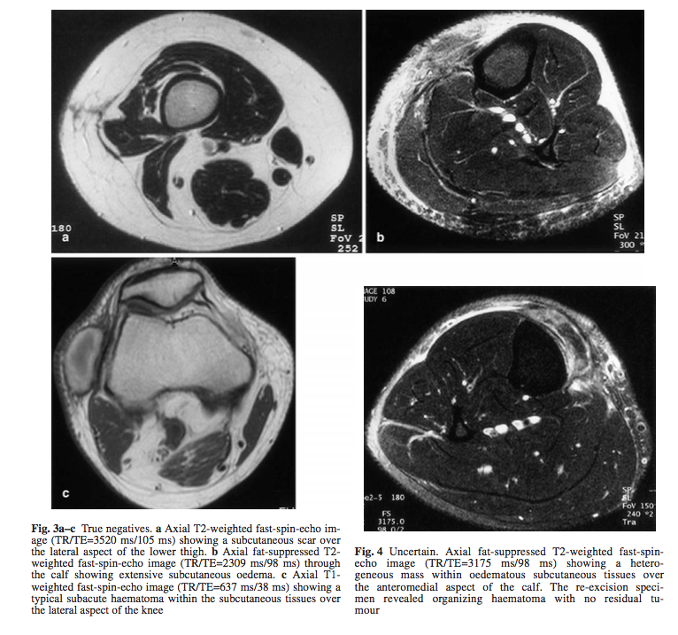
Figure 3. Axial MRIs after Unplanned excision of Sarcomas.

The analysis by Amandine Crombe et al. highlights important results on the prediction of the efficacy of a neo-adjuvant chemotherapy treatment in locally advanced sarcomas. According to this analysis, in fact, using diffusion sequences, with MRI it would be possible to assess the presence of peri-lesional edema to the tumor, the extent of which seems to be directly correlated with the effectiveness of chemotherapy treatment and with the elimination of satellite tumor tissue around the margins of the neoplasm itself. This data could be fundamental to predict the outcome of the therapeutic approach by directing towards a subsequent extensive surgery and possibly modifying the neo-adjuvant scheme. This approach also makes it possible to predict DFS (Disease Free Survival) ³²

The biopsy.
The histological demonstration of a soft tissue sarcoma can make use of numerous instruments, the choice depends on several factors: site and type of the lesion, experience of the surgeon, radiologist, and pathologist.

- Cytological examination by needle aspiration.
- Biopsy with a shearing needle, this method is now identified as the procedure of choice in most STMs of the extremities whatever the site as long as it is reachable ³³ ;
- Incisional biopsy, used in most cases for the trunk and limbs, this method must be performed possibly in the same center where the surgical resection will then be performed. This is often perfomed when a needle biopsy cannot be executed or when a first needle biopsy couldn’t deliver a diagnosis.
- Excisional biopsy to be used in very selected cases and adequately staged previously; usually when at pre-operative MRI there are clear sign of a benign neoplasm or when a small/superficial lesion could be excised with safe wide margins without morbidity.

Fine-needle aspiration has exclusively cytological but not cyto-architectural evaluation, which is why it has limited use in most other countries and is used above all in the suspicion of any recurrence, where the definition of malignancy and not histotype is sufficient to proceed with subsequent treatments.
Biopsy with a cutting needle is currently the main method of diagnosis. This means retains the advantages of limited invasiveness and can also be performed on an outpatient basis very simply, as for fine needle biopsy. In this case, an extensive frustule of tissue is taken and obviously has greater diagnostic accuracy.
The disadvantages are that it can be subject to contamination of the structures surrounding the tumor for this reason it requires an expert operator; the underestimation of the degree of aggressiveness of the disease and the possibility that the sampling involves necrotic parts of the tumor, which are not representative for reaching the diagnosis. Integrating radiological images with the histological result can add useful information. The shearing needle biopsy is now considered the procedure of choice in most cases of STMs of the extremities, whatever the location, if it is reachable.
In the case of large masses, it may also be useful to take multiple samples to have a greater probability of an exact diagnosis.
Incisional biopsy can be used whenever not enough information is obtained from needle biopsy, but only for the shapes of the limbs and superficial trunk. It should be banned for retroperitoneal and intra-cavitary forms in general, given the risk of non-recoverable contamination. It is important that this procedure is carried out in the same Centre that will then carry out the definitive surgical resection. It is also essential that the dictates of oncological surgery are respected, to avoid the risk of contaminating the surrounding tissues and affecting the local control of the disease.
The definition of excisional biopsy is sometimes applied to operations for the removal of lesions of the soft parts, in the absence of a prior pathological diagnosis; it is not a method to be recommended, even if it can be accepted for small superficial forms, always preceded by adequate iconography.
Intraoperative assessment in the freezer, on the other hand, should not be considered reliable for planning an appropriate intervention. ³⁴

Staging
TNM Staging as follows.

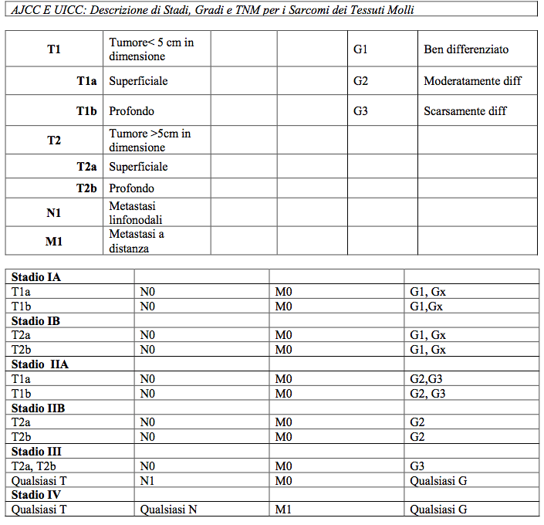³⁷

The staging of Enneking
Another staging system is the one proposed by Enneking in 1980. It is based on some considerations according to which a systemic surgical staging for sarcomas should:
- Incorporate the most important prognostic factors in order to catalog patients on the basis of the risk of disease progression and mortality they present.
- Delineate the stage of the disease so that it has implications for surgical management
- Indicate whether or not adjuvant treatment is necessary.
Based on decades of experience, the most logical systemic staging for sarcomas should include grade (G), disease extent (T), and the presence or absence of regional or distant metastases (M).
Grading.
According to this system, lesions are identified as:
- G0: These are benign tumors
- G1: These are low-grade sarcomas. These are treated with relatively more conservative approaches. They generally have a low number of mitosis and moderate cytological atypia, the clinical course is often indolent.
- G2: These are high-grade sarcomas. These require a more aggressive approach in order to achieve oncological radicality and local control. They are those correlated with a higher incidence of metastasis and are characterized by low differentiation, high mitotic index, necrosis and vascular invasion. Clinically they are also more active and tend to have a more rapid and invasive growth.
Based on the aggressiveness of the tumor, it is therefore possible to evaluate the type of margins that need to be obtained in order to have a definitive local control.

Extent of the pathology.
While the histological grade gives information about the surgical margins, the anatomical extent of the tumor indicates how the surgery should be performed.
In the approach to sarcomas of the extremities and crawler girdles, until the 80s, amputations exceeded 20%. With the introduction of the compartment concept, the strategy has changed, thus obtaining more conservative surgeries.
By anatomical compartment we mean an area delimited by structures that act as "barriers" for the invasion of neoplastic cells or the shedding of tumor microsatellites. These structures are the muscle fasciae, tendons, the adventitious layer of the vessels, the periosteum, the perineurium and the synovial membranes. Tumors that are located within these anatomical lodges are intracompartmental (A), if they involve or cross barriers, they are extracompartmental (B). See table.
Ennking's classification classifies the different cancers into:
- T0: these are benign tumors surrounded by a real capsule of fibrous tissue or bone.
- T1: represents a tumor that invades the surrounding pseudocapsule but remains within the anatomical compartment in which it formed.
- T2: is an extracompartmental tumor or a tumor that has extended beyond the anatomical barriers that delimit the compartment of origin. Both situations can result either from a spontaneous growth of an aggressive neoplasm, or from trauma (e.g. a fracture), or from iatrogenic causes (such as a biopsy, intralesional or marginal excisions).
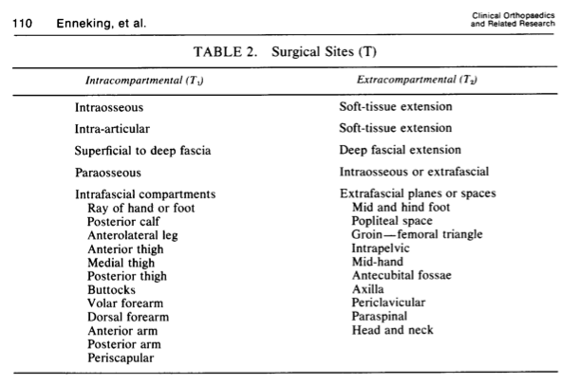
Table 1. Surgical sites according to Enneking.

A proper distinction between intra- and extracompartmental disease requires an appropriate combination of medical history, physical examination, angiography, CT scan, and other specialized studies.

Presence or absence of Metastases.
The presence of metastases is the third most important factor related to operative planning. In sarcomas, the most frequent route of spread is hematogenous and the organ most affected by all is the lung. Rarer, on the other hand, is lymph node involvement, which still has the same prognostic significance. Metastatic disease indicates a failure of local control and is closely correlated with a very reduced life expectancy.
Based on what is considered, the staging according to Enneking is as follows. ³⁸

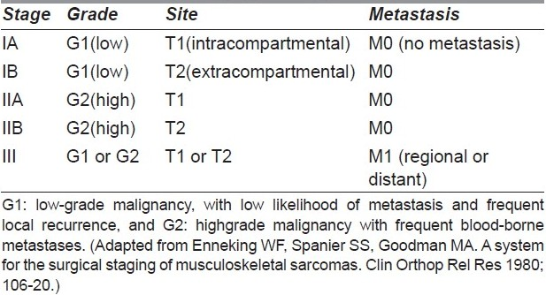
Table 2. The staging of Enneking.

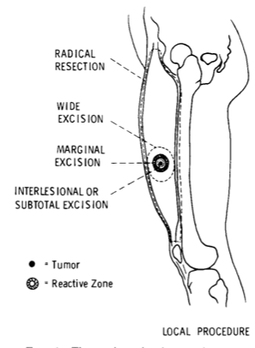

Figure 4. Surgical margins according to Enneking.

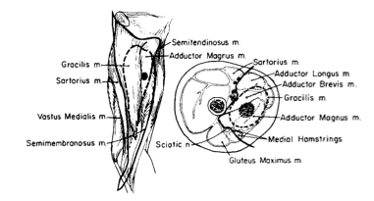
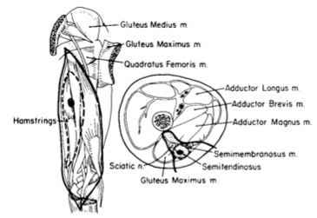

Figure 5. Theoretic Examples of wide and radical STS excisions according to Enneking Classification.

Treatment of soft tissue sarcomas
The treatment of soft tissue sarcomas is very complex and requires a multidisciplinary approach involving several specialists.
Therapy is multimodal and includes surgery, radiotherapy, and chemotherapy. It also often requires soft tissue reconstructive time with plastic surgery.
The choice of therapeutic approach depends on numerous factors including the histotype, grade, stage and location of the tumour, as well as the age and general condition of the patient. ⁹

It is possible to divide STMs into three different groups, which obviously provide different therapeutic strategies
- Limited local disease
- Locally advanced disease
- Metastatic disease

Based on this subdivision, therefore, we can understand how the size of the tissue removed has no implications regarding the type of surgery. Depending on the anatomical site, in fact, even an excision of just 2 cm can be radical if it completely removes an anatomical compartment (this is especially true for sarcomas that develop in the foot and hand).
This depend on the different soft tissue quality as barriers, however there’s never been a single published study that could give quantitative evidence about that topic.

Despite numerous studies on the subject, it is still widely debated whether the modality of intervention impacts on the patient's survival and whether the presence of macroscopic or microscopic positive margins following excision is a negative prognostic factor in terms of survival. However, many studies have shown that negative margins not only control the disease locally but are also associated with increased survival. ⁴⁴

Adjuvant Therapies

Radiotherapy
The aim of the radiotherapy approach is the local control of the disease, which has been confirmed to have an excellent efficacy of around 95%, however, studies are still unable to confirm whether this also has a positive impact in terms of long-term survival. ⁴⁵
It is important to define, however, that it is never a remedy for inadequate surgery, it should therefore only be used as a completion of oncological correct surgery. An unplanned intralesional or marginal intervention cannot be remedied, adjuvant therapy and must absolutely be radicalized at specialist reference centers.
In the case of radical or compartmental treatment, adjuvant radiotherapy may be omitted. If the surgery is extensive, on the other hand, radiotherapy is indicated if the sarcoma is intermediate or high grade in the limbs or in the superficial trunk, if the neoplasm is deep or larger than 5 cm. If the tumor is low-grade, however, it does not represent a standard of care and must be discussed by expert opinions. ⁴⁶

Recently, neoadjuvant radiotherapy, i.e. pre-operative, has also been introduced as a therapeutic strategy. This approach can lead to better local control and easier operability.
Preoperative radiotherapy has the following advantages: fewer doses to be delivered (50 Gy instead of 60, useful especially in young patients who would have a more significant risk of long-term complications); less volume of the field to be irradiated compared to the postoperative period; direct verification of the effectiveness of radiotherapy on the disease; fewer problems in wound healing.
To date, however, there are still no randomized trials that define which of the two approaches is better, hence the importance of the multidisciplinary approach and expert opinions. ⁴⁷
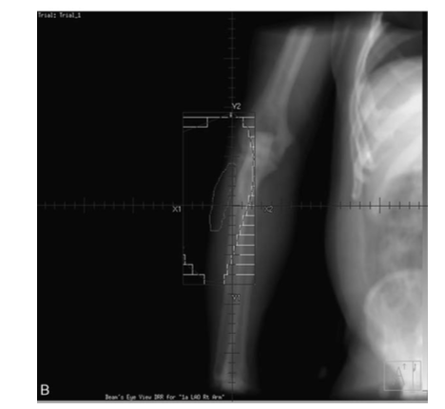
Figure 6. Radiotherapy irradiation field.
It is therefore indicated above all in cases where it is not possible to use conservative surgery, for large lesions or for critical locations such as near vessels or nerves, however it is associated with greater post-operative morbidity: 35% of complications such as wound dehiscence, delayed healing, infections, compared to 17% of post-operative surgery. To date, however, complication rates have decreased thanks to modern techniques. Conversely, there is a risk of higher late toxicity such as subcutaneous fibrosis, joint stiffness and bone fractures in the post-operative period and even a risk of subsequent post-irradiation malignancy. ^{48,49}

Brachytherapy
In STMs, brachytherapy can also be used as a therapeutic option in particular clinical settings, for example by delivering an additional dosage to a small area of tissue at greater risk of recurrence, or if the presence of microscopic residual tissue is expected.
Unlike external beam radiotherapy, it places the radioactive source inside or near the area to be treated, irradiation in this way affects only the tissues closest to the lesion, reducing the likelihood of unnecessary damage to the surrounding tissues. In addition to this, the advantage is also that the patient can go to the hospital less frequently as this approach is practiced on an outpatient basis, making it more accessible and convenient. ⁵⁰

Chemotherapy
Chemotherapy, like radiation therapy, is not a substitute for inadequate surgery. It uses a small number of drugs, mainly anthracyclines and ifosfamide and supported by hematopoietic growth factors.
However, the studies do not demonstrate an appreciable benefit from the use of this technique, even though this issue has been the subject of discussion for more than 30 years: while in the 80s, however, the case histories were scarce and did not take into account the enormous histological variability of tumors, the most consistent studies have been conducted since the 90s with greater uniformity of selection criteria.
Two published meta-analyses show a modest advantage induced by adjuvant chemotherapy with doxorubicin on disease-free survival (7%) and overall survival (4% at 10 years) ⁵¹ ⁵², others, however, have contrary results, confirming the ineffectiveness of the therapy.
As for neoadjuvant chemotherapy, this generally uses an anthracycline (driamycin or epirubicin) with ifosfamide.
In recent years, considerations related to tumor histotype have become increasingly important in pre-therapeutic planning to assess whether actually undertaking a chemotherapy approach is positive in terms of probability of response. Some histotypes seem to respond better to pharmacological treatment than others, in this way we try to personalize the therapy as much as possible soon.
The preoperative approach has a double meaning: the first is that of downsizing the disease, i.e. reduction of the tumor volume for cytoreductive purposes; the second is to facilitate conservative intervention by sterilizing the metastatic foci responsible for distant recurrences. Some studies report that the response rate is between 30 and 40% but a more conservative intervention than planned is achievable in only 20% of cases. ⁵³

The chemotherapy approach in locally advanced disease
Locally advanced disease is defined as the condition in which there is no distant metastasis, but the tumor cannot be treated surgically or, when possible, requires demolition surgery. The approaches in the two cases are different:
- In the former, cytoreductive surgery (or chemo or radiotherapy) is necessary to make the disease technically operable.
- In the second, in turn, it is possible to approach with direct demolition surgery that eradicates the disease in a good percentage of cases or start with a cytoreductive approach to carry out surgery as conservative as possible. There are no studies that confirm which is the best in terms of quality of life and survival, considering that amputation has very different repercussions depending on the site concerned.
Two large studies were conducted by Gronchi et al. With the aim of evaluating which is the best chemotherapy approach.
They report that in the population of patients with high-risk sarcomas localizations, the use of three cycles of neoadjuvant chemotherapy is not inferior in efficacy compared to the use of five cycles, the data also suggest that a standard chemotherapeutic approach does not have a lower efficacy than a personalized chemotherapy on individual histotypes. ^{54,55}

Metastatic disease
The most frequent metastases of STMs are to the lung, comprising about 20% of patients diagnosed with sarcoma, the second most frequent are to the liver and bones ⁵⁶. Lung metastases do not represent an absolute contraindication to surgery, in fact surgical removal is recommended if there is a number of metastases equal to or less than 5, in fact there is no scientific evidence that adjuvant chemotherapy can improve patient survival.
The 10-year survival of patients undergoing total metastatectomy is 16%, moreover, a free interval of more than one year between the resection of the primary tumor and the appearance of metastases seem to be a positive prognostic factor.
On the contrary, partial metastatectomy or surgery in the presence of concurrent extra-pulmonary metastatic disease does not provide demonstrable benefits to patients. ^{57,58}
When the disease is inoperable, it has a poor prognosis, with a median survival from when diagnosis is made of 10-12 months. First-line treatment includes drugs such as ifosfamide or decarbazine for palliative purposes only, with response rates of 20% but with a delay in progression of only 3-4 months, thus not having significant repercussions on patients' life expectancy.
Polychemotherapy has a higher efficacy but is not statistically significant.
For some years, even in metastatic disease, histotype-oriented chemotherapy has been concretely evaluated.
The Adriamycin + Decarbazine or Gemcitabine + Taxotere scheme are options in case of leiomyosarcoma or undifferentiated pleomorphic sarcoma, these are the two histological types where Ifosfamide seems to be less effective. ⁵⁹
In 2017, the combination of the drug Olaratumab (anti-PDGFRA) with doxorubicin was introduced as the first line of treatment in metastatic disease, which led to an improvement in survival compared to mono-chemotherapy with doxorubicin.
In general, all patients with metastatic sarcoma can benefit from adhering to experimental protocols that use drugs that are otherwise not available, but to date they are considered off label. ⁶⁰

Follow Up in Sarcomas of Any Site
The purpose of follow-up, i.e. subjecting the patient to periodic clinical and instrumental checks, is to promptly diagnose a local recurrence or metastasis in a patient who has been previously treated, in order to intervene as soon as possible. The other purpose is to evaluate any complications that have arisen because of the surgery performed. All this to improve the patient's survival and quality of life.
Since some studies show that the risk of relapse is highest between two and three years after surgery in high-grade tumors, and later in low-grade tumors, even if it varies according to the adjuvant approach used, currently the scheme is as follows:
- In high-grade pathologies, check-ups are carried out every 3 months in the first 2 years, every 6 months up to the fifth year and after this time the check-ups become annual
- In low-grade diseases, on the other hand, check-ups are every 4-6 months in the first 5 years and annually up to the tenth year, after which the patient is excluded from the control plan.
It is important to point out that there are few studies on the subject, so this timing is based on the consensus of some experts. ⁶¹
The methods used are for local recurrences, clinical control supported by ultrasound and/or MRI.
For chest X-ray metastases and in case of doubt also CT, according to some in high-grade forms CT would be necessary every 3 months regardless of the X-ray. ⁶²

Re-excisions.
Difference between planned and unplanned excision.
Soft tissue sarcomas, due to their sneaky nature both from an epidemiological and clinical point of view, are mistakenly mistaken for benign lesions and treated, consequently, as such.
Benign lesions are far more frequent in medical practice, with a ratio of 300:1 compared to malignant ones, require a less complex diagnostic and therapeutic approach and are characterized with a better prognosis. An inadequate surgical approach to a malignant tumor such as intralesional or marginal tumour excision does not guarantee oncological radicality, so the patient will necessarily have to undergo a further operation to perfect the surgical margins of the first surgery and remove the possible residual tumor. The very first therapeutic approach to a sarcoma could, if wrong, influence the final oncological outcome. ⁶³
The term "Unplanned Excision" was coined by Giuliano and Eilbert in 1985 to indicate the removal of the neoplastic mass in the absence of an accurate preoperative diagnostic procedure or without adequate margins of healthy tissue. This approach is oncologically inadequate and numerous studies report that it is correlated with a worse overall survival 6⁴. People who have undergone an unplanned operation represent between 14.7 and 53% of the new diagnoses of soft tissue sarcoma in specialized centers, it has also been reported that between 35-74% of these have residual neoplastic material identifiable on histological examination after re-excision. Inadequate biopsy sampling can also be a cause of UE. Sometimes, a falsely benign result after a needle biopsy could lead to an unappropriated excision of what it reveal to be a malignant STS. Mankin et al. report a biopsy diagnostic error of approximately 17.8% in a study of 597 patients. The most relevant data that emerges from this study is that a hasty biopsy is attributed to 16% of unnecessary amputations (when a falsely malignant STS reveal to be a benign neoplasm) and 10% of mortality.⁶⁵

On the contrary, a "Planned Excision" is an approach that follows an appropriate staging both local and systemic with the aid of Magnetic Resonance Imaging, chest X-ray and tissue biopsy, which are necessary for a correct pre-operative classification, as has been carefully defined by a group of sarcoma specialists.
It is important to point out, however, that literature around UE and PE contain controversial data with studies which point out to diametrically opposite directions. In fact, a good part of the studies claim that there are no significant differences between the two approaches, or even in some cases that UE has a better prognostic impact than an ED.
The reason could be sought in the fact that tumors that have undergone a planned operation are those that have more aggressive oncological characteristics and therefore with strong suspicions of malignancy. In fact, these tumors are on average larger, deeper, with faster growth and in some cases painful and infiltrating. Therefore, although the initial diagnostic and therapeutic approach is adequate, they often recur and more frequently give distant metastases. ⁶⁵ ⁶⁶
On the other hand, UE are usually linked to smaller and more superficial tumours that are naturally linked to better survival that, after a re-excision could remain the same, often at cost of adjunctive plastic surgery to fill tissue gaps created after re-excisions.

Management of a sarcoma after diagnosis

Following inadequate excision with a diagnosis of sarcoma, a re-excision of the previous surgical scar and tumour bed must be generally done.
Before surgery, a clinical assessment of the patient, an MRI study of the tumor bed and a chest CT scan to assess the possible presence of metastases will be essential, however excluding the presence of a tumour residual a priori if there is tumor residual is still impossible.
Re-excision surgery should possibly have all negative margins in histological specimens of at least 1 cm. ⁶⁷
According to a study conducted by Lewis et al., patients who underwent repeated re-excisions compared to those who had a single re-excision had a better survival.⁶⁸
Studies conducted on patients who have undergone only adjuvant radiotherapy treatment in the absence of unplanned surgery show recurrence rates at 50%.
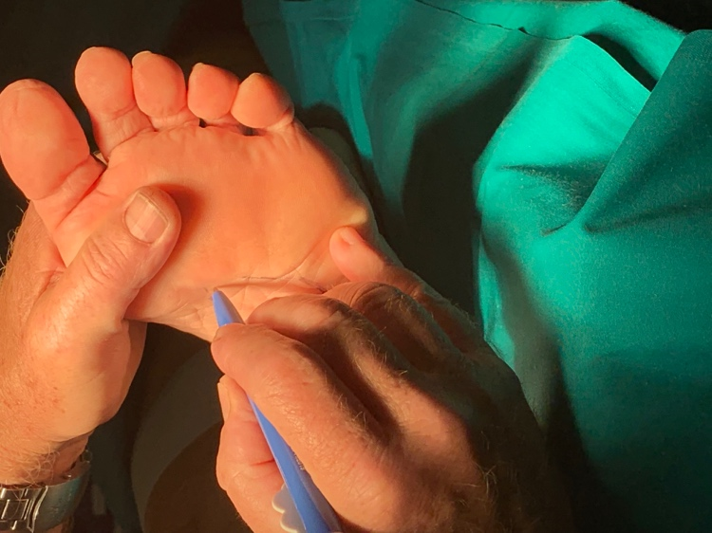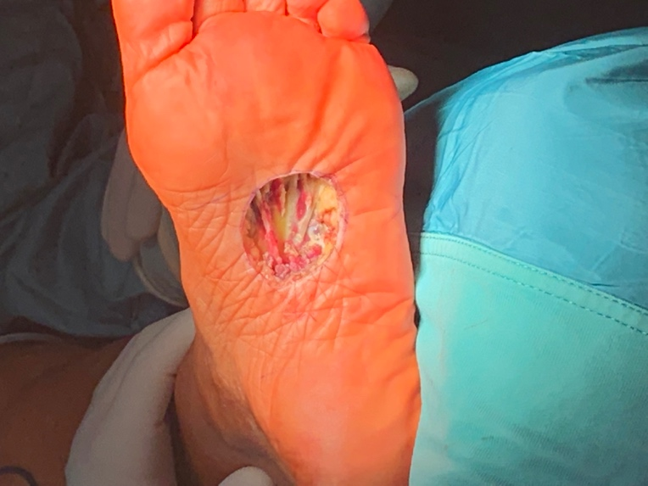
Figure 7. Clinical case of a patient radicalized after an Unplanned Excision, performed in a peripheral hospital in tuscany. The surgical scar was enlarged with clear margins of 1.5 cm.
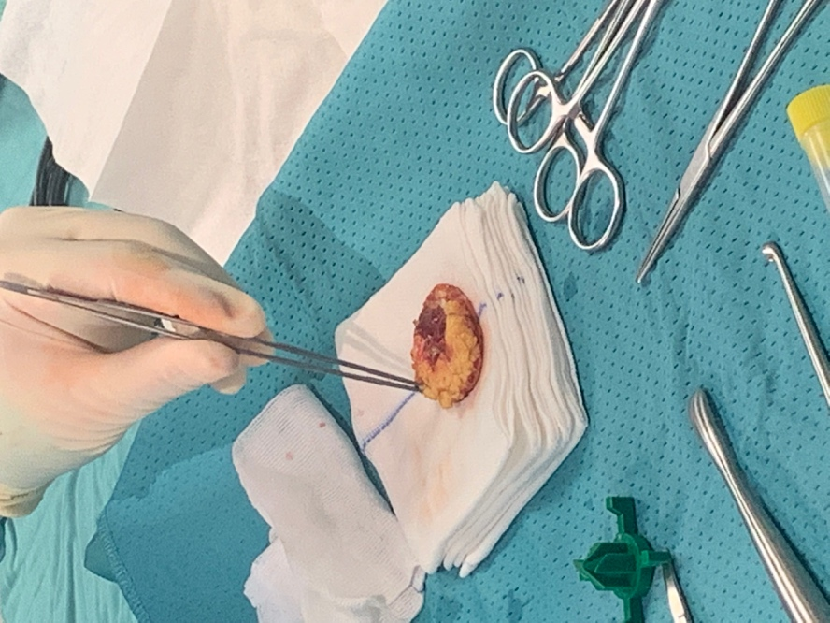
Figure 8. Clinical case as above, the specimen can be seen on the operating table.

Correlation between local recurrence and life expectancy
It is important to remember that not all studies agree that the diagnosis of local recurrence increases the risk of mortality in patients.
In fact, in some studies it is reported that radicalization does indeed bring a benefit in terms of local control of the disease, but the same conclusion cannot be confirmed for long-term survival or the onset of systemic disease. ⁶⁹

The delay in re-excision
Another controversial aspect is the time between the first excision and radicalization. The interval reported in literature is on average between 36 and 108 days. According to several experts, including Braunschweiger, delaying the second surgery correlates with a worsening of the patient's prognosis as it allows the remaining cancer cells to proliferate and acquire further malignant mutations, thus favoring recurrence.
According to others, however, delaying the surgery could promote better wound healing or reduce the complications associated with it, moreover the increase in fibroblastic activity in the healing process can capture the neoplastic cells and provide more defined margins for radicalization.
To date, however, there is no clear evidence in the literature to support these hypotheses. The study conducted by Han et al. recruited 104 patients who underwent radicalization after unplanned surgery for a time interval between 7 and 300 and were divided into two groups: those who were successful before and after 32 days. The study did not lead to significantly different results in terms of survival on these patients.⁷⁰

Data in the literature
The numerous studies that have been conducted have analyzed the impact that unplanned surgery has on disease-specific survival, the development of metastases and local recurrences.
The different centers specialized in the treatment of soft tissue sarcomas have reported different, often conflicting, results.
For example, Ueda et al. report that local recurrence is higher in patients who have undergone UE than in ED.
Fiore et al. analyzing 597 patients, of whom 279 underwent planned surgery and 318 unplanned, report that the cumulative 10-year incidence among people in the first group and those in the second group subjected to radicalization are respectively 16.4% and 18.7% for local recurrence, 20.2% and 17.6% for metastases, and 22.4% and 20.4% for mortality. This study therefore did not show statistically significant differences.
Hoshi et al. report a 5-year survival of 76% in both groups of patients and confirms the importance of radicalization compared to untreated patients after an EU.
Chandrasekar et al. showed that despite radicalization, the risk of local recurrence remains high and that the risk is twice as high when there is evidence of residual post-re-excision disease, in the case of high-grade tumors, if patients had undergone marginal radicalization, and in tumors located in the deeper fascia.

The role of specialized centers in the prognosis of STS
Cancer in general should always be treated in specialized centers, this is a truth that has been consolidated by numerous studies for most malignant neoplastic forms, however, as far as soft tissue sarcomas are concerned, the data in the literature are still lacking and the evidence that treatment in specialized centers correlates with a better outcome is scarce.
However, it is established that the approach to this disease must involve a multidisciplinary team that includes oncological orthopaedic surgeons, pathologists, and radiologists, in order to diagnose the malignant lesion or any recurrence early and above all to allow an appropriate surgical approach.
The study carried out by Bhangu et al. aimed precisely to investigate whether treatment at specialized centers is correlated with a better patient outcome compared to non-specialist DGH (District General Hospital) centers. Analyzing a group of 260 patients, of whom 37% had been operated on at a specialist center and the remaining 63% in 38 different peripheral hospitals, the conclusive data report very interesting results: patients who had been operated on at a non-specialized center had a local recurrence rate at 5 years of 39%, while those who had been treated in a specialized center had only 19%. However, the study did not demonstrate a significant difference in terms of survival in general. The most significant prognostic factors according to this study were the histological grade and depth of the tumor. ⁷¹

Prognostic factors in STS.
Based on the studies performed to date, there is unanimous agreement that the main parameters that influence the prognosis of patients are:
- The initial size of the tumor
- The depth of the tumor
- The FNCLCC class
- The state of the margins ⁷²

The initial size of the tumor is a fundamental prognostic factor, so much so that to date any mass greater than 5 cm superficial must be considered malignant until proven otherwise, this measurement is also the conventional limit that is used for staging.
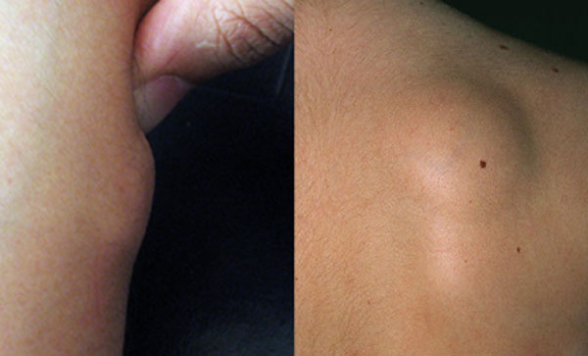
Figure 9. A superficial soft tissue mass.

Tumor volume seems to play an even more important role in the prognosis of patients than depth and grading parameters.
Peabody TD et al. selected 172 patients diagnosed with soft tissue sarcoma to assess whether there is indeed a difference in prognostic terms between a subcutaneous tumor and a deep tumor.
They were then divided into two groups that counted 52 superficial and 120 deep tumors. The absence of disease after 3 years was 85% for subcutaneous tumors and 54% for deep tumors. However, the statistical studies that were done later confirmed that more than the tumor position, relative risk of local recurrence and mortality were more influenced tumor size. In particular, a tumor size greater than 5 cm according to this study represents the most important prognostic indicator, superior to histological grading and depth, which should not be overlooked. ⁷³
By depth of the tumor we mean the location above or below the muscle fascia, the latter have on average a larger volume than the superficial ones and also different histological characteristics, on average they are more aggressive tumors and with a higher probability of local recurrence and metastasis, to date any deep tumor must be studied because it is strongly suspected of malignancy.
A study recruiting 433 patients all with a deep, high-grade sarcoma conducted by Sawamura et al. confirms that local recurrences are more frequent in such patients with a mean diagnosis at 10.7 months than in those who develop superficial and low-grade malignancies. Local recurrences are correlated with a worsening of patient survival.
As far as the histological study is concerned, the samples studied for each tumor were very low, but the study did not reveal significant differences in terms of prognosis. Another interesting fact is the evidence that patients who have had local recurrences have a higher risk of developing other recurrences than the population that has never had it. The same cannot be said for the risk of developing metastases, supporting the hypothesis that recurrences are rarely a direct source of metastasizing cells. A very strong correlation was also found between the initial aggressiveness of the tumor and the relapse of the disease itself.
Finally, this study supports the hypothesis that there is no significant difference between patients who underwent UE compared to ED, patients who underwent unplanned surgery at a specialized center in fact had more superficial and smaller tumors, therefore less aggressiveness and a tendency to local recurrence. ⁷⁴

The state of the margins after surgery can be described according to different classifications.

Residual tumor (R) classification:
- R0: corresponds to the absence of residual disease
- R1: Microscopic residual margins
- R2: macroscopic residual margins
According to this breakdown, the risk of local recurrence at 10 years is 8%, 21% and 44% respectively in R0, R1 and R2.

R+1 mm classification
This classification considers two subgroups of patients, those who have residues with margins less or greater than 1 mm. Reporting this as a cut-off that significantly changes the probability of local recurrence in patients, in particular the risk of local recurrence between R0 and R1<1mm ranges from 8% to 12% and is not statistically significant.

TMCC classification
It considers patients with positive margins who are divided into:
- Positive margins after planned surgery in which the tumor involves critical structures.
- Positive margins after radicalization.
- Positive margins after unplanned surgery.
According to this classification, positive margins on critical structures do not have a significantly different prognosis than R0 at 10 years (11% vs 8%), positive margins after unplanned surgery increase the risk at 10 years up to 35%. ⁷⁵
We can say that the quality of surgical resection therefore greatly influences the prognostic impact of patients, local recurrences in 65% of cases are multifocal and therefore very difficult to re-excise, which is why the primary approach is fundamental and necessarily multidisciplinary. ⁷⁶
A very interesting proposal was published in 2016 by Calligaro et al. who developed two nomograms to predict overall survival and the risk of developing metastases in patients with soft tissue sarcomas of the extremities and girdles.
In fact, this study, based on the case histories of four large institutes specialized in the treatment of sarcomas, has led to the production of two tables that make it possible to predict the prognosis of patients and the risk of developing metastases at 5 and 10 years. Compared to the AJCC classification, the parameters of the size, grading and anatomical location of the sarcoma are transformed into numerical values to express the patient's prognosis and the risk of manifesting distant metastases. The model, however, is to be validated in daily clinical practice and in a prospective way, but it is a valid proposal to better understand the natural history and plan therapy. ⁷⁶

Margin quality and quantity

Planning a soft tissue sarcoma resection is challenging, as the balance between oncological radicality and loss of function is necessary. Inadequate surgical excision has a significant impact on the risk of developing local recurrence (LR), but the concept of surgical margin is still debated in sarcoma surgery. Although a wide margin is certainly burdened by a lower risk of LR than a contaminated margin, it is not known which the distance to mantain is to obtain an oncologically valid result.
With the advent of Limb Salvage Surgery (LSS), from the 80s onwards, the proportion of amputations of the extremities has collapsed to less than 5% of surgical procedures. Thus, planning a proper margin has become an even more difficult and primary task.
Several studies⁸¹⁻⁹⁰, that considered the R0 or R1 classification (quantitative), have given controversial results with respect to how much the distance of the closest margin to the tumor is an indicator of a good oncological result. Recent studies attribute with R0 evaluation a sufficient margin that does not see microscopic or macroscopic contamination of the surface of the surgical specimen marked with ink. Other studies, based on the classification of Enneking and Kukushima^{77-79,81}, indicate different results significantly linked not only to the distance of the margin but also to its quality, as Gerrand has shown⁹⁴.
At the same time, it is also controversial the impact of the margin considered "adequate" with respect to the risk of developing distant metastases (STDs) and death due to tumor pathology. As recalled by Hoang, in the literature there are studies based on very different classifications that try to identify what are the anatomical characteristics of the "adequate" margin and to understand the impact of this on LR, MTS and Overall Survival. However, the vast heterogeneity of the classification systems and the setting of this type of research, has determined the impossibility of establishing safely how to obtain adequate resection margins and how much these will impact on local recurrences and survival. This information would be of primary importance, as it would help in decision making on the type of surgery to be applied for every single patient and on the balance between oncological radicality and the attempt to maintain an adequate functionality of the limbs.

Project
Patients requiring a soft tissue sarcoma resection of the extremities in the Orthopedic Oncology Unit of Careggi Univerity Hospital, were included in the study. A resection planning based on preoperative MRI was performed, where the surgeon draws the anatomical specimen highlighting it with radiological segmentation techniques. Once this planning has had been carried out, a virtual specimen with its surgical margins was available (preoperative MRI performed whitin maximum 15 days before surgery).
After the operation, the specimen was examined with a new MRI scan, before formalin fixation.
In this way, it will be possible to establish, in a three-dimensional way and on the entire anatomical specimen, the concordance between the planning and effective surgical procedure.
The patients are followed prospectively in particular by assessing local recurrence, metastases, and death due to cancer (in the latter two cases excluding patients who came to attention after unplanned excisions, with already diagnosed a metastasis or a local recurrence).
Firstly, an analysis of the specimens’ MRI was conducted, highlighting possible areas where insufficient margins were kept in place. Secondly, an image fusion between the preoperative MRI and the specimen were executed using Siemens Syngo Via Image Fusion Software to better assess how the tumour was removed.
Unfortunately, for technical reasons (temporary closure of the CTO MRI machine which was used to perform Specimen MRIs), five patients were included in the study. This protocol will continue in the future with the intent to enroll as many patients as possible, to raise the probabilities to have meaningful results.
At the present time, no one developed any local recurrence neither distant metastasis.
A preliminary analysis will concern possible relationships between a discordance between planning and intervention with respect to the risk of local recurrence. Secondly, when local recurrences would come to our attention (excluding patients for whom the recurrence has taken place on contaminated margins), the MRI of the anatomical pieces will be analyzed, to compare local recurrence specific site with quantity and quality of margins. Once the MRI of the area subject to Local Recurrence has been compared with the MRI of the operative piece, it will be possible to analyze the spatial position of the recurrence in relation to the previous margin. This will result in a precise quantitative mapping of the risk of developing local recurrence based on quality (anatomical position in relation to barriers) and the thickness of the margins. From this analysis it will be possible to subsequently develop a more precise system of classification of surgical margins in which the quality of the anatomical barriers and the distance from the margins will have a precise quantitative value derived from the evidence.

Methods
Our project (which was approved by the Ethical committee of Careggi Hospital) runs parallel to another prospective study that we are conducting with the Radiotherapy Unit, the SPRINT study, which aims to use radiological segmentation and pre-operative tumour mapping to better focus neo-adjuvant radiotherapy beam preserving the planned future surgical incision.
Pinnacle radiological segmentation software, that is used to “draw” our anatomical specimen, is available in their department only. Patients enrolled in the SPRINT protocol need the same pre-operative planning that we need for our study on surgical margins.
The same patients enrolled in the SPRINT protocol, needing tumour resection pre-operative planning performed using PINNACLE software, are enrolled in our study on surgical margins. In addition, we can reproduce the exact, virtually planned, incision in the surgical theatre thanks to the strategy included in the SPRINT protocol.
A pre-operative drawing of the future surgical scar with dermographic pencil is done, including the biopsy access point which will be excised during surgery. The incision tract is labelled using metal targets during CT centering scan for radiotherapy planning. The Radiotherapy planning phase will include a contouring of risk organs and target volumes, performed on TPS (Treatment Planning System) Pinnacle. The primary imaging is the centering CT scan, on which the target volumes are identified with the aid of rigid fusion with previously acquired MRI sequences. The radiotherapist, the surgeon and the physicist will assess, among others, a planned "surgical scar" and region of skin and subcutaneous tissue involved in the closure of the future resection site ("virtual flaps").
Planning of surgical intervention is carried out with the help of MIM (25800 Science Park Dr #180, Beachwood, OH 44122, Stati Uniti) software. The surgical scar is then faithfully reproduced during surgery using the skin markers introduced at the time of TC centering.
After surgery, the anatomical specimens were immediately sent to our Radiology Unit, in a short time (to preserve the anatomical piece from shrinking and deformations) and were scanned with MRI. The MRI was performed within 6 h from surgery and the same MRI machine was used for the entire series. Specimens were oriented according to the long axis of the long bone or the craniocaudal axis of the pelvic bone. A specific protocol to scan these anatomical pieces was defined, setting the organization between our Units to get this done. Imaging of the resected tumor specimen were obtained using a 1,5 Tesla MRI with the following specific sequences: axial 3D T1- and 3D T2-weighted. MRI acquisition parameters were specified as follows: reconstruction matrix 176 × 176, 0.5 mm section thickness, and 0.5 mm spacing between slices. The MRIs were reconstructed by MPR and saved in DICOM format with PACS.
Finally, the specimen MRIs were fused with the preoperative ones using SIEMENS Syngo Via Image Fusion software to have a visual direct representation of the tumour morphology and volumes compared to what was excised. A qualitative analysis of the surgical margins was conducted by examining fused MRI images. The analysis compared standard preoperative MRI scans with fused images created by combining preoperative MRI and specimen MRI. This approach allowed for a more detailed evaluation of the spatial relationship between the tumor and the resection margins. A surgeon and a radiologist, both experienced in sarcoma imaging and surgical planning, independently assessed these fused images. Their evaluation aimed to identify the closest margin to the tumor, focusing on areas of potential concern where the resection margin might be narrow. This independent analysis provided a robust cross-disciplinary perspective to assess the adequacy of the surgical margins and identify regions where margins could be insufficient.
To summarize:
Qualitative Analysis of Surgical Margins
To evaluate the surgical margins in soft tissue sarcoma, the following methodology was employed:
- Image Acquisition:
  - Preoperative MRI scans were obtained using a standardized imaging protocol for soft tissue sarcoma.
  - Specimen MRI scans were performed after surgical resection, ensuring proper orientation and positioning to match the preoperative imaging.
- Image Fusion:
  - Fused images were generated by combining the preoperative MRI with the corresponding specimen MRI.
  - Image fusion was performed using specialized software to align and overlay the scans accurately. This facilitated a detailed assessment of the spatial relationship between the tumor and the surgical margins.
- Independent Review Process:
  - The fused images (preoperative MRI vs. preoperative + specimen MRI) were independently analyzed by a surgeon and a radiologist, both experienced in sarcoma imaging.
  - Both reviewers assessed the scans without knowledge of each other’s findings to reduce bias.
- Qualitative Assesment:
  - The focus of the analysis was on identifying the closest margin between the tumor and surrounding tissues in the fused images.
  - Areas where the resection margin appeared narrow or unclear were given special attention.
  - The analysis also considered differences between the preoperative MRI alone and the fused images, highlighting discrepancies that might affect the margin evaluation.
- Documentation and Review:
  - Observations made by each reviewer were documented independently.
  - Differences in findings were reconciled through discussion, providing a consensus for the final margin assessment.
This structured approach ensured a precise and systematic evaluation of the surgical margins, enhancing the reliability and reproducibility of the analysis.

Results
Unfortunately, due to technical reasons (i.e. renewal of the MRI scan at CTO-Careggi, the one close to operative theatre, we were able to enroll only five patients so far. More patients will be included prospectively).
The five patients:
- 1: male, 65 years old, pleomorphic sarcoma of the trunk, surgical resection after neo-adjuvant radiotherapy, 20 months follow-up, no local recurrences, neither distant metastasis, post-surgical sieroma.
- 2: male, 52 years old: myxoid liposarcoma of the tight (medial side), after neo-adjuvant radiotherapy, surgical resection of the mass, 23 months follow-up, no local recurrences neither distant metastasis, no local complications.
- 3: male, 35 years old, myxoid liposarcoma of Gluteus Maximus distal end, surgery after neo-adjuvant radiotherapy, 19 months follow-up, no local recurrences, no metastasis, no complications.
- 4: male, 58 years old, myxoid liposarcoma of the rectus intermedius, left thigh, surgery after neoadjuvant radiotherapy, 6 months follow-up, no local recurrences, no metastasis, no complications.
- 5: male, grade 3 myxofibrosarcoma of the posterior region of the left thigh, 8 months follow-up, no pre-operative radiotherapy, no local recurrences, no metastasis, no complications.

Following figures: images of the preoperative and specimen MRIs of our enrolled cases, on MRI in axial, sagittal and coronal plane, coupled with imaging fusion between pre-operative and specimen MRIs.

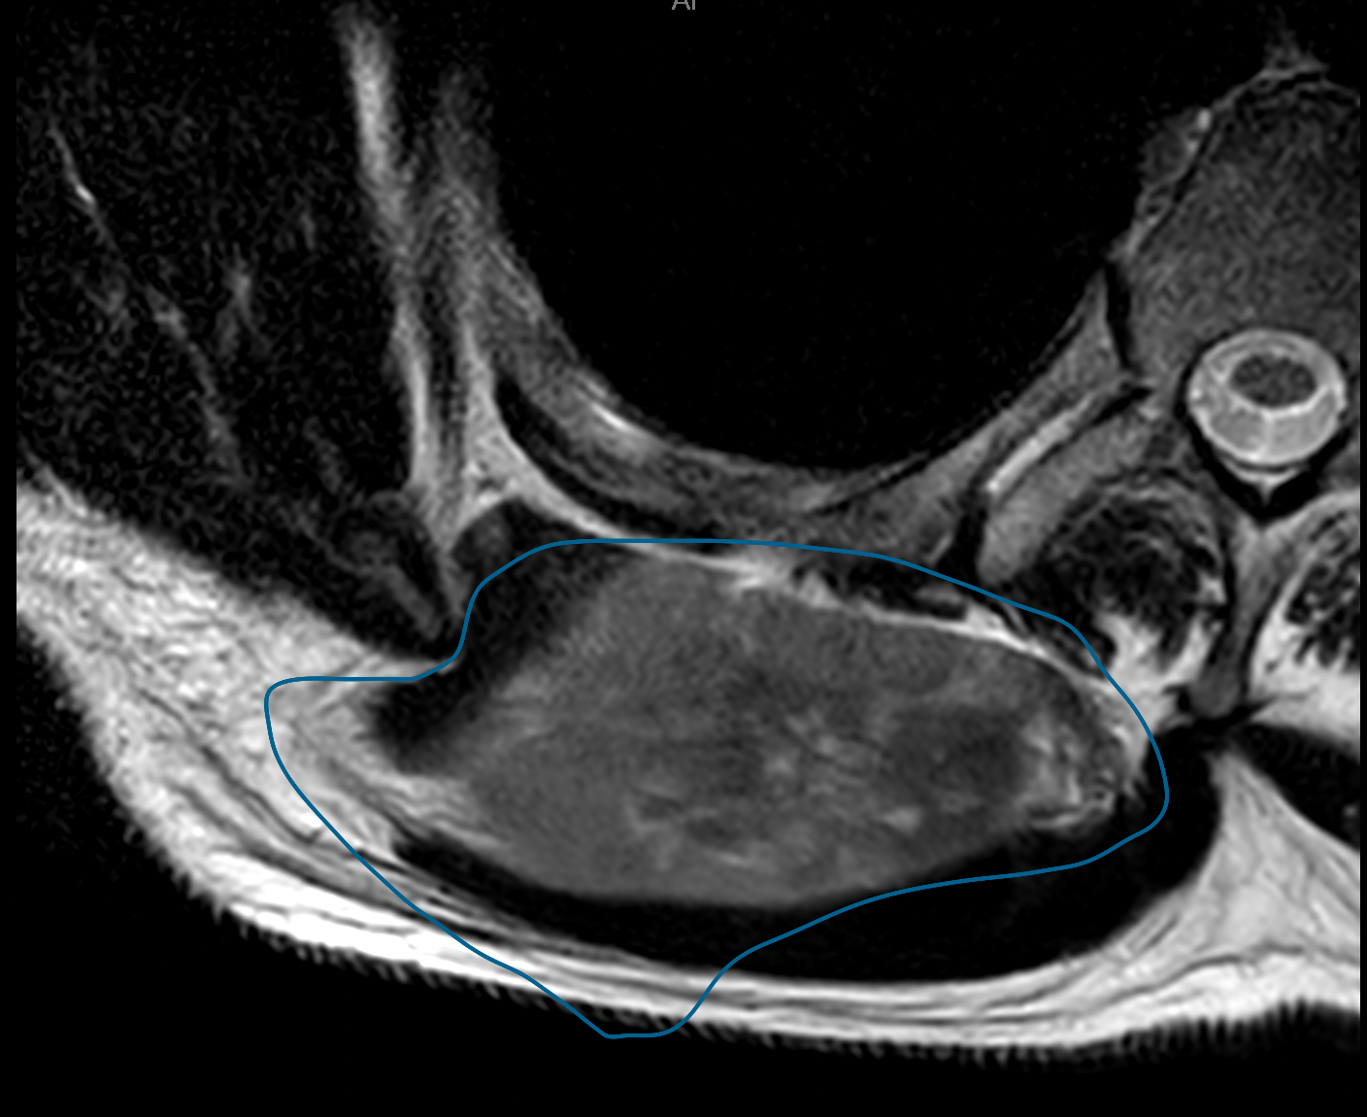

Fig 1. Pleomorphic sarcoma of the trunk. Drawing of surgical margins on axial plane.
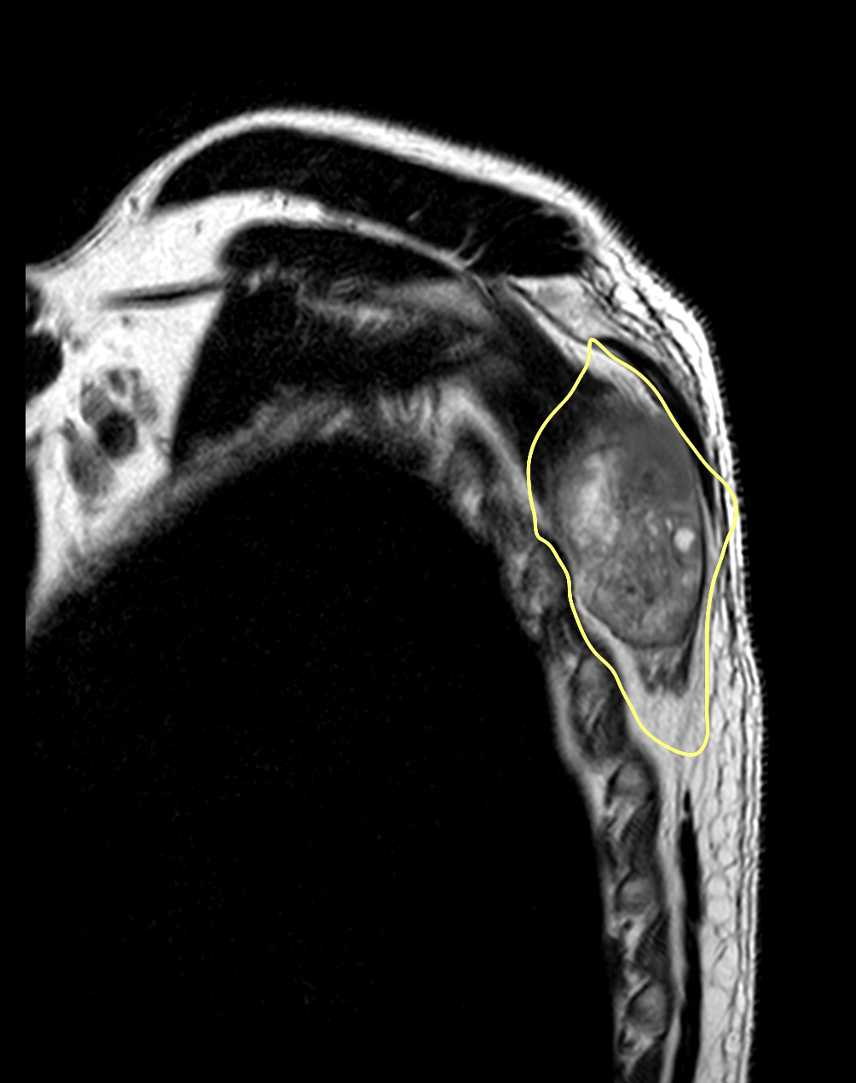

Fig 2. Pleomorphic sarcoma of the trunk. Drawing of surgical margins on sagittal plane.

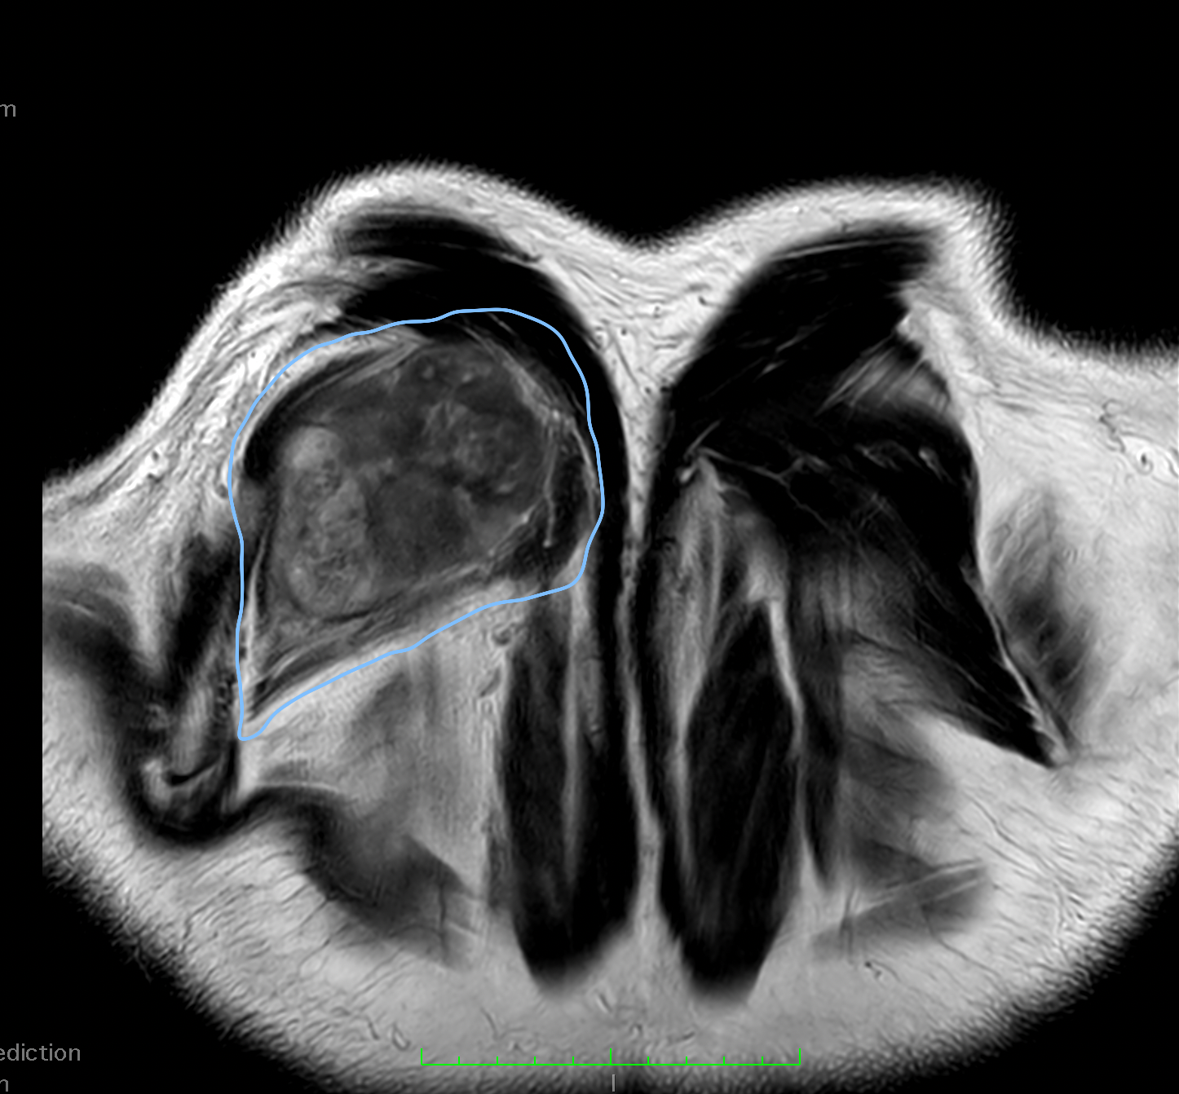

Fig 3. Pleomorphic sarcoma of the trunk. Drawing of surgical margins on coronal plane.

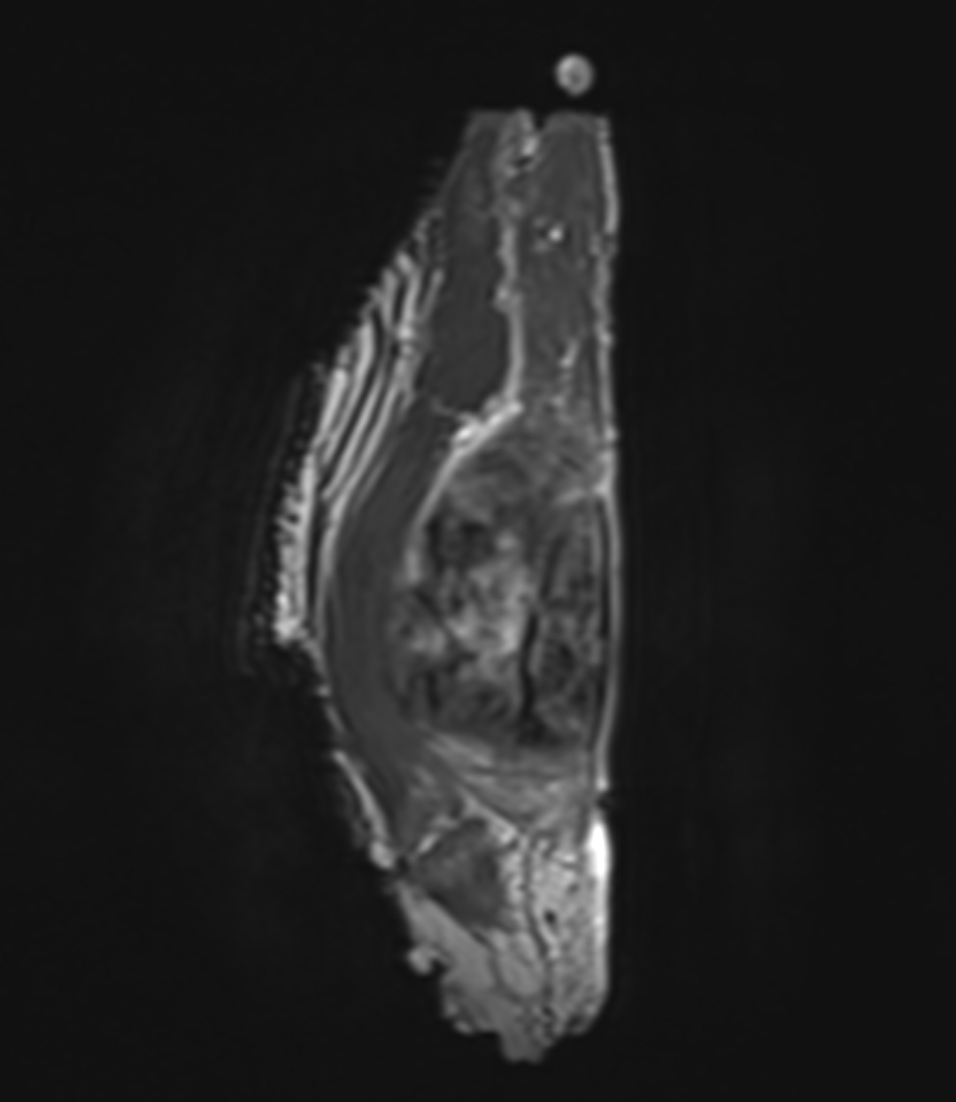

Fig 4. Pleomorphic sarcoma of the trunk. Surgical specimen on sagittal plane.

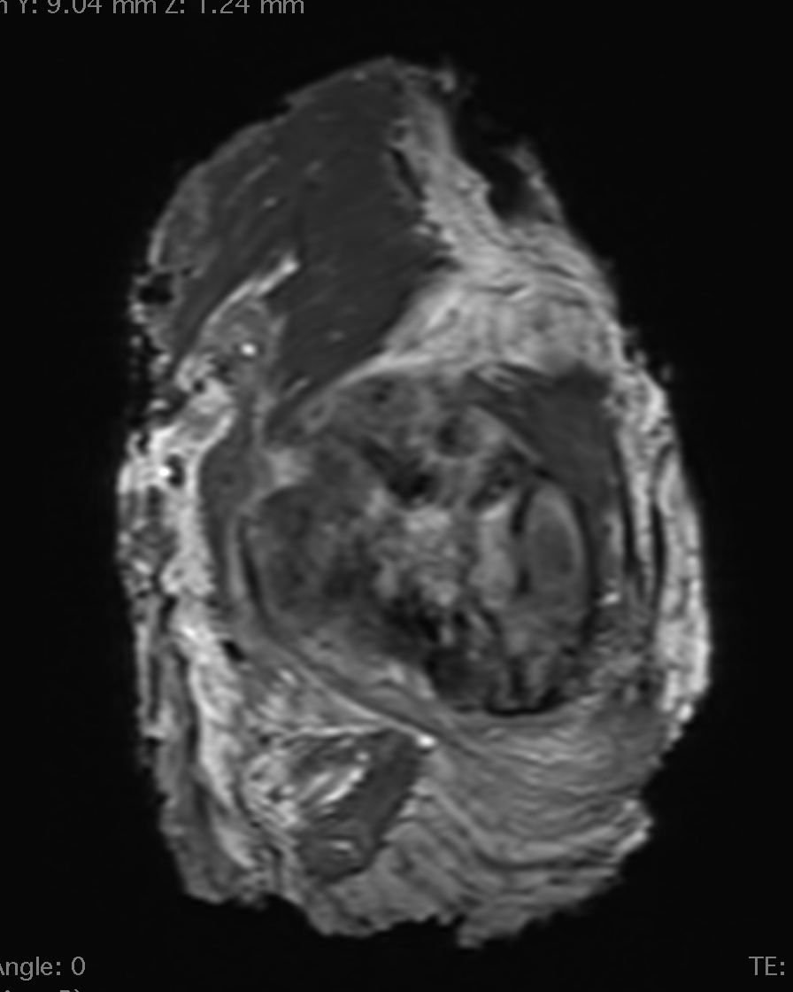

Fig 5. Pleomorphic sarcoma of the trunk. Surgical specimen on coronal plane.

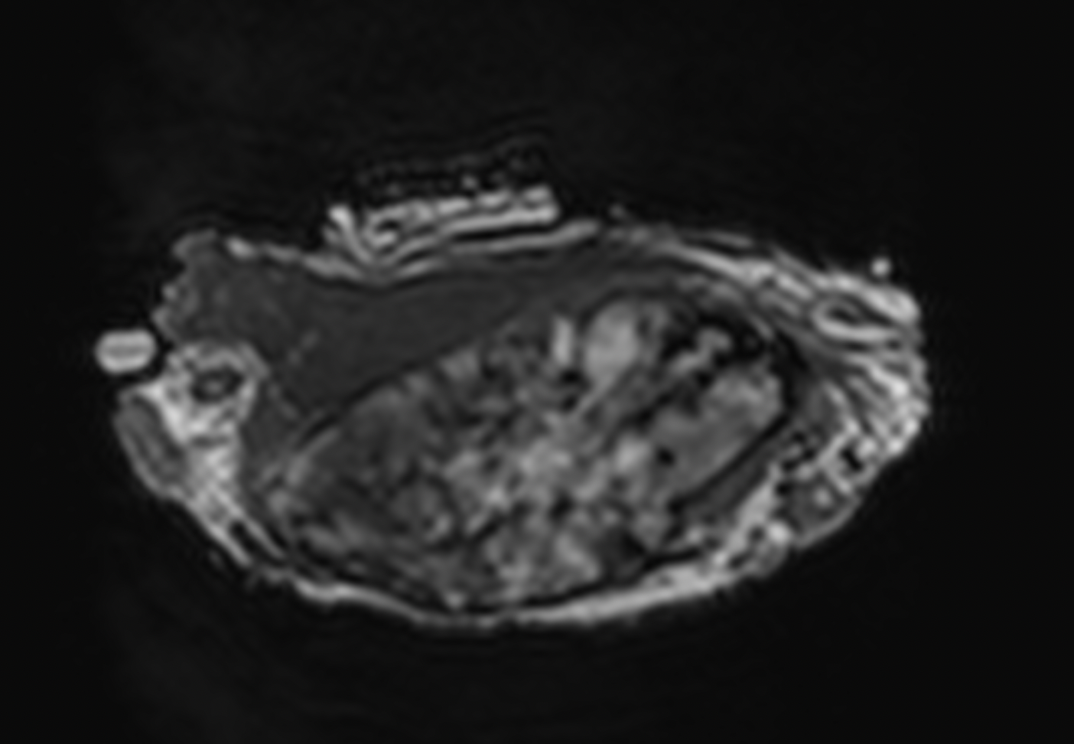

Fig 6. Pleomorphic sarcoma of the trunk. Surgical specimen on axial plane.

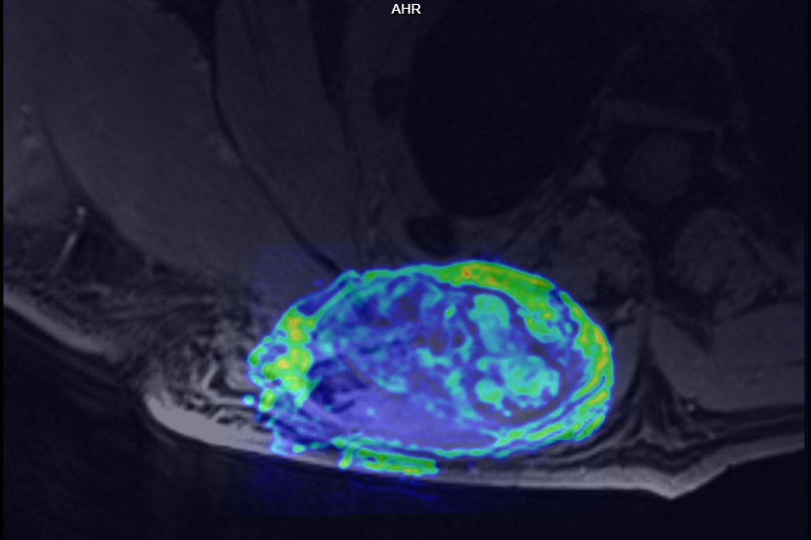

Fig 7. Pleomorphic sarcoma of the trunk. Surgical specimen on axial plane fused with the preoperative MRI, showing how the specimen was resected.

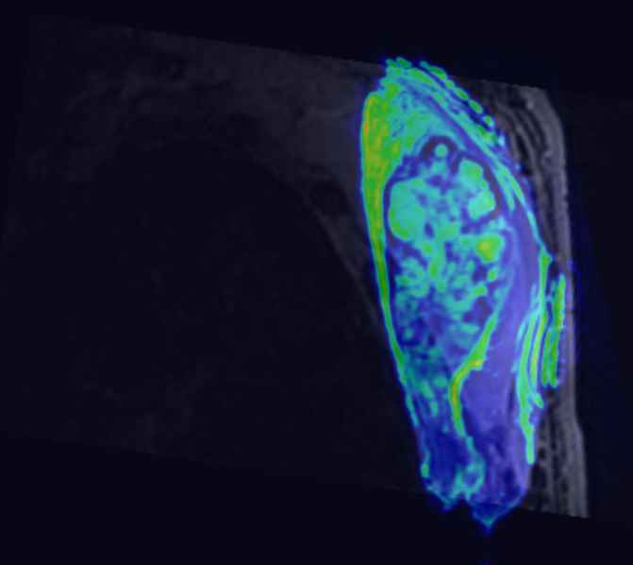

Fig 8. Pleomorphic sarcoma of the trunk. Surgical specimen on sagittal plane fused with the preoperative MRI.

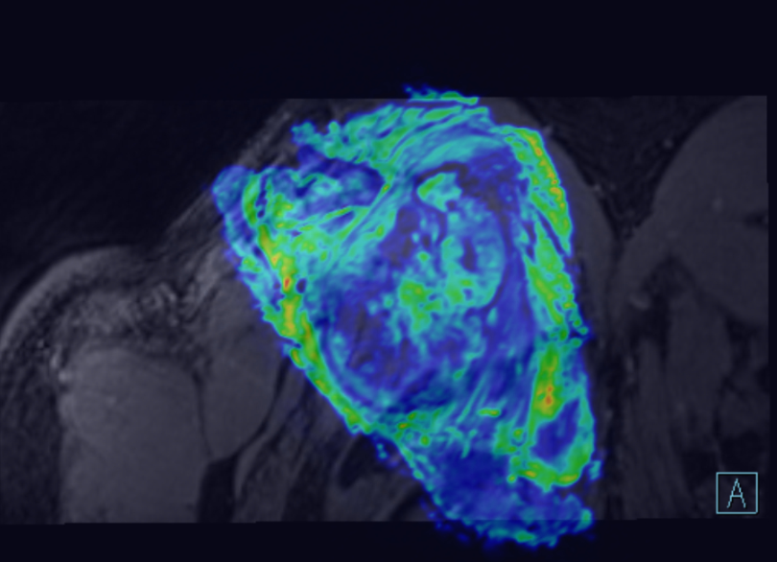

Fig 9. Pleomorphic sarcoma of the trunk. Surgical specimen on coronal plane fused with the preoperative MRI.

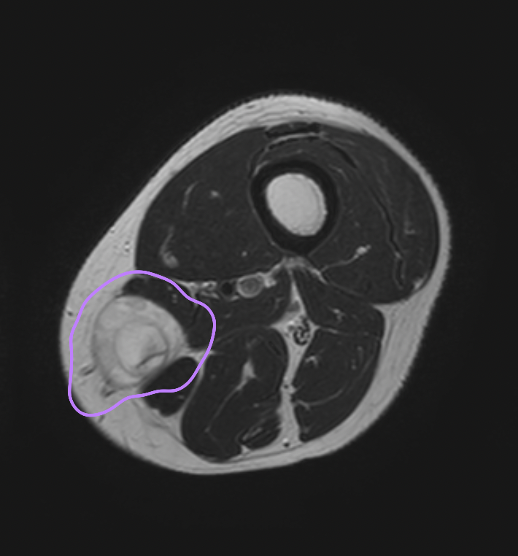

Fig 10. Myxoid liposarcoma of the tight: surgical margins drawing on axial plane.

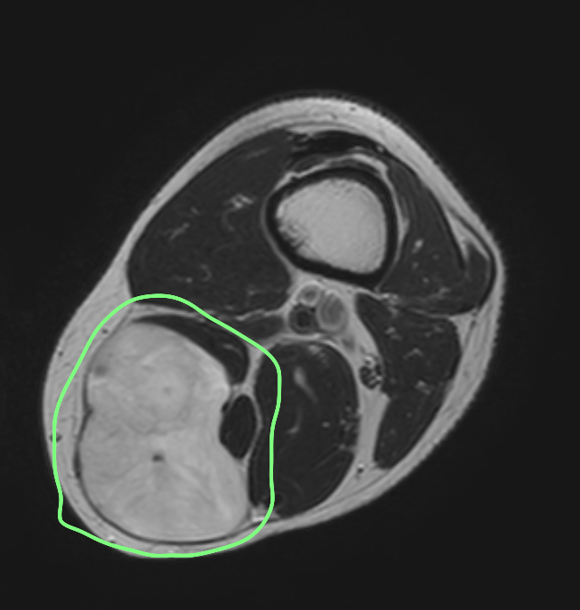

Fig 11. Myxoid liposarcoma of the tight: surgical drawing on axial plane.

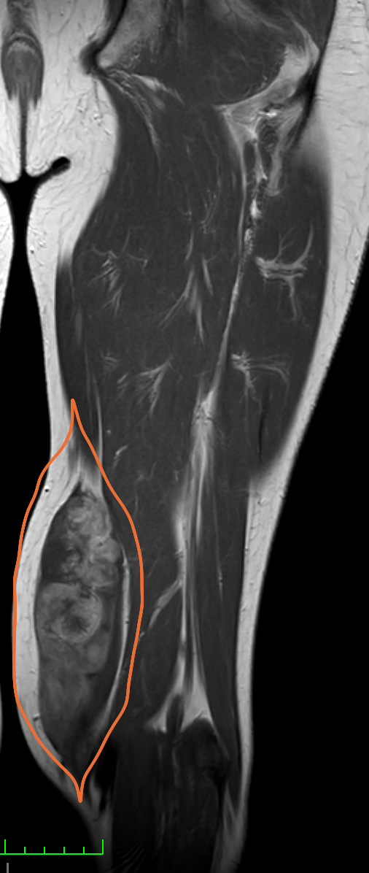

Fig 12. Myxoid liposarcoma of the tight: surgical margins on coronal plane.

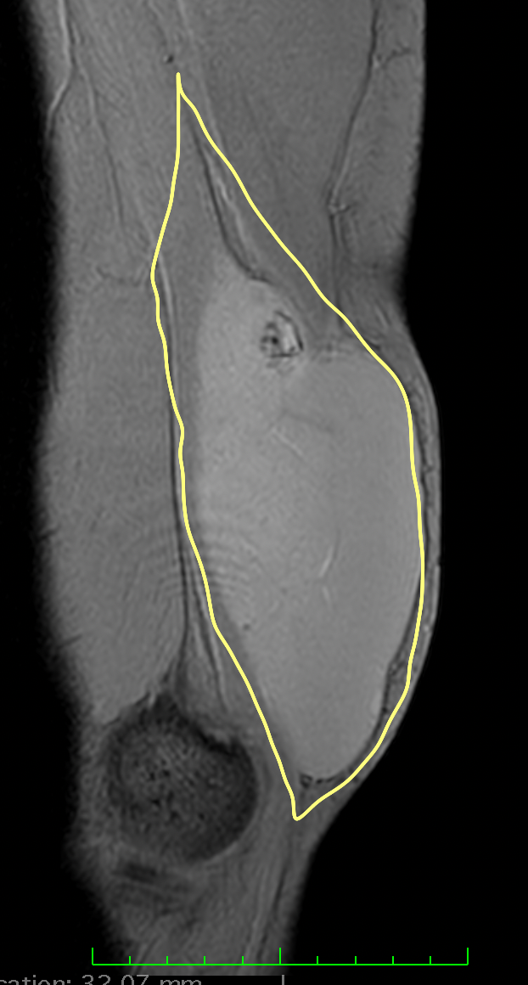

Fig 13. Myxoid liposarcoma of the tight: surgical margins on sagittal plane.

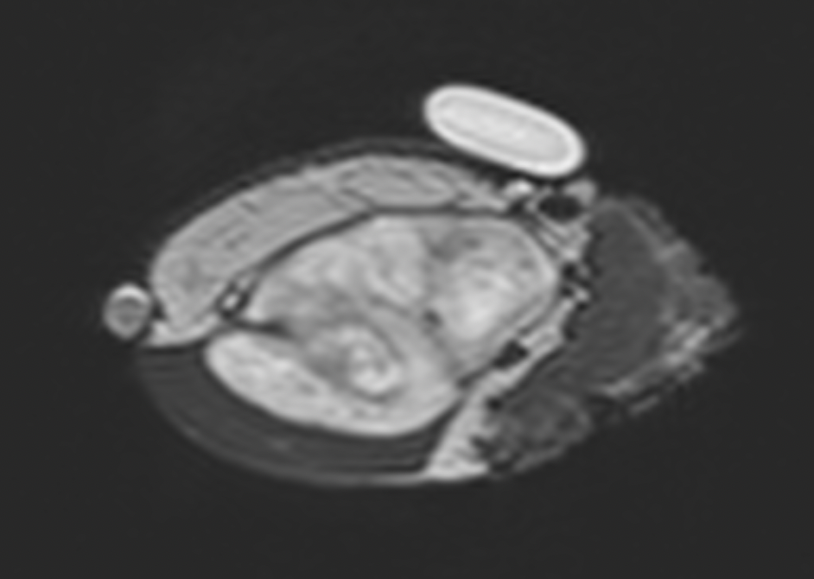

Fig 14 Myxoid liposarcoma of the tight: specimen on axial plane.

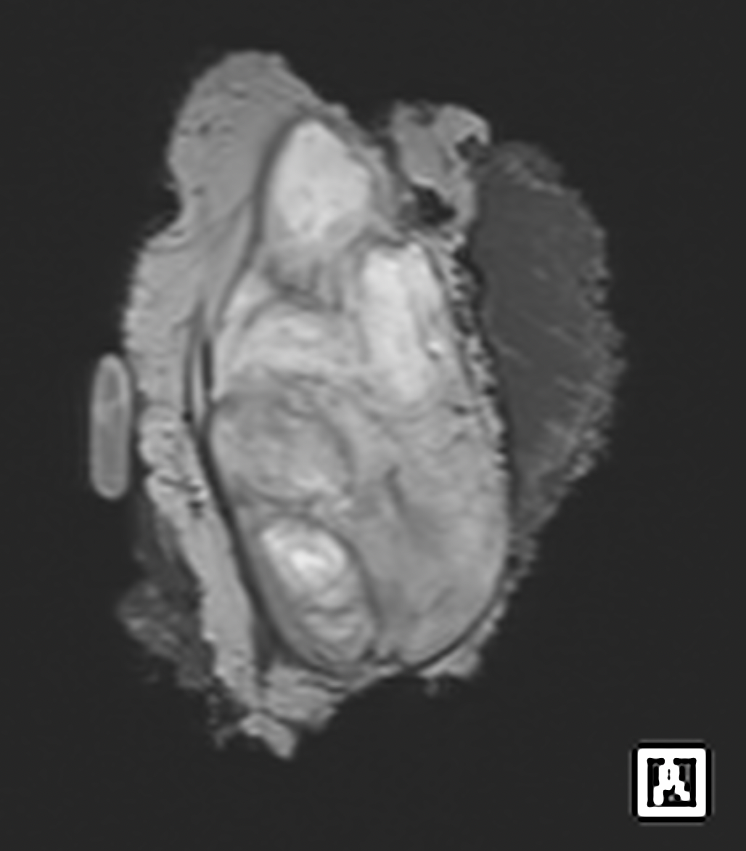

Fig 15. Myxoid liposarcoma of the tight: specimen on coronal plane.

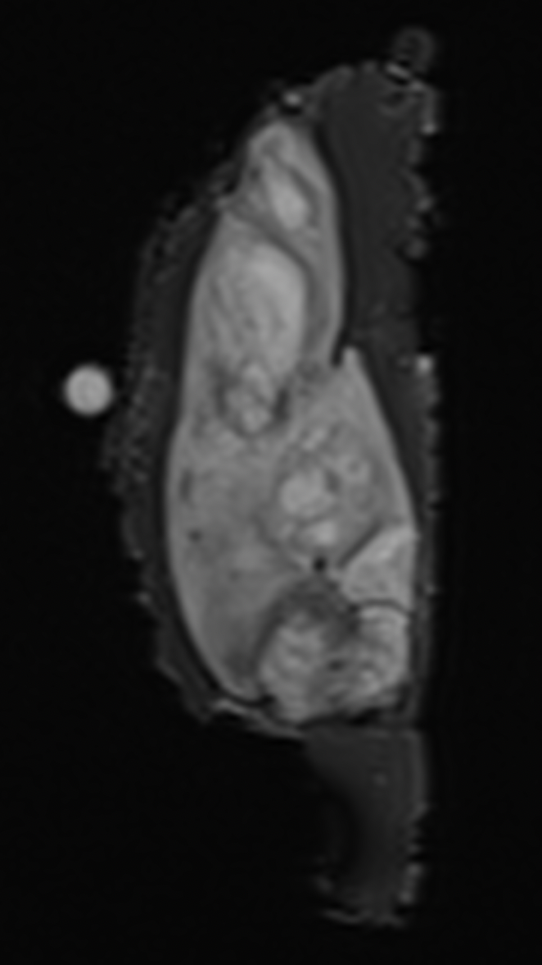

Fig 16. Myxoid liposarcoma of the tight: specimen on sagittal plane.

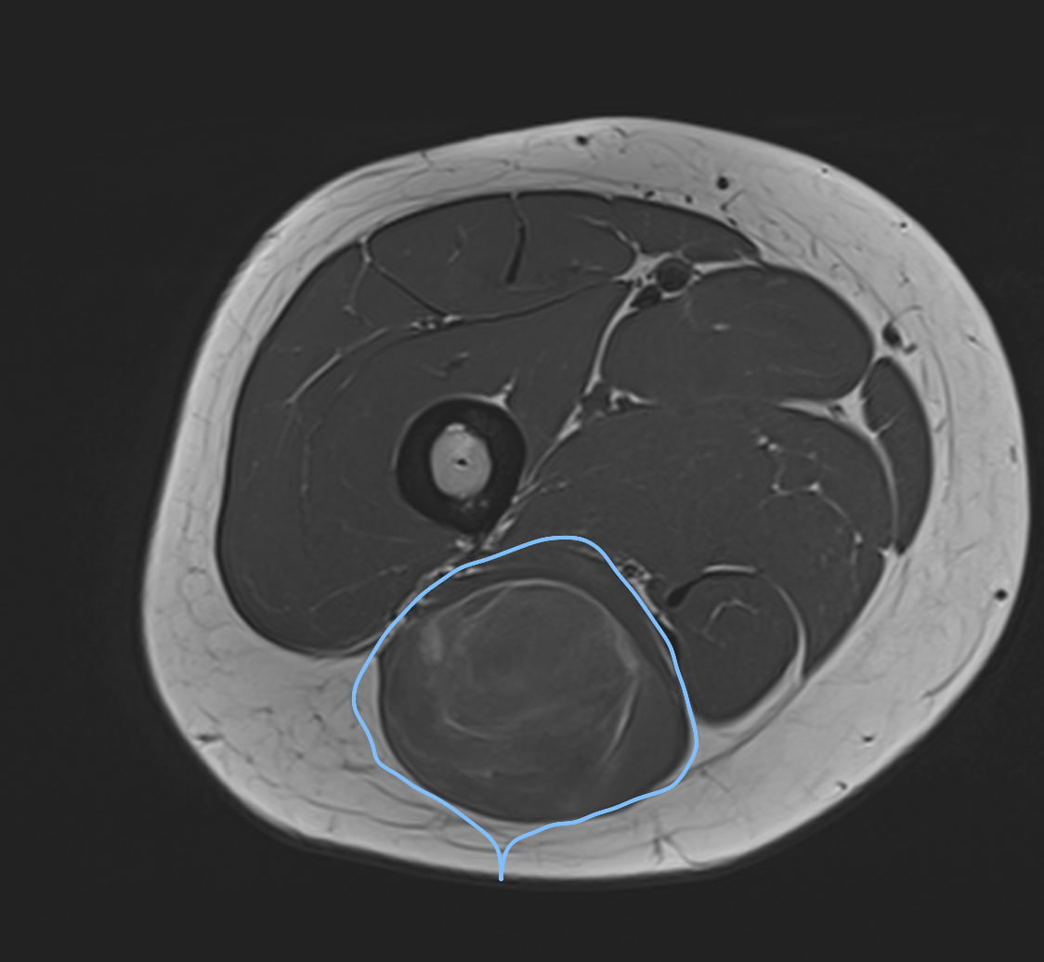

Fig 17. Myxoid liposarcoma of the Gluteus Maximus: surgical planning on axial plane.

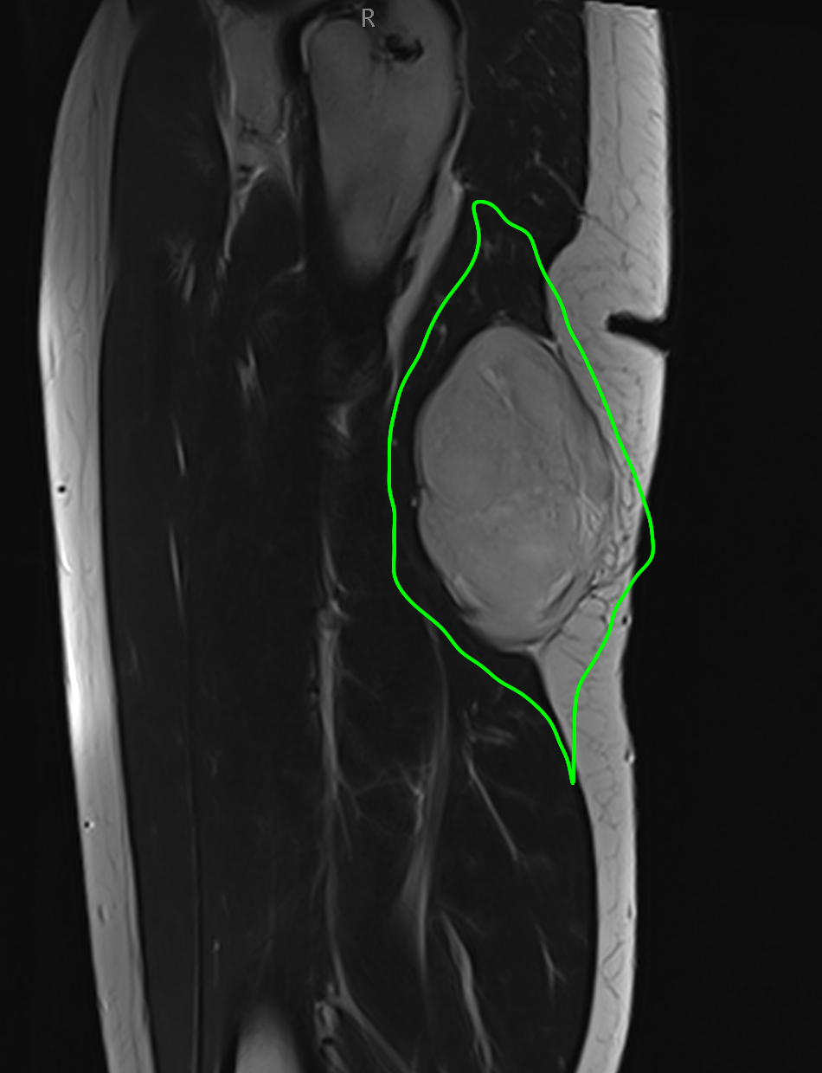

Fig 18. Myxoid liposarcoma of the Gluteus Maximus: surgical planning on sagittal plane.

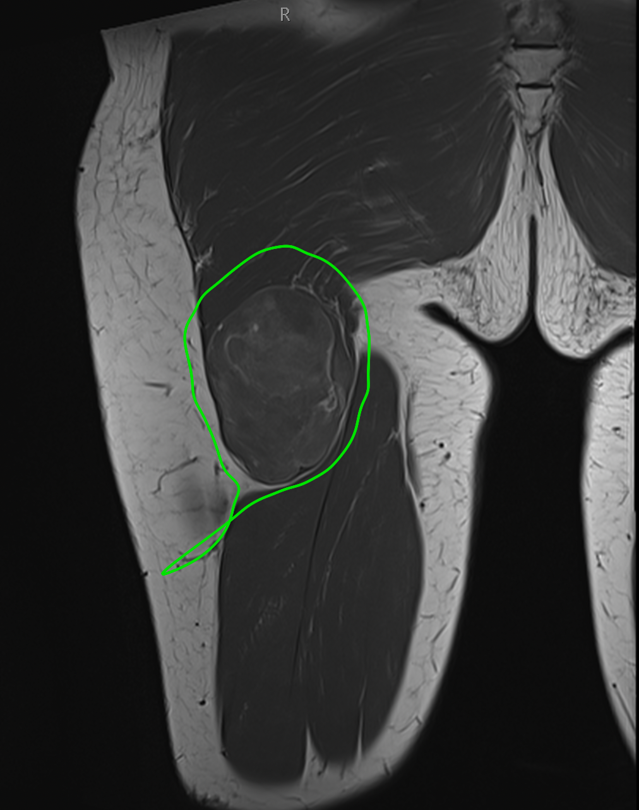

Fig 19. Myxoid liposarcoma of the Gluteus Maximus: surgical planning on coronal plane.

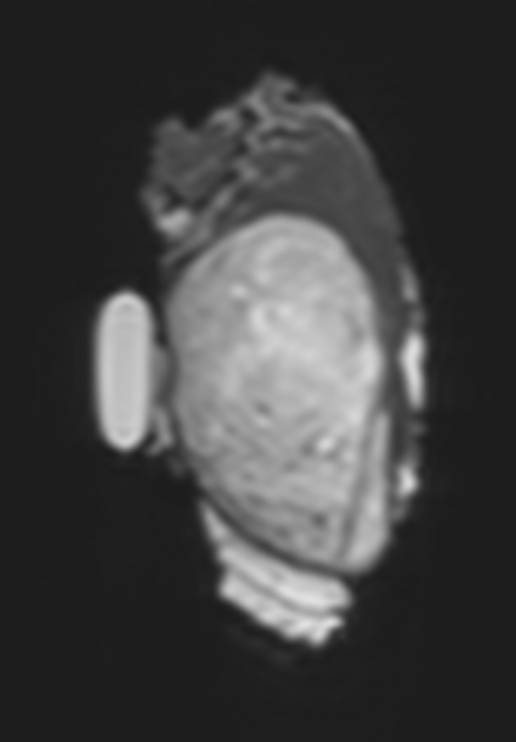

Fig 20. Myxoid liposarcoma of the Gluteus Maximus: surgical specimen on axial plane.

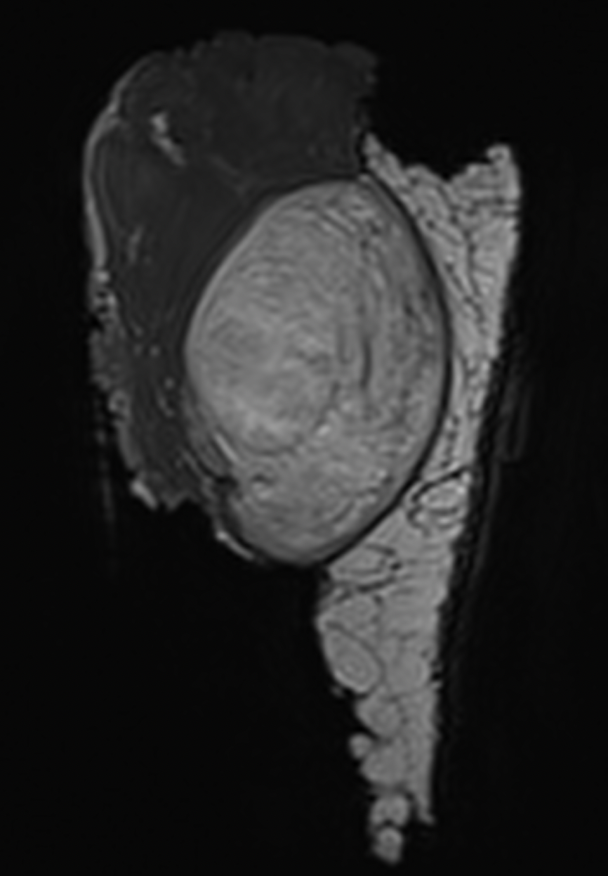

Fig 21. Myxoid liposarcoma of the Gluteus Maximus: surgical specimen on coronal plane.

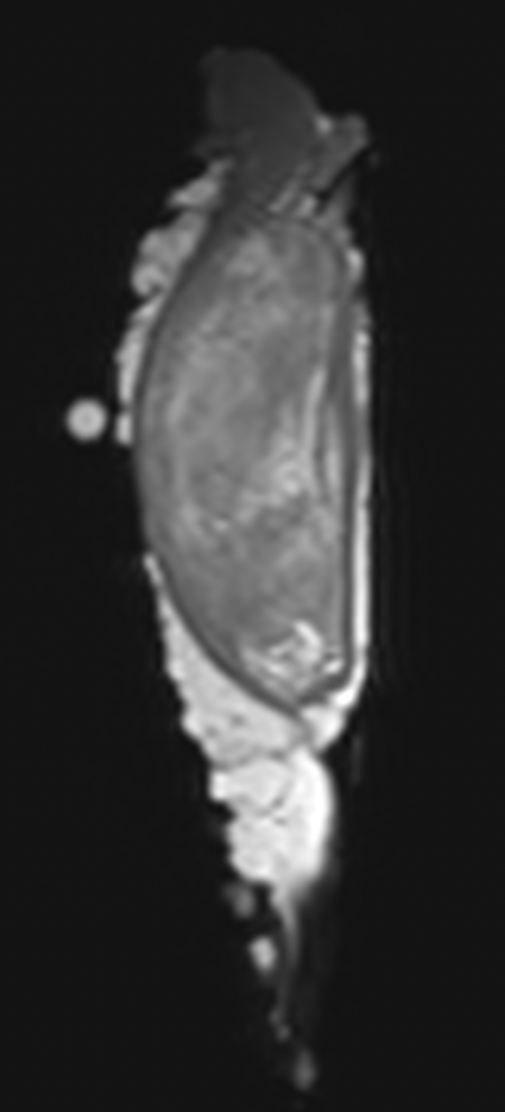

Fig 22. Myxoid liposarcoma of the Gluteus Maximus: surgical specimen on sagittal plane.

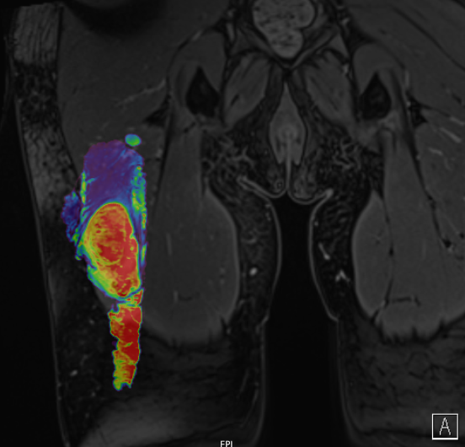

Fig 23. Myxoid liposarcoma of the Gluteus Maximus: surgical specimen on coronal plane fused with preoperative MRI.

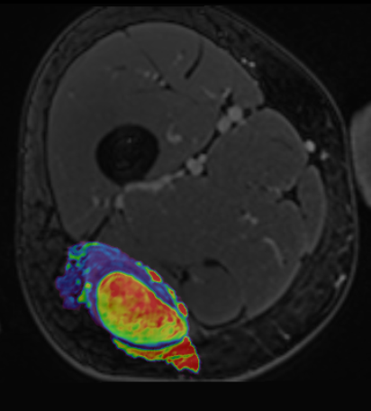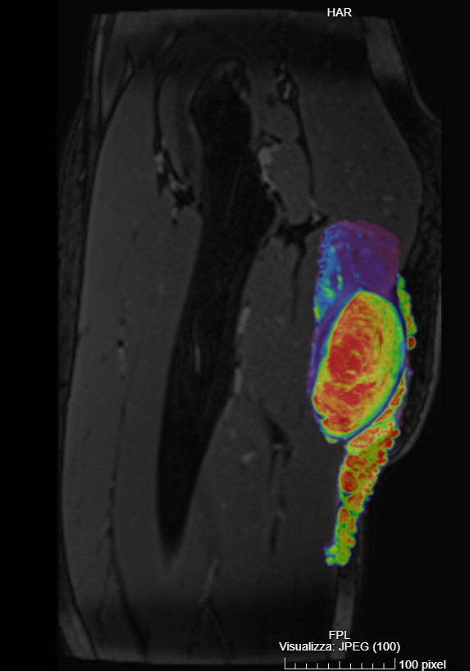
Fig 24. Myxoid liposarcoma of the Gluteus Maximus: surgical specimen on axial plane fused with preoperative MRI.

Fig 24. Myxoid liposarcoma of the Gluteus Maximus: surgical specimen on sagittal plane fused with preoperative MRI.

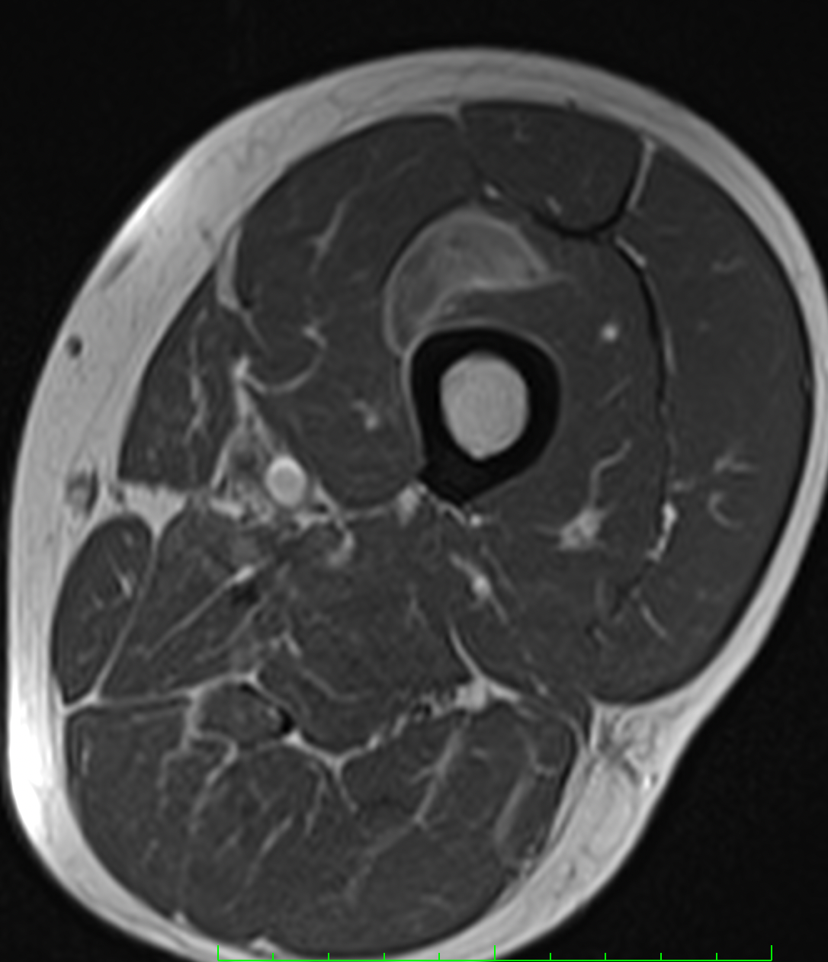

Fig 25. Myxoid liposarcoma of the Rectus Intermedius: preoperative MRI, axial plane.

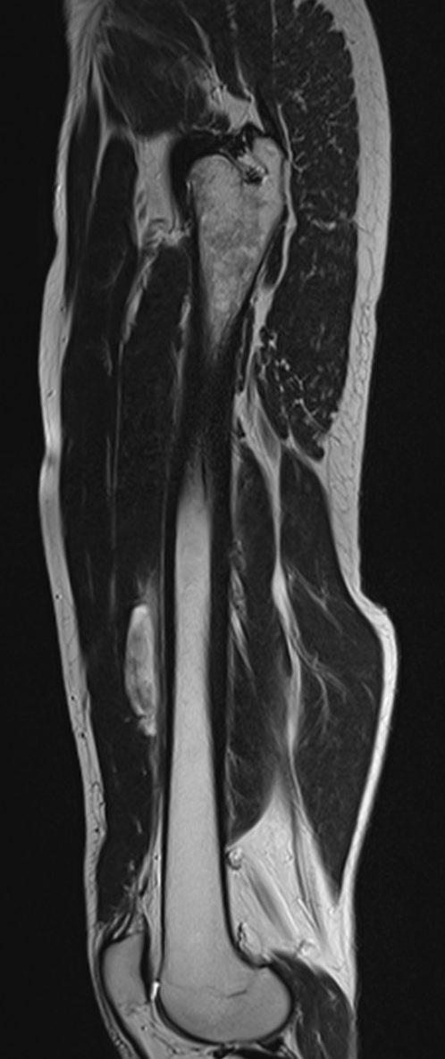

Fig 26. Myxoid liposarcoma of the Rectus Intermedius: preoperative MRI, sagittal plane.

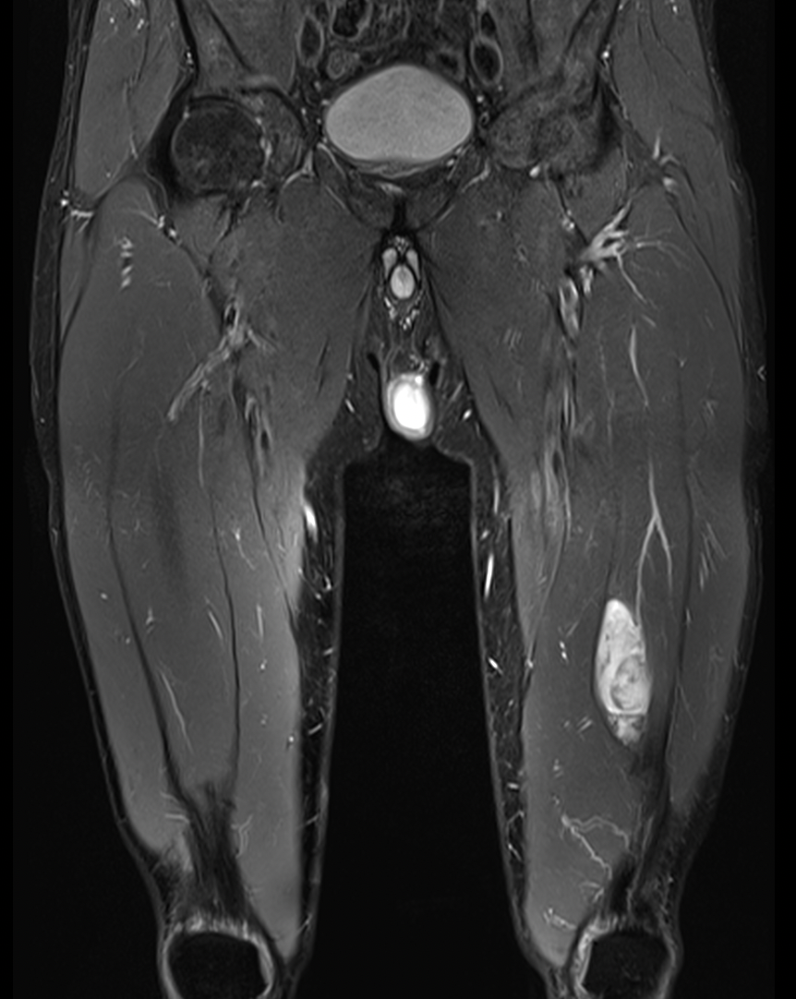

Fig 27. Myxoid liposarcoma of the Rectus Intermedius: preoperative MRI, coronal plane.

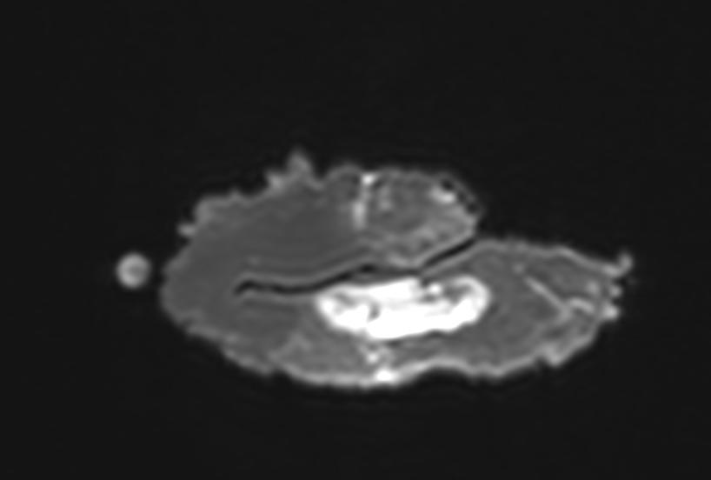

Fig 28. Myxoid liposarcoma of the Rectus Intermedius: specimen MRI, axial plane.

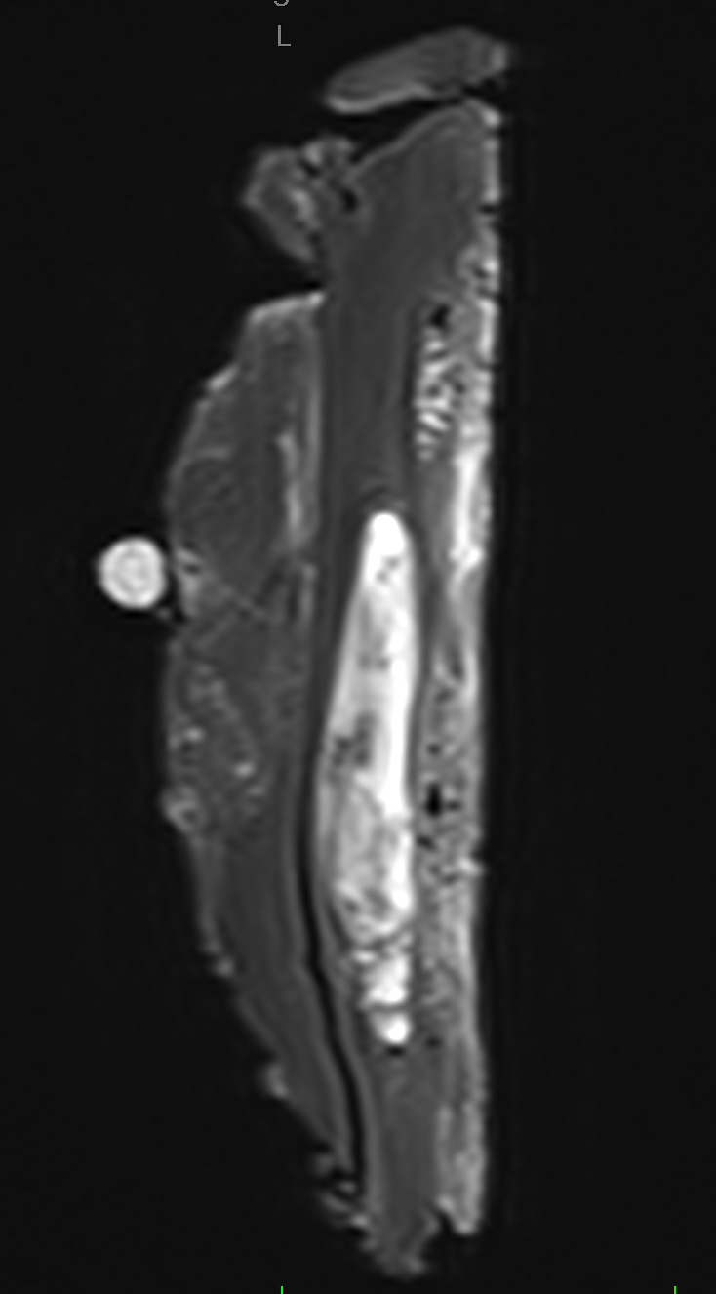

Fig 29. Myxoid liposarcoma of the Rectus Intermedius: specimen MRI, sagittal plane.

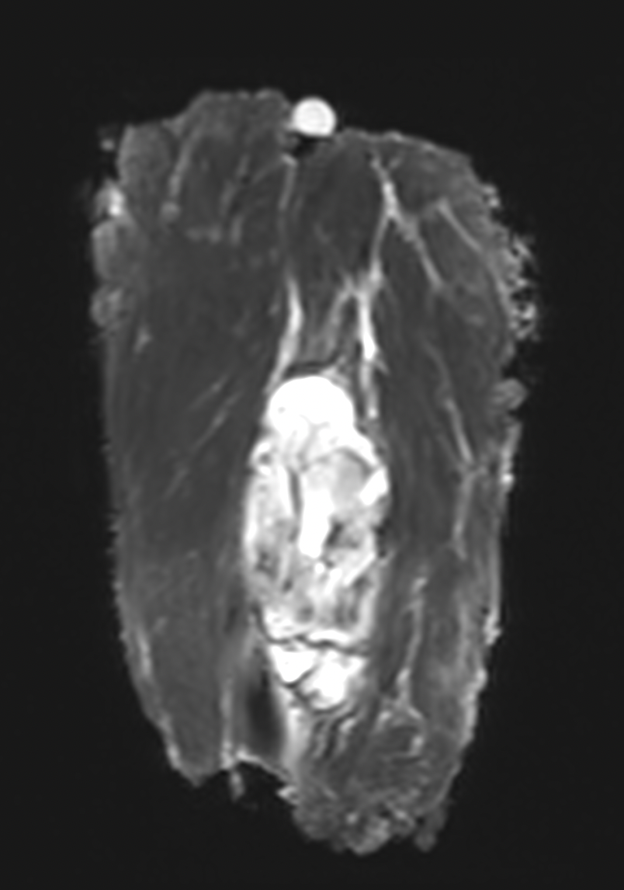

Fig 28. Myxoid liposarcoma of the Rectus Intermedius: specimen MRI, coronal plane.

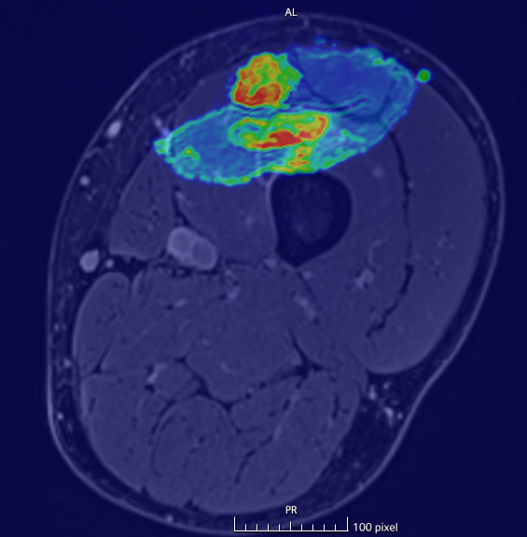

Fig 29. Myxoid liposarcoma of the Rectus Intermedius: specimen fused with pre-operative MRI, axial plane.

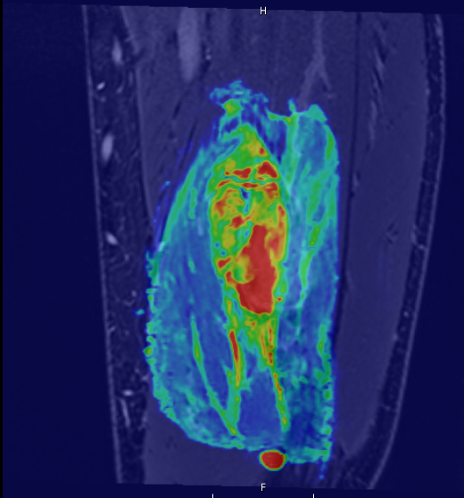

Fig 30. Myxoid liposarcoma of the Rectus Intermedius: specimen fused with pre-operative MRI, coronal plane.

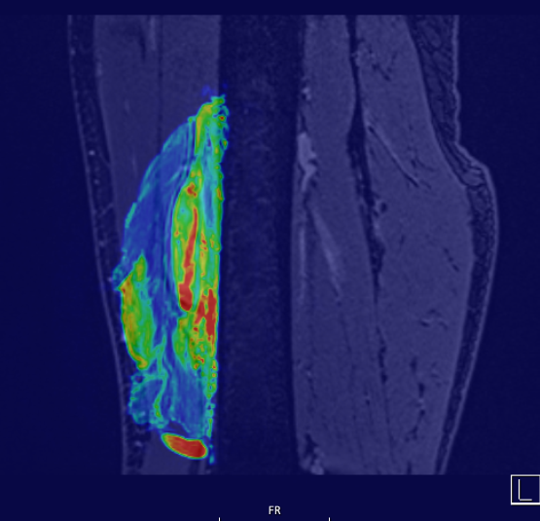

Fig 30. Myxoid liposarcoma of the Rectus Intermedius: specimen fused with pre-operative MRI, sagittal plane.

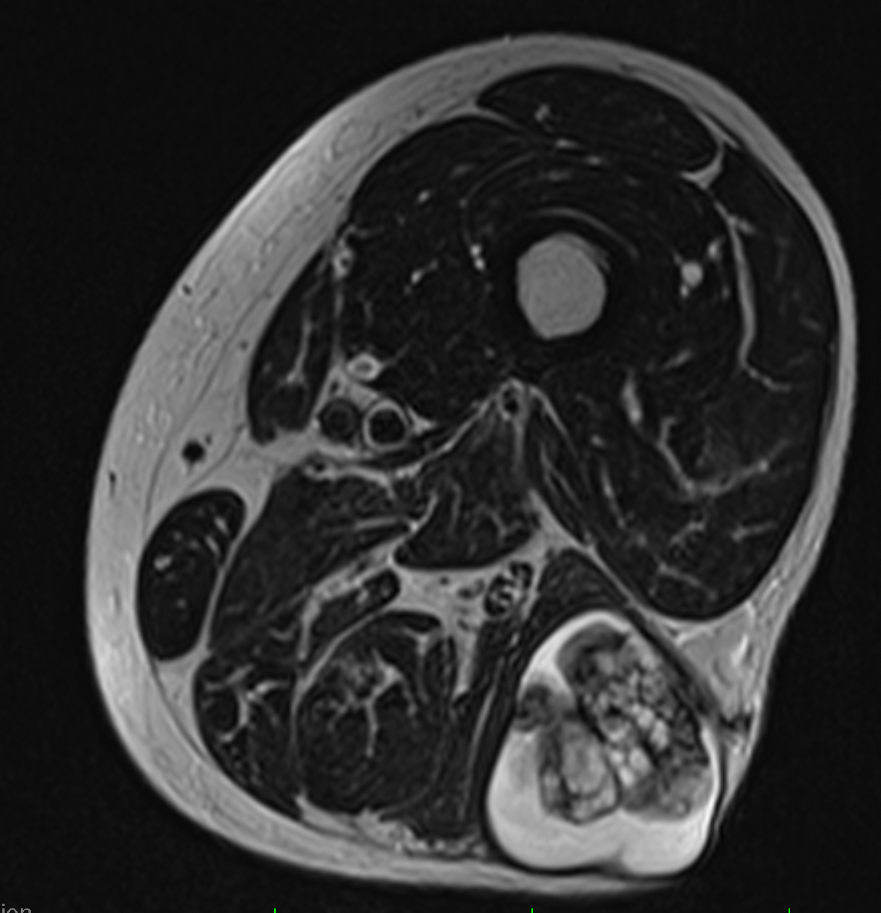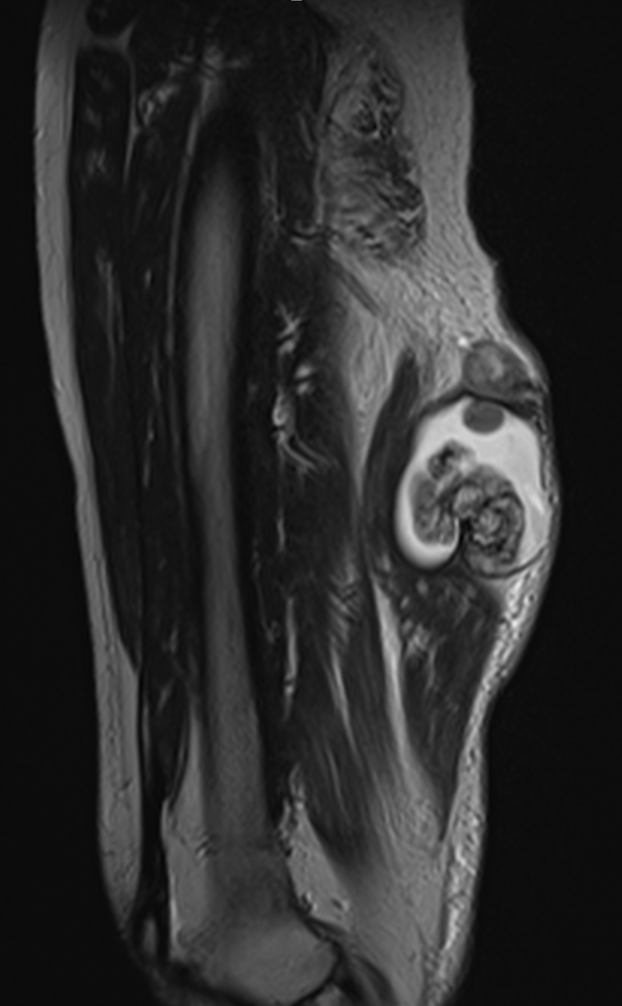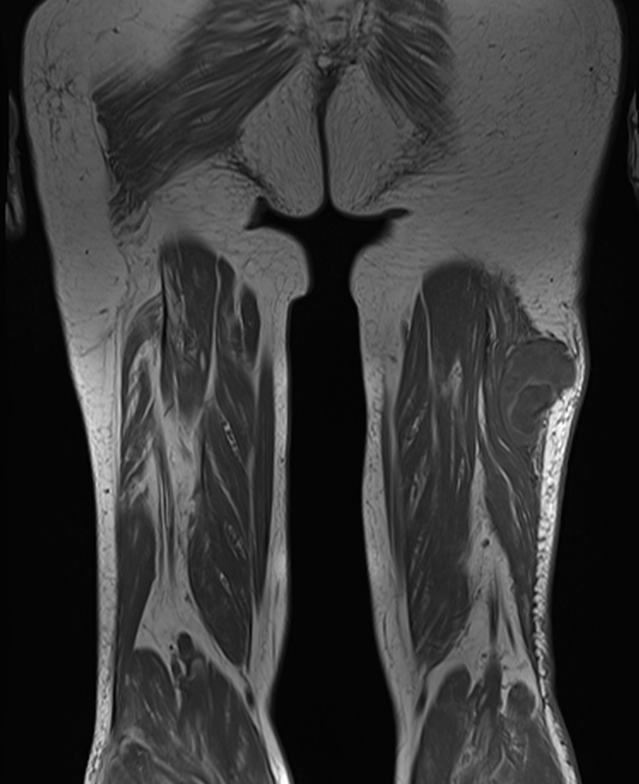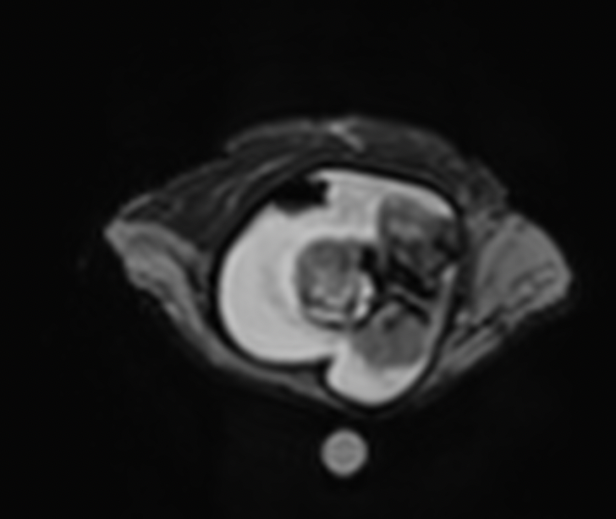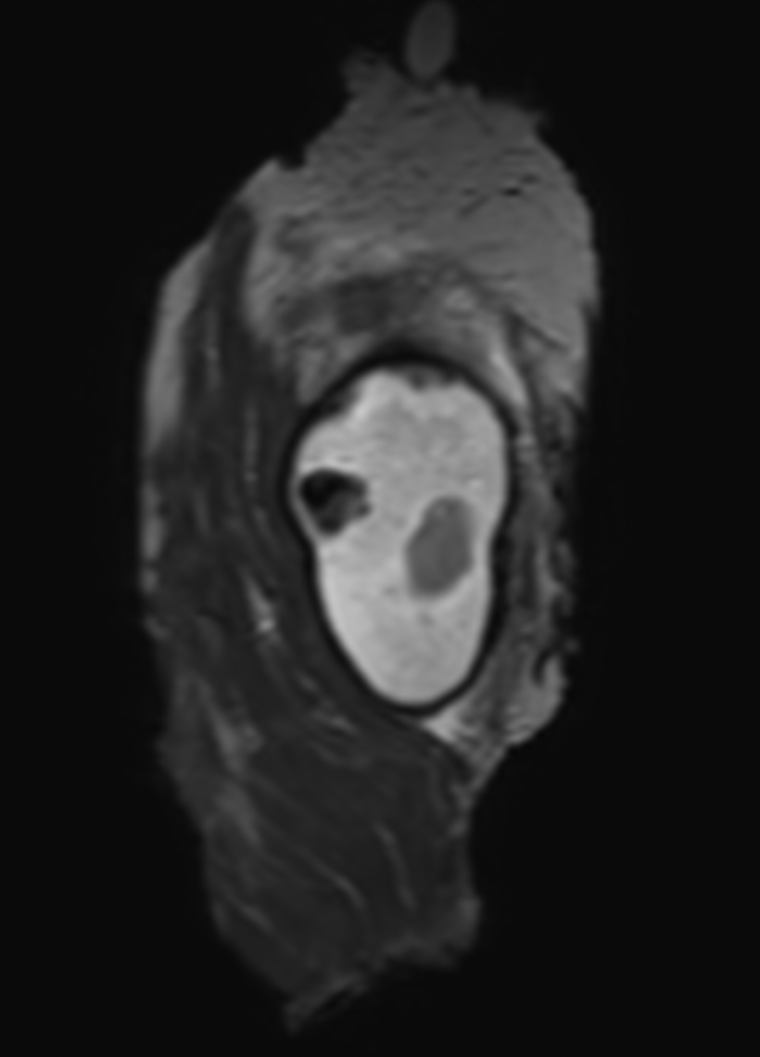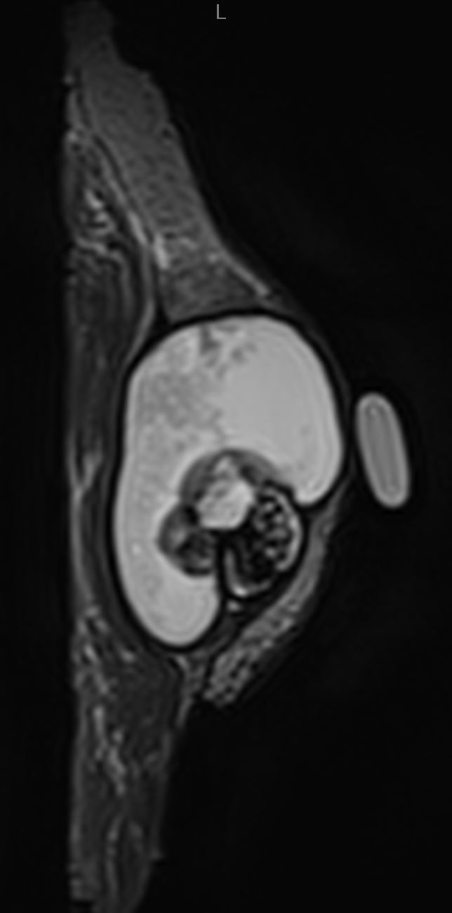
Fig 31. Myxofibrosarcoma of the left thigh: preoperative MRI, axial plane.

Fig 31. Myxofibrosarcoma of the left thigh: preoperative MRI, sagittal plane.

Fig 32. Myxofibrosarcoma of the left thigh: preoperative MRI, coronal plane.

Fig 32. Myxofibrosarcoma of the left thigh: MRI of the surgical specimen, axial plane.

Fig 33. Myxofibrosarcoma of the left thigh: MRI of the surgical specimen, coronal plane.

Fig 34. Myxofibrosarcoma of the left thigh: MRI of the surgical specimen, sagittal plane.

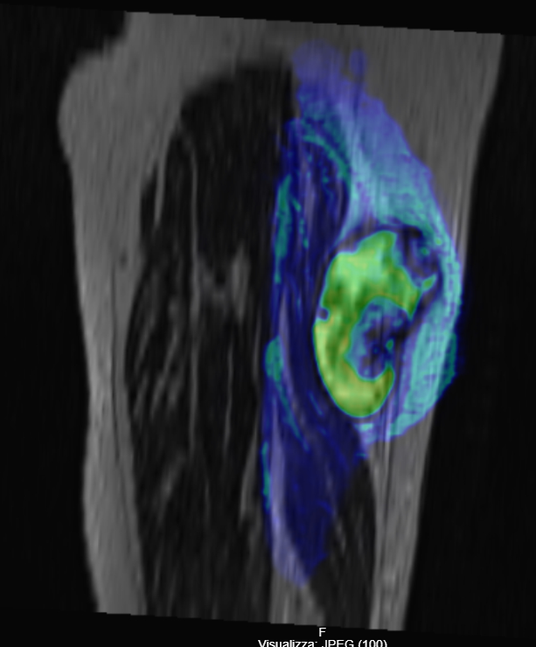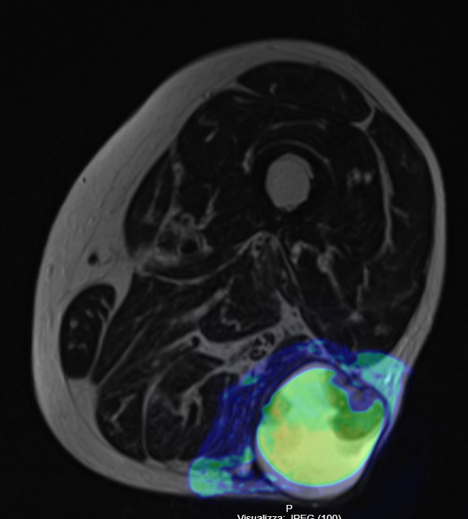
Fig 35. Myxofibrosarcoma of the left thigh: MRI of the surgical specimen fused with pre-operative scan, sagittal plane.

Fig 36. Myxofibrosarcoma of the left thigh: MRI of the surgical specimen fused with pre-operative scan, axial plane.

 | Surgical Plan | MRI Specimen
Trunk Sarcoma | 1mm fat | 3,4mm fat
Tight Sarcoma | 2mm fat + thin fascia | 1,5mm fat
GMP Sarcoma | 2mm fat + thin fascia | 0 mm (specimen muscle retraction?)
Rectus Intermedius Sarcoma | 2mm muscle + thick fascia | 4mm subcutaneous fat
Posterior Thigh Sarcoma | 5mm muscle + thin fascia | 5mm muscle + thin fascia
Tab 1. Closest Margin as reviewed on MRI imaging.

Discussion

The concept of achieving a "good margin" in surgical oncology, especially in the context of soft tissue sarcomas (STS), is critically important but remains a complex and often debated topic. Surgical margins refer to the distance between the edge of the tumor and the edge of the resected tissue, ideally ensuring that no microscopic tumor cells remain at the site of surgery. The goal is to achieve a balance between removing enough tissue to minimize the risk of local recurrence (LR) while preserving as much healthy tissue as possible to maintain function, particularly in limb-sparing procedures where muscle and other vital structures might be involved.

The Challenge of Defining a Good Margin
A "good margin" is traditionally considered one that minimizes the risk of residual tumor cells, thus reducing the likelihood of LR. In STS, wide surgical margins are often recommended to achieve local control, with the aim of leaving no microscopic cancer cells at the surgical site. However, defining what constitutes a sufficient margin can vary based on the tumor type, location, and surrounding anatomical structures. The presence of a good margin is believed to be a cornerstone of achieving local control, but its impact on overall survival (OS) is less clear, making this a point of debate in the surgical community⁹⁵⁻¹⁰⁰.

Balancing Oncological Safety and Functionality
From an oncological perspective, wide margins are often prioritized to ensure that the entire tumor, along with a buffer of healthy tissue, is removed to minimize the risk of LR. This approach is based on the premise that any residual microscopic tumor cells could lead to a recurrence, which may subsequently affect systemic outcomes such as distant metastasis. A wide margin is thus seen as a preventive measure to secure better local control.
On the other hand, obtaining wide margins in certain anatomical areas can result in significant loss of function. This is especially true when the tumor is in proximity to critical structures like major blood vessels, nerves, or muscles that are essential for limb movement or other bodily functions. Radical resections may achieve clear margins but at the cost of severely impairing the patient's quality of life due to the removal of muscles, tendons, or nerves.

The Trade-off:
Surgeons face a challenging trade-off: the need to remove sufficient tissue to minimize the risk of LR while preserving as much function as possible. For example, in limb-sparing surgeries, the surgeon must determine whether removing additional muscle and tissue to achieve a wider margin is justified by a potential decrease in LR risk, or whether this additional removal would result in a disproportionate loss of function without clear evidence of a survival benefit. This decision-making is particularly difficult in scenarios where the tumor's proximity to critical structures makes wide excision technically difficult.

Uncertainty of Margins’ Impact on Survival: A Shift in Surgical Perspective
Traditionally, obtaining free margins was seen as a cornerstone in STS surgery, since it determines LR rates. Local recurrences were seen as an event that could severely impair overall survival and hence oncological outcomes. In recent times, however, some authors like Gronchi tried to shift this perspective. They look at recurrences only as an expression of tumour aggressiveness rather than an event that per se could alter patients’ survival. When there is uncertainty about whether achieving a clear margin and local control impacts overall survival, it can drastically change the surgeon's approach to determining the extent of resection.
Studies like those of Bonvalot et al.⁹⁸, which found that local recurrence did not significantly impact overall survival in multivariate analyses, suggest that the oncological benefits of aggressive surgical margins might be less clear-cut than previously thought. If local control does not definitively translate into improved overall survival, the rationale for prioritizing wide surgical margins becomes less compelling, especially when balanced against the potential functional deficits resulting from more radical surgery.

Changing Perspectives on Radical Excision:
This uncertainty can lead to a shift away from radical excisions towards more conservative surgical approaches. If it is unclear whether wide margins confer a survival benefit, surgeons might lean towards preserving more tissue and opting for narrower margins to maintain the patient's function. This approach is especially pertinent when functional preservation is critical for maintaining the patient's quality of life, such as in younger patients or those with active lifestyles.
Bonvalot et al.⁹⁸ hypothesized that local control, specifically managing or preventing LR, might not have a significant impact on overall survival. Their study conducted a retrospective analysis of STS patients, showing that while LR was associated with worse overall survival in univariate analysis (HR: 1.7; 95% CI: 1.0–2.8; p = 0.04), this association lost statistical significance in multivariate analysis (HR: 1.5; 95% CI: 0.9–2.6; p = 0.2). These mixed findings have fueled debates on whether LR truly influences systemic outcomes, such as distant metastasis and overall mortality.
As mentioned in the context of Bonvalot et al.'s "wait-and-see" approach after unplanned excisions, if there is doubt regarding the impact of margins on survival, surgeons may consider delaying further aggressive resection until evidence of recurrence appears. This approach relies on monitoring the patient closely for signs of local recurrence and only intervening when it occurs. The underlying logic is that if local control has a limited impact on survival, subjecting the patient to a potentially disabling radical resection without a proven survival advantage might not be justified.

Challenges in Linking Local Recurrence to Overall Survival
One of the primary difficulties in establishing a definitive link between LR and OS stems from the nature of retrospective analyses, which inherently struggle to prove cause-and-effect relationships. Instead, researchers often rely on observed statistical correlations among variables. In the case of STS, a retrospective analysis of patients with and without LR may show differing rates of distant metastasis and survival outcomes, but it remains difficult to conclude whether LR itself is a causal factor or merely a reflection of a more aggressive underlying biology. In fact, authors like Gronchi and Bonvalot consider LR a marker of aggressive tumor biology—tumors prone to LR might also be more likely to metastasize due to their inherent nature, but the LR itself is not the driver of this process.
Conversely, other studies challenge this notion, arguing that LRs have a direct impact on both distant metastasis and OS. These studies suggest that a failure to achieve local control may facilitate the spread of cancer cells to distant sites, thus worsening systemic outcomes. For example, some data from a systematic review and metanalysis on the topic of re-excisions indicate that patients who experience LR are at increased risk of developing distant metastases and have a higher risk of mortality, with odds ratios (OR) reported at 1.55 for distant metastasis and 2.32 for death following an initial LR¹⁰⁰. This suggests that controlling LR might play a role in reducing the risk of systemic spread and thereby improving survival outcomes.

Methodological Challenges and the Limitations of Retrospective Analyses
Retrospective studies, such as the one conducted by Bonvalot et al., often suffer from biases and confounding factors that make it difficult to draw firm conclusions. These analyses typically rely on available medical records, which can introduce selection biases, variability in treatment approaches, and inconsistencies in follow-up. Moreover, many of these studies include heterogeneous patient populations with varying tumor subtypes, grades, and stages, making it challenging to isolate the impact of LR from other prognostic factors.
Additionally, statistical methods like multivariate analysis can adjust for known confounders, but they may fail to account for unmeasured variables that influence survival. In Bonvalot's study, the multivariate analysis did not find a statistically significant effect of LR on OS, leading to their hypothesis that local control does not alter mortality outcomes. However, the univariate analysis still indicated a negative impact of LR on OS, hinting at a possible connection that could be obscured by other confounding factors when using more complex statistical models.

Reconciling the Evidence: The Role of a Metanalysis
To address these challenges, metanalyses that pool data from multiple studies can provide a more robust understanding by analyzing outcomes across larger patient populations. The metanalysis mentioned, involving 4,831 patients, found a notable association between LR and poorer OS, suggesting that patients who experience LR are at a higher risk of developing distant metastases and have lower survival rates. This finding raises concerns about the validity of the "wait and see" approach, as it highlights the potential risks of not addressing LRs more aggressively.
The metanalysis's findings indicate that while retrospective data cannot establish a direct causal link, there is enough evidence to suggest that LR may influence survival outcomes in a significant subset of patients. This challenges the theoretical basis of delaying re-excisions and suggests that timely surgical management of LR could potentially improve systemic control and survival in select cases.

In my opinion, the ambiguity surrounding the definition of "safe" surgical margins and the impact of local control on overall survival in soft tissue sarcomas (STS) is a direct consequence of the inconsistent and varied ways that margins are classified across studies. This inconsistency is compounded by the rarity of the disease and the retrospective nature of most studies in this field, making it challenging to draw definitive conclusions about the true importance of surgical margins.
Variability in Margin Classifications: A Source of Ambiguity
The concept of surgical margins is foundational in the treatment of STS, but the lack of a standardized classification systems has led to a fragmented understanding of what constitutes a "safe" margin. This issue is exacerbated by the existence of multiple classification systems favored by different specialties, each with its own criteria and focus.
For instance, the Enneking Classifications categorizes margins as:
Intralesional: The tumor is transected, leaving residual disease.
Marginal: The resection is immediately adjacent to the tumor, potentially leaving microscopic residual disease.
Wide: The resection includes a rim of healthy tissue, providing a buffer around the tumor.
Radical: The entire anatomical compartment containing the tumor is removed.
The Enneking classification is intuitive for surgical planning, as it directly relates to the physical space around the tumor that is removed and is widely used by orthopedic surgeons. However, it may not always align with microscopic findings observed during pathological analysis.
On the other hand, R Classification (R0, R1, R2): is frequently used by pathologists and oncologists and is focused on the presence or absence of residual tumor cells at the resection margins:
R0: No residual tumor cells are detected microscopically, indicating a "clean" margin.
R1: Microscopic residual tumor cells are present at the margin, suggesting an increased risk of local recurrence.
R2: Macroscopic residual tumor remains, indicating a significant risk of local recurrence.
The R classification emphasizes the histological assessment of the resection specimen, providing a more detailed picture of the presence of microscopic disease. However, it does not directly account for the physical distance between the tumor and the margin, which can be clinically relevant in determining local recurrence risk.
Impact of Variability:
These different systems often yield conflicting interpretations of what constitutes an adequate margin. For instance, a resection classified as "wide" by Enneking's criteria might still be considered R1 if microscopic tumor cells are detected at the margin. Conversely, an R0 resection might not always correspond to a "wide" margin if the buffer of healthy tissue is very thin. These differences make it difficult to directly compare studies, analyze outcomes, or establish standardized guidelines.
Challenges of Comparing Studies and Deriving Meaning
The lack of uniformity in margin classification creates significant challenges when trying to extract meaningful data from the literature.
Studies that use different classification systems may draw different conclusions about the relationship between margin status and outcomes like local recurrence or overall survival. This makes it nearly impossible to conduct meta-analyses or systematic reviews that synthesize data across studies, as each study may define and measure margins differently.
Furthermore, the rarity of STS adds another layer of complexity. Due to the small number of cases, most studies are retrospective analyses, drawing from single-institution experiences or pooled data from multiple centers. Retrospective data is often inconsistent in terms of how margins are reported, making comparisons even more difficult. Moreover, retrospective studies are subject to selection biases and variations in treatment approaches over time, further complicating the interpretation of results.
In many studies, the assessment of local control and its impact on survival is not standardized, leading to variability in the reported outcomes. For example, some studies may report the distance of the margin in millimeters, while others categorize margins more qualitatively. The inconsistent reporting of what constitutes "positive" or "negative" margins further contributes to ambiguity in interpreting the relationship between local control and systemic prognosis.

Need for a Unified Classification System
Given the challenges posed by the current variability in margin classification, there is a pressing need for a new, unified classification system that could synthesize the best aspects of existing methods while introducing greater clarity and consistency. Such a system could integrate both the quantity (e.g., the physical distance of the margin) and the quality (e.g., what healthy tissue constitute a weak or strong barrier) of a surgical margin, providing a more holistic view of what makes it "safe". Here’s how this could be approached:
Incorporating Distance and Microscopic Findings: A new classification could include both the actual distance between the tumor and the edge of resection (e.g., measured in millimeters) and the presence or absence of microscopic tumor cells at the margin. This dual assessment would provide a more comprehensive understanding of both the physical extent of the resection and the biological characteristics of the margin.
Ideally, the development of this new classification system would be guided by evidence from prospective studies that explore the impact of various margin distances and especially what kind of tissue is left with the specimen on both local recurrence and survival. The aim of this project is in fact to collect data about margins quality and distances from tumour in a complete and 3D way thanks to MRI scans. Once recurrences will be observed, one could infer how these factors predict local control in a more evidence-based way. Then, an analysis of the impact of local control on overall survival could be made without being exposed to overwhelming quantity of confounding factors. Finally, a more precise classification of surgical margins could be made.
Essentially, the core of this project is the use of MRI imaging of surgical specimens to gather comprehensive data about the quality and distance of margins from the tumor. Traditional methods of assessing margins rely heavily on histopathological analysis, which involves evaluating thin slices of tissue under a microscope. While this provides detailed information on a microscopic level, it lacks the ability to offer a complete, three-dimensional perspective on how the tumor relates to the surrounding healthy tissue.
Using MRI scans of resected specimens allows researchers to visualize the entire resection volume, preserving the spatial relationships between the tumor and the margins. This means that both the distance between the tumor and the edges of the removed tissue and the type of tissue surrounding the tumor can be analyzed in a holistic manner. By evaluating these factors in three dimensions, researchers can gain a clearer understanding of what constitutes an effective surgical margin.

Aiming for Evidence-Based Insights
Once a substantial amount of data is collected, including cases with both successful local control and instances of recurrence, the goal is to identify patterns in how different types of margins influence outcomes. For example, researchers would look for correlations between the thickness and quality of the margin (e.g., whether the margin includes fat, muscle, or fascia) and the likelihood of local recurrence.
By focusing on the types of tissue that remain attached to the tumor and surrounding structures, this study could identify which tissue types provide a natural barrier to recurrence, potentially offering more insights than a simple measurement of margin distance. It could answer questions like: Does a 5 mm margin in muscle tissue provide better local control than a 3 mm margin in dense fibrous tissue?

Predicting Local Control with Greater Accuracy
One of the main objectives is to develop a model that can better predict local control based on a combination of margin distance and tissue quality. By analyzing data from a large number of cases where local recurrences occur, researchers could refine their understanding of how different margin characteristics influence the likelihood of local recurrence. This could lead to a more nuanced approach to classifying margins, moving beyond simple measurements to include qualitative factors that are currently underestimated in margin assessment.
For example, a new classification might stratify margins into categories like:
- Thick, fibrous margins of >5 mm: High probability of local control.
- Thin, muscle tissue margins of <3 mm: Increased risk of local recurrence.
- Mixed margins (e.g., part muscle, part fat): Intermediate risk, with recommendations based on specific tissue types.
Such a classification could be further validated through prospective studies, allowing for real-world testing of its predictive accuracy.

Assessing the Impact on Overall Survival
Once a clear understanding of how margin characteristics affect local control is established, the next step would be to examine the relationship between local control and overall survival. This is a crucial aspect of the study, as it seeks to clarify whether achieving good local control translates into a meaningful impact on long-term outcomes like survival.
By reducing the influence of confounding factors (e.g., variations in classifications, histopathological assessments), researchers can more accurately assess whether achieving a specific type of surgical margin is worth the trade-off in terms of surgical complexity or the risk of losing function. The goal is to determine if a particular margin approach contributes to better overall survival rates or if it primarily affects the risk of local recurrence without altering the long-term prognosis.

Towards a New Classification System
The aim is to create a new, refined classification system for surgical margins that integrates both quantitative and qualitative aspects of margins. Such a system would provide clearer guidance to surgeons on how to balance the goals of oncological safety and functional preservation in their procedures. It would help answer critical questions, such as:
- How wide does the margin need to be in specific types of tissue to minimize the risk of recurrence?
- What types of tissue should be prioritized in achieving a safe margin?
- When might it be acceptable to leave a narrower margin without compromising long-term survival?
The new classification system could become a valuable tool in clinical practice, helping surgeons make more informed decisions about the extent of tissue removal needed for each patient. This approach would also align with personalized medicine by tailoring surgical strategies to the unique anatomical and biological characteristics of each patient's tumor.
A unified classification system could also facilitate better communication and alignment among surgeons, pathologists, and oncologists, reducing discrepancies in the interpretation of surgical outcomes. This could lead to more consistent decision-making regarding postoperative treatments, such as radiotherapy, which is often considered when margins are close or positive.

Performing an MRI of the surgical specimen has provided a valuable opportunity to study the entire tumor and the surrounding healthy tissues in detail, offering insights that traditional histopathological analysis alone may not capture. By imaging the resected tissue, we gain a more comprehensive understanding of the spatial relationship between the tumor and its margins, allowing for a more precise assessment of the quality of the resection and the surrounding margins.

Insights from MRI of Surgical Specimens
The study revealed that all the resected specimens demonstrated very good surgical margins, with a high degree of concordance between the surgical plan and the actual execution. This finding suggests that when surgeons adhere closely to a preoperative plan based on detailed imaging, they can achieve margins that align well with the surgical intent. This is particularly encouraging as it may underscore the importance of meticulous preoperative planning in achieving good oncological outcomes.
In the cohort of patients studied, none developed local recurrence, which is consistent with the observation that the resected specimens had clear margins. Although the absence of local recurrence among the patients means that we couldn’t analyze differences in margin quality between those with and without recurrence, the uniformly positive outcomes suggest that achieving well-defined margins according to the plan could correlate with favorable clinical results.

Limitations and Challenges
This study was not without its challenges, particularly regarding the technical aspects of using MRI for analyzing the surgical specimens:
Tissue Shrinkage in the Longitudinal Plane. One limitation observed was the relative shrinkage of the resected tissues along the longitudinal plane during MRI imaging. Tissue shrinkage is a known artifact that can occur when a specimen is removed from the body, as the surrounding support structures are no longer present, and the tissue contracts. However, in this study, the extent of shrinkage did not appear to significantly affect the interpretation of the margins. The impact of this phenomenon was mitigated by comparing the MRI scans of the specimens to the preoperative MRI, allowing for an understanding of any changes in the size or shape of the tissues. Nonetheless, tissue shrinkage remains an inherent limitation when imaging surgical specimens and should be accounted for when interpreting the data.

Tissue Collapse Under Weight in the MRI Machine. Another technical challenge involved the collapse of the tissues under their own weight during MRI scanning. When placed inside the MRI machine, the resected tissues can deform due to gravity, which may alter their shape and potentially obscure the true spatial relationships observed during surgery. To address this issue, a potential solution could involve 3D printing a plastic model of the patient’s remaining anatomy, allowing the surgical specimen to be positioned in a way that mimics its in-situ orientation. By placing the specimen on this custom-made support, the natural shape of the tissues could be better preserved during MRI scanning, reducing the likelihood of deformation.
Despite this issue, the study found that tissue collapse had only a minor impact on the overall analysis. There was strong concordance between the preoperative MRI of the tumor and the MRI of the resected specimen when using fusion imaging techniques, suggesting that any distortions were manageable and did not significantly affect the interpretation of the surgical margins.
Encouraging Correlation Between Planning and Outcomes
The most promising aspect of this study is the observed correspondence between precise surgical planning and patient outcomes. Although the number of patients included in the study was limited, the fact that all patients experienced optimal outcomes suggests a positive correlation between the accurate execution of a preoperative plan and the achievement of good surgical margins. This finding is particularly important as it highlights the potential for imaging techniques, like MRI of resected specimens, to serve as a valuable quality control tool for surgeons.
By confirming that the margins achieved during surgery closely match the preoperative plan, surgeons can gain confidence in their technique and refine their approach to similar cases in the future. The ability to visualize the resected tissue in three dimensions through MRI can help identify any potential discrepancies between the plan and execution, offering an opportunity for continuous improvement in surgical practice.
The data suggests that imaging resected specimens could be used in future studies to explore the relationship between surgical margins and outcomes more deeply. If this technique were applied to a larger cohort of patients, it could provide a more robust dataset to analyze how variations in margin quality impact local recurrence and survival. It would also allow for a more nuanced understanding of the biological behavior of tumors at the margin, offering potential insights into which types of margins are most protective against recurrence.

While this project is still in its early stages, it has already yielded promising preliminary results, suggesting a potential path forward for improving surgical margin analysis in soft tissue sarcoma (STS). Here are some of the key findings and their implications:
Specimen MRI as a Tool for Margin Analysis: By following the protocol outlined, the MRI scanning of resected specimens has proven to be an effective method for evaluating the quality and thickness of surgical margins. Unlike traditional histopathological examination, MRI allows for a three-dimensional visualization of the entire surgical specimen, offering a complete perspective on how the tumor was removed relative to the surrounding healthy tissues. This imaging technique has made it possible to study the spatial characteristics of the margins more comprehensively, providing detailed insights into the areas where surgical precision is most critical.
The study has demonstrated a strong correlation between the preoperative surgical plan and the margins achieved during the procedure. This means that when surgeons adhere closely to their preoperative plan, the resulting margins tend to align with the intended resection boundaries. Although the number of patients analyzed so far is small, the findings are encouraging—each patient in the study has had a favorable prognosis, suggesting that precise surgical planning could be a key factor in achieving good oncological outcomes. This could be particularly valuable in guiding surgical strategy, as it highlights the importance of meticulous planning and execution.
The fusion of the resected specimen's MRI images with preoperative MRI scans has proven to be a powerful tool for quickly and visually assessing how the tumor was removed. This technique allows for a direct comparison between the pre-surgical state and the final resection, making it easier to evaluate the quality of the tissue that remains between the tumor bed and the removed specimen. Surgeons can assess whether sufficient healthy tissue was preserved around the tumor, which is critical for reducing the risk of local recurrence. This rapid assessment capability could potentially be integrated into surgical practice to provide immediate feedback on the quality of the resection.
In theory, in the future, if a specimen MRI could be done very shortly after the resection, a surgeon could improve margins on real time if they look inadequate on the scan.

While these initial findings are promising, achieving the ambitious goals of the study will require more time, a larger patient cohort, and sustained effort. The following challenges and areas for future work are particularly critical.
To validate the preliminary correlations and build a robust dataset, it will be necessary to include more patients in the study. The current sample size limits the ability to generalize the findings to a broader patient population.
More time is needed to track the long-term outcomes of patients and to assess the true predictive value of the imaging methods. This includes monitoring for potential late recurrences and assessing how the margin characteristics identified through MRI correlate with outcomes like survival and metastasis over a longer period. Such longitudinal data would help clarify the relationship between local control and overall survival, providing a stronger evidence base for future recommendations.
As the project progresses, there may be opportunities to refine the protocols for MRI scanning and image fusion. For example, exploring ways to further minimize tissue deformation during scanning could enhance the accuracy of margin measurements. Additionally, developing standardized methods for evaluating the fusion images could improve consistency in interpreting the results across different surgical teams.
If successful, this project could pave the way for a new standard in evaluating surgical margins, combining the anatomical detail provided by MRI with the precision of traditional histopathology. This would not only improve the accuracy of margin assessment but could also lead to a deeper understanding of how surgical technique influences long-term outcomes in STS patients. Ultimately, the goal is to develop a more evidence-based classification system for margins that considers both the quality and the quantity of tissue surrounding the tumor. Such a system could help resolve current ambiguities around margin definitions and provide clearer guidance for surgeons, potentially leading to better patient outcomes.
In conclusion, although the project is still in its infancy, it has already shown that using MRI for analyzing surgical specimens can provide valuable insights into the quality of margins and the effectiveness of surgical planning. With continued efforts to expand the study and refine the methodology, this approach could become a key tool in the future of oncological surgery, helping to bridge the gap between the surgical technique and patient survival.

Conclusions

This study demonstrates that using MRI to analyze resected surgical specimens offers a valuable enhancement to traditional histopathological methods, providing a detailed, three-dimensional view of the tumor and its margins. By enabling a precise evaluation of how closely the resection aligns with preoperative plans, MRI facilitates better quality control in surgical procedures. The strong correlation between meticulous preoperative planning and favorable patient outcomes suggests that achieving well-defined margins can lead to improved local control and potentially better long-term survival. Despite technical challenges such as tissue shrinkage and deformation during imaging, the study managed these limitations effectively, highlighting the potential of MRI as a tool for real-time margin assessment. Future research with larger patient cohorts and refined imaging protocols could validate these preliminary findings, helping to establish new standards for surgical margin evaluation in soft tissue sarcoma treatment and providing surgeons with clearer guidelines to optimize patient care.

References

- 1. AIOM. I numeri del cancro in Italia, 8 edizione. 2018.
- 2. Robbins & Cotran. Le Basi Patologiche Delle Malattie. Vol 2. 9th ed.
- 3. Gatta G, Ciccolallo L, Kunkler I, et al. Survival from rare cancer in adults: a population-based study. The Lancet Oncology. 2006;7(2):132-140.
- 4. Zahm SH, Fraumeni JF. The epidemiology of soft tissue sarcoma. Semin Oncol. 1997;24(5):504-514.
- 5. Strong LC, Williams WR, Tainsky MA. The Li–Fraumeni Syndrome: From Clinical Epidemiology to Molecular Genetics. Am J Epidemiol. 1992;135(2):190-199.
- 6. Vodanovich DA, M Choong PF. Soft-tissue Sarcomas. Indian J Orthop. 2018;52(1):35-44. doi:10.4103/ortho.IJOrtho_220_17
- 7. Linee Guida AIOM 2018 presentate a Roma durante il XX Congresso Nazionale Associazione Italiana di Oncologia Medica. Linee Guida, I sarcomi dei tessuti molli e GIST.
- 8. Deyrup AT, Weiss SW. Grading of soft tissue sarcomas: the challenge of providing precise information in an imprecise world. Histopathology. 2006;48(1):42-50.
- 9. Fletcher. WHO Classification of Tumours. Vol 5. 4th ed.; 2013.
- 10. Doyle LA. Sarcoma classification: An update based on the 2013 World Health Organization Classification of Tumors of Soft Tissue and Bone. Cancer. 2014;120(12):1763-1774.
- 11. Laurino L, Furlanetto A, Orvieto E, Dei Tos AP. Well-differentiated liposarcoma (atypical lipomatous tumors). Semin Diagn Pathol. 2001;18(4):258-262.
- 12. Singer S, Antonescu CR, Riedel E, Brennan MF. Histologic subtype and margin of resection predict pattern of recurrence and survival for retroperitoneal liposarcoma. Ann Surg. 2003;238(3):358-370; discussion 370-371.
- 13. Evans HL. Atypical lipomatous tumor, its variants, and its combined forms: a study of 61 cases, with a minimum follow-up of 10 years. Am J Surg Pathol. 2007;31(1):1-14.
- 14. Robbins e Cotran. Le Basi Patologiche Delle Malattie. Vol 2. 8th ed. Masson; 2014.
- 15. Bogucki B, Neuhaus I, Hurst EA. Dermatofibrosarcoma protuberans: a review of the literature. Dermatol Surg. 2012;38(4):537-551.
- 16. Yue Y, Liu Y, Song L, Chen X, Wang Y, Wang Z. MRI findings of low-grade fibromyxoid sarcoma: a case report and literature review. BMC Musculoskelet Disord. 2018;19.
- 17. Mizoshiri N, Shirai T, Terauchi R, et al. Hepatic metastases from primary extremity leiomyosarcomas. Medicine (Baltimore). 2018;97(18).
- 18. Paulino AC, Ikcu MF. Rhabdomyosarcoma. Curr Probl Cancer.; 2008.
- 19. de Bruikn DR. The (Epi)Genetics of Human Synovial Sarcoma. Genes Chromosomes Cancer; 2007.
- 20. Speth BM, Krieg AH, Kaelin A, et al. Synovial sarcoma in patients under 20 years of age: a multicenter study with a minimum follow-up of 10 years. Journal of Children’s Orthopaedics. 2011;5(5):335-342.
- 21. Trojani M, Contesso G, Coindre JM, et al. Soft-tissue sarcomas of adults; study of pathological prognostic variables and definition of a histopathological grading system. Int J Cancer. 1984;33(1):37-42.
- 22. Ball AB, Fisher C, Pittam M, Watkins RM, Westbury G. Diagnosis of soft tissue tumours by Tru-Cut biopsy. Br J Surg. 1990;77(7):756-758.
- 23. Campanacci. Bone and Soft Tissue Tumors, Clinical Features, Imaging, Pathology and Treatment. 1999th ed.
- 24. Casali PG, Abecassis N, Bauer S, et al. Soft tissue and visceral sarcomas: ESMO–EURACAN Clinical Practice Guidelines for diagnosis, treatment and follow-up†. Annals of Oncology. 2018;29(Supplement_4):iv51-iv67.
- 25. Rimondi E, Benassi MS, Bazzocchi A, et al. Translational research in diagnosis and management of soft tissue tumours. Cancer Imaging. 2016;16.
- 26. Fleming JB, Cantor SB, Varma DG, et al. Utility of chest computed tomography for staging in patients with T1 extremity soft tissue sarcomas. Cancer. 2001;92(4):863-868.
- 27. Noebauer-Huhmann IM, Weber M-A, Lalam RK, et al. Soft Tissue Tumors in Adults: ESSR-Approved Guidelines for Diagnostic Imaging. Semin Musculoskelet Radiol. 2015;19(5):475-482.
- 28. Demas B, Heelan R, Lane J, Marcove R, Hajdu S, Brennan M. Soft-tissue sarcomas of the extremities: comparison of MR and CT in determining the extent of disease. American Journal of Roentgenology. 1988;150(3):615-620.
- 29. Rijswijk CSP van, Geirnaerdt MJA, Hogendoorn PCW, et al. Soft-Tissue Tumors: Value of Static and Dynamic Gadopentetate Dimeglumine–enhanced MR Imaging in Prediction of Malignancy1. Radiology. November 2004.
- 30. De La Hoz Polo M, Dick E, Bhumbra R, Pollock R, Sandhu R, Saifuddin A. Surgical considerations when reporting MRI studies of soft tissue sarcoma of the limbs. Skeletal Radiology. 2017;46(12):1667-1678.
- 31. Patkar S, Gulia A, Juvekar S, Rekhi B, Puri A. Does magnetic resonance imaging accurately predict residual disease after unplanned excision of soft-tissue sarcomas? Indian J Cancer. 2016;53(3):408-411.
- 32. Crombé A, Le Loarer F, Stoeckle E, et al. MRI assessment of surrounding tissues in soft-tissue sarcoma during neoadjuvant chemotherapy can help predicting response and prognosis. European Journal of Radiology. 2018;109:178-187.
- 33. Kissin MW, Fisher C, Carter RL, Horton LW, Westbury G. Value of Tru-cut biopsy in the diagnosis of soft tissue tumours. Br J Surg. 1986;73(9):742-744.
- 34. Heslin MJ, Lewis JJ, Woodruff JM, Brennan MF. Core needle biopsy for diagnosis of extremity soft tissue sarcoma. Annals of Surgical Oncology. 1997;4(5):425-431.
- 35. Ramanathan RC, A’Hern R, Fisher C, Thomas JM. Modified staging system for extremity soft tissue sarcomas. Ann Surg Oncol. 1999;6(1):57-69.
- 36. Wunder JS, Healey JH, Davis AM, Brennan MF. A comparison of staging systems for localized extremity soft tissue sarcoma. Cancer. 2000;88(12):2721-2730.
- 37. Edge SB, American Joint Committee on Cancer, eds. AJCC Cancer Staging Manual. 7th ed. New York: Springer; 2010.
- 38. Spanier S. A System for the Surgical Staging of Musculoskeletal Sarcoma. Clinical Orthopaedics. 1980;(153):15.
- 39. Pisters PW, Leung DH, Woodruff J, Shi W, Brennan MF. Analysis of prognostic factors in 1,041 patients with localized soft tissue sarcomas of the extremities. J Clin Oncol. 1996;14(5):1679-1689.
- 40. Grimer R, Judson I, Peake D, Seddon B. Guidelines for the Management of Soft Tissue Sarcomas. Sarcoma. 2010;2010.
- 41. Cahlon O, Spierer M, Brennan MF, Singer S, Alektiar KM. Long-term outcomes in extremity soft tissue sarcoma after a pathologically negative re-resection and without radiotherapy. Cancer. 2008;112(12):2774-2779.
- 42. Bowden L, Booher RJ. The principles and technique of resection of soft parts for sarcoma. 1958. Clin Orthop Relat Res. 2004;(426):5-10.
- 43. Enneking WF, Spanier SS, Malawer MM. The effect of the anatomic setting on the results of surgical procedures for soft parts sarcoma of the thigh. Cancer. 1981;47(5):1005-1022.
- 44. Novais EN, Demiralp B, Alderete J, Larson MC, Rose PS, Sim FH. Do Surgical Margin and Local Recurrence Influence Survival in Soft Tissue Sarcomas? Clin Orthop Relat Res. 2010;468(11):3003-3011.
- 45. Beane JD, Yang JC, White D, Steinberg SM, Rosenberg SA, Rudloff U. Efficacy of Adjuvant Radiation Therapy in the Treatment of Soft Tissue Sarcoma of the Extremity: 20-year Follow-Up of a Randomized Prospective Trial. Annals of Surgical Oncology. 2014;21(8):2484-2489.
- 46. Esmo Guidelines Committee and EUROCAN. Soft tissue and visceral sarcomas: ESMO-EURACAN Clinical Prac- tice Guidelines for diagnosis, treatment and follow-up. Ann Oncolo 0. 2018.
- 47. Dagan R, Indelicato DJ, McGee L, et al. The significance of a marginal excision after preoperative radiation therapy for soft tissue sarcoma of the extremity: Marginal Excision After Preoperative RT for STS of the Extremity. Cancer. 2012;118(12):3199-3207.
- 48. O’Sullivan B, Davis AM, Turcotte R, et al. Preoperative versus postoperative radiotherapy in soft-tissue sarcoma of the limbs: a randomised trial. Lancet. 2002;359(9325):2235-2241.
- 49. O’Sullivan B, Griffin AM, Dickie CI, et al. Phase 2 study of preoperative image-guided intensity-modulated radiation therapy to reduce wound and combined modality morbidities in lower extremity soft tissue sarcoma. Cancer. 2013;119(10):1878-1884.
- 50. Naghavi AO, Fernandez DC, Mesko N, et al. American Brachytherapy Society consensus statement for soft tissue sarcoma brachytherapy. Brachytherapy. 2017;16(3):466-489.
- 51. Adjuvant chemotherapy for localised resectable soft-tissue sarcoma of adults: meta-analysis of individual data. Sarcoma Meta-analysis Collaboration. Lancet. 1997;350(9092):1647-1654.
- 52. Wang H-R, Fu Q, Liu Z, Li M-L, Zhai S-Q. A systematic review and meta-analysis of randomized controlled trials: Skin-patch of Chinese herbal medicine for patients with acute gouty arthritis. J Adv Nurs. March 2018.
- 53. Saponara M, Stacchiotti S, Casali PG, Gronchi A. (Neo)adjuvant treatment in localised soft tissue sarcoma: The unsolved affair. European Journal of Cancer. 2017;70:1-1
- 54. Gronchi A, Frustaci S, Mercuri M, et al. Short, full-dose adjuvant chemotherapy in high-risk adult soft tissue sarcomas: a randomized clinical trial from the Italian Sarcoma Group and the Spanish Sarcoma Group. J Clin Oncol. 2012;30(8):850-856.
- 55. Gronchi A, Ferrari S, Quagliuolo V, et al. Histotype-tailored neoadjuvant chemotherapy versus standard chemotherapy in patients with high-risk soft-tissue sarcomas (ISG-STS 1001): an international, open-label, randomised, controlled, phase 3, multicentre trial. Lancet Oncol. 2017;18(6):812-822.
- 56. Tepper JE, Suit HD. Radiation therapy alone for sarcoma of soft tissue. Cancer. 1985;56(3):475-479.
- 57. Roth JA, Putnam JB, Wesley MN, Rosenberg SA. Differing determinants of prognosis following resection of pulmonary metastases from osteogenic and soft tissue sarcoma patients. Cancer. 1985;55(6):1361-1366.
- 58. Temple LKF, Brennan MF. The role of pulmonary metastasectomy in soft tissue sarcoma. Semin Thorac Cardiovasc Surg. 2002;14(1):35-44.
- 59. Maki RG, Wathen JK, Patel SR, et al. Randomized phase II study of gemcitabine and docetaxel compared with gemcitabine alone in patients with metastatic soft tissue sarcomas: results of sarcoma alliance for research through collaboration study 002 [corrected]. J Clin Oncol. 2007;25(19):2755-2763.
- 60. Tap WD, Jones RL, Tine BAV, et al. Olaratumab and doxorubicin versus doxorubicin alone for treatment of soft-tissue sarcoma: an open-label phase 1b and randomised phase 2 trial. The Lancet. 2016;388(10043):488-497.
- 61. Beitler AL, Virgo KS, Johnson FE, Gibbs JF, Kraybill WG. Current follow-up strategies after potentially curative resection of extremity sarcomas: results of a survey of the members of the society of surgical oncology. Cancer. 2000;88(4):777-785.
- 62. Whooley BP, Gibbs JF, Mooney MM, McGrath BE, Kraybill WG. Primary Extremity Sarcoma: What Is the Appropriate Follow-Up? Ann Surg Oncol. 2000;7(1):9-14.
- 63. Giuliano AE, Eilber FR. The rationale for planned reoperation after unplanned total excision of soft-tissue sarcomas. Journal of Clinical Oncology. September 2016.
- 64. Chen C-F, Wu P-K, Chen W-M. Unplanned resection of soft tissue sarcoma. Formosan Journal of Surgery. 2015;48(4):117-120. doi:10.1016/j.fjs.2015.03.003
- 65. Charoenlap C, Imanishi J, Tanaka T, et al. Outcomes of unplanned sarcoma excision: impact of residual disease. Cancer Medicine. 2016;5(6):980-988.
- 66. Harati K, Lange K, Goertz O, et al. A single-institutional review of 68 patients with dermatofibrosarcoma protuberans: wide re-excision after inadequate previous surgery results in a high rate of local control. World Journal of Surgical Oncology. 2017;15(1).
- 67. Gingrich AA, Elias A, Michael Lee C-Y, et al. Predictors of residual disease after unplanned excision of soft tissue sarcomas. Journal of Surgical Research. 2017;208:26-32.
- 68. Brennan MF, Hilaris B, Shiu MH, et al. Local recurrence in adult soft-tissue sarcoma. A randomized trial of brachytherapy. Arch Surg. 1987;122(11):1289-1293.
- 69. Han I, Kang HG, Kang SC, Choi JR, Kim H-S. Does Delayed Reexcision Affect Outcome After Unplanned Excision for Soft Tissue Sarcoma? Clinical Orthopaedics and Related Research®. 2011;469(3):877-883.
- 70. Bhangu AA, Beard JAS, Grimer RJ. Should Soft Tissue Sarcomas be Treated at a Specialist Centre? Sarcoma. 2004;8(1):1-6.
- 71. Abbas JS, Holyoke ED, Moore R, Karakousis CP. The surgical treatment and outcome of soft-tissue sarcoma. Arch Surg. 1981;116(6):765-769.
- 72. Peabody TD, Monson D, Montag A, Schell MJ, Finn H, Simon MA. A comparison of the prognoses for deep and subcutaneous sarcomas of the extremities. J Bone Joint Surg Am. 1994;76(8):1167-1173.
- 73. Sawamura C, Matsumoto S, Shimoji T, Tanizawa T, Ae K. What Are Risk Factors for Local Recurrence of Deep High-grade Soft-tissue Sarcomas? Clinical Orthopaedics and Related Research®. 2012;470(3):700-705.
- 74. Gundle KR, Kafchinski L, Gupta S, et al. Analysis of Margin Classification Systems for Assessing the Risk of Local Recurrence After Soft Tissue Sarcoma Resection. J Clin Oncol. 2018;36(7):704-709.
- 75. Zornig C, Peiper M, Schroder S. Re-excision of soft tissue sarcoma after inadequate initial operation. British Journal of Surgery. 1995;82(2):278-279.
- 76. Callegaro D, Miceli R, Bonvalot S, et al. Development and external validation of two nomograms to predict overall survival and occurrence of distant metastases in adults after surgical resection of localised soft-tissue sarcomas of the extremities: a retrospective analysis. Lancet Oncol. 2016;17(5):671-680.
- 77. Odei B, Rwigema J-C, Eilber FR, et al. Predictors of Local Recurrence in Patients With Myxofibrosarcoma. Am J Clin Oncol. 2018;41(9):827-831.
- 78. Kikuta K, Kubota D, Yoshida A, et al. An analysis of factors related to recurrence of myxofibrosarcoma. Jpn J Clin Oncol. 2013;43(11):1093-1104.
- 79. Chandrasekar CR, Wafa H, Grimer RJ, Carter SR, Tillman RM, Abudu A. The effect of an unplanned excision of a soft-tissue sarcoma on prognosis. J Bone Joint Surg Br. 2008;90(2):203-208.
- 80. Enneking WF, Spanier SS, Goodman MA. A system for the surgical staging of musculoskeletal sarcoma. Clin Orthop Relat Res 1980;(153):106-20.
- 81. AJCC Manual for Staging of Cancer. 3rd ed. Philadelphia: JB Lippincott, 1988.
- 82. Wittekind C, Compton CC, Greene FL, et al. TNM residual tumor classification revisited. Cancer 2002;94:2511-6.
- 83. Kawaguchi N, Ahmed AR, Matsumoto S, Manabe J, Matsushita Y. The concept of curative margin in surgery for bone and soft tissue sarcoma.Clin Orthop Relat Res. 2004 Feb(419):165-72.
- 84. Trovik CS, Bauer HC, Alvegard TA, et al. Surgical margins, local recurrence and metastasis in soft tissue sarcomas: 559 surgically-treated patients from the Scandinavian Sarcoma Group Register. Eur J Cancer 2000;36:710-6.
- 85. Dickinson IC, Whitwell DJ, Battistuta D, et al. Surgical margin and its influence on survival in soft tissue sarcoma. ANZ J Surg 2006;76:104-9.
- 86. Vraa S, Keller J, Nielsen OS, et al. Soft-tissue sarcoma of the thigh: surgical margin influences local recurrence but not survival in 152 patients. Acta Orthop Scand 2001;72:72.
- 87. Gronchi A, Miceli R, Fiore M, et al. Extremity soft tissue sarcoma: adding to the prognostic meaning of local failure. Ann Surg Oncol 2007;14:1583-90.
- 88. Potter BK, Hwang PF, Forsberg JA, et al. Impact of margin status and local recurrence on soft-tissue sarcoma outcomes. J Bone Joint Surg Am 2013;95:e151.
- 89. Ahmad R, Jacobson A, Hornicek F, et al. The Width of the Surgical Margin Does Not Influence Outcomes in Extremity and Truncal Soft Tissue Sarcoma Treated With Radiotherapy. Oncologist 2016;21:1269-76.
- 90. Tang YW, Lai CS. The significance of close but negative excision margin for treatment of soft-tissue sarcoma. Ann Plast Surg 2012;69:633-6.
- 91. Kainhofer V, Smolle MA, Szkandera J, et al. The width of resection margins influences local recurrence in soft tissue sarcoma patients. Eur J Surg Oncol 2016;42:899-906.
- 92. Gundle KR, Kafchinski L, Gupta S, et al. Analysis of Margin Classification Systems for Assessing the Risk of Local Recurrence After Soft Tissue Sarcoma Resection. J Clin Oncol 2018;36:704-9.
- 93. Kamran Harati, Ole Goertz, Andreas Pieper, Adrien Daigeler, Hamid Joneidi-Jafari, Hiltrud Niggemann, Ingo Stricker, Marcus Lehnhardta. Soft Tissue Sarcomas Of The Extremities : Surgical Margins Can Be Close As Long As The Resected Tumor Has No Ink On It. TheOncologist 2017;22:1400–1410.
- 94. Gerrand, C.H., Wunder, J.S., Kandel, R.A., (...), Griffin, A.M., Davis, A.M. Classification of positive margins after resection of soft-tissue sarcoma of the limb predicts the risk of local recurrence. (2001). Journal of Bone and Joint Surgery - Series B 83(8), pp. 1149-1155.
- 95. Heslin MJ, Woodruff J, Brennan MF. Prognostic significance of a positive microscopic margin in high-risk extremity soft tissue sarcoma: implications for management. J Clin Oncol 1996;14:473-8.
- 96. Stojadinovic A, Leung DH, Hoos A, et al. Analysis of the prognostic significance of microscopic margins in 2,084 localized primary adult soft tissue sarcomas. Ann Surg 2002;235:424-34.
- 97. Tanabe KK, Pollock RE, Ellis LM, et al. Influence of surgical margins on outcome in patients with preoperatively irradiated extremity soft tissue sarcomas. Cancer 1994;73:1652-9.
- 98. Bonvalot S, Levy A, Terrier P, et al. Primary Extremity Soft Tissue Sarcomas: Does Local Control Impact Survival? Ann Surg Oncol 2017;24:194-201.
- 99. Hoang K, Gao Y, Miller BJ. The Variability in Surgical Margin Reporting in Limb Salvage Surgery for Sarcoma. Iowa Orthop J 2015;35:181-6.
- 100. Sacchetti F, Alsina AC, Morganti R, Innocenti M, Andreani L, Muratori F, Scoccianti G, Totti F, Campanacci DA, Capanna R. Re-excision after unplanned excision of soft tissue sarcoma: A systematic review and metanalysis. The rationale of systematic re-excision. J Orthop. 2021 May 14;25:244-251. doi: 10.1016/j.jor.2021.05.022. PMID: 34099954; PMCID: PMC8165293.

Ringraziamenti
Vorrei innanzitutto esprimere il mio profondo ringraziamento al Prof. Campanacci, che quattro anni fa mi ha dato l'opportunità di proseguire il mio percorso professionale in un ambito complesso e altamente specialistico come l’Ortopedia Oncologica. In questo reparto ho avuto il privilegio di collaborare con persone straordinarie come il Dott. Muratori e il Prof. Scoccianti, che non solo rappresentano un esempio eccellente di professionalità e competenza, ma mi hanno anche permesso di apprendere e crescere progressivamente, sempre in un ambiente che ha saputo bilanciare l'assenza di eccessive pressioni con la responsabilità di dare il meglio di sé.
Per la realizzazione della mia tesi, è stato fondamentale il contributo della Dott.ssa Roselli, che, grazie alla sua esperienza nella radiologia ortopedica, ha elaborato il protocollo per le risonanze magnetiche da eseguire e ne ha analizzato i risultati, inclusi i margini chirurgici. Un ringraziamento speciale va anche al Dr. Stefano Chiti, che ha reso possibile l'implementazione di questo protocollo di ricerca grazie alla sua preziosa collaborazione.
Un pensiero di profonda gratitudine va a mia moglie Susanna, che continua a supportarmi e sopportarmi nonostante tutte le difficoltà e le fatiche che il nostro cammino insieme ha comportato. Senza di lei, sarei perso. La famiglia che abbiamo costruito, e che ci ha donato la gioia immensa di Riccardo e Davide, rappresenta la vera forza motrice dietro ogni sacrificio e ogni progresso, sia sul piano lavorativo che personale, che sono riuscito a compiere nella mia vita.
Infine, desidero ringraziare i miei genitori, che mi hanno sostenuto in ogni fase della mia vita, permettendomi di studiare serenamente, senza pressioni economiche o psicologiche, e che sono sempre stati un punto di riferimento saldo e incoraggiante. Un ringraziamento speciale va anche a mio fratello Leonardo, che è sempre stato presente in ogni momento della nostra crescita e rappresenta un pilastro fondamentale nella mia vita.

