

UNIVERSITA’ DEGLI STUDI DI VERONA

DIPARTIMENTO DI MEDICINA

SCUOLA DI DOTTORATO DI SCIENZE DELLA VITA E DELLA SALUTE

DOTTORATO DI RICERCA IN INFIAMMAZIONE, IMMUNITA’ E CANCRO

CICLO/ANNO 34°/2018

TESI DI DOTTORATO DI RICERCA
THE ROLE OF γδ T CELLS IN THE PATHOGENESIS OF ALZHEIMER’S DISEASE

S.S.D. MED/04 PATOLOGIA GENERALE

Coordinatore: Prof.ssa Gabriela Constantin

Tutor: Prof.ssa Gabriela Constantin

Co-tutor: Dott.ssa Elena Zenaro

Dottoranda: Dott.ssa Anna Slanzi

Quest’opera è stata rilasciata con licenza Creative Commons Attribuzione – non commerciale
Non opere derivate 3.0 Italia. Per leggere una copia della licenza visita il sito web:

http://creativecommons.org/licenses/by-nc-nd/3.0/it/


Attribuzione Devi riconoscere una menzione di paternità adeguata, fornire un link alla licenza e indicare se sono state effettuate delle modifiche. Puoi fare ciò in qualsiasi maniera ragionevole possibile, ma non con modalità tali da suggerire che il licenziante avalli te o il tuo utilizzo del materiale.
Non Commerciale Non puoi usare il materiale per scopi commerciali.
Non opere derivate —Se remixi, trasformi il materiale o ti basi su di esso, non puoi distribuire il materiale così modificato.

The role of γδ T cells in the pathogenesis of Alzheimer’s Disease
Anna Slanzi
Tesi di Dottorato
Verona, 10 dicembre 2021

SOMMARIO
La malattia di Alzheimer è una grave patologia neurodegenerativa che attualmente affligge più di 45 milioni di persone nel mondo. Le manifestazioni cliniche sono rappresentate da progressiva perdita della memoria, cambiamenti comportamentali, impoverimento del linguaggio e deficit cognitivo. A livello neuropatologico, i tratti distintivi sono la formazione di depositi composti da peptidi di β-amiloide (Aβ) e la formazione di grovigli neurofibrillari intracellulari composti da proteina tau iperfosforilata. Nella patogenesi dell’Alzheimer vi è inoltre una forte componente neuro-infiammatoria, come dimostrato dall’identificazione di sottopopolazioni di leucociti circolanti, tra cui le cellule T, nel cervello di pazienti con Alzheimer e nei corrispondenti modelli murini. I linfociti T canonici hanno un recettore dei linfociti T (“T cell receptor”, TCR) composto da due catene glicoproteiche chiamate rispettivamente catena TCR α (alfa) e β (beta). Tuttavia, esiste anche una popolazione non canonica di linfociti T che presenta catene TCR γ (gamma) e δ (delta). Le cellule T γδ vengono suddivise in due gruppi, in base alle citochine da loro prodotte: IL-17 o IFN-γ. Precedenti studi hanno dimostrato il ruolo chiave delle cellule T γδ in malattie neurodegenerative come la sclerosi multipla e le malattie reumatiche autoimmuni. Tuttavia, il loro ruolo nella patogenesi della malattia di Alzheimer è ancora poco compreso. L’obiettivo di questo progetto di tesi è quello di caratterizzare l'impatto delle cellule T γδ sulla patogenesi della malattia in modelli murini di Alzheimer. Per questo motivo, abbiamo caratterizzato l’infiltrazione di cellule T γδ nelle meningi e nel cervello di topi 3xTg-AD durante lo sviluppo della malattia, osservando un picco di infiltrazione in fase preclinica. Invece, in topi 3xTg-AD deficitari di cellule T γδ, abbiamo osservato un miglioramento della memoria e una riduzione della neuroinfiammazione, così come una diminuzione dei depositi di Aβ e dell’iperfosforilazione della tau rispetto agli animali controllo. Le cellule T γδ infiltranti sono risultate altamente attivate e con un fenotipo riconducibile alla produzione di IL-17, suggerendo un possibile ruolo nella neurodegenerazione. Infatti, il blocco dell'IL-17 in vitro ha ridotto drasticamente la morte neuronale indotta dalle cellule T γδ, mentre in vivo ha portato ad un miglioramento delle caratteristiche neuropatologioche dell’Alzheimer, confermando un ruolo per le cellule T γδ IL-17⁺ nella patogenesi di questa malattia. I nostri risultati dimostrano quindi come l'attivazione dei linfociti T γδ nei topi 3xTg-AD sia cruciale nell’indurre lo sviluppo delle principali caratteristiche patologiche della malattia di Alzheimer, suggerendo che bloccare l'attività di queste cellule possa essere un interessante nuovo approccio terapeutico.

ABSTRACT
Alzheimer’s disease (AD) is a severe progressive neurodegenerative disorder representing the most common cause of dementia. Nowadays more than 45 million people worldwide are affected by AD, and this number will increase because of the increase in life expectancy. At the neuropathological level, the hallmarks of this disorder are deposition of beta amyloid (Aβ) peptides and neurofibrillary tangles (NFTs) formation. Vascular inflammation and a dysfunctional blood-brain-barrier (BBB) have been also implicated in the pathogenesis of AD. Moreover, circulating leukocyte subpopulations, including T cells, have been identified in the brains of patients with AD and in their corresponding animal models. The canonical T cells have a T cell receptor (TCR) composed of two glycoprotein chains called α (alpha) and β (beta) TCR chains. However, there is also a noncanonical population of T lymphocytes harboring γ (gamma) and δ (delta) TCR chains. γδ T cells are mainly divided into two distinct groups based on their cytokine production: IL-17 producers and IFN-γ producers, and they might play different roles in inflammatory conditions. Previous studies have shown that γδ T cells are involved in neurodegenerative disorders like multiple sclerosis (MS) and autoimmune rheumatic diseases. However, their role in the pathogenesis of AD is still poorly understood. Our main goal was to characterize the impact of γδ T cells on disease pathogenesis in animal models of AD. In this study, we reveal that γδ T cells begin to infiltrate the meninges and brain during the early stages of the disease in 3xTg-AD mice, which develop both amyloid and tau pathologies. In 3xTg-AD mice deficient for γδ T cells, we observed memory improvement and reduced neuroinflammation, Aβ deposition and tau hyperphosphorylation compared to control animals. We also found that infiltrating γδ T cells displayed transcriptional signatures of highly activated IL-17-producing cells potentially promoting neuronal damage. Indeed, IL-17 blockade in vitro dramatically reduced neuronal death induced by γδ T cells, suggesting activated γδ T cells contribute to neurodegeneration in AD. Importantly, IL-17 blockade in vivo ameliorated the neuropathological hallmarks of AD, confirming a role for IL-17⁺ γδ T cells in the pathogenesis of this disease. Our results therefore demonstrate that the activation of γδ T cells induces major pathological features of AD, suggesting that interfering with γδ T cell activity may offer a novel therapeutic approach for neurodegenerative diseases.

ABBREVIATIONS
Aβ Beta amyloid
AD Alzheimer’s disease
APC Antigen-presenting cell
APOE Apolipoprotein E
APP Amyloid precursor protein
BBB Blood brain barrier
CFC Contextual fear conditioning
CNS Central Nervous System
CAR Chimeric antigen receptor
CSF Cerebro-spinal fluid
CTF Carboxyl-terminal fragment
CVD Cardiovascular disease
C99 Transmembrane C-terminal fragment of APP
DEGs Differentially expressed genes
EAE Experimental autoimmune encephalomyelitis
GFAP Glial fibrillary acidic protein
GO Gene ontology
HSCs Hematopoietic stem cells
IL Interleukin
IFN-γ Interferon-γ
IHC Immunohistochemistry
I.P. Intraperitoneal
KEGG Kyoto Encyclopedia of Genes and Genomes
LOAD Late onset Alzheimer’s disease
LPS Lipopolysaccharide
MCI Mild cognitive impairment
MFI Mean fluorescence intensity
MHC Major histocompatibility complex
MS Multiple sclerosis
MRI Magnetic resonance scans
MWM Morris water maze
NIA–AA National Institute of Aging and Alzheimer’s Association
NF-κB Nuclear factor κB
NFTs Neurofibrillary tangles
NK Natural killer
OF Open field
PBS Phosphate buffered saline
PBST PBS containing 0.05 % Tween-20
PD Parkinson’s disease
PET Positron emission tomography
PFA Paraformaldehyde
PHF Paired helical filament
PSEN Presenilin
PSEN-1/2 Presenilin-1/2
ROS Reactive oxygen species
scRNA-seq single-cell RNA sequencing
TCR T cell receptor
Th T helper cells
TNFα Tumor necrotic factor α
WT Wild-type

CONTENTS
SOMMARIO 3
ABSTRACT 5
ABBREVIATIONS 7
INTRODUCTION 12
1. ALZHEIMER’S DISEASE 12
1.1 Signs and symptoms of AD 13
1.2 Risk factors 14
2. NEUROPATHOLOGICAL HALLMARKS 17
2.1 Amyloid plaques 17
2.2 Neurofibrillary tangles 20
2.3 Synaptic loss 21
2.4 Neuronal loss and brain atrophy 22
3. NEUROINFLAMMATION IN AD 22
3.1 The brain and its barriers 23
3.2 The role of microglia in heath and disease 24
3.3 The role of astrocytes in heath and disease 26
3.4 The role of immune cells in heath and disease in the brain 28
3.4.1 T lymphocytes 28
3.4.1.1 αβ T cells 29
3.4.1.2 γδ T cells 30
MATERIALS AND METHODS 32
4. Animals 32
4.1 Mice characterization 32
4.2. DNA extraction from tail biopsies 32
4.3 PCR 33
5. Isolation of leukocytes from mouse tissues 34
5.1 Blood 34
5.2 Meninges 34
5.3 Brain 34
5.4 Intestine 35
5.5 Spleen 35
6. Single-cell RNA sequencing 35
6.1 Cell preparation 35
6.2 Sequencing 36
6.3 Bioinformatics analysis and single-cell RNA-seq data cleaning 36
6.4 Dimensionality reduction and clustering 37
6.5 Data normalization 37
6.6 Cell classification, marker gene identification and enrichment analysis 38
7. Immunofluorescence staining on mouse brains 38
8. Flow cytometry 39
8.1 Intracellular staining 39
9. In vivo experiments 39
10. Behavioural assessments 40
10.1 Open field 40
10.2 Y-maze 41
10.3 Morris Water Maze 41
10.4 Contextual Fear Conditioning test 42
11. Neuropathological analysis on mouse brains 43
13. Co-culture experiments 44
13.1 Generation of naïve and IL-17+ γδ T cells 44
13.2 Sorting of γδ T cells 45
13.3 Primary cultures of neurons and astrocytes 46
13.4 Flow cytometry following co-culture of γδ T cells and glial cells 47
13.5 Measurement of intracellular Ca²⁺ release 47
13.6 Caspase activation assay 48
13.7 Phagocytosis assay 49
13.8 Intracellular reactive oxygen species (ROS) production assay 49
14. Statistical analysis 50
RESULTS 51
15.1 γδ T cells accumulate in the brains of 3xTg-AD mice starting at early disease stages 51
15.2 γδ T cells infiltrate the brain in 3xTg-AD mice 53
15.3 γδ T cells promote memory impairment in 3xTg-AD mice 54
15.4 Lack of γδ T cells reduces the neuropathological hallmarks of AD 58
15.5 Meningeal and brain-derived γδ T cells show a prominent activation status and produce IL-17 59
15.6 Vγ6+ cells are the predominant γδ T cell population in 3xTg-AD mice 66
15.7 IL-17⁺ γδ T cells induce neuronal apoptosis 69
15.8 IL-17⁺ γδ T cells induce astrocytes but not microglia activation 71
15.9 A therapeutic blockade of IL-17 mitigates the neuropathological hallmarks of AD 74
DISCUSSION 77

INTRODUCTION

ALZHEIMER’S DISEASE

Alzheimer’s disease was first described in 1906 by doctor Alois Alzheimer (1863-1915), which reported at the Tuebingen meeting of the Southwest German Psychiatrists in 1906 the case of a 51-year-old woman with a cluster of unusual symptoms, including problems with comprehension and memory, inability to speak, disorientation, behavioral problems and hallucinations¹. In 1907 Dr. Gaetano Perusini analyzed her brain specimens and noted shrinkage and abnormal deposits in and around nerve cells. Bielschowsky staining allowed then Dr. Alzheimer and Dr. Fischer to describe these pathological formations more completely, and in 1911 Dr. Simchowiz named them “senile plaques”². Despite this discovery, Alzheimer’s disease (AD) did not generate much interest at that time, indeed diagnostic criteria were established only in 1984³. They were then revised in 2011 and subsequently in 2018 to create separate diagnoses for the preclinical, mild cognitive impairment (MCI) and dementia stages of AD4,5. Nowadays this pathology is the most diffuse neurodegenerative disorder, and it affects more than 46.8 million people worldwide. This number is set to increase in the future due to an increase in the life expectancy⁶.
Alzheimer’s disease is a form of dementia clinically defined as the loss of cognitive functioning such as thinking, remembering, and reasoning, and behavioral abilities to such an extent that it interferes with the patient’s daily life and activities⁷. Three main stages of dementia can be identified:
- Pre-clinical stage: the initial stage of the disease, in which people experience memory loss and other cognitive problems such as repeating questions or personality and behavior changes, with absence of clinical signs and symptoms.
- Mild to moderate stage: typically the longest stage that involves damages in areas in the brain that control conscious thought, language, sensory processing and reasoning. Memory loss and confusion become worse, and people may hallucinate and behave impulsively.
- Severe stage: characterized by a strong presence of plaques and tangles in the brain. People are completely dependent on others for their care, because the pathology has a growing impact on physical and movement capabilities. Besides, there is a severe decline of the mental functions⁷.

Signs and symptoms of AD
In the early stage of the pathology, it is difficult to differentiate between the onset of AD and other types of age-related cognitive decline or age-related problems. Indeed, the most common initial symptom is a gradually worsening ability to remember new information, that occurs because the first neurons to be damaged and destroyed are usually in brain regions involved in forming new memories. As neurons in other parts of the brain are damaged and destroyed, individuals experience other difficulties, including neurobehavioral symptoms such as agitation, sleeplessness and delusions⁶. These damages are a consequence of the accumulation of both amyloid-β (Aβ) fragments and abnormal forms of tau protein (Figure 1). Extracellular Aβ plaques cause cell death, interfering with neuron-to-neuron communication at synapses level, whereas tau tangles induce cellular alterations blocking the transport of nutrients and other essential molecules inside neurons⁸.
From a histological point of view the main sign is an overall shrinkage of brain tissue, particularly in the hippocampus, an area of the brain that plays a key role in formation of new memories. Moreover, there is a noticeably enlargement of ventricles and a decrease in the number of nerve cells and synapses.

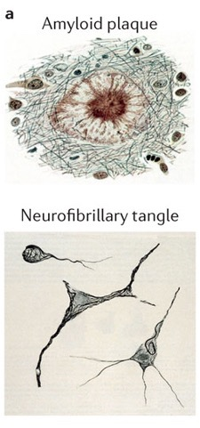
Figure 1. The neuropathological hallmarks of AD. Aβ plaques and neurofibrillary tangles (NFTs) stained using the Bielschowsky method of silver impregnation to visualize the aggregated proteins that constitute the extracellular plaques and intracellular NFTs. Adapted from Ref. #8, Nature Reviews.

Risk factors
The causes that lead to AD are still not known, and indeed there is no accepted theory explaining its pathogenesis. AD has been considered a disease with a multifactorial nature, associated with various risk factors (Figure 2) such as increasing age, genetic factors, infections, vascular diseases, head injuries, and other environmental factors⁷.
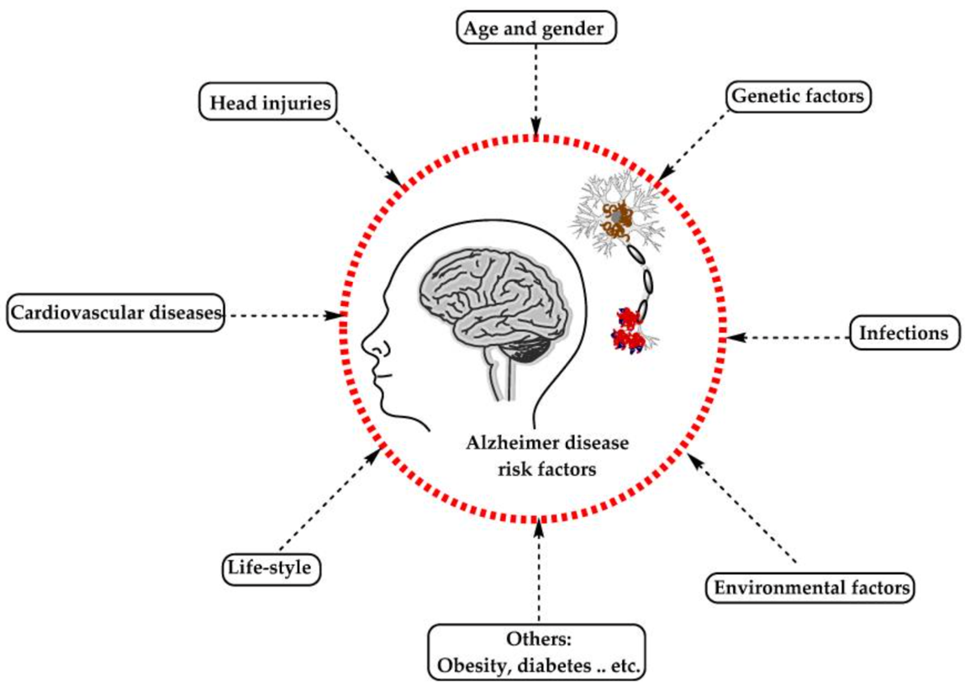
Figure 2. Main risk factors for AD. The image summarizes some of the known risk factors correlated with AD. Adapted from Ref. #7, Nature Reviews.

- Aging: the most important risk factor for AD is advanced age. There is an exponential incidence rate of AD between the ages of 65 and 85 years⁹. Aging is an irreversible process that involves a reduction in brain weight and volume, a loss of synapses, and an enlargement of ventricles in specific brain areas⁷.
- Genetic factors: over the years several mutations in inherited genes correlated with AD have been identified such as Amyloid Precursor Protein (APP), Presenilin-1 (PSEN-1) and Presenilin-2 (PSEN-2), Apolipoprotein E (ApoE), and other genes⁷. APP is a type I transmembrane protein expressed in several cell types, that undergoes cleavage by α-, β-, and γ-secretase to release Aβ. The pathological role of APP has been extensively studied, but the physiological role is still unknown. It is suggested to be involved in cell adhesion, neuritis growth, synaptogenesis, neuronal transport of proteins, transmembrane signal transduction and calcium metabolism¹⁰. Twenty-five of the thirty mutations found in the APP gene are related to AD and cause an accumulation of Aβ¹¹ (Figure 3).
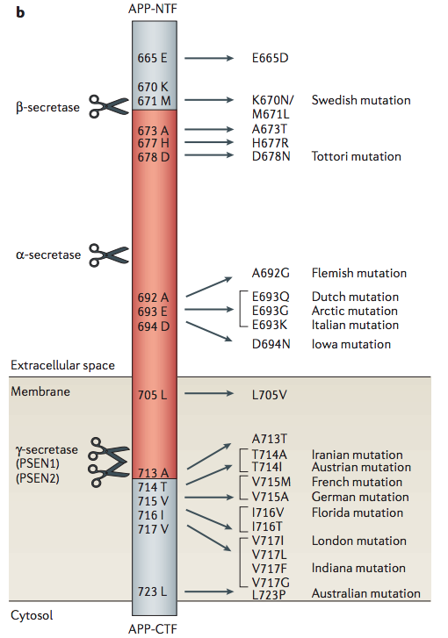
Figure 3. APP known mutations. Many different mutations as “Swedish” and “London” mutations are known to affect APP normal function. Adapted from Van Dam, D. and De Deyn, P.P., Nat Rev Drug Discov, 2006.

PSEN-1 and PSEN-2 are homologous genes, with 67% similarity, that encode the presenilins, the catalytic subunit of the γ-secretase complex involved in the production of Aβ from APP. Mutations in PSEN-1 are more common (Figure 4 right). Nowadays there are more than 200 mutations known, and they result in a defect in APP processing, increasing the amount of longer, more aggregation-prone forms of Aβ leading to neurodegeneration¹²⁻¹⁴. In contrast, PSEN-2 mutations are rare but might have a more severe effect, causing familial AD in the presence of normal PSEN-1 alleles⁷ (Figure 4 left).
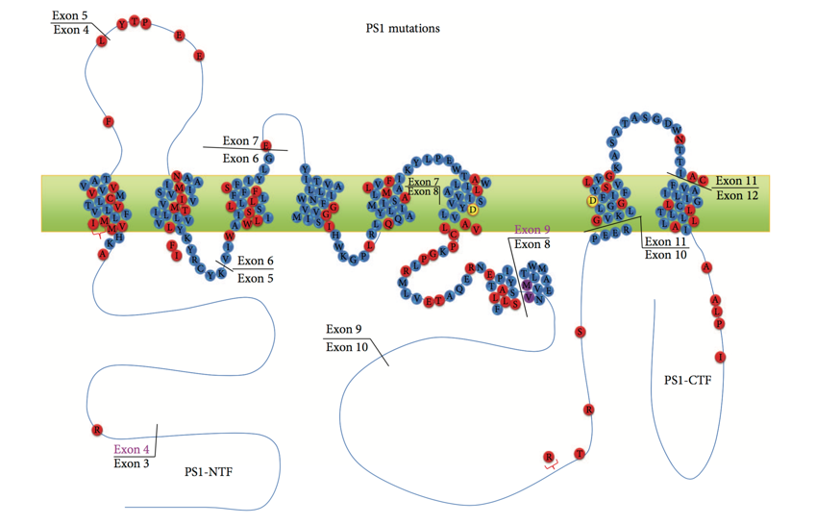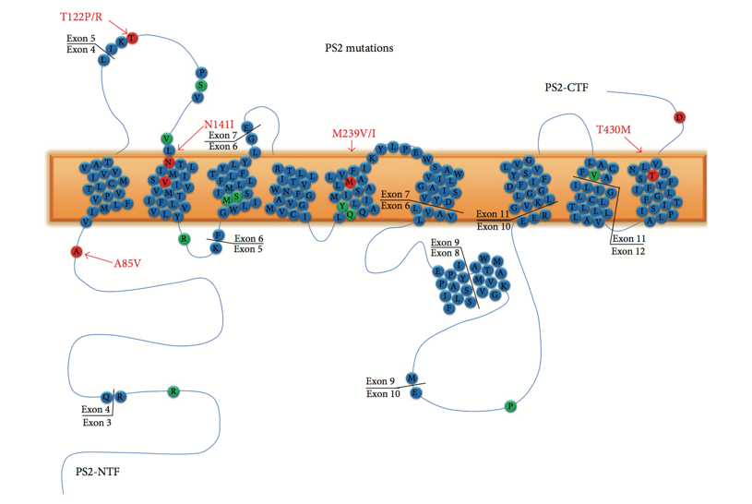
Figure 4. Schematic representation of PS1 and PS2 structures. Representation of PS1 (right) and PS2 (left) structure with some of their known mutations. Adapted from Meraz-Rios, M.A., et al., Oxid Med Cell Longev, 2014.

APOE is a secreted glycoprotein that binds cholesterol and phospholipids, and directly interact with Aβ. In the central nervous system (CNS), APOE is mainly expressed by glial cells, and it transports cholesterol to neurons via APOE receptors, and normally promotes proteolytic degradation of soluble forms of Aβ plaques¹⁵. There are three APOE isoforms, and the one correlated with the pathophysiology of AD is APOE4, through the promotion of Aβ plaques deposition, tau-induced neurodegeneration, neuroinflammation, as well as increasing the permeability of the blood brain barrier (BBB)¹⁶.
- Vascular diseases: AD patients usually have comorbidities such as cardiovascular disease (CVD), obesity, and diabetes. These diseases are often related and share an underlying pathology of atherosclerosis¹⁷. The mechanism by which vascular diseases influence cognition and AD risk remains under active investigation. There may be genetic, hormonal, or inflammatory processes behind it. For example, it seems that atherosclerotic lesions formed by high levels of cholesterol in the blood could mediate AD pathology inducing vascular changes⁹ and facilitating the deposition of Aβ plaques, which can lead to cognitive decline or induce inflammatory responses impairing cognitive functions.
- Environmental factors: not all AD cases are related to aging and genetic risk factors. Environmental risk factors such as air pollution, smoking, diet, heavy metals and infections may induce oxidative stress and inflammation, increasing the risk of developing AD7^{,17,18}. Among all, diet is known to play an important role in the pathogenesis of several diseases, including AD, and the gut microbiota is a fundamental player in this. Dietary changes influence the microbiome composition¹⁹⁻²², affecting several processes, such as the modulation of systemic inflammatory response and the availability of nutrients essential for normal brain functioning²². Several studies demonstrated a diminished microbiota diversity in AD patients and in corresponding animal models²³⁻²⁷ and this can trigger inflammation, cerebrovascular degeneration, Aβ aggregation and tau pathology.

NEUROPATHOLOGICAL HALLMARKS

AD hallmarks were first described in the eighties as intraneuronal NFTs, extracellular amyloid-containing neuritic plaques and cerebrovascular amyloid fibril deposits²⁸.

Amyloid plaques
Amyloid plaques formation is due to the extracellular accumulation and aggregation of Aβ peptides. Aβ aggregation is defined as an abnormal molecular process in which a protein, normally in an alpha-helical state, unfolds and re-conforms in a β-sheet conformation and aggregates to form insoluble fibril-like structures forming pathogenic Aβ plaques²⁹ (Figure 5).
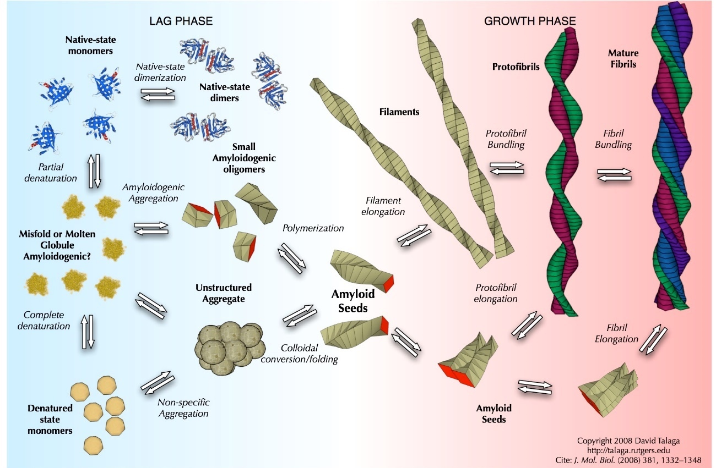
Figure 5. Aβ fibrils assembly. Adapted from Giurleo, J.T. et al., Journal of Molecular Biology, 2008.

Aβ is produced by the proteolytic cleavage of APP³⁰. The cleavage and processing of APP can be divided into two different pathways:
- non-amyloidogenic pathway, mediated by the cleavages of α- and γ-secretases;
- amyloidogenic pathway, mediated by the cleavages of β- and γ-secretases.
The common step of the two pathways is the cleavage performed by γ-secretase.
In the non-amyloidogenic pathway, APP is firstly cleaved at position 83 within the Aβ domain by α-secretase, a membrane bound endoprotease. This process leads to the production of a large amino-terminal ectodomain (sAPPα), which is secreted into the extracellular environment, and of a smaller carboxy-terminal fragment (CTF83). This fragment is retained into the membrane and it undergoes proteolysis by γ-secretase³⁰ (Figure 6, left).
The amyloidogenic pathway is the alternative cleavage pathway of APP that leads to the formation of insoluble peptides³¹. The amyloidogenic processing of APP to Aβ involves cleavage by β-secretase, that releases a large soluble extracellular N-terminal fragment, sAPPβ, leaving the C-terminal fragment of APP behind (C99). C99 is then cleaved by γ-secretase complex, which has two possible cleavage sites in it, resulting in the release Aβ peptides that can vary in length at the C-terminus³¹ (Figure 6, right). The most abundant isoforms generated are Aβ₁₋₄₀ and Aβ₁₋₄₂ that are 40 or 42 amino acids long, respectively³². The Aβ₁₋₄₂ form differs from Aβ₁₋₄₀ at the C-terminal for an addition of two amino acids, isoleucine and alanine, that render Aβ₁₋₄₂ form relatively insoluble and prone to aggregate⁹. Many other isoforms of Aβ peptides exist, however Aβ₁₋₄₀ and Aβ₁₋₄₂ strictly correlate with AD indeed Aβ₁₋₄₀ is normally found in the cerebro-spinal fluid (CSF) of AD patients, whereas Aβ₁₋₄₂ is the predominant component of senile plaques in the brain³³.
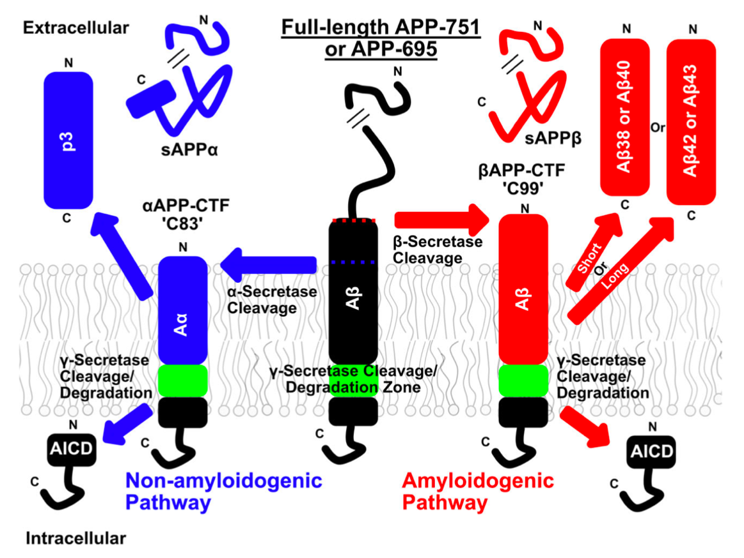
Figure 6. Non-amyloidogenic and amyloidogenic processing of APP. Full-length APP is represented in the middle of the figure. On the left (in blue) is shown the non-amyloidogenic proteolysis pathway, initiated by α-secretase and that generates sAPPα, and Aα peptides. On the right (in red) is shown the amyloidogenic proteolytic cascade, initiated by β-secretase and that generates sAPPβ, and Aβ peptides. In both pathways, γ-secretase cleavage is involved (highlighted in green). Adapted from Ref. #31, Protein Science.

Aβ plaques are classified as diffuse or dense-core (Figure 7), based on their morphology and positive or negative staining with dyes specific for the β-pleated sheet conformation such as Thioflavin-S or Congo Red. Diffuse plaques are amorphous amyloid deposits with ill-defined contours that are both Congo Red and Thioflavin-S negative. They are usually non-neuritic and not associated with glial responses or synaptic loss. Dense-core plaques are fibrillar amyloid deposits with a compact core that stains both with Thioflavin-S and Congo Red. They consist of Aβ peptides associated with axonal and dendritic enlargements that contain degenerated mitochondria, organelles and lysosomes (dystrophic neurites). They are surrounded by reactive astrocytes and activated microglial cells, and correlate with synaptic loss³⁴. In addition to Aβ, neuritic plaques in AD patients contain many other proteins such as tau, APP, and ubiquitin^{34,35}.
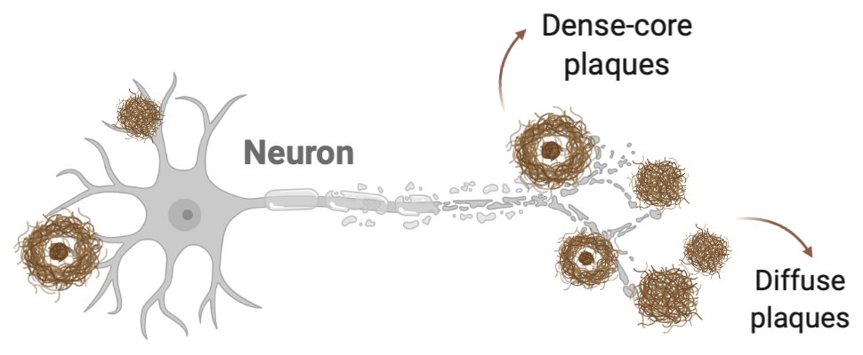
Figure 7. Aβ plaques deposition. Representation of diffuse and dense-core Aβ plaques surrounding a neuron. Created in BioRender.com.

Neurofibrillary tangles
The other neuropathological hallmark of AD is represented by intracellular NFTs, derived from pre-tangles of misfolded tau and small tau aggregates³⁶ (Figure 8). Tau protein is a normally soluble microtubule-associated protein. It is involved in the assembly and stability of microtubules in neuronal cells, through a complex interplay between the expression of different tau isoforms and tau phosphorylation³⁷. Indeed, the binding of tau to microtubules is highly regulated by phosphorylation³⁸. However, in AD tau protein undergoes to hyperphosphorylation, through mechanisms not completely understood, and hyperphosphorylated tau loses its affinity for microtubules, thus it could self-associates into structures called “paired helical filaments” (PHFs)³⁹. PHFs are tau fibrils that form pairs with a tridimensional helical conformation and a regular periodicity³⁴. Like Aβ oligomers, also these intermediate structures of abnormal tau are cytotoxic. PHFs accumulation into pyramidal neurons leads to formation of NFTs that destabilize microtubules, leading to the destruction of the cell transport system and causing neuronal degeneration and death. Although tau protein is the main component of NFTs, other protein such as cholinesterase and ubiquitin have been identified⁹.
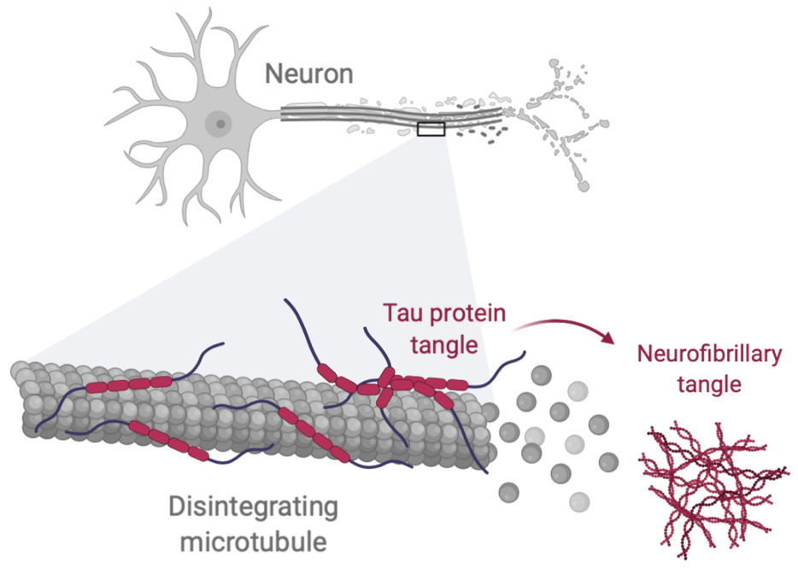
Figure 8. Neurofibrillary tangles. Representation of tau protein aggregates leading to microtuble’s destruction and subsequent neuronal death. Created in BioRender.com.

Synaptic loss
Synaptic loss is one of the first indicator of AD progression, found also in early stages of the disease, even though normal aging causes itself the loss of synapses^{40,41}. Indeed, over time the number, structure, and function of synapses change, consolidating or diminishing their contacts, in a process defined “synaptic plasticity”. This is a key process to optimize neuronal connections for cognitive functions such as learning and memory. For this reason, their aberrant function is implicated in several neurodegenerative disease⁴². There are different mechanisms contributing to synaptic dysfunction such as alterations in synaptic proteins, membrane lipids, vesicular function and loss of plasticity. Besides, also excitotoxicity, oxidative stress and apoptosis may contribute⁴³. The initial triggers may be both Aβ and tau. Extracellular Aβ accumulates around postsynaptic spines and presynaptic spines, whereas tau can be found in dendrites and in postsynaptic terminals of neurons, both interfering with several signaling pathways^{41,42}.

Neuronal loss and brain atrophy
The major pathological event in the brain correlated to AD progression is neuronal loss^{44,45}, that together with synaptic loss leads to brain atrophy. This loss of neurons is highly selective for certain brain regions and have a different time course between patients⁴⁶. Even though the molecular mechanisms leading to neuronal death in AD are not yet fully understood, Aβ has been suggested to play a pivotal role by disrupting mitochondrial integrity⁴⁷ or as a possible trigger of apoptosis⁴⁸. Moreover, Aβ may enhance the phosphorylation of tau that is consequently involved in phenomenon contributing to synaptic dysfunction and neuronal death⁴⁹. Another important downstream effect due to Aβ, is chronic neuroinflammation, which is characterized by both astrogliosis and microgliosis, leading to the production of pro-inflammatory factors, which are toxic in neuronal models of AD^{50,51}. Moreover, also peripheral inflammatory cells are involved in the development of AD. Indeed, blood-derived leukocyte subpopulations have been found in the brains of AD patients and in corresponding animal models, suggesting that they are involved in the exacerbation of neuroinflammation⁵²⁻⁵⁶.
It is important to underline that there is a reciprocal correlation between these phenomena and, indeed, Aβ accumulation in neurons causes prolonged inflammation, that increases the oxidative stress that facilitate Aβ deposition, creating an “amplification effect”⁵⁷.

NEUROINFLAMMATION IN AD

Over the last decade, the presence of a persistent immune response in the brain has emerged as a core phenomenon in AD pathology; however, the key role of inflammation in AD pathogenesis has been appreciated only in recent years, and is now clear that inflammation contributes and exacerbates AD pathology^{51,58-64} (Figure 9). The cells involved in this process are primarily microglia and astrocytes, but infiltrating peripheral immune cells may also contribute to neuroinflammation, especially under conditions of increased BBB permeability⁶⁴.
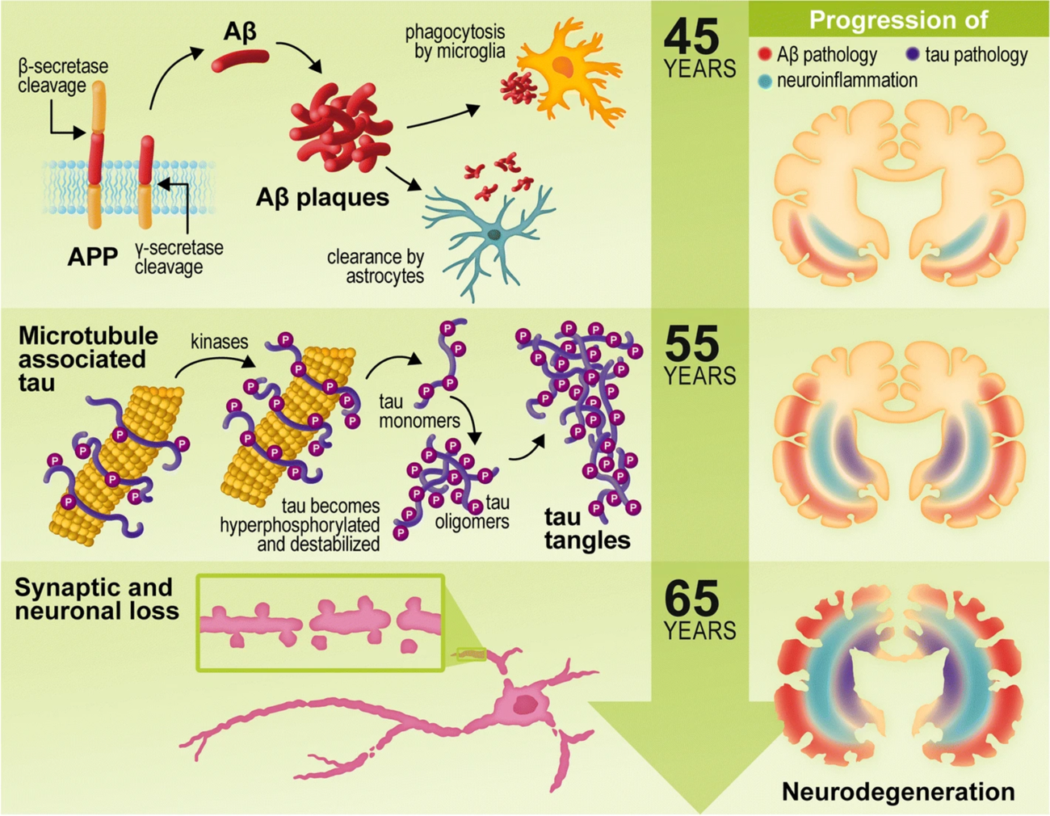
Figure 9. Overview of the pathogenic hallmarks of AD over time. In the initial stage of the pathology, the abnormal cleavage of APP by β- and γ-secretases leads to the formation of insoluble and intrinsically disordered Aβ monomers. Aβ induces the activation of microglia and astrocytes, initiating the inflammatory response in the brain and causing further production of Aβ. These phenomena are correlated to the hyperphosphorylation of tau, and the consequent formation of tau tangles, approximately 10 years after the initiation of Aβ deposition. The increase in Aβ plaques, inflammation, and tau hyperphosphorylation contributes to synaptic loss and neuronal death approximately 20 years following initial disease pathogenesis. Adapted from Ref. #83, Journal of Neuroinflammation.

The brain and its barriers
The brain had always been considered as an “immune-privileged site”, believed to tolerate the presence of foreign antigens without eliciting an immune response^{65,66}. Indeed, the CNS is surrounded by several layers that protect its integrity. First of all, it is enclosed by three layers of meninges:
- dura mater: the outermost layer composed of fibrous tissue and supplied with lymphatic vessels, meningeal arteries and veins^{67,68};
- arachnoid mater: impermeable to fluids, forms a barrier between the dura mater and the CSF, that flows between the arachnoid and the pia maters⁶⁹;
- pia mater: permeable to solutes and immune cells, coats veins and arteries in the subarachnoid space⁷⁰ (Figure 10).
Between the blood and the CNS parenchyma there is the BBB, composed by specialized endothelial cells joined by tight and adherent junctions⁷¹. The BBB is part of the neurovascular unit (NVU), together with pericytes, neurons, and glia limitans cells⁷², which maintain the permeability and the chemical composition of the brain interstitial fluid⁷³. Moreover, in the choroid plexus epithelium there is a blood-CSF barrier that regulates the entry of solutes and cells in the CSF^{74,75}. The CNS contains resident immune cells, such as parenchymal microglia, but also perivascular, meningeal and choroid plexus macrophages (Figure 10). In homeostatic conditions, perivascular, meningeal and choroid plexus macrophages sense blood danger signals, eliciting an immune response and the recruitment of peripheral leukocytes during pathological processes^{76,77}.
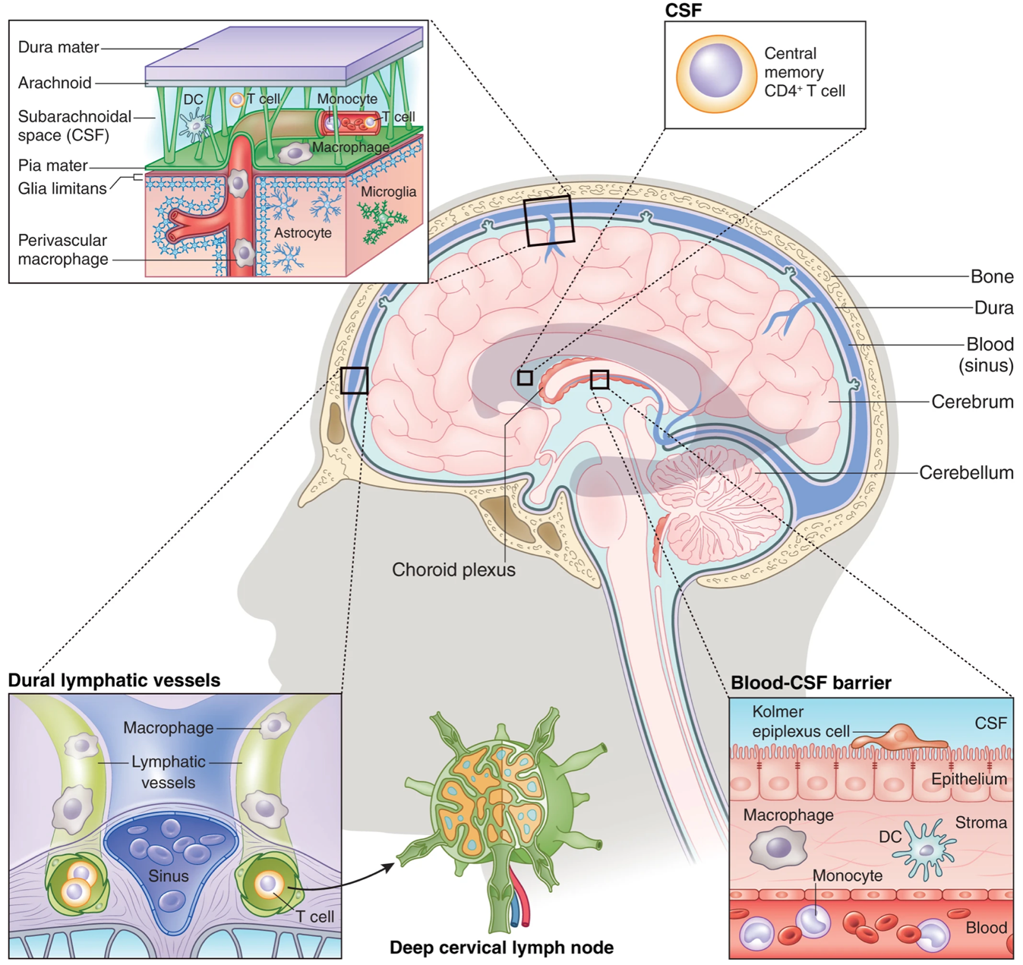
Figure 11. The brain and its barriers in healthy conditions. The dura mater, containing dural lymphatic vessels, and the leptomeninges (arachnoid mater and pia mater) surround and protect the brain (left upper part). Between arachnoid mater and pia mater flows the CSF, which is produced in the choroid plexus and contain also immune cells (right upper part). Leukocytes circulating in the CSF normally do not enter healthy brain parenchyma (right lower part) and are drained throughout meningeal lymphatic vessels to cervical lymph nodes (left lower part). Adapted from Prinz M. & Priller J., Nature Neuroscience, 2017.

The role of microglia in heath and disease
At the brain level, local inflammation is driven mainly by microglia, the resident macrophages of the CNS, classified as both glia and immune cells. In healthy conditions, microglia participate in several processes, such as maintenance of synapses, neurogenesis, regulation of cognitive functions, and phagocytosis (Figure 12a). Moreover, microglia are involved in the immunological surveillance of the brain, through the sensing of pathological stimuli and inflammatory signals^{57,63,79-81}. In resting conditions, microglia are morphologically characterized by a small soma and ramified processes, and their number is steady. Upon activation, however, microglia shifts to selected clonal expansion⁸², they short their cellular processes and enlarge their soma, acquiring an amoeboid phenotype⁸³ (Figure 11, upper). Microglia priming during immune responses is a major step in the removal of microbes and pathogens through phagocytosis, along with the clearance of cellular debris, toxic molecules, myelin byproducts, and protein deposits (e.g., Aβ peptides)⁵⁷. Once the cause of activation is eliminated, excess microglia are removed to re-establish a stable microglial network⁸². However, during aging, microglial cells exhibit signs of dystrophy, including reduced ramification and short, swollen processes⁸⁴, with a consequent decline in its ability to respond to insults⁸⁵ (Figure 11, bottom).
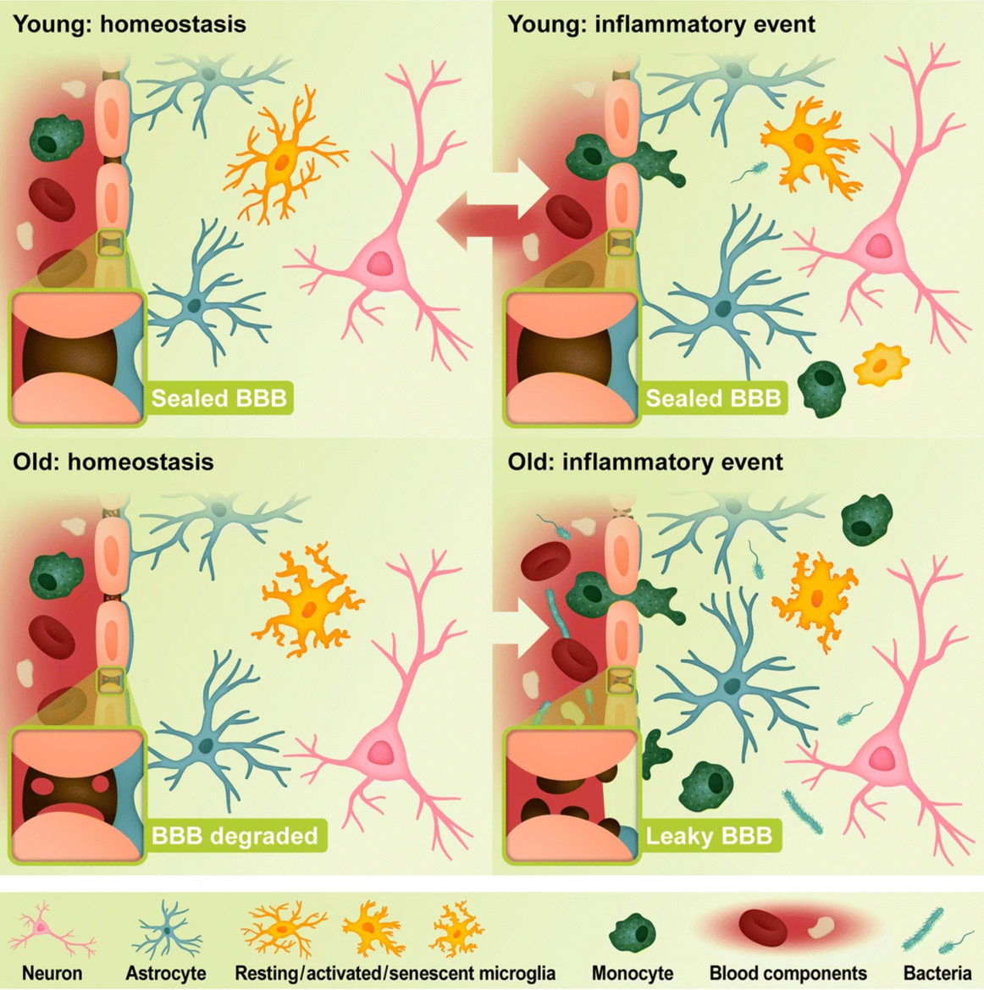
Figure 11. Microglia responses during inflammation in the young and old brain. Microglia (orange) have the role of surveillance in condition of homeostasis (left). Following an inflammatory event, microglia and astrocytes are activated and peripheral immune cells (green) cross the BBB to enhance phagocytosis and debris removal in the brain (right). However, in the young brain microglial cells can return to their surveillance role after the inflammatory event (upper), whereas in the aged brain they display an active phenotype, maintaining a low-level of inflammation also in homeostatic condition (bottom). Primed microglia respond to the stimuli faster, but they might become senescent. Adapted from Ref. #83, Journal of Neuroinflammation.

While in healthy brain Aβ peptides and small aggregates are removed by microglia through phagocytosis, the chronic stimulation of microglia by Aβ that occurs in the AD brain may lead to attenuated microglial phagocytosis and may cause prolonged inflammation^{86,87}. Indeed, microglia secrete several pro-inflammatory factors such as interleukin (IL)-1β, IL-6, and Tumor Necrosis Factor α (TNFα), leading to the activation of astrocytes and the recruitment of peripheral immune cells, enhancing neuroinflammation, but also synaptic dysfunction and neuronal death^{59,88} (Figure 12b). In sporadic AD the inefficient clearance of Aβ has been identified as one of the main pathogenic pathways. Indeed, excessive accumulation of Aβ, neuronal debris, and the release of activating factors establish chronic, non-resolving inflammation^{63,87}.

The role of astrocytes in heath and disease
Like microglia, astrocytes belong to the glial cell family and have heterogeneous functions within the CNS, such as the formation and function of synapses, bi-directional communication with neurons, and elimination of neurotoxic waste⁸⁹⁻⁹¹. Astrocytes are also fundamental component of the NVU, involved in the maintenance of cerebral blood flow homeostasis under physiological and pathological conditions⁷² (Figure 12a). Moreover, these cells react to pathological insults through a process named reactive gliosis or astrogliosis, in which activated astrocytes upregulate glial fibrillary acidic protein (GFAP) and repair and remodel damaged brain tissue⁹².
Given their housekeeping functions, in the pre-clinical stages of AD astrocytes are probably involved in trying to regain homeostasis. Indeed, in vitro and in vivo experiments have shown that astrocytes migrate towards and degrade Aβ plaques⁹³. However, during AD these cells contribute to the disruption of the BBB, favoring the extravasation of peripheral immune cells and the accumulation of Aβ^{94,95} (Figure 12b). Of note, astrocytes can acquire a neurotoxic phenotype upon activation by microglia, leading to loss of normal functions and production of higher amounts of cytokines. Under disease conditions, neurotoxic astrocytes work closely with microglia mediating toxic effects^{96,97}. These activated cells lose their normal functions and produce higher amounts of pro-inflammatory factors, which lead to neuronal dysfunction and damage. Moreover, astrocytes and microglia act in a synchronized manner with neurons to promote neurodegeneration.
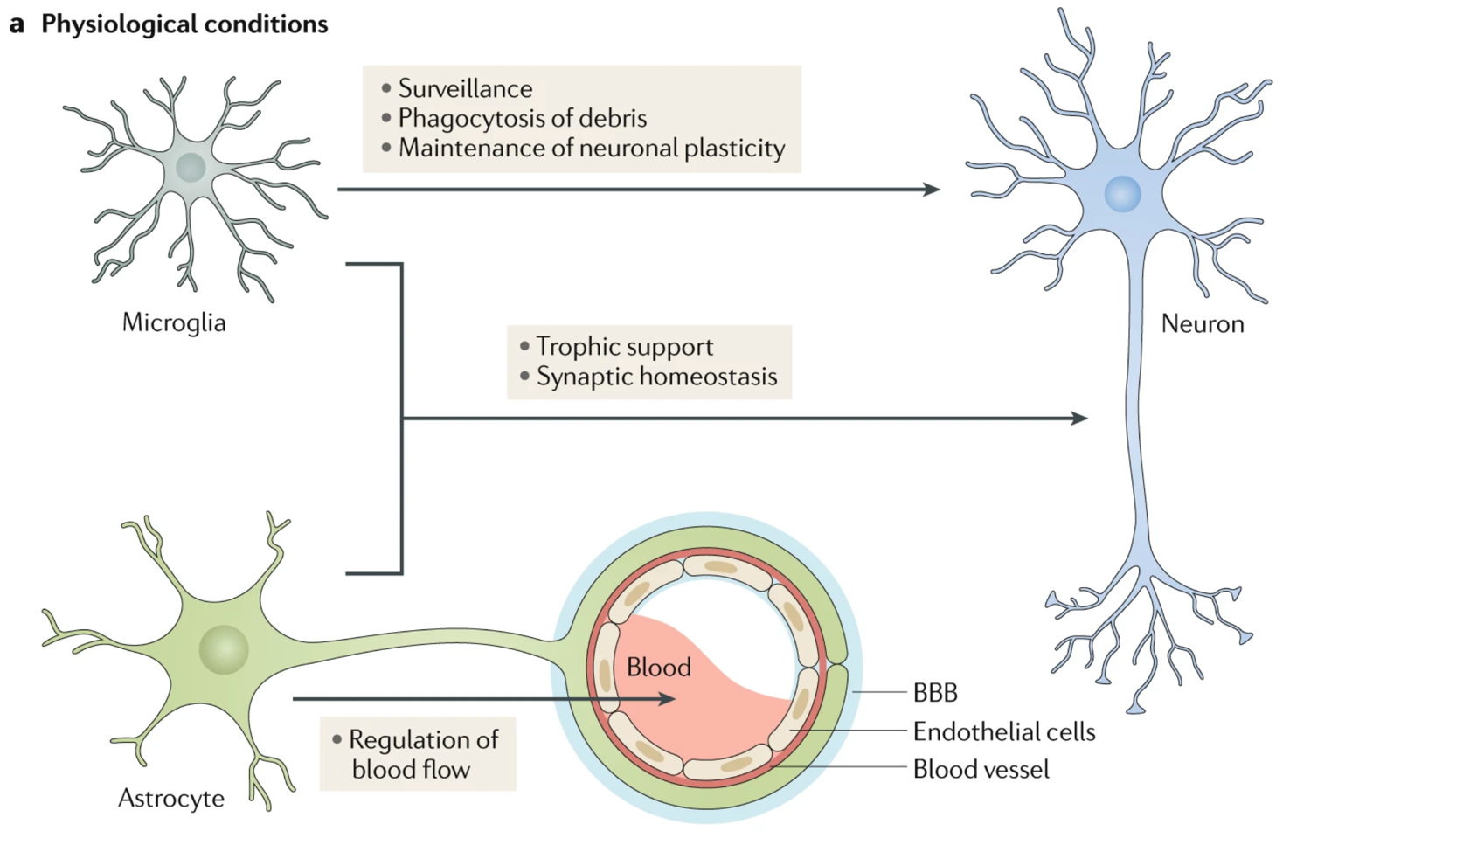
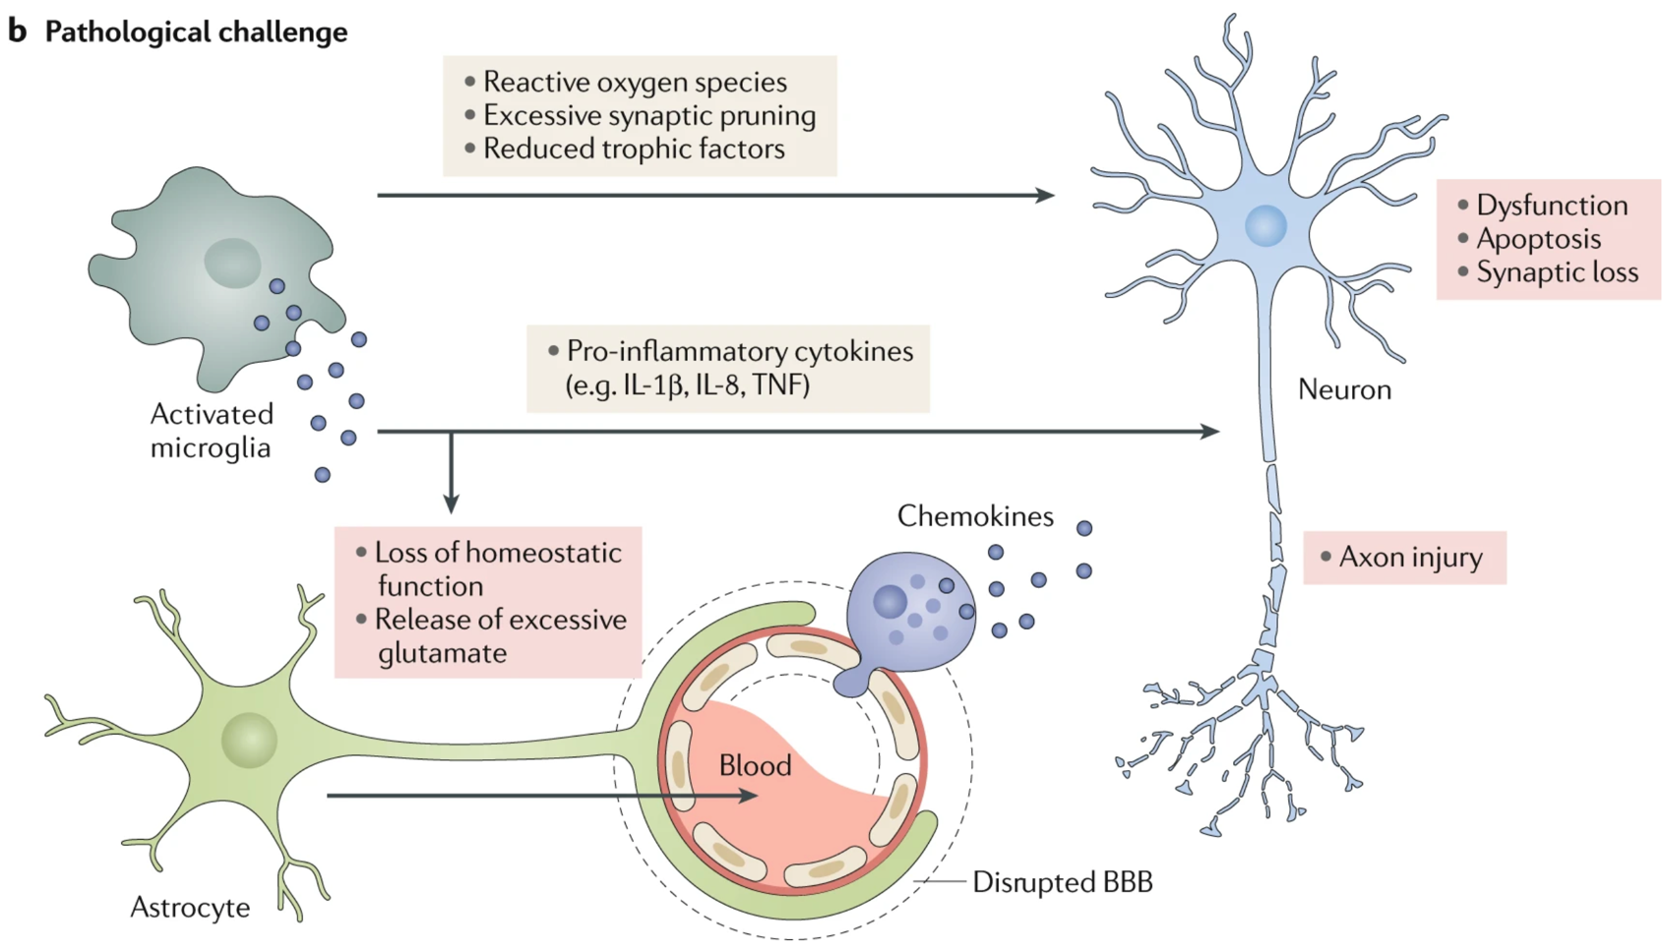
Figure 12. Microglia and astrocytes in normal and pathological conditions. (a) Under physiological conditions, resting, ramified microglia survey the brain microenvironment, to sense the presence of damage signals, and provide immune surveillance. Microglia is also involved in the removal of pathogens or debris, and in the maintenance of neuronal plasticity and synaptic homeostasis. Astrocyte processes form the outside layer of the BBB, and regulate cerebral blood flow, synaptic homeostasis and provide neurotrophic support. (b) Under pathological conditions, microglia and astrocytes are activated, and immune cells migrate through the damaged BBB causing an exacerbation of neuroinflammation. These activated cells lose their normal functions and produce higher amounts of pro-inflammatory factors, which lead to neuronal dysfunction and damage. Adapted from Leng F. and Edison P., Nature Reviews Neurology, 2020.

The role of immune cells in heath and disease in the brain
It has been recently shown that the brain and its barriers host in homeostatic conditions a remarkably high variety of immune cells, normally associated with the periphery⁹⁸⁻¹⁰². Indeed, within the normal CNS have been identified several types of monocytes, dendritic cells, T cells, B cells, natural killer (NK) cells, NKT cells, innate lymphoid cells, eosinophils, and mast cells¹⁰¹ (Figure 13). In pathological conditions, brain resident immune cells are combined with their infiltrating counterparts from the periphery^{101,103,104}. Their entry into the parenchyma is normally restricted by the BBB and the blood–CSF barrier^{72,105} however, during distresses or diseases, immune cells can pass through these barriers and enter the brain¹⁰⁵.
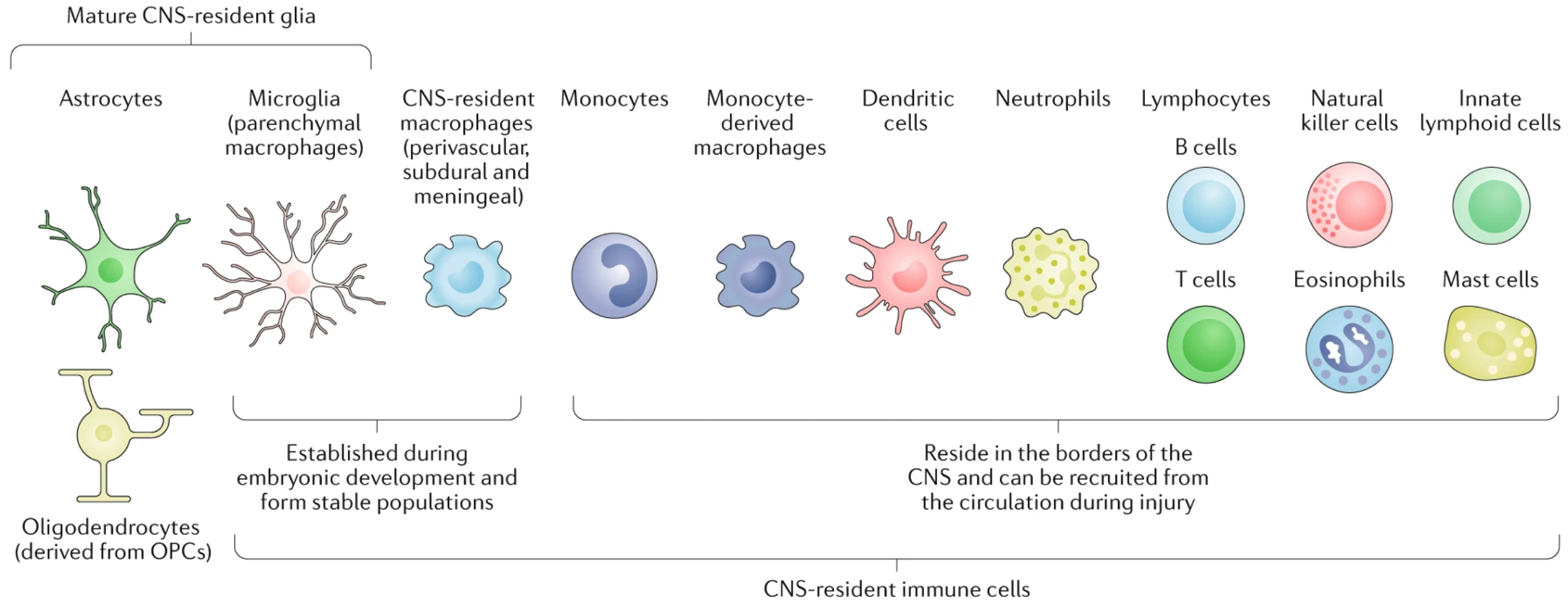
Figure 13. The resident glial and immune cells of the brain. Astrocytes, microglia and oligodendrocytes are the major resident glia of the CNS. Microglia are also considered resident immune cells of the CNS, together with the perivascular, subdural and meningeal macrophages. Other immune cells such as monocytes, monocyte-derived macrophages, dendritic cells, neutrophils, lymphocytes (T cells and B cells), NK cells, innate lymphoid cells, eosinophils and mast cells reside in the borders of the CNS. Adapted from Greenhalgh A.D. et al, Nature Reviews Neuroscience, 2020.

T lymphocytes
Among brain infiltrating immune cells, T lymphocytes (T cells) were first found in 1999 in higher presence in the blood of AD patients compared to healthy age-matched controls¹⁰⁷. T cells are involved in the acquired or antigen-specific immune response, together with B cells. Mammalian T cells originate from hematopoietic stem cells (HSCs) in the fetal liver and later in the bone marrow, in which HSC differentiate firstly into multipotent progenitors and then in lymphoid progenitors. Only a small part of these immature cells migrates then in the thymus, where they will differentiate into early thymic progenitors. These immature cells are reprogrammed into mature and fully functional T cells, under a gradual process which remove auto-reactive immature T-cells and allow the acquiring of the TCR receptor. The TCR is a protein complex composed of two variable antigen-binding chains. T cells can be divided in αβ or γδ T cells, depending on the TCR chains that they harbor¹⁰⁸ (Figure 14).
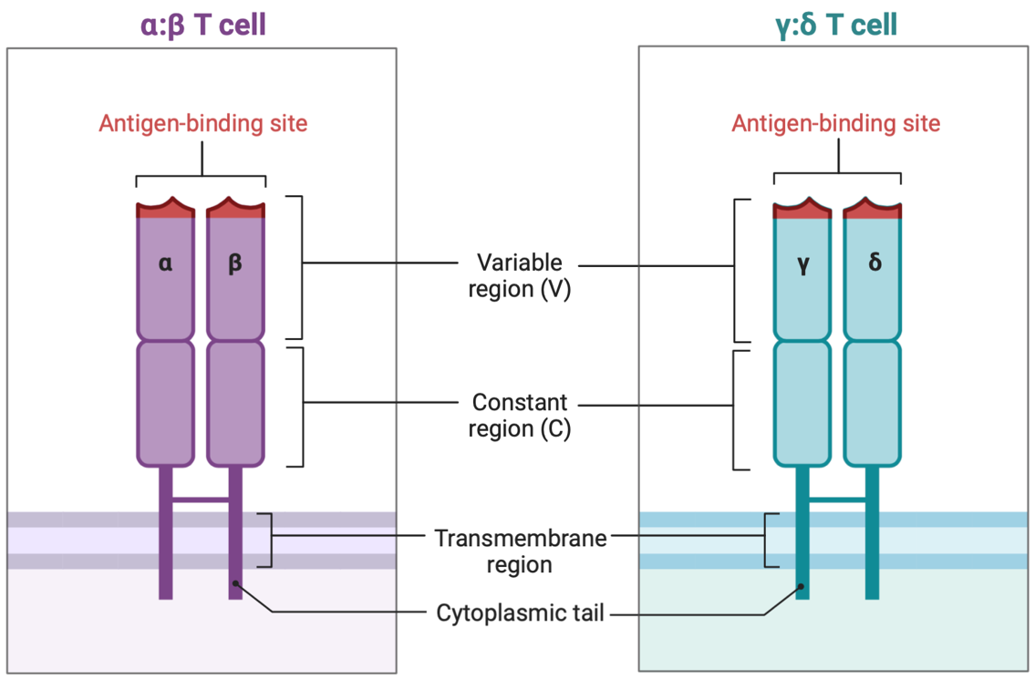
Figure 14. Two classes of TCRs. Representation of αβ TCR on the left, and γδ TCR on the right. The TCR is a disulfide-linked membrane bound heterodimeric protein composed of a constant and a variable region, that develops through a gene recombination process in the thymus. Created with BioRender.com.

αβ T cells
αβ T cells, usually named simply “T cells”, account for the 65–70% of T cells in a healthy human body. Mature T cells that express the αβ TCR are released into the blood and lymphatic vessels, where they could differentiate into the precursors of different subpopulations: helper T cells (CD4⁺) or cytotoxic T cells (CD8⁺). The differentiation depends on stimuli induced by linear peptides that have been processed and presented on the surface of antigen presenting cells (APCs) such as macrophages, dendritic cells or B cells¹⁰⁹ and on the cytokines present in the microenvironment. T helper (Th) cells have two main functions: cytokines production and B cell stimulation; cytotoxic T cells directly attack and destroy malignant cells or cells infected by viruses, thorough the induction of apoptosis in the target cell by the release of cytolytic granules or by the expression of ligands for death receptors¹¹⁰.
Several studies highlight that αβ T cells are involved in AD pathogenesis: they may infiltrate the brain parenchyma of AD patients and corresponding animal models, causing increased neuroinflammation^{52,71,104,111-116}. Once arrived in the brain parenchyma, infiltrating T cells could interact with glial cells and exacerbate neuronal damage^{117,118}.

γδ T cells
γδ T cells are considered as unconventional T cells, with an innate-like phenotype, which account for the 0.5-5% of all T lymphocytes. They have been accidentally discovered in 1984 during the characterization of α and β TCR^{119,120}. Differently from αβ T cells, γδ T cells become fully committed during thymic development¹²¹ and consist of a highly heterogeneous population¹²²⁻¹²⁴. They are classified based on the variable γ (Vγ) segment used during the rearrangement of the TCR γδ chain, which lead to the generation of different subtypes of γδ T cells¹²²⁻¹²⁴. In particular, Vγ4⁺ or Vγ6⁺ γδ T cell subsets are mostly IL-17 producers, whereas Vγ5⁺, Vγ1⁺ and Vγ7⁺ subsets produce mainly interferon-γ (IFN-γ) (nomenclature according to Heilig & Tonegawa¹²⁵). γδ T cells IL-17 and IFN-γ producers can be distinguished by their surface expression of the chemokine receptor CCR6 versus the expression of CD27 or NK1.1, respectively¹²⁶⁻¹²⁸ (Figure 15).
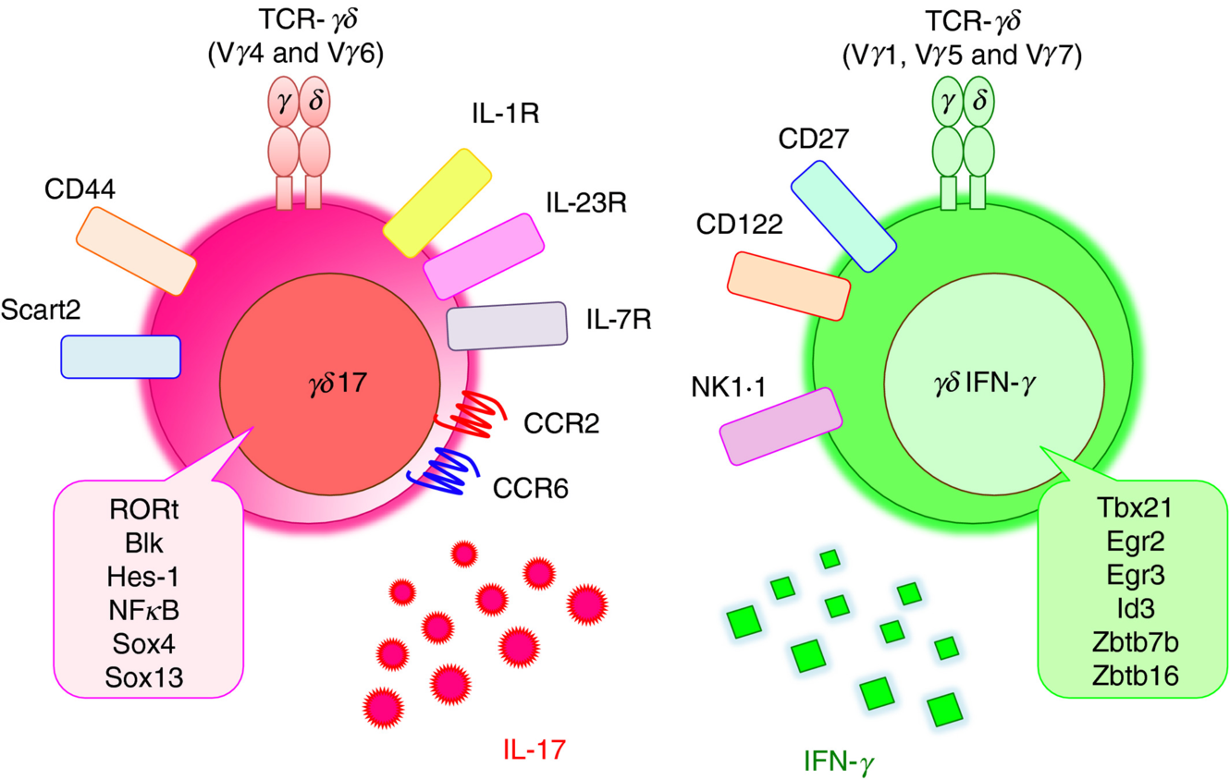
Figure 15. Thymic programming of γδ T cell subsets. γδ T cells harboring Vγ4 or Vγ6 chain express on their surface IL-1R, IL-23R, IL-7R, CCR2, CCR6, CD44 and Scart2, and are mainly IL-17 producers. γδ T cells harboring a Vγ1, Vγ5 or Vγ6 chain express on their surface CD27, CD122 and NK1.1, and are mainly IFN-γ producers.

γδ T cells play several functions, such as lysis of infected or damaged cells, production of cytokines and chemokines to regulate other cells, antigen presentation and production of growth factors¹²⁹. Despite their normal protective role in tissue surveillance and repair¹³⁰, γδ T cells may also cause damages after infiltrating in certain tissues. Thus, it has been demonstrated that IL-17-producing γδ T cells contribute to the pathogenesis of several inflammatory diseases, such as MS¹³¹, cerebral ischemia-reperfusion injury¹³², and arthritis¹³³. Moreover, IL-17 levels are higher in the serum of AD patients, and its increase is linked to disease progression¹³⁴. Altogether, these previous studies suggest that IL-17⁺ γδ T cells are related to several inflammatory diseases, and may therefore have a crucial role also in AD pathogenesis.
In this context, the main goal of our study was to explore the contribution of γδ T cells in AD progression. As γδ T cells cancer cell therapy is advancing into clinic (https://www.nature.com/articles/d43747-021-00018-w), understanding their role in AD could be the key for the discovery of new treatment strategies.

MATERIALS AND METHODS

4. Animals
The mouse strains 3xTg-AD (MMRRC stock no. 34830-JAX), Tcrd^{-/-} (B6.129P2-Tcrdtm1Mom/J stock no. 002120), as well as wild-type strains B6129SF2/J (stock no. 101045) and C57BL/6J (stock no. 000664 |Black 6) were purchased from the Jackson Laboratory. The 3xTg-AD mouse expresses the human mutant APPswe and PS1M146V genes, associated with familial AD, and the TauP301L mutation, associated with human tau pathology. Therefore, these mice develop both amyloid and tau pathology¹³⁵. We crossed 3xTg-AD and Tcrd^{-/-} mice to obtain a transgenic mouse with all transgenes that characterized 3xTg-AD and Tcrd^{-/-} models (APPSwe, tauP301L, PS1M146V knock-in and TCRγδ knock-out). Animals were housed in pathogen-free climate-controlled facilities and were provided with food and water ad libitum. The research involving animals was authorized by the Ethical Committee from the University of Verona and by the Italian Ministry of Health, Department of Veterinary Public Health, Nutrition and Food Safety, Directorate General of Animal Health and Veterinary Medicine (authorization nr. 164/2016-PR), as required by Italian legislation (D. Lgs 26/2014) as per the application of European Directive (2010/63/UE). All efforts were made to minimize the number of animals used and their suffering during the experimental procedures.

4.1 Mice characterization
Genotyping was performed to distinguish 3xTg-AD/Tcrd^{-/-} homozygous from heterozygous mice. APP, PSEN-1 and tau insertion and Tcrd^{-/-} deletion were investigated by PCR.

4.2. DNA extraction from tail biopsies
The final part of mouse tail was cut under sterile condition and placed into polypropylene microfuge tube, then kept on ice. DNA extraction was performed using 300µL of DirectPCR Lysis reagent (Viagen Biotech) containing freshly prepared 0.3 mg/ml of Proteinase K (Sigma Merck) for 0.5 cm tail. Tubes were incubated for 18h at 55°C in agitation to ensure complete tail lysis. To stop the enzymatic reaction, samples were incubated in water bath at 85°C for at least 45 minutes, and subsequently centrifuged for 5-10 seconds at maximum speed to eliminate residues.

4.3 PCR
The PCR mix used consisted of:
- 200 mM dNTPs (Promega);
- 0.4 mM forward and reverse primers (Life Technologies);
- 1.5 mM MgCl2 (Promega);
- 1.25 U GoTaq® Hot Start Polymerase (Promega);
- 5X PCR Green GoTaq® Flexi Buffer (Promega);
- 1 μl of crude DNA lysate was used as template.
PCR program for APP, PSEN-1, and tau consisted of an initial denaturation at 94°C for 4 min, followed by 35 cycles of 3 repeated steps: denaturation (94°C for 30 sec), annealing (54°C for APP, 65°C for PSEN1, and 65°C for tau) and extension (72°C for 30 sec). A final extension at 72°C for 5 min ends the program. PCR program for Tcrd^{-/-} consisted of an initial denaturation at 94°C for 4 min, followed by 30 cycles of 3 repeated steps denaturation (98°C for 10 sec), annealing (60°C for 30 sec) and extension (68°C for 60 sec). A final extension at 72°C for 5 min ends the program (GeneAmp® PCR System 9700).
The following primers purchased from Life Technologies were used:
FW APP (5‟ AGG ACT GAC CAC TCG ACC AG 3‟),
RV APP (5‟ CGG GGG TCT AGT TCT GCA T 3‟),
FW APP ctrl (5‟ CAA ATG TTG CTT GTC TGG TG 3‟),
RV APP ctrl (5‟ GTC AGT CGA GTG CAC AGT TT 3‟),
FW PS1 (5‟ AGG CAG GAA GAT CAC GTG TTC AAG TAC 3‟),
RV PS1 (5‟ CAC ACG CAC ACT CTG ACA TGC ACA GGC 3‟),
FW tau (5‟ TGA ACC AGG ATG GCT GAG 3‟),
RV tau (5‟ TTG TCA TCG CTT CCA GTC C 3‟),
FW tau ctrl (5‟ CTA GGC CAC AGA ATT GAA AGA TCT 3‟),
RV tau ctrl (5‟ GTA GGT GGA AAT TCT AGC ATC ATC C 3‟),
FW Tcrd^{-/-} (5” CTT GGG TGG AGA GGC TAT TC 3”),
RV Tcrd^{-/-} (5” AGG TGA GAT GAC AGG AGA TC 3”),
FW Tcrd^{-/-} ctrl (5” CAA ATG TTG CTT GTC TGG TG 3”),
RV Tcrd^{-/-} ctrl (5” GTC AGT CGA GTG CAC AGT TT 3”).
To estimate qualitatively the presence of APP, PSEN-1, tau and Tcrd^{-/-} product of amplification, 15 μl of PCR mixture were run on an agarose gel and visualized by Nancy staining (Nancy-520, Sigma Merck). TrackItTM 100bp DNA Ladder (Life Technologies) was used for sizing the double-stranded DNA from 100 to 1500 bp on the agarose gel.

5. Isolation of leukocytes from mouse tissues

5.1 Blood
Blood samples were collected from the retro-orbital plexus of anesthetized mice by sodium heparinized capillaries and were mixed with an equal volume of 1 % dextran plus 10 U/ml sodium heparin. After pelleting the erythrocytes, the overlying supernatant plasma-dextran suspension of leukocytes was washed in PBS, followed by erythrocyte lysis.

5.2 Meninges
Individual meninges (dura, arachnoid, and pia mater) were carefully removed from the interior aspect of skulls and surfaces of brains with fine surgical curved scissors and forceps, and enzymatically digested with a collagenase/DNase I solution at 37 °C for 15 min. The cell pellets were washed, resuspended in ice-cold PBS and stained for extracellular markers¹³⁶.

5.3 Brain
Mice were anesthetized and perfused through the left cardiac ventricle by injecting cold phosphate-buffered saline (PBS). The brain was homogenized using a gentleMACS Dissociator (Miltenyi Biotec) and digested with 20 U/ml DNase I and 1 mg/ml collagenase at 37 °C for 45 minutes. Cells were isolated by passing the digested tissue through a 70-μm cell strainer, resuspended in 30 % Percoll and loaded onto 70 % Percoll (GE Healthcare). The samples were then centrifuged at 1300 ×g for 20 minutes at 4 °C. Cells were removed from the interphase and washed with PBS.

5.4 Intestine
The gut contents and Peyer’s patches were removed before the small intestine was opened longitudinally, washed thoroughly with cold RPMI medium and cut into segments 2–3 cm in length to avoid winding. The segments were incubated in RPMI medium supplemented with 5 % FBS, 1 mM EDTA and 1mM DTT at 37 °C, rotating for 10 minutes. Epithelial cells were removed by passing the samples through a 70-μm cell strainer, incubating as above, and passing again through the cell strainer. The flow-through was pelleted, resuspended in 40 % Percoll, overlaid onto 70 % Percoll and centrifuged at 600 ×g for 20 minutes. Intraepithelial lymphocytes (IELs) were recovered from the interphase and washed twice in PBS.

5.5 Spleen
Spleens were removed and placed in PBS on ice. Then, the spleens were mechanically disrupted by their passage through a syringe and single-cell suspensions were obtained by filtration through 70-μm filter strainer. After erythrocyte lysis, the cells were blocked using anti-CD16/32 antibody for 20–30 min, and were stained for 30 min at 4°C with appropriate antibodies in 100μl of staining buffer (10% FBS in PBS). Nonviable cells were identified using 7-aminoactinomycin D (7-AAD, Thermo Fisher). Samples were run using a flow cytometer (Becton Dickinson LSRFortessa X-20) and analyzed using FlowJo software (Tree Star).

6. Single-cell RNA sequencing

6.1 Cell preparation
Pools of eight female mice (3xTg-AD or wild-type) were used for scRNA-seq analysis. Meninges (dura and arachnoid mater) were carefully removed from the interior aspect of skulls and surfaces of brains with fine surgical curved scissors and forceps. Brains were collected in ice-cold RPMI, separated from the choroid plexus and pia matter, and processed as described above. Leukocytes isolated from the meninges and brains were washed with PBS and labeled with an anti CD45–BV480 antibody (Becton Dickinson). The cells were re-suspended in PBS supplemented with 10% fetal bovine serum (FBS), and viable CD45⁺ and CD45^{high} cells were sorted from the meninges and brains, respectively, on a FACSAria Fusion (Becton Dickinson). For brain samples were sorted CD45^{high} cells to exclude microglia (portion of cells CD45⁺). Both the 3xTg-AD and wild-type samples consisted of > 98% viable cells.

6.2 Sequencing
Sorted cells were resuspended to a final concentration of 700 cells/µl and cDNA sequencing libraries were prepared using the 10× Genomics Chromium Controller and the Chromium Single Cell 3′ GEM, Library and Gel Bead kit v3 (Pleasanton) following the manufacturer’s instructions. Briefly, 10,000 live cells were loaded onto the Chromium Controller to recover 4000 single-cell gel-bead emulsions (GEMs) per inlet, uniquely barcoded. After cDNA synthesis, sequencing libraries were generated and final 10× library quality was assessed using the Fragment Analyzer High Sensitivity NGS kit (Agilent Technologies) before sequencing on the Illumina NextSeq500 platform, generating 75-bp paired-end reads (28 bp read 1, 91 bp read 2) at a depth of 50,000 reads per cell, yielding a median per-library depth of 72,783 reads per cell.

6.3 Bioinformatics analysis and single-cell RNA-seq data cleaning
Raw base call (BCL) files were processed using Cell Ranger v 6.0.1 (10× Genomics) in order to obtain a unique molecular identifier (UMI) count table for each sample. Briefly, two pipelines were used: cellranger mkfastq, which converts BCL files into FASTQ files, and cellranger counts, which takes FASTQ files from cellranger mkfastq and performs alignment, filtering, barcode counting, and UMI counting. To perform these steps, Mus musculus reference data (version mm10 2020-A) were downloaded from the 10× official website. The UMI count data were analyzed using the R statistical environment (v4.1.0) and Bioconductor software. Bioconductor packages DropletUtils (v1.12.0)^{137,138} and SingleCellExperiment (v1.14.0) were used to import and store the data, and emptyDrops was used to detect droplets without cells. For each gene, the mapID function of the AnnotationDbi package (v1.54.0)¹³⁹ was used to obtain gene names. Mitochondrial gene expression was used as a proxy for cell damage and cells with more than three median absolute deviations (MADs) in mitochondrial gene expression levels were discarded. RIKEN genes and ribosomal genes were removed¹⁴⁰. Finally, the datasets from the two genotypes were merged into a single SingleCellExperiment object, removing those genes with no detected UMIs in any cell.

6.4 Dimensionality reduction and clustering
The zinbwave package (v1.14.0)¹⁴¹ was used for dimensionality reduction, specifying K = 20 factors, using the 1000 most variable genes and accounting for the genotype effect. Clustering was carried out using the FindNeighbors and FindClusters functions of the Seurat package (v4.0.1)¹⁴²⁻¹⁴⁵, using the dimensionality-reduced matrix from zinbwave as input and using the smart local moving (SLM) clustering algorithm (algorithm = 3; resolution = 0.5). To visualize the cells and the clusters in two dimensions, the t-SNE projection was computed, starting from the 20 zinbwave factors, using the runTSNE function of the scater package (v1.20.0)¹⁴⁶.

6.5 Data normalization
Normalization factors were computed from the joint dataset using the computeSumFactors function of the scran (v1.20.0) package¹⁴⁷, providing it with cell clusters obtained using the quickCluster function (parameters min.mean = 0.5, block = genotype). We then used the normalize function of the scater package to apply the normalization factors and obtain the log-normalized counts.

6.6 Cell classification, marker gene identification and enrichment analysis
Cell types were identified using the SingleR (v1.6.0)¹⁴⁸ package with the built-in reference database based on the Immunologic Genome Project, using fine labels. A filter was applied to remove genes that were found in less than 5% of the cells. Finally, we used the findMarkers function of the scran package to test for DEGs between genotypes, within the population of γδ T cells. DEGs were enriched using clusterProfiler (v4.0.0)¹⁴⁹ as well as Gene Ontology (GO) biological processes terms and KEGG databases, to retrieve meaningful biological information about biological processes and pathways. GO analysis provided a list of terms involving the set of DEGs. We then generated a heat map comparing the set of DEGs involved in selected versus all GO terms. KEGG enrichment analysis provided a list of pathways involving the set of DEGs. Only pathways comprising more than four DEGs were considered relevant.

7. Immunofluorescence staining on mouse brains
Brains were collected, fixed overnight in 4 % paraformaldehyde (PFA), rinsed in PBS and immersed in cryoprotectant (PBS containing 30 % sucrose and 7 mM sodium azide) overnight. PFA-fixed brains were mounted in optimum cutting temperature (OCT) embedding compound (DDK Italia), and frozen at –20 °C. They were then cut into 30-μm coronal sections. Free floating coronal sections were incubated in a blocking buffer matching the secondary antibody, for 1 h at room temperature. The sections were then incubated overnight at 4 °C with 0.5 μg/ml anti-mouse IL-17 (R&D) and 2 μg/ml anti-mouse TCRγδ (GL3) (Genetex). After washing in PBS containing 0.05 % Tween-20 (PBST), the sections were incubated in the same blocking buffer as above containing 5 μg/ml Alexa Fluor 488-conjugated donkey anti-goat (Molecular Probes, Invitrogen) and 7.5 μg/ml biotinylated goat anti-hamster secondary antibodies for 1 hours at room temperature. After rinsing in PBST, the sections were stained in 25 μg/ml avidin-Texas Red in PBS at room temperature in the dark for 1 hour. Finally, nuclei were stained with 1 μg/ml DAPI for 8 minutes in the dark, before sections were transferred to glass slides and mounted with Dabco medium (EMS). Images were acquired on a Zeiss Axio Imager Z2 fluorescence microscope with an Apotome system (Carl Zeiss) and spatially deconvoluted using a linear unmixing algorithm in ZEN software (Carl Zeiss). Adjustments of brightness, contrast, or colour balance were applied to the whole image and without eliminating any information present in the original.

8. Flow cytometry
For cell surface staining, cells were labeled with antibodies purchased from Miltenyi Biotech, BD and Biolegend. Cell viability was confirmed using Viobility fixable dyes (Miltenyi Biotech) or 7-AAD (BD biosciences). Flow cytometry was performed using a MACSQuant Analyzer (Miltenyi Biotec) or Becton Dickinson LSRFortessa X-20 and data were analyzed with FlowJo Software to allow the selection of live cells after doublet removal. A specific gating strategy was used to identify the various leukocyte populations among all the CD45⁺ cells (blood, spleen and meninges) or CD45^{high} cells (brain). All experimental groups consisted of both male and female mice.

8.1 Intracellular staining
Briefly, cells isolated from the meninges and brain were stimulated for 4 h in complete RPMI media supplemented with PMA, ionomycin and brefeldin A at 37 °C before extracellular staining as described above. Cells were then permeabilized using the Foxp3/Transcription Factor Staining Buffer Set (Miltenyi Biotech) and stained for 30 min at 4 °C.

9. In vivo experiments
For anti-IL-17 treatment, we used an anti-IL-17 antibody purchased from the Niederkorn laboratory (University of Texas, Southwestern Medical School) and an anti-human RAS (clone Y13259) antibody was used as isotype control. Antibodies were diluted to 1 mg/ml in sterile endotoxin-free PBS. The mice were housed in groups of 2–4 same-sex littermates and individually, identified by ear punch. For each treatment and each antibody, we used at least 20 animals, 10 of each sex. Mice were injected intraperitoneally (i.p.) with 300 μg of each antibody every three days. Treatments were continued for 4 weeks, and after one month of rest, mice were sacrificed following the final behavioral assessment. The tests were ordered from least to most stressful to reduce the effect of stress on learning and memory, so the open field test was first, then the Y-maze test and the Morris water maze (MWM) test and then the contextual fear conditioning (CFC) test. Mice under deep anesthesia were perfused intracardially with ice-cold PBS containing 1 mM calcium/magnesium and subsequently with 4 % PFA. The brain was then isolated and post-fixed in 4 % PFA for 24 hours before cryopreservation as described above.

10. Behavioral assessments
Learning and memory capacity were assessed after four weeks from treatment, to avoid possible variable like stress, generating by continuer injections. Experiments were done blind with respect to the genotype or the treatment of mice.

10.1 Open field
The open field (OF) test is used to study locomotion, anxiety and stereotypical behaviors in mice. This test exploits a camera to record the movement of the mouse in the peripheral and central zones of a 50 × 50 × 30 cm box. Mice were habituated for at least 30 min in the testing room and then placed into the open field box to explore for 20 min. Videos were analyzed (AnyMaze) to determine the time spent in the central part of the arena (20 × 20 cm). Unhealthy or stressed animals show less motor activity within the box, and display an anxiety-like behavior when they tend to stay close to the walls and travel more in the periphery. Animals that spend more time in the central area of the box show lower levels of anxiety¹⁵⁰. To diminish odor cues, the arena was cleaned with 70 % ethanol. Investigators were blinded with respect to the genotype of the mice or the treatment.

10.2 Y-maze
The Y-maze test was used to assess spatial working memory, classified as a form of short-term memory, without training, reward, or punishment^{104,151}. The Y-maze apparatus was a symmetrical Y-shaped maze constructed from black plastic material with three arms at 120° extending from a central space. Mice were individually placed in the center of the apparatus and were allowed to explore freely through the maze for 8 minutes. We recorded the number of arms entered and the sequence. Alternation was defined as successive entries into the three arms (A, B and C) in overlapping triple sets (e.g., ABC or ACB but not ABA). The alternation percentage was calculated as the number of triads containing entries into all three arms divided by the maximum possible alternations (the total number of arms entered – 1) × 100. To diminish odor cues, the maze was cleaned with 70 % ethanol. Investigators were blinded with respect to the genotype of the mice or the treatment.

10.3 Morris Water Maze
The Morris Water Maze (MWM) test was used to assess spatial reference memory¹⁵¹. The test was performed in a circular white pool (180 cm diameter, 60 cm height, Ugo Basile) with water (25 ± 1 °C) to a height of 30 cm containing starch to make it opaque. The mice were recorded by a camera hanging 2 m above the center of the pool and connected to a video tracking system (ANY-maze software, Stoelting). The maze was designed with two virtual principal axes to create four equal quadrants. The end of each axis demarcated four cardinal points: north, south, east, and west. Two days before the test, the mice were familiarized with the investigator by allowing them to explore the investigator’s hands for 5 minutes to ensure confidence during subsequent handling. One day before the test, the mice were transferred to a cage flooded to a depth of 0.5 cm with tepid water (24 °C) for 30 seconds, and 15 minutes later they were returned to the same cage flooded to a depth of 8 cm, again for 30 seconds, thus familiarizing them with swimming. On the first day of the test, the mice were given three trials (60 seconds each) to find the flagged platform (10 cm in diameter) 1 cm above the clear water. Next, they were given three trials (60 seconds each) each day for four consecutive days to find the hidden platform submerged about 1 cm below the opaque water surface and located at a fixed quadrant center. The platform remained in the same position throughout the learning trials. The starting quadrant was selected randomly. If the animals failed to reach the escape platform within the given time, the test was terminated, and the mice were gently guided to the platform and allowed to remain for 10 seconds. The mice were then dried and returned to their home cage until the next trial. Retention of the spatial training was assessed 24 h after the last trial. In the probe trial, the platform was removed, and the mice were given 60 seconds to search the target quadrant. The escape latencies (s), the number of platform crossings in the target quadrant, and the swimming speed (cm/s) were recorded and analyzed using ANY-maze software. Investigators were blinded with respect to the genotype of the mice and the treatment.

10.4 Contextual Fear Conditioning test
The Contextual Fear Condition (CFC) test was used to assess associative learning^{104,151}. Mice were taught to associate a particular neutral conditional stimulus (an audible tone) with an aversive unconditional stimulus (a mild electrical foot shock) and show a conditional response (freezing). The test was performed in 30 × 24 × 21 cm chambers (Ugo Basile) featuring a stainless-steel rod floor through which a foot shock could be administered, two stimulus lights, one house light, and a solenoid, all controlled by ANY-maze software. Mice were trained and tested on two consecutive days. Training consisted of placing a mouse in a chamber, activating the stimulus and house lights, and allowing exploration for 2 minutes. A 15-seconds tone stimulus (2 Hz) then co-terminated with 2-seconds foot shock (1.5 mA). This pairing of stimuli was carried out twice in total, with presentation spaced 2 minutes apart. Thirty seconds after the second shock, the mice were removed from the chamber. Before the first mouse and between mice, the chamber was cleaned with isopropyl alcohol and allowed to dry before testing. After a further 20 hours, mice were placed back into the same training chamber for the contextual test for 5 minutes, with no tones or shocks delivered, and freezing behavior was recorded by the investigator. The freezing response was defined as a lack of movement except that required for respiration. At the end of the contextual test, mice were returned to their home cage. Approximately 2 hours later, mice were placed in a novel environment for the cued fear memory test. The novel environment consisted of a colored Plexiglas substrate that covered the steel rods of the floor, black and white striped plastic placed on the walls of the chamber, and the introduction of a novel odor into the testing chamber. After 2.5 minutes without stimulus presentation, mice were exposed to the auditory cue for the remaining 2.5 minutes, and freezing was scored again. The freezing score was expressed as a percentage for each portion of the test. Memory for the context of each subject was calculated by subtracting the percentage of freezing in the novel environment from that in the contextual environment. Investigators were blinded with respect to the genotype of the mice and the treatment.

11. Neuropathological analysis on mouse brains
Histological analyses and immunohistochemistry (IHC) were performed as described previously8^{,104}. Brain sections prepared as described above were incubated in blocking solution (2 % serum plus 0.4 % Triton X-100) for 18 hours at 4 °C with the anti-mouse Iba-1, anti-human Aβ 6E10, anti-human tau HT7 or anti-human phospho-tau AT180 antibodies. Aβ and tau staining requires epitope retrieval by incubating sections in 70 % formic acid for 20 minutes and 10 mM sodium citrate buffer (pH 8.5) pre-heated to 85 °C in water bath. After washing with PBST, we added 3 % H₂O₂ for 10 minutes at room temperature before washing the sections and incubating them with the biotinylated goat anti-rabbit and goat anti-mouse secondary antibodies. The immunoreactivity was visualized using the VECTASTAIN ABC kit (Vector Labs) for 30 minutes and Vector NovaRED (Vector Labs) as the chromogen for 3 minutes at room temperature. Finally, brain sections were washed with distilled water, transferred to glass slides, dehydrated in 95 % and 100 % ethanol for 1 minute each, cleared for 10 seconds in xylene and mounted with Eukitt mounting medium (Sigma). The areas represented by Iba-1⁺ immunoreactive microglia, Aβ deposits, total tau and phospho-tau positive neurons were determined in coronal sections throughout the cortex and the hippocampus. Sections were taken from the anterior hippocampus to the bregma at intervals of 500 μm (every fourth section) to analyze the whole area of the cortex and the hippocampus. Images were acquired using an AxioImager.Z2 microscope with an Apotome system and Zen blue software (Zeiss) at 20× and 40× magnification using Zeiss Axiocam 506 color. For the quantification of TCR γδ cells, one investigator (blinded with respect to the origin of each sample) counted positive cells using a Zeiss Axiophot microscope equipped with an Axiocam HCR camera and Axiovision software at 20× magnification (333.37 × 445.14 μm). Adjustments of brightness, contrast, or color balance were applied to the whole image and without eliminating any information present in the original. Iba-1⁺ immunoreactive microglia images were analyzed with ZEN blue software in combination with the ZEN Intellesis availing of a deep learning segmentation approach. The algorithm was trained on microglia images, labelling microglia signal as object, tissue background and no specific signals as background. After training, the automated segmentation was integrated into ZEN image analysis workflow and applied to Iba-1 images dataset. Artefacts and falsely identified microglial cells were manually identified and removed from analysis. Aβ deposits, total tau and phospho-tau positive neurons were determined using an in-house developed image analysis python algorithm. Investigators were blinded with respect to the genotype of the mice and the treatment.

13. Co-culture experiments

13.1 Generation of naïve and IL-17+ γδ T cells
Spleens and lymph nodes were collected from adult Tcrd^{-/-} transgenic mice and homogenized to obtain a single-cell suspension. γδ T cells were isolated by negative selection using the mouse Pan T cell isolation kit II (Miltenyi Biotec) according to the manufacturer’s instructions. The purity of γδ T cells was assessed by flow cytometry. Naïve γδ T cells were resuspended in fresh complete RPMI 1640 medium (supplemented with 10% heat inactivated fetal calf serum, 1% penicillin/streptomycin, 1% glutamine and 0.05 mM β-mercaptoethanol). For IL-17⁺ γδ T cell polarization, naïve γδ T cells were resuspended in fresh complete medium (1×10⁶ cells/ml) and seeded in round-bottom 96-well plates pre-coated for 1 h with 10 μg/ml anti-CD3 (Miltenyi Biotec). The medium was then supplemented with 50 ng/ml IL-1β (PeproTech), 50 ng/ml IL-23 (R&D Systems), 10 ng/ml IL-2 (R&D Systems), 2 μg/ml anti-CD28 (Miltenyi Biotec) and 10 μg/ml anti-IFNγ (clone HB170, R&D Systems) to block IFNγ⁺ phenotype switching. For the assessment of cytokine production, in vitro polarized γδ T cell were stimulated after 48 h with 10 µg/ml brefeldin A, 1 μg/ml ionomycin and 50 ng/ml phorbol 12-myristate 13-acetate (PMA) for 12 h. Harvested cells were fixed with Fixation Buffer (Biolegend, San Diego, CA, USA), permeabilized with Cytofix/Cytoperm kit (BD Biosciences) and labeled for flow cytometry on a MACSQuant Analyzer (Miltenyi Biotec) using the following antibodies: Vioblue-conjugated anti-γδ (Miltenyi Biotech), eFluor660-conjugated rat anti-mouse IL-17A (eBioscience, Thermo Fisher Scientific), phycoerythrin (PE)-conjugated rat anti-mouse IFNγ (Miltenyi Biotech), PerCP-Vio700-conjugated anti-CD3 (Miltenyi Biotech), APC-Vio770-conjugated anti-CD62L (Miltenyi Biotech), and FITC-conjugated anti-MHC class II (Miltenyi Biotech). Cells viability was evaluated by staining with 7-aminoactinomycin D (7-AAD) followed by analysis using FlowJo v10.7 (BD Biosciences, Franklin Lakes, NJ, USA).

13.2 Sorting of γδ T cells
Spleens and lymph nodes were collected from adult 3xTg-AD, wild-type and IL-17^{-/-} mice and were homogenized to obtain single cell suspensions. We then labeled 2 × 10⁸ cells for sorting on a FACSAria Fusion device (Beckton Dickinson) as double negative CD4– CD8– cells gated from the viable CD45^{high} population. Freshly sorted γδ T cells were washed, treated with antibiotic solution and seeded in complete medium overnight supplemented with IL-2 or polarized for 72 h with cytokines according to the experimental settings.

13.3 Primary cultures of neurons and astrocytes
Brains were isolated from newborn 3xTg-AD and WT mice and dissociated using the Adult Brain Dissociation kit (Miltenyi Biotec) with a gentleMACS Dissociator (Miltenyi Biotec) following the manufacturer’s instructions. Briefly, brains were weighed and cut into eight slices with a scalpel, then collected in a C Tube (Miltenyi Biotec) with an appropriate volume of enzymatic mix and placed on the gentle MACS Dissociator followed by a homogenization program for 30 min at 37°C. After centrifugation, samples were filtered and resuspended in cold D-PBS and the appropriate volume of debris removal solution (Miltenyi Biotec). The cell suspension was then transferred to a 15-ml tube and carefully overlaid with 4 ml of cold D-PBS. After centrifugation as above without braking and with a minimum ascending rate, the bottom phase was collected and resuspended in PBS containing Ca²⁺, Mg²⁺ and 0.5% bovine serum albumin (BSA). The cells were incubated with a non-neuronal cell biotin-antibody cocktail (Miltenyi Biotec) and CD11b (Miltenyi Biotec) to isolate neurons and microglia, respectively. Astrocytes were purified by negative selection from the flow-through of the microglial magnetic separation. The cell number was determined for each cell population at the end of the isolation protocol. Neurons were resuspended (5×10⁵ cells/ml) in Neurobasal medium (Neurobasal-A containing 1% B27 Supplement (Thermo Fisher Scientific), 1% glutamine and 1% penicillin/streptomycin) and seeded at a density of 1,5×10⁵ cells/well in a 48-well plate pre-coated for 1 h at 37° C with 0.1 mg/ml poly-D-lysine (Sigma-Aldrich) and 1 mg/ml laminin (Roche Diagnostics). Astrocytes and microglia were resuspended (1×10⁶ cells/ml) in DMEM-F12 medium supplemented with 10% fetal bovine serum (FBS), 1% glutamine and 1% penicillin/streptomycin. Astrocytes were seeded in a 48-well plate at a density of 7,5×10⁴ cells/well, whereas microglia were seeded in a 96-well plate at a density of 3×10⁴ cells/well. The culture medium was renewed every second day by replacing half of the conditioned medium with fresh.

13.4 Flow cytometry following co-culture of γδ T cells and glial cells
Fully differentiated astrocytes were separately co-cultured with either naïve or IL 17⁺ γδ T cells at a 1:1 ratio in a 5% CO₂ atmosphere at 37°C. Astrocytes alone were used as negative controls. After 24 h, astrocytes were collected and resuspended in saline solution enriched with 10% FBS then incubated for 15 min at room temperature with 1× Fc blocker (BD Biosciences) to block nonspecific binding. Antibodies were directly added to the samples and incubated for 15 min at 4°C in the dark. Astrocytes were labeled using the following antibodies: Vioblue-conjugated anti-MHC class II (Miltenyi Biotech), PE-conjugated anti-ACSA-1 (Miltenyi Biotech), FITC-conjugated anti-ACSA-2 (Miltenyi Biotech), APC-Vio770-conjugated anti-CD44 (Miltenyi Biotech), PE-Vio770-conjugated anti-CD11b (Miltenyi Biotech) or APC-conjugated anti-GFAP (Miltenyi Biotech). Cell viability was assessed by labeling with 7-AAD followed by flow cytometry as described above.

13.5 Measurement of intracellular Ca²⁺ release
Three days after isolation, neurons were washed carefully to remove cell debris before labeling for 30 min with 3 mM Biotracker 609 Red Ca²⁺ AM Dye (Merck Millipore, Burlington, MA, USA) according to the manufacturer’s instructions. Thereafter, naïve and IL-17⁺ γδ T cells were seeded separately onto neurons (at different ratios) and monitored for 5 h. Neurons without γδ T cells were used as negative controls. For time-lapse image acquisition, cells were resuspended in phenol-red free medium. Intracellular Ca²⁺ oscillations were measured using an Axio Observer.Z1/7 inverted wide-field microscope (Carl Zeiss, Oberkochen, Germany) equipped with a thermostatic chamber, Colibri 7 fluorescent LED illumination, a motorized stage, a Hamamatsu ORCA-Flash4.0 V3 Digital CMOS camera set at an output bit depth of 8, and the Zeiss ZEN 2.6 time-lapse module. A 40× LD Plan-Neofluar/0.6 Korr M27 built-in Zeiss objective (Carl Zeiss) was used for image acquisition over an area of 1.2×105 mm². The detect Ca²⁺ release, we set the LED module to 567 nm and used 50% light source intensity. To capture bright-field images of cell morphology, we used the TL LED with 23.66% light source intensity. Exposure time for fluorescence imaging was set manually and left unchanged for the entire duration of the experiment. Images were acquired every 5 min for 5 h at 37°C in a humidified 5% CO₂ atmosphere. Multi-field acquisition was achieved using the tiles tool with autofocus. Single acquisitions were converted into a movie format and quantified using ZEN v2.6 (Carl Zeiss). Frame-by-frame image analysis was also carried out using ZEN v2.6 without image preprocessing, allowing automatic quantification of cell segmentation, recognition and pixel intensity. Data were expressed and plotted as the number of cells positive for intracellular Ca²⁺ over time.

13.6 Caspase activation assay
To measure the frequency of apoptosis in cultured neurons, we used the FAM-FLICA Caspase 3/7 kit (ImmunoChemistry Technologies) according to the manufacturer’s instructions. The neurons were washed carefully and co-cultured with naïve or IL-17⁺ polarized γδ T cells at different ratios for 5 h. A sample with neurons alone was used as a negative control. Before staining, the neurons were washed to remove γδ T cells and were resuspended in fresh medium. We then added 30× FAM-FLICA working solution directly to the medium to achieve a 1× final concentration, and incubated the cells at 37°C in a humidified 5 % CO₂ atmosphere. The neurons were then washed three times for 10 min in apoptosis wash buffer (Immunochemistry Technologies) and dead cells were labeled with 0.5% propidium iodide (PI) for 5 min at 37°C. The cells were washed as above and resuspended in fresh buffer prior to microscopy. Images were acquired with a 40× Plan apochromatic objective (NA 0.6) mounted on the Axio Observer.Z1/7 inverted wide-field microscope (Carl Zeiss). Caspase 3/7 activation was detected using LED Module 475 nm (30% light source intensity) and PI⁺ cells were detected using LED Module 567 nm (50% light source intensity). Bright-field images were captured using the TL LED at 23.66% light source intensity. Caspase fluorescence and PI staining were quantified using ZEN v2.6 with automatic quantification of cell segmentation, recognition and pixel intensity as above. Data were expressed as the average fluorescence intensity after co-culture for 5 h.

13.7 Phagocytosis assay
Microglial cells were co-cultured for 1 h with naïve γδ T cells or IL-17+ γδ T cells (1:100 ratio) before the phagocytosis assay. Microglial cells without γδ T cells were used as a negative control. Fluorescence-labeled latex beads or Aβ42-FITC were incubated for 1 h with microglia, followed by washing and fixation steps as previously described¹⁵². For Iba1 staining, samples were incubated for 1 h in blocking solution and then overnight at 4°C with anti-mouse Iba1 antibody. After washing, samples were incubated with fluorescence-labeled secondary antibody in blocking solution for 1 h at room temperature. After further washing, nuclei were labeled with DAPI, chamber support was removed, and slides were mounted with Fluoro gel in DABCO mounting medium (Electron Microscopy Sciences). Images were acquired at 20× magnification with an AxioImager.Z2 microscope equipped with a Hamamatsu Camera and Zen blue software (Zeiss). Phagocytosis of latex beads was quantified using the ImageJ v 1.51 (NIH) cell counter plugin as ratio of microglial cells with phagocytosed beads to the total number of nuclei. Aβ42 phagocytosis was quantified as the ratio of total phagocytosed Aβ42 area to the total area of microglia using ZEN v2.6 with automatic quantification of cell segmentation, recognition and pixel intensity as above. Extracellular Aβ42-FITC was manually discarded using the ZEN software interactive analysis interface.

13.8 Intracellular reactive oxygen species (ROS) production assay
Microglia seeded in 96 well-plates were washed and labeled in pre-warmed 1× HBSS containing 5 µM CM-H₂DCFDA dye (Thermo Fisher Scientific), according to the manufacturer’s instructions. After 1 h at 37 °C in a 5% CO₂ atmosphere, samples were washed and naïve or IL-17⁺ γδ T cells were seeded on the microglia at a 1:1 or 1:100 ratio, with unstimulated microglia used as a negative control. Microglia treated with 1 µg/ml LPS and 10 ng/ml IFNγ or with 20 ng/ml PMA were used as a positive control. A sample with medium alone was used as a blank for normalization. Absorbance was measured after 1, 2, 3 and 18 h using a Victor X5 2030 Multilabel Plate Reader (Perkin Elmer) with a filter for fluorescein.

14. Statistical analysis
Statistical analysis was carried out using GraphPad Prism v8.0 (GraphPad Software). All values are presented as means ± SEM. We used a two-tailed multiple Student’s t test to compare unmatched groups with Gaussian distribution, and a two-tailed Mann–Whitney U-test to compare unmatched groups with non-Gaussian distribution. Differences in means among multiple datasets were determined by two-way analysis of variance (ANOVA) followed by Tukey’s multiple comparisons test. Differences were considered significant at P ≤ 0.05. The applied statistical analyses and the numbers of independent replicates (n) are reported in the figure legends. We used G*Power 3.1 software to calculate the effect size (E.S.) of each data set starting from mean and standard deviation of the two groups (n1 = n2). Next, we determine the Cohen’d coefficient considering the following ranges: E.S. < 0,2 small; E.S. = 0,2-0,8 medium; E.S. > 0,8 large.

RESULTS
The recruitment of blood circulating leukocytes to the site of inflammation is a critical step during the progress of an immune response. We have previously reported that neutrophils infiltrate the brains of AD patients and AD-like model mice, exacerbating of the disease¹⁰⁴. During this study, we also identified a population of immune IL-17⁺ cells that did not express CD4. These findings encouraged us to study the possible involvement of other leukocyte populations in AD pathology.

15.1 γδ T cells accumulate in the brains of 3xTg-AD mice starting at early disease stages
γδ T cells are key players in several inflammatory diseases¹³¹⁻¹³³. Moreover, IL-17⁺ γδ T cells infiltrate the meninges after stroke, enhancing leukocytes migration into brain parenchyma and consequently neuroinflammation¹⁵³. This evidence pointed our attention on this particular T cell subpopulation, that may be crucial in driving neuroinflammation also during AD. We thus investigated the contribution of γδ T cells to the pathological features of AD using the mouse disease model 3xTg-AD, which expresses three mutant human transgenes (PS1, APP and tau), and develops both amyloid and tau pathologies¹⁵⁴⁻¹⁵⁶. The 3xTg-AD mice start to show cognitive deficits at around 6 months of age, when amyloid deposits become evident in the neocortex, hippocampus and amygdala, and phosphorylated tau accumulates in the hippocampus^{104,154-156}. We first determined the extent of γδ T cell infiltration into the meninges and brain by flow cytometry at 2, 4, 6 and 12 months of age. We chose those timepoints because their correspond to different disease stages, and in particular:
- 2-4 months of age: pre-clinical stage;
- 6 months of age: onset of cognitive impairment;
- 12 months of age: severe stage¹³⁵.
Leukocytes were isolated from dissected meninges and brains and the number of infiltrated γδ T cells among the CD45⁺ (meninges) and CD45^{high} (brain) populations was compared to sex- and age-matched controls (Figure 16). Whereas the number of γδ T cells remain constantly high in AD mice, we observed a progressive reduction in the number of γδ T cells in meninges and brain with age in wild-type (WT) mice. This suggests that brain aging leads to a drop in the number of these cells, although the differences we observed were not statistically significant (Figure 16). Notably, we found a significant preclinical increase in the infiltration of γδ T cells in 3xTg-AD mice starting at 4 months in both the meninges and brain^{157,158} (Figure 16). Furthermore, the number of migrating γδ T cells increased significantly also during later disease stages compared to WT mice (Figure 16). The continuous profound infiltration of γδ T cells in both the meninges and brain, starting at 4 months of age, suggests these unconventional T cells play a role in the induction of cognitive deficit as well as disease progression.
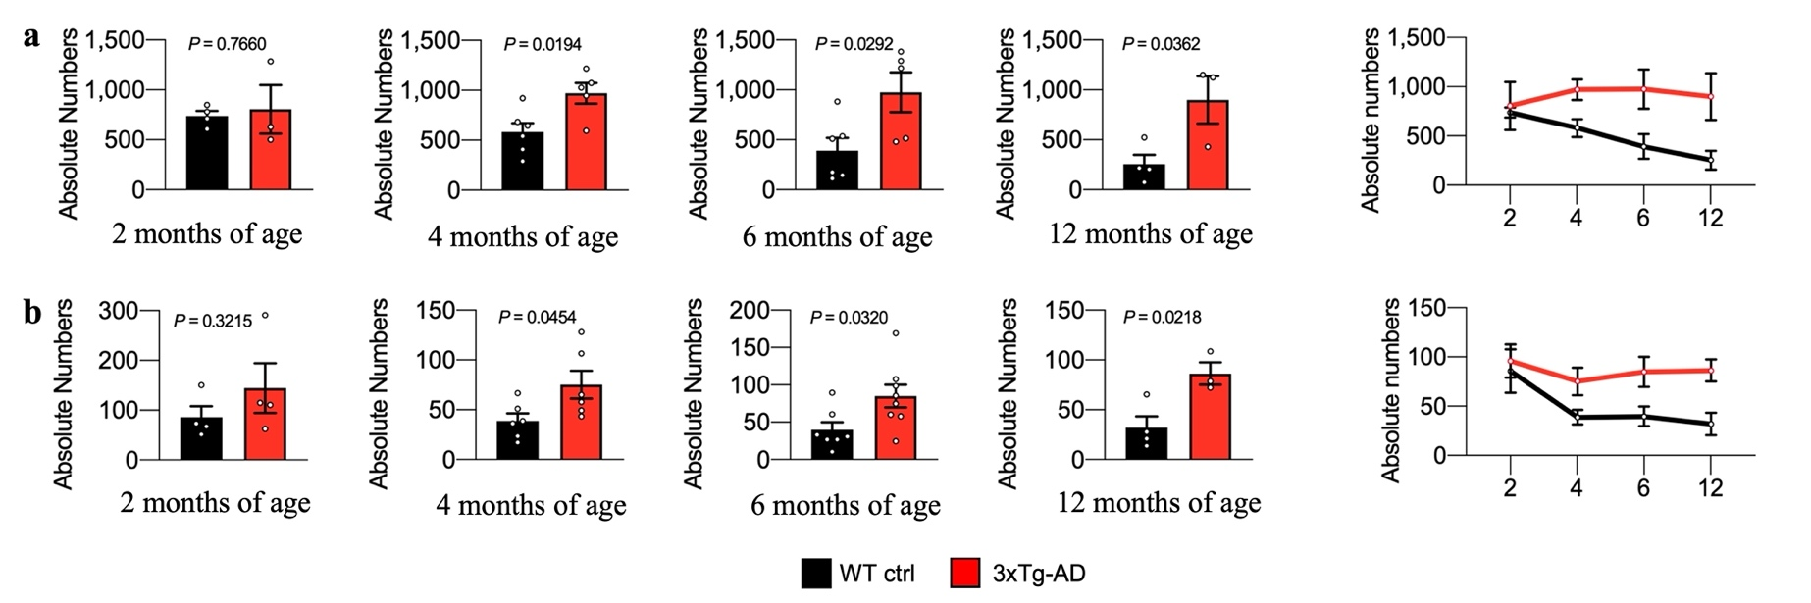
Figure 16. γδ T cells accumulate in the brains of 3xTg-AD mice. (a) Flow cytometry results showing the infiltration of γδ T cells in the meninges and (b) in the brain. Graphs show the absolute number of γδ T cells isolated from the brains of 3xTg-AD (red) (2, 12 months: n = 3; 4, 6 months: n = 5) and WT control (black) (2, 12 months: n = 4; 4, 6 months: n = 6) mice at the indicated ages (unpaired two-tailed t-test).

To understand if the imbalance of γδ T cells in AD-like model mice was systemic, we performed flow cytometry experiments also on the blood and the spleens of 3xTg-AD and WT mice at 2, 4, 6 and 12 months of age. No changes were observed in the percentages of blood γδ T cells, whereas we noticed a reduction of γδ T cells in the spleen reaching statistical significance at 6 months of age (Figure 17), suggesting a possible dysregulation in early response to infections in 3xTg-AD mice¹⁵⁹.
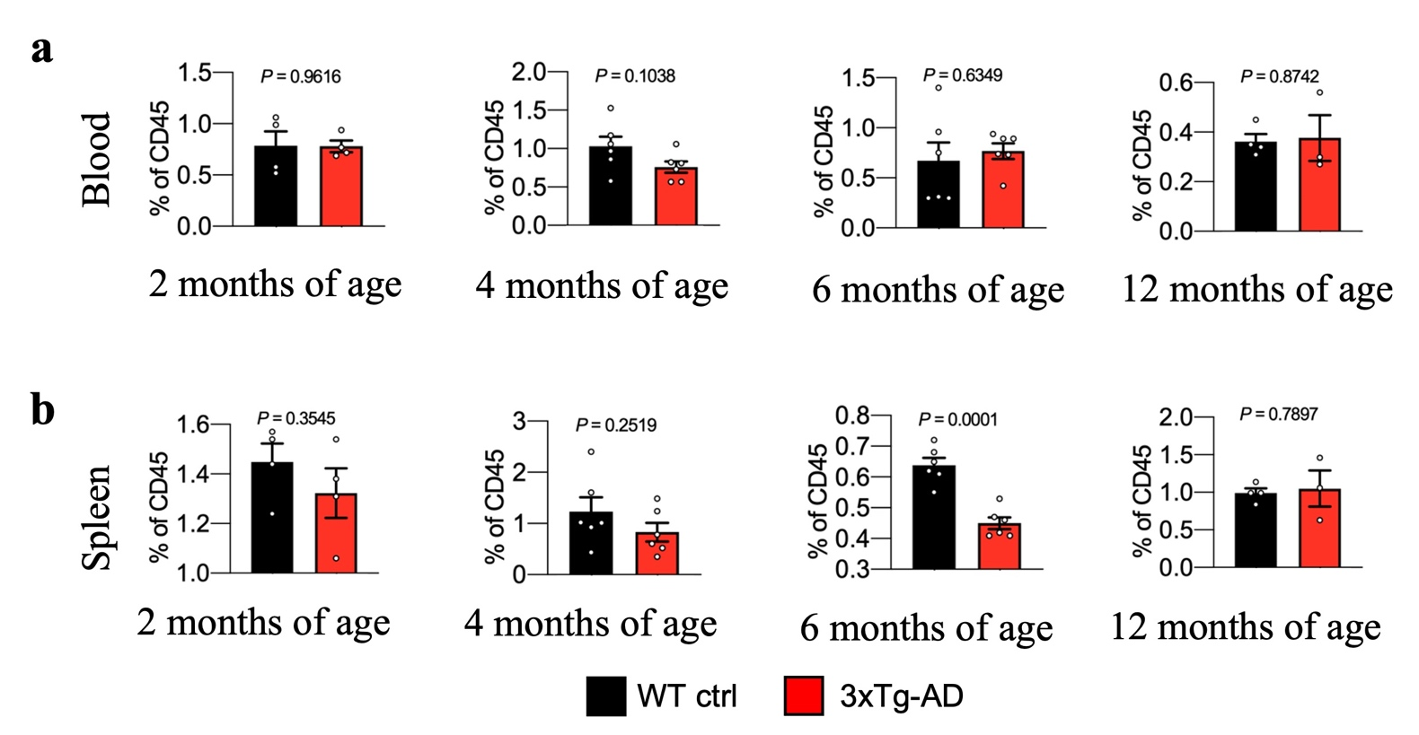
Figure 17. Characterization of γδ T cell accumulation and the effect of γδ T cell deficiency in 3xTg-AD mice. Graphs report the percentage of γδ T cells (a) in the blood and (b) spleen of WT controls (2 months: n = 4; 4, 6, 12 months: n = 6) and 3xTg-AD (2 months: n = 4; 4, 6, 12 months: n = 6) mice at the indicated time points. Results are presented as means ± S.D.; unpaired t-test.

15.2 γδ T cells infiltrate the brain in 3xTg-AD mice
We next verified the results on γδ T cells infiltration in 3xTg-AD mice obtained by flow cytometry using immunofluorescence microscopy. We confirmed a significant increase in the accumulation of γδ T cells in both sinusal and non-sinusal meninges in 3xTg-AD mice compared to WT animals (Figure 18a). The number of γδ T cells was also higher in brain areas involved in the neuropathological process, but no significant differences were observed in other areas (Figure 18b). Indeed, γδ T cells were found in close proximity to Aβ deposits and tau hyperphosphorylation, suggesting these cells are involved in the development of neuropathological changes in 3xTg-AD mice (Figure 18c).
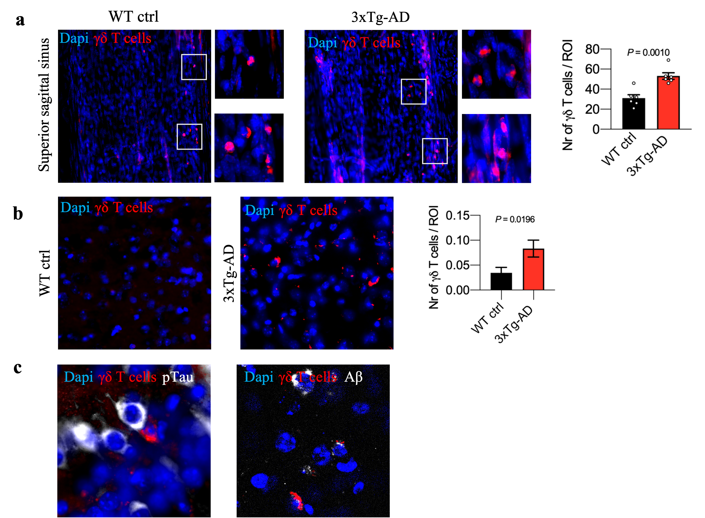
Figure 18. γδ T cells infiltrate the brain and contribute to disease development in 3xTg-AD mice. Representative images and quantitative analysis of γδ T cells (a) in the superior sagittal sinus of the meninges and (b) brain of WT controls and 3xTg-AD mice at 6 months of age. Nuclei are stained with DAPI (blue) and TCR γδ staining is shown in red. Scale bar = 20 μm; 40× magnification. Individual cells are zoomed in boxes (meninges, a). Scale bar = 5 μm (meninges: n = 2; brain: n = 4; unpaired t-test). (c) Representative images of γδ T cells (red) phosphorylated tau (p-Tau) (white, left) and Aβ deposits (white, right) in 3xTg-AD brains at 6 months of age. Nuclei are stained with DAPI (blue). Scale bar = 10 μm; 40× magnification.

15.3 γδ T cells promote memory impairment in 3xTg-AD mice
To understand the role of γδ T cells in the development of AD-like disease, we crossed 3xTg-AD mice with a strain deficient for the TCRγδ chain to generate 3xTg-AD×Tcrd^{-/-} mice lacking γδ T cells. We assessed the behavior of these mice at 9 months of age and observed no significant differences between the experimental groups in the hind limb clasping and ledge tests, suggesting no differences in motor coordination (Table 1).

Table 1. Motor coordination in ledge test and hind limb clasping.
 | Mouse | Sex | Ledge test |  |  | Clasping
1 | 3xTg-AD×Tcrd-/- | F | 0 | 0 | 0 | 0 | 0 | 0
2 | 3xTg-AD×Tcrd-/- | F | 0 | 0 | 0 | 0 | 0 | 0
3 | 3xTg-AD×Tcrd-/- | F | 0 | 0 | 0 | 0 | 0 | 0
4 | 3xTg-AD×Tcrd-/- | F | 0 | 0 | 0 | 0 | 0 | 0
5 | 3xTg-AD×Tcrd-/- | F | 0 | 0 | 0 | 0 | 0 | 0
6 | 3xTg-AD×Tcrd-/- | F | 0 | 0 | 0 | 0 | 0 | 0
7 | 3xTg-AD×Tcrd-/- | F | 0 | 0 | 0 | 2 | 1 | 1
8 | 3xTg-AD×Tcrd-/- | F | 0 | 0 | 0 | 0 | 0 | 0
9 | 3xTg-AD×Tcrd-/- | F | 0 | 0 | 0 | 0 | 0 | 0
10 | 3xTg-AD×Tcrd-/- | F | 0 | 0 | 0 | 0 | 0 | 0
11 | 3xTg-AD×Tcrd-/- | F | 0 | 0 | 0 | 0 | 0 | 0
1 | 3xTg-AD | F | 0 | 0 | 0 | 0 | 0 | 0
2 | 3xTg-AD | F | 0 | 0 | 0 | 0 | 0 | 0
3 | 3xTg-AD | F | 0 | 0 | 0 | 0 | 0 | 0
4 | 3xTg-AD | F | 0 | 0 | 0 | 0 | 0 | 0
5 | 3xTg-AD | F | 0 | 0 | 0 | 1 | 1 | 1
6 | 3xTg-AD | F | 0 | 0 | 0 | 0 | 0 | 0
7 | 3xTg-AD | F | 0 | 0 | 0 | 0 | 0 | 0
8 | 3xTg-AD | F | 0 | 0 | 0 | 0 | 0 | 0
9 | 3xTg-AD | F | 0 | 0 | 0 | 0 | 0 | 0
10 | 3xTg-AD | F | 0 | 0 | 0 | 0 | 0 | 0
1 | WT | F | 0 | 0 | 0 | 0 | 0 | 0
2 | WT | F | 0 | 0 | 0 | 0 | 0 | 0
3 | WT | F | 0 | 0 | 0 | 0 | 0 | 0
4 | WT | F | 0 | 0 | 0 | 0 | 0 | 0
5 | WT | F | 0 | 0 | 0 | 0 | 0 | 0
6 | WT | F | 0 | 0 | 0 | 0 | 0 | 0
7 | WT | F | 0 | 0 | 0 | 0 | 0 | 0
8 | WT | F | 0 | 0 | 0 | 0 | 0 | 0
9 | WT | F | 0 | 0 | 0 | 0 | 0 | 0
10 | WT | F | 0 | 0 | 0 | 0 | 0 | 0
11 | WT | F | 0 | 0 | 0 | 0 | 0 | 0
1 | 3xTg-AD×Tcrd-/- | M | 0 | 0 | 0 | 0 | 0 | 0
2 | 3xTg-AD×Tcrd-/- | M | 0 | 0 | 0 | 0 | 0 | 0
3 | 3xTg-AD×Tcrd-/- | M | 0 | 0 | 0 | 0 | 0 | 0
4 | 3xTg-AD×Tcrd-/- | M | 0 | 0 | 0 | 0 | 0 | 0
5 | 3xTg-AD×Tcrd-/- | M | 0 | 0 | 0 | 0 | 0 | 0
6 | 3xTg-AD×Tcrd-/- | M | 0 | 0 | 0 | 1 | 1 | 1
7 | 3xTg-AD×Tcrd-/- | M | 0 | 0 | 0 | 0 | 0 | 0
8 | 3xTg-AD×Tcrd-/- | M | 0 | 0 | 0 | 0 | 0 | 0
9 | 3xTg-AD×Tcrd-/- | M | 0 | 0 | 0 | 0 | 0 | 0
10 | 3xTg-AD×Tcrd-/- | M | 0 | 0 | 0 | 0 | 0 | 0
1 | 3xTg-AD | M | 0 | 0 | 0 | 0 | 0 | 0
2 | 3xTg-AD | M | 0 | 0 | 0 | 0 | 0 | 0
3 | 3xTg-AD | M | 0 | 0 | 0 | 0 | 0 | 0
4 | 3xTg-AD | M | 0 | 0 | 0 | 0 | 0 | 0
5 | 3xTg-AD | M | 0 | 0 | 0 | 2 | 2 | 0
6 | 3xTg-AD | M | 0 | 0 | 0 | 0 | 0 | 0
7 | 3xTg-AD | M | 0 | 2 | 2 | 1 | 1 | 1
8 | 3xTg-AD | M | 0 | 0 | 0 | 0 | 0 | 0
9 | 3xTg-AD | M | 0 | 0 | 0 | 1 | 1 | 0
10 | 3xTg-AD | M | 0 | 0 | 0 | 0 | 0 | 0
1 | WT | M | 0 | 0 | 0 | 0 | 0 | 0
2 | WT | M | 0 | 0 | 0 | 0 | 0 | 0
3 | WT | M | 0 | 0 | 0 | 0 | 0 | 0
4 | WT | M | 0 | 0 | 0 | 0 | 0 | 0
5 | WT | M | 0 | 0 | 0 | 0 | 0 | 0
6 | WT | M | 0 | 0 | 0 | 0 | 0 | 0
7 | WT | M | 0 | 0 | 0 | 0 | 0 | 0
8 | WT | M | 0 | 0 | 0 | 0 | 0 | 0
9 | WT | M | 0 | 0 | 0 | 0 | 0 | 0
10 | WT | M | 0 | 0 | 0 | 0 | 0 | 0

The Y-maze spontaneous alternation test and the contextual fear conditioning (CFC) associative learning task revealed that the absence of γδ T cells in 3xTg-AD×Tcrd^{-/-} mice rescued the memory impairment normally observed at this time point in 3xTg-AD mice (Figure 19a-c). No significant difference was observed between groups in the number of arms entered during the Y-maze test (Figure 19a), showing normal motor functions and normal exploratory behavior during the test. Moreover, the 3xTg-AD×Tcrd^{-/-} mice showed a significant amelioration in spatial learning capacity (escape latency) compared to 3xTg-AD mice, but no differences were observed in the probe trial, even if the performance of 3xTg-AD×Tcrd^{-/-} mice was slightly better than that of control 3xTg-AD mice (Figure 19d, e). Given that healthy young mice lacking γδ T cells have lower levels of anxiety¹⁵⁸ and that 3xTg-AD mice show increased anxiety behavior¹⁶⁰, we also measured anxiety-like behavior in the open field (OF) test. We found that 3xTg-AD×Tcrd^{-/-} mice spent more time in the center of the arena than both their 3xTg-AD and WT counterparts, supporting a role for γδ T cells in anxiety-like behavior in 3xTg-AD mice (Figure 19f). Collectively, our data suggest that γδ T cells contribute to the induction of learning and memory deficit, as well as increased anxiety in 3xTg-AD mice.
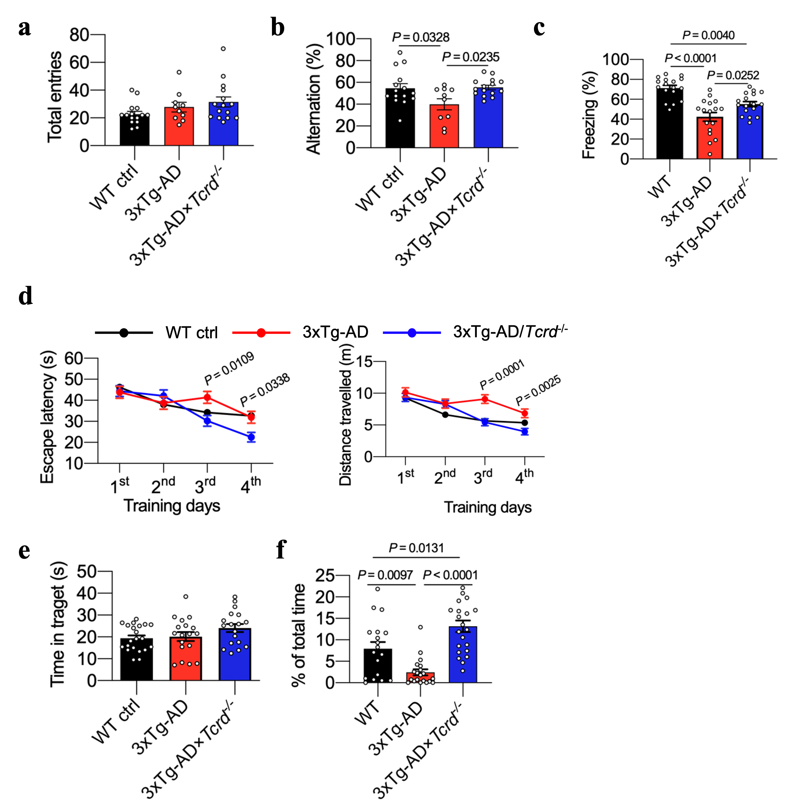
Figure 19. The lack of γδ T cells leads to an amelioration in cognitive performance in 3xTg-AD mice. Results are shown for the Y-maze test (a, b, n = 15 in WT group, n = 10 in 3xTg-AD group, n = 15 in 3xTg-AD/Tcrd^{-/-} group), CFC test (c, n = 17 in WT group, n = 17 in 3xTg-AD group, n = 17 in 3xTg-AD/Tcrd^{-/-} group), MWM test (d, e, n = 21 in WT group, n = 18 in 3xTg-AD group, n = 18 in 3xTg-AD/Tcrd^{-/-} group) and OF test (f, n = 18 in WT group, n = 20 in 3xTg-AD group, n = 22 in 3xTg-AD/Tcrd^{-/-} group). Values are means ± s.e.m, the experiment is representative of two with similar results. Statistical significance was determined by one-way ANOVA.

15.4 Lack of γδ T cells reduces the neuropathological hallmarks of AD
Next, we investigated whether the memory rescue achieved by the lack of γδ T cells in 3xTg-AD mice correlated with a reduction in the neuropathological hallmarks of AD. Coronal brain sections were stained for Iba-1 to study microglial density and shape in the cortex and hippocampus (subiculum and CA1 region). Our data showed a significant reduction in microglial density and the area occupied by these cells in 3xTg-AD×Tcrd^{-/-} compared to 3xTg-AD mice in both the cortex and hippocampus, suggesting that γδ T cells promote neuroinflammation in 3xTg-AD mice (Figure 20a, b). We also evaluated the impact of γδ T cell deficiency on the accumulation of Aβ, observing a significant reduction in the abundance of Aβ deposits in 3xTg-AD×Tcrd^{-/-} compared to 3xTg-AD mice, confirming that γδ T cells contribute to Aβ pathology (Figure 20c). Moreover, we studied tau phosphorylation using a monoclonal antibody specific for the pThr231 epitope, which is among the earliest phosphorylated tau epitopes to manifest in 3xTg-AD mice¹⁶¹. Our data revealed a dramatic reduction in tau hyperphosphorylation in the hippocampus (Figure 20d) in 3xTg-AD×Tcrd^{-/-} compared to 3xTg-AD mice, but no significant change in total tau levels between these experimental groups (Figure 20e). Taken together, our results demonstrate that γδ T cells play a key role in the induction of cognitive impairment and major neuropathological features of AD in 3xTg-AD mice.
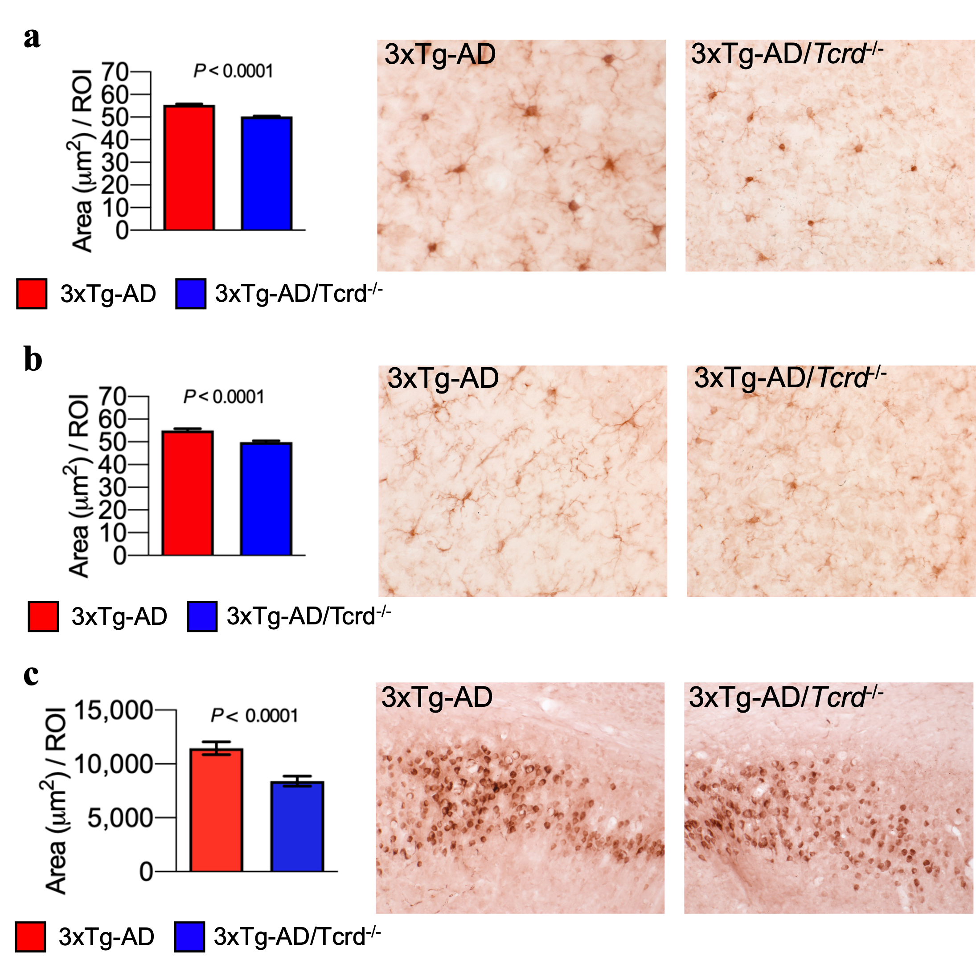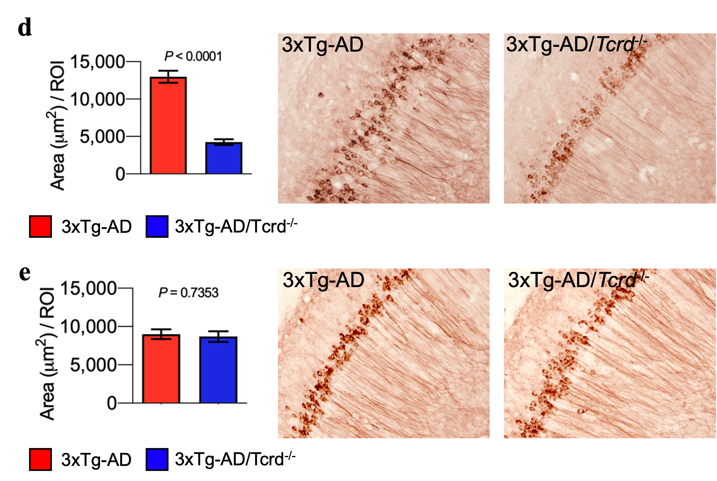
Figure 20. The lack of γδ T cells leads to a reduction of neuropathological features of AD in 3xTg-AD mice. (a–e) Histopathological analysis of brain sections from 3xTg-AD mice and 3xTg-AD×Tcrd^{-/-} (n = 4 per group, unpaired t-test). Representative images and quantitative analysis of Iba-1⁺ cells (a) in the cortex and (b) hippocampus (20× magnification; scale bar = 50 μm). Representative images and quantitative analysis of (c) Aβ deposition (6E10 staining), (d) hyperphosphorylated tau (AT180 staining), and (e) total tau (HT7 staining) in the hippocampus. (20× magnification; scale bar = 50 μm).

15.5 Meningeal and brain-derived γδ T cells show a prominent activation status and produce IL-17
To gain insight into the immune signature of γδ T cells and the molecular mechanisms underlying the role of these cells in AD pathogenesis, we isolated meningeal CD45⁺ cells and brain-infiltrating CD45^{high} cells from 6-month-old 3xTg-AD and wild-type mice and studied their gene expression profiles by single-cell RNA sequencing (scRNA-seq) (Figure 21).
In the meninges, we analyzed 4393 individual cells from 3xTg-AD mice and 5967 cells from WT mice. Transcriptionally distinct leukocyte subpopulations were identified by unsupervised clustering and dimensionality reduction using a smart local moving (SLM) clustering algorithm and t-distributed stochastic neighbor embedding (t-SNE). This revealed 15 clusters visualized on a t-SNE map, ranging from a minimum of 49 cells in cluster 14 to a maximum of 2665 cells in cluster 0 (Figure 21a). Cluster 6 (n = 481) consisted predominantly of γδ T cells, mapping near to the clusters of innate lymphoid cells (ILCs), NK cells, NKT cells and T cells (Figure 21a), confirming the unique nature of γδ T cells with hallmarks of both innate and adaptive immunity. The analysis of differentially expressed genes (DEGs) revealed a pathogenic signature indicating enhanced T cell activation in the γδ T cells from 3xTg-AD mice compared to controls. This included the upregulation of Il2ra, Arrb1, Igf1r and Cd44¹⁶²⁻¹⁶⁴, genes indicating the activation of nuclear factor κB (NF-κB) such as Nfkbia and Nfkbid¹⁶⁵ (Figure 21b), and genes representing antigen–receptor activation such as Nr4a1¹⁶⁶. We also observed the upregulation of genes involved in effector T cell migration during inflammatory responses (e.g., Ccr2, Cxcr6, Cxcr4 and Itgal), suggesting that γδ T cells from AD mice have an enhanced capacity for migration¹⁶⁷⁻¹⁷² (Figure 21b). Our scRNA-seq data showed that several genes relevant to the IL-17⁺ phenotype contribute to the pathogenic signature of γδ T cells in 3xTg-AD mice (Figure 21b). These included (1) Rora and Maf, encoding the transcription factors RORα and the transcriptional regulator c-Maf, which are pivotal regulators required for IL-17 production¹⁷³; (2) genes involved in IL-17 production, such as Il1r1, Sox13 and Blk, and Il17a encoding the cytokine IL-17A, indicating that these cells are primed toward the IL-17⁺ fate^{164,174}; (3) genes associated with IL-17⁺ γδ T cell expansion, such as Igf1r¹⁶³; (4) Ccr2, encoding the chemokine receptor CCR2, which is required for IL-17⁺ γδ T migration into the inflamed CNS during experimental autoimmune encephalomyelitis (EAE)¹⁶⁹, and Cxcr4, encoding the chemokine receptor for Cxcl12, the most widely expressed stromal chemokine in the meninges¹⁷¹. Interestingly, we also detected the expression of the scavenger receptor gene Scart1, a specific marker of activated effector CD44⁺ Vγ6⁺ γδ T17 cells ¹⁶⁴. Gene Ontology (GO) analysis indicated significant enrichment for biological processes involved in T cell activation and differentiation. Kyoto Encyclopedia of Genes and Genomes (KEGG) pathway analysis revealed in 3xTg-AD mice a significant enrichment for genes involved in the immune response in the context of infection and neurodegenerative diseases, as well as IL-17-mediated pathways. These results further emphasized the activated, pro-migratory, IL-17⁺ phenotype of meningeal γδ T cells in mice with AD-like pathology (Figure 21c).
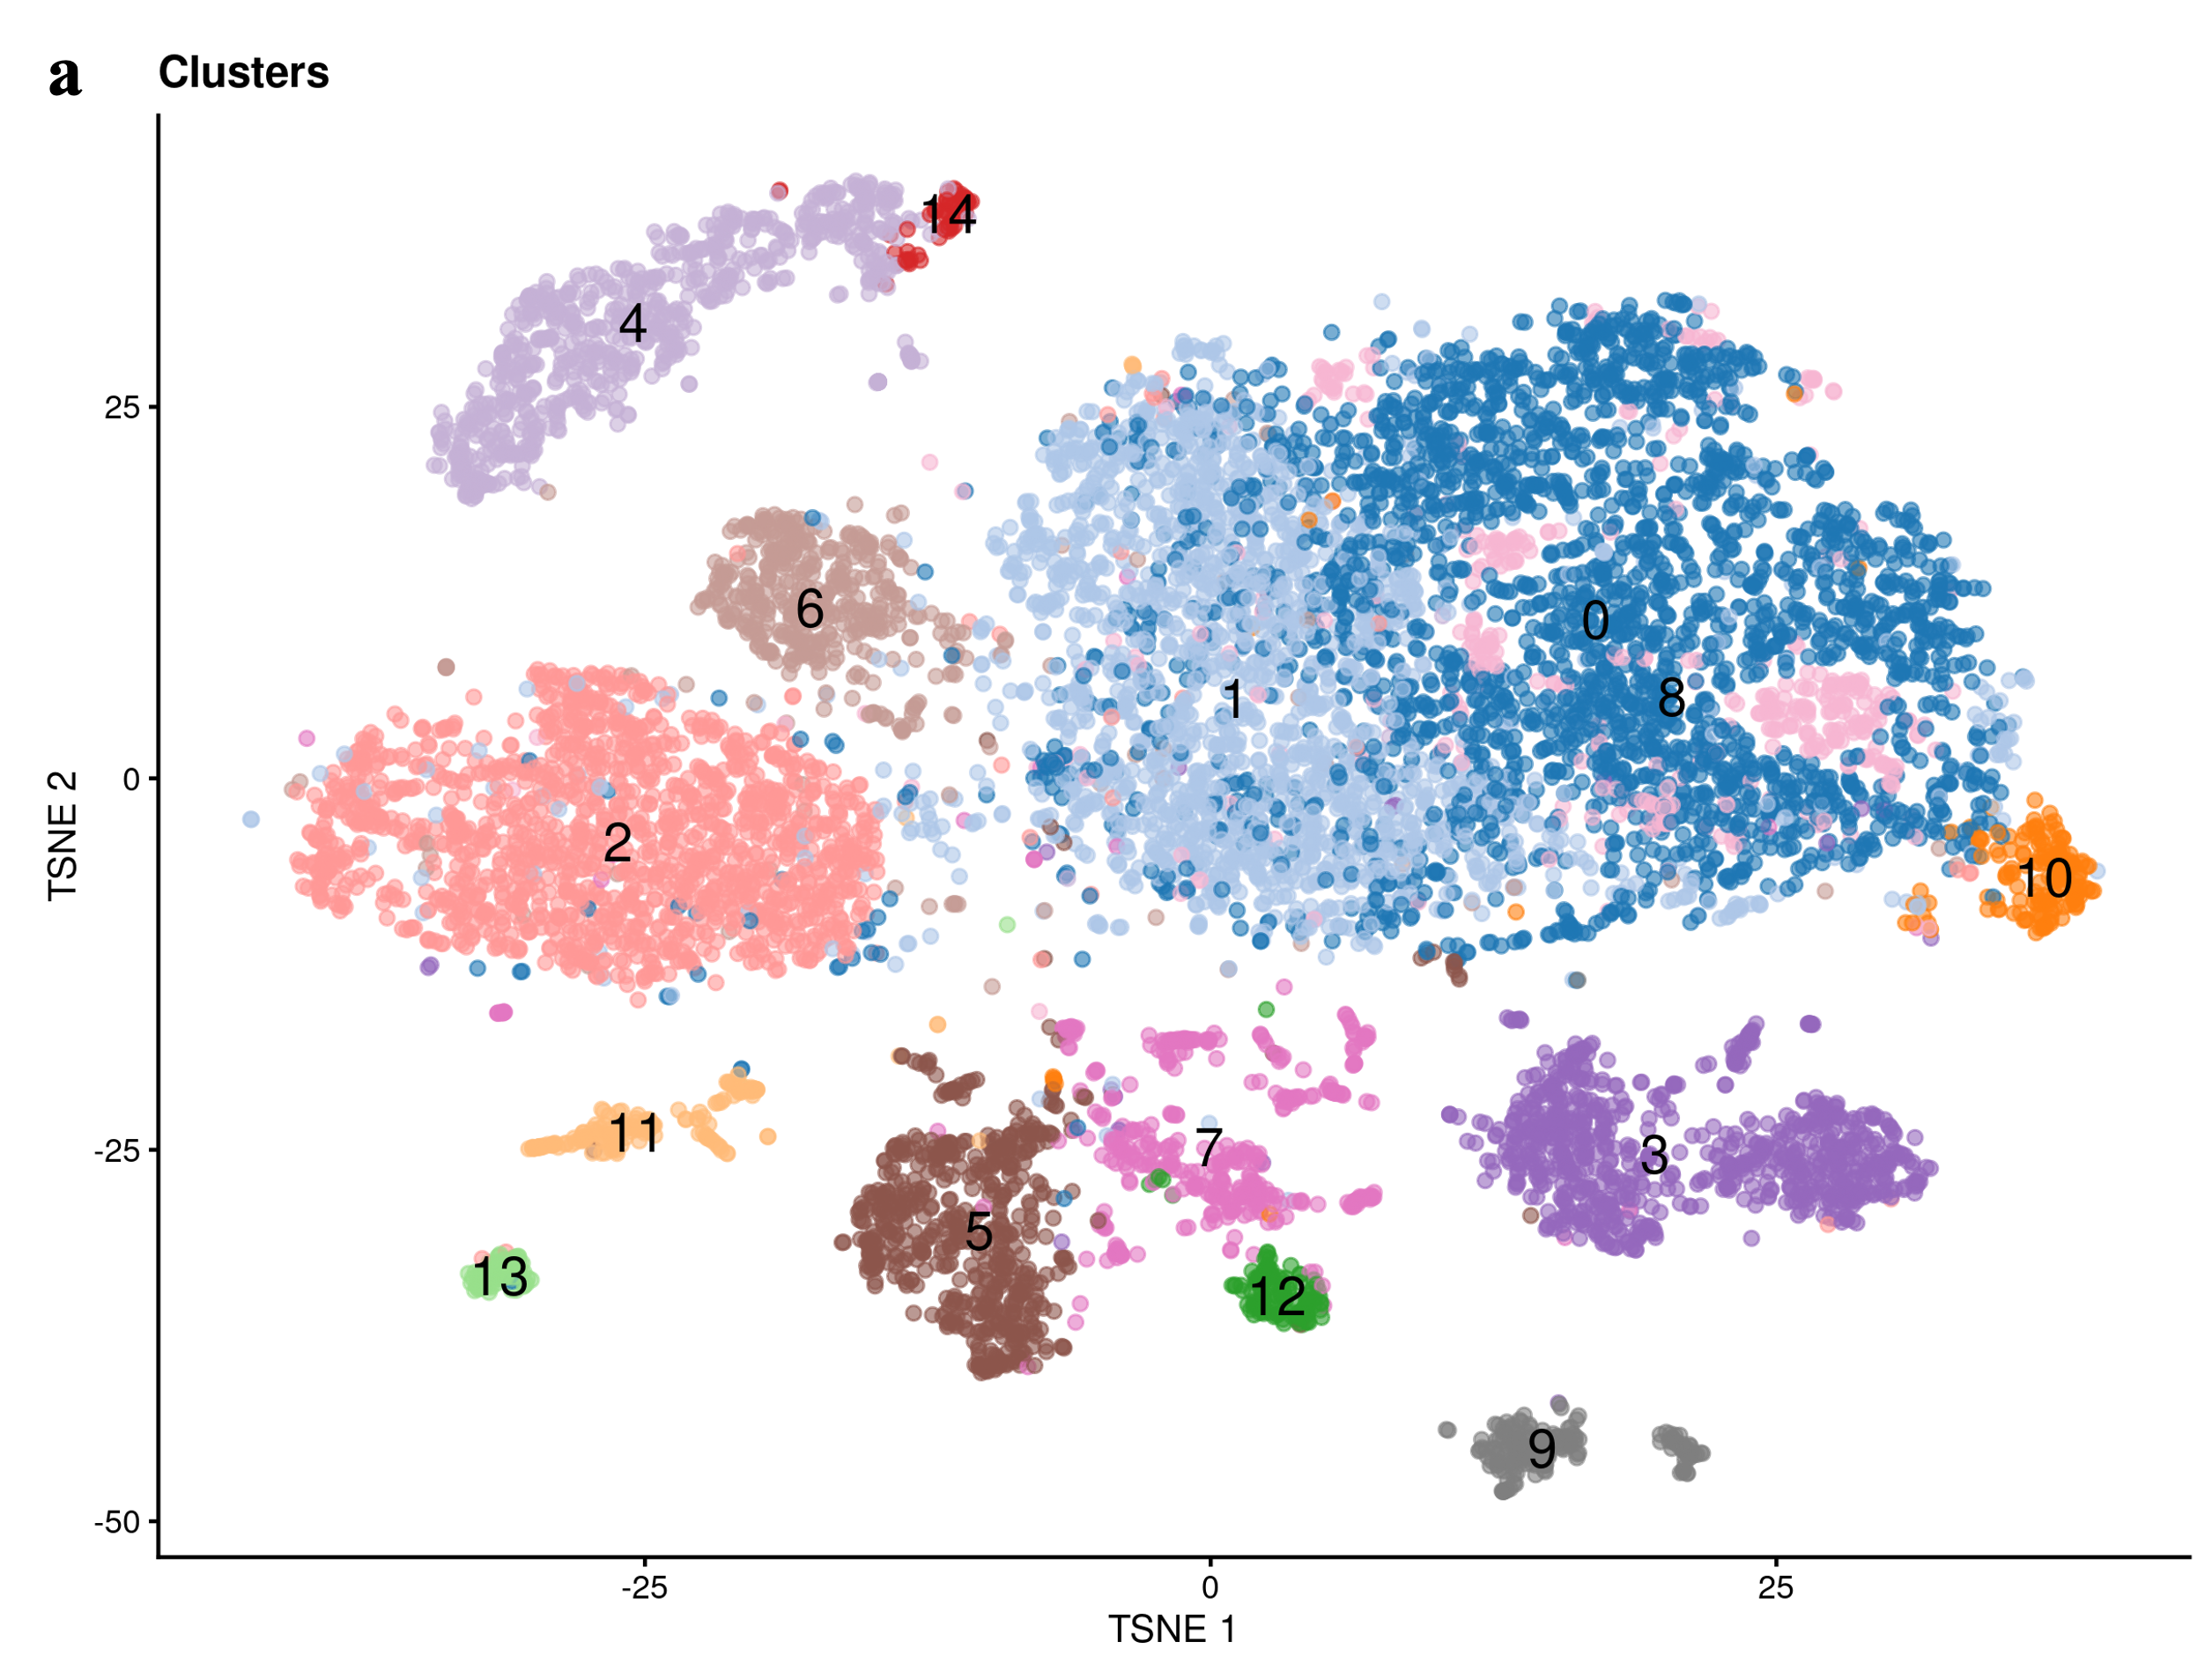
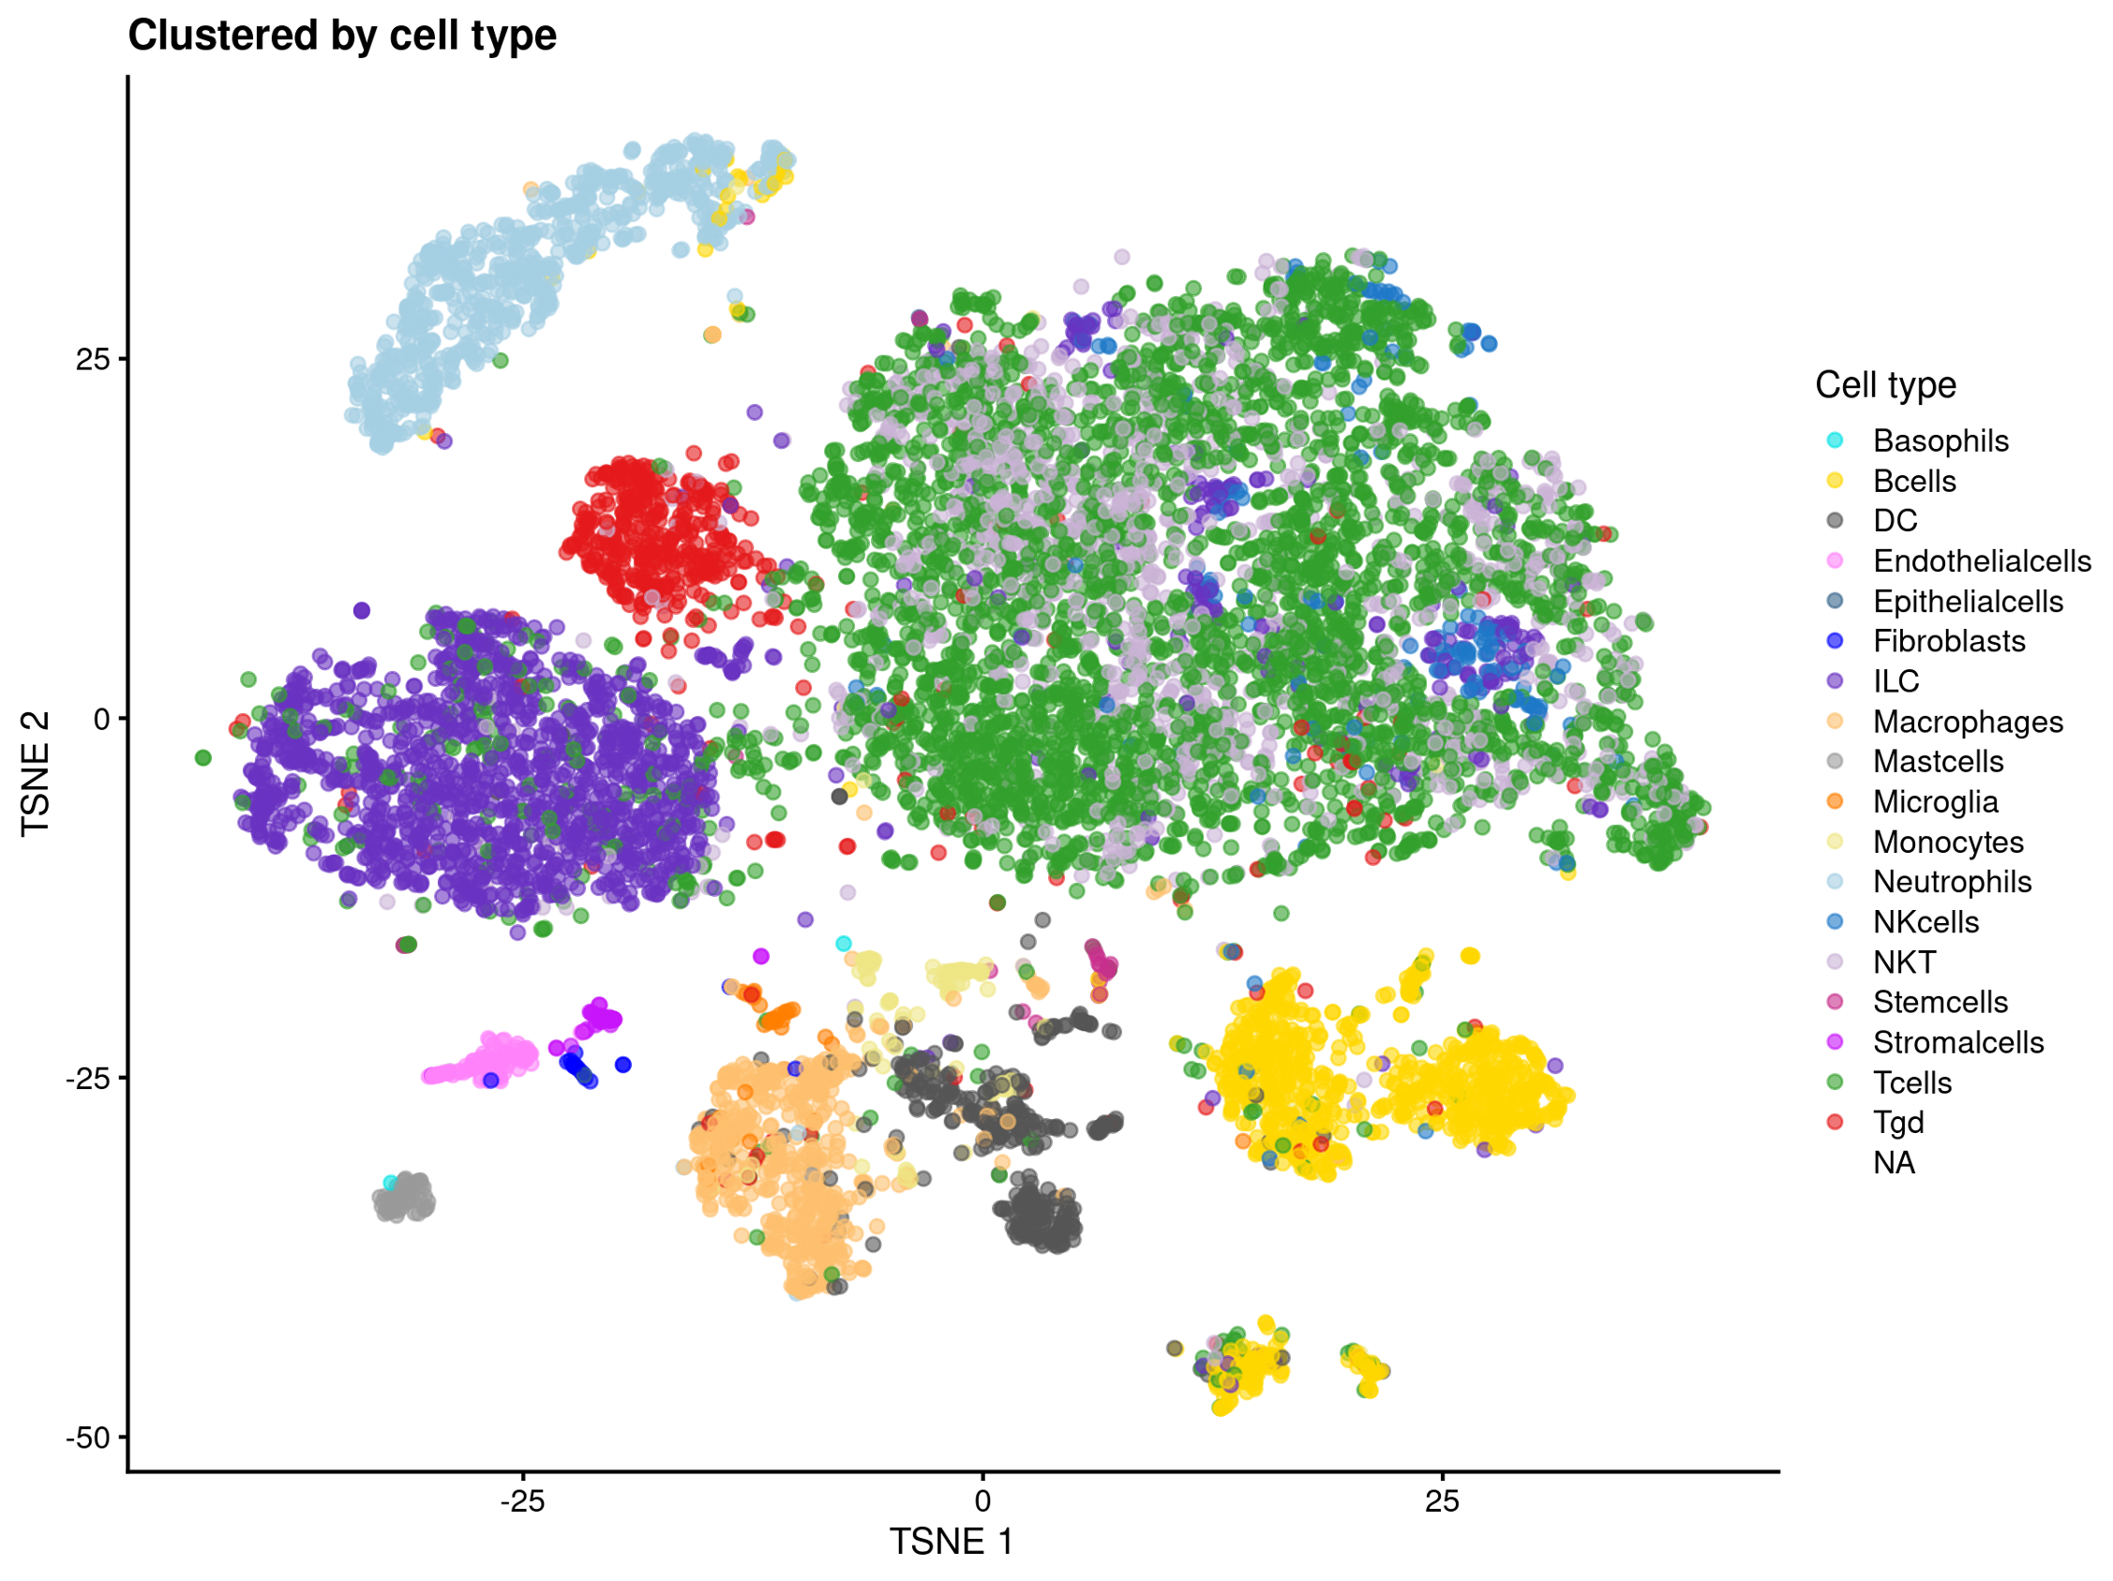
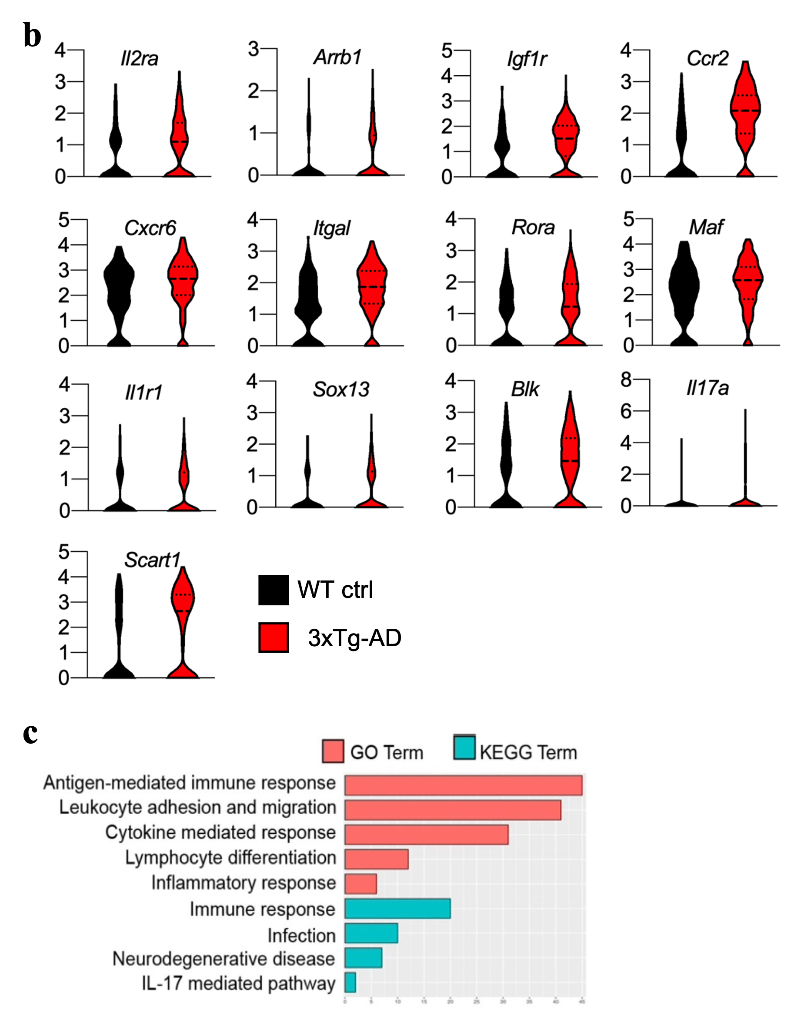
Figure 21. Transcriptomic landscape of meningeal γδ T cells shows increased activation and migration phenotype in 3xTg-AD mice. Single-cell RNA sequencing of CD45⁺ cells was used for leukocyte profiling and expression analysis. (a) The t-SNE projection of 10,360 individual leukocytes from 16 mice (3xTg-AD: n = 8; WT ctrl n = 8) resolved to 14 major clusters from the meninges. Each dot corresponds to a single cell, colored according to the cell cluster (left panel, a) and cell type (right panel, a). (b) Violin plots of expression levels for the indicated DEGs in γδ T cells from 3xTg-AD mice and wild-type (WT) controls. Annotated genes were divided into the main GO biological processes and KEGG pathways for enrichment analysis (P < 0.05 and at least four genes), and were divided into further subcategories (c).

In the brain, we analyzed 3337 individual cells from 3xTg-AD mice and 1883 cells from WT mice. The number of DEGs was lower in the brain than in the meninges because fewer γδ T cells infiltrate the brain (Figure 22). However, GO terms derived from the DEGs showed significant enrichment for biological processes involved in antigen-mediated T cell activation, cytokine-mediated responses, migration, inflammatory responses, and lymphocyte differentiation (Figure 22b). We observed the upregulation of Cd81, encoding the costimulatory molecule CD81 that contributes to TCR γδ⁺ T cell activation by transducing signals resulting in enhanced cytokine production¹⁷⁵. As observed for the meningeal γδ T cells, the chemokine receptor gene Ccr2 was upregulated in the brain-infiltrating γδ T cells of 3xTg-AD mice, suggesting that their migration into the inflamed AD brain is CCR2-dependent, as proposed in EAE model mice¹⁶⁹. Interestingly, the γδ T cell subset in the brain of 3xTg-AD mice was enriched for Serf2 mRNA, encoding a positive regulator of amyloid protein aggregation and proteotoxicity¹⁷⁶, as well as Apoe and Cst3. Apoe and Cst3 are associated with the hereditary forms of cerebral amyloid angiopathy and AD, respectively, suggesting that γδ T cells may promote the formation of Aβ deposits^{15,177}. Notably, both meningeal and brain-associated γδ T cells show the differential expression of Ctse, encoding the lysosomal endopeptidase cathepsin E, which also accumulates in the brains of human AD patients¹⁷⁸ (Figure 22c). The transcriptomic profiles of meningeal and brain γδ T cells suggest that these immune cells are activated, IL-17 producers and involved in AD development.
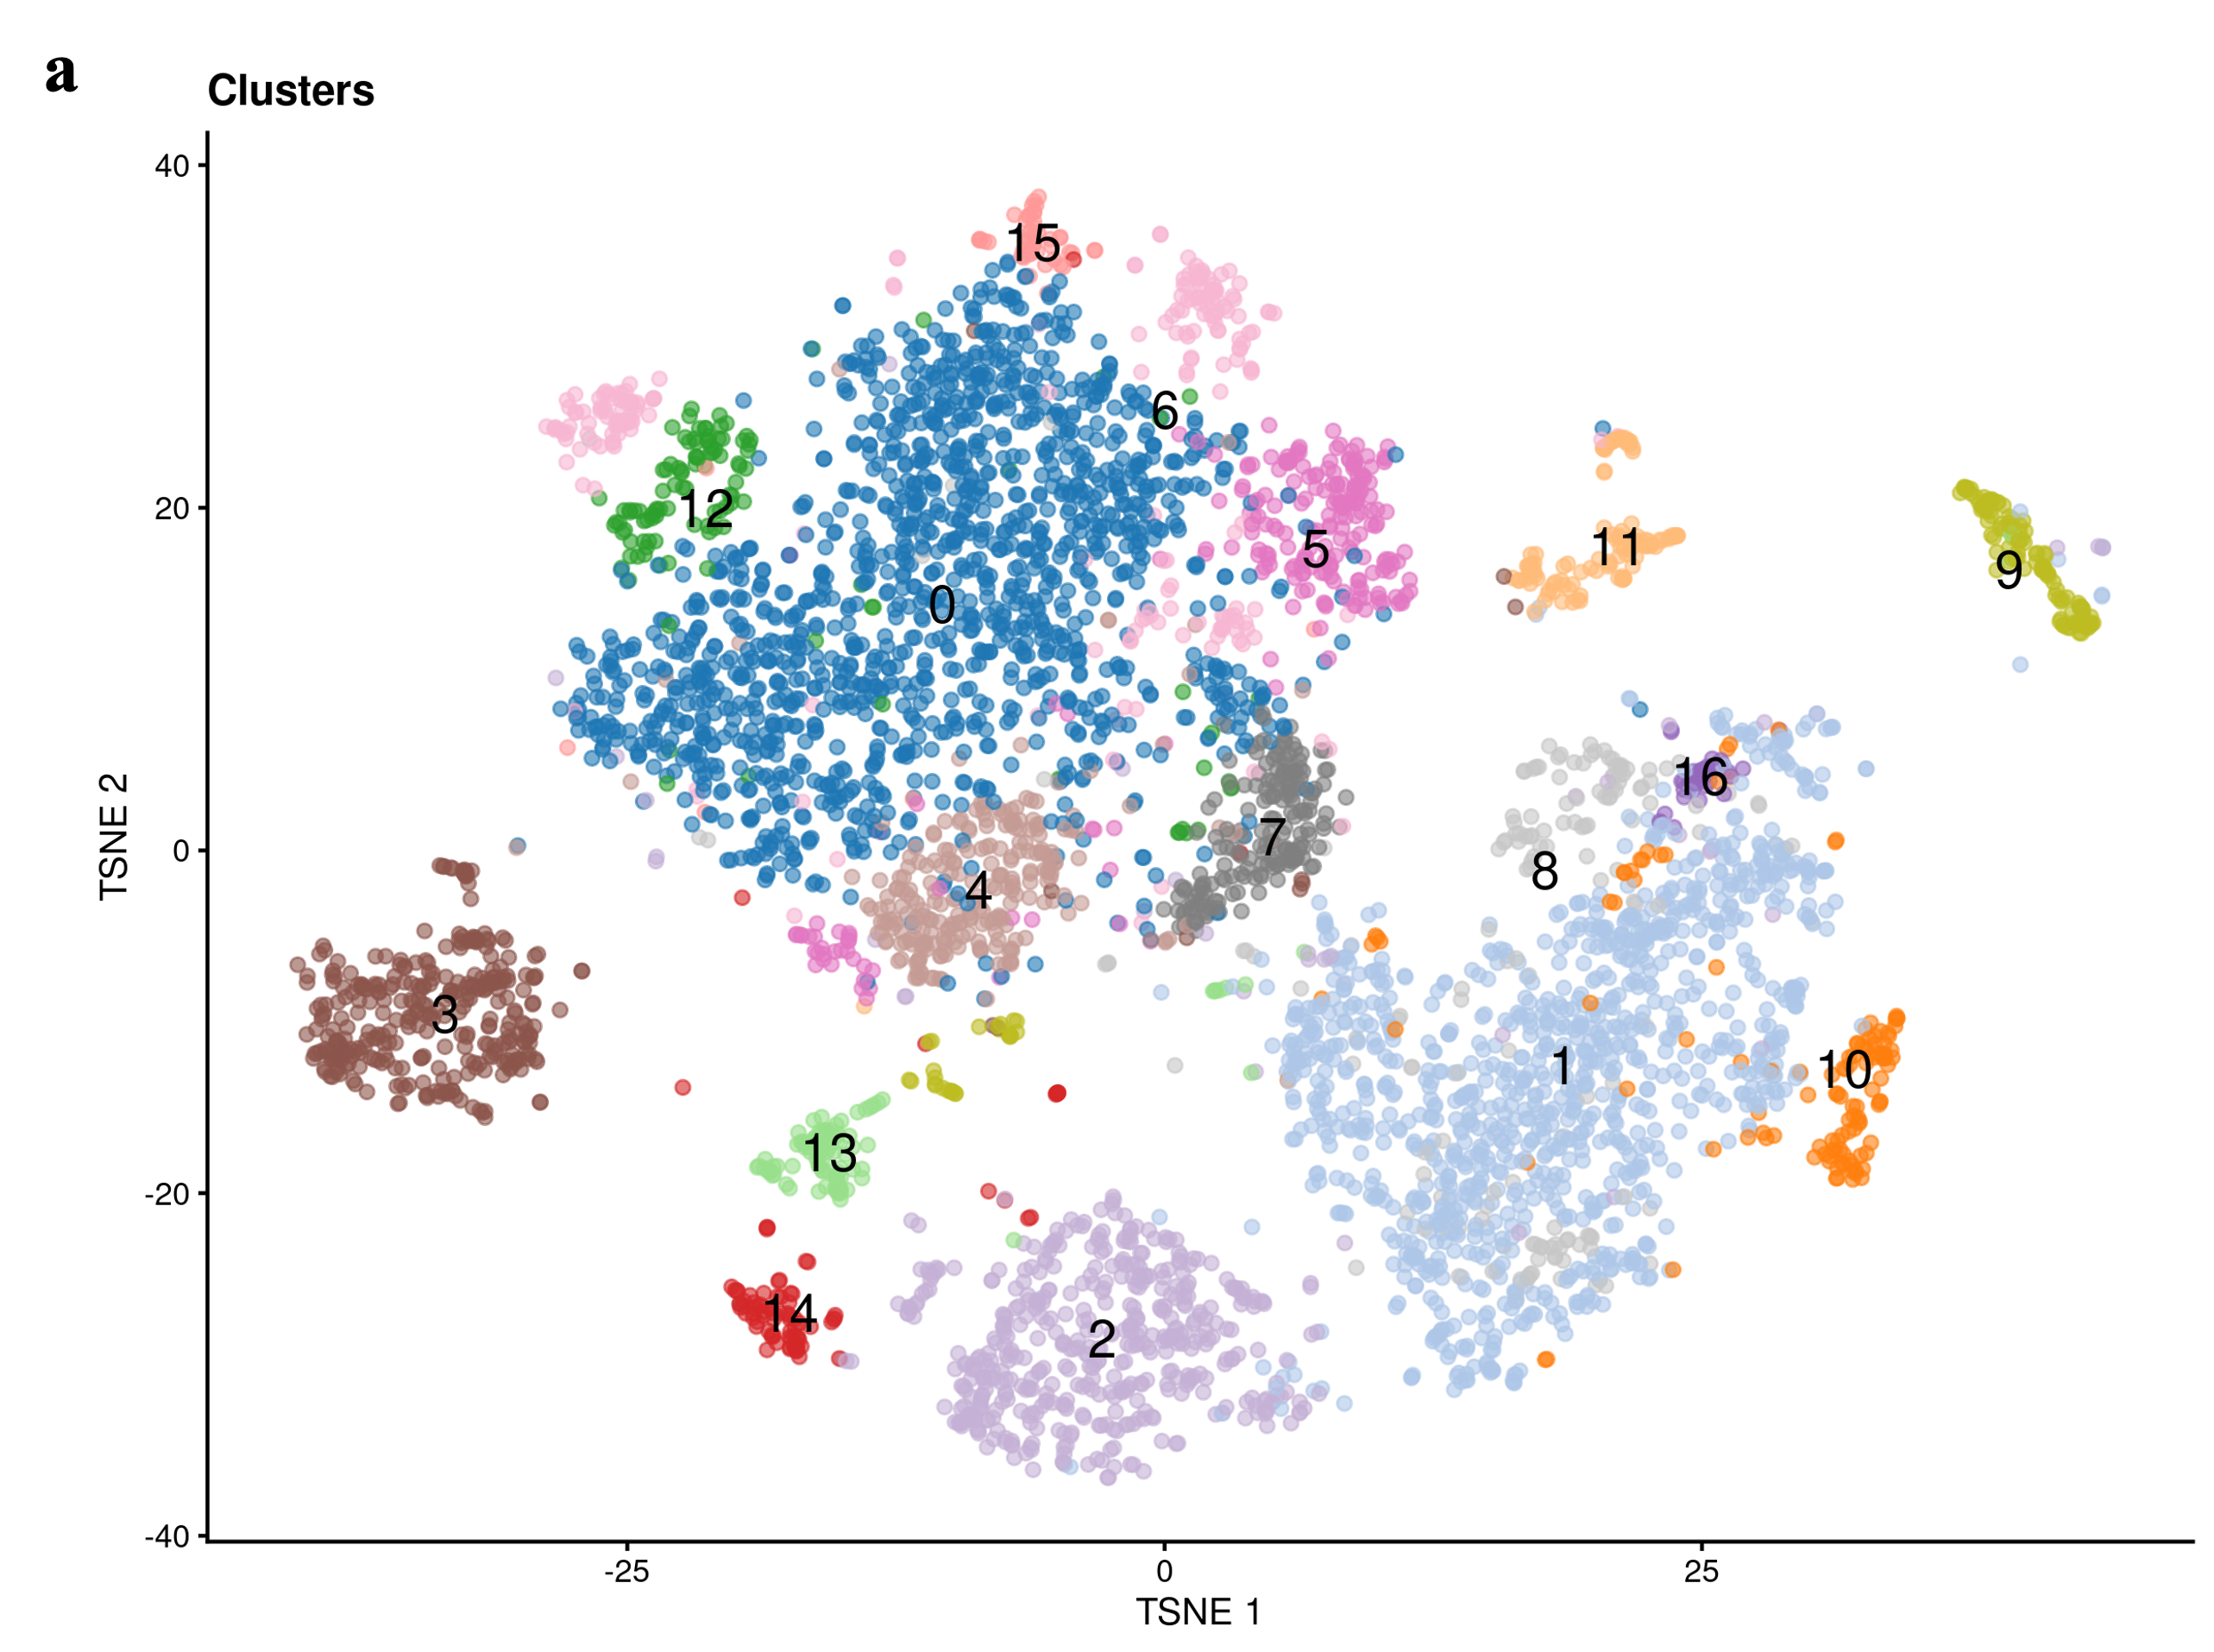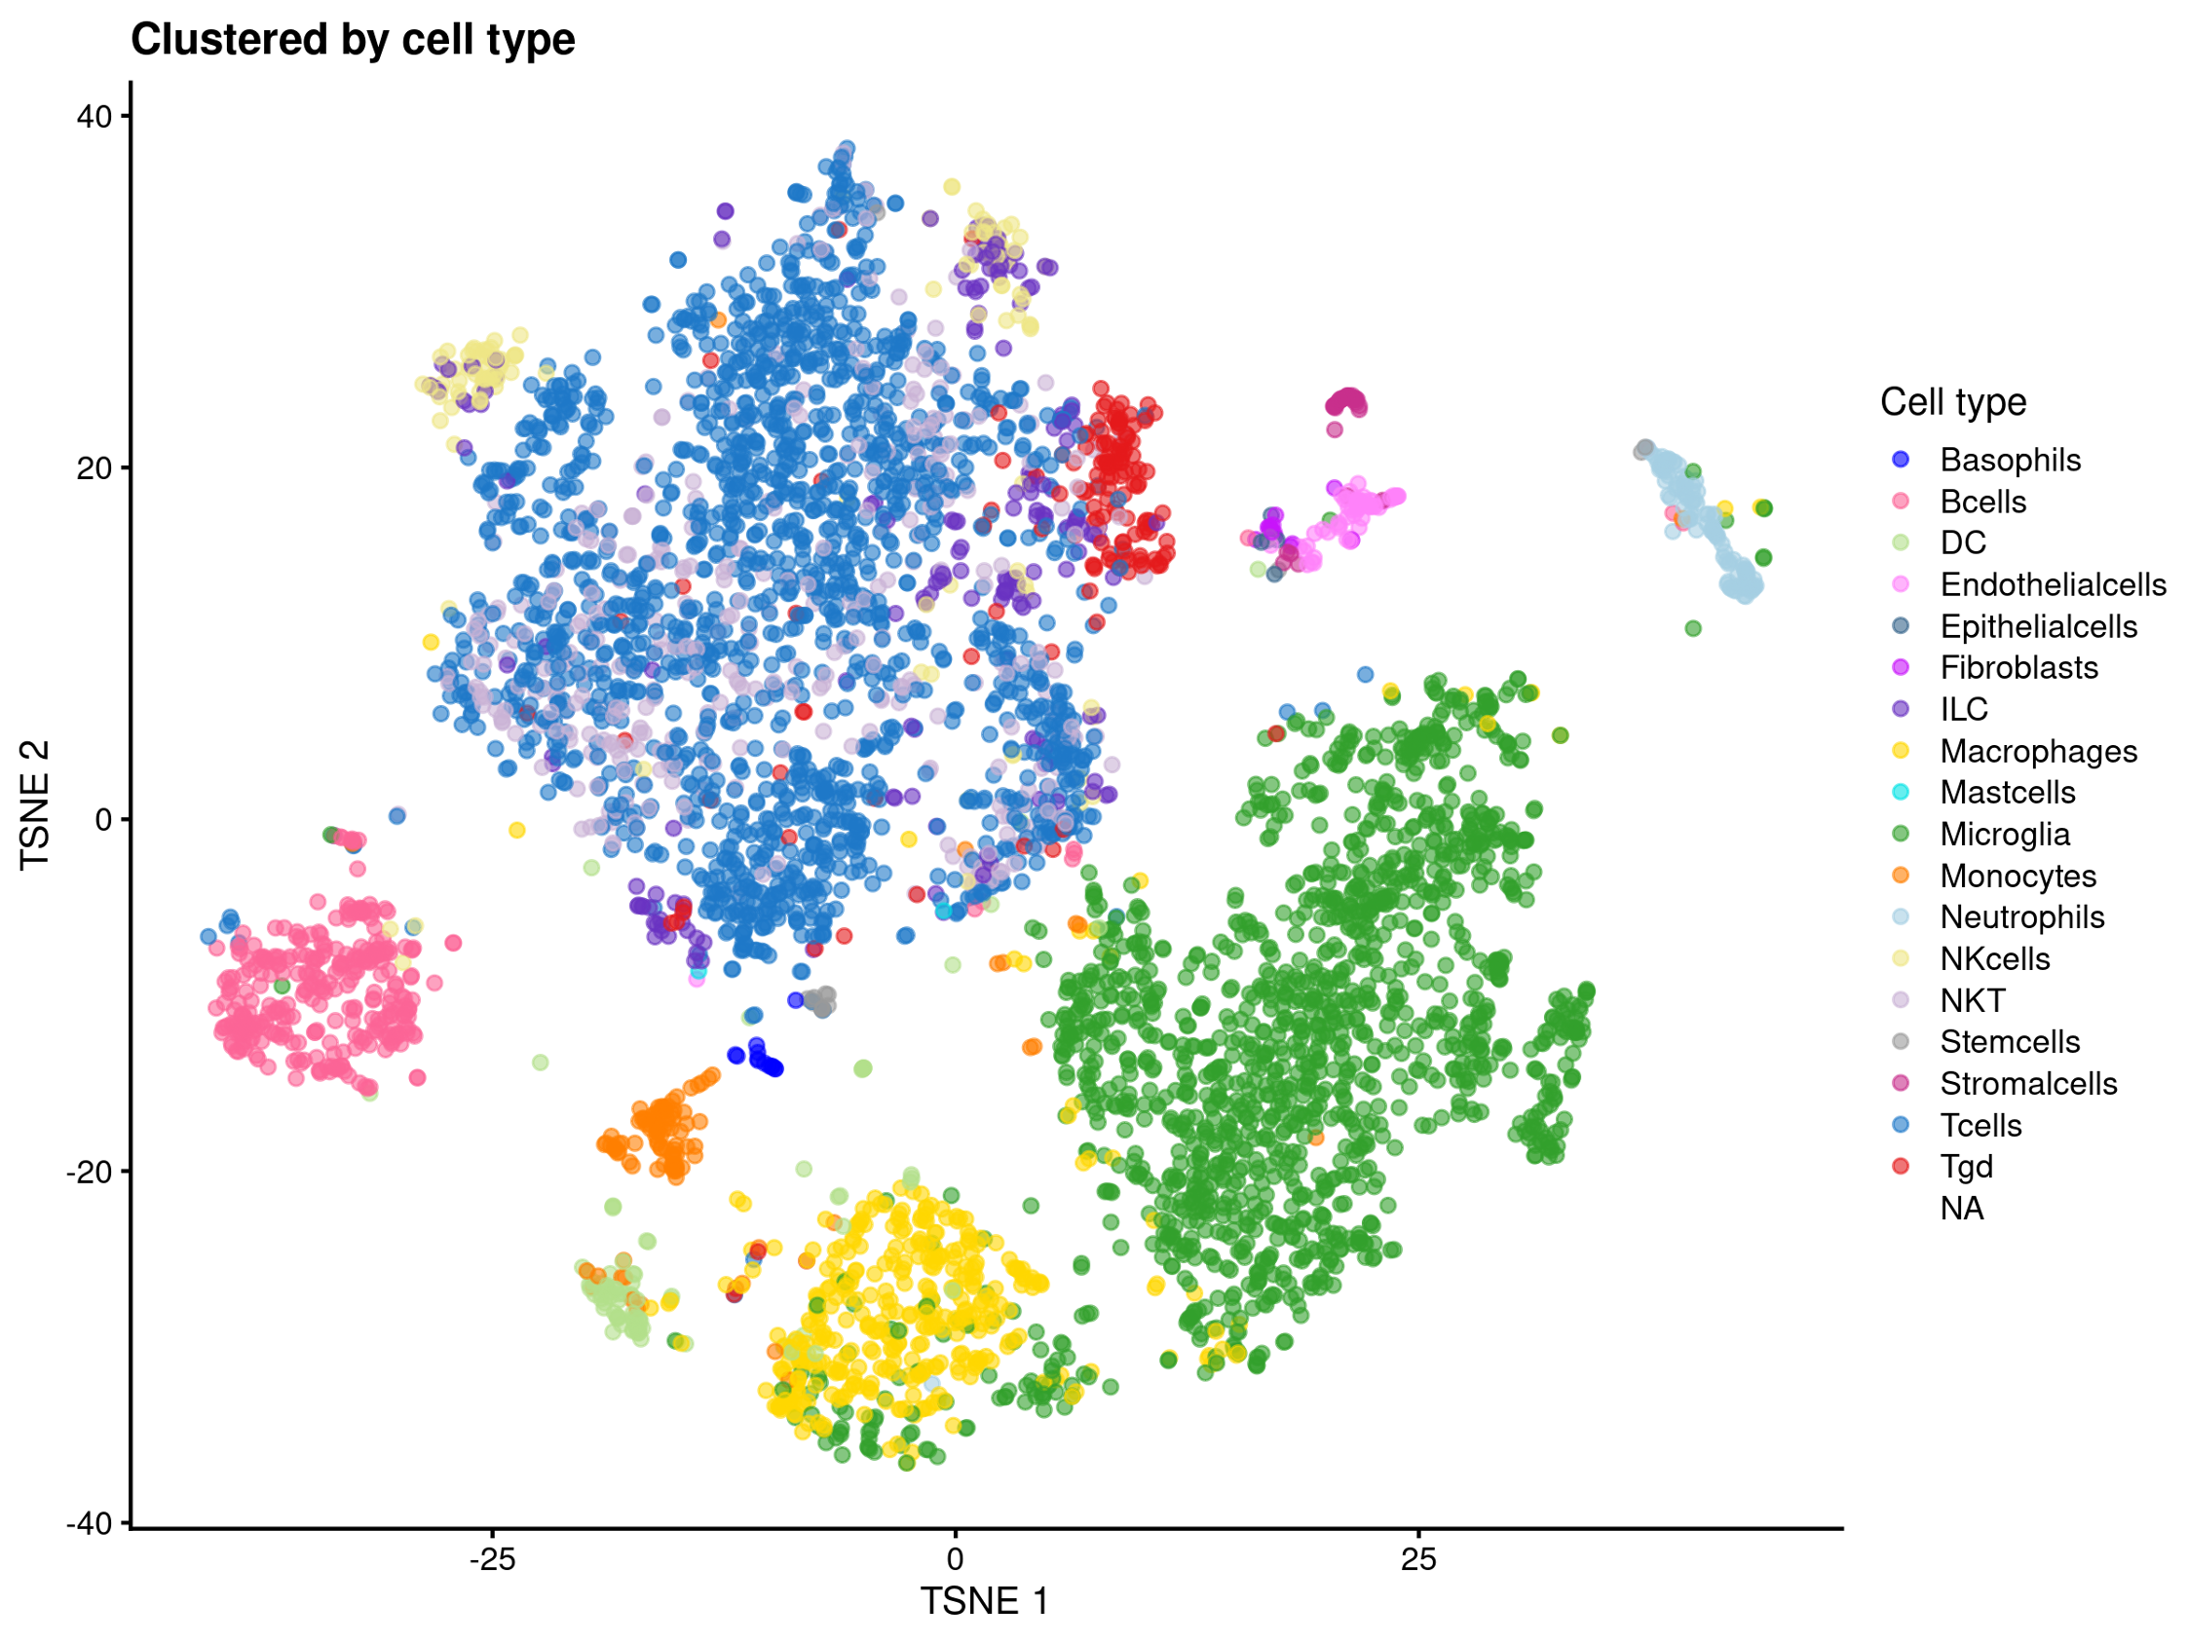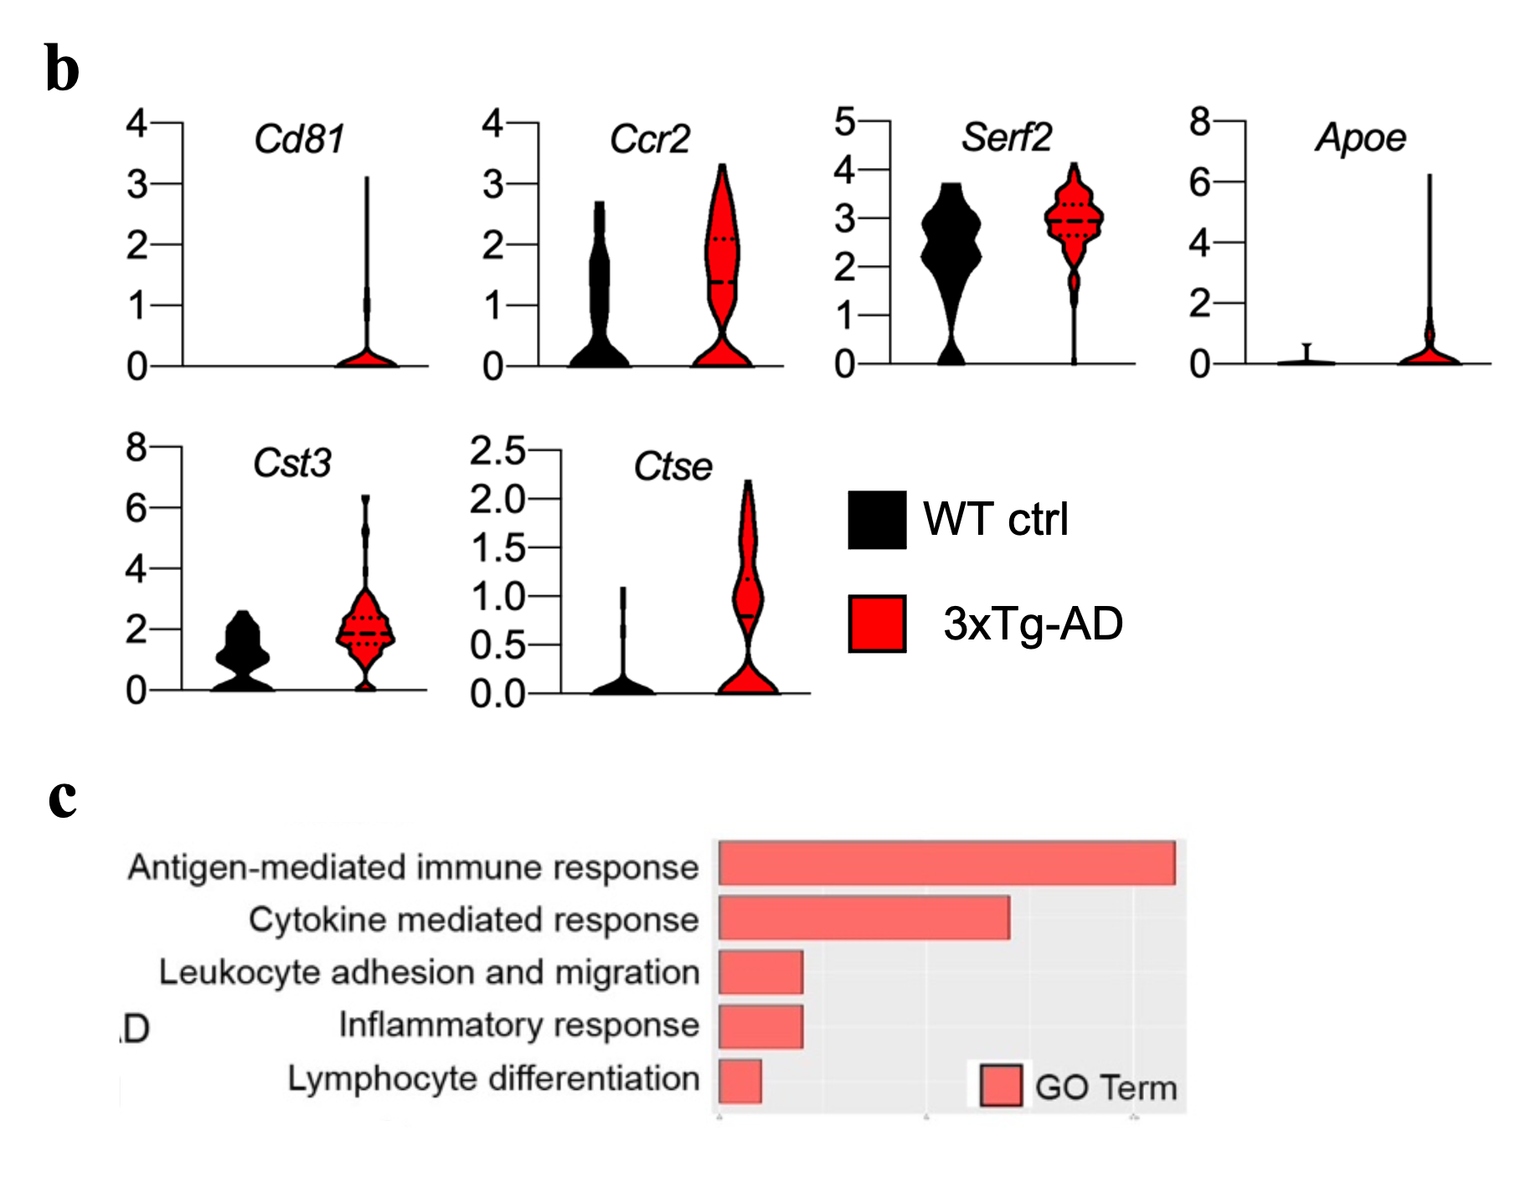
Figure 22. Transcriptomic landscape of brain-derived γδ T cells shows increased activation and migration phenotype in 3xTg-AD mice. Single-cell RNA sequencing of CD45^{high} cells was used for leukocyte profiling and expression analysis. (a) The t-SNE projection of 5220 individual leukocytes from 16 mice (3xTg-AD: n = 8; WT ctrl n = 8) resolved to 16 major clusters from the meninges. Each dot corresponds to a single cell, colored according to the cell cluster (left panel, a) and cell type (right panel, a). (b) Violin plots of expression levels for the indicated DEGs in γδ T cells from 3xTg-AD mice and wild-type (WT) controls. (c) Annotated genes were divided into the main GO biological processes and KEGG pathways for enrichment analysis (P < 0.05 and at least four genes), and were divided into further subcategories.

To further confirm the activated phenotype and increased migration potential of γδ T cells in AD mice, we measured the expression of adhesion molecules (LFA-1 and L-selectin) (Figure 23a – d) on circulating γδ T cells of 3xTg-AD mice and WT mice at 4 and 6 months of age. We observed a significant progressive increase in the expression of LFA-1 on the surface of circulating γδ T cells from 3xTg-AD mice (Figure 23a,b), and these results were supported by our scRNA-seq data showing the upregulation of Itgal in the meninges (Figure 21b). The 3xTg-AD mice also expressed lower levels of L-selectin in terms of percentage on circulating γδ T cells at all time points, suggesting that γδ cells in the blood of 3xTg-AD mice exist in a more activated state and may use LFA-1 integrin to migrate into the CNS (Figure 23c,d). We found that circulating γδ T cells expressed higher levels of CD69 and CD95 (FasR) in 3xTg-AD mice compared to controls, confirming the increased activation of circulating γδ T cells, further supporting a role for γδ T cell activation in disease progression in AD mice (Figure 23e – h).
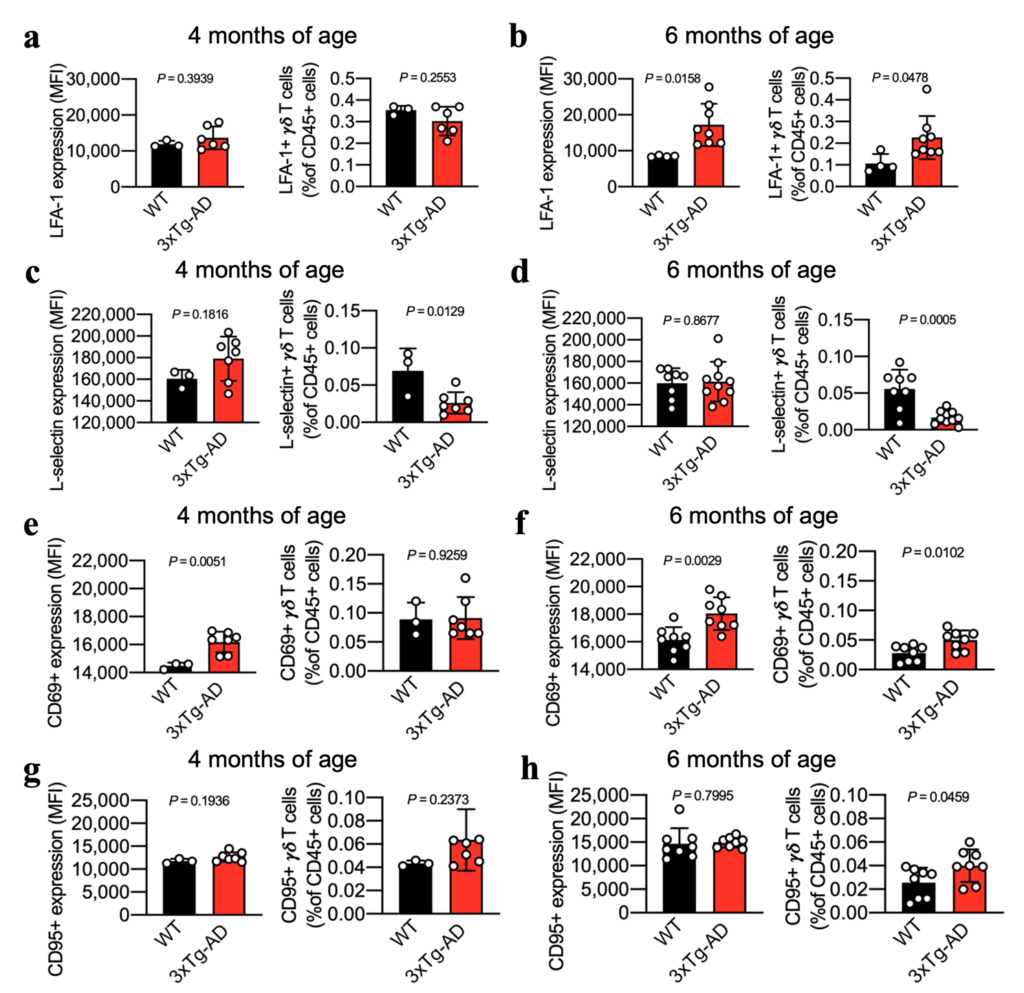
Figure 23. Flow cytometry experiments on circulating γδ T cells confirm their activated phenotype. Flow cytometry analysis of adhesion molecules and activation markers on circulating γδ T cells in 4 (a, c, e, g) and 6 (b, d, f, h) months old 3xTg-AD mice (n = 8) and WT controls (n = 4). (a) Mean fluorescence intensity (MFI) and percentage of LFA-1⁺ γδ T cells on CD45⁺ cells at 4 months of age. (b) Mean fluorescence intensity (MFI) and percentage of LFA-1⁺ γδ T cells on CD45⁺ cells at 6 months of age. (c) Mean fluorescence intensity (MFI) and percentage of L-selectin⁺ γδ T cells on CD45⁺ cells at 4 months of age. (d) Mean fluorescence intensity (MFI) and percentage of L-selectin⁺ γδ T cells on CD45⁺ cells at 6 months of age. (e) Mean fluorescence intensity (MFI) and percentage of CD69⁺ γδ T cells on CD45⁺ cells at 4 months of age. (f) Mean fluorescence intensity (MFI) and percentage of CD69⁺ γδ T cells on CD45⁺ cells at 6 months of age. (g) Mean fluorescence intensity (MFI) and percentage of CD95⁺ γδ T cells on CD45⁺ cells at 4 months of age. (h) Mean fluorescence intensity (MFI) and percentage of CD95⁺ γδ T cells on CD45⁺ cells at 6 months of age. Values are means ± S.D.; unpaired t-test.

15.6 Vγ6+ cells are the predominant γδ T cell population in 3xTg-AD mice
Flow cytometry was carried out to confirm our scRNA-seq data, and the analysis of Vγ chain expression by infiltrating γδ T cells clearly showed a significant increase in the number of Vγ6⁺ γδ T cells in both the meninges and brain (Figure 24a-c). Notably, Vγ6⁺ cells were the predominant γδ T cell population in the meninges and brain of 3xTg-AD mice and Vγ6 expression (Heilig and Tonegawa nomenclature¹²⁵) was previously associated with IL-17 production. These data agree with a recent report suggesting that Vγ6⁺ γδ T cells are the main γδ T cell subset producing IL-17A in the meninges of healthy mice¹⁵⁷. The activated and IL-17⁺ phenotype was confirmed by the observed increase in CCR6 and CD44 expression on both meningeal and brain γδ T cells, although the difference was not statistically significant in the brain (Figure 24d, e). Importantly, both meningeal and brain γδ T cells produced higher levels of IL-17 after stimulation, further supporting the role of IL-17⁺ γδ T cells in AD (Figure 24f).
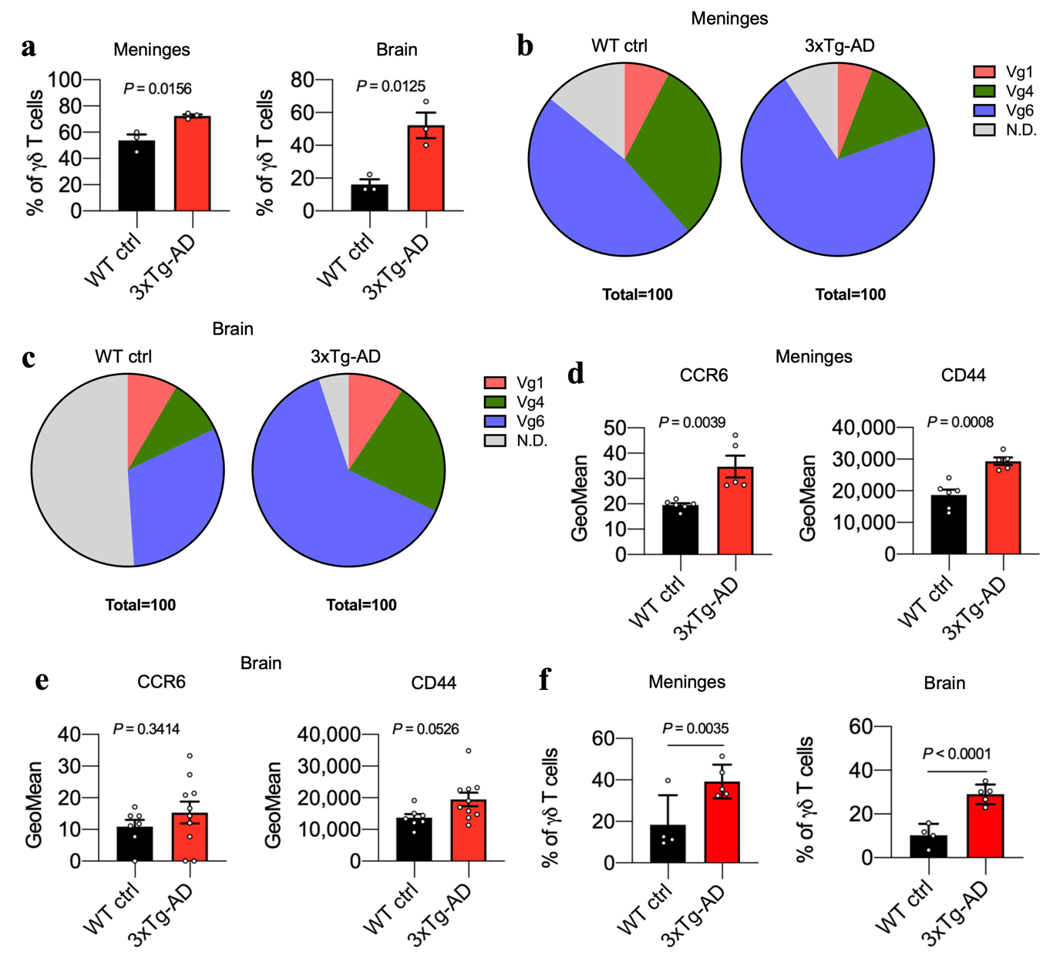
Figure 24. γδ T cells in 3xTg-AD mice are activated and express mainly the Vγ6 chain. Flow cytometry experiments showing Vγ expression and activation status of γδ T cells. (a – c) Flow cytometry analysis shows the percentage of Vγ6⁺ cells on γδ T cells in the indicated organs from WT controls and 3xTg-AD mice (a). Analysis of Vγ chains expression of γδ T cells from (b) the meninges and (c) the brain. (d – e) CCR6 (left) and CD44 (right) expression on γδ T cells in (d) the meninges and (e) the brain of WT controls (n = 6) and 3xTg-AD mice (n = 5). (f) Flow cytometry analysis of IL-17 production by γδ T cells in the meninges and brain of WT controls (n = 4) and 3xTg-AD mice (n = 5) at 6 months of age. Cells were stimulated with PMA, ionomycin and brefeldin A. Values are means ± S.D; unpaired t-test.

The role of IL-17⁺ γδ T cells in 3xTg-AD mice was confirmed by high-resolution wide-field immunofluorescence data showing a significant increase in the co-localization of IL-17 expression with TCR γδ⁺ cells in both the meninges and brain of 3xTg-AD mice compared to WT controls (Figure 25a-c). Our data therefore reveal a clear pathogenic signature of γδ T cells in the meninges and brain of 3xTg-AD mice, highlighting their activated, pro-migration and IL-17⁺ phenotype, and supporting a role for these cells in AD pathogenesis.
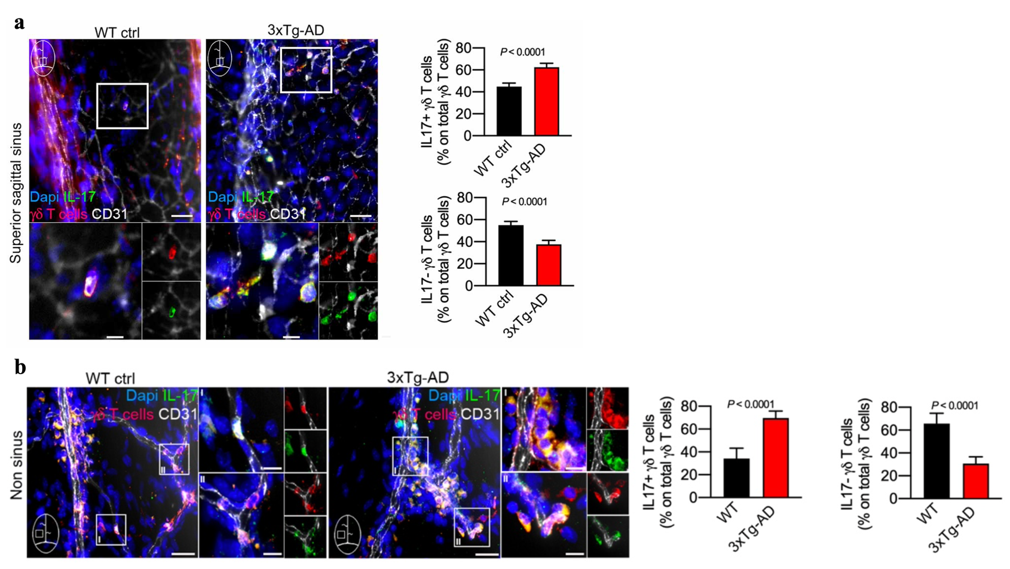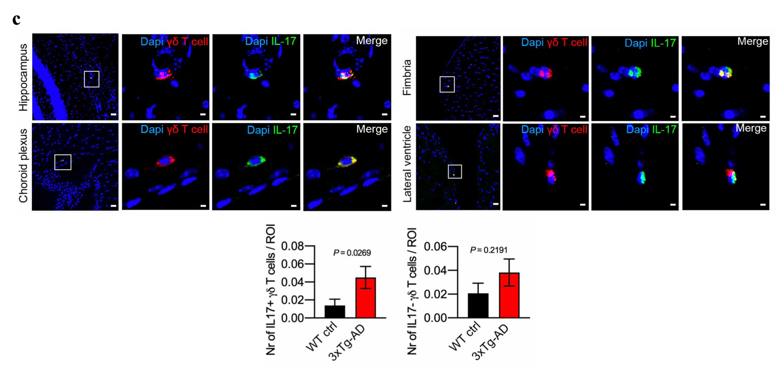
Figure 25. γδ T cells in 3xTg-AD mice are mainly IL-17⁺. Immunofluorescence staining and quantitative analysis. (a) Representative images and quantitative analysis of IL17⁺ and IL17– γδ T cells in the superior sagittal sinus of WT and 3xTg-AD mice at 6 months of age (n = 2 per group). (b) Representative images of meninges and quantitative analysis of IL-17⁺ and IL-17– γδ T cells in non-sinus dura of WT controls and 3xTg-AD mice at 6 months of age. (c) Representative images and quantitative analysis of coronal brain sections from WT controls and 3xTg-AD mice at 6 months of age (n = 4 per group). Nuclei are stained with DAPI (blue), along with staining for TCR γδ (red) and IL-17 (green). Scale bar = 20 μm; 40× magnification. Values are means ± s.e.m; Mann–Whitney U-test.

15.7 IL-17⁺ γδ T cells induce neuronal apoptosis
To understand the direct impact of activated γδ T cells on brain cells function, we co-cultured naïve and IL-17⁺ γδ T cells with neurons isolated from 3xTg-AD and WT ctrl mice (Figure 26, 27). Time-lapse wide-field imaging revealed an increase in cytoplasmic Ca²⁺ levels in neurons in contact with γδ T cells, suggesting that γδ T cells induce intracellular Ca²⁺ dysregulation, a phenomenon previously associated with neuronal dysfunction¹⁷⁹ (Figure 26a–c). Notably, we observed the formation of membrane blebs and axonal retraction in neurons in direct contact with IL-17⁺ γδ T cells, indicating these cells are toxic toward neuronal cells (Figure 26d). Interestingly, our live imaging experiments also revealed that single IL-17⁺ γδ T cells release long filopodia-like protrusions at the contact point with individual neurons isolated from 3xTg-AD mice, suggesting a profound activation process, including membrane and cytoskeleton rearrangements (Figure 26e)^{180,181}. This phenomenon suggests that IL-17⁺ γδ T cells form a larger sensing surface at their contact point with neurons, as well as bidirectional activation signals between these two cell types in the 3xTg-AD brain.
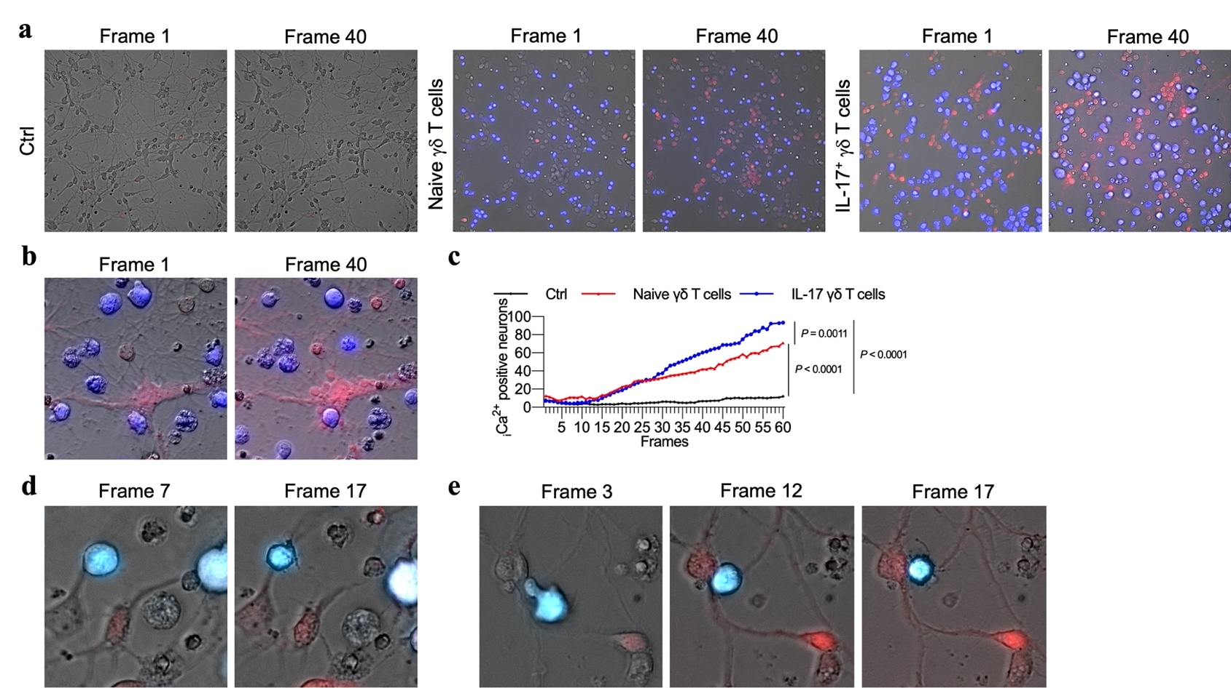
Figure 26. IL-17⁺ γδ T cells promote an increase of cytoplasmatic Ca²⁺ levels in neurons in vitro. IL-17⁺ γδ T cells were co-cultured in vitro with neurons obtained from 3xTg-AD and WT ctrl mice. The γδ T cells were obtained from adult Tcrb–/– mice and polarized to IL-17⁺ in vitro. a–b, Representative images from live imaging experiments (5-h time-lapse) of cultured neurons alone (Ctrl), or with naïve or IL-17⁺ γδ T cells. (a) Representative images of time-lapse videos showing Ca²⁺ release in 3xTg-AD neurons cultured alone (Ctrl), with naïve γδ T cells, or IL-17⁺ γδ T cells. (b) Zoomed image of apoptotic-like vesicles (blebs) in a 3xTg-AD neuron after co-culture with IL-17⁺ γδ T cells. (c) Quantification of iCa²⁺ in 3xTg-AD neurons over time. (d) Zoomed image of γδ T cells inducing axonal retraction after contact with neurons from 3xTg-AD mice. Scale bar = 20 μm. (e) IL17⁺ γδ T cells release filopodia-like protrusions following contact with neurons. Scale bar = 20 μm. Data are presented as means ± s.e.m.; one-way ANOVA.

To clearly demonstrate that IL17⁺ γδ T cells induce neuronal injury, we measured the activities of caspase 3 and 7 and observed that caspase activity was significantly higher in neurons from 3xTg-AD and WT mice co-cultured with IL-17⁺ γδ T cells at a 1:1 ratio (Figure 27a, b). There was no significant increase in caspase activity at ratios with lower proportions of γδ T cells (Figure 27e). However, even at a ratio of 1:100, we found that all γδ T cells were in contact with neuronal cells (Figure 27f). A blockade of IL-17 signaling significantly reduced caspase activity induced by IL-17⁺ γδ T cells in both WT and 3xTg-AD neurons, whereas no blocking effect was observed using naïve γδ T cells co-cultured with 3xTg-AD neurons, suggesting a role for IL-17 in activated γδ T cell-dependent neurotoxicity in AD mice (Figure 27c, d). A blockade of FasL achieved a significant effect only in co-cultures of IL-17⁺ γδ T cells and 3xTg-AD neurons, suggesting that FasL mediates cell–cell contact-dependent neurotoxicity (Figure 27c, d). Co-culture experiments in transwells also supported a role for IL-17 in caspase activation by IL-17⁺, but not naïve, γδ T cells (data not shown). The role of activated γδ T cells in AD was also supported by the observation that sorted γδ T cells from 3xTg-AD mice increased the caspase activity of healthy neurons, whereas wild-type γδ T cells had no effect (Figure 27g). Finally, activated IL-17-deficient γδ T cells did not increase caspase activity in 3xTg-AD neurons, further supporting a neurotoxic role for IL-17⁺ γδ T cells (Figure 27h).
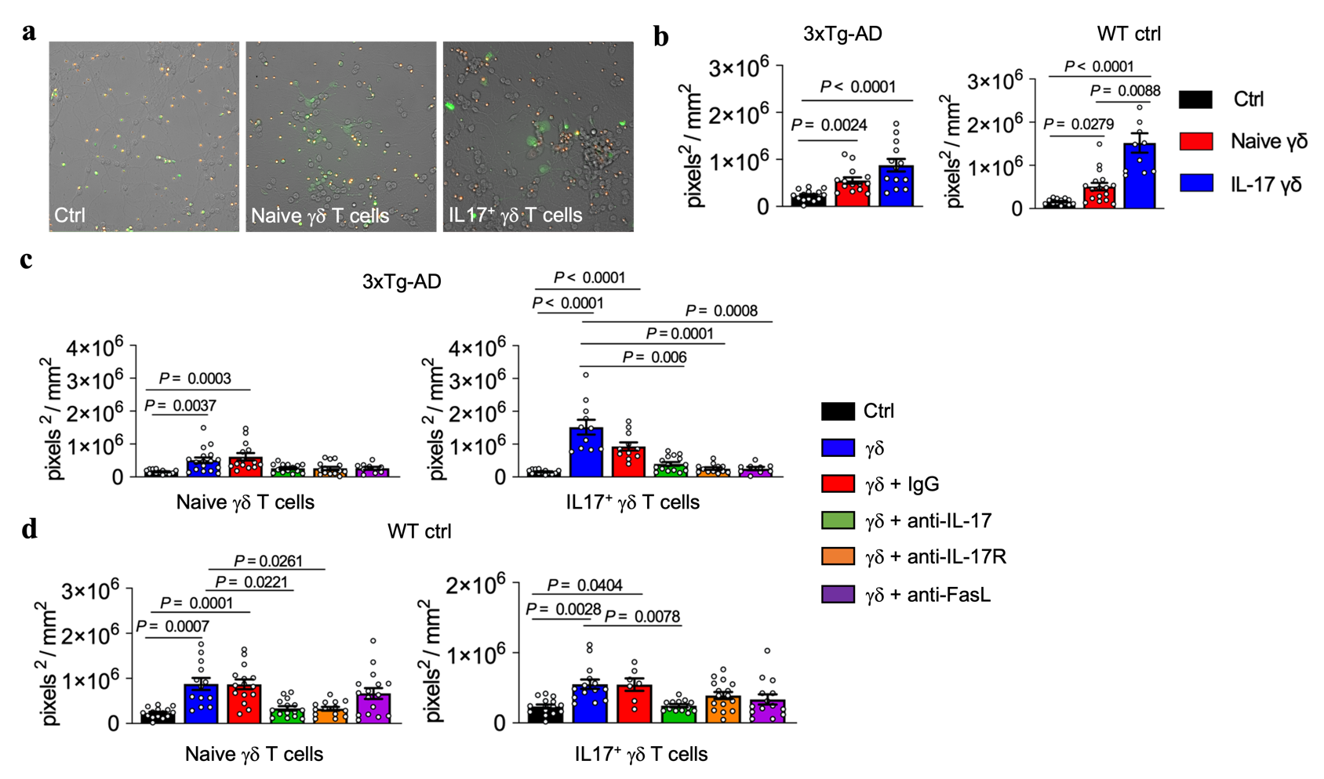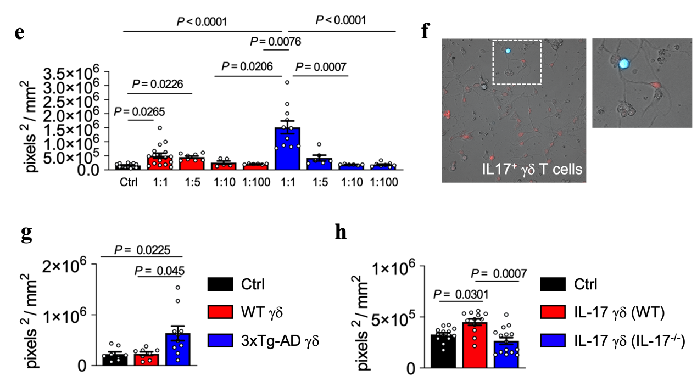
Figure 27. IL-17⁺ γδ T cells promote neuronal death in vitro. (a) Representative images of neurons after the FAM-FLICA caspase assay of cultured 3xTg-AD neurons alone (Ctrl), or with naïve or IL-17⁺ γδ T cells. FLICA (green) represents activated caspase 3/7⁺. Scale bar = 50 µm. (b) Quantification of caspase 3/7⁺ in 3xTg-AD neurons (left) and in WT neurons (right). (c – d) Quantification of caspase 3/7⁺ after treatment with control antibody (IgG), anti-IL-17, IL-17R or FasL blocking antibodies in (c) 3xTg-AD and (d) WT neurons co-cultured with naïve γδ T cells (left) and with or IL-17⁺ γδ T cells (right). (e) Quantification of caspase 3/7⁺ in 3xTg-AD neurons co-cultured at different ratios with naïve and IL17⁺ γδ T cells. (f) IL-17⁺ γδ T cell in direct contact with a neuron in ratio 1:100. (g) Quantification of caspase 3/7⁺ in WT neurons after co-culture with WT or 3xTg-AD γδ T cells sorted from lymph nodes and spleens. (h) Quantification of caspase 3/7⁺ in 3xTg-AD neurons after co-culture with IL-17⁺ γδ T cells from WT or Il-17a^{-/-}Il17f^{-/-} mice sorted from lymph nodes and spleens. Data are presented as means ± s.e.m.; one-way ANOVA.

15.8 IL-17⁺ γδ T cells induce astrocytes but not microglia activation
To further understand the impact of activated γδ T cells on the function of brain cells, we co-cultured naïve and IL-17⁺ γδ T cells with astrocytes and microglia isolated from 3xTg-AD and WT ctrl mice (Figure 28 and 29, respectively). We found that the expression of major histocompatibility complex (MHC) II was induced on astrocytes in the presence of IL-17⁺ γδ T cells at a 1:1 ratio (Figure 28a), but not at lower ratios (Figure 28b,c). No effect was observed using naïve γδ T cells obtained from healthy animals or from 3xTg-AD mice (Figure 28d). However, when we blocked IL-17 in vitro in co-cultures with astrocytes and γδ T cells, we did not observe a significant effect on MHC-II expression in astrocytes, suggesting that cytokines other than IL-17 released by γδ T cells induce the higher MHC-II expression levels (Figure 28e). Indeed, our data agree with previous studies showing that Th17 cells, which produce IL-17, do not significantly enhance MHC-II expression by astrocytes¹⁸².
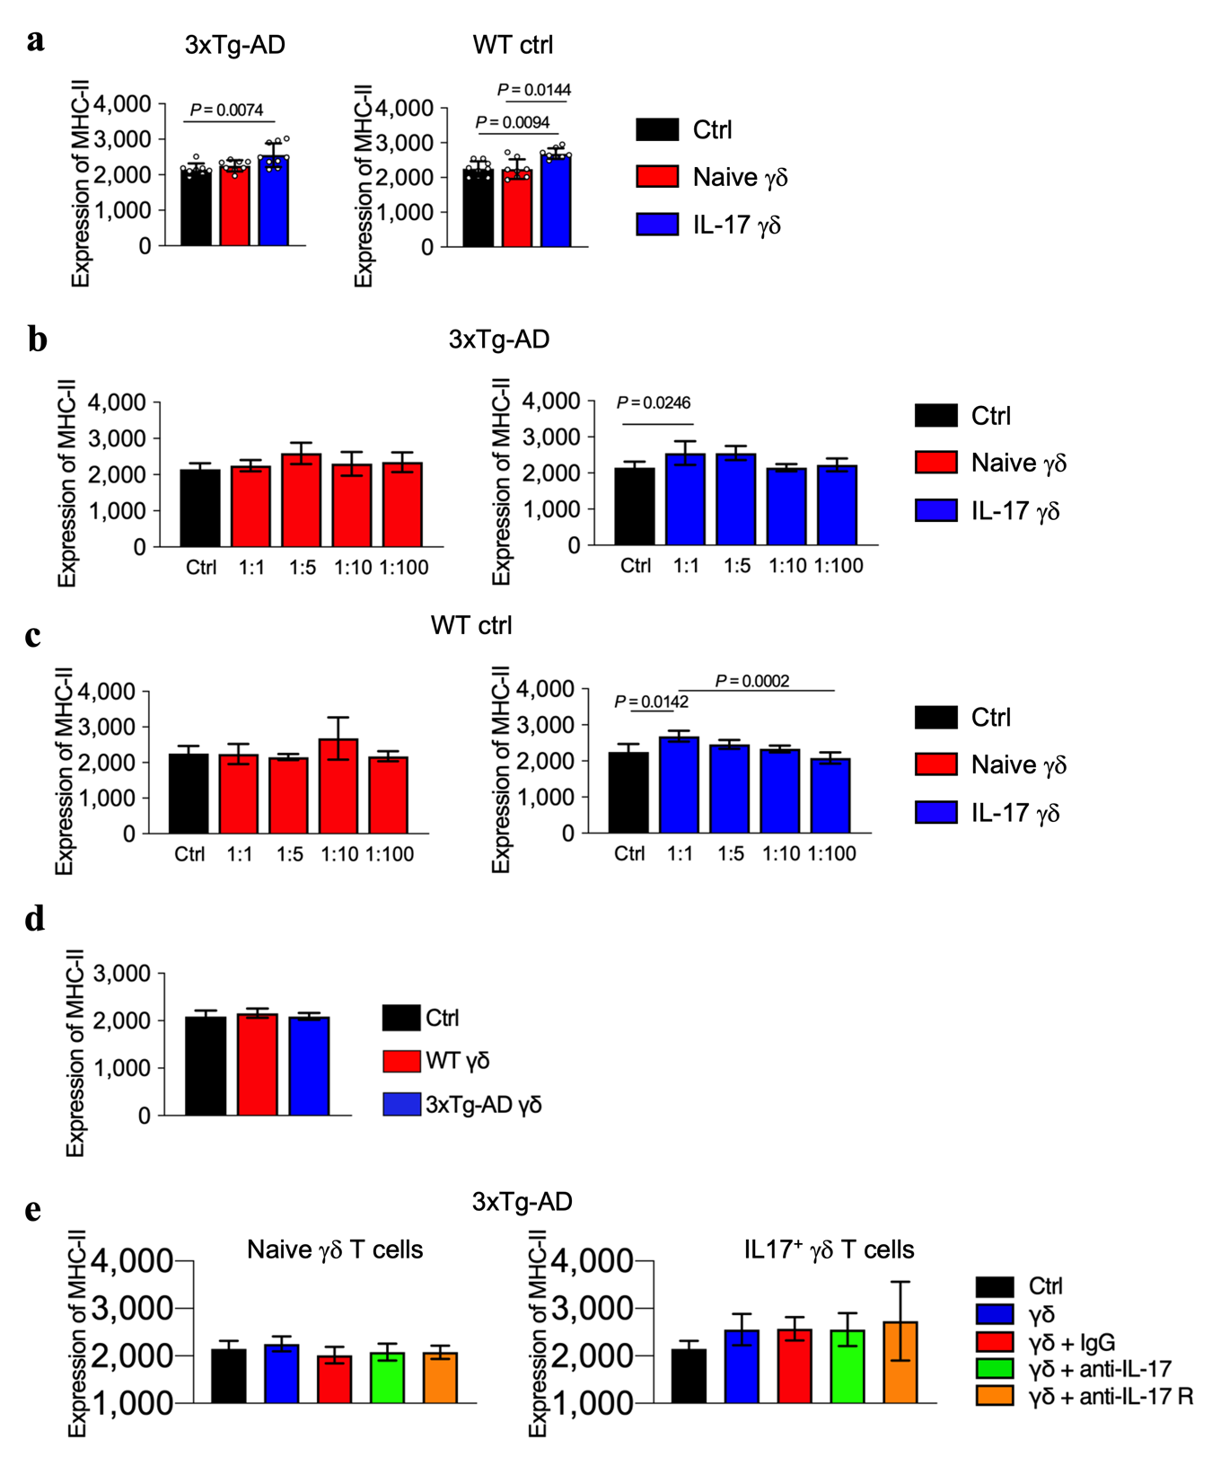
Figure 28. γδ T cells promote astrocyte activation in vitro. Flow cytometry on 3xTg-AD and WT ctrl astrocytes co-cultured with naïve or IL-17 polarized γδ T cells. (a) Bars represent the mean fluorescence intensity (MFI) of 3xTg-AD astrocytes (left) and WT astrocytes (right) positive for MHC-II cultured alone (Ctrl) or co-cultured with naïve γδ T cells (Naïve γδ) or IL-17⁺ γδ T cells (IL-17 γδ). Expression of MHC-II on astrocytes from (b) 3xTg-AD and (c) WT mice co-cultured at different ratios with naïve and IL-17⁺ γδ T cells. (d) Expression of MHC-II on astrocytes from WT mice co-cultured with γδ T cells sorted from WT and 3xTg-AD mice. (e) Expression of MHC-II on astrocytes obtained from 3xTg-AD mice cultured with naïve (left) or IL-17⁺ (right) γδ T cells at a ratio of 1:1 with anti-IL-17 or anti-IL-17R blocking antibodies. Data are presented as means ± S.D.; one-way ANOVA.

Furthermore, γδ T cells had no effect on ROS production by microglial cells in vitro or their ability to take up latex beads and Aβ by phagocytosis, in line with earlier reports¹⁸³ (Figure 29). Taken together, our in vitro experiments on brain cells from 3xTg-AD mice showed that IL-17⁺ γδ T cells have a direct toxic effect on neurons and can activate astrocytes providing yet more evidence that γδ T cells play a key role in neuroinflammation and neuronal damage in AD.
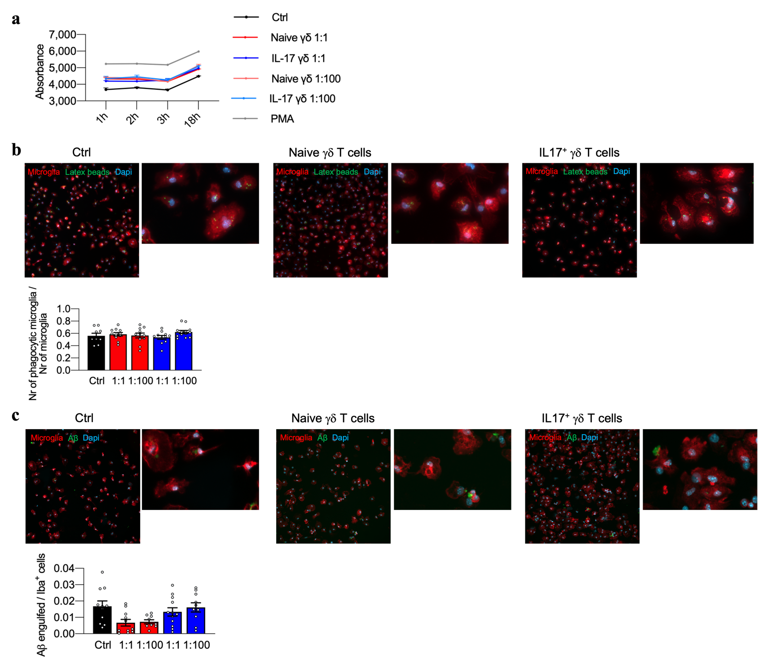
Figure 29. IL-17⁺ γδ T cells have no effect on microglia activation in vitro. (a) Kinetics of intracellular ROS production by microglia from 3xTg-AD mice following co-culture at different ratios with naïve and IL-17⁺ γδ T cells, or after stimulation with PMA. Phagocytosis of fluorescent (b) latex beads and (c) Aβ42 by microglia isolated from 3xTg-AD mice after pre-incubation with naïve or IL-17⁺ γδ T cells at different ratios. Phagocytosis was normalized to the total number of microglia or the total surface of microglia in the acquired field. Data are presented as means ± s.e.m.; two-way ANOVA. (b, c) Representative images (scale bar = 50 μm) and zoomed images (scale bar = 20 μm) show phagocytosed (b) latex beads and (c) Aβ42 at 20× magnification.

15.9 A therapeutic blockade of IL-17 mitigates the neuropathological hallmarks of AD
To determine whether IL-17 has a direct pathological effect in AD, 3xTg-AD mice at 6 months of age were injected with an anti-IL-17 or isotype control antibody every 3 days for 1 month. A transient blockade of IL-17 had no effect in the CFC test in either WT or 3xTg-AD mice compared to the isotype-treated controls (Figure 30a), in agreement with recent data showing that Tcrd^{-/-} mice have no learning and memory deficits¹⁵⁸. Because IL-17 is involved in anxiety-like behavior in young healthy mice¹⁵⁸, we also performed experiments in an OF test at 9 months of age. We found that an IL-17 blockade reduces anxiety in 3xTg-AD mice, although the data did not reach statistical significance, probably because anxiety is generally higher in 3xTg-AD mice and also increases with age (Figure 30b)^{160,184}.
We found that in the absence of IL-17, the two main hallmarks of AD (Aβ accumulation and tau hyperphosphorylation) were also ameliorated, with a significant reduction in the area of Aβ deposits and the presence of phosphorylated tau, whereas the level of total tau was unchanged (Figure 30c, d). Anti-IL-17 treatment significantly reduced microglial activation in both the hippocampus and cortex compared to the isotype control, suggesting that IL-17-dependent inflammatory responses have a role in microglial activation (Figure 30e). Together, these data demonstrate a role for IL-17 in the induction of AD’s neuropathological hallmarks and further support a role for IL-17⁺ γδ T cells in the pathogenesis of AD.
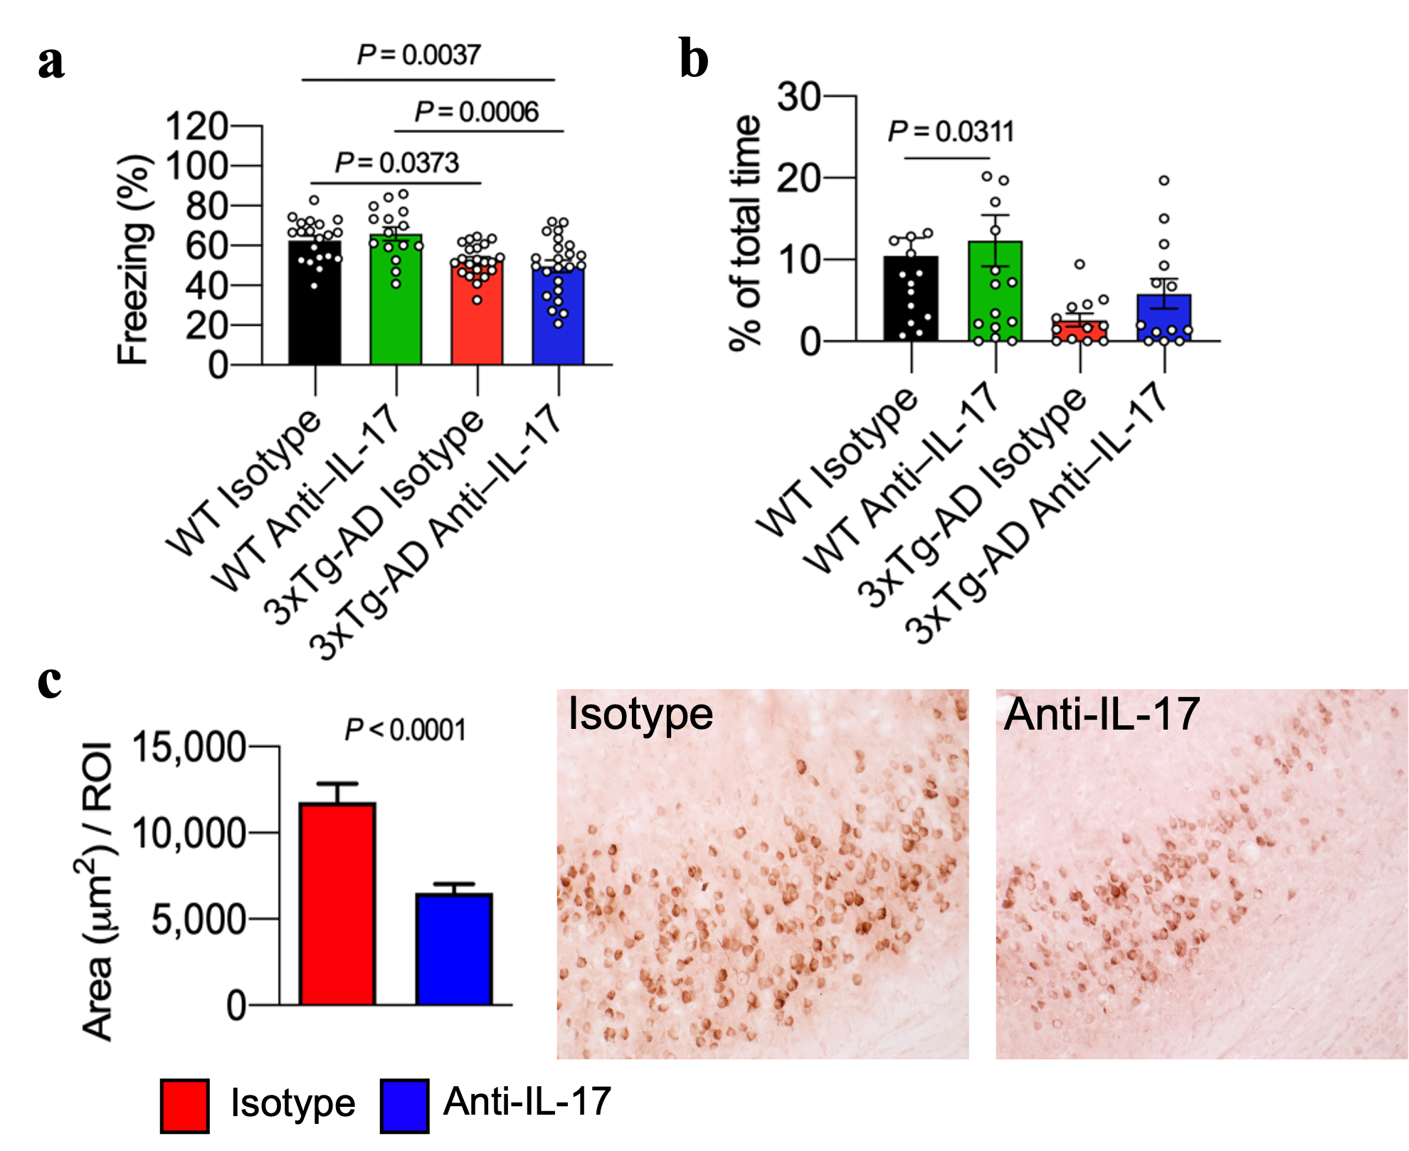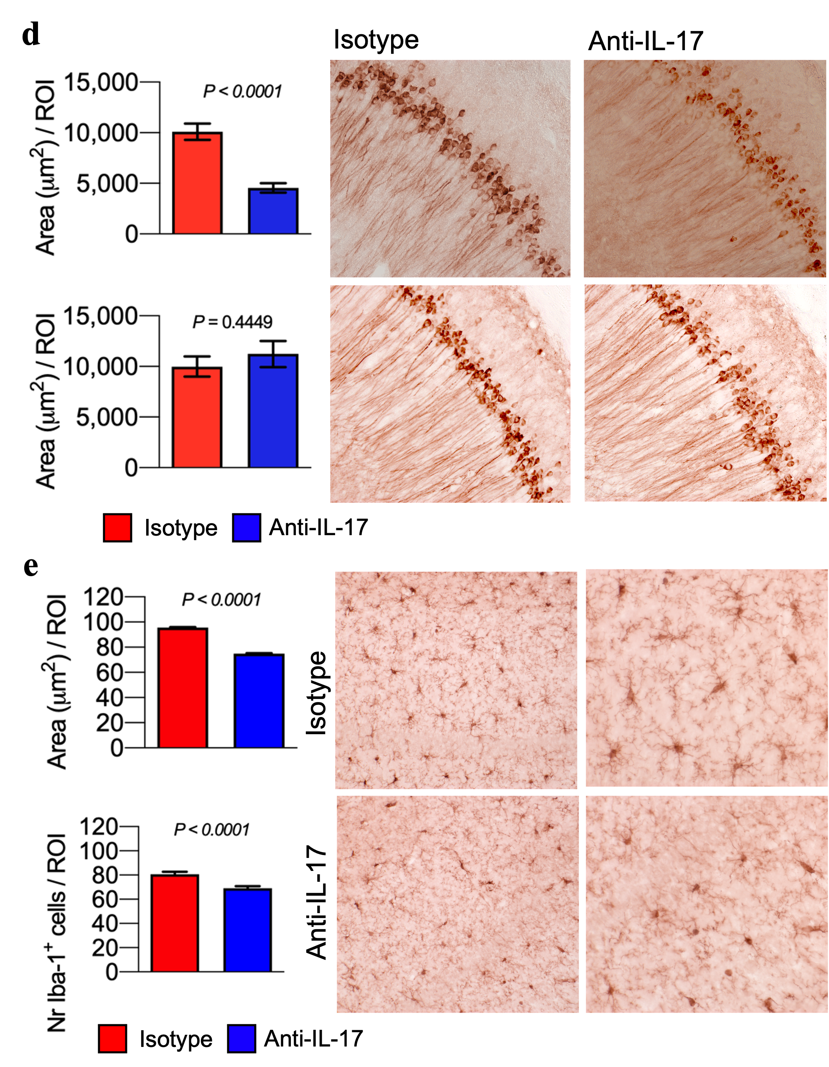
Figure 30. Therapeutic blockade of IL-17 ameliorates the disease in 3xTg-AD mice. (a, b) Evaluation of behavioral changes in WT controls and 3xTg-AD mice treated with anti-IL-17 or isotype control antibodies. (a) Results are shown for the CFC test (WT isotype: n = 11; WT anti-IL-17: n = 15; 3xTg-AD isotype: n = 12; 3xTg-AD anti-IL-17: n = 12; one-way ANOVA) and (b) OF test (WT isotype: n = 16; WT anti-IL-17: n = 17; 3xTg-AD isotype: n = 12; 3xTg-AD anti-IL-17: n = 13; one-way ANOVA). (c – d) Histopathological analysis of brain sections from 3xTg-AD mice treated with anti–IL-17 or isotype control antibodies (n = 4 per group). Quantitative analysis of (c) Aβ deposits (6E10 staining) and (d) hyperphosphorylated tau (AT180 staining) in the hippocampus with representative images. Scale bar = 50 μm; 20× magnification. (e) Quantitative analysis of Iba-1⁺ cells in the hippocampus with representative images. Scale bar = 50 μm; left = 20× magnification; right = 40× magnification. Brightness and contrast were adjusted as described in the methods section. Values are means ± s.e.m.; unpaired t-test.

DISCUSSION
There are currently more than 600 active clinical trials targeting AD (www.clinicaltrials.gov), and some of them are still focused on the reduction of Aβ load. However, increasing evidence suggest that a key feature of AD is the dysregulation of the immune system, that may become a primary therapeutic target for this devastating disorder. Indeed, in AD pathology both brain resident and peripherally derived immune cells are involved^{185,186}. We have previously demonstrated that both neutrophils and CD4⁺ T cells infiltrate the brain parenchyma of AD-like model mice, worsening both the behavioral and the neuropathological hallmarks of the disease^{104,151}. However, by studying neutrophil infiltration, we identified a particular population of IL-17⁺ immune cells that were not neutrophils nor expressed CD4. Although CD4 T cells are considered to be the principal source of IL-17, also CD8 T cells and several innate immune subsets have been shown to produce this cytokine¹⁷³. These findings encouraged us to study the possible involvement of other leukocyte populations in AD pathology, and our studies led to the identification of brain infiltrating unconventional T cells, namely γδ T cells, in 3xTg-AD mice.
γδ T cells are innate-like cells, normally involved in immune surveillance, that combine adaptive features with rapid responses to insults to initiate inflammatory reactions^{129,187-189}. Their activation is not restricted to antigen presentation by MHC molecules, making γδ T cells key contributors to the first line of defense that precedes αβ T cell responses. Indeed, they can be activated by lipid antigens or damage-associated molecular patterns, thus they can react to early brain damage in AD^{188,190}.
Our study supports the rapid response kinetics of γδ T cells observed in other diseases such as EAE and autoimmune rheumatic diseases¹³¹⁻¹³³, revealing an increased accumulation of γδ T cells in 3xTg-AD mice starting at 4 months of age, before the onset of clinical symptoms. This suggests a role for these cells in the induction of AD pathology. Although the number of γδ T cells declines with age in healthy mice, the greater infiltration of γδ T cells in the meninges and brains of 3xTg-AD mice starting at 4 months of age clearly indicates a role throughout the disease. The dysregulation of γδ T cell functions may drive neuroinflammation, neuronal damage, cognitive impairment, and neuropathological features in the AD brain.
These observations were sustained by subsequent experiments, in which the genetic ablation of γδ T cells in AD-like model mice (3xTg-AD×Tcrd–/–) led to a significant improvement in memory and less severe neuropathological changes in 3xTg-AD mice, demonstrating a causal link between γδ T cells and the development of behavioral and clinical symptoms of AD. The lower abundance of Aβ deposits in 3xTg-AD×Tcrd–/– mice suggests also that γδ T cells might control the clearance of Aβ in 3xTg-AD mice^{191,192}. Interestingly, in our scRNA-seq dataset of brain γδ T cells we observed the upregulation of Serf2, Apoe and Cst3, genes involved in Aβ production, suggesting that γδ T cells may not only inhibit Aβ clearance but also promote amyloidosis^{15,176,177}.
scRNA-seq is a high-throughput sequencing technique that allows the assessment of the key biological properties of each cell population in the sample by isolating single cells and generating sequencing libraries mapped to individual cells¹⁹³. We exploited this method to identify γδ T cell phenotype and functions in the meninges and brain of 3xTg-AD and WT mice. The profiling of γδ T cells from the brains of 3xTg-AD mice through scRNA-seq revealed the overexpression of Ccr2, Cxcr6, Cxcr4 and Itgal, which are involved in activated T cell migration¹⁶⁷⁻¹⁶⁹. Importantly, CCR2 is a chemokine receptor that promotes the migration of IL-17⁺ γδ T cells into the brain during EAE, suggesting that peripheral γδ T cells may infiltrate the meninges and the brain also during AD^{169,187}. Notably, the level of CCL2 (the major CCR2 ligand) in cerebrospinal fluid is higher in MCI/AD patients than controls, supporting that the CCR2/CCL2 axis mediates γδ T cell recruitment into the meninges and brain in AD¹⁹⁴. Moreover, our flow cytometry data demonstrated that circulating γδ T cells from 6-months-old 3xTg-AD mice showed higher levels of LFA-1 integrin compared to WT mice, suggesting that γδ T cells may use LFA-1 to migrate from the blood into the CNS¹⁹⁵ and supporting the upregulation of Itgal observed in scRNA-seq. We still do not have further evidence to confirm this hypothesis. Indeed, γδ T cells develop in the embryonic thymus, in which they are committed to the production of either IFN-γ or IL-17 through Vγ chain rearrangements¹²²⁻¹²⁴. Once committed, they selectively home to peripheral tissues, such as skin, tongue, dermis, uterus, testis, peritoneal cavity, adipose tissue, brain meninges, lungs, lymph nodes, and intestine, where they provide local immune responsiveness¹²⁹. In the context of CNS immunity, it has been recently demonstrated that in healthy conditions meningeal resident γδ T cells produce IL-17, enhancing synaptic plasticity and modulating neuronal synaptic signaling¹⁵⁷. Oppositely, during EAE, IL-17 perpetuates meningeal inflammation and over time might facilitate the entrance of cells into the CNS, in particular of meningeal resident immune cells¹⁹⁶. In ischemic human brain tissue it has been shown the infiltration of IL-17⁺ γδ T cells from the periphery, identifying a novel gut-brain axis and suggesting that T cells can traffic from the gut to the brain¹⁵³. Both in EAE and in stroke, IL-17⁺ γδ T cells infiltrate the brain parenchyma, promoting neuroinflammation within the brain meningeal spaces and altering the microenvironment^{153,196}. The activated brain-infiltrating γδ T cells in 3xTg-AD mice may therefore be circulating γδ T cells that have migrated to the brain or resident cells undergoing proliferation and differentiation, however their origin is complex and requires further studies.
Our scRNA-seq data also revealed that in AD mice γδ T cells acquire a strongly activated phenotype, indeed they upregulate markers of highly pathogenic effector T cells such as Il2ra, Arrb1, Igf1r and Cd44¹⁶²⁻¹⁶⁴. We also observed that meningeal γδ T cells strongly express Scart1, which correlates with effector Vγ6⁺ IL-17⁺ γδ T cells in the skin¹⁶⁴. Moreover, both meningeal and brain γδ T cells produce in vitro upon stimulation IL-17 and predominantly express Vγ6+, confirming the result obtained from the scRNA-seq and pointing out a role for IL-17⁺ cells in AD¹⁹⁷. The activated IL-17⁺ phenotype of brain-infiltrating γδ T cells in 3xTg-AD mice is supported by the presence of IL17⁺ γδ T cells in the AD brain. IL-17⁺ γδ T cells are rarely found under normal conditions¹⁸⁹, although meningeal resident IL-17⁺ γδ T cells may play a role in short-term memory under physiological conditions and in anxiety-like behavior in young healthy mice^{157,158}. However, a higher IL-17 production by γδ T cells in the CNS may induce neuroinflammation and neurodegeneration by promoting astrocyte activation and neuronal damage, as previously demonstrated in EAE and stroke^{153,196}, and confirmed in AD by our in vitro data. Indeed, we showed that IL17⁺ γδ T cells induce neuronal death in vitro and that a blockade of IL-17 signaling significantly reduce neuronal injury, suggesting a role for IL-17 in activated γδ T cell-dependent neurotoxicity in AD mice. Our results were supported also by an in vitro model of Parkinson’s disease (PD), that demonstrated in neurons derived from sporadic PD patients and blood derived T cells an increased in neuronal death due to IL-17¹⁹⁸. These conflicting evidence regarding IL-17 role in the CNS suggest the existence of a threshold below which IL-17 is protective and above which pathogenic neuroinflammation is triggered¹³⁰. IL-17⁺ γδ T cells homeostasis may be crucial for normal brain functioning and may need to be closely regulated.
We suggest that the contribution of IL-17⁺ γδ T cells to AD development and progression may involve multiple mechanisms. First, our data demonstrate that γδ T cells may act directly by producing IL-17, forming neurotoxic cell–cell contacts and activating astrocytes, but they may also promote indirect IL-17-dependent neutrophil inflammatory responses, including BBB damage, an early key pathogenetic event in AD^{71,134,179,199}. Then, our data show that the inhibition of γδ T cells or IL-17 in 3xTg-AD mice reduces microglial activation, suggesting there is an interplay between these two cell types in AD²⁰⁰. However, in vitro data show no direct effect of IL-17⁺γδ T cells on ROS production and phagocytosis of microglial cells, suggesting that microglial activation may depend on neutrophil recruitment promoted by activated γδ T cells in 3xTg-AD mice¹⁰⁴. The serum concentration of IL-17 increases in AD patients in line with the severity of symptoms, suggesting that therapies targeting IL-17 may benefit AD patients¹³⁴. We found that a transient systemic therapeutic blockade of IL-17 in 3xTg-AD mice inhibited neuroinflammation and reduced the major neuropathological hallmarks of AD, suggesting that the inhibition of γδ T cell activity may also represent a novel therapeutic approach for AD. Similar results were published during 2021 by Brigas and colleagues²⁰¹. These authors confirmed both the infiltration of γδ T cells in the CNS and the key role of IL-17 during disease progression in 3xTg-AD mice, although they reported different outcomes after the therapeutic blockade of IL-17. Indeed, after anti-IL-17 treatment in 3xTg-AD mice they described an amelioration in short-term memory, but they did not observe any differences on anxiety-like behavior nor an effect on Aβ or phosphorylated tau load. Besides, they did not notice significant signs of reduced neuroinflammation in terms of lower microglia activation. They therefore suggested that IL-17 neutralization in 3xTg-AD mice may delay the onset of short-term memory impairment²⁰¹. However, we must highlight the crucial differences on their and our treatment strategies. Among all, to be noted are the age of the mice and the administration route of anti-IL-17 antibody. Indeed, they treated the mice before the onset of clinical symptoms thorough intracerebroventricular administration, whereas we performed the treatment in elderly mice using a systemic i.p. administration. With this strategy, we showed not only that AD features can be reduced even after the onset of clinical symptoms, but also that IL-17 has a critical role in AD pathogenesis at the systemic level. This is a key difference between our study and the work by Brigas et al. (2021), because in our experimental settings we observed a reduction of both neuroinflammation and AD neuropathological hallmarks, demonstrating that the administration route is a key factor to take under consideration in order to more significantly reduce brain pathology²⁰².
In conclusion, we have identified novel mechanisms underlying AD, highlighting the pathogenic role of activated γδ T cells in memory decline and the accumulation of abnormal Aβ and tau. Our data provide evidence that targeting the molecular mechanisms of γδ T cell-dependent inflammatory responses may offer a new therapeutic strategy to prevent AD or at least delay the progression of this disease. For instance, we have unraveled the crucial role of IL-17 produced by γδ T cells in the pathogenesis of AD in 3xTg-AD mice, a mouse model harboring three human mutations associated with familial AD¹³⁵. This mouse model is widely used in pre-clinical research because at the neuropathological level it develops both amyloid and tau pathologies and at the behavioral level it presents cognitive impairments typical of AD¹³⁵. Thanks to its characteristics, it is an attractive model to study also neuroinflammation: it has been previously observed that the results obtained in 3xTg-AD mice are consistent with human AD pathology^{104,203}. Moreover, preliminary data from our group suggests the presence of infiltrating γδ T cells in the brain parenchyma of AD patients (not shown), but further evidence are needed to proceed in the clinic. However, given that several anti-IL-17 drugs are currently in clinical trials for different inflammatory disorders (https://clinicaltrials.gov/) such as psoriasis and rheumatoid arthritis^{204,205}, the use of such drugs also in AD may be feasible.
More interestingly, the FDA has currently approved four chimeric antigen receptor (CAR)-T cell therapy targeting cancer²⁰⁶⁻²⁰⁹. CAR-T cell therapy involve the genetic engineering of αβ T cells to produce receptors on their surface called CARs, that allow T cells to recognize a specific protein or antigen on tumor cells^{210,211}. Some companies are already exploiting this powerful technology to advance into clinic also γδ T cells for cancer cell therapy, focusing in particular on the subpopulation of Vγ1 γδ T cells for the treatment of hematological and solid tumors (https://www.nature.com/articles/d43747-021-00018-w). The advent into clinic of cancer cell therapies exploiting T cells, in particular γδ T cells, open the venue for a new possible treatment approach targeting inflammation in diseases such as AD, after pharmacokinetic and safety data become available.

Bibliography

1 Strassing, M. & Ganguli, M. About a peculiar disease of the cerebral cortex: Alzheimer’s original case revisited. Psychiatry, 30 - 33 (2005).
2 Lucci, B. The contribution of Gaetano Perusini to the definition of Alzheimer’s disease. Ital J Neurol Sci 19, 49-52 (1998).
3 McKhann, G. et al. Clinical diagnosis of Alzheimer's disease: report of the NINCDS-ADRDA Work Group under the auspices of Department of Health and Human Services Task Force on Alzheimer's Disease. Neurology 34, 939-944, doi:10.1212/wnl.34.7.939 (1984).
4 Jack, C. R., Jr. et al. NIA-AA Research Framework: Toward a biological definition of Alzheimer's disease. Alzheimers Dement 14, 535-562, doi:10.1016/j.jalz.2018.02.018 (2018).
5 McKhann, G. M. et al. The diagnosis of dementia due to Alzheimer's disease: recommendations from the National Institute on Aging-Alzheimer's Association workgroups on diagnostic guidelines for Alzheimer's disease. Alzheimers Dement 7, 263-269, doi:10.1016/j.jalz.2011.03.005 (2011).
6 2021 Alzheimer’s Disease Facts and Figures. Alzheimer’s & Dementia 17, 327–406, doi:10.1002/alz.12328 (2021).
7 Breijyeh, Z. & Karaman, R. Comprehensive Review on Alzheimer's Disease: Causes and Treatment. Molecules 25, doi:10.3390/molecules25245789 (2020).
8 Masters, C. L. et al. Alzheimer's disease. Nat Rev Dis Primers 1, 15056, doi:10.1038/nrdp.2015.56 (2015).
9 Alves, L., Correia, A. S., Miguel, R., Alegria, P. & Bugalho, P. Alzheimer's disease: a clinical practice-oriented review. Front Neurol 3, 63, doi:10.3389/fneur.2012.00063 (2012).
10 Zheng, H. & Koo, E. H. Biology and pathophysiology of the amyloid precursor protein. Mol Neurodegener 6, 27, doi:10.1186/1750-1326-6-27 (2011).
11 Zhang, Y. W., Thompson, R., Zhang, H. & Xu, H. APP processing in Alzheimer's disease. Mol Brain 4, 3, doi:10.1186/1756-6606-4-3 (2011).
12 Selkoe, D. J. & Hardy, J. The amyloid hypothesis of Alzheimer's disease at 25 years. EMBO Mol Med 8, 595-608, doi:10.15252/emmm.201606210 (2016).
13 Chavez-Gutierrez, L. et al. The mechanism of gamma-Secretase dysfunction in familial Alzheimer disease. EMBO J 31, 2261-2274, doi:10.1038/emboj.2012.79 (2012).
14 Szaruga, M. et al. Alzheimer's-Causing Mutations Shift Abeta Length by Destabilizing gamma-Secretase-Abetan Interactions. Cell 170, 443-456 e414, doi:10.1016/j.cell.2017.07.004 (2017).
15 Liu, C. C., Liu, C. C., Kanekiyo, T., Xu, H. & Bu, G. Apolipoprotein E and Alzheimer disease: risk, mechanisms and therapy. Nat Rev Neurol 9, 106-118, doi:10.1038/nrneurol.2012.263 (2013).
16 Serrano-Pozo, A., Das, S. & Hyman, B. T. APOE and Alzheimer's disease: advances in genetics, pathophysiology, and therapeutic approaches. Lancet Neurol 20, 68-80, doi:10.1016/S1474-4422(20)30412-9 (2021).
17 Santos, C. Y. et al. Pathophysiologic relationship between Alzheimer's disease, cerebrovascular disease, and cardiovascular risk: A review and synthesis. Alzheimers Dement (Amst) 7, 69-87, doi:10.1016/j.dadm.2017.01.005 (2017).
18 Grant, W. B., Campbell, A., Itzhaki, R. F. & Savory, J. The significance of environmental factors in the etiology of Alzheimer's disease. J Alzheimers Dis 4, 179-189, doi:10.3233/jad-2002-4308 (2002).
19 Bostanciklioglu, M. The role of gut microbiota in pathogenesis of Alzheimer's disease. J Appl Microbiol 127, 954-967, doi:10.1111/jam.14264 (2019).
20 Jiang, C., Li, G., Huang, P., Liu, Z. & Zhao, B. The Gut Microbiota and Alzheimer's Disease. J Alzheimers Dis 58, 1-15, doi:10.3233/JAD-161141 (2017).
21 Bonfili, L. et al. Microbiota modulation counteracts Alzheimer's disease progression influencing neuronal proteolysis and gut hormones plasma levels. Sci Rep 7, 2426, doi:10.1038/s41598-017-02587-2 (2017).
22 Romanenko, M., Kholin, V., Koliada, A. & Vaiserman, A. Nutrition, Gut Microbiota, and Alzheimer's Disease. Front Psychiatry 12, 712673, doi:10.3389/fpsyt.2021.712673 (2021).
23 Brandscheid, C. et al. Altered Gut Microbiome Composition and Tryptic Activity of the 5xFAD Alzheimer's Mouse Model. J Alzheimers Dis 56, 775-788, doi:10.3233/JAD-160926 (2017).
24 Wu, S. C., Cao, Z. S., Chang, K. M. & Juang, J. L. Intestinal microbial dysbiosis aggravates the progression of Alzheimer's disease in Drosophila. Nat Commun 8, 24, doi:10.1038/s41467-017-00040-6 (2017).
25 Vogt, N. M. et al. Gut microbiome alterations in Alzheimer's disease. Sci Rep 7, 13537, doi:10.1038/s41598-017-13601-y (2017).
26 Cattaneo, A. et al. Association of brain amyloidosis with pro-inflammatory gut bacterial taxa and peripheral inflammation markers in cognitively impaired elderly. Neurobiol Aging 49, 60-68, doi:10.1016/j.neurobiolaging.2016.08.019 (2017).
27 Kobayashi, Y. et al. Therapeutic potential of Bifidobacterium breve strain A1 for preventing cognitive impairment in Alzheimer's disease. Sci Rep 7, 13510, doi:10.1038/s41598-017-13368-2 (2017).
28 Glenner, G. G. & Wong, C. W. Alzheimer's disease: initial report of the purification and characterization of a novel cerebrovascular amyloid protein. Biochem Biophys Res Commun 120, 885-890, doi:10.1016/s0006-291x(84)80190-4 (1984).
29 Serpell, L. C. et al. The protofilament substructure of amyloid fibrils. J Mol Biol 300, 1033-1039, doi:10.1006/jmbi.2000.3908 (2000).
30 LaFerla, F. M., Green, K. N. & Oddo, S. Intracellular amyloid-beta in Alzheimer's disease. Nat Rev Neurosci 8, 499-509, doi:10.1038/nrn2168 (2007).
31 Castro, M. A., Hadziselimovic, A. & Sanders, C. R. The vexing complexity of the amyloidogenic pathway. Protein Sci 28, 1177-1193, doi:10.1002/pro.3606 (2019).
32 Murphy, M. P. & LeVine, H., 3rd. Alzheimer's disease and the amyloid-beta peptide. J Alzheimers Dis 19, 311-323, doi:10.3233/JAD-2010-1221 (2010).
33 Miyashita, N., Straub, J. E. & Thirumalai, D. Structures of beta-amyloid peptide 1-40, 1-42, and 1-55-the 672-726 fragment of APP-in a membrane environment with implications for interactions with gamma-secretase. J Am Chem Soc 131, 17843-17852, doi:10.1021/ja905457d (2009).
34 Serrano-Pozo, A., Frosch, M. P., Masliah, E. & Hyman, B. T. Neuropathological alterations in Alzheimer disease. Cold Spring Harb Perspect Med 1, a006189, doi:10.1101/cshperspect.a006189 (2011).
35 Norfray, J. F. & Provenzale, J. M. Alzheimer's disease: neuropathologic findings and recent advances in imaging. AJR Am J Roentgenol 182, 3-13, doi:10.2214/ajr.182.1.1820003 (2004).
36 DeTure, M. A. & Dickson, D. W. The neuropathological diagnosis of Alzheimer's disease. Mol Neurodegener 14, 32, doi:10.1186/s13024-019-0333-5 (2019).
37 Perl, D. P. Neuropathology of Alzheimer's disease. Mt Sinai J Med 77, 32-42, doi:10.1002/msj.20157 (2010).
38 Lee, H. G. et al. Tau phosphorylation in Alzheimer's disease: pathogen or protector? Trends Mol Med 11, 164-169, doi:10.1016/j.molmed.2005.02.008 (2005).
39 Alonso, A. D. et al. Hyperphosphorylation of Tau Associates With Changes in Its Function Beyond Microtubule Stability. Front Cell Neurosci 12, 338, doi:10.3389/fncel.2018.00338 (2018).
40 Querfurth, H. W. & LaFerla, F. M. Alzheimer's disease. N Engl J Med 362, 329-344, doi:10.1056/NEJMra0909142 (2010).
41 John, A. & Reddy, P. H. Synaptic basis of Alzheimer's disease: Focus on synaptic amyloid beta, P-tau and mitochondria. Ageing Res Rev 65, 101208, doi:10.1016/j.arr.2020.101208 (2021).
42 Chen, Y., Fu, A. K. Y. & Ip, N. Y. Synaptic dysfunction in Alzheimer's disease: Mechanisms and therapeutic strategies. Pharmacol Ther 195, 186-198, doi:10.1016/j.pharmthera.2018.11.006 (2019).
43 Coleman, P., Federoff, H. & Kurlan, R. A focus on the synapse for neuroprotection in Alzheimer disease and other dementias. Neurology 63, 1155-1162, doi:10.1212/01.wnl.0000140626.48118.0a (2004).
44 Coleman, P. D. & Flood, D. G. Neuron numbers and dendritic extent in normal aging and Alzheimer's disease. Neurobiol Aging 8, 521-545, doi:10.1016/0197-4580(87)90127-8 (1987).
45 Hof, P. R., Cox, K. & Morrison, J. H. Quantitative analysis of a vulnerable subset of pyramidal neurons in Alzheimer's disease: I. Superior frontal and inferior temporal cortex. J Comp Neurol 301, 44-54, doi:10.1002/cne.903010105 (1990).
46 Vickers, J. C. et al. The cause of neuronal degeneration in Alzheimer's disease. Prog Neurobiol 60, 139-165, doi:10.1016/s0301-0082(99)00023-4 (2000).
47 Mukhin, V. N., Pavlov, K. I. & Klimenko, V. M. [Mechanisms of Neuronal Loss in Alzheimer''S Disease]. Ross Fiziol Zh Im I M Sechenova 102, 113-129 (2016).
48 Bancher, C., Lassmann, H., Breitschopf, H. & Jellinger, K. A. Mechanisms of cell death in Alzheimer's disease. J Neural Transm Suppl 50, 141-152, doi:10.1007/978-3-7091-6842-4_14 (1997).
49 Liao, D., Miller, E. C. & Teravskis, P. J. Tau acts as a mediator for Alzheimer's disease-related synaptic deficits. Eur J Neurosci 39, 1202-1213, doi:10.1111/ejn.12504 (2014).
50 Donev, R., Kolev, M., Millet, B. & Thome, J. Neuronal death in Alzheimer's disease and therapeutic opportunities. J Cell Mol Med 13, 4329-4348, doi:10.1111/j.1582-4934.2009.00889.x (2009).
51 Akiyama, H. et al. Inflammation and Alzheimer's disease. Neurobiol Aging 21, 383-421, doi:10.1016/s0197-4580(00)00124-x (2000).
52 Togo, T. et al. Occurrence of T cells in the brain of Alzheimer's disease and other neurological diseases. J Neuroimmunol 124, 83-92, doi:10.1016/s0165-5728(01)00496-9 (2002).
53 Baik, S. H. et al. Migration of neutrophils targeting amyloid plaques in Alzheimer's disease mouse model. Neurobiol Aging 35, 1286-1292, doi:10.1016/j.neurobiolaging.2014.01.003 (2014).
54 Michaud, J. P., Bellavance, M. A., Prefontaine, P. & Rivest, S. Real-time in vivo imaging reveals the ability of monocytes to clear vascular amyloid beta. Cell Rep 5, 646-653, doi:10.1016/j.celrep.2013.10.010 (2013).
55 Schwartz, M., Kipnis, J., Rivest, S. & Prat, A. How do immune cells support and shape the brain in health, disease, and aging? J Neurosci 33, 17587-17596, doi:10.1523/JNEUROSCI.3241-13.2013 (2013).
56 Wyss-Coray, T. Inflammation in Alzheimer disease: driving force, bystander or beneficial response? Nat Med 12, 1005-1015, doi:10.1038/nm1484 (2006).
57 Colonna, M. & Butovsky, O. Microglia Function in the Central Nervous System During Health and Neurodegeneration. Annu Rev Immunol 35, 441-468, doi:10.1146/annurev-immunol-051116-052358 (2017).
58 Gandy, S. & Heppner, F. L. Microglia as dynamic and essential components of the amyloid hypothesis. Neuron 78, 575-577, doi:10.1016/j.neuron.2013.05.007 (2013).
59 Perry, V. H. & Holmes, C. Microglial priming in neurodegenerative disease. Nat Rev Neurol 10, 217-224, doi:10.1038/nrneurol.2014.38 (2014).
60 Cunningham, C. Microglia and neurodegeneration: the role of systemic inflammation. Glia 61, 71-90, doi:10.1002/glia.22350 (2013).
61 Sudduth, T. L., Schmitt, F. A., Nelson, P. T. & Wilcock, D. M. Neuroinflammatory phenotype in early Alzheimer's disease. Neurobiol Aging 34, 1051-1059, doi:10.1016/j.neurobiolaging.2012.09.012 (2013).
62 Hickman, S. E. & El Khoury, J. TREM2 and the neuroimmunology of Alzheimer's disease. Biochem Pharmacol 88, 495-498, doi:10.1016/j.bcp.2013.11.021 (2014).
63 Heneka, M. T. et al. Neuroinflammation in Alzheimer's disease. Lancet Neurol 14, 388-405, doi:10.1016/S1474-4422(15)70016-5 (2015).
64 Heneka, M. T., Kummer, M. P. & Latz, E. Innate immune activation in neurodegenerative disease. Nat Rev Immunol 14, 463-477, doi:10.1038/nri3705 (2014).
65 Billingham, R. E. & Boswell, T. Studies on the problem of corneal homografts. Proc R Soc Lond B Biol Sci 141, 392-406, doi:10.1098/rspb.1953.0049 (1953).
66 Medawar, P. B. Immunity to homologous grafted skin; the fate of skin homografts transplanted to the brain, to subcutaneous tissue, and to the anterior chamber of the eye. Br J Exp Pathol 29, 58-69 (1948).
67 Alcolado, R., Weller, R. O., Parrish, E. P. & Garrod, D. The cranial arachnoid and pia mater in man: anatomical and ultrastructural observations. Neuropathol Appl Neurobiol 14, 1-17, doi:10.1111/j.1365-2990.1988.tb00862.x (1988).
68 Vandenabeele, F., Creemers, J. & Lambrichts, I. Ultrastructure of the human spinal arachnoid mater and dura mater. J Anat 189 ( Pt 2), 417-430 (1996).
69 Yasuda, K. et al. Drug transporters on arachnoid barrier cells contribute to the blood-cerebrospinal fluid barrier. Drug Metab Dispos 41, 923-931, doi:10.1124/dmd.112.050344 (2013).
70 Hutchings, M. & Weller, R. O. Anatomical relationships of the pia mater to cerebral blood vessels in man. J Neurosurg 65, 316-325, doi:10.3171/jns.1986.65.3.0316 (1986).
71 Zenaro, E., Piacentino, G. & Constantin, G. The blood-brain barrier in Alzheimer's disease. Neurobiol Dis 107, 41-56, doi:10.1016/j.nbd.2016.07.007 (2017).
72 Abbott, N. J., Patabendige, A. A., Dolman, D. E., Yusof, S. R. & Begley, D. J. Structure and function of the blood-brain barrier. Neurobiol Dis 37, 13-25, doi:10.1016/j.nbd.2009.07.030 (2010).
73 Zlokovic, B. V. Neurovascular pathways to neurodegeneration in Alzheimer's disease and other disorders. Nat Rev Neurosci 12, 723-738, doi:10.1038/nrn3114 (2011).
74 Spector, R., Robert Snodgrass, S. & Johanson, C. E. A balanced view of the cerebrospinal fluid composition and functions: Focus on adult humans. Exp Neurol 273, 57-68, doi:10.1016/j.expneurol.2015.07.027 (2015).
75 Engelhardt, B. et al. Vascular, glial, and lymphatic immune gateways of the central nervous system. Acta Neuropathol 132, 317-338, doi:10.1007/s00401-016-1606-5 (2016).
76 Kivisakk, P. et al. Localizing central nervous system immune surveillance: meningeal antigen-presenting cells activate T cells during experimental autoimmune encephalomyelitis. Ann Neurol 65, 457-469, doi:10.1002/ana.21379 (2009).
77 Brendecke, S. M. & Prinz, M. Do not judge a cell by its cover--diversity of CNS resident, adjoining and infiltrating myeloid cells in inflammation. Semin Immunopathol 37, 591-605, doi:10.1007/s00281-015-0520-6 (2015).
78 Prinz, M. & Priller, J. The role of peripheral immune cells in the CNS in steady state and disease. Nat Neurosci 20, 136-144, doi:10.1038/nn.4475 (2017).
79 Gehrmann, J., Matsumoto, Y. & Kreutzberg, G. W. Microglia: intrinsic immuneffector cell of the brain. Brain Res Brain Res Rev 20, 269-287, doi:10.1016/0165-0173(94)00015-h (1995).
80 Schwartz, M. & Shechter, R. Systemic inflammatory cells fight off neurodegenerative disease. Nat Rev Neurol 6, 405-410, doi:10.1038/nrneurol.2010.71 (2010).
81 ElAli, A. & Rivest, S. Microglia in Alzheimer's disease: A multifaceted relationship. Brain Behav Immun 55, 138-150, doi:10.1016/j.bbi.2015.07.021 (2016).
82 Tay, T. L. et al. A new fate mapping system reveals context-dependent random or clonal expansion of microglia. Nat Neurosci 20, 793-803, doi:10.1038/nn.4547 (2017).
83 Newcombe, E. A. et al. Inflammation: the link between comorbidities, genetics, and Alzheimer's disease. J Neuroinflammation 15, 276, doi:10.1186/s12974-018-1313-3 (2018).
84 Sierra, A., Gottfried-Blackmore, A. C., McEwen, B. S. & Bulloch, K. Microglia derived from aging mice exhibit an altered inflammatory profile. Glia 55, 412-424, doi:10.1002/glia.20468 (2007).
85 Hefendehl, J. K. et al. Homeostatic and injury-induced microglia behavior in the aging brain. Aging Cell 13, 60-69, doi:10.1111/acel.12149 (2014).
86 Wright, A. L. et al. Neuroinflammation and neuronal loss precede Abeta plaque deposition in the hAPP-J20 mouse model of Alzheimer's disease. PLoS One 8, e59586, doi:10.1371/journal.pone.0059586 (2013).
87 Heneka, M. T., Golenbock, D. T. & Latz, E. Innate immunity in Alzheimer's disease. Nat Immunol 16, 229-236, doi:10.1038/ni.3102 (2015).
88 Lyman, M., Lloyd, D. G., Ji, X., Vizcaychipi, M. P. & Ma, D. Neuroinflammation: the role and consequences. Neurosci Res 79, 1-12, doi:10.1016/j.neures.2013.10.004 (2014).
89 Altman, R. & Rutledge, J. C. The vascular contribution to Alzheimer's disease. Clin Sci (Lond) 119, 407-421, doi:10.1042/CS20100094 (2010).
90 Petrelli, F., Pucci, L. & Bezzi, P. Astrocytes and Microglia and Their Potential Link with Autism Spectrum Disorders. Front Cell Neurosci 10, 21, doi:10.3389/fncel.2016.00021 (2016).
91 Verkhratsky, A., Olabarria, M., Noristani, H. N., Yeh, C. Y. & Rodriguez, J. J. Astrocytes in Alzheimer's disease. Neurotherapeutics 7, 399-412, doi:10.1016/j.nurt.2010.05.017 (2010).
92 Pekny, M., Wilhelmsson, U. & Pekna, M. The dual role of astrocyte activation and reactive gliosis. Neurosci Lett 565, 30-38, doi:10.1016/j.neulet.2013.12.071 (2014).
93 Wyss-Coray, T. et al. Adult mouse astrocytes degrade amyloid-beta in vitro and in situ. Nat Med 9, 453-457, doi:10.1038/nm838 (2003).
94 Yang, X., Askarova, S. & Lee, J. C. Membrane biophysics and mechanics in Alzheimer's disease. Mol Neurobiol 41, 138-148, doi:10.1007/s12035-010-8121-9 (2010).
95 Kisler, K., Nelson, A. R., Montagne, A. & Zlokovic, B. V. Cerebral blood flow regulation and neurovascular dysfunction in Alzheimer disease. Nat Rev Neurosci 18, 419-434, doi:10.1038/nrn.2017.48 (2017).
96 Liddelow, S. A. et al. Neurotoxic reactive astrocytes are induced by activated microglia. Nature 541, 481-487, doi:10.1038/nature21029 (2017).
97 Leng, F. & Edison, P. Neuroinflammation and microglial activation in Alzheimer disease: where do we go from here? Nat Rev Neurol 17, 157-172, doi:10.1038/s41582-020-00435-y (2021).
98 Prinz, M., Erny, D. & Hagemeyer, N. Ontogeny and homeostasis of CNS myeloid cells. Nat Immunol 18, 385-392, doi:10.1038/ni.3703 (2017).
99 Kipnis, J. Multifaceted interactions between adaptive immunity and the central nervous system. Science 353, 766-771, doi:10.1126/science.aag2638 (2016).
100 Goldmann, T. et al. Origin, fate and dynamics of macrophages at central nervous system interfaces. Nat Immunol 17, 797-805, doi:10.1038/ni.3423 (2016).
101 Mrdjen, D. et al. High-Dimensional Single-Cell Mapping of Central Nervous System Immune Cells Reveals Distinct Myeloid Subsets in Health, Aging, and Disease. Immunity 48, 599, doi:10.1016/j.immuni.2018.02.014 (2018).
102 Korin, B. et al. High-dimensional, single-cell characterization of the brain's immune compartment. Nat Neurosci 20, 1300-1309, doi:10.1038/nn.4610 (2017).
103 David, S., Kroner, A., Greenhalgh, A. D., Zarruk, J. G. & Lopez-Vales, R. Myeloid cell responses after spinal cord injury. J Neuroimmunol 321, 97-108, doi:10.1016/j.jneuroim.2018.06.003 (2018).
104 Zenaro, E. et al. Neutrophils promote Alzheimer's disease-like pathology and cognitive decline via LFA-1 integrin. Nat Med 21, 880-886, doi:10.1038/nm.3913 (2015).
105 Engelhardt, B., Vajkoczy, P. & Weller, R. O. The movers and shapers in immune privilege of the CNS. Nat Immunol 18, 123-131, doi:10.1038/ni.3666 (2017).
106 Greenhalgh, A. D., David, S. & Bennett, F. C. Immune cell regulation of glia during CNS injury and disease. Nat Rev Neurosci 21, 139-152, doi:10.1038/s41583-020-0263-9 (2020).
107 Lombardi, V. R., Garcia, M., Rey, L. & Cacabelos, R. Characterization of cytokine production, screening of lymphocyte subset patterns and in vitro apoptosis in healthy and Alzheimer's Disease (AD) individuals. J Neuroimmunol 97, 163-171, doi:10.1016/s0165-5728(99)00046-6 (1999).
108 Robey, E. & Fowlkes, B. J. The alpha beta versus gamma delta T-cell lineage choice. Curr Opin Immunol 10, 181-187, doi:10.1016/s0952-7915(98)80247-1 (1998).
109 Watts, C. & Powis, S. Pathways of antigen processing and presentation. Rev Immunogenet 1, 60-74 (1999).
110 Pennock, N. D. et al. T cell responses: naive to memory and everything in between. Adv Physiol Educ 37, 273-283, doi:10.1152/advan.00066.2013 (2013).
111 Ferretti, M. T. et al. T-cell brain infiltration and immature antigen-presenting cells in transgenic models of Alzheimer's disease-like cerebral amyloidosis. Brain Behav Immun 54, 211-225, doi:10.1016/j.bbi.2016.02.009 (2016).
112 Laurent, C. et al. Hippocampal T cell infiltration promotes neuroinflammation and cognitive decline in a mouse model of tauopathy. Brain 140, 184-200, doi:10.1093/brain/aww270 (2017).
113 Unger, M. S. et al. CD8(+) T-cells infiltrate Alzheimer's disease brains and regulate neuronal- and synapse-related gene expression in APP-PS1 transgenic mice. Brain Behav Immun 89, 67-86, doi:10.1016/j.bbi.2020.05.070 (2020).
114 Bell, R. D. & Zlokovic, B. V. Neurovascular mechanisms and blood-brain barrier disorder in Alzheimer's disease. Acta Neuropathol 118, 103-113, doi:10.1007/s00401-009-0522-3 (2009).
115 Unger, M. S. et al. Doublecortin expression in CD8+ T-cells and microglia at sites of amyloid-beta plaques: A potential role in shaping plaque pathology? Alzheimers Dement 14, 1022-1037, doi:10.1016/j.jalz.2018.02.017 (2018).
116 Blair, L. J. et al. Tau depletion prevents progressive blood-brain barrier damage in a mouse model of tauopathy. Acta Neuropathol Commun 3, 8, doi:10.1186/s40478-015-0186-2 (2015).
117 Schetters, S. T. T., Gomez-Nicola, D., Garcia-Vallejo, J. J. & Van Kooyk, Y. Neuroinflammation: Microglia and T Cells Get Ready to Tango. Front Immunol 8, 1905, doi:10.3389/fimmu.2017.01905 (2017).
118 Xie, L. & Yang, S. H. Interaction of astrocytes and T cells in physiological and pathological conditions. Brain Res 1623, 63-73, doi:10.1016/j.brainres.2015.03.026 (2015).
119 Saito, H. et al. A third rearranged and expressed gene in a clone of cytotoxic T lymphocytes. Nature 312, 36-40, doi:10.1038/312036a0 (1984).
120 Munoz-Ruiz, M., Sumaria, N., Pennington, D. J. & Silva-Santos, B. Thymic Determinants of gammadelta T Cell Differentiation. Trends Immunol 38, 336-344, doi:10.1016/j.it.2017.01.007 (2017).
121 Munoz-Ruiz, M. et al. TCR signal strength controls thymic differentiation of discrete proinflammatory gammadelta T cell subsets. Nat Immunol 17, 721-727, doi:10.1038/ni.3424 (2016).
122 Carding, S. R. & Egan, P. J. Gammadelta T cells: functional plasticity and heterogeneity. Nat Rev Immunol 2, 336-345, doi:10.1038/nri797 (2002).
123 Hayday, A. C. [gamma][delta] cells: a right time and a right place for a conserved third way of protection. Annu Rev Immunol 18, 975-1026, doi:10.1146/annurev.immunol.18.1.975 (2000).
124 Bonneville, M., O'Brien, R. L. & Born, W. K. Gammadelta T cell effector functions: a blend of innate programming and acquired plasticity. Nat Rev Immunol 10, 467-478, doi:10.1038/nri2781 (2010).
125 Heilig, J. S. & Tonegawa, S. Diversity of murine gamma genes and expression in fetal and adult T lymphocytes. Nature 322, 836-840, doi:10.1038/322836a0 (1986).
126 Ribot, J. C. et al. CD27 is a thymic determinant of the balance between interferon-gamma- and interleukin 17-producing gammadelta T cell subsets. Nat Immunol 10, 427-436, doi:10.1038/ni.1717 (2009).
127 Haas, J. D. et al. CCR6 and NK1.1 distinguish between IL-17A and IFN-gamma-producing gammadelta effector T cells. Eur J Immunol 39, 3488-3497, doi:10.1002/eji.200939922 (2009).
128 Akitsu, A. & Iwakura, Y. Interleukin-17-producing gammadelta T (gammadelta17) cells in inflammatory diseases. Immunology 155, 418-426, doi:10.1111/imm.12993 (2018).
129 Vantourout, P. & Hayday, A. Six-of-the-best: unique contributions of gammadelta T cells to immunology. Nat Rev Immunol 13, 88-100, doi:10.1038/nri3384 (2013).
130 Ribot, J. C., Lopes, N. & Silva-Santos, B. gammadelta T cells in tissue physiology and surveillance. Nat Rev Immunol 21, 221-232, doi:10.1038/s41577-020-00452-4 (2021).
131 Zarobkiewicz, M. K., Kowalska, W., Rolinski, J. & Bojarska-Junak, A. A. gammadelta T lymphocytes in the pathogenesis of multiple sclerosis and experimental autoimmune encephalomyelitis. J Neuroimmunol 330, 67-73, doi:10.1016/j.jneuroim.2019.02.009 (2019).
132 Shichita, T. et al. Pivotal role of cerebral interleukin-17-producing gammadeltaT cells in the delayed phase of ischemic brain injury. Nat Med 15, 946-950, doi:10.1038/nm.1999 (2009).
133 Bank, I. The Role of Gamma Delta T Cells in Autoimmune Rheumatic Diseases. Cells 9, doi:10.3390/cells9020462 (2020).
134 Chen, J. M., Jiang, G. X., Li, Q. W., Zhou, Z. M. & Cheng, Q. Increased serum levels of interleukin-18, -23 and -17 in Chinese patients with Alzheimer's disease. Dement Geriatr Cogn Disord 38, 321-329, doi:10.1159/000360606 (2014).
135 Oddo, S. et al. Triple-transgenic model of Alzheimer's disease with plaques and tangles: intracellular Abeta and synaptic dysfunction. Neuron 39, 409-421, doi:10.1016/s0896-6273(03)00434-3 (2003).
136 Derecki, N. C. et al. Regulation of learning and memory by meningeal immunity: a key role for IL-4. J Exp Med 207, 1067-1080, doi:10.1084/jem.20091419 (2010).
137 Lun, A. T. L. et al. EmptyDrops: distinguishing cells from empty droplets in droplet-based single-cell RNA sequencing data. Genome Biol 20, 63, doi:10.1186/s13059-019-1662-y (2019).
138 Griffiths, J. A., Richard, A. C., Bach, K., Lun, A. T. L. & Marioni, J. C. Detection and removal of barcode swapping in single-cell RNA-seq data. Nat Commun 9, 2667, doi:10.1038/s41467-018-05083-x (2018).
139 AnnotationDbi: Manipulation of SQLite-based annotations in Bioconductor. R package version 1.54.1, https://bioconductor.org/packages/AnnotationDbi. v. R package version 1.54.1 (Maintainer: Bioconductor Package Maintainer <maintainer at bioconductor.org>. Agès H, Carlson M, Falcon S, Li N. , 2021).
140 Alves de Lima, K. et al. Meningeal gammadelta T cells regulate anxiety-like behavior via IL-17a signaling in neurons. Nat Immunol 21, 1421-1429, doi:10.1038/s41590-020-0776-4 (2020).
141 Risso, D., Perraudeau, F., Gribkova, S., Dudoit, S. & Vert, J. P. A general and flexible method for signal extraction from single-cell RNA-seq data. Nat Commun 9, 284, doi:10.1038/s41467-017-02554-5 (2018).
142 Hao, Y. et al. Integrated analysis of multimodal single-cell data. Cell 184, 3573-3587 e3529, doi:10.1016/j.cell.2021.04.048 (2021).
143 Stuart, T. et al. Comprehensive Integration of Single-Cell Data. Cell 177, 1888-1902 e1821, doi:10.1016/j.cell.2019.05.031 (2019).
144 Butler, A., Hoffman, P., Smibert, P., Papalexi, E. & Satija, R. Integrating single-cell transcriptomic data across different conditions, technologies, and species. Nat Biotechnol 36, 411-420, doi:10.1038/nbt.4096 (2018).
145 Satija, R., Farrell, J. A., Gennert, D., Schier, A. F. & Regev, A. Spatial reconstruction of single-cell gene expression data. Nat Biotechnol 33, 495-502, doi:10.1038/nbt.3192 (2015).
146 McCarthy, D. J., Campbell, K. R., Lun, A. T. & Wills, Q. F. Scater: pre-processing, quality control, normalization and visualization of single-cell RNA-seq data in R. Bioinformatics 33, 1179-1186, doi:10.1093/bioinformatics/btw777 (2017).
147 Lun, A. T., McCarthy, D. J. & Marioni, J. C. A step-by-step workflow for low-level analysis of single-cell RNA-seq data with Bioconductor. F1000Res 5, 2122, doi:10.12688/f1000research.9501.2 (2016).
148 Aran, D. et al. Reference-based analysis of lung single-cell sequencing reveals a transitional profibrotic macrophage. Nat Immunol 20, 163-172, doi:10.1038/s41590-018-0276-y (2019).
149 Yu, G., Wang, L. G., Han, Y. & He, Q. Y. clusterProfiler: an R package for comparing biological themes among gene clusters. OMICS 16, 284-287, doi:10.1089/omi.2011.0118 (2012).
150 Kraeuter, A. K., Guest, P. C. & Sarnyai, Z. The Open Field Test for Measuring Locomotor Activity and Anxiety-Like Behavior. Methods Mol Biol 1916, 99-103, doi:10.1007/978-1-4939-8994-2_9 (2019).
151 Pietronigro, E. et al. Blockade of alpha4 integrins reduces leukocyte-endothelial interactions in cerebral vessels and improves memory in a mouse model of Alzheimer's disease. Sci Rep 9, 12055, doi:10.1038/s41598-019-48538-x (2019).
152 Lian, H., Roy, E. & Zheng, H. Microglial Phagocytosis Assay. Bio Protoc 6, doi:10.21769/BioProtoc.1988 (2016).
153 Benakis, C. et al. Commensal microbiota affects ischemic stroke outcome by regulating intestinal gammadelta T cells. Nat Med 22, 516-523, doi:10.1038/nm.4068 (2016).
154 Oddo, S., Caccamo, A., Kitazawa, M., Tseng, B. P. & LaFerla, F. M. Amyloid deposition precedes tangle formation in a triple transgenic model of Alzheimer's disease. Neurobiol Aging 24, 1063-1070 (2003).
155 Oddo, S. et al. Triple-Transgenic Model of Alzheimer's Disease with Plaques and Tangles. Neuron 39, 409-421, doi:10.1016/s0896-6273(03)00434-3 (2003).
156 Billings, L. M., Oddo, S., Green, K. N., McGaugh, J. L. & LaFerla, F. M. Intraneuronal Abeta causes the onset of early Alzheimer's disease-related cognitive deficits in transgenic mice. Neuron 45, 675-688, doi:10.1016/j.neuron.2005.01.040 (2005).
157 Ribeiro, M. et al. Meningeal gammadelta T cell-derived IL-17 controls synaptic plasticity and short-term memory. Sci Immunol 4, doi:10.1126/sciimmunol.aay5199 (2019).
158 Alves de Lima, K. et al. Meningeal γδ T cells regulate anxiety-like behavior via IL-17a signaling in neurons. Nature Immunology 21, 1421-1429, doi:10.1038/s41590-020-0776-4 (2020).
159 Lewis, S. M., Williams, A. & Eisenbarth, S. C. Structure and function of the immune system in the spleen. Sci Immunol 4, doi:10.1126/sciimmunol.aau6085 (2019).
160 Espana, J. et al. Intraneuronal beta-amyloid accumulation in the amygdala enhances fear and anxiety in Alzheimer's disease transgenic mice. Biol Psychiatry 67, 513-521, doi:10.1016/j.biopsych.2009.06.015 (2010).
161 Goedert, M. et al. Epitope mapping of monoclonal antibodies to the paired helical filaments of Alzheimer's disease: identification of phosphorylation sites in tau protein. Biochem J 301 ( Pt 3), 871-877, doi:10.1042/bj3010871 (1994).
162 Shi, Y. et al. Critical regulation of CD4+ T cell survival and autoimmunity by beta-arrestin 1. Nat Immunol 8, 817-824, doi:10.1038/ni1489 (2007).
163 Erlandsson, M. C. et al. IGF-1R signalling contributes to IL-6 production and T cell dependent inflammation in rheumatoid arthritis. Biochim Biophys Acta Mol Basis Dis 1863, 2158-2170, doi:10.1016/j.bbadis.2017.06.002 (2017).
164 Tan, L. et al. Single-Cell Transcriptomics Identifies the Adaptation of Scart1(+) Vgamma6(+) T Cells to Skin Residency as Activated Effector Cells. Cell Rep 27, 3657-3671 e3654, doi:10.1016/j.celrep.2019.05.064 (2019).
165 Blanchett, S., Boal-Carvalho, I., Layzell, S. & Seddon, B. NF-kappaB and Extrinsic Cell Death Pathways - Entwined Do-or-Die Decisions for T cells. Trends Immunol 42, 76-88, doi:10.1016/j.it.2020.10.013 (2021).
166 Moran, A. E. et al. T cell receptor signal strength in Treg and iNKT cell development demonstrated by a novel fluorescent reporter mouse. J Exp Med 208, 1279-1289, doi:10.1084/jem.20110308 (2011).
167 Thompson, L. F. et al. Regulation of leukocyte migration across endothelial barriers by ECTO-5'-nucleotidase-generated adenosine. Nucleosides Nucleotides Nucleic Acids 27, 755-760, doi:10.1080/15257770802145678 (2008).
168 Butcher, M. J., Wu, C. I., Waseem, T. & Galkina, E. V. CXCR6 regulates the recruitment of pro-inflammatory IL-17A-producing T cells into atherosclerotic aortas. Int Immunol 28, 255-261, doi:10.1093/intimm/dxv068 (2016).
169 McKenzie, D. R. et al. IL-17-producing gammadelta T cells switch migratory patterns between resting and activated states. Nat Commun 8, 15632, doi:10.1038/ncomms15632 (2017).
170 Reyes, R., Cardenes, B., Machado-Pineda, Y. & Cabanas, C. Tetraspanin CD9: A Key Regulator of Cell Adhesion in the Immune System. Front Immunol 9, 863, doi:10.3389/fimmu.2018.00863 (2018).
171 Rustenhoven, J. et al. Functional characterization of the dural sinuses as a neuroimmune interface. Cell 184, 1000-1016 e1027, doi:10.1016/j.cell.2020.12.040 (2021).
172 Smith, S. S. & Barnum, S. R. Differential expression of beta 2-integrins and cytokine production between gammadelta and alphabeta T cells in experimental autoimmune encephalomyelitis. J Leukoc Biol 83, 71-79, doi:10.1189/jlb.0407263 (2008).
173 Cua, D. J. & Tato, C. M. Innate IL-17-producing cells: the sentinels of the immune system. Nat Rev Immunol 10, 479-489, doi:10.1038/nri2800 (2010).
174 Zuberbuehler, M. K. et al. The transcription factor c-Maf is essential for the commitment of IL-17-producing gammadelta T cells. Nat Immunol 20, 73-85, doi:10.1038/s41590-018-0274-0 (2019).
175 Tseng, C. T., Miskovsky, E. & Klimpel, G. R. Crosslinking CD81 results in activation of TCRgammadelta T cells. Cell Immunol 207, 19-27, doi:10.1006/cimm.2000.1744 (2001).
176 van Ham, T. J. et al. Identification of MOAG-4/SERF as a regulator of age-related proteotoxicity. Cell 142, 601-612, doi:10.1016/j.cell.2010.07.020 (2010).
177 Olafsson, I., Thorsteinsson, L. & Jensson, O. The molecular pathology of hereditary cystatin C amyloid angiopathy causing brain hemorrhage. Brain Pathol 6, 121-126, doi:10.1111/j.1750-3639.1996.tb00795.x (1996).
178 Bernstein, H. G. & Wiederanders, B. An immunohistochemical study of cathepsin E in Alzheimer-type dementia brains. Brain Res 667, 287-290, doi:10.1016/0006-8993(94)91509-1 (1994).
179 Siffrin, V. et al. In vivo imaging of partially reversible th17 cell-induced neuronal dysfunction in the course of encephalomyelitis. Immunity 33, 424-436, doi:10.1016/j.immuni.2010.08.018 (2010).
180 Lamarche, N. et al. Rac and Cdc42 induce actin polymerization and G1 cell cycle progression independently of p65PAK and the JNK/SAPK MAP kinase cascade. Cell 87, 519-529, doi:10.1016/s0092-8674(00)81371-9 (1996).
181 Shulman, Z. et al. Lymphocyte crawling and transendothelial migration require chemokine triggering of high-affinity LFA-1 integrin. Immunity 30, 384-396, doi:10.1016/j.immuni.2008.12.020 (2009).
182 McQuillan, K., Lynch, M. A. & Mills, K. H. Activation of mixed glia by Abeta-specific Th1 and Th17 cells and its regulation by Th2 cells. Brain Behav Immun 24, 598-607, doi:10.1016/j.bbi.2010.01.003 (2010).
183 Derkow, K., Kruger, C., Dembny, P. & Lehnardt, S. Microglia Induce Neurotoxic IL-17+ gammadelta T Cells Dependent on TLR2, TLR4, and TLR9 Activation. PLoS One 10, e0135898, doi:10.1371/journal.pone.0135898 (2015).
184 Shoji, H., Takao, K., Hattori, S. & Miyakawa, T. Age-related changes in behavior in C57BL/6J mice from young adulthood to middle age. Mol Brain 9, 11, doi:10.1186/s13041-016-0191-9 (2016).
185 Paouri, E. & Georgopoulos, S. Systemic and CNS Inflammation Crosstalk: Implications for Alzheimer's Disease. Curr Alzheimer Res 16, 559-574, doi:10.2174/1567205016666190321154618 (2019).
186 Bettcher, B. M., Tansey, M. G., Dorothee, G. & Heneka, M. T. Peripheral and central immune system crosstalk in Alzheimer disease - a research prospectus. Nat Rev Neurol 17, 689-701, doi:10.1038/s41582-021-00549-x (2021).
187 Papotto, P. H., Ribot, J. C. & Silva-Santos, B. IL-17(+) gammadelta T cells as kick-starters of inflammation. Nat Immunol 18, 604-611, doi:10.1038/ni.3726 (2017).
188 Hayday, A. C. gammadelta T Cell Update: Adaptate Orchestrators of Immune Surveillance. J Immunol 203, 311-320, doi:10.4049/jimmunol.1800934 (2019).
189 Silva-Santos, B., Mensurado, S. & Coffelt, S. B. gammadelta T cells: pleiotropic immune effectors with therapeutic potential in cancer. Nat Rev Cancer 19, 392-404, doi:10.1038/s41568-019-0153-5 (2019).
190 Vermijlen, D., Gatti, D., Kouzeli, A., Rus, T. & Eberl, M. gammadelta T cell responses: How many ligands will it take till we know? Semin Cell Dev Biol 84, 75-86, doi:10.1016/j.semcdb.2017.10.009 (2018).
191 Cooper, J. M. et al. Regulation of tau internalization, degradation, and seeding by LRP1 reveals multiple pathways for tau catabolism. J Biol Chem 296, 100715, doi:10.1016/j.jbc.2021.100715 (2021).
192 Kang, D. E. et al. Modulation of amyloid beta-protein clearance and Alzheimer's disease susceptibility by the LDL receptor-related protein pathway. J Clin Invest 106, 1159-1166, doi:10.1172/JCI11013 (2000).
193 Olsen, T. K. & Baryawno, N. Introduction to Single-Cell RNA Sequencing. Curr Protoc Mol Biol 122, e57, doi:10.1002/cpmb.57 (2018).
194 Pillai, J. A. et al. Inflammatory pathway analytes predicting rapid cognitive decline in MCI stage of Alzheimer's disease. Ann Clin Transl Neurol 7, 1225-1239, doi:10.1002/acn3.51109 (2020).
195 Walling, B. L. & Kim, M. LFA-1 in T Cell Migration and Differentiation. Front Immunol 9, 952, doi:10.3389/fimmu.2018.00952 (2018).
196 Pikor, N. B. et al. Integration of Th17- and Lymphotoxin-Derived Signals Initiates Meningeal-Resident Stromal Cell Remodeling to Propagate Neuroinflammation. Immunity 43, 1160-1173, doi:10.1016/j.immuni.2015.11.010 (2015).
197 Haas, J. D. et al. Development of interleukin-17-producing gammadelta T cells is restricted to a functional embryonic wave. Immunity 37, 48-59, doi:10.1016/j.immuni.2012.06.003 (2012).
198 Sommer, A. et al. Th17 Lymphocytes Induce Neuronal Cell Death in a Human iPSC-Based Model of Parkinson's Disease. Cell Stem Cell 23, 123-131 e126, doi:10.1016/j.stem.2018.06.015 (2018).
199 Cristiano, C. et al. Neutralization of IL-17 rescues amyloid-beta-induced neuroinflammation and memory impairment. Br J Pharmacol 176, 3544-3557, doi:10.1111/bph.14586 (2019).
200 Kawanokuchi, J. et al. Production and functions of IL-17 in microglia. J Neuroimmunol 194, 54-61, doi:10.1016/j.jneuroim.2007.11.006 (2008).
201 Brigas, H. C. et al. IL-17 triggers the onset of cognitive and synaptic deficits in early stages of Alzheimer's disease. Cell Rep 36, 109574, doi:10.1016/j.celrep.2021.109574 (2021).
202 Turner, P. V., Brabb, T., Pekow, C. & Vasbinder, M. A. Administration of substances to laboratory animals: routes of administration and factors to consider. J Am Assoc Lab Anim Sci 50, 600-613 (2011).
203 St-Amour, I. et al. Peripheral adaptive immunity of the triple transgenic mouse model of Alzheimer's disease. J Neuroinflammation 16, 3, doi:10.1186/s12974-018-1380-5 (2019).
204 Kunwar, S., Dahal, K. & Sharma, S. Anti-IL-17 therapy in treatment of rheumatoid arthritis: a systematic literature review and meta-analysis of randomized controlled trials. Rheumatol Int 36, 1065-1075, doi:10.1007/s00296-016-3480-9 (2016).
205 Frieder, J., Kivelevitch, D. & Menter, A. Secukinumab: a review of the anti-IL-17A biologic for the treatment of psoriasis. Ther Adv Chronic Dis 9, 5-21, doi:10.1177/2040622317738910 (2018).
206 Mullard, A. FDA approves first BCMA-targeted CAR-T cell therapy. Nat Rev Drug Discov 20, 332, doi:10.1038/d41573-021-00063-1 (2021).
207 Administration, U. S. F. D. FDA approval brings first gene therapy to the United States, <https://www.fda.gov/news-events/press-announcements/fda-approval-brings-first-gene-therapy-united-states> (2017).
208 Administration, U. S. F. D. FDA approves CAR-T cell therapy to treat adults with certain types of large B-cell lymphoma, <https://www.fda.gov/news-events/press-announcements/fda-approves-car-t-cell-therapy-treat-adults-certain-types-large-b-cell-lymphoma> (2017).
209 Administration, U. S. F. D. FDA approves brexucabtagene autoleucel for relapsed or refractory mantle cell lymphoma, <https://www.fda.gov/drugs/resources-information-approved-drugs/fda-approves-brexucabtagene-autoleucel-relapsed-or-refractory-mantle-cell-lymphoma> (2020).
210 NIH, N. C. I. CAR T Cells: Engineering Patients’ Immune Cells to Treat Their Cancers, <https://www.cancer.gov/about-cancer/treatment/research/car-t-cells> (2019).
211 Pule, M. A. et al. Virus-specific T cells engineered to coexpress tumor-specific receptors: persistence and antitumor activity in individuals with neuroblastoma. Nat Med 14, 1264-1270, doi:10.1038/nm.1882 (2008).

