
UNIVERSITÀ DEGLI STUDI DI
CASSINO E DEL LAZIO MERIDIONALE

PhD Degree in
“Metodi, Modelli e Tecnologie per l’Ingegneria”
(Methods, Models and Technologies for Engineering)
Curriculum: Electrical Engineering

XXXV cycle
Electromagnetic modeling of innovative systems for energy production via nuclear fusion and for energy wireless transfer
SSD: ING-IND/31

PhD Coordinator  Professor Fabrizio Marignetti |  | PhD Candidate  Gennaro Di Mambro
Supervisor
Professor Antonio Maffucci

Co-supervisor
Professor Salvatore Ventre

Acknowledgements

Abstract
The challenges of facing the increasing energy demand and of addressing a sustainable development require innovative solutions both in the production and in the distribution of the electrical energy. This Thesis addresses two innovative technologies proposed for these purposes: the use of the Nuclear Fusion technology to supply “clean” electrical energy, and of the Wireless Energy Transfer technology as a key factor enabling the “green” electric mobility.
The purposes of this doctoral Thesis are that of presenting the electromagnetic models to be used for describe the applications of the above technologies, and that of analyzing of specific case-studies.
In the context of the nuclear fusion machines (tokamaks), two particular devices have been here modelled and analyzed: the divertor assembly to be installed in the Tokamak DEMO, and a neutron-diagnostic module (Ex-port RNC) proposed for the Tokamak ITER. For these two different objects, the aim was to develop a low-frequency electromgnetic model suitable for calculating the mechanical loads (forces and moments) associated to electromagnetic fast transients or to ferromagnetic effects.
As for the second topic, associated to the electrical mobility, two different Wireless Power Transfer (WPT) systems have been modelled, based on inductive coupling: a static WPT for recharging public transportation vehicles (buses) developed by the Spanish company Circe, and a dynamic WPT designed and realized by the Politecnico di Torino for rechearging small trucks. Static and dynamic models have been developed to study the behavior of the coupled coils, to analyze the overall performance, to study the dynamic effects, and to suggest guidelines for the system optimization.
The Thesis has been carried out in the frame of the following projects and grants:
- DEMO: EUROFUSION Consortium, Euratom research and training program 2014-2018 and 2019-2020 under grant agreement No 633053.
- ITER: F4E, Fusion4Energy, “Framework Partnership Agreement for Diagnostic Development and Design of Radial Neutron Camera and Radial Gamma Ray Spectrometer”, F4E FPA327
- MICEV, “Metrology for Inductive Charging of Electric Vehicles”, H2020-EMPIR, grant JRP 16ENG08 (2017-2021).
Table of contents

Acknowledgements 4
Abstract 5
List of Figures 9
List of Tables 15
Introduction 17
1. Nuclear Fusion and Wireless Power Transfer: technologies for energy 21
1.1 General description of a Fusion Reactor 21
1.1.1 The fusion reactions on Earth 23
1.2 Magnetic confinement reactors and the ITER project 25
1.2.1 The TOKAMAK: a magnetic confinement reactor 25
1.2.2 A fusion power plant 30
1.2.3 The history of the tokamaks 31
1.2.4 The ITER project 35
1.2.5 Mission and technical design 38
1.3 Wireless Power Transfer systems 41
1.3.1 Historical overview 41
1.3.2 Typologies of WPT systems 48
1.3.3. IPT applications and characteristics 51
2. Formulations of low-frequency electromagnetic problems 55
2.1 Criteria to assess the electromagnetic model 55
2.2 Formulation of magneto-static and magneto-quasi-static models 58
2.2.1 General formulation of magneto-static problems 58
2.2.2 General formulation of magneto-quasi-static problems 60
2.2.3 Formulations through electromagnetic potentials 63
2.3 A magneto-static problem: analysis of the ferromagnetic effect 66
2.4. A magneto-quasi-static problem: the eddy current problem 67
2.4.1 Overview of the eddy-current problem formulations 68
2.5 Formulation of multi-physics problems 76
2.5.1 A multi-physics model for the electromagnetic analysis of a tokamak 76
2.5.2 A multi-physics model for the electromagnetic analysis of a WPT system 80
2.6. Resume of the chapter and main findings 83
3. Modeling the electromagnetic response of fusion reactor components 85
3.1 A hybrid model for the EM analysis of a divertor 91
3.1.1 Model Components 92
3.1.2 sources, excitation, boundary conditions 96
3.2 A submodelling approach for the EM analysis of an ex-port system 99
3.2.1 Global and local components 100
3.2.2 Cut boundaries and interpolation 102
3.3 A static model for the analysis of ferromagnetic effects 103
3.3.1 Model Components 104
3.3.2 Sources excitations and boundary conditions 106
3.4. Resume of the chapter and main findings 107
4. EM analysis on components of the ITER and EU-DEMO machines 109
4.1 EM loads on DEMO divertors resulting from fast transient events 109
4.1.1 Event and excitations 109
4.1.2 Numerical implementation 113
4.1.3 Computed distributions of current densities 115
4.1.4 Evaluation of forces and moments 120
4.1.5 Mesh assessment 123
4.2 EM loads on DEMO divertors resulting from ferromagnetic effects 125
4.2.1 Event and excitations 125
4.2.2 Numerical Implementation 126
4.2.3 Computed distribution of the magnetic flux density 127
4.2.4 Evaluation of Forces and moments 130
4.3 EM loads on ITER ex-port RNC resulting from fast transient events 132
4.3.1 Event and excitations 132
4.3.2 Numerical implementation 134
4.3.3 Computed distributions of current densities 136
4.3.5 Evaluation of forces and moments 139
4.4 Resume of the chapter and main findings 141
5. Modeling the electromagnetic PADs of WPT Systems 143
5.1 The architecture of a resonant IPT system for automotive 143
5.2 Equivalent circuit models for the PADs of a WPT system 149
5.3 Behavioral models for the mutual inductance of a WPT PAD 154
5.4 Resume of the chapter and main findings 161
6. EM analysis of the PADs of static and dynamic WPT systems 163
6.1 The analyzed IPT systems: VICTORIA and POLITO 163
6.2 Equivalent circuit parameters for the analyzed IPT systems 167
6.2.1 Numerical implementation of the MQS solution 167
6.2.2 Analysis results: inductance parameters of the PADs 168
6.3 Sensitivity analysis of IPT systems with behavioral models 170
6.4 Study of the dynamic effects on IPT systems 175
6.5 Resume of the chapter and main findings 178
Conclusions 179
List of the publications of the PhD candidate 184
References 187

List of Figures
- Fig. 1.1 A fusion reaction between deuterium and tritium
- Fig. 1.2 Average mass per nucleon (in atomic mass units) versus atomic mass number A, showing a minimum around Fe (A ≈ 56) (Dolan 2014)
- Fig. 1.3 Terrestrial power flows (Dolan, 2014)
- Fig. 1.4 Plasma confinement in a Tokamak
- Fig. 1.5 Simple magnetic ‘‘mirror’’ fields B (top) and ‘‘spindle cusp’’ fields (bottom) produced by bar magnets (left side) or by a pair of circular magnet coils carrying currents I (right side) (Dolan 2014).
- Fig. 1.6 A simple magnetic mirror (top) and axial variation of magnetic field strength (bottom) (Dolan 2014)
- Fig. 1.7 A toroidal magnetic field. The magnet coil currents, I, create a toroidal magnetic field, Bt. (Dolan 2014)
- Fig. 1.8 The toroidal plasma current J induces the poloidal field component Bp. The sum of Bp plus Bt results in the helical magnetic field B (Chen 2011)
- Fig. 1.9 A conventional stellarator (Chen 2011)
- Fig. 1.10 Simplified cutaway view of a fusion reactor connected to a Rankine cycle (steam turbine cycle) to generate electricity. DT means ‘‘deuterium–tritium’’ (Dolan 2014).
- Fig. 1.11 The JET tokamak in Culham, UK (JET 2018)
- Fig. 1.12 ITER machine and its main components of ITER. A person is shown for scale (in red circle). Courtesy of ITER Organization
- Figure 1.13 – Scheme of the components of a generic IPT system for an electric vehicle.
- Figure 1.14 Section of the routed transmitter and receiver of the PATH prototype (S. E. Shladover, 2007).
- Figure 1.15 Position of the Conductix system receiver, before lowering (a), and with the lowered receiver 4 cm away from the transmitter (b).
- Figure 1.16 – Ferrite and street-implanted transmitter segment of the OLEV system (S. Y. Choi et al., 2015).
- Figure 1.17 – OLEV System Scheme.
- Figure 1.18 – Representation of a passive shielding system applied on OLEV buses.
- Figure 1.19 – Diagram of the FABRIC dynamic IPT system of the Polytechnic of Turin (V. Cirimele et al., 2018).
- Figure 1.20 Different types of Wireless Power Transmission (V. Cirimele, 2018).
- Figure 1.21 Generic scheme of (a) a Capacitive (CPT), and (b) an Inductive Power Transfer system (IPT).
- Figure 1.22 Graphical representation of an IPT system.
- Figure 1.23 Examples of the use of IPT for low powers with inductive (a), or resonant (b) transmission.
- Figure 2.1 Reference geometry for the magneto-static problem.
- Figure 2.2 Reference geometry for the magneto quasi-static problem.
- Figure 2.3 Typical structure of an eddy-current problem with conducting and non-conducting regions.
- Figure 2.4 Reference geometry considering the Plasma domain and the conductor domain (coupled through the ∂Ω surface).
- Figure 2.5 WPT dynamic system (Rx is the Receiver Coil, Tx the Transmitter and v0 is the constant value of the speed imposed to the Rx Coil during the dynamic analysis).
- Figure 2.6 – Regions where the dynamic effects are negligible or not in modelling a coil pair of a WPT system, as functions of vehicle speed, magnetic characteristic time and coil lengths (Di Capua et al., 2021).
- Figure 3.1. Model used to represent the anti-symmetric Components of the Halo currents (the red path and the anti-symmetric in green) (Sadakov et al., 2022).
- Figure 3.2. Model designed to simulate the HALO current during the AVDE event built by inserting poloidal bridges into which the equivalent Halo current is injected (Sadakov et al., 2022).
- Figure 3.3. Model designed to simulate the HALO current during the AVDE event built by inserting helical bridges into which the equivalent Halo current is injected (Sadakov et al., 2022).
- Figure 3.4. Model implemented for the study of the BB system. In the presented sector different objects can be observed such as toroidal and poloidal field coils, the breeding blanket, the vacuum vessel etc. (Maione et al., 2021).
- Figure 3.5. Sector Model of the ITER Tokamak (Cau et al., 2022).
- Figure 3.6. Model representing the symmetry conditions used in ITER: (a) Model of the Vacuum Vessel and linked to it the external poloidal plane on which are imposed the periodicity conditions; (b) view of the external poloidal planes only (Cau et al., 2022).
- Figure 3.7. View of the analysed 22.5° sector.
- Figure 3.8. View of the simplified divertor (left). A section of the cassette (right).
- Fig. 3.9. B-H magnetization curve of the Eurofer97 steel (Mergia et al., 2008).
- Fig. 3.10. Results due to the External Field B absorbed in the Divertor made in Eurofer97 (a); B Field absorbed by the Divertor made in Air (b).
- Fig. 3.11. Snapshots of the plasma configurations for the event VDE_DOWN_74ms, at the time instants: (a) t=0s; (b) t=1.53s; (c) t = 1.65s; (d) t = 1.67s (Di Mambro et al., 2022).
- Fig. 3.12. Time evolution of (a) the poloidal beta, and (b), (c) the radial and vertical coordinates of the plasma centroid, during the VDE_DOWN_74ms event (Di Mambro et al., 2022).
- Fig. 3.13. Overview of the Global Model used (a); a detail of the lower part of the same sector including the domes the cassettes the inner and outer vertical targets (b), detail of the upper part of the sector that includes the shielding blanket, the internal ribs of the VV, the Vessel Ports Extensions and the VV (c).
- Figure 3.14 Exploded view of the Ex-port CAD model (materials are described in Table 3.3).
- Figure 3.15 Simplified CAD model of the Ex-port adopted for EM analysis.
- Figure 3.16. The analyzed 22.5° sector of DEMO in-vessel assembly, including the divertors (in red), blankets (in green), the toroidal field coils (in yellow) and the layer with the equivalent sources associated to plasma currents (in blue) (Di Mambro et al., 2023).
- Figure 3.17. The passive structure representing the disposition of the Divertor Cassettes in the 22.5° sector (Di Mambro et al., 2023).
- Figure 3.18. The passive structure of the Blankets that lies in the 22.5° sector (Di Mambro et al., 2023).
- Figure 3.19 toroidal filaments (inner blue lamina) and the TFCs (outside in yellow).
- Figure 4.1. Eddy-current problem excitation: PFV (left) and TFV (right) coils.
- Figure 4.2. Surfaces where the Halo currents are injected (in green).
- Figure 4.3. Total equivalent current flowing into the PFV coils (VDE_DOWN_74ms).
- Figure 4.4. Total equivalent current flowing into the TFV coils (VDE_DOWN_74ms).
- Figure 4.5. Total Halo current injected into a Divertor+Blanket assembly (VDE_DOWN_74ms).
- Figure 4.6. Meshing of the divertor assembly.
- Figure 4.7. Ansys SOLID97 element.
- Figure 4.8. Mesh element metrics for the adopted mesh.
- Figure 4.9 Current density distribution in the vessel at t*= 1.632s.
- Figure 4.10. Current density distribution on the blankets at t*= 1.632s. The highest values are concentrated in the downward part (on the blankets supports to vessel).
- Figure 4.11. Current density distribution on the divertor cassette at t*= 1.632s. As it is shown, one effect of the excitations is the creation of current loops.
- Figure 4.12. Distribution of the current density on the cassette at t*= 1.632s. Inner current loops (a), outer current loops (b).
- Figure 4.13 Distribution of the current density on the cooling system at t*= 1.632s.
- Figure 4.14. Current density on the cooling system at t*= 1.632s: inner target.
- Figure 4.15. Current density on the cooling system at t*= 1.632s: outer target.
- Figure 4.16. Resultants of the Lorentz forces (left), and of the moments (right), referred to the whole divertor, due to eddy and halo currents (VDE_DOWN_74ms).
- Figure 4.17. Resultants of the Lorentz forces (left) and of the moments (right) for the cassette only, due to eddy and halo currents (VDE_DOWN_74ms).
- Figure 4.18. Resultants of the Lorentz forces (left) and of the moments (right) for the cooling system, due to eddy and halo currents (VDE_DOWN_74ms).
- Figure 4.19. Resultants of the Lorentz forces for the coarse mesh (left) and of the fine mesh (right) for the Whole Divertor, due to eddy currents only (VDE_DOWN_74ms).
- Figure 4.20. The analyzed 22.5° sector of DEMO in-vessel assembly, including the divertors (in red), blankets (in green), the toroidal field coils (in yellow) and the layer with the equivalent sources associated to plasma currents (in blue).
- Figure 4.21. Side view of a meshed divertor.
- Fig. 4.22 Distribution of the magnetic flux density B in the ferromagnetic regions imposed by external excitations: (a) on the Central Divertor (b) on a blanket module.
- Fig. 4.23 Distribution of the total magnetic flux density: (a) on the Central Divertor (b) on a single Blanket module.
- Fig. 4.24 Distribution of the magnetic flux density due to the magnetization of the ferromagnetic regions: (a) on the Central Divertor (b) on a single Blanket module.
- Figure 4.25 Equivalent toroidal current representing the event VDE_down_36ms.
- Figure 4.26 Equivalent toroidal current representing the event MD_up_36ms.
- Figure 4.27 - Conformal meshing of (a) external enclosure (cut boundary of the local model); (b) ex-port RNC.
- Figure 4.28 – EM mesh statistics.
- Figure 4.29 – Quality metrics for the adopted mesh.
- Figure 4.30: Distribution of B field in the area of the Ex-port RNC (from Global Model analysis).
- Figure 4.31: Distribution of B field in the area of the Ex-port RNC (from Local Model analysis).
- Figure 4.32 – Eddy current distribution on the ex-port for the VDE event at t* = 10.76s: side view; (b) top view.
- Figure 4.33 – Eddy current distribution on the ex-port for the MD event at t* = 10.001s: side view; (b) top view.
- Figure 4.34 – EM loads on the ex-port RNC associated to VDE_down 36ms: (a) resultant Lorentz Force; (b) resultant moments (referred to the center of mass).
- Figure 4.35 – EM loads on the ex-port RNC associated to MD_up 36ms: (a) resultant Lorentz Force; (b) resultant moments (referred to the center of mass).
- Figure 5.1 – IPT system for automotive with circuit diagram.
- Figure 5.2 – Circuit representation of a generic transmitter-receiver system (a), of the receiver only (b).
- Figure 5.3 – Generic two-port representing the coil pair (b); load conditions for the WPT systems (b).
- Figure 5.4 – Circuit representation based on the type of resonance applied: S-S (a), S-P (b), P-S (c), P-P (d).
- Figure 5.5 – Schematic of a PAD: coils, ferrite beds and metallic shield.
- Figure 5.6 WPTS coils: their reciprocal position is given by the coordinates {Δx, Δy, Δz} of the RX coil center point PRX with respect to the TX coil center point PTX (located in the origin), and a by rotation angle α.
- Figure 5.7. Repeatable Pareto-optimal solutions
- Figure 6.1. VICTORIA IPT system realized by Circe, Spain.
- Figure 6.2. POLITO IPT system realized by Politecnico di Torino, Italy.
- Figure 6.3 VICTORIA IPTS architecture (MICEV Internal Deliverable).
- Fig. 6.4 POLITO IPTS architecture (a) and details of the post-regulator stage (b) (MICEV Internal Deliverable).
- Figure 6.5. WPTS-1: POLITO coil pair only (a) and the whole PAD, with aluminum chassis in grey and ferrite beds in blue (Di Capua et al., 2021).
- Figure 6.6. WPTS-2: VICTORIA coil pair only (a) and the whole PAD, with aluminum chassis in grey and ferrite beds in blue (Di Capua et al., 2021).
- Figure 6.7. Mesh adopted for the numerical analysis of the POLITO IPT system.
- Figure 6.8. Mesh adopted for the numerical analysis of the VICTORIA IPT system.
- Figure 6.9. Validation of the behavioral model (6.3) for WPTS-1: (a) mutual inductance values obtained by FEM simulations (blue markers), and by the model (6.3), with the original pi coefficients (red markers) and by the cosine approximation (6.4) of pi (green markers); (b) relative percent errors.
- Figure 6.10. Contour plots of mutual inductance (given in μH) versus Δx, Δz for WPTS-1: (a) α = 0° and (b) α = 20°.
- Figure 6.11. Contour plots of mutual inductance (given in μH) versus Δx, Δz for WPTS-2: (a) α = 0° and (b) α = 20°.
- Figure 6.12. Contour plots of mutual inductance (given in μH) versus R, θ for WPTS-1: (a) α = 0° and (b) α = 20°.
- Figure 6.13. Contour plots of mutual inductance (given in μH) versus R, θ for WPTS-2: (a) α = 0° and (b) α = 20°.
- Figure 6.14. Coil geometry (and mesh) for the analysis of dynamic effects on POLITO IPTs.
- Figure 6.15: Positions of the RX coil over the TX one at some time instants: (a) t = 0s (initial); (b) t = 20 ms; (c) t= 50 ms (final).
- Figure 6.16: Computed dynamic mutual inductance vs time.

List of Tables
- Table 1.1 Nuclear reactions of interest (Dolan 2014)
- Table 1.2 – Frequency and power references in IPT applications.
- Table 2.1 Comparison of various formulations in terms of degrees of freedom.
- Table 2.2 Computational tools that describes the interaction between the plasma and the surrounding structures (Barbato, 2015).
- Table 3.1. Model components and material properties (ITER D_2MT9X8 – Mergia et al., 2008).
- Table 3.2. Expected ranges of the static magnetic flux density in the magnetic components of the model, for the studied event.
- Table 3.3 Materials assigned to the Global-Model of the sector used to perform the analysis (see Figure 3.4).
- Table 3.4 Materials assigned to the Local-Model represented by the Ex-port RNC (see Figure 3.4).
- Table 3.5. EUROFER97 properties (Mergia et al., 2008), (Theodorou et al., 2019) -(G. Di Mambro et al., 2022).
- Table 4.1. Statistics and Element quality for the adopted mesh.
- Table 4.2. Reference points (GMC) for the evaluation of the resultant moments.
- Table 4.3. Maximum values of the Lorentz forces and associated moments for each system.
- Table 4.4. Maximum values of the Lorentz forces and associated moments for each system (by using Eurofer for the whole Cooling System).
- Table 4.5. Maximum values of the Lorentz forces and associated moments for each system (by assuming insulating supports between the Vertical Targets and Divertor Cassettes).
- Table 4.6 Statistics related to the finer mesh
- Table 4.7 Features of the blankets and the divertors meshes.
- Table 4.8 Computed values of the resultants of ferromagnetic forces and moments (total).
- Table 4.9 Computed values of the resultants of ferromagnetic forces and moments (TF Coils only).
- Table 4.10 Peak values for the resultant Lorentz forces and moments on the ex-port, for the two considered events (with time instants at which the peaks occur).
- Table 5.1. GP model expressions
- Table 5.2. Metrics values for the GP models.
- Table 6.1 Parameters of the PADs for the two analyzed WPTs
- Table 6.2 Computed and measured values of the inductances of the WPT systems
- Table 6.3a Contributions of the PAD components on the inductances (WPTS-1)
- Table 6.3b Contributions of the PAD components on the inductances (WPTS-2)
- Table 6.4 Analyzed positions of misalignment of both WPTs (training dataset)
- Table 6.5 Analyzed positions of misalignment of both WPTs (validation dataset)
- Table 6.6 Fitting coefficients for the behavioral model (6.3) and (6.4)
- Table 6.7: Dynamic (Md) versus static (Ms) values of the mutual inductance

Introduction
Technological progress relating to the generation and distribuiont of electrical energy is more and more a crucial factor in a sustainable future that must face challenges as the increase in the world population, and the need for decarbonisation to mitigate the problems related to climate change.
In this stream, this Thesis work analyzes two innovative technologies for the electrical energy: the Nuclear Fusion technology, proposed to supply “clean” electrical energy, and the Wireless Energy Transfer technology, proposed as a novel way to transfer energy, enabling the “green” electric mobility. Specifically, this Thesis deals with the models to be used for describing the electromagnetic behavior of some relevant components of both technologies, analyzing significant case-studies.
The Fusion Nuclear technology based on the magnetic confinement of a plasma is here analyzed, whose core is the thermoelectric system known as the “Tokamak”. The plasma confined inside it is brought to the conditions under which the fusion reaction takes place and the energy is produced. The process can create various types of instabilities giving rise to fast electromagnetic transients, whose effects are modelled in this work.
The Wireless Power Transfer systems based on the inductive coupling proposed for automotive applications are here analyzed. Specifically, the Thesis deals with electromagnetic and circuital models for the core of these systems, namely the coupled coil systems (pads). Static and dynamic models are developed to study the behavior of such coupled coils, to analyze the overall performance, to study the dynamic effects, and to suggest guidelines for the system optimization.
The common frame shared by the two topics is the possibility of modelling the above problems by using low-frequency magneto-quasi-static models, here solved by means of various formulations and different numerical approaches.
This thesis work is organized as follows:
Chapter 1. This Chapter introduces the Nuclear Fusion and the Wireless Power Transfer technologies, presenting their history, the state of the art and the perspectives. A brief description to the case-studies analyzed in this Thesis is also provided.
Chapter 2. This Chapter addresses the modelling of electromagnetic problems in the magnetico-static and magneto-quasi-static limit. Criteria are presented to establish the conditions under which these models can be used. The models are then formulated by following the different approaches presented in literature, starting from those based on the use of potentials. The evaluation of ferromagnetic forces is formulated, as an example of magneto-static problem, whereas the evaluation of the eddy currents induced by fast transients is given as an example of formulation of magneto-quasi static problems. Finally, multi-physics models are also shown, related to the two applications of the Thesis: the electromagnetic equations are coupled to the fluidodynamics one for the study of the Fusion machines, and to the motion equations for the study of the dynamic wireless power transfer systems
Chapter 3. The Chapter concerns the electromagnetic modeling of some relevant components of tokamaks. A hybrid model is proposed to analyze the behavior of the divertor module of the tokamak EU-DEMO, under the effect of the electromagnetic transients produced by a plasma disruption. A submoddeling approach is instead proposed to study the similar behavior of a module of one of the neutron diagnostic systems in the ITER tokamak. Finally, an integral formulation approach is proposed to evaluate the ferromagnetic effects on the divertor module of the tokamak EU-DEMO.
Chapter 4. In this Chapter, details are provided on the numerical implementations of the models introduced in the previous chapter. Then the analysis results are presented and discussed, with reference to relevant scenarios expected in the operation of the tokamaks. The distributions of the current density and the resultant mechanical loads (Lorentz forces and moments) on the analyzed components are provided, and the influence of some design choices are discussed.
Chapter 5. The modelling of Wireless Power Transfer systems for electric vehicles are addressed in this Chapter. The main architectures are presented, showing the possible choices based on resonant inductively-coupled systems. The electromagnetic model of the coupled pads is then presented, as a mean to obtain the final two-port circuit representation of the pads, to be used in the system-level design and analysis. Therefore, in the magneto-quasi-static approximation, the parameters to be identified are the resistance and inductance matrix entries. Numerical formulations of the problem of evaluating such parameters are presented. In addition, the derivation of analytical behavioral models for these paramaters is proposed, based on Genetic Programming.
Chapter 6. This Chapter provides the results of the models presented in the previous chapter. Two Wireless Power Systems are studied, a static (Victoria system) and a dynamic system (Polito system). The inductance matrix parameters associated to the pads of the two systems are derived by using numerical FEM models and are successfully validated against experiments or alternative models. The behavioral model proposed in Chapter 5 is then used to analytically relate the mutual inductance versus the geometric parameters describing the relative positions of the two coils. A parametric analysis for both systems is performed, to check the effect on the magnetic coupling of the misalignment of the transmitting and receiving pads. Finally, an electrodynamical analysis allows to assess the criteria which the coil parameters of a dynamic Wireless Power Transfer system may be approximated to their static values.

CHAPTER 1

Nuclear Fusion and Wireless Power Transfer:
technologies for energy

Nuclear Fusion and Wireless Power Transfer: technologies for energy

1.1 General description of a Fusion Reactor
The stars, including our Sun, are propelled by nuclear fusion events. Energy is what enables all life on Earth. Because the energy is created by the fusion of light atoms, such hydrogen, at the extraordinarily high pressures and temperatures found at the sun's centre (15 million °C), the process is known as "fusion." Large amounts of energy are produced as protons and deuterons are fused into heavier elements at high temperatures, but the reaction rate is slow enough that the fuel lasts for millions of years.
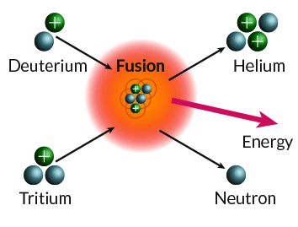
Fig. 1.1 A fusion reaction between deuterium and tritium

The production of energy is due to mass defect, as for the fission case. If uranium fissions into lighter elements, the resulting total mass is lower, and the difference is released as energy according to
E = ΔMc² | (1.1)
where ΔM is the change of total mass, and c is the speed of light. Figure 1.2 shows that elements with intermediate mass, such as Fe, have lower mass per nucleon than light elements (H, He), and heavy elements (Pb, U, …). If light elements fuse into heavier ones, the resulting total mass is also lower, and energy is released. In order to enable such a reaction, high temperature and pressure values are needed: the density and temperature in the solar core are ≈1.5 x 105 kg/m³ (*1031 particles/m³) and 1.3 keV (15 MK), and the enormous mass of fuel is held together by gravity. When heated to a high temperature, fuel transforms into "plasma," or a sea of positive ions and negative electrons, which is a fully ionised gas. Examples of plasmas include stars, fluorescent lights, welding arcs, fires, explosions, the ionosphere, commercial plasma processing equipment, and gaseous lasers.

Fig. 1.2 Average mass per nucleon (in atomic mass units) versus atomic mass number A, showing a minimum around Fe (A ≈ 56) (Dolan, 2014)

The earth absorbs approximately 178,000 TeraWatt (TW) of solar energy, of which a large portion is reflected, reradiated, or absorbed to generate water evaporation (Fig. 1.3). Approximately 3,000 TW is used by winds, 300 TW by waves, and 80 TW by photosynthesis, which creates biomass. The ''green'' energy sources are used to create hydrogen fuel, which is a portable fuel that could likely supply all of humanity's needs.
Fig. 1.3 Terrestrial power flows (Dolan, 2014)

1.1.1 The fusion reactions on Earth
The fundamental benefit of a terrestrial fusion reactor is that it may be situated close to load centres and operate without regard to wind or weather. Lithium and deuterium, the fuels used in nuclear fusion, are extremely abundant and cheap. Gases must be heated to extraordinarily high temperatures—roughly 150 million degrees °C—where atoms entirely ionise in order to recreate this process on Earth. Table 1.1 displays the primary fusion reactions that might be helpful on Earth.
While ''catalysed'' DD fusion can only create 0.2 MW/m³, and other fuels can produce much lower amounts, DT fuel can produce a power density of roughly 6 MW/m³ at a plasma pressure of 1 MPa (*10 atm). Deuterium taken from water and tritium created during the fusion process through contact with lithium (DT reaction) are the two hydrogen isotopes that can undergo fusion the most easily. Deuterium and tritium nuclei combine to create helium, a neutron, and a significant amount of energy. Since tritium has a 12.3 year half-life, it is not widely distributed in the natural world. As a result, lithium can be used to make tritium fuel by neutron capture. Deuterium occurs naturally at a rate of 1.539 10⁻⁴ hydrogen.

Table 1.1 Nuclear reactions of interest (Dolan 2014)
Name | Abbreviation | Reaction (energy, MeV) | Total (MeV) | Energy (10⁻¹² J)
DT | T(d,n)⁴He | D+T $→$ ⁴He(3.54) + n(14.05) | 17.59 | 2.818
DDn | D(d,n)³He | D+D $→$ ³He(0.82) + n(2.45) | 3.27 | 0.524
DDp | D(d,p)T | D+D $→$ T(1.01) + p(3.02) | 4.03 | 0.646
TT | T(t,2n)⁴He | T+T $→$ n + n + ⁴He | 11.3 | 1.81
D-³He | ³He (d,p)⁴He | D+³He $→$ ⁴He (3.66) + p(14.6) | 18.3 | 2.93
p-⁶Li | ⁶Li(p,α) ³He | ⁶Li +p $→$ ⁴He + ³He | 4.02 | 0.644
p-¹¹B | ¹¹B(p,2α) ⁴He | ¹¹B +p $→$ 3(⁴He) | 8.68 | 1.39
Reactions for breeding tritium (Natural lithium = 7.42% ⁶Li and 92.58% ⁷Li)
n-⁶Li | ⁶Li(n,α)T | ⁶Li +n(thermal) $→$ ⁴He (2.05) + T(2.73) | 4.78 | 0.766
n-⁷Li | ⁷Li(n,n’+α)T | ⁷Li + n(fast)$→$ T + ⁴He + n | -2.47 | -0.396

In order to build a fusion reactor on Earth, two conditions must be fulfilled:
- Raising the temperature of the DT fuel to T * 10 keV (120 million Kelvin). The positive fuel ions oppose one another; thus heating is necessary to move them quickly enough to get close enough for reactions to happen.
- The heated fuel must be contained for a long enough time and under enough pressure for a small percentage of it to ''burn.
Plasma may be confined by six means
- Solid walls: Glass or metal tubes may be used to store low-temperature plasmas, such as fluorescent lights. For small periods of time, solid walls may improve the confinement of hot plasma in magnetic fields, but sustained contact rapidly cools the plasma through heat conduction and may overheat or erode the wall.
- Gravity: While the Sun and other star plasmas are constrained by gravity, the mass of laboratory plasma is far too low for self-gravitational attraction to be significant.
- Inertia: Particle or laser beams can compress a small fuel pellet to a very high-density of 1030 ions/m³, for example. The compressed fuel plasma's rate of expansion is constrained by inertia, resulting in confinement for periods of around 1 ns, which is long enough for fusion and ignition to take place.
- Electrostatic fields: Positive and negative maxima of the electrostatic potential can be established using high voltage electrodes. Ions are repelled by positive potentials, and electrons by negative potentials. Constantly biassed at high voltages, concentric spherical grids are the conventional construction of so-called "inertial electrostatic confinement" (IEC) devices.
- Magnetic fields: Due to the Lorentz force, which forces electrons and ions to spiral around magnetic field lines, magnetic fields can confine plasmas. This makes it difficult for them to easily cross the magnetic field. The plasma can, in theory, be well confined if the magnetic field lines are large circles, like those found in a torus, though various processes can compromise confinement. The focus of this thesis is magnetic confinement systems.
- Radio frequency and microwave fields can effectively contain low pressure plasma, but huge power inputs would be required.

1.2 Magnetic confinement reactors and the ITER project

1.2.1 The TOKAMAK: a magnetic confinement reactor
Strong magnetic fields are used to create a "cage" that keeps the particles from escaping in order to accomplish magnetic confinement. The so-called TOKAMAK (a Russian abbreviation for "toroidal chamber with axial magnetic field"), in which the plasma is contained in a doughnut-shaped vessel, is one conceivable implementation of this cage. A magnetic field is created using specialised coils, which causes the plasma particles to move in spirals without ever coming into contact with the walls.
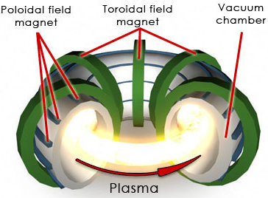
Fig. 1.4 Plasma confinement in a Tokamak (Courtesy ITER)

In a fusion plasma, positively and negatively charged ions as well as negatively charged electrons are at extremely high temperatures and moving at very high speeds. Particles from the hot plasma must be contained in the centre area in order to maintain the fusion process; otherwise, the plasma will quickly cool. Devices for magnetic confinement fusion take advantage of the way that charged particles in a magnetic field experience the Lorentz force and travel along the field lines in helical pathways. A solenoid is the most basic type of magnetic confinement device. A solenoid's plasma will spiral around the lines of force that run down the middle of it, stopping motion in that direction. This does not, however, stop movement in that direction. The simple fix is to bend the solenoid into a torus shape by bending it in a circle. However, it was shown that such a configuration is not uniform; the field on the outside of the torus is smaller than on the inside for purely geometrical reasons. The electrons and ions are made to drift throughout the field as a result of the asymmetry until they eventually collide with the torus's walls. The answer is to contour the lines such that they twist, much like the stripes on a candy cane or barber pole, rather than just encircling the torus. Any single particle in such a field will initially be at the outside edge, where it will drift in one direction, let's say up, and then, as it travels along its magnetic axis, will end up at the inner edge, where it will drift in the opposite direction. Although this cancellation is not ideal, calculations indicated that it was sufficient to allow the fuel to stay in the reactor for a useful amount of time.
Let's first examine basic magnetic "mirrors" like those in Fig. 1.5 in order to comprehend the concepts of magnetic confinement. A plasma ion moving towards a magnet coil from near the centre of a magnetic mirror would encounter a stronger magnetic field. Both the rotating velocity component and the parallel velocity component would rise in the higher field.
Fig. 1.5 Simple magnetic ‘‘mirror’’ fields B (top) and ‘‘spindle cusp’’ fields (bottom) produced by bar magnets (left side) or by a pair of circular magnet coils carrying currents I (right side) (Dolan 2014).

The magnetic mirror's name comes from the fact that plasma contained in the central areas would gradually drop until it reached zero and then be reflected back towards the centre. In high field areas like positions a and b in Fig. 1.6, ions would typically cycle back and forth between them.
In a similar manner, electrons would likewise be constrained. High magnetic fields can reflect electrons and ions, but those with high enough velocities along the field lines can escape. Furthermore, confinement is constrained by the time required for Coulomb collisions to increase the parallel velocities, making it impossible to achieve the desired energy gain ratios. A closed toroidal magnetic field can be used to solve the end loss issue; for an example, see Fig. 1.7.
However, electrons and ions are poorly contained in a basic toroidal magnetic field because they tend to migrate outward (Chen, 2011). However, the drift can be countered by twisting the magnetic field lines. There are two ways to twist. A poloidal magnetic field is produced in tokamaks by the induction of a plasma current in the toroidal direction, as shown in Fig. 1.8.
Fig. 1.6 A simple magnetic mirror (top) and axial variation of magnetic field strength (bottom) (Dolan 2014)

Fig. 1.7 A toroidal magnetic field. The magnet coil currents, I, create a toroidal magnetic field, Bt. (Dolan 2014)
Fig. 1.8 The toroidal plasma current J induces the poloidal field component Bp. The sum of Bp plus Bt results in the helical magnetic field B (Chen 2011)
Helical coils are employed in Stellarators to twist the magnetic field, which eliminates the need for a powerful toroidal plasma current and allows for long-term operation. A traditional stellarator is depicted in Figure 1.9 along with a torsatron (or heliotron), which only has helical windings with currents flowing in one direction. The typical stellarator has both toroidal field coils and helical windings in alternate directions.
Fig. 1.9 A conventional stellarator (Chen 2011)
The plasma can be kept in equilibrium (force balance) by a magnetic field, but in order
to produce energy, this plasma needs to be contained for a long enough time for fusion to take place. The plasma equilibrium is therefore a key objective for this technology. Since we require a plasma temperature T of approximately 108 MK ( 10 keV), while the wall temperature should remain at approximately 2,000 K (0.17 eV), this plasma equilibrium must avoid thermodynamic equilibrium, where all components tend to arrive at the same temperature. According to Chen 2011, Freidberg 2008, and Kikuchi (2012), the following processes tend to move the plasma towards the undesired thermodynamic equilibrium:
• Plasma flow along B—in open magnetic systems or in ‘‘ergodic’’ (randomly oriented) magnetic field lines.
• Plasma Drift across the magnetic field, caused by electric fields, magnetic field gradients, magnetic field curvature, etc.
• Heat Transport—conduction and convection.
• Radiation losses—line radiation, bremsstrahlung radiation, and cyclotron radiation.
• Magnetohydrodynamic (MHD) instabilities—changes of plasma shape driven by gradients of pressure or current density.
• Microinstabilities—interactions of particles and waves that increase heat transport.
• Charge exchange—neutralization of hot ions by neutral atoms, allowing their escape.
Fusion science must create confinement systems that can simultaneously stop all of the aforementioned loss processes, using high-temperature, low-activation materials that can endure the harsh conditions of the reactor. The tokamak is the top contender for a workable fusion reactor as of 2018.

1.2.2 A fusion power plant
Figure 1.10 shows a potential tokamak-based fusion power plant. Magnet coils, a shield, and a blanket around the thermonuclear plasma. The hot plasma is thermally insulated from the walls by the high magnetic field. Conduction, convection, radiation, and energetic neutrons inside the blanket deposit heat from the fusion reactions on the walls. The thermal energy is transferred by a coolant to a steam generator, where the steam turns a turbine that turns an electrical power generator. The feed water is then fed back through the steam generator once the steam has been condensed. Similar to traditional plants that produce heat through the use of coal or nuclear fission, this fusion power plant uses nuclear fusion reactions to do so. The fusion reactor heat source is the only component of the power plant that has not yet reached its full potential.

Fig. 1.10 Simplified cutaway view of a fusion reactor connected to a Rankine cycle (steam turbine cycle) to generate electricity. DT means ‘‘deuterium–tritium’’ (Dolan 2014)

If nuclear fusion could be successfully developed, it would have some advantages over nuclear fission:
  - No runaway reaction (super criticality) hazard.
  - Expensive emergency core cooling systems not required.
  - No emergency evacuation plan required for general public.
  - No fission products or long-lived high-level radioactive waste (there would still be some lower-level radioactive wastes, such as radioactive steel).
  - Possibility of recycling fusion reactor materials (for example reduced activation steel could be recycled after several years of cooling).
  - Widespread availability and easy transport of fuels.
Some disadvantages of fusion power plants include high capital cost, radiation damage by 14-MeV neutrons, containment of radioactive tritium, and the need for remote maintenance of the radioactive blanket.

1.2.3 The history of the tokamaks
There have been three distinct eras in the development of magnetic confinement fusion. The early age began in the 1940s but really took off in 1951, when it was generally accepted that creating practical fusion devices would be very straightforward and that all that remained to be done was to choose a viable design from among the numerous suggestions. The second phase—known as "the doldrums"—began in 1958 after information from the US, UK, and USSR was made public and revealed that all three programmes were plagued by significant issues and that there was no obvious way ahead. Since 1968, when information about the tokamak was made public, the third period has been in effect.
Tokamaks were invented in the 1950s by Soviet physicists Igor Tamm and Andrei Sakharov, inspired by an original idea of Oleg Lavrentiev. It had earlier been demonstrated that a stable plasma equilibrium requires magnetic field lines that wind around the torus in a helix. Devices like the z-pinch and stellarator had attempted this, but demonstrated serious instabilities anyway. By the mid-1960s the tokamak designs began to show greatly improved performance. Initial results were released in 1965, but were ignored. In 1968, at the third IAEA International Conference on Plasma Physics and Controlled Nuclear Fusion Research at Novosibirsk, Soviet scientists announced that they had achieved electron temperatures of over 1000 eV in a tokamak device. The team's 1969 publication confirmed the improvements, resulting in a stampede of tokamak construction. Therefore, by the mid-1970s, dozens of tokamaks were in use around the world. By the late 1970s, newer machines had reached all of the conditions needed for practical fusion, although not at the same time nor in a single reactor. At this point, the first serious attempts to produce a breakeven tokamak design emerged, notably the Joint European Torus in the UK, the Tokamak Fusion Test Reactor in the US, and the T-10 in the USSR. With the goal of breakeven now in sight, a new series of machines were designed that would run on a fuel of deuterium and tritium, as opposed to test gasses. These machines had the explicit goal of reaching breakeven. The result obtained by these machines (for instance JET, see Fig.1.11) demonstrated new problems that limited their performance and suggested as a way to solve them the design of a much larger and more expensive machine, while in parallel many smaller designs, and offshoots like the spherical tokamak, continue to be used to investigate performance parameters and other issues.
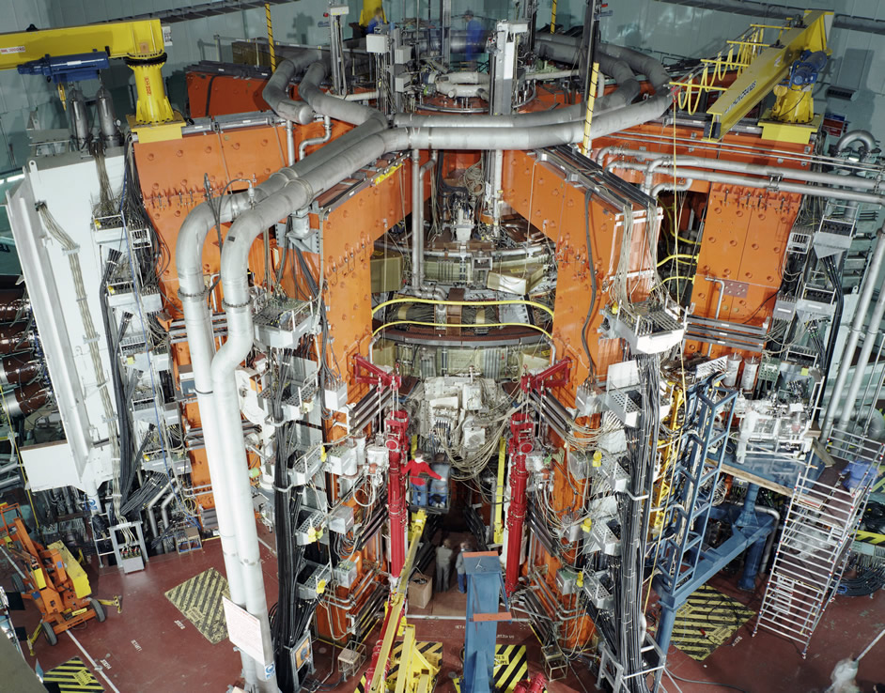
Fig. 1.11 The JET tokamak in Culham, UK (JET 2018)

The tokamaks currently in operation (in chronological order of start of operations) are the following:
• 1960s: TM1-MH (since 1977 as Castor; since 2007 as Golem) in Prague, Czech Republic. In operation in Kurchatov Institute since the early 1960s but renamed to Castor in 1977 and moved to IPP CAS, Prague. In 2007 moved to FNSPE, Czech Technical University in Prague and renamed to Golem.
• 1975: T-10, in Kurchatov Institute, Moscow, Russia (formerly Soviet Union); 2 MW
• 1983: Joint European Torus (JET), in Culham, United Kingdom
• 1985: JT-60, in Naka, Ibaraki Prefecture, Japan; (Being upgraded 2015-2018 to Super, Advanced model)
• 1987: STOR-M, University of Saskatchewan; Canada; first demonstration of alternating current in a tokamak.
• 1988: Tore Supra, at the CEA, Cadarache, France
• 1989: Aditya, at Institute for Plasma Research (IPR) in Gujarat, India
• 1980s: DIII-D, in San Diego, US; operated by General Atomics since the late 1980s
• 1989: COMPASS, in Prague, Czech Republic; in operation since 2008, previously operated from 1989 to 1999 in Culham, United Kingdom
• 1990: FTU, in Frascati, Italy
• 1991: ISTTOK, at the Instituto de Plasmas e Fusão Nuclear, Lisbon, Portugal;
• 1991: ASDEX Upgrade, in Garching, Germany
• 1992: H-1NF (H-1 National Plasma Fusion Research Facility) based on the H-1 Heliac device built by Australia National University's plasma physics group and in operation since 1992
• 1992: Tokamak à configuration variable (TCV), at the EPFL, Switzerland
• 1994: TCABR, at the University of São Paulo, São Paulo, Brazil; this tokamak was transferred from Swiss Plasma Center in Switzerland
• 1995: HT-7, in Hefei, at the Institute of Plasma Physics, China
• 1999: MAST, in Culham, United Kingdom
• 1999: NSTX in Princeton, New Jersey
• 1999: Globus-M in Ioffe Institute, Saint Petersburg, Russia
• 1990s: Pegasus Toroidal Experiment at the University of Wisconsin-Madison; in operation since the late 1990s
• 2002: HL-2A, in Chengdu, China
• 2006: EAST (HT-7U), in Hefei, at The Hefei Institutes of Physical Science, China (ITER member)
• 2008: KSTAR, in Daejon, South Korea (ITER member)
• 2010: JT-60SA, in Naka, Japan (ITER member); upgraded from the JT-60.
• 2012: Medusa CR, in Cartago, at The Instituto Tecnológico de Costa Rica, Costa Rica
• 2012: SST-1, in Gandhinagar, at the Institute for Plasma Research, India (ITER member)
• 2012: IR-T1, Islamic Azad University, Science and Research Branch, Tehran, Iran
• 2012: ST25 at Tokamak Energy at Culham, Oxfordshire, UK (now at Milton Park)
• 2014: ST25 (HTS) the first tokamak to have all magnetic fields formed from high temperature superconducting magnets, at Tokamak Energy based in Oxfordshire, UK
As recalled, new tokamaks are planned:
• ITER, international project in Cadarache, France; 500 MW; construction began in 2010, first plasma expected in 2020.
• DEMO; 2000 MW, continuous operation, connected to power grid. Planned successor to ITER; construction to begin in 2024 according to preliminary timetable.
• CFETR, also known as "China Fusion Engineering Test Reactor"; 200 MW; Next generation Chinese fusion reactor, is a new tokamak device.

The ITER project

ITER (International Thermonuclear Experimental Reactor and Latin for "the way") is an international nuclear fusion research and engineering project, which will be the world's largest magnetic confinement plasma physics experiment. It is an experimental tokamak nuclear fusion reactor that is being built next to the Cadarache facility in Saint-Paul-lès-Durance, in Provence, southern France.
The ITER thermonuclear fusion reactor has been designed to produce a fusion plasma equivalent to 500 megawatts of thermal output power for around twenty minutes while 50 megawatts of thermal power are injected into the tokamak, resulting in a ten-fold gain of plasma heating power. Thereby the machine aims to demonstrate the principle of producing more thermal power from the fusion process than is used to heat the plasma, something that has not yet been achieved in any fusion reactor. The total electricity consumed by the reactor and facilities during peak periods of plasma operation will be as much as 620 MW. The reactor is only designed to produce a fusion plasma, and the emitted heat from the fusion reaction will be vented to the atmosphere without generating electricity. ITER's planned successor, DEMO, is expected to be the first fusion reactor to produce electricity in an experimental environment. DEMO's anticipated success is expected to lead to full-scale electricity-producing fusion power stations and future commercial reactors.
The project is funded and run by seven-member entities—the European Union, India, Japan, China, Russia, South Korea, and the United States. The EU, as host party for the ITER complex, is contributing about 45 percent of the cost, with the other six parties contributing approximately 9 percent each. In 2016 the ITER organization signed a technical cooperation agreement with the national nuclear fusion agency of Australia, enabling this country access to research results of ITER in exchange for construction of selected parts of ITER machine.
Construction of the ITER Tokamak complex started in 2013 and the building costs are now over US$14 billion as of June 2015. The facility is expected to finish its construction phase in 2021 and will start commissioning the reactor that same year. Initial plasma experiments are scheduled to begin in 2025, with full deuterium–tritium fusion experiments starting in 2035. If ITER becomes operational, it will become the largest magnetic confinement plasma physics experiment in use with a plasma volume of 840 cubic meters, surpassing the Joint European Torus by almost a factor of 10. The first commercial demonstration fusion power station, named DEMO, is proposed to follow on from the ITER project.
ITER began in 1985 as a Reagan–Gorbachev initiative with the equal participation of the Soviet Union, the European Union (through European Atomic Energy Community), the United States, and Japan through the 1988–1998 initial design phases. Preparations for the first Gorbachev-Reagan Summit showed that there were no tangible agreements in the works for the summit.
One energy research project, however, was being considered quietly by two physicists, Alvin Trivelpiece and Evgeny Velikhov. The project involved collaboration on the next phase of magnetic fusion research — the construction of a demonstration model. At the time, magnetic fusion research was ongoing in Japan, Europe, the Soviet Union and the US. Velikhov and Trivelpiece believed that taking the next step in fusion research would be beyond the budget of any of the key nations and that collaboration would be useful internationally. A major bureaucratic fight erupted in the US government over the project. One argument against collaboration was that the Soviets would use it to steal US technology and know-how. A second was symbolic — the Soviet physicist Andrei Sakharov was in internal exile and the US was pushing the Soviet Union on its human rights record. The United States National Security Council convened a meeting under the direction of William Flynn Martin that resulted in a consensus that the US should go forward with the project. Martin and Velikhov concluded the agreement that was agreed at the summit and announced in the last paragraph of this historic summit meeting, "... The two leaders emphasized the potential importance of the work aimed at utilizing controlled thermonuclear fusion for peaceful purposes and, in this connection, advocated the widest practicable development of international cooperation in obtaining this source of energy, which is essentially inexhaustible, for the benefit for all mankind." Conceptual and engineering design phases carried out under the auspices of the IAEA led to an acceptable, detailed design in 2001, underpinned by US$650 million worth of research and development Japan, Russian Federation (replacing the Soviet Union), and United States (which opted out of the project in 1999 and returned in 2003), were joined in negotiations by China, South Korea, and Canada (who then terminated its participation at the end of 2003). India officially became part of ITER in December 2005.by the "ITER Parties" to establish its practical feasibility. These parties, namely EU, On 28 June 2005, it was officially announced that ITER would be built in the European Union in Southern France. The negotiations that led to the decision ended in a compromise between the EU and Japan, in that Japan was promised 20% of the research staff on the French location of ITER, as well as the head of the administrative body of ITER. In addition, another research facility for the project will be built in Japan, and the European Union has agreed to contribute about 50% of the costs.
On 21 November 2006, an international consortium signed a formal agreement to build the reactor. On 24 September 2007, the People's Republic of China became the seventh party to deposit the ITER Agreement to the IAEA. Finally, on 24 October 2007, the ITER Agreement entered into force and the ITER Organization came into existence.
Fusion for Energy (F4E), the EU agency in charge of the European contribution to the project, is located in Barcelona, Spain. Fusion for Energy is the European Union's Joint Undertaking for ITER and the Development of Fusion Energy. According to the agency's website (F4E, 2018): "F4E is responsible for providing Europe's contribution to ITER, the world's largest scientific partnership that aims to demonstrate fusion as a viable and sustainable source of energy. [...] F4E also supports fusion research and development initiatives [...]"
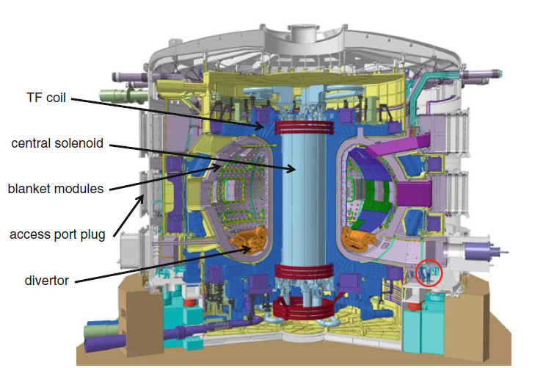
Fig. 1.12 ITER machine and its main components of ITER. A person is shown for scale (in red circle). Courtesy of ITER Organization

1.2.5 Mission and technical design
ITER's mission is to demonstrate the feasibility of fusion power, and prove that it can work without negative impact. Specifically, the project aims to:
  - Momentarily produce ten times more thermal energy from fusion heating than is supplied by auxiliary heating (a Q value equals 10).
  - Produce a steady-state plasma with a Q value greater than 5. (Q = 1 is breakeven.)
  - Maintain a fusion pulse for up to 8 minutes.
  - Ignite a "burning" (self-sustaining) plasma. (i.e. 'ignition' see Lawson criterion)
  - Develop technologies and processes needed for a fusion power station — including superconducting magnets and remote handling (maintenance by robot).
  - Verify tritium breeding concepts.
  - Refine neutron shield/heat conversion technology (most of the energy in the D+T fusion reaction is released in the form of fast neutrons).
Vacuum vessel
The vacuum vessel is the central part of the ITER machine: a double walled steel container in which the plasma is contained by means of magnetic fields. The ITER vacuum vessel will be twice as large and 16 times as heavy as any previously manufactured fusion vessel: each of the nine torus shaped sectors will weigh between 390 and 430 tonnes. When all the shielding and port structures are included, this adds up to a total of 5,116 tonnes. Its external diameter will measure 19.4 metres (64 ft), the internal 6.5 metres (21 ft). Once assembled, the whole structure will be 11.3 metres (37 ft) high. The primary function of the vacuum vessel is to provide a hermetically sealed plasma container. Its main components are the main vessel, the port structures and the supporting system. The main vessel is a double walled structure with poloidal and toroidal stiffening ribs between 60-millimetre-thick (2.4 in) shells to reinforce the vessel structure. These ribs also form the flow passages for the cooling water. The space between the double walls will be filled with shield structures made of stainless steel. The inner surfaces of the vessel will act as the interface with breeder modules containing the breeder blanket component. These modules will provide shielding from the high-energy neutrons produced by the fusion reactions and some will also be used for tritium breeding concepts. The vacuum vessel has 18 upper, 17 equatorials (of which 14 regular equatorial ports and 3 destinated to the Neutral Beam Injectors Equatorial Ports (Kwon, 2009)) and 9 lower ports that will be used for remote handling operations, diagnostic systems, neutral beam injections and vacuum pumping.
Breeder blanket
Owing to very limited terrestrial resources of tritium, a key component of the ITER reactor design is the breeder blanket. This component, located adjacent to the vacuum vessel, serves to produce tritium through reaction with neutrons from the plasma. There are several reactions that produce tritium within the blanket. 6Li produces tritium via n,t reactions with moderated neutrons, 7Li produces tritium via interactions with higher energy neutrons via n,nt reactions. Concepts for the breeder blanket include helium cooled lithium lead (HCLL) and helium cooled pebble bed (HCPB) methods. Six different Test Blanket Modules (TBM) will be tested in ITER and will share a common box geometry. Materials for use as breeder pebbles in the HCPB concept include lithium metatitanate and lithium orthosilicate. Requirements of breeder materials include good tritium production and extraction, mechanical stability and low activation levels.
Magnet system
The central solenoid coil will use superconducting niobium-tin to carry 46 kA and produce a field of up to 13.5 T. The 18 toroidal field coils will also use niobium-tin. At their maximum field strength of 11.8 teslas, they will be able to store 41 gigajoules. They have been tested at a record 80 kA. Other lower field ITER magnets (PF and CC) will use niobium-titanium for their superconducting elements. As of now, the in-wall shielding blocks to protect the magnets from high energy neutrons are being manufactured and transported from the Avasarala technologies in Bangalore India to the ITER center.
Additional heating
There will be three types of external heating in ITER:
  - Two Heating Neutral Beam injectors (HNB), each providing about 17MW to the burning plasma, with the possibility to add a third one. Main requirements: 1MeV of deuterium beam energy, 40A of total current and up to 1h of beam pulse duration
  - Ion Cyclotron Resonance Heating (ICRH)
  - Electron Cyclotron Resonance Heating (ECRH)
Cryostat
The cryostat is a large 3,800-tonne stainless steel structure surrounding the vacuum vessel and the superconducting magnets, in order to provide a super-cool vacuum environment. Its thickness ranging from 50 to 250 mm will allow it to withstand the atmospheric pressure on the area of a volume of 8,500 cubic meters. The total of 54 modules of the cryostat will be engineered, procured, manufactured, and installed by Larsen & Toubro Heavy Engineering.
Cooling systems
The ITER tokamak will use three interconnected cooling systems. Most of the heat will be removed by a primary water-cooling loop, itself cooled by water through a heat exchanger within the tokamak building's secondary confinement. The secondary cooling loop will be cooled by a larger complex, comprising a cooling tower, a 5 km pipeline supplying water from Canal de Provence, and basins that allow cooling water to be cooled and tested for chemical contamination and tritium before being released into the Durance River. This system will need to dissipate an average power of 450 MW during the tokamak's operation. A liquid nitrogen system will provide a further 1,300 kW of cooling to 80 kelvins, and a liquid helium system will provide 75 kW of cooling to 4.5 K. The liquid helium system will be designed, manufactured, installed and commissioned by Air Liquide.

Wireless Power Transfer systems

The concept of a Wireless Power Transfer system can be introduced here with reference to the recharging system for automotive represented in Figure 5.1. The wireless coupling take place thanks to the inductive coupling (IPT systems) between two coils: the transmitter one is powered by a conversion stage which supplies a high frequency current, whereas the receiver one is connected to the battery pack by means of an AC/DC converter. The two coils are complemented by the mechanical and magnetic structures, to form the so-called PADs. Static and dynamic WPT systems may be considered, with the first aimed at rechearging the electrical vehicle during its stops, and the second when in motion. The installation of an WPT dynamic recharging system in road infrastructures would have enormous positive implications for the various problems associated with the energy system: in addition to eliminating the need for compulsory stops to recharge the vehicle, there would be the possibility of reducing the size of the batteries (and consequently reduce bulk and weight).
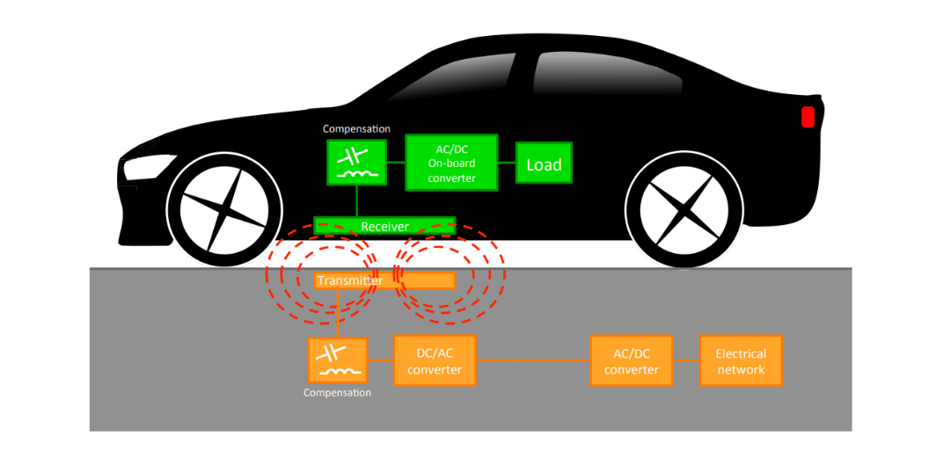
Figure 1.13 – Scheme of the components of a generic IPT system for an electric vehicle.

1.3.1 Historical overview
Although it is a technology on which research has concentrated its efforts only recently obtaining an effective implementation, to find the first references to the concept of Wireless Power Transfer (WPT) one can go back in time to Faraday's first experiments on electromagnetic induction and on the transmission through fluids, dating back to 1832. If therefore the proper term of WPT has been introduced only in the last decades, it is equally true that the scientific community has always shown great interest in hypothesizing and evaluating the use of mechanisms aimed at wireless energy transfer. In addition to Faraday's experiments already mentioned, we can also recall those carried out by Tesla who was the first to speak of wireless energy transmission (N. Tesla, 1927) and, after obtaining American citizenship, from 1891 conducted several experiments on inductive and capacitive (N. Tesla, 1891) which led him to a first attempt at a wireless lighting system using an LC receiver circuit tuned in resonance with another LC transmitter circuit. Still citable were the applications of radio frequencies studied by Hertz in 1895.
The development of these concepts arose primarily thanks to the discoveries made by Ampère on how an electric current produces a magnetic field, and by Faraday on the relationship between electric and magnetic fields and on how a time-varying magnetic field can interact with a circuit electric leading to an induced electromotive force. The unification between electric and magnetic phenomena in electromagnetism will then be expressed and completed by Maxwell in 1861 through Maxwell's Equations.
Finally, it was Tesla, after obtaining the patent for a wireless transmission system over long distances, who identified and defined two important parameters in the development of wireless transmission. In particular, the scholar and inventor concentrated on an inductive type transmission where the power was transmitted between two coils through the magnetic field, and noted (N. Tesla, 1900):
a) the need to increase the operating frequencies to obtain an increase in transmitted power;
b) the possibility of combining the use of capacitance (Tesla used a Leyden jar in its prototype) with coils in order to work at resonant frequencies and obtain better transmission efficiency.
Tesla's works, despite the right hypothesis of the need to use resonant systems, however remained confined to being non-repeatable experiments on a large scale also due to the practical limitations of the system (very high operating voltages, safety problems, low efficiencies due to the high frequency losses due to skin effect) and by the technological limits on the control systems of the historical period.
The advent of power electronics was a key element that allowed the advancement of research in the creation of prototypes and applications of inductive power transmission. It was in 1943 that the first electric car was found with an Inductive Power Transfer (IPT) charging system, created by the Soviet electrical engineer George Iljitch Babat. The prototype, renamed HF Automobile, was a system composed of a series of copper pipes that formed a path under the asphalt layer, and a receiver positioned on the vehicle about 20 cm above the ground. The system served to supply a motor with a power of 2 kW, with current values ​​of hundreds of amperes at a frequency of 50 kHz, overall the prototype acted with an efficiency of 4%, however it represented the first attempt to unite the world automotive and an IPT system (G.I. Babat, 1951). Subsequent developments can be found in 1974 when a prototype was made with solid state units and thyristor inverters, with a frequency of 10 kHz and a nominal current of 2000 A. The resonance was obtained by means of capacitors connected in series and then connected to a DC motor with an intermediate rectifier, but this prototype was soon abandoned (D.V. Otto, 1974). Moving on about ten years, we find a further project carried out in California and under the name of PATH, the purpose of which was to obtain an operating system capable of recharging small electric buses through a portion of the road where the of transmission, the control of which was delegated to a system of variable capacities that altered the resonance frequency of the receiver. This prototype supplied a power value of 200 kW with a maximum current of 2000 A deriving from an electric machine at a frequency of 400 Hz, with an air-gap of between 5 and 10 cm, for an efficiency obtained around 60%. Although it was an important result, there were unfortunately several critical issues, in particular the dimensions and weight represented the main problem (the receiver had a length of 4.5 meters for a weight of 850 kg) (S. E. Shladover, 2007).
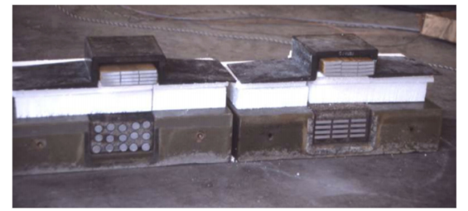
Figure 1.14 Section of the routed transmitter and receiver of the PATH prototype
(Shladover, 2007).

The more power electronics progressed and technologically advanced, the more the interest of industries and research for IPT systems grew, having available electronic devices capable of operating beyond tens of kHz with currents of hundreds of amperes. In 1997 the first IPT system for public transport was commercialized by Wampfler AG (today renamed Conductix), based on the works and patents of the University of Auckland (J. Boys and A. Green, 1995 – J. Boys and A. Green, 1998). The application sees a stationary recharging of the buses by aligning, with the aid of a video camera, the transmitter (positioned on the road surface) and the receiver, with a subsequent lowering of the latter to reduce the air-gap up to a distance of 4 cm. This type of structure has been currently in use in Genoa and Turin since 2002, and operates during bus stops through two pairs of transmitter-receiver, at a frequency of 15 kHz and a nominal current of 80 A, for a power value equal to to 30 kW per coil.
More recently, several companies and research centers that in recent years have concentrated and have devised solutions for electric mobility through IPT systems. A startup born out of Utah State University under the name of WAVE markets its IPT technology for charging electric buses. In the first prototype, one was used university shuttle equipped with a receiver of the same size as the transmitter, inserted into the ground of the bus station. With an efficiency reached of 90%, at each stop the transfer of 25 kW at 20 kHz took place, with an air-gap of about 15-25 cm (https://waveipt.com).
In 2015 Bombardier announced PRIMOVE (currently transitioned to IPT Technology), a program and set of solutions based on IPT technology and aimed at buses, light commercial vehicles and private transportation. Developed to work during bus stops, it allowed a recharge of a power of 200kW. Remaining on the static IPT solutions, the work carried out by HaloIPT, a New Zealand company born from the University of Auckland, whose proposal consisted of a charging system in the range between 3.3 and 20 kW, can be cited; in 2011 Rolls Royce acquired this technology for charging the Phantom EV model.

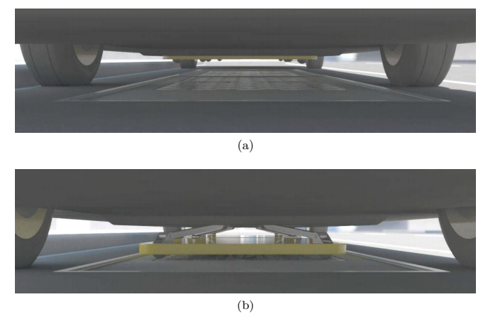
Figure 1.15 Position of the Conductix system receiver, before lowering (a), and with the lowered receiver 4 cm away from the transmitter (b).

WiTricity, another successful spin-off born from the Massachusetts Institute of Technology in 2007, has developed several resonance-based IPT systems, with solutions with a power between 3.6 and 11 kW and an efficiency higher than 90% (https://witricity.com/products/automotive). This technology has been taken and implemented by various automobile companies such as Toyota, BMW, Honda and Nissan.
Another product marketed is Plugless Power, a 3.3 kW IPT stationary charging system developed by Evatran and marketed in collaboration with Bosch, successfully tested on Chevrolet VOLT models and on Nissan Leaf EV. A special feature of this system is its adaptability to any EV model, with a control panel with power electronics that can be connected to the low voltage mains and the transmitter pad that can be positioned on the ground of the parking lot or garage (Carlson et al., 2014).
At the level of IPT dynamic systems, the work carried out by the Korea Advanced Institute of Science and Technology (KAIST) is noteworthy, which in 2009 presented a Shaped Magnetic Field In Resonance (SMFIR) system, based on forcing and confining the flow in well-defined paths using a large amount of ferrite (Suh, 2011).
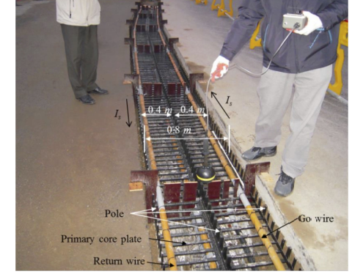
Figure 1.16 – Ferrite and street-implanted transmitter segment of the OLEV system
(S. Y. Choi et al., 2015).
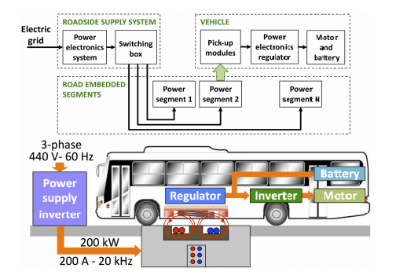
Figure 1.17 – OLEV System Scheme.

Then applied to OLEV (Online Electric Vehicle) buses in 2011, currently two of these vehicles are still operating on the campuses of the cities of Daejeonn and Gumi, in South Korea. At a technical level, the system starts from a conversion stage and, with a current value of 200 A and a frequency of 20 kHz, the receiver is powered and is integrated into the road in sections of 122.5 m in length, each section then divided into segments of length ranging from 2.5 to 24 m (Suh, 2011). On the receiver side, on the other hand, there is a complex shielding architecture, both active and passive, to confine the magnetic path and to improve the electromagnetic compatibility problem. An example of such a system is represented in Figure 5.4 which shows a series of copper brushes used to create a shielding closed conductive path. The OLEV versions developed by KAIST reached a maximum power of about 200 kW and an efficiency of 74% (Huh et al., 2011).
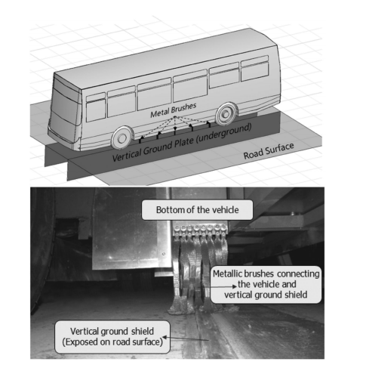
Figure 1.18 – Representation of a passive shielding system applied on OLEV buses.
In addition to the alternatives mentioned so far, there are several active projects being developed by research centers and companies, aimed at solving the main problems of IPT technology and defining its standards. A notable contribution comes from the Oak Ridge National Laboratory (ORNL), which is carrying out tests and research on coil design, power flux adjustments, leakage flux reduction, misalignment tolerances and interchangeability (Miller et al., 2015).
One of the IPT system analyzied in this Thesis is a product of two project, the first of which started at the end of 2012: the eCo-FEV project. It was born, aimed at creating an integration platform for electric vehicles, with the aim of making all the various infrastructures relating to the vehicle communicating, including the charging infrastructures. Starting from the eCo-FEV project, the Energy Department of the Polytechnic of Turin has developed a first prototype of a dynamic IPT for a light commercial transport vehicle, with five transmitters positioned on the road surface and vehicle identification using optical sensors. Currently, the research carried out by the Turin Polytechnic team continues with the FABRIC project, where a recharging architecture is proposed consisting of a series of 50 transmitters 1.5 m long at a distance of 50 cm from each other. Each transmitter is powered by a dedicated DC/AC converter, at a frequency of 85 kHz and a nominal power of 20 kW for each converter, with a fixed maximum speed of the vehicle at 70 km/h (Cirimele et al., 2018).
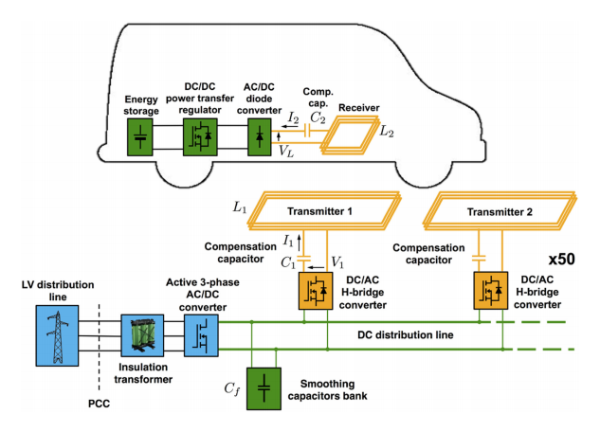
Figure 1.19 – Diagram of the FABRIC dynamic IPT system of the Polytechnic of Turin (V. Cirimele et al., 2018).

1.3.2 Typologies of WPT systems

A generic WPT system consists of a transmitter connected to the energy source, the coupling elements (they can be coils, metal plates or an antenna) and finally the receiver to which the load is then connected. Since there are no electrical contacts, first of all there is a reduction in the problems associated with erosion and electrical maintenance, but the main advantage of this system is also the independence between receiver and transmitter, which also ensures the recharging process without the need to have a human interaction.
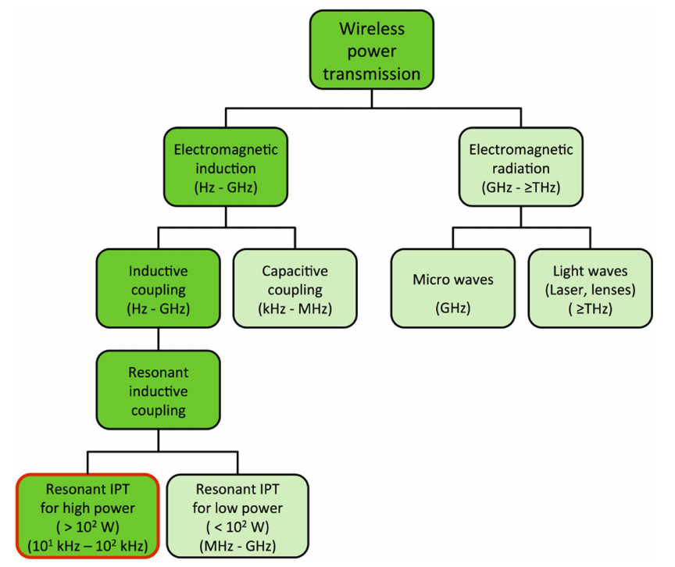
Figure 1.20 Different types of Wireless Power Transmission (Cirimele, 2018).

The list of possible technologies that can be used for energy transmission through electromagnetic fields is not short and can be differentiated according to the distance, i.e. the coupling region between transmitter and receiver (Near-Field or nonradiative region, Far-Field or radiative region), and according to the type of electromagnetic energy. In the study of Near-Field techniques, reference can be made to a capacitive coupling where the transfer takes place via the electric field using a coupling between two electrodes, or to an inductive coupling and with particular attention to a resonant inductive coupling. Moving instead in the frequency range of GHz and ≥THz (microwaves and light waves) we fall within the Far-Field applications where the power is transferred through electromagnetic radiation and can reach considerable distances but with the need to align the receiver.
Capacitive Power Transfer:
A Capacitive Power Transfer (CPT) system (Fig.1.17a) uses the electric field for power transfer, with multiple advantages: negligible eddy-current losses, low cost and weight, good performance in case of misalignments. Structurally, only a few metal plates are actually used to achieve the coupling between receiver and transmitter, and the thickness and quality of the material do not particularly affect the performance (L. Pichon, 2020). The applications are mainly aimed at integrated circuits, biomedical devices and personal electronic devices.
(a)
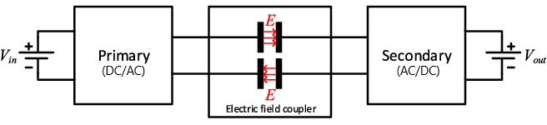

(b)
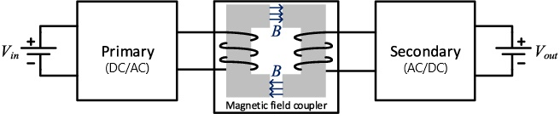
Figure 1.21 Generic scheme of (a) a Capacitive (CPT), and (b) an Inductive Power Transfer system (IPT).

Inductive Power Transfer:
Parallel to the CPT, in the Inductive Power Transfer (IPT) the principle of magnetic induction is exploited for the transfer of power, based on the aforementioned Maxwell's Laws (Fig.1.17b): a time-varying current in a conductor generates a magnetic field which interacts with a receiver, on which a voltage is generated due to the time-varying magnetic flux. In itself this system does not appear to be particularly advantageous due to a radical reduction in efficiency as the distance that separates the transmitter and receiver coils increases. This implies that the use of this method is reserved for a few applications where the coils are adjacent or extremely close to each other (for example the recharging of a smartphone through contact with a support), in other cases it is now preferable to rely on an LC system resonant given the numerous advantages compared to the purely inductive method.
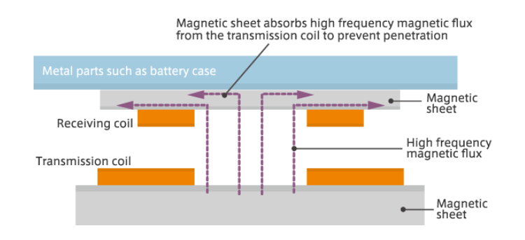
Figure 1.22 Graphical representation of an IPT system.

1.3.3. IPT applications and characteristics
Referring only to magnetic inductive and resonant methods, the field of applicability can be divided into:
• mobile applications (telephone and smartphones, tablets, notebooks, lighting equipment, video cameras, cameras);
• logistic and civil applications (household appliances, televisions, small robots, audiovisual equipment, kitchen systems);
• electric vehicles;
• medical equipment, used for recharging Active Medical Implant (AMI) batteries such as neuro-stimulators or external tools, offering a means to reduce invasive surgery in case of medical implants and creating a safer healthcare environment.
Since there are different solutions designed by various industrial companies and research centers, the standards are different. In addition to the sector of application, the classification is made according to the operating frequency ranges and according to the power of the system.
In Table 1.2 there is an overview of the values ​​of frequencies and powers currently used in WPT systems and more suitable to become reference bands (applications below 30 MHz have been taken into consideration) (SRdoc, 2019).

Table 1.2 – Frequency and power references in IPT applications.
Frequency | Power (or H field) | Applications
19 – 21 kHz | >20 kW | Bus, Heavy transport vehicles
59 – 61 kHz | - | Electrical Vehicles
79 – 90 kHz | 3.7 kW – 20 kW | Electrical Vehicles
100 – 205/300 kHz | <200W | Mobile
6765 – 6795 kHz | <30 W | Mobile
9 – 315 kHz | (400 A/m at 10 cm) | Medical Sector
20 – 80 kHz | 200 W – 2.4 kW | Home appliance
300 – 500 kHz | <5 W | Small devices

An excellent example of today's widespread use of an IPT system is the Qi standard, currently present in many low-power devices (mobile phones, tablets and laptops) and developed by the Wireless Power Consortium since 2008. In the specifications of this standard the reported power values ​​are within 5 W, using an inductive coupling between two planar coils for a maximum distance of 4 cm (D. van Wageningen and T. Staring, 2010). Starting from 2011, the Wireless Power Consortium also extended the specifications to medium power and in 2019 the maximum limit was raised to 30 - 65 W, the current goal is to reach 200 W.
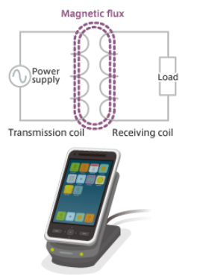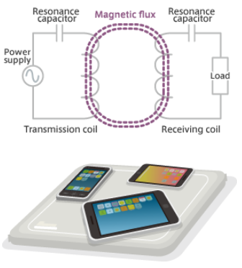
(b)
(a)
Figure 1.23 Examples of the use of IPT for low powers with inductive (a), or resonant (b) transmission.

Before introducing the state of research on IPT systems in the automotive sector, it is right to make a further differentiation between static and dynamic technology: if until now we have mainly talked about charging applications with stationary objects, having physically decoupled transmitter and receiver in fact, it does not preclude the possibility of energy transfer systems with one of the two elements in motion, as occurs in the technologies being developed for electric vehicles. While on the one hand the static part already has a solid basis to be standardized, even in automotive applications, the dynamic side on the other hand still has a long way to go to arrive at a stable, optimized and functional system for marketing. In fact, currently there is no standard on the shapes of transmitters and receivers, on frequency values ​​or on power levels. These last two factors in particular are linked to everything connected with the support structure: the dimensions of the coils, the power electronics technology to be implemented, the distances in the air between the receiver and the transmitter and finally also the electromagnetic compatibility with the rest of the vehicle. Last but not least is the aspect of safety and exposure of people to the magnetic fields generated by IPT applications.

CHAPTER 2

Formulations of low-frequency electromagnetic problems

2. Formulations of low-frequency electromagnetic problems

2.1 Criteria to assess the electromagnetic model
The two applications analyzed in this Thesis can be modelled by using magnetostatic or magneto-quasi-static formulations of the electromagnetic problem. In the following, the general theory of electromagnetic formulation is reviewed and criteria are presented to choose the proper model to be applied for the specific application under investigation.
The choice of the usable model is possible through a process of dimensionless Maxwell's equations, allowing a numerical comparison to define the negligibility of a component or not.
Maxwell's equations describe the evolution of the electromagnetic field.
$$\left\{\begin{aligned}∇×E=-\frac{∂B}{∂t} \\ \\ ∇×H=J+\frac{∂D}{∂t} \\ \\ ∇⋅D=ρ \\ \\ ∇⋅B=0\end{aligned}\right.$$ | (2.1)
where $\overline{E}$ is the Electric Field, $\overline{B}$ is the magnetic flux density, $\overline{D}$ the electric induction, $\overline{J}$ the current density, $\overline{H}$ the magnetic field, and $ρ$ represents the charge density. In support of the system (2.1) the constitutive equations must be added and so (for linear and homogeneous materials):
$${B=f_{1}\left(H\right) → B=μH \atop \begin{aligned}D=f_{2}\left(E\right) → D=εE \\ J=f_{3}\left(E\right) → J=σE\end{aligned}}$$ | (2.2)
where $μ$ is the magnetic permeability, $ε$ is the dielectric constant, $σ$ is the electric conductivity. Finally, the conditions of regularity at infinity and the connection conditions must be added.
From the energy point of view, it can be introduced the concept of the magnetic and electric energy:
$$W_{m}=\iiint_{Ω}^{ }{\frac{1}{2}}{\frac{\left|B\right|}{μ}}^{2}dΩ$$ | (2.3)
$$W_{e}=\iiint_{Ω}^{ }{\frac{1}{2}}{ε\left|E\right|}^{2}dΩ$$ | (2.4)
Depending on the conditions in which the system operates, different cases can be obtained starting from the Full-Wave model presented by (2.1). The negligence of the time derivatives allows us to implement some approximations to the model, which also allow us to apply the circuit models to the problem, while in the presence of propagation it is no longer possible to follow this approach. The conditions to be able to model the problem with a quasi-stationary approach can be formulated starting from a dimensionless analysis of the quantities involved.
In the frequency domain, the fields can be expressed through the following form:
 | $$\overline{E}\left(\overline{r},t\right)=\hat{E}\left(\overline{r}\right) e^{jωt}$$ | (2.5)
where $\hat{E}$ is a vectorial field which depends only on the distance and not on the time. So, it can be expressed the same Model seen in 3.1 but in the frequency domain:
 | $$\left\{\begin{aligned}∇×\hat{E}=-jω\hat{B} \\ \\ ∇×\hat{H}=J+jω\hat{D}\end{aligned}\right.$$ | (2.6)
The next step involves a normalization of each factor with a reference value (for example the RMS value). This leads to writing the quantities in the following form:
 | $${\hat{E}=E_{rif} ∙\overline{e} \atop \begin{aligned}\hat{B}=B_{rif}∙\overline{b} \\ … \\ μ=μ_{rif}∙μ_{N} \\ ε=ε_{rif}∙ε_{N} \\ …\end{aligned}}$$ | (2.7)
with $\overline{e}, \overline{b}$, … are represented the functions of the unitary order. $E_{rif}$,$B_{rif}$, … represents the reference values while $μ_{N}$, … represents the normalized values into the materials. Having defined this, we can finally obtain a dimensionless form of Maxwell's equations, presented below:
 | $$\left\{\begin{aligned}∇×\overline{e}=-αβ \overline{b} \\ \\ ∇×\overline{h}=\frac{τ_{M}}{τ_{EM}} \overline{j}\frac{1}{α}+\frac{β}{α}\overline{d}\end{aligned}\right.$$ | (2.8)
Once the normalization has been carried out, it is extremely more practical to define the concept of negligibility. The parameters introduced for the adimensionalization are the following:
- c, speed of propagation in the medium.
 | $$c=\frac{1}{\sqrt{ε_{rif} μ_{rif}}}$$ | (2.9)
- $τ_{EM}$, represents the electromagnetic constant of the system and represents the propagation time of the wave.
 | $$τ_{EM}=\frac{l}{c}=l\sqrt{ε_{rif} μ_{rif}}=\sqrt{τ_{M}τ_{E}}$$ | (2.10)
where l is the reference length and is the longest length in the system so as to obtain the longest time constant.
- $τ_{M}$, represents the magnetic time constant, associated with the penetration times of the B field in the conductors.
 | $$τ_{M}={σ_{rif} μ_{rif} l}^{2}$$ | (2.11)
- $τ_{E}$, represents the electric time constant or constant of relaxation of the charge, and indicates the time for the diffusion of the charge in the conductors up to equilibrium.
 | $$τ_{E}=\frac{ε_{rif}}{σ_{rif}}$$ | (2.12)
- $α$, expresses the energy ratio of the system. The energy values ​​can be referred to (2.3) and (2.4), keeping in mind however the process of normalization of the fields.
 | $$α=\sqrt{\frac{W_{M}}{W_{E}}}$$ | (2.13)
- $β$, used to create a link between the operating frequency and the electromagnetic time constant.
$β={ω τ}_{EM}=2πf\frac{l}{c}$ | (2.14)
Through (2.8) it is possible to note how the parameter β defines or not the negligibility of the propagation and therefore the possibility of using stationary and quasi-stationary models. By defining k as a threshold value associated with the chosen level of accuracy, the imposed condition is:
 | $$β≤k≪1$$ | (2.15)
This condition influences the choice of frequencies and lengths of the system, having that from the definition (3.14) it can be expressed:
$$β=2πf\frac{l}{c}≪1 → l≪\frac{c}{2πf}=\frac{λ}{2π}$$ | (2.16)
where λ represents the ratio between the propagation speed c and the frequency f (also known as the wavelength), in fact it is the distance traveled by the wave in one period of oscillation. In the context of low-frequency analysis (such as those presented in this doctoral thesis for WPT and fusion-type systems), the condition occurs in which the system itself has a prevalence of magnetic energy with respect to electric energy ($W_{M}≫W_{E}$), therefore a formulation of the Magneto-quasi-static (MQS) type is used. In case there are time-invariant excitation currents in the system (like the one studied in section 3.2.1) it will be possible to use a formulation of the Magneto-Static type (MS).

2.2 Formulation of magneto-static and magneto-quasi-static models

2.2.1 General formulation of magneto-static problems
Let us consider the generic problem shown in Figure 2.1. The magneto-static (MS) formulation of the problem is the wollowing:
 | $$\left\{\begin{aligned}∇×H=J \\ ∇∙B=0\end{aligned}\right. in Ω$$ | (2.17)
where J is the current density assigned, H and B are respectively the magnetic field and the flux magnetic density.
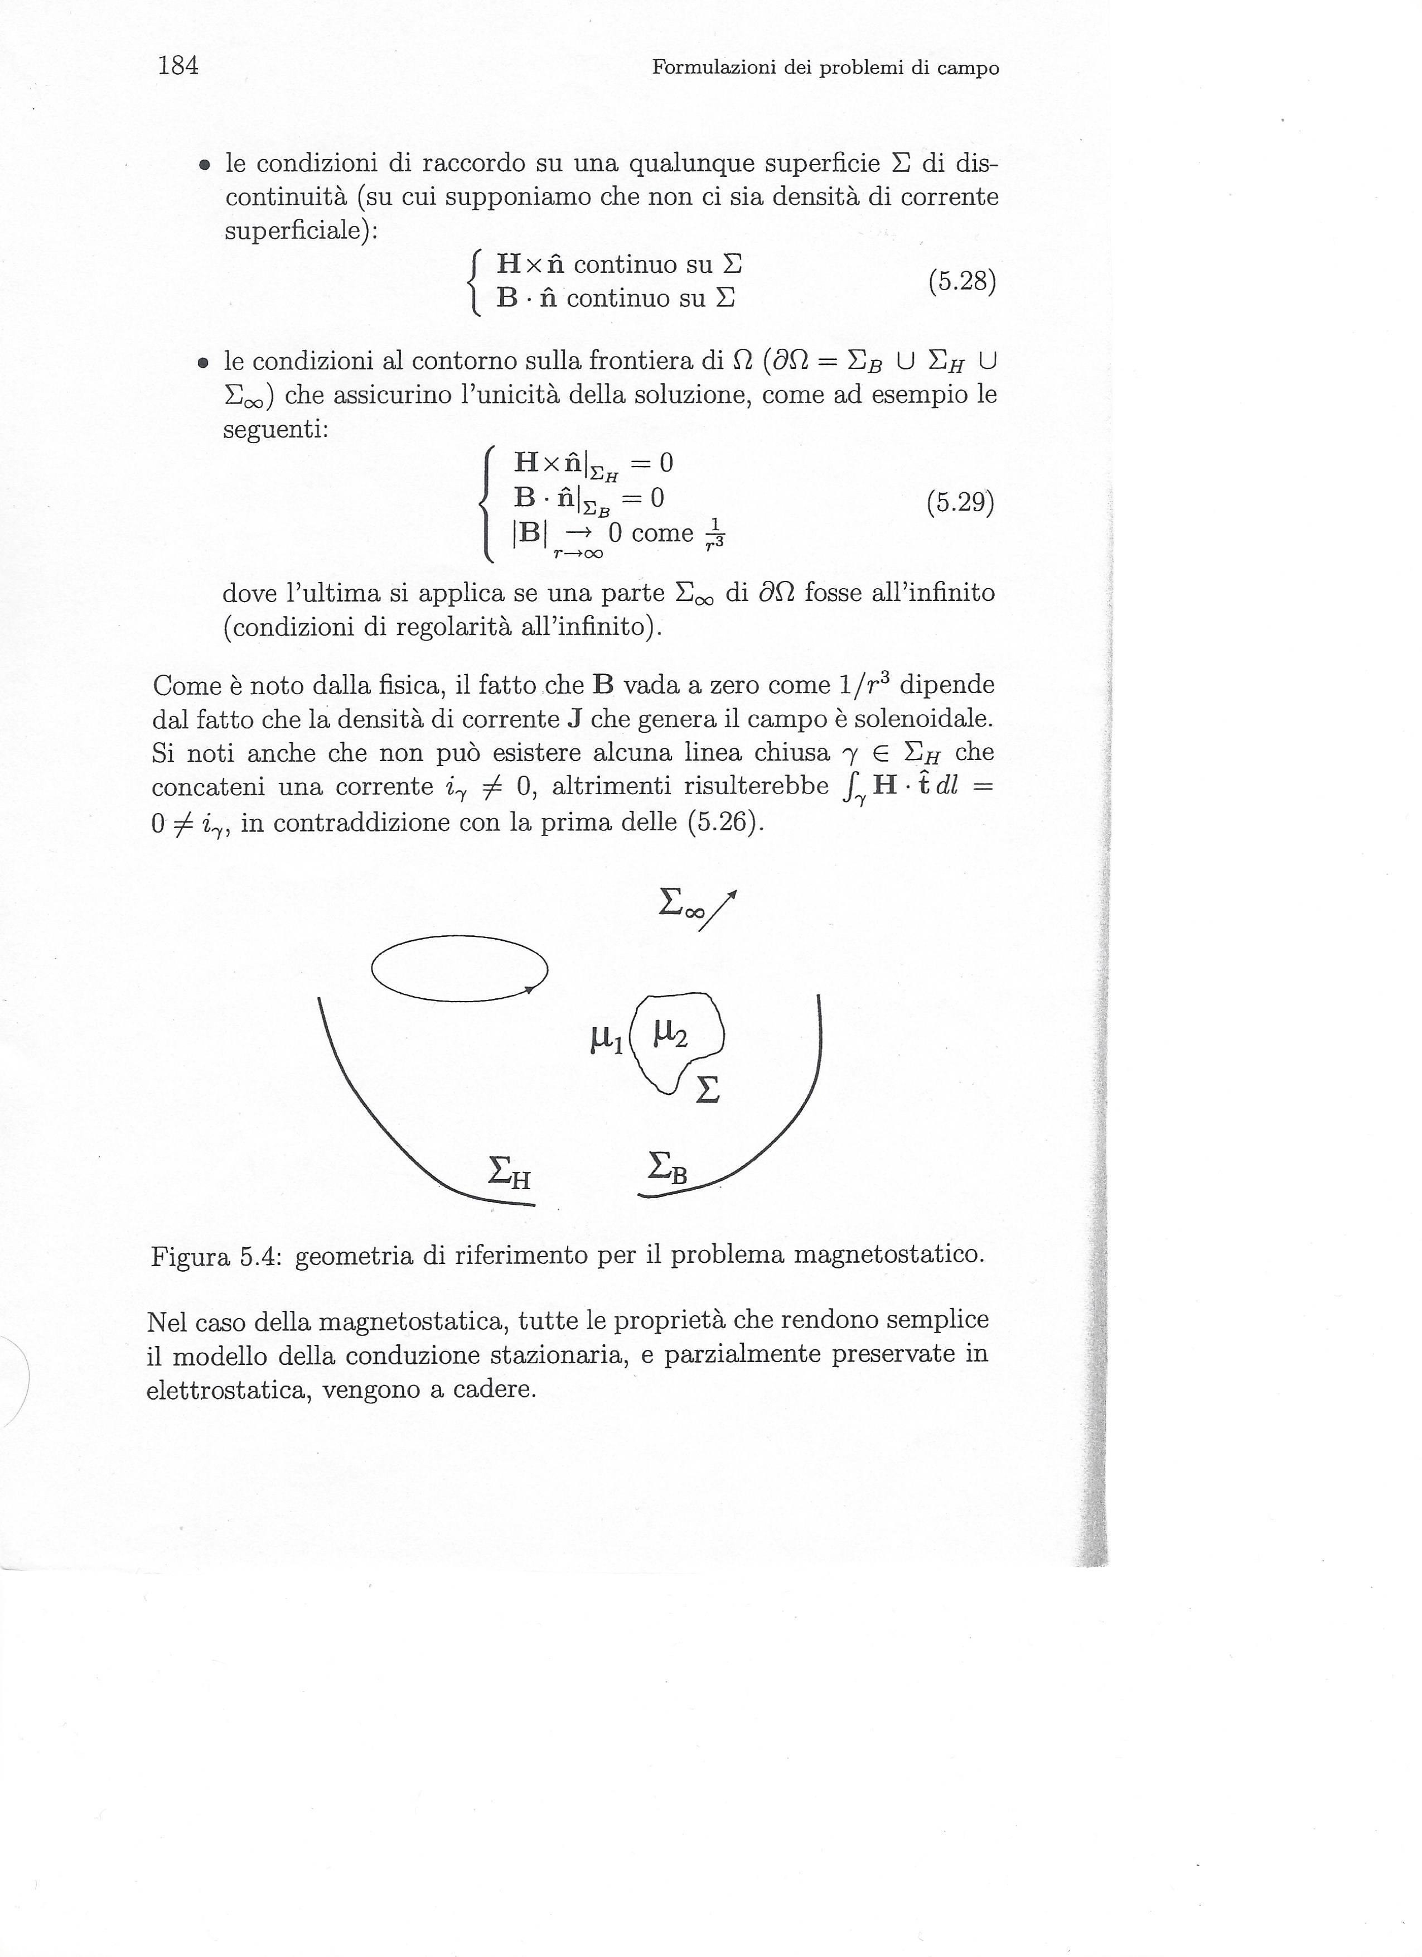
Figure 2.1 Reference geometry of the magneto-static problem

The model must be closed with the following relations:
    - A constitutive relation (supposed linear):
 | $$B=μH$$ | (2.18)
where μ is the magnetic permeability
    - The conditions of connection on any surface Σ of discontinuity (on which it is assumed that there is no density of superficial current):
 | $$\left\{\begin{aligned}H×\hat{n} continuous on Σ \\ B∙\hat{n} continuous on Σ\end{aligned}\right.$$ | (2.19)
    - The boundary conditions on the border of Ω ($∂Ω=Σ_{B}∪Σ_{H}∪Σ_{∞}$) that ensure the solution unity, as for example the followings equations:
 | $$\left\{\begin{aligned}H×\hat{n}|_{Σ_{H}}=0 \\ B∙\hat{n}|_{Σ_{B}}=0 \\ \left|B\right|\overset{→}{r→∞}0 fall off as \frac{1}{r^{3}}\end{aligned}\right.$$ | (2.20)
where the last equation is applied if one part $Σ_{∞}$ of $∂Ω$ were to infinity (regularity conditions to infinity).
As is known from physics, the fact that B goes to zero like 1/r³ depends on the fact that the current density J which generates the field is solenoidal. Note that there cannot be any closed line γ$ϵ Σ_{H}$ that concatenates a current $i_{γ}≠0$, otherwise it would appear $\int_{γ}{H∙\hat{t}} dl=0≠i_{γ}$, in contradiction with the first of the (2.20).
In the case of magneto-statics, all the properties that make the model of stationary conduction simple, and partially preserved in electrostatics, come to fall.
    - The vast majority of magnetic materials of applicative interest are strongly non-linear. Indeed, they even exhibit a hysterical behavior. Therefore, the constitutive relationship (2.18) is to be understood as a drastic simplification that is adopted, when possible, in order not to make the problem excessively difficult.
    - In general case, it is not possible to introduce scalar potential. This possibility is valid only with many precautions and clarifications necessary for this purpose. This makes the intrinsically vector magneto-static problem, and therefore, in general, much more expensive to solve, as point by point there's the need to find three scalar quantities (such as three components of a vector), rather than one.
    - There is no material that allows to approximate well the boundary conditions expressed by the first two of the (2.20), unless one is satisfied with the simplifications introduced by adopting the model of magnetic circuits. In fact, the vacuum has non-zero permeability $μ_{0}$, and all materials have a relative permeability $μ_{r}=\frac{μ}{μ_{0}}$ that goes from just under 1 to a few tens of thousands. Therefore, in general the problem should be solved on unlimited domains.
These peculiarities make the magnetostatic model the most difficult of static problems, although it is the fundamental importance in the applications. This observation makes it indispensable to thoroughly investigate the different possibilities of formulation of the model, in order to be able to judge the most convenient for each specific situation.

2.2.2 General formulation of magneto-quasi-static problems
Let us consider the generic problem shown in Figure 2.2. The differential formulation of the MQS model is given by:
 | $$\left\{\begin{aligned}∇×E=-\frac{∂B}{∂t} \\ ∇×H=J\end{aligned}\right. in V$$ | (2.21)
wherein the current density J is unknown in the conducting part (both Vc) of the resolution domain, while it is assigned (equal Jg) in the remaining part ("air" V - Vc) (Figure 2.2).
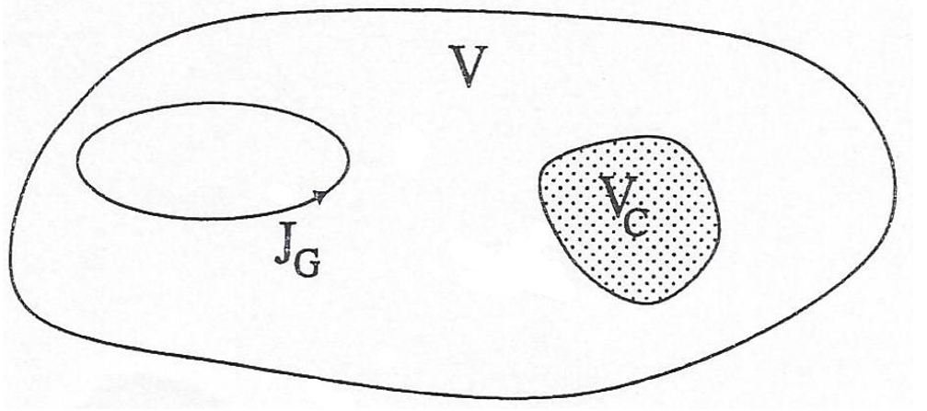
Figure 2.2 Reference’s geometry for the magneto quasi-static problem.
The problem is closed by adding:
    - the initial conditions that guarantee ∇∙B=0
    - the conditions of connection on any Σ surface of discontinuity:
 | $$\left\{\begin{aligned}E×\hat{n}, H×\hat{n} continouous on Σ \\ J∙\hat{n}, B∙\hat{n} continouous on Σ\end{aligned}\right.$$ | (2.22)
    - the boundary conditions on border of V that assures the unity of solutions, whose particularization depends on the formulation chosen each time.
The observation that in V - Vc the current density is assigned, makes the following subdivision of equations natural:
 | $\left\{\begin{aligned}∇×E=-\frac{∂B}{∂t} \\ ∇×H=J \end{aligned}\right.$ in V_{c} | (2.23)
 | $\left\{\begin{aligned}∇×H=J_{g} \\ ∇∙B=0 \end{aligned}\right.$ in V - V_{c} | (2.24)
From this way of writing the equations, it immediately transpires that the magneto quasi-static model consists in the coupling of an almost static model in the conducting region and of a static model (the one for the magneto-static) in the non-conducting area. From this observation they immediately get some food for thought.
    - MQS problem is much more difficult to solve than the other static problems, and also than the electro-quasi-static problem. The number of possible different formulations is also very high, each with its own pros and cons (see later).
    - From the mathematical numerical point of view, the greatest difficulty posed in the MQS equations consists in the tiling of a static ("elliptic") and a diffusive ("parabolic") mathematical problem, which inter alia connected with suitable conditions of the type (2.21) on the separation surface between the conductive part and the non-conductive part.
    - The Magneto-quasi-static model has as a limit case the magneto-static one when the current induced in the conducting part is canceled, i.e. when the temporal derivatives are void. In particular, a current Jg that varies over time is used to induce currents.
    - The system of equations (2.22) - (2.24) makes it possible to find H (and therefore B) in the whole domain V, from which it is possible, by means (2.23), to obtain J in Vc and therefore E in Vc through the constitutive relation. In V - Vc the current density is assigned, therefore known, while E is not. Consequently, the magneto-quasi-static model does not require (or does not allow) the direct calculation of the electric field outside the conductor. This information can be retrieved a-posteriori, adding Gauss equation to the model. In fact, once you find B, you just have to solve, assuming nothing about the density of free charge, the equations:
 | $\left\{\begin{aligned}∇×E=-\frac{∂B}{∂t} \\ ∇∙(εE)=0 \end{aligned}\right.$ in V - V_{c} | (2.25)
The tangential component of E on Σc is known, cause is known the electric field in Vc.
As a consequence of the aforementioned point, there is generally a discontinuity of the normal component of the electric field on the conductor surface, and therefore an accumulation of surface charge. This happens though the results $J∙\hat{n}=0$ on Σc, since the current density is zero in V - Vc and the normal component is continuous. This apparently paradoxical fact is a consequence of the fact that the suppression of the term of displacement current has rendered the preservation of the charge no longer true.
There are many possible formulations of the MQS problem, belonging to two categories: magnetic formulations (that is, in terms of magnitudes related to the magnetic field) and electrical ones (that is, in terms of quantities related to the electric field). In both cases, it is possible to give formulations in terms of field (by using directly the fields), of potentials (by additional variables introduced ad hoc) and mixed. Furthermore, while in magneto-static it has been possible to derive some formulations in which the unknown is scalar, in the MQS case this possibility is compromised by the fact that unknown currents are present, in addition to those assigned.

2.2.3 Formulations through electromagnetic potentials
The electromagnetic field variables H and E can be solved directly, but it is often found to be advantageous to use potentials describing the field. If H or potentials describing H are used as unknowns, the formulations are called magnetic formulations. The magnetic field intensity H is expressed by means of the electric vector potential T, the reduced magnetic scalar potential Y or the total magnetic scalar potential Ω. Conversely, the electric field intensity E or potentials expressing E are used as unknowns in electric formulations. The magnetic vector potential A and the electric scalar potential V are often used to define E. The potentials can be modified and used either separately or together in different regions in order to find a suitable formulation. Various authors use various notations for the potentials and the formulations.
In the quasi-static approximation, the divergence of the eddy-current density vanishes, $∇∙J=0$, which implies the existence of the electric vector potential T defined by:
 | $$∇×T= J$$ | (2.26)
The magnetic field intensity can be partitioned into two terms
 | $$H=T_{0}+H_{m}$$ | (2.27)
where T₀ is a magnetic field whose curl is the source current density J_{c}, i.e.,
 | $$∇×T_{0}={ J}_{c}$$ | (2.28)
The vector field T₀ is referred to as the source field in this work. The most straightforward choice for T₀ is H_{s}, the magnetic field due to the source current density in free space. The magnetic field H_{m} is the remaining part of the magnetic field H.
In the conducting region, no source currents are present and the magnetic field T₀ is irrotational. Thus, the comparison of the second equation in (2.23) and the equation (2.28) gives for the magnetic field intensity
 | $$H=T_{0}+T-∇ψ$$ | (2.29)
where Ψ is the reduced magnetic scalar potential. In the non-conducting region, the induced field H_{m} is irrotational and the magnetic field intensity is given by
 | $$H=T_{0}-∇ψ$$ | (2.30)
This combination of the potentials is denoted by the T−Ψ ,Ψ formulation. The magnetic field intensity in the conducting region may also be given by
 | $$H=T-∇Ω$$ | (2.31)
where Ω is the total magnetic scalar potential. Then, the magnetic field intensity in the non-conducting region is expressed as
 | $$H=-∇Ω$$ | (2.32)
This combination of the potentials is denoted as the T−Ω,Ω formulation.
At the interface of two materials with different permeabilities, the normal component of the magnetic field intensity is discontinuous. In the T−Ψ ,Ψ or the T−Ω,Ω formulations where T is approximated by nodal basis functions, this discontinuity is included in the magnetic scalar potential, or more precisely, in the jump of the normal derivative of the magnetic scalar potential at the interface.
This ensures that the normal component of T can be continuous over the interface. On the other hand, in the T−Ψ ,Ψ or the T−Ω,Ω formulations where T is approximated by edge basis functions, the discontinuity of the normal component of the magnetic field intensity can be included in the jump of the normal component of T at the interface. This is true since the edge elements allow the normal component of a vector function to jump across the interface of two materials with different permeabilities.
The divergence of the magnetic flux density vanishes, $∇∙B= 0$, and the magnetic vector potential A may be defined as
 | $$∇×A= B$$ | (2.33)
In the conducting region, the electric and the magnetic field depend on each other, and the first Eq. of (2.26) must also be considered. So, the first equation of (2.23) together with Eq. (2.33) give for the electric field intensity
 | $$E=-\frac{∂A}{∂t}-∇V$$ | (2.34)
where V is the reduced electric scalar potential. If A is defined in the whole region, the formulation is called the A - V, A formulation. On the other hand, if Ψ, instead of A, is defined in the non-conducting region, the formulation is denoted by the A - V,Ψ formulation. The magnetic vector potential can also be defined so that the electric field intensity is described by the magnetic vector potential alone. The modified magnetic vector potential is, thus, defined as
 | $$\overline{A}=A+\int_{0}^{t}{∇V}dt$$ | (2.35)
At the interface of two materials with different conductivities, the normal component of the electric field intensity is discontinuous. In the A - V,Ψ formulation where A is approximated by nodal basis functions, this discontinuity is included in the electric scalar potential V, or more precisely, in the jump of the normal derivative of V at the interface. This ensures that the normal component of A can be continuous over the interface. On the other hand, in the A - V,Ψ formulation where A is approximated by edge basis functions, the discontinuity of the normal component of the electric field intensity can be included in the jump of the normal component of A at the interface. If the conductivity is homogeneous, the normal component of A can also be continuous without the use of V, and the electric scalar potential can be eliminated. This idea has first been applied to the $\overline{A}$,Ψ formulation which is obtained by using A’. Another way of eliminating V is to set V equal to zero resulting in the A - V,Ψ formulation.

2.3 A magneto-static problem: analysis of the ferromagnetic effect

An integral formulation of the MQS is studied here, for the purpose of solving the problem of ferromagnetic effect in structures where magnetic materials are present. This model will be used in Chapter 3 to analyze the ferromagnetic forces acting on the divertors of DEMO machine.
Let us assume a refernce problem where the conductor region is denoted as V_{C} and the magnetic materials (even non-linear) are located in a domain $V_{M}$.
The mathematical model may be cast in integral form by introducing a vector potential, A, and a scalar one, ϕ, to define the electrical field, E, and the magnetic one, B, as follows:
 | $E=-∇ϕ, ∇×A=B,$ | (2.36)
In this way, Faraday’s law is implicitly imposed. The vector potential is calculated from the current density, J, flowing inside the conductors’ region, V_{C}, and from the density, J_{S}, of the currents located outside that region, as follows:
 | $A(r,t)=\frac{μ_{0}}{4π}\int_{V_{C}}{\frac{J(r^{'},t)}{\left|r-r^{'}\right|}dV^{'}+A_{s}(r,t)},$ | (2.37)
 | $A_{s}(r,t)=\frac{μ_{0}}{4π}\int_{R^{3}-V_{C}}{\frac{J(r^{'},t)}{\left|r-r^{'}\right|}dV^{'})},$ | (2.38)

The integral formulation of the problem comes from the following non-linear magneto-static volume integral equation (in weak form):
 | $$\int_{V_{M}}{W_{M}∙\left[G^{-1}\left(M\right)-B\left[M\right]-B_{s}\right]dV=0, ∀W_{M}∈L^{2}\left(V_{M}\right),}$$ | (2.39)
where $M=G(B)$ is the constitutive equation of the magnetic material in the $V_{M}$ domain, and $B_{s}$ is the vector potential given by the external sources, and the operator $B$ is the magnetic flux density for assigned magnetization $M$ as defined through the Biot-Savart law. The magnetization $M$ is in turns expressed as the linear combination of piecewise constant functions P_{j.}
$$M\left(r,t\right)= \sum_{j}{M_{j}\left(t\right)P_{j}(r)}in V_{M}$$ | (2.40)
The solution can be accomplished by means of a Picard-Banach iteration, and it is convenient formulate the magnetization in the following form:
 | $$M=\left(B/{µ_{0}}-H\right)p$$ | (2.41)
where H=v(B)B is the magnetic field, v(B) is the non-linear isotropic magnetic reluctivity of the magnetic material, and p is the ferromagnetic/no-ferromagnetic volume ratio.

2.4. A magneto-quasi-static problem: the eddy current problem

A typical structure of an eddy-current problem with conducting and nonconducting regions is shown in Figure 2.3. The boundaries of the conducting region Ω₁ and the non-conducting region Ω₂ are denoted by Γ₁ and Γ₂, respectively.
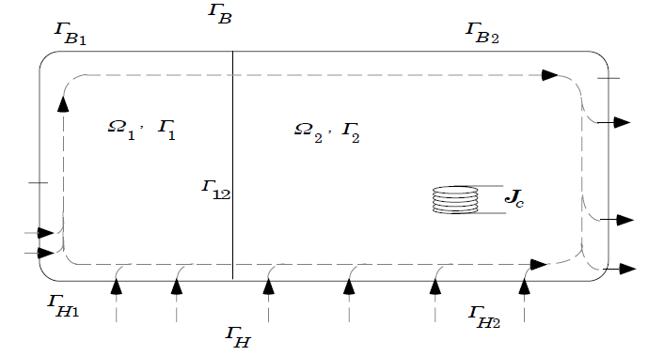
Figure 2.3 Typical structure of an eddy-current problem with conducting and non-conducting regions.

The interface between these two regions is denoted by Γ₁₂ and is a part of Γ₁ and Γ₂. Coils carrying known source current densities J_{c} are included in the non-conducting region Ω₂. The arrows illustrate the flow of a magnetic field. These arrows are used to distinguish between the two parts Γ_{H} and Γ_{B} of the outer boundary where different conditions apply. Those parts of Γ₁ and Γ₂ which belong to Γ_{H} are denoted by Γ_{H1} and Γ_{H2}, respectively. Similarly, those parts of Γ₁ and Γ₂ which belong to Γ_{B} are denoted by Γ_{B1} and Γ_{B2}, respectively. At the interface Γ₁₂, Maxwell’s equations imply continuity conditions on the normal component of the magnetic flux density and on the tangential component of the magnetic field intensity,
 | $$B_{1}∙n_{1}+B_{2}∙n_{2}=0, H_{1}×n_{1}+H_{2}×n_{2}=0$$ | (2.42)
where n₁ and n₂ are the unit normal vectors directed outward from the conducting and the non-conducting regions, respectively.
On the outer boundary, three conditions are imposed: the tangential component of the magnetic field intensity is zero on Γ_{H,} the normal component of the magnetic flux density is zero on Γ_{B,} and the normal component of the current density is zero on Γ₁
 | $H×n=0$, $B∙n=0, J∙n_{1}=0$ | (2.43)
where n is the unit normal vector directed outward from the region in question. The boundary and interface conditions are assumed to be homogeneous for the sake of simplicity.
The electromagnetic field problems are described by various field formulations. The variable to be solved may be the field intensity vector, a vector potential, a scalar potential, or a combination of these. A field formulation is defined by the choice of the unknown variables and the application of constitutive equations, as well as quasi-static Maxwell’s equations supplemented by appropriate boundary conditions and additional constraints. The finite element method is used to solve the system of equations obtained, and the finite elements used are the first-order nodal elements and the low-order edge elements.

2.4.1 Overview of the eddy-current problem formulations
The formulations used for solving eddy-current problems are usually based either on the electric vector potential T, such as the T−Ψ ,Ψ and the T−Ω,Ω formulations, or on the magnetic vector potential A, such as the A - V, A, the A - V,Ψ and the A,Ψ formulations (Villone, 2003).
A comparison of various formulations concerning the degrees of freedom (DOF) can be seen in Table 2.1. The scalar potentials are approximated by nodal basis functions, whereas the vector potentials are approximated either by nodal basis functions or by edge basis functions.

Table 2.1 Comparison of various formulations in terms of degrees of freedom.
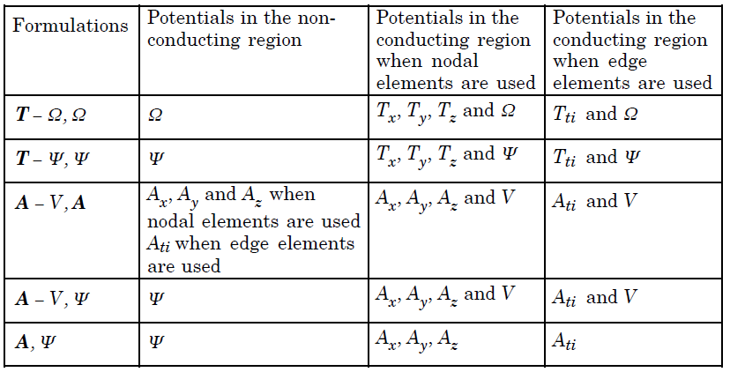
The use of the magnetic vector potential approximated by nodal basis functions in the non-conducting region requires three components of A to be solved. Furthermore, the use of A in the non-conducting region necessitates the inclusion of the coils in the discretization, which increases the number of unknowns and complicates the construction of the finite element mesh, especially in the presence of coils of geometrically complex shapes. The use of the reduced magnetic scalar potential in the non-conducting region reduces the number of degrees of freedom from three components for A to one component for Ψ, when A is approximated by nodal basis functions. Consequently, computational costs are reduced.
In addition, Ψ allows us to exclude the current sources in the non-conducting region from the discretization by evaluating the vector field T₀, defined by Eq. (2.28). This is an important advantage of reducing the number of unknowns. In the non-conducting region where Ψ is defined, the rotational part of the magnetic field produced by the given source current distribution in free space is modelled by the field H_{s}. If H_{s} is approximated by nodal basis functions, then cancellation problems can occur in high-permeability regions. In such regions, the magnetic field intensity H is close to zero. The approximated field H_{s} contains polynomial terms not present in the solution space of − ∇Ψ, since − ∇Ψ and H_{s} lie in different approximation spaces. Consequently, − ∇Ψ cannot cancel the approximated field H_{s} as it should have done, and − ∇Ψ and the approximated field H_{s} are nearly equal in magnitude and opposite in direction. The cancellation problems can be avoided by using a total scalar potential in high permeability regions, by approximating H_{s} by means of the edge basis functions or by an edge element representation of T₀, which is usually carried out by using Ampere’s law. The use of the total magnetic scalar potential in the non-conducting region comprising the current sources also necessitates the inclusion of these sources in the discretization. Nakata et al. have enforced a constant and uniformly distributed current density by assuming that a low-conducting material is placed between the coil sides. Since the current density is equal to the curl of the vector potential, Eq. (2.26), T is distributed uniformly in the low-conducting material and linearly in the current sources. The T−Ω,Ω formulation is effective when the shape of the current sources is simple. For current sources of complicated shapes, this procedure may become cumbersome. The electric vector potential formulations show a distinct advantage when solving the field in laminated regions. Since the eddy currents induced in laminated regions flow only in a plane parallel to the laminations, the components of T that are tangential to the laminations may be omitted according to Eq. (2.26), thus, reducing the number of degrees of freedom.
The T−Ω,Ω and the T−Ψ ,Ψ formulations are the chosen electric vector potential formulations in this work. These formulations are based on T and either Ω or Ψ in the conducting region and only Ω or Ψ in the non-conducting region. The scalar potentials Ω and Ψ are approximated by nodal basis functions, whereas the vector potential T is approximated either by nodal basis functions or by edge basis functions.
For the sake of brevity, the following sub-sections present the T−Ψ ,Ψ formulation when T is approximated by nodal basis functions and edge basis functions, respectively.
The A - V,Ψ and the A,Ψ formulations are the chosen magnetic vector potential formulations in this work. These formulations are based on A and V (V is eliminated in the A,Ψ formulation) in the conducting region and only Ψ in the non-conducting region. The scalar potentials V and Ψ are approximated by nodal basis functions, whereas the vector potential A is approximated either by nodal basis functions or by edge basis functions.

T−Ψ ,Ψ Formulation Using Nodal Basis Functions for Approximating T
In the T−Ψ ,Ψ formulation, T is defined by Eq. (2.26) whereas Ψ is defined by Eq. (2.26) in the conducting region and by Eq. (2.29) in the non-conducting region. In the conducting region, the first Equation of (2.23) remains to be solved. Substituting the third Eq. (2.2) and (2.26) in the first Eq. of (2.23) and considering the constitutive equation (2.18) and the relationship (2.27) give
$$∇×\left(\frac{1}{σ}∇×T\right)+μ\left(\frac{∂T_{0}}{∂t}+\frac{∂T}{∂t}-∇\frac{∂ψ}{∂t}\right)=0$$ | (2.44)

By taking the divergence on both sides of Eq. (2.44), the solenoidality of the magnetic flux density $∇∙B= 0$ is satisfied. The vector potential T is approximated by nodal basis functions. In order to ensure the uniqueness of T, a divergence condition is applied. This is done by adding a penalty term to the original equation (2.44). Equation (2.44) is, thus, replaced by
$$∇×\left(\frac{1}{σ}∇×T\right)-∇×\left(\frac{1}{σ}∇∙T\right)+μ\left(\frac{∂T_{0}}{∂t}+\frac{∂T}{∂t}-∇\frac{∂ψ}{∂t}\right)=0$$ | (2.45)
where the second term is the penalty term. By taking the divergence on both sides of Eq. (2.45), the solenoidality of the magnetic flux density ($∇∙B= 0$) is not satisfied due to the penalty term. Thus, the solenoidality of the flux density
 | $$∇∙μ\left(T_{0}+T-∇ψ\right)=0$$ | (2.46)
and the boundary condition (2.30) on Γ_{B1}
 | $$n_{1}∙μ\left(T_{0}+T-∇ψ\right)=0$$ | (2.47)
are required. On Γ_{B1}, Eq. (2.47) is improved by applying a homogeneous Dirichlet condition to the normal component of the electric vector potential. If the Coulomb gauge is satisfied in the whole region, then Eqs. (2.44) and (2.45) are equivalent and the inclusion of the additional term in Eq. (2.45) is justified. The satisfaction of the Coulomb gauge in the whole region is done by fulfilling the homogeneous Dirichlet boundary condition on Γ₁
 | $$\frac{1}{σ}∇∙T=0$$ | (2.48)
Equations (2.31), (2.37) give the boundary condition for Ψ on Γ_{H1}
 | $$n_{1}×\left(T_{0}-∇ψ\right)=0$$ | (2.49)
Equation (2.49) can be integrated to give the value of the reduced magnetic scalar potential in an arbitrary point on the surface Γ_{H1}
 | $$ψ=ψ_{0}+\int_{p1}^{p2}{T_{0}∙dl}$$ | (2.50)
which is an inhomogeneous Dirichlet boundary condition with p2 as the considered point on Γ_{H1} where Ψ is to be determined, and p1 as the reference point on Γ_{H1} where Ψ =Ψ₀ . In the non-conducting region, Eqs. (2.12), (2.13) and (2.48) give
 | $$∇∙μ\left(T_{0}-∇ψ\right)=0$$ | (2.51)
Equations (2.13), (2.19) and (2.31) give the boundary condition for Ψ on Γ_{B2}
 | $$n_{2}∙μ\left(T_{0}-∇ψ\right)=0$$ | (2.52)
Equations (2.18) and (2.31) give the boundary condition for Ψ on Γ_{H2}
 | $$n_{2}×\left(T_{0}-∇ψ\right)=0$$ | (2.53)
Eq. (2.52) can be integrated to give the value of the reduced magnetic scalar potential on Γ_{H2}. This integration is obtained by Eq. (2.50). The interface conditions (2.16) and (2.17) have to be satisfied on Γ₁₂. Substituting Eqs. (2.13), (2.27) and (2.30) into Eqs. (2.16) and (2.17) gives
$n_{1}∙μ_{1}\left(T_{0}+T-∇ψ\right)+n_{2}∙μ_{2}\left(T_{0}-∇ψ\right)=0$ |  |  | (2.54)
$n_{1}×\left(T_{0}+T-∇ψ\right)+n_{2}×\left(T_{0}-∇ψ\right)=0$ |  | (2.55)
In the discretization of the equations by the finite element method, Eq. (2.42) is satisfied implicitly. The continuity of the reduced magnetic scalar potential across Γ₁₂ ensure that Eq. (2.43) is satisfied. The differential equations (2.27), (2.28), (2.34), the interface condition (2.44) and the boundary conditions (2.32) on Γ_{H1} and Γ_{H2} , (2.24), (2.29), (2.30), (2.34) are the equations applied in the T −Ψ ,Ψ formulation. A laminated region implies that the permeability and the conductivity in this region are dependent on the direction of the field. Hence, a laminated region is anisotropic. In laminated regions, the electric anisotropy is treated by fulfilling
 | $$T_{t1}=T_{t2}=0$$ | (2.56)
where Tt1 and Tt2 are the components of T tangential to the laminated sheets. The conductivity in the tangential directions is then assumed to be a scalar.
In laminated regions, the permeability must be represented by a tensor in order to take into account magnetic anisotropy. For instance, by assuming the laminations to be in the xy or yz or xz-plane, the permeability tensor can be written as
 | $$μ=\left[\begin{matrix}μ_{x} & 0 & 0 \\ 0 & μ_{y} & 0 \\ 0 & 0 & μ_{z}\end{matrix}\right]$$ | (2.57)
where μ_{x}, μ_{y} and μ_{z} are the permeability components in the x, y and z directions.

T −Ψ ,Ψ Formulation Using Edge Basis Functions for Approximating T
When the T −Ψ ,Ψ formulation is used and the vector potential T is approximated by edge basis functions, Eq. (2.26) must be solved in the conducting region. In order to ensure the uniqueness of T, the tree-gauge method is applied. The boundary condition (2.24) is satisfied by eliminating the degrees of freedom associated with the edges of the tree and the co-tree on Γ₁. Therefore, it is essential that all the co-tree edges of Γ₁ are closed by the tree edges also lying on Γ₁. In addition, the boundary conditions (2.30) and (2.32) are required. The second term in the right-hand side of Eq. (2.32) is integrated along the edges of the finite element mesh. In the non-conducting region, the differential equation and the boundary conditions applied are the same as those presented in Section above, since the scalar potential Ψ is approximated by nodal basis functions. In laminated regions, the electric anisotropy is treated by fulfilling Eq. (2.46).
When edge elements are used, the line integrals of T along the edges are the degrees of freedom. Consequently, by using hexahedral elements where all the edges are orthogonal to each other, Eq. (2.46) is fulfilled by treating the edges lying in the plane of the laminated sheets as tree edges. On the other hand, by using tetrahedral elements or hexahedral elements where the edges are not orthogonal to each other, the anisotropic conductivity cannot be treated. This is because the conductivity in these cases has to be explicitly set to zero in the direction normal to the laminated sheets, which is impossible because the normal component of the magnetic flux is zero on Γ_{B} . Magnetic anisotropy is considered by representing the permeability by the diagonal tensor (2.57).

A - V,Ψ Formulation Using Nodal Basis Functions for Approximating A

In the A − V,Ψ formulation, A and V are defined by Eqs. $B∙n=0$ and $J∙n_{1}=0$, respectively. In the conducting region, the Eq. (2.18) remains to be solved. Considering the constitutive equations (2.20) and (2.21) and substituting Eqs. (2.19) and (2.20) into Eq. (2.18) yield
$∇×\left(\frac{1}{μ}∇×A\right)+σ\frac{∂A}{∂t}+σ∇V=0$ | (2.58)
By taking the divergence on both sides of Eq. (2.55), the solenoidality of the current density (2.6) is satisfied. The vector potential A is approximated by nodal basis functions. In order to ensure the uniqueness of A, a divergence condition is applied. This is done by adding a penalty term to the original equation (2.57). Equation (2.57) is, thus, replaced by
$$∇×\left(\frac{1}{μ}∇×A\right)-∇×\left(\frac{1}{μ}∇∙A\right)+σ\frac{∂A}{∂t}+σ∇V=0$$ | (2.59)
where the second term is the penalty term. By taking the divergence on both sides of Eq. (2.58), the solenoidality of the current density (2.6) is not satisfied due to the penalty term. Thus, the solenoidality of the current density
 | $$∇∙\left(-σ\frac{∂A}{∂t}-σ∇V\right)=0$$ | (2.60)
and the boundary condition $J∙n_{1}=0$ on Γ₁
 | $$n_{1}∙\left(-σ\frac{∂A}{∂t}-σ∇V\right)=0$$ | (2.61)

are required. Similar to the T −Ψ ,Ψ formulation, the homogeneous Dirichlet boundary condition on Γ_{B1}

 | $$\frac{1}{μ}∇∙A=0$$ | (2.62)

has to be fulfilled in order to satisfy the Coulomb gauge in the whole region. The interface conditions (2.42) have to be satisfied on Γ₁₂. Substituting Eqs. (2.2), (2.30) and (2.33) into Eqs. (2.42) gives
$n_{1}∙\left(∇×A\right)+n_{2}∙μ_{2}(T_{0}-∇ψ)=0$ | (2.63)
$n_{1}∙\frac{1}{μ_{1}}\left(∇×A\right)+n_{2}×(T_{0}-∇ψ)=0$ | (2.64)
In the discretization of the equations by the finite element method, Eqs. (2.62) and (2.63) are satisfied implicitly. The differential equations (2.50), (2.58), (2.59), the interface conditions (2.61), (2.62) and the boundary conditions (2.49) on Γ_{H2} , (2.37), (2.38), (2.39), (2.51), (2.60), (2.61) are the equations applied in the A − V,Ψ formulation.

A − V,Ψ Formulation Using Edge Basis Functions for Approximating A
When the A − V,Ψ formulation is used and the vector potential A is approximated by edge basis functions, Eq. (2.57) must be solved in the conducting region. The boundary condition (2.37) is satisfied by eliminating the degrees of freedom associated with the edges of the tree and the co-tree on Γ_{B1}. Therefore, it is essential that all the co-tree edges of Γ_{B1} are closed by the tree edges also lying on Γ_{B1}. In addition, the boundary conditions (2.38) and (2.60) are required. The interface conditions (2.62) and (2.63) are also valid here, and are satisfied in accordance with the discussion presented in Section 3.6.1. In laminated regions, the electric anisotropy is represented by the diagonal tensor (2.64).

A ,Ψ Formulation
When the A ,Ψ formulation is used and the vector potential A is approximated by nodal basis functions, the differential equation

$∇×\left(\frac{1}{μ}∇×A\right)-∇×\left(\frac{1}{μ}∇∙A\right)+σ\frac{∂A}{∂t}+σ∇V=0$ | (2.65)
must be solved in the conducting region. In addition, the differential equation (2.48) in the non-conducting region, the interface conditions (2.62), (2.63), as well as the boundary conditions (2.49) on Γ_{H2}, (2.29), (2.30), (2.31), (2.51), (2.60), (2.61) are the equations applied in the A ,Ψ formulation. On the other hand, if the vector potential A is approximated by edge basis functions, the differential equation

$$∇×\left(\frac{1}{μ}∇×A\right)+σ\frac{∂A}{∂t}=0$$ |  | (2.66)
must be solved in the conducting region. In laminated regions, the electric anisotropy is represented by the diagonal tensor (2.63).

2.5 Formulation of multi-physics problems

The models presented in the previous sections are describing problems where only the electromagnetic interactions are taken into account, hence problems described by Maxwell's equations only. However, the two applications analyzed in this Thesis involve also fluidodynamics (to describe the motion of the plasma inside the tokamak) and mechanics (to describe the motion of the coils in the wireless power transfer systems)
In the following, we briefly describe the formulations of these two multi-physics problems.

2.5.1 A multi-physics model for the electromagnetic analysis of a tokamak
As pointed out, in a nuclear fusion machine the electromagnetic behavior is strictly related to the plasma behavior, and thus the problem to be studied is of a more complex nature. In particular, the fluidodynamics behavior of the plasma in a tokamak machine must be modelled, and the most popular way to do it is to the use of the so-called Magneto-Hydro-Dynamic model (which, for simplicity, from this point on will be named by the acronym MHD) (Freidberg, 1987). This model considers the fact that a fluid in the plasma stage responds to various stresses of different nature. In fact, what happens to a conductive fluid in motion, such as a plasma in a Tokamak, is that if subjected to a magnetic field of suitable intensity it can be polarized by it (with the consequent induction of eddy currents inside it) and therefore change in turn the external magnetic field. Thanks to this logic (used by the Tokamak to avoid breakage due to the fact that the plasma at hundreds of millions of Celsius damages the internal walls of the machine) "magnetic confinement" is obtained. The model is expressed by the equation system (2.67) and physically represents these effects through a recombination of the Navier-Stokes equations (coming from the field of fluid dynamics) and the Maxwell equations of electromagnetism. More specifically, this model is derived from the hypothesis that an electrically conductive fluid is being treated (respecting the condition of quasi-neutrality, i.e. that property such that the positive charges inside the plasma are perfectly balanced with the negative ones).
(a)  (b)  (c)  (d)  (e) | $$\left\{\begin{aligned}ρ\frac{∂V}{∂t}+ρV∙∇V=-∇P+J×B \\ \frac{∂B}{∂t}=-∇×E \\ E+V×B=ηJ \\ ∇×B=μ_{0}J \\ \frac{∂P}{∂t}+V∙∇P+ΓP∇∙V=0\end{aligned}\right.$$ | (2.67)
Here: 2.67a is the momentum equation, 2.67b is Faraday's law, 2.67c is the generalized Ohm's law, 2.67d is Ampere's law and 2.67e is the energy equation. And, again, B is the magnetic flux density, E is the electric field, $Γ$is the heat ratio specific, $η$ is the resistivity of the plasma, P is the pressure, V is the velocity related to the plasma and $μ_{0}$ is the magnetic permeability in vacuum.
From the model represented in (2.67), it is possible to obtain a static model if we consider the condition where $τ_{A}≪τ_{ω}$ (i.e. when the Alfvén time $τ_{A}$ is much less than the decay time of the eddy currents). Under this assumption it is possible to linearize the complete MHD model arriving at:
(a)  (b)  (c)  (d)  (e) | $$\left\{\begin{aligned}0≅-∇p+j×B+J×b \\ ∇∙b=0 \\ b=∇×(ξ×B) \\ ∇×b=μ_{0}j \\ p=-ξ∙∇P-ΓP∇∙ξ\end{aligned}\right.$$ | (2.68)
with $ξ$ representing the plasma displacement.
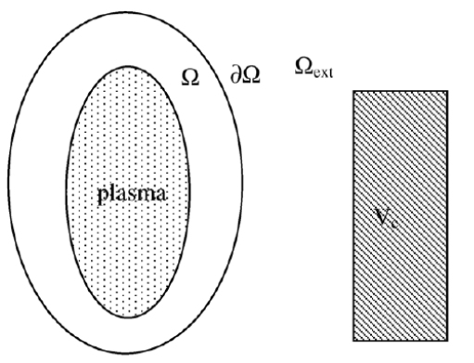
Figure 2.4 Reference geometry considering the Plasma domain and the conductor domain (coupled through the ∂Ω surface)

In this Thesis, the MHD model will not be solved, and the effect of the plasma evolution will be included in terms of equivalent sources (secondary excitations representing the plasma) in the electromagnetic model. This is possible following, for instance, the CarMa approach (Portone et al., 2008).
To this end, we start from the hypothesis of having an axisymmetric equilibrium configuration of the plasma. In the domain that will be taken as an example (Figure 2.4) there are also conductors and the further assumption that is made in this case is that the plasma does not touch the conducting parts. In particular, in the example, two domains can be observed $Ω$ and $Ω_{ext}$ in which the plasma is defined in the first zone while the conducting zone is in the second. Between the two zones there is a coupling surface $∂Ω$.
In the region it is possible to consider the linearized model of the MHD equations (2.68) while outside, Maxwell's equations are valid for the MQS case. The CarMa approach divides these two worlds. In fact, by expanding field b on the coupling frontier ∂Ω, we arrive at the condition in which by means of mathematical manipulation it is possible to solve the problem of the coupling between MHD and MQS on the frontier by calculating the portion of field B due to the equivalent plasma current and finding that related to external currents.

Table 2.2 Computational tools that describes the interaction between the plasma and the surrounding structures (Barbato, 2015).
Computational Tool | Plasma Description | Structures
PROTEUS (Albanese et al., 1987), MAXFEA(Barbareschi, 1993), CREATE_NL (Albanese et al., 2003) | Axisymmetric Evolutionary equilibrium | Axisymmetric (Finite Elements)
DINA (Khayrutdinov et al., 1993) | Axisymmetric Evolutionary equilibrium | Axisymmetric (Filaments)
TSC (Jardin et al., 1986) | Axisymmetric MHD equations | Axisymmetric (Finite Differences)
CREATE_L (Albanese et al., 1998), PET (Kevin, 1997) | Axisymmetric Linearized perturbed equilibrium | Axisymmetric (Finite Elements)
MARS (Bondeson et al., 1992), MARS-F (Liu et al., 2000) | Three-dimensional Linearized MHD | Axisymmetric (in thin wall)
VALEN (Bialek at al., 2001), STARWALL (Strumberger at al., 2008) | Three-dimensional Linearized MHD | Three dimensional (thin wall)
CarMa (Portone et al., 2008) | Three-dimensional Linearized MHD | Three dimensional (volumetric)
M3D (Park et al., 1999), JOREK (Czarny et al., 2008) | Three-dimensional Nonlinear MHD | Axisymmetric (thin wall)
CARIDDI (Albanese et al., 1988), ANSYS (Miki at al., 2001) | Axisymmetric Filaments with imposed currents | Three dimensional (volumetric)
CarMa0NL (Villone et al., 2013 - Barbato, 2015) | Axisymmetric Evolutionary equilibrium | Three dimensional (volumetric)

The CarMa approach is not the only one that can be used to be able to represent plasma in an equivalent way. Many other methods have been proposed in literature and are listed in Tab 2.2.

2.5.2 A multi-physics model for the electromagnetic analysis of a WPT system
As pointed out in the introduction to such systems (Chapter 1), in the dynamic WPT systems the receiving coil is moving over the transmitting one, as schematically depicted in Fig.2.5.
As a consequence, solving the electromagnetic problem, for instance for the purpose of evaluating the self and mutual inductances of the coupled coils, requires solving a coupled electro-mechanical problem. Assuming the simple case as in Figure 2.5, this multi-physics model can be written as the following system of Maxwell's equations coupled to the equation of uniform motion (2.69)-(2.70).
 | $$\left\{\begin{aligned}∇×E\left(r\left(t\right),t\right)=-\frac{∂B\left(r\left(t\right),t\right)}{∂t} \\ \\ ∇×H\left(r\left(t\right),t\right)=J\left(r\left(t\right),t\right) \\ \\ ∇⋅B\left(r\left(t\right),t\right)=0 \end{aligned}\right.$$ | (2.69)
 | $$\left\{\begin{aligned}r_{rx}=r_{rx}\left(t\right) \\ v_{rx}=v_{rx}\left(t\right)\end{aligned}\right.$$ | (2.70)
where $r_{rx}$ is is the position vector of the receiving coil (in movement) and $v_{rx}$ is its the speed. The model must be of course closed with proper boundary and regularity conditions.

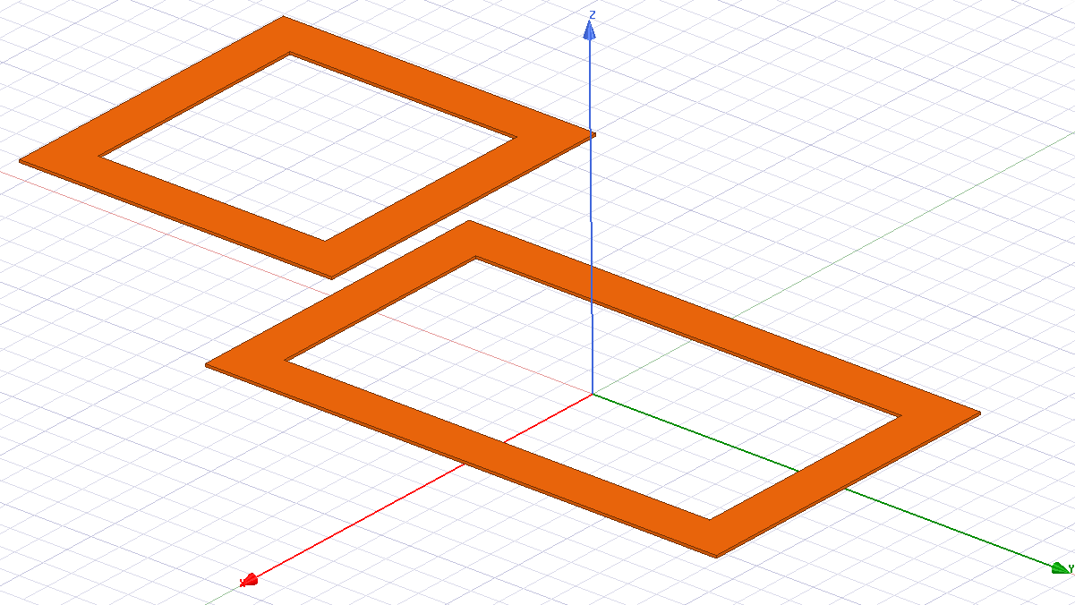
Tx-Coil
v₀
Rx-Coil
Figure 2.5 WPT dynamic system (Rx is the Receiver Coil, Tx the Transmitter and v₀ is the constant value of the speed imposed to the Rx Coil during the dynamic analysis).

As a consequence, the WPT parameters are to be evaluated by means of the multi-physics models, therefore for instance the mutual inductance computed in dynamic conditions would differ from that provided by the static model:
 | $$M_{D}≠M_{S}$$ | (2.71)

In a dynamic WPT system it may not always be possible to introduce the concept of double two-port, which leads to consider the evolution in the time domain of voltage and current of the two coils as the only physically acceptable quantity.
In the following, we derive a simple criterion to establish the conditions under which the dynamic effects do not lead to considerable variations with respect to the static model. In this case it is possible to define a two-port model also for the dynamic case, obtaining the acceptable assumption that the dynamic inductances are almost equal to that of the static model. To this end, let us consider the simple case o a receiving coil moving at a constant speed v₀, see Figure 2.5, hence the poblem to be solved is given by the MQS model coupled to the equation of uniform rectilinear motion.
Having defined this, the first step is the comparison between the electromagnetic characteristic time and the characteristic time associated with the motion of the vehicle. Assuming to know the matrices describing the coupled coil system (L and R), the magnetic time constants are calculated using the eigenvalues ​​of the matrix $[L^{-1}R]$ and the largest value is taken. For the time associated with the movement of the vehicle (to which the receiver and the receiver coils are connected) a simplified case is assumed, i.e. a linear trajectory above the transmission system with a constant speed ($v_{rx}=v_{0}$). Having a length $l_{tx}$ on the longitudinal direction (or vehicle movement) it can be easily defined the flight time as $t_{f}={l_{tx}}/{v_{0}}$ .
In order for the approximation between the two models to be possible, two conditions must be met (Di Capua et al., 2021). The first requires that in both cases, static and dynamic, the permanent sinusoidal regime is reached in every position of the trajectory, i.e. the time constant of movement t_{f} must be much greater than the duration of the transient MQS imposed at $4τ_{M}$. This criterion can be expressed by the relation:
 | $$δ≜ \frac{4τ_{M}}{t_{f}}≪1$$ | (2.72)
In addition, it is also necessary that the currents induced by the movement, in the coils of the IPT system and in the conductive elements must be negligible. This happens if:
 | $$γ≜ \frac{1}{ω_{0}t_{f}}≪1$$ | (2.73)
with $ω_{0}$ the angular resonance frequency.
If at every instant and position of the trajectory described by the vehicle during recharging both conditions (2.72) and (2.73) are verified, then the behavior of the dynamic system is equivalent to a static one in the same position. The second condition expressed by (2.73) is practically always verified bearing in mind the operating frequencies in IPT systems (in the order of kHz but always below 100 kHz) and the $l_{tx}$ lengths varying around one metre. Any reasonable vehicle speed effectively complies with the condition. As far as the first relationship is concerned, however, the values ​​of the magnetic time constant vary according to the characteristics of the system and in general it can be said that the inductance value can vary from tens to hundreds of μH while the resistances from tens to hundreds of mΩ, from which $τ_{M}$ ranges in the range of ms. Assuming δ=0.1 it is possible to evaluate the maximum speeds in which the equivalent static model can be used (Figure 2.26) also based on the length of the receiver (Di Capua et al., 2021).
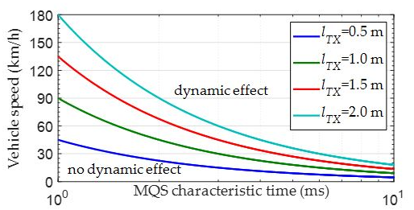
Figure 2.6 – Regions where the dynamic effects are negligible or not in modelling a coil pair of a WPT system, as functions of vehicle speed, magnetic characteristic time and coil lengths (Di Capua et al., 2021).

2.6. Resume of the chapter and main findings

  - The chapter has presented the models to be used for analyzing the two applications studied in this Thesis. Both of them refers to a low-frequency magnetic problem.
  - A preliminary study carried out by analysing a dimensionless formulation of Maxwell equations has led to the determination ot the three fundamental time constants (electromagnetic, magnetic and electric).
  - A criterion has been established to define the proper model to be used. The propagation effect can be neglected when the characteristic geometrical dimensions are muh smaller than the wavelength. In this case, a low-frequency condition occurs, and the problem can be described by means of a Magneto-Quasi-Static (MQS) model if there is a prevalence of magnetic energy with respect to electric energy ($W_{M}≫W_{E}$). In case there are time-invariant excitation currents in the system it is possible to use a formulation of the Magneto-Static type (MS).
  - Formulations of the MQS and MS problems are presented, first in terms of fields and then in terms of potentials.
  - As an example of MS problem, the study of the ferromagnetic effect is modelled through an integral formulation involving the potentials
  - As an example of MQS problem, the case of eddy-currents induced in conductive materials is provided, and many formulations are presented based on different use of potentials
  - The multi-physics problem associated to the electromagnetic analysis of a tokamak including the plasma dynamics is formulated. An approach allowing decoupling the fluidodynamics and the electromagnetic problems is presents (CarMa).
  - The multi-physics problem associated to the electromagnetic analysis of a wireless power transfer system including the motion of the receiving coil is formulated.
  - A criterion has been established to determine whether or not the coil pair parameters are affected by the dynamic effect. The criterion releates the vehicle velocity, the characteristic MQS time and the transmitting coil length.

CHAPTER 3

Modeling the electromagnetic response of fusion reactor components

3. Modeling the electromagnetic response of fusion reactor components

The analysis of the devices used in nuclear fusion machine can be carried out with different approaches, depending on the complexity of the problem and on the possibility to simplify it. As already discussed in Chapter 2, in this Thesis we will refer to pure Electromagnetic models, hence the fluidodynamics effects of the plasma are taken into account by means of equivalent electromagnetic sources.
Nevertheless, the problem complexity can be as high to require high computational facilities in order to run the model, especially when fast transients are to be investigated. The thing that must necessarily be taken into account is not only the characteristic of the model studied but also the type of forcing terms related to the event to be analysed.
In case of no symmetry of with respect to the machine, the model must, in principle, describe the whole machine (Albanese et al., 2015). A series of models to be used in asymmetric cases is for instance provided in the work (Sadakov et al., 2022), that describes the calculation of the asymmetric Lorentz forces on all Tokamak structures due to asymmetric vertical displacement events (AVDE). For instance, Figure 3.1 take from this work is related to the study of the effect of Halo currents.

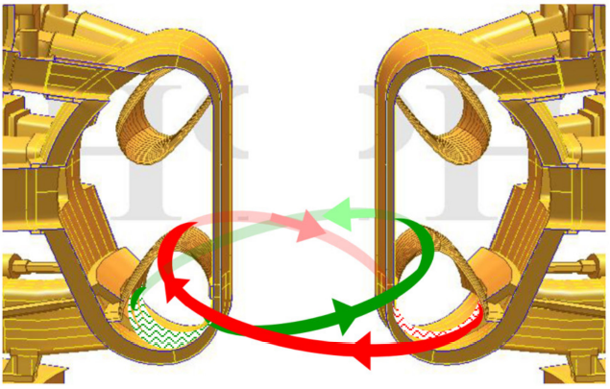
Figure 3.1. Model used to represent the anti-symmetric components of the halo currents (the red path and the anti-symmetric in green) (Sadakov et al., 2022).

Specifically, the curves in green and red represent the possible paths of the Halo currents which are injected into the lower part of the Tokamak (which therefore involves a part of the Vacuum Vessel, the Breeding Blanket and the Divertor). In order to have a possible representation of this forcing terms, two parametric studies based on two different types of models were carried out, the first shown in Figure 3.2 and the second in Figure 3.3. In the first model, the injection of the current takes place according to the poloidal direction while the second is constructed by inserting bridges which allow the injection of this current only in the helical direction. The two proposed methods allow to parameterize the lateral loads in two different ways in the lower parts of the Vaacum Vessel (more evident in the first model, for example, it is possible to observe that the shapes of the bridges recall the internal upper arrangement of the divertor cassette).
Therefore, using these models provide complementary useful information to designers to figure out the characteristics of different scenarios of antisymmetric events.

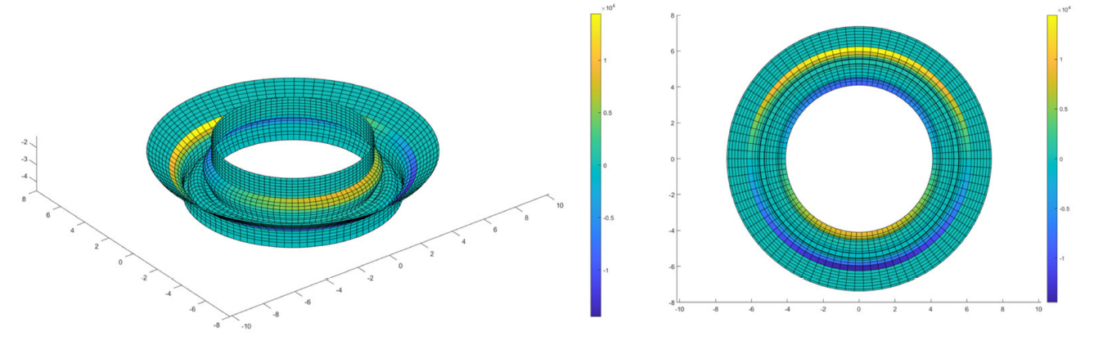
Figure 3.2. Model designed to simulate the Halo current during the AVDE event built by inserting poloidal bridges into which the equivalent Halo current is injected
(Sadakov et al., 2022).

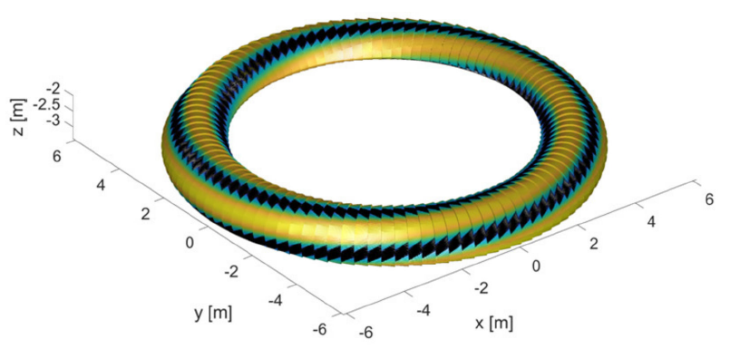
Figure 3.3. Model designed to simulate the Halo current during the AVDE event built by inserting helical bridges into which the equivalent Halo current is injected
(Sadakov et al., 2022).

When the problem can be symmetrized, then a big simplification can take place. Let us for instance refer to the work (I. A. Maione et al., 2021) which calculated the loads due to EM events on the Breeding Blanket during the Pre-conceptual design phase for the DEMO project.
In this work, in fact, only one sector of the DEMO Tokamak is simulated, thanks to the the symmetry conditions (Figure 3.4). This is because it is assumed the current penetration into the Breeding Blanket's auxiliary systems is practically negligible. Therefore, starting from this assumption, the Global Model used is studied by imposing symmetrical conditions, i.e. by coupling the DOFs of all the nodes on the two external shear planes (the shear planes are the two external poloidal sections of the sector spaced along the poloidal angle) as well as the VOLT DOF on the cutting planes for conductive objects.
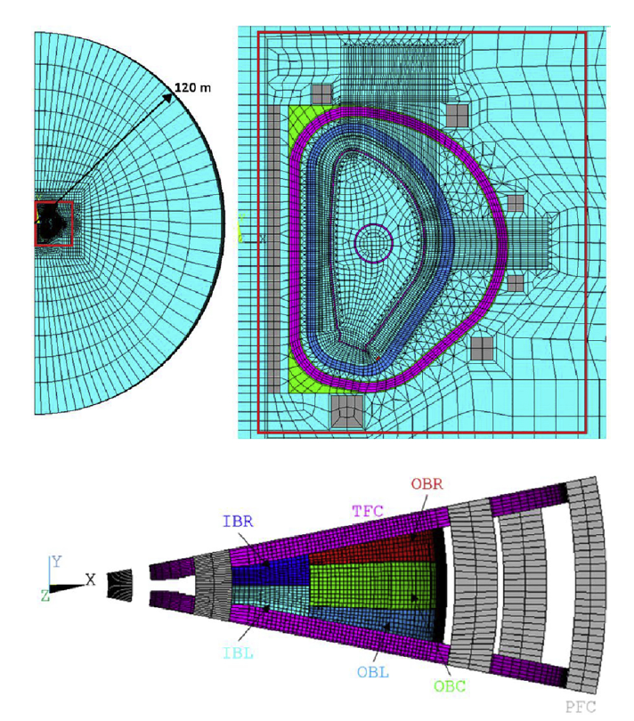
Figure 3.4. Model implemented for the study of the Breeding Blanket system. In the presented sector different objects can be observed, such as toroidal and poloidal field coils, the breeding blanket, the vacuum vessel etc. (Maione et al., 2021).

Similarly, also in the work (F. Cau et al., 2022) a model is used that exploits the symmetry conditions to best reproduce the effects of the studied plasma events. In particular, for this work, in addition to the use of symmetry conditions and periodicity, the analysis is supported by a recursive technique based on the QR decomposion. Thanks to the use of this technique, an enormous decrease in the computational cost is demonstrated. Then this proposed technique is applied to a model used on a large scale, represented by the Tokamak ITER (Figure 3.5). The symmetry and periodicity conditions used in the current work are represented in Figure 3.6.

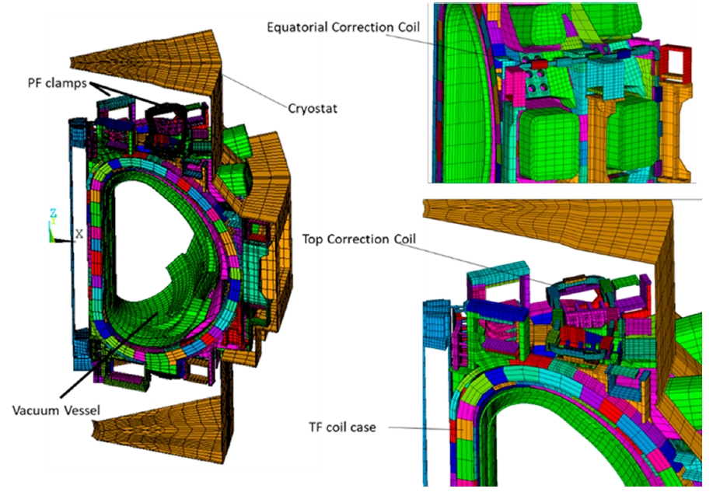
Figure 3.5. Sector Model of the ITER Tokamak (Cau et al., 2022).

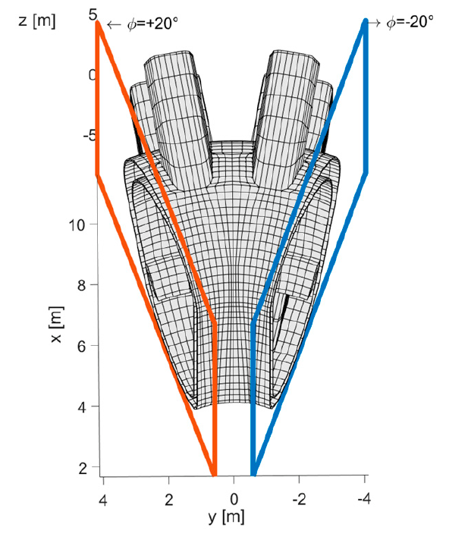
(a) (b)

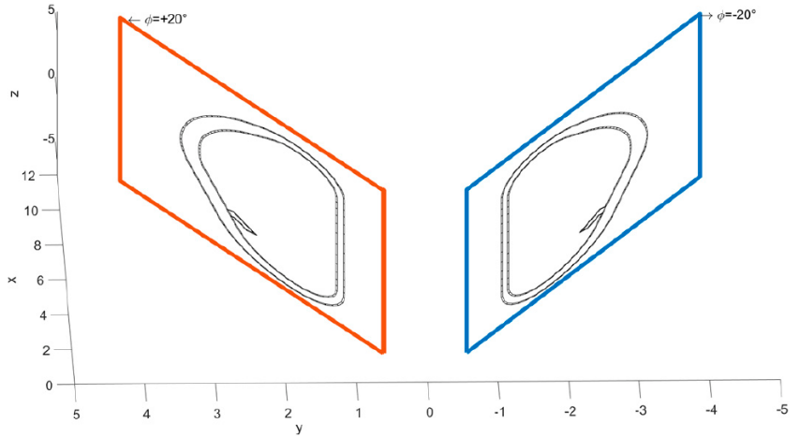

Figure 3.6. Model representing the symmetry conditions used in ITER: (a) Model of the Vacuum Vessel and linked to it the external poloidal plane on which are imposed the periodicity conditions; (b) view of the external poloidal planes only (Cau et al., 2022).

So far, we have briefly presented three examples of problems where the whole tokamak was considered, even when the symmetry can reduce it to a single sector. In this Thesis we are instead investigating case-studies where the interest is focused to only a single component of the tokamak, and specifically to a divertor of DEMO tokamak and to an ex-port assemply of a neutron diagnostic in ITER tokamak.
In both cases, the correct analysis of the EM effects (such as the eddy and the halo currents) requires a level of detail that is likely to be unaffordable if replicated for each component of a whole tokamak assembly, even in case of sector simplification by symmetry. Indeed, the electromagnetic modeling must retain the particularities of the objects to be modelled both in terms of geometry and materials (through their properties such as electrical resistivity and/or magnetic permeability). It is needed to establish criteria to simplify the CAD models that have particularly articulated geometric shapes, by simplifying small mechanical parts that have negligible effects on the EM analysis. In this case, there is the possibility of building a simpler mesh, therefore with fewer elements and which consequently allows savings from the point of view of computational costs. All this obviously accepting the compromise of losing precision in the results if we consider details and particularities of the model (which, however, have a limited weight in relation to the results obtained on the entire object).
Depending on the simulation conditions, two different approaches will be presented in the following, that will be applied to the above-mentioned two case-studies for the study of fast EM transients associated to particular plasma events such as Vertical Displacement Events (VDE) or Major Disruptions (MD).
- Hybrid model approach, a single step model, where the device under study is a part of a model including the main external components and suitable excitations representing the EM effects of the event. This approach will be here used for the Divertor of DEMO Tokamak.
- sub-modelling approach, a two-step model where first a whole sector is simulated (global model) and then its results are used to define proper boundary conditions for a second model where only the device under study is included. This approach will be used for an ex-port module of the ITER Radial Neutron Camera.

3.1 A hybrid model for the EM analysis of a divertor
A hybrid modelling approach is here adopted to study the EM behavior of a divertor module of a tokamak. It can be considered as “hybrid”, since it settles between a pure “local” and a pure “global” model. In a local model, only the divertor would be included and the effect of the external world would be represented through suitable boundary conditions at the cutting boundary, as in the zooming or submodelling approaches (see next section). In a global model, all the passive and active components would be considered, such as for instance vessel, blankets, Poloidal Field Coils (PFC) and Toroidal Field Coils (TFC). The hybrid model adopted here includes the divertors (with finer details on its subparts) and the main external passive components such as Vacuum Vessel, blanket modules, rails (with a coarser description), see Fig. 3.7. The model does not contain active components such as PFCs and TFCs, and the excitation is provided by suitable sets of equivalent currents.
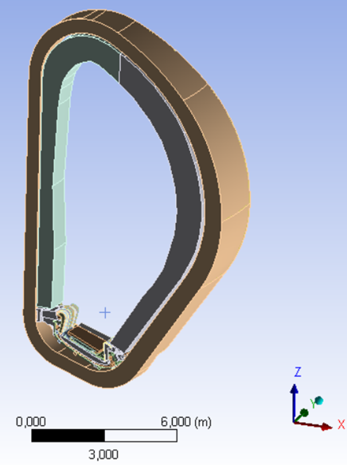
Figure 3.7. View of the analysed 22.5° sector.

3.1.1 Model Components
As pointed out in the Introduction, in this paper a hybrid modelling approach is adopted, since the proposed model settles between a local and a global one. In a local model, only the divertor would be included and the effect of the external world would be represented through suitable boundary conditions at the cutting boundary, as in the zooming or submodelling approaches. In a global model, all the passive and active components would be considered, such as for instance vessel, blankets, PFCs and TFCs. The model adopted in this paper includes the divertors (with finer details on its subparts) and the main external passive components such as VV, blanket modules, rails (with a coarser description), see Fig.3.7. The model does not contain active components such as PFCs and TFCs, and the excitation is provided by suitable sets of equivalent currents imposed on two layers (PFV and TFV) and by a known equilibrium magnetic field.
The model here reported is assumed to be a toroidal sector of 22.5°. This kind of model is suitable choice for performing a 3D EM analysis of the whole machine, assuming rotational symmetry and imposing periodicity conditions.
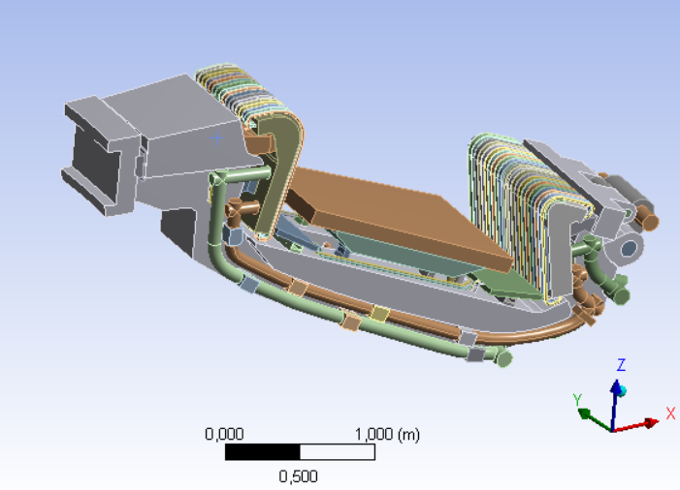
The CAD model includes three divertor modules, the blanket, the Vacuum Vessel (VV), and the inward and outward divertor supports to VV. The details of a single divertor module are visible in Fig. 3.8. The electrical properties of the materials used for the model components are listed in Table 3.1, taken from (ITER Material Property Handbook D_2MT9X8 – Mergia et al., 2008).
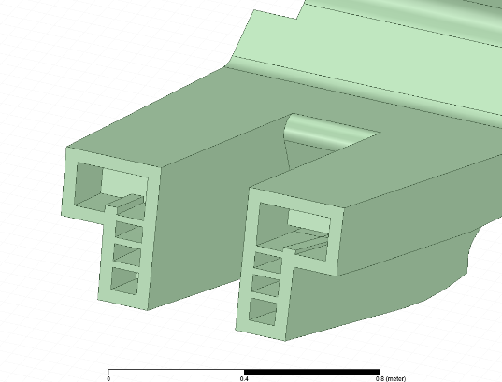

Figure 3.8. View of the simplified divertor (left). A section of the cassette (right).
The following simplifying assumptions have been made:
- the VV is a simplified version of the actual one, including the downward hole corresponding to the lower port, retaining the doubleshell steel structure with a thickness of 6 cm;
- the blankets have been modelled as bulk structures: equivalent conductivity and permeability values have been used to consider the void ratio. They are made of two different pieces, respectively in the inboard and outboard sides. The supports that electrically connect the blankets to the vessel are also included;
- the divertor cassettes have been modeled like the original cassettes also considering the actual positioning of the internal poloidal and toroidal ribs. Furthermore, the cassette-to-VV inward and outward supports have been properly included;
- the cooling pipes of the vertical targets have been simplified. Each two pipes in the original CAD has been grouped into an equivalent pipe, with the same cross section of the original two pipes, hence the final volume is left unchanged. All the small pipes (e.g., the pipes that bring water to shielding liners) have been modeled as a bulk conductor. An equivalent conductivity value has been used to take into account the original ratio between water and steel volumes.
Table 3.1. Model components and material properties
(ITER D_2MT9X8 – Mergia et al., 2008)
Component | Material | Resistivity [Ωm] | Relative Permeability
Vessel | AISI 316 L(N) IG | 7.59 x 10⁻⁷ | 1
Blanket | EUROFER 97 | 8.54 x 10⁻⁷ | 39 - 53
Divertor Cassette | EUROFER 97 | 8.54 x 10⁻⁷ | 39 – 53
Cassette Support to VV (Inward) | AISI 316 L(N) IG | 7.59 x 10⁻⁷ | 1
Cassette Support To Vessel (Wishbone) | Ti-6Al-4V | 1.5 x 10⁻⁶ | 1
Pipes, Manifolds and Cooling System Supports | AISI 316 L(N) IG | 7.59 x 10⁻⁷ | 1
Inner e Outer Reflector Plates and the Shielding Liner | EUROFER 97 | 8.54 x 10⁻⁷ | 39 – 53
Cooling Pipes (Vertical Targets) | CuCrZr | 2.33 x 10⁻⁸ | 1
Vertical Target Cassette | AISI 316 L(N) IG | 7.59 x 10⁻⁷ | 1

As shown in Table 3.1, the blanket and cassette modules (made by EUROFER97) exhibit magnetic properties (Mergia et al., 2008). The B-H magnetization curve of such a material (reported in Fig. 3.9) is derived from the data provided in (I. A. Maione et al., 2013). For such a material, the relative permeability associated to the linear tract of this curve is reported to fall in the range 39-53, also depending on the actual temperature (Mergia et al., 2008). The saturation can be assumed to occur for a level of magnetic flux density B approximately equal to 3T. Note that both the permeability in the linear tract and the saturation field can change as an effect of neutron irradiation. Although no specific work is available on the EUROFER97, the results provided in (Kempf et al., 2014) for magnetic steels used in nuclear vessels suggest that a neutron irradiation may change the B-H response. Specifically, after irradiation, the permeability in the linear tract is lower and the saturation occurs for lower values of the magnetic field.
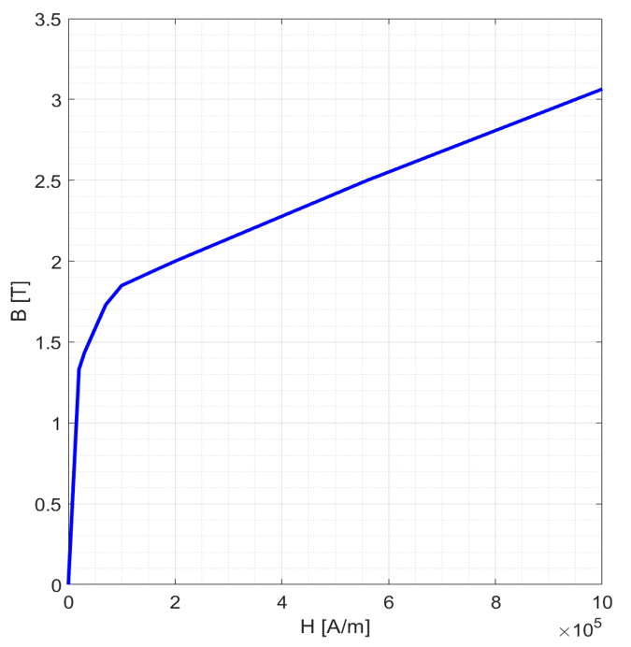
Fig. 3.9. B-H magnetization curve of the Eurofer97 steel (Mergia et al., 2008).

Table 3.2. Expected ranges of the static magnetic flux density in the magnetic components of the model, for the studied event.
Component | B_{min} [T] | B_{max} [T]
Divertor Cassette | 4.81 | 8.20
Outer Blanket Module | 3.38 | 5.06
Inner Blanket Module | 4.97 | 8.57

However, all the above considerations do not have a significant impact for this analysis, since for the transient event considered (VDE downward 74ms, see SubChapter 4.1), the expected values of the static magnetic flux density in the magnetic regions (see Table 3.2) bring these components to work in a magnetic saturation condition. In this sense, the external static field can be calculated using the following analytical expression (Cocilovo, 2016):
 | $$Bext= \frac{B_{0}}{r}R_{0}$$ | (3.1)
In which: B₀ is the static field at the major radius R0 of the DEMO Tokamak and r is the radial positioning of the object under study. To verify the fact that in the standard operating conditions of the Tokamak DEMO (i.e. considering B₀=4.89T (DEMO)) one goes to work in saturation conditions, two types of simulations were carried out on the divertor module: the first one assuming the real B-H curve in Fig.3.9 for Eurofer97, the second one assuming the material to be saturated (hence, assuming it as made of air) thanks to the behavior due to the BH Curve in Figure 3.9). The results are shown in Fig.3.10: the maximum error found between these two conditions is about 10%, thus demonstrating the assumption.
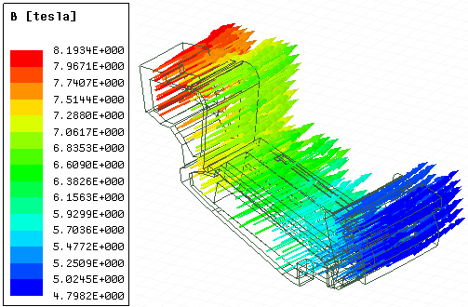
a) b)
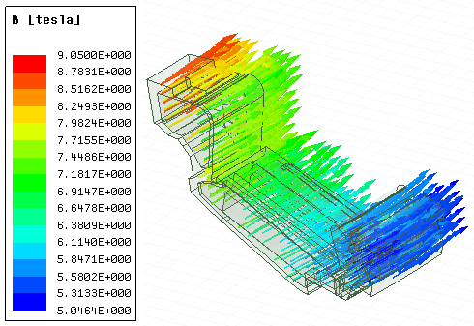
Fig. 3.10. Results due to the External Field B absorbed in the Divertor made in Eurofer97 (a); B Field absorbed by the Divertor made in Air (b).

3.1.2 sources, excitation, boundary conditions
The plasma event studied for this type of analysis is a vertical disruption of the "VDE_down_74ms" type (Villone, 2019). This case takes hold according to a certain sequence of events. Specifically, the chain of events is as it follows. A plasma event characterized by a sudden variation of poloidal beta (a glitch) triggers the VDE, so that the plasma moves vertically (exponentially downwards, until it hits the first wall. When boundary safety factor drops below 2, the Thermal Quench (TQ) occurs, lasting 4 ms. During this fast phenomenon, a current density flattening occurs (Hender, 2007). As a consequence, the plasma internal inductance decreased abruptly, leading to a spike of plasma current around 5% to approximately guarantee magnetic flux conservation inside the plasma. Immediately after, a linear Current Quench (CQ) takes place, bringing the toroidal current to zero in 74 ms. This QC event has been chosen since it is among the fastest ones predicted for EU-DEMO, by extrapolation and scaling of experimental results obtained in other machines (Hender, 2007). Note that the plasma undergoes progressive changes of topology: starting from a single null configuration, it hits the wall outboard and gets limiter; then, due to TQ+CQ, the plasma “shrinks” and gets diverted again, so that it moves downwards with an X-point configuration. Eventually it touches the wall in the divertor region, switching again to a limiter configuration (Fig. 3.4). At that time, the q_95 safety factor (i.e. the safety factor of the magnetic surface enclosing 95% of the total poloidal flux) is around 2.4. The time evolution of poloidal beta and of the radial and vertical coordinates of the plasma centroid are reported in Fig. 3.5.
The plasma simulations have been carried out with the CarMa0NL code (Villone, 2013). This computational tool describes the electromagnetic interaction of the plasma with the surrounding structures via a set of suitable filamentary currents, located on a fixed surface, whose time-varying values are found imposing that they provide the same poloidal magnetic field as the plasma on the structures. In this sense, it can be said that these currents are equivalent to the plasma and are used in the present work of thesis as the PFV (Poloidal Field Variation) set of current. Another source of eddy currents is the time variation of the plasma toroidal flux. By using this quantity, as provided by CarMa0NL, it is possible to derive the TFV (Toroidal Field Variation) set of currents. In addition, the model excitations are completed by the inclusion of the Halo currents, directly injected in the components located in the lower part of the studied assembly, hit by the plasma during the evolution of the instability event. Also, this quantity is computed by CarMa0NL (green region in Fig. 3.11d) and used as input.

(a) (b) (c) (d)
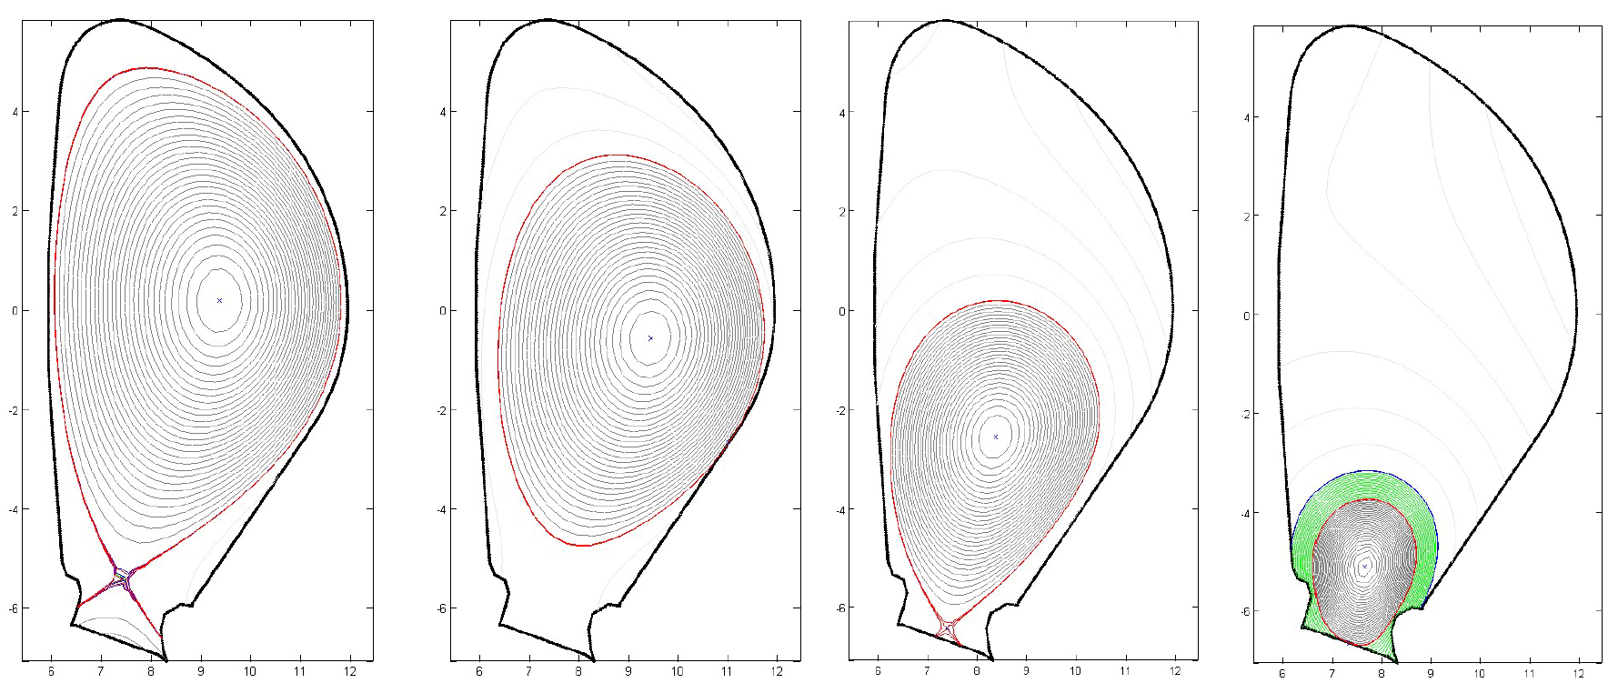
Fig. 3.11. Snapshots of the plasma configurations for the event VDE_DOWN_74ms,
at the time instants: (a) t=0s; (b) t=1.53s; (c) t = 1.65s; (d) t = 1.67s (Di Mambro et al., 2022).

(a)
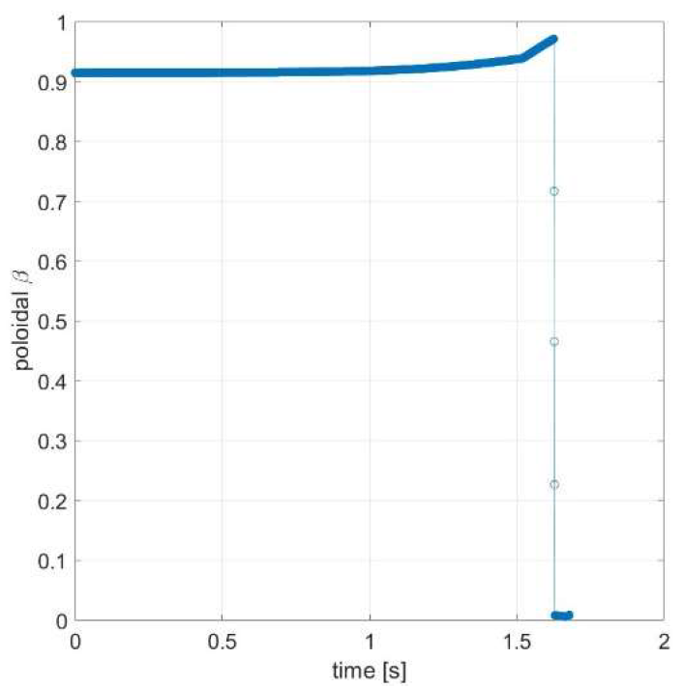
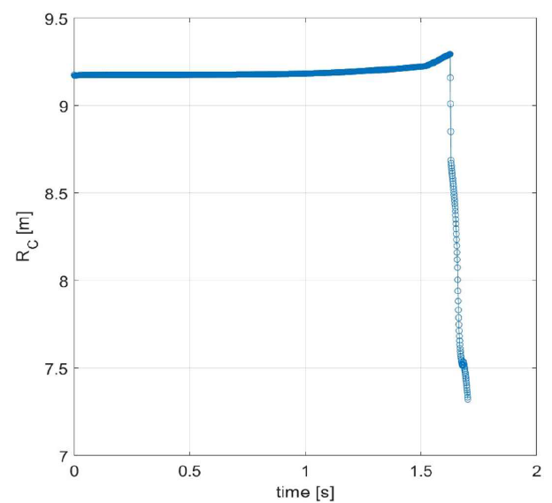
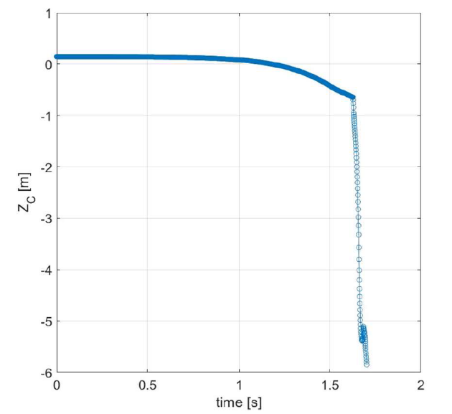
(b) (c)

Fig. 3.12. Time evolution of (a) the poloidal beta, and (b), (c) the radial and vertical coordinates of the plasma centroid, during the VDE_DOWN_74ms event
(Di Mambro et al., 2022).

3.2 A submodelling approach for the EM analysis of an ex-port system
The sub-modeling approach, used in this work, is based on the possibility of linking the degrees of freedom of the sub-model boundaries with those of the global model mesh. As already mentioned in the introduction to this Chapter, this link is created by means of the interpolation between the finer and coarser mesh. Using interpolation, in fact, it is not necessary that the two meshes are equal therefore the Local Model can be studied through the use of a more detailed (finer) mesh than that of the Global Model (coarse).
(a)
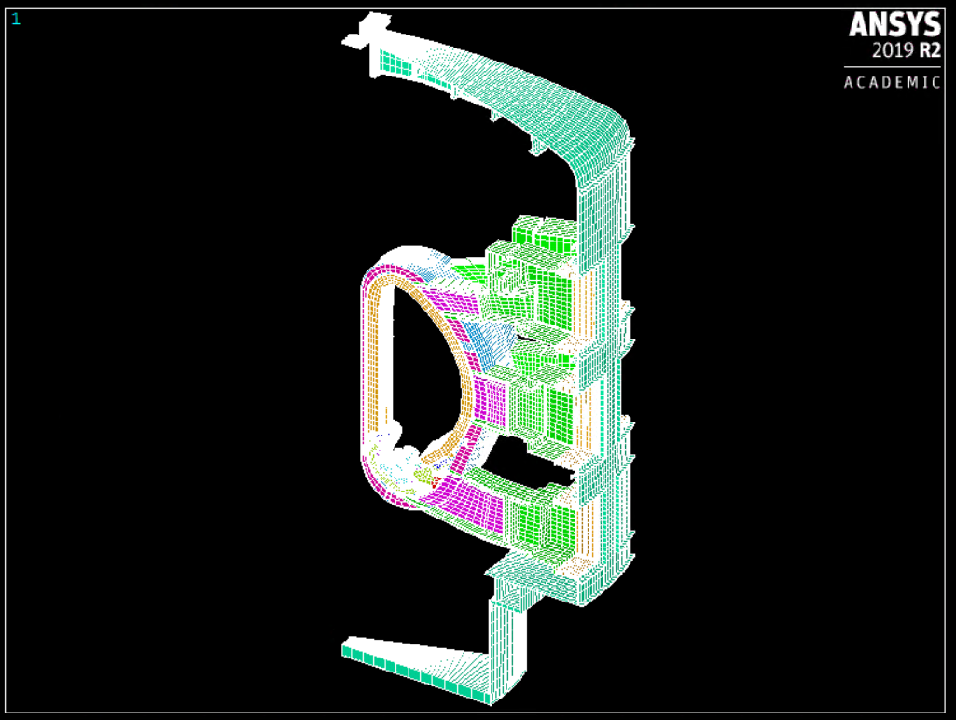
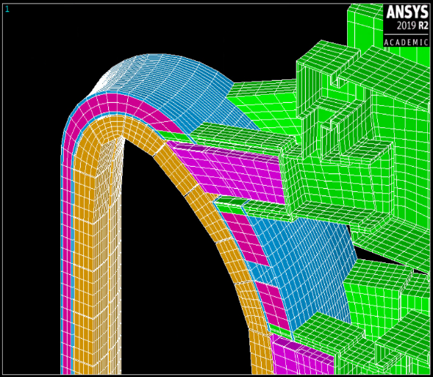
(b) (c)
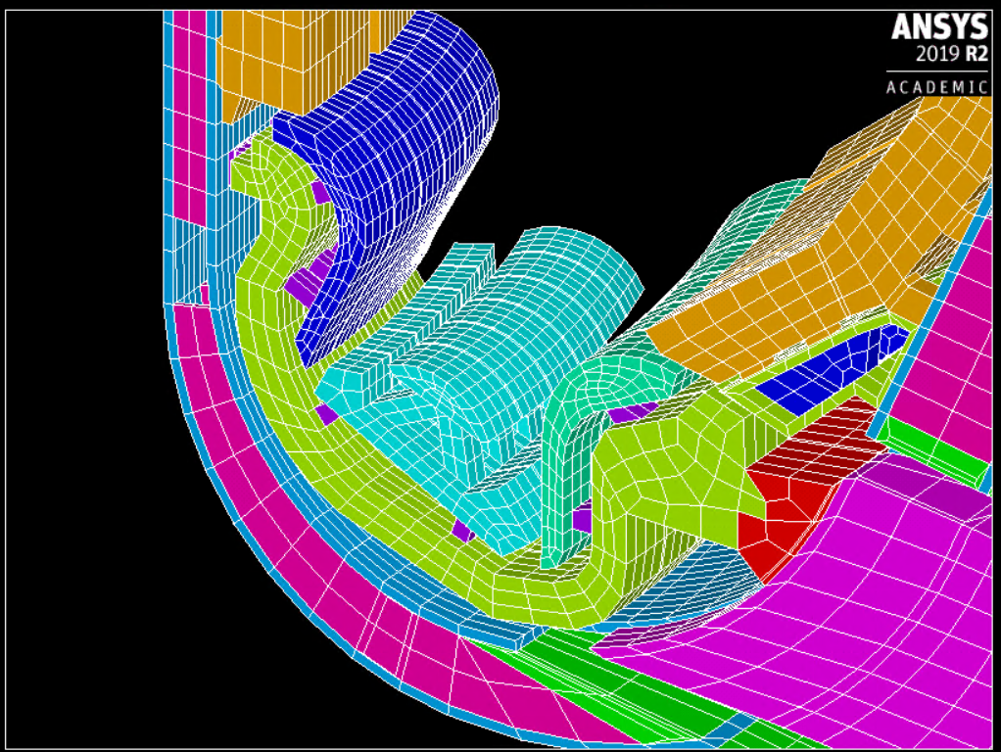
Fig. 3.13. Overview of the Global Model used (a); a detail of the lower part of the same sector including the domes the cassettes the inner and outer vertical targets (b), detail of the upper part of the sector that includes the shielding blanket, the internal ribs of the VV, the Vessel Ports Extensions and the VV (c).

3.2.1 Global and local components
For what concern the Global Model, the model used is a 20° sector of the ITER Tokamak, that includes several objects: Vessel, Vessel Port Plug, Coils, Blankets, Divertors Assembly and the Cryostat (as shown in Figure 3.12). The materials properties of the used Global Model are reported in Table 3.3. The resistivity value of the materials marked with * has been homogenized by considering the ratio between nominal volumes and the component volumes that are included in this Global Model. Note that, for the purpose described in this sub-Chapter, the original sector of the Global Model (of 20°) has been symmetrized, so to obtain a 40° sector model.
The Local Model has been developed by using the reference of the ITER Ex-port RNC CAD in Figure 3.14. The materials and the components are listed in Table 3.4.
Table 3.3 Materials assigned to the Global Model of the sector used to perform the EM analysis (see Figure 3.4)

Object | Resistivity [Ωm]
Blanket* | 1.6 x 10⁻⁶
Divertor Cassette* | 1.5 x 10⁻⁶
Divertor vertical targets* | 9 x 10⁻⁷
Dome* | 1.1 x 10⁻⁶
Rail* | 6.0 x 10⁻⁷
Vessel ribs and ports | 8.15 x 10⁻⁷
Port bellows* | 4 x 10⁻⁷
Cryostat | 7.2 x 10⁻⁷

Table 3.4 Materials assigned to the Local Model of the Ex-port RNC (see Fig. 3.4)
Part Number | Name | Material | Resistivity [Ωm]
1 | Main centre block | SS316L(N) -IG [ITER_222TU5] | 7.74 x 10⁻⁷
2 | Side block A | SWX-277 | ---
3 | Side block B | SWX-277 | ---
4 | Top block | SWX-277 | ---
5 | Detectors support structure | SS316L(N) -IG | 7.74 x 10⁻⁷
6 | Rear block | SWX-277 | ---
7 | Lead nose | Lead [Lide et al., 2005] | 2.08 x 10⁻⁷

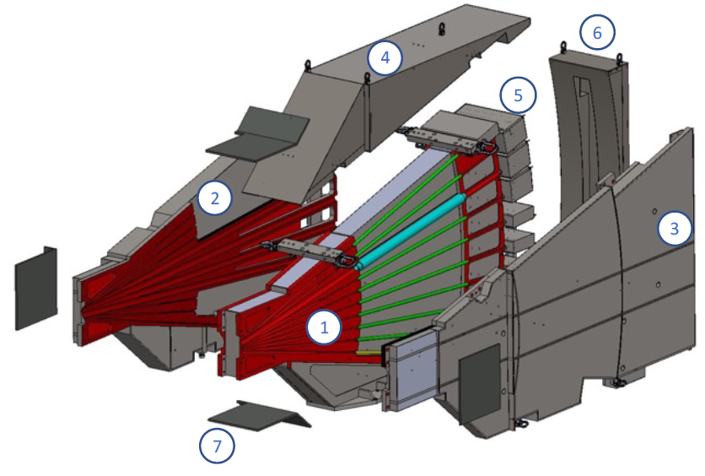
Figure 3.14 Exploded view of the Ex-port CAD model (materials are in Table 3.3)

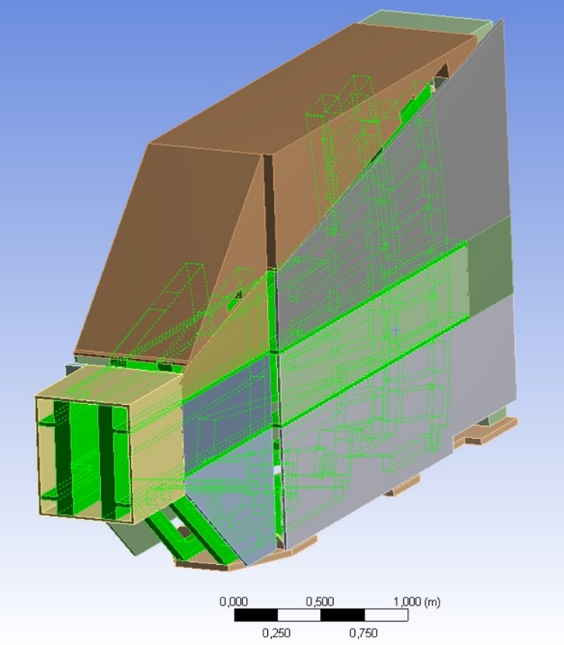
Figure 3.15 Simplified CAD model of the Ex-port adopted for EM analysis
To be precise, from the original CAD Model of the Ex-port RNC, the CAD simplified version shown in Fig.3.15 has been derived for the purpose of EM analysis. The following simplifications and assumptions have been considered:
• small mechanical details are omitted, not significant to the purpose of the EM analysis;
• the Neutronic shielding blocks 2, 3, 4 and 6 in Fig.3.14 are non-conducting, since they are made of concrete (SWX-277). From the EM point of view, the contribution comes from the external panels that contain the concrete, since they are made of steel;
• the currents flowing through the position monitoring sensors located on the “nose” of the ex-port RNC and connected to the closure plate are neglected.

3.2.2 Cut boundaries and interpolation
The key of the submodelling approach is the definition of proper boundary conditions that reproduce the equivalent excitations to be applied to the Local Model.
To define the, first of all, it is necessary to carry out a complete simulation of the Global Model of the particular event that one wishes to study. Immediately afterwards, separately, the outer boundary of the sub model is constructed (which, from this point on, will be called the "cut-boundary"). Then, in relation to the event launched for the Global simulation, a "link" is created between the DOFs on the nodes of the cut-boundary of the Local Model mesh and those adjacent to them in the same area but belonging to Global Model mesh. It must be remembered that the DOFs are represented by the Vector Potentials Ax, Ay, Az for each node of the cut-boundary).
The action of interpolating these DOFs is described in the next Chapter, where the numerical implementation of this model is discussed.
Finally, using these DOFs as excitations imposed on the cut-boundary it will be possible to launch the sub-model simulation of the thoughtful reference event.

3.3 A static model for the analysis of ferromagnetic effects
In this section the attention is focused on the static ferromagnetic interaction between tokamak components. To this end, it will be used the static model presented in paragraph 2.3, based on an integral formulation.
Specifically, the study proposed here refers to the evaluation of the interactions between the divertor cassettes and the blankets in EU-DEMO tokamak (see Figure 3.16), being both made of the ferromagnetic material EUROFER 97. These interactions are expressed by forces and torques acting on these structures, as a consequence of their magnetization and of the spatial variation of the toroidal magnetic field. The model proposed in sub section 3.3.1, describes this problem in a static limit, assuming a 22.5° sector of DEMO machine, including all the ferromagnetic components and the Coils Filaments used to impose the Exctitations. Besides the excitations, the adopted formulation only requires to model the conducting and ferromagnetic elements, namely the three divertor cassettes and two blankets shown in Fig.3.16.
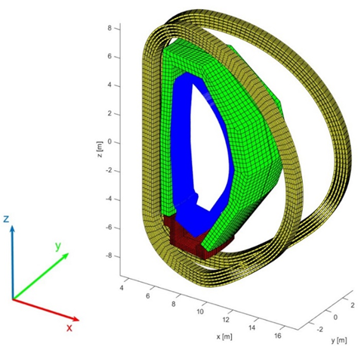
Figure 3.16. The analyzed 22.5° sector of DEMO in-vessel assembly, including the divertors (in red), blankets (in green), the toroidal field coils (in yellow) and the layer with the equivalent sources associated to plasma currents (in blue)
(Di Mambro et al., 2023).

3.3.1 Model Components
The analyzed EM model is the 22.5° sector of the DEMO tokamak reported in Fig.3.16, that includes divertors, blankets, toroidal field coils and a layer with equivalent currents associated to plasma currents, as it will be clarified later. Indeed, this choice exploits the symmetries of the machine, that can be seen as the result of 16 toroidal rotations of the sector of 22.5°.
The following Figures detail the three cassettes of the divertor (Figure 3.17) and the Blanket Modules (Figure 3.18) of the overall model depicted in Figure 3.16.
The resistivity and permeability of the materials are listed in Table 3.4, taken from (Mergia et al., 2008), (Theodorou et al., 2019), (G. Di Mambro et al., 2022). Note that the permeability values refer to the linear tract of the B-H curve in Fig.3.9, derived from the data in (Mergia et al., 2008). Note that, as pointed out in (G. Di Mambro et al., 2022), this characteristic can be affected by actual temperature values and neutron irradiation levels typical of operating conditions.

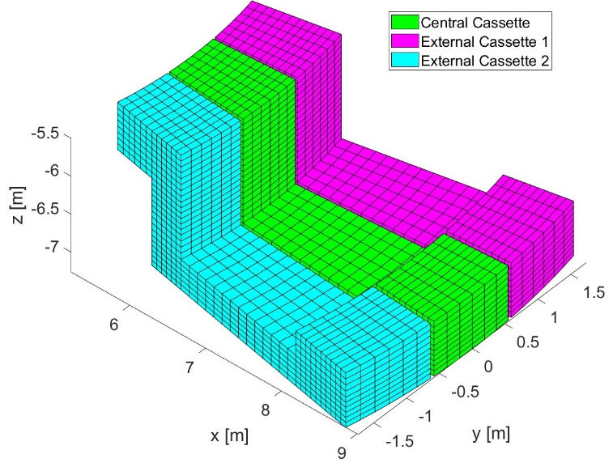
Figure 3.17. The passive structure representing the disposition of the Divertor Cassettes in the 22.5° sector (Di Mambro et al., 2023).
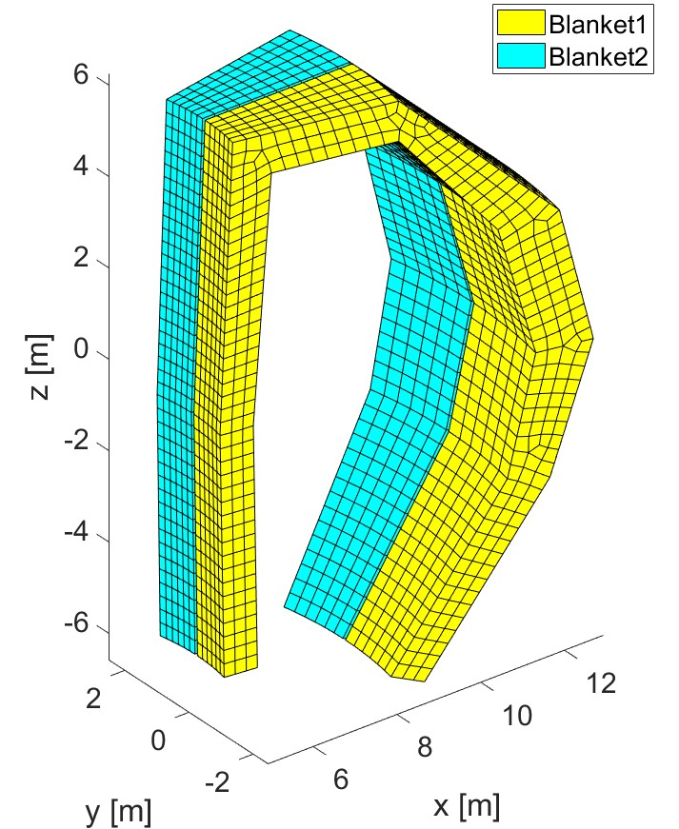
Figure 3.18. The passive structure of the Blankets that lies in the 22.5° sector
(Di Mambro et al., 2023).

Table 3.5. EUROFER97 properties
(Mergia et al., 2008), (Theodorou et al., 2019), (G. Di Mambro et al., 2022)

Components | Material | Resistivity [Ωm] | Relative Permeability
Blankets, Divertor Cassettes | EUROFER97 | 8,54 x 10⁻⁷ | 39 - 53

Finally, it is useful to underline that the CAD models describing the ferromagnetic elements have been strongly simplified (for instance, with respect to the model in Fig. 3.7), but retaining approximatively the same volume of the original model. Specifically, the volume of each of the three cassettes is equal to 2.3 m³, whereas that of each of the two blanket modules is 42 m³. Furthermore, the ratio 𝑝 between ferromagnetic/no ferromagnetic volumes is equal to 38.3% in the cassettes and to 8.3% in the blankets. Therefore, the EUROFER volume of three divertors is equal to 2.64 m³ whereas that of the two blankets is equal to 6.80 m³.

3.3.2 Sources excitations and boundary conditions
The exciting sources of the model are given by the external toroidal field coils or induced by the internal field induced by the toroidal plasma currents. Specifically, the desired static field configuration is created by imposing a total current of 32.6MA flowing through the toroidal field coils (TFCs – as shown in Figure 3.19 in yellow), and by adding the contribution coming from the plasma current at equilibrium. The latter contribution is imposed by considering equivalent currents flowing through a high number of toroidally directed filaments, see blue layer in Figure 3.19. The identification of these equivalent currents has been obtained through plasma simulations carried out with the CarMa0NL code (Villone, 2013) (as yet depicted in section 3.1.2). The total current resulting from this evaluation is equal to 19.07 MA. The 3D analysis is then performed on such a sector, imposing periodicity conditions on the magnetization M at the boundaries:
𝑴(𝑟, 𝑧, 𝑗) = 𝑴(𝑟, 𝑧, 𝑗 + 2𝑘/16) for k=1..16.

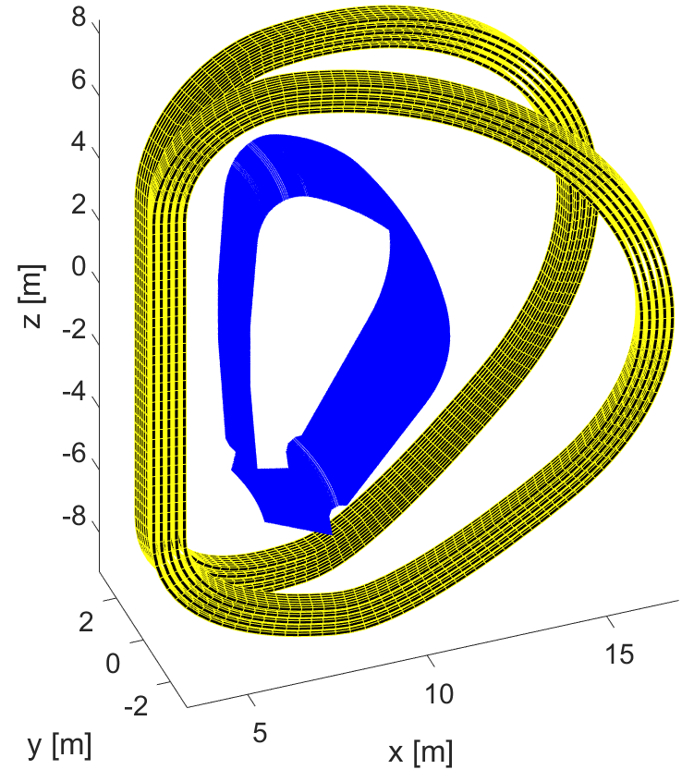
Figure 3.19 toroidal filaments (inner blue lamina) and the TFCs (outside in yellow)
(Di Mambro et al., 2023).

3.4. Resume of the chapter and main findings
- The main approaches for the EM analysis of a nuclear fusion machines have been resumed, in case of asymmetric and symmetric problems.
- A hybrid approach has been proposed to perform the analysis of the EM loads acting on the divertor module of the EU-DEMO machine. The approach models a 22.5° sector of the Tokamak, thanks to symmetry and periodicity properties of the problem. The model includes a finely detailed CAD of the divertor and a coarser description of the main external objects like blankets, Vacuum Vessel, rails. The problem is formulated for carrying out a fast transient analysis due to a disruption events: the excitations (equivalent poloidal and toroidal currents and halo current) refers to a Vertical Displacemnt Event (VDE). Specifically, the current filaments representing the plasma events are extracted by using the code CarMa0NL.
- An alternative approach is presented, based on the so-called submodelling technique. The case-study is the analysis of the eddy currents again associated to VDE event induced on a component of the ITER diagnostics system “Radial Neutron Camera”. In this case two models are solved. A Global Model contains all the main components falling in a 40° sector ot ITER tokamak: the blankets, the divertors, the cryostat, the vessel and the vessel doors. Its solution is used to identify proper boundary conditions of a Local Model that only include a detailed CAD model of the component under study (RNC ex-port module) acting as the forcing term. These boundary conditions are identified by interpolating the Degrees of Freedom (DoF) of the two models on the boundary nodes of the two meshes. Specifically, in the adopted formulation the DoFs are the values of the vector potential (Ax, Ay, Az).
- A third model has been presented to face a magneto-static problem, that is the analysis of the static ferromagnetic forces acting on the EU-DEMO divertors due to the presence of the ferromagnetic material EUROFER-97. The model consideres again the 22.5° sector of the tokamak and is expressed through integral formulation of the static problem, with homogenized materials. The model sources are given by the currents of the TF Coils and by the plasma currents.

CHAPTER 4

EM analysis on components of the ITER and EU-DEMO machines

4. EM analysis on components of the ITER and EU-DEMO machines
This Chapter deals with the analysis of the case-studies modelled in Chapter 3:
- EM loads acting on the Divertor of the EU-DEMO machine, as the effect of the fast transients associated to a Vertical Displacement Event (sub-section 4.1)
- EM loads acting on the Divertor of the EU-DEMO machine, as ther result of the ferromagnetic effect (sub-section 4.3).
- EM loads acting on the EX-Port RNC module of the ITER machine, as the effect of the fast transients associated to a Vertical Displacement Event and to a Major Disruption one (sub-section 4.2)

4.1 EM loads on DEMO divertors resulting from fast transient events

The case study and its model have been detailed in Section 3.1, see also Figure 3.7 for an overview of the analyzed geometry.

4.1.1 Event and excitations
The fast-transient event analyzed for this case-study is a downward Vertical Displacement Event, hereafter denoted as “VDE_DOWN_74ms”, whose details can be found in (Villone, 2019). This event is associated to a plasma instability of particular interest for the divertor integrity.
As pointed out in Section 3.1, the transient EM effects produced by a plasma disruption are reproduced outside the region occupied by the plasma by imposing suitable equivalent currents in two sets of filaments: the PFV (poloidal field variation) and the TFV (toroidal field variation) array depicted in Fig.4.1. Here, in addition, the model excitations are completed by the inclusion of the Halo currents, directly injected in the components located in the lower part of the vessel, such as the lower parts of the blankets, the liner and so on (see Fig. 4.2).

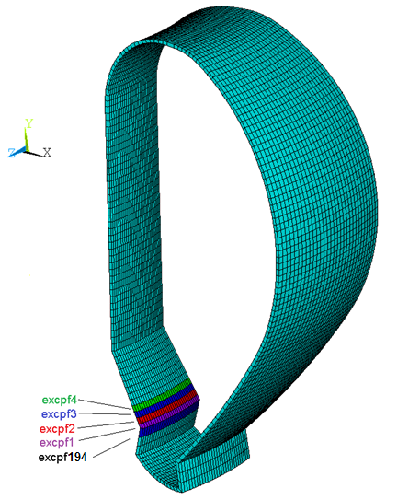 | 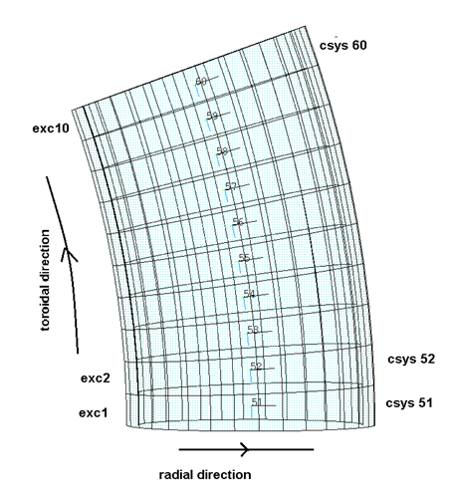
Figure 4.1. Eddy-current problem excitation: PFV (left) and TFV (right) coils.

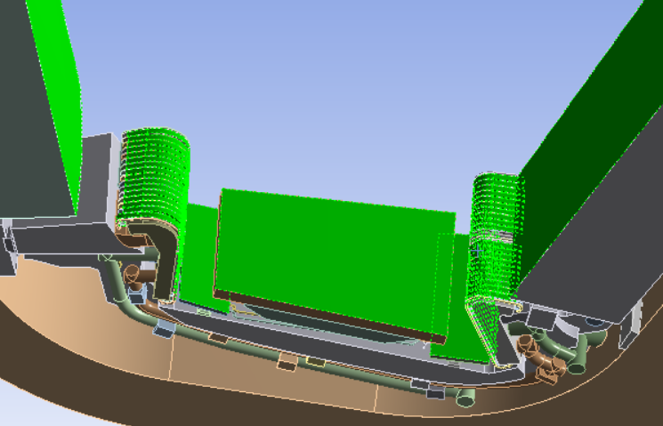
Figure 4.2. Surfaces where the Halo currents are injected (in green)

The equivalent PFV currents to be used are provided by the plasma simulations carried out in (Villone, 2019), (Villone, 2013) with the CarMa0NL code. Another source of eddy currents is the time variation of the plasma toroidal flux. By using this quantity, it is possible to derive the TFV (Toroidal Field Variation) set of currents for the considered event. The time-domain evolution of the total equivalent current flowing into the PFV and TFV coils are given in Fig. 4.3 and Fig. 4.4, for the considered event.
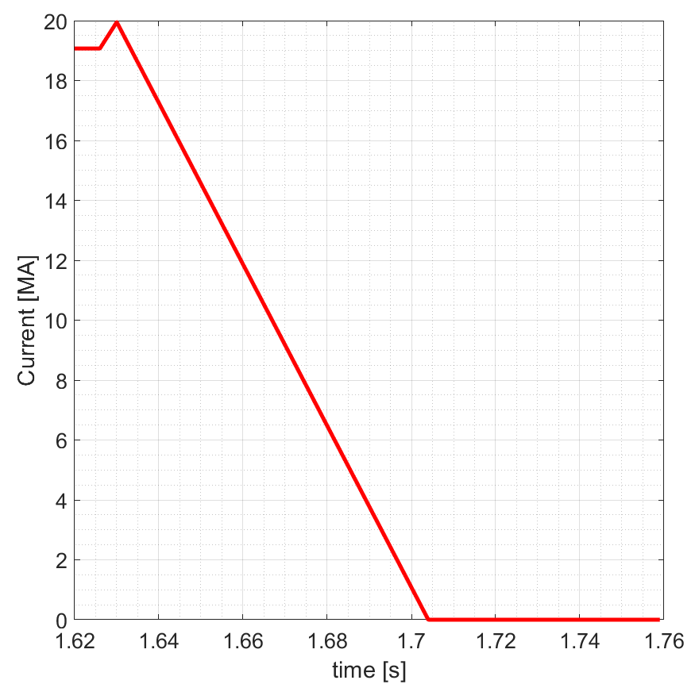
Figure 4.3. Total equivalent current flowing into the PFV coils (VDE_DOWN_74ms)

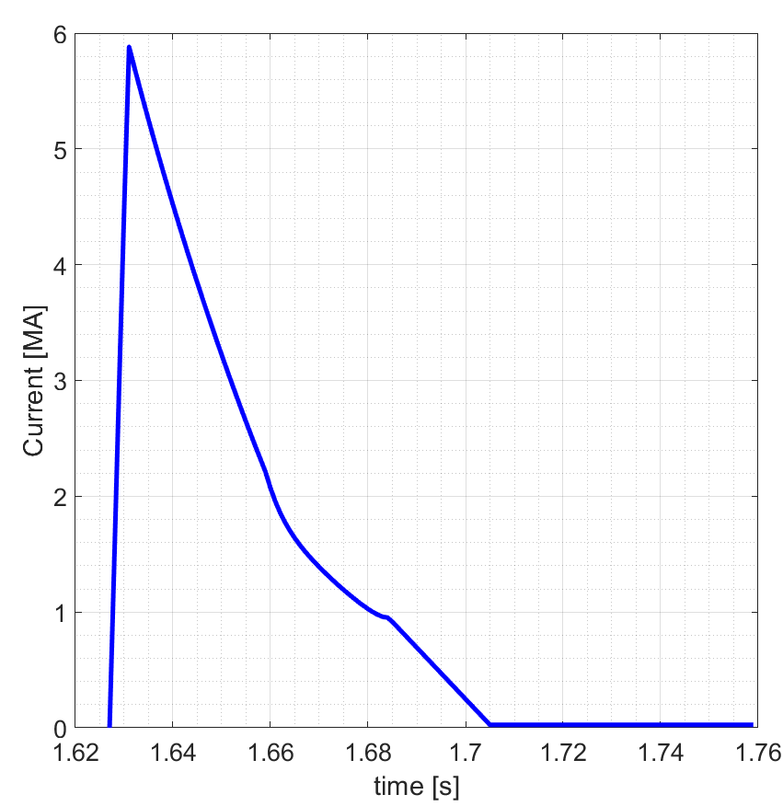
Figure 4.4. Total equivalent current flowing into the TFV coils (VDE_DOWN_74ms)

For the same event, the total Halo current injected into one of the three “divertor+blanket” assemblies hosted in the analysed sector is shown in Fig.4.5. The PFV and TFV excitations start approximately at t=1.63s, while the Halo currents start later, as expected, at t = 1.66 s.

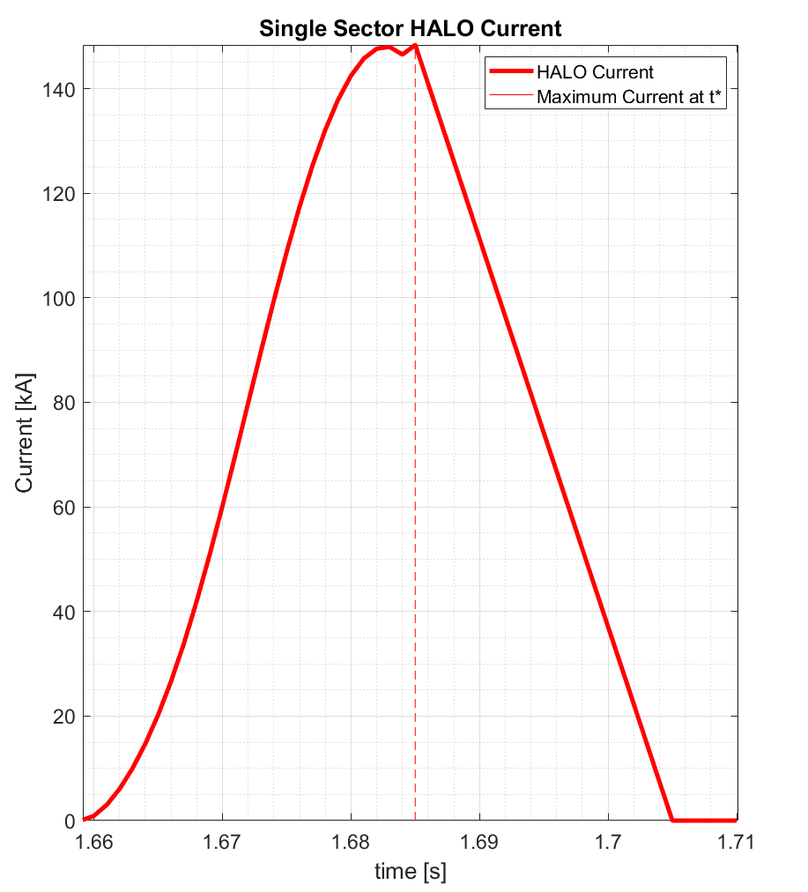
Figure 4.5. Total Halo current injected into a Divertor+Blanket assembly (VDE_DOWN_74ms)

4.1.2 Numerical implementation
The tool used to perform the low frequency transient analysis for this Case-study is ANSYS APDL EMAG (ansys.com). The eddy-current problem is solved by using a formulation based on the vector potential, namely the A-V formulation discussed in Chapter 2. An adaptive and conformal meshing based on tetrahedrons is used to model the problem: Figure 4.5 shows the meshed divertor assembly.
SOLID97 is the mesh element chosen to activate the use of this formulation: it is the 3-D 8-node element reported in Fig. 4.6, that has up to five degrees of freedom per node out of six defined DOFs. In this type of analysis, the DOFs used are the three aliquotes of the vector potential in the three directions (Ax, Ay and Az) and the one related to the electric potential (VOLT). This element is based on the magnetic vector potential with the Coulomb gauge. Furthermore, this element allows to perform analysis in static, AC time harmonic and (the one used in this analysis) transient mode.
The adopted mesh statistics are reported in Table 4.1. The quality of the mesh is checked by evaluating a metric that is calculated from the shape of each single element (literally called "Element quality” in the mesh statistic menu related to the Ansys Magnetostatic tool of WorkBench): the closer to 1 is this index, the better is the quality. The distribution of the element metrics among the mesh is reported in Fig. 4.8 and shows a good quality (the average value for such an index is about 0.60, with a standard deviation of 0.23).

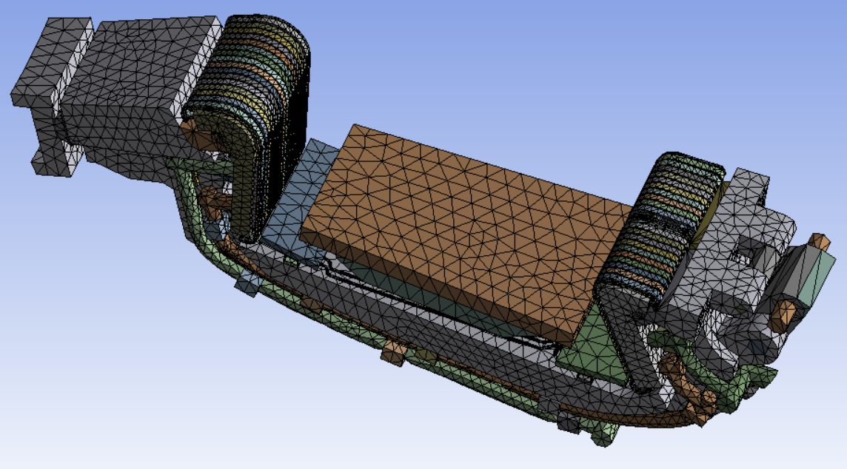
Figure 4.6. Meshing of the divertor assembly.

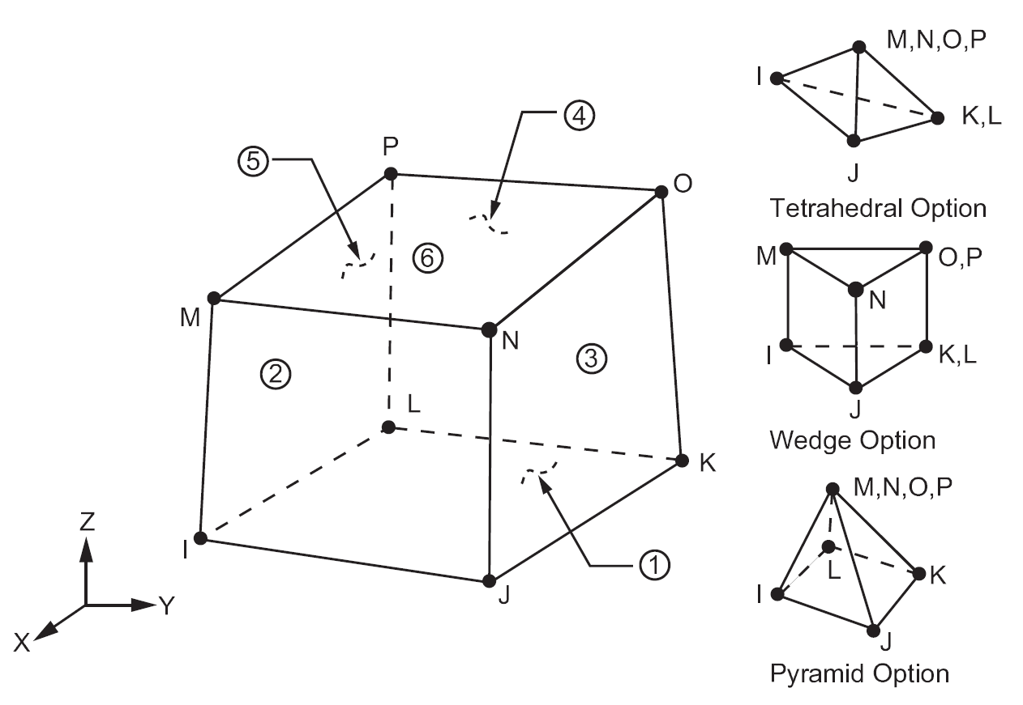
Figure 4.7 Ansys SOLID97 element adopted for the eddy-current analysis (Ansys, 2018).

Table 4.1. Statistics and Element quality for the adopted mesh
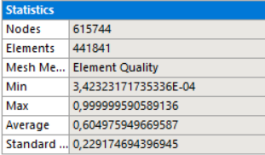
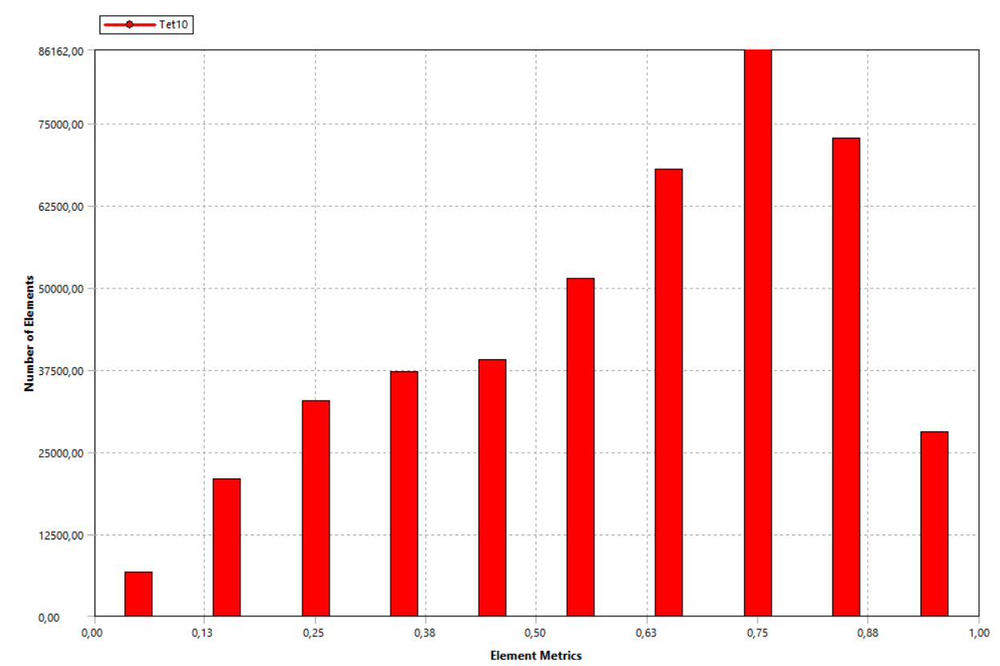
86162
75000
62500
50000
37500
25000
12500
0
Number of Elements
0 0.13 0.25 0.38 0.50 0.63 0.75 0.88 1
Element Metrics

Figure 4.8. Mesh element metrics for the adopted mesh.

4.1.3 Computed distributions of current densities
The results of the numerical analysis are shown here, in terms of computed spatial distributions of the density of current, $J\left(x,y,z,t\right)$, that is fundamental in view of evaluating the loads associated to the event. In the following, the current density distribution $J\left(x,y,z,t^{*}\right)$ is plotted for the main components of the model, referring to the time instant t* = 1.632s, that corresponds to the instant for which the resultant force on the whole divertor is maximum, as shown in Tab.4.3.
Figures 4.9 and 4.10 refer to the current distribution inside the vessel: as expected, the highest values are concentrated in the downward part (on the blankets supports to vessel). Figures 4.11 and 4.12 are shown the current density in the cassettes, highligtning the creation of current loops as an effect of the excitations.

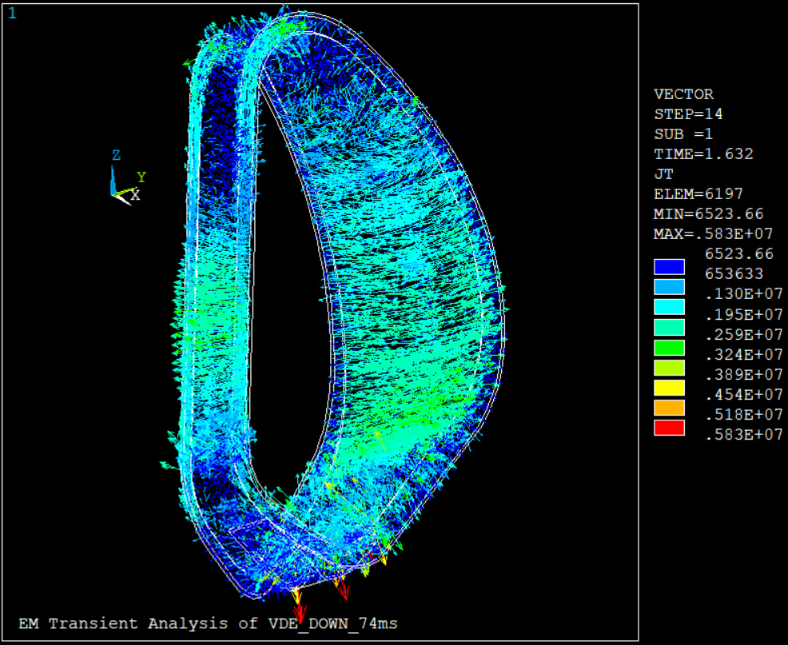
Figure 4.9 Current density distribution in the vessel at t*= 1.632s.
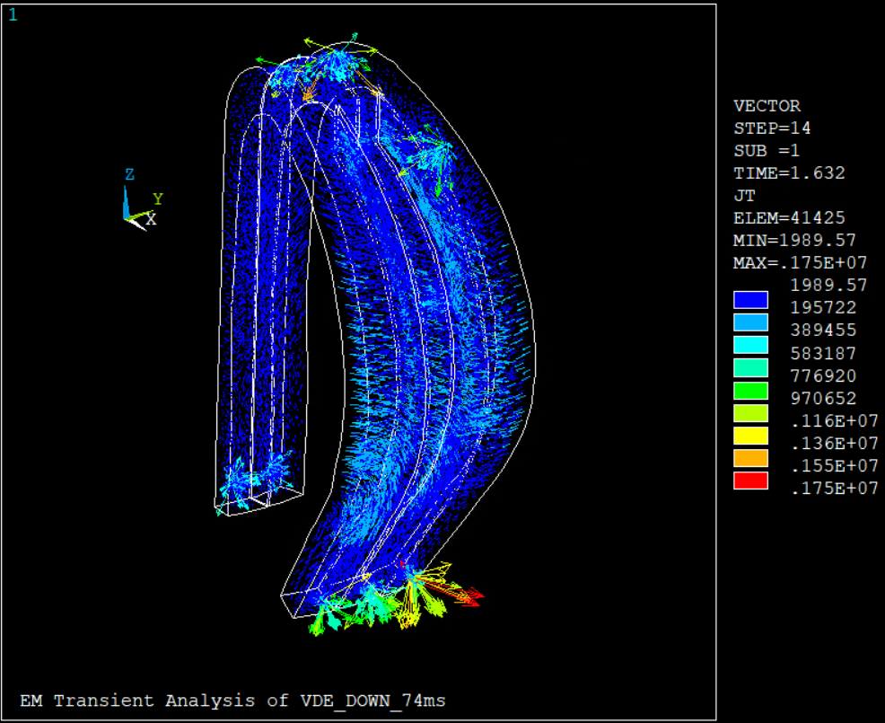
Figure 4.10. Current density distribution on the blankets at t*= 1.632s. The highest values are concentrated in the downward part (on the blankets supports to vessel).

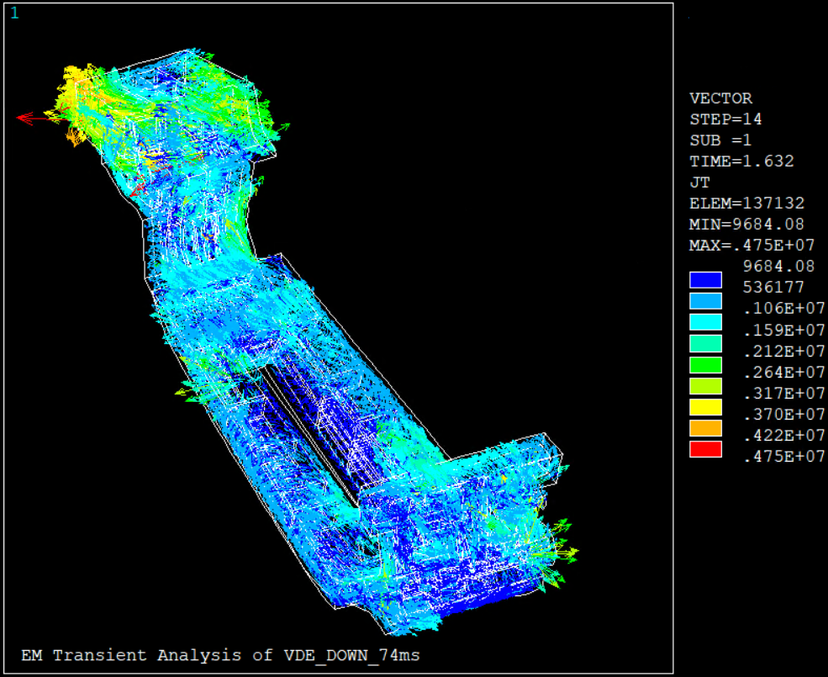
Figure 4.11. Current density distribution on the divertor cassette at t*= 1.632s. As it is shown, one effect of the excitations is the creation of current loops.
(a)
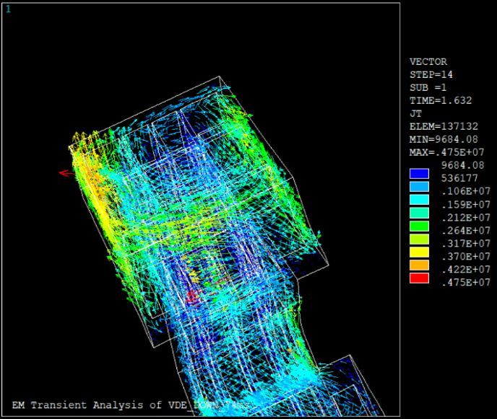

(b)
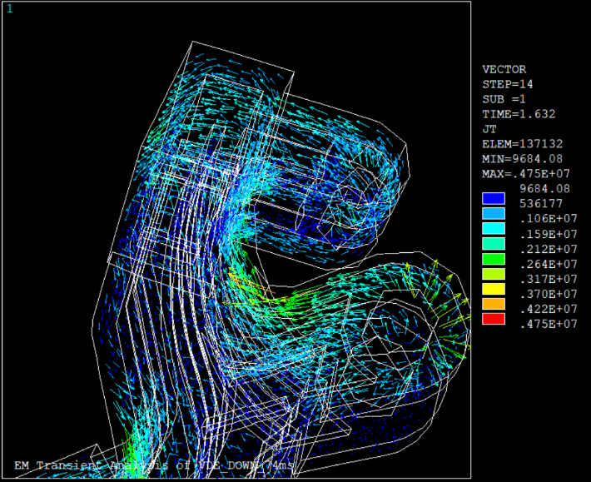
Figure 4.12. Distribution of the current density on the cassette at t*= 1.632s.
Inner current loops (a), outer current loops (b).

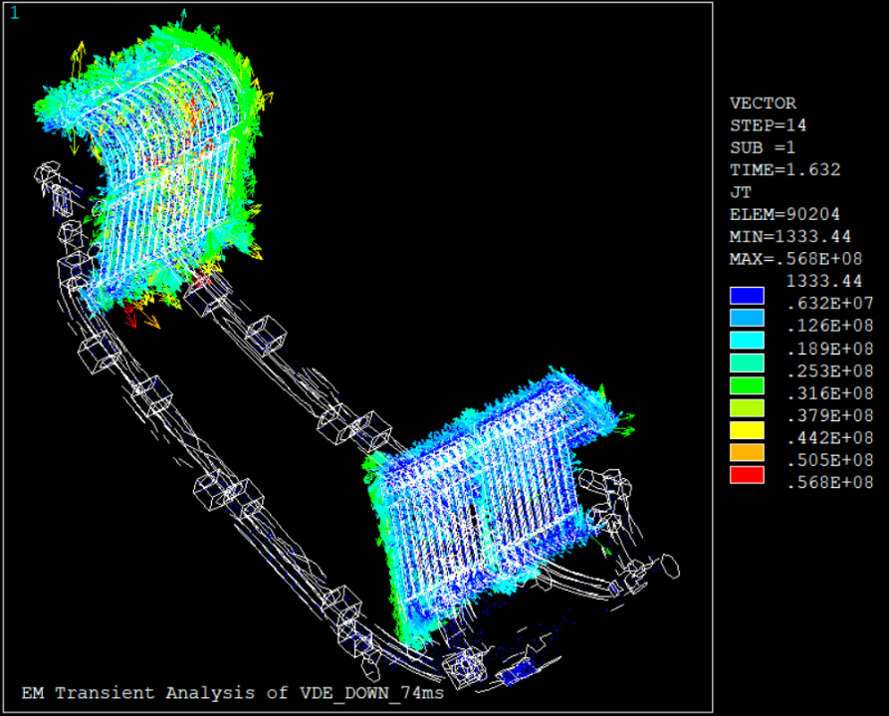
Figure 4.13 Distribution of the current density on the cooling system at t*= 1.632s.

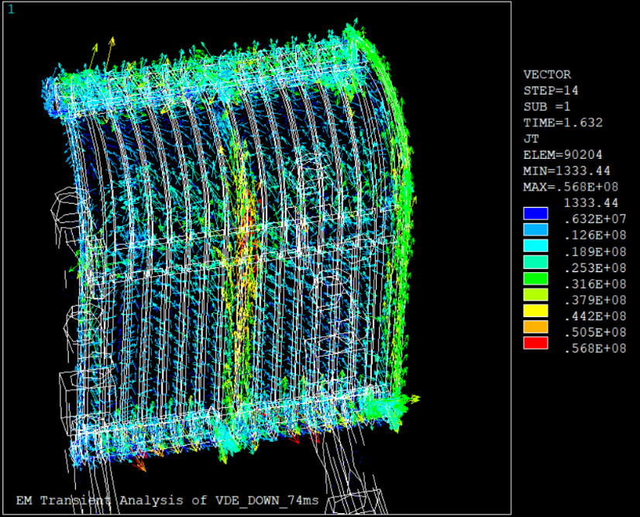
Figure 4.14. Current density on the cooling system at t*= 1.632s: inner target.
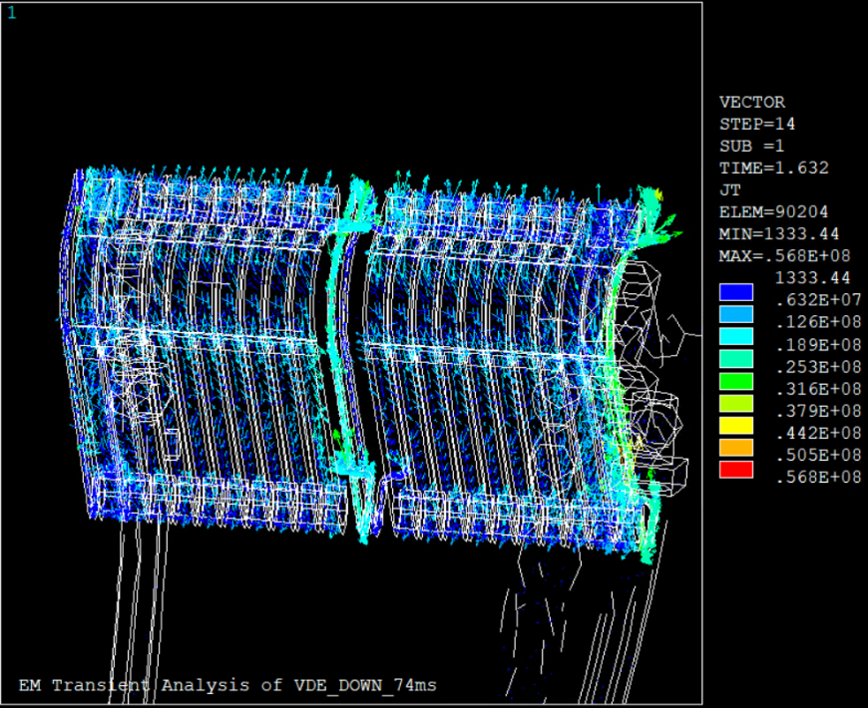
Figure 4.15. Current density on the cooling system at t*= 1.632s: outer target.

Finally, Figures 4.13-4.15 refer to the cooling system. The distribution of current density in this system is symmetrical both for the inner and outer parts of the cooling. These loops are created on the inner and outer vertical targets (the maximum current density is obtained in the external pipes of the loop as shown, for example, in Fig. 4.14). This current trend is justified by the fact that the vertical target zones are made of different material (CuCrZr), with lower resistivity (ITER- 2232UB_2MDMST) compared to the material of the remaining tubes of the cooling system (AISI 316 SS). Namely, the largest part of the current is closed on the material with lower resistivity (CuCrZr).

4.1.4 Evaluation of forces and moments
After the EM analysis is carried out, the mechanical loads can be computing starting from the evaluation of the volumetric density of Lorentz forces given by:
$f_{tot}\left(x,y,z,t\right)=J\left(x,y,z,t\right)×B_{tot}(x,y,z,t)$, | (4.1)
being $×$the symbol of the vector product. Here $J(x,y,z,t)$ is the current density and $B_{tot}\left(x,y,z,t\right)$ is the magnetic induction field, given by the sum of the contribution coming from the transient analysis, $B(x,y,z,t)$, and the static contribution associated to the equilibrium field due to PF and TF coils, say $B_{0}(x,y,z,t)$:
$B_{tot}\left(x,y,z,t\right)=B\left(x,y,z,t\right)+B_{0}(x,y,z,t)$. | (4.2)
The resultant forces are calculated by integrating the force density (4.2) in the volume of interest (the whole divertor and/or any of its subcomponents). In addition, the resultant moments of forces are calculated with reference to the Geometric Mass Center (GMC) of the component of interest.
Figures 4.16 shows the resultant of Lorentz forces and of the related moments referred to the whole divertor assembly. As pointed out, the global reference system has been adopted: x-axis corresponds to the radial direction, whereas y- and z- axes correspond to the toroidal and vertical directions. The disruption is assumed to take place at the time instant t = 0s.
For the results that follows, all the resultant moments have been evaluated with reference to the Geometric Mass Center (GMC) of the analyzed components, whose coordinates in the global reference system are given in Table 4.2.
Figures 4.17 and 4.18 report the EM loads referred to the two subsystems: Cassette, Fig.4.17, and Cooling system (cooling pipes + vertical target + supports to VV), Fig.4.18.
Finally, Table 4.3 summarizes the maximum values of the resultant forces and moments and the time instant at which this maximum is attained.

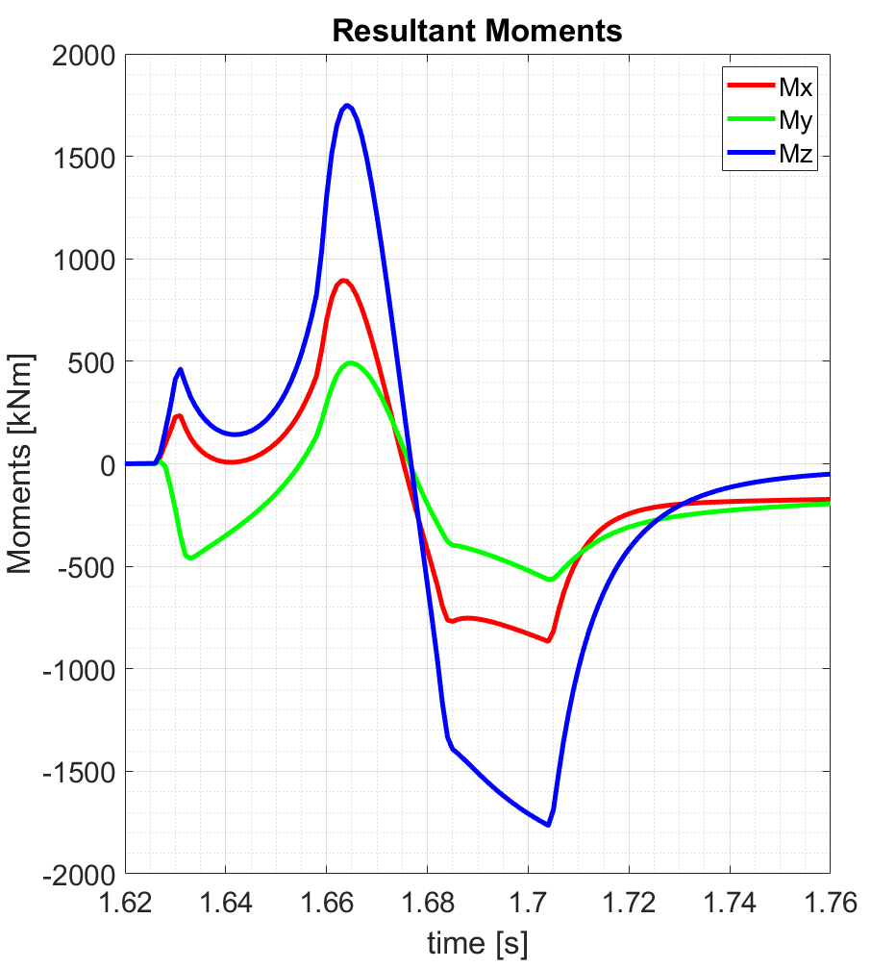
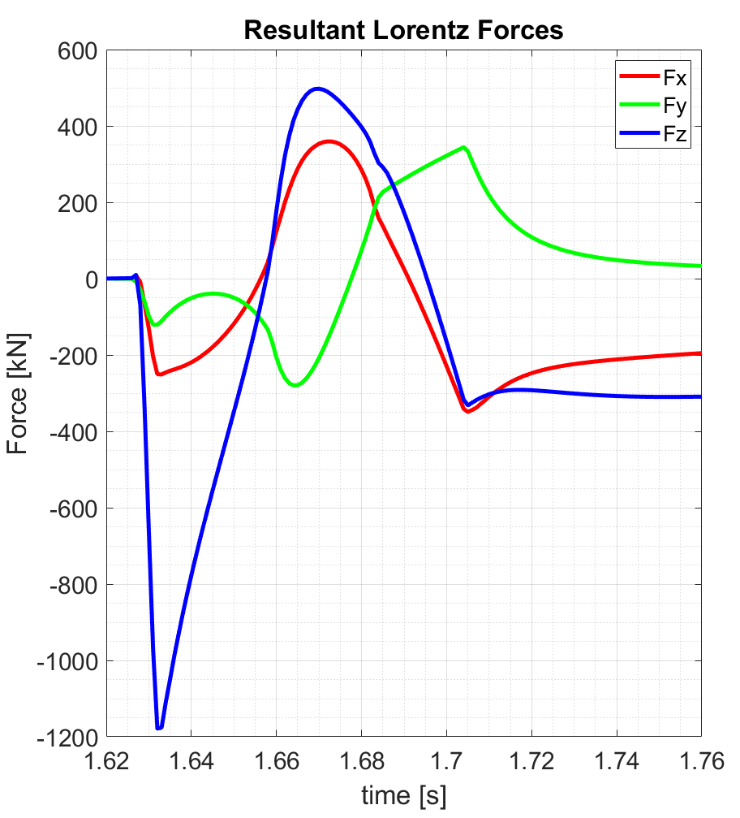
Figure 4.16. Resultants of the Lorentz forces (left), and of the moments (right), referred to the whole divertor, due to eddy and halo currents (VDE_DOWN_74ms)

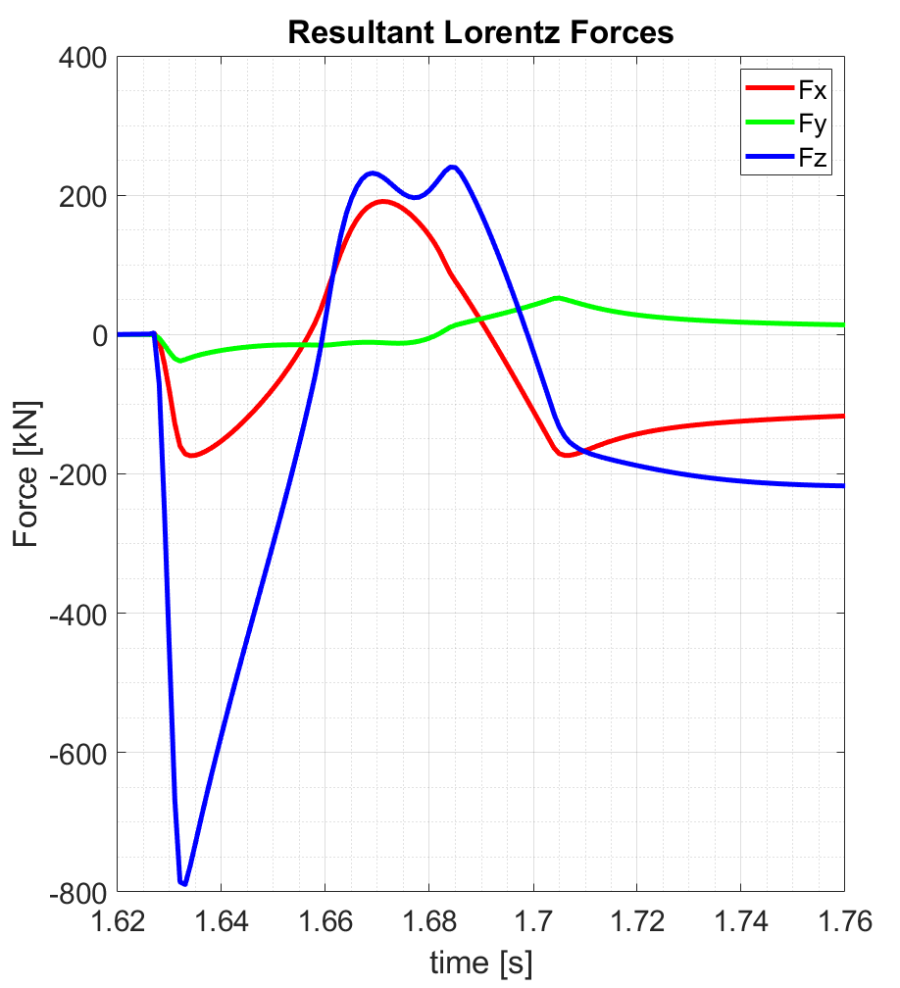 | 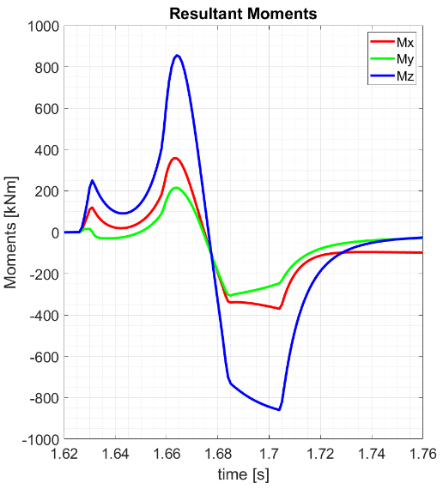
Figure 4.17. Resultants of the Lorentz forces (left) and of the moments (right) for the cassette only, due to eddy and halo currents (VDE_DOWN_74ms)

Table 4.2. Reference points (GMC) for the evaluation of the resultant moments
Coordinate | Divertor | Cassette | Cooling
x [m] | 7.3369 | 7.1998 | 7.4826
y [m] | -0.9677 | -0.9461 | -0.9903
z [m] | -6.5215 | -6.6790 | -6.5092
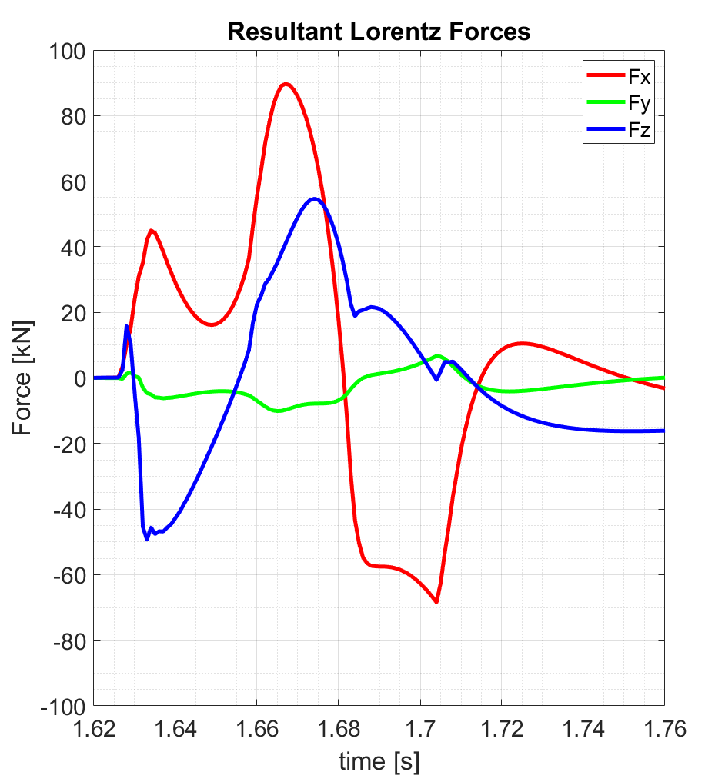 | 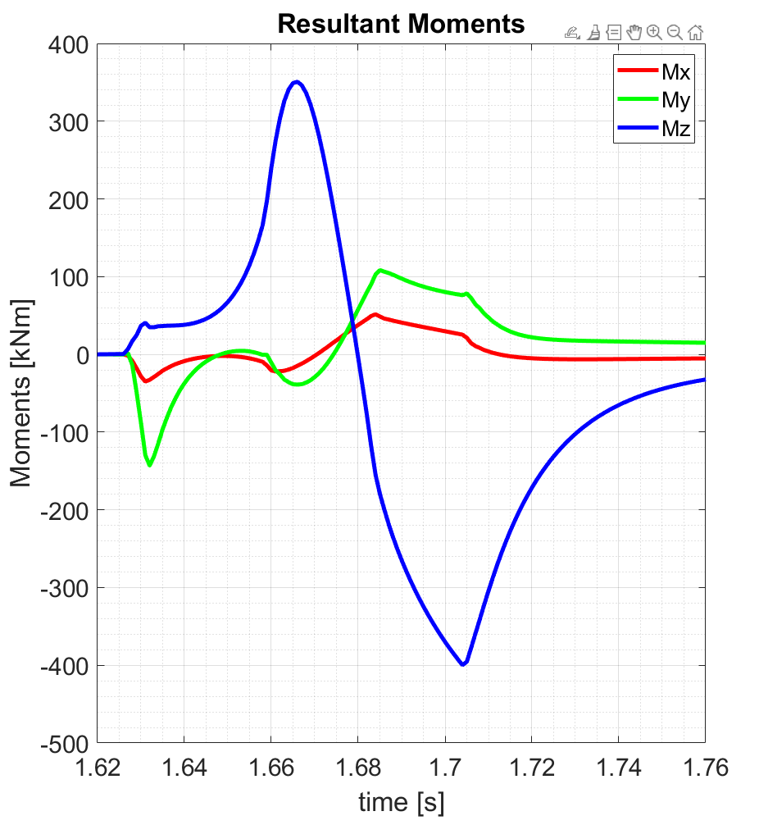
Figure 4.18. Resultants of the Lorentz forces (left) and of the moments (right) for the cooling system, due to eddy and halo currents (VDE_DOWN_74ms)

Table 4.3. Maximum values of the Lorentz forces and associated moments for each system.
System | Fx [MN] | Time [s] | Fy [MN] | Time [s] | Fz [MN] | Time [s] | Mx [kNm] | Time [s] | My [kNm] | Time [s] | Mz [kNm] | Time [s]
Divertor | 0.36 | 1.672 | 0.34 | 1.704 | -1.18 | 1.632 | 894.4 | 1.663 | -564.6 | 1.704 | -1764 | 1.704
Cassette | 0.19 | 1.671 | 0.05 | 1.705 | -0.79 | 1.633 | -369.8 | 1.704 | -305.8 | 1.685 | -859.2 | 1.704
Cooling | 0.09 | 1.667 | -0.01 | 1.665 | 0.05 | 1.674 | 51.45 | 1.684 | -143.1 | 1.632 | -399.7 | 1.704

The computed resultants of forces and moments suggest that the maximum load on the whole divertor assembly is associated to the vertical component of the force (about -1.2MN) and moment (about -1.8 MNm), referred to the Geometric Mass Center.
The maximum loads associated to the subsystem given by the cassettes are again associated to the vertical components of the force (about -0.8 MN) and moment (about -0.9 MNm). The maximum loads associated to the subsystem given by the cooling system (cooling pipes, vertical targets) are lower: Fx=0.09 MN and Mz = -0.4 MNm
A sensitivity analysis is the carried out to check the effect of reaplcing the steel with EUROFER in realizing the Cooling system components. The results are summarized in Table 4.4. In addition, the analysis is performed also in the case of assuming the supports between cassettes and vertical targets to be insulating (Table 4.5).

Table 4.4. Maximum values of the Lorentz forces and associated moments for each system (by using Eurofer for the whole Cooling System).
System | Fx [MN] | Time [s] | Fy [MN] | Time [s] | Fz [MN] | Time [s] | Mx [kNm] | Time [s] | My [kNm] | Time [s] | Mz [kNm] | Time [s]
Divertor | 0.35 | 1.673 | 0.34 | 1.704 | -1.18 | 1.632 | 896.3 | 1.663 | -552.5 | 1.704 | -1760 | 1.704
Cassette | 0.19 | 1.671 | 0.05 | 1.705 | -0.79 | 1.633 | -370.2 | 1.704 | -304.2 | 1.685 | -860.7 | 1.704
Cooling | 0.09 | 1.667 | -0.01 | 1.665 | 0.05 | 1.674 | 48.31 | 1.684 | -141.9 | 1.632 | -393.7 | 1.704

Table 4.5. Maximum values of the Lorentz forces and associated moments for each system (by using insulating supports between Vertical Targets and Divertor Cassettes).
System | Fx [MN] | Time [s] | Fy [MN] | Time [s] | Fz [MN] | Time [s] | Mx [kNm] | Time [s] | My [kNm] | Time [s] | Mz [kNm] | Time [s]
Divertor | 0.36 | 1.673 | 0.33 | 1.704 | -1.19 | 1.632 | 880.34 | 1.663 | -559.1 | 1.704 | 1679.5 | 1.664
Cassette | 0.19 | 1.671 | 0.05 | 1.705 | -0.80 | 1.633 | -370.74 | 1.704 | -302.8 | 1.685 | -860.0 | 1.704
Cooling | 0.10 | 1.672 | -0.01 | 1.680 | 0.08 | 1.674 | 44.22 | 1.684 | -140.3 | 1.632 | -277.3 | 1.704

As shown in both Tables, the results do not significantly change by assuming to use EUROFER for all the Cooling System components or by assuming the supports between cassettes and vertical targets to be insulating.

4.1.5 Mesh assessment
A mesh assessment of the model shown in the previous chapters was carried out. In particular, for the sake of simplicity, the assessment was performed with reference to the model for the computation of the eddy-currents. Indeed, adding the halo currents do not introduce significant differences in terms of spatial and time characteristics, hence they can be neglected to this purpose. A refined mesh has been considered, whose characteristics are shown Table 4.6, whose number of elements is about +30% larger than the reference mesh in Table 4.1. The results obtained by using the two meshes are compared in Figure 4.19, that plots the resultant Lorentz forces in the two cases.
Table 4.6 Statistics related to the finer mesh.
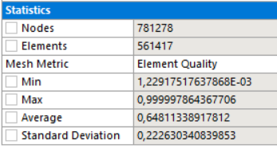

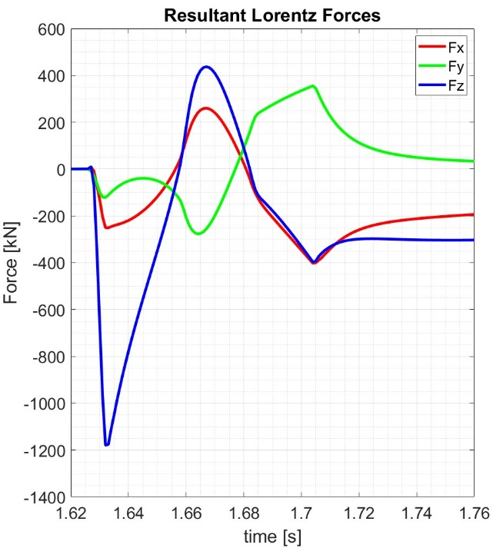
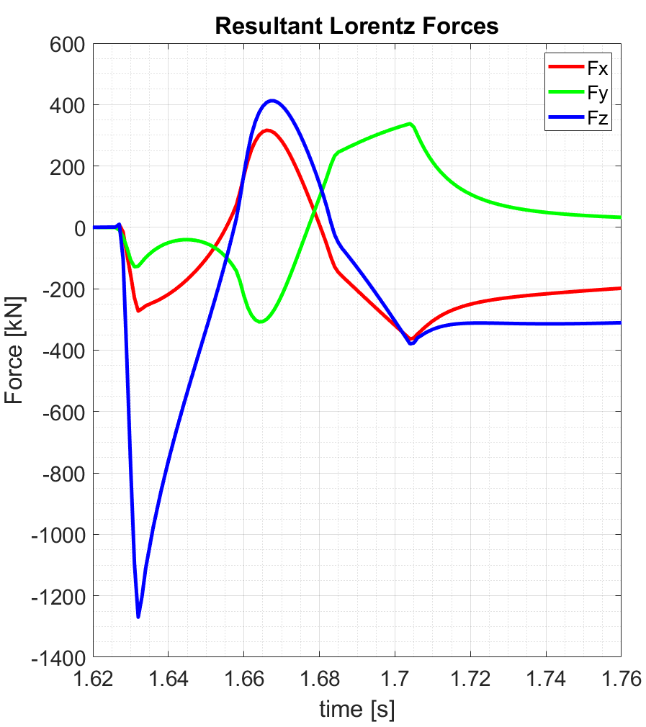
Figure 4.19. Resultants of the Lorentz forces for the coarse mesh (left) and of the fine mesh (right) for the Whole Divertor, due to eddy currents only (VDE_DOWN_74ms).

The maximum error on the peaks of the 3 components does not exceed 7%, that is a level of accuracy acceptable for our purposes.

4.2 EM loads on DEMO divertors resulting from ferromagnetic effects

The case study and its model have been detailed in Section 3.1, see also Figure 3.7 for an overview of the analyzed geometry.

4.2.1 Event and excitations
The excitation sources of the model impose in the considered sector a static field that corresponds to the equilibrium scenario defined in (Villone, 2013). Following the approach described in sub-section 3.3.2, the excitations used for the analysis are:
- a static magnetic field, created by the imposition of 32.6 MA through the TFCs;
- an equivalent current source representing the plasma current at equilibrium (as shown in sub-section 3.3.1). As it will be shown in Section 4.2.4, the contribution to the loads coming from this term is a correction to the main one coming from the TF coils. Other possible contributions, coming from axisymmetric sources (for instance, Poloidal Field coils) are found to be negligible.
Figure 4.20. The analyzed 22.5° sector of DEMO in-vessel assembly, including the divertors (in red), blankets (in green), the toroidal field coils (in yellow) and the layer with the equivalent sources associated to plasma currents (in blue)
(Di Mambro et al., 2023).

4.2.2 Numerical Implementation
The analysis has been performed by using CARIDDI code (R. Albanese and G. Rubinacci, 1988), that numerically solves the magneto-static volume integral equation (2.39).
The CAD model is much more simplified with respect to that adopted in Section 4.1 for the transient analysis, but retaining approximatively the same volume of the original model. Specifically, the volume of each of the three cassettes is equal to 2.3 m³, whereas that of each of the two blanket modules is 42 m³. Furthermore, the ratio $p$ between ferromagnetic/no ferromagnetic volumes is equal to 38.3% in the cassettes and to 8.3% in the blankets. Therefore, the EUROFER volume of three divertors is equal to 2.64 m³ whereas that of the two blankets is equal to 6.80 m³.
The integral formulation allows a great simplification of the meshing, since it requires the discretization of the metallic parts only (magnetic or conducting). The Figure 4.21 shows a detail of a meshed divertor: an adaptive conformal hexahedrons meshing has been used. The characteristics of the mesh are reported in Table 4.7.
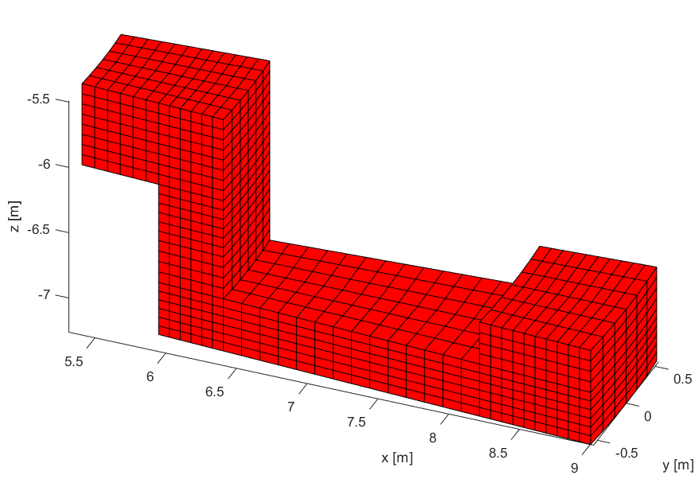
Figure 4.21. Side view of a meshed divertor (Di Mambro et al., 2023).

Table 4.7 Features of the blankets and the divertors meshes.
Component | Nodes | Elements
Divertor cassettes | 9261 | 6768
Blanket modules | 5852 | 3780

4.2.3 Computed distribution of the magnetic flux density
The computed spatial distributions of the magnetic flux density B in the considered regions are plotted in Fig.4.22,4.23 and 4.24. Specifically, Fig.4.22 shows the field imposed by the external sources in the regions of the divertor and of the blanket, assumed to be non-magnetic.
(a)
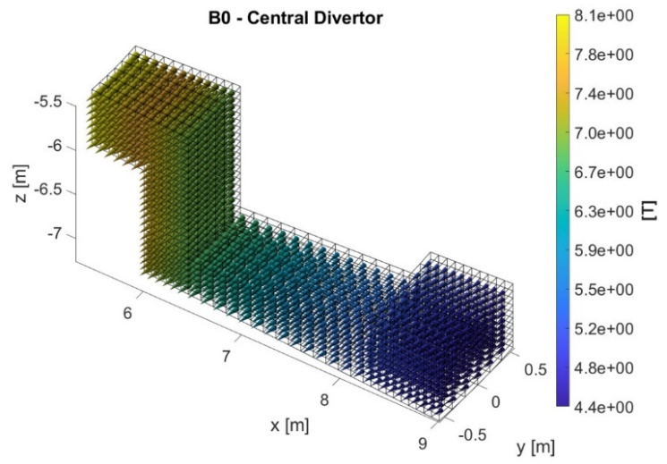
(b)
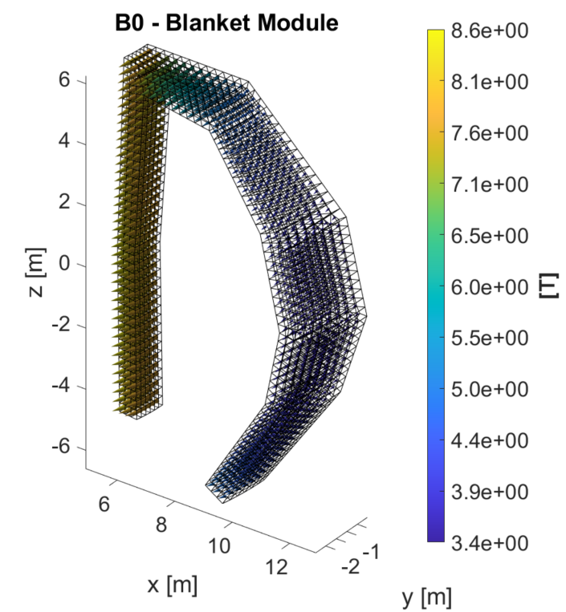

Fig. 4.22 Distribution of the magnetic flux density B in the ferromagnetic regions imposed by external excitations: (a) on the Central Divertor (b) on a blanket module
(Di Mambro et al., 2023).
Instead, the total field computed in the same regions, that also includes the effect of magnetization, is shown in Fig.4.23. By comparing the two results, it is evident that the effect of the magnetization on the total B field is limited. To better highlight this point, Fig.4.24 reports the magnetic flux density associated to the induced magnetization.
(a)
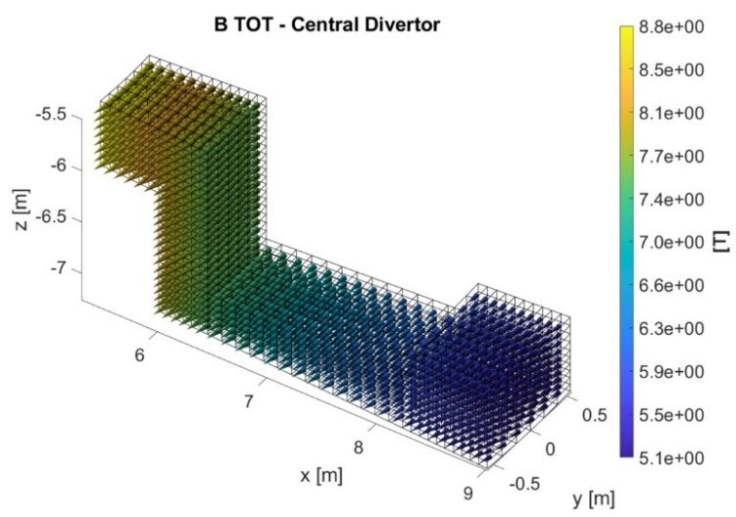
(b)
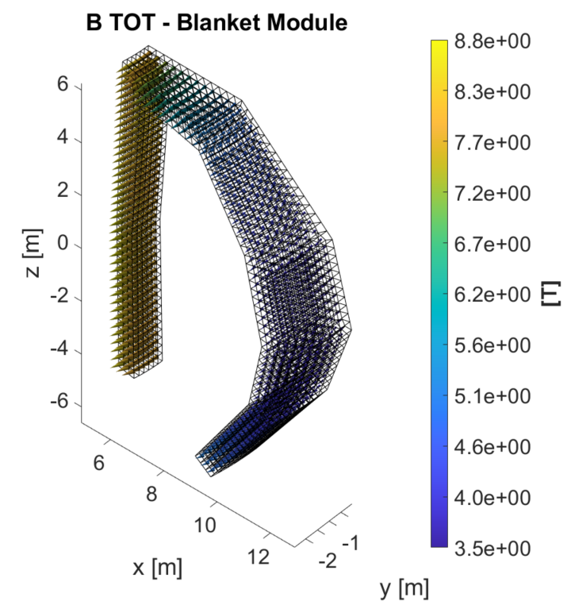
Fig. 4.23 Distribution of the total magnetic flux density: (a) on the Central Divertor (b) on a single Blanket module (Di Mambro et al., 2023).
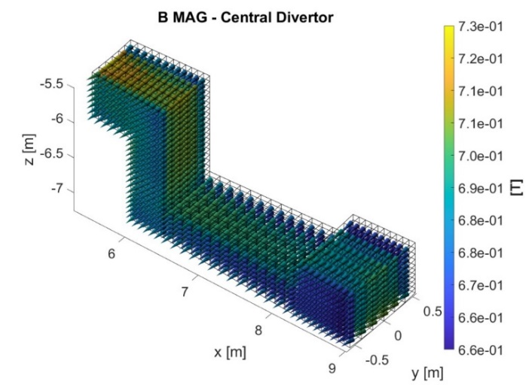
(b)
(a)
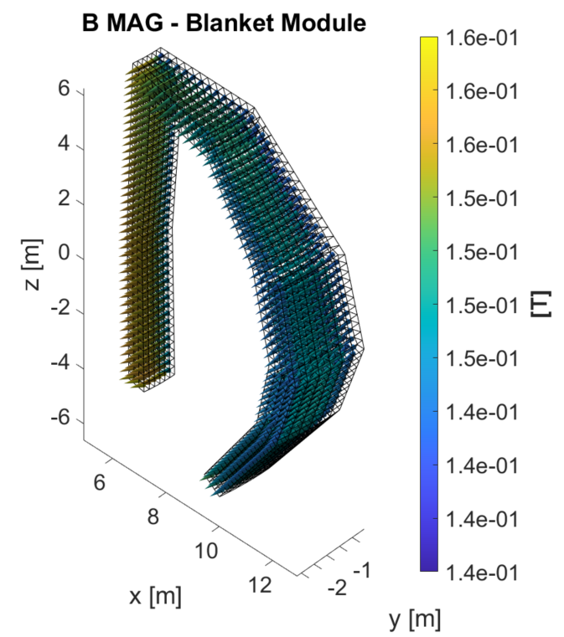
Fig. 4.24 Distribution of the magnetic flux density due to the magnetization of the ferromagnetic regions: (a) on the Central Divertor (b) on a single Blanket module
(Di Mambro et al., 2023).
Note that this result is also due to the fact that in the considered regions occupied by cassettes and blankets, the levels of the static magnetic flux density associated to the considered operating condition range from 3.38T to 8.57 T (see (Di Mambro, 2022)). By checking Fig.4.22, it is evident that these levels are driving the ferromagnetic material to work in the saturation region, so lowering the effect of magnetization.

4.2.4 Evaluation of Forces and moments
Once the static problem is solved and the distribution of the magnetic field is calculated, the $F_{k}$ and the torques $T_{k}$ on the k-ith element can be computed by using Kelvin’s method (see G. Di Mambro et al., 2023):
$F_{k}= \int_{V_{Mk}}{M ∙ ∇μ_{0}H_{extk} dV}$. | (4.3)
$$T_{k}= \int_{V_{Mk}}{M x μ_{0}H_{extk} dV}+ \int_{V_{Mk}}{r x F_{k} dV}$$ | (4.4)

Here, H_{ext} is the external magnetic field imposed by the external coils, and V_{Mk} is the volume of the considered ferromagnetic object.
The computed distributions of field and magnetization have been used to evaluate the resultant ferromagnetic forces and moments associated to each element of the model, as reported in Table 4.8. Note that the moments are computed with respect to the center of mass of each element.
Both for the divertors and for the blankets, the main component of the ferromagnetic resultant force is the radial one (|Fx |max=1.25 MN and |Fx |max=3.27 MN), respectively, that results to be 1-2 orders of magnitude larger than the others. Considering the reference axes (See Fig. 4.20), these radial forces are all directed towards the inner part of the machine.
As for the torques, in the divertors the main components are the toroidal ones (|My|max=8.71 MNm), whereas in the blankets the toroidal and vertical ones are comparable (|My|max=2.81 MNm, |Mz|max=2.57 MNm). To highlight the effect of the axisymmetric source (plasma current), the same analysis has been carried out by using the TF coils excitation only, and the results are summarized in Table 4.9. The variation on the peak values of forces and of moments is less than 5%, hence the contribution coming from such a source is negligible compared to the limits of the accuracy of the results of the proposed model.

Table 4.8 Computed values of the resultants of ferromagnetic forces and moments (total).
 | Fx [MN] | Fy [MN] | Fz  [MN] | Mx  [MNm] | My  [MNm] | Mz  [MNm]
Central Cassette | - 1.25 | - 0.02 | 0.25 | - 0.13 | 6.30 | -0.14
External Cassette 1 | - 1.20 | 0.11 | - 0.09 | 0.67 | 8.60 | 2.00
External Cassette 2 | - 1.19 | - 0.08 | - 0.12 | - 0.50 | 8.71 | -1.83
Blanket 1 | -3.27 | 0.05 | -0.02 | 0.05 | -2.66 | -2.57
Blanket 2 | -3.27 | -0.05 | 0.06 | -0.04 | -2.81 | 2.57

Table 4.9 Computed values of the resultants of ferromagnetic forces and moments
(TF Coils only).
 | Fx [MN] | Fy [MN] | Fz  [MN] | Mx [MNm] | My [MNm] | Mz [MNm]
Central Cassette | -1.25 | 0.00 | 0.24 | 0.01 | 6.41 | 0.01
External Cassette 1 | -1.19 | 0.10 | -0.13 | 0.58 | 8.78 | 1.93
External Cassette 2 | -1.19 | -0.10 | -0.13 | -0.57 | 8.78 | -1.91
Blanket 1 | -3.23 | 0.04 | 0.003 | 0.04 | -2.81 | -2.60
Blanket 2 | -3.23 | -0.04 | 0.003 | -0.04 | -2.81 | 2.60

As a final consideration, it is possible to observe that the order of magnitude of these static loads is comparable to the EM loads coming from transient effects associated to the VDE event (eddy currents, halo currents, presented in previous section 4.1.4).

4.3 EM loads on ITER ex-port RNC resulting from fast transient events
The case study and its model have been detailed in Section 3.2, see also Figures 3.13-3.14 for an overview of the analyzed geometry.

4.3.1 Event and excitations
The values adopted as excitations of the Global Model are referred to a Vertical Displace Event (VDE_down_36ms) downwards with duration of 36ms and to a Major Disruption (MD_up_36ms) upwards with the same duration (M. Roccella and R. Roccella, 2011).
Figures 4.25 and 4.26 show the time-domain evolution of the equivalent total toroidal currents related to the VDE_down_36ms and to the MD_up_36ms events, respectively. As pointed out in Section 3.2, these currents are used in the Global Model analysis.
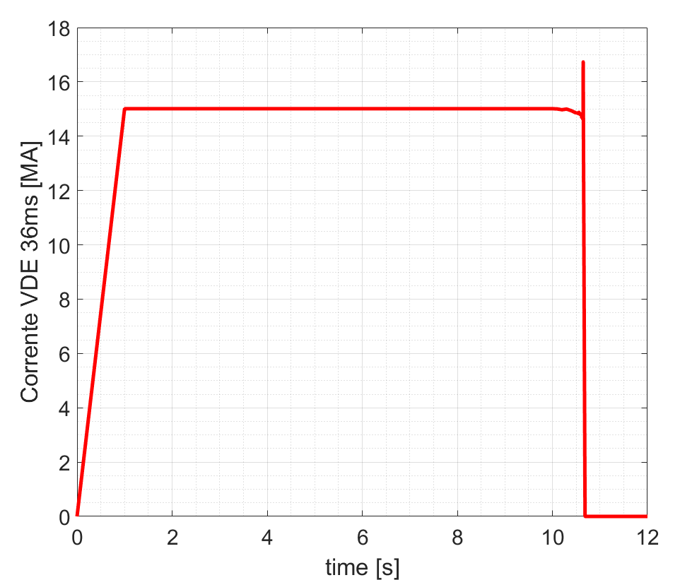
Figure 4.25 Equivalent toroidal current representing the event VDE_down_36ms.
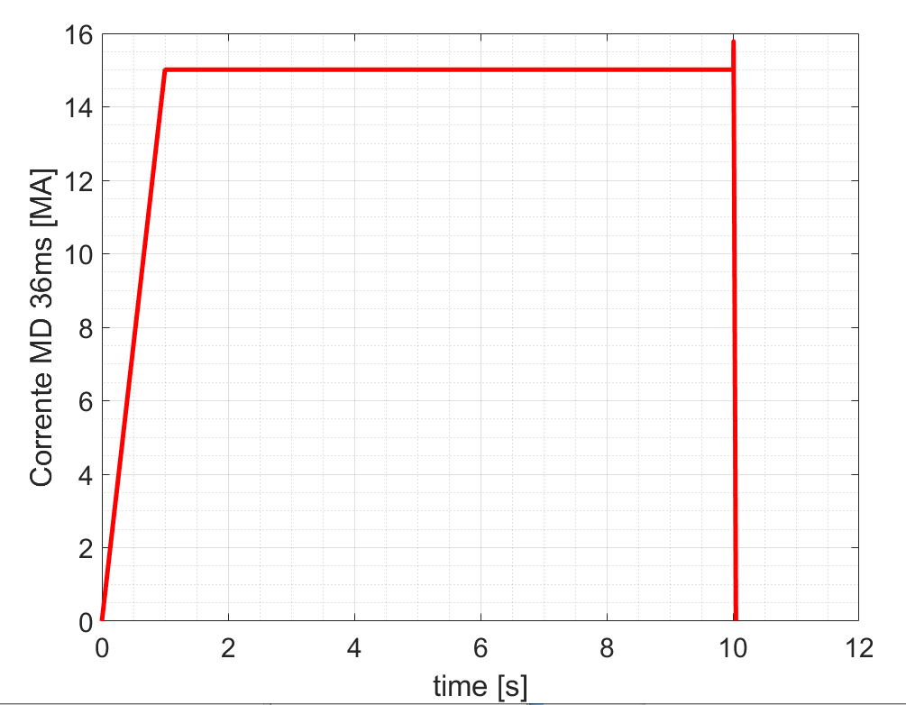
Figure 4.26 Equivalent toroidal current representing the event MD_up_36ms.

The EM analysis has been performed using the SubModeling technique discussed in Section 3.2. We recall that for the Global Model the considered excitations are:
- The equivalent toroidal current filaments (the so-called “poloidal field variation coils”) that imposes the poloidal field representing the plasma events;
- The Poloidal Field Coils outside the Vessel, generating the field that confines the Plasma.
For what concerns instead the boundaries, conditions of periodicity apply for the vertical plans of the considered sector.
For the Local model, having adopted the sub-modelling approach, the excitations are given through proper boundary conditions, derived from the results of the Global Model, interpolated on the cut-boundaries defining the limits of the Local one. In particular, the parameters used to impose the excitations on the cut boundaries of the local model are represented by the Vector Potential (Ax, Ay, Az) imposed on the external nodes. In this case study, interpolating only the A dofs was possible because in the cut boundary there are no cuts of conductor elements but only air. In the event that the cut boundary cuts conductive objects, it is necessary also the interpolation of the VOLT dof.

4.3.2 Numerical implementation
As done for the transient eddy-current analysis in Section 4.1, the tool used to analyze this Case-study is again ANSYS APDL EMAG (ansys.com). Same considerations as those done in subsection 4.1.2 apply as concerns the numerical implementation, again developed by creating an adaptive conformal mesh has been built, based on the tetrahedrons elements and by using the SOLID97 element. Figure 4.27a and 4.27b represents the mesh adopted for the external enclosure and for the whole internal Object respectively. The mesh statistics and quality metrics are provided in Figures 4.28 and 4.29.
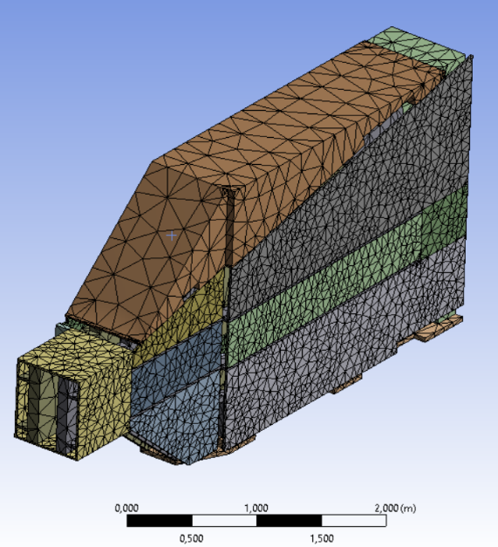
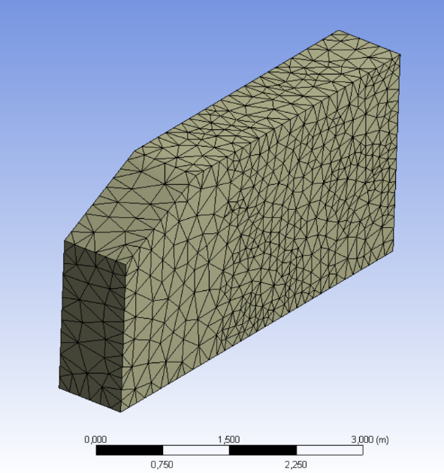
(a) (b)

Figure 4.27 - Conformal meshing of (a) external enclosure (cut boundary of the local model); (b) ex-port RNC.

Figure 4.28 – EM mesh statistics.

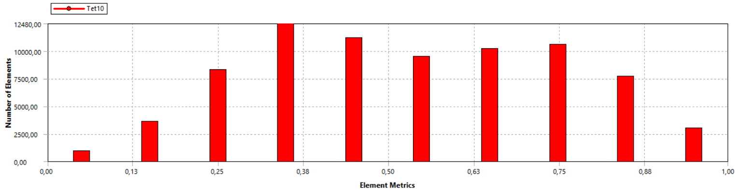
12480
10000
7500
5000
2500
0

Number of Elements

Element Metrics
0 0.13 0.25 0.38 0.50 0.63 0.75 0.88 1

Figure 4.29 – Quality metrics for the adopted mesh.

To ensure the reliability of the results of the analyzes carried out, a sanity check was performed by considering the variation of the magnetic flux density B at the location of the Ex-port RNC for the VDE_down_36ms event. Figures 4.30 and 4.31 show the spatial distribution of B in the position of the Ex-port RNC, as computed from the Global and the Local Model, respectively. The maximum difference that can be found is no higher than 10%. Similar results were obtained for the other event.
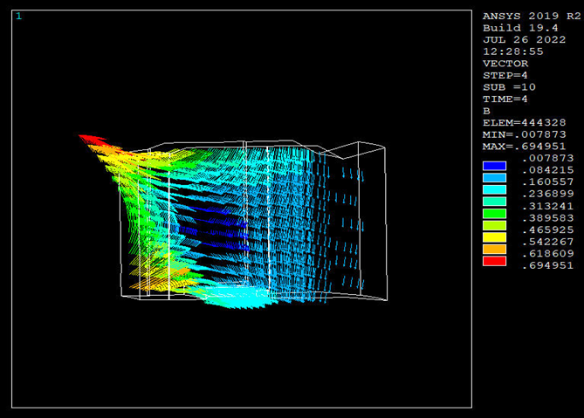
Figure 4.30 Distribution of B field in the area of the Ex-port RNC
(from Global Model analysis).
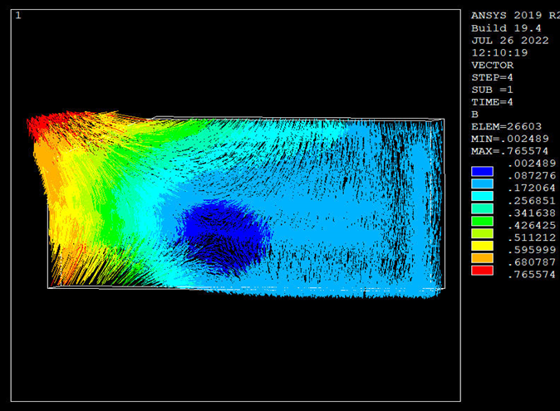
Figure 4.31 Distribution of B field in the area of the Ex-port RNC
(from Local Model analysis).

4.3.3 Computed distributions of current densities
The results of the numerical analysis are shown here, in terms of computed spatial distributions of the density of the eddy currents, $J\left(x,y,z,t\right)$, on the whole object (the Export-RNC assembly).
Figure 4.32 refers to the VDE event and show the current distribution at the time instant at which the largest component of the Lorentz’s Force (Fx) reaches his maximum value (t* = 10.76s).
Similarly, Figure 4.33 refers to the MD event and show the current distribution at the time instant at which the largest component of the Lorentz’s Force (Fx) reaches his maximum value (t* = 10.001s).

(a)
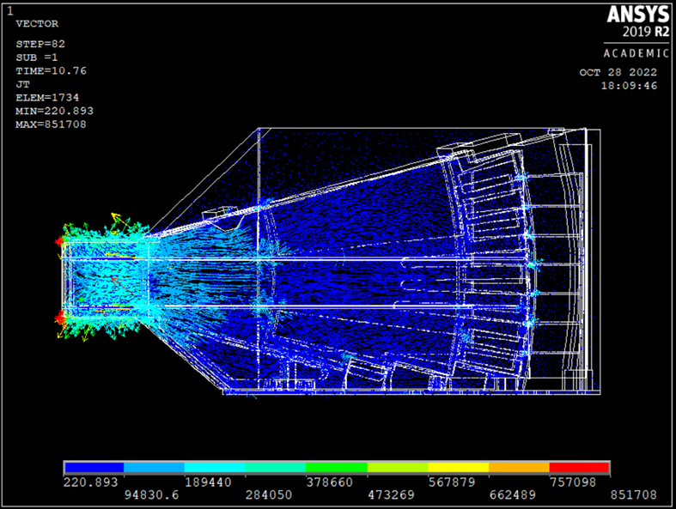
(b)
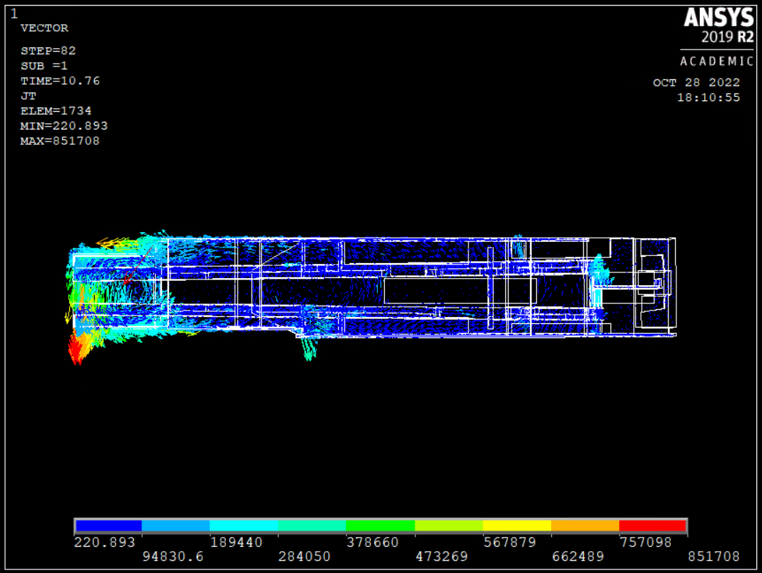
Figure 4.32: Eddy current distribution on the ex-port for the VDE event at t* = 10.76s: side view; (b) top view.
(a)
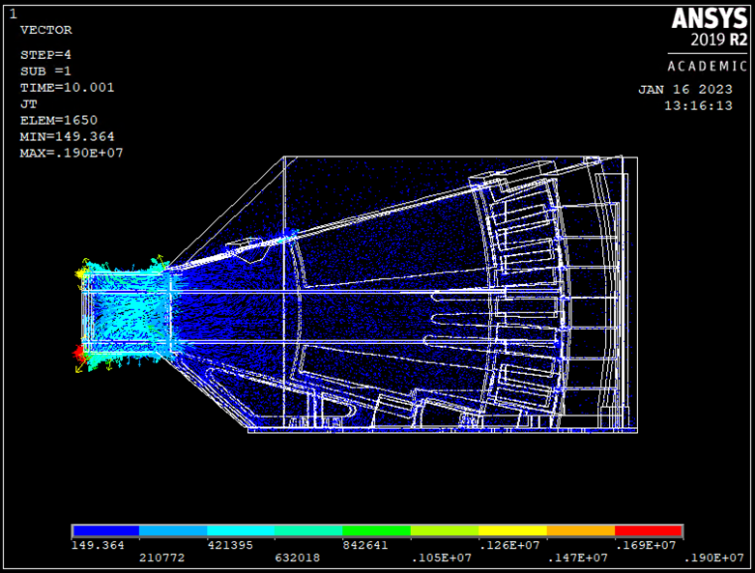
(b)
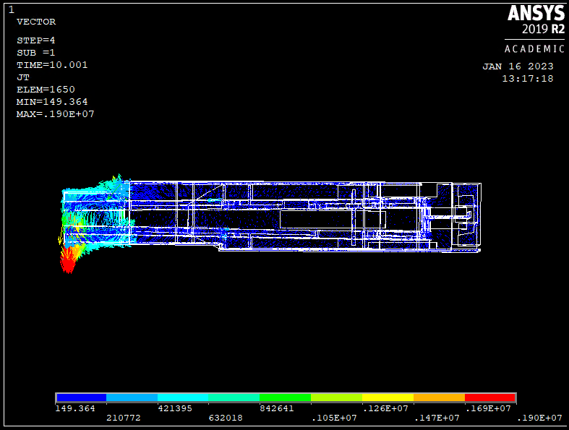
Figure 4.33: Eddy current distribution on the ex-port for the MD event at t* = 10.001s: side view; (b) top view.

4.3.5 Evaluation of forces and moments
The resultant forces and moments on the ex-port due to the VDE and MD events, computed as in (4.1), are shown in Fig.4.34 and Fig. 4.35, respectively.
(a) (b)
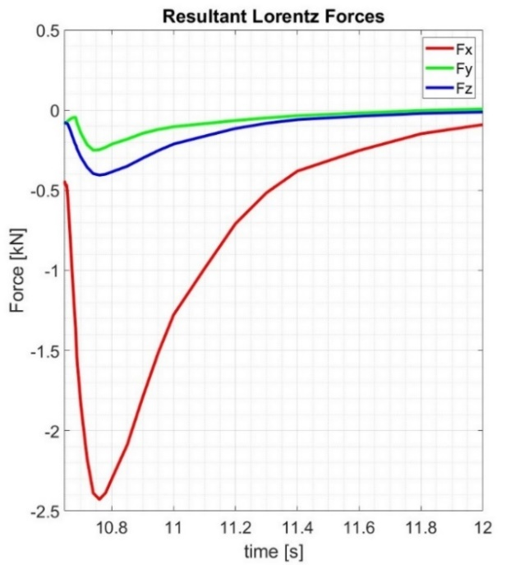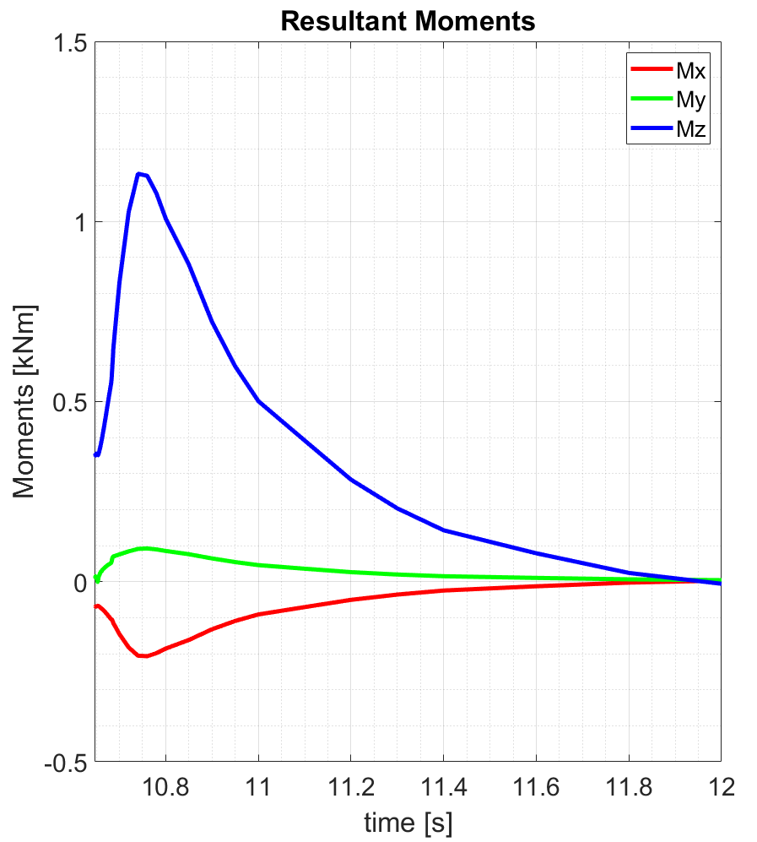
Figure 4.34 – EM loads on the ex-port RNC associated to VDE_down 36ms: (a) resultant Lorentz Force; (b) resultant moments (referred to the center of mass).
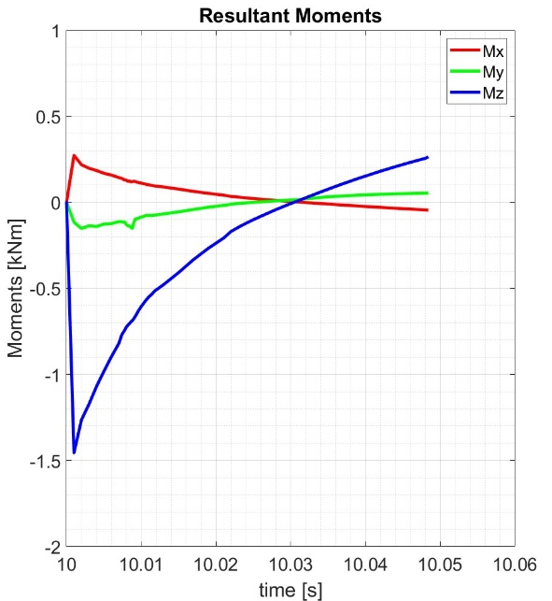
(a) (b)
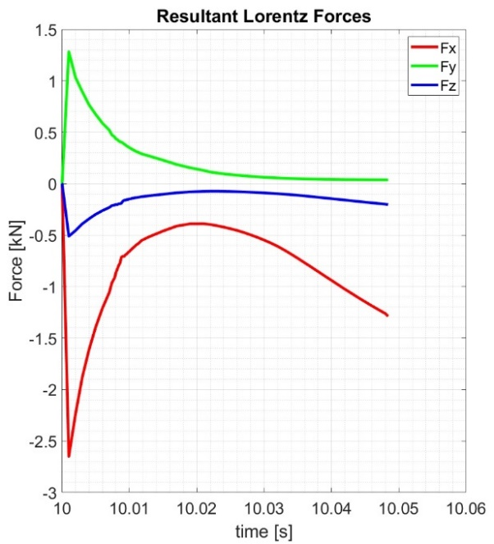
Figure 4.35 – EM loads on the ex-port RNC associated to MD_up 36ms: (a) resultant Lorentz Force; (b) resultant moments (referred to the center of mass).

The peak values are summarized in Table 4.10.
For what concern the VDE_down 36ms event, the maximum component of the Lorentz force is the radial one (Fx), that reaches the value of -2.43 kN. The peak value of the resultant moments with respect to the center of mass of the component) is associated to the vertical component (Mz) and is equal to 1.13 kNm.
The analysis of the MD_up_36ms event provides the same qualitative results, being again Fx and Mz the components with maximum values (Fx=-2,65 kN, Mz=-1.45kNm).
Table 4.10 Peak values for the resultant Lorentz forces and moments on the ex-port, for the two considered events (with time instants at which the peaks occur).
Event | Fx [kN] | time [s] | Fy [kN] | time [s] | Fz [kN] | time [s] | Mx [kNm] | time [s] | My [kNm] | time [s] | Mz [kNm] | time [s]
VDE | -2.43 | 10.76 | -0.25 | 10.74 | -0.41 | 10.76 | -0.21 | 10.76 | 0.10 | 10.76 | 1.13 | 10.74
MD | -2.65 | 10.001 | 1.28 | 10.001 | -0.51 | 10.001 | 0.27 | 10.001 | -0.15 | 10.002 | -1.45 | 10.001

4.4 Resume of the chapter and main findings
- Three Case-studies have been here analyzed, one of them referred to a magneto-static problem (static ferromagnetic analysis) and two related to magneto-quasi-static problem (study of eddy-current problems)
- The EM loads acting on the Divertor of the EU-DEMO machine have been evaluated, with reference to the Vertical Displacement Event (VDE_down_74ms). The most relevant component of the Lorentz forces is the vertical one, that reaches a value of -1.18MN. The most relevant resultant moment is again the vertical one, with a maximum of -1.76MNm.
- The above results do not significantly change by replacing the steel with Eurofer for realzing the cooling system components or by assuming the supports between cassettes and vertical targets to be insulating rather than conducting.
- The EM loads acting on the Divertor of the EU-DEMO machine are also studied with reference to the static ferromagnetic effects. The main component of the static ferromagnetic force acting on the divertor assembly is the radial one (peak value equal to -1.25MN) whereas the most relevant component of the moments is the Toroidal one (peak value 6.30MNm).
- The EM loads acting on the EX-Port RNC module of the ITER machine are also computed, as the effect of the fast transients associated to a Vertical Displacement Event (s VDE_down_36ms) and a Major Disruption one (MD_up_36ms). For the VDE event, the maximum component of the Lorentz force is the radial one, that reaches the peak value of -2.43 kN. The peak value of the resultant moments is instead associated to the vertical component and is equal to 1.13 kNm. The analysis of the MD_up_36ms event provides the same qualitative results, being again the radial force and vertical moment the components with maximum values (-2,65 kN and -1.45kNm).

CHAPTER 5

Modeling the electromagnetic PADs of WPT systems

5. Modeling the electromagnetic PADs of WPT Systems

5.1 The architecture of a resonant IPT system for automotive
Once the system has been divided between the transmitter (routed or placed on the road surface) and the receiver (EV), different sections can be indicated based on their role in the system itself: the source stage, the conversion system on the transmitter side (from the AC power low frequency conversion is performed in DC and subsequently in AC in high frequency), the compensation stages which lead to resonance and the pads which link transmitter and receiver, the rectification stage from AC in high frequency to DC on the receiver side and finally the battery system that acts as a load, Figure 5.1.
The most promising architecture for IPT systems in automotive applications is based on resonant circuits, given the advantages in terms of higher power transfer and efficiency. The resonant effect is also exploited in other applications (e.g. resonant converters).
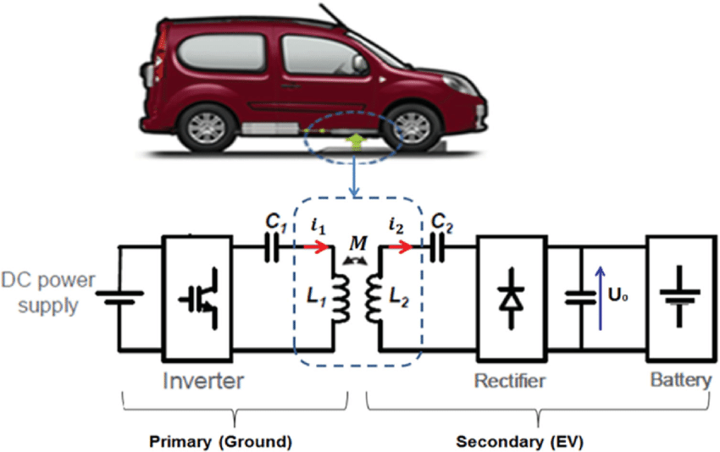
Figure 5.1 – IPT system for automotive with circuit diagram.
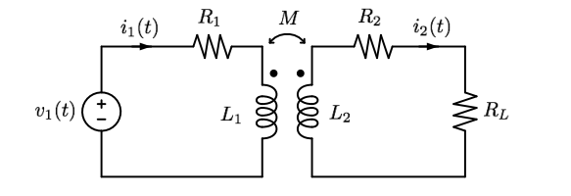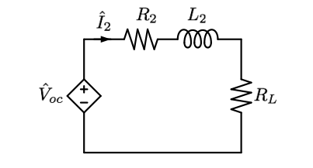
(a)
(b)
Figure 5.2 – Circuit representation of a generic transmitter-receiver system (a), of the receiver only (b).
A simple circuit model for the IPT system is given in Fig.5.2, based on the representation of the pair of coils as an inductively coupled two-port characterized by an inductance matrix L associated to the terminal currents and fluxes (see Fig.5.3a)
 | $$\overline{Φ}=L\overline{I} → \left[\begin{aligned}Φ_{1} \\ Φ_{2}\end{aligned}\right]=\left[\begin{matrix}Φ_{11} & Φ_{12} \\ Φ_{21} & Φ_{22}\end{matrix}\right]=\left[\begin{matrix}L_{11} & M \\ M & L_{22}\end{matrix}\right] \left[\begin{aligned}I_{1} \\ I_{2}\end{aligned}\right]$$ | (5.1)
and a resistance matrix R associated to the ohmic losses on the coils
 | $$R=\left[\begin{matrix}R_{1} & 0 \\ 0 & R_{2}\end{matrix}\right]$$ | (5.2)
(a)
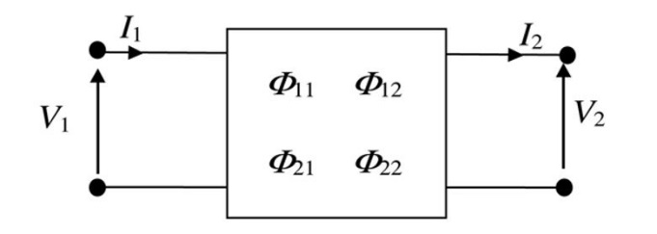
(b)
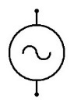
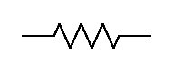
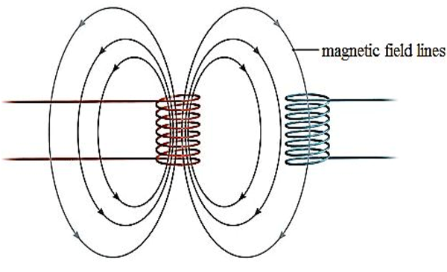
v₁(t)
R_{L}
Figure 5.3 – Generic two-port representing the coil pair (a); load conditions for the WPT systems (b).

Taking into account the typical load conditions for WPT systems (Fig.3b), the relations between the terminal voltages and currents, considering Faraday’s Law, is written as:
$$v_{1}\left(t\right)=R_{1}i_{1}\left(t\right)+L_{1}\frac{di_{1}}{dt}-M\frac{{di}_{2}}{dt}$$ | (5.3)
$$M\frac{di_{1}}{dt}=R_{2}i_{2}\left(t\right)+R_{L}i_{2}\left(t\right)+L_{2}\frac{di_{2}}{dt}$$ | (5.4)
Having defined the open-circuit voltage at port 1 as follows:
 | $v_{oc}(t)=M\frac{di_{1}}{dt}$. | (5.5)
Finally, the coupling coefficient k can be defined as:
 | $$k=\frac{M}{\sqrt{L_{1}L_{2}}} , with 0≤k≤1$$ | (5.6)
which links the mutual inductance with the self-inductances of the two coils, and in fact expresses the quantity of flux which from the first coil is linked to the second.
The second principle to address that defines IPT systems is resonance. To understand the need to use a resonant system for power transfer, the power can be evaluated by using phasors. It should be noted that for these considerations the approximation to the first harmonic and an iso-frequency behavior of the system are taken into account. Under this consideration, the system expressed in (5.3)-(5.4) can be rewritten, indicating with ω the angular frequency of the system, through the symbolic method in:
 | $$\left\{\begin{aligned}{\hat{V}}_{1}=R_{1}{\hat{I}}_{1}+{jωL}_{1}{\hat{I}}_{1}-jωM{\hat{I}}_{2} \\ \\ jωM{\hat{I}}_{1}=R_{2}{\hat{I}}_{2}+R_{L}{\hat{I}}_{2}+jωL_{2}{\hat{I}}_{2}\end{aligned}\right.$$ | (5.7)
from which the total impedance seen from the supply side can be extracted by deriving ${\hat{I}}_{2}$ from the second equation in (5.7) and replacing it in the first, one obtains in conclusion:
 | $${\hat{Z}}_{T}=\frac{{\hat{V}}_{1}}{{\hat{I}}_{1}}=\left(R_{1}+jωL_{1}\right)+\left(\frac{ω^{2}M^{2}}{R_{2}+R_{L}+jωL_{2}}\right)$$ | (5.8)
The first term of (5.8) expresses the impedance of the transmitter side, without taking into account any coupling with the receiver, while the second term is the impedance of the receiver seen from the transmitter. In conclusion, therefore, the apparent power supplied by the source can be defined:
 | $$S_{1}={\hat{V}}_{1}{\hat{I}}_{1}={\hat{Z}}_{T}I_{1}^{2} ;$$ | (5.9)
and the one transferred to the receiver:
 | $$S_{2}=V_{oc}I_{2} → \frac{ω^{2}M^{2}}{\sqrt{{\left(R_{2}+R_{L}\right)}^{2}+{\left(ωL_{2}\right)}^{2}}}I_{1}^{2}=Z_{R}I_{1}^{2}$$ | (5.10)
From (5.10) it is highlighted how on the transmitter side the effect of the coupling with the receiver can be seen as reflected impedance ${\hat{Z}}_{R}$ reported. It is therefore clear that to maximize the transferred power it is important to compensate for the presence of the inductive component by passing through the phenomenon of resonance, and therefore through the insertion of capacities suitably tuned to a certain operating frequency, positioning them in series or in parallel with respect to the coil system. The goal is to obtain the maximum power transfer and, evaluating the side of the receiver, it is obtainable in the condition where:
 | $$ω^{2}L_{2}C_{2}-1=0 → C_{2}=\frac{1}{{\left(2πf_{0}\right)}^{2}L_{2}} ;$$ | (5.11)
with f₀ the value of the resonance frequency, which can also be expressed as an angular resonance frequency$ω_{0}=2πf_{0}$.
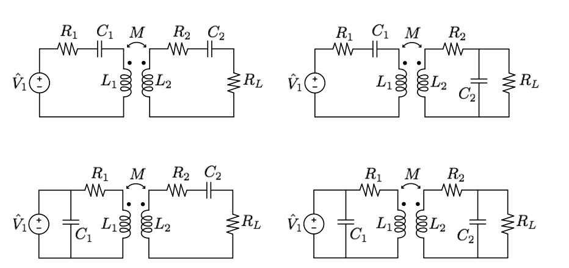
(d)
(b)
(a)
(c)
Figure 5.4 – Circuit representation based on the type of resonance applied:
S-S (a), S-P (b), P-S (c), P-P (d).

Taking into account (5.10), we obtain that the capacitance C1 must be chosen in such a way as to compensate both the self-inductance L1 and the contribution of the imaginary part given by the reflected impedance of the receiver, tuned to the same resonant frequency. The value of ${\hat{Z}}_{R}$ will obviously depend on the choice of resonance topology. To this end, the usable structures can be grouped into four basic topologies, indicating the transmitter-receiver reference and order: Series-Series (S-S), Series-Parallel (S-P), Parallel-Series (P-S), Parallel-Parallel (P-P), see Figure 5.4.
Let us refer first to a parallel compensation configuration on the receiver side. Starting from the general definition, we write the reflected impedance:
 | $${\hat{Z}}_{R}=\frac{ω_{0}^{2}M^{2}}{{\hat{Z}}_{2}}$$ | (5.12)
and, applying (5.11) to replace the capacitance value C2 and have an expression with only the inductive parameters, we can write ${\hat{Z}}_{2}$ as:
 | $${\hat{Z}}_{2,p}=jω_{0}L_{2}+\frac{R_{L}}{1+{jω}_{0}R_{L}C_{2}} → \frac{jω_{0}L_{2}}{1+\frac{{j R}_{L}}{ω_{0}L_{2}}}$$ | (5.13)
and consequentially with ${\hat{Z}}_{R,p}$ expressed with:
 | $${\hat{Z}}_{R,p}=\frac{ω_{0}^{2}M^{2}+{jω_{0}R}_{L}\frac{M^{2}}{L_{2}}}{j{ω_{0}}_{ }L_{2}}$$ | (5.14)
In the case of series compensation on the receiver instead it’s obtained:
 | $${\hat{Z}}_{2,s}=jω_{0}L_{2}+\frac{1}{{jω}_{0}C_{2}}+R_{L} → R_{L}$$ | (5.15)
So, consequentially ${\hat{Z}}_{R,s}$ is expressed with:
 | $${\hat{Z}}_{R,s}=\frac{ω_{0}^{2}M^{2}}{R_{L}}$$ | (5.16)
It can be seen from (5.16) how, if a series configuration is chosen on the receiver, the ${\hat{Z}}_{R}$ will have only the real part. At this point it is possible to evaluate the configuration of the transmitter, thus obtaining the four types already mentioned above. If the capacitance C1 is placed in parallel, the following relationship must be satisfied:
 | $$Im\left\{\left(\frac{1}{{jω}_{0}C_{1}}\right) // \left({jω}_{0}L_{1}+{\hat{Z}}_{R}\right) \right\}=0$$ | (5.17)
Dually in the series case we need:
 | $$Im\left\{\left(\frac{1}{{jω}_{0}C_{1}}\right)+\left({jω}_{0}L_{1}+{\hat{Z}}_{R}\right) \right\}=0$$ | (5.18)
In conclusion, the relationships for C1 are reported:
 | $$\left\{\begin{aligned}C_{1,SS}=\frac{1}{ω_{0}^{2}L_{1}} \\ \\ C_{1,SP}=\frac{1}{ω_{0}^{2}\left({ L}_{1}-\frac{M^{2}}{L_{2}}\right)} \\ \\ C_{1,PS}=\frac{L_{1}}{{\left(\frac{ω_{0}^{2}M^{2}}{R_{L}}\right)}^{2}+ω_{0}^{2}L_{2} } \\ \\ C_{1,PP}=\frac{L_{1}-\frac{M^{2}}{L_{2}}}{\left(\frac{M^{2}R_{L}}{L_{2}}\right)+ω_{0}^{2}{\left(L_{1}-\frac{M^{2}}{L_{2}}\right)}^{2}} \end{aligned}\right.$$ | (5.19)
The total equivalent impedances defined in (5.8) can be expressed again with considerations of compensation and chosen configuration. Neglecting the terms referring to the resistances of the coils, it can be obtained:

 | $$\left\{\begin{aligned}{\hat{Z}}_{T,SS}=j\left(ωL_{1}-\frac{1}{ωC_{1}}\right)+\frac{ω^{2}M^{2}}{R_{L}+j\left(ωL_{2}-\frac{1}{ωC_{2}}\right)} \\ \\ {\hat{Z}}_{T,SP}=j\left(ωL_{1}-\frac{1}{ωC_{1}}\right)+\frac{ω^{2}M^{2}}{jωL_{2}+\frac{R_{L}}{1+jωR_{L}C_{2}}} \\ \\ {\hat{Z}}_{T,PS}={\left(\frac{1}{jωL_{1}+\frac{ω^{2}M^{2}}{R_{L}+j\left(ωL_{2}-\frac{1}{{ωC}_{2}}\right)} }+jωC_{1}\right)}^{-1} \\ \\ {\hat{Z}}_{T,PP}={\left(\frac{1}{jωL_{1}+\frac{ω^{2}M^{2}}{jωL_{2}+\frac{R_{L}}{1+jωR_{L}C_{2}}} }+jωC_{1}\right)}^{-1} \end{aligned}\right.$$ | (5.20)
The choice of configuration therefore has an impact on the general performance of the system and, based on the application and operating conditions, a particular type could be more suitable than the alternatives. For example, if it is considered an almost absent coupling between transmitter and receiver (M→0), the behavior at the value of the resonance frequency ω₀ takes the form:
 | $${{\hat{Z}}_{T,SS}≈{\hat{Z}}_{T,SP}≈jωL_{1}+\frac{1}{jωC_{1}} \underset{→}{ω=ω_{0}} 0 \atop \begin{aligned} \\ {\hat{Z}}_{T,PP}≈{\hat{Z}}_{T,PS}≈{\left(\frac{1}{jωL_{1}}+jωC_{1}\right)}^{-1} \underset{→}{ω=ω_{0}} ∞\end{aligned}}$$ | (5.21)
i.e. the series type tends to behave like an impedance of zero value (short circuit), while the parallel type tends to behave like an impedance of value tending to infinity (open circuit).
However, a precise evaluation of the efficiency of the entire IPT system has numerous factors within it (think of the dissipative phenomena of electronic power converters up to the hysteresis losses of the ferromagnetic elements), which is why it is preferable to refer to an analytically less complex. The maximum efficiency of an IPT system can be estimated through the power transmission efficiency, which depends on the product between k and Q (Bosshard et al., 2015), where the first is the already mentioned coupling coefficient while the second is the quality factor of the coils of our system and takes into account the losses in the windings, ferrite cores and shields. The maximum efficiency value in an optimized system can be expressed as follows (Bosshard et al., 2015):
 | $$η_{max}=\frac{{\left(kQ\right)}^{2}}{{\left(1+\sqrt{1+{\left(kQ\right)}^{2}}\right)}^{2}}≈1-\frac{2}{kQ}$$ | (5.22)
from which the need to maximize the product kQ is immediate, where the coupling factor varies considerably according to the dimensions, the chosen geometries and the misalignments. In conclusion, the parameters for optimizing the system also necessarily involve the design of the coils and ferrite cores, on which the main characteristics and technological choices will be presented below.

5.2 Equivalent circuit models for the PADs of a WPT system

A primary role in the Wireless Power Transfer (WPT) systems is naturally played by the system of the coils enabling the inductive coupling: the derivation of suitable electromagnetic models of such pairs is the first necessary step to be executed, followed by the consequent equivalent circuit models which allow the system level analysis. In practical applications, the coil pair is a complicated 3D system with different material properties, usually made by the coils, a metallic shield and some ferrite beds (the assembly is usually referred to as the “pad”, Fig.5.5).
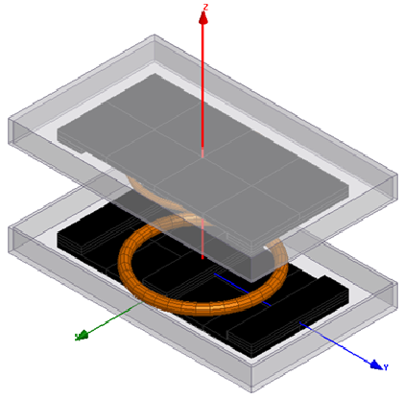
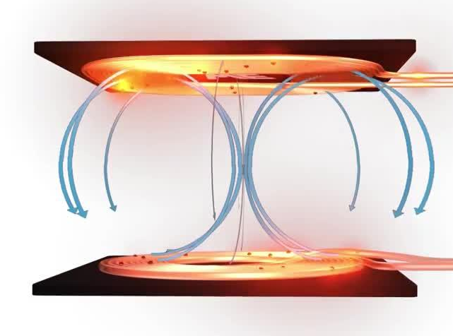

Figure 5.5. Schematic of a PAD: coils, ferrite beds and metallic shield.

Coils, ferrites and shields can be optimized for the specific application (to maximize the efficiency, the delivered power and so on…), hence a large variety of configurations have been so far proposed for realizing these systems (Sample et al., 2011, Rakhymbay A. et al, 2018).
Taking into account the criteria se in Chapter 2, in the typical operating conditions, the physical dimensions of the WPT coil pairs are much larger than the characteristic wavelength, i.e.: $≫λ=\frac{c}{f}$ . In addition, the magnetic energy is always larger than the electrical one, hence the electromagnetic analysis may be performed in the quasi-static limit, where the signal propagation is negligible and lumped equivalent circuits fully suffice to describe the problem. In addition, the magnetic energy is of course much larger than the electrical one, hence the problem to be solved is described by the Magnetic Quasi-Static (MQS) model, that reads in time domain:
$$∇×E(r)=-\frac{∂B(r,t)}{∂t}$$ | (5.23)
$$∇×H\left(r\right)=J\left(r,t\right)$$ | (5.24)
$$∇∙B(r,t)=0$$ | (5.25)
closed by the constitutive relations for the considered media,
$B=B\left(H\right) \left(e.g., B=μH\right), J=J\left(E\right) (e.g, J=σE$), | (5.26)
and by the proper boundary and regularity conditions on the field.
In the MQS approximation, once the electromagnetic problem is solved, the coil pair may be modelled as a circuital two-port described by two coil resistance and a coupled inductor, Fig.5.4.
Therefore, the self- and mutual-induction coefficients may be directly calculated by the definition of the two-port in Figure 5.3a, as:
 | $$L_{11}={\left.\frac{Φ_{11}}{I_{1}}\right|}_{I_{2}=0} ; {\left.L_{22}=\frac{Φ_{22}}{I_{2}}\right|}_{I_{1}=0}$$ | (5.27)
 | $$M_{12}={\left.\frac{Φ_{12}}{I_{2}}\right|}_{I_{1}=0}={\left.\frac{Φ_{21}}{I_{1}}\right|}_{I_{2}=0}=M_{21}$$ | (5.28)
Alternatively, these circuit parameters can be retrieved by evaluating the total stored magnetic energy (that resides in the domain $Ω_{T}$ where the magnetic field is non negligible), and the total dissipated electrical power (that refers to the domains $Ω_{C}$of the conductors), as follows:
$$\iiint_{Ω_{T}}{\frac{{|B\left(r\right)|}^{2}}{2μ\left(r\right)}dΩ}=\frac{1}{2}\left(L_{1}I_{1}^{2}+L_{2}I_{2}^{2}+2MI_{1}I_{2}\right)$$ | (5.29)
The integral formulation is always the best choice to evaluate the resistance parameters, that can be retrieved from (by neglecting the eddy currents induced in one coil by the other one):
$$\iiint_{Ω_{C}}{{σ|J\left(r\right)|}^{2}dΩ}=R_{1}I_{1}^{2}+R_{2}I_{2}^{2}.$$ | (5.30)
The MQS model (5.23)-(5.26) may be solved analytically or semi-analytically if simple geometries are considered, for instance by exploiting symmetries or simplifications. For instance, proposed analytical or semi-analytical techniques to evaluate the inductances are based on the classical Biot-Savart law (R. Ravaud et al., 2010), on Bessel and Struve functions (J. T. Conway et al., 2007) or Heuman’s lambda function (Babic S. et al., 2011). For instance, the mutual inductance may be computed from Biot-Savart law as:
(5.31)
whereas the use of the Heuman’s lambda function would lead to (Babic S. et al., 2011):
(5.32)
When it is possible to use the analytical or semi-analytical models, a great advantage comes not only from a reduced computational cost, but also from the qualitative insight in the solution provided by these models, which allows an easy imposition of design rules, a low-cost mapping for the parametric analysis in the optimization phases, and so on.
However, as already pointed out, in all the cases of practical interest, the coils pair is characterized by complicated 3D geometries, including metallic parts (e.g., shields, housing, vehicle chassis, etc..) and ferrite beds for controlling the magnetic flux lines. Consequently, the solution of the MQS problem usually requires numerical full 3D models. Finite Element Method (FEM) simulations have been carried out in (Y. Zhang et al., 2018), for different values of coils lateral misalignment and tilt angle, and in (M. S. Carmeli et al., 2015) to optimize the ferrite arrangements and determine the coil turn number for multi-turn spiral coils. In (B. Olukotun et al., 2018), parametric performance evaluations of different resonant coil designs have been performed by means of FEM simulations, for different values of axial, longitudinal and lateral misalignments of the coils.
In view of the FEM numerical solution (discussed in details in Chapter 8 for the study of the pads associated to a static WPT), an integral formulation of the MQS problem (5.23)-(5.26) can be here introduced. As pointed out in Chapter 2, the integral formulations have the advantage that the regularity conditions at infinity are automatically taken into account, and only the domain of the conductors, $Ω_{C}$ and of the magnetic region of the ferrite beds must be meshed. Moreover, it is sufficient to discretize only the most external part of the ferrite beds for a thickness of the order of the skin depth.
The eddy currents are numerically approximated using edge element shape functions N_{k}‘s and the electric vector potential T (such that J=∇×T) with a two-component gauge condition to guarantee its uniqueness (J = _{k} I_{k} ∇×N_{k}), while the magnetization vector is supposed to be piecewise constant (P_{k}’s are unit vector pulse functions): M = _{k} M_{k} P_{k} .
Assuming a sinusoidal excitation, expressing the electric field as E = −jA − , and using the Biot-Savart law to calculate the magnetic vector potential A due to the eddy currents J, the magnetization M and the external currents J₀ (A₀ accounts for J₀), we automatically solve the field equations in the MQS limit.
Next, by imposing the constitutive equations J=σE and , where in weak form, with the Galerkin method, we obtain the following linear system of algebraic equations:
 | (5.33)
 | (5.34)
M=KB, | (5.35)
where, in the case of isotropic magnetic materials, K is a diagonal matrix defined with reference to the magnetic constitutive equation, whereas the other matrices in (5.33)-(5.34) are defined as:
 | (5.36)
 | (5.37)
 | (5.38)
 | (5.39)
, | (5.40)

, | (5.41)
 | (5.42)
Here, I and M are the column vectors made by the complex coefficients of the expansions of J and M, respectively, while B is the column vector made by the averaged value of the components of B in each finite element within the iron.
The system can be rewritten in the following compact form:
(5.43)
where
(5.44)
(5.45)
(5.46)
and is the N×1 column vector of the phasors of the currents circulating in the inducing coils (note that (5.46) follows from (5.45) after recognizing that U and W are linear function of the current circulating in the inducing coils). Finally, the column vector of the coil voltages can be written as
(5.47)
where , is the matrix of the impedance of the coils without ferrite beds and the matrix is given by .
Once we derive a multiport representation, the equivalent circuit parameters of the coils system in Fig.10b are straightforward.

Behavioral models for the mutual inductance of a WPT PAD
As pointed out in the previous Section, in real WPT systems only the numerical approaches allow to derive the equivalent two-port circuit representing the electromagnetic PAD. However, an analytical formulation of the circuit parameter is useful for the design and optimization of the overall system. It is for instance important to describe the behavior of the mutul inductance versus the coil misalignement, see Figure 5.6. If only the numerical FEM solutions are used, the study of the effect of misalignments between the coils on their mutual inductance M, would lead to a high computational cost, that sometimes makes unaffordable a systematic investigation of a wide range of geometrical positions with a fine resolution.
In this Thesis, a possible solution is proposed, with the derivation of analytical behavioral models, see details in (Di Capua G. et al., 2021).
The analyzed geometry is drawn in Fig. 5.6 showing the two coils in a generic position, characterized by a vertical distance, Δx, and by a misalignment in the horizontal plane (y, z), described by a displacement (Δy, Δz) and a rotation α. The coils misalignment in may be represented by the vector that connects the coils center points (P_{TX} and P_{RX}), whose amplitude (distance, R) and angle θ are given by (5.48):
(5.48)
No longitudinal misalignment has been considered for the investigation (Δy = 0cm), as in this analysis the static WPT process only has been simulated.
Figure 5.6. WPTS coils: their reciprocal position is given by the coordinates {Δx, Δy, Δz} of the RX coil center point P_{RX} with respect to the TX coil center point P_{TX}
(located in the origin), and a by rotation angle α.
The behavioral models have been developed by using Genetic Programming (GP) is a special evolutionary algorithm in which the population is composed of models. During its evolution, the GP algorithm transforms the current population of models into a new population by applying classical genetic operations, such as selection, cross-over, mutation, etc. The GP models are generally represented by means of tree structures. To construct such trees, the GP algorithm considers a non-terminal set of elementary functions (herein, sum, multiplication, division, logarithm, arctangent, hyperbolic tangent, sine, exponential and power function have been used) and a terminal set composed of constant coefficients and input variables.
An important feature to be addressed is the complexity of the models. To this end, complexity factors (cf) are usually assigned to all the elements included in the above sets. In particular, the following values have been herein assumed for the elements of the terminal set: cf = 0.6 for the multiplication of input variables and cf = 1 for all the other operations between input variables, and for constant coefficients. Instead, the following values have been considered for the non-terminal set: cf = 1 for sum and/or multiplication of elementary functions, cf = 1.5 for all the other functions. To quantify the global complexity of each GP model, an index F_{complexity} has been introduced and calculated as follows:
- if a function is the argument of another function, the complexity factors cf of the two functions are multiplied;
- if two functions are multiplied or summed, their complexity factors cf are summed and subsequently multiplied by the complexity factor of a sum or a product.
In the work (Di Capua et al, 2021) two different approaches for deriving the mutual inductance behavioral model M_{behav} have been investigated:
- Approach 1: the mutual inductance is modeled as an explicit function of the coils axial (Δx) and lateral (Δz) misalignments, i.e. M_{behav}(Δx,Δz,p(α)), and parametrized with respect to the rotation angle, α;
- Approach 2: the mutual inductance has as direct inputs the coils centers distance (R) and angle (θ), i.e. M_{behav}(R,θ,p(α)), and is again parametrized with respect to α.
In both approaches, the rotation angle α is used as the parameter influencing the values of model coefficients p(α). Here we only report the results for Approach 1, being those for Approach 2 available at the cited reference.
Let us refer to the WPT coils in Fig. 5.13 and consider a set of m₁ rotation angle values α_{j1}, j₁ = 1,…,m₁, used as the behavioral model parameter. For each α_{j1} value, n couples of axial and lateral misalignments (Δx_{i}, Δz_{i}) have been analyzed, with i = 1,…,n. For each of the n×m₁ test conditions, a data vector has been created, including the test values (Δx_{i}, Δz_{i}) and the corresponding mutual inductance M_{ij1} = M(Δx_{i},Δz_{i},α_{j1}), obtained by means of FEM simulations. Such n×m₁ data vectors compose the training data set T₁ of the GP algorithm.
The GP algorithm has to identify the behavioral model M_{behav}(Δx,Δz,p(α)), such that the value of the function M_{behav} computed for each test condition of the training data set T₁ is as close as possible to the corresponding training value M_{ij1}, ∈{1,…,n} and j₁ ∈{1,…,m₁}. The structure of the function M_{behav} has to be the same for all the rotation angle values α_{j1}, j₁ = 1,…,m₁, while the coefficients p vary with α. To determine the coefficients p for each α_{j1}, a Non-Linear Least Squares (NLLS) method (based on Levenberg-Marquardt optimization) has been applied to the n experimental data vectors relevant to α_{j1}. Thus, the values of coefficients p have been determined by minimizing the χ-squared error, evaluated between the training mutual inductance values M_{ij1} and the GP-predicted values M_{behav}(Δx_{i},Δz_{i},p(α_{j1})), for i = 1,…,n:
(5.49)
Then, the interpolating functions p(α) have been determined, as will be discussed in the next Section. The same procedure has been repeated for WPTS-2, characterized by a set of m₂ rotation angle values α_{j2}, j₂=1,…,m₂, resulting in a training dataset T₂ composed of n×m₂ data vectors. To estimate the overall model accuracy, the Root Mean Square Error (RMSE) over the whole training data set T = T₁T₂ of the two analyzed WPTS coil pairs has been evaluated according to (5.49):
(5.50)
A Multi-Objective GP (MOGP) algorithm has been adopted to identify the models that offer an optimal trade-off between accuracy (RMSE) and complexity (F_{complexity}). In this paper, an elitist Non-dominated Sorting Genetic Algorithm (NSGA-II) has been used, which searches for the models jointly minimizing RMSE and F_{complexity} values. Multiple runs of the MOGP algorithm have been executed, to discover the most repeatable GP models. Specifically, each model generated by the GP has been scored on the basis of the following metrics:
- N_{run} – the number of runs during which the algorithm has discovered the model;
- N_{gen} – the average number of generations during which the model survived in the population;
- {μ_{err}, σ_{err}, err_{max}} – the mean value, standard deviation and maximum value of the model percent error over the training data set T (see Table III);
- ${\text{err}}_{\text{max}}^{\text{V}}$ – the maximum value of the model percent error over the validation data set V (see Table IV);
- N_{mon} – the average number of intervals over which the model coefficients p change their monotonicity with α.
The best models are the ones maximizing the first two metrics and minimizing the last five metrics. In general, the use of simpler behavioral models with a unitary value of the N_{mon} metric results in the monotonous coefficients p, which can then be easily approximated as functions of α.
The approach has been used with reference to the case study of the dynamic WPT system POLITO studied in Chapter 6, to which we refer for the numerical details. MOGP algorithm has been executed over 50 runs, with a population of 500 models evolving over 300 generations for each run. Only the non-dominated Pareto-optimal solutions having the repeatability of at least 10 runs and the maximum percent error lower than 15% have been considered for further comparison. Such solutions are represented as blue markers in Fig. 5.7 and labelled with increasing solution numbers. The related model expressions are provided in Table 5.1, while the respective values for the metrics {N_{run}, N_{gen}, μ_{err}, σ_{err}, err_{max}, ${\text{err}}_{\text{max}}^{\text{V}}$, N_{mon}} are given in Table 5.2. Let us note that Fig. 5.14 can contain model solutions discovered by the GP algorithm during certain runs, which are dominated by some other solutions discovered in the other independent runs. Since such models still present high repeatability and good error metrics, they have also been considered for the final comparison. Among the solutions of Fig. 5.7, only for model #9 all the coefficients are monotonous with the rotation angle α (N_{mon} = 1), thus facilitating the determination of the interpolating functions p(α). Such a model, given in (5.51), is characterized by a high repeatability (N_{run} = 18 runs) and age (N_{gen} = 176 generations) and low percent errors over the training dataset T, and presents a good trade-off among the other metrics. This model has been therefore selected as an optimal behavioral model of the mutual inductance for Approach #1 and will be used in the numerical analysis in Chapter 6.
(5.51)

Figure 5.7. Repeatable Pareto-optimal solutions

Table 5.1 - GP model expressions
Model | Fx [kN]
#1
#2
#3
#4
#5
#6
#7
#8
#9
#10

Table 5.2 - Metrics values for the GP models
Model | N_{run} | N_{gen} | μ_{err} [%] | σ_{err} [%] | err_{max} [%] | ${\text{err}}_{\text{max}}^{\text{V}}$ [%] | N_{mon}
#1 | 14 | 199 | -0.03 | 1.8 | 12.1 | 8.1 | 1.5
#2 | 21 | 224 | -0.03 | 1.9 | 12 | 7.8 | 1.2
#3 | 15 | 188 | -0.03 | 1.9 | 12 | 8.1 | 1.5
#4 | 15 | 215 | -0.06 | 2.4 | 11.7 | 7.8 | 1.1
#5 | 15 | 155 | -0.06 | 2.4 | 13 | 10.7 | 1.1
#6 | 13 | 164 | -0.06 | 2.4 | 12.1 | 9.6 | 1.4
#7 | 12 | 145 | -0.06 | 2.4 | 12.1 | 9.6 | 1.4
#8 | 30 | 158 | -0.08 | 2.8 | 14 | 7.9 | 1.4
#9 | 18 | 176 | -0.16 | 4 | 14.9 | 13.5 | 1
#10 | 25 | 150 | -0.18 | 4.3 | 12.4 | 12.8 | 1.2

Resume of the chapter and main findings
- The core of an Inductive Power Transfer (IPT) system is the coil pair, where the wireless energy transfer takes place through the inductive coupling. At the transmitting and receiver side, the coils are complemented by shields and ferrites, to form the so-called PADs. In the low frequency approximation, the PADs are modelled by means of an equivalent two-port circuit with a resistance matrix, taking into account the ohmic losses, and an inductance one representing the flux-current relations.
- The most efficient architectures for IPT systems are based on resonant circuits, obtained by adding suitable compensation capacitors to the above-mentioned two-port. Series-series, series-parallel, parallel-parallel e parallel-series schemes are possible, and the advantages of using each of them are here discussed.
- Low frequency electromagnetic models have been here presented, aimed at the evaluation of the R and L matrices entries.
- In simplified conditions, analytical models can be used, and examples are here given of formulas providing the mutual inductance parameter M, that is the most important one to describe the PAD coupling.
- In real condition, the two-port parameters of the PAD pair must be extracted by means of numerical models, and computing them for instance by imposing the relations between energy and currents. A FEM numerical integral formulation is here discussed, naturally leading to the building of R and L matrices
- The Thesis also presents an approach to derive analytical behavior models from FEM simulations. This is useful during the design of the WPT systems, for instance for quick evaluation of the system performance under non-nominal condition. The case analyzed in this Thesis, for instance, refers to the sensitivity of the magnetic coupling factor to the misalignment of the TX and RX coils.
- The behavioral model of the mutual inductance here is derived by using a Genetic Programming Multi-Objective algorithm.

CHAPTER 6

EM analysis of the PADs of static and dynamic WPT systems

6. EM analysis of the PADs of static and dynamic WPT systems
The two applications of IPT systems analyzed in this Thesis have been studied in the frame of the Project MICEV: Metrology for Inductive Charging of Electric Vehicle, part of the European Metrology Program for Innovation and Research (EMPIR). The project was aimed at accurately evaluating the efficiency of an IPT system and the transmitted power also contemplating the exposure standards human (Euramet Project MICEV, 2020).

6.1 The analyzed IPT systems: VICTORIA and POLITO
As an example of static system, it has been analyzed the IPT system named “VICTORIA” produced by the Company CIRCE, (Ruiz, 2014), to be used for recharging public buses, see Fig.6.1. The system can transfer 50 kW maximum power at 25 kHz frequency.

Figure 6.1. VICTORIA IPT system realized by Circe, Spain.

An example of dynamic system has been instead provided by the IPT system “POLITO”, developed by the Politecnico di Torino to rechearge cars and small vans, see Figure 6.2 (Ruffo et al., 2018; V. Cirimele et al., 2018; V. Cirimele et al., 2017). The system can transfer 11 kW maximum power at 85 kHz frequency.

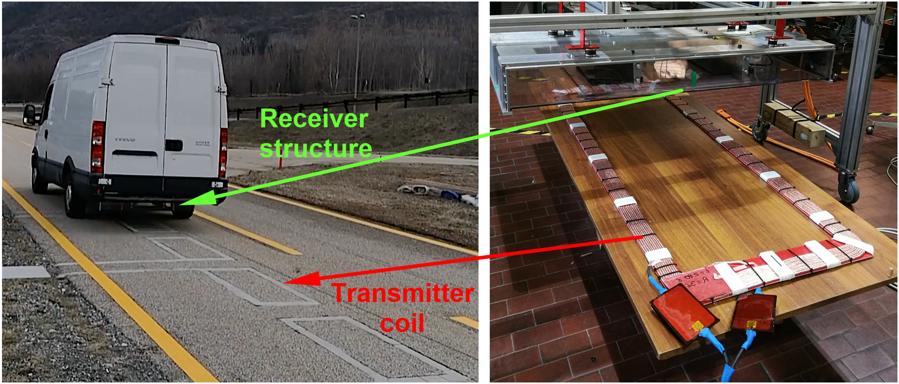
Figure 6.2. POLITO IPT system realized by Politecnico di Torino, Italy.

The power electronic transmitter and receiver stages of VICTORIA and POLITO test-bench IPT systems are based on different architectures, power devices and control solutions. Figure 6.3 shows the architecture of the VICTORIA IPTS, where:
1 | AC/DC Grid multilevel converter + DC Bus 1 + DC/DC Buck Converter
2 | DC Bus 2
3 | DC/AC-MF H-Bridge Converter. AC-MF: Medium frequency square wave.
4 | Primary WPT Resonant tank. SP Topology
5 | Secondary WPT Resonant tank. S Topology
6 | AC-MF/DC Secondary converter. Diodes rectifier bridge.
7 | Electric vehicle batteries and filter.
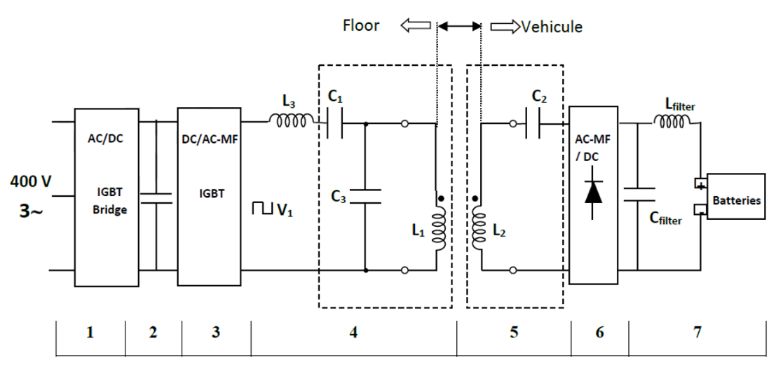

Figure 6.3 VICTORIA IPTS architecture (MICEV Internal Deliverable).

Figure 6.4 instead shows the architecture of the POLITO IPTS. As shown in the detail of Figure 6.4b, the rectifier boost post-regulator consists of a nine-phase interleaved boost converter, where each leg is based on an insulated-gate bipolar transistor and operates, with a phase shift of 40◦ among legs.
(a) (b)
Fig. 6.4 POLITO IPTS architecture (a) and details of the post-regulator stage (b) (MICEV Internal Deliverable).

This Thesis is focused on the derivation of the equivalent circuits of the two PAD architectures: in the following, we will refer to the POLITO pad system as WPTS-1, see Figure 6.5, and to the VICTORIA pad system as WPTS-2, Figure 6.6. The figures highlight the transmitting (TX) and receiving (RX) coils. The models also include an aluminum structure (which simulates the vehicle chassis) and some ferrite parts. As pointed out before, these two systems differ in the architecture and the operating frequency. In terms of geometry, the WPTS-1 system uses a longer transmitter (1.5 m) compared to the receiver (0.3 m), while the WPTS-2 system adopts the larger size receiver (2.64 m) compared to a smaller transmitter (0.65 m). All the details are summarized in Table 6.1 (Di Capua et al., 2021).

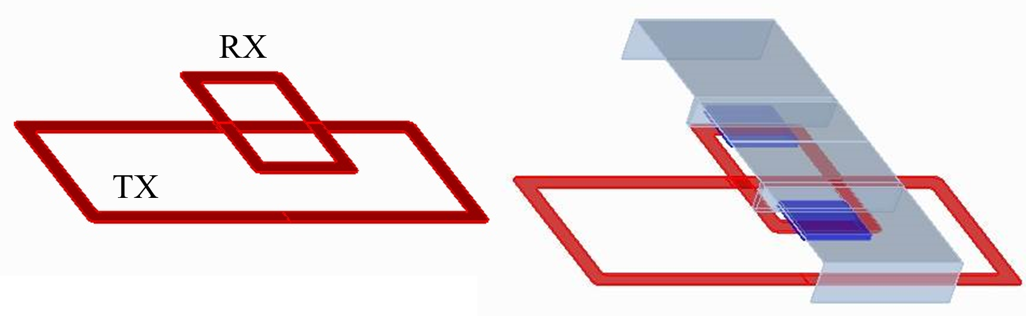
(b)
(a)
Figure 6.5. WPTS-1: POLITO coil pair only (a) and the whole PAD, with aluminum chassis in grey and ferrite beds in blue (Di Capua et al., 2021).

(a)
(b)
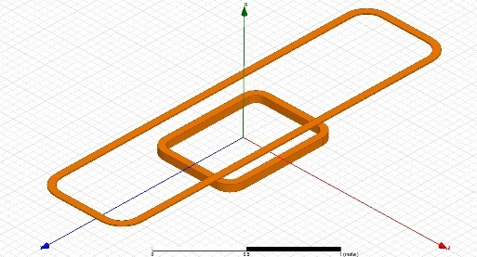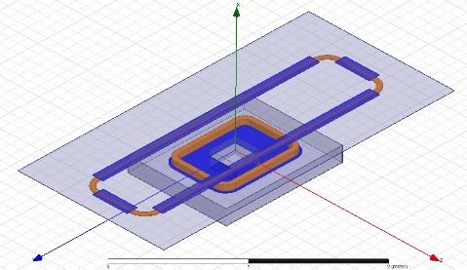
Figure 6.6. WPTS-2: VICTORIA coil pair only (a) and the whole PAD, with aluminum chassis in grey and ferrite beds in blue (Di Capua et al., 2021).

Table 6.1 Parameters of the PADs for the two analyzed WPTs
Parameter | WPTS-1 | WPTS-2
Frequency | 85 kHz | 25 kHz
TX wire cross-section | 28 mm2 | 300 mm2
RX wire cross-section | 28 mm2 | 50 mm2
TX number of turns | 10 | 2
RX number of turns | 10 | 4
TX inner dimensions | 1.5 m x 0.5 m | 0.635 m x 0.864 m
RX inner dimensions | 0.3 m x 0.5 m | 2.640 m x 0.750 m
Vertical distance between coils, Dx | 20 cm | 15 cm
Chassis conductivity (Aluminium) | 33.4 MS/m | 38 MS/m
Ferrite relative permeability | 2000 | 2000

6.2 Equivalent circuit parameters for the analyzed IPT systems

6.2.1 Numerical implementation of the MQS solution

The equivalent circuits for the coupled pads of the above-mentioned IPT systems have been obtained starting from a numerical FEM simulation carried out by using the full 3-D numerical solver Cariddi (Albanese et al., 1998), an electromagnetic code solving the MQS integral formulation presented in Chapters 2 and 4.
Figure 6.7 provides the details of the mesh adopted to simulate the POLITO IPT system: a total number of 49720 elements have been used. This level of mesh refinement was needed to ensure that the mesh quality was compatible with the small skin depth associated to the operating frequency value of 85 kHz: indeed, this assessment of the mesh allows limiting the discretization errors to less than 1%.
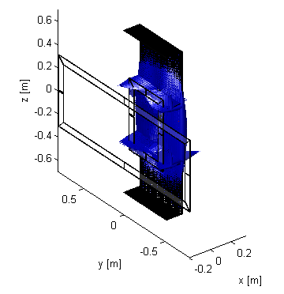
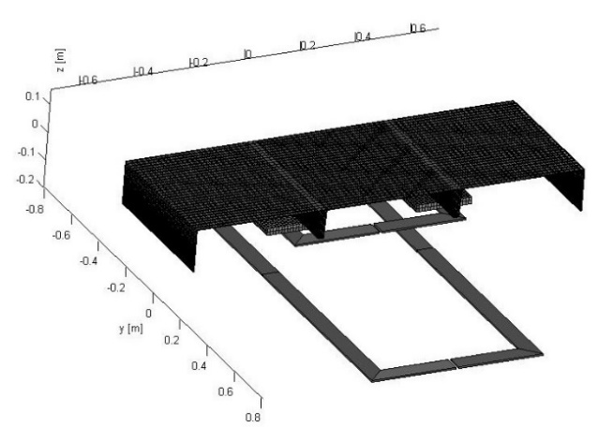

Figure 6.7. Mesh adopted for the numerical analysis of the POLITO IPT system.

Figure 6.8 provides instead the details of the mesh adopted to simulate the VICTORIA IPT system: in this case, a total number of 320011 elements have been used. This mesh refinement was need to ensure that the mesh quality was compatible with the small skin depth associated to the operating frequency value of 25 kHz: indeed, this assessment of the mesh allows limiting the discretization errors to less than 1%.

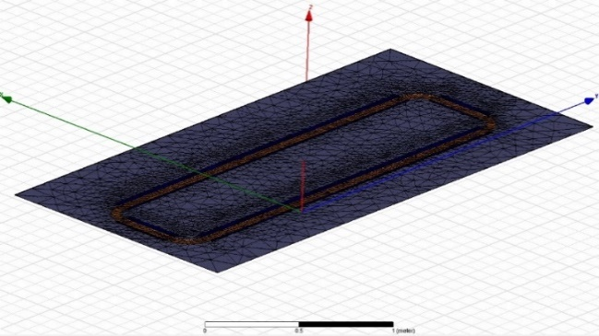
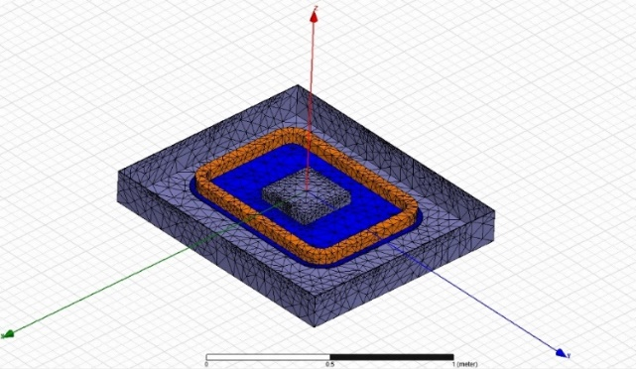

Figure 6.8. Mesh adopted for the numerical analysis of the VICTORIA IPT system.

For WPTS-2, an alternative numerical implementation has been carried out by using Ansys Maxwell. The 3D-Magnetostatic formulation is based on the use of magnetic scalar potential though the edges. In particular, the H field is formulated as follows:
 | $$H=Hp+∇φ+Hc$$ | (6.1)
where $φ$ is the magnetic scalar potential, $Hp$ is the particular solution costructed by assigning values to all the edges in the mesh in such way that Ampere’s law holds on all contours of all tetrahedra faces in the mesh, and finally $Hc$ takes into account the magnetic coercitivity (considering the presence of permanent magnets). The degree of freedom linked to the application of this formulation are: the nodal values of the magnetic scalar potential and ten values per element (in the case of this analysis, tethraedra) at each of the four vertices ad all six mid edges nodes. The approximation inside each element is quadratic.

6.2.2 Analysis results: inductance parameters of the PADs

The solution of the MQS model has led to the results reported in Table 6.2 for both IPT systems. The results obtained with the aluminum chassis have been validated with an excellent agreement against the experimental measurements made on the system. Details on the experimental characterization may be found in (Ruiz, 2014) and (V. Cirimele, 2017). The WPTS-2 coil pair has been analyzed by means of Cariddi code and by using Ansys Maxwell, since in this case the measurements were not available. Once again, the results in Table 6.2 are in good agreement. It is worth noting that a uniform current density has been assumed in the coil wires, which reproduces the real operating conditions. Indeed, for a given operating frequency, the real coils are made by suitable litz wires to avoid the skin effect in the coil windings. This assumption has no effect on the evaluation of the mutual inductance. The developed numerical models have been then used to study the influence on the inductances of the different components of the pad, and the results are given in Table 6.3a for WPTS-1 and in Table 6.3b for WPTS-2.

Table 6.2 Computed and measured values of the inductances of the WPT systems
Parameter | WPTS-1 (Cariddi) | WPTS-1 (Measured) | WPTS-2 (Cariddi) | WPTS-2 (Ansys)
L_{TX} (𝜇H) | 278.6 | 281.4 | 6.4 | 6.9
L_{RX} (𝜇H) | 115.4 | 119.8 | 81.0 | 84.9
M (𝜇H) | 18.1 | 18.3 | 2.0 | 2.0

Table 6.3a Contributions of the PAD components on the inductances (WPTS-1)
Parameter | Complete PAD | Coils only | Coils + shield | Coils + ferrites
L_{TX} (𝜇H) | 278.6 | 279.6 | 276.7 | 280.8
L_{RX} (𝜇H) | 115.4 | 97.4 | 83.6 | 122.4
M (𝜇H) | 18.1 | 16.7 | 10.8 | 21.7

Table 6.3b Contributions of the PAD components on the inductances (WPTS-2)
Parameter | Complete PAD | Coils only | Coils + shield | Coils + ferrites
L_{TX} (𝜇H) | 6.4 | 5.7 | 7.5 | 6.9
L_{RX} (𝜇H) | 81.0 | 72.2 | 84.9 | 85.0
M (𝜇H) | 2.0 | 3.2 | 2.8 | 2.0

6.3 Sensitivity analysis of IPT systems with behavioral models
As already pointed out, a crucial parameter affecting the overall performance of the IPT system is the mutual inductance (M) between TX and RX coils, which may strongly change if the coils are not perfectly aligned. This can happen for static WPTs when the driver does not correctly park the vehicle, or in dynamic WPTs, taking into account the variation of the relative positions of the coils during the vehicle motion due to. Therefore, an accurate design and optimization of WPTs requires the knowledge of the profile of M around the nominal position (or trajectory of the motion). An optimized design and sensitivity analysis require an a priori knowledge of the mutual inductance in a huge number of relative spatial positions of the coils. Two possible approaches can provide these data: (i) the use of a numerical interpolation of the values stored in a look-up table, previously obtained by measurements or by numerical solutions of the 3D magnetic problem; (ii) the use of analytical models, able to relate the mutual inductance to the spatial variables of the trajectory. In this Thesis, we follow the second approach, by deriving, validating and using an analytical behavioral model of M following the approach presented in Chapter 5, Section 5.3. In the following, we refer to the study of the static WPT system VICTORIA and to the static condition of the POLITO WPT. The same approach can be used for the dynamic condition (such as POLITO), as shown in (Di Capua G. et al., 2021).
The analyzed geometry is drawn in Figure 5.13 showing the two coils in a generic position, characterized by a vertical distance, Δx, and by a misalignment in the horizontal plane (y, z), described by a displacement (Δy, Δz) and a rotation α. The coils misalignment may be represented by the vector that connects the coils center points (PTX and PRX), whose amplitude (distance, R) and angle θ are given in the following:
$R= \sqrt{{Δx}^{2}+ {Δy}^{2}+ {Δz}^{2}}, θ= \tan^{-1}\left(\frac{Δx}{\sqrt{{Δy}^{2}+ {Δz}^{2}}}\right)$ | (6.2)
Following the approach presented in Section 5.3, we first compute the values of M from FEM simulation in different positions, see Tables 6.5 and Tables 6.6, for both WPTs. The datasets habve been then divided into two subsets, one to be used to train the behavirola model (and hence to identify it), see Table 6.5, ad the other to validate it (see Table 6.6).

Table 6.4 Analyzed positions of misalignment of both WPTs (training dataset)
Parameter | WPTS-1 | WPTS-2
Δx (cm) | {15, 20, 25, 30} | {10, 15, 20, 25}
Δz (cm) | {0, 10, 15, 25} | {0, 5, 10, 15}
α (°) | {0, 10, 20, 30, 40} | {0, 10, 20}

Table 6.5 Analyzed positions of misalignment of both WPTs (validation dataset)
Parameter | WPTS-1 | WPTS-2
Δx (cm) | {17.5, 22.5, 27.5} | {12.5, 17.5, 22.5}
Δz (cm) | {5, 12.5, 20} | {2.5, 7.5, 12.5}
α (°) | {0, 20, 40} | {0, 10, 20}

By applying the procedure described in Section 5.3, the following behavioral model can be derived for both the WPTs, see eq. (5.42):
. | (6.3)
The coefficients p_{i}, i = 0,1,2, identified by the GP algorithm for model (6.3) can be approximated as cosine functions of α (green curves):
(6.4)
The values of coefficients a_{i,0} and a_{i,1}, with i = 0,1,2, are given in Table 6.6 for the two WPTSs. The mutual inductance values obtained by using model (6.3) are compared in Figure 6.9a with those provided by FEM simulations for WPTS-1, over the 80 test conditions of training data set. In particular, blue markers refer to FEM solution, whereas the red and the green ones refer, respectively, to the behavioral model solutions with the original p_{i} coefficients identified by the GP algorithm and with the cosine approximations (6.4) of such coefficients. The training set data and relative model predictions have been sorted first in the ascending order of α, then in the ascending order of Δx and, finally, of Δz, as indicated by the arrows in Figure 6.9a and Figure 6.9(b) shows the relevant percent errors of the model (6.3) with respect to FEM-based data.

Table 6.6 Fitting coefficients for the behavioral model (6.3) and (6.4)
 | WPTS-1 |  | WPTS-2
Coefficient | a_{i,0} | a_{i,1} | a_{i,0} | a_{i,1}
p₀ | 3.59e-01 | 3.34e+00 | 1.90e-01 | 1.44e-01
p₁ | -1.45e+01 | -1.18e+01 | -6.62e+01 | 1.85e+01
p₂ | 3.38e+00 | 1.40e+01 | 2.90e+00 | -7.17e-01

(a)

(b)
Figure 6.9. Validation of the behavioral model (6.3) for WPTS-1: (a) mutual inductance values obtained by FEM simulations (blue markers), and by the model (6.3), with the original pi coefficients (red markers) and by the cosine approximation (6.4) of pi (green markers); (b) relative percent errors.

Similar results are found for the validation of the model for the WPTS-2, as shown in (Di Capua G. et al, 2021).
Once the behavioral models have been validated, they have been used to identify the locus of spatial misalignments that ensure a given value of the mutual inductance M. For example, the simple mathematical form of model (6.3) permits to obtain intelligible information about the spatial change of the mutual inductance, according to spatial misalignments Δx and Δz and for given values of the rotation angle α. Figs. 13-14 show the contour plots of the mutual inductance versus Δx and Δz, at α = 0° and α = 20°, for WPTS-1 and WPTS-2, respectively. Similarly, Figs. 15-16 show the contour plots of the mutual inductance versus R and θ, at α = 0° and α = 20°, for WPTS-1 and WPTS-2, respectively. The generation of such maps can greatly facilitate both the system and coils design optimization, which will likely be the future development of this research.
- (b)
Figure 6.10. Contour plots of mutual inductance (given in μH) versus Δx, Δz
for WPTS-1: (a) α = 0° and (b) α = 20°.

- (b)
Figure 6.11. Contour plots of mutual inductance (given in μH) versus Δx, Δz
for WPTS-2: (a) α = 0° and (b) α = 20°.

- (b)
Figure 6.12. Contour plots of mutual inductance (given in μH) versus R, θ
for WPTS-1: (a) α = 0° and (b) α = 20°.

- (b)
Figure 6.13. Contour plots of mutual inductance (given in μH) versus R, θ
for WPTS-2: (a) α = 0° and (b) α = 20°

6.4 Study of the dynamic effects on IPT systems
As pointed out in Chapter 2, subsection 2.5.2, the inductance parameters computed with a static and a dynamic model may differ, due to the electrodynamic effects associated to the vehicle motion. Here, we perform a numerical analysis of a case study derived from the dynamic IPT system POLITO, to assess the criteria announced in Chapter 2, under which the dynamic effects may be neglected, namely criteria (2.72) and (2.73) and map given in Figure 2.6.
In the following, for the sake of simplicity, only the coils of POLITO system are considered, see Figure 6.14 (thus, the PADs are in air, without ferrites and shields). The electrodynamical simulation has been carried out by using Ansys Maxwell, assuming a time-harmonic excitation of the coils (at 85 kHz) and a linear motion of the RX coil at the speed of 10m/s (36 km/h). The time-consuming Ansys Maxwell dynamic transient simulation mode has ben used, thus it has been necessary to used a coarse mesh (almost 10000 elements), also given the fact that for such a speed the time-step has been chosen equal to 1µs. In this condition, the dynamic simulation was running for 15 days.

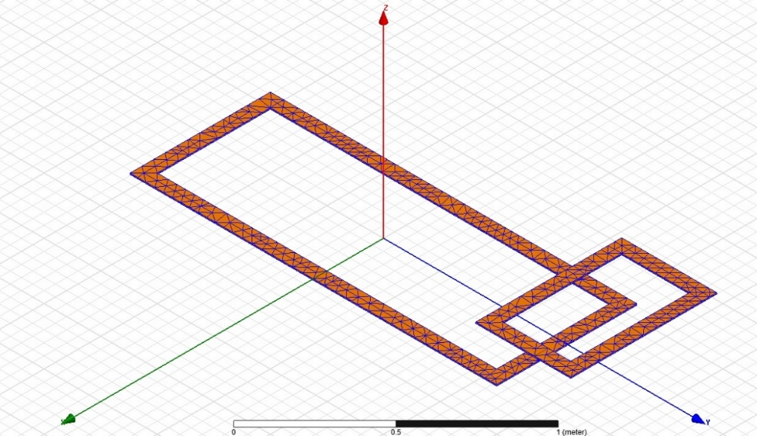
Figure 6.14. Coil geometry (and mesh) for the analysis of dynamic effects
on POLITO IPTs

Some relevant positions of the TX coil over the RX coils during the motion are shown in Figure 6.15: at the initial time instant (t = 0s) the RX coil starts from a position that is external to the TX one, then it reaches to center after 50 ms, at the given speed.
(a)
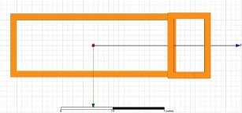
(b)
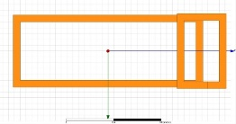
(c)
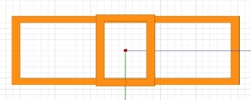
Figure 6.15: Positions of the RX coil over the TX one at some time instants:
(a) t = 0s (initial); (b) t = 20 ms; (c) t= 50 ms (final).

Figure 6.16 represents the waveform of the computed dynamic mutual inductance vs time. In the last portion of the graph (when the trend of the mutual inductance is saturated), the receiver appears to have its surface totally inside the surface of the transmitter Coil. The computed dynamic mutual inductance values are compared in Table 6.7 to those derived from the static limit.
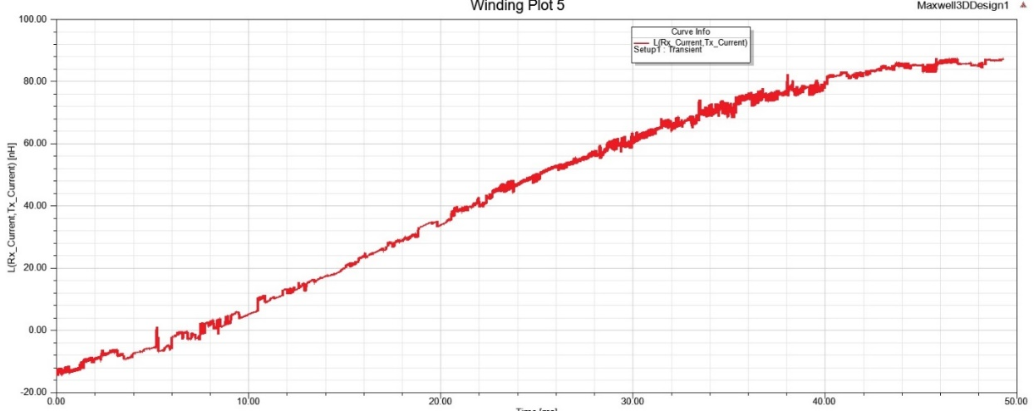
Figure 6.16: Computed dynamic mutual inductance vs time

Table 6.7: Dynamic (Md) versus static (Ms) values of the mutual inductance
Time instant [ms] | Ms  [µH] | Md  [µH]
0 | -1.41 | -1.45
10 | 0.55 | 0.54
20 | 3.2 | 3.39
30 | 6.3 | 5.99
50 | 8.5 | 8.6

For the considered speed of 36 km/h (10 m/s), the coil dimensions and the electromagnetic time constants calculated for this coil pair, both the criteria set in (2.72) and (2.73) are satisfied. Indeed, the numerical results provided in Table 6.7 are demonstrating the criteria, since the static and dynamic solutions differ by a maximum relative error of about 5–6%. Of course, lower values of $δ$ in (2.37) would provide a better accuracy (it would mean lowering the percentage error between M_{D} and M_{S} in Table 6.7).

6.5 Resume of the chapter and main findings
- Two WPT systems have been analyzed in this Chapter, both based on Inductive Coupling (IPT systems): a 50 kW-power, 25 kHz-resonant static system (VICTORIA) produced by the Spanish company CIRCE, and a 11 kW-power , 85 kHz-resonant dynamic one (POLITO) developed by Politecnico di Torino, Italy.
- The inductance matrix parameters associated to the pads of the two systems have been derived by using a numerical FEM integral formulation implemented in the proprietary code Cariddi.
- For POLITO IPT, self inductances equal to 278.6 µH and 115.4 µH and a mutual inductance of 18.1 µH have been found, and successfully compared to the experimental measurements (with an error less than 3%).
- For VICTORIA IPT, self inductances equal to 6.4 µH and 81.0 µH and a mutual inductance of 2.0 µH have been found, and successfully compared to the results of a numerical simulation carried out by using the commercial tool Ansys Maxwell (with an error less than 7%).
- A Multi-Objective Genetic Programming algorithm has been used to derive behavioral model of the mutual inductance versus the geometric parameters describing the relative positions of the two coils. The Thesis shows that it is possible to use the same behavioral model for modeling the two different WPT systems, sharing the shape of the coils (rectangular coils). The models only differ in the coefficients, and just a reduced training data set is required to tune them.
- A parametric analysis for both systems has been performed, assuming the vertical distance fixed and a sweep linked to the variation of the longitudinal and transverse positioning between the coils. The analysis allows building design maps that easily provide spatial misalignments that ensures a given value of the mutual inductance.
- The results of the analyzes carried on are used to fed to the multi-objective genetic algorithm.
- An electrodynamical analysis of the POLITO system coils assuming a fixed speed of the RX coil of 36 m/s has allowed to numerically verify the consistency of the criteria announced in Chapter 2 under which the coil parameters of a dynamic WPT system (mutual inductances) may be approximated to their static values.

Conclusions
In this Thesis work, two main applications in the field of energy management and production have been analysed: the first related to the production of electricity from Nuclear Fusion reactions and the second connected instead to the transport of electricity via Wireless Power Transfer (WPT).
The first application pertains to one of the possible mechanisms for nuclear fusion, based on the magnetic confinement of plasma by using the Tokamak machine. The second application, on the other hand, is related to the possibility of using the inductive coupling between two coils as the fundamental mechanisms for rechearging the batteries of electrical vehicles by WPT.
For both technologies, case-studies have been here modelled an analyzed, sharing the same starting point, that is the magneto-quasi-static model. The following results have been obtained about the modelling.
  - A preliminary study carried out by analysing a dimensionless formulation of Maxwell equations has led to the determination ot the three fundamental time constants (electromagnetic, magnetic and electric).
  - A criterion has been established to define the proper model to be used. The propagation effect can be neglected when the characteristic geometrical dimensions are muh smaller than the wavelength. In this case, a low-frequency condition occurs, and the problem can be described by means of a Magneto-Quasi-Static (MQS) model if there is a prevalence of magnetic energy with respect to electric energy ($W_{M}≫W_{E}$). In case there are time-invariant excitation currents in the system it is possible to use a formulation of the Magneto-Static type (MS).
  - Formulations of the MQS and MS problems are presented, first in terms of fields and then in terms of potentials.
  - As an example of MS problem, the study of the ferromagnetic effect is modelled through an integral formulation involving the potentials
  - As an example of MQS problem, the case of eddy-currents induced in conductive materials is provided, and many formulations are presented based on different use of potentials
  - The multi-physics problem associated to the electromagnetic analysis of a tokamak including the plasma dynamics is formulated. An approach allowing decoupling the fluidodynamics and the electromagnetic problems is presents (CarMa).
  - The multi-physics problem associated to the electromagnetic analysis of a wireless power transfer system including the motion of the receiving coil is formulated.
  - A criterion has been established to determine whether or not the coil pair parameters are affected by the dynamic effect. The criterion releates the vehicle velocity, the characteristic MQS time and the transmitting coil length.
As for the first application, two main problems have been analyzed in this Thesis. The first refers to the Divertor modeul of the EU-DEMO tokamak, the second to the diagnostics Radial Neutron Camera the ITER tokamak. The following results have been obtained in modelling such components.
- A hybrid approach has been proposed to perform the analysis of the EM loads acting on the divertor module of the EU-DEMO machine. The approach models a 22.5° sector of the Tokamak, thanks to symmetry and periodicity properties of the problem. The model includes a finely detailed CAD of the divertor and a coarser description of the main external objects like blankets, Vacuum Vessel, rails. The problem is formulated for carrying out a fast transient analysis due to a disruption events: the excitations (equivalent poloidal and toroidal currents and halo current) refers to a Vertical Displacemnt Event (VDE). Specifically, the current filaments representing the plasma events are extracted by using the code CarMa0NL.
- An alternative approach is presented, based on the so-called submodelling technique. The case-study is the analysis of the eddy currents again associated to VDE event induced on a component of the ITER diagnostics system “Radial Neutron Camera”. In this case two models are solved. A Global Model contains all the main components falling in a 40° sector ot ITER tokamak: the blankets, the divertors, the cryostat, the vessel and the vessel doors. Its solution is used to identify proper boundary conditions of a Local Model that only include a detailed CAD model of the component under study (RNC ex-port module) acting as the forcing term. These boundary conditions are identified by interpolating the Degrees of Freedom (DoF) of the two models on the boundary nodes of the two meshes. Specifically, in the adopted formulation the DoFs are the values of the vector potential (Ax, Ay, Az).
- A third model has been presented to face a magneto-static problem, that is the analysis of the static ferromagnetic forces acting on the EU-DEMO divertors due to the presence of the ferromagnetic material EUROFER-97. The model consideres again the 22.5° sector of the tokamak and is expressed through integral formulation of the static problem, with homogenized materials. The model sources are given by the currents of the TF Coils and by the plasma currents.
The above models have been then used to perform the numerical analysis of the case-studied under investigation. Specifically, the following results have been obtained.
- The EM loads acting on the Divertor of the EU-DEMO machine have been evaluated, with reference to the Vertical Displacement Event (VDE_down_74ms). The most relevant component of the Lorentz forces is the vertical one, that reaches a value of -1.18MN. The most relevant resultant moment is again the vertical one, with a maximum of -1.76MNm.
- The above results do not significantly change by replacing the steel with Eurofer for realzing the cooling system components or by assuming the supports between cassettes and vertical targets to be insulating rather than conducting.
- The EM loads acting on the Divertor of the EU-DEMO machine are also studied with reference to the static ferromagnetic effects. The main component of the static ferromagnetic force acting on the divertor assembly is the radial one (peak value equal to -1.25MN) whereas the most relevant component of the moments is the Toroidal one (peak value 6.30MNm).
- The EM loads acting on the EX-Port RNC module of the ITER machine are also computed, as the effect of the fast transients associated to a Vertical Displacement Event (s VDE_down_36ms) and a Major Disruption one (MD_up_36ms). For the VDE event, the maximum component of the Lorentz force is the radial one, that reaches the peak value of -2.43 kN. The peak value of the resultant moments is instead associated to the vertical component and is equal to 1.13 kNm. The analysis of the MD_up_36ms event provides the same qualitative results, being again the radial force and vertical moment the components with maximum values (-2,65 kN and -1.45kNm).
The case-studies related to the WPT systems analyzed in this Thesis refer to static and dynamic Inductive Power Transfer (IPT) system, based on resonant architectures, to be used for vehicle rechearging. The modelling activity on these systems has provided the following results.
- In the low frequency approximation, the PADs are modelled by means of an equivalent two-port circuit with a resistance matrix, taking into account the ohmic losses, and an inductance one representing the flux-current relations.
- The most efficient architectures for IPT systems are based on resonant circuits, obtained by adding suitable compensation capacitors to the above-mentioned two-port. Series-series, series-parallel, parallel-parallel e parallel-series schemes are possible, and the advantages of using each of them are here discussed.
- Low frequency electromagnetic models have been here presented, aimed at the evaluation of the R and L matrices entries.
- In simplified conditions, analytical models can be used, and examples are here given of formulas providing the mutual inductance parameter M, that is the most important one to describe the PAD coupling.
- In real condition, the two-port parameters of the PAD pair must be extracted by means of numerical models, and computing them for instance by imposing the relations between energy and currents. A FEM numerical integral formulation is here discussed, naturally leading to the building of R and L matrices
- The Thesis also presents an approach to derive analytical behavior models from FEM simulations. This is useful during the design of the WPT systems, for instance for quick evaluation of the system performance under non-nominal condition. The case analyzed in this Thesis, for instance, refers to the sensitivity of the magnetic coupling factor to the misalignment of the TX and RX coils.
- The behavioral model of the mutual inductance here is derived by using a Genetic Programming Multi-Objective algorithm.
The case-studies related to the IPT systems analyzed in this Thesis refer to the 50 kW-power and 25 kHz-resonant static system “VICTORIA” produced by the Spanish Company CIRCE, to be used for recharging public buses, and to the 11 kW-power , 85 kHz-resonant dynamic system “POLITO” developed by Politecnico di Torino, Italy, for recharging cars and small vans. The numerical analysis of these systems has produced the following results.
- The inductance matrix parameters associated to the pads of the two systems have been derived by using a numerical FEM integral formulation implemented in the proprietary code Cariddi.
- For POLITO IPT, self inductances equal to 278.6 µH and 115.4 µH and a mutual inductance of 18.1 µH have been found, and successfully compared to the experimental measurements (with an error less than 3%).
- For VICTORIA IPT, self inductances equal to 6.4 µH and 81.0 µH and a mutual inductance of 2.0 µH have been found, and successfully compared to the results of a numerical simulation carried out by using the commercial tool Ansys Maxwell (with an error less than 7%).
- A Multi-Objective Genetic Programming algorithm has been used to derive behavioral model of the mutual inductance versus the geometric parameters describing the relative positions of the two coils. The Thesis shows that it is possible to use the same behavioral model for modeling the two different WPT systems, sharing the shape of the coils (rectangular coils). The models only differ in the coefficients, and just a reduced training data set is required to tune them.
- A parametric analysis for both systems has been performed, assuming the vertical distance fixed and a sweep linked to the variation of the longitudinal and transverse positioning between the coils. The analysis allows building design maps that easily provide spatial misalignments that ensures a given value of the mutual inductance.
- The results of the analyzes carried on are used to fed to the multi-objective genetic algorithm.
- An electrodynamical analysis of the POLITO system coils assuming a fixed speed of the RX coil of 36 m/s has allowed to numerically verify the consistency of the criteria announced in Chapter 2 under which the coil parameters of a dynamic WPT system (mutual inductances) may be approximated to their static values.

List of the publications of the PhD candidate
Papers in international journals
[P1] G. Mazzone, Jeong-Ha You, C. Bachmann, U. Bonavolontà, V. Cerri, D. Coccorese, D. Dongiovanni, D. Flammini, P. Frosi, L. Forest, G. Di Gironimo, G. Di Mambro, V. Imbriani, A. Maffucci, D. Marzullo, P.A. Di Maio, M.T. Porfiri, E. Vallone, R. Villari, E. Visca, C. Vorpahl, “Eurofusion-DEMO Divertor – Cassette Design and Integration”, Fusion Engineering and Design, Vol. 157, 2020, p.111656, https://doi.org/10.1016/j.fusengdes.2020.111656
[P2] K. Stoyka, G. Di Mambro, N. Femia, A. Maffucci, S. Ventre, F. Villone, “Behavioral modeling of Wireless Power Transfer System coils,” Mathematics and Computers in Simulation,” Vol.183, May 2021, pg.208-220, DOI: 10.1016/j.matcom.2020.01.004,
[P3] G. Di Capua, A. Maffucci, K. Stoyka, G. Di Mambro, S. Ventre, V. Cirimele, F. Freschi, F. Villone and N. Femia, Analysis of Dynamic Wireless Power Transfer System based on Behavioral Modeling of the Mutual Inductance, MDPI Journal, Sustainability 2021, vol.13, no.5, p2556, DOI: 10.3390/su13052556,
[P4] G. Di Capua, N. Femia, K. Stoyka, G. Di Mambro, A. Maffucci, S. Ventre. F. Villone, “Mutual Inductance Behavioral Modeling for Wireless Power Transfer System Coils” IEEE Transactions on Industrial Electronics, vol. 68, no. 3, pp. 2196-2206, March 2021, doi: 10.1109/TIE.2019.2962432.
[P5] J.H. You, G. Mazzone, E. Visca, H. Greuner, M. Fursdon, Y. Addab, C. Bachmann, T. Barrett, U. Bonavolontà, B. Böswirth, F.M. Castrovinci, C. Carelli, D. Coccorese, R. Coppola, F. Crescenzi, G. Di Gironimo, P.A. Di Maio, G. Di Mambro, F. Domptail, D. Dongiovanni, G. Dose, D. Flammini, L. Forest, P. Frosi, F. Gallay, B.E. Ghidersa, C. Harrington, K. Hunger, V. Imbriani, M. Li, A. Lukenskas, A. Maffucci, N. Mantel, D. Marzullo, T. Minniti, A.V. Müller, S. Noce, M.T. Porfiri, A. Quartararo, M. Richou, S. Roccella, D. Terentyev, A. Tincani, E. Vallone, S. Ventre, R. Villari, F. Villone, C. Vorpahl, K. Zhang, “Divertor of the European DEMO: Engineering and technologies for power exhaust,” Fusion Engineering and Design, Volume 175, 2022, 113010, ISSN 0920-3796, https://doi.org/10.1016/j.fusengdes.2022.113010 .
[P6] G. Di Mambro, A. Maffucci, G. Mazzone, S. Ventre, F. Villone, J.H. You, “Mechanical impact of electromagnetic transients on the Eurofusion-DEMO divertor. Part 1: Vertical Displacement Event” Fusion Engineering and Design, 2022, Vol.175, p.112999, DOI: 10.1016/j.fusengdes.2021.112999
[P7] G. Di Mambro, A. Maffucci, G. Mazzone, G. Rubinacci, S. Ventre, F. Villone, J.H. You, “Ferromagnetic forces acting on the EU-DEMO divertor”; Fusion Engineering and Design, 2023, Vol. 190, p.113522, https://doi.org/10.1016/j.fusengdes.2023.113522.
[P8] D. Marocco, F. Belli, D. Bocian, G. Brolatti, C. Centioli, A. Colangeli, G. Di Mambro, D. Flammini; N. Fonnesu, G. Gandolfo, R. Kantor, J. Kotula, A. Maffucci; G. Mariano, D. Marzullo, R. Ortwein, S. Podda; F. Pompili, M. Riva, D. Sancristóbal, R. Villari, “Nuclear design of a shielded cabinet for electronics: the ITER Radial Neutron Camera case study”, Fusion Engineering and Design, 2023, Vol. 191, p.113542, https://doi.org/10.1016/j.fusengdes.2023.113542
Papers and abstracts presented at international conferences
[C1] K. Stoyka, G. Di Capua, G. Di Mambro, N. Femia, A. Maffucci, S. Ventre, “Design Optimization of a Dynamic Inductive Power Transfer System Based on Behavioral Modeling,” IEEE Conf. on Electromagnetic Field Computation, CEFC 2020, Pisa, Nov. 2020, paper ID # 700.
[C2] K. Stoyka, G. Di Capua, G. Di Mambro, N. Femia, F. Freschi, A. Maffucci, S. Ventre, “Behavioral Models for the Analysis of Dynamic Wireless Charging Systems for Electrical Vehicles,” IEEE Int. Symp. On Circuits and Systems, ISCAS 2020, Siviglia (Spain), 11-14 Oct. 2020, paper n. 9180785, doi: 10.1109/ISCAS45731.2020.9180785.
[C3] Di Mambro G., Antonini R., Oliva N., De Guglielmo L., Di Capua G., Femia N., Maffucci A., Ventre S. “Control-Oriented Optimization of Coil Pair Design in Dynamic WPT Systems for Electrical Vehicles,” Proc. of 18th International Conference on Synthesis, Modeling, Analysis and Simulation Methods, and Applications to Circuit Design, SMACD 2022, Villasimius (Italy) 12-15 June 2022, paper 180847, DOI: 10.1109/SMACD55068.2022.9816302
[C4] G. Di Mambro, A. Maffucci, G. Mazzone, G. Rubinacci, S. Ventre, F. Villone, J.H. You, “Ferromagnetic forces acting on the EU-DEMO divertor”, 32nd SOFT Symposium on Fusion Technology, 8–23 Sep. 2022, Dubrovnik, Croatia, ID: 39.
[C5] D. Marocco, F. Belli, D. Bocian, G. Brolatti, C. Centioli, A. Colangeli, G. Di Mambro, D. Flammini; N. Fonnesu, G. Gandolfo, R. Kantor, J. Kotula, A. Maffucci; G. Mariano, D. Marzullo, R. Ortwein, S. Podda; F. Pompili, M. Riva, D. Sancristóbal, R. Villari, “Nuclear design of a shielded cabinet for electronics: the ITER Radial Neutron Camera case study”, 32nd SOFT 32nd Symposium on Fusion Technology, 8 – 23 Sep. 2022, Dubrovnik, Croatia, paper ID: 817.
Abstracts presented at national conferences
[N1] G. Di Capua, G. Di Mambro, N. Femia, A. Maffucci, K. Stoyka, A. Tamburrino, S. Ventre, F. Villone, “Inductance models for wireless power transfer system coils,” XXXV Riunione Annuale Ricercatori di Elettrotecnica, Viterbo, 20-21/6/2019
[N2] G. Di Mambro, A. Maffucci, G. Mazzone, S. Ventre, F. Villone, J.H. You, “Electromagnetic Analysis of the European DEMO divertor”, XXXVI Riunione Annuale dei Ricercatori di Elettrotecnica, Ancona, 23-25/6/2022
Technical reports and project deliverables
[R1] MICEV, Metrology for Inductive Charging of Electric Vehicles, Technical Report D.2, 16ENG08, Feb 2020.
[R2] A. Maffucci, G. Di Mambro, S. Ventre, F. Villone, G. Mazzone, “DIV-1-T007-D010 AWP2020 Electromagnetic Analysis for Divertor Assembly 2020 (EFDA_ 2NSV56)
[R3] A. Maffucci, G. Di Mambro, S. Ventre, F. Villone, G. Mazzone, “DIV-1-T005-D010 Electromagnetic Analysis for Divertor Assembly 2021” (EFDA_ 2PHVW7)
[R4] A. Maffucci, G. Di Mambro, D. Marocco, “RT-F4E FPA327 07-93 EX-port RNC EM loads calculations and analyses”, Oct. 2022
[R5] A. Maffucci, G. Di Mambro, S. Ventre, F. Villone, G. Mazzone, “, DIV-1-T014-D001 Electromagnetic Analysis for Divertor Assembly 2022 (EFDA_ 2Q43ZK)

References
Papers and books
- Albanese R. Rubinacci G. (1988), Integral Formulation for 3D Eddy Current Computation Using Edge Elements, IEE Proceedings, Vol. 135, No. 7, Sept. 1988;
- Albanese, F. Villone (1998), The Linearized CREATE-L Plasma Response Model for the Control of Current, Position and Shape in Tokamaks, Nucl. Fusion 38 723, 1998;
- Albanese, G. Rubinacci (1998), “Finite Element Methods for the Solution of 3D Eddy Current Problems”, Advances in Imaging and Electron Physics, vol.102, pp.1-86, 1998;
- Albanese, J. Blum and O. De Barbieri (1987), Numerical Studies of the Next European Torus via the PROTEUS Code, Proc. 12th Conf. on the Numerical Simulation of Plasmas (San Francisco, CA), 1987;
- Albanese, M. Mattei, G. Calabrò and F. Villone (2003), Unified Treatment of Forward and Inverse Problems in the Numerical Simulation of Tokamak Plasmas, Proc. 11th Int. Simp. On Applied Electromagnetics and Mechanics (Versailles, France), pp 404-5, 2003;
- Albanese, R., B. Carpentieri, M. Cavinato, S. Minucci, R. Palmaccio, A. Portone, G. Rubinacci, P. Testoni, S. Ventre, F. Villone (2015), “Effects of asymmetric vertical disruptions on ITER components,” Fusion Engineering and Design, Vol. 94, 2015, pp. 7-21,
- Babat (1951), “High frequency electric transport system with contactless transmission of energy”, Sept. 1951. Application number GB926946A, 1951;
- Babic S., et al (2011), “New Formulas for Mutual Inductance and Axial Magnetic Force Between a Thin Wall Solenoid and a Thick Circular Coil of Rectangular Cross-Section,” IEEE Transactions on Magnetics, Vol. 47, pp. 2034 - 2044, Aug 2011.
- Barbareschi (1993), The MAXFEA Code, Plasma Control Technical Meeting, Naka Japan, 1993;
- Barbato (2015), “Advanced Numerical Models and Methods for Computational Electromagnetics Applied to Controlled Thermonuclear Fusion and Non-Destructive Testing” (PhD Thesis), University of Cassino and Southern Lazio, Italy, January 2015;
- Barkenbus (2020), “Prospects for Electric Vehicles,” Sustainability, vol. 12, no. 14, p. 5813, Jul. 2020;
- Bialek at al. (2001), Modelling of Active Control of External Magneto-Hydrodynamic Instabilities, Phys. Plasmas 8 2170, 2001;
- Bondeson, G. Vlad, H. Lütjens (1992), Resistive Toroidal Stability of Internal Kink Modes in Circular and Shaped Tokamaks, Phys. Fluids B 4 1889-900, 1992;
- Bosshard, J. W. Kolar, J. Mühlethaler, I. Stevanovi´c, B. Wunsch, and F. Canales (2015), “Modeling and η-α-Pareto optimization of inductive power transfer coils for electric vehicles,” in IEEE Journal of Emerging and Selected Topics in Power Electronics, vol. 3, no. 1, pp. 50-64, March 2015;
- Boys and A. Green (1995), “Inductive power pick-up coils”, Apr. 27 1995. WO Patent App. PCT/NZ1994/000,115, 1995;
- Boys and A. Green (1998), “Flux concentrator for an inductive power transfer system”, Oct. 13 1998. US Patent 5,821,638, 1998;
- Carlson, and B. Normann (2014), “Test Results of the PLUGLESS™ Inductive Charging System from Evatran Group, Inc.”, SAE Int. J. Alt. Powertrains, vol. 3, pp. 64–71, 2014;
- Carmeli M. S., F. Castelli-Dezza, M. Mauri, G. Foglia (2015), “Contactless energy transmission system for electrical vehicles batteries charging”, 2015 Int. Conf. on Clean Electr. Power (ICCEP), Taormina, June 2015.
- Cau, A. G. Chiariello, G. Rubinacci, V. Scalera, A. Tamburrino, S. Ventre, F. Villone (2008), “A Fast Matrix Compression Method for Large Scale Numerical Modelling of Rotationally Symmetric 3D Passive Structures in Fusion Devices”, MDPI Journal, Energies, 15, 3214. https://doi.org/10.3390/en15093214, 2022;
- CFETR, China Fusion Engineering Test Reactor, China - Yuanxi Wan, Jiangang Li, Yong Liu, Xiaolin Wang, Vincent Chan, Changan Chen, Xuru Duan, Peng Fu, Xiang Gao, Kaiming Feng, Songlin Liu, Yuntao Song, Peide Weng, Baonian Wan, Farong Wan, Heyi Wang, Songtao Wu, Minyou Ye, Qingwei Yang, Guoyao Zheng, Ge Zhuang, Qiang Li and CFETR team (2017); Published 23 June 2017, IAEA, Vienna; DOI 10.1088/1741-4326/aa686a Nuclear Fusion, Volume 57, Number 10, 2017;
- Chen, F.F (2011), “An indispensable truth, how fusion power can save the planet”, Springer, 2011;
- Chen, F.F (2011), “Introduction to Plasma Physics and Controlled Fusion”, Springer, 2011;
- Choi, B. W. Gu, S. Y. Jeong and C. T. Rim (2015), "Advances in Wireless Power Transfer Systems for Roadway-Powered Electric Vehicles," in IEEE Journal of Emerging and Selected Topics in Power Electronics, vol. 3, no. 1, pp. 18-36, March 2015.
- Cirimele (2017), “Design and integration of a dynamic IPT system for automotive applications”, PhD Thesis, Politecnico di Torino, Italy, 2017;
- Cirimele, M. Diana, F. Freschi and M. Mitolo (2018), “Inductive Power Transfer for Automotive Applications: State-of-the-Art and Future Trends,” in IEEE Transactions on Industry Applications, vol. 54, no. 5, pp. 4069-4079, Sept.-Oct. 2018;
- Conway J.T. (2007), “Inductance Calculations for Noncoaxial Coils Using Bessel Functions, IEEE Transactions on Magnetics, Vol. 43, pp. 1023 - 1034, Feb 2007.
- Czarny and G. Huysmans (2008), Bézier Surfaces and Finite Element for MHD Simulations, J. Comp. Phys. 227 7423-45, 2008;
- Deb, A. Pratap, S. Agarwal, T. Meyarivan (2002), “A Fast and Elitist Multiobjective Genetic Algorithm: NSGA-II”, IEEE Transactions on Evolutionary Computation, vol. 6, no. 2, pp. 182–197, Apr. 2002;
- Di Capua et al. (2016), “Genetic Programming Approach for Identification of Ferrite Inductors Power Loss Models”, Annual Conf. of IEEE Industrial Electronics Society (IECON), Florence, IT, Oct. 2016;
- Di Capua et al. (2017), “Power and efficiency analysis of high-frequency Wireless Power Transfer Systems”, Int. Journal of Electrical Power & Energy Systems, vol. 84, pp. 124-134, Jan. 2017;
- Di Capua et al. (2018), “Loss Behavioral Modeling for Ferrite Inductors”, Int. Conf. on Synthesis, Modeling, Analysis and Simulation Methods and Appl. to Circuit Design (SMACD), Prague, CZ, July 2018;
- Di Capua, A. Maffucci, K. Stoyka, G. Di Mambro, S. Ventre, V. Cirimele, F. Freschi, F. Villone, and N. Femia (2021), “Analysis of Dynamic Wireless Power Transfer Systems Based on Behavioral Modeling of Mutual Inductance,” Sustainability, vol. 13, no. 5, p. 2556, Feb. 2021;
- Di Capua, N. Femia, K. Stoyka, G. Di Mambro, A. Maffucci, S. Ventre and F. Villone (2021), "Mutual Inductance Behavioral Modeling for Wireless Power Transfer System Coils," in IEEE Transactions on Industrial Electronics, vol. 68, no. 3, pp. 2196-2206, March 2021;
- Di Mambro, A. Maffucci, G. Mazzone, S. Ventre, F. Villone, J.H. You (2022), Mechanical impact of electromagnetic transients on the European DEMO divertor. Part 1: Vertical displacement event, Fusion Eng. Des. 175 (2022), 112999, 2022;
- Di Mambro, A. Maffucci, G. Mazzone, G. Rubinacci, S. Ventre, F. Villone, J.H. You (2023), “Ferromagnetic forces acting on the EU-DEMO divertor”; Fusion Engineering and Design, 190, (2023) 113522. https://doi.org/10.1016/j.fusengdes.2023.113522
- Dolan (2014), T.J., Magnetic Fusion Technology, Ed. Springer, 2014;
- Federici, et al. (2019), Overview of the DEMO staged design approach in Europe, Nucl. Fusion 59 (2019), 066013, 2019;
- Femia et al. (2016), “In-system IGBT power loss behavioral modeling”, Int. Conf. on Synthesis, Modeling, Analysis and Simulation Methods and Appl. to Circuit Design (SMACD), Lisbon, PT, June 2016;
- Freidberg J.P. (1987), “Ideal Magnetohydrodynamics” (New York: Plenum)
- Freidberg, J.P. (2008), “Plasma Physics and Fusion Energy,” Cambridge University Press, 2008;
- Hender et al. (2007), MHD stability, operational limits and disruptions, Nucl. Fusion. 47, S128, 2007;
- Huh, S. W. Lee, W. Y. Lee, G. H. Cho and C. T. Rim (2011), "Narrow-Width Inductive Power Transfer System for Online Electrical Vehicles," in IEEE Transactions on Power Electronics, vol. 26, no. 12, pp. 3666-3679, Dec. 2011;
- IR-T1, Tehran, Iran – D. Dorranian, M. Ghoranneviss, M. Salem, M. Mahmoodi D (2006), “Recent Results of IRAN-T1 Tokamak”, AIP Conference Proceedings 875, 111 (2006); https://doi.org/10.1063/1.2405912, 2006;
- Jardin, N. Pomphrey and J. De Lucia (1986), Dynamic Modelling of Transport and Positional Control of Tokamaks, J. Comp. Phys. 66 481, 1986;
- Kempf, et al. (2014), Correlation between radiation damage and magnetic properties in reactor vessel steels, J. Nucl. Mater. 445, 55–62, 2014;
- Kevin (1997), Numerical Simulation of Plasma Equilibrium and Shape Control in Tight Tokamak GLOBUS-M, Fusion Technology (Amsterdam: Elsevier) pp 821-4, 1997;
- Khayrutdinov, V. E. Lukash (1993), Studies of Plasma Equilibrium and Transport in a Tokamak Fusion Device with the Inverse-Variable Technique, J. Comp. Phys. 109 193, 1993;
- Kikuchi, M. (2008), “Frontiers in Fusion Research: Physics and Fusion”, Springer, 2012;
- Koza (1992), Genetic Programming: on the programming of computers by means of natural selection. Cambridge, MA, USA: MIT Press, 1992;
- Kwon et al. (2009), Structural analyses for equatorial and lower ports of the ITER vacuum vessel, Fusion Engineering and Design 84 (2009) 1144–1150;
- Lide, D. R. (2005), ed. 2005. CRC Handbook of Chemistry and Physics (85th ed.) CRC Press. ISBN: 978-0-8493-0484-2, 2005;
- Liu et al. (2000), Feedback Stabilization of Nonaxisymmetric Resistive Wall Modes in Tokamaks. I. Electromagnetic Model, Phys. Plasmas 7 3681, 2000;
- Maione, M. Marracci, B. Tellini (2013), Study on remanent magnetization of Fe-9Cr steel and its effect on in-vessel remote handling for future fusion reactors, Fusion Eng. Des. 88, 2092–2095, 2013;
- Maione, M. Roccella, F. Lucca, F. Villone, F. Hernandez, A. Del Nevo, C. Bachmann (2021), Fusion Engineering and Design, 166, https://doi.org/10.1016/j.fusengdes.2021.112285, 2021;
- Mastrostefano (2013), “Analytical, numerical and computational models for the analysis of the effects of conductors on the evolution of MHDinstabilities” (PhD Thesis), University of Cassino and Southern Lazio, Italy, 2013;
- Mergia, N. Boukos (2008), Structural, thermal, “Electrical and magnetic properties of Eurofer 97 steel”, J. Nuclear Materials 373, 1–8, 2008;
- Miki et al. (2001), Vertical Displacement Event/Disruption Electromagnetic Analysis for the ITER-FEAT Vacuum Vessel and In-Vessel Component, Fusion Engineering and Design 58-59 555-9, 2001;
- Miller, P. T. Jones, J. -M. Li and O. C. Onar (2015), "ORNL Experience and Challenges Facing Dynamic Wireless Power Charging of EV's," in IEEE Circuits and Systems Magazine, vol. 15, no. 2, pp. 40-53, 2015;
- Olukotun B., J. S. Partridge, R. W. G. Bucknall (2018), “Optimal Finite Element Modelling and 3-D Parametric Analysis of Strong Coupled Resonant Coils for Bidirectional Wireless Power Transfer”, Proc. of 53rd International Universities Power Eng. Conference (UPEC), Glasgow, UK, Sept. 2018.
- Otto (1974), “Power supply equipment for electrically-driven vehicle”, JP Patent 49 063 111, Jun. 1974;
- Park (1999), Plasma Simulation Studies Using Multilevel Physics Model, Phys. Plasmas 6 1796, 1999;
- Pichon (2020), “Electromagnetic Analysis and Simulation Aspects of Wireless Power Transfer in the Domain of Inductive Power Transmission Technology”, in Journal of Electromagnetic Waves and Applications, vol. 34, no. 13, pp. 1719-1755, Jul. 2020;
- Portone, F. Villone, Y. Liu, R. Albanese and G. Rubinacci (2008), Linearly Perturbed MHD Equilibria and 3D Eddy Current Coupling via the Control Surface Method, Plasma Phys. and Controlled Fusion 50 085004, 2008;
- Rakhymbay A. et al, “Precise analysis of mutual inductance variation in dynamic wireless charging of electric vehicle, Energies, vol.11, p.624, 2018
- Ravaud R. (2010), G. Lemarquand, V. Lemarquand, C. Akyel, “Cylindrical Magnets and Coils: Fields, Forces, and Inductances,” IEEE Transactions on Magnetics, Vol. 46, pp. 3585 – 3590, Sep. 2010.
- Ruffo et al. (2018), “Sensorless control of the charging process of a dynamic inductive power transfer system with interleaved nine-phase boost converter”, IEEE Trans. on Industrial Electronics, Feb. 2018;
- Ruffo, V. Cirimele, M. Diana, M. Khalilian, A. L. Ganga, P. Guglielmi (2018), “Sensorless Control of the Charging Process of a Dynamic Inductive Power Transfer System with an Interleaved Nine-Phase Boost Converter”, IEEE Trans. on Industrial Electronics, vol. 65, no. 10, pp. 7630-7639, Oct. 2018;
- Ruiz (2014), “ITS systems developing in Malaga”, 2nd Congress EU Core Net Cities, 2014;
- Sadakov, F. Villone, G. Rubinacci, S. Ventre (2022), “Simple parametric Model for Calculation of Lateral Electromagnetic Loads in Tokamaks at Asymmetric Vertical Displacement Events (AVDE)”, MDPI Journal, Plasma, 5, 306–323. https://doi.org/10.3390/plasma5030024, 2022;
- Sample A. P., David A., Meyer D.A., J.R. Smith, “Analysis, experimental results, and range adaptation of magnetically coupled resonators for wireless power transfer”, IEEE Trans. Ind. Electron., vol. 58, pp. 544-554, 2011.
- Shladover (2007), "PATH at 20—History and Major Milestones", in IEEE Transactions on Intelligent Transportation Systems, vol. 8, no. 4, pp. 584-592, Dec. 2007;
- Smirnov V.P., “Tokamak foundation in USSR/Russia 1950–1990”, Nuclear Fusion Institute, RRC ’Kurchatov Institute’, Moscow, Russia, Nucl. Fusion 50 (2010) 014003, DOI:10.1088/0029-5515/50/1/014003, 2010;
- Sonntag, E. A. Lomonova and J. L. Duarte (2008), "Implementation of the Neumann formula for calculating the mutual inductance between planar PCB inductors," 2008 18th International Conference on Electrical Machines, 2008, pp. 1-6. 2008;
- Strumberger at al. (2008), On Fully Three-Dimensional Resistive Wall Mode and Feedback Stabilization Computations, Phys. Plasmas 15 056110, 2008;
- Suh (2011), “Application of shaped magnetic field in resonance (SMFIR) technology to future urban transportation,” in Proc. CIRP Design Conf., pp. 226–232 , 2011;
- System Reference document (SRdoc) (2010); Wireless Power Transmission (WPT) systems operating below 30 MHz, ETSI TR 103 493 (V1.1.1), Feb. 2019.D. van Wageningen and T. Staring, 2010;
- Tesla (1891), “Experiments with Alternate Currents of Very High Frequency and Their Application to Methods of Artificial Illumination”, lecture before the American Institute of Electrical Engineers, Columbia College, N.Y, May 1891;
- Tesla (1927), “World system of wireless transmission of energy,” Telegraph and Telephone Age, 1927;
- Tesla (1990), “Apparatus for transmission of electrical energy,” May 15 1900. US Patent 649,621, 1900;
- Theodorou et al. (2019), “Resistivity Recovery Stages of Proton Irradiated EUROFER97 Steel,”, Proc. HNPS Adv. Nucl. Phys. 25 (2019) 235. April, 2019;
- TM1-MH (since 1977 as Castor; since 2007 as GOLEM, Prague, Czech Republic) (2010) - V. Svoboda et al. “Former Tokamak CASTOR becomes remotely controllable GOLEM at the Czech Technical University in Prague ”. In: Europhysics Conference Abstracts. 37th EPS Conference on Plasma Physics (online: http: // ocs. ciemat. es/ EPS2010PAP/ pdf/ P2. 111. pdf ). Vol. 34A. 2010. isbn: 2-914771-62-2, 2010;
- Villone et al. (2019), Report on 3D Electromagnetic analysis of DEMO disruptions, EFDA_D_2MUNQ3, 2019;
- Villone F., Trevisan (2003), F. “Modelli numerici per campi e circuiti”, Editore SGE (Padova), 2003;
- Villone, L. Barbato, S. Mastrostefano, Ventre S (2013), “Coupling of nonlinear axisymmetric plasma evolution with three-dimensional volumetric conductors”, Plasma Phys. Control. Fusion 5, 095008, 2013.
- Y. Zhang, L. Wang, Y. Guo, C. Tao (2018), “Design and Optimization of Asymmetrical Spiral Rectangular Pads for EV Wireless Charging”, 2018 IEEE 4th Southern Power Electr. Conf. (SPEC), Singapore, Dec. 2018.

Phd theses
- Barbato (2015), “Advanced Numerical Models and Methods for Computational Electromagnetics Applied to Controlled Thermonuclear Fusion and Non-Destructive Testing” (PhD Thesis), University of Cassino and Southern Lazio, Italy, January 2015;
- Mastrostefano (2013), “Analytical, numerical and computational models for the analysis of the effects of conductors on the evolution of MHD instabilities” (PhD Thesis), University of Cassino and Southern Lazio, Italy, 2013;
- Sadek (2016), “Power Electronic Converter Topologies used in Electric Vehicles” (PhD Thesis), Faculty of Engineering, Ain Shams University, Cairo, Egypt, September 2016

Internal reports, patents
- Boys and A. Green, “Flux concentrator for an inductive power transfer system”, Oct. 13 1998. US Patent 5,821,638, 1998;
- Boys and A. Green, “Inductive power pick-up coils”, Apr. 27 1995. WO Patent App. PCT/NZ1994/000,115, 1995;
- Cocilovo er al., “Structural Analysis Report for Divertor Cassette 2015”, EFDA_D_2MZGPJ, 2016;
- ITER Document No. S 74 MA 2, File Code: ITER-AA01-3201, Electrical_Resistivity222TU5
- ITER Internal Deliverable, Material Property Handbook - 2232UB_2MDMST
- ITER Internal Deliverable, Material Property Handbook on EUROFER97, 2MT9X8_v1_0.
- MICEV Internal Deliverable (2019), Report on the modelling approach and results (A.2.2.7), December 2019
- Roccella and R. Roccella, Global Model of ITER Vessel for the EM Analyses, ITER_D_3BQBVY v1.1, 2011;
- Villone et al., Report on 3D Electromagnetic analysis of DEMO disruptions, EFDA_D_2MUNQ3, 2019;
- Vishay Electronics, VS-ETY020P120F datasheet, available online.

Web resources
- Aditya, at Institute for Plasma Research (IPR) in Gujarat, India -http://www.ipr.res.in/tokamak_research_1.html
- ANSYS, “SOLID 97”, ansys.com, 2018
- ASDEX Upgrade Garching Germany - https://www.ipp.mpg.de/16195/asdex
- COMPASS Prague - https://www.ipp.cas.cz/vyzkum/Projekty/COMPASS_U.html
- DEMO, Construction begin in 2030 - https://euro-fusion.org/programme/demo/
- DIII-D, in San Diego, US - https://www.d3dfusion.com/home
- Dolan, T.J., Magnetic Fusion Technology, Ed. Springer, 2014; https://link.springer.com/book/10.1007/978-1-4471-5556-0
- Euramet Project MICEV, “Metrology for inductive charging of electric vehicles,” 2017–2020. [Online]. Disponibile all’indirizzo: https://micev.eu/ , 2020;
- F4E, Fusion For Energy, c/ Josep Pla, Barcelona, Spain - fusionforenergy.europa.eu
- FTU, in Frascati, Italy - http://www.fusione.enea.it/FTU/index.html.en
- Globus-M in Ioffe Institute, Saint Petersburg, Russia - http://www.ioffe.ru/HTPPL/
- H-1NF Australia https://web.archive.org/web/20130409180149/http://h1nf.anu.edu.au/
- Hender et al., MHD stability, operational limits and disruptions, Nucl. Fusion. 47, S128, 2007; - https://iopscience.iop.org/article/10.1088/0029-5515/39/12/303/pdf
- HL-2A, in Chengdu, China - https://en.cnnc.com.cn/2019-11/22/c_426403.htm EAST (HT-7U), in Hefei, China - http://english.hf.cas.cn/ic/ip/east/
- HT-7 Hefei, China - http://english.hf.cas.cn/ic/ip/ht7/
- https://waveipt.com
- https://witricity.com/products/automotive
- https://www.tesla.com/supercharger
- IEA (2020), “Global EV Outlook 2020”, IEA, Jun. 2020 [Online]. Available at the address: https://www.iea.org/reports/global-ev-outlook-2020;
- ISTTOK, at the Instituto de Plasmas e Fusão Nuclear, Lisbon, Portugal - https://www.ipfn.tecnico.ulisboa.pt/research/experimental-physics
- ITER Organization, Cadarache, France - https://www.iter.org/
- ITER, Cadarache, France - https://www.iter.org/
- JET – Joint European Undertaking - https://euro-fusion.org/devices/jet/
- JT-60, in Naka, Ibaraki Prefecture, Japan - https://www.jt60sa.org/wp/
- JT-60SA, in Naka, Japan - https://www.jt60sa.org/wp/main-research-objectve/
- KSTAR, in Daejon, South Korea https://web.archive.org/web/20140904035945/ http://www.nfri.re.kr/english/research/kstar_operation_01.php
- MAST Culham, UK - https://ccfe.ukaea.uk/research/mast-upgrade/
- Medusa CR, in Cartago, Costa Rica - https://www.tec.ac.cr/grupo-investigacion/grupo-plasmas-0
- Metrohm.com
- NSTX in Princeton, New Jersey, USA - https://www.pppl.gov/research/nstx-u
- Pegasus Toroidal Experiment at the University of Wisconsin-Madison, USA -https://pegasus.ep.wisc.edu/
- SST-1, in Gandhinagar, India - http://www.ipr.res.in/research.html
- ST25 (HTS), Oxfordshire, UK - https://www.tokamakenergy.co.uk/technology/
- ST25, Culham, UK - https://www.tokamakenergy.co.uk/technology/
- STOR-M, University of Saskatchewan; Canada - https://research-groups.usask.ca/plasma-physics/#WhatisPlasma
- T-10, in Kurchatov Institute, Moscow, Russia
- TCABR Sao Paulo, Brazil - http://www.fap.if.usp.br/~vannucci/TCABR.html
- Texas Instruments Inc., “Comparing the Merits of Integrated Power Modules versus Discrete Regulators”, SNVA635B, Sept. 2016; - https://www.ti.com/lit/wp/snva635b/snva635b.pdf?ts=1676905313938&ref_url=https%253A%252F%252Fwww.google.com%252F
- Tokamak TCV EPFL Switzerland - https://www.epfl.ch/research/domains/swiss-plasma-center/research/tcv/
- Tore Supra, at the CEA, Cadarache - https://irfm.cea.fr/en/west/index.php

