UNIVERSITA’ VITA-SALUTE SAN RAFFAELE

CORSO DI DOTTORATO DI RICERCA INTERNAZIONALE IN MEDICINA MOLECOLARE
CURRICULUM IN NEUROSCIENZE E NEUROLOGIA SPERIMENTALE

UNRAVELLING THE PHENOTYPIC SPECTRUM OF INDIVIDUALS WITH DUCHENNE MUSCULAR DYSTROPHY

DoS: Dr Stefano Previtali
Second supervisor: Prof. Enrico Bertini
Tesi di DOTTORATO DI RICERCA di Alberto Andrea Zambon
Matr. 017576
Ciclo di Dottorato: XXXVI
SSD: MED/26

Anno Accademico 2022/2023

CONSULTAZIONE TESI DI DOTTORATO DI RICERCA
Il/la sottoscritto/I Alberto Zambon Matricola / registration number 017576
nat_ a/ born at Lower Merion (USA) il/on 12.08.1988
autore della tesi di Dottorato di ricerca dal titolo / author of the PhD Thesis titled
UNRAVELLING THE PHENOTYPIC SPECTRUM OF INDIVIDUALS WITH DUCHENNE MUSCULAR DYSTROPHY
AUTORIZZA la Consultazione della tesi / AUTHORIZES the public release of the thesis
X NON AUTORIZZA la Consultazione della tesi per 12 mesi /DOES NOT AUTHORIZE the public release of the thesis for 12 months
a partire dalla data di conseguimento del titolo e precisamente / from the PhD thesis date, specifically
Dal / from 22/12/2023 Al / to 22/12/2024
Poiché /because:
□ l’intera ricerca o parti di essa sono potenzialmente soggette a brevettabilità/ The whole project or part of it might be subject to patentability;
X ci sono parti di tesi che sono già state sottoposte a un editore o sono in attesa di pubblicazione/ Parts of the thesis have been or are being submitted to a publisher or are in press;
□ la tesi è finanziata da enti esterni che vantano dei diritti su di esse e sulla loro pubblicazione/ the thesis project is financed by external bodies that have rights over it and on its publication.
Si rende noto che parti della tesi sono indisponibili in relazione all’utilizzo di dati tutelati da segreto industriale (da lasciare solo se applicabile) /Please Note: some parts of the thesis are not available in relation to the norm of the use of information protected by trade secret (To leave only if relevant)
E’ fatto divieto di riprodurre, in tutto o in parte, quanto in essa contenuto / Copyright the contents of the thesis in whole or in part is forbidden Data /Date ................……..... Firma /Signature ……............................................
DECLARATION
This thesis has been:
- composed by myself and has not been used in any previous application for a degree. Throughout the text I use both ‘I’ and ‘We’ interchangeably.
- has been written according to the editing guidelines approved by the University.
- The results of Study 1a, 2 and 3 have been published in peer-reviewed journals:
- Zambon AA, Waldrop MA, Alles R, et al. Phenotypic Spectrum of Dystrophinopathy Due to Duchenne Muscular Dystrophy Exon 2 Duplications. Neurology.2021;10.1212/WNL.0000000000013246. doi:10.1212/WNL.0000000000013246
- Zambon AA, Ayyar Gupta V, Ridout D, et al. Peak functional ability and age at loss of ambulation in Duchenne muscular dystrophy. Dev Med Child Neurol. 2022;64(8):979-988. doi:10.1111/dmcn.15176
- Zambon AA, Trucco F, Laverty A, et al. Respiratory Function and Sleep Disordered Breathing in Pediatric Duchenne Muscular Dystrophy. Neurology. 2022;10.1212/WNL.0000000000200932. doi:10.1212/WNL.0000000000200932
Permission to use images and other material covered by copyright has been sought and obtained. For the following image/s (Figure 1,2,4,7,8) it was not possible to obtain permission and is/are therefore included in thesis under the “fair use” exception (Italian legislative Decree no. 68/2003).
All the results presented here were obtained by myself, except for:
- Data from control group in study 1a was provided by Prof Kevin Flanigan and his group, from Nationwide Children’s Hospital, Columbus. Statistical analysis was supported by Sara Conroy and Melissa Moore-Clingenpeel, and performed on behalf of the Italian DMD Network and the United Dystrophinopathy Project
- Statistical analysis for study 2 and 3 was supported by Deborah Ridout, NIHR Great Ormond Street Hospital Biomedical Research Centre, London, UK.
- Data of study 2 were analysed on behalf of the national-based registry called UK Northstar Clinical Network
- DNA breakpoint and RNA transcript analysis was performed in collaboration with Prof Alessandra Ferlini, Dr Maria Sofia Falzarano, Dr Martina Mietto, and Dr Rita Selvatici, from Università di Ferrara, Italy

All sources of information are acknowledged by means of reference.

AKNOWLEDGEMENTS
I would like to acknowledge the support of my colleagues at the Neuromuscular Repair Unit in IRCCS San Raffaele Hospital, guided by Dr. Stefano Previtali, without whom this work would not have been possible. I am also grateful to the colleagues of the Neurology Department, led by Prof. Massimo Filippi.
I am deeply appreciative of Dr. Federica Trucco for her mentorship and guidance through the field of neuromuscular disorders and her collaborative approach to sharing ideas and projects. I extend my gratitude to Professor Francesco Muntoni and the team at the Dubowitz Neuromuscular Centre in London, who have been a source of inspiration. Special thanks to Deborah Ridout, Giovanni Baranello, Adnan Manzur, Mariacristina Scoto, Anna Sarkozy, Pinki Munot, and Vandana Gupta.
I want to recognize the important role played by our partners in facilitating the studies of this PhD project, including colleagues at Università di Ferrara (Prof. Alessandra Ferlini, Dr. Maria Sofia Falzarano, and Dr. Martina Mietto), the Italian DMD network, The NorthStar network, and the team led by Prof. Kevin Flanigan at Nationwide Children's Hospital in Columbus, Ohio.
Lastly, I am grateful to the patients and their families for their participation in these studies, which has been invaluable to our research.
ABSTRACT
Duchenne muscular dystrophy (DMD) is an X-linked neuromuscular disorder characterized by the progressive deterioration of gross motor, cardiac and respiratory function. With an incidence of 1:5000 live male births, it is among the most common degenerative conditions in children. Despite advancements in the understanding of molecular mechanisms and the development of several different therapeutic approaches, at present there is no effective cure for the disease. The path towards clinical trial readiness and development of drugs is hampered by different flaws. First, an incomplete understanding of the biological reasons underlying the clinical variability observed in patients. Second, a limited knowledge of the biomarkers required to capture changes within a specific time frame, which is usually narrow in interventional trials. Third, the inadequate acknowledgement of the existence of subpopulations whose disease trajectory might deviate from the expected. In this PhD project, we aimed to expand and challenge the current knowledge regarding the natural history of DMD. We demonstrated for the first time that patients harboring a duplication of exon 2, the most common out-of-frame duplication in DMD, collectively present with a milder disease course, with some individuals being able to walk 10 years beyond the expected age at loss of ambulation but also with patients displaying a severe disease course. By the initiation of prospective, longitudinal study we aim to fully characterize this sub-cohort of patients and identify the molecular mechanisms contributing to phenotype modulation. This requires a multi-step approach that includes analysis of DNA breakpoints, definition of mRNA transcripts and quantification of protein expression. The study, which has included 24 patients, is ongoing. In order to be able to refine the definition of disease severity in younger patients, we also performed a study to provide a quantitative framework for the designation of long-term prognosis based on the maximum-achieved motor function. Such data was not available in the literature. We found that both the North Star ambulatory assessment and the timed rise from the floor measured at the age of expected peak of motor function were associated with the age at loss of ambulation. Lastly, we investigated the relationship between the progressive deterioration of respiratory function measured by forced vital capacity (FVC) and the onset of abnormal nocturnal gas exchanges. Not only we provided data that clarify the correlation between FVC values and the risk of hypoventilation, but we found that, in contrast to what is currently believed, up to a fifth of patients may in fact display a more rapid, and nonlinear progression of respiratory function. This information will be useful both for the care of patients and for the design of clinical trials.
TABLE OF CONTENTS
ACRONYMS AND ABBREVIATIONS 1
LIST OF FIGURES AND TABLES 3
1. Introduction: Dystrophinopathies 5
1.1. Epidemiology and clinical presentation 5
1.1.1. Diagnosis 5
1.1.2. Disease progression 6
1.2. Genetics 7
1.3. Protein structure and pathogenesis 10
1.3.1. Downstream effects related to the lack of dystrophin 12
1.4. Disease Management and treatment 15
1.4.1. Standards of care 15
1.4.2. Steroid treatment 17
1.4.3. Experimental treatments 19
1.5. Outcome measures 26
1.5.1. Motor function 27
1.5.2. Cardio-respiratory function 28
1.5.3. Muscle biopsy: dystrophin expression 30
1.5.4. Exploratory biomarkers 32
1.6. Disease modifiers and genotype–phenotype correlations 32
1.6.1. Trans-acting modifiers 32
1.6.2. Cis-acting modifiers 33
1.6.3. Exon 2 duplication 35
1.7. Open Issues 37
2. AIM OF THE WORK 39
3. RESULTS 41
3. Study 1: Exon 2 duplication 41
3.1 Sub-study 1a: results 41
3.1.1. Cohort description 41
3.1.2. Motor function/Loss of Ambulation 43
3.1.3. Respiratory and cardiac function 45
3.2. Considerations 46
3.3. Sub-study 1b: results 50
3.3.1. Cohort description 51
3.3.2. Deep phenotyping 51
3.3.3. DNA breakpoints analysis 52
3.3.4. RNA transcript and protein expression analysis on muscle biopsy samples 52
4. Study 2: Peak of motor function and association with age at LOA 53
4.1. Study 2: results 54
4.1.1. Population characteristics 54
4.1.2. Baseline assessment: Functional scores and CS treatment 57
4.1.3. Loss of ambulation 58
4.1.4. Multivariable analysis 61
4.2. Considerations 63
5. Study 3: Respiratory function and sleep disordered breathing in pediatric Duchenne Muscular Dystrophy 67
5.1. Study 3: results 67
5.1.1. Patients’ selection process 68
5.1.2. Population characteristics 68
5.1.3. Progression of respiratory function 70
5.1.4. Characterization of sleep disordered breathing 73
5.1.5. Relationship between SDB and FVC% 75
5.2. Considerations 75
6. DISCUSSION 80
7. MATERIALS AND METHODS 85
7.1 Study 1a: methods 85
7.1.1. Study design and selection of patients 85
7.1.2. Standard Protocol Approvals, Registrations, and Patient Consents 85
7.1.3. Procedures 86
7.1.4 Statistical analysis 87
7.2. Study 1b: methods 87
7.2.1. Study design and patients’ selection 87
7.2.2. Procedures 87
7.2.3. Statistical plan 90
7.3. Study 2: methods 91
7.3.1. Study design selection of patients 91
7.3.2. Procedures 91
7.3.3. Statistical analysis 92
7.4. Study 3: methods 93
7.4.1. Study Design and selection of patients 93
7.4.2. Standard Protocol Approvals, Registrations, and Patient Consents 93
7.4.3. Procedures 94
7.4.4. Statistical analysis 96
REFERENCES 98
APPENDICES 112

ACRONYMS AND ABBREVIATIONS
AHI: apnea-hypopnea index
AON: anti-sense oligonucleotides
BiPAP: bilevel positive airway pressure
BMD: Becker muscular dystrophy
BMI: body mass index
B-NH: borderline nocturnal hypoventilation
CGH: comparative genomic hybridization
CnAHI: central apnea hypopnea index
CR: cysteine-rich
CS: corticosteroids
DAPC: dystrophin-associated protein complex
DG: dystroglycan
Dp427: Dystrophin 427 kDa
DMD: Duchenne muscular dystrophy
Dup2: Duplication of exon 2
Dys: dystrophin protein
FDA: Food and Drug Administration
FVC: forced vital capacity
FVC%p: forced vital capacity % predicted
GLI: Global Lung Initiative
H: Hinge
ICD: implantable cardioverter defibrillator
IF: immunofluorescence
IHC: Immunohistochemistry
IMD: intermediate muscular dystrophy
IQR: interquartile range
IRES: internal ribosomal entry site
ITAFs: IRES trans-activation factors
LVFS: left ventricular fractional shortening
LoA: loss of ambulation
MLPA: multiplex ligation-dependent probe amplification
NH: nocturnal hypoventilation
NMV: Nocturnal mechanical ventilation
NSAA North Star Ambulatory Assessment
OAHI: obstructive apnea-hypopnea index
OSA: obstructive sleep apnea
PFT: pulmonary function test
PMO: phosphorodiamidate morpholino oligomers
PPMO: peptide phosphorodiamidate morpholino oligomers
PPV/NPV: positive predictive value/ negative predictive value
PTC: premature termination codon
PUL: Performance of Upper Limb
ROS: reactive oxygen species
SD: standard deviation
SDB: sleep disordered breathing
SS: sleep study
TRF: Timed rise from the floor (from supine)
TST: total sleep time
WB: Western Blot
4SC: 4 stairs climb
6MWT: 6-minute walking test
10MWR: 10-meter walk-run velocity

LIST OF FIGURES AND TABLES
Figures
Figure 1.1 | DMD gene structure and promoters
Figure 1.2 | The reading-frame rule
Figure 1.3 | The dystrophin associated complex
Figure 1.4 | Dystrophin structure and the complex protein network and interactome of the DCG complex
Figure 1.2 | Muscle histology of index patient.
Figure 1.6 | Patient’s needs according to disease stage
Figure 1.7 | The landscape of potential treatments for Dystrophinopathies
Figure 1.8 | Structure of micro-dystrophins
Figure 1.9 | Evolution of cardiac involvement in DMD.
Figure 3.1 | Schematic representation of study 1a design, including inclusion criteria, objectives and procedures
Figure 3.2 | Age at loss of ambulation in the entire Dup2 cohort.
Figure 3.3 | Age at loss of ambulation in subjects clinically diagnosed with DMD phenotypes.
Figure 3.4 | Hypothesized molecular mechanisms participating in the amelioration of Dup2-associated phenotype
Figure 3.5 | Kaplan Meier curve depicting Age at loss of ambulation in the Italian Cohort of Dup2 patients
Figure 4.1 | Schematic representation of study 2 design, including inclusion criteria, objectives and procedures
Figure 4.2 | Patients’ selection and genotype
Figure 4.3 | Baseline function
Figure 4.4 | Kaplan-Meier curves showing time to loss of ambulation according to NSAA group (A) and TRF time (B).
Figure 4.5 | Rainbow plot representing the distribution of NSAA scores at baseline according to genotype and Kaplan–Meier curve showing time to LOA according to genotype.
Figure 5.1 | Schematic representation of study 3 design, including inclusion criteria, objectives and procedures
Figure 5.2 | Age at meeting specific FVC% thresholds in patients categorized according to the age at loss of ambulation.
Figure 5.3 | Rapid FVC decline.
Figure S5.1 | Association between age at loss of ambulation and peak FVC/FVC%.
Figure S5.2 | Difference between OSA and Diaphragmatic SDB in DMD.
Tables
Table 3.1 | Summary of Dup2 patients
Table 3.2 | Cardiac and respiratory function among Dup2 subjects.
Table 4.1 | Demographics, corticosteroid treatment and baseline functional abilities
Table 4.2 | Genotype, baseline NSAA score and age at LOA
Table 5.1 | Population Characteristics (respiratory cohort)
Table 5.2 | Matrix to calculate sensitivity, specificity, positive predictive value (PPV) and negative predictive value (NPV) of FVC<50% to indicate the presence of nocturnal hypoventilation
Table 7.4.1 | Sleep study criteria
Table S4.1 | Cox regression parameters for the time-to-event analysis of LoA

1. Introduction: Dystrophinopathies

1.1. Epidemiology and clinical presentation
Dystrophinopathies are a spectrum of X-linked neuromuscular conditions caused by pathogenic variants in the DMD gene. This encodes for dystrophin (dys), a protein with a structural role anchoring the actin cytoskeleton to the sarcolemma membrane along with other proteins that together form the dystrophin-associated protein complex (DAPC).
Duchenne muscular dystrophy (DMD), historically defined by loss of ambulation (LoA) occurring before the 13th birthday, constitutes the most severe end of the spectrum, while Becker muscular dystrophy (BMD), defined by loss of ambulation after 16 years of age, is a milder disease form with later onset and slower progression. Patients losing ambulation between 13 and 16 years are defined “intermediate” (IMD). Moreover, mutations in the DMD gene occasionally cause isolated X-linked cardiomyopathy (Nakamura, 2015) or may manifest in symptomatic female carriers (Sarkozy et al, 2023)
DMD is the most common form of muscular dystrophy affecting around 20 (95%CI 16.6-23.6) per 100.000 live male births (Crisafulli et al, 2020), while the prevalence of BMD is fewer than 8 cases per 100.000 (Mah et al, 2014). Disease onset occurs within the first years of life; DMD boys are usually referred to a tertiary center between 3-6 years of age, but a retrospective review of clinical history often unveils mildly delayed acquisition of developmental milestones, including language. First signs and symptoms also include tiptoe walking, increased muscle bulk of the calves, frequent falls, difficulties/inability to run or climb stairs and difficulty to raise from the floor (positive Gowers’ manouvre, namely the need to push on the thighs to stand up) (Birnkrant et al, 2018c). Of note, close to a half of patients in Italy are diagnosed following the incidental finding of persistently elevated creatine kinase (CK) and/or transaminases serum levels detected during routine or pre-surgery blood tests (D'Amico et al, 2017).

1.1.1. Diagnosis
After suggestive features are noted, a timely diagnosis should be achieved as part of the optimal care of these patients. In the past, the demonstration of defective dystrophin protein expression in muscle biopsy samples represented the cornerstone of the diagnostic process. Nowadays, the performance of immunohistochemistry (IHC) of tissue cryosections or western blot (WB) of muscle extract is limited to selected cases (e.g., to interpret the effects of genetic variants on dystrophin expression; see chapter 1.6.3). Genetic analysis represents the gold standard for diagnosis. Considering that close to 70% of patients harbor single or multi exons deletions or duplications, multiplex ligation-dependent probe amplification (MLPA) or comparative genomic hybridization (CGH) array are the first line tests performed in the suspect of a dystrophinopathy. Genetic sequencing is usually performed to screen for the remaining type of mutations, namely point mutations and small deletions/duplications/insertions.

1.1.2. Disease progression
Despite the early appearance of muscle weakness, affected boys can slowly acquire new motor skills up to the age of 7 years. Afterwards, the disease plateaus for few months and then display a progressive weakening of skeletal, respiratory, and cardiac muscles. In the absence of treatment, LoA occurs by a median age of 10-12 years in “typical” DMD boys. (Bello et al, 2016b; Gloss et al, 2016; McDonald et al, 2018c; Ricotti et al, 2013). In BMD, age at LoA is highly variable.
Although upper limb strength already declines in late-ambulatory stages, after loss of ambulation patients manifest increasing challenges in elevating the arms due to diminished shoulder muscle strength. The functionality of the upper arm, particularly the capacity to bring the hand to the mouth, usually remains intact until the mid-adolescent years.
Importantly, the loss of the ability to walk independently is only one of the major disease milestones, preceded by the inability to climb stairs and stand up from the floor, and followed by deterioration of upper limbs strength, the development of progressive respiratory muscle weakness resulting in a restrictive pulmonary disease and chronic respiratory failure, the appearance of dilated cardiomyopathy and arrhythmias, and orthopedic complications such as bone fractures and scoliosis.
Of note, intellectual disability, speech delay, autistic spectrum disorder and other neurodevelopmental or neuropsychiatric disorders are increasingly recognized as important comorbidities in both DMD and BMD.
Thanks to the development of guidelines for care and management (Birnkrant et al, 2018a; Birnkrant et al., 2018c; Birnkrant et al, 2018d), the early initiation of corticosteroids (CS) treatment, and the optimal management of cardiopulmonary function, patients with DMD can now survive beyond their forties (Eagle et al, 2002; Ishikawa et al, 2011; Kieny et al, 2013; Passamano et al, 2012). However, premature death may still occur during adolescence or early adulthood due to cardiac failure, fatal arrythmias, respiratory failure, and fractures-induced fat emboli. With the improvement of respiratory care, cardiac failure remains the leading cause of mortality in the older patients.

1.2. Genetics
The complete DMD gene, which spans approximately 2.4 megabases and is one of the largest genes described in humans, encompasses eight promoters and 79 exons and is located at Xp21. The three promoters situated upstream (Dp427b - brain, Dp427p – purkinjee, and Dp427m - muscle) produce the full-length cDNA of approximately 11.4 kilobases, resulting in the formation of the 427 kD full-length dystrophin proteins including the primary muscle isoform. In addition to these, four internal promoters (Dp260, Dp140, Dp116, and Dp71) are responsible for generating truncated N-terminal isoforms of dystrophin, particularly in non-muscle tissues such as central nervous system and the retina (Doorenweerd et al, 2017). Further diversification of dystrophin isoforms is achieved through alternative splicing at the 3'-end, or alternative polyadenylation, which adds a poly(A) tail to RNA. This process yields additional dystrophin isoforms, such as Dp40 (Figure 1.1). (Duan et al, 2021)
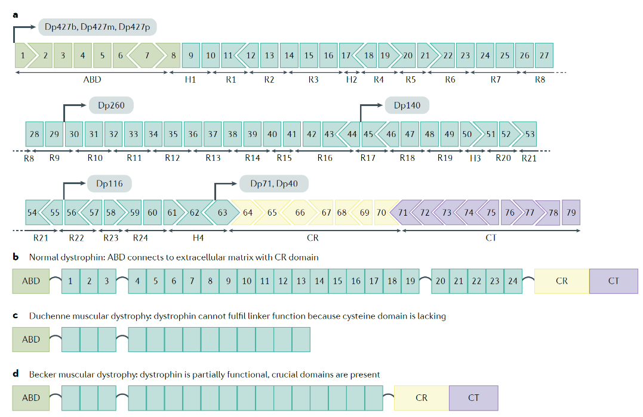
Figure 1.1. DMD gene structure and promoters (From Duan et al 2021)
The localization of genetic defect within the DMD gene has an impact on the production of alternative dys isoforms, whose absence is thought to account for comorbidities like neuro-cognitive impairment (Doorenweerd, 2020). In agreement with this hypothesis, the risk of intellectual disability increases with mutations situated at the 3’ end of the gene (Ricotti et al, 2016a).
Dystrophinopathies are caused by a wide array of different type of mutations (Muntoni et al, 2003). Deletions are the most common molecular defect (68-77% of cases), (Bladen et al, 2015; Tuffery-Giraud et al, 2009) followed by point mutations, duplications (11-13% of cases), (Bladen et al., 2015; Juan-Mateu et al, 2015; Tuffery-Giraud et al., 2009; Wang et al, 2017) and small rearrangements. In 2-7% of cases DMD can be causesd by splice-altering deep intronic mutations which cannot be detected by standard tecniques (Waldrop et al, 2022).
Of note, deletions and duplications are predominantly concentrated in specific hotspot regions situated in proximity to exons 2–19 and 45–55 (Muntoni et al., 2003).
While there is no clear correlation between the size of the deletion and the resultant clinical phenotype, the DMD vs BMD form can largely be predicted based on the “reading frame rule”: a severe, DMD phenotype is associated in ~90% of cases with out-of-frame pathogenic variants that induce a frameshift in the protein-coding sequence resulting in unstable RNA and subsequent nearly complete absence of dystrophin expression in muscles. (Flanigan et al, 2009b; Tuffery-Giraud et al., 2009) (see Figure 1.2)
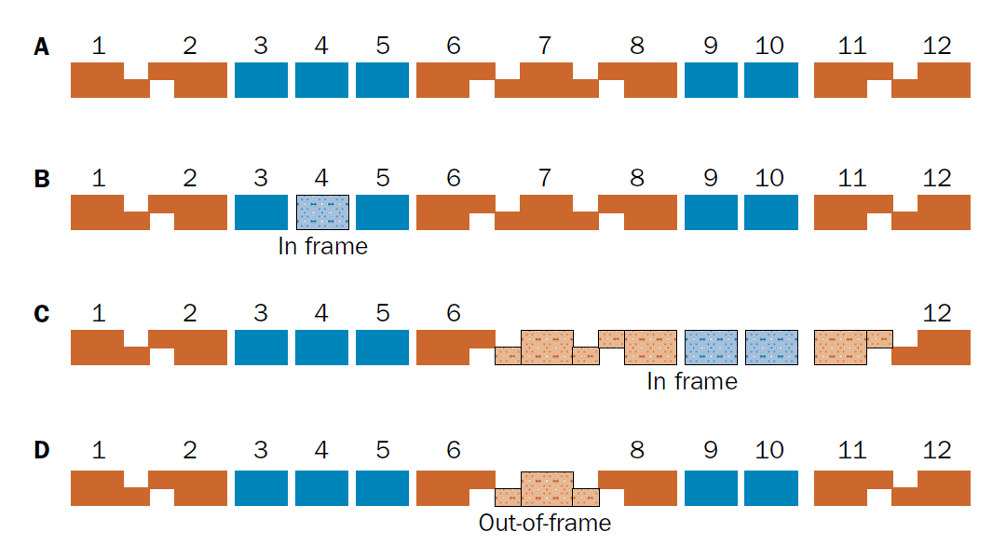
Figure 1.2. The reading-frame rule. The removal of exon 4 (B) and 7-11 (C) maintains the reading frame, in contrast to deletion of exon 7 (D) (from Muntoni et al 2003)
By contrast, the presence of residual, smaller but functional dystrophin proteins resulting from in-frame deletions or duplications located in the middle of the gene and therefore not affecting the F-actin, extracellular matrix binding and C-term domains can partially rescue the phenotype, hence being associated with BMD. Of note, there are few but important exceptions, particularly when mutations are located in the 5’ of the gene and mainly due to the formation of alternative transcripts (see section below). (Gualandi et al, 2006; Kesari et al, 2008)

1.3. Protein structure and pathogenesis
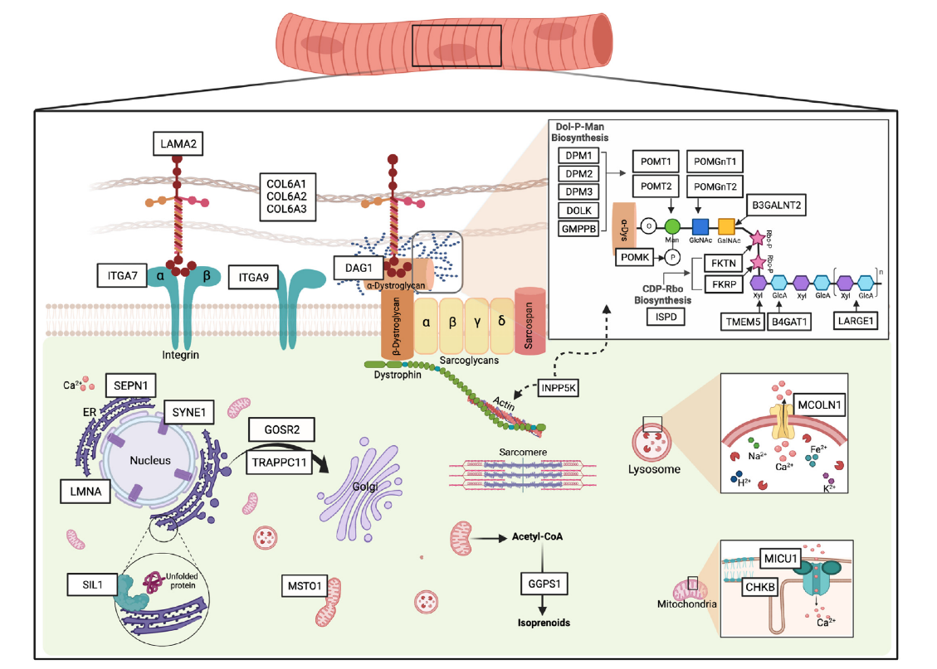
The 427-kDa dystrophin, a large rod-shaped protein, is an essential component of the dystrophin-associated protein complex (DAPC, previously known as DGC), a network of intracellular, transmembrane, and extracellular proteins that play a crucial role in connecting the extracellular matrix to the intracellular actin cytoskeleton in skeletal and cardiac muscles (Figure 1.3). Mutations in components of the DAPC cause other congenital or limb-girdle muscular dystrophies. Cytoplasmic components of DAPC include dystrobrevins, syntrophins, neuronal nitric oxide synthase (nNOS), calmodulins, PAR1b, and myospryn.
Figure 1.3. The dystrophin associated complex. Rod-shaped dystrophin depicted in the center of the figure (from Zambon et al 2021)
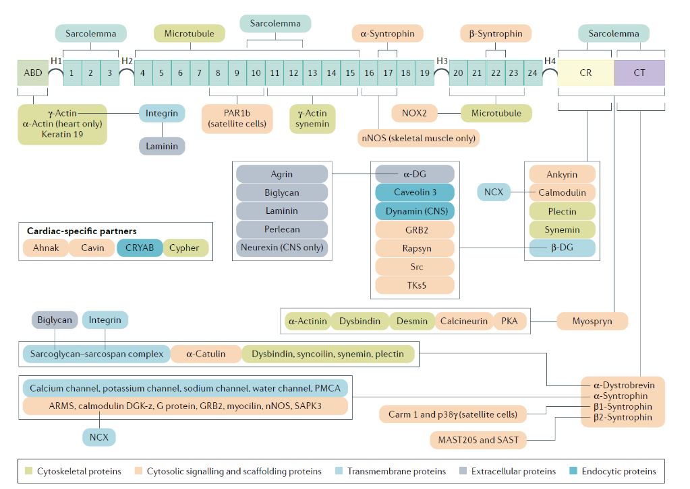
Dystrophin contains 4 domains: an actin-binding amino-terminal domain (ABD1) that anchors the protein to the sub-sarcolemma cytoskeleton, a central rod domain containing 24 spectrin repeats separated by four hinge (H) regions, a cysteine-rich (CR) domain that anchors dystrophin to the sarcolemma primarily the binding of β-DG, and a carboxyl-terminus domain that mediates sarcolemmal localization by interacting with dystrobrevin and syntrophins.
Figure 1.4. Dystrophin structure and the complex protein network and interactome of the DAPC (from Duan et al 2021)
Our understanding of the interaction between dystrophin and both sarcolemma and the sarcomeric network has evolved in the last years. For example, while ABD1 is well-known to bind F-actin by two calponin-homolog motifs, a second domain (ABD2) contained in the central part of the rod was found to cooperate with ABD1 to bind with actin filaments by electrostatic interaction (Gao & McNally, 2015), hence supplying for the partial absence of ABD1 in those milder cases caused by mutations located in the 5’ of the gene in which part at least part of ABD1 is maintained (Wein et al, 2014). Moreover, dystrophin-sarcolemma interaction is not exclusively mediated by the CR domain, which was previously thought to be the sole responsible for dystrophin membrane binding through β-DG. In fact, starting from the description of atypical patients (Helliwell et al, 1992), preclinical studies provided evidence that dystrophin contains other highly conserved membrane binding domains in the rod (4 in skeletal muscle and 3 in the heart) that can independently interact with the plasma membrane.
R8-10 interact with Par1b (or Mark2) and is thought to play an important role in the control of symmetric/asymmetric cell division in satellite cell niche while other motifs are important for microtubule binding and stability.
All the above conveys a picture of the complex and multifaceted interactions underlying the dynamic participation of dystrophin in maintaining the integrity of the muscle cell membrane. (Zhao et al, 2016)

1.3.1. Downstream effects related to the lack of dystrophin
The primary effect caused by the lack of the dystrophin protein in skeletal and cardiac muscles is progressive muscle degeneration and necrosis, which is reflected in the changes observed on muscle histology. These include muscle fiber necrosis and regeneration, variability in fiber size, centralized nuclei, fiber splitting, connective and fatty tissue infiltration, endomysial fibrosis, inflammatory infiltrates, and loss of dystrophin staining on immunohistochemistry (Figure 1.5).
Figure 1.5. Muscle histology of index patient. A) H&E staining show dystrophic changes. B) Immunofluorescence (antibodies against the C-term, Rod and N-Term domain) shows complete absence of dystrophin. C) A Few revertant fibers are observed at immunohistochemistry (arrows)
The DAPC plays a significant role in both mechanical support and signaling pathways and is crucial for preserving the structural integrity and contractile function of muscle cells. Disruption or disassembly of the DAPC results in a cascade of consequences that profoundly impact muscle cell functionality and are likely to act in parallel to generate muscle damage. These comprise susceptibility to muscle stress, NOS-dependent functional ischemia, increased reactive oxygen species production (ROS), calcium overload, mitochondrial dysfunction, inflammation, fibrosis, and inability to properly regenerate muscle (Bez Batti Angulski et al, 2023).
The first elucidated consequence of dystrophin absence is an elevated vulnerability to mechanical strain, leading to subsequent damage to the sarcolemma. In striated muscle, cycles of contraction and relaxation of muscle fibers mediated by the sarcomere generate force. When the DAPC is disassembled, the sarcolemma become leaky and highly susceptible to injury, particularly in those muscles subjected to greater mechanical stress, including the diaphragm.
Lack of dystrophin, which contains the specific NOS-binding residues at R16 and R17, also cause nNOS abnormal localization. This is a crucial component of the DAPC that mediates vasodilation in response to muscle exercise; its displacement can cause functional ischaemia.
Another phenomenon observed in dystrophic muscles is an increase in cytosolic calcium levels. Although the mechanisms involved in the disruption of calcium homeostasis are not fully understood (e.g., entrance from muscle tears or via different types of ion channels), an increase in cytosolic calcium has several detrimental effects including triggering of degenerative pathways (e.g., Ca⁺⁺-dependent calpain protease and phospholipase A2 activation) and mitochondrial dysfunction (Mareedu et al, 2021).
An abnormal increase in free radicals is also observed in affected muscles, which are also more vulnerable to oxidative stress compared to healthy muscles.
A role of inflammation was hypothesized in view of the presence of infiltrating macrophages and T-cells in muscle biopsies and the positive clinical response to chronic corticosteroids treatment. Inflammatory responses occur before the onset of symptoms, perturb muscle homeostasis and impede the mechanisms facilitating muscle repair and regeneration (Nitahara-Kasahara et al, 2016). Of note, macrophages have been recently found to play key role in the disease progression of the disease (Bhattarai et al, 2022).
Chronic inflammation together with continues cycle of degeneration and regeneration ultimately cause progressive fibrosis. This process is primarily mediated by the release of transforming growth factor-β (TGF-β) from the skeletal muscle and is favored by the production of myostatin, whose inhibitors have been explored in various neuromuscular conditions. Fibrosis not only hinders the normal contractile function of skeletal and cardiac muscles, but abnormal changes in the extracellular matrix (ECM) are likely to progressively impact the ability of precursor cells (i.e., satellite cells) to regenerate. Of note, it also reduces the possibility of experimental treatments to revert aberrant pathology.
Indeed, it is postulated that the incapacity for muscle regeneration plays a pivotal role in driving the advancement of muscle deterioration in Dystrophinopathies. In conjunction with putative cell-autonomous deficiencies in myogenic commitment and asymmetric cell division (Dumont & Rudnicki, 2016), impaired regenerative processes are also attributed to secondary effects stemming from alterations in the microenvironment consequent to dystrophin deficiency. These alterations encompass matrix remodelling, epigenetic modifications, and persistent inflammatory responses.

1.4. Disease Management and treatment

1.4.1. Standards of care
It's important to note that while significant progress has been made in developing disease-modifying approaches for DMD, there is no effective cure available. A multidisciplinary approach that combines various strategies to manage symptoms, slow disease progression, and improve the quality of life of affected individuals is required for the provision of care for these patients.
The development of international guidelines helped clinicians standardize assessments that evaluate multiple systems that are either affected as a consequence of disease progression or due to chronic corticosteroid treatment.
The principal domains that need to be addressed (yearly or every six months) in DMD patients are: respiratory function, cardiac function, orthopaedic complications such as fractures or scoliosis (Birnkrant et al., 2018a), endocrine aspects such as puberty and bone-health, gastrointestinal function and nutrition (Birnkrant et al, 2018b), and psychological care (Birnkrant et al., 2018d).
A key point in the management of patients is the definition of “disease stages”. These can be subdivided in early ambulatory, late ambulatory (characterized by more rapid deterioration), early non-ambulatory, and a late non-ambulatory (characterized by the higher prevalence of comorbidities). This is a pragmatic concept that help define different needs in terms of investigations, monitoring, and interventions. Moreover, a detailed knowledge of each stage is critical when designing clinical trials.
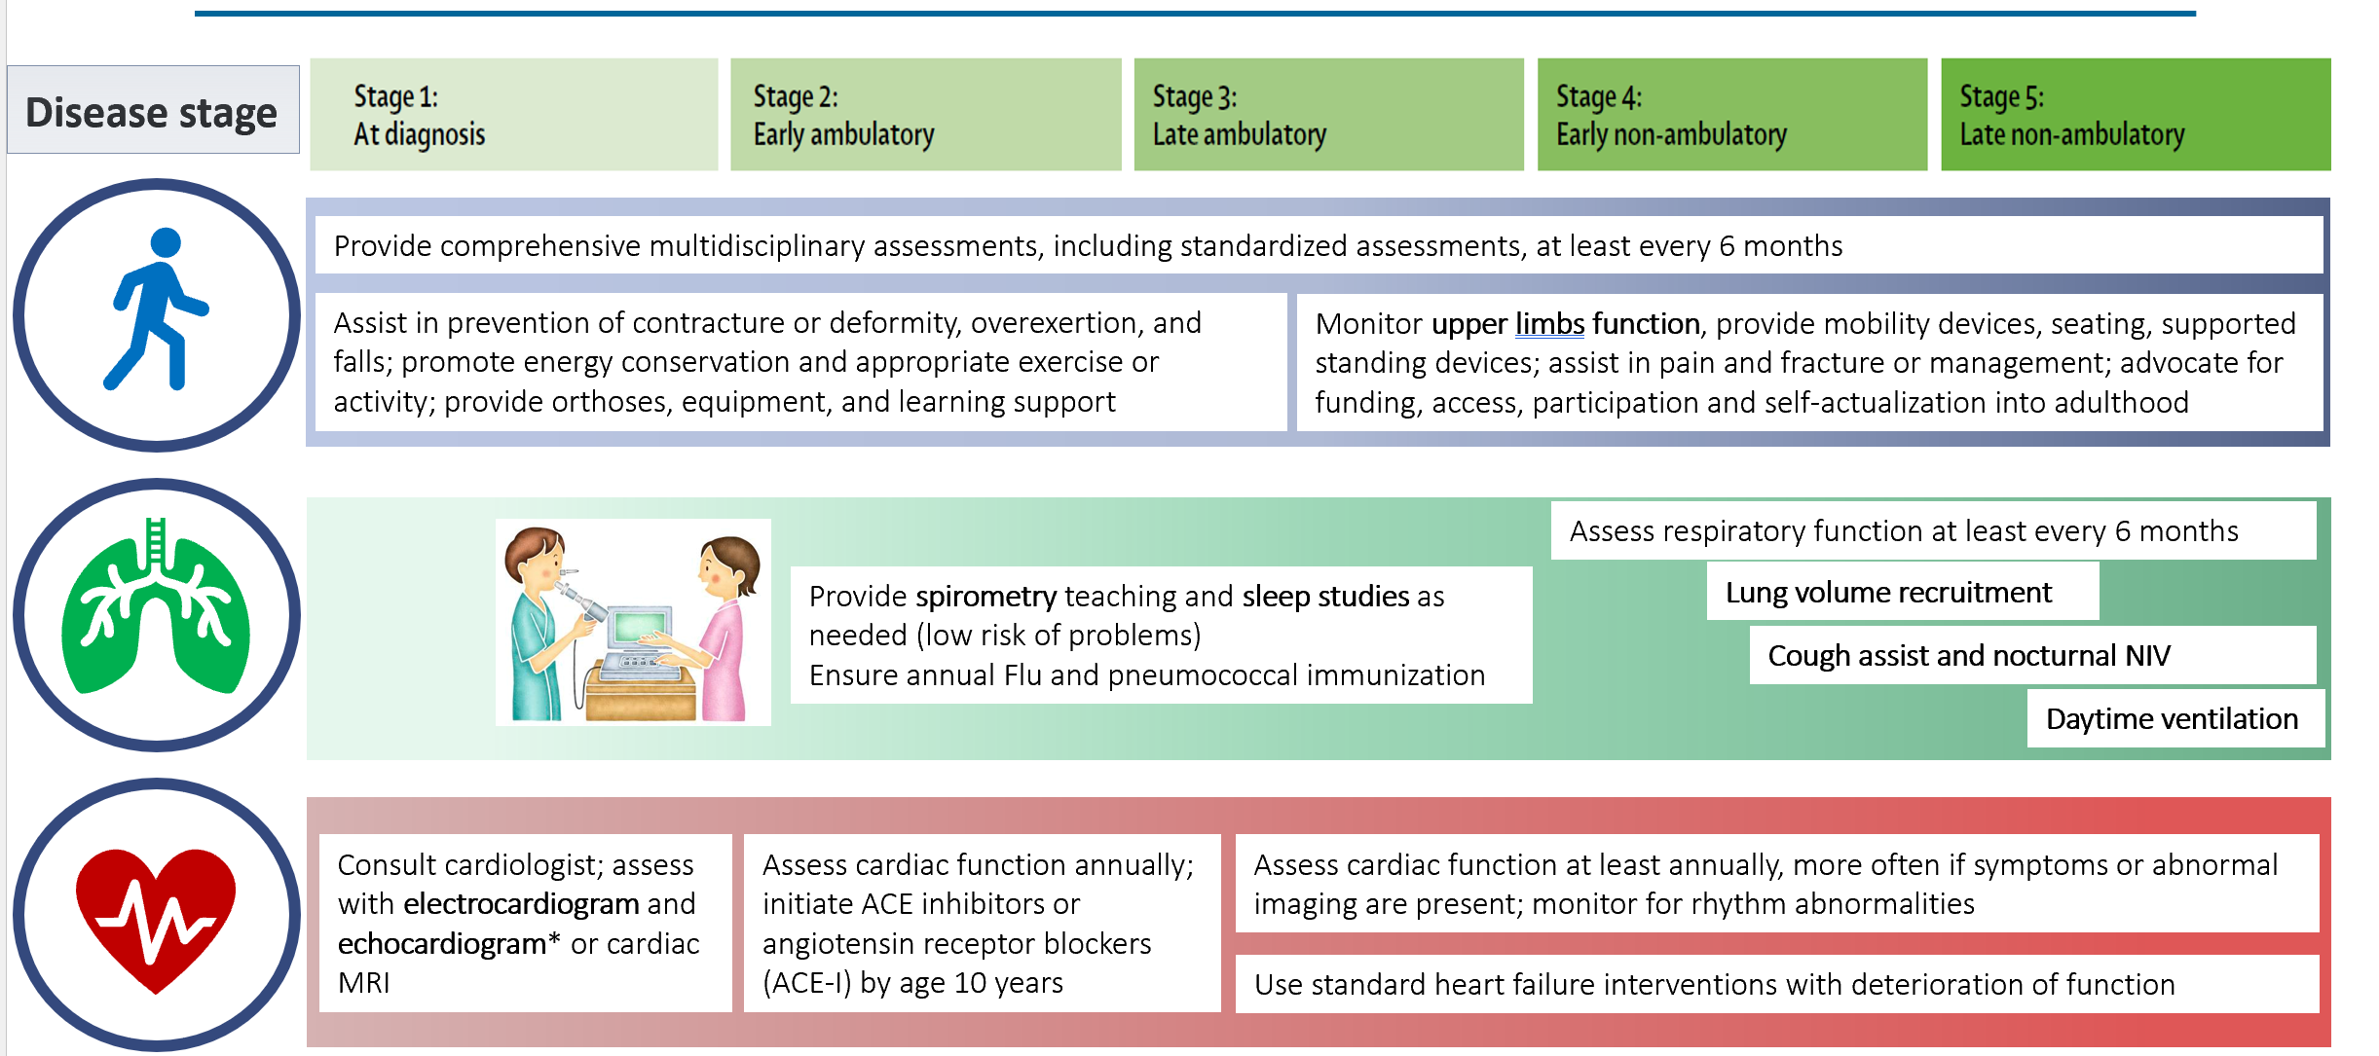
Figure 1.6. Patient’s needs according to disease stage. (Adapted from Birnkrant et al 2018)
Motor function should be monitored with standardized and reproducible assessments, aimed at measuring changes in muscle strength over time. The most commonly used tools in clinical setting will be discussed below. Regular physiotherapy assessments are also required to assist in prevention of contractures and deformities, and to provide indications for physical exercise, orthoses and prescription of other devices (e.g., wheelchair)
Pulmonary insufficiency remains one of the main contributors to mortality and imparts significant morbidity due to compromised vital capacity and challenges related to airway clearance (Birnkrant et al, 2022). The implementation of respiratory care and nocturnal ventilatory support has played a pivotal role in extending life expectancy and enhancing the quality of life for individuals with DMD. Mechanical insufflator/exsufflator devices have demonstrated efficacy in reducing the incidence of pulmonary infections and should be considered standard practice in this population. Along with cardiac failure and arrythmias, respiratory impairment is the leading cause of morbidity and mortality in DMD. (Birnkrant et al, 2016; Birnkrant & Carter) The standard of care recommendations on provision of respiratory intervention with non-invasive nocturnal mechanical ventilation (NMV) have contributed to prolong survival over the past decades. (Barber et al, 2013; Eagle et al., 2002; Ishikawa et al., 2011; McDonald et al., 2018c; Passamano et al., 2012; Schram et al, 2013) However, the optimal timing for NMV introduction remains uncertain and usually driven by expert consensus, as there is limited published evidence available for this recommendation. (Birnkrant et al., 2018a; Fauroux & Lofaso, 2005) Current guidelines include FVC percentage predicted (FVC%) below 50 as an indication for NMV, particularly in late non-ambulatory stages (Birnkrant et al., 2018a). In clinical practice though, irrespective of FVC% values, NMV is often not considered until sleep study reveal an abnormal result, (Sheehan et al, 2018) which in DMD can be either nocturnal hypoventilation (NH, the first manifestation of chronic respiratory insufficiency) or other sleep disordered breathing (SDB), or in presence of other clinical indications. (Aboussouan & Mireles-Cabodevila, 2017; Khan & Heckmatt, 1994a; Sawnani et al, 2015b)
In DMD, the development of cardiomyopathy is virtually universal and assumes increasing clinical significance after loss of ambulation (Birnkrant et al., 2016). Of note, there might be discrepancies between cardiac impairment and the degree of skeletal and/or respiratory muscle involvement (Birnkrant & Carter, 2021), possibly due to differences in dystrophin expression and DAPC composition between these organs (Johnson et al, 2012). While the typical onset of cardiomyopathy is cited around 14 to 15 years of age (Trucco et al, 2020), its incidence may be as high as 25% by the age of 6 and 59% by the age of 10. Clinical guidelines recommend initiating echocardiogram screening at the time of diagnosis or by the age of 6, followed by biennial assessments until age 10, and annual evaluations thereafter. Cardiac MRI allows for the detection of fibrosis and diastolic dysfunction prior to the manifestation of systolic dysfunction. Therapeutically, the management strategy often involves early administration of afterload-reducing medications, such as angiotensin-converting enzyme inhibitors or angiotensin receptor blockers, even before echocardiographic abnormalities become apparent. Cardiac conduction abnormalities are prevalent, underscoring the necessity for regular Holter monitoring. In Becker muscular dystrophy (BMD), a condition with milder skeletal muscle involvement, cardiomyopathy is also frequent and may culminate in cardiac transplantation. Once chronic heart failure occurs, mean survival is just 8 months (Wang et al, 2018a).
After losing ambulation, patients are also at higher risk of developing scoliosis. It is advisable to seek orthopaedic consultation for individuals with noticeable scoliosis, and annual assessments via x-ray should be performed to monitor its progression. In selected patients, surgical interventions aimed at spine stabilization, when combined with nocturnal ventilation, have demonstrated the potential to extend survival into the fourth decade of life, given the superimposed detrimental effect of spine curvature on respiratory function.
Impaired growth, delayed puberty and obesity are all consequences of chronic steroid treatment. While growth-hormone administration is rarely considered, testosterone injections are becoming part of the standards of care.

1.4.2. Steroid treatment
Although the first trials of corticosteroids in boys affected by DMD date back almost 50 years (Dubowitz, 2013), only in the last two decades solid scientific evidence was gathered to build strong recommendation on their use and provide information of strengths and limitations of different dose regimens (Matthews et al, 2016). The precise mechanisms of CS effect remain unclear, but postulated actions encompass membrane stabilization, increase in total muscle mass and strength, stimulation of insulin-like growth factors, enhanced myoblast proliferation, reduced fibrosis, and attenuated inflammatory responses (e.g., reduced cytokine production and diminished lymphocyte reactivity).
There are two products that are currently interchangeably used: prednisolone 0.75 mg/kg/day and deflazacort 0.9 mg/kg/day (Guglieri et al, 2022a). Different regimes (daily vs intermittent) can be selected to balance efficacy with side effects, but everyday administration yields higher results in terms of preservation of muscle function. Treatment is usually started around 4-5 years of age and should be continued even after the loss of ambulation, due to potential beneficial effect on the preservation of upper limbs strength, cardiorespiratory function, and ultimately survival (Barber et al., 2013; McDonald et al., 2018c; McNally et al, 2015; Schram et al., 2013).
There is strong evidence that CS can delay LoA by 2-4 years (Bello et al, 2015; Ricotti et al., 2013). A longer preservation of independent ambulation also results in later onset of both respiratory insufficiency and severe scoliosis (Yilmaz et al, 2004). Indeed, pulmonary decline is linked with diaphragmatic contraction, not only due to primary muscle degeneration but also to positioning of the fibers, affected by scoliosis and ribcage stiffness.
Despite the beneficial for slowing disease progression, CS treatment is associated with a range of side effects that require careful monitoring and management. These include a) weight gain and obesity that may exacerbate mobility issues and compromise overall health; b) growth retardation and short stature, c) impaired bone health with increased risk of osteoporosis and fractures, d) cushingoid features, e) behavioural and psychological effects such as irritability, mood swings, and emotional instability with the potential to exacerbate underlying neurocognitive phenotype, f) gastrointestinal issues (gastritis, ulcers, and increased appetite), g) abnormal glucose metabolism (corticosteroids can induce insulin resistance, leading to glucose intolerance or diabetes), h) hypertension, i) immunosuppression, j) cataracts, k) and adrenal suppression (prolonged use of corticosteroids can suppress the adrenal glands, potentially leading to adrenal insufficiency if treatment is abruptly discontinued, hence requiring the provision of emergency indications). Vamolorone is a molecule that has been developed to reduce the burden of CS treatment. While retaining anti-inflammatory properties, this was designed to have fewer side effects compared to traditional corticosteroids commonly used in DMD. While its effectiveness compared to other products is under investigation, the molecule showed promising results indicating an improved safety profile in terms of bone and growth-related morbidities, and was recently recommended for marketing authorization by the EMA. (Guglieri et al, 2022b)

1.4.3. Experimental treatments
Disease-modifying mechanisms in DMD refer to the various strategies aimed at slowing down or altering the course of the disease. Two main approaches are pursued: the first is to try to restore the production of dystrophin either in a full-length or truncated form, the second is to act on one of the many pathways altered because of dystrophin deficiency (Verhaart & Aartsma-Rus, 2019). Of note, despite a provisional approval by FDA of 6 different products, the evidence of their clinical efficacy is limited.
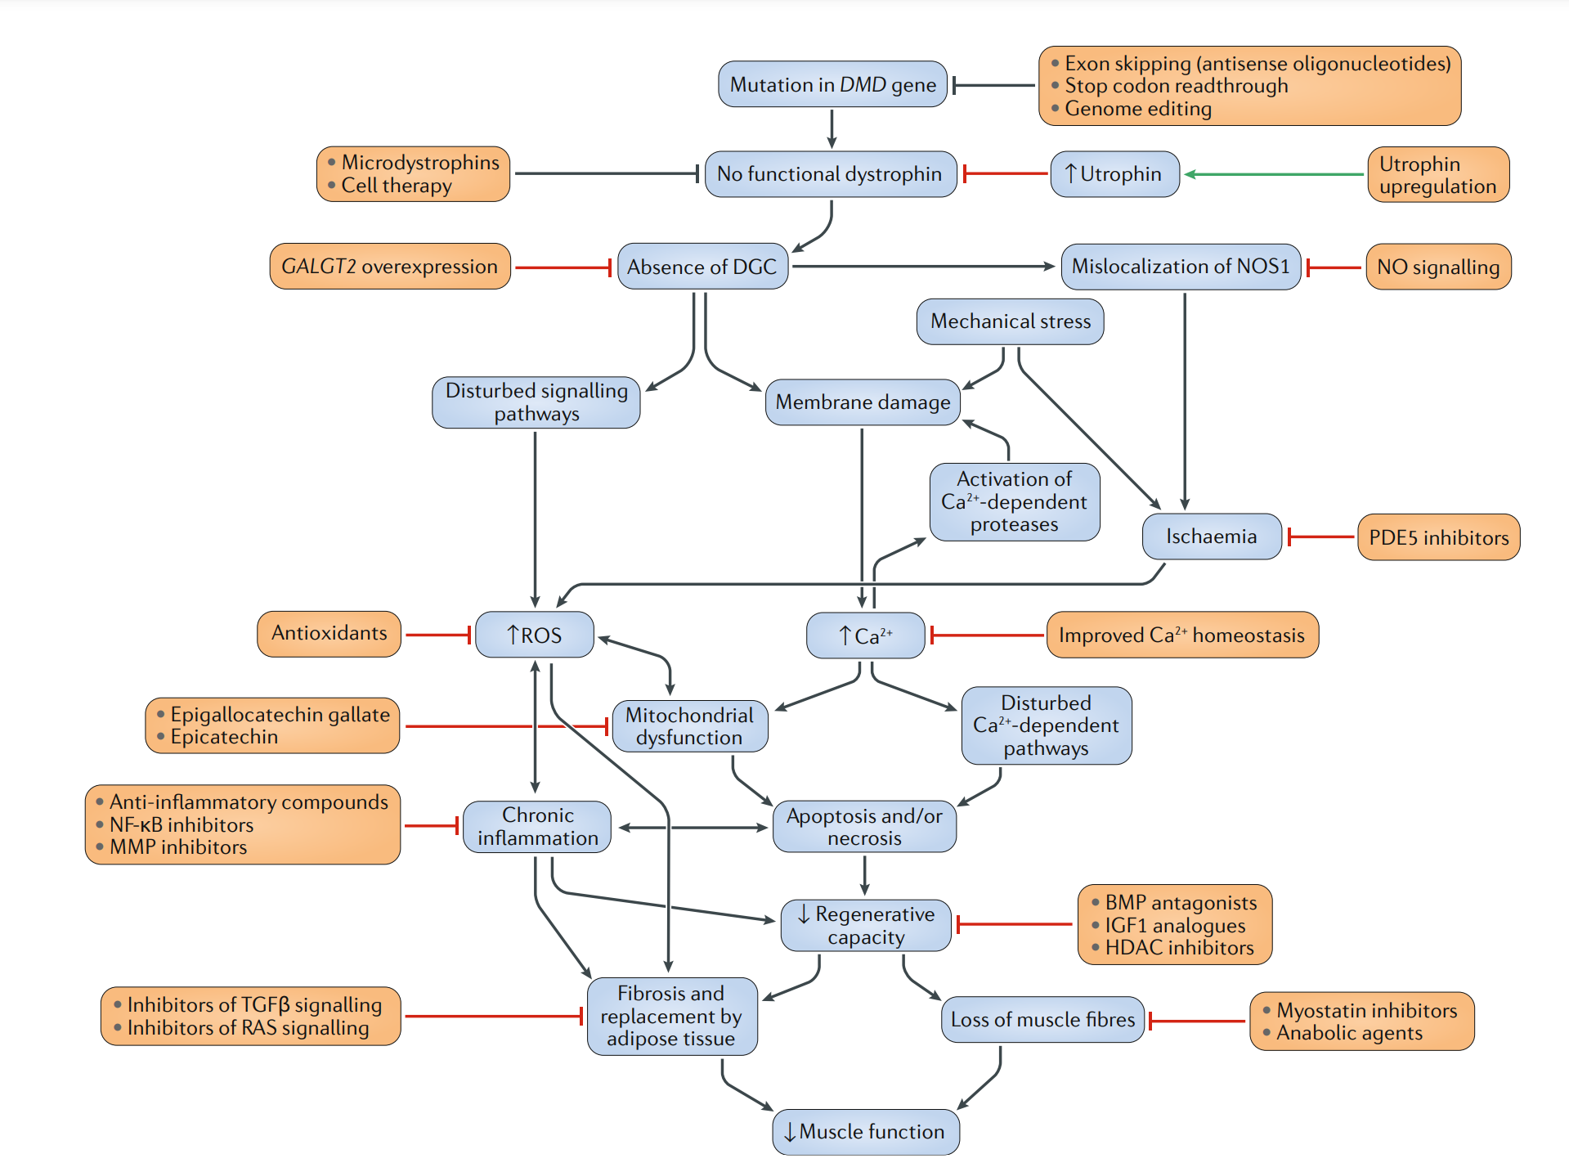
Figure 1.7. The landscape of potential treatments for Dystrophinopathies (from Verhaart et al 2019)

1.5.3.1 Gene Therapy
The replacement of a defective gene could be seen as the optimal strategy for many autosomal-recessive or X-linked disorders. Moreover, the appealing aspect of utilizing gene therapy as an approach to treat DMD lies in the prospect that DMD patients can be eligible for this treatment irrespective of the specific dystrophin mutation underlying their condition. However, the large size of the DMD gene represents a major obstacle for currently used viral vectors, such as AAV (loading capacity up to 4.7Kb) and lentiviruses (loading capacity up to 10kb). To overcome such limitations, in the past few years different companies and labs developed micro or mini-dystrophins, which are truncated dystrophins lacking at least part of the central rod but designed to keep essential domains such as N-Term and CR-domain.
A key finding posing the basis for the development of AAV-delivered micro-dystrophins is that the large central rod domain is particularly resilient to large in-frame deletions, as demonstrated by mildly-affected patients harboring large in-frame deletions affecting up to 46% of the coding sequence (England et al, 1990). The deeper understanding of the structure and role of dystrophin itself (e.g., nNOS and microtubule binding, protein stability etc.) helped implement the quality of these products, which are currently under investigation in Phase I/II trials. At least four different companies have developed micro/mini-dystrophin products that share the N-Term and C-term domains, but differ in terms of length and parts of the rod-domain that are included (Figure 1.8) (Elangkovan & Dickson, 2021). This may lead to different protein stability and benefit in view of the presence/absence of protein-interacting domains. Another difference resides in the type of AAV serotypes used, with 1, 6, 8, 9, rh10, and rh74 found to have tropism for skeletal muscle and heart. The systemic delivery of such products in large animal models of DMD have shown significant patho-physiological improvements, leading to clinical trials in humans (Duan, 2018)
In a phase II trial, Delandistrogene moxeparvovec (SRP-9001), an AAVrh74-delivered 138kDa micro-dystrophin, was administered to 41 patients (21 after crossover) aged between 4 and 8 years old (Mendell et al, 2023; Zaidman et al, 2023). These displayed increased SRP-9001 dystrophin expression (around 39% of normal) after 48 weeks, and a different trajectory of NSAA compared to controls, although it could be argued that an increase in NSAA increase in this age range is expected also in naïve boys. Phase III trial (EMBARK study (NCT05096221)) (Muntoni et al, 2023a) failed to meet the primary endpoints though and FDA conditionally approved Delandistrogene moxeparvovec only in patients aged between 4 and 5 years of age.
Results from SGT-001 (Solid Biosciences -IGNITE study NCT03368742), PF06939926 (Pfizer; CIFFREO Phase 3 study NCT04281485) and GNT 0004 are still pending.
The main side effects of AAV gene therapy are linked to immunogenicity. Of note, these are not limited to the immune response generally expected in patients receiving AAV treatment (e.g., elevation of liver enzymes). Serious, T-cell mediated reactions observed in 5 patients treated with different micro-dystrophin constructs and vectors (i.e., AAV9 and AAV rh74) prompted further investigations. The presence of mutations excluding exons coding for Hinge 1, (considered essential for the correct localization of dystrophin to the sarcolemma) and the first spectrin-like repeat domains, which are present in all the constructs but missing in these patients, likely provoked immune reactions against these nonself epitopes (Bönnemann et al, 2023). Following these observations, inclusion criteria for trials were amended.

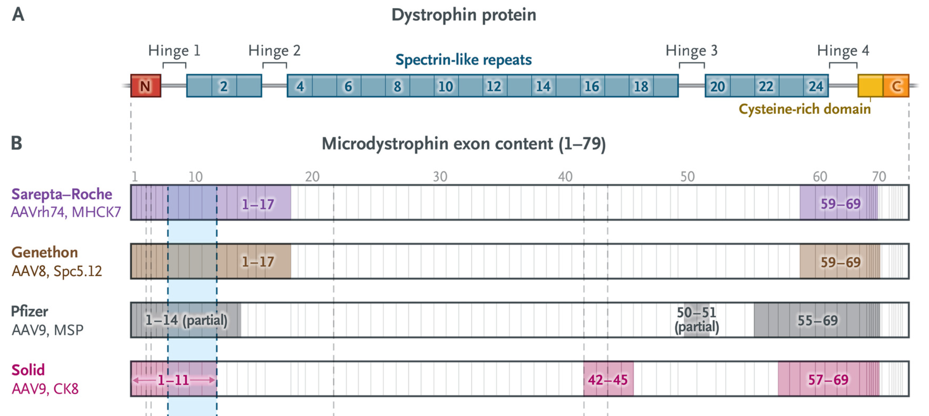

Figure 1.8 Structure of micro-dystrophins (From Bonnemann et al 2023)

Lastly, additional concerns related to gene therapy are related to a) the ability of dystrophin constructs that are smaller than those observed in mild BMD cases and lack specific subdomains to fully fulfil their biomolecular role, b) the ability to transfect cardiac myocytes, c) the dilution in time of the product: due to the limited efficacy of AAV vectors in specifically targeting the stem cells reservoir (Arnett et al, 2014); when muscle injury occurs, the recruited satellite cells participating in the repair process will lack the therapeutic transgene. Consequently, this may result in the gradual dilution and eventual disappearance of the transduced cells over time.
1.5.3.2 Gene editing
In spite of recent advancements, the experimental gene-editing approach remains at an early stage of development and raises several noteworthy considerations. The most promising system in this regard is the CRISPR/Cas9 system, which has undergone continuous refinement in recent years. Theoretically, a single infusion of CRISPR genome-editing components holds the potential to address DMD by rectifying genetic mutations at the genomic level. The CRISPR/Cas9 system consists primarily of two crucial components: the CRISPR-associated (Cas) endonuclease and a single guide RNA (sgRNA). The sgRNA serves as the guiding element, directing Cas9 to a specific ~20-nucleotide region within the genome, which harbors the complementary sequence necessary for precise editing.
Achieving genetic repair in even a small fraction of muscle nuclei could facilitate dystrophin production and its subsequent distribution throughout myofibers, considering that skeletal muscle fibers are multinucleated. Notably, various strategies, including exon excision, exon skipping, exon reframing, and exon knock-in, hold promise for potential implementation in this context.
It is essential to acknowledge that the risk of off-target mutations in vivo is still a significant apprehension. Additionally, addressing the challenges of effective delivery to muscle tissues presents a shared obstacle with other therapeutic approaches, along with potential concerns related to immunogenicity (Bez Batti Angulski et al., 2023; Stephenson & Flanigan, 2021).
1.5.3.3 Exon Skipping
Exon-skipping is a therapeutic strategy that employs anti-sense oligonucleotides (AON) to induce alternative splicing by the interference with pre mRNA, thereby bypassing mutated exons. This process aims to restore the reading frame of the dystrophin gene, effectively converting a Duchenne muscular dystrophy (DMD) mutation into a Becker muscular dystrophy (BMD) mutation. The design of optimal exon-skipping and the assessment of the functional implications of the resulting dystrophin products have heavily relied on clinical observations and biochemical characterizations of dystrophin domains. It is essential to note that this approach is mutation-specific (Takeda et al, 2021).
Many individuals with DMD harbour deletions in one or more exons, with a prevalent clustering of deletions occurring in exons 43–55. Consequently, specific exon-skipping strategies can be applied to larger subgroups of patients.
Various exon-skipping product types have been developed, including 2′-O-methyl-modified RNA (Drisapersen), phosphorodiamidate morpholino oligomers (PMO), and tricycloDNA antisense molecules. PMOs are uncharged compounds that pose challenges for in vitro cell introduction but exhibit high levels of systemic delivery and efficient exon skipping within dystrophic muscle tissue. To enhance cellular uptake, PMOs have been improved through conjugation with arginine-rich cell-penetrating peptides, resulting in peptide phosphorodiamidate morpholino oligomers (PPMOs)(Tsoumpra et al, 2019). The safety profile of PMOs and PPMOs has generally been favorable.
In 2016 Eteplirsen (Exondys 51), a 30-nucleotide PMO, was the first the first FDA-approved therapy targeting mutations amenable to exon 51 skipping, encompassing the majority of DMD mutations (14%). Eteplirsen, which requires weekly IV administrations, showed a good safety profile. At present, the U.S. FDA has also conditionally approved exon-skipping products targeting exons 53 (Vitolarsen and Golodirsen), and 45 (Casimersen) (Clemens et al, 2022; Clemens et al, 2020; Frank et al, 2020).
Importantly, these approvals have been granted based on observed changes in dystrophin expression in muscle tissue, although the full correlation with clinical benefits is still undergoing evaluation. Moreover, although dystrophin expression on IHC increased by up to 23% compared to pre-treatment in patients treated with Eteplirsen (compared to baseline), western blot performed on muscle biopsies of patients at 12 and 48 weeks after treatment (n=11 and 13 patients, respectively) detected a level of protein that was limited to 0.22-0.93% of healthy individuals (Lim et al, 2017). Similar results were obtained with other PMO products (Komaki et al, 2020), with Golodirsen increasing expression of dystrophin at 48 weeks to 1.019% of normal (range, 0.09%–4.30%)(Frank et al., 2020). Results from a Phase III trial on Casimersen (Essence trial) are still pending (Iannaccone et al, 2022).
Despite the appeal and applicability of exon-skipping techniques and the approval of four anti-sense oligonucleotides (AONs) for clinical trials, concerns persist regarding their delivery efficiency. Consequently, certain companies have developed PPMOs conjugated with fatty acid binders (FABs) to enhance muscle delivery. Furthermore, there is ongoing exploration of multi-exon skipping as a means to treat a broader patient population and ensure that the resultant transcript contains in-phase spectrin repeats. This consideration is particularly relevant given the milder Becker muscular dystrophy (BMD) phenotype associated with in-frame deletions spanning exons 45 to 55.
Of note, a combined strategy using an AAV9 vector expressing U7 small nuclear RNAs has been explored as a way to deliver targeted exon skipping in humans. (Wein et al, 2022; Wein et al, 2017)
1.5.3.4 Small molecules targeting nonsense mutations.
Around 10%–15% of patients with DMD have a nonsense mutation that induces a premature termination codon (PTC) in the mRNA, causing the ribosome to terminate translation and failing to synthesize the remainder of the protein PTC. Aminoglycoside are drugs that can bind to the ribosome and its partners, hence disrupting its ability to recognize the premature stop codon. However, due to a high risk of toxicity, Ataluren (Translarna TM, previously known as PTC124) was found as a potentially safer alternative to induce stop codon read-through (McDonald et al, 2017). Due to the limitations of its efficacy data, the European Medicine Agency (EMA) is considering the retraction of its approval.
1.5.3.5 Cell-based therapies
Cell-based therapeutic approaches were initially explored as a means to introduce full-length dystrophin into muscle tissues. However, significant challenges, primarily related to safety concerns and the limited distribution of cells following systemic administration, have yet to be fully addressed. Multiple cell types with multilineage or pluripotent potential have been investigated, including satellite cells (myoblasts), hematopoietic-derived cells, pericytes, and mesenchymal stem cells (Berry, 2015; Cossu et al, 2015) Given the complexities associated with achieving satisfactory integration into affected muscles, current research in cell-based therapies is focusing on harnessing secondary effects rather than primarily rescuing muscle integrity. For instance, engineered mesangioblasts hold promise to facilitate exon skipping without the necessity for repeated infusions (Cossu et al, 2022).
Cardiosphere-derived cells are believed to exert immunomodulatory, antifibrotic, and regenerative effects in individuals with dystrophinopathy and heart failure through the secretion of exosomes containing bioactive cargo. The HOPE-2 trial (NCT03406780) is a multicentre, randomized, double-blind, placebo-controlled Phase II clinical trial involving the repeated intravenous administration of CDCs. In a small subset of non-ambulatory patients, preliminary results suggest the ability to attenuate the progression of upper limb and cardiac impairments (McDonald et al, 2022).
1.5.3.6 Pharmacological Therapies
Ongoing research continues to explore new potential therapies targeting the different downstream pathways described in chapter 1.2.1 and Figure 1.7.
Considering the instability of the muscle membrane in DMD, an innovative therapeutic approach may involve the utilization of synthetic block copolymers as membrane stabilizing agents. This strategy aims to mitigate muscle damage by directly enhancing the stability of the dystrophin-deficient muscle membrane. Promising research findings have emerged, paving the way for clinical trials involving the administration of P188 (NCT03558958).
Myostatin inhibitors were thought to be a good candidate given potential to increase muscle bulk and counteract fibrosis. However, all the trials in human failed, possibly due to pre-existing downregulation of myostatin pathways observed in patients affected by neuromuscular disorders (Mariot et al, 2017).
Upregulation of utrophin, a structural and functional paralog of dystrophin encoded by the UTRN gene that is activated in the absence of dystrophin, has been explored in preclinical models. So far, no products have been translated to humans and concerns remain regarding its potential effectiveness, given the lack of important domains.
Safety and efficacy of tamoxifen, a drug with a potential benefit in other neuromuscular disorders, is also currently being explored in boys with Duchenne muscular dystrophy (TAMDMD - NCT03354039)
Among products that failed to demonstrate a clinical benefit there are anti-oxidant (Idebenone - Sideros trial), anti-inflammatory molecule targeting the NF-κB pathway (Edasalonexent - PolarisDMD Trial) (Finkel et al, 2021), and anti-fibrotic monoclonal antibodies (Pamrevlumab – Fibrogen).
Lastly, the role of Givinostat, a histone deacetylase inhibitor with potential anti-inflammatory activity, is being explored in Phase III trial (NCT02851797)

1.5. Outcome measures
The advent of clinical trials has underscored the necessity for established outcome measures and comprehensive longitudinal natural history studies. There are different types of outcome measures: functional scales that quantify tasks performed by patients, patient’s reported questionnaires, and biomarkers that capture changes in tissue characteristics (e.g., biopsy or imaging) or circulating molecules (e.g., proteins, micro-RNAs etc). A lot of research has been performed in the last ten years to identify the best clinical items, highlighting their strength and limitations. On the other hand, it is harder to determine the clinical relevance of biomarkers that still need to demonstrate the ability to predict loss of significant disease milestone or capture minimally clinically important differences. All these should demonstrate reliability (e.g., inter-rater), sensitivity to longitudinal change, accessibility (e.g., applicability in different contexts), and validity compared to other well-established measures.
The 6-minute walk test (6MWT) was selected for the first interventional trials. Concurrently, disease-specific functional assessments, including the North Star Ambulatory Assessment (NSAA), the Performance of Upper Limb test (PUL), and timed tasks, have gained prominence in clinical evaluations. Moreover, longitudinal natural history studies have revealed that the progression of DMD follows a non-linear trajectory, characterized by substantial variability even within a 12-month timeframe.
As previously mentioned, a comprehensive understanding of each disease stage and possible confounding factors is imperative when designing clinical trials and defining the target population that will be subjected to investigation for specific study endpoints. This is even more important considering that most trials cover a limited time span (e.g., 52 weeks). As an example, if a child is recruited at a very young age, it will be challenging to determine whether clinical improvements are due to an experimental treatment or to his natural history. At the same time, age at loss of ambulation could not be the optimal endpoint in a population of patients who are getting closer to achieving this specific milestone, etc.
In the next chapters we will address the current knowledge regarding motor, respiratory and cardiac progression of DMD patients and the most commonly used biomarkers in research setting.

1.5.1. Motor function
From early childhood, boys with DMD perform worse than healthy peers in terms of motor abilities (Mercuri et al, 2016b). These can be measured by a 34-point functional scale specifically developed for DMD, the NSAA. While NSAA scores in normally developing males are expected to peak at 4 years of age, in DMD this occurs at a median age of 6-7 years, after which the scores plateau and subsequently decline (Muntoni et al, 2019b; Ricotti et al, 2016b).
NSAA was developed to capture gross motor function in patients specifically affected by DMD, and have been validated in multiple studies, being one of the most reliable measures to capture changes in DMD, including children younger than 5 years. (Mayhew et al, 2022; Mercuri et al, 2016a; Mercuri et al., 2016b; Ricotti et al., 2016b) Importantly, NSAA contains also timed items such as the ability to raise from the floor and walk 10m. A detailed description is provided in the Appendix.
The 6-minute walking test (6MWT), modified from the one developed for adults with cardiopulmonary disease, is another commonly used tool in both clinical and research setting. Although this is a useful and widely used test, 6MWT is not considered reliable in children below 7-5 years of age, hence is not really informative if applied to patients recruited in trials at a very young age (Mayhew et al., 2022; Mercuri et al, 2016c). Moreover, further research unveiled further limitations related to non-linear progression over time, interobserver variability and potential biases related to motivation during test (Goemans et al, 2013; McDonald et al, 2013b)
Important outcome measures which are believed to improve prediction of conventional functional scales regarding short-term trajectories are timed tests (Goemans et al, 2016). Timed tests include the time required to rise from the floor from supine (TRF), 10-meter run/walk velocity (10MWR), and 4 stairs climb (4SC). Together with a 6MWT distance <350m (Mazzone et al, 2013), a 10MWR >10s and a TRF>10s have been associated to a higher risk of losing ambulation within 2 years (Mazzone et al, 2016; McDonald et al., 2013b)
Finally, the only approved outcome measure in non-ambulant boys is the PUL module, which was designed to measure upper limb strength in children affected by DMD both before and after loss of ambulation. At present, the version 2 (PUL 2.0 – max value 42 points compared to PUL 1.2, max value 74 points) is considered the most reliable scale in both clinical and research setting (Mayhew et al, 2020). The 22 motor-related items encompassed by the PUL2.0 cover three distinct dimensions: the shoulder dimension with a maximal score of 12, the elbow dimension with a peak score of 17, and the distal wrist/hand dimension capping at 13 points.

1.5.2. Cardio-respiratory function
Subclinical changes (fibrosis of the left ventricular wall) can be detected by cardiac MRI even in the first decade of life, but cardiac impairment usually become evident in during adolescence. One point of concern is the variable definition of “cardiac dysfunction” in DMD, which varies according to different studies (Ashwath et al, 2014; Barber et al., 2013; Barp et al, 2015; Markham et al, 2008; Schram et al., 2013; Silversides et al, 2003; Spurney et al, 2014). This is usually broadly defined by an ejection fraction (EF%) < 45-55% and a left ventricle fractional shortening <28%. Surprisingly, there are limited natural history studies describing the progression of cardiomyopathy in patients with DMD. Trucco and colleagues found that the yearly decline of LVFS% was 0.67% per year (95% CI, 0.55-0.79; P < .001) in the whole population adjusted for age at baseline, and that the LVFS% yearly decline was 1.17% per year (95% CI, 0.79- 1.55) in a CS-naïve group and 0.53% per year (95% CI, 0.40-0.67) in a CS-treated group (P < .01). An important caveat is that those definitions, based on ultrasound measurements, are operator-dependent and subject to the quality of the assessment (e.g., poor window quality). Hence, echocardiogram is rarely used in the context of clinical trials as a primary endpoint, and cardiac MRI may be preferred as secondary endpoint.
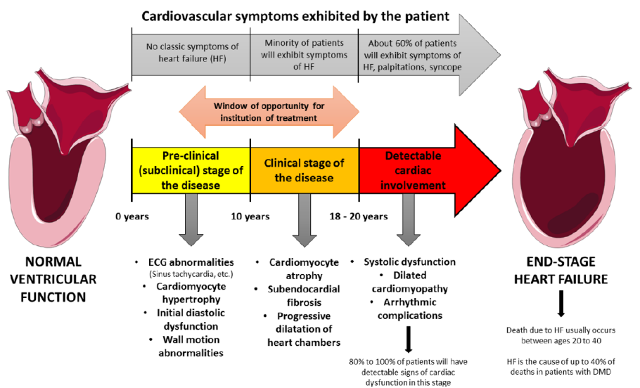
Figure 1.9 Evolution of cardiac involvement in DMD. (from D’Amario et al 2017)
Respiratory function is routinely measured with pulmonary function tests (PFT), (Birnkrant et al., 2018a; Mayer, 2019) with several parameters providing information regarding inspiratory and/or expiratory function. (Finder et al, 2017; Meier et al, 2017) Forced vital capacity (FVC), measured by spirometry, quantifies dynamic lung volumes and provides information regarding inspiratory and expiratory muscles. Spirometry is considered the most informative test to guide therapeutic interventions. (Sheehan et al., 2018). Reference values taking into account age, height, sex and ethnicity are available to calculate FVC percentage of predicted (FVC%p) (Quanjer et al, 2012). A decline in FVC/FVC%p typically becomes apparent following loss of ambulation (LoMauro et al, 2018). Starting from ~80% at the age of 6-8.6y, FVC%p is thought to linearly decline by 4.1-6.1% per year (Bello et al, 2020; Henricson et al, 2013; Kinane et al, 2018; Trucco et al, 2022), hence the trajectory of FVC%p is usually selected as primary respiratory endpoint in several clinical trials targeting non-ambulant populations. Of note, respiratory function was found to correlate with upper limb strength in different studies (McDonald et al, 1995; Meier et al., 2017; Ricotti et al, 2019).
An FVC<60% is thought to be associated with a higher risk of abnormal gas exchanges during the night, hence advocating the performance of annual sleep studies and the consideration of bilevel positive airway pressure (BiPAP) support. Whilst FVC < 1 L has been associated with decreased 3-year survival and 4.1-fold increase in mortality risk, (McDonald et al, 2018a; Phillips et al, 2001) and values <0.68 L with a higher risk of awake hypoventilation, (Toussaint et al, 2007) the relationship between pulmonary function and the risk of nocturnal hypoventilation is yet to be clarified.

1.5.3. Muscle biopsy: dystrophin expression
The primary molecular endpoint in numerous clinical trials targeting DMD and the essential proof of concept underpinning therapeutic strategies involve the augmentation of dystrophin production. Regardless of the specific therapeutic modality employed, the immunohistochemical assessment and quantification of sarcolemmal dystrophin constitute pivotal pathological outcome measures. The evaluation of dystrophin protein expression encompasses various methodologies, including immunofluorescent (IF) or immunohistochemical (IHC) staining of muscle tissue sections (Figure 1.5), as well as immunoblot analysis of homogenized tissue or Western blot (WB) analysis. The prevailing clinical practice implies IF or IHC staining utilizing three distinct antibodies, each targeting the N-terminal, C-terminal, and central rod domains of dystrophin. This comprehensive antibody approach is necessary due to the potential for erroneous results in patients harboring in-frame deletions of exons encoding the epitope, which could occur if solely a rod domain antibody is employed.
Techniques aimed at the quantification of dystrophin expression are flawed by technical challenges pertaining to reproducibility and specificity, and therefore, these are predominantly performed within research settings rather than routine clinical practice. In typical clinical scenarios, dystrophin expression is qualitatively assessed. Notably, muscle biopsies from DMD patients frequently reveal the presence of revertant fibers, which manifest as clusters of fibers exhibiting substantial dystrophin expression. This phenomenon arises from aberrant mRNA splicing, resulting in a subset of mRNA molecules possessing an open reading frame that permits dystrophin synthesis.
Western blotting can show protein size and offers quantitative estimations (Mishra et al, 2017).
Phenotype severity in dystrophinopathy mainly depends on the amount of residual dystrophin in muscle: the higher the amount of dystrophin protein, the less severe the phenotype. Importantly, also higher DAPC co-expression and preservation of nNOS localization have been associated with milder phenotypes (Anthony et al, 2011). The threshold above which dystrophin expression can prevent muscle pathology is thought to be around 30% (Neri et al, 2007).
However, what is the exact boundary between DMD and BMD is far more nuanced. While some authors proposed that dystrophin expression below 10% is associated with a severe phenotype even in BMD (van den Bergen et al, 2014b), recent data suggest that dystrophin level as low as 0-0.5% or 0.5-5% (compared to 0%) had the potential to partially ameliorate phenotype (de Feraudy et al, 2021; Waldrop et al, 2018). An important caveat is that also a few patients with no detectable dystrophin showed milder phenotype in the former study. Possible explanations to this discrepancy include differences in sensitivity observed between different dystrophin antibodies, and possible spatial and temporal variations of dystrophin expression within the muscle.
All the above conveys the complexity of establishing efficacy endpoints in clinical trials, particularly if we consider that that currently approved treatments (i.e. Ataluren, Eteplirsen and Golodirsen) increase dystrophin levels only by close to 1% (Charleston et al, 2018; Frank et al., 2020).
Lastly, a very important point supported by the description of peculiar cases is that translation of full-length dystrophin at very low levels might be more important than higher concentrations of truncated proteins (either as a result of spontaneous or induced exon skipping or AAV-delivered micro-dystrophins), particularly when lacking important residues whose function is yet to be fully elucidated.
In conclusion, all the above indicate the need of refining the methodology used to determine dystrophin expression considering all these potential biases. To evaluate the molecular efficacy of DMD clinical trials, solid, reliable and objective methodology for dystrophin quantification must be developed, ideally being able to correlate its levels also to key DAPC interactions, to prove surrogate molecular functionality. A step towards this direction is the development of automated image analysis systems and digital scripts applied to high quality images acquired via highly reproducible methods (Scaglioni et al, 2020; Vetter et al, 2022). Alternatively, the use of more sensitive techniques such as mass spectrometry has been proposed (Farrokhi et al, 2022).

1.5.4. Exploratory biomarkers
Biomarkers with higher sensitivity to change and better predictive power have been explored in several neurological disease, including DMD. Their reproducibility and applicability are still under investigation.
Examples include imaging modalities such as muscle or cardiac MRI (Barnard et al, 2020), or novel techniques such as multispectral optoacoustic tomography (Regensburger et al, 2019). Quantitative muscle magnetic resonance methods such as MRI and spectroscopy can be used to quantify fat fraction or T2 water.
Finally, accelerometers and other wearable devices that have the capacity to generate large amount of digital data both in controlled settings and in real-life are now used to “feed” models that have the potential to revolutionize the field in the near future (Poleur et al, 2023; Ricotti et al, 2023).

1.6. Disease modifiers and genotype–phenotype correlations
As outlined in the chapters above, the degree of severity of skeletal and cardiac phenotype in Dystrophinopathies is not solely dependent on the “reading-frame” rule and the residual expression of the dystrophin protein (i.e., the complete absence of dystrophin protein vs the variable expression of a truncated form) (de Feraudy et al., 2021). Several factors participate in modulating clinical severity even when the reading-frame is maintained. These include cis-acting factor (i.e., factor residing within the same gene) such as the localization of pathogenic variants (central rod vs N or C-Term domains), the maintenance/disruption of the correct phasing of spectrin repeats (that may result in protein misfolding and instability), the selective loss of structural motifs, the presence of alternative transcripts (Lai et al, 2009), and trans-acting modifiers.

1.6.1. Trans-acting modifiers
The main variable able to significantly delay the age at achievement of significant disease-related milestones such as loss of ambulation, respiratory insufficiency and cardiac failure, is exposure to corticosteroids. The role of other factors (e.g., weight and height) is less clear (Stimpson et al, 2022).
When it comes to trans-acting genetic modifiers, several candidates have been proposed by different groups, mostly involved in pro-fibrotic or pro-inflammatory pathways. Importantly, only a proportion of such results have been replicated and none were associated with a dramatic change in diseases course.
So far, the strongest evidence support a protective role of LTBP4, a gene encoding for a constituent of the latent transforming growth factor β (TGFβ) complex (Bello et al., 2020; Flanigan et al, 2013; van den Bergen et al, 2015; Weiss et al, 2018). No effect was seen on respiratory function, but the protective isoleucine-alanine-alanine-methionine protein haplotype of LTBP4 seemed to delay the onset of dilatative cardiomyopathy in CS-treated patients (Barp et al., 2015). A later onset of cardiomyopathy was also associated with the dominant G allele in SPP1 rs28357094. Other modifiers belonging to the same pathways include thrombospondin-1 (THBS1) and Tctex1 domain containing 1 (TCTEX1D1) (Spitali et al, 2020)
Variations in the genetic sequence proximal to CD40 impact the expression of CD40, a critical mediator involved in T-cell polarization. Specifically, a variant linked to increased CD40 expression was linked to delayed loss of ambulation. (Bello et al, 2016a) Both CD40-increasing allele and the dominant G allele in SPP1, encoding for pleiotropic cytokine osteopontin, showed a beneficial effect on both ambulatory and respiratory function (Bello & Pegoraro, 2019; Bello et al, 2012; Pegoraro et al, 2011). Conflicting results on ambulatory and cardiac function were found in variants located in the ACTN3 gene (Hogarth et al, 2017).
Lastly, single nucleotide polymorphisms (SNP) were recently identified by genome-wide association analysis in genes implicated in self-renewal and asymmetric division of satellite cells (Flanigan et al, 2023).

1.6.2. Cis-acting modifiers
Although several type of mutations within the DMD gene can cause the same severe phenotype, some exceptions do exist. This knowledge is crucial when designing clinical trials, particularly considering that treated cohorts usually consist of relatively small number of patients.
An important factor that has been identified is the presence of spontaneous exon skipping, demonstrated in both nonsense mutations (particularly within exon 29 and 31) (Okubo et al, 2020) and deletions. Importantly, even a minimal production of dystrophin protein may result in amelioration of muscle weakness (Waldrop et al., 2018)
Alternative splicing allows the production of multiple mRNA isoforms from a single gene by selectively including or excluding exons. Regulatory sequences and splicing factors influence alternative splicing decisions. Splicing can be regulated by cis-acting elements within the pre-mRNA, such as exonic and intronic splicing enhancers (ESEs and ISEs) and splicing silencers (ESSs and ISSs). Trans-acting factors, such as serine/arginine-rich proteins and heterogeneous nuclear ribonucleoproteins (hnRNPs), bind to these cis-elements to promote or inhibit splicing. Of note, spontaneous exon skipping is likely the result of a complex interaction between several signals leading to intrinsically weak exon definition, hence not merely linked to the presence/absence of splicing silencers or enhancers but also to the way intronic regions are affected (Flanigan et al, 2011b; Trabelsi et al, 2014).
Many groups found that patients harboring deletions bordering exon 8 and exon 44 may display a milder disease course as a consequence of spontaneous exon skipping. (Bello et al., 2016b; Haber et al, 2021; van den Bergen et al, 2014a; Wang et al, 2018b) The evidence supporting a more severe phenotype in mutations amenable exon 53 skipping is at least conflicting, but a more severe phenotype related to mutations amenable to exon 51 skipping was found in multiple studies. In one study, children amenable to exon 44 skipping also had a slower respiratory decline (4.5% per year) than patients not amenable to skipping of exon 44 (P < .05), while discrepant results are observed in patients amenable to skip 45, 51, and 53 compared with the remaining patients (Bello et al., 2020; Trucco et al., 2020).
Notwithstanding the above findings, a recent meta-analysis of 6 different cohorts of patients established that genotypes accounted for only a minority of 1-year changes in NSAA, and the magnitude of the effect was lower than minimal clinically important changes (Muntoni et al, 2023b).
In addition to alternative splicing, meaningful exceptions to the reading frame rule can result from alternative translational initiation. The higher probability of having a milder phenotype despite an out-of-frame mutation occurs when the latter resides within the 5’ of the protein (Gangopadhyay et al, 1992; Muntoni et al, 1994). For example, deletion of exon 3-7 is well known to generate a milder phenotype, due to the initiation of translation within exon 8 (Muntoni et al., 2003; Winnard et al, 1995). Another example was found in a patient harbouring a nonsense mutation occurring in exon 1 and initiation of translation within exon 6 (Flanigan et al, 2009a; Gurvich et al, 2009)
Lastly, in BMD patients there is an earlier onset of cardiomyopathy if the N-terminal and specific sub-domains are involved (Jefferies et al, 2005; Kaspar et al, 2009) but such associations have been poorly explored in patients with DMD (Ashwath et al., 2014).
Very recently, dystrophin isoforms have been hypothesized to determine clinical severity (and reliability of functional assessments) (Chesshyre et al, 2022)

1.6.3. Exon 2 duplication
Duplication of exon 2 (Dup2) is the most common duplication in the DMD gene (6.3-9.8% of all duplications and 1-2% of total cases). This results in a frame shift and thus, an expected severe DMD phenotype. Most studies cataloging known DMD pathogenic variants in large databases have listed those with Dup2 phenotypically as DMD. (Bladen et al., 2015; Juan-Mateu et al., 2015; Okubo et al, 2017; Tuffery-Giraud et al., 2009; White et al, 2006)
However, in a large cohort of 1,111 dystrophinopathy patients, 20% of twenty Dup2 individuals were clinically classified with milder IMD or BMD phenotypes. More recently, a discordance in clinical severity between BMD and DMD phenotypes has been reported in a pair of Dup2 half siblings, confirming variability within the same family (Flanigan et al., 2009b; Vainzof et al, 2016). A potential explanation for this variability is offered by the identification of a glucocorticoid-responsive internal ribosomal entry site (IRES) within exon 5 of the DMD gene which can drive expression of an N-truncated but functional dystrophin from an AUG codon within exon 6 (Gurvich et al., 2009; Wein et al., 2014). Patients who express this isoform have a markedly attenuated phenotype (Flanigan et al., 2009a). Notably, studies in reporter systems showed that IRES activation was robust in the presence of exon 2 deletions and was ablated in exon 2 duplications in vitro (Wein et al., 2014), but such in vivo studies may not reflect variability in utilization of the IRES in muscle fibers, offering a mechanism for variability of phenotype. The same study showed a potential for CS treatment to revert IRES ablation in presence of a Dup2.

1.7. Open Issues
At present, there is no curative treatment available for patients affected by Duchenne muscular dystrophy. Despite different therapeutic strategies being under development to counteract the primary genetic defect or other downstream effects, these a likely to impact on the rate of deterioration of muscle, respiratory and cardiac function, rather than offer a definite cure. Moreover, the path towards the clinical translation of such treatments is characterized by several challenges.
As an example, we are increasingly aware that the DMD population is not as homogenous as once thought, with sub-populations displaying different disease trajectories due to largely unknown mechanisms (Mercuri et al., 2016c; Muntoni et al., 2019b). The main purpose of Phase II/III trials is to demonstrate the effect of the intervention on one or more outcome measures, selected as primary endpoints. Given such phenotypic diversity, ideally a solid study design would comprise a double-blind randomization and a placebo-control group. However, considering the rarity and severity of the disease, it is not deemed ethical to maintain a control group on placebo for a long period of time. A 3 or 2:1 ratio in the randomization process and a switch to treatment after a 26 or 52-week period can partially overcome this problem and is now common practice, particularly when dystrophin expression is the primary endpoint. Nonetheless, such a design necessitates the selection of outcome measures that possess sufficient sensitivity to detect changes within such a brief temporal span. Another appealing strategy, is to select “controls” from cohorts already characterized in large, prospectively collected, natural history studies (Goemans et al, 2020b; Muntoni et al, 2022). For instance, propensity score matching is a statistical method used to reduce the effects of confounding variable when randomized controlled trials are not feasible. After matching, the treated and untreated groups are more comparable, which means any difference in outcomes can be more confidently attributed to the treatment rather than confounding variables.
Regardless of the approach that is chosen, it is crucial to select endpoints that are accurate enough within specific disease-stages (e.g., NSAA in young patients, NSAA or 6MWT in late ambulatory, FVC%p and PUL2.0 in early non-ambulant etc.). Moreover, to be able to appropriately evaluate the progression rate of such measures, efforts should be driven to the identification of all possible meaningful covariates. Indeed, considering the little expected effect magnitude of current treatments, a deep understanding of the disease is not only crucial in the management of patients, but also to keep refining the inclusion criteria for trials and interpretation of their results. Unsurprisingly, not all such elements, whose discovery may also open up new venues for treatment, have been uncovered.

2. AIM OF THE WORK
The objective of our PhD project is to expand and challenge the current knowledge regarding the natural history of patients affected by DMD and to investigate the molecular basis underlying phenotypic variability observed in different sub-populations.
The identification of potential differences in disease trajectory and the discovery of the biological mechanisms causing differences in disease course not only will help refine the care of patients but will improve clinical trial readiness.
In particular, based on clinical observation made on an index patient in whom we first observed a discrepancy between an out-of-frame variant (i.e., duplication of exon 2) and a Becker-like phenotype, we decided to investigate whether his genotype was intrinsically correlated with a milder presentation. The definition of mild vs severe dystrophinopathy is historically associated with the age at loss of ambulation, hence this cannot be applied to ambulant patients. Moreover, this does not capture the phenotypic differences related to cardiorespiratory function and upper limb impairment, which are still poorly understood. Therefore, we performed further studies to support the definition of mild vs severe phenotype in different disease stages.
Specifically, our aims are:
- To perform a detailed characterization of DMD individuals harboring Dup2 variant, which is limited in the literature, and explore the molecular mechanisms underlying different phenotypes.
- To assess whether the performance achieved at the age of expected peak of motor abilities is associated with long-term outcome (i.e., LOA). This information will provide evidence to support/dispute the classification of patients into different phenotypic categories when assessed in earlier stages (i.e., DMD vs IMD vs BMD)
- To describe the decline of respiratory function captured by pulmonary function tests (PFT) and clarify whether there are subgroups of patients with different trajectories. Of note, the earliest and clinically meaningful detrimental effect of the decline in respiratory function is the progressive alteration of nocturnal gas exchanges (i.e., nocturnal hypoventilation - NH), whose correlation with PFT is poorly explored. As such, we aim to clarify which is the relationship between PFT and the onset of NH.

3. RESULTS

3. Study 1: Exon 2 duplication
In this first study, we aim to investigate whether the milder phenotype observed in an index patient who was ambulant in his twenties despite the presence of a Dup2 out-of-frame mutation was due to his genotype. To test this hypothesis, we first conducted a retrospective study on a cohort of Italian and US individuals harbouring the same exon 2 duplication, to verify whether there were differences in terms of age at loss of ambulation between this subset of patients and a control group (Sub-study 1a). Subsequently, we initiated a prospective study aimed at collecting a national cohort of Dup2 patients. This cohort will be longitudinally characterized in terms of motor, respiratory and cardiac function (Study 1b). Moreover, a stepwise approach from analysis of DNA breakpoints characterization to protein expression was planned to identify the molecular mechanisms underlying different trajectories within this subpopulation of DMD patients.

3.1 Sub-study 1a: results
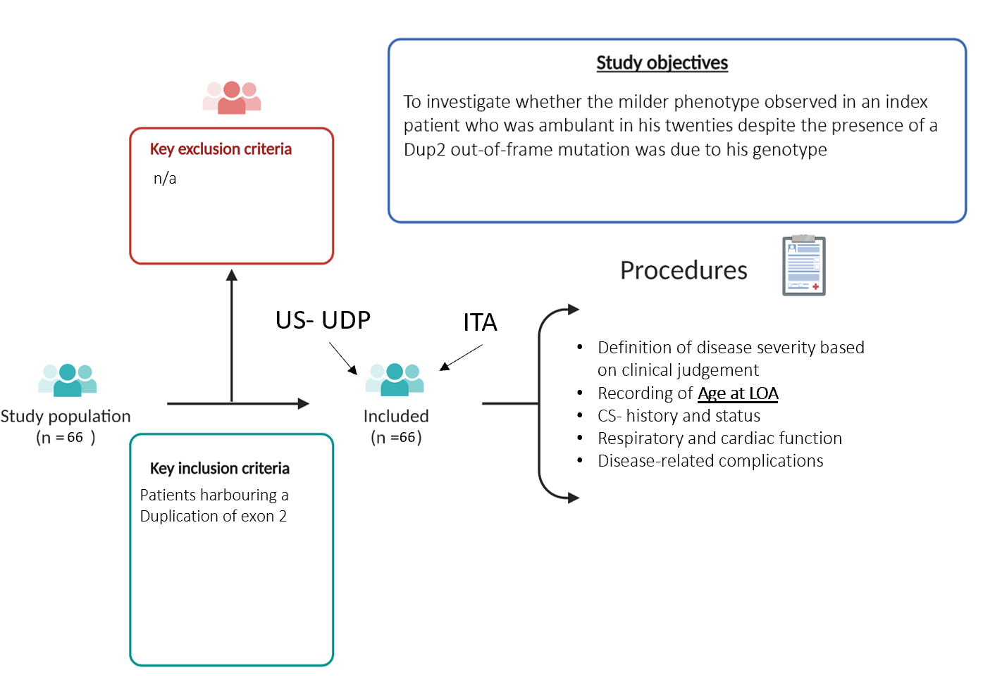
Figure 3.1. Schematic representation of study design, including inclusion criteria, objectives and procedures

3.1.1. Cohort description
We identified 66 Dup2 individuals from an Italian and a US-based network. These were included in the analysis, including 40 (61%) of whom were from the UDP (US) database and 26 (39%) from the Italian network. There was no significant difference in age at diagnosis, age at last examination, or current age between the two cohorts (Table 3.1). The median (IQR) age at diagnosis was 4.6 years (2.6-6.7) and median (IQR) age at last observation was 15.4 years (8.8-26.0). Sixty-three subjects (95%) were alive at the time of analysis, two were deceased. Survival status was not available for 1 individual.
Thirty-nine subjects (61%) were classified as DMD, nineteen (30%) as BMD, and 6 (9%) as IMD. Two very young subjects (<4 years) at the time of this study were not phenotypically categorized. Subjects in the Italian cohort were more likely to be classified as the milder BMD or IMD compared to the UDP cohort, which was predominantly DMD (p=0.036). Forty-seven subjects (75%) were classified as having steroid exposure (“CS-ever”), with similar rates between the Italian (76%) and UDP (74%) cohorts.
Table 3.1 Summary of Dup2 patients
 | All | Italian | UDP | N | p-value
Age at Diagnosis, mean (SD) | 4.67 (2.66) | 4.28 (2.88) | 4.94 (2.51) | 62
Age at last follow up, median (IQR) | 15.4 (8.79;26.0) | 15.7 (9.85; 26.7) | 14.9 (8.74;24.0) | 66
Current age, mean (SD) | 20.7 (10.0) | 21.3 (9.11) | 20.3 (10.7) | 66
Alive, n (%) | 62 (95) | 23 (92) | 39 (97.5) | 65
Diagnosis, n (% within cohort)
DMD | 39 (60.9) | 10 (41.7) | 29 (72.5) | 64 | 0.036
IMD | 6 (9.4) | 4 (16.7) | 2 (5.0)
BMD | 19 (29.7) | 10 (41.7) | 9 (22.5)
Ambulant, n (%) | 32 (50) | 13 (50) | 19 (50) | 64 | >0.99
Age at LOA, median (IQR) | 12.1 (10.8;14.2) | 12.0 (11.0;13.0) | 12.2 (10.8;17.2) | 32 | 0.645
Steroid use prior to LOA, n (%) | 47 (74.6%) | 19 (76.0%) | 28 (73.7%) | 63 | >0.99
Comparison of general clinical characteristics shows no significant difference between Dup2 subjects identified within the Italian network and the UDP database. Abbreviations: BMD, Becker muscular dystrophy; DMD, Duchenne muscular dystrophy; IMD, Intermediate muscular dystrophy; IQR, interquartile range; LOA, loss of ambulation; N, number; SD, standard deviation. Age is expressed in years.

3.1.2. Motor function/Loss of Ambulation
In a survival analysis of all subjects with information on ambulation status (an analysis that incudes age at last observation for subjects who are still ambulant), there is no evidence of a difference in age at median LOA between the Italian (13.0 years) and US (12.7 years) groups (HR: 0.79, 95% CI: 0.38 – 1.68, p=0.54). However, as expected there was evidence that age at LOA was different between the CS-ever (16.5 years) and CS-never (11.0 years) subjects (HR: 0.45, 95% CI: 0.21-9=0.94, p=0.03, Figure 3.1). Similar steroid effects were found within each cohort; in the Italian cohort, CS-never subjects had a median age at LOA of 11.0 years vs 17.0 years for CS-ever subjects, and in the UDP cohort, CS-never subjects had a median age at LOA of 12.0 vs 16.5 years for the CS-ever.
Further comparison of the two cohorts used a subset analysis of only those subjects who had reached LOA, excluding still-ambulant subjects. As expected, this subset analysis demonstrates slightly different values for median LOA from the survival analysis reported above, but still shows no significant differences between the Italian and UDP cohorts. For the subset of thirty-two subjects (48%) whom had a recorded age at LOA, the observed median (IQR) age at LOA was 12.1 years (10.8-14.2) and there was no significant difference between the Italian (12.0 yrs; IQR, 11.0-13.0) and UDP cohorts (12.2; IQR, 10.8-17.2 years) when all phenotypes were included. When comparing steroid use, CS-ever subjects had a later age at LOA of 12.6 years (IQR, 11.8 – 17 years) versus 11.0 years (IQR, 9.9 – 12.3 years) in CS-never subjects, but this difference was not statistically significant, likely due to the smaller sample size in this subset analysis.
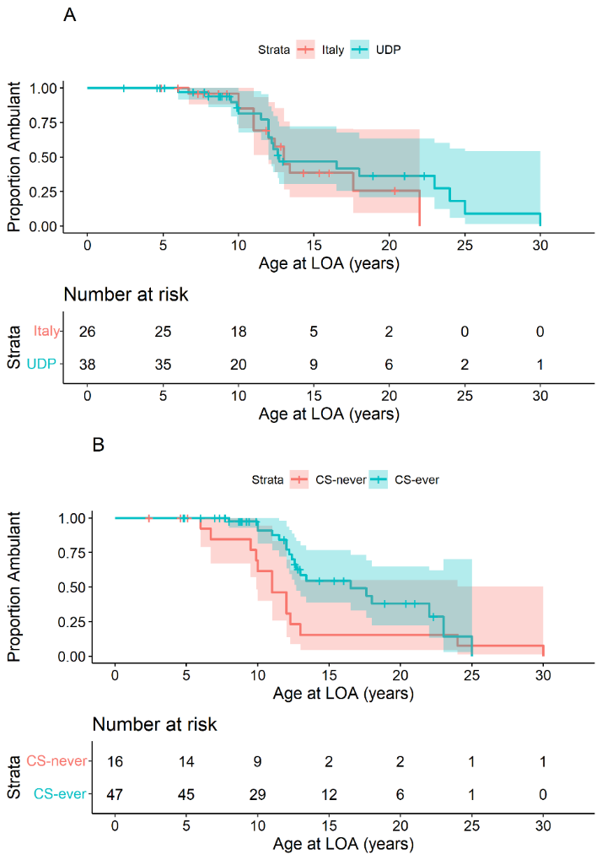
Figure 3.2 Age at loss of ambulation in the entire Dup2 cohort. Top panel: Loss of ambulation is similar between the UDP and Italian cohorts. Two subjects from the UDP-Dup2 cohort are not included due to unknown ambulation status. Median age of estimated LOA was similar between groups 13 years for the Italian cohort and 12.7 years for the NCH cohort (HR: 0.79, 95% CI: 0.38 – 1.68, p=0.54). Bottom panel: Loss of ambulation among entire Dup2 cohort suggests a significant corticosteroid treatment effect. Three subjects are not included due to incomplete steroid information. Estimated LOA was significantly older for those who were exposed to greater 6 months of corticosteroids (CS-ever; median of 16.5 years) versus those exposed to less than 6 months (CS-never; 11.0 years) (HR: 0.45, 95% CI: 0.21-9=0.94, p=0.03).
Under the assumption that distinct DMD and BMD phenotypes occurred in Dup2 patients, in order to determine whether also Dup2-associated DMD was different from other DMD-associated phenotypes, we analyzed only those subjects given a clinical diagnosis of DMD and compared them to a cohort of non-Dup2 UDP controls. As a group, even those subjects with a clinical classification of DMD walked significantly longer: median age at LOA for the UDP controls was 10.5 years, compared to 12.0 years for the Dup2 cohort (HR Dup2 vs. UDP: 0.29, CI: 0.17, 0.51, p <0.001) (Figure 3.2).
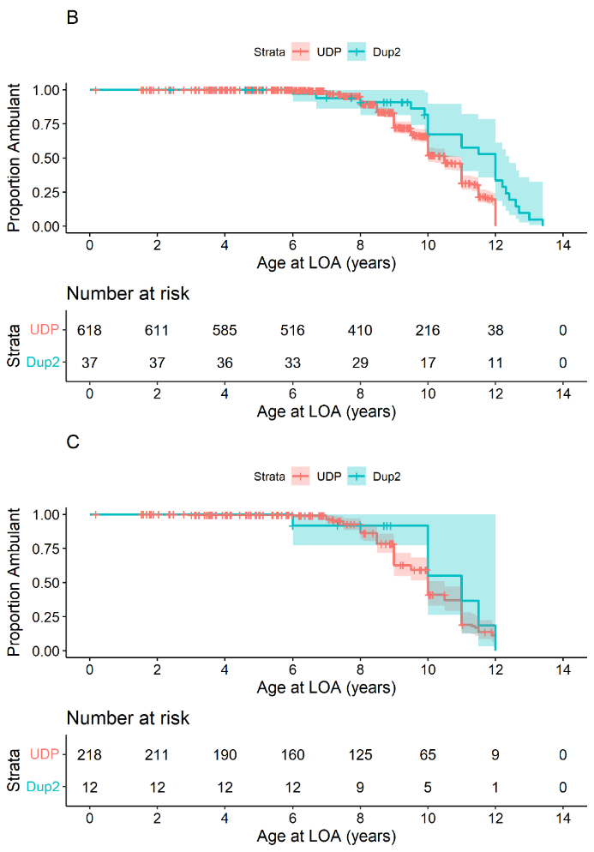
Figure 3.3. Age at loss of ambulation in subjects clinically diagnosed with DMD phenotypes. Top panel: All Dup2 DMD subjects compared to a natural history comparator group. Comparison of Dup2 subjects clinically characterized with DMD, regardless of steroid treatment status, compared to non-Dup2 DMD subjects from the UDP database shows prolonged ambulation. The median age at LOA for the UDP cohort was 10.5 years vs 12.0 years for the combined Italian and NCH cohorts (HR: 0.29, 95% CI: 0.17, 0.51, p < 0.001). Bottom panel: CS-never Dup2 DMD subjects compared to a natural history comparator group. Comparison of only corticosteroid-untreated Dup2 subjects clinically characterized with DMD to non-Dup2 DMD subjects from the UDP database also shows prolonged ambulation. Among CS-never subjects, the median age at LOA for the UDP Cohort was 10.0 years versus 11.0 years for the Dup2 CS-never subjects (HR: 0.65, 95% CI: 0.52, 0.82, p < 0.001).

3.1.3. Respiratory and cardiac function
Spirometry was performed in 39 Dup2 subjects at a median (IQR) age of 14.9 years (9.65-22.25). Median (IQR) FVC% predicted (FVC%p) was 90.0% (70.5, 98.5). Although this is a limited dataset, all subjects had FVC%p above 60% until at least 20 years of age. Information on cardiac status was available in 55 subjects; twenty-four had been diagnosed with cardiomyopathy. Of those with an EF reported, the median (IQR) ejection fraction was 58% (50-63.4). One CS-never subject, who lost ambulation at 11 years, received an implantable cardioverter defibrillator (ICD) at 14.9 years.
Table 3.2 Cardiac and respiratory function among Dup2 subjects.
 | All | Italian | NCH | N | p-value
Age at cardiomyopathy diagnosis or last normal, median (IQR) | 12.9 (8.70;19.4) | 14.9 (11.3;19.0) | 12.2 (8.10;20.1) | 52 | 0.565
Cardiomyopathy, n yes (%) | 24 (43.6) | 8 (44.4) | 16 (43.2) | 55 | >0.99
EF%, median (IQR) | 58 (50;65) | 63 (45;65) | 58.0 (50;64.6) | 33 | 0.985
FVC percent predicted, median (IQR) | 90.0 (70.5;98.5) | 88.0 (76.0;90.8) | 91.0 (68.0;108) | 39 | 0.192
Age at FVC%p | 15.4 (9.7, 22.2) | 13.6 (9.4-18.5) | 17.0 (9.9, 23.5) | 39 | 0.098

3.2. Considerations
A duplication of DMD exon 2—the most common duplication pathogenic variant in the Dystrophinopathies—results in a shift in reading frame and is predicted to result in an absence of dystrophin expression and a DMD phenotype. Consistent with this prediction the majority of large databases of dystrophinopathy genotypes have characterized Dup2 individuals as DMD (Bladen et al., 2015; Juan-Mateu et al., 2015; Okubo et al., 2017; Tuffery-Giraud et al., 2009; White et al., 2006), although these databases do not typically describe how phenotypic classifications were derived. In a previous analysis of the UDP database where prospective classification criteria were defined for 1111 subjects, 20% of Dup2 patients were defined as having milder phenotypes (Flanigan et al., 2009b). In the present cohort, containing more than triple that number of Dup2 subjects, 39% have a milder phenotype, with 24% of these milder patients clinically classified as IMD and 76% classified as BMD using either clinical examination (in still-ambulant patients) or age at LOA criteria. These data suggest that in at least some Dup2 patients, molecular mechanisms of disease amelioration may be present. This hypothesis is supported by analysis of only those Dup2 patients clinically classified as DMD (LOA<13y); in comparison to a large cohort of controls from the UDP database, where Dup2 DMD subjects walk 1.5 years longer than non-Dup2 DMD genotypes.
One possible mechanism for this attenuated phenotype is the presence of a functional IRES within exon 5. This IRES drives cap-independent translation that is initiated at an AUG codon within exon 6. The resulting dystrophin isoform lacks the first calponin homology (CH1) domain within the canonical dystrophin actin binding domain 1 (ABD1). Despite predictions that disruption of the ABD1 domain obligatorily results in significant loss of dystrophin function, patients who express dystrophin lacking the CH1 domain (the ΔCH1 isoform) demonstrate abundant dystrophin expression, properly localized at the sarcolemmal membrane (Gurvich et al., 2009). More importantly, they show minimal functional defects, with the most prominent symptoms being myalgias and elevations in serum creatine kinase (Flanigan et al., 2009a). Consistent with the observation of a predominance of DMD phenotypes among patients with Dup2 pathogenic variants, in vitro experiments showed the IRES to be inactive in the presence of an exon 2 duplication within the mRNA (Wein et al., 2014). However, IRES utilization is controlled by a variety of IRES trans-activations factors (ITAFs), which play a role in activation in mammalian cells by a variety of mechanisms (Faye & Holcik, 2015; Godet et al, 2019). Expression or regulation of these auxiliary factors may well vary in the population, allowing a possible pathway for variability of expression of the highly functional ΔCH1 isoform in muscle tissue, leading to variable phenotypes.
Because the DMD exon 5 IRES has been shown to be steroid-responsive in both cell culture and in the Dup2 mouse model (Wein et al., 2014), the observation of an apparent CS treatment effect in our Dup2 cohort is of particular interest. Treatment of Dup2 subjects with CS seemed to provide a larger treatment effect, as judged by LOA, in comparison to UDP control non-Dup2 subjects similarly treated with CS. This apparent differential effect of CS therapy could be consistent with IRES activation, suggesting that treatment of Dup2 patients with CS results in more benefit for a given dose. We note that all but two subjects with a milder phenotype were exposed to corticosteroids for at least 6 months prior to losing ambulation, perhaps supporting the hypothesis that corticosteroids may provide an additional benefit in Dup2 subjects. If CS-induced IRES activation is responsible for a more robust CS effect on age at LOA, the increased use of CS in modern clinical practice may contribute to the higher reported fraction of Dup2 patients identified with IMD or BMD in this analysis in comparison to previous studies (Flanigan et al., 2009b), as our clinical definitions are based on LOA.
It is worth noting that if either of these IRES-based explanations—variable endogenous IRES activation, or increased IRES-driven expression due to CS therapy—is active, they are not sufficiently robust to result in maximal IRES activation. None of the Dup2 subjects we describe presented with the exceedingly mild phenotypes associated with the presence of the p.Trp3X founder allele, in which expression at levels estimated at 15% resulted in ambulation into the 7th decade (Flanigan et al., 2009a; Gurvich et al., 2009). In contrast, the oldest ambulant BMD subject we describe is currently 22.3 years old, but significantly and clearly affected by muscle weakness.
An alternate hypothesis for what appears to be a mildly attenuated phenotype is that alteration of native exon splicing results in exclusion of one copy of the duplicated exon 2. Low levels of alternative splicing leading to an mRNA with an open reading frame have been invoked as a cause of an attenuated phenotype in the presence of central rod domain out-of-frame deletion pathogenic variants, particularly in the case of exon 44 (van den Bergen et al., 2014a; Wang et al., 2018b). In the presence of an exon 2 duplication, native splicing events resulting in exclusion of a single exon 2 would restore an entirely normal DMD transcript. Expression of even very low levels of a normal protein might be expected to result in amelioration of the phenotype, as levels of dystrophin expression around 3% of normal in a nearly full-length dystrophin due to altered central rod region splicing have been shown to do (Waldrop et al., 2018).
Our analysis has concentrated on LOA as an outcome, as it is relatively uniformly recorded in multiple record sources. However, our data preliminarily suggest that respiratory dysfunction may be milder in the Dup2 population. Recent publications suggest that the median age at reaching an FVC%p value below 50% is 16 years in DMD patients.(McDonald et al, 2018b; Ricotti et al., 2019; Trucco et al., 2020) Acknowledging the small sample size for available FVC data in our cohorts, none had an FVC%p below 60% prior to such age 16, regardless of clinical phenotype or CS use. The cardiac data is similarly limited in this cohort and although cardiac function may be slightly milder in the BMD phenotypes, overall cardiac function did not appear to be significant different than typically seen. (McNally et al., 2015)
We acknowledge several limitations to our study. First, the sample size is relatively small, although we note that this is the largest collection of phenotypic Dup2 data published to date. Another is its retrospective nature, with a reliance on data collected by a widespread group of clinicians. A third is the inherent risk in assigning clinical classifications to younger subjects. Here we attempted to minimize this by utilizing functional outcomes data whenever possible for subjects ages 4 to 9 years. For this group, outcomes on measures such as the 100 meter walk time and NSAA have been established, allowing comparison of results to the range expected in DMD, and results far exceeding those expected performances could aid the expert clinicians in assigning a clinical classification of IMD or BMD. As a further conservative measure, phenotypic classification was not assigned to the two subjects under the age of 4. Finally, we acknowledge that a variety of other genetic modifiers may influence the severity of DMD symptoms (Bello & Pegoraro, 2019), but note that our cohort size is too small to anticipate detection of effects from such known modifiers.
The largest limitation of our study is the absence of molecular data to correlate with these clinical findings. This is due in large part to the decreasing incidence of muscle biopsies in the diagnostic pathway for dystrophinopathies, and the increasing availability of definitive copy number tests from genomic DNA. Such muscle studies would be informative. We note that our alternative hypothesis of amelioration (of mRNA splicing and IRES translation) are not mutually exclusive, and both may be active. Determination of whether one or both are depends on further studies of RNA and protein from muscle biopsies, which are beyond the scope of this manuscript. Available tissues were limited, with wide variation in handling and time of storage. Nevertheless, our data describe the heterogeneity and range of dystrophinopathy phenotypes associated with duplications of exon 2, and may provide guidance for the enrollment in and interpretation of data from trials of therapies directed specifically to the Dup2 genotype.

Sub-study 1b: results
As mentioned before, the main limitations of Sub-study 1a are its retrospective design and the lack of genomic or molecular data to perform a correlation analysis between these and clinical records. For this reason, we initiated a longitudinal, prospective study on an Italian cohort of Dup2 patients, aiming at collecting biological samples and deep phenotype patients. The study is ongoing, hence only preliminary results, along with the study plan, are presented below.
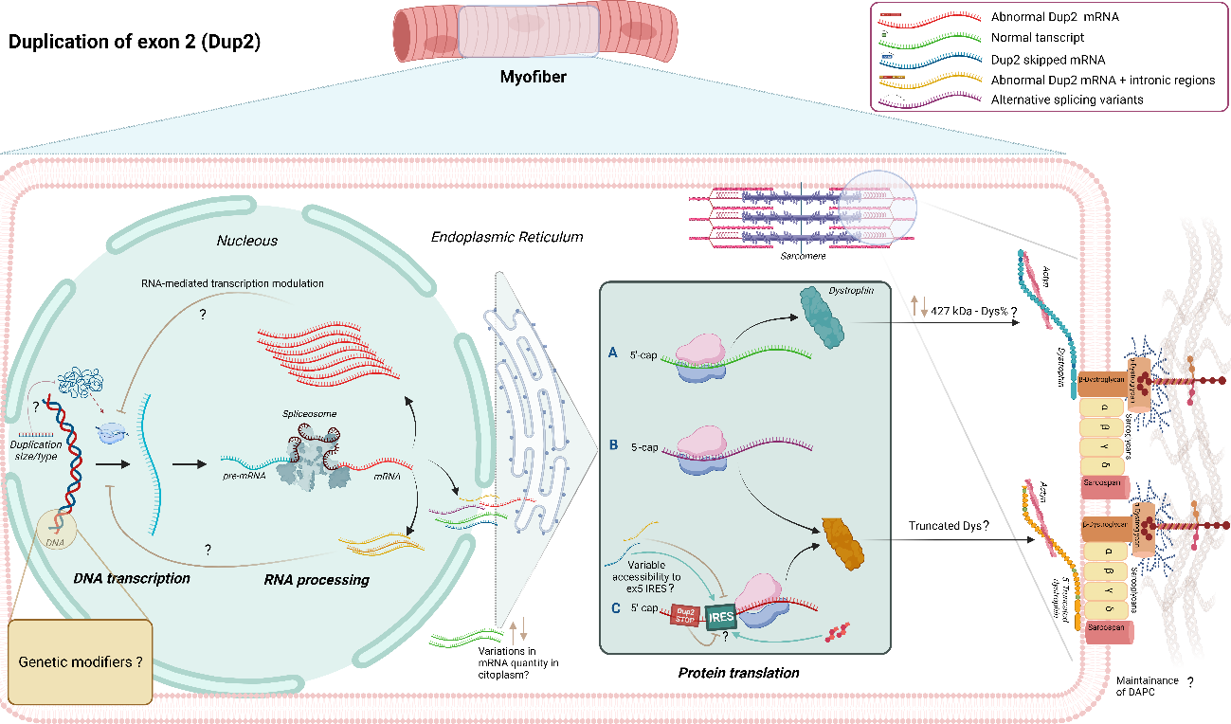
Figure 3.4. Hypothesized molecular mechanisms participating in the amelioration of Dup2-associated phenotype. At DNA level (left), potential disease modifiers include tans-acting genetic variants, the size/type of the duplication possibly impacting on chromatin accessibility, and RNA mediated modulation of DMD/modifiers transcription. At RNA level, differences in terms of alternative splicing, mRNA total quantity and/or its localization within the cell could account for variable disease severity. Lastly, at a protein level, we may identify differences in terms of full-length (427kDa) protein expression or the presence of truncated dystrophin isoforms. The latter could be due to spontaneous exon skipping, or to IRES-mediated translation of Dys starting from exon 6, as observed in patients harbouring an exon 2 deletion. IRES activation may be influenced by the characteristics of the duplication or the presence of alternative transcripts, or modulated by steroid exposure.

Cohort description
Twenty-four patients from 13 Italian Tertiary Care Centres signed an informed consent to participate in the DUP2-DMD study. Median (IQR) age at first and last visit was 10,9 (6,7-12,8) and 13y (11,4-20,8), respectively. There were a median of 2 visits per patient (range 1-13, IQR 2-3.5).
Thirteen patients were classified as DMD (56%), 8 as IMD (35%) and 2 as BMD (9%). Seventeen patients were current CS users (8 DMD, 7 IMD, 2 BMD), 3 were past users (3 DMD) and 4 were CS naïve patients (2 DMD, 1 IMD, 1 n/a).
The estimated median (IQR) age at loss of ambulation was 14 years (12-17 years)
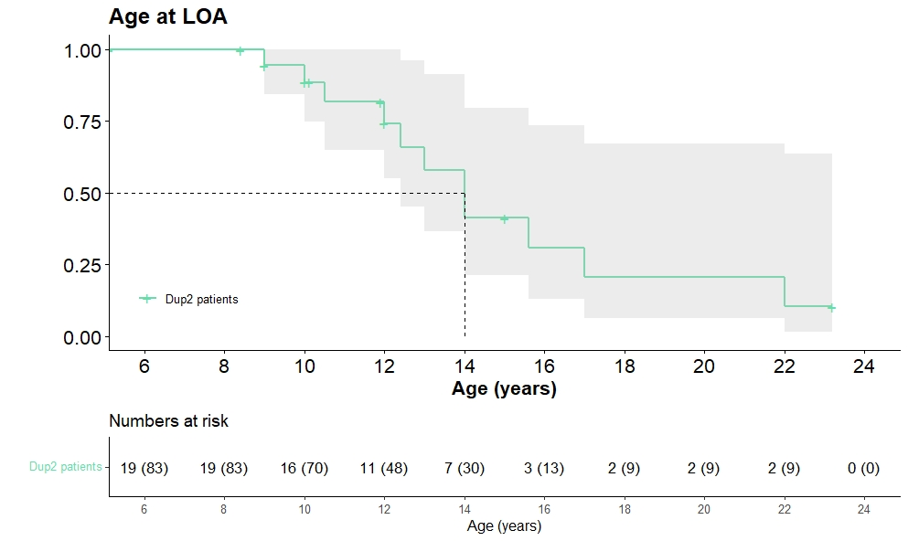
Figure 3.5. Kaplan Meier curve depicting Age at loss of ambulation in the Italian Cohort of Dup2 patients.
Blood samples were collected from all patients. WGS analysis of 10 patients was completed at the time of this manuscript. Muscle biopsy material was available for 10 patients.

Deep phenotyping
Given the limitations of a definition based solely on clinical judgement and/or age at LOA, we plan to rank patients according to their motor and respiratory performances regardless of their current age or ambulatory status. In order to do so, we will consider the following variables in addition to age at LOA: NSAA total score, PUL2.0 total sore, FVC%p. For each variable, a centile will be calculated from age-matched control group. These will be considered together to determine a quantitative ranking.
Cardiac function will be considered separately given the paucity of data regarding phenotype-genotype correlation and the existence of discordant phenotypes.

3.3.3. DNA breakpoints analysis
WGS analysis will be performed on 20 patients. All duplications of the first 10 analyzed patients were in tandem. One patient showed an in tandem non-contiguous duplication. The intronic region Intr1-chrx:33078186-33078347 was included in 6/10 patients. Neither the size of the duplication (ranging from 53.901 255.830 base pairs) nor the inclusion of the intronic region seemed to correlate with phenotype.

RNA transcript and protein expression analysis on muscle biopsy samples
FluiDMD card, a kit specifically developed to profile all exon-exon junctions of the 79 exons of the DMD transcript, including the DMD isoform promoter and/or first exon unique regions, will be utilized to characterize transcripts and check for differences between patients. Transcript analysis and quantification of protein expression is ongoing.

4. Study 2: Peak of motor function and association with age at LOA
Due to the difficulties in establishing phenotypical severity in young patients, the objective of the study was to investigate whether the motor performance achieved at the age of expected peak (i.e., 6-7 years) was associated with age at loss of ambulation in a large cohort of DMD patients harboring different mutations.
DMD patients usually display a median age at LoA of 10 years in corticosteroids (CS)-naïve patients (meaning those individuals who had never received steroid treatment), with a delay of 2-4 years when long-term CS treatment is administered (Bello et al., 2016b; McDonald et al., 2018c; Ricotti et al., 2013).
Most research currently focuses on 12-36 months trajectory of different motor (Brogna et al, 2019a; Mazzone et al, 2011; Mazzone et al., 2016; McDonald et al., 2013b; Pane et al, 2014; Ricotti et al., 2016b) and respiratory (Buyse et al, 2015; Henricson et al., 2013; LoMauro et al, 2015) outcome measures providing comparative data for ongoing interventional trials, in which the typical duration ranges between 48 and 144 weeks (Goemans et al., 2020b). However, information about early prognostic factors of long-term decline is lacking, for instance the relationship between the highest achieved functional ability and age at LOA. This is relevant considering that the DMD spectrum encompasses clusters of boys with different trajectories of ambulatory function (Mercuri et al., 2016c), and that such variability poses significant challenges when designing clinical trials. In addition, information regarding future prognosis would help counsel families, anticipate complications and tailor the care for patients in a cost-benefit manner. A recent study described four latent class groups based on the age at which NSAA total score fell below the 5th centile (namely, ~10, 12, 14 and > 15 years) (Muntoni et al., 2019b). However, while patients belonging to each group presented with different characteristics at first NSAA assessment (e.g., age at CS initiation and functional scores), the study was not designed to establish which baseline factors were associated with subsequent age at LOA.
Here we aim to assess whether two commonly used functional scores (namely, NSAA total score and timed rise from floor supine -TRF) recorded at the age of expected best motor performance are associated with age at LOA in boys with DMD treated according to the current standards of care.

4.1. Study 2: results

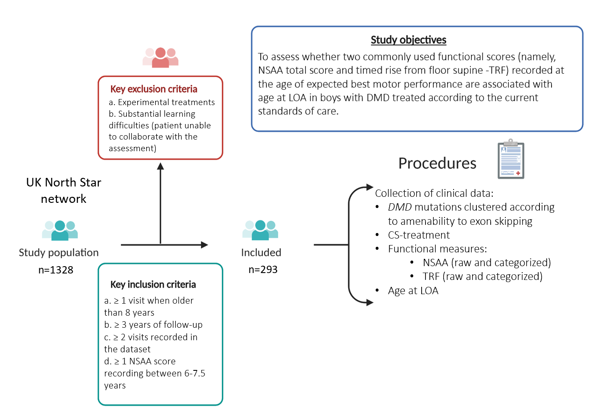
Figure 4.1. Schematic representation of study 2 design, including inclusion criteria, objectives and procedures

4.1.1. Population characteristics
A total of 293 patients from 13 different centres in the United Kingdom were included in this study. The mean (SD) age at first and last visit was 5.5 (1.2) and 12.7 (2.8) years, respectively. Two hundred and eighty-six patients received CS treatment before losing ambulation, 7 were CS-naïve. The mean (SD) age at CS-treatment initiation was 5.5 (1) years. For 109/286 (38%) patients, CS regime and/or CS type was subsequently changed before losing ambulation (“CS-switcher”). Including CS-switcher, 160 (56%) patients were predominantly treated with daily CS, and 83 (29%) with intermittent CS regimen. Cohort characteristics are presented in Table 3.
Figure 4.2 Patients’ selection and genotype

Table 4.1 Demographics, corticosteroid treatment and baseline functional abilities
 | Patients (n=293)
Age at first visit, years  Mean (SD)  Median (IQR) | 5.5 (1.2)  5.5 (4.8-6.3)
Age at last visit, years  Mean (SD)  Median (IQR) | 12.7 (2.9)  12.7 (10.1-15.1)
Years of follow-up  Mean (SD)  Median (IQR) | 7.3 (2.8)  6.9 (5-9.2)
Ambulatory status at last visit  Ambulatory  Non-ambulatory | 133 (45%)  160 (55%)
Age at CS initiation  Mean (SD)  Median (IQR) | 5.5 (1)  5.4 (4.8-6.1)
CS regimen before LOA, n (%/293)  CS-Naïve  CS-treated  CS-Regimen:  Daily  Intermittent  n/a  Switcher  Predominantly Daily  Predominantly Intermittent  50/50  n/a | 7 (2%)  101 (34%)  52 (18%)  24 (8%)  109 (38%)  59/109  31/109  14/109  5/109
CS switcher before LOA, n (%/109)  Switch CS type  Switch CS regimen  Switch CS type and regimen  Stopped | 109  29 (28%)  58 (55%)  19 (19%)  3 (3%)
CS mean annual dose pro-kilo before LOA,  mean % of desired (SD) ‡  Daily regimen  Intermittent regimen  Switcher  Predominantly daily  Predominantly Intermittent | 74% (14)  41% (4)  71% (12)  51% (8)
Age at baseline, years  Mean (SD) | 6.8 (0.5)
NSAA total score at baseline, median (IQR)  CS-naïve* (n=30)  CS-treated (n=263) | 24 (19-30)  27 (22-31)
Time to rise at baseline in sec, median (IQR)  CS-naïve* (n=30)  CS-treated (N=250) | 5.1 (4.1-7.4; range 1.8-17.3)  4 (3.2-5.5; range 1.2-22)
‡ The mean annual CS dose pro-kilo was calculated from the time of CS initiation to the age at LOA or to the age of 11, years if patients were still ambulant. Considering 0.75 mg/kg and 0.9 mg/kg * 365 days a year the optimal dose (100%), we calculated the % of desired annual dose per year and subsequently the average % of desired annual CS dose before LOA, such that if 0.75 mg/kg prednisolone intermittent regimen were used this would be equal to 50% of optimal dose. * CS-Naïve at baseline. Abbreviations: CS, corticosteroids; IQR, interquartile range; n, number of patients; n/a, data not available; SD, standard deviation.

4.1.2. Baseline assessment: Functional scores and CS treatment
The mean (SD) age at baseline was 6.8 years (0.5). The median (IQR) highest NSAA score at baseline was 27 (22-31) and the mean (SD) time to rise from the floor was 4.9 seconds (2.9) (Figure 4.2 A). There was a significant negative correlation between total NSAA and TRF at baseline (Spearman r = -0.64; P < .0001) (Figure 4.2B). Information regarding CS regimen at baseline was available for 224/293 patients. Of the remaining 69 subjects, 30 were CS-naïve (23 of whom were subsequently started on CS). There was no correlation between CS dose pro/kg and total NSAA score at baseline (Figure 4.2C). Before LOA, two hundred and eleven (72%) patients were on prednisolone (116 on a mean dose of 0.6 mg/Kg daily; 77 on a mean dose of 0.6 mg/kg intermittent 10 days on/off), 32 (11%) on deflazacort (25 on a median dose of 0.7 mg/Kg daily, 6 on a median dose of 0.7 mg/kg intermittent), 20 on unspecified CS type, and 30 were CS-naïve.
Figure 4.3. Baseline function. Panel A: Histogram plot showing frequency of NSAA scores at baseline. Panel B: Scatter plot showing correlation between NSAA and TRF at baseline. Panel C: Scatter plot showing correlation between CS dose/regimen and NSAA score at baseline. Abbreviations: CS, corticosteroids; NSAA, North Star Ambulatory Assessment.

4.1.3. Loss of ambulation
A total of 160/293 patients lost ambulation. Twenty-two of the 160 patients (13.75%) had a long bone fracture within 6 months before LOA. The overall estimated median age at LOA (IQR) was 11.7 years (10.1-14.4).
Relationship between baseline functional abilities and LOA
Higher NSAA scores at baseline were associated with a later age at LOA (P < 0.001; Figure 4.3 A). For subjects with NSAA score <22, the probability (95% CI) of being ambulant at the age of 11 and 13 years was 0.32 (0.21-0.45) and 0.13 (0.05-0.34), respectively, while for NSAA scores of 22-25 the probability was 0.42 (0.29-0.6) and 0.19 (0.09-0.38). For patients with a NSAA score of 26-28 the probability was 0.59 (0.46-0.76) and 0.34 (0.21-0.55), while for NSAA score of 29-31 the probability was 0.85 (0.75-0.96) and 0.34 (0.21-0.54), and finally for NSAA score of 32-34 the probability was 0.82 (0.71-0.94) and 0.61 (0.47-0.79), respectively. None of the subjects with a baseline NSAA score < 26 were ambulant after 15 years.
TRF at baseline was positively associated with age at LOA (HR 1.13; 95% CI 1.09-1.17, P<0.001). When considered as TRF groups, a faster time to rise from supine at baseline was also significantly associated with an older age at LOA (P <.0001; Figure 4.3B). In particular, the median (IQR) age at LOA for patients rising from the floor in ≤3.5, from 3.6 to 5, and > 5 seconds was 14.4 years (12.4-16.1), 12.4 years (10.7-14.1), and 10.2 years (9-11.9), respectively.
Figure 4.4. Kaplan-Meier curves showing time to loss of ambulation according to NSAA group (A) and TRF time (B). Abbreviations: LOA, loss of ambulation; NSAA, North Star Ambulatory Assessment; TRF, Timed Rise from Floor.
Genotype and LOA
Descriptively, no apparent differences were found except for individuals harbouring duplications and pathogenic variants amenable to exon 44 skipping, who appeared to reach LOA at a later median age than the other genotypes (Table 4.2 and Figure 4.4).
Figure 4.5. Rainbow plot representing the distribution of NSAA scores at baseline according to genotype and Kaplan–Meier curve showing time to LOA according to genotype.

Corticosteroid regimen at baseline and LOA
The median (IQR) age at LOA of patients treated with daily vs intermittent CS regimens was 12.4 (10.2-14.8) vs 11.4 (10.1-13) years, respectively (P=0.11). The event LOA was recorded in 81/141 and 41/83 patients, respectively.

4.1.4. Multivariable analysis
We considered the simultaneous effects of baseline factors (NSAA, TRF and CS regimen) on LOA to assess if these were still independently associated with outcome or whether effects were attenuated after adjustment (Table S1). Overall, CS regimen and TRF were the most important factors (P = 0.011 and 0.007, respectively), with Intermittent regimen and TRF>5s associated with earlier LOA. NSAA group 32-34 at baseline was also important (P = 0.06) being associated with delayed LOA. After adjusting for steroids and NSAA score we found that on average boys with a longer TRF (>5 s) had an increased hazard ratio of 1.96 in losing ambulation, meaning 96% higher risk compared with those with a rise time between 3.6-5 s. Conversely, those with shorter baseline rise times <3.5 s had an 18% lower risk of losing ambulation than those with rise times 3.6-5 s, over a similar time period.
Using the middle group (NSAA scores between 26-28 units) as reference, boys with a lower NSAA score comprised between 22-25 units had a 26% increased risk of losing ambulation. Furthermore, boys with an even lower NSAA score of < 22 units at baseline had a 53% greater risk of losing ambulation, over a similar time period. For boys in the higher NSAA score categories at baseline there was a risk reduction in losing ambulation of 30% for those with scores between 29-31 and 48% for those with scores >31, compared with those scoring NSAA 26-28.
Boys on Daily regime at baseline had a 41% reduction in risk of losing ambulation, compared with those on intermittent regime, after adjusting for motor function outcomes (P = 0.01).

Table 4.2. Genotype, baseline NSAA score and age at LOA
 | Factor | n (%) | Median NSAA baseline (IQR) | Median TRF baseline (IQR) | Median age, y,  at LOA (IQR)
DMD genotype | Exon 44 skipping amenable deletion | 22 (7%) | 30 (27-31) range 16-34 | 3.5 (2.9-4.1) | 12.8 (11.1-13.8)
DMD genotype | Exon 45 skipping amenable deletion | 26 (9%) | 25 (19-30) range 9-34 | 3.8 (3.2-5.5) | 11.1 (10-15.6)
DMD genotype | Exon 51 skipping amenable deletion | 41 (14%) | 27 (22-31) range 13-34 | 4.1 (3.1-5.7) | 11.1 (9.3-12.6)
DMD genotype | Exon 53 skipping amenable deletion | 24 (8%) | 25 (21-30) range 8-33 | 4.6 (3.3-5.6) | 12.4 (9.9-14.8)
DMD genotype | Exon 55 skipping amenable deletions | 14 (5%) | 28 (25-31) range 19-34 | 4.5 (2.5-6.3) | -
DMD genotype | Exon 50 skipping amenable deletions | 10 (3%) | 25 (23-28) range 21-33 | 3.9 (3.4-4.9) | -
DMD genotype | Other out-of-frame Del | 61 (21%) | 27 (24-30) range 11-34 | 4.2 (3.5-5.6) | 11.5 (10.2-13.9)
DMD genotype | Other out-of-frame Dup | 27 (9%) | 28 (22-33) range 15-34 | 4 (3.1-4.6) | 12.9 (11.6-15.9)
DMD genotype | Nonsense mutations | 48 (16%) | 27 (21-31) range 10-34 | 4.7 (3.2-5.8) | 10.7 (9.9-14.4)
DMD genotype | Other frameshifting or unknown mutation | 30 (10%) | 26 (22-30; range 10-33) | 4.9 (3.4-5.9) | 11.3 (10.1-14.7)
*Patients amenable to skipping of multiple exons (such as skip exon 50 and 52). TRF is expressed in seconds.

4.2. Considerations
DMD may be considered a rather homogeneous disorder with reference to the lifespan of a healthy individual. However, if we “change lens” to focus on different developmental stages, an important phenotypic variability is revealed. Although few studies tried to identify predictive factors of motor deterioration (Goemans et al, 2020a; Goemans et al, 2020c) and to establish the risk of functional losses over a 24-month period (Mazzone et al., 2016; Mazzone et al., 2013; Ricotti et al., 2016b), we still have limited knowledge regarding what will determine individual long-term outcomes, particularly when patients are assessed before decline of their motor abilities. Therefore, we aimed to explore whether selected factors recorded at an early stage of the disease impact age at LOA. Importantly, we intended to generate results that could be easily transferred to clinical practice.
Given the heterogeneity of the 6MWT before 7 years of age (Mercuri et al., 2016c), we focused on the total NSAA total score and TRF, which are two of the most commonly used outcome measures in clinical practice (Ricotti et al., 2016b). DMD boys achieve their highest NSAA score at a mean (SD) age of 6.8 (0.7) years (Chesshyre et al, 2021), thus we established the pragmatic window of 6 years -7 years 6 months as baseline. At this time point, we found a clear correlation between NSAA and TRF (R -0.64). We here demonstrated for the first time that the best motor performance recorded in this age range (both in terms of NSAA score and TRF) is associated with age at LOA. Other studies provided evidence that a number of functional measures can serve as predictors of motor deterioration; for instance, boys with 6MWT< 350 meters or TRF values of 5 s or longer are likely to experience decline in function, and those with TRF values ≥10 s are at risk for losing ambulation during the following 24 months (Mazzone et al., 2016; McDonald et al., 2013b). Another important lesson provided by other research groups is that the addition of timed test to conventional functional scales may improve prediction of short-term trajectories (Goemans et al., 2016). Nevertheless, most of these studies included older individuals who were closer to achieve major disease milestones such as LOA, with unsurprisingly higher TRF values or lower NSAA/6MWT scores. Here we suggest that, in contrast to 6MWT, both NSAA and TRF may be also considered as early predictors of age at LOA. This observation is in keeping with previous findings showing that the lower the peak NSAA score a DMD patient achieved (and the younger the age at which this peak was reached), the earlier his ambulatory capability started declining (Muntoni et al., 2019b). Moreover, in the same study those patients who achieved a NSAA score ≤ 5 beyond the age of 15 years had higher baseline NSAA values compared to individuals with earlier loss of ambulatory function. It should be noted though that the better-performing group was older (mean baseline age 8.3 vs overall 7.1 years), potentially introducing an interpretation bias, but also suggesting that preservation of motor function later into the first decade could be a strong additional prognostic factor for LOA.
When considering functional measures alone, we observed a hazard increase of 10% of losing ambulation over the same time for every second increase in the recorded baseline TRF. Those individuals with a peak raw NSAA score > 31 had 0.82 and ~0.6 probability of being ambulant after the age of 11 and 13 years, respectively. This means that boys with peak NSAA score 32, 33 and 34 may have close to double the chances of being ambulant at the age of 13 years compared to those with a peak NSAA 26-27-28 (i.e., patients belonging to the “middle” group).
Subsequently, we performed a multivariable analysis to assess if these measures, together with CS regimen at baseline, were still independently associated with outcome. The effect of all three factors remained significant. For example, those individuals scoring lowest (< 22) or highest (>31) NSAA values had an increase/decrease of approximately 50% in the risk of losing ambulation compared to the intermediate group (26-28), regardless baseline TRF and CS regimen. These data allow us to provide a rational and quantitative framework to the general notion that milder patients are likely to walk for longer. However, they also suggest that a non-negligible proportion of patients (~40%) may lose ambulation before 13 years despite presenting with very good baseline motor abilities, adding to the difficulty of giving a prognosis to younger patients. This seemingly contrasting result could be explained by the complexity of the pathogenesis underlying DMD, with different mechanisms each associated with potential for modifiers (including muscle damage, inflammation, and regeneration failure), and theoretically playing different roles in specific stages of the disease (Duan et al., 2021).
This work is a first step in assessing potential early clinical predictors for LOA. Although TRF seemed more informative than NSAA in multivariable analysis, the combination of the two to form an inclusive predictive model was beyond the scope of this study. Moreover, the caveat is that in such a rare (and heterogeneous) disorder it is extremely difficult to create a reliable predictive model.
Several other factors could contribute to modify natural history of DMD, particularly CS treatment and genotype. While solid evidence has been provided regarding the beneficial effects of CS-treatment (vs naïve) (McDonald et al., 2018c), we have limited knowledge regarding the differences given by different CS types/regimens due to potential biases introduced in real-world practice. As an example, the earlier initiation of steroids has been variably associated with a higher rate of improvement <7 years of age (Ricotti et al., 2016b), but also with worse outcomes likely reflecting the real life scenario in which more severe patient are offered steroids earlier compared to later presenters (Muntoni et al., 2019b). We here confirmed that the use of daily vs intermittent regimen at baseline was associated with lower risk of LOA, though this advantage had a smaller magnitude than previously reported (Ricotti et al., 2013). Interestingly, we also observed that a good proportion of patients were on a CS dose that was >20% lesser than the optimal dose pro-kilo indicated for DFZ and PDN (around 30%). The clinical significance of this is unclear (Quattrocelli et al, 2017) but researchers should consider this pitfall which is rarely depicted in other observational studies (Bello et al., 2015; Goemans et al., 2020b).
Lastly, while we added to the evidence that patients harbouring a pathogenic variant amenable to the skipping of exon 44 show a milder phenotype (Bello et al., 2016b; Brogna et al., 2019a; Ricotti et al., 2016b), we did not find solid evidence linking variants amenable to other exon skipping to worse/better outcomes. This is in keeping with existing conflicting data (Bello et al., 2016b; Brogna et al., 2019a; Muntoni et al., 2019b; Servais et al, 2015), confirming that, with the exception of a few genotypes in which residual dystrophin expression can be observed, dystrophin mutations are not usually considered the primary driver of disease progression in patients with DMD. Only 2 patients with a Duplication of exon 2 were present in this cohort of patients, hence a separate analysis was not possible.
This study has several limitations. First, the NS database well describes real-world practice but has some missing data. Given the inability to precisely define NSAA peak (approximately half of our patients lacked a NSAA score < 6 years), we needed to define a pragmatic age boundary as baseline. By considering the highest score in a time window < 18 months, we tried to minimize potential biases introduced by poor child compliance at the time of the assessment. In multivariable analysis, we considered CS regimen at baseline, but close to forty percent of patients later switched steroid type and/or regimen. Lastly, all patients included in the study are subject to the standards of care of a single country (UK). While on one hand we expect a significant ethnic heterogenicity, this cohort might not be representative of other DMD populations.
In conclusion, both NSAA and TRF recorded at the age of expected peak are significant determinants of age at LOA in boys with DMD, the latter being more important even when recorded early in the disease course. This work highlights the multiple variables that can affect the design of clinical trials and the importance of including baseline measures in future retrospective studies whose main endpoint is LOA. Finally, we provide useful information that will help clinicians to counsel families in a clinical setting, particularly when discussing prognosis.

5. Study 3: Respiratory function and sleep disordered breathing in pediatric Duchenne Muscular Dystrophy
Boys with DMD achieve lower maximum lung volumes compared to healthy peers and, particularly after losing ambulation, display a steady decline in respiratory function as measured by FVC and FVC%p (LoMauro et al., 2018). Previous studies suggest a linear decline of FVC%p by 4-6% per years (see Section 1.6.2). The earliest detrimental effect of the decline in respiratory function is the onset of nocturnal hypoventilation. However, the correlation between FVC and NH has not been well established. Moreover, patients with DMD may display other kinds of sleep disordered breathing (SDB) such as obstruction and central apnoeas. In this study we aimed to identify the prevalence and features of SDB in a large pediatric DMD population followed at a single tertiary care center in London, UK, and to investigate the relationship between FVC/FVC% and sleep abnormalities.

5.1. Study 3: results
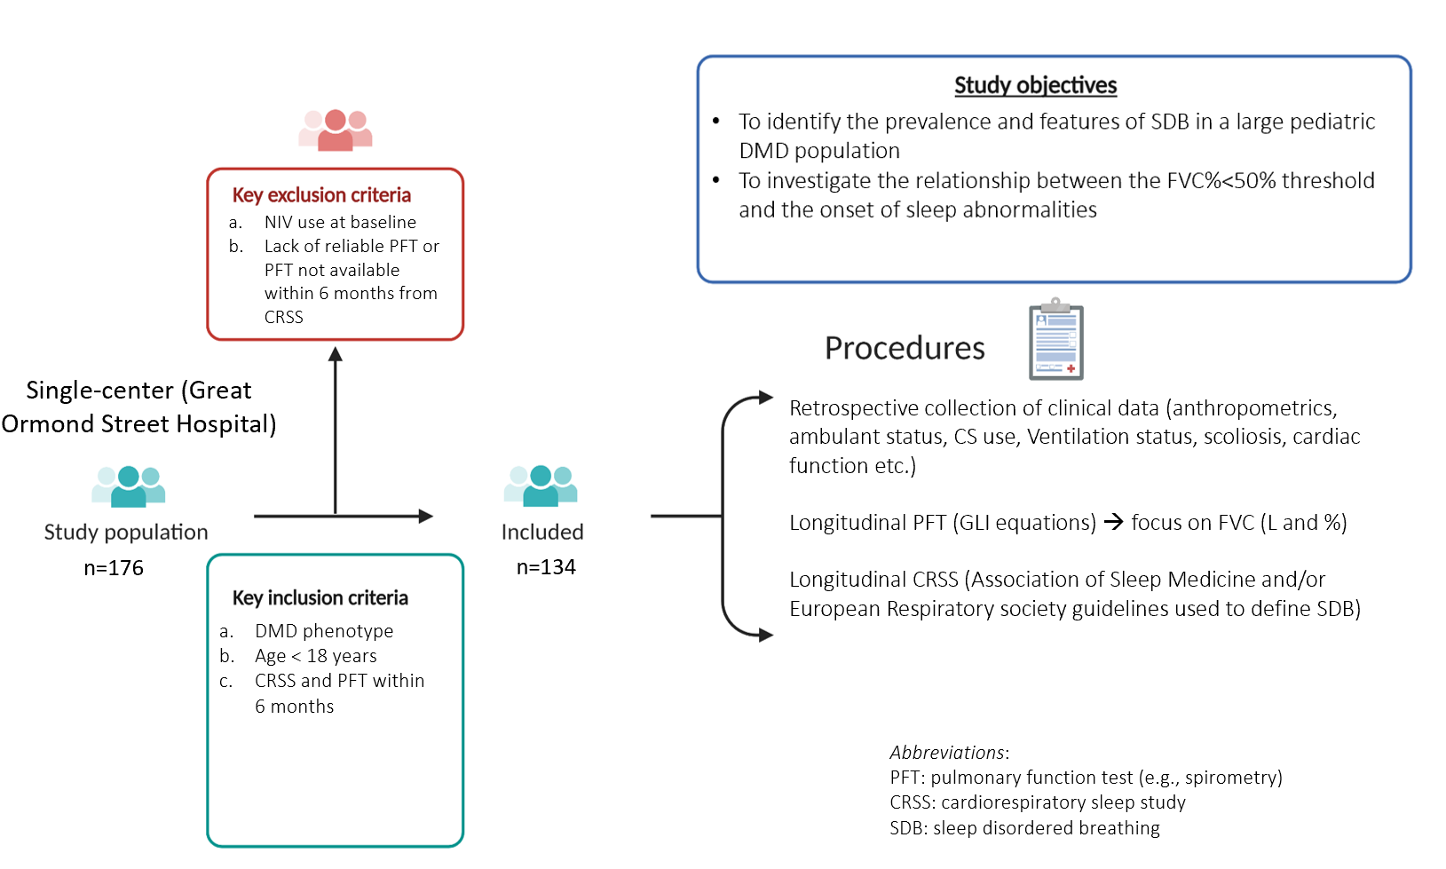
Figure 5.1. Schematic representation of study 3 design, including inclusion criteria, objectives and procedures

5.1.1. Patients’ selection process
Sixteen out of 176 screened patients (9%) were excluded because they could not perform a reliable spirometry. Additional 24 patients were excluded because they were either already on non-invasive mechanical ventilation (NMV) at the time of first sleep study (SS) or because spirometry was not conducted within 6 months as per inclusion criteria. Of these 24, 12 subjects had been started on NMV at a median age of 14.4 years.

5.1.2. Population characteristics
This study cohort comprises 134 DMD patients <18 years. 284 SS satisfied inclusion criteria (60 patients had 1 SS, 29 two SS, 24 three SS, and 21 more than four SS). The median (IQR) age at first and last sleep study was 13 years (11-15) and 15 years (13-16) respectively. A total of 1222 PFTs across a median period of 5.9 years (range 0-12.4) per subject were examined and 1217/1222 were considered reliable for analysis. The mean (SD) time between SS and its coupled PFT was 2.4 (1.3) months. Population characteristics are summarized in Table 5.1.

Table 5.1 Population Characteristics (respiratory cohort)
 | Patients (n 134)
Pulmonary function test - PFT (n 1222)
Age at first PFT, years  Mean (SD) | 9.7 (3.5)
Age at last PFT, years  Mean (SD) | 15.2 (2.6)
Cardiorespiratory sleep studies - SS (n 284)
Age at first SS, years  Mean (SD) | 12.9 (2.7); range 4.2-17.2
Age at last SS, years  Mean (SD) | 14.3 (2.6); range 6.3-17.8
Sleep study results, n (%)  CO2 retention:  Normal  NH  B-NH  n/a  Hypoxemia  OAHI>5 | 224 (79)  15 (5)  43 (15)  2 (1)  11 (4)  34 (12)
PFT results at the time of first SS  FVC L, mean (SD)  FVC %, mean (SD) | 1.88 (0.6); range 0.59-3.3  65 (20); range 17-111
PFT results at the time of last SS  FVC L, mean (SD)  FVC %, mean (SD) | 1.87 (0.8); range 0.59-3.9  53 (20); range 17-90
Ambulatory status at first SS, n (%)  Ambulatory  Non-ambulatory | 31 (23%)  103 (77%)
Ambulatory status at last SS, n (%)  Ambulatory  Non-ambulatory | 16 (12%)  118 (88%)
Estimated age at LOA*, years  Median (IQR) | 10.4 (9.3-12)
Corticosteroid use, n (%)  CS-naïve  CS-treated | 35 (26%)  98 (74%)
Genotype, n (%)  Deletions  Duplications  Point mutations  Frameshift  Promoter region  Undefined | 83 (62)  19 (14)  20 (15)  8 (6)  1 (1)  3 (2)

*Overall age at LOA was estimated using the Kaplan Meier method. Mean (SD) time between sleep study and related spirometry was 2.4 (1.5) months. Abbreviations: CS, corticosteroids; FVC, forced vital capacity; LOA, loss of ambulation; B-NH, borderline nocturnal hypoventilation, PFT pulmonary function test; oAHI, obstructive apnea-hypopnea index; SS, sleep study.

Estimated median age at LOA in CS-naïve (n=35) was 9.6 years (95% CI 9.1-10.1; IQR 8.8-10.6), in CS-treated patients (> 6 months) (n=98) the median age at LOA was 10.8 years (95% CI 10.4-11.2; IQR 9.7-12.7). One hundred and eighteen (88%) subjects lost ambulation before their last SS, 123 (92%) before their last PFT. At last SS, 27 (20%) subjects were CS-naïve, 27 (20%) had been previously treated with CS (“past”), 79 (59%) were still under CS-treatment.
Thirty-four patients (25%) were established on NMV after last SS, at a median age of 14.9 years.

5.1.3. Progression of respiratory function
As previously described, the progression of FVC%p in DMD follows a biphasic trajectory, with acquisition of a peak value in the first decade of life followed by a decline. Patients losing ambulation earlier displayed lower FVC L and % values at peak and achieved FVC L peak at a younger age (Figure S5.1).
FVC% decline towards clinically meaningful thresholds was then assessed. Overall, the estimated median (IQR) age when FVC% predicted fell below 60%, 50% and 40% was 15.1 (13.5-16.9), 16.2 (14.7-17.7) and 17.4 years (15.8-18.9), respectively. For each of the FVC% thresholds there was a significant relationship between age at LOA and median age at reaching the threshold (Figure 5.1 A-C; P <0.001). For FVC%<50 the median (IQR) age for group A, B, and C was 14.4 (13-15.2), 15.9 (14.8-17.5), and 17.7 years (17.5-18.1), respectively. After adjusting for CS treatment, differences between LOA groups remained unchanged. The overall estimated median (IQR) time from LOA to FVC<50% was 5.8 years (4.2-6.7), with no significant differences between LOA groups (P= 1.66) (Figure 5.1D).
Figure 5.2. Age at meeting specific FVC% thresholds in patients categorized according to the age at loss of ambulation. Kaplan-Meier curves representing time to FVC <60% (A), <50% (B), <40% (C) and time from loss of ambulation to FVC<50% (D) according to the age at LOA. Numbers at risk are expressed as absolute (%).
A subset of patients demonstrated a more rapid decline.
We observed that 23/134 subjects presented an unexpected drop of respiratory function (defined by a decline of >10% in FVC L and >20% of FVC% between two assessments occurring within a year). The drop occurred within a median of 8 months (IQR 6.5- 11.7 months) between subsequent assessments. Additional 9 subjects had a decline in FVC% > 10% /year. No significant change in height/ height measurement method accounted for such FVC% variation. For the former 23 patients, the median (IQR) age at FVC drop was 14.6 years (13-16.2), occurring at a median (IQR) of 5.5 years (3.2-7.2) after LOA. Median (IQR) FVC% before and after drop were 46.6% (30.8-58.9) and 31.4% (22.2-40.4). Eleven /23 individuals presented with cardiomyopathy at the age of drop, but ten had a normal cardiac fractional shortening (data not available in 2). The was no prevalence of a specific genotype in patients presenting with sudden drop of FVC L/% (Figure 5.2 A, B). LOA did not occur earlier in these 32 individuals compared to those who declined linearly.
Figure 5.3. Rapid FVC decline. Individual trajectories of FVC% (A) and FVC L (B) of the 32 patients identified as presenting a sudden rapid decline of respiratory function. FVC and FVC% are depicted with reference to time from loss of ambulation (LOA). To help visualize the different slope of progression compared to “average” DMD, we added a dotted line in Panel A representing what would be like the putative 6.1% annual decline previously reported in the literature.

5.1.4. Characterization of sleep disordered breathing
Overnight gas exchange - Hypoventilation
Fourteen patients (15/284 SS) were diagnosed with NH, eleven from their first available sleep study. All subjects were non ambulant, with a median (range) age at LOA of 9.4 years (6.6-11.7). The median (IQR) age at NH was 14.9 years old (14.2-16.3), with all but two outliers being in a late-non ambulatory stage (from 4.5 to 7.8 years after LOA). Median (IQR) FVC L and FVC % were 1.4 L (0.9-1.8) and 39% (26.9-63.9), respectively. Nine/14 subjects had severe scoliosis, and 2 moderate scoliosis (Cobb Angle 40 and 42°, respectively). Six/14 subjects were CS-naïve, 6 were past users, and only 2 were currently CS-treated. Ten out of 14 subjects had an underlying cardiomyopathy with a median (IQR) LVFS% of 23.5% (20.7-24.8). The median BMI at first study was 20.2 (range 6.6-37.9). Notably, none of the patients had a history of recurrent chest infections. Seven out of 14 subjects additionally had OSA (OAHI>5) with 3/7 with OAHI>10.
There were two outliers aged 11.2 and 11.5 years respectively who presented with NH in an early-non ambulant stage, in the absence of scoliosis and cardiac impairment. The first had OSA-associated NH, the second isolated NH with only REM-related central events.
Information regarding the presence/absence of a sudden decline in FVC was available in 10/14 individuals. If we exclude the two outliers, 5/8 subjects who developed NH presented a sudden decline of respiratory function before last sleep study.
Overnight gas exchange - Borderline nocturnal hypoventilation (B-NH)
A total of 31 patients (43 SS) met the criteria for borderline nocturnal hypoventilation (B-NH), at a median (IQR) age of 14.2 (12.4-15.8) years. In non-ambulant subjects, B-NH was detected at a median (IQR) of 4.2 (2-5.4) years after LOA. Seven patients with B-NH were still ambulant. In 26/43, B-NH was associated with significant respiratory events, 5 studies had OAHI>10, 3 CnAHI>5. Median (IQR) FVC L and FVC % were 1.7 L (1.2-2.3) and 59% (38.6-84.8), respectively.
Fifteen/31 patients showed no or only mild scoliosis, 4 had a moderate spinal curvature, 7 had severe spinal curvature, and 5 had previously received spinal fusion. Fifteen/31 patients were currently on CS, 9 were past users, and 6 were CS-naïve (including one 4.2-year-old boy who had not yet started CS). Ten out of 30 subjects (data not available in 1) had an underlying cardiomyopathy, with a median (IQR) LVFS% of 27.5% (22.8-29), and 13/24 patients were on cardiac medication (either ace-inhibitors or ace-inhibitors + beta blockers). The median (IQR) BMI at first study was 23.1 (16.6-27.1).
Overnight gas exchange - Hypoxemia
Ten patients (11 SS) had nocturnal hypoxemia as per criteria indicated in Table 7.4.1. Two had clusters of hypoxemia associated with obstructive events and B-NH. Two had prolonged hypoxemia associated with obstructive events (moderate and severe) without significant CO2 retention. None of the patients with hypoxemia had concomitant nocturnal hypoventilation (according to AASM criteria). Patients with hypoxemia without OSA (n=6) had median age 15.2 years (range 13.5-17.1), median FVC L 1.5 L (range 1.1-2.3), and median FVC% 49.4% (range 36.7-59). Three out of six patients had cardiomyopathy, 5 were on CS-treatment (1 past user), 4 had no or mild scoliosis and 2 had moderate scoliosis. The median BMI was 23.3 (range 22.7-27.8).
Respiratory events - OSA
A total of 26 patients (34 SS) were diagnosed with OSA based on the detection of OAHI>5, at a median (IQR) age of 14.1 years (11.6-15.2). In 2 patients OSA was diagnosed at 4.2 and 4.6 years old, respectively. In non-ambulant patients, OSA was detected at a median (IQR) of 3.5 (1.7-5.7) years after LOA. Five patients were still ambulant, and 10 were in an early non-ambulatory phase. Only 4 individuals reported daytime symptoms (information was available in 20). OSA was associated with B-NH and NH in 12 and 4 patients, respectively.
Median (IQR) FVC L and FVC % were 1.6L (1.3-2.0) and 58.3% (42.8-74.3), respectively. Fifteen / 26 patients showed no or only mild scoliosis, 2 had moderate scoliosis, 5 had severe spinal curvature, and 3 had previously received spinal fusion. Fifteen/26 patients were currently on CS, 4 were past users, and 7 were CS-naïve (including one 4.2-year-old boy who had not started CS yet). Ten out of 26 subjects had an underlying cardiomyopathy with a median (IQR) LVFS% of 24.5% (22.3-25.8), and 13/22 patients were on cardiac medication. The median (IQR) BMI at first abnormal sleep study was 23.6 (17.7-27.5).

5.1.5. Relationship between SDB and FVC%
Seventy-nine sleep studies out of 284 were recorded when patients showed an FVC% <50. In 66% of these, there was no significant alteration of gas exchange, in 20% there was B-NH, and in 14% there was NH. To establish the sensitivity and specificity of the FVC%<50 threshold in capturing NH we only considered the first available sleep study for each patient. Of the 132 first assessments, 107 were normal, 14 borderline (B-NH) and 11 abnormal (NH). If we consider normal/borderline vs abnormal (NH) the sensitivity of FVC<50% in picking up NH was 73% (8/11), specificity 86% (104/121), the positive predictive value (PPV) 32% (8/25), and negative predictive value (NPV) of 97% (104/107) (eTable 2). If we consider the accuracy of FVC<50% in detecting not only NH but also B-NH, PPV and NPV would be 44% and 87%, respectively.

Table 5.2 Matrix to calculate sensitivity, specificity, positive predictive value (PPV) and negative predictive value (NPV) of FVC<50% to indicate the presence of nocturnal hypoventilation (Only the first study of each patient was considered).
 | Disease (NH) | Normal (B-NH + normal)
Test + (FVC<50%) | 8 | 17 | 25 (tot Test +)
Test – (FVC>50%) | 3 | 104 | 107 (tot Test -)
 | 11 (tot disease) | 121 (tot normal)
Abbreviations: B-NH, borderline nocturnal hypoventilation; FVC, forced vital capacity; NH, nocturnal hypoventilation; tot, total; +, positive; -, negative

5.2. Considerations
The decline of respiratory function in DMD leads to the progressive alteration of nocturnal gas exchanges. Nocturnal hypoventilation, which can be effectively treated with NMV, usually represents the first manifestation. In DMD, NH results from rapid shallow breathing in supine position during sleep and the decrease in the ventilatory response to hypercapnia (Aboussouan, 2015). This initially affects rapid eye movement (REM) sleep, when the decline in central ventilatory drive is associated with diaphragm dependence and upper airway hypotonia (Hukins & Hillman, 2000). Importantly, not only NH may precede daytime hypercapnia by several years, but it contributes to its occurrence by desensitizing the response of central chemoreceptors to CO2-induced pH changes (Hall & Irvin, 2014).
Current guidelines include FVC%< 50 as an indication for NMV. This is based on experts’ opinion, considering such threshold as red flag of an increased risk of CO2 retention during sleep, (Birnkrant et al., 2018a; Sheehan et al., 2018) and also indirectly suggested by one study indicating that the odds of hypoventilation may increase by 20% for every 10% predicted reduction in FVC%. (Sawnani et al, 2015a) However, there is surprisingly limited published evidence on the correlation between PFT and the onset of NH and other SDB in DMD.
In the current study, we observed that almost one in two patients scoring FVC%<50 presents some degree of CO2 retention during sleep (i.e., ~30% had NH and ~ 20% borderline NH), with the odds of detecting an abnormal exam based on FVC<50% increasing by 12% when we expanded the criteria of NH to include borderline CO2 elevation. Both specificity and NPV for NH at first sleep study were above 85%, meaning that it is unlikely to find NH if a patient has an FVC value >50%. Indeed, around nine out of ten DMD boys presenting with FVC>50% had a normal overnight gas exchange but it is of note that 28% of patients with NH had FVC>50%. While these findings support the common practice prompting the initiation of NMV based on alteration of SS rather than FVC% alone, (Hoque, 2016) the key question that remains open is when to start screening patients for sleep abnormalities and which clinical parameters mandate a closer follow-up and a more pro-active approach.
While the detection of NH was mostly explainable by the functional status of these patients, most being late non-ambulant often with associated scoliosis and cardiomyopathy, we also observed exceptions. As an example, two boys presented with NH already at 11 years in the absence of significant comorbidities (only in one case NH was associated with significant obstructive events and FVC >60%). This is in agreement with a previous study suggesting that a specific sub-group of younger DMD patients might be at higher risk of early NH, for reasons that still need to be elucidated. (Sawnani et al., 2015a)
It is important to remark that the spectrum of sleep abnormalities in pediatric DMD is not fully deciphered. The current definition of NH itself by the American Academy of Sleep Medicine has limitations, being based on NH associated to OSA in healthy children. A recent experts consensus has therefore expanded the possible criteria to initiate NMV in DMD (Birnkrant et al., 2018a). We observed the presence of B-NH in around 10% patients referred to sleep studies for the first time, also in a milder stage of the disease (e.g., early-non ambulant, mild scoliosis, no cardiomyopathy). The most relevant factors contributing to the progression from B-NH to NH such as scoliosis (LoMauro et al., 2018), as well as the timing of progression itself, need to be identified and further analyzed in depth.
The trajectory of respiratory deterioration rather than single observations could be important. In DMD FVC (L) increases when patients are ambulant, plateaus during early non-ambulatory stages and subsequently declines, with a degree of variability among subjects. (Birnkrant & Carter; LoMauro et al., 2018) When considered as % of predicted, FVC peaks at a median age of 6-9 years, followed by a mean annual decline of 4-6.1%. (LoMauro et al., 2018; Mayer et al, 2015; McDonald et al., 1995; Meier et al., 2017; Miller et al, 1988; Trucco et al., 2020) There is increasing evidence that prolonged ambulation and CS-treatment are associated with a higher peak of FVC (L), FVC% (and Peak expiratory flow- PEF) and with an older age at which the threshold of FVC (L) < 1 L is achieved, although the rate of annual decline is thought to remain unchanged. (Humbertclaude et al, 2012; McDonald et al., 2018c; Trucco et al., 2020)
In keeping with what previously reported, we confirmed a strong association between the age at loss of ambulation, the peak value of both FVC L and % (the former occurring around 2 years after LOA), and the time at achieving significant FVC% thresholds.
Other aspects that should be considered are the phenotypic spectrum of the DMD population and different trajectories of clinical progression also observed regarding motor function. (Muntoni et al., 2019b) While the age at LOA, (Humbertclaude et al., 2012) absolute value of FVC (L) at peak,(McDonald et al., 1995) and different genotypes (Bello et al., 2020; Trucco et al., 2020; Trucco et al., 2022) have been variably associated with different rates of FVC% deterioration, their interplay on the subsequent decline is not fully understood. Additionally, it is likely that further and yet not well characterized factors contribute to these events. Indeed, while the rate of FVC% decline after LOA is often considered to be linear, (LoMauro et al., 2018) this might not be always the case, as demonstrated by the fact that nearly one fifth of our cohort displayed a sudden drop of respiratory function years after having lost ambulation. The determinants of such drop and whether patients presenting a sudden respiratory deterioration are the ones at higher risk of experiencing early NH need to be clarified in a prospective manner, with important consequences on the provision of a more tailored care to patients.
Despite NH being relevant as indicator for NMV establishment, the most common form of sleep disordered breathing in the ambulatory and early non-ambulatory stage of DMD is OSA. (Sawnani et al., 2015a; Suresh et al, 2005) Current guidelines indicate that reported symptoms (e.g., daytime sleepiness, reduced performance, morning headache) should warrant the execution of SS, when obstruction is suspected. (Sheehan et al., 2018) However, similar to what observed with nocturnal hypercapnia, (Bach & Martinez, 2011) patients with DMD very seldom report daytime symptoms in the presence of OSA (only 20% in this cohort). (Pabary et al, 2019)
Interestingly, we detected OSA later than previously reported. (Suresh et al., 2005) Possible explanations include the overall older age at first SS, the use of different criteria to define OSA and the fact that the events scored as obstructive in DMD might differ from the general population. This is particularly true in the second decade when, due to diaphragmatic dysfunction, pseudo central/diaphragmatic sleep disordered breathing is potentially diagnosed as obstructive. (Aboussouan, 2015; Khan & Heckmatt, 1994b) During REM sleep, the combination of reduction of airflow identified as apnea or hypopnea and the presence of out of phase residual movements of abdomen and chest are scored as obstruction at cardiorespiratory polygraphy (as per AASM criteria) but are in fact, particularly in children with intrinsic muscle weakness, the expression of an ineffective breath due to weakened diaphragm (Figure S5.2). Following a Delphi method approach, we subsequently developed novel criteria for the definition of diaphragmatic SDB in DMD and tested inter-rater reliability on the sub-cohort of patients originally recruited in this sub-study. Of note, the new definition led to the re-scoring and re-definition of a significant number of the 32 studies originally deemed as obstructive (Trucco et al, under second revision in Thorax).
It needs to be considered that in this study we use CRSS (i.e., level 3 sleep study) rather than full polysomnography for the diagnosis of pediatric SDB. This can have led to the underestimation of the severity of sleep apnea as respiratory events would be scored based on oxygen desaturations only and the ones leading to cortical arousals would not be scored.
In the context of OSA, CS-induced weight gain is understandably a major concern based on risk profiles observed in the adult population. Nevertheless, we found no significant correlation between OAHI and BMI, possibly reflecting a higher prevalence of diaphragmatic SDB in this population compared to younger cohorts. Further research to clarify the morbidity of obstructive SDB is warranted considering that “true” OSA is a well-established contributing factor to cardiovascular risk (including arrythmias, a potential cause of sudden death), at least in adults. (Sánchez-de-la-Torre et al, 2013) This is particularly relevant if we considered that reduced heart rate (HR) variability and higher resting average HR (Thomas et al, 2015) are common findings in DMD, although their genesis remains unclear.
There were several limitations in our study. First, although both SS and PFT results were prospectively recorded, additional data was retrospectively collected from case note review. Second, and most importantly for the main aim of the study, NH was detected only in a relatively small proportion of SS and this was a major shortcoming in creating a strong prognostic model. Moreover, NH was already present from the first available SS in 11/14 patients; as such, we might have overestimated the age at onset of NH. Third, there is no consensus regarding the definition of B-NH and also the definition of NH in the pediatric population is debated (Fauroux & Lofaso, 2005), and our results should be interpreted accordingly. Lastly, sleep events which are commonly reported as OSA following criteria created for healthy population might in fact represent diaphragmatic weakness.

6. DISCUSSION
Duchenne muscular dystrophy (DMD) is one of the most prevalent neurodegenerative disorders in children. Despite advancements in the understanding of molecular mechanisms and the development of several different therapeutic approaches, at present there is no cure for the disease. The path towards clinical trial readiness and development of effective treatments is characterized by different challenges. First, the need to better understand the biological reasons underlying the clinical variability observed in patients. Second, the necessity to refine the knowledge of the biomarkers required to capture changes within a specific time frame, which is usually narrow in interventional trials and variably sensitive according to disease stage. Third, the limited acknowledgement of the existence of subpopulations whose disease trajectory might deviate from the expected. In this PhD project, we aimed to expand and challenge the current knowledge regarding the natural history of DMD.
The clinical severity of patients with Dystrophinopathies is believed to be mainly determined by the so called “reading-frame rule”, namely if the underlying genomic rearrangement maintains or disrupts the reading frame of the gene. Duplication of exon 2 (Dup2), the most common DMD duplication accounting for up to 2% of total cases, is predicted out-of-frame. Accordingly, it has been historically associated with a complete loss of the dystrophin protein and a subsequent DMD phenotype (i.e., loss of ambulation <13 years). However, we identified a Dup2 patient who is still able to walk independently in his twenties and has not yet displayed the expected significant deterioration of respiratory and cardiac function. While the reason for this could derive from trans-acting genetic modifiers, we first wondered whether the duplication of exon 2, similarly to what already described in other mutations affecting the 5’ end of the transcript, could in fact be associated with a milder phenotype. We therefore conducted a retrospective cohort study on a large population of Dup2 patients recruited from 2 different nation-based networks (i.e., Italy and US). The main finding was that Dup2 patients collectively displayed an older age at LOA compared to a control group, even when only severe patients were selected for the analysis. The magnitude of the effect in individuals treated with CS was greater than expected, suggesting a possible specific action of corticosteroids at a molecular level, as discussed in chapter 3.2. Not only age at LOA was delayed by few years, but a subset of individuals (including index patient) presented with a remarkably milder phenotype, both in terms of motor and respiratory function (Zambon et al, 2022c).
The main limitation of this study was the absence of molecular data to correlate with clinical phenotype. As such, we started a prospective cohort study aimed at deep phenotyping patients and collecting/analyzing biological samples. We have so far recruited 24 patients. The first challenge is to obtain enough clinical data to allow a more refined, multidomain severity ranking that takes into account not only the age at LOA, but also upper limbs strength, gross motor function in younger still-ambulant patients, and cardio-respiratory function. Once such longitudinal characterization is completed, we will proceed with a stepwise approach to correlate phenotype with molecular data. Specifically, we will perform a DNA breakpoint analysis to fully characterize the duplication of exon 2. In particular, information regarding the size of the duplication and its type (e.g., in tandem duplication, complex genomic rearrangement, duplication that include intronic regions, etc.) will be obtained through WGS analysis and confirmed with Sanger sequencing. Moreover, WGS will be utilized to study currently known trans-acting genetic modifiers (see chapter 1.6.1). So far, 20 blood samples have been collected and a preliminary analysis on a subset of 10 patients have not yielded significant results. Muscle biopsy is currently not routinely performed for diagnosis in DMD, and it is not considered ethical to propose an invasive procedure in the context of an observational study. For this reason, we were only able to collect samples for 10/25 patients. Analysis of the mRNA transcripts and quantification of protein expression are ongoing.
One of the key challenges in the definition of disease severity in younger patients is the limited knowledge regarding long-term prognostic factors. Indeed, previous studies have mainly focused on medium-term trajectories of different functional measures and identified potential predictors of short-term outcome (see Chapter 4.2). In Study 2, we first demonstrated that both the NSAA and the time required to stand up from the floor (TRF) recorded in patients assessed at the age of expected peak of motor function (i.e., 7 years) are associated with the age at LOA. Furthermore, we provided a quantitative framework that allows to estimate the probability of being ambulant at 13 years given motor function at peak. This information not only is important in clinical setting as it is easily obtainable, but in the context of study 1b we can now provide evidence to support the definition of disease severity in younger patients. The flip of the coin is that a significant proportion of patients may lose ambulation within a time-frame typical of DMD, despite presenting with excellent motor performances at peak. This information is important because it conveys all the complexity underlying the disease, and the limitations of studies that categorize patients without a precise delineation of the criteria chosen to determine DMD vs IMD vs BMD. Moreover, in contrast to what previously reported, we suggest that the association of specific genotypes (e.g., mutations amenable to exon 53 skipping) with more severe phenotypes might not be as solid as proposed (Figure 4.4.). Lastly, in study 2 we found that there is a significant variability in the dose pro/Kg of CS administered to patients, despite current recommendations set by the standards of care. Such heterogeneity is likely to be even higher in patients who lost ambulation, considering the need to taper therapy in view of the increasing side effects observed in older patients. Although the meaning of this is not clear, it should be considered as a possible confounding factor in observational cohort studies (Zambon et al, 2022a).
As previously anticipated, the definition of clinical severity in patients with Dystrophinopathies should be fostered by the collection of clinical data that assess multiple domains. One critical aspect of the disease and important cause of morbidity is respiratory function. This is routinely measured in clinical setting by pulmonary function tests, with forced vital capacity (FVC) being deemed one of the most reliable measures to obtain information regarding both inspiratory and expiratory muscle strength. Change in FVC% is also commonly used as primary respiratory endpoint in interventional trials. The lower FVC/FVC%, the higher is the probability of respiratory failure, meaning a reduced ability to expel secretions, a higher risk of recurrent chest infection and, most importantly, a progressive alteration of gas exchanges. The latter are characterized by an initial increase in CO2 retention during sleep (in particular starting during REM-sleep), which in turns desensitize central chemoreceptors hence resetting central ventilatory drive, and is followed by daytime hypercapnia and hypoxia. Of note, there is very limited data that correlate FVC with the onset of nocturnal hypoventilation and other sleep related disorders. This is a critical point, as NH is considered one of the earliest markers of respiratory failure and can be successfully treated with non-invasive mechanical ventilation (NIV). In study 3, we described respiratory progression in a large cohort of patients and correlate this with the results of cardiorespiratory sleep studies (Zambon et al, 2022b). As discussed in Chapter 5.2, we mainly evaluated the accuracy of the currently used threshold of FVC%<50 as an indicator for initiating (NIV). In agreement with previous findings, we observed that the threshold of FVC <50% is achieved at a median age of 15-16 years in DMD. Moreover, its high negative predictive value means that it is unlikely to detect hypoventilation in patients with an FVC>50%. However, FVC alone may still fail to identify those patients who experience signs of respiratory failure or those who are at higher risk of progression towards NH. Our data shows that both lower FVC% values and severe scoliosis are associated with NH, but the FVC threshold of 50% is not accurate enough in predicting NH.
Of note, while the decline of FVC% is considered linear based on previous studies (4-6% per year), we found that up to a fifth of patients in fact present a more rapid and non-linear decline of respiratory function after losing ambulation. Which are the contributing factors and whether these patients are at higher risk of developing early NH and therefore should be promptly treated is yet to be established. Another important finding is that the definition as per the criteria of the American and European academies of sleep medicine of “obstructive sleep apnoeas”, which are common in DMD, cannot capture the complexity of sleep disordered breathing in this disease. As described in Figure S5.2 and previously suggested by other authors (Aboussouan & Mireles-Cabodevila, 2017), the alterations in sleep recordings subsequent to diaphragmatic weakness could be misclassified as “obstructive” but in fact be the expression of a different pathophysiological mechanism. Starting from the cohort of patients analyzed in Study 3, we subsequently performed a multi-step analysis to define new criteria for diapghragmatic SDB. This, if their reliability is confirmed in other populations, could be an important milestone in the characterization of respiratory progression in DMD and may represent a novel biomarker of early respiratory failure (Trucco et al, under review).
In conclusion, both in clinical setting and in translational research, there is still necessity to further elucidate the natural history and molecular mechanism underlying Dystrophinopathies. The opportunity to study a genetically homogeneous sub-population fully characterized both at clinical and biological level represents a unique model to confirm currently known disease modifiers and identify novel mechanisms that contribute to the modulation of phenotype. This PhD project further underlines the importance of a rigorous clinical characterization in view of the existence of a disease spectrum and all the possible confounding factors, before proceeding with the correlation with molecular data. Our findings can be applied both to refine the care of patients and the interpretation of clinical trials results.

7. MATERIALS AND METHODS

7.1 Study 1a: methods

7.1.1. Study design and selection of patients
In this cross-sectional retrospective observational study, subjects with a genetically confirmed duplication of exon 2 were identified through two different networks: the Italian DMD Network (Bello et al., 2012; Brogna et al, 2019b; D'Amico et al., 2017; Mercuri & Group, 2016) and the United Dystrophinopathy Project (UDP) database, a large genotype-phenotype consortium(Flanigan et al., 2013; Flanigan et al., 2009b; Flanigan et al, 2011a; Weiss et al., 2018). Both networks are large databases of demographic, clinical and genetic information of subjects with Dystrophinopathies. For the UDP, inclusion criteria include symptoms consistent with a dystrophinopathy along with either (a) an X-linked family history, and/or (b) absent or altered dystrophin expression on muscle biopsy, and/or (c) clinical genetic analysis that demonstrates a pathogenic variant in the DMD gene. Subjects enrolled without a defined mutation undergo genetic analysis as part of the project, and for all subjects, the DMD mutation is determined by complete interrogation of copy number for all exons, and sequencing of all exons in patients without exon copy number changes. There are no exclusion criteria. For the Italian network, enrollment is only dependent on a confirmed genetic diagnosis of dystrophinopathy and a willingness to participate. The UDP began enrollment in 2003 and the Italian DMD Network began enrollment in 2018. Any subject present in the database as of August 2020 was included.

7.1.2. Standard Protocol Approvals, Registrations, and Patient Consents
The work completed in this study has been approved by the Institutional Review Board at Nationwide Children’s Hospital (614 722 2708) under the “Translational Research in the Dystrophinopathies” protocol for the UDP cohort and the Ospedale San Raffaele Ethical Committee under the protocol “Banca-Inspe” for the Italian cohort. Consent has been obtained from each patient/subject or (for minor subjects) from their parents or guardians in order to obtain and analyze subject data.

7.1.3. Procedures
Data collected included age, survival status, clinical phenotypic characterization (DMD/IMD/BMD), ambulation status, functional status, disease-related complications, and corticosteroid use. When applicable, other experimental therapeutic agents were recorded. Clinical and genetic data were pseudoanonymized and entered into a secured database. After review of the clinical information a clinical classification of either DMD, IMD or BMD was assigned, based on previously published criteria: DMD (loss of ambulation at ≤ age 12); IMD (loss of ambulation between age 13 and age 15 (inclusive); and BMD (loss of ambulation at ≥ age 16)(Dent et al, 2005; Flanigan et al., 2009b). As these criteria are based upon age at loss of ambulation, classification in ambulant subjects was assigned by clinicians based upon a combination of clinical judgement and functional scores at last assessment (e.g., 6-minute walk test, North Star Ambulatory Assessment). Both of these outcome measures have been well characterized in DMD and one can determine if a certain time or score at a particular age is more characteristic of a DMD, IMD or BMD phenotype(McDonald et al, 2013a; McDonald et al, 2010; Muntoni et al, 2019a). Two subjects were too young (<4 years of age) for expert clinicians to establish a clinical classification. Data sources included both clinical evaluation reports from which data was extracted and research evaluations. When available, respiratory function was recorded as forced vital capacity percent predicted (FVC%p) at last visit. Cardiomyopathy was assessed by review of the clinical echocardiographic reports, and recorded as either present (defined as left ventricular ejection fraction, LVEF <55%) or absent (LVEF >55%) from clinical echocardiogram reports in each database. When available the first abnormal or last normal echocardiogram were also recorded. Lastly, subjects were grouped based on corticosteroid (CS) use as “CS-never” (never treated or treated for <6 months, consistent with earlier usage(Flanigan et al., 2013; Weiss et al., 2018)) and “CS-ever” (received at least 6 months of corticosteroid treatment prior to loss of ambulation (LOA) or last evaluation timepoint).
As a natural history group for comparison of age at LOA, the same data was extracted from 618 subject records in the UDP database with a known of date of LOA, a clinical diagnosis of DMD, and completely characterized steroid treatment status; this subset was considered our dystrophinopathy control group. Subjects were excluded from this comparator group if they had duplications of exon 2, or other pathogenic variants known to be associated with an ameliorated phenotype, including deletion of exons 3-7 or deletion in the rod domain in which low-level endogenous skipping of exon 44 may occur(Bello et al., 2016b).

7.1.4 Statistical analysis
Group comparisons were evaluated using chi-square or Fisher’s exact tests for categorical variables, Wilcoxon rank sum tests or Kruskal-Wallis tests for continuous variables. For time to event variables (age at loss of ambulation) Cox proportional hazards regression with log-rank tests were used. For those who were still ambulant, their time was censored at their last recorded visit. All analyses were conducted using R for Statistical Computing. Results were considered significant when p.value <0.05.

7.2. Study 1b: methods

7.2.1. Study design and patients’ selection
This is an observational, retrospective and prospective multicenter longitudinal study to characterize the Italian DMD Dup2 population and identify possible prognostic/predictive markers. As the prevalence of DMD in the general population is estimated in 2,8 cases/10,000, and Dup2 is estimated as 1-2% of all DMD population, we expected to identify in Italy 18-36 patients. To fulfil this goal, all the 15 Italian tertiary Centers for neuromuscular disorders were contacted and those following Dup2 DMD patients were included in the study.
Pediatric and adult DMD patients harboring a genetically confirmed duplication of the exon 2 in the dystrophin gene who have signed informed consent were included in the study. Patients lacking genetic confirmation of Dup2 mutation were excluded. The study DUP2-DMD is funded by Telethon (Principal Investigator: Dr Stefano Previtali). Eighteen patients included in the prospective cohort study were previously analyzed in the retrospective study 1a.

7.2.2. Procedures
Clinical assessments
All the clinical procedures are part of the standard of care applied in patients affected by DMD. Patients are assessed every 6 months when ambulant, every 12 months after losing ambulation. The results of investigations or functional assessments will be retrospectively collected by clinical notes when available and prospectively recorded when patients attend Tertiary Centers during scheduled follow-up. In particular, functional exercise capacity and mobility will be assessed in all individuals by means of the ambulatory status, the 6MWT and the NSAA. For the 6MWT, the total distance travelled, in meters, will be recorded along with the validity of the test as assessed by the test administrator. The NSAA is to be performed by qualified, trained staff. The NSAA is a scale that rates patient performance on various functional activities. It was designed to be used in boys with DMD who are able to stand and has been used in young boys with DMD. During this assessment, patients perform 17 different functional activities, including a 10-meter walk/run; rising from a sit to stand, standing on one leg, climbing a box step, descending a box step, rising from lying to sitting, rising from the floor, lifting the head, standing on heels, and jumping. Patients will be graded as follows: 2 = normal, no obvious modification of activity; 1 = modified method but achieves goal independent of physical assistance from another; and 0 = unable to achieve goal independently. Spirometry will be performed according to the European Respiratory Society guidelines by qualified respiratory therapists. FVC% predicted will be calculated using predicted equations from the Global Lung Function Initiative (GLI), including those observations performed prior to the implementation of GLI or retrospectively collected. Tests will be conducted in the sitting position, over 10-30 minutes, allowing for patient recovery. We will exclude measurements that did not meet reproducibility standards. Echocardiogram: transthoracic echocardiogram will be performed according to standard techniques by a trained cardiologist. We will collect measures including ejection fraction and fractional shortening, expressed as %. Blood samples will be collected in concomitance of phlebotomy already scheduled for regular blood tests (such as Vitamin D). Informed consent for genetic testing will be obtained before whole exome sequencing. Urinary-stem cells will be collected from the morning fresh urine of Dup2 patients and processed as published.
Muscle Biopsies
Muscle biopsies from healthy subjects and Dup2 DMD patients have been already collected under each local ethical regulation (UNIFE Ethical Committee approval N. 9/2005, 25/10/2005)
Cells
Urinary-Stem cells (USCs) will be obtained from fresh morning urine of Dup2 DMD patients whose muscle biopsy will be not available. All individuals will sign informed consent before urine collection (UNIFE Ethical Committee approval N. 66/2020, 23/01/2020). Cells will be isolated and cultured from urine specimens as previously described (Falzarano et al, 2016; Falzarano et al, 2021).
RNA analysis
Total RNA will be extracted from DMD skeletal muscle and USCs using the RNeasy-kit, and reverse transcribed into cDNA using random primers and the High-Capacity cDNA Reverse Transcription Kit (Applied Biosystems). RT-PCR will be performed on β-actin to verify cDNA synthesis. The DMD transcript analysis will be performed by FluiDMD cards (Bovolenta et al, 2012) that profile all exon-exon junctions of the 79 exons of the DMD transcript, including the DMD isoform promoter and/or first exon unique regions (B, M, P, Dp260, Dp140, Dp116, Dp71). FluiDMD cards will be run on an Applied Biosystems real-time 7900HT appliance (Thermo Fisher Scientific). The cycle threshold (Ct) values obtained for all exon junctions and DMD isoform systems will be normalized by using human b-actin as the housekeeping gene (?Ct = Ct exon junction system – Ct b-actin). PCR products will be quantified with the Agilent high sensitivity DNA kit (Agilent) on an Agilent 2100 Bioanalyzer according to the manufacturer's instructions (Hiller et al, 2018). The percentage of each DMD transcript variant will be calculated as the ratio of DMD transcript variant and total DMD transcripts, according to the formula: DMD transcript variant % = (molarity transcript variant)/(Total DMD transcripts) x 100%.
WGS (Whole genome sequencing)
Total DNA will be extracted from enrolled patients’ peripheral blood using QiASymphony automation. Genome capture kit (Illumina) will be used to enrich the whole human genome and sequenced by using NextSeq2000 illumina platform. Output data files will be delivered in standard file formats: FASTQ, BAM, VCF, CNS and Excel. DMD gene annotated sequences will be interrogated to evaluate the full gene configuration and the presence of all variation types (including complex rearrangements), as described (Nallamilli et al., 2021). The variants and regions will be annotated with tens of data sources including genomic location (dbSNP, gene/transcript biotype, gene name, transcript, etc.), functional annotation (synonymous/non-synonymous, splice sites, amino acid affected, impact, etc.), population frequencies (general and population specific gnomAD, ExAC, 1000G, EVS, etc.), known pathogenicity (ClinVar, local databases), effect prediction (CADD, Mutation Taster, polyphen2, SIFT, SnpEff, etc.) and conservation and variation intolerance scores (gerp++, phylop, phastCons, and RVIS).

7.2.3. Statistical plan
All patients known to harbour a Dup2 mutation in the DMD gene will be included in the study. We will collect demographics, clinical phenotypic characterization (DMD/IMD/BMD), ambulation status, functional status, disease-related complications, and corticosteroid use. When applicable, other experimental therapeutic agents will be recorded. We will consider the following respiratory measures: FVC (L) and FVC%. When possible, we will calculate the age at FVC% falling below 50. Cardiac function will be recorded by either report of cardiomyopathy (yes/no) in the database, or when available, either first abnormal or last normal echocardiogram. Lastly, subject will be classified based on corticosteroid (CS) use as “CS-naïve” (never treated or treated for <6 months and “CS current” (under treatment or stopped since <1 year before last visit/LoA) and “past” (not under treatment, but previously treated for >6 months) according to CS exposure. The primary clinical endpoint is time to loss of ambulation (LOA). Secondary endpoints include the characterization of DNA breakpoints in mild vs severe phenotypes and the change over time of the following functional measurements:
a. Motor function: The 6 Minute Walk test (6MWT) and North Star Ambulatory Assessment (NSAA) including sub-items such as Time to Rise from the floor.
b. Respiratory function: Forced Vital Capacity (FVC) Liters (L) and % of predicted; time to FVC% <50%. Time to Nocturnal Ventilation initiation.
c. Cardiac function: Left ventricular ejection fraction (EF) as measured by echocardiogram.
Descriptive statistics will be generated for all measures, mean and standard deviation will be used for normally distributed data and median, IQR for skewed data. Categorical data will be summarized as frequency and percentages. Group comparisons will be evaluated using chi-square or Fisher’s exact tests for categorical variables, Wilcoxon rank sum tests or Kruskal-Wallis tests for continuous variables, and log-rank tests for time-to event variables (age at loss of ambulation (LOA)). All analyses will be conducted using R for Statistical Computing or SPSS. Results will be considered significant when p. value <0.05.

7.3. Study 2: methods

7.3.1. Study design selection of patients
This is a retrospective cohort study on patients affected by Duchenne muscular dystrophy, whose data was prospectively collected according to a pre-defined protocol. Through the DMD UK NorthStar Network (a national network of 23 UK neuromuscular centres) database, patient data meeting the following criteria were included in the analysis: a) at least one visit > 8 years, b) at least 3 years of follow-up, c) at least 2 visits recorded in the dataset, d) availability of at least one NSAA score recording between 6 years and 7 years 6 months of age. The reason why we selected criterion “d” was that previous studies showed that NSAA is expected to peak between 6.3 and 7 years of age (Muntoni et al., 2019b; Ricotti et al., 2016b) and, more precisely, at a mean age (SD) of 6.8 (0.7) years (Chesshyre et al., 2021). Patients exposed to drugs potentially impacting on LOA (e.g., Ataluren, exon skipping) and patients with substantial learning difficulties unable to collaborate with the assessment were excluded (North Star collects prospectively substantial learning difficulties affecting the possibility to perform a reliable assessment)

7.3.2. Procedures
The following variables were collected and reviewed: date of birth, height, weight, DMD gene mutation (thereafter genotype), CS-treatment, NSAA total score and TRF, age at LOA (defined by the inability to walk 10 steps independently), age at last ambulant visit (for those still ambulant or those lacking information regarding age at LOA), presence of long bone fractures near to the age at LOA. DMD genotypes were grouped according to amenability to specific exon skipping as those which have already achieved clinical application or are in advanced pre-clinical studies.
NorthStar Ambulatory Assessment and functional scores
The NSAA is a validated, 34-points, functional scale, developed for ambulant boys with DMD. The scale is suitable for multicentric studies and is widely used in clinical settings and as primary or secondary endpoint in clinical trials (Mayhew et al, 2011; Mendell et al, 2020; Miller et al, 2020; Ricotti et al., 2016b). The NSAA includes 17 items, 2 of which are timed. Specifically, we analysed TRF, measured in seconds (s) (Scott et al, 2012). The highest NSAA score recorded within the 6 years-7 years 6 months window (and its concomitant TRF recording) was used as baseline measurement.
Corticosteroid exposure calculation
Longitudinal CS treatment was reviewed for each patient. CS type, regime and dose per kg for each visit were recorded. We defined CS-regime as “predominantly daily” or “predominantly intermittent” when one regimen was used for >50% of time before LOA. According to DMD guidelines, the recommended daily dose pro kilo for prednisolone and deflazacort is 0.75 mg/kg and 0.9 mg/kg, respectively. In clinical practice though, CS dose and regimens are often adjusted due to side effects (e.g., weight gain, behavioural changes). This is not always clearly depicted in previous studies where information is often limited to CS exposure “yes or no” or CS regimen used. We therefore calculated the CS dose pro-kilo at baseline expressed as % of the optimal dose, namely 0.75 mg/kg and 0.9 mg/kg for prednisone and deflazacort, respectively.

7.3.3. Statistical analysis
Descriptive statistics, including mean, standard deviation or median and IQR were generated for all continuous measures as appropriate and categorical data was summarized as frequency and percentage. Spearman correlation test was used to determine correlation for skewed variables. Log-rank tests and Cox regression analysis was used to explore the relationship between patient baseline characteristics and age at loss of ambulation (LOA). For those patients who had not yet lost ambulation, we used their age at last ambulant visit as a censored measure. The proportional hazard assumption was checked for all models.
We performed univariate analysis to explore the relationship between the following baseline characteristics and age at loss of ambulation: NSAA score (first as actual NSAA and then categorised as <22, 22-25, 26-28, 29-31, and 32-34), TRF (first as actual TRF and then categorised as ≤3.5 s, 3.6-5 s, >5 s), CS regimen at baseline (intermittent vs daily), and genotype. Patients amenable to two different exon skipping were included in both groups (e.g., exon 44 and 55, exon 51 and 53, and exon 50 and 52 – Figure 4.4.). To aid interpretation of results, we established NSAA and TRF categories based on clinical meaningfulness, namely intervals that reflect a significant functional difference. Only those measures that were significantly associated with LOA in the univariate analysis or are known to be clinically meaningful were included in the multivariable analysis (namely, NSAA, TRF and CS regimen). For multivariable analysis results, we present hazard ratio and 95% CIs and use a single reference category to calculate hazard ratios. In addition, we present probability estimates for age at loss of ambulation with 95%Cis. All analyses were conducted using R for Statistical Computing. Results were considered significant when p. Value <0.05.

7.4. Study 3: methods

7.4.1. Study Design and selection of patients
This is a retrospective cohort study conducted on pediatric patients (<18years) affected by DMD. We included all subjects with a consistent phenotype, a pathologic DMD variant expected to lead to a DMD phenotype, and/or absence of dystrophin on muscle biopsy at immunohistochemistry (IHC). All patients performed at least one cardiorespiratory SS at Great Ormond Street Hospital (London) between 2010-2020. We ultimately considered patients with SS performed before NMV initiation and within 6 months from the first available PFT, a timeframe which was considered reasonable in view of the expected annual decline in FVC%.

7.4.2. Standard Protocol Approvals, Registrations, and Patient Consents
This study was registered as clinical audit (Ref number 2871) in agreement with Great Ormond Street Hospital trust guidelines and approved by the Institutional Review Board. The ethics board determined that participant consent was not required for a registered audit.

7.4.3. Procedures
PFTs are routinely collected on DMD patients attending clinics (every 6-12 months, according to the standard of care); raw data are prospectively and automatically stored in a secured database. This dataset was used to obtain the following variables: age at achievement of specific FVC% thresholds and peak of FVC L/%.
Raw data extracted from sleep studies are prospectively stored in a separated secured database. Importantly, the definitions for respiratory events used for scoring purposes and summarized in Table 1 were retrospectively applied based on both raw parameters (e.g., AHI, CO2 levels etc.) and sleep study reports. From clinical records, we retrieved information at the time of every sleep study including age, weight, height, BMI, ambulation status, corticosteroid (CS) treatment, cardiac function and treatment, scoliosis (severity defined as mild <20°, moderate 20-44°, severe ≥45°, when Cobb Angle was available), and spinal fusion. Information regarding genotype, age at LOA, age at NMV initiation/indication for NMV, presence of behavioral problems or learning difficulties and age at CS initiation were also collected. PFTs parameters were imported from the first dataset.
Pulmonary Function Test
Spirometry was performed according to the Pediatric ARTP Standards by specialist pediatric physiologists.(Sylvester et al, 2020) FVC% predicted was calculated using predicted equations from the Global Lung Function Initiative (GLI), including those observations performed prior to the implementation of GLI in our centre.(Quanjer et al., 2012) Tests were conducted in the sitting position, over 10-30 minutes, allowing for patient recovery. We considered the longitudinal trajectory of the following measures: FVC (L) and FVC%. Where possible (namely, when we had multiple longitudinal measurements), we calculated the age at FVC% predicted < 60/50/40 (representing progressive thresholds of restrictive respiratory impairment commonly considered in clinical practice), the peak value of FVC (L) and FVC% (which are expected to occur between 10-14 years and 7-9 years, respectively) and age when achieved. (LoMauro et al., 2018)
Sleep study
The presence and severity of sleep disordered breathing was assessed via a cardiorespiratory sleep study coupled with transcutaneous (tc) capnography. Sleep studies are not routinely performed in all DMD boys and indications for sleep study may include the presence of symptoms suggestive for hypoventilation/obstruction, pre-surgical screening, occurrence of severe chest infection, low FVC% values, or baseline screening after losing ambulation. However, information regarding the indication for sleep study was not available for every single patient. Further details regarding the device we used are provided in eMethods in the Supplement. We applied criteria to define respiratory events as indicated in Table 1. Specifically, hypoventilation was defined as carbon dioxide >6.7 kPa (>50 mmHg) for >25% of the recorded night as per American Association of Sleep Medicine (AASM) rules.(Berry R.; Brooks R; Gamaldo CE; Harding, 2015; Berry et al, 2012) The OAHI threshold of 5 (instead of 1) was used to define clinically significant OSA, as per AASM and European Respiratory society (ERS) guidelines indicating that when OAHI is above 5, OSA is unlikely to resolve spontaneously and the child is at risk for morbidity (i.e. needing closer follow-up, or initiation of treatment in presence of symptoms/other comorbidities). (Kaditis et al, 2016) We used the International Classification of Sleep Disorders (ICSD-3) criteria to define central apnea (namely, CnAHI≥5 and CnAHI >50% of the total AHI). To define isolated hypoxemia, we selected an adapted threshold that has been considered clinically meaningful in previously published pediatric populations (Amaddeo et al, 2016). As there is no consensus regarding the definition of borderline-hypoventilation, we applied the criteria indicated in Table 7.4.1.

Table 7.4.1 Sleep study criteria
Definition of SDB | Criteria
Alteration of gas exchange
Nocturnal Hypoventilation (NH) | tcCO2 >50 mmHg for >25% of total sleep time (TST) (Berry et al., 2012)
Borderline nocturnal hypoventilation (B-NH) | Mean tcCO2 levels 45-50 mmHg  and/or  tcCO2> 50 mmHg≤25% of TST (namely, not meeting NH criteria)
Hypoxemia | Mean SpO₂ <94%  and/or  SpO₂ <90% for ≥2% of TST
Respiratory Events
Clinically meaningful Obstructive sleep apnea (OSA) | OAHI > 5 (Severe if OAHI>10)(Kaditis et al., 2016)
Central apneas | CnAHI≥5 and CnAHI >50% of the total AHI

Table legend: Criteria to define gas exchange abnormalities and respiratory events. With the exception of NH and B-NH, such criteria were not mutually exclusive. Abbreviations: AHI, Apnea-hypopnea index. Cn, central; CO, carbon oxide; OAHI, obstructive Apnea-hypopnea index; OSA, obstructive sleep apnea; SpO2, oxygen saturation; TST, total sleep time.
Definition of LOA groups
To correlate age at LOA with the achievement of specific FVC% thresholds, we categorized patients according to the age at LOA ≤ 9.3 years (Group A), 9.3<LOA<12.0 (Group B), LOA ≥12 years (Group C), and ambulant patients at last follow-up (FU) (Group D). The cut-offs of 9.3 and 12 years represent the 1st and 3rd quartile, respectively, of the estimated age at LOA in this cohort, calculated with Kaplan Meier method. The division in 3 groups rather than 4 was chosen to be more representative of “classic” DMD phenotype vs extremes.

7.4.4. Statistical analysis
Descriptive statistics are presented for all measures, mean and standard deviation were used for normally distributed data and median, IQR and range for skewed data. Categorical data were summarized as frequency and percentage. Individual FVC trajectories were plotted as line charts. Kruskal Wallis was used to compare median values between groups (e.g., LOA groups, NIV indication). Kaplan-Meier method was used to estimate median (IQR or 95% CI) time to event for pre-specified FVC% thresholds. Log-rank tests and Cox regression analysis were used to explore the relationship between LOA groups and time at the achievement of specific FVC% thresholds (i.e., <60/50/40). Multivariable Cox regression analysis was used to adjust for the effect of CS-treatment for those patients who had not achieved such “milestones”, we used their age at last PFT as a censored measure.
To establish the sensitivity, specificity, positive predictive value (PPV) and negative predictive value (NPV) of the FVC%<50 threshold to detect NH we considered the first available sleep study for each patient. To describe the prevalence of DMD-related complications (e.g., scoliosis, cardiomyopathy etc.) and concomitant treatments at the time of an abnormal sleep study, we selected the first study in which NH, B-NH, OSA, or hypoxemia were detected for each patient.
We used Stata, R and SPSS software for statistical analysis and a P value < 0.05 was considered significant for all analyses.

REFERENCES
Aboussouan LS (2015) Sleep-disordered Breathing in Neuromuscular Disease. American journal of respiratory and critical care medicine 191: 979-989
Aboussouan LS, Mireles-Cabodevila E (2017) Sleep-Disordered Breathing in Neuromuscular Disease: Diagnostic and Therapeutic Challenges. Chest 152: 880-892
Amaddeo A, Moreau J, Frapin A, Khirani S, Felix O, Fernandez-Bolanos M, Ramirez A, Fauroux B (2016) Long term continuous positive airway pressure (CPAP) and noninvasive ventilation (NIV) in children: Initiation criteria in real life. Pediatr Pulmonol 51: 968-974
Anthony K, Cirak S, Torelli S, Tasca G, Feng L, Arechavala-Gomeza V, Armaroli A, Guglieri M, Straathof CS, Verschuuren JJ et al (2011) Dystrophin quantification and clinical correlations in Becker muscular dystrophy: implications for clinical trials. Brain : a journal of neurology 134: 3547-3559
Arnett AL, Konieczny P, Ramos JN, Hall J, Odom G, Yablonka-Reuveni Z, Chamberlain JR, Chamberlain JS (2014) Adeno-associated viral (AAV) vectors do not efficiently target muscle satellite cells. Molecular therapy Methods & clinical development 1: 14038-
Ashwath ML, Jacobs IB, Crowe CA, Ashwath RC, Super DM, Bahler RC (2014) Left ventricular dysfunction in duchenne muscular dystrophy and genotype. The American journal of cardiology 114: 284-289
Bach JR, Martinez D (2011) Duchenne muscular dystrophy: continuous noninvasive ventilatory support prolongs survival. Respiratory care 56: 744-750
Barber BJ, Andrews JG, Lu Z, West NA, Meaney FJ, Price ET, Gray A, Sheehan DW, Pandya S, Yang M, Cunniff C (2013) Oral Corticosteroids and Onset of Cardiomyopathy in Duchenne Muscular Dystrophy. The Journal of Pediatrics 163: 1080-1084.e1081
Barnard AM, Willcocks RJ, Triplett WT, Forbes SC, Daniels MJ, Chakraborty S, Lott DJ, Senesac CR, Finanger EL, Harrington AT et al (2020) MR biomarkers predict clinical function in Duchenne muscular dystrophy. Neurology 94: e897-e909
Barp A, Bello L, Politano L, Melacini P, Calore C, Polo A, Vianello S, Sorarù G, Semplicini C, Pantic B et al (2015) Genetic Modifiers of Duchenne Muscular Dystrophy and Dilated Cardiomyopathy. PLoS One 10: e0141240
Bello L, D'Angelo G, Villa M, Fusto A, Vianello S, Merlo B, Sabbatini D, Barp A, Gandossini S, Magri F et al (2020) Genetic modifiers of respiratory function in Duchenne muscular dystrophy. Annals of clinical and translational neurology 7: 786-798
Bello L, Flanigan KM, Weiss RB, Spitali P, Aartsma-Rus A, Muntoni F, Zaharieva I, Ferlini A, Mercuri E, Tuffery-Giraud S et al (2016a) Association Study of Exon Variants in the NF-κB and TGFβ Pathways Identifies CD40 as a Modifier of Duchenne Muscular Dystrophy. American journal of human genetics 99: 1163-1171
Bello L, Gordish-Dressman H, Morgenroth LP, Henricson EK, Duong T, Hoffman EP, Cnaan A, McDonald CM (2015) Prednisone/prednisolone and deflazacort regimens in the CINRG Duchenne Natural History Study. Neurology 85: 1048-1055
Bello L, Morgenroth LP, Gordish-Dressman H, Hoffman EP, McDonald CM, Cirak S (2016b) DMD genotypes and loss of ambulation in the CINRG Duchenne Natural History Study. Neurology 87: 401-409
Bello L, Pegoraro E (2019) The "Usual Suspects": Genes for Inflammation, Fibrosis, Regeneration, and Muscle Strength Modify Duchenne Muscular Dystrophy. J Clin Med 8
Bello L, Piva L, Barp A, Taglia A, Picillo E, Vasco G, Pane M, Previtali SC, Torrente Y, Gazzerro E et al (2012) Importance of SPP1 genotype as a covariate in clinical trials in Duchenne muscular dystrophy. Neurology 79: 159-162
Berry R.; Brooks R; Gamaldo CE; Harding SL, RM; Marcus, CL; and Vaughn BV; for the American Academy of Sleep Medicine, 2015. The AASM Manual for the Scoring of Sleep and Associated Events: Rules, Terminology and Technical Specifications, Version 2.2 ed.
Berry RB, Budhiraja R, Gottlieb DJ, Gozal D, Iber C, Kapur VK, Marcus CL, Mehra R, Parthasarathy S, Quan SF et al (2012) Rules for scoring respiratory events in sleep: update of the 2007 AASM Manual for the Scoring of Sleep and Associated Events. Deliberations of the Sleep Apnea Definitions Task Force of the American Academy of Sleep Medicine. Journal of clinical sleep medicine : JCSM : official publication of the American Academy of Sleep Medicine 8: 597-619
Berry SE (2015) Concise review: mesoangioblast and mesenchymal stem cell therapy for muscular dystrophy: progress, challenges, and future directions. Stem cells translational medicine 4: 91-98
Bez Batti Angulski A, Hosny N, Cohen H, Martin AA, Hahn D, Bauer J, Metzger JM (2023) Duchenne muscular dystrophy: disease mechanism and therapeutic strategies. Front Physiol 14: 1183101
Bhattarai S, Li Q, Ding J, Liang F, Gusev E, Lapohos O, Fonseca GJ, Kaufmann E, Divangahi M, Petrof BJ (2022) TLR4 is a regulator of trained immunity in a murine model of Duchenne muscular dystrophy. Nat Commun 13: 879
Birnkrant DJ, Ararat E, Mhanna MJ (2016) Cardiac phenotype determines survival in Duchenne muscular dystrophy. Pediatr Pulmonol 51: 70-76
Birnkrant DJ, Bello L, Butterfield RJ, Carter JC, Cripe LH, Cripe TP, McKim DA, Nandi D, Pegoraro E (2022) Cardiorespiratory management of Duchenne muscular dystrophy: emerging therapies, neuromuscular genetics, and new clinical challenges. The Lancet Respiratory medicine 10: 403-420
Birnkrant DJ, Bushby K, Bann CM, Alman BA, Apkon SD, Blackwell A, Case LE, Cripe L, Hadjiyannakis S, Olson AK et al (2018a) Diagnosis and management of Duchenne muscular dystrophy, part 2: respiratory, cardiac, bone health, and orthopaedic management. The Lancet Neurology 17: 347-361
Birnkrant DJ, Bushby K, Bann CM, Apkon SD, Blackwell A, Brumbaugh D, Case LE, Clemens PR, Hadjiyannakis S, Pandya S et al (2018b) Diagnosis and management of Duchenne muscular dystrophy, part 1: diagnosis, and neuromuscular, rehabilitation, endocrine, and gastrointestinal and nutritional management. The Lancet Neurology 17: 211-212
Birnkrant DJ, Bushby K, Bann CM, Apkon SD, Blackwell A, Brumbaugh D, Case LE, Clemens PR, Hadjiyannakis S, Pandya S et al (2018c) Diagnosis and management of Duchenne muscular dystrophy, part 1: diagnosis, and neuromuscular, rehabilitation, endocrine, and gastrointestinal and nutritional management. The Lancet Neurology 17: 251-267
Birnkrant DJ, Bushby K, Bann CM, Apkon SD, Blackwell A, Colvin MK, Cripe L, Herron AR, Kennedy A, Kinnett K et al (2018d) Diagnosis and management of Duchenne muscular dystrophy, part 3: primary care, emergency management, psychosocial care, and transitions of care across the lifespan. The Lancet Neurology 17: 445-455
Birnkrant DJ, Carter JC Cardiopulmonary phenotypic variability and discordance in Duchenne muscular dystrophy: Implications for new therapies. Pediatr Pulmonol n/a
Birnkrant DJ, Carter JC (2021) Cardiopulmonary phenotypic variability and discordance in Duchenne muscular dystrophy: Implications for new therapies. Pediatr Pulmonol 56: 738-746
Bladen CL, Salgado D, Monges S, Foncuberta ME, Kekou K, Kosma K, Dawkins H, Lamont L, Roy AJ, Chamova T et al (2015) The TREAT-NMD DMD global database: Analysis of more than 7,000 duchenne muscular dystrophy mutations. Human Mutation 36: 395-402
Bönnemann CG, Belluscio BA, Braun S, Morris C, Singh T, Muntoni F (2023) Dystrophin Immunity after Gene Therapy for Duchenne's Muscular Dystrophy. N Engl J Med 388: 2294-2296
Bovolenta M, Scotton C, Falzarano MS, Gualandi F, Ferlini A (2012) Rapid, comprehensive analysis of the dystrophin transcript by a custom micro-fluidic exome array. Hum Mutat 33: 572-581
Brogna C, Coratti G, Pane M, Ricotti V, Messina S, D'Amico A, Bruno C, Vita G, Berardinelli A, Mazzone E et al (2019a) Long-term natural history data in Duchenne muscular dystrophy ambulant patients with mutations amenable to skip exons 44, 45, 51 and 53. PLoS One 14: e0218683
Brogna C, Coratti G, Pane M, Ricotti V, Messina S, D'Amico A, Bruno C, Vita G, Berardinelli A, Mazzone E et al (2019b) Long-term natural history data in Duchenne muscular dystrophy ambulant patients with mutations amenable to skip exons 44, 45, 51 and 53. PLoS One 14: e0218683
Buyse GM, Voit T, Schara U, Straathof CSM, D'Angelo MG, Bernert G, Cuisset JM, Finkel RS, Goemans N, McDonald CM et al (2015) Efficacy of idebenone on respiratory function in patients with Duchenne muscular dystrophy not using glucocorticoids (DELOS): a double-blind randomised placebo-controlled phase 3 trial. Lancet (London, England) 385: 1748-1757
Charleston JS, Schnell FJ, Dworzak J, Donoghue C, Lewis S, Chen L, Young GD, Milici AJ, Voss J, DeAlwis U et al (2018) Eteplirsen treatment for Duchenne muscular dystrophy: Exon skipping and dystrophin production. Neurology 90: e2146-e2154
Chesshyre M, Ridout D, Hashimoto Y, Ookubo Y, Torelli S, Maresh K, Ricotti V, Abbott L, Gupta VA, Main M et al (2022) Investigating the role of dystrophin isoform deficiency in motor function in Duchenne muscular dystrophy. Journal of cachexia, sarcopenia and muscle 13: 1360-1372
Chesshyre M, Ridout D, Hashimoto Y, Ookubo Y, Torelli S, Maresh K, Ricotti V, Abbott L, Gupta VA, Main M et al (2021) Duchenne muscular dystrophy patients lacking the dystrophin isoforms Dp140 and Dp71 and mouse models lacking Dp140 have a more severe motor phenotype. medRxiv: 2021.2007.2027.21261120
Clemens PR, Rao VK, Connolly AM, Harper AD, Mah JK, McDonald CM, Smith EC, Zaidman CM, Nakagawa T, Hoffman EP (2022) Long-Term Functional Efficacy and Safety of Viltolarsen in Patients with Duchenne Muscular Dystrophy. Journal of neuromuscular diseases 9: 493-501
Clemens PR, Rao VK, Connolly AM, Harper AD, Mah JK, Smith EC, McDonald CM, Zaidman CM, Morgenroth LP, Osaki H et al (2020) Safety, Tolerability, and Efficacy of Viltolarsen in Boys With Duchenne Muscular Dystrophy Amenable to Exon 53 Skipping: A Phase 2 Randomized Clinical Trial. JAMA Neurol 77: 982-991
Cossu G, Previtali SC, Napolitano S, Cicalese MP, Tedesco FS, Nicastro F, Noviello M, Roostalu U, Natali Sora MG, Scarlato M et al (2015) Intra-arterial transplantation of HLA-matched donor mesoangioblasts in Duchenne muscular dystrophy. EMBO molecular medicine 7: 1513-1528
Cossu G, Tonlorenzi R, Brunelli S, Sampaolesi M, Messina G, Azzoni E, Benedetti S, Biressi S, Bonfanti C, Bragg L et al (2022) Mesoangioblasts at 20: From the embryonic aorta to the patient bed. Frontiers in genetics 13: 1056114
Crisafulli S, Sultana J, Fontana A, Salvo F, Messina S, Trifirò G (2020) Global epidemiology of Duchenne muscular dystrophy: an updated systematic review and meta-analysis. Orphanet J Rare Dis 15: 141
D'Amico A, Catteruccia M, Baranello G, Politano L, Govoni A, Previtali SC, Pane M, D'Angelo MG, Bruno C, Messina S et al (2017) Diagnosis of Duchenne Muscular Dystrophy in Italy in the last decade: Critical issues and areas for improvements. Neuromuscular disorders : NMD 27: 447-451
de Feraudy Y, Ben Yaou R, Wahbi K, Stalens C, Stantzou A, Laugel V, Desguerre I, Servais L, Leturcq F, Amthor H (2021) Very Low Residual Dystrophin Quantity Is Associated with Milder Dystrophinopathy. Ann Neurol 89: 280-292
Dent KM, Dunn DM, von Niederhausern AC, Aoyagi AT, Kerr L, Bromberg MB, Hart KJ, Tuohy T, White S, den Dunnen JT et al (2005) Improved molecular diagnosis of dystrophinopathies in an unselected clinical cohort. Am J Med Genet A 134: 295-298
Doorenweerd N (2020) Combining genetics, neuropsychology and neuroimaging to improve understanding of brain involvement in Duchenne muscular dystrophy - a narrative review. Neuromuscular Disorders 30: 437-442
Doorenweerd N, Mahfouz A, van Putten M, Kaliyaperumal R, PAC TH, Hendriksen JGM, Aartsma-Rus AM, Verschuuren J, Niks EH, Reinders MJT et al (2017) Timing and localization of human dystrophin isoform expression provide insights into the cognitive phenotype of Duchenne muscular dystrophy. Sci Rep 7: 12575
Duan D (2018) Micro-Dystrophin Gene Therapy Goes Systemic in Duchenne Muscular Dystrophy Patients. Hum Gene Ther 29: 733-736
Duan D, Goemans N, Takeda S, Mercuri E, Aartsma-Rus A (2021) Duchenne muscular dystrophy. Nature reviews Disease primers 7: 13
Dubowitz V (2013) Steroids in Duchenne dystrophy. Neuromuscular disorders : NMD 23: 527-528
Dumont NA, Rudnicki MA (2016) Targeting muscle stem cell intrinsic defects to treat Duchenne muscular dystrophy. npj Regenerative Medicine 1: 16006
Eagle M, Baudouin SV, Chandler C, Giddings DR, Bullock R, Bushby K (2002) Survival in Duchenne muscular dystrophy: improvements in life expectancy since 1967 and the impact of home nocturnal ventilation. Neuromuscular disorders : NMD 12: 926-929
Elangkovan N, Dickson G (2021) Gene Therapy for Duchenne Muscular Dystrophy. Journal of neuromuscular diseases 8: S303-S316
England SB, Nicholson LV, Johnson MA, Forrest SM, Love DR, Zubrzycka-Gaarn EE, Bulman DE, Harris JB, Davies KE (1990) Very mild muscular dystrophy associated with the deletion of 46% of dystrophin. Nature 343: 180-182
Falzarano MS, D'Amario D, Siracusano A, Massetti M, Amodeo A, La Neve F, Maroni CR, Mercuri E, Osman H, Scotton C et al (2016) Duchenne Muscular Dystrophy Myogenic Cells from Urine-Derived Stem Cells Recapitulate the Dystrophin Genotype and Phenotype. Hum Gene Ther 27: 772-783
Falzarano MS, Rossi R, Grilli A, Fang M, Osman H, Sabatelli P, Antoniel M, Lu Z, Li W, Selvatici R et al (2021) Urine-Derived Stem Cells Express 571 Neuromuscular Disorders Causing Genes, Making Them a Potential in vitro Model for Rare Genetic Diseases. Front Physiol 12: 716471
Farrokhi V, Walsh J, Palandra J, Brodfuehrer J, Caiazzo T, Owens J, Binks M, Neelakantan S, Yong F, Dua P et al (2022) Dystrophin and mini-dystrophin quantification by mass spectrometry in skeletal muscle for gene therapy development in Duchenne muscular dystrophy. Gene therapy 29: 608-615
Fauroux B, Lofaso F (2005) Non-invasive mechanical ventilation: when to start for what benefit? Thorax 60: 979
Faye MD, Holcik M (2015) The role of IRES trans-acting factors in carcinogenesis. Biochim Biophys Acta 1849: 887-897
Finder J, Mayer OH, Sheehan D, Sawnani H, Abresch RT, Benditt J, Birnkrant DJ, Duong T, Henricson E, Kinnett K et al (2017) Pulmonary Endpoints in Duchenne Muscular Dystrophy. A Workshop Summary. American journal of respiratory and critical care medicine 196: 512-519
Finkel RS, McDonald CM, Lee Sweeney H, Finanger E, Neil Knierbein E, Wagner KR, Mathews KD, Marks W, Statland J, Nance J et al (2021) A Randomized, Double-Blind, Placebo-Controlled, Global Phase 3 Study of Edasalonexent in Pediatric Patients with Duchenne Muscular Dystrophy: Results of the PolarisDMD Trial. Journal of neuromuscular diseases 8: 769-784
Flanigan KM, Ceco E, Lamar KM, Kaminoh Y, Dunn DM, Mendell JR, King WM, Pestronk A, Florence JM, Mathews KD et al (2013) LTBP4 genotype predicts age of ambulatory loss in Duchenne muscular dystrophy. Ann Neurol 73: 481-488
Flanigan KM, Dunn DM, von Niederhausern A, Howard MT, Mendell J, Connolly A, Saunders C, Modrcin A, Dasouki M, Comi GP et al (2009a) DMD Trp3X nonsense mutation associated with a founder effect in North American families with mild Becker muscular dystrophy. Neuromuscular disorders : NMD 19: 743-748
Flanigan KM, Dunn DM, Von Niederhausern A, Soltanzadeh P, Gappmaier E, Howard MT, Sampson JB, Mendell JR, Wall C, King WM et al (2009b) Mutational spectrum of DMD mutations in dystrophinopathy patients: Application of modern diagnostic techniques to a large cohort. Human Mutation 30: 1657-1666
Flanigan KM, Dunn DM, von Niederhausern A, Soltanzadeh P, Howard MT, Sampson JB, Swoboda KJ, Bromberg MB, Mendell JR, Taylor LE et al (2011a) Nonsense mutation-associated Becker muscular dystrophy: interplay between exon definition and splicing regulatory elements within the DMD gene. Human mutation 32: 299-308
Flanigan KM, Dunn DM, von Niederhausern A, Soltanzadeh P, Howard MT, Sampson JB, Swoboda KJ, Bromberg MB, Mendell JR, Taylor LE et al (2011b) Nonsense mutation-associated Becker muscular dystrophy: interplay between exon definition and splicing regulatory elements within the DMD gene. Hum Mutat 32: 299-308
Flanigan KM, Waldrop MA, Martin PT, Alles R, Dunn DM, Alfano LN, Simmons TR, Moore-Clingenpeel M, Burian J, Seok SC et al (2023) A genome-wide association analysis of loss of ambulation in dystrophinopathy patients suggests multiple candidate modifiers of disease severity. European journal of human genetics : EJHG 31: 663-673
Frank DE, Schnell FJ, Akana C, El-Husayni SH, Desjardins CA, Morgan J, Charleston JS, Sardone V, Domingos J, Dickson G et al (2020) Increased dystrophin production with golodirsen in patients with Duchenne muscular dystrophy. Neurology 94: e2270-e2282
Gangopadhyay SB, Sherratt TG, Heckmatt JZ, Dubowitz V, Miller G, Shokeir M, Ray PN, Strong PN, Worton RG (1992) Dystrophin in frameshift deletion patients with Becker muscular dystrophy. American journal of human genetics 51: 562-570
Gao QQ, McNally EM (2015) The Dystrophin Complex: Structure, Function, and Implications for Therapy. Comprehensive Physiology 5: 1223-1239
Gloss D, Moxley RT, 3rd, Ashwal S, Oskoui M (2016) Practice guideline update summary: Corticosteroid treatment of Duchenne muscular dystrophy: Report of the Guideline Development Subcommittee of the American Academy of Neurology. Neurology 86: 465-472
Godet AC, David F, Hantelys F, Tatin F, Lacazette E, Garmy-Susini B, Prats AC (2019) IRES Trans-Acting Factors, Key Actors of the Stress Response. Int J Mol Sci 20
Goemans N, Klingels K, Van Den Hauwe M, Boons S, Verstraete L, Peeters C, Feys H, Buyse G (2013) Six-minute walk test: Reference values and prediction equation in healthy boys aged 5 to12 years. PLoS ONE 8
Goemans N, McDonald C, Signorovitch J, Sajeev G, Fillbrunn M, Wong H, Mercuri E, Vandenborne K, Muntoni F, Ward S et al (2020a) DMD &amp; BMD &#x2013; CLINICAL: P.55 Prognostic factors for loss of ability to rise from supine in Duchenne muscular dystrophy (DMD). Neuromuscular Disorders 30: S63-S64
Goemans N, Signorovitch J, Sajeev G, Yao Z, Gordish-Dressman H, McDonald CM, Vandenborne K, Miller D, Ward SJ, Mercuri E (2020b) Suitability of external controls for drug evaluation in Duchenne muscular dystrophy. Neurology 95: e1381-e1391
Goemans N, Vanden Hauwe M, Signorovitch J, Swallow E, Song J (2016) Individualized Prediction of Changes in 6-Minute Walk Distance for Patients with Duchenne Muscular Dystrophy. PLoS One 11: e0164684
Goemans N, Wong B, Van den Hauwe M, Signorovitch J, Sajeev G, Cox D, Landry J, Jenkins M, Dieye I, Yao Z et al (2020c) Prognostic factors for changes in the timed 4-stair climb in patients with Duchenne muscular dystrophy, and implications for measuring drug efficacy: A multi-institutional collaboration. PLoS One 15: e0232870
Gualandi F, Rimessi P, Trabanelli C, Spitali P, Neri M, Patarnello T, Angelini C, Yau SC, Abbs S, Muntoni F et al (2006) Intronic breakpoint definition and transcription analysis in DMD/BMD patients with deletion/duplication at the 5' mutation hot spot of the dystrophin gene. Gene 370: 26-33
Guglieri M, Bushby K, McDermott MP, Hart KA, Tawil R, Martens WB, Herr BE, McColl E, Speed C, Wilkinson J et al (2022a) Effect of Different Corticosteroid Dosing Regimens on Clinical Outcomes in Boys With Duchenne Muscular Dystrophy: A Randomized Clinical Trial. Jama 327: 1456-1468
Guglieri M, Clemens PR, Perlman SJ, Smith EC, Horrocks I, Finkel RS, Mah JK, Deconinck N, Goemans N, Haberlova J et al (2022b) Efficacy and Safety of Vamorolone vs Placebo and Prednisone Among Boys With Duchenne Muscular Dystrophy: A Randomized Clinical Trial. JAMA Neurol 79: 1005-1014
Gurvich OL, Maiti B, Weiss RB, Aggarwal G, Howard MT, Flanigan KM (2009) DMD exon 1 truncating point mutations: amelioration of phenotype by alternative translation initiation in exon 6. Hum Mutat 30: 633-640
Haber G, Conway KM, Paramsothy P, Roy A, Rogers H, Ling X, Kozauer N, Street N, Romitti PA, Fox DJ et al (2021) Association of genetic mutations and loss of ambulation in childhood-onset dystrophinopathy. Muscle & nerve 63: 181-191
Hall GL, Irvin CG (2014) Using lung function measurements to greater advantage in patients with lung disease: which test and when? Respirology (Carlton, Vic) 19: 780-781
Helliwell TR, Ellis JM, Mountford RC, Appleton RE, Morris GE (1992) A truncated dystrophin lacking the C-terminal domains is localized at the muscle membrane. American journal of human genetics 50: 508-514
Henricson EK, Abresch RT, Cnaan A, Hu F, Duong T, Arrieta A, Han J, Escolar DM, Florence JM, Clemens PR et al (2013) The cooperative international neuromuscular research group Duchenne natural history study: glucocorticoid treatment preserves clinically meaningful functional milestones and reduces rate of disease progression as measured by manual muscle testing and other commonly used clinical trial outcome measures. Muscle & nerve 48: 55-67
Hiller M, Falzarano MS, Garcia-Jimenez I, Sardone V, Verheul RC, Popplewell L, Anthony K, Ruiz-Del-Yerro E, Osman H, Goeman JJ et al (2018) A multicenter comparison of quantification methods for antisense oligonucleotide-induced DMD exon 51 skipping in Duchenne muscular dystrophy cell cultures. PLoS One 13: e0204485
Hogarth MW, Houweling PJ, Thomas KC, Gordish-Dressman H, Bello L, Cooperative International Neuromuscular Research G, Pegoraro E, Hoffman EP, Head SI, North KN (2017) Evidence for ACTN3 as a genetic modifier of Duchenne muscular dystrophy. Nat Commun 8: 14143
Hoque R (2016) Sleep-Disordered Breathing in Duchenne Muscular Dystrophy: An Assessment of the Literature. Journal of clinical sleep medicine : JCSM : official publication of the American Academy of Sleep Medicine 12: 905-911
Hukins CA, Hillman DR (2000) Daytime predictors of sleep hypoventilation in Duchenne muscular dystrophy. American journal of respiratory and critical care medicine 161: 166-170
Humbertclaude V, Hamroun D, Bezzou K, Bérard C, Boespflug-Tanguy O, Bommelaer C, Campana-Salort E, Cances C, Chabrol B, Commare MC et al (2012) Motor and respiratory heterogeneity in Duchenne patients: implication for clinical trials. European journal of paediatric neurology : EJPN : official journal of the European Paediatric Neurology Society 16: 149-160
Iannaccone S, Phan H, Straub V, Muntoni F, Wolf D, Malhotra J, Chu R, Darton E, Mercuri E (2022) P.132 Casimersen in patients with Duchenne muscular dystrophy amenable to exon 45 skipping: Interim results from the Phase 3 ESSENCE trial. Neuromuscular Disorders 32: S102
Ishikawa Y, Miura T, Ishikawa Y, Aoyagi T, Ogata H, Hamada S, Minami R (2011) Duchenne muscular dystrophy: survival by cardio-respiratory interventions. Neuromuscular disorders : NMD 21: 47-51
Jefferies JL, Eidem BW, Belmont JW, Craigen WJ, Ware SM, Fernbach SD, Neish SR, Smith EO, Towbin JA (2005) Genetic predictors and remodeling of dilated cardiomyopathy in muscular dystrophy. Circulation 112: 2799-2804
Johnson EK, Zhang L, Adams ME, Phillips A, Freitas MA, Froehner SC, Green-Church KB, Montanaro F (2012) Proteomic analysis reveals new cardiac-specific dystrophin-associated proteins. PLoS One 7: e43515
Juan-Mateu J, Gonzalez-Quereda L, Rodriguez MJ, Baena M, Verdura E, Nascimento A, Ortez C, Baiget M, Gallano P (2015) DMD mutations in 576 dystrophinopathy families: A step forward in genotype-phenotype correlations. PLoS ONE 10: 1-21
Kaditis AG, Alonso Alvarez ML, Boudewyns A, Alexopoulos EI, Ersu R, Joosten K, Larramona H, Miano S, Narang I, Trang H et al (2016) Obstructive sleep disordered breathing in 2- to 18-year-old children: diagnosis and management. The European respiratory journal 47: 69-94
Kaspar RW, Allen HD, Ray WC, Alvarez CE, Kissel JT, Pestronk A, Weiss RB, Flanigan KM, Mendell JR, Montanaro F (2009) Analysis of dystrophin deletion mutations predicts age of cardiomyopathy onset in becker muscular dystrophy. Circulation Cardiovascular genetics 2: 544-551
Kesari A, Pirra LN, Bremadesam L, McIntyre O, Gordon E, Dubrovsky AL, Viswanathan V, Hoffman EP (2008) Integrated DNA, cDNA, and protein studies in Becker muscular dystrophy show high exception to the reading frame rule. Hum Mutat 29: 728-737
Khan Y, Heckmatt JZ (1994a) Obstructive apnoeas in Duchenne muscular dystrophy. Thorax 49: 157-161
Khan Y, Heckmatt JZ (1994b) Obstructive apnoeas in Duchenne muscular dystrophy. Thorax 49: 157-161
Kieny P, Chollet S, Delalande P, Le Fort M, Magot A, Pereon Y, Perrouin Verbe B (2013) Evolution of life expectancy of patients with Duchenne muscular dystrophy at AFM Yolaine de Kepper centre between 1981 and 2011. Annals of physical and rehabilitation medicine 56: 443-454
Kinane TB, Mayer OH, Duda PW, Lowes LP, Moody SL, Mendell JR (2018) Long-Term Pulmonary Function in Duchenne Muscular Dystrophy: Comparison of Eteplirsen-Treated Patients to Natural History. Journal of neuromuscular diseases 5: 47-58
Komaki H, Takeshima Y, Matsumura T, Ozasa S, Funato M, Takeshita E, Iwata Y, Yajima H, Egawa Y, Toramoto T et al (2020) Viltolarsen in Japanese Duchenne muscular dystrophy patients: A phase 1/2 study. Annals of clinical and translational neurology 7: 2393-2408
Lai Y, Thomas GD, Yue Y, Yang HT, Li D, Long C, Judge L, Bostick B, Chamberlain JS, Terjung RL, Duan D (2009) Dystrophins carrying spectrin-like repeats 16 and 17 anchor nNOS to the sarcolemma and enhance exercise performance in a mouse model of muscular dystrophy. The Journal of clinical investigation 119: 624-635
Lim KR, Maruyama R, Yokota T (2017) Eteplirsen in the treatment of Duchenne muscular dystrophy. Drug Des Devel Ther 11: 533-545
LoMauro A, D'Angelo MG, Aliverti A (2015) Assessment and management of respiratory function in patients with Duchenne muscular dystrophy: current and emerging options. Therapeutics and clinical risk management 11: 1475-1488
LoMauro A, Romei M, Gandossini S, Pascuzzo R, Vantini S, D'Angelo MG, Aliverti A (2018) Evolution of respiratory function in Duchenne muscular dystrophy from childhood to adulthood. The European respiratory journal 51
Mah JK, Korngut L, Dykeman J, Day L, Pringsheim T, Jette N (2014) A systematic review and meta-analysis on the epidemiology of Duchenne and Becker muscular dystrophy. Neuromuscular disorders : NMD 24: 482-491
Mareedu S, Million ED, Duan D, Babu GJ (2021) Abnormal Calcium Handling in Duchenne Muscular Dystrophy: Mechanisms and Potential Therapies. Front Physiol 12: 647010
Mariot V, Joubert R, Hourdé C, Féasson L, Hanna M, Muntoni F, Maisonobe T, Servais L, Bogni C, Le Panse R et al (2017) Downregulation of myostatin pathway in neuromuscular diseases may explain challenges of anti-myostatin therapeutic approaches. Nat Commun 8: 1859
Markham LW, Kinnett K, Wong BL, Woodrow Benson D, Cripe LH (2008) Corticosteroid treatment retards development of ventricular dysfunction in Duchenne muscular dystrophy. Neuromuscular disorders : NMD 18: 365-370
Matthews E, Brassington R, Kuntzer T, Jichi F, Manzur AY (2016) Corticosteroids for the treatment of Duchenne muscular dystrophy. The Cochrane database of systematic reviews 2016: Cd003725
Mayer OH (2019) Clinical pulmonary function testing in Duchenne muscular dystrophy. Paediatric respiratory reviews 30: 9-12
Mayer OH, Finkel RS, Rummey C, Benton MJ, Glanzman AM, Flickinger J, Lindström BM, Meier T (2015) Characterization of pulmonary function in Duchenne Muscular Dystrophy. Pediatr Pulmonol 50: 487-494
Mayhew A, Cano S, Scott E, Eagle M, Bushby K, Muntoni F (2011) Moving towards meaningful measurement: Rasch analysis of the North Star Ambulatory Assessment in Duchenne muscular dystrophy. Dev Med Child Neurol 53: 535-542
Mayhew AG, Coratti G, Mazzone ES, Klingels K, James M, Pane M, Straub V, Goemans N, Mercuri E (2020) Performance of Upper Limb module for Duchenne muscular dystrophy. Dev Med Child Neurol 62: 633-639
Mayhew AG, Moat D, McDermott MP, Eagle M, Griggs RC, King WM, James MK, Muni-Lofra R, Shillington A, Gregson S et al (2022) Functional outcome measures in young, steroid-naïve boys with Duchenne muscular dystrophy. Neuromuscular disorders : NMD 32: 460-467
Mazzone E, Vasco G, Sormani MP, Torrente Y, Berardinelli A, Messina S, D'Amico A, Doglio L, Politano L, Cavallaro F et al (2011) Functional changes in Duchenne muscular dystrophy: a 12-month longitudinal cohort study. Neurology 77: 250-256
Mazzone ES, Coratti G, Sormani MP, Messina S, Pane M, D'Amico A, Colia G, Fanelli L, Berardinelli A, Gardani A et al (2016) Timed rise from floor as a predictor of disease progression in Duchenne muscular dystrophy: An observational study. PLoS ONE 11: 3-11
Mazzone ES, Pane M, Sormani MP, Scalise R, Berardinelli A, Messina S, Torrente Y, D'Amico A, Doglio L, Viggiano E et al (2013) 24 month longitudinal data in ambulant boys with Duchenne muscular dystrophy. PLoS One 8: e52512
McDonald CM, Abresch RT, Carter GT, Fowler WM, Jr., Johnson ER, Kilmer DD, Sigford BJ (1995) Profiles of neuromuscular diseases. Duchenne muscular dystrophy. American journal of physical medicine & rehabilitation 74: S70-92
McDonald CM, Campbell C, Torricelli RE, Finkel RS, Flanigan KM, Goemans N, Heydemann P, Kaminska A, Kirschner J, Muntoni F et al (2017) Ataluren in patients with nonsense mutation Duchenne muscular dystrophy (ACT DMD): a multicentre, randomised, double-blind, placebo-controlled, phase 3 trial. Lancet (London, England) 390: 1489-1498
McDonald CM, Gordish-Dressman H, Henricson EK, Duong T, Joyce NC, Jhawar S, Leinonen M, Hsu F, Connolly AM, Cnaan A, Abresch RT (2018a) Longitudinal pulmonary function testing outcome measures in Duchenne muscular dystrophy: Long-term natural history with and without glucocorticoids. Neuromuscular disorders : NMD 28: 897-909
McDonald CM, Gordish-Dressman H, Henricson EK, Duong T, Joyce NC, Jhawar S, Leinonen M, Hsu F, Connolly AM, Cnaan A et al (2018b) Longitudinal pulmonary function testing outcome measures in Duchenne muscular dystrophy: Long-term natural history with and without glucocorticoids. Neuromuscular disorders : NMD 28: 897-909
McDonald CM, Henricson EK, Abresch RT, Duong T, Joyce NC, Hu F, Clemens PR, Hoffman EP, Cnaan A, Gordish-Dressman H (2018c) Long-term effects of glucocorticoids on function, quality of life, and survival in patients with Duchenne muscular dystrophy: a prospective cohort study. Lancet 391: 451-461
McDonald CM, Henricson EK, Abresch RT, Florence J, Eagle M, Gappmaier E, Glanzman AM, Group PG-DS, Spiegel R, Barth J et al (2013a) The 6-minute walk test and other clinical endpoints in duchenne muscular dystrophy: reliability, concurrent validity, and minimal clinically important differences from a multicenter study. Muscle Nerve 48: 357-368
McDonald CM, Henricson EK, Abresch RT, Florence JM, Eagle M, Gappmaier E, Glanzman AM, Spiegel R, Barth J, Elfring G et al (2013b) The 6-minute walk test and other endpoints in Duchenne muscular dystrophy: longitudinal natural history observations over 48 weeks from a multicenter study. Muscle & nerve 48: 343-356
McDonald CM, Henricson EK, Han JJ, Abresch RT, Nicorici A, Atkinson L, Elfring GL, Reha A, Miller LL (2010) The 6-minute walk test in Duchenne/Becker muscular dystrophy: longitudinal observations. Muscle Nerve 42: 966-974
McDonald CM, Marbán E, Hendrix S, Hogan N, Ruckdeschel Smith R, Eagle M, Finkel RS, Tian C, Janas J, Harmelink MM et al (2022) Repeated intravenous cardiosphere-derived cell therapy in late-stage Duchenne muscular dystrophy (HOPE-2): a multicentre, randomised, double-blind, placebo-controlled, phase 2 trial. Lancet (London, England) 399: 1049-1058
McNally EM, Kaltman JR, Benson DW, Canter CE, Cripe LH, Duan D, Finder JD, Groh WJ, Hoffman EP, Judge DP et al (2015) Contemporary cardiac issues in Duchenne muscular dystrophy. Working Group of the National Heart, Lung, and Blood Institute in collaboration with Parent Project Muscular Dystrophy. Circulation 131: 1590-1598
Meier T, Rummey C, Leinonen M, Spagnolo P, Mayer OH, Buyse GM (2017) Characterization of pulmonary function in 10-18 year old patients with Duchenne muscular dystrophy. Neuromuscular disorders : NMD 27: 307-314
Mendell JR, Sahenk Z, Lehman K, Nease C, Lowes LP, Miller NF, Iammarino MA, Alfano LN, Nicholl A, Al-Zaidy S et al (2020) Assessment of Systemic Delivery of rAAVrh74.MHCK7.micro-dystrophin in Children With Duchenne Muscular Dystrophy: A Nonrandomized Controlled Trial. JAMA Neurol 77: 1122-1131
Mendell JR, Shieh PB, McDonald CM, Sahenk Z, Lehman KJ, Lowes LP, Reash NF, Iammarino MA, Alfano LN, Sabo B et al (2023) Expression of SRP-9001 dystrophin and stabilization of motor function up to 2 years post-treatment with delandistrogene moxeparvovec gene therapy in individuals with Duchenne muscular dystrophy. Frontiers in cell and developmental biology 11: 1167762
Mercuri E, Coratti G, Messina S, Ricotti V, Baranello G, D'Amico A, Pera MC, Albamonte E, Sivo S, Mazzone ES et al (2016a) Revised North Star Ambulatory Assessment for Young Boys with Duchenne Muscular Dystrophy. PLoS One 11: e0160195
Mercuri E, Coratti G, Messina S, Ricotti V, Baranello G, D’Amico A, Pera MC, Albamonte E, Sivo S, Mazzone ES et al (2016b) Revised North Star Ambulatory Assessment for Young Boys with Duchenne Muscular Dystrophy. PLOS ONE 11: e0160195
Mercuri E, Group DMDI (2016) Registries versus tertiary care centers: How do we measure standards of care in Duchenne muscular dystrophy? Neuromuscular disorders : NMD 26: 261-263
Mercuri E, Signorovitch JE, Swallow E, Song J, Ward SJ (2016c) Categorizing natural history trajectories of ambulatory function measured by the 6-minute walk distance in patients with Duchenne muscular dystrophy. Neuromuscular disorders : NMD 26: 576-583
Miller F, Moseley CF, Koreska J, Levison H (1988) Pulmonary function and scoliosis in Duchenne dystrophy. Journal of pediatric orthopedics 8: 133-137
Miller NF, Alfano LN, Iammarino MA, Connolly AM, Moore-Clingenpeel M, Powers BR, Tsao CY, Waldrop MA, Flanigan KM, Mendell JR, Lowes LP (2020) Natural History of Steroid-Treated Young Boys With Duchenne Muscular Dystrophy Using the NSAA, 100m, and Timed Functional Tests. Pediatr Neurol 113: 15-20
Mishra M, Tiwari S, Gomes AV (2017) Protein purification and analysis: next generation Western blotting techniques. Expert review of proteomics 14: 1037-1053
Muntoni F, Domingos J, Manzur AY, Mayhew A, Guglieri M, Network UKN, Sajeev G, Signorovitch J, Ward SJ (2019a) Categorising trajectories and individual item changes of the North Star Ambulatory Assessment in patients with Duchenne muscular dystrophy. PLoS One 14: e0221097
Muntoni F, Domingos J, Manzur AY, Mayhew A, Guglieri M, Sajeev G, Signorovitch J, Ward SJ (2019b) Categorising trajectories and individual item changes of the North Star Ambulatory Assessment in patients with Duchenne muscular dystrophy. PLoS One 14: e0221097
Muntoni F, Gobbi P, Sewry C, Sherratt T, Taylor J, Sandhu SK, Abbs S, Roberts R, Hodgson SV, Bobrow M, et al. (1994) Deletions in the 5' region of dystrophin and resulting phenotypes. J Med Genet 31: 843-847
Muntoni F, Mercuri E, Schmidt US, Komaki H, Richardson J, Singh T, Guridi M, Mason S, Murphy A, Yu L et al (2023a) EMBARK, a Phase 3 Trial Evaluating Safety and Efficacy of Delandistrogene Moxeparvovec (SRP- 9001) in Duchenne Muscular Dystrophy (DMD): Study Design and Baseline Characteristics (P5-8.012). Neurology 100: 3691
Muntoni F, Signorovitch J, Sajeev G, Goemans N, Wong B, Tian C, Mercuri E, Done N, Wong H, Moss J et al (2022) Real-world and natural history data for drug evaluation in Duchenne muscular dystrophy: suitability of the North Star Ambulatory Assessment for comparisons with external controls. Neuromuscular disorders : NMD 32: 271-283
Muntoni F, Signorovitch J, Sajeev G, Lane H, Jenkins M, Dieye I, Ward SJ, McDonald C, Goemans N, Niks EH et al (2023b) DMD Genotypes and Motor Function in Duchenne Muscular Dystrophy: A Multi-institution Meta-analysis With Implications for Clinical Trials. Neurology 100: e1540-e1554
Muntoni F, Torelli S, Ferlini A (2003) Dystrophin and mutations: One gene, several proteins, multiple phenotypes. Lancet Neurology 2: 731-740
Nakamura A (2015) X-Linked Dilated Cardiomyopathy: A Cardiospecific Phenotype of Dystrophinopathy. Pharmaceuticals (Basel, Switzerland) 8: 303-320
Neri M, Torelli S, Brown S, Ugo I, Sabatelli P, Merlini L, Spitali P, Rimessi P, Gualandi F, Sewry C et al (2007) Dystrophin levels as low as 30% are sufficient to avoid muscular dystrophy in the human. Neuromuscular disorders : NMD 17: 913-918
Nitahara-Kasahara Y, Takeda S, Okada T (2016) Inflammatory predisposition predicts disease phenotypes in muscular dystrophy. Inflammation and regeneration 36: 14
Okubo M, Goto K, Komaki H, Nakamura H, Mori-Yoshimura M, Hayashi YK, Mitsuhashi S, Noguchi S, Kimura E, Nishino I (2017) Comprehensive analysis for genetic diagnosis of Dystrophinopathies in Japan. Orphanet Journal of Rare Diseases 12: 149
Okubo M, Noguchi S, Hayashi S, Nakamura H, Komaki H, Matsuo M, Nishino I (2020) Exon skipping induced by nonsense/frameshift mutations in DMD gene results in Becker muscular dystrophy. Hum Genet 139: 247-255
Pabary R, Goubau C, Russo K, Laverty A, Abel F, Samuels M (2019) Screening for sleep-disordered breathing with Pediatric Sleep Questionnaire in children with underlying conditions. Journal of Sleep Research 28: e12826
Pane M, Mazzone ES, Sivo S, Sormani MP, Messina S, D'Amico A, Carlesi A, Vita G, Fanelli L, Berardinelli A et al (2014) Long term natural history data in ambulant boys with duchenne muscular dystrophy: 36-month changes. PLoS ONE 9: 6-11
Passamano L, Taglia A, Palladino A, Viggiano E, D'Ambrosio P, Scutifero M, Rosaria Cecio M, Torre V, F DEL, Picillo E et al (2012) Improvement of survival in Duchenne Muscular Dystrophy: retrospective analysis of 835 patients. Acta myologica : myopathies and cardiomyopathies : official journal of the Mediterranean Society of Myology 31: 121-125
Pegoraro E, Hoffman EP, Piva L, Gavassini BF, Cagnin S, Ermani M, Bello L, Soraru G, Pacchioni B, Bonifati MD et al (2011) SPP1 genotype is a determinant of disease severity in Duchenne muscular dystrophy. Neurology 76: 219-226
Phillips MF, Quinlivan RC, Edwards RH, Calverley PM (2001) Changes in spirometry over time as a prognostic marker in patients with Duchenne muscular dystrophy. American journal of respiratory and critical care medicine 164: 2191-2194
Poleur M, Markati T, Servais L (2023) The use of digital outcome measures in clinical trials in rare neurological diseases: a systematic literature review. Orphanet J Rare Dis 18: 224
Quanjer PH, Stanojevic S, Cole TJ, Baur X, Hall GL, Culver BH, Enright PL, Hankinson JL, Ip MSM, Zheng J, Stocks J (2012) Multi-ethnic reference values for spirometry for the 3–95-yr age range: the global lung function 2012 equations. European Respiratory Journal 40: 1324-1343
Quattrocelli M, Barefield DY, Warner JL, Vo AH, Hadhazy M, Earley JU, Demonbreun AR, McNally EM (2017) Intermittent glucocorticoid steroid dosing enhances muscle repair without eliciting muscle atrophy. The Journal of clinical investigation 127: 2418-2432
Regensburger AP, Fonteyne LM, Jüngert J, Wagner AL, Gerhalter T, Nagel AM, Heiss R, Flenkenthaler F, Qurashi M, Neurath MF et al (2019) Detection of collagens by multispectral optoacoustic tomography as an imaging biomarker for Duchenne muscular dystrophy. Nat Med 25: 1905-1915
Ricotti V, Kadirvelu B, Selby V, Festenstein R, Mercuri E, Voit T, Faisal AA (2023) Wearable full-body motion tracking of activities of daily living predicts disease trajectory in Duchenne muscular dystrophy. Nat Med 29: 95-103
Ricotti V, Mandy WP, Scoto M, Pane M, Deconinck N, Messina S, Mercuri E, Skuse DH, Muntoni F (2016a) Neurodevelopmental, emotional, and behavioural problems in Duchenne muscular dystrophy in relation to underlying dystrophin gene mutations. Dev Med Child Neurol 58: 77-84
Ricotti V, Ridout DA, Pane M, Main M, Mayhew A, Mercuri E, Manzur AY, Muntoni F (2016b) The NorthStar Ambulatory Assessment in Duchenne muscular dystrophy: considerations for the design of clinical trials. Journal of neurology, neurosurgery, and psychiatry 87: 149-155
Ricotti V, Ridout DA, Scott E, Quinlivan R, Robb SA, Manzur AY, Muntoni F (2013) Long-term benefits and adverse effects of intermittent versus daily glucocorticoids in boys with Duchenne muscular dystrophy. Journal of neurology, neurosurgery, and psychiatry 84: 698-705
Ricotti V, Selby V, Ridout D, Domingos J, Decostre V, Mayhew A, Eagle M, Butler J, Guglieri M, Van der Holst M et al (2019) Respiratory and upper limb function as outcome measures in ambulant and non-ambulant subjects with Duchenne muscular dystrophy: A prospective multicentre study. Neuromuscular disorders : NMD 29: 261-268
Sánchez-de-la-Torre M, Campos-Rodriguez F, Barbé F (2013) Obstructive sleep apnoea and cardiovascular disease. The Lancet Respiratory Medicine 1: 61-72
Sarkozy A, Quinlivan R, Bourke JP, Ferlini A (2023) 263rd ENMC International Workshop: Focus on female carriers of dystrophinopathy: refining recommendations for prevention, diagnosis, surveillance, and treatment. Hoofddorp, The Netherlands, 13-15 May 2022. Neuromuscular disorders : NMD 33: 274-284
Sawnani H, Thampratankul L, Szczesniak RD, Fenchel MC, Simakajornboon N (2015a) Sleep disordered breathing in young boys with Duchenne muscular dystrophy. The Journal of pediatrics 166: 640-645.e641
Sawnani H, Thampratankul L, Szczesniak RD, Fenchel MC, Simakajornboon N (2015b) Sleep Disordered Breathing in Young Boys with Duchenne&#xa0;Muscular&#xa0;Dystrophy. The Journal of Pediatrics 166: 640-645.e641
Scaglioni D, Ellis M, Catapano F, Torelli S, Chambers D, Feng L, Sewry C, Morgan J, Muntoni F, Phadke R (2020) A high-throughput digital script for multiplexed immunofluorescent analysis and quantification of sarcolemmal and sarcomeric proteins in muscular dystrophies. Acta neuropathologica communications 8: 53
Schram G, Fournier A, Leduc H, Dahdah N, Therien J, Vanasse M, Khairy P (2013) All-cause mortality and cardiovascular outcomes with prophylactic steroid therapy in Duchenne muscular dystrophy. Journal of the American College of Cardiology 61: 948-954
Scott E, Eagle M, Mayhew A, Freeman J, Main M, Sheehan J, Manzur A, Muntoni F (2012) Development of a functional assessment scale for ambulatory boys with Duchenne muscular dystrophy. Physiotherapy research international : the journal for researchers and clinicians in physical therapy 17: 101-109
Servais L, Montus M, Guiner CL, Ben Yaou R, Annoussamy M, Moraux A, Hogrel JY, Seferian AM, Zehrouni K, Le Moing AG et al (2015) Non-Ambulant Duchenne Patients Theoretically Treatable by Exon 53 Skipping have Severe Phenotype. Journal of neuromuscular diseases 2: 269-279
Sheehan DW, Birnkrant DJ, Benditt JO, Eagle M, Finder JD, Kissel J, Kravitz RM, Sawnani H, Shell R, Sussman MD, Wolfe LF (2018) Respiratory Management of the Patient With Duchenne Muscular Dystrophy. Pediatrics 142: S62-s71
Silversides CK, Webb GD, Harris VA, Biggar DW (2003) Effects of deflazacort on left ventricular function in patients with Duchenne muscular dystrophy. The American journal of cardiology 91: 769-772
Spitali P, Zaharieva I, Bohringer S, Hiller M, Chaouch A, Roos A, Scotton C, Claustres M, Bello L, McDonald CM et al (2020) TCTEX1D1 is a genetic modifier of disease progression in Duchenne muscular dystrophy. European journal of human genetics : EJHG 28: 815-825
Spurney C, Shimizu R, Morgenroth LP, Kolski H, Gordish-Dressman H, Clemens PR (2014) Cooperative International Neuromuscular Research Group Duchenne Natural History Study demonstrates insufficient diagnosis and treatment of cardiomyopathy in Duchenne muscular dystrophy. Muscle & nerve 50: 250-256
Stephenson AA, Flanigan KM (2021) Gene editing and modulation for Duchenne muscular dystrophy. Progress in molecular biology and translational science 182: 225-255
Stimpson G, Raquq S, Chesshyre M, Fewtrell M, Ridout D, Sarkozy A, Manzur A, Ayyar Gupta V, De Amicis R, Muntoni F, Baranello G (2022) Growth pattern trajectories in boys with Duchenne muscular dystrophy. Orphanet J Rare Dis 17: 20
Suresh S, Wales P, Dakin C, Harris M-A, Cooper DM (2005) Sleep-related breathing disorder in Duchenne muscular dystrophy: Disease spectrum in the paediatric population. Journal of Paediatrics and Child Health 41: 500-503
Sylvester KP, Clayton N, Cliff I, Hepple M, Kendrick A, Kirkby J, Miller M, Moore A, Rafferty GF, Reilly L et al (2020) ARTP statement on pulmonary function testing 2020. BMJ Open Respiratory Research 7: e000575
Takeda S, Clemens PR, Hoffman EP (2021) Exon-Skipping in Duchenne Muscular Dystrophy. Journal of neuromuscular diseases 8: S343-s358
Thomas TO, Jefferies JL, Lorts A, Anderson JB, Gao Z, Benson DW, Hor KN, Cripe LH, Urbina EM (2015) Autonomic dysfunction: a driving force for myocardial fibrosis in young Duchenne muscular dystrophy patients? Pediatric cardiology 36: 561-568
Toussaint M, Steens M, Soudon P (2007) Lung function accurately predicts hypercapnia in patients with Duchenne muscular dystrophy. Chest 131: 368-375
Trabelsi M, Beugnet C, Deburgrave N, Commere V, Orhant L, Leturcq F, Chelly J (2014) When a mid-intronic variation of DMD gene creates an ESE site. Neuromuscular disorders : NMD 24: 1111-1117
Trucco F, Domingos JP, Tay CG, Ridout D, Maresh K, Munot P, Sarkozy A, Robb S, Quinlivan R, Riley M et al (2020) Cardiorespiratory Progression Over 5 Years and Role of Corticosteroids in Duchenne Muscular Dystrophy: A Single-Site Retrospective Longitudinal Study. Chest
Trucco F, Ridout D, Domingos J, Maresh K, Chesshyre M, Munot P, Sarkozy A, Robb S, Quinlivan R, Riley M et al (2022) Genotype-related respiratory progression in Duchenne muscular dystrophy-A multicenter international study. Muscle & nerve 65: 67-74
Tsoumpra MK, Fukumoto S, Matsumoto T, Takeda S, Wood MJA, Aoki Y (2019) Peptide-conjugate antisense based splice-correction for Duchenne muscular dystrophy and other neuromuscular diseases. EBioMedicine 45: 630-645
Tuffery-Giraud S, Beroud C, Leturcq F, Yaou RB, Hamroun D, Michel-Calemard L, Moizard MP, Bernard R, Cossee M, Boisseau P et al (2009) Genotype-phenotype analysis in 2,405 patients with a dystrophinopathy using the UMD-DMD database: a model of nationwide knowledgebase. Hum Mutat 30: 934-945
Vainzof M, Feitosa L, Canovas M, Ayub-Guerrieri D, Pavanello Rde C, Zatz M (2016) Concordant utrophin upregulation in phenotypically discordant DMD/BMD brothers. Neuromuscular disorders : NMD 26: 197-200
van den Bergen JC, Ginjaar HB, Niks EH, Aartsma-Rus A, Verschuuren JJ (2014a) Prolonged Ambulation in Duchenne Patients with a Mutation Amenable to Exon 44 Skipping. Journal of neuromuscular diseases 1: 91-94
van den Bergen JC, Hiller M, Böhringer S, Vijfhuizen L, Ginjaar HB, Chaouch A, Bushby K, Straub V, Scoto M, Cirak S et al (2015) Validation of genetic modifiers for Duchenne muscular dystrophy: a multicentre study assessing SPP1 and LTBP4 variants. Journal of neurology, neurosurgery, and psychiatry 86: 1060-1065
van den Bergen JC, Wokke BH, Janson AA, van Duinen SG, Hulsker MA, Ginjaar HB, van Deutekom JC, Aartsma-Rus A, Kan HE, Verschuuren JJ (2014b) Dystrophin levels and clinical severity in Becker muscular dystrophy patients. Journal of neurology, neurosurgery, and psychiatry 85: 747-753
Verhaart IEC, Aartsma-Rus A (2019) Therapeutic developments for Duchenne muscular dystrophy. Nature reviews Neurology 15: 373-386
Vetter TA, Nicolau S, Bradley AJ, Frair EC, Flanigan KM (2022) Automated immunofluorescence analysis for sensitive and precise dystrophin quantification in muscle biopsies. Neuropathology and applied neurobiology 48: e12785
Waldrop MA, Gumienny F, El Husayni S, Frank DE, Weiss RB, Flanigan KM (2018) Low-level dystrophin expression attenuating the dystrophinopathy phenotype. Neuromuscular disorders : NMD 28: 116-121
Waldrop MA, Moore SA, Mathews KD, Darbro BW, Medne L, Finkel R, Connolly AM, Crawford TO, Drachman D, Wein N et al (2022) Intron mutations and early transcription termination in Duchenne and Becker muscular dystrophy. Hum Mutat 43: 511-528
Wang DN, Wang ZQ, Yan L, He J, Lin MT, Chen WJ, Wang N (2017) Clinical and mutational characteristics of Duchenne muscular dystrophy patients based on a comprehensive database in South China. Neuromuscular Disorders 27: 715-722
Wang M, Birnkrant DJ, Super DM, Jacobs IB, Bahler RC (2018a) Progressive left ventricular dysfunction and long-term outcomes in patients with Duchenne muscular dystrophy receiving cardiopulmonary therapies. Open heart 5: e000783
Wang RT, Barthelemy F, Martin AS, Douine ED, Eskin A, Lucas A, Lavigne J, Peay H, Khanlou N, Sweeney L et al (2018b) DMD genotype correlations from the Duchenne Registry: Endogenous exon skipping is a factor in prolonged ambulation for individuals with a defined mutation subtype. Human mutation 39: 1193-1202
Wein N, Vetter TA, Vulin A, Simmons TR, Frair EC, Bradley AJ, Gushchina LV, Almeida CF, Huang N, Lesman D et al (2022) Systemic delivery of an AAV9 exon-skipping vector significantly improves or prevents features of Duchenne muscular dystrophy in the Dup2 mouse. Molecular therapy Methods & clinical development 26: 279-293
Wein N, Vulin A, Falzarano MS, Szigyarto CAK, Maiti B, Findlay A, Heller KN, Uhlén M, Bakthavachalu B, Messina S et al (2014) Translation from a DMD exon 5 IRES results in a functional dystrophin isoform that attenuates dystrophinopathy in humans and mice. Nature Medicine 20: 992-1000
Wein N, Vulin A, Findlay AR, Gumienny F, Huang N, Wilton SD, Flanigan KM (2017) Efficient Skipping of Single Exon Duplications in DMD Patient-Derived Cell Lines Using an Antisense Oligonucleotide Approach. Journal of neuromuscular diseases 4: 199-207
Weiss RB, Vieland VJ, Dunn DM, Kaminoh Y, Flanigan KM, United Dystrophinopathy P (2018) Long-range genomic regulators of THBS1 and LTBP4 modify disease severity in duchenne muscular dystrophy. Annals of neurology 84: 234-245
White SJ, Aartsma-Rus A, Flanigan KM, Weiss RB, Kneppers AL, Lalic T, Janson AA, Ginjaar HB, Breuning MH, den Dunnen JT (2006) Duplications in the DMD gene. Human mutation 27: 938-945
Winnard AV, Mendell JR, Prior TW, Florence J, Burghes AH (1995) Frameshift deletions of exons 3-7 and revertant fibers in Duchenne muscular dystrophy: mechanisms of dystrophin production. American journal of human genetics 56: 158-166
Yilmaz O, Karaduman A, Topaloğlu H (2004) Prednisolone therapy in Duchenne muscular dystrophy prolongs ambulation and prevents scoliosis. European journal of neurology 11: 541-544
Zaidman CM, Proud CM, McDonald CM, Lehman KJ, Goedeker NL, Mason S, Murphy AP, Guridi M, Wang S, Reid C et al (2023) Delandistrogene Moxeparvovec Gene Therapy in Ambulatory Patients (Aged ≥4 to <8 Years) with Duchenne Muscular Dystrophy: 1-Year Interim Results from Study SRP-9001-103 (ENDEAVOR). Ann Neurol 94: 955-968
Zambon AA, Ayyar Gupta V, Ridout D, Manzur AY, Baranello G, Trucco F, Muntoni F (2022a) Peak functional ability and age at loss of ambulation in Duchenne muscular dystrophy. Dev Med Child Neurol 64: 979-988
Zambon AA, Trucco F, Laverty A, Riley M, Ridout D, Manzur AY, Abel F, Muntoni F (2022b) Respiratory Function and Sleep Disordered Breathing in Pediatric Duchenne Muscular Dystrophy. Neurology 99: e1216-e1226
Zambon AA, Waldrop MA, Alles R, Weiss RB, Conroy S, Moore-Clingenpeel M, Previtali S, Flanigan KM (2022c) Phenotypic Spectrum of Dystrophinopathy Due to Duchenne Muscular Dystrophy Exon 2 Duplications. Neurology 98: e730-e738
Zhao J, Kodippili K, Yue Y, Hakim CH, Wasala L, Pan X, Zhang K, Yang NN, Duan D, Lai Y (2016) Dystrophin contains multiple independent membrane-binding domains. Hum Mol Genet 25: 3647-3653

APPENDICES
APPENDIX 1 - SUPPLEMENTARY FIGURES AND TABLES
Figure S5.1. Association between age at loss of ambulation and peak FVC/FVC%. The peak of FVC L and % predicted was available in 93 and 53 subjects, respectively. Despite the small sample size of each group, there was a statistically significant difference between the different LOA groups in terms of peak of FVC L (P<0.001), age at peak FVC L (P<0.001), peak FVC % (P 0.02), but not age at peak FVC% (P 0.23). Box plots representing the median and IQR values of FVC L peak (A), age at FVC L peak achievement (B), FVC% peak (C), age at FVC% peak achievement (D) according to age at loss of ambulation. The median (range) age at last spirometry of patients belonging to LOA group A, B, C and D was 13.8 (9-18.9), 16.4 (10.3-22), 16.9 (14.1-18.8) and 13.3 (6.4-17.3) years, respectively. There were 17 subjects in Group A, 46 in Group B, 21 in Group C and 9 in Group D with available FVC peak. There were 10 subjects in Group A, 26 in group B, 9 in Group C, 8 in group D with available FVC% peak. Abbreviations: FVC: forced vital capacity.

Figure S5.2, Difference between OSA and Diaphragmatic SDB in DMD.
Of the 34 studies in which an OAHI>5 was scored, eight (7 pts) showed clear diaphragmatic SDB, 16 (14 pts) showed OSA, 6 showed mostly OSA with a bit of diaphragmatic SDB, and 2 showed a mixed picture of OSA, central and diaphragmatic SDB.
Panel A. DMD patient with OSA. Significant respiratory effort in both thoracic and abdominal bands (orange circles) with paradox and significantly reduced nasal flow =OSA (arrow). Associated desaturation with each respiratory event and overall increase in CO2. In between event, recovery breaths with even large efforts (asterisk).
Panel B. DMD patient with pseudo-OSA/diaphragmatic SDB. Minimal respiratory effort during the event with “recovery” breath representing normal effort – associated reduced nasal flow (arrow) as not enough effort to generate flow – associated desaturation and overall increase in CO2. This is more in keeping with respiratory muscle fatigue with both effort bands (in particular thoracic) showing minimal effort during these events. This has to be scored as OSA following AASM guidelines as there is movement during the event so cannot be scored as a pure central event and there is paradox during the hypopnoeas. However, the pattern of breathing is clearly different.
Table S4.1. Cox regression parameters for the time-to-event analysis of LoA
Variable | Hazard Ratio | 95% CI | P -value
Baseline CS regimen  Intermittent  Daily | 1  .5858554 | .3878032 .8850534 | 0.011
Baseline NSAA group  NSAA <22  NSAA 22-25  NSAA 26-28  NSAA 29-31  NSAA 32-34 | 1.530288  1.255326  1  .7006613  .5207411 | .8148407 2.873913  .7086082 2.223856  .3759582 1.3058  .2615223 1.036896 | 0.186  0.436  0.263  0.063
Timed rise group  <3.5 s  3.6-5 s  >5 s | .8206209  1  1.957949 | .4541442 1.48283  1.201986 3.189359 | 0.513  0.007
Age at CS start | 1.042381 | .809847 1.341683 | 0.747
Table legend. The proportional hazards assumption is satisfied for the above model. Overall test for baseline NSAA group, P = 0.05. Overall test for Timed rise group, P = 0.01

APPENDIX 2 – Functional scales
Performance of the Upper Limb Module (PUL 2.0)
Preferred arm (circle): Left / Right Note: Same arm must be used for ALL tests
Elbow extension range of motion:  Left (° )______ Right (° )______ | Elbow supination ROM:  Left: Full 3/4 1/2 1/4  Right: Full 3/4 1/2 1/4
Entry Item A. – Start with A to determine if PUL needs to be completed at this assessment, and to identify starting point for subsequent testing items. Circle score for each item. DO NOT INCLUDE ITEM A IN TOTAL SCORE
Item | Description | 0 | 1 | 2 | 3 | 4 | 5 | 6
A. | Entry item | No useful function of hands | Can use hands to hold pen or pick up a coin or drive a powered chair | Can raise 1 or 2 hands to mouth but cannot raise a cup with a 200g weight in it to mouth | Can raise a plastic cup with 200g weight in it to mouth using 1 or 2 hands | Can raise both arms to shoulder height simultan-eously (with or without compensation, i.e. elbow bent or in extension) | Can raise both arms simultaneously above head only by flexing the elbow (shortening circumference of the movement) or using accessory muscles | Can abduct both arms simultan-eously, elbows in extension in a full circle until they touch above the head
For item A, if the subject achieves:

A score of 6: do NOT perform the rest of the PUL assessment at this visit.

A score of 3, 4, or 5 on item A: start with item 1.

A score of 0, 1, or 2: start with item 7.

High level shoulder Dimension
Item | Description | 0 | 1 | 2 | Score
1  Score from Entry item above | Shoulder abduction both arms above head  “Raise your arms out to the side and above your head– try and keep straight elbows” | Unable | Can raise both arms simultaneously above head only by flexing the elbow - with compensation | Can abduct both arms simultaneously with elbows in extension in a full circle until they touch above the head
2 | Raise both arms to shoulder height (elbows at shoulder height)  “Raise your arms to shoulder level” | Unable | Can raise both arms to shoulder height either one at a time or with elbows flexed (with compensation) | Can raise both elbows to shoulder height without compensation  e.g. simultaneously with elbows straight
High level shoulder Dimension (continued)
Item | Description | 0 | 1 | 2 | Score
3 | Shoulder flexion to shoulder height (no weights)  “Reach out and touch my hand” – | Unable | Able with compensation | Able without compensation
4 | Shoulder flexion to shoulder height with 500g weight  “Reach out and touch my hand” – | Unable | Able to lift 500g weight with compensation | Able to lift 500g weight without compensation
5 | Shoulder flexion above shoulder height with 500 g weight  Hand on lap – “give me the weight” | Unable | Able to lift 500g weight with compensation | Able to lift 500g weight without compensation
6 | Shoulder flexion above shoulder with 1 kg weight  Hand on lap – “give me the weight” | Unable | Able to lift 1 kg weight with compensation | Able to lift 1 kg weight without compensation

Mid-level elbow Dimension
Do these tests on all individuals
Item | Description | 0 | 1 | 2 | Score
7 | Hand(s) to mouth  “Bring the cup to your mouth with one hand” | Unable | Able to bring 200g in cup with any compensation to mouth (can use more than one hand and / or bring head to hands) | Able to bring 200g in cup to mouth with one hand no elbow support  (without compensation)
8 | Hands to table from lap  “Bring both hands from lap to table” | Unable | Able to bring two hands completely (to wrist crease) to table but NOT simultaneously or in one action | Two hands completely on table simultaneously
9 | Move weight on table 100g  “Move the weight from outside circle to center circle” | Unable | Can move 100g weight from outer to center circle using compensation  (slide forearm or elbow make contact with table) | Can lift 100g weight from outer to center circle without compensation
Mid-level elbow Dimension (continued)
Item | Description | 0 | 1 | 2 | Score
10 | Move weight on table 500g  “Move the weight from outside circle to center circle” | Unable | Can move 500g weight from outer to center circle using compensation  (slide forearm or elbow make contact with table) | Can lift 500g weight from outer to center circle without compensation
11 | Move weight on table 1kg  “Move the weight from outside circle to center circle” | Unable | Can move 1kg weight from outer to center circle using compensation  (slide forearm or elbow make contact with table) | Can lift 1kg weight from outer to center circle without compensation
12 | Lift heavy can diagonally  “Lift can from this circle nearest your hand to this circle furthest away and across your body” | Unable | Can move heavy can from nearest circle across body with compensation  (slide forearm or elbow make contact with table) | Can lift heavy can from nearest circle across body without compensation
13 | Stack of three cans  “Stack these two cans, one at a time on the middle can using one hand” | Unable to stack third can even with compensation | Able to stack third can with compensation | Able to stack third can without compensation
14 | Stack of five cans  “Stack these two additional cans, one at a time on top of this can using one hand” | Unable to stack fifth can even with compensation | Able to stack fifth can with compensation | Able to stack fifth can without compensation
15 | Remove lid from container  “Use your hands to open this container” | Unable | Opens completely

Distal wrist and hand Dimension Do these tests on all individuals
Item | Description | 0 | 1 | 2 | Score
16 | Tearing paper  “Tear the sheet of paper beginning from here” | Unable | Tears the sheet of paper folded in half from the folded edge | Tears the sheet of paper folded in 4,beginning from the folded edge
17 | Tracing path  “Use your pencil to complete the path in one smooth movement” | Unable | Completes the path with compensation - needs to raise pencil from paper or pivot arm | Able to complete the path without stops or raising hand from paper
18 | Push on light  “Push on the light with the fingers of one hand” | Unable | Able to turn the light on momentarily with fingers of one hand | Able to turn the light on permanently with fingers of one hand
19 | Supination  “Pick up the light and turn your hand over” | Unable | Picks up the light but either turns hands over incompletely or uses compensation to turn it over | Picks up the light, and turns the hand over completely with no compensatory movements
20 | Picking up coins  “Using one hand, Pick up 6 coins, one at a time” | Cannot pick up one coin | Can pick up one coin/ token | Can pick up six coins in one hand
21 | Placing finger on number diagram  (precision not essential)  “Using one finger to touch each number on the diagram” | Cannot raise the finger or slide it on the diagram | Able to place finger (slide or lift) between at least two squares | Able to place finger successively on the numbers of the diagram  (with or without compensation)
22 | Pick up 10g weight finger pinch  “Pick up this small weight like this (by body of weight)” | Unable | Able to grip and lift weight off surface
TOTAL PUL SCORE (DO NOT INCLUDE ENTRY ITEM A):

Additional Material
Item 17: Tracing a path


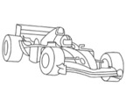

< 5 cm >

Item 21: Placing finger on number diagram
Instruction: Starting on the yellow number 1 point to the numbers 1 to 10 in turn following the arrow

1
2
3
4
5
7
8
6
10
9

10 Meter Walk/Run: First Test

Test completed: Yes □ No □

The 10 Meter Run/Walk will be completed twice during the visit: the first time, just the time will be recorded, and the second time will be during the NSAA, when time, NSAA score, and functional grade will be recorded.

Time to complete 10 m walk: ____ ____ . ____seconds
Time to complete 10 m run: ____ ____ . ____seconds

10 Meter Run Detail
Grade

☐ |  | 1. Unable to walk independently
☐ |  | 2. Unable to walk independently but can walk with knee-ankle foot orthoses (KAFO) or support from a person
☐ |  | 3. Highly adapted wide based lordotic gait. Cannot increase walking speed
☐ |  | 4. Moderately adapted gait. Can pick up speed but cannot run
☐ |  | 5. Able to pick up speed, but runs with a double stance phase, i.e. cannot achieve both feet off the ground
☐ |  | 6. Runs and gets both feet off the ground (with no double stance phase)

Comments: Please explain if test not performed or any efforts were rendered invalid/unusable.

4 Stair Climb

Test completed: Yes □ No □
Time to complete 4 stair ascend: ____ ____ . ____seconds
4 Stair Ascend Detail
Grade

☐ |  | 1. Unable to climb 4 standard stairs
☐ |  | 2. Climbs 4 standard stairs “marking time” (climbs one foot at a time, with both feet on a step before moving to next step), uses both arms on one or both handrails or uses 1 handrail and the other arm pushes on the leg
☐ |  | 3. Climbs 4 standard stairs “marking time” (climbs one foot at a time, with both feet on a step before moving to next step), using one arm on one handrail or one hand pushing on leg or body
☐ |  | 4. Climbs 4 standard stairs “marking time” (climbs one foot at a time, with both feet on a step before moving to next step), not needing handrail and not using hands to push on leg
☐ |  | 5. Climbs 4 standard stairs alternating feet, needs handrail/s for support or uses arms to push on the leg or body
☐ |  | 6. Climbs 4 standard stairs alternating feet, not  needing handrail support or using arm to push on the leg
Comments: Please explain if test not performed or any efforts were rendered invalid/unusable.

Time to Stand From Supine
Test completed: Yes □ No □
The Time to Stand From Supine will be completed twice during the visit: the first time, just the time will be recorded, and the second time will be during the NSAA, when time, NSAA score, and functional grade will be recorded.
Time to complete Stand From Supine: ____ ____ . ____seconds

Stand from Supine Grade | Detail
☐ | 1: Unable to stand from supine, even with use of a chair
☐ | 2: Assisted Gowers – requires furniture for assist in arising from supine to full upright posture (no time to be recorded)
☐ | 3: Rolls over, stands up with both hands “climbing up” the legs to achieve full upright posture.
☐ | 4: Rolls over, stands up with 1 hand support on leg
☐ | 5: Rolls to the side and stands up with one or both hands on the floor to start to rise but does not touch legs
☐ | 6: Stands up without rolling over or using hands on legs or floor

North Star Ambulatory Assessment (NSAA)

Activity | 2 | 1 | 0 | Score
1. Stand | Stands upright, still and symmetrically, without compensation (with heels flat and legs in neutral) for minimum count of 3 seconds | Stands still but with some degree of compensation (e.g. on toes or with legs abducted or with bottom stuck out) for minimum count of 3 seconds | Cannot stand still or independently, needs support (even minimal)
2. Walk | Walks with heel-toe or flat-footed gait pattern | Persistent or habitual toe walker, unable to heel-toe consistently | Loss of independent ambulation – may use KAFOs or walk short distances with assistance
3. Stand up from chair | Keeping arms folded. Starting position 90º hips and knees, feet on floor/supported on a box step. | With help from thighs / push on chair / prone turn or alters starting position by widening base. | Unable | Timed  _ _._ secs
4. Stand on one leg - right | Able to stand upright in a relaxed manner (no fixation) for count of 3 seconds | Stands but either momentarily or with trunk side-flexion or needs fixation e.g. by thighs adducted or other trick | Unable
5. Stand on one leg - left | Able to stand upright in a relaxed manner (no fixation) for count of 3 seconds | Stands but either momentarily or with trunk side-flexion or needs fixation e.g. by thighs adducted or other trick | Unable
6. Climb box step - right | Faces step – no support needed | Goes up sideways / rotates trunk / circumducts hip or needs support | Unable
7. Descend box step -right | Faces forward, steps down controlling weight-bearing leg. No support needed | Sideways, skips down or needs support | Unable
8. Climb box step - left | Faces step – no support needed | Goes up sideways / rotates trunk / circumducts hip or needs support | Unable
9. Descend box step -left | Faces forward, steps down controlling weight-bearing leg. No support needed | Sideways, skips down or needs support | Unable
10. Lifts head | In supine, head must be lifted in mid-line. Chin moves towards chest | Head is lifted but through side flexion or with no neck flexion (protracts) | Unable
11. Gets to sitting | Starts in supine – may use one hand / arm to push up | Uses two arms / pulls on legs or turns towards floor. | Unable
12. Rise from floor | No evidence of Gower’s maneuver. | Exhibits at least one of the components described– in particular rolls towards floor, and/or use hand(s) on legs | (a) NEEDS external support of object e.g. chair OR (b) Unable | Timed  _ _._ secs
13. Stands on heels | Both feet at the same time, clearly standing on heels only (acceptable to move a few steps to keep balance) for count of 3 | Only raises forefeet or only manages to dorsiflex one foot. | Unable
14. Jump | Both feet at the same time, clear the ground simultaneously | One foot after the other (skip) or does not fully clear both feet at the same time. | Unable
15. Hop right leg | Clears forefoot and heel off floor | Able to bend knee and raise heel, no floor clearance | Unable
16. Hop left leg | Clears forefoot and heel off floor | Able to bend knee and raise heel, no floor clearance | Unable
17.Run (10m) | Both feet off the ground (no double stance phase during running) | ‘Duchenne jog’ or fast walk | Walk | Timed  _ _._ secs
TOTAL= /34



Pulmonary Function Testing (PFT)

Standing height: ____________ cm OR Ulna length: _____________ cm
Weight: ______________ kg Estimated height based on ulna length: ____________ cm

Estimated height (cm) = 4.605U + 1.308A +28.003
U = length of the ulna (to the nearest 0.1 cm) measured using a segmometer
A = subject’s age (to the nearest year). If the subject is 18 years or older, 18 will be used for the age.
Pulmonary Function Test  (at least 3 trials of each must be completed, max of 6 until best effort is achieved) | Volume or Rate | Highest Percent Predicted
Forced Vital Capacity (FVC) | ______ . ___ L ______ . ___ L  ______ . ___ L ______ . ___ L  ______ . ___ L ______ . ___ L | ___________ %
Peak Expiratory Flow (PEF) | _________ L/sec _________ L/sec  _________ L/sec _________ L/sec  _________ L/sec _________ L/sec | ___________ %
Forced Expiratory Volume in the first second (FEV1) | ______ . ___ L ______ . ___ L  ______ . ___ L ______ . ___ L  ______ . ___ L ______ . ___ L | ___________ %
FEV1/FVC | ______ . ___ % ______ . ___ %  ______ . ___ % ______ . ___ %  ______ . ___ % ______ . ___ % | ___________ %
Cough Peak Flow (CPF) | _________ L/min _________ L/min  _________ L/min _________ L/min  _________ L/min _________ L/min

