

DOTTORATO DI RICERCA IN SCIENZE BIOMEDICHE
CICLO XXXVI
COORDINATORE Prof. Fabrizio Chiti

CHRONODIET:
a randomised clinical trial to evaluate the effects of a chronotype-adapted diet on weight loss in overweight/obese subjects

Settore Scientifico Disciplinare BIO/09

Dottorando Supervisore
Dott.ssa Sofia Lotti Prof.ssa Barbara Colombini

Coordinatore
Prof. Fabrizio Chiti

Anni 2020/2023

TABLE OF CONTENTS

LIST OF ABBREVIATIONS 3
ABSTRACT 5
1. INTRODUCTION 7
2. OVERWEIGHT AND OBESITY: THIRD MILLENNIUM EPIDEMIC 9
2.1 Definition and diagnosis 10
2.2 Epidemiology 13
2.3 Etiopathogenesis 17
2.3.1 Genetic determinants 17
2.3.2 Environmental determinants 21
2.4 Health consequences of obesity 25
2.5 Treatment 28
3. CHRONO-NUTRITION 35
3.1 Definition 35
3.2 Human circadian clock 35
3.4 Circadian rhythms synchronizers 38
3.4.1 Light 39
3.4.2 Arousal stimuli 40
3.5 Circadian rhythms and physiological processes of nutrition 45
3.6 Chronotype 48
3.6.1 Chronotype assessment 49
3.6.2 Factors influencing chronotype 53
3.7 Chronotype and dietary habits 54
4. AIM OF THE STUDY 58
5. EXPERIMENTAL PROCEDURES 59
5.1 Study design and sample 59
5.2 Outcomes 61
5.3 Eligibility criteria 61
5.4 Intervention diets 62
5.5 Data collection 65
5.6 Compliance and acceptability 66
5.7 Data management 67
5.8 Statistical analysis 67
6. RESULTS 69
6.1 Participants 69
6.2 Dietary intake 74
6.3 Body weight and body composition 75
6.4 Glycemic profile 80
6.5 Lipid profile 81
6.6 Other biochemical parameters 84
6.7 Functional evaluation of gut microbiota 86
6.8 Health status and quality of life 90
6.9 Compliance 92
DISCUSSION AND CONCLUSION 94
REFERENCES 98
WEBSITES 117
LIST OF PUBLICATIONS 118
LIST OF ORAL PRESENTATIONS RELATED TO THE PHD PROJECT 121
LIST OF AWARDS RELATED TO THE PHD PROJECT 121
APPENDICES 122
Appendix A: Study protocol 122
Appendix B: Ethics Committee 141
Appendix C: Study materials 145

LIST OF ABBREVIATIONS

AGRP | agouti-related protein
ALT | alanine transaminase
AMPA | α-amino-3-hydroxy-5-methyl-4-isoxazolepropionic acid
AMPK | adenosine monophosphate activated protein kinase
ARC | arcuate nucleus
AST | aspartate aminotransferase
ATM | active tissue mass
BIA | bioimpedance analysis
BMC | body cell mass
BMR | resting basal metabolic rate
BMI | body mass index
CaMK | calcium-calmodulin kinase
CIRPs | cold-inducible RNA-binding proteins
CNS | central nervous system
CSM | Composite Scale of Morningness
CVD | cardiovascular disease risk
DASH | Dietary Approaches to Stop Hypertension
DMLO | dim light melatonin onset
DTS | Diurnal Type Scale
DXA | dual X-ray densitometry
EASO | European Society for the Study of Obesity
ECM | extracellular mass
ECW | extracellular water
EFAD | European Federation of Dietitians
FAA | food anticipatory activity
FEO | food-entrainable oscillator
FM | fat mass
FFM | free fat mass
γGT | gamma-glutamyl transferase
GLP-1 | glucagon-like peptide-1
HDL | high-density lipoprotein cholesterol
HSF1 | heat shock factor 1
ICM | intracellular water
ICMJE | International Committee of Medical Journal editors
LDL | low-density lipoprotein cholesterol
LEPR | leptin receptor
MAPK | mitogen-activated protein kinase pathway
MC4R | melanocortin 4 receptors
MCTQ | Munich Chronotype Questionnaire
MEQ | Morningness-Eveningness Questionnaire
MET | metabolic equivalent
NAFLD | non-alcoholic fatty liver disease
NMDA | N-methyl D-aspartate
NPΥ | neuropeptide Υ
PACAP | pituitary adenylyl cyclase activating peptide
PhA | phase angle
PKA | protein kinase
POMC | pro-opiomelanocortin
pRGCs | photosensitive ganglion cells
PYY | peptide tyrosine-tyrosine
PVN | paraventricular nucleus
RHT | retino-hypothalamic tract
rMEQ | reduced Morningness-Eveningness Questionnaire
RZ | resistance
SCFAs | short chain fatty acids
TBW | total body water
T2DM | type 2 diabetes
TRPC | transient-receptor potential channels
UPF | ultra-processed foods
WHO | World Health Organization
Xc | reactance
Z | impedance

ABSTRACT

Background: Obesity and its associated health complications have become a global public health concern, necessitating innovative approaches to weight management. One emerging area of research focuses on the influence of chronotype, an individual's preferred timing for daily activities, on eating habits, weight regulation and metabolic health. Recent observational studies suggest that the misalignment between an individual's chronotype and external cues, such as meal timing, may contribute to metabolic dysregulation and obesity, but evidence from intervention studies is still limited.

Aim: The aim of this study was to conduct a randomized controlled trial designed to explore the effects of a 4-month period of chronotype-adapted diet, compared with a conventional calorie distribution diet, on weight loss, cardiometabolic health, and gut microbiota composition.

Methods: Participants were randomly assigned to either the intervention group or the control group. The intervention group received a low-calorie chronotype-adjusted diet with a calorie distribution adapted to the individual chronotype (morning or evening), optimizing meal timing according to their peak metabolic periods. The control group followed a standardized low-calorie healthy eating plan. Anthropometric measurements, body composition, blood, and fecal samples were obtained from each participant at the beginning and the end of the study.

Results: Eighty-two subjects were enrolled into the study, of whom 71 completed the study (68% female, mean age: 51 years). The total participations rate at the end of the study was 86.5%. Both diets showed a similar effect on weight loss and BMI reduction, with a difference between the chronotype-adjusted and control diets in end-of-diet values of - 1 kg for weight (p=0.19) and - 0.3 kg/m² for BMI (p=0.29). However, the intervention group showed a significantly (p<0.05) higher reduction of fat mass (- 2.3%; - 2.1 kg) compared to the control diet, as well as reporting a significant increase in free fat mass (+3%). No differences emerged between the intervention and control groups in terms of biochemical profile, but the analysis of the changes within each group showed that the intervention group significantly decreased the glucose (- 3%) and triglyceride levels (- 11.7%), while the control one showed a significantly reduction of the total cholesterol (- 4.8%) and LDL-cholesterol (- 7.1%). Regarding the gut microbiota functionality, in comparison to the control group, the intervention group reported a significant increase of anti-inflammatory isobutyric (+ 0.42% vs - 0.25%) and 2-methilbutyric acids levels (+ 0.43% vs - 0.44%). Subgroup analyses, on the one hand, associated evening subjects with a greater improvement of body composition due to a significantly reduction of fat mass (- 3.4%; - 2.9 kg) and an increase of body cellular mass (+3.7%) and phase angle (+0.9°), on the other hand, with a significantly increase of triglyceride levels (+20.3%). Morning subjects showed instead a significantly reduction in glucose concentrations (- 5%) and a significantly increase of the gut microbiota production of 2-methylbutyric (+ 0.92%) and isovaleric acids (+ 0.95%). Both groups reported a similar adherence to the diet plan received during the study.

Discussion: The chronotype-adjusted diet seems to be more effective to improve the body composition by reducing fat mass, although no differences emerged for weight and BMI. Both diets showed similar effects on the improvement of the cardiovascular risk profile, however, the chronotype-adapted diet significantly increase the gut microbiota production of anti-inflammatory SCFAs. Although future experimental studies are needed to confirm these preliminary results, our findings suggest that it may be of great interest to also consider the patient's chronotype when developing personalized diet plans to increase the effectiveness of low-calorie diets, improve the cardiovascular risk profile and the gut microbiota functionality.

1. INTRODUCTION

In recent years, obesity has become one of the most obvious and at the same time most neglected public health problems. A growing global epidemic of overweight and obesity – termed “globesity” - is taking hold in many parts of the world, posing significant challenges to public health policies (Boutari and Mantzoros, 2022). The complex interplay between lifestyle factors, including diet, physical activity, and sleep patterns, has been recognized as key contributors to weight management and overall health (Lopez-Jimenez et al., 2022). However, effective strategies for the prevention and management of overweight and obesity are still limited.
An emerging body of evidence suggests that the timing of food intake, in relation to individual chronotype, may be involved in modulating metabolic processes and promoting optimal body weight and cardiometabolic health (Lotti et al., 2022; Phoi et al., 2022). Chronotype refers to an individual's preference for activity and sleep patterns during a 24-hour cycle and is generally determined based on the scores obtained from validated questionnaires such as the Morningness Eveningness Questionnaire (MEQ) (Horne and Ostberg, 1976). Early risers, who are preferentially active in the morning, are said to have a morning chronotype, while late risers with more nocturnal activities are said to have an evening chronotype (Adan et al., 2012). Research has indicated that chronotype is not merely a preference but is genetically determined and associated with variations in circadian rhythms, hormonal regulation, and metabolic function (Lack et al., 2009).
The rationale for examining the effects of a chronotype-adapted diet stems from the growing number of studies suggesting that circadian rhythms play a crucial role in metabolic regulation and overall health (Cagampang and Bruce, 2012; Almoosawi et al., 2019). Disruptions in circadian rhythms, often resulting from modern lifestyle factors such as irregular sleep schedules and food intake, have been associated with adverse health outcomes, including obesity, metabolic syndrome, and alterations in gut microbiota composition (Fishbein et al., 2021). A chronotype-adapted approach involves consuming most calories during the peak period of wakefulness, when metabolic processes are most active, and adapting the timing of meals accordingly for individuals with different chronotypes. A recent clinical study conducted in overweight and obese subjects showed that a chronotype-adapted dietary intervention resulted in greater weight and fat mass loss than a non-adapted intervention, suggesting that aligning mealtimes and macronutrient distribution to an individual's chronotype may be a promising approach to enhance weight loss efforts (Galindo Muñoz et al., 2020). In contrast, several studies have shown that individuals with a misaligned sleep-wake schedule, especially late risers forced into an early-rising routine, experience disruptions in various physiological processes, including alterations in appetite regulation, glucose metabolism, and lipid profiles (Ruddick-Collins et al., 2018; Almoosawi et al., 2019). These metabolic disorders can ultimately lead to weight gain and an increased risk of cardiometabolic diseases. The composition and activity of the gut microbiota have also been linked to energy metabolism and metabolic health (Montenegreo et al., 2023). In this regard, recent investigations have demonstrated bidirectional communication between the gut microbiota and the host's circadian system, further emphasizing the potential role of chronotype, dietary patterns and timing in modulating this intricate relationship (Lotti et al., 2023).
Despite the great interest in this topic, most of the studies available to date are observational. Therefore, the aim of this study is to conduct a randomized controlled trial to investigate the effects of a chronotype-adapted diet, compared with a diet with a conventional calorie distribution, on weight loss, cardiometabolic health, and gut microbiota functionality. The hypothesis of the study is that aligning dietary patterns with the individual inherent biological clock will optimize metabolic processes and promote beneficial changes in gut microbial, ultimately leading to improved health outcomes. It is also speculated that a chronotype-adapted diet may have a lower dropout rate because these diets are more easily adapted to each patient's preferences.

2. OVERWEIGHT AND OBESITY: THIRD MILLENNIUM EPIDEMIC

2.1 Definition and diagnosis

Overweight and obesity is a condition characterised by an excessive presence of fatty tissue in the body that increases the risk of adverse health consequences. The increase in body weight is due to a positive energy balance that occurs when energy intake is less than expenditure, however, although the main cause remains abnormal food intake, there are also other factors that can contribute to rapid weight gain and these are to be found in complex genetic-environmental interactions.
Overweight and obesity are defined on the basis of Body Mass Index (BMI), which is calculated as weight in kilograms (kg) divided by height in metres squared (m²). On the basis of the results obtained, four categories can be distinguished:

- Underweight (16.5-18.4 kg/ m²)
- Normal weight (18.5-24.9 kg/ m²)
- Overweight (25-30 kg/ m²)
- Obesity (>30 kg/ m²)

Obesity is further divided into:

- First degree obesity (30-34.9 kg/ m²)
- Second degree obesity (35-39.9 kg/ m²)
- Third degree obesity (>40 kg/ m²)

These ranges were established as a result of studies correlating the BMI with mortality from various disease states, the results of this association produced a “J” curve in which the point of lowest mortality is between 18.5 and 24.9 kg/m², which corresponds to the normal-weight range (Berrington de Gonzalez et al., 2010; Bhaskaran et al., 2018). An increase or decrease in BMI is associated with an increased risk of mortality (Berrington de Gonzalez et al., 2010; Bhaskaran et al., 2018). However, BMI is an imperfect measure as it does not take into account the difference between fat mass and lean mass, therefore, even individuals with little fat such as athletes can have a relatively high BMI. Furthermore, it has been shown that even a good percentage of people with a BMI <30 kg/m² can have a high percentage of fat while being classified as non-obese.
For these reasons, another parameter that must be taken into account when diagnosing obesity is the waist circumference, an index that makes it possible to assess the visceral fat that is associated with an increased cardiovascular risk (WHO 2008). Values, in order not to incur unfavourable conditions, must be less than 102 cm in men and 88 cm in women (WHO 2008). The World Health Organization (WHO) strongly recommends the assessment of waist circumference associated with BMI to define obesity and relative risk of developing cardiovascular diseases, type 2 diabetes and dyslipidaemia (WHO 2008).
In addition to BMI and waist circumference, which are imprecise indices, instrumental methods can be used to assess body composition and overweight and obesity, the main ones being bioimpedance analysis (BIA) and dual X-ray densitometry (DXA). These instruments, with varying degrees of accuracy, allow estimation of excess weight and measurement of fat mass.
BIA analysis is a non-invasive technique that allows a more accurate measurement of adiposity (Ricciardi and Talbot, 2007). It is based on the principle that different parts of the human body can behave as conductors, semiconductors and insulators. Electrolyte solutions are good conductors, while bones and fat mass act as insulators. The test is performed by placing electrodes on the person's body, the number of which can vary from 2 to 8. One of the most widely used is the four-electrode BIA, in which two electrodes are placed on the hand, 5 cm apart, and two on the foot at the same distance. An alternating electric current is passed at low intensity (800µA) and fixed frequency (usually 50 Hrzt). When the current passes through fluids, it returns the resistance (RZ), while passing through cell membranes defines the reactance (Xc). Impedance (Z), on the other hand, expresses the total impediment to the passage of current. From these three parameters, through estimating equations, the following parameters are defined:

- Total Body Water (TBW): which in turn is divided into intracellular water (ICW), contained within cells; and extracellular water (ECW), the volume found outside cells, mainly in the interstitial space, between cells, within blood vessels, in lymphatic tissue and in spinal fluid
- Body Cell Mass (BMC) or Active Tissue Mass (ATM): represents the metabolically active part of lean mass, i.e. the part responsible for basal metabolism
- Extracellular Mass (ECM): is the metabolically inactive compartment of structure, support and transport
- Free Fat Mass (FFM): is the lean mass and gives the total percentage of muscle, water, skin and organs. It is given by the sum of BCM and ECM
- Fat Mass (FM): represents the total percentage of fat tissue
- Resting Basal Metabolic Rate (BMR): the amount of energy expended while at rest in a neutrally temperate environment, and in a post-absorptive state (meaning that the digestive system is inactive).
- Phase Angle (PhA): is the electrical parameter that expresses the proportion between intra- and extra-cellular spaces and, in a healthy individual, the value ranges between 5 and 7 degrees.

Fat mass values vary depending on age and gender (Fig. 2.1). Generally, in men the normal range is between 7-20%, whereas in women a higher fat mass is constitutionally present, and the range is between 21-33%. Using BIA, it is possible to obtain a more precise breakdown of body weight, it is easy to use and relatively inexpensive, but the disadvantage is that it is very sensitive to hydration.

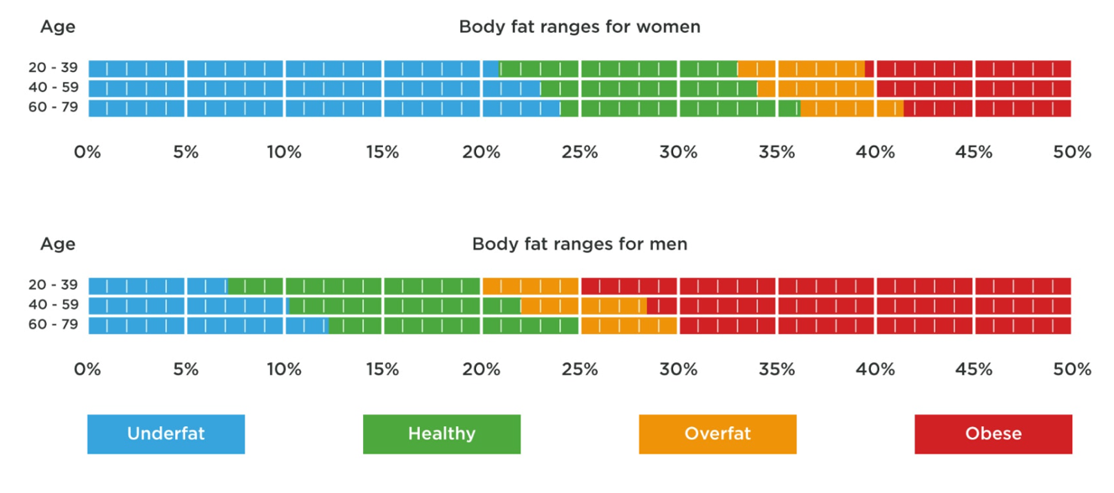
Figure 2.1. Variation in fat mass values according to age and gender. (Source: https://tanitaaustralia.com/)

DXA analysis, on the other hand, is a two-dimensional imaging technique that is the gold standard for assessing bone mineral density. However, it can also provide a very accurate estimate of body composition (Bazzocchi et al., 2016). It uses X-rays with energy of 99 KeV and 44.5 KeV and by exploiting the difference in attenuation experienced by each ray, it is possible to obtain images in two separate components: bone and soft tissue. It is the most accurate of the methods for estimating total body fat, as DXA obtains a direct measure of FT, whereas BIA obtains it indirectly by subtracting FFM from total weight. The disadvantage of DXA is that it is a very expensive instrument, which is why it is not used in outpatient practice, and it also exposes the operator and the patient to ionising radiation, albeit minimal.

2.2 Epidemiology
Obesity is now considered the largest non-infectious epidemic of the third millennium, so much so that the WHO coined the term “Globesity”. In recent history, it has been identified as a serious public health challenge globally and as a major determinant of disability and death. Obesity-related ill-health accounted for over 5.0 million deaths globally in 2019, with more than half of these deaths occurring among people under 70 years old (GBD 2019).
In 2016, 39% of adults aged 18 years and older were overweight or obese worldwide (Fig. 2.2). The percentage of overweight people tends to be higher in wealthier countries and lower in low-income countries. North America is the part of the world with the highest prevalence, with 70% of the population being overweight or obese, followed by Europe and Oceania. At the other extreme are South Asia and sub-Saharan Africa, where only about one in five adults has a BMI greater than 25 kg/m² (WHO 2022).
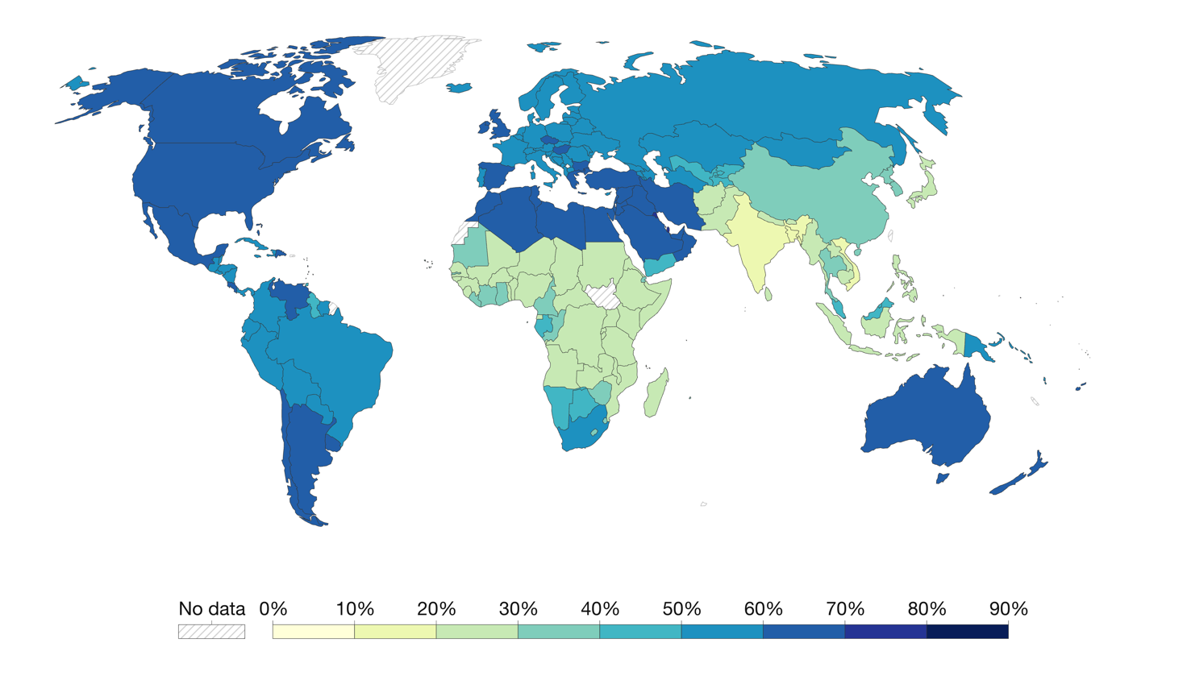
Figure 2.2. Share of adults that are overweight or obese, 2016. (Source: https://ourworldindata.org/obesity).

Focusing on European data, the 2016 WHO European Region estimates, prepared by the WHO Global Health Observatory and standardised by age, indicate that 59% of adults in the WHO European Region are overweight or obese, with the highest levels of overweight and obesity in the Mediterranean and Eastern European countries (WHO 2022). There was a 21% increase in prevalence compared to 2006 estimates and a 138% increase compared to 1975 estimates (WHO 2022). Some socioeconomic determinants, such as gender, income, education and employment status, may play a role in these numbers. In particular, gender analysis showed that levels of overweight and obesity are higher among males (63%) than among females (54%). In contrast, analysing obesity alone showed a prevalence of this condition among females (24%) compared to males (22%) (Fig. 2.3). Furthermore, it was found that educational inequalities are widespread, with a higher prevalence of obesity in people with a lower level of education (WHO 2022).

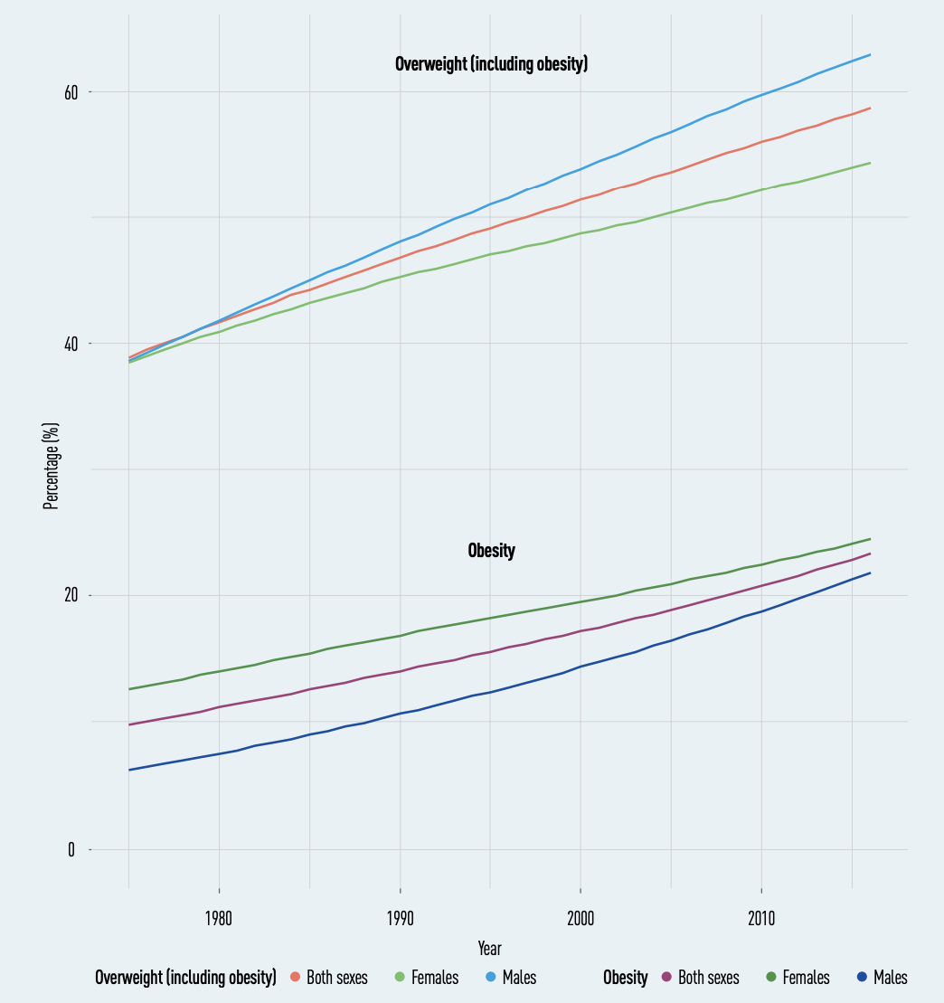
Figure 2.3. Prevalence of overweight and obesity among adults in the WHO European Region, by sex (1975-2016). (Source: WHO, Regional Office for Europe. WHO European Regional Obesity Report. 2022).
Similar data were also collected in Italy, where more than 35% of the adult population is overweight and 10% obese. The differences on the territory confirm a North-South gap in which the southern regions have the highest prevalence of obese (Molise 14.1%, Abruzzo 12.7% and Apulia 12.3%) and overweight (Basilicata 39.9%, Campania 39.3% and Sicily 38.7%) adults compared to the northern regions (obese: Bolzano PA 7.8% and Lombardy 8.7%; overweight: Trento PA 27.1% and Valle d'Aosta 30.4%) (Osservasalute 2016). The percentage of the population in excess weight increases as age increases and, in particular, overweight increases from 14% in the 18-24 age group to 46% in the 65-74 age group, while obesity increases from 2.3% to 15.3% for the same age groups. Furthermore, the condition of excess weight is more widespread among men than among women (overweight: 44% vs. 27.3%; obesity: 10.8% vs. 9%) (Osservasalute 2016).
Alarming data also emerged in the younger segments of the population. Joint UNICEF/WHO/World Bank estimates reveal that in 2020, overweight and obesity were a widespread problem in the WHO European Region, with 4.4 million children under 5 years of age (or 7.9% of children in this age group) in this condition (WHO 2022). The prevalence of overweight and obesity increases in the 5-9 age group, with one in eight (11.6%) children suffering from obesity and almost one in three (29.5%) from overweight. As in the case of adult estimates, overweight and obesity are more prevalent in male children and in Mediterranean countries (WHO 2022).
The increasing prevalence of overweight and obesity has consequences for both health and the economy. The global economic costs of overweight and obesity in 2020 reached almost $2 trillion (World Obesity Federation, 2022). Taking into account rising demographic levels and changes in age distribution, and assuming that obesity prevalence trends continue, costs are expected to increase to more than $3 trillion by 2030 and to as much as $18 trillion by 2060 (Fig. 2.4). It is also necessary to consider the health impact of individuals living with obesity, which leads to a large health burden on the population, which also has financial implications due to the treatment of obesity-related diseases. It has been found that people with obesity have treatment costs that are 30% higher than those without (Withrow et al., 2011), while there may also be indirect costs due to loss of earnings from premature mortality and obesity-related disability. Obesity alone was estimated to be responsible for 8% of healthcare costs in EU Member States in 2014 (Withrow et al., 2011).

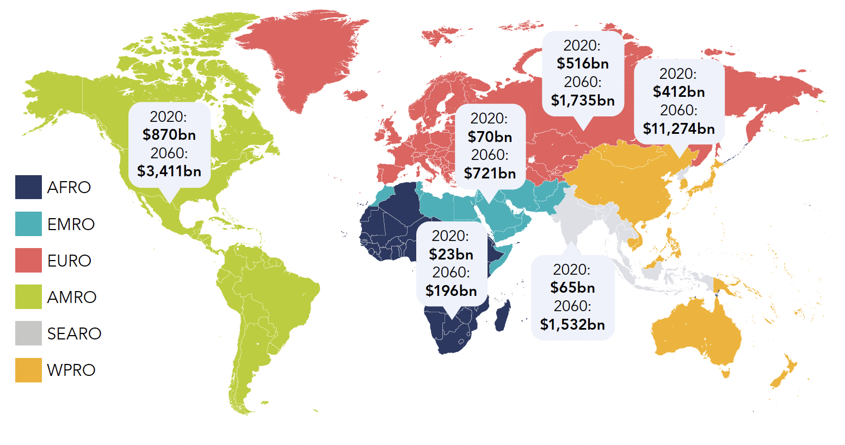
Figure 2.4. Estimated economic costs in the World Health Organization’s regions, 2020 and 2060. (Source: World Obesity Federation, 2022).

2.3 Etiopathogenesis
Weight gain in individuals, understood in terms of an increase in adipose tissue, is the result of an energy imbalance, where the amount of energy intake is greater than the amount of energy used over a period of time (WHO discussion paper, 2021). However, this simple idea may obscure the complex nature of the ways in which behaviours leading to energy intake and expenditure can be determined, not to mention the large number of interactive influences on them that make obesity a multifactorial disease.

2.3.1 Genetic determinants
Among the various causes contributing to the altered energy balance is genetic susceptibility. Twin, family and adoption studies have estimated the heritability of obesity to be between 40-70% (Maes et al., 1997; Elks et al., 2012). Classically, obesity is divided into two broad categories (Fig. 2.5):

- Monogenetic causes: which is inherited in a Mendelian pattern, is typically rare, early-onset and severe, and involves chromosomal deletions or defects in a single gene co-involved in appetite and weight regulation, such as leptin, Agouti-related protein (AGRP), pro-opiomelanocortin (POMC) and peptide tyrosine-tyrosine (PYY).

- Polygenetic causes: which contribute to obesity through the cumulative contribution of several genes and can lead to increased calorie intake, hunger levels or decreased satiety and a greater tendency to accumulate fat. Polygenic obesity follows a similar pattern of heritability as other complex traits and diseases.

Although often considered to be two distinct forms, gene discovery studies of monogenic and polygenic obesity have converged on what seems to be broadly similar underlying biology. Specifically, the central nervous system (CNS) and neuronal pathways that control the hedonic aspects of food intake have emerged as the major drivers of body weight for both monogenic and polygenic obesity. Furthermore, early evidence shows that the expression of mutations causing monogenic obesity may - at least in part - be influenced by the individual’s polygenic susceptibility to obesity (Chami et al., 2020).

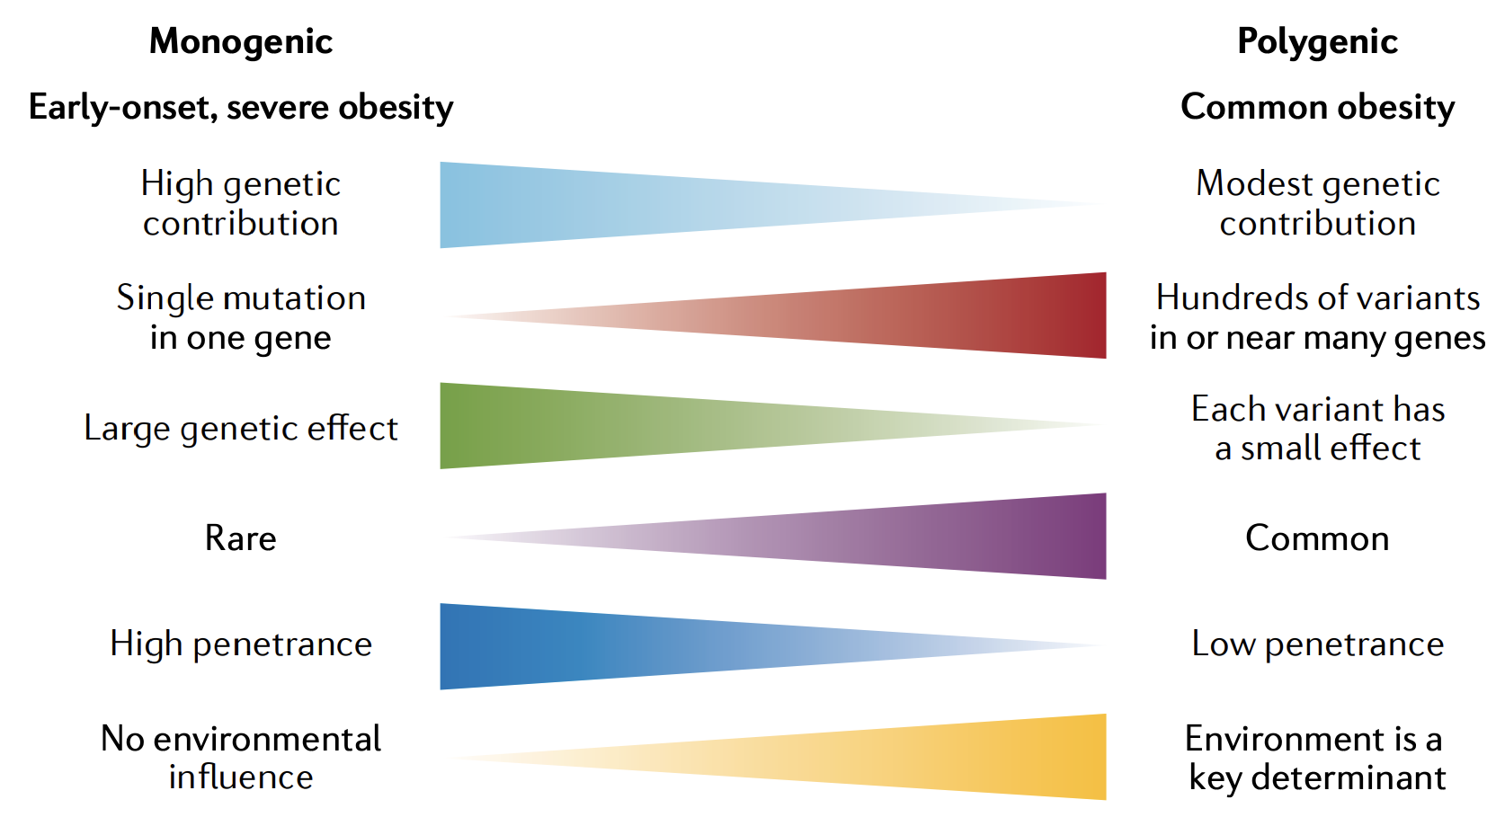
Figure 2.5. Key features of monogenic and polygenic forms of obesity. (Source: Loos RJF, Yeo GSH. The genetics of obesity: from discovery to biology. Nat Rev Genet. 2022; 23:120-133).

Over the past two decades, genetic studies have revealed two surprisingly cogent, overarching biological messages: first, the leptin–melanocortin pathway is a key appetitive control circuit (Farooqi and O'Rahilly, 2006) (Fig. 2.6); and second, genes that are either enriched or exclusively expressed within the brain and CNS have a central role in obesity. Leptin is a key hormone secreted by adipocytes, which circulates at levels proportional to fat mass (Friedman and Halaas, 1998). It also responds to acute changes in energy status, as its levels decrease with food deprivation and are restored during re-feeding. Leptin signals through the leptin receptor (LEPR), which is expressed in various regions of the CNS. When leptin interacts with the LEPR present in the arcuate nucleus (ARC) of the hypothalamus, it leads to the expression of POMC. POMC neurons in the ARC project to melanocortin 4 receptors (MC4R) in the paraventricular nucleus (PVN), where melanocortin peptides signal decreased food intake (Cowley et al., 1999). In contrast, AGRP acts as an endogenous antagonist of MC4R to increase food intake (Cowley et al., 1999). It is safe to say that the fine balance between melanocortinergic agonism and AGRP antagonism of MC4R, in response to peripheral nutritional signals such as leptin, plays a central role in influencing appetitive drive (Cowley et al., 1999). Genetic evidence clearly supports this view, with mutations in most genes of the melanocortin pathway leading to hyperphagia and severe obesity in both humans and mice (Farooqi and O'Rahilly, 2006). Indeed, the vast majority of single-gene breaks that cause severe early obesity in humans fall within this pathway, including LEPR, POMC, AGRP, MCR4R. Mutations in MC4R, in particular, are the most common single-gene defect leading to hyperphagia and obesity. Pathogenic mutations in MC4R are found in up to 5% of cases of severe childhood obesity and in up to 0.3% of the general population (Wade et al., 2021).

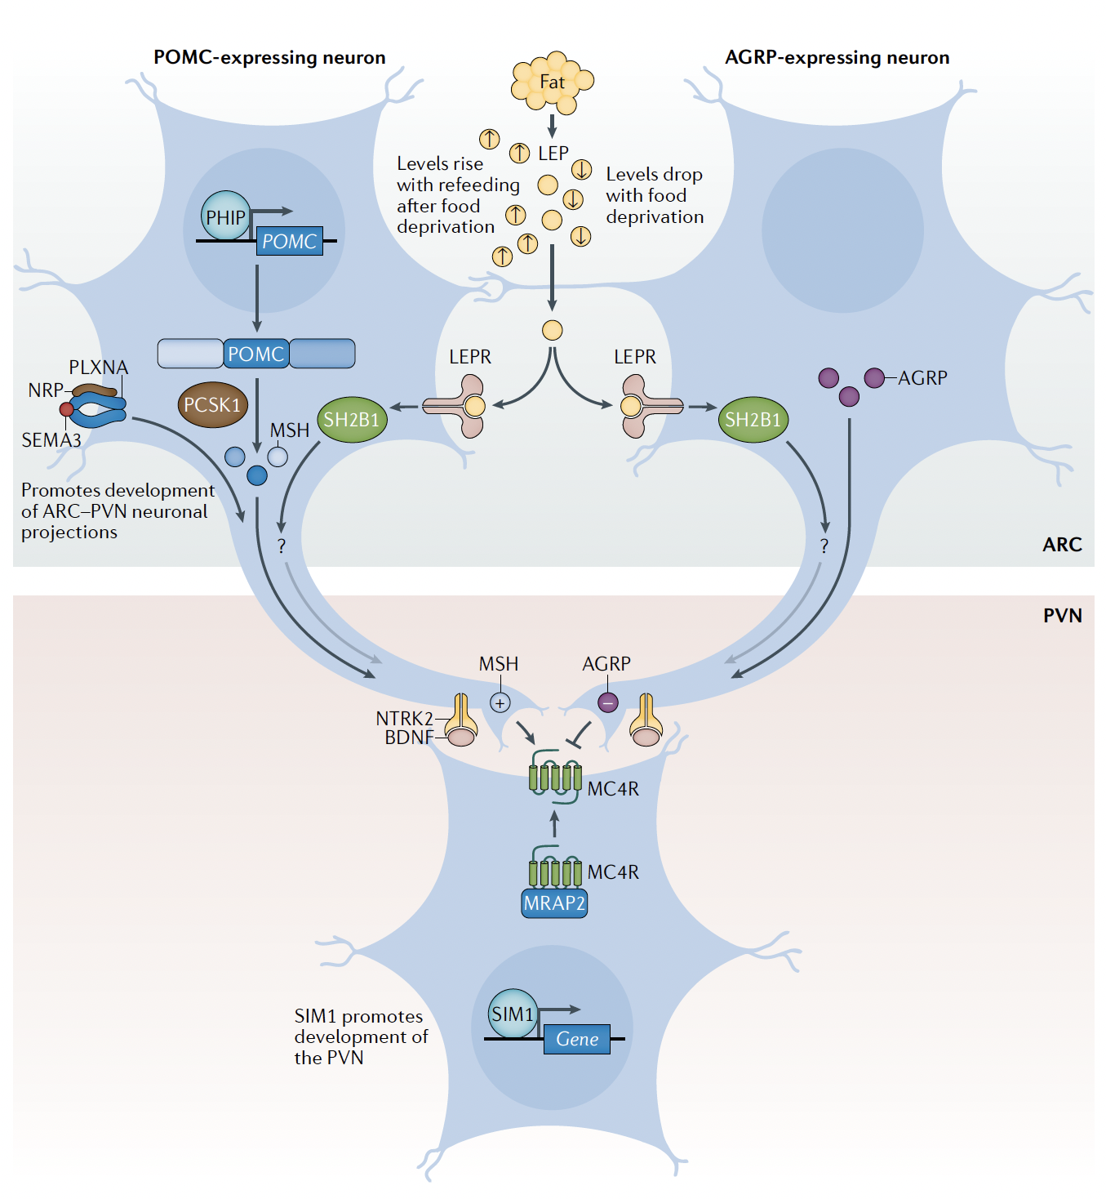
Figure 2.6. The leptin-melanocortin pathway (Source: Loos RJF, Yeo GSH. The genetics of obesity: from discovery to biology. Nat Rev Genet. 2022; 23:120-133).

2.3.2 Environmental determinants
The rapid recent increase in the overall prevalence of overweight and obesity demonstrates that environmental factors - particularly behaviours linked to diet and physical activity - are key determinants of obesity. The increased availability of cheaper and more energy dense food, urbanisation and less physical activity have led to the development of environments defined as “obesogenic”. This term refers to the sum of influences that promote obesity, recognised as the net result of biological, behavioural and environmental impacts acting through mediators of energy intake and expenditure (Swinbur and Egger, 2002). These influences are generally more pronounced in deprived urban areas where limited food choices are available, often referred to as food deserts, and where individuals feel less able to use available space for physical activity (Parkes and Kearns, 2001; Shenassa et al., 2006; Townshend and Lake 2009).

Diet
The changing lifestyle of society in recent years has made it more difficult to have a healthy diet. The sale of products on a large scale and the huge availability of different foods has led people to take in more daily calories. In 1961, the daily caloric intake was 2194 kcal/day compared to 2870 kcal/day in 2011 (Fig. 2.7). The increase in daily calorie intake is a worldwide phenomenon, with higher levels in more developed countries such as America and European countries (Ranganathan J and Waite, 2016). However, this increase also occurs in less economically developed countries, such as Ethiopia (Ranganathan J and Waite, 2016). What makes the situation worrying is the fact that the increase in daily calories is due to an increased intake of fat and simple sugars, mainly from fast food and consumption of sugary drinks. Currently, sugary soft drinks contribute 8-9% of total energy intake in both children and adults, increasing the risk of overweight and obesity and probably the risk of diabetes, fractures and dental caries (Nielsen and Popkin, 2001).
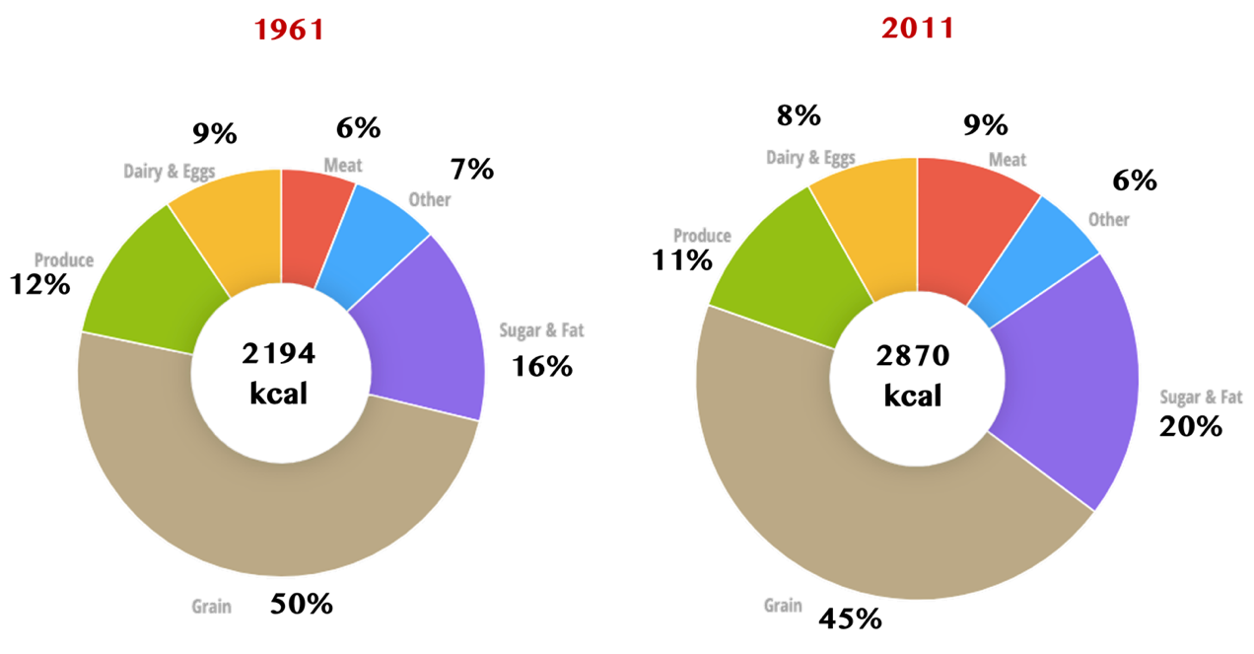
Figure 2.7. The increase of daily caloric intake from 1961 to 2011. (Source: https://www.nationalgeographic.com/what-the-world-eats/).

In addition, people have less time to devote to preparing healthy and balanced meals, which leads them to more easily take advantage of ready-to-eat foods. At the same time, high-calorie foods have become cheaper and more convenient and are heavily advertised and promoted. In this situation, the consumption of industrially processed foods, so-called ultra-processed foods (UPF), has increased dramatically, reaching 50%-60% of daily energy intake in some high-income countries (Adams and White, 2015; Martínez Steele et al., 2016). However, the rate of UPF consumption in Italy are much lower, around 15% of total energy intake. Typically, UPF are bulk packaged breads, sugary breakfast cereals, buns, biscuits, sweet or salty packaged snacks, instant soups and noodles, processed meats and some industrially prepared meals. These foods represent easily accessible and convenient sources of energy for many people, particularly in urban areas or for those with extended or unusual working hours. However, unlike fresh or minimally processed foods, UPF tend to have a higher energy density and may trigger a higher rate of energy consumption/intake (Hall et al., 2019). These properties can lead to excessive energy consumption and weight gain when consuming a diet high in UPF, as reported in a recent prospective study of adults from 9 European countries, which found that higher UPF consumption was associated with significantly higher body weight gain at 5 years in a dose-response manner (Cordova et al., 2021). In addition, a 15% higher risk of becoming overweight or obese was found for participants with normal weight at baseline in the highest quintile of UPF consumption compared to the lowest quintile (Cordova et al., 2021). Similar results have emerged from several other prospective cohort studies conducted in different parts of the world, such as Spain, France and Brazil (Mendonça et al., 2016; Beslay et al., 2020; Canhada et al., 2020). While these data are concerning, it is important to note that they were derived from observational studies, underscoring the necessity to reinforce them with experimental research. Furthermore, it would be interesting to assess adherence to the Mediterranean Diet, considered among the most effective in maintaining body weight, in relation to the consumption of UPF. The initial available evidence seems to suggest that a higher consumption of UPF is associated with lower adherence to the Mediterranean regimen, inevitably impacting the course of body weight (Dinu et al., 2022).
Another eating factor that can improve the overweight and obesity risk is eating outside the home. This habit has increased over time, with a quarter of meals and snacks now being consumed away from the home. Food eaten away from home tends to be more energy-dense than food prepared at home, because it is higher in fat ad lower in fibre. It may also be served in larger portions. In adults in the USA, it has been shown that eating away from home is associated with higher energy intake and risk of obesity (McCroy et al., 1999; French et al., 2000).

Physical activity
Physical activity is important in preventing excess weight as it is one of the components - together with resting energy expenditure and thermogenesis - of energy expenditure. Long-term observational studies of physical activity in relation to weight maintenance fairly consistently show a relationship between the two. For example, the prospective Harvard cohorts showed that women and men who reported increasing their recreational activity levels by 23.2 metabolic equivalent (MET)-hours per week (top quintile) gained 0.8 kg less within the next 4 years of follow-up than those who decreased their activity levels by 16.3 MET-hours per week (bottom quintile) (Mozaffarian et al., 2011). One MET is defined as the ratio of the energy consumed during a specific activity to the energy consumed while sitting quietly (3.5 mL O₂ kg⁻¹ min⁻¹). Similarly, the 15-year Coronary Artery Risk Development in Young Adults (CARDIA) Study reported that each 0.5 hour per day of walking, the most popular type of recreational activity among adults, was associated with 0.15 kg/year less weight gain in men and 0.29 kg/year less weight gain in women (Gordon-Larsen et al., 2009). Taken together, these long-term epidemiological investigations indicate that moderate-intensity physical activity is associated with prevention of weight gain.
In the last few years, physical activity research has expanded its focus to include the potentially detrimental effects of sedentary behaviour on energy balance. The prevalence of sedentary behaviour has increased significantly in recent years, with objectively assessed measures showing that adults spend 50-60% of their day sedentary (Matthew et al., 2008). Sedentary behaviour occurs in various areas of life, including watching television or videos, using a computer, reading or sitting at a desk, counter, bus, car or train. Prolonged time spent sedentary reduces energy expenditure and displaces light-intensity physical activities, potentially leading to weight gain over time. The Nurses’ Health Study examined the association between sedentary behaviours, in particular television viewing, and risk of obesity (Hu et al., 2003). The findings showed that time spent watching television was positively related to risk of obesity. Specifically, each increment of 2 hours per day in television watching was associated with a 23% increase in obesity after adjusting for age, smoking, diet, and physical activity. Also, each increment of 2 hours per day in sitting at work was associated with a statistically non-significant 5% increase in obesity. These results highlight the potential value of decreasing prolonged television watching and other sedentary behaviours for preventing obesity in adults.
In the same way, computer gaming and social media use are other important sources of sedentary time spent, especially among young adults. A prospective cohort study conducted in Sweden among 2593 young adults examined the association between computer use in leisure time for playing/emailing/chatting and the development of overweight during 5 years of follow-up (Thomée et al., 2015). Compared to those who reported not playing computer games, women with a high volume of computer play (> 2 hours per day) had an odds ratio of developing overweight of 3.0 after adjustment for age, occupation, social support, physical activity, sleep and total computer use. No statistically significant association was found among men. The results of this small cohort study suggest that sedentary behaviour occurring during computer gaming is a potential risk factor for overweight, but further research is needed.

2.4 Health consequences of obesity
Living with overweight or obesity increases the risk of a range of diseases, many of which are found to occur more frequently with increasing BMI (Fig. 2.8) (Malnick and Knobler, 2006; GBD 2015). Excess adiposity is also linked to increased mortality, with those living with obesity found to have a life expectancy five years shorter than those with a "healthy" weight status (Whitlock et al., 2009). Recent estimates suggest that overweight and obesity cause more than 1.2 million deaths across the WHO European Region every year; this represents more than 13% of total deaths, ranking fourth behind high blood pressure, dietary risks and tobacco use (WHO 2022).
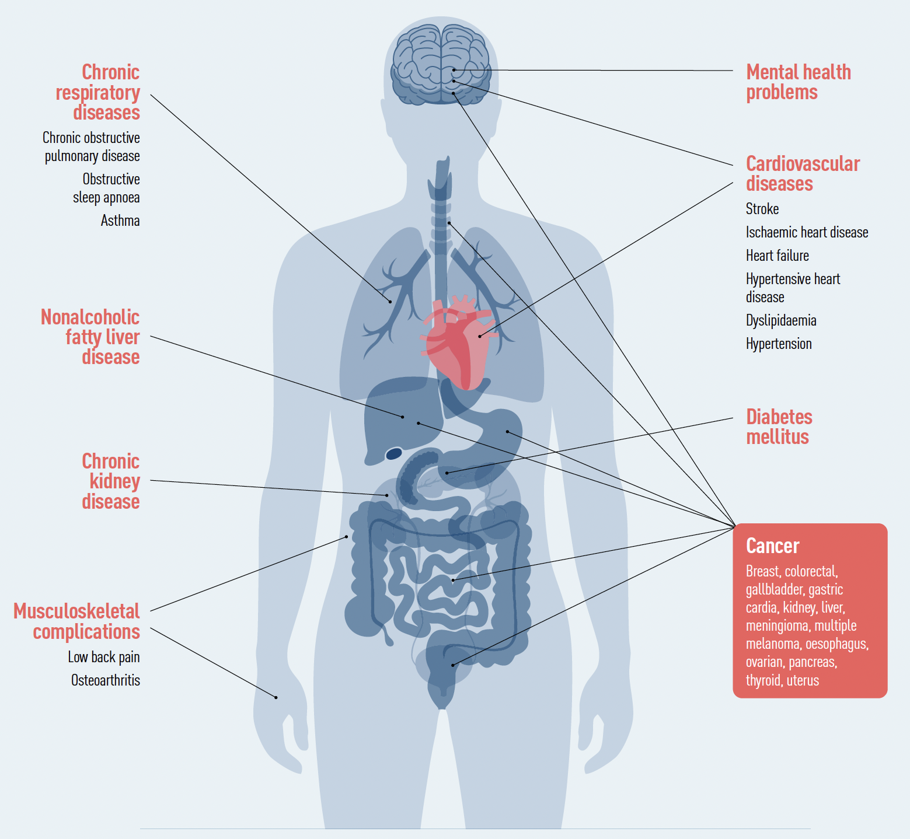
Figure 2.8. Medical conditions associated with obesity. (Source: WHO, Regional Office for Europe. WHO European Regional Obesity Report. 2022).

These health issues arise in people living with obesity in part because adipose tissue is a metabolically active endocrine organ, with fat cells (adipocytes) releasing and receiving hormones. Adipocytes release substances called adipocytokines; these are associated with a range of systemic or local actions including glucose and lipid metabolism, cell development, inflammation and oxidative stress, which can lead to a number of health problems (Townsend and Scriven, 2014). Visceral fat, which surrounds the organs within the abdominal cavity, has a greater impact on health than subcutaneous fat, as it is more biologically active, has a higher density of cells, carries more blood flow and is located close to the portal vein, which results in an increased concentration of fatty acids reaching the liver (Matsuzawa et al., 1995). Recent evidence from 2022, argues that the negative health effects of obesity stem not simply from an excess of fat but from the decline in its ability to respond to changes, or in other words, its plasticity (Sakers et al., 2022). The makeup and functioning of this tissue changes in response to weight fluctuations and aging. As fat declines in plasticity due to aging and obesity, it loses its ability to respond to bodily cues. In the current model of this phenomenon, the rapid growth of adipose tissue outpaces its blood supply, depriving the fat cells of oxygen and causing the accumulation of cells that no longer divide (Sakers et al., 2022). This leads to the metabolic issues already mentioned earlier, such as insulin resistance, inflammation, and cell death. The mass and metabolic activity of adipose tissue result in it affecting almost everybody system, with excess adiposity carrying health implications throughout the life course.
Obesity is linked with clusters of diseases that greatly increase cardiovascular disease risk (CVD), which is the most common cause of death in Europe (Townsend et al., 2022). These include atherosclerosis, hypertension, dyslipidaemia, insulin resistance, coagulability, endothelial dysfunction and inflammation (Sowers, 2003). As a consequence, those living with obesity are at substantially elevated risk of a range of CVDs, particularly obesity increases the risk for stroke and coronary heart disease, the two most common forms of CVD mortality (Sowers, 2003). For both these diseases, abdominal obesity has been shown to be a greater predictor than total fat mass, indicating the higher risk associated with abdominal and visceral fat accumulation (Larsson et al., 1984).
Similar to CVD risk, individuals living overweight or obese have an increased risk of developing different types of cancer, with a higher risk of hormone-dependent (endocrine) cancers for those with abdominal obesity (Calle and Kaaks, 2004). While cardiovascular disease is the most common cause of death throughout the European WHO region, cancer now causes more deaths than cardiovascular disease in several higher-income countries; this is the consequence of a sharp decline in cardiovascular disease mortality, aligned with stable cancer mortality rates, over several decades (Townsend et al., 2022). Excess body weight increases the risk of many cancers, including those of the endometrium, breast (particularly postmenopausal), colorectum, gallbladder, pancreas, liver, kidney, gastric and oesophageal tract, thyroid, ovary and blood (Calle and Kaaks, 2004; Renehan et al., 2008; Lauby-Secretan et al., 2016). At the same time, obesity is linked to the development of more serious forms of cancer, such as metastatic cancer, as well as an increased risk of dying from it (Calle and Kaaks, 2004).
In addition to its link with these two prominent chronic diseases, obesity may lead to a greater risk of many others, including, but not limited to, metabolic diseases such as non-alcoholic fatty liver disease (NAFLD), type 2 diabetes (T2DM), musculoskeletal, respiratory and reproductive issues, and various psychological and mental health problems (GBD 2015).

2.5 Treatment
There is a need to provide care for those living with obesity, with treatment recommended to follow a “chronic care” approach in which the choice of treatment is dependent on the severity of obesity, along with a number of other personal factors. Multicomponent behavioural interventions are generally considered to be the best approach for treating obesity in both children and adults, with intensive and long-term care strategies recommended (Townsend and Scriven, 2014). Although clinical interventions, such as drug therapy and bariatric surgery, are available and have been found to be effective, they are not suitable for all people and robust criteria are required to determine those for whom such treatment would be appropriate.

Healthy Lifestyle
A correct lifestyle is an indispensable tool for both prevention and therapy of overweight and obesity, in which diet and physical activity play a central role.
Diet and nutritional education represent the first weapons to be used in the treatment of a condition of overweight or obesity. Recently, the European Society for the Study of Obesity (EASO) and the European Federation of Dietitians (EFAD) published a position paper to provide an update on possible options for medical nutritional therapy of obesity (Hassapidou et al., 2023). The review confirms the effectiveness of five diets: the Mediterranean diet, vegetarian diets, the Dietary Approaches to Stop Hypertension (DASH) diet, the Nordic diet, and low-carbohydrate diets that are associated with better metabolic health, regardless of changes in body weight (Hassapidou et al., 2023). These dietary patterns include little salt, added sugars, alcohol, tropical oils and processed foods and are rich in non-starchy vegetables, fruits, whole grains and legumes. In addition to identifying the most effective diets, this paper has shown that while calorie restriction options are effective in promoting weight loss in the short term, to achieve greater dietary adherence with long-term behavioural changes, it is necessary to support the diet with interventions based on changes in eating habits, food quality and mindfulness of the choices of what it was bring to table (Hassapidou et al., 2023). Similar results had also emerged in an umbrella review in which the most consistent evidence was reported for the MD, with suggestive evidence of an improvement in weight, BMI, total cholesterol, glucose, and blood pressure (Dinu et al., 2020). Suggestive evidence of an improvement in weight and blood pressure was also reported for the DASH diet (Dinu et al., 2020). Low-carbohydrate, high-protein, low-fat, and low glycemic-index/load diets showed suggestive and/or weak evidence of a reduction in weight and BMI, but contrasting evidence for lipid, glycemic, and blood pressure parameters, suggesting potential risks of unfavorable effects (Dinu et al., 2020). Among all the diets evaluated, the Mediterranean diet had the strongest and most consistent evidence of a beneficial effect on both anthropometric parameters and cardiometabolic risk factors (Fig. 2.9).

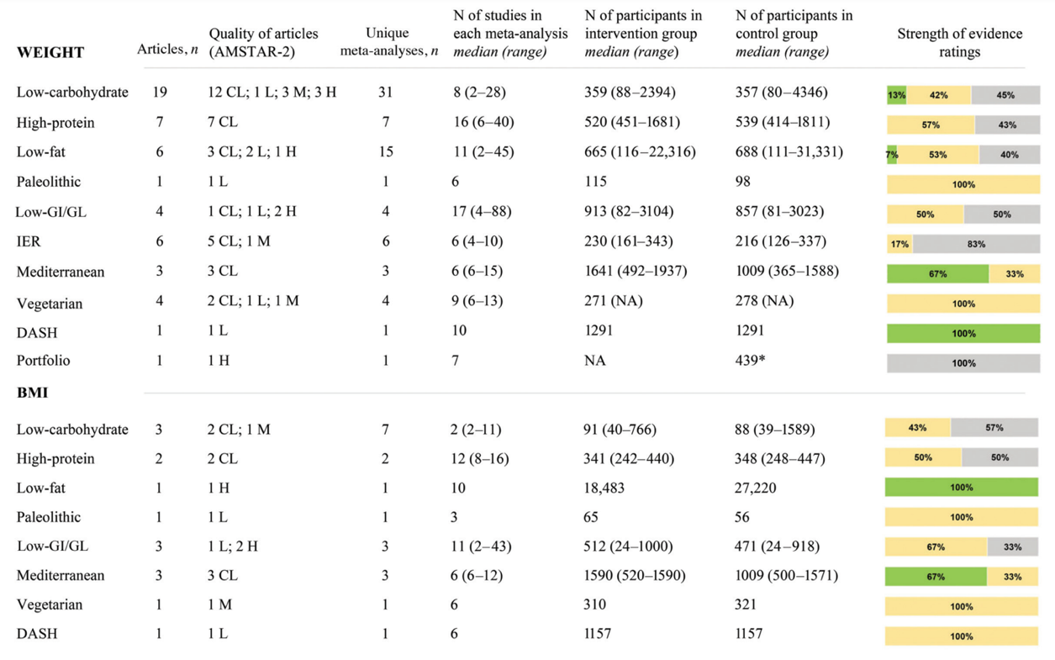
Figure 2.9. Summary and strength of evidence of meta-analyses of randomized controlled trials evaluating anthropometric parameters in adults. Green = suggestive evidence; orange = weak evidence; grey = no evidence. (Source: Dinu et al. Effects of Popular Diets on Anthropometric and Cardiometabolic Parameters: An Umbrella Review of Meta-Analyses of Randomized Controlled Trials. Adv Nutr. 2020; 11:815-833.).

Similarly, promoting physical activity and reducing sedentariness are now priority public health actions to ensure health and well-being at all ages, prevent weight gain and improve people's quality of life. The current WHO recommendations on physical activity for the health of the adult population recommend performing at least 150-300 minutes of moderate-intensity aerobic exercise or at least 75-150 minutes of vigorous activity plus strengthening exercises of the major muscle groups at least twice a week (Bull et al., 2020). This can be achieved, for example, through 5 exercise sessions of at least 30 minutes per week or by performing at least 25 minutes of vigorous intensity exercise 3 times per week. The recommended amount of physical activity can be spread out over the day to better include exercise in the daily activity routine. Accumulating higher amounts of physical activity than the minimum recommended amount provides additional health benefits and a more effective risk reduction for various chronic diseases, including cardiovascular and metabolic pathologies (Bull et al., 2020). However, it is difficult to arrive at a general recommendation on the minimum amount of exercise to ensure health benefits, as it is important to realise that “little is better than nothing” and that therefore some health benefits for sedentary adults can be achieved even with minimal amounts of physical activity (e.g. 60 minutes per week) (Bull et al., 2020).

Pharmacological treatment

Recourse to pharmacological treatment of overweight and obesity should only take place after it has been demonstrated that diet, exercise and, where indicated, cognitive-behavioural therapy are ineffective in inducing weight loss or maintaining weight loss. Currently in Italy, drugs for the treatment of overweight and obesity are administered to adults with a BMI ≥ 30 kg/m², or in overweight patients (BMI ≥ 27 kg/m²) with associated risk factors. Drug therapy should be discontinued if a body weight loss of at least 5% is not achieved after a period of 4 to 12 weeks (depending on the drug taken) (Montan et al., 2019). Commercially authorised drugs for long-term treatment include:

- Orlistat: reduces the absorption of dietary fat in the gastrointestinal tract; in particular, it blocks the enzyme lipase, which breaks down dietary triglycerides in order to ensure their absorption.

- Liraglutide: is an analogue of human glucagon-like peptide-1 (GLP-1), a hormone called incretin that is secreted in the intestine and brain in response to food intake. The hormone (and thus also liraglutide) binds to the GLP-1 receptor, activating it. This leads to insulin secretion by the pancreas, reduced gastric emptying and a central increase in satiety and reduced appetite. The final effect is an increase in the sense of fullness and satiety, which therefore leads to a reduction in food intake.

- Naltrexone and bupropion: the combination of these two active ingredients increases calorie loss and has an effect on the sense of gratification associated with food intake. For these reasons it is able to reduce appetite, making it easier to follow a low-calorie diet.

The problem with these drugs is that they can cause numerous adverse effects, especially to the gastrointestinal system, such as nausea, vomiting, diarrhoea, reduced absorption of vitamins A, D and E, or, in the case of naltrexone/bupropion, even to drowsiness and cases of unconsciousness (Montan et al., 2019). Moreover, the long-term effects of these pharmacological agents are not fully known. In fact, some previous weight-loss drugs have been withdrawn due to safety concerns, which emphasises the need for a more careful evaluation of the effects of the various pharmacological agents currently used to treat obesity (Montan et al., 2019).

Bariatric surgery
A further option that treats obesity, but in this case only when it is severe, is bariatric surgery. Indications for surgery vary from country to country and is generally reserved for persons with BMI > 35 kg/m² or BMI > 40 kg/m² with at least one obesity-related complication such as diabetes, hypertension, dyslipidaemia or obstructive sleep apnoea. The aim of bariatric surgery is in fact twofold: weight loss and resolution or prevention of serious, even fatal, comorbidities that obesity entails (Arterburn and Courcoulas, 2014). There are various operations, the most frequently performed of which are the following:

- Gastric banding: is a restrictive type of operation that consists of placing a regular circular band of silicone around the upper portion of the stomach so as to obtain a pocket under the oesophagus; the band can be adjusted externally by the doctor to have a greater or lesser restrictive effect. The procedure is reversible and allows the loss of approximately 50% of the excess weight.

- Gastrectomy: is an irreversible restrictive operation that consists of resecting a large portion of the stomach while the remaining portion takes on a tubular appearance so that satiety is achieved sooner. This operation allows about 60% of the excess weight to be lost with a low risk of regaining the lost kilos (20-30%), however, it exposes to serious side effects such as gastric fistulas.

- Gastric bypass: is a mixed operation, with both restrictive and malabsorptive action and leads to the loss of about 65-70% of excess weight, guaranteeing good weight maintenance over the long term, if the guidelines for proper nutrition are followed. It involves the formation of a small pocket in the upper part of the stomach obtained by surgical resection of the organ. This pocket is connected directly to the small intestine by means of a Y-shaped loop. The small size of the pocket severely limits dietary intake and promotes an early feeling of satiety, even after eating a small amount of food. The bypass thus allows certain areas where nutrient absorption occurs to be bypassed, leading to less absorption of nutrients and, consequently, less weight gain. At the same time, however, it can induce nutritional deficiencies for which monitoring of patients after surgery is essential.
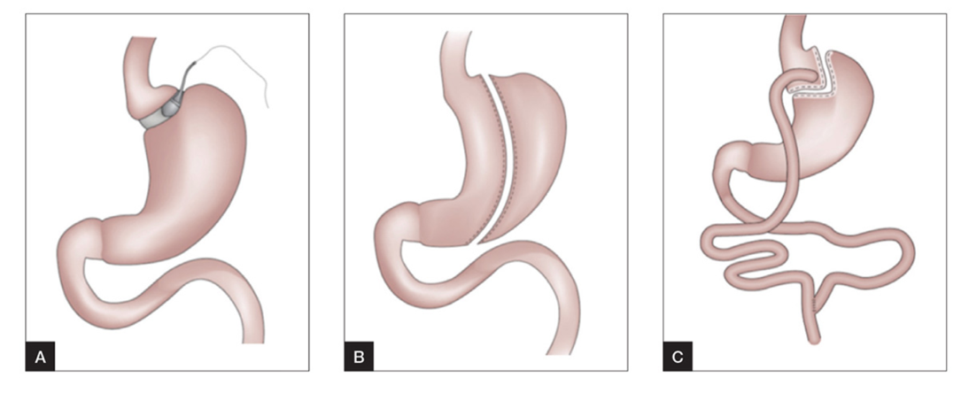
Figure 2.10. The three most commonly performed operations for the treatment of obesity: (A) gastric binding; (B) gastrectomy; (C) gastric bypass. (Source: Lee and Dixon. Bariatric-metabolic surgery: A guide for the primary care physician. Aust Fam Physician. 2017; 46:465-471).

New therapeutic perspectives
As the prevalence of overweight and obesity continues to increase, researchers are actively exploring novel therapeutic approaches to address this pressing issue. Genetic therapies represent a promising avenue, striving to pinpoint genetic markers linked to obesity (Ramos-Lopez et al., 2017). The goal is to develop targeted treatments that can either correct or influence genes implicated in the regulation of body weight. Additionally, neuroscience has emerged as a valuable asset in this field, seeking to enhance the understanding of the intricate brain and neural mechanisms governing appetite (Dickson and Chowen, 2020). This exploration may pave the way for innovative therapies, such as brain stimulation or precision medications. However, it's crucial to note that these treatments are intricate and costly, with their widespread implementation not anticipated in the short term. Consequently, the current focus remains on lifestyle modifications and adopting a balanced diet. Progress is evident, especially in chrono-nutrition research, which investigates whether the timing of meals can impact metabolic health. Recent findings indicate that aligning eating habits with one's circadian rhythms could potentially foster weight maintenance or even facilitate weight loss.

3. CHRONO-NUTRITION

3.1 Definition
The expansion of knowledge in the area of chronobiology and a deeper understanding of the relationship between circadian rhythms and nutrition have led to the emergence of a new branch of research called chrono-nutrition. This field of research studies the three temporal aspects of eating behaviour - the time, frequency and regularity of meals - and the impact these have on human health (Flanagan et al., 2021). The importance of “when we eat” is linked to our 24-hour internal biological timing system and a growing body of evidence, both in animals and humans, indicates that the timing of food intake can have a profound impact on metabolic health and general well-being (Almoosawi et al., 2016; Potter et al., 2016). In this view, the study of the impact of the timing of eating by matching elements from nutritional research with chrono-biology could have significant implications for personalized nutrition in terms of reducing the prevalence and burden of chronic diseases.

3.2 Human circadian clock
Life on Earth is affected by cyclically recurring changes that are primarily due to the Earth's rotation around its axis. The alternation of light and darkness, as well as the daily fluctuations in temperature, are a reflection of the succession of day and night and represent only some of the most obvious environmental events that occur as a direct consequence of rotation (Roenneberg et al., 2016). The circadian clock itself is a system of adaptation to the Earth's rotation and confers a structured 24-hour rhythm that is found at every level of the living system: from gene expression to the behavioural level (Farshadi et al., 2015). The development of such a biological clock is not the exclusive prerogative of the most evolved living beings, but is a highly conserved system found in eukaryotes, including mammals, as well as prokaryotes.
In mammals, the circadian system consists of a hierarchical network of clocks where the master circadian clock, located in the suprachiasmatic nucleus (CNS) of the hypothalamus, synchronizes clocks in peripheral tissues to drive behavioural and humoral rhythms (Fig. 3.1). The location of the CNS, which is adjacent to the optic chiasm, makes it ideal for receiving light input that is detected by retinal ganglion cells, that contain photopigment melanopsin, and sent to the master clock via the retinohypothalamic tract (Lananna and Musiek, 2020). Although the light is the main driving agent for the master clock in the CNS, other external cues, also called “synchronizers” or “zeitgebers”, can influence the circadian rhythm synchronization (Xie et al., 2019). These include body temperature, mealtimes, social interactions, and physical exercise, and are particularly important for the circadian clock system in peripheral tissues that cannot perceive daylight signals (Hirota and Fukada, 2004). The master circadian clock processes a neurohumoral output after receiving external timing cues to control physiological activity in numerous tissues and organs (Cagampang and Bruce 2012).
The linking between the master circadian clock and peripheral tissues involves numerous mediators, including circulating hormones, cytokines, metabolites, and sympathetic activation (Xie et al., 2019). At the cellular level, the circadian oscillations are controlled by cell-autonomous transcriptional/translational feedback loops (TTFLs). At the cycle beginning, two transcription activators included in the core clock genes, CLOCK and BMAL1, produce a heterodimer, bind to the cis-acting promoter element E-box (5’-CACGTG-3’), and activate the transcription of the PER and CRY genes (Xie et al., 2019). After translation, PER and CRY proteins accumulate, dimerise, and produce complexes that translocate back to the nucleus and inhibit the transcriptional activity of the CLOCK/BMAL1 heterodimer (Cagampang and Bruce 2012). Another loop is coupled to the core TTFLs to complete the oscillation. This loop comprises RORs and REV-ERB, two proteins that are positive and negative regulators of BMAL1 transcription, respectively. Together, these two interlocking transcriptional feedback loops make an oscillatory expression pattern over a period of approximately 24 hours, regulating numerous physiological processes including immune responses, hormone secretion and digestion (Takahashi, 2017; Vallée et al., 2020).
The presence of a circadian transcriptional clock in almost every cell of the body suggests that the rhythmicity of metabolic functions is a key health component. When behaviours such as sleep or eating are not synchronised with the surrounding environment (e.g., dark/light cycles), an alteration of circadian rhythms occurs. This condition is defined as chrono-disruption, i.e. a major disturbance in the circadian organization of physiology, endocrinology, metabolism and behaviour, with consequent negative effects on the body's homeostasis (Erren and Reiter, 2009). In particular, numerous studies have shown that an alteration in circadian rhythms leads to an inflammatory state and impaired immune system function (Zheng et al., 2020; Colombini et al., 2022), promoting the onset of several cardiometabolic diseases and cancer (Patterson et al., 2017; Hurley et al., 2019). More recently, a chrono-disruption has also been associated with the development of age-related neurodegenerative diseases such as Alzheimer's and Parkinson's disease (Verma et al., 2023). However, further investigations are needed to better prove this link.
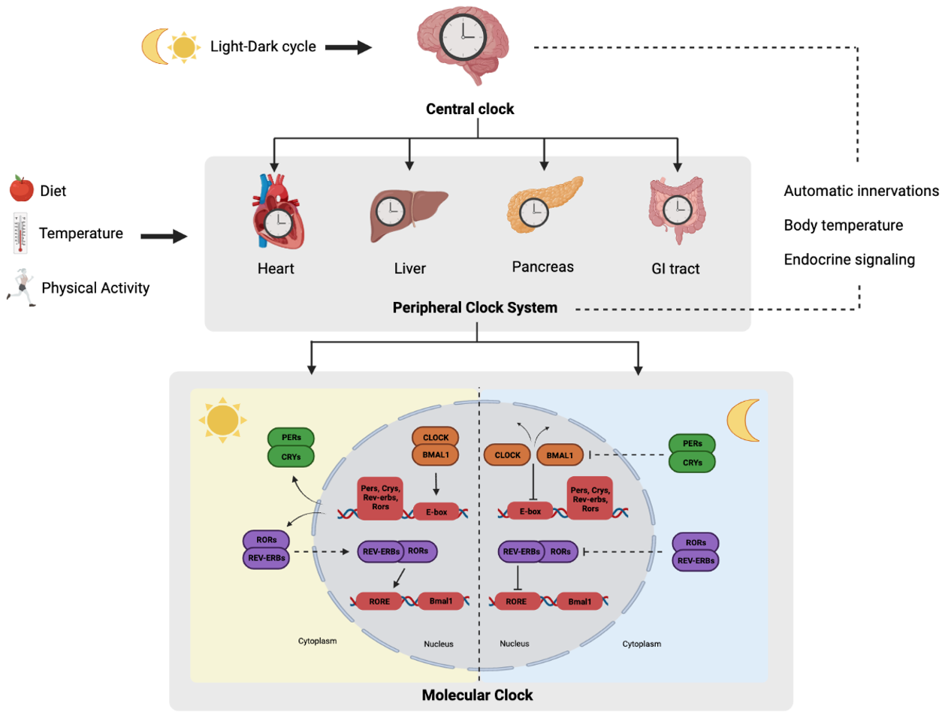
Figure 3.1. The human circadian clock system. (Source: Lotti et al. Circadian rhythms, gut microbiota, and diet: Possible implications for health. Nutr Metab Cardiovasc Dis. 2023; 33:1490-1500).
3.3 Circadian rhythms
The term “circadian” has Latin etymology: it derives from circa and diem, which can be translated as “about a day” (Halberg, 1963). The biological clock has the task of synchronising the rhythm throughout the day of biological, physiological and behavioural processes with the external environment. The time of a rhythm is called a period and can be classified according to its duration. For example, there is the ultradian rhythm, characterised by a duration of less than 24 hours, but continuous in time, like the heartbeat. Oscillations characterised by a 24-hour periodicity are called circadian, like the sleep-wake cycle. Then there are rhythms whose periodicity exceeds 24 hours and are called infradian rhythms, which can be weekly, monthly as well as yearly (Halberg, 1963).
However, most biological rhythms follow a circadian pattern, which led to the assumption until a few decades ago that they depended exclusively on the light-dark cycle. In reality, a characteristic feature of biological rhythms is the persistence of their oscillation even under conditions of environmental isolation, such that blindness or prolonged periods in the dark do not disrupt the circadian rhythm of various functions (Jegla and Poulson 1968; Reitzel et al., 2010).
Demonstrating the importance of rhythmicity for living beings, most mammalian physiological systems, such as the cardiovascular, digestive, nervous and urinary systems, appear to be subject to circadian control. The secretion of hormones that regulate appetite, blood pressure or heart rate show fluctuations that occur according to regular rhythms (Eckel-Mahan and Sassone-Corsi, 2013).

3.4 Circadian rhythms synchronizers
Every living being on Earth is in constant communication with its environment, receiving stimuli of a different nature to which it must respond appropriately. This continuous exchange of information is useful for the endogenous biological clock to harmonise the rhythms of biological, physiological, metabolic and behavioural processes with external rhythmicity. The external input signals that synchronise the endogenous clock are called “zeitgebers”, a German term that literally means “time givers” (Dibner et al., 2010). These synchronising signals can reset the body's circadian clock and bring all cells into the same phase of circadian oscillation, a process called synchronisation of circadian rhythms.

3.4.1 Light
Most organisms acquire temporal information through the variation of light intensity over the course of the day to reset their clock, referred to as “photic entrainment” (Roenneberg and Foster, 1997). Light radiation, to date, is considered the most powerful agent for synchronising circadian rhythms.
The cascades of light signals that regulate the circadian clock are quite complex (Fig. 3.2). In vivo, photosensitive ganglion cells (pRGCs) receive light information through the presence of melanopsin, a photopigment (Hankins et al., 2008). When stimulated by light, melanopsin causes the activation of G-protein-coupled signalling cascades that lead to the opening of transient-receptor potential channels (TRPC) such as TRPC6 and TRPC7, Ca²⁺ influx, and cellular depolarisation (Polentini et al., 2015). This signal is transmitted from the pRGCs to the CNS via the retino-hypothalamic tract (RHT), whose main neurotransmitters for photic entrainment are glutamate, pituitary adenylyl cyclase activating peptide (PACAP), substance P and aspartate (Mikkelsen et al., 1993). Once glutamate binds to its receptors such as N-methyl D-aspartate (NMDA) or α-amino-3-hydroxy-5-methyl-4-isoxazolepropionic acid (AMPA) receptors, it causes cell depolarisation and the activation of specific kinases including protein kinase (PKA), calcium-calmodulin kinase (CaMK), mitogen-activated protein kinase pathway (MAPK) (Meijer et al., 2003). These kinases are involved in CREB phosphorylation resulting in transcription of clock genes such as PER1 and PER2 (Meijer et al., 2003). This complex biochemical pathway allows the endogenous clock system to synchronise with the external environment.
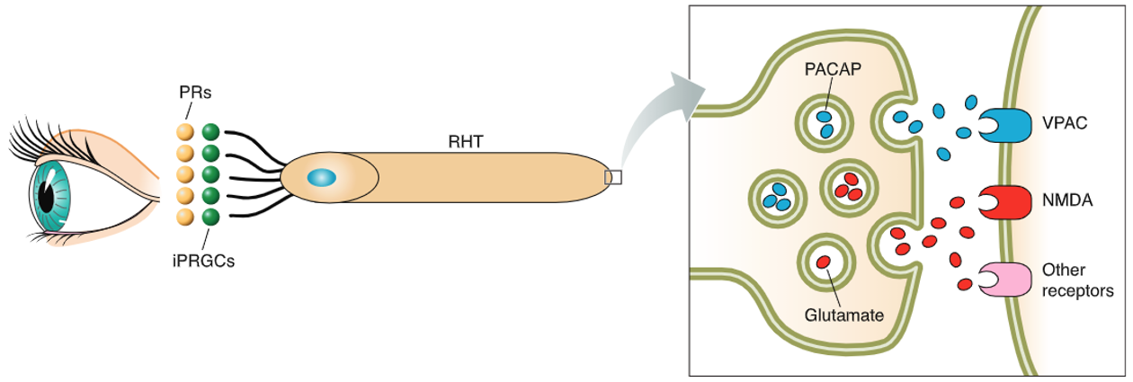
Figure 3.2. Schematic representation of the RHT, which originates from the pRGCs and innervates, via glutamate and PACAP neurotransmission, the ventral part of the SNC (Source: Golombek and Rosenstein. Physiology of circadian entrainment. Physiol Rev. 2010; 90:1063-1102).

One aspect of light radiation that cannot be overlooked is the strength of the intensity with which it manifests itself. The intensity of outdoor light in broad daylight can vary from 10,000 lux to tens of thousands of lux depending on the cloudiness of the sky, while most indoor environments remain below 400 lux. At the time of our ancestors, the light-dark cycle was much more powerful than what we experience in modern life, as the intensity of this strong zeitgeber is now mitigated by expedients such as artificial lighting (Carvalho et al., 2014). It has been observed that city life characterised by constant exposure to light, noise and social crowding significantly reduces synchronisation with the light-dark cycle (Hale et al., 2007; Carvalho et al., 2014). For example, Roenneberg and colleagues observed that the timing of exposure to strong outdoor daylight determines the sleep phase and that each additional hour spent outdoors is associated with 30 minutes of early sleep (Roenneberg et al., 2003).

3.4.2 Arousal stimuli
Although light is the main synchroniser of the central biological clock, other environmental stimuli can synchronise circadian rhythms at a peripheral level. These factors are called “non-photic entrainment” stimuli and include temperature, food, exercise, constraint stress and social interactions.

Temperature
Temperature has a weaker synchronising effect than light. In fact, although many physiological processes depend on environmental temperature, the circadian system has an important feature called temperature compensation, in which circadian oscillations remain resistant to changes in temperature. This implies that the period length continues to be around 24 hours despite changes in environmental temperature (Isojima et al., 2009; Narasimamurthy and Virshup, 2017). However, the amplitude of circadian gene expression in peripheral cells and tissues can instead be synchronised by temperature fluctuations (Brown et al., 2002; Ohnishi et al., 2014). The intrinsic mechanism of temperature effects on circadian rhythms may be mediated by heat shock factor 1 (HSF1) and cold-inducible RNA-binding proteins (CIRPs) (Fig. 3.3). HSF1 is a circadian transcription factor that binds the heat shock element sequence in a daily rhythmic manner, leading to the circadian activation of downstream promoters including PER2 (Kornmann et al., 2007; Tamaru et al., 2011). Pharmacological HSF1 inhibition or HSF1 deficiency lengthens circadian free-running periods while it blocks heat-pulse induced synchronization of PER2 rhythms. On the other hand, HSF1 and its transcriptional target HSP90 interacts with BMAL1-CLOCK protein complex to stabilize BMAL1 after a heat-shock pulse (Tamaru et al., 2011). Another key player in the circadian regulation of peripheral clocks by body temperature rhythms are CIRPs (Morf et al. 2012). Induced by cold temperatures, CIRPs preferentially associate with regions of RNA close to polyadenylation sites and enable the high-amplitude expression of circadian genes, including the CLOCK gene (Ki et al., 2015).

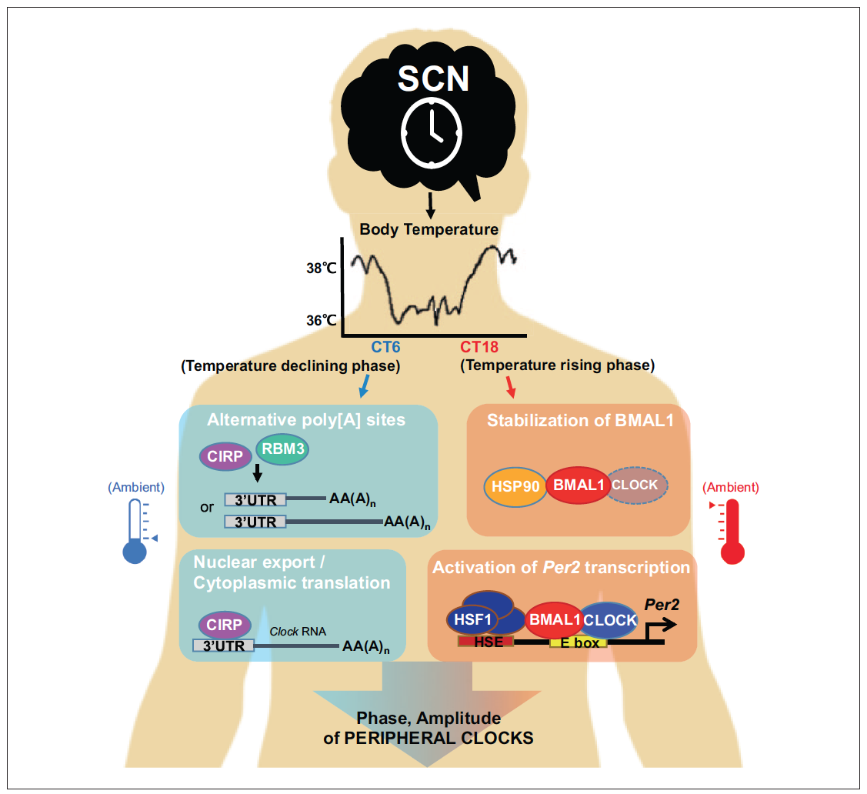
Figure 3.3. Mammalian pacemaker neurons in the hypothalamic suprachiasmatic nucleus (CNS) generate body temperature rhythms to synchronize peripheral clocks (Source: Ki et al. Warming Up Your Tick-Tock: Temperature-Dependent Regulation of Circadian Clocks. Neuroscientist. 2015; 21:503-518).

Exercise
Since numerous evidences have shown that different non-photic inputs affect circadian rhythm phase, more recently researchers have also evaluated the role of physical activity. Some parameters used to evaluate physical performance in humans, such as muscle strength, anaerobic power and joint flexibility, oscillate according to a circadian pattern that overlaps with that of body temperature. These findings suggest that there may be a “suitable” time of day for physical activity.
Interesting evidence has been collected in studies on mice models which highlighted that exercise causes a shift in the circadian rhythms of these nocturnal animals (Edgar and Dement, 1991; Mistlberger et al., 1996; Yamada et al., 1986). In particular, periodic exposure to exercise, which for mice consists of spinning a wheel or running on a treadmill, causes an anticipation of the rest phase and a delay in the activity phase. These results showed the potential ability of exercise to synchronize circadian rhythms, leading to the hypothesis that the same occurs in humans.
One of the more notable human studies is that of Yamada and colleagues, in which an intervention group got two hours of regular exercise twice a day while awake, while a control group sat in a chair on occasions in which the active counterparty exercised (Yamada et al., 2006). Both groups were placed under constant light conditions. By measuring the plasma concentration of melatonin, it emerged that the release phase of this hormone was significantly advanced in subjects who exercised regularly, compared to the control group. These results suggest that regular exercise can influence and synchronize the circadian system even in evolutionarily more complex organisms (Yamada et al., 2006). Several sessions of physical activity regularly practiced seem to facilitate the realignment of the circadian rhythm of melatonin release to anticipate or delay the sleep-wake cycle to re-establish synchrony with the environmental rhythmicity.
Possible hypotheses have been advanced to justify the phase reset of the circadian system following physical activity. One possible theory is based on the "communication" of physical exercise with the SNC via the hypothalamic genic tract. In particular, an important role would appear to be played by neuropeptide Υ (NPΥ) and serotonin (Janik et al., 1995; Grossman et al., 2000). These neurotransmitters have been proposed as possible candidates able to mediate the effects of physical activity, promoting an arousal state and the activation of serotonergic pathways. However, other evidences suggest that the ability of physical activity to induce a phase change in circadian rhythms is due to the increase in temperature it causes, remembering that temperature is a powerful zeitgeber (Weinert and Waterhouse, 1999; Waterhouse et al., 2004).

Food
Of particular interest is also the high reactivity that the molecular components of the circadian system show in relation to food intake. As already mentioned, peripheral clocks, in addition to receiving signals from the master clock on how to reset their phase, can be influenced by other synchronising factors. Among the most relevant synchronising agents is food intake, highlighting the important relationship between the circadian system and metabolic processes (Stephan, 2002). In mammals, food is supplied and consumed within a few hours, a condition called timed feeding or time restriction of feeding. It has been seen that this time-restricted feeding in rodents induces a time-specific excitatory state known as food anticipatory activity (FAA) (Richter, 1922). As the adjective itself suggests, this is a behaviour that is enacted approximately 2-3 hours before the meal and is manifested, for example, by the rodent's search for food as the time of its usual feeding approaches (Richter, 1922). The presence of this behaviour suggests that these animals are able to remember when they feed using their endogenous clock, as the FAA occurs at the same time each day, even after prolonged fasting. This has led to the hypothesis of the existence of a food-entrainable oscillator (FEO), properly called the food-entrainable oscillator, capable of driving the synchronisation of feeding behaviour and FAA, but apparently distinct from the central clock (Stephan, 2002).
Feeding-fasting signals synchronise circadian clocks in peripheral tissues by determining the periodic availability of many circulating macronutrients (Woods et al., 2005). For example, ingestion of food causes the release of insulin into the bloodstream and induces the expression of clock genes in insulin-sensitive tissues such as liver, fat and muscle (Oike et al., 2014). Feeding also increases blood glucose levels and high glucose concentrations can reduce the expression of PER1 and PER2 in fibroblasts (Hirota et al., 2010) and indirectly regulate adenosine monophosphate activated protein kinase (AMPK), which controls the stability of CRYs clock genes (Lamia et al., 2009). Thus, the role of the feeding-fasting cycle on peripheral circadian rhythms seems quite evident.

3.5 Circadian rhythms and physiological processes of nutrition
As already seen in the previous paragraph, nutrition is the main synchronising agent for peripheral organs that cannot perceive the light stimulus. Thus, the timing, frequency and regularity of meal intake are crucial in the regulation of circadian rhythms. Under physiological conditions, the feeding-fasting cycle is triggered by the central biological clock on the basis of the sleep-wake cycle. When meal consumption is regular, the central clock generates anticipatory food intake activity by increasing the sense of appetite, promoting the secretion of digestive enzymes and increasing intestinal motility. In contrast, irregular and sudden meal intake causes immediate activation of the peripheral clocks, but not the central clock (Baron et al., 2014). When meal consumption is constantly irregular, a condition of “desynchronization” occurs between the central biological clock, which remains synchronised with the light-dark cycle, and the peripheral clocks, which synchronise with food consumption (Baron et al., 2014).
First of all, eating meals at late times can lead to altered endocrine secretion. The daily human physiology is divided between an activity phase that begins at 10 a.m. and ends at 10 p.m., when the resting phase starts (Patterson et al., 2015). The alternation of these two phases determines the oscillations of several hormones involved in metabolic regulation (Fig. 3.4). Between 7 and 8 a.m., at the beginning of the day’s activity, the body is prepared to wake up due to a cortisol peak. This hormone prepares the body for the increase in energetic demands induced by activity (Gavrila et al., 2003). With cortisol, the concentration of another hormone, ghrelin, increases. It has three peaks of secretion during the day, just before the main meals, as it is responsible for increasing appetite and stimulating food intake. From 10 a.m. to 8 p.m., adiponectin is secreted by fat tissue cells, an important regulator of glucose and lipid metabolism. In particular, adiponectin improves glycolysis and insulin sensitivity, preventing fat accumulation (Gavrila et al., 2003). During the afternoon, from 2 to 6 p.m. there is a peak of insulin, which counteracts the action of adiponectin by promoting the storage of energy substrates. Finally, leptin is secreted and peaks at around 7 p.m., suppressing food intake, increasing lipolysis and inhibiting fat storage (Gavrila et al., 2003). Several hormone levels peak during the activity phase, suggesting early hours of the day are more optimal for food intake than the evening (Charlot et al., 2021). In contrast, food intake during the resting phase opposes the rhythm of the internal clock and is hypothesised to be a risk factor for the onset of obesity, diabetes and cardiovascular disease.

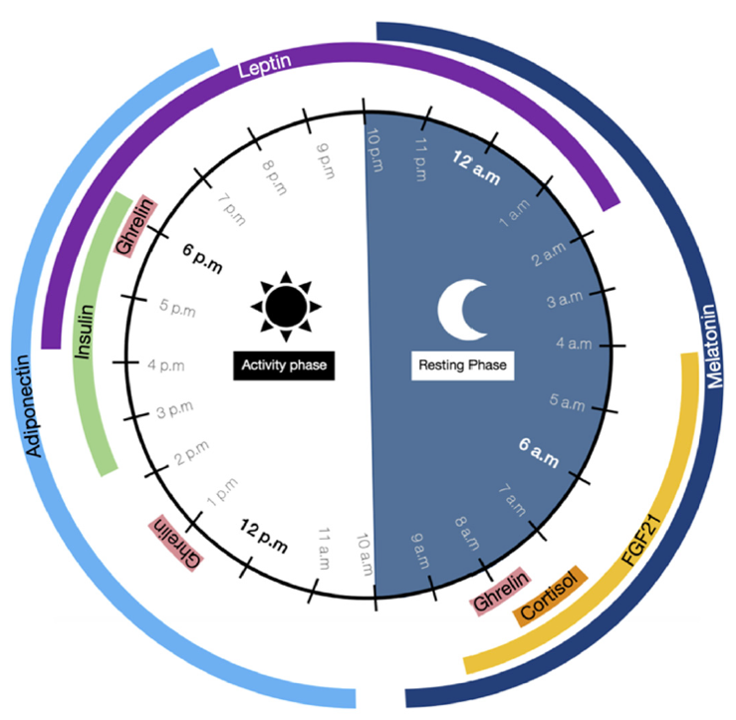
Figure 3.4. Time-of-day-dependent patterns of circulating hormone levels variation (Source: Charlot et al. Beneficial Effects of Early Time-Restricted Feeding on Metabolic Diseases: Importance of Aligning Food Habits with the Circadian Clock. Nutrients. 2021; 13:1405).

Glucose metabolism in humans also follows a circadian rhythm. Glucose tolerance varies over the course of the day, peaking during daylight hours when food is typically consumed, and decreasing during the hours of darkness when we usually fast. Numerous studies have observed how eating meals at late times significantly alters blood glucose values. For instance, Sato and colleagues showed that subjects who consumed dinner later reported a significantly increased glycaemic response to both the evening meal and the subsequent breakfast. In addition, the overall 24-hour average blood glucose level was increased following the late evening meal (Sato et al., 2011). Similar results also emerged in the study by Kajiyama and colleagues, in that subjects who ate dinner at 9:00 p.m. compared to those who ate dinner at 6:00 p.m. reported a significantly higher incremental glucose peak, as well as overall blood glucose values (Kajiyama et al., 2018). In addition to the time of day, skipping some meals, particularly breakfast, also seems to have a negative impact on blood glucose. Skipping the first meal of the day significantly increases the overall 24-hour average blood glucose and increases the risk of developing type 2 diabetes by up to 21% (Mekary et al., 2012). In the light of these evidences, it seems increasingly clear that glucose metabolism is not only influenced by what and how much we eat, but also by when the meal is consumed.
Blood lipid levels also seem to fluctuate according to circadian rhythms throughout the day, but little evidence is available to date. Plasma triacylglycerol, the main lipid component of dietary fat circulating after a meal, appears to be influenced by both the circadian clock and the time of sleep, with higher levels during the biological night (defined as the time between the beginning and the end of melatonin secretion), regardless of nutrient intake (Morgan et al., 2003). More recently, a study showed that every one-hour increase in the time of the last meal of the day was associated with lower high-density lipoprotein (HDL) cholesterol values and an increase in glucose, glycated haemoglobin, insulin and C-reactive protein values (Wirth et al., 2021). Furthermore, skipping some meals, primarily breakfast, was associated with a worsening of the lipid profile, in particular with significantly higher values of total cholesterol and low-density lipoprotein (LDL) cholesterol (Farshchi et al., 2005).
Of particular interest are recent findings that have hypothesised a bidirectional relationship between circadian rhythms and the gut microbiota. In fact, 60% of the composition of the microbiota fluctuates over a 24-hour period, as the 20% of the microbial functional pathways (Thaiss et al., 2014). At the same time, studies have shown that the gut microbiota itself synchronises the host's circadian biological clock by releasing signals of a different nature. A key role in maintaining the balance between circadian rhythms and the gut microbiota seems to be attributed to meal timing and diet quality, as well as to certain microbial metabolites, in particular short-chain fatty acids (SCFA) (Leone et al., 2015; Carasso et al., 2021). To date, studies investigating the relationship between circadian rhythms and microbiota have been conducted mainly in animal models, which highlights the need to develop studies in humans as well. Despite this, the results are promising, and it would appear that a condition of chrono-disruption and consequent alteration of the relationship between circadian rhythms and microbiota may favour the onset of cardiovascular diseases, cancer, gastrointestinal disorders and mental illness (Fig. 3.5).
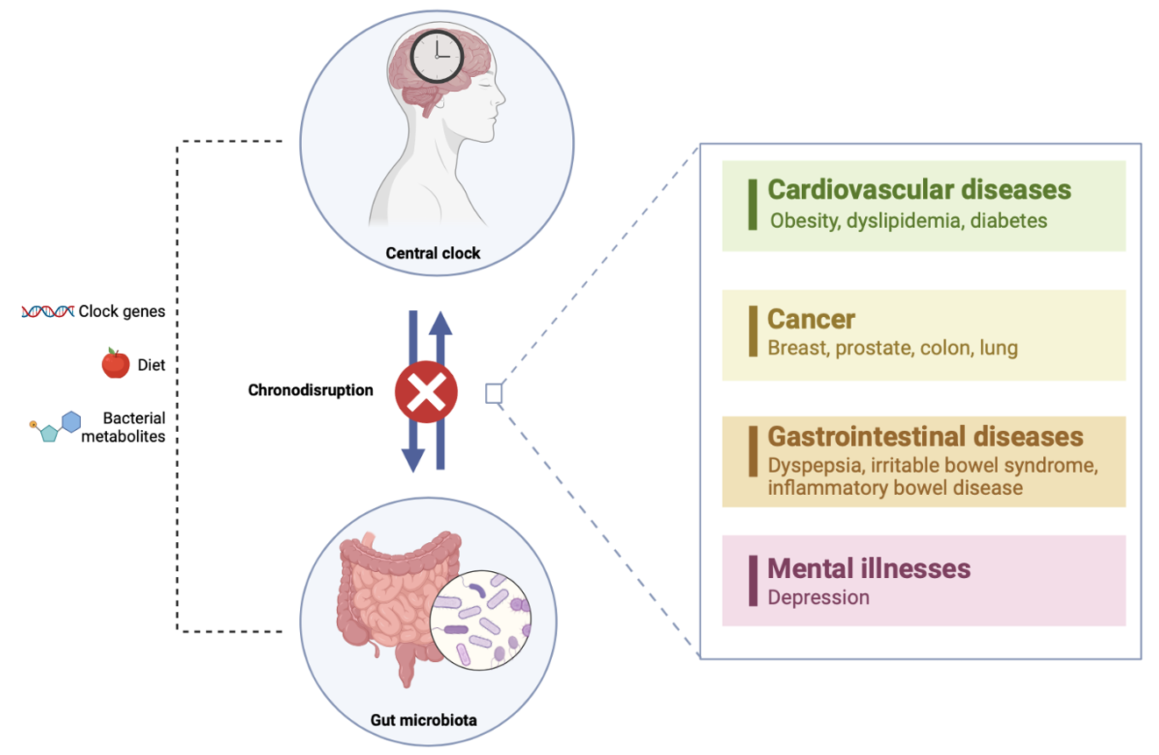
Figure 3.5. Chronic diseases associated with an alteration of circadian rhythms and gut dysbiosis. (Source: Lotti et al. Circadian rhythms, gut microbiota, and diet: Possible implications for health. Nutr Metab Cardiovasc Dis. 2023; 33:1490-1500).

3.6 Chronotype
The individual expression of circadian rhythmicity is defined as “chronotype”, a complex phenotype that reflects individual differences in sleep timing and activity preferences. There are three chronotypes expressed as a continuum between two extremes, from morning to evening (Horne and Ostberg, 1976). People with a morning chronotype are those who prefer the first part of the day to carry out their activities, as this is the time when they feel at their peak mental and physical capabilities. Furthermore, they are used to getting up early in the morning and going to bed early in the evening (Adan et al., 2012). Evening types, on the other hand, feel most fit in the afternoon and prefer the evening as the optimal time to perform their activities. Unlike morning people, these individuals tend to go to bed late at night and wake up late in the morning (Adan et al., 2012). Between the two circadian extremes, a considerable deviation in the phase of the internal clock rhythm has been observed, by about 2 hours, which is inevitably reflected in differences in physiological and mental functioning. Under constant routine conditions, typically evening subjects report their peak state of alertness around 4 p.m., whereas extremely morning subjects reach their peak state of alertness much earlier, at around 2 p.m. (Lucassen et al., 2013). Between the morning and evening chronotype there is the intermediate one, which as the name suggests has intermediate characteristics between the two extreme chronotypes.

3.6.1 Chronotype assessment
Chronotype can be measured by a variety of methods, ranging from questionnaires based on self-reported information to biological measures such as the Dim Light Melatonin Onset (DLMO). Promising research is also developing in the field of genetics and the study of the sleep-wake cycle.

Dim light melatonin onset (DMLO)
To date, the greatest reliable measure of the circadian phase of the human master clock is the DMLO (Almoosawi et al., 2019). It consists of measuring melatonin secretion in blood or saliva samples collected under low-light conditions in the hours before the onset of usual sleep. The technique involves measuring the concentration of melatonin in a blood or saliva sample taken a few hours before the scheduled bedtime. It is based on the concept that the synthesis of melatonin, secreted by the pineal gland, follows a circadian rhythm modulated by the suprachiasmatic nuclei and exposure of the eye to light. In individuals normally synchronised with the light-dark cycle, the circadian rhythm of melatonin secretion peaks during the night. Conversely, during the day melatonin levels are very low and increase in the evening as light intensity decreases (Kennaway et al., 2020). The time of onset of melatonin secretion under dimmed light conditions is called DLMO and is the marker of choice for circadian rhythm because it is not influenced by external interfering factors. In most cases, the melatonin pattern obtained from five saliva samples taken at one-hour intervals is sufficient to determine the DLMO (Kennaway et al., 2020). However, this is an invasive practice that makes melatonin analysis difficult to apply in large-scale studies, as the level of cooperation required from participants is high. Moreover, it is an expensive and laboriously demanding evaluation test (Almoosawi et al., 2019; Mazri et al., 2019). In order to avoid these complications, urinary samples can be analysed in epidemiological studies in order to assess the concentration of melatonin metabolites. However, even this approach has its drawbacks due to the poor resolution of urine samples, which has a negative impact on the accuracy of measurements (Almoosawi et al., 2019).

Validated questionnaires
Currently, the administration of questionnaires remains the most widely used measure to define chronotype, due to its low cost and ease of use. In particular, the MEQ is the most used in the literature, which specifically measures psychological preference for behaviour (Horne and Ostberg, 1976). The MEQ traditionally consists of 19 multiple-choice questions. Some of the questions in the questionnaire are: "What time would you prefer to get up, more or less, if you were completely free to plan your day?" or "You have to do two hours of physically demanding work and you are free to plan your day. Considering your rhythms, what time would you choose?". These 19 items investigate the respondents' sleep-wake cycle and preferred times of day for physical and mental activities (Horne and Ostberg, 1976). Each answer corresponds to a score, determined using a Likert scale. Assignment to one chronotype rather than another depends on the total score obtained simply by calculating the sum of the scores for each response. The ranges for classifying the population into the three chronotypes are as follows: a score up to 41 identifies an evening subject; a score between 42 and 58 defines an intermediate subject; a score above 59 identifies a morning subject. The MEQ is a validated questionnaire and the results obtained are reliable. However, it has several limitations, including the length, which has often been criticised. To compensate for this, Adan and Almirall devised a reduced MEQ, extrapolating only five items from the 19 in the original version (Adan and Almirall, 1991). The reduced Morningness-eveningness Questionnaire (rMEQ), consisting of a smaller number of questions, can be a valuable tool for recruiting a larger number of participants and thus be more suitable for large-scale studies.
The Munich Chronotype Questionnaire (MCTQ) is another widely used questionnaire to define chronotype and, unlike the MEQ, offers the advantage of collecting detailed information on sleep-wake behaviour. In fact, the MCTQ allows the assessment of “social jet lag”, quantified by the difference in hours between the median sleep points on workdays and rest days, by classifying subjects into seven different chronotypes (Roenneberg et al., 2003).
Finally, there are two further questionnaires, the Composite Scale of Morningness (CSM) and the Preference Scale. The former consists of 13 multiple-choice items of which nine are extrapolated from the MEQ, and the remaining four from another questionnaire known as the Diurnal Type Scale (DTS) (Jankowski, 2015). Similar to the MEQ, each answer given corresponds to a score that can vary from 1 to 4, or up to 5 in questions with multiple choices. The total score is calculated by summing up the scores in each item: a score of 22 or less indicates an evening chronotype, scores above 44 identify a morning chronotype, while a score intermediate to these is associated with subjects with an intermediate chronotype (Jankowski, 2015). The Preference Scale, on the other hand, consists of 12 items with no reference to a specific time of day. This is to overcome a limitation of the above-mentioned questionnaires, which is that of implying that the respondent has a typically daytime schedule. Similarly, to what was observed for the other questionnaires, also in this rating scale the total score is derived from the sum of the scores obtained for each item. The range ranges from a minimum of 12, extremely evening subjects, to a maximum of 60, extremely early morning subjects (Smith et al., 2002).

Actigraphy
More recently, the study of sleep has also been considered for the definition of the chronotype. Through the use of an actigraph, which is a three-dimensional movement sensor placed on the wrist like a watch and which allows the movements made by the patient's body to be recorded for a duration of one or more days, it is possible to study sleep patterns. Recent evidence has found that acrophasic activity in evening subjects occurs almost 2:20 hours later than in morning subjects. In fact, evening subjects reach peak activity in the late afternoon compared to morning subjects who reach it in the early afternoon (Montaruli et al., 2021). Furthermore, evidence supports the hypothesis that acrophase is linearly and inversely related to MEQ and rMEQ score (Fig. 3.6). Specifically, for each additional point in the MEQ score, acrophase is earlier by about 5 minutes, just as for each additional point in the rMEQ score, acrophase is shorter by about 16 minutes (Montaruli et al., 2017). This relationship allows actigraphy to be able to identify an individual chronotype.

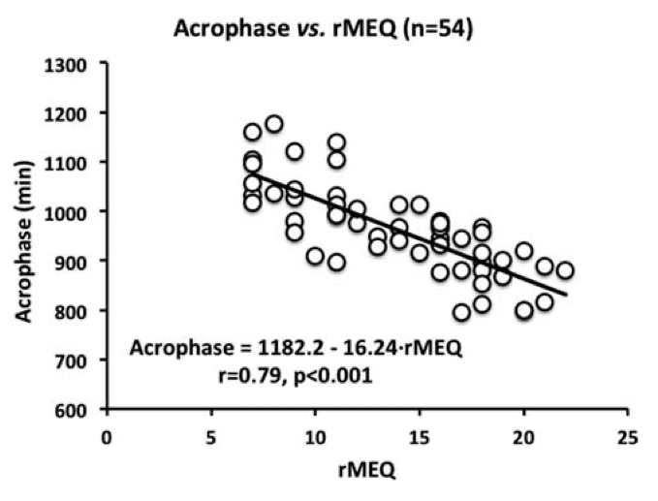
Figure 3.6. Graphical representation of the linear and inverse correlation between acrophase and rMEQ score (Source: Montaruli et al. The Circadian Typology: The Role of Physical Activity and Melatonin. Sport Sci. Health. 2017; 13: 469–476 27).

3.6.2 Factors influencing chronotype
The distribution of chronotypes in a given population is defined by numerous factors, both genetic and environmental. In general, the 60% of the population shows an intermediate chronotype, with the remaining 40% shifted between the morning and evening chronotypes (Almoosawi et al., 2019). In recent years, several genome-wide association studies have characterised important polymorphisms in clock genes that might underlie some of the inter-individual and inter-ethnic differences in chronotype. Among these, the CLOCK 3111T/C central clock gene polymorphism would appear to be associated with the evening chronotype, increased risk of obesity and reduced sleepiness (Ruiz-Lozano et al., 2016). Other polymorphisms have been associated with the morning chronotype, 22 loci have been identified to date. In particular, it would appear that the variant most associated with the morning chronotype is rs516134, which is located close to RGS16, a known regulator of circadian rhythms (Hu et al., 2016).
Demographic characteristics, such as gender and age, also appear to moderate the morningness-eveningness trait. Regarding the gender, although not all studies agree, a higher prevalence of morningness has been found in women than in men, who reported higher eveningness. The lack of consistency in findings could be due to the absence of information on relevant confounders that could affect a potential association between gender and chronotype. For example, in women, but not in men, having children was found to be the strongest determinant of the morning chronotype. This could imply that having children is a more important social factor influencing a woman's chronotype than her partner, and potentially an effect modifier that needs to be considered when analysing nutritional surveys (Almoosawi et al., 2019). Age is another factor that influences the time preferences, which vary throughout human life. Children predominantly show a morning chronotype that changes to eveningness during adolescence, and then returns to morningness again around the 50 age (Jankowski 2015). These variations are probably due to changes in gonadal hormone secretion and societal and lifestyle demands (Broms et al., 2014). For instance, while artificial light prolongs daylight and allows humans to work at night, favouring a change in subjects' chronotype towards the eveningness, school and certain work schedules that begin early in the morning may favour a shift of the evening chronotype towards the morningness (Fabbian et al., 2016). So, also environmental cues such as light, social interactions, and study/work schedules are each thought to entrain the circadian system.

3.7 Chronotype and dietary habits
The chronotype is a complex multicomponent factor not only because it is determined by a multiplicity of parameters, but also by virtue of the fact that it can influence other variables. Several studies have shown that belonging to one chronotype rather than another can affect aspects such as mood, academic performance, personality traits and even eating behaviour (Cohen-Zio et al., 2018; Au et al., 2017; Mazri et al., 2019). However, to date, it is still unclear whether the chronotype is a determinant of eating habits, and thus a causal factor, or whether it is more simply a reflection of the effect of diet and nutritional constituents on peripheral clocks. In any case, certain characteristics and behaviours have been identified that are more common in one chronotype than another. In particular, subjects with an evening chronotype were associated with worse eating habits than morning subjects, especially in terms of the time and regularity of meal consumption, and diet quality (Mazri et al., 2019; Phoi et al., 2021).
A recent review comprising 36 studies showed that evening subjects had later meal timing and distributed a greater amount of energy and nutrient intake to the later day part (Mazri et al., 2019). The delay in meal consumption between the morning and evening subjects was quantified at approximately 1 - 1.5 hours (Lucassen et al., 2013). Recently, another interesting concept regarding mealtimes has also been analysed in relation to the chronotype, known as the midpoint of food/energy intake. It is the point in time between the first and last eating episode, which suggests the spread of food/energy intake throughout the day. Several studies reported that evening types had a significantly later midpoint of intake than morning ones (Vera et al., 2018; Teixeira et al., 2018; Rosi et al., 2022). It has been hypothesised that this delay in meal consumption observed in evening subjects is due to a delay in the release of appetite-regulating peptides such as leptin and ghrelin (Meule et al., 2012). Shifting the eating phase to what would be the resting phase for the body can have a significant impact on cardio-metabolic health, as it goes against the circadian rhythm of the central clock.
Moreover, this delay in circadian rhythms observed in evening subjects also leads to a lack of signalling by the biological clocks that signal when a meal is to be eaten, favouring the skipping of some meals (Meule et al., 2012). This is particularly true for breakfast, as highlighted in a recent scoping review by Phoi and colleagues, in which 5 out of 6 studies showed a greater tendency to skip breakfast in evening subjects (Phoi et al., 2021). This association has also been observed in some younger peoples, such as university students (Teixeira et al., 2018; Rodríguez-Muñoz et al., 2020) and school-age children (Yu et al., 2020). More recently, a higher frequency of skipping other meals besides breakfast, such as mid-morning snack and lunch, has also been observed (Lotti et al., 2022). The meal skipping observed in evening people may be related to their sleeping habits, especially about breakfast. Since evening types are more frequently associated with social jet lag, which forces them to adapt their biological rhythms to the schedules imposed by society, they tend to accumulate a sleep debt during the week, which is then recovered at the weekend (Wittmann et al., 2006; Silva et al., 2016). Thus, evening subjects sleep less than required and they may prefer to sleep a little longer in the morning instead of having breakfast (Teixeira et al., 2018). A further hypothesis is that meal skipping observed in evening subjects is linked to a genetic predisposition, as shown in a study of 53 pairs of female twins which found that the time and consumption of breakfast and lunch are significantly influenced by genetic factors (Lopez-Minguez et al., 2019).
More recently, a potential influence of chronotype on the quality of the diet has also been hypothesised. Only a small number of studies have investigated the relationship between chronotype and micro- and macronutrient intake, most of which reported no significant differences between chronotypes in daily consumption of carbohydrates, proteins and fats (Mazri et al., 2019). Even more limited evidence is available for fibre and micronutrients (Mazri et al., 2019). The greatest concordance of results is for sucrose consumption, which is significantly higher in evening subjects (Kanerva et al., 2012; Maukonen et al., 2017).
Analysing the consumption of specific food groups, a higher intake of sweet food and beverages was observed in evening subjects (Kanerva et al., 2012; Maukonen et al., 2017). The latter usually joint with other unhealthy eating practices, such as lower consumption of vegetables and higher intake of caffeine and alcohol. Interestingly, some studies have revealed that alcohol and caffeine consumption may increase the predisposition to the evening chronotype (Rupp et al., 2007; Robinson et al., 2013), probably because subjects who go to bed later are more likely to engage in “evening habits”, including drinking (Wittmann et al., 2010). Some studies also revealed that evening chronotypes consume significantly more alcoholic beverages after 8 p.m. than morning and intermediate chronotypes (Maukonen et al., 2017).
During the past two years, research has also begun to assess whether there is a chronotype influence on adherence to specific dietary patterns such as MD. MD is characterized by high consumption of plant foods, moderate consumption of fish, dairy products, and eggs, and low consumption of meat and meat products (Dinu et al., 2021). Thanks to its composition, it is globally recognized as one of the best diets to prevent cardiometabolic diseases and reduce morbidity and mortality from all causes (Dinu et al., 2018). Most of the studies that have recently evaluated the relationship between chronotype and MD have been conducted in Spain and Italy (Rodriguez-Munoz et al., 2020; Lotti et al., 2022; Zeron-Rugiero et al., 2019; De Amicis et al., 2020; Muscogiuri et al., 2020). All of these studies associated morning subjects with a higher adherence to MD, mainly due to a high consumption of fruit, legumes, olive oil and a reduced consumption of meat and meat products (Fig. 3.7). Of particular interest are the results of De Amicis et al., who associated morning people with significantly higher adherence to MD and lower waist circumference and visceral fat values than evening subjects (De Amicis et al., 2020). There are several potential mechanisms that may predispose evening persons to be less adherent to a healthy diet, including social jet lag (Adan et al., 2012; Friborg et al., 2014), and different personality traits among chronotypes. In fact, it was observed that evening subjects tend to be less conscientious and have less self-control than the other chronotypes (Mukherji et al., 2013).
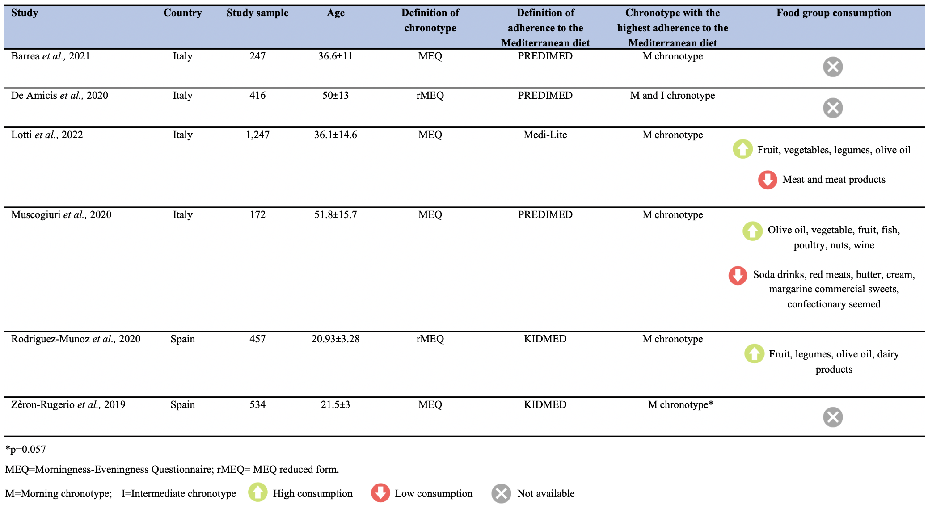

Figure 3.7. Summary of human studies that analysed the effect of chronotype on the MD adherence (Source: Lotti et al. Circadian rhythms, gut microbiota, and diet: Possible implications for health. Nutr Metab Cardiovasc Dis. 2023; 33:1490-1500).

4. AIM OF THE STUDY

The aim of CHRONODIET study was to carry out a 4-month randomized, parallel-group, two-arms, open-label trial in overweight or obese subjects, in order to compare the effect of a diet-adapted to the individual chronotype versus a control diet on the following outcomes:

- anthropometric and body composition parameters (weight, BMI, fat mass, free fat mass, total body water body cellular mass, extra-cellular water, total body water)
- glycemic profile (fasting glucose)
- lipid profile (total cholesterol, LDL-cholesterol, HDL-cholesterol, triglycerides)
- gut microbiota functionality

5. EXPERIMENTAL PROCEDURES

5.1 Study design and sample
The study was designed as a 4-month randomized, parallel-group, two-arms, open-label, superiority trial with 1:1 allocation ratio to either intervention or control arms, it was conducted at the Unit of Clinical Nutrition of the Careggi University Hospital, Florence, Italy.
The calculation of the sample size and statistical power was measured considering the 80% probability to show as statistically significant (p<0.05) a 1.4% weight reduction difference between the intervention group and the control group, with a standard deviation of 0.4% and a loss at follow-up of 22%. This calculation was derived from a study in the literature that evaluated the difference between a diet adapted to the chronotype and a control diet in overweight/obese subjects (Galindo Muñoz et al., 2016). The minimum number of subjects to be recruited to obtain reliable results with a statistical power of 0.8 (Beta) and 0.05 (Alpha) was 54 participants per group. As the study is currently ongoing, it is anticipated that a total of 108 subjects will be enrolled in the coming months.
The recruitment was done by trial personnel using advertisements in local media, newspapers, social media, official papers and websites. Subjects were also recruited from a pre-existing database of participants and from friends or relatives of the hospital and university staff.
A web-based online randomization procedure was used to generate the allocation sequence. No adaptive randomization procedures were performed. The random assignment sequence was produced and managed by an investigator who was not involved in the recruitment of participants. The order of assignment was kept secret from the experimenters who enrolled participants or assigned interventions. The group assignment was presented on a folded sheet of paper in a sealed envelope. Blinding of study participants and nutritionists was not possible due to the obvious differences between intervention diets; however, outcome measures could not be easily influenced by the observer. In addition, study personnel who enrolled participants, data collectors, outcome assessors, and data analysts were blinded to the treatment assignment, and a researcher from outside the research team entered the data into the database.
Each participant underwent an initial medical examination during which anthropometric parameters and body composition were assessed, a blood and stool sample were collected, eating habits were investigated by means of a frequency questionnaire and the completion of a 3-day food diary, and the individual chronotype was defined by means of the MEQ. At the end of the 4-month intervention period, anthropometric parameters and body composition were re-evaluated and a blood and stool sample were collected. The various phases of the study are illustrated in the Figure 6.1.
The study protocol was approved by the Tuscany Regional Ethics Committee of the Azienda Ospedaliera Universitaria di Careggi, Florence (n 21035_spe) (Appendix A and B). The Ethics Committee's approval covered the study protocol, the information sheet and consent form, questionnaires, interviews, any other written information that was provided to participants and any advertising that was used during the study (Appendix C). Given the nature of the study, no post-study arrangements are necessary. The study protocol has also been registered with the Clinical Trials Registry (clinicaltrials.gov: NCT05941871, registered on 18/05/2023) and complies with the requirements of the International Committee of Medical Journal editors (ICMJE).

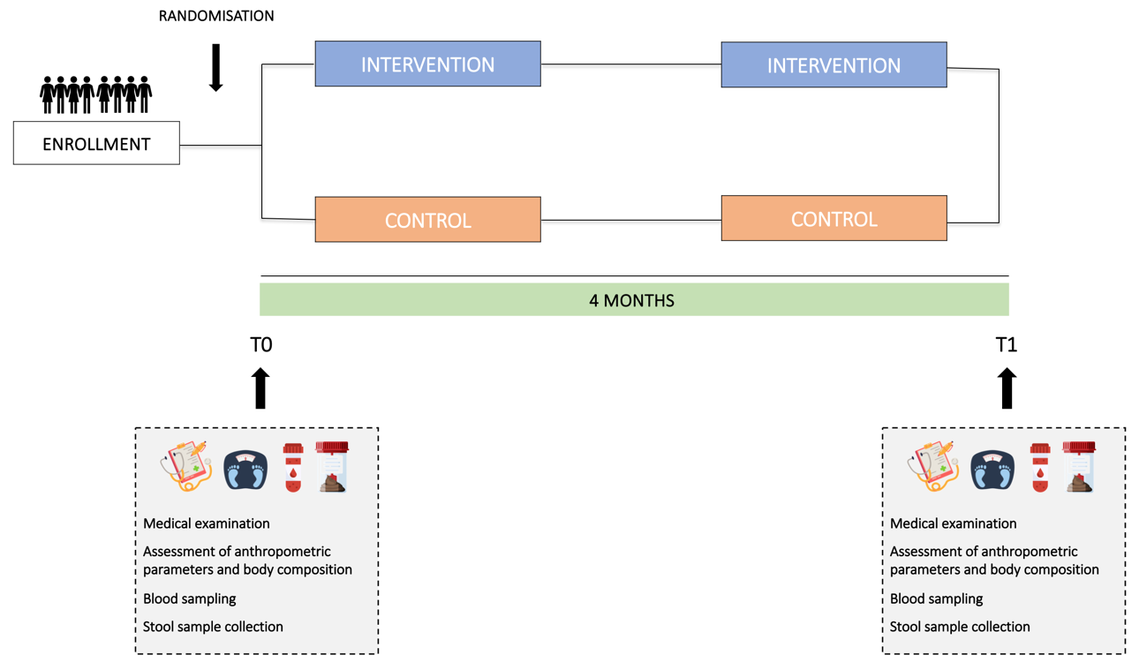
Figure 5.1. Organization of the intervention study.

5.2 Outcomes
The primary outcome was weight change from baseline. Secondary outcomes were: 1) BMI and fat mass change from baseline; 2) glycemic and lipid profile change from baseline (fasting glucose, total cholesterol, LDL-cholesterol, HDL-cholesterol, triglycerides); 3) fecal microbiota functionality and SCFAs change from baseline. Body weight was measured as a unique and established quantitative primary outcome, while assessment of body composition, biochemical profile, and gut microbiota provided information on the cardiometabolic status of participants. The metric used was the change in mean values from the beginning to the end of each dietary intervention.

5.3 Eligibility criteria
The inclusion criteria were being overweight or obese with a BMI ≥ 25 kg/m² and being aged 18-65 years old. Exclusion criteria were as follows:

- presence of chronic illnesses or unstable conditions that could interfere with the dietary intervention (e.g., cancer, kidney or liver disease, inflammatory bowel disease, cognitive decline, psychiatric disease);
- drug therapies that could interfere with the effectiveness of the dietary intervention (e.g., use of corticosteroids, anti-diabetic drugs);
- pregnancy or intention to become pregnant in the next 12 months;
- breastfeeding;
- current or recent (last 3 months) adoption of a low-calorie diet.

5.4 Intervention diets
After a 2-week run-in period, eligible participants were divided into two groups: the intervention group (or chrono group), which was administered a low-calorie chronotype-adapted diet with a calorie distribution adapted to the individual chronotype (morning or evening), and the control group, which was administered a low-calorie control diet with a standard calorie distribution.
In the intervention group, chronotypes were assessed according to scores obtained with the MEQ (Horne and Ostberg, 1976). Participants with a score between 52 and 86 were classified as morning chronotypes and received a morning-adjusted diet, while those with a score between 16 and 51 were classified as evening chronotypes and received an evening-adjusted diet (Galindo Muñoz et al., 2020). The daily caloric distribution was as follows: 1) morning chronotype - 40% of the daily kcal was administered before lunch and 20% in the second part of the day (specifically: 30% at breakfast, 10% in the morning snack, 40% at lunch, 5% at snack and 15% at dinner); 2) evening chronotype - 20% of the daily kcal was administered before lunch and 50% in the second part of the day (specifically: 15% kcal at breakfast, 5% in the morning snack, 30% at lunch, 10% at snack and 40% at dinner) (Fig. 5.2). The daily caloric distribution in the control group was as follows: 20% kcal at breakfast, 10% in the morning snack, 35% at lunch, 10% at snack and 25% at dinner (Fig. 5.2).

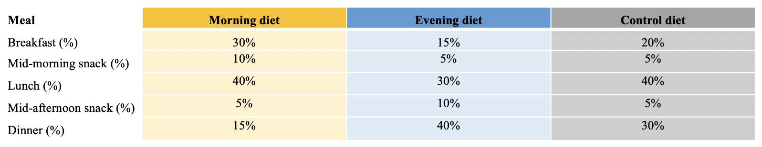
Figure 5.2. Daily caloric distribution of the intervention study.

Both diets were hypocaloric with respect to the participants' energy requirements. Specifically, they provided 1200 kcal for women and 1400 kcal for men with a body weight <90 kg at the first visit, and 1400 kcal for women and 1700 kcal for men with a body weight >90 kg. Furthermore, both dietary profiles had about 30% of the energy coming from fat, 15-20% from protein, and the remaining 50-55% from carbohydrates (mainly complex). The only difference was the distribution of calories throughout the day, which was chronotype-based in the intervention group and standard in the control group. The weekly portion sizes and frequencies of the food groups were calculated based on the recommendations of the Italian Dietary Guidelines (CREA, 2018). As shown in Figure 5.3, no substantial differences were found in the frequency of all the food groups.

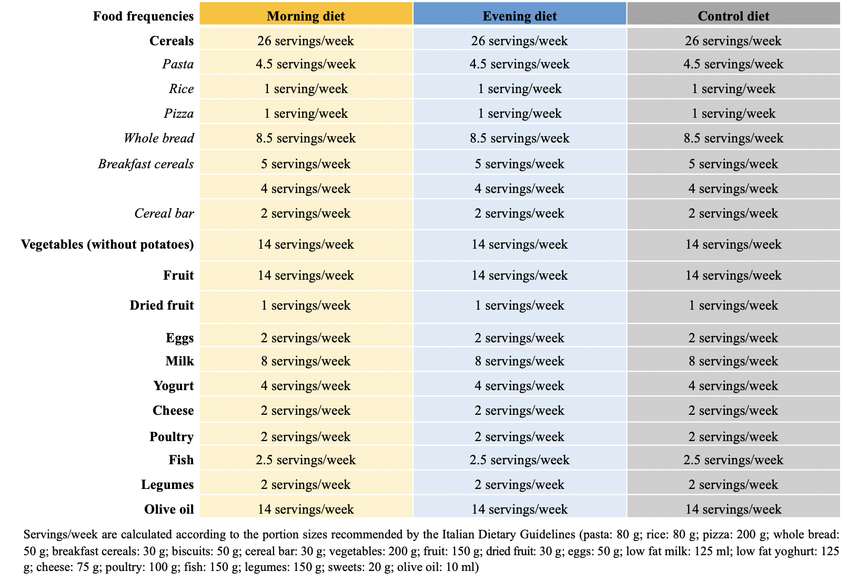
Figure 5.3. Food frequency of the intervention study.

Participants could discontinue the intervention or withdraw from the study for the following reasons: (1) at the request of the participant; (2) if the investigator felt that a participant's health was compromised due to adverse events or concomitant illness that developed after entering the study.
In order to improve adherence to the intervention protocols, qualified nutritionists provided participants with a detailed one-week menu plan based on their intervention group, with all food ingredients expressed by weight and/or volume, and a handout containing details of the assigned diet with possible substitutions. No meals or supplements were provided. For both diets, alcoholic beverages were limited to one per day for women and two per day for men.

5.5 Data collection
Assessments and data collection at baseline and follow-up were carried out at the Unit of Clinical Nutrition of the Careggi University Hospital, Florence, Italy, by study staff. All subjects were examined between 7:30 am and 10:30 am after a 12-hour fasting period. The standardized assessment at baseline for the intervention and control groups included a questionnaire regarding demographic information, risk factors and comorbidities. In addition, during the baseline visit, participants were educated about the objectives and methods of the clinical study. Sessions for all participants were similar in duration and content, except for details about diet; nutritionists were instructed not to comment in favor of one diet over the other or indicate their eating habits.

Anthropometric measurements and body composition
Weight and height were measured with a stadiometer. BMI will be calculated as weight (kg) / height (m)². Body composition was determined with a bioelectrical impedance analyzer (Akern, model SE 101) at baseline and at follow-up visits.

Blood samples
Blood samples were collected at the beginning and end of each intervention phase. Blood samples were centrifuged at 3,000 rpm for 15 minutes, aliquoted to obtain serum, and stored at -20°C until analysis. The following biochemical measures were evaluated: complete blood count, fasting glucose, lipid profile (total cholesterol, LDL-cholesterol, HDL-cholesterol, triglycerides), liver function tests (aspartate aminotransferase (AST), alanine transaminase (ALT), gamma-glutamyl transferase (γGT), renal function test (uric acid), mineral profile (sodium, potassium, magnesium, calcium), iron metabolism (iron, ferritin) and vitamin profile (vitamin B12, folic acid).

Stool samples
Stool samples (four or five scoops totaling 4 g) were collected before and after each intervention and immediately stored at -80°C. Stool sample collection kits, including containers, were provided to each participant.
The qualitative and quantitative evaluation of fecal microbial-derived SCFAs (acetic, propionic, butyric, isobutyric, 2-methylbutyric, isovaleric and valeric acids) was performed by Agilent gas chromatography-mass spectrometry (GC-MS) system composed with 5971 single quadrupole mass spectrometer, 5890 gas chromatograph and 7673 autosampler, through a previously described GC-MS method (Niccolai et al., 2019). Briefly, just before the analysis, stool samples were thawed and added with sodium bicarbonate 0.25 mM solution (1:1 w/v) in a 1.5 mL centrifuge tube. Then, the obtained suspensions were sonicated for 5 minutes, centrifuged at 5000 rpm for 10 minutes and then the supernatants were collected. The SCFAs were finally extracted as follow: an aliquot of 100μL of sample solution (corresponding to 0.1 mg of stool sample) was added of 50 μL of internal standards mixture, 1 mL of tert-butyl methyl ether and 50 μL of HCl 6 M + 0.5 M NaCl solution in a 1.5 mL centrifuge tube. Subsequently, each tube was shaken in a vortex apparatus for 2 min, centrifuged at 10,000 rpm for 5 min, and lastly the solvent layer was transferred to an autosampler vial and processed three times.

5.6 Compliance and acceptability
Plans to promote participant retention and follow-up completion include the use of behavior change strategies such as self-monitoring and availability of study staff for any dietary counseling. In addition, participants were contacted once during the study period to promote dietary compliance. A nutritionist called unannounced, and each participant recalled his or her 24-hour diet. At the end of the study, participants were asked to fill out an adherence questionnaire in which they indicated the extent to which they complied with the diets they received. They also had to indicate whether and what kind of modifications they made to the diets they received and whether they encountered any difficulties. Finally, in the last part of the questionnaire, they were asked whether they had improved, worsened or remained unchanged in a number of symptoms (e.g. digestion, abdominal bloating, bowel regularity, sleep quality, etc.).
If participants did not show up for the scheduled appointment, a maximum of three phone calls were made and an e-mail was sent before withdrawing the participant from the study. Participants who wished to prematurely discontinue the study before the 4-month evaluation did not undergo further clinical and laboratory evaluations. The reason for withdrawal was documented in the participant's record for later analysis when interpreting the results. The entire study was discontinued if the observed results warrant premature discontinuation.

5.7 Data management
All data was collected in an electronic database. Data or other identifiable documents were not recorded in the database, and participants were identified only by a unique study identification number. Hard copies of the files linking the participant identification number to the person's contact details were stored securely in a locked file cabinet in a locked office, accessible only to key members of the research team. Participant files and other source data (including copies of protocols, questionnaires, original test result reports, correspondence, informed consent records, and other documents related to the conduct of the study) were retained for the maximum period allowed by the institution. The data was made available upon request after publication.

5.8 Statistical analysis
Statistical analyses were performed using SPSS software for Macintosh (SPSS Inc., Chicago, IL, USA). Continuous variables were summarized using the mean and standard deviations. Categorical variables were presented in terms of frequencies and percentages. Data were analyzed using intention-to-treat and on-treat procedures. Evaluation of distributions and checking for outliers were performed using histograms and box plots.
First, a basic statistical descriptive study to analyze the general characteristics of the population studied was performed. Differences between the intervention and control group were analyzed using Chi Square tests for categorical variables and the Mann Whitney test for independent continuous variables. Differences before-after within the group for the continuous variables were analyzed with the Wilcoxon test.
The results were analyzed within each group using a general linear model for repeated measurements adjusted for possible confounding factors (i.e., weight change from pre- to post intervention). Differences between absolute variations (mean baseline values subtracted from mean values after intervention) were estimated by independent sample T-test. Since these tests assume normal data distribution, non-distributed data have been transformed into logs and further analyses were made with the processed data. However, to facilitate interpretation, the log data were again converted to the original scale (antilog) and presented as geometric means with 95% confidence intervals (CI).
Taking into account that the intervention group was composed of both morning and evening subjects, subgroup analyses were carried out to evaluate if there were statistical differences in sociodemographic variables, anthropometric and biochemical parameters, and adherence to the study intervention. A P value < 0.05 was considered statistically significant.

6. RESULTS

6.1 Participants
Ninety-two subjects were assessed for eligibility but 10 were excluded because they did not meet the inclusion criteria or because they refused to participate. Hence, 82 subjects were enrolled and entered the randomization. Figure 6.1 shows the enrolment of participants in the study.

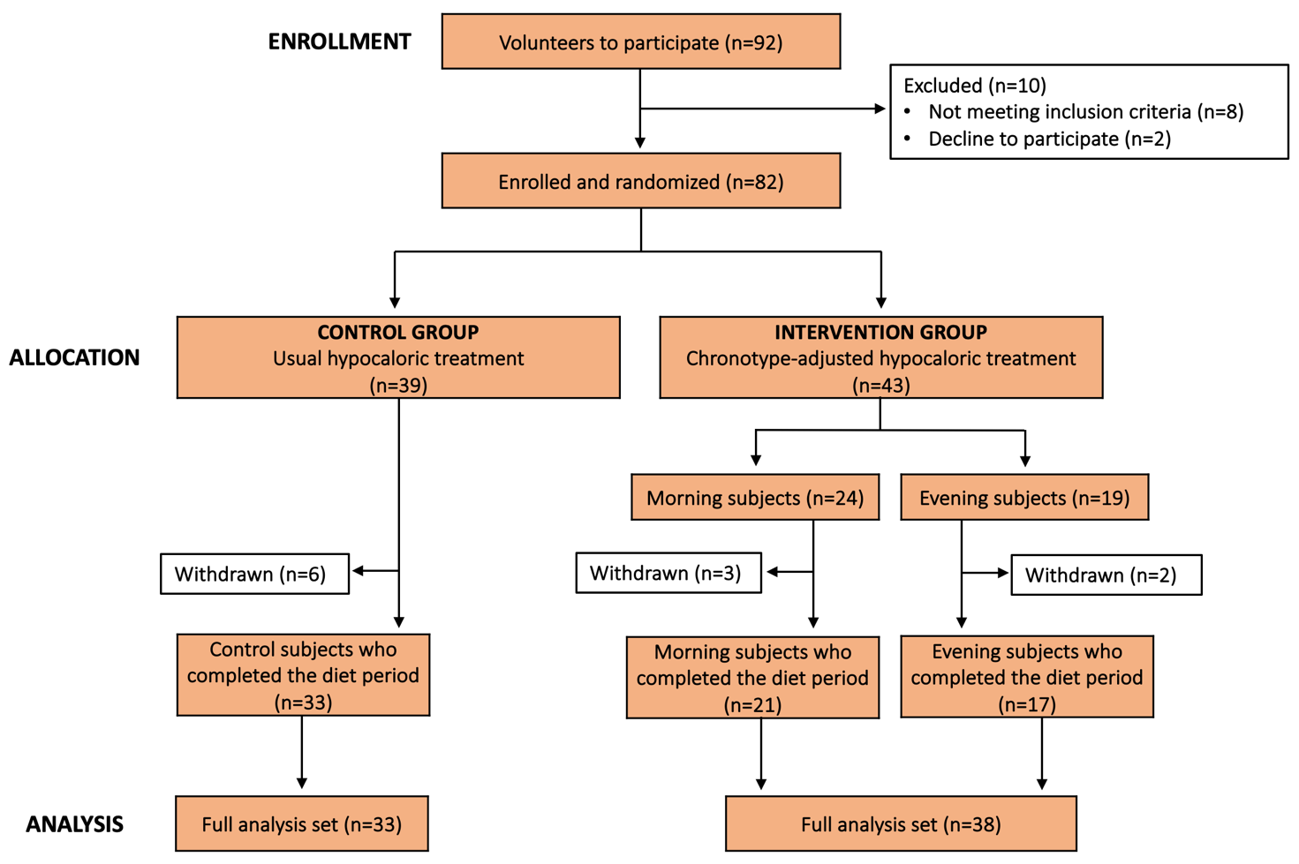

Figure 6.1. Flow-chart of the study.

Thirty-nine subjects were randomized in the control group and 43 in the intervention one, who according to their chronotype were divided into 24 subjects with morning intervention and 19 subjects with evening intervention. Eleven participants dropped out of the study for personal reasons or due to the impossibility to be adherent to the dietary regime administered. A total of 71 subjects concluded the study and were included in the analyses. The participation rate at the end of the study was 86.6%.
Sociodemographic characteristics, blood biomarkers values and dietary profile of the studied population, according to the dietary intervention, are shown in Table 6.2.
The majority of the participants were female (68%). The mean age was 53 years (range 21-65) and the BMI was on average 29.5 ± 4.6 kg/m², with 31% of the sample being obese. More than half of the sample was married, had children, had a university degree, did not smoke and practiced physical activity at least 1-2 times a week. At the time of enrollment, all blood parameters were in the normal range with median fasting glucose level of 87.6 ± 10.3 mg/dL, total cholesterol of 190.5 ± 36.3 mg/dL and triglycerides of 97.5 ± 53.5 mg/dL. The analysis of the dietary profile showed that the sample assumed a mean daily caloric intake of 1731.3 ± 425.3 kcal, with a mean percentage of carbohydrates, fats and protein of 44%, 39% and 17%, respectively. The daily percentage of saturated fat intake was 15%, while the intake of cholesterol was on average of 213.4 mg/day. The daily intake of fibre was 17 g/day.
No significant differences were found between participants of the intervention and control groups in all the sociodemographic variables, anthropometric and blood parameters. Likewise, from the dietary profile analysis no significant differences emerged between the two groups in the dietary composition before the onset of the study.

Table 6.2. Sociodemographic and anthropometric characteristics, blood biomarkers values and dietary profile of the sample according to randomization.
 | All  (n=71) | Control group  (n=33) | Chrono group  (n=38) | p-value
Sociodemographic characteristics
Gender  Female, n (%) | 48 (67.6) | 21 (63.6) | 27 (71.1) | 0.50
Age, years | 53 (21-65) | 54 (29-65) | 50 (21-65) | 0.16
Weight, kg | 83.3 ± 16.6 | 83 ± 17.1 | 83.5 ± 16.4 | 0.88
BMI, kg/m²  Overweight (25-29.9 kg/m²)  Obese (>30 kg/m²) | 29.5 ± 4.6  49 (69)  22 (31) | 29.5 ± 4.6  22 (66.7)  11 (33.3) | 29.5 ± 4.3  27 (71.1)  11 (28.9) | 0.95  0.69
FM (%) | 30.2 ± 8.5 | 28.8 ± 7.1 | 31.4 ± 7.9 | 0.10
Marital status  Unmarried/single, n (%)  Married/partner, n (%) | 17 (23.9)  54 (76.1) | 8 (24.2)  25 (75.8) | 9 (23.7)  29 (76.3) | 0.95
Children  Yes, n (%) | 47 (66.2) | 23 (69.7) | 24 (63.2) | 0.56
Educational level  Prim/sec school, n (%)  High school, n (%)  University, n (%) | 4 (5.6)  28 (39.4)  39 (54.9) | 3 (9.1)  14 (42.4)  16 (48.5) | 1 (2.6)  14 (36.8)  23 (60.5) | 0.38
Smoking,  Current, n (%) | 5 (7) | 2 (6.1) | 3 (7.9) | 0.76
Physical activity  No, n (%)  1-2 times a week, n (%)  >3 times a week, n (%) | 27 (38)  21 (30)  23 (32) | 13 (40)  10 (30)  10 (30) | 14 (37)  11 (29)  12 (34) | 0.94
Blood biomarkers
Glucose, mg/dL | 87.6 ± 10.3 | 87.7 ± 11.7 | 87.5 ± 9.1 | 0.60
Total cholesterol, mg/dL | 190.5 ± 36.3 | 196.8 ± 41.1 | 185.1 ± 31.1 | 0.18
HDL-cholesterol, mg/dL | 58.2 ± 13.8 | 59.6 ± 13.6 | 57 ± 14.1 | 0.32
LDL-cholesterol, mg/dL | 112.7 ± 31.3 | 116.8 ± 33.4 | 109.2 ± 29.4 | 0.45
Triglycerides, mg/dL | 97.5 ± 53.5 | 101.5 ± 65.7 | 94.1 ± 40.7 | 0.76
ALT, U/L | 21.4 ± 10.5 | 22.3 ± 9 | 20.7 ± 11.8 | 0.28
AST, U/L | 19.3 ± 4.9 | 19.8 ± 4.7 | 18.8 ± 5.1 | 0.26
Folate, ng/mL | 6.6 ± 4.1 | 7.4 ± 4.8 | 5.9 ± 3.1 | 0.12
Vitamin B12, pg/mL | 415.1 ± 140.6 | 441.3 ± 135.2 | 392.3 ± 143.1 | 0.15
Dietary profile
Total energy, kcal/day | 1731 ± 425 | 1660 ± 283 | 1792 ± 514 | 0.33
Carbohydrate, % of energy | 43.6 ± 6.6 | 44.6 ± 6.9 | 42.7 ± 6.2 | 0.27
Protein, % of energy | 17.4 ± 3.3 | 17.6 ± 3.7 | 17.3 ± 3 | 0.79
Total fats, % of energy  Total cholesterol, mg  Saturated fat, % of energy | 38.5 ± 6.6  213.4 ± 130.1  15.1 ± 3.4 | 37.4 ± 6  220.5 ± 106.6  14.4 ± 4 | 39.4 ± 7.1  207.2 ± 148.7  15.7 ± 2.8 | 0.16  0.35  0.13
Fibre, g | 17.9 ± 5.3 | 16.5 ± 4.6 | 19.1 ± 5.7 | 0.05
p-value was calculated using the Chi-square test for categorical variables and the Mann-Whitney test for continuous variables.
ALT: Alanine aminotransferases; AST: Aspartate aminotransferases; BMI: Body Mass Index; FM: Fat Mass GT: Glutamyl Transferase; HDL: High Density Lipoprotein; LDL: Low Density Lipoprotein.

Taking into account that intervention group was composed of morning and evening subjects, a subgroup analysis was carried out to evaluate if there were statistical differences in sociodemographic characteristics, blood biomarkers and dietary habits according to the different chronotypes (Table 6.3). Interestingly, subjects with an evening chronotype had a significantly lower median age (45 years vs. 55 years; p=0.01), while having children was significantly associated with morning chronotype (81% vs. 41%; p=0.01). No significant differences emerged for the other sociodemographic variables, as well as for all the blood biomarkers.
With regard to the dietary profile, the evening subjects were associated with a significantly higher total daily energy intake (1890 ± 341 kcal/die vs. 1713 ± 617; p=0.009) and a significantly higher intake of saturated fat (16.9 ± 2.5 % of energy vs. 14.8 ± 2.7 % of energy; p=0.01) than the morning subjects. No significant differences emerged for the daily intake of carbohydrates, protein, total fat and fibre according to chronotype.

Table 6.3. Sociodemographic and anthropometric characteristics, blood biomarkers and dietary profile according to chronotype.
 | Chrono group |  | p-value
 | Morning  (n=21) | Evening  (n=17) | p-value
Sociodemographic characteristics
Gender  Female, n (%) | 14 (66.7) | 13 (76.5) | 0.50
Age, years | 55 (24-65) | 45 (21-63) | 0.01
Weight, kg | 83.3 ± 18 | 83.8 ± 14.8 | 0.60
BMI, kg/m²  Overweight (25-29.9 kg/m²)  Obese (>30 kg/m²) | 29.5 ± 4.5  14 (66.7)  7 (33.3) | 29.5 ± 4.2  13 (76.5)  4 (23.5) | 0.81  0.51
Fat mass (%) | 31.4 ± 6.7 | 31.5 ± 9.3 | 0.93
Marital status  Unmarried/single, n (%)  Married/partner, n (%) | 3 (14.3)  18 (85.7) | 6 (35.3)  11 (64.7) | 0.13
Children  Yes, n (%) | 17 (81) | 7 (41.2) | 0.01
Educational level  Prim/sec school, n (%)  High school, n (%)  University, n (%) | -  9 (42.9)  12 (57.1) | 1 (5.9)  5 (29.4)  11 (64.7) | 0.41
Smoking  Current, n (%) | 1 (4.8) | 2 (11.8) | 0.39
Physical activity  No, n (%)  1-2 times a week, n (%)  >3 times a week, n (%) | 9 (42)  6 (29)  6 (29) | 5 (30)  5 (30)  7 (40) | 0.63
Blood biomarkers
Glucose, mg/dL | 90.1 ± 9.3 | 84.4 ± 8.1 | 0.13
Total cholesterol, mg/dL | 189.8 ± 32.3 | 179.2 ± 29.3 | 0.15
HDL-cholesterol, mg/dL | 55.8 ± 10.3 | 58.4 ± 17.9 | 0.77
LDL-cholesterol, mg/dL | 115.6 ± 29.4 | 101.2 ± 28.2 | 0.06
Triglycerides, mg/dL | 91.4 ± 27.3 | 97.4 ± 53.7 | 0.83
ALT, U/L | 19.1 ± 2.7 | 18.3 ± 7.1 | 0.38
AST, U/L | 19.1 ± 2.7 | 18.3 ± 7.1 | 0.09
Folate, ng/mL | 6.5 ± 3.6 | 5.2 ± 2.4 | 0.67
Vitamin B12, pg/mL | 6.5 ± 3.6 | 5.2 ± 2.4 | 0.15
Dietary profile
Total energy, kcal/day | 1713 ± 617 | 1890 ± 341 | 0.009
Carbohydrate, % of energy | 43.2 ± 6.1 | 42.2 ± 6.5 | 0.95
Protein, % of energy | 17.6 ± 2.9 | 17.0 ± 3.2 | 0.54
Total fat, % of energy  Total cholesterol, mg  Saturated fat, % of energy | 40.3 ± 8.8  202.8 ± 86.5  14.8 ± 2.7 | 38.5 ± 4  212.6 ± 87.1  16.9 ± 2.5 | 0.50  0.20  0.01
Fibre, g | 19.5 ± 5.6 | 18.7 ± 6.1 | 0.95
p-value was calculated using the Chi-square test for categorical variables and the Mann-Whitney test for continuous variables.
ALT: Alanine aminotransferases; AST: Aspartate aminotransferases; BMI: Body Mass Index; FM: Fat Mass GT: Glutamyl Transferase; HDL: High Density Lipoprotein; LDL: Low Density Lipoprotein.

6.2 Dietary intake
The analysis of dietary profiles at the end of the study demonstrated that participants significantly decreased total energy, total fats, cholesterol and saturated fat intakes compared to baseline, as reported in Table 6.4. On the other hand, a significantly increase of carbohydrates and fibre intake was observed.
However, no significant difference in the variations emerged between the intervention and the control groups, apart from the saturated fat intake, which was significantly lower in the intervention group than the control (- 1.2%, p=0.001).

Table 6.4. Variations in dietary intake according to randomization.
 | All  (n=71) | Control group  (n=33) |  | Intervention group  (n=38) | p-value°
Total energy, kcal/day  Change (after-before) | - 349 ± 387* |  | - 264 ± 212* | - 422 ± 438* | 0.05
Carbohydrate, % of energy  Change (after-before) | 10.2 ± 7.1* |  | 8.7 ± 7.5* | 11.6 ± 6.4* | 0.10
Protein, % of energy  Change (after-before) | - 0.2 ± 3.3 |  | - 0.06 ± 3.7 | - 0.3 ± 3.0 | 0.60
Total fat, % of energy  Change (after-before) | - 9.8 ± 7* |  | - 8.5 ± 6.7* | - 10.8 ± 7.1* | 0.45
Total cholesterol, mg  Change (after-before) | - 77.2 ± 126.9* |  | - 76.5 ± 100.3* | - 77.8 ± 147.6* | 0.55
Saturated fat, % of energy  Change (after-before) | - 3.6 ± 3.7* |  | - 3 ± 4.4* | - 4.2 ± 3* | 0.001
Fibre, g  Change (after-before) | 10.4 ± 6.4* |  | 12 ± 6.5* | 9 ± 6.1* | 0.46
Data are reported as mean ± standard deviation
* denotes p<0.05 for change after-before the intervention
°denotes difference between change in intervention and in control group

Table 6.5 shows the sub-analysis that was then carried out to assess the variations between each intervention group and the control group. No significant difference in the variations were observed, apart from the daily fibre intake, which was significantly lower in the morning group than the control (- 3.9 g/die, p=0.01). No differences emerged between the two types of chronotype-adjusted interventions.

Table 6.5. Variations in dietary intake according to each intervention groups and the control group.
 | Control group  (n=33) |  | Intervention group |  |  |  | p-valueˆ
 |  |  | Morning  (n=21) |  | Evening (n=17)
Total energy, kcal/day  Change (after-before) | - 264 ± 212 | - 376 ± 545 |  | - 479 ± 402 |  | 0.13
Carbohydrate, % of energy  Change (after-before) | 8.7 ± 7.5 | 11.2 ± 6.1 |  | 12.1 ± 6.9 |  | 0.98
Protein, % of energy  Change (after-before) | - 0.06 ± 3.7 | - 0.6 ± 2.9 |  | - 0.02 ± 3.2 |  | 0.56
Total fat, % of energy  Change (after-before) | - 8.5 ± 6.7 | - 11.7 ± 8.8 |  | - 9.7 ± 4.0 |  | 0.46
Total cholesterol, mg  Change (after-before) | - 76.5 ± 100.3 | - 76.5 ± 183.2 |  | - 79.5 ± 91.9 |  | 0.32
Saturated fat, % of energy  Change (after-before) | - 3.0 ± 4.4 | - 3.5 ± 2.9 |  | - 5.1 ± 2.8 |  | 0.06
Fibre, g  Change (after-before) | 12.0 ± 6.5 | 8.2 ± 4.9 |  | 10.0 ± 7.4 |  | 0.41
Data are reported as mean ± standard deviation
°denotes difference between change in morning group and in control group
ˆdenotes difference between change in morning group and in evening group

6.3 Body weight and body composition
Both diets showed a similar effect on weight loss and BMI reduction, with a difference between the chronotype-adjusted and control diets in end-of-diet values of - 1 kg for body weight (p=0.19) and - 0.3 kg/m² for BMI (p=0.29). Instead, regarding fat mass, it was found that the intervention group reduced fat mass significantly more than the control group, with the chronotype-adjusted diet which determined a higher reduction of - 2.3% and - 2.1 kg of fat mass compared to control diet.
Figure 6.6 shows the changes in weight and BMI within each group. A significant body weight reduction of - 4 kg (95% CI - 5.1; - 3) and - 3 kg (95% CI - 4.1; -1.8) with a significant BMI reduction of - 1.3 kg/m² (95% CI - 1.7; - 1) and - 1.1 kg/m² (95% CI - 1.5; - 0.7) for the chronotype-adjusted and control diets was reported.

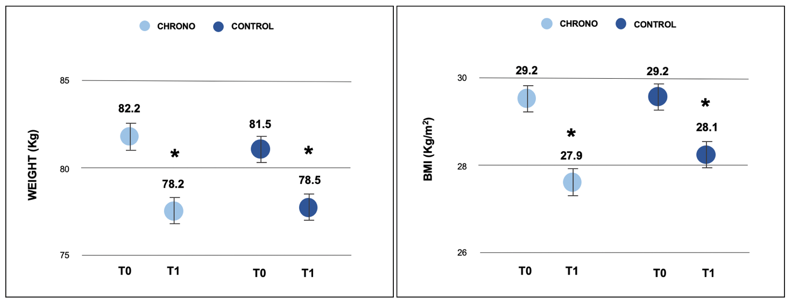
Figure 6.6. Changes in weight and BMI according to dietary intervention at the end of the study
(* denotes p<0.05 for change within each group).

However, when the evaluation of fat mass loss was conducted within each group, a significantly reduction in fat mass percentage (- 2.9%, 95% CI - 4.4; - 1.3 vs - 0.6%, 95% CI - 2.2; 1.1) and in kilos (- 3.4 kg, 95% CI - 5.2; - 1.8 vs - 1.4 kg, 95% CI - 3.2; 0.4) emerged only in the intervention group as showed in Figure 6.7.

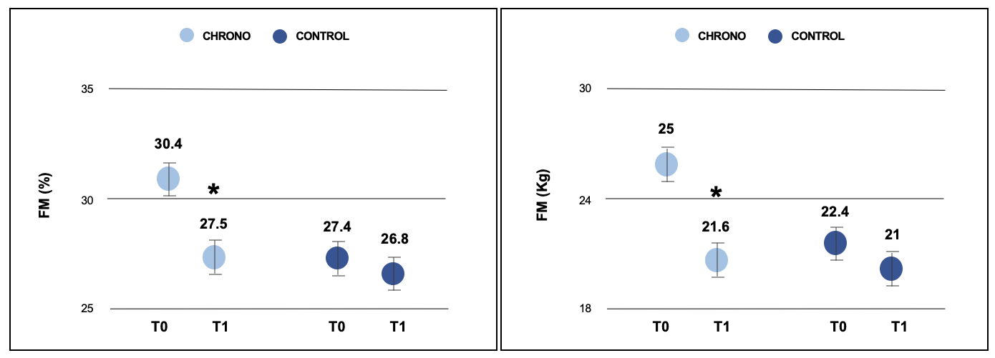
Figure 6.7. Changes in fat mass in percentage and in kilos according to dietary intervention at the end of the study (* denotes p<0.05 for change within each group).

Analyzing the other body composition parameters, such as the percentage of fat-free mass, total and extra-cellular water, body cellular mass and phase angle, no significant differences emerged between the intervention and control groups at the end of the study, as shown in Table 6.8. However, analysis of the changes within each group showed that the intervention group significantly (p=0.001) increased the free fat mass by + 3% (95% CI 1.4; 4.3) and the total body water by + 2.4% (95% CI 1; 3.9) at the end of the study, while the control group did not report any other changes in terms of body composition.

Table 6.8. Differences in free fat mass, total and extra-cellular water, body cellular mass and phase angle between the chrono and control groups at the end of the study.
 | Control ∆_{post-pre} | Chrono ∆_{post-pre} | ∆Chrono - ∆Control | p-value ∆_{Control vs} ∆_{Chrono}
FFM, % | 1.5 (- 0.01; 3.1) | 3.0 (1.4; 4.3) | 1.3 (- 3.5; 0.8) | 0.57
TBW, % | 1.4 (- 0.08; 3.0) | 2.4 (1.0; 3.9) | 1.0 (-3.1; 1.1) | 0.15
ECW, % | 1.0 (- 1.0; 3.0) | 1.2 (- 0.6; 3.1) | 0.2 (-3.0; 2.5) | 0.47
BCM, % | - 1.7 (- 3.8; 0.4) | - 1.6 (- 3.6; 0.3) | 0.05 (-2.9; 2.8) | 0.85
Phase angle, ° | - 0.4 (- 0.9; 0.05) | - 0.4 (- 0.9; - 0.01) | - 0.03 (- 0.06; 0.7) | 0.77
Data are reported as geometric mean and 95% confidence interval (CI)
p-value calculated using the independent sample T-test
BCM: Body Cellular Mass; BMI: Body Mass Index; ECM: Extra-Cellular Water; FFM: Free Fat Mass; FM:Fat Mass; TBW: Total Body Water.

A first subgroup analysis was carried out to evaluate if there were statistical differences between the control group and each group of chronotype-adjusted intervention in terms of weight loss and body composition parameters. As reported in Table 6.9, no significant differences emerged between the morning intervention group and the control group, whereas participants in the evening intervention group showed a significant reduction of both fat mass percentage (- 3.4%) and in kilos (- 2.9 kg) compared to the control group.

Table 6.9. Differences in weight loss and body composition parameters between the control and each chronotype-adjusted intervention group at the end of the study.
 | Morning  ∆_{post-pre} | Evening  ∆_{post-pre} |  | Control  ∆_{post-pre} | p-value  ∆_{Morning vs} ∆_{Control} | p-value  ∆_{Evening vs} ∆_{Control}
Weight, kg | - 3.9 (- 5.5; -2.4) | - 4.1 (- 5.4; -2.8) |  | - 3 (- 4.2; - 1.7) | 0.08 | 0.68
BMI, kg/m² | -1.3 (- 1.9; - 0.8) | -1.4 (- 1.9; - 0.9) |  | - 1.1 (- 1.5; - 0.7) | 0.09 | 0.25
FM, % | - 1.9 (- 4.1; 0.2) | - 4.0 (- 6.5; - 1.5) |  | - 0.6 (- 2.3; - 1.1) | 0.26 | 0.03
FM, kg | - 2.9 (- 5.3; - 0.4) | - 4.4 (- 7.2; - 1.5) |  | - 1.4 (- 3.4; 0.5) | 0.24 | 0.05
FFM, % | 1.9 (- 0.02; 3.9) | 4.0 (1.6; 6.3) |  | 1.5 (- 0.02; 3.1) | 0.41 | 0.76
TBW, % | 2.1 (0.02; 4.2) | 2.8 (0.3; 5.3) |  | 1.4 (- 0.2; 3.1) | 0.13 | 0.54
ECW, % | 2.8 (0.1; 5.5) | - 0.8 (- 3.5; 2.0) |  | 1.0 (- 1.2; 3.1) | 0.75 | 0.24
BCM, % | - 3.3 (- 6.1; - 0.5) | 0.4 (- 2.4; 3.1) |  | - 1.7 (- 3.9; 0.5) | 0.80 | 0.41
Phase angle, ° | - 0.9 (- 1.5; - 0.2) | 0.07 (- 0.5; 0.6) |  | - 0.4 (- 0.9; 0.8) | 0.34 | 0.34
Data are reported as geometric mean and 95% confidence interval (CI)
p-value calculated using the independent sample T-test
BCM: Body Cellular Mass; BMI: Body Mass Index; ECM: Extra-Cellular Water; FFM: Free Fat Mass; FM:Fat Mass; TBW: Total Body Water.

A second subgroup analysis was performed to evaluate if there were differences between the two kind of intervention groups at the end of the study. Although there was no statistically significant difference in weight and fat mass loss, the evening subjects reported a significant increase in body cellular mass percentage (+3.7 %) and a significant improvement in phase angle (+0.9°), as showed in Figure 6.10. No differences emerged for the other body composition parameters.

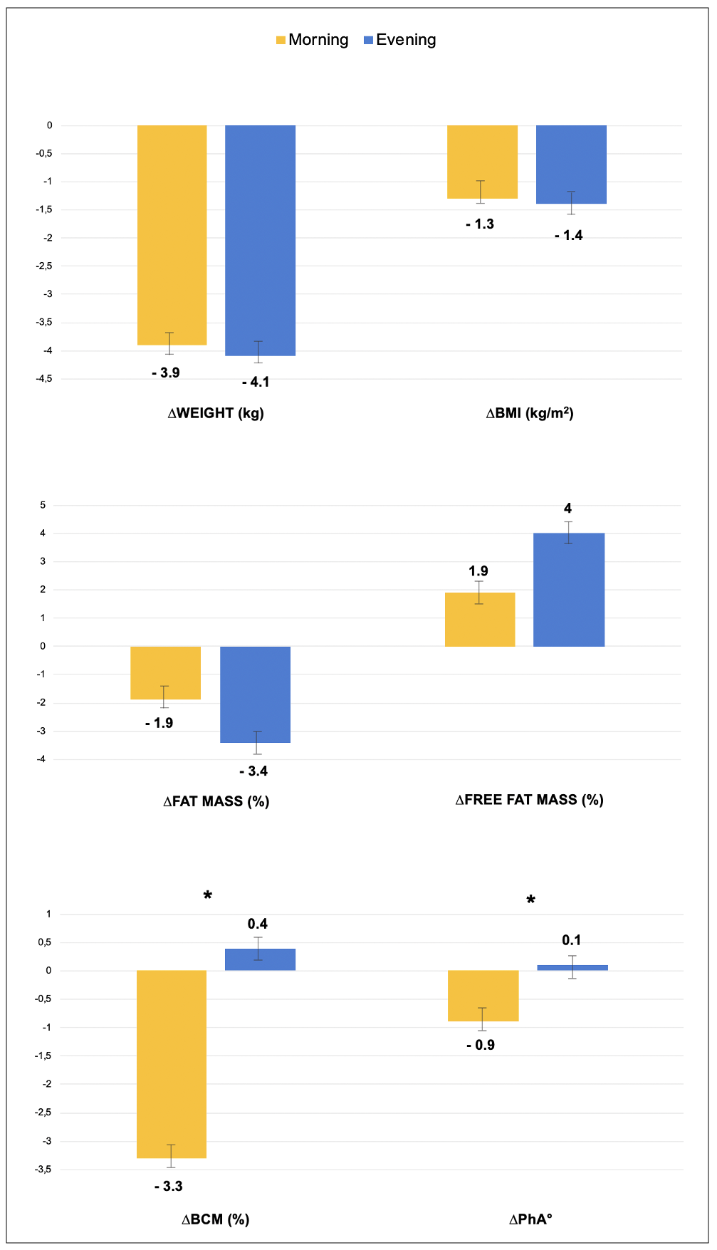
Figure 6.10. Changes in weight, BMI and body composition parameters between the two intervention groups (* denotes p<0.05).

6.4 Glycemic profile
Both chronotype-adjusted and control diets showed a similar effect on glycemic profile at the end of the study, with a difference between the intervention and control groups in end-of-diet values of - 2.5 mg/dL for fasting glucose (p=0.26). However, analysis of the changes within each group showed that the chrono group significantly decreased the glucose (- 2.7 mg/dL; - 3%) at the end of the study and when a subgroup analysis was performed according to the type of chronotype intervention, only morning subjects reported an improvement of glycemic profile with a significant (p=0.04) glucose levels reduction of - 4.4 mg/dL (- 5%) than the control group, as shown in Figure 6.11.

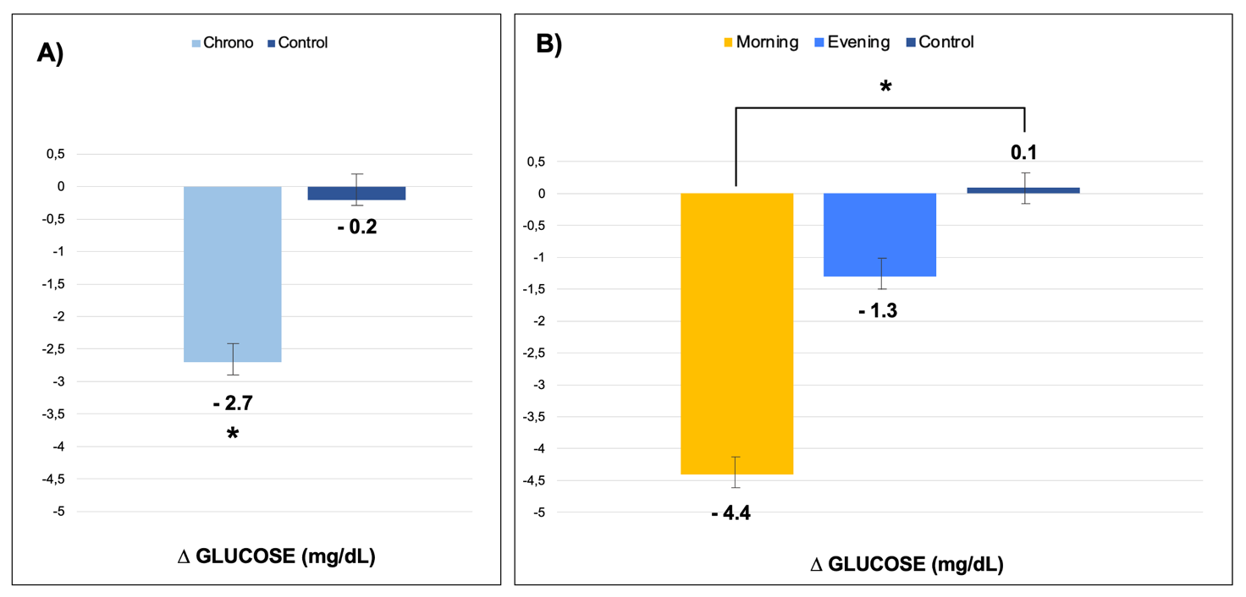
Figure 6.11. Changes in glycemic profile within each diet groups (A) and according to the different type of chronotype intervention (B) (* denotes p<0.05).

6.5 Lipid profile
No significant differences emerged in terms of lipid profile between the intervention and control groups at the end of the diet period. In details, a difference between the participants with the chronotype-adapted diet and controls of 8.5 mg/dL for total cholesterol (p=0.89), 1 mg/dL for HDL-cholesterol (p=0.35), 6.3 mg/dL for LDL-cholesterol (p=0.38) and 6 mg/dL for triglycerides (p=0.36) was observed.
However, when the analysis of the changes within each group was performed, the chrono group showed a significantly decreased of the triglyceride levels (- 6 mg/dL; - 11.7%), while the control one showed a significantly reduction of the total cholesterol (- 9.5 mg/dL; - 4.8%) and LDL-cholesterol (- 8.3 mg/dL; - 7.1%), as reported in Figure 6.12.
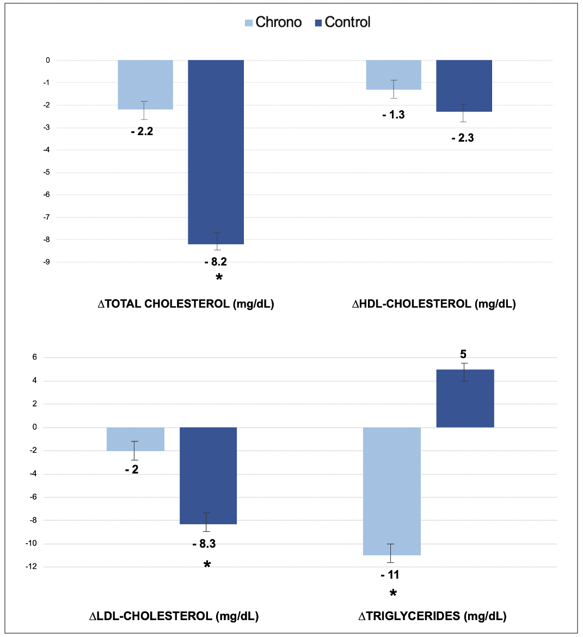
Figure 6.12. Changes in lipid profile within each diet group (* denotes p<0.05).
In Table 6.13 is reported the subgroup analysis performed to compare the changes of the lipid profile values between each chronotype-adjusted intervention and the control at the end of the diet period. No significant differences were observed between both evening and morning groups and the control group for total cholesterol, HDL-cholesterol, LDL-cholesterol and triglyceride levels.

Table 6.13. Differences in lipid profile between each intervention group and the control at the end of the study.
 | Morning  ∆_{post-pre} | Evening  ∆_{post-pre} | Control  ∆_{post-pre} | p-value  ∆_{Morning vs} ∆_{Control} | p-value  ∆_{Evening vs} ∆_{Control}
Total cholesterol, mg/dL | - 4.1 (- 15.1; 6.8) | 0.1 (- 12.5; 12.7) | - 8.2 (- 17; 0.6) | 0.56 | 0.28
HDL-cholesterol, mg/dL | - 0.7 (- 4; 2.5) | - 2.1 (- 5.2; 0.9) | - 2.2 (- 4.8; 0.4) | 0.47 | 0.97
LDL-cholesterol, mg/dL | - 3.7 (- 12.6; 5.1) | - 3.7 (- 12.6; 5.1) | - 7.3 (- 14.4; - 0.3) | 0.52 | 0.52
Triglycerides, mg/dL | 1.4 (- 19.1; 21.9) | 19.8 (- 4.5; 44) | 6.6 (- 9.8; 23) | 0.70 | 0.37
Data are reported as geometric mean and 95% confidence interval (CI)
p-value calculated using the independent sample T-test
HDL: High Density Lipoprotein; LDL: Low Density Lipoprotein.

Analyzing instead the differences according to each chronotype-adapted intervention for lipid parameters, a significant difference was observed for triglyceride levels, with evening subjects showing a significant (p=0.05) increase of +19.8 mg/dL (+20.3%) compared to morning subjects (+1.4 mg/dL; +1.5%), as shown in Figure 6.14.

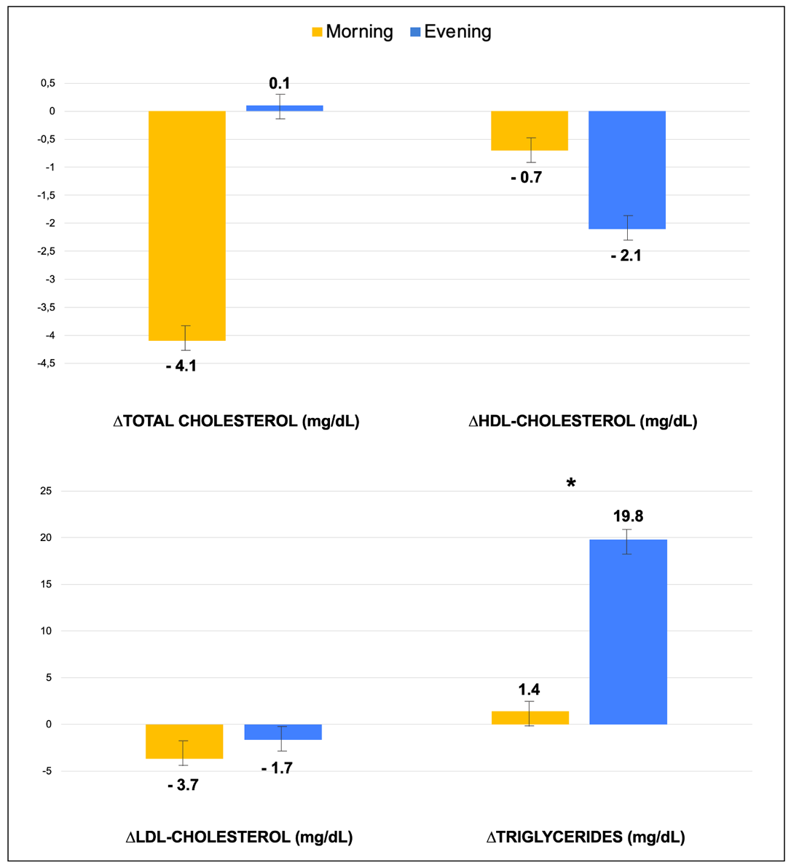
Figure 6.14. Changes in lipid profile between the two intervention groups
(* denotes p<0.05).

6.6 Other biochemical parameters

Table 6.15 reports the comparison between the intervention and control groups in terms of the other blood biomarkers analyzed at the end of the study, including liver function tests, vitamins, iron status, minerals and uric acid. Analyses revealed no statistically significant differences in the effect of the intervention and control diet on all the blood parameters evaluated.

Table 6.15. Differences between the intervention and control groups for the liver functionality, vitamins, minerals and uric acid levels at the end of the study.
 | Control ∆_{post-pre} | Chrono ∆_{post-pre} | ∆Chrono - ∆Control | p-value ∆_{Control vs} ∆_{Chrono}
ALT, U/L | - 3.1 (- 5.7; - 0.6) | - 2.6 (- 5; - 0.2) | 0.5 (- 3.5; 3.7) | 0.44
AST, U/L | - 1.3 (- 3.2; 0.4) | - 1.0 (- 2.5; 0.7) | 0.4 (- 2.5; 2.5) | 0.05
Gamma-GT, U/L | - 2.0 (- 5.3; 1.4) | - 1.2 (- 4.3; 2) | 0.8 (- 5.1; 4.1) | 0.24
Folate, ng/mL | 1.4 (- 2; 4.8) | - 0.1 (- 3.4; 3.1) | - 1.6 (- 2.2; 6.9) | 0.17
Vitamin B12, pg/mL | - 62.5 (- 100.6; -24.5) | - 24.8 (- 60.2; 10.6) | 37.7 (- 82.9; 22.1) | 0.11
Ferritin, ng/mL | - 13.4 (- 38.2; 11.3) | - 10.3 (- 33.3; 12.9) | 3.2 (- 34.4; 32.7) | 0.33
Iron, µg/dL | - 10 (- 23.1; 3.2) | 3.2 (- 9; 14.5) | 13.2 (- 30.8; 4.4) | 0.07
Sodium, mEq/L | 0.9 (- 4.9; 6.7) | - 3.2 (- 8.5; 2.2) | - 4.1 (- 4.2; 11.4) | 0.16
Potassium, mEq/L | - 0.1 (- 0.3; 0.1) | 0.1 (- 0.1; 0.3) | 0.2 (- 0.5; 0.3) | 0.29
Calcium, mg/dL | 0.02 (- 0.3; 0.3) | - 0.08 (- 0.4; 0.2) | - 0.1 (-0.4; 0.5) | 0.13
Magnesium, mg/dL | - 0.03 (- 0.7; 0.6) | 0.5 (- 0.1; 1.1) | 0.5 (- 1.4; 0.6) | 0.10
Uric acid, mg/dL | 0.1 (- 0.1; 0.3) | 0.1 (- 0.1; 0.3) | 0.02 (- 0.3; 0.3) | 0.56
Data are reported as geometric mean and 95% confidence interval (CI)
p-value calculated using the independent sample T-test
ALT: Alanine aminotransferases; AST: Aspartate aminotransferases; GT: Glutamyl Transferase.

Figure 6.16 reports the analysis of the changes within each group, which instead showed that both intervention and control groups reported an improvement of the liver functionality, with a significant decrease of ALT concentrations of - 2.6 U/L (- 12%) in the intervention group and of - 3.1 U/L (- 14.3%) in the control group. The control group also showed a significant (p=0.001) reduction of Gamma-GT (- 2 U/L; - 9.5%). No significant differences emerged in terms of vitamins, uric acid and minerals within each group, except for iron which significantly (p=0.03) decrease in the control group (- 10 µg/dL; - 11%).
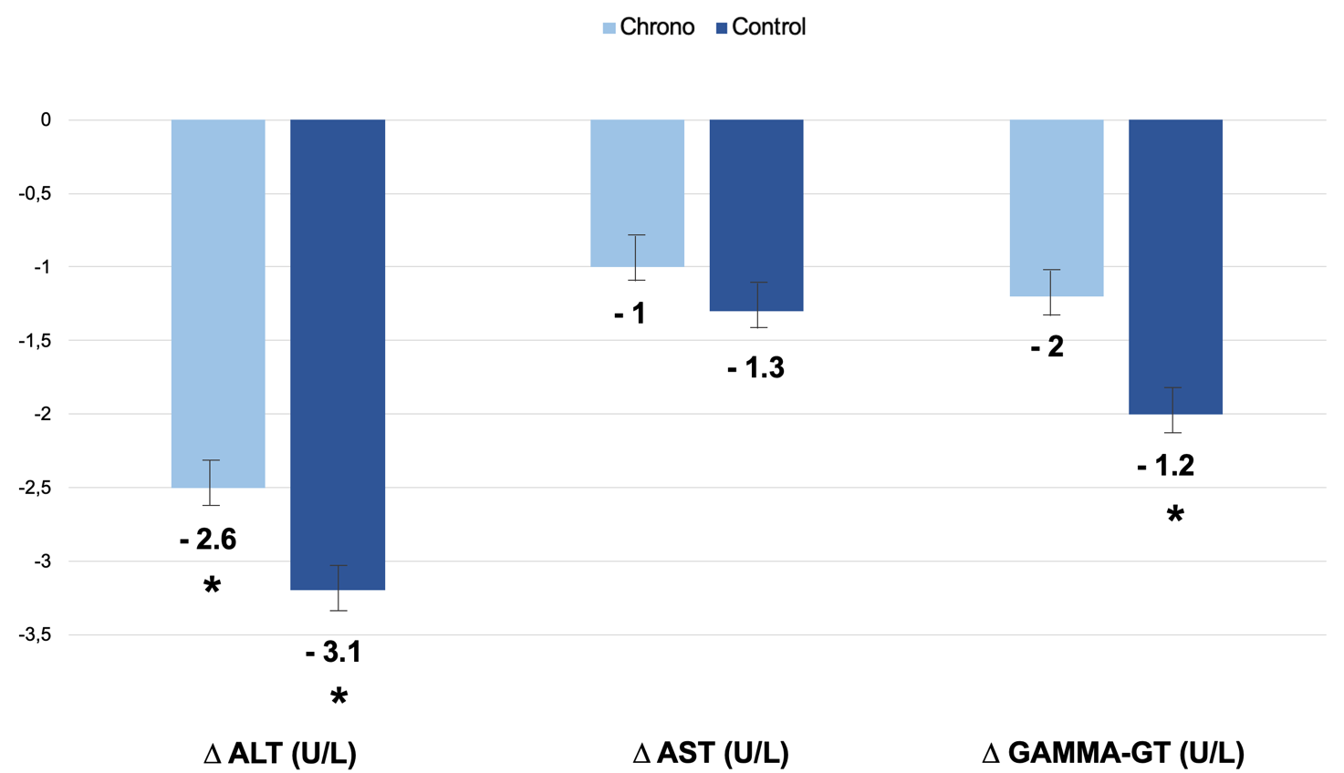

Figure 6.16. Changes in liver functionality within each diet group (* denotes p<0.05).

As shown in Table 6.17, no significant differences were observed between both the evening and morning groups and the control group for liver functionality, vitamins, minerals and uric acid levels. The same results were observed performing the comparison between the evening and morning intervention.

Table 6.17. Differences in liver functionality, vitamins, minerals, and uric acid levels between each intervention group and the control at the end of the study.
 | Morning  ∆_{post-pre} | Evening  ∆_{post-pre} | Control  ∆_{post-pre} | p-value  ∆_{Morning vs} ∆_{Control} | p-value  ∆_{Evening vs} ∆_{Control}
ALT, U/L | - 3.0 (- 6.3; 0.3) | - 2.8 (- 6.9; 1.3) | - 2.8 (- 5.4; - 0.2) | 0.92 | 0.98
AST, U/L | - 0.9 (- 3.3; 1.4) | - 1.5 (- 4.5; 1.5) | - 1.1 (- 3; 0.8) | 0.89 | 0.85
Gamma-GT, U/L | - 1.8 (- 3.9; 0.2) | - 2.5 (- 7.7; 2.8) | - 1.8 (- 3.4; - 0.2) | 0.97 | 0.16
Folate, ng/mL | 0.9 (- 2.0; 3.8) | 0.9 (- 2.0; 3.8) | 1.8 (- 0.5; 4.1) | 0.59 | 0.59
Vitamin B12, pg/mL | - 49.3 (- 102.5; 3.9) | - 2.2 (- 58.3; 53.9) | - 58.6 (- 101; - 16.1) | 0.78 | 0.10
Ferritin, ng/mL | 0.07 (- 34.1; 34.3) | - 25.4 (- 63.2; 12.4) | - 12.2 (- 39.4; 15.1) | 0.57 | 0.57
Iron, µg/dL | 5.1 (- 8.0; 18.2) | 1 (- 18.3; 20.2) | - 9.9 (- 20.4; 0.5) | 0.07 | 0.36
Sodium, mEq/L | 1.0 (0.01; 1.9) | - 7.8 (- 17.2; 1.6) | 0.7 (- 0.09; 1.4) | 0.62 | 0.14
Potassium, mEq/L | - 0.03 (- 0.2; 0.1) | 0.3 (- 0.1; 0.6) | - 0.09 (- 0.2; 0.04) | 0.56 | 0.14
Calcium, mg/dL | 0.3 (0.01; 0.2) | - 0.3 (- 0.8; 0.2) | 0.2 (- 0.3; 0.3) | 0.09 | 0.35
Magnesium, mg/dL | 0.08 (0.01; 0.1) | 1.0 (- 0.1; 2.0) | - 0.003 (- 0.05; 0.05) | 0.05 | 0.15
Uric acid, mg/dL | 0.08 (- 0.2; 0.3) | 0.2 (- 0.1; 0.5) | 0.09 (- 0.1; 0.3) | 0.95 | 0.68
Data are reported as geometric mean and 95% confidence interval (CI)
p-value calculated using the independent sample T-test
ALT: Alanine aminotransferases; AST: Aspartate aminotransferases; GT: Glutamyl Transferase.

6.7 Functional evaluation of gut microbiota

The Figure 6.18 shows the effects of interventions on the gut microbiota functionality, in particular the SCFAs production, including the acetic acid, propionic acid, butyric acid, isobutyric acid, 2-methylbutyric acid, isovaleric acid and valeric acid. In details, in comparison to the control group, the chrono group reported a significant increase of anti-inflammatory isobutyric (+ 0.42% vs - 0.25%) and 2-methilbutyric acids levels (+ 0.43% vs - 0.44%), while no differences were observed for the other SCFAs abundances.

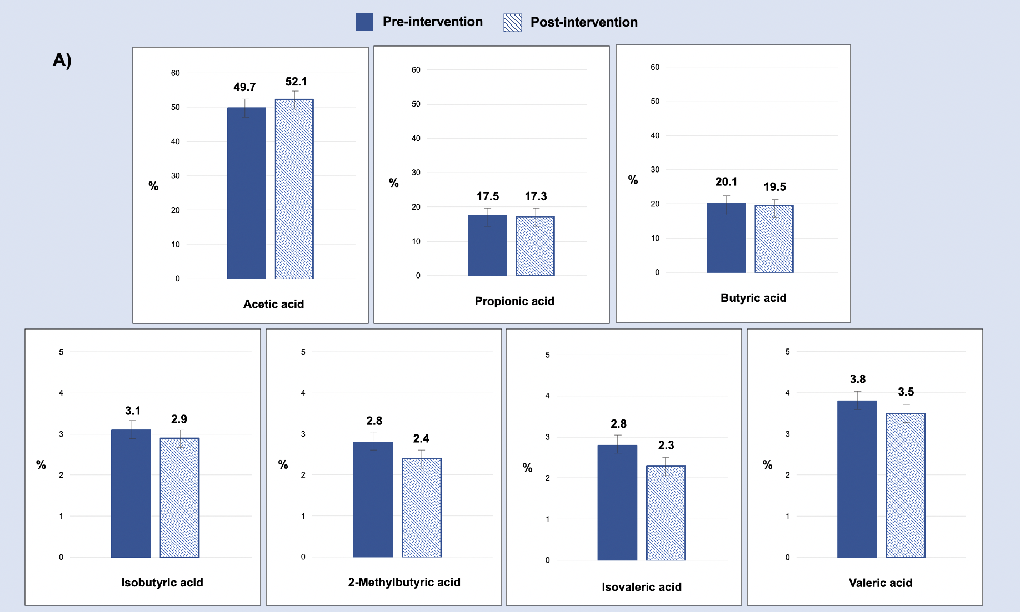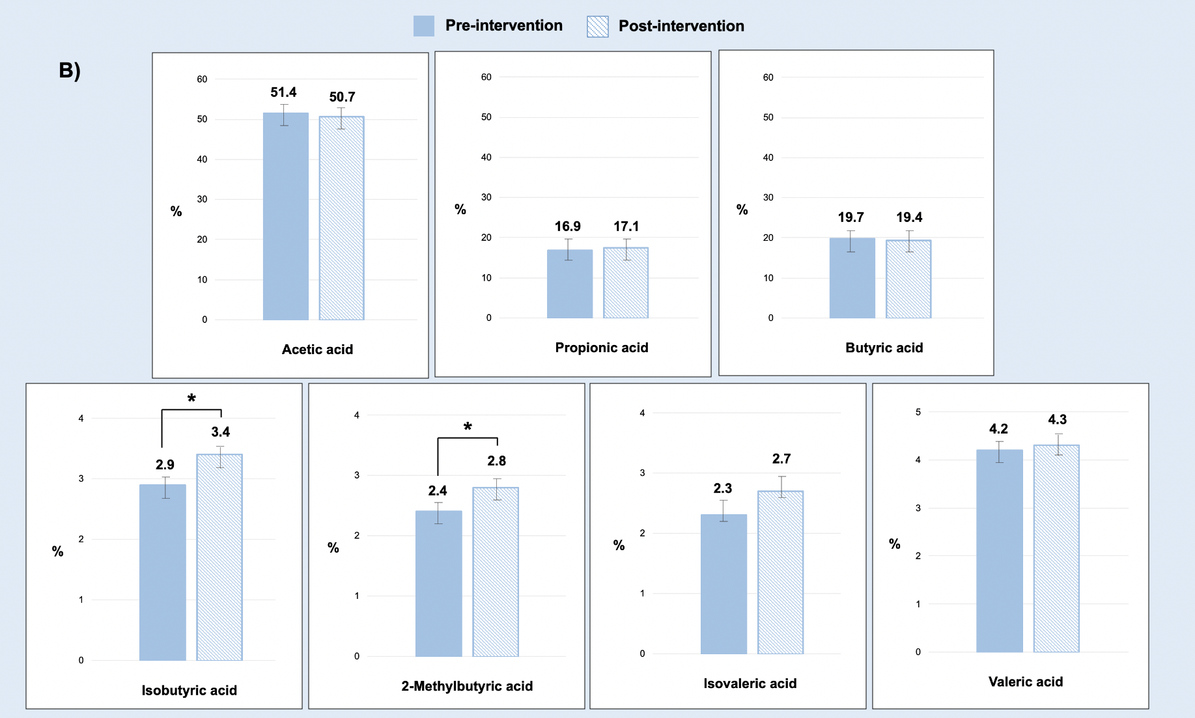
Figure 6.18. The effects on SCFAs abundances of control (A) and chrono (B) interventions.

More detailed data regarding the effects of interventions on the gut microbiota functionality are reported in Table 6.19.

Table 6.19. SCFAs variation according to the dietary interventions.

SCFAs % | Control pre | Control post | p-value | Chrono pre | Chrono post | p-value
Acetic acid | 49.77 (9.82) | 52.13 (5.47) | 0.14 | 51.40 (6.99) | 50.17 (10.29) | 0.61
Propionic acid | 17.54 (7.17) | 17.37 (6.24) | 0.48 | 16.94 (5.16) | 17.14 (4.49) | 0.72
Butyric acid | 20.16 (5.59) | 19.50 (9.83) | 0.83 | 19.70 (5.37) | 19.44 (7.61) | 0.67
Isobutyric acid | 3.10 (2.27) | 2.85 (2.54) | 0.46 | 2.95 (1.60) | 3.37 (1.52) | 0.03
2-Methylbutyric acid | 2.82 (2.46) | 2.38 (3.12) | 0.18 | 2.41 (1.94) | 2.84 (1.96) | 0.04
Isovaleric acid | 2.82 (2.47) | 2.28 (2.76) | 0.15 | 2.35 (1.44) | 2.70 (2.28) | 0.11
Valeric acid | 3.79 (1.94) | 3.49 (1.56) | 0.43 | 4.18 (1.89) | 4.33 (1.55) | 0.51
Data are reported as mean percentage (interquartile range, IQR). P-values were assessed with the Wilcoxon signed-rank test for intra-groups comparison and with the Mann-Whitney test for inter-groups comparisons.

In addition, when a comparison between each intervention group and the control was performed, the morning group showed a significant increase of 2-methylbutyric (+ 0.92%) and isovaleric (+ 0.95%) acids, as reported in Figure 6.20.

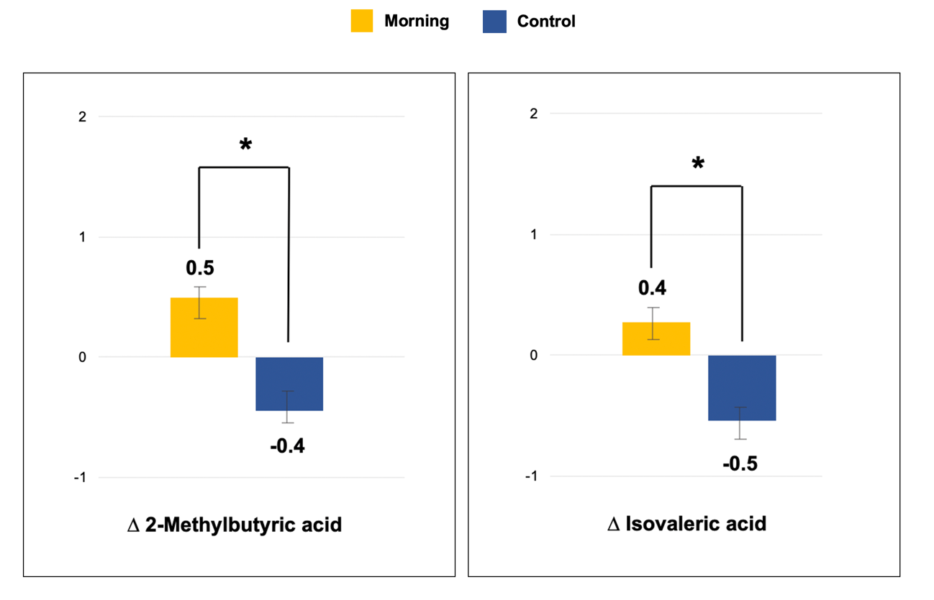
Figure 6.20. Differences on SCFAs abundances between the morning and control groups.

However, apart from 2-methylbutyric and isovaleric acids, no other significant differences emerged between the morning and control groups in terms of SCFAs abundance. Similarly, the evening subjects showed no differences compared to the control for any SCFAs, as summarized in Table 6.21.

Table 6.21. Differences in SCFAs abundances between each intervention group and the control at the end of the study.
SCFAs % | Morning  ∆_{post-pre} | Evening  ∆_{post-pre} | Control  ∆_{post-pre} | p-value  ∆_{Morning vs} ∆_{Control} | p-value  ∆_{Evening vs} ∆_{Control}
Acetic acid | -0.67 (11.44) | -1.93 (7.34) | 2.36 (9.43) | 0.34 | 0.19
Propionic acid | 0.24 (4.90) | 0.14 (4.25) | -0.17 (6.27) | 0.56 | 0.48
Butyric acid | -0.86 (8.77) | 0.48 (6.91) | -0.66 (4.27) | 0.99 | 0.93
Isobutyric acid | 0.45 (1.38) | 0.38 (1.00) | -0.25 (1.61) | 0.09 | 0.13
2-Methylbutyric acid | 0.48 (1.77) | 0.25 (1.23) | -0.44 (1.60) | 0.04 | 0.16
Isovaleric acid | 0.41 (1.76) | 0.27 (1.01) | -0.54 (1.68) | 0.04 | 0.14
Valeric acid | -0.06 (2.25) | 0.41 (2.10) | -0.30 (1.65) | 0.80 | 0.12
Data are reported as mean percentage (interquartile range, IQR). P-values were assessed with Mann-Whitney test.

Finally, the evaluation of the effects of the intervention between the morning and evening groups also did not show statistically significant differences in the gut microbiota functionality, as reported in Table 6.22.

Table 6.22. Differences in SCFAs abundances between the morning and evening groups at the end of the study.
SCFAs % | Morning  ∆_{post-pre} | Evening  ∆_{post-pre} | p-value
Acetic acid | -0.67 (11.44) | -1.93 (7.34) | 0.77
Propionic acid | 0.24 (4.90) | 0.14 (4.25) | 0.93
Butyric acid | -0.86 (8.77) | 0.48 (6.91) | 0.79
Isobutyric acid | 0.45 (1.38) | 0.38 (1.00) | 0.88
2-Methylbutyric acid | 0.48 (1.77) | 0.25 (1.23) | 0.66
Isovaleric acid | 0.41 (1.76) | 0.27 (1.01) | 0.70
Valeric acid | -0.06 (2.25) | 0.41 (2.10) | 0.28

Data are reported as mean percentage (interquartile range, IQR). P-values were assessed with Mann-Whitney test.

6.8 Health status and quality of life
At the end of the study, all participants completed a questionnaire to assess changes in health status, evaluating gastro-intestinal and mental health symptoms, sleep quality, fatigue and quality of life. 86% (n=61) of the participants declared to have improved their health status. The analysis of the individual health changes is shown in Figure 6.23. In particular, the most improved conditions during the study were abdominal bloating (n=35; 49%), bowel regularity (n=31; 44%) and digestion (n=30; 42%). Moreover, the 45% (n=29) of the entire sample declared an improvement in quality of life.

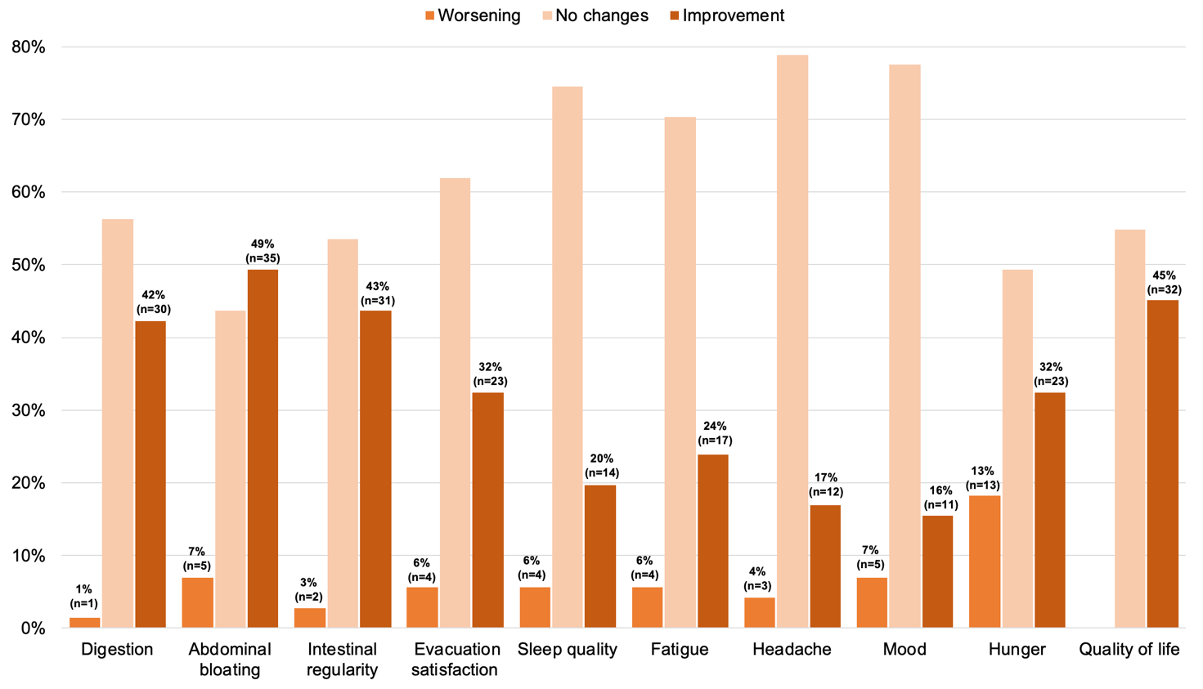
Figure 6.23. Changes of health status after the intervention period in the entire sample.

An analysis was conducted to see if there were any differences between the intervention and control group with regard to improvements in health status as reported in Figure 6.24, and it was found that the control group reported a significant improvement in quality of life (58% vs 34%) and bowel regularity (58% vs 32%) compared to the intervention group.

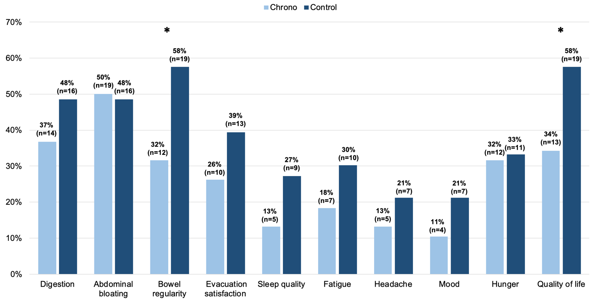
Figure 6.24. Number of subjects who reported improved health conditions after the intervention period according to treatment group (* denotes p<0.05).

Evaluating the different types of intervention according to chronotypes, no statistically significant differences were found between morning and evening subjects with regard to health condition and quality of life.

6.9 Compliance
Eleven participants dropped out of the study for personal reasons or due to the impossibility to be adherent to the dietary regime administered. Comparison of baseline characteristics between participants who had completed the study and those who dropped out showed no differences for all the sociodemographic information and all the blood parameters analyzed (Table 6.25).

Table 6.25. Baseline characteristics of the study population according to the completion of the study.
 | Completers  (n=71) | Non-completers  (n=11) | p-value
Sociodemographic characteristics
Gender  Female, n (%) | 48 (67.6) | 6 (55) | 0.39
Age, years | 53 (21-65) | 45 (26-65) | 0.18
Weight, kg | 83.3 ± 16.6 | 83.8 ± 13.6 | 0.68
BMI, kg/m²  Overweight (25-29.9 kg/m²)  Obese (>30 kg/m²) | 29.5 ± 4.6  49 (69)  22 (31) | 28.7 ± 4.1  8 (72.7)  3 (27.3) | 0.55  0.80
FM (%) | 30.2 ± 8.5 | 28.1 ± 9.2 | 0.56
Marital status  Unmarried/single, n (%)  Married/partner, n (%) | 17 (23.9)  54 (76.1) | 4 (36.4)  7 (63.6) | 0.38
Children  Yes, n (%) | 47 (66.2) | 6 (54.5) | 0.45
Educational level  Prim/sec school, n (%)  High school, n (%)  University, n (%) | 4 (5.6)  28 (39.4)  39 (54.9) | -  3 (27.3)  8 (72.7) | 0.46
Smoking  Smoker, n (%) | 5 (7.0) | 2 (18.2) | 0.21
Physical activity  No, n (%)  1-2 times a week, n (%)  >3 times a week, n (%) | 27 (38.0)  21 (30.0)  23 (32.0) | 6 (54.5)  1 (9.1)  3 (36.4) | 0.33
Blood biomarkers
Glucose, mg/dL | 87.6 ± 10.3 | 86.2 ± 8.5 | 0.57
Total cholesterol, mg/dL | 190.5 ± 36.3 | 177.6 ± 29.7 | 0.36
HDL-cholesterol, mg/dL | 58.2 ± 13.8 | 56 ± 14.9 | 0.71
LDL-cholesterol, mg/dL | 112.7 ± 31.3 | 107.7 ± 23.9 | 0.57
Triglycerides, mg/dL | 97.5 ± 53.5 | 91.3 ± 29.3 | 0.90
ALT, U/L | 21.4 ± 10.5 | 20.4 ± 9.0 | 0.59
AST, U/L | 19.3 ± 4.9 | 19.8 ± 5.1 | 0.69
Folate, ng/mL | 6.6 ± 4.1 | 6.0 ± 2.7 | 0.85
Vitamin B12, pg/mL | 415.1 ± 140.6 | 449.6 ± 284.2 | 0.61
p-value was calculated using the Chi-square test for categorical variables and the Mann-Whitney test for continuous variables.
ALT: Alanine aminotransferases; AST: Aspartate aminotransferases; BMI: Body Mass Index; FM: Fat Mass GT: Glutamyl Transferase; HDL: High Density Lipoprotein; LDL: Low Density Lipoprotein.

To better investigate adherence to the diet plan, all participants were asked to fill out a questionnaire at the end of the study. From analysis, almost all participants included in the analyses reported on a scale of - not at all, quite well, very well - that they were quite well (n=66; 93%) adherent to the diet plan and none stated that they did not follow the diet at all. Moreover, the majority of the sample stated that they had not made any major changes to the diet plan they had received (n=41; 58%) and that the plan was easy to implement (n=64; 90%).
Adherence to the dietary regimen was also assessed in relation to the assignment of the intervention or control group. There were no statistically significant differences in adherence between the two groups, with both reporting that they were very (chrono: 5% vs. control: 9%) or quite well (chrono: 95% vs. control: 91%) adherent to the diet regime.
In the same way, no significant differences in terms of adherence to the diet plan emerged according to the different types of chronotype intervention, with the 94% (n=16) of morning subjects and the 95% (n=20) of evening subjects who declared to be very or quite well adherent to the diet.

DISCUSSION AND CONCLUSION

The “CHRONODIET” project is situated within the emerging field of chrono-nutrition, a novel branch of nutritional research that aims to explore the interplay between meal frequency, regularity, and consumption patterns and their impact on human health. The premises that led to the development of this trial stem from several studies I conducted in collaboration with my research group during my PhD.
The initial phase of my doctoral research involved an extensive review of the existing literature that led to the publication of the first systematic review and meta-analysis on the topic. This study examined how an individual's circadian rhythms, known as chronotype, influence various aspects of health (Lotti et al., 2022). The results showed that subjects with an evening chronotype exhibited a significantly worse cardiovascular profile than morning chronotypes, due to higher levels of glucose, LDL-cholesterol and triglycerides. Furthermore, these subjects reported an increased risk of developing chronic diseases, such as diabetes, cancer, and depression (Lotti et al., 2022). Based on this initial evidence, we conducted a series of observational studies to investigate the relationship between chronotype, eating habits and health in the Italian population (Dinu et al., 2022; Rosi et al, 2022; Lotti et al., 2022). The results of these studies revealed that individuals with evening chronotypes had lower adherence to the Mediterranean diet, had higher consumption of ultra-processed foods, displayed a propensity to skip meals more frequently, and tended to eat late at night (Dinu et al., 2022; Rosi et al, 2022; Lotti et al., 2022). Furthermore, the evening chronotype was found to be associated with an increased risk of presenting symptoms of depression, anxiety, and stress. Subsequently, my research extended to an exploration of potential underlying causes contributing to these observed effects. This phase included a focus on investigating the role of inflammation and the gut microbiota (Colombini et al., 2022; Lotti et al., 2023).

The "CHRONODIET" project represents the first randomized controlled trial that investigate the effects of a chronotype-adjusted diet, compared with a diet with a conventional calorie distribution, on weight loss and cardiometabolic health, also considering the gut microbiota functionality. Following the 4-month intervention, the chronotype-adjusted diet resulted in a greater reduction in fat mass percentage compared to the control diet, despite no significant differences in weight loss and BMI values. Notably, the group that underwent the evening intervention exhibited the most substantial improvements in body composition. Regarding blood biomarkers, both diets similarly contributed to a significant improvement in most cardiometabolic parameters and liver functionality. The chronotype-adjusted diet caused a significant reduction in fasting glucose and triglyceride levels, while the control diet determined a significant reduction of total cholesterol and LDL-cholesterol. Evaluating the differences between the intervention groups, only morning subjects showed a significant reduction of the blood glucose. Evening subjects, on the other hand, reported a significant increase of the triglyceride’s levels. As to the gut microbiota functionality, analysis showed a significant increase of the anti-inflammatory SCFAs in the intervention group, in particular in the morning subjects. Analysis of the adherence to the dietary plan and the health benefits found by following it showed that the intervention and control group were equally adherent to the dietary regimen.
Considering that the ideal treatment for an overweight or obese patient is aimed to reach the greatest loss of body fat with the greatest maintenance of muscle mass, our results suggest that, regarding anthropometric parameters, a chronotype-adjusted diet is more effective than a conventional hypocaloric diet. Indeed, although no statistically significant differences were observed between the two groups in terms of weight loss and BMI, participants in the intervention group showed a significantly greater reduction in the percentage of fat mass. When comparing our findings with the only similar study available in the literature (Galindo Muñoz et al., 2020), both studies observed a statistically significant reduction in fat mass among the group that received the chronotype-adjusted diet. However, in the study conducted by Galindo Muñoz and colleagues, they also noted a significantly greater reduction in weight, approximately 1 kg (Galindo Muñoz et al., 2020). A similar trend was observed in our study, although it did not reach statistical significance. It's worth highlighting that as the study progresses and the entire sample is recruited, it is possible that we may obtain more robust and meaningful data. Another noteworthy difference is that only our study revealed a significant increase in fat-free mass within the intervention group, coupled with a substantial enhancement in body composition among individuals with evening chronotypes compared to those with morning chronotypes and the control group.
From the analysis of the effect of the chronotype-adjusted diet before and after intervention, a significant improvement of fasting glucose levels also emerged, but when the subgroup analysis was performed, this significant improvement was observed only in the morning subjects. It is assumed that aligning eating habits with one’s chronotype can help consume meals in the quantities and times in which the body is more tolerant to glucose and sensitive to insulin, promoting excellent metabolization of carbohydrates (Poggiogalle et al., 2018). For this reason, it is not surprising to observe an improvement in glucose values in morning subjects, as they had a diet with a higher caloric intake in the first part of the day, precisely when the maximum functioning of glucose metabolism occurs (Henry et al., 2020). On the other hand, the evening subjects reported a significant increase in triglycerides at the end of the study, even though the values remained within the normal range. Similar results were also obtained in our previous meta-analysis that associated evening subjects with significantly higher triglyceride’s values (Lotti et al., 2022). Previous studies showed that plasma triglyceride’s concentrations are elevated during the biological nighttime, and that the postprandial response after a night meal is amplified compared with the same meal consumed during the day (Morgan et al., 2003). Thus, the results of this trial seem to reinforce this hypothesis.
An extremely innovative aspect of this project is that it also studied microbial functionality by observing an increased production of anti-inflammatory SCFAs in the group with the chronotype-adapted diet. This may suggest that an alignment of dietary behavior with individual circadian rhythms may have a positive impact on microbial function and consequently on host health. In fact, increased production of SCFAs is associated with better regulation of metabolism, nutrient absorption and blood glucose regulation, and above all with a reduction in intestinal inflammatory status (Xiong et al., 2022). Considering that inflammation itself follows circadian rhythms (Colombini et al., 2022), as evidenced by the oscillation of cytokines and hormones, future studies investigating the interconnected mechanisms between circadian rhythms, inflammation and the gut microbiota are sorely needed.
In conclusion, the results of this project show that the chronotype-adjusted diet is more effective to improve the body composition thanks to a reduction in fat mass and an increase in free fat mass, although no differences emerged for weight and BMI. This seems particularly true for the evening intervention. Given the growing burden of obesity worldwide, gaining new insights into the possible mechanisms affecting the variable response to food intake and weight-loss diets is critical to improving the effectiveness of weight management programs. Although new research is undoubtedly needed to understand the precise physiological and metabolic mechanisms through which a chronotype-adjusted diet can induce an improvement in body composition, in certain cardiometabolic parameters and in gut microbiota functionality, at the moment it could be of great interest to consider also the patient’s circadian preferences, in order to increase the effectiveness of low-calorie diets.

REFERENCES

- Boutari C, Mantzoros CS. A 2022 update on the epidemiology of obesity and a call to action: as its twin COVID-19 pandemic appears to be receding, the obesity and dysmetabolism pandemic continues to rage on. Metabolism. 2022; 133:155217.
- Lopez-Jimenez F, Almahmeed W, Bays H, Cuevas A, Di Angelantonio E, le Roux CW, Sattar N, Sun MC, Wittert G, Pinto FJ, Wilding JPH. Obesity and cardiovascular disease: mechanistic insights and management strategies. A joint position paper by the World Heart Federation and World Obesity Federation. Eur J Prev Cardiol. 2022; 29:2218-2237.
- Lotti S, Pagliai G, Colombini B, Sofi F, Dinu M. Chronotype Differences in Energy Intake, Cardiometabolic Risk Parameters, Cancer, and Depression: A Systematic Review with Meta-Analysis of Observational Studies. Adv Nutr. 2022; 13:269-281.
- Phoi YY, Rogers M, Bonham MP, Dorrian J, Coates AM. A scoping review of chronotype and temporal patterns of eating of adults: tools used, findings, and future directions. Nutr Res Rev. 2022; 35:112-135.
- Horne JA, Ostberg O. A self-assessment questionnaire to determine morningness-eveningness in human circadian rhythms. Int J Chronobiol 1976; 4:97e110
- Adan A, Archer SN, Hidalgo MP, Di Milia L, Natale V, Randler C. Circadian typology: a comprehensive review. Chronobiol Int. 2012; 29:1153-75
- Lack L, Bailey M, Lovato N, Wright H. Chronotype differences in circadian rhythms of temperature, melatonin, and sleepiness as measured in a modified constant routine protocol. Nat Sci Sleep. 2009; 1:1-8.
- Cagampang FR, Bruce KD. The role of the circadian clock system in nutrition and metabolism. Br J Nutr. 2012; 108:381-92.
- Almoosawi S, Vingeliene S, Gachon F, Voortman T, Palla L, Johnston JD, Van Dam RM, Darimont C, Karagounis LG. Chronotype: Implications for Epidemiologic Studies on Chrono-Nutrition and Cardiometabolic Health. Adv Nutr. 2019; 10:30-42.
- Fishbein AB, Knutson KL, Zee PC. Circadian disruption and human health. J Clin Invest. 2021; 131:e148286.
- Galindo Muñoz JS, Gómez Gallego M, Díaz Soler I, Barberá Ortega MC, Martínez Cáceres CM, Hernández Morante JJ. Effect of a chronotype-adjusted diet on weight loss effectiveness: A randomized clinical trial. Clin Nutr. 2020; 39:1041-1048.
- Ruddick-Collins LC, Johnston JD, Morgan PJ, Johnstone AM. The Big Breakfast Study: Chrono-nutrition influence on energy expenditure and bodyweight. Nutr Bull. 2018; 43:174-183.
- Montenegro J, Armet AM, Willing BP, Deehan EC, Fassini PG, Mota JF, Walter J, Prado CM. Exploring the Influence of Gut Microbiome on Energy Metabolism in Humans. Adv Nutr. 2023; 14:840-857.
- Lotti S, Dinu M, Colombini B, Amedei A, Sofi F. Circadian rhythms, gut microbiota, and diet: Possible implications for health. Nutr Metab Cardiovasc Dis. 2023; 33:1490-1500.
- Berrington de Gonzalez A, Hartge P, Cerhan JR, Flint AJ, Hannan L, MacInnis RJ, Moore SC, Tobias GS, Anton-Culver H, Freeman LB, Beeson WL, Clipp SL, English DR, Folsom AR, Freedman DM, Giles G, Hakansson N, Henderson KD, Hoffman-Bolton J, Hoppin JA, Koenig KL, Lee IM, Linet MS, Park Y, Pocobelli G, Schatzkin A, Sesso HD, Weiderpass E, Willcox BJ, Wolk A, Zeleniuch-Jacquotte A, Willett WC, Thun MJ. Body-mass index and mortality among 1.46 million white adults. N Engl J Med. 2010; 363:2211-9.
- Bhaskaran K, Dos-Santos-Silva I, Leon DA, Douglas IJ, Smeeth L. Association of BMI with overall and cause-specific mortality: a population-based cohort study of 3·6 million adults in the UK. Lancet Diabetes Endocrinol. 2018; 6:944-953.
- Waist circumference and waist–hip ratio: report of a WHO expert consultation, Geneva, 8-11 December 2008.
- Ricciardi R, Talbot LA. Use of bioelectrical impedance analysis in the evaluation, treatment, and prevention of overweight and obesity. J Am Acad Nurse Pract. 2007; 19:235-41.
- Bazzocchi A, Ponti F, Albisinni U, Battista G, Guglielmi G. DXA: Technical aspects and application. Eur J Radiol. 2016; 85:1481-92.
- GBD 2019 Risk Factor Collaborators. Global burden of 87 risk factors in 204 countries and territories, 1990–2019: a systematic analysis for the Global Burden of Disease Study 2019. Lancet, 2020; 396:1223-49.
- WHO European Regional Obesity Report 2022. World Health Organization. Regional Office for Europe.
- Rapporto Osservasalute 2016. Stato di salute e qualità dell’assistenza nelle regioni italiane. Osservatorio Nazionale sulla salute nelle regioni italiane.
- The economic Impact of Overweight and obesity in 2020 and 2060. World Obesity Federation, 2022.
- Withrow D, Alter DA. The economic burden of obesity worldwide: a systematic review of the direct costs of obesity. Obes Rev. 2011; 12:131-41.
- WHO Discussion Paper: draft recommendations for the prevention and management of obesity over the life course, including potential targets. Geneva: World Health Organization; 2021.
- Maes HH, Neale MC, Eaves LJ. Genetic and environmental factors in relative body weight and human adiposity. Behav Genet. 1997; 27:325-51.
- Elks CE, den Hoed M, Zhao JH, Sharp SJ, Wareham NJ, Loos RJ, Ong KK. Variability in the heritability of body mass index: a systematic review and meta-regression. Front Endocrinol (Lausanne). 2012; 3:29.
- Chami N, Preuss M, Walker RW, Moscati A, Loos RJF. The role of polygenic susceptibility to obesity among carriers of pathogenic mutations in MC4R in the UK Biobank population. PLoS Med. 2020; 17:e1003196.
- Loos RJF, Yeo GSH. The genetics of obesity: from discovery to biology. Nat Rev Genet. 2022; 23:120-133.
- Farooqi S, O'Rahilly S. Genetics of obesity in humans. Endocr Rev. 2006; 27:710-18.
- Friedman JM, Halaas JL. Leptin and the regulation of body weight in mammals. Nature. 1998; 395:763-70.
- Cowley MA, Pronchuk N, Fan W, Dinulescu DM, Colmers WF, Cone RD. Integration of NPY, AGRP, and melanocortin signals in the hypothalamic paraventricular nucleus: evidence of a cellular basis for the adipostat. Neuron. 1999; 24:155-63.
- Wade KH, Lam BYH, Melvin A, Pan W, Corbin LJ, Hughes DA, Rainbow K, Chen JH, Duckett K, Liu X, Mokrosiński J, Mörseburg A, Neaves S, Williamson A, Zhang C, Farooqi IS, Yeo GSH, Timpson NJ, O'Rahilly S. Loss-of-function mutations in the melanocortin 4 receptor in a UK birth cohort. Nat Med. 2021; 27:1088-1096.
- Swinburn B, Egger G. Preventive strategies against weight gain and obesity. Obes Rev. 2002; 3:289-301.
- Parkes A, Kearns A. The multi-dimensional neighbourhood and health: a cross-sectional analysis of the Scottish Household Survey, 2001. Health Place. 2006; 12:1-18.
- Shenassa ED, Liebhaber A, Ezeamama A. Perceived safety of area of residence and exercise: a pan-European study. Am J Epidemiol. 2006; 163:1012-7.
- Townshend T, Lake AA. Obesogenic urban form: theory, policy and practice. Health Place. 2009; 15:909-16.
- Ranganathan J and Waite R. Sustainable Diets: What You Need to Know in 12 Charts. 2016. World Resources Institute.

- Nielsen SJ, Popkin BM. Changes in beverage intake between 1977 and 2001. Am J Prev Med. 2004; 27:205-10.
- Adams J, White M. Characterisation of UK diets according to degree of food processing and associations with socio-demographics and obesity: cross-sectional analysis of UK National Diet and Nutrition Survey (2008-12). Int J Behav Nutr Phys Act. 2015; 12:160.
- Martínez Steele E, Baraldi LG, Louzada ML, Moubarac JC, Mozaffarian D, Monteiro CA. Ultra-processed foods and added sugars in the US diet: evidence from a nationally representative cross-sectional study. BMJ Open. 2016; 6:e009892.
- Hall KD, Ayuketah A, Brychta R, Cai H, Cassimatis T, Chen KY, Chung ST, Costa E, Courville A, Darcey V, Fletcher LA, Forde CG, Gharib AM, Guo J, Howard R, Joseph PV, McGehee S, Ouwerkerk R, Raisinger K, Rozga I, Stagliano M, Walter M, Walter PJ, Yang S, Zhou M. Ultra-Processed Diets Cause Excess Calorie Intake and Weight Gain: An Inpatient Randomized Controlled Trial of Ad Libitum Food Intake. Cell Metab. 2019; 30:67-77.e3.
- Cordova R, Kliemann N, Huybrechts I, Rauber F, Vamos EP, Levy RB, Wagner KH, Viallon V, Casagrande C, Nicolas G, Dahm CC, Zhang J, Halkjær J, Tjønneland A, Boutron-Ruault MC, Mancini FR, Laouali N, Katzke V, Srour B, Jannasch F, Schulze MB, Masala G, Grioni S, Panico S, van der Schouw YT, Derksen JWG, Rylander C, Skeie G, Jakszyn P, Rodriguez-Barranco M, Huerta JM, Barricarte A, Brunkwall L, Ramne S, Bodén S, Perez-Cornago A, Heath AK, Vineis P, Weiderpass E, Monteiro CA, Gunter MJ, Millett C, Freisling H. Consumption of ultra-processed foods associated with weight gain and obesity in adults: A multi-national cohort study. Clin Nutr. 2021; 40:5079-5088
- Mendonça RD, Pimenta AM, Gea A, de la Fuente-Arrillaga C, Martinez-Gonzalez MA, Lopes AC, Bes-Rastrollo M. Ultraprocessed food consumption and risk of overweight and obesity: the University of Navarra Follow-Up (SUN) cohort study. Am J Clin Nutr. 2016; 104:1433-1440.
- Beslay M, Srour B, Méjean C, Allès B, Fiolet T, Debras C, Chazelas E, Deschasaux M, Wendeu-Foyet MG, Hercberg S, Galan P, Monteiro CA, Deschamps V, Calixto Andrade G, Kesse-Guyot E, Julia C, Touvier M. Ultra-processed food intake in association with BMI change and risk of overweight and obesity: A prospective analysis of the French NutriNet-Santé cohort. PLoS Med. 2020; 17:e1003256.
- Canhada SL, Luft VC, Giatti L, Duncan BB, Chor D, Fonseca MJMD, Matos SMA, Molina MDCB, Barreto SM, Levy RB, Schmidt MI. Ultra-processed foods, incident overweight and obesity, and longitudinal changes in weight and waist circumference: the Brazilian Longitudinal Study of Adult Health (ELSA-Brasil). Public Health Nutr. 2020; 23:1076-1086.
- Dinu M, Tristan Asensi M, Pagliai G, Lotti S, Martini D, Colombini B, Sofi F. Consumption of Ultra-Processed Foods Is Inversely Associated with Adherence to the Mediterranean Diet: A Cross-Sectional Study. Nutrients. 2022; 14:2073.
- McCrory MA, Fuss PJ, Hays NP, Vinken AG, Greenberg AS, Roberts SB. Overeating in America: association between restaurant food consumption and body fatness in healthy adult men and women ages 19 to 80. Obes Res. 1999; 7:564-71.
- French SA, Harnack L, Jeffery RW. Fast food restaurant use among women in the Pound of Prevention study: dietary, behavioral and demographic correlates. Int J Obes Relat Metab Disord. 2000; 24:1353-9.
- Mozaffarian D, Hao T, Rimm EB, Willett WC, Hu FB. Changes in diet and lifestyle and long-term weight gain in women and men. N Engl J Med. 2011; 364:2392-404.
- Gordon-Larsen P, Hou N, Sidney S, Sternfeld B, Lewis CE, Jacobs DR Jr, Popkin BM. Fifteen-year longitudinal trends in walking patterns and their impact on weight change. Am J Clin Nutr. 2009; 89:19-26.
- Matthews CE, Chen KY, Freedson PS, Buchowski MS, Beech BM, Pate RR, Troiano RP. Amount of time spent in sedentary behaviors in the United States, 2003-2004. Am J Epidemiol. 2008; 167:875-81.
- Hu FB, Li TY, Colditz GA, Willett WC, Manson JE. Television watching and other sedentary behaviors in relation to risk of obesity and type 2 diabetes mellitus in women. JAMA. 2003; 289:1785-91.
- Thomée S, Lissner L, Hagberg M, Grimby-Ekman A. Leisure time computer use and overweight development in young adults--a prospective study. BMC Public Health. 2015; 15:839.
- Malnick SD, Knobler H. The medical complications of obesity. QJM. 2006; 99:565-79.
- GBD 2015 Obesity Collaborators; Afshin A, Forouzanfar MH, Reitsma MB, Sur P, Estep K, Lee A, Marczak L, Mokdad AH, Moradi-Lakeh M, Naghavi M et al. Health Effects of Overweight and Obesity in 195 Countries over 25 Years. N Engl J Med. 2017; 377:13-27.
- Prospective Studies Collaboration; Whitlock G, Lewington S, Sherliker P, Clarke R, Emberson J, Halsey J, Qizilbash N, Collins R, Peto R. Body-mass index and cause-specific mortality in 900 000 adults: collaborative analyses of 57 prospective studies. Lancet. 2009; 373:1083-96.
- Townsend N, Scriven A. Public health mini-guides: obesity. London: Churchill Livingstone, Elsevier; 2014.
- Matsuzawa Y, Shimomura I, Nakamura T, Keno Y, Kotani K, Tokunaga K. Pathophysiology and pathogenesis of visceral fat obesity. Obes Res. 1995; 3 Suppl 2:187S-194S.
- Sakers A, De Siqueira MK, Seale P, Villanueva CJ. Adipose-tissue plasticity in health and disease. Cell. 2022; 185:419-446.
- Townsend N, Kazakiewicz D, Lucy Wright F, Timmis A, Huculeci R, Torbica A, Gale CP, Achenbach S, Weidinger F, Vardas P. Epidemiology of cardiovascular disease in Europe. Nat Rev Cardiol. 2022; 19:133-143.
- Sowers JR. Obesity as a cardiovascular risk factor. Am J Med. 2003; 115 Suppl 8A:37S-41S.
- Larsson B, Svärdsudd K, Welin L, Wilhelmsen L, Björntorp P, Tibblin G. Abdominal adipose tissue distribution, obesity, and risk of cardiovascular disease and death: 13 year follow up of participants in the study of men born in 1913. Br Med J (Clin Res Ed). 1984; 288:1401-4.
- Calle EE, Kaaks R. Overweight, obesity and cancer: epidemiological evidence and proposed mechanisms. Nat Rev Cancer. 2004; 4:579-91.
- Renehan AG, Tyson M, Egger M, Heller RF, Zwahlen M. Body-mass index and incidence of cancer: a systematic review and meta-analysis of prospective observational studies. Lancet. 2008; 371:569-78.
- Lauby-Secretan B, Scoccianti C, Loomis D, Grosse Y, Bianchini F, Straif K; International Agency for Research on Cancer Handbook Working Group. Body Fatness and Cancer--Viewpoint of the IARC Working Group. N Engl J Med. 2016; 375:794-8.
- Hassapidou M, Vlassopoulos A, Kalliostra M, Govers E, Mulrooney H, Ells L, Salas XR, Muscogiuri G, Darleska TH, Busetto L, Yumuk VD, Dicker D, Halford J, Woodward E, Douglas P, Brown J, Brown T. European Association for the Study of Obesity Position Statement on Medical Nutrition Therapy for the Management of Overweight and Obesity in Adults Developed in Collaboration with the European Federation of the Associations of Dietitians. Obes Facts. 2023; 16:11-28.
- Dinu M, Pagliai G, Angelino D, Rosi A, Dall'Asta M, Bresciani L, Ferraris C, Guglielmetti M, Godos J, Del Bo' C, Nucci D, Meroni E, Landini L, Martini D, Sofi F. Effects of Popular Diets on Anthropometric and Cardiometabolic Parameters: An Umbrella Review of Meta-Analyses of Randomized Controlled Trials. Adv Nutr. 2020; 11:815-833.
- Bull FC, Al-Ansari SS, Biddle S, Borodulin K, Buman MP, Cardon G, Carty C, Chaput JP, Chastin S, Chou R, Dempsey PC, DiPietro L, Ekelund U, Firth J, Friedenreich CM, Garcia L, Gichu M, Jago R, Katzmarzyk PT, Lambert E, Leitzmann M, Milton K, Ortega FB, Ranasinghe C, Stamatakis E, Tiedemann A, Troiano RP, van der Ploeg HP, Wari V, Willumsen JF. World Health Organization 2020 guidelines on physical activity and sedentary behaviour. Br J Sports Med. 2020; 54:1451-1462.
- Montan PD, Sourlas A, Olivero J, Silverio D, Guzman E, Kosmas CE. Pharmacologic therapy of obesity: mechanisms of action and cardiometabolic effects. Ann Transl Med. 2019; 7:393.
- Arterburn DE, Courcoulas AP. Bariatric surgery for obesity and metabolic conditions in adults. BMJ. 2014; 349:g3961.
- Lee PC, Dixon J. Bariatric-metabolic surgery: A guide for the primary care physician. Aust Fam Physician. 2017; 46:465-471.
- Ramos-Lopez O, Milagro FI, Allayee H, Chmurzynska A, Choi MS, Curi R, De Caterina R, Ferguson LR, Goni L, Kang JX, Kohlmeier M, Marti A, Moreno LA, Pérusse L, Prasad C, Qi L, Reifen R, Riezu-Boj JI, San-Cristobal R, Santos JL, Martínez JA. Guide for Current Nutrigenetic, Nutrigenomic, and Nutriepigenetic Approaches for Precision Nutrition Involving the Prevention and Management of Chronic Diseases Associated with Obesity. J Nutrigenet Nutrigenomics. 2017; 10:43-62.
- Dickson SL, Chowen JA. Neuroscience of obesity. Neuroscience. 2020 Nov 1; 447:1-2.
- Flanagan A, Bechtold DA, Pot GK, Johnston JD. Chrono-nutrition: From molecular and neuronal mechanisms to human epidemiology and timed feeding patterns. J Neurochem. 2021; 157:53-72.
- Almoosawi S, Vingeliene S, Karagounis LG, Pot GK. Chrono-nutrition: a review of current evidence from observational studies on global trends in time-of-day of energy intake and its association with obesity. Proc Nutr Soc. 2016; 75:487-500.
- Potter GD, Skene DJ, Arendt J, Cade JE, Grant PJ, Hardie LJ. Circadian Rhythm and Sleep Disruption: Causes, Metabolic Consequences, and Countermeasures. Endocr Rev. 2016; 37:584-608.
- Roenneberg T, Merrow M. The Circadian Clock and Human Health. Curr Biol. 2016; 26:R432-R443.
- Farshadi E, van der Horst GTJ, Chaves I. Molecular Links between the Circadian Clock and the Cell Cycle. J Mol Biol. 2020; 432:3515-3524.
- Lananna BV, Musiek ES. The wrinkling of time: Aging, inflammation, oxidative stress, and the circadian clock in neurodegeneration. Neurobiol Dis. 2020; 139:104832.
- Xie Y, Tang Q, Chen G, Xie M, Yu S, Zhao J, Chen L. New insights into the Circadian Rhythm and its related diseases. Front Physiol. 2019; 10:682.
- Hirota T, Fukada Y. Resetting mechanism of central and peripheral circadian clocks in mammals. Zoolog Sci. 2004; 21:359-68.
- Cagampang FR, Bruce KD. The role of the circadian clock system in nutrition and metabolism. Br J Nutr. 2012; 108:381-92.
- Takahashi JS. Transcriptional architecture of the mammalian circadian clock. Nat Rev Genet. 2017; 18:164-179.
- Vallée A, Lecarpentier Y, Guillevin R, Vallée JN. Circadian rhythms, Neuroinflammation and Oxidative Stress in the Story of Parkinson's Disease. Cells. 2020; 9:314.
- Erren TC, Reiter RJ. Defining chronodisruption. J Pineal Res. 2009; 46:245-247 16.
- Zheng D, Ratiner K, Elinav E. Circadian Influences of Diet on the Microbiome and Immunity. Trends Immunol. 2020; 41:512-530.
- Colombini B, Dinu M, Murgo E, et al. Ageing and Low-Level Chronic Inflammation: The Role of the Biological Clock. Antioxidants (Basel). 2022; 11:2228.
- Patterson RE, Sears DD. Metabolic Effects of Intermittent Fasting. Annu Rev Nutr. 2017; 37:371-393.
- Hurley S, Goldberg D, Von Behren J, Clague DeHart J, Wang S, Reynolds P. Chronotype and postmenopausal breast cancer risk among women in the California Teachers Study. Chronobiol Int. 2019; 36:1504-1514.
- Verma AK, Singh S, Rizvi SI. Aging, circadian disruption and neurodegeneration: Interesting interplay. Exp Gerontol. 2023; 172:112076 - Dibner C, Schibler U, Albrecht U. The mammalian circadian timing system: organization and coordination of central and peripheral clocks. Annu Rev Physiol. 2010; 72:517-549.
- Halberg F. Circadian (about twenty-four-hour) rhythms in experimental medicine. Proc R Soc Med. 1963; 56:253-7.
- Jegla TC, Poulson TL. Evidence of circadian rhythms in a cave crayfish. J Exp Zool. 1968; 168:273–82.
- Reitzel A, Behrendt L, Tarrant A, Yamazaki S. Light entrained rhythmic gene expression in the sea anemone Nematostella vectensis: the evolution of the animal circadian clock. PLoS One. 2010; 5:e12805.
- Eckel-Mahan K, Sassone-Corsi P. Metabolism and the circadian clock converge. Physiol Rev. 2013; 93:107-135.
- Dibner C, Schibler U, Albrecht U. The mammalian circadian timing system: organization and coordination of central and peripheral clocks. Annu Rev Physiol. 2010; 72:517-549.
- Roenneberg T, Foster RG. Twilight times: light and the circadian system. Photochem Photobiol. 1997; 66:549-561.
- Golombek DA, Rosenstein RE. Physiology of circadian entrainment. Physiol Rev. 2010; 90:1063-1102.
- Hankins MW, Peirson SN, Foster RG. Melanopsin: an exciting photopigment. Trends Neurosci. 2008; 31:27-36.
- Poletini MO, Moraes MN, Ramos BC, Jerônimo R, Castrucci AM. TRP channels: a missing bond in the entrainment mechanism of peripheral clocks throughout evolution. Temperature (Austin). 2015; 2:522-534.
- Mikkelsen JD, Larsen PJ, Ebling FJ. Distribution of N-methyl D-aspartate (NMDA) receptor mRNAs in the rat suprachiasmatic nucleus. Brain Res. 1993; 632:329-333.
- Meijer JH, Schwartz WJ. In search of the pathways for light-induced pacemaker resetting in the suprachiasmatic nucleus. J Biol Rhythms. 2003; 18:235-249.
- Carvalho FG, Hidalgo MP, Levandovski R. Differences in circadian patterns between rural and urban populations: an epidemiological study in countryside. Chronobiol Int 2014; 31:442–9.
- Hale L, Do DP. Racial differences in self-reports of sleep duration in a population-based study. Sleep 2007; 30:1096–103.
- Roenneberg T, Wirz-Justice A, Merrow M. Life between clocks: daily temporal patterns of human chronotypes. J Biol Rhythms 2003; 18:80–90.
- Isojima Y, Nakajima M, Ukai H, et al. CKIepsilon/delta-dependent phosphorylation is a temperature-insensitive, period-determining process in the mammalian circadian clock. Proc Natl Acad Sci U S A. 2009; 106:15744-15749.
- Narasimamurthy R, Virshup DM. Molecular Mechanisms Regulating Temperature Compensation of the Circadian Clock. Front Neurol. 2017; 8:161.
- Brown SA, Zumbrunn G, Fleury-Olela F, Preitner N, Schibler U. Rhythms of mammalian body temperature can sustain peripheral circadian clocks. Curr Biol. 2002; 12:1574-1583.
- Ohnishi N, Tahara Y, Kuriki D, Haraguchi A, Shibata S. Warm water bath stimulates phase-shifts of the peripheral circadian clocks in PER2::LUCIFERASE mouse. PLoS One. 2014; 9:e100272.
- Ki Y, Ri H, Lee H, Yoo E, Choe J, Lim C. Warming Up Your Tick-Tock: Temperature-Dependent Regulation of Circadian Clocks. Neuroscientist. 2015; 21:503-518.
- Kornmann B, Schaad O, Bujard H, Takahashi JS, Schibler U. System-driven and oscillator-dependent circadian transcription in mice with a conditionally active liver clock. PLoS Biol. 2007; 5:e34.
- Tamaru T, Hattori M, Honda K, Benjamin I, Ozawa T, Takamatsu K. Synchronization of circadian Per2 rhythms and HSF1-BMAL1:CLOCK interaction in mouse fibroblasts after short-term heat shock pulse. PLoS One. 2011; 6:e24521.
- Morf J, Rey G, Schneider K, et al. Cold-inducible RNA-binding protein modulates circadian gene expression posttranscriptionally. Science. 2012; 338:379-383.
- Edgar DM, Dement WC. Regularly scheduled voluntary exercise synchronizes the mouse circadian clock. Am J Physiol. 1991; 261:R928-R933.
- Mistlberger RE, Marchant EG, Sinclair SV. Nonphotic phase-shifting and the motivation to run: cold exposure reexamined. J Biol Rhythms. 1996; 11:208-215.
- Yamada N, Shimoda K, Takahashi K, Takahashi S. Change in period of free-running rhythms determined by two different tools in blinded rats. Physiol Behav. 1986; 36:357-362.
- Yamanaka Y, Honma K, Hashimoto S, Takasu N, Miyazaki T, Honma S. Effects of physical exercise on human circadian rhythms”. Sleep and Biological Rhythms. 2006; S199–S206.
- Janik D, Mikkelsen JD, Mrosovsky N. Cellular colocalization of Fos and neuropeptide Y in the intergeniculate leaflet after nonphotic phase-shifting events. Brain Res. 1995; 698: 137–45.
- Grossman GH, Mistlberger RE, Antle MC, Ehlen JC, Glass JD. Sleep deprivation stimulates serotonin release in the suprachiasmatic nucleus. Neuroreport 2000; 11:1929–32.
- Weinert D, Waterhouse J. Daily activity and body temperature rhythms do not change simultaneously with age in laboratory mice. Physiol. Behav. 1999; 66:605–12.
- Waterhouse J, Edwards B, Bedford P, Hughes A, Robinson K, Nevill A, Weinert D, Reilly T. Thermoregulation during mild exercise at different circadian times. Chronobiol. Int. 2004; 21: 253–75
- Horne JA, Ostberg O. A self-assessment questionnaire to determine morningness-eveningness in human circadian rhythms. Int J Chronobiol. 1976; 4:97-110 19.
- Stephan FK. The "other" circadian system: food as a Zeitgeber. J Biol Rhythms. 2002; 17:284-292
- Richter CP. Abehavioristic study of the activity of therat. Comp Psychol Monogr. 1922; 1:1-54.
- Woods SC. Signals that influence food intake and body weight. Physiol Behav. 2005; 86:709-716.
- Oike H, Oishi K, Kobori M. Nutrients, Clock Genes, and Chrononutrition. Curr Nutr Rep. 2014; 3:204-212.
- Hirota T, Kon N, Itagaki T, Hoshina N, Okano T, Fukada Y. Transcriptional repressor TIEG1 regulates Bmal1 gene through GC box and controls circadian clockwork. Genes Cells. 2010; 15:111-12.1
- Lamia KA, Sachdeva UM, DiTacchio L, et al. AMPK regulates the circadian clock by cryptochrome phosphorylation and degradation. Science. 2009; 32:437-440.
- Baron KG, Reid KJ. Circadian misalignment and health. Int Rev Psychiatry. 2014; 26:139-154.
- Patterson RE, Laughlin GA, LaCroix AZ, et al. Intermittent Fasting and Human Metabolic Health. J Acad Nutr Diet. 2015; 115:1203-1212.
- Charlot A, Hutt F, Sabatier E, Zoll J. Beneficial Effects of Early Time-Restricted Feeding on Metabolic Diseases: Importance of Aligning Food Habits with the Circadian Clock. Nutrients. 2021; 13:1405.
- Gavrila A, Peng CK, Chan JL, Mietus JE, Goldberger AL, Mantzoros CS. Diurnal and ultradian dynamics of serum adiponectin in healthy men: comparison with leptin, circulating soluble leptin receptor, and cortisol patterns. J Clin Endocrinol Metab. 2003; 88:2838-2843.
- Sato M, Nakamura K, Ogata H, et al. Acute effect of late evening meal on diurnal variation of blood glucose and energy metabolism. Obes Res Clin Pract. 2011; 5:e169-e266.
- Kajiyama S, Imai S, Hashimoto Y, et al. Divided consumption of late-night-dinner improves glucose excursions in young healthy women: A randomized cross-over clinical trial. Diabetes Res Clin Pract. 2018; 136:78-84.
- Mekary RA, Giovannucci E, Willett WC, van Dam RM, Hu FB. Eating patterns and type 2 diabetes risk in men: breakfast omission, eating frequency, and snacking. Am J Clin Nutr. 2012; 95:1182-1189.
- Morgan L, Hampton S, Gibbs M, Arendt J. Circadian aspects of postprandial metabolism. Chronobiol Int. 2003; 20:795-808.
- Wirth MD, Zhao L, Turner-McGrievy GM, Ortaglia A. Associations between Fasting Duration, Timing of First and Last Meal, and Cardiometabolic Endpoints in the National Health and Nutrition Examination Survey. Nutrients. 2021; 13:2686.
- Farshchi HR, Taylor MA, Macdonald IA. Beneficial metabolic effects of regular meal frequency on dietary thermogenesis, insulin sensitivity, and fasting lipid profiles in healthy obese women. Am J Clin Nutr. 2005; 81:16-24.
- Thaiss CA, Zeevi D, Levy M, Zilberman-Schapira G, Suez J, Tengeler AC, Abramson L, Katz MN, Korem T, Zmora N, Kuperman Y, Biton I, Gilad S, Harmelin A, Shapiro H, Halpern Z, Segal E, Elinav E. Transkingdom control of microbiota diurnal oscillations promotes metabolic homeostasis. Cell. 2014; 159:514-29.
- Leone V, Gibbons SM, Martinez K, Hutchison AL, Huang EY, Cham CM, Pierre JF, Heneghan AF, Nadimpalli A, Hubert N, Zale E, Wang Y, Huang Y, Theriault B, Dinner AR, Musch MW, Kudsk KA, Prendergast BJ, Gilbert JA, Chang EB. Effects of diurnal variation of gut microbes and high-fat feeding on host circadian clock function and metabolism. Cell Host Microbe. 2015; 17:681-9 62.
- Carasso S, Fishman B, Lask LS, Shochat T, Geva-Zatorsky N, Tauber E. Metagenomic analysis reveals the signature of gut microbiota associated with human chronotypes. FASEB J. 2021; 35:e22011.
- Lucassen EA, Zhao X, Rother KI, et al. Evening chronotype is associated with changes in eating behavior, more sleep apnea, and increased stress hormones in short sleeping obese individuals. PLoS One. 2013; 8:e56519 19.
- Kennaway DJ. Measuring melatonin by immunoassay. J Pineal Res. 2020; 69:e12657.
- Mazri FH, Manaf ZA, Shahar S, Mat Ludin AF. The Association between Chronotype and Dietary Pattern among Adults: A Scoping Review. Int J Environ Res Public Health. 2019; 17:68.
- Adan A, Almirall H. Horne & Östberg Morningness-Eveningness Questionnaire: a reduced scale. Personal Individ Differ. 1991; 12:241–53.
- Roenneberg T, Wirz-Justice A, Merrow M. Life between clocks: daily temporal patterns of human chronotypes. J Biol Rhythms. 2003; 18:80-90.
- Jankowski KS. Composite Scale of Morningness: psychometric properties, validity with Munich ChronoType Questionnaire and age/sex differences in Poland. Eur Psychiatry. 2015; 30:166-171.
- Smith CS, Folkard S, Schmieder RA, Parra LF, Spelten E, Almiral H, Sen RN, Sahu S, Perez LM, Tisak J. Investigation of morning–evening orientation in six countries using the preferences scale. Personal Individ Differ. 2002; 32:S949–S968 26.
- Montaruli A, Castelli L, Mulè A, Scurati R, Esposito F, Galasso L, Roveda E. Biological Rhythm and Chronotype: New Perspectives in Health. Biomolecules. 2021; 11:487.
- Montaruli A, Galasso L, Caumo A, Cè E, Pesenti C, Roveda E, Esposito F. The Circadian Typology: The Role of Physical Activity and Melatonin. Sport Sci. Health. 2017; 13: 469–476 27.
- Ruiz-Lozano T, Vidal J, de Hollanda A, Canteras M, Garaulet M, Izquierdo-Pulido M. Evening chronotype associates with obesity in severely obese subjects: interaction with CLOCK 3111T/C. Int J Obes (Lond). 2016; 40:1550-1557.
- Hu J, Khodadadi-Jamayran A, Mao M, et al. AKAP95 regulates splicing through scaffolding RNAs and RNA processing factors. Nat Commun. 2016; 7:13347 30.
- Broms, U., Pitkäniemi, J., Bäckmand, H., Heikkilä, K., Koskenvuo, M., Peltonen, M., Sarna, S., Vartiainen, E., Kaprio, J., Partonen, T. Long-term consistency of diurnal-type preferences among men. Chronobiol. Int. 2014; 31, 182–188.
- Fabbian F, Zucchi B, De Giorgi A, Tiseo R, Boari B, Salmi R, Cappadona R, Gianesini G, Bassi E, Signani F, Raparelli V, Basili S, Manfredini R. Chronotype, gender and general health. Chronobiol Int. 2016; 33:863-82.
- Cohen-Zion M, Shiloh E. Evening chronotype and sleepiness predict impairment in executive abilities and academic performance of adolescents. Chronobiol Int. 2018; 35:137-145.
- Au J, Reece J. The relationship between chronotype and depressive symptoms: A meta-analysis. J Affect Disord. 2017; 218:93-104.
- Vera B, Dashti HS, Gómez-Abellán P, Hernández-Martínez AM, Esteban A, Scheer FAJL, Saxena R, Garaulet M. Modifiable lifestyle behaviors, but not a genetic risk score, associate with metabolic syndrome in evening chronotypes. Sci Rep. 2018; 8:945.
- Teixeira GP, Mota MC, Crispim CA. Eveningness is associated with skipping breakfast and poor nutritional intake in Brazilian undergraduate students. Chronobiol Int. 2018; 35:358-367.
- Rosi A, Lotti S, Vitale M, et al. Association between chronotype, sleep pattern, and eating behaviours in a group of Italian adults. Int J Food Sci Nutr. 2022; 73:981-988.
- Meule A, Roeser K, Randler C, Kübler A. Skipping breakfast: morningness-eveningness preference is differentially related to state and trait food cravings. Eat Weight Disord. 2012; 17:e304-e308.
- Rodríguez-Muñoz PM, Carmona-Torres JM, Rivera-Picón C, Fabbian F, Manfredini R, Rodríguez-Borrego MA, López-Soto PJ. Associations between Chronotype, Adherence to the Mediterranean Diet and Sexual Opinion among University Students. Nutrients. 2020; 12:1900.
- Yu BY, Yeung WF, Ho YS, Ho FYY, Chung KF, Lee RLT, Lam MY, Chen S. Associations between the Chronotypes and Eating Habits of Hong Kong School-Aged Children. Int J Environ Res Public Health. 2020; 17:2583.
- Lotti S, Pagliai G, Asensi MT, et al. Morning chronotype is associated with higher adherence to the Mediterranean diet in a sample of Italian adults. Nutr Metab Cardiovasc Dis. 2022; 32:2086-2092.
- Wittmann M, Dinich J, Merrow M, Roenneberg T. Social jetlag: misalignment of biological and social time. Chronobiol Int 2006; 23:497–509 63.
- Silva CM, Mota MC, Miranda MT, Paim SL, Waterhouse J, Crispim CA. Chronotype, social jetlag and sleep debt are associated with dietary intake among Brazilian undergraduate students. Chronobiol Int 2016; 33:740e8 64.
- Lopez-Minguez J, Dashti HS, Madrid-Valero JJ, Madrid JA, Saxena R, Scheer FAJL, Ordoñana JR, Garaulet M. Heritability of the timing of food intake. Clin Nutr. 2019; 38:767-773 48.
- Kanerva N, Kronholm E, Partonen T, et al. Tendency toward eveningness is associated with unhealthy dietary habits. Chronobiol Int. 2012; 29:920-927 21.
- Maukonen M, Kanerva N, Partonen T, Kronholm E, Tapanainen H, Kontto J, Männistö S. Chronotype differences in timing of energy and macronutrient intakes: A population-based study in adults. Obesity (Silver Spring). 2017; 25:608-615 67.
- Rupp, T.L.; Acebo, C.; Carskadon, M.A. Evening alcohol suppresses salivary melatonin in young adults. Chronobiol. Int. 2007, 24, 463–470.
- Robinson, D.; Gelaye, B.; Tadesse, M.G.; Williams, M.A.; Lemma, S.; Berhane, Y. Daytime Sleepiness, Circadian Preference, Ca eine Consumption and Khat Use among College Students in Ethiopia. J. Sleep Disord. Treat. Care 2013, 3 69.
- Wittmann, M.; Paulus, M.; Roenneberg, T. Decreased psychological well-being in late “chronotypes” is mediated by smoking and alcohol consumption. Subst. Use Misuse 2010, 45, 15–30 70.
- Dinu M, Lotti S, Pagliai G, Pisciotta L, Zavatarelli M, Borriello M, Solinas R, Galuffo R, Clavarino A, Acerra E, Sofi F, On Behalf Of The Working Group Of The facciamoComunicAzione Project. Mediterranean Diet Adherence in a Sample of Italian Adolescents Attending Secondary School-The "#facciamoComunicAzione" Project. Nutrients. 2021; 13:2806.
- Dinu M, Pagliai G, Casini A, Sofi F. Mediterranean diet and multiple health outcomes: an umbrella review of meta-analyses of observational studies and randomised trials. Eur J Clin Nutr. 2018; 72:30-43 82.
- Zerón-Rugerio MF, Cambras T, Izquierdo-Pulido M. Social Jet Lag Associates Negatively with the Adherence to the Mediterranean Diet and Body Mass Index among Young Adults. Nutrients. 2019; 11:1756.
- De Amicis R, Galasso L, Leone A, Vignati L, De Carlo G, Foppiani A, Montaruli A, Roveda E, Cè E, Esposito F, Vanzulli A, Battezzati A, Bertoli S. Is Abdominal Fat Distribution Associated with Chronotype in Adults Independently of Lifestyle Factors? Nutrients. 2020; 12:592.
- Muscogiuri G, Barrea L, Aprano S, Framondi L, Di Matteo R, Laudisio D, Pugliese G, Savastano S, Colao A, On Behalf Of The Opera Prevention Project. Chronotype and Adherence to the Mediterranean Diet in Obesity: Results from the Opera Prevention Project. Nutrients. 2020; 12:1354 21.
- Friborg O, Rosenvinge JH, Wynn R, Gradisar M. Sleep timing, chronotype, mood, and behavior at an Arctic latitude (69° N). Sleep Med. 2014; 15:798-807 48.
- Dinu M, Lotti S, Napoletano A, Corrao A, Pagliai G, Tristan Asensi M, Gianfredi V, Nucci D, Colombini B, Sofi F. Association between Psychological Disorders, Mediterranean Diet, and Chronotype in a Group of Italian Adults. Int J Environ Res Public Health. 2022; 20:335.
- Colombini B, Dinu M, Murgo E, Lotti S, Tarquini R, Sofi F, Mazzoccoli G. Ageing and Low-Level Chronic Inflammation: The Role of the Biological Clock. Antioxidants (Basel). 2022; 11:2228
- Mukherji A, Kobiita A, Ye T, Chambon P. Homeostasis in intestinal epithelium is orchestrated by the circadian clock and microbiota cues transduced by TLRs. Cell. 2013; 153:812-827.
- CREA. Centro di Ricerca Alimenti e la Nutrizione. 2018. Linee Guida per una Sana Alimentazione. Available online at: https://www.crea.gov.it/en/web/alimenti-e-nutrizione/-/linee-guida-per-una-sana-alimentazione-2018 (accessed September 17, 2023).
- Niccolai E, Baldi S, Ricci F, Russo E, Nannini G, Menicatti M, Poli G, Taddei A, Bartolucci G, Calabrò AS, Stingo FC, Amedei A. Evaluation and comparison of short chain fatty acids composition in gut diseases. World J Gastroenterol. 2019; 25:5543-5558.
- Poggiogalle E, Jamshed H, Peterson CM. Circadian regulation of glucose, lipid, and energy metabolism in humans. Metabolism. 2018; 84:11-27.
- Henry CJ, Kaur B, Quek RYC. Chrononutrition in the management of diabetes. Nutr Diabetes. 2020; 10:6.
- Xiong RG, Zhou DD, Wu SX, Huang SY, Saimaiti A, Yang ZJ, Shang A, Zhao CN, Gan RY, Li HB. Health Benefits and Side Effects of Short-Chain Fatty Acids. Foods. 2022; 11:2863.

WEBSITES

- https://tanitaaustralia.com/
- https://ourworldindata.org/obesity
- https://www.nationalgeographic.com/what-the-world-eats/)

LIST OF PUBLICATIONS

- Dinu M*, Lotti S*, Pagliai G, Napoletano A, Tristan Asensi M, Giangrandi I, Marcucci R, Amedei A, Colombini B, Sofi F. Effects of a chronotype-adapted diet on weight loss, cardiometabolic health and gut microbiota: a study protocol for a randomized controlled trial. (Submitted). *The authors equally contributed to the work.

- Lotti S, Napoletano A, Tristan Asensi M, Pagliai G, Giangrandi I, Colombini B, Dinu M, Sofi F. Changes in the Mediterranean diet adherence and consumption of its food groups in a sample of more than 10,000 Italian adults between 2019 and 2022. Int J Food Sci Nutr. 2024; doi:10.1080/09637486.2024.2313979.

- Sofi F, Dinu M, Reboldi G, Lotti S, Genovese L, Tritto I, Gensini G, Gibson CM, Giuseppe A. Worldwide impact of COVID-19 on hospital admissions for non-ST-elevation acute coronary syndromes (NSTACS): a systematic review with meta-analysis of 553,038 cases. Eur Heart J Qual Care Clin Outcomes. 2023 Aug 14:qcad048.

- Lotti S, Dinu M, Colombini B, Amedei A, Sofi F. Circadian rhythms, gut microbiota, and diet: Possible implications for health. Nutr Metab Cardiovasc Dis. 2023; 33:1490-1500.

- Pagliai G, Coman MM, Baldi S, Dinu M, Nannini G, Russo E, Curini L, Colombini B, Lotti S, Pallecchi M, Di Gloria L, Bartolucci G, Ramazzotti M, Verdenelli MC, Sofi F, Amedei A. Effects of the probiotic Lactiplantibacillus plantarum IMC 510® on body composition, biochemical parameters, gut microbiota composition and function, and clinical symptoms of overweight/obese subjects. Front Nutr. 2023; 10:1142527.

- Tristan Asensi M, Pagliai G, Lotti S, Corrao A, Colombini B, Giangrandi I, Sofi F, Dinu M. Adherence to the Mediterranean Diet and Ultra-Processed Foods Consumption in a Group of Italian Patients with Celiac Disease. Nutrients. 2023; 15:938.

- Tristan Asensi M, Giangrandi I, Sartini L, Pagliai G, Dinu M, Lotti S, Colombini B, Sofi F. Quality of life and nutritional status of a group of post-operative head and neck cancer patients. Nutrición Hospitalaria. 2023. http://dx.doi.org/10.20960/nh.04638.

- Dinu M*, Lotti S*, Napoletano A, Corrao A, Pagliai G, Tristan Asensi M, Gianfredi V, Nucci D, Colombini B, Sofi F. Association between Psychological Disorders, Mediterranean Diet, and Chronotype in a Group of Italian Adults. Int J Environ Res Public Health. 2022; 20:335.
*The authors equally contributed to the work.

- Colombini B, Dinu M, Murgo E, Lotti S, Tarquini R, Sofi F, Mazzoccoli G. Ageing and Low-Level Chronic Inflammation: The Role of the Biological Clock. Antioxidants (Basel). 2022; 11:2228

- Rosi A, Lotti S, Vitale M, Pagliai G, Madarena MP, Bonaccio M, Esposito S, Ferraris C, Guglielmetti M, Angelino D, Martini D, Dinu M. Association between chronotype, sleep pattern, and eating behaviours in a group of Italian adults. Int J Food Sci Nutr. 2022; 73:981-988.

- Lotti S, Pagliai G, Asensi MT, Giangrandi I, Colombini B, Sofi F, Dinu M. Morning chronotype is associated with higher adherence to the Mediterranean diet in a sample of Italian adults. Nutr Metab Cardiovasc Dis. 2022; 32:2086-2092.

- Dinu M, Tristan Asensi M, Pagliai G, Lotti S, Martini D, Colombini B, Sofi F. Consumption of Ultra-Processed Foods Is Inversely Associated with Adherence to the Mediterranean Diet: A Cross-Sectional Study. Nutrients. 2022; 14:2073.

- Lotti S, Dinu M, Pagliai G, Giangrandi I, Colombini B, Sofi F. Adherence to the Mediterranean diet increased during the COVID-19 lockdown in Italy: results from the web-based Medi-Lite questionnaire. Int J Food Sci Nutr. 2022; 73:650-656.

- Lotti S, Pagliai G, Colombini B, Sofi F, Dinu M. Chronotype Differences in Energy Intake, Cardiometabolic Risk Parameters, Cancer, and Depression: A Systematic Review with Meta-Analysis of Observational Studies. Adv Nutr. 2022; 13:269-281.

- Dinu M, Lotti S, Pagliai G, Pisciotta L, Zavatarelli M, Borriello M, Solinas R, Galuffo R, Clavarino A, Acerra E, Sofi F, On Behalf Of The Working Group Of The facciamoComunicAzione Project. Mediterranean Diet Adherence in a Sample of Italian Adolescents Attending Secondary School-The "#facciamoComunicAzione" Project. Nutrients. 2021; 13:2806.

- Dinu M, Pagliai G, Lotti S, Giangrandi I, Colombini B, Sofi F. Adherence to Mediterranean Diet Measured through Medi-Lite Score and Obesity: A Retrospective Study. Nutrients. 2021; 13:2007.

LIST OF ORAL PRESENTATIONS RELATED TO THE

PHD PROJECT

2023 | Lotti S, Dinu M, Durante M, Tuci F, Tristan Asensi M, Pagliai G, Napoletano A, Giangrandi I, Colombini B, Sofi F. The role of chronotype on body composition, eating habits and cardiometabolic risk parameters in a sample of overweight/obese subjects. XLIII National Congress of the Italian Society of Human Nutrition 2023. Arezzo, 7-9 June, 2023.
2022 | Lotti S, Dinu M, Pagliai G, Tristan Asensi M, Giangrandi I, Colombini B, Sofi F. Morning chronotype is associated with higher adherence to the Mediterranean diet among Italian adults. XLII National Congress of the Italian Society of Human Nutrition 2022. Naples, 4-6 April, 2022.
2021 | Lotti S, Dinu M, Pagliai G, Giangrandi I, Colombini B, Sofi F. Is there a relationship between chronotype, dietary habits and health status? A systematic review with meta-analysis.  XLI National Congress of the Italian Society of Human Nutrition 2021, Virtual Edition. 9-10 and 16-17 April, 2021.

LIST OF AWARDS RELATED TO THE PHD PROJECT

2023 | Best poster presentation at the 14th European Nutrition Conference FENS 2023. Title of the article: “The role of chronotype on body composition, eating habits and cardiometabolic risk parameters in a sample of overweight/obese subjects”.
2022 | Best article published in 2021 on nutritional sciences. Title of the article: “Chronotype differences in energy intake, cardiometabolic risk parameters, cancer and depression: a systematic review with meta-analysis of observational studies”. Award given by the Italian Society of Human Nutrition (SINU) entitled “Gianvincenzo Barba” for Scientific Research and Innovation in Human Nutrition - Edition 2022.
2021 | Best oral comunication at the XLI National Congress of the Italian Society of Human Nutrition. Title of the article: “Is there a relationship between chronotype, dietary habits and health status? A systematic review with meta-analysis”.

APPENDICES

Appendix A: Study protocol

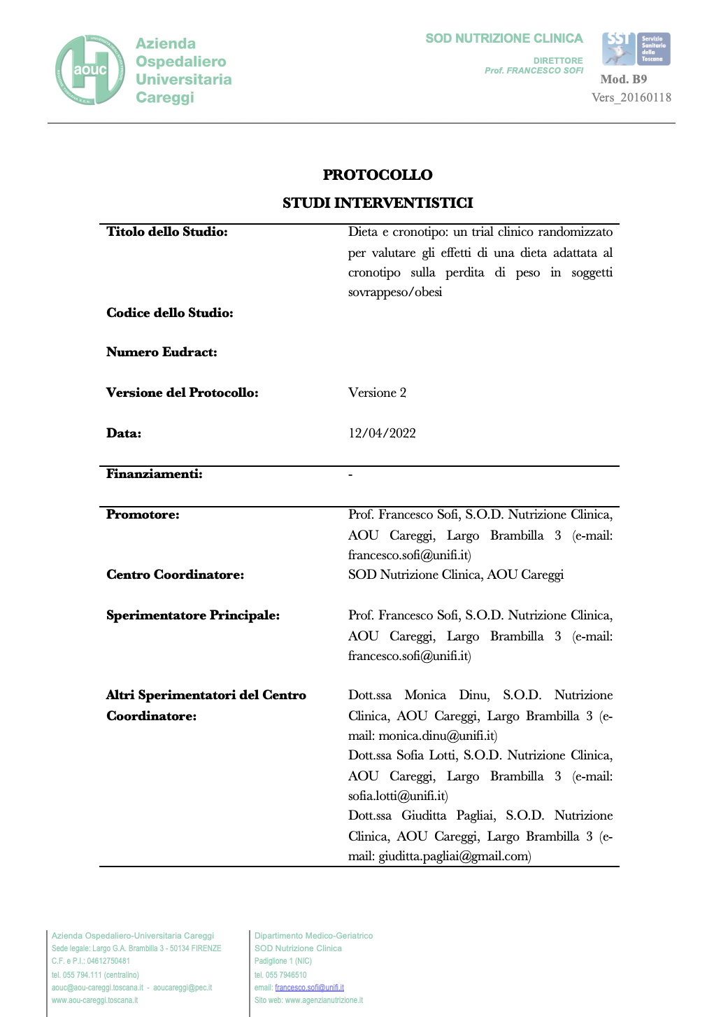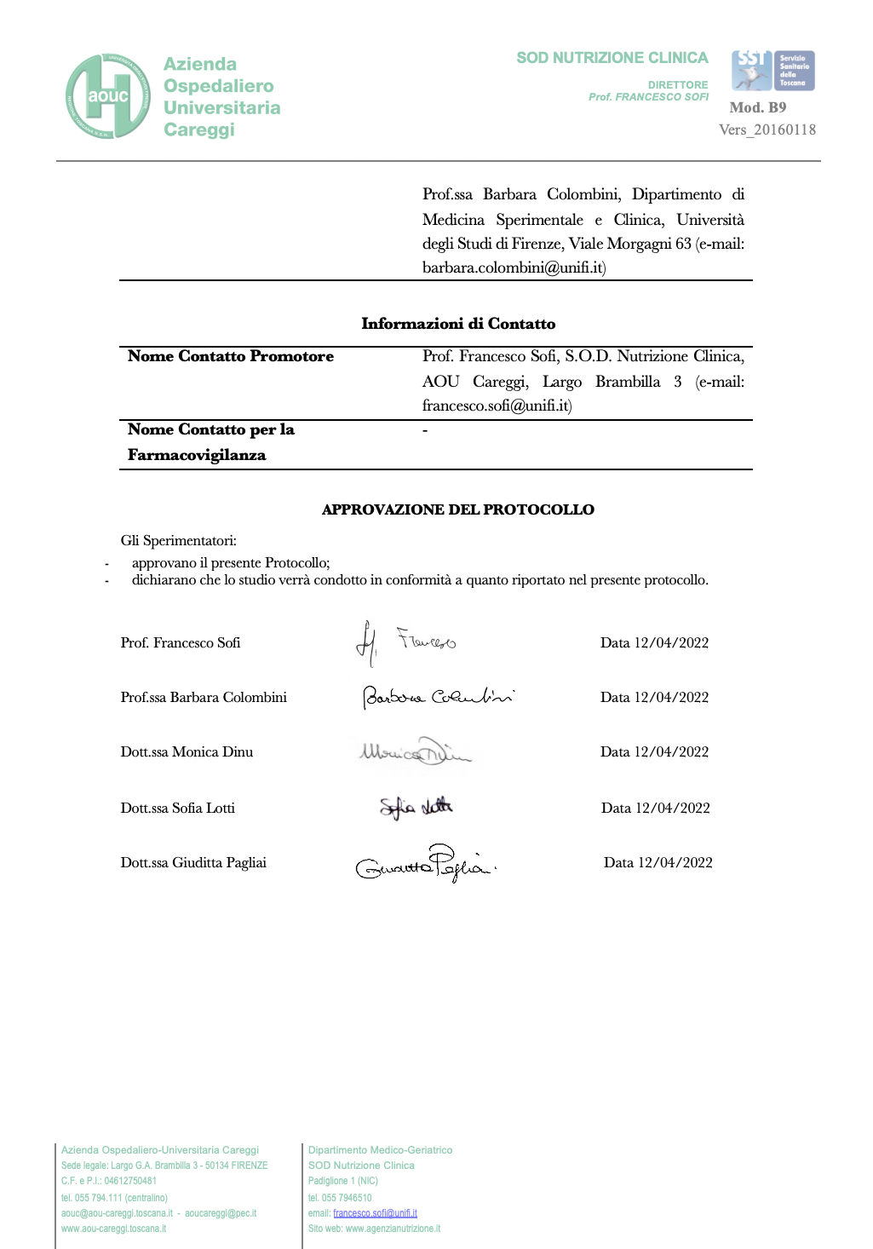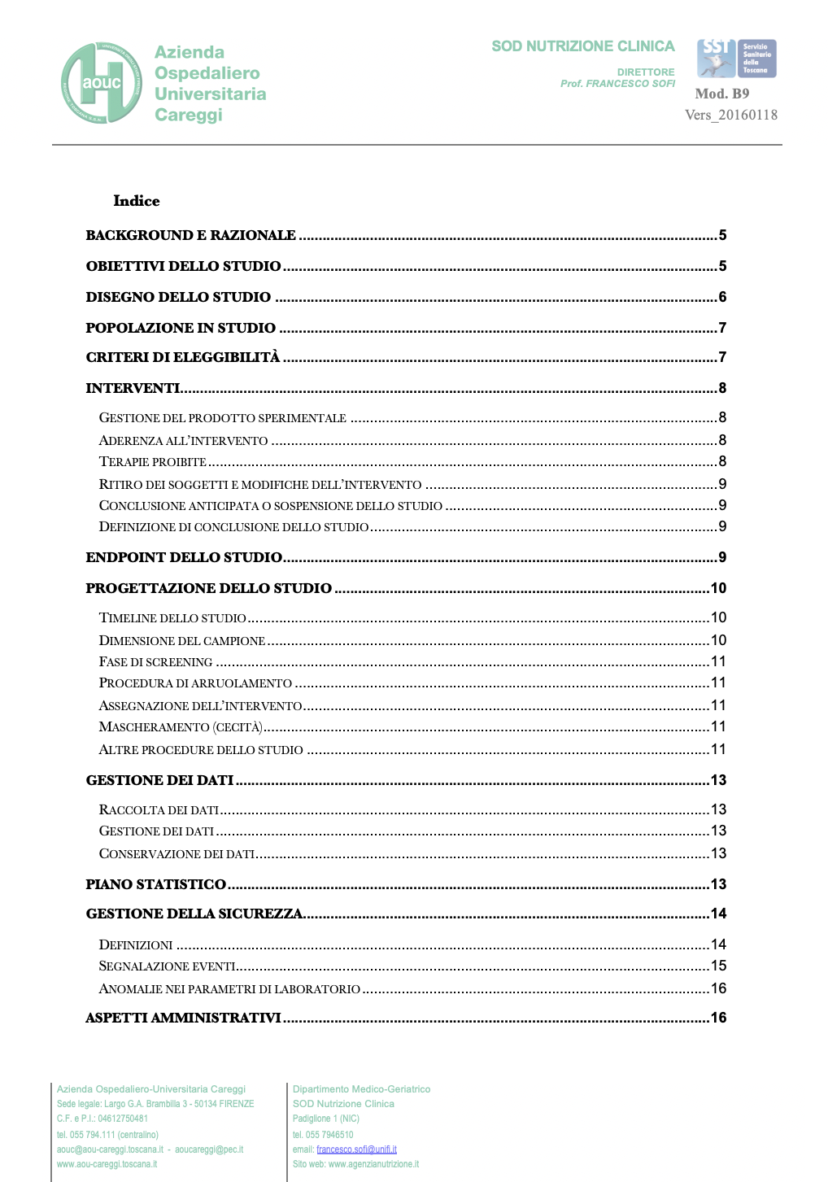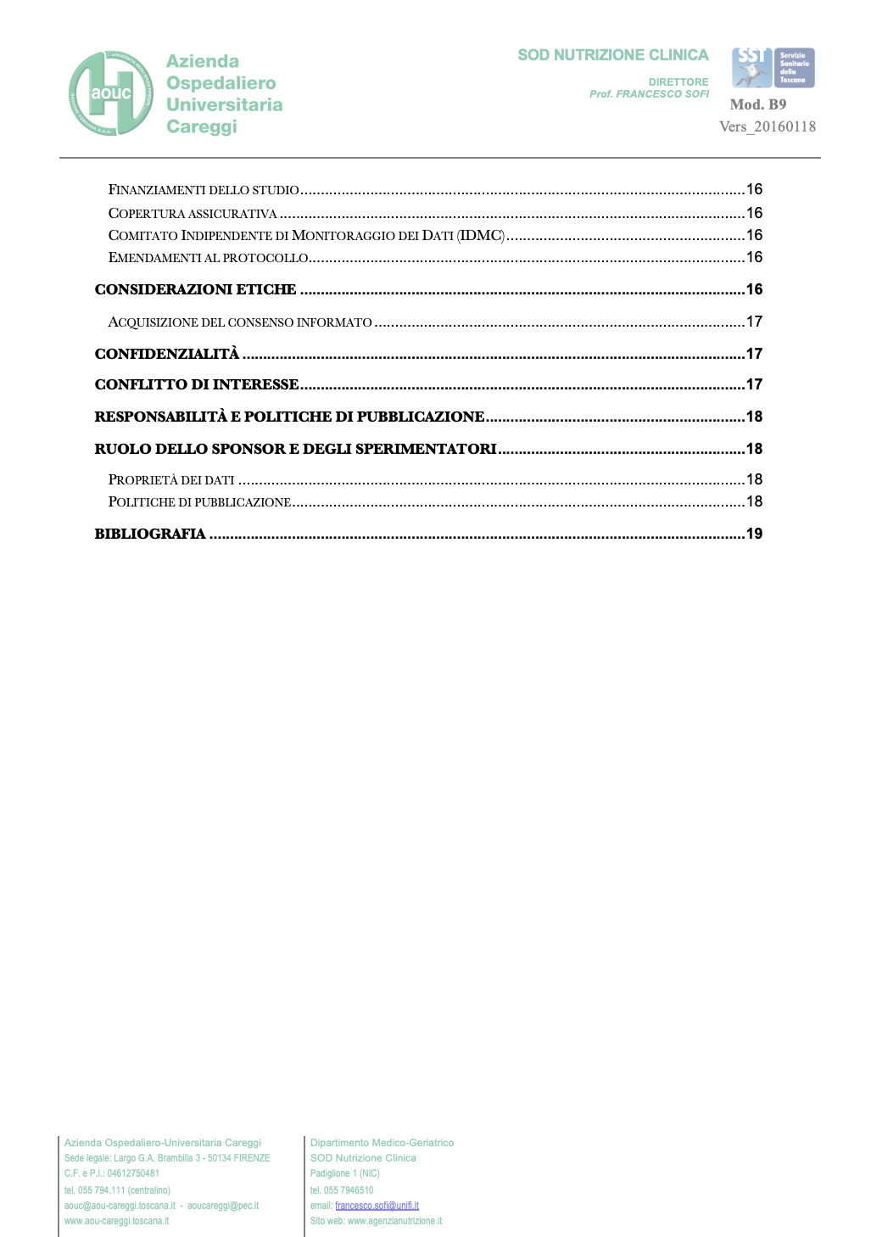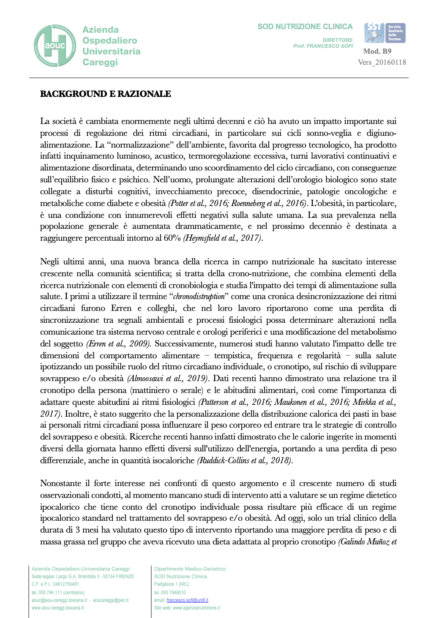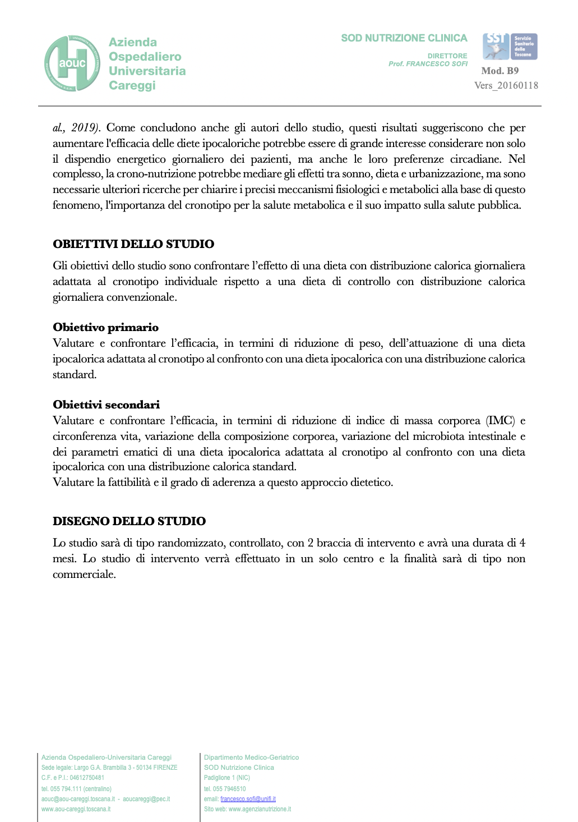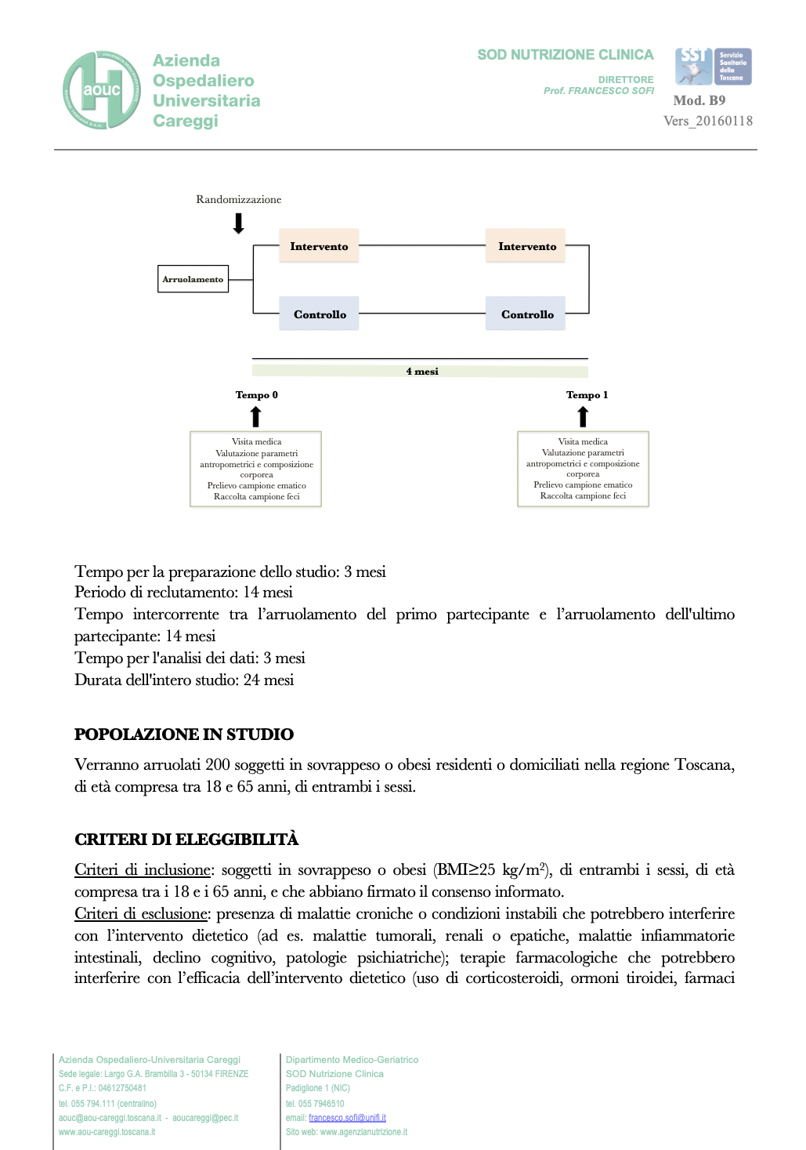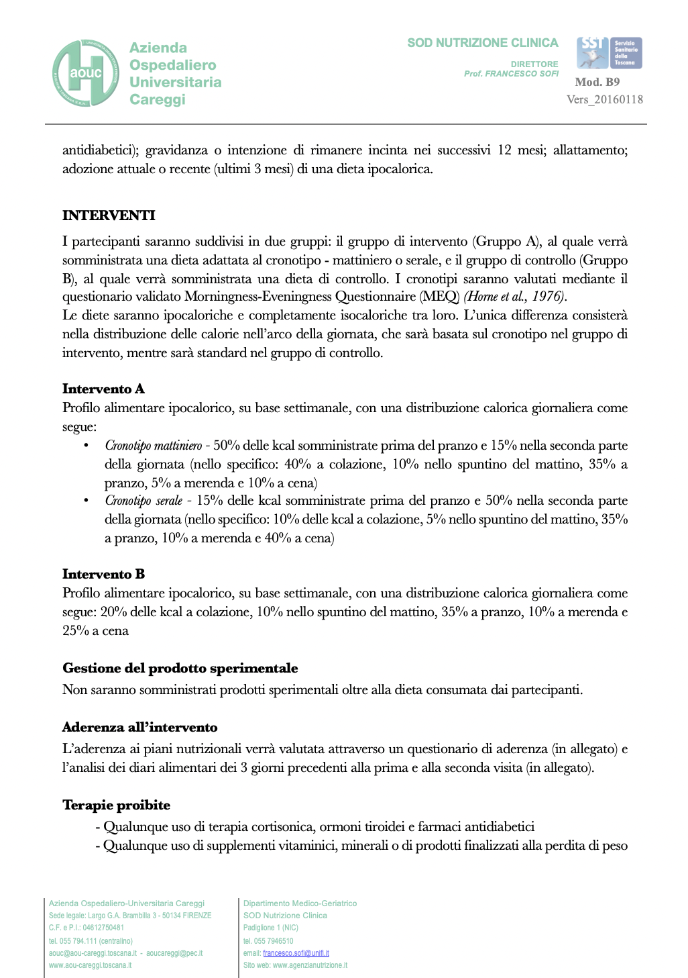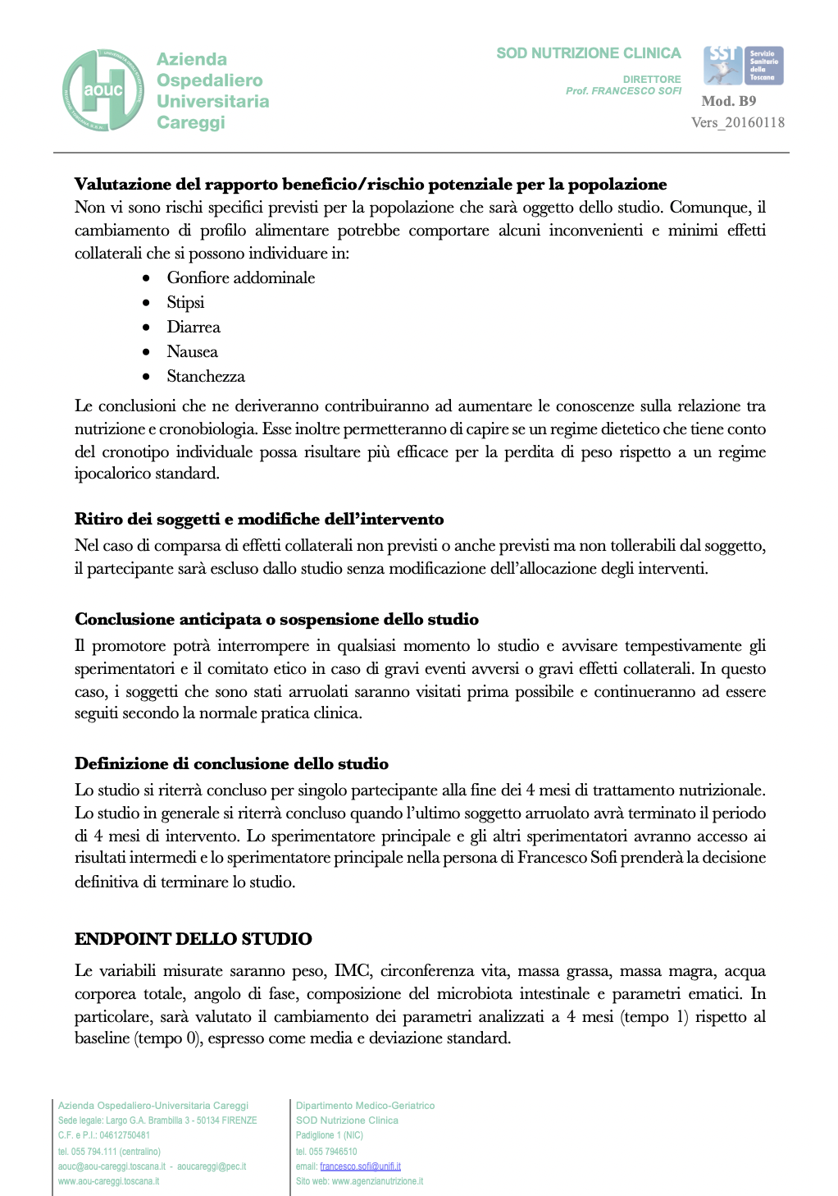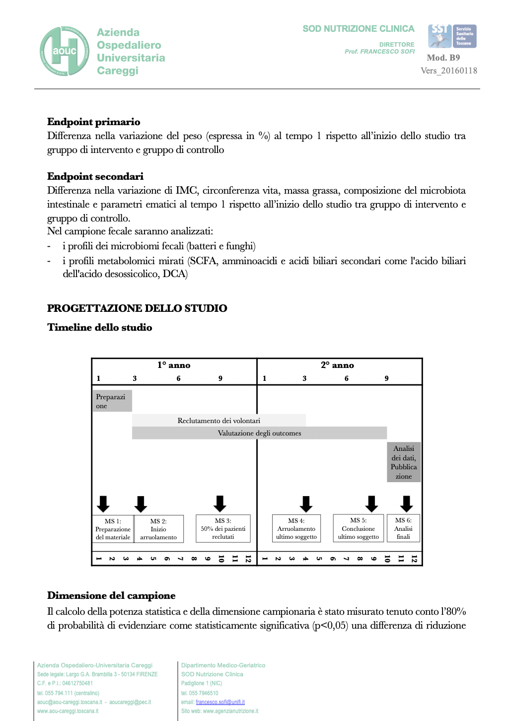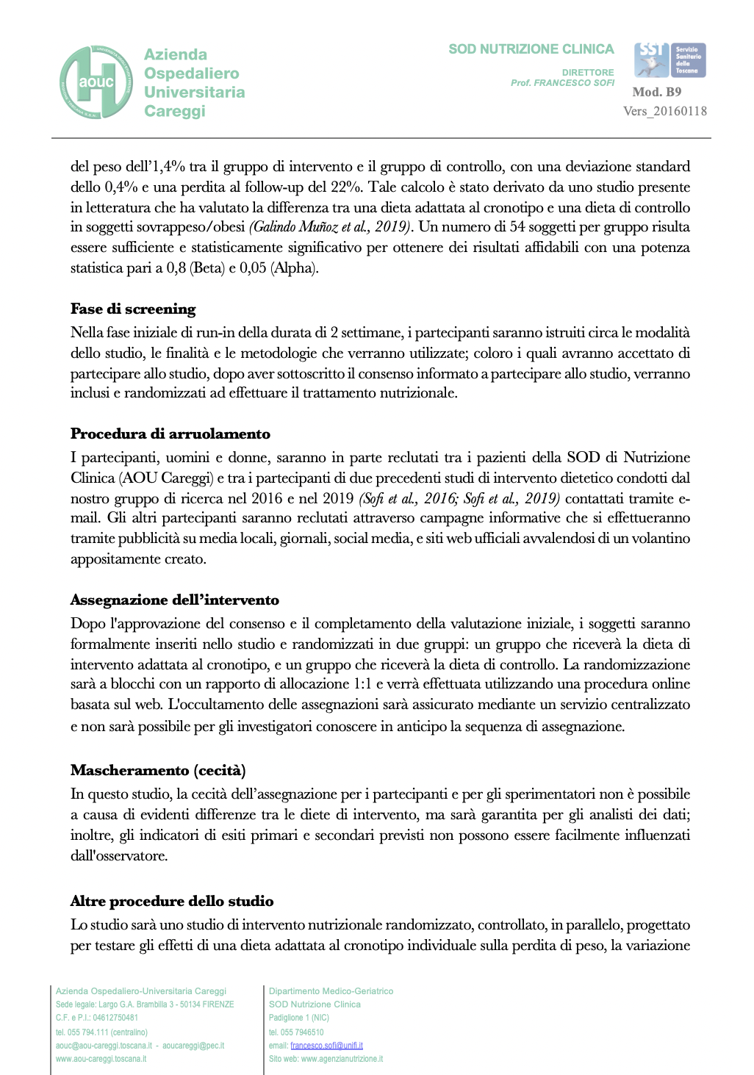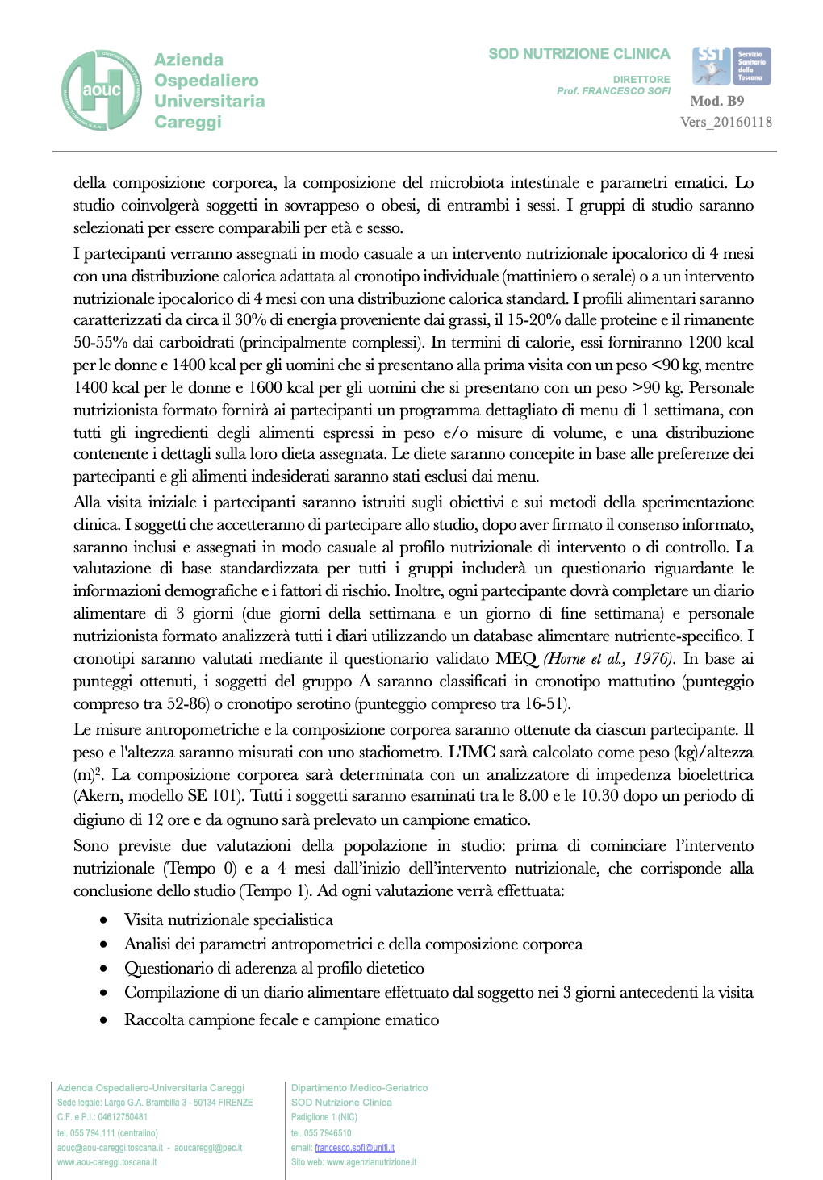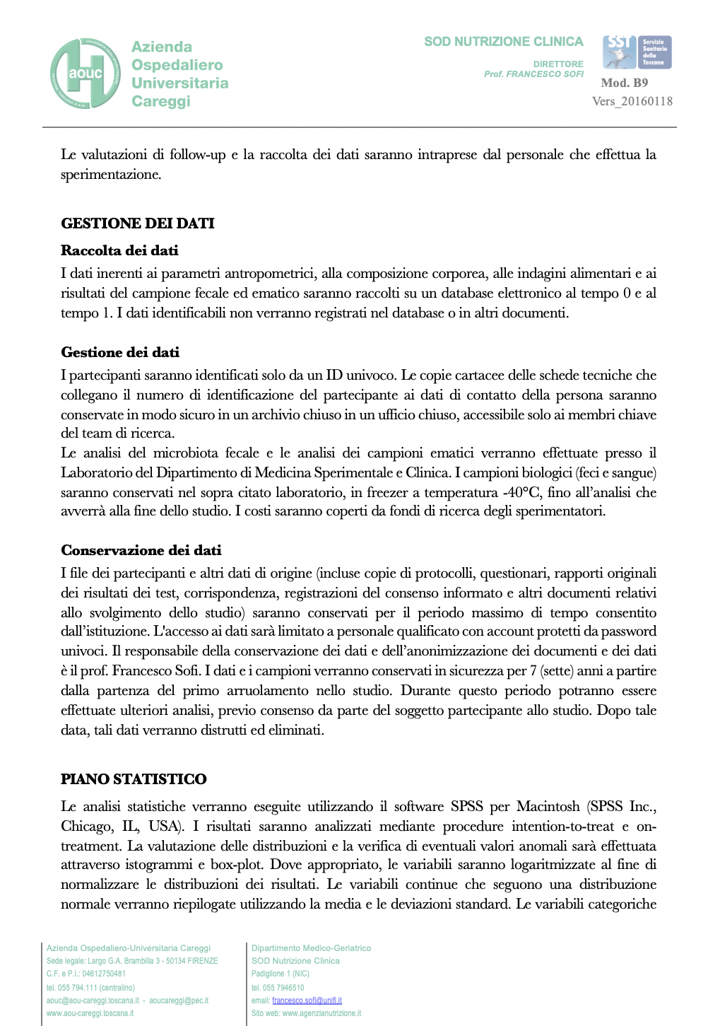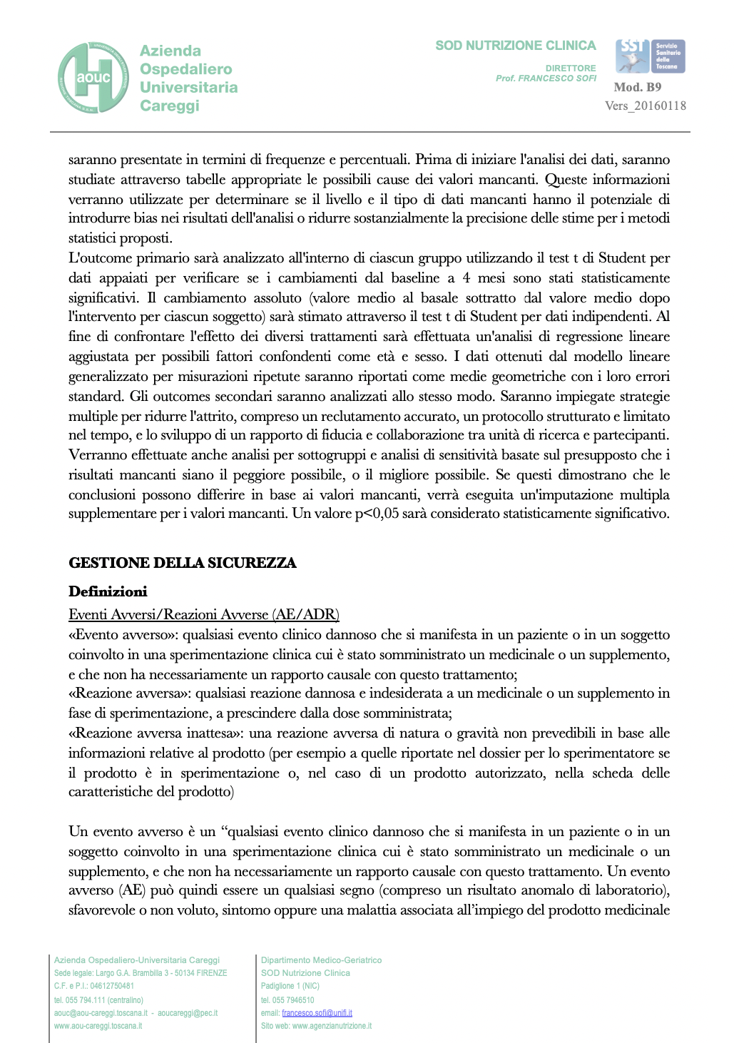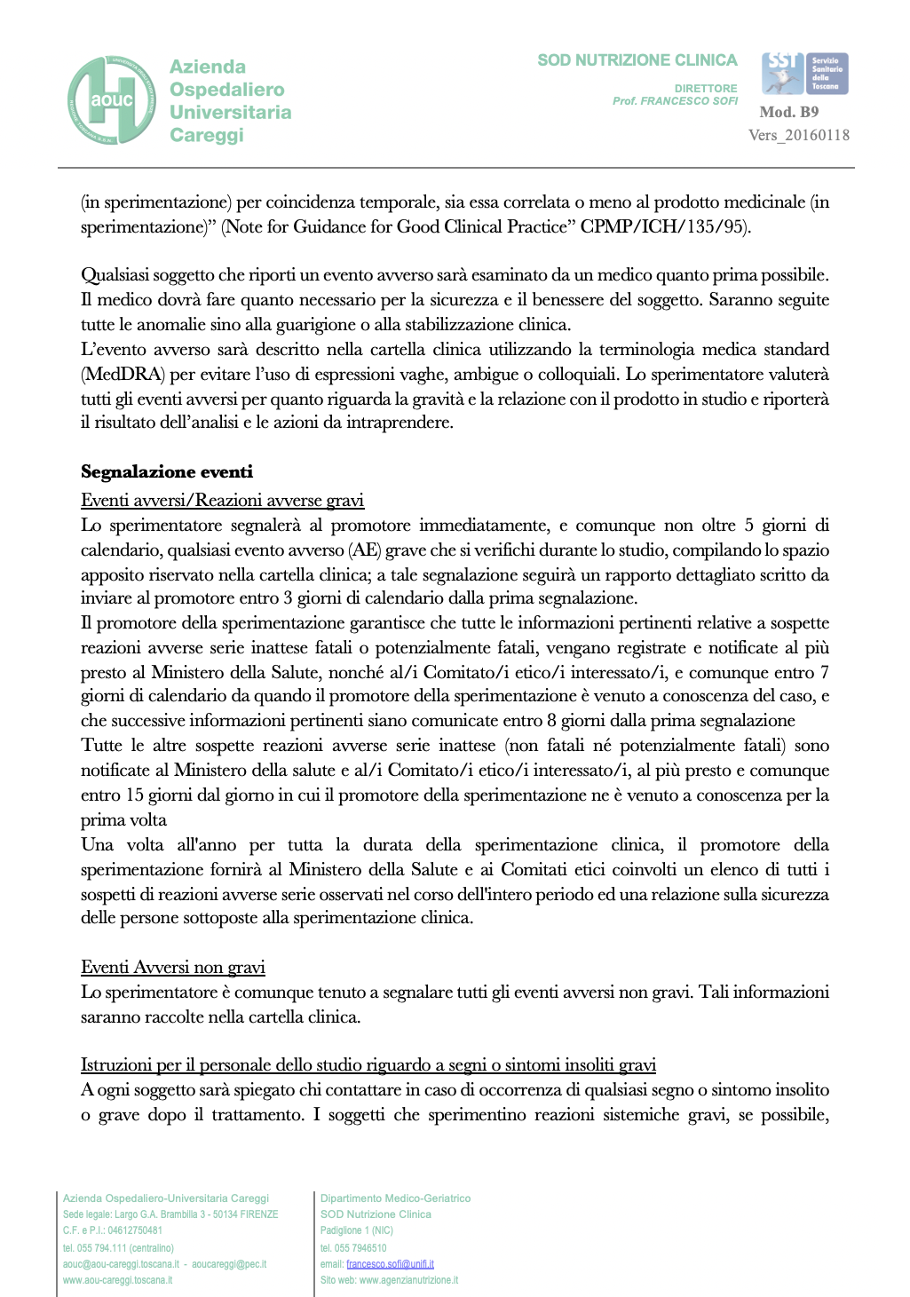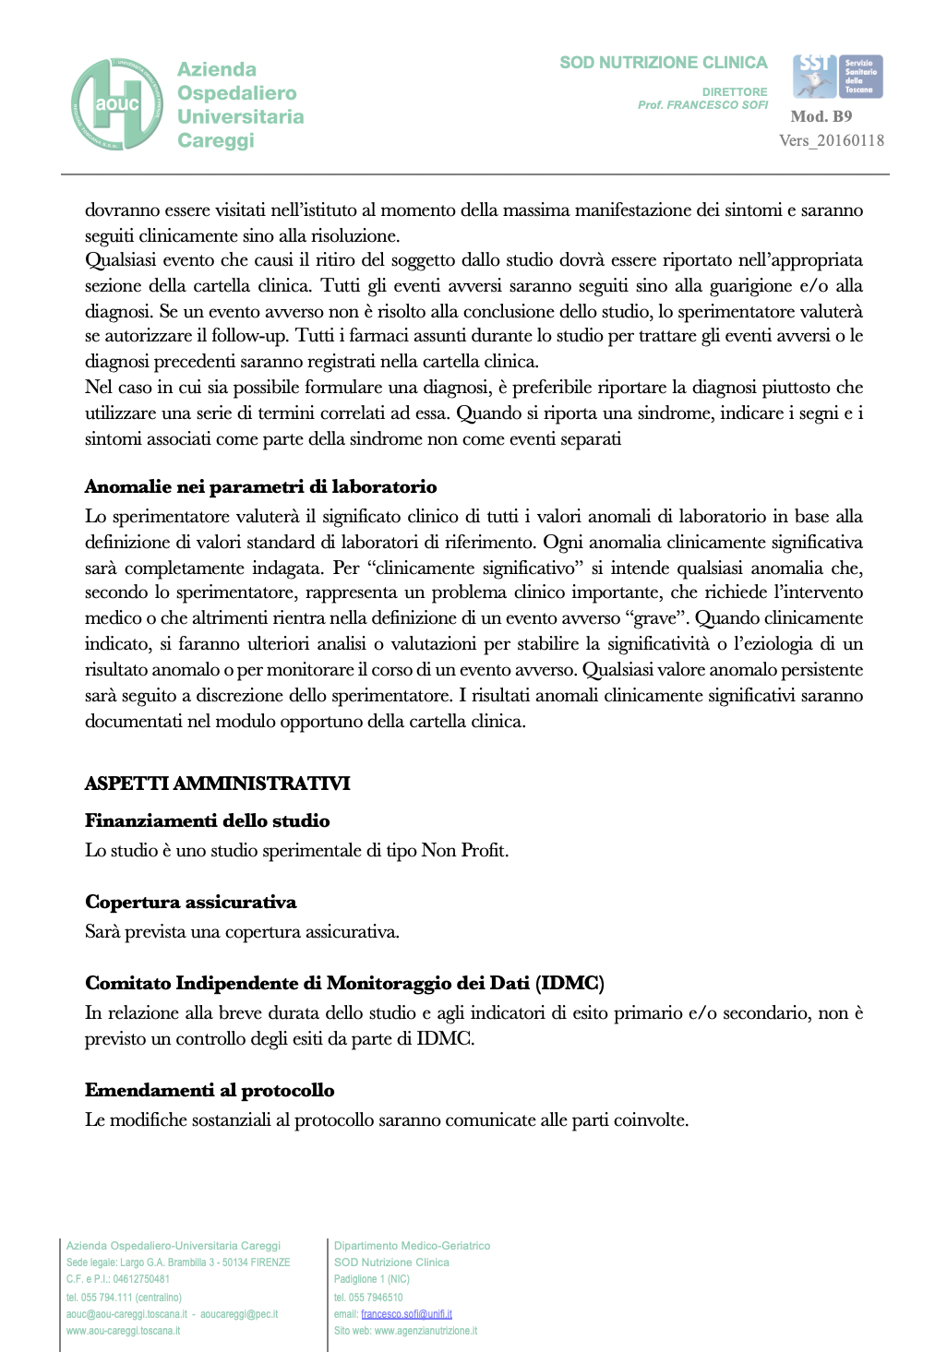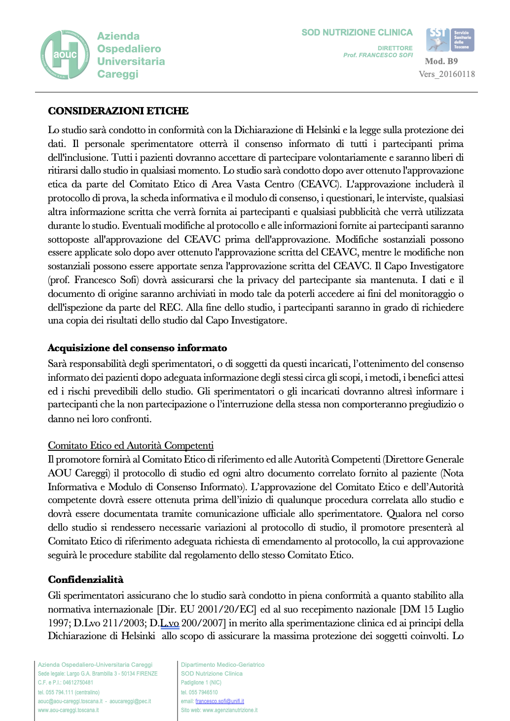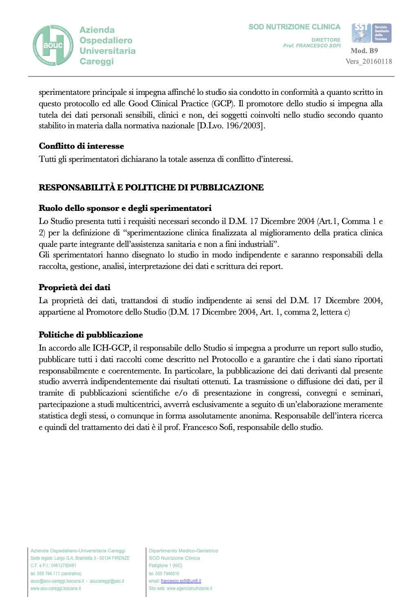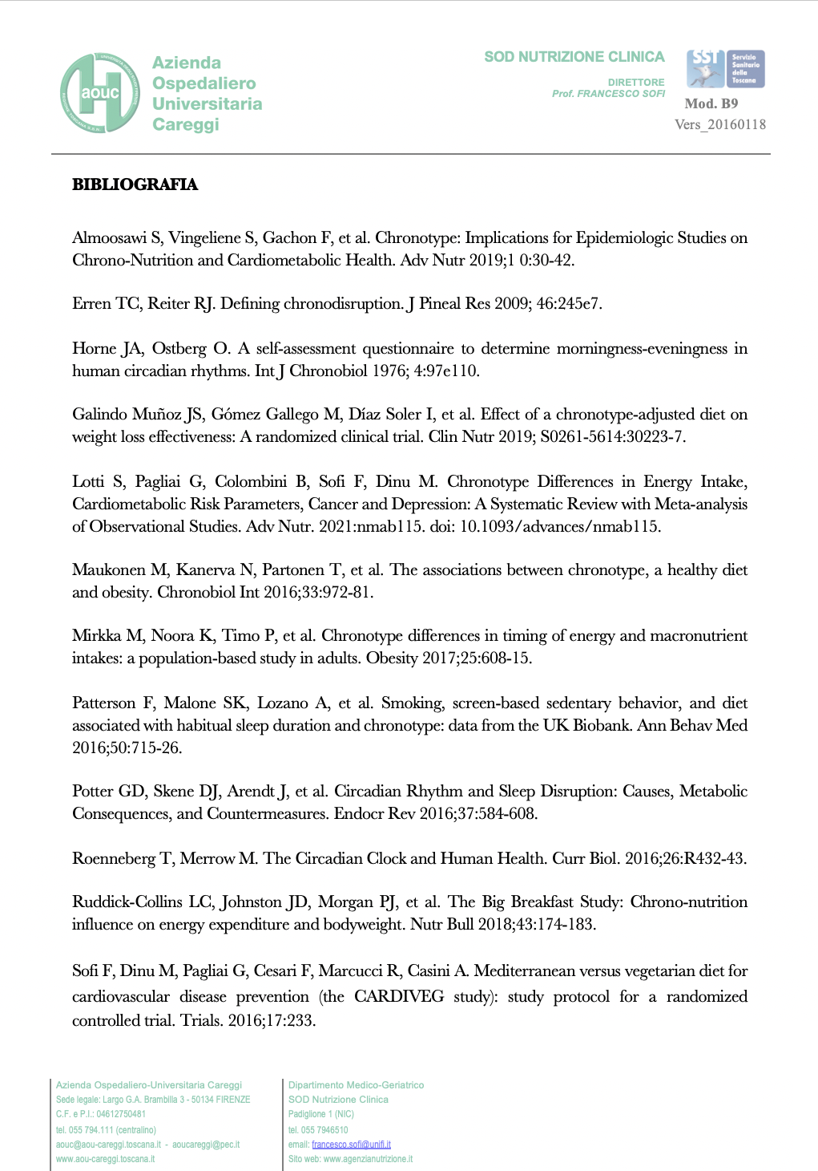

Appendix B: Ethics Committee

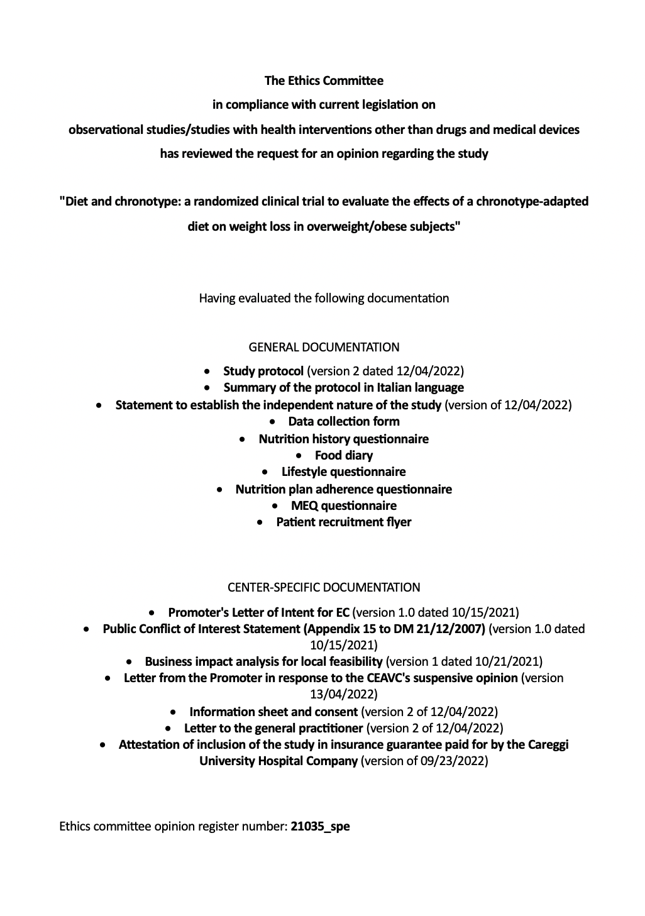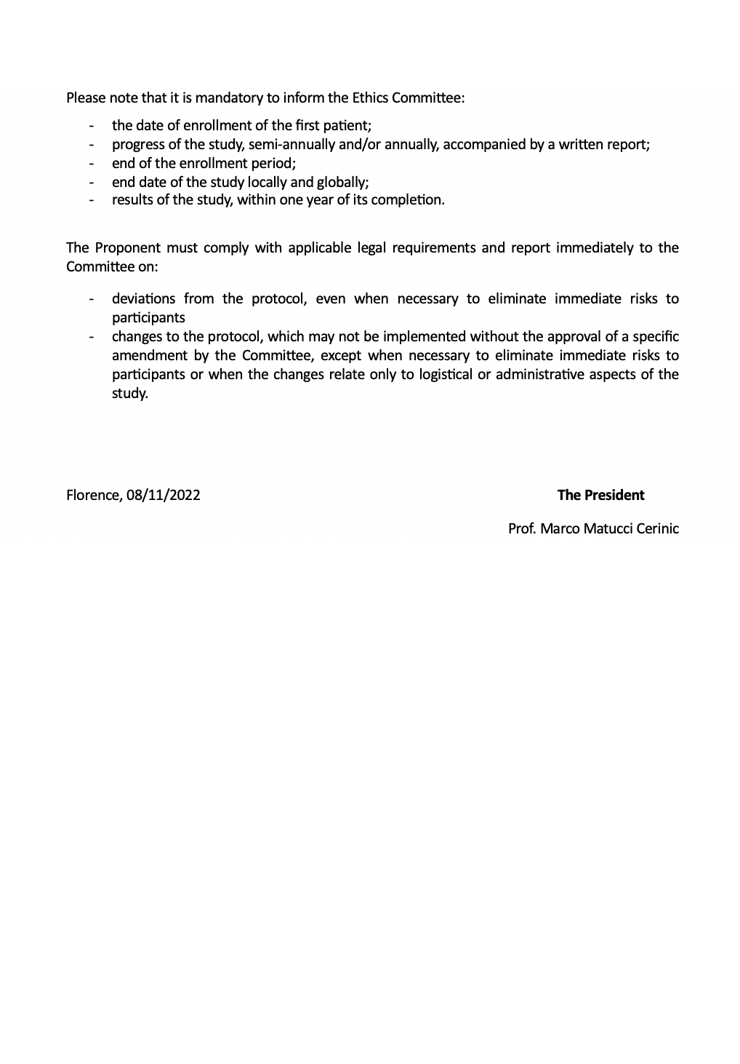

Appendix C: Study materials

MEDICAL HISTORY SHEET
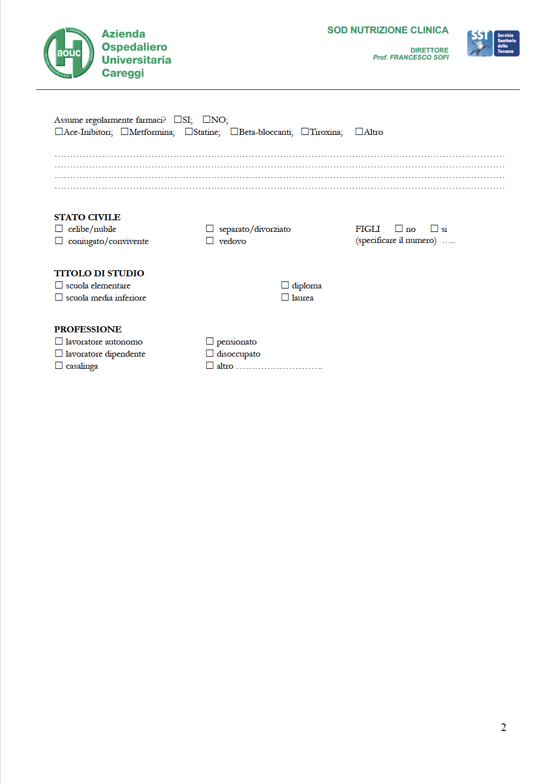

INFORMATION SHEET
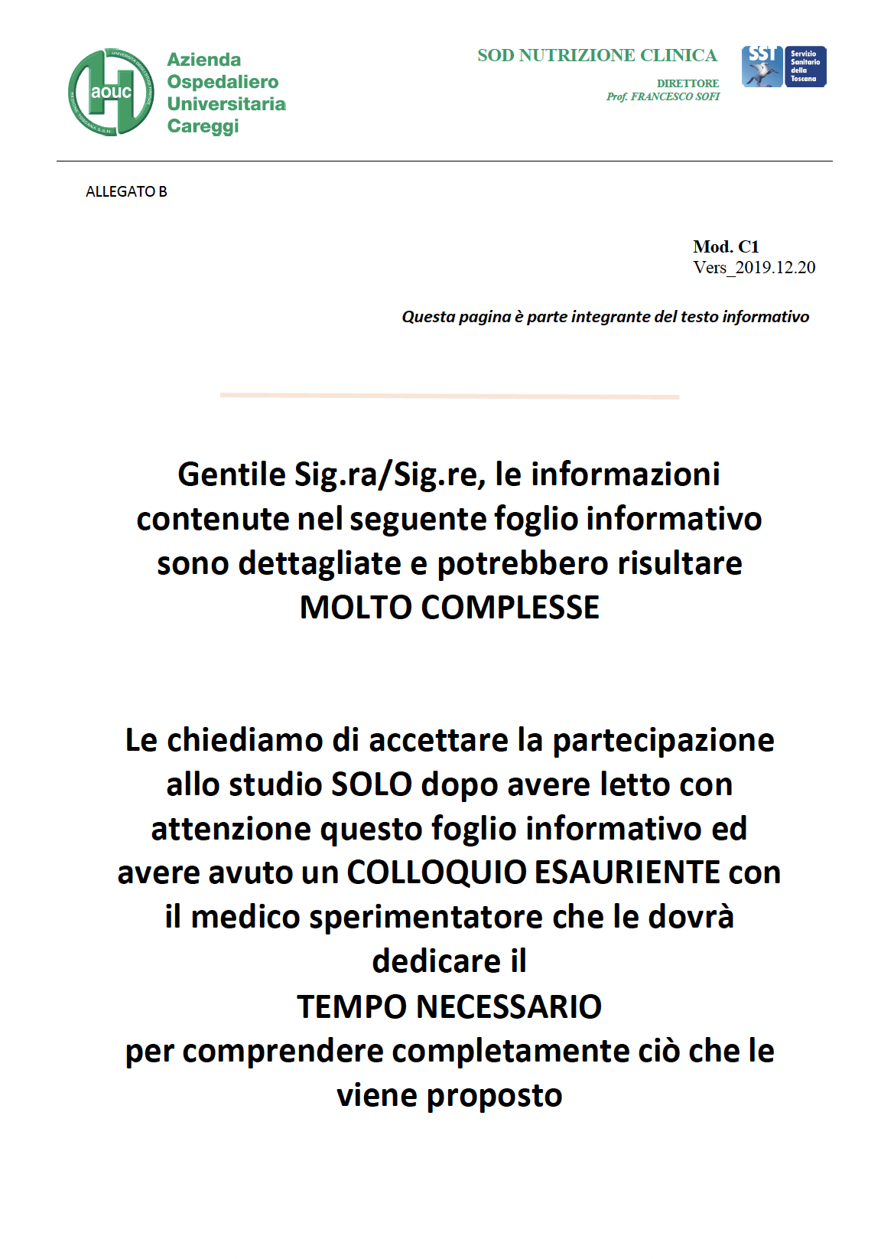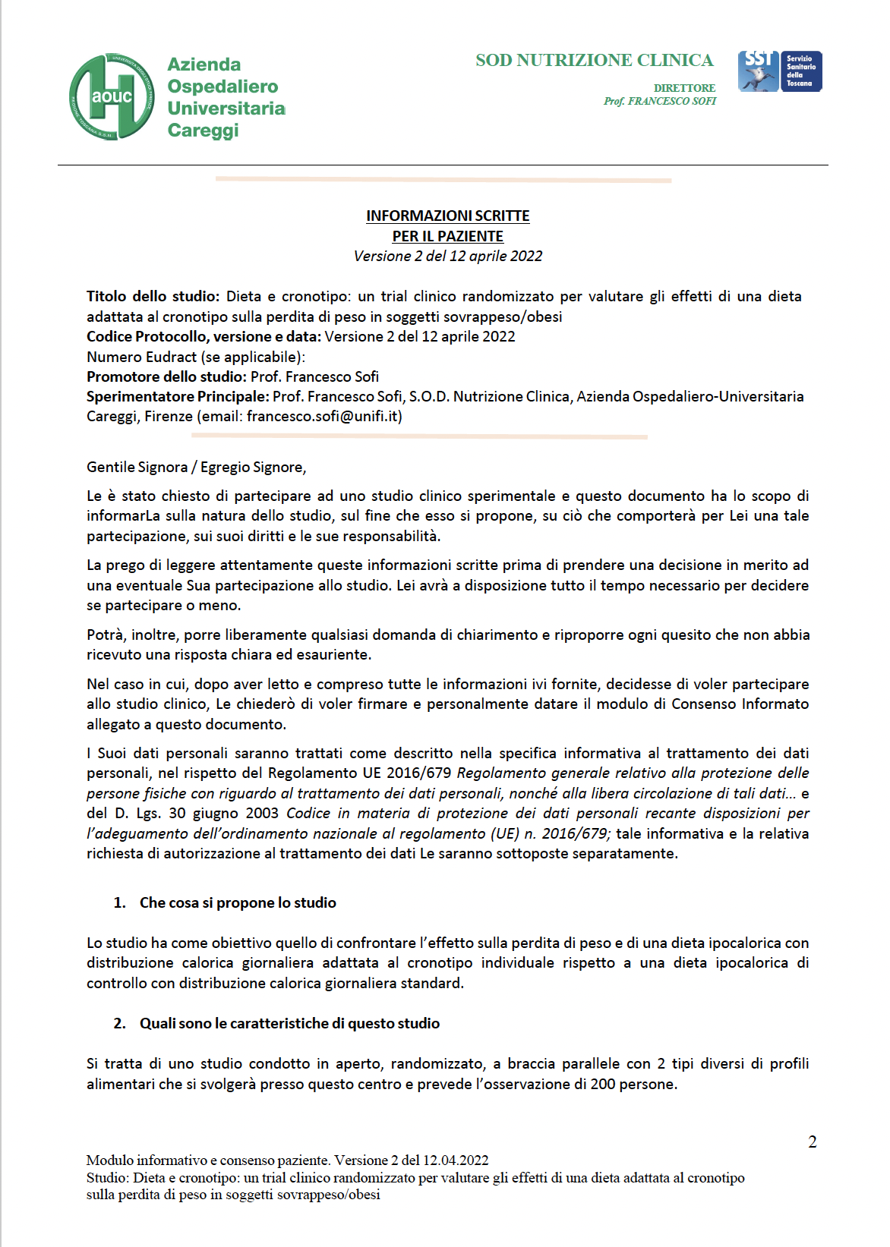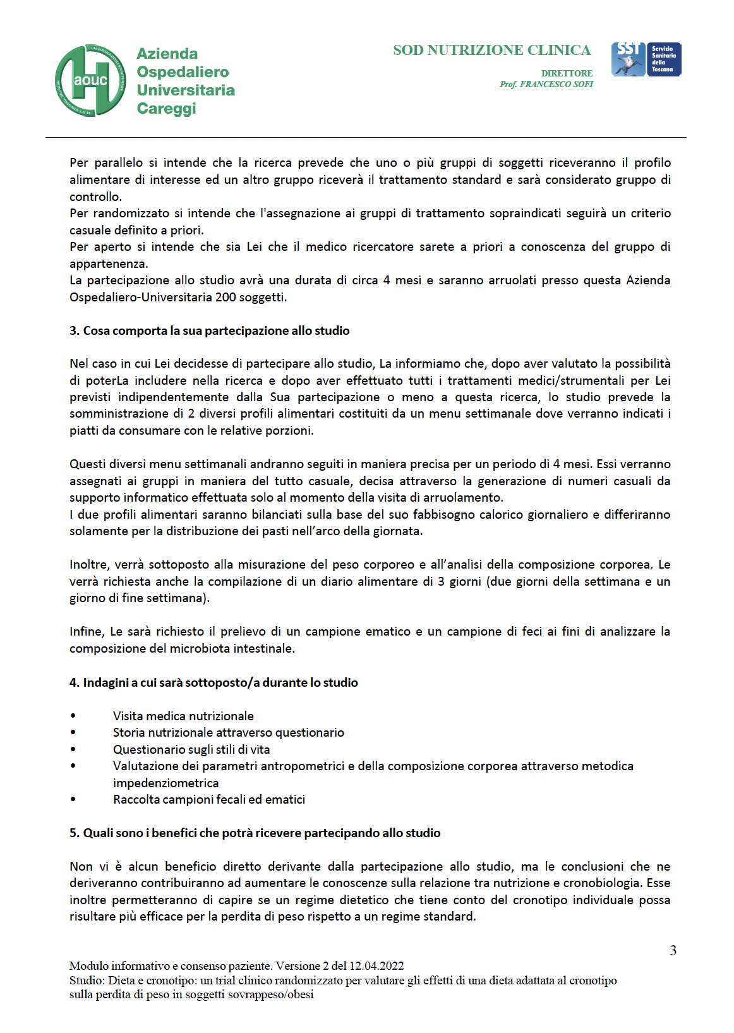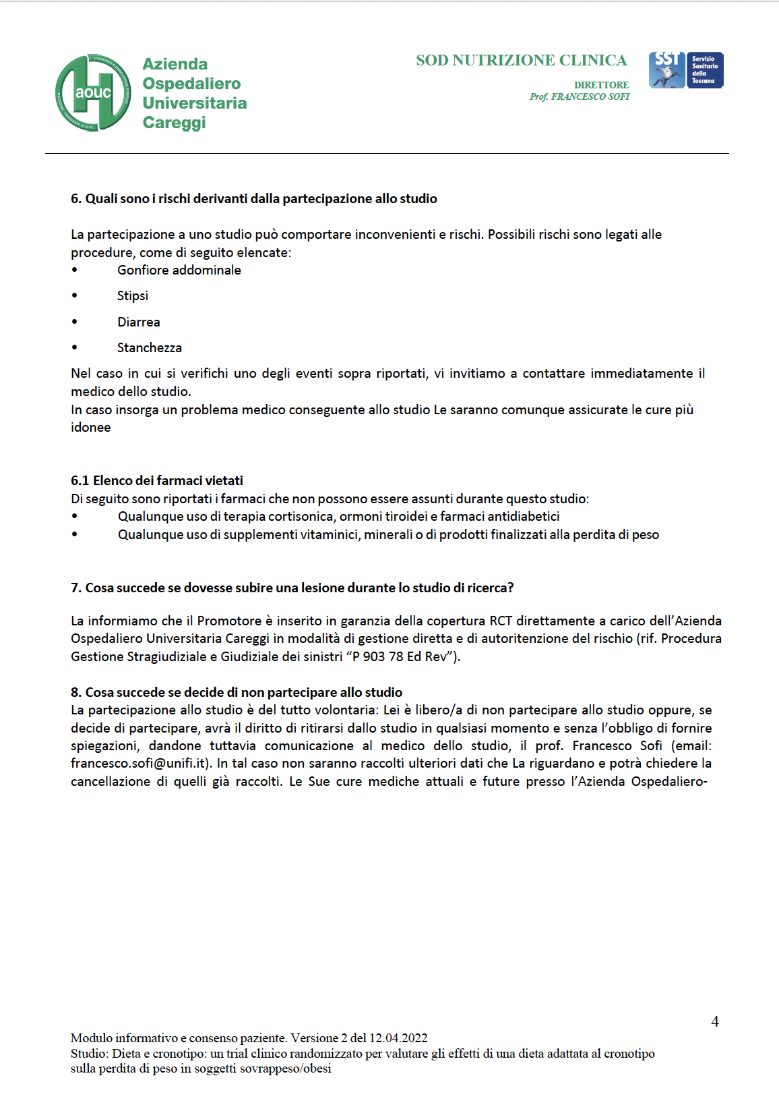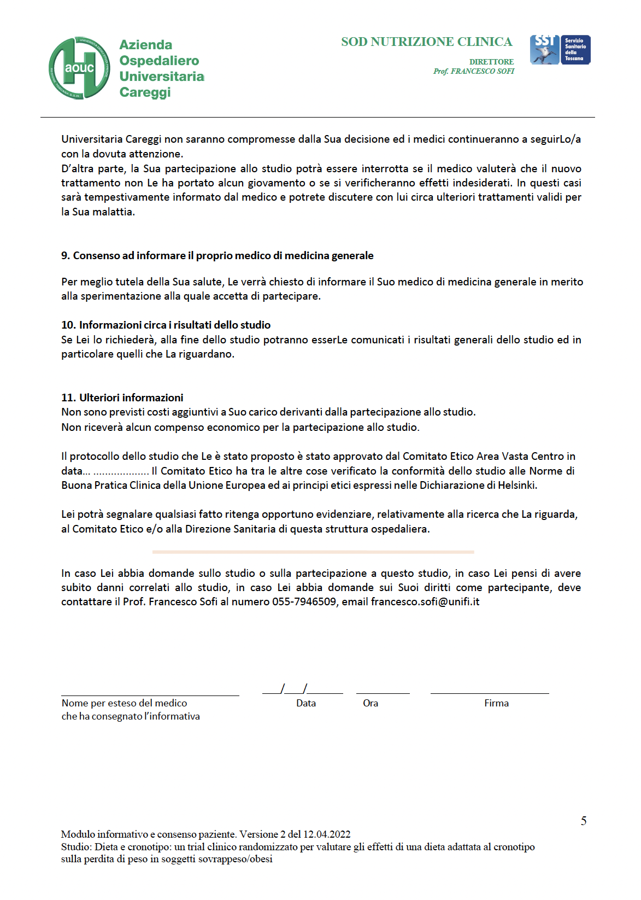

CONSENT FORM
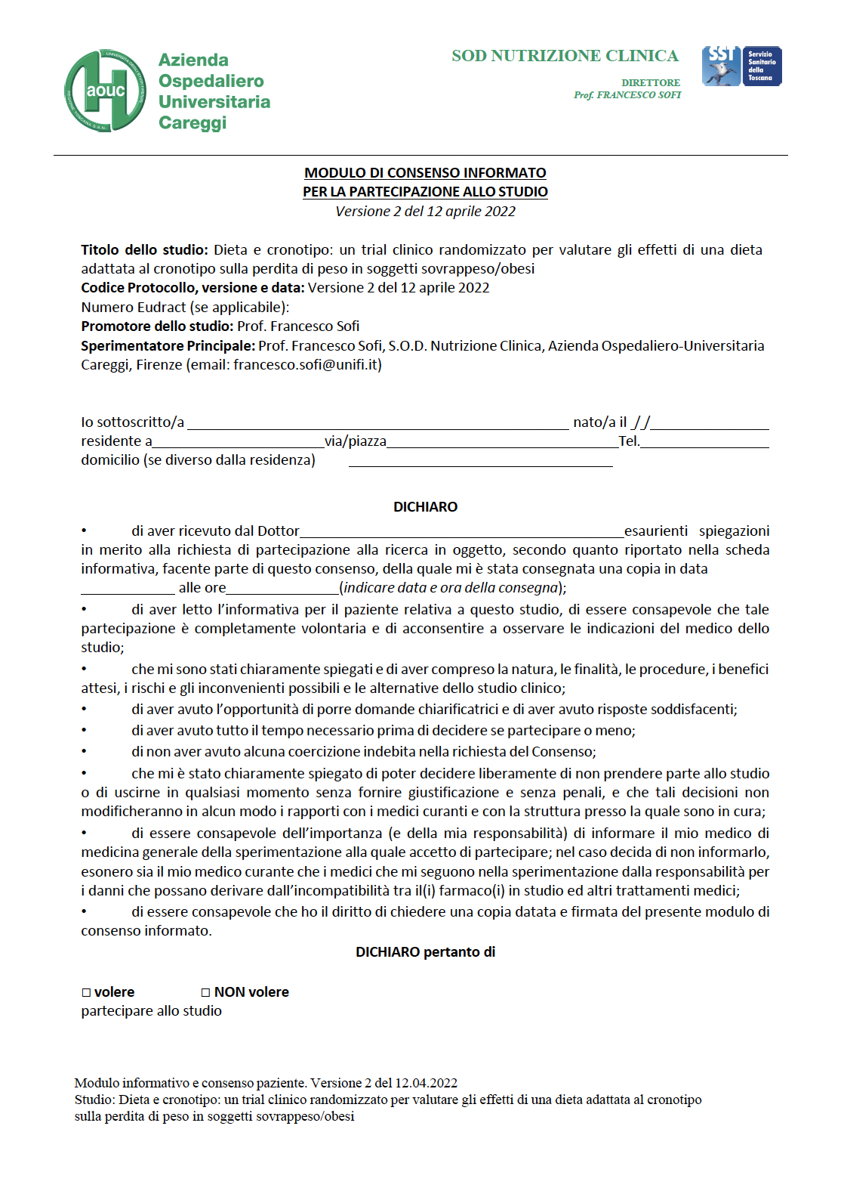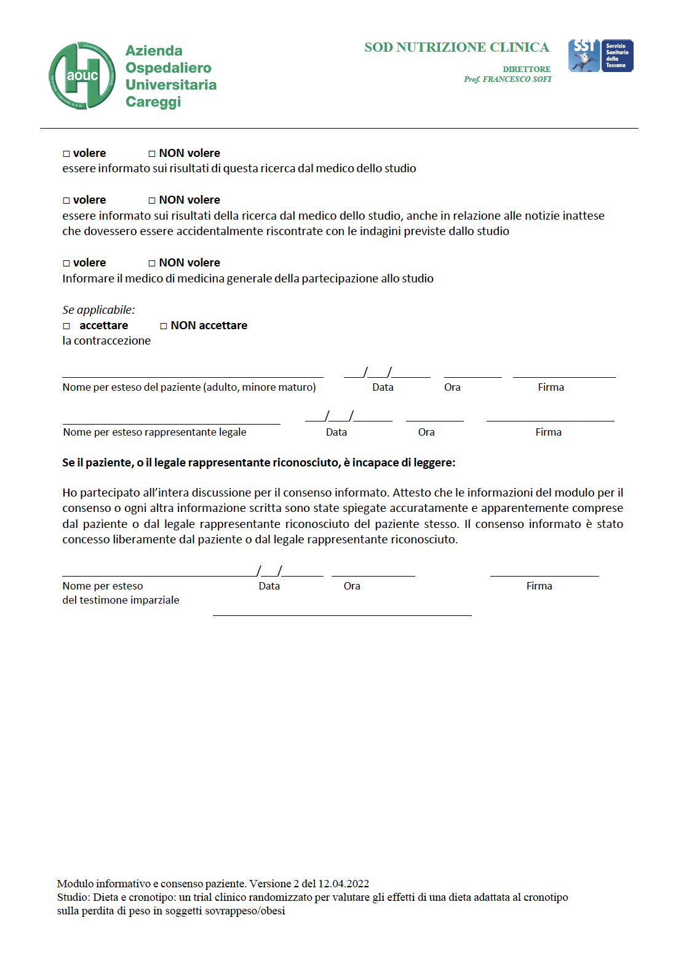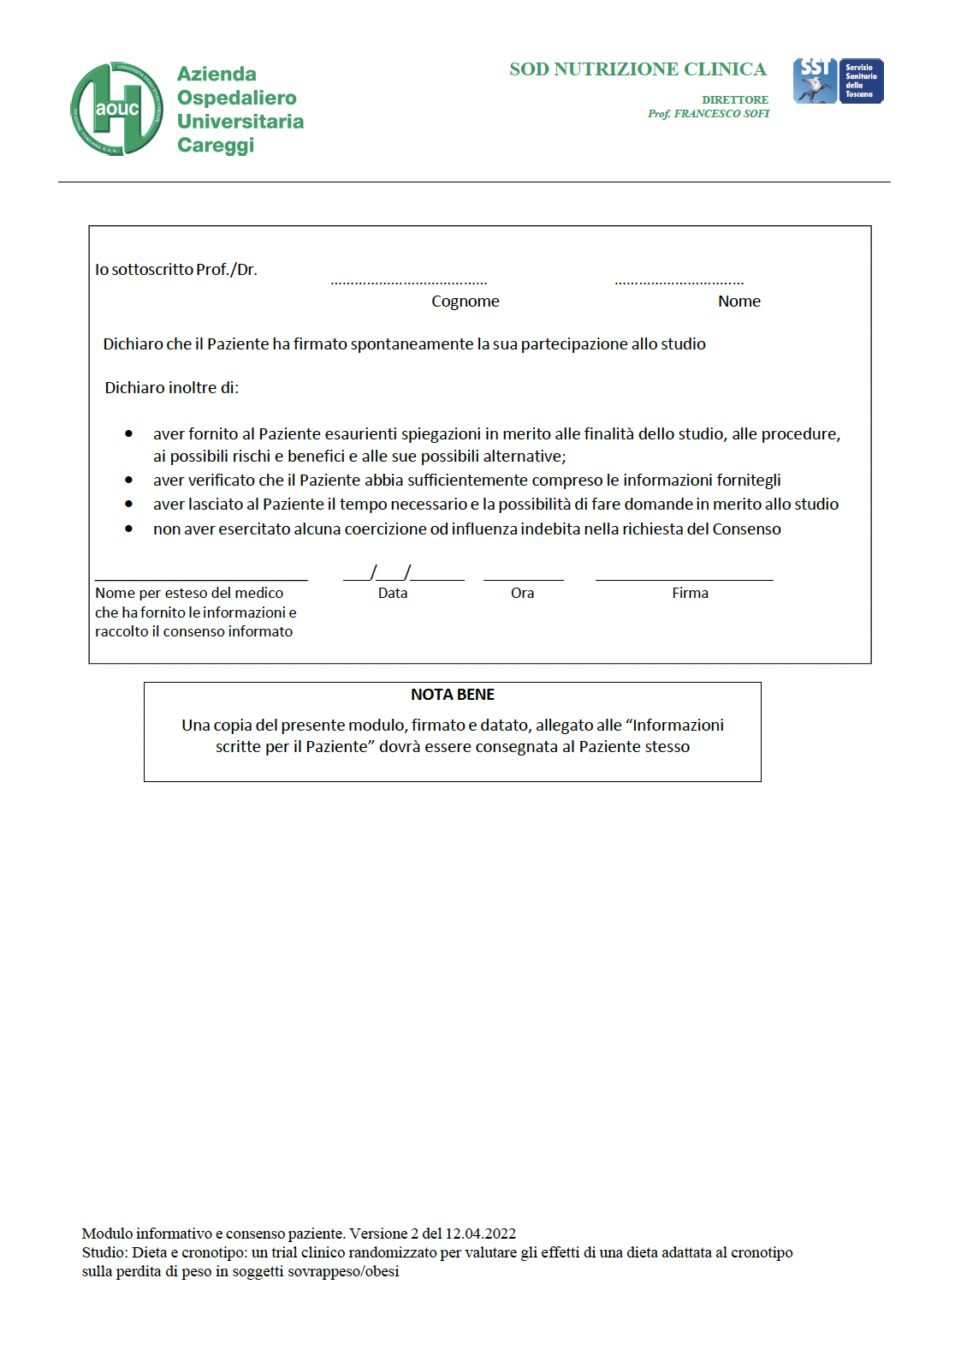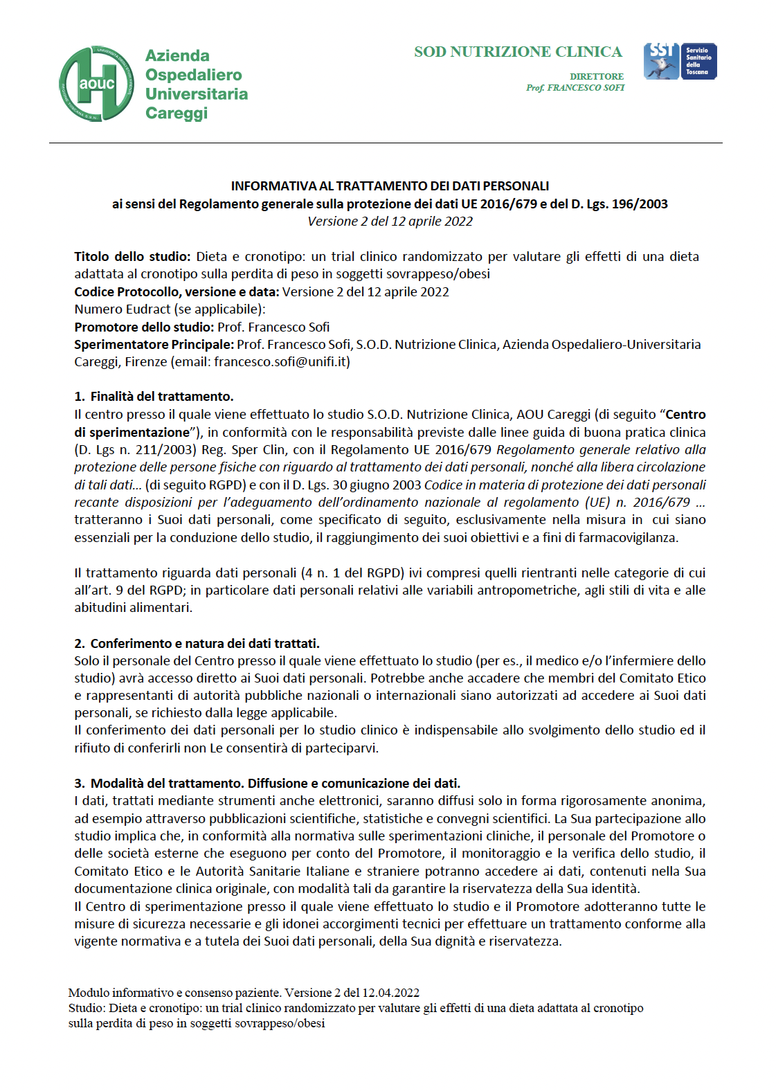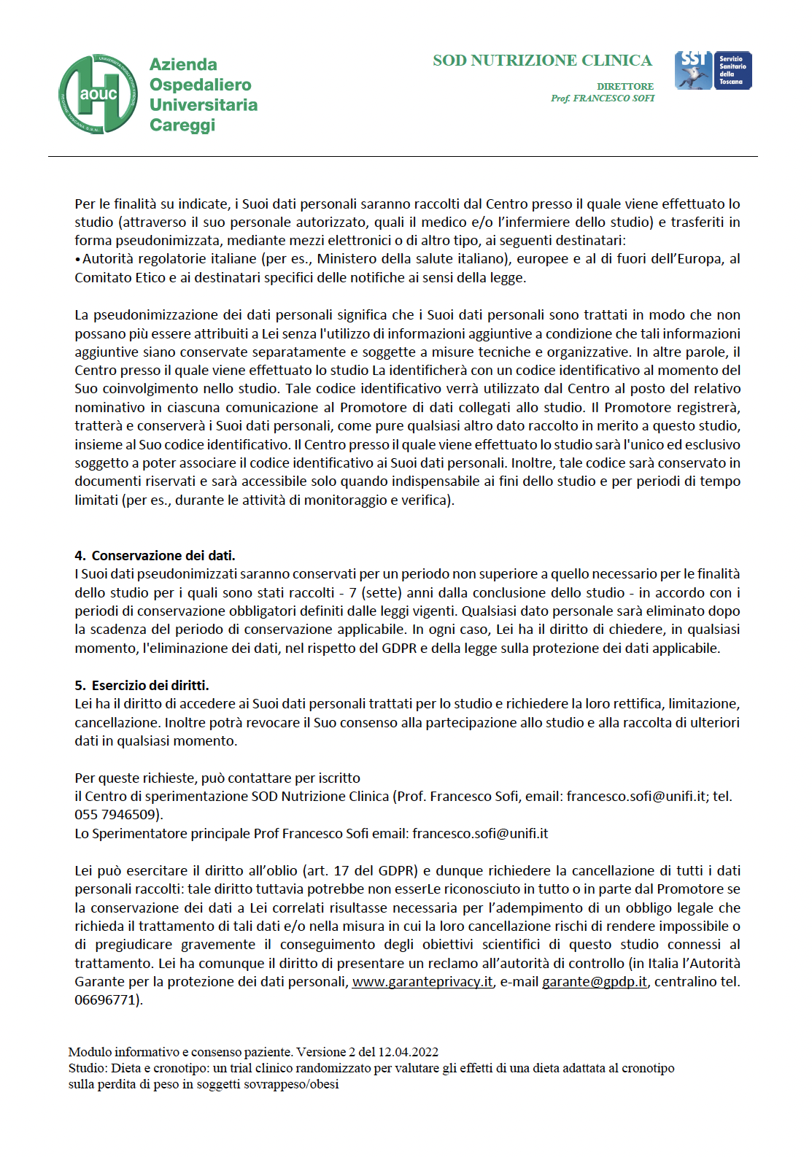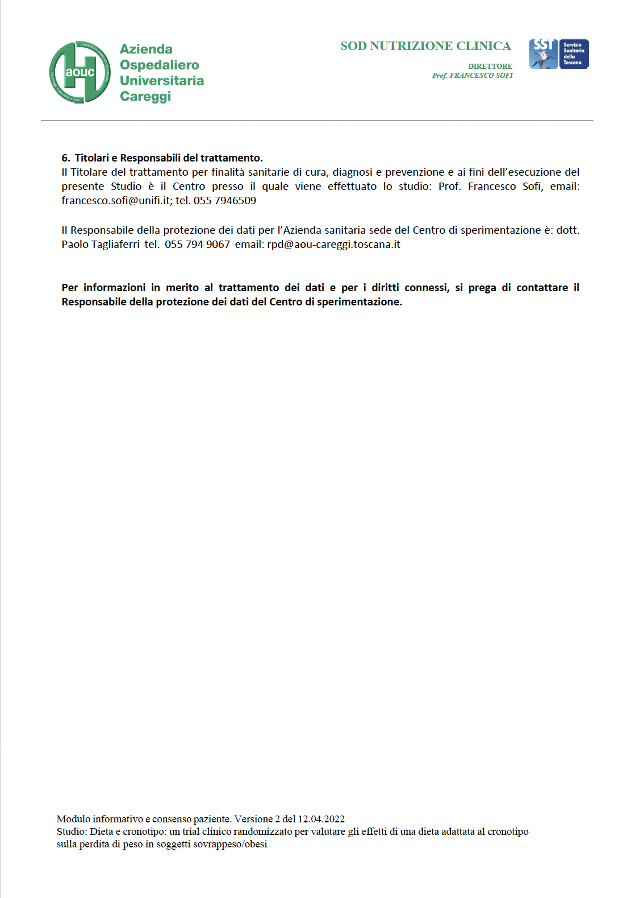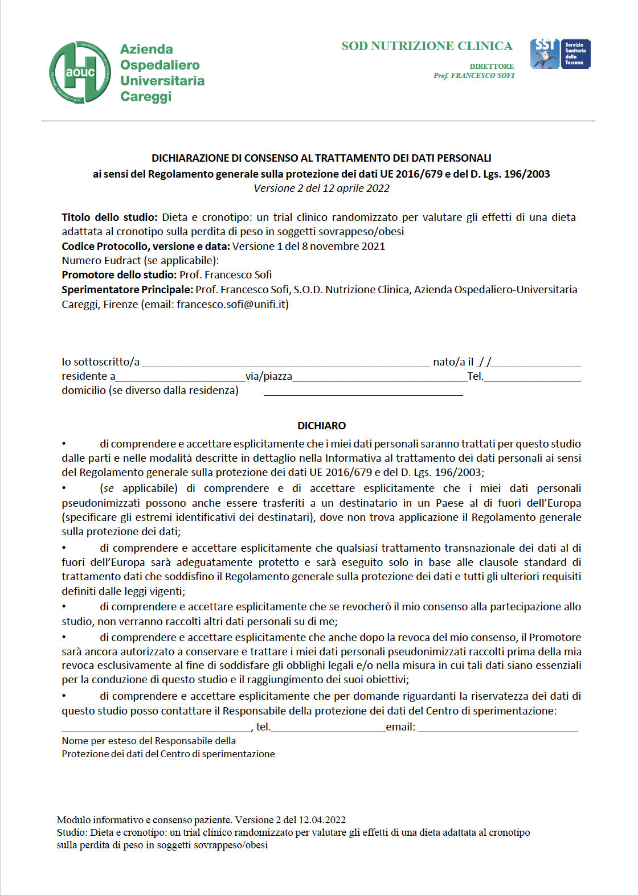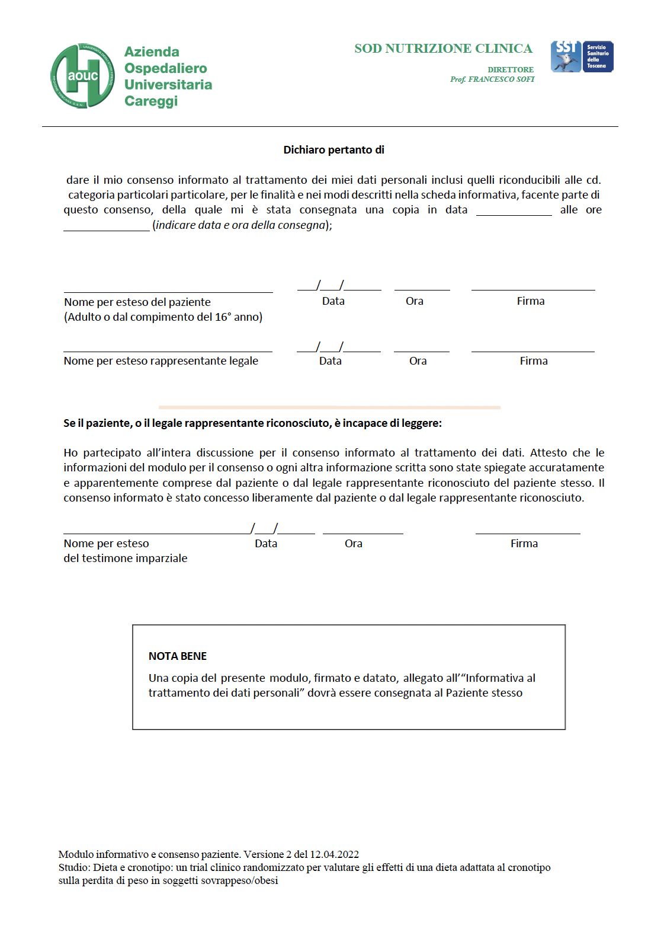

INFORMATION SHEET FOR THE DOCTOR

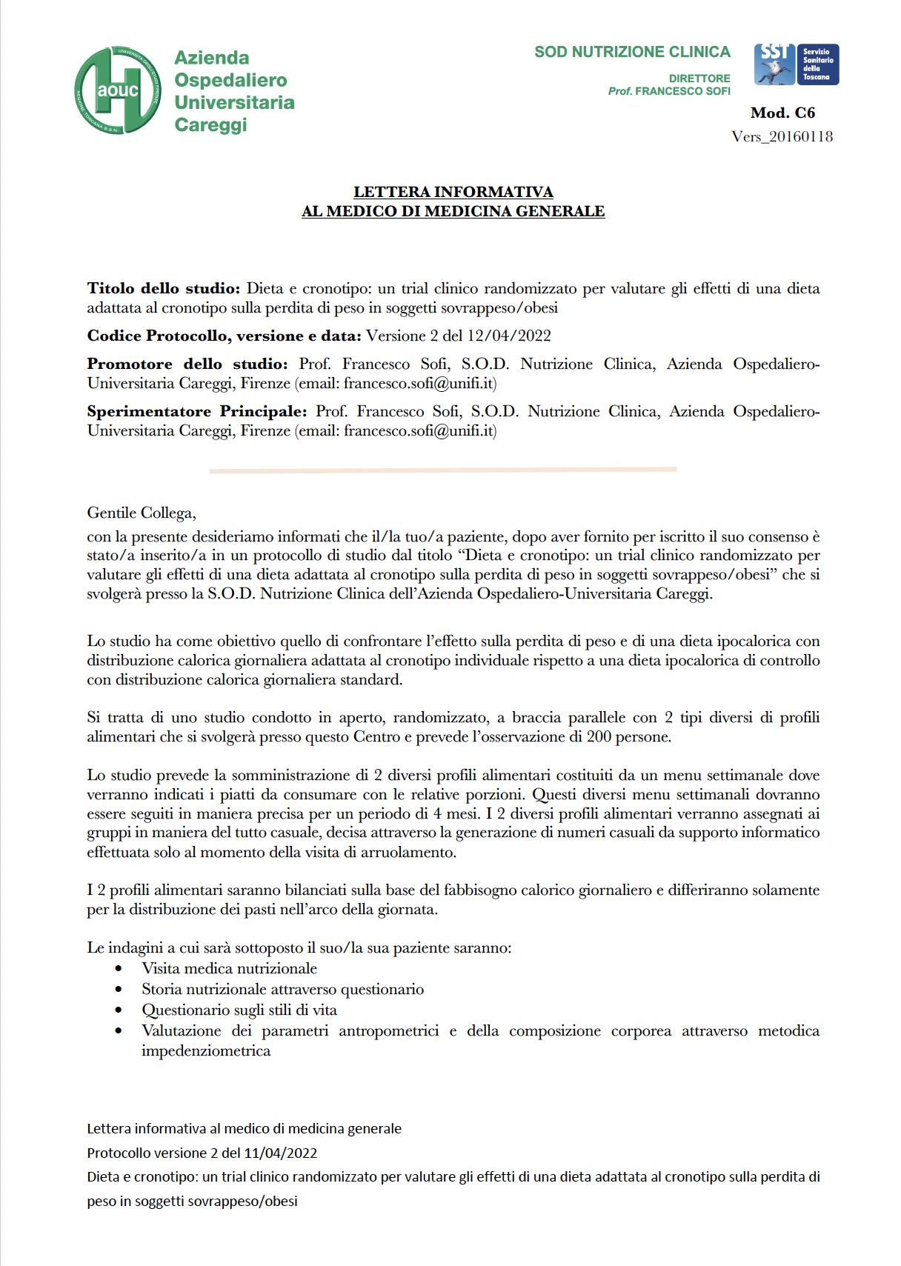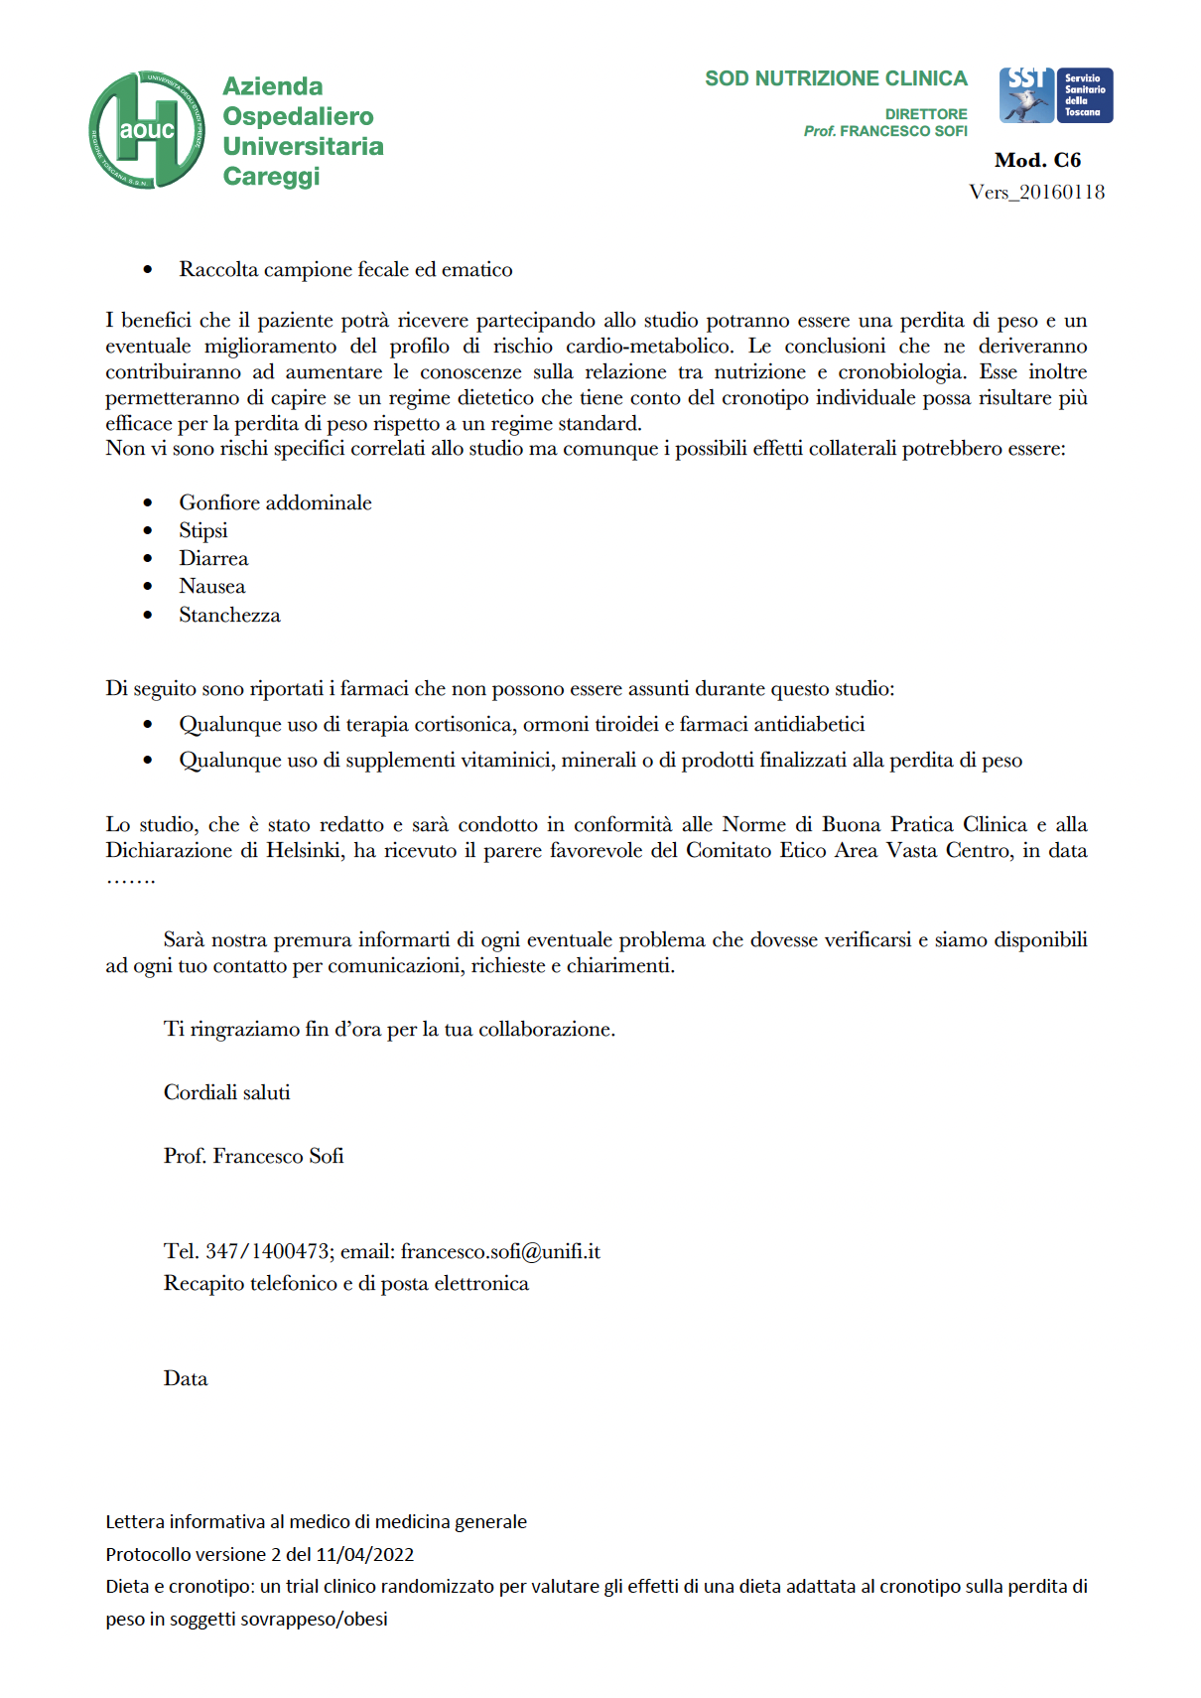

QUESTIONNAIRE FOR THE ASSESSMENT OF THE ADHERENCE
TO THE DIET

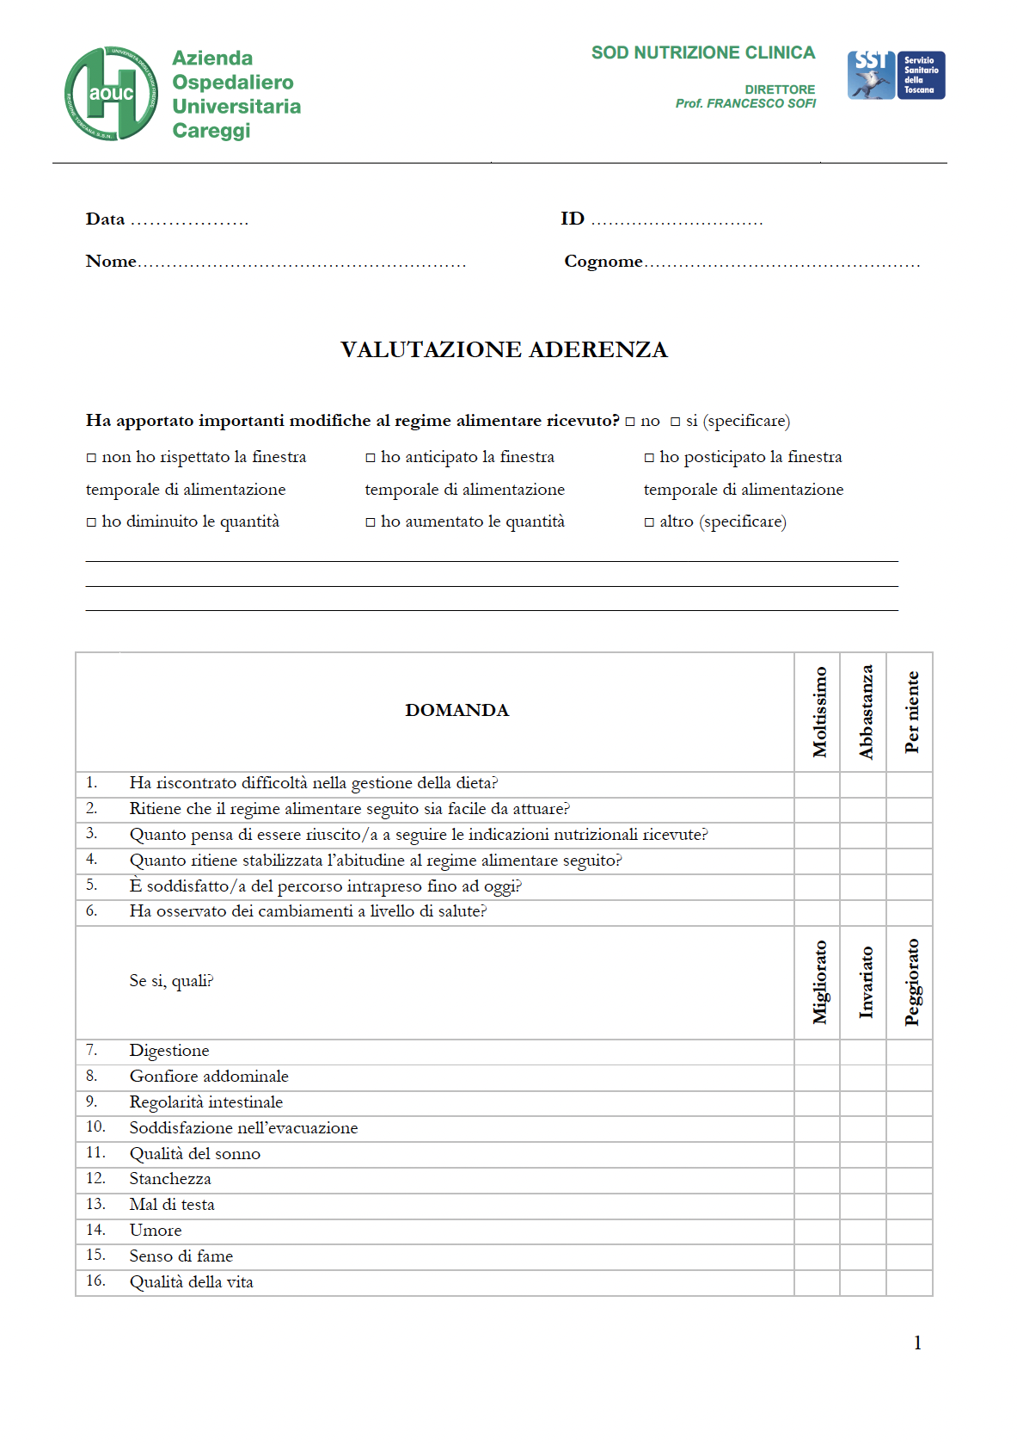

3-DAY FOOD DIARY

(below is a one-day example)
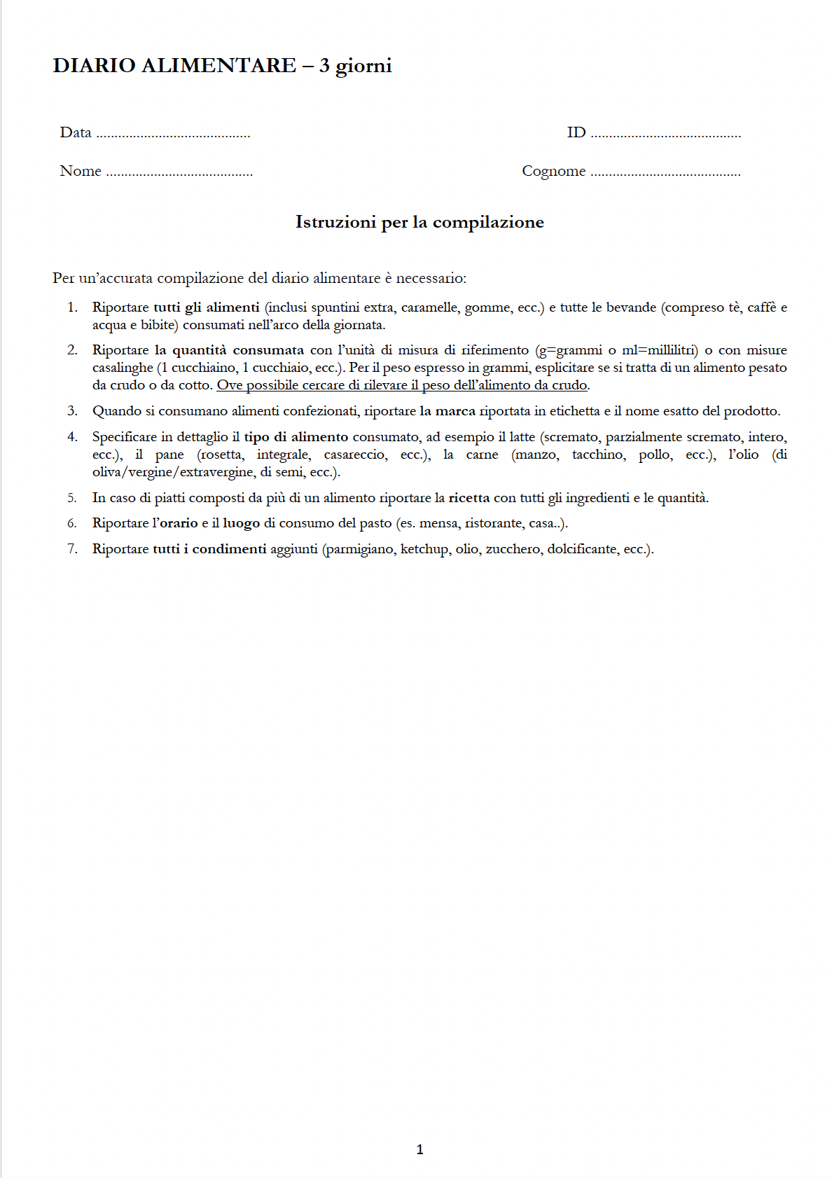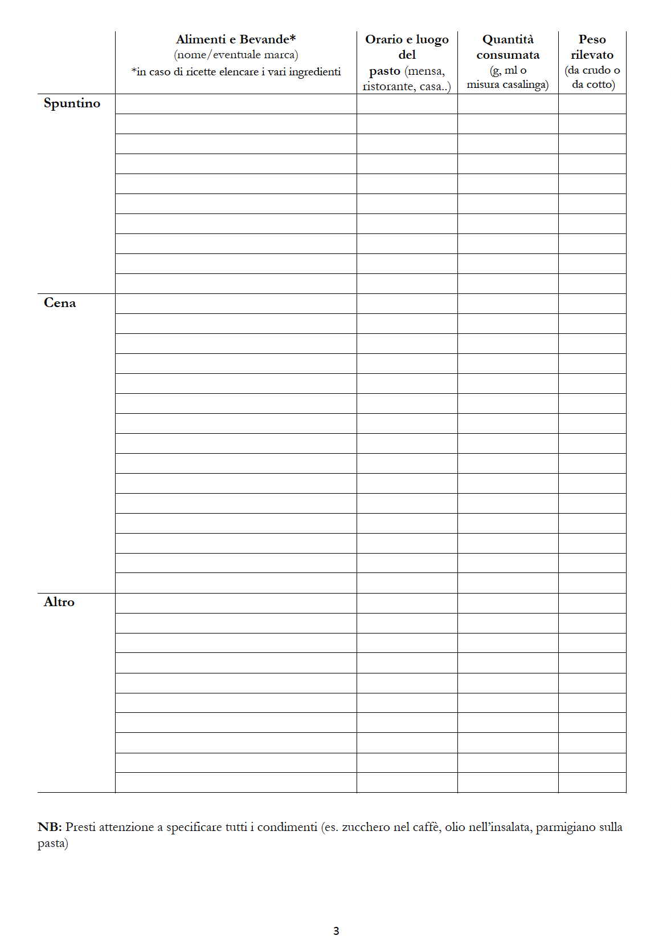

MORNINGNESS-EVENINGNESS QUESTIONNAIRE

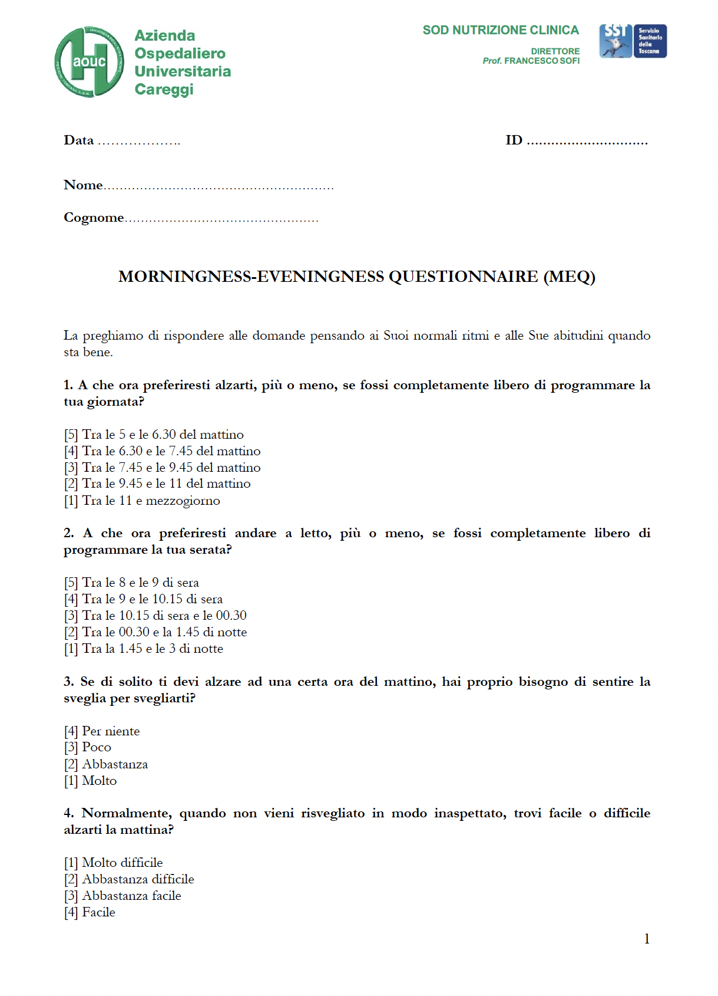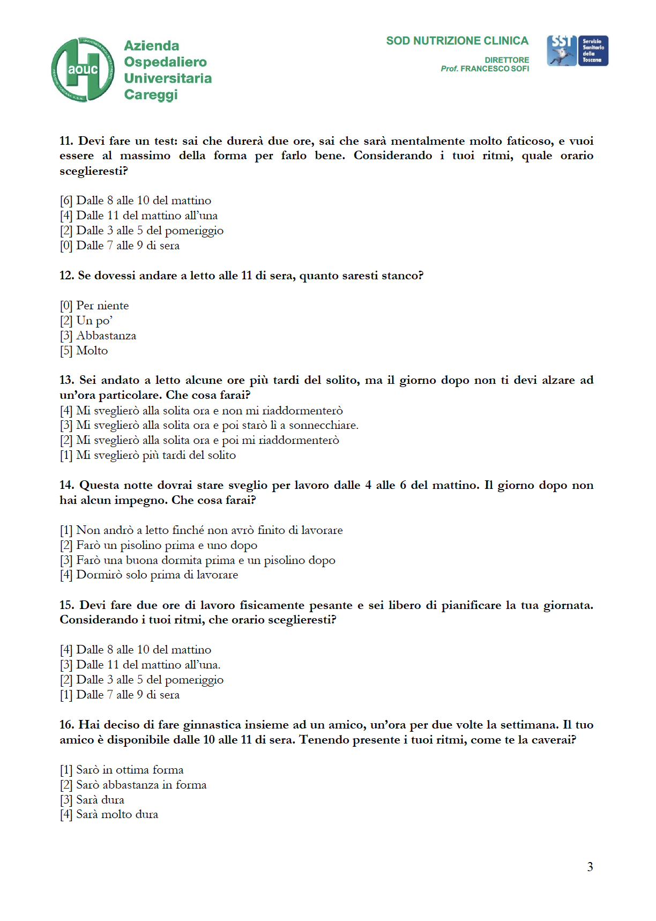

DIETS

1) Morning diet (below is a one-day example of the 1200 kcal diet)

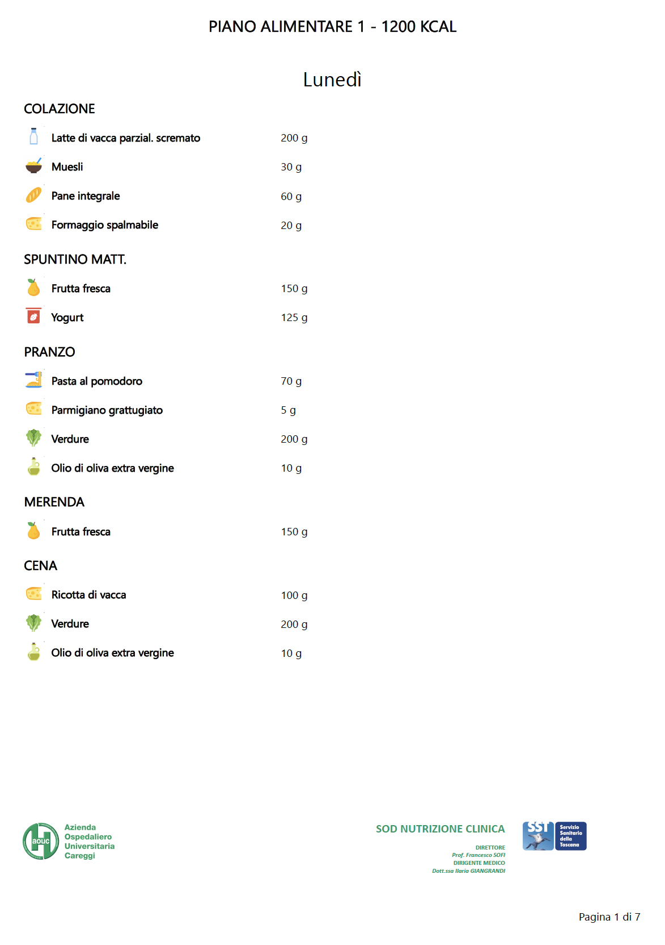

2) Evening diet (below is a one-day example of the 1200 kcal diet)

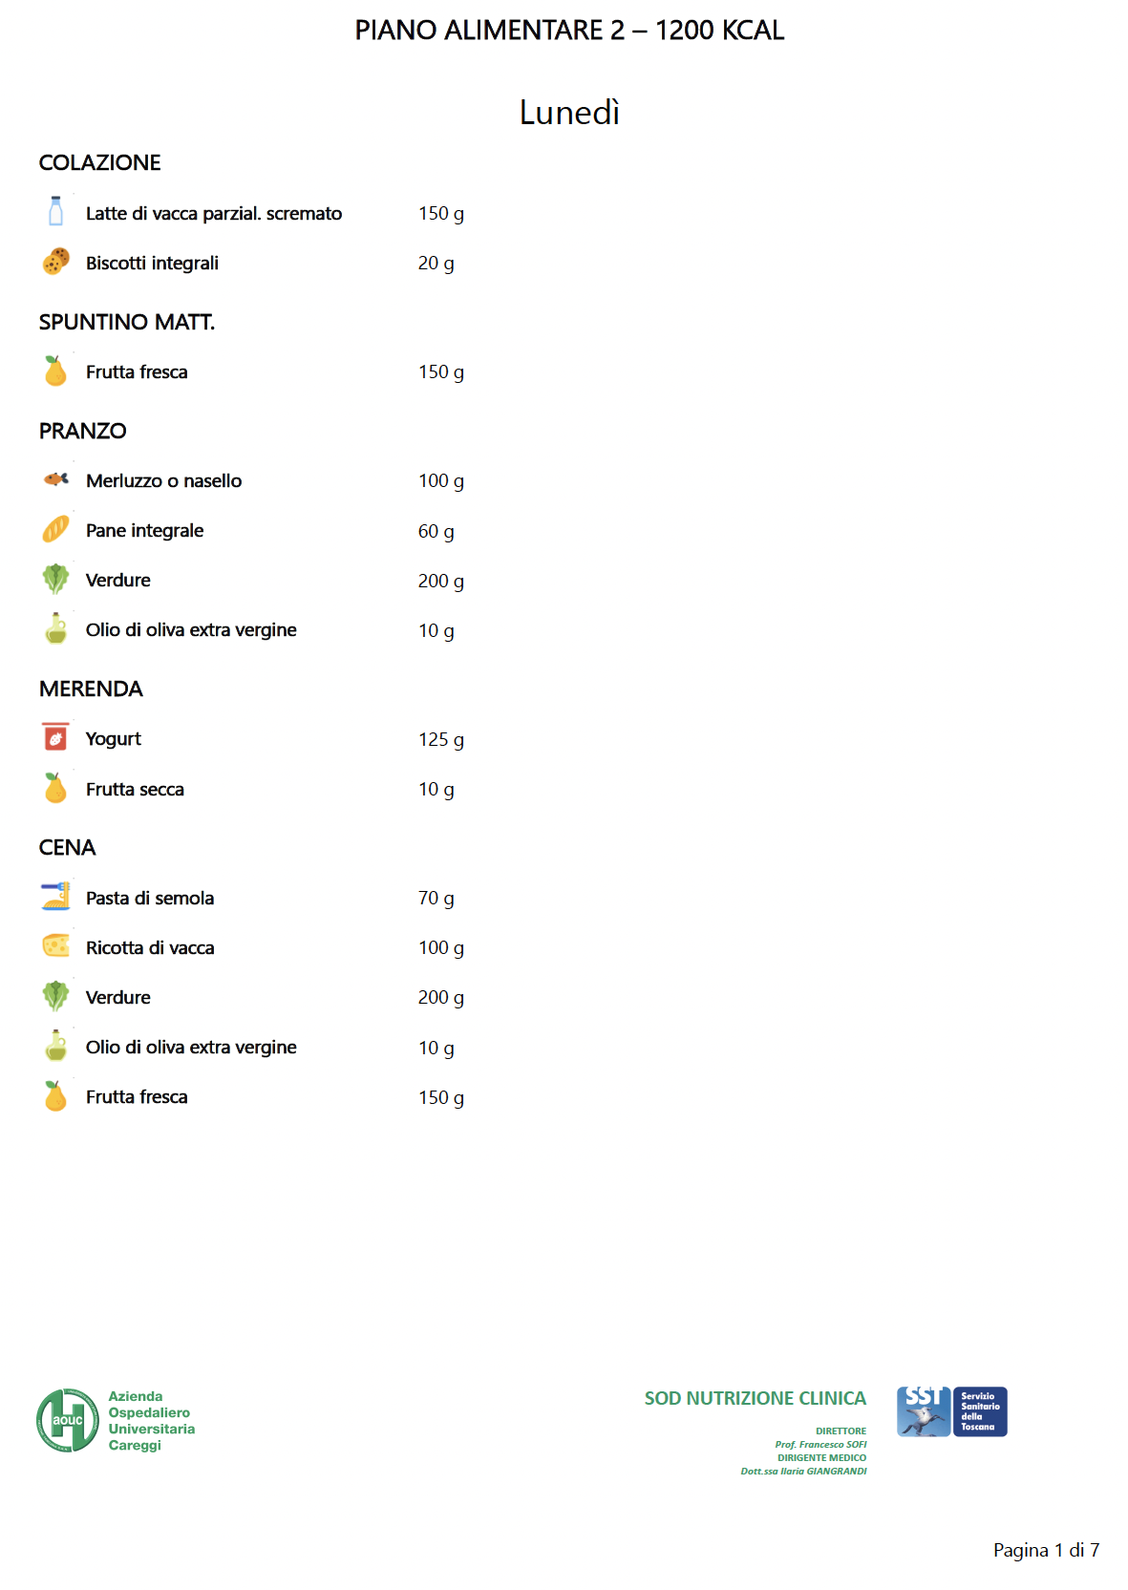

3) Control diet (below is a one-day example of the 1200 kcal diet)

