

Università degli Studi “G. d’Annunzio”

Chieti – Pescara

DOCTORAL SCHOOL

Department of Innovative Technologies in Medicine & Dentistry

Doctoral Program in Innovative Technologies in Medicine & Dentistry 38° cycle

Doctoral Thesis
Inflammatory microbial stress: the associative trigger linking oral and systemic diseases

SSD MEDS-16/A

PhD Candidate: Coordinator:
Francesca Angiolani Chiar.mo Prof. Sergio Caputi

N. Matr: Tutor:
3232295 Chiar.mo Prof. Maurizio Piattelli

ACCADEMIC YEAR 2022/2025

“Abbi fiducia nel cammino che hai scelto:
ogni sforzo, anche il più silenzioso, costruisce ciò che diventerai.
Non smettere di credere nel valore del tuo impegno,
perché è lì che nasce il tuo futuro.
A te stessa, che hai avuto la forza di continuare.”

INDEX
1. INTRODUCTION 4
1.1 Periodontal disease 7
1.1.1 Pathogenesis 8
1.1.2 Risk factors 11
1.1.3 FUSOBACTERIUM NUCLEATUM 14
1.1.3.1 Overview and structural features 14
1.1.3.2 Major Virulence Determinants 17
1.1.3.3 Oral conditions and local pathogenicity 21
1.1.3.4 Systemic involvement and extraoral pathogenicity 22
1.1.4 PREVOTELLA INTERMEDIA 25
1.1.4.1 Overview and structural features 25
1.1.4.2 Virulence Factors of Prevotella intermedia 27
1.1.4.3 Oral conditions 31
1.1.4.4 Sistemic involvement and extraoral pathogenicity 33
1.2 Correlations with systemic conditions 37
1.2.1 Female reproductive disorders 41
1.2.2 ENDOMETRIOSIS 45
1.2.2.1 Prevalence, Pathogenesis, and Classification 45
1.2.2.2 Clinical Subtypes, Diagnosis, and Symptomatology 52
1.2.2.3 Management and Treatment of Endometriosis 59
2. AIM OF THE STUDY 62
3. MATERERIALS AND METHODS 63
3.1 Type of the study 63
3.2 Population and patient selection criteria 63
3.3 Endometriosis classification used in recruiting 64
3.4 Periodontal disease classification used in recruiting 64
3.5 Saliva Sampling 65
3.6 The saliva testing and Real-PCR 65
3.7 Statistical Analysis 66
3.8 Ethics 66
4. RESULTS 71
4.1 Quantitative real-time PCR results of periodontal pathogens in healthy controls and endometriosis patients 71
4.2 Relative distribution of periodontal bacterial complexes 72
5. DISCUSSIONS 74
6. LIMITATIONS 80
7. CONCLUSIONS 81
REFERENCES 82

INTRODUCTION

The human microbiome plays a central role in health and disease. Microbial dysbiosis is increasingly identified as a cause of chronic inflammatory conditions, affecting both local and systemic pathologies. In the field of oral medicine, disturbances to the oral microbiome have been associated with systemic inflammation, suggesting a potential link between periodontal disease and other systemic conditions.
Endometriosis is a chronic, estrogen-dependent inflammatory disorder involving the presence of endometrial-like tissue outside the uterine cavity. It affects approximately 10% of women of reproductive age and is associated with pelvic pain, infertility, fatigue, and reduced quality of life. Its etiology remains incompletely understood, but recent models emphasize the contribution of endocrine disruptors, genetic predisposition, and genital tract dysbiosis.
The systemic nature of the disease is highlighted by its associations with oral health issues, such as periodontal disease and temporomandibular joint dysfunction.
Periodontal disease (PD) is one of the most prevalent chronic inflammatory conditions that compromises the tissues supporting the teeth and represents a significant global health issue. Approximately 10% of adults are affected by severe forms, which are marked by dysbiotic bacterial biofilms and a long-lasting inflammatory response in the host.
It is generally classified into two categories: gingivitis, which is limited to a reversible inflammation of the gingival tissues, and periodontitis, which involves progressive and irreversible damage to the periodontal ligament and alveolar bone. If not properly managed, periodontitis can ultimately result in tooth loss; in addition it has been increasingly linked to systemic health implications, including cardiovascular disorders, metabolic diseases such as diabetes, complications during pregnancy, and various other inflammatory conditions .
Epidemiological evidence suggests that periodontitis may impact female reproductive health highlighting the link between PD and disorders related to infertility, such as PCOS, bacterial vaginosis and endometriosis. In a clinical study, it found that 70% of women with endometriosis had severe periodontitis compared to healthy controls, supporting the idea of shared inflammatory pathways. Furthermore, a recent Mendelian randomized analysis has provided genetic evidence of a causal relationship between periodontitis and peritoneal endometriosis.
Periodontitis is a chronic multifactorial inflammatory disease, which, similarly to endometrios, is associated with chronic low-grade inflammation. Furthermore, inflammatory markers such as C-reactive protein (CRP), interleukin-6 (IL-6), and tumor necrosis factor-α (TNF-α) are elevated in both conditions, which could influence wound healing and tissue regeneration in periodontal therapy.
In addition to immunological factors, mitochondrial dysfunction and environmental stressors are increasingly recognized as contributing to female reproductive disorders.
Palmerini et al. (2021) have shown that altered mitochondrial ultrastructure in oocytes compromises maturation and early embryonic development, while toxic environmental exposures impair granulosa cell function and induce oxidative stress, thereby reducing fertility potential.
Chronic oxidative stress generated within endometriotic lesions can amplify systemic inflammatory responses. Such alterations may indirectly shape the oral microbial ecosystem, influencing the host’s immune reactivity toward periodontal biofilm communities⁷.
Moreover, specific microbial taxa appear to play a fundamental key role in this interplay.
Indeed, Hicks et al. (2025) reported an increase in Fusobacterium Nucleatum in the oral microbiota of women with moderate to severe endometriosis. In parallel, Muraoka et al. (2023) conducted experimental work demonstrating that F. Nucleatum can proliferate in ectopic endometrial tissue. This process involves the induction of fibroblast-to-myofibroblast transition via TGF-β and IL-6 signalling, thereby promoting lesion development.
Together, these observations support the hypothesis that oral pathogens may act as systemic effectors in the pathogenesis of endometriosis.
Several novel therapeutic approaches are currently being explored in experimental models of endometriosis, further broadening the spectrum of potential management strategies.
Taken together, the evidence suggests that endometriosis and periodontal disease share overlapping microbial, inflammatory, oxidative stress, and bioenergetic mechanisms which may intersect with chronic inflammation and microbiome dysregulation in endometriosis and periodontal disease.
Few studies have directly examined the periodontal microbiota in women with endometriosis, and the potential use of salivary biomarkers as early diagnostic indicators remains largely unexplored.
Therefore, the relationship between female reproductive disorders and periodontal disease appears complex and multifactorial. It is crucial for healthcare professionals to understand this bidirectional relationship, as this may support earlier diagnosis and help reduce the risk of systemic conditions resulting from the primary disorder¹⁰. Furthermore, this knowledge provides the basis for integrated care that addresses both oral and reproductive health in women and further research is needed to clarify the underlying mechanisms and develop targeted interventions to improve health outcomes for affected patients.

1.1 Periodontal disease
Periodontal disease comprises a spectrum of inflammatory pathologies that impact the tissues supporting the teeth. Within this category, two distinct entities are typically recognized: gingivitis and periodontitis.
Gingivitis represents a reversible inflammatory condition limited to the gingival tissues without causing attachment loss. Conversely, periodontitis is characterized as a multifactorial inflammatory disease involving irreversible destruction of the tooth-supporting apparatus, including the periodontal ligament and alveolar bone.
The American Academy of Periodontology (AAP) defines chronic periodontitis: “[…] as an inflammatory condition of the gingival tissues that extends to the adjacent tooth-supporting apparatus. This condition is characterized by clinical attachment loss (CAL), measured through probing depth assessment, resulting from the destruction of the periodontal ligament and the adjacent supporting bone”.
Chronic periodontitis exerts a profound psychological influence on the individual's well-being, as it represents the leading cause of tooth loss in the adult population of industrialized nations. This condition can compromise mastication, speech, and esthetic appearance, resulting in significant psychological distress and social impairment.
The prevalence of periodontal disease varies based on ethnicity, geographic region, and age distribution. In the pediatric population, prevalence rates remain below 1%, while adult populations demonstrate prevalence rates approaching 30%. Studies from the National Health and Nutrition Examination Survey (NHANES) report that 42% of the adult population exhibits periodontitis, with prevalence increasing to approximately 68% in adults aged 65 years or older²¹.
Chronic periodontitis develops gradually over time, commencing with gingivitis and progressing to advanced periodontal destruction, typically manifesting from the third to fourth decade of life onward. Research demonstrates that periodontitis constitutes a leading cause of tooth loss, with withdrawal from social activities reported due to aesthetic concerns and functional limitations related to mastication and phonation. Furthermore, untreated periodontitis results in alveolar bone resorption, progressive loss of the periodontal ligament, and formation of periodontal pockets, ultimately compromising overall quality of life²⁰²¹.

1.1.1 Pathogenesis
Periodontitis develops through the action of specific pathogenic bacteria that evoke an amplified inflammatory reaction localized to gingival tissues. These bacteria appear to be acquired at early stages of life: as supported by literature, there is a vertical transmission from parents to offspring or horizontal transmission between intimate partners. The etiological factor underlying periodontal disease is consequently the accumulation of specific bacterial taxa that collectively constitute bacterial dental plaque. According to the definition established by Wilderer and Charaklis in 1989, dental plaque is characterized as “a biofilm constituting of bacterial material adhered to tooth surfaces or to any other hard non-shedding substrate”.
The accumulation of this microbial deposit between the tooth surface and gingival tissues precipitates a significant local inflammatory response mediated by the associated gingival tissues.¹⁹⁹; clinically, gingival tissue exhibits heterogeneous inflammatory changes, frequently characterized by variable degrees of tissue atrophy or, alternatively, fibrotic hypertrophy, edematous swelling, erythema, bleeding upon probing, and in severe cases, purulent discharge.
The initiation of an inflammatory response fulfills a dual function: on one hand, it provides a protective mechanism against bacterial invasion and preserves host defense mechanisms; on the other hand, when the inflammatory reaction becomes exaggerated, persistent, and insufficiently regulated, it precipitates irreversible destruction of the periodontal apparatus. The dysregulation of the inflammatory cascade, characterized by excessive production of pro-inflammatory mediators, overwhelms the host's capacity for tissue remodeling and repair, thereby driving progressive periodontal tissue destruction. (Figure 1)
The tendency of inflamed regions to undergo irreversible structural tissue destruction exhibits pathogen specificity, as not all lesions initiated by gingivitis progress to periodontitis. According to the specific plaque hypothesis formulated by Loesche et al (1979), a higher risk of tissue destruction was identified at sites colonized by periodontal pathogens in comparison to other microbial species.
The bacterial pathogens most frequently isolated from active periodontal sites include three aerobic species: Actinobacillus actinomycetemcomitans, Campylobacter rectus, and Eikenella corrodens. Additionally, seven anaerobic species have been consistently identified: Porphyromonas gingivalis, Bacteroides forsythus, Treponema denticola, Prevotella intermedia, Fusobacterium nucleatum, Eubacterium species, and oral spirochetes. These organisms demonstrate enhanced pathogenic potential through the production of virulence factors including lipopolysaccharides (LPS), proteolytic enzymes, and immunomodulatory toxins that directly compromise host tissue integrity.
As in many opportunistic infections, the presence of bacteria alone does not explain the development of periodontitis, but periodontitis does not develop in their absence. In other words, the infectious agent is necessary but not sufficient to understand the development of the disease.
Therefore, bacteria represent the primum movens of periodontal damage, while the pathogenesis of the disease depends primarily on at least two-thirds of the damage resulting from the host's inflammatory response.
Specifically, bacterial factors consist of products of bacterial metabolism, such as sulfur dioxide or enzymes like bacterial collagenase or lipopolysaccharide (LPS), which exert direct toxic effects on attachment apparatus cells and alveolar bone cells. Conversely, damaging factors derived from the host principally originate from the activation of both specific and innate immunity triggered by bacterial factors.
Periodontitis is a disease in which the immune system plays a significant role in determining tissue lesions; it is an “immune-mediated disease”. The host immune response, when dysregulated or exaggerated in response to the microbial challenge, mediates progressive destruction of the periodontal apparatus rather than achieving microbial clearance.
Bacterial plaque activates cell-mediated immunity, an event that produces a deleterious biological consequence, as lymphocyte activation determines the production and massive release of lymphokines, including cytokines and interleukins such as IL-1, IL-6, IL-8, TNF-alpha, and PGE2 released by the immune system which subsequently activate osteoclasts and determine osteolysis.
Conversely, in innate immunity, the immune system is activated in a non-specific manner and targets polymorphonuclear leukocytes (PMN), which function to phagocytose bacterial factors or bacteria themselves. However, during exocytosis, the final phase of phagocytosis, they release into the extracellular environment the remnants of their ingested material, including active lysosomal enzymes that damage surrounding periodontal structures.
Thus, the pathogenesis of periodontitis can be attributed to individual susceptibility determined by genetic background and lifestyle factors that permit bacteria to express their pathogenic potential. The disease develops through a complex interplay of environmental dysbiosis, inherited genetic risk factors, acquired epigenetic modifications, and lifestyle elements such as smoking and dietary habits.
In this regard, the host must be susceptible at both the local and systemic level; the local environment must permit bacterial virulence factors to be expressed and must contain bacterial species that augment infection or that are unable to inhibit the pathogenic activity of the periodonto-pathogen; finally, the pathogen must be present in sufficient quantities to trigger disease progression and activate the immune system.
When Löe, Theilade, and Jensen demonstrated that plaque correlates with gingivitis, they also made an important observation regarding individual susceptibility, as evidenced by the variable time intervals in which periodontal disease manifested among the 10 dental students studied. These subjects, who abstained from oral hygiene measures for several days, developed experimental gingivitis at different time points, and when they subsequently resumed standard oral hygiene practices, periodontal health was restored within 7-10 days.
This individual susceptibility defines the population subset at high risk for developing periodontitis. Periodontitis develops in severe form in genetically predisposed individuals. Genetic factors are now recognized to account for approximately 50% of the variance in periodontitis risk in populations. Polymorphisms in genes encoding inflammatory mediators such as interleukins (IL-1A, IL-1B, IL-6, IL-10) and matrix metalloproteinases (MMP-2, MMP-3, MMP-8, MMP-9) are associated with increased susceptibility to periodontal disease. It is believed that genetic susceptibility is due to variations in the subject's genes that lead to reduced efficiency of the immune system and an alteration of the inflammatory response balance, responsible for increased destructive effects of inflammation. Recent studies indicate that the polymorphism of the gene encoding interleukin-1 is associated with the severity of periodontitis. These polymorphisms are variations in the DNA sequence of genes encoding IL-1 and IL-1 beta. Further research is nevertheless necessary to verify the genetic contribution responsible for the initiation and progression of periodontitis.

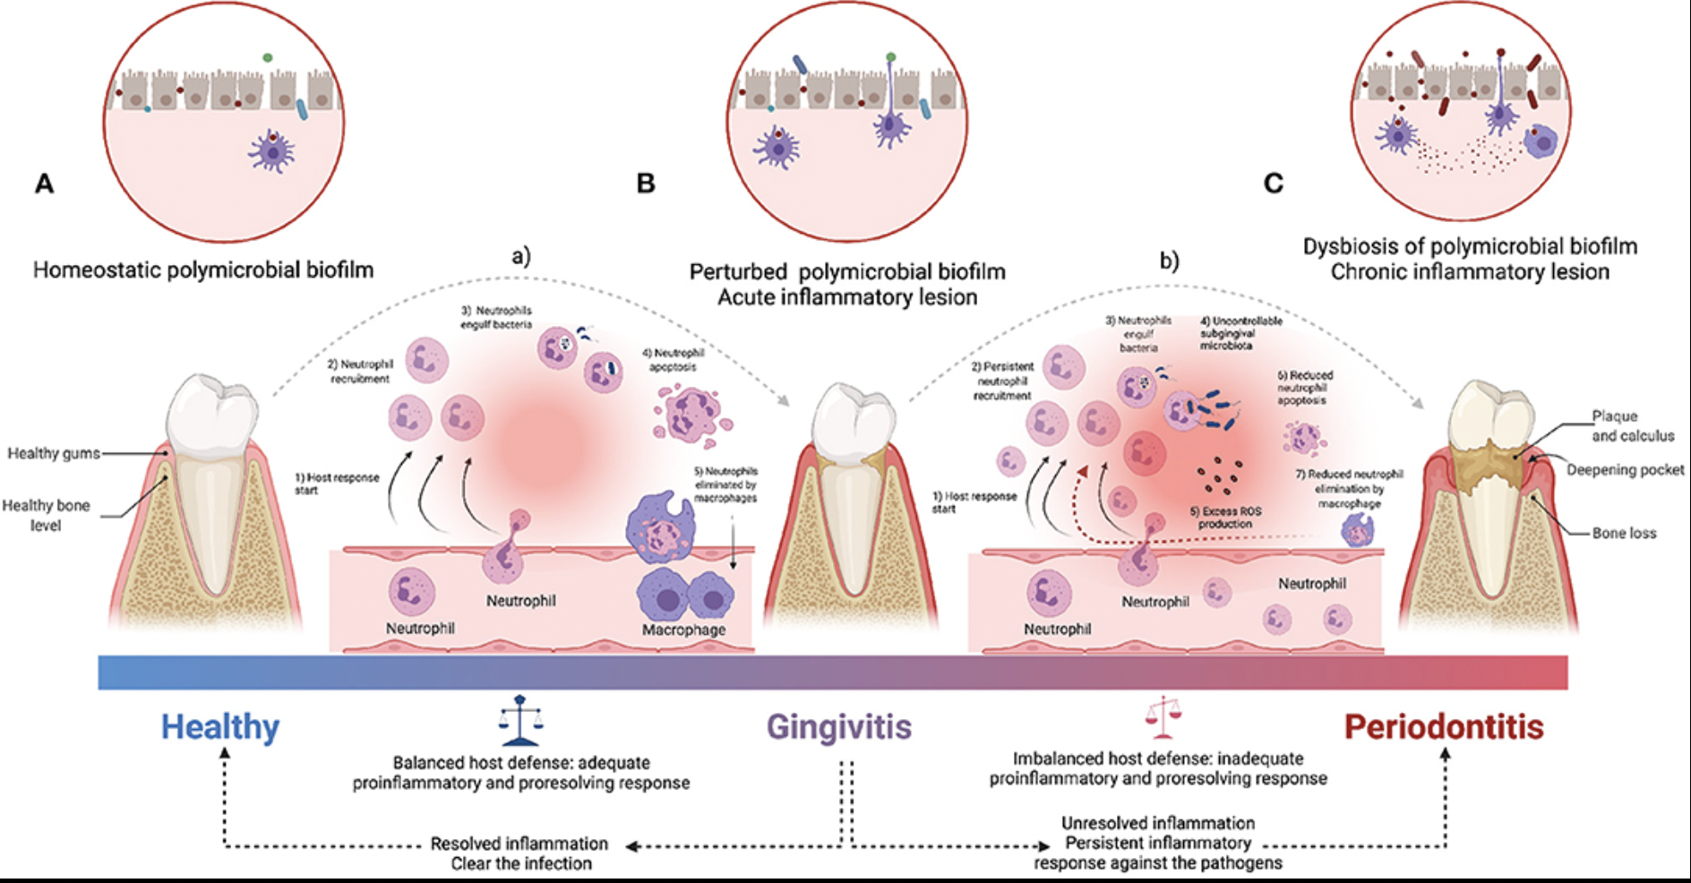

Figure 1. Schematic representation of periodontal disease progression associated with biofilm dysbiosis and impaired immune regulation.

1.1.2 Risk factors
The phenotype, defined as the clinical manifestation of pathologies, is the result of environmental factors, genotype, and the interaction between genotype and environment. Environmental factors encompass nutrition, respiratory exposure, dietary intake, and lifestyle habits including alcohol consumption, smoking, and oral hygiene practices. The genotype encompasses the presence of genes and interactions among multiple genes. Gene-environmental interactions describe how the environment interacts with genotype. To achieve the final clinical outcome and disease manifestation, all three components must be present and verified. Merely possessing a specific gene linked to disease predisposition is insufficient; rather, multiple genes must collaborate to produce the final phenotypic result. Furthermore, having solely a determined genetic profile is inadequate because interactions of these genes with environmental factors must be considered. Therefore, the underlying concept is expressed through epigenetics, the branch of genetics that addresses reversible heritable changes in the phenotype of a cell or organism without alterations in the DNA sequence itself. Epigenetics operates on the principle that our parents bequeath to us not only DNA sequences but also the molecular structure of these sequences. DNA methylation and histone acetylation of proteins bound to DNA modify the molecular conformation, which can be either linear or compacted; when compacted, RNA cannot replicate that segment and consequently the gene cannot be expressed. The key factor is that gene expression depends on proteins; if these proteins bind to specific genetic loci and inactivate them, those genes remain unexpressed. Therefore, possessing a correct or incorrect gene is less important than ensuring that the predisposing gene remains inactivated. Genes exhibit low penetrance and are influenced by environmental factors; this means that every individual, regardless of inherited genotype, can through daily lifestyle choices influence and modify what their parents inscribed in their genome—thus, “we are not predetermined” to develop a specific pathology. Each individual can control environmental factors to prevent expression and activate inactivating mechanisms for disease-predisposing genes. Consequently, modifiable lifestyle factors, particularly smoking and home oral hygiene practices, prove essential for both prevention and prognosis of periodontal disease.
Regarding modifiable risk factors, a distinction can be made between systemic and local risk factors. Among systemic factors are identified systemic diseases, smoking, stress, medications, socioeconomic status, environment, and nutrition; whereas the principal local risk factors are the reduction or alteration of salivary composition, mouth breathing, exogenous mechanical, chemical, and thermal stimuli, occlusal trauma, and parafunctional habits.
Tobacco smoking and stress are two systemic risk factors of particular relevance in industrialized societies. Smoking is one of the principal risk factors for periodontitis, as the pathological mechanism reported includes an alteration of the vascular tissue of the periodontium, direct effects on bacterial microflora, inhibitory effects on immunoglobulin levels and antibody response to bacterial plaque; alteration of fibroblast proliferation and adhesion, alteration of chemotaxis and phagocytosis, and abnormal release of proteases from neutrophil cells, which become involved in bone resorption. Not only does smoking increase the risk that disease develops, but the response to periodontal therapy is also altered in smokers. Smokers demonstrate increased subgingival bacterial diversity with pathogen-enriched communities characterized by higher proportions of red- and orange-complex bacteria, as well as lower levels of key protective bacterial species. Additionally, smoking induces an imbalance in the immune response, characterized by elevated levels of pro-inflammatory cytokines including interleukin-8, interleukin-17, and abnormal neutrophil enzyme activity, which amplifies tissue destruction. Furthermore, the signs and symptoms of the disease, such as gingival redness and bleeding, are masked by the attenuation of inflammation induced by smoking. Stress is also considered today an important risk factor, and some researchers have demonstrated that the alteration of the inflammatory response in periodontal disease is caused by psychological factors such as stress, anxiety, and depression. The correlation between altered psychological states and the appearance of periodontitis is underscored by the fact that, in situations of hyperactivation of the adaptive system, high concentrations of adrenocorticotropic hormone (ACTH) are released from the hypothalamus, and glucocorticoids are released from the adrenal cortex. Particularly, the latter exhibit an important immunosuppressive role as they determine the reduction in the number of lymphocytes, monocytes, and eosinophils, and result in the inhibition of macrophage and neutrophil migration Corticosteroids furthermore cause an alteration of the complex system of cytokine production, of IL-12, and modify the balance between IL-10 and TNF, and act on other inflammatory mechanisms including NK cell activity, phagocytosis, and cytotoxic activity of T cells. Elevated salivary cortisol suppresses both innate and adaptive immune mechanisms through inhibition of secretory immunoglobulin production and impairment of neutrophil-mediated bactericidal activity, critical host defenses against periodontal pathogens. This immunological compromise permits the establishment and persistence of dysbiotic bacterial biofilms characterized by enhanced expression of virulence-associated genes and epithelial tissue invasion capabilities¹⁰ . The relationship between psychological stress and periodontal dysbiosis operates through bidirectional signaling: stress-induced elevation of cortisol simultaneously drives microbial community dysbiosis while suppressing host immune defenses, whereas the dysbiotic microbiota maintains chronic low-grade inflammatory states via continuous production of lipopolysaccharides (LPS) and pathogen-associated molecular patterns (PAMPs). This self-perpetuating cycle activates pro-inflammatory macrophage populations (M1 phenotype), upregulates matrix-degrading enzymes (MMP-8, MMP-9), and increases RANKL expression, all critical mediators of alveolar bone resorption. Furthermore, cortisol directly disrupts the osteoprotegerin (OPG)/RANKL ratio within periodontal tissues, accelerating bone loss through suppression of osteoblastic differentiation and reduced local OPG production. Based on these scientific findings, it is essential for the dentist to elucidate to patients with specific risk factors the benefits derived from the discontinuation of such habits. The general health status of the individual is an aspect that contributes to the development of periodontal disease. Many systemic conditions are associated with or predispose to attachment loss. Severe periodontitis has been documented in patients affected by agranulocytosis, cyclic neutropenia, Chediak-Higashi syndrome, diabetes mellitus, Down syndrome, and Papillon-Lefèvre syndrome, which have neutrophil functional deficits as secondary effects and are therefore frequently associated with periodontitis. According to the American Academy of Periodontology in 1999, patients with HIV infection can develop necrotizing ulcerative periodontitis, in which destruction of the periodontium occurs with bleeding, tissue necrosis, and pain. The picture that emerges is that of a disease of significant social relevance, characterized by an infection that causes a chronic inflammatory response.

1.1.3 FUSOBACTERIUM NUCLEATUM

1.1.3.1 Overview and structural features
Fusobacterium nucleatum is a prevalent opportunistic bacterium in the oral cavity that can participate in a wide spectrum of local and systemic infections. Recent investigations have demonstrated that this species tends to accumulate within periodontal lesions, sites of halitosis, infected dental pulp, oral malignancies, and multiple extra-oral disease foci, including reproductive.
The genus Fusobacterium comprises Gram-negative, obligately anaerobic bacteria with a fusiform morphology and a marked ability to colonize mucosal surfaces of the oral cavity and other body sites. Fusobacterium nucleatum is the reference species of the genus and is frequently involved in periodontal and endodontic infections as well as in various extra-oral diseases. (Figure 2)
From a morphological standpoint, F. nucleatum appears as a very thin, elongated bacillus with tapered ends, giving it a characteristic spindle-like shape, and it stains Gram-negative and non-spore-forming with the Gram stain. The cells can arrange in chains or in “head-to-tail” configurations, forming filaments that contribute to the structural organization of the oral biofilm.
Under transmission electron microscopy, the cell shows a typical Gram-negative envelope with an outer membrane rich in lipopolysaccharides, a thin peptidoglycan layer, and a defined periplasmic space surrounding the cytoplasmic membrane. In histological sections of infected tissues, F. nucleatum often appears as compact aggregates of fusiform bacilli that can assume a “nucleus-like” appearance, which inspired the epithet “nucleatum”. Members of the genus Fusobacterium are typically Gram-negative, slender, pointed bacilli that often appear in pairs aligned end-to-end. On blood agar they form very small, punctate colonies, and in some species, including F. nucleatum, characteristic “fried-egg” colonies become evident after 3–5 days of incubation; certain strains can also display hemolytic activity. Overall, Fusobacterium spp. exhibit considerable variability in Gram-staining behavior and cell morphology, ranging from coccoid or pleomorphic forms to rod-shaped cells with rounded or tapered ends, frequently arranged in an end-to-end fashion⁶⁹. Fusobacterium nucleatum grows best on enriched media, for example those supplemented with trypticase, peptone or yeast extract. It relies mainly on amino acids and short peptides as energy substrates, showing a marked preference for glutamate, histidine and aspartate, and generally favors peptides over free amino acids. During fermentation, F. nucleatum catabolizes glutamate and lysine, generating end products such as acetate and butyrate that are central to its energy metabolism⁶⁸.
Traditionally, F. nucleatum has been divided into five subspecies based on phenotypic characteristics (biochemical profiles, serotypes, colony morphology) and DNA–DNA hybridization patterns: F.nucleatum subsp. nucleatum, subsp. polymorphum, subsp. fusiforme, subsp. vincentii, and subsp. animalis. The subsp. Nucleatum represents the “classic” oral group, frequently isolated from subgingival plaque and periodontal lesions; polymorphum is characterized by high phenotypic variability and more heterogeneous colonies; fusiforme and vincentii display distinct but closely related biochemical profiles; animalis is more often recovered from animal hosts, although it can also be found in humans⁶⁸.
Comparative genomic studies using metrics such as average nucleotide identity and digital DNA–DNA hybridization have suggested that the four main subspecies (nucleatum, polymorphum, vincentii, animalis, often with fusiforme grouped with vincentii) meet the thresholds to be regarded as separate species rather than mere subspecies.
A recent review summarized this taxonomic evolution and proposed the elevation of F. animalis, F. vincentii (alongside F. nucleatum), and F. polymorphum to full species status, while emphasizing that this framework has not yet been universally adopted in clinical practice.
More recent phylogenetic analyses based on 16S rRNA, rpoB, zinc-protease genes and multiple housekeeping genes have suggested merging F. nucleatum subsp. fusiforme and subsp. vincentii into a single subspecies, fusiforme/vincentii, because of their tight genetic relatedness. On the same phylogenetic basis, some authors have proposed reclassifying the traditional subspecies into four distinct Fusobacterium species; however, this revised taxonomy has not yet gained universal acceptance, and in clinical and laboratory practice the classical subspecies division is still widely used⁷⁴.
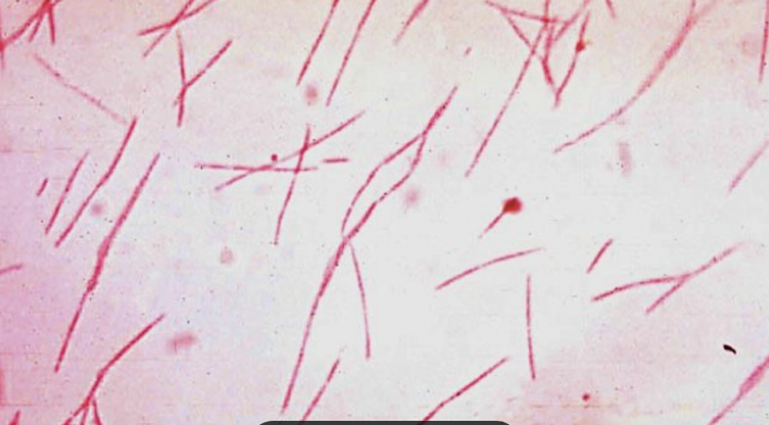
Figure 2. Microscopic appearance of Fusobacterium nucleatum.
Representative image showing the characteristic spindle-shaped (fusiform) morphology of Fusobacterium nucleatum, a Gram-negative anaerobic bacterium involved in periodontal biofilm formation and inflammation.

1.1.3.2 Major Virulence Determinants
F. nucleatum operates as a key connector that integrates both commensalic and pathogenic microbial populations that colonize tooth surfaces and epithelial compartments, thereby mediating mutual interactions among anaerobic and facultative anaerobic bacterial taxa. This linking capacity constitutes a vital component in the development of progressive periodontal pathology and proves indispensable for both the establishment and advancement of the organized supragingival and subgingival biofilm architecture. The outer membrane architecture of F. nucleatum comprises the following principal virulence factors⁷⁴:
-FadA adhesin, a filamentous protein functioning as both an adhesion molecule and invasive agent;
-Fap2, a lectin-like autotransporter adhesin with immunosuppressive properties;
-RadD, a co-aggregation mediator facilitating biofilm assembly;
-Type 5 secreted autotransporters (T5SS), including large adhesins and membrane-associated proteases;
-Outer membrane proteins (FomA, Aid1, CmpA),promoting inter-bacterial interactions;
-Lipopolysaccharides (LPS), potent inflammatory triggers;
-Serine proteases, tissue-degrading enzymes;
-Metabolic byproducts, including butyric acid, hydrogen sulfide, and methylmercaptan
-Outer membrane vesicles (OMVs), vehicles for virulence factor delivery and immunomodulation;
FadA Adhesin and Cellular Invasion
The FadA adhesin represents the primary virulence determinant in F. nucleatum, functioning in dual capacity as both an adhesion molecule and an invasive agent facilitating host cell penetration. FadA engages with E-cadherin displayed on epithelial cell surfaces, enabling bacterial invasion while simultaneously disrupting cell-to-cell adhesion and intercellular signaling pathways, thereby permitting the ingress of supplementary pathogens into gingival connective tissues. Once internalized, F. nucleatum engages the retinoic acid-inducible gene I (RIG-I) receptor via FadA, activating the nuclear factor kappa-B (NF-κB) signaling cascade and triggering an inflammatory response that results in collateral tissue injury. Additionally, F. nucleatum generates amyloid structures derived from FadA during pathologic or stress-induced conditions, which enhance biofilm assembly, augment acid resistance, and promote bacterial adhesion to host surfaces. Notably, amyloid FadA has demonstrated capacity to induce bone loss within periodontal tissues in animal models.
Fap2 Lectin-Like Adhesin and Immune Evasion
The Fap2 lectin-like adhesin binds with specificity to galactose and immunologic receptors (such as TIGIT) on host cell membranes, mediating bacterial binding to tumoral cells while simultaneously inhibiting the cytotoxic responses of T lymphocytes and natural killer cells⁷⁷.
RadD and Biofilm Co-Aggregation
RadD protein facilitates the co-aggregation of F. nucleatum with additional plaque-inhabiting microorganisms, promoting inter-bacterial bridging with known periodontal pathogens and enabling the assembly of increasingly sophisticated and resistant polymicrobial biofilm configurations.
Lipopolysaccharides and Inflammatory Cascade
The outer membrane lipopolysaccharides and accessory wall components generate a potent pro-inflammatory response through engagement with TLR2 and TLR4 on gingival epithelial cells and fibroblasts. Upon bacterial cell death, released LPS molecules are recognized by these receptors, triggering activation of the NLRP3 inflammasome complex, which orchestrates the production of interleukin-1 β (IL-1 β) and amplifies the inflammatory cascade within periodontal tissues, driving alveolar bone resorption. The coordinated production of TNF-α, IL-6, and IL-8 collectively drives periodontal tissue destruction⁶⁹ ⁷⁷.
Serine Proteases and Tissue Degradation
The 61–65 kilodalton serine endopeptidase, designated fusolisin, that is secreted by F. nucleatum possesses enzymatic capacity to dismantle host tissue architecture and extracellular matrix scaffolding. This proteolytic enzyme liberates nutrient substrates that are indispensable for bacterial anabolism and growth metabolism. Concomitantly, fusolisin catalyzes the proteolytic cleavage of the alpha chain of immunoglobulin A (IgA), thereby undermining the protective mucosal immune barrier and facilitating pathogenic evasion of host defenses. The protease additionally hydrolyzes additional structural proteins of the extracellular matrix, including collagen and fibronectin, resulting in the degradation of periodontal supporting tissues and suppression of innate immune effector molecules. Furthermore, F. nucleatum-derived proteolytic activity operates in concert with host-derived metalloproteinases (MMPs) to amplify the magnitude of pericellular connective tissue destruction during periodontal disease progression.
Butyric Acid and Metabolic Pathways
Butyric acid, a predominant end-product of bacterial fermentation pathways in F. nucleatum, exerts dual effects on the integrity and restoration of periodontal connective tissues through distinct biological mechanisms. High concentrations of butyrate stimulate the formation of oxidative stress markers and reactive oxygen species (ROS) within bone-forming osteoblastic populations. This ROS generation subsequently promotes the biosynthesis and discharge of eicosanoid signaling molecules (8-isoprostaglandin F2α) and matrix-degrading zinc-dependent enzymes, specifically matrix metalloproteinase-2 (MMP-2). These molecular mediators collectively orchestrate the destruction of alveolar bone architecture and compromise the capacity for tissue healing and regeneration. Supplementary volatile fermentation byproducts including hydrogen sulfide and volatile thiols such as methylmercaptan suppress both the proliferative activity of fibroblast populations and the functionality of local immune cell compartments. Through these mechanisms, F. nucleatum metabolites establish a pathogenic microenvironment that permits sustained bacterial colonization, and within malignant tissue compartments, facilitates neoplastic progression and tumor aggression.
Epithelial-Mesenchymal Transition (EMT)
Fusobacterium nucleatum and allied Gram-negative periodontal organisms induce epithelial-mesenchymal transition (EMT) within gingival epithelial cells, upregulating Snail-1 expression while suppressing E-cadherin synthesis and disrupting epithelial cell adhesion. As the gingival epithelium loses structural cohesion, invading pathogens readily penetrate more deeply into subjacent tissues, exacerbating tissue destruction and disease progression⁷⁷⁷⁸.
Neutrophil Suppression and Immune Evasion
The subspecies F. nucleatum subsp. nucleatum and F. nucleatum subsp. polymorphum demonstrate the capacity to inhibit the generation of reactive oxygen species (ROS) including superoxide anions from neutrophils. This suppression mechanism prevents the oxidative killing pathways that normally inactivate invading pathogens. The bacterium triggers both necrotic and apoptotic cell death pathways in neutrophils simultaneously. This dual-pathway induced death effectively diminishes the presence of functional neutrophils at bacterial inoculation sites. By impairing neutrophil antimicrobial capacity during early periodontal disease pathogenesis, F. nucleatum enables the progressive accumulation of secondary anaerobic pathogens, notably Porphyromonas gingivalis, within disease-affected tissue compartments. This microbial succession cascade thereby accelerates the temporal progression of periodontal pathology.
Macrophage Infiltration and Osteoclast Activation
F. nucleatum stimulates the biosynthesis and secretion of interleukin-1 β, interleukin-6, tumor necrosis factor-α, and the high-mobility-group box 1 protein (HMGB1) whilst concurrently promoting the recruitment and accumulation of mononuclear phagocytes within inflamed gingival tissues. This coordinated immune activation drives rapid inflammatory responses within the periodontium. The bacterial pathogenic process further facilitates the mobilization and maturation of multinucleated bone-resorbing osteoclasts. The differentiation of these osteoclasts is amplified through IL-1 β and TNF-α-dependent signaling mechanisms. The intensified generation of pro-inflammatory mediators orchestrated through F. nucleatum exposure demonstrates a direct causal association with osteoclast maturation. This process results in the destruction of alveolar bone tissue.
Impairment of Tissue Repair Processes
Furthermore, F. nucleatum impairs tissue restoration processes by activating the protein kinase B (Akt) and NF-κB signaling cascades, leading to enhanced fibroblast apoptosis, elevated ROS biosynthesis, and secretion of pro-inflammatory mediators, all of which collectively compromise tissue repair capacity and perpetuate inflammation.
Outer Membrane Vesicles and Inter-Cellular Communication
Like other Gram-negative organisms, F. nucleatum can release extracellular or outer membrane vesicles (OMVs) containing multiple bioactive molecules that participate in inter-bacterial communication and inter-species interactions with host cellular compartments. These vesicles function as important mediators of virulence factor delivery and immunomodulation.

1.1.3.3 Oral conditions and local pathogenicity
Fusobacterium nucleatum, a Gram-negative obligate anaerobe inhabiting the human oral cavity, represents both a commensal organism and a pathogenic agent depending on environmental and host factors. This bacterium functions as a linchpin within oral polymicrobial communities, facilitating direct interactions among diverse microbial taxa that colonize dental structures and epithelial tissues. The capacity of F. nucleatum to transition from a benign colonizer to an aggressive pathogen underscores its clinical significance in various oral disease processes. While F. nucleatum is classically recognized as a periodontal pathogen that actively participates in the destruction and inflammatory remodeling of the tooth-supporting apparatus and periodontal tissues, its pathogenic repertoire extends beyond the parodontium to encompass additional oral microenvironments. The organism is implicated in the etiopathogenesis of oral malodor through volatile metabolite generation. Additionally, F. nucleatum participates significantly in endodontic infections affecting the dental pulp and periapical tissues. These diverse pathogenic mechanisms collectively demonstrate that F. nucleatum represents a versatile and clinically consequential member of the oral bacterial microbiota.
Halitosis and Volatile Sulfur Compound Production
F. nucleatum plays a primary etiological role in the development of oral malodor (halitosis), particularly through its capacity to generate volatile sulfur-containing compounds. This bacterium exhibits preferential colonization of the dorsal and posterior regions of the tongue, where anaerobic microenvironments favor its proliferation and metabolic activity. The volatile sulfur compounds synthesized by F. nucleatum, particularly hydrogen sulfide and thiomethane derivatives, represent the predominant intraoral sources of foul-smelling breath. In comparative in vitro investigations, F. nucleatum demonstrated capacity to generate approximately 450 parts per billion of volatile sulfur compounds within 6 hours of anaerobic cultivation. When cultivated in polymicrobial assemblages with other periodontal pathogens such as Porphyromonas gingivalis and Prevotella intermedia, F. nucleatum exhibits synergistic enhancement of volatile sulfur compound biosynthesis. Maximal volatile compound values are achieved within 30 minutes of co-culture. The production of these odoriferous metabolites is inextricably linked to the bacterium's proteolytic and fermentative metabolic pathways.
Endodontic Involvement and Pulp Infection
F. nucleatum is frequently recovered from infected endodontic tissues, including scenarios involving pulpal necrosis and apical inflammatory lesions. The bacterium's ability to penetrate traumatically damaged or caries-compromised pulp tissue permits establishment of infection within the protected root canal system. Once established within the dental pulp, F. nucleatum activates toll-like receptors (TLR2 and TLR4) expressed on odontoblasts and pulp-resident immune cells. This activation triggers the nuclear factor kappa-B (NF-κB) transcription pathway. This signaling cascade results in the enhanced synthesis of pro-inflammatory mediators including TNF-α, IL-8, IL-1β, and IL-6 by infected pulp tissues. The bacterium's serine proteases and lipopolysaccharides further amplify the inflammatory microenvironment. These amplified inflammatory conditions create situations conducive to pulpal necrosis and periapical pathology. Clinical investigations examining emergency endodontic presentations revealed that F. nucleatum was isolated exclusively from teeth manifesting severe interappointment pain (Visual Analogue Scale ≥6). Concomitant clinical swelling and suppurative exudate were present within the root canals. In contrast, teeth with lower pain severity scores demonstrated variable bacterial recovery, but notably lacked F. nucleatum. These findings establish a strong epidemiological association between F. nucleatum presence and the severity of acute endodontic inflammatory episodes.
Dissemination and Systemic Access
Infections confined to periodontal or endodontic compartments create anatomical pathways permitting F. nucleatum translocation into the systemic circulation. This hematogenous route of bacterial access from oral reservoirs enables the organism to colonize distal anatomical sites. The translocation allows participation in the pathogenesis of extraoral disease processes⁹³.

1.1.3.4 Systemic involvement and extraoral pathogenicity
Fusobacterium nucleatum transcends its traditional role as an oral pathogen and functions as a systemic threat capable of disseminating through multiple organ systems via hematogenous translocation from periodontal and endodontic reservoirs. The bacterium has been implicated in colorectal malignancy, adverse pregnancy outcomes, reproductive dysfunction, and chronic inflammatory conditions affecting extraoral tissues. This capacity for systemic involvement elevates F. nucleatum from a localized oral threat to a multisystem pathogenic agent of considerable clinical consequence.
Colorectal Cancer and Gastrointestinal Malignancy
Individuals with colorectal cancer (CRC) demonstrate significantly elevated concentrations of F. nucleatum within neoplastic tissues relative to normal colonic mucosa. The bacterial strains isolated from cancerous lesions are genetically identical to those from the oral cavity, suggesting hematogenous transmission from the periodontal compartment to the colorectal tract. F. nucleatum exerts oncogenic effects through the FadA adhesin, which activates the Wnt/β-catenin cascade, facilitating malignant transformation. The complementary Fap2 adhesin recognizes acetylgalactosamine residues overexpressed on tumor cell surfaces and binds to the inhibitory receptor TIGIT on natural killer cells, thereby suppressing antitumoral immune responses. F. nucleatum induces a pro-inflammatory state characterized by elevated TNF-α, IL-1β, and IL-6 production, while simultaneously regulating glycolytic metabolism to support tumor cell growth⁹⁹.
Adverse Pregnancy Outcomes and Fetoplacental Infection
Fusobacterium nucleatum has been identified within placental tissues, fetal membranes, amniotic fluid, and fetal tissues in women experiencing preterm birth, intrauterine fetal demise, and neonatal sepsis. Bacterial strains recovered from the placenta and amniotic fluid demonstrate genetic concordance with F. nucleatum strains residing in the maternal subgingival biofilm, providing compelling evidence that fetoplacental infection originates from the oral reservoir. In pregnant mouse models, hematogenous injection of F. nucleatum resulted in fetal loss within 72 hours, with the bacterial infection remaining confined to the fetoplacental unit. The bacterium invades placental endothelial cells, penetrates the endothelial barrier, and establishes infection within decidual and placental tissues before accessing the amniotic fluid and fetal compartments. F. nucleatum infection activates toll-like receptor 4 (TLR4)-mediated placental inflammatory signaling, triggering the synthesis of pro-inflammatory cytokines that initiate uterine contractions and precipitate pregnancy loss.
Endometriosis and Reproductive Microbiome Dysbiosis
Approximately 64% of women with endometriosis demonstrate Fusobacterium infiltration within eutopic endometrial tissue, compared with less than 10% of asymptomatic control women without endometriosis. Bacterial infection activates transforming growth factor-β (TGF-β) signaling, promoting the differentiation of endometrial fibroblasts into contractile myofibroblasts expressing transgelin (TAGLN), which facilitate lesion implantation and progression. In murine endometriosis models, targeted antibiotic therapy directed against Fusobacterium effectively prevented disease establishment and reduced both the quantity and mass of established lesions, suggesting bacterial eradication as a potential therapeutic strategy. (Figure 3)
Polycystic Ovary Syndrome and Microbial Dysbiosis
Dysbiotic alterations of the gut microbiota in polycystic ovary syndrome (PCOS) are characterized by altered bacterial community composition, including increased representation of Fusobacterium and other potential pathobionts. The dysbiosis associated with PCOS leads to elevated systemic concentrations of lipopolysaccharide (LPS), causing “metabolic endotoxemia” that activates toll-like receptors on immune cells. This chronic low-grade inflammatory activation perpetuates the hormonal dysregulation and metabolic dysfunction characteristic of PCOS, while simultaneously compromising estrogen biosynthesis within ovarian granulosa cells. Although the precise mechanistic contribution of Fusobacterium to PCOS pathogenesis requires further investigation, the dysbiosis-inflammation axis represents a potential therapeutic target for intervention.

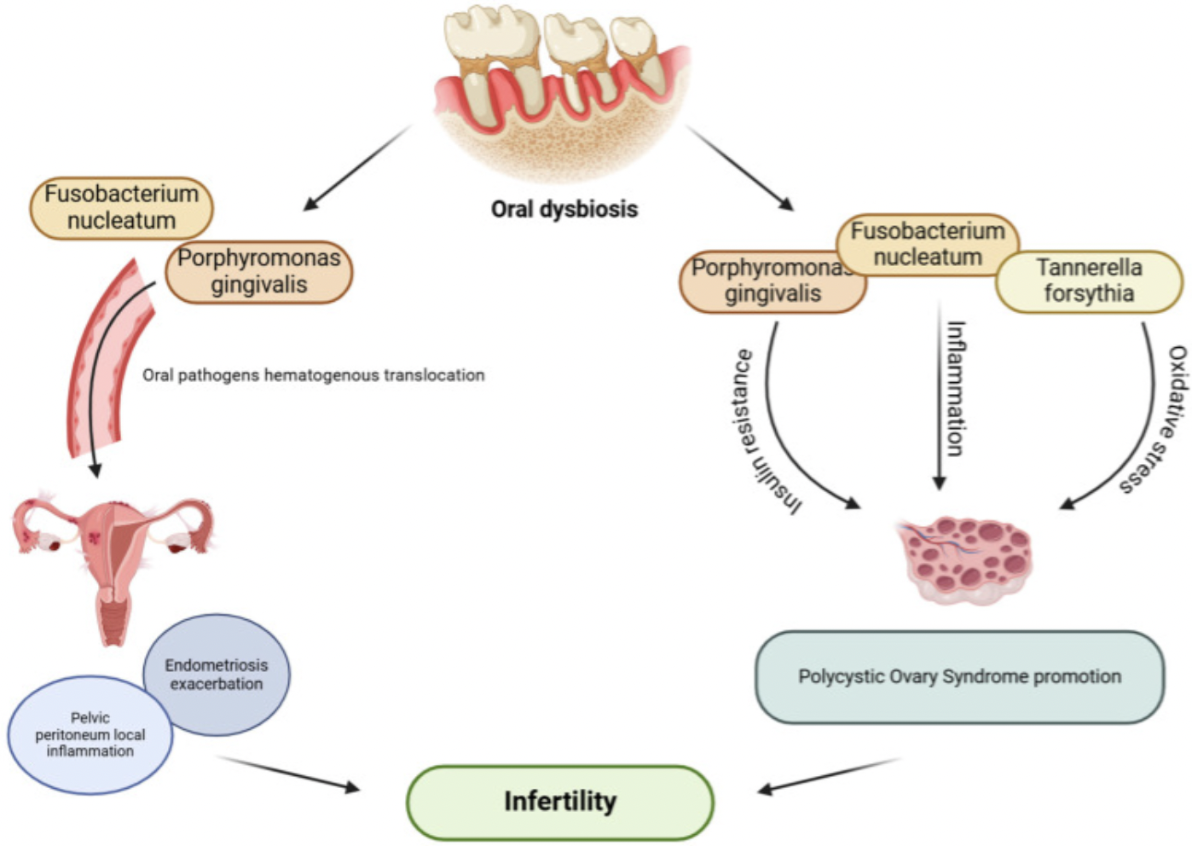
Figure 3. Proposed link between oral dysbiosis and gynecological inflammatory conditions.
Schematic illustration showing the potential role of periodontal pathogens, including Fusobacterium nucleatum and Porphyromonas gingivalis, in systemic inflammatory pathways that may contribute to endometriosis exacerbation, pelvic inflammation, and conditions associated with female infertility.

1.1.4 PREVOTELLA INTERMEDIA

1.1.4.1 Overview and structural features
Prevotella intermedia constitutes a gram-negative, strictly anaerobic, rod-shaped microorganism situated taxonomically within the phylum Bacteroidetes. (Figure 4) The organism manifests a distinctive phenotypic trait involving the synthesis of dark-pigmented bacterial colonies on nutrient media containing blood, progressing through a chromatic spectrum from light grey through brown tones to deep black coloration, a property that defines its classification within the black-pigmented rod (BPR) categorization. Genomic analysis documents a chromosomal organization totaling approximately 3.16 million nucleotide base pairs, encoding roughly 2,502 distinct protein-coding sequences within a guanine-cytosine molecular composition of 43.8%.
Prevotella intermedia exhibits the canonical gram-negative bacterial cellular envelope consisting of an outer lipopolysaccharide-containing membrane layer, an intervening peptidoglycan cross-linked cell wall structure, and an inner cytoplasmic bilayer. The bacterial cellular surface demonstrates remarkable morphological intricacy, featuring four categorically distinct classes of pili and appendage-like structures differentiated by their diameter measurements, ranging from type A appendages with 1-2 nanometer dimensions through progressively larger type B, C, and D structural variants, indicative of heterogeneous adhesion apparatus.
Contemporary genomic sequencing initiatives and comparative analysis of multiple P. intermedia clinical isolates – encompassing reference strain designations ATCC 25611, ATCC 49046, ATCC 15032, ATCC 15033, and a clinical environmental isolate Pi17 – have documented substantial inter-isolate genetic heterogeneity driven by chromosomal copy number variations (CNVs) and individual nucleotide polymorphic substitutions (SNPs). Remarkably, genes encoding carbohydrate-transforming enzymes (glycosyltransferases) and iron/hemin-acquisition mechanisms show pronounced strain-specific divergence. Counterintuitively, the ATCC 49046 isolate, which fails to synthesize the prototypical mucilaginous exopolysaccharide capsule (EPS), traditionally recognized as a cardinal virulence attribute, paradoxically demonstrated the most potent virulence characteristics among analyzed strains, suggesting that polysaccharide matrix production alone cannot explain pathogenic potential¹⁰⁴.
The species maintains approximately 165-170 conserved genetic loci representing core genes enabling ecological adaptation across diverse oral niches, facilitating organism survival within both supragingival (oxygen-rich) and subgingival (anaerobic) compartments. Despite minimal phylogenetic nucleotide sequence alignment (~3%) distinguishing different clinical isolates, a remarkably well-conserved 49-kilobase chromosomal segment is present across P. intermedia populations, suggesting evolutionary selection pressure maintaining particular pathogenic determinants.
The bacterium’s chromosome organization reveals the presence of two circular DNA molecules, a structural feature that distinguishes P. intermedia from many other oral bacteria. These chromosomal elements show remarkable variation in size, with the larger primary chromosome exhibiting substantial gene content homogeneity across strains, while secondary chromosomal structures demonstrate noteworthy dimensional heterogeneity and extensive genomic rearrangement patterns. The organisms maintain an extraordinary abundance of conjugative and mobilizable transposable genetic elements within secondary chromosomal compartments, which have undergone dramatic rearrangement and have introduced numerous strain-specific genetic sequences.
Prevotella intermedia obligatorily requires completely oxygen-free microenvironments, demonstrating absolute intolerance to dissolved or gaseous oxygen. The organism preferentially utilizes proteinaceous substrates, amino acids and peptide fragments, as primary carbon and energy sources, catabolizing these nitrogen-containing compounds via the Embden-Meyerhof-Parnas glycolytic pathway and glucose-oxidative routes operating under strictly anaerobic conditions. This metabolic specialization in proteolysis reflects evolutionary adaptation to the nutrient composition of subgingival ecosystems, where protein degradation products predominate and carbohydrate availability remains limited¹⁰⁴.
The organism synthesizes extracellular enzymatic machinery targeting periodontal structural proteins, including collagenous tissues, fibronectin-containing matrices, and elastin components, through constitutively expressed extracellular proteolytic enzymes (both serine and cysteine protease classes), generating short-chain volatile fatty acids and ammonia nitrogenous byproducts. These proteolytic decomposition products exert notable cytotoxic activity against host cells and antimicrobial peptides. P. intermedia demonstrates metabolic flexibility permitting catabolism of diverse carbohydrate and protein substrates, enabling ecological survival across both health-associated (supragingival plaque) and disease-associated (subgingival calculus) microenvironments.
Observable extracellular proteolytic activity generates characteristic hemolytic zones (cleared erythrocyte areas) on blood-supplemented culture media, hemolysis patterns distinctly diagnostic for this species. Colonial morphology typically presents as smooth, lustrous formations with dark pigmentation resulting from accumulation of iron-protoporphyrin complexes liberated from hemoglobin through enzymatic fragmentation via the interpain A cysteine protease pathway.
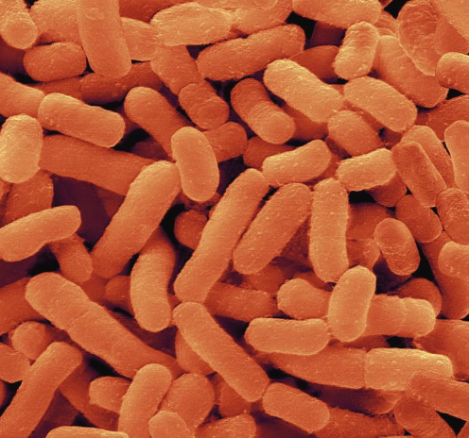

Figure 4. Representative microscopic image of Prevotella Intermedia.
Gram-negative anaerobic rods displaying a short, rounded morphology, consistent with Prevotella species commonly detected within the oral microbiota.

1.1.4.2 Virulence Factors of Prevotella intermedia
Prevotella intermedia accomplishes pathogenic functionality through an integrated collection of extracellular virulence factors that cooperatively promote tissue invasion, intracellular bacterial persistence, and circumvention of host immune effector mechanisms. The dominant virulence determinants, specifically the gram-negative endotoxin and cysteine proteolytic enzymes, exert multiplex effects encompassing direct tissue destructive activity, pro-inflammatory signal amplification, and simultaneous evasion of complement-mediated and antibody-dependent bactericidal attack.
Lipopolysaccharide Endotoxin and Pattern Recognition Mechanisms
The gram-negative bacterial envelope incorporates lipopolysaccharide (LPS), a bioactive lipid-polysaccharide macromolecule recognized as a potent pathogen-associated molecular pattern (PAMP) engaged by Toll-like receptor 4 (TLR4) on innate immune cell populations. P. intermedia-derived LPS stimulates elevated interleukin-8 expression within gingival fibroblast populations, triggers pro-inflammatory gene expression cascades in oral epithelial cell lines (KB-designated cells), and simultaneously impairs phagocytic capability and chemoattractant-driven motility in human dental-derived stem cell preparations. Distinct from endotoxin-mediated effects, P. intermedia secretes glycoprotein molecules (though not LPS itself) that selectively stimulate production of myeloid differentiation factors – granulocyte-colony stimulating factor (G-CSF) and granulocyte-macrophage colony-stimulating factor (GM-CSF) – within oral epithelial keratinocyte populations, orchestrating neutrophil and macrophage recruitment toward inflammatory periodontal lesion sites.
Interpain A: A Multifunctional 90-Kilodalton Cysteine Protease
Prevotella intermedia secretes interpain A (designated InpA), a 90-kilodalton-mass protease with cysteine residues within the catalytic center, structurally homologous to streptopain (SpeB) produced by the human pathogen Streptococcus pyogenes. This enzyme accomplishes dual critical functions: (1) extraction and acquisition of iron-protoporphyrin nutrients from host blood hemoglobin through stepwise proteolytic fragmentation, and (2) inactivation and neutralization of serum complement factors, antibody immunoglobulins, and antimicrobial peptide molecules, effector molecules constituting the bactericidal potential of human blood serum.
The proteolytic mechanism of InpA-mediated hemoglobin degradation proceeds through sequential chemical transformation. At physiologic neutral pH (7.5), InpA catalyzes oxidation of oxygen-carrying oxyhemoglobin to hydroxymethemoglobin derivatives. Under subgingival acidic conditions (pH <6) generated by bacterial saccharolytic metabolism, the resulting methaemoglobin in either aqueous or acidic-modified form becomes susceptible to InpA enzymatic cleavage, liberating iron-containing porphyrin molecular fragments. Quantitative enzyme kinetics demonstrate that InpA accelerates spontaneous hemoglobin auto-oxidation approximately threefold relative to uninhibited control reactions. Specific inhibition employing cysteine protease inhibitors (such as E-64 compound) reduces oxidation velocity by approximately 80%, establishing that enzymatic proteolysis constitutes the primary mechanism mediating hemoglobin-degradation pathways.
P. intermedia isolates expressing InpA demonstrate substantially enhanced resistance to serum complement-mediated bactericidal mechanisms relative to isolates lacking this protease, with complement-resistance substantially diminished following administration of cysteine protease inhibitors. InpA enzymatic activity synergistically amplifies the complement-inactivating effects of gingipain proteases generated by P. gingivalis, a phenomenon of considerable significance within mixed-organism biofilms containing both pathogenic species¹¹².
The bacterium synthesizes hemin-binding protein variants, specifically designated PinO and PinA homologs, which function as hemophore-like molecules facilitating iron-protoporphyrin acquisition from host albumin-hemin complexes. These proteins preferentially function under reducing microenvironmental conditions and operate through heme coordination mechanisms biochemically distinct from the Porphyromonas gingivalis HmuY hemophore system, employing methionine amino acid residues rather than histidine residues as primary iron-coordinating ligands.
Proteolytic Diversity and Tissue-Degrading Enzyme Systems
Beyond interpain A, P. intermedia manufactures a diverse array of tissue-destructive proteolytic enzymes conferring pathogenic capacity. Trypsin-like serine proteases actively degrade structural proteins essential for periodontal tissue architecture, specifically collagenous tissue matrices and fibronectin adhesion proteins, promoting progressive tissue matrix dissolution. Elastase-catalyzed reactions target elastic fibers distributed throughout the periodontal ligament and alveolar bone supporting structures. Secreted immunoglobulin A (IgA) protease activity cleaves mucosal antibodies, subverting IgA-mediated mucosal defense immunity. Acid-catalyzed and alkaline-catalyzed phosphatase activities facilitate alveolar bone mineral demineralization and subsequent resorption through enzymatic phosphate mobilization.
Genomic inventory analysis identifies that P. intermedia genomes encode 24-26 strain-specific protease/peptidase-encoding genes complementing approximately 145-170 core protease genes shared among isolates. Among these strain-specific proteases, bacteriocin or lantibiotic-exporting enzymes are notably enriched, suggesting that intraspecific bacterial competition rather than strictly host tissue degradation may represent significant evolutionary drivers for protease diversity.
Nuclease Production and Neutrophil Extracellular Trap Degradation
P. intermedia produces nuclease enzymes specifically designated NucD and NucA molecular variants capable of degrading the proteinaceous and DNA-based architecture comprising neutrophil extracellular traps (NETs), a critical innate immune barrier mechanism through which neutrophils immobilize, concentrate, and bactericidally kill pathogenic microorganisms. These nuclease-mediated NET-degradative activities facilitate evasion of NET-dependent killing mechanisms, permitting enhanced tissue penetration and systemic microbial dissemination.
Type IX Secretion System and Cargo Protein Translocation
The bacterium possesses a Type IX secretion apparatus (designated T9SS), a protein transport mechanism present within the Fibrobacteres-Bacteroidetes-Chlorobi bacterial superphylum. This specialized secretion system transports multiple pathogenic cargo proteins across the bacterial envelope, including enzymes degrading extracellular polysaccharides, cell-surface displayed adhesion molecules, gliding-motility associated proteins, and biofilm-matrix biosynthetic factors. T9SS cargo proteins represent novel therapeutic targets distinct from classical virulence determinants, offering potential antimicrobial intervention approaches independent of protease or adhesin-directed therapies. The core genome of P. intermedia contains gene sets encoding complete Type IX secretion system architecture.
Piliation, Adhesion Molecules, and Biofilm Architecture
P. intermedia expresses multiple pili and adhesin-type surface proteins facilitating bacterial cell-to-cell signaling interactions, biofilm structural organization, and penetration through epithelial cellular barriers. The bacterium displays distinct biofilm secretome profiles dependent upon growth mode biofilm versus planktonic cultivation with biofilm secretomes containing 109 proteins while planktonic secretomes contain 136 distinct proteins. Only approximately 6 proteins with predicted virulence capacity were identified in both biofilm and planktonic secretome preparations, indicating fundamental metabolic and virulence-factor distinctions between these growth modes.
Biofilm-derived secretomes induced substantially higher concentrations of inflammatory mediators, specifically MIP-1α/MIP-1β, IL-1β, and IL-8, compared to planktonic secretomes, indicating that sessile biofilm-dwelling bacteria express a distinctly different virulence arsenal compared to planktonic (free-floating) counterparts. Notable virulence factors within biofilm secretomes included thioredoxin, hemin-binding proteins, peptidase M6, NADH oxidase, and trypsin, an enzyme set substantially divergent from planktonic secretome composition¹¹⁸.
Exopolysaccharide (EPS) synthesis, producing visually apparent mucoid/slimy colonial phenotypes, traditionally represents a recognized virulence attribute associated with enhanced biofilm maturation and resistance to antimicrobial challenge, though genomic evidence documents that EPS production shows heterogeneity among clinical isolates and does not universally correlate with virulence expression.
Polysaccharide Capsule and Immune Evasion
Surface-displayed polysaccharide capsules composed of repetitive glycan linkages shield underlying cell-wall antigens from antibody molecular recognition and complement protein deposition. Genes encoding capsule biosynthesis demonstrate marked inter-strain variation in copy number and nucleotide sequence, reflecting adaptive evolution and evasion of host-derived capsule-directed immunologic responses.

1.1.4.3 Oral conditions
Prevotella intermedia occupies a flexible ecological position in the oral cavity, behaving as a facultative commensal in health but showing a clear shift toward pathogenic behaviour in disease. Epidemiological surveys in subjects without periodontal breakdown report P. intermedia in about 71% of individuals, where it constitutes roughly 70% of all black-pigmented rods isolated from clinically healthy subgingival sites. In contrast, its relative abundance rises markedly inside periodontal pockets with active tissue destruction, reaching about 41.7% of the total microbiota in active lesions compared with 37.3% in inactive sites. Isolates from diseased pockets display an enhanced virulence phenotype, with higher production of trypsin-like serine proteases, lipid-degrading enzymes, acid and alkaline phosphatases, and carbohydrate-degrading enzymes than strains recovered from healthy sites.
Within subgingival biofilms, Prevotella intermedia is recognized as an important periodontal pathogen implicated in both chronic, slowly progressive periodontitis and more rapidly destructive disease phenotypes. Its pathogenic potential is primarily driven by the production of proteolytic enzymes, lipopolysaccharides, and pro-inflammatory surface molecules that activate host inflammatory pathways and contribute to progressive damage of gingival connective tissue, the periodontal ligament, and adjacent mineralized structures, including cementum and alveolar bone³³.
P. intermedia commonly coaggregates with members of the red and orange complexes, such as Porphyromonas gingivalis and Fusobacterium nucleatum, forming polymicrobial consortia within which synergistic metabolic interactions enhance overall virulence³⁴. In these communities, P. intermedia contributes to the establishment of reduced oxygen microenvironments favorable to strict anaerobes and utilizes iron-containing compounds derived from hemoglobin degradation mediated by P. gingivalis gingipains. Moreover, the InpA protease of P. intermedia has been shown to potentiate complement inactivation initiated by P. gingivalis, thereby increasing serum resistance and promoting persistence of the polymicrobial biofilm.
Acute Necrotizing Ulcerative Gingivitis (ANUG)
Prevotella intermedia has been consistently identified as a major microbial contributor to acute necrotizing ulcerative gingivitis, a rapidly developing periodontal condition characterized by severe pain, gingival tissue necrosis, and spontaneous bleeding³³.The acute clinical presentation is associated with a sudden overgrowth of P. intermedia together with other anaerobic bacteria within pre-existing subgingival biofilm communities, followed by bacterial invasion through ulcerated gingival epithelium. Proteolytic enzyme activity, combined with the effects of lipopolysaccharides and host-derived pro-inflammatory mediators, promotes extensive tissue destruction and accounts for the characteristic necrotic and hemorrhagic features of the lesions.
Endodontic-Origin Infections and Apical Periodontal Inflammation
Prevotella intermedia has been definitively identified as a significant causative organism in endodontic pulpal infections, including root canal infection establishment, apical periodontitis progression (inflammatory destruction surrounding the apex of tooth roots), and periapical abscess formation. The bacterium’s capacity for invasion into dentinal tubule structures and formation of antibiotic-resistant biofilms within the endodontic system compartment complicates antimicrobial therapeutic efficacy. The organism’s proteolytic enzymes progressively damage apical periodontal tissues while bacterial endotoxin diffuses through the apical foramen opening, triggering periapical inflammatory responses and osteoclastic bone resorption.
Suppurative Dental Abscess Formation
P. intermedia is also commonly recovered from suppurative dental abscesses, including periodontal and periapical origin, where its proteases and other virulence factors favour progression from a localized purulent focus to more extensive tissue involvement and, in severe cases, potential spread via the bloodstream.
Severe Necrotizing Orofacial Infection (Noma/Cancrum Oris)
Notably, this species has been implicated as part of the polymicrobial flora in noma (cancrum oris), a fulminant necrotizing orofacial infection seen mainly in severely malnourished or immunocompromised individuals; its strong proteolytic activity and capacity to drive intense inflammation are believed to contribute to the rapidly progressive soft-tissue destruction that may extend from the gingiva to involve facial soft tissues and underlying bone.

1.1.4.4 Sistemic involvement and extraoral pathogenicity
Although primarily regarded as an oral pathobiont associated with periodontal and endodontic infections, Prevotella intermedia has demonstrated the capacity to disseminate beyond the oral cavity through transient bacteremia originating from inflamed periodontal tissues or odontogenic infection sites. Such bacteremic episodes may occur during routine oral activities or dental procedures and provide a plausible route for systemic spread. Once in the circulation, immune evasion mechanisms, including resistance to serum bactericidal activity mediated by cysteine proteases such as interpain A may enhance bacterial survival and facilitate secondary colonization of anatomically distant sites¹¹². Clinically, P. intermedia has been isolated from a variety of extra-oral infections, including head and neck infections, respiratory tract infections, and rare but severe conditions such as intracranial abscesses and purulent pericarditis, typically as part of polymicrobial anaerobic consortia rather than as a solitary pathogen.
Respiratory tract infections and pulmonary inflammation
In the respiratory tract, P. intermedia is most often implicated in aspiration-related and polymicrobial pulmonary infections involving oral anaerobes¹³⁰. Experimental and clinical evidence suggests that this species can exacerbate pneumonia severity when present alongside other respiratory pathogens, partly through modulation of host immune responses. Animal models indicate that secreted products of P. intermedia may impair neutrophil bactericidal activity and disrupt effective clearance mechanisms, thereby amplifying inflammatory lung damage during mixed infections. These findings support a contributory, rather than primary, pathogenic role for P. intermedia in respiratory disease, particularly in elderly or immunocompromised individuals.
Oncological associations: limited and emerging evidence
Compared with Fusobacterium nucleatum, the oncological relevance of P. intermedia remains considerably less established. Microbiome profiling studies have reported increased abundance of Prevotella species, including P. intermedia, in colorectal and oral squamous cell carcinoma tissues relative to adjacent non-malignant mucosa. Experimental data suggest that secreted virulence factors such as interpain A may influence epithelial proliferation, migration, and inflammatory signaling in vitro and in animal models, potentially shaping a tumor-promoting microenvironment. However, current evidence supports a secondary, context-dependent role rather than a direct oncogenic function.
Infectious Pericarditis and Cardiac Complications
Prevotella intermedia has been documented, although rarely, as a causative agent in bacterial pericarditis (infection of the fibrous pericardial sac) presenting with massive pericardial effusion fluid accumulation and hemodynamic pericardial tamponade (compression of cardiac filling). A clinical case documentation involved a 70-year-old male patient with predisposing cardiac risk factors (chronic heart failure, stage 5 chronic kidney disease, diabetes mellitus) presenting with fever, dyspnea, and imaging-documented massive pericardial fluid accumulation. Bacterial culture of aspirated pericardial fluid identified P. intermedia as the causative pathogen, establishing clinical reality that this organism represents a potential extraoral pathogen capable of life-threatening cardiac infection complications.
Pneumonia and Respiratory Tract Infection
Prevotella intermedia contributes to respiratory tract infections primarily in the context of aspiration-related and polymicrobial pneumonia involving oral anaerobes. Clinical observations indicate that elderly individuals with increased oral Prevotella abundance experience worse pneumonia outcomes compared with those dominated by other anaerobic genera, suggesting differential virulence behavior in pulmonary infections¹¹⁶.
Experimental murine models demonstrate that P. intermedia exacerbates pneumonia caused by oral streptococci by inducing neutrophil dysfunction, resulting in reduced survival, increased bacterial dissemination, and more severe lung pathology compared with monoinfection¹¹⁶.
Mechanistically, secreted products of P. intermedia impair neutrophil bactericidal activity and macrophage recruitment, partly through suppression of CCR2 expression and degradation of neutrophil extracellular traps, thereby compromising pulmonary host defense during mixed infections¹¹⁶.
Severe Asthma Phenotype and Systemic Respiratory Inflammation
Epidemiological studies have identified a significant association between periodontitis and severe asthma phenotypes, even after adjustment for confounding factors. Elevated subgingival levels of P. intermedia show an independent association with severe asthma, supporting a mechanistic link between oral microbial dysbiosis and systemic airway inflammation.
A distinctive biological feature of P. intermedia is its selective affinity for steroid hormone-rich mucosal environments. The bacterium can utilize progesterone and related sex hormones as alternative growth factors, a property originally described in periodontal contexts and later linked to pregnancy-associated shifts in oral microbial composition. This hormone-responsive phenotype provides a biological rationale for the frequent detection of P. intermedia in female reproductive tract environments, particularly during periods of hormonal fluctuation such as puberty and pregnancy.
Recent advances in sequencing technologies have challenged the traditional concept of a sterile uterine cavity, demonstrating that the endometrium can host a low-biomass microbiota. Within this context, Prevotella species, including P. intermedia, have been implicated in endometrial dysbiosis and chronic low-grade inflammation. Experimental human endometrial epithelial models show that members of the Prevotella genus can modulate innate immune signaling and compromise epithelial barrier integrity, mechanisms that may be relevant to conditions such as chronic endometritis and endometriosis. Although species-level attribution remains limited in some studies, these findings support a plausible contributory role for P. intermedia in endometrial immune dysregulation and disease persistence rather than as a primary etiologic agent.
Adverse Pregnancy Complications and Fetoplacental Infection
Accumulating evidence implicates Prevotella species, including P. intermedia, in fetoplacental bacterial infection and pregnancy-associated complications. Periodontal pathogens, including P. intermedia, achieve hematogenous dissemination from subgingival disease sites toward the feto-placental unit through bacteremic episodes associated with periodontal disease and dental procedures. Within the placental microecological context, P. intermedia may establish invasive infection, trigger toll-like receptor-dependent placental inflammatory signaling cascades, and stimulate pro-inflammatory cytokine production that precipitates preterm labor onset, premature placental membrane rupture, or intrauterine fetal demise.
The bacterium’s inherent biofilm-formation capability facilitates persistent infection within endometrial epithelial tissue, potentially sustaining chronic inflammatory states predisposing toward adverse gestational outcomes. Genomic analysis indicates that P. intermedia possesses genetic determinants encoding Type IX secretion apparatus components and polysaccharide-degrading enzymatic systems facilitating penetration through endometrial epithelial barrier defenses.
Bacterial Vaginosis and Upper Reproductive Tract Dysbiosis
Prevotella intermedia and related Prevotella species constitute major bacterial constituents of the dysbiotic vaginal microbiota characteristic of bacterial vaginosis (BV). Within the BV microecological context, Prevotella species function as early-colonizing pioneering organisms that compromise endometrial epithelial barrier function, promote biofilm maturation, and create ecological opportunities facilitating secondary pathogenic colonization by Gardnerella vaginalis and other BV-associated microorganisms.
Although Prevotella species demonstrate relatively modest direct pro-inflammatory activity toward endometrial epithelial cells during in vitro assessment, the genus substantially contributes to upper reproductive tract pathology through mechanisms of barrier function disruption, biofilm-mediated protection of secondary pathogens, and facilitation of ascending infection from lower to upper reproductive tract compartments. Prevotella species have been recovered from endometrial tissue and fallopian tube biopsies obtained from women with pelvic inflammatory disease (PID), endometrial inflammation (endometritis), and uterine infection (pyometra), indicating capacity for establishing upper reproductive tract infections. The documented association between Prevotella genus abundance and endometrial polyp formation, endometriosis development, and chronic endometrial tissue dysfunction suggests contributions to reproductive pathology. Prevotella species, rather than individual species such as P. intermedia, have been associated with endometrial dysbiosis and inflammatory microenvironments in women with endometriosis. Current evidence does not support a sentinel or biomarker role for Prevotella intermedia in endometriosis; its involvement appears context-dependent and likely secondary to broader microbial dysbiosis.

1.2 Correlations with systemic conditions
In recent years, increasing scientific attention has been directed toward the systemic effects of periodontitis. Evidence indicates that periodontal disease is not confined to the oral cavity but may induce alterations at the whole-body level. In particular, periodontal pathogens are able to infiltrate gingival tissues and subsequently gain access to the systemic circulation, providing a biological basis for the association between periodontitis and systemic conditions.
The concept that oral infections, such as periodontitis, may influence a patient’s general health is not a recent one. Between the late nineteenth and early twentieth centuries, physicians and dentists increasingly supported the idea that infections—particularly those originating in the oral cavity—could act as causal factors for a wide range of systemic diseases. This perspective led to the development of the so-called “focal infection theory”, which was largely driven by early microbiological investigations conducted by Miller.
In 1891, Miller published a seminal work entitled “The Mouth as a Focus of Infection”, in which he proposed the existence of an infectious nidus arising from oral diseases, including periodontitis. According to this theory, microorganisms originating in periodontal tissues could disseminate via the bloodstream and affect distant organs. As a consequence, a widespread clinical practice emerged that involved the extraction of teeth—even those that appeared clinically healthy—as a form of preventive or therapeutic “oral sanitation” aimed at preventing or treating systemic conditions such as joint, cardiac, hepatic, renal, and pancreatic diseases.
However, it became evident that systemic diseases also developed in individuals who were orally healthy or even edentulous. Consequently, by the 1950s, the focal infection theory was largely abandoned.
Only toward the late twentieth century did scientific interest re-emerge in exploring potential associations between periodontal diseases and systemic conditions, leading to the development of a specific research field known as “periomedicine.”
At present, the prevailing scientific consensus recognizes periodontitis as a clinically relevant risk factor for several systemic diseases, including cardiovascular disorders, diabetes mellitus, and adverse pregnancy outcomes such as preterm birth.
This paradigm shift has moved away from the concept of disease confined to a single organ and toward a broader framework of systemic inflammation. For example, individuals with poorly controlled diabetes exhibit a markedly increased risk up to threefold of developing periodontitis compared with non-diabetic subjects.
The immune response to pathogenic agents is organized into two main branches: the specific (adaptive) immune response and the non-specific (innate) immune response. Both rely on the mobilization of distinct cellular lineages that not only proliferate but also secrete chemical mediators, such as lymphokines with local hormone-like activity, which in turn recruit additional immune cells. As a result, a localized inflammatory focus may lead to a distant systemic response involving multiple organs and systems. Two principal mechanisms explain how a localized inflammatory process should be considered a systemic condition. The first is a direct mechanism, whereby bacteria originating from a chronic oral infection may enter the bloodstream, leading to episodes of bacteremia following bacterial release into the circulatory system. A second, indirect mechanism involves the abundant production of pro-inflammatory factors, including cytokines and interleukins, which can disseminate to distant tissues and contribute to the development of a generalized inflammatory state within the organism. The secretion of inflammatory mediators by activated immune cells also mobilizes osteoclasts, which represent the primary cellular effectors of periodontal tissue destruction. These cells derive from the immune system, specifically from the monocyte lineage, and therefore retain membrane receptors for inflammatory mediators. This explains why bone cells are strongly stimulated and recruited during immune system activation and account for a substantial proportion of periodontal tissue damage. During gingival inflammation, the activated cellular populations produce large quantities of inflammatory mediators that do not remain confined to the local inflammatory site but enter the systemic circulation, becoming part of a broader inflammatory network and ultimately affecting distant organs and systems. This observation has raised the question of how an apparently small anatomical structure, such as the oral cavity and more specifically inflamed gingival tissue, can exert systemic effects. The answer lies in the actual extent of the affected tissue. Research conducted by Frank Abbas and colleagues quantified the inflamed periodontal surface area by conceptually unfolding all periodontal pockets of a patient with periodontitis, demonstrating that the total inflamed surface may reach approximately 40 cm². This represents a substantial surface area, capable of continuously releasing inflammatory mediators into the systemic circulation. Consequently, substances produced within inflamed gingival tissues may exert measurable effects on the rest of the organism. Furthermore, patients with periodontitis exhibit significant alterations in systemic inflammatory parameters compared with individuals with a healthy periodontium. Specifically, it has been reported increased circulating neutrophil counts and elevated levels of systemic inflammatory markers, such as C-reactive protein, a hepatic acute-phase protein synthesized in response to inflammatory stimuli. Therefore, the inflammatory status of these patients can be assessed using biochemical parameters such as the erythrocyte sedimentation rate (ESR) and C-reactive protein levels, which reflect the magnitude of the systemic inflammatory condition. Cytokines are produced not only by inflamed tissues but also by organs and tissues that appear non-inflamed, such as adipose tissue. In this way, a generalized condition is established in which inflammatory chemical mediators become highly concentrated within biological fluids and are therefore able to exert their effects at distant sites. Systemic inflammatory status is now widely recognized to be associated with a broad range of diseases that, until relatively recently, were not considered inflammatory in nature, including cancer, diabetes mellitus, cardiovascular diseases, and neurodegenerative disorders such as Alzheimer’s disease. Today, the distinction between degenerative and inflammatory diseases is no longer clearly defined, as the vast majority of degenerative conditions are now understood to have an inflammatory basis. The clinical and biological relevance of systemic inflammation is such that the American Journal of Cardiology and the Journal of Periodontology have issued a joint consensus to highlight and disseminate research addressing the close relationship between cardiovascular diseases, metabolic disorders such as diabetes, obstetric conditions including preterm birth, and reproductive disorders such as polycystic ovary syndrome (PCOS) and endometriosis, in relation to periodontal disease. (Figure 5) The association between these systemic conditions and periodontitis has been extensively investigated in order to integrate current knowledge in this field, consistently identifying systemic inflammation as the underlying common pathogenic mechanism. However, periodontitis is not the sole condition capable of inducing a systemic inflammatory state that affects distant organs and systems. The relationship is bidirectional, as any generalized inflammatory condition may, in turn, negatively influence periodontal health. Many of these diseases, including periodontitis, frequently coexist within the context of the so-called metabolic syndrome, a systemic condition characterized by chronic low-grade inflammation. Metabolic syndrome is diagnosed when at least three of the following five criteria are present: increased waist circumference (measured midway between the xiphoid process and the umbilicus), exceeding approximately 100 cm in men and 88 cm in women; triglyceride levels above 150 mg/dL; arterial blood pressure greater than 130/85 mmHg in both sexes; and fasting blood glucose levels exceeding 110 mg/dL. It is important to recognize that total cholesterol comprises different fractions, including high-density lipoproteins (HDL), which should be maintained above 40–50 mg/100 mL, and low-density lipoproteins with regard to cholesterol metabolism. The critical factor is not merely total cholesterol concentration but the preservation of adequate HDL levels. High-density lipoproteins facilitate the removal of free cholesterol from circulation, thereby preventing its infiltration into the vascular wall following endothelial injury and reducing the formation of atherosclerotic plaques. When at least three of these metabolic parameters are altered, the diagnosis of metabolic syndrome is established. Importantly, several studies evaluating the systemic consequences of improving local inflammatory conditions have demonstrated a reduction in systemic inflammatory markers following periodontal therapy. These findings support the concept that periodontitis, together with other chronic inflammatory diseases affecting different body systems, contributes significantly to the overall systemic inflammatory burden .
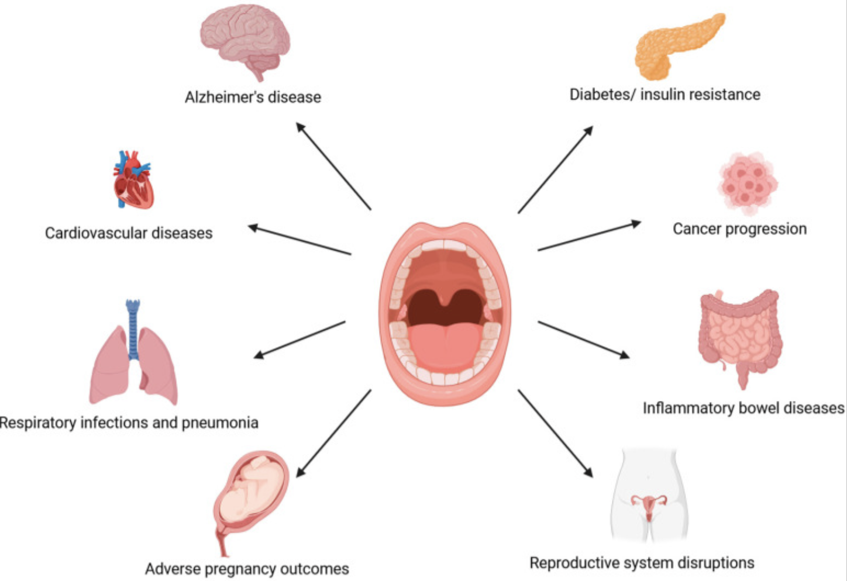

Figure 5. Systemic effects associated with oral dysbiosis and periodontal inflammation.
Schematic representation illustrating the potential associations between periodontal disease–related oral dysbiosis and a wide range of systemic conditions, including cardiovascular disease, metabolic disorders, neurodegenerative diseases, inflammatory bowel diseases, cancer progression, and reproductive system alterations.

1.2.1 Female reproductive disorders
Female reproductive disorders represent conditions that can have a significant impact on women’s overall well-being. Research suggests that hormonal fluctuations occurring during the menstrual cycle, pregnancy, and menopause may influence the oral environment and contribute to increased susceptibility to oral diseases, such as periodontitis. Conversely, periodontal disease may have important implications for female reproductive health. Evidence indicates a potential association between periodontal pathogens and adverse pregnancy outcomes, including preterm birth, low birth weight, and preeclampsia. The dissemination of oral bacteria and their by-products into the systemic circulation may trigger an inflammatory response and disrupt the delicate balance essential for a successful pregnancy.
Female reproductive disorders encompass a range of conditions that can markedly affect women’s general health and quality of life. Accumulating evidence indicates that hormonal variations associated with the menstrual cycle, pregnancy, and the menopausal transition can modify the oral ecosystem, altering host responses and predisposing women to oral inflammatory conditions, particularly periodontal disease.
Conversely, periodontal pathology may also exert systemic effects that extend to female reproductive health. Several studies have reported an association between periodontal infections and unfavorable pregnancy outcomes, such as preterm delivery, low birth weight, and preeclampsia. The translocation of periodontal bacteria and their inflammatory mediators into the systemic circulation may promote a chronic inflammatory state, potentially interfering with the finely regulated biological processes required for the maintenance of a healthy pregnancy.
Polycystic ovary syndrome (PCOS)
Furthermore, polycystic ovary syndrome (PCOS), one of the most prevalent endocrine disorders among women of reproductive age, has been associated with an increased risk of developing periodontal disease. PCOS is a common metabolic and endocrine disorder affecting women of childbearing age. It is characterized by oligo/anovulation, hyperandro- genism, and polycystic ovarian morphology.
Depending on diagnostic criteria such as the Rotterdam criteria, which require at least two of these features, its global prevalence ranges between 5% and 20%. Despite its high prevalence, approximately 70% of affected women remain undiagnosed. Polycystic ovary syndrome is frequently accompanied by metabolic and systemic comorbidities, including insulin resistance, type 2 diabetes mellitus, cardiovascular disorders, obesity, and reproductive dysfunction, with a global prevalence estimated between 8% and 13% among women. Emerging evidence characterizes PCOS as a multisystem condition, comparable to periodontal disease, as both disorders share underlying mechanisms involving chronic systemic inflammation and endocrine dysregulation.
Due to profound alterations in metabolic homeostasis and endocrine regulation, women affected by PCOS may exhibit a wide range of reproductive manifestations, including menstrual irregularities, endometrial abnormalities, and infertility, alongside systemic conditions such as insulin resistance, diabetes mellitus, cardiovascular disease, and obesity. In addition, the endocrine–metabolic dysfunction characteristic of PCOS promotes a state of chronic low-grade systemic inflammation, leading to increased circulating levels of pro-inflammatory cytokines.
These systemic changes are mirrored in salivary biomarkers and in the composition of the oral microbiome. Indeed, evidence indicates that oral microbial communities are altered in patients with PCOS in response to variations in estradiol levels, as well as in the presence of insulin resistance and obesity, highlighting how metabolic disorders can influence microbial metabolomics.
PCOS may contribute to periodontal inflammation through inflammatory mediators such as interleukins (including IL-6 and IL-17, the latter induced by IL-36), C-reactive protein (CRP), tumor necrosis factor (TNF), and matrix metalloproteinase-8 (MMP-8), which have been detected in both serum and saliva Dysregulated MMP expression has also been associated with ovulatory dysfunction in PCOS, potentially impairing follicular development at different stages. However, the precise role of sex hormones in modulating pro-inflammatory cytokine release remains incompletely understood. Although several reviews have addressed this topic, definitive evidence supporting a direct association between PCOS and periodontal disease is still lacking. Moreover, preventive strategies targeting PCOS in this context remain underexplored, and PCOS has not yet been established in the literature as a reliable marker for early diagnosis.
Clinically, these mechanisms translate into an increased susceptibility of patients with PCOS to periodontal diseases. Alterations in the host endocrine and metabolic environment may lead to qualitative and quantitative changes in the oral microbial biofilm¹⁵⁶. Furthermore, hyperandrogenism, reduced estradiol levels, and insulin resistance negatively affect bone metabolism, compromise tissue resilience, and increase the vulnerability of gingival epithelial cells to microbial infection¹⁵⁶. Elevated concentrations of pro-inflammatory cytokines further exacerbate periodontal inflammation, potentially accelerating disease progression and severity¹⁵⁶.
Endometriosis
A biological key-link between endometriosis and periodontal diseases is inflammation. Endometrial lesions promote oxidative stress and sustained chronic inflammation, leading to increased levels of pro-inflammatory cytokines detectable in serum and saliva, which may influence oral biofilm composition and modulate the host immune response to periodontal pathogens.
In addition, since endometriosis is an estrogen-dependent disorder, also TMD might be correlated. It is noteworthy that the temporomandibular joint (TMJ) cartilage expresses estrogen receptors that are essential for maintaining normal tissue trophism. In this regard, Wójcik et al. (2023) reported a preliminary correlation between pelvic pain severity in patients with endometriosis and temporomandibular joint pain. TMJ pain in these patients should therefore be carefully evaluated. Gala et al. (2021) reported an extrapelvic endometriotic lesion involving the mandible, initially misdiagnosed as a facial fibroma.
Effects of Fertility Treatments on Bone Mineral Density
The use of hormonal therapies in women has markedly increased over recent decades, both for the management of menopausal symptoms and as a cornerstone of infertility treatment protocols.
Female reproductive potential declines progressively with advancing age, leading to impaired oocyte competence well before the onset of natural menopause.
Menopause is a life stage strongly associated with accelerated bone turnover and increased markers of bone resorption, resulting in a substantially elevated risk of osteoporosis. These skeletal alterations are primarily driven by estrogen deficiency and by a compensatory rise in circulating follicle-stimulating hormone (FSH), which has been independently implicated in bone loss.
The decline in estradiol levels compromises estrogen receptor signaling in osteoblasts, thereby reducing bone formation and indirectly promoting osteoclast differentiation and activity. As estrogen-mediated inhibition of osteoclastogenesis diminishes, bone resorption becomes predominant, leading to deterioration of both cortical and trabecular bone architecture.
In parallel, controlled ovarian stimulation represents an essential component of assisted reproductive technologies (ART), with gonadotropins playing a pivotal role in follicular recruitment and maturation. FSH is the principal regulator of antral follicle growth, whereas luteinizing hormone (LH) enhances ovarian steroidogenesis and supports dominant follicle development. According to the two-cell, two-gonadotropin model, LH stimulates androgen synthesis in theca cells, while FSH promotes granulosa cell proliferation and estradiol production. The primary objective of gonadotropin stimulation is to achieve adequate estradiol concentrations, which are associated with improved oocyte yield, enhanced oocyte quality, and more physiological reproductive outcomes.
Technological advances have led to the development of recombinant human gonadotropins, including recombinant FSH (r-hFSH) and recombinant LH (r-hLH), offering greater purity and dosing precision compared with urinary-derived preparations.
Emerging evidence indicates that gonadotropin exposure may exert tissue-specific effects extending beyond the reproductive system, influencing skeletal metabolism as well.
While r-hFSH promotes follicular growth and accelerates endometrial maturation, r-hLH appears to optimize follicular microenvironmental conditions and improve metabolic sensitivity. Conversely, experimental studies suggest that elevated FSH levels may enhance alveolar bone resorption through activation of cyclooxygenase-2 signaling pathways. FSH has also been shown to upregulate osteoclast-associated genes, including RANK, MMP-9, and TRAP, thereby stimulating osteoclast differentiation and bone resorptive activity. These findings raise concerns regarding the potential long-term effects of ART-related hormonal stimulation on skeletal health, including the integrity of alveolar bone. Comprehensive evaluation of bone metabolism markers in women undergoing assisted reproduction may therefore provide valuable insights into the systemic and oral health consequences of fertility treatments.
The relationship between periodontal disease and female reproductive conditions represents a highly intricate clinical interplay. Gaining insight into the reciprocal influence between oral and reproductive health is crucial for clinicians, as it supports the adoption of holistic care models that integrate dental and gynecological perspectives. Advancing knowledge in this field requires further investigation to clarify the biological pathways linking these disorders and to inform the development of focused preventive and therapeutic interventions capable of improving overall health outcomes in women.

1.2.2 ENDOMETRIOSIS

1.2.2.1 Prevalence, Pathogenesis, and Classification
Endometriosis is a benign chronic gynecological disorder characterized by the presence of endometrial-like tissue outside the uterine cavity. This ectopic tissue, consisting of endometrial glands and stroma, retains responsiveness to hormonal stimuli and elicits a persistent inflammatory response, leading to significant clinical manifestations as well as substantial psychosocial consequences. Despite being one of the most common gynecological conditions affecting women of reproductive age, endometriosis frequently remains undiagnosed or is diagnosed only after a substantial delay, resulting in considerable patient suffering and a marked negative impact on quality of life. Endometriosis affects approximately 10% of women of reproductive age, with prevalence estimates rising to as high as 15% in certain populations. In Canada, the condition is estimated to affect around one million individuals. The prevalence is substantially higher in specific clinical subgroups, as endometriosis is identified in approximately 40–50% of women experiencing persistent chronic pelvic pain and in 30–40% of women with infertility¹⁷⁸ .
Although the precise pathogenesis of endometriosis has not yet been fully elucidated, the most widely accepted hypothesis is the theory of retrograde menstruation. According to this model, during menstruation, endometrial cells contained within the menstrual fluid flow backward through the fallopian tubes into the peritoneal cavity. While retrograde menstruation is estimated to occur in most women, only a subset develops endometriosis, indicating that additional biological, immunological, and environmental factors are essential for disease initiation and progression¹⁷⁷ ¹⁷⁸.
Failure of the physiological mechanisms responsible for the clearance and elimination of ectopic endometrial cells allows their implantation and long-term survival within ectopic sites. This process is driven by multiple, interrelated biological alterations, including disrupted cell adhesion and enhanced proliferative capacity, which facilitate abnormal attachment and expansion of ectopic endometrial tissue¹⁷⁶. In addition, accumulating evidence indicates that somatic mutations may arise within ectopic lesions, conferring selective growth and survival advantages to endometrial cells and contributing to lesion persistence and progression.
A sustained inflammatory microenvironment further supports lesion establishment, as chronic cytokine- and chemokine-mediated inflammation promotes angiogenesis, tissue remodeling, and immune cell recruitment, thereby reinforcing disease chronicity. Local dysregulation of steroidogenesis also plays a central role, with ectopic endometrial tissue acquiring the ability to synthesize estrogens locally, which in turn stimulates cellular proliferation and perpetuates inflammatory signaling in an autocrine and paracrine manner²²⁰.
Moreover, pathological neurogenesis has emerged as a key feature of endometriosis, characterized by aberrant growth and increased density of nerve fibers within endometriotic lesions, which contributes not only to lesion maintenance but also to the development and persistence of chronic pelvic pain. Finally, immune dysregulation represents a critical pathogenic mechanism, as impaired cellular and humoral immune responses reduce the capacity to recognize and eliminate ectopic endometrial cells, thereby enabling their survival and expansion in ectopic environments.
The coelomic metaplasia hypothesis posits that the peritoneal mesothelium, which is embryologically derived from coelomic epithelial cells, undergoes a metaplastic transformation into endometrial-like glandular and stromal tiss. Immunohistochemical investigations of endometriosis have revealed a highly complex molecular landscape, characterized by profound alterations in multiple biological pathways involved in inflammation, cell adhesion, cell survival, and pain perception¹⁷⁶ ¹⁷⁷. The microenvironment of endometriotic lesions is markedly pro-inflammatory, with increased expression of mediators such as leukemia inhibitory factor (LIF), which is particularly elevated in ectopic tissue during the secretory phase and contributes to the maintenance of local inflammation while potentially impairing embryo implantation mechanisms¹⁷⁷.
Concomitantly, cyclooxygenase-2 (COX-2) is overexpressed in both eutopic and ectopic endometrial tissues, promoting excessive prostaglandin synthesis and playing a central role in the development of pelvic pain and the persistence of chronic inflammation.
Growing evidence also supports the involvement of stress-response systems, as increased levels of corticotropin-releasing hormone (CRH) and urocortin (UCN) have been detected in endometriotic lesions, where they contribute to immune modulation and amplification of inflammatory signaling.
Within this context, mast cell infiltration and activation emerge as key pathogenic features, with a higher density of activated and degranulated mast cells observed in ectopic tissue, particularly in deep infiltrating endometriosis compared with superficial peritoneal lesions.
Consistent with a state of persistent oxidative stress, variable expression of heme oxygenase (HO) has been reported in endometriotic lesions, suggesting an imbalance in antioxidant defense mechanisms that further sustains the inflammatory milieu. From the perspective of cell adhesion and invasiveness, endometriosis is characterized by dysregulated expression of adhesion molecules, including integrins – particularly the α4 and α5 subunits – which facilitate abnormal cellular attachment and migration of ectopic endometrial cells into surrounding tissues. Simultaneously, reduced expression of CD44 and E-cadherin in ectopic tissue reflects a loss of normal cell–cell adhesion, promoting a more migratory and invasive cellular phenotype²²⁰. The presence of phosphorylated ezrin within the stromal compartment of endometriotic lesions further supports the role of cytoskeletal reorganization and cell–matrix interactions in disease progression and invasiveness.
Another critical pathogenic hallmark is the dysregulation of apoptotic pathways, as demonstrated by reduced p53 expression in ectopic tissue, indicating impaired elimination of aberrant cells¹⁸³. In parallel, increased expression of the anti-apoptotic protein BCL-2 confers a survival advantage to ectopic cells and has been correlated with disease severity, particularly in deep infiltrating endometriosis¹⁸³.Moreover, decreased levels of PIAS3 suggest disruption of the STAT3 signaling pathway, which is known to regulate cell proliferation and sustain chronic inflammatory responses¹⁸³ .
Neural involvement represents a pivotal component in the pathogenesis of endometriosis-associated pain, as evidenced by the presence of the neuronal marker PGP9.5 within endometriotic tissue but not in healthy controls, indicating lesion-associated neo-innervation.
Additionally, localized expression of nerve growth factor (NGF), particularly pronounced in ovarian lesions, promotes nerve fiber growth and peripheral sensitization, thereby contributing to chronic pain development. Finally, increased expression of the transient receptor potential channels TRPA1 and TRPV1, especially in deep endometriosis, has been implicated in nociceptive signal transduction and the maintenance of chronic pelvic pain. (Figure 6)
Risk factors
Several epidemiological and biological factors have been identified as predisposing to the development of endometriosis, suggesting a multifactorial etiology involving early-life, reproductive, metabolic, and genetic influences. Low birth weight has been associated with an increased risk of endometriosis later in life, supporting the hypothesis that early developmental programming may influence disease susceptibility¹⁸⁴.Congenital Müllerian anomalies have also been linked to a higher prevalence of endometriosis, likely due to altered menstrual outflow and increased retrograde menstruation.
Reproductive characteristics such as early menarche, short menstrual cycles, and heavy menstrual bleeding have consistently been associated with increased risk, as they result in prolonged lifetime exposure to menstruation and retrograde flow of endometrial cells . A low body mass index has likewise been identified as a risk factor, possibly reflecting hormonal, metabolic, or inflammatory differences influencing estrogen bioavailability . Nulliparity represents another established risk factor, although this association may partly reflect reverse causality related to endometriosis-associated infertility¹⁹⁶ ¹⁹⁹.
A strong genetic component has been demonstrated, with twin studies estimating heritability at approximately 50%, and first-degree relatives of affected women exhibiting a 3- to 15-fold increased risk of developing the disease. Additionally, differences in prevalence across ethnic and racial groups have been reported, with higher rates observed among Asian women and lower rates among women of African descent, although these findings may be influenced by disparities in healthcare access, diagnostic practices, and sociocultural factors.
Surgical Classification Systems
The revised American Society for Reproductive Medicine (rASRM) classification, last updated in 1996, remains the most widely used staging system for endometriosis worldwide. This system is based on intraoperative findings and assigns weighted scores according to the size and extent of peritoneal implants, ovarian endometriomas, obliteration of the posterior cul-de-sac, and the presence and severity of ovarian and tubal adhesions. The cumulative score determines disease stage, ranging from minimal (Stage I) to severe (Stage IV) endometriosis. (Figure 7)
Although the rASRM classification is easy to apply, widely accepted, and useful for standardized surgical documentation, it has important limitations, including arbitrary scoring, interobserver variability, poor reproducibility for ovarian and cul-de-sac disease, and lack of correlation with pain severity, infertility, quality of life, or treatment outcomes¹⁹⁷. Moreover, it does not adequately describe lesion morphology or account for deep infiltrating endometriosis and retroperitoneal involvement¹⁹⁷.
To overcome these limitations, the ENZIAN classification was introduced in 2005 as a complementary system specifically designed to describe deep infiltrating endometriosis involving retroperitoneal structures . This system divides retroperitoneal disease into three anatomical compartments – A (rectovaginal septum and vagina), B (uterosacral ligaments and pelvic sidewall), and C (rectum and sigmoid colon) – with lesion size graded according to depth of infiltration²⁰⁶.
Additional extragenital or distant lesions are recorded separately using “F” categories, and the nomenclature resembles the TNM system used in oncology. The ENZIAN classification provides a more precise morphological description of deep disease and can be partially assessed preoperatively using imaging modalities. However, its international adoption remains limited, it is relatively complex for routine clinical use, and it has limited prognostic value for symptom progression, quality of life, or treatment response²⁰⁶.
Endometriosis Fertility Index (EFI)
The Endometriosis Fertility Index (EFI), introduced in 2010, is a validated prognostic tool designed to predict spontaneous pregnancy rates in women with surgically confirmed endometriosis who wish to conceive without assisted reproductive technologies. The EFI integrates historical factors such as age, duration of infertility, and prior pregnancy history with surgical findings, including rASRM lesion scores and an assessment of postoperative tubal and ovarian function known as the least function score.
EFI scores range from 0 to 10 and are used to estimate cumulative pregnancy rates over time, providing valuable guidance for fertility counseling and treatment planning. While the EFI has been externally validated in multiple populations, it does not correlate with pain symptoms, does not account for uterine factors, adenomyosis, or ovarian reserve, and does not incorporate non-mechanical mechanisms of endometriosis-associated infertility.
Imaging-Based Classification Systems
In recent years, imaging-based staging systems have been developed to allow standardized preoperative assessment of endometriosis using transvaginal ultrasound and magnetic resonance imaging. Among these, the International Deep Endometriosis Analysis (IDEA) consensus proposes a systematic four-step ultrasound approach for evaluating pelvic compartments. Other systems, including the Ultrasound-Based Endometriosis Staging System (UBESS) and the Endometriosis Surgical–Ultrasonographic System (ESUS), aim to predict surgical complexity and guide operative planning.
Additional scoring systems, such as ENDORECT, combine ultrasound and MRI findings to estimate the risk of rectosigmoid involvement. These approaches represent an important shift toward non-invasive, preoperative disease mapping and personalized surgical planning.
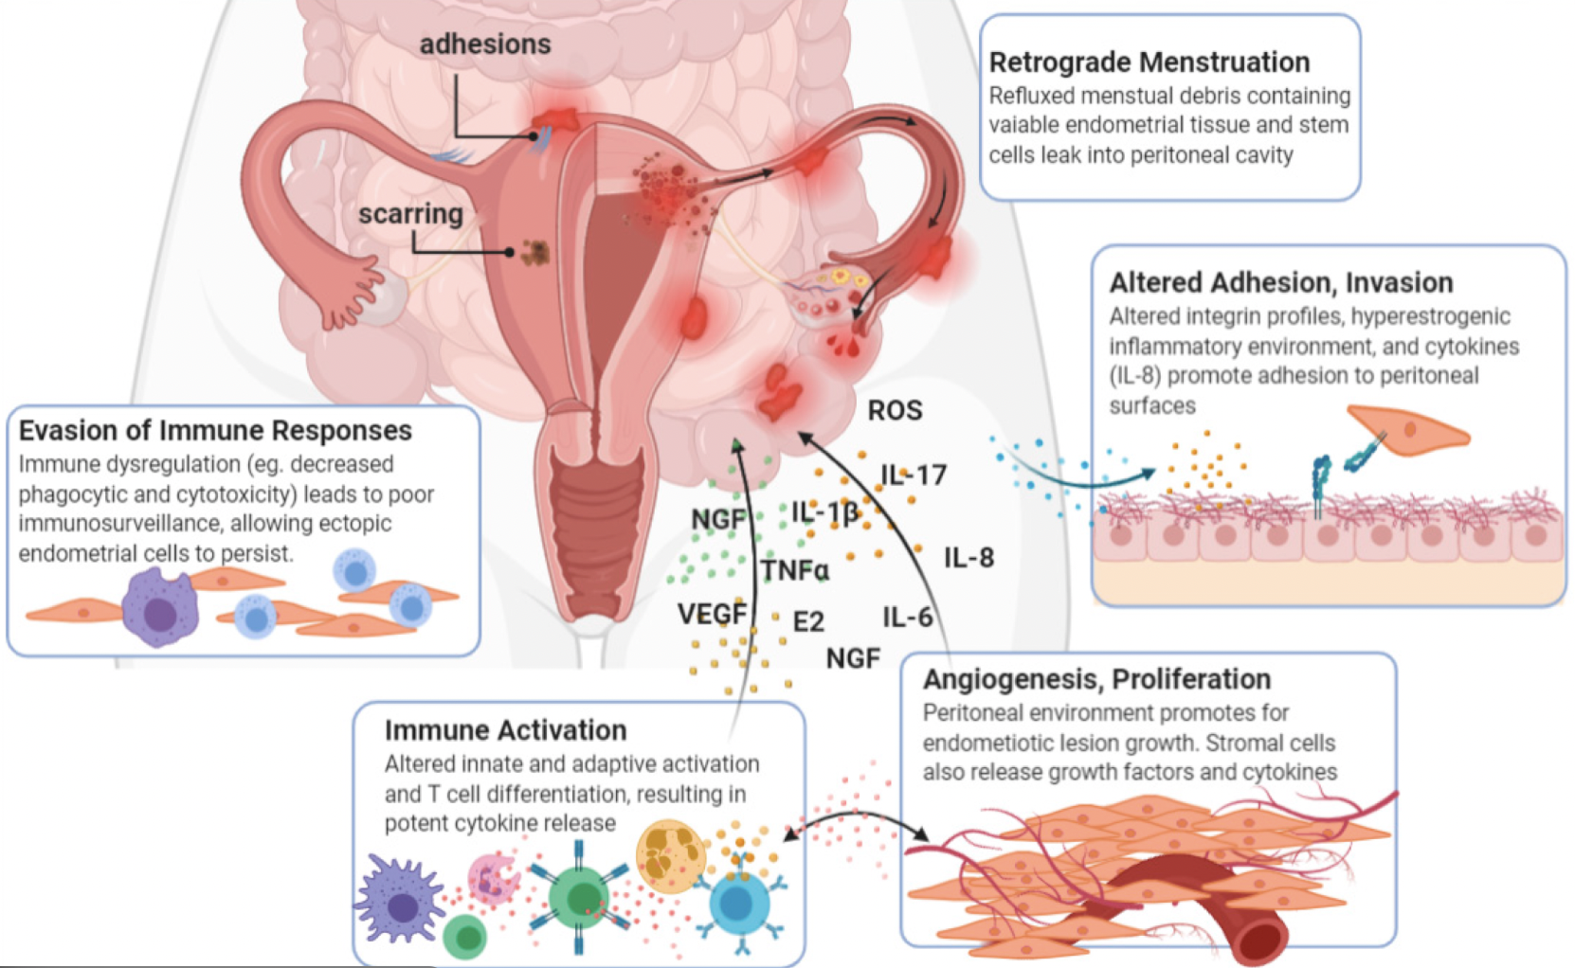

Figure 6. Schematic representation of the main pathogenic mechanisms involved in endometriosis.
The figure illustrates key processes underlying endometriosis development, including retrograde menstruation, immune response evasion, inflammatory cytokine release, oxidative stress, altered cell adhesion and invasion, and angiogenesis supporting ectopic lesion growth.

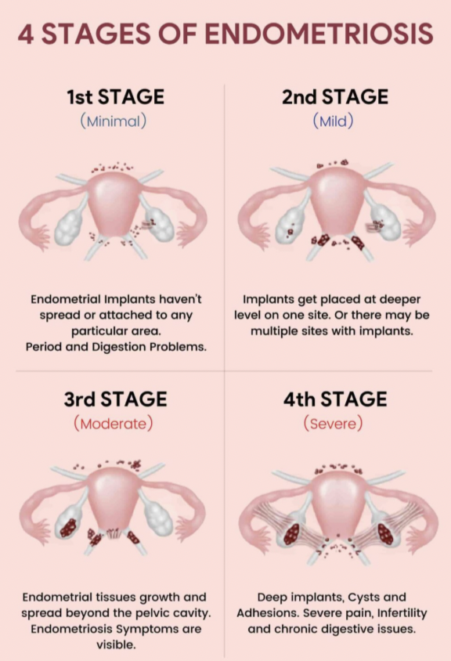

Figure 7. Classification of endometriosis into four stages.
The four-stage classification illustrated corresponds to a simplified representation of the revised American Society for Reproductive Medicine (rASRM) staging system, which is based on intraoperative findings and is used for postoperative disease staging rather than for diagnostic purposes.

1.2.2.2 Clinical Subtypes, Diagnosis, and Symptomatology
Endometriosis manifests in three main pelvic phenotypes that frequently coexist within the same patient: Superficial peritoneal endometriosis, ovarian endometriomas, deep infiltrating endometriosis and extraperitoneal endometriosis ¹⁹⁶ . (Figure 8) Superficial peritoneal endometriosis is the most common subtype and is characterized by lesions confined to the peritoneal surface with a depth of less than 5 mm¹⁸⁷.These lesions may appear as clear, white, red, or dark pigmented implants and are often difficult to detect using non-invasive imaging, requiring laparoscopic visualization for diagnosis¹⁸.
Ovarian endometriomas are cystic lesions containing ectopic endometrial tissue and hemosiderin-rich fluid, commonly referred to as “chocolate cysts,” and are frequently associated with deep infiltrating disease. They rarely regress spontaneously and generally require surgical management when symptomatic or large, although conservative monitoring may be appropriate in selected cases²¹².
Deep infiltrating endometriosis is defined by lesions penetrating at least 5 mm beneath the peritoneal surface and represents the most severe disease phenotype¹⁸⁷. It is strongly associated with severe chronic pain, infertility, and potential end-organ damage, including bowel obstruction and ureteral compromise¹⁸⁷.The most commonly affected sites include the uterosacral ligaments, posterior cul-de-sac, rectovaginal septum, rectosigmoid colon, and, less frequently, the urinary tract and anterior compartment.
Rarely, endometriosis may occur outside the pelvic cavity, involving extraperitoneal sites such as the diaphragm, thorax, skin, subcutaneous tissue, or surgical scars. These forms are associated with site-specific symptoms, including cyclical thoracic pain or catamenial pneumothorax, and are best evaluated using magnetic resonance imaging.
A key clinical feature of endometriosis is the lack of correlation between symptom severity and the anatomical extent of disease, as women with extensive lesions may be asymptomatic, whereas others with minimal disease can experience severe and disabling symptoms¹⁸³. This marked clinical heterogeneity represents one of the main challenges in diagnosis and management¹⁹⁶.
The classical presentation of endometriosis is traditionally described as a symptom triad including dysmenorrhea, deep dyspareunia, and infertility. Secondary dysmenorrhea is the most frequent manifestation and typically develops after years of relatively painless menstruation, with a gradual onset and progressive worsening over time. Unlike primary dysmenorrhea, pain associated with endometriosis often persists for several days, responds poorly to non-steroidal anti-inflammatory drugs, and may significantly interfere with daily functioning and quality of life¹⁸⁴ ²¹⁶.
Deep dyspareunia is another hallmark symptom and is commonly described as a deep pelvic or crushing pain during sexual intercourse. This symptom is strongly associated with deep infiltrating endometriosis involving the uterosacral ligaments and the rectovaginal septum and is frequently linked to reduced sexual satisfaction, decreased libido, and impaired intimate relationships.
Infertility affects a substantial proportion of women with endometriosis and may represent the sole clinical manifestation in some cases. The mechanisms underlying endometriosis-associated infertility are multifactorial and include peritoneal inflammation, anatomical distortion due to adhesions, altered tubal function, and impaired oocyte and embryo quality.
Beyond cyclical pain, many women develop chronic non-cyclical pelvic pain, which may become the predominant symptom over time. This transition from cyclical to persistent pain reflects the development of central sensitization and nociplastic pain mechanisms rather than ongoing peripheral tissue damage alone.
Deep infiltrating endometriosis involving pelvic organs is associated with organ-specific symptoms that often worsen during menstruation. Rectosigmoid involvement may cause dyschezia and, in advanced cases, cyclic rectal bleeding, whereas bladder or ureteral infiltration can result in dysuria, urinary frequency, or cyclic hematuria.
Extra-pelvic manifestations, although rare, may occur when endometriotic lesions involve the diaphragm or thoracic cavity, leading to cyclic chest pain, dyspnea, shoulder pain, or catamenial hemoptysis. These forms are frequently underdiagnosed due to their atypical presentation.
In addition to site-specific symptoms, many patients report non-specific complaints such as abdominal bloating, low back pain, abnormal uterine bleeding, gastrointestinal disturbances, urinary symptoms, and profound fatigue, the latter often being underestimated despite its significant impact on daily functioning.
The natural history of endometriosis is highly variable, with longitudinal laparoscopic studies demonstrating that lesions may progress, remain stable, or even regress in untreated women. These observations have challenged the traditional concept of endometriosis as a uniformly progressive disease²²⁶. Symptom onset commonly occurs during adolescence, while symptoms often improve after menopause due to estrogen deprivation, although persistent pain may continue in a subset of patients.
A proportion of women develop persistent chronic pelvic pain despite adequate surgical and medical treatment, reflecting a shift toward central sensitization and altered nociceptive processing. Nociplastic pain, defined as pain arising from altered nociception without clear evidence of ongoing tissue injury, has been increasingly recognized in endometriosis-associated pain syndromes. Proposed mechanisms include impaired descending inhibitory pathways and cross-sensitization between visceral and somatic structures at the spinal and supraspinal level.
Central sensitization may also explain the frequent coexistence of endometriosis with other chronic pain conditions such as vulvodynia, irritable bowel syndrome, painful bladder syndrome, and fibromyalgia. The resulting dissociation between lesion burden and symptom severity further contributes to diagnostic delay and therapeutic frustration¹⁹⁶.
Endometriosis has a profound negative impact on quality of life and psychological well-being. Women with endometriosis consistently report lower health-related quality of life compared with unaffected controls and exhibit high rates of depression and anxiety. Psychological comorbidities, including stress-related disorders and social withdrawal, are particularly common in patients with severe or long-standing disease.
The burden of disease extends across multiple domains of daily life, affecting work productivity, interpersonal relationships, sexual health, family planning, and overall mental health. Pain catastrophizing and maladaptive coping strategies further amplify pain perception and worsen quality of life, contributing to a self-perpetuating cycle of pain and psychological distress.
A major paradigm shift in international guidelines has occurred over the last decade, moving from surgical diagnosis based on laparoscopy with histological confirmation toward a non-surgical, clinical diagnosis grounded in symptoms, physical examination, and imaging findings. This transition has been driven by the recognition that diagnostic laparoscopy is not curative, exposes patients to surgical risks, and contributes to unacceptable diagnostic delays, which may extend up to 7–11 years from symptom onset.
Careful clinical history taking represents the cornerstone of endometriosis diagnosis. A large UK population-based case–control study involving more than 5,000 women with endometriosis identified several symptoms strongly associated with increased disease risk, including dysmenorrhea, deep dyspareunia or postcoital bleeding, chronic abdominopelvic pain, menorrhagia, and a history of subfertility. These findings highlight the importance of structured history taking focused on pain characteristics, temporal association with the menstrual cycle, symptom progression, impact on quality of life, and reproductive intentions.
Adolescents represent a particularly challenging population, as endometriosis may present with atypical or treatment-resistant dysmenorrhea, often leading to underrecognition and diagnostic delay in this age group.
Pelvic Physical Examination
Pelvic examination remains an important component of the diagnostic process, although its diagnostic accuracy is limited. Typical abnormal findings may include a fixed retroverted uterus, tenderness or nodularity of shortened uterosacral ligaments, palpable nodules in the posterior vaginal fornix suggestive of rectovaginal disease, adnexal masses consistent with ovarian endometriomas, and reduced ovarian mobility due to adhesions¹⁹⁷. However, a normal pelvic examination does not exclude endometriosis, particularly superficial peritoneal disease, underscoring the need for complementary imaging¹⁹⁷ ¹⁸³.
Transvaginal Ultrasound (TVS)
Transvaginal ultrasound is recommended as the first-line imaging modality for suspected endometriosis owing to its accessibility, cost-effectiveness, and high patient acceptability. TVS demonstrates high diagnostic accuracy for ovarian endometriomas and can identify alternative causes of pelvic pain while allowing dynamic assessment of organ mobility. (Figure 9) When performed by expert operators, TVS has been shown to outperform routine ultrasound in detecting deep infiltrating endometriosis (DIE), although a substantial learning curve, often exceeding 2,000 examinations, is required to achieve proficiency.
Nevertheless, TVS is operator-dependent and has limited sensitivity for superficial peritoneal lesions and certain DIE locations, such as the rectovaginal septum and parametrium.
To standardize ultrasound assessment, the International Deep Endometriosis Analysis (IDEA) consensus recommends a structured four-step approach that includes routine evaluation of the uterus and adnexa, assessment of site-specific tenderness and ovarian mobility, real-time evaluation of the sliding sign to assess cul-de-sac obliteration, and systematic examination of anterior and posterior pelvic compartments for DIE nodules²⁴⁵. This protocol has significantly improved the reproducibility and diagnostic performance of TVS in expert hands.
Magnetic resonance imaging is recommended as a second-line modality following TVS or when ultrasound is not feasible or acceptable, such as in virginal patients or those unable to tolerate transvaginal examination. MRI provides a comprehensive anatomical overview of the pelvis and demonstrates sensitivity and specificity exceeding 90% for DIE when interpreted by experienced radiologists. It is particularly valuable for detecting adenomyosis, retroperitoneal disease, and parametrial or ureteral involvement.
Despite these advantages, MRI is costly, less widely available, time-consuming, and shares the limitation of poor sensitivity for superficial peritoneal disease²⁰⁹.
Diagnostic laparoscopy is no longer recommended as a routine first-line diagnostic tool in international guidelines. Its use is discouraged because it does not constitute definitive treatment, carries inherent surgical risks, and may delay symptom management²²⁵. However, laparoscopic surgery with complete excision of lesions remains the gold standard for therapeutic management of deep infiltrating endometriosis when surgery is indicated, allowing both histological confirmation and symptom-directed treatment.
Although imaging and laparoscopic evaluation remain the cornerstones of endometriosis diagnosis, numerous studies have investigated the potential utility of biochemical biomarkers in supporting diagnosis and stratifying disease severity. Biomarkers may provide additional insight into the underlying biology of endometriosis and help identify patients with more active or extensive disease, even if no single marker has yet demonstrated sufficient diagnostic accuracy to replace standard methods.
In the peritoneal fluid of women with endometriosis, a distinct pro-inflammatory milieu has been consistently reported. Levels of cytokines such as interleukin-6 (IL-6), interleukin-8 (IL-8), tumor necrosis factor-α (TNF-α), and interleukin-1β (IL-1β) are elevated compared with controls, reflecting ongoing local inflammation and immune activation. Increased concentrations of macrophage populations, identified by markers such as CD14 and CD68, further support the presence of innate immune cell recruitment within the peritoneal environment. Additionally, elevated levels of vascular endothelial growth factor (VEGF) in peritoneal fluid indicate enhanced angiogenic activity, a process essential for ectopic lesion establishment and persistence⁷⁵.
Serum biomarkers have also been explored, although they tend to be less specific. Circulating pro-inflammatory cytokines such as IL-6 and IL-8 may reflect systemic inflammation associated with active endometriosis, but they lack specificity for endometriotic disease. The cancer antigen CA-125 remains the most extensively studied serum marker; while elevated CA-125 levels are associated with moderate to severe endometriosis, the marker’s sensitivity and specificity are insufficient for use as a standalone diagnostic test. Nonetheless, CA-125 may be useful in disease monitoring and in conjunction with clinical and imaging findings²⁴⁶.
Endometrial Tissue Biomarker
Analyses of eutopic endometrial tissue from women with endometriosis have revealed molecular alterations that may reflect local pathophysiological processes. Increased expression of aromatase (CYP19A1) within endometrial tissues is thought to contribute to localized estrogen production, reinforcing proliferative and inflammatory signaling within ectopic lesions. Altered expression of progesterone receptors, particularly reduced progesterone receptor B relative to A, has been documented and is interpreted as evidence of progesterone resistance, a feature implicated in abnormal endometrial receptivity and lesion persistence. Elevated expression of multiple endometrial cytokines and chemokines also characterizes tissues from affected women, consistent with a pro-inflammatory microenvironment that may underlie both lesion establishment and associated symptoms²²⁰.
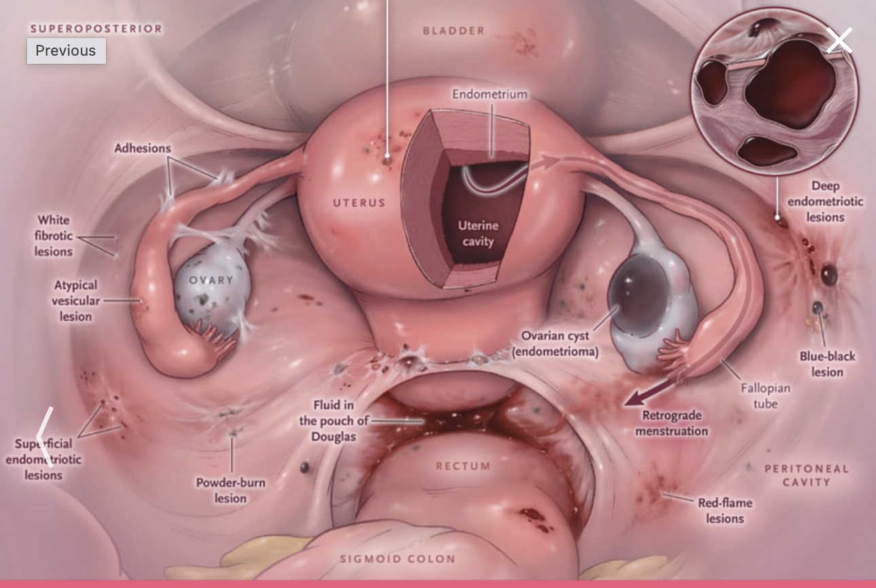
Figure 8. Anatomical distribution of endometriotic lesions within the pelvic cavity.
Schematic illustration showing common sites and morphological types of endometriosis, including superficial peritoneal lesions, ovarian endometriomas, deep infiltrating endometriotic lesions, adhesions, and inflammatory involvement of pelvic structures.
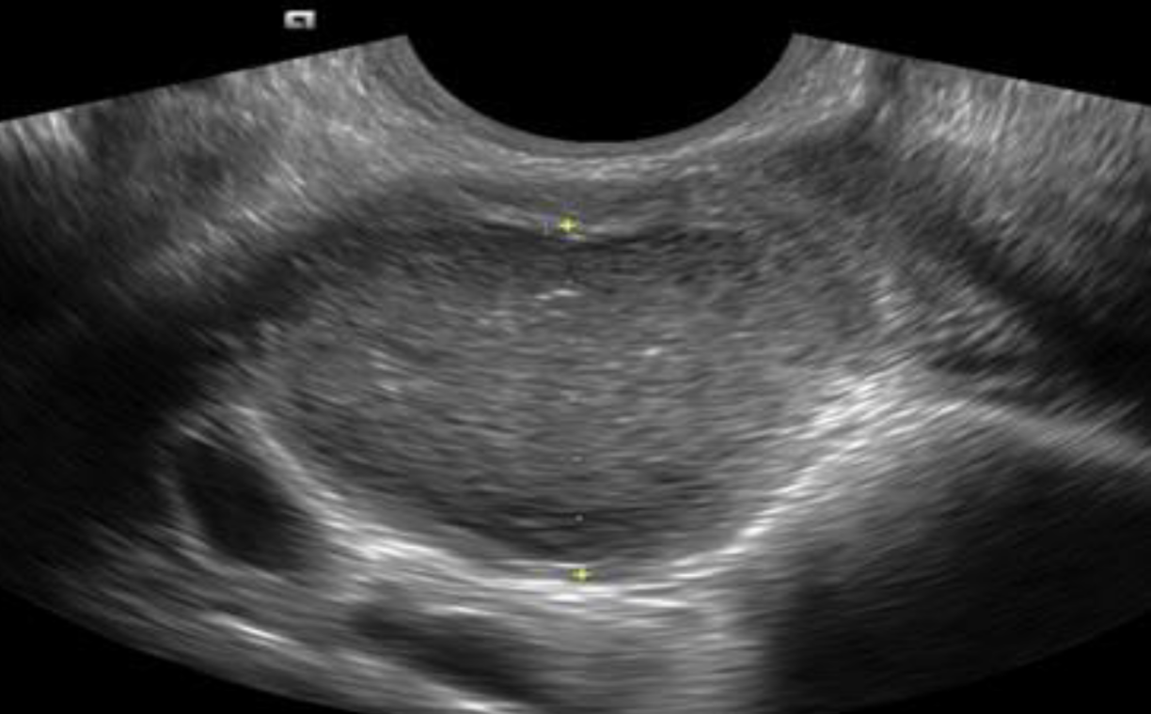

Figure 9. Transvaginal ultrasound image of an ovarian endometrioma.
The image shows a cystic ovarian lesion with homogeneous low-level internal echoes, consistent with the typical “ground-glass” appearance of an endometrioma.

1.2.2.3 Management and Treatment of Endometriosis
Endometriosis is a chronic inflammatory disease for which no definitive cure currently exists, and management is therefore aimed at long-term symptom control, preservation of fertility, and improvement of quality of life. Contemporary management strategies integrate medical, surgical, or combined approaches, with increasing recognition of the importance of multidisciplinary care, particularly in patients with complex disease or persistent pain syndromes (Vercellini et al., 2014; ESHRE Guideline, 2022).
Current international guidelines support a patient-centered approach in which endometriosis may be diagnosed clinically, without mandatory diagnostic laparoscopy, and in which first-line medical therapy can be initiated in primary or non-specialist care settings. Treatment decisions should be individualized based on symptom severity, reproductive goals, comorbidities, patient preferences, and the overall impact on quality of life, acknowledging that multiple therapeutic trials may be required to achieve adequate symptom relief¹⁹⁷.
Medical Treatment
Medical management represents the first-line approach for most symptomatic patients. Non-steroidal anti-inflammatory drugs are commonly used for dysmenorrhea, although evidence supporting their efficacy for chronic non-cyclical pain remains limited. Hormonal therapies, including combined hormonal contraceptives and progestin-only regimens, are the cornerstone of long-term treatment and demonstrate comparable efficacy in reducing endometriosis-associated pain. Continuous regimens are generally preferred over cyclic administration due to superior pain control¹⁹⁷. Second-line therapies are reserved for patients with refractory symptoms or intolerance to first-line options. Gonadotropin-releasing hormone (GnRH) agonists and antagonists effectively reduce pain by inducing a hypoestrogenic state, although their use is limited by menopausal-like adverse effects and bone mineral density loss, which can be mitigated by add-back therapy. Aromatase inhibitors may be considered in selected cases, typically in combination with ovarian suppression, whereas danazol is no longer recommended due to its unfavorable safety profile¹⁸⁴.
Surgical Treatment
Surgical intervention is indicated when medical therapy is contraindicated, poorly tolerated, ineffective, or when endometriosis causes organ dysfunction such as bowel or ureteral obstruction. Minimally invasive laparoscopic excision is the preferred surgical approach and is associated with reduced postoperative morbidity and faster recovery compared with laparotomy. Excisional techniques are favored over ablation when feasible, as they allow histological confirmation and may reduce recurrence rates¹⁹⁷.
Specific surgical strategies depend on disease phenotype. Ovarian endometriomas larger than 3 cm are optimally managed by cystectomy rather than drainage or ablation, although preservation of ovarian reserve is a critical consideration. Deep infiltrating endometriosis should be managed in specialized referral centers due to the need for multidisciplinary expertise and the higher risk of complications. Hysterectomy may be considered in selected patients with refractory symptoms who have completed childbearing, although it is not universally curative and pain may persist due to residual disease or central sensitization¹⁹⁷.
Chronic Pain and Multidisciplinary Care
A subset of patients continues to experience persistent pelvic pain despite optimal medical and surgical treatment. This condition is increasingly recognized as a manifestation of central sensitization or nociplastic pain and requires a multimodal, multidisciplinary approach. Effective management may include pelvic floor physiotherapy, psychological interventions such as cognitive behavioral therapy, and targeted pharmacologic strategies for neuropathic pain, emphasizing the importance of integrated care models¹⁸⁴.
Endometriosis-Associated Infertility
Endometriosis is associated with reduced fertility through multiple mechanisms, including distorted pelvic anatomy, inflammatory peritoneal environments, and impaired oocyte quality. Surgical treatment may improve spontaneous conception rates in patients with minimal to moderate disease, while the Endometriosis Fertility Index (EFI) is a validated tool for predicting post-surgical fertility outcomes. Importantly, assisted reproductive technologies, including IVF, remain effective in women with endometriosis, with pregnancy and live birth rates comparable to those observed in other infertility populations, except in cases of severely compromised ovarian reserve.
Early recognition and timely management of endometriosis are essential to reduce diagnostic delay and disease burden. Current evidence supports a shift toward non-surgical clinical diagnosis and individualized, patient-centered treatment strategies. While both medical and surgical therapies can provide substantial symptom relief, recurrence remains common, highlighting the chronic nature of the disease. Multidisciplinary care is essential for patients with persistent pain, and fertility outcomes with assisted reproduction are generally reassuring. Ongoing research is needed to refine therapeutic strategies and improve long-term outcomes for affected women (Vercellini et al., 2014; ESHRE Guideline, 2022).

AIM OF THE STUDY

The aim of the present study in line with the WHO commitment to “leave no one behind”, was to investigate the presence and composition of periodontal bacterial populations in women without periodontal disease but with and without reproductive disorder, in order to identify salivary biomarkers that may contribute to the early diagnosis of endometriosis as a non-invasive diagnostic biomarker.
The ultimate goal is to protect female health through the implementation of oral medicine and gender dentistry knowledge, in line with Goals 3 (health and well-being) and 5 (gender equality) of the United Nations 2030 Agenda for Sustainable Development.

MATERERIALS AND METHODS

3.1 Type of the study
The study is an observational case-control study, with a cross-section sampling.

3.2 Population and patient selection criteria
The population who donated the saliva sample included women in reproductive age (18-45 years), without any clinical sign of periodontal disease, according the 2017 periodontal disease classification.
Five women with a diagnosis of endometriosis, but with no treatment for it and five healthy women were finally recruited for the study.
Informed consent was obtained from all participants. Saliva sample collection was performed at the dental clinic of the School of Dentistry, ALDENT University, Tirana, Albania. Participant recruitment and sample collection were conducted between March 2025 and September 2025.
The study included patients with a previous ultrasound-based diagnosis of endometriosis who had discontinued medical therapy, as well as patients with an early diagnosis of endometriosis who had not yet undergone medical treatment.
All recruited patients presented with confirmed gynecological conditions, including uterine fibroids, abnormal uterine bleeding, and ovarian cysts. None of the enrolled patients had previously undergone surgical treatment for endometriosis.
Women with endometriosis currently receiving medical therapy and those diagnosed with polycystic ovary syndrome (PCOS) were not recruited. Additional exclusion criteria included pregnancy, smoking, diabetes, postmenopausal status, and suspected malignancy. Furthermore, participants who had received systemic antibiotic therapy within the previous three months, had undergone periodontal treatment within the last six months, or were affected by periodontal disease were excluded.
The sample recruitment process is illustrated in the flowchart presented in Figure 10.
The final sample size comprised 10 participants, including 5 women diagnosed with endometriosis without periodontal disease and 5 women without endometriosis and without periodontal disease, serving as the control group.

3.3 Endometriosis classification used in recruiting

Women with endometriosis were recruited at the Tirana Clinic and included subjects with a confirmed diagnosis of endometriosis based on transvaginal ultrasound (TVS), which is currently regarded as the first-line diagnostic imaging modality for the assessment of ovarian endometriosis¹⁸⁴ ¹¹.
Periodontal screening was performed by dentists immediately following gynecological recruitment.
Diagnosis was supported by gynecological clinical records, and recruitment was based on clinical and imaging criteria, without the application of surgical staging or classification systems. Patient selection was conducted in accordance with predefined inclusion and exclusion criteria. The study included patients with a previous ultrasound-based diagnosis of endometriosis who had discontinued medical therapy, as well as patients with an early diagnosis of endometriosis who had not yet received medical treatment. All recruited patients presented with gynecological conditions confirmed in their clinical records, including uterine fibroids, abnormal uterine bleeding, and ovarian cysts. None of the enrolled patients had previously undergone surgical treatment for endometriosis.

3.4 Periodontal disease classification used in recruiting
Periodontal screening was performed by dentists immediately following gynecological recruitment.
The periodontal parameters assessed and recorded were based on the latest classification of periodontal disease as defined by the American Academy of Periodontology (AAP) and the European Federation of Periodontology (EFP) in 2017, updating the previous classification system²⁵⁸. (Table 1)
The instruments utilized for periodontal screening included an intraoral mirror and the Williams periodontal probe (Hu-Friedy, Chicago, IL, USA).
All surfaces of all present teeth were examined using the Plaque Index (PI) and Gingival Index (GI), and the mean values were recorded.
Periodontal pockets were measured as the distance from the gingival margin to the position of the periodontal probe tip inserted into the pocket using the Williams probe.
Pocket depth was assessed on each tooth at six sites, namely mesiobuccal, buccal, distobuccal, mesiolingual, lingual, and distolingual, and the mean value was calculated.
Clinical attachment loss (CAL) was measured as the distance from a fixed anatomical reference point, that is the cementoenamel junction (CEJ), to the base of the probable pocket using the Williams probe. Based on the mean CAL scores, the severity of periodontal disease was classified.
Individuals without gingivitis or periodontitis were considered to have a healthy periodontal status, and full-mouth radiographs were not deemed necessary to confirm this health condition.

3.5 Saliva Sampling
Saliva sampling was performed following the dental examination of the recruited eligible patients, using sterile tubes into which patients collected their saliva sample.
Prior to saliva collection, all patients were instructed to:
refrain from drinking, eating, and chewing gum for at least 2 hours before sampling;
avoid using chlorhexidine-based mouthrinses and not undergo antibiotic therapy in the 6 months preceding saliva collection.
Following the sampling procedure, two dental operators (FA and FR) were tasked with collecting the saliva from each sample using 5 sterile paper cones, subsequently placing the cones into the appropriate collection tubes provided by the Biomolecular Diagnostic kit. (Figure 11-12)
All kits containing paper points were stored under refrigerated conditions (2–8 °C) for short-term storage throughout the 10-day collection period before being shipped to the same company for subsequent analysis.

3.6 The saliva testing and Real-PCR
The BPA microbiological test (Bacterial Periodontal Assessment), performed by Biomolecular Diagnostic using RealTime PCR methodology, provides qualitative and quantitative results concerning bacterial, fungal, and viral populations present in the oral cavity, responsible for periodontitis and implant-related complications.
Real-Time PCR is a highly sensitive and specific molecular technique that enables the amplification and simultaneous quantification of target DNA sequences through the detection of fluorescent signals generated during the amplification process. During analysis, specific primers and fluorescent probes bind to target microbial DNA sequences, and the progressive increase in fluorescence intensity at each amplification cycle is directly proportional to the amount of amplified product, allowing real-time monitoring and accurate quantification of low-abundance microorganisms. Owing to its high analytical sensitivity and precision, this methodology is particularly suitable for the investigation of complex microbial communities, such as the oral microbiota. The test may furnish indications regarding the overall composition of the populations present in the oral cavity (multisite BPA), or specific indications for individual periodontal pocket sites (site-specific BPA). (Table 2)
The BPA test provides various levels of analytical depth, thereby responding to the diverse clinical requirements of the practitioner.

3.7 Statistical Analysis
Due to the sample size, the data were analyzed using the Mann–Whitney test, followed by the Bonferroni post-hoc analysis for multiple comparisons. The hypothesis was considered null if the p value resulted < 0.05. The calculations were performed sing GraphPad Prism version 10.6.1(892) for Windows, GraphPad Software, Boston, Massachusetts USA, www.graphpad.com.

3.8 Ethics
The present study was approved by the Medical Ethics Committee of the School of Dentistry “ALDENT” University of Tirana, Albania (approval number 18/1, March 4, 2025), and all participants reviewed, completed, and signed a written informed consent form.

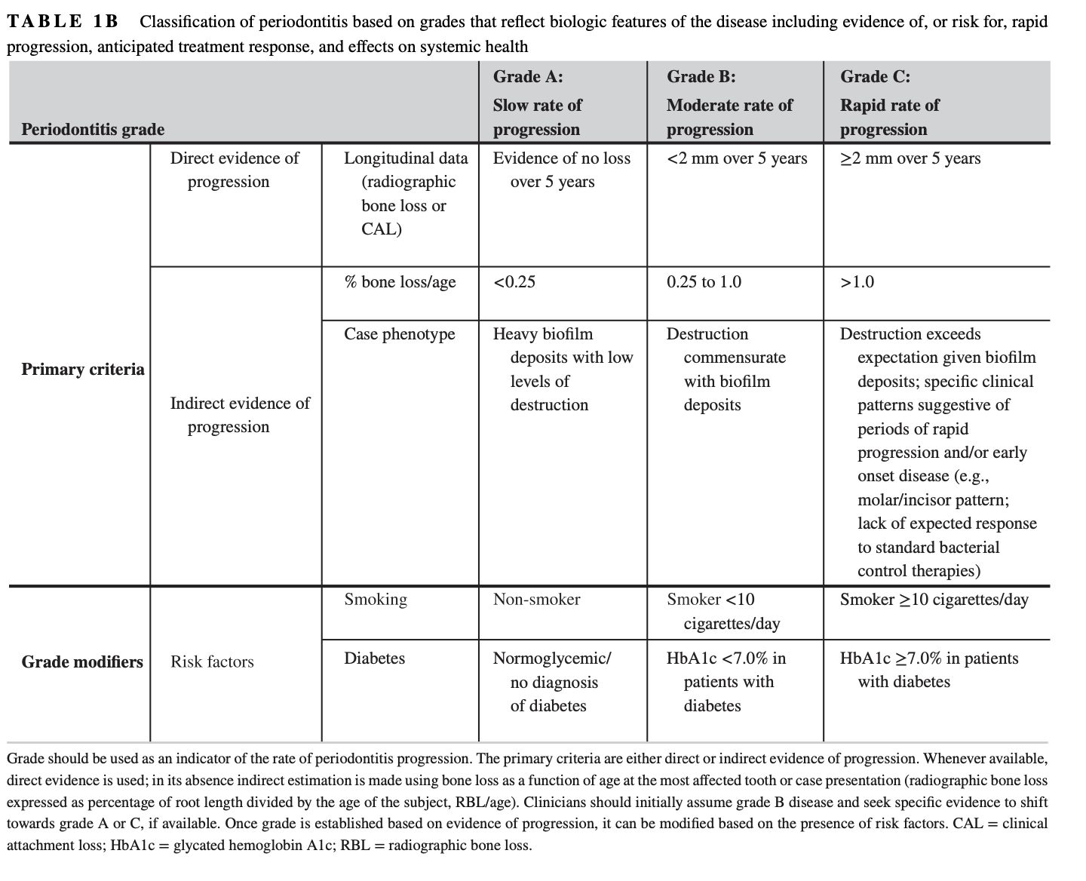

Table 1 Classification of periodontitis based on grades that reflect biologic features of the disease including evidence of, or risk for, rapid progression, anticipated treatment response, and effects on systemic health

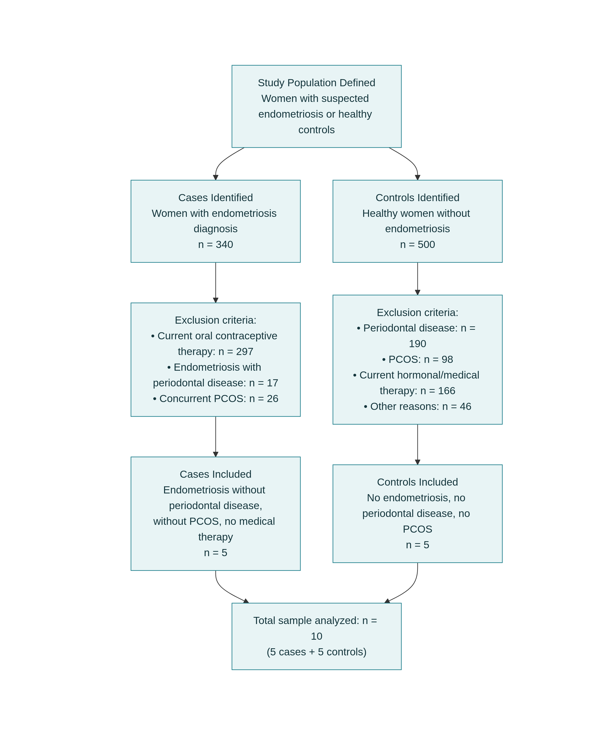

Figure 10. Flowchart of Patient Recruitment: Observational Case-Control Study on Endometriosis and Periodontal Disease Exclusion reasons were mutually exclusive.

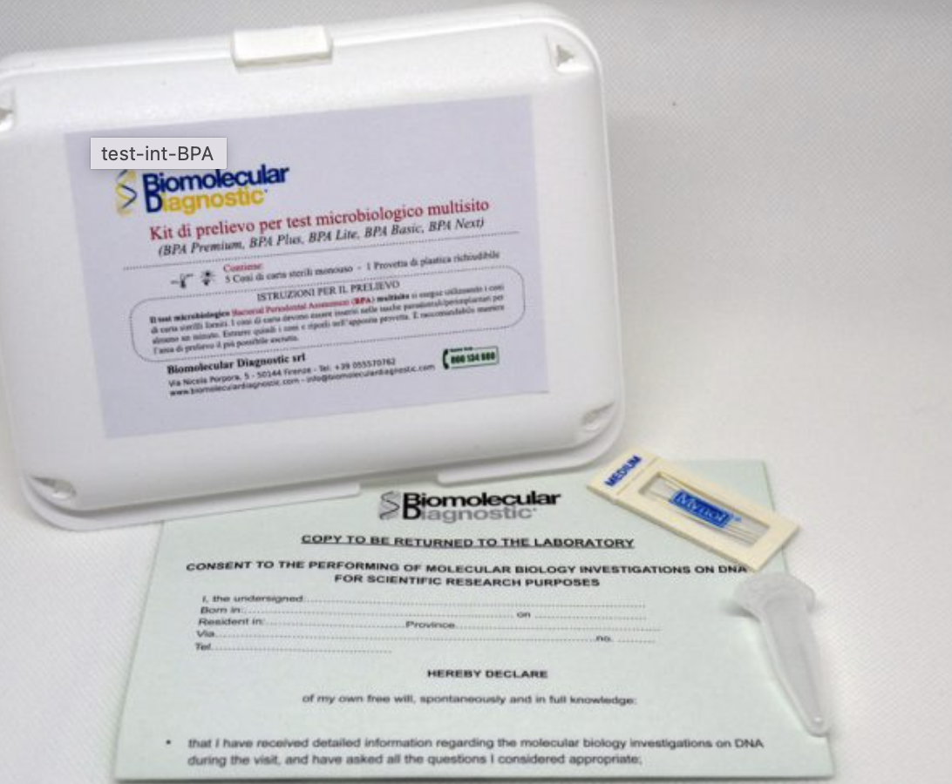

Figure 11. Appropriate collection tubes provided by the Biomolecular Diagnostic kit.

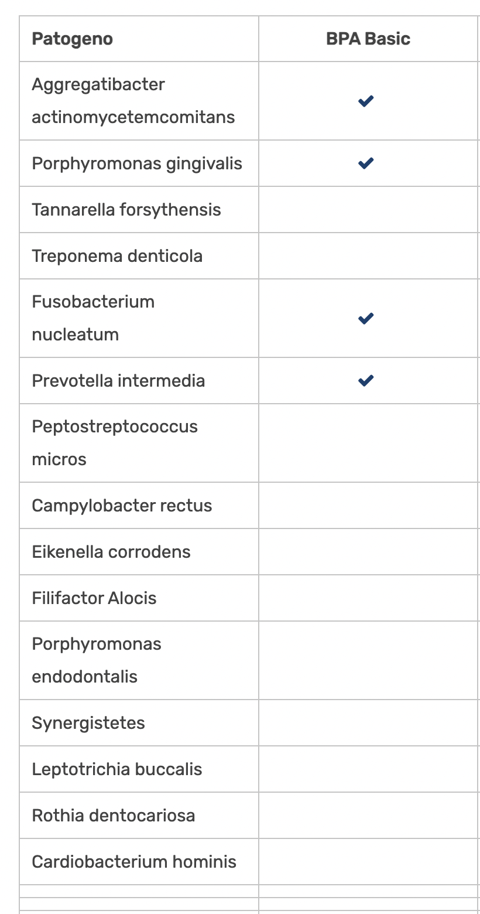
Table 2. Periodontal pathogens analyzed using the biomolecular diagnostic kit (BPA Basic).

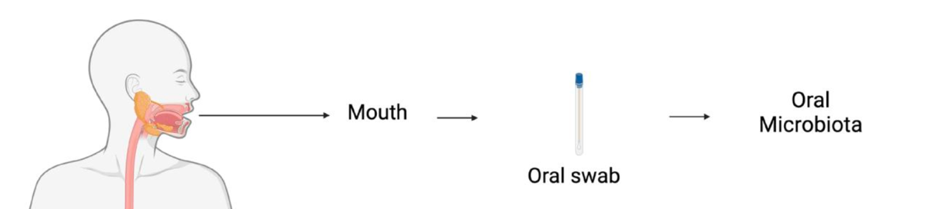

Figure 12. Overview of sample collection and study cohorts. All participants were provided with kits for saliva sample collection. The diagram illustrates the collection of oral microbiota using an oral swab obtained from the oral cavity prior to laboratory analysis.

4. RESULTS

4.1 Quantitative real-time PCR results of periodontal pathogens in healthy controls and endometriosis patients
Five endometriosis patients and clinically periodontally health were selected for the study and five health women in reproductive age (between 18 and 45 years of age).
The RealTime PCR revealed a microbial percentage higher in the endometriosis group than in the control group (Tables 3 and 4).
As regard the presence of the investigated bacteria, two species appear to prevail in the endometriosis group: P.Intermedia and F. Nucleatum (Table 3).
Endometriosis Patients | Aggregatibacter actynomicetemcomitans | Porphyromonas gingivalis | Prevotella Intermedia | Fusobacterium nucleatum | % pathogens
1 | 0 | 0 | 6.67* 10³ | 1.06 * 10³ | 12.9
2 | 0 | 0 | 3.31* 10² | 3.02 * 10² | 7.6
3 | 3.77 * 10³ | 0 | 4.09 * 10³ | 7.65 * 10² | 27.2
4 | 0 | 0 | 0 | 2.74 * 10² | 5.6
5 | 0 | 0 | 9.12* 10³ | 5.49 * 10³ | 16.3
The Mann Whitney test between the F. Nucleatum of the endometriosis and the control groups did not result statistically significant with a p-value = 0.05 (Table 5).
Table 3. RealTime PCR of the endometriosis patients microbial saliva.

Control Patients | Aggregatibacter actynomicetemcomitans | Porphyromonas gingivalis | Prevotella Intermedia | Fusobacterium nucleatum | % pathogens
1 | 0 | 0 | 2.72* 10³ | 1.08 * 10² | 15
2 | 0 | 0 | 0 | 0 | 0
3 | 1.81* 10² | 0 | 8.08 * 10³ | 7.82 * 10² | 12
4 | 0 | 0 | 0 | 1.13 * 10² | 3
5 | 0 | 0 | 0 | 0 | 0
Table 4. RealTime PCR of the control subjects microbial saliva.

Mann Whitney test between Endometriosis and Control Patients- F. nucleatum | 3
P value | 0.0556
Table 5. Mann Whitney test. P value = 0.05.

4.2 Relative distribution of periodontal bacterial complexes
The relative distribution of periodontal bacterial complexes differed between groups. Healthy controls were predominantly characterized by saprophytic bacteria, whereas patients with endometriosis showed an increased proportion of orange complex species and the presence of red complex bacteria. These findings suggest a shift toward a more dysbiotic subgingival microbiota in endometriosis patients.
The relative distribution of periodontal bacterial complexes differed between groups. Healthy controls showed a microbiota predominantly composed of saprophytic bacteria, whereas patients with endometriosis exhibited an increased proportion of orange complex species and the presence of red complex bacteria (Table 6, Figure 13).
Bacterial complex | Healthy controls (%) | Endometriosis patients (%)
Saprophytic bacteria | 86.8 ± 8.5 | 72.3 ± 11.6
Orange complex | 13.2 ± 8.5 | 24.9 ± 10.4
Red complex (extended) | 0.0 ± 0.0 | 2.8 ± 6.1
Table 6. Relative distribution of periodontal bacterial complexes in healthy controls and endometriosis patients.
Data are expressed as mean ± SD of relative abundance (%).
Relative distribution was calculated from real-time PCR analysis of subgingival samples.

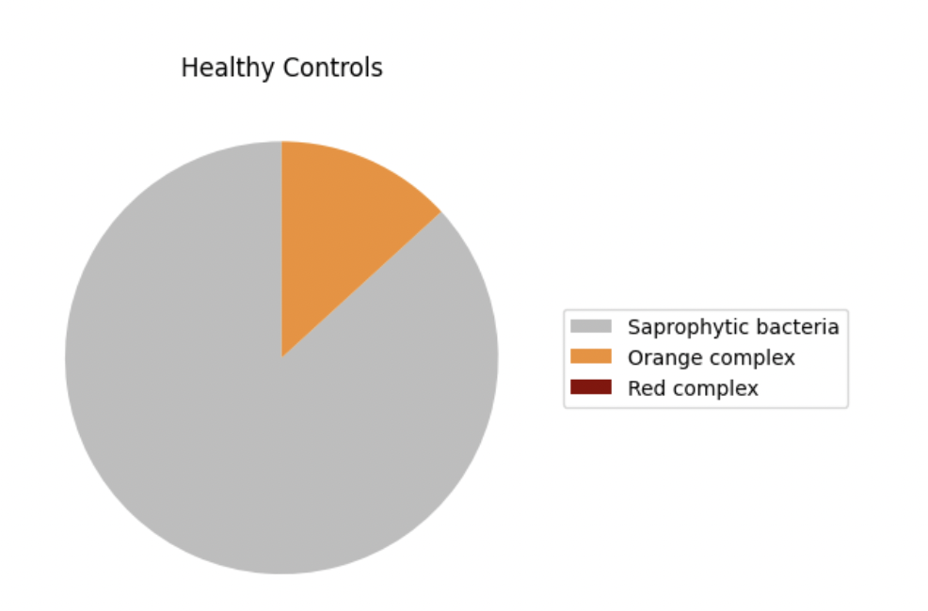
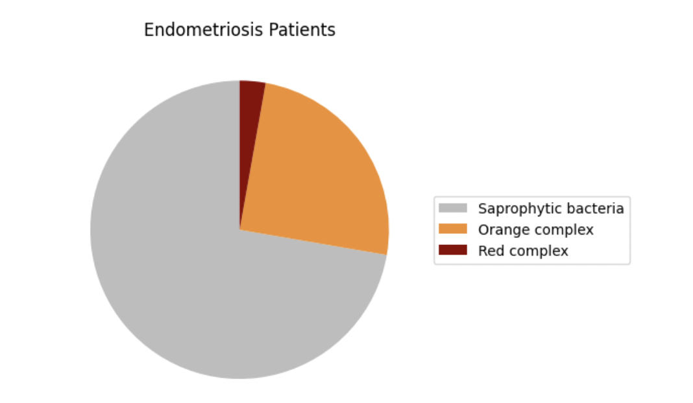

Figure 13. Relative distribution of periodontal bacterial complexes.
(A) Healthy controls. (B) Endometriosis patients.
(A) Healthy controls exhibited a microbiota predominantly composed of saprophytic bacteria, with a limited representation of orange complex species and no detectable red complex bacteria. (B) Patients with endometriosis showed a shift toward a more dysbiotic microbial profile, characterized by an increased proportion of orange complex bacteria and the presence of red complex species.

5. DISCUSSIONS

Oral environment and systemic diseases: two voices talking each other
The present study explored the subgingival microbial profile of women affected by endometriosis using real-time PCR, focusing on both quantitative bacterial load and the relative distribution of periodontal bacterial complexes. The results indicate discernible differences between endometriosis patients and healthy controls, suggesting an association between endometriosis and a shift toward a more dysbiotic periodontal microbiota.
Quantitative PCR findings revealed a higher total bacterial load and an increased detection of periodontal pathogens in the endometriosis group. Bacteria belonging to the orange complex, including P. Intermedia and F. Nucleatum, accounted for a greater proportion of the microbial burden compared with controls. These species are recognized as key contributors to periodontal inflammation and are often implicated in the transition from microbial homeostasis to dysbiosis within the subgingival niche³⁴.
The analysis of the relative distribution of bacterial complexes further supported these observations. Healthy controls exhibited a microbiota largely dominated by saprophytic species, whereas patients with endometriosis showed an enrichment of orange complex bacteria and the presence of red complex species. This microbial pattern is clinically relevant, as the predominance of orange and red complex bacteria has been associated with increased inflammatory activity and periodontal tissue susceptibility, even in individuals without overt clinical signs of periodontitis ³⁹.
The microbial alterations observed in endometriosis patients may be explained by the systemic inflammatory and hormonal environment characteristic of the disease. Endometriosis is a chronic estrogen-dependent condition associated with immune dysregulation, oxidative stress, and elevated circulating levels of pro-inflammatory cytokines¹⁸³²²⁰.These systemic factors may influence the oral ecosystem by modifying host immune responses, salivary composition, and epithelial barrier integrity, thereby promoting the colonization and persistence of periodontal pathogens¹⁵⁰.
It appears clear the oral cavity environment may reflect systemic inflammatory disorders, supporting the idea of oral biomarkers as indicators of systemic disease.
The absence of clinical periodontal disease limits the ability to establish a direct link between microbial alterations and tissue destruction; however, it also supports the hypothesis that endometriosis-associated dysbiosis may represent an early, preclinical microbial shift .
Similar observations have been reported in other systemic inflammatory conditions, reinforcing the hypothesis that subclinical microbial changes may represent an early stage of periodontal involvement.
Although the difference in F. nucleatum abundance did not reach statistical significance, the observed trend suggests that the lack of significance may be related to the limited sample size rather than the absence of a biological effect.
F. nucleatum: an oral biomarker in a disease modifier of the oral microbial ecosystem
Fusobacterium nucleatum is a Gram-negative anaerobic bacterium with well-recognized pro-inflammatory properties and the ability to substantially influence host immune responses. At the molecular level, structural components of the bacterial cell wall, particularly lipopolysaccharide (LPS), interact with Toll-like receptors, mainly TLR4, triggering innate inflammatory signaling pathways. This activation results in the release of pro-inflammatory cytokines, increased oxidative stress, and impairment of inflammation-resolution mechanisms¹⁸³.
Through these mechanisms, F. nucleatum may contribute to the maintenance of a persistent inflammatory state, acting as a potential amplifier of systemic inflammation. This aspect is particularly relevant in the context of endometriosis, a chronic condition characterized by immune dysregulation and elevated circulating levels of inflammatory mediators, which play a central role in disease pathophysiology¹⁸³.
Bacterial translocation
A distinctive feature of F. nucleatum is its documented capacity for hematogenous dissemination from the oral cavity to extra-oral sites. Clinical observations and experimental studies have demonstrated that this microorganism can reach the placenta and amniotic fluid originating from the oral microbiota, overcoming epithelial and vascular barriers.
In murine models, intravenous inoculation of F. nucleatum during pregnancy leads to infection localized to the feto-placental unit and subsequent fetal loss. Importantly, the absence of TLR4 markedly reduces fetal mortality, indicating that host-mediated inflammatory responses, rather than bacterial presence alone, are the primary drivers of tissue damage.
Collectively, these findings support the hypothesis that F. nucleatum may function as a microbial “messenger” between the oral cavity and distant anatomical sites, contributing to the systemic spread of inflammation.
In recent years, this concept has been further expanded by a hypothetical model proposing that microbial and inflammatory signals may act very early in life, potentially influencing susceptibility to endometriosis later in adulthood. García-Peñarrubia et al. suggested that alterations of the maternal gut–genital microbiota, together with subclinical infections, may contribute to immune programming during prenatal and perinatal life, thereby creating a permissive environment for endometriosis development (Hum Reprod Update. 2020).
According to this model, bacteria originating from the oral cavity may survive transit through the gastrointestinal tract, colonize the intestinal microbiota, and interact with mucosal immune barriers. From this perspective, vertical microbial transmission may occur during vaginal delivery, particularly given the anatomical proximity between the vaginal and anal canals, allowing maternal microorganisms to colonize the neonatal microbiome. These early-life microbial exposures may persist as part of the offspring’s microbiota and contribute to long-term immune modulation, potentially increasing susceptibility to chronic inflammatory conditions such as endometriosis.
In recent years, Fusobacterium nucleatum has been proposed as a potential co-factor in the development of certain gynecological disorders. A translational study conducted in a Japanese cohort reported the detection of Fusobacterium DNA or viable bacteria in the endometrium or endometriotic lesions in approximately 60–65% of women with endometriosis, compared with less than 10% of control subjects, suggesting a possible role in lesion implantation and persistence.
However, subsequent investigations have failed to consistently demonstrate a significant presence of F. nucleatum in eutopic endometrial tissue across all analyzed cohorts, indicating that this association may be restricted to specific patient subgroups rather than being universally applicable to all individuals with endometriosis.
Beyond endometriosis, alterations of the female reproductive tract microbiota characterized by an increased abundance of Fusobacterium have also been described in certain gynecological malignancies, such as high-grade endometrial carcinoma, where this bacterial genus has been explored as a potential prognostic biomarker.
Overall, these observations suggest that F. nucleatum may exert a dual role within the female reproductive tract: at low levels, it may act as a physiological modulator of the local immune environment, whereas at higher concentrations it may promote pathological inflammation, reflecting a delicate balance between commensalism and disease.
Recent experimental evidence further supports a potential mechanistic role of Fusobacterium nucleatum in endometriosis pathogenesis. In a murine model, Muraoka et al. demonstrated that Fusobacterium is able to proliferate within ectopic endometrial tissue and actively promote lesion development. The authors showed that bacterial infection induces fibroblast-to-myofibroblast transition through activation of TGF-β and IL-6 signaling pathways, leading to increased cellular proliferation, migration, and extracellular matrix remodeling. Notably, regression of endometriotic lesions was observed following targeted antibiotic eradication of Fusobacterium, rather than periodontal treatment per se, indicating that bacterial presence plays a direct role in lesion progression. Importantly, this experimental model did not involve periodontal disease, suggesting that Fusobacterium-mediated effects on endometriosis may occur independently of overt periodontal pathology and may reflect a broader systemic microbial influence¹⁰².
Rather than acting as a direct etiological factor for periodontal disease, endometriosis may be conceptualized as a systemic modifier of the oral microbial ecosystem, capable of lowering the threshold for dysbiosis in individuals who are otherwise periodontally healthy. Endometriosis is characterized by chronic low-grade systemic inflammation, immune dysregulation, oxidative stress, and altered hormonal signaling, all of which may influence host–microbe interactions beyond the pelvic environment¹⁸³.
Systemic inflammatory mediators and hormonal fluctuations associated with endometriosis may affect key protective mechanisms within the oral cavity, including epithelial barrier integrity, salivary composition, and innate immune surveillance. Such alterations could reduce host tolerance to otherwise commensal microbial communities, facilitating a shift toward a dysbiotic oral microbiota without the immediate manifestation of clinical periodontal disease¹⁵⁰.
In this framework, changes in the subgingival microbial profile observed in women with endometriosis may reflect a preclinical ecological imbalance rather than overt periodontal pathology. This concept is consistent with current models of periodontal disease pathogenesis, in which host susceptibility and systemic modifiers play a crucial role in determining microbial community structure and inflammatory outcomes³⁹.
Therefore, endometriosis may indirectly shape the oral microbial ecosystem by creating a systemic environment that favors dysbiosis, supporting the hypothesis that oral microbial alterations in these patients represent an early biological signal of systemic inflammatory burden rather than a direct consequence of local periodontal breakdown.
Oral microbiota as a potential non-invasive biomarker
The findings of the present study further support the emerging concept of the oral microbiota as a potential non-invasive biomarker of systemic inflammatory conditions. The qualitative and quantitative alterations observed in the subgingival microbial profile of women with endometriosis suggest that the oral cavity may reflect, at least in part, the systemic inflammatory milieu associated with the disease.
In this perspective, the oral microbiota may represent an accessible biological interface capable of mirroring host immune and inflammatory status. Unlike traditional clinical assessments, which often detect disease only after the onset of overt symptoms, microbial profiling may capture early ecological shifts toward dysbiosis, even in the absence of clinically evident periodontal disease. This concept is consistent with current models of periodontal pathogenesis, in which microbial imbalance precedes tissue destruction and is strongly influenced by host susceptibility and systemic modifiers¹⁵⁰.
The use of high-sensitivity biomolecular techniques, such as real-time PCR, allows the detection of subtle microbial changes that may be indicative of altered host–microbiota interactions. In women with endometriosis, such microbial signatures could complement gynecological and clinical evaluations, contributing to a more comprehensive characterization of the inflammatory phenotype and potentially supporting individualized monitoring strategies¹²⁵.
Importantly, the absence of overt periodontal disease in the study population strengthens the hypothesis that the observed microbial alterations represent a preclinical or subclinical signal rather than a consequence of local periodontal breakdown. Similar patterns have been reported in other systemic inflammatory conditions, where microbial shifts precede or occur independently of clinically manifest periodontal pathology.
Taken together, these observations suggest that oral microbial profiling may hold promise as a non-invasive adjunctive biomarker in the context of endometriosis. While causality cannot be inferred from the present findings, the identification of oral microbial signatures associated with systemic inflammatory states opens new perspectives for integrative, multidisciplinary approaches to disease assessment and monitoring. Future studies conducted on larger and more diverse cohorts will be essential to validate the clinical utility of oral microbiota-based biomarkers and to define their potential role in personalized management strategies for women with endometriosis.

6. LIMITATIONS

Several limitations should be acknowledged. The small sample size limits the generalizability of the findings and restricts the ability to perform robust inferential statistical analyses. Moreover, the cross-sectional design precludes conclusions regarding causality. Potential confounding factors, including dietary habits, psychosocial stress, and subtle hormonal variations, could not be fully controlled. Future studies employing larger cohorts, longitudinal designs, and integrated assessments of periodontal clinical parameters and systemic inflammatory biomarkers are needed to clarify the relationship between endometriosis and periodontal dysbiosis.
The use of saliva samples, while limiting site-specific periodontal interpretation, may better reflect systemic influences on the oral microbiota, which is particularly relevant in the context of a systemic inflammatory disease such as endometriosis.
Despite these limitations, the present study provides novel preliminary evidence supporting an association between endometriosis and alterations in the periodontal microbiota. These findings contribute to the growing body of literature on oral–systemic health interactions and underscore the importance of interdisciplinary collaboration between dental and gynecological healthcare professionals. Early periodontal monitoring may represent a valuable component of comprehensive care in women affected by endometriosis.

7. CONCLUSIONS
The present study analyzes the relationship between disorders of the female reproductive sphere and the implications of oral medicine, highlighting possible bidirectional interactions and shared pathogenetic mechanisms. The adoption of integrated multidisciplinary strategies, involving gynecological and dental expertise, may contribute to optimizing clinical outcomes and promoting better overall health in women. In this context, early diagnosis, the implementation of timely interventions, and the adoption of preventive measures aimed at maintaining oral health through appropriate oral hygiene play a fundamental role.
Overall, these results suggest that the analysis of the oral microbiota, through biomolecular techniques, could represent a complementary non-invasive tool in the early identification of alterations associated with periodontal and reproductive disorders, to be integrated with traditional diagnostic approaches.
A multidisciplinary approach involving gynecological and dental expertise therefore appears desirable for a more comprehensive evaluation of women’s health and for the implementation of targeted preventive and monitoring strategies.
In conclusion, further studies will be necessary to clarify the role of these interactions in periodontitis and in reproductive pathologies such as endometriosis, as well as to further investigate the biological processes involved.

REFERENCES

Bianchi S, Nottola SA, Torge D, Palmerini MG, Macchiarelli G, Cecconi S. Association between female reproductive health and mancozeb: systematic review of experimental models. Int J Environ Res Public Health. 2020;17(7):2580. doi:10.3390/ijerph17072580.
As-Sanie S, Mackenzie SC, Morrison L, Schrepf A, Zondervan KT, Horne AW, Missmer SA. Endometriosis: A Review. JAMA. 2025 Jul 1;334(1):64-78. doi: 10.1001/jama.2025.2975. PMID: 40323608.
Garcia-Penarrubia P, Ruiz-Alcaraz AJ, Martinez-Esparza M, Marin P, Machado-Linde F. Hypothetical roadmap towards endometriosis: prenatal endocrine-disrupting chemical pollutant exposure, anogenital distance, gut-genital microbiota, and subclinical infections. Hum Reprod Update. 2020;26(2):214-246. doi:https://doi.org/10.1093/humupd/dmz044
Bernardi S, Falisi G, Tari SR, Al-Hamed FS, Scarano A. One out of ten: when oral medicine should not leave behind women affected by reproductive disorders. Ann Stomatol (Roma). 2024;2(1):1-6. doi:10.5281/zenodo.10412345
Wang Y, Wu Y, Song J. Global and Regional Burden of Periodontal Disease in Adults (1990-2021). Int Dent J. 2025 Dec;75(6):103883. doi: 10.1016/j.identj.2025.103883. Epub 2025 Sep 3. PMID: 40902507; PMCID: PMC12444476.
Van Dyke TE, Bartold PM, Reynolds EC. The Nexus Between Periodontal Inflammation and Dysbiosis. Front Immunol. 2020 Mar 31;11:511. doi: 10.3389/fimmu.2020.00511. PMID: 32296429; PMCID: PMC7136396.
Joseph, R.A.; Ajitkumar, S.; Balaji, S.K.; Santhanakrishnan, M. Evaluation of Microbial Profile in Patients with Polycystic Ovary Syndrome and Periodontal Disease: A Case-Control Study. Int. J. Fertil. Steril. 2023, 17, 248–253.
Huddleston, H.G.; Dokras, A. Diagnosis and Treatment of Polycystic Ovary Syndrome. JAMA 2022, 327, 274–275.
Machado VM, Tavares AM, Lopes FF, et al. Periodontitis and female infertility: a systematic review. J Obstet Gynaecol Res. 2020;46(10):1892-901. doi:10.1111/jog.14391.
Angiolani, F.; Gerardi, D.; Bernardi, S.; Torge, D.; Bianchi, S.; Piattelli, M.; Varvara, G. Bidirectional Relationship Between Periodontal Disease and Reproductive Disorders: Focus on Polycystic Ovary Syndrome. Oral 2025, 5, 67. https://doi.org/10.3390/oral5030067
Thomas V, Bhat KG, Katti S, Kushtagi P. Periodontal disease and reproductive health: an observational study among women with endometriosis. J Hum Reprod Sci. 2018;11(3):256-61. doi:10.4103/jhrs.JHRS_138_18.
Jin B, Chen Y, Li Z, Zhang H, Li Y, Zhao Q, et al. Periodontitis and peritoneal endometriosis: a bidirectional causal relationship? A two-sample Mendelian randomization study. Front Immunol. 2024;15:1423079. doi:10.3389/fimmu.2024.1423079
Bianchi, S.; Bernardi, S.; Mattei, A.; Cristiano, L.; Mancini, L.; Torge, D.; Varvara, G.; Macchiarelli, G.; Marchetti, E. Morphological and Biological Evaluations of Human Periodontal Ligament Fibroblasts in Contact with Different Bovine Bone Grafts Treated with Low-Temperature Deproteinisation Protocol. Int. J. Mol. Sci. 2022, 23, 5273
Belli M, Palmerini MG, Bianchi S, Bernardi S, Khalili MA, Nottola SA, et al. Ultrastructure of mitochondria of human oocytes in different clinical conditions during assisted reproduction. Arch Biochem Biophys. 2021;703:108854. doi:10.1016/j.abb.2021.108854.
Palmerini MG, Belli M, Nottola SA, Bianchi S, Cecconi S, Macchiarelli G. Mancozeb impairs the ultrastructure of mouse granulosa cells in a dose-dependent manner. J Reprod Dev. 2018;64(1):75-82. doi:10.1262/jrd.2017-143.
Bianchi S, Nottola SA, Torge D, Palmerini MG, Macchiarelli G, Cecconi S. Association between female reproductive health and mancozeb: systematic review of experimental models. Int J Environ Res Public Health. 2020;17(7):2580. doi:10.3390/ijerph17072580.
Hicks SD, Sun L, Kennedy R, Bhattacharya S, Lane CE, Zhang Y, et al. Oral, vaginal, and stool microbial signatures in patients with endometriosis as potential diagnostic biomarkers. BJOG. 2025;132(5):651-60. doi:10.1111/1471-0528.17890.
Muraoka H, Tsubokura H, Takahashi H, Yamamoto T, Komiyama S, Fukuda S, et al. Fusobacterium nucleatum accelerates endometriosis development in mice by inducing epithelial-mesenchymal transition. Sci Transl Med. 2023;15(702):eadd1531. doi:10.1126/scitranslmed.add1531.
Placidi M, Casoli G, Vergara T, Muzii L, Porpora MG, Ludovisi M, et al. D-chiro-inositol effectively counteracts endometriosis in a mouse model. Mol Med. 2025;31:134. doi:10.1186/s10020-025-01178-6
Bendifallah S, Suisse S, Puchar A, Delbos L, Poilblanc M, Descamps P, Golfier F, Jornea L, Bouteiller D, Touboul C, Dabi Y, Daraï E. Salivary MicroRNA Signature for Diagnosis of Endometriosis. J Clin Med. 2022 Jan 26;11(3):612. doi: 10.3390/jcm11030612. PMID: 35160066; PMCID: PMC8836532.
Łasica A, Golec P, Laskus A, Zalewska M, Gędaj M, Popowska M. Periodontitis: etiology, conventional treatments, and emerging bacteriophage and predatory bacteria therapies. Front Microbiol. 2024 Sep 26;15:1469414. doi: 10.3389/fmicb.2024.1469414. PMID: 39391608; PMCID: PMC11464445.
Könönen E, Gursoy M, Gursoy UK. Periodontitis: A Multifaceted Disease of Tooth-Supporting Tissues. J Clin Med. 2019 Jul 31;8(8):1135. doi: 10.3390/jcm8081135. PMID: 31370168; PMCID: PMC6723779.
Chmielewski M, Pilloni A, Cuozzo A, D'Albis G, D'Elia G, Papi P, Marini L. The 2018 Classification of Periodontitis: Challenges from Clinical Perspective. Dent J (Basel). 2025 Aug 8;13(8):361. doi: 10.3390/dj13080361. PMID: 40863064; PMCID: PMC12385251.
Eke PI, Wei L, Borgnakke WS, Thornton-Evans G, Zhang X, Lu H, McGuire LC, Genco RJ. Periodontitis prevalence in adults ≥ 65 years of age, in the USA. Periodontol 2000. 2016 Oct;72(1):76-95. doi: 10.1111/prd.12145. PMID: 27501492; PMCID: PMC8223257.
Bertolini M, Clark D. Periodontal disease as a model to study chronic inflammation in aging. Geroscience. 2024 Aug;46(4):3695-3709. doi: 10.1007/s11357-023-00835-0. Epub 2023 Jun 7. PMID: 37285008; PMCID: PMC11226587.
Socransky SS, Haffajee AD. The bacterial etiology of destructive periodontal disease: current concepts. J Periodontol. 1992 63(4 Suppl):322-31.
Sanz M, Quirynen M; European Workshop in Periodontology group A. Advances in the aetiology of periodontitis. Consensus report of the 5th European Workshop in Periodontology. J Clin Periodontol. 2005 32 Suppl 6:54-6.
Van Winkelhoff AJ, Boutaga K. Transmission of periodontal bacteria and models of infection. J Clin Periodontol. 2005 32 Suppl 6:16-27.
Wilderer, P. A., & Charaklis, W. G. (1989). Structure and function of biofilms. In W. G. Charaklis & K. C. Marshall (Eds.), Biofilms (pp. 5–17). New York: John Wiley & Sons.
Bascones-Martínez A, Muñoz-Corcuera M, Noronha S, Mota P, Bascones-Ilundain C, Campo-Trapero J. Host defence mechanisms against bacterial aggression in periodontal disease: Basic mechanisms. Med Oral Patol Oral Cir Bucal. 2009 Dec 1;14(12):e680-5. doi: 10.4317/medoral.14.e680. PMID: 19680192.
Page RC. The role of inflammatory mediators in the pathogenesis of periodontal disease. J Periodontal Res. 1991 26(3 Pt 2):230-42.
Madianos PN, Bobetsis YA, Kinane DF. Generation of inflammatory stimuli: how bacteria set up inflammatory responses inthe gingiva. J Clin Periodontol. 32 Suppl 2005 6:57-71.
Loesche WJ. Clinical and microbiological aspects of chemotherapeutic agents used according to the specific plaque hypothesis. J Dent Res. 1979 Dec;58(12):2404-12. doi: 10.1177/00220345790580120905. PMID: 41862.
Socransky, S. S., and A. D. Haffajee. “Implications of periodontal microbiology for the treatment of periodontal infections.” Compendium (Newtown, Pa.). Supplement 18 1994: S684-5.
Page RC, Offenbacher S, Schroeder HE, Seymour GJ, Kornman KS. 1997 Advances in the pathogenesis of periodontitis: summary of developments, clinical implications and future directions. Periodontol 2000. 14:216-48.
Giannobile WV. Host-response therapeutics for periodontal diseases. J Periodontol. 2008 Aug;79(8 Suppl):1592-600. doi: 10.1902/jop.2008.080174. PMID: 18673015; PMCID: PMC2583215.
Talapko J, Juzbašić M, Meštrović T, Matijević T, Mesarić D, Katalinić D, Erić S, Milostić-Srb A, Flam J, Škrlec I. Aggregatibacter actinomycetemcomitans: From the Oral Cavity to the Heart Valves. Microorganisms. 2024 Jul 17;12(7):1451. doi: 10.3390/microorganisms12071451. PMID: 39065217; PMCID: PMC11279289.
Silva N, Abusleme L, Bravo D, Dutzan N, Garcia-Sesnich J, Vernal R, Hernández M, Gamonal J. Host response mechanisms in periodontal diseases. J Appl Oral Sci. 2015 May-Jun;23(3):329-55. doi: 10.1590/1678-775720140259. PMID: 26221929; PMCID: PMC4510669.
Hajishengallis G. Periodontitis: from microbial immune subversion to systemic inflammation. Nat Rev Immunol. 2015 Jan;15(1):30-44. doi: 10.1038/nri3785. PMID: 25534621; PMCID: PMC4276050.
Neurath N, Kesting M. Cytokines in gingivitis and periodontitis: from pathogenesis to therapeutic targets. Front Immunol. 2024 Aug 26;15:1435054. doi: 10.3389/fimmu.2024.1435054. PMID: 39253090; PMCID: PMC11381234.
Scott DA, Krauss J. Neutrophils in periodontal inflammation. Front Oral Biol. 2012;15:56-83. doi: 10.1159/000329672. Epub 2011 Nov 11. PMID: 22142957; PMCID: PMC3335266.
Miller DR, Lamster IB, Chasens AI. Role of the polymorphonuclear leukocyte in periodontal health and disease. J Clin Periodontol. 1984 Jan;11(1):1-15. doi: 10.1111/j.1600-051x.1984.tb01303.x. PMID: 6363459.
Heitz-Mayfield LJ. Disease progression: identification of high-risk groups and individuals for periodontitis. J Clin Periodontol. 32 Suppl 2005 6:196- 209.
LOE H, THEILADE E, JENSEN SB. EXPERIMENTAL GINGIVITIS IN MAN. J Periodontol (1930). 1965 May-Jun;36:177-87. doi: 10.1902/jop.1965.36.3.177. PMID: 14296927.
Michalowicz BS, Aeppli D, Virag JG, Klump DG, Hinrichs JE, Segal NL, Bouchard TJ Jr, Pihlstrom BL. Periodontal findings in adult twins. J Periodontol. 1991 62(5):293-9.
Kornman KS, Crane A, Wang HY, di Giovine FS, Newman MG, Pirk FW, Wilson TG Jr, Higginbottom FL, Duff GW. The interleukin-1 genotype as a severity factor in adult periodontal disease. J Clin Periodontol. 1997 Jan;24(1):72-7. doi: 10.1111/j.1600-051x.1997.tb01187.x. PMID: 9049801.
Larsson L. Current Concepts of Epigenetics and Its Role in Periodontitis. Curr Oral Health Rep. 2017;4(4):286-293. doi: 10.1007/s40496-017-0156-9. Epub 2017 Nov 6. PMID: 29201597; PMCID: PMC5688199.
Liaw A, Liu C, Ivanovski S, Han P. The Relevance of DNA Methylation and Histone Modification in Periodontitis: A Scoping Review. Cells. 2022 Oct 13;11(20):3211. doi: 10.3390/cells11203211. PMID: 36291079; PMCID: PMC9601099.
Cho YD, Kim WJ, Ryoo HM, Kim HG, Kim KH, Ku Y, Seol YJ. Current advances of epigenetics in periodontology from ENCODE project: a review and future perspectives. Clin Epigenetics. 2021 Apr 26;13(1):92. doi: 10.1186/s13148-021-01074-w. PMID: 33902683; PMCID: PMC8077755.
Ojima M, Hanioka T. Destructive effects of smoking on molecular and genetic factors of periodontal disease. Tob Induc Dis. 2010 Feb 20;8(1):4. doi: 10.1186/1617-9625-8-4. PMID: 20170537; PMCID: PMC2836317.
Hayman L, Steffen MJ, Stevens J, Badger E, Tempro P, Fuller B, McGuire A, Al-Sabbagh M, Thomas MV, Ebersole JL. Smoking and periodontal disease: discrimination of antibody responses to pathogenic and commensal oral bacteria. Clin Exp Immunol. 2011 Apr;164(1):118-26. doi: 10.1111/j.1365-2249.2010.04314.x. Epub 2011 Feb 8. PMID: 21303363; PMCID: PMC3074224.
Omer-Cihangir R, Baser U, Kucukgergin C, Aykol-Sahin G, Huck O, Yalcin F. Impact of Smoking on Neutrophil Enzyme Levels in Gingivitis: A Case-Control Study. Int J Environ Res Public Health. 2021 Jul 30;18(15):8075. doi: 10.3390/ijerph18158075. PMID: 34360367; PMCID: PMC8345369.
Barbour, Suzanne E., et al. “Tobacco and smoking: environmental factors that modify the host response (immune system) and have an impact on periodontal health.” Critical Reviews in Oral Biology & Medicine 8.4 1997: 437-460.
Jiang Y, Zhou X, Cheng L, Li M. The Impact of Smoking on Subgingival Microflora: From Periodontal Health to Disease. Front Microbiol. 2020 Jan 29;11:66. doi: 10.3389/fmicb.2020.00066. PMID: 32063898; PMCID: PMC7000377.
Breivik, Torbjørn, et al. “Effects of hypothalamic‐pituitary‐adrenal axis reactivity on periodontal tissue destruction in rats.” European journal of oral sciences 108.2 2000: 115-122.
Bellavance MA, Rivest S. The HPA - Immune Axis and the Immunomodulatory Actions of Glucocorticoids in the Brain. Front Immunol. 2014 Mar 31;5:136. doi: 10.3389/fimmu.2014.00136. PMID: 24744759; PMCID: PMC3978367.
Reiche, Edna Maria Vissoci, Sandra Odebrecht Vargas Nunes, and Helena Kaminami Morimoto. “Stress, depression, the immune system, and cancer.” The lancet oncology 5.10 2004: 617-625.
Sadrejamali M, Mohammadi S, Esfahanizadeh N. Evaluation of salivary cortisol levels in peri-implant diseases: An analytical observational study. J Adv Periodontol Implant Dent. 2025 Oct 19;17(4):188-195. doi: 10.34172/japid.025.3817. PMID: 41399637; PMCID: PMC12702085.
Liu L, Yu Y, Fei Z, Li M, Wu FX, Li HD, Pan Y, Wang J. An interpretable boosting model to predict side effects of analgesics for osteoarthritis. BMC Syst Biol. 2018 Nov 22;12(Suppl 6):105. doi: 10.1186/s12918-018-0624-4. PMID: 30463545; PMCID: PMC6249730.
Kee OT, Harun H, Mustafa N, Abdul Murad NA, Chin SF, Jaafar R, Abdullah N. Cardiovascular complications in a diabetes prediction model using machine learning: a systematic review. Cardiovasc Diabetol. 2023 Jan 19;22(1):13. doi: 10.1186/s12933-023-01741-7. PMID: 36658644; PMCID: PMC9854013.
Swoboda CM, Miller CK, Wills CE. Setting Single or Multiple Goals for Diet and Physical Activity Behaviors Improves Cardiovascular Disease Risk Factors in Adults With Type 2 Diabetes: A Pragmatic Pilot Randomized Trial. Diabetes Educ. 2016 Aug;42(4):429-43. doi: 10.1177/0145721716650043. Epub 2016 May 18. PMID: 27194048.
Lerner UH. Bone remodeling in post-menopausal osteoporosis. J Dent Res. 2006 Jul;85(7):584-95. doi: 10.1177/154405910608500703. PMID: 16798857.
Nualart Grollmus ZC, Morales Chávez MC, Silvestre Donat FJ. Periodontal disease associated to systemic genetic disorders. Med Oral Patol Oral Cir Bucal. 2007 May 1;12(3):E211-5. PMID: 17468717.
Roberts H, White P, Dias I, McKaig S, Veeramachaneni R, Thakker N, Grant M, Chapple I. Characterization of neutrophil function in Papillon-Lefèvre syndrome. J Leukoc Biol. 2016 Aug;100(2):433-44. doi: 10.1189/jlb.5A1015-489R. Epub 2016 Mar 8. PMID: 26957212.
Armitage GC. Development of a classification system for periodontal diseases and conditions. Ann Periodontol. 1999 Dec;4(1):1-6. doi: 10.1902/annals.1999.4.1.1. PMID: 10863370.
Fonseca RRS, Carvalho CA, Rodrigues TMS, Cavaleiro RMS, Menezes SAF, Machado LFA. Severe Necrotizing Periodontitis in an HIV-Infected Patient: Case Report and Non-Surgical Treatment. Clin Adv Periodontics. 2021 Jun;11(2):59-63. doi: 10.1002/cap.10105. Epub 2020 May 9. PMID: 32277739.
Yang X, Zhang S, Ning T, Wu J. Fusobacterium nucleatum in Health and Disease. MedComm (2020). 2025 Nov 9;6(11):e70465. doi: 10.1002/mco2.70465. PMID: 41216129; PMCID: PMC12596987.
Kapatral Vanderson I, Ivanova N, Reznik G, Los T, Lykidis A, Bhattacharyya A, Bartman A, Gardner W, Grechkin G, Zhu L, Vasieva O, Chu L, Kogan Y, Chaga O, Goltsman E, Bernal A, Larsen N, D’Souza M, Walunas T, PuschG, Haselkorn R, Fonstein M, Kyrpides N, Overbeek R. 2002. Genome Sequence and Analysis of the Oral Bacterium Fusobacterium nucleatum Strain ATCC 25586. J Bacteriol 184:. https://doi.org/10.1128/jb.184.7.2005-2018.2002
Groeger S, Zhou Y, Ruf S, Meyle J. Pathogenic Mechanisms of Fusobacterium nucleatum on Oral Epithelial Cells. Front Oral Health. 2022 Apr 5;3:831607. doi: 10.3389/froh.2022.831607. PMID: 35478496; PMCID: PMC9037381.
Nayak S, Shetty ND, Kamath DG. Commensalism of Fusobacterium nucleatum - The dilemma. J Indian Soc Periodontol. 2024 Jul-Aug;28(4):427-430. doi: 10.4103/jisp.jisp_286_23. Epub 2025 Jan 6. PMID: 40018722; PMCID: PMC11864332.
Kim HS, Lee DS, Chang YH, Kim MJ, Koh S, Kim J, Seong JH, Song SK, Shin HS, Son JB, Jung MY, Park SN, Yoo SY, Cho KW, Kim DK, Moon S, Kim D, Choi Y, Kim BO, Jang HS, Kim CS, Kim C, Choe SJ, Kook JK. Application of rpoB and zinc protease gene for use in molecular discrimination of Fusobacterium nucleatum subspecies. J Clin Microbiol. 2010 Feb;48(2):545-53. doi: 10.1128/JCM.01631-09. Epub 2009 Dec 2. PMID: 19955278; PMCID: PMC2815611.
Kook JK, Park SN, Lim YK, Cho E, Jo E, Roh H, Shin Y, Paek J, Kim HS, Kim H, Shin JH, Chang YH. Genome-Based Reclassification of Fusobacterium nucleatum Subspecies at the Species Level. Curr Microbiol. 2017 Oct;74(10):1137-1147. doi: 10.1007/s00284-017-1296-9. Epub 2017 Jul 7. Erratum in: Curr Microbiol. 2020 Nov;77(11):3807. doi: 10.1007/s00284-020-02133-w. Erratum in: Curr Microbiol. 2021 Dec 1;79(1):2. doi: 10.1007/s00284-021-02680-w. PMID: 28687946.
Wolf M, Steinberg T, Scholz KJ, Kruse A, Rezasoltani S, Conrads G, Al-Ahmad A, Cieplik F. The rise and evolving role of Fusobacterium nucleatum subspecies. Curr Res Microb Sci. 2025 Jun 6;9:100414. doi: 10.1016/j.crmicr.2025.100414. PMID: 40547902; PMCID: PMC12178932.
Umaña A,Sanders BE, Yoo CC, Casasanta MA, Udayasuryan B, Verbridge SS, Slade DJ. 2019. Utilizing Whole Fusobacterium Genomes To Identify, Correct, and Characterize Potential Virulence Protein Families. J Bacteriol 201:10.1128/jb.00273-19. https://doi.org/10.1128/jb.00273-19
Chen Y, Shi T, Li Y, Huang L, Yin D. Fusobacterium nucleatum: The Opportunistic Pathogen of Periodontal and Peri-Implant Diseases. Front Microbiol. 2022 Mar 11;13:860149. doi: 10.3389/fmicb.2022.860149. PMID: 35369522; PMCID: PMC8966671.
Thurnheer T, Karygianni L, Flury M, Belibasakis GN. Fusobacterium Species and Subspecies Differentially Affect the Composition and Architecture of Supra- and Subgingival Biofilms Models. Front Microbiol. 2019 Jul 30;10:1716. doi: 10.3389/fmicb.2019.01716. PMID: 31417514; PMCID: PMC6683768.
Sadeghloo Z, Ebrahimi S, Hakemi-Vala M, Totonchi M, Sadeghi A, Fatemi N. Fusobacterium nucleatum and non-coding RNAs: orchestrating oncogenic pathways in colorectal cancer. Gut Pathog. 2025 Oct 4;17(1):78. doi: 10.1186/s13099-025-00757-6. PMID: 41046274; PMCID: PMC12495833.
Sun CH, Li BB, Wang B, Zhao J, Zhang XY, Li TT, Li WB, Tang D, Qiu MJ, Wang XC, Zhu CM, Qian ZR. The role of Fusobacterium nucleatum in colorectal cancer: from carcinogenesis to clinical management. Chronic Dis Transl Med. 2019 Oct 1;5(3):178-187. doi: 10.1016/j.cdtm.2019.09.001. PMID: 31891129; PMCID: PMC6926109.
Marongiu GL, Fink U, Schöpf F, Oder A, von Kries JP, Roderer D. Structural basis for immune cell binding of Fusobacterium nucleatum via the trimeric autotransporter adhesin CbpF. Proc Natl Acad Sci U S A. 2025 Apr 15;122(15):e2418155122. doi: 10.1073/pnas.2418155122. Epub 2025 Apr 8. PMID: 40198705; PMCID: PMC12012533.
Kaplan CW, Lux R, Haake SK, Shi W. The Fusobacterium nucleatum outer membrane protein RadD is an arginine-inhibitable adhesin required for inter-species adherence and the structured architecture of multispecies biofilm. Mol Microbiol. 2009 Jan;71(1):35-47. doi: 10.1111/j.1365-2958.2008.06503.x. Epub 2008 Nov 7. PMID: 19007407; PMCID: PMC2741168.
Doron L, Coppenhagen-Glazer S, Ibrahim Y, Eini A, Naor R, Rosen G, Bachrach G. Identification and characterization of fusolisin, the Fusobacterium nucleatum autotransporter serine protease. PLoS One. 2014 Oct 30;9(10):e111329. doi: 10.1371/journal.pone.0111329. PMID: 25357190; PMCID: PMC4214739.
Chen Y, Huang Z, Tang Z, Huang Y, Huang M, Liu H, Ziebolz D, Schmalz G, Jia B, Zhao J. More Than Just a Periodontal Pathogen -the Research Progress on Fusobacterium nucleatum. Front Cell Infect Microbiol. 2022 Feb 3;12:815318. doi: 10.3389/fcimb.2022.815318. PMID: 35186795; PMCID: PMC8851061.
Uitto VJ, Baillie D, Wu Q, Gendron R, Grenier D, Putnins EE, Kanervo A, Firth JD. Fusobacterium nucleatum increases collagenase 3 production and migration of epithelial cells. Infect Immun. 2005 Feb;73(2):1171-9. doi: 10.1128/IAI.73.2.1171-1179.2005. PMID: 15664960; PMCID: PMC547012.
Idrus E, Harsono TS, Lestari W, Suniarti DF. Fusobacterium nucleatum mechanism of action in alveolar bone destruction: Scoping review. J Indian Soc Periodontol. 2024 May-Jun;28(3):290-296. doi: 10.4103/jisp.jisp_269_23. Epub 2024 Dec 2. PMID: 39742069; PMCID: PMC11684578.
Chen YW, Camacho MI, Chen Y, Bhat AH, Chang C, Peluso EA, Wu C, Das A, Ton-That H. Genetic Determinants of Hydrogen Sulfide Biosynthesis in Fusobacterium nucleatum Are Required for Bacterial Fitness, Antibiotic Sensitivity, and Virulence. mBio. 2022 Oct 26;13(5):e0193622. doi: 10.1128/mbio.01936-22. Epub 2022 Sep 8. PMID: 36073813; PMCID: PMC9600241.
Eskandari-Malayeri F, Rezeai M, Narimani T, Esmaeil N, Azizi M. Investigating the effect of Fusobacterium nucleatum on the aggressive behavior of cancer-associated fibroblasts in colorectal cancer. Discov Oncol. 2024 Jul 19;15(1):292. doi: 10.1007/s12672-024-01156-0. PMID: 39030445; PMCID: PMC11264641.
Tavares LJ, Klein MI, Panariello BHD, Dorigatti de Avila E, Pavarina AC. An in vitro model of Fusobacterium nucleatum and Porphyromonas gingivalis in single- and dual-species biofilms. J Periodontal Implant Sci. 2018 Feb 27;48(1):12-21. doi: 10.5051/jpis.2018.48.1.12. PMID: 29535887; PMCID: PMC5841263.
Muchova M, Kuehne SA, Grant MM, Smith PP, Nagi M, Chapple ILC, Hirschfeld J. Fusobacterium nucleatum elicits subspecies-specific responses in human neutrophils. Front Cell Infect Microbiol. 2024 Oct 10;14:1449539. doi: 10.3389/fcimb.2024.1449539. PMID: 39450334; PMCID: PMC11499235.
Ellett F, Kacamak NI, Alvarez CR, Oliveira EHS, Hasturk H, Paster BJ, Kantarci A, Irimia D. Fusobacterium nucleatum dissemination by neutrophils. J Oral Microbiol. 2023 Jun 4;15(1):2217067. doi: 10.1080/20002297.2023.2217067. PMID: 37283724; PMCID: PMC10240972.
Bui FQ, Johnson L, Roberts J, Hung SC, Lee J, Atanasova KR, Huang PR, Yilmaz Ö, Ojcius DM. Fusobacterium nucleatum infection of gingival epithelial cells leads to NLRP3 inflammasome-dependent secretion of IL-1β and the danger signals ASC and HMGB1. Cell Microbiol. 2016 Jul;18(7):970-81. doi: 10.1111/cmi.12560. Epub 2016 Feb 5. PMID: 26687842; PMCID: PMC5101013.
Gao H, Sun T, Yang F, Yuan J, Yang M, Kang W, Tang D, Zhang J, Feng Q. The Pathogenic Effects of Fusobacterium nucleatum on the Proliferation, Osteogenic Differentiation, and Transcriptome of Osteoblasts. Front Cell Dev Biol. 2020 Sep 11;8:807. doi: 10.3389/fcell.2020.00807. PMID: 33042984; PMCID: PMC7517582.
Li W, Zhang Z, Wu R, Mao M, Ji Y, Wang X, Dou S, Yan M, Chen W. Fusobacterium nucleatum-Derived Outer Membrane Vesicles Promote Immunotherapy Resistance via Changes in Tryptophan Metabolism in Tumour-Associated Macrophages. J Extracell Vesicles. 2025 Apr;14(4):e70070. doi: 10.1002/jev2.70070. PMID: 40241230; PMCID: PMC12003102.
Fan Z, Tang P, Li C, Yang Q, Xu Y, Su C, Li L. Fusobacterium nucleatum and its associated systemic diseases: epidemiologic studies and possible mechanisms. J Oral Microbiol. 2022 Nov 14;15(1):2145729. doi: 10.1080/20002297.2022.2145729. PMID: 36407281; PMCID: PMC9673791.
Ciani L, Libonati A, Dri M, Pomella S, Campanella V, Barillari G. About a Possible Impact of Endodontic Infections by Fusobacterium nucleatum or Porphyromonas gingivalis on Oral Carcinogenesis: A Literature Overview. Int J Mol Sci. 2024 May 7;25(10):5083. doi: 10.3390/ijms25105083. PMID: 38791123; PMCID: PMC11121237.
Quirynen M, Van Eldere J, Pauwels M, Bollen CM, van Steenberghe D. In vitro volatile sulfur compound production of oral bacteria in different culture media. Quintessence Int. 1999 May;30(5):351-6. PMID: 10635291.
Chávez de Paz Villanueva LE. Fusobacterium nucleatum in endodontic flare-ups. Oral Surg Oral Med Oral Pathol Oral Radiol Endod. 2002 Feb;93(2):179-83. doi: 10.1067/moe.2002.120803. PMID: 11862208.
Ou S, Wang H, Tao Y, Luo K, Ye J, Ran S, Guan Z, Wang Y, Hu H, Huang R. Fusobacterium nucleatum and colorectal cancer: From phenomenon to mechanism. Front Cell Infect Microbiol. 2022 Nov 29;12:1020583. doi: 10.3389/fcimb.2022.1020583. PMID: 36523635; PMCID: PMC9745098.
Vander Haar EL, So J, Gyamfi-Bannerman C, Han YW. Fusobacterium nucleatum and adverse pregnancy outcomes: Epidemiological and mechanistic evidence. Anaerobe. 2018 Apr;50:55-59. doi: 10.1016/j.anaerobe.2018.01.008. Epub 2018 Feb 2. PMID: 29409815; PMCID: PMC6750227.
Galasso L, Termite F, Mignini I, Esposto G, Borriello R, Vitale F, Nicoletti A, Paratore M, Ainora ME, Gasbarrini A, Zocco MA. Unraveling the Role of Fusobacterium nucleatum in Colorectal Cancer: Molecular Mechanisms and Pathogenic Insights. Cancers (Basel). 2025 Jan 23;17(3):368. doi: 10.3390/cancers17030368. PMID: 39941737; PMCID: PMC11816155.
Ou S, Wang H, Tao Y, Luo K, Ye J, Ran S, Guan Z, Wang Y, Hu H, Huang R. Fusobacterium nucleatum and colorectal cancer: From phenomenon to mechanism. Front Cell Infect Microbiol. 2022 Nov 29;12:1020583. doi: 10.3389/fcimb.2022.1020583. PMID: 36523635; PMCID: PMC9745098.
Vander Haar EL, So J, Gyamfi-Bannerman C, Han YW. Fusobacterium nucleatum and adverse pregnancy outcomes: Epidemiological and mechanistic evidence. Anaerobe. 2018 Apr;50:55-59. doi: 10.1016/j.anaerobe.2018.01.008. Epub 2018 Feb 2. PMID: 29409815; PMCID: PMC6750227.
Muraoka A, Suzuki M, Hamaguchi T, Watanabe S, Iijima K, Murofushi Y, Shinjo K, Osuka S, Hariyama Y, Ito M, Ohno K, Kiyono T, Kyo S, Iwase A, Kikkawa F, Kajiyama H, Kondo Y. Fusobacterium infection facilitates the development of endometriosis through the phenotypic transition of endometrial fibroblasts. Sci Transl Med. 2023 Jun 14;15(700):eadd1531. doi: 10.1126/scitranslmed.add1531. Epub 2023 Jun 14. PMID: 37315109.
Ju S, Kang ZY, Yang LY, Xia YJ, Guo YM, Li S, Yan H, Qi MK, Wang HP, Zhong L. Gut microbiota and ovarian diseases: a new therapeutic perspective. J Ovarian Res. 2025 May 21;18(1):105. doi: 10.1186/s13048-025-01684-5. PMID: 40399985; PMCID: PMC12093725.
Kwack KH, Jang EY, Yang SB, Lee JH, Moon JH. Genomic and phenotypic comparison of Prevotella intermedia strains possessing different virulence in vivo. Virulence. 2022 Dec;13(1):1133-1145. doi: 10.1080/21505594.2022.2095718. PMID: 35791444; PMCID: PMC9262359.
Naito M, Ogura Y, Itoh T, Shoji M, Okamoto M, Hayashi T, Nakayama K. The complete genome sequencing of Prevotella intermedia strain OMA14 and a subsequent fine-scale, intra-species genomic comparison reveal an unusual amplification of conjugative and mobile transposons and identify a novel Prevotella-lineage-specific repeat. DNA Res. 2016 Feb;23(1):11-9. doi: 10.1093/dnares/dsv032. Epub 2015 Dec 8. PMID: 26645327; PMCID: PMC4755523.
Könönen E, Fteita D, Gursoy UK, Gursoy M. Prevotella species as oral residents and infectious agents with potential impact on systemic conditions. J Oral Microbiol. 2022 May 26;14(1):2079814. doi: 10.1080/20002297.2022.2079814. PMID: 36393976; PMCID: PMC9662046.
Byrne DP, Wawrzonek K, Jaworska A, Birss AJ, Potempa J, Smalley JW. Role of the cysteine protease interpain A of Prevotella intermedia in breakdown and release of haem from haemoglobin. Biochem J. 2009 Dec 14;425(1):257-64. doi: 10.1042/BJ20090343. PMID: 19814715; PMCID: PMC2882103.
Jang E, Kim M, Noh MH, Moon J, Lee J. In Vitro Effects of Polyphosphate against Prevotella intermedia in Planktonic Phase and Biofilm. Antimicrob Agents Chemother 60:. 2016 https://doi.org/10.1128/aac.01861-15
Zhang, S., Zhao, Y., Lalsiamthara, J., Peng, Y., Qi, L., Deng, S., & Wang, Q. 2025. Current research progress on Prevotella intermedia and associated diseases. Critical Reviews in Microbiology, 51(4), 545–562. https://doi.org/10.1080/1040841X.2024.2390594
Könönen E, Fteita D, Gursoy UK, Gursoy M. Prevotella species as oral residents and infectious agents with potential impact on systemic conditions. J Oral Microbiol. 2022 May 26;14(1):2079814. doi: 10.1080/20002297.2022.2079814. PMID: 36393976; PMCID: PMC9662046.
Byrne DP, Wawrzonek K, Jaworska A, Birss AJ, Potempa J, Smalley JW. Role of the cysteine protease interpain A of Prevotella intermedia in breakdown and release of haem from haemoglobin. Biochem J. 2009 Dec 14;425(1):257-64. doi: 10.1042/BJ20090343. PMID: 19814715; PMCID: PMC2882103.
Potempa M, Potempa J, Kantyka T, Nguyen KA, Wawrzonek K, Manandhar SP, Popadiak K, Riesbeck K, Eick S, Blom AM. Interpain A, a cysteine proteinase from Prevotella intermedia, inhibits complement by degrading complement factor C3. PLoS Pathog. 2009 Feb;5(2):e1000316. doi: 10.1371/journal.ppat.1000316. Epub 2009 Feb 27. Erratum in: PLoS Pathog. 2009 Mar;5(3). doi: 10.1371/annotation/e82f810e-738a-47e5-9295-5a0cc9a0dc6c. PMID: 19247445; PMCID: PMC2642729.
Marcin Bielecki, Svetlana Antonyuk, Richard W. Strange, Klaudia Siemińska, John W. Smalley, Paweł Mackiewicz, Michał Śmiga, Megan Cowan, Michael J. Capper, Paulina Ślęzak, Mariusz Olczak, Teresa Olczak; Prevotella intermedia produces two proteins homologous to Porphyromonas gingivalis HmuY but with different heme coordination mode. Biochem J 31 January 2020; 477 (2): 381–405. doi: https://doi.org/10.1042/BCJ20190607
Kataoka K, Kawabata S, Koyanagi K, Hashimoto Y, Miyake T, Fujihashi K. Respiratory FimA-Specific Secretory IgA Antibodies Upregulated by DC-Targeting Nasal Double DNA Adjuvant Are Essential for Elimination of Porphyromonas gingivalis. Front Immunol. 2021 Feb 25;12:634923. doi: 10.3389/fimmu.2021.634923. PMID: 33717178; PMCID: PMC7948520.
Ruan Y, Shen L, Zou Y, Qi Z, Yin J, Jiang J, Guo L, He L, Chen Z, Tang Z, Qin S. Comparative genome analysis of Prevotella intermedia strain isolated from infected root canal reveals features related to pathogenicity and adaptation. BMC Genomics. 2015 Feb 25;16(1):122. doi: 10.1186/s12864-015-1272-3. PMID: 25765460; PMCID: PMC4349605.
Ashizawa H, Iwanaga N, Nemoto K, Hirayama T, Yoshida M, Takeda K, Ide S, Tashiro M, Hosogaya N, Takazono T, Kosai K, Sakamoto N, Izumikawa K, Naito M, Tanaka Y, Yanagihara K, Yatera K, Mukae H. Prevotella intermedia Synergistically Exacerbates Pneumonia Induced by Oral Streptococci. J Infect Dis. 2025 Aug 14;232(2):e280-e289. doi: 10.1093/infdis/jiaf278. PMID: 40424590; PMCID: PMC12349947.
Naito M, Ogura Y, Itoh T, Shoji M, Okamoto M, Hayashi T, Nakayama K. The complete genome sequencing of Prevotella intermedia strain OMA14 and a subsequent fine-scale, intra-species genomic comparison reveal an unusual amplification of conjugative and mobile transposons and identify a novel Prevotella-lineage-specific repeat. DNA Res. 2016 Feb;23(1):11-9. doi: 10.1093/dnares/dsv032. Epub 2015 Dec 8. PMID: 26645327; PMCID: PMC4755523.
Karched M, Bhardwaj RG, Qudeimat M, Al-Khabbaz A, Ellepola A. Proteomic analysis of the periodontal pathogen Prevotella intermedia secretomes in biofilm and planktonic lifestyles. Sci Rep. 2022 Apr 4;12(1):5636. doi: 10.1038/s41598-022-09085-0. PMID: 35379855; PMCID: PMC8980031.
Kwack KH, Jang EY, Yang SB, Lee JH, Moon JH. Genomic and phenotypic comparison of Prevotella intermedia strains possessing different virulence in vivo. Virulence. 2022 Dec;13(1):1133-1145. doi: 10.1080/21505594.2022.2095718. PMID: 35791444; PMCID: PMC9262359.
Zhang Y, Zhen M, Zhan Y, Song Y, Zhang Q, Wang J. Population-Genomic Insights into Variation in Prevotella intermedia and Prevotella nigrescens Isolates and Its Association with Periodontal Disease. Front Cell Infect Microbiol. 2017 Sep 21;7:409. doi: 10.3389/fcimb.2017.00409. PMID: 28983469; PMCID: PMC5613308.
Maeda N, Okamoto M, Kondo K, Ishikawa H, Osada R, Tsurumoto A, Fujita H. Incidence of Prevotella intermedia and Prevotella nigrescens in periodontal health and disease. Microbiol Immunol. 1998;42(9):583-9. doi: 10.1111/j.1348-0421.1998.tb02328.x. PMID: 9802558.
Loesche WJ, Grossman NS. Periodontal disease as a specific, albeit chronic, infection: diagnosis and treatment. Clin Microbiol Rev. 2001 Oct;14(4):727-52, table of contents. doi: 10.1128/CMR.14.4.727-752.2001. PMID: 11585783; PMCID: PMC89001.
Smalley JW, Olczak T. Heme acquisition mechanisms of Porphyromonas gingivalis - strategies used in a polymicrobial community in a heme-limited host environment. Mol Oral Microbiol. 2017 Feb;32(1):1-23. doi: 10.1111/omi.12149. Epub 2016 Jan 28. PMID: 26662717.
Potempa J, Pike RN. Corruption of innate immunity by bacterial proteases. J Innate Immun. 2009;1(2):70-87. doi: 10.1159/000181144. PMID: 19756242; PMCID: PMC2743019.
Hajishengallis G, Lamont RJ.Breaking bad: manipulation of the host response by periodontal pathogens. Nat Rev Microbiol. 2014;12(7):477–489.
LISTGARTEN MA. ELECTRON MICROSCOPIC OBSERVATIONS ON THE BACTERIAL FLORA OF ACUTE NECROTIZING ULCERATIVE GINGIVITIS. J Periodontol (1930). 1965 Jul-Aug;36:328-39. doi: 10.1902/jop.1965.36.4.328. PMID: 14326701.
Slots J, Ting M. Actinobacillus actinomycetemcomitans and Porphyromonas gingivalis in human periodontal disease: occurrence and treatment. Periodontol 2000. 1999 Jun;20:82-121. doi: 10.1111/j.1600-0757.1999.tb00159.x. PMID: 10522224.
Rajaram A, Kotrashetti VS, Somannavar PD, Ingalagi P, Bhat K. Culture-based identification of pigmented Porphyromonas and Prevotella species in primary endodontic infections. J Dent Res Dent Clin Dent Prospects. 2016;10(3):136-41. doi: 10.15171/joddd.2016.022. Epub 2016 Aug 17. PMID: 27651878; PMCID: PMC5025213.
Brook I. Microbiology and management of periodontal infections. Gen Dent. 2003 Sep-Oct;51(5):424-8. PMID: 15055631.
Feller L, Khammissa RAG, Altini M, Lemmer J. Noma (cancrum oris): An unresolved global challenge. Periodontol 2000. 2019 Jun;80(1):189-199. doi: 10.1111/prd.12275. PMID: 31090145; PMCID: PMC7328761.
Tomás I, Diz P, Tobías A, Scully C, Donos N. Periodontal health status and bacteraemia from daily oral activities: systematic review/meta-analysis. J Clin Periodontol. 2012 Mar;39(3):213-28. doi: 10.1111/j.1600-051X.2011.01784.x. Epub 2011 Sep 15. PMID: 22092606.
Lockhart PB, Brennan MT, Sasser HC, Fox PC, Paster BJ, Bahrani-Mougeot FK. Bacteremia associated with toothbrushing and dental extraction. Circulation. 2008 Jun 17;117(24):3118-25. doi: 10.1161/CIRCULATIONAHA.107.758524. Epub 2008 Jun 9. PMID: 18541739; PMCID: PMC2746717.
Nagaoka K, Yanagihara K, Morinaga Y, Nakamura S, Harada T, Hasegawa H, Izumikawa K, Ishimatsu Y, Kakeya H, Nishimura M, Kohno S. Prevotella intermedia induces severe bacteremic pneumococcal pneumonia in mice with upregulated platelet-activating factor receptor expression. Infect Immun. 2014 Feb;82(2):587-93. doi: 10.1128/IAI.00943-13. Epub 2013 Nov 18. PMID: 24478074; PMCID: PMC3911379.
Ashizawa H, Iwanaga N, Nemoto K, Hirayama T, Yoshida M, Takeda K, Ide S, Tashiro M, Hosogaya N, Takazono T, Kosai K, Sakamoto N, Izumikawa K, Naito M, Tanaka Y, Yanagihara K, Yatera K, Mukae H. Prevotella intermedia Synergistically Exacerbates Pneumonia Induced by Oral Streptococci. J Infect Dis. 2025 Aug 14;232(2):e280-e289. doi: 10.1093/infdis/jiaf278. PMID: 40424590; PMCID: PMC12349947.
Zhou Y, Qin Y, Ma J, Li Z, Heng W, Zhang L, Liu H, Li R, Zhang M, Peng Q, Ye P, Duan N, Liu T, Wang W, Wang X. Heat-killed Prevotella intermedia promotes the progression of oral squamous cell carcinoma by inhibiting the expression of tumor suppressors and affecting the tumor microenvironment. Exp Hematol Oncol. 2024 Mar 21;13(1):33. doi: 10.1186/s40164-024-00500-y. PMID: 38515216; PMCID: PMC10956211.
Lo CH, Wu DC, Jao SW, Wu CC, Lin CY, Chuang CH, Lin YB, Chen CH, Chen YT, Chen JH, Hsiao KH, Chen YJ, Chen YT, Wang JY, Li LH. Enrichment of Prevotella intermedia in human colorectal cancer and its additive effects with Fusobacterium nucleatum on the malignant transformation of colorectal adenomas. J Biomed Sci. 2022 Oct 27;29(1):88. doi: 10.1186/s12929-022-00869-0. PMID: 36303164; PMCID: PMC9615364.
Xu W, Han D, Chen T, Wang Q. Infected pericardial effusion caused by Prevotella intermedia: a rare diagnosis. Front Cell Infect Microbiol. 2025 Jun 16;15:1612282. doi: 10.3389/fcimb.2025.1612282. PMID: 40589867; PMCID: PMC12206786.
Lopes MP, Cruz ÁA, Xavier MT, Stöcker A, Carvalho-Filho P, Miranda PM, Meyer RJ, Soledade KR, Gomes-Filho IS, Trindade SC. Prevotella intermedia and periodontitis are associated with severe asthma. J Periodontol. 2020 Jan;91(1):46-54. doi: 10.1002/JPER.19-0065. Epub 2019 Aug 16. PMID: 31342509.
Kotrashetti VS, Bhat KG, Kumbar VM, Naik SS. Isolation, identification, and quantification of Prevotella intermedia and Prevotella nigrescens in subgingival plaque samples of periodontally healthy and chronic periodontitis patients through chromogenic in situ hybridization. J Indian Soc Periodontol. 2024 Jul-Aug;28(4):443-448. doi: 10.4103/jisp.jisp_99_23. Epub 2025 Jan 6. PMID: 40018721; PMCID: PMC11864337.
Warrier DE, Jacob C. Isolation, transportation and culture method of Prevotella intermedia: A review. Int J Res Trends Innov. 2020;5(1)
Nannan M, Xiaoping L, Ying J. Periodontal disease in pregnancy and adverse pregnancy outcomes: Progress in related mechanisms and management strategies. Front Med (Lausanne). 2022 Oct 25;9:963956. doi: 10.3389/fmed.2022.963956. PMID: 36388896; PMCID: PMC964077
Ilhan ZE, Łaniewski P, Tonachio A, Herbst-Kralovetz MM. Members of Prevotella Genus Distinctively Modulate Innate Immune and Barrier Functions in a Human Three-Dimensional Endometrial Epithelial Cell Model. J Infect Dis. 2020 Nov 13;222(12):2082-2092. doi: 10.1093/infdis/jiaa324. PMID: 32515473; PMCID: PMC7661762.
Sandros J, Papapanou PN, Nannmark U, Dahlen G. Porphyromonas gingivalis invades human pocket epithelium in vitro. J Periodontal Res. 1994 29(1):62-9.
Miller WD. The human mouth as a focus of infection. Dental Cosmos. 1891;33:689–713.
Scannapieco FA. Position paper of The American Academy of Periodontology: periodontal disease as a potential risk factor for systemic diseases. J Periodontol. 1998 Jul;69(7):841-50. PMID: 9706864.
Heitz-Mayfield LJ. Disease progression: identification of high-risk groups and individuals for periodontitis. J Clin Periodontol. 200532 Suppl 6:196- 209.
Ioannidou E, Malekzadeh T, Dongari-Bagtzoglou A. Effect of periodontal treatment on serum C-reactive protein levels: a systematic review and meta-analysis. J Periodontol. 2006 77(10):1635-42.
D’Aiuto F, Nibali L, Parkar M, Suvan J, Tonetti MS.Short-term effects of intensive periodontal therapy on serum inflammatory markers and cholesterol. J Dent Res. 2005 84(3):269-73.
D’Aiuto F, Parkar M, Nibali L, Suvan J, Lessem J, Tonetti MS. Periodontal infections cause changes in traditional and novel cardiovascular risk factors: results from a randomized controlled clinical trial. Am Heart J. 2006151(5):977-84.
Genco RJ, Borgnakke WS. Risk factors for periodontal disease. Periodontol 2000. 2013 Jun;62(1):59-94. doi: 10.1111/j.1600-0757.2012.00457.x. PMID: 23574464.
Laine MA. Effect of pregnancy on periodontal and dental health. Acta Odontol Scand. 2002 Oct;60(5):257-64. doi: 10.1080/00016350260248210. PMID: 12418714.
Ide M, Papapanou PN. Epidemiology of association between maternal periodontal disease and adverse pregnancy outcomes--systematic review. J Clin Periodontol. 2013 Apr;40 Suppl 14:S181-94. doi: 10.1111/jcpe.12063. PMID: 23627328.
Xiong X, Buekens P, Fraser WD, Beck J, Offenbacher S. Periodontal disease and adverse pregnancy outcomes: a systematic review. BJOG. 2006 Feb;113(2):135-43. doi: 10.1111/j.1471-0528.2005.00827.x. PMID: 16411989.
Han YW. Oral health and adverse pregnancy outcomes - what's next? J Dent Res. 2011 Mar;90(3):289-93. doi: 10.1177/0022034510381905. Epub 2010 Nov 1. PMID: 21041548; PMCID: PMC3144105.
Stener-Victorin, E.; Teede, H.; Norman, R.J.; Legro, R.; Goodarzi, M.O.; Dokras, A.; Laven, J.; Hoeger, K.; Piltonen, T.T. Polycystic ovary syndrome. Nat. Rev. Dis. Prim. 2024, 10, 27. [CrossRef] [PubMed]
Sirmans, S.M.; Pate, K.A. Epidemiology, diagnosis, and management of polycystic ovary syndrome. Clin. Epidemiol. 2013, 6, 1–13. [CrossRef] [PubMed] [PubMed Central]
Rotterdam ESHRE/ASRM-Sponsored PCOS Consensus Workshop Group. Revised 2003 consensus on diagnostic criteria and long-term health risks related to polycystic ovary syndrome (PCOS). Hum. Reprod. 2004, 19, 41–47. [CrossRef] [PubMed]
Dursun E, Akalın FA, Güncü GN, Çınar N, Aksoy DY, Tözüm TF, Kılınc K, Yıldız BO. Periodontal disease in polycystic ovary syndrome. Fertil Steril. 2011 Jan;95(1):320-3. doi: 10.1016/j.fertnstert.2010.07.1052. PMID: 20800834.
Gomes-Filho IS, Cruz SSD, Trindade SC, Passos-Soares JS, Carvalho-Filho PC, Figueiredo ACMG, Lyrio AO, Hintz AM, Pereira MG, Scannapieco F. Periodontitis and respiratory diseases: A systematic review with meta-analysis. Oral Dis. 2020 Mar;26(2):439-446. doi: 10.1111/odi.13228. Epub 2019 Nov 28. PMID: 31715080.
Könönen E, Gursoy M, Gursoy UK. Periodontitis: A Multifaceted Disease of Tooth-Supporting Tissues. J Clin Med. 2019 Jul 31;8(8):1135. doi: 10.3390/jcm8081135. PMID: 31370168; PMCID: PMC6723779.
Akcali A, Huck O, Tenenbaum H, Davideau JL, Buduneli N. Periodontal diseases and stress: a brief review. J Oral Rehabil. 2013 Jan;40(1):60-8. doi: 10.1111/j.1365-2842.2012.02341.x. Epub 2012 Aug 7. PMID: 22882663.
Cabral-Pacheco GA, Garza-Veloz I, Castruita-De la Rosa C, Ramirez-Acuña JM, Perez-Romero BA, Guerrero-Rodriguez JF, Martinez-Avila N, Martinez-Fierro ML. The Roles of Matrix Metalloproteinases and Their Inhibitors in Human Diseases. Int J Mol Sci. 2020 Dec 20;21(24):9739. doi: 10.3390/ijms21249739. PMID: 33419373; PMCID: PMC7767220.
Lewandowski KC, Komorowski J, O'Callaghan CJ, Tan BK, Chen J, Prelevic GM, Randeva HS. Increased circulating levels of matrix metalloproteinase-2 and -9 in women with the polycystic ovary syndrome. J Clin Endocrinol Metab. 2006 Mar;91(3):1173-7. doi: 10.1210/jc.2005-0648. Epub 2005 Dec 6. PMID: 16338908.
Márquez-Arrico CF, Silvestre-Rangil J, Gutiérrez-Castillo L, Martinez-Herrera M, Silvestre FJ, Rocha M. Association between Periodontal Diseases and Polycystic Ovary Syndrome: A Systematic Review. J Clin Med. 2020 May 23;9(5):1586. doi: 10.3390/jcm9051586. PMID: 32456146; PMCID: PMC7290429.
Wójcik M, Goździewicz T, Hudáková Z, Siatkowski I. Endometriosis and the Temporomandibular Joint-Preliminary Observations. J Clin Med. 2023 Apr 14;12(8):2862. doi: 10.3390/jcm12082862. PMID: 37109199; PMCID: PMC10144081.
Gala RJ, Sluga R, Giri S, Sharma R. Endometriosis of the mandible: A rare extrapelvic presentation mistaken for a facial fibroma – A case report. Rev Fac Med Hum. 2021;21(2):347–351. doi:10.25176/rfmh.v21i2.4033
Broekmans FJ, Knauff EA, te Velde ER, Macklon NS, Fauser BC. Female reproductive ageing: current knowledge and future trends. Trends Endocrinol Metab. 2007 Mar;18(2):58-65. doi: 10.1016/j.tem.2007.01.004. Epub 2007 Feb 1. PMID: 17275321.
Khosla S, Melton LJ 3rd, Riggs BL. Clinical review 144: Estrogen and the male skeleton. J Clin Endocrinol Metab. 2002 Apr;87(4):1443-50. doi: 10.1210/jcem.87.4.8417. PMID: 11932262.
Sun L, Peng Y, Sharrow AC, Iqbal J, Zhang Z, Papachristou DJ, Zaidi S, Zhu LL, Yaroslavskiy BB, Zhou H, Zallone A, Sairam MR, Kumar TR, Bo W, Braun J, Cardoso-Landa L, Schaffler MB, Moonga BS, Blair HC, Zaidi M. FSH directly regulates bone mass. Cell. 2006 Apr 21;125(2):247-60. doi: 10.1016/j.cell.2006.01.051. PMID: 16630814.
Khosla S, Oursler MJ, Monroe DG. Estrogen and the skeleton. Trends Endocrinol Metab. 2012 Nov;23(11):576-81. doi: 10.1016/j.tem.2012.03.008. Epub 2012 May 16. PMID: 22595550; PMCID: PMC3424385.
Manolagas SC. From estrogen-centric to aging and oxidative stress: a revised perspective of the pathogenesis of osteoporosis. Endocr Rev. 2010 Jun;31(3):266-300. doi: 10.1210/er.2009-0024. Epub 2010 Jan 5. PMID: 20051526; PMCID: PMC3365845.
Alviggi C, Vigilante L, Cariati F, Conforti A, Humaidan P. The role of recombinant LH in ovarian stimulation: what's new? Reprod Biol Endocrinol. 2025 Mar 10;23(Suppl 1):38. doi: 10.1186/s12958-025-01361-8. PMID: 40059197; PMCID: PMC11892182.
Li X, Zeng C, Shang J, Wang S, Gao XL, Xue Q. Association between serum estradiol level on the human chorionic gonadotrophin administration day and clinical outcome. Chin Med J (Engl). 2019 May 20;132(10):1194-1201. doi: 10.1097/CM9.0000000000000251. PMID: 30973445; PMCID: PMC6511421.
Ezcurra D, Humaidan P. A review of luteinising hormone and human chorionic gonadotropin when used in assisted reproductive technology. Reprod Biol Endocrinol. 2014 Oct 3;12:95. doi: 10.1186/1477-7827-12-95. PMID: 25280580; PMCID: PMC4287577.
Zhu LL, Blair H, Cao J, Yuen T, Latif R, Guo L, Tourkova IL, Li J, Davies TF, Sun L, Bian Z, Rosen C, Zallone A, New MI, Zaidi M. Blocking antibody to the β-subunit of FSH prevents bone loss by inhibiting bone resorption and stimulating bone synthesis. Proc Natl Acad Sci U S A. 2012 Sep 4;109(36):14574-9. doi: 10.1073/pnas.1212806109. Epub 2012 Aug 20. PMID: 22908268; PMCID: PMC3437842.
Laganà AS, Garzon S, Götte M, Viganò P, Franchi M, Ghezzi F, Martin DC. The Pathogenesis of Endometriosis: Molecular and Cell Biology Insights. Int J Mol Sci. 2019 Nov 10;20(22):5615. doi: 10.3390/ijms20225615. PMID: 31717614; PMCID: PMC6888544
Monnin N, Fattet AJ, Koscinski I. Endometriosis: Update of Pathophysiology, (Epi) Genetic and Environmental Involvement. Biomedicines. 2023 Mar 22;11(3):978. doi: 10.3390/biomedicines11030978. PMID: 36979957; PMCID: PMC10046867.
Ortega-Gutiérrez M, Muñoz-Gamez A, Girón-Prieto MS. Primary Care Approach to Endometriosis: Diagnostic Challenges and Management Strategies-A Narrative Review. J Clin Med. 2025 Jul 4;14(13):4757. doi: 10.3390/jcm14134757. PMID: 40649131; PMCID: PMC12251040.
Chen Y, Waseem S, Luo L. Advances in the diagnosis and management of endometriosis: A comprehensive review. Pathol Res Pract. 2025 Feb;266:155813. doi: 10.1016/j.prp.2025.155813. Epub 2025 Jan 9. PMID: 39808858.
Anglesio MS, Papadopoulos N, Ayhan A, Nazeran TM, Noë M, Horlings HM, Lum A, Jones S, Senz J, Seckin T, Ho J, Wu RC, Lac V, Ogawa H, Tessier-Cloutier B, Alhassan R, Wang A, Wang Y, Cohen JD, Wong F, Hasanovic A, Orr N, Zhang M, Popoli M, McMahon W, Wood LD, Mattox A, Allaire C, Segars J, Williams C, Tomasetti C, Boyd N, Kinzler KW, Gilks CB, Diaz L, Wang TL, Vogelstein B, Yong PJ, Huntsman DG, Shih IM. Cancer-Associated Mutations in Endometriosis without Cancer. N Engl J Med. 2017 May 11;376(19):1835-1848. doi: 10.1056/NEJMoa1614814. PMID: 28489996; PMCID: PMC5555376.
Alotaibi FT. Pathophysiology of Endometriosis: Insights from Immunohistochemical Analysis of Ectopic and Eutopic Tissues. Int J Mol Sci. 2025 Jun 22;26(13):5998. doi: 10.3390/ijms26135998. PMID: 40649777; PMCID: PMC12249977.
Manavalan MA, Babtain M, Weessies M, Nap A, Verdurmen WPR, Taurin S, Sater M, Brock R. Etiologies of endometriosis and model systems: is there a risk of a tunnel vision? Front Med (Lausanne). 2025 Oct 13;12:1675051. doi: 10.3389/fmed.2025.1675051. PMID: 41158459; PMCID: PMC12554752.
Giudice LC. Clinical practice. Endometriosis. N Engl J Med. 2010 Jun 24;362(25):2389-98. doi: 10.1056/NEJMcp1000274. PMID: 20573927; PMCID: PMC3108065.
Kao LC, Germeyer A, Tulac S, et al. Expression profiling of endometrium from women with endometriosis reveals candidate genes for disease-based implantation failure and infertility. Hum Reprod. 2003;18(3):588–598.doi:10.1093/humrep/deg108 PMID: 12615831.
Berkley KJ, Rapkin AJ, Papka RE. The pains of endometriosis. Science. 2005 Jun 10;308(5728):1587-9. doi: 10.1126/science.1111445. PMID: 15947176.
Vergetaki A, Jeschke U, Vrekoussis T, Taliouri E, Sabatini L, Papakonstanti EA, Makrigiannakis A. Differential expression of CRH, UCN, CRHR1 and CRHR2 in eutopic and ectopic endometrium of women with endometriosis. PLoS One. 2013 Apr 24;8(4):e62313. doi: 10.1371/journal.pone.0062313. PMID: 23638035; PMCID: PMC3634725.
Viganò P, Parazzini F, Somigliana E, Vercellini P. Endometriosis: epidemiology and aetiological factors. Best Pract Res Clin Obstet Gynaecol. 2004 Apr;18(2):177-200. doi: 10.1016/j.bpobgyn.2004.01.007. PMID: 15157637.
Santanam N, Murphy AA, Parthasarathy S. Macrophages, oxidation, and endometriosis. Ann N Y Acad Sci. 2002 Mar;955:183-98; discussion 19-200, 396-406. doi: 10.1111/j.1749-6632.2002.tb02779.x. PMID: 11949947.
Yilmaz BD, Bulun SE. Endometriosis and nuclear receptors. Hum Reprod Update. 2019 Jul 1;25(4):473-485. doi: 10.1093/humupd/dmz005. PMID: 30809650; PMCID: PMC6601390.
Peloggia A, Andres MP, Abrão MS. Expression of ezrin protein and phosphorylated ezrin in pelvic endometriotic lesions. Clinics (Sao Paulo). 2022 Jul 3;77:100074. doi: 10.1016/j.clinsp.2022.100074. PMID: 35793608; PMCID: PMC9260236.
Kim BG, Yoo JY, Kim TH, Shin JH, Langenheim JF, Ferguson SD, Fazleabas AT, Young SL, Lessey BA, Jeong JW. Aberrant activation of signal transducer and activator of transcription-3 (STAT3) signaling in endometriosis. Hum Reprod. 2015 May;30(5):1069-78. doi: 10.1093/humrep/dev050. Epub 2015 Mar 6. PMID: 25750101; PMCID: PMC4400199.
Tokushige N, Markham R, Russell P, Fraser IS. High density of small nerve fibres in the functional layer of the endometrium in women with endometriosis. Hum Reprod. 2006 Mar;21(3):782-7. doi: 10.1093/humrep/dei368. Epub 2005 Oct 27. PMID: 16253968.
Anaf V, Chapron C, El Nakadi I, De Moor V, Simonart T, Noël JC. Pain, mast cells, and nerves in peritoneal, ovarian, and deep infiltrating endometriosis. Fertil Steril. 2006 Nov;86(5):1336-43. doi: 10.1016/j.fertnstert.2006.03.057. Epub 2006 Sep 27. PMID: 17007852.
Greaves E, Grieve K, Horne AW, Saunders PT. Elevated peritoneal expression and estrogen regulation of nociceptive ion channels in endometriosis. J Clin Endocrinol Metab. 2014 Sep;99(9):E1738-43. doi: 10.1210/jc.2014-2282. Epub 2014 Jul 16. PMID: 25029427; PMCID: PMC4207935.
Sanfilippo JS. Infertility classification: a work in progress sounds like SOAP revisited. Fertil Steril. 2005 Apr;83(4):842-3. doi: 10.1016/j.fertnstert.2004.12.021. PMID: 15820786.
Zondervan KT, Becker CM, Missmer SA. Endometriosis. N Engl J Med. 2020 Mar 26;382(13):1244-1256. doi: 10.1056/NEJMra1810764. PMID: 32212520.
Vercellini P, Consonni D, Dridi D, Bracco B, Frattaruolo MP, Somigliana E. Uterine adenomyosis and in vitro fertilization outcome: a systematic review and meta-analysis. Hum Reprod. 2014 May;29(5):964-77. doi: 10.1093/humrep/deu041. Epub 2014 Mar 12. PMID: 24622619.
Roque M, Lattes K, Serra S, Solà I, Geber S, Carreras R, Checa MA. Fresh embryo transfer versus frozen embryo transfer in in vitro fertilization cycles: a systematic review and meta-analysis. Fertil Steril. 2013 Jan;99(1):156-162. doi: 10.1016/j.fertnstert.2012.09.003. Epub 2012 Oct 3. PMID: 23040524.
Missmer SA, Chavarro JE, Malspeis S, Bertone-Johnson ER, Hornstein MD, Spiegelman D, Barbieri RL, Willett WC, Hankinson SE. A prospective study of dietary fat consumption and endometriosis risk. Hum Reprod. 2010 Jun;25(6):1528-35. doi: 10.1093/humrep/deq044. Epub 2010 Mar 23. PMID: 20332166; PMCID: PMC2873173.
Saha R, Pettersson HJ, Svedberg P, Olovsson M, Bergqvist A, Marions L, Tornvall P, Kuja-Halkola R. Heritability of endometriosis. Fertil Steril. 2015 Oct;104(4):947-952. doi:10.1016/j.fertnstert.2015.06.035. Epub 2015 Jul 22. PMID: 26209831.
Treloar SA, O'Connor DT, O'Connor VM, Martin NG. Genetic influences on endometriosis in an Australian twin sample. sueT@qimr.edu.au. Fertil Steril. 1999 Apr;71(4):701-10. doi: 10.1016/s0015-0282(98)00540-8. PMID: 10202882.
Bougie O, Healey J, Singh SS. Behind the times: revisiting endometriosis and race. Am J Obstet Gynecol. 2019 Jul;221(1):35.e1-35.e5. doi: 10.1016/j.ajog.2019.01.238. Epub 2019 Feb 6. PMID: 30738028.
American Society for Reproductive Medicine. Revised American Society for Reproductive Medicine classification of endometriosis: 1996.Fertil Steril. 1997;67(5):817–821. PMID: 9130884
Adamson GD. Endometriosis classification: an update. Curr Opin Obstet Gynecol. 2011 Aug;23(4):213-20. doi: 10.1097/GCO.0b013e328348a3ba. PMID: 21666464.
Greaves E, Grieve K, Horne AW, Saunders PT. Elevated peritoneal expression and estrogen regulation of nociceptive ion channels in endometriosis. J Clin Endocrinol Metab. 2014 Sep;99(9):E1738-43. doi: 10.1210/jc.2014-2282. Epub 2014 Jul 16. PMID: 25029427; PMCID: PMC4207935.
Tuttlies F, Keckstein J, Ulrich U, Possover M, Schweppe KW, Wustlich M, Buchweitz O, Greb R, Kandolf O, Mangold R, Masetti W, Neis K, Rauter G, Reeka N, Richter O, Schindler AE, Sillem M, Terruhn V, Tinneberg HR. ENZIAN-Score, eine Klassifikation der tief infiltrierenden Endometriose [ENZIAN-score, a classification of deep infiltrating endometriosis]. Zentralbl Gynakol. 2005 Oct;127(5):275-81. German. doi: 10.1055/s-2005-836904. PMID: 16195969.
Foti PV, Farina R, Palmucci S, Vizzini IAA, Libertini N, Coronella M, Spadola S, Caltabiano R, Iraci M, Basile A, Milone P, Cianci A, Ettorre GC. Endometriosis: clinical features, MR imaging findings and pathologic correlation. Insights Imaging. 2018 Apr;9(2):149-172. doi: 10.1007/s13244-017-0591-0. Epub 2018 Feb 15. PMID: 29450853; PMCID: PMC5893487.
Lee SY, Koo YJ, Lee DH. Classification of endometriosis. Yeungnam Univ J Med. 2021 Jan;38(1):10-18. doi: 10.12701/yujm.2020.00444. Epub 2020 Aug 7. PMID: 32764213; PMCID: PMC7787892.
Bazot M, Bharwani N, Huchon C, Kinkel K, Cunha TM, Guerra A, Manganaro L, Buñesch L, Kido A, Togashi K, Thomassin-Naggara I, Rockall AG. European society of urogenital radiology (ESUR) guidelines: MR imaging of pelvic endometriosis. Eur Radiol. 2017 Jul;27(7):2765-2775. doi: 10.1007/s00330-016-4673-z. Epub 2016 Dec 5. PMID: 27921160; PMCID: PMC5486785.
Somigliana E, Viganò P, Benaglia L, Busnelli A, Paffoni A, Vercellini P. Ovarian stimulation and endometriosis progression or recurrence: a systematic review. Reprod Biomed Online. 2019 Feb;38(2):185-194. doi: 10.1016/j.rbmo.2018.11.021. Epub 2018 Dec 23. PMID: 30609970.
Redwine DB. Age-related evolution in color appearance of endometriosis. Fertil Steril. 1987 Dec;48(6):1062-3. PMID: 3678506.
Muzii L, Di Tucci C, Di Feliciantonio M, Marchetti C, Perniola G, Panici PB. The effect of surgery for endometrioma on ovarian reserve evaluated by antral follicle count: a systematic review and meta-analysis. Hum Reprod. 2014 Oct 10;29(10):2190-8. doi: 10.1093/humrep/deu199. Epub 2014 Aug 1. PMID: 25085800.
Daniilidis A, Grigoriadis G, Kalaitzopoulos DR, Angioni S, Kalkan Ü, Crestani A, Merlot B, Roman H. Surgical Management of Ovarian Endometrioma: Impact on Ovarian Reserve Parameters and Reproductive Outcomes. J Clin Med. 2023 Aug 16;12(16):5324. doi: 10.3390/jcm12165324. PMID: 37629367; PMCID: PMC10455819.
Chapron C, Fauconnier A, Vieira M, Barakat H, Dousset B, Pansini V, Vacher-Lavenu MC, Dubuisson JB. Anatomical distribution of deeply infiltrating endometriosis: surgical implications and proposition for a classification. Hum Reprod. 2003 Jan;18(1):157-61. doi: 10.1093/humrep/deg009. PMID: 12525459.
Nezhat C, King LP, Paka C, Odegaard J, Beygui R. Bilateral thoracic endometriosis affecting the lung and diaphragm. JSLS. 2012 Jan-Mar;16(1):140-2. doi: 10.4293/108680812X13291597716384. PMID: 22906342; PMCID: PMC3407434.
Joseph J, Sahn SA. Thoracic endometriosis syndrome: new observations from an analysis of 110 cases. Am J Med. 1996 Feb;100(2):164-70. doi: 10.1016/s0002-9343(97)89454-5. PMID: 8629650.
Alifano M, Trisolini R, Cancellieri A, Regnard JF. Thoracic endometriosis: current knowledge. Ann Thorac Surg. 2006 Feb;81(2):761-9. doi: 10.1016/j.athoracsur.2005.07.044. PMID: 16427904.
Ferrero S, Esposito F, Abbamonte LH, Anserini P, Remorgida V, Ragni N. Quality of sex life in women with endometriosis and deep dyspareunia. Fertil Steril. 2005 Mar;83(3):573-9. doi: 10.1016/j.fertnstert.2004.07.973. PMID: 15749483.
Tripoli TM, Sato H, Sartori MG, de Araujo FF, Girão MJ, Schor E. Evaluation of quality of life and sexual satisfaction in women suffering from chronic pelvic pain with or without endometriosis. J Sex Med. 2011 Feb;8(2):497-503. doi: 10.1111/j.1743-6109.2010.01976.x. Epub 2010 Aug 16. PMID: 20722779.
Bulun SE, Yilmaz BD, Sison C, Miyazaki K, Bernardi L, Liu S, Kohlmeier A, Yin P, Milad M, Wei J. Endometriosis. Endocr Rev. 2019 Aug 1;40(4):1048-1079. doi: 10.1210/er.2018-00242. PMID: 30994890; PMCID: PMC6693056.
Somigliana E, Viganò P, Benaglia L, Busnelli A, Paffoni A, Vercellini P. Ovarian stimulation and endometriosis progression or recurrence: a systematic review. Reprod Biomed Online. 2019 Feb;38(2):185-194. doi: 10.1016/j.rbmo.2018.11.021. Epub 2018 Dec 23. PMID: 30609970.
Stratton P, Berkley KJ. Chronic pelvic pain and endometriosis: translational evidence of the relationship and implications. Hum Reprod Update. 2011 May-Jun;17(3):327-46. doi: 10.1093/humupd/dmq050. Epub 2010 Nov 23. PMID: 21106492; PMCID: PMC3072022.
Raja SN, Carr DB, Cohen M, Finnerup NB, Flor H, Gibson S, Keefe FJ, Mogil JS, Ringkamp M, Sluka KA, Song XJ, Stevens B, Sullivan MD, Tutelman PR, Ushida T, Vader K. The revised International Association for the Study of Pain definition of pain: concepts, challenges, and compromises. Pain. 2020 Sep 1;161(9):1976-1982. doi: 10.1097/j.pain.0000000000001939. PMID: 32694387; PMCID: PMC7680716.
Abrão MS, Petraglia F, Falcone T, Keckstein J, Osuga Y, Chapron C. Deep endometriosis infiltrating the recto-sigmoid: critical factors to consider before management. Hum Reprod Update. 2015 May-Jun;21(3):329-39. doi: 10.1093/humupd/dmv003. Epub 2015 Jan 24. PMID: 25618908.
Nezhat C, King LP, Paka C, Odegaard J, Beygui R. Bilateral thoracic endometriosis affecting the lung and diaphragm. JSLS. 2012 Jan-Mar;16(1):140-2. doi: 10.4293/108680812X13291597716384. PMID: 22906342; PMCID: PMC3407434.
Greaves E, Grieve K, Horne AW, Saunders PT. Elevated peritoneal expression and estrogen regulation of nociceptive ion channels in endometriosis. J Clin Endocrinol Metab. 2014 Sep;99(9):E1738-43. doi: 10.1210/jc.2014-2282. Epub 2014 Jul 16. PMID: 25029427; PMCID: PMC4207935.
Nnoaham KE, Hummelshoj L, Webster P, d'Hooghe T, de Cicco Nardone F, de Cicco Nardone C, Jenkinson C, Kennedy SH, Zondervan KT; World Endometriosis Research Foundation Global Study of Women's Health consortium. Impact of endometriosis on quality of life and work productivity: a multicenter study across ten countries. Fertil Steril. 2011 Aug;96(2):366-373.e8. doi: 10.1016/j.fertnstert.2011.05.090. Epub 2011 Jun 30. PMID: 21718982; PMCID: PMC3679489.
Sutton CJ, Ewen SP, Whitelaw N, Haines P. Prospective, randomized, double-blind, controlled trial of laser laparoscopy in the treatment of pelvic pain associated with minimal, mild, and moderate endometriosis. Fertil Steril. 1994 Oct;62(4):696-700. doi: 10.1016/s0015-0282(16)56990-8. PMID: 7926075.
Hickey M, Ballard K, Farquhar C. Endometriosis. BMJ. 2014 Mar 19;348:g1752. doi: 10.1136/bmj.g1752. PMID: 24647161.
Finnerup NB, Haroutounian S, Kamerman P, Baron R, Bennett DLH, Bouhassira D, Cruccu G, Freeman R, Hansson P, Nurmikko T, Raja SN, Rice ASC, Serra J, Smith BH, Treede RD, Jensen TS. Neuropathic pain: an updated grading system for research and clinical practice. Pain. 2016 Aug;157(8):1599-1606.
Berkley KJ. A life of pelvic pain. Physiol Behav. 2005 Oct 15;86(3):272-80. doi: 10.1016/j.physbeh.2005.08.013. Epub 2005 Sep 2. PMID: 16139851.
Sinaii N, Plumb K, Cotton L, Lambert A, Kennedy S, Zondervan K, Stratton P. Differences in characteristics among 1,000 women with endometriosis based on extent of disease. Fertil Steril. 2008 Mar;89(3):538-45. doi: 10.1016/j.fertnstert.2007.03.069. Epub 2007 May 11. PMID: 17498711; PMCID: PMC2939902.
De Graaff AA, D'Hooghe TM, Dunselman GA, Dirksen CD, Hummelshoj L; WERF EndoCost Consortium; Simoens S. The significant effect of endometriosis on physical, mental and social wellbeing: results from an international cross-sectional survey. Hum Reprod. 2013 Oct;28(10):2677-85. doi: 10.1093/humrep/det284. Epub 2013 Jul 11. PMID: 23847114.
Boehm JK, Chen Y, Williams DR, Ryff CD, Kubzansky LD. Subjective well-being and cardiometabolic health: An 8-11year study of midlife adults. J Psychosom Res. 2016 Jun;85:1-8. doi: 10.1016/j.jpsychores.2016.03.018. Epub 2016 Mar 29. PMID: 27212662; PMCID: PMC4889157.
Sepulcri Rde P, do Amaral VF. Depressive symptoms, anxiety, and quality of life in women with pelvic endometriosis. Eur J Obstet Gynecol Reprod Biol. 2009 Jan;142(1):53-6. doi: 10.1016/j.ejogrb.2008.09.003. Epub 2008 Nov 17. PMID: 19010584.
Carey ET, Till SR, As-Sanie S.Pain catastrophizing and its relationship to quality of life in women with endometriosis. Pain Medicine. 2014;15(8):1261–1271.doi:10.1111/pme.12431PMID: 24825220
Sullivan MJ, Thorn B, Haythornthwaite JA, Keefe F, Martin M, Bradley LA, Lefebvre JC. Theoretical perspectives on the relation between catastrophizing and pain. Clin J Pain. 2001 Mar;17(1):52-64. doi: 10.1097/00002508-200103000-00008. PMID: 11289089.
National Guideline Alliance (UK). Endometriosis: diagnosis and management. London: National Institute for Health and Care Excellence (NICE); 2017 Sep. PMID: 29787038.
Becker CM, Bokor A, Heikinheimo O, Horne A, Jansen F, Kiesel L, King K, Kvaskoff M, Nap A, Petersen K, Saridogan E, Tomassetti C, van Hanegem N, Vulliemoz N, Vermeulen N; ESHRE Endometriosis Guideline Group. ESHRE guideline: endometriosis. Hum Reprod Open. 2022 Feb 26;2022(2):hoac009. doi: 10.1093/hropen/hoac009. PMID: 35350465; PMCID: PMC8951218.
Nnoaham KE, Hummelshoj L, Webster P, d'Hooghe T, de Cicco Nardone F, de Cicco Nardone C, Jenkinson C, Kennedy SH, Zondervan KT; World Endometriosis Research Foundation Global Study of Women's Health consortium. Impact of endometriosis on quality of life and work productivity: a multicenter study across ten countries. Fertil Steril. 2011 Aug;96(2):366-373.e8. doi: 10.1016/j.fertnstert.2011.05.090. Epub 2011 Jun 30. PMID: 21718982; PMCID: PMC3679489.
Yilmaz BD, Bulun SE. Endometriosis and nuclear receptors. Hum Reprod Update. 2019 Jul 1;25(4):473-485. doi: 10.1093/humupd/dmz005. PMID: 30809650; PMCID: PMC6601390.
Ballard KD, Seaman HE, de Vries CS, Wright JT. Can symptomatology help in the diagnosis of endometriosis? Findings from a national case-control study--Part 1. BJOG. 2008 Oct;115(11):1382-91. doi: 10.1111/j.1471-0528.2008.01878.x. Epub 2008 Aug 19. PMID: 18715240.
Janssen EB, Rijkers AC, Hoppenbrouwers K, Meuleman C, D'Hooghe TM. Prevalence of endometriosis diagnosed by laparoscopy in adolescents with dysmenorrhea or chronic pelvic pain: a systematic review. Hum Reprod Update. 2013 Sep-Oct;19(5):570-82. doi: 10.1093/humupd/dmt016. Epub 2013 May 31. PMID: 23727940.
Bazot M, Daraï E. Diagnosis of deep endometriosis: clinical examination, ultrasonography, magnetic resonance imaging, and other techniques. Fertil Steril. 2017 Dec;108(6):886-894. doi: 10.1016/j.fertnstert.2017.10.026. PMID: 29202963.
Guerriero S, Condous G, van den Bosch T, Valentin L, Leone FP, Van Schoubroeck D, Exacoustos C, Installé AJ, Martins WP, Abrao MS, Hudelist G, Bazot M, Alcazar JL, Gonçalves MO, Pascual MA, Ajossa S, Savelli L, Dunham R, Reid S, Menakaya U, Bourne T, Ferrero S, Leon M, Bignardi T, Holland T, Jurkovic D, Benacerraf B, Osuga Y, Somigliana E, Timmerman D. Systematic approach to sonographic evaluation of the pelvis in women with suspected endometriosis, including terms, definitions and measurements: a consensus opinion from the International Deep Endometriosis Analysis (IDEA) group. Ultrasound Obstet Gynecol. 2016 Sep;48(3):318-32. doi: 10.1002/uog.15955. Epub 2016 Jun 28. PMID: 27349699.
Nisenblat V, Bossuyt PM, Farquhar C, Johnson N, Hull ML. Imaging modalities for the non-invasive diagnosis of endometriosis. Cochrane Database Syst Rev. 2016 Feb 26;2(2):CD009591. doi: 10.1002/14651858.CD009591.pub2. PMID: 26919512; PMCID: PMC7100540.
Guerriero S, Saba L, Pascual MA, Ajossa S, Rodriguez I, Mais V, Alcazar JL. Transvaginal ultrasound vs magnetic resonance imaging for diagnosing deep infiltrating endometriosis: systematic review and meta-analysis. Ultrasound Obstet Gynecol. 2018 May;51(5):586-595. doi: 10.1002/uog.18961. PMID: 29154402.
Hudelist G, English J, Thomas AE, Tinelli A, Singer CF, Keckstein J. Diagnostic accuracy of transvaginal ultrasound for non-invasive diagnosis of bowel endometriosis: systematic review and meta-analysis. Ultrasound Obstet Gynecol. 2011 Mar;37(3):257-63. doi: 10.1002/uog.8858. PMID: 20954166.
Bazot M, Darai E, Hourani R, Thomassin I, Cortez A, Uzan S, Buy JN. Deep pelvic endometriosis: MR imaging for diagnosis and prediction of extension of disease. Radiology. 2004 Aug;232(2):379-89. doi: 10.1148/radiol.2322030762. Epub 2004 Jun 17. PMID: 15205479.
Thomassin-Naggara I, Poncelet E, Jalaguier-Coudray A, Guerra A, Fournier LS, Stojanovic S, Millet I, Bharwani N, Juhan V, Cunha TM, Masselli G, Balleyguier C, Malhaire C, Perrot NF, Sadowski EA, Bazot M, Taourel P, Porcher R, Darai E, Reinhold C, Rockall AG. Ovarian-Adnexal Reporting Data System Magnetic Resonance Imaging (O-RADS MRI) Score for Risk Stratification of Sonographically Indeterminate Adnexal Masses. JAMA Netw Open. 2020 Jan 3;3(1):e1919896. doi: 10.1001/jamanetworkopen.2019.19896. PMID: 31977064; PMCID: PMC6991280.
Yamada I, Aung W, Himeno Y, Nakagawa T, Shibuya H. Diffusion coefficients in abdominal organs and hepatic lesions: evaluation with intravoxel incoherent motion echo-planar MR imaging. Radiology. 1999 Mar;210(3):617-23. doi: 10.1148/radiology.210.3.r99fe17617. PMID: 10207458.
Daniilidis A, Grigoriadis G, Kalaitzopoulos DR, Angioni S, Kalkan Ü, Crestani A, Merlot B, Roman H. Surgical Management of Ovarian Endometrioma: Impact on Ovarian Reserve Parameters and Reproductive Outcomes. J Clin Med. 2023 Aug 16;12(16):5324. doi: 10.3390/jcm12165324. PMID: 37629367; PMCID: PMC10455819.
Dunselman GA, Vermeulen N, Becker C, Calhaz-Jorge C, D'Hooghe T, De Bie B, Heikinheimo O, Horne AW, Kiesel L, Nap A, Prentice A, Saridogan E, Soriano D, Nelen W; European Society of Human Reproduction and Embryology. ESHRE guideline: management of women with endometriosis. Hum Reprod. 2014 Mar;29(3):400-12. doi: 10.1093/humrep/det457. Epub 2014 Jan 15. PMID: 24435778.
Vodolazkaia A, El-Aalamat Y, Popovic D, Mihalyi A, Bossuyt X, Kyama CM, Fassbender A, Bokor A, Schols D, Huskens D, Meuleman C, Peeraer K, Tomassetti C, Gevaert O, Waelkens E, Kasran A, De Moor B, D'Hooghe TM. Evaluation of a panel of 28 biomarkers for the non-invasive diagnosis of endometriosis. Hum Reprod. 2012 Sep;27(9):2698-711. doi: 10.1093/humrep/des234. Epub 2012 Jun 26. PMID: 22736326.
Fassbender A, Vodolazkaia A, Saunders P, Lebovic D, Waelkens E, De Moor B, D'Hooghe T. Biomarkers of endometriosis. Fertil Steril. 2013 Mar 15;99(4):1135-45. doi: 10.1016/j.fertnstert.2013.01.097. Epub 2013 Feb 13. PMID: 23414923.
Adamson GD, Pasta DJ. Endometriosis fertility index: the new, validated endometriosis staging system. Fertil Steril. 2010 Oct;94(5):1609-15. doi: 10.1016/j.fertnstert.2009.09.035. PMID: 19931076.
Available online: https://www.agenziacoesione.gov.it/comunicazione/agenda-2030-per-lo-sviluppo-sostenibile/ (accessed on 1 May 2024).
Benlioglu C, Telek SB, Ata B. Reproductive Outcomes in Infertile Women with Endometriosis Undergoing Assisted Reproductive Technology. Gynecol Obstet Invest. 2025;90(4):374-380. doi: 10.1159/000543213. Epub 2025 Jan 25. PMID: 39864416.
Papapanou PN, Sanz M, Buduneli N, Dietrich T, Feres M, Fine DH, Flemmig TF, Garcia R, Giannobile WV, Graziani F, Greenwell H, Herrera D, Kao RT, Kebschull M, Kinane DF, Kirkwood KL, Kocher T, Kornman KS, Kumar PS, Loos BG, Machtei E, Meng H, Mombelli A, Needleman I, Offenbacher S, Seymour GJ, Teles R, Tonetti MS. Periodontitis: Consensus report of workgroup 2 of the 2017 World Workshop on the Classification of Periodontal and Peri-Implant Diseases and Conditions. J Periodontol. 2018 Jun;89 Suppl 1:S173-S182. doi: 10.1002/JPER.17-0721. PMID: 29926951.
Armitage GC. Development of a classification system for periodontal diseases and conditions. Ann Periodontol 1999;4:1‐6.
Heid CA, Stevens J, Livak KJ, Williams PM. Real time quantitative PCR. Genome Res. 1996 Oct;6(10):986-94. doi: 10.1101/gr.6.10.986. PMID: 8908518.
Socransky SS, Haffajee AD, Cugini MA, Smith C, Kent RL Jr. Microbial complexes in subgingival plaque. J Clin Periodontol. 1998 Feb;25(2):134-44. doi: 10.1111/j.1600-051x.1998.tb02419.x. PMID: 9495612.
D'Aiuto F, Parkar M, Andreou G, Suvan J, Brett PM, Ready D, Tonetti MS. Periodontitis and systemic inflammation: control of the local infection is associated with a reduction in serum inflammatory markers. J Dent Res. 2004 Feb;83(2):156-60. doi: 10.1177/154405910408300214. PMID: 14742655.
Ide M, Papapanou PN. Epidemiology of association between maternal periodontal disease and adverse pregnancy outcomes. Periodontol 2000. 2013;61:183–202.)
Han YW, Redline RW, Li M, Yin L, Hill GB, McCormick TS. Fusobacterium nucleatum induces premature and term stillbirths in pregnant mice: implication of oral bacteria in preterm birth. Infect Immun. 2004 Apr;72(4):2272-9. doi: 10.1128/IAI.72.4.2272-2279.2004. PMID: 15039352; PMCID: PMC375172.
Fardini Y, Wang X, Témoin S, Nithianantham S, Lee D, Shoham M, Han YW. Fusobacterium nucleatum adhesin FadA binds vascular endothelial cadherin and alters endothelial integrity. Mol Microbiol. 2011 Dec;82(6):1468-80. doi: 10.1111/j.1365-2958.2011.07905.x. Epub 2011 Nov 15. PMID: 22040113; PMCID: PMC3237733.
Garcia-Penarrubia P, Ruiz-Alcaraz AJ, Martinez-Esparza M, Marin P, Machado-Linde F. Hypothetical roadmap towards endometriosis: prenatal endocrine-disrupting chemical pollutant exposure, anogenital distance, gut-genital microbiota, and subclinical infections. Hum Reprod Update. 2020;26(2):214-246. doi:https://doi.org/10.1093/humupd/dmz044
Walther-António MR, Chen J, Multinu F, Hokenstad A, Distad TJ, Cheek EH, Keeney GL, Creedon DJ, Nelson H, Mariani A, Chia N. Potential contribution of the uterine microbiome in the development of endometrial cancer. Genome Med. 2016 Nov 25;8(1):122. doi: 10.1186/s13073-016-0368-y. PMID: 27884207; PMCID: PMC5123330.
Kellesarian SV, Malignaggi VR, Kellesarian TV, Al-Kheraif AA, Alwageet MM, Malmstrom H, Romanos GE, Javed F. Association between periodontal disease and polycystic ovary syndrome: a systematic review. Int J Impot Res. 2017 May;29(3):89-95. doi: 10.1038/ijir.2017.7. Epub 2017 Mar 9. PMID: 28275229.

